ECONOMICS OF RESOURCE RECOVERY – HOSIERY WASTE AS A CANDIDATE

By
N.NITHYA
(11PIR06)

A THESIS SUBMITTED TO
AVINASHILINGAM INSTITUTE FOR HOME SCIENCE AND HIGHER EDUCATION FOR WOMEN
COIMBATORE-641043

In partial fulfillment of the requirements for the Degree of

MASTER OF SCIENCE IN
INTERIOR DESIGN AND RESOURCE MANAGEMENT

MAY 2013

ECONOMICS OF RESOURCE RECOVERY – HOSIERY WASTE AS A CANDIDATE

By
N.NITHYA
(11PIR06)

A THESIS SUBMITTED TO
AVINASHILINGAM INSTITUTE FOR HOME SCIENCE AND HIGHER EDUCATION FOR WOMEN
COIMBATORE-641043

In partial fulfillment of the requirements for the Degree of

MASTER OF SCIENCE IN
INTERIOR DESIGN AND RESOURCE MANAGEMENT

MAY 2013

Certified as a Bonafide Research Work

Signature of the Signature of the
Head of the Department Guide

LIST O FCONTENTS

CHAPTER NO. | TITLE | PAGE NO.
 | LIST OF TABLES
 | LIST OF FIGURES
 | LIST OF PLATES
 | LIST OF EXHIBITS
 | LIST OF BOXES
 | LIST OF APPENDICES
I | INTRODUCTION | 1
II | REVIEW OF LITERATURE | 8
 | - Cotton – Cultivation and Business in India | 8
 | - Processing of Cotton to Knitted Fabric | 11
 | - Waste Obtained in Cotton Processing | 16
 | - Resource Recovery of Cotton Waste as a Food Crop | 18
 | - Resource Recovery of Cotton Waste as a Cash Crop | 20
III | PLAN AND PROCEDURE | 23
 | - Ethnographic Study | 23
 | - Functioning of a Ginning Mill | 24
 | - Study of a Cotton Seed Oil Mill | 26
 | - Operations in Pre-Knitting Units | 27
 | - Profile of Post Knitting Units (Hosiery Units) | 28
 | - Status of Hosiery Waste Dealers | 30
CHAPTER NO. | TITLE | PAGE NO.
IV | RESULTS AND DISCUSSION | 33
 | - Findings of the Ethnographic Study | 33
 | - Panorama of Units- Cotton to Hosiery Goods | 34
 | - Resource Use in Hosiery (Post –Knitting) Industries | 43
 | - Resource Recovery in Hosiery Units | 53
 | - Monetary Benefits from Sale of Recovered Resources | 55
 | - Cascading of Waste through Agents | 57
 | - Flow Chart on Resource Recovery Cycle | 63
V | SUMMARY AND CONCLUSION | 66
 | REFERENCES
 | APPENDICES

LIST OF TABLES

TABLE NO. | TITLE | PAGE NO.
1 | Recoverable Resources from Cotton Seed Processing | 19
2 | Waste Recovered from Pre knitting and Post knitting | 21
3 | Status - quo of Textile Industry in Tirupur | 33
4 | Resource Recovered from Post-Ginned Cotton Waste | 39
5 | Resource Use in Unit Producing Men’s Undergarments | 44
6 | Product Particulars of Units producing Men’s Undergarments | 45
7 | Resource Use in Units Producing Out fits | 47
8 | Products made in Unit Producing out fits | 47
9 | Resource Use in Unit Producing both Men’s and Ladies Undergarments | 48
10 | Production Particulars of Unit Producing Men’s and Ladies Undergarments | 50
11 | Job Work Involving Cutting for Garments | 50
12 | Resource Recovery in Garment Construction Units (absolute) | 54
13 | Resource Recovery in Manufacturing Units (Percentage) | 55
14 | Commercial Value of Recovered Resources (Garment Construction) | 56
15 | Waste Returned to suppliers by job workers and Prospective Returns | 56
TABLE NO. | TITLE | PAGE NO.
16 | Commercial Value of Waste Sold from Sewing Units | 57
17 | Resource Recovery in Siphoning Units | 58
18 | Commercial Value of Processing Wastes | 60
19 | Average Daily Earnings from Trading of Waste to Mills | 62

LIST OF FIGURES
FIGURE NO. | TITLE | PAGE NO.
1 | Distribution of world cotton fiber | 9
2 | Top Ten Cotton Production- 2011 | 9
3 | World cotton production (million tonnes), by main countries, 1980/81 - 2012/13 | 10
4 | Universal density bale 500 pounds | 12
5 | Steps in Making Fibers into Yarns | 14
6 | Wastes emerge in different stages of processing of cotton seed | 18
7 | Resource recovery of cotton seed | 19
8 | The Story Board-Processing of Raw Cotton | 36
9 | Waste Realized in Pre- Ginning Mills | 37
10 | Spun Cotton Fiber from Open End Mills | 43
11 | Resource Use in Units Producing Men’s Undergarments | 46
12 | Products from 100 kg each of Knitted Fabric | 46
13 | Plethora of Resource Recovery - A Pipe Line Process | 65

LIST OF PLATES
PLATES NO. | TITLE | PAGE NO.
1 | Visit to the Cotton Seed Oil Mill | 38
2 | Spinning and Knitting Process | 42
3 | Machine cutting Process | 49
4 | Sewing Process in Units | 51
5 | Survey in Manual Cutting Units | 52
6 | Process of Recycling of Finer waste | 59

LIST OF EXHIBITS

EXHIBITS NO. | TITLE | PAGE NO.
1 | Multiple stages in Making of Fiber to Fabric | 15
2 | Status - Employment in Hosiery Units | 35
3 | Geographical Distribution of Hosiery Units in the Major Centers | 35
4 | Efficient Resource Recovery – Wealth from Waste | 64

LIST OF BOXES

BOXES NO. | TITLE | PAGE NO.
1 | Cotton Facts | 2
2 | Cotton- The Versatile Pod | 22
3 | Garment construction | 54
4 | Undergarments | 55

LIST OF APPENDIX
TABLE NO. | TITLE | PAGE NO.
1 | Interview to Elicit Information on the Functioning of Hosiery (Garment Construction)

ACKNOWLEDGEMNT
“Gratitude is the most exquisite from of courtesy.”
- Jacques Maritan
Words would not suffice to express the gratitude the investigator feels for the immense blessing of God Almighty for his grace and mercy showered on her for carrying out the study successfully and blessing her with an empathetic family.
The investigation owes her reverential gratitude to the Founder and Former Chancellor of Avinashinilgam Institute for Home Science and Higher Education for Women, Coimbatore, Dr. (Thiru) T.S. Avinashilingam and Former Chancellor, Hon. Colonel Padmashri Dr. (Mrs.) Rajammal. P. Devadas, M.A, Msc., Ph.D., for their wishes and blessings.
The investigation owes her profound gratitude to Dr. (Mr.) T.S.K. Meenashisundaram, M.A., M.Phil., Ph.D., Chancellor, Avinashinilgam Institute for Home Science and Higher Education for Women, Coimbatore, for providing the infrastructural facilities for the conduct of the study in this esteemed institution.
The author sincerely expresses her gratefulness to Hon. Colonel Dr. (Mrs.) Sheela Ramachandran, M.Sc, P.G.Dip., Ph.D., Vice Chancellor, Avinashinilgam Institute for Home Science and Higher Education for Women, Coimbatore, for endowing her with inspirational support and amenities required for undertaking the research work.
With great sense of sincerity, the investigation conveys her heartfelt thanks to Dr. (Mrs.) Gowri Ramakrishnan, M.Sc., M.Phil., Ph.D., Registrar, Avinashinilgam Institute for Home Science and Higher Education for Women, Coimbatore, for her kind help extended throughout the period of the study.
The investigation also convey her indebtedness to Dr.(Mrs.)A. Venmathi, M.sc., Dip.Ed., M.Phil., Ph.D, Professor and Head, Department of Resource Management, Avinashinilgam Institute for Home Science and Higher Education for Women, Coimbatore, for her consistent encouragement and immense support throughout the study.
The investigator feels extremely happy and fortunate to place herself under the able guidance of her esteemed guide Dr. (Mrs.) Visalakshi Rajeswari, Msc., M.phil., Ph.d, Professor, Department of Resource Management, Avinashinilgam Institute for Home Science and Higher Education for Women, Coimbatore. She records her deep sense of gratitude and indebtedness to her guide for her adroit, innovative, excellent and impetus guidance, constant encouragement, steadfast support, untiring patience, unalloyed interest, meticulous supervision, valuable advice and constructive criticism renderer for the successful accomplishment of the research.
The investigation wishes to thank to her parents, other members of her family and her beloved friends whose constant motivation; steady support and selfless help, care and concern were her backbone throughout the period of the study and, which is hard to express as,
“A thankful heart is not only the greater virtue, but the parent of all other virtues.”
- Cicero

INTRODUCTION
Mahatma Gandhi portrayed while spinning cotton with a wheel is still an outstanding symbol in the collective unconscious.
Cotton is a soft, fluffy staple fiber that grows in a bolls, or protective capsule, around the seeds of cotton plants of the genus Gossypium. It is a plant which grows wild in many places on the earth. The fiber is almost pure cellulose. Under natural condition, the cotton bolls will tend to increase the dispersion of the seeds (Corbman, 1983). It has been known about, cultivated and put to use by people of many lands for Centuries (Hake, et al. 1996).In fact, for over 3000 years (1500 BC to AD 1700), India was recognized as the cradle of the cotton industry (http://www.ecottonindia.com/history.htm).
Scientists and historians have found shreds of cloth or written reference to cotton dating back at least seven-thousand years. The oldest discovery was made in a Mexican cave, where scientists unearthed bits and pieces of cotton bolls and cloth. Archaeologists have also found cloth fragments in the Indus Valley of India (Pakistan) dating about 3000 B.C. In 1500 B.C. cotton was referred to in a Hindu Rig-Veda hymn mentioning "threads in the loom." It is generally believed that the first cultivation of cotton was in India, though it grew wild in several locations around the world (NIIR Board, 2009).
Cotton was first cultivated in the Old World 7,000 years ago (5th millennium BCE), by the inhabitants of Indus Valley Civilization. Evidence of cotton cultivation has been found at the site of Mehrgarh, where early cotton threads have been preserved in copper beads. Cotton cultivation became more widespread during the Indus Valley Civilization, which covered a huge swath of the Northwestern part of the South Asia, comprising today parts of Eastern Pakistan and Northwestern India. Cotton in India is the "King of Crops" and is also the "White Gold" of India. The history of Cotton is as old as the history of India. From time immemorial, India was the only country known for its cotton fabrics, the rest of the world being clad in wool. An examination of the samples of apparel found in the excavation at Mohenjo-Daro disclosed to the world the height of excellence reached in the manufacture of cotton textiles on India some 5000 years ago (Lange,1998). The Indus cotton industry was well developed and some methods used in cotton spinning and fabrication continued to be used until the modern industrialization of India. Between 2000 and 1000 BCE cotton became widespread in much of India, for example, it has been found at the site of Hallus in Karnataka around 1000 BCE. The use of cotton textiles had spread from India to the Mediterranean and beyond (Raychaudhuri, et al. 1983).It is the most widely used, most popular natural textile fiber cloth in clothing today (Shaw,1998). In the three zones and among the nine States producing cotton in India, Tamil Nadu features in the South zone (Roche and Julian, 1994).

Herodotus, an ancient Greek historian, mentions Indian cotton in the 5th century BCE (Before Common/Christen Era) as "a wool exceeding in beauty and goodness that of sheep." When Alexander the Great invaded India, his troops started wearing cotton clothes that were more comfortable than their previous woolen ones. Strabo, another Greek historian, mentioned the vividness of Indian fabrics, and Arrian told of Indian–Arab trade of cotton fabrics in 130 CE. Egyptians grew and spun cotton from 6–700 CE (Common Era) (Gilroy, 2010).

Box 1: Cotton Facts
Cotton is a part of every one’s daily lives from the time one dries his/her face on a soft cotton towel in the morning until they slide between fresh cotton sheets at night. It has hundreds of uses, from blue jeans to shoe strings. Clothing and household items are the largest uses, but industrial products account from many thousands of bales (http://www.ecottonindia.com /history.htm). It is harvested from the cotton plant composed of 88-96 per cent cellulose; the remainder is waxes, protein, and pectin materials (Jeihanipour and Taherzadeh, 2009). This fiber is spun into yarn and used to make soft and breathable textile.
All parts of the cotton plant are useful. The most important is the fiber or lint, which is used in making cotton cloth. Linters – the short fuzz on the seed – provide cellulose for making plastics, explosives and other products. Linters also are incorporated into high quality paper products and processed into batting for padding mattresses, furniture and automobile cushions (Corbman, 1983). Linters are traditionally used in the manufacture of paper and as a raw material in the manufacture of cellulose. In the UK, linters are referred to as “cotton wool”. This can also be a refined product (absorbent cotton in U.S. usage) which has medical, cosmetics and many other practical uses (Smith and Cothren, 1999). Cotton supports the dairy industry by providing a source of food for the milk cows. Cotton related job opportunities can be found from the farm where the cotton is produced to the department store where the garments are sold. (http://www.cottonsjourney.com/Storyofcotton/default.asp). At the farm level alone, the production of each year’s crop stimulates business activities for factories and enterprises throughout the country. Processing and handling of cotton after it leaves the farm generates even more business activity (Thomas, 2006).Thus cotton contributes to diversified fields of activity and entrepreneurship.
The cotton gin is where cotton fiber is separated from the cotton seed. The raw fiber, called lint, makes its way through another series of pipes to a press where it is compressed into bales (Riello and Parthasarathi, 2011).Textile mills purchase cotton and receive the bales from gin yards or cotton warehouses. These mills start with raw bales of cotton and process them in stages until they produce yarn (fibers twisted into threads used in weaving or knitting) or cloth (fabric or material constructed from weaving or knitting states, Chaudhry, (1997).
Knitting is one of the methods of turning yarn into fabric. Knit fabric is constructed of yarns made into loops (stitches) which are linked together by the use of needles. There are two basic types of knitted fabric. The weft knit fabrics are made with yarns forming loops the width of the fabric on a circular machine, producing jersey knit used in T-shirts and underwear. The warp knit fabrics are produced by feeding yarns to form loops in a lengthwise direction and are used for tricot fabrics and cotton lace. Knitted fabrics are softer and more flexible than woven fabrics, making them ideal for sweaters, active sportswear and hosiery (Sadler, 2004).
Goods knit or woven like hose are called Hosiery. Any fabric which is knitted comes under the head of hosiery. Cheap hosiery is made on the circular stocking frame. (http://chestofbooks.com/crafts/needlework/Scientific-Sewing-And-Garment-Cutting/Materials-And-Their-Manufacture-Hosiery. html).
Hosiery, also referred to as leg wear, describes garments worn directly on the feet and legs. The term originated as the collective term for products of which a maker or seller is termed a hosier; and those products are also known generically as hose. The term is also used for all types of knitted fabric, and its thickness and weight is defined in terms of denier or opacity. Lower denier measurements of 5 to 15 describe a hose which may be sheer in appearance, whereas styles of 40 and above are dense, with little to no light able to come through on 100 denier items (Sadler, 2004).

The first references to hosiery can be found in works of Hesiod, where Romans are said to have used leather or cloth in forms of strips to cover their lower body parts. Even the Egyptians speculated to have used hosiery as socks have been found in certain tombs. (http://en.wikipedia.org/wiki/Hosiery).

Tirupur, 50kms from Coimbatore district of Tamil Nadu has emerged as a leading cotton knitwear industrial cluster in South India both for overseas market and the domestic market, primarily because the climatic conditions (high temperature and low rainfall) facilitate easy processing of yarn. In addition, availability of raw material and cheap labour has ensured that the textile industry activities here experienced rapid growth in the last two decades. There are more than 9000 functional small scale units. The City contributes 56 per cent of India’s total cotton knitwear exports and accounts for a considerable portion of the domestic market as well state, Sharma and Saini (2001).
Buyers from around 35 countries visit Tirupur frequently. This small City annually contributes about INR.11000 crores (Rs. 110 billion) in foreign exchange earnings to the country, besides an earning matching or surpassing the above figure to cater the domestic market. In brief, the economic prosperity of Tirupur depends highly on this industry and most of the local people are in one way or another involved in the knitwear business. (http://www.cleanindiajournal.com/tirupur_towards_replicating_a_green_town_concept/).
Waste has been defined as any product or substance that has no further use or value for the person or organization that owns it, and which is, or will be, discarded (Dwivedi, 1979). However, what may be discarded by one party may have value to another. Thus, the definition for ‘waste’ should be redefined to consider this waste as a potential reusable resource for others. The amount of waste generated, and its actual or potential negative effects on the environment, are matters of concern to governments, industry and the community (waste http://www.cottonwaste.net/spec/cw/).Tirupur also has been described as being a high producer of waste when compared to other developed economies, in lieu of the innumerable hosiery units existing in the small topographical area.
Several steps processes are required for converting cotton plants to cotton fabric (Kampeerapappum, 2012). During step process over 25 per cent cotton fibers are lost as waste (Yuen, et al. 2009). Typically, cotton waste is used for low value products such as cotton bolls and cotton batting. Plainly said, diversification of units based on varied wastes as base materials is the unique feature of Tirupur City, which indirectly contributes to ‘waste’ both from pre knitting and post knitting industries / units.
According to the information collected from Industrial Corporation, Tirupur, there are five cluster regions where the maximum of textile units are located. The reports for 2011-12 (recent one available) show that among the total textiles related and allied units, existing in Tirupur 36 per cent are hosiery industries. As hosiery industries basically do garment construction which involves cutting and sewing, wastes generated has to be more. In total, the waste generated in the processing of knitted fabric along with garment construction waste is assumed to be of a larger magnitude.
It is a well known fact that any industry / factory would ultimately pollute the environment with their solid waste and or effluents. Tirupur is famous for the effluent that the dyeing industries discharge into rivers. But what happens to the magnitude of solid waste that emerge from the multi faceted units that function in the City? Are there possibilities for recovering the wasted resources and for entrepreneurship? It is a challenge for all eco-lovers.
These queries enthused the investigator, a Resource Management scholar, to launch on the study on ‘Economics of Resource Recovery-Hosiery Waste as a Candidate’ with the following objectives:
- Trace the Process Journey of Cotton bolls to Hosiery
- Track Waste Emerging from Each Processing Phase
- Identify the Recoverable Resource at each Stage
- Examine the Prospects for Resource Recovery at Each Stage
- Portray Economics of Resource Recovery of Hosiery Waste through Entrepreneurship.
One can imagine the plight; if all solid wastes, thus generated are not properly disposed can contribute to environmental degradation. Contrarily, ‘feelers’ are that they would be adequately taken care of. Hence, it is hoped that the study would throw light on a positive note that such wastes would be purposefully utilized and that the efficient Management Strategies implemented in tackling waste in the Hosiery landscape would enable Tirupur earn its name – the ‘Dollar City’.

II REVIEW OF LITERATURE
The literature pertaining to the study on ‘Economics of Resource Recovery-Hosiery Waste as a Candidate’ is reviewed under the following headings:
- Cotton – Cultivation and Business in India
- Processing of Cotton to Knitted Fabric
- Waste Obtained in Cotton Processing
- Resource Recovery of Cotton Waste as a Food Crop
- Resource Recovery of Cotton Waste as a Cash Crop
- Cotton – Cultivation and Business in India
When, the cotton fiber was first woven into cloth is not known; but the time evidently antedates history (Brown, 2002).

Cotton's rise to global importance came about as a result of the cultural transformation of Europe and Britain's trading empire. Calico and chintz, types of cotton fabrics, became popular in Europe, and by 1664 the East India Company was importing a quarter of a million pieces into Britain. By the 18th Century, the middle class had become more concerned with cleanliness and fashion, and there was a demand for easily washable and colourful fabric. Wool continued to dominate the European markets, but cotton prints were introduced to Britain by the East India Company in the 1690s. Imports of calicoes, cheap cotton fabrics from Kozhikode, (Calicut), in India, found a mass market among the poor. By 1721 these calicoes threatened British manufacturers, and Parliament passed the Calico Act that banned calicoes for clothing or domestic purposes. In 1774 the act was repealed with the invention of machines that allowed for British manufacturers to compete with Eastern fabrics. (Huckell and Lisa, 1993).

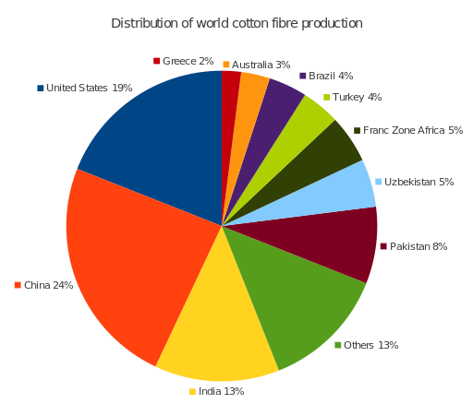
In Pakistan, cotton is grown predominantly in the provinces of Punjab, and Sindh. The leading area of cotton production is the south Punjab. In Sindh, Sanghar is the most important cotton producing district. Faisalabad is a leader in textiles within Pakistan. Punjab has a tropical wet and dry climate throughout the year therefore enhancing the growth of cotton. As India also shares a part of Punjab, India also claims in the production of cotton. (http://www.cottonsjourney.com/Storyofcotton/ default.asp).
Source: http://www.cottonsjourney.com/Storyofcotton /default.asp
Figure 1: Distribution of world cotton fiber
Top ten cotton producers—2011
(480-pound bales)
People's Republic of China | 33.0 million bales
India | 27.0 million bales
United States | 18.0 million bales
Pakistan | 10.3 million bales
Brazil | 9.3 million bales
Uzbekistan | 4.6 million bales
Australia | 4.2 million bales
Turkey | 2.8 million bales
Turkmenistan | 1.6 million bales
Greece | 1.4 million bales
The five leading exporters of cotton in 2011 in the global level are the United States, India, Brazil, Australia, and Uzbekistan (http:// en.wikipedia .org/wiki/Cotton).
Figure 2: Top Ten Cotton Production- 2011
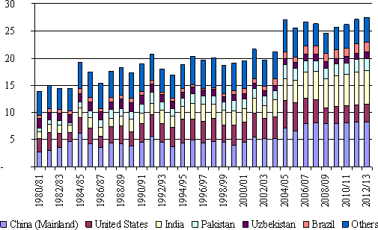
In India, the States of Maharashtra (26.63%), Gujarat (17.96%) and Andhra Pradesh (13.75%) and also Madhya Pradesh are the leading cotton producing States. These States have a predominantly tropical wet and dry climate. Cotton producing areas in India are spread throughout the country. There are nine States which are the major cotton producing ones. These can be grouped into three major regions of North Zone, Central Zone and South Zone. Besides the major States, in these zones, cotton is also grown on a minor scale in the States of Assam, Bihar, Kerala, Meghalaya, Orissa, Uttar Pradesh, Tripura and West Bengal (Roche and Julian, 1994).
Source: National Cotton Council of America – Rankings. Cotton.org (2011-03-13)
Figure 3: World cotton production (million tonnes), by main countries, 1980/81 - 2012/13

Source: UNCTAD secretariat, based on International Cotton Advisory Committee (ICAC) statistics (2001)

Cotton had multi-faceted uses among consumers. In addition to the textile industry, cotton is used in fishing nets, coffee filters, tents, explosives manufacture, cotton paper, and in bookbinding. The first Chinese paper was made of cotton fiber. Fire hoses were once made of cotton. The cottonseed which remains after the cotton is ginned is used to produce cottonseed oil, which, after refining, can be consumed by humans like any other vegetable oil. The cottonseed meal that is left generally is fed to ruminant livestock. Cottonseed hulls can be added to dairy cattle rations for roughage. During the American slavery period, cotton root bark was used in folk remedies as an abortifacient, that is, to induce a miscarriage (Schoen and Brian, 2009).
The major end uses for cotton fiber include wearing apparel, home furnishings, and other industrial uses (such as medical supplies). The cotton fiber is made primarily into yarns and threads for use in the textile and apparel sectors (wearing apparel would account for approximately 60% of cotton consumption). Cotton is also used to make home furnishings, such as draperies (eventually the third major end use) or professional garments (about 5% of cotton fiber demand) stated Brown and Ware, way back in 1958. Besides such traditional uses and as a result of different finishing processes that have been applied to the cotton fiber, cotton is now made into speciality materials suitable for a great variety of uses. Cotton fabrics with speciality applications include, for example, fire-proof (flame resistant) apparel, which is suitable for professional uses and provides effective protection against potential risks associated with high temperature and particularly flashover. Flame resistant cotton fabrics are treated with chemical. (Volti and Rudi, 1999). Cotton also finds speciality applications in medical and hygienic uses. Most notably, the fiber is used to manufacture hydrophile cotton (cotton wool), compress, gauze bandages, tampons or sanitary towels, and cotton swabs. In this field, the most suitable cotton variety is the species Gossypium herbaceum with short-staple thick fibers which dates from 1963 according to Brady and Eugene. Now nanotechnology has found ways to exploit the quabtions of cotton for various appheations.
- Processing of Cotton to Knitted Fabric
Cotton, to be brought to a usable stage undergoes a series of processes from its origin as cotton pods or cotton bolls.
Cotton pods after harvesting are subjected to ginning. The first step in the ginning process is when the cotton is vacuumed into tubes that carry it to a dryer to reduce moisture and improve the fiber quality. Then it runs through cleaning equipment to remove leaf trash, sticks and other foreign matter. Ginning is accomplished by one of two methods. Cotton varieties with shorter staple or fiber length are ginned with saw gins. This process involves the use of circular saws that grip the fibers and pull them through narrow slots (Thomas, 2006).
The seeds are too large to pass through these openings, resulting in the fibers being pulled away from the seed. Long fiber cottons are ginned in a roller gin because saw gins can damage their delicate fibers. The roller gin was invented in India centuries ago and this concept is still used in modern gins. Long staple cottons, like Pima, separate from the seed more easily than Upland varieties. A roller gin uses a rough roller to grab the fiber and pull it under a rotating bar with gaps too small for the seed to pass (Yafa and Stephen, 2005). Ginning machine in its simplest form consists of a roller with a broad steel blade sprung against it. The roller draws the cotton. Wound between itself is the blade and the seeds. The seed being large and hard instead of following are freed from the cotton fiber and drop off into a receptacle arranged for them. (NIIR BOARD –National Institute of Industrial Research, 2009). The fiber obtained after ginning is called Lint.
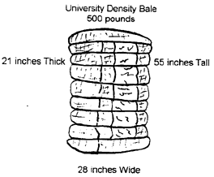
The raw fiber, called lint, makes its way through another series of pipes to a press where it is compressed into bales (lint packaged for market), banded with eight steel straps, sampled for classing, wrapped for protection then loaded onto trucks for shipment to storage yards, textile mills and foreign countries. The cotton industry has adopted a standard for a bale of cotton, 55 inches tall, 28 inches wide, and 21 inches thick, weighing approximately 500 pounds. A bale meeting these requirements is called a universal density bale (Thomas and Oliver, 2007).
Figure 4: Universal density bale 500 pounds
Cotton linters are the short, fuzzy hair like fibers that remain on the seeds after they have been separated from the fiber in the cotton gin. The cotton linters are removed by a second ginning process (Corbman, 1983).This linter removal process is usually done twice and the fibers are collected and pressed into 600 pound /272.15 kg bales. The linters of the highest grade are referred to as first-cut linters which are longer more resilient fibers (http://www.cottonsjourney.com/Storyofcotton/default.asp).
Spinning: Yarn spinning is a process of making or converting fiber materials into yarns. Since few centuries ago, spinning has been known as a process of converting raw materials (fiber) such as cotton and wool into yarns for making textile fabric or products (O’Meara, 2008).
Textile mills purchase cotton and receive the bales from gin yards or cotton warehouses. These mills start with raw bales of cotton and process them in stages until they produce yarn (fibers twisted into threads used in weaving or knitting) or cloth (fabric or material constructed from weaving or knitting).Yarns are made up of any number of plies, each ply being a single spun yarn. These single ply of yarn are twisted in the opposite direction (plied) together to make a thicker yarn. (Sara, 2007). Natural fibers such as these have the advantage of being slightly elastic and very breathable, while trapping a great deal of air, making for a fairly warm fabric. There are several thicknesses of yarn, also referred to as weight (Standards and Guidelines for Crochet & Knitting).

Steps in Making Fibers into Yarns according to Collier and Tortora (2001):
Blow room: A process where the raw materials packed in bale forms (supplier) will be opened and cleaned of the impurities on the surface by using bale opener machine.
Carding: This is where the flock from bales will be opened into individual fiber. It will ease in removing the excess impurities on the fiber surface. At this point, short fiber which is not suitable for production in terms of length requirements will be eliminated.
Combing: This is a process where the yarn will be straightened again so that they are arranged in parallel manner, and at the same time, the remaining short fiber will be eliminated completely from the longer staple fiber. By doing this, long-staple will produce stronger and smoother fabric which are highly in demand in the market.
Drawing: At this stage, it will be pulled by the sliver in lengthwise direction over each other, making it stronger and thinner in production which is very important in evenness of the yarn.

Figure 5: Steps in Making Fibers into Yarns

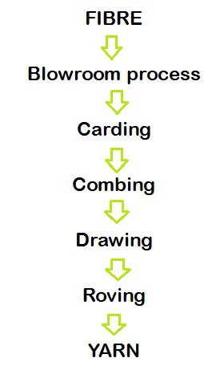

Comber Noil
Cotton selvage
waste

Roving Ends

Waste Realised
Roving: This is the final stage where the preparatory steps are taken for insertion of the twist. Enough twist is given to hold the fibers together but still has no tensile strength. The roving in bobbins is placed in spinning frame where it passes several sets of rollers which run at high-speed to convert into yarn forms. In all these stages cotton incurs processing wastes.
Spun yarn is made by twisting or otherwise bonding staple fibers together to make a cohesive thread, or "single."(Kadolph, 1977) Twisting fibers into yarn in the process called spinning can be dated back to the Upper Paleolithic, (Barber and Wayland, 1994) and yarn spinning was one of the very first processes to be industrialized. Spun yarns may contain a single type of fiber, or be a blend of various types.
Yarn is a long continuous length of interlocked fibers, suitable for use in the production of textiles, sewing, crocheting, knitting, weaving and rope making. Yarn is any fiber used to construct a fabric. The most common plant fiber is cotton (cotton lint), which is typically spun into fine yarn for mechanical weaving or knitting into cloth (Advameg, 2007).
Knitting: After weaving, the most prevalent method of fabric construction is knitting. Its popularity has grown tremendously over the recent years. Most hosiery garments are made by knitting methods. Modern hosiery is usually
tight-fitting by virtue of stretchy fabrics and meshes. Older forms include binding to achieve a tight fit. Due to its close fit, most hosiery can be worn as an undergarment, but it is more commonly worn as a combined under/outer garment. Hosiery is essentially any kind of knitted covering designed specifically for both the legs and feet (http://en.wikipedia.org/wiki/Hosiery).
Knitting process: The first process in knitted fabric manufacturing is knitting. Knitting is defined to be the formation of fabric by the intermeshing of loops of yarn. Unlike weaving, which requires two yarn sets, knitting is possible in using only a single set of yarns. The set may consist of a single yarn or a single group of yarns or weft knit (Neelima, 2009). Knitting is the process through which the yarn is turned into knitted fabric by joining consecutive row of loops using different types of knitting machines. Broadly, there are three types of knitting, which is jersey, interlock and rib. Each type of knitting process has a variation in the knitting process (Sadler, 2004). Dyeing process, dryer process, compacting process, knitted fabric cutting and sewing of the knitted fabric are the next respective processes in making of hosiery. Checking, ironing, packing is the process after sewing the fabric. Then the final finished product comes out for the market for selling.
- Waste Obtained in Cotton Processing
Wastes emerge in cotton processing in two different phases:
- Pre – Knitting Phase
- Post – Knitting Phase
The wastes obtained in these two types are entirely different and lend for recovery of resource in entirely different ways.
1. Waste obtained in Pre - Knitting Phase: The cotton pod on processing gives out a very usable product called Lint or ‘Cotton fiber’, which gives the name to the plant. At the same time other wastes that are of no use to the textile industry also emerge. It is mainly the cotton seed, which when side treated becomes a highly ‘resourceful waste’. Hence journey of seed cotton from a ginning machine is given below.
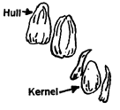
The delinted seeds now go to the huller. The huller removes the tough seed coat with a series of knives and shakers. The knives cut the hulls (tough outer shell of the seed) to loosen them from the kernels (the inside meat of the seed, rich in oil) and shakers separate the hulls and kernels. The kernels are now ready for oil extraction and the hulls are sent to storage to be sold for livestock feed. Cottonseed mills, in the late 1800's, used manual powered mechanical pressure to squeeze the oil from the seed. This was very labor intensive and at best recovered only one-half the oil contained in the seed. Today's mills are either screw press or solvent extraction types. The oil is removed from the meats leaving only 1-2 per cent oil in the meats.
Crude cottonseed oil requires further processing before it may be used for food. The first step in this process is refining. With the scientific use of heat, sodium hydroxide and a centrifuge (equipment used to separate substances through spinning action), the dark colored crude oil is transformed into a transparent, yellow oil. This clear oil may then be bleached with a special bleaching clay to produce a transparent, amber colored oil. Upon further processing, the oil is deodorized or treated so it will remain clear and have no unwanted flavors (Ensminger, et al, 1993).
According to UNCTAD (2001) the effective fiber that could be extracted from 100 kg of seed cotton is only 30-45 kg. The rest are cotton seeds, which have a very high commercial value. Wastes emerge in different stages of processing and are efficiently recovered as resources as explained in Fig 6. The Flow chart also illustrates end uses.

- Absorbent cotton medical grade
- Felts for Upholstery
- Yarns
- Fiber
- Pulp
- Felts for Upholstery

Cotton seed
Shaker room
First cut linters
Second cut linters
Hulls
Oil extraction
Cotton seed oil
Cotton seed meal
Gin stands
Huller

Kernels

Figure 6: Wastes emerge in different stages of processing of cotton seed

Waste from the spinning mills (Linter) of first and second quality fiber to produce yarn of combined unit raw fabric to second and third quality respectively. During the extraction process, in the pre – knitting phase, wastes occur as comber noil, roving ends and cotton selvage waste as explained in Fig 5.
- Waste obtained in Post - Knitting Phase
As with pre knitting phases, in the post knitting phases too processing wastes are inevitable. They are hosiery clippings, hosiery cutting waste (coloured and white), hosiery yarn waste (coloured and white) and hosiery sewing waste, which have multiple uses.
- Resource Recovery of Cotton Waste as a Food Crop
According to UNCTAD (2001) from a known quantity of cotton bolls only 42 percent of fiber cotton is obtained. The rest goes as cotton seed (58%). As this is a major waste in the processing of cotton to knitted fabric, further resource recovery possible from cotton seed are explained in the following Table 1 and Fig 7.
- Resource Recovery of Cotton Seed

58% 3%
Hulls
Linter
Seeds
Seed Cotton(100%)
40%
Meal
42%
Oil
15%
Figure 7: Resource recovery of cotton seed

According Corbman (1983) and Neelima (2009), the following wastes are obtained in the oil mills as ‘recoverable resources’.
Table 1: Recoverable Resources from Cotton Seed Processing
Waste and proportion | Particulars | Further uses
Linters (3%) | Linters are the short, fuzzy hair like fibers that remain on the seeds after they have been separated from the fiber in the cotton gin. The cotton linters are removed by a second ginning process. | They are used in the manufacture of rayons and acetates, plastics, shatterproof glass, gun-cotton, photographic film, and fast-drying lacquers, and for other purpose.
Hulls (40%) | The hulls, which are the outside portion of the cottonseeds, are obtained after the linter have been removed. | The hulls are rich in nitrogen, an important plant food, and are used as fertilizer, in the manufacture of paper, plastics and livestock feed and as a base for explosives.
Inner seeds -kernel (57%) | Inner seed - the meat of the seed inside the hull | Yields cotton seed oil, which is used in cooking oils and compounds and in the manufacture of soap. The residue of the inner seed becomes cattle feed.
Meal | The solid wastes obtained after milling. | The meats are then dried and ground to produce a 41% protein livestock feed, called cottonseed meal. Cottonseed meals' major value is the high protein it contains to build muscle, nerve, blood and hair. A small amount of cottonseed meal is used for fertilizer. Its organic matter improves soil texture and reduces watering needs
Cottonseed oil | Crude and refined oil. | Cottonseed oil is used in several products. Depending on its stage of refinement, it can be used in snack foods, mayonnaise, margarine, baking or frying oils, explosives, cosmetics, rubber, soap, insecticides and many other products.

- Resource Recovery of Cotton Waste as a Cash crop
Waste obtained from pre knitting and post knitting portray that cotton waste also qualify as a cash crop, the details are which are listed below in the following Table.

Table 2: Waste Recovered from Pre knitting and Post knitting
Stages of knitting | Waste Recovered | Nature of waste | Uses
Pre kitting | Comber noil  Roving ends  Cotton selvage waste | 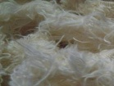  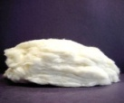  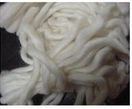 | Multiple
Post Knitting | Hosiery clippings  Hosiery cutting and sewing waste  Hosiery colour yarn waste  Hosiery white yarn waste  White banian waste | 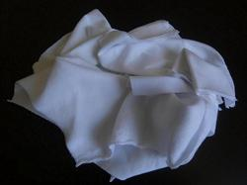  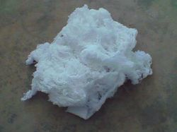  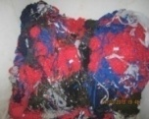  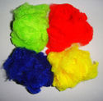  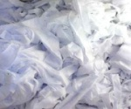 | Multiple
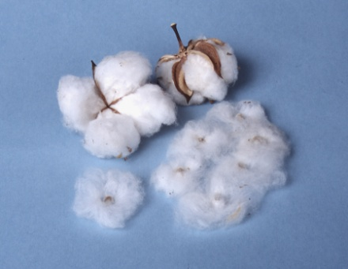

COTTON- THE VERSATILE POD: Cotton is used to make a number of textile products. These include terrycloth for highly absorbent bath towels and robes; denim for blue jeans; cambric, popularly used in the manufacture of blue work shirts (from which we get the term "blue-collar"); and corduroy, seersucker, and cotton twill. Socks, underwear, and most T-shirts are made from cotton. Bed sheets often are made from cotton. Cotton also is used to make yarn used in crochet and knitting. Fabric also can be made from recycled or recovered cotton that otherwise would be thrown away during the spinning, weaving, or cutting process. While many fabrics are made completely of cotton, some materials blend cotton with other fibers, including rayon and synthetic fibers such as polyester. It can either be used in knitted or woven fabrics, as it can be blended with elastine to make a stretchier thread for knitted fabrics, and apparel such as stretch jeans.
Cotton thus proves as a Versatile pod.
Box 2: Cotton- The Versatile Pod
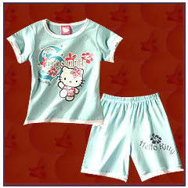
Electrospun nonwoven fabrics are used in variety applications such as specialty filters (Dotti, et.al., 2007), composite reinforcement (Zucchelli, et.al., 2011), protective clothing (Lee and Obendorf, 2006), tissue engineering (Lannutti, et.al., 2007), Wound dressing (Khil, et.al., 2003) and catalytic application (Luepong,et.al., 2010).

III. PLAN AND PROCEDURE
The plan and procedure pertaining to the study on ‘Economics of Resource Recovery-Hosiery Waste as a Candidate’ is streamlined to include the following phases:
- Ethnographic Study
- Functioning of a Ginning Mill
- Study of a Cotton Seed Oil Mill
- Operations in Pre-Knitting Units
- Profile of Post Knitting Units (Hosiery Units)
- Status of Hosiery Waste Dealers
- Ethnographic Study
Ethnographic Study is a qualitative research design aimed at exploring cultural phenomena. The resulting field study or a case report reflects the knowledge and the system of meanings in the lives of a cultural group (Agar and Michael, 1996).
To learn extensively about a geographical area intended for an indepth study, ethnographic study is a must. Tirupur, in Tamil Nadu is best known as the ‘City of Hosiery’, as units dealing in the knitted fabric engulf the City’s horizon, the aspect which decided the sampling method as purposive. Purposive sampling, is one that is selected based on the knowledge of a population and the purpose of the study (Ravichandran and Nakkiram, 2009) The subjects are selected because of some characteristic. As a preliminary step, therefore, it was decided to locate the presence of such industries / units dealing with knitted fabric functional in the City and the employment potential therein. To this effect the office of Industrial Corporation, located in Tirupur was approached. Secondary data was collected from the office. Secondary data is the data that have been already collected by and readily available from other sources. Such data are cheaper and more quickly obtainable than the primary data and also may be available when primary data cannot be obtained at all (Rajendarkumar, 2008).
The information which satisfied the requirements of the study was then collected, the details of which are presented under Results and Discussion.
- Functioning of a Ginning Mill
Ginning is the process of separating the cotton fibers from the cotton seeds. The term ‘gin’ is an abbreviation for engine, and means ‘machine’. The place where ginning process takes place is called a ginning mill.
According to UNCTAD (2001) effective fiber obtained from cotton bolls is lesser than 50 per cent of the raw material. To comprehend the processing of knitted fabric, (which is later constructed as hosiery products), the resource used and wastes realized, visit to a ginning mill, the preliminary step in obtaining the fiber for the fabric was felt necessary. This part of the study, therefore, included:
- Selection of Locale and Sample
A sample ginning mill in Karuvampalayam in Tirupur city was the locale selected for the study. Ease in access, an established mill with rich experience in the field and willingness to disclose data facilitated selection of the locale. A sample is any group of measurement selected from a population (Bhattacharya, 2003). A sample is obtained by selecting individual participants who are easy to get (Gravetter and Forzano, 2011). The sample and the locale was thus selected based on purposive sampling, a method of selecting sample on the basis of knowledge of the research problems to allow selection of ‘typical’ persons for inclusion in the sample ( Khan, 2008).

- Selection of Method
Face to face interview with the supervisor and owner of the mill facilitated getting adequate information about the operational details of the mill. Face to face interview is a method of personal interview with the interviewees to get the necessary information (Chaudhary, 2009).
- Collection of Data
General details regarding the stages involved in ginning process – i.e., removal of fiber from cotton bolls - was obtained through both primary and secondary data. Based on the secondary data a check list was prepared indicating the various stages in the ginning process. Primary data was collected during the visit. During the visit and interview, necessary details on quantum of raw material used, products realized, amount and wastes generated were requested and filled in. Primary data are those, which are collected afresh and for the time, and happen to be original in character. Primary data refers to that is generated to meet the specific requirement of the investigation at hand(Khan, 2008). Visit in person also helped to observe the premises for minute details. Observation is a method of data collection in which the situation of interest is watched and the relevant facts, actions and behaviors are recorded (Khanzode, 2007).
- Analysis of the Data
From the data collected, the process of ginning was understood and the details on ‘resource’ used and resources generated were elicited under each stage. It was interesting to know that cotton qualified both as a food crop and a cash crop as the outcomes of the ginning process brought out resources which had both food value and cash value. The findings are presented under Chapter IV.

- Study of a Cotton Seed Oil Mill
As literature studies propound that more than 50 per cent of the cotton seeds emerge as waste in the processing of raw cotton, the plight o f those wastes had to be analyzed. With this in view this part of the study included:
- Selection of Locale of Sample
Apart from the hosiery units that thrive in Tirupur City, it was found that a few cotton seed mills also exist that are fed from the wastes that emerge from ginning industries. Hence a sample cotton seed oil mill, located near Tirupur (Outskirts of Tirupur) and which had the reputation of being in the field for many years and who showed interest to participate in the study was selected adopting convenience sampling, which accommodates members of the population to be chosen based on their relative ease of access. (Wiederman, 1999 and Lucas, 2012).
- Selection of Method
Case study was the method chosen for the study. Verma and Verma, (1989) quote Young in defining Case study as a method of exploring and analyzing the life of social unit, be that unit a person, a family, institution, cultural groups or even an entire community. This enabled observation of minute details too. Observation means viewing or seeing for specific details (Krishnaswami and Ranganatham, 2005).
- Conducting the Study and Documentation of Data
The mill was visited after getting prior permission. Details of the various operations that took place from the procurement of cotton seeds to the refining of oil and other wastes that emerged were jotted down in the proper sequence. The findings are documented under Chapter IV.
- Operations in Pre-Knitting Units
The processes that cotton undergoes in the ginning process, i.e., till the fiber is obtained and later till the yarn is made are categorized under pre-knitting processes. In order to get the textile from the fiber called ‘lint’, the fibers have to undergo other processes classified as cotton processing which includes various steps in the blow room, carding, combing, drawing, roving and spinning, which bring out the yarn. During these stages, a processing waste of 5-6 per cent cannot be avoided. But after obtaining the yarn, it is subjected to two processes – weaving or knitting. If woven, cloth is obtained, and if knitted, knitted fabric is obtained which when subjected to garment construction is termed as ‘hosiery’ (Spencer, 2005). Today, knitting is a very big industry which has two main divisions. One division manufactures knitted goods for apparel production, sewing centers, consumers and others. The other division manufactures finished apparel such as hosiery, sweaters and underwear. Evidently in all these processes, wastes generation seems to be inevitable. Hence this part of the study included: collection of data from pre-knitting processes in spinning mills and open end mills.
- Data Collection on Spinning Waste (from spinning mills)
Primary data by contacting a partner of a mill (as visit to the mills was prohibited) revealed that in the spinning mills (which use ‘lint’ as base material) three types of yarns were produced. When the organization itself or the investigator collects data it is called primary data (Khan, 2008). In the first quality yarns production the mill incurred a loss of 30 per cent (which emerged as waste cotton). This waste was added to cotton to produce second quality fiber and waste from this process was used to produce the third quality yarn. Therefore, waste occurring in the processing stages were reused (recycled) there itself and hence resources recovery of the waste was simultaneous. Naturally no wastes were shunted out of the mills except minimal floor wastes. Secondary data collected from printed matter and websites also agreed with these statements. Secondary data is data collected by someone other than the user ( Kelly, 2005).
- Visit to an Open End Mill
To comprehend the operation in an open end mill where linter (fiber obtained after the cleaning of cotton seed) is used along with other low stable fiber, one open end mill was visited. The data was collected orally from Managers regarding quantum of fiber used and the quantum of yarn obtained and the waste generated in the process. One open end mill located in Tirupur was chosen for the study adopting convenience sampling. This sampling method draws representative data by selecting people because of the ease of their volunteering or selecting units because of their availability or easy access (Sharma and Jain, 2004). As visit to these units are highly restricted, and as the process is uniform across all mills, it was felt that one sample was adequate enough. Ease in access, willingness of the proprietor to disclose facts and show around and take photographs aided in selection of the unit.
- Conduct of the Study and Presentation of Data
The study was conducted during the slot allotted by the proprietor and when the mill was in working schedule. The flow of activities as per the operational schedule was noted down, necessary details were collected. Information obtained was analysed and is presented under Chapter IV.
- Profile of Post Knitting Units (Hosiery Units)
Yarn from the spinning mills was procured by the hosiery units (the post knitting units) for garment construction. Data collection from these Units was channelized to include:

- Investigatory Study
An investigatory study was carried out by interviewing local public at random and from secondary data obtained from brochures and other printed matter, which revealed that three types of garment construction units thrived in Tirupur. Secondary data are the historical statistical data which are maintained by internal and external agencies which best describes the historic trends of a particular organization or a product and can be accessed by proper authentication from the concerned for any productive purpose (Singh and Nath, 2007). The three groups existing in Tirupur were:
- Units which Cut and Sew Garments
- Units which Cut Garments as Job Workers
- Job Workers who Sew Garments
As all the three are important components of the hosiery industry all the three groups were selected. Based on these observations, this part of the study focused on getting information on the following lines:
- Selection of Locale and Sample
The locale selected for the study was Tirupur City, the cradle of hosiery units in India; Hence the sampling adopted was purposive sampling which focuses on the sampling techniques where the units that are investigated are based on the judgment of the researcher (Jackson, 2010).
Though, the sample selected was from the three types of units, to be precise they belonged to two categories.
- Who did garment construction (both cutting and sewing of fabrics and
- Who either outsourced part of their work or their counterpart, the job workers (who undertook cutting or sewing of garments).
Therefore three samples (who took up garment construction of varied goods) and two job workers (who cut) and one job worker who took up sewing alone were selected adopting convenience sampling. Familiarity, ease in communication and assurance to collect necessary data in lieu of their willingness to disclose trade secrets were the factors that motivated choice of these units. Convenience sampling is a non- probability sampling technique. As the name implies, the sample is identified primarily by convenience (Anderson, et al., 2008).
- Selection of Method
The case study method ,which emphasizes the total situation or combination of factors, the description of the process or consequences of events in which behavior occurs coupled with the study of the individual behavior in its total setting and the analysis and comparison of cases (Sharma, 2007) was the method chosen for studying the ‘modus operandi’ of the Units. Details enquired of from the owners during visits to individual Units were on resources used, products made, types and quantum of waste generated, prospects for recovery and monetary returns. Information on cost of purchase of raw materials and returns from sale of waste was also culled out.
- Presentation of Data
The information collected through the visits is presented as individual Case Studies under Results and Discussion.
- Status of Hosiery Waste Dealers
Wastes generated from all the garment construction units (of any type) were reported to be taken away by Dealers who run trading enterprises of wasted fabrics. Hence this part of the study included:

- Selection of Locale and Sample
The locale remained the same as waste from knitted fabrics found prospects for recovery in the same area – Tirupur: Convenience sampling also referred to as ‘accidental’ or ‘availability sampling’, as it involves the choice of readily available subjects or objects for the study (Brink, et al., 2006) was the sampling method adopted.
Sample for this part of the study had to be chosen with utmost care and caution, as this sample was the kingpin who decided the fate of the wastes generated. Rich experience, knowledge of the trade, good business acumen and above all an interest to share trade secrets decided choice of the sample. However, all those engaged in this trade followed a set, uniform pattern of business. Hence one agent who satisfied the requirements of the study and trading in Tirupur was selected adopting purposive sampling. Purposive sampling is a sampling method where the sample is chosen with a purpose in mind (Panneerselvam, 2004 ).
- Collection and Presentation of Data
Operational details pertaining to collection of waste and trading thereafter was studied as a Case Study. A case refers to a unit of study. Each case is unique; therefore a case is not comparable and yields non-addictive and non-quantitative data. The researchers have considerable freedom in gathering information from variety of sources (Rajendarkumar, 2008) The investigator accompanied the sample while he collected waste from units and to the places of storage and observed the activities done in the godowns, mode of trade and tradesmen contacted, till the last scrap of waste was handed over. Entire operational details were noted down.
This case study revealed the magnitude of trade prospects revolving around ‘just the wastes developed from garment construction units’. Concept of demand and supply and social responsibility to environmental protection from the entrepreneur’s side was also studied. A prospect for future uses in the nanotech field also has been pointed out. The findings are presented under Chapter IV.
It is hoped that this study would throw light on the different phases where wastes get generated and how the resource recovery component occurs in cotton to garment construction at varied levels. It can be an eye opener for future endeavours.

100% Decorative items
COTTON BOLLS
Twig/ leaves/ plant (as mulch/fuel)

42% 58%
Cotton seed
Fiber (Lint)

Spinning mills
Open end mills
100kg of Fiber
70%-90% 10%-30% 3% 40% 57%
Low quality yarn
Quality yarn
Hulls
Kernels
Linter

- Feed for livestock
- Mulch and soil
- Barn
- Oil
- Others like plastic, synthetic rubber, petroleum are derived.
- Yarns
- Felts for upholstery
- Fiber pulp for paper
- Absorbent cotton Medical grade
- Pulp -
- Viscose
- Rayon spun yarn
- Plastics
- Films

Cutting waste
Sewing waste
Cutting
Coloured and white waste
Fabric
Crude oil
Meal and cake
Garment construction
Cloth
Sewing
Fertilizer and
Cattle feed

Low gossypol crude oil
Refined oil
Agents
Preparation of food
- Glycerin
- Soap
- Livestock feed
- Fatty acid

Future will also used in preparing nano fibers
Sent to second quality garment making
Rethreaded to yarn (used for cleaning)
Crushing mills (to convert to fiber)
Automobile, Aircraft
Industries, Doll making

To 20 open end mills
To 40 crushing mills
For production of household linen
Exhibit 4: Efficient Resource Recovery – Wealth from Waste

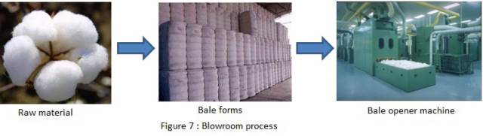
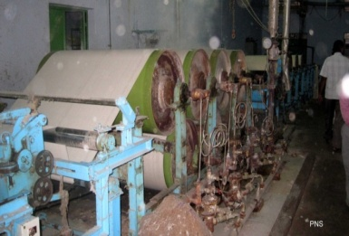

Bale form
Ginning process
Cotton

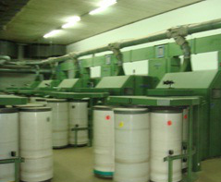
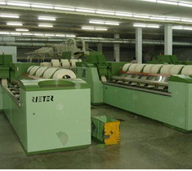

Combing
Carding
Bale opener

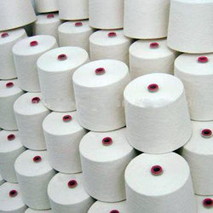
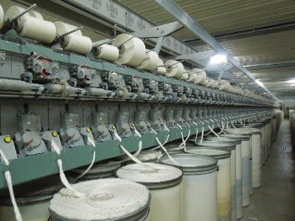
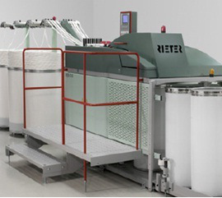

Yarn
Drawing
Open End spinning

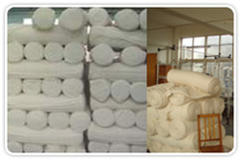
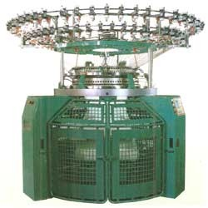

Exhibit 1: Multiple stages in Making of Fiber to Fabric
Knitting
Knitted Fabric

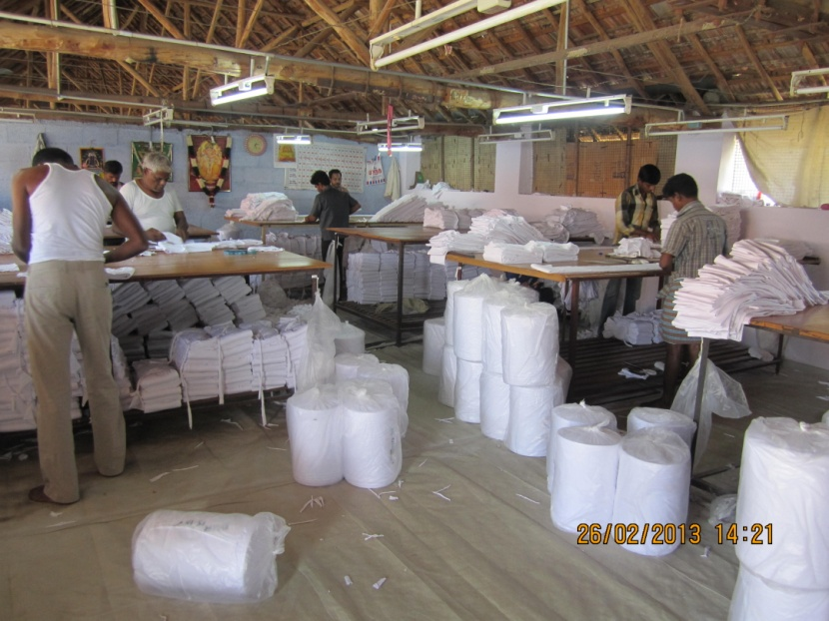

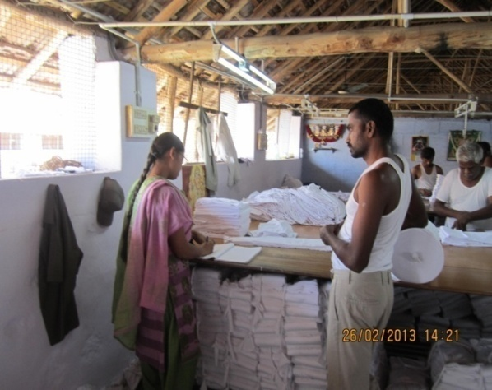

Process in manual cutting units

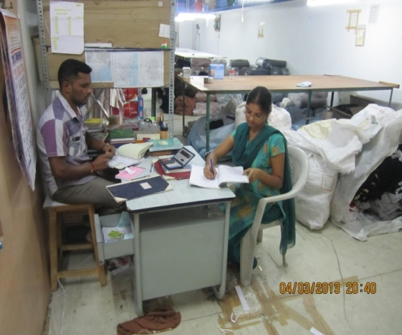

Plate 5: Survey in Manual Cutting Units

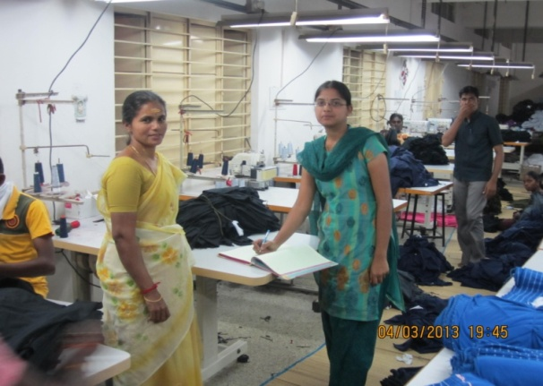
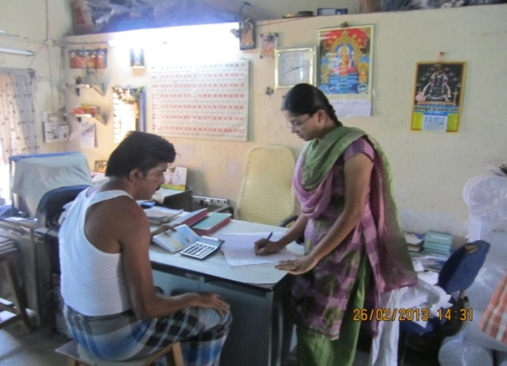
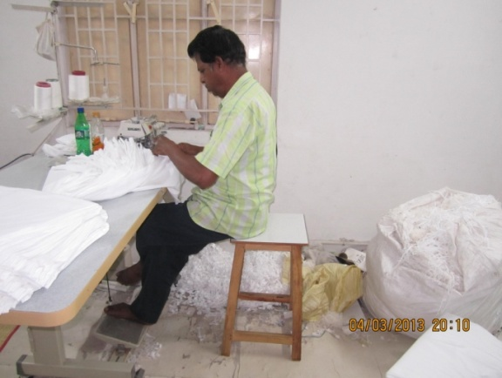
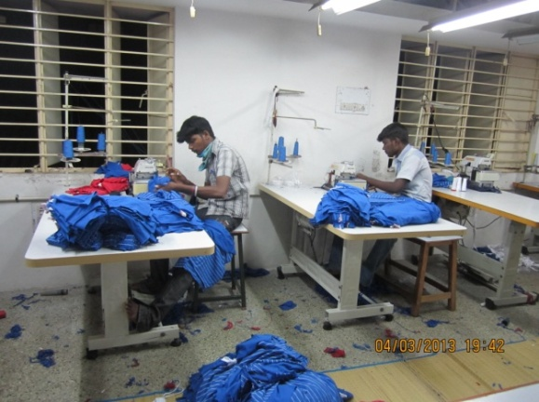
Plate 4: Sewing Process in Units
Survey taken in the sewing Units
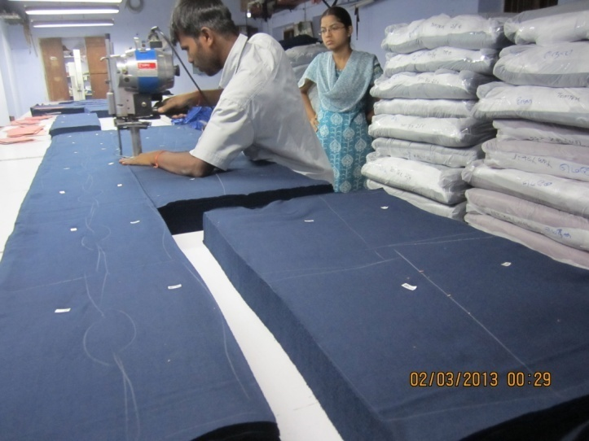

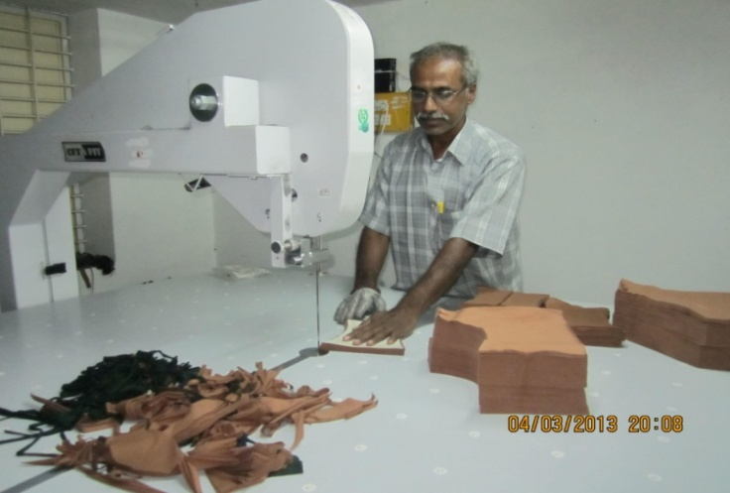
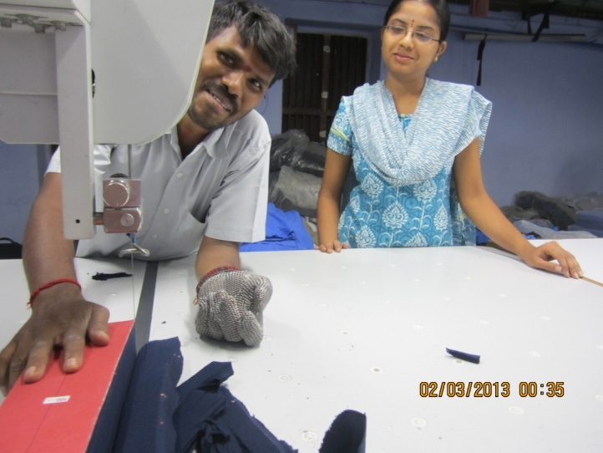
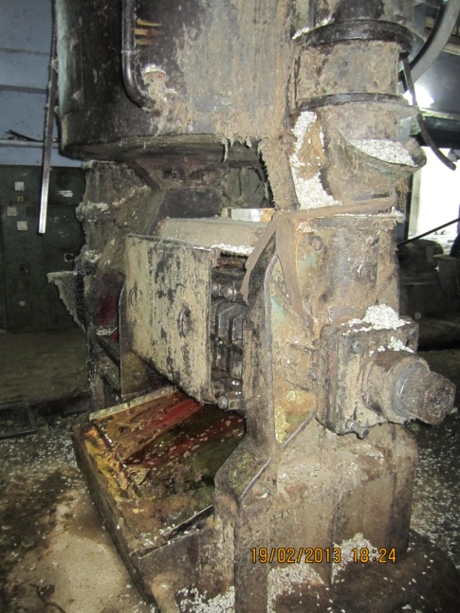
Plate 3: Machine Cutting Process
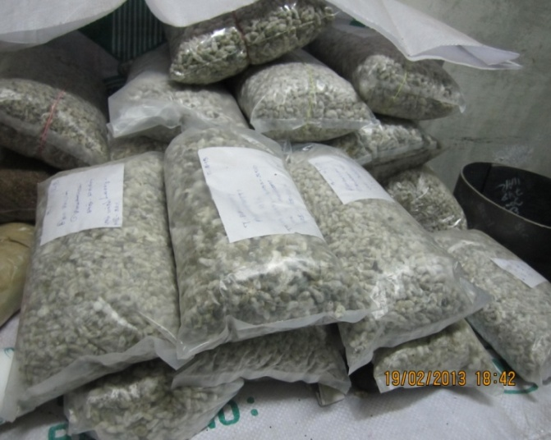
Cotton seed oil extracting machine
Cotton seed in various qualities

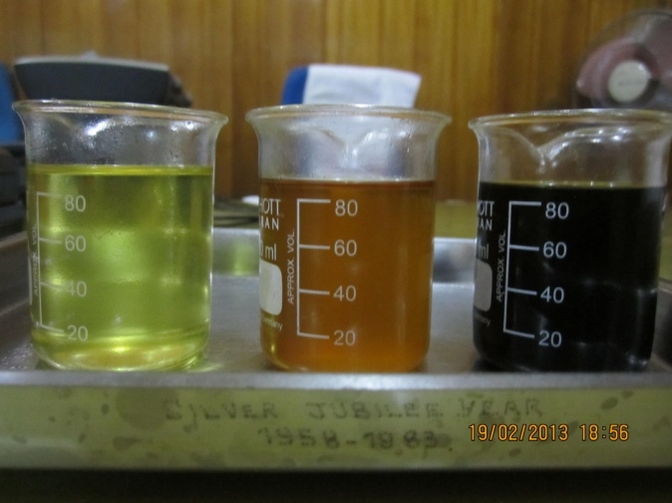

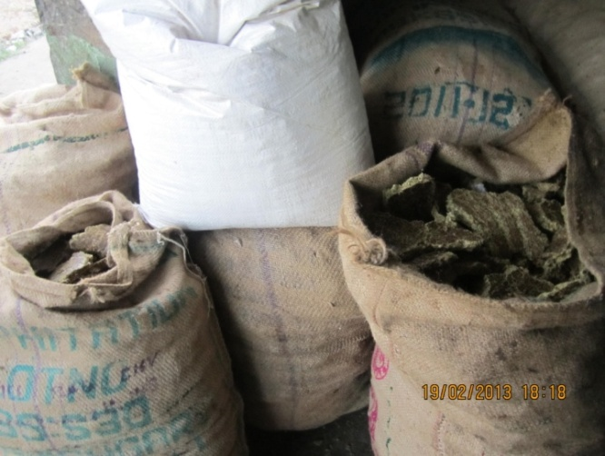
Meal collected after oil extraction
Various stage of refining the oil
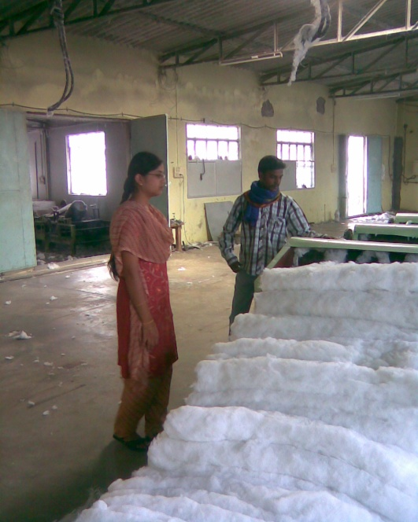
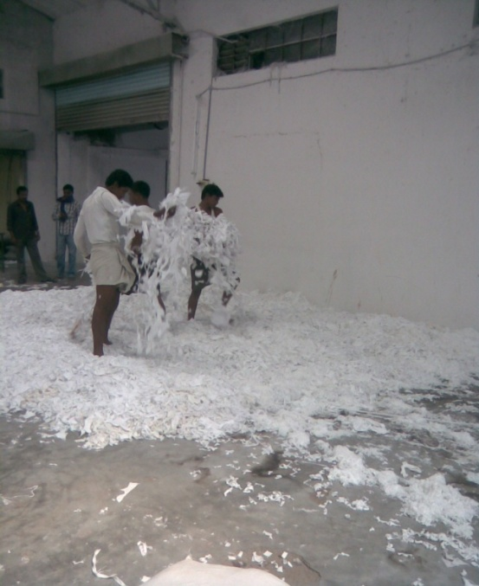
Plate 1: Visit to the Cotton Seed Oil Mill

Unwanted materials removed from waste before crushing
Waste fabric after crushing in the machine comes out as fiber

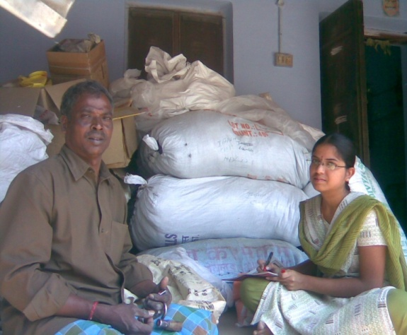
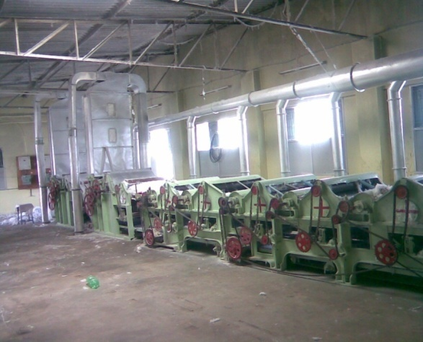
Waste crushing machine
Interview of the waste trader

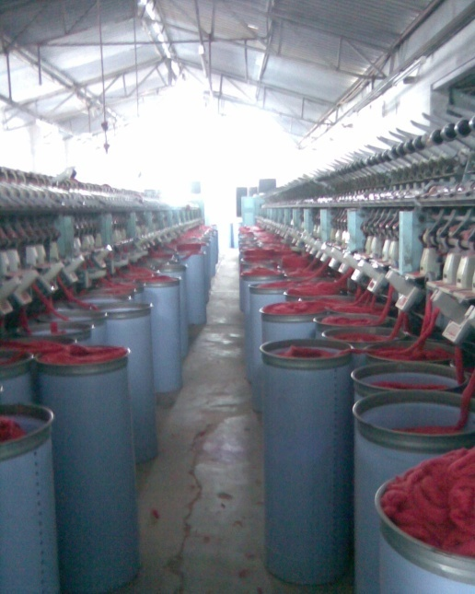
Plate 6: Process of Recycling of Finer waste
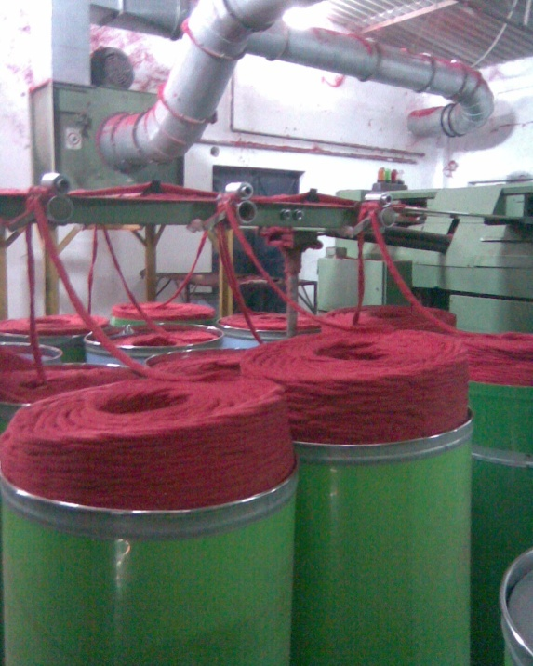
Spinning of yarn in Open End mills

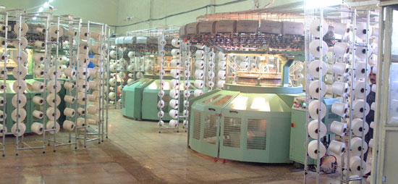
Plate 2: Spinning and Knitting Process
Knitting Machine

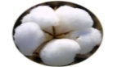
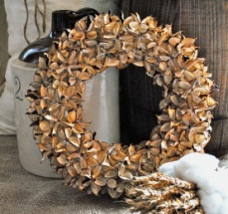
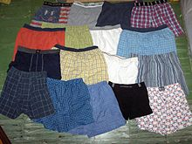
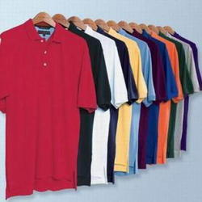
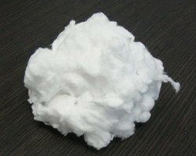
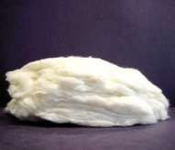
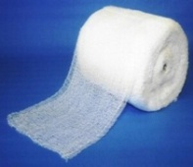
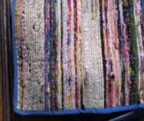
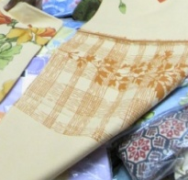
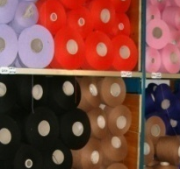
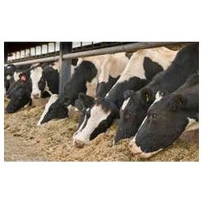

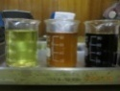
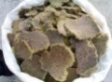
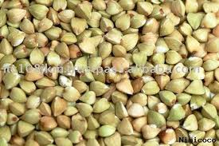
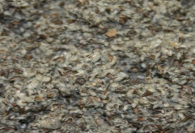
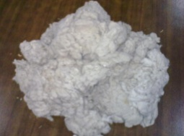
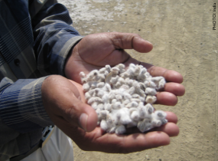
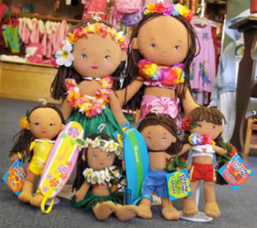
Figure 13: Plethora of Resource Recovery - A Pipe Line Process

IV RESULTS AND DISCUSSION
The findings pertaining to the study on ‘Economics of Resource Recovery-Hosiery Waste as a Candidate’ are discussed under the following broad headings:
- Findings of the Ethnographic Study
- Panorama of Units-Cotton to Hosiery Goods
- Resource Use in Hosiery (Post-Knitting) Industries
- Resource Recovery in Hosiery Units
- Monetary Benefits from Sale of Recovered Resources
- Cascading of Waste through Agents
- Flow Chart on Resource Recovery Cycle
- Findings of the Ethnographic Study
The data collected from the Industrial Corporation of Tirupur City revealed the following.
- Status - quo of Textile Industry
The wide panorama of textile industry that help monetize for millions of workers in Tirupur was studied, the details of which are tabulated below.
Table 3: Status - quo of Textile Industry in Tirupur
Geographical area | Total No. of units | Employ -ment in total no. of units | No. of Hosiery units among total units | Employ- ment in hosiery units among total employ-ment | Hosiery units as % of total units | Employ-ment in Hosiery units as % of total employ-ment
P N Road | 893 | 18502 | 343 | 11316 | 38.4 | 61.1
Mangalam Road | 693 | 14148 | 187 | 8407 | 27 | 59.42
Angeripalayam | 579 | 14586 | 266 | 8496 | 46 | 58.24
Mannarai | 509 | 10954 | 220 | 6099 | 43.2 | 55.67
Annuparpalayam | 360 | 7689 | 79 | 1952 | 22 | 25.38
Total | 3034 | 65879 | 1095 | 36270 | 36.1 | 55.1
It was recorded that there was five major cluster regions where there was a conglomeration of maximum number of textile industry / units in Tirupur apart from the other regions which also added considerably to the number. In these five cluster regions, there were 3034 textile and allied units among which 1095 were hosiery Units (a good 36 %). A look into the employment potential in these units showed from among the 65879 workers, 36270 were employed in the hosiery units (55.1%).Exhibit (2). Project the employment status in hosiery industry in Tirupur.
Though possibility for diversification is highly potent, it was found that preference for employment was more in hosiery units. These facts prove that the choice of the sample is justified.
- Panorama of Units-Cotton to Hosiery Goods
Cotton is adjudged as both a food crop and a cash crop. It gains the name as a food crop because, the reusable waste product from the processing procedures end up in food products and this happens in the pre-weaving / knitting industries. The end products from post-weaving / knitting industries evidently earn good revenue; hence, referred to as cash crop.
This part of the study therefore, reveals the processing of cotton from its raw stage to the stages which gets its name both as food crop and cash crop.
- Resource Generation in Cotton as a Food Crop
- Resource Generation in Cotton as a Cash Crop
- Resource Obtained from Cotton Fiber (Lint) - Fiber to Fabric (Hosiery)
- Resource Generation in Cotton as a Food Crop: This part of the study is described under:

- The Story Board-Processing of Raw Cotton
- Waste Utilization in Pre Knitting Industries-Cotton as a Food Crop
- The Story Board-Processing of Raw Cotton
This aspect of the study describes the stages through which the raw cotton gets processed to the fabric stage. It is explained through a story board (Fig 8)
1st stage waste
2nd stage waste

RAW COTTON (COTTON BOLLS)

COTTON FIBER (LINT)
COTTON SEED
TEXTILE
YARN
FOOD MATERIALS
LINTERS

Figure 8: The Story Board-Processing of Raw Cotton

The major element obtained from cotton bolls is fiber (lint). The cotton fiber (lint) obtained is converted into yarn which when used for weaving produces cloth and if knitted produces knit wear or hosiery.
The other product, generally referred to as ‘waste’ from cotton mills is cotton seed, the processing of which yields linter and food materials.
The story board explains that in each stage of the cotton processing, realizing some sort of waste is inevitable. The ensuing part of the Results, explain the waste realized in each stage.
- Waste Utilization in Pre Knitting Industries-Cotton as a Food Crop
This aspect of the study is discussed under:
- Waste Realized in Pre-Ginning Mills
- Consumption Value Products from First Stage Waste – Cotton seed
- Resource Recovered from Post-Ginned Cotton Waste
- Waste Realized in Pre-Ginning Mills: Cotton waste that emerges as cotton seed the major waste realized in pre ginning mills - undergoes a series of processes to sustain its name as a food crop. The following Figure (9) and Plate (1) - explain the same.
RAW COTTON
PRE GINNING MILL
From cotton seed 2nd quality fiber is obtained called linter.
COTTON SEED
1st stage waste
2nd stage waste

LINTER
KERNELS
HULLS

Figure 9: Waste Realized in Pre- Ginning Mills

Raw cotton when processed yields cotton seed as a major waste. Further processing of cotton seed recovers hulls and kernels as by products. Along with these a considerable quantity of linter is also recovered which experts categorise as low quality fiber. These factors prove that cotton is a food crop, as the two major recovered resources are reused as components in food materials namely hulls and kernels (cattle and/or poultry feed).

- Consumption Value Products from First Stage Waste – Cotton seed
Visit to an oil mill that crushed cotton seed to bring out usable products of consumption value was quite an interesting event. From the crushers/hullers who separated the hulls from the kernels to the varied processes which brought out the ‘gold oil’, sequencing was awesome. From 100kg of cotton seed they were able to get 15kg of oil and 40kg meal. Apart from that the hulls which were separated as a waste also added to the resource stock as a livestock feed or fuel. Thus even those considered as solid waste which contributed in no way to hosiery were found to add to the commercial value of cotton indirectly.
- Resource Recovered from Post-Ginning Cotton Waste:
The pre ginning cotton waste on further processing yield the post ginning waste. The following Table explains the resources recovered from cotton waste emerging from the post ginning mills.
Table 4: Resource Recovered from Post-Ginned Cotton Waste
 | First stage waste | Resource recovered and its quantity(second stage waste) | Further uses  (Resource recovery possible)
100%  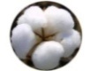  RAW  C  O  T  T  O  N | COTTON SEED  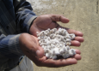  ( 58% ) | LINTER (3% ) | - First cut linter (longer more resilient fiber)  - Second cut linter (short fiber or fuzz)  - Combined with the other fiber to produce low quality yarn
 |  | 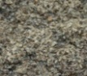  HULLS  ( 40% ) | - If plastic content is there it is used for small parts of textiles machinery.  - Used as a mud in oil well drilling.  - Production of synthetic rubber and petroleum refining
 |  | MEAL (42% ) | - Cattle feed and poultry feed.  - Used for fertilizer(small amount)  - As organic matter to improve soil texture and reduce watering needs.
 |  | COTTON SEED OIL  (15% ) | - Depending on its stage of refinement, it can be used in snack foods, mayonnaise, margarine, baking or frying oil, explosives, cosmetics, rubber, soap, insecticides and many other products.
These factors prove that cotton even as a wasted resource (cotton seed) is a good example for a food crop. These not only contribute to the food industry, but paves way for diversified product production and entrepreneurship.
- Resource Generation in Cotton as a Cash Crop: This aspect of the study is explained under:
- Cotton as a Revenue Earning Fiber
Visit to a ginning mill revealed that from a known quantity of raw cotton only one-third is obtained as cotton fibre and the rest was cotton seed. From 300 kg of raw cotton, the effective cotton fiber -the lint- obtained was to the tune of 100kg, while the waste produced at this level was almost 100 per cent more i.e. 200 kg of cotton seed. These mills were found to sell both cotton fibre and cotton seeds which fetched good returns in the commercial market. Profitable entrepreneurship was flourishing in this level too.
These observations prove that cotton is a cash crop. The effective cotton fiber available from the known quantum of raw cotton is explained in the following chapter.
- Resource Obtained from Cotton Fiber (Lint)-Fiber to Fabric (Hosiery)
- Yarn Production in Spinning Mills
- Spun Cotton Fiber from Open End Mills
This part of the study is delineated under:
- Yarn Production in Spinning Mills
Based on the quality of fiber used for yarn making, the survey revealed co-existence of two types of mills – regular spinning mills and open end mills. Both the mills were visited; the findings of which are presented below:
Visit to two knitting units revealed that the next stage involved twisting of cotton fiber into threads used in weaving or knitting. From 100 kg cotton fiber – 70 kg of first quality or 80 kg of second quality or 90 kg of third quality yarn was twisted and spun. From this yarn, approximately 70/80/90 kg of woven fabric or nearly 70/80/90 kg of knitted fabric are obtained depending upon the quality of yarn used respectively.
It was found that in this stage, processing waste does not occur. Even if they occur, it was a negligible, one – two per cent. The reason being that the 30 per cent waste that occurs in the twisting of first quality fiber is send out and added to produce second quality fiber and the 20 per cent waste that occurs there is sent to produce third quality fiber. So the wasted fiber was found to be sent out and then reused to produce yarns of lesser quality.

Therefore the processing from raw cotton to knitted fabric involved the above said processes and evidently the effective material obtained as hosiery was to the tune of 70/80/90 kg yarn from 100kg fiber and to 70/80/90 kg knitted fabric. Cotton linters are fine, silky fibers which adhere to the seeds of the cotton plant after ginning. These curly fibers typically are less than 1/8 in (3 mm) long. The term also may apply to the longer textile fiber staple lint as well as the shorter fuzzy fibers from some upland species (Tortora and Collier,1997).
- Spun Cotton Fiber from Open End Mills

Contrarily if the yarn were spun in open end mills (which spun linter along with low staple fiber), waste realized was minimal to the tune of 7 – 9 kg per 1000 kg of fiber.

Though it is easily said, the processes from fiber to hosiery also showcased a definite and distinct pre-knitting stage, as shown in Fig. 10.
LINT
FABRIC
YARN
TWISTED YARN
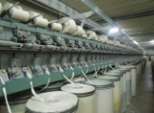
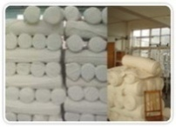
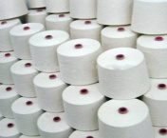
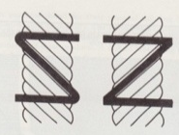

Figure 10: Spun Cotton Fiber from Open End Mills

- Resource Use in Hosiery (Post-Knitting) Industries
As explained in the plan and procedure of the study, there exists two types of Units dealing with hosiery (knitted fabric).They are:
Those who manufacture goods performing two major processes of cutting and sewing garments. While the other group either out source part of their work or undertake job work. Hence, samples under each category were chosen and their ‘modus operandi’ studied as individual case studies, the details of which are explained in the ensuring pages.
- Findings of the Case Studies: This aspect of the study is explained under:
- Resource Use in Manufacturing (Garment Construction) Units
- Resource Use in Units Undertaking Job Work
- Resource Use in Manufacturing (Garment Construction) Units
The manufacturing units took up both cutting and sewing of knitted fabric. Bales of cotton knitted fabric were bought from mills and the samples were found to cut and sew the materials in their own units. The findings revealed three types of manufacturing units to be existing based on garment produced. They are:
- Unit Producing Men’s Undergarments
- Unit Producing Out Fits
- Unit Producing Both Men’s and Ladies Under Garments
- Unit Producing Men’s Undergarments: Details about the Unit, producing men’s undergarments is explained below
- Resource Use: Tables (5) and (6) portray the details on the raw material purchased and the products made by the selected Unit.
Table 5: Resource Use in Unit Producing Men’s Undergarments
Months of study | Purchase of Coloured fabric |  | Purchase of White fabric
 | Raw Material (in kg) | Cost of Raw Material (` per kg) | Raw Material (in kg) | Cost of Raw Material (` per kg)
1 | 2,000 | 320 | 1,000 | 280
2 | 1,500 | 320 | 1,000 | 280
3 | 3,000 | 320 | 500 | 280
4 | 2,000 | 320 | 500 | 280
Sample took up cutting and then sewing of men’s undergarments in both coloured and white knitted fabric. The unit was found to employ 32 workers; two alone for cutting and 30 for sewing. Machine cutting was the method used to cut fabrics, where they could adjust for varied dimensions and also achieve reduction in waste generation. Despite being a small scale unit it was comparatively a larger one. During the study period (November to February), they had purchased from 1500-3000kg of coloured raw material totaling 8500 kg (for the period) at a cost of ` 320 per kg and 3000 kg of white fabric at the rate of ` 280 per kg. The study made evident that cost of raw matrials was very high.
- Products Made: Table shows the possible number of pieces obtained from 100kg of fabric and the cost per piece according to dimensions

Table 6: Product Particulars of Units producing Men’s Undergarments
Products sewn from 100 kg each of fabric | Possible no. of pieces (approximately) from 100kg each | Cost (in ` according to dimensions)
Products sewn from 100 kg each of fabric | Possible no. of pieces (approximately) from 100kg each | 75, 80, 85, 90 cms | 95, 100 cms
Men’s brief | 2,500 | 65 | 70
Trunks | 900 | 90 | 95
Trunks (Ribbed fabric) | 600 | 115 | 125
The unit dealt with sewing of men’s undergarments (brief and trunks) of different qualities. It was explained that they could sew 2500 pieces of men’s brief, 900 pieces of trunks of fine fabric and 600 pieces of trunks of ribbed fabrics from 100 kg each of raw material. They were cut into six different dimensions (75, 80, 85, 90, 95, 100cms). The size of sewing products and the type of finished products (brief or trunk) decided the cost of the product. Comparatively trunks of ribbed fabric cost double the cost of ordinary briefs.

Most hosiery garments are made by knitting methods. Modern hosiery is usually tight-fitting by virtue of stretchy fabrics and meshes. Older forms include binding to achieve a tight fit. Due to its close fit, most hosiery can be worn as an undergarment, but it is more commonly worn as a combined under/outer garment (http://en.wikipedia.org/wiki/Hosiery).
- Unit Producing Out Fits: Details about the unit producing out fits is explained below:
- Resource Use: Table (7) delineates the details on the raw materials purchased and the products made by the unit.

Table 7: Resource Use in Units Producing Out fits
Months of study | Purchase of Coloured fabric
Months of study | Raw Material (in kg) | Cost of Raw Material (` per kg)
1 | 5,000 | 260
2 | 5,000 | 260
3 | 5,000 | 260
4 | 5,000 | 265
Sample took up cutting and sewing of out fits namely T-shirts, full pants and three-fourth pants in colored knitted fabric. The unit was found to have employed 30 workers, two alone for cutting and the rest for sewing. This unit also was comparatively a large one. During the study period they had purchased 20,000 kg of colored raw material at a cost of ` 260 per kg. It is not wonder that hosiery goods are expensive in the market.
- Products Made: Table (8) shows the possible number of pieces obtained from 100kg of fabric and the cost per piece depending on size:
Table 8: Products made in Unit Producing out fits
Products sewn from 100 kg each of fabric | Possible no. of pieces  (approximately) from 100 kg each | Cost (in ` according to size)
Products sewn from 100 kg each of fabric | Possible no. of pieces  (approximately) from 100 kg each | Small | Medium | Large | Extra Large
T-Shirts | 625 | 65 | 70 | 75 | 80
Full pants | 315 | 97 | 105 | 113 | 121
Three-fourth pants | 400 | 96 | 96 | 101 | 106
The Unit dealt with sewing of T-shirts, full pants and three-fourth pants of different size -from small to extra large. From a known quantity of raw material, namely 100 kg they were able to make 625 pieces of T- shirts. Similarly from the same quantum either 315 full pant or 400 three-fourth pants of variable sizes could be made. Type of garment and their size decided the cost of product. Pants of both types cost more than T-shirts. The Unit had employed five workers each who did cutting work and sewing work respectively.
- Unit Producing Both Men’s and Ladies Undergarments: The third type of sample cut and sews white fabrics but only cut colored fabric. Coloured fabric was not sewn by them.
- Resource use: Table explains the details on the raw material purchased and the products made by the units.
Table 9: Resource Use in Unit Producing both Men’s and Ladies Undergarments
Months of study | Purchase of Coloured fabric |  | Purchase of White fabric
Months of study | Raw Material (in kg) | Cost of Raw Material (` per kg) | Raw Material (in kg) | Cost of Raw Material (` per kg)
1 | 2,000 | 320 | 3,000 | 280
2 | 2,000 | 320 | 3,000 | 280
3 | 2,000 | 320 | 3,000 | 280
4 | 2,000 | 320 | 3,000 | 280
This unit was found to have purchased 8000kg of colored fabric at a cost of ` 320 per kg which they cut but sent out for sewing. Contrarily they had purchased 12,000 kg of white fabric at a cost of ` 280 per kg and cut and stitched the garment. The unit had employed five workers each for cutting and sewing respectively. Another feature of this unit was that they gave part of their work for job work.
These facts highlight the umpteen options available for entrepreneurship and self propelled earning in this industry.

- Products Produced: Table shows that the possible number of pieces obtained from 100kg of fabric and the cost per piece according to dimensions.
Table 10: Production Particulars of Unit Producing Men’s and Ladies Undergarments
Products | Possible no. of pieces(approximately) for 100 kg each | Cost (` according to dimensions)
Products | Possible no. of pieces(approximately) for 100 kg each | 75, 80, 85, 90 cms | 95, 100 cms
Ladies under garments | 3,000 | 45 | 50
Banian | 900 | 70 | 75

From 100 kg of fabric the Unit reported of stitching 3000 under garments for women. From an equal amount of fabric they could bring out only 900 inner wear (Banians) for men.
- Resource Use in Units Undertaking Job Work: Among units taking up job work there were two categories. They are:
- Job Work Involving Cutting for Garments
- Job Work Involving Sewing of Garments
- Job Work Involving Cutting for Garments
Sample four and five were found to be taking up only job works of cutting. Table explains details regarding job work involving cutting of garment alone.
Table 11: Job Work Involving Cutting for Garments
Months of study | Cutting Banians (Adult Men) | Cutting Banians (Baby Size)
Months of study | Raw Materials handed over (in kg) | Raw Materials handed over (in kg)
1 | 2,500 | 9,000
2 | 2,500 | 9,000
3 | 2,200 | 9,000
4 | 2,400 | 9,000

Two units under taking job work for cutting white material for banians (both for adult men and baby size) reported to have employed 10 and 17 workers respectively. Unlike garment construction units, in these units manual cutting was practiced. During the study period the former unit was handed over 9600kg of raw material while the latter (cutting for baby size) was handed over 36000 kg of raw material. Evidently production of baby size garment was found to be extensive.
- Job Work Involving Sewing of Garments: The resources used and product produced in the unit which took up job work of sewing alone is explained below
- Resource use: The units had employed seven tailors. They dealt only with white fabric. The uniqueness of this unit was that they were handed over only the pieces of cut fabric to be sewn into garment. During the study period 68,000 pieces of cut fabric was handed over to the unit for stitching.
- Products produced: They were found to sew adult banians of different dimensions – 80, 85, 90, 95, 100 both with and without sleeve.
- Resource Recovery in Hosiery Units
This aspect of the study is explained under:
- Resource Recovery in Garment Construction Units
- Resource Recovery in Units Undertaking job Work
- Resource Recovery in Garment Construction Units: Waste generated in the three types of garment construction units studied is presented under Table

Table 12: Resource Recovery in Garment Construction Units (absolute)
Type of Units | Coloured Waste (in kg) |  | White Waste  (in kg) |  | Bit Waste  (in kg)
Type of Units | Cutting | Sewing | Cutting | Sewing | Coloured | White
Under garments makers | 282 | 340 | 109 | 32.5 | 2 | 3.1
Outfit makers | 2,386 | 1,020 | - | - | 21.9 | -
Makers of under garments for women and inner garments for men | 1,424 | - | 1,560 | 450 | 26.5 | 30

Garment construction: Before sewing together an article of clothing, a pattern is generally followed to construct the garment. A pattern can be quite simple; some patterns are nothing more than a mathematical formula that the sewer calculates based on the wearer's measurements. Most clothing today is mass produced, and conforms to standard sizing, based on body measurements that are intended to fit the greatest proportion of the population.
Box 3: Garment construction
Table (12) portrays the quantum of waste generated from the purchase and processing done for garment making during the study period. From the data it is evident that the under garment making unit brought out the least amount of waste as they could adjust for products of various dimensions and cut accordingly avoiding maximum waste. The data also proves that post knitting waste in the garment units producing outputs and women/men’s innerwear is comparatively higher. To get an insight into the proportion of material that goes as ‘waste’ from these units, calculation was done and is presented under Table (13).

Table 13: Resource Recovery in Manufacturing Units (Percentage)
Type of Units | Raw Material Purchased  (in kg) |  | Waste Realized (in %)
Type of Units | Coloured | White | Coloured | White
Under garments makers | 8,500 | 3,000 | 7.34 | 4.81
Outfit makers | 20,000 | - | 17.1 | -
Makers of under garments for women and inner garments for men | 8,000 | 12,000 | 18.13 | 17
This calculation also proved that the waste emerging out of units producing outfits and ladies undergarments and men’s inner wear to be quite higher than the unit producing under garments of various sizes. While the owners were also found to sell the wasted resource and reap returns, it clearly shows the possibility for rotation of funds among different entrepreneurs.
Undergarments: Different styles of undergarments are generally worn by women and men. Undergarments commonly worn by women today include brassieres and panties while men often wear briefs or boxers. Items commonly worn by both sexes include T-shirts and sleeveless shirts.

Box 4: Undergarments
- Monetary Benefits from Sale of Recovered Resources
Following Table (14) illustrates the monetary returns obtained by the selected units from the sale of hosiery waste that emerged from their units.
- Commercial Value of Recovered Resource (Garment Construction)
- Market Value of Recovered Resource (Job Work Units)
- Commercial Value of Recovered Resource (Garment Construction)
Table portrays the details on the commercial value of recovered resource from garment construction units.
Table 14: Commercial Value of Recovered Resources (Garment Construction)
Type of Units | Total Investment(in `) |  | Return from Sale of Hosiery Waste
Type of Units |  |  | ( in `) |  | ( in % )
Type of Units | Coloured | White | Coloured | White | coloured | White
Under garments makers | 27,20,000 | 84,000 | 4,091 | 7,490 | 0.20 | 8.92
Outfit makers | 52,25,000 | - | 36,345 | - | 0.7 | -
Makers of under garments for women and inner garments for men | 25,60,000 | 33,60,000 | 21,126 | 1,04,561 | 0.83 | 3.11
Comparatively waste from white fabric fetched more returns than the coloured ones. Nevertheless both type of wastes were revenue earners for the garment manufacturers as they had dealers ready at hand to take away the waste as raw material to be supplied to other siphoning units.
- Market Value of Recovered Resource (Job Work Units)
The monetary benefits realized by the job workers from sale of waste fabric are depicted through the following Table.
Table 15: Waste Returned to suppliers by job workers and Prospective Returns
Type of units | Raw material handed over (in kg) | Waste returned to suppliers
Type of units | Raw material handed over (in kg) | (in kg) | ( in %)
Inner wear for adult | 9,600 | 1396 | 14.6
Inner wear for babies | 36,000 | 7,210 | 20.02
A significant feature of job workers who undertook cutting alone was that they cannot sell the wastes realized. They have to return them to those who supplied raw materials who in turn sold the waste and kept the returns. Nevertheless, it was found that cutting was the process which realized maximum waste; for instance in cutting of inner wear for adult, they cut away 1396 kg of waste from 9600 kg of raw material. Cutting waste from baby’s inner wear was found to be very high; almost 20 per cent of raw material was cut out. Probably this is the reason for the exhorbitant cost of inner wear for babies and which is highly disproportionate to the material used for the product.
Table 16: Commercial Value of Waste Sold from Sewing Units
Type of unit | Raw material handed over (in pieces) | Sewing waste returns
Type of unit | Raw material handed over (in pieces) | (in kg) | ( in `)
Inner wear for adult (both sleeve and sleeveless) | 68,000 | 235 | 8,540
Job workers who had taken sewing jobs were not expected to return the sewing waste. Hence apart from the earnings from sewing, they could enjoy from the sale of waste too. Waste from sewing again was found to be quite lucrative.
- Cascading of Wastes through Agents
- The owners of the various Units studied revealed the existence of very many Agents who collected wasted fabric alone from all the units for further sale and processing, to whom alone they also handed over.
- Secondary data collected from Tirupur City revealed the presence of 7000 dealers in large scale and 2000 dealers in small scale thriving on the business in Tirupur.
- To comprehend the extent of purchase of waste fabric per day from varied units (of different magnitude) details of the Case Study done choosing one agent as a sample is presented below.
- The sample was found to buy both coloured and white fabric from different units strewn across Tirupur City. Depending upon space for storage, the garment making units (cutting / sewing) were found to sell relevant wastes either once in a week or fort nightly. The agents collected the waste too, stored them in their godown, segregated and sold the waste to the siphoning units. Evidently they were found to sell waste fabric either daily or once in two days. As smaller bits of waste have to be shredded to yarn in the premises, delay occurred in sale of waste.
- In the segregation process, the workers appointed for the job by the agents segregated the waste collected under three categories: larger pieces, medium and smaller pieces and very small bits, which were siphoned out to specific Agents who sold them for appropriate uses. Table gives the summarized version of how hosiery wastes down the line get a commercial value.
Table 17: Resource Recovery in Siphoning Units
Categories of waste | Further uses
Comparatively larger pieces | They were sent to second quality garment making units
Medium size bits | Automobile and other units (where they use for cleaning, dust cloth).
Smaller bits (coloured) | Rethreaded to yarn and sent to automobile workshops.
Smaller bits (white) | Rethreaded to yarn and sent to sub agents (used only for cleaning air craft).
Very small bits | Send to 40 mills which crush the material to process fiber again.
Very small bits | Another 20 mills which convert these  fibers to yarn.
Very small bits | Yarn goes to the dealers of bed sheets, towel and carpet makers.

The study revealed 40+20 mills (outside of Tirupur) where entirely depended on wastes from Tirupur for survival.
From comparatably larger bits to shreds – all kinds of knitted wastes are recycled which find a place as a resource in the commercial market.
Similarly other wastes from pre knitting and post knitting industries which could not be recycled in parent units were also bought by the agents and handed over to retail traders who sought uses for them elsewhere. Waste obtained from such pre knitting and post knitting processes portray that cotton waste also qualified as a cash crop, the details of which are explained below (Table 18)
Table 18: Commercial Value of Processing Wastes
Type of wastes in pre knitting | Further uses as recovered resource
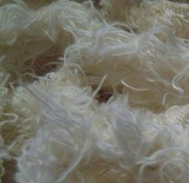  Comber Noil | This cotton waste is used in different applications. It is produced in cotton mills during the process of extracting. It is combined with other fabrics to produce yarn.
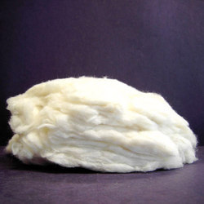  Roving Ends | This is waste that occurs in spinning mills after the raw cotton is being treated in roving machine. They are widely used for making fabrics of different types. As it is pure soft cotton; it is used as bandage material in the treatment of wounds / injuries.
Cotton Selvage Waste | This waste is obtained in cotton mills after the process of extracting cotton. It is widely used as component for making rugs, carpets that are machine knit and handmade.

Type of wastes in post knitting | Its uses
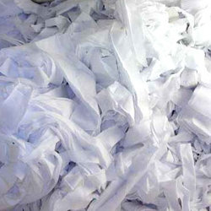  Hosiery clippings | These waste are used in fabricating various items like accessory cloth wipers, mats, dolls, mops and other items.
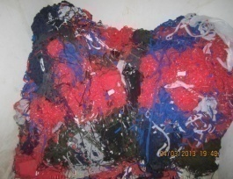  Hosiery cutting and sewing waste | Cut waste available in different sizes and shapes is widely used to make wipers, cloth dolls, dusters, mats and other cloth items, which have both household and industrial uses.
Hosiery colour yarn waste | Hosiery colour yarn waste is used for cleaning of industry machines and components. It is very useful in all type of industries.
Hosiery white yarn waste | It is very useful for industrial component cleaning, electronics, component machine cleaning, automobile component cleaning, air craft cleaning and various component cleaning purpose.
White Banian Waste | The premium white banian waste that is available in hosiery especially big pieces. T-shirt bits are of optimum quality hence are highly useful in industries for cleaning purposes. Those from high quality hosiery material find other effective uses.

Thus these agents emerge as the channelizes for transferring different kinds of wasted resources to entrepreneurs who invest in them as base material for their produce. Hence these agents were found to earn well, the details of which at presented in Table. As majority of waste is sold to mills, details on earnings from sale to mills alone are considered.
Table 19: Average Daily Earnings from Trading of Waste to Mills
Type of waste |  | Waste collected from units (in kg) | Buying  Cost of waste per kg (in ` ) | Selling cost of Waste per kg (in `) | Profit Realized (` in range per day)
Sewing Waste | Coloured | 5,000 | 4 | 5 | 5,000
Sewing Waste | White | 2,000 | 40 | 41.5 | 3,000
Cutting Waste | Coloured | 3,000 | 14-17 | 15-18 | 3,000-12,000
Cutting Waste | White | 3,200 | 55-58 | 57-58 | 6,400-9,600
Bit Waste | Coloured | 360 | 30-35 | 36 | 360-2,160
Bit Waste | White | 385 | 60 | 61 | 385

Cutting waste of white fabric and coloured bits were the ones which fetched maximum returns. Yet the agents were found to sell them only on a marginal profit. Except bits all other wastes were found to fetch good returns for the agents.

The study also brought to light that, apart from the prospects for earning from resource recovery, the trade in hosiery also had very bright prospects for entrepreneurship and employment generation as is evident from employment employed in Units, to the different mills and the entrepreneurs who are engaged in resource recovery trade. It is therefore concluded that the hosiery industry is a rich source of entrepreneurship, employment, trade potential and above all an eco friendly enterprise which recycles every bit from waste to the scrap, for practical and functional uses. By all means this industry caters to the demand – supply chain.
- Flow Chart on Resource Recovery Cycle
To summarise in a nutshell, the waste generated and resource recovered at each stage of the cotton process to garment construction in hosiery, a Flow Chart has been prepared and is presented as an Exhibit (4).

Thus in post knitting units, the fabrics are treated to bring them to any form based on the stage of production and fabric availability and its quality. Ultimately the wastes from these units emerge as different kinds of apparel or home furnishing materials as given below
- Apparel - Wide range of wearing apparel: blouses, shirts, dresses, children swear, active wear, separates, swimwear, suits, jackets, skirts, pants, sweaters, hosiery, neckwear.
- Home Fashion - curtains, draperies, bedspreads, comforters, throws, sheets, towels, table cloths, table mats and napkins
It is time to wonder ‘Is there a resource like cotton’?

V. SUMMARY AND CONCLUSION
Production sequence, consumption and trading – all levels witness emerging of wastes of many sorts, and textiles/hosiery in particular is no exception. Tirupur, in Tamil Nadu, is globally acclaimed as the cradle of hosiery industry, which evidently is a huge foreign exchange earner for the Country. The process from the cotton bolls to knitted fabric and thereafter in the construction of garments throws huge amounts of wastes of different types. The cascading of wastes from one level to another and their effluent reuses is a great challenge for the innumerable entrepreneurs who thrive on diversified avenues related to hosiery. These facts enthused the investigator to launch on a study on ‘Economics of Resource Recovery-Hosiery Waste as a Candidate’ with the objectives of tracking wastes emerging from various levels and identify the resource recovery strategies implemented which led to monetary gains. The findings of the study are summarized under:
- Hosiery Canvas
Details recorded in the Industrial Corporation of Tirupur, the locale selected for the study revealed the following:
- There are five cluster regions engulfing maximum of textile units (3034) among which 1095 are hosiery units.
- The textile units employed 65879 workers while hosiery units employed 55.1 per cent more (36270).
- Cotton – a Food Crop and a Cash Crop
- Processing of cotton in pre ginning mills witnessed bringing out quality cotton fiber called lint, from which yarn was twisted either to be woven into cloth or knitted fabric to make hosiery, on the one hand.
- On the other hand cotton seed was brought out as waste in pre ginning mills from which low quality cotton fiber called linters, and cotton seed as waste was obtained.
- The former proves cotton as a cash crop and the latter justifies cotton as a food crop.
- Visit to pre spinning and post ginning mills and an oil mill facilitated comprehending the operational details in these units.
- Post – Ginning Wastes and Recovery
- As a food crop the wastes emerging from the post ginning mills evidently were cotton seed oil, hulls, meals and linter (low quality fiber) as a major by product.
- As a cash crop the waste emerging from the post ginning mill was linter which was mixed with other fibers to produce low quality yarn.
- In the entire process from a known quantum of raw cotton bolls, 58 per cent was found to be cotton seed as waste from which three per cent of linter could be recovered in the refining process. Further processing in the oil mill enabled recovery of 40 per cent of hulls, 15 per cent of cotton seed oil and 42 per cent of meal as reusable resources.
- From 300 kg of cotton bolls, effective cotton obtained was only 100 kg. The ratio of cotton fiber to cotton seed was 1:2.
- Lint - the magic fiber
- Lint or high quality yarn was spun in Spinning mills while linter (low staple fiber) was spun into Open end mills
- Lint from the Ginning mills was spun into yarn by twisting process in Spinning mills. As entry was prohibited, secondary data was collected.
- Data disclosed revealed, spinning of 100 kg of cotton fiber yielded 70 kg of first quality yarn or 80 kg of second quality or 70 kg of third quality yarns. The reason being the 30 per cent waste that occurred in the twisting of first quality yarn was sent out to twist second quality yarn and 20 per cent waste that occurred there was added to fiber to produce third quality yarn. So waste generated and recycled for recovery as resource (different quality yarns) was an in-house quality assurance measure. Moreover, such reduction occurred also because of, further processing done like dyeing etc.
- Contrarily in open end mills, linters were used as base fiber. As linter was spun with low staple fiber, waste realized was minimal to the tune of 7-9 kg per 1000 kg of fiber.
- Hence the processing wastes that occurred in both quality fiber spinning mills and open end mills were recycled and recovered within their own premises. Waste, if at all was there was only floor waste which was taken away by the automobile workshop owners for cleaning purposes.
- Oil and Meals: The consumables
- The cotton seed which is obtained from pre ginning mills, was processed to extract cotton seed oil and the residue was dried out as meal both having very high consumption value.
- Status-quo of Knitting and Post Knitting Units (Hosiery)
- Visits to two knitting units revealed that with negligible waste of one - two per cent in processing, they were able to weave or knit fabrics equivalent to the yarn used; i.e. they could get 90 kg of knit fabric from 90 kg of yarn. Evidently the knitting units produced very little wastes. This was a very heartening finding.
- Contrarily, post – knitting units were found to bring out wastes of various types as they were engaged in garment construction.
- Based on the type of units, wastes generated differed. Study revealed co-existence of two types of units. Manufacturing (which undertook both cutting and sewing of garments) and job workers (who either cut or sew garments)
- Three units belonging to manufacturing, two units (job workers) doing cutting and one unit doing sewing alone were selected for the study. Case study of the Units was the method adopted.
- All the three manufacturing Units selected for the study were small scale units.
- Case Study of Garment Construction Units
Case 1: The Unit producing men’s under garments had employed 32 workers (two alone for cutting) and had purchased 8,500kg of coloured fabric and 3,000 kg of white fabric costing ` 280-320/kg for white and coloured fabric respectively during the study period.
- The products made were of three types – briefs, trunks and trunks of ribbed fabric.
- The study revealed that from 100 kg of fabric approximately 2,500, 900 and 600 pieces of briefs and trunks (ordinary and ribbed) respectively of six varied sizes could be made.
Case 2: The second Unit selected produced outfits, namely T-shirts, full pants and three fourths, which approximately they reported to be able to produce 625, 315 or 400 pieces of the garments respectively of four varied sizes from 100 kg each of raw material.
- Only coloured material was used by the units.
- They had employed 30 workers.
- The unit had purchased 20,000 kg of coloured raw material at a cost of ` 260/kg.
Case 3: The third Unit cut and sew white fabrics, and cut coloured fabric.
- They did not sew coloured fabric.
- During the study period the unit had purchased 8,000 kg of coloured and 12,000 kg of white fabric costing ` 320/kg and ` 280/kg respectively.
- Out of 100 kg each of fabric, they reported to be producing 3,000 pieces of ladies under garments and 900 pieces of banians respectively.
- They had employed five each who did cutting and sewing respectively.
- Case Study of Job Workers
Case 1: The two Units selected under the first category was found to have taken up job work on cutting alone.
- They were found to cut materials for both adult size banians and baby size banians, for which they were handed over (by the outsourcing units) 9,600 kg and 36,000 kg white material respectively.
- The Units were run employing 10 and 17 workers respectively.
Case 2: The Unit under took sewing of white adult banians alone, for which they were handed over 68,000 pieces of cut fabric during the study period.
- The Unit had employed seven tailors.
- They sew adult banains of varied sizes for which cut fabric was given by the owners.
- Resource Recovery Possible in selected units:
Garment Construction units:
- Cutting waste (coloured and white fabric) in undergarment making units reported to have obtained wastes to the tune of 282 and 109 kg each respectively along with two kg and 3.1 kg of bits respectively during the study period.
- Among outfit makers coloured fabric waste amounting to 2,386 kg from cutting, 1,020 kg from sewing and 21.9 kg of bits was reported of.
- The third unit recorded coloured cutting waste of 1,424 kg alone (as they did not sew coloured fabric). While cutting and sewing wastes to the tune of 1,560 kg, and 450 kg respectively added by 26.5 kg of coloured bits and 30 kg of white bits were also reported of.
- Evidently these factors proved that the wastes from manufacturing units (garment construction units) were very high.
- Calculations made as per cent of waste generated to total fabric produced revealed the following:
- While under garment makers realized coloured waste to the tune of 7.34 per cent of total fabric purchased, the waste from white fabric was 4.81 per cent.
- Outfits makers realized 17.1 per cent of the coloured fabric they purchased as waste.
- Under garment makers for women and inner garment makers for men – the third group - obtained 18.13 per cent coloured waste and 17 per cent of white waste.
- Monetizing Wealth from Waste
- While the three garment construction units were found to sell coloured fabric waste to the tune of ` 4,091, 36,345, and 21,126 ( all less than one per cent of total investment) respectively, white fabric waste was sold by the first and third units to the tune of ` 7,490 and 1,04,561 (8.92 and 3.11 per cent of total investment ) respectively.
- It is evident therefore that white waste fetched more than coloured fabric and the waste from coloured fabric was much lesser than white fabric.
- Job work in Cutting
- This group had to return the waste incurred in cutting to the owners who had handed over fabric for cutting.
- While those who had cut for adult inner wear had returned 14.6 per cent of the total cloth handed over and cut waste from baby size inner wear was 20.02 per cent of the total fabric respectively.
- Though cutting work also incurred waste, the job workers did not earn from sale of waste fabric.

- Job Workers doing Sewing
- Comparatively those who did job work of sewing benefitted better, because sewing waste to the tune of 235 kg was realized from the 68,000 pieces of fabric handed over for sewing.
- The sale of sewing waste had helped them earn ` 8,540/- during the study period.
- Waste Siphoning through Agents
- All the waste from the units explained above was found to be handed over to Agents (traders/waste cloth merchants) who further traded on the ‘Resource’ that they collected.
- Secondary data collected revealed 7,000 dealers in large scale and 2,000 dealers in small scale to thrive on the business.
- The traders collected (bought) waste from various units at intervals (set by the units), stored them in personal godowns, categorised type of waste based on size and quality and sold them to prospective users down the line. These traders were found to sell wasted resources almost daily.
- Considerably large pieces were sent to second quality garment making units.
- Medium size bits were sold to automobile shops.
- Smaller coloured bits were rethreaded in the godowns and the yarns sold to automobile workshops.
- Smaller white bits were rethreaded in the godowns and sold to sub agents who had tender for supplying the resource for air craft cleaning.
- Very small bits were sold to 40 crushing mills which crushed the material to process fiber again. From them it was handed over to existing 20 mills which converted them to yarn again and sold to production units of bed sheets, towels and carpet makers.
- It was surprising to note 40 plus 20 mills in Tirupur thrived on such recovery process or the products.
- Similarly waste from pre knitting units like comber noil, roving ends, cotton selvage waste also were recovered as resource in making mixed yarns, bandage materials and furnishings. Post knitting wastes like hosiery clippings (used for fabricating wipers, mops, dolls, mats, etc.), hosiery cutting and sewing waste (dolls, dusters, mats making), coloured hosiery waste (for cleaning industry machines and components), white hosiery waste (cleaning of electronic goods and air craft) and white banian waste – all had multiple uses once they left the unit as waste.
- The waste merchants were found to earn on an average ` 5000/- per day from this business.
These facts proved the following and led to solid conclusions.
Conclusions:
- Resource recovery of Pre Knitting and Post Knitting waste is a highly productive and lucrative endeavor, - ‘Not even a single bit of yarn goes as waste’.
- Entrepreneurship based on these units is flourishing well in the selected locale.
- Prospects for recovering the resources have been well studied, experimented and been successful.
- Problem of solid waste disposal has been tackled in a very strategic way.
- Employability and monetary benefits from the point of industrial, regional, State and National - level is efficiently managed.
Hence the following recommendations are put forth for further research.
Recommendations
- Literature study focusses attention to the use of cotton waste in nanotechnology to aid in the medical field. Use of hosiery waste in particular for the purpose has to be taken up as an in-depth study.
- Envisage prospects for using the waste as component material in construction materials.
- A macro level study can be submitted as a project to comprehend the concept as a ‘Big Picture’.
As the adage – goes: Recover the resource in waste as a best practice

Waste is a wealth potential
Waste is a threat to environment and life
Waste is a nuisance to the society, but
Waste is also a challenge to meet.
The selected sample has taken the challenge and has found the strengths in such ‘wasted resources’.

AVINASHILINGAM INSTITUTE FOR HOME SCIENCE AND HIGHER EDUCATION FOR WOMEN COIMBATORE-641043
INTERVIEW TO ELICIT INFORMATION ON THE FUNCTIONING OF HOSIERY (GARMENT CONSTRUCTION)
APPENDIX I
- Name of the Unit:
- Location of the unit:
- Type of unit
Both cutting and sewing Only sewing Partly cutting and sewing

- What type of fabric they deal with
Only coloured Both coloured and white
Only white

- Products made
- Under garments
Men’s briefs Women under garments Men’s trunk Others (for children)
- Inner garments
Banian with sleeve Banian without sleeve
- Out fits
F
M

T-shirts
F
M

Full pants
Three – fourth pants
F
M

Shorts
F
M

F
M

Bermudas

- No. of employees working in the unit.
<10 10-20 20-30 30-40
Specify number:

- Raw materials purchased per month. Specify in kgs
Coloured fabric
Quantity
kg
Cost
` per kg
White fabric
Quantity
kg
Cost
` per kg

- Quantum of raw materials (fabric) used for one day’s production
Coloured
kg/ per day
kg/ per day

White
kg/ per day

- Quantum of waste generated
Coloured
kg/ per day
kg/ per day

White
kg/ per day

- Quantum of products made using
Coloured fabric
White fabric

- Mention the quantum of waste they obtaining per lot (While processing)
 | Coloured | White
Cutting waste
Sewing waste
Bit waste

- Within how many days these wastes are taken away by the waste dealers.
Daily Once in two days
Within one week Twice in a month Monthly once
- To whom do you sell the waste?
Regular agents Any body
- Rate at which waste is sold to traders.

