By Saranya. M (17PAP011)

Thesis Submitted to
Avinashilingam Institute for Home Science and Higher Education for Women Coimbatore-641043



In Partial fulfillment of the Requirement for the Degree of Master of Science in Applied Psychology

April 2019

By Saranya. M (17PAP011)

Thesis Submitted to
Avinashilingam Institute for Home Science and Higher Education for Women Coimbatore-641043



In Partial fulfillment of the Requirement for the Degree of Master of Science in Applied Psychology

April 2019

By Saranya. M (17PAP011)
Thesis Submitted to
Avinashilingam Institute for Home Science and Higher Education for Women Coimbatore-641043

In Partial fulfillment of the Requirement for the Degree of Master of Science in Applied Psychology

April 2019


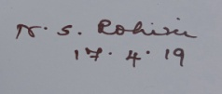
Signature of the Head of Department Signature of Guide

To acknowledge is to be contented and blissful. I would like to admit my special marks of respect at the feet of God Almighty, for his immense blessings in making this study a success.
I express my respectful thanks and sincere gratitude to Padmashree Dr. P. Krishna Kumar, Chancellor, Avinashilingam Institute for Home Science and Higher Education for Women, Coimbatore, for providing the conductive infrastructure for the conduct of the research study.
I would record my deep sense of indebtedness to the Vice Chancellor, Dr. Premavathi Vijayan and the Registrar Dr. S. Kowsalya, Avinashilingam Institute for Home Science and Higher Education for Women, Coimbatore, for extending all possible help towards the completion of the study.
I am privileged to express my deep sense of gratitude to respectable Dr. (Miss).N.S. Rohini, M.A., M.Phil. (Madras University), Ph.D. (Bharathiar University), Professor, Department of Psychology, Avinashilingam Institute for Home Science and Higher Education for Women, Coimbatore, for her constant source of inspiration, concern, encouragement and support presented at every stage of this study. I further convey my gratitude for her critical discussions, suggestion and valuable guidance throughout the study, which helped me to accomplish this work. Words are insufficient to thank her for initially directing and enlightening me regarding the project.
I owe my deepest and heart filled gratitude to Dr. S. Gayathridevi, Associate Professor and Head, Department of psychology, Avinashilingam Institute for Home Science and Higher Education for Women, Coimbatore, for the necessary facilities provided by her which enabled me to complete the project.
The research would not have been made possible without the kind permission, co-operation and support of the participants in Coimbatore. I would like to express my heartfelt thanks to the subjects who actively engaged themselves and co-operated well for doing the research work.
I owe my deepest gratitude to my parents Mr. T. Muthukumar and Mrs. M. Hemalatha. Words cannot express how grateful I am to my family members for all the sacrifice that they have made on my behalf.
I owe my gratitude to my family members and friends who had been motivating and supporting throughout the conduct of the study.

CHAPTER | TITLE
I | INTRODUCTION
II | REVIEW OF LITERATURE
III | METHOD  Objectives Research Question Hypotheses  Area Sample Tools Procedure  Analysis of data
IV | RESULTSAND DISCUSSIONS
V | SUMMARY AND CONCLUSIONS
VI | REFERENCES
VII | ANNEXURES

TABLE NO | TITLE
Table I | LEVELS OF MEMORY IN THE SAMPLE BEFORE  AND AFTER INTERVENTION
Table II | LEVELS OF PROBLEM SOLVING SKILL IN THE  SAMPLE BEFORE AND AFTER INTERVENTION
Table III | SIGNIFICANCE OF DIFFERENCE BETWEEN MEAN MEMORY BEFORE AND AFTER INTERVENTION  (Brain Gym Exercise)
Table IV | SIGNIFICANCE OF DIFFERENCE BETWEEN MEAN PROBLEM SOLVING SKILL BEFORE AND AFTER  INTERVENTION (Brain Gym Exercise)
Table V | SIGNIFICANCE OF DIFFERENCE BETWEEN MEAN  MEMORY BEFORE AND AFTER INTERVENTION (JPMR)
Table VI | SIGNIFICANCE OF DIFFERENCE BETWEEN MEAN  PROBLEM SOLVING SKILL BEFORE AND AFTER INTERVENTION (JPMR)
Table VII | SIGNIFICANCE OF DIFFRENCE BETWEEN MEAN  OF BRAIN GYM EXERCISE AND JPMR IN MEMORY
Table VIII | SIGNIFICANCE OF DIFFERENCE BETWEEN MEAN OF BRAIN GYM EXERCISE AND JPMR IN PROBLEM SOLVING SKILL

ABSTRACT

From Sankara College of Science and Commerce, Saravanampatty, Coimbatore, 157 students were screened using Multifactorial Memory Questionnaire for measuring the level of memory (Troyer and Rich, 2002) and Problem Solving Skill Questionnaire for assessing the level of problem solving skill (Ginter, Darden and Gazda, 1996). Out of which 84 students with “Low” and “Average” level of memory and problem solving skill were selected by purposive sampling. The selected sample were split into two groups, each consisting of 42 students, wherein one group was intervened with Brain gym exercise and the other with JPMR for a period of 12 days. The duration of each session was for 35 minutes. After 15 days of the intervention the Post- Assessment test was carried out using the same tools. The statistical analysis done using SPSS showed that the level of memory increased after the practice of Brain gym exercise with a mean difference of 5.57 which is statistically significant at 0.01 level. Similarly, the problem solving skill also showed an increase in its mean value (from 38.1 to 40.4) after the practice of Brain gym exercise. The mean difference (1.1) of memory after the practice of JPMR has not showed any significant change in the memory level whereas the mean problem solving skill after the practice of JPMR has shown a significance at 0.05 level with a mean difference of 1.4. The results clearly proves that both the interventions are effective, but on the whole Brain gym exercise is more effective than JPMR with a higher mean of 9.9 and 10 in case of memory and problem solving skill respectively.

CHAPTER-I INTRODUCTION

MEMORY

“Memory is the diary that we all carry about with us”

-Oscar Wilde

Memory is one of the interesting topic of study among researchers in the 20th century. Memory is defined as the means by which an individual draws on our past experiences in order to use this information in the present (Sternberg, 1999). If one did not possess the capacity to remember or recall the activities of one’s life oriented information, it would make an individual struggle to lead one’s life in a peaceful manner. Memory makes us who we are, helping us remember the solutions for who, what, where, how and when of our everyday life happenings. Memory is pliable but it tends to decline with an increase in age although many researchers believe that it can be ameliorated through proper food intake and sufficient scheduled sleep (Jenson, 2011).

EVOLUTIONARY STUDY OF HUMAN MEMORY

The study of human memory stretches back at least 2000 years to Aristotle’s early attempt to understand memory in his treaties on “On the soul”. In this he compared the human mind to a blank slate and theorized that all humans are born free of any knowledge and are merely the sum of their experiences (Kumar, 2007). In antiquity, it was generally assumed that there were two sorts of memory: the natural memory, which is the inborn memory that everyone uses every day and the second type is the artificial memory which is obtained through training and learning. The contributions about memory by Cicero and Quintillian was passed down to the medieval scholastics and later the scholars of renaissance (Iacono, 2009). Later in 18th century English philosopher David Hartley hypothesised that memories were encoded through hidden motion in the nervous system (Livingston, 2000). William James and William Wund carried out research on how human memory functions and they found the concept of neural plasticity of brain relating to human memory (Lopez, 2009). In 1881, Ribot’s Law was proposed which stated that amnesia has a time- gradient in that recent memories are more likely to be lost than the remote memories (Rosen, 2007). The first scientific approach to study memory was initiated by Herman Ebbinghaus in the mid-eighties and some of his findings from this work were learning curve and forgetting curve, and his classification of three distinct types of memory: sensory, short-term and long- term memory which remain relevant to this day (Mayoclinic, 2010). As early as

1904 another Canadian, Donald Hebb, intuited that “neurons that fire together, wire together”, implying that the encoding of memories occurred as connection between neurons which were established through repeated use and this was referred to as the Hebb’s Rule. Based on this rule several scientists worked together and identified the molecular changes during memory formation and the involvement of the neurotransmitters in the process of memorization (Geerlings, 2007). As computer technology developed in 1950’s and 1960’s, the parallels between computer memory and the human memory process became apparent, leading to the advances in understanding the concepts of encoding, storage and retrieval process of human memory which was when the changes in the overall study of memory has come to be known and was called as the period of cognitive revolution (Saul, 2013). In 1968, Richard Atkinson and Richard Shiffrin first described their model of memory which was called the multi-store model of memory- consisting of the sensory memory, short-term memory and the long- term memory which is still a popular model for studying memory and its concept. The pioneering research on human memory by Endel Tulving from 1972 onwards has likewise been highly influential. He was the first to propose two distinct kinds of long-memory which are episodic and semantic (McLeod, 2013). Nowadays, the study of human memory is considered part of the discipline of neuroscience and cognitive psychology and the interdisciplinary link between the two is called the cognitive neuroscience which is the subject that mostly deals with all the cognitive process (Kurt, 2018).

MODELS OF MEMORY

Memory and its working are explained by several philosophers in each one’s individual manner under the name of a model some of those models associated with memory are:
The Atkinson-Shiffrin Model Tulving's Model of memory Parallel Distributed Processing The Atkinson-Shiffrin Model
This model is also called as the “Multi Store Model” proposed by Atkinson and Shiffrin in the year 1968. It is a structural model that explains memory consists of three stores which are sensory memory, short-term memory and long-term memory and states that information passes from one memory to another in a linear manner and this process is called information processing. The information is detected by the sense organs and it enters the sensory memory and this information if attended then is passed on to the short term memory from where it is moved to the long term memory

only in the case of intensive practice and rehearsal. If there is a lack of practice or rehearsal then the information present in the short term memory is forgotten forever through the process of decay and displacement. One strength of this model is that it gives a good understanding of the structure and working of the short term memory in brief. On the other hand it explains that short term and long term memory gets operated in an independent single uniform manner but which is contradicted (Eysenck, 2012).

Tulving's Model of memory

Parallel to the Atkinson-Shiffrin model Tulving proposes that memory consists of short term and long-term memory. Within the concept of long-term memory he develops the categories of Explicit, Semantic and Procedural memory and states that explicit and semantic memory is a memory that is more associated with facts and events and that are consciously retained by an individual since it is learned through experience (Lock, 2001). On the other hand the procedural memory is an implicit form of memory and it is associated with an individual’s inborn or innate skills and talents, henceforth it can be unconsciously retained at any point of time in case of continuous use of the skill. This model was accepted by many other philosophers and there are research which are being done as a continuation of Tulving’s Model (Dusseldorp, 2007).

Parallel Distributed Processing

As the name proposes this model states that memory is the activation of connections in different regions (distribution) at the same period (parallel). This is absolutely a different methodology to the serial concept presented in the previous models. Cognitive processes are perceived of as networks within which the fundamentals have multiple associations. The prominence in this model is on the connections rather than the fundamentals they link. Units or nodes once accessed or activated then in turn excite or inhibit other nodes through various connections that are present. The patterns of the activations that occur provides escalation to cognitive representations such as memory and knowledge (Harish, 2000).

TYPES OF MEMORY

Memory takes many guises. An individual knows that when one stores a memory, it is information which is stored but based on the type of information and along with its duration for retention aids in determining what type of memory it is (Alan, 2007). The biggest classification of

memory is basically of two types under which all the other categories fall which are Long-Term Memory and Short –Term Memory.

MEMORY AND ITS TYPES


HUMAN MEMORY


SESORY MEMORY
SHORT-TERM MEMORY
LONG-TERM MEMORY
DECLARATIVE MEMORY
PROCEDURAL MEMORY
EPISODIC MEMORY
SEMANTIC MEMORY

SENSORY MEMORY

It is the shortest elements of memory. Sensory memory is the ability to retain the sensory information after the sensory stimuli has ended. It acts like a middleman or an intermediate for the stimuli received through five senses of sight, hearing, smell, taste and touch, which are retained accurately, but very briefly (Sperling, 1963).
The sensory stimuli that is detected by our senses can either be deliberately ignored which means that it disappears almost instantaneously, or it can also be perceived which indicates that it

enters our sensory memory and moreover this process is usually considered to occur totally extrinsic of an individual’s conscious attention therefore unless like other types of memory sensory memory cannot be kept prolonged by rehearsal or any other means (Winkler, 2005). Sensory memory is an ultra-short term memory and dissipates very quickly within a period of 200-500 milliseconds (1/5-1/2 of a second) after the perception of an item (Laureati, 2011).

SHORT-TERM MEMORY

Short-Term Memory is also called as the working memory which acts like scratch pad helping one to temporarily recall the information which was processed at any point of time. The short term memory can store small amount of information ranging from 7-8 which can be kept active for duration of 5- 17 seconds and sometimes up to a minute (Cowan, 2001). The sensory information is passed from the sensory memory to the short term memory by providing attention to that particular memory and however this information will disappear forever unless one makes a conscious effort to retain it and moreover the short term memory is an essential aspect which is required to step towards the next level of retention which is the long term memory (Olick, 2010).
The central executive part of the pre frontal cortex at the front of the brain appears to play a major role in the formation of the short term memory and working memory. The important part of storage in short term memory is played by the central executive which controls two loops which are neutral where one assists the visual process and the other one aids in the process of language which is also called as the phonological loop, these loops work together to store the information sent from the sensory memory to short term memory temporarily until another new information is to be stored.
The type and characteristic of the information also affects the amount of retention that can be done on that particular information. For example, more words can be recalled if they are shorter and commonly used or if phonetically sound similar. Therefore the others complex words can be remembered through the process of “chunking of information” which can lead to increase of remembrance capacity in short term memory. Chunking is the organization of material into shorter meaningful groups to make them more manageable (Jenson, 2005).
Short-term memory spontaneously decays over time, typically between the periods of 10 - 15 seconds, but information may be retained for up to a minute, depending on the content. However, it can be extended by repetition or rehearsal, so that the information re-enters the short-term store and is retained for a further period. When several elements such as digits, words or pictures are held in short- term memory simultaneously, they effectively compete with each other for recall. New content,

therefore, gradually pushes out older content and this process is known as displacement, unless the older content is actively protected against interference by rehearsal or by directing attention to it. Sometime outside interference tends to cause disturbances in short-term memory retention, and for this reason people often feel a distinct desire to complete the tasks held in short-term memory as soon as possible (Sara, 2000).


MAINTENANCE & ELABORATIVE

STIMULI SENSORY MEMORY
REHEARSAL

ATTENTION WORKING MEMORY

RETRIEVE

LONG – TERM MEMORY

ENCODE

CAPACITY: 7-9 CHUNKS
CAPACITY: 3-7 UNITS
DURATION: 0.5-3 SECONDS
DURATION: 5-15
SECONDS (without rehearsal)

CAPACITY: INFINITE DURATION: PERMANENT

LONG-TERM MEMORY

Long term memory is our brain’s system for storing, manipulating and also retrieving information and is also the type of memory in which information is held in a definite manner over a long period of time (as days, weeks or years). Through the process of association and rehearsal the content in the short term memory can become long term memory. While long term memory is also liable to forgetting process. There are number of factors that can influence how long the information endures in long term memory (Squire, 2014). Initially the way in which the memory was encoded plays a major role. Secondly the number of times one access the content can also strengthen the memory and its duration of presence in the long term memory. The long term memory is classified into two types:

DECLARATIVE MEMORY

Declarative memory is the memory of facts and events and refers to those memories that can be wilfully recalled. It is also called as “Explicit Memory”, since it consists of information that is clearly stored and retrieved (Clayton, 1998). One particular aspect of declarative memory is called the Flashbulb Memory which is a vivid snapshot of events like surprise and shocks which are resistant to forgetting since they are strongly oriented to emotions (Neisser, 1982).

Declarative memory is further classified into two types which are: Episodic Memory and Semantic Memory. Episodic Memory is an autobiographical memory which represents specific events and experiences that occurred in a series of time period, from which one can reconstruct the actual events that took place at any point of one’s life. Whereas the Semantic Memory is more of a structured collection of facts, meanings and knowledge about the external world that an individual has acquired in one’s lifetime (John, 1976).

PROCEDURAL MEMORY

Declarative memory works on the basis of “Knowing what” a particular concept is but the procedural memory works on the basis on “Knowing how” a particular concept works. Procedural memory is can be called as the unconscious memory of skills which are acquired through continuous practice and repetition. This memory is also called as the “Implicit Memory” because certain activity which were gained as an experience by rehearsing it for a long time creating a particular neural network for itself, aids in performing the activity automatically without any conscious concentration over it (Daniel, 2010).

MEMORY LOSS

Memory loss is uncommon forgetfulness where an individual will not be able to remember new events, recall one or more memories of the past, or both. The memory loss is defined as the decline in the memory accompanied by no disturbances in cognitive aspects which can persist for either a short or long period of time depending on the cause. Memory loss which is also called as amnesia is classified into two types, anterograde and retrograde amnesia (Shunsaku, 2001).

Anterograde Amnesia:

When an individual is incapable to store and recall new information but is able to recollect data and events that occurred earlier, it is known as anterograde amnesia (Carlson, 2000). Anterograde amnesia is an enduring condition generally believed to be caused by damage to the hippocampus area of the brain. This impairment can be caused by an accident, as a result of surgery, alcohol, and even an acute deficiency of thiamine known as Korsakoff’s syndrome. Whatever the cause of the trauma, the person affected will be unable to convert their short term experiences into long-term memory (Erdogan, 2010).

Retrograde Amnesia

Retrograde amnesia is the loss of memory aspects to events before the injury. The more severe the case, the farther back in time the memory loss extends. This pattern of destroying newer memories before older ones is called Ribot's law (Kirshner, 2016). It occurs since the neural pathways of newer memories are not as strong as older ones that have been strengthened by years of retrieval. Retrograde amnesia usually follows damage to areas of the brain besides the hippocampus and also results from damage to the brain closely allied with declarative memory, such as temporal lobe and prefrontal cortex (Mastin, 2010).

CAUSES OF MEMORY LOSS

Memory loss can vary based on both, the content of information and the time duration of memory deterioration but any of these aspects will have a specific cause behind it. Some of the causes are as follows:

Sleep Deprivation

The brain involves itself in several functions when an individual is asleep. The hippocampus and neo cortex part of the brain involves in the process of replaying the stored long term memories which favors the individual to review and process the memories, helping them to last for a longer period of time in memory (Carol, 2017). Therefore a lack of sleep destroys the process of long term memory content retention and also the process of the stabilizing and securing the recently formed memories (Sarkissian, 2014).

Vitamin Deficiency

Lack of vitamins can affect the memory ability. Especially deficiency of vitamin B1 and B12 can lead to Korsakoff’s syndrome which is a type of dementia. More over memory problems are more likely to occur by a specific illness called pernicious anemia which is also caused due to the lack of vitamin B12, this illness not only affects memory but also brings about confusion, irritability, apathy and shortness of breath in the affected individual (Kate, 2018).

Alcohol Abuse

Alcohol consumption initially causes “Black outs” in the drinkers which is the primary sign that indicates that memory is getting affected. However, continuous intake of alcohol inhibits the absorption of nutrition which consumed through food. Excess alcohol is toxic to brain cells since it kills the brain cells especially parts of the hippocampus which is responsible for the creation of memories, storage and transferring short term memory to long term memory (Corr, 2018).

Head Injury

A heavy knock to the head can potentially affect the brain functions and memory since it creates a hard bump which leads to the formation of subdural haematoma. This formation is primarily a blood clot on the surface of the brain and its dura matter which causes memory loss symptoms by bringing about a disturbance in the neural communication. Likewise, the memory loss caused due to stroke also occurs over the same way (Hyla, 2013).

Digital Dementia

Individuals relying heavily on technology will suffer deterioration in cerebral performance such as short term memory dysfunction. Constant connection and overuse of technology can lead to lateralization of brain function which means the brain suffers imbalance. This impairs working memory as well as executive functions, the damage can also extend towards impairing the cognitive functions such as ability to concentrate, short attention and memory span ( Spitzer, 2012).

Drug Abuse:

Use of any drug in continuous manner will bring about a change in the brain structure and also its functional aspects. The usage of drug will usually cause the death of the brain cells and also brings about a change in the level of neurotransmitter production. Especially, glutamate which plays a vital role in memory is produced less whereas the dopamine production level is increased when drug are used (Laguna, 2017). Moreover, the incessant use of drugs causes dysfunction in hippocampus and amygdala affecting the major cognitive functions such as memory, attention and learning (Peter, 2014).

TREATMENT FOR MEMORY LOSS

There are several techniques present in order to improve memory and its capacity, but the major and the most primarily used techniques for preventing memory loss and improving the memory ability are explained below:

Practicing Meditation

Meditation is one of the ancient techniques which is being practiced by many individuals in order feel a sense of relaxation, to improving concentration, reduce stress and so on… But, it is startling to know that practicing meditation has several impacts on biological aspects of the brain structure like the thickening of the cerebral cortex due to the increase of the blood vessels which in turn improves the cognitive aspects of the brain such as memory, concentration and also the processing speed of the individual (Belle, 2014). Mindfulness meditation which is now becoming popular in western countries as a therapy for cognitive improvement has shown a great result to individuals practicing this mediation in the aspects of working memory capacity and also in the progression of recalling the processed memory (Lazar, 2016).

Medication

There are several medications present for the improvement of memory such as the amphetamine and dextroamphetamine (Adderall) medications help in remembering the procedural aspects such as riding a bicycle or in performing the daily functions of the day. These drugs helps the individual to remember and recall the information present in the implicit memory which will favor the individual to perform the particular function in a correct manner (Lila, 2017). Similarly medications including the Acetyl-L-Carnitine content will improve the memory and its processing speed in an individual, but it is unfortunately used in an illegal manner in some corporate companies in order for increasing their turn over (Quiza, 2017).

Practicing Yoga

Historically and anecdotally, yoga has been thought to be beneficial in many aspects of well- being physically as well as psychologically. The yoga training involving Kundalini, which involves breathing exercises, chanting, meditation, hand movements and visualization of light. This type of

yoga practiced will improve memory because it involves chanting and visualizations, which may strengthen certain verbal and visual skills, and also improve overall awareness and attention (Rachael, 2016). It is also to be known that practicing yoga may increase the production of a protein called brain- derived neurotrophic growth factor, which stimulates the growth of connections among neurons increasing the level of memory (Wilson, 2018).

Exercising

Exercise improves sleep, which can consequently enhance your memory skills. Furthermore, in a more direct correspondence, regular aerobic exercise actually boosts the size of the hippocampus which is the area of the brain that plays a key role in verbal memory and learning (Forsey, 2017).Exercise also has a great impact over memory by increasing the heart rate which in turn increases the blood circulation throughout the body especially towards the central nervous system, thereby up surging the information processing in memory (Caroline, 2018).

PROBLEM SOLVING SKILL

Problem solving refers to cognitive processing directed at accomplishing an intention when the problem solver initially does not have any idea how to start with solving an issue. A problem occurs while someone has an aim but does not know a way to acquire it. Problems can be categorized as routine or non-routine, and as well defined or ill defined. The fundamental concepts of problem solving are acknowledgement of the facts, concepts, methods, strategies, and beliefs of that particular problem. The primary cognitive processes in problem solving are representing, making plans, executing, and monitoring following which a particular problem is solved to reach a solution.

DEFINITION
A problem is defined as the perceived gap between the existing state and a desired state, or a deviation from a norm, standard or status and problem solving refers to the process of finding solutions to problems encountered in life. It is a systematic process which defines a problematic situation where there is a gap between actual and expected situation or there is something that is unsatisfactory and it is a process where one identifies the problem as an opportunity for which a resolution or solution is needed to be implemented by an individual or group and which finally should be worth-while solving (Brandell, 1997).

Classes of Problems

Problem solving is basically a process that involves a state of desire for reaching a goal from a condition that is far from it. Generally, problems can be classified into two types:
Ill- defined problems – Ill-defined problems, as the name suggests, are those problems which are not defined properly. These are the problems that do not have any clear goals, or information, or solution paths, or any clear expected solutions. In ill-defined problems, it is not clear what information one should start from. It is also not clear when the solution has been reached, or what rules apply in finding out that solution.
Well-Defined problems – Well- defined problems, in contrast, are those in which all the aspects of the problem are clearly laid out. These problems have specific goals, clearly defined solution paths, and clear expected solutions. Well defined problems generally present with a small set of information from where one can start, and often come with a set of rules or guidelines to abide by while working towards a goal (Cherry, 2017).

The Problem-Solving Cycle

Problem Solving is a purposeful, goal- directed action. It is a process that involves finding, analyzing, and solving those problems. Problem solving has the ultimate goal of overcoming any obstacles, and finding out a solution to the problem that resolves the issue in the best possible way. A problem can be anything, right from trying to remember the name of your favorite restaurant, to a difficult numerical problem. How a problem is solved, however, depends on the unique situation it exists in. In some cases, one might take the help of carefully learnt factual information to solve a problem, while in some other situation, creative solutions might be the best way to go. In order to solve a problem correctly, it is important to follow a few steps, which have also been referred to as the ‘Problem-Solving Cycle’. This cycle includes some basic steps that can be followed in order to solve a problem. But this is only in the ideal situation or a scenario; in reality, many times people often skip some steps, or even go back to earlier steps a number of times until the desired goal is reached (Rudolf, 2017).

The Problem-Solving Cycle includes the following steps

- Problem Identification
- Problem Definition and Representation
- Strategy Formulation
- Organization of Information
- Resource Allocation
- Monitoring
- Evaluation

Problem Identification

Problem identification calls upon educators to utilize a multi-source (e.g., instruction, curriculum, environment, and learner), multi-method (e.g., review, interview, observe, and test) approach in gathering information in order to ensure that the problem is matched with evidence-based, standardized interventions or solutions. As the first step in problem analysis, problem identification, if done well, provides the foundation for a solution. Bergan (1995) stated problem identification consists of two steps: identifying and acknowledging that a discrepancy exists (i.e., identifying that there is a problem), and developing a problem identification statement.

Problem Definition and Representation

A problem representation is a cognitive structure process which is constructed by a solver when interpreting a problem on the basis of one’s domain-related knowledge and its organization. A problem representation is a graphical representation of the means to solve a problem, the representation could utilize flow charts, graphs or any other form of clarifying the problem and the means to solve it this is an important step in problem solving cycle since it helps the problem solver to visualize the problem (Kendra, 2018).

Strategy Formulation

The problem solving cycle includes one important step have to plan a strategy for solving the problem which may involve
  - Analysis – breaking down the whole of a complex problem into manageable elements

  - Synthesis – putting together various elements in order to arrange it in a particular format for it to reach some degree of utility

  - Divergent thinking – trying to generate a diverse assortment of possible alternative solutions to a problem
  - Convergent thinking – narrowing down the multiple possibilities to converge on a single, best solution (Kahneman, 2011).
The next step in the problem solving cycle is to develop a strategy in order to solve the problem. This step may vary according to the situation and also according to the problem solver’s preferences.

Organization of Information

The information that is available needs to be organized, before one can come up with a solution to a problem. The more the information that is available, the better prepared a problem solver is to come up with an accurate solution. The organization of the available information should be processed in a way that it enables one to implement the strategy that has been framed in the previous stage which helps in finding the most suitable solution.

Resource Allocation

Before problem solving begins, it is important to decide how high in the priority list the problem is, so that appropriate amount of resources (time, money, equipment, and space) can be allocated to it. If the problem is judged to be very important, then more resources can be allocated to finding its solution. But when the resources are limited then the individual will have to decide how much one wants to invest into the resources for problem solving.

Monitoring

Monitoring is also a significant process in solving a problem. Monitoring the progress while working towards a solution is important, as the strategies and approaches employed presently can be re-evaluated if a good progress is not being made in the problem solving process. Moreover it is necessary to monitor the process of solving the problem to make sure that we are getting closer to the goal.

Evaluation

The last step in problem solving is evaluation. After the solution of the problem has been found, it is important to evaluate the results in order to find whether or not the best possible solution to the problem has been reached. This evaluation might be immediate, such as checking the results of a math problem to ensure the answer is correct, or it can be delayed, such as evaluating the success of

a therapy program after several months of treatment. New problems can be recognized, the problem may be redefined, new strategies may come to light, and new resources may become available but this is a significant check which helps in looking at the entire problem solving process for an over-all correction (Beckman, 2008).

Obstacles in Problem Solving Skill

During the process of problem solving one will face several hassles which will obstruct the process of problem solving. Firstly, the mental set which makes an individual or the problem solver seeing a problem in a particular way instead of other possible ways due to experience which usually causes one to adopt an ineffective strategy and can prevent the adoption of the best or an appropriate problem solving strategy and finally disturbs the accurate problem solving. Secondly, making an assumptions without realizing the facts filled in the problem which happens when there occurs a lack of concentration in the problem definition and representation which makes the problem solver difficult to approach the problem in a new way. Thirdly, functional fixedness which is an inability g to assign new functions and roles to elements of a problem which can all be eliminated while processing the problem solving cycle when each of its steps are carried out in an attentive and focused mode (Ewert, 2008).

ENHANCEMENT OF PROBLEM SOLVING SKILL

Problem solving skill can be increased by involving oneself in various activities such as playing puzzles or other brain teasers which improve the thinking level thereby increasing the problem solving skill (Wilson, 2010). But, apart from the above there are several other techniques which enhance the level of problem solving skill which are the following

Meditation

Practice of Shamatha which bring about a sense of calmness within the individual, also increases the level of problem solving skill by enhancing the clarity, the ability to concentrate and generally helps remove mental stress (Avi, 2014). Nirvana (Profound Peace) is the extension of dukkha (Compulsive Thinking) are words stated by Buddha which means that an individual who is peaceful inside is wise and sensible outside (Colin, 2015).

Problem Solving Therapy

Problem-solving therapy refers to a psychological treatment that guides one to effectively manage the negative effects of inconvenient and stressful events that can occur in life (Wilson, 2010). This therapy mainly focuses on mindfulness training which favours in enhancing the decision making skill and creative means of dealing with problems. This therapy is now being practiced by indoor sport players who are indulged in chess, Chinese checkers and other related games (Arthur, 2013).

Practicing Jigsaw Puzzles

According to a research conducted by researchers during the 1900s, the practice of Jigsaw puzzles are helpful in enhancing many cognitive aspects improving logical thinking, learning comprehending and the memory. The practice of Jigsaw puzzles makes both hemispheres of the brain simultaneously since the right hemisphere, our creative side sees the “Big Picture” and the left hemisphere which is our analytical side, attempts to sort out the separate pieces logically. Henceforth, practicing of puzzles helps in improving the speed and accuracy of problem solving and think logically (Ellis, 2017).

Apart from the above there also two other treatments which the study focuses on which are the Brain Gym Exercise and Jacobson’s Progressive Muscle Relaxation Technique which are explained below.

BRAIN GYM EXERCISE

Paul E. Dennison and Gail E. Dennison in the 1970’s found that movement can overcome several cognitive problems such as concentration, memory, problem solving, self-confidence and also academic performance. Based on his finding he designed an exercise called “Brain Gym Exercise” which regulates and improves an individual’s brain activities and will bring about a positive change in cognition, memory and problem solving abilities. Brain Gym helps to improve neurological function so that areas of the brain are more strongly connected and accessible for any given task. The exercise uses developmental movements and provides a level of immediate improvement. It is simple and fun which can be practiced children from 8 years old and above (Anamika, 2017).

ACTIVITIES IN BRAIN GYM EXERCISE

Brain Gym, Educational Kinesiology or Movement Therapy is a series of movements, done with intention and designed to ‘wake-up’ the brain or to stimulate brain function. Its focus is improved learning and mental organization. The idea is that these are simple exercises that anyone can do at

home or at work or at school and they are often used with children who have special needs or need to improve their learning ability. They are designed to strengthen the relationship between body and mind .It is a set of exercises or activities which initially starts with drinking a glass of water which is tailed by the following exercises

- Cross Crawl
- Hook Ups
- Lazy Eight
- Neck Rolls
- Brain Buttons
- The Thinking Cap
- The Elephant
- Positive Points (Tian, 2017)

EFFECTS OF BRAIN GYM EXERCISE

Brain Gym exercises are used to improve focus and attention skill when children or adults repeat the exercises regularly and slowly. On practicing these exercises there is often a noticeable improvement in memory, concentration, relationships and communication, and physical coordination. Though it is not 100% clear how and why this happens the thinking is that it exercises areas of the brain and strengthens neurological pathways that may not be well used otherwise. It allows participants to practice and strengthen physical coordination pathways. The therapy also requires them to be focused and present (i.e. mindful) during the exercises, supporting a habit of focus and single- mindedness. The exercises stimulate particular areas of the brain to improve its function, improve the integration between brain parts and links between the two hemispheres (Beare, 2108).

Children and adults often habitually rely more heavily on one hemisphere of the brain and under use the other, particularly in times of stress. This then means the other side of the brain is unutilized and therefore the person may not be functioning optimally. A lot of Brain gym exercises are designed to cross over from one side to the other – for example making sideways figure eights or putting an elbow to the opposite knee. The aim of this exercise is to strengthen the connections between left and right brain activity, strengthen neural pathways and improve coordination. When our brains work better our whole body works better and we have an increased sense of well-being. Therefore this exercises can be used by everyone and are not limited to those with learning difficulties or coordination problems. They are a great accompaniment to life and learning (Richard, 2016).

BRAIN GYM IN MULTIPLE DISCIPLINES

As explained before brain gym exercise can be practiced by children as well as adults which favours the individual to recognise and improve several aspects related to one’s cognition. Since these brain gym exercise are encompassed of simple movements they are enjoyed and practiced in many corporate companies, MNCs and also by staffs in school. Some of the major areas where brain gym is practiced and the improvement in those disciplines are

Brain Gym in Business

Brain gym exercise practiced in business sectors favors in improving the staff’s and management’s motivation, creativity and analytical thinking, stress management, improved teamwork, confident public speaking, improved organization, effective communication skills, increased productivity (Kenneth, 2018).

Brain Gym in Schools

This exercise favors in improvement over attitude, attention, discipline, improving reading and comprehension, handwriting, homework performance, less exam pressure and improved behavior of their students. Issues with dyslexia, behavioral difficulties, ADHD, autism, and self-confidence can greatly improve (Beare, 2108).

Brain Gym in Sport

Sport personnel get improved and gain full mind-body coordination for optimum performance and attain endurance, focus, and improved muscle tone which also includes reduction in stress and injuries, improved accuracy, self-confidence and so on which can all make a significant difference in their sport performance (Richard, 2016).

Brain Gym in Personal Development

In terms of personal development an individual can sense a reduction in stress, depression, fears, anger, anxiety, unresolved past trauma, abuse, mid-life crisis and phobias whereas practicing brain gym can bring about a positive life changes in relationships, self-worth, and finding a new direction are just a few of the aspects that it can help to resolve and lead one to attain more opportunities and a more fulfilling and successful life (Tian, 2017).

JACOBSON’S PROGRESSIVE MUSCLE RELAXATION TECHNIQUE

Relaxed mind, remember better! Stronger and more lasting memories are likely to be formed when a person is relaxed and the cognition related neurons in the brain fire in synchrony with certain brain waves. In 1924, Edmund Jacobson designed a relaxation technique which involves tensing and relaxing specific muscles at a time, to achieve overall relaxation of the body which will help in reducing the stress and anxiety, which in turn will restore the well-being and improve the cognitive abilities (Molinari, 2013).

The aim of this technique is to quiet the mind and to allow thoughts to flow in a smooth, level rhythm, and induce the relaxation response. This mental quiet allows for rest and rejuvenation that does not always occur, even during sleep. Jacobson’s relaxation technique is a type of therapy that focuses on tightening and relaxing specific muscle groups in sequence. It’s also known as progressive relaxation therapy. By concentrating on specific areas and tensing and then relaxing them for a duration of about 30 minutes, after which one can become more aware of one’s body and physical sensations (Katharina, 2010).

Effects of Jacobson’s Progressive Muscle Relaxation Technique

Relaxation can help reduce the stress hormone known as cortisol which helps our body deal with various stressful situations. When cortisol levels remain elevated for a long period of time, it can cause high blood pressure. High levels of cortisol can disrupt sleep cycles, create negative mood patterns, zap the physical energy, and even cause one to store body fat. But when one relaxes and cortisol levels have a chance to normalize, which leads the individual to have a better chance to minimize the negative effects and improve the overall health and well-being (Raphel, 2009). Relaxation generally uses our conscious mind and somatic nervous system to achieve subconscious changes in the autonomic nervous system. The autonomic nervous system controls heart rate, breathing rate, blood pressure, and the ebb and flow of hormones like adrenaline. When the individual consciously relaxes, then one’s autonomic nervous system also shows a positive response gradually. Relaxation techniques help to modify that underlying activity in the autonomic nervous system from the adrenaline hormone which causes the fight-or-flight side to the aforementioned hormone which favors in rest-and-digest part of our nervous system. This has a variety of effects which helps to put ourselves ‘at ease’ and promoting a positive sense of well-being (Timothy, 2017).Researchers found that when neurons involved in memory were synchronized with the theta waves during information acquisition, the memories were stronger and this action of theta waves and

the neurons associated with memory can be brought in to synchrony when the individual is in a relaxed state therefore accomplishing a good memory capacity which provokes a good problem solving skill and further increasing one’s concentration and focus (Jennifer, 2007).

NEED FOR THE STUDY

Individuals face large amount of physical and psychological problems in their day today life and these problems has diverse effects on one’s cognition, memory and other skills which in turn will affect their ability to progress. Decline in the level of memory and problem solving skill in young adults will pave way for them to face issues like joblessness or deterioration in status or salary in his/her work place. This decline in memory and problem solving skill can be enhanced through practice of Brain Gym Exercise and can be maintained by practicing JPMR. When an individual enhances his/her skill of memory and problem solving, it can help them to gain more self-confidence to do activities in an encouraged manner.

CHAPTER-II REVIEW OF LITERATURE
The study on “A Comparative Study of Brain Gym Exercise and JPMR in enhancing Memory and Problem Solving Skill” was reviewed under the following
- Memory
- Problem solving skill
- Brain gym exercise
- JPMR

MEMORY
Patrick (2016) conducted a research on “Effects of kinesiology on memory among school students”. The aim of the study was assess the level of memory before and after the intervention of kinesiology for the school students. The study included 127 school students belonging to a couple of private schools in and around Bangalore city. The tools used to measure the memory among the sample was Wechsler’s Memory Scale and the intervention was provided for a period of 4 weeks. The result of the study revealed that there was a significant difference in the level of memory before and after the practice of kinesiology.
Banerjee, Das and Mishra (2014) conducted a study on “Assessment of working memory in young adults”. The study aimed at assessing the level of working memory among the young adults. The research consisted of 250 young adults of age ranging from 20-24 years and the study used 20 set of mutually exclusive words and 40 set of visual objects for the assessment of memory in the samples. The assessment schedules included 3 sessions in which the subjects were made to listen to the 20 set of words spoken and observe the objects for 1 minute and later assessed for memory with their level of verbal and visual retention ability. The result of the study stated that the mean score of each session were higher in case of female and verbal word testing is a better one for assessing the working memory ability.
Nikki and Lauren (2012) conducted a research on “Relaxing music counters heightened consolidation of emotional memory.” The research consisted of 84 participants, the sample were made to view a slide show during which they listened to either an emotional o neural narration, and were exposed to relaxing music. Retention was tested one week later through forced choice recognition test. The findings provide further insight into the capacity of relaxing music to attenuate the strength of

emotional memory, offering support for the therapeutic use of music and the result stated that relaxing music can counter the increased arousal levels that Neuro-modulate memory.
Abibha and Rosemary (2012) conducted a research on “Changes in Neural Connectivity and Memory following a Yoga Intervention”. The study explored the relationship between performance on memory tests and resting state of functional connectivity before and after yoga intervention. The study consisted of 48 samples above the age of 50 and the participants received yoga intervention for a period of 12 weeks after the pre assessment for memory and the result of the study showed a statistically significant improvement in visual, spatial and verbal memory.
Amish, Elizabeth, Anastasia, Ling, and Lois (2010) conducted a research on “Examining the protective effects of mindfulness training on working memory capacity and affective experiences.” The study investigated the impact of mindfulness training on working memory capacity and affective experience. The researches recruited 12 military cohorts during the high-stress pre deployment interval and provided mindfulness training to 6 and the remaining were control groups. The experimental group attended an 8 week mindfulness training exercise and the result suggested that sufficient mindfulness training can protect against functional impairments associated with memory due to high-stress context.
Sara and Andrew (2010) conducted a research on “Effect of Yoga on concentration and memory in relation to stress”. The aim of the study was to assess the effect of yoga modules on concentration and memory. The study consisted of 56 samples, the participants were assessed with concentration questionnaire and Wechsler’s Memory scale and were interpreted to have a below average level of memory and moderate level of concentration. The participants were made to practice yoga for 7 weeks and each session was for a duration of 1 hour. The results show that the participants yielded higher concentration levels and exhibited better short term memory.
Jason and Paul (2007) conducted a research on “Effect on Yoga on Memory and Cognitive functions in adults”. The study consisted of 118 participants (Married Male and Female). Initially the study assessed their level of memory and cognitive functions and the participants were subjected to Yoga practice for a period of 8 weeks and each session was for a duration of 1hours 30 minutes, the practice included Warrior pose, easy lotus, sun salutations, breathing and meditation exercise. The results were assessed after a week of intervention which revealed that there was an increase in the level of memory and other cognitive functions such as concentration and attention.
Rhonda and Rosemary (2005) conducted a research on “A meta-analysis of working memory impairments in children with Attention Deficit Hyperactivity Disorder”. The study aimed at

determining the empirical evidence for deficits in working memory processes in children and adolescents with ADHD. The study consisted of 40 ADHD children and it also included adolescents exploratory meta-analysis procedures which was used to investigate and assess the exposition of working memory impairment in children with ADHD and the result of the research revealed that children with ADHD exhibited deficits in several concepts of working memory such as verbal and spatial aspects that were independent of co- morbidity with language learning disorder or weakness in general intellectual ability.
Passolunghi and Siegel (2001) conducted a study on “Short term memory, working memory and inhibitory control in children with difficulties in arithmetic problem solving”. The relationship between short term memory, working memory, inhibitory control and arithmetic problem solving skill were studied in children with poor in arithmetic problem solving skill (n=23) using the Memory Assessment Scale developed by Micheal Williams and Problem Solving Spectra Analysis and the results of the assessment were compared to another group of children possessing good problem solving skill (n=26). The result showed that problem solving performance is affected by the accessibility of non-target and irrelevant information present in memory during the process of problem solving.
William, Teasdale and Segal (2000) conducted a research on “Mindfulness- based cognitive therapy reduces over-general autobiographical memory in formerly depressed patients.” The research processed by captivating 22 recovered depressed patients and randomly allocated the participants to receive either treatment as usual or the mindfulness technique in cognitive behavior therapy which is designed to reduce the risk of relapse for a period of 3 months. The result of the research stated that the control group showed no change in specificity of memories recalled in response to cue words, the treatment group showed a significantly reduced number of generic memories. Although such a memory deficit may arise from long-standing tendencies to encode, and retrieve events generically, such a style is open to modification.
Madeline, Jennifer, Kevin and Patricia (1993) conducted a research on “Memory and attention in combat related post-traumatic stress disorder”. The aim of the study was to analyze the memory and attention skill among the veterans diagnosed with PTSD in comparison with veterans not diagnosed with PTSD. The research consisted of 27 Vietnam combat veterans diagnosed with PTSD were compared on measures of attention/concentration, new learning and memory with Army National Guard enlistees who reported no unusual traumatic events or stress related symptoms. Results obtained through assessment with Wechsler’s Adult Memory Scale on the participants showed that PTSD veterans performed more poorly than the comparison sample on a measure of verbal learning,

exhibiting less proficient cumulative acquisition across repeated exposures, greater sensitivity to proactive interference and more preservatives errors, the finding therefore suggest that diagnoses of chronic PTSD in combat veterans are associated with cognitive performance deficit.

PROBLEM SOLVING SKILL

Swanson and Lee (2001) conducted a study on “Mathematical problem solving and working memory in children with learning difficulties”. The purpose of the investigation was to explore the relationship between working memory and the mathematical problem solving in children with Learning Disabilities. The population of the study was 27 of age ranging from 8 to 11 years. The tools used for the analysis are Wechsler’s Memory Scale and Problem Solving Assessment developed by Williams Adams and the result of the study stated that, the influence of the working memory on problem solving accuracy was mediated by the long term memory processes related to the knowledge of algorithms.
Solomon R conducted a research on the “Effect of Learning through the Arts (LTA) On Problem Solving among Fifth Grade Students” in the year 2012. The study examines the program’s impact on fifth grade students’ problem solving skills. Six schools with similar demographic and socioeconomic characteristics were involved in the study. There were 415 students involved in this study. Initially the participants were assessed with problem solving skill assessments and at the end of the assessment result, 200 students were selected for the further research work. The selected participants were taught the LTA program activities and were made to practice it for a period of 2 months and after which the post-assessment was done using the same problem solving assessment and the result of the assessment revealed that there was an increase in the problem solving skill among the selected participants with a significant level of mean difference.
Chiara and Linda conducted a comparative study (2001) on “The relations between short-term memory, working memory, inhibitory control, and arithmetic word problem solution in children”. The students, poor in arithmetic problem solving (n = 23) were selected for the study and were given the problem solving skill assessment developed by Wendy Adams. Their problem solving scores were compared with a group of good problem solvers (n = 26) and their problem solving skill were also measured using the same assessment, matched for vocabulary, age, and gender. The results validated the hypothesis of poor problem solvers' general deficit in inhibitory processes. The participants had lower scores and made more intrusion errors in a series of working memory tasks requiring inhibition of irrelevant information. The results showed that problem solving performance is related to the ability of reducing the accessibility of non-target and irrelevant information in memory. Span tasks that imply

passive storage of information showed that poor problem solvers were impaired to retain numerical information, but did not differ from children who did not have difficulty with mathematics when the material included words.
Ajawani, Mariyam and Sandhya (2012) examined the “Problem Solving abilities of Cognitively High Intelligent Adolescents”. This study aimed at finding the interaction effects of emotional intelligence and hemispheric dominance of task on problem solving ability of adolescent subjects, a final sample of 120 cognitively high intelligent adolescents aging 16-18 years and studying in 10th and 11th class were equally drawn from high and low emotional intelligence groups and were randomly assigned to either three hemispheric domain groups i.e., uni-dextrous (left brain) thinking, uni-dextrous (right brain) thinking, ambidextrous(left + right brain) thinking. Each group was given a list of 10 anagrams, related to the respective hemispheric dominance of thinking, to be solved one by one and the result of the study revealed that all the hemispheric dominant problem solving depends on emotional intelligence which also a positive effect on the problem solving when the decision has to be made rationally.
Hanegem (2012) conducted a study on “Promoting Students’ Problem-Solving Skills in Secondary Mathematics Education”. The aim of this study was to promote the problem-solving skills in mathematics education and knowledge in students. The study focused explicitly on providing a problem-solving model to students, problems which have to be experienced as real problems, and the role of the teacher in guiding the problem-solving process of students. A design-based research approach is adopted to develop a series of 36 lessons during nine weeks. The designed lessons were taught to five grade 8 classes by three teachers, including the researcher herself. A pre- and post-test was conducted with 121 students. Also mini-interviews with groups of four students about the awareness of students’ own problem-solving process were carried out each week. Results show that the problem-solving skills of students significantly improved and the awareness of students’ own problem-solving process and skills increased. Therefore, it was concluded that a well-implemented multidimensional approach, focused on explicitly providing a problem-solving model which includes the activities that are real problems, and the guidance of the teacher, promote problem-solving skills of students in secondary mathematics education.
Anastasia and Panayiota (2017) conducted a study on “An Intervention Program for Enhancing Interpersonal Problem-Solving Skills in Children with Intellectual Disabilities”. The study regarded an instructional problem-solving skills program that was developed for a student with intellectual disabilities within the school setting. The participants of the study included 55 intellectually disabled

children and they were trained with the problem solving program for a period of 3 months. The design and implementation processes of this educational intervention were premised on the principles of action research and unfolded around four interrelated phases, namely planning, acting, observing and reflecting. The findings indicated that the study participant were receptive to the instruction and demonstrated improved performance in recognizing, defining and formulating a problem related to social/interpersonal situations as well as in generating solution/ alternative solutions for resolving such problems.

BRAIN GYM EXERCISE

Nagarkar, Rakode and Malwade (2018) conducted a study on “Effectiveness of Brain Gym Exercise on Quality of Life in children with Autism Spectrum Disorder”. The participants of the study were 15 students of age ranging from 7-17 years with mild autism. Initially the participants were made to practice Brain Gym Exercise for a time period of 12 weeks. The pre and the post-test were done using the Pediatric Health related Quality of Life questionnaire and the data analysis showed that after Brain Gym Exercise, there was a marked reduction in the affected quality of life such as education and health aspects, than before the intervention.
Cancela (2017) conducted a study on “Effect of Brain Gym exercise for elderly people with cognitive impairment”. The study aimed at analyzing the effectiveness of brain gym exercise on elderly people with cognitive impairment. The study consisted of 50 elderly people above the age of 65. The participants were initially assessed for their functional independence using the Barthel Index Spanish version and cognitive functions using mini mental status examination and 34 samples among the 50 were selected for the study. The selected sample were made to practice Brain Gym Exercise for a period of 90 days and the same assessments were assessed for the selected participants and the result of the study stated that the samples involved in practicing the Brain Gym Exercise showed an improvement in certain aspects of their cognitive functions such as memory, attention and also functional independence at an appreciable level.
Velayudham and Jecinth (2017) conducted a research on “The effect of brain gym exercise on self- esteem and sensory processing speed on high school hearing impaired students”. The study aimed at analyzing whether the high school hearing impaired children engaging in brain gym exercise on a regular basis has enhanced their self-esteem and their sensory processing speed or the stroop effect. The study consisted of 30 samples (M=15 and F=15).Initially the participants were made to attend a pre-test using comprehensive self-esteem questionnaire and stroop color test and were made to practice brain gym exercise for a period of 15 days. Later the post test was given on the fifteenth day and the

result stated that there was a significant improvement in the stroop test and the sensory processing ability among the hearing impaired children whereas the self-esteem level did not vary much before and after the practice of the brain gym exercise.
Ocampo, Varela and Laura. (2016) conducted a study on “Effectiveness of brain gym activities in enhancing writing performance of Ist grade pupils”. The study consisted of 25 Ist grade students (M=13; F=12) and the pre-test was to write a passage in one of their text book in order to check the legibility of their writing. Later the participants were taught the Brain Gym exercise movements and were instructed to practice the movements in order for it to become a part of their daily routine activities. After 20 days of continuous practice for 15 minutes the same passage was provided to the students and their writings after practice of brain gym became the evidence for the hypothesis to be proved that brain gym movements improves the legibility, regular spacing, and the speed of writing.
Watson and Klson (2014) conducted a study on “The effect of brain gym on academic engagement for children with development disabilities.” The participants of the study included 8 male children with autism of age range 7 to 9 years. Initially the academic engagement of the student was measured using a 30 second time sample; every 30 seconds the data recorder measured the level of child’s academic engagement before and after practicing the Brain gym exercise which was provided for a period of 10 minutes in each session and after 2 weeks which consisted of 10 session. The result of the study was analyzed which stated that student’s continuous participation in brain gym exercises initiated the development of academic engagement of participants compared to the latter level.
Kariuki and Kent (2014) had conducted a study on “The effect of Brain Gym Exercise on student’s performance in comprehension in 4th grade students”. The purpose of this study was to examine the difference between student’s scores in comprehension (English Language Arts) tests when they are indulged in Brain Gym activities before class instructions. The samples used for the study consisted of 11 males and 9 females. Data was collected using the Pearson Reading Comprehension Test. The students of the study were tested after five days of receiving the brain gym exercises for a duration of 10 weeks and the overall result of the study stated that there was a slight significant difference in the level of the participant’s comprehension skill before and after the practice of the brain gym exercise.

JPMR

Josmitha and Asha (2015) conducted a study on “Effect of Academic Stress Reduction by Jacobson’s Progressive Muscle Relaxation Technique”. This study aimed at examining the effect of Jacobson’s Progressive Muscle Relaxation Technique on academic stress among adolescent students

in and around schools of Bangalore. The study consisted of 100 adolescent children initially, who were assessed with self-administered stress rating scale from which 65 students were selected and the opted participants were provided Jacobson’s Progressive Muscle Relaxation Technique for a period of 20 days for a duration of 30 minutes for each session and the stress level in participants was tested using the same scale at the 20th day of intervention and the result stated that Jacobson’s Progressive Muscle Relaxation Technique was effective in reducing the academic stress among the adolescent children.
Patel (2014) conducted a study on the “Effectiveness of Jacobson’s Progressive Muscle Relaxation Technique on stress among the staff nurses working in selected hospitals at Vadodara city”. The aim of the study was to determine the effectiveness of Jacobson’s Progressive Muscle Relaxation Technique on the level of stress among the staff nurses and also the association between the post test scores with selected demographic variables. The study consisted of 30 nurses from the selected nurses of Vadodara city and the tools used for the study was divided into two sections section I- Demographic Data Collection Tool and section II- Stress Assessment Rating Scale and the samples were given the Jacobson’s Progressive Muscle Relaxation Technique for a period of 1 month for a duration of 30 minutes and on comparing the results of the Pre and the Post test of the samples for stress the result stated that the Jacobson’s Progressive Muscle Relaxation Technique was effective and reduced the level of stress among the staff nurses and there was no significant difference between the demographic data.
Mamelak (2013) conducted a study on “Relaxed mind remember better”. The study consisted of 24 samples. Initially the participants were given progressive muscle relaxation therapy and shown 100 photos of a range of objects and allowed to view each for one second. Fifteen to thirty minutes later they were shown another set of 100 photos (50 new ones and 50 from the previous set) and were asked to recall the ones which they had seen before and say how confident they were about it. The result of the study was determined with the help of an electroencephalogram which recorded the neuron activities of the participants; they found that the recognition was stronger when the learning took place while neurons were firing in synchrony with the theta waves which was the effect of the relaxation therapy given for them.
Zargarzedh and Shirazi (2013) conducted a research on “The effect of Jacobson’s Progressive Muscle Relaxation Technique on test anxiety among nursing students”. The study aimed at reducing the level of test anxiety among the nursing students using the Jacobson’s Progressive Muscle Relaxation Technique. The study consisted of 116 participants and the samples were initially assessed with Sarason Test Anxiety Questionnaire (Iranian version) from which 94 samples possessing test

anxiety were selected for the study and were made to practice Jacobson’s Progressive Muscle Relaxation Technique for a duration of 30 minutes for a period 20 days and the day before the exam the samples were again assessed the Sarason Test Anxiety Scale and the result of the study stated that the Jacobson’s Progressive Muscle Relaxation Technique showed a positive effect in changing the level of test anxiety by reducing its level among the nursing students.
Giju Thomas (2006) carried out ―A quasi experimental study to determine the “Effectiveness of progressive muscle relaxation technique on anxiety among elderly people” in selected old age home at Bangalore. The study was carried out in sarvodaya old age home, Bangalore. Data was obtained from the 40 elderly persons staying in sarvodaya old age home through the standard state trait anxiety inventory scale. Purposive sampling technique was used for the analysis and the selected participants were made to practice Progressive Muscle Relaxation Therapy for a period of 12 weeks and the findings of the study reveals that the mean level of anxiety during pretest was 89.82 and post-test it was reduced to 69.55 and there was an effectiveness found after the practice progressive muscle relaxation technique through statistical analysis by using paired t- test. (t = 5.524 P< 0.05)
Scheufele (1999) conducted a research on “The effects of progressive relaxation and music on attention”. The study aimed at examining the effects of progressive relaxation therapy along with music on attention which is based on the cognitive behavior model of relaxation. The self- report attention scale was provided for 67 volunteers and among them 42 participants were selected opted as the subjects for the study based on the interpretation and scoring done through the self-report attention scale and the subjects were made to practice the progressive muscle relaxation therapy along with a background music for a duration of 30 minutes for a period of 30 days and the subjects were again assessed for their attention level using the same scale and the result of the study matched the hypothesis framed that a regular practice of progressive muscle relaxation along with music will improve the level of attention.
Berry (1981) conducted a study on “An evaluation of progressive muscle relaxation on stress related symptoms in a geriatric population”. Ten highly anxious women, between the ages of sixty- nine and eighty-four, participated in a five month study designed to test the hypothesis that progressive muscle relaxation would reduce psychosocial stress in a group of high risk senior citizens. The women, lost their husbands within the last five years, responded to an offer extended to nervous senior citizens to participate in a relaxation study. Five women were assigned to the treatment group and five to a control group. The treatment group received two weeks of baseline evaluation, ten weeks of one hour in vivo relaxation training, and ten weeks of home practice using taped instructions. The control group

had an identical schedule except instead of progressive relaxation training they received a pseudo relaxation procedure and had no home practice. All participants were evaluated prior to training and also at the end of training using the standardized Self Perceived Stress Scale. Participants were measured on the following factors: 1) state and trait anxiety, 2) self-report muscle tension, 3) hours to fall asleep, 4) number of nocturnal awakenings, and 5) headaches. Results indicate significant differences on all five measures between the experimental and control group. With the exception of trait anxiety, the experimental group manifested significant improvements on the remaining five measures from baseline to end of training. For state anxiety, a significant improvement continued during the ten weeks of home practice following the end of training.

CHAPTER-III METHODOLOGY
The study on “A Comparative Study of Brain Gym Exercise and JPMR in enhancing Memory and Problem Solving Skill” was carried out involving the following steps:
- Objectives
- Research Questions
- Hypothesis
- Area
- Sample
- Tools
- Procedure
- Analysis of Data

OBJECTIVES:

Primary Objectives:
- To find the effect of Brain Gym Exercise and JPMR in enhancing the Memory in Young Adults.
- To find the effect of Brain Gym Exercise and JPMR in enhancing the level of Problem Solving skill in Young Adults.

Secondary Objectives:
- To assess the level of Memory in the Young Adults.
- To assess the level of Problem Solving Skill in the Young Adults.
- Comparing the effect of the Brain Gym Exercise and JPMR in enhancing Memory and Problem solving skill in young adults.

RESEARCH QUESTIONS:

  - What is the level of memory in young adults?
  - What is the level of problem solving skill in young adults?
  - Does Brain Gym Exercise help in enhancing memory and problem solving skill in young adults?
  - Does JPMR help in enhancing memory and problem solving in young adults?

HYPOTHESIS:

The following hypotheses are being verified by the present study, constructed based on the objectives and research questions:
H1 Brain Gym exercise is effective in enhancing memory in young adults.

H1 Brain Gym exercise is effective in enhancing Problem solving skill in young adults.

H1 JPMR is effective in enhancing memory in young adults.

H1 JPMR is not effective in enhancing problem solving skill in young adults.

H1 There will be no difference between Brain Gym exercise and JPMR in enhancing memory.

H1 There will be no difference between Brain Gym exercise and JPMR in enhancing problem solving skill.

AREA:

Sankara College of Science and Commerce, Saravanampatty, Coimbatore was selected for the study. The reason for selecting this area were:
- Availability of the sample.
- Permission and facilities provided by the institute authorities to carry out the research.
- Willingness and co-operation of the sample to serve as subjects in the action research.

SAMPLE

84 college students age ranging from 20-25 were selected for the study. Out of 84 samples, 24 were female and 60 were male. The Brain Gym Exercise was provided for 42(M-30; F-12) sample and the JPMR (M-30; F-12) was provided for 42 sample.
Purposive Sampling Technique is used for the study. A purposive sampling is a non- probability sample that is selected based on characteristics of a participant group and the objective of the study. Purposive sampling is also known as judgmental, selective or subjective sampling (Crossman, 2018).

Inclusion Criteria:

- The sample with low or average level of memory
- The sample with low or moderate level of problem solving skill
- The sample with age range 18-30 years

Exclusion Criteria:

- The sample with above average and high level of memory
- The sample with high level of problem solving skill
- The sample with physical or psychological issues

TOOLS:

The following tools were used for data collection:

Socio-Demographic Status Profile: The Socio-Demographic Status Profile, developed by the researcher, was used for the gathering of basic information about the sample including initials, age, gender, stream, Socio-Economic Status etc.
Multi-factorial Memory Questionnaire: The standardized Multifactorial Memory Questionnaire developed by Angela K. Troyer and Jill B. Rich (2007) was used for the research study to assess the level of memory among the participants. The scale has a significant level of internal consistency value (α=0.93), and a reliability value of 0.86. The scale consisted of 20 statements with 5 alternatives: “All the time”, “Often”, “Sometimes”, “Rarely” and “Never”.
Problem Solving Skill Questionnaire: The standardized Problem Solving Skill Questionnaire was developed by Derèli Ìman (2009). This scale was used for assessing the level of problem solving skill of the participants of the study. The scale had a factor loading value of 0.59 which was the result of the construct validity and the reliability value of the scale is 0.50. The scale consisted of 15 statements and 4 alternatives which are: “Completely Agree”, “Mostly Agree”, “Completely Disagree” and “Mostly Disagree”.

PROCEDURE

Flow Chart

Pre Assessment to find the level of Memory and Problem Solving skill among Young Adults (N= 157)
Subjects with low and average level of Memory and Problem Solving skill are selected (N=84)
Brain Gym Exercises and JPMR are given to the selected sample
Post Assessment for Memory and Problem Solving skill using the same tools
Efficacy of Brain Gym Exercises and JPMR
Assessments Problem Questionnaire
are
made
Solving
constructed
with
Skill
by
Derèli Ìman (2009) and Multi- factorial Memory Questionnaire developed by Troyer and Rich (2007)

Initially, permission was obtained from the authorities of Sankara College of Science and Commerce, Saravanampatty, Coimbatore. Then, the investigator established rapport with the students. Personal data sheet was distributed to collect relevant personal background details. Later, Multifactorial Memory Questionnaire and Problem Solving Skill Questionnaire were given to the participants for the Pre-Assessment. Students were asked to respond to the questionnaires as per the given instructions. Out of the total 170 sample, 157 participants’ response sheet which were completely filled were opted for the scoring process. Their scores were recorded and as per the norms, they were interpreted. The sample interpreted to have low and average level of memory and problem solving

skill based on the score obtained were screened for the interventional study (N=84). The next phase of the research consisted of splitting the participants into two batches each consisting of 42 students, for the provision of Brain Gym Exercise and Progressive muscle relaxation therapy respectively. The samples belonging to Batch-I were taught and made to practice Brain Gym Exercise every morning before the initiation of their regular classes for a duration of 20 minutes which continued for a period of 12 days and the other 42 samples fitting into the Batch-II were made to practice the Jacobson’s Progressive Muscle Relaxation Therapy for a duration of 35 minutes which also was conducted for a period of 12 days. After 15 days of the intervention the Post- Assessment test was carried out using the same tools.

INTERVENTION PROGRAMME

Brain Gym Exercise

Paul and Gail designed a set of exercise comprising of movements which can help an individual overcome problems in cognitive and as well as physical aspects. The basic activities of Brain Gym Exercise were provided for the selected samples as follows:
“Drink water as much as possible and take a comfortable position making sure that you have enough space for doing the exercise…Now follow the instructions given and concentrate on each movement when you are doing the exercise”

Cross Crawl
“In a comfortable standing position start the exercise with your right hand elbow touch your left knee diagonally across your body. In the same way, repeat the exercise with your left hand touching your right knee. Alternate the directions as in a march-past. Ensuring that one touches the knee with the elbow completely and properly and this is done for a count of 10”.

Hook Ups
“Sit in a comfortable position and then cross your left ankle over his right. Now stretch the arms, cross them and interlace the fingers. Then bring your hands towards your chest and keep still. Take a deep breath for 10-15 seconds and let go”.

Lazy Eight
“Extend your arm straight out in front of you interlacing the fingers. It should be equal to his shoulder level. With thumb pointing toward the ceiling, slowly and smoothly trace the shape of a large figure 8 trying to focus your eyes on the thumb”.

Neck Rolls
“Bend your head forward and relax your shoulders. Close your eyes and take a deep breath and easily roll the head from side to side making small circles while breathing deeply. Ensure to complete 4 to 5 side to side rotation”.

Brain Buttons
“There are two hollow areas under our collarbone which is about 1 inch out from the centre of our chest. Using the thumbs and fingers of one hand, rub these areas slowly with little pressure for 50 seconds while resting the other hand over the navel”.

The Thinking Cap
“Using one hand at the top of your each ear, try to unroll the curved parts gently of the outer edges of both ears together. It is continued until the bottom of the ears are reached. Reprise it again another 4 times”.

The Elephant
“You need to place your left ear on your left shoulder. Extend you left arm like an elephant’s trunk and draw the infinity sign in front of you, which crosses up in the middle. Make sure that your knees are relaxed. You can switch arms after 5 complete signs”.

Positive Points
“Gently touch the spot above the eye, halfway in between the eyebrow and the hairline using your fingertips of each hand. Slowly rub the area for 10-15 seconds taking in deep breaths while keeping your eyes closed. Now take a relief and repeat this for 3 times”.

Jacobson’s Progressive Muscle Relaxation Technique

“Jacobson’s Progressive muscle relaxation is an exercise that relaxes your mind and body by gradually tensing and relaxation muscles throughout your whole body. You will be made to tense each muscle, but without straining, and then suddenly release the tension and feel the muscles relax. You will tense each muscle for about 5-10 seconds. If you have any pain or discomfort at any of the targeted muscles feel free to omit that step. Throughout this exercise you may imagine the muscles tensing and a sense of relaxation flowing over them as you free the stress from your body. It is essential that you keep breathing all through the exercise. Now let us start with the exercise”.
“Lie down in a comfortable position making sure that you have enough space to spread your arms and legs. Allow your attention to concentrate only on your body. If you begin to notice your mind drifting away to other thoughts, bring it back to the muscle you are tensing and relaxing on”.

“Inhale deeply through your abdomen, hold for a few second, and exhale slowly. Again, as you inhale notice your stomach rising and your lungs filling with air. As you exhale, imagine the tension, stress and other negative thoughts in your body being released and flowing out of your body. And again inhale…..and respire out freely. Feel your body it has already started to relax.
As you go through each pace, remember to keep breathing. Now let us begin with the tensing of the muscles and releasing them to feel the relaxation”.
- “Start off with curling your toes under, tensing your feet muscle. Clench for about 5 seconds and then release. Now imagine a wave of relaxation slowly spreading through your feet muscle which bears the entire weight of your body. Hiatus for about 10 seconds”.
- “Now bend your feet, pulling your toes in the direction of your face and feel the tension in your calves. Grasp for about 5 seconds, and relax, feel the weight of your legs dipping down. Hiatus for about 10 seconds”.
- “Stiffen your thighs by pressing your knees together. Clench for about 5 seconds…and release. Hiatus for about 10 seconds”.
- “Feel the softness in your upper body letting go of the tension and stress, grasp for about 5 seconds, and relax Take a cessation for about 10 seconds”.
- “Gradually arch your lower back. Clutch for about 5 seconds, relax. Take a cessation for about 10 seconds”.
- “Now constrict the muscles in your stomach by sucking in. Clench for about 5 seconds, and release. Take a cessation for about 10 seconds”.
- “Stiffen your chest by taking a deep breath in, Clench for about 5 seconds, and exhale, puffing out all the tension”.
- “Tense your upper back by towing your shoulders back trying to make your shoulder blades touch. Clench for about 5 seconds, and release. Taking a Break for about 10 seconds, lift your shoulders up as if they could touch your ears. Clench for about 5 seconds, and quickly release, feeling their heaviness. Break in proceedings for about 10 seconds”.
- “Now tauten your triceps by spreading out your arms and fastening your elbows. Clench for about 5 seconds, and release. Break in proceedings for about 10 seconds”.
- “Now, contract your biceps. Sense that buildup of tension. You may even imagine that muscle is tightening. Clench for about 5 seconds, and release, relishing the feeling of softness”.
- “Now, tightly, but without straining, compress your fists and hold this position until I say stop. Clench for about 5 seconds, and release. Break in proceedings for about 10 seconds”.

- “Stiffen your head muscles by pressing it towards the floor. Grip it for about 5 seconds, and release, sensing the tension melting away. Hiatus for about 10 seconds. Now feel the heaviness of your relaxed head and neck sink. Release the tension and relax gradually”.
- “Next, tauten your eye muscles by peering your eyelids tightly shut. Clench for about 5 seconds, and release. Hiatus for about 10 seconds”.
- “Now smile broadly, feeling your mouth and cheeks tense. Keep it stiff for about 5 seconds, and release, feel the softness in your face. Break in proceedings for about 10 seconds”.
- “Tauten the muscles in your forehead by raising your eyebrows as high as you can. Clench for about three seconds. And shortly release feeling that tension fall away. Break in proceedings for about 10 seconds”.
- “Now imagine a flood of relaxation slowly spreading through your body beginning at your head and spreading all the way down to your feet. Feel the heaviness of your relaxed body. Inhale in…and out…in…out….in…out”.

EXPERIMENTAL DESIGN:

The study consisted of two variables Memory and Problem Solving Skill which were measured before and after practicing Brain Gym Exercise and JPMR.

 | Pre Test | Treatment | Post Test
Test Area | Level of phenomenon before treatment -Memory (A)  Problem Solving Skill (B) | Brain Gym Exercise | Level of phenomenon after treatment -Memory (A1)  Problem Solving Skill (B1)
Test Area | Level of phenomenon before treatment -Memory (C)  Problem Solving Skill (D) | JPMR | Level of phenomenon after treatment -Memory (C1)  Problem Solving Skill (D1)

Treatment Effect:

Treatment | Outcome
Brain Gym Exercise | (A - A1) + (B - B1)
JPMR | (C – C1) + (D – D1)

ANALYSIS OF DATA:

The data will be analyzed statistically using the SPSS 20.0 package. The Mean, Standard Deviation and t-test were computed.

CHAPTER-IV RESULTS AND DISCUSSION
In this study an attempt was made to appraise the level of memory and problem solving skill by providing Brain Gym Exercise and JPMR to the young adults. For this Mean, Standard Deviation, t- values, and mean differences in pre and post tests were examined. An attempt was also made to analyze the most effective intervention between the two provided using the independent sample t-test.
The results of the study are analyzed, tabulated and discussed in the following pages

TABLE –I

LEVELS OF MEMORY IN THE SAMPLE BEFORE AND AFTER INTERVENTION
N=157

VARIABLE | LEVEL | BEFORE INTERVENTION |  | AFTER INTERVENTION
 |  | Number | Percentage | Number | Percentage
 | Low | 8 | 5 | 0 | 0
MEMORY | Average | 76 | 48 | 23 | 15
 | High | 66 | 42 | 134 | 85
Percentages are rounded off

Young adulthood is considered as the period of healthy life. But due to the growth of technology and alteration of daily life style, changes have occurred, affecting their health status in terms of physical as well as psychological factors (Ashman, 2009). In today’s scenario all individuals are prone to stress and are also dependent on technology for every aspect which has a negative impact on several cognitive factors, especially our memory, ability to concentrate, reason and also problem solving capability. As Table-I divulge, initially, 5% of the sample being students had a low level of memory and 76% of them had average level of memory. The mentioned levels may be attributed to the response for the questionnaire, focusing on the digital trend, which indicate the pre occupation with technology among young adults causing a disturbance otherwise called digital dementia.
From the re-assessment it is heartwarming to know that after the intervention, there was a drastic change in the improvement of memory levels with 85% and 15% of high and average levels respectively. The Brain Gym Exercise used help to improve the focus and attention skills by strengthening the neurological pathways.

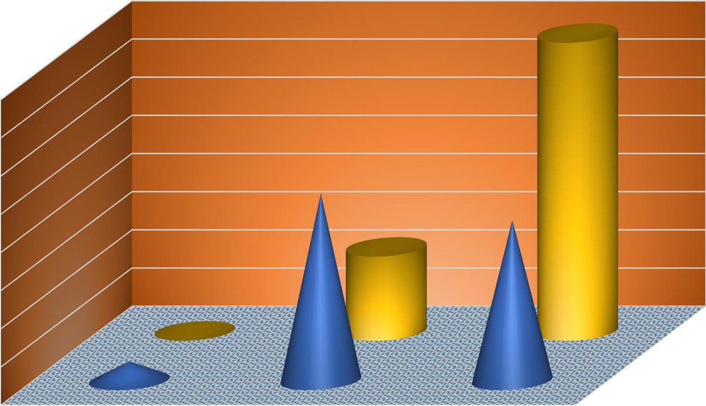
before after
high
average
low
0
before
10
after
80

70

60

50

40

30

20

FIGURE –I

LEVELS OF MEMORY IN THE SAMPLE BEFORE AND AFTER INTERVENTION

N=157

TABLE –II

LEVELS OF PROBLEM SOLVING SKILL IN THE SAMPLE BEFORE AND AFTER INTERVENTION
N=157

VARIABLE | LEVEL | BEFORE INTERVENTION |  | AFTER INTERVENTION
 |  | Number | Percentage | Number | Percentage
 | Low | 7 | 5 | 0 | 0
Problem Solving Skill | Moderate | 77 | 49 | 34 | 22
Problem Solving Skill | High | 66 | 42 | 123 | 78
Percentages are rounded off

During childhood the kids depend on their parents or caretakers for handling any problem or for making any decision, but as they mature they tend to develop the problem solving skill by getting themselves exposed to varied situation through which they acquire the capability of solving problems in a skillful manner thereby gaining experience. Table-II shows the level of problem solving skill among the sample before and after the intervention, in which only 5% of the sample had “low” problem solving skills, 49% were “moderate” and 42% had high level of problem solving skills which is as expected. The overall response given by the sample for the questionnaire shows that the reason for the low level of problem solving skill may be due to the over dependency on the external sources like social media, gadgets and other technology for solving a problem rather than using one’s own cognitive aspect to find a solution for the problem. Another evidence is that sample with low and average level of problem solving skill are not much interested in practicing the brain hackers or other puzzles whereas the sample with high scores show a good interest in it. But it is gratifying to know that after the provision of the Brain Gym Exercise there was an increase in the problem solving skill among the sample, with a rise from 42% to 78% in the “high” level category of problem solving skill. This increase in the levels might have occurred due to the intervention program that strengthens the habit of focusing and single mindedness helping the individual to concentrate on the situation in hand and arrive at an appropriate decision or solution for the problem.

FIGURE–II

LEVELS OF PROBLEM SOLVING SKILL IN THE SAMPLE BEFORE AND AFTER INTERVENTION

N=157
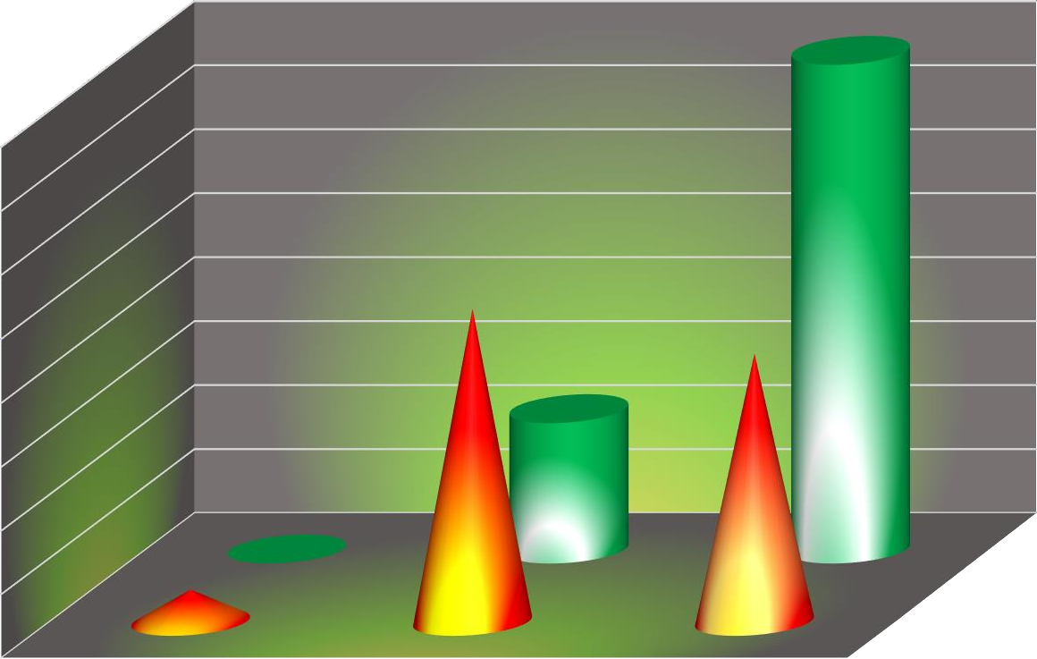
before after
high
average
low
0
before
10
after
80

70

60

50

40

30

20

TABLE-III

SIGNIFICANCE OF DIFFERENCE BETWEEN MEAN MEMORY BEFORE AND AFTER INTERVENTION
(Brain Gym Exercise)
N=84

 |  | MEAN (SD) | t-VALUE | SIGNIFICANCE
VARIABLE | CONDITION | MEAN (SD)
MEMORY | BEFORE | 34.95  (4.374) | 7.957 | .000**
 | AFTER | 40.52  (5.600)
** – Significant at 0.01 level

Table-III shows the significance of the mean memory before and after the intervention of the Brain Gym Exercise. It is observed from the data that the mean capacity for memory was 34.95 before the intervention while after the intervention the mean was 40.52 and the mean difference is 5.57. Brain Gym Exercise guarantees a betterment in memory after the practice of the activities by the sample. It is amazing to note that the increase in the capacity for memory after the practice of Brain Gym Exercise is promising. The procedure of the physiological movement in turn stimulates the brain strengthening the neurological pathways. The t-value of 7.96 clearly indicates a high significant difference between before and after intervention which shows the efficacy of the intervention i.e., Brain Gym Exercise at
level. Hence the hypothesis “Brain Gym exercise is effective in enhancing memory in young adults” is accepted.

FIGURE-III

MEAN MEMORY IN THE SAMPLE BEFORE AND AFTER INTERVENTION
(Brain Gym Exercise)
N=84
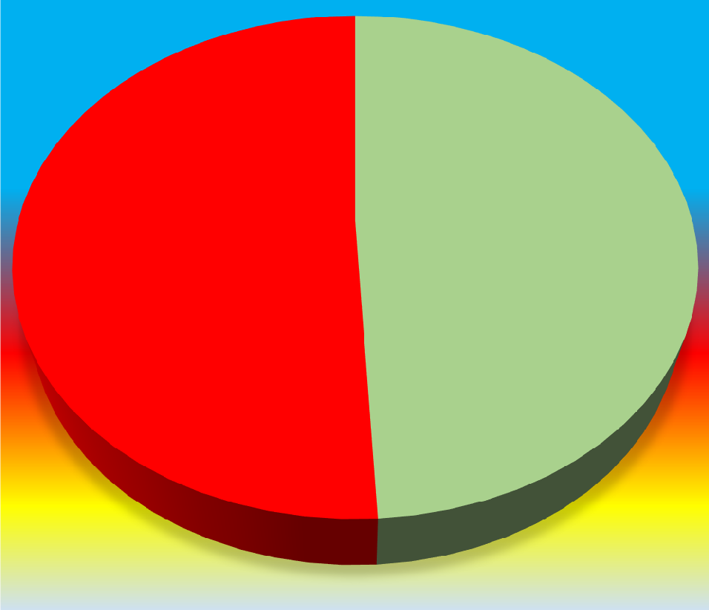
Mean Value of Memory

34
40
beforeintervention
after intervention

TABLE-IV

SIGNIFICANCE OF DIFFERENCE BETWEEN MEAN PROBLEM SOLVING SKILL BEFORE AND AFTER INTERVENTION
(BRAIN GYM EXERCISE)
N=84

 |  | MEAN (SD) | t-VALUE | SIGNIFICANCE
VARIABLE | CONDITION | MEAN (SD)
PROBLEM SOLVING SKILL | BEFORE | 38.12  (4.062) | 4.150 | .000**
PROBLEM SOLVING SKILL | AFTER | 40.48  (5.828)
** – Significant at 0.01 level

Table IV shows the mean problem solving skill before and after the intervention. It is noteworthy to annotate that the mean problem solving skill before the intervention was 38.12 and after the intervention it has raised up to 40.48 which assures the furtherance in problem solving skill after the practice of Brian Gym Exercise. The t-value is 4.15 which shows the significance at 0.01 level. Hence the hypothesis “Brain Gym exercise will help in the enhancement of Problem solving skill in young adults” is accepted. The mean difference is 2.36, indicating an increase in problem solving skill after the intervention. The positive increase in mean difference proves that the practice of Brain Gym Exercise will enhance the integration between brain parts and the links between the hemispheres. Hence the hypothesis “Brain Gym exercise is effective in enhancing Problem solving skill in young adults” is accepted.

FIGURE-IV

MEAN PROBLEM SOLVING SKILL IN THE SAMPLE BEFORE AND AFTER INTERVENTION (BRAIN GYM EXERCISE)

N=84
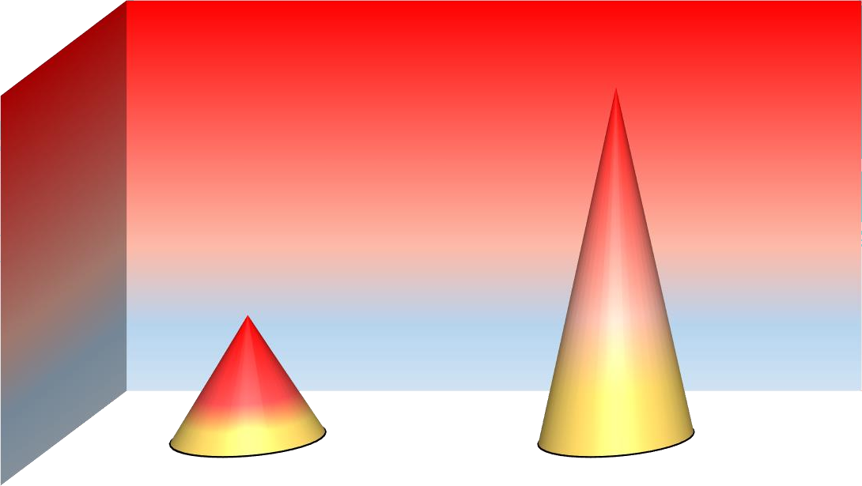
after intervention
beforeintervention
29
mean
30.8

30.6

30.4

30.2

30

29.8

29.6

29.4

29.2
Mean Value Of Memory

TABLE-V

SIGNIFICANCE OF DIFFERENCE BETWEEN MEAN MEMORY BEFORE AND AFTER INTERVENTION (JPMR)
N=84

 |  | MEAN (SD) | t-VALUE | SIGNIFICANCE
VARIABLE | CONDITION | MEAN (SD)
MEMORY | BEFORE | 29.57  (5.306) | 1.684 | ns
 | AFTER | 30.62  (5.441)
ns- Not Significant

Table-V shows the significance of the mean memory before and after the intervention of the JPMR. It is observed from the data that the mean capacity for memory was 29.57 before the intervention while after the intervention the mean increased to 30.62 and t value is 1.68 which is insignificant. Hence the hypothesis “JPMR is effective in enhancing memory in young adults” is rejected. Relaxation has the capacity to equalize imbalance in cortisol levels and maintain homeostasis in hormones during times of stress and negative experiences. Unfortunately there is no such observation in the present study as observed from the pre and post -test.

FIGURE-V

MEAN MEMORY IN THE SAMPLE BEFORE AND AFTER INTERVENTION (JPMR)
N=84

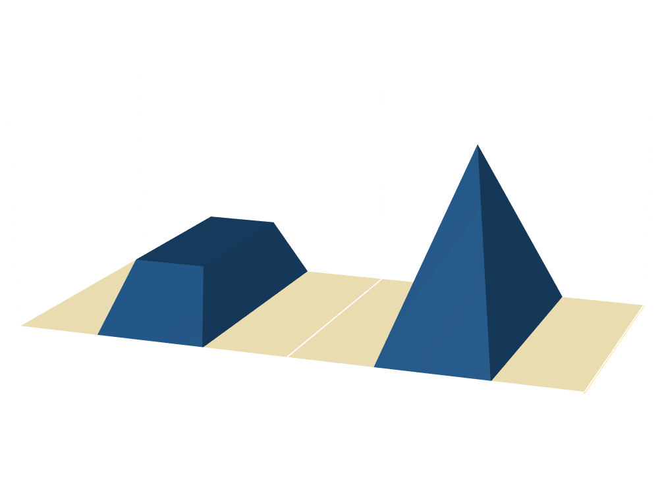
MEAN VALUE OF PROBLEM SOLVING SKILL

30.8
30.6
30.4
30.2
30
29.8
29.6
29.4
29.2
29
mean
B E F O R E I N T E R V E N T I O N
A F T E R I N T E R V E N T I O N

29.57
30.62

TABLE-VI

SIGNIFICANCE OF DIFFERENCE BETWEEN MEAN PROBLEM SOLVING SKILL BEFORE AND AFTER INTERVENTION (JPMR)
N=84

 |  | MEAN (SD) | t-VALUE | SIGNIFICANCE
VARIABLE | CONDITION | MEAN (SD)
PROBLEM SOLIVING SKILL | BEFORE | 30.81  (5.735) | 2.6737 | .031*
PROBLEM SOLIVING SKILL | AFTER | 31.45  (6.743) | 2.6737 | .031*
*- Significant at 0.05 level

Table VI shows the mean problem solving skill before and after the intervention. The process of finding solutions to difficult and complex issues is termed problem solving. Difficulty arises when one’s mental frame work are tense. The relaxation training meted out to the sample show an improvement in problem solving skills as observed from the mean difference of 1.36, while the t-value is 2.67 significant at 0.05 level. Hence the hypothesis “JPMR is not effective in enhancing problem solving skill in young adults” is rejected. The investigator’s perception of JPMR technique was that, the relaxation would benefit the physical body thereby reducing stress but would not address the cognition. Surprisingly this sample has reported that this technique had improved their concentration, analytical skills and decision making. This is a clear indication of significant difference before and after intervention.

FIGURE-VI

MEAN PROBLEM SOLVING SKILL IN THE SAPMLE BEFORE AND AFTER INTERVENTION (JPMR)
N=84


AFTRE INTERVENTION
BEFORE INTERVENTION
31.6
31.4
31.2
31
30.8
30.6
30.4
MEAN

TABLE-VII

SIGNIFICANCE OF DIFFRENCE BETWEEN MEAN OF BRAIN GYM EXERCISE AND JPMR IN MEMORY
N=84

 |  | MEAN (SD) | t-VALUE | SIGNIFICANCE
VARIABLE | INTERVENTION | MEAN (SD)
MEMORY | BRAIN GYM EXERCISE | 40.52  (5.100) | 8.607 | .000**
 | JPMR | 30.61  (5.441)
** – Significant at 0.01 level

Table VII shows the effect of Brain gym exercise over JPMR in improving memory. It is observed from the data, the mean of Brain gym exercise is 40.52 and JPMR is 30.61 with a mean difference of 9.91. The t-value of 8.61 is highly significant at 0.01 level. Hence the hypothesis “There will be no difference between Brain Gym exercise and JPMR in enhancing memory” is rejected. Brain gym is a physically oriented intervention putting the application of physical and mental faculties to action. The exercises strengthens the neurological pathways, paving way in developing new neurons thereby increasing the mental capacity. The relaxation using JPMR is not without benefit. In this a conscious training is imparted by addressing the sub conscious mind thereby neutralizing the negative emotions and facilitating vivid recollections. It may be argued that both the techniques involved exert the physiological expressions and therefore is effective in enhancing memory, with Brain gym exercise being more effective.

FIGURE-VII

MEAN OF BRAIN GYM EXERCISE AND JPMR IN THE SAMPLE FOR MEMORY

N=84
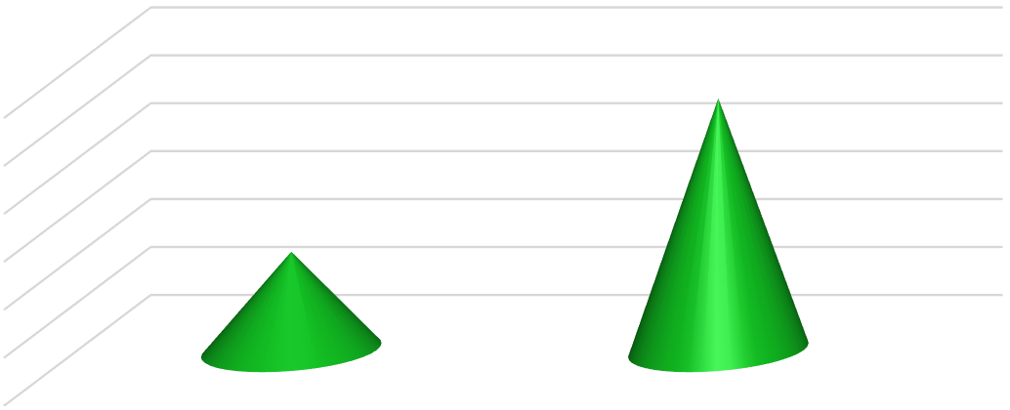
AFTRE INTERVENTION
BEFORE INTERVENTION
31.6
31.4
31.2
31
30.8
30.6
30.4
MEAN

TABLE -VIII

SIGNIFICANCE OF DIFFERENCE BETWEEN MEAN OF BRAIN GYM EXERCISE AND JPMR IN PROBLEM SOLVING SKILL
N=84

 |  | MEAN (SD) | t-VALUE | SIGNIFICANCE
VARIABLE | INTERVENTION | MEAN (SD)
PROBLEM SOLVING  SKILL | BRAIN GYM EXERCISE | 40.48  (5.828) | 7.289 | .000**
PROBLEM SOLVING  SKILL |  | 30.45  (6.743)
 | JPMR | 30.45  (6.743)
** – Significant at 0.01 level

Table VIII shows the effect of Brain gym exercise over JPMR in problem solving skill. From the table it is observed the mean of Brain gym exercise is 40.48 and for JPMR it is 30.45, the mean difference is 10.03. The t-value is 7.28 which is highly significant at 0.01 level. Hence the hypothesis “There will be no difference between Brain Gym exercise and JPMR in enhancing problem solving skill” is rejected. Exercise affects brain by increasing heart rate, in turn pumping more oxygen to the brain. It aids in nourishing the growth of brain cells, maintaining healthy blood pressure, improves energy, lifts moods and lowers stress and anxiety contributing to brain health. While the above mentioned exercise are true of brain gym, the JPMR technique is practiced with a conscious tightening and loosening of the muscles by mindfully relaxing to achieve higher order functioning.

FIGURE -VIII

SIGNIFICANCE OF DIFFERENCE BETWEEN MEAN OF BRAIN GYM EXERCISE AND JPMR IN PROBLEM SOLVING SKILL
N=84
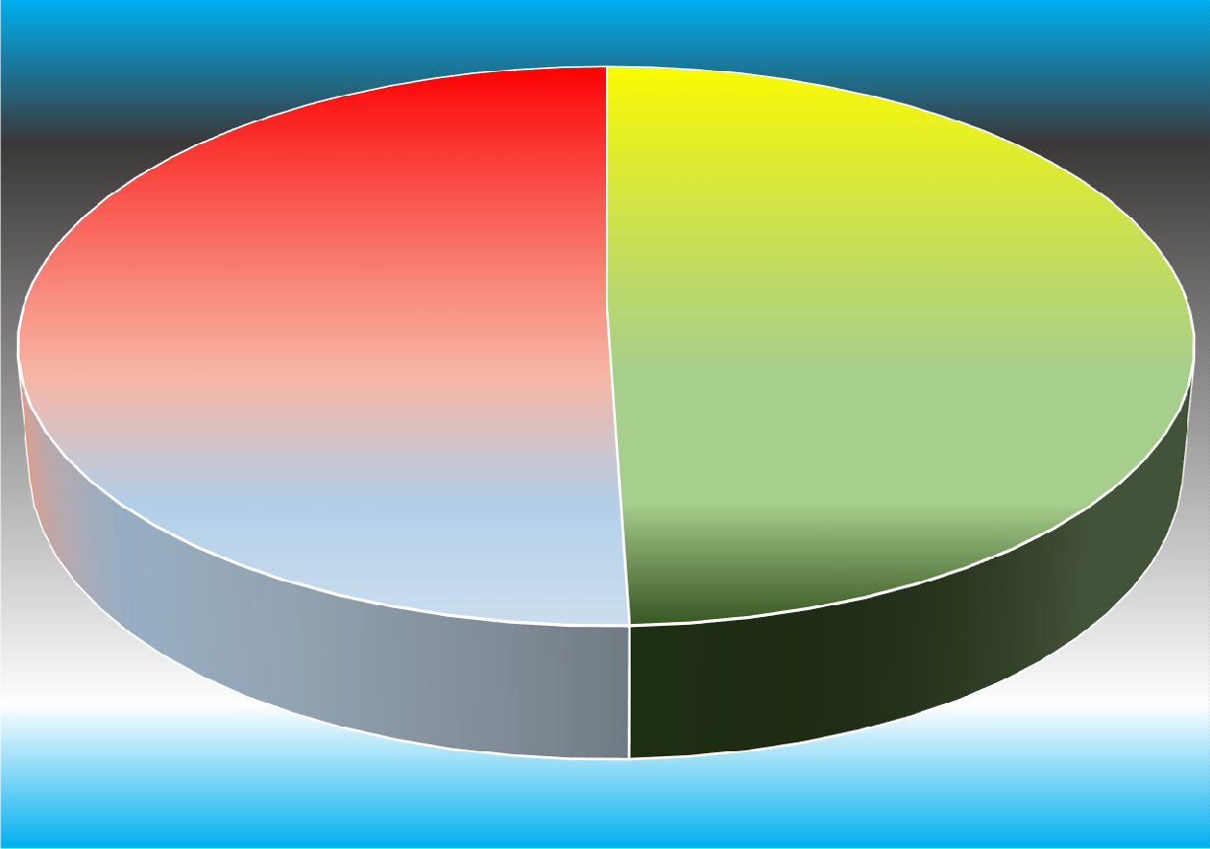
30.4
JPMR
40.4
Brain Gym
Exercise

CHAPTER-V SUMMARY AND CONCLUSION

A study on “A Comparative Study of Brain Gym Exercise and JPMR in enhancing Memory and Problem Solving Skill” was conducted with the following objectives.
    - To assess the level of Memory in the Young Adults.
    - To assess the level of Problem Solving Skill in the Young Adults.
    - To find the effect of Brain Gym Exercise and JPMR in enhancing the Memory in Young Adults.
    - To find the effect of Brain Gym Exercise and JPMR in enhancing the level of Problem Solving skill in Young Adults.
    - Comparing the effect of the Brain Gym Exercise and JPMR in enhancing Memory and Problem solving skill in young adults.
From Sankara College of Science and Commerce, Saravanampatty, Coimbatore, 84 students were selected for the study through purposive sampling. They were in the age range of 18 to 22 years. The sample was screened for the interventional study using the following tools: Multifactorial Memory Questionnaire for measuring the level of memory (Troyer and Rich, 2007) and Problem Solving Skill Questionnaire for assessing the level of problem solving skill (Ginter, Darden and Gazda, 2009).
The sample was divided into batches each consisting of 42 students. One batch was given the intervention of Brain Gym Exercise while the other was trained in Jacobson’s Progressive Muscle Relaxation therapy for a period of 12 days. The duration of each session was for 35 minutes. After 15 days the Post- Assessment test was carried out using the same tools. Lastly, the data was analyzed using the SPSS software.

CONCLUSION

      - Initially most of the sample had “average” level of memory (48%) and the rest had “low” (5%) and “high” (42%) level of memory.
      - Primarily the sample with “High” problem solving skill were 42%, average and low levels were 47% and 5% respectively.
      - The mean memory was 34.5 before Brain gym exercise and it increased to 40.5 after the intervention. The mean difference in memory is statistically significant at 0.01 level. Hence the hypothesis “Brain Gym exercise will help in the enhancement of memory in young adults” is accepted.

      - The mean problem solving skill before the Brain gym exercise was 38.1 and it increased to 40.4 after the intervention. The mean difference in problem solving skill is statistically significant at 0.01 level. Hence the hypothesis “Brain Gym exercise will help in the enhancement of Problem solving skill in young adults” is accepted.
      - Before the practice of JPMR the mean memory among the sample was 29.5 and after the intervention the mean memory was observed to be 30.6. The mean difference in memory is 1.6 which is statistically not significant. Hence the hypothesis “JPMR will help in the enhancement of memory in young adults” is rejected.
      - The mean problem solving skill before JPMR was 30.8 and after the intervention of problem solving skill the mean increased to 31.4. The mean difference is 1.36and the t-value is 2.67 which is statistically significant at 0.05 level. Hence the hypothesis “JPMR will not help in the enhancement of problem solving skill in young adults” is rejected.
      - The results of the research revealed that intervention of Brain gym exercise is effective in enhancing memory than JPMR. This is clearly revealed in the mean value of 40.5and
30.6 for Brain gym exercise and JPMR respectively. The mean difference is 9.9 and the t- value 8.16 which is significant at 0.01 level. Hence the hypothesis “There will be no difference between Brain Gym exercise and JPMR in enhancing memory” is rejected.
      - Similarly the mean of Brain gym exercise and JPMR were compared for its effect over problem solving skill. The mean of Brain gym exercise was 40.4 and for JPMR it was
30.4. The mean difference was 10. The t-value is 7.28 was statistically significant at
0.01 level, rejecting the hypothesis “There will be no difference between Brain Gym exercise and JPMR in enhancing problem solving skill”.

LIMITATION

    - The sample for the study were selected from only one institution.
    - The sample belonging to only one discipline were only selected for the study.
    - Only sample age ranging from 18-22 years were available for the study and the other age sample of young adults were not included.

RECOMMENDATIONS

    - Brain gym exercise can be provided for students in colleges and schools in order to improve their cognitive skills and keeping them active all through the day.
    - Appointing psychologists at schools and colleges helps the student themselves and also the management to acknowledge about their cognitive skills based on which therapies and psychological interventions can be provided for their overall enhancement.

SUGGESTIONS FOR FURTHER RESEARCH

    - Researches can be conducted involving many colleges of both private and public sectors.
    - The research can be expanded to the diversified and cross cultural samples from different districts in Tamil Nadu.

REFERENCE

Ajawani, J. et al. (2012). Problem Solving Abilities of Cognitively High Intelligent Adolescents. Journal of Indian Academy of Applied Psychology. 38(01), 126-133.
Amish, P., Elizabeth, A & Lois Gelfand. (2010). Examining the protective effects of mindfulness training on working memory capacity and affective experience. Journal of Emotions. 10 (01), 55-59.
Andrew. , Watson Leon & Klson. M. (2014). The effect of brain gym on academic engagement for children with development disabilities. International Journal of Special Education. 24(11), 56-77.
Belle, (2014). https://www.buffer.com

Cancela Martin. (2017). Effect of Brain Gym exercise for elderly people with cognitive impairment. Journal of Neuro-Science. 34 (01), 44-49.
Carlson, N. (2000). Memory. Psychology: the science of behavior. http://qz.com

Carol, V. (2017). www.webmd.com

Caroline, K. (2018). https://blog.hubspot.com

Cass, P. (2013). https://nutritionreview.org

Chiara, M & Linda, S. (2001).The relations between short-term memory, working memory, inhibitory control, and arithmetic word problem solution in children. Journal of Experimental Child Psychology. 80 (01), 45-57.
Corr, A. (2018). https://www.unforgettable.org

David Berry. (1981). An evaluation of progressive muscle relaxation on stress related symptoms in a geriatric population. International Journal of Psychiatry. 10 (02), 125- 177.
Erdogan, S. (2010). Anterograde Amnesia. Psikiyatride Guncel Yaklasimlar-Current Approaches in Psychiatry. 2 (2), 174–189.
Forsey, M. (2017). http://www.human-memory.net

George, R. (2014). http://www.msdmanuals.com

Giju Thomas. (2006). Effectiveness of progressive muscle relaxation technique on anxiety among elderly people. Journal of Psychology and Psychotherapy. 12 (07), 75-112.
Hannah Hayne. (2011). Childhood amnesia. Wiley Interdisciplinary Reviews: Cognitive Science. 2 (2), 136–145.
Harry Hyla. (2013). https://nutritionreview.org

James, O. (2014). http://www.medicalnewstoday.com

Jose Ocampo., Leonora Varela & Laura Varela. (2007).The effect of brain gym on academic engagement for children with development disabilities. International Journal of Special Education. 29 (02), 87-202.
Josévan, H. (2017). Promoting Students’ Problem-Solving Skills in Secondary Mathematics Education. Journal of Mathematical Thinking and Learning. 47 (23).
Josmitha John & Asha Kumar. (2015). Effect of Academic Stress Reduction by Jacobson’s Progressive Muscle Relaxation Technique. International Research Journal of Medical Sciences. 03 (08), 7-13.
Kariuki, C & Kent, K. (2014). The effect of Brain Gym Exercise on student’s performance in comprehension in 4th grade students. Journal of experimental psychology. 18, 643-662.
Kate, (2018). https://www.unforgettable.org

Kirshner & Ally B. (2016). Intellectual and memory impairments. https://www.livescience.com

Lee, Swanson & Carole, Sachse. (2001). Mathematical problem solving and working memory in children with learning difficulties. Journal of Experimental Psychology. 79 (03), 294-321.
Lila, (2017). http://qz.com

Madeline Uddo., et al. (1993). Memory and attention in combat related post-traumatic stress disorder. Journal of Psychopathology and Behavioral Assessment. 15 (01), 43-52.
Mamelak Parihar. (2013). Relaxed mind remember better. Journal of Neurobiology of Learning and Memory. 24 (13), 56-61.
Maryam Zargarzedh. , & Maryam Shirazi. (2013). The effect of Jacobson’s Progressive Muscle Relaxation Technique on test anxiety among nursing students. Iranian Journal of Nursery and Midwifery Research. 19 (06), 607-612.

Mastin, L. (2010). The human memory: Retrograde amnesia http://www.msdmanuals.com

Mastin, L. (2018). http://www.human-memory.net

Nagarkar Dhahir., Rakode Misheal & Malwade, James. (2018). Effectiveness of Brain Gym Exercise on Quality of Life in children with Autism Spectrum Disorder. International Journal of Healthcare and Biomedical Research. 06 (02), 11-16.
Nikki, S & Lauren, V. (2010). Relaxing music counters heighted consolidation of emotional memory. Journal of Psychiatry. 97 (02), 220-228.
Oyebode, F. (2015). Disturbance of memory. http://www.msdmanuals.com

Palak, Patel. (2014). Effectiveness of Jacobson’s Progressive Muscle Relaxation Technique on stress among the staff nurses working in selected hospitals at Vadodara city. Journal of Nursing and Health Science. 03 (03), 34-59.
Passolunghi & Linda (2001). Short term memory, working memory and inhibitory control in children with difficulties in arithmetic problem solving. Journal of Experimental Child Psychology. 80, 44-55.
Peter Scheufele. (1999). The effects of progressive relaxation and music on attention. Journal of Clinical Psychology. 07,143-178.
Rachael, T (2016). https://www.livescience.com

Rhonda. M & Rosemary. T, (2005). A meta-analysis of working memory impairments in children with ADHD. Journal of the American Academy of child & Adolescent Psychiatry. 44 (04), 377-384.
Rodolfo. (2016). The functional state of thalamus and the associated neuronal play. Physiological Reviews 68(3), 649-742.
Sarkissian, K (2014). www.webmd.com

Solomon, R. (2012). Effect of Learning through the Arts (LTA) On Problem Solving among Fifth Grade Students. Journal of Experimental Psychology. 13 (03), 29-37.
Spitzer, S (2012). https://www.alzheimers.net

Swasti Banerjee., Tanya Das & Jayanti Mishra. (2014). Assessment of working memory in young adults. International Journal of Health Science and Research. 04 (2).

Velayudham, A. & Juliana Jecinth. (2017). The effect of brain gym exercise on self-esteem and sensory processing speed on high school hearing impaired students. The International Journal of Indian Psychology. 4 (02), 1256-1263.
Vlachou Anastasia & Stavroussi Panayiota. (2017). An Intervention Program for Enhancing Interpersonal Problem-Solving Skills in Children with Intellectual Disabilities. Hellenic Journal of Psychology. 14, 114-138.
William, J., Teasdale, J., & Segal, Z. (2000). Mindfulness-based cognitive therapy reduces over general autobiographical memory in formerly depressed patients. Journal of Abnormal Psychology. 109 (01), 150-155.
Wilson, T (2018) http://www.webmd.com.

ANNEXURE-1 INFORMED CONSENT FORM
Use of questionnaires for students

You are being invited to take part in a research study. Before you decide to participate in this study, it is important that you understand why the research is being done and what it will involve. Please take the time to read the following information carefully. Please ask the researcher if there is anything that is not clear or if you need more information. The purpose of the study is to find “A Comparative Study of Brain Gym Exercise and JPMR in enhancing Memory and Problem Solving Skill”.
STUDY PROCEDURE

You will be given two tests of paper-pencil type along with socio demographic profile. You need to respond to all the items in the test. There is no expected time commitment for this test. Any amount of time can be taken to complete the tests. There is no risk in undertaking the study. There will be no direct benefits to you for your participation in this study. Your responses to the question will be anonymous and kept confidential. Your participation in this study is voluntary. It is up to you to decide whether or not to take part in this study. If you decide to take part in this study, you will be asked to sign this form. You are free to withdraw at any time and without giving any reason. There are no costs to you for your participation in this study.
Consent

“By signing this consent form, I confirm that I have read and understood the information and have the opportunity to ask questions. I understand that my participation is voluntary and I am free to withdraw at any time, without giving a reason and without cost. I voluntarily agree to take part in this study.”
Signature: Date:

Socio-Demographic Data
NAME: GENDER: M / F

YEAR & DEPT: AGE:

E-Mail: SES:

ANNEXURE-2

Multi- Factorial Memory Questionnaire Troyer and Rich (2007)
Read each statement and decide whether you completely agree, mostly agree, mostly disagree, or completely disagree with the statement. Once you have made your decision, darken the appropriate response corresponding to its number
1 = Completely Agree 2 = Mostly Agree

3 = Mostly Disagree 4 = Completely Disagree

NO | STATEMENT | OPTIONS
1 | I contact experts and gather as much information as possible before making decisions  about my education | 1 | 2 | 3 | 4
2 | There is no one for me to observe directly in order to find out about the kind of work I  might like to do. | 1 | 2 | 3 | 4
3 | When solving a problem, I am able to think everything through in my own head. | 1 | 2 | 3 | 4
4 | Once I have decided what kind of work I want to do, I know how to go about getting it. | 1 | 2 | 3 | 4
5 | I can compare and look carefully at the various ideas I develop. | 1 | 2 | 3 | 4
6 | I like to make plans and take action steps before making a final decision about a job. | 1 | 2 | 3 | 4
7 | When it is time to make an important educational or occupational decision, I am able to develop an appropriate plan of action. | 1 | 2 | 3 | 4
8 | When it comes to solving a problem, I consider all of the things that are part of the problem before deciding what to do. | 1 | 2 | 3 | 4
9 | I do not know which talents to work on that will help me in the future. | 1 | 2 | 3 | 4
10 | I share my problem on social media to get other’s opinion to make decision. | 1 | 2 | 3 | 4
11 | I use information I gather to help me develop several different ways to solve a problem. | 1 | 2 | 3 | 4
12 | I know where to go to find dependable information about jobs. | 1 | 2 | 3 | 4
13 | I am able to solve problems through the use of logic. | 1 | 2 | 3 | 4
14 | I know how my actions and decisions will affect my occupational Choice | 1 | 2 | 3 | 4
15 | In exploring the kind of work I might want to do, I get information about it, talk to people who work at it, and get a part-time job that is like the work I am considering. | 1 | 2 | 3 | 4

ANNEXURE-3
Problem Solving Skill Questionnaire Derèli Ìman (2009)
Read each statement carefully and decide how often you have done each one in the last five months. Then check the box next to the appropriate response.

0 = All the time 1= Often 2 = Sometime 3 = Rarely 4 = Never

NO | STATEMENT | OPTIONS
1 | Forget to pay a bill or any borrowed money on time. | 0 | 1 | 2 | 3 | 4
2 | Misplace something you use daily, like your keys or glasses etc. | 0 | 1 | 2 | 3 | 4
3 | Have trouble remembering a telephone number you just looked up. | 0 | 1 | 2 | 3 | 4
4 | Not recall the name of someone you just met. | 0 | 1 | 2 | 3 | 4
5 | Leave something behind you meant to bring it with you.(eg: forgetting a notebook for a class) | 0 | 1 | 2 | 3 | 4
6 | Forget an appointment. | 0 | 1 | 2 | 3 | 4
7 | Forget what you were just about to do (eg: walk into a room and forget what  you went there to do). | 0 | 1 | 2 | 3 | 4
8 | Forget to go, On the way journeys (eg: forgetting to go shop on the way to  home) | 0 | 1 | 2 | 3 | 4
9 | In conversation, have difficulty coming up with a specific word that you  want. | 0 | 1 | 2 | 3 | 4
10 | Have trouble remembering details from a newspaper or magazine article you read earlier. | 0 | 1 | 2 | 3 | 4
11 | Forget to take medication. | 0 | 1 | 2 | 3 | 4
12 | Not recall the name of someone you have known for some time. | 0 | 1 | 2 | 3 | 4
13 | Forget to pass on a message. | 0 | 1 | 2 | 3 | 4
14 | Forget what you were going to say in conversation. | 0 | 1 | 2 | 3 | 4
15 | Forget a birthday or anniversary of your family member or friend | 0 | 1 | 2 | 3 | 4
16 | Forget a telephone number you use frequently. | 0 | 1 | 2 | 3 | 4
17 | Retell a story or joke to the same person because you forget you already told  him or her. | 0 | 1 | 2 | 3 | 4
18 | Misplace something that you put away a few days ago. | 0 | 1 | 2 | 3 | 4
19 | Forget to buy something you intended to buy. | 0 | 1 | 2 | 3 | 4
20 | Forget details about a recent conversation. | 0 | 1 | 2 | 3 | 4

