EFFICIENT INDEXING METHOD OVER
UNCERTAIN DATA

M.SINDHU
10PCR20

A Project Report submitted to Avinashilingam Deemed University for Women, Coimbatore in partial fulfilment of the requirements for the Master’s Degree in Computer Science.

April, 2012

ACKNOWLEDGEMENT

I would like to express my sincere thanks to God Almighty, for his constant love and grace that he has showered upon me.
I am very grateful to Dr.T.S.K.Meenakshi Sundaram, M.A., M.Phil., Ph.D., Chancellor, Avinashilingam Deemed University for Women, Coimbatore, for his support and encouragement during the course of my study.
I heartily thank Dr. (Mrs).Sheela Ramachandran, M.Sc., P.G Dip., Ph.D., Vice Chancellor, Avinashilingam Deemed University for Women, Coimbatore, for extending all resources that facilitated the conduct of the present study.
I express my humble gratitude to Dr.(Mrs).Gowri Ramakrishnan, M.Sc., M.Phil., Ph.D., Registrar, Avinashilingam Deemed University for Women, Coimbatore, for providing all facilities necessary for the study.
I am also thankful to Dr. (Mrs). R. Parvatham, M.Sc., Dip.Ed., M.Phil., Ph.D., Dean, Faculty of Science, Avinashilingam Deemed University for Women, Coimbatore, for granting the facility required.
I wish to place on record my deep sense of gratitude to Dr. (Mrs).G.Padmavathi, M.Sc., M.Phil., Ph.D., Professor and Head of the Department of Computer Science, for providing all the facilities to complete the project.
I owe great deal of gratitude to my esteemed guide (Mrs).V.Srividhya M.Sc., M.Phil., Assistant Professor, Department of Computer Science, for her guidance, valuable suggestion and constant encouragement in successfully completing this project.
I take this unique opportunity to express my sincere thanks to my project Coordinator Dr.(Mrs).P.Subashini, M.C.A., M.Phil., Ph.D., Associate Professor,Department of Computer Science, for her kind advice and knowledgeable suggestion, which helped me to complete my project successfully.
I have great pleasure in expressing deep sense of gratitude to all other staffs and non-teaching staffs who stood behind the screen in making of project.
I would extend my hearty thanks to one and all who helped me directly or indirectly for successful completion of my project.
Last yet importantly, I would like to thank my parents, my family members, my friends and all my well-wishers for their kind inspiration, blessings and encouragement during the completion of the course of project.

SYNOPSIS
The project entitled “EFFICIENT INDEXING METHOD OVER UNCERTAIN DATA”, deals with managing and mining the uncertain data in a large volume of database. The rapid development of various optical, infrared, radar sensors and Global Positioning System techniques, there is a huge amount of multidimensional uncertain data collected and accumulated everyday. Recently, considerable research efforts have been made in the field of indexing, analyzing and mining uncertain data. In order to efficiently manage and mine uncertain data, effective indexing techniques are highly desirable.
The existing index structures for multidimensional data are sensitive to the size or shape of uncertain regions of uncertain objects and the queries. The purpose of an index is used to find data based on a certain key value quickly by going directly to the first record with that key, instead of searching the entire database. An index is a performance-tuning method of allowing faster retrieval of records. Thus using a novel R-Tree based inverted index structure, named UI-Tree to efficiently support various queries including range queries, similarity joins and their size estimation, as well as top-k range query, over multidimensional uncertain objects against continuous or discrete cases.
The objective of the system is to provide a space-efficient index structure for organizing multidimensional uncertain objects, named UI-tree. The UI-tree index is a depth balanced tree structure similar to R-tree and can also support arbitrary Probability Density Function of uncertain objects. It also includes index maintenance algorithms like uncertain object partition based on spatial clustering, insertion and deletion of uncertain objects.

CONTENTS

S.NO PARTICULARS PAGE NO

1. INTRODUCTION 1.1 Problem Definition 2
1.2 Overview of the project 2
1.3 Organization Profile 4
2. SYSTEM CONFIGURATION
2.1 Hardware Configuration 6
2.2 Software Configuration 6
2.3 About the Software 7
3. SYSTEM STUDY AND ANALYSIS
3.1 Existing System 11
3.2 Proposed System 12
3.3 Feasibility Study 13
4. SYSTEM DESIGN
4.1 Input Design 15
4.2 Output Design 17
4.3 Database Design 18
5. SYSTEM DEVELOPMENT
5.1 Module Description 21
5.1.1 Server Monitoring 21
5.1.2 Authentication 22
5.1.3 Uncertain object partition 22

5.1.4 Insertion and deletion of objects 23
5.1.5 Indexing uncertain object 23
6. SYSTEM TESTING AND IMPLEMENTATION
6.1 System Testing 24
6.1.1 Unit Testing 24
6.1.2 Integration Testing 25
6.1.3 Validation Testing 25
6.1.4 Acceptance Testing 25
6.2 System Implementation 26
6.3 System Maintenance 27
7. CONCLUSION 28
8. SCOPE FOR FURTHER DEVELOPMENT 29
BIBLIOGRAPHY
APPENDIX
    - Dataflow Diagram
    - Table Design
    - Screen Shots

- INTRODUCTION
Managing and mining uncertain data have various applications which cover data cleaning, sensor data analysis, moving objects tracking, information retrieval, crime fighting, economic decision making and market surveillance. Common causes of uncertainty in these applications include data randomness and incompleteness, limitation of measuring equipment, delay or loss of data updates and privacy preservation. A large amount of uncertain data is collected and accumulated with the wide application of Global Positioning System equipment and various optical, infrared and radar sensors. Thus managing and analyzing large volumes of uncertain data over multidimensional objects is done by R-Tree based inverted index structure, named UI-Tree.
Range search over uncertain data is important in query processing and data mining. A server monitors a set of user equipped with Global Positioning System and location information of each user is sent back to the server every five minutes. Based on this periodically updated location information and other factors like velocity constraint, at each time stamp, the location of a user is within a circle until next update arrives. If the location is not exact the users satisfy the query partially, which means that they are within the query region with a probability. This probability can be intuitively computed based on the intersection between one uncertain region and the query region, also the specific Probability Density Function (PDF) information inside each user’s uncertain region. Results with low probability values are often of no interest to users and a probability threshold is sometimes given beforehand to return results with probability no less than this threshold only.

1.1 PROBLEM DEFINITION
To obtain a space-efficient index structure for organizing multidimensional uncertain object using UI-Tree which support arbitrary Probability Density Function of uncertain object. The index provides efficient solutions for various types of queries based on UI-Tree, including range query, size estimation of range query, probabilistic top-k range query, and similarity join. It should provide rigorous analysis to estimate the filtering capacity of UI-Tree.

1.2 OVERVIEW OF PROJECT

A space-efficient index structure for organizing multidimensional uncertain objects, UI-Tree is proposed. The UI-tree index includes the maintenance algorithm such as uncertain object partition, insertion and deletion of objects. The partition of uncertain object is based on the spatial “clustering” information of instances of an uncertain object. Before inserting an uncertain object into UI-Tree, need to partition the uncertain object into groups such that any of the object instance belongs to one and only one group. The partition is done by starting with one group which is the uncertain region of the uncertain object, and recursively partition the groups into two parts with the same probability value along a particular dimension.
The UI-Tree structure algorithm also includes insertion, deletion to index the uncertain object. The insert operation of UI-Tree is similar to R-Tree except that the probability value of the node is considered and need to merge words to reduce the space. In order to incrementally maintain the UI-Tree with limited space, need to merge words. The deletion of an uncertain object is by finding all words, which include posting tuples. Then, the tuples are removed from their corresponding posting list. Based on deletion of tuple the index is updated after deleting the uncertain object.
The indexing technique is a partition-based index structure such that the spatial “clustering” information can be kept and the filtering capacity is less sensitive to the shape of query region. The UI-tree is a depth balanced tree structure similar to R-tree and each node corresponds to a disk page. Each entry of the leaf node is a word with its posting list and a set of entries is organized by a leaf node which contains Minimum Bounding Rectangle(MBR) of the words. The non leaf node of the UI-tree is exactly the same as that of R-tree except that the probability value is kept in its entry at parent node.
Thus the index structure maintenance algorithm include uncertain object partition, insertion and deletion of uncertain objects which is based on spatial clustering information to obtain a space efficient index structure.

1.3 ORGANIZATION PROFILE

Cognizant Technology Solutions Corporation (Cognizant) is a provider of custom information technology, consulting and business process outsourcing services. The Company is engaged in technology strategy consulting, complex systems development and integration, enterprise software package implementation and maintenance, data warehousing, business intelligence and analytics, application testing, application maintenance, infrastructure management, and business and knowledge process outsourcing (BPO and KPO). The Company operates in four segments: Financial Services; Healthcare; Manufacturing, Retail and Logistics, and Other, which includes communications, information, media and entertainment, and high technology. Cognizant combines a passion for client satisfaction, technology innovation, deep industry and business process expertise, and a global, collaborative workforce that embodies the future of work.
MISSION
Cognizant's single minded mission is to dedicate our business process and technology innovation know-how, our deep industry expertise and worldwide resources to working together with clients to make their businesses stronger.

FINANCIAL SERVICES
During the year ended December 31, 2011, the Company’s Financial Services business segment represented approximately 41.1% of its total revenues. Its Financial Services segment provides services to its customers operating in the industries, such as banking and insurance. The Company focuses on traditional retail and commercial banks, and diversified financial enterprises. The Company assists these clients in areas, such as consumer lending, cards and payments, wholesale banking, risk management, investment banking and brokerage, asset and wealth management, corporate services and retail banking. It also focuses on the needs of broker asset management firms, depositories, clearing organizations and exchanges. Cognizant assists with the needs of property and casualty insurers, life insurers, reinsurance firms and insurance brokers. It focuses on areas, such as business acquisition, policy administration, claims processing, management reporting, regulatory compliance and reinsurance.
CUSTOMER DELIGHT
Our success is measured by the exceptional value we create for our clients. We strive constantly to create value in all our endeavors through tangible results. Every team member will have the customer's best interest at heart and will promote customer delight by focusing on efficient procedures and high quality standards.

- SYSTEM CONFIGURATION
This section describes about the hardware and software specification needed for both the development and implementation phases of the project.
2.1 HARDWARE CONFIGURATION

PROCESSOR : PENTIUM IV 2.6 GHz, Intel Core 2 Duo.
RAM : 512 MB DD RAM
MONITOR : 15” COLOR
HARD DISK : 40 GB
CDDRIVE : LG 52X

2.2 SOFTWARE CONFIGURATION

Front End : JAVA, J2EE (JSP)
Back End : My SQL 2005
Operating System : Windows XP/07
IDE : Net Beans
Web Server : Tomcat 5.5.

2.3 ABOUT THE SOFTWARE

Front end – Java
Java has two things: a programming language and a platform. Java is a high-level programming language that is all of the following:
- Simple Architecture-neutral
- Object-oriented Portable Secure
- Distributed High-performance
- Interpreted Multithreaded
- Robust Dynamic
Each Java program is both compiled and interpreted. With a compiler java program is translated into an intermediate language called Java byte codes the platform-independent code instruction is passed and run on the computer. Compilation happens just once; interpretation occurs each time the program is executed.
JAVA PLATFORM
A platform is the hardware of software environment in which a program runs. The Java platform differs from most other platforms in that it’s a software only platform that runs on the top of other, hardware-based platform.
Java platform has two components:
- The Java Virtual Machine (Java VM)
- The Java Application Programming Interface (Java API)
The Java API is a large collection of ready-made software components that provide many useful capabilities, such as graphical user interface (GUI) widgets. The Java API is grouped into libraries (packages) of related components.
J2EE

The J2EE platform uses a multitiered distributed application model. Application logic is divided into components according to function, and the various application components.

J2EE applications are made up of components. A J2EE component is a self-contained functional software unit that is assembled into a J2EE application with its related classes and files and that communicates with other components. The J2EE specification defines the following J2EE components:
- Application clients and applets are components that run on the client.
- Java Servlet and Java Server Pages (JSP) technology components are Web components that run on the server.
- Enterprise JavaBeans (EJB) components (enterprise beans) are business components that run on the server.

J2EE components are written in the Java programming language and are compiled in the same way as any program in the language. The difference between J2EE components and "standard" Java classes is that J2EE components are assembled into a J2EE application, verified to be well formed and in compliance with the J2EE specification, and deployed to production, where they are run and managed by the J2EE server.

APACHE TOMCAT
Apache Tomcat (or Jakarta Tomcat or simply Tomcat) is an open source servlet container developed by the Apache Software Foundation (ASF). Tomcat implements the Java Servlet and the Java Server Pages (JSP) specifications from Sun Microsystems, and provides a "pure Java" HTTP web server environment for Java code to run.
Tomcat should not be confused with the Apache web server, which is a C implementation of an HTTP web server; these two web servers are not bundled together. Apache Tomcat includes tools for configuration and management, but can also be configured by editing XML configuration files.
TOMCAT SERVER
Tomcat is a web server which can be used to execute the j2EE components. Tomcat provides many new and changed features which includes,
Dynamic reloading and compilation – Tomcat can be configured to dynamically recompile and reload servlet, servlet helper classes, and
Java Server Page (JSP) helper classes when a servlet or JSP is called. When the compile and reload features are enabled, Tomcat dynamically recompiles and reloads a servlet when it is called. Tomcat also dynamically recompiles and reloads classes in the WEB-INF/classes directory and tag library classes when they are called by a servlet or JSP. This feature is disabled by default.

BACK END
MS-SQL SERVER 2005

SQL (Pronounced Sequel) is the programming language that defines and manipulates the database. SQL databases are a relational database, which means simply the data store in a set of simple relations. The data definition language (DDL) commands to creating and altering databases and tables.

The update, delete or retrieve data in a table with data manipulation commands (DML). DML commands include commands to alter and fetch data. The most common SQL commands include commands is the SELECT command, which allows to retrieve data from the database.
In addition to SQL commands, the oracle server has a procedural language called PL/SQL. PL/SQL enables the programmer to program SQL statement. It allows to control the flow of a SQL program, to use variables, and to write error-handling procedures.

SQL
SQL (Structured Query Language) is a database computer language designed for managing data in relational database management systems (RDBMS). Its scope includes data query and update, schema creation and modification, and data access control.
The most common operation in SQL is the query, which is performed with the declarative SELECT statement. SELECT retrieves data from one or more tables, or expressions. A query includes a list of columns to be included in the final result immediately following the SELECT keyword. An asterisk ("*") can also be used to specify that the query should return all columns of the queried tables.
- SYSTEM STUDY AND ANALYSIS
The system study is comparative study of existing system and proposed system in order to analysis the development. It helps to understand the functions of the existing system. So it exposes the requirements and expansion of the existing system.
3.1 EXISTING SYSTEM
There are two types of techniques for indexing uncertain data with arbitrary Probability Density Function (PDF). The first type is R-Tree based index more specifically, the uncertain region of multidimensional uncertain objects are grouped by R-Tree where each data unit is the Minimum Bounding Rectangle (MBR) of a Probability Density Function.
The second type of index is based on probabilistically constrained regions (PCRs) .The uncertain region of an object is partitioned with respect to a set of probability values. Partitioning results are then organized into a R-Tree style structure named U-Tree. U-Tree significantly outperforms uncertain region based index by utilizing probability thresholds in range query processing.
Drawbacks of existing system
- The Drawback of this approach is that the uncertain region of an object is considered as an atomic unit, which leads to a poor performance for the probabilistic threshold based queries when individual Minimum Bounding Rectangle (MBR) are large.

- While U-Tree supports the range queries with rectangular regions aligning the dimensional axes of data space well, it may not always provide a good support to range queries with non-rectangular regions or rectangular regions not aligning to axes.
3.2 PROPOSED SYSTEM
In proposed system a space-efficient index structure for organizing multidimensional uncertain objects, UI-Tree, is proposed. UI-Tree can support arbitrary Probability Density Function of uncertain objects. The index provides efficient solutions for various types of queries based on UI-Tree, including range query, size estimation of range query, probabilistic top-k range query and similarity join. It provide rigorous analysis to estimate the filtering capacity of UI-Tree.
Advantages of proposed system
- It is simple and performs well if the uncertain regions of objects are very small regarding the query region size.
- As the uncertain region is considered as an atomic unit in the index, without further exploring the detailed information it cannot tell whether or not an uncertain object satisfies the query when uncertain region overlaps range query. Such an index inherently limits the filtering capacity of the index and is not suitable to the probabilistic threshold related queries.

3.3 FEASIBILITY STUDY
The feasibility of the project is analyzed in this phase and business proposal is put forth with a very general plan for the project and some cost estimates. During system analysis the feasibility study of the proposed system is to be carried out. This is to ensure that the proposed system is not a burden to the company. For feasibility analysis, some understanding of the major requirements for the system is essential.
ECONOMICAL FEASIBILITY
This study is carried out to check the economic impact that the system will have on the organization. The amount of fund that the company can pour into the research and development of the system is limited. The expenditures must be justified. Thus the developed system as well within the budget and this was achieved because most of the technologies used are freely available. Only the customized products had to be purchased. It also includes,
- Improvement resulting over the existing method in terms of accuracy, timeliness
- Cost comparison
- Estimate on the life expectancy of the hardware
- Overall objective
OPERATIONAL FEASIBILITY
The aspect of study is to check the level of acceptance of the system by the user. This includes the process of training the user to use the system efficiently. The user must not feel threatened by the system, instead must accept it as a necessity.
The level of acceptance by the users solely depends on the methods that are employed to educate the user about the system and to make him familiar with it. The level of confidence must be raised so that he is also able to make some constructive criticism, which is welcomed, as he is the final user of the system.
TECHNICAL FEASIBILITY
This study is carried out to check the technical feasibility, that is, the technical requirements of the system. Any system developed must not have a high demand on the available technical resources. This will lead to high demands on the available technical resources. This will lead to high demands being placed on the client. The developed system must have a modest requirement, as only minimal or null changes are required for implementing this system.

4. SYSTEM DESIGN
System design centers the software engineering and applied science regardless of the software process model that is used. Once the software requirements have been analyzed and specified, tests that are required in the building and verifying the software is done. Each activity transforms information in a number that ultimately results in validated computer software.
There are mainly three characteristics that serve as guide for evaluation of good design. They are
- The design must implement all of explicit requirements contained in the analysis model, and it must accommodate all of the implicit requirements desired by the customer.
- The design must be readable, understandable guide for those who generate code and for those who test and subsequently support the software.
- The design should provide a complete picture of software, addressing the data, its functional and behavioral domains from the implementation perspective.
System design is a process of planning a new system to the complement of the existing system. The design based on the limitations of the existing system and the requirements specification gathered in the phase of system analysis.
4.1 INPUT DESIGN
Input design process is to design the various inputs needed into a machine oriented format. The main objective is to create an input layout that is easy to follow and to avoid operator errors. The design phase includes designing of various input files used to develop the system. Separate master data and entries has been developed and designed in this phase. Master file contains relatively permanent details while the transaction files contain temporary details that are updated in regular interval of time.
The input forms used in the system are
- User registration
- User login window
- Admin registration
- Admin login window
- New user registration
USER REGISTRATION
User registration form is used for creating a member in the system. This form contains the controls like textbox and buttons. If all the information is given by the user the message box will appear.
USER LOGIN WINDOW
User login window design involves the controls like textbox, buttons for viewing the previous and next users. After they register their information they are allowed to view the applied information based on their location.
ADMIN REGISTRATION
Admin registration form which includes textboxes and buttons to submit the details. If the Id and the password is authenticated the admin is allowed to view the details of the user.

ADMIN LOGIN WINDOW
Admin login window includes the controls like textbox and other basic control so that the admin can view the user details clearly .The admin has the authentication control over the user. Unregistered user cannot be allowed in to the system.
NEW USER REGISTRATION
New user registration window contains the controls like textboxes and buttons. The first button is used to submit the information to register as a member and the second button to reset the field. After the registration of basic information the user is allowed into the next window.
4.2 OUTPUT DESIGN
Output is the most important and direct source of information to the user. Efficient intelligible output design should improve the system’s relationship with the user and in decision-making.
Output design generally refers to the results generated by the system. For many end users on the basis of the output to evaluate the usefulness of the application. Efficient software must be able to produce effective reports.
The reports generated are
- User details
- Indexed objects
- Location
USER DETAILS
The registered user can be viewed by admin in this report. This report contains user name, password, date of birth, email Id, address and location. The admin will have permission to view the entire processes done by the user. New user has to signup to register with their personal details such as name, address, date of birth, phone no.
The user can only view the authenticated page after getting registered to the approach. User can view their personal information and the data which was sent by them.
INDEXED OBJECTS
The report which includes the indexing of uncertain object, which is partitioned based on the spatial “clustering” information of instances of an object. The report basically includes the uncertain objects that are indexed by the UI-tree structure algorithm such as the uncertain object partition, insertion and deletion of uncertain objects.
LOCATION
The report involves the user’s location at that particular time with their name and the details. It also contains the detailed information about the location with the specified name.
4.3 DATABASE DESIGN
A database is a collection of interrelated data stored with a minimum of redundancy to serve many applications. It minimizes the embedded in using separate files. The organization data in a database aims to achieve major objectives.
- In a database information from several files are coordinated, accessed and operated upon as though it is a single file
- In a database all data are stored in a place only and it allows each application to access it. This approach results in more consistent information.
- The objective seeks to allow changes in the content and organization of physical data without reprogramming the application
- To structure the data so that any pertinent relationship between can be represented
- To permit simple retrieval of data in response
- To query and reports required, simplifying data maintenance.
The database tables used are
USER LOGIN
User login table which includes user id and password. This table is used to store the member information who has already registered as member. The table has the unique key called primary key as uid. Each user’s id is set as a primary key in this table. The login and password field is validated by the test case called valid user name and password. If user name and password given is valid then the user details is displayed else the same login screen appears with the error message.
NEW USER REGISTRATION
New user registration table which includes user name, password, date of birth, mail id, mobile no, address, location. This table is used to store the user’s personal information. The mobile no field is validated by the test case called Empty Field validation by checking all the fields are valid or not. If the Mobile field contains exactly 10 characters, goes to next field otherwise it shows error message.
ADMIN LOGIN
Admin login table which includes id and password . The purpose of this table is to make the system authenticated. Admin has the control over the users details and the system. The login and password field is validated by the test case called valid user name and password. If user name and password given is valid then the admin page details is displayed else the same login screen appears with the error message.

5. SYSTEM DEVELOPMENT
The system development is used in project management and it describes the stages involved in a project.
5.1 MODULE DESCRIPTION
The modules involved are
- Server Monitoring
- Authentication
- Uncertain object partition
- Insertion and deletion of objects
- Indexing uncertain object

5.1.1 SERVER MONITORING
The Server will monitor each and every objects (or) data inside the database like the activities the source destination points of every object and server will get all the details about the object whenever it needs. Every time the objects will forward the position details to server.
Server manages the information and provides certain access to the user. It also manages the user to know the privileged access. Server is an important phenomenon to control the activities of the user.

5.1.2 AUTHENTICATION
This module contains the user and the administrator authentications. The admin has the permission to view the entire processes done by the user. New user has to signup to register with their personal details such as name, address, dob, phone no.
The user can only view the authenticated page after getting registered to the approach. User can view their personal information and the data which sent by them.

5.1.3 UNCERTAIN OBJECT PARTITION
In this module the uncertain object is partitioned based on the spatial “clustering” information of instances of an uncertain object. Before inserting an uncertain object into UI-Tree, need to partition the uncertain object into groups such that any of the object instance belongs to one and only one group. The uncertain object is partitioned into groups and each group consists of the object identity, probability and MBR of the group.
The partition is done by starting with one group which is the uncertain region of the uncertain object, and recursively partition the groups into two parts with the same probability value along a particular dimension. As the partition is conducted on every uncertain object the depth of the partition, comes up with groups. For the discrete case instance of the uncertain object corresponds to a possible occurrence of the uncertain object. This is because in each iteration, first finding the median value of a set of elements on the selected dimension with time complexity and then separates the groups into two parts with one scan. As to the continuous case, finding the median value based on the Cumulative Density Functions (CDFs) of the uncertain object and the partition cost is depended on CDF.
5.1.4 INSERTION AND DELETION OF OBJECTS
In this module the UI-Tree structure includes insertion and deletion algorithm to insert or delete the objects.
Insertion
- The insert operation of UI-Tree is similar to R-Tree except that the probability value of the node is considered and need to merge words to reduce the space.
- In order to incrementally maintain the UI-Tree with limited space, need to merge words.
Deletion
- For uncertain object to be deleted, by finding all words, which include posting tuples . Then, the tuples are removed from their corresponding posting list.
- Based on deletion of tuple the index is updated after deleting the uncertain object.

5.1.5 INDEXING UNCERTAIN OBJECT
In this module the uncertain objects are indexed using the R-Tree based inverted index technique. The indexing technique is a partition-based index structure such that the spatial “clustering” information can be kept and the filtering capacity is less sensitive to the shape of query region.
The UI-tree is a depth balanced tree structure similar to R-tree and each node corresponds to a disk page. Each entry of the leaf node is a word with its posting list and a set of entries is organized by a leaf node which contains MBR of the words. The nonleaf node of the UI-tree is exactly the same as that of R-tree except that the probability value is kept in its entry at parent node.
6. SYSTEM TESTING AND IMPLEMENTATION
6.1 TESTING
Testing is vital to the success of the system. System testing makes a logical assumption that if all parts of the system are correct, the goal will be successfully achieved. The main objective of testing is to uncover errors from the system. Testing is done for each module. After testing all the modules, the modules are integrated and testing of the final system is done with the test data, specially designed to show that the system will operate successfully in all its aspects conditions. The testing steps are
- Unit testing
- Integration testing
- Validation testing
- Acceptance testing
6.1.1 UNIT TESTING
Unit testing verification efforts on the smallest unit of software design, module. This is known as “Module Testing”. The modules are tested separately. This testing is carried out during programming stage itself. In these testing steps, each module is found to be working satisfactorily as regard to the expected output from the module. Each module was tested individually and the corresponding errors generated were reviewed and rectified.
In registration page the username length has been fixed as minimum four characters the input has given various lengths and the field has been validating through unit testing.
In user login module the password has been fixed as seven digit characters has been tested through unit testing.
6.1.2 INTEGRATION TESTING
A comprehensive integration testing is carried out using integrated test plans in the design phase of the development as guide to ensure the behavior of functions with live data. The member module can integrate with user module.
Testing is done for each module. After testing all the modules, the modules are integrated and tested of the final system is done with the test data. In admin registration module, the admin can get the result for the user details.
6.1.3 VALIDATION TESTING
The system undergoes validation testing to test the user name checkup for the login forms. User data is validating for the correctness of it. It provides final assurances that software meets all functional, behavioral and performance requirement.
Validation testing is made in login form. In login form, the correct user only will be accepted as a user. The other user will not be accepted. In login module, check whether the user information are valid.
6.1.4 ACCEPTANCE TESTING
Acceptance testing involves planning and execution of functional tests, performance tests in order to demonstrate that the implemented system satisfies its requirements. It compares between the actual result and expected result. When custom software is built for one customer, a series of acceptance tests are conducted to enable the user to validate all requirements.
In fact acceptance cumulative errors that might degrade the system over time will incorporate test cases developed during integration testing. Additional testing cases are added to achieve the desired level functional, performance of the entire system.
6.2 SYSTEM IMPLEMENTATION
Implementation is the stage of the project when the theoretical design is turned in to a working system. The most crucial stage is achieving new system and giving the user’s confidence is that the new system will work and be effective in the implementation stage. This stage consist of
- Testing the developed program with sample data
- Detection and correction of errors
- Testing whether the system meets user requirements
- Creating filters of the system with actual data
- Training user personnel
It involves careful maintaining, investigation of the current system and it’s constraints and implementation, design of methods to achieve the change over, and evaluation of change over, and evaluation of change over methods. Apart from maintenance, there are two major tasks of preparing for implementations are education and training of users and system testing.
The system has been tested with sample data and adequate corrections were made as per user requirements. The user has very little chances of making data entry errors since enough validation checks and validation error message are provided in the system. The end user with minimum amount of computer knowledge will be able to key in the data and understand the error messages. All reports have been found to satisfy their requirements.
In the system, clustering technique is used to group the objects into category wise. A cluster is therefore a collection of objects which are “similar” between them and are “dissimilar” to the objects belonging to other clusters.
6.3 SYSTEM MAINTENANCE
To backup is to create a redundant copy, so that if anything happen to the original file, can recourse to the backup. The process can be as simple as copying file to diskettes, but this soon becomes a problem where files are too big for diskette, where there are too many files, or where too many diskettes are required.
A better solution is to use an archive (such as WinZip) or a backup utility to create a single compressed file from a collection of data file, and to split this over as many diskettes as required. This uses fewer diskettes and allows large files to be backed up even if the file is larger than a diskette can hold.
For large data sets, is to use a bulk storage medium such as tape, zip disk, CD or similar. These are generally faster and more reliable than diskettes.
The system will usually have a facility to backup data and core system files to the hard drive, and another to copy the most recent of such backups to diskettes. This project should use this whenever you have done more work than want to redo from scratch. If work is saved outside the designated data sub tree then it won’t be backed up by this process will have to make it own arrangements to back it up.

7. CONCLUSION

The project investigates the problem of indexing multidimensional uncertain objects with arbitrary Probability Density Function and proposes a novel index structure UI-Tree. Combining R-Tree and inverted index techniques, UI-Tree is space effective and well supports different shapes of query regions. UI-Tree serves as a general index, where efficient processing of range queries is desirable. The system also propose solutions for various types of queries based on UI-Tree, including range query, size estimation of range query, top-k range query, and similarity join. It also efficiently support spatial queries which essentially depend on range query.
The system evolves a space-efficient index structure for organizing multidimensional uncertain object using UI-tree index structure. Indexing in a database system is used to make different records easier to access quickly. Indexes may be unnecessary for smaller databases, where the queries can locate data quickly and easily. But indexes are dynamic and powerful tools for optimizing the performance of large databases. Range search is also a key component in the filtering phase of many queries in mining uncertain data such as similarity join. The system meet objective by serving as a index structures for multidimensional data which is not sensitive to the size or shape of uncertain regions of uncertain objects and the queries.
Thus UI-tree is simple and performs well if the uncertain regions of objects are very small regarding the query region size. The index serves as a depth balanced tree structure and provides a rigorous analysis to estimate the filtering capacity of tree structure.

8. SCOPE FOR FURTHER DEVELOPMENT

The project has covered almost all the requirements and improvements which can easily be done. Every application has its own merits and demerits. There is wide scope for future development of the software.
The system proposed solutions for various types of queries based on UI-Tree, including range query, size estimation of range query, top-k range query and similarity join. The extensive experiments demonstrate that UI-Tree outperforms the previous studies.
In the future, investigation of how to apply the UI-Tree technique to efficiently manage and mining spatial uncertain data, including nearest neighbor query, reverse nearest neighbor query, probabilistic skyline computation and clustering.
It is essential to change the software when new software arrives with more advanced features. So it is much necessary for further development. Further enhancements can be done in an efficient manner with disruption to the system.

APPENDIX

DATA FLOW DIAGRAM

LEVEL 0
user
Admin
Server processing

Admin details
Database

User details Database details

LEVEL 1

search
Tracking process
user
admin
server
authentication
result
manage
search authenticate request
result
Username,pwd

authenticate
username,pwd authenticate
Manage information of user
Configure the data storage
execute
result request manage
configure configuration details
View report

LEVEL 1.1 LOGIN

user
admin
authentication

authenticate

authenticate

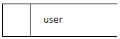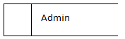

LEVEL 1.2 INDEXING UNCERTAIN OBJECT

user
Indexing uncertain object

Apply

admin
manage the Server process

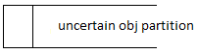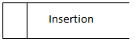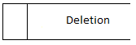

LEVEL 1.3 VIEW REPORT

View report
Require view report info 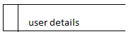
admin

Result information result
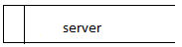

TABLE DESIGN

TABLE NAME: USER LOGIN
Column name | Data type | Description
Uname | Varchar(50) | User name
pwd | Varchar(50) | Password

TABLE NAME:ADMIN LOGIN
Column name | Data type | Description
Aname | Varchar(50) | Admin name
pwd | Varchar(50) | Password

TABLE NAME: NEW USER REGISTRATION
Column name | Data type | Description
Uname | Varchar(50) | User name
Pwd | Varchar(50) | Password
Rpwd | Varchar(50) | Re type password
Dob | Varchar(50) | Date of birth
Email | Varchar(50) | Email id
Pno | Varchar(50) | Phone no
add | Varchar(50) | Address

SCREEN SHOTS

HOME PAGE

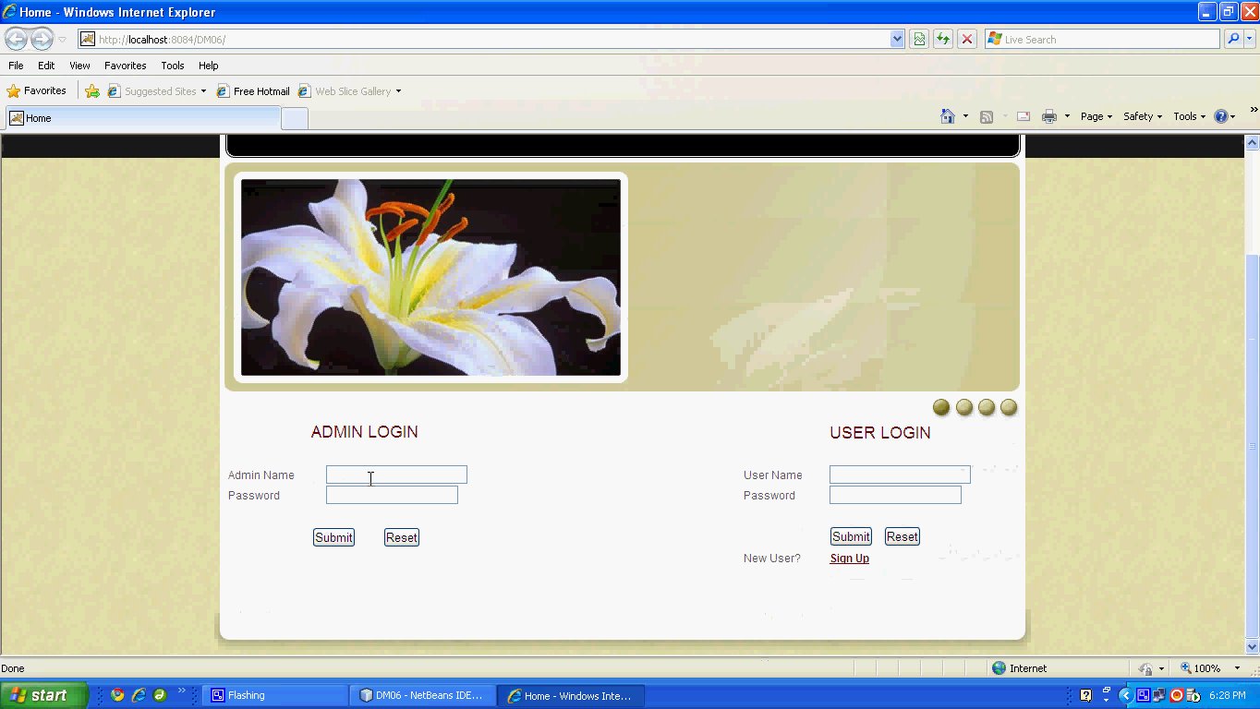

ADMIN PAGE

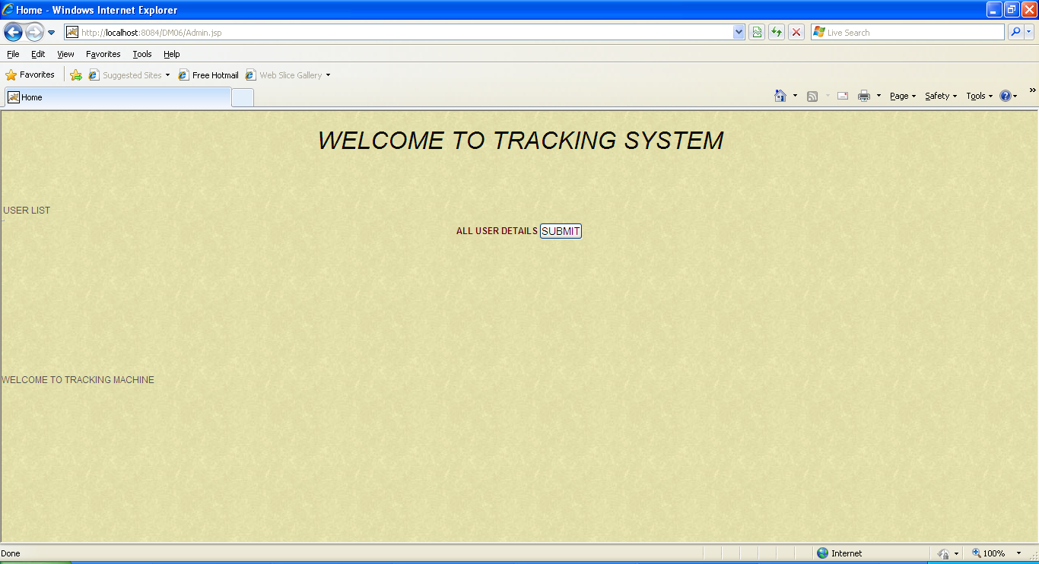

NEW USER REGISTRATION

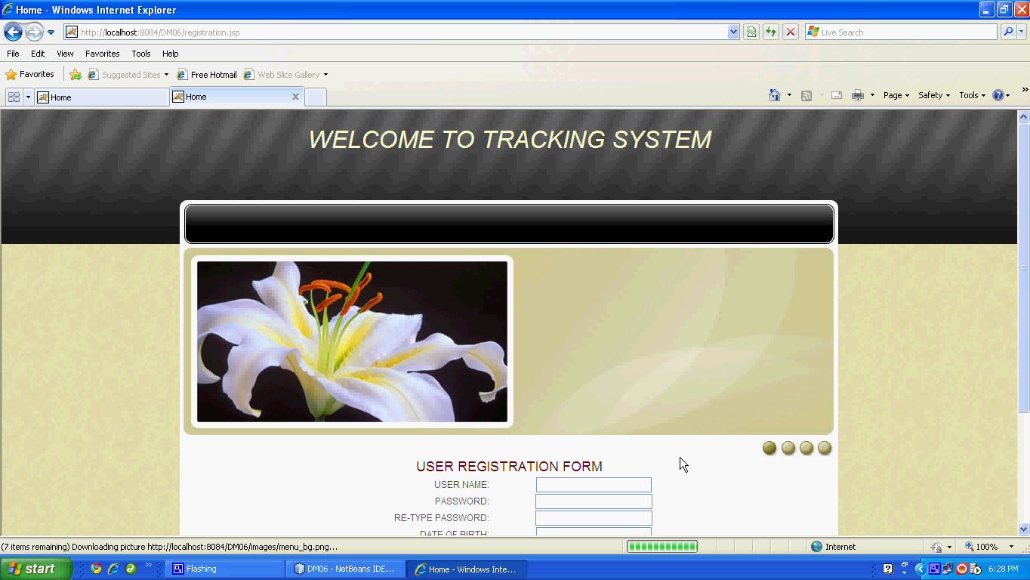

USER DETAIlS

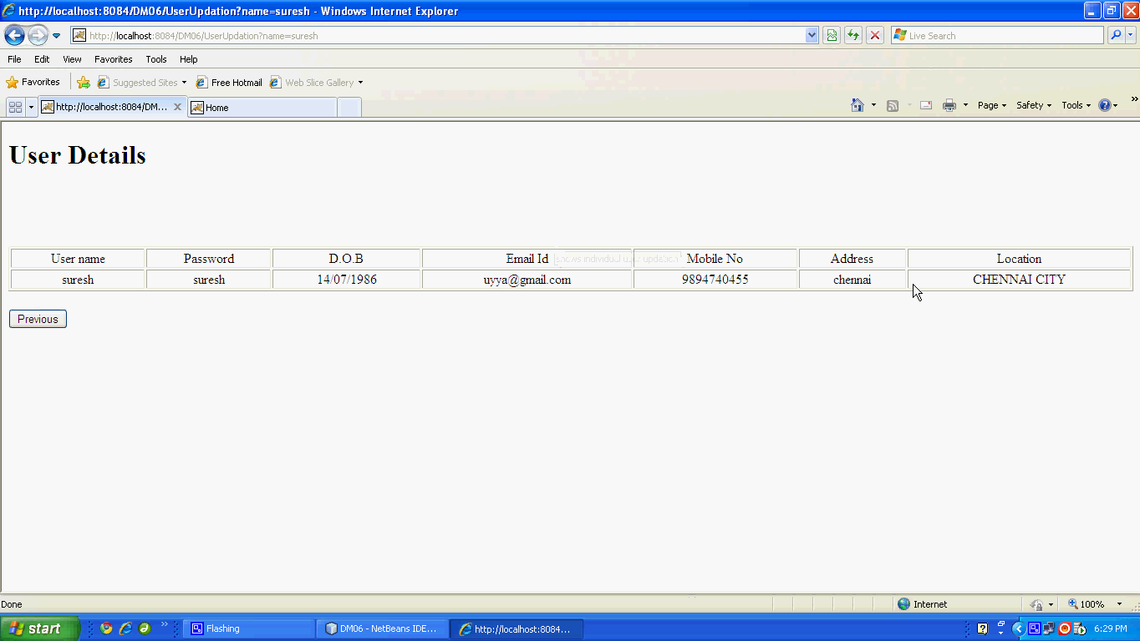

ADMIN WINDOW

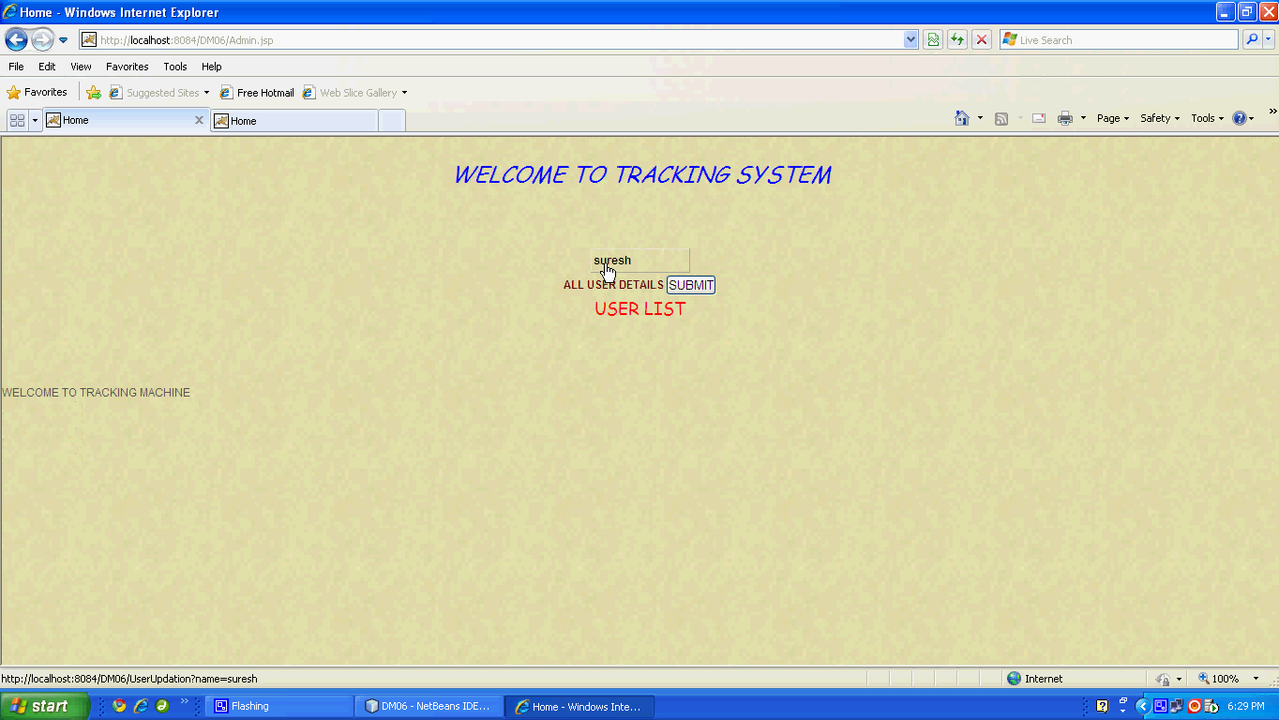

OBJECT PARTITION

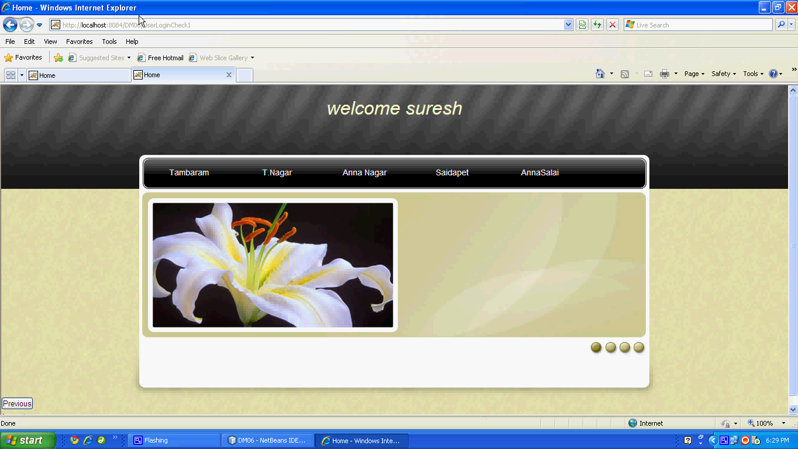

INDEXED OBJECTS

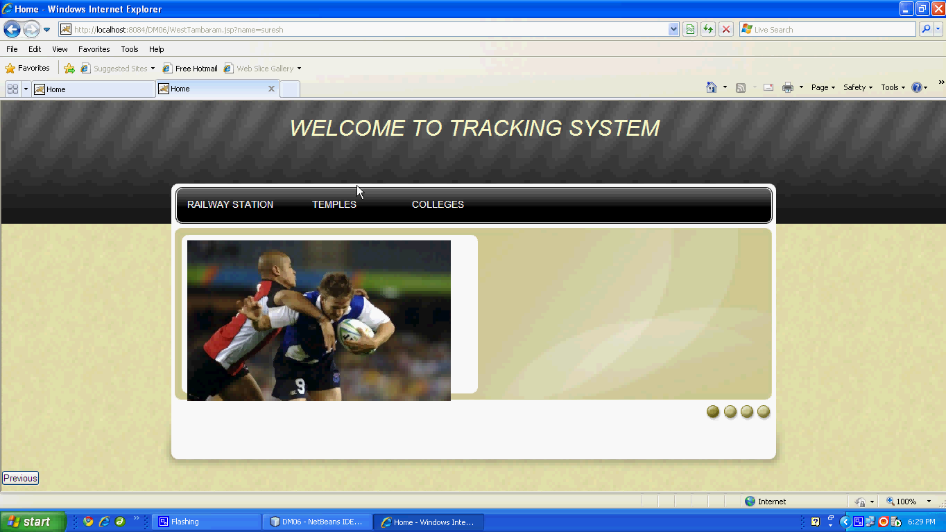

USER DETAILS

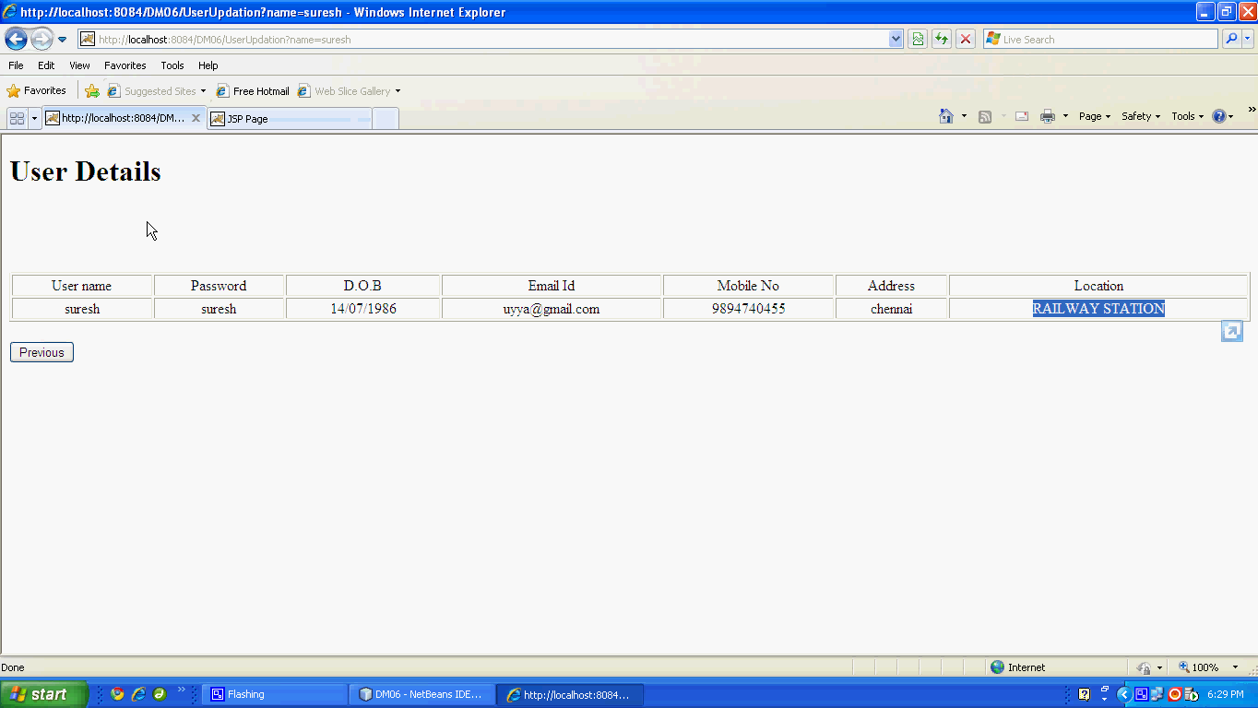

LOCATION DETAILS

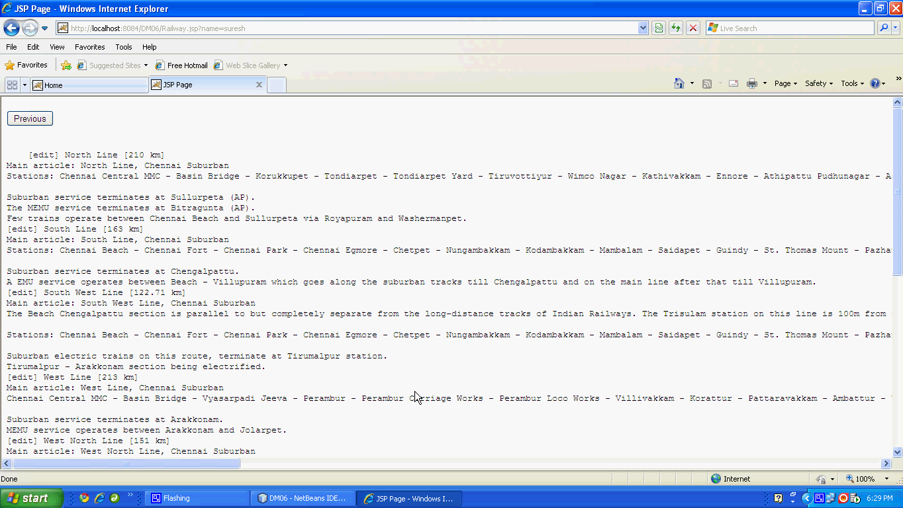

INDEXED OBJECTS

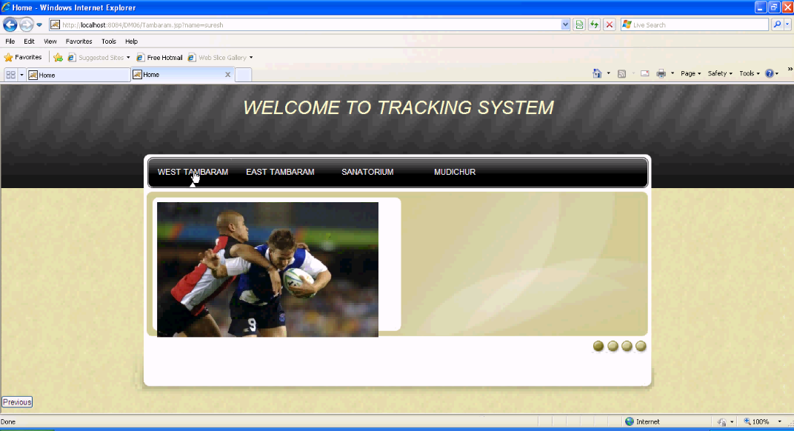

USER DETAILS

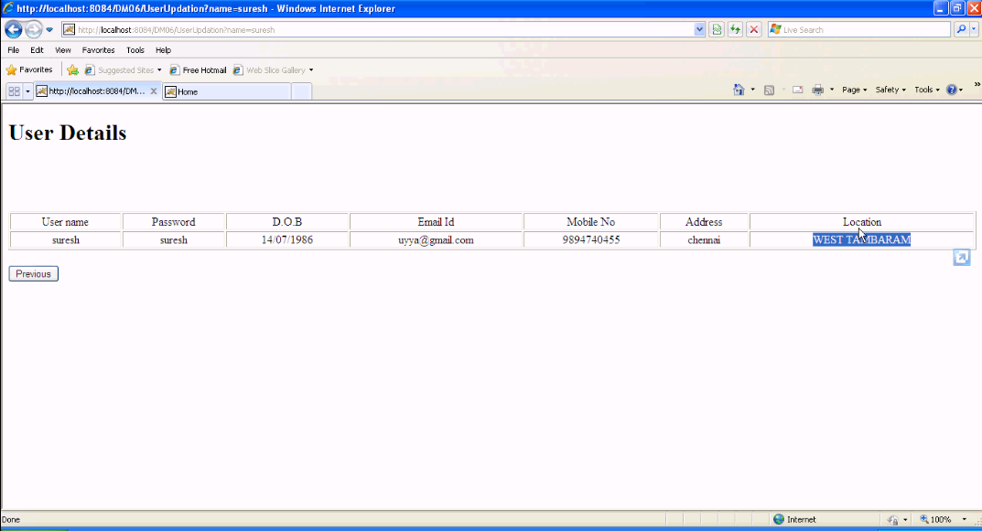

REPORT

INPUT SCREEN

USER DETAILS REPORT

LOCATION INFORMATION

