

Avinashilingam Institute for Home Science and Higher Education for Women
(Deemed to be University under Category ‘A’ by MHRD, Estd. u/s 3 of UGC Act 1956)
Re-accredited with ‘A+’ Grade by NAAC. Recognised by UGC Under Section 12B
Coimbatore - 641 043, Tamil Nadu, India

Master’s Degree Examination – November 2019
Semester III

Class : II PG Time: 3 hours Major : Biotechnology Max. Marks: 60

17MBTC20 - Environmental Biotechnology (Self study)

Part A 10 x ½ =5
Choose the correct answer

1. Which is the renewable exhaustible natural energy resource?
a.Coal b. Petroleum c. Kerosene d.Biomass
2. In an ecosystem, the energy flow is always
a.Always unidirectional b. Always bidirectional
c. In any direction d. Always down directional
3. The term biomass most often refers to ___________
a) Inorganic matter b) Organic matter
c) Chemicals d) Ammonium compounds
4. The percentage of carbondioxide in the bio methane is ____________
a) 30-40 b) 32-43 c) 35-45 d) 55-60.
5. The bio ethanol obtained in the fermentation process has __________ purity.
a) 99% b) 99.2% c) 99.4% d) 99.7%
6. The percentage of carbondioxide in the bio methane is ____________
a) 30-40 b) 32-43 c) 35-45 d) 55-60
7. Pests may be not be destroyed through
a. Parasites b. Insecticides c.herbicides d. pesticides.
8. Which cleanup approach involves removing groundwater or soil from its natural setting to allow for bioremediation?
a. In situ bioremediation b. Ex situ bioremediation
c. Bioaugmentation d.Phytoremediation
9. What is called for the chemicals which emit with vinyl floors?
a) Pathogens b) Vinyl oxidize c) Phthalates d) Chorines.
10.What is the hazardous pollutant released from luminous substances?
a) Arsenic b) Barium c) Zinc d) Silver

PART B ( 5 x 4 =20)
Each answer should not exceed 200 words or one page.
11.a. Write a note on the main sources of air pollution .
OR
b. Explain the reservoirs of oxygen cycle.
12.a. Describe the structure and properties of chitin
OR
b. How do you manage slaughterhouse waste? Illustrate.
13.a. Demonstrate the principle involved in hydrogen gas production.
OR
b. Give a brief note on the chemistry and uses of xanthan gum
14.a. Enumerate the factors influencing the microbial degradation of hydrocarbons
OR
b. Explain the types of phytoremediation.
15a. Classify tropical cyclones based on wind speed and Explain.
OR
b. Discuss the factors influencing soil erosion.
PART –C ( 5 x 7=35)
Answer all questions
16.a. Discuss about sources, types and management of water pollution..
OR
b. Give an account on the primary , secondary and tertiary waste water treatment
17.a. Write a note on i. algal blooms ii. plant biomass
OR
b. Exemplify the history, regulations and health benefits of probiotics
18.a. How do you prepare ethanol from molasses by using S.Cerevisiae? Illustrate.
OR
b. Elaborate on the renewable and non renewable energy sources.
19.a. Elaborate on the types and applications of bioremediation.
OR
b. Illustrate the role of microbes in treatment of oil pollution.
20.a. Discuss the formation, hazards and prevention of hailstroms.
OR
b. Explain the different stages in disaster management .
************************************************

AVINASHILINGAM INSTITUTE FOR HOME SCIENCE AND HIGHER EDUCATION FOR WOMEN, COIMBATORE- 64 1043
MASTERS DEGREE EXAMINATIONS- NOVEMBER 2019 .
17MBTC20-ENVIRONMENTAL BIOTECHNOLOGY-SET - II
SEMESTER – III
Class – II PG Time : 3 Hours
Major : Biotechology Max. Marks : 60
PART A (10 x ½= 5)
Answer all the following
Circle the correct answer
1.Which of the following requires maximum energy?
a.Secondary consumer . b. Decomposer
c. Primary consumer d. Primary producer
2. Which of the following Environmentalists first gave the concept of Biodiversity ‘hotspots’ ?
a. Gaylord Nelson b. Norman Myers c. John Muir d. Robertson.
3. _________ is called as the bio gas.
a) Bio ethanol b) Bio methane c) Bio diesel d) Bio butanol
4. By using single-cell protein, amount of protein produced by 50 kgs of yeast is
a.180 tons b. 100 tons c. 300 tons d. 250 tons
5. To make transport fuel the bio ethanol is blended with _________
a) Diesel b) Petrol c) Oil d) Kerosene
6. Which of the following is used to check vortex and to improve aeration efficiency in a
fermentor?
a. Impelle b. Baffles c. Sparger d. blade.
7. What is the reason that oil pollution attracts the greatest attention?
a) Because of the volume b) Because of the density
c) Because of the mass d) Because of the visibility
8. First use of pure microbiological process in an industrial procedure was made by.
a.Alexander b. Louis c.Charles Darwin d.Chaim Weizmann
9. The current rates of disease are increasing at alarming speeds and most are closely linked with known____________________
a) Carcinogens b) Invigorating c) Organic farming d) Balanced diet.
10. Open burning to recover copper wires causes ____
a) Silicosis b) Lung disease c) Kidney inflammation d) PAH exposure
PART B ( 5 x 4 =20)
Each answer should not exceed 200 words or one page.
11.a. Explain the causes and impact of thermal pollution.
OR
b. Describe the process involved in water cycle
12.a. Describe the structure and properties of pectin
OR
b. Write the advantages and disadvantages of Single cell protein
13.a. Demonstrate the principle involved in ethanol fermentation
OR
b. Give a brief note on the renewable and non renewabale energy sources
14.a Write a note on biosorption and bioaccumulation.
OR
b. Discuss the microbial degradation of pesticides
15a. Illustrate the effects of earth quake..
OR
b. Explain the causes and prevention of chemical hazards
PART –C ( 5 x 7=35)
Answer all questions
16.a. Discuss about the causes, harmful effects and management of air pollution .
OR
b. Illustrate the composition, collection, transport and disposal method of solid wastes .
17.a. Describe the plant and animal biomass with one example each.
OR
b. Explain ocean biomass and bacterial biomass with examples.
18.a. Elaborate on the production of ethanol from yeast fermentation process.
OR
b. Demonstrate the composition , production process and applications of biogas.
19.a.What is in-situ and ex-situ bioremediation? Explain in detail
OR
b. Exemplify the history , techniques and future prospects of biomining.
20.a. Illustrate the types of environmental hazards ? Explain natural environmental hazard with an example
OR
b.Give an account on disaster management and its role in society
************************************************

AVINASHILINGAM INSTITUTE FOR HOME SCIENCE AND HIGHER EDUCATION FOR WOMEN, COIMBATORE- 64 1043
MASTERS DEGREE EXAMINATIONS- NOVEMBER 2019 .
17MBTC20-ENVIRONMENTAL BIOTECHNOLOGY- SET -I
SEMESTER – III
Class – II PG Time : 3 Hours
Major : Biotechnology Max. Marks : 60
PART A (10 x ½= 5)
Answer all the following
1 | 2 | 3 | 4 | 5 | 6 | 7 | 8 | 9 | 10
d | a | b | b | d | b | a | b | c | c

PART B ( 5 x 4 =20)
Each answer should not exceed 200 words or one page.
11.a. Write a note on the main sources of air pollution .
Air pollution occurs when harmful or excessive quantities of substances including gases, particles, and biological molecules are introduced into Earth's atmosphere. Dust from natural sources, usually large areas of land with little or no vegetation
Methane, emitted by the digestion of food by animals, for example cattle Fumes from paint, hair spray, varnish, aerosol sprays and other solvents. These can be substantial; emissions from these sources was estimated to account for almost half of pollution from volatile organic compounds
OR
b. Explain the reservoirs of oxygen cycle.
Oxygen is one of the most abundant elements on Earth and represents a large portion of each main reservoir. By far the largest reservoir of Earth's oxygen is within the silicate and oxide minerals of the crust and mantle (99.5% by weight).
12.a. Describe the structure and properties of chitin
Chitin (C₈H₁₃O₅N)_{n} a long-chain polymer of N-acetylglucosamine, is a derivative of glucose. It is a primary component of cell walls in fungi, the exoskeletons of arthropods, such as crustaceans and insects, the radulae of molluscs, cephalopod beaks, and the scales of fish and lissamphibians. The structure of chitin is comparable to another polysaccharide—cellulose, forming crystalline nanofibrils or whiskers. In terms of function, it may be compared to the protein keratin. Chitin has proved useful for several medicinal, industrial and biotechnological purposes.
OR
b. How do you manage slaughterhouse waste? Illustrate.
Meat processing effluents are usually pretreated using screeners, settlers, and blood collection systems, followed by physicochemical treatment methods, such as coagulation, flocculation, sedimentation, DAF, or secondary biological treatment. Although biological treatment is able to provide high organic and nutrient removal efficiencies, further treatment by AOPs, or other BAT, is required for a high-quality effluent.
13.a. Demonstrate the principle involved in hydrogen gas production.
The main reactions involve fermentation of sugars. Important reactions start with glucose, which is converted to acetic acid:
C₆H₁₂O₆ + 2 H₂O → 2 CH₃CO₂H + 2 CO₂ + 4 H₂
A related reaction gives formate instead of carbon dioxide:
C₆H₁₂O₆ + 2 H₂O → 2 CH₃CO₂H + 2 HCO₂H + 2 H₂
OR
b. Give a brief note on the chemistry and uses of xanthan gum
Xanthan gum is a polysaccharide with many industrial uses, including as a common food additive. It is an effective thickening agent and stabilizer to prevent ingredients from separating. It can be produced from simple sugars using a fermentation process, and derives its name from the species of bacteria used, Xanthomonas campestris.
14.a. Enumerate the factors influencing the microbial degradation of hydrocarbons
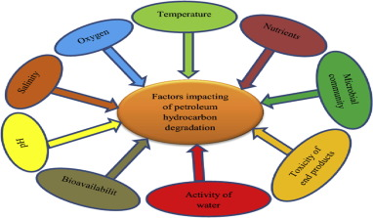
OR
b. Explain the types of phytoremediation.
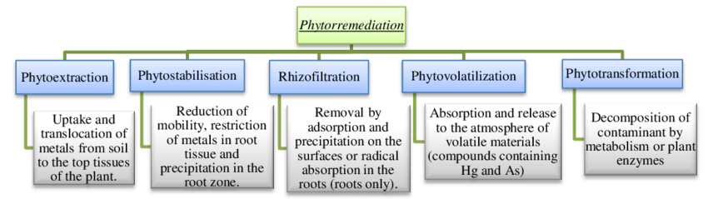

15a. Classify tropical cyclones based on wind speed and Explain.
Tropical Cyclone. Less than 125 km/h. Gales. Minimal house damage.
2 Tropical Cyclone. 125 - 164 km/h. Destructive winds.
3 Severe Tropical Cyclone. 165 - 224 km/h. Very destructive winds.
4 Severe Tropical Cyclone. 225 - 279 km/h. Very destructive winds.
5 Severe Tropical Cyclone. More than 280 km/h. Extremely destructive winds.
OR
b. Discuss the factors influencing soil erosion.
Main factors are – Climate, Soil structure and composition, topography, and vegetation
The amount and intensity of precipitation is the main climatic factor governing soil erosion by water. Soil containing high levels of organic materials are often more resistant to erosion, because the organic materials coagulate soil colloids and create a stronger, more stable soil structure.
PART –C ( 5 x 7=35)
Answer all questions
16.a. Discuss about sources, types and management of water pollution.
Water pollution is the contamination of water bodies, usually as a result of human activities. Water bodies include for example lakes, rivers, oceans, aquifers and groundwater. Water pollution results when contaminants are introduced into the natural environment. For example, releasing inadequately treated wastewater into natural water bodies can lead to degradation of aquatic ecosystems. In turn, this can lead to public health problems for people living downstream.
OR
b. Give an account on the primary ,secondary and tertiary waste water treatment.
Primary treatment removes material that will either float or readily settle out by gravity. It includes the physical processes of screening, comminution, grit removal, and sedimentation.
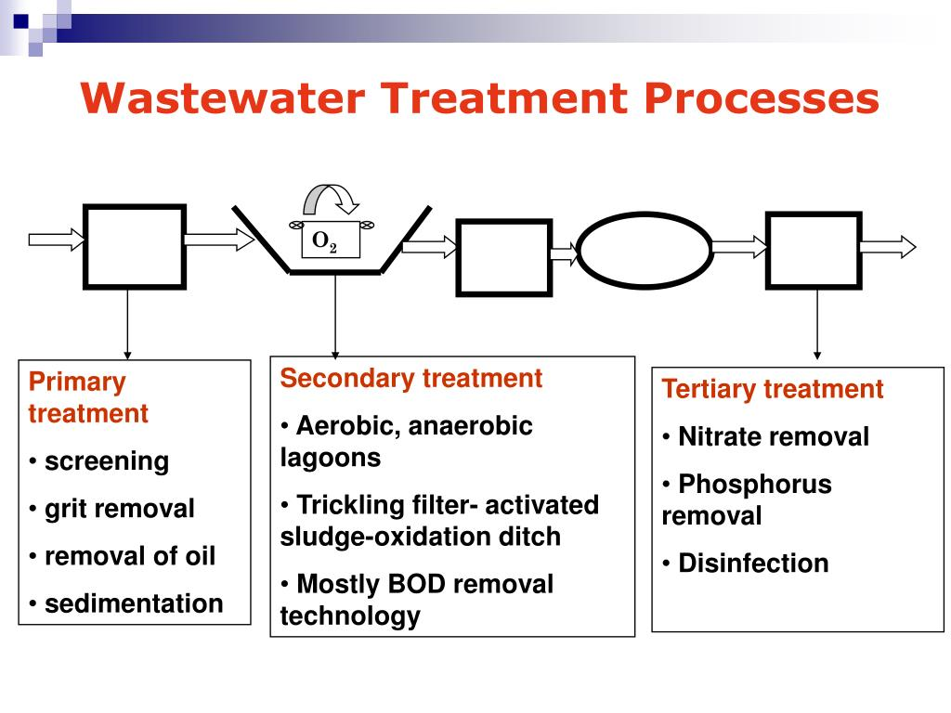
17.a. Write a note on i. algal blooms ii. plant biomass (3+4)
An algal bloom or algae bloom is a rapid increase or accumulation in the population of algae in freshwater or marine water systems, and is recognized by the discoloration in the water from their pigments.Plant biomass is a valuable resource for renewable materials whether they are transportation fuels, chemical intermediates/bulk chemicals, or sources of heat and generated power.
OR
b. Exemplify the history, regulations and health benefits of probiotics
Probiotics are live microorganisms intended to provide health benefits when consumed, generally by improving or restoring the gut flora. Probiotics are considered generally safe to consume, but may cause bacteria-host interactions and unwanted side effects in rare cases.

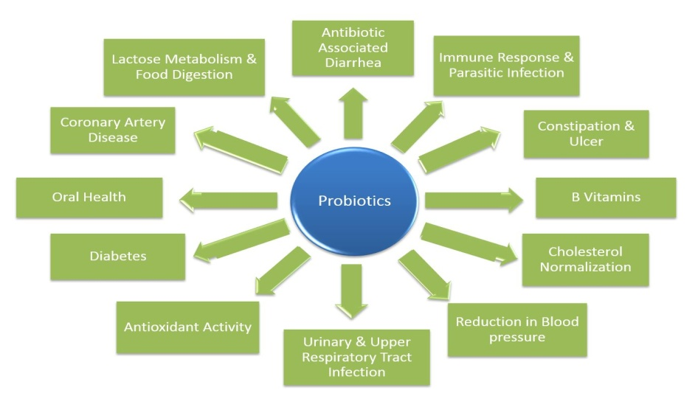
18.a. How do you prepare ethanol from molasses by using S.Cerevisiae? Illustrate.
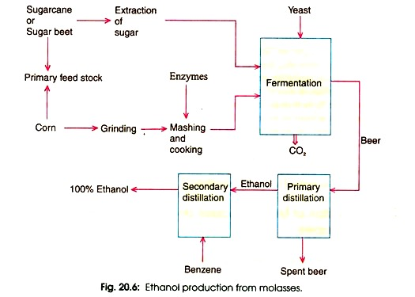
OR
b. Elaborate on the renewable and non renewable energy sources.
A renewable resource is a natural resource which will replenish to replace the portion depleted by usage and consumption, either through natural reproduction or other recurring processes in a finite amount of time in a human time scale
Non-renewable energy comes from sources that will run out or will not be replenished in our lifetimes—or even in many, many lifetimes. Most non-renewable energy sources are fossil fuels: coal, petroleum, and natural gas. Carbon is the main element in fossil fuels.
19.a. Elaborate on the types and applications of bioremediation.
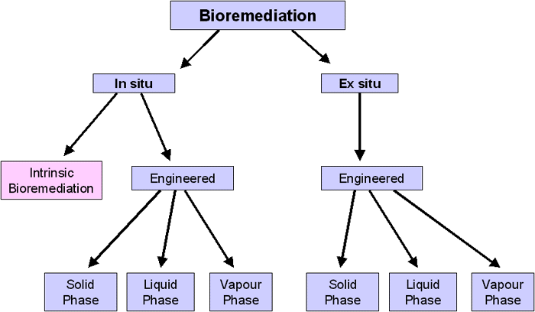
OR
b. Illustrate the role of microbes in treatment of oil pollution.
Oil degrading organisms have evolved to use the hydrocarbons and organic compounds in petroleum as energy, and use molecular transfer mechanisms to denature these toxins. The aerobic and anaerobic properties of these microbes allow them to respire and ferment compounds as well, and this tends to result in the transformation of toxins into innocuous compounds.
20.a. Discuss the formation, hazards and prevention of hailstroms.
Hail forms in strong thunderstorm clouds, particularly those with intense updrafts, high liquid water content, great vertical extent, large water droplets, and where a good portion of the cloud layer is below freezing 0 °C (32 °F). These types of strong updrafts can also indicate the presence of a tornado. The growth rate of hailstones is impacted by factors such as higher elevation, lower freezing zones, and wind shear.
OR
b. Explain the different stages in disaster management .
The four phases of disaster: 1) mitigation; 2) preparedness; 3) response; and 4) recovery. The model helps frame issues related to disaster preparedness as well as economic and business recovery after a disaster.
************************************************

AVINASHILINGAM INSTITUTE FOR HOME SCIENCE AND HIGHER EDUCATION FOR WOMEN,COIMBATORE- 64 1043
MASTERS DEGREE EXAMINATIONS- NOVEMBER 2019 .
17MBTC20-ENVIRONMENTAL BIOTECHNOLOGY-SET - II
SEMESTER – III
Class – II PG Time : 3 Hours
Major : Biotechology Max. Marks : 60
PART A (10 x ½= 5)
Answer all the following
1 | 2 | 3 | 4 | 5 | 6 | 7 | 8 | 9 | 10
d | b | b | d | b | b | d | d | a | a

PART B ( 5 x 4 =20)
Each answer should not exceed 200 words or one page.
11.a. Explain the causes and impact of thermal pollution.
Thermal pollution is the degradation of water quality by any process that changes ambient water temperature. A common cause of thermal pollution is the use of water as a coolant by power plants and industrial manufacturers. Other causes of thermal pollution include soil erosion. This will elevate water and expose it to sunlight.
OR
b. Describe the process involved in water cycle
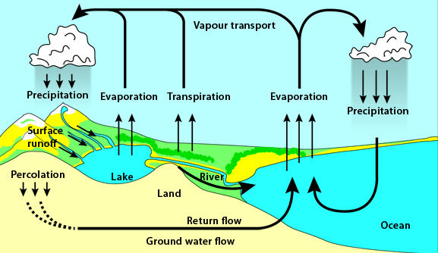

12.a. Describe the structure and properties of pectin
Pectin is a structural polysaccharide that is integral for the stability of plant cell walls. The biological function of pectin is to cross-link cellulose and hemicellulose fibers, providing rigidity to the cell wall. Pectin is also a major component of the middle lamella, where it helps to bind cells together.
OR
b. Write the advantages and disadvantages of Single cell protein
Single-cell proteins (SCP) refers to edible unicellular microorganisms. The biomass or protein extract from pure or mixed cultures of algae, yeasts, fungi or bacteria may be used as an ingredient or a substitute for protein-rich foods, and is suitable for human consumption or as animal feeds. Industrial agriculture is marked by a high water footprint, high land use, biodiversity destruction, general environmental degradation
13.a. Demonstrate the principle involved in ethanol fermentation
Ethanol fermentation, also called alcoholic fermentation, is a biological process which converts sugars such as glucose, fructose, and sucrose into cellular energy, producing ethanol and carbon dioxide as by-products. Because yeasts perform this conversion in the absence of oxygen, alcoholic fermentation is considered an anaerobic process. It also takes place in some species of fish (including goldfish and carp) where (along with lactic acid fermentation) it provides energy when oxygen is scarce.
OR
b. Give a brief note on the renewable and non renewabale energy sources
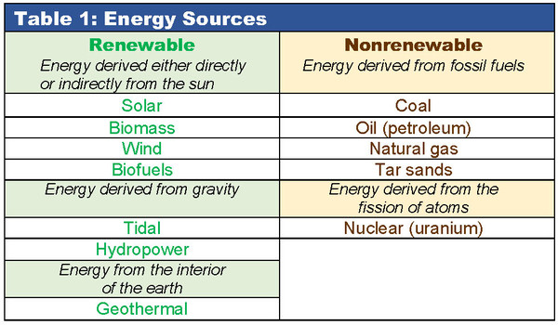
14.a Write a note on biosorption and bioaccumulation.
Biosorption is a metabolically passive process, meaning it does not require energy, and the amount of contaminants a sorbent can remove is dependent on kinetic equilibrium and the composition of the sorbents cellular surface. Contaminants are adsorbed onto the cellular structure.Bioaccumulation is an active metabolic process driven by energy from a living organism and requires respiration.
OR
b. Discuss the microbial degradation of pesticides
Pesticide fate in the environment is affected by microbial activity. Some pesticides are readily degraded by microorganisms, others have proven to be recalcitrant. A diverse group of bacteria, including members of the genera Alcaligenes, Flavobacterium, Pseudomonas and Rhodococcus, metabolize pesticides.
15a. Illustrate the effects of earth quake.
An earthquake (also known as a quake, tremor or temblor) is the shaking of the surface of the Earth, resulting from the sudden release of energy in the Earth's lithosphere that creates seismic waves.
OR
b. Explain the causes and prevention of chemical hazards
A chemical hazard is a type of occupational hazard caused by exposure to chemicals in the workplace. Exposure to chemicals in the workplace can cause acute or long-term detrimental health effects. There are many types of hazardous chemicals, including neurotoxins, immune agents, dermatologic agents, carcinogens, reproductive toxins, systemic toxins, asthmagens, pneumoconiotic agents, and sensitizers.
PART –C ( 5 x 7=35)
Answer all questions
16.a. Discuss about the causes, harmful effects and management of air pollution .
Air pollution occurs when harmful or excessive quantities of substances including gases, particles, and biological molecules are introduced into Earth's atmosphere. It may cause diseases, allergies and even death to humans; it may also cause harm to other living organisms such as animals and food crops, and may damage the natural or built environment. Both human activity and natural processes can generate air pollution.
OR
b. Illustrate the composition, collection, transport and disposal method of solid wastes .
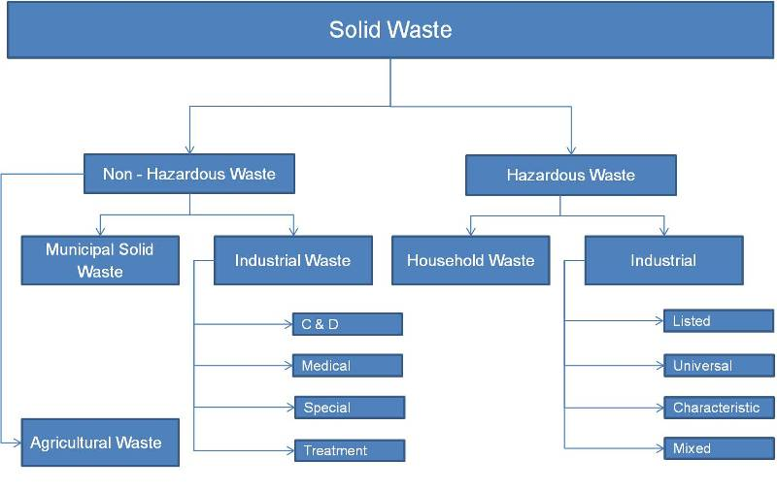
17.a. Describe the plant and animal biomass with one example each.
Biomass, the weight or total quantity of living organisms of one animal or plant species(species biomass) or of all the species in a community (community biomass), commonly referred to a unit area or volume of habitat
Plant biomass is a valuable resource for renewable materials whether they are transportation fuels, chemical intermediates/bulk chemicals, or sources of heat and generated power.
OR
b. Explain ocean biomass and bacterial biomass with examples.
Ocean or marine biomass, in a reversal of terrestrial biomass, can increase at higher trophic levels. In the ocean, the food chain typically starts with phytoplankton, and follows the course:
Phytoplankton → zooplankton → predatory zooplankton → filter feeders → predatory fish
Microbial biomass (bacteria and fungi) is a measure of the mass of the living component of soil organic matter. The microbial biomass decompose plant and animal residues and soil organic matter to release carbon dioxide and plant available nutrients.

18.a. Elaborate on the production of ethanol from yeast fermentation process
OR
b. Demonstrate the composition , production process and applications of biogas.
Biogas is produced using well-established technology in a process involving several stages:
- Biowaste is crushed into smaller pieces and slurrified to prepare it for the anaerobic digestion process. Slurrifying means adding liquid to the biowaste to make it easier to process.
- Microbes need warm conditions, so the biowaste is heated to around 37 °C.
- The actual biogas production takes place through anaerobic digestion in large tanks for about three weeks.
- In the final stage, the gas is purified (upgraded) by removing impurities and carbon dioxide.
19.a.What is in-situ and ex-situ bioremediation? Explain in detail
OR
b. Exemplify the history , techniques and future prospects of biomining.
Biomining is a technique of extracting metals from ores and other solid materials typically using prokaryotes or fungi. These organisms secrete different organic compounds that chelate metals from the environment and bring it back to the cell where they are typically used to coordinate electrons. It was discovered in the mid 1900s that microorganisms use metals in the cell.
20.a. Illustrate the types of environmental hazards ? Explain natural environmental hazard with an example
An environmental hazard is a substance, a state or an event which has the potential to threaten the surrounding natural environment / or adversely affect people's health, including pollution and natural disasters such as storms and earthquakes.
OR
b.Give an account on disaster management and its role in society
Disaster Management can be defined as the organization and management of resources and responsibilities for dealing with all humanitarian aspects of emergencies, in particular preparedness, response and recovery in order to lessen the impact ofdisasters.
************************************************

