Designing and Construction of Garments Using Fabric Scraps Collected From Selected Boutiques

By,
P.PRIYANKA
(17PTF014)

A Thesis submitted to the
Avinashilingam Institute for Home Science and Higher Education for Women, Coimbatore-641 043.

In partial Fulfillment of the Requirement for the
Degree of Master of Science
in
Textile and fashion Apparel

APRIL, 2019
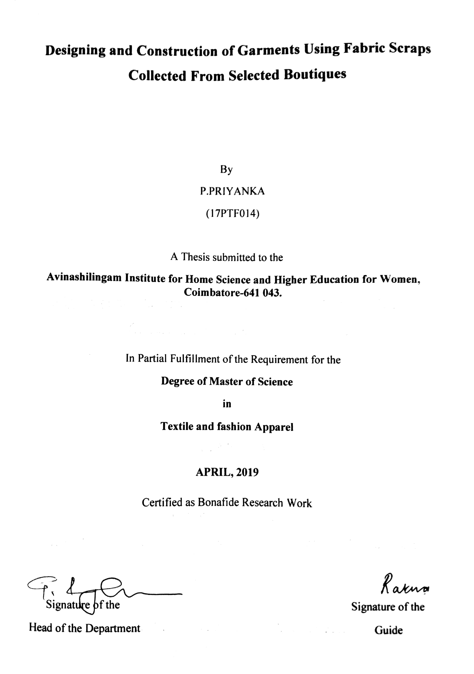

ACKNOWLEDGEMENT
The investigator places her humble salutations and prayer to the ALMIGHTY GOD for his uncountable blessings showered upon her throughout the study.
The investigator expresses her sincere thanks to the former chancellors of Avinashilingam Institute for Home Science and Higher Education for Women, Coimbatore, Padmabushan. Dr. T.S. AVINASHILINGAM and HON. COL. Padmashri, Dr. (Tmt.) RAJAMMAL P. DEVADAS, M.A., M.Sc., Ph.D. (Ohio State) Hon, D.Sc, (Azad Agri, University, Kanpur) for heavenly blessing.
The investigator expresses her sincere thanks to Padmashri Dr. P.R. KRISHNAKUMAR, Chancellor of Avinashilingam Institute for Home Science and Higher Education for Women, Coimbatore, for providing the infrastructural facilities for the conduct of the study.
The investigator records her gratitude to Dr.(Mrs.) PREMAVATHY VIJAYAN, M.Sc., M.Ed., Dip. Spl. Edn., M.Phil.., Ph.D., Vice Chancellor, Avinashilingam Institute for Home Science and Higher Education for Women, Coimbatore, for providing all the amenties required for the conduct of the study.
The investigator records her gratitude to Dr. (Mrs.) S. KOWSALYA, M.Sc., M.Phil., Ph.D., Registrar, Avinashilingam Institute for Home Science and Higher Education for Women, Coimbatore, for providing all the help for the smooth conduct of the study.
The investigator records her respectful gratitude to Dr. (Tmt) N. VASUGI RAAJA, M.Sc., M.B.A., M.Phil, (Madras), Ph.D. Dean, Faculty of Home Science, Professor in Textiles and Clothing, Avinashilingam Institute for Home Science and Higher Education for Women, Coimbatore, for constant encouragement which have helped in the successful completion of this study.
The investigator records her gratitude to Dr. (Tmt.) G.BAGYALAKSHMI , M.Sc., M.Phil., Ph.D., Associate Professor and Head, Department of Textiles and Clothing. Avinashilingam Institute for Home Science and Higher Education for Women, Coimbatore, for constant guidance and encourage which have helped in the successful completion of this study.
The investigator feels extremely proud and privileged for having worked under the guidance of her esteem guide, Dr. (Mrs.) U. Ratna, M.Sc., M. Phil., Ph.D., (Avinashilingam)., Associate Professor, Department of Textiles and Clothing, Avinashilingam Institute of Home Science and Higher Education for Women, Coimbatore, for her constant motivation, keen interest, untiring patience, innovative ideas, suggestion, constant love and easy approach throughout the study.
She also wishes to thank all the TEACHING, NON-TEACHING, STAFF and STUDENTS of the department of Textiles and Clothing who helped her to carry out the research work. She acknowledges her special thanks to Avinashilingam Institute of Home Science and Higher Education for Women, for the library facilities and guidance provided.
The investigator gratefully acknowledges the encouragement, timely help and support received from her friends. She expresses her deepest sense of gratitude to her Beloved Parents, Family Members and Friends for extending their support without them the study would never have been seen the light of the day.

S.NO | TITLES | Page No
 | LIST OF PLATES
 | INTRODUCTION | 1
 | REVIEW OF LITERATURE | 4
 | 2.1 DESIGNING | 6
 | 2.1.1 Definition | 6
 | 2.1.2 Principles of Design | 6
 | 2.1.3 Elements of Design | 8
 | 2.1.4 Types of Designing | 10
 | 2.2 BOUTIQUE | 11
 | 2.2.1 Definition | 12
 | 2.2.2 Classification | 12
 | 2.3 SUSTAINABILITY | 12
 | 2.3.1 Definition | 13
 | 2.3.2 Classification | 14
 | 2.3.2.1 Reduce | 15
 | 2.3.2.2 Reuse | 15
 | 2.3.2.3 Recycle | 15
 | 2.3.2 Need of sustainability in apparel industry | 16
 | 2.4 FABRIC | 16
 | 2.4.1 Classification of fabrics | 16
 | 2.5 STYLES OF GARMENT | 18
 | 2.6 GARMENT MANUFACTURINGPROCESS | 26
 | 2.7 BODY MEASUREMENTS | 33
 | 2.8 FASHION PORTFOLIO PREPARATIO | 35
 | 2.8.1 Definition | 35
 | 2.8.2 Types of Portfolio | 36
 | 2.8.3 Fashion Portfolio Boards | 36
III | EXPERIMENTAL PROCEDURE | 45
 | 3.1 SELECTION OF BOUTIQUE | 45
 | 3.2 SELECTION OF FABRIC | 45
 | 3.3 SELECTION OF GARMENT | 45
 | 3.4 PORTFOLIO PREPARATION | 45
 | 3.4.1 Inspiration Board | 46
 | 3.4.2 Mood Board | 47
 | 3.4.3 Colour Board | 48
 | 3.4.4 Customer Profile | 49
 | 3.4.5 Photographs | 50
 | 3.5 DESIGNING | 51
 | 3.6 DRAFTING AND CONSTRUSTION | 51
 | 3.6.1 Princess Cut Blouse | 51
 | 3.6.2 Skirt | 55
 | 3.6.3 Maxi Top | 56
 | 3.6.4 Kurta | 56
IV | RESULT AND DISCUSSION | 60
 | 4.1 PORTFOLIO PRESENTATION | 61
 | 4.2 GARMENT DESIGN | 65
V | SUMMARY AND CONCLUSION | 68

LIST OF PLATES

P.NO | PLATE | Page No
I | Inspiration Board | 46
II | Mood Board | 47
III | Colour Board | 48
IV | Customer Profile | 49
IV | Photographs of Garments | 50
V | Drafting To the Bodice Pattern: Method 1 | 52
VI | Drafting To the Bodice Pattern: Method II | 53
VII | Drafting the Sleeve Pattern | 54
VIII | Skirt Pattern | 56
IX | Maxi Top | 57
X | Drafting the Front and Back Patterns | 58
XI | Sleeve Pattern | 59

BIBLOGRAPHY

BOOKS:

- A Briggs-Goode, K Townsend (2011) “Textile Design: Principles, Advances and Applications” Woodhead Publishing Limited.
- A.W. Koester and N.O.Bryant, (2001) “Fashion Terms and Styles for Women's Garments” Oregon State University Extension Service.
- Alison Beazley, Terry Bond (2009) “Computer-Aided Pattern Design and Product Development” Pages displayed by permission of John Wiley & Sons.
- Alison Smith (2006) “The Sewing Book” Dorling Kindersley Ltd.
- Angel Fernández, Daniela Santos Quartino (2014) “Fashion Print Design: From Idea to the Final Print” Schiffer Publishing, Limited.
- Anna Kiper (2016) “Fashion Portfolio: Design and Presentation” Pavilion Books.
- Anni Albers (2003) “On Weaving” Manufatured in the united states of America Dover publications, Inc.
- Asim Kumar Roy Choudhury (2013) “Principles of Textile Finishing” permission of Woodhead Publishing.
- Clara Grant (2013) “Courses of Exercises for Young Children in Sorting, Ravelling, Paper Tearing” Read Books Ltd.
- Colin Gale, Jasbir Kaur (2002) “The Textile Book” Bloomsbury Academic.
- Ezinma Mbonu (2014) “Fashion Design Research” Laurence King Publishing.
- Frazier M. Douglass IV (2012) “The Tent Camper’S Handbook” permission of Universe.
- G. J. Sumath (2007) “Elements of Fashion and Apparel Design” Published by new age International (p) Ltd.
- Glock (2005) “Apparel Manufacturing: Sewn Product Analysis” Dorling kihdersley Pvt, Ltd., licensees of Pearson Education in South Asia.
- Ineta Vilumsone-Nemes (2018) “ndustrial Cutting of Textile Materials
The Textile Institute Book Series” Elsevier Science
- J Fan, L Hunter, (2009) “Engineering Apparel Fabrics and Garments” permission of Elsevier.
- J Wilson (2001) “Handbook of Textile Design” woodhead Publishing ltd and CRC Press LLC.
- Janace E. Bubonia (2017) “Apparel Production Terms and Processes: Studio Instant Access” Bloomsbury Academic.
- Jenny Udale (2008) “Basics Fashion Design 02: Textiles and Fashion” publiched by ava publishing SA Rue des Fontenailes 16 Case Postats 1000 Lausanne 5 Switzerland.
- Jo Baker-Waters (2016) “Pattern Cutting Techniques for Ladies' Jackets” The Crowood Press.
- John Hopkins (2006) “Basics Fashion Design 05: Fashion Drawing” permission of AVA Publishing. Copyright.
- John Hopkins (2015) “Fashion Drawing” permission of Bloomsbury Publishing.
- Kitty G. Dickson (2004) “Inside the Fashion Business” permission of Pearson Education India. Copyright.
- Laura Nugent (2008) “Computerized Patternmaking for Apparel Production” Bloomsbury Academic.
- Linda Tain (2018) “Portfolio Presentation for Fashion Designers” Bloomsbury Academic.
- Lisa Arnold, Marianne Egan (2012) “Fashion Drawing For Dummies” permission of John Wiley & Sons. Copyright.
- Lisa Springsteel (2006) “Becoming a Fashion Designer” permission of John Wiley & Sons. Copyright.
- Mary Ann Scott, Margaret Stevens (2015) “Botanical Sketchbook: Drawing, painting and illustration for botanical artists” Pavilion Books.
- Mary Carolyn Beaudry (2006) “Findings: The Material Culture of Needlework And Sewing” permission of Yale University Press.
- Mary G. Wolfe (2008) “Fashion Marketing & Merchandising” Goodheart Willcox Company.
- Melanie Bowles, Ceri Isaac (2014) “Digital Textile Design: Portfolio Skills” Laurence King Publishing.
- Michael James,Paul N. Daniels, Denton (2002) “Textile terms and definitions” Textile Institute.
- Mykyung Uh, Injoo Kim (2001) “Apparel Making in Fashion Design” Bloomsbury Academic.
- Nancy Wolford, Ellen Cheever, NKBA (National Kitchen and Bath Association) (2015) “Kitchen and Bath Design Principles: Elements, Form, Styles” Joho wilwy & sons, Inc, Hoboken, New Jersey.
- Nicole Thompson (2017) “Textile Waste & The 3R’s:Textile waste strategy recommendations for the City of Toronto” A Major PaperSubmitted to the Faculty of Environmental Studiesin partial fulfillment of the requirements for the degree of Master in Environmental StudiesYork University.
- Prabhu Thankaraju (2019) “Startup 500 Business Ideas: Business Strategies and 500 Business How to Start” prabhu thangarajan.
- Prasanta Sarkar (2015) “Garment Manufacturing: Processes,Practices and Technology” online clothing study Gurgaon, India.
- Rajkishore Nayak, Rajiv Padhye (2013) “Garment Manufacturing Technology” Woodhead pubishing, permission of Elsevier. .
- Rajkishore Nayak, Rajiv Padhye (2015) “Garment Manufacturing Technology” permission of Elsevier. Copyright.
- Richard Blackburn (2009) “Sustainable Textiles: Life Cycle and Environmental Impac” published by woodhead publishing limited in association with the textile institute woodhead publishing limited, Abington hall, granta park, great Abington Cambridge.
- Richard Sorger, Jenny Udale (2006) “ The Fundamentals of Fashion Design” publiched by ava publishing SA Rue des Fontenailes 16 Case Postats 1000 Lausanne 5 Switzerland.
- Rosie Wilson (2012) “The Fashion Industry” Hachette Children's Group.
- Russell V. Luepker, Alun Evans, Paul McKeigue, K. Srinath Reddy (2006) “Cardiovascular Survey Methods, Volume 2” displayed by permission of World Health Organization.
- Sarah Veblen (2013) “The Complete Photo Guide to Perfect Fitting” Creative Publishing international.
- sekhri, seema, (2016) “Textbook Of Fabric Science Fundamentals To Finishing” Published by Asoke K. Ghosh, PHI Learning Private Limited, Rimjhim House, 111, Patpatganj Industrial Estate , Delhi
- SINGH, S. P., Mehta, Promila (2006) “Human Body Measurements: Concepts and Applications” permission of PHI Learning Pvt. Ltd..
- Steven Hayes, John McLoughlin, Dorothy Fairclough (2012) “Garment Technology for Fashion Designers” permission of John Wiley & Sons.
- Subramanian Senthilkannan Muthu (2016) “Sustainability in the Textile Industry” Springer Nature The registered Company is springer nature Singapore Pte Ltd.
- T. Karthik, P. Ganesan, D. Gopalakrishnan (2015) “Apparel Manufacturing Technology” permission of CRC Press.
- Thomas Werner (2019) “The Fashion Image: Planning and Producing Fashion Photographs and Films” permission of Bloomsbury Publishing.
- Timo Rissanen (2018) “Zero Waste Fashion Design” Bloomsbury academic.
- T Rowe (2009) “Interior Textiles: Design and Developments” Pages displayed by permission of Elsevier.
- Vikki Haffenden, Frederica Patmore (2003) “The Knitting Book: Yarns, Techniques, Stitches, Patterns” dorling Kindersley Limited 80 Strand, London WC2R ORL Penguin Group (UK).
- W. H. Hulme (2013) “The Theory of Garment-Pattern Making - A Textbook for Clothing Designers” Read Books Ltd.
- Willow Sidhe (2009) “About Boutiques” Leaf Group Ltd. / Leaf Group Media, All Rights Reserved.
- Winifred Aldrich (2013) “Fabrics and Pattern Cutting” permission of John Wiley & Sons.
- Winifred Aldrich (2015) “Metric Pattern Cutting for Women's Wear” permission of John Wiley & Sons
- Wucius Wong.,(1993) “Principles of Form and Design” JOHN WILEY &SONS, INC. New yark Chichester Weinheim Brisbane Singapore Toronto.
- Yordan Kyosev (2014) “Braiding Technology for Textiles: Principles, Design and Processes” Woodhead Publishing.
INTERNET:
- http://textilelearner.blogspot.com/2012/07/what-is-fabric-warp-weft-fabric.html
- http://textilelearner.blogspot.com/2015/08/different-types-and-classification-of.html
- http://textilelearner.blogspot.com/2019/02/3-rs-of-sustainability-in-textiles.html
- http://www.garmentsmerchandising.com/flow-chart-of-garments-manufacturing-process/
- https://www.2bfuntex.eu/sites/default/files/materials/Sustainable%20textiles_Antonela%20Curteza.pdf
- https://www.incredibleart.org/files/elements2.htm
- https://www.marthastewart.com/1504765/tricks-to-taking-accurate-body-measurements
- https://www.slideshare.net/AshikurRahmanRanok1/stitch-classification
- https://www.theguardian.com/artanddesign/2015/mar/27/sonia-delaunay-avant-garde-queen-art-fashion-vibrant-tate-modern
- https://www.wikihow.com/Prepare-a-Fashion-Design-Portfolio
JOURNAL:
- Subramanian Senthilkannan Muthu., (2019) “Circular Economy in Textiles and Apparel: Processing, Manufacturing, and Design” Woodhead pubishing is in imprint Elsevier the officers, mess business centre Royston road duxford, CB22 4QH, United kingdom The Boulevard, Langford Lane, kidlington, OX5 1GB, United kingdom.
- Daisie Jo Grobler.(2016) “Reduce, Reuse, Recycle: The Why and Wherefore” Registered with the Department of Higher Education and Training until 31 December 2020 as a private higher education institution under the Higher Education Act, 1997.

- INTRODUCTION
The design is the development of a plan or convention for the construction of an object, technique or measurable human declaration. The design has been used in various fields like the interior, garment design, graphical user interfaces, and skyscrapers etc. Today design plays a major role in every field to get a good result. (Sorger and Udale, 2006)
A portfolio is an assemblage of work that shows a candidates skills and knowledge across a number of project works or practical studies. It is a visual representation of interests, exploration about work, experimentation, design and development and final pieces. For getting job in fashion industry, every fashion designer has to make an attractive portfolio to show his/her experience or creativity in this field. (Hopkins, 2012)
In the garment manufacturing, the first step is designing the sketch for the dresses that should be organized. Garment suitability is the first priority for every consumer. To get just right fit of garment, well planned or defect free pattern have to be needed. These samples are required to check the measurements, style, and fit. So they can be available in similar fabrics in the actual measurements and qualifications. Some buyers may need these samples if they want to print the photos of garments on photo inlays, packing box, hang tag, etc. (Glock, 2005)
Pattern grading is the scaling of a pattern to a changed size by incrementing important points of a pattern to smaller or bigger sizes. Once a designer has finished a drawing of a garment, it is altered into a sample pattern. Pattern Grading is the procedure whereby patterns of unlike sizes are produced from the unique master pattern. (Tain, 2018)
Marker making is a pre-preparation of fabric cutting throughout huge amount of garments production. In the marker formation, unlike pattern parts are drawn on a large thin paper and consider fabric size, garments size retain, fabric fault and cutting table size, length marker competence is depending on the pattern style. Two methods were typically used for marker making in the apparel manufacturing. (nayak, Padhye , 2015)
Spreading is a preliminary operation for cutting. The main aim of the spreading method is to lay the several fabric ply compulsory for the construction process to the marker length lacking any tension on the fabric. The composition of each spread, i.e. the number of plies of each colour is obtained from the cut order plan. (Nemes 2018)
This is the main operation of the cutting room as they are spread and cut into garments. Of all the operations in the cutting room, spreading are the mainly decisive, since once the fabric has been cut, it is different to rectify serious defects. (Waters, 2016) “Bundling” is the procedure of disassembling the stacked and cut pieces and reassembling them in produce lots of grouped by apparel unit, colour dye lot, and quantity of garments. (Grant, 2013)
Stitching or sewing is done after the cut pieces are bundled according to size, colour and quantities determined by the sewing room. Garments are sewn in a gathering line, with the garment attractive total as it progresses along the sewing line. Sewing machine operators accept a bundle of cut fabric and frequently sew the same portion of the garment, passing that finished portion to the next worker (Smith, 2006).
It becomes compulsory to preserve from the quality right from the production stage in order to send an acceptable final product to the consumer through the right quality which in turn promotes in getting constant orders from the same customers.(Nayak,Padhye,2013) After a garment is completely sewn and assembled, it is transferred for final pressing. The irons have steam supplied by an on-site container (Choudhury, 2013).
Final inspection is the final steps of garment inspection system. In this step complete garments are inspected by consumer. Different parts of clothing are inspected in this phase such as apparel main fabric, garnishing, trims, label, fabric faults etc. There are assorted systems for finishing inspection in the garment industry. Final inspection is extremely important for an export order consignment. ( Glock, 2005)
Garment packaging is the procedure of packaging, compressing, substantial or creating of goods for the purpose of fortification and their appropriate management. This is the finishing process in the production of garments, which prepares the completed merchandise for delivery to the consumer (Fan, Hunter, 2009).
The “three R’s” of waste organization, are the management optional for creating a sustainable life. The three R’s – reduce, reuse and recycle – all help to decrease on the amount of waste left. They preserve natural resources, landfill space and power. Plus, the three R’s help to dispose of waste in landfills. (Grobler, 2016) This fashion can be shredded, ground down, and then reprocessed to make new products. Textile recycling can remove virgin, raw material out of the garments and repurposed them in new fibers and textiles. (Thompson, 2017)
Every day tons of fabric scraps are sound in garment units and boutiques. In order to make use of fabric scraps the investigator has selected the topic “DESIGNING AND CONSTRUCTION OF GARMENTS USING FABRIC SCRAPS COLLECTED FROM SELECTED BOUTIQUES” with the following objectives.
- To study different textile waste.
- To select textile waste from boutique to construct garments.
- Design and create portfolio for fabrics collected.
- Construct garment based on the design.
.

2. REVIEW OF LITERATURE
  - Designing
2.1.1 Definition
2.1.2 Principles of Design
2.1.3 Elements of Design
2.1.4 Types of Designing
2.2 Boutique
2.2.1 Definition
2.2.2 Classification
2.3 Sustainability
2.3.1 Definition
2.3.2 Classification
2.3.2.1 Reduce
2.3.2.2 Reuse
2.3.2.3 Recycle
2.3.3 Need of Sustainability In Apparel Industry
2.4 Different Types of Fabric

2.4.1 Classification of Fabrics
2.5 Styles of Garment
2.6 Garment Manufacturing Process
2.7 Body Measurements
2.8 Fashion Portfolio Preparation
2.8.1 Definition
2.8.2 Types of Portfolio
2.8.3 Fashion Portfolio Boards

2.1 Design
The design is a plan or convention for the construction of an object, technique or measurable human declaration. In some cases, the direct construction of an object and is also considered to use design thinking. The design has been used in various fields like the interior, garment design, graphical user interfaces, and skyscrapers etc. Today design plays a major role in every field to get a good result.(Sorger and Udale, 2006).
    - Definition
Textile design is the process of planning and producing a fabric's appearance and structure. Textile designers dream up designs that are woven or knitted into cloth or printed on fabric. They might suggest types of thread to weave together for a specific look and feel to create patterns that adorn a fabric surface. Textile designers might also specify a dyeing method, or the use of dyes to colour fibres or fabric surfaces to achieve a desired effect. (Udale, 2008)
2.1.2 Principles of Design
The principles are models used to organize or arrange the fundamental elements of design. (Jirasek, 2009)
• Balance
• Proportion
• Rhythm
• Emphasis
• Unit
• Pattern
• Repetition
• Movement
• Variety
Balance:
Balance is the division of the visual weight of objects, colour, texture, and space. The elements required to make a design texture balanced. In symmetrical balance, the elements used on one surface of the design are similar to those on the other surface. In asymmetrical balance, the surfaces are unusual but still look balanced. In radial balance, the elements are fixed around a centre point and may be related. (Wilson, 2001)
Proportion:
The feeling of unity created when all parts like sizes, amounts, or number relate well each other. By drawing the human figure, the proportion can refer to the size of the head compared to the rest body. (uh and Kim, 2001)
Rhythm:
Rhythm is formed in one or further elements of design are used repeatedly to create a texture of planned movement. To keep rhythm moving and active, variety is essential. (Bubonia, 2017)
Emphasis:
Emphasis is the part of the design that catches the viewer’s attention. Usually, the designs will make one area outlook in contrasting with other separates. These can be different in size, colour, texture, shape. (Smith, 2006)
Unity:

Unity is the feeling of harmony between the designs which creates a sense of completeness. The Unity Principle of Design states that design elements should be both visually and conceptually harmonious. Unity can be constructed in two ways as Conceptual unity and Visual unity (Wilson, 2001)
Pattern:
The repeating of an object or symbol results in creation of the design. Patterns can have multiple meanings and elements in design. Repetition focuses on the same object being repeated; patterns are made up from different components which are then repeated in the same way throughout the design. A seamless pattern is one that flows throughout without flaw in the beginning or end: the entire pattern is a single, coherent unit. This approach to design becomes especially important when thinking about designs which incorporate significant amounts of colour, texture or depth (Sumath, 2007)
Repetition:
The repetition of elements of design creates unity within the creation of the design. Repetition is the use of similar or connected pictorial elements. For example, similar shapes, colours or lines that are used more than once. Repetition can be regular or irregular and even or uneven
Movement:
The viewer's eye sees through the formation of design, often to focal parts. Such movement directed along a line, edges, shape, and colour within the creation of the design.
Variety:
The use of several elements of design holds the viewer’s interest and to guide the viewer's eye through and around the creation of the design. (Goode and ownsend, 2011)
2.1.3 Elements of Design:
The elements are modules or parts which can be isolated and defined in every visual design or formation of design. (Roueche, 2010)
• Line
• Shape
• Shape or form
• Colour
• Texture
Line:
Line is defined as a distinct, elongated mark as if it is drawn by a pencil or pen. There are three different types of line: 1) Straight, 2) Curved, and 3) Jagged. When used in clothing, line can suggest movement or rhythm while directing the eye from one part of the body to another. Further, line can draw attention to a specific part of the body or emphasize a specific detail in a garment. For example, a topstitch used on a pair of designer blue jeans draws attention to the seams throughout the garment focusing attention to the length of the leg and/or the pockets of the jeans. (Wolfe, 2011)
Space
Space is often used when designing the interior space of a home or building. Space is defined as an element of design consisting of a continuous expanse of distance without forms, which is divided with walls, partitions, and furnishings. Filled space and empty space is called negative space. In clothing design, designers use the negative and positive space associated with shapes to create a surface design or pattern. The other elements of design can be used to define the contrast between the negative and positive space found on fabrics in clothing or used in interior spaces. (Nielson, Taylor 2011)
Shape or Form
Shape is defined as the silhouette, or overall outline of a garment or other item. When a designer is creating a garment, how it is cut out and the construction techniques used impact the shape or form of the final product. When an individual is walking down the street, the image seen from a distance is considered his/her shape, form, or silhouette. The shape or form of a garment can be used by the wearer to draw attention to or away from various parts of the body. The larger the shape of a garment the larger the silhouette of an individual will be seen and vice versa. (Wolfe, 2011)
Texture
The texture of a clothing item is determined by the fibre content, yarns, and method of construction used. Texture is defined as the surface quality of a. Finishes can be applied to clothing during the manufacturing process that also change the overall texture or feel of a clothing item. To describe the texture of a specific garment, the following words can be used: rough, smooth, dull, shiny, firm, crisp, fuzzy, bulky, nubby, soft, shaggy, flat, harsh, sheer, loopy, furry, scratchy, delicate, sparkling, and fine. There are two different types of texture, structural texture and added visual texture. (Wolfe, 2010)
Colour
Colour is seen through the mode of light redirects off a surface, or in collared light bases. There are major colours, less important colours, and tertiary colours. Also it’s called Hue. Colour provides individuals the opportunity to express feelings, create illusions in appearance, and can bring overall excitement to a personal wardrobe. Researchers have found that different colours can symbolize different moods, feelings, cultural practices, or as a communication tool. There are three characteristics of colour that are described using the following terms: hue, value, and intensity. (Ballast, 2002)
2. 1.4 Types of Designing
Textile designers capture various types of cloths and fabrics and fashion works of art. At their feet lies the world of colour, patterns, treatments, formation, and point of view. Truly, the textile designer is privileged in possessing infinite tools which is to actualize the inner-workings of their creative thoughts.(Rowe, 2009)
- Weaving
- Knitting
- Printing
- Dyeing
- Embroidery
Weaving
Weaving is a method of textile manufacture in which warp and weft yarns are interlaced at right angles to form a fabric or material. (Albers, 2003)

Knitting
Knitting is the technique of constructing fabric by interlocking the yarn by loops. The two most important classes of knitting are weft knitting and warp knitting. (Haffenden, kinnersly, 2003)
Printing
Textile printing is a branch of textile wet processing equipment. It is a kind of dyeing in which colour can be applied to the fabric in specific patterns or designs Textile printing is the method of applying colour to fabric in definite patterns or designs. In properly printed fabrics the colour is bonded among the fibre, so as to resist washing and friction. Textile printing is related to dyeing but in the whole fabric is uniformly covered with one colour, whereas in printing one or more colours can be applied to it in certain parts only, and in sharply distinct patterns. (Hollander, 2013)
Dyeing
Dyeing in textiles is a process in which colour is transferred to a finished textile or textile material to add permanent and long-lasting colour. It can be done by hand or by machine. Dyes are available in the form of powders, crystals, pastes or liquid dispersions and they dissolve totally in an aqueous solution like water. (Bubonia, 2013)
Embroidery
Embroidery is the craft of decorating fabric or other materials using a needle to apply thread or yarn. The definition of embroidery is the art of applying decorative designs onto fabric using a needle. These motifs are traditionally rendered in thread and are composed of different kinds of stitches. (Glock, 2005)
  - Boutique
The word "boutique" means "shop" in French. It is derived from the Old French word "bodice," meaning apothecary. Boutiques grow in popularity each year as people search for alternatives to mass- produced clothing and goods. (Briggs-Goode, 2013)
2.2.1 Definition
The term "boutique" and also "designer" refer to both goods and services which have some element that is claimed to justify a very high price, it called boutique pricing. As with the fine art market, and the use of art in money laundering schemes, national governments have to be worried with boutique shops and the high pricing of boutique goods as instruments in deception and other monetary schemes. (Webster's, 2016)
    - Types
There are two main types of boutiques--stand-alone and chain.
- Stand-alone boutiques generally have a single owner and location.
- Chain boutiques are owned by a larger company and can be located in wealthy areas around the globe. They may even be located within a larger department store or shopping centre.(Sidhe, 2009)

Benefits
Boutiques offer many benefits such as availability of unique goods. Trendy products are available at most boutiques for lower prices than mainstream stores. High-quality items are associated with boutiques because they are often handmade or acquired directly from designers. When shopping at boutiques, the customer receives personal attention from staff due to the small size of the shop. High prices are also a benefit to many consumers because they attest the quality of the merchandise.
2.3 Sustainability
The “three R’s” of waste organization, are the management optional for creating a sustainable life. The three R’s – reduce, reuse and recycle – all help to decrease on the amount of waste. They preserve natural resources, landfill space and power. Plus, the three R’s keep land and money communities use to dispose of waste in landfills. (Grobler, 2016) a new landfill has become difficult and more expensive due to environmental regulations and public opposition. By refusing to buy items that you don’t need, reusing items more than once and disposing the items that are no longer in use at appropriate recycling centres, can contribute towards a healthier planet. (Mulla, 2019)
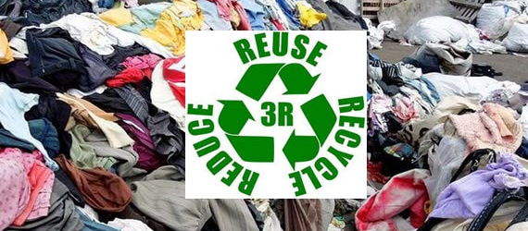
Worldwide, customers are buying and disposing clothes of almost five times as much clothing as they did 25 years ago. More than 10.5 million tons of clothing ends up in landfills every year. Clothing and textiles report for more than 6% of all. Textile effluence is a severe problem around the world. According to some estimate, the textile industry is the second-largest polluter next to oil. Happily, there are more and more new and inventive textile recycling methods and ways to diminish textile waste that are gaining prominence about the world and providing a great advantage to our planet. (Muthu, 2016) The most general way to battle textile waste is to provide used clothing. Innumerable charities and frugality stores collect donated clothing for re-sale or sharing, and almost half of used clothing gets wear again. However, not all fashion is suitable to be re-worn. This fashion can be shredded, ground down, and then reprocessed to make new products. Textile recycling can remove virgin, raw material out of the garments and repurposed them in new fibres and textiles. (Thompson, 2017)
2.3.1. Definition
The sustainability is heard as incredible called the “waste pecking order” you may be wondering what that means. It is the charge of right of way of actions to be engaged to decrease the amount of waste generated, and to develop overall waste organization process and programs. Sustain means ‘to maintain’ or ‘uphold’. To improve the quality of ecosystems IUCN 1991. ( Muthu, 2019) The idea of reducing what is produced and what is consumed is essential to the waste hierarchy. The logic following it is simple to understand – if there is less waste, then there is less to reprocess or reuse. The process of reducing begins with an assessment of what you are using, and what it is used for. Using multi-use items is necessary to beginning reduction.
2.3.2 CLASSIFICATION
The sustainability can be reduced in two ways as Buy used and Swap and Share
It can also be classified into three ways as:
- Re-Fashion
- Reuse
- Recycle
Buy Used
Thrift stores, garage sales and consignments are amazing places to get tons of garments and other textiles like tablecloths and cloth napkins. Tons of reuse fabric, yarn and other goodies can be received at thrift stores.

Swap and Share
It helps to create the garments exchange between your friends. A party is planted where each person brings garments that he or she no longer needs. Trade with friends so that each person leaves with fresh items for their wardrobe – without expenses a dime or sending anything to the landfill.
2.3.2.1 Re-Fashion
The popularity and importance of online blogs; DIY has never been so exciting and creative. Check out online DIY property can be checked for creative ideas on and way to turn an old t-shirt into amazing fresh and new. (Richard Blackburn, 2009)
2.3.2.2 Reuse
Fashion changes from season to season, but even non-fashion vistas frequently dispose of textiles. As a biodegradable material, textiles shouldn't be tossed in the waste, but even recycling uses energy. The first option should be to reuse. Look over each item, and consider why they no longer want it. If simple repairs or dressmaking could be possible use it again, place it in the "fixable" pile. If the item is in good shape and just no longer fits you or you simply don't want it any longer, place it in the "donate" pile. If the item is stained, ripped or otherwise damage, place it in the "recycle" pile. Locate a local style who can mend in "fixable" pile. Sort from side to side in "recycle" pile and look for items that can be repurposed. Cut old T-shirts into rags and reuse button. Gather everything that's left into a container for recycling. Drop off textiles at a central facility, or there may be drop-off bins in various places found in town. Drop-off bins allow to tossing the items directly into the covered bin, saving the use of a plastic bag. (Rissanen, 2018)
2.3.2.3 Recycle
Recycling involve recovering the valuable raw materials from a creation, using either mechanical or element recovery processes, and utilizing these as inputs into new merchandise. This process keeps needless waste out of landfills and conserves virgin materials. Widespread acceptance of textile recycling can help to move the apparel industry away from a traditional linear market, in which goods are produced, consumed, and disposed of, to a circular economy. In a globular economy, products are produced and consumed, but property from discarded products are improved and reused in the production process. A circular economy reduces the impacts related with a linear system by extracting the highest value from materials and ensuring farming of new resources is not required. The recycling development includes two stages. The collection- managing of textiles and the processing of textiles. (Muthu, 2016)
2.3.3 Need of Sustainability in Apparel Industry
- Consumption of natural has increased dramatically in the last 40 years
- At every stage of textile production, vast amounts of energy, clean water and chemicals are used to process the textiles and apparel.
- Issues like that of global warming, natural resource depletion, toxic waste disposal, and increasing air, water and soil pollution are of global importance.
- Thus apparel industry also needs to eliminate environmental hazards, improve process efficiency. (Richard Blackburn, 2019)
2.4 Fabric
The term fabric can be defined as a planner structure produced by interlaced/ interloped of yarns or fibres and felts made by interlocking fibres. It is a manufactured assembly of fibres or yarns that has substantial surface area in relation to its thickness and sufficient mechanical strength to give the assembly inherent cohesion. Basically, there are three methods by which fabrics are made. (Kiron, 2012)
2.4.1 Classification
Generally fabric can be classified in two ways.
- Classification of textile fabrics with reference to fabric formation techniques.
- Classification of textile fabrics with reference to raw material.
Classification of textile fabrics with reference to fabric formation techniques:
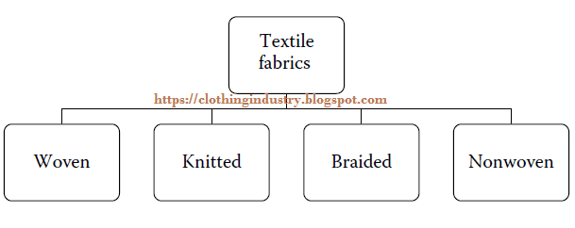

Woven
The formal structure of a woven fabric is defined by weave, thread density, crimp and yarn count. Woven fabrics are made by using two or more sets of yarn interlaced at right angles to each other. Much variety is produced by weaving. Woven fabrics are generally more durable. A woven fabric which is used in clothing and garments is for decoration and covering purposes. (Mazharul Islam Kiron, 2014)
Knitted
Knitting is the construction of an elastic, porous fabric, created by interlocking yarns by means of needles. Knitted fabrics can be made much more quickly and easily than woven fabrics at comparatively less cost. Two yarns forming loops in each course of the fabric. Knitting machines form loops of yarn with many pointed needles or shafts. The vertical rows of loops are called ribs or Wales, and horizontal rows of loops are called courses. Knitted fabrics are used for designing active clothing such as sports clothing. Their elastic nature permits for abundant physical activity. (Michael James Denton, 2002)
Braided
Braiding can be done in machine or hand method of interlacing three or more yarns or bias-cut cloth strips in such a way that they cross one another and are laid together in diagonal formation, forming a narrow strip of flat or tubular fabric. The word plaiting is generally applied when such materials as rope or straw are employed. (Kyosev, 2014)
Nonwoven
Nonwoven fabrics are broadly defined as sheet or web structures bonded together by entangling fibre or filaments mechanically, thermally, or chemically. They are flat, porous sheets that are made directly from separate fibres or from molten plastic or plastic film. They are not made by weaving or knitting and do not require converting the fibres to yarn. (Russell, 2013)

Classification of textile fabrics with reference to raw material:
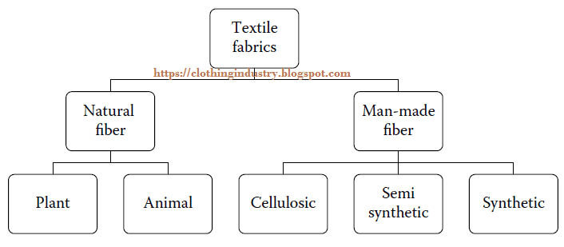
Natural fibres may be defined as bio-based fibres or fibres from plant and animal origins. This definition includes all natural cellulosic fibres and protein-based fibres such as wool and silk. The mineral fibres are excluded by this definition, which occur naturally but are not bio-based. They are known to cause health risk and are prohibited in many countries. The man-made fibres are cellulosic, semi-synthetic, or synthetic.
The natural fibres have been in considerable demand in recent years because they are eco-friendly and renewable. In addition, the natural fibres have low density, better thermal properties, and are biodegradable. The man-made fibres on the other hand offer the advantage of tailored properties (physical or mechanical) and are also durable. A major problem with man-made fibres is their non-biodegradability. The extraction of crude oil to manufacture man-made fibres creates toxic by-products that cause damage to the local environment. Currently, the researchers are working to address this issue, and they offer a green solution to these problems. (sekhri, seema, 2016)
2.5 Styles of Garment
The different styles of women’s garment were mentioned below with model pictures.

Dresses without Waistline Seam
Chemise
Straight dress not including a waistline seam, cut with few or no darts. (It is also called as sack, shift, or pencil.)
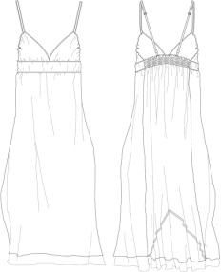
A-Line
Dress with usual shoulders, slight flare toward the hemline, but not including a waistline seam. (Also called as shift or skimmer.)
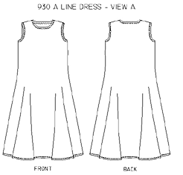
Trapeze
Dress with usual shoulders, no waistline seam, more flare at the hemline than A-line.
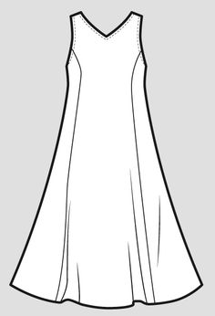

Caftan
Lengthy dress with highlighted opening for the neck and long sleeves.
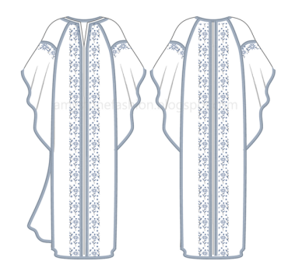
Float
Straight dress with no waistline seam, flavour controlled from pleats or gathers at shoulders or yoke.
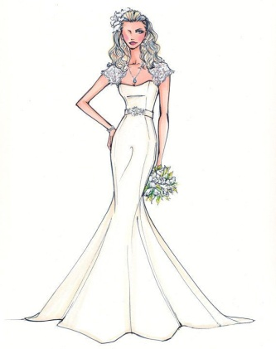
Wedge
Dress without a waistline seam, has wide shoulders and tapers to a narrow hemline. Usually have dolman sleeves.
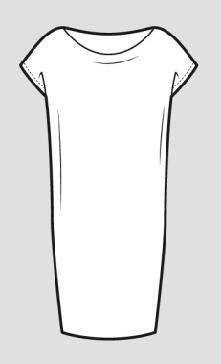

Sheath
Straight narrow dress without waistline seam, fitted with darts.
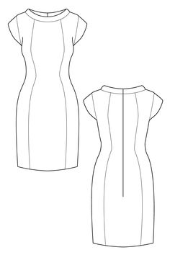
Princess
Dress without waistline seam, fitted by curved seams originating at the shoulder or armhole, extending over the bust to the hem. The skirt may or may not be flared.

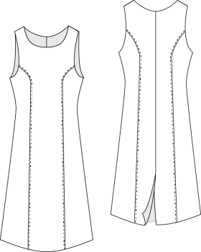

Dresses with Waistline Seam
Basic
Simple fitted dress, usually cut with jewel neckline, darts, fitted set-in sleeves, natural waistline, and straight skirt. (Also called as fitted dress)
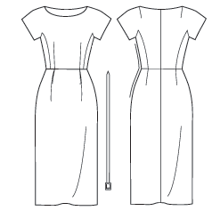

Elasticized Waist
Waist contains elastic for comfort. Dress may be of any style, either with or without waistline seam. It may be belted or unbelted.
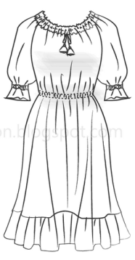
Empire
Dress with high waistline under the bust.
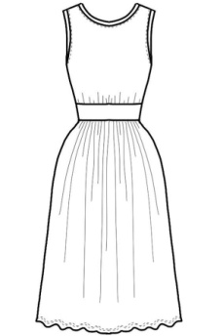
Shirtwaist
Dress with bodice styled like a tailored shirt, usually buttoned from neck to below waist, with either a straight or full skirt. (May be called as shirt dress if it does not have a waistline)
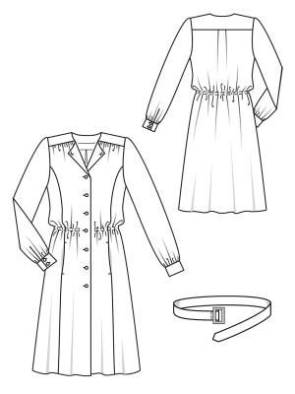
Dresses With or Without Waistline Seam
Jumper
Sleeveless, collarless dress worn with a blouse or sweater underneath.
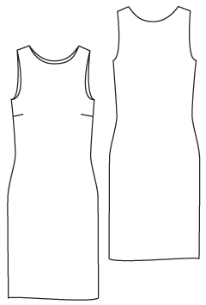.
Coat Dress
Dress which fastens (usually with buttons) from the neck to the hem like a coat. Dress may be single- or double-breasted, worn belted or unbelted.
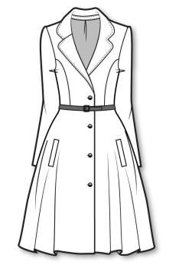
Sundress
Dress with camisole or halter type top worn for casual summer wear.
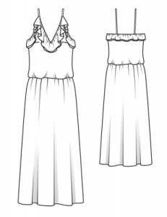
Asymmetric
Dress that is not the same on left and right sides. It may drape to one side or close to one side. It may cover only one shoulder. (Also called as one-shoulder or toga)
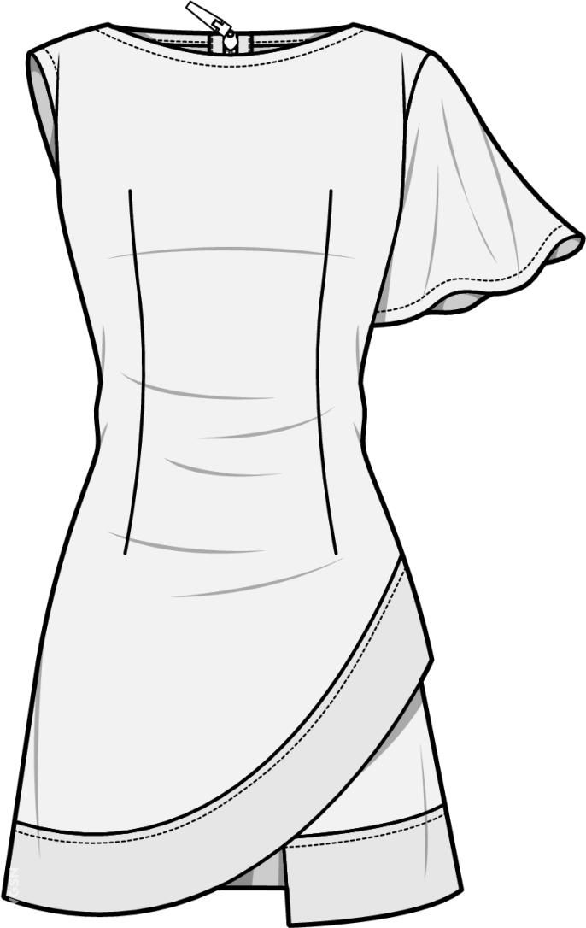
Draped
Dress with additional fullness pleated, gathered, or held to one side.
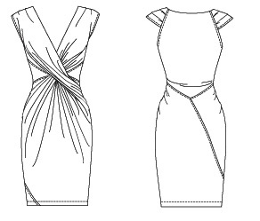

Wrap
Dress wraps and fastens to one side, either front or back. It may be held with button/buttonhole, tie, or belt. Variations include back-wrap, kimono, and surplice.
Bath robe dresses.
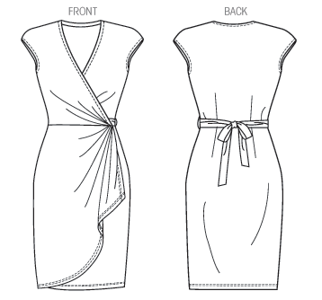
Jump Shut
Combination of bodice with divided or split skirt. Variations include calotte dress, pant gown, panel pant dress, and pant shift. (A.W. Koester and N.O. Bryant, 2001)
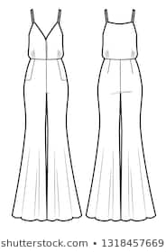

2.6. Garment Manufacturing Process
Design
↓
Pattern Making
↓
Fit Sample Making
↓
Production Pattern Making
↓
Grading
↓
Marker Making
↓
Fabric Spreading
↓
Fabric Cutting
↓
Cutting Parts Sorting or Bundling
↓
Sewing
↓
Garments Inspection
↓
Garments Ironing and Finishing
↓
Final Inspection
↓
Garments Packing
↓
Cartooning
↓
Shipment
(Islam, 2015)

Manufacturing Steps

Design
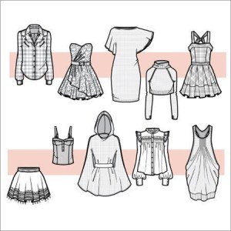
In the garment manufacturing, the first step is designing the sketch for the dresses that should be organized. For this purpose, the designer first draws several rough sketches in the sketch book or in the CAD/CAM by their own imagination or as per the buyer’s needs. (Sarkar, 2015)
- Pattern Making
Garment suitability is the 1st priority for every consumer. To get just right fit of garment, well planned or defect free pattern have to be needed. When decorative designs are applied on the garment, then a perfect pattern should be formed for making this garment. A standard pattern making is the mainly essential part to the success of ready-to-wear clothing
- Pattern drafting method
- Pattern draping method
- Flat pattern making method (Hulme, 2013
- Fit Sample Making
These samples are to be ready after getting the order sheets. These samples are required to check the measurements, style, and fit. So they can be complete in available similar fabrics but in the actual measurements and qualifications. Some buyers may need these samples if they want to print the photos of garments on photo inlays, packing box, hang tag, etc.
These samples may be needed for local announcement or buyer’s promotional occasions. Buyers will ask customers to make the photo samples according to the intentional model’s body fit. So it is important to severely adhere to these measurements. Consumer may ask these samples to send either from production or before preliminary production. (Veblen, 2013)
- Production Pattern Making
Pattern grading is the scaling of a pattern to a changed size by incrementing important points of a pattern to smaller or bigger sizes. Once a designer has finished a drawing of a garment, it is altered into a sample pattern.
“Patternmaking” is the system of creating all the precisely sized pieces necessary to create a full garment. For a lot of smaller manufacturers, pattern making is still done on paper for the reason that the cost of computerized systems remains prohibitive. (Nugent, 2008)
- Grading
Pattern Grading is the procedure whereby patterns of unlike sizes are produced from the unique master pattern. This procedure can be performed manually or mechanically by a computerized organization. Patterns are graded according to size charts which there the sizes and the standard measurements of the population group for which the garments are planned. (Beazley and Bond, 2009)
- Marker Making
Marker making is a pre-preparation of fabric cutting throughout huge amount of garments production. In the marker formation, unlike pattern parts are drawn on a large thin paper and to considering fabric size, garments size ration, fabric fault and cutting table size, length marker competence is depending on. There are two methods typically used for marker making in the apparel manufacturing. (Nayak and Padhye , 2015)
- Computerized method.
- Manual method

- Fabric Spreading
Spreading is a preliminary operation for cutting. The main aim of the spreading method is to lay the several fabric ply compulsory to the marker length lacking any tension on the fabric. The lay height depends on order size, fabric characteristic, capacity of the spreader, cutting method and equipment used. The favourite of mode of spreading will pressure the cost of spreading as well as complete garment quality. The composition of each spread, i.e. the number of plies of each colour is obtained from the cut order plan. (Nemes 2018)
- Flat spreads (scrambled spread)
- Stepped spreads (section spreads)

- Fabric Cutting
This is the main operation of the cutting room as they are spread and cut into garments. Of all the operations in the cutting room, this is the mainly decisive, since once the fabric has been cut, very small can be done to rectify serious defects.
- A first preparation consideration is whether the totals here in the cutting room are the same as persons required to maintain full manufacture in the sewing room and consequently the planned delivery programme. Any cloth trouble created in the cutting room can affect the production in the sewing room. Assuming all workings of fabric, design, and trims are adequate and accurately planned and cut, the next stage is to expand the cutting room plan to the sewing room.
- All cutting operations are approved out by directly knife cutting equipment. (Waters, 2016)

- Sorting Or Bundling
“Bundling” is the procedure of disassembling the stacked and cut pieces and reassembling them in produce lots of grouped by apparel unit, colour dye lot, and quantity of garments. Manufacturers use a range of bundling process depending upon their wants, with four fundamental systems being the generally common among local manufacturers:
- Group bundling
- Item bundling
- Progressive bundling
- Modular or “team based”
- Unit production system (UPS) (Grant, 2013)
- Sewing
Stitching or sewing is done after the cut pieces are bundled according to size, colour and quantities determined by the sewing room. Garments are sewn in a gathering line, with the garment attractive total as it progresses along the sewing line. Sewing machine operators accept a bundle of cut fabric and frequently sew the same portion of the garment, passing that finished portion to the next worker. For example, the first operator can sew the collar to the body of the garment and the next machinist may sew a sleeve to the body. (Smith, 2006).
Quality assurance is performed at the end of the sewing line to make sure that the garment has been properly assembled and that no manufacturing defects exist. as needed, the garment will be reworked or mended at designated sewing stations. This labour-intensive procedure gradually transforms pieces of fabric into designer clothing. ( Beaudry, 2006)
- The central development in the maker of clothing is the joining together of workings.
- Stitching is finished as per the requirement given by the buyer.
- More power single needle or mechanized sewing machines are used to total the sewing operation. Fusing machines for fusing collar components, button, and buttonhole, sewing machines for sewing button and buttonholes are purposely working.( Bubonia, 2017)
11. Garments Inspection
It becomes compulsory to preserve the quality right starting the production stage in order to send an acceptable final product to the consumer through the right quality which in turn marks in getting constant orders from the same customers. The garment manufacturers look over their products by designated accountable inspectors then only the right quality manufactured goods will reach the consumer. Under quality declaration process, the largeness production is inspected previous to delivered to the consumers. (Nayak and Padhye, 2013)

12. Garments Ironing and Finishing
After a garment is completely sewn and assembled, it is transferred to the ironing part of the provision for final pressing. All ironing position consists of an iron and an ironing stage. The irons are comparable looking to residential models but have steam supplied by an on-site container (Choudhury, 2013). Workers organize the steam with foot pedals and the steam is delivered by way of overhead hoses frankly to the iron. In most amenities, the ironing platforms are capable of with a ventilation system that draws steam from end to end the ironing table and exhausts it outside the industrial unit. ( McLoughlin and Fairclough, 2012)
13. Final Inspection
Final inspection is the final steps of garment inspection system. In this step complete garments are inspected by consumer. Different parts of clothing are inspected in this phase such as apparel main fabric, garnishing, trims, label, fabric faults etc. There are assorted systems for finishing inspection in the garment industry. Final inspection is extremely important for an export order consignment. (Glock, 2005)

14. Garments Packing
Garment packaging is the procedure of packaging, compressing, substantial or creating of goods for the purpose of fortification and their appropriate management. This is the finishing process in the production of garments, which prepares the completed merchandise for delivery to the consumer (Fan, Hunter, 2009). It is a significant part of the garment manufacturing process. These operations come under the materials management methods and are no less significant than other systems used in the industrial unit. After completing the complete manufacturing task, apparel is necessary to be packed. After packing, it is placed in cartons as per instructions and followed by it is stored in a store section previous to it is delivered to the individual buyer. (Douglass, 2012)
15. Cartooning
At last cartooning or packing the garments according to Buyer comment. The progression of packing of inner boxes entered into the carton is called cartooning. The packet is properly perverted by the scotch tape. Some information like carton box no, size, shipping mark and the destination are printed on the carton. (Nayak and Padhye, 2015)
Shipping
Manufacture goes from end to end different kind of steps. It needs many quality checking and endorsement to be perfect. It is run by those system is called manufacture system likes printing, knitting, dyeing, cutting, sample making, sewing etc. Shipping is a method process of representation which covers planning and implementation of proceeds, shipments, nominations and itineraries for transport, truck or pipeline. It can handle humanity scale calculations and tracking of vessels and inventories at compound terminals and berths. This functioning representation includes all internal and outside movements. (Karthik, Ganesan and Gopalakrishnan , 2015)

2.7 Body Measurements

1. Neck and Bust:
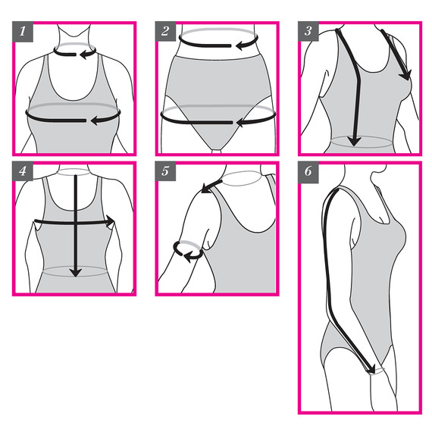
To measure neck, pull the tape around the middle, coming from the back to the front. It should sit at the base of the neck above the collar bone.
To measure bust, the tape should be brought around your back and around to the front. It should be pulled around the apex (or fullest) point of bust. It should be aligned parallel to the floor, making a straight, horizontal line across both your front and back. Someone can help to record measurements. (Singh, Mehta and promila, 2006)
2. Waist and Hips
The smallest part of torso and right underneath rib cage near belly button. Make sure the tape is even across the front and back and parallel to the floor.
(Evans and McKeigue, 2006)

3. Front Waist Length
Measurement has to be taken from the side base of neck, at the top shoulder line, and going down towards waist level passing over bust point. Try to keep the tape as straight as possible. To measure bust depth, use the same starting point on the shoulder as front waist length, measuring down to the apex of bust point.
4. Back Waist Length
This one is definitely a two person job, so a parson has to and have them measure from the nape of the neck, down spine and to waist. To measure the back width, measure horizontally between arm attachments points (underarm)
5. Shoulder
This is shoulder seam length. Measure from the base of neck, right in the middle of shoulder and along to the tip of your shoulder. If there is trouble determining your shoulder tip, find a garment in your closet that fits well and has a collar and sleeve. Then measure the shoulder length of the garment. To measure under the arm, wrap your measuring tape around the fullest part of your arm above your elbow.
6. Arm Length
The arm just should slightly bend, and measurement from the tip of shoulder over the elbow to wrist line has to be taken. (Winifred Aldrich, 2015)
2.8 Fashion Portfolio Preparation
A portfolio is an assemblage of work that shows a candidates skills and knowledge across a number of project works or practical studies. It is a visual representation of interests, exploration about work, experimentation, design and development and final pieces. For getting job in fashion industry, every fashion designer has to make an attractive portfolio to show his/her experience or creativity in this field. (Hopkins, 2012)
    - Definition
In the world of fashion, every new product or style begins with an idea. Fashion design is defined by the creators of new footwear, clothing and accessories. Fashion designing involves a set of skills that range from market research and creativity to sketching and fabric selection. The fashion designers guide the process from inception to production. (Kiper, 2016)
2.8.2 Types of Portfolio
- Admission portfolio ( For post graduate students)
- Professional portfolio ( For fashion designer)
Admission portfolio
- When you submit your admission portfolio for Fashion Design area, it express your drawing test, a design test, a sewing test, a written essay, and a portfolio cover page.
- Creative knowledge should be represented in both design sketches and garment images. Originality, creativity, and design aesthetic are more valuable for fashion design area.
- All schools or university have different portfolio requirements, so make the designers should read the requirements and follow them.
Professional portfolio
After completing fashion design education, every fashion designer has a dream to get a reputed job in the fashion industry. But to get there, they must have a fashion design professional portfolio. Portfolio is a key step to employment as a Fashion Designer. It’s essential to make a professional portfolio that indicates creativity, talents and skills. (Hopkins, 2015)
    - Fashion Portfolio Boards

2.8.3.1 Find Inspiration
Spend as much time on this part of the process. Sometimes it takes a while to become inspired by an idea. It is important to get this part right because inspiration is going to be the focus of the collection. Even if they have decided what to work on after went through step one, that only need to add a particular category or item to the current body of work, don’t want to hold back from finding new inspiration in an entirely different area. Might get an idea for a particular detail for garments from a completely different source (Hopkins , 2006).
The cut out pictures from magazines and cattalo’s are collected. Scroll through Interest and “pin” anything like and make different boards. Then print them all out. Either takes pictures with phone, quick sketches of things that noticed. Eventually, there comes a bit of clarity. They will not know exactly what items they are going to design or the exact colours or styles. (Springsteel, 2006)
      - Finding Focus on Ideas
Colour Palette
The exact colour standards decided just yet. Should have a general idea of the colours that think will be important in your collection. Look through your tear sheets and see what colours have emerged as important trend colours. Remember that colours selected need to be appropriate for the market. A bright green colour may be a hot trend right now, but it may not be the right shade for the customer base. Or maybe that colour should only be injected in a small way. (Thankaraju, 2019)

Collection of Pages
In general, the answer to this question is, however many pages it takes to show the full concept. However, keep in mind the person viewing the portfolio doesn’t have all day. They need to be able to get the full picture of your abilities and the design aesthetic in a short amount of time. (Wolfe 2008) Also, try to be consistent with the groupings in your book. If they have six pages for one group, it should be the same for all groups.

Different Outfits or Items
If the portfolio they are working on is a collection base project where the need to have tops, bottoms, over pieces, etc. it is not necessary to design a huge amount of items. In fact, I would dare say the fewer the better. As long as the group shows a complete look and gets the concept across that is all that matters. If they are working on a category driven project like I am, then the need to decide what is going to drive your collection. You can tell a story by styling details that all coordinate together. They can design a grouping based on fabrication or yarns. Based on this information figure out how many pieces they need to show a complete idea. (Wilson, 2012)

The Top Trends Research Get Across In the Collection
In order to keep the work looking fresh and on-trend, always want to make sure the hitting at least one trend in each collection. One trend because most likely they are only doing 4-6 pages of a collection. Two of which will be colour, mood, and concept. That doesn’t leave room for hitting every single fashion trend that’s out there. The trend to choose can be silhouette drive, detail-driven, fabric, or even pattern driven. (Kiper, 2016)
      - Mood Board

A mood board is usually the first page of a fashion portfolio. Its purpose is to set the tone of the collection and give the reader the immediate look and feel of collection. In one glance the reader needs to be able to understand the overall feeling of concept. This is start by laying out your images on a single page. Proportions and placement has to be considered this page as a cover page should be considered as a cover page. Need to add text that gives a descriptive name to collection. Depending on how many pages decided to do, may need to leave some room for colour palette. This is a rough draft. (Werner, 2019)

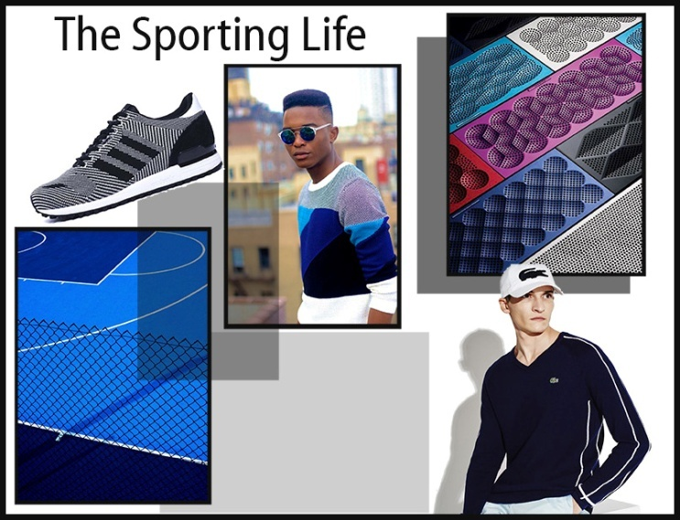

2.8.3.4 COLOUR PALETTE
Select colour palette for portfolio collection. The designer will have a pretty good idea as to which colours are inspired to the garment. The colours are popping up and inspiring the design. The images to garment mood board need to tie back to garment colour palette. For this reason, it is important that the images garment chose tie back to colour palette. This is the reason to personally choose to create colour palette after creating mood board to get inspired by the images put together. However, it is perfectly acceptable to create a colour palette first and then find images for mood board that tie in together. Either way works.

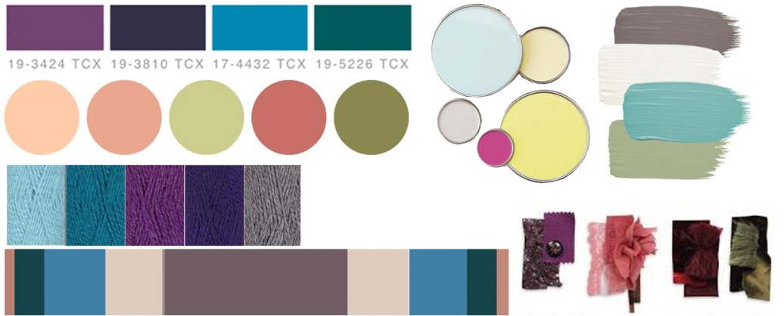

After have finalized colours it is time to add them to mood board. That means deciding how they want to present colours on board. There are multiple ways to do this. Some layouts show some colours are more important by showing them in larger shapes. (Tain, 2018)

2.8.3.5 Create Concept Board

It might include inspirational images, swatches, or details. Collection about mesh, Is it about colour blocking, Is it about architectural design construction, It should also serve as a guide to the designer to stay on track. Images need to convey the inspiration with details, silhouette, or fabric. Start to sketch. A design should always be able to go back to your concept board “this design match back to the original concept. (Mbonu, 2014)

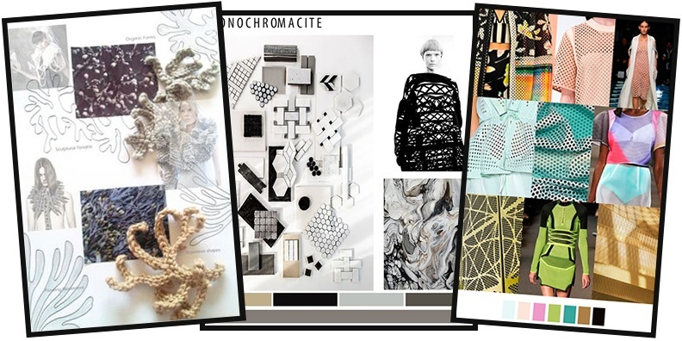

2.8.3.6 Sketch Ideas
Many people find this part of the process the most difficult. It is easy to get inspired by pictures and colures. They have to put pen to point it can be hard. That is this step of the process want they relax is. This session is basically another brainstorming session. The five steps should be followed to get the most out of brainstorming session and get a well thought out collection (Dickerson, 2014).
Steps to Sketching Ideas
1. Choose materials. Sketchpad, pencils, collared pencils, markers, etc.
2. Give them a set period of time to just let the ideas flow onto paper. During this time the sketches are rough drafts. They do not have to be full on fashion illustrations. They just need to be basic sketches to get idea across, and with enough detail that they can recognize and remember what they liked about it. Some people sketch with bodies
3. Pull out your tear sheets of images that inspired them when to be creating the mood and concept boards and see if they help to spark new ideas.
4, All of the sketches must be gone through and see what pieces to love, and which pieces go together nicely to make an outfit if applicable. If they are making a collection portfolio with full outfits decide how many you want to show.

5. From here they should know how many holes there are that need to fill in. Do another short sketching session for the missing pieces for the collection. For example: If the designed one is an awesome blouse and skirt, they may need to design some completer pieces like a jacket. Keep doing this process until they have all the pieces for the collection. (Scott and Stevens, 2015)

2.8.3.7. Find the Fabrics
The next step in creating a killer fashion portfolio is to find the fabrics that they want to use. Depending on the type of collection they are doing this could mean woven fabric, knit fabric, prints, or yarn. The fabrics choose will make the designs come to life. Knowledge of textiles will help to decide what the correct fabric content, yarn size, and fabric weight they need for the designs. (Bowles, Isaac, 2014)
There are several resources to find fabrics. The stakes are as follows
- Local Fabric Stores – Go to fabric stores in the area and ask for cuttings of the fabrics that they like.
- Garments – Cut swatches from existing garments. This is also a good source for design details.
- Vendor swatch cards – If they are presently working in the industry they may have access to fabric cards given to the by mills to showcase their collections.
- Trade Shows – Visit fabric trade shows and collect swatches from different vendors.
- Swatch Houses – There is one more resource available to industry professionals. There are swatch houses for knits, woven’s, and sweaters that sell swatches to a designer for inspiration. However, these are very expensive (Arnold and Egan, 2012).

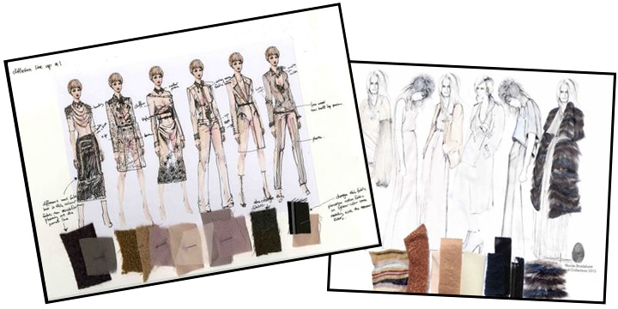

2.8.3.8. Flat Sketches
Flat sketch is a detailed sketch of a garment that shows construction details. It needs to demonstrate how the garment is to be constructed including stitch detail, button or zipper closures, or any other special details. A flat sketch does not include a body figure, an entire outfit or how it is styled together.
A flat sketch should also be drawn in proper proportion to a real garment. It should not be stylized or shown in any sort of exaggerated form. This type of sketch is usually drawn on the computer using a program such as Adobe Illustrator or Corel Draw. Other than in your fashion portfolio you will also find these types of drawing in a “tech pack”. A tech pack is a technical package the designer gives to the factory, which will then follow the instructions to make the photo garment. (Fernández and Quartino, 2014)
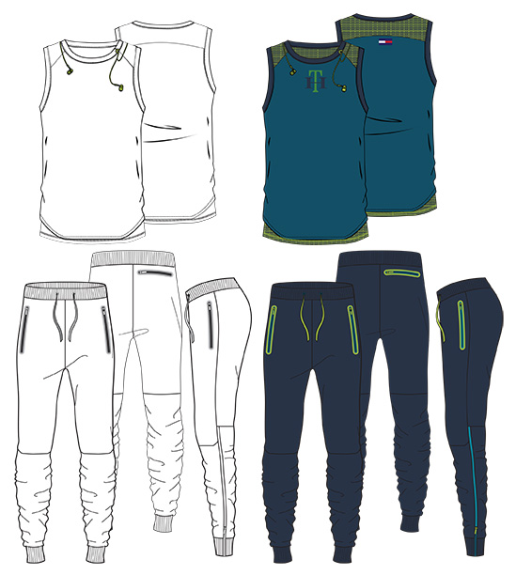

2.8.3.9. Fashion Illustrations

The actual fashion illustrations are one of the last things while making a fashion portfolio. The illustrations should really catch the eye of the viewer. Use unexpected poses and figure compositions. The illustrations come to represent who woman is – to tell us about the mood of clothes, to make us want to be that women.
When drawing the illustrations thinking about all the accessories, makeup, shoes and attitude of the model. (Kiper, 2011)

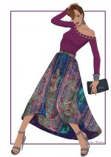

3. Experimental Procedure
3.1 Selection of Boutique
3.2 Selection of Fabric
3.3 Selection of Garment
3.4 Portfolio Preparation
3.4.1 Inspiration Board
3.4.2 Mood Board
3.4.3 Colour Board
3.4.4 Customer Profile
3.4.5 Photographs of Garments
3.5 Designing
3.6 Drafting and Construction
3.6.1 Princess Cut Blouse
3.6.2 Skirt
3.6.3 Maxi Top
3.6.4 Kurta

3.1 Selection of Boutique
The boutique was selected in and in and around the Coimbatore city to collect waste fabric. The investigator went to few boutiques and requested to spare their fabric scraps. Thamarai studio, Smrithis and PSR boutique was selected.
3.2 Selection of Fabric
The fabrics were collected from the selected boutiques. The fabrics were selected based on colour, texture, pattern and designs. Fabrics such as plain weave, jacquard, dobby, checked, twill, satin, jute, sheer fabrics were collected there fabrics were picked randomly and arranged bared on the colour contrast for prepare of designing.
3.3 Selection of Garment
Women’s clothing plays a major role, where vast variety of colour, patterns, designs, styles can be women always spend an extra time and effect for selecting garments. They always look for lakes trend and varieties. In women’s clothing and asymmetrical designs can be incorporate. Hume the investigator have selected women garments.
3.4 Portfolio Preparation
The portfolio was done on the selected theme “HOLI” which express the all colours and so it finally it results with multi colours.

3.4.1 Inspiration Board
At first, a theme has to be selected and an inspiration board was to be made on theme “Holi”. It was made visually interesting and enjoyable. Get the viewer excited about the design. An image from magazines and internet explains the design and inspiration which was used. The colors, swatches of fabric, and even text used in this portfolio convey the theme and inspiration further. The best ideas and designs were included in a logical, aesthetical and pleasing way. Considering this, the investigator selected the theme holi and this can be done on portfolio by using inspired and matching item of waste fabric swatches of different colors and patterns.
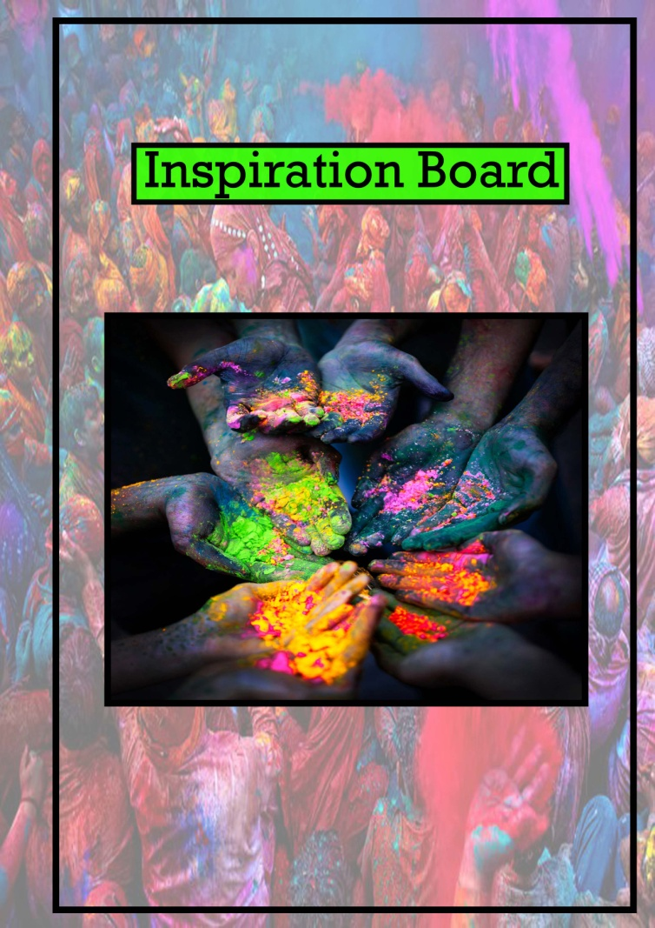
PLATE I
Inspiration Board

3.4.2 Mood Board
The tone of entire collection was made with the use of colour and inspirational images. The images have explaining the season of the collection and also it need to represent the aesthetic appearance of collection. It can also show that the theme holi was inspired from the colours and textures of various fabrics and their designs. The mood board was made with the help of inspirational figures. Before starting further works, a research has been done about the latest fashion trends, colour, and work backwards through the entire history and trend of fashion career. The investigator collected pictures from the zone of interest and some magazines related to matching colourful images related to holi for making the entire mood board.

PLATE II
Mood Board
3.4.3 Fabric and Colour Board
Fabric swatches and color board can be made separately to differentiate its color and texture from one another. It was sure that the collected fabrics from different boutiques were colorful and trendy. Multi coloured swatches were collected and organized to make different garment. The waste fabrics of some particular boutiques were collected and used. The investigator used clear digital images of fabric instead of the real thing to make a color board. The investigator had chosen fabrics and color that make sense for the construction/drape of the garments. Color swatches are very important to convey the color story.
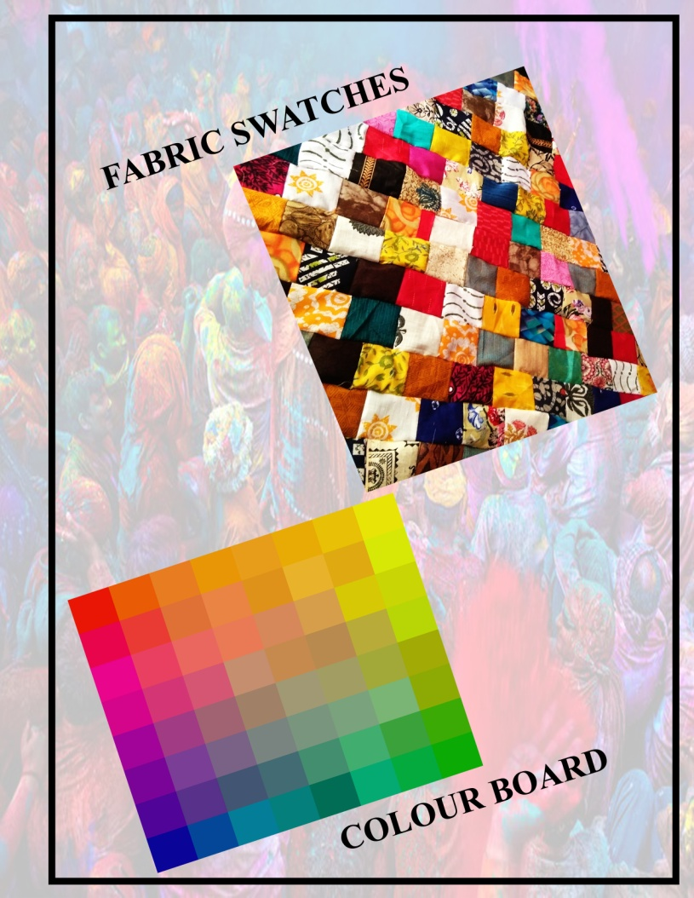
PLATE III
Colour Board
3.4.4 Customer Profile

A deep understanding of investigated ideas and working details of client will guide always to do the best work. Focusing on the ideal and work client, their pain points and the fact that they are their best solution allows positive energy to flow into the garment construction. This knowledge will enhance my marketing efforts and attract ideal clients and works to be in greater numbers, all while allowing them to step forward with my true purpose and succeed as an entrepreneur. Customer profile can be made, which includes customer details, name, age, occupation, garment using for, colours and category (garment, accessories and enrichment) of a customer and this all details including customer profile and interest are client vision board.
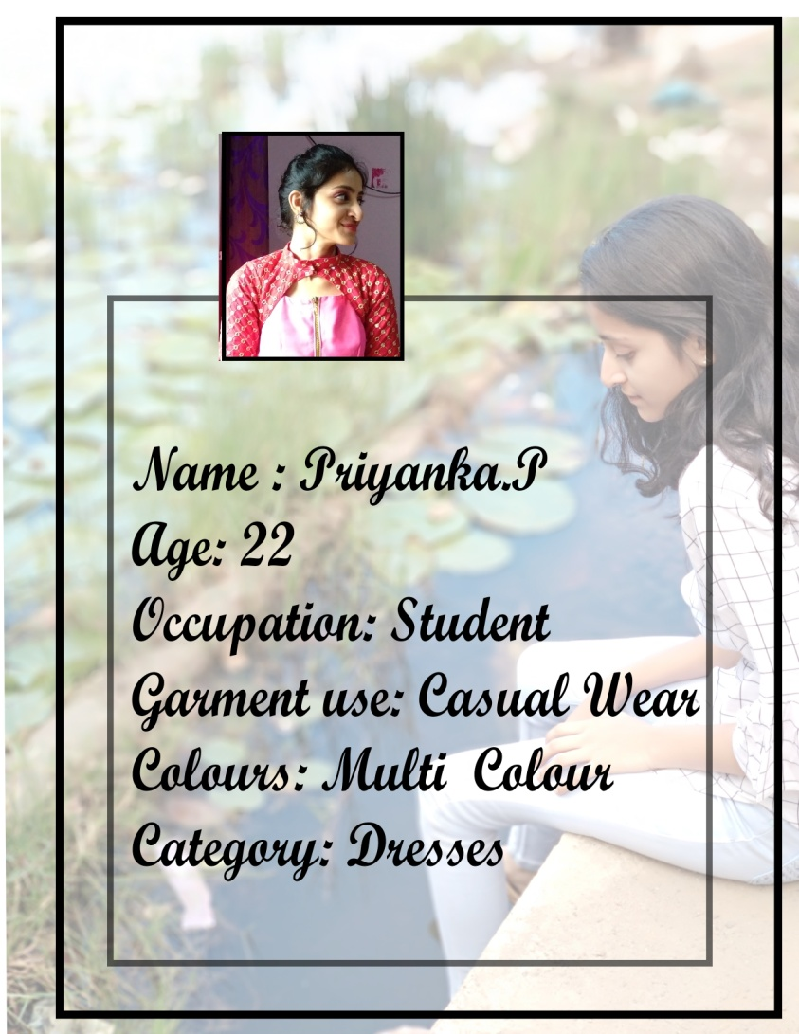
PLATE IV
Customer Profile
3.4.6 Photographs of Garments
The constructed garment focused on designing for a certain demographic or around a certain theme. The investigator selected fabric pieces that represent her personal style and approach to design. And it was also based on the illustration made for the ideal customer or customers. The work done which includes collection of fabric swatches of different colours, patterns and textures, which were mix matched and patched together to form any piece of fabric. These fabrics were converted into different styles of garment.
The different styles of garment such as Blouses, Maxi top, Kameez, Mermaid skirt with Crop top and full length gathered skirt were designed and constructed. The investigator had taken photographs of the constructed garments and the background were edited and designed with the Computer Aided designing to enhance the beauty of the garment and its style of wearing.
.
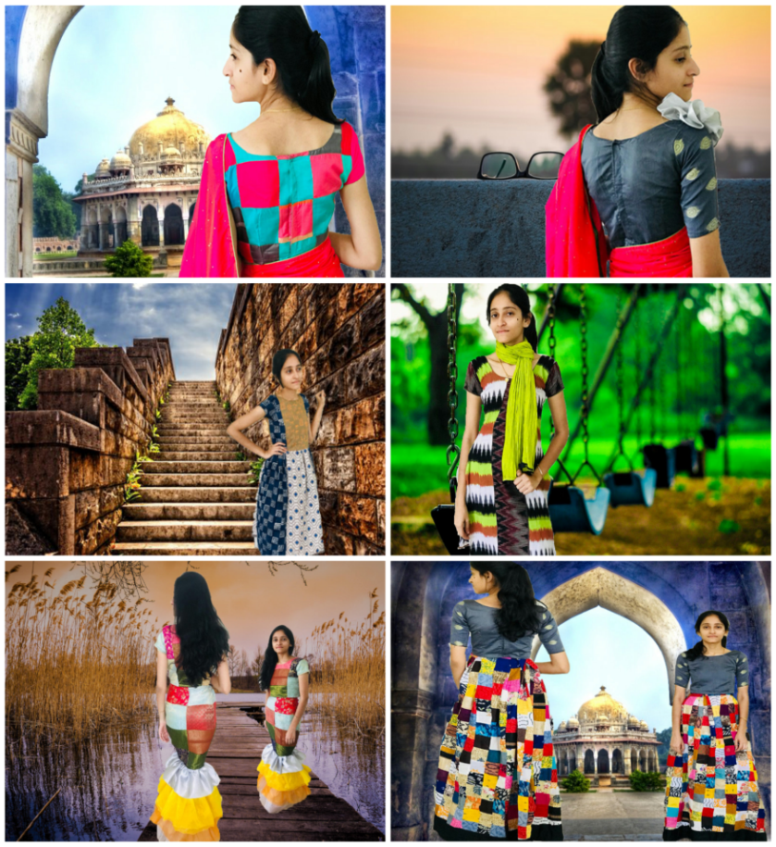
PLATE IV
Photographs of Garments
3.5 Designing
Garment for women’s clothing was designed in many aspects on the theme “HOLI” the garments which were are as follows
- Princes cat blouse
- Skirt
- Maxi top
- Kameez
- Mermaid skirt top

3.6 Drafting and Construction
The pattern was drafted for the selected designs along with the required measurements and it was constructed based on it.
3.6.1 Princess Cut Blouse
Blouses are the basic upper garment worn with skirt or sarees. There are two styles blouses namely basic blouse and princess cut blouse. Here the investigator constructed the princess cut blouse with boat neck and back opening. In the first method back and front are drafted within the same rectangle as for the boat neck front. In the second method, back and front are drafted separately in order to make the front pattern slightly wider than the back the front pattern. The investigator had made princess cut blouse with the waste fabric swatches, which were stitched together into patches and used for construction.
Measurements
- Bust – 29”
- Waist – 31”
- Shoulder width – 14”
- Back waist length – 13.5”
- Front waist length – 14”
- Shoulder to bust – 10”
- Distance between bust point – 7”
- Shoulder seam – 14.5”
- Back neck depth – 3.5”
- Front neck depth – 3.5”
- Sleeve length – 9.5’
- Lower arm – 8”
Drafting To the Bodice Pattern: Method 1
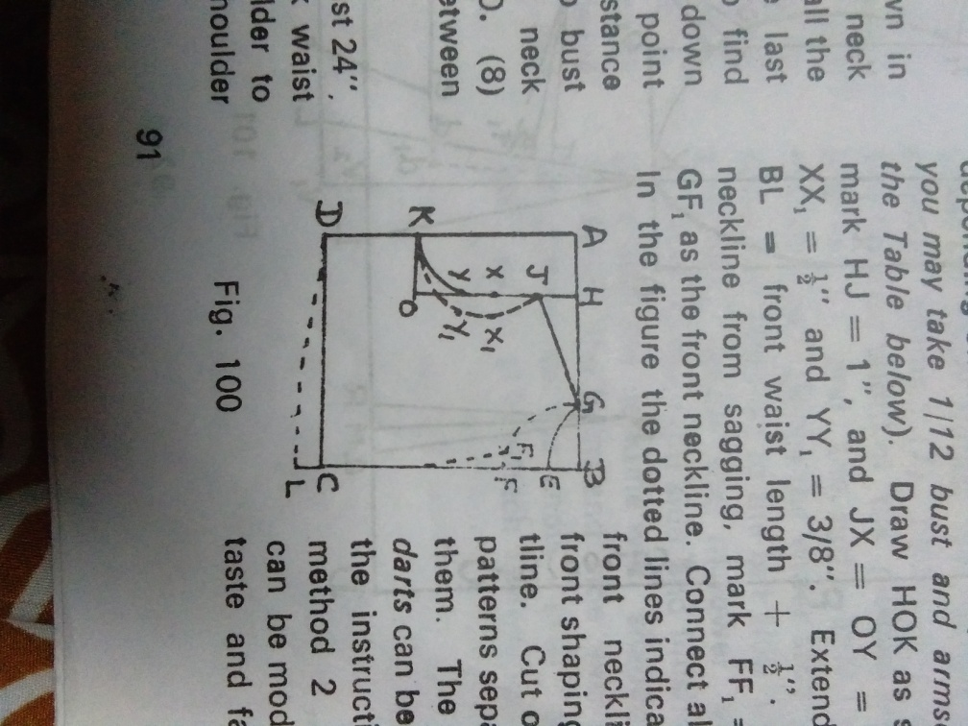
PLATE V
Drafting To the Bodice Pattern: Method 1
- Draw rectangle ABCD with AB bust + 5/8" and BC back waist length + 1/2". On BA, mark BH=1/2" back width and BG=1/12" bust.
- On BC, mark BE= 1" and BF=1/12 bust+ 1/4". On AD, mark AK = 1/4 bust- 1/2" to 1 1/2" depending on the bust size.. Draw HOK as shown.
- On HO, mark HJ =1", and JX=OY 1/3 JO. Mark xx, = 1/2" and YY1= 3/8". Extend BC to L taking BL=front waist length + 1/2".
- To prevent the neckline from sagging, mark FF1=1/4" and take GF1 as the front neckline. Connect all lines shown.
- In the figure the dotted lines indicate with centre front shaping, and front waistline.
- Cut out back and front patterns separate band front patterns separately and label them.

Drafting To the Bodice Pattern: Method 2
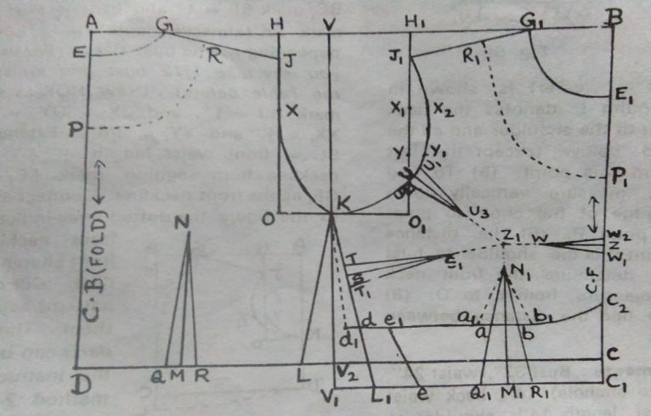
PLATE VI
- Draw rectangle ABCD with AB=1/2 bust=1 1/4" and BC = back waist length+ 1/2". Mark BV ==1/2 AB in case the bust size is small, 1/2 AB+1/4" for medium bust size and 1/2 AB + 1/4" for large bust size. Extend BC to C1 taking BC1= front waist length +1/2".
- Draw VV1 parallel to and equal to BC1. Mark V2 where this line intersects DC. Label AD as centre back line and BC1 as centre front line. Now the back pattern will be drafted within rectangle AVV2D and the front pattern within rectangle VBC1V1. Back: Mark AE =1", AG 1/12 bust, AH ==1/2=back width and. Draw HOK as shown. Mark HJ=1 and JX = 1/3 Jo. Connect all lines as shown.
FRONT: Mark BG1 = 1/2=front neck width = 1/12 bust 1/4". Take BE1= 1/12 bust +1/4"and BH=1/2 back width-" Draw H, O, K as shown. Mark H1J1 = 1" divide J1O1 into 3 equal parts by points X1 and Y. Mark X1X2 =1/2" and YY1= 1/4" connect all lines as shown.
Back Side Seam and Dart:
- For average and back waist as 1/2 waist + 1/2" and plump figures calculate front waist as 1/2 waist + 1/2" and back waist as 1/2 waist - 1/2".
- On the back pattern, mark DL = 1/2 back waist +1" and DM =1/2 DL. Draw MN = V2K minus 1" to 11/2".
- Mark MQ= MR = 1/2". Connect QN and RN to complete the back dart. Also connect KL the back side seam line.

Front Side Seam and Dart:
- On the front pattern, mark C1L1= 1/2 front waist +1 1/2" 1/8 for ease. Connect KL, for front side seam. Locate bust point Z, as follows: BZ shoulder to bust + 1/4" ease.
- ZZ1=1/2=distance between bust points or 1/12 bust+1/2. Draw the darts as ex lined below. (1) Front waist line dart: Mark Z1 N1=1/2" and draw N1M1 as shown.
- Mark M1Q1=on KL1 mark S1" to 1 1/2" below the level of the ST =ST1=1/2" x. Connect TS1 and T1S1 to complete the dart.
- Centre front dart: Mark Z1W = 1" along Z1Z. Mark ZW1 =ZW2=3/8". Connect WW1 and WW2 to complete the dart.
- Armhole dart: This dart is usually pinned at the time of fitting. On armhole curve J1K1 mark U3/4" away from Y1 in the direction shown. Connect UZ1 and mark Z1U8"Mark UU1= UU2=1/4" Complete the dart as shown.
Drafting the Sleeve Pattern
- Draw rectangle ABCD with the following dimensions keeping AD on Fold. AB= Armscye depth minus ¾”. AD = Sleeve length. Mark BE = 1/2 AB and DF=1/2 lower arm 1/8" Connect AB and EF.
- Divide AE into 4 equal parts and mark a, b, c as shown. Mark aa1=1/2", bb1=1/4", cc=1/4 " and cc2=1/2" in the directions shown. Connect A a1 b1 c1 E for back and A a1 b c2 E for front sleeve lines. Cut out the sleeve cap seam lines. Cut out the sleeve pattern and label it.
. 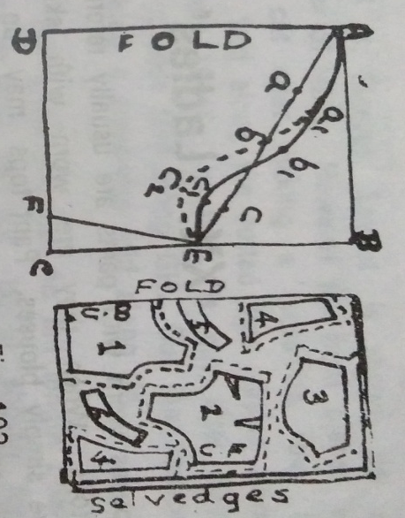
PLATE VII
Drafting the Sleeve Pattern
Steps I Construction:
- Stay stitches the neckline of boat neck front and back.
- Tack the front and back together after tacking the darts. Check the fit and make the fit and make the necessary alterations.
- Tack the side seams of sleeve and check the fit.
- Machine ash the darts.
- Attach waist yokes to boat neck fronts.
- Stitch side seams and shoulder seams.
- Finish the front opening the finished width of the placket should be about 5/8" to" and the right side should overlap the left side. Hence the wider strip should be attached to the left side and finished like a binding while the narrower strip should be attached to the right side and finished like a facing.
- Finish the neckline with shaped or bias facing.
- Finish the hems and side seams of sleeves and attach them to the choli.
- Finish the hem of choli back.
- Attached fasteners.
3.6.2 Skirt
The most common types of skirts used in girls and women’s garments are plain skirts with minimum flare, gathered skirts, pleated skirt, gored skirts, flared skirts and circular skirts. The investigator had chosen gathered skirt and the pattern were drafted based on the measurements in a pattern sheet. In this, the length of the fabric being gathered primarily and it should be 2 to 3 times the finished length of the garment.
Measurements:
- Waist- 31”
- Hip- 27”
- Skirt length- 41”
- Distance from waist to hip- 4”
Cutting and Stitching Procedure
- First of all cut out the material needed for the waist band. Calculating the cutting width of band as twice finished width +3/4" allowance =3" to 4", and length as waist circumference +3" allowance.
- AB-width of fabric and BC = twice skirt length + 6 hem allowance. Mark E and F mid points of AD and BC respectively.
- Cut the fabric along EF and separate into 2 sections. Label one section as front skirt and the other as back skirt. Joined front and back skirt sections together as shown in so that AF =71".
- Now joined AE and FG together leaving a s mall opening for placket. Gather the waistline to the desired size and finish with waist band.
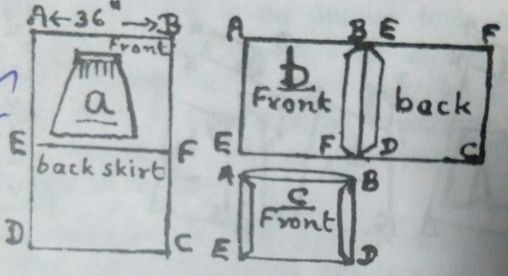
PLATE VIII
Skirt Pattern
3.6.3 Maxi Top
In this design the bodice front is cut in three panels. The centre panel has diamond shaped pin tucks stitched on it. The technique is to cutting the required amount of fabric and making the tucks on it and later cutting out in proper shape using the centre panel pattern. The front skirt is cut in 3 panels or gores. Instead, plain gathered skirt and sleeves may also be used. The design can be modified by changing the type of fullness within the centre panel. Instead of tucks, the investigator had done smocking pleats or shirring.
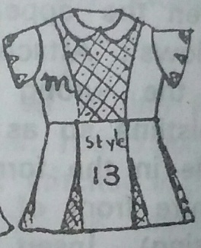
PLATE IX
Maxi Top
Measurements
- Chest – 20”
- Back width – 20”
- Back waist length – 9”
- Top circumference – 18”
- sleeve length – 4’
- Lower arm circumference – 8”
- Wrist circumference – 5 ½”
- Hip waist – 21”
- Hip – 4”
Preparing the Pattern for a Maxi Top
- At first the basic patterns was drafted and then trace the basic front bodice pattern on a large sheet of paper and label it as JFKLMD.
- Extend the centre front line JD till T taking DT = skirt length. Draw TT1= L1L =1” to 1 ½ depending on the flare required. Skirt length Draw TT1= L1L+ 1/2 depending on the flare required.
- Connect TU as shown for hemline. if the desire to have shaping near the waist connected MU and LMU as the side seam.
- Sleeve pattern to draft the basic sleeve pattern, draw rectangle ABCD with AB bust-" and AD sleeve length. Mark BE AB and DD, lower arm Connect ED, for side seam of sleeve.
- Join AE, divide it into 4 equal parts and mark a1b1c1 Mark Ad 3/8 he" and cf 3/8 in the directions shown. Connect AdbfE for front and AeE for back sleeve cap label it. Seam lines. Cut out the sleeve pattern.
3.6.4 Kurta
Measurements:
- Bust – 29”
- Waist – 31”
- Hip back with bottom circumference – 24.5”
- Full length – 34"
- Back waist length – 9”
- Waist to hip – 4’
- Slit length – 18’
- Sleeve length – 4”
- Lower arm - 8”

Drafting the Front and Back Patterns
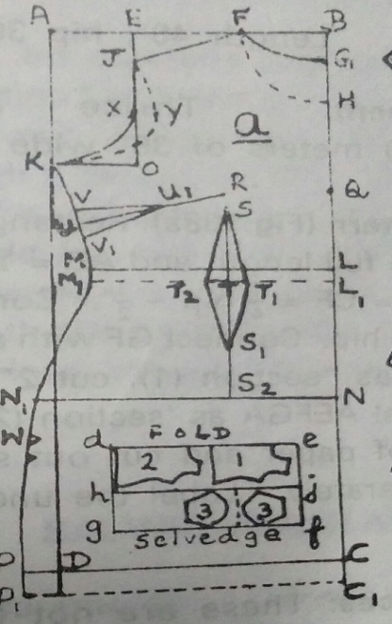
PLATE X
Drafting the Front and Back Patterns
- Draw rectangle ABCD with AB= 1/4 bust +1 1/4" and BC full length, the following: BE= ½ back width, BF 1/12 bust +1/4" Mark AK= armscye depth= ¼ bust- ½” to 1 ½” for adults and 1/4 bust for children. Draw neck lines, shoulder line and JOK as shown. Mark JX 1/3 JO and XY=1/2".
- Draw back and front armscye lines as shown. Mark BL= back waist length and LM = 1/4 waist +1 ½” Mark LN= waist to hip and draw NN1 +1/4. Mark CP=1/4 bottom circumference.
- If a side seam dart is desired draw also the lines L1M1 and C1 P1 taking LL1=CC1 = 1 "Connect KMN1PP1 as shown. Mark PW= slit length and cut a notch at W and also a notch 1" below it which is to be used for the front pattern only if a side seam dart has been introduced.
Sleeve
Garments can be constructed in two different styles, which are with and without sleeves. Sleeves can be of various styles such as puff sleeve, long sleeve, tulip sleeve, elbow sleeve, petal sleeve, leg-of-mutton sleeve etc. These sleeves were constructed based on its aesthetic appearance and function. Plain sleeve was most commonly used sleeve in all type of garment and it was more comfortable than others. Hereby, the investigator had chosen plain sleeve for kurta due to its comfort.
PLATE XI
Sleeve Pattern

4. RESULT AND DISCUSSION

4.1 Portfolio Presentation
4.2 Garment Design

4.1 Portfolio Presentation
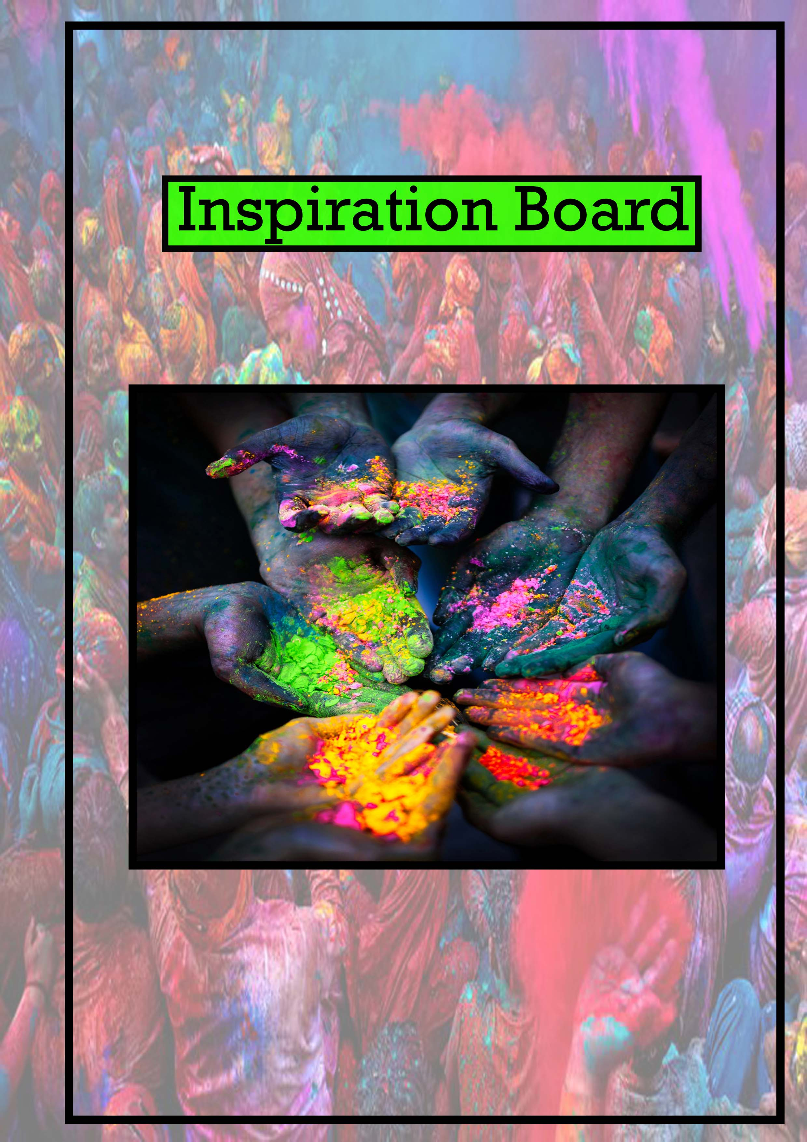


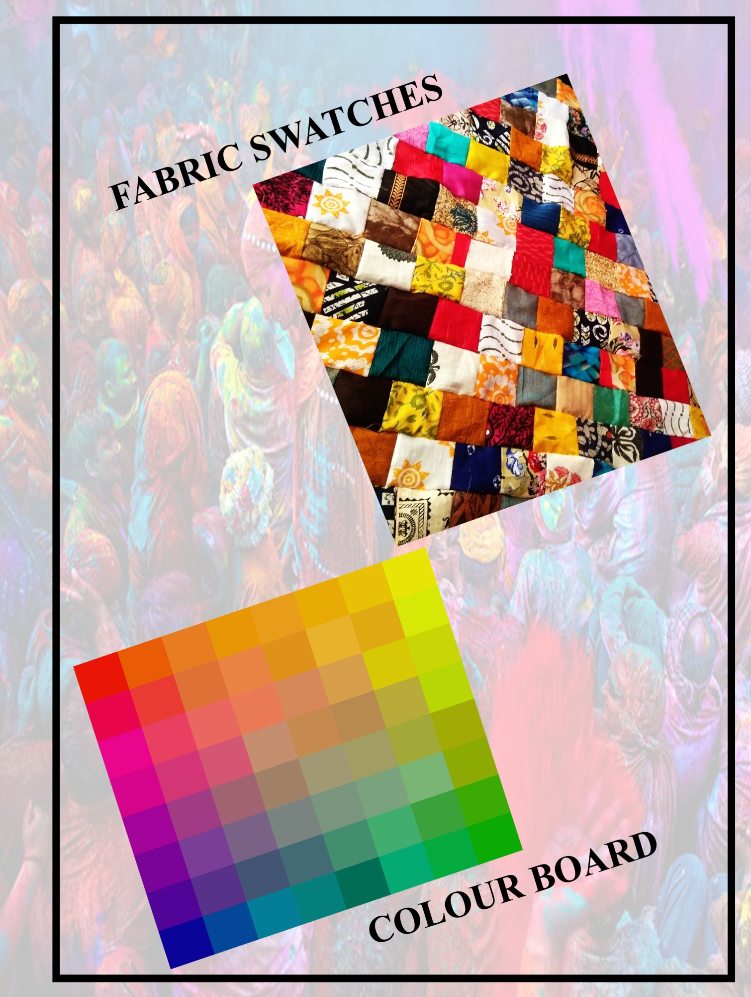
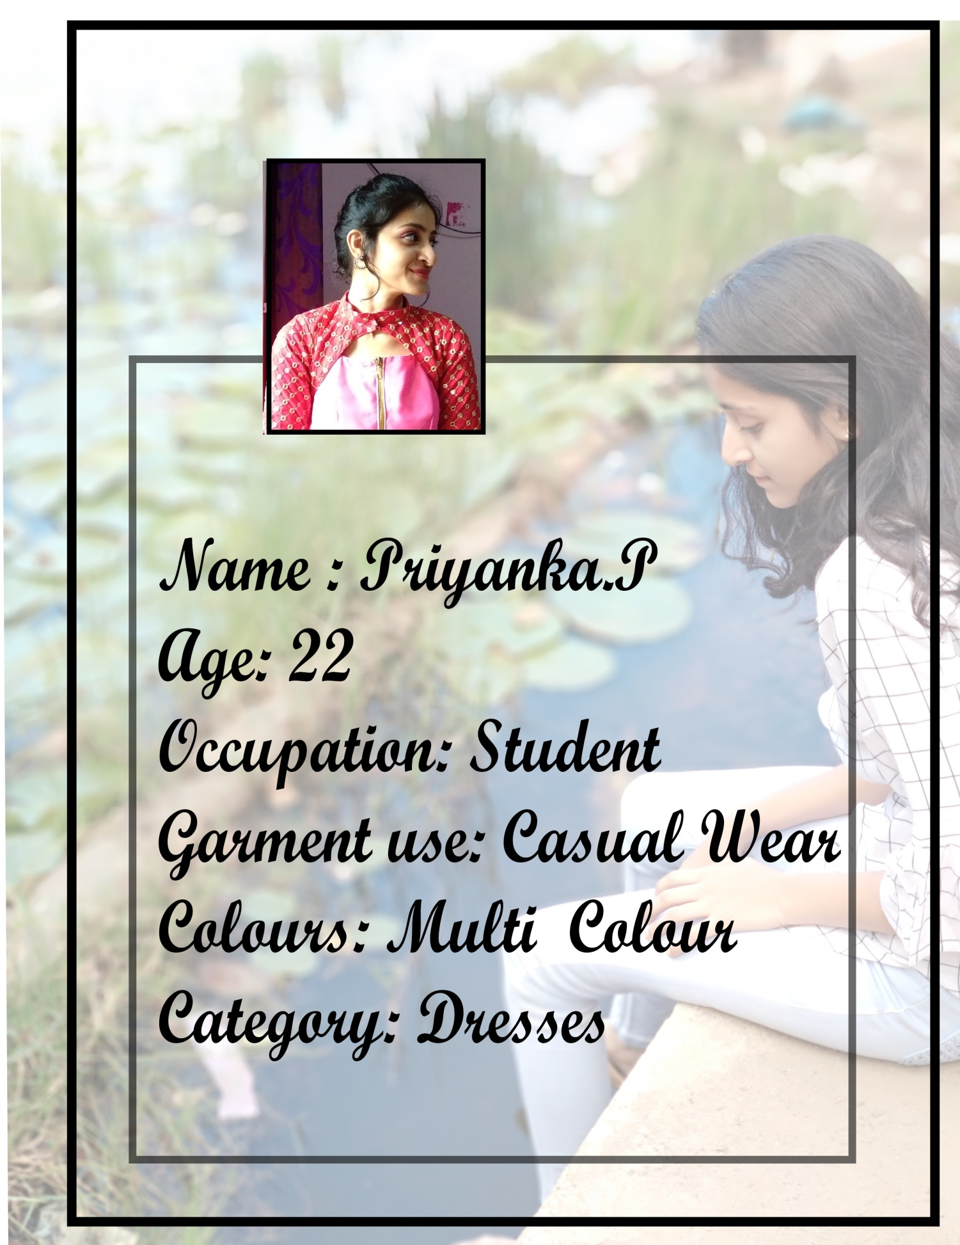
4.2 Garment Design

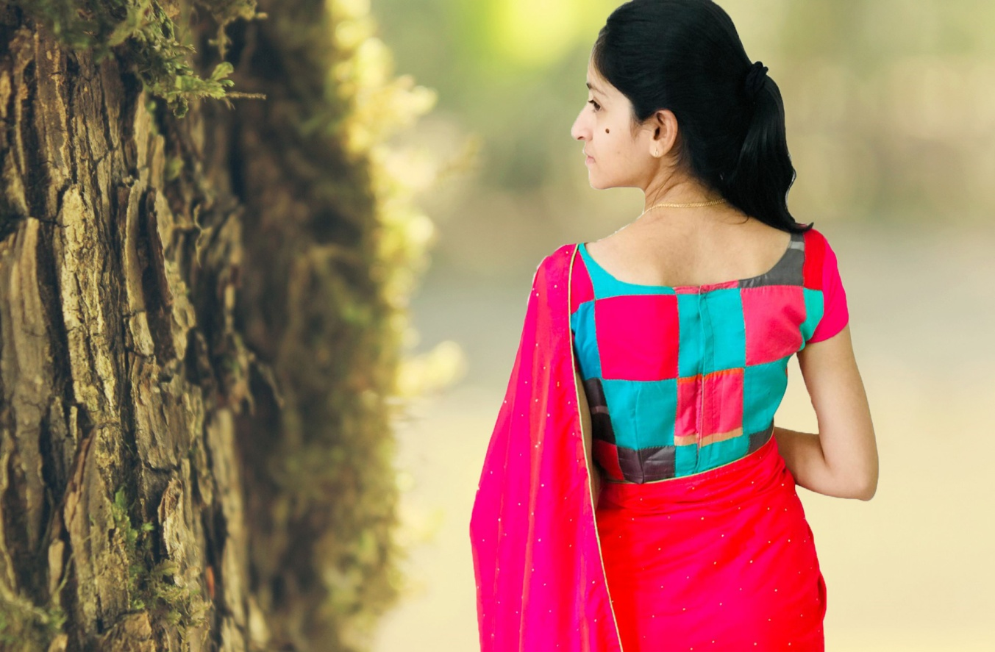
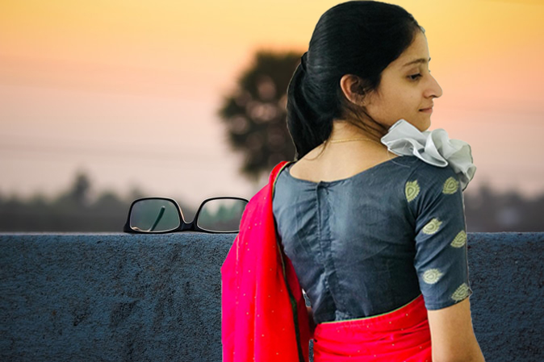
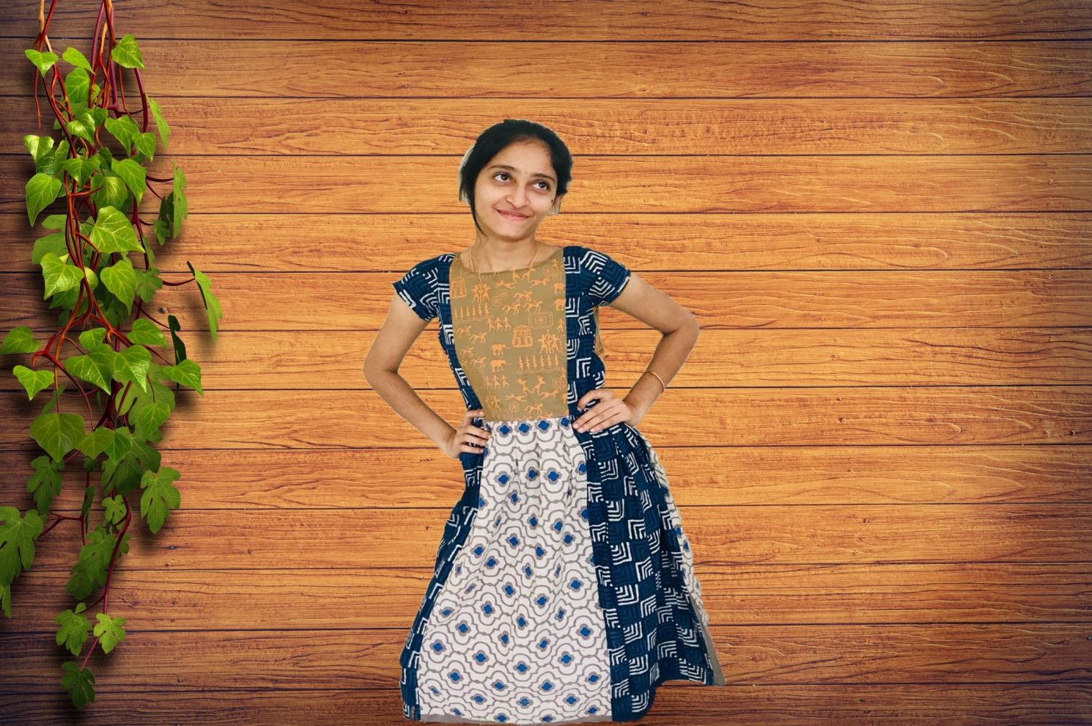
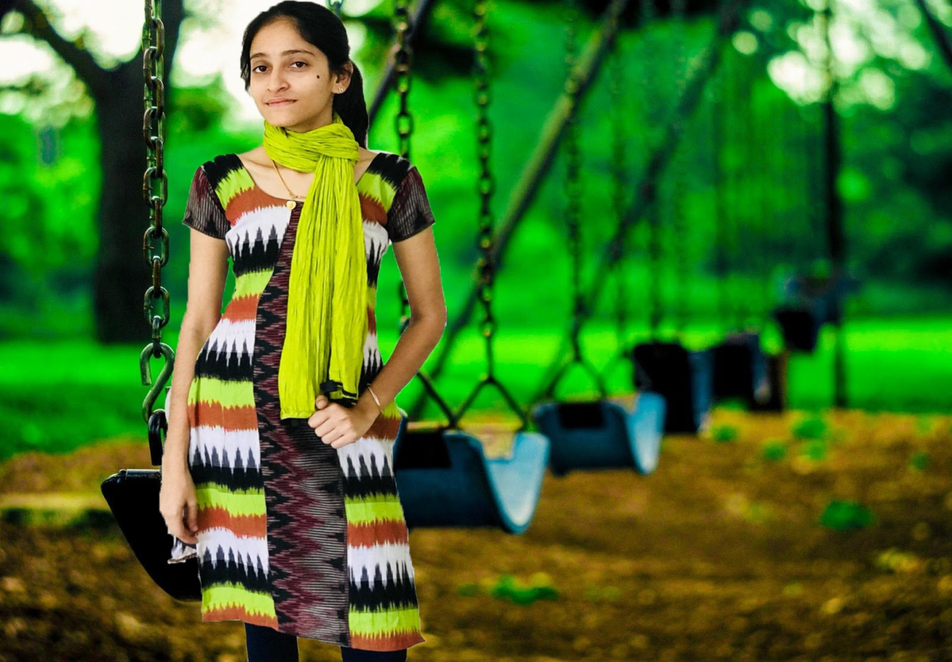
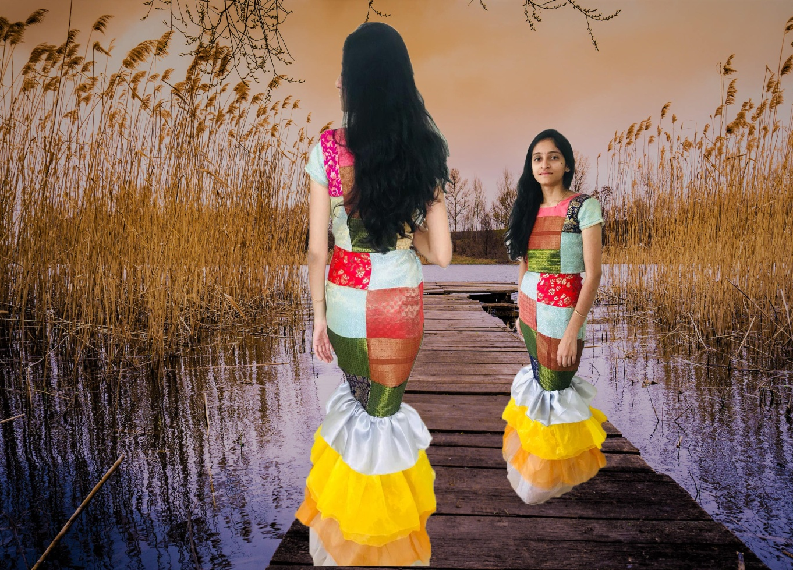
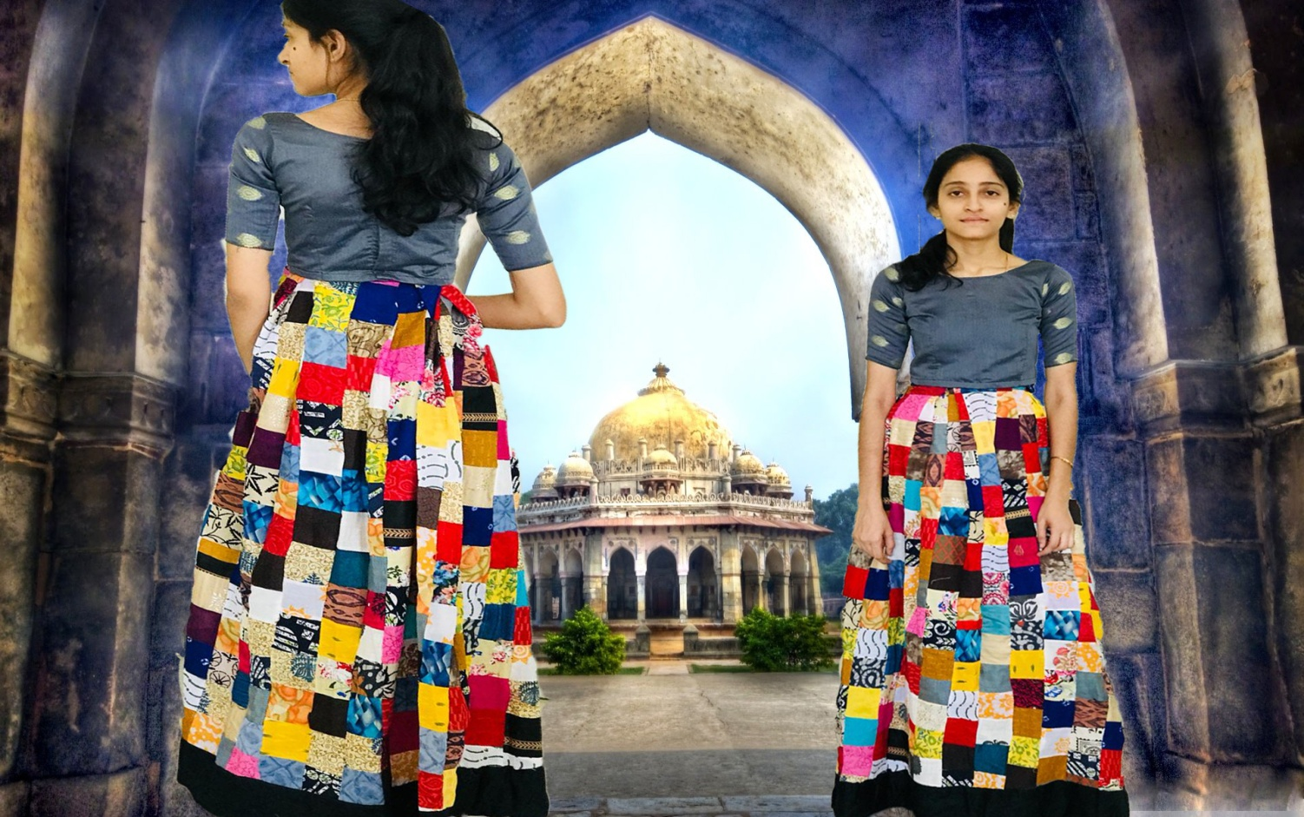

5. SUMMARY AND CONCLUSION
The issues related to textile waste generation are due to over consumption of textiles in western world. Like other wastes, textile waste disposal through landfill and incineration is responsible for global warming. Many agencies and stake holders are making efforts to contribute towards the aim for saving in resources of raw materials, energy water etc. and reducing the blow on environment for sustainable development. In future textile recycling would be as important manufacturing activity as textile manufacturing.The textile recycling industry continues to search for new viable value-added products made from used textile. Designing and construction of women’s garments using fabric scraps collected from selected boutiques. It is a new area to be explored. These garments were very much appreciated by consumer. Different styles of garments for different age group can be produced using fabric scraps from boutiques.

