Work – Life Balance of Women Employees in Manufacturing Industries

Angelin Rebecca David
(14PSW001)

Thesis submitted to
Avinashilingam Institute for Home Scienceand HigherEducation for Women,
Coimbatore – 641043

In Partial Fulfillment of the Requirements for the
Master’s degree in Social Work
The Departmentof Home Science Extension Education
APRIL, 2016

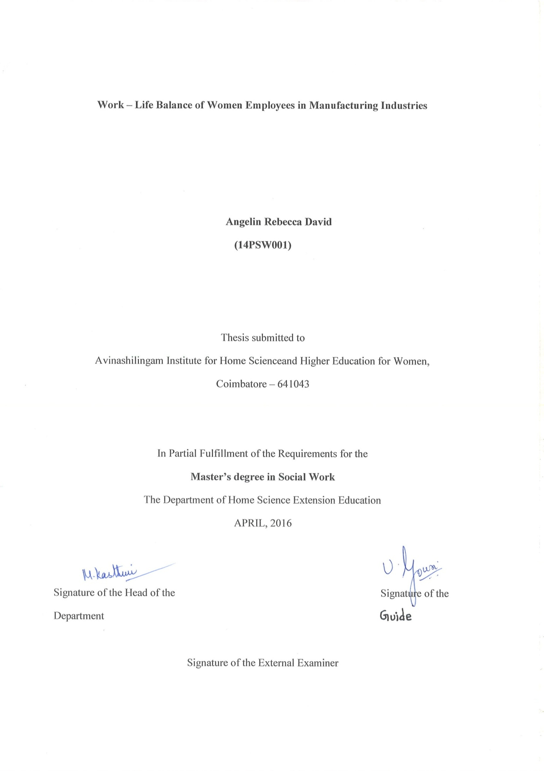

CERTIFICATE
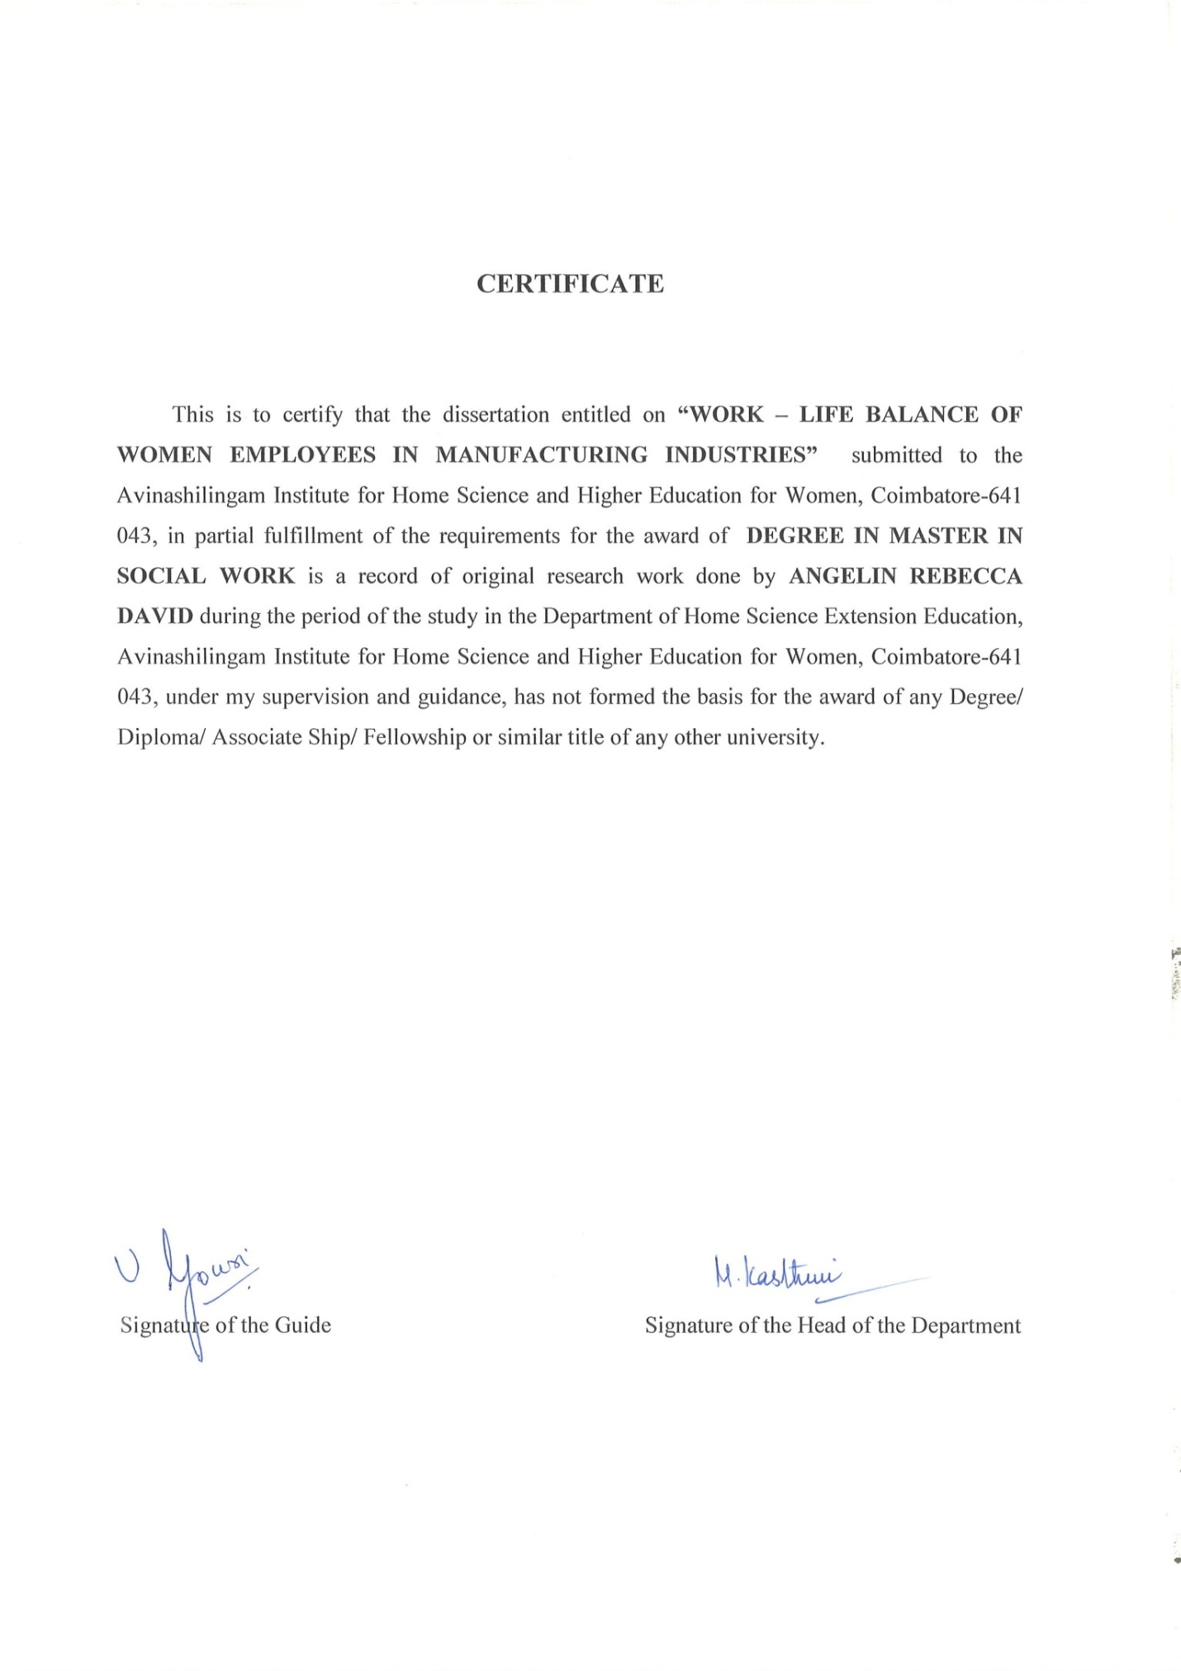

DECLARATION

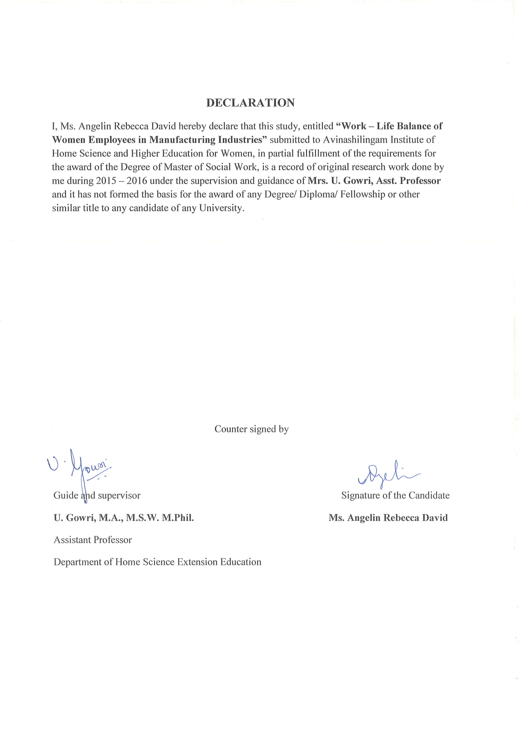

ACKNOWLEDGEMENT

ACKNOWLEDGEMENT
I thank the Lord Almighty for his Grace and Blessings, His everlasting love, bountiful mercy and amazing grace showered on me throughout the study.
A Project of such a comprehensive finish cannot be completed without the help of numerous sources and people throughout the long rugged path of success. I too realize this fact and so I am greatly indebted to all of them and take this opportunity to show my gratitude to them.
I would like to express my sincere thanks to Dr. P. R. Krishna Kumar, Chancellor, Avinashilingam Institute for Home science and higher Education for women, Coimbatore for providing the opportunity to carry out this academic exercise leading to the award of Master of Social Work in Home science Extension Education.
I owe my special thanks to Dr.PremavathyVijayan, Vice chancellor I/C, Avinashilingam Institute for Home science and Higher Education for Women, Coimbatore for the facilities provided to carry out the study.
I am immensely grateful to Dr. (Mrs.) A. Venmathi, M.Sc., Dip., Ed, M.Phil., Ph.D., Registrar, Avinashilingam Institute for Home Science and Higher Education for Women, Coimbatore for her constant encouragement.
I express my heartfelt thanks to Dr. (Mrs.) N. Vasugi, M.Sc., M.B.A., M.Phil., PhD., Dean, Faculty of Home science, Avinashilingam Institute for Home Science and Higher Education for Women, Coimbatore for her constant help and support at all times of need.
I feel extremely happy and overwhelmed with the support and encouragement given byDr. M. Kasthuri, M.Sc., M.Phil., Ph.D., Professor and Head, Department of Extension Education, Faculty of Home Science,Avinashilingam Institute for Home Science and Higher Education for Women, Coimbatore.
I feel highly indebtedtoMrs. U. Gowri, M.A., M.S.W., M.Phil, Assistant Professor, Department of Extension Education, Faculty of Home Science, Avinashilingam institute for Home Science and Higher Education for Women, Coimbatore, for her valuable help, guidance and encouragement rendered throughout the study.
I express my sincere thanks to all myTeachers in the Department of Extension Education,Faculty of Home Science,Avinashilingam Institute for Home science and Higher Education for women, Coimbatore for their advice and support throughout the study.
I am deeply thankful to my belovedParents for their constant encouragement, steady support and valuable help in the completion of the study.
Lastly, I offer my profound thanks to all those who supported and helped me during the course and completion of the study.

Angelin Rebecca David

CONTENTS
CONTENTS
CHAPTER NO | TITLE | PAGE NO
 | CHAPTER – I | 1 - 10
1 | Introduction | 1
1.1 | Concept of work-life balance | 1 - 2
1.2 | Root causes for work – life imbalance | 3
1.3 | Consequences of an imbalance | 3 - 6
1.4 | Work – life in India | 6
1.5 | Historical and Religious contexts | 6
1.6 | Status of women | 6 - 7
1.7 | Role of women in manufacturing industry | 7
1.8 | Related Studies | 8
1.9 | Strategies for work – life harmony | 8
1.10 | What are work – life strategies? | 8 - 9
1.11 | Need for the study | 9
1.12 | Conclusion | 9 - 10
 | CHAPTER – II | 11 - 14
 | REVIEW OF LITERATURE
 | CHAPTER – III
 | RESEARCH METHODOLOGY | 15 - 20
3.1 | Introduction | 15
3.2 | Title of the study | 15
3.3 | Objectives of the study | 15
3.4 | Need for the study | 15
3.5 | Research Hypotheses | 16
3.6 | Sources of data | 16
3.6.1 | Primary data | 16
3.6.2 | Secondary data | 16
3.7 | Research design | 16
3.8 | Universe of the study | 17
3.9 | Sampling Procedure | 17
3.10 | Exclusion and Inclusion Criteria | 17
3.11 | Tools used for Data collection | 17 – 18
3.12 | Period and tools used for data collection | 18
3.13 | Data analysis and interpretation | 18
3.14 | Difficulties encountered | 18 – 19
3.15 | Limitations of the study | 19
3.16 | Conceptual definition | 19
3.16.1 | Work – life balance | 19
3.16.2 | Manufacturing industry | 19
3.17 | Chapterization of the study | 19 - 20
3.18 | Conclusion | 20
 | CHAPTER – IV | 21 - 42
 | TABULATION, ANALYSIS AND INTERPRETATION
 | CHAPTER – V | 43 – 46
 | FINDINGS, DISCUSSION, SUGGESTION AND CONCLUSION
5.1 | Findings related to Socio – demographic profile | 43
5.2 | Findings related to Work related factors | 43
5.3 | Findings related to Home related factors | 44
5.4 | Findings related to Policy for work – life balance | 44
5.5 | Findings related to Association | 44
5.6 | Discussion | 44 – 45
5.7 | Role of an Industrial Social Worker | 45
5.8 | Suggestions | 46
5.9 | Conclusion | 46
 | BIBLIOGRAPHY | 47 - 48
 | APPENDIX | 49 - 51

LIST OF TABLES

LIST OF TABLES
Table No. | Title | Page No.
1. | Distribution of Respondents based on Number of Years of Married life | 23
2. | Distribution of Respondents based on Number of Children | 24
3. | Distribution of Respondents based on Number of Years of Experience | 27
4. | Distribution of Respondents based on Husband’s Educational Qualification | 31
5. | Distribution of Respondents based on how they commute to work | 33
6. | Distribution of Respondents based on Work Targets | 34
7. | Distribution of Respondents based on Assistance in Elderly and Child Care | 35
8. | Distribution of Respondents based on Family Conflict | 36
9. | Distribution of Respondents based on Flexible Work Timings to take care of emergencies at home | 37
10. | Distribution of Respondents based on Low Performance at Work having Negative Influence on Family Domain | 38
11. | Distribution of Respondents based on Work Family Conflict resulting in Lower Life Satisfaction | 39
12. | Distribution of Respondents based on Satisfaction with Policy Implementation | 40
13. | Association between Marital Status and Work - Life Balance | 41
14. | Association between Educational Qualification and Work – Life Balance | 42

LIST OF FIGURES

LIST OF FIGURES
Figure No. | Title | Page No.
1. | Graphical representation of Respondents’ Age | 21
2. | Graphical representation of Marital Status of the Respondents | 22
3. | Graphical representation of Respondents based on other Dependents | 25
4. | Graphical representation of Respondents based on Educational Qualification | 26
5. | Graphical representation of Respondents based on Monthly Income | 28
6. | Graphical representation of Respondents based on Department | 29
7. | Graphical representation of Respondents based on Designation | 30
8. | Graphical representation of Respondents based on Work Sector of Spouses | 32

APPENDIX

LIST OF APPENDICES

APPENDIX. NO | TITLE | PAGE. NO
1. | A questionnaire on the Work – Life Balance of Women Employees in Manufacturing Industries | 49 -51

CHAPTER - I

INTRODCUCTION
WORK – LIFE BALANCE OF WOMEN EMPLOYEES IN MANUFACTURING INDUSTRIES
- Introduction
Julie Cohen (2015) defines Work – Life Balance as “as the unique mix of choices we each make based on our values, priorities, and goals which gives us personal and professional satisfaction. This combination of choices is unique to each of us and it evolves throughout the course of our lives.”
Most psychologists would agree that the demands of an employee's career should not overwhelm the individual's ability to enjoy a satisfying personal life outside of the business environment. The meaning of Work - Life Balance can be difficult to determine - we believe that, to be most effective, Work - Life Balance should be defined on an individual basis. The Work – life balance of an individual depends on various factors such as nature of work, work timings, designation of the individual and increasing number of responsibilities and so on. Work - Life Balance describes the relationship between your work and the commitments in the rest of your life and how they impact on one another.
Employers, employees and government want to maximize participation in the workforce. However, in our demanding lives many people struggle to balance work and the responsibilities of caring for children, family members with a disability or elderly parents. For other workers it is often difficult to find time outside work for study, volunteering, taking care of their own health or participating in sport and recreation. There is no ideal Work - Life Balance; everyone is different and the 'right' balance may alter over time as families grow older and personal commitments change.
For employers the capacity to negotiate flexible work arrangements provides an antidote to loss of skills and experience and the high cost of recruitment and retention in a competitive labour market. Employers who provide flexible work options immediately gain a competitive edge in the labour market by becoming 'employers of choice'. Work-life balance is a concept that supports the efforts of employees to split their time and energy between work and the other important aspects of their lives. Work-life balance is a daily effort to make time for family, friends, community participation, spirituality, personal growth, self-care and other personal activities, in addition to the demands of the workplace.
Work-life balance is assisted by employers who institute policies, procedures, actions and expectations that enable employees to easily pursue more balanced lives.The pursuit of work-life balance reduces the stress with regard to employee experience. When they spend the majority of their days on work-related activities and feel as if they are neglecting the other important components of their lives, stress and unhappiness result. Work-life balance enables employees to feel as if they are paying attention to all the important aspects of their lives.
Because many employees experience a personal, professional and monetary need to achieve, work-life balance is challenging. Employers can assist employees to experience work-life balance by offering such opportunities as flexible work schedules, paid time off (PTO) policies, responsible time and communication expectations and company-sponsored family events and activities.Managers are important to employees seeking work-life balance. Managers who pursue work-life balance in their own lives, model appropriate behavior and support employees in their pursuit of work-life balance. They create a work environment in which work-life balance is expected, enabled and supported. They retain outstanding employees to whom work-life balance is important.
1.1 Concept of work-life balance:
Work–life balance has been defined as“a concept including proper prioritizing between "work" (career and ambition) and "lifestyle" (health, pleasure, leisure, family and spiritual development/meditation)”.
The work-leisure dichotomy was invented in the mid-1800s. Paul Krassner remarked that anthropologists use a definition of happiness that is to have as little separation as possible "between your work and your play". The expression "work–life balance" was first used in the United Kingdom in the late 1970s to describe the balance between an individual's work and personal life. In the United States, this phrase was first used in 1986.

1.2 Root Causes of Work-Life Imbalance

Most people who suffer from work-life imbalance tend to assume the problem is one of time. They often lament, "If only there were more hours in the day!" But while we donot have control over the passage of time, we do have control over what we do during it. If onefeels that he/she does nothave enough time to achieve his/her goals and fulfill his/her responsibilities, then one may need to find additional resources to deal with them. More realistically, he/she probably need to reassess the goals and responsibilities they currently have. The root causes of Work – life imbalance may be as follows:
- Excessive multi – tasking
- Trying to work faster
- Making promises that one cannot keep
The following are some of the signs which show that one does not have a proper Work – life balance
- Short temperedness
- Lack of joy
- Constant worrying
- Feeling sick
- Lack of control
- Easily irritated.

1.3 Consequences of an Imbalance
Mental health is a balancing act that may be affected by four factors: the influence of unfavourable genes, by wounding trauma, by private pressures and most recently by the stress of working. Many people expose themselves unsolicited to the so-called job stress, because the "hard worker" enjoys a very high social recognition. These aspects can be the cause of an imbalance in the areas of life. But there are also other reasons which can lead to such an imbalance.
Remarkable is, for example, the increase in non-occupational activities with obligation character, which include mainly house and garden work, maintenance and support of family members or volunteer activities. All this can contribute to the perception of a chronic lack of time. This time pressure is, amongst others, influenced by their own age, the age and number of children in the household, marital status, the profession and level of employment as well as the income level. The psychological strain, which in turn affects the health, increases due to the strong pressure of time, but also by the complexity of work, growing responsibilities, concern for long-term existential protection and more. The mentioned stresses and strains could lead in the long term to irreversible, physical signs of wear as well as to negative effects on the human cardiovascular and immune systems.
Prominent cultural beliefs that parenthood is the best avenue for a happy fulfilling life may not be justified. In, The Joys of Parenthood Reconsidered, what was found is the opposite, that parents actually suffer worse mental and physical health than childless adults. This is associated with the high costs of parenthood described in the article. The book also states that, “There is lack of institutional support which would help ease the social and economic burdens associated with parenthood.”
Psychoanalysts diagnose uncertainty as the dominant attitude to life in the postmodern society.This uncertainty can be caused by the pressure which is executed from the society to the humans. It is the uncertainty to fail, but also the fear of their own limits, not to achieve something what the society expects, and especially the desire for recognition in all areas of life. In today's society we are in a permanent competition. Appearance, occupation, education of the children - everything is compared to a media staged ideal. Everything should be perfect, because this deep-rooted aversion to all average, the pathological pursuit to excellence - these are old traditions. Whoever wants more - on the job, from the partner, from the children, from themselves - will one day be burned out and empty inside. She is then faced with the realization that perfection does not exist. Who is nowadays empty inside and burned out, is in the common language, a Burnout. But due to the definitional problems, burnout is till this date not a recognized illness. An attempt to define this concept more closely can be: a condition that gets only the passionate, that is certainly not a mental illness but only a grave exhaustion (but can lead to numerous sick days). It can benefit the term that it is a disease model which is socially acceptable and also, to some extent, the individual self-esteem stabilizing. This finding in turn facilitates many undetected depressed people, the way to a qualified treatment. According to experts in the field are, in addition to the ultra-hard-working and the idealists, mainly the perfectionist, the loner, the grim and the thin-skinned, especially endangered of a burnout. All together they usually have a lack of a healthy distance to work.
Another factor is also, that for example decision-makers in government offices and upper echelons are not allowed to show weaknesses or signs of disease etc., because this would immediately lead to doubts of the ability for further responsibility. Only 20 percent of managers do sports regularly and also only 2 percent keep regularly preventive medical check-up.In such a position other priorities seem to be set and the time is lacking for regular sports. Frightening is that the job has such a high priority, that people waive screening as a sign of weakness. In contrast to that, the burnout syndrome seems to be gaining popularity. There seems nothing to be ashamed to show weaknesses, but quite the opposite: The burnout is part of a successful career like a home for the role model family. Besides that the statement which describes the burnout as a "socially recognized precious version of the depression and despair that lets also at the moment of failure the self-image intact" fits and therefore concludes "Only losers become depressed, burnout against it is a diagnosis for winners, more precisely, for former winners."
Having an in-balance between your work and personal life can have very damaging effects on your health. An in-balance is basically a lack of clearly defined and consistently enforced boundaries between your work life and your personal life. When you fail to have a healthy Work - Life Balance, you end up experiencing emotional stress,anxietyand even depression.
The strongest factor that impacts on Poor Work - Life Balance is the amount of time spent at work. The higher levels of work-family conflict encountered by employees are often as a result of their longer work hours.
Other reasons include:
- job insecurity
- Supervisor conflict
- lack of co-worker support
- work overload
- role conflict and ambiguity
- job dissatisfaction and
- extensive use of digital technology that blurs the boundaries between home and work.
1.4 Work-Life in India
As India continues to emerge as a global economic power, understanding the dynamics between work and personal lives specific to this culture is increasingly important. In India, the work-life agenda is very much aligned with the social and institutional context of the country.
1.5 Historical and Religious Contexts
India is the world’s largest democracy, the seventh largest country in area and the second most populous country in the world. Indian civilization dates back more than 3,000 years. The country was largely under the rule of Hindu kings until the 11th – 12th century AD, after which it was dominated by Mughal rulers who arrived from Central Asia. The 16th century onwards saw the country under British colonial rule. As a modern nation state, India is relatively young, having attained independence in the year 1947. The constitution of the country declares India as a secular state (The Constitution of India - Preamble), but religion is an important facet of contemporary Indian life. The Hindu population that constitutes a majority at 80% dominates much of India’s social, cultural, economic and political climate.
1.6 Status of Women
The status of women in India has seen many changes over its long history (Pruthi, Devi &Pruthi, 2003). While in ancient India women enjoyed many freedoms, in recent history women have been relegated to a lower status than males in practically all spheres of life, with Hindu widows having particularly low status. This has led to high gender inequality in the country (Chhokar, et al., 2007). India’s sex ratio is heavily skewed in favor of men (933 females for 1000 males, 2001 Census Survey of India). Working women form about 32 percent of the working population. Most of these women are employed in the unorganized workforce, where they are either self-employed or are wage earners without formal employment contracts and ineligible for any social benefits. The percentage of women in the organized sector increased from 12.2 percent in 1981 to 14.1 percent in 1991 and 17.2 percent in 1999. As per the 2011 Census Survey of India, about 58 percent of the women in the organized sector were employed in the public sector, with the remaining 42 percent being employed in the private sector. This rise in working women is likely to increase the number of dual-income families, some studies estimate by perhaps 2.5 million per year (Hindu Business Line). However, this figure needs to be approached with some caution as there is also a huge dropout rate of women from the workforce as they approach their mid-30s, due to work-family conflict as well as societal pressure. Although the employment and status of women has been changing due to the forces of modernization and industrialization (Pruthi, et al., 2003) and due to the efforts of the women’s movement in India, this change has been slow (Krishnaraj, 2003). Largely the status quo appears to be maintained through the endorsement of and internalization of Hindu cultural beliefs of male supremacy and caste purity, superiority, and chastity. India’s value system and demographic statistics explain the absence of research in the work-family area, and also build a case for it, especially since redistribution of work and family roles is critical for empowerment of women in such contexts.
1.7 Role of women in manufacturing industry
Throughout the world, women make a vital contribution to industrial output. Over 200 million women are employed across all industry sectors, with half of this number in developing countries. Their work not only sustains their families, but also makes a major contribution to socio-economic progress. Most women are employed in low-skilled, poorly paid positions, where they are often exposed to health hazards. On the other hand, we are seeing the advance of an increasing number of highly educated women into senior decision-making positions. The creativity and talents of all women are an invaluable resource, which can and should be developed both for their own self-realization and for the benefit of society as a whole. The key to enhancing women’s opportunities, and hence their position in industry and the economy, is to provide them with access to know-how, technologies and credit. Training to upgrade women’s technological capabilities and to enhance their entrepreneurial and business skills, whether in simple artisanal production or in high technology industries, is at the heart of allowing women to advance to more rewarding positions.

1.8 Related Studies
In 2006, 53% of employees felt they had a good work-life balance, according to a Corporate Executive Board (CEB) report. That was reduced to 30% in the first quarter of 2009, the CEB reported. Many employees today are so busy making a living that they have no time to make a life.In contrast, numerous studies have shown the most productive employees are well-rounded professionals with full and well-balanced lives, both in and out of the workplace. Likewise, the most successful companies are those that foster employee health and well-being while enhancing organizational performance and productivity.Today work-life balance ranks as one of the most important workplace attributes -- second only to compensation and workers who feel they have a better work-life balance tend to work 21% harder than employees who feel overworked.

1.9 Strategies for work-life harmony
A work-life friendly workplace is a win-win situation for both employers and employees. One can get resources such as toolkits and funding to put in place work-life strategies at one’s workplace to gain competitive advantage with greater productivity.

1.10 What are work-life strategies?
Work-life strategies are measures you can put in place to help your employees manage work responsibilities alongside personal needs. They help raise employee productivity at work and make your organization more competitive.
Work-life strategies can be divided into 3 broad categories:
- Flexible work arrangements
- Enhanced leave benefits
- Employee support schemes
Work-life strategies have also been found to benefit organizations in the following ways:
- Higher productivity and shareholder value
- Improved employee engagement and satisfaction
- Improved attraction and retention of talent
- Reduced health-related costs (e.g. absenteeism, medical leave)
- Improved customer experience
1.11 Need for the study:
Work–life balance has been defined as“a concept including proper prioritizing between "work" (career and ambition) and "lifestyle" (health, pleasure, leisure, family and spiritual development/meditation)”. Most psychologists would agree that the demands of an employee's career should not overwhelm the individual's ability to enjoy a satisfying personal life outside of the business environment. The meaning of Work - Life Balance can be difficult to determine - we believe that, to be most effective, Work - Life Balance should be defined on an individual basis. The Work – life balance of an individual depends on various factors such as nature of work, work timings, designation of the individual and increasing number of responsibilities and so on. Work - Life Balance describes the relationship between your work and the commitments in the rest of your life and how they impact on one another.
Although there is a lot of research on Work – life balance, still many aspects remain unexplored. Research has to be done to find out what can be done to have an effective Work – Life balance and what employers and employees have to do for each other’s wellness. Policies to be designed for effective Work – life balance should clearly explain what it expects from the employers’ and employees’ side. Hence the need for such a study arose and the current research may throw light on Work – Life Balance of Women Employees in Manufacturing Industries.
1.12 Conclusion:

The present study tries to shed more light on Work – life balance of women employees in Manufacturing Industries. It aims at making an attempt to analyze the problems working women face in balancing their personal and professional life. It further tries to analyze what changes an employee has to adopt both in her family and work atmosphere in order to have a proper work – life balance. It tries to place importance on the part of the employers to design policies for work – life balance for employee retention and a long term association of competent employees for the success of the organization.

CHAPTER – II

REVIEW OF LITERATURE

CHAPTER 2
REVIEW OF LITERATURE
A literature review is a text of a scholarly paper, which includes the current knowledge including substantive findings, as well as theoretical and methodological contributions to a particular topic. Literature reviews are secondary sources, and do not report new or original experimental work. The current study tries to describe the factors contributing to Work – life balance and also makes an analysis of factors contributing to Work – life balance. It strives to analyze the root causes and consequences of Work – life imbalance. Previous studies are indicators for Work – life balance in different sectors in the context of the nature of the industry, job content, role and responsibility of the employee and the outcome in terms of the pros and cons of the specified industry.
DhamodaranV.et.al. (2014) studied work – life balance of women employees in fish net manufacturing industry and revealed that women do not have the opportunity of delegating family life to someone else unlike men who delegate the family to their wives.

The major factors influencing the Work - Life Balance of Women professionals in Indiawas identified by Mani Vijaya (2013)through her research and she reveals that role conflict, lack of recognition, organizational politics, gender discrimination, elderly and children care issues, quality of health, problems in time management and lack of proper social support.
Santhana Lakshmi K. (2013) conducted a study and found that the educational institutions should address the Work - Life Balance related issues among their staff, specifically women and take a holistic approach to design and implement the policies to support the teaching staff to manage their WLB.
Employees learn different kinds of behaviour from workplace life and private life. Since reciprocal interactions between both the life domains occur, a Green Work - Life Balanceconcept is suggested to facilitate environmentally friendly behavior for them. (GayathriN.,KarthikeyanP. (2013).
Lakshmi Vijaya et al (2013) have studied and found the issues and problems of women faculty working in educational institutions. They also found that women faculty members underwent severe stress in the process of attaining Work - Life Balance. Continued work pressure resulted in poor performance. The result revealed that many female teachers have neglected their health in the process of improving the life of their family members and their students.
Shiva G. (2013) studied that “Women professionals in high position in their office do not return from office in correct time, cook, clean and look after their family affairs. This makes them more stress and leads to some health problems”.
YadavK. Rajesh, DabhadeNishant(2013)have concluded that the women working in all types of professions demonstrate that there are no gender differences in work. The increasing demands at work place, the interface between work life and personal life needs more attention. It leads to stress and such situation affects person’s health both physiologically and psychologically.
KarthikeyanP.et.al.(2013) studied Work - Life Balance of women employees and revealed the various challenges and issues faced by women employees to achieve Work - Life Balance are managing household chores and professional responsibilities, taking care of children, handling work stress and so on.

PurohitManisha (2013) studied Work - Life Balance of women employees in various industrial sectors in Pune region and revealed that there is a need for organizations to adopt human resource strategies and policies to accommodate Work - Life Balance of employees.

Ramadoss (2012) observed in his study that high job control, supervisor support for family related issues and one’s own coping resources were significantly related to positive spillover from work to family and the direction of the relationships were positive for women in IT enabled sectors.
Shalini and Bhawna(2012) reported in their study, quality of work life is being used by the organizations as a strategic tool to attract and retain the employees and more importantly to help them to maintain Work - Life Balance with equal attention on performance and commitment at work.
SundarK.et.al. (2012) studied work – life balance of women employees in information technology industry and measured the overall Work - Life Balance of employees irrespective of
their cadres and found that all the employees do not have a proper Work – Life Balance because of the increasing work responsibilities.

Susi S. &JawaharraniK. (2011) agreed that a strong organizational culture increases employee’s intent to remain in the organization. Work - Life Balance must be supported and encouraged at all levels of the organization including senior management, line managers and all staff.
Mohan and Ashok (2011) explained that “Stress is often developed when an individual is assigned a major responsibility without proper authority and delegation of power, inter personal factors such as group cohesiveness, functional dependence, communication frequency, relative authority and organizational difference between role sender and focal persons”.
Reddy KrishnaN.(2010) concluded that the married women employees indeed experience Work Family Conflict (WFC) while attempting to balance their work and family lives. Thus, Organization needs to formulate guidelines for the management of WFCs since they are related to job satisfaction and performance of the employees.
Niharika and Supriya (2010) have studied the work based factors and family related factors that are considered to contribute to Work - Life Balance. Work based factors are flexi time, option to work part time and freedom to work from home and the family related factors are child care facility and flexibility to take care of emergencies at home.
Reddy Krishna and Vranda (2010) discussed the issues of Family and Work Conflict and Work Family Conflict are more likely to exert negative influences in the family domain, resulting in lower life satisfaction and greater internal conflict within the family variables impact the experience of WFC and FWC.
Women are mostly into full time services and are working 8 hours per day and 5 days in a week minimum and are confronted by increasing workload every day. So, most of them carry work and responsibilities to home but balancing between these two complex situations in the present day fast life requires talent, tact, skill and caution. Women have to cope up with high work targets, office commitments, tight meeting schedules and the duties and responsibilities of life and home. Employers should concentrate on framing various policies and schemes to facilitate Work - Life Balance to encourage and attract women employees. (GhoshSayanti, 2010).
Amita Singh (2010), suggested that flexi time, home working, child care facilities, option to work part time are facilities that need to be introduced and recommended for building a supportive work environment in the IT sector in India.
Mathew and Pachanatham (2009) stated that the women workforce in India was mainly employed in non-managerial, subordinate or low profile positions in the past. At present, they occupy almost all categories of positions in the workplace. These changes in work culture have added to women’s duties and responsibilities to their family as well as to society.
Conclusion:
By reviewing the studies conducted earlier, the researcher found that the work-life balance of women employees have to be studied in depth and a detailed analysis of the various factors leading to balanced work-life is needed. The organizations have to adopt appropriate human resource strategies and policies to accommodate work-life balance of employees. It was also observed through the reviews that in the home front women do not have the opportunity of delegating family life to someone else unlike men. By studying work-life balance of women employees, the various challenges and issues faced by women employees could also be revealed and the role to be played by both the organizations and the family could be emphasized.

CHAPTER - III

METHODOLOGY

CHAPTER III
METHODOLOGY
3.1 Introduction:
This study was undertaken for the purpose of analyzing the work – life balance of women employees in Manufacturing Industries. According to Clifford Woody “research comprises of defining and redefining problems, collecting, organizing and evaluating data, making deductions, suggesting solutions and drawing conclusions”.
3.2 Title of the study:
The title of the study is “Work – Life Balance of Women Employees in Manufacturing Industries”.
3.3 Objectives of the study:
- To study the Work - Life Balance of women employees in Manufacturing Industries
- To understand the factors responsible for work - life imbalance
- To elucidate the effects of work life imbalance

3.4 Need for the study:
Women, nowadays, have increasing number of roles to play at home as well in the workplace. As women are highly ambitious to be higher achievers in their work / job, they had to compromise with various things both at home and at work. This leads to stress among them where they find it difficult to achieve higher levels of satisfaction at home or at work. This lower level of job satisfaction or life satisfaction tends to affect the other walks of life. Therefore,there is a pertinent need to analyze the conditions which may lead to balanced work- life of every working woman and it is very essential to know how the work place and family life can be modified so that they achieve greater satisfaction at both the ends. By analyzing the Work - Life Balance, one will be able to find out the effects of improper Work - Life Balance and what behavior and organizational changes have to be done to have a proper Work - Life Balance.

3.5 Research Hypotheses:
- Marital status of a woman employee plays a dominant role in work – life balance.
- Educational qualification of an employee influences work – life.
- There is an association between number of years of experience and work – life balance.
- Age is a factor of work – life balance.
- Married women with children face difficulty in managing their work and life.
3.6 Sources of data:
3.6.1 Primary data:
The data were collected from women employees working inElgiEquipments and ATS – Elgi Pvt. Ltd., Coimbatore. ATS – Elgi is a subsidiary of ElgiEquipments which was established in 1960 as service station and reciprocating compressor manufacturing company. Over the years ELGI has become a multiproduct, multi market company manufacturing technical superior products. The manufacturing unit is established in Coimbatore. ATS – Elgi manufactures garage and body shop equipments.
3.6.2 Secondary data:
The data were collected through various sources such as books, journals and the internet.
3.7 Research design:
A research design is a logical and systematic plan prepared for directing a research study. It specifies the objectives of the study, the methodology and techniques to be adopted for achieving the objectives. It constitutes the blue print for the collection, measurement and analysis of data.
The research design of the present study is Descriptive in nature.Descriptive research is a study designed to depict the participants in an accurate way. More simply put, descriptive research is all about describing people who take part in the study.In the current study, the Work-life balance of women employees isanalyzed and interpreted to find out the factors responsible for improper Work - Life Balance and effects of improper Work - Life Balance.

3.8 Universe of the study:
For the current study, the researcher considered only women employees working in Manufacturing Industries for her study.ElgiEquipments and ATS – Elgi Pvt. Ltd., Coimbatore were selected as universe of the current study. Though there were many women employees in these two companies, at the executive level only 70 women employees were there. Out of them 60 women employees were selected using inclusion / exclusion criteria.
3.9 Sampling Procedure:
The sampling method used by the researcher was convenient sampling.Convenient sampling is a non – probability sampling technique where subjects are selected because of their convenient accessibility and proximity to the researcher. A convenience sample is one of the main types of non – probability sampling methods. A convenience sample is made up of people who are easy to reach. The advantages of this type of sampling are the time and cost required to carry out a convenience sample is relatively less.
3.10 Exclusion and inclusion criteria
- The study excludes unskilled women employees.
- The study excludes non – executive cadre women employees.
- The study includes only women employees from Manufacturing Industries.
- The study includes employees who are above 25 and below 55 years of age.
- The study has included only those women employees who were willing to cooperate with the research.

3.11 Tools used for data collection:

The tool used for data collection was questionnaire. It was divided into five headings namely

I Socio – demographic profile
II Work – related factors
III Home – related factors
IV Policy for work – life balance
V Work - Life BalanceScale. This is an arbitrary self-structured scale comprised of 59 questions and it includes both positive and negative statements with multiple responses for each item namely Strongly agree ( SA), Agree ( A), Neither agree nor disagree ( N ), Disagree ( D ) and Strongly disagree ( SD).

The scoring was done as follows:
For positive statements, SA – 5, A – 4, N – 3, D – 2, SD – 1.
For negative statements, SA – 1, A – 2, N – 3, D – 4, SD – 5.
The maximum score of the scale was 279.
The minimum score of the scale was 79.
Higher the score, better balanced is Work – Life.
Since the scale was a self – prepared scale, the reliability and validity are yet to be tested.

3.12 Period of data collection:
The period of data collection was from January to February, 2016

3.13 Data analysis and interpretation:

The data collected were first presented into data sheet and then analyzed using SPSS and Excel. The tables, figures and charts were prepared with the data base and based on the analysis, appropriate and adequate interpretations were given.

3.14 Difficulties encountered:

The researcher encountered the following difficulties during the research.

- The respondents took more time to complete the questionnaire as they had their own responsibilities at work which had to be completed within a given period of time.
- The time period to complete the data collection was very limited.
- The researcher had difficulty in convincing the respondents about the purpose of the study.

3.15 Limitations of the study

There are some limitations for this research which are as follows:-

- The study was done only with women employees working in only two Manufacturing Industries in Coimbatore city. Therefore a larger generalization of the research finding will not be possible.
- The study could not analyze the Work – life balance of women employees in other sectors because it focused only on the manufacturing industry.
- The data was collected only from women working in manufacturing sector; therefore the findings of the study cannot be generalized to men.

3.16 Conceptual Definition:

3.16.1 Work – life Balance

Work–life balance is a concept including proper prioritizing between "work" (career and ambition) and "lifestyle" (health, pleasure, leisure, family and spiritual development/meditation).
3.16.2 Manufacturing industry

The term may refer to a range of human activity, from handicraft to high tech, but is most commonly applied to industrial production, in which raw materials are transformed into finished goods on a large scale.
3.17 Chapterization of the study
Chapter – I
This chapter deals with the introduction of the study, statement, description related to the study.
Chapter – II
For any research study, survey of literature is important This chapter deals with the various reviews of literature that were taken as sourcematerials.
Chapter – III
This chapter deals with the research methodology in particular containing the title of the study, objectives of the study, need for the study, research design, sampling procedure, tools used for data collection, difficulties encountered, limitation of the study and analysis of data of the terms used.
Chapter – IV
This chapter deals with the analysis and interpretation of data, generalization; particularly the objectives could be achieved only by analyzing the data and interpreting on the basis of literature.
Chapter – V
This chapter includes in it the various findings, discussions, suggestions and conclusion of the study.
3.18 Conclusion:
Research methodology is a way to systematically solve the research problem. It may be understood as a science of studying how research is done scientifically. Research methodology has many dimensions and research methods do constitute a part of the research methodology. When we talk of research methods but also consider the logic behind the methods we use in the context of our research study and explain only we are using a particular method or technique and why we are not using others so that research results are capable of being evaluated of either by researcher herself or by others.
CHAPTER – IV

TABULATION & INTERPRETATION
CHAPTER 4
TABULATION AND INTERPRETATION
Figure 1
Graphical representation of Respondents’ Age

Here, it is noted that nearly 75 percent belong to the age group of 25 – 40 years. From this it is understood that women who fall in this category will have a difficulty in balancing their Work – Life. It is also understood that women who belong to the age group of above 40 years do not constitute a major part of the women workforce in the manufacturing sector.

Figure 2
Graphical representation of the Marital Status of the Respondents

It can be observed that nearly 53 percent of the women are married. Married working women find it difficult to balance Work and Life because of the demanding roles at home and workplace. Unmarried women may not have a great difficulty in managing Work – Life because they will not have many roles at home.

Table 1
Distribution of Respondents based on Number of Years of Married Life
S.No. | No.of years of married life | Frequency | Percent
1. | 0-5 | 32 | 53.3
2. | 6-10 | 7 | 11.7
3. | 11-15 | 12 | 20.0
4. | 16-20 | 7 | 11.7
5. | 21-25 | 1 | 1.7
6. | above 25 | 1 | 1.7
 | Total | 60 | 100.0

From the above table it is understood that nearly 80 percent of the respondents have a married life of 15 years. They may have small children which would place a lot of responsibility on their part when it comes to taking care of children. This increases their personal responsibilities to a great extent and hence their Work – Life balance may not be proper.

Table 2
Distribution of Respondents based on Number of Children
S.No. | No.of children | Frequency | Percent
1. | No child | 24 | 40.0
2. | One child | 26 | 43.3
3. | Two children | 10 | 16.7
 | Total | 60 | 100.0

The above table shows that nearly 43 percent of respondents have one child and 40 percent of them have no children. Working women having no child or having one child may not find it difficult to balance Work and Life because they may have comparatively less personal responsibilities.

Figure 3
Graphical representation of Respondents based on other Dependents

It can be observed that nearly 60 percent of the respondents have no other dependents at home. So it is understood that they will not have a problem in having a proper Work – Life.

Figure 4
Graphical representation of Respondents based on Educational Qualification

The figure shows that 52 percent of the respondents have completed their postgraduate degree. It is a common understanding that people with high educational qualifications have the capacity to cope with situations and with adjustmental levels is higher than the less educated persons.

Table 3
Distribution of Respondents based on Number of Years of Experience
S.No. | No.of years of experience | Frequency | Percent
1. | 0-5yrs | 22 | 36.7
2. | 6-10yrs | 16 | 26.7
3. | 11-15yrs | 8 | 13.3
4. | 16-20yrs | 12 | 20.0
5. | above 20yrs | 2 | 3.3
 | Total | 60 | 100.0

It can be observed from the table that nearly 64 percent of the respondents have a work experience of 6 to 20 years. Therefore they will not have a great difficulty in having a proper Work – Life Balance because they will be already accustomed to their work timings and challenges and will know how to manage their personal and professional responsibilities.

Figure 5
Graphical representation of Respondents based on Monthly Income

From the figure, it can be noted that 49 percent of the respondents earn Rs. 11000 – 20000 per month. Employees who feel that their monthly income is not enough to afford for all the expenses may work overtime and hence will have a difficulty in managing Work and Life.

Figure 6
Graphical representation of Respondents based on Department

From the figure, it can be observed that the respondents were from all departments and that 25 percent of the respondents were from the Customer Care department where the job is very demanding and gives a lot of pressure to the employees. Employees from this department may have a difficulty in having a proper Work – Life Balance.

Figure 7
Graphical representation of Respondents based on Designation

From the figure, it is noted that 25 percent of the respondents work as Customer Care Service Executives and it can be understood that employees who take up this job may have a difficulty in balancing their personal and professional responsibilities. This may be because they have to be able to attend all the calls they receive from customers regarding product complaints, servicing, delivery and so on.

Table 4
Distribution of Respondents based on Husband’s Educational Qualification
S. No. | Husband's Educational Qualification | Frequency | Percent
1. | Diploma | 16 | 26.7
2. | Undergraduate | 23 | 38.3
3. | Postgraduate | 21 | 35.0
 | Total | 60 | 100.0

From the above table, it is noted that nearly 70 percent of the respondents’ spouses have completed their undergraduate and postgraduate degree and hence the respondents may have family support to certain extent and they will not much difficulty in balancing Work and Life.

Figure 8
Graphical representation of Respondents based on Work Sector of Spouses

The above figure shows that nearly 53 percent of the respondents’ spouses work in the private sector which may lead to the respondent having to take care of all the household responsibilities by herself which may lead to an improper Work – Life Balance.

Table 5
Distribution of Respondents based on Mode of transport
S. No. | Commute to work | Frequency | Percent
1. | By Own transport | 49 | 81.7
2. | By Public transport | 11 | 18.3
 | Total | 60 | 100.0

From the above table it is understood that 82 percent of the respondents commute to work by their own transport. This is because the company is not providing any transport facility for their employees as the employees reside in different parts of the city.

Table 6
Distribution of Respondents based on Work Targets
S. No. | Work targets | Frequency | Percent
1. | Yes | 55 | 91.7
2. | No | 5 | 8.3
 | Total | 60 | 100.0

The above data shows that 92 percent of the respondents have work targets as they come under the executive category. Work targets are set only for employees in the higher levels of authority in the organization. Work targets are a way of assessing an employee’s ability to cope with the increasing work responsibilities.

Table 7
Distribution of Respondents based on Assistance in Elderly and Child Care at Home

S. No. | Anyone assisting in elderly and child care | Frequency | Percent
1. | Yes | 24 | 40.0
2. | No | 36 | 60.0
 | Total | 60 | 100.0

The above data shows that 60 percent of the respondents have said that they do not have anyone assisting them at home in elderly and child care. This might increase the difficulty in balancing their Work – Life. They will have more responsibilities at home because they have to take care of their children and elderly people at home, if any.

Table 8

Distribution of Respondents based on Family Conflict

S. No. | Family conflict | Frequency | Percent
1. | Yes | 34 | 56.7
2. | No | 26 | 43.3
 | Total | 60 | 100.0

The above data shows that 56.7 percent of the respondents have said that they experience family conflict. This may be due to working overtime and not being able to meet family needs and spend quality time with family. Family conflict may arise due to various reasons such as lack of family support, failure to understand one’swork responsibilities and so on.

Table 9
Distribution of Respondents based on Flexible Work Timings
S.No. | Flexible work timings | Frequency | Percent
1. | Yes | 55 | 91.7
2. | No | 5 | 8.3
 | Total | 60 | 100.0

The above data shows that 91.7 percent of the respondents have said that their work timings are such that an employee can take care of emergencies at home. A relaxation is given between 8 a.m. and 9a.m.Employees can come to work between 8 a.m.& 9 a.m. and can leave office after having worked for 10 hours from the time they enter the office.

Table 10
Distribution of Respondents based on negative influenceoflow performanceon family
S.No. | Negative influence of low performance on family | Frequency | Percent
1. | Yes | 31 | 51.7
2. | No | 29 | 48.3
 | Total | 60 | 100.0

From the above table, it is clear that 52 percent of the employees feel that their low performance at work has a negative influence on family domain whereas 48 percent of the employees feel that their low performance at work does not have a negative influence on family domain. Individuals differ in their opinion when it comes to their perspective about life. The reason for this may be that they feel that low performance at work might lead to working overtime which would result in missing out on quality time with the family.

Table 11
Distribution of Respondents based on Work Family Conflict resulting in Lower Life Satisfaction
S.No. | Work family conflict results in lower life satisfaction | Frequency | Percent
1. | Yes | 47 | 78.3
2. | No | 13 | 21.7
 | Total | 60 | 100.0

The above data shows that 78 percent of the respondents feel that Work Family Conflict results in Lower Life Satisfaction because a person’s inability to manage Work and Life will lead to worrying about work even when not actually at work and being depressed about not being able to have a proper Work – Life Balance.

Table 12
Distribution of Respondents based on Satisfaction with Work-life Policy Implementation
S.No. |  | Frequency | Percent
  Satisfaction with the implementation of policy
1. | Yes | 15 | 25.0
2. | No | 45 | 75.0
 | Total | 60 | 100.0

The above data shows that 75 percent of the respondents are not satisfied with the implementation of policy because it does not meet personal needs and does not alter the hours of work per day. The employees feel that the policy should be designed in such a way that it is employee – centered and caters to all the employee needs.

Table 13
Association between Marital Status and Work - Life Balance

Marital status | Work - Life Balance |  |  | Total
Marital status | ( Low)  99& below | (Medium)  100 –121 | (High)  121&  above | Total
Unmarried | 6 | 3 | 3 | 12
Married | 8 | 26 | 10 | 44
Divorcee | 1 | 1 | 1 | 3
Separated | 0 | 0 | 1 | 1
Total | 15 | 30 | 15 | 60

X² = 9.470 d.f = 6 P = .149 (>0.05)
Null Hypothesis: There is no association between Marital Status and Work - Life Balance

Chi – square was applied to find out the association between marital status and the Work - Life Balance of the respondents. It is found out that there is no association between the marital status and the work – life balance of the respondents. Therefore the null hypothesis is accepted which means the marital status does not influence the work-life balance.

Table 14

Association between Educational Qualification and Work – Life Balance

Educational Qualification | Work - Life Balance |  |  | Total
Educational Qualification | ( Low)  99& below | (Medium)  100 –121 | (High)  121&  above | Total
Diploma | 6 | 2 | 1 | 9
Undergraduate | 3 | 10 | 7 | 20
Postgraduate | 6 | 18 | 7 | 31
Total | 15 | 30 | 15 | 60

X² = 10.804 d.f = 4 P = .029 (>0.05)

Null Hypothesis: There is no association between educational qualification and work – life balance

Chi – square was applied to find out the association between educational qualification and the Work - Life Balance of the respondents. It is found out that there is no association between educational qualification and the work – life balance of the respondents.Therefore the null hypothesis is accepted which means that the educational qualification does not influence the work-life balance.

CHAPTER - V

FINDINGS, DISCUSSION, SUGGESTIONS AND CONCLUSION

CHAPTER – 5
FINDINGS, DISCUSSION, SUGGESTIONS AND CONCLUSION

This chapter deals with findings of data analysed in the previous chapter and attempts to capture the essence of the study. This chapter also consists of details on the implication of the present study and social work intervention.
5.1 Findings related to Socio – demographic Profile:
- Majority (65.0 percent)of the respondents are in the age group of 25 – 45 years.
- More than half (53.3 percent) of the respondents are married.
- Nearly three fourth (73.3 percent)of the respondents have a married life of up to15 years.
- Less than half (43.3 percent) of the respondents have one child so they may not have difficulty in balancing personal and professional life.
- Three fifth (60.0 percent) of the respondents do not have any other dependents at home.
- A little more than half of the respondents (51.7 percent) are postgraduate degree holders.
- 36.7 percent of the respondents have a work experience of up to 5 years.
- Less than half (48.3 percent)of the respondents get a salary of Rs.11,000 – 20,000 per month.
- One fourth of the respondents (25.0 percent) belong to the customer care department.
- One fourth of the respondents (25.0 percent) work as customer care service executives.
- 38.3 percent of the respondents’ spouses are undergraduate degree holders.
- More thanhalf of the respondents’ spouses (53.3 percent)work in the private sector.
- 31.7 percent of the respondents earn a total family income of Rs.21,000 – 40,000 per month.

5.2 Findings related to Work related factors:

- 81.7 percent of the respondents commute to work by their own transport.

- 91.7 percent of the respondents do not have work targets and 8.3 percent of the respondents have work targets.

5.3 Findings related to Home related factors:

- Three fifth(60.0 percent) of the respondents do not have anyone assisting them in elderly and child care.
- More than half (56.7 percent) of the respondents experience family conflict.
- A high majority (91.7 percent) of the respondents feel that they have flexible work timings to take care of emergencies at home.
- More than half (51.7 percent) of the respondents feel that their low performance at work has a negative influence on family domain.
- Majority (78.3 percent) of the respondents feel that WorkFamily conflict results in Lower life satisfaction.

5.4 Findings related to Policy for Work – life balance:

- Majority (75.0 percent) of the respondents are not satisfied with the implementation of the policy.

5.5 Findings related to Association:

- There is no significant association between the marital status and the work – life balance of the respondents.
- There is no significant association between the educational qualification and the work – life balance of the respondents.

5.6 Discussion

Work – Life Balance plays a major role in the lives of working women. It is very important to have a proper balance between Work and Life to live a stress free life. Work-life balance is assisted by employers who institute policies, procedures, actions and expectations that enable employees to pursue more balanced lives. The pursuit of work-life balance reduces the stress with regard to employee experience.Previous studies onWork - Life Balance of women employees revealed the various challenges and issues faced by women employees to achieve Work - Life Balance and the management of household chores and professional responsibilities, taking care of children, handling work stress and so on.

The current study tried to analyze the factors responsible and the effects of improper Work – Life balance and it has been found that marital status does not influence Work – Life Balance. It was also found that women have a great difficulty on their part to manage Work and Life because of the increasing responsibilities at home and workplace. Lack of family support and understanding one’s job demands by the family leads to further more problems in managing Work and Life.

5.7 Role of an Industrial Social Worker

An Industrial Social Worker has the following roles to play in the context of work life balance:
- The Industrial Social Worker can play a major role in formulating Work – Life Balance policies after understanding the needs and constraints of the employees.
- He/she should be able to build a good rapport with the employees so that he/ she will be able to identify their needs.
- He/she should understand the importance of his/her role to be able to provide for the welfare of employees.
- He/she should be able to arrange for the recreation of employees to ensure a stress free life to employees. This would improve better performance of employees.
- He/she should be able to administer employee counseling.

5.8 Suggestions

For further research, the researcher suggests that more emphasis should be laid upon what employers could do for the retention of employees and what strategies have to be adopted and the factors responsible for improper Work – life balance should be studied in detail and accurately explained. The researcher also suggests that more studies should be conducted to study the Work – life balance of employees working in Manufacturing Industries.

5.9 Conclusion
The current study analyzed the Work – Life Balance of Women Employees in Manufacturing Industries and studied how working women encounter difficulties in managing their roles at home and work. The current study also analyzed what each employee feels regarding Work Family Conflict and their low performance at work. It was also found through the study, that the marital status and educational qualification do not affect the Work – Life Balance.

BIBLIOGRAPHY

BIBLIOGRAPHY

- Andrew McVicar (2003), “Workplace Stress in nursing”, Vijaya publications, 3rd Edition p.p:123-125.

- Arora and Aroar P.N (2003), “Statistics for Management”, S. Chand publications, New Delhi, 2nd edition, p.p 43-47.

- Atkinson, J., and Meager, N. (1986). Changing working patterns. How Companies Achieve Flexibility to Meet New Needs.

- Bachmann, K. (2000). Work-life Balance. Are Employers Listening? Ottawa: Conference Board of Canada.

- Barbara Morgan and Laura Hensley (1998), “Supporting working mothers through group work a multimodal psycho educational approach”, Vijaya Publications, 2nd edition, p.p: 32-36.

- BiswajeetPattanayak (2006), “Human Resource Management”, Prentice Hall of India Publication, 3rd edition, p.p: 187-192.

- Baral, R., and Bhargava, S. (2010). Work-family enrichment as a mediator between organizational interventions for work-life balance and job outcomes. Journal of Managerial Psychology, 25(3), p.p 274-300.

- Burke, R. J. (2002). Organizational values, job experiences and satisfactions among managerial and professional women and men. Women in Management Review, 17(5), pp 228-236.

- Campbell DJ, Campbell KM, Kennard D. The effects of family responsibilities on the work commitment and job performance of non-professional women. Occupa Organ Psych. 1994; 67:283–96.

- Chassin, L., Zeiss, A., Cooper, K., and Reaven, J. (1985). Role perceptions, self-role congruence and marital satisfaction in dual-worker couples with preschool children. Social Psychology Quarterly, pp 301-311.

- C.R. Kothari (2004), “Research Methodology”, New Age International Publishers, New Delhi, p.p: 76-77

- Gayathri N, Karthikeyan P. Work life balance in India–A social responsibility or a competitive tool. International Research Journal of Business and Management 2013; 1: 103-109.
- Gayathri N, Karthikeyan P. (2013) A Review on Green Human Resource Management with Exclusive Allusion to Green Work Life Balance, International Research Journal of Business and Management; 5: 40-45.

- Mani V. (2013), Work Life Balance and Women Professionals, Global Journal of Management and Business Research Interdisciplinary; 13(5): 2013.

- Maskowska Z. (1995) psychosocial characteristics of work and family as a determinant of stress and well-being of women: A preliminary study. IntOccup Med Environ Health ; 8:215–22.

- Padma S, Sudhir Reddy M. (2013) Impact of Child care responsibility on Work Life Balance (WLB) of School Teachers. International Journal of Advanced Research in Business Management and Administration; 1(1).

- Ramanna A, Bombawale U. Transitory status images of working women in modern India. Indian Soc Work. 1984; 45:189–202.

- Shiva G. (2013), A study on Work Family Balance and Challenges faced by working women, IOSR Journal of Business and Management; 14(5): 1-4.

- Srivastava V. New Delhi: National Publishing House; 1978. Employment of educated women in India; its causes and consequences.

- Super DE. A life-span, life-space approach to career development. Vocat Behar. 1980; 16:282–9.

Website References:
- http://www.workflexibility.org/author-insights-julie-cohen-7-keys-work-life-balance/
- http://www.businessdictionary.com/definition/work-life-balance.html
- http:/www.selfgrowth.com/articles/the_symptoms_and_impact_of_lack_of_work_life_balanc
- https://www.mentalhealth.org.uk/a-to-z/w/work-life-balance
- http://www.ncbi.nlm.nih.gov/pmc/articles/PMC3122548/
- https://www.bc.edu/content/dam/files/centers/cwf/pdf/BCCWF_EBS-India.pdf
- http://ijmrr.com/admin/upload_data/journal_Sudha%20%203aug14mrr.pdf
- http://www.pbr.co.in/Dec2013/6.pdf

APPENDIX

AVINASHILINGAM INSTITUTE FOR HOME SCIENCE AND
HIGHER EDUCATION FOR WOMEN
COIMBATORE- 43.

QUESTIONNAIRE ON WORK-LIFE BALANCE OF WOMEN EMPLOYEES IN MANUFACTURING INDUSTRIES
Purpose: This questionnaire contains questions relating to Work - Life Balance. Please make sure that you answer all the questions. It will be ensured that the responses given by the respondent will be kept confidential and used only for academic purposes.
I Socio- Demographic profile:
- Age:
- Marital status: a) unmarried b) married c) divorcee d) separated
- No. of years of married life:
- No. of children:
- Age of children: a) 1st child ------ b) 2nd child -------- c) 3rd child -------
- No. of other dependents at home:
- Educational qualification: a)diploma b) undergraduate c) postgraduate
- No. of years of experience:
- Monthly income: Rs.-----
- Department: a) Reliability b) Materials c) Marketing d) Finance e) Customer care f) HR
- Designation:
- Husband’s education: a) diploma b) undergraduate c) postgraduate
- Sector: a) government b) private c) business/entrepreneur
- Total family income per month:Rs.-----
II Work related factors:
- Do you work on shifts? Yes / No
- How do you come for work? 1)company transport 2)own transport 3)public transport
- Do you have crèches in your company? Yes/No
- Do you have canteen? Yes/No
- Do you have work targets? Yes/No

III Home related factors:

- Does anyone assist you in elderly & child care? Yes/No
- Do you experience family conflict? Yes/No
- Are your work timings flexible to take care of emergencies at home? Yes/No
- Does your low performance at work have a negative influence on family domain? Yes/No
- Do you think that Work Family Conflict results in lower life satisfaction? Yes/No

IV Policy for Work - Life Balance:

- Is there a Work - Life Balance policy in your company? Yes/No
- Are you aware of the existing policy? Yes/No
- If aware, are you satisfied with the implementation of policy? Yes/No
- If no, what are your expectations regarding it?
i)
ii)
iii)
The following are a few statements relating to Work - Life Balance. There are five options for each statement. Please tick the option which is most appropriate for you.
SA- Strongly agree A- Agree N- Neither agree nor disagree D- DisagreeSD- Strongly Disagree
S. No. | Statements | SA | A | N | D | SD
29. | I have good interpersonal relationship among co – workers
30. | I have less work burden
31. | There is delegation of powers
32. | Powers are delegated appropriately
33. | There is no gender discrimination
34. | I get support from higher authorities for family issues
35. | Generally I have work – life balance
36. | The amount of time I spend at work is adequate to handle my professional responsibilities
37. | I often think about work, even when I am not actually at work
38. | Because of pressure of work, I miss out on quality time with my family and friends
39. | I feel tired / depressed because of issues at work
40. | Flexible working hours will help me have a better work – life balance
41. | My work gives me enough satisfaction to create a better atmosphere in my home
42. | Most of my colleagues have a positive influence on my work – life balance
43. | Being an employed woman, gives me space & status in my social circle
44. | The effort I put in work positively reflects on the quality of my life style
45. | Family members are a part of work achievements
46. | Suggestions offered by me are given due importance both at work and at home
47. | My organization has social functions at times suitable for families
48. | My organization takes initiatives to manage work life of its employees
49. | If employees have good work-life balance, the organization will be more effective and successful
50. | Policies have been implemented to support and manage Work - Life Balance
51. | Hours of work per day are flexible enough to manage my personal responsibilities
52. | I am able to complete my targets on time
53. | I am able to spend enough time with my family
54. | I have adequate holidays/ paid time-off
55. | Company has a separate work-life balance policy
56. | The work-life balance policy should be customized to individual needs
57. | I experience high levels of stress resulting from my job
58. | I suffer from a stress-related disease
59. | My family supports me in helping me achieve my work targets

