A COMPARATIVE STUDY ON NUTRIENTS PRESENT IN FRESH AND PROCESSED FRUIT JUICES USING ENERGY DISPERSIVE SPECTROSCOPY

M.REVATHI (17PFD016)

Thesis submitted to the Avinashilingam Institute for Home Science and
Higher Education for Women, Coimbatore – 641 043

In Partial Fulfilment of the Requirements for the Degree of Master of Science in
Food Service Management and Dietetics

A COMPARATIVE STUDY ON NUTRIENTS PRESENT IN FRESH AND PROCESSED FRUIT JUICES USING ENERGY DISPERSIVE SPECTROSCOPY

M.REVATHI (17PFD016)

Thesis submitted to the Avinashilingam Institute for Home Science and
Higher Education for Women, Coimbatore – 641 043

In Partial Fulfilment of the Requirements for the Degree of Master of Science in
Food Service Management and Dietetics

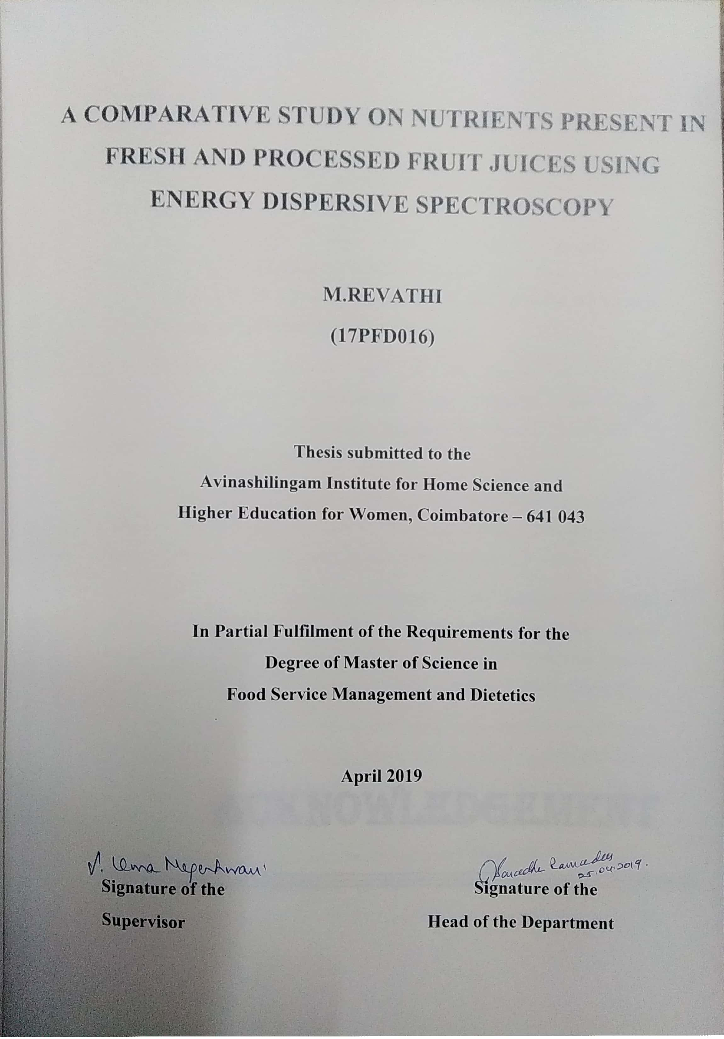
ACKNOWLEDGEMENT
I owe my sincere thanks to Lord Almighty and My Lovable Parents without whom I would have been nothing and showering their generous blessings upon me in all endeavors.
The investigator pays her reverential homage to (Late) Dr. T.S AVINASHILINGAM, Founder, and First Chancellor, Avinashilingam Institute for Home Science and Higher Education for Women, Coimbatore, for being a perennial source of inspiration.
Reverential homage is paid to the Doyen of Nutrition, Dr. (Mrs) RAJAMMAL P. DEVADAS, Former Chancellor, Avinashilingam Institute for Home Science and Higher Education for Women, Coimbatore, for having been a source of inspiration.
The investigator is grateful to Padmashri Dr. P. R.KRISHNA KUMAR, Chancellor, Avinashilingam Institute for Home Science and Higher Education for Women, Coimbatore, for providing an opportunity to conduct the study.
The investigator expresses her gratitude to Dr. T.S.K. MEENAKSHI SUNDARAM, M.A., M.Phil., Ph.D. (Honoris Caussa) Managing Trustee, Avinashilingam Institute for Home Science and Higher Education for Women, Coimbatore, for providing infrastructure and all amenities to conduct the study.
The investigator owes her special thanks and gratitude to Dr. (Mrs) PREMAVATHY VIJAYAN, M.Sc, M.Ed, Dip. Spl.Edn.(U.K), M.Phil, Ph.D,
Vice Chancellor, Avinashilingam Institute for Home Science and Higher Education for Women, Coimbatore, for facilitating the completion of the study.
She records her gratitude to Dr. (Mrs). S. KOWSALYA, M.Sc., M.Phil., Ph.D., Registrar, Avinashilingam Institute for Home Science and Higher Education for Women, Coimbatore, for providing all the facilities for the smooth conduct of the study.

I place on record my heartfelt thanks to Hon.Col.Dr. (Tmt.) Saroja Prabakaran, M.A.,Dip.Ed.,Ph.D.,Former Vice Chancellor, The Director, Hall of Residence, Avinashilingam Educational Trust Institutions Hostel, Coimbatore, for extending all possible help towards the completion of the study.
She expresses her heartfelt thanks to Dr. (Mrs). N.VASUGI RAJA, M.Sc,
M. Phil, Ph.D., Dean Faculty of Home Science, Avinashilingam Institute for Home Science and Higher Education for Women, Coimbatore, for her help and constant support to carry out the research.
The investigator expresses her special thanks and sincere gratitude to Dr. (Mrs) V. SARADHA RAMADAS, M.Sc, M. Phil., Ph.D., Professor and Head, Department of Food Service Management and Dietetics, Avinashilingam Institute for Home Science and Higher education For Women, Coimbatore, for her keen interest, valuable help, concern and encouragement which has helped in the successful completion of the study.
The investigator expresses her deep sense of gratitude and whole hearted thanks to her supervisor Dr. (Mrs.) S. UMA MAGESHWARI, M.Sc., M. Phil., Ph.D., Dean Student Affairs and Professor, Department of Food Service Management and Dietetics, Avinashilingam Institute for Home Science and Higher Education for Women, Coimbatore, whose ability to probe beneath text was a true gift and her insight has strengthened this study significantly. Her meticulous guidance, deep concern, constructive suggestions, continued motivation, enduring support and gentle care rendered from the initial to the final level of the study enabled the investigator to complete the research successfully.
The investigator acknowledges with gratitude the good wishes and encouragement of All the Staff Members of the Department of Food Service Management and Dietetics, Avinashilingam Institute for Home Science and Higher Education for Women, Coimbatore.

I would like to express my special thanks to my Parents, Sister, my Friends and all my Well-wishers for their constant encouragement, support and help in carrying out this work successfully.

CONTENTS

CHAPTER NO | TITLE | PAGENO
 | LIST OF TABLES LIST OF FIGURES LIST OF ANNEXURES
I | INTRODUTION | 1
II | REVIEW OF LITERATURE  - Fruits - An overview  - Fruit Juices and Health Benefits  - Nutrients Present in Fruit Juices  - Effect of Processing on Fruit Juices  - Field Emission Scanning Electron Microscopy (FESEM) | 6
III | METHODOLOGY  - Market survey on consumption of fruit juices  - Selection of departmental stores  - Survey on processed fruit juices  - Survey on consumption of fresh fruit juices  - Formulation of fresh fruit juices  - Analysis of fresh and processed fruit juices using  - Field Emission Scanning Electron Microscopy (FESEM) specimen preparation (coating for the sample)  - FESEM procedure  - EDAX procedure | 18
IV | RESULTS AND DISCUSSION  - Details on the Market Survey on Consumption of Fruit Juices  - Field Emission Scanning Electron Microscopy (FESEM)  - Structure of Fresh and Processed Apple Juices  - Nutrient Content and Graphical Representation of Fresh and Processed Apple Juices  - Quant Results of Fresh and Processed Apple Juices | 23

CHAPTER NO | TITLE | PAGENO
- Structure of Fresh and Processed Pomegranate Juices
  - Nutrient Content and Graphical Representation of Fresh and Processed Pomegranate Juices
  - Quant Results of Fresh and Processed Pomegranate Juices
- Structure of Fresh and Processed Grape Juices
  - Nutrient Content and Graphical Representation of Fresh and Processed Apple Juices
  - Quant Results of Fresh and Processed Grape Juices
- Structure of Fresh and Processed Pineapple juices
  - Nutrient Content and Graphical Representation of Fresh and Processed Pineapple Juices
  - Quant Results of Fresh and Processed Pineapple Juices
- Structure of Fresh and Processed Guava Juices
  - Nutrient Content and Graphical Representation of Fresh and Processed Guava Juices
  - Quant Results of Fresh and Processed Guava Juices
V | SUMMARY AND CONCLUSION | 59
VI | BIBLIOGRAPHY | 63
VII | ANNEXURES | 72

LIST OF TABLES

TABLE NO | TITILE | PAGE NO
I | Availability of Processed Fruit Juices | 24
II | Consumption of fruit juices among selected consumers | 25
III | Weight and atomic percentage of fresh apple juice | 30
IV | Weight and atomic percentage of processed apple juice | 31
V | Weight and atomic percentage of fresh pomegranate juice | 36
VI | Weight and atomic percentage of processed pomegranate juice | 37
VII | Weight and atomic percentage of fresh grape juice | 42
VIII | Weight and atomic percentage of processed grape juice | 43
IX | Weight and atomic percentage of fresh pineapple juice | 48
X | Weight and atomic percentage of processed pineapple juice | 49
XI | Weight and atomic percentage of guava juice | 54
XII | Weight and atomic percentage of processed guava juice | 55
XIII | Consolidated Table of Quant Results for Fresh and Processed Fruit Juices | 56

LIST OF FIGURES

FIGURE NO | TITILE | PAGE NO
1 | Sputter Carbon Coater | 21
2 | Sputter coating chamber during sputtering | 21
3 | FESEM analysis of fresh apple juice | 26
4 | FESEM analysis of processed apple juice | 26
5 | Illustrates the FESEM analysis of fresh apple juice | 27
6 | Illustrates the FESEM analysis of processed apple juice | 27
7 | Graphical representation of fresh apple juice | 29
8 | Graphical representation of processed apple juice | 29
9 | FESEM analysis of fresh pomegranate juice | 32
10 | FESEM analysis of processed pomegranate juice | 32
11 | Illustrates the FESEM analysis of fresh pomegranate juice | 33
12 | Illustrates the FESEM analysis of processed pomegranate juice | 33
13 | Graphical representation of fresh pomegranate juice | 35
14 | Graphical representation of processed pomegranate juice | 35
15 | FESEM analysis of fresh grape juice | 38
16 | FESEM analysis of processed grape juice | 38
17 | Illustrates the FESEM analysis of fresh grape juice | 39

FIGURE NO | TITILE | PAGE NO
18 | Illustrates the FESEM analysis of processed grape juice | 39
19 | Graphical representation of fresh grape juice | 41
20 | Graphical representation of processed grape juice | 41
21 | FESEM analysis of fresh pineapple juice | 44
22 | FESEM analysis of processed pineapple juice | 44
23 | Illustrates the FESEM analysis of fresh pineapple juice | 45
24 | Illustrates the FESEM analysis of processed pineapple juice | 45
25 | Graphical representation of fresh pineapple juice | 47
26 | Graphical representation of processed pineapple juice | 47
27 | FESEM analysis of fresh guava juice | 50
28 | FESEM analysis of processed guava juice | 50
29 | Illustrates the FESEM analysis of fresh guava juice | 51
30 | Illustrates the FESEM analysis of processed apple juice | 51
31 | Graphical representation of fresh guava juice | 53
32 | Graphical representation of processed guava juice | 53

LIST OF ANNEXURES

ANNEXURE N0 | TITLE | PAGE NO
I | Ethical Clearance Committee | 71
II | Questionnaires | 72

CHAPTER I INTRODUCTION
Fruits are the seed bearing structure in plants formed from the ovary of flowering plants. Fruits are the sweet, fleshy, edible part of a plant and it also contains seeds. Fruits are sweet or sour and are widely classified as a drupe, pome, berry and hesperidium. Fruits have wide variety of colours, shapes and flavours. They also have some medicinal and aesthetic value.
Fruits are essential in everyday meal as they contain all the required nutrients for a balanced diet. It is one of the major groups among the five food groups. Nutritionally fruits are considered as the superior source of micronutrients such as vitamins and minerals. Fruits include a diverse group of plant foods that vary greatly in content of energy and nutrients. They have biologically active substances which can helps to protect from diseases. Fruits are usually eaten raw, although some varieties can be cooked.
The cycle of fruit growing involves a year round activity and involves physical techniques such as control over shape, size and growing of plant in a proper direction. The earliest fruit culture was started around 3rd millennium BCE (Before the Common Era), the fruit that was cultivated in the earlier period was dates, fig, olives and pomegranate and grapes.
India is the second largest producer of fruits and contributes only one percent of the global market of the fruit processing industry. India‘s great deal of variety of climate ensures availability of all varieties of fresh fruits. India stands second in the production of fruits after China. India produced about
90.2 million metric tonnes of fruits during the year 2015 – 2016, during the period of 2016 – 2017 the production of fruits was about 92 million tonnes, two percent higher than previous year. India exported fruits for about Rs. 4,229.03 cores in the period 2017 – 2018 (Daniel workman, 2019).

The annual production of fruits in India is estimated to be nearly one million tonnes and contributes only one percent to the total export. The exporting of fresh fruits are also gradually increasing year by year. Citrus fruits and mango are the major exported. Banana, apple and papaya are other fruits that are exported.
Due to the lack of proper processing and packaging facilities thirty percent of the fruits are getting wasted in India and only two to three percent are totally produced as processed in India.
The current trend of eating healthy and fresh is driving a change in lifestyle globally, with many, finding of alternatives in fresh fruit juices to bottled or fizzy drinks.
In India, the wastage of fresh fruit produce has been estimated to be of a very high order, i.e, around 30 – 35 percent of the total production during harvest, storage, grading, transport, packaging and distribution because of the challenges involved in the industry (Sharma et al., 2016).
The lack of temperature controlled vehicles, unavailability of cold chain facilities in various parts of country for preserving the produce, results in immense loss to the nation (Rais et al., 2015).
Based on the perishability level of fruits preservations techniques were introduced and used. The preservation of fruits by canning method, developed by Nicolas Appert was started in the 11th century. Later many new technologies were developed such as quick freezing and freeze drying.
As technology is developing, the consumption of the fruits as juices have increased to improve digestion and to supply all the required nutrients. Though the edible portion of the fruits contains more amounts of nutrients, the liquid juices were introduced to promote the growth rate of marketing industry and to satisfy the customer sale.

In India the fresh fruit juice industry is largely unorganised and an untapped industry. Changing lifestyle for hygienic and clean fruit juices is creating a growth for fresh fruit juices in India.
In India the juice market is echeloned into three segments namely: fruit drinks (with maximum 30percent fruit content) holds about 50-60percent market share, fruit juices (with almost 100percent fruit content) holds about 30- 35percent market share and nectar drinks (with almost 30-90percent fruit content) holds just about 10 percent market share of entire juice in the Indian market (Yogeshsingh, 2018).
In recent years, there has been a tremendous shift of consumer preferences from aerated drinks to packaged fruit juices. Consumers are well assured of the hygiene maintained by the company manufacturing packaged fruit juices as they are FSSAI certified. Consumer heavily trusts the international and national brands on parameters of quality and hygiene. The single point juice counter may not maintain the desired hygiene and sanitation while preparing juices.
All packaged fruit juices are having high-shelf life ranging from six months to one year. They are exposed to heat treatment which makes juices lose all its vitamins in order to impart such long shelf life. The availability of packaged juices has the largest share in market with almost 90percent and they are in the form of tetra-packs, tin or pet bottles; but tetra-packs. The packs are available in various sizes. The potential capacity of packaged juice market is approximately of gigantic Rs 1,500 crore. Fruits used in packaged juices are not visible to consumer and hence low quality fruits are also used by juice making companies. Such packaged juices have patulin (organic compound harmful to mankind) in them indicating poor quality of fruits used in it. Most of juice extraction processes are not production satisfactory quantity and quality of juices (Yogesh Singh, 2018).
By using the FESEM the nutrients were analysed. It is helpful to observe the minute particles in nutrients are identified. The structure shows the equally dispersive. The atomic weight and weight percentage is been

represented through FESEM. The graphical representation the amount of nutrient presents in the sample it‘s been identified in EDAX.
A FESEM is microscope that works with electrons (particles with a negative charge) instead of light. These electrons are liberated by a field emission source. The object is scanned by electrons according to a zig – zag patter. FESEM produces clearer, less electrostatically distorted images with spatial resolution down to 1.5 nm which is 3 to 6 times better than conventional SEM. Reduced penetration of low kinetic energy electrons probes closer to the immediate material surface. High quality, low voltage images can be obtained with negligible electrical charging of samples(Accelerating voltages range from
to 30 kV).
Surface morphology and correlation of surface appearance can be identified. Characterization of size, shape, and dispersion of additives particulate and the fibers in composites and blends. The height and lateral dimensions of nanometer – sized object can be measured. Characterization of size distribution and cell size in foam materials are identified. Fracture and failure analysis can be detected. Defect analysis can be done.
The ability to examine smallor – area contamination spots at electron accelerating voltages compatible with energy dispersive spectroscopy (EDS). Penetration of low kinetic- energy electrons probes closer to the immediate materal surface is reduced. High quality low voltage images with negligible electrical charging of samples (accelerating voltages ranging from 0.5 to 30 kilovolts). Essentially no need for placing conducting coating on insulating materials.

Need for the study
Fresh fruit juices are rich in nutrients and have more health benefits to compared to processed fruit juices. But food technology has advanced and all food products are made available in processed from. Even though the processing has a lot of advantages, when the availability is adequate the consumption of fresh fruit juices is far more beneficial to us. Fresh and processed fruit juices do not have the same structure and nutrients and hence an attempt was made to find out the difference in structure and nutrients in fruits

in their fresh from and also in processed one. As the world is moving faster, technology has taken its own avatar, and almost all the products are made available in processed form. The education level and the emergency of new disease have increased the demand for fruit juices due to the disease and health promotions properties and also awareness about fresh fruit juices indirectly least to the higher demand and consumption of fruits.

Objectives
The objective of study was to

    - Identify the nutrients present in fresh and processed juices using FESEM

    - Compare the nutrient content between fresh and processed juices

CHAPTER II

REVIEW OF LITERATURE

The literature is pertaining to the study ―A Comparative Study on Nutrients Present in Fresh and Processed Fruit Juices Using Energy Dispersive Spectroscopy‖ is presented
- Fruits - An overview
- Fruit Juices and Health Benefits
- Nutrients Present in Fruit Juices
- Effect of Processing on Fruit Juices
- Field Emission Scanning Electron Microscopy (FESEM)

Fruits - An overview

Fruits are naturally plant products and juicy seed in nature that may be taken raw as food. They are readily available, accessible, and affordable in many environments and are naturally endowed with potentials of health benefits. Humans are persistently exposed to various oxidants capable of causing many degenerative diseases (Rabiu et al., 2018).
Fruit contains large amounts of simple sugars (glucose, fructose, sucrose, etc.), which are well known to induce obesity. Thus, considering the amount of simple sugars found in fruit, it is reasonable to expect that their consumption should contribute to obesity rather than weight reduction (Satya P. Sharma et al., 2016).
The consumption of fruits and fruit juices could have both positive and negative effect on the part of consumers. Fruits and fruit juices processed under hygienic condition could play important role in enhancing consumers health through inhibition of breast cancer, congestive heart failure (CHF), and urinary tract infection. The nutritional richness of fruits and fruit juices makes the product good medium for microbial growth, vehicle of food borne pathogens and associated complications (Hylemariam Mihiretie et al., 2015).

There is an increasing trend of fruit juice consumption due to increasing reported health benefits of antioxidant content present in fruit juices. The aim of this study was to compare the total phenolic contents (TPC) and antioxidant activities of fresh fruit juices, commercial 100percent fruit juices and fruit drinks. Pomegranate juices demonstrated the highest antioxidant activities among commercial 100percent fruit juices.Fruits drinks group had the lowest TPC and antioxidant activities for all types of fruits (Wern et al., 2016).
Although composition of fruit juices is different from that of the edible portion of fruits, they contain polyphenols and vitamins. Drinking fruit juices is very popular in many countries. The studies showed that fruit juices affect cardiovascular risk factors, such as lowering blood pressure and improving blood lipid profiles. The main mechanisms of action included antioxidant effects, improvement of the aspects of the cardiovascular system, inhibition of platelet aggregation, anti-inflammatory effects, and prevention of hyperhomocysteinemia. Drinking juices might be a potential way to improve cardiovascular health, especially mixtures of juices because they contain a variety of polyphenols, vitamins, and minerals from different fruits and vegetables (JieZheng et al., 2017).
In developing countries like India, where street food vending is very common, there is lack of information on the incidence of food borne illnesses. On the other hand the quality of fruit juices is strictly maintained in developed countries under several laws and regulations but in many developing and underdeveloped countries, the manufacturer are not concerned about the microbiological safety and hygiene of fruit juices because of lack of enforcement of the law. Thus the transmission of certain human diseases through juice and other drinks in recent years is a serious problem. One of the aim of this present investigation is to assess the sensory attributes of freshly available fruit and vegetable juices, their physico chemical qualities and their comparison with the processed juices sold under different brand name. (Aleem et al., 2017).
There has been an increasing appreciation and understanding of the link between dietary fruit and vegetable intake and improved health in humans. The widespread and growing intake of apples and apple juice/products and their

rich phytochemical profile suggest their important potential to affect the health of the populations consuming them. Exposure to apples and apple products has been associated with beneficial effects on risk, markers, and etiology of cancer, cardiovascular disease, asthma, and Alzheimer‘s disease. Recent work suggests that these products may also be associated with improved outcomes related to cognitive decline of normal aging, diabetes, weight management, bone health, pulmonary function, and gastrointestinal protection (Dianne A. Hyson, 2011)
The advantages of these membrane processes over traditional methods are lower thermal damage to product, increase in aroma retention, less energy consumption, and lower equipment costs. Membrane concentration of fruit juice not only provides microbiological stability but also permits economy in packaging and distribution of the finished product due to a reduction in bulk by weight and volume (Bhattacharjee et al., 2017).
A comparison between fresh and commercial pomegranate juice obtained by conventional and organic agricultural practices was conducted. The total phenolic content values ranged from 2285 to 2457 mg GAE L−1; however, there was no significant difference among conventional and organic juices (Nuncio-Jauregui et al., 2015).

Fruit Juices and Health Benefits

Vegetable/fruit juices provide polyphenols, oligosaccharides, fiber and nitrate (beet juice), which may induce a prebiotic-like effect. Juice-based diets are becoming popular. However, there is a lack of scientific evidence of their health benefits. It was our hypothesis that changes in the intestinal microbiota induced by a juice-based diet play an important role in their health benefits (Susanne M. Henning et al., 2017). One-hundred percent fruit juice consumption is associated with a number of health benefits, such as improved cardiovascular health and decreased obesity, although some of these and other potential benefits are controversial. The combination of whole fruit and 100percent juice improved dietary density of potassium and vitamin C without significantly increasing total calories (Roger Clemens et al., 2015).

Fresh fruits are rich sources of polyphenolic compounds. The polyphenolics present in plant sources are known to have beneficial effects, especially in the prevention of cardio-vascular diseases, cancer, etc. Therefore, the consumption of fresh fruits is not only associated with vitamin supplementation, but also serves as an effective preventive agent for many diseases. The polyphenolic compounds comprise a wide range of phytochemicals including tannins, flavonoids, phenolic acids, stilbenes and lignans (Nazan Cevik, et al.,).
The flavour taste and aroma are valued for fresh juices nutritional benefits. The consumption of fruit juices human diet has a number of benefits including antioxidants fibre, phytonutrients, vitamins and minerals and being useful for preventing disease. Hence the consumption of fresh juices has a positive impact on health being consumed immediately or stored at controlled conditions (Kaddumukasa et al., 2017).
Epidemiologic evidence suggests that fruit consumption may lower the risk of cardiovascular diseases through blood pressure (BP)–lowering effects; little is known on the independent effect of raw fruit and fruit juice on BP (Linda M Oude Griep et al., 2013).
Fruits are used commonly in form of fleshy or pulpy, juice. Fruit juices and beverages are most effective against disease related to such as reduced levels of oxidative stress, obesity, diabetes, atherosclerosis, high blood pressure, diabetes, osteoporosis, arthritis, some forms of cancer and even biological aging, chronic inflammation, Cardiovascular diseases. Antioxidant analysis such as Total Phenol, Flavanoids, Total antioxidant capacity, Vit C, Anthocyanins content in Pomegranate, strawberry, Red grapes, orange, Dried Green Tea. Fruit beverages were prepared at different ratio. Its‘ content of antioxidants shows highly significant different with each other (Dharti et al., 2014).
New polyphenol-rich beverages were prepared using sour and sweet pomegranate juices in different proportions (reaching pH 4.0). The results of

sensory tests suggest that mixed beverages are preferred to pure sweet juices (Zaouay et al.,2014).
Among the examined fruit juices, the black currant juices contained the highest amounts of all groups of the phenolics and exhibited strong antioxidant capacity. The amount of anthocyanins determined by HPLC method ranged from 92.36 to 512.73 mg/L in red grape and black currant juices, respectively (N. Mitic et al., 2011)
The amount of Vitamin C content of some fresh fruit degradaded with time was investigated; Pineapple, Orange, Watermelon and Tomato stored under difference conditions. The juices from the samples were extracted and vitamin C content in the juice was analysed at room temperature, 400C and at seven (7) days storage by indophenols titration method. (Abubakar El-Ishaq et al., 2015).
The use of enzymes in juice industry has contributed in increasing the yield and production of various types of juices. Pectinolytic enzymes are one of the important groups of enzymes used in fruit processing industry. These are one of the upcoming enzymes of fruit processing industries (Tapre, A. R.et al., 2014).
Apples contain a variety of phytochemicals, including quercetin, catechin, phloridzin and chlorogenic acid, all of which are strong antioxidants. The phytochemical composition of apples varies greatly between different varieties of apples, and there are also small changes in phytochemicals during the maturation and ripening of the fruit. Storage has little to no effect on apple phytochemicals, but processing can greatly affect apple phytochemicals (Manoj Charde et al., 2011).
Orange (citrus sinensis) is well known for its nutritional and medicinal properties throughout the world. From times immemorial, whole orange plant including ripe and unripe fruits, juice, orange peels, leaves and flowers are used as a traditional medicine. The major medicinal properties of orange include anti – bacterial, anti-fungal, anti – diabetic, cardio-protective, anti- cancer, anti-arthritic, anti-inflammatory, anti-oxidant, anti-tubercular, anti- asthmatic and anti-hypertension (Milind et al., 2012).

The improved extraction of S. cocculoidespulp increases juice yield as well as juice quality by supplying larger amounts of phenolic compounds that have potential health benefits and act as dietary sources of antioxidants for the prevention of diseases caused by oxidative stress (Ruth T. Ngadze et al., 2018).
Diabetes mellitus has become a worldwide health problem. Whether
fruit juice is beneficial in glycemic control is still inconclusive. This study aimed to synthesize evidence from randomized controlled trials on fruit juice in relationship to glucose control and insulin sensitivity (Bin Wang et al., 2014).

Current scientific evidence also suggests a protective role for fruits and vegetables in prevention of coronary heart disease, and evidence is accumulating for a protective role in stroke. In addition, a new scientific base is emerging to support a protective role for fruits and vegetables in prevention of cataract formation, chronic obstructive pulmonary disease, diverticulosis, and possibly, hypertension(Van Duyn MA et al., 2000).

Nutrients Present in Fruit Juices

Fruits have a high content of fibre and vitamins, and are low in calories and fat. Fruits healthy properties are beneficial because of their content in vitamins, anti-oxidant, micro-nutrients and minerals, which is helpful in prolonging of life by protecting and rejuvenating tissues, cell and organs. It protects from aliments like hair-fall, wrinkling of skin, memory loss and age- related macular degenerating of the retina in the eyes, cancer, Alzheimer‘s disease, osteoporosis amongst others (AfshanKaleem et al., 2016). All kind of fruits are believed to contain high amount of natural antioxidant properties such as vitamins, phenol, flavonoid and carotenoid (U K Ibrahim et al., 2016).

Fruits are considered a good source of polyphenols and antioxidant capacities which are beneficial in protecting the human body against damage

induced by reactive species. Polyphenol content and antioxidant capacity of different fruits, vegetables and fruit juices. (Rudy Alvarez et al., 2016).

The carbohydrates, flavoniods, tannins and glycosides were present where as the alkaloids and saponins were absent in all the above fruit juices. Qualitative and quantitative analysis by TLC and DPPH methods revealed the presence of antioxidants in all the fruit juices except cantaloupe (BathalVijaya Kumar et al., 2013).The Phytochemical components of the fruit juices were analysed whereby the amount of alkaloids was higher than the amount of flavonoids. . Nutritional, chemical compositions and antimicrobial activities of individual fruit juice and their blend were also carried out using standard methods (Olayinka T. Ogunmefun et al., 2018).
The total phenolic content of 13 commercially available fruit juices and juice drinks, selected to represent the most popular juice flavors in the United Kingdom, were analyzed using the Folin−Ciocalteu assay. Purple grape juice contained the largest number of individual phenolic compounds and also the highest concentration of total phenolics. The main components were flavan-3- ols, anthocyanins, and hydroxycinnamates, which accounted for 93percent of the total phenolic content. In contrast, white grape juice, which contained principally hydroxycinnamates, had the lowest total phenolic content (Mullen et al., 2007).
Stability of the total phenolic content ascorbicacid, total carotenoids and antioxidant activity in eight fruit beverages was analyzed. Pomegranate juice presented the highest values for antioxidant acitivity by DPPH. The antioxidant capacity was stable at 4 and 8ᵒc for the first 8 days of storage; while carotenoids and ascorbic acid were slightly degraded through the storage time, possibly due to oxidation and / or reactions with other compounds (C. Castro-Lopez et al., 2016).
Fresh, processed fruits and vegetables including frozen and canned, cooked, 100percent fruit juices and 100percent vegetable juices, as well as dry fruits are all considered as servings of fruits and vegetables per day. A wide variety of fruits, vegetables, whole grains, and other plant foods provide a

range of nutrients and different bioactive compounds including phytochemicals, vitamins, minerals, and fibers. More and more evidence suggests that the health benefits of fruits, vegetables, whole grains, and other plant foods are attributed to the synergy or interactions of bioactive compounds and other nutrients in whole foods. Therefore, consumers should obtain their nutrients, antioxidants, bioactive compounds, and phytochemicals from a balanced diet with a wide variety of fruits, vegetables, whole grains, and other plant foods for optimal nutrition, health, and well-being, not from dietary supplements (RuiHai Liu, 2013).
Most guidelines recommend eating a diet with a high intake of fiber-rich food including fruit. This is based on the many positive effects of fruit on human health. However some health professionals have concerns that fruit intake has a negative impact on glycemic control and therefore recommend restricting the fruit intake (Allan S Christensen et al., 2013).
Dietary recommendations to promote health include fresh, frozen and tinned fruit, but few studies have examined the health benefits of tinned fruit. We therefore studied the association between tinned fruit consumption and mortality (Erlend T. Aasheim et al., 2015).
The dietary consumption of fruit and vegetable is associated with a lower incidence of degenerative diseases such as cardiovascular disease. All varieties of apple contain several antioxidants and polyphenols that possess many biological activities, such as antioxidant and anti-inflammation properties. The review describes the nutritional properties of apples and their derivatives, with a particular attention to polyphenol compounds (Ferretti et al., 2014).
Apples contain a variety of phytochemicals, including quercetin, catechin, phloridzin and chlorogenic acid, all of which are strong antioxidants. The phytochemical composition of apples varies greatly between different varieties of apples, and there are also small changes in phytochemicals during the maturation and ripening of the fruit. Storage has little to no effect on apple phytochemicals, but processing can greatly affect apple phytochemicals (Boyer et al., 2004).

Effect of Processing on Fruit Juices

Fruits are particularly rich in phenolic compounds with antioxidant activity, and therefore, the fruits juices are also naturally rich in these compounds. The aim of this review is to focus on the effect of processing and storage over these compounds, such as thermal pasteurization, pulsed electric fields, high pressure, ultrasound, microwave treatment, microfiltration, refrigeration and freezing (Raquel de Pinho Ferreira Guine et al., 2016).
Carbonation of fruit juices can also have a great scope in the future as carbonated soft drinks are very popular among youth and are known for their thrust quenching and refreshing properties but they lack the nutritional value. But the fruit juices which contain all the nourishing properties and the goodness of the fruit if they are carbonated then they can be a popular choice among youth for fruit drinks. Carbonated fruit based beverage is a new concept which provides nutritional elements of the fruit along with natural pigments and flavor in addition to carbonation effects (ShilpiVerma et al., 2018).
The first of a two-part review of the recent and classical literature reveals that loss of nutrients in fresh products during storage and cooking may be more substantial than commonly perceived. Depending on the commodity, freezing and canning processes may preserve nutrient value. The initial thermal treatment of processed products can cause loss of water-soluble and oxygen- labile nutrients such as vitamin C and B vitamins. However, these nutrients are relatively stable during subsequent canned storage owing to the lack of oxygen.Frozen products lose fewer nutrients initially because of the short heating time in blanching, but they lose more nutrients during storage owing to oxidation. Phenolic compounds are also water-soluble and oxygenlabile, but changes during processing, storage and cooking appear to be highly variable by commodity (Rickman et.al, 2007).
An overview of the most relevant outbreaks involving food borne pathogens and spoilage microorganisms associated with fruit juices is provided. One of the sections provides data on the sources of fruit juice contamination,

followed by perspectives on preservation methods. Furthermore, considerations on the role of international guidelines about exotic fruit juices in respect to public health, and of the microbiological status of fruit juices used as food/beverage ingredients are discussed (AllineArtigiani Lima Tribst et al., 2009).
The produced juice blends were subjected to chemical and sensory evaluation at one week interval for five weeks storage time. The chemical analysis showed that, there is a gradual decrease in titratable acidity and Vitamin-C along the storage period. TSS and pH increased progressively during storage period (M.A.Islamet et al., 2014).Physicochemical, microbiological and sensory qualities of the juice were analysed before they were stored for 8 weeks. Changes in physicochemical quality and microbiological quality were analysed regularly during the period of storage (S.Abbo et al., 2006).
The effect of time and temperature on the content of vitamin C, total polyphenols and individual phenolic compounds as well as on the antioxidant activity of two commercial orange juices was studied. The polyphenol content was determined using Folin–Ciocalteu and HPLC methods. It was found that vitamin C and free and conjugated hydroxycinnamic acids were the most affected by both duration and temperature of storage. The decrease in the content of polyphenols and vitamin C upon storage was reflected by the decrease in the antioxidant capacity of orange juices (Klimczak et al., 2006).
Pressure-treated foods have sensory properties similar to fresh products, which is a major advantage in juice processing as it matches consumer demand for healthy, nutritious and ‗‗natural‘‘ products. However, an important issue rises when we consider the acceptance of such products by the consumer (Deliza et al., 2004).
Processing of apples into apple sauce caused rather small changes in phenolic content whereas during processing into cloudy juices only 53percent of fruit phenolics were found in juices. Much higher losses of phenolics were found during clear juices production. A strong effect of temperature on

phenolics content was found during the production of clear juices.

(Ma rkowski et al., 2006).
Aerobic plate count (APC) in juice samples was nil when measured before and after neutralization of pH. However, after enrichment of couple of samples growth of bacteria was observed on nutrient agar and MacConkey agar media. These findings indicate that manufacturers might use high amount of preservatives that had bacteriostatic effect on microbes. It can be suggested that processed juices should be prepared under hygienic condition without use of high amount of preservatives that might cause health hazard. (M AbulBasar et al., 2007).

The liquid preservation that presented the best results was grapefruit juice, which provided the highest vitamin C (323 mg.L-1) and total carotenoids (16.4 mg.L-1) contents (the main carotenoid found was β-cryptoxanthin), intense orange color, high thermal stability, and very good sensory quality (e.g. intense floral and fresh-mandarin aromas and low levels of off-flavors) (Antonio Jose Perez-Lopez, 2010).
Main isolates were colonies of microorganisms, the reduced hygienic condition of the fruit juice makers and absence of information of using disinfection during processing, also the promising physico-chemical settings of the fruit juices could be contributed to the high microbial concentrations. Thus, great level of workers sanitation is necessity and the use of decontaminators would be better applied for the betterment the microbial quality, safety, and shelf life (TarekegnGebreyesusAbisso et al., 2018).
The preservation of the juice was carried out using sugar, benzoic acid, citric and a combination of citric and benzoic acid under room temperature. This happens to be the best among all. The juice under other preservation like 4percent sugar went bad after three days, while that of 4percent citric acid maintained its qualities for one week and some days, but thereafter the aroma started to fade. The combination of 3percent benzoic acid and 4percent citric acid maintained the qualities of the juice fairly between two to three weeks (Akpanet al., 2005).

Field Emission Scanning Electron Microscopy (FESEM)

The applicability and reliability of field emission scanning electron microscopy and energy dispersive X-ray (FE-SEM/EDX) to scan structure of materials at the micro-and/or the nanoscale level, characterize the material with its elemental properties have opened this research to obtain new features from EDX spectral of cervical cells to distinguish normal and abnormal cells to be fed into classification tool. For cervical cell classification, this study proposes new features of cervical cell based on FE-SEM/EDX spectrum that are suitable and can be differentiated the cervical cell to be normal and abnormal. The applicability of FE-SEM/EDX data based on line scanning technique was tested by using discriminant analysis (Jusman et al.,).
Important morphological features like porous pattern, topography, pore size and shape were studied. The external layer (cribellum) of C. concinnus was found to be consisting of a characteristic pentagonal array of pores which were star in shape and irregular in size, with a diameter of 224.7 nm and a pore-to-pore distance of 160.6 nm. The second diatom species investigated, Coscinodiscus sp. showed frustule with radially-oriented pattern of alternating grid-like arrangements of pores with honeycomb topography with pore diameter of 132.1 and distance between arrays were 61.01nm. The O. Mobiliensis images showed well organisation of holes (foramen) showed hexagonal organisation and all the pores are circular with same size and pores of 328.6 nm diameter with pore to pore distance was 252.8 nm (Gnanamoorthy et al., 2014).

CHAPTER III METHODOLOGY
The methodology of the study entitled ―A Comparative Study on Nutrients Present in Fresh and Processed Fruit Juices Using Energy Dispersive Spectroscopy‖ is given under the following headings.

Market survey on consumption of fruit juices

  - Selection of departmental stores
  - Survey on processed fruit juices
  - Survey on consumption of fresh fruit juices

Formulation of fresh fruit juices

- Analysis of fresh and processed fruit juices using

  - Field Emission Scanning Electron Microscopy (FESEM) specimen preparation (coating for the sample)
  - FESEM procedure
  - EDAX procedure

Market survey on consumption of fruit juices

The study was approved by the Institutional Ethics Committee Number IHEC/18-19/FSMD/16.
In order to find out the availability and consumption pattern of fruit juices, a market survey was done as a preliminary step.

Selection of Departmental Stores

The market survey was carried out in selected departmental stores in Coimbatore to study the availability of processed fruit juices. The departmental stores were selected by convenient sampling (Kothari, 2018). A total of 5 departmental stores were selected from Coimbatore. Due permission was obtained from the departmental managers and by observation method the survey was done.

Survey on Processed Fruit Juices

From the selected departmental stores, a survey was taken by giving a questionnaire, (Annexure II) to the customers of the departmental stores. Details regarding the consumption of fruit juices were collected and the choice of selection of fruit juices was noted.

Survey on Fresh Fruit Juices

A common questionnaire including the frequently consumed fresh fruit juices was given to the consumers from five fruit juice stalls in Coimbatore. The fruit juices consumed popularly were selected depending upon the consumers preferences. The same was carried out in five fruit juice stalls.

Formulation of Fresh Fruit Juices

The amount of nutrient in fruit juices and fruit juice structure was analysed. Fresh fruit juices were prepared hygienically with proper cleaned equipments. Fruits that are selected should be fresh and free from insects. The method followed in the preparation of five fruit juices that are selected as sample are mentioned below,

Preparation of Apple juice

100g of fresh apple was taken and washed thoroughly and the edible portions are cut into pieces. To that 20g of sugar and 30 ml of milk was added and grind into a smooth liquid using processor and strained. 2ml of the strained fruit juice was taken as a sample and was given for analysis.

Preparation of Pomegranate Juice

The pomegranate peel was removed and 100g of pomegranate pulp was taken. To that 20g of sugar and 30 ml of milk was added and grind into a smooth liquid using processor and strained. 2ml of the strained fruit juice was taken as a sample and was given for analysis.

Preparation of Grape juice

100g of fresh grapes the non edible also taken without stalks and washed thoroughly. To that 20g of sugar was added and grind into a smooth liquid using processor and strained. 2ml of the strained fruit juice was taken as a sample and was given for analysis.

Preparation of pineapple juice
100g fresh edible portion of pineapple was taken and cut into pieces and then added 20g of sugar and 30ml of water and grind. 2ml of the strained fruit juice was taken as a sample and was given for analysis.

Preparation of guava juice

100g of fresh edible portion of guava was taken and cut into pieces then added 20g of sugar and 30 mi of milk was added. 2ml of the strained fruit juice was taken as a sample and was given for analysis.

Analysis of Selected Fruit Juices

The selected fruit juice samples were analysed using 2 methods, EDAX analysis method and FESEM analysis method
FESEM analysis helps in identifying the structure of fruit juices and nutrients that are present in the sample. EDX analysis helps in plotting the nutrients based on the level/ amount of nutrients present in the sample.

Field Emission Scanning Electron Microscopy (FESEM) specimen preparation (coating for the sample)
For FESEM analysis in a normal mode the sample should be dry and conducting. Otherwise they need to be coated with carbon or gold.
  - Sample (fresh juice)
  - Small drop of sample is placed on double side adhesive carbon tape which is kept on aluminium strub.
  - Above coated samples were allowed to dry in a vacuum decicator.
  - After drying keep it in gold – sputtered for 60 sec.

  - After sputtering the sample it‘s analysed for morphology in TESCAN MIRA – 3 FESEM.
  - Analysed for their surface morphology under different magnification.
  - The element was found out by the EDAX analyser.

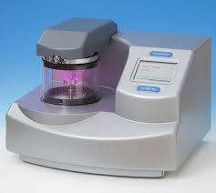
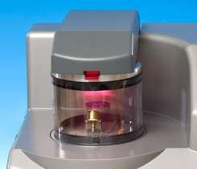

Figure 1 Sputter Carbon Coater Figure 2 Sputter coating
chamber during sputtering
- FESEM procedure
Nanotechnology has strongly driven the development of recent electron microscopy, with demands not only for increasing resolution but also for more information from the sample. The field emission scanning electron microscope (FE-SEM) images a sample surface by raster scanning over it with a high-energy beam of electrons. The electrons interact with the atoms comprising the sample to produce signals that contain information about surface topography, composition and other properties, such as electrical conductivity. The function of the electron gun is to provide a large and stable current in a small beam. There are two classes of emission source: thermionic emitter and field emitter. Emitter type is the main difference between the Scanning Electron Microscope (SEM) and the Field Emission Scanning Electron Microscope (FE-SEM). Field Emission Source is smaller, a lower level of the beam condensation is necessary to have a probe useful for image processing. This makes the FESEM the highest resolution instrument. The size range in Nanoscience is typically from hundreds

of nanometers down to the atomic level (approximately 0.2 nm), in which the materials (nano materials) can have different or enhanced chemical/physical properties compared to the same ones at a bulk size.

EDAX analysis

Energy dispersive spectroscopy (EDAX OR EDS) is an x-ray spectroscopy method for determining elemental compositions. Peaks corresponding to the elements making up the true composition of the sample. The data generated by EDS or EDAX analysis consist of spectroscopy being analysed. ENERGY DISPERSIVE X-RAY SPECTROSCOY (EDS or EDAX)
interaction of an electron beam with a sample target produces a variety of emissions, including x- rays.
EDS can be used to find the chemical composition of material down to a spot size of a few microns and to create element composition maps over a much broader raster area.
The percentage of elements present is each sample can be identified. It will be demonstrate in the form of graphs were the weight and atomic percentage are being used.

CHAPTER IV RESULTS AND DISCUSSION
The results pertaining to the study entitled ―A Comparative Study on Nutrients Present in Fresh and Processed Fruit Juices Using Energy Dispersive Spectroscopy‖ is discussed under the following

Details on the Market Survey on Consumption of Fruit Juices
- Field Emission Scanning Electron Microscopy (FESEM) a)Structure of Fresh and Processed Apple Juices
  - Nutrient Content and Graphical Representation of Fresh and Processed Apple Juices
  - Quant Results of Fresh and Processed Apple Juices

Structure of Fresh and Processed Pomegranate Juices
  - Nutrient Content and Graphical Representation of Fresh and Processed Pomegranate Juices
  - Quant Results of Fresh and Processed Pomegranate Juices

Structure of Fresh and Processed Grape Juices
  - Nutrient Content and Graphical Representation of Fresh and Processed Apple Juices
  - Quant Results of Fresh and Processed Grape Juices

Structure of Fresh and Processed Pineapple juices
  - Nutrient Content and Graphical Representation of Fresh and Processed Pineapple Juices
  - Quant Results of Fresh and Processed Pineapple Juices

Structure of Fresh and Processed Guava Juices
  - Nutrient Content and Graphical Representation of Fresh and Processed Guava Juices
  - Quant Results of Fresh and Processed Guava Juices

- Details on the Market survey on Consumption of Fruit Juices

Survey on Processed Fruit Juices

The results of the survey carried out in the departmental stores regarding availability of fruit juices are presented below.

Table I
Availability of Processed Fruit Juices

Processed Fruit Juices | Departmental Stores (N = 5)
Apple | 5
Grape | 5
Orange | 5
Mango | 4
Pineapple | 3
Cranberry | 2
Guava | 3
Mixed fruit juices | 5

Table I illustrates the most commonly available processed fruit juices in the market. Availability of apple, grapes, orange and mixed fruit juices were seen in all departmental stores. Mango juice was seen in four departmental stores and the availability of pineapple and guava was similar and seen in three departmental stores. The availability of Cranberry was very less and noticed only in two stores in the market because cranberry is not a familiar fruit in India.

Consumption of Fresh Juices

The preference of fruit juices among selected consumers is given in table II.

Table II
Consumption of fruit juices among selected consumers

Fresh fruit juices | Consumers (N=100)
Apple | 16
Watermelon | 17
Pomegranate | 14
Grapes | 12
Pineapple | 10
Guava | 5
Muskmelon | 7
Orange | 6
Mango | 3
Lemon | 5
Papaya | 5

From Table II it is seen that the consumption of watermelon, apple, pomegranate, grapes and pineapple fresh fruit juices were higher and were mostly preferred by the consumers. Guava, muskmelon, orange, lemon and papaya were less consumed when compared to other fresh fruit juices.

Field Emission Scanning Electron Microscopy (FESEM)

Structure of Fresh and Processed Apple Juices


Figure 3 FESEM analysis of fresh Figure 4 FESEM analysis of apple juice processed apple juice
For both fresh apple juice and processed apple juice it was observed that the appearance of the juices was different from each other. The fresh juice was porous in nature whereas the processed apple juice had layer formulation. Fresh juice particles surface was polished and it has a dense structure with pores, when compared to processed apple fresh juice figure 4 the particles had polished surface and of peculiar layered structure without pores. This may be due to the homogenization of the processed juices during processing.
The identified width of fresh apple juice was about 7.15mm (figure 3) whereas for processed apple juice the width was about 7.87mm. SEM high volt was 15.0kv (figure 4) and (figure 3) 10.0 kv. This signifies that processed apple juice had higher width and volt.

Nutrient Content and Graphical Representation of Fresh and Processed Apple Juices
The elements which are present in minute particles were found evenly by using the FESEM
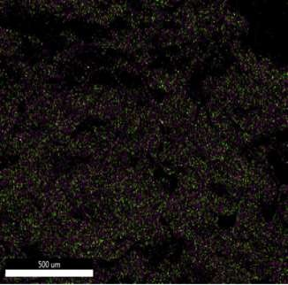
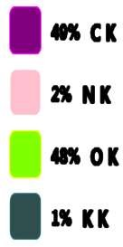

Figure 5 illustrates the FESEM analysis of fresh apple juice
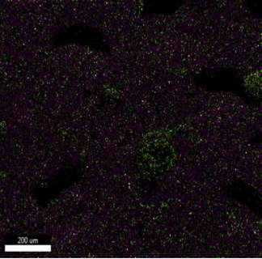
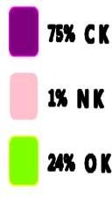

Figure 6 illustrates the FESEM analysis of processed apple juice

While Comparing FESEM analysis of the fresh and processed apple juices, processed apple juice contained 75percent carbon and was higher when compared with the fresh apple juice which contained only 49percent of carbon. Comparitively the amount of oxygen present in fresh apple juice was 48percent while the processed apple juice contained only 24percent of oxygen. Pointing out that fresh products contain more of oxygen and it is always adjustable to take fresh products. The composition of nitrogen content was very low i.e only 2percent in fresh apple juice and 1percent in processed apple juices.Potassium was present only in fresh apple juice and was absent in processed apple juice. This could be because of processing techniques which may remove the potassium from fresh apple juice.
Apple juices of many varieties are high in malic acid and potassium. Distribution of phenolics between the various varieties was highly variable with some juices containg little if any phenolic compounds (Eisele et al., 2004). Apples contain a variety of photochemical, including quercetin, catechin, phloridzin and chlorogenic acid, all of which are strong antioxidants (Boyer et al., 2004).

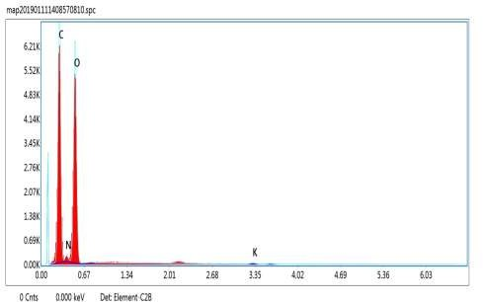

Figure 7 graphical representation of fresh apple juice
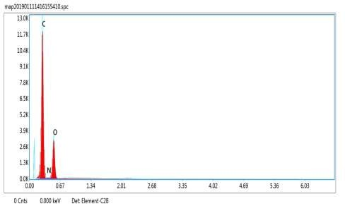

Figure 8 graphical representation of processed apple juice

Figure 7 and 8 gives the graphical representation of the nutrients present in the fresh and processed apple juices. The graph shows that carbon was present about 6.21k which was lower than processed apple juice about 11.7k. The fresh apple juices contain more of oxygen (5.52k), when compared with the processed apple juice (3.9k). This might be a reason for high shelf life of processed apple juices. Nitrogen peak was at the bottom level for fresh apple juice.

Quant Results of Fresh and Processed Apple Juices

Table III

Weight and Atomic Percentage of Fresh Apple Juice

FRESH APPLE JUICE
Elements | Weight % | Atomic %
C K | 41.69 | 48.88
N K | 3.38 | 3.40
O K | 53.71 | 47.28
K K | 1.22 | 0.44

Table III shows that atomic percentage was higher compared to the weight of the elements. The carbon content of fresh apple juice weighed lower of 41.69 and atomic percentage of 48.88. Nitrogen weighed 3.38 and atomic percentage was 3.40. The oxygen weight found in fresh apple juice was higher of 53.71 and atomic percentage was 47.28. Potassium was only present in fresh apple juice and weighed 1.22.

Table IV

Weight and Atomic Percentage of Processed Apple Juice

PROCESSED APPLE JUICE
Elements | Weight % | Atomic %
C K | 64.15 | 70.27
N K | 2.13 | 2.00
O K | 33.72 | 27.73
The table IV processed apple juices contained higher amount of carbon which weighs about 64.15 and atomic percentage of 70.27. Nitrogen had minimal difference in the weight and atomic percentage. Nitrogen weight was
2.13 and atomic percentage was 2.00 in processed apple juice respectively. The oxygen weighed 33.72 and atomic percentage (27.73).

Structure of Fresh and Processed Pomegranate Juices


a
b
Figure 9 FESEM analysis of fresh Figure 10 FESEM analysis pomegranate juice of processed pomegranate juice
The surface of the fresh pomegranate juice was patchy, with pores and layers present on it (figure 9) whereas the processed pomegranate juice was like a crushed paper (figure 10). The particle polished surface of fresh pomegranate juice illustrates that it had a dense structure which showed light pores and normal layer formation.
The width of fresh pomegranate juice was about 9.85mm whereas for processed pomegranate juice the width was about 9.95mm by giving them SEM HV (high volt): 5.0 kv. This signifies that processed pomegranate juice had higher width and same level of volt.

Nutrient Content and Graphical Representation of Fresh and Processed Pomegranate Juices
The elements which are present in minute particles of found evenly by using the FESEM.
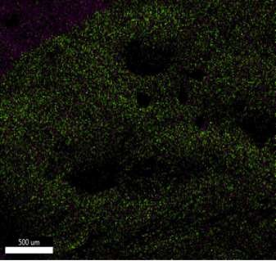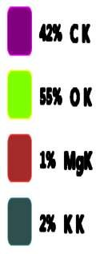

Figure 11 illustrates the FESEM analysis of fresh pomegranate juice

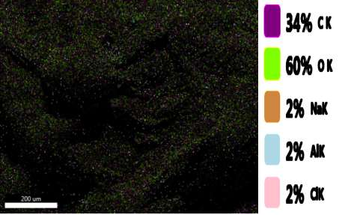

Figure 12 illustrates the FESEM analysis of processed pomegranate juice

While comparing the pomegranate juices, the carbon present in fresh pomegranate juice was 42percent and processed pomegranate juice contained (34percent of carbon). The processed pomegranate juice had higher content of oxygen (60percent) and 55percent in fresh pomegranate juice. The Potassium was present at 2percent in fresh pomegranate juice and it‘s absent in processed pomegranate juice. As discussed earlier, processing techniques may remove the potassium content present in the processed juices. The 2percent of sodium, aluminium and chlorine are equally distributed in processed juice and it‘s absent in fresh pomegranate juice. Magnesium was present at 1percent in fresh pomegranate juice and it‘s absent in processed pomegranate juice. This could be because of some preservatives added in processed pomegranate juice.
Pomegranate fruits are very rich in anthocyanin (potent antioxident flavonoid) which provide juice with its brilliant color (Hernandez, F., et al., 1999). Besides its antioxidant properties studies have shown that anthocyanin also has anti-carcinogenic potential (Bagchi, D., et al.2004). The effects of pomegranate juice have focused on its ability to treat prostate cancer, diabetes, and atherosclerosis.

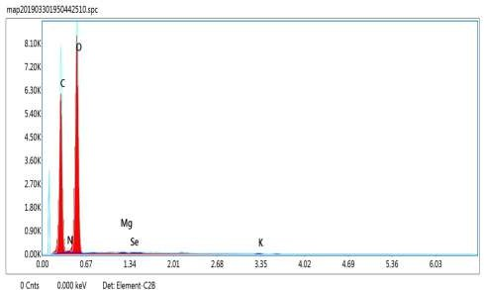

Figure 13 graphical representation of fresh pomegranate juice
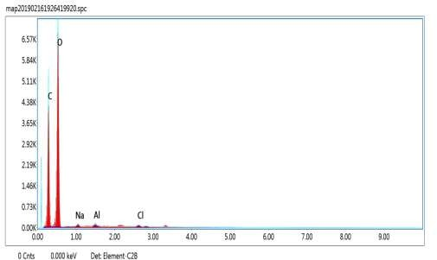

Figure 14 graphical representation of processed pomegranate juice

From the fresh pomegranate juice, it is clear that the level of oxygen was higher 7.38k and processed pomegranate juice was 6.57k. The carbon had its peak at 6.56k in fresh pomegranate juice whereas in processed pomegranate juice it was about 4.38k. Nutrients like magnesium, potassium, sodium, aluminium and chlorine are all present at the base level in the fresh and processed pomegranate juices. These nutrients did not show any peak value.

Quant Results in Fresh and Processed Pomegranate Juices

Table V

Weight and atomic weight of fresh pomegranate juice

FRESH POMEGRANATE JUICE
Elements | Weight % | Atomic %
C K | 39.16 | 46.49
O K | 59.22 | 52.78
Mg K | 0.65 | 0.38
K K | 0.96 | 0.35

The table V fresh pomegranate juice had higher amount of oxygen which weighed of 59.22 and atomic weight (52.78). The carbon weight was
39.16 and atomic weight 46.49. Magnesium and potassium had minimum different in weight and atomic weight.

Table VI

Weight and Atomic Weight of Processed Pomegranate Juice

PROCESSED POMEGRANATE JUICE
Elements | Weight % | Atomic %
C K | 35.94 | 43.13
O K | 61.66 | 55.56
Na K | 1.08 | 0.68
AIK | 0.72 | 0.39
CIK | 0.60 | 0.25

Table VI shows that processed pomegranate juice the oxygen present were in higher level which weighed 61.66 and atomic percentage 55.56. The carbon content of processed pomegranate juice weighed lower of 35.94 and atomic percentage of 43.13. Sodium, aluminium and chlorine had similarly different in weighed and atomic percentage.

Structure of Fresh and Processed Grape Juices

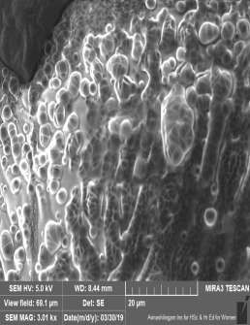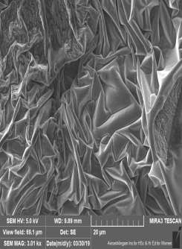
a
b

Figure 15 FESEM analysis of fresh Figure 16 FESEM analysis of grape juice processed grape juice

According to the figure 15 the appearance of the fresh grape juice was like cluster of bubbles bound together. The presence of single spherical structure was also found. The appearance of the processed grape juice was like a crusted paper in which certain hollows were present (figure 16).
The width of fresh grape juice was about 8.44mm (figure 15) whereas for processed grape juice the width was about 9.89mm. This signifies that processed grape juice had higher width and same level of volt has that of fresh grape juice.

Nutrient Content and Graphical Representation of Fresh and Processed Grape Juices
The elements which are present in minute particles of found evenly by using the FESEM.
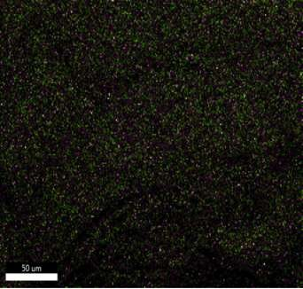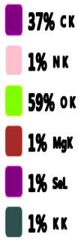

Figure 17 illustrates the FESEM analysis of fresh grape juice

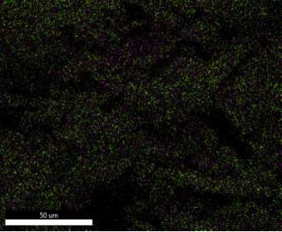

Figure 18 illustrates the FESEM analysis of processed grape juice

The oxygen content of processed grape juice was 54percent and it was lowerd in fresh grape juice (59percent).The carbon content was higher in processed grape juice then the fresh grape juice. Contrastly, the potassium was equally distributed in both the grape juices compered to other select fruit juices. Magnesium, selenium and nitrogen were only present in fresh grape juice and was absent in processed grape juice. The processing tecquices may infiuncen the presence of nutrient in the processed juices.
Grapes are abundant in polyphenols, which are known for numerous biological activities and health-promoting benefits. Grape has been useful for reducing the extent of diabetes mellitus, cardiovascular disorders and digestive problems (Imran, et al., 2017). Grape seeds, grape skin, and grape juice contain several types of polyphenols, including resveratrol, phenolic acids, anthocyanins, and flavonoids (Philadelphia, 2008).Their potential beneficial effects on human health specifically the ability to prevent various diseases associated with oxidative stress, including cancers, cardiovascular and neurodegenerative diseases (Cosme et al., 2018).

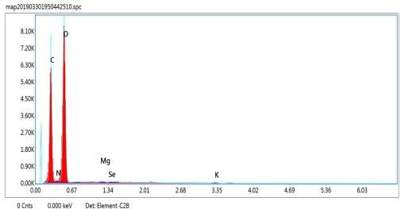

Figure 19 graphical representation of fresh grape juice
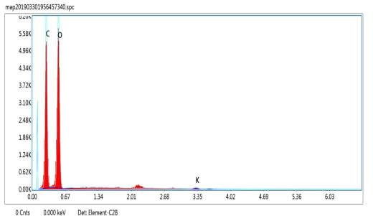

Figure 20 graphical representation of processed grape

From figure 19 and 20, the nutrient present in fresh and processed grape juices were representation graphical. Even though the oxygen content in fresh and processed grape juices had its peak, the value of the fresh grape juice was higher than processed grape juice. Fresh and processed grape juice, it cleared that level of oxygen was higher level 8.10k and (figure 20) 5.58k. Magnesium, selenium, nitrogen and potassium were all present in base level.

Quant Results of Fresh and Processed Grape Juices

Table VII
Weight and Atomic Percentage of Fresh Grape Juice

FRESH GRPAE JUICE
Elements | Weight % | Atomic %
C K | 35.55 | 42.64
N K | 1.81 | 1.87
O K | 60.97 | 54.90
MgK | 0.32 | 0.19
SeL | 0.52 | 0.10
K K | 0.83 | 0.31

Table VII fresh grape juice had higher amount present in oxygen and weighed 60.97 and 54.90 in atomic percentage. Oxygen was also weighed higher in fresh grape juice. Comparatively the amount of carbon present was
35.55 weight and atomic percentage (42.64). Nitrogen was lower weight was
1.81 and atomic percentage of 1.87. Magnesium, selenium and nitrogen were only present in fresh grape juice.

Table VIII

Weight and Atomic Percentage of Processed Grape Juice

PROCESSED GRAPE JUICE
Elements | Weight % | Atomic %
C K | 39.92 | 47.38
O K | 58.38 | 52.01
K K | 1.70 | 0.62

The processed grape juices the amount of carbon weighed 39.92 and
47.38 in atomic percentage. Table VIII comparatively oxygen was higher amount in weight (58.38) and atomic percentage was 52.01. Processed grape juice then fresh grape juice (35.55). Potassium has minimum difference in weight and atomic percentage.

Analysis of Fresh and Processed Pineapple juices

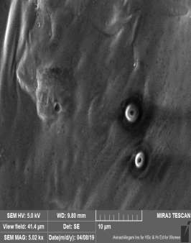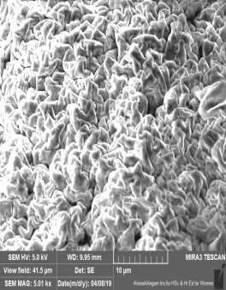
a
b

Figure 21 FESEM analysis of fresh Figure 22 FESEM analysis of pineapple juice of processed pineapple juice

According to the figure 21, the appearance of fresh pineapple juice shows a had a clear surface whereas the appearance of processed pineapple juice had too many layers because of its concentrated form. The fresh pineapple juice had only some pores whereas the processed pineapple juice had many pores because of layered structure. Therefore it is evident that fresh pineapple juice had a smooth structure compare to processed pineapple juice. The concentration of sugar might be a reason for the difference in structure.
The width of fresh pineapple juice was about 9.80mm (figure 21) whereas for processed pineapple juice the width was about 9.95mm. This signifies that processed pineapple juice had higher width and same level of volt.

Nutrient Content and Smart Quant Results of Fresh and Processed Pineapple Juice
The elements which are present in minute particles of found evenly by using the FESEM.

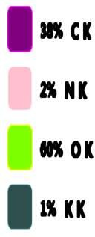

Figure 23 illustrates the FESEM analysis of fresh pineapple juice


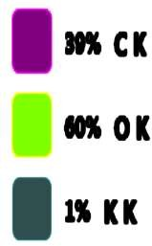

Figure 24 illustrates the FESEM analysis of processed pineapple juice

The comparison of pineapple juices, the carbon present in processed pineapple juices was 39percent which was slightly higher in amount then fresh pineapple juice. The oxygen (60percent) and potassium (1percent) was equally distributed in both fresh and processed pineapple juices. Additionally, nitrogen was absent in processed pineapple juice.
Pineapple (Ananascomosus) also contains, potassium, magnesium, copper, beta-carotene. A number of possible health benefits from drinking pineapple juice have been Boosting the immune system, Digestion, Cancer, Skin and Eyes (Megan Ware, 2017). The pineapple juice contain Phytochemical components were analysed whereby the amount of alkaloids was higher than the amount of flavonoids (Ogunmefun, et al., 2018). Pineapple processing plays an important role in juice preservation.
Because the quality of the pineapple juice is affected by the processing technology applied to it. (Hounhouigan et al., 2014).

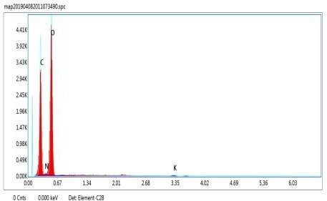

Figure 25 graphical representation of fresh pineapple juice

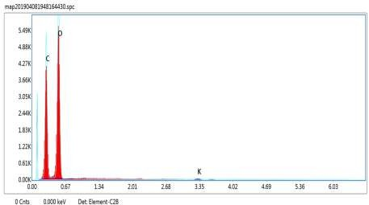

Figure 26 graphical representation of processed pineapple juice

From the figure 25 and 26, the processed pineapple juice had higher levels of oxygen (5.49k) then fresh pineapple juice. The carbon peak level of fresh pineapple juice was 3.43k and for processed pineapple juice it was about 4.27k. The other nutrients were found in minimal amount which were not seen in the graph.

Quant Results of Fresh and Processed Pineapple Juices

Table IX
Weight and Atomic Percentage of Fresh Pineapple Juice

FRESH PINEAPPLE JUICE
Elements | Weight % | Atomic %
C K | 34.94 | 41.89
N K | 1.89 | 1.94
O K | 61.90 | 55.71
K K | 1.27 | 0.47

From the table IX more amount of oxygen was present in fresh pineapple juice. The amount of oxygen weighed was 61.90 and 55.71 atomic percentage. Comparatively the atomic percentage of carbon was 41.89 and it is high and its weight was 34.94. Potassium weight was (1.27).

Table X
Weight and Atomic Percentage of Processed Pineapple juice

PROCESSED PINEAPPLE JUICE
Elements | Weight % | Atomic %
C K | 36.29 | 43.47
O K | 62.29 | 56.01
K K | 1.43 | 0.52

The carbon and oxygen was higher in both weight and atomic percentage. The oxygen weighs about 62.29 and its atomic percentage was about 56.01. The carbon atomic percentage was higher 43.47 and potassium was 0.52.

Structure of Fresh and Processed Guava Juices

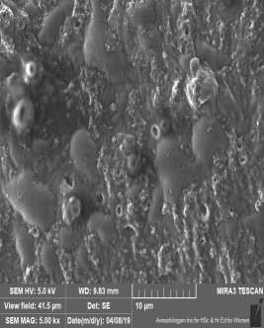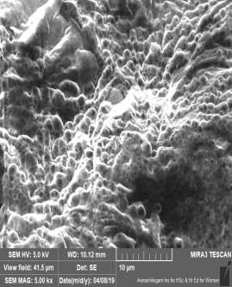
a
b

Figure 27 FESEM analysis of Fresh Figure 28 FESEM analysis guava juice of processed guava juice

For both fresh and processed guava juices, the fresh guava juice has more solid layers in nature whereas the processed guava juice had more accumulation of bubble formulation. This may be due to the homogenization of the processed juices during processing. The Pores nature was present only in processed guava juice.
The width was fresh grape juice was about 9.83mm (figure 27) whereas for processed guava juice the width is about 10.12mm. This signifies that processed guava juice had higher width and same level of volt.

Nutrient Content and Smart Quant Results of Fresh and Processed Guava Juices
The elements which are present in minute particles of found evenly by using the FESEM

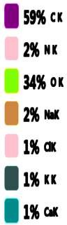

Figure 29 illustrates the FESEM analysis of fresh guava juice

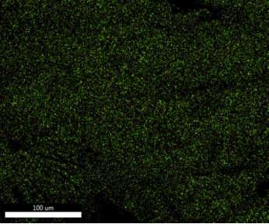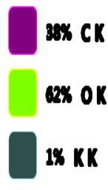

Figure 30 illustrates the FESEM analysis of processed guava juice

While comparing the fresh guava juice with processed guava juice, the carbon present in fresh guava juice (59percent) was higher than processed guava juice in concentrate the oxygen was present highly in processed guava juice. The potassium was equally distributed in both fresh and processed guava juices. The 2percent of nitrogen and sodium present in fresh guava juice and its absents in processed guava juice. The amount of chlorine and calcium was 1percent in fresh guava juice.
Heat processing decrease majority of flavour components in the juice when compared with freshly extracted juice and pressure treated fruit juices gradually changes the volatile compounds during storage (Yen et al., 1999). According to (campoli et al 2018) ultrasonication is an alternative to develop the physical and nutritional properties of fruit juices.

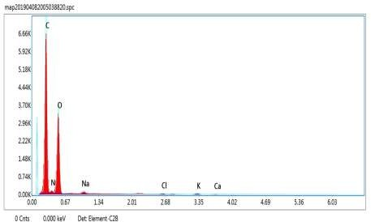

Figure 31 graphical representation of fresh guava juice

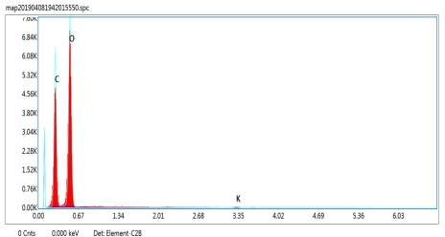

Figure 32 graphical representation of processed guava juice

The figures illustrates the higher the peak level of oxygen in processed guava juice which was about 6.84.The levels of nitrogen, sodium, chlorine, potassium and calcium this nutrients fount to be minimal.

Quant Results of Fresh and Processed Guava Juices

Table XI
Weight and Atomic Percentage of Fresh Guava Juice

FRESH GUAVA JUICE
Elements | Weight % | Atomic %
C K | 50.60 | 58.58
N K | 2.76 | 2.74
O K | 42.29 | 36.75
Na K | 1.49 | 0.90
CIK | 0.61 | 0.24
K K | 1.53 | 0.55
CaK | 0.72 | 0.25

It is evident from the table XI, the fresh guava juice contained high amount of carbon. In this carbon weighs about 50.60 and its atomic percentage was 58.58. The oxygen weighed higher its about 42.29 and atomic percentage was 36.75. Nitrogen, sodium, chlorine, potassium and calcium had minimal difference in weight and atomic percentages.

Table XII

Weight and Atomic Percentage of Processed Guava juice

PROCESSED GUAVA JUICE
Elements | Weight % | Atomic %
C K | 36.12 | 43.15
O K | 63.04 | 56.54
K K | 0.84 | 0.31

The processed guava juice contains oxygen which weighs (63.04) and its atomic percentage was 56.54. Carbon had minimal difference in weighed and atomic percentage 43.15 and its weight was about 36.12.

Table XIII
Consolidated Table of Quant Results for Fresh and Processed Fruit Juices

 | FRESH JUICES
JUICES | C K W A |  | N K  W A |  | O K  W A |  | K K W A |  | Mg K W A |  | Se L W A |  | Na K W A |  | ClK W A |  | CaK W A
Apple juice | 41.69 | 48.88 | 3.38 | 3.40 | 53.71 | 47.28 | 1.22 | 0.44 | - | - | - | - | - | - | - | - | - | -
Pomegranate juice | 39.16 | 46.49 | - | - | 59.22 | 52.78 | 0.96 | 0.35 | 0.65 | 0.38 | - | - | - | - | - | - | - | -
Grape juice | 35.55 | 42.64 | 1.81 | 1.87 | 60.97 | 54.90 | 0.83 | 0.31 | 0.32 | 0.19 | 0.52 | 0.10 | - | - | - | - | - | -
Pineapple juice | 34.94 | 41.89 | 1.89 | 1.94 | 61.90 | 55.71 | 1.27 | 0.47 | - | - | - | - | - | - | - | - | - | -
Guava juice | 50.60 | 58.58 | 2.76 | 2.74 | 42.29 | 36.75 | 1.53 | 0.55 | - | - | - | - | 1.49 | 0.90 | 0.61 | 0.24 | 0.72 | 0.25

(W - Weight %, A - Atomic %)

 | PROCESSED JUICES
JUICES | C K %  W A |  | N K%  W A |  | O K%  W A |  | Na K %  W A |  | AlK%  W A |  | ClK  W A |  | K K  W A
Apple juice | 64.15 | 70.27 | 2.13 | 2.00 | 33.72 | 27.73 | - | - | - | - | - | - | - | -
Pomegranate juice | 35.94 | 43.13 | - | - | 61.66 | 55.56 | 1.08 | 0.68 | 0.72 | 0.39 | 0.60 | 0.25 | - | -
Grape juice | 39.92 | 47.38 | - | - | 58.38 | 52.01 | - | - | - | - | 1.70 | 0.62
Pineapple Juice | 36.29 | 43.47 | - | - | 62.29 | 56.01 | - | - | - | - | - | - | 1.43 | 0.52
Guava Juice | 36.12 | 43.15 | - | - | 63.04 | 56.54 | - | - | - | - | - | - | 0.84 | 0.31

(W - Weight %, A - Atomic %)

DISCUSSION

Carbon and oxygen are present in both fresh and processed fruit juices. The carbon content was present in both fruit juices while compare to the fresh fruit juices the processed fresh juice has high.
Carbon is perhaps the simple most important element. Carbon atoms make up an immense part of molecular structure without carbon many other elements that make up our bodies would not be able to function probably human beings are a ―carbon based life form. Our supply of carbon was therefore an essential component of the human diet. Fruit contained abundant stores of carbon.
Potassium was absent in processed apple pomegranate and fresh guava juice. In other fruit juices potassium was present. It supports blood pressure, cardiovascular health, and bone also muscle strength. Oxygen was commonly present in all fruit juices. Oxygen can be present as dissolved gas in solution or associated with pulp particles oxygen in air present in spaces between the juice vesicles and from the surroundings, saturates the juice production.
In fresh juice elements like carbon, nitrogen, oxygen, potassium selenium, sodium, chlorine and calcium present. The processed juice the elements present are carbon, nitrogen, oxygen, sodium, aluminium chlorine and potassium.
In all fresh juices some additional elements was not removable but in processed juices only in pomegranate juice additionally element are been present. In other processed juice same nutrients are present. This could be because of processing techniques which may remove the other elements.
In fresh juice the removal of elements is not done but in processed juice some elements are removed due to some techniques, so I conclude that fresh fruit juices is the best while compare to the processed fruit juices.

SUMMARY AND CONCULSION

SUMMARY

Fruits are essential in everyday meal as they contain all the required nutrients for a balanced diet. It is one of the major groups among the five food groups and they are the superior source of micronutrients such as vitamins and minerals and help to protect from diseases. As technology is developing, the consumption of the fruits as juices have increased. Fruits used in packaged juices are not visible to consumer and hence low quality fruits are also used by juice making companies.
A market survey was carried out in five departmental stores in Coimbatore to study the availability of processed fruit juices. Five fruit stalls were approached to find out the popularity of fresh fruit juices. The fruit juices selected were apple, pomegranate, grapes, pineapple and guava. The selected fruit juice samples namely fresh and processed were analysed using 2 methods, EDAX analysis method and FESEM. A FESEM is microscope that works with electrons (particles with a negative charge) instead of light. Two ml was given to the analysis of FESEM.

The salient findings of the study are

  - Most commonly available processed fruit juices in the market were apple, grapes, orange and mixed fruit juices in all departmental stores.
  - Mango juice was seen in four departmental stores and the availability of pineapple and guava was similar and seen in three departmental stores.
  - The consumption of fresh fruit juices was watermelon, apple, pomegranate, grapes and pineapple fresh fruit juices were higher and were mostly preferred by the consumers.

Fresh and Processed Apple Juice

  - While Comparing FESEM analysis of the fresh and processed apple juices, processed apple juice contained 75percent carbon and was higher when compared with the fresh apple juice which contained only 49 of carbon. Potassium was present only in fresh apple juice and was absent in processed apple juice.
  - Carbon had a higher peak in fresh and processed fruit juices and fresh juice contained more of oxygen compared to processed apple juice.
  - Carbon content of fresh apple juice weighed lower of 41.69 and atomic percentage of 48.88. The oxygen weight found in fresh apple juice was higher of 53.71 and atomic percentage was 47.28.

Fresh and Processed Pomegranate Juices

- The carbon present in fresh pomegranate juice was 42percent and processed pomegranate juice contained (34percent of carbon). The processed pomegranate juice had higher content of oxygen (60percent) and 55percent in fresh pomegranate juice.
- Two percent of sodium, aluminium and chlorine were equally distributed in processed juice. Potassium was absent in processed juice.
- Oxygen had a peak in both fresh and processed pomegranate juices. The carbon was high peak in fresh pomegranate juice (6.56k).
- The fresh pomegranate juice had higher amount of oxygen which weighed of 59.22 and atomic weight (52.78).
- The fresh and pomegranate juice was magnesium and potassium had minimum difference in weight and atomic weight.
- The oxygen was present in a processed pomegranate juice higher level which weighed 61.66 and atomic percentage 55.56. The carbon content of processed pomegranate juice weighed lower of 35.94 and atomic percentage of 43.13.

Fresh and Processed Grape Juices

- The oxygen content of processed grape juice was 54percent and it was lowerd in fresh grape juice (59percent).The carbon content was higher in processed grape juice then the fresh grape juice.
- The potassium was equally distributed in both grape juices. Magnesium, selenium and nitrogen were only present in fresh grape juice.
- Oxygen content in fresh and processed grape juices had higher peak, the value of the fresh grape juice was higher than processed grape juice.
- Carbon present was 35.55 weight and atomic percentage (42.64). Magnesium, selenium and nitrogen were only present in fresh grape juice.
- In processed grape juice comparatively oxygen was higher amount in weight (58.38) and atomic percentage was 52.01 and processed grape juice then fresh grape juice (35.55).

Fresh and Processed Pineapple Juice

- The comparison of pineapple juices, the carbon present in processed pineapple juices was 39percent which was slightly higher in amount then fresh pineapple juice.
- The oxygen (60percent) and potassium (1percent) was equally distributed in both fresh and processed pineapple juices. Nitrogen was absent in processed grape juice.
- Both fresh and processed carbon was higher peak leave and oxygen was minimal different in this graph.
- The amount of oxygen weighed was 61.90 and 55.71 atomic percentage. Comparatively the atomic percentage of carbon was 41.89 and it is high and its weight was 34.94.
- The carbon and oxygen was higher in both weight and atomic percentage. The oxygen weighs about 62.29 and its atomic percentage was about 56.01.

Fresh and Processed Guava Juices

- While comparing the fresh guava juice with processed guava juice, the carbon present in fresh guava juice (59percent) was higher than processed guava juice.
- In concentrate the oxygen was present highly in processed guava juice. The 2percent of nitrogen and sodium present in fresh guava juice and its absents in processed guava juice.
- The 1percent of calcium and chlorine present in fresh guava juice. The 2percent of nitrogen and sodium present in fresh guava juice and its absents in processed guava juice.
- The higher the peak level of oxygen in processed guava juice which was about 6.84. The levels of nitrogen, sodium, chlorine, potassium and calcium this nutrients fount to be minimal.
- The fresh guava juice contained high amount of carbon. In this carbon weighs about 50.60 and its atomic percentage was 58.58. The oxygen weighed higher its about 42.29 and atomic percentage was 36.75.
- The processed guava juice contained oxygen which weighs (63.04) and its atomic percentage was 56.54. Carbon had minimal difference in weighed and atomic percentage 43.15 and its weight was about 36.12.

CONCLUSION

Carbon and oxygen were present in both fresh and processed fruit juices. Potassium was absent in grape, pineapple and guava processed fruit juices which was comparatively less. The FESEM analysis, showed that surface of processed fresh fruit juices was substantially more different from fruit juices. The pores were prominent in fresh than processed fruit juices. The processing techniques which were followed could be a reason for absence of nutrients. Therefore the study proves that fresh fruit juices are better than processed fruit juices.

BIBLIOGRAPHY VI

- Aanchal Sharma, Dr.Binod Kumar Singh, Dr.Neeraj Anand, 2016. Fruit Processing Industry in India. A Short Review, Pp: 1
- Abubakar El-Ishaq, Simon Obirinakem, 2015.Effect of Temperature and Storage on Vitamin C Content in Fruits Juice, International Journal of Chemical and Biomolecular Science, Vol. 1, No. 2, Pp: 17 – 21
- Afshan Kaleem, Humaira Nazir, Samra Pervaiz, Mehwish Iqtedar, Roheena Abdullah, Mahwish Aftab and Shagufta Naz, 2016. Investigation of The Effect of Temperature on vitamin C In Fresh and Packed Fruit Juices, Pp: 117 – 120
- Allan S Christensen, Lone Viggers, Kjeld Hasselström and Søren Gregersen, 2013.Effect of fruit restriction on glycemic control in patients with type 2 diabetes – a randomized trial, Nutrition Journal, Pp: 1 – 6
- AllineArtigiani Lima Tribst, Anderson de Souza Sant‘Ana&Pilar Rodriguez de Massaguer, 2009.Review: Microbiological quality and safety of fruit juices—past, present and future perspectives, Critical Reviews in Microbiology, Pp: 310 – 339
- Antonio Jose Perez-Lopez, 2010.Quality of canned mandarin as affected by preservation liquid, Pp: 1105 – 1113
- Bagchi D, 2004.Anti-angiogenic, antioxidant, and anti-carcinogenic properties of a novel anthocyanin-rich berry extract formula.‖ Biochemistry (Moscow), Pp: 75 - 80
- BathalVijaya Kumar, Mannepula Sreedharamurthy, Obulam Vijaya Sarathi Reddy, 2013.Physico-Chemical Analysis of Fresh and Probioticated Fruit Juices with Lactobacillus Casei, International Journal of Applied Sciences and Biotechnology, Vol. 1(3), Pp: 127 – 131

- Bin Wang, Kai Liu, MantianMi, Jian Wang, 2014.Effect of fruit juice on Glucose control and sensitivity in Adults: A Meta – Analysis of 12 Randomized controlled Trials, Pp:1 - 22
- C. Castro-Lopez a, E.J.Sanchez-Alejo a, S.Saucedo-Pompa b, R.Rojas a, J. Aranda-Ruiz a, G.C.G.Martínez-Avila, 2016. Fluctuations in phenolic content, ascorbic acid and total carotenoids and antioxidant activity of fruit beverages during storage, Pp: 1 – 16
- Chiranjit Bhattacharjee V.K.Saxena, Suman Dutta, 2017.Fruit juice processing using membrane technology: A Review, Innovating food science and emerging technologies, Vol. 43, Pp: 136 - 153
- Daniel Workman, 2019.India‘s Top 10 Exports, page no: 1

- Dharti P and Dhanika P, 2014.Development and Evolution of Anitioxidant Rich Fruit Beverage, International Journal of Food Science, Nutrition and Dietetics, Pp: 160 – 163
- Dianne A. Hyson, 2017.A Comprehensive Review of Apples and Apple Components and Their Relationship to Human Health, Pp: 408 – 420
- Emmanuel S. Abbo, Taiwo O. Olurin and Grace Odeyemi, 2006.Studies on the storage stability of soursop (Annonamuricata L.)Juice, African Journal of Biotechnology, Vol 5 (19), Pp: 1808 – 1812
- Erlend T. Aasheim, Stephen J. Sharp, Paul N. Appleby, Martin J. Shipley, Marleen A.H. Lentjes, Kay-Tee Khaw, Eric Brunner, Tim J. Key, Nicholas
J. Wareham, 2015.Tinned Fruit Consumption and Mortality in Three Prospective Cohorts, Pp: 1 – 15
- Faten Zaouay, Hounaida Hadj Salem, Rahma Labidi and Messaoud Mars, 2014.Development and quality assessment of new drinks combining sweet and sour pomegranate juices, Nutrition and Food Science, Pp: 1 – 8

- Fernanda Cosme 1, Teresa Pinto 2 and Alice Vilela, 2018.Phenolic Compounds and Antioxidant Activity in Grape Juices: A Chemical and Sensory View, Pp: 1 – 14
- GiannaFerretti, ImmaTurco, TizianaBacchetti, 2014.Apple as a Source of Dietary Phytonutrients: Bioavailability and Evidence of Protective Effects against Human Cardiovascular Disease, Food and Nutrition Sciences, Pp: 1234 – 1246
- Hernandez F, 1999. ―Evolution of juice anthocyanins during ripening of new selected pomegranate (Punicagranatum) clones.‖ European Food Research and Technology , Pp: 39 - 42
- HylemariamMihiretie and KassuDesta, 2015.Microbiological Criteria and Quality of Fruits and Fruit Juices in Ethiopia and International Experience,Journal ofMedical Microbiology & Diagnosis, Vol. 4, Issue. 4, Pp: 1 – 4
- Inga Klimczak_, Maria Maecka, Mirosawa Szlachta, Anna Gliszczynska- S wigo, 2006. Effect of storage on the content of polyphenols, vitamin C and the antioxidant activity of orange juices, Journal of Food Composition and Analysis, Pp: 313 – 322
- JaroslawMarkowski and WitoldPlocharski, 2006.Determination of Phenolic Compounds in Apples and Processed Apple Products, Journal of Fruit and Ornamental Plant Research, Vol. 14 (Suppl. 2), Pp: 133 - 142
- Jeanelle Boyer and RuiHai Liu, 2004. Apple phytochemicals and their health benefits, Nutrition Journal, Pp: 1 – 15
- JieZheng, Yue Zhou, Sha Li, Pei Zhang, Tong Zhou, Dong-Ping Xu and Hua-Bin Li, 2017. Effects and Mechanisms of Fruit and Vegetable Juices on Cardiovascular Diseases, international journal of Molecular sciences, Pp: 1 – 15.

- Joy C Rickman, Diane M Barrett and Christine M Bruhn, 2007.Nutritional comparison of fresh and canned fruits and vegetables. Part1. Vitamins C and B and phenolic compounds, Journal of the science of Food and Agriculture, Pp: 930 – 944
- KhawHui Wern, Hasnah Haron and Chan Boon Keng, 2016.Comparison of Total Phenolic Contents (TPC) and Antioxidant Activities of Fresh Fruit Juices, Commercial 100percent Fruit Juices and Fruit Drinks, Pp: 1319 – 1327
- Linda M Oude Griep, Jeremiah Stamler, Queenie Chan, Linda Van Horn, Lyn M Steffen, Katsuyuki Miura, HirotsuguUeshima, Nagako Okuda, Liancheng Zhao, Martha L Daviglus, and Paul Elliott, 2013.Association of raw fruit and fruit juice consumption with blood pressure: the Intermap Study, Pp:1083 – 1091
- M Abul Basar and Sabita Rezwana Rahman, 2007.Assessment of Microbiological Quality of Processed Fruit Juice, Vol. 24, Number 2, Pp: 166 – 168
- M.A. Islam, L. Ahmad, S. Ahmed, A. Sarker, 2014.Biochemical composition and shelf life study of Mixed Fruit Juice from Orange & Pineapple, J. Environ. Sci. & Natural Resources, Pp: 227 – 232
- Manoj Charde, R. D. Chakole, Azhar Ahmed, 2011.Apple Phytochemicals for Human Benefits, International Journal of Pharmacological Research, Vol. 1, Issue 2, Pp: 40 – 5.
- Mary Ann S Van Duyn MA, Elizabeth Pivonka E, 2000.Overview of the health benefits of fruit and vegetable consumption for the dietetics professional: selected literature, Vol. 100, Issue 12, Pp: 1511 – 1521
- Megan Ware, 2017.five possible health benefits of pineapple juice, Pp: 1 – 9.

- Menouwesso H. Hounhoulgan, Anita R. Linnemann, Mohamed M. Soumanou and MartinusJ.SVan Boekel.2014, Effect of Processing on the Quality of Pineapple Juice, Food Reviews International, Vol. 30, Issue 2, Pp: 112 - 133
- Milan N. Mitic, Mirjana V. Obradovic, Danijela A. Kostic, Danijela C. Naskovic, Ruzica J. Micic, 2011.Phenolics content and antioxidant capacity of commercial red fruit juices, Pp: 611 – 619
- Muhammad Imran, AbdurRauf, Ali Imran, Muhammad Nadeem, 2017. Health Benefits of Grapes Polyphenols, Pp: 1 – 4
- Nallely Nuncio-Jauregui, Marina Cano-Lamadrid, Francisca Hernandez, Angel A. Carbonell-Barrachina and Angel Calin-Sanchez, 2015. Comparison of Fresh and Commercial Pomegranate Juices from Mollar de Elche Cultivar Grown under Conventional or Organic Farming Practices, Pp: 34 - 44
- NazanCevik, BayramKizilkaya, GulenTurker, the Condensed Tannin Content of Fresh Fruits Cultivated in Ida Mountains, Canakkale, Turkey, Pp: 49 – 51
- Olayinka T. Ogunmefun, Oluwakemi S. Asoso,Babawale P. Olatunjiand Omotola M. Ogundele, 2018.Nutritional values, chemical compositions and antimicrobial activities of fruit juice from pineapple (AnanascomosusL.)and coconut (CocosnuciferaL.) blends, Journals Food Science Nutrition, VoL.1, Issue 2, Pp: 40 – 46
- Olayinka T. Ogunmefun, Oluwakemi S. Asoso, Babawale P. Olatunji and Omotola M. Ogundele, 2018.Nutritional values, chemical compositions and antimicrobial activities of fruit juice from pineapple (Ananascomosus L.) and coconut (Cocosnucifera L.) blends, Vol. 2, Issue 2, Pp: 40 – 46
- P. Gnanamoorthy, V. Karthikeyan, V. Ashok Prabu, 2013.Field Emission Scanning Electron Microscopy (FESEM) characterisation of the porous silica nanoparticulate structure of marine diatoms, Pp: 225 – 233

- Parle Milind and Chaturvedi Dev, 2012.Orange: Range of Benefits,
International Research Journal of Pharmacy, Pp: 59 – 63.

- Philadelphia, PA, 2008.Mounting Evidence Shows Health Benefits of Grape Polyphenols, Pp: 1 – 6.
- Phoebe P. Kaddumukasa, Samuel M. Imathiu, Julius M. Mathara, Jesca L. Nakavuma, 2017.Influence of physicochemical parameters on storage stability:Microbiological quality of fresh unpasteurized fruit juices, Original Research, Pp: 1098 – 1105.
- R. Deliza a, A. Rosenthal a, F.B.D. Abadio b, Carlos H.O. Silva c, C. Castillo, 2004.Application of high pressure technology in the fruit juice processing: benefits perceived by consumers, Journal of Food Engineering, Pp:241 – 246.
- Rais M and Sheoran A, 2015.Scope of Supply Chain Management in Fruits and Vegetables in India, Journal of Food Processing & Technology, Vol. 6, Issue 3, Pp: 1 – 7.
- Raquel de Pinho Ferreira Guineand Maria Joao Barroca, 2016.Influence of Processing and Storage on Fruit Juices Phenolic Compounds, International Journal of Medical and Biological Frontiers, Vol. 20, Number 1, Pp: 45 - 58
- Roger Clemens, Adam Drewnowski, Mario G Ferruzzi, Cheryl D Toner, and Diane Welland, 2015. Squeezing Fact from Fiction about 100percent Fruit Juice, Pp: 236s – 243s
- Rudy Alvarez, Hector Araya, Rosa Navarro-Lisboa and Carol Lopez de Dicastillo, 2016.Evaluation of Polyphenol Content and Antioxidant Capacity of Fruits and Vegetables Using a Modified Enzymatic Extraction, Pp: 462 – 467.
- RuiHai Liu, 2013.Health-Promoting Components of Fruits and Vegetables in the Diet, Pp: 384s – 392s.

- Ruth T. Ngadze, Ruud Verkerk, Loveness K. Nyanga, Vincenzo Fogliano, Rosalia Ferracane, Antonio D. Troise, Anita R. Linnemann, 2018.Effect of heat and pectinase maceration onphenolic compounds and physicochemical quality of Strychnoscocculoidesjuice, Pp: 1 – 13.
- Sadaf Aleem and PW Ramteke, 2017.Sensory and Nutritional study of locally available fresh and processed fruit and vegetable juices in Allahabad City, The Pharma Innovation Journal ,Pp; 380 – 386.
- Satya P. Sharma, Hea J. Chung ,Hyeon J. Kim and Seong T. Hong, 2016.Paradoxical Effects of Fruit on Obesity, Pp:1 – 16.
- ShilpiVerma, 2018.Fruit Based Carbonated Soft Drinks for Nutritional Security and Value Chain Development – A Review, International Journal of Current Microbiology and Applied Sciences, Vol 7, Number 11, Pp: 3084 – 3095.
- SulaimanRabiu, AbdullahiDandare, Aminu Bello, 2018.Comparative antioxidants content of ripe and unripe fruits consumed in Sokoto Metropolis,Vol. 7, Pp: 28 – 33.
- Susanne M. Henning , Jieping Yang, Paul Shao, Ru-Po Lee, Jianjun Huang, Austin Ly, Mark Hsu, Qing-Yi Lu, Gail Thames, David Heber &Zhaoping Li, 2017. Health benefit of vegetable/ fruit juice-based diet: Role of microbiome, Scientific Reports, Pp: 1 – 9.
- Tapre, A. R. and Jain, R. K, 2014.Pectinases: Enzymes for fruit processing industry, International Food Research Journal, Pp: 447 – 453.
- Tarekegn Gebreyesus Abisso, Bekele Chakiso Gugero and Yemane Hailu Fissuh, 2018. Physical Quality and Microbiological Safety of Some Fruit Juices Served in Cafes/Juice Houses: The Case of Hossana Town, Southern Ethiopia, Acta Scientific Nutritional Health, Vol. 2 Issue 6, Pp: 24 – 28.

- Thomas A. Eiselea, Stephen R. Drake, 2005.The partial compositional characteristics of apple juice from 175 apple varieties, Journal of Food Composition and Analysis, Pp: 213 – 221.
- U K Ibrahim, N Kamarrudin, M U H Suzihaque and S AbdHashib, 2016. Local Fruit Waste as a Potential Source of Natural Antioxidant: An Overview, Pp: 1 - 9.
- William Mullen, Serena C. Marks, and Alan Crozier, 2007.Evaluation of Phenolic Compounds in Commercial Fruit Juices and Fruit Drinks,Journal of agricultural and food chemistry, Pp: 3148 – 3157.
- Yessi Jusman, Widdya Rahmalina, Sri Kartini, May Valzon and Siti Nurul Aqmariah Mohd Kanafiah, New Features of Cervical Precancerous Cell Based on FE-SEM/EDX Line Scanning for Classification Systems, Journal of Telecommunication, Electronic and Computer Engineering,Vol. 10, Pp: 37 – 42.
- Yogesh Singh, 2018.Packaged Juice Market Growth in India - Current and Future Scenario, Pp: 1 – 2.



ANNEXURE VII

II. QUESTIONNAIRES

Name:
Age : Sex:
Education: Contact no:
Address:

 | Name | Qualification | Occupation
Father
Mother
Siblings

- Do you consume fruit juices?
  - Yes b) No

- If yes what do you prefer?
  - Apple b) Pineapple c) Orange
d) Watermelon e) Mango f) Lemon
g) Grapes | h) Pomegranate | i) Muskmelon
j) Carrot | k) Mousambi | l) Guava
m) Papaya | n) Amla

- How often do you consume fruit juices?
  - Daily b) Once in three days
c) Twice in a month d) rarely

- Why do you prefer the particular fruit juices?
  - Taste b) Health benefits
c) Hot weather d) Quick source of energy
e) Just for refreshment

- What kind/source of fruit juices do you prefer?
  - Fresh b) Processed

- If processed what brand do you prefer the most?
  - Fruity b) Tropicana c) Minute maid
d) Real e) Others

- Are you aware of the preservatives used in processed fruit juices?
  - Yes b) No

- If yes, are you aware of the consequences of consumption of those preservatives?
  - yes b)No

- If yes what are the consequences of consuming those preservatives?
  - Allergic reaction b) Vomiting c)diarrhoea
d) Others

