

Avinashilingam Institute for Home Science and Higher Education for Women
(Deemed to be University under Category ‘A’ by MHRD, Estd. u/s 3 of UGC Act 1956)
Re-accredited with ‘A+’ Grade by NAAC. Recognised by UGC Under Section 12B
Coimbatore - 641 043, Tamil Nadu, India

Master’s Degree Examination – November 2019
III Semester

Class: II PG Time: 3 hours
Major: Master of Computer Applications Max. Marks: 60

17MCAC14 Software Engineering

Part - A 10 x ½ = 5
Choose the correct answer
- State the activity that assesses risks which may affect the outcomes of project or
quality of product.
a. software project tracking and control b. formal technical reviews
c. software quality assurance d. risk management

- Choose the proper expansion for TSP.
a. Team Set Process b. Team System Process
c. Team Software Process d. Team Software Product

- Locate the incremental software process model that emphasizes a short
development cycle.
a. Waterfall model b. Incremental process model
c. RAD model d. Spiral model

4. Indicate which of the following model, the agile process belong to.
a. Sequential b. Iterative c. Incremental d. both b & c

5. Identify the configuration model that combines procedures and tools to manage
different versions of configuration objects that are created during the software process.
a. Configuration status reporting b. Change control
c. Version control d. SCIs

6. Discover which of the following is not considered one of the four important elements that
should exist when a configuration management system is developed.
- Validation elements b. Component elements
- Process elements d. Human elements

7. Infer which of the following contains a state transition diagram that is a sequential
specification of behavior.
a. data flow diagram b. state transition diagram
c. control specification d. workflow diagram

8. Name the best type of module coupling.
a. Control Coupling b. Stamp Coupling
c. Content Coupling d. Data Coupling

- State the test that verifies that all elements mesh properly and overall system functions/performance is achieved.
a. Integration testing b. System Testing
c. Unit testing d. Validation testing

10. Locate, in which of the following categories, Black-box testing attempts to find errors.
a. Incorrect or missing functions b. Interface errors
c. Behavior or performance errors d. All of the above

Part - B 5 x 4 = 20
Answer the following
Each answer should not exceed 200 words or one page

11. a. Discuss process patterns.
(Or)
11. b. Describe CMMI Level 2 and Level 3.

12. a. Quote the significances of incremental process models.
(Or)
12. b. Explain Agile process.

13. a. Sketch the views of system engineering hierarchy.
(Or)
13. b. List the problems that help to understand why requirement elicitation is difficult.

14. a. Appraise the concept of “design within the context of software engineering”.
(Or)
14. b. Compare refactoring and refinement.

15. a. Discriminate between Verification and Validation.
(Or)
15. b. Analyze the importance of Business process reengineering.

Part - C 5 x 7 = 35
Answer the following
Each answer should not exceed 600 words or three pages

16. a. Justify –Is Process Assessment need to be standardized?
(Or)
16. b. Express the needs and functionalities of Team software process.

17. a. Compare Agile software development methods with waterfall model.
(Or)
17. b. Outline the concepts of prototype model with its dimensions.

18. a. Summarize the concepts of software configuration management.
(Or)
18. b. Order the stages of negotiation process.

19. a. Discuss the following:
(i) Requirement analysis
(ii) Object oriented analysis.
(Or)
19. b. Appraise about:
(i) Abstraction
(ii) Modularity
(iii) Information hiding

20. a. Discuss in detail about test strategies.
(Or)
20. b. Discuss the various techniques of black box testing in detail.

**********

Avinashilingam Institute for Home Science and Higher Education for Women
(Deemed to be University) Coimbatore – 641 043.

Department of Computer Science
Class: II PG Time: 3 hours
Major: Master of Computer Applications Max.marks: 60

17MCA14 Software Engineering
Scheme of Valuation
Part A 10 x ½ = 5
- d. risk management
- c. Team Software Process
- c. RAD model
- d. both b & c
- c. Version control
- a. Validation elements
- c. control specification
- d. Data Coupling
- b. System Testing
- d. All of the above

Part – B 5 x 4 = 20
- a. Process patterns can be defined as the set of activities, actions, work tasks or work products and similar related behaviour followed in a software development life cycle.
Process patterns can be more easily understood by dividing it into terms, Process which means the steps followed to achieve a task and patterns which means the recurrence of same basic features during the lifecycle of a process. Thus in a more universal term process patterns are common or general solution for a complexity.
Typical Examples are:
1. Customer communication (a process activity).
2. Analysis (an action).
3. Requirements gathering (a process task).
4. Reviewing a work product (a process task).
5. Design model (a work product).
Process Patterns can be best seen in software design cycle which involves the common stages of development. For example, a generic software design life cycles has following steps:
1. Communication.
2. Planning.
3. Modeling which involves requirement gathering, analysis and design from business perspective.
4. Development which involves code generation and testing.
5. Deployment includes the code deployment and testing in the production environment.
(Or)
11.b. Maturity Level 2 – Managed:
At maturity level 2, an organization has achieved all the specific and generic goals of the maturity level 2process areas. In other words, the projects of the organization have ensured that requirements are managed and that processes are planned, performed, measured, and controlled.

Maturity Level 2 – Defined:

A maturity level is a well-defined evolutionary plateau toward achieving a mature software process. Each maturity level provides a layer in the foundation for continuous process improvement.

- a. It involves both development and maintenance. The product is defined as finished when it satisfies all of its requirements. This model combines the elements of the waterfall model with the iterative philosophy of prototyping.
- Generates working software quickly and early during the software life cycle.
- This model is more flexible – less costly to change scope and requirements.
- It is easier to test and debug during a smaller iteration.
- In this model customer can respond to each built.
- Easier to manage risk because risky pieces are identified and handled during its iteration.
(Or)
b. Agile software development is an approach to software development under which requirements and solutions evolve through the collaborative effort of self-organizing and cross-functional teams and their customer(s)/end user(s). It advocates adaptive planning, evolutionary development, early delivery, and continual improvement, and it encourages rapid and flexible response to change.
- Tools and processes are important, but it is more important to have competent people working together effectively.
- Good documentation is useful in helping people to understand how the software is built and how to use it, but the main point of development is to create software, not documentation.
- A contract is important but is no substitute for working closely with customers to discover what they need.
- A project plan is important, but it must not be too rigid to accommodate changes in technology or the environment, stakeholders' priorities, and people's understanding of the problem and its solution.
- a.
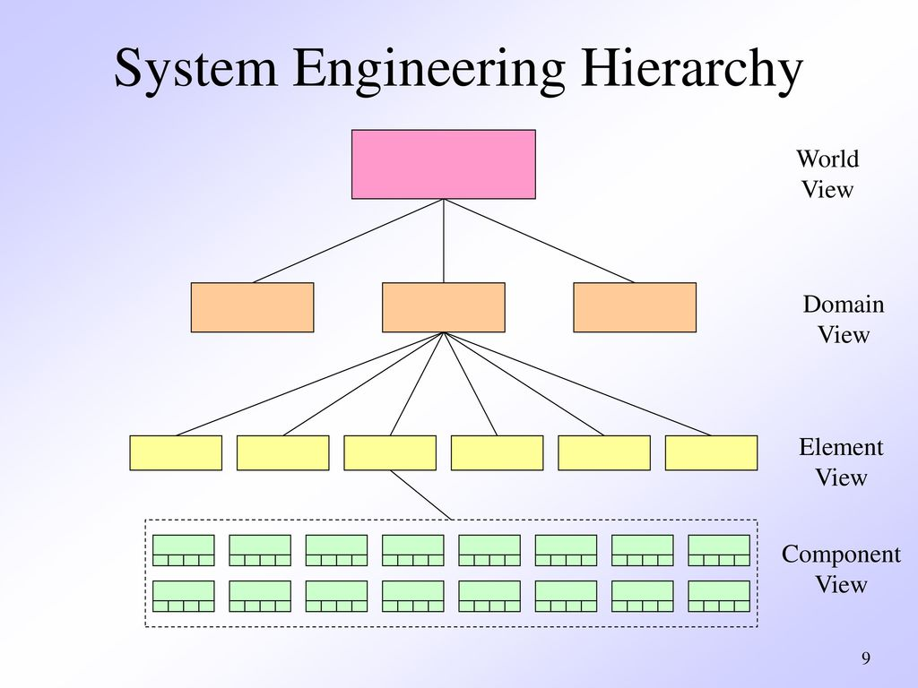
(Or)

13. b. Why requirements elicitation is difficult:
•Problems of scope: The system boundary is ill-defined
•Problems of volatility: The requirements change over time.
•Problems of understanding:
- The customers are not completely sure what is needed.
- They don’t know the capabilities & limitations of computers.
- They don’t have a full understanding of the problem domain.
- They have trouble communicating their needs.
- They omit information that is believed to be obvious.
- They specify requirements that are ambiguous or untestable

- a. Software design sits at the technical kernel of software engineering and is applied regardless of the software process model that is used. Beginning once software requirements have been analyzed and modeled, software design is the last software engineering action within the modeling activity and sets the stage for construction.
- The design must implement all of the explicit requirements contained in the requirements model, and it must accommodate all of the implicit requirements desired by stakeholders.
- The design must be a readable, understandable guide for those who generate code and for those who test and subsequently support the software.
- The design should provide a complete picture of the software, addressing the data, functional, and behavioral domains from an implementation perspective.
(Or)
14.b. Refactoring is the process of changing a software system to improve its internal structure without altering the external behaviour of the code. Refactoring makes your code finer, leaner, better, cleaner.
After being refactored, your code is ready for some future features you didn’t think about six months ago. It is used to make your system performance much better and faster than it actually is.
Unlike refactoring, Refinement is much more complex. You literary throw away the old code and build from scratch a new one. In most cases, software developers get rid of the slow components in the first place, and/or create the architecture that can support the growth.

15. a. Verification Vs Validation:
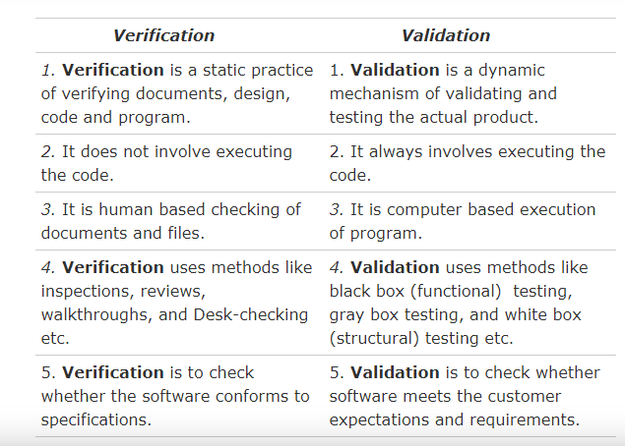

(Or)
15. b. Business process reengineering is also known as business process redesign, business transformation, or business process change management.
Business process re-engineering (BPR) is a business management strategy, originally pioneered in the early 1990s, focusing on the analysis and design of workflows and business processes within an organization. BPR aimed to help organizations fundamentally rethink how they do their work in order to improve customer service, cut operational costs, and become world-class competitors.

BPR seeks to help companies radically restructure their organizations by focusing on the ground-up design of their business processes. According to early BPR proponent Thomas H. Davenport (1990), a business process is a set of logically related tasks performed to achieve a defined business outcome. Re-engineering emphasized a holistic focus on business objectives and how processes related to them, encouraging full-scale recreation of processes rather than iterative optimization of sub-processes.
Part - C
Answer should not exceed 600 words or three pages 5 x 7 = 35

- a. Need for Process Assessment: It is an important initial step in addressing software problems or issues is to treat the entire development task as a process which can be controlled, measured, and improved.
It is a matter for debate whether software quality is best measured directly from the software product itself or indirectly from the software process.
A general process assessment method contains a number of elements:
- A diagnostic tool or instrument to enable the maturity of software processes to be meansured and a maturity level or profile to be drawn up.
- An underlying generic process maturity model on which to base the assessment and to derive the priorities for improvement
- A set of best practices or norms for comparison, either explicitly, or implicitly in the assignment of levels or profiles
- Supporting best practice guidelines to support the improvement planning process.
- A clear mechanism for presenting results.
Process standards Software process standards are standards which constrain the process which may be used to develop and maintain software by defining characteristics or properties which a conforming process must possess.
(Or)
16. b. Need: The primary goal of TSP is to create a team environment for establishing and maintaining a self-directed team, and supporting disciplined individual work as a base of PSP framework. Self-directed team means that the team manages itself, plans and tracks their work, manages the quality of their work, and works proactively to meet team goals.
TSP has two principal components: team-building and team-working:
Team-building is a process that defines roles for each team member and sets up teamwork through TSP launch and periodical relaunch. Team-working is a process that deals with engineering processes and practices utilized by the team. TSP, in short, provides engineers and managers with a way that establishes and manages their team to produce the high-quality software on schedule and budget.
Functionalities:
Before engineers can participate in the TSP, it is required that they have already learned about the PSP, so that the TSP can work effectively. Training is also required for other team members, the team lead and management. The TSP software development cycle begins with a planning process called the launch, led by a coach who has been specially trained, and is either certified or provisional.
The launch is designed to begin the team building process, and during this time teams and managers establish goals, define team roles, assess risks, estimate effort, allocate tasks, and produce a team plan. During an execution phase, developers track planned and actual effort, schedule, and defects meeting regularly (usually weekly) to report status and revise plans. A development cycle ends with a Post Mortem to assess performance, revise planning parameters, and capture lessons learned for process improvement.
The coach role focuses on supporting the team and the individuals on the team as the process expert while being independent of direct project management responsibility. The team leader role is different from the coach role in that, team leaders are responsible to management for products and project outcomes while the coach is responsible for developing individual and team performance.

17. a. One of the differences between agile software development methods and waterfall is the approach to quality and testing.
In the waterfall model, there is always a separate testing phase after a build phase; however, in agile software development testing is completed in the same iteration as programming.
Another difference is that traditional "waterfall" software development moves a project through various Software Development Lifecycle (SDLC) phases. One phase is completed in its entirety before moving on to the next phase.
Because testing is done in every iteration—which develops a small piece of the software—users can frequently use those new pieces of software and validate the value. After the users know the real value of the updated piece of software, they can make better decisions about the software's future. Having a value retrospective and software re-planning session in each iteration—Scrum typically has iterations of just two weeks—helps the team continuously adapt its plans so as to maximize the value it delivers.
This follows a pattern similar to the PDCA cycle, as the work is planned, done, checked (in the review and retrospective), and any changes agreed are acted upon. This iterative approach supports a product rather than a project mind set. This provides greater flexibility throughout the development process; whereas on projects the requirements are defined and locked down from the very beginning, making it difficult to change them later.
Iterative product development allows the software to evolve in response to changes in business environment or market requirements. Because of the short iteration style of agile software development, it also has strong connections with the lean startup concept.
(Or)
- b. The process of prototyping involves the following steps::
- Identify basic requirements
Determine basic requirements including the input and output information desired. Details, such as security, can typically be ignored.
- Develop initial prototype
The initial prototype is developed that includes only user interfaces. (See Horizontal Prototype, below)
- Review
The customers, including end-users, examine the prototype and provide feedback on potential additions or changes.
- Revise and enhance the prototype
Using the feedback both the specifications and the prototype can be improved. Negotiation about what is within the scope of the contract/product may be necessary. If changes are introduced then a repeat of steps #3 and #4 may be needed.

Dimensions of Prototype

Horizontal prototype:
A common term for a user interface prototype is the horizontal prototype. It provides a broad view of an entire system or subsystem, focusing on user interaction more than low-level system functionality, such as database access. Horizontal prototypes are useful for:
- Confirmation of user interface requirements and system scope,
- Demonstration version of the system to obtain buy-in from the business,
- Develop preliminary estimates of development time, cost and effort.

Vertical prototype:
A vertical prototype is an enhanced complete elaboration of a single subsystem or function. It is useful for obtaining detailed requirements for a given function, with the following benefits:
- Refinement database design.
- Obtain information on data volumes and system interface needs, for network sizing and performance engineering.
- Clarify complex requirements by drilling down to actual system functionality.
- a. In software engineering, software configuration management (SCM or S/W CM) is the task of tracking and controlling changes in the software, part of the larger cross-disciplinary field of configuration management. SCM practices include revision control and the establishment of baselines. If something goes wrong, SCM can determine what was changed and who changed it. If a configuration is working well, SCM can determine how to replicate it across many hosts.
The acronym "SCM" is also expanded as source configuration management process and software change and configuration management. However, "configuration" is generally understood to cover changes typically made by a system administrator.
The history of software configuration management (SCM) in computing can be traced back as early as the 1950s, when CM (for Configuration Management), originally for hardware development and production control, was being applied to software development. Early software had a physical footprint, such as cards, tapes, and other media. The first software configuration management was a manual operation. With the advances in language and complexity, software engineering, involving configuration management and other methods, became a major concern due to issues like schedule, budget, and quality. Practical lessons, over the years, had led to the definition, and establishment, of procedures and tools.
The goals of SCM are generally:
- Configuration identification - Identifying configurations, configuration items and baselines.
- Configuration control - Implementing a controlled change process. This is usually achieved by setting up a change control board whose primary function is to approve or reject all change requests that are sent against any baseline.
- Configuration status accounting - Recording and reporting all the necessary information on the status of the development process.
- Configuration auditing - Ensuring that configurations contain all their intended parts and are sound with respect to their specifying documents, including requirements, architectural specifications and user manuals.
(Or)

18. b. Stages in the Negotiation Process:
However, negotiators need not sacrifice effective negotiation in favor of a positive relationship between parties. Rather than conceding, each side can appreciate that the other has emotions and motivations of their own and use this to their advantage in discussing the issue. In fact, perspective-taking can help move parties toward a more integrative solution. There are few techniques illustrated effectively to improve perspective-taking in their book Getting to Yes, and through the following, negotiators can separate people from the problem itself.
- Put yourself in their shoes – People tend to search for information that confirms his or her own beliefs and often ignore information that contradicts prior beliefs. In order to negotiate effectively, it is important to empathize with the other party's point of view. One should be open to other views and attempt to approach an issue from the perspective of the other.
- Discuss each other's perceptions – A more direct approach to understanding the other party is to explicitly discuss each other's perceptions. Each individual should openly and honestly share his or her perceptions without assigning blame or judgement to the other.
- Find opportunities to act inconsistently with his or her views – It is possible that the other party has prior perceptions and expectations about the other side. The other side can act in a way that directly contradicts those preconceptions, which can effectively send a message that the party is interested in an integrative negotiation.
- Face-saving – This approach refers to justifying a stance based on one's previously expressed principles and values in a negotiation. This approach to an issue is less arbitrary, and thus, it is more understandable from the opposing party's perspective.
Additionally, negotiators can use certain communication techniques to build a stronger relationship and develop more meaningful negotiation solution.
- Active listening – Listening is more than just hearing what the other side is saying. Active listening involves paying close attention to what is being said verbally and nonverbally. It involves periodically seeking further clarification from the person. By asking the person exactly what they mean, they may realize you are not simply walking through a routine, but rather take them seriously.
- Speak for a purpose – Too much information can be as harmful as too little. Before stating an important point, determine exactly what you wish you communicate to the other party. Determine the exact purpose that this shared information will serve.
- a. (i) Requirements analysis:
It focuses on the tasks that determine the needs or conditions to meet the new or altered product or project, taking account of the possibly conflicting requirements of the various stakeholders, analyzing, documenting, validating and managing software or system requirements.
Requirements analysis is critical to the success or failure of a systems or software project. The requirements should be documented, actionable, measurable, testable, traceable, related to identified business needs or opportunities, and defined to a level of detail sufficient for system design.
Conceptually, requirements analysis includes three types of activities:
- Eliciting requirements: (e.g. the project charter or definition), business process documentation, and stakeholder interviews. This is sometimes also called requirements gathering or requirements discovery.
- Analyzing requirements: determining whether the stated requirements are clear, complete, consistent and unambiguous, and resolving any apparent conflicts.
- Recording requirements: Requirements may be documented in various forms, usually including a summary list and may include natural-language documents, use cases, user stories, process specifications and a variety of models including data models.
(ii) Object oriented Analysis:
Common models used in OOA are use cases and object models. Use cases describe scenarios for standard domain functions that the system must accomplish. Object models describe the names, class relations (e.g. Circle is a subclass of Shape), operations, and properties of the main objects. User-interface mockups or prototypes can also be created to help understanding.
The purpose of any analysis activity in the software life-cycle is to create a model
of the system's functional requirements that is independent of implementation
constraints.
The main difference between object-oriented analysis and other forms of analysis is that by the object-oriented approach we organize requirements around objects, which integrate both behaviors (processes) and states (data) modeled after real world objects that the system interacts with. In other or traditional analysis methodologies, the two aspects: processes and data are considered separately. For example, data may be modeled by ER diagrams, and behaviors by flow charts or structure charts.
(Or)
19.b. They are as follows:
    - Abstraction:
- the process of removing physical, spatial, or temporal details or attributes in the study of objects or systems in order to focus attention on details of higher importance, it is also very similar in nature to the process of generalization;
- the creation of abstract concept-objects which are created by mirroring common features or attributes from various non-abstract objects or systems of study — the result of the process of abstraction.
  - Modularity:
- In modular programming, modularity refers to the compartmentalization and interrelation of the parts of a software package.
- In software design, modularity refers to a logical partitioning of the "software design" that allows complex software to be manageable for the purpose of implementation and maintenance. The logic of partitioning may be based on related functions, implementation considerations, data links, or other criteria.
- In self-reconfiguring modular robotics, modularity refers to the ability of the robotic system to automatically achieve different morphologies to execute the task at hand.
  - Information hiding:
- A common use of information hiding is to hide the physical storage layout for data so that if it is changed, the change is restricted to a small subset of the total program.
- For example, if a three-dimensional point (x,y,z) is represented in a program with three floating point scalar variables and later, the representation is changed to a single array variable of size three, a module designed with information hiding in mind would protect the remainder of the program from such a change.
20. a. A test strategy is an outline that describes the testing approach of the software development cycle. It is created to inform project managers, testers, and developers about some key issues of the testing process. This includes the testing objective, methods of testing new functions, total time and resources required for the project, and the testing environment.
Test strategies describe how the product risks of the stakeholders are mitigated at the test-level, which types of testing are to be performed, and which entry and exit criteria apply. They are created based on development design documents. System design documents are primarily used, and occasionally conceptual design documents may be referred to. Design documents describe the functionality of the software to be enabled in the upcoming release. For every stage of development design, a corresponding test strategy should be created to test the new feature sets.
The test schedule should also document the number of testers available for testing. If possible, assign test cases to each tester.
It is often difficult to make an accurate estimate of the test schedule since the testing phase involves many uncertainties. Planners should take into account the extra time needed to accommodate contingent issues. One way to make this approximation is to look at the time needed by the previous releases of the software. If the software is new, multiplying the initial testing schedule approximation by two is a good way to start.

The roles and responsibilities of the test leader, individual testers, and project manager are to be clearly defined at a project level in this section. This may not have names associated, but the role must be very clearly defined.
Testing strategies should be reviewed by the developers. They should also be reviewed by test leads for all levels of testing to make sure the coverage is complete, yet not overlapping. Both the testing manager and the development managers should approve the test strategy before testing can begin.

20.b. Black-box testing is a method of software testing that examines the functionality of an application without peering into its internal structures or workings. This method of test can be applied virtually to every level of software testing: unit, integration, system and acceptance. It is sometimes referred to as specification-based testing.
Typical black-box test design techniques include:
- Decision table testing
- All-pairs testing
- Equivalence partitioning
- Boundary value analysis
- Cause–effect graph
- Error guessing
- State transition testing
- Use case testing
- User story testing
- Domain analysis
- Syntax testing
- Combining technique
Specific knowledge of the application's code, internal structure and programming knowledge in general is not required. The tester is aware of what the software is supposed to do but is not aware of how it does it. For instance, the tester is aware that a particular input returns a certain, invariable output but is not aware of how the software produces the output in the first place.
***************

