SECURED AND MULTIFUNCTIONAL BUSINESS PROCESS FOR ONLINE PURCHASE

KARTHIKA.S
09PCA08

A Project Report Submitted to Avinashilingam University for Women, Coimbatore in partial fulfillment of the requirements for the
Master’s Degree in Computer Applications

April, 2012

Signature of the Signature of the
Head of the Department Supervisor

Signature of the

External Examiner
ACKNOWLEDGEMENT

I would like to express my sincere thanks to God Almighty, for his constant love and grace that he has showered upon me.

I am very grateful to Mr.T.S.K.MeenakshiSundaram, M.A., M.Phil., Chancellor, and Avinashilingam Institute for Home Science and Higher Education for Women, Coimbatore, for his support and encouragement during the course of my study.

I heartily thank Dr.(Mrs).Sheela Ramachandran M.Sc., P.G DIP., Ph.D., Vice Chancellor, and Avinashilingam Institute for Home Science and Higher Education for Women, Coimbatore, for extending all resources that facilitated the conduct of the present study.

I express my humble gratitude to Dr.(Mrs). Gowri Ramakrishnan M.Sc., M.Phil., Ph.D., Registrar, and Avinashilingam Institute for Home Science and Higher Education for Women, Coimbatore, for providing all facilities necessary for the study.

I am also thankful to Dr.(Mrs). R. Parvatham M.Sc., Dip.Ed. M.Phil., Ph.D., Dean Faculty of Science, for granting the facility required.

I wish to place on record my deep sense of gratitude to Dr.(Mrs).G.Padmavathi M.Sc., M.Phil., Ph.D., Professor and Head, Department of Computer Science, for providing all the facilities to complete the project.

I take this unique opportunity to express my sincere thanks to my project Coordinator Dr.P.Subashini, M.C.A., M.Phil., Ph.D., Associate Professor, Department of Computer Science, for her kind advice and knowledgeable suggestion, which helped me to complete my project successfully.

I am greatly indebted to my esteemed guide Mrs.Anitha, M.Sc.,M.Phil.,(Ph.D)., Department of Computer Science, for her inspiring and constant encouragement and timely guidelines at every stage of this project and who helped me to complete this project a successful one.
We have great pleasure in expressing our deep sense of gratitude to all other staffs and non-teaching staffs who stood behind the screen in making of project.

I would extend my hearty thanks to one and all who helped me directly or indirectly for successful completion of my project.

Last yet importantly, I would like to thank my parents, my friends and all my well-wishers for their kind inspiration.

SYNOPSIS

The project entitled “Secured and Multifunctional Business Process for Online Purchase” provides the opportunity to combine multiple business service software such as Purchase, Sales, Shipping and Loan Process into single software. The application online purchase has developed to prove the concept of multifunctional business process. The business people conversations, data sharing and requirements are secured with the usage of protocols such as WSDL, UDDI, and SOAP.

The goal of the project is to bring the business process under one roof as online business and the main prospective is to access entire business in a computerized platform. The entire business process comes under the single monitoring system to observe and analyze the behavior of another system to satisfy the other system requirements. Language-Action Perspective provides the opportunity to characterize messages in conversation protocols as actions. The actions are used in decision making to communication between business peoples.

A monitor is a system that “observes and analyzes the behavior of another system, determining qualities of interest, such as the satisfaction of the target system’s requirements”. Service systems build upon the basic idea of software as a service that allows legacy and new applications to declare their capabilities in a machine-readable format. Conversation among the web services to share and secure the information between business software. The project demonstrates how the framework can be implemented and evaluates it with multiple scenarios such as the transaction between merchant and customer that include specifying and monitoring open-service policy commitments.

CONTENTS

Page No

1. INTRODUCTION 1
2. SYSTEM CONFIGURATION 3 2.1 HARDWARE SPECIFICATION 3 2.2 SOFTWARE SPECIFICATION 3
2.3 ABOUT THE SOFTWARE 4

3. SYSTEM STUDY AND ANALYSIS 8 3.1 EXISTING SYSTEM 8 3.2 PROPOSED SYSTEM 9
4. SYSTEM DESIGN 10
4.1 INPUT DESIGN 10 4.2 OUTPUT DESIGN 11
4.3 DATABASE DESIGN 13

5. SYSTEM DEVELOPMENT 15
5.1 MODULE DESCRIPTION 15
5.1.1 CUSTOMER DETAILS 15
5.1.2 MERCHANT DETAILS 16
5.1.3 LOAN APPROVAL 16
5.1.4 SHIPPING PROCESS 17
5.1.5 PAYMENT GATEWAY 17
5.1.6 MONITORING SOFTWARE SYSTEM 17

Page No

6. SYSTEM TESTING 19
6.1 UNIT TESTING 19
6.2 INTEGRATION TESTING 20
6.3 VALIDATION TESTING 20
6.4 SYSTEM TESTING 20
6.5 ACCEPTANCE TESTING 21
6.6 WHITE BOX TESTING 21
6.7 BLACK BOX TESTING 21

7. SYSTEM IMPLEMENTATION 22

8. CONCLUSION 23

9. SCOPE FOR FUTURE ENHANCEMENT 24

10. BIBLIOGRAPHY 25

11. APPENDIX 27
11.1 UML DIAGRMAS 27
11.2 TABLE DESIGN 29
11.3 SCREEN SHOTS 36

1. INTRODUCTION

The project presents a framework for monitoring of business service systems. It formalizes interaction protocols, policies, and commitments that account for standard and extended effects following the language-action perspective, and allows specification of goals and monitors at varied abstraction levels. The project demonstrates how the framework can be implemented and evaluates it with multiple scenarios that include specifying and monitoring open-service policy commitments. Online shopping trend has introduced new dimensions with the rapidly changing requirements of the people all over the globe.

Business processes are increasingly distributed by online service. Each online service needs software. Different kinds of people are involved in business. Everyone have separate software for their business. In the project, people make the communication and transaction between the software by using some concepts and rules that become best secured and monitoring service software. Most of our large software systems are now constructed as group of interoperating system (as systems of systems) made to interoperate through various form of interfaces.

In the project, the software systems are constructed as group of interoperated system made to interoperating through various form of interfaces. The project uses the concept of Language Action Perspective (LAP), LAP is theoretical based approach to modeling and developing business process and information system. By using LAP concept, the computer was capable for supporting “conversations” between business peoples and the LAP concept also used to give the accurate and timely information for Decision Making. Service system enablers are available to give the support for conversation between services, which can provide a loosely coupled, peer-to-peer interaction model and also the project provide the service of monitoring system to monitor the business.

The application used in the project is online purchase is to describe the business process between the customer and the merchant. In the project, the monitoring service observes and analysis behavior and requirements of the business peoples, such as customers and merchants, and also connecting with other business peoples like shippers and bankers. In the project, online purchase includes the additional feature loan process than the existing online purchase. Service system enablers make the interactions between business people through internet.

The service system enablers provide a conversation policy that allows each party to maintain its own record of the conversation’s state. The Conversations follows three important points, first, processes can be modeled as a composition of conversations. Second, conversation protocols can be specified for services. Third, conversations provide the possibility for monitoring at different levels of granularity and temporality.

MAIN OBJECTIVES:

- The objective of multifunctional business process is to connect multiple business processes into a single online process.
- The multifunctional service is to make online business trouble-free.
- Reduces the manual process.
- Operations monitoring over the internet.
- Monitoring service system provides the opportunity for secured online business and also increases the accuracy.
- Multi-user software.

2. SYSTEM CONFIGURATION

The system configuration section describes the hardware and software specification needed for both development and implementation phases of this project.

2.1 HARDWARE SPECIFICATION

Processor : Intel® Pentium®
RAM : 512 MB
Hard disk drives : 300 GB
Cache memory : 512 DB
Floppy Drive : 31/2-Inch Floppy Disk
Monitor : 14 Inch HCL Color Monitor
Keyboard : HCL
Mouse : Scroll Mouse

2.2 SOFTWARE SPECIFICATION

Framework : Microsoft Visual Studio 2008

Software : ASP.NET

Language : C#

Operating System : Microsoft Windows XP (2002)

Database : SQL Server 2008

2.3 ABOUT THE SOFTWARE

FEATURES OF .NET:
Microsoft .NET is a set of Microsoft software technologies for rapidly building and integrating XML Web services, Microsoft Windows-based applications, and Web solutions. The .NET Framework is a language-neutral platform for writing programs that can easily and securely interoperate. There’s no language barrier with .NET: there are numerous languages available to the developer including Managed C++, C#, Visual Basic and Java Script. The .NET framework provides the foundation for components to interact seamlessly, whether locally or remotely on different platforms. “.NET” is also the collective name given to various software components built upon the .NET platform. These will be both products (Visual Studio.NET and Windows.NET Server, for instance) and services (like Passport, .NET My Services, and so on).

ASP.Net:
This project is developed using ASP.NET. ASP.NET is a unified Web development model that includes the services necessary for you to build enterprise-class Web applications with a minimum of coding. ASP.NET is part of the .NET Framework, and when coding ASP.NET applications you have access to classes in the .NET Framework. You can code your applications in any language compatible with the common language runtime (CLR), including Microsoft Visual Basic and C#. These languages enable you to develop ASP.NET applications that benefit from the common language runtime, type safety, inheritance, and so on.
ADVANTAGES OF ASP.NET:
1. ASP.NET drastically reduces the amount of code required to build large applications.
2. With built-in Windows authentication and per-application configuration, your applications are safe and secured.
3. It provides better performance by taking advantage of early binding, just-in-time compilation, native optimization, and caching services right out of the box.

C #:

C# 3.0 (“C# Orcas”) introduces several language extensions that build on C# 2.0 to support the creation and use of higher order, functional style class libraries. The extensions enable construction of compositional APIs that have equal expressive power of query languages in domains such as relational databases and XML.

The extensions include:
- Implicitly typed local variables, which permit the type of local variables to be inferred from the expressions used to initialize them.
- Extension methods, which make it possible to extend existing types and constructed types with additional methods.
- Lambda expressions, an evolution of anonymous methods that provides improved type inference and conversions to both delegate types and expression trees.
- Object initializers, which ease construction and initialization of objects.
- Anonymous types, which are tuple types automatically inferred and created from object initializers.
- Implicitly typed arrays, a form of array creation and initialization that infers the element type of the array from an array initializer.
- Query expressions, which provide a language integrated syntax for queries that is similar to relational and hierarchical query languages such as SQL and XQuery.
- Expression trees, which permit lambda expressions to be represented as data (expression trees) instead of as code (delegates).

MICROSOFT SQL SERVER 2008

Microsoft SQL Server is a relational database management and analysis system for e-commerce, line-of-business and data warehousing solutions. SQL Server 2008, the latest version, includes support for XML and HTTP, Performance and availability features to partition load and ensure uptime and advanced management and tuning functionality to automate routine tasks and lower total cost of ownership.

Microsoft SQL Server 2008 extends the performance, reliability, quality, and ease-of-use of Microsoft SQL Server. Microsoft SQL Server 2008 includes several new features that make it an excellent database platform for large-scale online transaction processing (OLTP), data warehousing, and e-commerce applications. The OLAP Services feature available in SQL Server is now called SQL Server 2008 Analysis Services.
SERVICE SYSTEM ENABLERS
Service systems build upon the basic idea of software as a service that allows legacy and new applications to declare their capabilities in a machine-readable format. Once deployed, the services can be linked to support cross functional business processes. Core standards for publishing (WSDL 2001), finding (UDDI 2005), and binding (SOAP 2003) provide key enablers for these service systems.

WSDL:

WSDL is an XML-based language for describing Web services and how to access them. WSDL stands for Web Services Description Language, and is an XML-based language for describing Web Services. WSDL 1.1 was suggested in a note to W3C in March 2001 (by Ariba, IBM and Microsoft), as a language for describing Web Services. The note also described how to use WSDL in conjunction with SOAP 1.1, HTTP GET/POST, and MIME types. WSDL 1.2, the first working drafts were published 17. December 2001.The latest working drafts were published 11. June 2003.WSDL 2.0 became a W3C Recommendation 26. June 2007.

UDDI:
Universal Description, Discovery and Integration (UDDI) is a directory service where businesses can register and search for Web services. UDDI is a platform-independent framework for describing services, discovering businesses, and integrating business services by using the Internet.
- UDDI stands for Universal Description, Discovery and Integration
- UDDI is a directory for storing information about web services
- UDDI is a directory of web service interfaces described by WSDL
- UDDI communicates via SOAP
- UDDI is built into the Microsoft .NET platform
UDDI uses World Wide Web Consortium (W3C) and Internet Engineering Task Force (IETF) Internet standards such as XML, HTTP, and DNS protocols. UDDI uses WSDL to describe interfaces to web services. Additionally, cross platform programming features are addressed by adopting SOAP, known as XML Protocol messaging specifications found at the W3C Web site.
SOAP:
SOAP is a simple XML-based protocol to let applications exchange information over HTTP. In our SOAP tutorial, you will learn what SOAP is, and how it uses XML to exchange information between applications. SOAP is an important for application development to allow Internet communication between programs. Today's applications communicate using Remote Procedure Calls (RPC) between objects like DCOM and CORBA, but HTTP was not designed for this. RPC represents a compatibility and security problem; firewalls and proxy servers will normally block this kind of traffic. A better way to communicate between applications is over HTTP, because HTTP is supported by all Internet browsers and servers. SOAP was created to accomplish this. SOAP provides a way to communicate between applications running on different operating systems, with different technologies and programming languages.

3. SYSTEM STUDY AND ANALYSIS

System analysis is the general term that refers to an orderly and structured procedure for identifying and solving problems. It involves the study of existing system to understand how they function. This knowledge will helps to identify what the new system includes than the existing system.

3.1 EXISTING SYSTEM
The existing “online purchase” mainly concentrates only on the purchase and sales process but net banking, imports, exports, was taken as manual efforts which was a tedious process and was not feasible to customer and also to the sales agents which is accessed from multiple service software. The existing system deals with the multiple monitoring service systems which makes the business as confused. The existing system was unpredictable to process sequence and uncertain events are occurred.

DRAWBACKS OF EXISTING SYSTEM

- The existing system didn’t fulfill the entire business process in single software.
- Not Secured.
- Less accurate.
- More complexity to conversation between the business people.
- Inconvenience to conversations

3.2 PROPOSED SYSTEM

In proposed system most of our large business software systems are constructed as group of interoperating systems made to interoperate through various forms of interfaces. The proposed software concentrates more on user friendly interfaces and promotes user to purchase faster and easier. In proposed system more facilities includes such as net banking, loan process. The proposed system is feasible to customer and also to the sales agents which is accessed from multiple service software.

MERITS OF PROPOSED SYSTEM

- The main merit of proposed system is to make online business as powerful, fast and efficient marketing and purchasing.
- The application online purchase includes the additional feature loan process as proposed.
- In proposed system, the project using the concept language action perspective to provide the communication as secured and perfect monitoring service.
- The monitoring service system and the service system enablers are to reduce complexity and inconvenience of the conversation.
- Well-specified business processes with service to perform tasks are advanced changes such as stability, feasibility, predictability.
- Highly Secured in accessing information over Network, with various user level accesses.
- Flexible to import and export data.
- Highly Integrated software, among various functional areas in an online purchase.
- On-line postings of transactions, so that the information from the system is up-to date.

4. SYSTEM DESIGN

Design is the first process in the development phase of any engineered system. The inputs to the design are the software requirements and the output will be the design specification applicable to all software design.

4.1 INPUT DESIGN

Input design is the most important part of the overall system design, which requires a careful attention. Often the collection of input data is the most expensive part of the system. The main objective of the input design is to provide user friendly interaction. The user has to make a minimum input as a whole process is automated. Many errors may occur during this phase. So to make the system study, the inputs given by the user is strictly validated before making a manipulation with input.

The forms included in the input design are Registration, Login, Customer Entry Detail, Merchant Entry Detail, Purchase Item, Prepare Quote, Transport Detail, Shipper Entry Detail, Profile Details to Bank, Apply Loan, Deposit, and Fund Transfer.
- In the Registration form customers, merchants, shippers can register their details. After the registration, every user can login into their web page (refer in appendix 11.3.1).
- Login form is created for security purpose. Every user have their own unit code and division code in that form. There will be a particular name for login and appropriate password to get into the home page. From the home page all other forms could be easily access (refer in appendix 11.3.2).
- Customer Entry Detail form is the form which gives the full information about customer name, address, customer shop detail (refer in appendix 11.3.3).
- Merchant Entry Detail form is the form which gives the information about merchant name, address, merchant shop detail for customer verification (refer in appendix 11.3.7).
- Purchase Item is the input form, in the form where customer can enter the order details. The form includes the detail about customer, customer shop detail and purchase item details (refer in appendix 11.3.9).
- Prepare Quote is the form to prepare quotation report to customer by merchant, where the detail report of item, item price and the merchant’s rules are viewed (refer in appendix 11.3.12).
- Transport Detail, is the form where merchant can send the transport details to shipper which includes customer name, customer shop name, delivery place, delivery date and rules (refer in appendix 11.3.11).
- Shipper Entry Detail form is the form which gives the information about shipper name, ship name.
- Profile Details to Bank is a form where the admin stores the details of the customer for Banking (refer in appendix 11.3.16).
- Apply Loan is a form where the user can enter the detail to apply loan. The form includes the detail about loan id, loan description, minimum loan value, loan type (refer in appendix 11.3.15).
- Deposit is a form where the admin can deposit the approved money to the user.
- Fund Transfer is the form where customer can transfer the money to merchant (refer in appendix 11.3.219). These are all the forms that are included in the input design.
4.2 OUTPUT DESIGN
Computer output is most important and direct source of information to the user. Efficient and intelligible output design should improve the system’s relationship with the user and help in decision making. The nature of processing and procedures related to the system were classified and gives the output results.

Output from the computer system is required to communicate the result of processing to the user and to provide permanent copy of these results for later consultation. While designing the output, the type of output, concern format, and frequency response has been taken into consideration.

The main output generated here is the reports. The reports were generated for selective reasons. The various reports generated are View Merchant Details, View Quotation Report, View Customer Order Report, View Shipper Details, View Transport Orders, Account Statement and Loan Sanction.
- In View Merchant Details form, all the registered customers can view the details of all registered merchants (refer in appendix 11.3.4).
- View Quotation Report is the form where the customer can view the quotation given by the merchant (refer in appendix 11.3.6).
- View Customer Order Report is the form where the merchant can view the order given by the customer (refer in appendix 11.3.8).
- In View Shipper Details all the registered merchants can view the details of all registered shippers (refer in appendix 11.3.10).
- View Transport Orders is the form where the shipper can view the transport orders given by the merchant (refer in appendix 11.3.12).
- Account Statement is a form where the user can view the account statements.
- Loan Sanction is a form where the admin can view the details of the customers who got the loan (refer in appendix 11.3.18). These are all the forms that are included in the output design.

4.3 DATABASE DESIGN

Database design is the process of producing a detailed data model of a database. The logical design of the base data structures used to store the data. The project uses the Microsoft SQL server 2008 to create the tables for data storage. The term database design can be used to describe many different parts of the design of an overall database system. Principally, and most correctly, it can be thought of as the logical design of the base data structures used to store the data.

The project contains sixteen different tables. Tables are used to store and retrieve the data from input and to output. The database includes,
- REGISTER table is the table which gives the information to login form such as the USER_NAME, PASSWORD and ROLE (refer in appendix 11.2.1).
- CUSTOMER is the table which includes the detail about the customer’s profile, the table includes the fields such as CUSTOMER_NAME, ADDRESS, SHOP_NAME and so on (refer in appendix 11.2.2).
- ORDERING table is the table where the customer orders can store, which contains many fields namely NAME, DELIVERY_PLACE, ITEM_TYPE, ITEM, DELIVERY_DATE, and MERCHANT_NAME (refer in appendix 11.2.5).
- MERCHANT table is the table used to store the merchant’s profile. The table includes the field such as MERCHANT_NAME, ADDRESS, EMAIL_ID, TELEPHONE, ACCOUNT_NUMBER (refer in appendix 11.2.3).
- QUOTATION is the table where the merchant quotation report can store which the details such as the MERCHANT_NAME, SHOP_NAME, CUSTOMER_SHOP_NAME, CUSTOMER_NAME, TOTAL_AMOUNT, DELIVERY_PLACE and so on(refer in appendix 11.2.6).
- ORDER_SHIP is the table where the transport order information can store which is given by the merchant to the shipper. The table contains the fields CUSTOMER_NAME, CUSTOMER_SHOP, SENDER_NAME, MY_SHOP, DELEVERY_PLACE and CONDITIONS (refer in appendix 11.2.7).

- SHIPPER table is the table which shows the shipper’s profile information. The table contains several fields namely SHIP_NAME, SHIPPER_NAME, ACCOUNT_NUMBER and so on (refer in appendix 11.2.4).

Banking process contains the tables namely NEW_CUSTOMER, LOAN_ISSUE, ENQUIRY, LOAN_DATAILS, LOGIN, CALCULATE, CHEQUE_BOOK.
- NEW_CUSTOMER table is the table where the users profile information can store which the table includes the detail about PASSWORD, USER_NAME, ACCOUNT_NO, TEM_ADDRESS, MEMBER_TYPE, BALANCE and so on (refer in appendix 11.2.8).
- LOAN_ISSUE is the table the details such as the LOAN_AMOUNT, MONTHLY_INTEREST, and MIN_LOAN_VALUE (refer in appendix 11.2.9).
- ENQUIRY table there are many kinds of fields which are LOAN_DES, LOAN_TYPE, MAX_VALUE (refer in appendix 11.2.13).
- LOAN_DATAILS table there are seven kinds of fields which are LOAN_ID, LOAN_DESCRIPTION, LOAN_TYPE, MAX, RATE, MIN_LOAN and MAX_LOAN.
- CHEQUE_BOOK is the table which the details such as the NAME, ACC_NO, PIN, DATE, ACCOUNT_TYPE, BRANCH_NAME and CHEQUE_BOOK(refer in appendix 11.2.12).
.

5. SYSTEM DEVELOPMENT

The systems development is a conceptual model used in project management that describes the stages involved in an information system development project, from an initial feasibility study through maintenance of the completed application.

5.1 MODULE DESCRIPTION
In the project, the multilevel functional service is between the customer, merchant, bank, shipper and the payment gateway. The project is based on complete online business service. The project provides the service such as shopping, loan approval, shipping service and payments through online. The project consist of five main modules namely Customer Details, Merchant Details, Shipping Process, Loan Transaction, Payment Gateway. Login form is available in home page. Login form is created for security purpose each project will have its own unit code and division code in that form. There will be a particular name for login and appropriate password to get into the home page. From the home page all other forms could be easily access.
5.1.1 CUSTOMER DETAILS

In customer details module customer personal details and requirements are registered. Once all the information are registered the detail will viewed and processed by merchant and banker. Using the customer page any customer can get the assistance from the available customer support executive online. In the customer module the details about various customers are maintained and each has a unique id. And includes about various merchants are maintained and each has a unique id. The customer select best merchant and then send quote to that merchant mail account. And also send his particulars and conditions.

The module includes the details about, Entry details, which is the form provided to the customer to enter their personal details. Merchant details form is the form which gives the information about the Merchant Name, Merchant Contact Number, Merchant Email Id, Product Details, and so on. Purchase Item, in the purchase item customer can order the items. Quotation Report is to view the quotation which is send by the merchant. Net Banking is to transfer money to merchant.

5.1.2 MERCHANT DETAILS

In the merchant module the details about various merchants are maintained and each has a unique id. The merchants receives item id, consults its policy for quoting and sends the quote price item price, and receives either accept-quote or reject-quote. The product provide by the merchant is authorized.
The module includes the details about, Entry details which page is provided to the merchant to enter their personal details. Customer Order is the form which has information about the ordered items by customer for their purchase. Prepare Quotation to prepare the quotation for customer’s purchase. Shipper Details form is the form which gives the information about the Shipper Name, Shipper Contact Number, Shipper Email Id, and so on. Net Banking is to transfer the money through online. Transport Details shows all transport details which are delivered to transport by particular merchant.

5.1.3 LOAN APPROVAL

In the loan transaction module the authentication of the customer’s to be checked their quotation and items are monitored. Then, loan approver confirms his account and quotation to be authorized/unauthorized. If, the customer to be authorized person the loan to be sanction to that specific customer. When unauthorized customer loan to be rejected.
The module includes the details about, Profile is customer’s personal profile to admin view. Apply Loan, in the form apply loan customer can apply the loan for their purchase without any risk. Loan Sanction, in the loan sanction form the Admin can approve the customer’s request after checking customer’s details.
5.1.4 SHIPPING PROCESS

The shipper who transports the product to the customer from merchant within the given deadline. And the shipper knows the conditions and commitments of both customer and merchants. The shipper gets the orders from merchants and sends to the particular customer.
The module includes the details about, Entry Details, which is the form provided to the shipper to enter their personal details. Transport Orders is to prepare the order to shipper which contains customer details and product details. Net Banking form is the form to receive the money from the merchant through online. Send Mail is to send conformation message to customer.

5.1.5 PAYMENT GATEWAY

Merchants who authorize the customer payments for his purchase order. The customer who pays the money to merchants account. After payment information by customer, eventually merchants receives receipt.
The module includes the details about, Found Transfer is to transfer money from one account to another which has three fields To, From, Account Number. Account Statement which gives the statement to user. WAP is to send account statement to mobile after any transaction of account. WAP (Wireless Access Protocol) for security purpose.

5.1.6 MONITORING SOFTWARE SYSTEM

The Customer Details, Merchant Details, Loan Transaction, Shipping Process and Payment Gateway module’s behaviors and conversation activities are monitor by monitoring software system. Monitoring software systems is closely tied to the monitoring of requirements and how the conversations realized in software. A monitor is a system that “observes and analyzes the behavior of software, determining qualities of interest, such as the satisfaction of the software system’s requirements”.

A requirements monitor determines the requirements status from a stream of significant input events. An event source presents a stream of software event objects that represent their real-world events. The central monitoring issues, therefore, include: event acquisition, event analysis. The monitor system works by the concept LAP.

LANGUAGE ACTION PERSPECTIVE (LAP)

LAP is a theoretical based approach to modeling and developing business process and information systems. The concept is “language is not only for exchanging information, but also performs the actions such actions are claimed to represent the foundation of communication and organization”. LAP provides the opportunity to characterize messages as actions in conversation protocol. The actions are used in decision making between business peoples to communication.

LAYER VIEW IN MONITORING SERVICE SYSTEM

The bridging between the services is facilitated by multiple abstraction layers. The lowest layer captures message exchanges with protocols such as SOAP or REST. The middle layers capture event sequences following interaction policies. The highest level, then, represents the monitor, which reports on the state of specified policies.

Policy Monitor A monitor reports on the compliance a system has with its state policies.
For example, 95% of agents comply with the service interaction polices.
Interaction Policy An interaction policy specifies the rules of engagement of the software.
For example, a buyer must provide payment for services.
Interaction services A services is provided by a set of interacting services fulfilling a
functions. Lower layer captures message exchanges with the protocols such as SOAP and web service protocols.

6. SYSTEM TESTING

The purpose of testing is to discover errors. Testing is the process of trying to discover every conceivable fault or weakness in a work product. Testing provides a way to check the functionality of components, sub assemblies, assemblies and/or a finished product. Testing is the process of exercising software with the intent of ensuring that the software system meets its requirements and user expectations and does not fail in an unacceptable manner. There are various types of test. Each test type addresses a specific testing requirement.

6.1 UNIT TESTING

Unit testing is usually conducted as part of a combined code and unit test phase of the software lifecycle, although it is not uncommon for coding and unit testing to be conducted as two distinct phases.

TEST STRATEGY AND APPROACH
Field testing will be performed manually and functional tests will be written in detail.

TEST OBJECTIVES

- All field entries must work properly.
- Pages must be activated from the identified link.
- The entry screen, messages and responses must not be delayed.

FEATURES TO BE TESTED

- Verify that the entries are of the correct format
- No duplicate entries should be allowed
- All links should take the user to the correct page.

The unit testing done in the project with the customer module. In the customer module, after inserting the customer details the message box did not work. It shows the error. After unit testing the correction done successfully.

6.2 INTEGRATION TESTING

Software integration testing is the incremental integration testing of two or more integrated software components on a single platform to produce failures caused by interface defects. The task of the integration test is to check that components or software applications, e.g. components in a software system or – one step up – software applications at the company level – interact without error.

TEST RESULTS: All the test cases mentioned above passed successfully. The defected errors are countered.

6.3 VALIDATION TESTING

Validation testing is one, which checks the given data is valid one, or not. In the project, first stage username and password is checked. If the username and password is valid one, then the services will provided to the user. Hence validation testing takes place at the all kind of projects.

The validation testing done in the project with the Shipper Entry Detail module. In the Shipper Entry Detail module, the error displayed in the mail_id list box. After validation, the Shipper Entry Detail stored without any error.

6. 4 SYSTEM TESTING

System testing ensures that the entire integrated software system meets requirements. It tests a configuration to ensure known and predictable results. An example of system testing is the configuration oriented system integration test. System testing is based on process descriptions and flows, emphasizing pre-driven process links and integration points.

6.5 ACCEPTANCE TESTING

User Acceptance Testing is a critical phase of any project and requires significant participation by the end user. It also ensures that the system meets the functional requirements.
TEST RESULTS: All the test cases mentioned above passed successfully. No defects were encountered.

6.6 WHITE BOX TESTING

White Box Testing is a testing in which the software tester has knowledge of the inner workings, structure and language of the software. White box testing methods used to test the software guarantees that all independent parts within a module have been exercised at least once and exercise all logical decisions on their true and false sides.

6.7 BLACK BOX TESTING

Black Box Testing is testing the software without any knowledge of the inner workings, structure or language of the module being tested. Black box tests, as most other kinds of tests, must be written from a definitive source document, such as specification or requirements document, such as specification or requirements document. It is a testing in which the software under test is treated, as a black box. Any one cannot view its functionalities. The test provides inputs and responds to outputs without considering how the software works.

7. SYSTEM IMPLEMENTATION

Implementation is a process of bringing a developed system into operation and turning it over to the user. Implementation activities extend from the number of plans. The beginning of the phase is to create the schedule and manage the different activities that must be integrated into plan.
In the implementation phase, peoples who have a role customer, merchant, shipper and admin should register in secured and multifunctional business process for online purchase with their role. After the registration they are permit to access their web pages. They can login with login id and password which are provided by administrator.

If a given role is customer, customer can enter their full details for merchant and other business people verification, can view merchant information, order the items, view the quotation reports, and also use net banking. In this project, customer can apply loan through this software.

If a given role is merchant, merchant can enter their full details for customer and other business people verification, view the customer orders, also prepare quotation to customers, view the shippers detail and also they can use net banking.

The main highlight of this project is to have a facility to apply loan, if a customer have to apply loan, through this project they can apply loan in bank, and banker will verify the details of customer and will give approval without any risk. Net banking is a necessary aspect, this project provide a facility of net banking to transfer money. This whole business process will monitor by single monitoring service.

8. CONCLUSION

The project “Secured and Multifunctional Business for Online Purchase” is implemented successfully and it is more useful for secured and humble online purchase. The system is well designed with proper in-built system controls. The possibility of any unavoidable system failures has been considerably reduced. The system provides varied reports to enhance effective decisions, based on the user.

The applications works well and satisfy the users. The application is tested well and errors are properly debugged. The project successfully supports the multiple conversations. The project presented a framework and an approach for single monitoring of service systems. Finally the project strongly supports purchasing, marketing, shipping and loan process.

9. SCOPE FOR FUTURE ENHANCEMENT

Scope is a measure of considering a necessary part of a project. Every application has its own merits and demerits. The project has covered almost all the requirements. Further requirements and improvements can easily be done since the coding is mainly structured or modular in nature. Changing the existing modules or adding new modules can append improvements.

The shop will require more secure encryption to provide more secure transaction. Future system may incorporate digital signature technique to ensure much effective security for the customer. Digital signature will provide the secure data transactions and also during the money transaction for purchase. Global dealing can be made. Customer will be given with reward point for frequent purchase.

9. BIBILIOGRAPHY

9.1 JOURNAL REFERENCE

- William N. Robinson, monitoring service system from language action perspective, JANUARY-MARCH 2011.
- W.N. Robinson, Monitoring Software Requirements Using Instrumented Code, 2001.
- M.S. Feather et al, Reconciling System Requirements and Runtime Behavior,1998.
- M. zur Muehlen et al, Developing Web Services Choreography Standards—The Case of REST vs. SOAP, 2005.
- M. Pistore et al, Planning and Monitoring Web Service Composition, 2004.
- A.Lazovik et al, Associating Assertions with Business Processes and Monitoring Their Execution, 2001.
- L. Baresi and S. Guinea, “Towards Dynamic Monitoring of WS BPEL Processes, 2005.
- L. Baresi et al, Monitors for Composed Services, 2002.
- N. Desai et al, Engineering Foreign Exchange Processes via Commitment Protocols, 2001.
- Chopra and M. Singh, Producing Compliant Interactions: Conformance, Coverage, and Interoperability, 2006.
- Mallya and M. Singh, Specifying and Resolving Preferences among Agent Interaction Patterns, 2006.
- N. Desai et al, Business Process Adaptations via Protocols, 2006.
- E.M. Maximilien and M. Singh, Toward Web Services Interaction styles, 2004.
- Z. Manna and A. Prueli, The Temporal Logic of Reactive and Concurrent Systems, 1992.
- M.B. Dwyer et al, Patterns in Property Specifications for Finite State Verification, 1999.
- S. Flake, Enhancing the Message Concept of the Object Constraint Language, 2001.

- P. Johannesson and E. Perjons, “Design Principles for Process Modelling in Enterprise Application Integration, 2001.
- S.A. Moore, “A Foundation for Flexible Automated Electronic Communication, 2001.
- K. Umapathy and S. Purao, “Exploring Alternatives for Repre senting Design Knowledge about Enterprise Integration, 2007.
- S. Sankar and M. Mandal, Concurrent Runtime Monitoring of Formally Specified Programs, 1993.
- Y. Yan et al, Monitoring Web Service Networks in a Model Based Approach, 2005.
- H. Roth et al, Probing and Monitoring of WSBPEL Processes with Web Services, 2006.
- A. Lazovik et al, Planning and Monitoring the Execution of Web Service Requests,2005.
- L. Baresi and S. Guinea, “Towards Dynamic Monitoring of WS BPEL Processes, 1999.
- M. Lind and G. Goldkuhl, Generic Layered Patterns for Business Modelling, 2001.
- J.L.G. Dietz,“The Atoms, Molecules and Matter of Organizations, 2002.

9.2 SITE REFERRENCE

- http://www.sourcefordgde.com
- http://www.networkcomputing.com/
- http://www.ieee.org
- http://www.emule-project.net/
- http://www.sei.cmu.edu/
- http://cassandra.apache.org/
- http://searchwebservices.techtarget.com/originalContent/

11 APPENDIX

11.1 UML DIAGRAMS
11.1.1 SYSTEM FLOW DIAGRAM

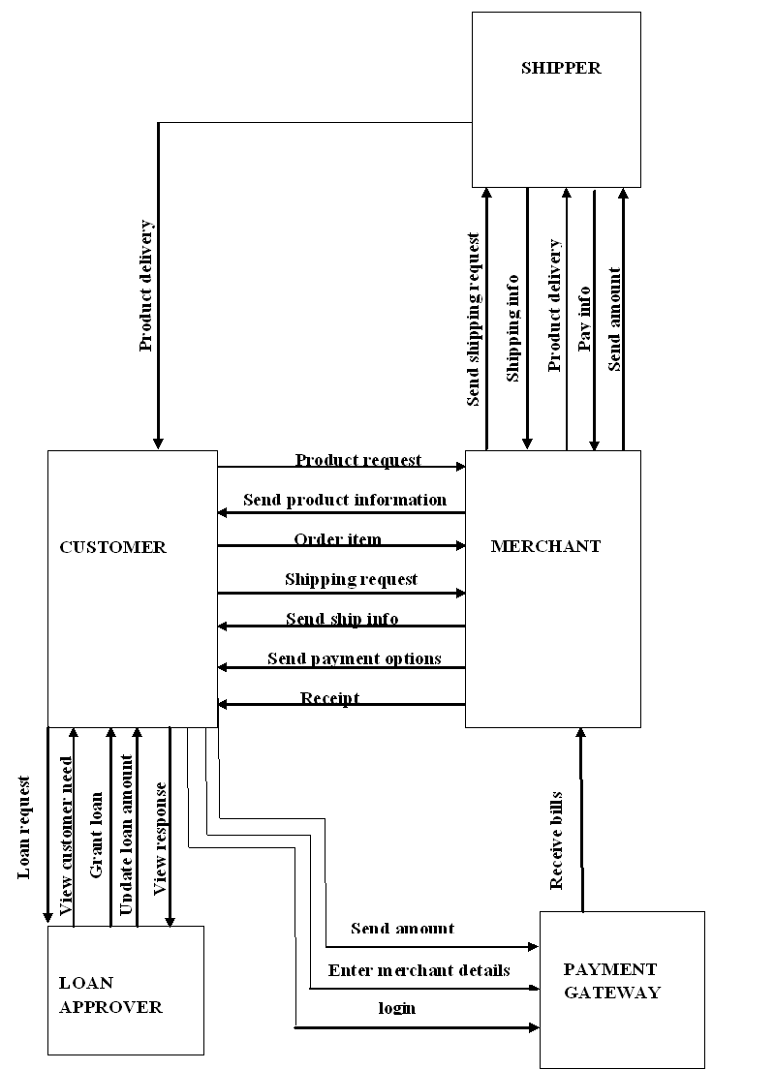
11.1.2 SEQUENCE DIAGRAM

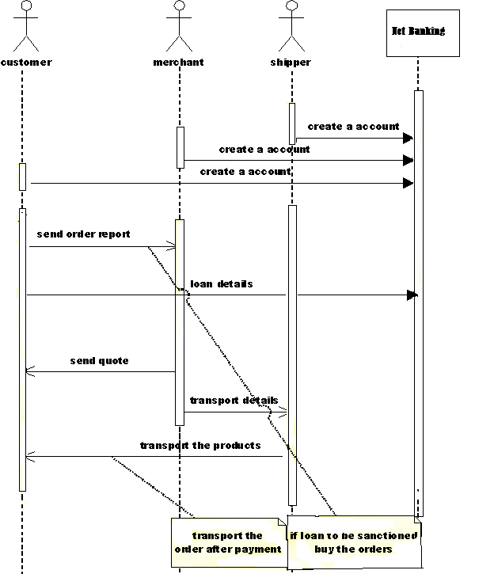

11.2 TABLE DESIGN
11.2.1 TABLE NAME : REGISTER
PRIMARY KEY: USER_NAME, PASSWORD, ROLE.

FIELD NAME | DATA TYPE
FULL_NAME | Nvarchar
USER_NAME | Nvarchar
PASSWORD | Nvarchar
EMAIL_ID | Nvarchar
ROLE | Nvarchar

11.2.2 TABLE NAME : CUSTOMER
PRIMARY KEY: CUSTOMER_NAME

FIELD NAME | DATA TYPE
CUSTOMER_NAME | Nvarchar
ADDRESS | Nvarchar
CITY | Nvarchar
SHOP_NAME | Nvarchar
COUNTRY | Nvarchar
STATE | Nvarchar
OTHER_STATE | Nvarchar
EMAIL_ID | Nvarchar
TELEPHONE | Int
ACCOUNT_NUMBER | Int
ABOUT | Nvarchar(MAX)

11.2.3 TABLE NAME : MERCHANT
PRIMARY KEY : MERCHANT_NAME

FIELD NAME | DATA TYPE
MERCHANT_NAME | Nvarchar
ADDRESS | Nvarchar
CITY | Nvarchar
SHOP_NAME | Nvarchar
COUNTRY | Nvarchar
STATE | Nvarchar
OTHER_STATE | Nvarchar
EMAIL_ID | Nvarchar
PHONE_NO | Int
ACC_NO | Int
ABOUT | nvarchar(MAX)

11.2.4 TABLE NAME : SHIPPER
PRIMARY KEY: SHIP_NAME, SHIPPER_NAME

FIELD NAME | DATA TYPE
SHIP_NAME | Nvarchar
SHIPPER_NAME | Nvarchar
CONDITIONS | Nvarchar
EMAIL_ID | Nvarchar
PHONE | Int
ACCOUNT_NUMBER | Int

11.2.5 TABLE NAME : ORDERING
PRIMARY KEY : NAME, MERCHANT_NAME

FIELD NAME | DATA TYPE
NAME | Nvarchar
CITY | Nvarchar
SHOP_NAME | Nvarchar
STATE | Nvarchar
COUNTRY | Nvarchar
DELIVERY_PLACE | Nvarchar
EMAIL_ID | Nvarchar
TELEPHONE | Int
ITEM_TYPE | Nvarchar
ITEM | Nvarchar
ORDER_DATE | Datetime
DELIVERY_DATE | Nvarchar
ACCEPT_OUR_RULES | Nvarchar(MAX)
MERCHANT_NAME | Datetime

11.2.6 TABLE NAME : QUOTATION
PRIMARY KEY : MERCHANT_NAME, CUSTOMER_NAME, DELIVERY_DATE

FIELD NAME | DATA TYPE
MERCHANT_NAME | Nvarchar
SHOP_NAME | Nvarchar
CUSTOMER_SHOP_NAME | Nvarchar
CUSTOMER_NAME | Nvarchar
CITY | Nvarchar
EMAIL_ID | Nvarchar
TELEPHONE | Int
TOTAL_AMOUNT | Int
DELIVERY_PLACE | Nvarchar
CATEGORY | Nvarchar
ORDER_ITEMS | Nvarchar
ORDER_DATE | Datetime
DELIVERY_DATE | Datetime
NOTE | Varchar

11.2.7 TABLE NAME : ORDER_SHIP
PRIMARY KEY : CUSTOMER_NAME ,DELEVERY_PLACE, SENDER_NAME

FIELD NAME | DATA TYPE
CUSTOMER_NAME | Nvarchar
CUSTOMER_SHOP | Nvarchar
SENDER_NAME | Nvarchar
MY_SHOP | Nvarchar
DELEVERY_PLACE | Nvarchar
PRODUCT | Nvarchar
EMAIL_ID | Nvarchar
CONDITIONS | Nvarchar(MAX)
ORDER_DATE | Datetime

11.2.8 TABLE NAME : NEW_CUSTOMER
PRIMARY KEY : PASSWORD, USER_NAME, ACCOUNT_NO, MEMBER_TYPE.

FIELD NAME | DATA TYPE
PASSWORD | Nvarchar
USER_NAME | Nvarchar
NAME | Vnarchar
ACCOUNT_NO | Int
PIN | Decimal
SEX | Varchar
AGE | Decimal
REGISTERED_DATE | Datetime
QUALIFICATION | Varchar
PER_ ADD | Varchar
PER_CITY | Varchar
PER_SATE | Varchar
PER_PIN | Numeric
TEM_ADDRESS | Varchar
TEM_CITY | Varchar
TEM_STATE | Varchar
TEM_PIN | Numeric
PHONE_NO | Numeric
ACCOUNT_TYPE | Varchar
BRANCH_NAME | Varchar
MEMBER_TYPE | Varchar
BALANCE | Numeric

11.2.9 TABLE NAME : LOAN_ISSUE
PRIMARY KEY : LOAN_ID

FIELD NAME | DATA TYPE
LOAN_ID | Decimal
LOAN_DESCRIPTION | Varchar
LOAN_TYPE | Varchar
RATE | Decimal
MIN_LOAN | Decimal
MAX_LOAN | Decimal

11.2.11 TABLE NAME : LOGIN
PRIMARY KEY : USER_ID, PASSWORD, MEMBER_TYPE

FIELD NAME | DATA TYPE
USER_ID | Nvarchar
PASSWORD | Nvarchar
MEMBER_TYPE | Datetime

11.2.11 TABLE NAME : CALCULATE
PRIMARY KEY : USER_NAME, ISSUE_ID

FIELD NAME | DATA TYPE
USER_NAME | Varchar
ISSUE_ID | Int
APPROVAL_ID | Int
INSTAL | Decimal
DATE | Datetime

11.2.12 TABLE NAME : CHEQUE_BOOK
PRIMARY KEY : ACC_NO, NAME.

FIELD NAME | DATA TYPE
NAME | Nvarchar
ACC_NO | Decimal
PIN | Decimal
DATE | Datetime
ACCOUNT_TYPE | Nvarchar
BRANCH_NAME | Nvarchar
CHEQUE_BOOK | Varchar

11.2.13 TABLE NAME : ENQUIRY
PRIMARY KEY : LOAN_ID, USER_NAME

FIELD NAME | DATA TYPE
USER_NAME | Nvarchar
LOAN_ID | Decimal
LOAN_DES | Nvarchar
LOAN_TYPE | Nvarchar
MAX_VALUE | Decimal
OCCUPATION | Nvarchar

11.3 SCREEN SHOTS

11.3.1 REGISTRATION

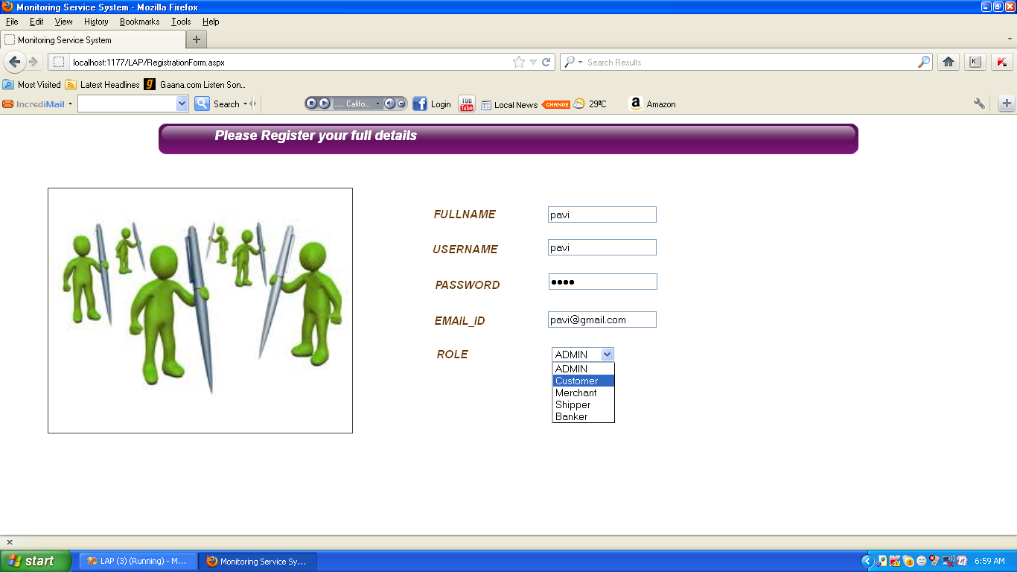

11.3.2 LOGIN PAGE

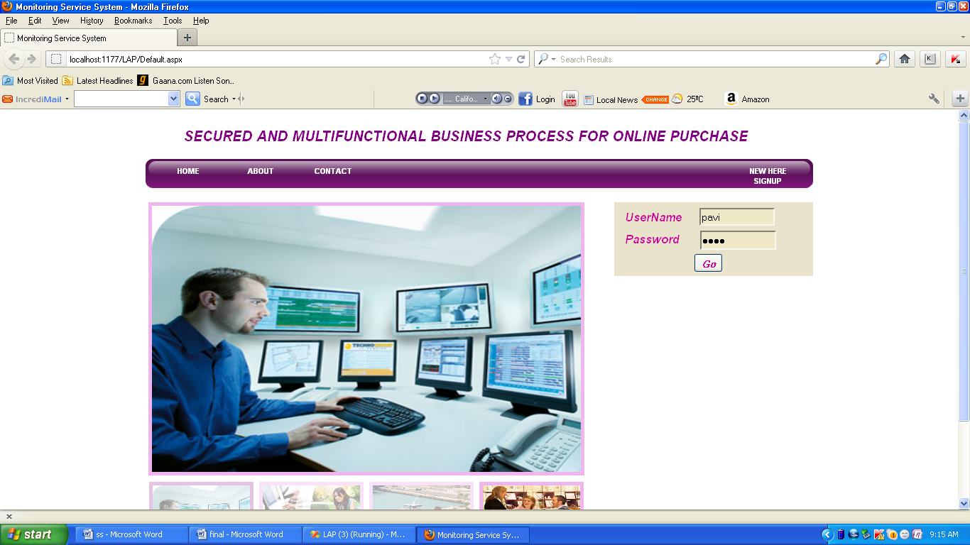

11.3.3 CUSTOMER ENTRY DETAILS

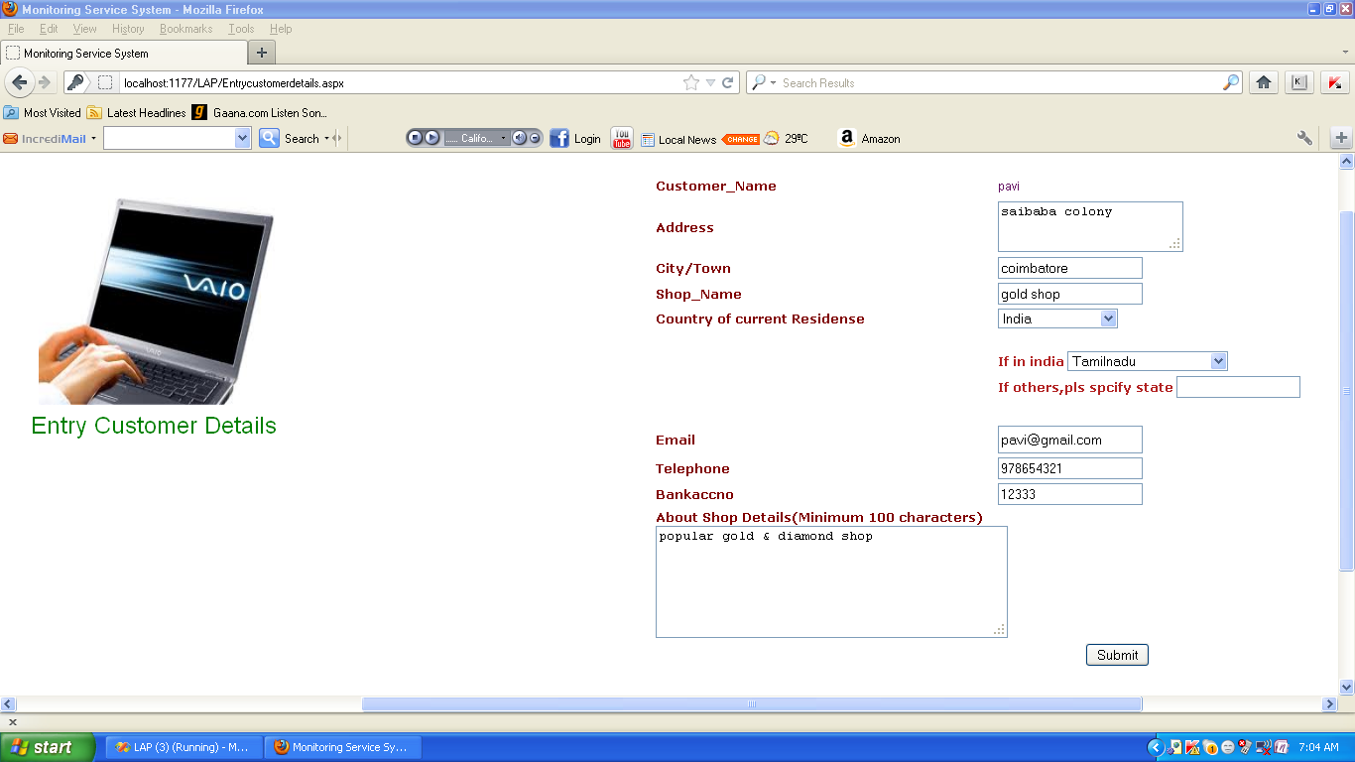

11.3.4 VIEW MERCHANTS LIST

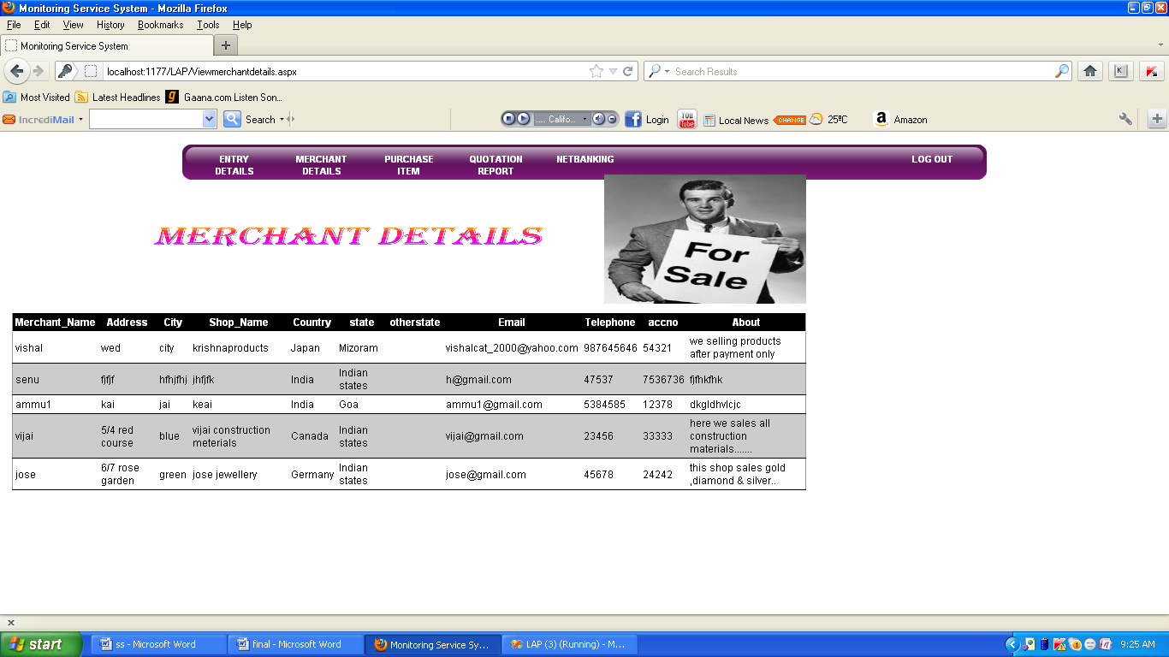

11.3.5 PURCHASE ITEM

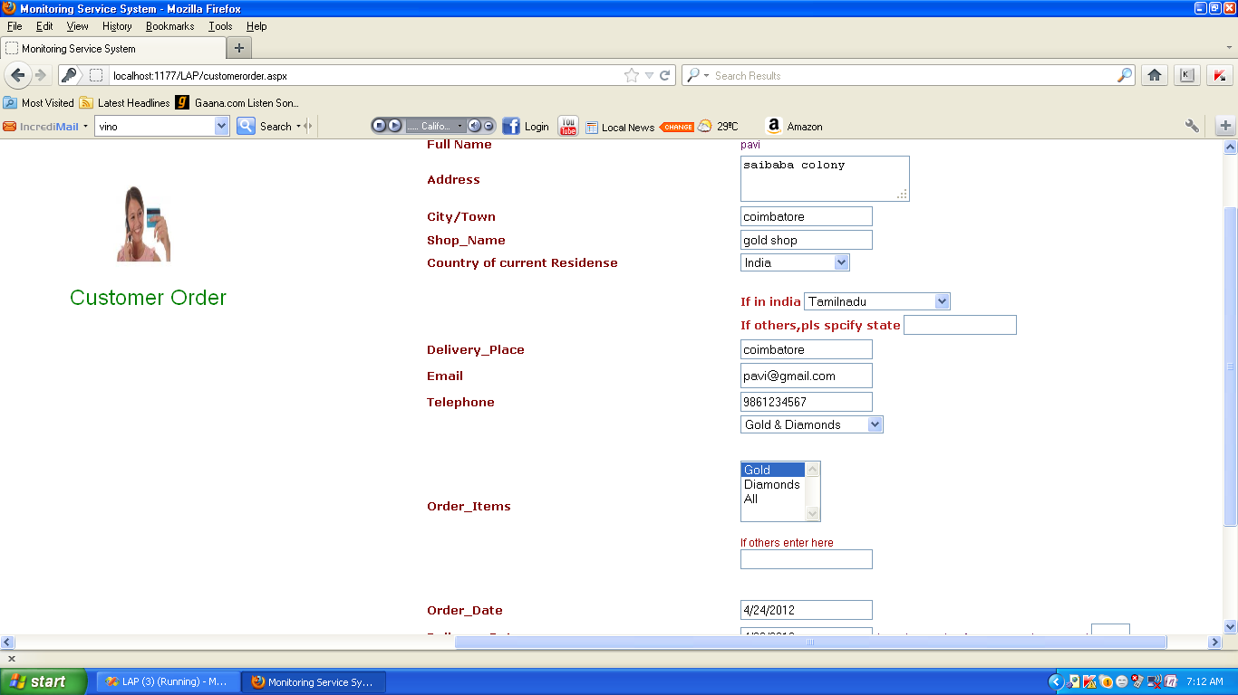

11.3.6 VIEW QUOTATION REPORT

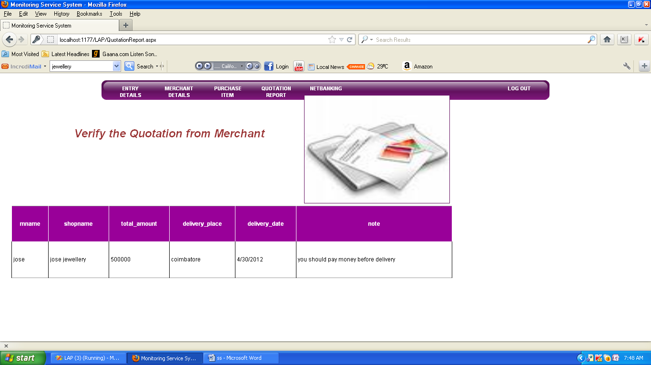

11.3.7 MERCHANTS ENTRY DETAIL

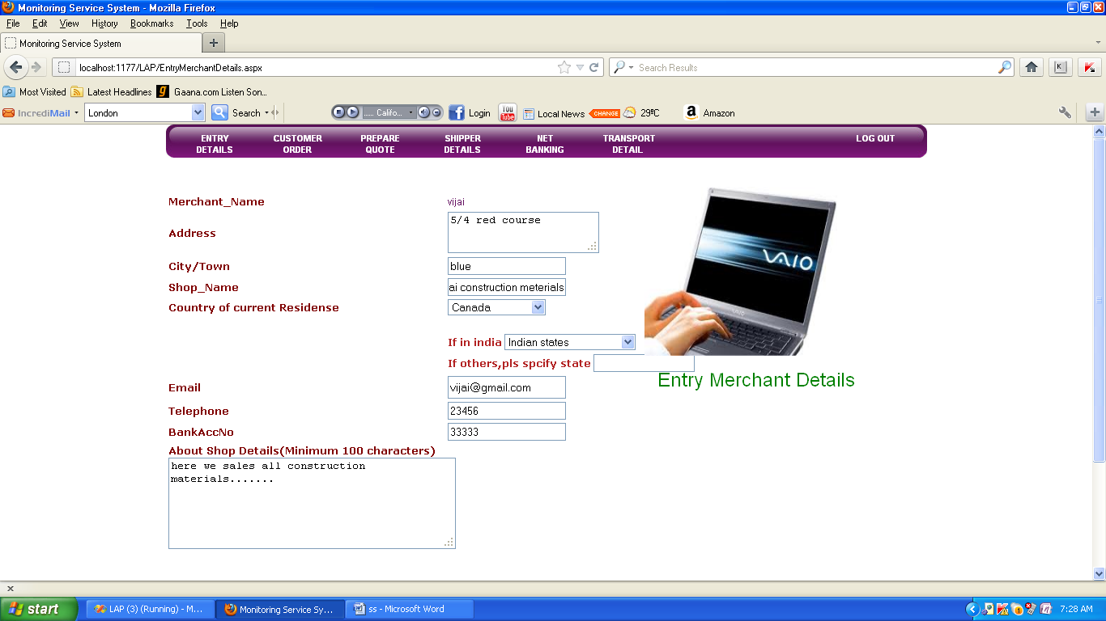

11.3.8 VIEW CUSTOMER ORDERS

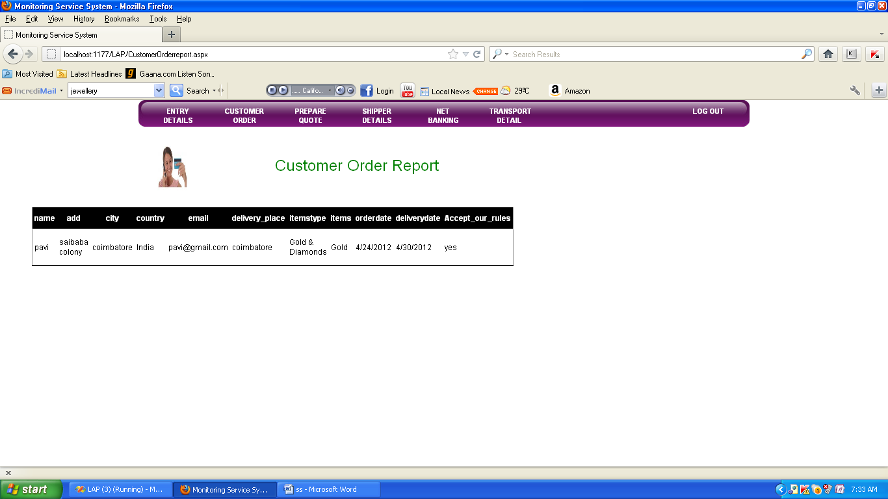

11.3.9 PREPARE QUOTATION FOR CUSTOMER

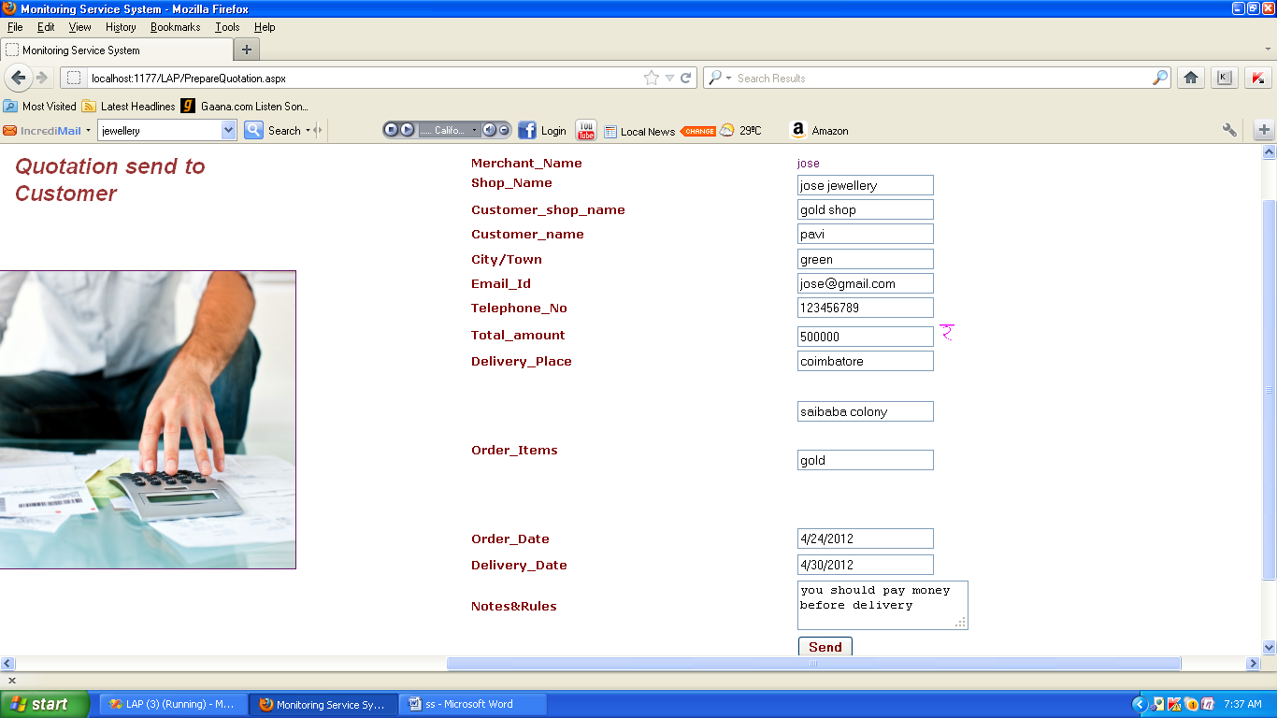

11.3.10 VIEW SHIPPERS DETAIL

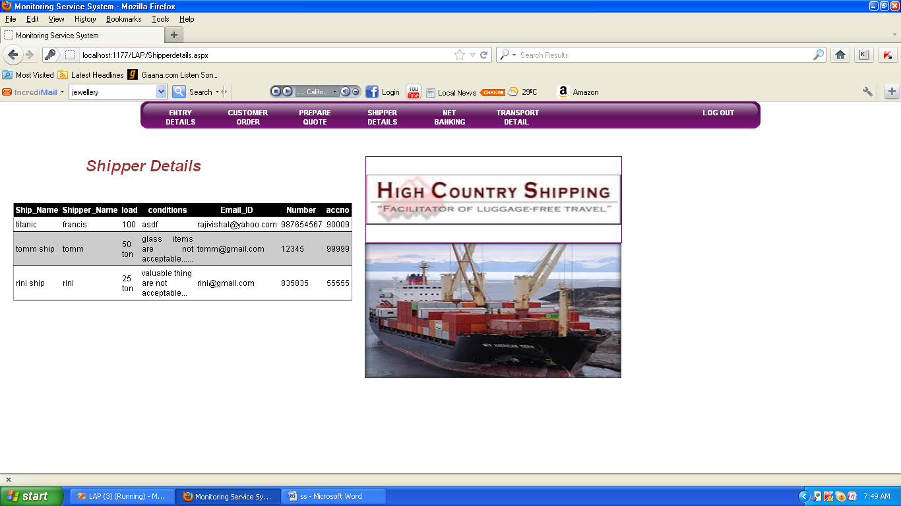

11.3.11 SEND TRANSPORT DETAIL TO SHIPPER

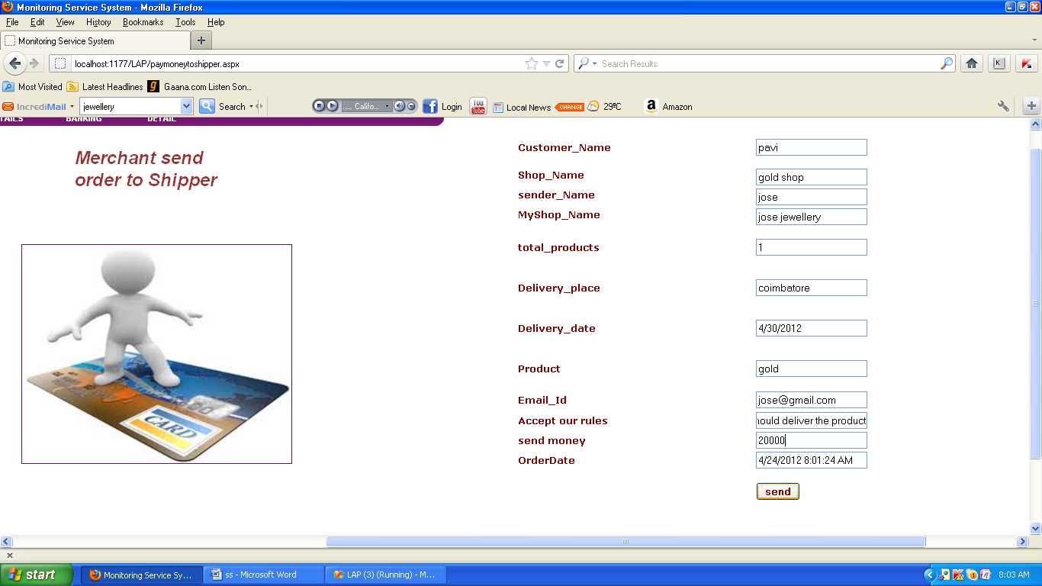

11.3.12 VIEW TRANSPORT ORDERS

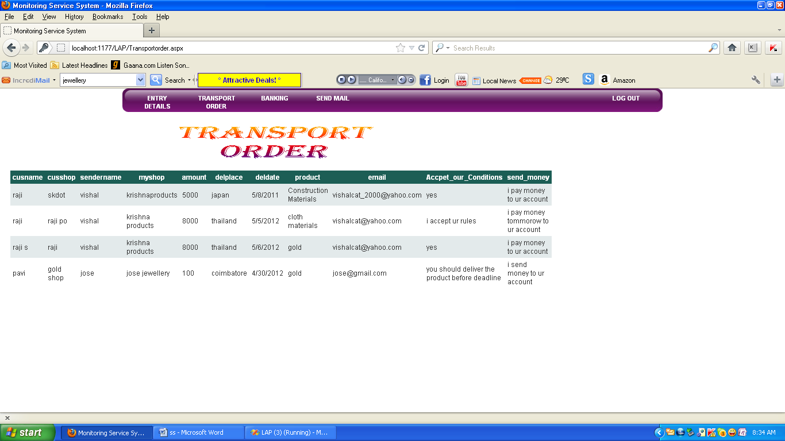

11.3.13 REGISTRATION FOR BANKING

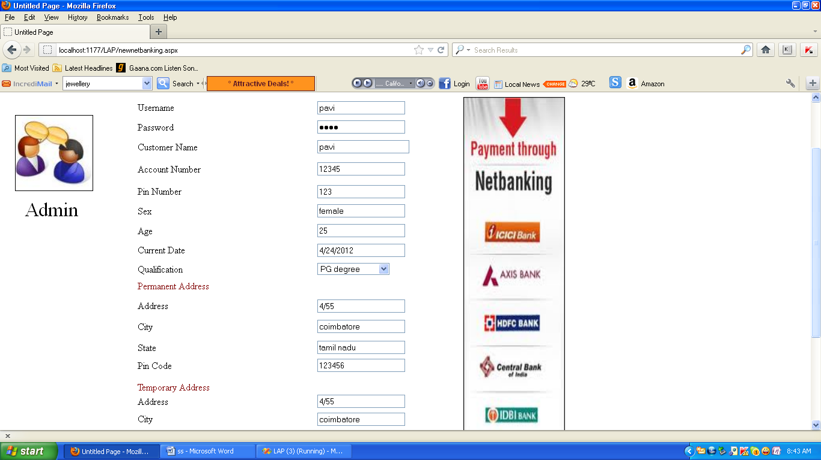

11.3.14 LOGIN FORM FOR NETBANKING

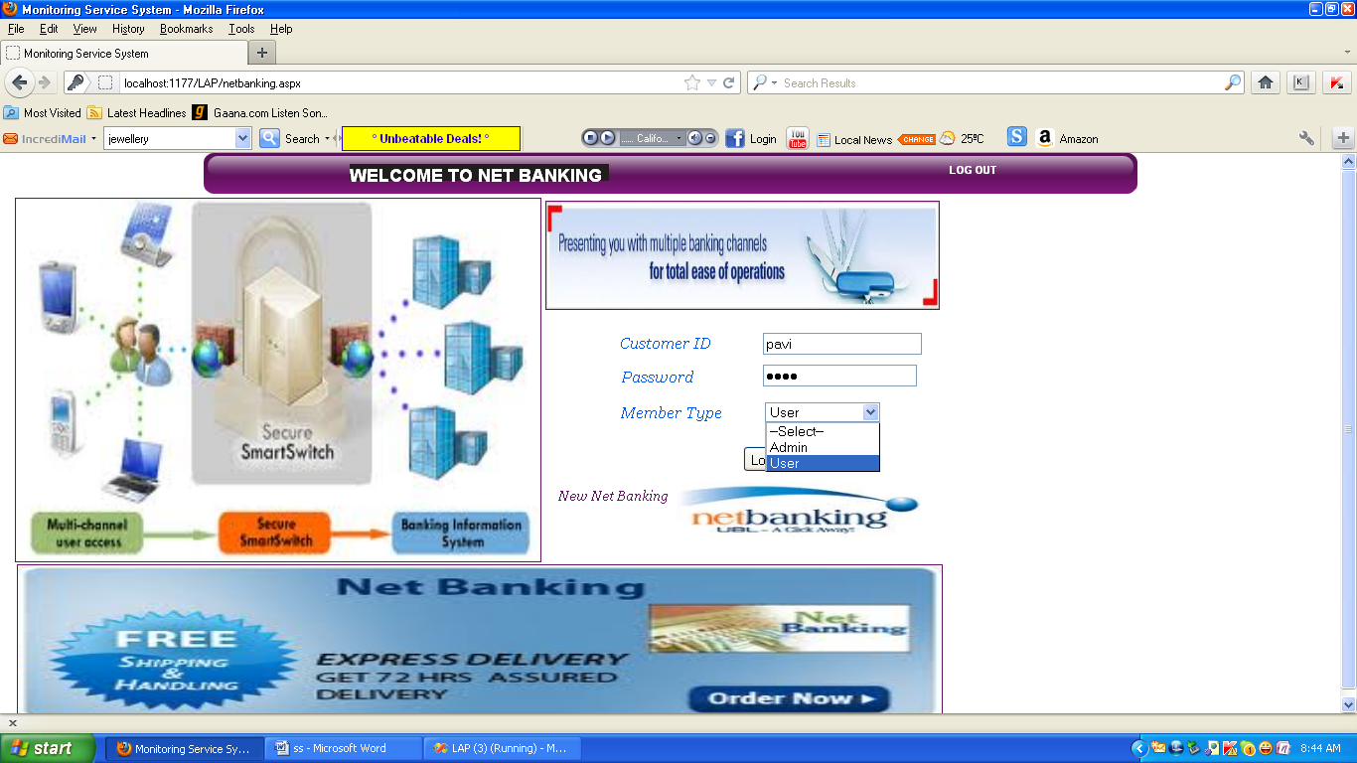

11.3.15 APPLY LOAN

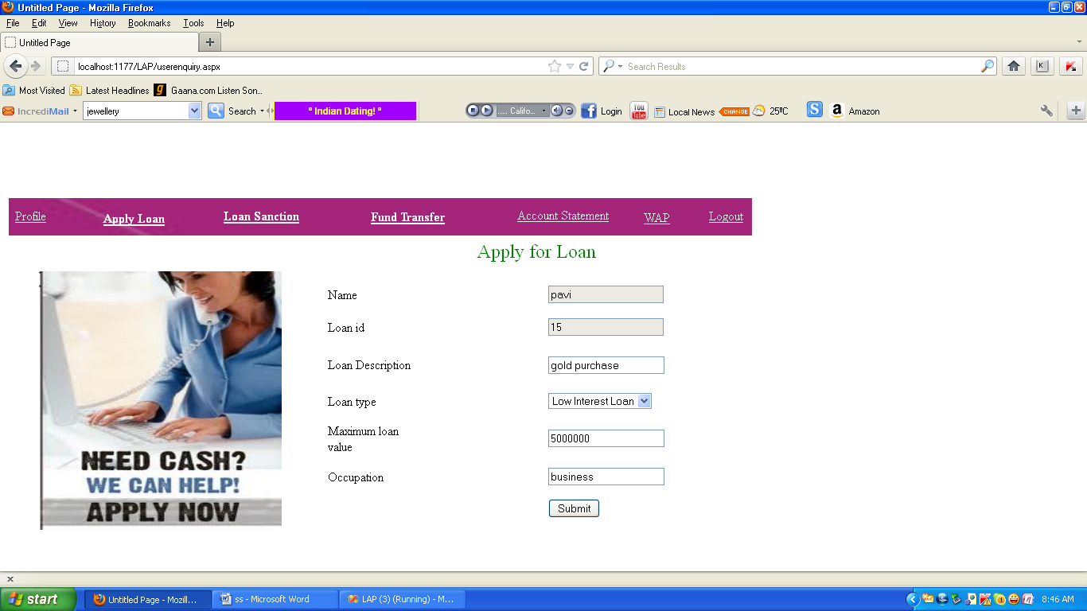

11.3.16 ACCOUNT HOLDERS DETAIL

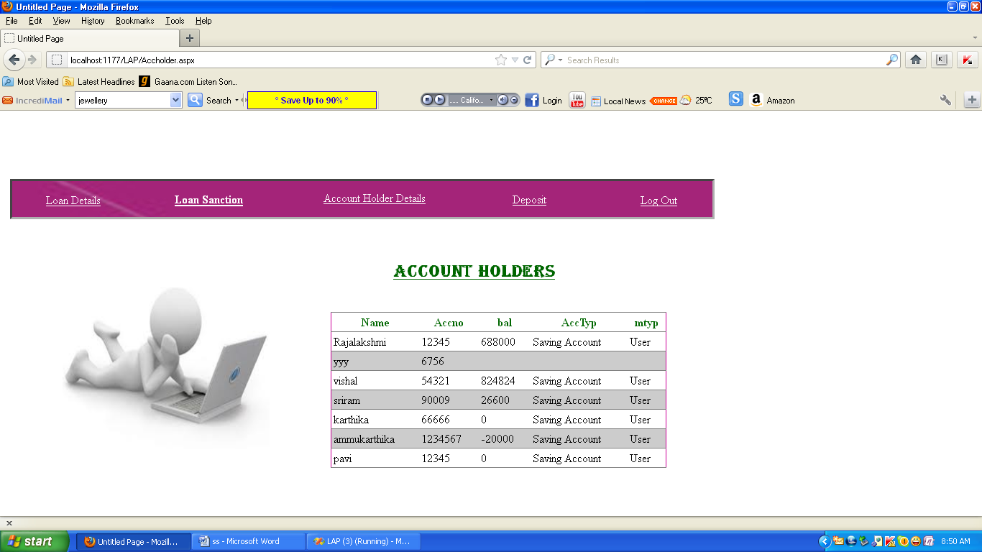

11.3.17 LOAN PROCESS

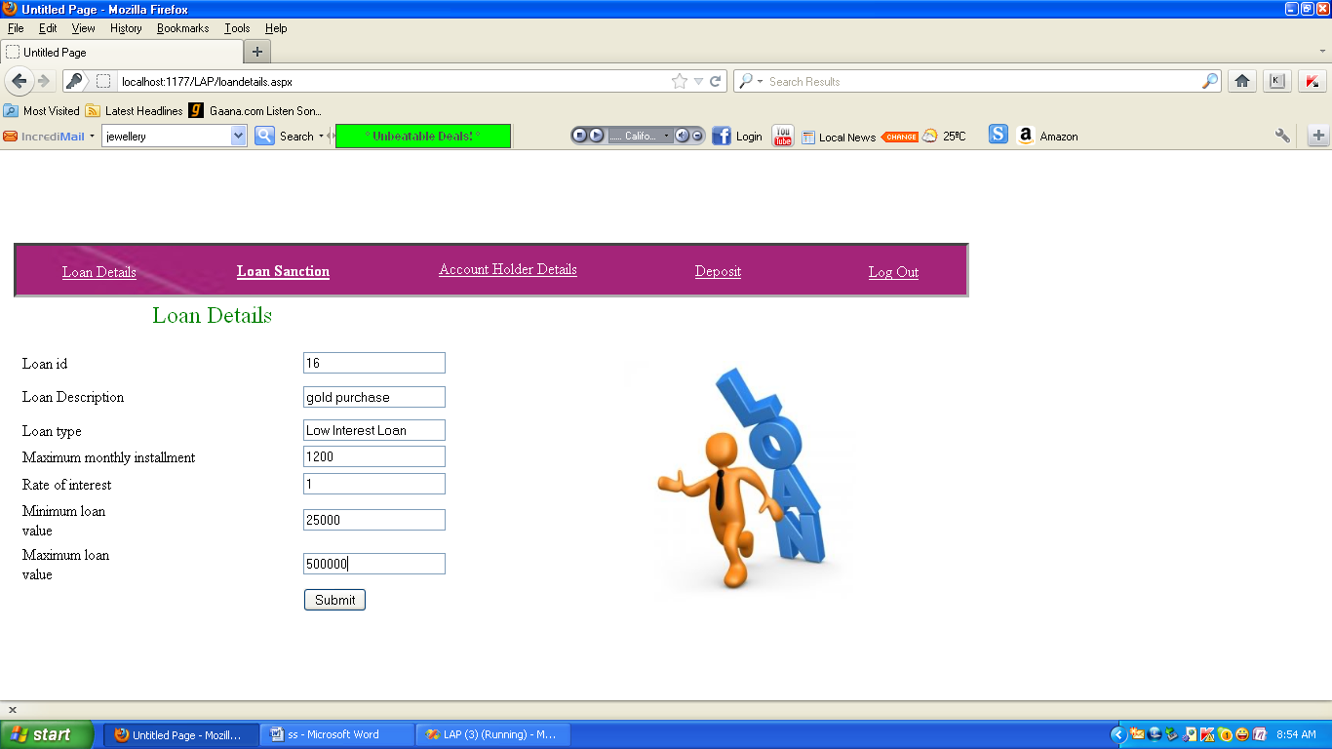

11.3.18 LOAN APPROVAL

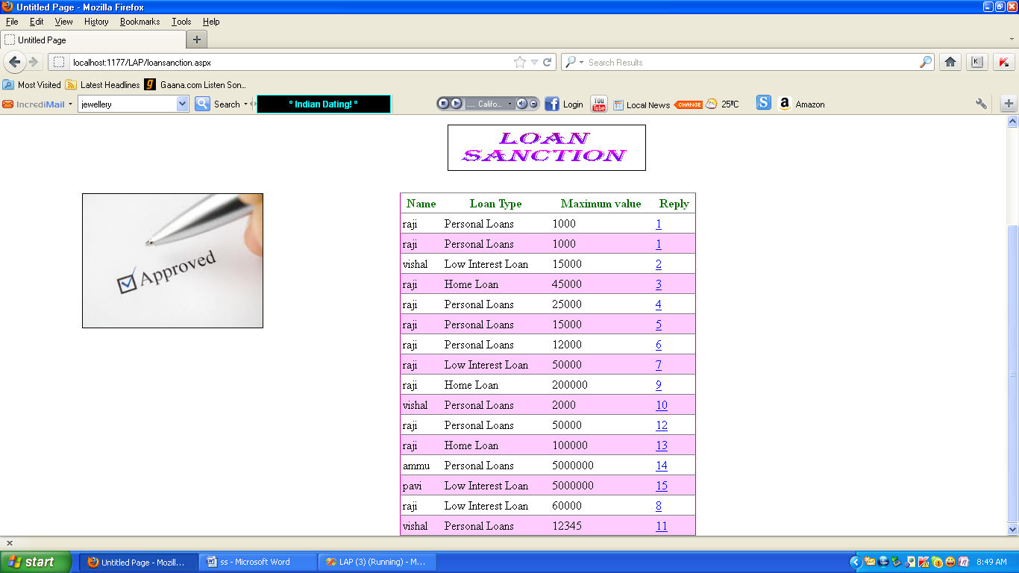

11.3.19 MONEY TRANSACTION

