INSURANCE POLICY MANAGEMENT SYSTEM
Submitted by
M.PAVITHRA (17PCC011)

Under the Guidance of
Dr.(Mrs) A.R.RIHANA BANU M.Com (CA),PGDCA,SET,Ph.D

In partial fulfilment of the requirements for the award of the degree of
Master of Commerce with Computer Applications

APRIL-2019
DEPARTMENT OF COMMERCE
AVINASHILINGAM INSTITUTE FOR HOME SCIENCE AND
HIGHER EDUCATION FOR WOMEN
COIMBATORE – 641043

CERTIFICATE



DECLARATION

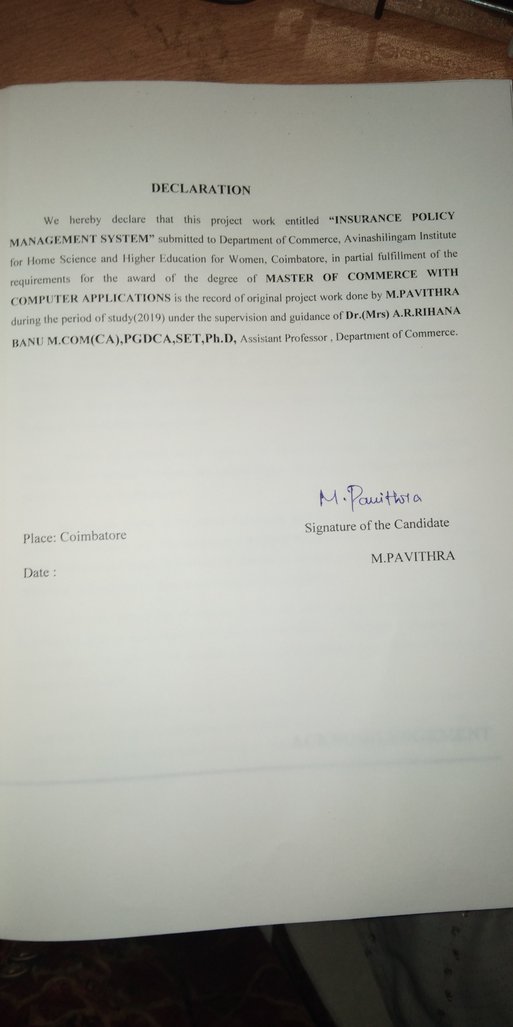

ACKNOWLEDGEMENT

ACKNOWLEDGEMENT
First and foremost, I thank the God Almighty who has been a power of strength towards the successful completion of the project work
I express my gratitude to our Chancellor Shri,Dr.P.R.Krishnakumar of Avinashilingam Institute for Home Science and Higher Education for Women, Coimbatore, for his support and kindness.
I express my sincere and heartfelt gratitude to our Vice Chancellor Dr.(Mrs) Premavathy Vijayan M.Sc, M.Ed., Dip.Spl.Edn., M.Phil., Ph.D., Avinashilingam Institute for Home Science and Higher Education for Women, Coimbatore for the resources facilitated for completion of my project.
I express my gratitude to our Registrar Dr.(Mrs)S.Kowsalya., M.sc.,M.Phil.,Ph.D., Avinashilingam Institute for Home Science and Higher Education for Women, for providing all facilities necessary for the project.
My special thanks to Dr.(Mrs.) U.Jerinabi M.Com.,Dip.Ed.,M.Phil.,Ph.D., Dean, School of Commerce and Management,and Dr(Mrs) D.Geetha M.Com., Dip.Ed., M.Phil., Ph.D.,Professor and Head, Department of Commerce for their encouragement and for giving necessary help and support for completing the project successfully.
I take this opportunity to express my sincere thanks to my supervisor and guide Dr.(Mrs)A.R.Rihana banu M.Com (CA),PGDCA,SET,Ph.D Assistant Professor Department of Commerce for her valuable guidance timely support, suggestions and motivation throughout the project.
Last yet importantly, I would like to thank all the partners in “Capital First Ltd” Coimbatore for the support throughout my endeavor and also I thank my parents, friends and well-wishers who have contributed directly or indirectly to the successful completion of the project.

CONTENTS

CONTENTS
CHAPTER | PARTICULARS | PAGE NO
I | INTRODUCTION  1.1.OVERVIEW OF THE PROJECT  1.2.ABOUT THE COMPANY | 1
II. | SYSTEM SPECIFICATION  2.1. HARWARE SPECIFICATION  2.2. SOFTWARE SPECIFICATION | 3
III | SYSTEM ANALYSIS  3.1. EXISTING SYSTEM  3.2. PROPOSED SYSTEM  3.3 FEASABILITY STUDY | 10
IV | SYSTEM DESIGN AND DEVELOPMENT  4.1. INTRODUCTION  4.2. LOGICAL DESIGN  4.3.PHYSICAL DESIGN  4.4.INPUT DESIGN  4.5.OUTPUT DESIGN  4.6.DATA FLOW DIAGRAM  4.7.TABLE DESIGN  4.8.CODE DESGN  4.9.FORM DESIGN | 14
V | SYSTEM TESTING  5.1.INTRODUCTION  5.2.TYPES OF TESTING | 60
VI | SYSTEM IMPLEMENTATION  6.1.INTRODUCTION  6.2.SYSTEM MAINTEANCE | 63
VII | FUTURE SCOPE AND CONCLUSION | 66
 | BIBLIOGRAPHY | 67
ABSTRACT:
The project entitled “INSURANCE POLICY MANAGEMENT SYSTEM” is developed by using vb.net as front end and SQL server as backend.
The primary objective of this project is to support the insurance agents for managing the insurance schemes and the database of policy holder.It works by sending email alert to the insurance policy holders about the insurance policies in case of payment and default in payment.This project design a simple software application for insurance companies for managing customer database.In this application administrator will add customer details,policy details, payment details, pending payment and email alert that is to be sent to the user. These insurance specifications are updated to database. The user can login and view the insurance information. Altogether it would be helpful to the insurance company agents to maintain the schemes available in various insurance companies and the policy holders under each scheme.

chapter-I

CHAPTER I
INTRODUCTION
1.1 OVER VIEW OF THE PROJECT
Online Insurance Management System is a web application which is developed for tracking the details of the insurance policy and customer details. This web site is an online insurance information management system that provides easy access of information regarding the people and resources of insurance. Policy Holder can view their own personal details when login into the Policy Holder module. This project is useful for any kind of insurance company to manage the insurance details, to sanction the insurance for customer, process the insurance policy details and all kind of insurance process through online. In this online process, when the user enter into the website it will show details about insurance and its types, also it will show the details about different duration schemes to the corresponding insurance type or insurance policy. The main objective of the developed system is to allow holder register insured persons with their Id, name, address and also policy details.. It also helps the customer to view their own insurance status. If the user registered insurance policy to this website, it will process that registration form by verification and immediately give the policy holder ID to the user. The web site provides easy links for easy navigation in the site. After submission of registration form the admin will process to verify that particular details registered by the customer and gets into the process of issuing the insurance policy. The developed system should allow admin users to register insured persons with their Id, name, address, medical history and also policy details. Then the admin send the permanent policy holder ID and password to the customer and also send status information about insurance policy to the corresponding policy holder. Due to dynamic features, the members, Admin members should be able to understand the provided facilities. If the policy holder wants to view the information about their own policy details, he/she login to policy status page by using the policy holder ID and password had already given by insurance company and view their own details and also provide the feedback to the insurance company. An online help documentation will be provided to help the users and visitors in using the facilities.

1.2 PROFILE OF CAPITAL FIRST LTD
1.2 PROFILE OF CAPITAL FIRST LTD
COMPANY NAME: Capital First LTD
NATURE: Partnership Firm
ADDRESS: D.NO.218/2, Brindha complex,
2nd floor, RSpuram,
Near post office,
Coimbatore (Dist)-641002.
MANAGER NAME: H.Priya
PARTNERS NAME: H.Priya and R.Muthu
PHONE NO: 9600464148
CAPITAL INVESTMENT: 20LAKHS
Capital First Limited, listed in NSE and BSE, is a leading Indian financial and insurance institution, specializing in providing debt financing and insurance policies to consumers in India. The insurance provider provides a comprehensive product bunch of all the lines of business like health insurance, two wheeler insurance, home insurance, travel insurance and car insurance, which includes the corporate policies like liability insurance and property insurance. .
Between 2008 to 2010, the Company was largely in the business of wholesale financing,insurance, asset management, and had joint venture in Foreign Exchange and retail equity broking. Between 2010 to 2012, Mr. Vaidyanathan acquired a stake in the company, changed the business model to retail, and executed a Management Buyout of the company by securing equity backing from Warburg Pincus for Rs. 810 Crores and changed the name of the company to Capital First. Unlike traditional models of finance and insurance Capital First has successfully created new models to finance and insurance MSMEs and Indian consumers, in the hitherto unbanked and under-penetrated segments.

chapter-II

CHAPTER – II
SYSTEM SPECIFICATION

2.1 HARDWARE SPECIFICATION
PROCESSOR : INTEL DUAL CORE
RAM : 64 GB
MONITOR : 15” COLOR
HARD DISK : 4 GB
CD DRIVE : LG 52X
KEYBOARD : STANDARD 102 KEYS
2.2 SOFTWARE SPECIFICATION

OPERATING SYSTEM : Windows XP

FRONT END : Visual Studio .NET

BACK END : MY SQL SERVER 2008

ABOUT WINDOWS XP
Windows XP is a computer operating system and graphical user interface (GUI), which enables you to work with a wide variety of programs on your computer, often simultaneously. Windows XP is itself a special computer program that communicates your instructions to the actual computer hardware, and displays the results.

Key features of Windows XP are,
Windows within Windows
A Window refers to a rectangular area of the screen, within which you may view program folders and files, or display file contents such as documents, spreadsheets, and graphic images. A window can occupy part of the screen, can be maximised to fill the entire screen, or can be minimized so that it is no longer visible but remains active and is easily reaccessed.
The Desktop
The Desktop gives you access to everything you need in Windows XP. It occupies the entire screen, and unlike a window, it can’t be reduced in size. The desktop consists of a coloured or patterned background, containing small pictures called Icons that represent programs or data stores. Double-clicking on an icon opens the corresponding program or file inside a window.
The Taskbar
The Taskbar lies across the bottom edge of your screen. The Start button on the left provides access to all the programs, data files, and other features available on your computer. When you open a program or file, a corresponding rectangular icon will be displayed on your taskbar - even if the program has been minimized and is no longer visible on your screen. To access that program, you just need to click its icon on the taskbar.

The Start Menu
When you click on the Start button, a set of menu options is displayed. The contents will vary depending on your computer setup and most frequently accessed programs. If you click on the All Programs option, you’ll see a list of all the programs installed on your computer – even those that don’t have icons on the desktop. Press the [ESC] (escape) key to close the menu.
Help
One of the menu options displayed when you click the Start button, is labelled Help and Support. If you select this option, a Help window will open. To get help on a specific topic, type a word or phrase in the blank space at the top left of the window and then click the search arrow; alternatively, you can click to browse any of the Help topics listed in the window. Click the X in the top right corner to close the Help window.
ABOUT VISUAL BASIC .NET
Visual Basic .NET (VB.NET) is an object-oriented computer programming language implemented on the .NET Framework. Although it is an evolution of classic Visual Basic language, it is not backwards-compatible with VB6, and any code written in the old version does not compile under VB.NET.
Like all other .NET languages, VB.NET has complete support for object-oriented concepts. Everything in VB.NET is an object, including all of the primitive types (Short, Integer, Long, String, Boolean, etc.) and user-defined types, events, and even assemblies. All objects inherits from the base class Object.
VB.NET is implemented by Microsoft's .NET framework. Therefore, it has full access to all the libraries in the .Net Framework. It's also possible to run VB.NET programs on Mono, the open-source alternative to .NET, not only under Windows, but even Linux or Mac OSX.
FEATURES OF VB.NET
- Boolean Conditions
- Automatic Garbage Collection
- Standard Library
- Assembly Versioning
- Properties and Events
- Delegates and Events Management
- Easy-to-use Generics
- Indexers
- Conditional Compilation
- Simple Multithreading

The .Net Framework
The .Net framework is a revolutionary platform that helps you to write the following types of applications such as,
- Windows applications
- Web applications
- Web services
The .Net framework applications are multi-platform applications. The framework has been designed in such a way that it can be used from any of the following languages such as,
- Visual Basic
- C#
- C++
- Jscript and
- COBOL etc.
All these languages can access the framework as well as communicate with each other.
The .Net framework consists of an enormous library of codes used by the client languages like VB.Net. These languages use object-oriented methodology.
Following are some of the components of the .Net framework
- Common Language Runtime (CLR)
- The .Net Framework Class Library
- Common Language Specification
- Common Type System
- Metadata and Assemblies
- Windows Forms
- ASP.Net and ASP.Net AJAX
- ADO.Net
- Windows Workflow Foundation (WF)
- Windows Presentation Foundation
- Windows Communication Foundation (WCF)
- LINQ

INTEGRATED DEVELOPMENT ENVIRONMENT (IDE) FOR VB.NET
Microsoft provides the following development tools for VB.Net programming −
- Visual Studio 2010 (VS)
- Visual Basic 2010 Express (VBE)
- Visual Web Developer
The Visual Basic 2010 Express (VBE) and Visual Web Developer tools are used free. Using these tools, you can write all kinds of VB.Net programs from simple command-line applications to more complex applications. Visual Basic Express and Visual Web Developer Express edition are trimmed down versions of Visual Studio and has the same look and feel. They retain most features of Visual Studio.
A VB.Net program basically consists of the following parts −
- Namespace declaration
- A class or module
- One or more procedures
- Variables
- The Main procedure
- Statements & Expressions
- Comments

Compile & Execute VB.Net Program
If you are using Visual Studio.Net IDE, take the following steps −
- Start Visual Studio.
- On the menu bar, choose File → New → Project.
- Choose Visual Basic from templates
- Choose Console Application.
- Specify a name and location for your project using the Browse button, and then choose the OK button.
- The new project appears in Solution Explorer.
- Write code in the Code Editor.
- Click the Run button or the F5 key to run the project.
SYNTAX
- Object − Objects have states and behaviors. Example: A dog has states - color, name, breed as well as behaviors - wagging, barking, eating, etc. An object is an instance of a class.
- Class − A class can be defined as a template/blueprint that describes the behaviors/states that objects of its type support.
- Methods − A method is basically a behavior. A class can contain many methods. It is in methods where the logics are written, data is manipulated and all the actions are executed.
- Instance Variables − Each object has its unique set of instance variables. An object's state is created by the values assigned to these instance variables.

DATA TYPES
Data Type | Storage Allocation | Value Range
Boolean | Depends on implementing platform | True or False
Byte | 1 byte | 0 through 255 (unsigned)
Char | 2 bytes | 0 through 65535 (unsigned)
Date | 8 bytes | 0:00:00 (midnight) on January 1, 0001 through 11:59:59 PM on December 31, 9999
Decimal | 16 bytes | 0 through +/-79,228,162,514,264,337,593,543,950,335 (+/-7.9...E+28) with no decimal point; 0 through +/-7.9228162514264337593543950335 with 28 places to the right of the decimal
Double | 8 bytes | -1.79769313486231570E+308 through -4.94065645841246544E-324, for negative values  4.94065645841246544E-324 through 1.79769313486231570E+308, for positive values
Integer | 4 bytes | -2,147,483,648 through 2,147,483,647 (signed)
Long | 8 bytes | -9,223,372,036,854,775,808 through 9,223,372,036,854,775,807(signed)
Object | 4 bytes on 32-bit platform  8 bytes on 64-bit platform | Any type can be stored in a variable of type Object
SByte | 1 byte | -128 through 127 (signed)
Short | 2 bytes | -32,768 through 32,767 (signed)
Single | 4 bytes | -3.4028235E+38 through -1.401298E-45 for negative values;  1.401298E-45 through 3.4028235E+38 for positive values
String | Depends on implementing platform | 0 to approximately 2 billion Unicode characters
UInteger | 4 bytes | 0 through 4,294,967,295 (unsigned)
ULong | 8 bytes | 0 through 18,446,744,073,709,551,615 (unsigned)
User-Defined | Depends on implementing platform | Each member of the structure has a range determined by its data type and independent of the ranges of the other members
UShort | 2 bytes | 0 through 65,535 (unsigned)

MY SQL SERVER 2008
The purpose of this document is to help you migrate your applications when you are migrating the underlying database from Microsoft SQL server to some other database. Most of the issues encountered when migrating applications to use Microsoft SQL server database are related to database incompatibility. This paper presents these incompatibilities and provides solutions for many issues. The choices made about how to migrate your application affect how you migrate the underlying database from Microsoft SQL server to some other database.

SQL Server Security
  - Login Authentication.
  - Windows NT Authentication.
  - SQL Server Authentication
  - Permissions validation on user database.
  - T-SQL statements sent to SQL server.
  - SQL server checks user permissions on receipt of T-SQL statements

FEATURES OF SQL SERVER
- Created by Microsoft and Sybase in the 80s.
- Is SQL Compliant - Uses ANSI SQL
- Supports SQL – 92 standards - Uses T-SQL
- Stores data in a central location and delivers it to clients on request
- New Server Architecture
- Graphic Administration Tools
- Maintains ANSI standards and 6.x Compatibility
- Data integrity means reliability and accuracy of data.
- Integrity rules keep data consistent.
- Supports Client/Server model.
- Request response dialog.
- workload is split between the client and the server.
- Operating System compatibility.
- Runs on Win 95/98 NT, Netware, UNIX, OS/2, Appletalk, Banyan VINES.
- SQL Server must have Service Pack 4 (SP4) to run on Windows NT 4.0.
- Multiple protocol compatibility.
- SQL Server supports these protocols - Appletalk, TCP/IP.
- SMP Compatibility and Scalability
- Supports multiple processors. SMP leads to scalability.

chapter-III

CHAPTER III
SYSTEM ANALYSIS
System analysis is a process of gathering and interpreting facts, diagnosing problems and the information to recommend improvements on the system. It is a problem solving activity that requires intensive communication between the system users and system developers. System analysis or study is an important phase of any system development process. The system is studied to the minutest detail and analyzed. The system analyst plays the role of the interrogator and dwells deep into the working of the present system. The system is viewed as a whole and the input to the system are identified. The outputs from the organizations are traced to the various processes. System analysis is concerned with becoming aware of the problem, identifying the relevant and decisional variables, analyzing and synthesizing the various factors and determining an optimal or at least a satisfactory solution or program of action.
A detailed study of the process must be made by various techniques like interviews, questionnaires etc. The data collected by these sources must be scrutinized to arrive to a conclusion. The conclusion is an understanding of how the system functions. This system is called the existing system. Now the existing system is subjected to close study and problem areas are identified. The designer now functions as a problem solver and tries to sort out the difficulties that the enterprise faces. The solutions are given as proposals. The proposal is then weighed with the existing system analytically and the best one is selected. The proposal is presented to the user for an endorsement by the user. The proposal is reviewed on user request and suitable changes are made. This is loop that ends as soon as the user is satisfied with proposal.
Preliminary study is the process of gathering and interpreting facts, using the information for further studies on the system. Preliminary study is problem solving activity that requires intensive communication between the system users and system developers. It does various feasibility studies. In these studies a rough figure of the system activities can be obtained, from which the decision about the strategies to be followed for effective system study and analysis can be taken.

EXISING INSURANCE MANAGEMENT SYSTEM
The existing system is the manual system. The manual system is prone to error. It is time consuming. It is difficult to search for a particular data from the whole policy holders’s database of an insurance company. Most of the insurance organizations are not having any existing fully computerized system integrated with the policy holder’s accessibility. This system involves a lot of manual entries with the applications to perform the desired task. Every member organization has its own data structure. Usage of papers in the payment process leads to less efficiency, less accuracy and less productivity. Due to lack of centralized data structure, it is very difficult to merge the data to analyze the statistics
DISADVANTAGES
- More time consuming process.
- The existing system has no security measure against logging in and no checks are made for authorized user.
- The end user has to remember a lot of command to make efficient use of the system
- The system does not have any descriptive reports and thus did not help management in decision-making.

PROPOSED INSURANCE MANAGEMENT SYSTEM
The proposed system is built to manage the policy holder details, agent details, policy details, claim details and payment details. The proposed system is designed to eliminate the drawbacks of the existing system. It is designed to eliminate the flaws of the present system in order to provide a permanent solution to the problems. The primary aim of the new system is to speedup transactions. This insurance management system will be developed for managing the insurance management system. The overall system is controlled through the main menu. The report is prepared scheme wise and maintained by the concerned officials.
ADVANTAGES
- Present system provide Effective insurance verification and SMS intimation
- Less Time consuming process.
- Easy access to information.
FEASIBILITY STUDY
An important outcome of the preliminary investigation is the determination that the system requested is feasible. Feasibility study is carried out to select the best system that meets the performance requirements. Feasibility study is both necessary and prudent to evaluate the feasibility of the project at the earliest possible time. It involves preliminary investigation of the project and examines whether the designed system will be useful to the organization. Months or years of effort, thousand for millions of money and untold professional embarrassment can be averted if an in-conceived system is recognized early in the definition phase.
The different types of feasibility are: Technical feasibility, Operational feasibility, Economical feasibility.
3.3.1 TECHNICAL FEASIBILITY
Technical Feasibility deals with the hardware as well as software requirements. Technology is not a constraint to type system development. We have to find out whether the necessary technology, the proposed equipments have the capacity to hold the data, which is used in the project, should be checked to carryout this technical feasibility.
The technical feasibility issues usually raised during the feasibility stage of investigation includes these
- This software is running in windows 2000 Operating System, which can be easily installed.
- The hardware required is Pentium based server.
- The system can be expanded.
3.3.2 BEHAVIORAL FEASIBILITY
This feasibility test asks if the system will work when it is developed and installed.
Operational feasibility in this project:
- The proposed system offers greater level of user-friendliness.
- The proposed system produces best results and gives high performance. It can be implemented easily .
3.3.3 ECONOMICAL FEASIBILITY
Economical Feasibility deals about the economical impact faced by the organization to implement a new system. Financial benefits must equal or exceed the costs. The cost of conducting a full system, including software and hardware cost for the class of application being considered should be evaluated. Economic Feasibility in this project:
- The cost to conduct a full system investigation is possible.
- There is no additional manpower requirement.
- There is no additional cost involved in maintaining the proposed system.

chapter-IV

CHAPTER-IV
SYSTEM DESIGN
4 .1 INTRODUCTION
System Design is the most creative and challenging phase in the system life cycle. Design is the first step into the development phase for any engineered product or system. Design is a creative process. A good design is the key to effective system. System design is a solution how to approach the creation of a new system. System design transforms a logic representation of what is required to do into the physical specification. The specification is converted into physical reality during development.
4.2 LOGICAL DESIGN
The logical flow of a system and define the boundaries of a system. It includes the following steps:
- Reviews the current physical system – its data flows, file content, volumes, frequencies etc.
- Prepares output specifications – that is, determines the format, content and Frequency of reports.
- Prepares input specifications – format, content and most of the input functions.
- Prepares edit, security and control specifications.
- Specifies the implementation plan.
- Prepares a logical design walk through of the information flow, output, input, controls and implementation plan.
- Reviews benefits, costs, target dates and system constraints.

4.3 PHYSICAL DESIGN
Physical system produces the working systems by define the design specifications that tell the programmers exactly what the candidate system must do. It includes the following steps.
- Design the physical system.
- Specify input and output media.
- Design the database and specify backup procedures.
- Design physical information flow through the system and a physical design Walk through.
- Plan system implementation.
- Prepare a conversion schedule and target date.
- Determine training procedures, courses and timetable.
- Devise a test and implementation plan and specify any new hardware/software.
- Update benefits , costs , conversion date and system constraints

DESIGN/SPECIFICATION ACTIVITIES
- Concept formulation.
- Problem understanding.
- High level requirements proposals.
- Feasibility study.
- Requirements engineering.
- Architectural design.
4.4 INPUT DESIGN
Input Design deals with what data should be given as input, how the data should be arranged or code, the dialog to guide the operating personnel in providing input, methods for preparing input validations and steps to follow when error occur. Input Design is the process of converting a user-oriented description of the input into a computer-based system. This design is important to avoid errors in the data input process and show the correct direction to the management for getting correct information from the computerized system. It is achieved by creating user-friendly screens for the data entry to handle large volume of data. The goal of designing input is to make data entry easier and to be free from errors. The data entry screen is designed in such a way that all the data manipulates can be performed. It also provides record viewing facilities.
When the data is entered it will check for its validity. Data can be entered with the help of screens. Appropriate messages are provided as when needed so that the user will not be in maize of instant. Thus the objective of input design is to create an input layout that is easy to follow.
In this project, the input design consists of a log in screen, tab for compression/ decompression, source and destination browsing button, a menu list for selecting the algorithm, Compress/Decompress option, compress/decompress button.
4.5 OUTPUT DESIGN
A quality output is one, which meets the requirements of the end user and presents the information clearly. The objective of output design is to convey information about past activities, current status or projections of the future, signal important events, opportunities, problems, or warnings, trigger an action, confirm an action etc. Efficient, intelligible output design should improve the system’s relationship with the user and helps in decisions making. In output design the emphasis is on displaying the output on a CRT screen in a predefined format. The primary consideration in design of output is the information requirement and objectives of the end users. The major formation of the output is to convey the information and so its layout and design need a careful consideration.
There is an output display screen for showing the compressed/ decompressed file or folder details (Original file size, Compressed/Decompressed file size, distinct characters)

4.6 DATA FLOW DIAGRAM
The first step is to draw a Data Flow Diagram (DFD). The DFD was first developed by Larry Constantine as a way of expressing system requirements in graphical form.
A DFD also known as a “bubble chart” has the purpose of clarifying system requirements and identifying major transformations that will become programs in system design. So, it is the starting point of the design phase that functionally decomposes the requirements specifications down to the lowest level of detail. A DFD consists of series of bubbles join by the data flows in the system.
The purpose of data flow diagrams is to provide a semantic bridge between users and systems developers. The diagrams are:
- Graphical, eliminating thousands of words;
- Logical representations, modeling WHAT a system does, rather than physical models showing.
- Hierarchical, showing systems at any level of detail; and
- Jargon less, allowing user understanding and reviewing.
The goal of data flow diagramming is to have a commonly understood model of a system. The diagrams are the basis of structured systems analysis. Data flow diagrams are supported by other techniques of structured systems analysis such as data structure diagrams, data dictionaries, and procedure-representing techniques such as decision tables, decision trees, and structured English.

- Represents a process

- Which shows data flow

- Designation of the data

- Shows Data source

DATA FLOW DIAGRAM
Level-0

People view policy
Login and add insurance, store payment details
Admin
Insurance Portal
People
Admin verify people details
Register /login and view profile
l

Level 1
l
If login successful
User id and password
Login table
Admin
Login Process
Insurance
Insurance table
Payment table
Store payment information
Store insurance information
Payment
Retrieves data from login table for authentication
Admin add insurance details
View holder payment details
Payment details
Feed back
Feedback table
Feedback details
Store feedback information
Report

Level2
If login successful
User id and password
User table
User
Register/ Login Process
Policy Profile
Policy table

Payment table
View Payment details
Policy Payment
Request
Response
User view policy profile
view policy information
View policy payment
Feedback table
Store feedback details
Feedback
User add feedback

ER DIAGRAM
Policy apply
Reason
I id
B id
Payment
B amt
F name
Insurance
I_id

I Name
Category
Des
Amt
Proof
User
Username
U_id
U name
Password
F id
con
B Date
time
B id
Payment date
Tot Amt
Fid
Balance level
Total level
I id

I id

15. TABLE DESIGN
Login table
S.no | Colum Name | Datatype | Description | Constraint
1 | Username | Varchar(20) | Contains login username | Not null
2 | Password | Varchar(20) | Contains login password | Not null

Policy table
Primary key: Policy id
S.no | Colum Name | Datatype | Description | Constraint
1 | Policy ID | Integer | Contains new policy id | Primary key
2 | Policy Name | Varchar(30) | Contains new policy name | Not null
3 | Policy type | Varchar(20) | Contains policy type | Not null
4 | Policy amount | Money | Contains policy amount | Not null
5 | Duration | Datetime | Contains policy time duration | Not null
6 | Claim amount | Money | Contains policy claim amount | Not null
7 | Description | Varchar(Max) | Contains policy description | Not null
8 | Eligibility | Varhcar(50) | Contains claim eligibility | Not null

New Peoples register table
Primary key: Peoples id
S.no | Colum Name | Datatype | Description | Constraint
1 | Peoples id | Integer | Contains peoples id | Primary key
2 | Peoples name | Varchar(20) | Contains peoples name | Not null
3 | Gender | Varchar(10) | Contains peoples gender | Not null
4 | Contact | Integer | Contains peoples contact | Not null
5 | Address | Varchar(200) | Contains peoples address | Not null
6 | State | Varchar(20) | Contains peoples state | Not null
7 | Category | Varchar(20) | Contains peoples category | Not null
8 | Agri type | Varchar(20) | Contains peoples agri type | Not null

Policy Selection table
Primary key: Booking id, Foreign key: Policy id, Peoples id
S.no | Colum Name | Datatype | Description | Constraint
1 | Bookingdate | Datetime | Contains policy booking date | Not null
2 | Booking id | Integer | Contains policy booking id | Primary key
3 | Policy id | Integer | Contains policy id | Foreign key
4 | Policy amount | Money | Contains policy amount | Not null
5 | Duration | Datetime | Contains policy duration | Not null
6 | Peoples id | Integer | Contains peoples id | Foreign key
7 | Peoples type | Varchar(20) | Contains peoples type | Not null
8 | Due amount | Money | Contains peoples selection due amount | Not null
8 | Land details | Varchar(100) | Contains peoples land information | Not null
9 | Land photo | Image | Contains peoples land photo | Not null
10 | Proof details | Varchar(50) | Contains land document details | Not null

Payment table [due payment details]
Primary key: Payment id, Foreign key: Peoples id
S.no | Colum Name | Datatype | Description | Constraint
1 | Payment date | Datetime | Contains peoples policy install pay date | Not null
2 | Payment id | Integer | Contains payment primary id | Primary key
3 | Policy id | Integer | Contains policy id | Foreign key
4 | Peoples id | Integer | Contains peoples id | Foreign key
5 | Due amount | Money | Contains policy due amount | Not null
6 | Due count | Integer | Contains policy due count | Not null
7 | Balance due | Integr | Contains balance due count | Not null
8 | Balance amount | Money | Contains balance payment | Not null

Policy claim table
Primary key: Claim id, foreign key: Policy id, Peoples id
S.no | Colum Name | Datatype | Description | Constraint
1 | Claim date | Datetime | Contains peoples policy claim date | Not null
2 | Claim id | Integer | Contains policy claim primary id | Primary key
3 | Policy id | Integer | Contains policy id | Foreign key
4 | Peoples id | Integer | Contains peoples id | Foreign key
5 | Policy amount | Money | Contains policy total amount | Not null
6 | Total paid | Money | Contains peoples paid total amount | Not null
7 | Claim amount | Monet | Contains policy claim amount | Not null
8 | Reason | Varchar(100) | Contains policy claim reason | Not null
9 | Claim description | Varchar(max) | Contains policy claim description | Not null
10 | Image | Image | Contains peoples claim reason image | Not null

CODE DESIGN
Code is an ordered collection of symbols designed to provide unique identification of an attribute. Codes can be used for various purposes. They can specify object’s physical or performance characteristics and they can be used to give operational instructions. They also can show inter relationships and may sometimes used to achieve secrecy or confidentiality. Codes are designed for optimum human-oriented use and machine efficiency. Codes possess uniqueness, expandability, conciseness, uniform nets, simplicity, versatility, sort ability, meaningfulness and operability. Sufficient effort and time is spent in the preliminary study of the problem to design an efficient code. Activate serve scripting is object oriented. The source code is designed so that it can do transaction efficiently. It is the code that dose all the updating, modifications, etc. for all object used in the project there exist an associated source code, which explains the work of that object. It also describes the flow of the project. Source code is enhanced by structured coding techniques by good internal comments and features provided by the language. The code design in this project is made modular. The modular behavior enables easy debugging and testing. Inserting comment statement wherever enhances the coding. This is done during the documentation process coding is done in such a way that errors can be trapped easily. Also modifications can easily be appended due to the codes modular behavior

SAMPLE CODE
HOME
Partial Class Homepage
Inherits System.Web.UI.Page

End Class

NEW REGISTRATION
Imports System.Data.SqlClient

Partial Class Register

Inherits System.Web.UI.Page
Public con As New System.Data.SqlClient.SqlConnection("Data Source=.;Initial Catalog=onlineinsurance;Integrated Security=True")
Protected Sub Button1_Click(ByVal sender As Object, ByVal e As System.EventArgs) Handles Button1.Click
con.Close()
con.Open()
Dim cmd As New SqlCommand("insert into register values('" + TextBox1.Text + "','" + TextBox2.Text + "','" + DropDownList1.Text + "','" + TextBox3.Text + "','" + TextBox4.Text + "','" + TextBox5.Text + "','" + TextBox6.Text + "','" + TextBox7.Text + "','" + TextBox8.Text + "')", con)
cmd.ExecuteNonQuery()
Response.Write("<script>alert('Registered Successfully')</script>")
con.Close()

End Sub

Protected Sub Button2_Click(ByVal sender As Object, ByVal e As System.EventArgs) Handles Button2.Click
TextBox2.Text = ""
TextBox3.Text = ""
TextBox4.Text = ""
TextBox5.Text = ""
TextBox6.Text = ""
TextBox7.Text = ""
TextBox8.Text = ""
DropDownList1.Text = ""
End Sub
Dim ss As Integer
Private Sub rid()
con.Close()
con.Open()
Dim cmd As New SqlCommand("select max(customerid) from register", con)
Dim dr As SqlDataReader
dr = cmd.ExecuteReader
If (dr.Read) Then
If IsDBNull(dr.Item(0)) Then
ss = 0
Else
ss = dr.Item(0)
ss = ss + 0
End If
End If
con.Close()
End Sub

Protected Sub Page_Load(ByVal sender As Object, ByVal e As System.EventArgs) Handles Me.Load
rid()
TextBox1.Text = ss + 1
End Sub
End Class

LOGIN
Imports System.Data.SqlClient

Partial Class Login
Inherits System.Web.UI.Page
Public con As New System.Data.SqlClient.SqlConnection("Data Source=.;Initial Catalog=onlineinsurance;Integrated Security=True")

Protected Sub Button1_Click(ByVal sender As Object, ByVal e As System.EventArgs) Handles Button1.Click
If (TextBox1.Text = "Admin" And TextBox2.Text = "Admin") Then
Response.Redirect("Adminhome.aspx")

Else
con.Close()
con.Open()
Dim cmd As New SqlCommand("select username,password from register where username='" + TextBox1.Text + "' and password='" + TextBox2.Text + "'", con)
cmd.ExecuteNonQuery()
Response.Redirect("userhome.aspx")
con.Close()

End If
End Sub
End Class

ADD CUSTOMER
Imports System.Data.SqlClient
Partial Class AddEvent
Inherits System.Web.UI.Page
Public con As New System.Data.SqlClient.SqlConnection("Data Source=.;Initial Catalog=onlineinsurance;Integrated Security=True")
Protected Sub Button1_Click(ByVal sender As Object, ByVal e As System.EventArgs) Handles Button1.Click
con.Close()
con.Open()
Dim cmd As New SqlCommand("insert into customer values('" + TextBox1.Text + "','" + TextBox2.Text + "','" + DropDownList1.Text + "','" + TextBox3.Text + "','" + TextBox4.Text + "','" + TextBox5.Text + "','" + TextBox6.Text + "','" + TextBox7.Text + "','" + TextBox8.Text + "')", con)
cmd.ExecuteNonQuery()
Response.Write("<script>alert('Customer Added Sucessfully')</script>")
con.Close()
End Sub

Protected Sub Button2_Click(ByVal sender As Object, ByVal e As System.EventArgs) Handles Button2.Click
TextBox2.Text = ""
TextBox3.Text = ""
TextBox4.Text = ""
TextBox5.Text = ""
TextBox6.Text = ""
TextBox7.Text = ""
TextBox8.Text = ""
DropDownList1.Text = ""

End Sub
Dim ss As Integer
Private Sub cid()
con.Close()
con.Open()
Dim cmd As New SqlCommand("select max(customerid) from customer", con)
Dim dr As SqlDataReader
dr = cmd.ExecuteReader
If (dr.Read) Then
If IsDBNull(dr.Item(0)) Then
ss = 0
Else
ss = dr.Item(0)
ss = ss + 0
End If
End If
con.Close()
End Sub

Protected Sub Page_Load(ByVal sender As Object, ByVal e As System.EventArgs) Handles Me.Load
cid()
TextBox1.Text = ss + 1

End Sub

Protected Sub TextBox1_TextChanged(ByVal sender As Object, ByVal e As System.EventArgs) Handles TextBox1.TextChanged

End Sub
End Class

ADD POLICY DETAILS
Imports System.Data.SqlClient

Partial Class Addmeeting
Inherits System.Web.UI.Page
Public con As New System.Data.SqlClient.SqlConnection("Data Source=.;Initial Catalog=onlineinsurance;Integrated Security=True")
Protected Sub Button1_Click(ByVal sender As Object, ByVal e As System.EventArgs) Handles Button1.Click
con.Close()
con.Open()
Dim cmd As New SqlCommand("insert into policyholder values('" + TextBox1.Text + "','" + TextBox2.Text + "','" + DropDownList1.Text + "','" + TextBox3.Text + "','" + TextBox4.Text + "','" + TextBox5.Text + "','" + TextBox6.Text + "','" + TextBox7.Text + "','" + TextBox9.Text + "','" + TextBox8.Text + "')", con)
cmd.ExecuteNonQuery()
Response.Write("<script>alert('Policy Booking Added Sucessfully')</script>")
con.Close()

End Sub

Protected Sub Button2_Click(ByVal sender As Object, ByVal e As System.EventArgs) Handles Button2.Click

TextBox2.Text = ""
TextBox3.Text = ""
TextBox4.Text = ""
TextBox5.Text = ""
TextBox6.Text = ""
TextBox7.Text = ""
TextBox8.Text = ""
TextBox9.Text = ""
DropDownList1.Text = ""

End Sub
Dim ss As Integer
Private Sub rid()
con.Close()
con.Open()
Dim cmd As New SqlCommand("select max(policyid) from policyholder", con)
Dim dr As SqlDataReader
dr = cmd.ExecuteReader
If (dr.Read) Then
If IsDBNull(dr.Item(0)) Then
ss = 0
Else
ss = dr.Item(0)
ss = ss + 0
End If
End If
con.Close()
End Sub

Protected Sub Page_Load(ByVal sender As Object, ByVal e As System.EventArgs) Handles Me.Load
rid()
TextBox1.Text = ss + 1
TextBox3.Text = System.DateTime.Now.ToString()

End Sub

Protected Sub TextBox2_TextChanged(ByVal sender As Object, ByVal e As System.EventArgs) Handles TextBox2.TextChanged

End Sub
End Class

PAYMENT DETAILS
Imports System.Data.SqlClient
Imports System.Data

Partial Class AddGreetings
Inherits System.Web.UI.Page
Public con As New System.Data.SqlClient.SqlConnection("Data Source=.;Initial Catalog=onlineinsurance;Integrated Security=True")
Protected Sub Button1_Click(ByVal sender As Object, ByVal e As System.EventArgs) Handles Button1.Click
con.Close()
con.Open()
Dim cmd As New SqlCommand("insert into payment values('" + TextBox1.Text + "','" + TextBox2.Text + "','" + DropDownList1.Text + "','" + TextBox3.Text + "','" + TextBox4.Text + "','" + TextBox5.Text + "','" + TextBox6.Text + "','" + TextBox7.Text + "','" + TextBox8.Text + "','" + Label1.Text + "')", con)
cmd.ExecuteNonQuery()
Response.Write("<script>alert('Payment Added Sucessfully')</script>")
con.Close()
End Sub

Protected Sub Button2_Click(ByVal sender As Object, ByVal e As System.EventArgs) Handles Button2.Click

TextBox3.Text = ""
TextBox4.Text = ""
TextBox5.Text = ""
TextBox6.Text = ""
TextBox7.Text = ""
TextBox8.Text = ""
End Sub

Protected Sub Page_Load(ByVal sender As Object, ByVal e As System.EventArgs) Handles Me.Load
TextBox1.Text = System.DateTime.Today
pid()
TextBox2.Text = ss + 1
aid()
did()
Label1.Text = sp + 1

End Sub
Dim ss As Integer
Private Sub pid()
con.Close()
con.Open()
Dim cmd As New SqlCommand("select max(paymentid) from payment", con)
Dim dr As SqlDataReader
dr = cmd.ExecuteReader
If (dr.Read) Then
If IsDBNull(dr.Item(0)) Then
ss = 0
Else
ss = dr.Item(0)
ss = ss + 0
End If
End If
con.Close()
End Sub
Private Sub aid()
con.Close()
con.Open()
Dim da As New SqlDataAdapter("select policyid from policyholder", con)
Dim dt As New DataTable
Dim dr As DataRow
da.Fill(dt)
For Each dr In dt.Rows
DropDownList1.Items.Add(dr.Item(0))
Next
con.Close()
End Sub

Protected Sub DropDownList1_SelectedIndexChanged(ByVal sender As Object, ByVal e As System.EventArgs) Handles DropDownList1.SelectedIndexChanged
con.Close()
con.Open()
Dim da As New SqlCommand("select customername,policytype,coverageamount,permiumamount from policyholder where policyid='" + DropDownList1.Text + "' ", con)
Dim ds As SqlDataReader
ds = da.ExecuteReader
While (ds.Read())
TextBox3.Text = ds.Item(0)
TextBox4.Text = ds.Item(1)
TextBox5.Text = ds.Item(2)
TextBox6.Text = ds.Item(3)
End While
con.Close()
End Sub

Protected Sub TextBox7_TextChanged(ByVal sender As Object, ByVal e As System.EventArgs) Handles TextBox7.TextChanged
TextBox8.Text = Val(TextBox6.Text) - Val(TextBox7.Text)

End Sub
Dim sp As Integer
Private Sub did()
con.Close()
con.Open()
Dim cmd As New SqlCommand("select max(duecount) from payment", con)
Dim dr As SqlDataReader
dr = cmd.ExecuteReader
If (dr.Read) Then
If IsDBNull(dr.Item(0)) Then
sp = 0
Else
sp = dr.Item(0)
sp = sp + 0
End If
End If
con.Close()
End Sub
End Class

PENDING PAYMENT
Imports System.Data.SqlClient
Imports System.IO
Imports System.Data

Partial Class Addpending
Inherits System.Web.UI.Page
Public con As New System.Data.SqlClient.SqlConnection("Data Source=.;Initial Catalog=onlineinsurance;Integrated Security=True")
Protected Sub Button1_Click(ByVal sender As Object, ByVal e As System.EventArgs) Handles Button1.Click
con.Close()
con.Open()
Dim cmd As New SqlCommand("insert into pending values('" + DropDownList1.Text + "','" + TextBox1.Text + "','" + TextBox2.Text + "','" + TextBox3.Text + "','" + TextBox4.Text + "','" + TextBox5.Text + "','" + TextBox6.Text + "','" + TextBox7.Text + "')", con)
cmd.ExecuteNonQuery()
Response.Write("<script>alert('Pending Added Sucessfully')</script>")
Response.Write("<script>alert('Mail Alert Send to Customer Successfully')</script>")
EMAIL()
con.Close()
End Sub

Protected Sub Button2_Click(ByVal sender As Object, ByVal e As System.EventArgs) Handles Button2.Click
TextBox1.Text = ""
TextBox2.Text = ""
TextBox3.Text = ""
TextBox4.Text = ""
TextBox5.Text = ""
TextBox6.Text = ""
TextBox7.Text = ""
DropDownList1.Text = ""

End Sub
Private Sub aid()
con.Close()
con.Open()
Dim da As New SqlDataAdapter("select policyid from policyholder where policyid not in(select policyid from payment)", con)
Dim dt As New DataTable
Dim dr As DataRow
da.Fill(dt)
For Each dr In dt.Rows
DropDownList1.Items.Add(dr.Item(0))
Next
con.Close()
End Sub

Protected Sub Page_Load(ByVal sender As Object, ByVal e As System.EventArgs) Handles Me.Load
aid()
TextBox6.Text = System.DateTime.Today
End Sub

Protected Sub DropDownList1_SelectedIndexChanged(ByVal sender As Object, ByVal e As System.EventArgs) Handles DropDownList1.SelectedIndexChanged
con.Close()
con.Open()
Dim da As New SqlCommand("select customername,policytype,coverageamount,permiumamount,emailid from policyholder where policyid='" + DropDownList1.Text + "' ", con)
Dim ds As SqlDataReader
ds = da.ExecuteReader
While (ds.Read())
TextBox1.Text = ds.Item(0)
TextBox2.Text = ds.Item(1)
TextBox3.Text = ds.Item(2)
TextBox4.Text = ds.Item(3)
TextBox7.Text = ds.Item(4)
End While
con.Close()
End Sub
Private Sub EMAIL()
Try

Dim cmd As New SqlCommand
Dim con As New SqlConnection("server=.;integrated security=true;database=onlineinsurance")
Dim mail As New System.Net.Mail.MailMessage()
Dim cred As New System.Net.NetworkCredential("hasidata@gmail.com", "hasi@123456")
cmd = New SqlCommand("select emailid from policyholder where customername='" + TextBox1.Text + "'", con)
con.Open()
Dim dr1 As SqlDataReader = cmd.ExecuteReader()
If dr1.Read() Then
Dim em As String = dr1(0).ToString()
mail.[To].Add(em)
mail.Subject = "Payment Pending Alert Mail"

mail.From = New System.Net.Mail.MailAddress("hasidata@gmail.com")
mail.IsBodyHtml = True
' Aceptamos HTML
mail.Body = ("Dear Customer='" + TextBox1.Text + "',Your Policy Payment='" + TextBox4.Text + "',Balance Amount='" + TextBox5.Text + "',last date is='" + TextBox6.Text + "'")
Dim smtp As New System.Net.Mail.SmtpClient("smtp.gmail.com")

smtp.UseDefaultCredentials = False
smtp.EnableSsl = True
smtp.Credentials = cred
'asignamos la credencial
smtp.Send(mail)
End If
con.Close()

'btnsave.Enabled = False
Catch ex As Exception
MsgBox(ex.Message)
End Try
End Sub
End Class

VIEW FEEDBACK
Imports System.Data.SqlClient
Imports System.Data

Partial Class Feedback
Inherits System.Web.UI.Page
Public con As New System.Data.SqlClient.SqlConnection("Data Source=.;Initial Catalog=onlineinsurance;Integrated Security=True")
Protected Sub Button1_Click(ByVal sender As Object, ByVal e As System.EventArgs) Handles Button1.Click
con.Close()
con.Open()
Dim cmd As New SqlCommand("insert into feedback values('" + TextBox1.Text + "','" + TextBox2.Text + "','" + DropDownList1.Text + "','" + TextBox3.Text + "','" + DropDownList2.Text + "','" + TextBox4.Text + "')", con)
cmd.ExecuteNonQuery()
Response.Write("<script>alert('Feedback Added Sucessfully')</script>")
con.Close()

End Sub

Protected Sub Page_Load(ByVal sender As Object, ByVal e As System.EventArgs) Handles Me.Load
TextBox1.Text = System.DateTime.Now
fid()
TextBox2.Text = ss + 1
aid()

End Sub

Protected Sub Button2_Click(ByVal sender As Object, ByVal e As System.EventArgs) Handles Button2.Click
TextBox3.Text = ""
TextBox4.Text = ""
DropDownList1.Text = ""
DropDownList2.Text = ""

End Sub
Dim ss As Integer
Private Sub fid()
con.Close()
con.Open()
Dim cmd As New SqlCommand("select max(feedbackid) from feedback", con)
Dim dr As SqlDataReader
dr = cmd.ExecuteReader
If (dr.Read) Then
If IsDBNull(dr.Item(0)) Then
ss = 0
Else
ss = dr.Item(0)
ss = ss + 0
End If
End If
con.Close()
End Sub
Private Sub aid()
con.Close()
con.Open()
Dim da As New SqlDataAdapter("select customerid from register", con)
Dim dt As New DataTable
Dim dr As DataRow
da.Fill(dt)
For Each dr In dt.Rows
DropDownList1.Items.Add(dr.Item(0))
Next
con.Close()
End Sub

Protected Sub DropDownList1_SelectedIndexChanged(ByVal sender As Object, ByVal e As System.EventArgs) Handles DropDownList1.SelectedIndexChanged
con.Close()
con.Open()
Dim da As New SqlCommand("select customername from register where customerid='" + DropDownList1.Text + "' ", con)
Dim ds As SqlDataReader
ds = da.ExecuteReader
While (ds.Read())
TextBox3.Text = ds.Item(0)

End While
con.Close()
End Sub
End Class

REPORT
Imports System.Data.SqlClient
Imports System.Data

Partial Class Report
Inherits System.Web.UI.Page
Public con As New System.Data.SqlClient.SqlConnection("Data Source=.;Initial Catalog=onlineinsurance;Integrated Security=True")
Protected Sub LinkButton1_Click(ByVal sender As Object, ByVal e As System.EventArgs) Handles LinkButton1.Click
con.Close()
con.Open()
Dim cmd As New SqlCommand("select * from customer", con)
Dim da As New SqlDataAdapter(cmd)
Dim ds As New DataSet
da.Fill(ds)
GridView1.DataSource = ds.Tables(0)
GridView1.DataBind()
con.Close()
End Sub

Protected Sub LinkButton2_Click(ByVal sender As Object, ByVal e As System.EventArgs) Handles LinkButton2.Click
con.Close()
con.Open()
Dim cmd As New SqlCommand("select * from policyholder", con)
Dim da As New SqlDataAdapter(cmd)
Dim ds As New DataSet
da.Fill(ds)
GridView1.DataSource = ds.Tables(0)
GridView1.DataBind()
con.Close()
End Sub

Protected Sub LinkButton3_Click(ByVal sender As Object, ByVal e As System.EventArgs) Handles LinkButton3.Click
con.Close()
con.Open()
Dim cmd As New SqlCommand("select * from payment", con)
Dim da As New SqlDataAdapter(cmd)
Dim ds As New DataSet
da.Fill(ds)
GridView1.DataSource = ds.Tables(0)
GridView1.DataBind()
con.Close()
End Sub
Protected Sub LinkButton4_Click(ByVal sender As Object, ByVal e As System.EventArgs) Handles LinkButton4.Click
con.Close()
con.Open()
Dim cmd As New SqlCommand("select * from pending", con)
Dim da As New SqlDataAdapter(cmd)
Dim ds As New DataSet
da.Fill(ds)
GridView1.DataSource = ds.Tables(0)
GridView1.DataBind()
con.Close()
End Sub
End Class

VIEW INSURANCE
Imports System.Data.SqlClient
Imports System.Data

Partial Class ViewInsurance
Inherits System.Web.UI.Page
Public con As New System.Data.SqlClient.SqlConnection("Data Source=.;Initial Catalog=onlineinsurance;Integrated Security=True")
Protected Sub LinkButton1_Click(ByVal sender As Object, ByVal e As System.EventArgs) Handles LinkButton1.Click
con.Close()
con.Open()
Dim cmd As New SqlCommand("select * from policyholder where policyid='" + TextBox1.Text + "'", con)
Dim da As New SqlDataAdapter(cmd)
Dim ds As New DataSet
da.Fill(ds)
GridView1.DataSource = ds.Tables(0)
GridView1.DataBind()
con.Close()
End Sub

Protected Sub Page_Load(ByVal sender As Object, ByVal e As System.EventArgs) Handles Me.Load

End Sub
End Class

VIEW PAYMENT
Imports System.Data.SqlClient
Imports System.Data

Partial Class ViewPayment
Inherits System.Web.UI.Page
Public con As New System.Data.SqlClient.SqlConnection("Data Source=.;Initial Catalog=onlineinsurance;Integrated Security=True")
Protected Sub LinkButton1_Click(ByVal sender As Object, ByVal e As System.EventArgs) Handles LinkButton1.Click
con.Close()
con.Open()
Dim cmd As New SqlCommand("select * from payment where policyid='" + TextBox1.Text + "'", con)
Dim da As New SqlDataAdapter(cmd)
Dim ds As New DataSet
da.Fill(ds)
GridView1.DataSource = ds.Tables(0)
GridView1.DataBind()
con.Close()
End Sub
End Class
VIEW PENDING PAY
Imports System.Data.SqlClient
Imports System.Data

Partial Class ViewPending
Inherits System.Web.UI.Page
Public con As New System.Data.SqlClient.SqlConnection("Data Source=.;Initial Catalog=onlineinsurance;Integrated Security=True")
Protected Sub Page_Load(ByVal sender As Object, ByVal e As System.EventArgs) Handles Me.Load

End Sub

Protected Sub LinkButton1_Click(ByVal sender As Object, ByVal e As System.EventArgs) Handles LinkButton1.Click
con.Close()
con.Open()
Dim cmd As New SqlCommand("select * from pending where policyid='" + TextBox1.Text + "'", con)
Dim da As New SqlDataAdapter(cmd)
Dim ds As New DataSet
da.Fill(ds)
GridView1.DataSource = ds.Tables(0)
GridView1.DataBind()
con.Close()
End Sub
End Class

FEEDBACK
Imports System.Data.SqlClient
Imports System.Data

Partial Class ViewFeedback
Inherits System.Web.UI.Page
Public con As New System.Data.SqlClient.SqlConnection("Data Source=.;Initial Catalog=onlineinsurance;Integrated Security=True")
Protected Sub Page_Load(ByVal sender As Object, ByVal e As System.EventArgs) Handles Me.Load
con.Close()
con.Open()
Dim cmd As New SqlCommand("select * from feedback", con)
Dim da As New SqlDataAdapter(cmd)
Dim ds As New DataSet
da.Fill(ds)
GridView1.DataSource = ds.Tables(0)
GridView1.DataBind()
con.Close()
End Sub
End Class

ADMIN LOGIN
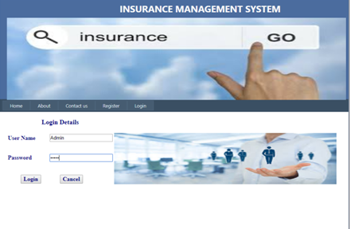

NEW REGISTRATION
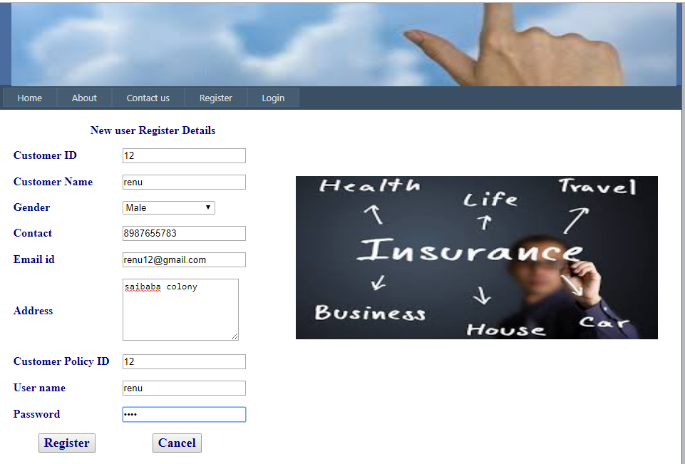
ADD CUSTOMER
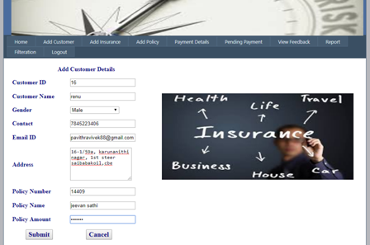

ADD POLICY
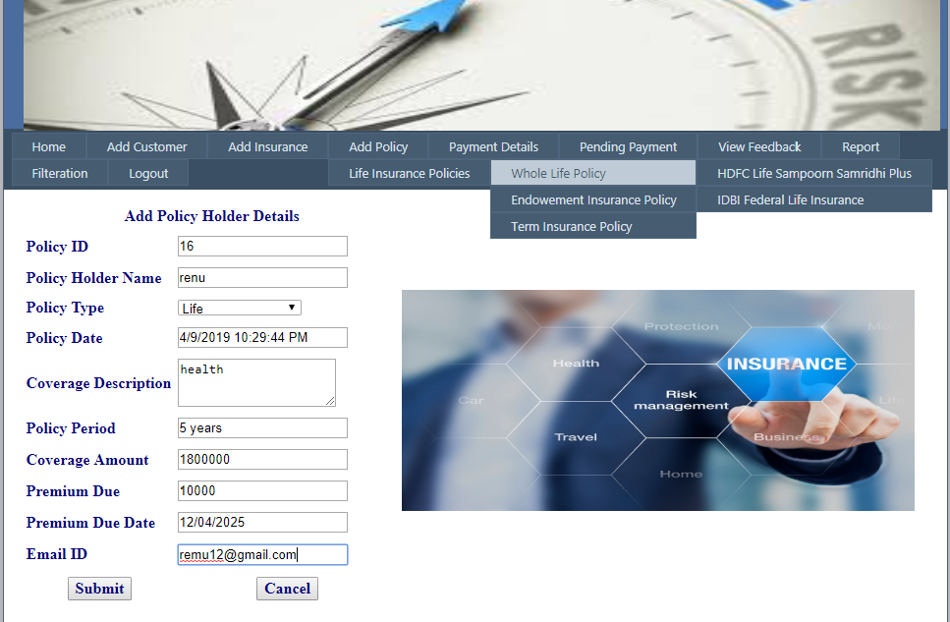

PAYMENT DETAILS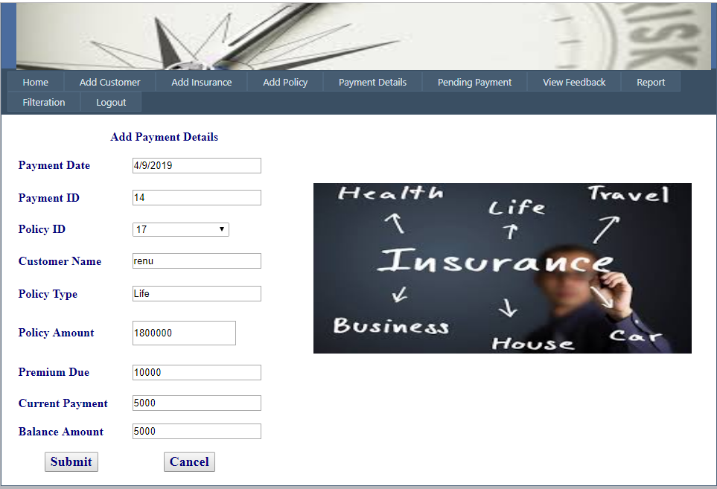

PENDING PAYMENT
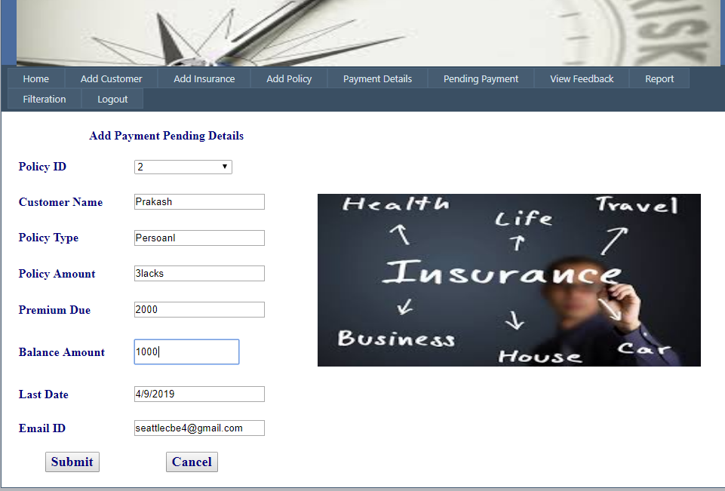

FEEDBACK
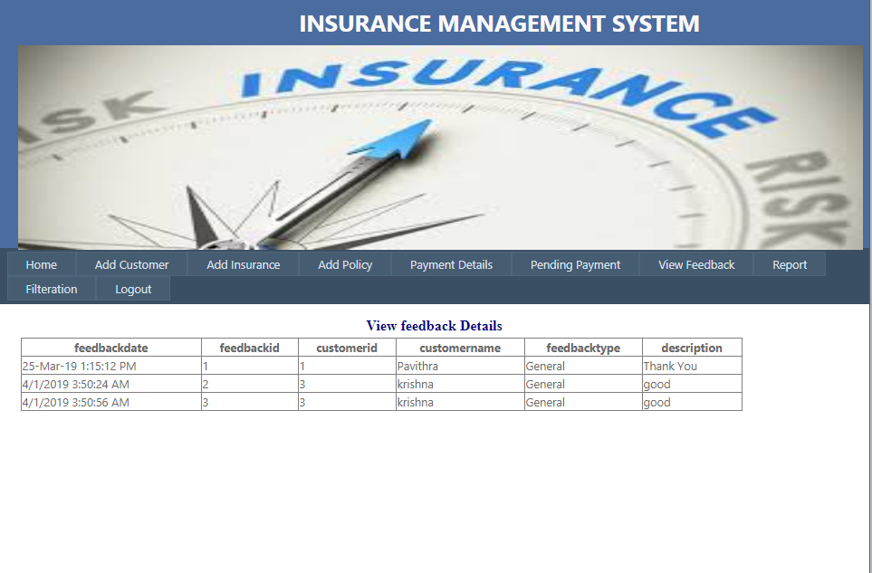

REPORT
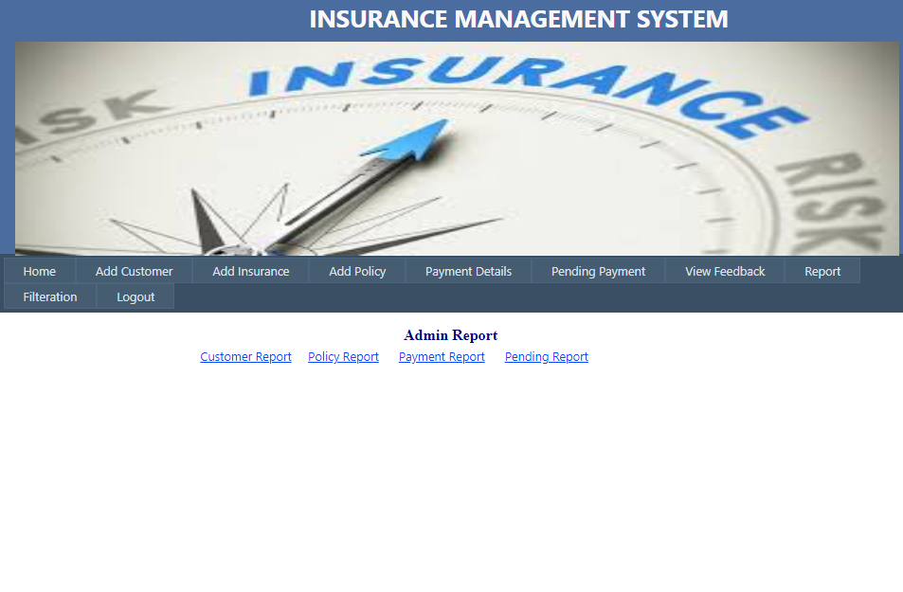

FILTERATION
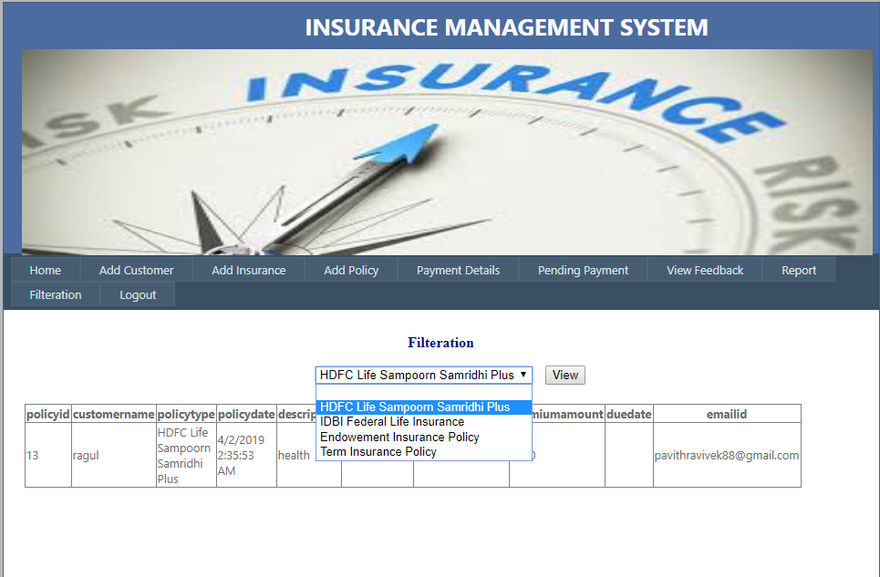

USER LOGIN
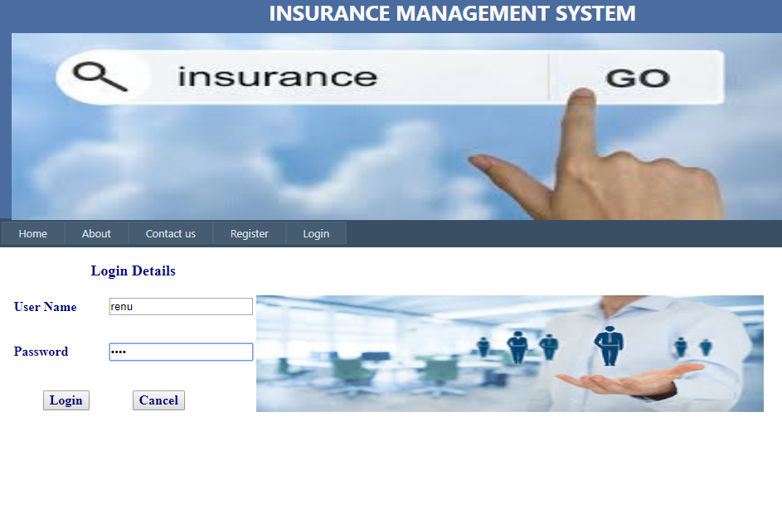

VIEW INSURANCE
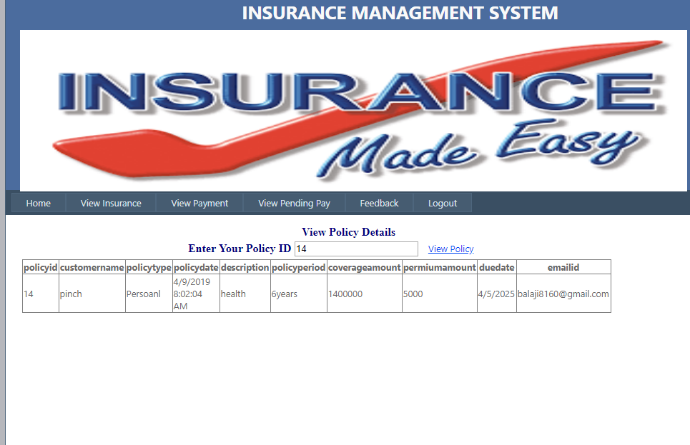

VIEW PAYMENT
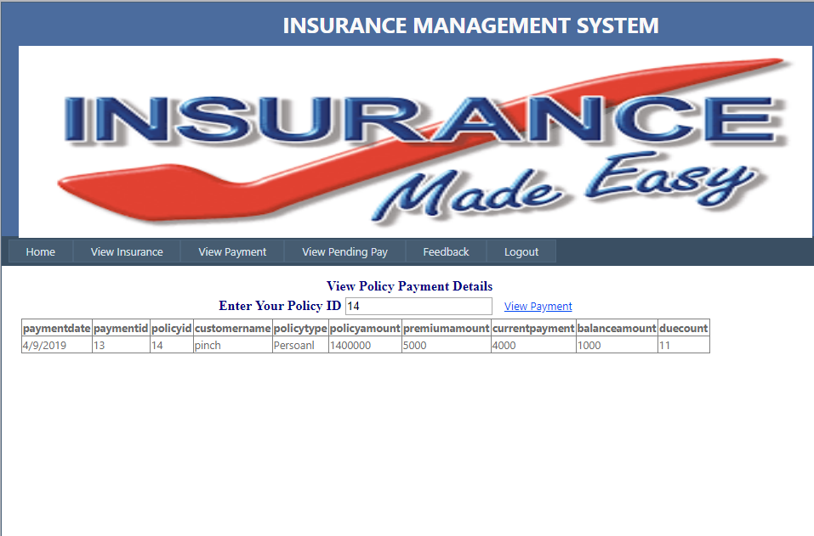

VIEW PENDING PAY
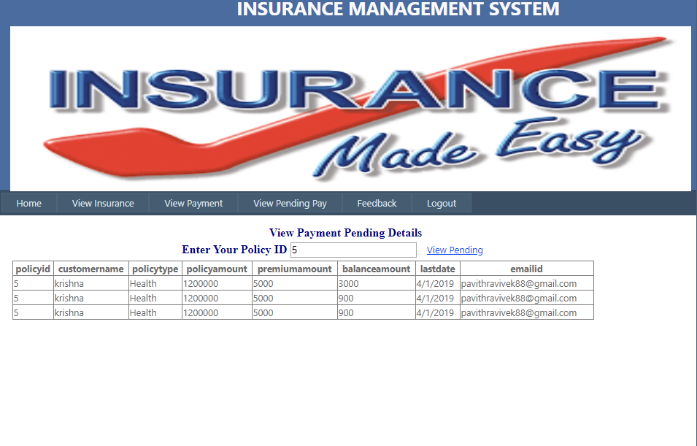

FEEDBACK
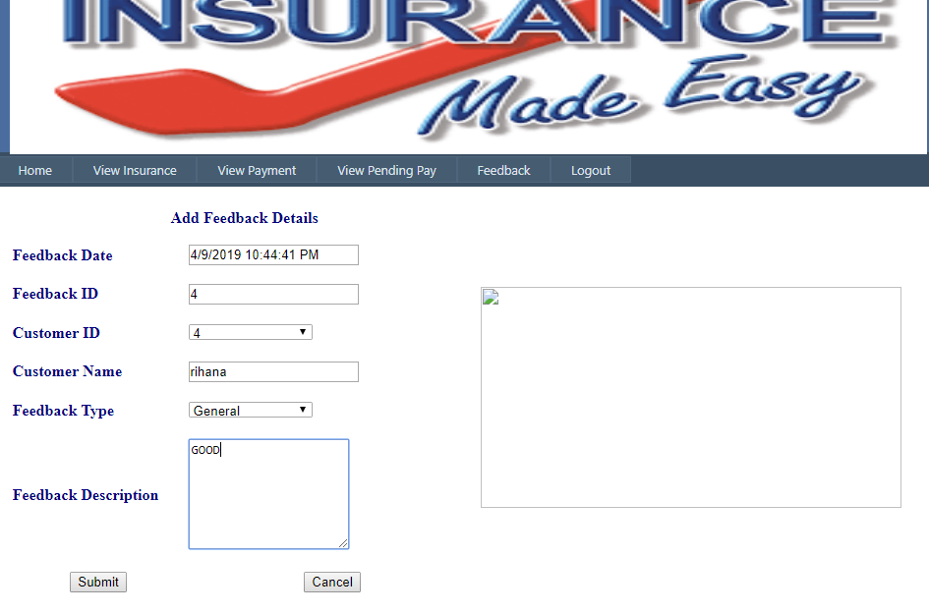

chapter-v

CHAPTER-V
SYSTEM TESTING
Testing is a series of different tests that whose primary purpose is to fully exercise the computer based system. Although each test has a different purpose, all work should verify that all system element have been properly integrated and performed allocated function. Testing is the process of checking whether the developed system works according to the actual requirement and objectives of the system.

The philosophy behind testing is to find the errors. A good test is one that has a high probability of finding an undiscovered error. A successful test is one that uncovers the undiscovered error. Test cases are devised with this purpose in mind. A test case is a set of data that the system will process as an input. However the data are created with the intent of determining whether the system will process them correctly without any errors to produce the required output.
TYPES OF TESTING
- Unit testing
- Integration testing
- Verification testing
- Validation testing
- White Box testing
- Black box testing
- Test data output

5.1 UNIT TESTING
Unit testing is a level of software testing where individual units/ components of a software are tested. The purpose is to validate that each unit of the software performs as designed. A unit is the smallest testable part of any software. It usually has one or a few inputs and usually a single output.

5.2 INTEGRATION TESTING
The entire project was split into small program; each of this single programs gives a frame as an output. These programs were tested individually; at last all these programs where combined together by creating another program where all these constructors were used. It give a lot of problem by not functioning is an integrated manner.
The user interface testing is important since the user has to declare that the arrangements made in frames are convenient and it is satisfied. when the frames where given for the test, the end user gave suggestion. Based on their suggestions the frames where modified and put into practice.
5.3VERIFICATION TESTING
Verification is the process of evaluating work-products of a development phase to determine whether they meet the specified requirements.
verification ensures that the product is built according to the requirements and design specifications. The artefacts such as test Plans, requirement specification, design, code and test cases are evaluated.
5.4 VALIDATION TESTING
At the culmination of the black box testing software is completely assembled as a package. Interfacing errors have been uncovered and corrected and a final series of test i.e., Validation succeeds when the software function in a manner that can be reasonably Accepted by the customer.
5.5 WHITE BOX TESTING
White box testing (also known as Clear Box Testing, Open Box Testing, Glass Box Testing, Transparent Box Testing, Code-Based Testing or Structural Testing) is a software testing method in which the internal structure/design/implementation of the item being tested is known to the tester. The tester chooses inputs to exercise paths through the code and determines the appropriate outputs. Programming know-how and the implementation knowledge is essential. White box testing is testing beyond the user interface and into the nitty-gritty of a system.
This method is named so because the software program, in the eyes of the tester, is like a white/transparent box; inside which one clearly sees.

5.7 BLACK BOX TESTING
Black box testing is done to find out the the following information as shown in below:
- Incorrect or missing functions
- Interface errors.
- Errors or database access.
- Performance error.
- Termination error.
The mentioned testing is carried out successfully for this application according to the user’s requirement specification.

5.8 TEST DATA OUTPUT
After preparing test data, the system under study is tested using the test data. While testing the system using test data, errors are again uncovered and corrected by using above testing and corrections are also noted for future use.

chapter-VI
CHAPTER 6
SYSTEM IMPLEMETATION
The purpose of System Implementation can be summarized as making the new system available to a prepared set of users (the deployment), and positioning on-going support and maintenance of the system within the Performing Organization (the transition). At a finer level of detail, deploying the system consists of executing all steps necessary to educate the Consumers on the use of the new system, placing the newly developed system into production, confirming that all data required at the start of operations is available and accurate, and validating that business functions that interact with the system are functioning properly. Transitioning the system support responsibilities involves changing from a system development to a system support and maintenance mode of operation, with ownership of the new system moving from the Project Team to the Performing Organization.
List of System implementation is the important stage of project when the theoretical design is tuned into practical system. The main stages in the implementation are as follows:
- Planning
- Training
- System testing and
- Changeover Planning
Planning is the first task in the system implementation. Planning means deciding on the method and the time scale to be adopted. At the time of implementation of any system people from different departments and system analysis involve. They are confirmed to practical problem of controlling various activities of people outside their own data processing departments. The line managers controlled through an implementation coordinating committee. The committee considers ideas, problems and complaints of user department, it must also consider;
The implications of system environment are
- Self selection and allocation form implementation tasks.
- Consultation with unions and resources available.
- Standby facilities and channels of communication.

The purpose of Prepare for System Implementation is to take all possible steps to ensure that the upcoming system deployment and transition occurs smoothly, efficiently, and flawlessly. In the implementation of any new system, it is necessary to ensure that the Consumer community is best positioned to utilize the system once deployment efforts have been validated. Therefore, all necessary training activities must be scheduled and coordinated. As this training is often the first exposure to the system for many individuals, it should be conducted as professionally and competently as possible. A positive training experience is a great first step towards Customer acceptance of the system.
During System Implementation it is essential that everyone involved be absolutely synchronized with the deployment plan and with each other. Often the performance of deployment efforts impacts many of the Performing Organization’s normal business operations. Examples of these impacts include:
- Consumers may experience a period of time in which the systems that they depend on to perform their jobs are temporarily unavailable to them. They may be asked to maintain detailed manual records or logs of business functions that they perform to be entered into the new system once it is operational.
- Technical Services personnel may be required to assume significant implementation responsibilities while at the same time having to continue current levels of service on other critical business systems.
- Technical Support personnel may experience unusually high volumes of support requests due to the possible disruption of day-to-day processing.
Because of these and other impacts, the communication of planned deployment activities to all parties involved in the project is critical. A smooth deployment requires strong leadership, planning, and communications. By this point in the project lifecycle, the team will have spent countless hours devising and refining the steps to be followed. During this preparation process the Project Manager must verify that all conditions that must be met prior to initiating deployment activities have been met, and that the final ‘green light’ is on for the team to proceed.

The final process within the System Development Lifecycle is to transition ownership of the system support responsibilities to the Performing Organization. In order for there to be an efficient and effective transition, the Project Manager should make sure that all involved parties are aware of the transition plan, the timing of the various transition activities, and their role in its execution.
Due to the number of project participants in this phase of the SDLC, many of the necessary conditions and activities may be beyond the direct control of the Project Manager. Consequently, all Project Team members with roles in the implementation efforts must understand the plan, acknowledge their responsibilities, recognize the extent to which other implementation efforts are dependent upon them, and confirm their commitment.

6.2 SYSTEM MAINTENANCE
All system is dynamic and subjects to constantly changing requirements. Effort must be devoted to adapting them and design must be flexible specified so that such changes can be easily implemented. This activity is called system maintains. It includes improvement of system functions and correction of errors.
Back up for the entire database files are taken and stored in secondary storage devices like magnetic tapes and disks so that is possible to restore the system at the earliest. If there is a breakdown or collapse, then the system gives provision to restore database files. Storing data in a separate secondary device leads to an effective and efficient maintains of the system.
The master file has flags for maintains. After the mentioned period, the rejection suppliers, unused data in the files will be deleted in the master file. This method is the increasing the memory to store the data.

chapter-VI I

CHAPTER 7

CONCLUSION AND FURTHER SCOPE
This project provides complete details about insurance agency. This software is based on the general requirements of insurance agency. Any insurance organization can easily adopt this software with minor or no changes. Use of this application will reduce paper work and work load on the staff. This project has a lot of scope.

CONCLUSION
The web based insurance system application was successfully created to store all the user details, insurance details, policy details, policy payment details, payment, feedback details and report details into the database using this application. The application was tested very well and the errors were properly debugged. Testing also concluded that the performance of the system is satisfactory. All the necessary output is generated. This system thus provides an easy way to automate all the functionalities of insurance organizations. If this application is implemented, it would be helpful for the insurance agents and policy holders to manage and access the data effectively. Further enhancements can be made to the project, so that the website functions in a very attractive and useful manner than the present one. It is concluded that the application works well and satisfy the needs. The application is tested very well and errors are properly debugged. It also acts as the sharing of files to the valuable resources.

BIBLIOGRAPHY
Books Referred:
- Alex Homer , ‘Professional VB.NET 1.1’, 2004 Edition, Wrox Publications
- Clayton crooks II ‘Learning Visual Basic .Net Through Applications’
- Roger S Pressman, ‘Software Engineering’, 2000 Edition, Dreamtech Publications
- Steven Holzner, ‘Visual Basic.NET Black Book’, 2003 Edition, Dreamtech Publications
- A.Keyton Weissinger ,“ASP IN A NUTSHELL”,Shroff Publishers and distributors Pvt.Ltd, February 1999
- A.Russel Jones, ”ASP.NET Complete Reference”, Sybex Publications, February 18,2002
- DATABASE SYSTEM CONCEPTS, Henry F.Korth, Megraw-Hill, Third Edition, 1997.
- Steven Holzner, ‘C#.NET Black Book’, 2003 Edition, Dreamtech Publications
- SQL SERVER HIGH AVAILABILITY, Paul Bertucci, Sams publishing, First Edition, 2004. [5]. SOFTWARE ENGINEERING ONCEPT,Richared E.Fairly Tata Megraw-Hill Publications, Third Edition, 1997.

WEBSITES
- http://www.C#corner.net
- http://www.w3schools.com/asp.net
- http://asp.net-tutorial.com
- http://en.wikipedia.org/wiki/asp.net
- www.msdn.microsoft.com
- www.vbcity.com
- www.vbdotnetheaven.com
- www.codeproject.com
- www.dotnetjohn.com

