TOURISM AND TRAVEL MANAGEMENT SYSTEM

Submitted By
DEEPADHARSHINI S (19PCC002)
Under the Guidance of

Dr.A.R. Rihana Banu, M.Com (CA) .,PGDCA,SET,Ph.d.,

In partial fulfillment of the requirement for the award of the degree of

Master of commerce with Computer Applications

MAY 2021

DEPARTMENT OF COMMERCE

Thesis submitted to
AVINASHILINGAM INSTITUTE FOR HOME SCIENCE
AND HIGHER EDUCATION FOR WOMEN.
COIMBATORE- 641043.
CERTIFICATE
This is to certify that the project work entitled “TOURISM AND TRAVEL MANAGEMENT SYSYEM”, submitted to Department of Commerce, Avinashilingam Institute for Home Science and Higher Education for Woman, Coimbatore, in partial fulfilment of MASTER OF COMMERCE WITH COMPUTER APPLICATIONS, is the record of the original project work done by DEEPADHARSHINI S (19PCC002) during the period of her study, under my supervision and guidance.

Signature of the Guide

Signature of the Head of the Department

Signature of the Supervisor

Submitted for the viva voice examination held on________________________

Internal Examiner External Examiner

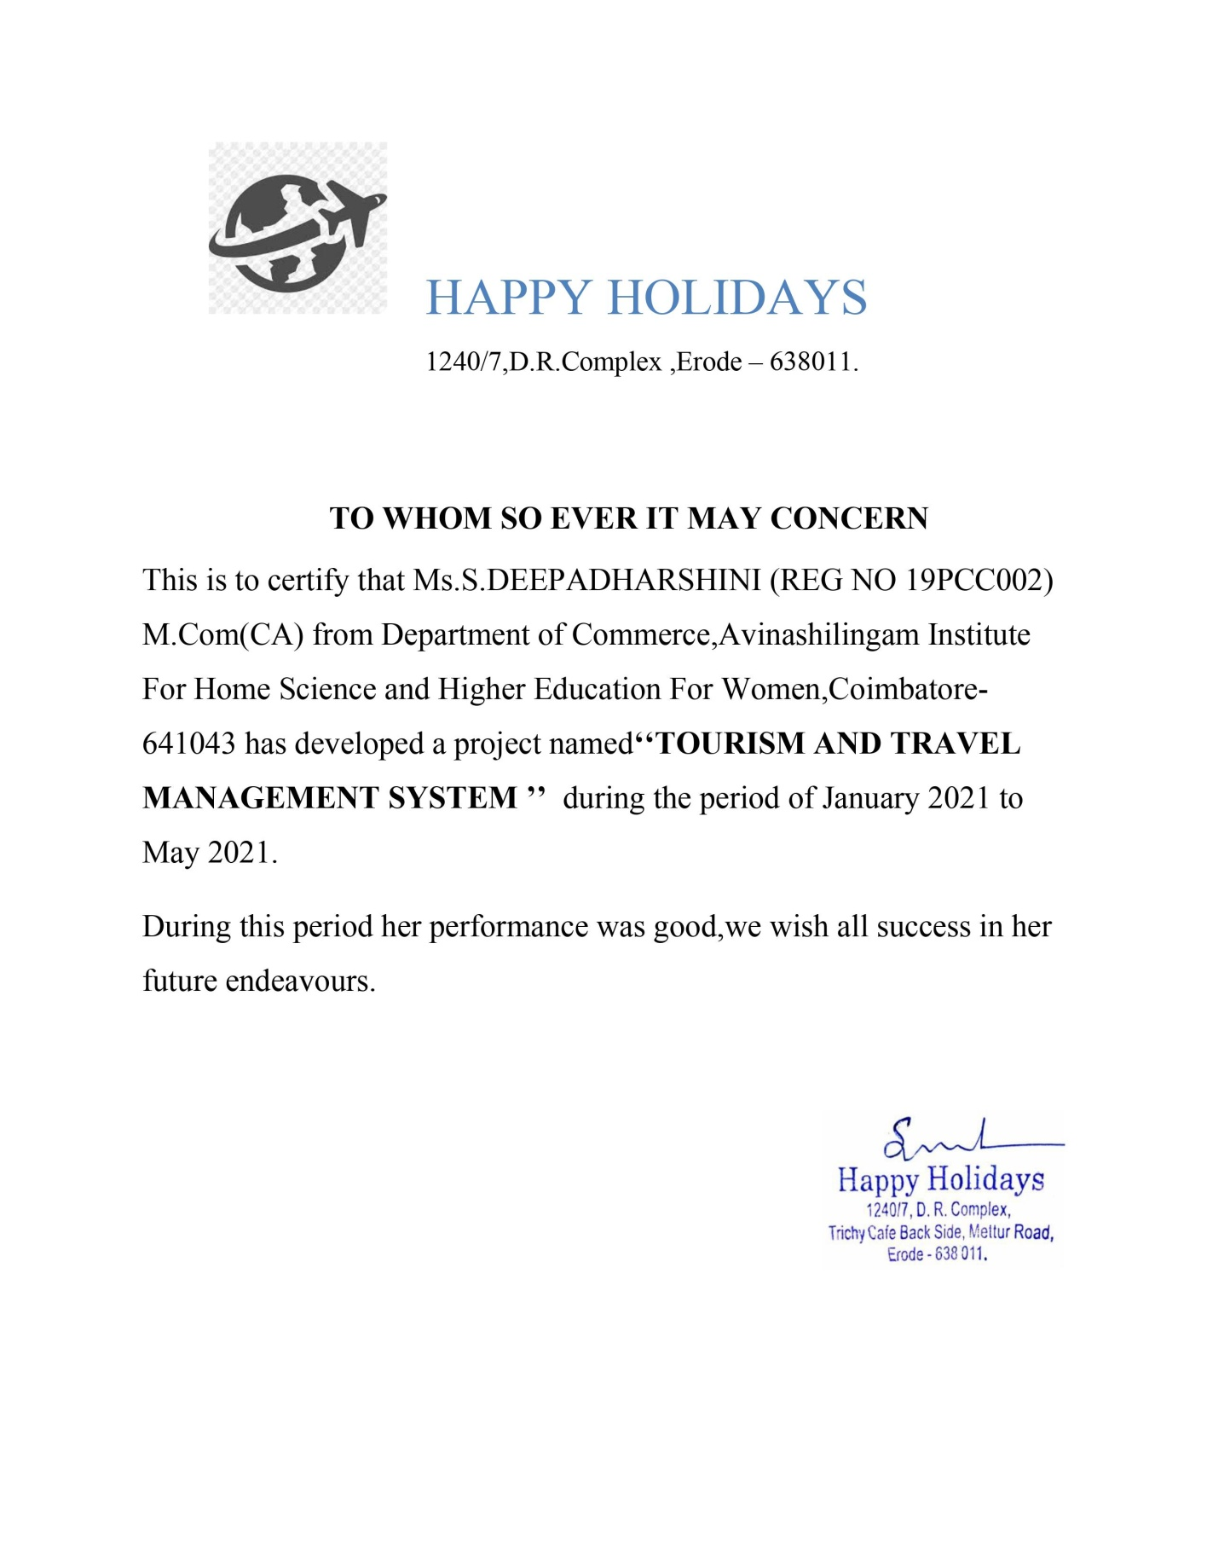

DECLARATION
I hereby declare that this project work entitled “TOURISM AND TRAVEL MANAGEMENT SYSTEM” submitted to Department of Commerce, Avinashilingam Institute for Home Science and Higher Education for Women, Coimbatore, in partial fulfilment of the requirement for the award of the degree of MASTER OF COMMERCE WITH COMPUTER APPLICATIONS is the bonafide record of original project work done by DEEPADHARSHINI S(19PCC002) during the period of her study under the supervision and guidance of DR. A.R. RIHANA BANU M.Com (CA)., PGDCA, SET.,
Ph,d., teaching assistant, Department of Commerce.

Place:
Date: Signature of the candidate

ACKNOWLEDGEMENT
I would like to express my sincere thanks to God Almighty, for his constant love and grace that he has showed upon me, which kept me in good health, and sound mind without which my project would not have reached a successful end.
I would like to express my deep sense of reverential gratitude and sincere thanks to Prof. S. P. Thyagarajan, Chancellor, Avinashilingam Institute for Home Science and Higher Education for Woman, Coimbatore- 43 for the opportunity given to me for undertaking this study and for providing the needed facility during the course of my study.
I owe my great deal of my gratitude to DR. Premavathy Vijayan, M.Sc., M.Ed., Dip. Spl. Edn., M.Phil., Ph.D., Vice Chancellor, Avinashilingam Institute for Home Science and Higher Education for Woman, Coimbatore- 43, for extending all resources that facilitated the conduct of the present study.
I express my gratitude to Dr. S. Kowsalya, M.Sc., M.Phil., Ph.D Registrar, Avinashilingam Institute for Home Science and Higher Education for Woman, Coimbatore, for providing all facilities necessary for the study.
I would express my boundless thanks to Dr. (Mrs). P. Chitramani, M.B.A., M.Phil., Ph.D., NET, SLET, Dean, School of Commerce and Management, Avinashilingam Institute for Home Science and Higher Education for Woman, Coimbatore, for granting the facility required.
I am also thankful to Dr. (Mrs). D. Geetha, M.Com., Dip.Ed., M.Phil., Ph.D., Professor and Head of the Department of Commerce for giving necessary help and support for completing the project successfully.
I express my heart full gratitude to my mentor Dr. A.R. Rihana Banu, M.Com (CA)., PGDCA,SET,Ph.d.,Department of Commerce, for the valuable guidance and for her timely support, suggestions and motivation throughout the project.
I have a great pleasure in expressing my deep sense of my gratitude to all other staff and non-teaching staff that helped us to complete the project.
I would extend our thanks to one and all helped us directly and indirectly for successful completion of our project. Last yet importantly, we would like to thank our parents, friends and all our well-wishers for their kind inspiration.

ABSTRACT
The project entitled “TOURISM AND TRAVEL MANAGEMENT SYSYEM” is developed using Microsoft Visual Studio.Net2008 as front end and MS Access Server as back end. This software offers an effective and easy way for managing travels business. It provides comprehensive details about the travel booking like bus and car, types of vehicle which the user wants to take as they wish depending on the availablity. In this project, the details of the employees like unique ID, name, license number, place of contact, date of joining, contact address and employee salary amount are maintained, along with these details they can also manage the data like the vehicle they used to drive frequently and the details about that car can be fed into the database. An admin can book the travels by providing the details of the customer which is saved as records into the system for future reference. The customers provided details along with the trip details like source and their destination, trip date, contact number, customer address, and type of vehicle the customer opt for are maintained. Based on these details, the trip is assigned for the customer who wants to take a trip in the cab or travels. The assigning trip report will provide a detailed report consisting of details in the trip like vehicle used, employee name, customer name and place of source till destination. The employee detail is kept as report in order to view the employee information. Package information is also displayed in the module from where customer can choose any packages. All these process are maintained by administrator.

CONTENTS

CHAPTER NO | TITLE | PAGE NO
I | INTRODUCTION | 1
I | 1.1 Overview of the project | 1
I | 1.2 About the company | 2
I | 1.3 Company Profile | 2
I | 1.4 Objective of the Project | 3
II | SYSTEM SPECIFICATION | 5
II | 2.1 System Configuration | 5
II | 2.2 Software Feature
III | SYSTEM ANALYSIS | 13
III | 3.1 Existing System | 13
III | 3.2 Proposed System | 13
III | 3.3 Feasibility Study | 14
IV | SYSTEM DESIGN AND DEVELOPMENT | 16
IV | 4.1 Table design | 16
IV | 4.2 Data Flow Diagram | 22
IV | 4.3 Entity Relationship Diagram | 25
V | System Testing | 98
VI | System Implementation | 100
VII | CONCLUSION | 101
 | BIBLIOGRAPHY | 102

CHAPTER I
INTRODUCTION
1.1 OVERVIEW OF THE PROJECT:
The objective of the project is to develop a system that automates the processes
and activities of a travel and. The purpose is to design a system using which one can
perform all operations related to traveling.
EXISTING SYSTEM:
In the present system a customer has to approach various agencies to find details
of places and to book tickets. This often requires a lot of time and effort. A customer
may not get the desired information from these offices and often the customer may be
misguided.Itis tediousfora customer to plan aparticularjourney and haveit
executed properly.
PROPOSED SYSTEM:
The proposed system is a web based application and maintains a centralized
repository of allrelated information. The system allows one to easily access the
relevant information and make necessary travel arrangements. Users can decide about
places they want to visit and make bookings online for travel and accommodation
In general if any user plans for any tour they must consult any travelling agency for purchasing package. At the same time the user has to do travelling reservations from source till destination, hotel reservations at destination place and other travel reservations from destination to other places.This involves lots of work. The main aim of this project is to help the tourism companies to manage the customers, hotels, vehicles and agents. It makes all operations of the tour company easy and accurate.

Proposed system:
Travel Management is the travel agency which gives all the required facilities to their customers when they are ready to plan for any tour. By using this portal the user can book any travel packages, they can reserve their tickets for any travel, they can book hotels and also it provides help to the users.

The facilities provided by this portal are following
- Add and View Packages.
- Travelling.
  - Bus Travel.
  - Car Travel.
- Ticket Booking.
- Cancellation
- Customer Form.
- Employees Page.
- Reports.

  - ABOUT COMPANY:
Happy Holidays was founded in 2012 by Saravanan Muthukumaran and since that humble beginning it has grown into a trusted resource that has helped tens of thousands of people better enjoy their travel.
We insist on prompt and pleasant customer service and the best hotels, visitor attractions and entertainment. By sharing with you the hidden places not mentioned in guidebooks, the local people you wouldn’t otherwise meet and the traditions you may not have experienced by yourself, we ensure that you get an authentic and enhanced experience you simply could not have had on your own.
At Happy Holidays, we strive to earn repeat business from you and want you to recommend us to your friends and family. Your referrals are extremely valuable to us and we know that we have to work diligently to deserve them.

1.3 COMPANY PROFILE OF TOURISM AND TRAVEL MANAGEMENT SYSTEM

AGENCY NAME : Happy Holidays
YEAR OF ESTABLISHMENT : 2012
FOUNDER/OWNER’S NAME : Saravanan Muthukumaran
ADDRESS : 1240/7,D.R.Complex,Mettur road,Erode
PHONE NO : 9870987908
EMAIL ID : happyholidays@gmail.com
ANNUAL TURNOVER : 2000000 (lakhs)

1.4 OBJECTIVES OF THE PROJECT:
This software is highly programmed in order to provide the best services to customers and various travelling agents in the field of tourisms activities such as bookings, accommodations, food services, tourism spot details and many more. This integrated software offers one of the best way of managing all the travel related businesses.

MODULES:
    - Admin login

    - Customer details

    - Employee details

    - Package details

    - Ticket booking

    - Cancellation

    - Report generation

ADMIN LOGIN:
This is the initial module in which admin can login. Admin has all right to view and modify the details in the system. Admin logs into the system by specifying unique username and password. Admin has to enter all the details subjected to the packages and has the full authority to add, delete and update information.

CUSTOMER DETAILS:

The above module shows the customer details like customer id, customer name, gender, contact number, email id and address etc

EMPLOYEE DETAILS:

In employee details module will the admin to manage his employee, each employee has an employee id and the id helps the admin to keep track of his employee by knowing details like employee’s name, salary, designation, phone number, address etc.

PACKAGE DETAILS:
The admin can create packages by creating package page which the type, price, details, place details all the travel tour package details can be added here. Which it will be showed in admin homepage.
TICKET BOOKING:
In this module maintain the booking of travel packages by the user by selecting a various packages with date and certain comments.
CANCELLATION:
Admin can cancel any package or any Customer ticket bookings.
REPORT DETAILS:
Reports can be generated to find out the details of customer, employee, package, billing etc which can be accessed for future references.

CHAPTER-II
SYSTEM SPECIFICATION
A System Specification also known as System Requirement Software is a document which sets out what the client expects and what is expected of the software system which is being developed. It is a mutual agreement and insurance policy between client and developer and is a vital part of the Software Development Lifecycle.

2.1 SYSTEM CONFIGURATION

HARDWARE CONFIGURATION:
Processor : Intel Pentium IV 2.4 GHZ or above
Ram : 256MB of RAM
Hard disk : 40 GB or higher

SOFTWARE CONFIGURATION:
Operating system : Windows XP
Front End : VB.Net2008
Back End : Microsoft Access 2003

2.2 SOFTWARE FEATURES:
WINDOWS OPERATING SYSTEM:
The Windows experience operating system is available as home and professional edition and are similar suitable for the use on standalone computers. The home edition is suitable for user which worked with Windows 9x/ME till now and don’t need special network or security features in their environment. If the users have used Windows NT/2000 private, in business or both, the Professional Edition is not only with a view of the administration optimally. Microsoft already encloses 10000 drivers on the installation media of Windows XP; about the Windows update furthermore 2000 drivers are available. The Professional Edition of Windows XP has more network features than the Home Edition. An update of Windows 9x/ME is possible, with Windows NT/2000 only the Professional Edition can be used for update. Optional FAT32 and NTFS are available as the file system for the installation partition. Windows XP (Windows version 5.1) becomes a predecessor of Windows 9x/ME as well as Windows NT/2000 and is available for 32-bits CPUs in the following versions:

  - Embedded
  - Home Edition (1 CPU) for private user (Oct 2001)
  - Professional Edition (2 CPU) for business user (Oct 2001)
  - Media Center (1 CPU) especially for Tablet PCs (Nov 2002)
  - Tablet PC Edition especially for Tablet PCs (Nov 2002)
  - Server Edition (4 CPU)

FEATURES:

- Fast user switching
- Network assistant
- Remote control for the diagnosis(Remote assistant)
- Simplified user interface
- Windows Media Player
- Internet Explorer 6.0
- Windows
- Movie Maker

The graphic device interface (GDI) in the version GDI+ can take advance of gamma correction and 3D interfaces in high color depth. Windows XP is more based on HTML than previous versions. The system control was designed complete in HTML. Another system modification in Security Center,which shows the status and settings of the firewall, automatic updates and one additional antivirus program.
The new memory functions “data execution prevention” protects software code in the memory in front of manipulation like the insert of malicious program code to be executed, the protection works only with 64-bit processors. The improved firewall now can detect waiting ports for connections and the definitions of exception rules for various network services. The browser was extended by a pop-up blocker; the file execution protection with information about the used download zone was revised generally.

FRONT END: VISUAL BASIC.NET
VB.NET is a multi-paradigm programming language developed by Microsoft on the .NET framework. It was launched in 2002 as a successor to the Visual Basic language. This was the first version of VB.NET (VB.NET 7.0) and it relied on .NET version 1.0.
In 2003, the second version of VB.NET, VB.NET 7.1, was released. This one relied on .NET version 1.1. This version came with a number of improvements including support for .NET Compact Framework and an improved reliability and performance of the .NET IDE. VB.NET 2003 was also made available in the academic edition of Visual Studio.NET and distributed to various scholars from different countries for free.
In 2005, VB.NET 8.0 was released. The .NET core portion was dropped from its name so as to distinguish it from the classical Visual Basic language. This version was named Visual Basic 2005. This version came with many features since Microsoft wanted this language to be used for rapid application developers. They also wanted to make it different from C# language. Some of the features introduced by this version of VB.NET included partial classes, generics, nullable types, operator overloading, and unsigned integer support. This version also saw the introduction of the IsNot operator.
In 2008, VB 9.0 was introduced. This was released together with .NET 3.5. Some of the features added to this release of VB.NET included anonymous types, true conditional operator, LINQ support, XML literals, Lambda expressions, extension methods, and type inference.
In 2010, Microsoft released VB 2010 (code 10.0). They wanted to use a Dynamic Language Runtime for this release, but they opted for co-evolution strategy shared between VB.NET and C# to bring these languages closer to each other.
In 2012, VB 2012 (code 11.0) was release together with .NET 4.5. Its features included call hierarchy, iterators, caller data, asynchronous programming with "await" and "async" statements and the "Global" keyword in the "namespace" statements.
In 2015, VB 2015 (code 14.0) was released alongside Visual Studio 2015. The "?." operator was introduced to do inline null checks. A string interpolation feature was also introduced to help in formatting strings inline.
In 2017, VB 2017 (code 15.0) was introduced alongside Visual Studio 2017. A better way of organizing source code in just a single action was introduced.
VB.NET Features
VB.NET comes loaded with numerous features that have made it a popular programming language amongst programmers worldwide. These features include the following:
- VB.NET is not case sensitive like other languages such as C++ and Java.
- It is an object-oriented programming language. It treats everything as an object.
- Automatic code formatting, XML designer, improved object browser etc.
- Garbage collection is automated.
- Support for Boolean conditions for decision making.
- Simple multithreading, allowing your apps to deal with multiple tasks simultaneously.
- Simple generics.
- A standard library.
- Events management.
- References. You should reference an external object that is to be used in a VB.NET application.
- Attributes, which are tags for providing additional information regarding elements that have been defined within a program.
- Windows Forms- you can inherit your form from an already existing form.
Advantages of VB.NET
- The following are the pros/benefits you will enjoy for coding in VB.NET:
- Your code will be formatted automatically.
- You will use object-oriented constructs to create an enterprise-class code.
- You can create web applications with modern features like performance counters, event logs, and file system.
- You can create your web forms with much ease through the visual forms designer. You will also enjoy drag and drop capability to replace any elements that you may need.
- You can connect your applications to other applications created in languages that run on the .NET framework.
- You will enjoy features like docking, automatic control anchoring, and in-place menu editor all good for developing web applications.

Disadvantages of VB.NET
- Below are some of the drawbacks/cons associated with VB.NET:
- VB.NET cannot handle pointers directly. This is a significant disadvantage since pointers are much necessary for programming. Any additional coding will lead to many CPU cycles, requiring more processing time. Your application will become slow.
- VB.NET is easy to learn. This has led to a large talent pool. Hence, it may be challenging to secure a job as a VB.NET programmer.

Summary:
- VB.NET was developed by Microsoft.
- It is an object-oriented language.
- The language is not case sensitive.
- VB.NET programs run on the .NET framework.
- In VB.NET, the garbage collection process has been automated.
- The language provides windows forms from which you can inherit your own forms.
- VB.NET allows you to enjoy the drag and drop feature when creating a user interface.

BACK END: Microsoft Access 2003.
Microsoft Access is the default database of Microsoft Visual Basic.Net. Microsoft Access 2003 provides many new features that make working with data and designing a database even easier. Microsoft Access Database is a collection of data and objects related to particular topic or purpose. Microsoft Access Database may contain tables; queries, forms, reports, macros modules and shortcuts top data access pages.
Microsoft Access is a Relational Database Management System. Using Access we can organize our data according to subject and can store information about how different subject are related. In general MS-Access database can have several small tables.
Microsoft Office Access, previously known as Microsoft Access, is a relational database management system from Microsoft that combines the relational Microsoft Jet Database Engine with a graphical user interface and software development tools. It is a member of the 2007 Microsoft Office system.
Access can use data stored in Access/Jet, Microsoft SQL Server, Oracle, or any ODBC-compliant data container (including MySQL and PostgreSQL). Skilled software developers and data architects use it to develop application software. Relatively unskilled programmers and non-programmer "power users" can use it to build simple applications. It supports some object-oriented techniques but falls short of being a fully object-oriented development tool.
Access was also the name of a communications program from Microsoft, meant to compete with ProComm and other programs. This proved a failure and was dropped. Years later Microsoft reused the name for its database software.
Access is used by small businesses, within departments of large corporations, and by hobby programmers to create ad hoc customized desktop systems for handling the creation and manipulation of data. Access can be used as a database for basic web based applications hosted on Microsoft's Internet Information Services and utilizing Microsoft Active Server Pages ASP. Most typical web applications should use tools like ASP/Microsoft SQL Server or the LAMP stack.
Some professional application developers use Access for rapid application development, especially for the creation of prototypes and standalone applications that serve as tools for on-the-road salesmen. Access does not scale well if data access is via a network, so applications that are used by more than a handful of people tend to rely on Client-Server based solutions. However, an Access "front end" (the forms, reports, queries and VB code) can be used against a host of database back ends, including JET (file-based database engine, used in Access by default), Microsoft SQL Server, Oracle, and any other ODBC-compliant product.

Features
One of the benefits of Access from a programmer's perspective is its relative compatibility with SQL (structured query language) —queries may be viewed and edited as SQL statements, and SQL statements can be used directly in Macros and VBA Modules to manipulate Access tables. Users may mix and use both VBA and "Macros" for programming forms and logic and offers object-oriented possibilities.
MSDE (Microsoft SQL Server Desktop Engine) 2000, a mini-version of MS SQL Server 2000, is included with the developer edition of Office XP and may be used with Access as an alternative to the Jet Database Engine.
Unlike a modern RDBMS, the Access and the Jet Engine implements database triggers and stored procedures in a non-standard way. Stored Procedures are implemented in VB.Net, and Triggers are only available from embedded Forms. Both Triggers and Stored procedures are only available to applications built completely within the Access database management system. Client applications built with VB or C++ are not able to access these features. Starting in MS Access 2003 (Jet 4.0), there is a new syntax for creating queries with parameters, in a way that looks like creating stored procedures, but these procedures are still limited to one statement per procedure. Microsoft Access does allow forms to contain code that is triggered as changes are made to the underlying table (as long as the modifications are done only with that form), and it is common to use pass-through queries and other techniques in Access to run stored procedures in RDBMSs that support these.
In ADP files (supported in MS Access 2003 and later), the database-related features are entirely different, because this type of file connects to a MSDE or Microsoft SQL Server, instead of using the Jet Engine. Thus, it supports the creation of nearly all objects in the underlying server (tables with constraints and triggers, views, stored procedures and UDF-s). However, only forms, reports, macros and modules are stored in the ADP file (the other objects are stored in the back-end database).

FILE DESIGN
A code generator is a suite of programs that matches the input to an appropriate code template and from these produces modules of code. The code is made simple in such a way that another programmer can easily understand and work on that in future. The crucial phase in the system development life cycle is the successful implementation of the new system design. The process of converting as new or revised system into an operational one is known as system implementation. This includes all those activities that take place to convert from an old system to a new system. The system can be implemented only after a through testing is done and if it is found to work according to the specifications.

INPUT DESIGN:
Input design is the process of converting the user-oriented inputs to a computer based format. The goal of the input design is to make the data entry easier, logical and as free from errors.
The entire data entry screen is interactive in nature, so that the user can directly enter into data according to the prompted messages. The users are also provided with option of selecting an appropriate input from a list of values. This will reduce the number of error, which are otherwise likely to arise if they were to be entered by the user itself.

OUTPUT DESIGN:
Output design is very important concept in the computerized system, without reliable output the user may feel the entire system is unnecessary and avoids using it. The proper output design is important in any system and facilitates effective decision-making. The output design of this system includes various reports. Output is the most important and direct source of information the user. Efficient, intelligible output design should improve the system’s relationships with the user and help in decision making. Output requirements are designed during system analysis. A good starting point for the output design is the data flow diagram.

CHAPTER-III
SYSTEM ANALYSIS
It involves studying a procedure or business in order to identify its goals and purposes and create system and procedures that will achieve them in an efficient way. Use cases are a widely used systems analysis modelling tool for identifying and expressing the functional requirements of a system.

3.1 EXISTING SYSTEM
In the existing system, all the records are not kept perfectly because all the work is done manually, so keeping up to date details of the vehicles, timings of bookings, seat availability for reservation, vehicles or rooms/hotels availability is not done. Amount of the overall trips are kept in documents and the calculations done are manually which made lead to huge mistakes.
Thus, the existing system is very time consuming and being manual work sometimes lead to a great loss as well.

DISADVANTAGES:
- The database is maintained manually which is rather tedious and error prone.
- Time delay is more because the management has to go through many records for transaction.
- The details of the customer is not maintained.
- Involves huge paper work and maintenance of paper records is highly hectic.
- The existing system involves large man power.
- Storing and retrieving the information is very difficult.
3.2 PROPOSED SYSTEM
The propose system is highly automated and makes the travelling activities much easier and flexible. The user can get the very right information at the very right time. Customers can get the knowledge of the hotels and vehicles they are going to use in their trip prior to their starting of trip. This will increase the trust of the customer into the travel company as well.

Once the bookings are confirmed all the travel details, customer details as well as all the relevant details related to the trip like hotel name, room number, vehicle number, vehicle owner’s details, date of arriving, date of departure, food to be served and every single detail will be available to the client. They just need once to click using mouse and everything is made available to them.

BENEFITS OF PROPOSED SYSTEM
The following benefits accrue to the studio. It decides to implement the proposal system.
- Expense becomes less.
- Large volumes of data can be stored with ease.
- Security is assured.
- Maintenance of file is flexible.
- Stored data and procedures can be easily edited.
- Easy report generation.
- Less manpower required.
- Management gets a clear idea of the concern.
- Using Customer based queries, the data are extracted from the main database.

3.3 FEASIBILITY STUDY:
An important outcome of the preliminary investigation is the determination that the system requested is feasible. Feasibility study is carried out to select the best system that meets the performance requirements. Feasibility study is both necessary and prudent to evaluate the feasibility of the project at the earliest possible time. It involves preliminary investigation of the project and examines whether the designed system will be useful. In this system each and every process can be feasible for the user and the developer.

The different types of feasibility are:
  - Technical feasibility
  - Behavioural feasibility
  - Economical feasibility
  - Operational feasibility

TECHNICAL FEASIBILITY:
Technical feasibility deals with the hardware as well as software requirements. Technology is not a constraint to type system development. Technical feasibility is the assessment of the technical view of the system. The system is developed for dot net environment; a platform independent tool is used to develop the system. The development risk concerns the probability, the function of all elements and its performance should be same in all platforms and in the system that is being developed.
The software used to develop this system is Windows XP, visual studio Dot net is done efficiently, and the concept of SQL helps to create the application backend. These components are also helpful in providing interactivity to java applications.

BEHAVIORAL FEASIBILITY:
It is common knowledge that computer illustrations have something to do with turnover transfers, retraining and changes in user or developer status. The main emphasis is customer service, personal contacts with customers. The proposed system produces best results and gives high performance. It can be implemented easily.

ECONOMICAL FEASIBILITY:
Economical feasibility deals about the economical impact faced by the organisation to implement a new system. Financial benefits must equal or exceed the costs. The cost of conducting a full system, including software and hardware cost for the class of application being considered should be evaluated.
Economic feasibility in this project:
    - The cost to conduct a full system investigation is possible
    - There is no additional manpower requirement.
    - There is no additional cost involved in maintaining the proposed system

OPERATIONAL FEASIBILITY:
Operational feasibility refers to the measure of solving problems with the help of a new proposed system. It helps in taking advantages of the opportunities and fulfils the requirements as identified during the development of the project.

CHAPTER IV
SYSTEM DESIGN AND DEVELOPMENT
4.1 TABLE DESIGN:
Login Table:
Field Name | Data type | Description
Username | Varchar,(50) | Username
Password | Varchar,(50) | Password
Package table:
Field name | Data type | Description
Package_Name | Text | Package Name
Hote_info | Memo | Hotel Information
Days | Number | Package Days
Day_to_Day | Memo | Days To Days
Bus_No | Text | Bus Number
Bus_Name | Text | Bus Name
Distance | Text | Distance
Departure_Date_bus | Date/Time | Departure Date Bus
Departure_Time_Bus | Date/Time | Departure Time Bus
Return_date | Date/Time | Return Date
Couple | Currency | Couple
Extra | Currency | Extra Amount
Child | Currency | Child Package Amount
Adult | Currency | Adult Package Amount
Tour_cost_include | Text | Tour Cost Include
Photos | Text | Tour Place Photo

Employee table:
Field Name | Data type | Description
Employee id | Text | Employee Id
Employee name | Text | Employee Name
Emp_address | Text | Employee Address
Emp_Email | Text | Employee Email
Emp_ContactNo | Text | Employee Contact Number
Emp_BDate | Date/Time | Employee Birthday Date
Emp_Status | Text | Employee Status
Qualification | Text | Employee Qualification
Emp_JDate | Date/Time | Employee Join Date
Emp_Salary | Currency | Employee Salary
Emp_photo | Text | Employee Photo

Car table:
Field Name | Data type | Description
car_no | Text | Car Number
car_name | Text | Car Name
car_millage | Text | Car Millage
Color | Text | Car color
Kmph | Number | Car Kilometre per hour
car_seats | Number | Car Seats
Ac | Text | Car Ac
Charges_Pkm | Currency | Car Charges per kilometre
car_inc | Text | Car includes
car_img | Text | Car image
Dept_date | Text | Car departure date
Return_date | Text | Car return date

Bus Ticket table:
Primary key: Customer_ID
Field Name | Data type | Description
Customer_ID | Text | Customer ID
Booking_Date | Text | package Booking Date
Customer_Name | Text | Customer Name
Customer_Address | Text | Customer Address
Customer_Telephone | Text | Customer Telephone
Customer_Email_ID | Text | Customer Email ID
Package | Text | package name
Travel_in | Text | Travel Mode
Bus_Name | Text | Bus Name
Bus_No | Text | Bus Number
Dept_Date | Date/Time | Departure date
Dept_Time | Date/Time | Departure time
Boarding_place | Text | Boarding place
No_of_Seats | Text | number of seats
Seat_numbers | Text | Seat numbers
Male | Text | Number Of Male
Female | Text | Number Of Female
Kids | Text | Number Of Kid
Fare | Currency | Fare Details
Discoumt | Number | Discount Amount
Amount | Text | Total Amount
Cash | Text | Cash Value
Bank | Text | Bank Details
Cheque_No | Text | Cheque Number
Branch_Name | Text | Branch Name
Bank_Name | Text | Bank Name

Cancellation table:
Primary key: Customer_ID
Field Name | Data Type | Description
Customer_Id | Text | Customer Id
Cancellation_Date | Date/Time | Customer Date
Customer_Name | Text | Customer Name
Customer_Address | Text | Customer Address
Customer_Telephone | Text | Customer Telephone
Customer_Email_Id | Text | Customer Email Id
Package | Text | Package Name
Travel_In | Text | Travel Mode
Bus_Name | Text | Bus Name
Bus_No | Text | Bus Number
Dept_Date | Date/Time | Departure Date
Dept_Time | Date/Time | Departure Time
Boarding_Place | Text | Boarding Place
No_Of_Seats | Text | Number Of Seats
Seat_Numbers | Text | Seat Numbers
Male | Text | Number Of Male
Female | Text | Number Of Female
Kids | Text | Number Of Kid
Fare | Currency | Fare Details
Discoumt | Number | Discount Amount
Amount | Text | Total Amount
Cash | Text | Cash Value
Bank | Text | Bank Details
Cheque_No | Text | Cheque Number
Branch_Name | Text | Branch Name
Bank_Name | Text | Bank Name

Volvo table:
Field Name | Data type | Description
Bus_no | Text | Bus number
Bus_Name | Text | Bus name
Bus_kmph | Text | Bus kilometre
Millage | Text | Millage
AC | Text | Ac includes
Color | Text | Bus colour
Bus_Max_seats | Number | Bus maximum seats
Book_seats | Number | Seats booking
Remaining_seats | Number | Remaining seats
Charges_PKm | Currency | Charges per kilometre
Departed | Text | Departed date
Return | Text | Return date
Image | Text | Bus image
sit1 | Text | Seat number
sit2 | Text | Seat number
sit3 | Text | Seat number
Continues from sit4 to sit40

Total Booking Table
Field Name | Data type | Description
Customer_ID | Text | Customer ID
Booking_date | Date/Time | Package Booking Date
Customer_Name | Text | Customer Name
Customer_Address | Text | CustomerAddress
Customer_Telephone | Text | CustomerTelephone
Customer_Email_ID | Text | CustomerEmailID
Package | Text | Package name
Travel_in | Text | Travel Mode
Bus_Name | Text | Bus Name
Bus_No | Text | Bus Number
Dept_Date | Date/Time | Departure date
Dept_Time | Date/Time | Departure time
Boarding_place | Text | Boarding place
No_of_Seats | Text | Number of seats
Seat_numbers | Text | Seat numbers
Male | Text | Number of male
Female | Text | Number of female
Kids | Text | Number of kid
Fare | Currency | Fare details
Discoumt | Number | Discount amount
Amount | Text | Total amount
Cash | Text | Cash value
Bank | Text | Bank details
Cheque_No | Text | Cheque Number
Branch_Name | Text | Branch Name
Bank_Name | Text | Bank Name

4.2 DATA FLOW DIAGRAM
The data flow diagram (DFD) is a graphical tool used for expressing system requirements in a graphical form. The DFD also known as the “bubble chart” has the purpose of clarifying system requirements and identifying major transformations that will become programs in system design. Thus DFD can be stated as the starting point of the design phase that functionally decomposes the requirements specifications down to the lowest level of detail. The DFD consists of series of bubbles joined by lines. The bubbles represent data transformations and the lines represent data flows in the system.

The symbols appearing in the DFD has been explained below:

- Which shows data flow

- Represent the process

- - - Designation of the data

- Shows data source

Level-0
Manage Tours and Travels
Provide Service
Provide service to Customer
Admin

LEVEL-1

Login
Exit
Admin
Username Wrong
Password Password
Customer Details

Customer-Tb

Package Details
Package-Tb

Employee
details
Employee-Tb

Booking Details
booking-Tb

Travels
Details

bus-Tb

Report

4.4 ENTITY RELATIONSHIP DIAGRAM
no-of seats
boading
color
package name
km
travelmode
package
name
name
Ac

Tot-amt
id
Seats
buss ticket details
id
car details

name

Packages
details

Manage
days

hotel info

busno

Customer
details
Employee
details

Cus-name
Address
E-id
Basic pay

Cus-id
Mail-id
E-name
Address
Gender
Contact-no
Contact-no
Gender
Designation nn

CODING DESIGN
PROGRAM CODING:
LOGIN FORM
Dim WithEvents adoPrimaryRS As ADODB.Recordset
Dim URS As New ADODB.Recordset
Option Explicit
Public LoginSucceeded As Boolean
Private Sub cmdCancel_Click()
'set the global var to false
'to denote a failed login
LoginSucceeded = False
Unload Me
End Sub

Private Sub cmdOK_Click()
If errMSG = True Then
Exit Sub
Else
If txtPassword.Text = txtPass.Text Then
LoginSucceeded = True
Unload Me
INDEX_MDI.Show
frmIndex.Show
Else
MsgBox "Invalid Password, try again!", , "Login"
txtPassword.SetFocus
SendKeys "{Home}+{End}"
End If
End If
End Sub

Private Sub Form_Load()
Connect
With URS
.Open "Select *from Users", con, 1, 2
.Close
End With
End Sub
Private Sub Form_Unload(Cancel As Integer)
con.Close
End Sub
Function errMSG() As Boolean
If txtUserName.Text = "" Then
MsgBox "Enter UserName"
txtUserName.SetFocus
errMSG = True
ElseIf txtPassword.Text = "" Then
MsgBox "Enter Password"
txtPassword.SetFocus
errMSG = True
End If
End Function
Private Sub txtUserName_LostFocus()
With URS
.Open "Select *From Users where UserName='"& txtUserName.Text &"'", con, 1, 3
If .RecordCount = 0 Then
MsgBox "Invalid username"
txtUserName.SetFocus
SendKeys "{Home}+{End}"
Else
txtPass = !Password
End If
.Close
End With
End Sub
INDEX FORM
Private Sub mnBasePack_Click()
Unload frmBus
Unload frmCars
Unload frmemp
Unload frmPassword
Unload frmHelp
Unload frmIndex
Unload frmLogin
Unload frmTotalBooking
Unload Ticket_booking
Unload TimeTable
Unload frmCustomerDetails
frmPackages.Show
End Sub

Public Sub Index_click()
Unload frmBus
Unload frmCars
Unload frmCustomerDetails
Unload frmemp
Unload frmPassword
Unload frmHelp
Unload frmLogin
Unload frmPackages
Unload frmTotalBooking
Unload Ticket_booking
Unload TimeTable
frmIndex.Show
End Sub

Public Sub Package_click()
Unload frmBus
Unload frmCars
Unload frmCustomerDetails
Unload frmPassword
Unload frmemp
Unload frmHelp
Unload frmIndex
Unload frmLogin
Unload frmTotalBooking
Unload Ticket_booking
Unload TimeTable
frmPackages.Show
End Sub

Public Sub Ticket_click()
Unload frmBus
Unload frmCars
Unload frmCustomerDetails
Unload frmPassword
Unload frmemp
Unload frmHelp
Unload frmIndex
Unload frmLogin
Unload frmPackages
Unload frmTotalBooking
Unload TimeTable
Ticket_booking.Show
End Sub

Public Sub Total_click()
Unload frmBus
Unload frmCars
Unload frmCustomerDetails
Unload frmPassword
Unload frmemp
Unload frmHelp
Unload frmIndex
Unload frmLogin
Unload frmPackages
Unload Ticket_booking
Unload TimeTable
frmTotalBooking.Show
End Sub

Public Sub Search_click()
Unload frmBus
Unload frmCars
Unload frmemp
Unload frmPassword
Unload frmHelp
Unload frmIndex
Unload frmLogin
Unload frmPackages
Unload frmTotalBooking
Unload Ticket_booking
Unload TimeTable
frmCustomerDetails.Show
End Sub
Public Sub Close_click()
End
End Sub

Private Sub mnAbout_Click()
frmAbout.Show
End Sub
Private Sub mnBackup_Click()
frmBackup.Show
End Sub

Private Sub mnBuses_Click()
Unload frmCars
Unload frmCustomerDetails
Unload frmemp
Unload frmHelp
Unload frmPassword
Unload frmIndex
Unload frmLogin
Unload frmPackages
Unload frmTotalBooking
Unload Ticket_booking
Unload TimeTable
frmBus.Show
End Sub

Private Sub mnCancellation_Click()
Unload frmBus
Unload frmCars
Unload frmCustomerDetails
Unload frmPassword
Unload frmemp
Unload frmHelp
Unload frmIndex
Unload frmLogin
Unload frmPackages
Unload frmTotalBooking
Unload TimeTable
Ticket_booking.Show
MsgBox "Now click on Cancellation", , "Note"
End Sub
Private Sub mnCarBooking_Click()
End Sub
Private Sub mnCancellations_Click()
Unload frmBus
Unload frmCars
Unload frmCustomerDetails
Unload frmPassword
Unload frmemp
Unload frmHelp
Unload frmIndex
Unload frmLogin
Unload frmPackages
Unload frmTotalBooking
Unload Ticket_booking
Unload TimeTable
DataReportCancellation.Show
End Sub
Private Sub mnCars_Click()
Unload frmBus
Unload frmCustomerDetails
Unload frmemp
Unload frmHelp
Unload frmPassword
Unload frmIndex
Unload frmLogin
Unload frmPackages
Unload frmTotalBooking
Unload Ticket_booking
Unload TimeTable
frmCars.Show
End Sub
Private Sub mnCustomer_Click()
Unload frmBus
Unload frmCars
Unload frmemp
Unload frmHelp
Unload frmIndex
Unload frmPassword
Unload frmLogin
Unload frmPackages
Unload frmTotalBooking
Unload Ticket_booking
Unload TimeTable
frmCustomerDetails.Show
End Sub
Private Sub mnEmployee_Click()
Unload frmBus
Unload frmCars
Unload frmPassword
Unload frmCustomerDetails
Unload frmHelp
Unload frmIndex
Unload frmLogin
Unload frmPackages
Unload frmTotalBooking
Unload Ticket_booking
Unload TimeTable
frmemp.Show
End Sub

Private Sub mnEPass_Click()
Unload frmBus
Unload frmCars
Unload frmCustomerDetails
Unload frmemp
Unload frmHelp
Unload frmLogin
Unload frmPackages
Unload frmTotalBooking
Unload Ticket_booking
Unload TimeTable
Unload frmIndex
frmPassword.Show
End Sub

Private Sub mnExit_Click()
End
End Sub
Private Sub mngetstarted_Click()
Unload frmBus
Unload frmPassword
Unload frmCars
Unload frmCustomerDetails
Unload frmemp
Unload frmHelp
Unload frmLogin
Unload frmPackages
Unload frmTotalBooking
Unload Ticket_booking
Unload TimeTable
frmIndex.Show
End Sub

Private Sub mnhowdoi_Click()
Unload frmBus
Unload frmCars
Unload frmPassword
Unload frmCustomerDetails
Unload frmemp
Unload frmIndex
Unload frmLogin
Unload frmPackages
Unload frmTotalBooking
Unload Ticket_booking
Unload TimeTable
frmHelp.Show
End Sub

Private Sub mnPackages_Click()
Unload frmBus
Unload frmCars
Unload frmPassword
Unload frmCustomerDetails
Unload frmemp
Unload frmHelp
Unload frmIndex
Unload frmLogin
Unload frmTotalBooking
Unload Ticket_booking
Unload TimeTable
frmPackages.Show
End Sub

Private Sub mnpackgedet_Click()
Unload frmBus
Unload frmCars
Unload frmCustomerDetails
Unload frmPassword
Unload frmemp
Unload frmHelp
Unload frmIndex
Unload frmLogin
Unload frmTotalBooking
Unload Ticket_booking
Unload TimeTable
frmPackages.Show
End Sub

Private Sub mnSchedule_Click()
Unload frmBus
Unload frmCars
Unload frmCustomerDetails
Unload frmPassword
Unload frmemp
Unload frmHelp
Unload frmIndex
Unload frmLogin
Unload frmPackages
Unload frmTotalBooking
Unload Ticket_booking
TimeTable.Show
End Sub

Private Sub mnTicketBooking_Click()
Unload frmBus
Unload frmCars
Unload frmCustomerDetails
Unload frmPassword
Unload frmemp
Unload frmHelp
Unload frmIndex
Unload frmLogin
Unload frmPackages
Unload frmTotalBooking
Unload TimeTable
Ticket_booking.Show
End Sub

Private Sub mnTickets_Click()
Unload frmBus
Unload frmCars
Unload frmPassword
Unload frmCustomerDetails
Unload frmemp
Unload frmHelp
Unload frmIndex
Unload frmLogin
Unload frmPackages
Unload frmTotalBooking
Unload Ticket_booking
Unload TimeTable
DataReportBus.Show
End Sub

Private Sub mnTotal_Click()
Unload frmBus
Unload frmCars
Unload frmPassword
Unload frmCustomerDetails
Unload frmemp
Unload frmHelp
Unload frmIndex
Unload frmLogin
Unload frmPackages
Unload frmTotalBooking
Unload Ticket_booking
Unload TimeTable
DataReportTotal.Show
End Sub

Private Sub mnTotalBooking_Click()
Unload frmBus
Unload frmCars
Unload frmPassword
Unload frmCustomerDetails
Unload frmemp
Unload frmHelp
Unload frmIndex
Unload frmLogin
Unload frmPackages
Unload Ticket_booking
Unload TimeTable
frmTotalBooking.Show
End Sub

Private Sub tb_Click()
Unload frmBus
Unload frmCars
Unload frmCustomerDetails
Unload frmPassword
Unload frmemp
Unload frmHelp
Unload frmIndex
Unload frmLogin
Unload frmPackages
Unload frmTotalBooking
Unload TimeTable
Unload INDEX_MDI
Ticket_booking.Show
End Sub

PACKAGE FORM
Dim WithEvents adoPrimaryRS As ADODB.Recordset
Dim busnoRS As New ADODB.Recordset
Dim carnoRS As New ADODB.Recordset
Dim packnameRS As New ADODB.Recordset
Dim a As Integer
'Dim viewRS As New ADODB.Recordset
Public Function PackagesGrid()
End Function
Private Sub Command3_Click()
End Sub
Private Sub cmdAdd_Click()
If Message = True Then
Exit Sub
End If

With packnameRS
.Open "Select *from packages", con, 1, 2
.AddNew
!Package_Name = txtPackageName
!Days = txtDay
!Day_to_Day = txtdays
!Bus_No = txtBusNo
!Bus_Name = txtBname
!Hote_info = txtHotels
!Departure_Date_bus = txtdeptDatebus
!Departure_Time_Bus = txtdeptTimebus
!Return_date = txtBusReturn
!Couple = txtcouple
!Extra = txtExtrasFare
!Child = txtFarekids
!Adult = txtadult
!Tour_cost_include = txtInclude
!Photos = lblimg.Caption
.Update
.Close
End With
With busnoRS
.Open "Select *from Volvo where Bus_no='"& txtBusNo.Text &"'", con, 1, 3
!sit1 = "0"
!sit2 = "0"
!sit3 = "0"
.
. Continues (!sit4 = "0" to !sit40 = "0")

!Book_seats = "0"
!Remaining_seats = "0"
!Departed = txtdeptDatebus
!Return = txtBusReturn
.Update
.Close
End With
MsgBox "Package Added Succesfully", , "Inserted"
cmdUpdate.Enabled = True
cmdDelete.Enabled = True
cmdAdd.Value = False
lblpack.Caption = "Select Package"
lstpackagelist.Visible = True
txtPackageName.Visible = False
End Sub

Private Sub cmdBrowse_Click()
On Error GoTo imageError
ImageBrowser.Filter = "Picture(*.bmp,*.gif,*.jpg)"
ImageBrowser.ShowOpen

lblPathholder.Caption = ImageBrowser.FileName
imgplaceView.Picture = LoadPicture(lblPathholder.Caption)
lblPathholder.Caption = App.Path + "\imgs\Places\" + ImageBrowser.FileTitle
VBA.FileCopy (ImageBrowser.FileName), (lblPathholder.Caption)
lblimg.Caption = ImageBrowser.FileTitle
Exit Sub

imageError:
imgplaceView.Picture = LoadPicture(App.Path &"\imgs\Places\A.jpg")
lblimg.Caption = "A.jpg"
End Sub

Private Sub cmdDelete_Click()
With packnameRS
.Open "Select *from packages where Package_Name='"& lstpackagelist.Text &"'", con, 1, 2
.Delete
.Close
End With
MsgBox "Data deleted Succesfully", , "Smart Travel"
Unload Me
Load Me
End Sub

Private Sub cmdExit_Click()
Unload Me
frmIndex.Show
End Sub

Private Sub cmdUpdate_Click()
With packnameRS
.Open "Select *from packages where Package_Name='"& lstpackagelist.Text &"'", con, 1, 2
!Days = txtDay
!Day_to_Day = txtdays
!Bus_No = txtBusNo
!Bus_Name = txtBname
!Hote_info = txtHotels
!Departure_Date_bus = txtdeptDatebus
!Departure_Time_Bus = txtdeptTimebus
!Return_date = txtBusReturn
!Couple = txtcouple
!Extra = txtExtrasFare
!Child = txtFarekids
!Adult = txtadult
!Tour_cost_include = txtInclude
!Photos = lblimg.Caption

.Update
.Close
End With
a = MsgBox("Package details updated Succesfully Do you want to update Bus Details", vbInformation + vbYesNo)
If a = vbYes Then
With busnoRS
.Open "Select *from Volvo where Bus_no='"& txtBusNo.Text &"'", con, 1, 3
!sit1 = "0"
!sit2 = "0"
!sit3 = "0"
.
. Continues (!sit4 = "0" to !sit40 = "0")
.
!Book_seats = "0"
!Remaining_seats = "0"
!Departed = txtdeptDatebus
!Return = txtBusReturn
.Update
.Close
End With
End If
If a = vbNo Then
MsgBox "Package detail updated succesfully", , "Update"
End If
cmdNew.Visible = True
Unload Me
Load Me
End Sub

Private Sub cmdClose_Click()
DataGrid1.Visible = False
cmdClose.Visible = False
cmdQickView.Visible = True
End Sub

Private Sub cmdEdit_Click()
lstVolvo.Enabled = True
cmdNew.Enabled = True
cmdDelete.Enabled = True
cmdUpdate.Enabled = True
End Sub

Private Sub cmdNew_Click()
MsgBox "Do you want to add New Package", , "New"
TxtPlaceDescription = ""
txtDay = ""
txtdays = ""
txtBusNo = ""
txtBname = ""
txtHotels = ""
TxtPlaceDescription = ""
txtdeptDatebus = ""
txtdeptTimebus = ""
txtBusReturn = ""
txtcouple = ""
txtExtrasFare = ""
txtFarekids = ""
txtadult = ""
txtInclude = ""

lblpack.Caption = "Enter Package Name"
lstpackagelist.Visible = False
txtPackageName.Visible = True
cmdDelete.Enabled = False
cmdUpdate.Enabled = False
cmdAdd.Visible = True
cmdAdd.Enabled = True
cmdNew.Visible = False
End Sub

Private Sub cmdQickView_Click()
DataGrid1.Visible = True
cmdClose.Visible = True
cmdQickView.Visible = False
End Sub

Private Sub DeartureDTP_Change()
txtdeptDatebus.Text = DeartureDTP
End Sub

Private Sub Form_Load()
Connect
With packnameRS
.Open "Select * from packages", con, 1, 2
While Not .EOF
lstpackagelist.AddItem !Package_Name
.MoveNext
Wend
Call PackagesGrid
.Close
End With
With busnoRS
.Open "Select *from Volvo", con, 1, 2
While Not .EOF
lstVolvo.AddItem !Bus_No
.MoveNext
Wend
.Close
End With
imageError:
imgplaceView.Picture = LoadPicture(App.Path &"\imgs\Places\A.jpg")
lblimg.Caption = "A.jpg"
End Sub
Function Message() As Boolean
If txtPackageName.Text = "" Then
MsgBox "Please Enter packagename"
txtPackageName.SetFocus
Message = True
ElseIf txtDay.Text = "" Then
MsgBox "Please Enter Days"
txtDay.SetFocus
Message = True
ElseIf txtHotels.Text = "" Then
MsgBox "Please Enter Hotel information"
txtHotels.SetFocus
Message = True
ElseIf txtdays.Text = "" Then
MsgBox "Please Enter day inforamtion"
txtdays.SetFocus
Message = True
ElseIf txtBusNo.Text = "" Then
MsgBox "Please Enter Bus No "
lstVolvo.SetFocus
Message = True

ElseIf txtdeptDatebus.Text = "" Then
MsgBox "Please Enter Departure Date"
DeartureDTP.SetFocus
Message = True
ElseIf txtdeptTimebus.Text = "" Then
MsgBox "Please Enter Departure Time"
txtdeptTimebus.SetFocus
Message = True
ElseIf txtBusReturn.Text = "" Then
MsgBox "Please Enter return Date"
ReturnDTP.SetFocus
Message = True
ElseIf txtcouple.Text = "" Then
MsgBox "Please Enter Couple charges"
txtcouple.SetFocus
Message = True
ElseIf txtExtrasFare.Text = "" Then
MsgBox "Please Enter Extra fare"
txtExtrasFare.SetFocus
Message = True
ElseIf txtFarekids.Text = "" Then
MsgBox "Please Enter Kids Charges"
txtFarekids.SetFocus
Message = True
ElseIf txtadult.Text = "" Then
MsgBox "Please Enter adult Charges"
txtadult.SetFocus
Message = True
ElseIf txtInclude.Text = "" Then
MsgBox "Please Enter package include"
txtInclude.SetFocus
Message = True
End If
End Function

Private Sub Form_Unload(Cancel As Integer)
con.Close
End Sub

Private Sub Label11_Click()
PlaceInfoFrame.Visible = False
End Sub

Private Sub lblClose_Click()
hotelDetailFrame.Visible = False
End Sub
Private Sub lblimg_Change()
If lblimg.Caption = "" Then
lblimg.Caption = "A.jpg"
Else
imgplaceView.Picture = LoadPicture(App.Path + "\imgs\Places\" + lblimg.Caption)
End If
'imgplaceView.Picture=LoadPicture(App.Path "imgs\Places"+lblimg.Caption )
End Sub

Private Sub lblplus_Click()
PlaceInfoFrame.Visible = True
End Sub

Private Sub lblShow_Click()
hotelDetailFrame.Visible = True
End Sub

Private Sub lstpackagelist_Click()
With packnameRS
.Open "Select * from packages where Package_Name='"& lstpackagelist.Text &"'", con, 1, 2
If Not .EOF Then
txtNamePack = !Package_Name
txtdays = !Day_to_Day
txtHotels = !Hote_info
txtdays = !Day_to_Day
txtBusNo = !Bus_No
txtcouple = !Couple
txtExtrasFare = !Extra
txtdeptDatebus = !Departure_Date_bus
txtdeptTimebus = !Departure_Time_Bus
txtFarekids = !Child
txtBusReturn = !Return_date
txtBname = !Bus_Name
txtDay = !Days
txtInclude = !Tour_cost_include
txtadult = !Adult
lblimg = !Photos
.Close
End If
End With
End Sub

Private Sub lstVolvo_Click()
FrameStatus.Visible = True
With busnoRS
.Open "Select *from Volvo where Bus_No='"& lstVolvo.Text &"'", con, 1, 2
txtBusNo = !Bus_No
txtBname = !Bus_Name
txtDept = !Departed
txtRet = !Return
.Close
End With
End Sub

Private Sub lstVolvo_LostFocus()
FrameStatus.Visible = False
End Sub

Private Sub ReturnDTP_Change()
txtBusReturn.Text = ReturnDTP
End Sub

Private Sub txtdays_Change()
txtDaYTO.Text = txtdays.Text
End Sub

Private Sub txtHotels_Change()
txtHotelinformation.Text = txtHotels.Text
End Sub

CUSTOMER DETAILS
Dim WithEvents adoPrimaryRS As ADODB.Recordset
Dim rs As New ADODB.Recordset
Dim rs2 As New ADODB.Recordset
Dim Trs As New ADODB.Recordset
Dim CanRs As New ADODB.Recordset
Dim customer1, customer2 As String

Private Sub cmbCanID_Click()
With CanRs
.Open "Select *from Cancellations where Customer_ID='"& cmbCanID.Text &"'", con, 1, 2
txtCanCID = !Customer_ID
txtCanCN = !Customer_Name
txtCanCADD = !Customer_Address
txtCanCP = !Customer_Telephone
txtCanCEmai = !Customer_Email_ID
txtCanCP = !Customer_Telephone
txtCanP = !Customer_Telephone
txtCanB = !Bus_Name
txtCanBNo = !Bus_No
txtCanDeptdate = !Dept_Date
txtCanNo_of_seats = !No_of_Seats
txtCanseatNo = !Cancel_seats
txtTotalAmtC = !Fare
txtCanAmtDeducted = !Amount_deducted
txtCanReturn = !Return_Amt
.Close
End With
End Sub

Private Sub cmbCustomerID_Click()
With rs
.Open "Select *from BusTickets where Customer_ID='"& cmbCustomerID.Text &"'", con, 1, 2
txtcustid = !Customer_ID
txtcustname = !Customer_Name
txtcustadd = !Customer_Address
txtcusttelephone = !Customer_Telephone
txtcustemailid = !Customer_Email_ID
txtPackage = !Package
txtBusName = !Bus_Name
txtBusNo = !Bus_No
txtSeats = !Seat_numbers
txtDeptdate = !Dept_Date
txtDeptTime = !Dept_time
txtNoSeats = !No_of_Seats
txtFares = !Amount
txtpiadAmount = !Amount
txtChargesPKM = "Not Applicable"
'txtReturnDate = !Return_date
txtBoarding = !Boarding_Place
txtCash = !Cash
txtBank = !Bank
txtChequeNo = !Cheque_No
txtBranchName = !Branch_Name
txtBankName = !Bank_Name
.Close
End With
End Sub

Private Sub cmbCustomerID2_Click()
With rs
.Open "Select *from TotalBooking where Customer_ID='"& cmbCustomerID2.Text &"'", con, 1, 2
txtcustid = !Customer_ID
txtcustname = !Customer_Name
txtcustadd = !Customer_Address
txtcusttelephone = !Customer_Telephone
txtcustemailid = !Customer_Email_ID
txtPackage = !Package
txtBusName = !Bus_Car_Name
txtBusNo = !Car_or_Bus_No
txtSeats = "Not Applicable"
txtBoarding = !Boarding_Place
txtChargesPKM = !Charges_PKm
txtCash = !Cash
txtBank = !Bank
txtChequeNo = !Cheque_No
txtBankName = !Bank_Name
txtBranchName = !Branch_Name
txtDeptdate = !Dept_Date
txtDeptTime = !Dept_time
txtNoSeats = "Not Applicable"
txtFares = "Not Fix"
txtpiadAmount = !paid
.Close
End With
End Sub

Private Sub cmbSelectType_Click()
If cmbSelectType.Text = "Bus Tickets" Then
lstBusTickets.Visible = True
lstTotalBooking.Visible = False

MSFlexGridTickets.Visible = True
MSFlexGridTotal.Visible = False
txtSearch2.Visible = False
cmdSearch2.Visible = False
cmdSearch.Visible = True
txtSearch.Visible = True
End If
If cmbSelectType.Text = "Total Booking" Then
lstBusTickets.Visible = False
lstTotalBooking.Visible = True
MSFlexGridTickets.Visible = False
MSFlexGridTotal.Visible = True
txtSearch2.Visible = True
cmdSearch2.Visible = True
cmdSearch.Visible = False
txtSearch.Visible = False
End If
End Sub

Private Sub cmdEdit_Click()
cmdUpdate.Visible = True
lblDistanceCalci.Visible = True
lbltotal.Visible = True
lblPayMent.Visible = True
txtDistanceCalci.Visible = True
txtUpdCalci.Visible = True
txtTotalPayment.Visible = True
End Sub

Private Sub cmdExit_Click()
Unload Me
frmIndex.Show
End Sub

Private Sub cmdSearch_Click()
If txtSearch.Text = "" Then
MsgBox "Select Search option", , "Select"
Else
With rs
.Open "Select * from BusTickets where "& customer1 &"='"& txtSearch &"'", con, 1, 2
If .RecordCount = 0 Then
MsgBox "Record Not Found", , "Not Found"
txtSearch.SetFocus
End If
Call TicketsGrid
.Close
End With
End If
End Sub

Private Sub cmdSearch2_Click()
If txtSearch2.Text = "" Then
MsgBox "Select option", , "Search"
Else
With Trs
.Open "Select * from TotalBooking where "& customer2 &"='"& txtSearch2.Text &"'", con, 1, 3
If .RecordCount = 0 Then
MsgBox "Record not found", , "Not Found"
End If
Call TotalsGrid
.Close
End With
End If
End Sub

Private Sub Combo1_Change()
End Sub
Private Sub cmdUpdate_Click()
With Trs
.Open "Select *from TotalBooking where Customer_ID='"& cmbCustomerID2.Text &"'", con, 1, 2
!paid = txtTotalPayment
!Distance = txtDistanceCalci
.Update
.Requery
.Close
End With
MsgBox "Update Succesfully", , "Update"
cmdUpdate.Visible = False
lblDistanceCalci.Visible = False
lbltotal.Visible = False
lblPayMent.Visible = False

txtDistanceCalci.Visible = False
txtUpdCalci.Visible = False
txtTotalPayment.Visible = False
End Sub

Private Sub Form_Load()
SSTab1.Tab = 1
Connect
With rs
.Open "Select *from BusTickets", con, 1, 2
While Not .EOF
cmbCustomerID.AddItem !Customer_ID
.MoveNext
Wend
Call TicketsGrid

.Close
End With
With Trs
.Open "Select *from TotalBooking", con, 1, 2
While Not .EOF
cmbCustomerID2.AddItem !Customer_ID
.MoveNext
Wend
Call TotalsGrid
.Close
End With

With CanRs
.Open "Select *From Cancellations ", con, 1, 2
While Not .EOF
cmbCanID.AddItem !Customer_ID
.MoveNext
Wend
.Close
End With
cmbSelectType.AddItem "Bus Tickets"
cmbSelectType.AddItem "Total Booking"
lstBusTickets.AddItem "Customer ID"
lstBusTickets.AddItem "Customer Name"
lstBusTickets.AddItem "Package"
lstBusTickets.AddItem "Bus No"
lstBusTickets.AddItem "Bus Name"
lstTotalBooking.AddItem "Customer ID"
lstTotalBooking.AddItem "Customer Name"
lstTotalBooking.AddItem "Package"
lstTotalBooking.AddItem "Car No"
lstTotalBooking.AddItem "Car Name"
End Sub
Function nosel() As Boolean
If cmbSelectType.Text = "Select Data" Then
MsgBox "First Select Type"
nosel = True
cmbSelectType.SetFocus
End If
End Function

Public Function TicketsGrid()
MSFlexGridTickets.Clear
MSFlexGridTickets.FormatString = "Customer ID |Booking Date |Customer Name |Customer_Address |Customer Telephone |Customer Email ID |Package | Travel in |Bus Name |Bus No |Dept Time |Dept Date |No of Seats |Seat numbers |Male |Female |Kids |Fare |Discoumt |Amount "
MSFlexGridTickets.Rows = 1
'rs.MoveNext
Do While Not rs.EOF
MSFlexGridTickets.AddItem rs!Customer_ID & vbTab & rs!Booking_date & vbTab & rs!Customer_Name & vbTab & rs!Customer_Address & vbTab & rs!Customer_Telephone & vbTab & rs!Customer_Email_ID & vbTab & rs!Package & vbTab & rs!Travel_in & vbTab & rs!Bus_Name & vbTab & rs!Bus_No & vbTab & rs!Dept_time & vbTab & rs!Dept_Date & vbTab & rs!No_of_Seats & vbTab & rs!Seat_numbers & vbTab & rs!Male & vbTab & rs!Female & vbTab & rs!Kids & vbTab & rs!Fare & vbTab & rs!Discoumt & vbTab & rs!Amount
rs.MoveNext
Loop
End Function

Public Function TotalsGrid()
MSFlexGridTotal.Clear
MSFlexGridTotal.FormatString = "Customer ID |Booking date |Customer Name |Customer Address |Customer Telephone |Customer Email ID |Package |Bus Car Name |Bus or Car No |Dept date |Dept time |Return Date |Boarding Place |Charges PKM |Cash |Bank |Cheque No |Bank Name |Branch Name |paid "
MSFlexGridTotal.Rows = 1

'Trs.MoveFirst
Do While Not Trs.EOF
MSFlexGridTotal.AddItem Trs!Customer_ID & vbTab & Trs!Booking_date & vbTab & Trs!Customer_Name & vbTab & Trs!Customer_Address & vbTab & Trs!Customer_Telephone & vbTab & Trs!Customer_Email_ID & vbTab & Trs!Package & vbTab & Trs!Bus_Car_Name & vbTab & Trs!Car_or_Bus_No & vbTab & Trs!Dept_Date & vbTab & Trs!Dept_time & vbTab & Trs!Return_date & vbTab & Trs!Boarding_Place & vbTab & Trs!Charges_PKm & vbTab & Trs!Cash & vbTab & Trs!Bank & vbTab & Trs!Cheque_No & vbTab & Trs!Bank_Name & vbTab & Trs!Branch_Name & vbTab & Trs!paid
Trs.MoveNext
Loop
End Function
Private Sub Form_Unload(Cancel As Integer)
con.Close
End Sub

Private Sub lstBusTickets_Click()
If nosel = True Then
Exit Sub
Else
Select Case lstBusTickets.ListIndex
Case 0:
customer1 = "Customer_ID "
txtSearch.Text = "Enter Customer ID"
Call selectText(txtSearch)

Case 1:
customer1 = "Customer_Name"
txtSearch.Text = "Enter Customer Name"
Call selectText(txtSearch)
Case 2:
customer1 = "Package"
txtSearch.Text = "Enter Package Name"
Call selectText(txtSearch)
Case 3:
customer1 = "Bus_No"
txtSearch.Text = "Enter Bus No"
Call selectText(txtSearch)
Case 4:
customer1 = "Bus_Name"
txtSearch.Text = "Enter Bus Name"
Call selectText(txtSearch)
End Select
End If
End Sub

Private Sub lstTotalBooking_Click()
Select Case lstTotalBooking.ListIndex
Case 0:
customer2 = "Customer_ID "
txtSearch2.Text = "Enter Customer ID"
Call selectText(txtSearch2)
Case 1:
customer2 = "Customer_Name"
txtSearch2.Text = "Enter Customer Name"
Call selectText(txtSearch2)
Case 2:
customer2 = "Package"
txtSearch2.Text = "Enter Package Name"
Call selectText(txtSearch2)
Case 3:
customer2 = "Bus_Car_No"
txtSearch2.Text = "Enter Bus No"
Call selectText(txtSearch2)
Case 4:
customer2 = "Bus_Car_Name "
txtSearch2.Text = "Enter Bus Name"
Call selectText(txtSearch2)
End Select
End Sub

Private Sub optTickets_Click()
If optTickets.Value = True Then
cmbCustomerID.Visible = True
cmbCustomerID2.Visible = False
cmdEdit.Visible = False
cmdUpdate.Visible = False
lblDistanceCalci.Visible = False
lbltotal.Visible = False
lblPayMent.Visible = False
txtDistanceCalci.Visible = False
txtUpdCalci.Visible = False
txtTotalPayment.Visible = False
End If
End Sub

Private Sub optTotal_Click()
If optTotal.Value = True Then
cmbCustomerID2.Visible = True
cmbCustomerID.Visible = False
cmdEdit.Visible = True
End If
End Sub

Private Sub txtDistanceCalci_Change()
txtUpdCalci.Text = Val(txtDistanceCalci.Text) * Val(txtChargesPKM.Text)
End Sub

Private Sub txtUpdCalci_Change()
txtTotalPayment.Text = Val(txtpiadAmount.Text) + Val(txtUpdCalci.Text)
End Sub

TICKETBOOKING
Dim WithEvents adoPrimaryRS As ADODB.Recordset
Dim noRs As New ADODB.Recordset
Dim packRS As New ADODB.Recordset
Dim BRs As New ADODB.Recordset
Dim CanRs As New ADODB.Recordset
Dim volvoRs As New ADODB.Recordset
Dim cancelRS As New ADODB.Recordset
Dim a, b, c, d As Double
Private Sub c1_Click()
If C1.Value = Checked Then
txtseatnumber.Text = txtseatnumber.Text &""&"1"
End If
End Sub
Private Sub c2_Click()
If C2.Value = Checked Then
txtseatnumber.Text = txtseatnumber.Text &""&"2"
End If
End Sub

Private Sub c3_Click()
If C3.Value = Checked Then
txtseatnumber.Text = txtseatnumber.Text &""&"3"
End If
End Sub
.
.
. Continues from C4th value till C40th value

Private Sub Adodc1_WillMove(ByVal adReason As ADODB.EventReasonEnum, adStatus As ADODB.EventStatusEnum, ByVal pRecordset As ADODB.Recordset)
End Sub

Private Sub Check1_Click()
If Check1.Value = Checked Then
txtseatnumber.Text = txtseatnumber.Text &""&"1"
End If
End Sub

Private Sub Check10_Click()
If Check10.Value = Checked Then
txtseatnumber.Text = txtseatnumber.Text &""&"10"
End If
End Sub

. Continues from Check11th value till Check19th value

Private Sub Check2_Click()
If Check2.Value = Checked Then
txtseatnumber.Text = txtseatnumber.Text &""&"2"
End If
End Sub

Private Sub Check20_Click()
If Check20.Value = Checked Then
txtseatnumber.Text = txtseatnumber.Text &""&"20"
End If
End Sub
.
. Continues from Check21st value till C29th value
.
Private Sub Check3_Click()
If Check3.Value = Checked Then
txtseatnumber.Text = txtseatnumber.Text &""&"3"
End If
End Sub
.
. Continues from C30th value till C36th value
.
Private Sub Check4_Click()
If Check4.Value = Checked Then
txtseatnumber.Text = txtseatnumber.Text &""&"4"
End If
End Sub
. Continues from Check5th value till Check9th value
.
Private Sub cmbf_Click()
txttotalfare.Text = Val(txttotalfare.Text) + Val(cmbf.Text) * Val(txtFPP.Text)
End Sub

Private Sub cmbkid_Click()
txttotalfare.Text = Val(txttotalfare.Text) + Val(cmbkid.Text) * Val(txtFPK.Text)
End Sub

Private Sub cmbm_Click()
txttotalfare.Text = Val(txttotalfare.Text) + Val(cmbm.Text) * Val(txtFPP.Text)
End Sub

Private Sub CheckAdult_Click()
If CheckAdult.Value = Checked Then
CheckCouple.Enabled = False
CheckExtra.Enabled = False
CheckChildren.Enabled = False
'txtNoOfAdults.Enabled = True
txtNoOfAdults.Text = "1"
cmdExtraD.Enabled = False
cmdChildrenD.Enabled = False
cmdExtraI.Enabled = False
cmdNoChildI.Enabled = False
End If
End Sub

Private Sub CheckChildren_Click()
If CheckChildren.Value = Checked Then
txtNoofChildren.Text = "1"
txttotalfare.Text = Val(txttotalfare.Text) + Val(txtextra.Text)
txttotalseats.Text = Val(txttotalseats.Text) + 1
End If
End Sub

Private Sub CheckCouple_Click()
If CheckCouple.Value = Checked Then
CheckAdult.Enabled = False
txtNoCouple.Text = "2"
txttotalfare.Text = Val(txttotalfare.Text) + Val(txtCouple.Text)
End If
End Sub

Private Sub CheckExtra_Click()
If CheckExtra.Value = Checked Then
txtNoOFextra.Text = "1"
txttotalfare.Text = Val(txttotalfare.Text) + Val(txtextra.Text)
txttotalseats.Text = Val(txttotalseats.Text) + 1
End If
End Sub

Private Sub cmbpackage_Click()
txtseatnumber.Text = ""
With packRS
.Open "Select *from packages where Package_Name='"& cmbpackage.Text &"'", con, 1, 3
If Not .EOF Then
txtCBname = !Bus_Name
txtBusName = !Bus_Name
txtCBno = !Bus_No
txtdeptdate = !Departure_Date_bus
txtdepttime = !Departure_Time_Bus
txtadult = !Adult
txtCouple = !Couple
txtextra = !Extra
txtchild = !Child
.Close
End If
End With
End Sub

Private Sub cmdCancel_Click()
txtcust_id.Visible = False
txtsearch.Visible = True
cmdsearch.Visible = True
cmbpackage.Visible = False
txtPackage.Visible = True
txttotalfare.Visible = False
txtTotalAmt.Visible = True
txtdiscount.Visible = False
txtDeducted.Visible = True
txtExactAmount.Visible = False
txtAmtreturn.Visible = True
txtSeatCancel.Visible = True
txttotalseats.Enabled = False
txtdiscountCalc.Visible = False
Submit.Visible = False
cmdSubmit2.Visible = True
lblCancel.Visible = True
lblTotalAmt.Caption = "Total Amount"
txtTotalAmt.Visible = True
lblDiscount.Caption = "Amount Deducted"
txtDeducted.Visible = True
lblExactAmt.Caption = "Amount Return"
txtAmtreturn.Visible = True
End Sub

Private Sub cmdReset_Click()
Unload Me
Load Me
End Sub

Private Sub cmdSubmit2_Click()
txtRS.Text = Val(txtAS.Text) - Val(txtBook.Text)
With cancelRS
.Open "Select *from Cancellations", con, 1, 2
.AddNew
!Customer_ID = txtcust_id
!Cancellation_date = txtBookingdate
!Customer_Name = txtcust_name
!Customer_Address = txtcust_add
!Customer_Telephone = txtphone_no
!Customer_Email_ID = txtemail_id
!Package = cmbpackage
!Travel_in = Mode
!Bus_Name = txtCBname
!Bus_No = txtCBno
!Cancel_seats = txtSeatCancel
!Seat_numbers = txtseatnumber
!Dept_Date = txtdeptdate
!Dept_time = txtdepttime
!No_of_Seats = txttotalseats
!Male = txtMales
!Female = txtFemales
!Kids = txtChildrens
!Fare = txtTotalAmt
!Amount_deducted = txtDeducted
!Return_Amt = txtAmtreturn

.Update
.Close
End With
MsgBox "Ticket Cancel"
With volvoRs
.Open "Select *from Volvo where Bus_no='"& txtCBno.Text &"'", con, 1, 2
If txtCBname.Text = "Volvo" Then
!sit1 = Check1
!sit2 = Check2
!sit3 = Check3
.
. Continues from !sit3 = Check3 till !sit36 = Check36
!Book_seats = txtBook
!Remaining_seats = txtRS
.Update
End If

If txtCBname.Text = "Ac" Then
!sit1 = C1
!sit2 = C2
!sit3 = C3
.
. Continues from !sit4 = C4 till !sit40 = C40
!Book_seats = txtBook
!Remaining_seats = txtRS
.Update
End If
If txtCBname.Text = "Sleeper" Then
!sit1 = chk1
!sit2 = chk2
!sit3 = chk3
. Continues from !sit4 = chk4 till !sit32 = chk32

!Book_seats = txtBook
!Remaining_seats = txtRS
.Update
End If
.Close
End With
'With BRs
'.Open "Select *from BusTickets where Customer_ID='"& txtSearch.Text &"'", con, 1, 3
'.Delete
'.Close
'End With
'MsgBox "Data Deleted"
MsgBox "Bus Detail Updated"
End Sub
Private Sub cmdChildrenD_Click()
a = Val(txtNoofChildren.Text)
a = a - 1
txttotalfare.Text = Val(txttotalfare.Text) - Val(txtNoofChildren.Text) * Val(txtchild.Text)
txttotalseats.Text = Val(txttotalseats.Text) - 1

If a <= 0 Then
MsgBox "What is this", , "?"
cmdChildrenD.Enabled = False
Else
txtNoofChildren.Text = a
End If
End Sub

Private Sub cmdExtraD_Click()
a = Val(txtNoOFextra.Text)
a = a - 1
'txtTotalAmt = Val(txtTotalAmt.Text) - Val(txtadult.Text)
txttotalfare.Text = Val(txttotalfare.Text) - Val(txtNoOFextra.Text) * Val(txtextra.Text)
txttotalseats.Text = Val(txttotalseats.Text) - 1
If a <= 0 Then
MsgBox "What is this", , "?"
cmdExtraD.Enabled = False
Else
txtNoOFextra.Text = a
End If
End Sub

Private Sub cmdExtraI_Click()
cmdExtraD.Enabled = True
a = Val(txtNoOFextra.Text)
a = a + 1

txtNoOFextra.Text = a
txttotalfare.Text = Val(txttotalfare.Text) + Val(txtNoOFextra.Text) * Val(txtextra.Text)
txttotalseats.Text = Val(txttotalseats.Text) + 1
'txtTotalAmt.Text = Val(txtTotalAmt.Text) + Val(txtextra.Text)
End Sub

Private Sub cmdNoChildI_Click()
cmdChildrenD.Enabled = True
a = Val(txtNoofChildren.Text)
a = a + 1
txtNoofChildren.Text = a
txttotalfare.Text = Val(txttotalfare.Text) + Val(txtNoofChildren.Text) * Val(txtchild.Text)
txttotalseats.Text = Val(txttotalseats.Text) + 1
'txtTotalAmt.Text = Val(txtTotalAmt.Text) - Val(txtchild.Text)
End Sub
Private Sub cmdNoopPersonD_Click()
a = Val(txtNoOfAdults.Text)
a = a - 1
txttotalfare.Text = Val(txttotalfare.Text) - Val(txtNoOFextra.Text) * Val(txtextra.Text)
txttotalseats.Text = Val(txttotalseats.Text) - 1
If a <= 0 Then
MsgBox "What is this", , "?"
cmdNoopPersonD.Enabled = False
Else
txtNoOfAdults.Text = a
End If
End Sub

Private Sub cmdNoopPersonI_Click()
cmdNoopPersonD.Enabled = True
a = Val(txtNoOfAdults.Text)
a = a + 1
txtNoOfAdults.Text = a
'txtTotalAmt = Val(txtTotalAmt.Text) + Val(txtadult.Text)
End Sub

Private Sub cmdSearch_Click()
With CanRs
.Open "Select *from BusTickets where Customer_ID='"& txtsearch.Text &"'", con, 1, 3
If .RecordCount = 0 Then
MsgBox "Record not found"
MsgBox "Reenter Customer ID", vbCritical, "Smart Travels"
txtsearch.SetFocus
Else
txtcust_id = !Customer_ID
txtcust_name = !Customer_Name
txtcust_add = !Customer_Address
txtphone_no = !Customer_Telephone
txtemail_id = !Customer_Email_ID
txtPackage = !Package
txtCBname = !Bus_Name
txtCBno = !Bus_No
txtdeptdate = !Dept_Date
txtdepttime = !Dept_time
txttotalseats = !No_of_Seats
txtseatnumber = !Seat_numbers
txtMales = !Male
txtFemales = !Female
txtChildrens = !Kids
txtTotalAmt = !Amount
End If
.Close
End With
MsgBox "Cancel seat number "& txtseatnumber.Text &" only", , "Cancel"
End Sub

Private Sub Command4_Click()
End Sub

Private Sub Command2_Click()
End Sub

Private Sub Command3_Click()
End Sub

Private Sub Command1_Click()
usermainpage.Show
End Sub

Private Sub Exit_Click()
Unload Me
End Sub

Private Sub List2_Click()
End Sub

Private Sub cmbOpt_Click()
If cmbOpt.Text = "Individual" Then
txttotalseats.Text = "1"
End If
If cmbOpt.Text = "Couple" Then
txttotalseats.Text = "2"
End If
If cmbOpt.Text = "Family" Then
For i = 1 To 5
cmbkid.AddItem i
Next
End If
End Sub
Private Sub Image3_Click()
End Sub
Private Sub Form_Unload(Cancel As Integer)
con.Close
INDEX_MDI.MDIToolbar1.Visible = False
End Sub

Private Sub optCash_Click()
If optCash.Value = True Then
txtCash.Text = "Yes"
txtBank.Text = "No"
txtBranch.Text = "No"
txtchequeNo.Text = "No"
txtBank_Name.Text = "No"
optCheque.Enabled = True
End If
End Sub

Private Sub optCheque_Click()
If optCheque.Value = True Then
frameCheque.Visible = True
optCash.Enabled = False
txtBank.Text = "Yes"
txtCash = "No"
End If
End Sub

Private Sub chk1_Click()
If chk1.Value = Checked Then
txtseatnumber.Text = txtseatnumber.Text &""&"1"
End If
End Sub

Private Sub chk10_Click()
If chk10.Value = Checked Then
txtseatnumber.Text = txtseatnumber.Text &""&"10"
End If
End Sub

Private Sub chk12_Click()
If chk12.Value = Checked Then
txtseatnumber.Text = txtseatnumber.Text &""&"12"
End If
End Sub

. Continues from chk13_Click() till chk19_Click()

Private Sub chk2_Click()
If chk2.Value = Checked Then
txtseatnumber.Text = txtseatnumber.Text &""&"2"
End If
End Sub

Private Sub chk20_Click()
If chk20.Value = Checked Then
txtseatnumber.Text = txtseatnumber.Text &""&"20"
End If
End Sub

. Continues from chk21_Click() till chk29_Click()

Private Sub chk3_Click()
If chk3.Value = Checked Then
txtseatnumber.Text = txtseatnumber.Text &""&"3"
End If
End Sub

Private Sub chk30_Click()
If chk30.Value = Checked Then
txtseatnumber.Text = txtseatnumber.Text &""&"30"
End If
End Sub

. Continues from chk31_Click() till chk32_Click()

Private Sub chk4_Click()
If chk4.Value = Checked Then
txtseatnumber.Text = txtseatnumber.Text &""&"4"
End If
End Sub

. Continues from chk5_Click() till chk9_Click()

Private Sub Submit_Click()
If Message = True Then
Exit Sub
End If
txtBook.Text = Val(txtBook.Text) + Val(txttotalseats.Text)
txtRS.Text = Val(txtAS.Text) - Val(txtBook.Text)
With BRs
.Open "Select * from BusTickets", con, 1, 2
.AddNew
!Customer_ID = txtcust_id
!Booking_date = txtBookingdate
!Customer_Name = txtcust_name
!Customer_Address = txtcust_add
!Customer_Telephone = txtphone_no
!Customer_Email_ID = txtemail_id
!Package = cmbpackage
!Travel_in = Mode
!Bus_Name = txtCBname
!Bus_No = txtCBno
!Travel_in = "Bus"
!Seat_numbers = txtseatnumber
!Dept_Date = txtdeptdate
!Dept_time = txtdepttime
!No_of_Seats = txttotalseats
!Boarding_Place = txtboardingplace
!Male = txtMales
!Female = txtFemales
!Kids = txtChildrens
!Fare = txttotalfare
!Discoumt = txtdiscount
!Amount = txtExactAmount
!Cash = txtCash
!Bank = txtBank
!Cheque_No = txtchequeNo
!Branch_Name = txtBranch
!Bank_Name = txtBank_Name
.Update
.Close
MsgBox "Data addded succesfully", , "Success"
End With

With volvoRs
.Open "Select *from Volvo where Bus_no='"& txtCBno.Text &"'", con, 1, 2
If txtCBname.Text = "Volvo" Then
!sit1 = Check1
!sit2 = Check2
!sit3 = Check3

. Continues from !sit4 = Check4 till !sit36 = Check36

!Book_seats = txtBook
!Remaining_seats = txtRS
.Update
End If

If txtCBname.Text = "Ac" Then
!sit1 = C1
!sit2 = C2
!sit3 = C3
.
. Continues from !sit4 = C4 till !sit40 = C40

!Book_seats = txtBook
!Remaining_seats = txtRS
.Update
End If

If txtCBname.Text = "Sleeper" Then
!sit1 = chk1
!sit2 = chk2
!sit3 = chk3
.
. Continues from !sit4 = chk4 till !sit32 = chk32
.
!Book_seats = txtBook
!Remaining_seats = txtRS
.Update
End If
.Close
End With

MsgBox "bus Detail Updated", , "Bus Update"
frmTicketBill.lblBookinID.Caption = txtcust_id
frmTicketBill.lblCustomerNAme.Caption = txtcust_name
frmTicketBill.lblPackage.Caption = cmbpackage.Text
frmTicketBill.lblBusName.Caption = txtCBname
frmTicketBill.lblBusNo.Caption = txtCBno
frmTicketBill.lblDeptDate.Caption = txtdeptdate
frmTicketBill.lblDeptTime.Caption = txtdepttime
frmTicketBill.lblmale.Caption = txtMales
frmTicketBill.lblfemale.Caption = txtFemales
frmTicketBill.lblChild.Caption = txtChildrens
frmTicketBill.lblseatNumber.Caption = txtseatnumber
frmTicketBill.lblToalAmt.Caption = txttotalfare
frmTicketBill.lblDiscount.Caption = txtdiscount
frmTicketBill.lblAmountPaid.Caption = txtExactAmount
If optCash.Value = True Then
frmTicketBill.lblBy.Caption = "Cash"
End If
If optCheque.Value = True Then
frmTicketBill.lblBy.Caption = "Cheque"
End If

frmTicketBill.Show
Unload Me
End Sub

Private Sub Form_Load()
txtBookingdate.Text = Format(Date, "dd-mmm-yy")
txtseatnumber.Text = ""
'INDEX_MDI.MDIToolbar1.Visible = False
Connect

With packRS
.Open "select * from packages", con, 1, 2
While Not .EOF
cmbpackage.AddItem !Package_Name
.MoveNext
Wend
.Close
End With

With BRs
.Open "Select * from BusTickets ", con, 1, 2
While .EOF = False
txtcust_id.Text = Customer_ID + 1
.MoveNext
Wend
.Close
End With
End Sub
Function Message() As Boolean

If txtcust_name = "" Then
MsgBox "Please Enter Name"
txtcust_name.SetFocus
Message = True
ElseIf txtcust_add = "" Then
MsgBox "Please Enter Address"
txtcust_add.SetFocus
Message = True
ElseIf txtemail_id = "" Then
MsgBox "Please Enter email ID"
txtemail_id.SetFocus
Message = True
ElseIf txtphone_no = "" Then
MsgBox "Please Enter Phone number"
txtphone_no.SetFocus
Message = True
ElseIf cmbpackage.Text = "Select Package" Then
MsgBox "Please Select Package "
cmbpackage.SetFocus
Message = True
ElseIf txtMales.Text = "" Then
MsgBox "Please Enter Value "
txtMales.SetFocus
Message = True
ElseIf txtboardingplace.Text = "" Then
MsgBox "Please Enter boarding place "
txtboardingplace.SetFocus
Message = True
ElseIf txtdiscount.Text = "" Then
MsgBox "Please Enter discount "
txtdiscount.SetFocus
Message = True
End If
End Function
Private Sub txtBranch_LostFocus()
frameCheque.Visible = False
End Sub

Private Sub txtCancelTickets_LostFocus()
a = Val(txtCancelTickets.Text)
b = Val(txtAS.Text)
c = b - a
txtRS.Text = c
End Sub

Private Sub txtCBname_Change()
If txtCBname.Text = "Volvo" Then
FrameVolvo.Visible = True
frameAc.Visible = False
FrameSleeper.Visible = False
ElseIf txtCBname.Text = "Ac" Then
frameAc.Visible = True
FrameVolvo.Visible = False
FrameSleeper.Visible = False
ElseIf txtCBname.Text = "Sleeper" Then
FrameSleeper.Visible = True
frameAc.Visible = False
FrameVolvo.Visible = False
End If
End Sub

Private Sub txtCBno_Change()
With volvoRs
.Open "Select *from Volvo where Bus_no='"& txtCBno.Text &"'", con, 1, 3
If Not .EOF Then
txtAS = !Bus_Max_seats
txtBook = !Book_seats
txtRS = !Remaining_seats
End If
.Close
End With
If txtCBname.Text = "Volvo" Then
With volvoRs
.Open "Select *from Volvo where Bus_no='"& txtCBno.Text &"'", con, 1, 3
If Not .EOF Then
Check1 = !sit1
Check2 = !sit2
Check3 = !sit3
.
. Continues from Check4 = !sit4 till Check36 = !sit36
End If
.Close
End With
End If
If txtCBname.Text = "Ac" Then
With volvoRs
.Open "Select *from Volvo where Bus_no='"& txtCBno.Text &"'", con, 1, 3
C1 = !sit1
C2 = !sit2
C3 = !sit3
.
. Continues from C4 = !sit4 till C40 = !sit40
.
.Close
End With
End If
If txtCBname.Text = "Sleeper" Then
With volvoRs
.Open "Select *from Volvo where Bus_no='"& txtCBno.Text &"'", con, 1, 3
chk1 = !sit1
chk2 = !sit2
chk3 = !sit3
.
. Continues from chk4 = !sit4 till chk32 = !sit32
.
.Close
End With
End If
txtseatnumber.Text = ""
End Sub

Private Sub txtDeducted_Change()
a = Val(txtTotalAmt.Text)
b = Val(txtDeducted.Text)
d = b / 100 * a
c = d
txtAmtreturn = a - c
End Sub

Private Sub txtDiscount_Change()
a = Val(txttotalfare)
b = Val(txtdiscount)
c = Val(txtExactAmount)
d = Val(txtdiscountCalc)
d = b / 100 * a
txtdiscountCalc.Text = d
c = d
txtExactAmount = a - c
End Sub

Private Sub txtemail_id_LostFocus()
Dim i, j, k As String
i = txtemail_id.Text
j = InStr(i, "@")
k = InStr(i, ".")
If j = 0 Or k = 0 Then
MsgBox "Invalid email ID", , "Invalid"
txtemail_id.Text = ""
txtemail_id.SetFocus
End If
End Sub

Private Sub txtNoCouple_Change()
txttotalseats.Text = txtNoCouple.Text
End Sub

Private Sub txtNoOfAdults_Change()
txttotalseats.Text = txtNoOfAdults.Text
txttotalfare.Text = Val(txtNoOfAdults.Text) * Val(txtadult.Text)
End Sub

Private Sub txtPackage_Change()
With packRS
.Open "Select *from packages where Package_Name='"& txtPackage.Text &"'", con, 1, 3
If Not .EOF Then
txtCBname = !Bus_Name
txtBusName = !Bus_Name
txtCBno = !Bus_No
txtdeptdate = !Departure_Date_bus
txtdepttime = !Departure_Time_Bus
txtadult = !Adult
txtCouple = !Couple
txtextra = !Extra
txtchild = !Child
.Close
End If
End With
End Sub

Private Sub txtphone_no_Change()
'If Not IsNumeric(txtphone_no.Text) Or Len(Trim(txtphone_no.Text)) < 10 Then
' MsgBox "Invalid Mobile Number"
' txtphone_no.Text = ""
' txtphone_no.SetFocus
'End If
End Sub

Private Sub txtSeatCancel_Change()
txtBook.Text = Val(txtBook.Text) - Val(txtSeatCancel.Text)
End Sub

FORM DESIGN
LOGIN
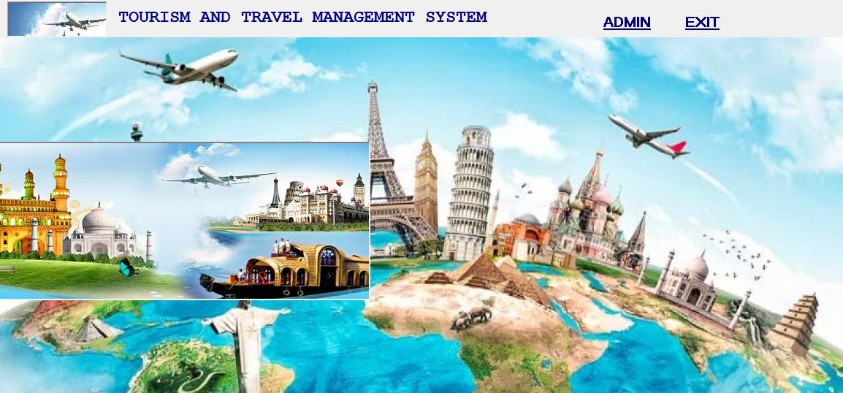

MDI FORM
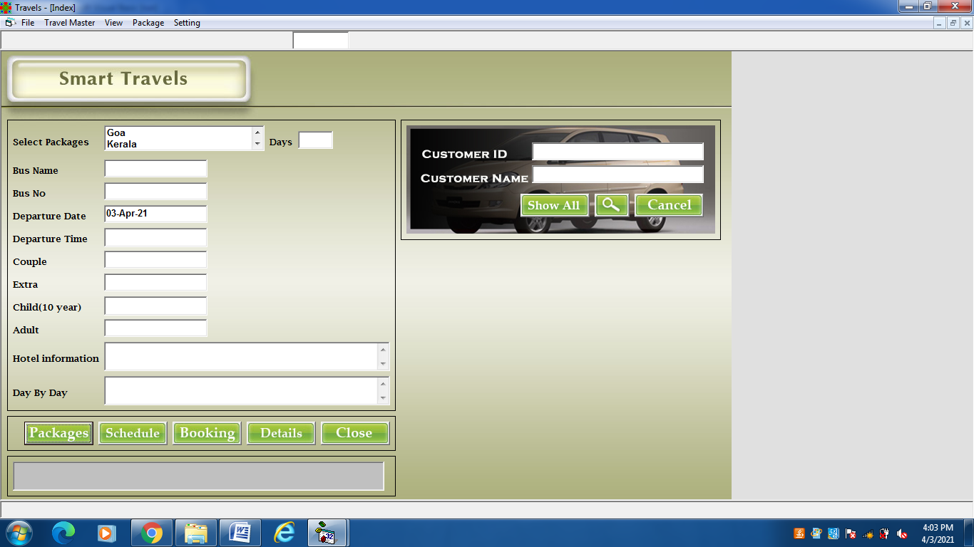

ADMIN INDEX
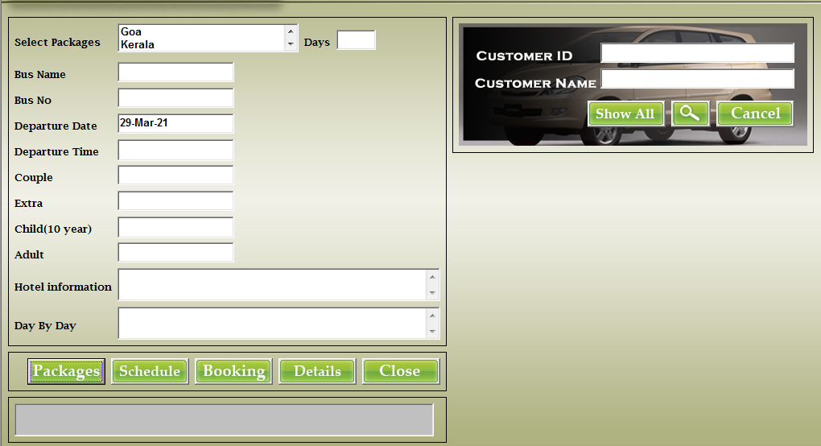

ADD PACKAGE
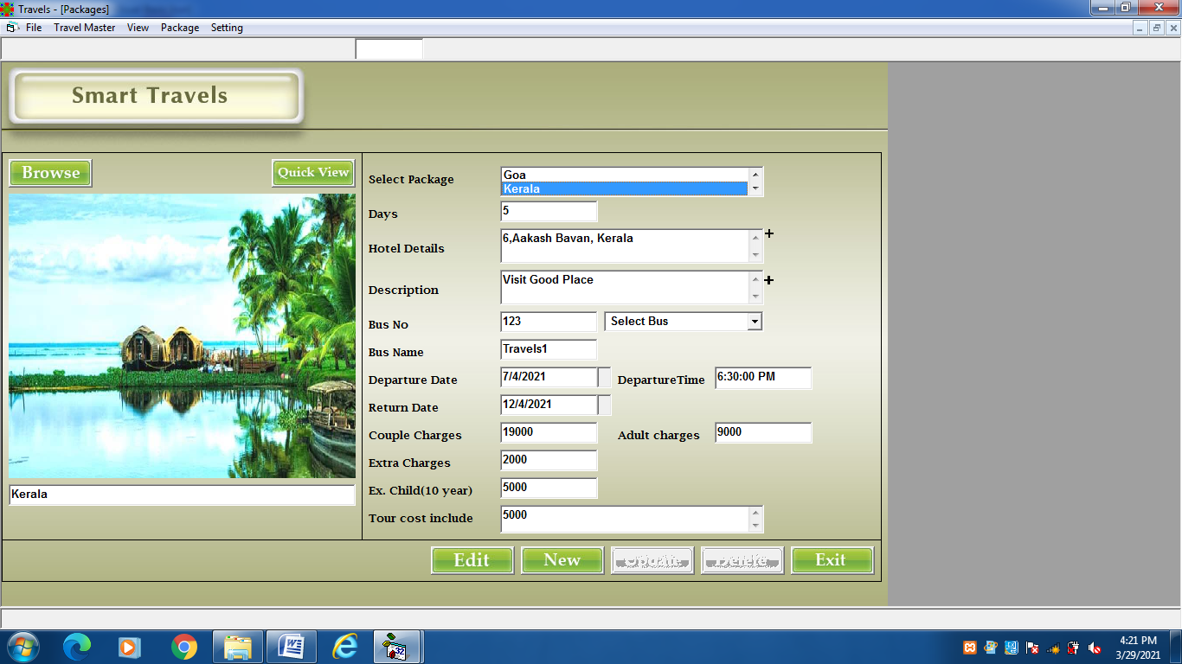

TRAVELLING MODE
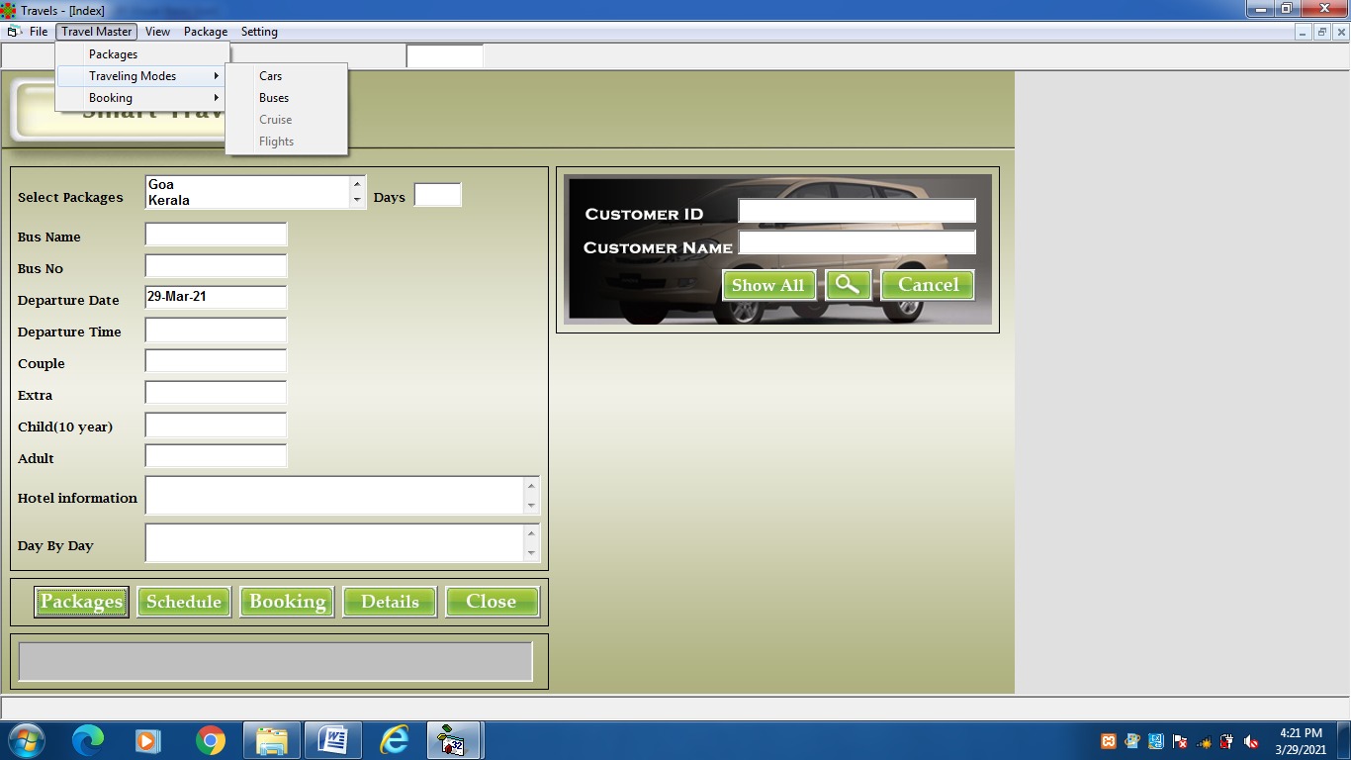

ADD CAR
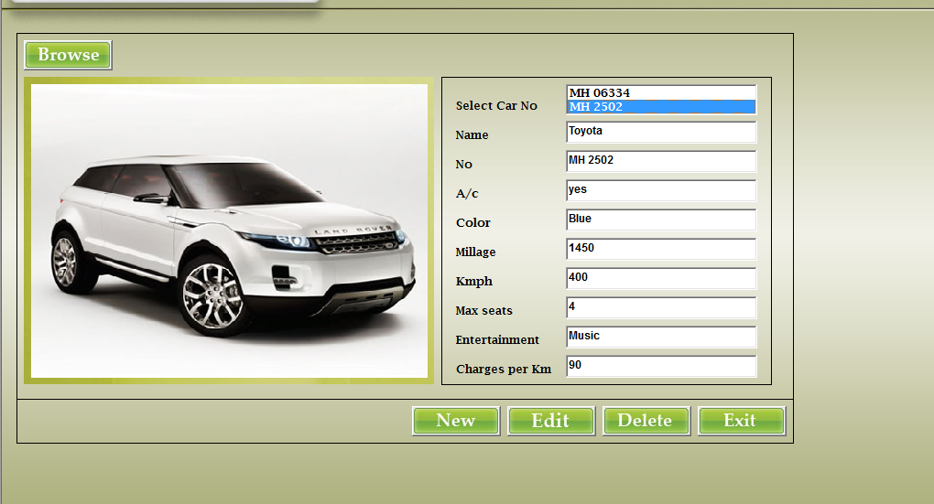

ADD BUS
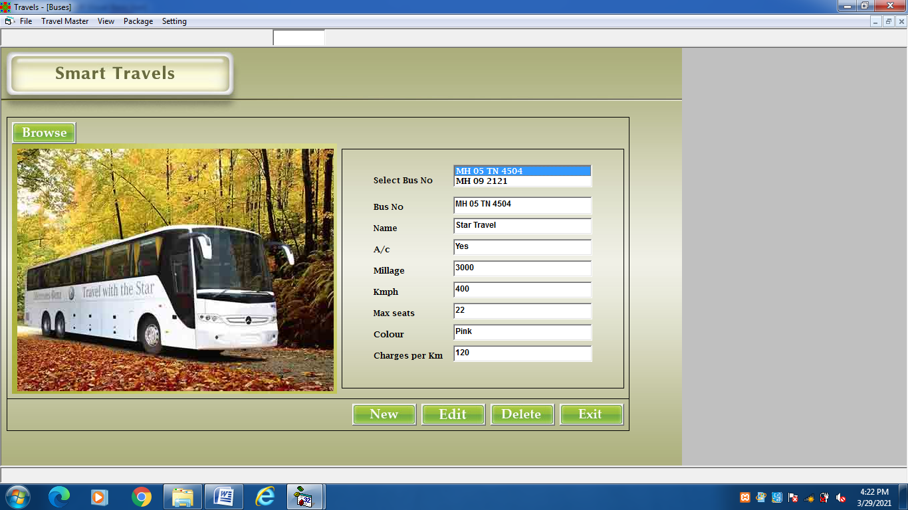

SCHEDULE
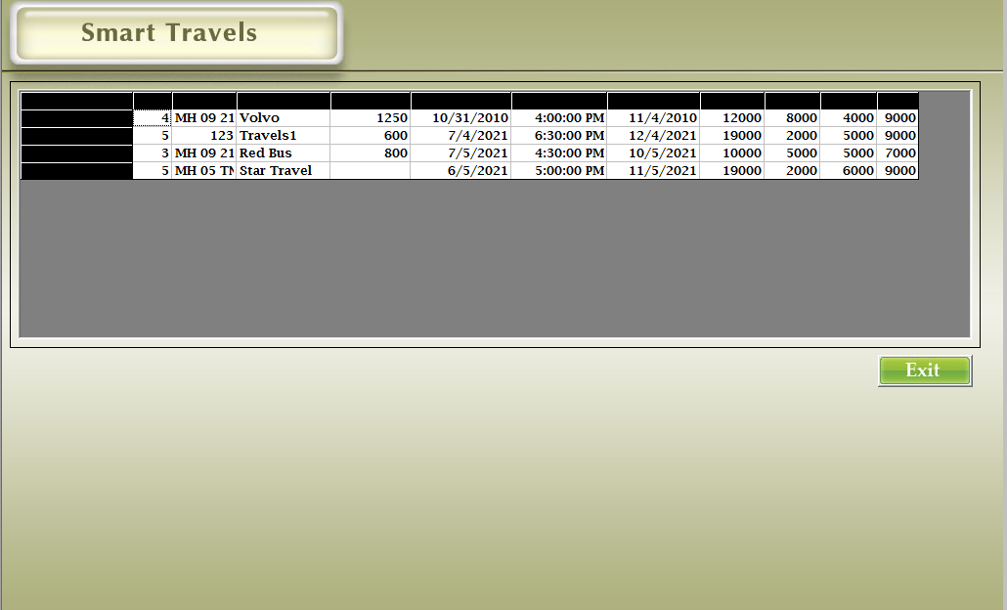

ADD EMPLOYEE
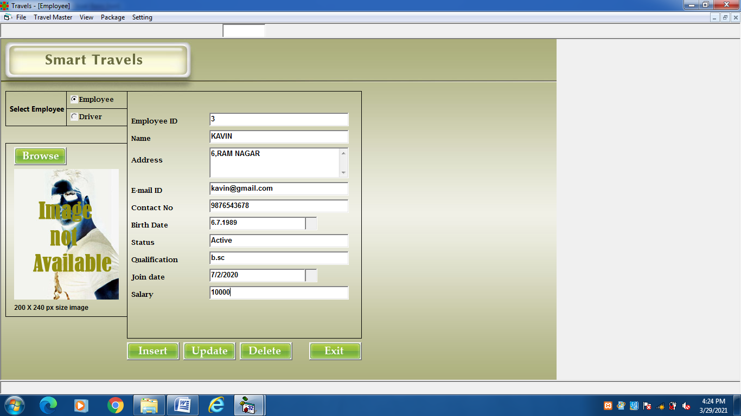

CUSTOMER DETAILS
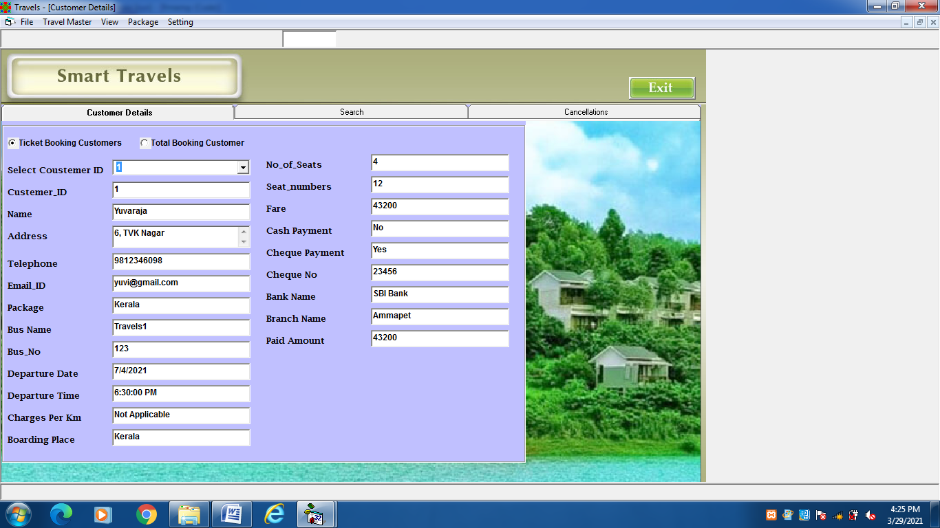

CHANGE PASSWORD

TICKET BOOKING
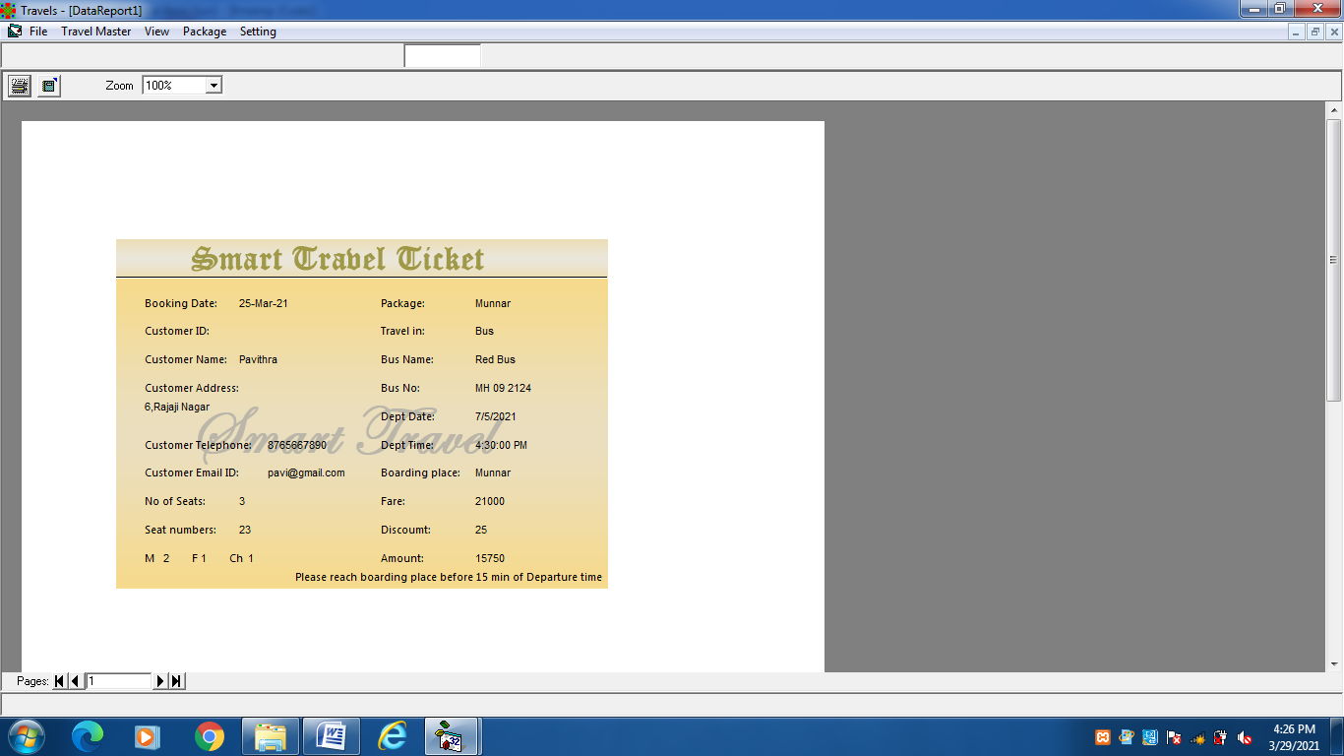

Book Package
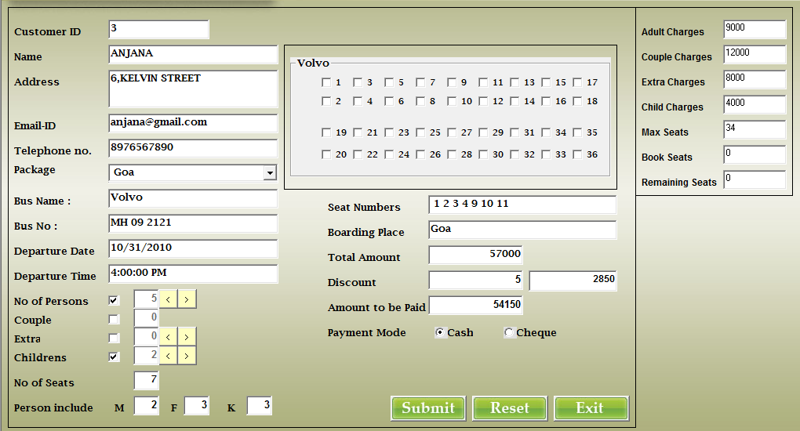

TICKET BOOKING BILL
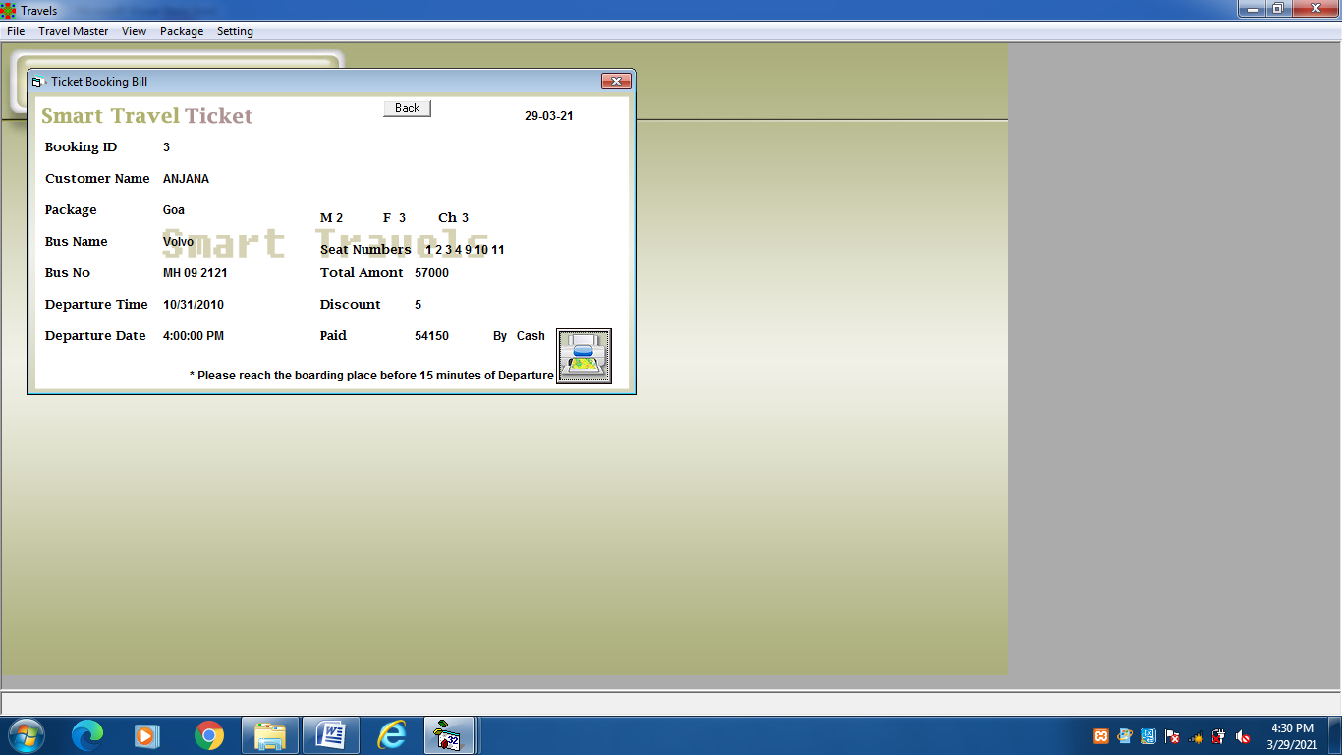
CHAPTER-V
SYSTEM TESTING
5.1 SYSTEM TESTING
System testing is the state of implementation, which is aimed at ensuring that the system works accurately and efficiently. It certifies that the whole set of programs hang together. System testing requires a test plans, that consists of several key activities and steps for run program, string, system and user acceptance testing.. Testing phase is the development phase that validates the code against the functional specifications. The objective of testing is to discover errors. To fulfil this objective a series of test step such as the unit test, integration test, validation and system test where planned and executed.
UNIT TESTING
The unit testing was conducted during the development phase. we test their specific functionality individually or with other units. However, unit testing is designed to test small pieces of functionality rather than the system as a whole. This allows us to conduct the first round of testing to eliminate bugs before the other major tests.
BLACK BOX TESTING
This test demonstrates that all software function is operational, input is properly accepted, correct output is generated and integrity of external information is maintained. Black Box testing was conducted to detect errors in the following categories.
- Incorrect or missing function
- Interface errors
- Error external database
- Performance and termination testing
All independent paths within a module have been exercised at least once.

WHITE BOX TESTING
White box testing of software is predicated on close examination of Procedural details providing test that exercise specific tests of conditions and orloops test logical paththroughthe software. This testing attempts to guarantee that All independent paths within a module have been exercised at least once.
VALIDATION TESTING
At the end of Integration Testing, software is completely assembled as a package, interfacing errors have been uncovered and correction testing begins. Software Testing and Validation is achieved through serried of black box tests that demonstrate conformity with the requirements. A test plan outlines the classes of tests to be conducted and a test procedure defines specific test cases that will be used to demonstrate conformity with requirements.
INTEGRATION TESTING
Integration testing is a systematic technique for constructing the program Structure. While at the same time conducting tests to uncover errors associated with Interfacing. The objective is to take unit tested components and built a program Structure that has been dictated by design. There is a often attempt non – incremental integration that is to construct the program using a “Big bang “approach. All components are combined in advance. The entire program is tested as a whole incremental integration is the antithesis of the bang approach.
- Top – down integration testing is an incremental approach to construct of program structure.
- The integration process is performed is a series of five steps :
- The main control module is used to test drive and stubs are substituted for all components directly subroutine to the main control module.
- Depending on the integration approach selected subroutine stubs are replaced on at a time with actual components.
- Tests are conducted as each component is integrated.
- On completion of each set of tests another stubs is replaced with the real components.

CHAPTER VI
SYSTEM IMPLEMENTATION
Implementation is the stage of the project when the theoretical design is turned out into a working system. Thus it can be considered to be the most critical stage in achieving a successful new system and in giving the user, confidence that the new system will work and be effective.
The implementation stage involves careful planning, investigation of the existing system and its constraints on implementation, designing of methods to achieve changeover and evaluation of changeover methods. Implementation is the process of converting a new system design into operation.
It is the phase that focuses on user training, site preparation and file conversion for installing a candidate system. The important factor that should be considered here is that the conversion should not disrupt the functioning of the organisation.4
The application is implemented in Microsoft visual Basic.Net as front end and Microsoft Access 2003 as back end.

An analysis of user training focuses on two factors
  - User capabilities
  - Nature of the system

Users range from the native to highly sophisticated. Hence they should be trained about the usage of software. The user should takes care to see that in the event of interruption due to power failure.

CHAPTER-VII
CONCLUSION & FUTURE ENHANCEMENTS
  - CONCLUSION:
The use of computerization has very little chances of committing any data entry error since it has enough validation check.The use MS ACCESS serves the purpose for which it has been developed ,as the user can process data much faster than manual system.The primary aim of development of the software has been to help the officials at the concern to easily manage the voluminous data
  - SCOPE OF FUTURE ENHANCEMENTS:
ASP.NET can replace the front –end tool such as HTML and CSS for more speed.To provide better facility regarding security,it uses security provides software and we can access from any place and anywhere .It can have an enhancement in the future according to the user’s requirements.

BIBLIOGRAPHY
BIBLIOGRAPHY
Books Referred:
- Steven Holzner, “Visual Basic.Net Black Book”, 2003 Edition, Dreamtech Publications
- Richards Fairley, ”Software Engineering Concepts”
- Roger S Pressman, “Software Engineering”, 2000 Edition, Dreamtech Publications

Websites:
- https://www.tutorialspoint.com/vb.net/

- https://en.m.wikipedia.org/wiki/visualbasic.net

- https://www.techopedia.com

- https://www.javatpoint.com

- https://www.techonthenet.com

- https://www.smartdraw.com

