Morphometric Variation of Rice Weevil, Sitophilusoryzae(L.)in Different Cereal and Antifungal Activity of Selected Medicinal Plants against the Mycoflora from Infested Cereals

By
Yamini.V.M
[Reg.No.16PZO013]

Thesis submitted to the
Avinashilingam Institute for Home Science and
HigherEducation for Women
Coimbatore- 641043.

In partial fulfillment of the requirement for the degree of
Master of Science in Zoology

APRIL 2018

Morphometric Variation of Rice Weevil, Sitophilus oryzae (L.) in Different Cereal and Antifungal Activity of Selected Medicinal Plants against the Mycoflora from Infested Cereals

By
Yamini.V.M
[Reg.No.16PZO013]

Thesis submitted to the
Avinashilingam Institute for Home Science and
HigherEducation for Women
Coimbatore- 641043.

In partial fulfillment of the requirement for the degree of
Master of Science in Zoology

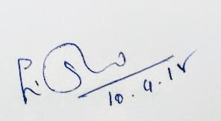
APRIL 2018


Signature of the Head of the Signature of the
Department Supervisor

ACKNOWLEDGEMENT
First and foremost, I am extremely thankful to the LORD ALMIGHTY for giving me the power to believe in myself and pursue my dreams.
I takes immense pleasure in thanking Dr. (Thiru) P.R Krishnakumar, Chancellor Avinashilingam Institute for Home science and Higher Education for women, Coimbatore, for providing the conductive infrastructure for the conduct of the research study.
I would like to thank Dr.(Tmt) Premavathy Vijayan, M.Sc., M.Ed., Dip.Ed., M.Phil., Ph.D. Registrar (Incharge), Avinashilingam Institute for home science and Higher Education for Women, Coimbatore, for the the encouragement opportunity provided to develop and establish my skills.
I extend my grateful thanks to Dr. (Tmt) A. Venmathi, M.Sc., Dip.Ed., M.Phil., Ph.D. Registrar (Incharge), Avinashilingam Institute for Home Science and Higher Education for Women, Coimbatore, for rendering adequate help required to carry out the work.
The author extends her heartfelt thanks to Dr. (Tmt) S. Kowsalya, Registrar, Avinashilingam Institute for Home Science and Higher Education for Women, Coimbatore, for the encouragement given by her during the investigation.
I express my heartful thanks to Dr. (Tmt) A.Parvathi, M.Sc., Dip.Ed.,M.Phil.,Ph.D.,Dean, Faculty of science, Avinashilingam Institute for Home Science and Higher Education for Women, Coimbatore, for her excellent support, unflinching encouragement and guidance during the cource of the investigation.
I record my deep sense of gratitude to Dr. (Tmt) E. Shanthi, M.Sc.,Dip.Ed., M.Phil.,Associate Professor and Head , Department of Zoology, Avinashilingam Institute for Home Science and Higher Education for Women, Coimbatore, for her excellent support, inspiring guidance, constant encouragement, meticulous care, constant support and tremendous care rendered for carrying out my thesis successfully.
I extend my deep sense of gratitude to Dr. K. Maheshwari, M.Sc., M.Phil.,Ph.D., Assistant Professor(SS), Department of Zoology, Avinashilingam Institute for Home Science and Higher Education for Women, Coimbatore,for her valuable advice, timely suggestions and also co-operation for the successful completion of the study.
I would like to express my sincere thanks to all the Staff Members of the Department of Zoology, Avinashilingam Institute for Home Science and Higher Education for Women, Coimbatore,for their help and support in the successful completion of this dissertation.
My special thanks to my Beloved Parents, for their help whenever required to complete this work.
I also thank All My Friends for their continuous encouragement and support throughout the work.

CONTENTS

S.NO | LIST OF CONTENTS | PAGE NO.
 | LIST OF TABLES
 | LIST OF FIGURES
 | LIST OF PLATES
1. | INTRODUCTION
2. | REVIEW OF LITERATURE
3. | MATERIALS AND METHODS
4. | RESULT AND DISCUSSION
5. | SUMMARY AND CONCLUSION
6. | REFERENCE
 | BIBLIOGRAPHY

LIST OF TABLES
TABLE NO. | TITLE | P.NO.
I | CEREALS SELECTED FOR THE REARING OF RICE WEEVIL
II | PLANT PRODUCTS EVALUATED FOR ITS EFFICACY
III | MORPHOMETRIC MEASUREMENTS OF THE RICE WEEVIL, SITOPHILUS ORYZAE IN SELECTED CEREALS
IV | MORPHOMETRIC MEASUREMENTS OF THE RICE WEEVIL, SITOPHILUS ORYZAE IN SELECTED CEREALS
V | ANTIFUNGAL ACTIVITY OF THE SELECTED MEDICINAL PLANTS AGAINST ASPERGILLUS NIGER
VI | ANTIFUNGAL ACTIVITY OF THE SELECTED MEDICINAL PLANTS AGAINST ASPERGILLUS FLAVUS
VII | ANTIFUNGAL ACTIVITY OF THE SELECTED MEDICINAL PLANTS AGAINST TRICHODERMA

LIST OF FIGURES
FIGURE NO. | TITLE | PAGE NO.
I | MORPHOMETRIC MEASUREMENTS OF THE RICE WEEVIL, SITOPHILUS ORYZAE IN SELECTED CEREALS-BODY LENGTH
II | MORPHOMETRIC MEASUREMENTS OF THE RICE WEEVIL, SITOPHILUS ORYZAE IN SELECTED CEREALS-ANTENNA LENGTH
III | MORPHOMETRIC MEASUREMENTS OF THE RICE WEEVIL, SITOPHILUS ORYZAE IN SELECTED CEREALS-ROSTRUM LENGTH
IV | MORPHOMETRIC MEASUREMENTS OF THE RICE WEEVIL, SITOPHILUS ORYZAE IN SELECTED CEREALS-THORAX LENGTH
V | MORPHOMETRIC MEASUREMENTS OF THE RICE WEEVIL, SITOPHILUS ORYZAE IN SELECTED CEREALS-FORE LIMB LENGTH
VI | MORPHOMETRIC MEASUREMENTS OF THE RICE WEEVIL, SITOPHILUS ORYZAE IN SELECTED CEREALS-MID LIMB LENGTH
VII | MORPHOMETRIC MEASUREMENTS OF THE RICE WEEVIL, SITOPHILUS ORYZAE IN SELECTED CEREALS-HIND LIMB LENGTH
VIII | MORPHOMETRIC MEASUREMENTS OF THE RICE WEEVIL, SITOPHILUS ORYZAE IN SELECTED CEREALS-WING LENGTH
IX | MORPHOMETRIC MEASUREMENTS OF THE RICE WEEVIL, SITOPHILUS ORYZAE IN SELECTED CEREALS- ABDOMEN LENGTH
X | MORPHOMETRIC MEASUREMENTS OF THE RICE WEEVIL, SITOPHILUS ORYZAE IN SELECTED CEREALS-WEIGHT OF INSECTS
XI | ANTIFUNGAL ACTIVITY OF THE SELECTED MEDICINAL PLANTS AGAINST ASPERGILLUS NIGER
XII | ANTIFUNGAL ACTIVITY OF THE SELECTED MEDICINAL PLANTS AGAINST ASPERGILLUS FLAVUS
XIII | ANTIFUNGAL ACTIVITY OF THE SELECTED MEDICINAL PLANTS AGAINST TRICHODERMA

LIST OF PLATES
PLATE NO. | TITLE | PAGE NO.
I | A. MORPHOMETRIC ANALYSIS- EXPERIMENTAL SETUP
II | - MALE AND FEMALE OF SITOPHILUS ORYZAE INSECT  - VARIOUS SIZE OF INSECTS IN SELECTED CEREALS
III | TEST PLANTS EVALUATED FOR ITS ANTIMYCOBIAL ACTIVITIES
IV | ISOLATED FUNGAL STRAINS FROM INFESTED CEREAL
V | ANTIFUNGAL ACTIVITY OF SELECTED MEDICINAL PLANTS AGAINST ASPERGILLUS NIGER
VI | ANTIFUNGAL ACTIVITY OF SELECTED MEDICINAL PLANTS AGAINST ASPERGILLUS FLAVUS
VII | ANTIFUNGAL ACTIVITY OF SELECTED MEDICINAL PLANTS AGAINST TRICHODERMA

I. INTRODUCTION
The term cereal is a derivative from Latin word 'cerealis' meaning ‘grain’ which is botanically, a type of fruit called a caryopsis, composed of the endosperm, germ and bran. The cereals are annual common grass members of the grass family (a monocot family Poaceae, also known as Gramineae), which usually have long, thin stalks, such as wheat, rice, maize, sorghum, millet, barley and rye,whose starchy grains are used as food. Cereal science is a study concerned with all technical aspects of cereal. It is to study thenature of the cereals and the changes that occur naturally and as a result of handling and processing.
Cereal grains have been the principal component of human diet and have played a major role in shaping human civilization for thousands of years. Around theworld; rice, wheat, and maize, and to a lesser extent, sorghum and millet are important staples and critical to daily survival of billions of people. More than 50% of world’s daily caloric intake is derived directly from cereal grains consumption. Most of the grains used for human food are milled to remove the bran (pericarp) and germ, primarily to meet sensory expectations of consumers. The milling process strips the grains of important nutrients including dietary fiber, phenolics, vitamins and minerals which are beneficial to health (Awika, 2011).
The studies have shown that whole grains consumption are associated with diminished risk of serious diet-related diseases. These conditions include coronary heart disease,certain cancers (especially of the large bowel), inflammatory bowel disease and disordered laxation. Carbohydrates are important contributors to the health benefits of whole grains. Insoluble non-starch polysaccharides (major components of dietary fiber) are effective laxatives. While soluble non-starch polysaccharides (especially mixed-link β-glucans) has lower plasma cholesterol and so can reduce heart disease risk, but, the effect is inconsistent (Topping,2007).
Stored grains are subject to losses due to a number of causes which includes physical, sanitary and nutritional deprivation, from their maturation to the utilization. In India the damage of stored grains by insect pests was estimated to 6.5 percent of the total grain storage (Raju, 1984). Among the stored grain pests, the rice weevil, Sitophilus oryzae(Linnaeus, 1763) (Coleoptera,Curculionidae), is one of the significant pests of stored rice causing both quantitative and qualitative losses to grain imparting severe economic loss (Aslam et al.2004; Shaaya et al. 1991). Regardless of the accessibility of modern technologies for grain storage and pest control,some farmers still use traditional methods of storage and pest control. Grain stored under such conditions is very susceptible to heavy losses (Aslam et al.2004).
Understanding of the pest life-cycle is thus the prerequisite for the adoption and execution of the proper management strategy. A considerable work on the life cycle of S.oryzae though had been carried out but expressed variable results (Wille 1923; Bheemanna 1986; Barbuiya et al., 2002). The duration of each life cycle (Wille, 1923), the characteristics of the morphs (Barbuiya et al. 2002) of each growth stages and the number of generation in each year (Bheemanna 1986) varied considerably in consideration of both the prevailing climatic factors and the food source.
Insects show morphometric variations associated with the environment which may be result of either phenotypical responses or genetic inheritance, or both. (Begon et al.,2006) reported that the individuals that composed a species population are not identical and may vary, sometimes very slightly, in size, development rate and/or in response to temperature. Studies point out that the variation in body size is a property of natural populations and has important ramifications for the understanding of the dynamics and stability of ecological systems (Filin and Ovadia, 2007). Assessing the morphometric characteristics of insects has been very useful in population studies, in terms of communities, and is used for the identification of nymph stages, features of sexual dimorphism (Cepeda-Pizarro et al.,2003; Domenico, 2005; Cherril, 2005; Franceschini et al., 2005; Ferreira et al., 2006; Seffrin et al., 2006), life history and evolution with host plants (Ahnesjo and Forsman, 2003; Adis et al., 2008).
Aflatoxin contamination of crops is a worldwide food safety concern. Aflatoxins refer to a group of four mycotoxins (B1, B2, G1 and G2) produced primarily by two closely related fungi, A. flavus and A. parasiticus. Many strategies, including natural control, biological control, control of insect pest, development of resistant cultivar, have been investigated to manage aflatoxins in crops. Among them, natural control appears to be the most promising approach for control of aflatoxins in post-harvested crops.
Health hazards from exposure to toxic chemicals and economic considerations make natural plant extracts ideal alternatives to protect food and feed from fungal contamination (Reddy et al., 2009). An inhibitory effect of neem extracts on biosynthesis of aflatoxins (groups B and G) in fungal mycelia was reported by Bhatnagar et al. (1990). In an another study aflatoxin production by A. parasiticus was suppressed depending on the concentration of the plant aqueous extract added to the culture media at the time of spore inoculation. Aflatoxin production in fungal mycelia grown for 96 h in culture media containing 50% neem leaf and seed extracts was inhibited by 90 and 65%, respectively (Razzaghi-Abyaneh et al., 2005).
Fungal contamination of stored commodities is a very serious problem in tropical warm regions of the world. Contamination by storage fungi and their mycotoxins is of great concern in herbal drug and food industry. Fungi, especially the species of Aspergillus and Penicillium are among the major reported genera having the ability to produce mycotoxins during storage (Gautam and Bhadauria, 2008; 2009). These fungi producing related mycotoxins reduce the quality of food products and the medicinal potential of herbal drugs. In previous reports, A. niger (commonly known as black Aspergilli), was recorded as a most dominating fungal species to be associated with herbal drugs during storage (Bugno et. al., 2006, Gautam and Bhadauria, 2008; 2009). A. niger is a saprophytic and filamentous fungus found in soil, forage, organic debris and food product, causing black mould of onion, Shallot; stem rot of Dracaena; root stalk rot of Sansevieria; and boll rot of Cotton; spoilage of cashew kernels, dates, figs, vanilla pods and dried prune (Bobbarala et. al., 2009).
The use of chemical pesticides is a very popular practice to control various plant diseases management as compare to natural one which are prepared from plants or plant parts. But, consumer now demands less use of synthetic fungicides due to the non-biodegradability, pollutive nature and residual toxicities of chemical pesticides. Several studies have revealed the plant extracts as source of natural pesticides that make excellent efforts for new pesticide development (Arokiyaraj et. al., 2008; Gangadevi et. al., 2008; Brindha et. al., 2009). Since, many spices and herbs have been used for centuries as preservatives for foods and medicinal purposes, some of them possess antimicrobial potential in combination and is considered as alternatives to conventional antimicrobial agents especially in this era of antimicrobial drug resistance (Nwaopara et. al., 2009).
The preservative actions of herbs and spices have received much attention in the literature where studies have been reported and showed that mycotoxin-producing molds may be inhibited by some herbs and spices. They generally produce many secondary metabolites such as alkaloid, flavonoids, tannins and phenolic compounds which are the important sources of microbicides, pesticides and many pharmaceutical drugs (Mahesh and Satish, 2008). Therefore, the main objectiveof this study was to evaluate the antifungal efficacy of commonly used spices against the growth of A. niger.
In view of the above facts, a study was conducted with the following objectives.
- To access the influence of different cereals on size of S. oryzae by traditional morphometric measurements.
- To find out the more susceptible and resistant of cereals against S. oryzae.
- To screen the antimycobial activity of selected medicinal plants against the mycoflora isolated from heavily infested cereals.

II. REVIEW OF LITERATURE
The literature pertaining to the infestation of rice weevil, Sitophilus oryzae in different cereals and their morphometric variation in variety of cereals have been reviewed for the present work. The antifungal properties and other activities of the selected medicinal plants were also analysed under the following headings.
II. 1. Prevalence of rice weevil in cereals
Rice weevil, Sitophilus oryzae is an internal primary feeder of all the cereals. It damages the grain by feeding the endosperm of the cereal and thus causing major damage to the food grains and makes them unfit for consumption.
Subedi et al., 2009 suggested storage grain losses of major cereal crops can be attributed primarily to attack by rice insect pests, diseases, and rodents (Rana and K.C., 1977). It is generally believed that half of the storage losses are usually caused by insects. In Nepal, Sitotroga cerealella L., Sitophilus spp., and Rhyzopertha dominica L. are among the major pests of stored rice grains (Neupane, 2002). Storage grain loss is 7-10% in Nepal. Of these pests, Sitophilus oryzae is the most cosmopolitan in nature, and causes severe losses in rice, maize, barley, wheat, and other crops (Bhatia et. al., 1975; Singh et. al., 1980; Neupane, 1995). While the hot, humid climate of Southeast Asia is quite suitable for rice cultivation, it is equally suitable for rapid stored-product insect development which can result in explosive outbreaks, potentially causing devastating post-harvest rice grain damage.
S. oryzae is universally regarded as one of the most destructive primary pests of stored cereals such as barley, maize, rice, and wheat. Annual grain loss in storage due to these insects approaches 15% (Joshi et al., 1991). It is estimated that 20% of the total maize harvest is lost annually due to insect pest attack (Upadhyay et al., 2001). In one study, the maximum grain loss in wheat attributable to a single weevil was measured at 19%, and it was nearly 57% in rice (Banerjee and Nazimuddin, 1985). Five host crops (polished rice, rough rice, wheat, maize, and barley) were tested to determine the host preference of S. oryzae under free and nochoice conditions. Grain weight decrease, number of F1 progeny and percent grain damage differed significantly among the various selected host grains. Grain weight loss was found to be the greatest in polished rice (14.11%) and it was the least in rough rice (2.95%). The greatest percentage of weight loss was observed in wheat. A similar finding was reported by (Banerjee and Nazimuddin 1985), where the maximum single kernel weight decrease attributable to an individual larva was 57 and 19 percent in rice and wheat, respectively. Regarding individual insect consumption, it has been reported that Sitophilus oryzae and Rizopertha domonica can consume 0.49 mg and 1.5 mg (respectively) of grain daily and produce 11-12 mg and 54 mg ( respectively) of waste products throughout their lives . Percent grain damage was assessed at 15, 30, 45, and 60 days following experiment inception. The greatest grain damage was observed in polished rice (18.75% for free choice and 14.00% for no choice) and was followed by wheat (16.25% for free choice and 12.50% for no choice). These values are not unexpected, considering that an exceedingly high level of damage (67.78%) was reported by in wheat, while the level was 40.97% in maize. In this study, F1 progeny population (adults) was greatest in polished rice (138.8 in free-choice and 122.5 in no-choice). These values were followed by wheat, maize, barley, and rough rice. (Teotia and Tewari 1977) studied the ovipositional behavior and development of Sitophilus oryzae L. on various natural foods, and observed that oviposition was higher in rice and wheat grains and lower in un-husked barley and maize. In fact, previous studies have revealed that rice (followed by wheat, jowar, barley, and maize) is the most preferred host in terms of oviposition (Teotia and Tewari, 1977).
II.2 Morphometric analysis
Morphometric analysis of the rice weevil, Sitophilus oryzae was meager. Therefore a study of morphometric analysis of different insects were reviewed.
Przybycien and Waclawik 2015 reported that the morphometry has been one of first method used in biological studies but today, in “molecular era’, it is still relevant for discovering biodiversity (Wanek & Sturmbauer 2015) and resolving phylogenies (Klingenberg & Marugán-Lobón 2013). Morphometric measurements are widely used in integrative approach to systematics along with molecular data (Ober & Connolly 2015) which may result in taxonomical revision (Grobler et al., 2006). One of the most important questions is which morphological traits should be chosenfor such analysis. Variability of some traits better reflects phylogeny of taxa than variability of the others (which can be checked by comparison with DNA phylogeny). Redundancy of used traits can lead to disturbance of obtained results in attempt to resolve phylogeny based on morphological variation. There are many methods for finding appropriate measurements, for example Principal Components Analysis (PCA)(Rensburg et al., 2003). When correctly chosen, morphometric measurements may be very helpful in establishing phylogeny, especially of species which are not easy to distinguish due to few or even no diagnostic traits (De Bivort et al., 2010; Navia et al., 2015). Also, when there is a conflict between morphological and molecular data, this does not always mean that morphology is uninformative. Such kind of conflict may result from many flaws of molecular analyses (Watanabe et al., 2015), which are connected with such proesses as introgression, incomplete lineage sorting or influence of endosymbionts (Stewart et al., 2014; Whitworth et al., 2007).
Claver and Yaqub 2015 reported that morphometry is the measurement and analysis of form and the main premise of morphometrics is that a statistical analysis of genetic variability expressed by morphological character, a measure of population differentiation, and ultimately of speciation (Sorensen and Foottit, 1992; Dujardin et al., 1999).
Jadhav et al., 2017 reported correct identiﬁcation of an insect pest is a pre-requisite for any pest management programme. Morphometric analysis is useful in ﬁnding morphological differences to distinguish closely related species and propose new species (McNamee1993; Adsavakulchai et al., 1999). Deoxyribonucleic acid (DNA) barcoding is the current molecular tool of choice for supporting insect identiﬁcation. DNA barcoding utilizes a short genetic sequence of about 650 base pairs from the cytochrome c oxidase subunit 1(COI) of the mitochondrial gene (Jinbo et al., 2011; Folmer et al., 1994). Use of DNA barcoding in taxonomy for rapid species descriptions was suggested by many workers (Virgilio et al., 2010; Herbert et al., 2003; Ball et al., 2006). DNA Barcoding as a reliable tool for identiﬁcation of Coleoptera was reported by (Greenstone et al., 2005). The high speciﬁcity of the COI region makes it an ideal tool for diagnostics (Jalali et al., 2015; Hebert et al., 2004). Effectiveness of this approach have also been established in birds (Hebert et al., 2004), ﬁsh (Barrett et al., 2005) and spiders. DNA barcoding systems are being established for plants (Kress et al., 2005), macroalgae (Saunders et al., 2005), fungi (Summerbell et al., 2005), protista (Scicluna et al., 2006) and bacteria (Sogin et al., 2006) as well. DNA barcoding is poised to contribute to taxonomic research and International Nucleotide Sequence Database (GenBank) has adopted a unique keyword identiﬁer (BARCDE) to recognize standard barcode sequences speciﬁed by the scientiﬁc community such as Consortium for the Barcode of Life (CBOL) (Hajibabaei et al., 2007). Identiﬁcation of insects using DNA barcodes serves as supplementary conﬁrmation tool for the taxonomic characteristics of the insects (Jinbo et al., 2011).
Dujardin 2011 descried that the phenotype is the product of the interaction between genes and environment. Phenotypic variation is then an expected outcome of more than one factor. It can be scored by measurable changes in anatomy, morphology, physiology, life history, behavior, etc. (West-Eberhard, 1989; Gadagkar and Chandrashekara, 2005).
Morphometric techniques aim at measuring size, shape, and the relation between size and shape (allometry). Before the so-called “revolution” (Rohlf and Marcus, 1993), shape was an abstraction, a residue after scaling for size, and it was not possible to visualize the “residue.” The replacement of initial variables describing a distance between two anatomical points by the coordinates of these points, and the subsequent visualizing techniques, represented a giant step in the direct study of forms. The shift from traditional morphometrics to more complex geometric functions was facilitated by the development of image processing tools. Not only land- mark methods but also “outline methods” (Rohlf and Marcus, 1993) and other techniques exploring textures and surface patterning (Lestrel, 2000) are used today.
Silva et al., 2013 reported that insects show morphometric variations associated with the environment which may be result of either phenotypical responses or genetic inheritance, or both. Begon et al. (2006) reported that the individuals that composed a species population are not identical and may vary, sometimes very slightly, in size, development rate and/or in response to temperature. Studies point out that the variation in body size is a property of natural populations and has important ramifications for the understanding of the dynamics and stability of ecological systems (Filin and Ovadia, 2007). Assessing the morphometric characteristics of insects has been very useful in population studies, in terms of communities, and is used for the identification of nymph stages, features of sexual dimorphism (Zolessi, 1956; Turk and Barrera, 1976; Cepeda-Pizarro et al., 2003; Domenico, 2005; Cherril, 2005; Franceschini et al., 2005; Ferreira et al., 2006; Seffrin et al., 2006), life history and evolution with host plants (Klingenberg and Spence, 1997; Ahnesjö and Forsman, 2003; Adis et al., 2008), as well as ecological studies of populations and communities (Dirsh, 1953; Roonwal, 1981; Filin and Ovadia 2007; Pires et al., 2008).
Kucluet al., 2010 suggested that size and shape variation is important in understanding ecological relationships because it generally correlates with the biology of many species. Body size is one of the most significant features of organisms and is correlated with a large number of ecological and physiological variables. In mosquitoes, body size has been shown to affect factors such as longevity, fecundity, and size of the blood meal (Silver and Renshaw 1999).
Alves and Hernandez 2017 reported the body shape is directly associated with several important ecological aspects, such as high speed displacement capabilities, and consequently predator prey interactions (Walker 2005; Gahan 1906). Shape characteristics can give advantages to males in sexual selection, having greater chances of mating (Fletcher 1919). Modiﬁcations in body shape offer advantages to certain types of behavior, such as foraging (Mathur and Singh 1959), reproduction and habitat use (Duffey 1953). Body morphology is also linked with community structuring since differences in shape are usually associated with different feeding and nesting strategies. Consequently, shape can be associated with better adapted competitors with improved foraging strategies in a particular community (Duffey 1980). In addition to providing important information on species ecology, body shape may also indicate the effects of possible environmental stressors on individuals. These environmental stressors may be natural, such as ultraviolet radiation Vinson (1962), or may be anthropic, like pollution (Makihara H, Mannakkara H, Fujimura T, Ohtake A 2008). Morphologicalalterations may imply possible ecological consequences, such as reduction in feed and displacement capacities (Vives 2009) Thus, in the face of environmental disturbances, body shape alterations may be classiﬁed as sublethal effects, and can affect an individuals ﬁtness. Sublethal effects are deﬁned as the physiological or behavioral changes in individuals exposed to chemical compounds.
Mehrparvar et.al.2012 carried out morphometric analyse on some populations of Aphis craccivora Koch (Hemiptera: Aphididae) associated with different host plants. Twelve morphological characters were measured. Two multivariate discriminant analyses, Canonical variates analysis and Cluster analysis were employed to discriminate individuals of A. craccivora populations on amorphological basis. Both Canonical variates analysis and Cluster analysis revealed significant differences among A. craccivora collected from different host plants.
A stepwise Canonical variates analysis selected four morphological characters (siphunculus length, ultimate rostral segment length, basal diameter of siphunculus and processus terminalis length) from which two (siphunculus length and ultimaterostral segment length) showed the highest contribution to the separation of host-associated populations and 87.6% of individuals were again classified correctly into their original populations. The result of morphometric analyses performed here revealed the existence of three morphologically differentiated groups within A. craccivora associated with different host plants which provide evidence for the presence of host related forms.This study demonstrates that morphometric analysis of morphological characters can discriminate among host related groups based on size variation and clearly separates the individuals of A. craccivora. The aphid population associated with Robinia pseudoacacia was clearly separated from other populations. The most importantdiscriminatory characters of A. craccivora and their functions in relation to adaptation of populations with different host plant species are discussed. The results of morphological structure of A. craccivora provide the framework to investigate the genetic and biological differences among these entities so that we could be able to exactly evaluate their taxonomic situation.
Devi et al.,2014 studied the biology and morphometry of Callosobruchus maculatus. The life cycle consisted of egg, four larval instars (L1, L2, L3 and L4), pupa and adult. The morphometric measurementsrevealed that the average length and breadth of egg were 0.47± 0.08 mm and 0.12± 0.21 mm respectively. The mean length and breadth of L1, L2, L3 and L4 were 0.60± 0.03 mm, 1.19± 0.05 mm, 2.43± 0.15 mm, 3.64± 0.18 mm and 0.22± 0.03 mm, 0.77± 0.02 mm, 1.22± 0.08 mm, 2.00± 0.11 mm respectively. The average length of male pupa and female pupa was 4.07± 0.00, 4.57± 0.07 mm and breadth was 2.35± 0.07 mm, 2.60± 0.06 mm respectively. The average length and breadth of male and female adult was 3.21± 0.06 mm, 3.70±0.12 mm and 1.91± 0.05 mm, 2.17±0.05 mm respectively. The life cycle took 45-48 days for completion.

Rajak et al.,2016 analysed the morphological characters of Apis dorsata worker bees were analyzed after collecting moribund worker bees from different areas in Mysore District that experiences climate of semi-malnad type in southern dry zone part of Karnataka. Around 32 morphological characters were measured with the help of computer aided microscope Axion Vision ref. 4.8 software. The thorax, abdomen and overall body length showed significant variation between the workers bees. However, head length didn’t show significant variation between the worker bees which belong to different areas. Interestingly, the head breadth, tongue length, mandible and antenna length showed significant variation between the worker bees. Further, length of thorax, length & breadth of fore wing, hind wing and hamuli numbers also showed significant difference between A.dorsata worker bees except the thorax breadth. Furthermore, fore leg and mid leg length showed significant difference between worker bees of different areas excepting the hind leg. Pearson’s correlation studies revealed that there is a considerable relationship existed between few morphological traits and the body length of A. dorsata worker bees collected from different areas of Mysore District. Thus, it can be concluded that morphometric variations perhaps discriminate intraspecific groups of honeybee colonies as different ecotypes. Although it is simple, computer program-assisted morphometric analysis of the wing and body parts might provide useful information for honeybee biodiversity studies.
Salami et al., 2017observed the developmental stages of Callosobruchusanaliswere observed under laboratory conditions at 28±2°C and 72±5% relative humidity. The results showed that female C. analisbegan to lay eggs within 24hours and have an oviposition period of 8.50 ± 0.70 days and an average of 13.00±0.50 eggs were laid by individual C. analisthroughout their lifetime. The mean developmental periods from egg to larva and larva to pupa were observed to be 8.50±0.79 and 4.50±0.70 days, respectively. The unmated bruchids were observed to have lived longer than the mated bruchids as the unmated bruchids lifespan was on average 10.50±0.81 days, as opposed to 2.50±0.75 days for mated females. Adult male C. analishave an average antenna length of 2.96±0.08 mm which is slightly longer than 2.42±0.12 mm on average for female bruchids.
Bamidele et al.,2012 investigated themorphometry of the dry-season population of adult pyrgomorphid grasshopper from six different locations in southern Nigeria were investigated with a view to determining the similarity of the large populations of the pyrgomorphid grasshopper, arising from the recent large scale cultivation of cassava plant in Nigeria. Measurements of body parts including forewing length, hindwing length, pronotum width, pronotum length, head width, body length, femur length, tibia length, tarsus length and antenna length of male and female specimens from each of the locations were made. The results showed that male and female from different locations were statistically different from each other in morphological characters (Wilk's Lambda 0.41, P < 0.001), with the body length, pronotum length, pronotum width, and head width, being the best discriminatory characters. Canonical variate analysis (CVA) also showed that male specimens from all locations form clusters with overlapping ellipses with Port-Harcourt and Abakaliki populations being the most distinct.The CVA plot for the female specimens from the six locations also revealed overlapping ellipses with Port-Harcourt specimens being very distinct from the other populations. The discriminant function analysis showed that the male and female specimens from Port-Harcourt were the most correctly classified compared to specimens from other locations studied. The present study demonstrated the morphological similarities between the male and female populations in southern Nigeria. However, the study confirmed the existence of some morphological differences within the male and female population from different locations.
Klingenber, 2001 observed that developmental mechanisms are usually assumed to evolve by natural selection of the morphological traits they produce. Therefore, information on phenotypic traits is an important component of comparative studies of development. Morphometrics permits the rigorous quantitative analysis of variation in organismal size and shapeand is increasingly being used in developmental contexts. The new methods of morphometrics combine a geometric concept of shape with the procedures of multivariate statistics, and constitute a powerful and ﬂexible set of tools for analyzing morphological variation. This paper brieﬂy reviews these methods and provides examples of their application in studies of genetic variation and developmental modularity. The results of morphometric analyses can be readily interpreted in relation to the geometry and anatomical structure of the parts under study. Genetic studies of shape in the mouse mandible found two recurrent patterns in environmental and genetic variation from different origins, suggesting that the development system ‘channels’ the phenotypic expression of variation in similar ways. Moreover, by analyzing the correlations of left-right asymmetries of morphometric traits, it is possible to delimit the spatial extent of developmental modules. These methods complement the experimental approaches of developmental biology and genetics and can be expected to be especially fruitful in combination with them.
II. 3 Natural products from plants as fungicides
In early fifties of the twentieth century the agrochemical industry provided agriculture with a vast array of chemicals for crop protection, including fungicides. Random synthesis, biological screening and empirical optimization yielded many effective compounds (Cremlyn, 1991). Whereas it is generally acknowledged that the use of pesticides has large benefits to farmers, the present use of pesticides in agriculture also causes negative environmental (and health-related) effects to society. For example, during and after application of pesticides a substantial amount of it could end up in soil, ground- and surface water or air. These negative effects demands for an effective policy. Such policies have been initiated, both at the level of the individual Member States of the European Union and at the level of the European Union itself (Oppenheimer & Donnelly, 1997). Their selectivity between target organisms and plants is mainly based on differences in uptake. The more recently developed protective chemicals are more potent in terms of dose required to control the pest or disease, and in distinguishing between target and non-target organisms. They usually have a specific mode of action. Since selective compounds are specific site inhibitors in the metabolism of target organisms, the risk of developing resistance is high. This has occurred for a number of fungal plant pathogens (Delp, 1988).
Although pathogenic microorganisms are mainly controlled chemically, the use of synthetic compounds is limited due to several undesirable aspects, which include carcinogenicity, teratogenicity, acute toxicity and the requirement of an extended degradation period with consequent development of environmental pollution problems. The new awareness of modern consumers about these problems has created a “green” consumer profile that demands the absence of synthetic chemicals in food production and preservation together with extended shelf life of the majority of food products. Fungal infections remain a therapeutic problem in many fields despite the availability of a number of treatments. Such diseases in humans have markedly increased during the past ten years, especially in immune compromised patients. Consequently, up to 10% of hospital acquired systemic infections are caused by fungi. Altogether this forces the scientific community, agro–industry and pharmaceutical companies to search for natural compounds that will satisfy consumer requirements (Harvey, 2008). Furthermore, there is growing concern about chemicals for protection because of their undesirable side effects in humans, other target organisms and their behavior and fate in the environment (Jespers, 1994).
The total number of all known natural products is around one million, including both bioactive and inactive compounds, plants metabolites 600000, fungal metabolites 8600, microbial metabolites recognized until now is around 50000. It is an obvious question, where is the border in the diversity of natural products? The general needs of the human society are continuously increasing. We need every new compounds which may be useful for the human society. More food, new drugs, and other goods are highly necessary for the benefit of humankind. The only question is the existence of sufficient natural and technical resources to fulfill these demands. Fortunately, in the area of the research of bioactive microbial products it seems that the ever expanding scientific and technical possibilities are increasing together with the continuously widening needs of the human therapy, veterinary and agriculture. The problem really is not whether we would be able to discover further new useful microbial compounds, but rather how can we optimize and quickly and effectively apply the chances derived from the new discoveries. How can we pick up and use effectively the proverbial needle found in the haystack (Berdy, 2005).
However, screening of more than a million substances in the last decade has resulted in the introduction of only a very limited number of compounds with novel modes of action and resistance. This explains the renewed interest of the chemical industry in natural compounds with a variety of unique characteristics, waiting to be exploited. Natural products derived from plants and fungi have traditionally been used in ethnomedicine. Throughout the development of both Western and Eastern civilizations, whole plants, fungi, their parts, derived compounds and extracts have functioned as sources of food and medicine, symbolic articles in religious and social ceremonies, and remedies to modify behavior. Plant and fungal extracts and compounds containing physiologically active biochemicals have immense potential for producing new agents of great benefit to mankind. In this context, systematic screening of secondary metabolites of folk herbs and fungi may result in the discovery of novel and effective antimicrobial compounds (Hussain et al., 2011). Recently, interest has been growing in natural products due to their availability, fewer side effects and less toxicity as well as better biodegradability when compared to other available antimicrobial agents and preservatives. Thus, plants and mushroom may offer great potential and hope. Consequently, natural products are attracting the attention of scientists because they are cheaper, safer, eco-friendly and within the reach of the current medical community.
II. 4 Plant extracts and metabolites
Plant extracts and metabolites with increasing acceptance of traditional plants as an alternative form of health care the search for active compounds in plants becomes very important. Medicinal and aromatic plants have been employed for many centuries and they are mentioned in folklore from ancient times. After the advent of antibiotics in the 1950s, the use of plant derivatives as antimicrobials become virtually nonexistent to be rediscovered, as well as other alternative forms of medical treatments in the late 1990s (Cowan, 1999). There are several approaches to choosing sources of natural products for the discovery of potential antifungal compounds. One of approach is to investigate whole extracts of potential antifungal plants. Other approaches are to obtain biological material, which has not previously been studied for fractionation and testing, or some other sources. One strategy is to use ethnobotanical and/or chemical ecology clues to select which plants to sample (Duke et al., 2000). Here at first we will discuss the antifungal activities of plants extracts and after that some secondary metabolites derived from plants.
There are many reports concerning the antifungal activity of plant extracts, but we will mention only a few. (Ushiki et al., 1996) found that root extracts from twelve medicinal plants displayed antimicrobial activity against certain pathogens of soil-borne plant diseases. Among these plants, Geranium pratense (Bigroot geranium) strongly inhibited the growth of Streptomyces scabies which causes common scab of potato. It was shown that geranin, isolated from Bigroot geranium roots possessed a 1.25% higher antimicrobial effect than streptomycin (Ushiki et al., 1997). Previous studies indicated that certain crops and vegetables contain antimicrobial substances in their roots, and that these substances directly suppress growth of the pathogen and development of the disease (Clarke, 1966; Masaoka et al., 1993; Naqvi and Chauhan 1980; Yoshihara et al., 1988). In a program to screen extracts from medicinal plants for fungicidal activity, it was found that aqueous extracts of Reynoutria suchalinensis (Polygonaceae) showed favorable protecting control of powdery mildew (Herger et al., 1988). An ethanol extract of Phlomis fruticosa (Jerusalem sage) (Labiatae) tested by diffusion method inhibited Aspergillus niger, Penicillium ochrochloron, Trichoderma viride, Fusarium tricinctum and Phomopsis helianthi. Moreover, this extract had fungicidal activity against Cladosporium cladosporioides and Aspergillus ochraceus at a very low concentration (10-20 g/ml), (Ristić et al., 2000).
Further investigation showed that when this extract was hydrolyzed with HCL and -glucosidases, which remove sugars from flavonoids, it possessed greater antifungal activities than the original ethanol extract. Lower antifungal activity of the whole ethanol extract may be due to the presence of some aglycones, unstable flavonoid glycosides (Sokovićet al., 2000). It is generally known that flavonoid glycosides show lower activity against the microorganisms than aglycones (Raoha et al., 2000). Strong antifungal activity of a dealcoholized extract of leaves of Cassia tora was obtained against Aspergillus niger (Mukherje et al., 1996; Sato et al., 2000) analyzed 29 plants extracts against Arthrinium sacchari and Chaetonium funicola. The ethanol extracts of fifteen plants showed antifungal activity, but Acer nikoense (Nikko maple), Glycyrrhiza glabra and Thea sinensis (Tsa) were the most effective plants in very low amounts. Whole, fresh involucral bracts of cardoon, Cynara cardunculus L. (Compositae), were extracted with EtOH and an aqueous suspension of this extract was partitioned successively with CHCl3, EtOAc and n-BuOH, leaving a residual water extract. Each extract was evaluated for antifungal properties.
Antimicrobial activity was estimated using a microdilution technique against Aspergillus niger, A. ochraceus, A. flavus, Penicillium ochrochloron, P. funiculosum, Trichoderma viride, Fusarium tricinctum and Alternaria alternata. All cardoon extracts were found to possess antifungal activity comparable with standard mycotics (Kukićet al., 2008). Antifungal assays of branched centaury Centaurium pulchellum (Gentianaceae) extracts and secoiridoid glycosides isolated from this extracts have been studied as potent bioactive compounds against five fungal species. Methanol extracts from both aerial parts and roots exhibited excellent antifungal (0.1-2 mg/ml) activity. Pure secoiridoid glycosides isolated from these extracts demonstrated very strong antifungal (0.001-0.1 mg/ml) activity (Šiler et al., 2010). The antifungal activity of methanol extracts of three different Labiatae species (Catmint),
Nepeta rtanjensis, N. sibirica and N. nervosa (grown in vitro) against eight fungal species, was evaluated. All tested extracts showed significant antifungal activity, with that from, N. rtanjensis being the strongest (Nestorovićet al., 2010). Genuine mosses constitute a large group of nonvascular higher plants, consisting of about 14 000 species. Generally, bryophytes are not damaged by microorganisms, insects, snails, slugs, and other small mammals. Up to date, over several hundred new compounds have been isolated from bryophytes and their structures elucidated (Veljićet al., 2009). In spite of a number of secondary metabolites identified from various mosses, the chemical profiles of most species are insufficiently known or even unknown. Secondary metabolites from mosses, identified so far, include terpenoids, flavonoids and bibenzyls, and also derivatives of fatty acids. Mosses rich in flavonoids has been found to possess strong antimicrobial activity (Veljićet al., 2009).
An ethanol extract of bryophyte, Bryum argenteum (silver moss), showed antifungal activity against two fungi (A. niger and P. ochrochloron) (Sabovljevićet al., 2006). Our investigations also demonstrated that methanol extracts of selected genuine mosses (Pleurozium schreberi, Palustriella commutata, Homalothecium philippeanum, Anomodon attenuatus, Rhytidium rugosum, Hylocomium splendens, Dicranum scoparium and Leucobryum glaucum) possess antimicrobial activity when tested by the microdilution method (Veljićet al., 2008). When the antifungal activity of methanol extracts of the mosses Fontinalis antipyretica var. antipyretica, Hypnum cupressiforme and Ctenidium molluscum were analyzed, that of the first species showed strongest activity against the following micromycetes: Trichoderma viride, Penicillium funiculosum, P. ochrochloron, Aspergillus fumigatus, A. flavus and A. niger (Veljićet al., 2009).
The antifungal activity of extracts of three bryophyte species, two mosses (Atrichum undulatum, Physcomitrella patens) and a liverwort (Marchantia polymorpha ssp. ruderalis), grown under natural conditions and in axenic culture, was evaluated by the microdilution method against five fungal species. Each bryophyte extracts was active against all fungi tested. In general, extracts made from material grown in laboratory (in vitro) conditions express stronger antifungal activity than those made from material from under natural conditions. Some of the fungi tested reacted similarly to both extracts (Sabovljevićet al., 2011). The antimicrobial activity of a dimethyl sulfoxide extract of the moss Rhodobryum ontariense was evaluated by microdilution method against Aspergillus versicolor, A. fumigatus, Penicillium funiculosum, P. ochrochloron and Trichoderma viride. The extract was active against all the fungi tested but to varying degrees. This finding implies that R. ontariense could be considered as a promising material for natural antifungal products(Pejin et al., 2012 in press).
III MATERIALS AND METHODS
The investigation was carried out in the laboratory to screen the morphometry of the rice weevil, Sitophilus oryzae in four different cereals and the mycoflora from infested cereals were isolated and the antifungal activity of selected medicinal plants were evaluated against the isolated isolated mycoflora from the infested cereals. The methodology used in the present study were described under the following headings.
III. 1. Collection of the cereals
The four different cereals were procured from the local departmental stores, cleaned manually and sun dried for 2 hours. The dried cereals were transferred to zip lock covers and tightly closed with small holes for good air circulation. The zip lock covers containing four different cereals Viz., Corn(Zea mays), Sorghum(Sorghum bicolor), Rice(Oryza sativa)) and Wheat(Triticum aestivum)which belongs to the family poaeceae.
TABLE - I CEREALS SELECTED FOR THE REARING OF RICE WEEVIL
S.NO | BINOMIAL NAME | COMMON NAME | TAMIL NAME
1. | Zea mays | Corn | Makkaa cholam
2. | Sorghum bicolor | Sorghum | Cholam
3. | Oryzae sativa | Rice | Arisi
4. | Triticum aestivum | Wheat | Kothumai
III. 2. Maintenance and rearing of test insects, Sitophilus oryzae
A pilot study was conducted in households of Coimbatore city to find out the prevalence of cereal pest in different cereals. The study revealed the presence of Sitophilus oryzae in almost all the cereals. Therefore, these insects were selected as test insects for the present study. The insect used in the present study was obtained from the Department of pulses and oilseeds, Tamil Nadu Agricultural University, Coimbatore. Hundred (100gm) of each cereals were weighed and Ten(10 pairs)of Sitophilus oryzae were introduced in each zip lock covers. Freshly emerged adults of Sitophilus oryzae after 28- 35 days of introduction were used for morphometric analysis.
PLATE I
MORPHOMETRIC ANALYSIS
EXPERIMENTAL SETUP

CORN RICE

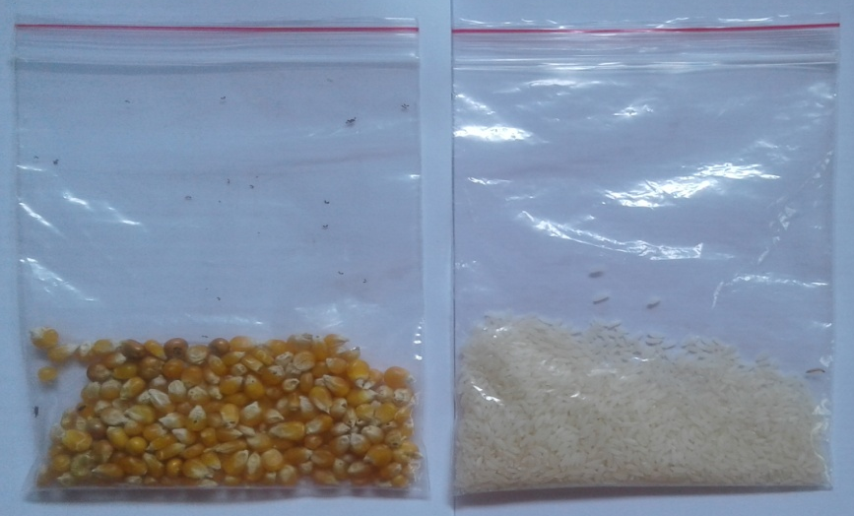
WHEAT SORGHUM
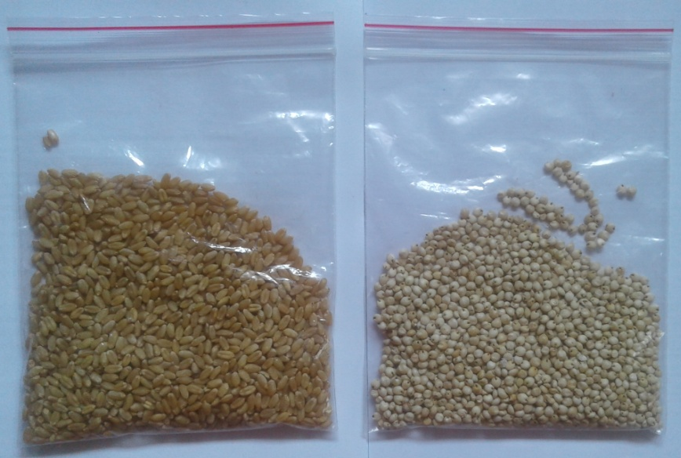

PLATE II

A. FEMALE AND MALE OF SITOPHILUS ORYZAE INSECT
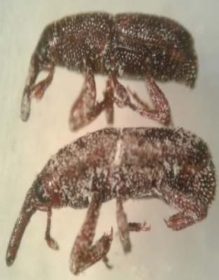
B. SIZE OF INSECTS IN DIFFERENT CEREALS
SORGHUM RICE
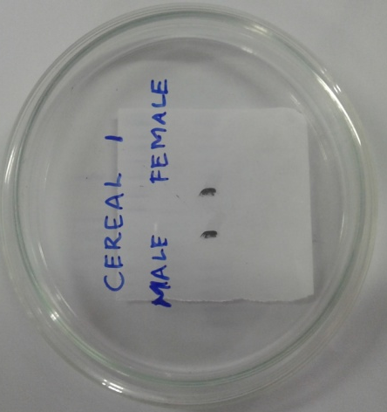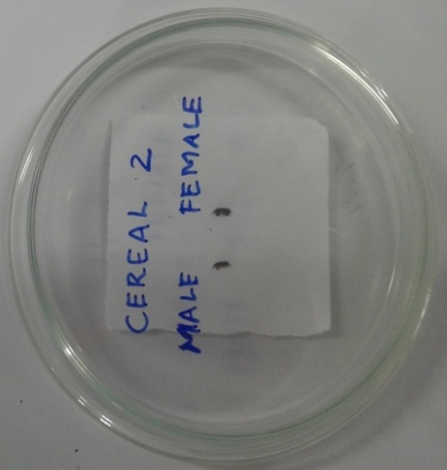
WHEAT CORN
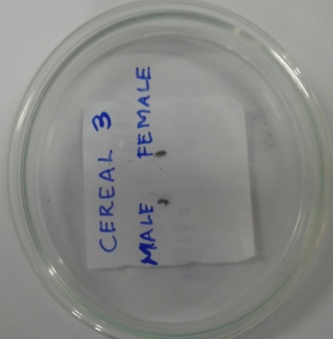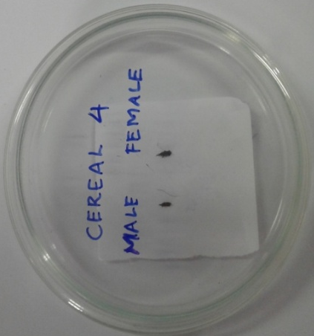

III. 3. Morphometric analysis
From each population Twenty(20) individuals of both the sexes were collected from all the selected cereals for morphometric analysis. The collected samples were then processed and mounted. After calculating the length and weight of each individuals, the parts of the insects were dissected using the scalpel, dissecting needle and forceps.
The characters to be measured were magnified and analysed using Stemi Denver 210/ binocular microscope. The traditional method of morphometric measurements were taken under Olympus stereoscope microscope equipped with an eye piece (10/100x)occulometer and stage micrometer.
The following measurements were taken and recorded
- Body length
- Thorax
- Abdomen
- Fore limb
- Mid limb
- Hind limb
- Rostrum
- Antenna
III.4. Preparation of leaf extracts
In the present study, the sorghum infested by Sitophilus oryzae was prone to fungal infection. Hence an attempt was made in the present investigation to find out the natural antifungal agent from the selected medicinal plants. Fresh leaves of selected medicinal plants were collected from in and around Universuty campus. They were surface cleaned with running tap water followed by double distilled water to remove debris and other contaminated organic contents. Hundred (100gm) of finely cut fresh leaves were pulverized in a mechanical blender. Powdered plant material were kept in a beaker containing 100 ml double distilled water and boiled for 10 min. The aqueous extracts was cooled down and filtered with Whatmann No.1filter paper and extract was stored at 4 $°$C for further.
PLATE III
TEST PLANTS EVALUATED FOR ITS ANTIMYCOBIAL ACTIVITIES

PAPAYA NEEM
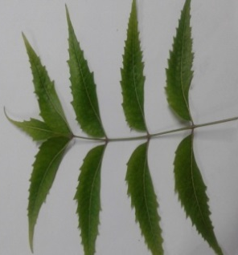
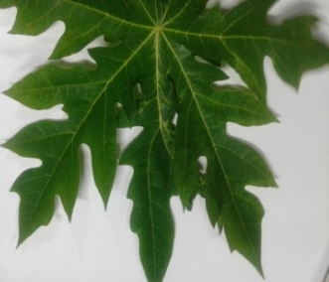

HENNA
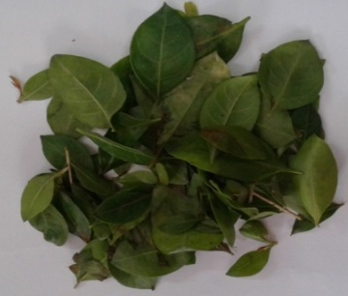

LEMON ANNONA

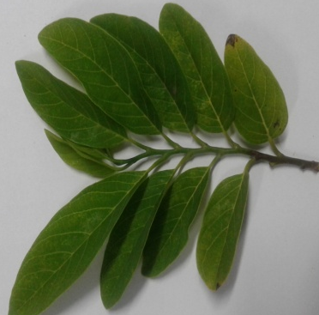
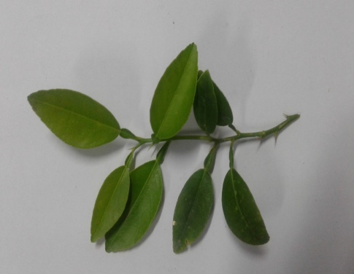

PLATE IV
AQUEOUS EXTRACT OF SELECTED MEDICINAL PLANTS

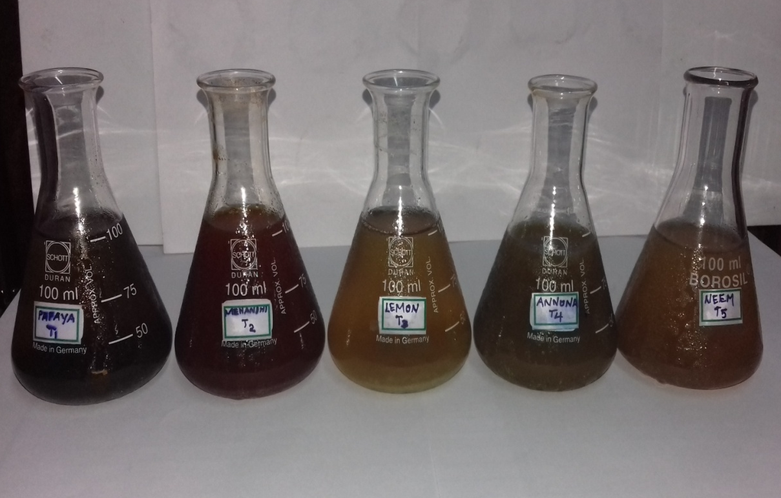

The five plants Viz.,

TABLE- II PLANT PRODUCTS EVALUATED FOR ITS EFFICACY

S.NO | BOTANICAL NAME | COMMON NAME | TAMIL NAME | FAMILY NAME
1. | Carica papaya | Papaya | Pappali | Caricacea
2. | Annona squamosa | Annona | Seetha | Annonacea
3 | Lawsonia inermis | Henna | Marudhaani | Lythracea
4. | Citrus lemon | Lemon | Elumichai | Rutacea
5. | Azadirachta indica | Neem | Veppalai | Meliacea

PLATEV
ISOLATED FUNGAL STRAINS FROM INFESTED SORGHUM

- NIGER A. FLAVUS
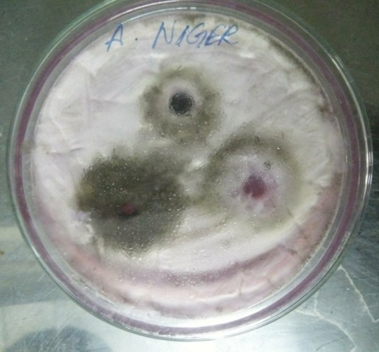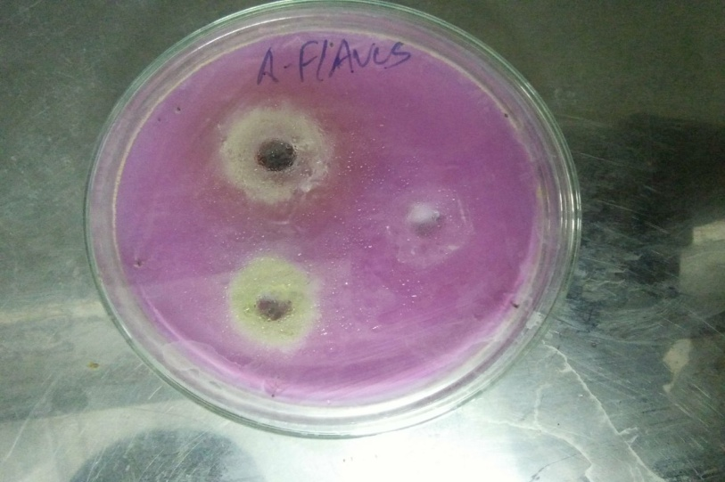

TRICHODERMA
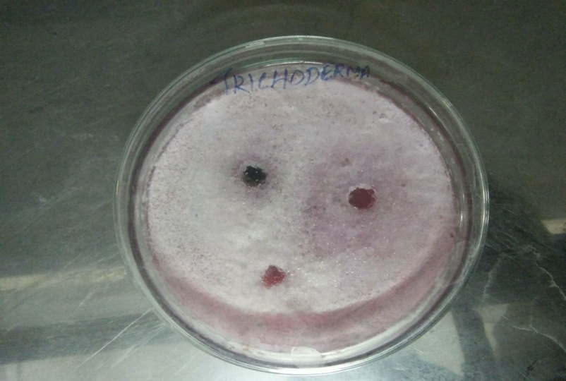

III.5. Screening of antimicrobial activities of selected plant product extracts
III. 5.1. Isolation of fungal strains by serial dilution methods
The infected sorghum sample with microbial contamination was collected from the laboratory culture bottles. The infected sorghum was ground into fine powder using mortar and pestle. One gram of sorghum powder was taken and dissolved in 10ml of distilled water. It forms the supernatant. The sample test tubes were sterilized and labeled from${10}^{-1}$to ${10}^{-9}$and filled with 9 ml of distilled water. One ml of the supernatant was correctly pipetted out into the test tubes, which was marked as${10}^{-1}$and shaken well. Again,1 ml from this sample(${10}^{-1}$) was poured into the other test tube (${10}^{-2}$) and mixed well. To dilute further, the same procedure was followed for other test tubes also.
From the selected dilution, 1 ml of the sample is pipette out into the centre of sterile petri plates. The medium used for the isolation of fungal strain was Rose Bengal Chloramphenicol Agar medium. The molted and cooled medium at (45°C to 50°C) was poured into each petri plates with inoculums before setting. The petriplate was incubated at room temperature for seven days.
III.5.2. Fungal slide preparation and identification
With the help of sterilized inoculation loop, a unit of different fungal colonies from the agar slants were taken and placed on separate glass slides and teased. It was stained with a drop of lactophenol cotton blue stain. Cover slip was placed and the slide was viewed under the microscope for the identification of different genera. The fungi were identified based on conidial and colony characterization.
III.5.3. In vitro antimycobial activity
The Agar Well Diffusion Assay was adopted for evaluation of the antimicrobial activities of selected medicinal plant extracts against the Aspergillus flavus, Aspergillus niger and Trichoderma isolated from infected sorghum. The petriplate with Rose Bengal Chloramphenicol Agar Medium wre inoculated using sterile cotton swabs dipped in inoculums suspension. The entire agar surface of

each plate was inoculated with this swab first in horizontal direction and then in vertical direction to get the uniform lawn of fungi Using a flame cork borer, 0.5 cm diameter well was made in the media at a distance of 1-2 cm from the periphery and one well in the centre of the plates. These plates were labeled and 20µl of plant product extracts (20%, 40%, 60%, 80% and 100% concentration) were aseptically filled in ecach well. Then the plates were incubated for 24 hours at room temperature.
The efficacy of medicinal aqueous plant product extracts were recorded by measuring the diameter of inhibition zone at the end of 24-48 hours of incubation.
III.5.4. Determination of minimum inhibitory concentration (MIC) using Microbroth Dilution Test
The antimicrobial effectiveness of a compound is often described in terms of its minimum Inhibitory concentration (MIC), the lowest concentration of the compound capable of inhibiting the growth of the challenging organism. Among the different doses against Aspergillus niger, Aspergillus flavus and Trichoderma of Indian borage, 100% concentration of Papaya, Annona, Lemon, Henna and Neem leaves were selected to carry out the MIC.
The dilution test was performed to determine the MIC using the standard procedure.Sabourads Dextrose broth containing isolated fungal strains were taken separately in the microtitre plates. The effective concentration of the Papaya, Neem, Lemon, Annona and Henna extracts were added in the broth and serially diluted. Duplicates were run for the effective concentration of the aqueous plant extracts. The plates were incubated at 37°C for 24h and the turbidity was removed. The lowest concentration that inhibited the visible growth of the tested organism was recorded as the MIC.
In the present study the MIC values of Indian borage, papaya,lemon, annona, neem and henna leaves were determined against the important storage fungi, Aspergillus niger, Aspergillus flavus and Trichoderma.

III.5.5. Statistical analysis
The observation on weight, length and parts of Sitophilus oryzae were subjected to One Way Analysis of variance (ANOVA).
The data on antifungal screening of different medicinal plants against the mycoflora isolated from infested pulses were subjected to two way Analysis of Variance (Two-way ANOVA)`
The mean obtained were grouped using least significant difference (LSD) and Duncan`s Multiple Range Test (DMRT).

IV RESULTS
The present investigation was carried out with the aim of finding out the relationship between the grain size and the size of the insects. Significant differences have been observed between different cereals and the size of the rice weevil.The different parameters observed were body length, antenna, rostrum, thorax, fore limb, mid limb, hind limb, wing length and abdomen. In addition to that, the weight of both the male and female Sitophilus oryzae were also recorded.
The statistical analysis revealed that variation occurs among the insects in different cereals. Differences in morphometric measurements werealso observed for both male and female Sitophilusoryzae .
IV.1. Morphometric measurements of the rice weevil, Sitophilus oryzae in selected cereals- body length
The results of the morphometric measurements of body length of the rice weevil, Sitophilus oryzae in different cereals showed significant variation among different treatments. Of the different cereals used for the rearing of Sitophilus oryzae both corn male and corn female recorded maximum body length (3.585 mm).
The body length of the rice weevil was highest in T7 corn male and T8 corn female (3.585mm). Next to corn, the body length was maximum in T2 sorghum female and T1 sorghum male (3.490 and 3.485mm). The insect body length was moderate in T4 rice female and T5 wheat male(3.385 and 3.385 mm). Minimum body length was observed for T3 rice male and T6 wheat female(3.285 and 3.285 mm).
The overall result showed that the significant variation of body length were observed in different cereals. The length of Sitophilus oryzae was maximum in corn female and corn male followed by sorghum female and male. This shows that the susceptibility of corn and sorghum to rice weevil infestation which is evident from their maximum body length. In comparison with corn and sorghum, the body length of both male and female rice weevil in wheat and rice were minimum.

This might be attributed to the size of the rice which is smaller when compared with that of corn and sorghum while the wheat does not permit the rice weevil to attain its maximum size.
IV.2. Morphometric measurements of the rice weevil, Sitophilus oryzae in selected cereals- antenna length
The results of the morphometric measurements of antenna length of the rice weevil, Sitophilus oryzae in different cereals showed significant variation among different treatments. Of the different cereals used for the rearing of Sitophilus oryzae both sorghum female and corn male were recorded maximum antenna length (0.035 mm).
The antenna length of the rice weevil was highest in T2 sorghum female and T7 corn male (0.035 mm). Next to sorghum and corn, the antenna length was maximum in T1 sorghum male and T8 corn female(0.034 mm). The insect antenna length was moderate in T5 wheat male T3 rice male and T4 rice female(0.033, 0.032 and 0.032 mm respectively). Minimum antenna length was observed for T6 wheat female (0.031 mm).
The observation on the antenna length of S. oryzae revealed that the length was maximum in corn female and corn male followed by sorghum female and male. In comparison with corn and sorghum, the antenna length of both male and female rice weevil in wheat and rice were maximum.
IV.3. Morphometric measurements of the rice weevil, Sitophilus oryzae in selected cereals- rostrum length
The results of the morphometric measurements of rostrum length of the rice weevil, S. oryzae in different cereals showed significant variation among different treatments.
The rostrum length of the rice weevil was highest in T7 corn male and T8 corn female (0.054 and 0.054 mm). Next to corn, the rostrum length was maximum in T2 sorghum female T1 sorghum male and T4 rice female(0.053, 0.052and 0.052 mm). The insect rostrum length was moderate in T6 wheat female T5 wheat male (0.051 and 0.051 mm).Minimum rostrum length were observed for T3 rice male (0.049 mm).
The analysis of rostrum length showed that the significant variation of rostrum length were observed in different cereals. The length of rostrum in S. oryzae was maximum in corn female and corn male followed by sorghum female and male. In comparison with corn and sorghum, the rostrum length of both male and female rice weevil in wheat and rice were minimum.
IV.4. Morphometric measurements of the rice weevil,Sitophilus oryzae in selected cereals- thorax length
The results of the morphometric measurements of thorax length of the rice weevil S. oryzae in different cereals were tabulated (Table III).The thoracic length of all the females were significantly higher than that of males.
The thorax length of the rice weevil was highest in T8 corn female (0.072 mm). Next to corn the thorax length was maximum in T4 ricefemale T2 sorghum female (0.068 and 0.067 mm). The insect thorax length was moderate in T6 wheat female T7 corn male (0.066 and 0.065mm).Minimum thorax length were observed for T5 wheat male and T3 rice male (0.059 and 0.058 mm). The poorest thorax length was observed in T1 sorghum male (0.057 mm).
The result on thorax length of S.oryzae showed that the female possessed longer thorax in comparison with that of male. The thoracic length of S. oryzae was maximum in the females of corn, rice and sorghum and minimum in the males of wheat, rice and sorghum.
IV.5. Morphometric measurements of the rice weevil, Sitophilus oryzae in selected cereals- fore limb, mid limb and hind limb lengths
The rice weevil, S.oryzae possess three pairs of legs as fore limb, mid limb and hind limb which are attached to the ventral region of thorax and used for moving of the insects. Similar to that of thorax and abdomen the limbs of the rice weevil were longer in female than that of male. The mean values of the fore limb, mid limb and hind limb showed that the size of the limbs gradually increased from fore limb to hind limb and the mean values were 0.924 mm, 0.987 mm and 0.996 mm for fore limb, mid limb and hind limb respectively (Table IV). Of the different cereals used for the rearing of S. oryzae corn female were recorded maximum fore limb length (0.102 mm).
The fore limb length of the rice weevil was highest in T8 corn female (0.102 mm). Next to corn the fore limb length was maximum in T2 sorghum female and followed by T4 rice female (0.099 and 0.098mm respectively). The insect fore limb length was moderate in T1 sorghum male, T7 corn male and T5 wheat male (0.088, 0.087 and 0.086 mm respectively). Minimum fore limblength were observed for T3 rice male (0.085 mm) and T5 wheat male which were on par with each other.
The mid limb length of the rice weevil was highest in T8 corn female (0.111 mm). Next to corn the mid limb length was maximum in T2 sorghum female followed by T6 wheat female (0.109 and 0.106 mm). The insect mid limb length was moderate in T7 corn male, T1 sorghum male and T5 wheat male (0.097, 0.089 and 0.088 mm). The poorest mid limb length was observed in T3 rice male (0.087 mm).
The observation on the mid limb of the rice weevil indicated that the mid limb length of all the females werehigher than that of males.
The hind limb length of the rice weevil was highest in T4 rice female (0.108 mm). Next to rice the hind limb length was maximum in T8 corn female (0.107mm) and followed by T2 sorghum female (0.106 mm). The insect hind limb length was 0.103 mm inT6 wheat female. The hind limb length was minimum for the males of T1 sorghum male (0.096 mm), T5 wheat male (0.094 mm), T3 rice male (0.087 mm) and T7 corn male (0.093 mm) treatments.
The study on morphometric measurements of the limbs indicated that the females possessed long legs than that of males. The average length of three pairs of limbs indicated that the hind limbs are longer than that of mid limb and fore limb. The increasing order of hierarchy of the length of limbs were fore limb (GM = 0.0924 mm) < mid limb (GM= 0.0987 mm) < hind limb (GM= 0.0996 mm).
IV.6. Morphometric measurements of the rice weevil, Sitophilus oryzae in selected cereals- wing length
The wing length of the rice weevil was highest in T8 corn female (0.098 mm). Next to corn the wing length was maximum in T7 corn male and following T2 sorghum female (0.096 and 0.092 mm). The insect wing length was third highest in T4 rice female (0.091 mm) and moderate in T6 wheat female (0.089 mm). Minimum wing length were observed for T1 sotghum male and T5 wheat male (0.085 and 0.084 mm).The poorest wing length was observed in T3 rice male (0.083 mm).
The results on the length of the wing stated that the females possesses longer wing length (0.089 mm-0.098 mm) than males. Among the different cereals used for rearing of S. oryzae, T8 corn female (0.098 mm) and T1 corn male (0.096 mm) registered the length. Minimum wing length was noticed for T3 rice male (0.083 mm).
IV.7. Morphometric measurements of the rice weevil, Sitophilus oryzae in selected cereals- abdomen length
The results of the morphometric measurements of abdomen length of the rice weevil, S. oryzae in different cereals showed significant variation among different treatments. Among the three body parts, the abdomen has maximum length. The abdomen was elongate, subcylindrical with the apex bent downwards. Similar to thorax and wings, the abdomen length was found to be higher in females than males.
The abdomen length of the rice weevil was highest in T8 corn female (0.115mm). Next to corn the thorax length was maximum in T2 sorghum female and T4 rice female (0.112 and 0.111 mm). The insect abdomen length was moderate in T6 wheat female T7 corn male (0.109 and 0.106 mm).Minimum abdomen length were observed for T1 sorghum male and T5 wheat male (0.104 and 0.103 mm). The poorest abdomen length was observed in T3 rice male (0.102 mm).
The data on the length of abdomen in the rice weevil reared in different cereals revealed that it possess maximum length in comparison with the remaining body parts such as head and thorax when the females and males of S. oryzae were compared, the females possess the maximum abdominal length in all cereals. The highest length of the abdomen was noticed in T8 corn female, T2 sorghum female and T4 rice female. The length of abdomen was minimum for T5 wheat male and T3 rice male.
IV.8. Morphometric measurements of the rice weevil, Sitophilus oryzae in selected cereals- Weight of insect
The weight of the rice weevil was highest in T8 corn female (2.085 mm). Next to corn the weight was maximum in females of T2 sorghum and followed by T4 rice (1.885 and 1.790 mm). The insect weight was moderate in T7 corn male T1 sorghum male (1.385 and 1.285 mm). Minimum weight were observed for T5 wheat male (1.185 mm) and the poorest weight was observed in T3 rice male (1.090 mm).
The weight of the insects after its emergence from different cereals were weighed and recorded. Significant difference of the weight between male and female could be observed. The egg-laden females possess maximum weight than that of males. In addition to that, the rice weevil emerged from different cereals such as sorghum, rice, wheat and corn showed the variation in their weight.
The scrunity of all data on morphometric measurements of S. oryzae registered that the length of thorax, fore limb, mid limb, hind limb, wings and abdomen were higher in females than that of males. Among the cereals used for the rearing of rice weevil, the corn and sorghum were found to be more susceptible to rice weevil infestation. The rice weevil emergence from wheat and rice were minimum in size of all the parameters in comparison with that of corn and sorghum. Eventhough the infestation of rice weevil in wheat and rice could be observed, the infestation level of wheat and rice were minimum in comparison with that of corn and sorghum.Therefore the present study suggests that the corn and sorghum need more attention during their storage and the rice and wheat exhibit somesort of resistence against the rice weevil.
IV.2.1 Antifungal activity
IV.2.2Screening of antimycobial activities of selected medicinal plant product extracts
During the course of investigation a mycobial contamination in sorghum was noticed. The different types of fungal strains infesting the stored sorghum were isolated. The isolated mycoflora includes Aspergillus niger, Aspergillus flavus and Trichoderma species. The screening of antifungal activity of five selected medicinal plants wre evaluated against the isolated fungi. The five medicinal plants used for evaluation of its antifungal activity were papaya, Carica papaya, neem, Azadirachta indica, henna, Lawsonia inermis, lemon, Citrus lemon and annona, Annona squamosa.
The screening of antifungal activity of the selected medicinal plants against the isolated fungi indicated that the antifungal activity of medicinal plants exert maximum against A. niger and the grand mean being (GM=14.42 mm) followed by Trichoderma (GM=12.93 mm) and minimum against A. flavus (GM=12.14 mm). The statistical analysis of the data revealed that a dose dependent increase in the antifungal activity could be noticed. Lower doses of the aqueous extracts of medicinal plants exhibit minimum antifungal activity whereas the higher doses recoeded the maximum antifungal activity.
Different concentrations of 20%, 40%, 60%, 80% and 100% of each extract have been prepared and evaluated against the isolated fungi. In addition to the aqueous extract of these leaves, a positive and negative control using Fluconazole and Double Distilled Water respectively have been tested.
IV.2.3 Screening of antifungal activities of selected medicinal plant extracts against Aspergillus niger:
The Table- V. Showed that the screening of antifungal activities of selected medicinal plants against A. niger. Significant variation could be observed between the control and the treatments. A dose dependent increase in the zone of inhibition could be noticed among the treatments. In comparison with the aqueous extracts of selected medicinal plants, a positive control using flucanozole recorded the highest zone of inhibition.
Among the aqueous extracts of various medicinal plants, papaya recorded the maximum inhibition against A. niger and the mean values being 14.42 mm. Next to papaya, the neem and henna extracts recorded the maximum inhibition (15.80 and 15.10 mm respectively). The antifungal activity was minimum for lemon and annona against A. niger and the mean values recorded were (14.87 mm and 13.81 mm respectively).
Among the different dosages used the 100% concentration recorded the maximum inhibition against A. niger. The 100% concentration of neem registered the highest antifungal activity (20.33 mm) followed by papaya and henna (19.66 and 18.66 mm respectively). Moderate antifungal activity of the cent percent concentration of lemon and annona were noticed (17.66 and 16.66 mm). In comparison with that of the cent percent concentration of all the extracts and the positive control using flucanozole (24.66 mm) recorded maximum the inhibition zone was minimum for 20% concentration of all the selected medicinal plants (10.66 mm to 13.33 mm).
The Minimum Inhibitory Concentration (MIC) of the effective leaf extracts of papaya, neem and annona against the A. niger were accessed as 2.01 mg/ml, 1.95 mg/ml and 1.76 mg/ml.
IV.2.4 Screening of antifungal activities of selected medicinal plant extracts against Aspergillus flavus
The Table-VI.Showed that the screening of antifungal activities of selected medicinal plants against A. flavus. Significant variation could be observed between the control and the treatments. A dose dependent increase in the zone of inhibition could be noticed among the treatments. In comparison with the aqueous extracts of selected medicinal plants, a positive control using flucanozole recorded the highest zone of inhibition (22.66 mm).
Among the aqueous extracts of various medicinal plants, neem recorded the maximum inhibition against A. flavus and the values ranged from 11.00 mm to 16.66 mm. Next to neem, the 60%, 80% and 100% concentration of annona extracts recorded the maximum inhibition of 13.00 mm, 15.00mm and 16.33 mm respectively. The aqueous extract of henna was also observed to be equally effective with annona and the diameter of inhibition zone ranges from 10.66 mm to 16.33 mm. The 20% concentration of papaya leaf were ineffective in producing inhibition against A.flavus (0.00 mm). Minimum antifungal activity was notice for lemon and papaya and the inhibition zone ranges from (3.33 to 15.66 mm).
Among the selected medicinal plants used for its antifungal activity the neem, annona and henna recorded the maximum inhibition against A. flavus while the lemon and papaya registered minimum inhibitory effect against this species.
The Minimum Inhibitory Concentration (MIC) of the effective leaf extracts of papaya, neem and annona against the A. flavus were accessed as 1.94 mg/ml, 1.85 mg/ml and 1.76 mg/ml.

IV.2.5 Screening of antifungal activities of selected medicinal plant extracts against Trichoderma:
The Table-VII. Showed that the screening of antifungal activities of selected medicinal plants against Trichoderma. Significant variation could be observed between the control and the treatments. A dose dependent increase in the zone of inhibition could be noticed among the treatments. In comparison with the aqueous extracts of selected medicinal plants, a positive control using flucanozole recorded the highest zone of inhibition (20.66 mm).
Among the aqueous extracts of various medicinal plants, neem recorded the maximum inhibition against Trichoderma and the values ranged from 11.66 mm to 18.33 mm. Next to neem, the 60%, 80% and 100% concentration of papaya extracts recorded the maximum inhibition of 14.33 mm, 15.66mm and 17.33 mm respectively. The aqueous extract of lemon and annona observed to be moderately effective and the diameter of inhibition zone ranges from 10.33 mm to 17.66 mm.
The antifungal activity of all the concentration of henna produced the inhibition against Trichoderma. However, the minimum antifungal activity of henna in comparison with that of neem, papaya, lemon and annona was noticed and the mean value being (12.67 mm).
The scrutiny of the antifungal activity of selected medicinal plants against Trichoderma revealed that the higher concentration of neem extracts were found to be effective against Trichoderma species which was followed by papaya. The lemon and annona extracts were found to be moderately effective against the isolated mycoflora (10.33 to 17.66 mm). Minimum inhibition was recorded for henna against Trichoderma species (10.35 to 15.33 mm).
The Minimum Inhibitory Concentration (MIC) of the effective leaf extracts of papaya, neem and annona against the Trichoderma were accessed as 1.96 mg/ml, 1.89 mg/ml and 1.78 mg/ml.

TABLE-III MORPHOMETRIC MEASUREMENTS OF THE RICE WEEVIL, SITOPHILUS ORYZAE IN SELECTED CEREALS
S.NO | TREATMENT | LENGTH OF BODY | LENGTH OF ROSTRUM | LENGTH OF ANTENNA | LENGTH OF THORAX
1. | T1 SORGHUM MALE | $${3.485}^{d}$$ | $${0.052}^{d}$$ | $${0.034}^{c}$$ | $${0.057}^{h}$$
2. | T2 SORGHUM FEMALE | $${3.490}^{c}$$ | $${0.053}^{c}$$ | $${0.035}^{a}$$ | $${0.067}^{c}$$
3. | T3 RICE MALE | $${3.285}^{g}$$ | $${0.049}^{h}$$ | $${0.032}^{f}$$ | $${0.058}^{g}$$
4. | T4 RICE FEMALE | $${3.385}^{e}$$ | $${0.052}^{e}$$ | $${0.032}^{g}$$ | $${0.068}^{b}$$
5. | T5 WHEAT MALE | $${3.385}^{f}$$ | $${0.051}^{g}$$ | $${0.033}^{e}$$ | $${0.059}^{f}$$
6. | T6 WHEAT FEMALE | $${3.285}^{h}$$ | $${0.051}^{f}$$ | $${0.031}^{h}$$ | $${0.066}^{d}$$
7. | T7 CORN MALE | $${3.585}^{a}$$ | $${0.054}^{a}$$ | $${0.035}^{b}$$ | $${0.065}^{e}$$
8. | T8 CORN FEMALE | $${3.585}^{b}$$ | $${0.054}^{b}$$ | $${0.034}^{d}$$ | $${0.072}^{a}$$
 | GRAND MEAN  SEd =  CD(0.05%)= | 3.436  0.0083  0.0170 | 0.052  0.0003  0.0007 | 0.033  0.0001  0.0001 | 0.064  0.0005  0.0010

*SEd = Standard Deviation
*CD = Critical difference
Mean with the same letter in each column are not significant
TABLE- IV MORPHOMETRIC MEASUREMENTS OF THE RICE WEEVIL, SITOPHILUS ORYZAE IN SELECTED CEREALS
S.NO | TREATMENT | LENGTH OF FORE LIMB | LENGTH OF MID LIMB | LENGTH OF HIND LIMB | LENGTH OF WING | LENGTH OF ABDOMEN | WEIGHT
1. | T1 SORGHUM  MALE | $${0.088}^{d}$$ | $${0.089}^{f}$$ | $${0.096}^{e}$$ | $${0.085}^{f}$$ | $${0.104}^{f}$$ | $${1.285}^{f}$$
2. | T2 SORGHUM FEMALE | $${0.099}^{b}$$ | $${0.109}^{b}$$ | $${0.106}^{c}$$ | $${0.092}^{c}$$ | $${0.112}^{b}$$ | $${1.885}^{b}$$
3. | T3 RICE MALE | $${0.085}^{e}$$ | $${0.087}^{h}$$ | $${0.093}^{g}$$ | $${0.083}^{h}$$ | $${0.102}^{h}$$ | $${1.090}^{h}$$
4. | T4 RICE FEMALE | $${0.098}^{b}$$ | $${0.105}^{d}$$ | $${0.108}^{a}$$ | $${0.091}^{d}$$ | $${0.111}^{c}$$ | $${1.790}^{c}$$
5. | T5 WHEAT MALE | $${0.086}^{e}$$ | $${0.088}^{g}$$ | $${0.094}^{f}$$ | $${0.084}^{g}$$ | $${0.103}^{g}$$ | $${1.185}^{g}$$
6. | T6 WHEAT FEMALE | $${0.096}^{c}$$ | $${0.106}^{c}$$ | $${0.103}^{d}$$ | $${0.089}^{e}$$ | $${0.109}^{d}$$ | $${1.685}^{d}$$
7. | T7 CORN MALE | $${0.087}^{d}$$ | $${0.097}^{e}$$ | $${0.093}^{g}$$ | $${0.096}^{b}$$ | $${0.106}^{e}$$ | $${1.385}^{e}$$
8. | T8 CORN FEMALE | $${0.102}^{a}$$ | $${0.111}^{a}$$ | $${0.107}^{b}$$ | $${0.098}^{a}$$ | $${0.115}^{a}$$ | $${2.085}^{a}$$
 | GRAND MEAN  SEd =  CD(0.05%)= | 0.092  0.0005  0.0014 | 0.098  0.0002  0.0003 | 0.099  0.0002  0.0003 | 0.089  0.0002  0.0003 | 0.107  0.0002  0.0003 | 1.549  0.0077  0.0158

*SEd = Standard Deviation
*CD = Critical difference
Mean with the same letter in each column are not significant

FIGURE- I MORPHOMETRIC MEASUREMENTS OF THE RICE WEEVIL, SITOPHILUS ORYZAE IN SELECTED CEREALS-BODY LENGTH

FIGURE-II MORPHOMETRIC MEASUREMENTS OF THE RICE WEEVIL, SITOPHILUS ORYZAE IN SELECTED CEREALS-ANTENNA LENGTH

FIGURE- III MORPHOMETRIC MEASUREMENTS OF THE RICE WEEVIL, SITOPHILUS ORYZAE IN SELECTED CEREALS-ROSTRUM LENGTH

FIGURE- IV MORPHOMETRIC MEASUREMENTS OF THE RICE WEEVIL, SITOPHILUS ORYZAE IN SELECTED CEREALS-THORAX LENGTH

FIGURE V MORPHOMETRIC MEASUREMENTS OF THE RICE WEEVIL, SITOPHILUS ORYZAE IN SELECTED CEREALS-FORE LIMB LENGTH

FIGURE VIMORPHOMETRIC MEASUREMENTS OF THE RICE WEEVIL, SITOPHILUS ORYZAE IN SELECTED CEREALS - MID LIMB LENGTH

FIGURE VII MORPHOMETRIC MEASUREMENTS OF THE RICE WEEVIL, SITOPHILUS ORYZAE IN SELECTED CEREALS-HIND LIMB LENGTH

FIGURE VIII MORPHOMETRIC MEASUREMENTS OF THE RICE WEEVIL, SITOPHILUS ORYZAE IN SELECTED CEREALS- WING LENGTH

FIGURE IX MORPHOMETRIC MEASUREMENTS OF THE RICE WEEVIL, SITOPHILUS ORYZAE IN SELECTED CEREALS-ABDOMEN LENGTH

FIGURE X MORPHOMETRIC MEASUREMENTS OF THE RICE WEEVIL, SITOPHILUS ORYZAE IN SELECTED CEREALS-WEIGHT OF INSECTS

TABLE V ANTIFUNGAL ACTIVITY OF THE SELECTED MEDICINAL PLANTS AGAINST ASPERGILLUS NIGER
S.NO | TREATMENTS | CONCENTRATIONS |  |  |  |  | MEAN
 |  | 20% | 40% | 60% | 80% | 100%
1. | FLUCANOZOLE | $${24.66}^{a}$$ | $${24.66}^{a}$$ | $${24.66}^{a}$$ | $${24.66}^{a}$$ | $${24.66}^{a}$$ | 24.67
2. | DOUBLE DISTILLED WATER | $${0.00}^{p}$$ | $${0.00}^{p}$$ | $${0.00}^{p}$$ | $${0.00}^{p}$$ | $${0.00}^{p}$$ | 0.00
3. | PAPAYA | $${13.33}^{bmn}$$ | $${14.33}^{klm}$$ | $${17.33}^{efg}$$ | $${18.00}^{de}$$ | $${19.66}^{bc}$$ | 16.53
4. | NEEM | $${12.33}^{n}$$ | $${13.33}^{mn}$$ | $${15.33}^{ijk}$$ | $${17.66}^{def}$$ | $${20.33}^{b}$$ | 15.80
5. | HENNA | $${12.33}^{n}$$ | $${13.33}^{mn}$$ | $${14.66}^{jkl}$$ | $${17.33}^{efg}$$ | $${18.66}^{cd}$$ | 15.27
6. | LEMON | $${12.33}^{n}$$ | $${13.33}^{mn}$$ | $${14.66}^{jkl}$$ | $${16.33}^{ghi}$$ | $${17.66}^{def}$$ | 14.87
7. | ANNONA | $${10.66}^{o}$$ | $${12.33}^{n}$$ | $${14.00}^{lm}$$ | $${15.66}^{hij}$$ | $${16.66}^{fgh}$$ | 13.81
 | MEAN | 12.24 | 13.05 | 14.38 | 15.67 | 16.81 | 14.42

S.NO |  | SEd | CD( 0.05%)
1. | T | 0.26427 | 0.52708
2. | C | 0.22335 | 0.44547
3. | T X C | 0.59094 | 1.17859

FIGURE XI ANTIFUNGAL ACTIVITY OF THE SELECTED MEDICINAL PLANTS AGAINST ASPERGILLUS NIGER

PLATE IV
ANTIFUNGAL ACTIVITY OF SELECTED MEDICINAL PLANTS AGAINST ASPERGILLUS NIGER

S.NO | TREATMENTS | PLANT  EXTRACTS | R1 | R2 | R3
1. | +VE | FLUCANOZOLE | 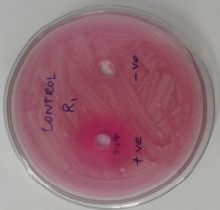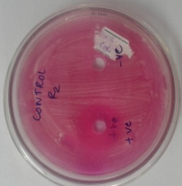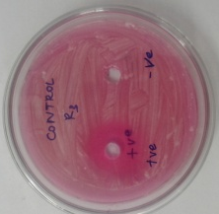
2. | ˗˗VE | DOUBLE DISTILLED WATER
3. | L3 | PAPAYA | 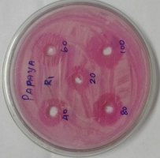 | 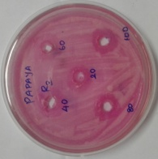 | 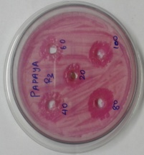
4. | L4 | NEEM | 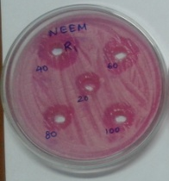 | 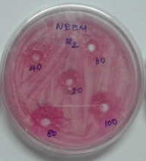 | 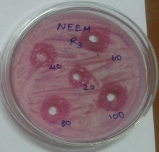
5. | L5 | HENNA | 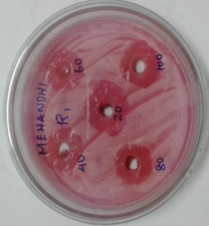 | 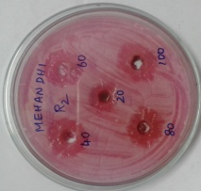 | 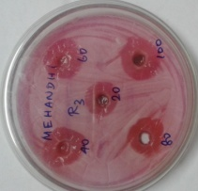
6. | L6 | LEMON | 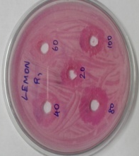 | 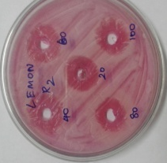 | 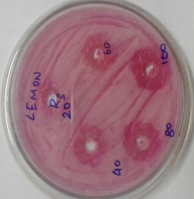
7. | L7 | ANNONA | 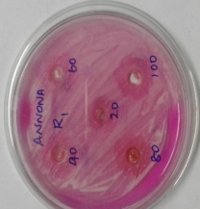 | 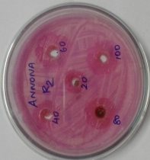 | 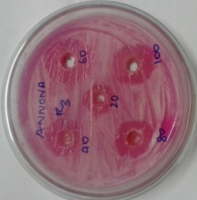

TABLE VI ANTIFUNGAL ACTIVITY OF THE SELECTED MEDICINAL PLANTS AGAINST ASPERGILLUS FLAVUS
S.NO | TREATMENTS | CONCENTRATIONS |  |  |  |  | MEAN
 |  | 20% | 40% | 60% | 80% | 100%
1. | FLUCANOZOLE | $${22.66}^{a}$$ | $${22.66}^{a}$$ | $${22.66}^{a}$$ | $${22.66}^{a}$$ | $${22.66}^{a}$$ | 22.67
2. | DMSO | $${0.00}^{i}$$ | $${0.00}^{i}$$ | $${0.00}^{i}$$ | $${0.00}^{i}$$ | $${0.00}^{i}$$ | 0.00
3. | PAPAYA | $$0.00$$ | $${11.33}^{efg}$$ | $${12.66}^{def}$$ | $${14.00}^{cd}$$ | $${15.33}^{bc}$$ | 10.67
4. | NEEM | $${11.00}^{fg}$$ | $${13.00}^{de}$$ | $${14.00}^{cd}$$ | $${15.66}^{bc}$$ | $${16.66}^{b}$$ | 14.07
5. | HENNA | $${10.66}^{g}$$ | $${11.66}^{efgg}$$ | $${13.00}^{de}$$ | $${14.33}^{cd}$$ | $${16.33}^{b}$$ | 13.20
6. | LEMON | $${3.33}^{h}$$ | $$10.66$$ | $${11.66}^{efg}$$ | $${14.00}^{cd}$$ | $${15.66}^{bc}$$ | 11.07
7. | ANNONA | $${10.33}^{g}$$ | $${12.00}^{efg}$$ | $${13.00}^{de}$$ | $${15.00}^{bc}$$ | $${16.33}^{b}$$ | 13.33
 | MEAN | 8.29 | 11.61 | 12.43 | 13.67 | 14.71 | 14.17

S.NO |  | SEd | CD( 0.05%)
1. | T | 0.42613 | 0.84989
2. | C | 0.36015 | 0.71829
3. | T X C | 0.95286 | 1.90042

FIGURE XII ANTIFUNGAL ACTIVITY OF THE SELECTED MEDICINAL PLANTS AGAINST ASPERGILLUS FLAVUS

PLATE VII
ANTIFUNGAL ACTIVITY OF SELECTED MEDICINAL PLANTS AGAINST ASPERGILLUS FLAVUS

S.NO | TREATMENTS | PLANT  EXTRACTS | R1 | R2 | R3
1. | +VE | FLUCANOZOLE | 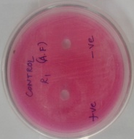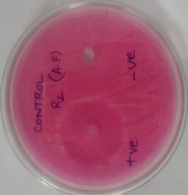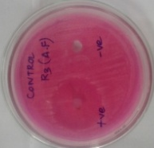
2. | ˗˗VE | DOUBLE DISTILLED WATER
3. | L3 | PAPAYA | 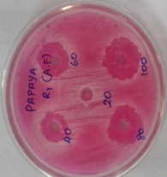 | 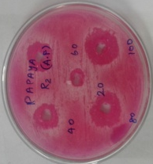 | 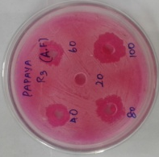
4. | L4 | NEEM | 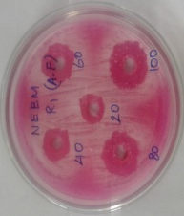 | 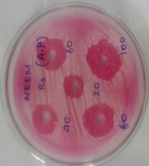 | 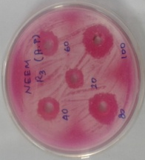
5. | L5 | HENNA | 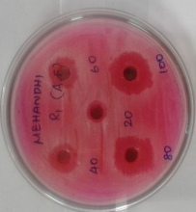 | 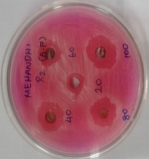 | 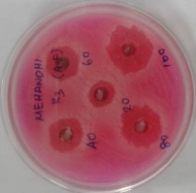
6. | L6 | LEMON | 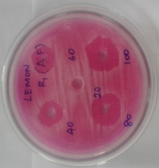 | 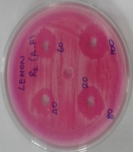 | 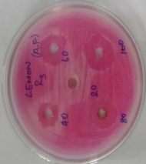
7. | L7 | ANNONA | 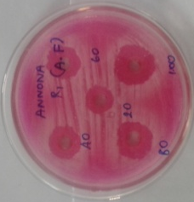 | 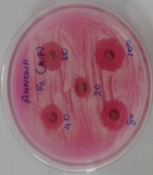 | 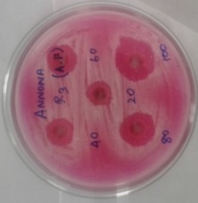

TABLE VII ANTIFUNGAL ACTIVITY OF THE SELECTED MEDICINAL PLANTS AGAINST TRICHODERMA
S.NO | TREATMENTS | CONCENTRATIONS |  |  |  |  | MEAN
 |  | 20% | 40% | 60% | 80% | 100%
1. | FLUCANOZOLE | $${20.66}^{a}$$ | $${20.66}^{a}$$ | $${20.66}^{a}$$ | $${20.66}^{a}$$ | $${20.66}^{a}$$ | 20.67
2. | DOUBLE DISTILLED WATER | $${0.00}^{j}$$ | $${0.00}^{j}$$ | $${0.00}^{j}$$ | $${0.00}^{j}$$ | $${0.00}^{j}$$ | 0.00
3. | PAPAYA | $${11.00}^{hi}$$ | $${12.66}^{f}$$ | $${14.33}^{e}$$ | $${15.66}^{d}$$ | $${17.33}^{c}$$ | 14.20
4. | NEEM | $${11.66}^{gh}$$ | $${13.66}^{e}$$ | $${15.66}^{d}$$ | $${17.33}^{c}$$ | $${18.33}^{b}$$ | 15.33
5. | HENNA | $${10.33}^{i}$$ | $${11.33}^{gh}$$ | $${12.66}^{f}$$ | $${13.66}^{e}$$ | $${15.33}^{d}$$ | 12.67
6. | LEMON | $${10.33}^{i}$$ | $${12.00}^{fg}$$ | $${14.00}^{e}$$ | $${15.33}^{d}$$ | $${17.66}^{bc}$$ | 13.87
7. | ANNONA | $${11.33}^{gh}$$ | $${12.67}^{f}$$ | $${13.66}^{e}$$ | $${15.33}^{d}$$ | $${16.00}^{d}$$ | 13.80
 | MEAN | 10.76 | 11.85 | 13.00 | 14.00 | 15.04 | 15.09

S.NO |  | SEd | CD( 0.05%)
1. | T | 0.20158 | 0.40204
2. | C | 0.17037 | 0.33979
3. | T X C | 0.45075 | 0.89899

FIGURE XIII ANTIFUNGAL ACTIVITY OF THE SELECTED MEDICINAL PLANTS AGAINST TRICHODERMA

PLATE VIII
ANTIFUNGAL ACTIVITY OF SELECTED MEDICINAL PLANTS
AGAINST TRICHODERMA

S.NO | TREATMENTS | PLANT  EXTRACTS | R1 | R2 | R3
1. | +VE | FLUCANOZOLE | 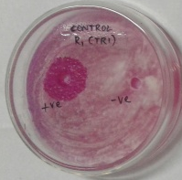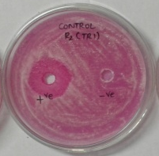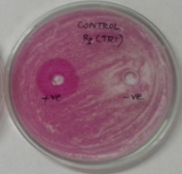
2. | ˗˗VE | DOUBLE DISTILLE WATER
3. | L3 | PAPAYA | 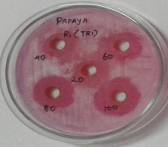 | 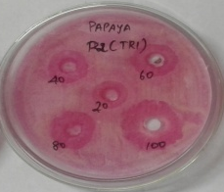 | 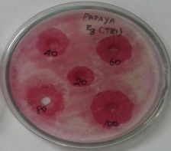
4. | L4 | NEEM | 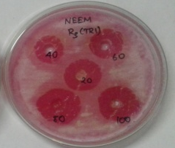 | 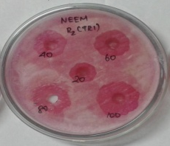
5. | L5 | HENNA | 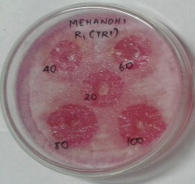 | 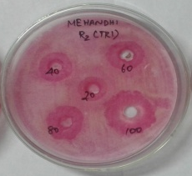 | 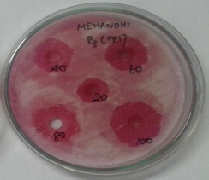
6. | L6 | LEMON | 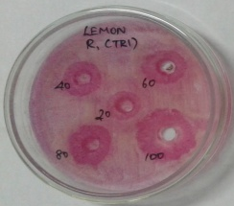 | 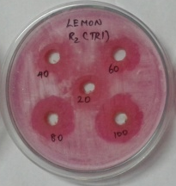 | 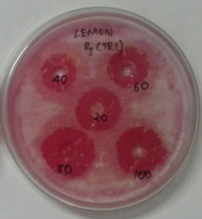
7. | L7 | ANNONA | 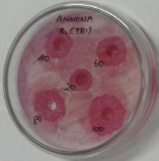 | 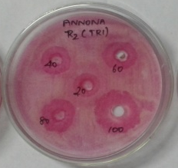 | 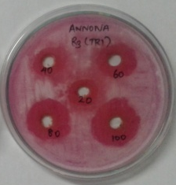

V. DISCUSSION
Stored grains are subject to losses due to a number of causes which includes physical, sanitary and nutritional deprivation, from their maturation to the utilization. In India the damage of stored grains by insect pests was estimated to 6.5 percent of the total grain storage (Raju, 1984). Among the stored grain pests, the rice weevil, Sitophilus oryzae(Linnaeus, 1763) (Coleoptera, Curculionidae), is one of the significant pests of stored rice causing both quantitative and qualitative losses to grain imparting severe economic loss (Aslam et al.2004; Shaaya et al. 1991). Regardless of the accessibility of modern technologies for grain storage and pest control, some farmers still use traditional methods of storage. Grain stored under such conditions is very susceptible to heavy losses (Aslam et al.2004). Understanding of the pest life-cycle is thus the prerequisite for the adoption and execution of the proper management strategy . A considerable work on the life cycle of S.oryzae though had been carried out but expressed variable results (Wille 1923; Bheemanna 1986; Barbuiya et al., 2002). The duration of each life cycle (Wille, 1923), the characteristics of the morphs (Barbuiya et al. 2002) of each growth stages and the number of generation in each year (Bheemanna 1986) varied considerably in consideration of both the prevailing climatic factors and the food source.For this reason study of morphometric measurements of S. Oryzaein different cereals have been evaluated.
Klingenberg 2001 reported that developmental mechanisms are usually assumed to evolve by natural selection of the morphological traits they produce. Therefore, information on phenotypic traits is an important component of comparative studies of development. Morphometrics permits the rigorous quantitative analysis of variation in organismal size and shape, and is increasingly being used in developmental contexts. The new methods of morphometrics combine a geometric concept of shape with the procedures of multivariate statistics, and constitute a powerful and ﬂexible set of tools for analyzing morphological variation.
Many researchers were done an experiment with the rice weevil. The sexual dimorphism and geographical distribution of the S. oryzae were studied by many researchers. However, the relationship between the different cereals and the influence of those cereals on the size of rice weevil were not done by any researcher. Therefore, an attempt has been in the laboratory to investigate the influence and the susceptibility of the different food grains on the size of rice weevil.
In the present investigation the result of the morphometric analysis in both male and female of S. oryzae in different cereals showed that the body length and other parts of the insects were highest in corn and sorghum and minimum size of both male and female insects were observed in wheat and rice.
In our study, the body length, length of thorax, fore limb, mid limb, hind limb, wing, abdomen and weight of females of S. oryzae were maximum than that of males.
This corroborates with the findings of Tambe et al.,2010who reported in African palm weevil,Rhychophorus phoenicis, that the abdomen and head size are significantly greater in females of a African palm weevil, R. phoenicis.
In the present work the body size of the rice weevil, S. oryzae was significantly varied due to the nutritional parameters of different cereals. This was similar to the findings of Silver and Renshaw, 1999 who reported that the body size of mosquitoes vary depending upon the varieties of blood meal.
Kuclu et al., 2010 reported that the body size is one of the most significant features of organisms and is correlated with the large number of ecological and physiological variables. Similar to size, biological shape is one of the most conspicuous aspects of an organism phenotype an provides a link between the genotype and the environment. Body size may change with altitude and also habitat differences associated with altitude may affect the biological shape and some morphological characteristics.
The present investigation revealed that the efficacy of neem, Azadirachta indica as a potential antifungal agent against the fungi, A. niger, A. flavus and Trichoderma species. Similar observation on the efficacy of neem, Azadirachta indica have been reported by many researchers against phytopathogenic fungi namely A. flavus, Alternaria alternate and Fusarium oxysporum (Iqbal and javaid, 2012; Jabeen et al., 2014; Anil and Raj 2015; Abd El-Ghany et al., 2015 and Kanwal et al., 2011.
More recently Mondeli et al., 2009 studied the efficacy of different extracts of neem leaf on seed borne fungi, A. flavus. In this study the growth of fungi was inhibited significantly and controlled with both alcoholic and water extracts of all ages and of the concentration used, efficacy of various concentrations of four plant extracts prepared from, garlic, neem leaf, ginger and onion bulb were studied on reduction of A. flavus on mustard. They found that garlic extract is most effective followed by neem (Latif et al., 2006).
Minimum antifungal activity of aqueous extract of henna, Lawsonia inermis was noticed in our study. however, Sharma and Sharma 2011 reported the acetone extract of Lawsonia inermis showed highest antifungal activity against many fungi.
Antimicrobial activity of plants is due to the presence of secondary metabolites which are extracted in organic solvents due to their solubility (19) and each secondary metabolite has specific affinity for specific solvent, thus a organic solvent extract had differential activity for different organisms. Of all the extracts assayed acetone extract of L. Inermis and petroleum ether extract of E. citriodora showed maximum activity. Alkaloids, steroids, quinines and tannins are highly soluble in these solvents (20). Significant activity of these solvent extracts suggests that the antifungal activity of these plants may be due to the presence of secondary metabolites. The antifungal activity of the extracts was found superior than the synthetic fungicides used.
Despite the great success of pharmaceutical industries in developing new antibiotics finding new broad spectrum antifungal agents is still a priority due to the resistance development of fungal strains as well as absence of licensed antifungal vaccines.

VI. SUMMARY AND CONCLUSION
- An attempt was made in the laboratory to test the influence of selected cereals on the morphometric measurements of the rice weevil Sitophilus oryzae.The cereals selected were belong to the familypoaceae.
- A pilot study was conducted in the households of Coimbatore city to find out the prevalence of particular species of rice weevil in stored cereals.
- The study revealed the presence of S.oryzae in most of the cereals and therefore selected as test insect for the present investigation.
- The test insect S.oryzae was collected from TNAU. The insect used in the present study was obtained from Insectry, a division of entomology, Tamil Nadu Agricultural University, Coimbatore. Hundred gram (100gm) of each cereals were weighed and 10 pairs of Sitophilus oryzae were introduced in each zip lock covers. The insects were introduced in selected cereals and the freshly emerged adults of Sitophilus oryzae from the selected cereals were subjected to morphometric analysis.
- The morphometric measurements of body length, rostrum, antenna, thorax, fore limb, mid limb, hind limb,abdomen and wings were measured and recorded using ocular and stage micrometer.In addition to these parameters, the weight of the emerged adults have been recorded.
- The results for morphometric measurements of rice weevil, S.oryzaeshows that the insects of male and female reared in four cereals has variation in their body parts. The body length of both male and female insects in different cereals both corn male and female recorded maximum length (3.585 mm). Next to corn body length was maximum in sorghum male and female (T1 and T2). In comparison with corn and sorghum, the body length of both male and female rice weevil in wheat and rice were minimum.
- The observation on the antenna length of S. oryzae revealed that the length was maximum in corn female and corn male(0.034 and 0.035 mm) and followed by sorghum female and male (0.035 and 0.034 mm). In comparison with corn and sorghum, the antenna length of both male and female rice weevil in wheat and rice were minimum (0.032 and 0.032mm).
- The analysis of rostrum length showed that the significant variation of rostrum length were observed in different cereals. The length of rostrum in S. oryzae was maximum in corn female and corn male (0.054 mm) and followed by sorghum female and male (0.053 and 0.052 mm). In comparison with corn and sorghum, the rostrum length of both male and female rice weevil in wheat and rice were minimum (0.049 and 0.051 mm).
- The result on thorax length of S.oryzae showed that the female possessed longer thorax in comparison with that of male. The thoracic length of S. oryzae was maximum in the females of corn, rice and sorghum (0.072, 0.068 and 0.067 mm) and minimum in the males of wheat, rice and sorghum (0.057, 0.058 and 0.059 mm).
- The data on the length of abdomen in the rice weevil reared in different cereals revealed that it possess maximum length in comparison with the remaining body parts such as head and thorax when the females and males of S. oryzae were compared, the females possess the maximum abdominal length in all cereals. The highest length of the abdomen was noticed in T8 corn female, T2 sorghum female and T4 rice female (0.115, 0112 and 0.111mm). The length of abdomen was minimum for T5 wheat male and T3 rice male (0.104 and 0.103 mm).
- The study on morphometric measurements of the limbs indicated that the females possessed long legs than that of males. The average length of three pairs of limbs indicated that the hind limbs are longer than that of mid limb and fore limb. The increasing order of hierarchy of the length of limbs were fore limb (GM = 0.0924 mm) < mid limb (GM= 0.0987 mm) < hind limb (GM= 0.0996 mm).
- The wing length of the rice weevil was highest in T8 corn female (0.098 mm). Next to corn the wing length was maximum in T7 corn male and following T2 sorghum female (0.096 and 0.092 mm). The insect wing length was moderate in T4 rice female (0.091 mm) and T6 wheat female (0.089 mm). Minimum wing length were observed for T1 sotghum male and T5 wheat male (0.085 and 0.084 mm).The poorest wing length was observed in T3 rice male (0.083 mm).
- The weight of the rice weevil was highest in T8 corn female (2.085 mm). Next to corn the weight was maximum in females of T2 sorghum and followed by T4 rice (1.885 and 1.790 mm). The insect weight was moderate in T7 corn male T1 sorghum male (1.385 and 1.285 mm). Minimum weight were observed for T5 wheat male (1.185 mm) and the poorest weight was observed in T3 rice male (1.090 mm).
- The weight of the insects after its emergence from different cereals were weighed and recorded. Significant difference of the weight between male and female could be observed. The egg-laden females possess maximum weight than that of males. In addition to that, the rice weevil emerged from different cereals such as sorghum, rice, wheat and corn showed the variation in their weight.
- The scrutiny of the data on morphometric measurements of S. oryzae registered that the length of thorax, fore limb, mid limb, hind limb, wings and abdomen were higher in females than that of males. Among the cereals used for the rearing of rice weevil, the corn and sorghum were found to be more susceptible to rice weevil infestation. The rice weevil emergence from wheat and rice were minimum in size of all the parameters in comparison with that of corn and sorghum. Eventhough the infestation of rice weevil in wheat and rice could be observed, the infestation level of wheat and rice were minimum in comparison with that of corn and sorghum.
- The morphometric measurements of the rice weevil showed the higher infestation levels in corn and sorghum. These two cereals need more attention during their storage since their susceptibility to rice weevil infestation. In our study, rice weevil, S. oryzae possessed minimum emergence, minimum size of the length and other body parts in wheat and rice. This indicated somesort of resistance exhibited by these two food grains against S. oryzae. Therefore, further investigation needed to isolate the compound which produced resistance against the rice weevil in comparison with that of corn and sorghum. The morphometric measurements of rice weevil definitely and useful tool for the management of rice weevil in stored cereals.
- The different types of fungal strains infesting the stored sorghum were isolated. The isolated mycoflora includes Aspergillus niger, Aspergillus flavus and Trichoderma species. The screening of antifungal activity of five selected medicinal plants wre evaluated against the isolated fungi. The five medicinal plants used for evaluation of its antifungal activity were papaya, neem, henna, lemon and annona.
- Screening of antifungal activities of selected medicinal plants against A. niger. Among the aqueous extracts of various medicinal plants, papaya recorded the maximum inhibition against A. niger and the mean values being 14.42 mm. Next to papaya, the neem and henna extracts recorded the maximum inhibition (15.80 and 15.10 mm respectively). The antifungal activity was minimum for lemon and annona against A. niger and the mean values recorded were (14.87 mm and 13.81 mm respectively)
- Among the selected medicinal plants used for its antifungal activity the neem, annona and henna recorded the maximum inhibition against A. flavus while the lemon and papaya registered minimum inhibitory effect against this species.
- The scrutiny of the antifungal activity of selected medicinal plants against Trichoderma revealed that the higher concentration neem extracts were found to be effective against Trichoderma species which was followed by papaya. The lemon and annona extracts were found to be moderately effective against the isolated mycoflora (10.33 to 17.66 mm). Minimum inhibition was recorded for henna against Trichoderma species (10.35 to 15.33 mm).
- The screening of antifungal activity of selected medicinal plants observed that it is highly effective on A. niger and the grand mean value being (GM=14.42 mm) and followed that Trichoderma (GM=12.93 mm). less effective was observed in A. flavus (GM=12.14 mm)
- The screening of antifungal activity of selected medicinal plants identified potential source of natural antifungal agents against the storage fungi. The present work revealed the efficacy of neem and papaya as an effective antifungal agent against the storage fungi, A. niger, A. flavus and Trichoderma species. Natural product based fungicides are generally safer than synthetic onesbecause of their relatively short environmental half life and they are harmless to both living being and the environment.

BIBLIOGRAPHY
Adsavakulchai, A., Baimai V., Prachyabrued, W., Grote, P.J., Lertlum S. 1999. Morphometric study for identiﬁcation of the Bactrocera dorsalis complex (Diptera: Tephritidae) using wing image analysis. Biotropica Vol 13:37–48
Alves, V.M., Moura, M.O., de Carvalho, C.J.B. Wing shape is inﬂuenced by environmental variability in Polietina orbitalis (Stein) (Diptera: Muscidae). Rev. Bras. Entomol, Vol 60: 150–156.
Arokiyaraj, S., Martin, S., Perinbam, K., Marie Arockianathan, P., and Beatrice, V. (2008). Free radical scavenging activity and HPTLC finger print of Pterocarpus santalinus L. an in vitro study. Indian Journal of Science and Technology,Vol 1(7):1-7.
Aslan, I. 2004. Toxicity of essential oil vapours obtained from Pistacia spp. to the granary weevil, Sitophilus granarius(L.) (Coleoptera: Curculionidae). Journal of Plant Diseases and Protection 111: 400–407.
Awika, J. M. (2011). Major cereal grains production and use around the world. In Advances in cereal science: implications to food processing and health promotion (pp. 1-13).
Ball, S, L., Armstrong, K.F. (2006). DNA barcodes for insect pest identiﬁcation: a test case with tussock moths (Lepidoptera: Lymantriidae). Vol. 36(2):337–350
Bamidele, A.O., & Muse, W.A. (2012). A morphometric study of the variegated grasshopper Zonocerus variegates (Linn.)(Orthoptera: Pyrgomorphidae) from parts of southern Nigeria.Ife Journal of Science, 14(1), 61-73.
Banerjee, T.C. and S. Nazimuddin. 1985. Weight loss of wheat and rice caused by feeding of larvae and adults of the Sitophilus oryzae Linn. andRhiozopertha dominica F. Indian Journal of Agricultural Science 55(11): 703-706.
Barbhuiya, M. H., 2002.Biology of rice weevil, Sitophilus oryzae(L.) (Coleoptera :Curculionidae) in stored wheat Triticum vulgareand its control. Environment and Ecology, 20 : 1700-1702.
Barrett RDH, Hebert PDN (2005). Identifying spiders through DNA barcodes. Can J Zool 83:481–491.
Begon, M. 2006. Ecology: from individuals to ecosystems. 4th. ed. Oxford: Blackwell Publishing. 759 p.
Berdy, J. (2005). Bioactive Microbial Metabolites, A Personal View. The Journal of Antibiotic, Vol.58, No. 1, pp. 1-26.
Bhatia, S. K., V.S., Singh and H. G. Bansal. 1975. Varietal resistance in barley grain to laboratory infestation of rice weevil and lesser grain borer. Bulletin of Grain Technology 13 (2): 69-72.
Bhatnagar, D., Cleveland, T. E. & Lillehoj, E. B. (1989). Enzymes in aflatoxin B1 biosynthesis : strategies for identifying pertinent genes. Mycopathologia 107, 75-83.
Bheemanna, M., 1986. Studies on biology of rice weevil Sitophilus oryzae Linnaeus (Curculionidae :Coleptera) and host resistance in sorghum. M. Sc. (Agri.) Thesis, University of Agricultural Sciences, Dharwad.
Bobbarala, V., P.K. Katikala, K.C. Naidu and S. Penumajji. 2009. Antifungal activity of selected plant extracts against phytopathogenic fungi Aspergillus niger. Indian Journal Science and Technology Vol 2: 87-90
Bugno, A., Almodovara, A.B., Pereira, T.C., Pinto, T.A and Sabino, M. 2006. Occurrence of toxigenic fungi in herbal drugs.Brazilinal. Journal of Microbiology; 37: 1-8.
Bushra, S., & Aslam, M. (2014). Management of Sitotroga cerealella in stored cereal grains: a review. Archives of Phytopathology and Plant Protection, 47(19), 2365-2376.
Clarke, J.H. (1966). Studies on fungi in the root region. V. The antibiotic effects of root extracts of allium on some root surface fungi. Plant Soil, Vol. 25, pp. 32-40.
Claver, A.M and Yaqub.A 2015. Morphometric analysis of Tropicopolitan Bug Triatoma rubrofasciata (De geer) In two different parts of India. IJRSB.3 pp. 130-138.
Cowan, M.M. (1999). Plant Products as Antimicrobial Agents. Clinical Microbiology Reviews, Vol.12, No.4. pp. 564-582.
Cremlyn, R.J.W. (1991). Agrochemicals: preparation and mode of action. John Wiley, Chishester, UK, 396.
De Bivort B.L., Clouse R.M., Giribet G. 2010. A morphometrics-based phylogeny of the temperate Gondwanan mite harvestmen (Opiliones, Cyphophthalmi, Pettalidae).Journal of Zoological Systematics and Evolutionary Research.Vol.48: 294–309.
Delp, C.J. (1988). Fungicide resistance in North America. APS Press, ISBN, St. Paul. Minesota, USA, 133.
Devi,B.M and Devi, V. N 2014. Life cycle and morphometric measurement of callasobruchus analis on Gram. An International Journal. Vol 6(2): 86-89.
DujardinJ. P.SteindelM.ChavezT.MachaneM.SchofieldC. J.1999. Changes in the sexual dimorphism of Triatominae in the transition from natural to artificial habitats.Mem. Inst. Oswaldo Cruz94: 565–569
Duke, O.S.; Dayan, E.F.; Romagni, G.J. & Rimando, M.A. (2000). Natural products as sources of herbicides: current status and future trends. Weed Research, Vol. 40, pp. 99-111.
Ferreira, P.S.F.,2006. Seasonal abundance and sexual variation in morphometric traits of Oxelytrum discicolle (Brulle 1840) (Coleoptera: Silphidae) in a Brazilian Atlantic Forest. Biota Neotrop. 6(2):17.
Ferreira, PSF., Pires, EM., Guedes, RNC., Mendes, M. and Coelho, L., 2006. Seasonal abundance and sexual variation in morphometric traits of Oxelytrum discicolle (Brulle, 1840) (Coleoptera: Silphidae) in Brazilian Atlantic Forest. Biota Neotropica, vol. 6, no. 2, p. 1-7.
Filin, I., O.J. Schmitz, and O. Ovadia.2008. Consequences of individual size variation for survival of an insect herbivore: an analytical model and experimental field testing using the Red-legged Grasshopper.Journal of Orthoptera Research17:283–291.
Folmer O., Black, M., Hoeh W., Lutz R., Vrijenhoek, R. (1994). DNA primers for ampliﬁcation of mitochondrial cytocrome C oxidase subunit I from diverse metazoan invertebrates. Mol Mar Biol Biotechnol vol. 3:294–299.
Gadagkar, R., Chandrashekara, K., (2005). Behavioral diversity and its apportionment in a primitively eusocial wasp.pp. 108124. In: Ananthakrishnan, T.N., Whitman, D. (Eds.), Insect Phenotypic Plasticity. Diversity of Responses.Science Publishers, Inc., Enfield, NH, p. 213.
Gangadevi, V., Yogeswari, S., Kamalraj, S., Rani, G and Muthumary,J. (2008). The antibacterial activity of Acalypha indica L.Indian journal of Science and Technology.1(6).
Gautam, A.K and Bhadauria, R.2008. Occurrence of Toxigenic Moulds and Mycotoxins in Ayurvedic Medicine Trifla Churn.Journal of Mycology and Plant Pathology;vol.3: 664-6.
Greenstone MH., Rowley DL., Heimbach U., Lundgren JG., Pfan- nenstiel RS., Rehner, SA. (2005). Barcoding generalist predators by polymerase chain reaction: carabids and spiders. Mol Ecol 14:3247–3266.
Grobler G.C., Janse van Rensburg L., Bastos D.S., Chimimba C.T., Chown S.L. 2006. Molecular and morphometric assessment of the taxonomic status of Ectemnorhinus weevil species (Coleoptera: Curculionidae, Entiminae) from the sub-Antarctic Prince Edward Islands. Journal of Zoological Systematics and Evolutionary Research.Vol.44: 200–211.
Hajibabaei M, Singer GAC, Hebert PDN, Hickey DA (2007) DNA barcoding: how it complements taxonomy, molecular phylogenetics and population genetics. Trends Gene 23(4):167–172
Harvey, A.L. (2008). Natural products in drug discovery. Drug Discovery Today, Vol. 13, No. 19/20, pp. 894-901.
Herbert PDN, Cywinska A., Ball SL., deWaard JR. (2003). Bio- logica identiﬁcations through DNA barcodes. Proc R Soc B 270:313–321.

Herbert,PDN., Ratnasingham S., deWaard JR. (2003). Barcoding animal life: cytochrome C oxidase subunit I divergences among closely related species. Proc R Soc B 270(Suppl. I):96–99.
Hernández, M.I.M.; Monteiro, L.R.; Favila, M.E. The role of body size and shape in understanding competitive interactions within a community of Neotropical dung beetles. J. Insect Sci. 2011, 11, 1–14.
Hussain, I.A.; Anwar, F.; Nigam, P.S.; Sarker, S.D.; Moore, J.E.; Rao, J.R. & Mazumdar, A. (2011). Antibacterial activity of some Lamiaceae essential oils using resazurin as an indicator of cell growth. Food Science and Technology, Vol. 44, pp. 1199-1206.
Jalali SK, Ojha R, Venkatesan T (2015) DNA barcoding for Identiﬁcation of agriculturally important insects. In: Jalali SK, Ojha R, Venkatesan T, Chakravarthy AK (eds) New horizons in insect science: towards sustainable pest management. Springer India, New Delhi, pp 13–23.
Jinbo U., Kato T., Ito, M. (2011). Current progress in DNA bar- coding and future implications for Entomology. Entomol Sci 14:107–124.
Joshi, S. L., B. B. Karmacharya and B. R. Khadge. 1991. Trainer’s Manual of Plant Protection. Department of Agriculture, Central Agriculture Training Centre, Kathmandu, Nepal. 323p.
Klingenberg, C.P., Marugán-Lobón J. 2013. Evolutionary covariation in geometric morphometric data: Analyzing integration, modularity, and allometry in a phylogenetic context. Systematic Biology. 62: 591–610.
Kress WJ, Wurdack KJ, Zimmer EA, Weigt LA, Janzen DH (2005) Use of DNA barcodes to identify ﬂowering plants. Proc Natl Acad Sci USA 102:8369–8374.
Kukić, J.; Popović, V.; Petrović, S.; Mucaji, P.; Ćirić, A.; Stojković, D.,& Soković, M. (2008). Antioxidant and antimicrobial activity of Cynara cardunculus extarcts. Food Chemistry, Vol.107, pp. 861-868.
Mahesh B. and Satish S. (2008). Antimicrobial activity of someimportant medicinal plant against plant and humanpathogens. World Journal of Agricultural Sciences,4:839-843.
Masaoka, Y.; Kojima, M.; Sagihara, S.; Yohohara, T.; Koshino, M. & Ischihara, A. (1993). Dissolution of ferric phoshate by alfaalfa (Medicago sativa L.) root exudates. Plant Soil, Vol. 155/156, pp. 75-78.
McNamee S., Dytham, C. (1993). Morphometric discrimination of the species Drosophila melanogaster (Meigen) and D. simulans (Sturtevant) (Diptera: Drosophilidae). Syst Entomol 18:231–236.
McOrist, A. L., Miller, R. B., Bird, A. R., Keogh, J. B., Noakes, M., Topping, D. L., & Conlon, M. A. (2011). Fecal Butyrate Levels Vary Widely among Individuals but Are Usually Increased by a Diet High in Resistant Starch, 2. The Journal of nutrition, 141(5), 883-889.
Mukherjee, K.P., Saha, K., Saha, P.B., Pal, M. & Das, J. (1996). Antifungal activities of the leaf extract of Cassia tora Linn. (Fam. Leguminosae). Phytoterapy Research, Vol.10, pp. 521- 522
Naqvi, S.M.A. & Chauhan, S.K. (1980). Effect of root exudates on the spore germination of rhizosphere and rhizoplane mycoflora of chili (Capsicum annuum L.) cultivars. Plant Soil, Vol. 55, pp. 397-402.
Navia D., Ferreira C.B.S., Reis A.C., Gondim M.G.C. 2015. Traditional and geometric morphometrics supporting the differentiation of two new Retracrus (Phytoptidae) species associated with heliconias. Experimental & Applied Acarology. 67: 87–121.
Nestorović, J.; Mišić, D.; Šiler, B.; Soković, M.; Glamočlija, J.; Ćirić, A.; Maksimović, V. & Grubišić, D. (2010). Nepetalactone content in shoot cultures of three endemic Nepeta species and the evaluation of their antimicrobial activity. Fitoterapia, Vol. 81, pp. 621- 626.
Neupane, F. P. 1995. Agricultural Entomology in Nepal. Review of Agricultural Entomology 83 (12): 1291-1304.
Neupane, F. P. 2002. Efficacy of the botanicals against the cowpea weevil (Callosobruchus chinensis L.) and rice weevil (Sitophilus oryzae L.). J. Inst. Agric. Anim. Sci.4: 87-93.

Nwaopara, A., Anibeze, C., Akpuaka, F and Nwaopara, S. (2009).Antimicrobial Potentials of Yaji-Spices: The Constituentsof a Complex Nigerian Suya Meat Sauce Inducing HistologicalInvestigations. The Internet Journal of Alternative Medicine.6(2).
Ober K., Connolly C.T. 2015. Geometric morphometric and phylogenetic analyses of Arizona Sky Island populations of Scaphinotus petersi Roeschke (Coleoptera: Carabidae). Zoological Journal of the Linnean Society. 175: 107– 118.
Oberlander, H., Silhacek, D. L., Shaaya, E., & Ishaaya, I. (1997). Current status and future perspectives of the use of insect growth regulators for the control of stored product insects. Jo
Ozge Kuclu, Adnan Aldemir, and Berna Demirci (2010)Altitudinal variation in the morphometric characteristics of Aedes vexans Meigen from northeastern Turkey Journal of Vector Ecology 36 (1): 30-41. 2011.Pak. Gulf Econ. XXI(6):30-32.
Pejin, B.; Sabovljević, A.; Soković, M.; Glamočlija, J.; Ćirić, A.; Vujičić, M. & Sabovljević, M. (2012). Antimicrobial activity of Rhodobryum ontariense. Hemijska industrija, Research note, in press.
Przybycień M., Wacławik B. 2015. Morphometric measurements of Bryodaemon (Coleoptera: Curculionidae): contribution to phylogeny. Baltic J. Coleopterol., 15(2):129-136.
Rajak, B., S. Basavarajappa 2016.Morphometric Analysis of Giant Honeybee, Apis Ddorsata Worker Bees of Different Areas of Mysore District, Karnataka, India IOSR Journal of Pharmacy and Biological Sciences (IOSR-JPBS). Vol 11, (6). pp 07-12.
Raju. P.1894. The staggering storage of losses- causes and extent Pesticides 1894 Vol. 18. No.1 pp. 35-37.
Rana, P. N. and G. K. KC. 1977. Report on the studies of different types of storage structures in Nepal. Nepalese Journal of Agriculture 12: 203-215.

Raoha, I.P.; Remes, S.; Hienomen, M.; Hopia, M.; Kibkonen, M.; Kajada, T.; Pihlaja, K.; Vuorela, H. & Vuorela, P. (2000). Antimicrobial effect of Finissh plant extract containing flavonoids and other phenolic compounds. International Journal of Food Microbiology, Vol. 56, pp. 3-12.
Razzaghi-Abyaneh M, Allameh A, Tiraihi T, Shams-Ghahfarokhi M, Ghorbanian M (2005) Morphological alterations in toxigenic Aspergillus parasiticus exposed to neem (Azadirachta indica) leaf and seed aqueous extracts. Mycopathologia 159:565–570
Reddy KRN, Reddy CS, Abbas HK, Abel CA, Muralidharan K. 2008. Mycotoxigenic fungi, mycotoxins and management of rice grains.27:287–317.
Reddy, K.R.N., Reddy, C.S. and Muralidharan, K. 2009. Detection of Aspergillus spp. and aflatoxin B1in rice in India. Food Microbiology 26: 27-31.
Ristić, M.D.; Duletić-Laušević, S.; Knežević-Vukčević, J.; Marin, P.D.; Simić, D.; Vukojević, J.; Janaćković, P. & Vajs, V. (2000). Antimicrobial activity of essential oils and ethanol extract of Phlomis fruticosa L. (Lamiaceae). Phytoterapy Research, Vol. 14, pp. 267-271.
Rohlf, F.J., Marcus, L.F., 1993. A revolution in morphometrics. TREE 8 (4), 129132.
Sabovljević, A.; Soković, M.; Sabovljević, M. & Grubišić, D. (2006). Antimicrobial Activity of Bryum argenteum. Fitoterapia, Vol. 77, pp. 144-145.
Sabovljević, A.; Soković, M.; Sabovljević, M. & Grubišić, D. (2006). Antimicrobial Activity of Bryum argenteum. Fitoterapia, Vol. 77, pp. 144-145.
Salami, O. K. F, Akinneye, O.J, Salami, O.S., Morphometric analysis of the developmental stages and insecticidal efficacy of three botanical oils against adult Callasobruchus analis. Jour of Horti Research. Vol.25 (2) 81-84.
Saunders G.W (2005). Applying DNA barcoding to red macroal- gae: a preliminary appraisal holds promise for future applications. Philos Trans R Soc Lond B Biol Sci 360:1879–1888.
Scicluna SM., Tawari B., Clark C.G. (2006). DNA barcoding of blastocystis. Protist 157:77–85.

Shaaya E. 1997. Plant oils as fumigants and contact insecticides for the control of stored-product insects. J stored Prod RCS. 33:7–15.
Silva, FRJ., Marques, MI., Battirola, LD. and Lhano, MG., 2010. [Phenology of Cornops aquaticum (Bruner) (Orthoptera: Acrididae) in Eichhornia azurea (Pontederiaceae) in the northern region of Pantanal of Mato Grosso, Brazil]. Neotropical Entomology, vol. 39, no. 4, p. 535-542.
Silver, J. B. and M. Renshaw. 1999. Are mosquitoes from lower latitudes smaller? Med. Vet. Entomol. 13: 219- 223.
Singh, V. S., S.K., Bhatia and B.N. Murthy. 1980. Effect of hull on the resistance of barley varieties to the rice weevil Sitophilus oryzae L. infestation. Indian Journal of Entomology 42 (4): 576-581.
Sogin, M.L et al. (2006). Microbial diversity in the deep sea and the underexplored ‘rare biosphere’. Proc Natl Acad Sci USA 103:12115–12120.
Stewart, J.E., Timmer L.W., Lawrence C.B., Pryor B.M., Peever T.L. 2014. Discord between morphological and phylogenetic species boundaries: Incomplete lineage sorting and recombination results in fuzzy species boundaries in an asexual fungal pathogen. BMC Evolutionary Biology. 14: 38.
Summerbell, R.C et al. (2005). Microcoding: the second step in DNA barcoding. Philos Trans R Soc Lond B Biol Sci 360:1897–1903.
Teotia, T.P.S. and G.C. Tewari. 1977. Insecticidal properties of drupes of dharek (Melia azadarch) and rhizomes of sweetflag (Acorus calamus). Indian Journal of Entomology 39 (3): 222-227.
Upadhyay, I.P., K.B. Shrestha and G.P. Shivakoti. 2001. A literature review on post-harvest losses of maize with emphasis on storage losses. Technical Report. Regional Agriculture Research Station, Nepal Agriculture Research Council, Banke. 39p. Journal of Stored Products Research, 33(1), 1-6.
Ushiki, J.; Tahara, S.; Hayakawa, Y. & Tadano, T. (1997). Medicinal plants for suppressing soil-borne plant diseases. Journal of Soil Science and Plant Nutrition, Vol. 44, pp. 157-165.
Van Rensburg L.J., Chimimba C.T., Bastos D., Chown S.L. 2003. Morphometric measurement selection: An invertebrate case study based on weevils from sub- Antarctic Marion Island. Polar Biology. 27: 38–49.
Veljić, M.; Tarbuk, M.; Petar D.M.; Ćirić, A.; Soković, M. & Marin, M. (2008).Antimicrobial Activity of Methanol Extracts of Some Genuine Mosses from Serbia. Pharmaceutical Biology, Vol. 46, No. 12, pp. 871-875.
Virgilio M, Backeljau T, Nevado B, Meyer MD (2010) Com- parative performances of DNA barcoding across insect orders. BMC Bioinform 11:206.
Wanek K., Sturmbauer C. 2015. Form, function and phylogeny: Comparative morphometrics of Lake Tanganyika’s cichlid tribe Tropheini. Zoologica Scripta. 44: 362–373.
Ward, R.D, Zemlak T.S., Innes BH., Last PR., Hebert PDN (2005).DNA barcoding Australia’s ﬁsh species. Philos Trans R Soc Lond B Biol Sci 360:1847–1857.
Watanabe T., Yao, I., Akimoto S. 2015. Taxonomic revision of the Tuberculatus quercicola group (Hemiptera: Aphididae: Drepanosiphinae), myrmecophilous aphids associated with Quercus species, based on morphometric and molecular phylogenetic studies. Entomological Science. 18: 55–65.
West-Eberhard, M.J., 1989.Phenotypic plasticity and the origins of diversity.Annu.Rev. Ecol. Syst. 20, 249278.
Whitworth T.L., Dawson R.D., Magalon H., Baudry E. 2007. DNA barcoding cannot reliably identify species of the blowfly genus Protocalliphora (Diptera: Calli- phoridae). Proceedings of the Royal Society B: Biological Sciences. 274: 1731–1739.
Wille, J., 1923. Contribution to the biology of rice weevil C. oryzae Zeitschift Fuer
Yoshihara, T.; Hagihara, Y.; Nagaoka, T.; Chiba, S. & Sakamura, S. (1988). Fungitoxic compounds from the root of the eggplant stock. Annals of the Phytopathological Society of Japan, Vol. 54, pp. 453-459.

