Decolourization of methylene blue from aqueous solution using
rice husk

By
PONMOZHI.P.G
[16PZO006]

The Thesis Submitted to
Avinashilingam Institute for Home Science and Higher Education for WomenCoimbatore-641043

In Partial fulfilment of the requirement for the degree of
MASTER OF SCIENCE IN ZOOLOGY

APRIL 2018

Decolourization of methylene blue from aqueous solution using
rice husk

By
PONMOZHI.P.G
[16PZO006 ]

The Thesis Submitted to
Avinashilingam Institute for Home Science and Higher Education for WomenCoimbatore-641 043

In Partial fulfilment of the requirement for the degree of
MASTER OF SCIENCE IN ZOOLOGY

APRIL 2018
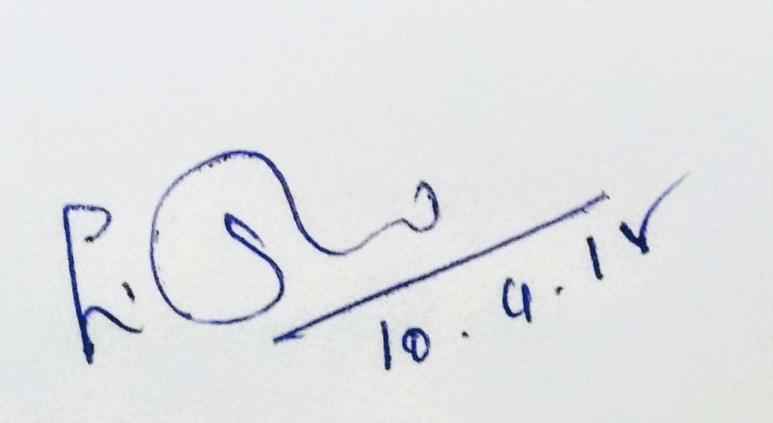

Signature of the Head of the Department Signature of the supervisor

ACKNOWLEDGEMENT
I would like to express my sincere thanks to God Almighty, for his constant love and grace that he has showered upon me.
I am very grateful to Padmashri Dr.P.R. Krishnakumar,Chancellor, AvinashilingamInsitute for Home Science and Higher Education for Women,Coimbatore, for his support and encouragement during the curse of my study.I heartily thank Dr.(Mrs.)PremavathyVijayan,M.Sc.,M.Ed.,Dip.Spl.Edn.,M.Phil.,Ph.D.,Vice Chancellor, AvinashilingamInsitute for Home Science and Higher Education for Women,Coimbatore, for extending all resources that facilitated the conduct of the present study.
I express my humble gratitude to Dr.Kowsalya, Registrar, AvinashilingamInsitute for Home Science and Higher Education for Women,Coimbatore, for providing all facilities necessary for the study.
I am also thankful to Dr.(Mrs.)A.Parvathi, M.Sc.,D.H.Ed., M.Phil., Ph.D., Faulty of Science, AvinashilingamInsitute for Home Science and Higher Education for Women,Coimbatore, for granting the facility required.
The author wishes her sincere and heartfelt gratitude Mrs.E.Shanthi, M.Sc.,Dip.Ed.,M.Phil. Associate Professor &Head ,AvinashilingamInsitute for Home Science and Higher Education for Women,Coimbatore,For her the constant support given during the period of investigation.
I wish to place on record my deep sense of gratitude to. Dr. P. Karthika M.Sc.,M.Phil.,Ph.D Assistant Professor, Department of Zoology,AvinashilingamInsitute for Home Science and Higher Education for Women,Coimbatore, for imparting in the tremendous assistance and well timed support for triumph of my project.
The investigator her gratitude and thanks to all Staff members andlab assistantsin the Department of Zoology, AvinashilingamInsitute for Home Science and Higher Education for Women,Coimbatore , For their help evinced throughout the course of this investigation.
On her personal note her profound thanks especially to her my father Mr.P.Ganesan, my mother Mrs.G.Mahadevi,BrotherP.G.Subburam and P.G.Maharajan, For their inspiration,unbounded affection, encouragement,support,prayers and loving care rendered throughout the study period.
The author Wishes to express her heartfelt thanks and all Friends for their support rendered throughout the study period.

CONTENTS

S.NO | TITLE | PAGENO.
1  2  3  4  5  6 | LIST OF FIGURE  LIST OF PLATES  INTRODUCTION  REVIEW OF LITERATURE  MATERIALS AND METHODS  3.1Chemistry of methylene blue  3.2 Preparation of rice husk powder  3.3 Preparation of dye solution  3.4 Dye adsorbtion studies  3.5 Characterization of rice husk  3.6 UV-vis spectral analysis  3.7 FTIR analysis (Fourier transformation  infrared spectroscopy)  RESULT AND DISCUSSION  4.1 Batch adsorption studies  4.1.1 Effect of adsorbent dose on dye  decolourization  4.1.2 Effect of dye concentration on dye  decolourization  4.1.3 Effect of temperature on dye  decolourization  4.1.4. Effect of pH on dye decolourization  4.2 FTIR result  4.3 UV result  SUMMARY AND CONCLUSION  BIBLIOGRAPHY | 1  7  16  19  35  37

LIST OF FIGURES

FIGURENO | TITLE | PAGENO  18  18  19  19  22  24  26  30  30  33  33  35  35
1  2  3  4  5  6  7  8  9  10 a  10 b  11 a  11 b | Dried rice husk  Fine grounded power of rice husk  Fine grounded power of rice husk  Experimental setup showing the increasing order of adsorbent (100mg- 1g)  Effect of adsorbent dose (mg) on the dye decolourization (mg).  Effect of dye concentration on the decolourization of dye (%).  Effect of temperature on the decolourization of dye (%).  Effect of temperature on the decolourization of dye (%).  Effect of ph concentration on the decolourization of dye (%).  FTIR spectrum with prominent peaks (before adsorption)  FTIR spectrum with prominent peaks (after adsorption)  UV- test in before adsorption  UV- test in after adsorption | PAGENO  18  18  19  19  22  24  26  30  30  33  33  35  35
- INTRODUCTION
With the development in technology the world is reaching to new horizons. Among the consequences of rapid growth are environmental disorder sand pollution problems. Beside so there needs the demand of water for industries has increased rapidly and resulted in the generation of a large amount of waste water containing large number of pollutants. Discharge of dye - bearing waste water into natural streams and rivers poses severe problems to the aquatic life, food web and causes damage to the aesthetic nature of the environment.The main sources of water contamination are industrialization, civilization, agricultural activities and other environmental and global changes. Few hundred organic pollutants have been found contaminating water resources. The contamination due to organic pollutants is very dangerous due to their various side effects and carcinogenic nature (Yang, 2011).
Textile industries consume large quantities of water and chemicals, especially in dyeing and ﬁnishing processes. On aver-age, 60–90% of total water consumption is spent in washing processes (Daneshvar et al.,2004).So it is estimated that around 10–15% of the dyes were lost during the dyeing processes. The discharge of highly colored synthetic dye efﬂuents can be very damaging to the receiving water bodies, since these dyes in the efﬂuents possess high water solubility although at low concentrations (<1 ppm). These compounds are highly visible and undesirable because they alter the natural appearance of rivers and lakes which impact on aquatic life like water plants and phytoplankton, interfering in transmission of sunlight, reducing photosynthesis and oxygenation of water reservoirs. Dyes used in the textile industry may be toxic to aquatic organisms and can be resistant to natural biological degradation (Khraisheh et al., 2003; Allen et al., 1988, 2003; Alpat et al., 2008).
Dyes are the important class of industrial pollutants (Al-Degs et al., 2001), that can even be identiﬁed by the human eye. Industries engaged in dyeing operation generate coloured effluent due to the presence of spent dye. Colouring dyes are used as a basic ingredient by many industries, such as textiles, rubber, plastics, printing, leather, cosmetics, etc., to color their products. Among various industries, textile industry ranks ﬁrst in usage of dyes for coloration of ﬁber.
Annual production of dyes is to the tune of 7x${10}^{5}$ tonnes in the global market. (Allen et al.,2005). The dyes produced are classified as cationic, anionic and nonionic dye. Anionic dye include various dye groups such as acid dyes, direct dyes, reactive dyes and while cationic dyes are basic dye.Acid dyes are water –soluble anionic dyes that are basic applied to fibers such as silk, wool, nylon.. Textile dyeing industries, pulp and paper industries and tanneries are the main consumers of dyes and are also responsible for discharge of voluminous coloured effluents. About 10 to 15% of the dyes consumed in the dyeing processes are disposed as the effluent. Various enzymes involved in the degradation of the dyes and the metabolites thus formed have been compiled (Dawood, 2014).
The increase in number of modern industry in the twenty-ﬁrst century that uses dye and ends up disposing it into the environment and water bodies causing diseases and other environmental risks to both aquatic life and human being is alarming (Adegoke et al.,2015).In response to the increasingly stringent discharge standards and discharge fee, textile industries must upgrade the performance of their wastewater treatment facilities with primary effort on reducing chemical oxygen demand and color. These dyes cause various diseases (Banat et al., 1996) especially allergy, dermatitis, skin irritation and also provoke cancer and mutation in humans (Lima et al., 2007). The currently existing techniques used for the removal of dyes are chemical coagulation/ﬂocculation, ozonation, oxidation, chemical precipitation, ion exchange, reverse osmosis and ultraﬁltration methods.
The removal of dyes from dye containing waste water has serious restrictions such as high cost, formation of hazardous by products and intensive energy requirement. Therefore the development of efﬁcient, low cost and eco-friendly technologies is needed to reduce the dye content in waste water. Hence, these pose a serious threat to human health and water quality, thereby becoming a matter of vital concern.The total dye consumption of the textile industry worldwide is in excess of 107 kg/year and an estimated 90 % of this ends up on fabrics. Consequently, 1,000 tones/year or more of dyes are discharged into waste streams by the textile industry worldwide.
Dyes can have acute and/or chronic effects on exposed organisms depending on the exposure time and dye concentration.Keeping the essentiality of color removal, concerned industries are required to treat the dye-bearing efﬂuents before dumping into the water bodies. Thus, the scientiﬁc community shoulders the responsibility of contributing to the waste treatment by developing effective dye removal technique. Among treatment technologies, adsorption is rapidly gaining prominence as a method of treating aqueous efﬂuent. Some of the advantages of adsorption process are possible regeneration at low cost, availability of known process equipment, sludge-free operation and recovery of the adsorbate (Kapdan and Kargi 2002). Activated carbon is the most widely used adsorbent for dye removal because of its extended surface area, micro-pore structures, high adsorption capacity and high degree of surface reactivity. However, commercially available activated carbon is very expensive and has high regeneration cost while being exhausted.
Dyes absorb and reﬂect sunlight entering water and so can interfere with the growth of bacteria and hinder photosynthesis in aquatic plants. The problems become graver due to the fact that the complex aromatic structures of the dyes render them ineffective in the presence of heat, light, microbes, and even oxidizing agents and degradation of the dyes become difﬁcult (Mishra, 1993).
Dye adsorption using activated carbon prepared from different sources and environmental implications. Also, its major challenges together with future prospects are summarized and discussed. Conclusively, the production of activated carbon from waste biomass for adsorption of these dyes is of great importance in pollution control and environmental conservation.
Dyes released by the textile industries pose a threat to the environmental safety. (Kaushiket al., (2009). The synthetic dyes are bright in colour and cause water pollution when discharged into water bodies and adsorption is found to be a simple and cost effective method for removal of colour from synthetic dyes.
Color removal from wastewater has been a matter of concern, both in the aesthetic sense and health point of view. Color removal from textile efﬂuents on a continuous industrial scale has been given much attention in the last few years, not only because of its potential toxicity, but also mainly due to its visibility problem. There have been various promising techniques for the removal of dyes from wastewater Bharathi and Ramesh (2013).However, the effectiveness of adsorption for dye removal from wastewater has made it an ideal alternative to other expensive treatment methods. In this review, an extensive list of sorbent literature has been compiled. The different agricultural waste materials as low-cost adsorbents for the removal of dyes from wastewater.
In India alone more than 400 million tonnes of agricultural residue is generated annually , which includes rice husk, bagasse, stalk, coir pith etc. Exploring application of the agricultural residues for use as adsorbents can provide suitable alternatives for the removal of spent dyes from industrial effluents (Raghuvanshi, 2004). Agricultural waste includes coir pith (Namasivayam and Kavitha 2002), orange peel (Rajeswari et al., 2001), banana peel (Annadurai et al., 2002), rice husk (Malik 2003), straw (Kannan and Sun- daram 2001), date pit (Banat et al., 2003), oil palm trunk ﬁber (Hameed and El-Khaiary 2008a), Murray peel (Hameed and Hakimi 2008), guava (Psidium guajava 2001) leaf powder (Ponnusami et al., 2008), almond shell (Ardejani et al., 2008), Pomelo (Citrus grandis) peel (Hameed et al., 2008), broad bean peel (Hameed and El-Khaiary 2008), peanut hull (Tanyildizi 2011), Citrullus lanatus rind (Bharathi and Ramesh 2012).
Selection of the precursor for the development of low cost adsorbents depends upon many factors. The precursor should be freely available, inexpensive and non-hazardous in nature. Moreover, for good adsorption results, high contents of carbon or oxygen in the adsorbent moiety are very necessary. Other characteristics include high abrasion resistance, high thermal stability and small pore diameters, which results in higher exposed surface area and, hence, high surface capacity for adsorption (Imran Ali 2012) Many treatment processes have been applied for the removal of dye from wastewater such as: Fenton process. (Behnajady et al., 2007), photo/ ferrioxalate system (Huang et al., 2007), photo-catalytic and electrochemical combined treatments (Neelavannan et al., 2007), photocatalytic degradation using UV/TiO2 (Sohrabi and Ghavami 2008), sonochemical degradation (Abbasi and Asi 2008), Fenton- biological treatment scheme (Lodha and Chaudhari 2008), biodegradation (Daneshvar et al., 2007), photo-Fenton processes (Garcia-Montano et al., 2007), integrated chemical, biological degradation (Sundarjanto et al., 2006), electrochemical degradation (Fan et al., 2008), adsorption process (Tan et al., 2007; Hameed et al., 2007a, b), chemical coagulation / ﬂocculation, ozonation, cloud point extraction, oxidation, nano-ﬁltration, chemical precipitation, ion- exchange, reverse osmosis and ultra-ﬁltration (Lorenc- Grabowsk and Gryglewic 2007); Malik and Saha 2003; Malik and Sanyal 2004; Banat et al., 1996).
Among treatment technologies adsorption is extremely gaining prominence. It is the most efﬁcient method for the removal of synthetic dyes from aqueous efﬂuents (Limaetal,2009; Calvete et al.,2010). Commercially activated carbon is an effective and the most widely used adsorbent because it has excellent adsorption efﬁciency, but recently many researchers have attempted to use natural waste as adsorbents due to the high cost of activated carbon (Garg et al., 2004). Some of these alternative biosorbents like banana pith, vine, eucalyptus bark, neem leaves, luffa cylindrical ﬁber, sunﬂower seed hull, soybean hull, hazelnut shell, neem saw dust, agricultural waste byproducts and teak wood bark were used as adsorbents for the puriﬁcation of waste water (Ardejani et al., 2007; Arslan-Alaton, 2003; Atun et al., 2003; Aydin et al., 2004; Tahir et al., 2005).
The growing demand for efﬁcient and low-cost treatment methods and the importance of adsorption has given rise to low-cost alternative adsorbents (LCAs). This overview highlights these LCAs comprising natural, industrial as well as synthetic materials/wastes and their application for dye removal. In addition, various other methods used for dye removal from water and wastewater are also complied in brief. Advantages and disadvantages of adsorbents, favorable conditions for particular adsorbate -adsorbent systems, and adsorption capacities of various low-cost adsorbents and commercial activated carbons as available in the literature are presented. Gupta et al.,(2008).
Biosorption is an emerging technique for water treatment utilizing abundantly available biomaterials (especially agricultural wastes). Among several agricultural wastes studied as biosorbents for water treatment, coconut has been of great importance as various parts of this tree (e.g. coir, shell, etc.) have been extensively studied as biosorbents for the removal of diverse type of pollutants from water. (Amit Bhatnagaret al., 2010). Coconut-based agricultural wastes have gained wide attention as effective biosorbents due to low-cost and signiﬁcant adsorption potential for the removal of various aquatic pollutants. In this review, an extensive list of coconut- based biosorbents from vast literature has been compiled and their adsorption capacities for various aquatic pollutants as available in the literature are presented. Available abundantly, high biosorption capacity, cost- effectiveness and renewability are the important factors making these materials as economical alternatives for water treatment and waste remediation. This paper presents a state of the art review of coconut-based biosorbents used for water pollution control, highlighting and discussing key advancement on the preparation of novel adsorbents utilizing coconut wastes, its major challenges together with the future prospective. It is evident from the literature survey that coconut-based biosorbents have shown good potential for the removal of various aquatic pollutants. However, still there is a need to ﬁnd out the practical utility of such developed adsorbents on commercial scale, leading to the superior improvement of pollution control and environmental preservation.
The use of activated carbon made of sugarcane bagasse, to eliminate cationic dyes present in waste water. It investigates the potential use of activated carbon made of sugarcane bagasse Farahania and Abdullaha(2011).Increase in the PH of the dye solution caused an equivalent increment in its adsorption efficiency. This study demonstrates that activated the carbon made from sugarcane bagasse is an efficient and cheap adsorbing agent and very effective at removing dyes present in solutions and the possibility of using it for a simple and inexpensive method of dye removal from waste waters in either stirred tank reactors or in batch reactors. The data obtained could be utilised to design an optimally productive system that uses either stirred tank reactors or batch reactors remove of cationic dyes from effluents industrial. This study predicts effect of rice husk on the removal of methylene blue dye.

2. REVIEW OF LITERATURE
Singh and Bhavana (2001) reported the adsorption capacity for the decolourization of wastewater containing safranine and methylene blue. The effect of system variables such as concentration, temperature,pH, contact time, adsorbent dosage and particle size are investigated. Removal of dye has been found to increase in dye concentration and pH of the solution. Kinetics of removal has been found to follow the first order rate expression. The adsorption isotherm data fitted both freundlich and Langmuir adsorption isotherms. Thermodynomic studies showed the adsorption to be an exothermic and spontaneous.
Ravikumar et al., (2005) reported the decolourization of Veroﬁx Red (Reactive Red 3GL) and Lanasyam brown Grl (Acid Brown 29) from aqueous solution by adsorption technique using a hybrid adsorbent that was prepared by pyrolysing a mixture of carbon and ﬂyash at 1:1 ratio. The combined eﬀect of pH, temperature, particle size and time on the dye adsorption was investigated and optimized using response surface methodology. The Reactive Red 3GL and those for Acid Brown 29 were 1.4, 27.5 C, 0.0515 mm and 285 min, respectively. Complete removal (100%) was observed for both the dyes using the hybrid adsorbent.
Flavio et al., (2008) utilized the yellow passion fruit (Passiﬂora edulis Sims. f. ﬂavicarpa Degener) peel a powdered solid waste, was tested as an alternative low-cost adsorbent for the removal of a basic dye, methylene blue (MB), from aqueous solutions. Adsorption of MB onto this natural adsorbent was studied by batch adsorption isotherms at room temperature. The eﬀects of shaking time and pH on adsorption capacity were studied. Thus they confirmed that the yellow passion fruit peel may be used as an alternative adsorbent to remove MB from aqueous solutions.
Umaet al., (2008) explored the adsorptive characteristics of Indigo Carmine (IC) dye from aqueous solution onto rice husk ash (RHA). Batch experiments were carried out to determine the inﬂuence of parameters like initial pH (pH0), contact time (t), adsorbent dose (m) and initial con- centration (C0) on the removal of IC. The pseudo-second-order kinetic model represented the adsorption kinetics of IC on to RHA. Equilibrium isotherms were analyzed by Freundlich and Langmuir isotherm studies.
Amit et al., (2010) reported that biosorption was an emerging technique for water treatment utilizing abundantly available biomaterials (especially agricultural wastes). Among several agricultural wastes studied as biosorbents for water treatment, coconut has been of great importance as various parts of this tree (e.g. coir, shell, etc.) have been extensively studied as biosorbents for the removal of diverse type of pollutants from water. Coconut-based agricultural wastes have gained wide attention as effective biosorbents due to low-cost and signiﬁcant adsorption potential for the removal of various aquatic pollutants. In this coconut- based biosorbents from vast literature has been compiled and their adsorption capacities for various aquatic pollutants as available in the literature are presented. Available abundantly, high biosorption capacity, cost- effectiveness and renewability are the important factors making these materials as economical alternatives for water treatment and waste remediation.
Pooja et al.,(2010)reported on the color removal of textile waste water containing dyes using waste material of sugar cane industry. The effiency of dye removal was tested using parameters like initial concentration of dye, adsorbent amount and adsorption time.
Velmurugan et al., (2011) prepared the adsorbent from orange peel, to remove methylene blue from an aqueous solution in a batch wise column. The study investigated the potential use of orange peel, pretreated with nominal treatment methods, for removal of methylene blue from simulated waste water. Treated orange peel used to adsorb methylene blue at varying dye concentration, adsorbent dosage, pH and contact time .similarly experiments were conducted with other low cost adsorbent such as banana peel, neem leaves and rice husk commercially available powdered activated carbon. The adsorption capacity of orange peels decreased in the order of methylene orange > methylene blue > Rhodamine B > congo red >methyl violet > amido black IOB. Dye removal y the adsorbents is quite effective, but orange peel is found is found to be very effective compared to other low cost adsorbent with in a short period. The sorption data were then correlated with the freundlich and the Langmuir adsorption isotherm models and the study indicated that the orange peel has greater affinity for methylene blue.
Meysamet al., (2011) demonstrated the utilization of activated carbon made of sugarcane bagasse, to eliminate cationic dyes present in waste water. Thus the studyemployed to design an optimally productive system that uses either stirred tank reactors or batch reactors remove of cationic dyes from effluents industrial.
Santhiel al., (2011) suggested the adsorption of Malachite green (MG) and Methylene blue (MB) from aqueous solutions on low cost adsorbent prepared from Annona squmosa seed (CAS) is studied experimentally. Results obtained indicated that the removal efﬁciency of Malachite green and Methylene blue at 27 ± 2C exceeds 75.66% and 24.33% respectively, and that the adsorption process is highly pH-dependent. Results showed that the optimum pH for dye removal is 6.0. These results suggested that A. squmosa seed is a potential low-cost adsorbent for the dye removal from industrial wastewater. The adsorption capacity of CAS on MG is greater than MB.
Ouasifet al., (2012) investigated the elimination of methylene blue from waste water by adsorption on clays and oil shales. These natural materials were decarbonated with hydrochloric acid and characterized by X-ray diffraction, X-ray fluorescence and infrared spectroscopy. Factors affecting adsorption were evaluated. Kinetic parameters calculated from the experimental data could be fitted to a pseudo-second-order kinetic model. The equilibrium of adsorption and the adsorption data are well described by the Langmuir model. Clays absorb more methylene blue than oil shales. The sorbents treated with hydrochloric acid have higher capacity than the starting materials.
Etimet al., (2012) studied the adsorption of methylene blue from aqueous solution onto coconut coir dust (CCD) a low cost agricultural waste material in a batch process was investigated. Adsorption was studied as a function of amount of adsorbent, pH and concentration with time. It was found that percent- age adsorption varied linearly with the amount of adsorbent and concentration with time but varies non-linearly with pH. Adsorption equilibrium data were represented by isotherm, kinetics and thermodynamics models.
El-said and Gamal (2012) investigated the Orange peel (OP) as a low cost natural waste adsorbent for the removal of textiles effluents. The results indicated that acidic solutions supported the adsorption of the studied dyes within (OP). Adsorption kinetic models were analyzed using the pseudo-first, second order equation fitted the experimental data very well. By the way, the effect of adsorbent surface was analyzed by scanning electron microscope(SEM),whereas the SEM images showed reasonable agreement with adsorption measurements.
Ali et al., (2012) stated that water pollution due to organic contaminants is a serious issue because of acute toxicities and carcinogenic nature of the pollutants. Among various water treatment methods, adsorption is considered as the best one due to its inexpensiveness, universal nature and ease of operation. Many waste materials used include fruit waste, coconut shell, rice husk, scrap tyres, bark and other tannin-rice materials, sawdust and other wood type materials, rice husk, petroleum wastes, fertilizer waster, fly ask, sugar industry blast furnace slag, clays and mud, sediment and soil, ore minerals etc.
Mafraet al., (2012) reported the orange peel adsorbent developed from an agricultural waste material was characterized and utilized for the removal of Remazol Brilliant Blue from an artificial textile-dye effluent. The adsorption thermodynamics of this dye-adsorbent pair was studied in a series of equilibrium experiments.The thermodynamic analysis of dye adsorption onto the orange peel adsorbent indicated its endothermic and spontaneous nature. Thus, the application of orange peel adsorbent for the removal of dye from a synthetic textile effluent was successfully demonstrated.
Yamina and Elandaloussi (2012) assessed the ability of two low-cost adsorbents timber sawdust (TSOH) and its alkaline treated analog (TSONa) to remove two basic dyes, namely, Methylene Blue and Methyl Green, from aqueous solutions. The presence of new functional groups on the surface of TSON a resulted in a dramatic increase of surface polarity and the density of sorption sites, thereby improving the sorption efﬁciency of the cationic dyes. The results revealed that the sorption process for TSON a was uniform and rapid.
Yamina Djilaliet al., (2012) assessed the ability of two low-cost adsorbents timber sawdust (TSOH) and its alkaline treated analog (TSONa) to remove two basic dyes, namely, Methylene Blue and Methyl Green, from aqueous solutions.
Zuraida et al.,(2013) carried out an investigation on explore the usability of the bacteria, Lactobacilillusdelbruckii for the removal of dye from aqueous solution. It involves the use of two commercial synthetic dye i.e. Reactive orange 16 (OR 16) and Reactive block 5 (RB 5). The effects of different parameters such as pH, temperature and initial dye concentration were studied and the effectiveness of this method to remove the dye solution was determined by measuring the percentage of the colour removal. The results showed that the bacteria are able to decolourize this two reactive dye and the optimum pH, temperature, and initial dye concentration were found to be 6 and 37ºC, 10 rpm, respectively. Therefore, Lactobacillus delbruckii is a tremendous potential strain for decolourization of reactive textile dye effluent, and it can be used as a practical alternative in the treatment of textile wastewater
Oznur Dulger et al., 2013 investigated on Sumac Leaves (SL) (Rhus Coriaria L.) inexpensive and effective adsorbent for the adsorption of methylene blue (MB) from aqueous solution. The effects of initial dye concentration, initial solution pH, phases contact time, and adsorbent dose on the adsorption of MB on SL were investigated. The amount of dye adsorbed was found to vary with initial solution pH, Sumac Leaves dose, MB concentration, and phases contact time. The maximum adsorption capacity was found from the isotherm model at25∘C.The value of the monolayer saturation capacity of SL was comparable to the adsorption capacities of some other adsorbent materials for MB.
Rajeev Kumar and Barakat (2013) utilized the binary oxidized Cactus fruit peel (CFP) as adsorbent for the removal of brilliant green (BG). The prepared adsorbent was characterized by Fourier transform infrared spectroscopy (FTIR) and Energy dispersive X-ray (EDAX). Batch adsorption studies were performed as a function of contact time, initial solution pH, initial BG concentration and temperature.
The white rot fungus Pycnoporus sanguineus (MUCL 51321) isolated in goban showed a high ability to decolourize and degrade two synthetic dye. On solid and liquid media, the fungus had a different enzyme activities (laccase and manganese peroxidase ) in the presence of different substrates.(Christiane et al.,(2013). At concentration of 0.05 g/L (orange G)0.3g/L (reactive blue 4),the respective rates of decolourization of 81% and 97% where observed after 15 days of incubation in liquid media. In the same time interval, changes on the spectra (UV- vis and FTIR) and the chromatograms (HPLC) showed that these decolourization were due to the degradation of dye by fungus with a production of new compounds. The study revealed the possibility of the use of this fungal strain in the microbial degradation process of synthetic dye.
Sudevi Basuet al., (2013) carried out an investigation on decolourization efficiencies of eco-friendly, cost effective adsorbents from fruit and vegetable peels (Watermelon Peel (WMP), Watermelon Rind (WMR), Mosambi Outer Peel (MOP), Mosambi Inner Peel (MIP), Papaya Peel (PAPP) and Potato Peel (POTP) on four synthetic dyes (Crystal Violet, Methylene Blue, Malachite Green and Methyl Orange). This research revealed that all fruit and vegetable peel adsorbents were found to be effective in removal of synthetic dyes.
Rajeev and Barakat (2013) investigated the decolourization of dye waste waters through fungi via two processes (biosorption and bioaccumulation) and discusses the effect of various process parameters like pH, temperature, dye concentration etc. on the dye removing efﬁciency of different fungi.
Muhammad et al., (2014) conducted batch adsorption experiment of malachite green (MG) with walnut shell (WS).Adsorption of MG onto WS was confirmed by FTIR analysis. Particle size, dosage, effect of dye concentration, pH, temperature, and ionic strength were investigated. The optimized conditions for adsorption process was carried out using WS of dosage 0.03g/20ml. dye,at room temperature, ambient pH and agitation rate of 250rpm for 2 h. the kinetics of the adsorption process was studied using four models:Thermodynamic studies showed that adsorption system is spontaneous and endothermic in nature. Regeneration of WS was investigated using three different solvent solution and the results showed 0.1M NaOH was able to regenerate and improve the adsorption capability of WS.
Arjun et al., (2015) employed low cost adsorbents such as rice husk (RH) and rice husk ash were used for removing dyes from aqueous medium and later Linear, Langmuir and Freundlichadsorption isotherms have been verified by using adsorption data. RH was activated by treating with nitric acid and RHA was prepared from RH by dolomite process. Natural dyes were extracted from the vegetable Amaranthus gangeticus by using a standard method. The removal efficiency of adsorbents was measured for the variation of parameters pH, contact time and adsorbents concentration. The RH removal efficiency was good for pH 11 close to 62.86% and it was continuous from 3.95% at pH 2. Alternately, RHA gave 80.21% at pH 2 and later was decreased to 1.5% at pH 9 and again increased from pH 11. It is noted that RHA removal efficiency is better than RH and adsorptions are well fitted with isotherms.
Tahir et al., 2016 utilized the waste product of sugar mill (bagasse) as low-cost adsorbent in natural, and modiﬁed forms for the removal of malachite green (MG) dye. The sugar cane bagasse (SB), carbonaceous bagasse (C- SB) and ﬂy ash bagasse (FA-SB) were tested as adsorbents for the removal of malachite green (MG) dye from aqueous solutions. The modiﬁed bagasse C-SB showed 89% removal, due to the formation of new modiﬁed surface and enhancement in its surface area and thus it could be employed as a low-cost alternative method for the removal of dyes and puriﬁcation of textile efﬂuents.
Saranya et al., (2016) revealed the potential of dried twigs of Melaleuca diosmifolia as a novel biosorbent for removing three cationic dyes, methylene blue (MB), acridine orange (AO) and malachite green (MG), and an anionic dye, eriochrome black T (EB) was evaluated in a batch adsorption process.The water extract obtained from the plant material induced fast decolorization of both categories of dyes followed by gradual flocculation, indicating its potential as a natural coagulant. Gas chromatographic analysis also indicated that the main electrostatic attraction between 1.8-cineole, 1-p-methene-8-thiol and furfural compounds of the biomaterial, and dye molecules resulted in the formation of initial Supramolecular complexes which further progressed into strong aggregates, leading to precipitation of dye–biomaterial complexes. Consistent with the batch studies, using selected plant material in real environmental water samples also resulted in effective dye removal, highlighting its potential for use in wastewater treatment.
Kamaraj and Umamaheswari (2017) described the preparation of low-cost and eco-friendly groundnut shell activated carbon (GSAC) by combined physical and chemical activation in a laboratory-scale facility. The fluorescent emission scanning electron microscope analysis exhibited well-defined pore formation and the energy dispersive X-ray analysis showed elemental composition of GSAC which is essential for the strong adsorption of the dye molecule. This study significantly emphasized that GSAC would be the effective adsorbent to remove methylene blue dye from aqueous solution that accompanied with significant microbiostatic activity. Utilization of groundnut shells serves dual purpose of simultaneous waste eradication,as well as cost-effective pollution treatment process.
SanmugaPriya and Senthamil Selvan (2017) reported the biosorption capacity of the water hyacinth in reducing the concentration of dyestuffs, heavy metals and minimizing certain other physiochemical parameters like TSS (total suspended solids), TDS (total dissolved solids), COD (chemical oxygen demand) and BOD (biological oxygen demand) in textile wastewater. Sorption kinetics through various models, factors inﬂuencing the biosorption capacity, and role of physical and chemical modiﬁcations in the water hyacinth were also discussed.
Bhalambaal and Sunil (2017) investigated the effect of coconut shell bio char on dye degradation in a microbial fuel cell (MFC) was investigated in the present study. The highest COD removal efficiency was about 77.7% (0.5g bio char),maximum current (1.07mA) and voltage(722mV) were obtained with1g biochar, biofilm optical microscopy characterization revealed the micro colonies intricate plate like structures. High adsorbent dosage might surface area for biofilm to generate electricity. The overall results the possibility of using biochar as an additive in MFC for efficient dye degradation.
Gui-Bing Hong and Yi-Kai Wang (2017) modified rice bran to make it a low-cost adsorbent to removereactive blue 4 (RB4) from aqueous solution. The effects of independent variables such as dye concentration (100-500ppm), adsorbent dosage (20-120mg) and temperature (30-60C̊)on the dye adsorption capacity of the modified rice bran adsorbent were investigated by using the response surface methodology (RSM). The thermodynamics analysis results indicated that the adsorption of RB4 onto the modified rice bran adsorbent is an endothermic, spontaneous monolayer adsorption that occurs through a physical process.
Mary et al.,(2018) reported the development of a multifunctional high surface area activated carbon (DRP), from a biomaterial, Delonixregia, with antimicrobial potential and demonstrated its applicability towards removal of two reactive dyes, Reactive Red (RR-120) and Reactive Blue (RB-4) with an adsorption capacity of ∼6.36 and 24 mg·g−1 respectively. The newer multifunctional activated carbon was prepared from the deseeded pods of Delonix regia through thermo-chemical surface modiﬁcation and characterized for surface and morphological characteristics, chemical composition, and thermal stability. DRP exhibited a high surface area of 1577 m2·g−1 with various active functional groups. The decolourisation eﬃciency was very high, ∼98% for both the dyes. The eﬀects of variousoperating parameters like pH, initial dye concentration, adsorbent dosage, surfactant, salt etc. DRP could successfully reduce the microbial growth of Gram positive B. subtilis with a higher zone of inhibition.
Thus plethora of literatures was evidenced as a baseline reference to frame the present investigation on the removal of methylene blue dye with rice husk, a low cost-effective adsorbant.

3. MATERIALS AND METHODS
Present investigation on “Rice husk as an adsorbent for the removal of textile dye from aqueous solution” was conducted to assess the decolourization potential for Methylene Blue dye.
3.1CHEMISTRY OF METHYLENE BLUE
Methylene Blue (MB) (C₃H₁₈C_{l}N₃S) is a monovalent cationic dye with molecular weight of 373.9. Methylene blue dye of analytical grade (Anmol chemicals) was purchased. It has several utilitiessuch as dyeing of silk, leather, paper & cotton as well as production of ink.
3.2 PREPARATION OF RICE HUSK POWDER
Rice husk (Fig.1) was collected from the local market and washed in tap water to remove soil particles. It was sun dried to remove moisture content, crushed well and ground in to a fine powder in an electric mixture cum grinder. The powder was sieved to get particles of uniform size (Fig.2) and stored for use in the study.
3.3 PREPARATION OF DYE SOLUTION
100mg of the dye was dissolved in 100ml of distilled water such that each 1ml contained 1mg of the dye. The required concentrations of dye solution (1-10 mg) were prepared from the above stock solution (Fig 3).
3.4 DYE ADSORBTION STUDIES
Batch experiments were conducted to get optimum conditions for dye removal namely optimum dye concentration, pH, contact time, temperature and adsorbent dose. Fixed amounts of adsorbent (100mg-1.0g) (Fig 4) were added to dye solution of varying concentrations (1mg-10mg)and maintained at different temperatures (10-60⁰ C) and pH(1-10) for time periods from 24 -90 hours.For adjusting the pH of dye solution diluted NaOH and HCL were used. At the end of each experiment the absorbance of the dye solution was read in a colorimeter at 420nm to estimate final dye concentration. Initial absorbance of each dye solution was also read in the colorimeter and % decolourization was calculated as follows.
Initial absorbance of dye − final absorbance of dye
% Decolourization = ------------------------------------------------------------- ×100
Initial absorbance of dye
All experiment were presented as triplicatesfor each parameter to get average values for calculation
3.5 CHARACTERIZATION OF RICE HUSK
The structural characterization of rice husk was done by UV-vis spectral and FTIR analysis
3.6 UV-VIS SPECTRAL ANALYSIS
Dye decolourization by the adsorbent was evaluated by subjecting the dye solution before and after adsorption to spectral analysis in the UV visible region.
3.7 FTIR ANALYSIS (FOURIER TRANSFORMATION INFRARED SPECTROSCOPY)
FTIR analysis was done in the spectral range of 500-4000 nm to study the functional groups available on the absorbent surface for adsorption.

PLATE 1
Fig.1
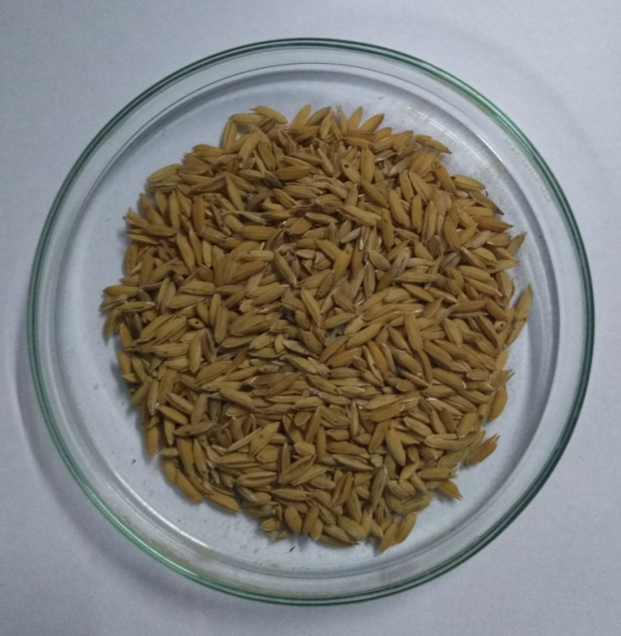

Dried rice husk

Fig.2
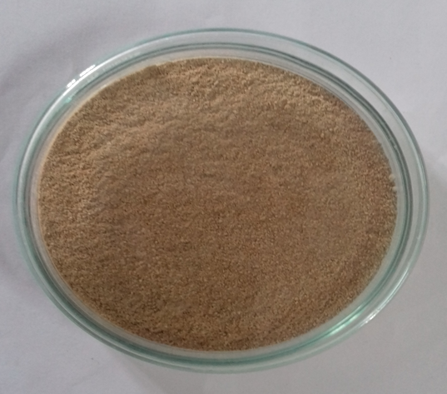

Fine grounded power of rice husk

PLATE 2
Fig. 3
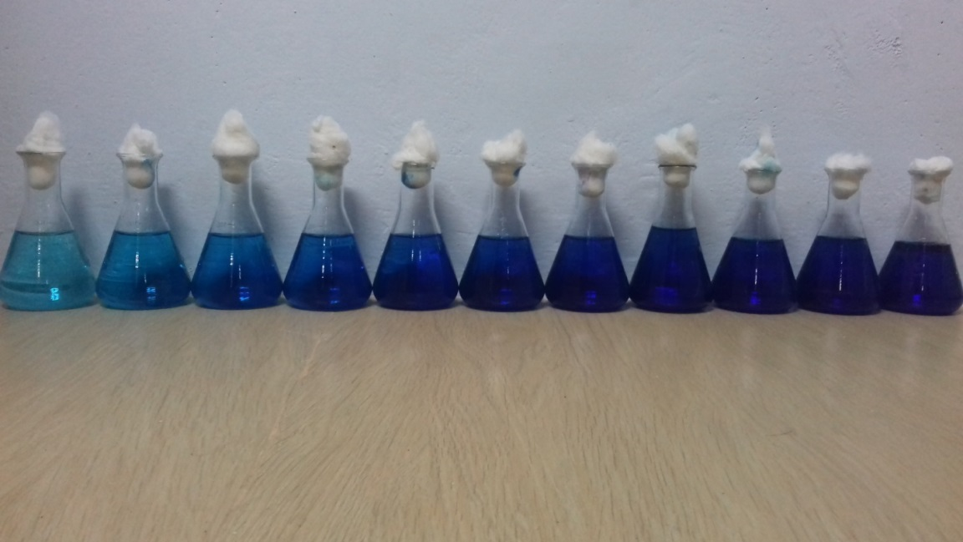

Experimental set up for different dye concentrations (1- 10 mg)

Fig.4
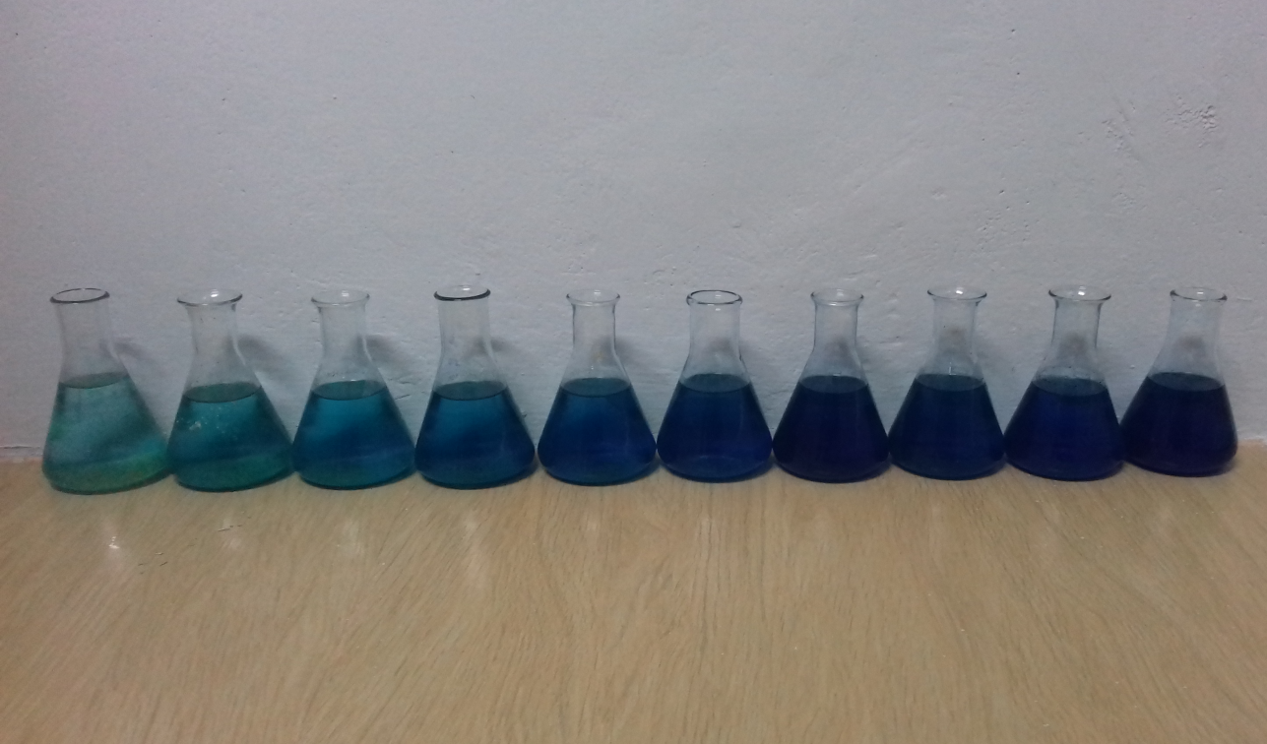

Experimental setup showing the increasing order of adsorbent (100mg- 1g)

4.RESULT AND DISCUSSION

  - BATCH ADSORPTION STUDIES
4.1.1EFFECT OF ADSORBENT DOSE ON DYE DECOLOURIZATION
The range of adsorbent doses waschosen from 100 to 1000mg with the dye concentration of 0.1g/100 ml in the treatment samples. Our results revealed that appreciable adsorption was visualized at 500mg with 42% of dye decolourization. Salleh et al.,(2011) suggested that the effect of adsorbent dosage on the adsorption process would be effective based on adsorbent–adsorbate solution with different amount of adsorbents added to ﬁxed initial dye concentration and shaken together until equilibrium time. Generally, the percentage of dye removal increases with increasing adsorbent dosage. Initially, the rate of increase in the percent dye removal has been found to be rapid which slowed down as the dose increased. This phenomenon can be explained, based on the fact that at lower adsorbent dose the adsorbate (dye) was more easily accessible and because of this, removal per unit weight of adsorbent is higher. With rise in adsorbent dose, there is less commensurate increase in adsorption, resulting from many sites remaining unsaturated during the adsorption (Jain et al. 2003).
But after a certain dosage the increase in removal efﬁciency is insigniﬁcant with respect to increase in dose. This is due to the fact that, at higher adsorbent concentration there was rapid superﬁcial adsorption onto the adsorbent surface that produced a lower solute concentration in the solution in the low dosage of the adsorbant. Thus, with increasing adsorbent dose, the amount of dye adsorbed per unit mass of adsorbent is reduced, thus causing a decrease in value (Han et al. 2007). Similarly, Sharma and Uma (2010) carried out an experiment with different adsorbent doses (0.40–0.60 g) in 50 mL of dye solution and analysed the effect of rice husk activated carbon on the removal of Methylene blue. They reported that the removal increased from 86.75 to 99.83 % with increasing adsorbent dose from 0.40 to 0.60 g. Similarly Hong and Wang et al.,(2017), investigated the surface structure of rice husk and its capacity of adsorption. They reported that the pre-treatment of ORB (original rice bran) had an appreciable adsorbing capacity than ORB. Singh and srivastava (2000) reported that the percent adsorption of dye on the rice husk carbon increased adsorbent dosage. Initially upto 40 mg/50mL the percent removal increases rapidly and reaches about 96% for safranine and methylene blue. For 100% removal of safranine and methylene blue dosages required are 1.6 g/L and 2g/L respectively.The high adsorbence of rice husk perhaps due to the presence of 64-74% volatile matters and 12-16% fixed carbon and 15-20% ash (armesto,2002).In addition, adsorbent such as (a) a large accessible pore volume (b) hydrophobicity (c) high thermal and hydro thermal stability (d) catalytic activity and (e) easy regeneration

PLATE 3

Fig.5
Effect of adsorbent dose (mg) on the dye decolourization (mg).

4.1.2 EFFECT OF DYE CONCENTRATION ONDYE DECOLOURIZATION
The effect of adsorbent at the different dye concentrations was tested and presented in fig.4 the decolourization potential showed an in variable manner of adsorption. A marked difference of decolourization was noted at 6 mg with the 76% of decolourization potential. This may be explained as a result of overlapping or aggregation of adsorption sites resulting in a decrease in the total adsorption surface area available to the dye and an increase in the diffusion path length. A similar trend was reported by El-Sayed (2011) in his studies of removal of methylene blue and crystal violet from aqueous solution by palm kernel ﬁbres. The percentage of dye removal is highly dependent on the initial amount of dye concentration. The effect of the initial dye concentration factor depends on the immediate relation between the dye concentration and the available binding sites on an adsorbent surface. Generally the percentage of dye removal decreases with an increase in initial dye concentration, which may be due to the saturation of adsorption sites on the adsorbent surface (Salleh et al., 2011) and the adsorption capacity increased with an increase in the initial concentration of the dye. At low concentrations there will be unoccupied active sites on the adsorbent surface, and when the initial dye concentration increases, the active sites required for adsorption of the dye molecules will not be available (Kannan and Sundaram, 2001). The effect of the initial concentration of MB/time of adsorption on the percentage of dye removal. It was found that more than 80% of the dye was removed in the ﬁrst minute of adsorption and increased slowly to maximum at equilibrium. Also, the percentage of adsorption decreased with an increase in the initial concentration and increased as the contact time prolonged. However, the increase in the initial dye concentration caused an increase in the loading capacity of the adsorbent and this may be due to the high driving force for mass at a high initial dye concentration (Bulut and Aydin, 2006). In other words, the residual concentration of dye molecules will be higher for higher initial dye concentrations. In the case of lower concentrations, the ratio of the initial number of dye molecules to the available adsorption sites is low and subsequently the fractional adsorption be- comes independent of the initial concentration.

PLATE 4

Fig. 6

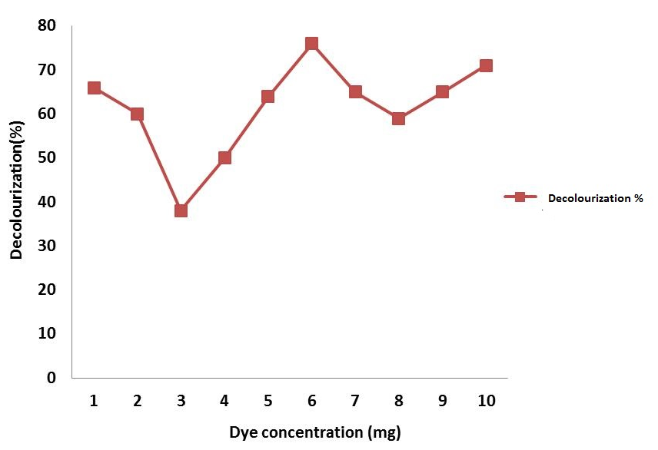

Effect of dye concentration on the decolourization of dye (%).

4.1.3 EFFECT OF TEMPERATURE ON DYE DECOLOURIZATION
The dosage was fixed from optimization studies, where in, the parameters like pH and temperature was varied to test the efficiency of the adsorbent. The decolourization potential of the adsorbent, rice husk was cheeked by the varying temperature from 10$C^{°}$- 40$C^{°}$. The experimental results portrayed that the effective adsorption of the dye by the rice husk was maximum at 30$C^{°}$ with 55% of decolourization. Thus the studies suggested that the textile dye was capable of removing dye at higher temperature as well, which was a prerequisite for their applicability in treating dye waste water. (Alkan and Dogan 2003). A study of the temperature dependence of adsorption reactions providing valuable knowledge about the enthalpy and entropy changes during adsorption. Temperature is an indicator for the adsorption nature whether it is an exothermic or endothermic process (Salleh et al,. 2011). If the adsorption capacity increases with increasing temperature then the adsorption is an endothermic process. This may be due to increasing the mobility of the dye molecules and an increase in the number of active sites for the adsorption with increasing temperature (Senthilkumaar et al., 2006). Senthilkumaar et al., (2006) reported that the enhancement of adsorption capacity of the activated carbon at higher temperatures is attributed to the enlargement of pore size and activation of the adsorbent surface. During the adsorption there, some structural changes in the dyes and the adsorbent occur (Hema and Arivoli 2007).The adsorbed water molecules, which were displaced by the adsorbate species, gain more translational entropy than it is lost by the adsorbate molecules, thus allowing the prevalence of randomness in the system. Increasing temperature may decrease the adsorptive forces between the dye species and the active sites on the adsorbent surface as a result of decreasing adsorption capacity (Ofomaja and Ho, 2007).

PLATE 5

Fig. 7

Effect of temperature on the decolourization of dye (%).

4.1.4.EFFECT OF pH ON DYE DECOLOURIZATION
pH factor is very crucial in adsorption studies especially dye adsorption. The pH of a medium controls the magnitude of electrostatic charges which are imparted both by the ionized dye molecules and the charges on the surface of the adsorbent. As a result, the rate of adsorption will vary with the pH of an aqueous medium (Onal et al., 2006). The pH was chosen as a parameter to test the adsorbent potential of the rice husk. The pH range of 1-10 was chosen, in which the acid range from 1-7 and alkaline there after 7-10. The best results were obtained at pH 9 with the decolourization percentage of 45% minimum percentage of decolourization was noted at the pH range of 2 (Onal et al., 2006). The pH factor is very important in the adsorption process especially for dye adsorption. The pH of a medium controlled the magnitude of electrostatic charges which were imparted by the ionized dye molecules. As a result, the rate of adsorption varied with the pH of an aqueous medium
Generally, at low pH solution, the percentage of dye removal decrease for cationic dye adsorption, while for anionic dyes the percentage of dye removal increased In contrast, at a high pH solution the percentage of dye removal will increase for cationic dye adsorption and decrease for anionic dye adsorption (Salleh et al. 2011). For cationic dyes, lower adsorption of dye at acidic pH is probably due to the presence of excess H+ ions competing with the cationgroups on the dye for adsorption sites. As surface charge density decreases with an increase in the solution pH, the electrostatic repulsion between the positively charged dye and the surface of the adsorbent was lowered, which resulted in an increase in the extent of adsorption (Wang et al. 2006).
Contrarily, Ansari and Mosayebzadeh (2010) reported that, an increase in the solution pH, the electrostatic repulsion between the positively charged cationic dyes and the surface of adsorbent is lowered and consequently the removal efﬁciency is increased. Garg et al. (2004) reported that the dye adsorption by coconut-based carbon was unaffected by pH changes in the range of 2–10. Sulphuric acid-treated sawdust had maximum dye adsorption (96 %) over the pH range of 6–10 which decreased to 70 % at pH of 2.0. By Formaldehyde treated sawdust, dye removal was minimum (26.8 %) at the pH of 2.0, which increased to 99 % at pH 10. Many researchers studied the isoelectric point (pHIEP) of adsorbents that prepared from agricultural solid wastes in order to better understand of adsorption mechanism. Cationic dye adsorption is favored at pH pHpzc, due to the presence of functional groups such as OH-, COO- groups (Radovic et al. 1997; Savova et al. 2003).
At high pH solution, the positive charge at the solution interface decreases and the adsorbent surface appears negatively charged (Ozcan et al. 2007). As a result, the cationic dye adsorption increases and anionic dye adsorption showed a decrease (Salleh et al. 2011). Zawani et al (2009) reported that adsorption of Remazol black 5 on the palm kernel shell activated carbon has optimum pH of 2 with maximum uptake at 27.44 mg g-1, and then, the uptake was declined signiﬁcantly. Solution pH inﬂuences both the carbon surface dye binding sites and the dye chemistry in water. At lower pH values, the carbon will have a net positive charge. Higher uptakes obtained at lower pH may be due to the electrostatic attractions between negatively charged functional groups located on the reactive dye and positively charged adsorbent surface. Hydrogen ion also acts as a bridging ligand between the adsorbent wall and the dye molecule (Aksu and Tezer 2005).
Dye adsorption eﬃciency was aﬀected by pH variation. The adsorption of MB increased with an increase pH. The optimum pH for the adsorption of MB was found to be in the range 7–10. This can be explained by considering the electrostatic attraction that exists between the negatively charged, surface of the adsorbent mainly due to pectin and MB, a cationic dye. Lower adsorption at acid pH was probably due to the presence of excess of H+ ions competing with the dye cations for adsorption sites. At alkaline pH, the number of positively charged sites decrease and the number of negatively charged sites increase which favors the removal of the cationic dye. Similar trends were observed for the adsorption of methylene blue onto Fe(III)/Cr(III) hydroxide (Namasivayam and Sumithra, 2005),malachitegreenontoagro-industrywaste(Garg et al., 2004), methylene blue onto various carbons (Kannan and Sundaram, 2001).
The effect pH of solution on removal of methylene blue has been studies by changing the pH over a range of (4-9) at constant operation condition concentration of dye 50 ppm. Jasim and Salman (2016) utilized Phragmites australis powder dosage of 4 gm/L and contact time of 90 min efficiently removed methylene blue in the basic medium and gradually ceased in acidic medium.

PLATE 6

Fig.8
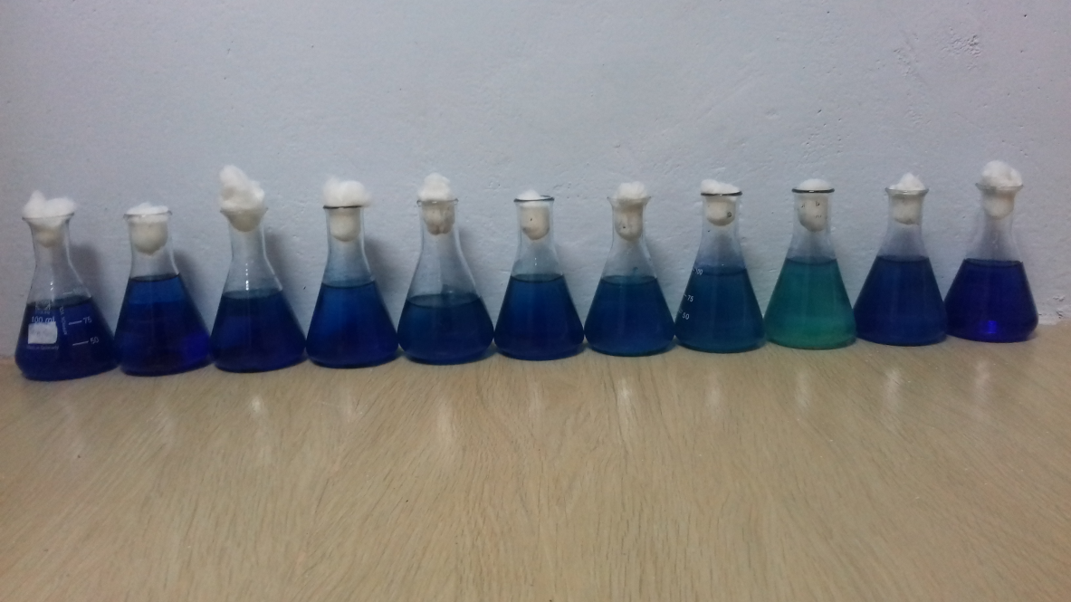

Experimental setup showing the removal of dye concentration from the 8 pH.

Fig.9

Effect of pH concentration on the decolourization of dye (%).

4.2 FTIR RESULT
The FTIR spectra from ranged 466 – 3750 ${cm}^{-1}$ of the adsorption spectra resulted in the presence of 8 prominent peaks at 466.77, 1045.42, 1512.19, 1657.07, 2376.03, 2927.94, 3410.15, and 3745.75. The 1512.07 ${cm}^{-1 }$correspond to the presence of carbonyl group while 1657 ${cm}^{-1 }$was associated with the conjugated alkenyl carbon functional groups C=C. Similarly, 2927.94 correspond to ${CH}_{2}$functional groups and alkeyl C=H stretch amino or amides.
The peak spectrum showed a broadband between 2800 and 3700 ${cm}^{-1 }$which indicated the presence of both free and hydrogen bonded OH groups and Sie OH groups on the adsorbent surface (Abou - Mesalam, 2003). Kamaraj and Uma maheshwari (2017) reported the FTIR spectra in the range 400$to 4000 {cm}^{-1}$ of GSAC was presented .This type analysis used for identification of organic functional group presented on the surface. In the FTIR spectrum a significant peak at 1453 ${cm}^{-1}$ is assigned to the characteristic ${CH}_{2}$ bending vibrations and is probably ascribable to carbonyl group which are highly conjugated in the grapheme layer. This is consistent with the basic nature of the carbon. Peak located at 1602 ${cm}^{-1}$ are due to conjugated C=C stretching vibrations. The peak located at 2923 ${cm}^{-1}$ is due to ${CH}_{2}$ stretching vibrations.Ousasif et al., (2013) reported that the FTIR spectrum of the NOS and NC displayed a characteristic carbonate absorption bands (1429, 875 and 712 cm-1) and silicates (1035 cm⁻¹).
Higher percentage of carbon and hydrogen than nitrogen suggested that carbon-hydrogen group might be available for adsorption of dye. The FTIR spectrum of untreated RH, as indicated the presence of various functional group at wavelength 3373 ${cm}^{-1}$ (O-H stretch), $2923{ cm}^{-1}$ (C- H stretch), 1739 ${ cm}^{-1}$ (C- O stretch),1630${ cm}^{-1}$(N - H bending), 1447 ${ cm}^{-1}$ (${CH}_{2}$ deformation ) and 1377 ${ cm}^{-1}$( ͞ COO symmetric stretching). Upon treatment of WS with MG dye, shifts of bonds were observed at 3342 ${cm}^{-1}$ (O ͞ H stretch), 1743 ${cm}^{-1}$ (C= O stretch), 1615 ${cm}^{-1}$ (N ͞ H bending), 1450 ${cm}^{-1}$ (${CH}_{2}$ deformation) and particularly 1373 ${cm}^{-1}$ ( ͞ COO symmetric stretching) was significantly sharper. The shifts of these bands may indicate the possibility of rice husk with methylene blue dye molecules via these functional groups.
In the FTIR analysis spectrum, which corresponded to the peaks after adsorption, showed sixteen peaks out of which is seven peaks where prominent, they were 1087.80, 1512.19, 1651.07, 2260.57, 2924.09,3410.15, 3745.70. On comparison with the spectral values, there were 5 common peaks recorded, (1512.19, 1651.07, 2927.94, 3410.15 & 3745.70).Ironically, eleven new peaks were noted which were,462.92, 567.07,798.53, 1087.85, 1327.03, 1381.13,1419.61, 1836.23, 2152.56, 2260.57, 2330.01 & 2364.73. The emergence of new peaks suggested that new functional groups corresponding to the above peak were formed due to the adsorption of dye.

PLATE 7
Fig.10a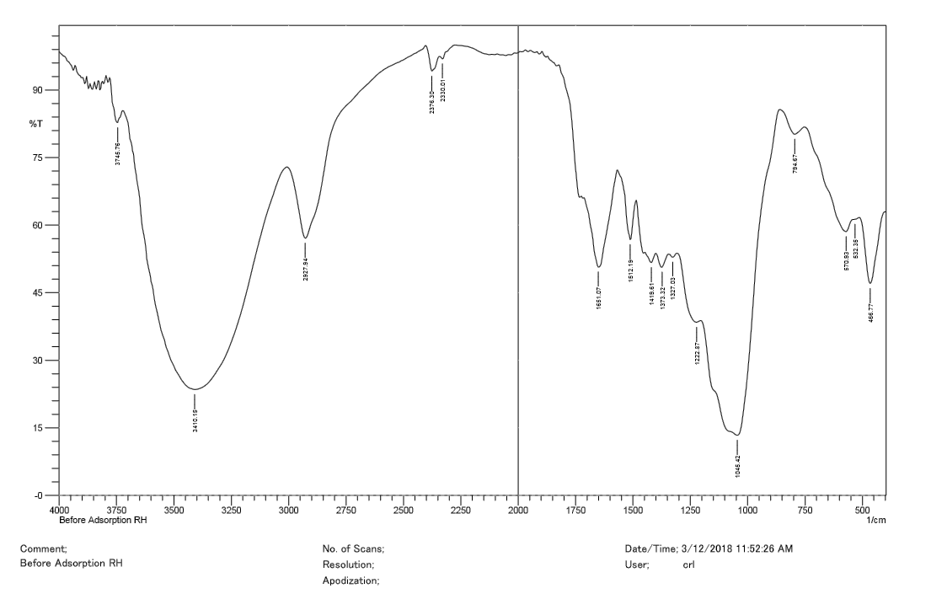
FTIR spectrum with prominent peaks (before adsorption)
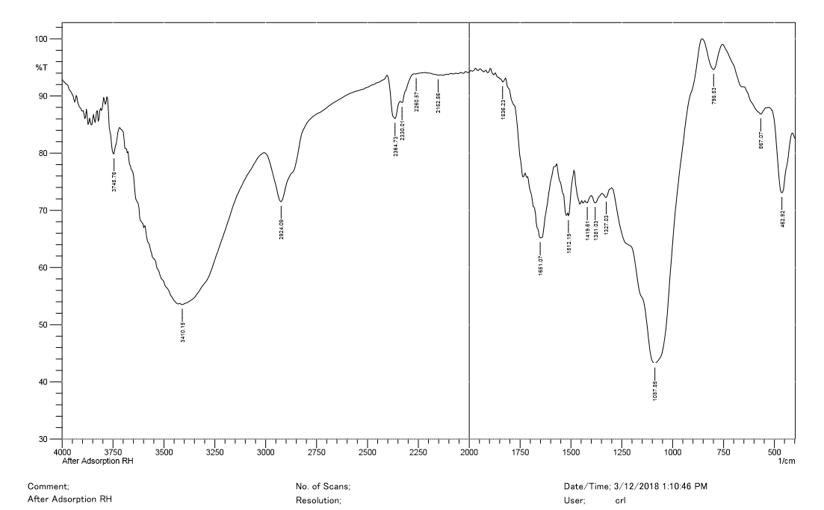
Fig.10b

FTIR spectrum with prominent peaks (after adsorption)

4.3 UV RESULT
The UV- spectral analysis was performed to evaluate the decolourization of methylene blue dye. The UV-spectrum had five major peaks sample corresponding to before adsorption, the major peaks was 727 nm with absorbance of 0.001. The UV spectrum of the sample after decolouriztion, revealed no prominent peaks notably the peak of 727 nm was absent, which in indicated that the Rice Husk has effectively adsorbent the dye components, the absence of the respective functional groups was the reason for the absence of peaks in the UV-spectrum. Taha and Mohamed (2009) reported the typical UV–Vis spectrum of MR73 azo dye which was represented as absorption bands at 492, 360 and 285nm with respective ochromophore chemical groups. Ironically, the after absorbance, the bands at 360 and 285nm decreased in absorbance at these specific wavelengths which correspond to the degradation of dye.

PLATE 8
Fig.11 a
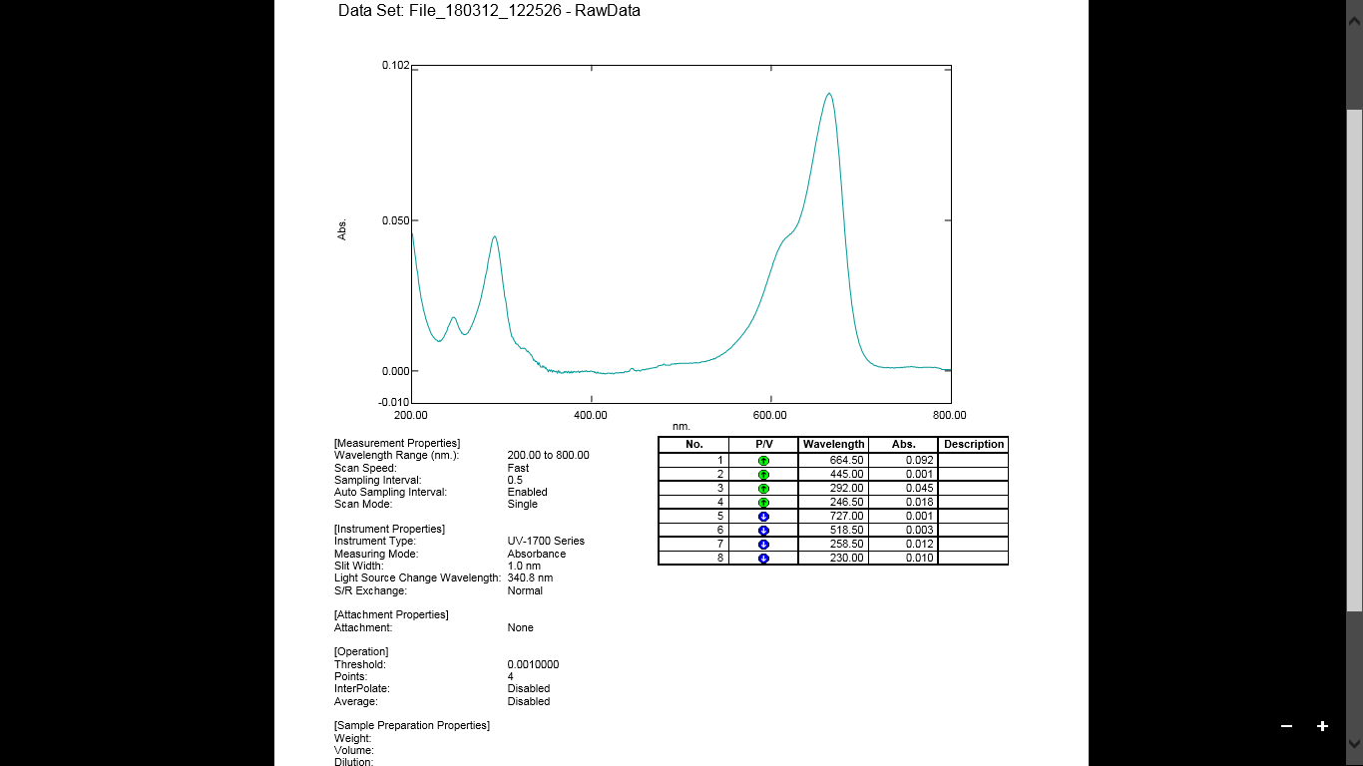

UV- test in before adsorption
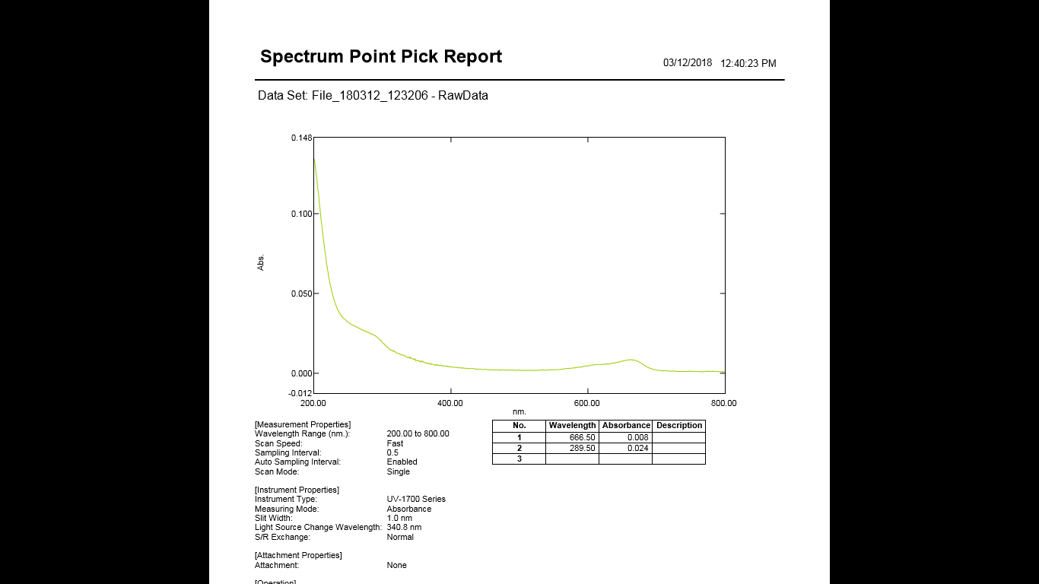
Fig.11 b

UV- test in after adsorption

5. SUMMARY AND CONCLUTION
The study was formulated to utilize the low cost effective adsorbent Rice Husk (RH) for the removal of Methylene Blue (MB) dye. Accordingly, various experimental parameters like optimization studies and spectra analysis was performed to evaluate the efficiency of the risk hush as adsorbent. The decolourization potential of the dye was maximum (55%) at 30º C similarly, the maximum adsorption of 45% was noted at a pH of 9. The efficient amount of 0.6g was attributed to 76% of decolourization of methylene blue dye. The UV spectral analysis revealed the disappearance of the prominent peak 727 nm in the UV spectrum after treatment which corresponded to the removal of functional groups of the methylene dye. Supportively, the FTIR spectrum also revealed deprivation of five peaks (466.77, 1045.42, 1657.07, 2376.03 and 3745.75) which inferred the alteration or removal of unique and specific functional group at corresponding wavelength. Thus the study lime-lighted the potential of rice husk as an effective adsorbent and decolourization component of methylene blue dye.

BIBLIOGRAPHY

Adegoke, K. A., & Bello, O. S. (2015). Dye sequestration using agricultural wastes as adsorbents. Water Resources and Industry, 12, 8-24.

Aksu, Z., & Tezer, S. (2005). Biosorption of reactive dyes on the green alga Chlorella vulgaris. Process Biochemistry, 40(3-4), 1347-1361.

Al-Degs, Y., Khraisheh, M. A. M., Allen, S. J., & Ahmad, M. N. A. (2001). Sorption behavior of cationic and anionic dyes from aqueous solution on different types of activated carbons. Separation Science and Technology, 36(1), 91-102.

Ali, I., Asim, M., & Khan, T. A. (2012). Low cost adsorbents for the removal of organic pollutants from wastewater. Journal of environmental management, 113, 170-183.

Ali, Imran, Mohd Asim, and Tabrez A. Khan. "Low cost adsorbents for the removal of organic pollutants from wastewater." Journal of environmental management 113 (2012): 170-183.

Allen, S. J. and Koumanova, B., Decolourisation of water/wastewater using adsorption (Review). J. University of Chemical Technology and Metal- lurgy, 40(3), 175-192 (2005).

Allen, S. J., McKay, G., & Khader, K. Y. (1988). The adsorption of acid dye onto peat from aqueous solution-solid diffusion model. Journal of colloid and interface science, 126(2), 517-524.

Amin, N. K. (2009). Removal of direct blue-106 dye from aqueous solution using new activated carbons developed from pomegranate peel: adsorption equilibrium and kinetics. Journal of hazardous materials, 165(1-3), 52-62.

Annadurai, G., Juang, R. S., & Lee, D. J. (2002). Use of cellulose-based wastes for adsorption of dyes from aqueous solutions. Journal of hazardous materials, 92(3), 263-274.

Ardejani, F. D., Badii, K., Limaee, N. Y., Mahmoodi, N. M., Arami, M., Shafaei, S. Z., & Mirhabibi, A. R. (2007). Numerical modelling and laboratory studies on the removal of Direct Red 23 and Direct Red 80 dyes from textile effluents using orange peel, a low-cost adsorbent. Dyes and Pigments, 73(2), 178-185.

Ardejani, F. D., Badii, K., Limaee, N. Y., Shafaei, S. Z., & Mirhabibi, A. R. (2008). Adsorption of Direct Red 80 dye from aqueous solution onto almond shells: Effect of pH, initial concentration and shell type. Journal of hazardous materials, 151(2-3), 730-737.

Atun, G., Hisarli, G., Sheldrick, W. S., & Muhler, M. (2003). Adsorptive removal of methylene blue from colored effluents on fuller's earth. Journal of colloid and interface science, 261(1), 32-39.

Ayyappan, C. S., Bhalambaal, V. M., & Kumar, S. (2017). Effect of biochar on bio-electrochemical dye degradation and energy production. Bioresource technology, 251, 165-170.

Baig, S. A., Zhu, J., Muhammad, N., Sheng, T., & Xu, X. (2014). Effect of synthesis methods on magnetic Kans grass biochar for enhanced As (III, V) adsorption from aqueous solutions. Biomass and Bioenergy, 71, 299-310.

Banat, F., Al-Asheh, S., & Al-Makhadmeh, L. (2003). Evaluation of the use of raw and activated date pits as potential adsorbents for dye containing waters. Process Biochemistry, 39(2), 193-202.

Banat, I. M., Nigam, P., Singh, D., & Marchant, R. (1996). Microbial decolorization of textile-dyecontaining effluents: a review. Bioresource technology, 58(3), 217-227.
Basu, S., & Lokesh, K. S. (2013). Spatial and temporal variations of river water quality: A case study of River Kabini at Nanjangud in Karnataka. International Journal of Water Resources and Environmental Engineering, 5(10), 591-596.

Behnajady, M. A., Modirshahla, N., & Ghanbary, F. (2007). A kinetic model for the decolorization of CI Acid Yellow 23 by Fenton process. Journal of Hazardous Materials, 148(1-2), 98-102.

Benazir, J. F., Suganthi, R., Rajvel, D., Pooja, M. P., & Mathithumilan, B. (2010). Bioremediation of chromium in tannery effluent by microbial consortia. African journal of biotechnology, 9(21), 3140-3143.

Bharathi, K. S., & Ramesh, S. T. (2013). Removal of dyes using agricultural waste as low-cost adsorbents: a review. Applied Water Science, 3(4), 773-790.

Bhatnagar, A., & Sillanpää, M. (2010). Utilization of agro-industrial and municipal waste materials as potential adsorbents for water treatment—a review. Chemical engineering journal, 157(2-3), 277-296.

Biswas, A., Rajeswari, M., Srivastava, R. C., Venkatesan, T., Greene, R. L., Lu, Q., ... & Millis, A. J. (2001). Strain-driven charge-ordered state in La 0.67 Ca 0.33 MnO 3. Physical Review B, 63(18), 184424.

Bulut, Y., & Aydın, H. (2006). A kinetics and thermodynamics study of methylene blue adsorption on wheat shells. Desalination, 194(1-3), 259-267.

Calvete, T., Lima, E. C., Cardoso, N. F., Dias, S. L., & Ribeiro, E. S. (2010). Removal of brilliant green dye from aqueous solutions using home made activated carbons. Clean–Soil, Air, Water, 38(5‐6), 521-532.
Costa, J., Mafra, I., Carrapatoso, I., & Oliveira, M. B. P. (2012). Almond allergens: molecular characterization, detection, and clinical relevance. Journal of agricultural and food chemistry, 60(6), 1337-1349.

Daneshvar, N., Khataee, A. R., Rasoulifard, M. H., & Pourhassan, M. (2007). Biodegradation of dye solution containing Malachite Green: Optimization of effective parameters using Taguchi method. Journal of Hazardous Materials, 143(1-2), 214-219.

Daneshvar, N., Salari, D., & Khataee, A. R. (2004). Photocatalytic degradation of azo dye acid red 14 in water on ZnO as an alternative catalyst to TiO2. Journal of photochemistry and photobiology A: chemistry, 162(2-3), 317-322.

Dawood, S., Sen, T. K., & Phan, C. (2014). Synthesis and characterisation of novel-activated carbon from waste biomass pine cone and its application in the removal of congo red dye from aqueous solution by adsorption. Water, Air, & Soil Pollution, 225(1), 1818.

Doğan, M., & Alkan, M. (2003). Removal of methyl violet from aqueous solution by perlite. Journal of Colloid and Interface Science, 267(1), 32-41.

Dreaden, E. C., Mackey, M. A., Huang, X., Kang, B., & El-Sayed, M. A. (2011). Beating cancer in multiple ways using nanogold. Chemical Society Reviews, 40(7), 3391-3404.

Dülger, Ö., Turak, F., Turhan, K., & Özgür, M. (2013). Sumac leaves as a novel low-cost adsorbent for removal of basic dye from aqueous solution. ISRN Analytical Chemistry, 2013.

Elmorsi, T. M., Riyad, Y. M., Mohamed, Z. H., & El Bary, H. M. A. (2010). Decolorization of Mordant red 73 azo dye in water using H2O2/UV and photo-Fenton treatment. Journal of Hazardous Materials, 174(1-3), 352-358.

Farahani, M., Abdullah, S. R. S., Hosseini, S., Shojaeipour, S., & Kashisaz, M. (2011). Adsorption-based cationic dyes using the carbon active sugarcane bagasse. Procedia Environmental Sciences, 10, 203-208.

García Montaño, J., & Peral Pérez, J. (2007). Combination of advanced oxidation processes and biological treatments for commercial reactive azo dyes removal. Universitat Autònoma de Barcelona,.

Garg, V. K., Amita, M., Kumar, R., & Gupta, R. (2004). Basic dye (methylene blue) removal from simulated wastewater by adsorption using Indian Rosewood sawdust: a timber industry waste. Dyes and pigments, 63(3), 243-250.

Gupta, V. K., Kumar, R., Nayak, A., Saleh, T. A., & Barakat, M. A. (2013). Adsorptive removal of dyes from aqueous solution onto carbon nanotubes: a review. Advances in Colloid and Interface Science, 193, 24-34.

Hameed, B. H., & El-Khaiary, M. I. (2008). Batch removal of malachite green from aqueous solutions by adsorption on oil palm trunk fibre: equilibrium isotherms and kinetic studies. Journal of hazardous materials, 154(1-3), 237-244.

Hameed, B. H., & Hakimi, H. (2008). Utilization of durian (Durio zibethinus Murray) peel as low cost sorbent for the removal of acid dye from aqueous solutions. Biochemical Engineering Journal, 39(2), 338-343.

Han, R., Shimamoto, T., Ando, J. I., & Ree, J. H. (2007). Seismic slip record in carbonate-bearing fault zones: An insight from high-velocity friction experiments on siderite gouge. Geology, 35(12), 1131-1134.

Han, R., Wang, Y., Han, P., Shi, J., Yang, J., & Lu, Y. (2006). Removal of methylene blue from aqueous solution by chaff in batch mode. Journal of Hazardous Materials, 137(1), 550-557.

Hong, G. B., & Wang, Y. K. (2017). Synthesis of low-cost adsorbent from rice bran for the removal of reactive dye based on the response surface methodology. Applied Surface Science, 423, 800-809.

Huang, F., Leonard, B. R., & Wu, X. (2007). Resistance of sugarcane borer to Bacillus thuringiensis Cry1Ab toxin. Entomologia Experimentalis et Applicata, 124(1), 117-123.

Huang, Z. H., Zheng, X., Lv, W., Wang, M., Yang, Q. H., & Kang, F. (2011). Adsorption of lead (II) ions from aqueous solution on low-temperature exfoliated graphene nanosheets. Langmuir, 27(12), 7558-7562.

Jain, M., & Tandon, S. K. (2003). Fluvial response to Late Quaternary climate changes, western India. Quaternary Science Reviews, 22(20), 2223-2235.

Kamaraj, M., & Umamaheswari, P. (2017). Preparation and characterization of Groundnut shell activated carbon as an efficient adsorbent for the removal of Methylene blue dye from aqueous solution with microbiostatic activity.

Kannan, N., & Sundaram, M. M. (2001). Kinetics and mechanism of removal of methylene blue by adsorption on various carbons—a comparative study. Dyes and pigments, 51(1), 25-40.

Kannan, N., & Sundaram, M. M. (2001). Kinetics and mechanism of removal of methylene blue by adsorption on various carbons a comparative study. Dyes and pigments, 51(1), 25-40.

Kapdan, I. K., & Kargi, F. (2002). Simultaneous biodegradation and adsorption of textile dyestuff in an activated sludge unit. Process Biochemistry, 37(9), 973-981.

Kaushik, P., & Malik, A. (2009). Fungal dye decolourization: recent advances and future potential. Environment International, 35(1), 127-141.
Kaushik, P., Mishra, A., & Malik, A. (2014). Dual application of agricultural residues for xylanase production and dye removal through solid state fermentation. International Biodeterioration & Biodegradation, 96, 1-8.

Kumar, A., Ergas, S., Yuan, X., Sahu, A., Zhang, Q., Dewulf, J., ... & Van Langenhove, H. (2010). Enhanced CO2 fixation and biofuel production via microalgae: recent developments and future directions.

Kumar, P. S., Ramalingam, S., Senthamarai, C., Niranjanaa, M., Vijayalakshmi, P., & Sivanesan, S. (2010). Adsorption of dye from aqueous solution by cashew nut shell: Studies on equilibrium isotherm, kinetics and thermodynamics of interactions. Desalination, 261(1-2), 52-60.

Kumar, R., & Barakat, M. A. (2013). Decolourization of hazardous brilliant green from aqueous solution using binary oxidized cactus fruit peel. Chemical engineering journal, 226, 377-383.

Lata, H., Mor, S., Garg, V. K., & Gupta, R. K. (2008). Removal of a dye from simulated wastewater by adsorption using treated parthenium biomass. Journal of Hazardous Materials, 153(1-2), 213-220.

Lima, R. O. A., Bazo, A. P., Salvadori, D. M. F., Rech, C. M., de Palma Oliveira, D., & de Aragão Umbuzeiro, G. (2007). Mutagenic and carcinogenic potential of a textile azo dye processing plant effluent that impacts a drinking water source. Mutation Research/Genetic Toxicology and Environmental Mutagenesis, 626(1), 53-60.

Malik, P. K. (2003). Use of activated carbons prepared from sawdust and rice-husk for adsorption of acid dyes: a case study of Acid Yellow 36. Dyes and pigments, 56(3), 239-249.

Malik, P. K., & Saha, S. K. (2003). Oxidation of direct dyes with hydrogen peroxide using ferrous ion as catalyst. Separation and purification technology, 31(3), 241-250.

Malik, P. K., & Sanyal, S. K. (2004). Kinetics of decolourisation of azo dyes in wastewater by UV/H2O2 process. Separation and Purification Technology, 36(3), 167-175.

Mishra G, Tripathy M (1993) A critical review of the treatment for decolorization of dye wastewater. Colourage 40:35–38

Namasivayam, C., & Kavitha, D. (2002). Removal of Congo Red from water by adsorption onto activated carbon prepared from coir pith, an agricultural solid waste. Dyes and pigments, 54(1), 47-58.

Namasivayam, C., & Sumithra, S. (2005). Removal of direct red 12B and methylene blue from water by adsorption onto Fe (III)/Cr (III) hydroxide, an industrial solid waste. Journal of environmental management, 74(3), 207-215.

Ofomaja, A. E., & Ho, Y. S. (2007). Effect of pH on cadmium biosorption by coconut copra meal. Journal of Hazardous Materials, 139(2), 356-362.

Önal, Y. (2006). Kinetics of adsorption of dyes from aqueous solution using activated carbon prepared from waste apricot. Journal of Hazardous Materials, 137(3), 1719-1728.

Özcan, A., Ömeroğlu, Ç., Erdoğan, Y., & Özcan, A. S. (2007). Modification of bentonite with a cationic surfactant: an adsorption study of textile dye Reactive Blue 19. Journal of hazardous materials, 140(1-2), 173-179.

Ponnusami, V., Vikram, S., & Srivastava, S. N. (2008). Guava (Psidium guajava) leaf powder: novel adsorbent for removal of methylene blue from aqueous solutions. Journal of hazardous materials, 152(1), 276-286.

Priya, E. S., & Selvan, P. S. (2017). Water hyacinth (Eichhornia crassipes)–An efficient and economic adsorbent for textile effluent treatment–A review. Arabian Journal of Chemistry, 10, S3548-S3558.

Radovic, L. R., Silva, I. F., Ume, J. I., Menendez, J. A., Leon, C. L. Y., & Scaroni, A. W. (1997). An experimental and theoretical study of the adsorption of aromatics possessing electron-withdrawing and electron-donating functional groups by chemically modified activated carbons. Carbon, 35(9), 1339-1348.

Raghuvanshi, S. P., Singh, R., Kaushik, C. P., & Raghav, A. K. (2004). Kinetics study of methylene blue dye bioadsorption on baggase. Applied Ecology and Environmental Research, 2(2), 35-43.

Ravikumar, K., Ramalingam, S., Krishnan, S., & Balu, K. (2005). Application of response surface methodology to optimize the process variables for reactive red and acid brown dye removal using a novel adsorbent. Dyes and pigments, 70(1), 18-26.

Royer, B., Cardoso, N. F., Lima, E. C., Vaghetti, J. C., Simon, N. M., Calvete, T., & Veses, R. C. (2009). Applications of Brazilian pine-fruit shell in natural and carbonized forms as adsorbents to removal of methylene blue from aqueous solutions—Kinetic and equilibrium study. Journal of Hazardous Materials, 164(2-3), 1213-1222.

Salleh, M. A. M., Mahmoud, D. K., Karim, W. A. W. A., & Idris, A. (2011). Cationic and anionic dye adsorption by agricultural solid wastes: A comprehensive review. Desalination, 280(1-3), 1-13.

Senthilkumar, M., & Selvakumar, N. (2006). Achieving expected depth of shade in reactive dye application using artificial neural network technique. Dyes and pigments, 68(2-3), 89-94.

Singh, D. K., & Srivastava, B. (2001). Basic dyes removal from wastewater by adsorption on rice husk carbon. . Trends in biotechnology, 28(7), 371-380.

Siti Zuraida, M., Nurhaslina, C. R., & Ku Halim, K. H. (2013). Influence of agitation, pH and temperature on growth and decolorization of batik wastewater by bacteria Lactobacillus delbruckii.
Sohrabi, M. R., & Ghavami, M. (2008). Photocatalytic degradation of Direct Red 23 dye using UV/TiO2: Effect of operational parameters. Journal of Hazardous Materials, 153(3), 1235-1239.

Tahir, H., Sultan, M., Akhtar, N., Hameed, U., & Abid, T. (2016). Application of natural and modified sugar cane bagasse for the removal of dye from aqueous solution. Journal of Saudi Chemical Society, 20, S115-S121.

Tanyildizi, M. Ş. (2011). Modeling of adsorption isotherms and kinetics of reactive dye from aqueous solution by peanut hull. Chemical Engineering Journal, 168(3), 1234-1240.

Travis, W. D., Brambilla, E., Noguchi, M., Nicholson, A. G., Geisinger, K. R., Yatabe, Y., ... & Garg, K. (2011). International association for the study of lung cancer/american thoracic society/european respiratory society international multidisciplinary classification of lung adenocarcinoma. Journal of thoracic oncology, 6(2), 244-285.

Umoren, S. A., Etim, U. J., & Israel, A. U. (2013). Adsorption of methylene blue from industrial effluent using poly (vinyl alcohol). J. Mater. Environ. Sci, 4(1), 75-86.

Yang, L., Liya, E. Y., & Ray, M. B. (2008). Degradation of paracetamol in aqueous solutions by TiO2 photocatalysis. Water research, 42(13), 3480-3488.

