“Developing Leadership Skill among Rural Women”

K.M.Pragathi
(14PSW010)

Thesis submitted to
Avinashilingam Institute for Home Science and Higher education for Women,
Coimbatore – 641043.

In Partial Fulfilment of the Requirements for the
Degree of Master of Social Work

April 2016

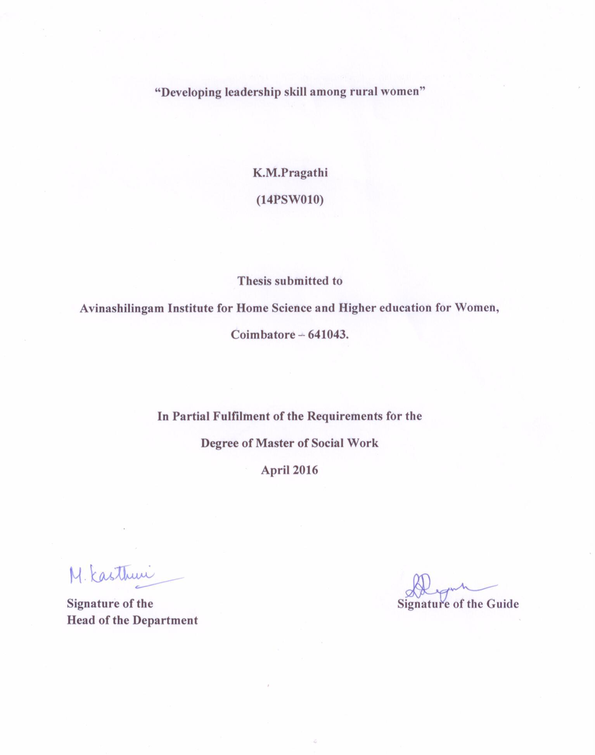

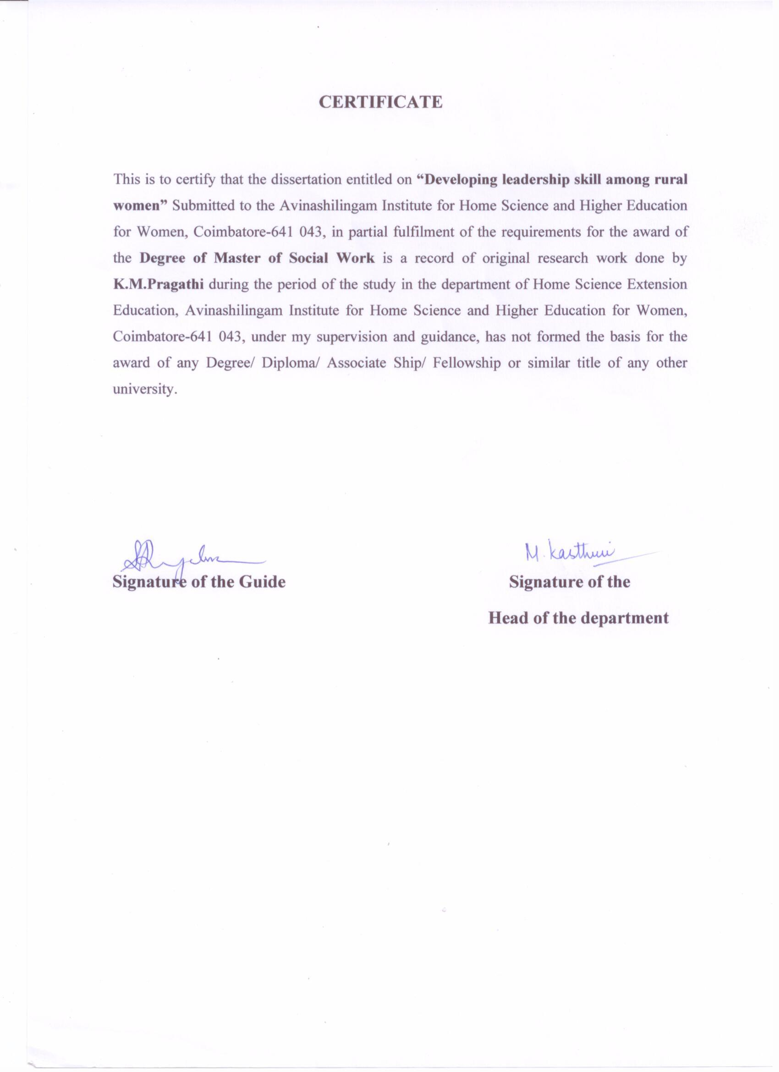
ACKNOWLEDGEMENT
This investigator places her deepest sense of gratitude and indebtedness at the feet of God Alimighty.
The investigator expresses her immense gratitude toPadmasreeDr.P.R.KrishnaKumar Chancellor,Avinashilingam Institute for Home Science and Higher Education for Women, Coimbatore, for providing the opportunity and exposure to the world of knowledge.
The researcher expresses her sincere gratitude to Dr.(Tmt) PremavathyVijayan, M.Sc., M.Ed., Dip.Spl.Edn., M.Phil., Ph.D.,Vice Chancellor I/C, Avinashilingam Institute for Home Science and Higher Education for Women, Coimbatore, for the administrative support given during the study.
The investigator expresses her thanks to Dr.(Tmt) Venmathi, M.Sc., M.Phil.,
Ph.D., Registrar,I/C, Avinashilingam Institute for Home Science and Higher Education for Women, Coimbatore, for the administrative support given during the study.
The investigator Expresses her thanks to Dr.(Tmt) N.VasugiRaaja, M.Sc., MBA, M.Phil., Ph.D., Faculty of Home Science, Avinashilingam Institute for Home Science and Higher Education for Women, Coimbatore, for her support and encouragement.
It investigator an immense pleasure and proudness to offer profound gratitude to her
bellowedDr. (Tmt) M.Kasthuri.,Professor and Head of the Department,Home science Extension Education, Avinashilingam Institute for Home Science and Higher Education for Women, Coimbatore, for her help in conduct of the study.
The investigator feels highly elated in manifesting her glowing sense of gratitude to the esteemed guide, Dr.(Tmt)S.Rajalakshmi, Assistant Professor-(SG),Department of Home Science Extension Education,Avinashilingam Institute for Home Science and Higher Education for Women, Coimbatore, for her innovative, excellent, intellectual guidance, meticulous super vision, valuable advice, untiring help and constant encouragement and learned counsel each and every minute offered throughout the course of the research work.
The investigator expresses her sincere thanks to all her beloved Teachers in the Department of Home Science Extension Education,Avinashilingam Institute for Home Science and Higher Education for Women, Coimbatore for their advice and support throughout the study.
The investigator is indebted to Dr. (Tmt)Sarojaprabhakaran, M.A., Dip. in Ed. (Madras), PH.D. (Mother Tereasa), Director Hall of Residency, for here endless support and cooperation throughout the study.
The investigator expresses her thanks to (Tmt) K.M.VelumaniMaruchammy, President of Ikkarinegamampanchayat, Sathyamangalam block, Erode district, for the facilities provided to carry out of the study.
On a moral personal note, she owes a special debt of gratitude to her Parents, Brothers, Sisters, Friends, for their encouragement offered throughout the period.
The researcher is also grateful in acknowledging the family members and her friends who helped the researcher to make this study a colourful one.
Last but not least, her special tribute at the feet of GOD Almighty for his immense blessings in making the study a success.

CONTENTS
CHAPTRER  NO. | TITLE | PAGE  NO.
 | LIST OF THE TABLE
 | LIST OF THE PLATE
I | INTRODUCTION | 1
II | REVIEW OF LITERATUER  A. Status of Women in India  B. Capacity building of Rural Women  C. Policies and Programme to Empower Women  D. Successful Story of Women Leaders  E. Related Research Study | 7
III | METHODOLOGY  A. Selection of Area  B. Selection of Sample  C. Selection of Methods and Tools  D. Collection of data  E. Obtaining ethical clearance of the study  F. Analysis and Interpretation of the data | 32
IV | RESULT AND DISCUSSION  A. Socio-economic characteristics of women  B. Status of Women  C. Impact of Educational Interventional | 37
V | SUMMARY AND CONCLUSION | 52
 | BIBLIOGRAPHY
 | APPENDICES

LIST OF THETABLES
TABLE  NO. | TITLE | PAGE  NO.
 | Literacy Rate in India | 9
 | Rural Urban Adult Literacy Rate | 11
 | Voting Percentage by Gender across different Parliament Elections | 12
 | Selection of the Sample | 33
 | Action Plan to Educated Leadership Skill | 35
 | Socio-Economic Characteristics of Women | 38
 | Daily Activities Performed by Women | 40
 | Accounts and Savings Habits of Women | 41
 | Health Problems Faced by Women | 42
 | Challenges Faced by Women | 43
 | Qualities Possessed by Women | 45
 | Areas of Decision Making Capacity | 46
 | Techniques of Decision Making Capacity | 47
 | Stress Experienced by Women | 48
 | Stress Management Techniques | 49
 | Awareness on Women Empowerment Programme | 50
 | Awareness on Women Rights | 51

LIST OF THE PLATE
PLATE  NO. | TITLE | PAGE  NO.
1. | Educational Intervention Programme | 36

I.INTRODUCTION
If you can become the leader you ought to be on the inside, you will be able to become the person you will be able to become the person you want on the outside. People will want to follow you. And when that happiness you’ll be able to take anything in this world.
- Napoleon
The basic unit of society is a woman. As woman makes a family, family makes a home and homes make a society. So never think that a society would come into existence without the contribution of women. Without education, no development is possible. A good healthy society doesn’t automatically emerge on its own and stands firm but it needs to be emerged and for its emergence women play a pivotal role and behavioral to health education women have their hands in it’s a woman who teaches how to behave, how to speak and how to deal with different classes of people and the basic fundamentals of a good society and women are the main contributors in building up a strong society (JayantySinh, 2006)
Women are continuously facing many problems even after having self-confidence, individuality, self-respect, personality, capacity, talent, and efficiency more than men. They are facing problems in their daily life even after they are given equal rights and opportunities like men by the Constitution of India.Women are considered in the society only to perform duties like bring up children, caring every family member, and other household activities. There are old and traditional faiths of people coming out for years that men are for thy field whereas women are only for the home. Now-a-days, women are breaking all the barriers of social issues and problems against them in the society (PaulChowdari, 2004).
India's literacy rate is 74.04 percent. Literacy rate among Indian women is 65.46 percent, while for men it is 82.14 percent. Among women, the literacy rate is 92 percent, and among men 96 percent. Literacy rate in rural areas was pegged at 71 percent last year, compared to 86 percent in urban areas, while among the age group of seven years and above, male literacy rate was found higher than the female literacy rate in rural areas.
Status of Women of the theme of an enabling environment for women’s participation in development will take in the fields of education, health and work. These three areas are recognized as critical for women’s effective participation in development. Better education, access to health services, and opportunities for work, particularly outside the household, comprises a set of critical conditions for positive changes in women involvement in development. Research has shown that a certain level of education and health strengthens of women and women participation in the leadership (AnjaniBushan, 2002).

Women face a lot of challenges because of the existence of patriarchal society, child bearing and family care roles, deep rooted cultural norms, etc in the Indian society. Women in India do not have equal access to autonomy, mobility to outside the home, social freedom, etc. The level of women education is less than men still in the modern age. Female illiteracy is higher in the rural areas. Where over 63% or more women remain unlettered. Some of the problems faced by the women are because of their domestic responsibilities, cultural and social specified roles, etc (Pushpanai, 2013)

Domestic violence is like endemic and widespread disease affects almost 70% of Indian women according to the women and child development official. It is performed by the husband, relative or other family member.Girls have no property rights like boys forever. Child Marriage of the girls by her parents in order to be escaped from dowry. It is highly practiced in the rural India.Dowry system is another huge women problem in the society which is increasing day by day. Women are ill-treated, man-handled, disrespected, tortured and suffer other cruelties (violence, murder and suicide) because of the lack of dowry at the time of marriage. These are the challenges faced by rural women in our country (Jairam Ramesh, 2007).

Women empowerment is also defined as a change in the context of a women’s life, which enables her increased capacity for leading a fulfilling human life. Empowering women may easily help to grow each and every member of the family without any extra effort. A woman is considered to be responsible for everything in the family so she can better solve all the problems from her own end. Empowerment of the women would automatically bring empowerment of everyone (PurusottamNayak, 2003).
Women empowerment activities and training, there has been a significant increase in the confidence of women. They have developed mutual trust, social security, skills and access to technology and credit through their women Groups and various People’s Organizations. The women groups have motivated the entire community to take up hygiene, sanitation, family planning and health care activities with the community (BidishaMahanta, 1999)
Women empowerment, it can be possible to change the male dominated country into the equally dominated country of rich economy. Women constitute half power of the country so in order to make this country a fully powerful country, women empowerment is very necessary. Empowering women to understand their rights to be independent in every area for their proper growth and development (Desai and Thakkar, 2007).
A woman in India is nearly 50% of its total population. Indian women are being empowered in the various field of the society effectively. Indian women working as teachers, professors, doctors, nurses, advocates, judges, managers, administrators, police officers, bank employees, clerks, typists, telephone operators, receptionists and personal assistants are found in almost all major cities in our country(Praveen Rai, 2011).

Leadership skills mostly are a pattern of motives. The successful leaders will tend to have a high need for power. Leadership as a critical management skill, it is the ability to motivate a group of people toward a common goal. These qualities will help you develop your skills as a leader. Leaders play a very huge role whether the task that they are taking on is big or small. The leaders face special challenges as they try to communicate and interact with their followers and potential followers to understand and know what they think and what they do. Leaders should know that creativity and innovation are the life of their organization (SujitSarkar, 2009).
The leader has a group or organization working to meet each challenge and achieve each goal. The leader's job is not to solve every problem alone, but to inspire those he or she leads to solve the problems. Good leaders recognize that they do not have all the answers and are constantly reeducating themselves on their businesses and sharpening their leadership skills. Beyond personal qualities such as vision and positive thought, a leader must also take careful steps to communicate with his or her staff in the best way possible. Formerly rare processes such as goal-setting, constant feedback and a system of rewards are now the norm in most workplaces. Some of the most important lessons of this book concentrate on your interactions with your group as a team, but also as individuals (Preeti Sharma, 2008)
Leadershipismoreoftenthannotabout“softskills”ratherthanhardskills.Knowledgeispowerandnaturally,forthosewhobelievepoweristheessenceofleadershipwillassumethatthosewhopossessmoreknowledgeandintelligencewillmakegoodleaders. Good leader must possess a combination of many varying Qualities. A great leader would have integrity vision, courage, humility, creativity, conviction, trustworthiness, fairness.
A good leader adapts his communication style depending on his audience. Leaders should identify the audience and their characteristics and interests, then adjust their communication style based on what the audience needs and what will encourage them to react to meet the goals of the communication (Kaufman & Rudd, 2009)

Women are participating in Gram Sabah. Many active leaders of the Self Help Groups have contested and been elected for various PRIs, co-operative bodies and other village level organizations. The leadership of women has been recognized by the society. They are now able to influence the Panchyati Raj Institutions to work for the benefit of the communities (Matland, 1998)
The term political participation has a very wide meaning. It is not only related to 'Right to Vote, but simultaneously relates to participation in decision making process, political activism, political consciousness, etc. Women in Indiaparticipate in voting, run for public offices and political parties at lower levels more than men. Political activism and voting are the strongest areas of women's political participation (pounder, 2002)
Rural women's access to education and training can have a major impact on their potential to access and benefit from income-generating opportunities and improve their overall well-being. A variety of approaches, including non-formal education, technical and vocational training, agricultural extension services, workplace training, training in new technologies and literacy and numeracy training are needed to address the various challenges rural women face (Rashid, 2011)
Education and training are essential components of any strategy to improve agricultural and non-farm productivity and rural women incomes. Learning about improved production technologies and methods, new products and markets, business skills, as well as life skills such as health management, decision-making, self confidence, or conflict management can make a big difference for many of the rural women (Ester Boserup, 2008)
Rural women’s major role in agriculture and other rural activities, higher barriers in education and training limit their opportunities and capacities to engage in more productive and remunerative work, perform managerial and leadership roles and participate fully in the development of their communities (MahapatraSubhasini ,2006)

Rural women are often limited to a narrow range of female dominated fields that reinforce their traditional roles and responsibilities. While this may improve their income generating opportunities, it will not give them the chance to benefit from newer, non-traditional fields, such as information and communication technologies(Kitchlu, 1991)

Equal participation of rural women in decision-making. Enhancing rural women leadership and meaningful participation in all forms of decision-making, from Parliaments to local governments and civil organizations, will ensure more attention is paid to meeting the needs of women and girls. For most poor people, local governments are the most important in political era. Women’s political empowerment by helping to reform electoral processes, change political parties, and strengthen parliaments, judiciaries and the civil service (Safilios, 2001)
Women play a crucial role in the economic welfare of the family. Women perform different tasks depending on their socio-economic structure, number of members in the family, the nature of professions they are involved in and many other factors. The authoritarian character of thetraditional joint family entails decision making powers concentrated in the position of the eldest male members Women are traditionally less involved in decision making at all levels (Costantini,1990)

Objectives of the study:
- Assess the socio-economic status and leadership qualities among rural women
- Enhancing the leadership skill
- Evaluating the impact of the programme

Need of the study:
Rural Women play a vital role directly and indirectly in the various fields of development. Socially,economically and educationally if she is strengthened she will enhance development in allother fields. The present study emphasizes on past and present status of leadership skills among rural women and government policy or scheme for womenempowerment.

Scope of the Study:

The scope of the study of developing leadership skill among rural women. But it isa project work, so the discussion on the matter is very brief in different angles.Status of Women, Capacity building of Rural Women and Policies and Programme to Empower Rural Womenfor specific and concise discussion is presented here.

Limitation of the study:
- Effort has taken to collect primary data from rural women.
- Due to lack of time consuming for rural women to attend leadership training programme.

II.REVIEW OF LITERATURE

A literature review is a survey of everything that has been written about a particular topic, Theory or research question. It may provide the background for larger work, or it may stand onits own. Much more than a simple list of sources, an effective literature review analyzes andSynthesizes information about key themes or issues.
The literature pertaining to the study entitled “Developing Leader Ship Skills among Rural Women” is reviewed under the following headings:
- Status of Women in India
- Capacity building of Rural Women
- Policies and Programme to Empower Women
- Successful Story of Women Leaders
- Related Research Study

A. Status of Women in India
Albert Della Bitta&Meginnis (2012), reported that status of women and their social relationship as necessitated by the new social, political and economic organization in society has come out through the routine factors of social change. In the political field, women now enjoy equal rights with men. The two important rights in the political field sanctioned to women by Indian Constitution are: female enfranchisement and eligibility for the legislature. Prior to independence, when the elections were held in 1946 for constitutional assembly, many prominent women of Indian like Sarojini Naidu, HansaMeheta, RenukaRai and others were elected. In the first general election held in 1952, several women contested for the LokSabha.

Saraf (2009), Viewed that Woman used to command acute power and importance in our ancient culture. The proof of this fact can be found in all the scriptures and even our mythological stories. We worship Goddess Durga, Lakshmi, Saraswati and many others. That shows how Indian civilization had revered the female form. Things have not remained the same in last few decades or even centuries. The social fabric has acquired completely new dimensions. The women are considered less powerful and important than men yet situation is not entirely bleak. Many private corporate bodies have also taken a keen interest in improving the economic status of women and the results are extremely encouraging. Pandit Jawaharlal Nehru had once said, “You can tell the condition of a nation by looking at the status of its women”.
Safilios (2001), stated that rural women play a vital role to the welfare of the family. They are basically viewed as the potential mothers and homemakers. Hence, decision-making power of women within the family has been looked upon as one of the important factors which may effect on well-being of the family.
Ferdinando(2007), viewed thatdecision-making power in order to make a comparison of women’s relative power. Domestic decision-making power is measured in non-reproductive health-related areas such as economics, mobility, children’s schooling and health.
International Institute for Population Sciences (2013) indicated thatFemale literacy rate in India, then it is lower than the male literacy rate today, the female literacy levels according to the Literacy Rate 2011 census are 65.46% where the male literacy rate is over 80%. India literacy rate has shown significant rise in the past 10 years.The literacy rates of different Indian states in 2001 and 2011. India's literacy rate is at 74.04%.Kerala is the most literate state in India, with 93.91% literacy. Bihar is the least literate state in India, with a literacy of 63.82%.

TABLE-I
LITERACY RATE IN INDIA (1951-2011)
Census Year | Person | Male | Female | Male - female gap in literacy rate
1951 | 18.33 | 27.16 | 8.86 | 18.30
1961 | 28.30 | 40.40 | 15.35 | 25.05
1971 | 34.45 | 45.96 | 21.97 | 23.98
1981 | 43.57 | 56.38 | 29.76 | 26.62
1991 | 52.21 | 64.13 | 39.29 | 24.84
2001 | 64.83 | 75.26 | 63.67 | 21.59
2011 | 74.04 | 82.14 | 65.46 | 16.68
Source: Census reports
According to Narayan, (2012), Population Census 2011, workers constituted 39.79 per cent of total population whereas the ratio of female workers was 25.51 per cent. At All-India level the percentage share of females as cultivators, Agricultural laborers, workers in the household industry and other workers stood at 24.92, 18.56, 2.95 & 47.20 respectively. The percentage of female main workers to total female population stood at 25.5 which show an increase as compared to 14.68 reported in the 2001 Census. Literacy rate amongst females was reported at 65.46 per cent which was less than the male literacy rate. 82.14 percent in the 2011 census. Work participation rate of female workers in rural areas was higher which stood at 30.0 as compared to the work participation rate of 15.4 percent in urban areas. The State of Himachal Pradesh had the highest female work participation rate (44.8 %) whereas the lowest was reported in case of Delhi (10.6 %). Percentage of female main workers, female marginal workers and female other workers to total female population was 59.6, 40.4 and 29.2 respectively.
Maya Majumdar (2005) narrated that, the changing status and position of the women in different periods and in different civilizations has very greatly influenced her upbringing and education. If during one period of time or in one civilization she was brought up as a prized possession of the parents in some others she was completely neglected and was accepted only as a provider of sexual pleasure to man and as a producer of his offspring. As a provider of pleasure and producer of children, her education was completely neglected but whenever she was given high prestige in society, her education became the primary concern of the social order. Thus the education of the women has been completely limited to her sociological status and psychological makeup. In the present book the focus is on the social psychological dimensions of a women education in india.
Sahu&pragyabharti (2009), stated that Women's Education in Ancient India, women and girls received less education than men. This was due to the set social norms. Interestingly, in the Vedic period women had access to education, but gradually they had lost this right. Women education in ancient India prevailed during the early Vedic period. In addition to that Indian scriptures Rig Veda and Upanishads mention about several women sages and seers. Women enjoyed equivalent position and rights in the early Vedic era. However, after 500 B.C, the position of women started to decline. The Islamic invasion played a vital role in restricting freedom and rights of the women. A radical change attended and there was a terrific constraint for women education in India.

Silvia Erzeel (2015), Viewed that Women education in medieval India further weakened and declined with the introduction of Purdah system . Different customs and conventions of diverse religions like Hinduism, Islam, and Christianity further deteriorated and depreciated the state of women in the country. A range of socio religious movements contributed to the development of women literacy in the country. Many leaders took several initiatives to make education available to the women of India. The ordered form of women education in India was incorporated in the early centuries of Christian era.

Norris (2009), expressed that Women's Education in Modern India,The idea of women empowerment was introduced at the International Women Conference at Nairobi in 1985. Education is milestone of women empowerment because it enables them to responds to the challenges, to confront their traditional role and change their life. So that we can't ignore the significance of education in reference to women empowerment India is poised to becoming superpower, a developed country by 2020. This can became reality only when the women of this nation became empowerment. India presently account for the largest number of illiterates in the world. Literacy rate in India have risen stridently from 18.3% in 1951 to 64.8% in 2001 in which enrolment of women in education have also risen sharply 7% to 54.16%.

TABLE-II
RURAL URBAN ADULT LITERACY RATE - 2011

Residence | Male | Female
Rural | 74.1 | 50.6
Urban | 88.3 | 76.9
Total | 78.8 | 59.3
Source: Census of India, Office of the Registrar General, India.

KanakalathaMukund (2008), viewed that Parliament of India the status of women in India has been subject to many great changes over the past few millennia. With a decline in their status from the ancient to medieval times, to the promotion of equal rights by many reformers, the history of women in India has been eventful. In modern India, women have held high offices including that of the President, Prime Minister, Speaker of the LokSabha,Leader of the Opposition, Union Ministers, Chief Ministers and Governors.

Anne Stenhammer (2012), opined that Women’s leadership and effective participation is increasingly on the development agenda of governments, bilateral and multilateral agencies, and non-governmental organizations, including women’s rights groups. Evidence from programmes and research demonstrates the important role women play as key actors and decision-makers in the development process across a wide range ofsectors.In the political arena in particular, there is growing momentum among governments to foster and ensure women’s participation and leadership in governance structures. Establishing quotas for women’s representation at different levels of governance has been a strategic tactic in achieving this goal in many countries.
TABLE-III
VOTING PERCENTAGE BY GENDER ACROSS DIFFERENT PARLIAMENT ELECTIONS
Year | Men | Women | Turnout  Difference
1957 | 56.0 | 38.8 | 17.2
1962 | 63.3 | 46.6 | 16.7
1967 | 66.7 | 55.5 | 11.2
1971 | 60.9 | 49.1 | 11.8
1977 | 65.6 | 54.9 | 10.7
1980 | 62.1 | 51.2 | 10.9
1984 | 68.1 | 58.6 | 9.5
1989 | 66.1 | 57.3 | 8.8
1991 | 61.5 | 51.3 | 10.2
1996 | 62.0 | 53.4 | 8.6
1998 | 65.7 | 57.6 | 8.1
1999 | 63.9 | 55.6 | 8.3
2004 | 61.6 | 53.6 | 8.0
2009 | 61.0 | 55.8 | 5.2
2014 | 67.1 | 65.7 | 1.4
Average | 63.4 | 53.6 | 9.7
Source Election Commission 1951-2014, Government of India
Robert E. Dowse (2007), reveal that Political participation is the hallmark of a democratic setup. Nature, success and effectiveness of democracy largely depend on the extent to which equal, effective and actual participation is provided by the system to all its citizens. As women comprise about half of the population, this section of society requires due attention in the system andadue share in process. Citizens' active participation in political affairs in a democracy is crucial andnecessary because it provides legitimacy to the system and also strengthens the democratic fabric. Democracy will fail in its objectives if women citizens lack equal opportunity to participate in the governmental decision-making process. They are to be equal partners in the nation-building and political development.

According to Norman Palmer (2005), political participation as the involvement of citizens in such political activities, which directly or indirectly influence the behavior and actions of decision-makers.It may be viewed as any "Voluntary action, successful or unsuccessful, organized or unorganized, episodic or continuous, employing legitimate or illegitimate methods, intended to influence the choice of public policies, the administration of public affairs, or the choices of political leaders at any level of government, local or national."

ApoorvaRathod (2014), explained that Representation of women in the Panchayati Raj Institutions (37%) is a marked improvement over their representation in both the LokSabha and RajyaSabha (11%). India is ranked111th in the World. Rankings of Women in national parliaments, compiledby the Inter-Parliamentary Union, below Afghanistan, Pakistan, Bangladesh and even Saudi Arabia. Women comprised 6.9% o f the total contestants in the 2009 General Elections, out of which only 10.9% were elected. Women voters also fall below the 50 % mark, and despite awareness campaigns, the percentage o f women in the new electorate falls short of even the national average. The reservation o f 1/3rdseat for women in all tiers o f the Panchayati Raj Institutions has demonstrated impact. The Women’s Reservation Bill, or The Constitution 108th Amendment Bill, proposes 33% reservation for women in the LokSabha and state assemblies for 15 years. The Bill was introduced in the Parliament in 1996, and subsequently in 1999, 2003, 2005, 200 8 and 2010. It was finally passed by the RajyaSabha in 2010, but is still pending in the LokSabha. With the dissolution of the current LokSabha, the Bill will lapse and will have to be re-introduced.

Shankar Rao, (2006), expressed that the Indian constitution has sanctioned to women two important political rights; female enfranchisement and eligibility for the legislature. Asearly as in 1937 itself, some women candidates had contested for elections tothe local legislative bodies and own. After the independence, the number ofwomen voters and women representatives in assemblies and parliament hasincreased sufficiently. Women have developed sufficient political awarenessand some of them have attained very high positions in political parties,legislatures and cabinets. We find some ministerial portfolios being headed bywomen. The nation witnessed in Smt. Indira Gandhi, its most powerful primeminister who gave her leadership to the country for more than a decade. Inmost of the states, 1/3 of the representation is reserved for women candidatesin the local bodies such as municipalities and panchayats, etc. It may be notedthat political awareness is present more among the city women than among therural women among the middle and upper class women than among the lowerclass women.

RaichelMatthai (2008),indicated that Political participation may be defined as voluntary participation in political affairs through membership, voting and partaking in the activities of the political parties, legislative bodies and/or politically motivated movements. The Constitution of India guarantees adult franchise and provides the framework for women to participate actively in politics. Article 15 of the Constitution prohibits discrimination on the grounds of religion, race, caste, sex or place of birth. It is a pity that women have not substantially availed of the constitutional provisions. The successive election statistics shows that the number of women who exercise their franchise has increased from election to election. For the last two decades almost equal numbers of men and women have gone to the polling booths to vote.

Chibber(2011), stated that Women in India are still not well represented in political life as members in Parliament and in state legislative assemblies thatwould require them to be active in the public sphere. Women’s representation in the LokSabha since the firstgeneral elections reveals that they continue to be grossly excluded from electoral participation at the top even after so many years of Independence. In 1952, they constituted 4.4% of the total members in the lower house which has increased to around 11% in 2009, but it is still below the world average of 20%. There was a significant rise in the number of women representatives elected to the LokSabha in 2009 as compared with 2004. Although this has important symbolic connotations for the future of women’s politics, it had nothing much to do with effective political mobilization of women in the 2009 elections.

Deshpande(2009), reported that, In the field of economy, the Platform’s strategic objectives focus on promoting women’s economic rights and independence, including access to employment, appropriate working conditions and control over economic resources; facilitating women’s equal access to resources, employment markets and trade, providing business services, training and access to markets, information and technology, particularly to low-income women; strengthening women’s economic capacity and commercial networks; eliminating occupational segregation and all forms of employment discrimination; and promoting harmonization of work and family responsibilities for women and men.
According to Sharma and Gupta (2012), stated that average daily employment of women in factories was 15.65 percent during the year 2010. At State level, average daily employment of women in the factories for all groups was 7,42,701 during the year 2010. The majority of Women workers i.e. 4,82,779 worked above 45 hours and up to 48 hours per week in the factories during the year 2010. Share of women employment in coal mines was reported as 3.05 percent during the year 2010. The share of women employment in mines was 4.41 per cent during the year 2010. Among all the different mines groups the highest employment of women was reported in magnetite mines i.e. 40.26 per cent. Percentage share of women employment to total employment in all Plantations taken together was reported at 55.86 during the year 2010. In the Plantations sector, the average daily employment of women was highest (2,13,951) in Assam during the year, 2010.
According to Mahanta (2013), Employment Service and Training, during the year, 2011 total number of women applicants on live register was reported at 13694.8 thousand which constituted 34.1 per cent of the total number of applicants on live register. Proportion of educated women job-seekers to total women on live register was reported at 85.3 percent during the year 2011. Average daily wage rates of female workers for regular, casual in public works and Casual in other works is 249.51, 86.54 and 70.19 respectively.Percentage of placement to registration of women job-seekers has increased from 2.7 per cent in 2009 to 5.3 per cent in 2010. Among major states, Tamil Nadu reported the highest number of women job-seekers (540.1 thousand), followed by Kerala (264.6 thousand) whereas, the lowest number was reported from Arunachal Pradesh (3.4 thousand) at the end of 2011.Placement of women job-seekers was the highest i.e. 39.1 thousand in Gujarat at the end of 2011.

Seth, Mira (2013), reviewed that Wages & Earnings,At All-India level, wages/salaries per manday worked for directly employed women worker was reported at Rs. 145.63 whereas it is almost double for their men counterpart (Rs. 288.14) for the year 2009-10. The wages/salaries per manday worked for directly employed women workers were Rs. 328.74, Rs. 293.55 and Rs.139.61 in Public sector, joint sector and private sector respectively, whereas for men workers it was much higher i.e. Rs. 619.86, Rs.725.47 and Rs. 255.47 respectively during 2009-10.Trade Unions, Percentage of women membership to total membership was reported at 37.5 per cent during the year 2010. Numbers of registered Trade Unions were 19,376 during the year 2010. Out of these only 2,937 unions submitted the returns. Percentage share of women to total membership of central unions and state unions was 35.21 percent and 37.63 per cent respectively for the year 2010 and it was 36.57 per cent and 32.28 per cent respectively for the year 2009.
According to Dewan (2009), globally women’s participation in the labour market remained steady in the two decades from 1990 to 2010, hovering around 52 per cent. In contrast, global labour force participation rates for men declined steadily over the same period, from 81 to 77 per cent. In 2010, women’s labour force participation rates remain below 30 per cent in Northern Africa and Western Asia; below 40 per cent in Southern Asia; and below 50 per cent in the Caribbean and Central America. The gap between participation rates of women and men has narrowed slightly in the last 20 years but remains considerable. The smallest gender gaps are in the early adult years and the widest in the prime working ages.
B. Capacity building of Rural Women

According to Bardoel et al.(2003), viewed that capacity building is defined as the "process of developing and strengthening the skills, instincts, abilities, processes and resources that organizations and communities need to survive, adapt, and thrive in the fast-changing world."Capacity building is a name for the familiar concepts of community and workforce development. Capacity building taps into existing abilities of individuals, communities, organizations or systems to increase involvement, decision-making and ownership of issues.
According to Lewis (2006), stated that capacity building as a means to promoting sustainable development is broadand can encompass a multitude of activities. In its publication.“Capacity Building for SustainableDevelopment“.capacity building as building abilities, relationships and valuesthat will enable organizations, groups and individuals to improve their performance and achievetheir development objectives. Capacity building was also described as initiating and sustaining aProcess of individual and organizational change that can equally refer to change within a state,Civil society or the private sector, as well as a change in processes that enhance cooperationbetween different groups of society. This definition puts emphasis on three aspects: (a) capacitybuilding as the catalyst and constant fuel for a process of change, (b) the importance of buildinginstitutional capacity, and the (c) involvement of a wide range of different groups in society.

According to Lena Et al (2012), reviewed that capacity building needs to recognize that ‘rural women’ is a heterogeneous social category. Farming and non-farming rural women for instance are, at least partly, connected to different institutional worlds from which specific capacity needs emerge. Also farming women are diverse. The specific context within which rural women are living and operating implies that capacity building efforts aimed at rural women’s empowerment must take account of ongoing agricultural and rural transformation processes and women’s priorities and needs arising from these.
Boraian (2003), expressed that empowering women to participate fully in economic life across all sectors is essential to build stronger economies, achieve internationally agreed goals for development and sustainability, and improve the quality of life for women, men, families and communities. Women’s empowerment aims at control of one’s own body and to be free from violence; equal access and control over resources, equal participation, voice and influence in societal decision-making processes, agenda setting and leadership; elimination of gender stereotypical roles, norms and symbols. This is also referred to as ‘power to’. To achieve these goals, women need to develop a capacity building. That is, the ability to get things done, to achieve the goals set. Agency is thus a core element of women’s empowerment. Hence involved capacity building must be aimed at developing women. Such capacity to act includes both individual and collective capacity. Individual women with agency have the disposal of different skills and more intangible capacities as awareness and understanding of the gendered nature of worldviews, structures, attitudes, values, behaviours, emotions, interests; a sense of self-esteem, feelings of entitlement and assertiveness. This is also referred to as ‘power within’.
Palanithurai&Parthiban (2007),viewed that, Women Empowerment “is a concept and construct which used by everyone is the world in all for a hand in all dimensions to indicate the increased activities for women’s advancement”. There by it has come to the centre stage of the political and admistrative system of the society. Movements from above and below have activity engaged women and others in pursuing the problems of women for decision_ making and implementation. As a result not only has the issue of women beer brought to the forefront but the women themselves have come to that space for redressing their problems on their own with the help of the available support structure. As a result the conditions of women are improving but the problems faced by them are also increasing.
Kumar Singh (2008),expressed thatWomen Empowerment is the buzzword now-a-days no country can afford development without considering women who constitute about half of its stock of human resource. However, development has by passed women in India despite worshiping and paying respect to women in mythology and historical texts. Gender disparities vary vastly across cultural, geographical and historical context. India is a large country with vast economic and socio-cultural diversity in its varied regions. The development issues related to women in a large country like India will not only be inappropriate but some times even misleading. Women specific and women related legislations have been enacted to safeguard the rights and interest of women, besides protecting against discrimination, violence and atrocities and also to prevent socially undesirable practices. Women empowerment means emancipation of women from the vicious grips of social, economical, political, caste and gender-based discrimination. It means granting women the freedom to make life choices. Women empowerment does not mean ‘deifying women’ rather it means replacing patriarchy with parity. In this regard, there are various facets of women empowerment.
According to Sandeep (2015), Social Women Empowerment a critical aspect of social empowerment of women is promotion of gender equality. Gender equality implies a society in which women and men enjoy the same opportunities, outcomes, rights and obligations in all spheres of life. Educational Women Empowerment it means empowering women with the knowledge, skills and self-confidence necessary to participate fully in the development process. It means making women aware of their rights and developing a confidence to claim them. Economical and occupational empowerment it implies a better quality of material life through sustainable livelihoods owned and managed by women. It means reducing their financial dependence on their male counterparts by making them a significant part of human resource. Legal Women Empowerment It suggests the provision of an effective legal structure which is supportive of women empowerment. It means addressing the gaps between what the law prescribes and what actually occurs. Political Women Empowerment it means existence of a political system favoring the participation in and control by the women of the political decision-making process and in governance.
According to Webster(2010), Women can be empowered in many ways; socially, economically, politically and legally. This thesis focuses on household dynamics, individual characteristics and gender-related constraints, when it comes to social and economic empowerment. In the discussion on women’s empowerment, gender equality and gender equity is terminology which is interrelated. Equality implies the condition or quality of being equal and equity is the equality of rights. In contrast to other terms, women’s empowerment relates to a process; a progression from one state to another. In addition, empowerment includes agency, in which women themselves are actors in the empowerment process. They must not only be able to make a decision, but be aware of their rights to make it. Women’s empowerment encompasses a complexity in comparison to other disadvantaged groups. Women make up half of the world’s population, and form a cross-cutting group that overlaps all other groups in society. Compared to other disadvantaged or socially excluded groups, the household and family relations play a central part in women’s disempowerment (Boender et al, 2002). Therefore, policies directed towards women’s empowerment must be directed to the family and household level.

Women empowerment has the power to change many things in the society and country. They are much better than men to deal with certain problems in the society. They can better understand the disadvantages of the overpopulation for their family and country. They are fully able to handle the economic conditions of the family and country through proper family planning. Women are capable enough to handle any impulsive violence in comparison to the men whether in the family or societyStephen Thomas (2008).
Mason et al (2003),viewed that look at women’s empowerment and social context in five Asian countries. In regard to empowerment they look at women’s say in household economic decisions, their say in family-size decisions, women’s freedom of movement, and their exposure to coercive controls by the husband. Their findings show that community can explain more variation in women’s empowerment than their personal and household characteristics. Within countries, they find that two-thirds or more of the variation in women’s empowerment between communities can be explained by gender norms. They also establish that female empowerment is
Multidimensional, where women can be empowered in some aspect and not in others,and this tends to vary between communities. Thus, they find that the proxy measure of women’s empowerment is problematic.

Kabeer’s (2008), reported that Women’s empowerment is typically discussed in relation to political, social and economic empowerment, but the economic empowerment of women has received particular attention and is often cited as one of the most important ways to promote gender equality, reduce poverty and improve the well-being of not only women, but children and societies. Economic empowerment includes women’s participation in activities as well as women’s economic decision-making and power. Employment, specifically paid employment, is seen as the fundamental component of economic empowerment.

C. Policies and Programme to Empower Women

According to Government of India indicated thatNational Policy for Empowerment of Women,2001It reiterates NHP’s demographic goal regarding IMR & MMR to be achieved byEnsuring equal access to comprehensive, affordable quality health care, Eliminating all forms of violence against women & girlsSafeguarding reproductive rights of women, Ensuring access to safe, effective & affordable family planning methods of their choice, Making special efforts to address the problem of nutrient deficiencies among women especially pregnant women provision of safe drinking water, toilet facilities and sanitation within accessible reach of households.
National Nutrition Policy 1993it was adopted by the Government of India in 1993 under the aegis of the Department of Women andChild Development. It advocated a multi-sectoral strategy for eradicating malnutrition and achieving optimum nutrition for all. The policy advocates the monitoring the nutrition levels across the country and sensitizing government machinery on the need for good nutrition and prevention of malnutrition. The National Nutrition Policy also includes the Food and Nutrition Board, which develops posters, audio jingles and video spots for disseminating correct facts about breastfeeding and complementary feeding.

National Mission for Empowerment of Women (NMEW)The National Mission for Empowerment of Women (NMEW) was launched by the Government of India on International Women’s Day in 2010 with the aim to strengthen overall processes that promote all-round Development of Women. This is a centrally sponsored scheme, coordinating all the women’s welfare and socio-economic development programmes across ministries and departments. The Mission contributes to empowering women socially, economically; erase crime and violence against women, to educate women, establishment of policies and programmes and spreading awareness.

Government of India launched Shree Shakti in the year of (2005), stated the programme is designed to provide special impetus to the economic and social empowerment of rural women in the State through the formation of self help groups (SHGs). It aims to make them self reliant through the habit of savings and proper utilization of financial resources. About 15 to 20 women join together to form one Self Help Group (SHG). The SHGs conduct regular meetings and pool their savings. The Government also provides funding to each group. The SHG members are given training on various aspects such as gender issues, leadership qualities, communication skills, book keeping, credit management and social issues. They are encouraged to take up income generating activities utilizing their savings and training and through getting bank loans and provide opportunities to get the benefit of the Development work of various Department. Eligibility / Target Beneficiary for Rural Women belong to BPL families, landless agricultural laborers, SC/ST’s.

According to IRDP was introduced in (1983),Development of Women and Children in Rural Areas (DWCRA). The programme is meant for the development of women and children in rural areas by providing a revolving fund of Rs. 25,000/- to a group of 10 – 15 women belonging to poverty group for undertaking economic activities and ancillary services like nutrition, health, child care, family welfare, immunization, literacy, adult education facilities which are covered for the beneficiary family.

Government of India has declared (2001) the National Policy for Empowerment of Women. The national policy of empowerment of women has set certain clear-cut goals and objectives. The policy aims at upliftment, development and empowerment in socio-economic and politico–cultural aspects, by creating in them awareness on various issues in relation to their empowerment.
D. Successful Story of Women Leaders
KumariMayawati
Mayawati, an Indian politician, is a member of the BahujanSamaj Party (BSP) of Uttar Pradesh. She has served the state for four terms as the Chief Minister. Her party focuses on the improvement, development and welfare of the Bahujans or Dalits, along with other religious minorities and backward classes. She resigned as party leader on 7 March 2012 after facing defeat from the rival Samajwadi Party in the 2012 Legislative Assembly elections. She was later elected as a member of the RajyaSabha or the Upper House of the Parliament. She was the youngest Chief Minister of Uttar Pradesh at that point of time. Mayawati also is the first ever female Dalit member to become the Chief Minister of an ndian state. She is considered an icon among the Dalits, and is popular as “Behenji” or sister. She has been lauded for the efforts she put in for raising fund for her party.
Sonia Gandhi
Sonia Gandhi Sonia Gandhi is the third-generation Indian politician of the Nehru-Gandhi family. Born as an Italian, Edvige Antonia AlbinaMaino, better known as Sonia Gandhi, is the widow of Rajiv Gandhi, former Prime Minister of India. Sonia Gandhi joined politics in 1997 amidst constant request from the party members since the demise of Rajiv Gandhi, who was assassinated in 1991. Her foreign origin has been a subject of controversy and debate in Indian politics She is the first foreign-born, to be the leader of a national party since Independence. Sonia Gandhi presently holds the position of President of the Indian National Congress Party- one of the oldest and most powerful parties in Indian politics, formed 125years ago. Earlier in 2004, she served as the Chairperson of the United Progressive Alliance, the alliance that ruled the country in the LokSabha. Sonia Gandhi is the longest serving President in the history of the party.
PratibhaPatil
PratibhaPatil has been elected the President of India and she has taken the place of Dr. A.P.J. Abdul Kalam on 25th July, 2007. Before being elected the President of India she was the Governor of Raiasthan. PratibhaPatil is the first female President of India. She has been a successful lawyer and she has acted actively on various posts in Indian National Congress swooned her for the post of President Chief Justice V G. Balakrishnan.
SushmaSwaraj
SushmaSwaraj is an Indian politician and member of the BharatiyaJanata Party. She is the present Union Minister for External Affairs in the government of India. She has served as a member of parliament for the sixth term and was the leader of opposition in the 15th LokSabha. She twice became MLA from Haryana during 1977-1982 and 1987-1990, and once from Delhi in 1998. In October 1998 she held the position of the first woman chief minister of Delhi. Her political career graph is a manifestation of her role in Indian politics. She held key positions both as a member of the ruling party and as that of opposition. She is a role model for many such young women who aspire to tread the path of Indian politics.
Saroji Naidu
Saroji Naidu also known by the sobriquet The Nightingale of India, was a child prodigy, Indian independence activist and poet. Naidu was the first Indian woman to become the President of the Indian National Congress and the first woman to become the Governor of Uttar Pradesh state. Was a great patriot, politician, orator and administrator.of all the famous women of India, her birthday is celebrated as "Women's Day".
Jayalalitha
JayalalithaJayaram is the Chief Minister of Tamil Nadu and general secretary of AIADMK (All India Anna DravidaMunnetraKazhagam). She is said to be a protege of former Tamil Nadu CM M G Ramachandran. like MGR, Jayalalitha also joined politics after a successful stint in Tamil film industry. She was born into a Tamil Iyengar family. In accordance with Iyengar custom, she was given two names, thus, her other name is Komalavalli. She entered politics in 1982 and joined MGR’s political party AIADMK. In 1984, she became a RajyaSabha MP and retained her seat till 1989. In 1989, she became the leader of opposition in Tamil Nadu assembly and after two years she won a landslide victory in state assembly elections in alliance with Congress party. She took over as the first elected female Chief Minister and the youngest ever Chief Minister of Tamil Nadu on 24 June 1991. It should be noted that JanakiRamachandran, the wife of MGR, was technically the first female chief minister of Tamil Nadu following her husband's death, but she was unelected. Presently, she is serving her third term as Chief Minister. In April 2011, her party as part of 13-party alliance comprehensively won the 14th state assembly elections.

E. Related Research Study
Bruce Winston and Kathleen Patterson (2007), Conducted study on “An Integrative Definition of Leadership”. This study addresses the problem of varied definitions of leadership and focuses on the possibility that as part of the social science tradition, the results of other leadership definitions focused only on isolated variables. A review of the leadership literature showed that parsimony may be a problem in understanding leadership. In contrast to parsimony, the study uncovered over 90 variables that may comprise the whole of leadership. The authors then proposed an integrative definition of leadership encompassing the 90 plus variables that may help researchers and practitioners to more fully understand the breadth and scope of leadership. As more research uncovers new insights into leadership, this integrative definition will need to be upgraded, and as well, this integrative definition could be used as a base for leadership development programs.
The study entitled “Women Empowerment Programme” was carried out by Amresh (2000). A vocational training – cum – income generation programme near also run for women of poor migrant families. This programme ends at upgrading the innate skills in hand embroidery (Kanth and Mirror work) for a beneficiaries group of 90 women with six groups funded by the development commissioner (handicrafts), ministory of textiles, Government of India. It enable the women beneficiaries to earn a income after the training and become self reliant and self sufficient.

Tanya Jakimow and Patrick Kilby (2006), Conducted study on “Empowering Women” Development agencies have increasingly regarded ‘empowerment’ as an essential objective to improve the well-being of marginalised women in India. The perceived success of self-help group (SHG) programmes in this project has encouraged their widespread application across India, becoming the primary mechanism to empower women. However, this success has often been assumed rather than proven, with evaluations generally lacking a conceptualisation of empowerment based on theoretical understandings of power relations. This article aims to overcome this by evaluating the potential of SHG programmes through the reduction of internal, institutional and social constraints that prevent the marginalised from pursuing their interests. An analysis of the ‘normative’ model of SHG programmes, and its actual application shows that while SHG programmes have the potential to empower women, this is often not realised through the persistence of ‘top-down’ approaches in implementation. SHG programmes are further limited in their ability to transform social relations due to their apparent insistence that the marginalised are the only legitimate actors in their own empowerment. Rather than argue for the discontinuation of SHG programmes in India, their potential to empower women can be increased through a ‘bottom-up’ orientation in implementation, while recognising that in and of themselves SHG programmes cannot reduce all the constraints preventing the pursuit of interests.
EswarappaKasi (2013), Conducted study on “Role of Women in Sericulture and Community Development: A Study from a South Indian Village” In any discourse on sociology and anthropology, one fact that clearly emerges is that women can generally be trusted to perform their duties with utmost care and attention. This is more so in the case of agriculture and allied activities. No wonder women are playing a very important role in the sericulture industry. Their qualities like maternal instincts and loving care of those under their charge prove to be very helpful in the successful breeding of silk worms. The sericulture industry has opened up phenomenal employment avenues and helped women to become important players in the decision-making process—whether in the household or in the community at large. The active involvement of women is very essential for the success of the any community development initiative. This has been proved on many occasions all over the world—more so in the developing countries. For instance, the success of Self Help Groups (SHGs) in Andhra Pradesh and other states of India is all due to the active role played by women. The thrust of this article is on the role of women in promotion of sericulture activities in the village, and how their participation has led to community development. Given the above backdrop, the present article is based on an empirical work undertaken in KothaIndlu village, Chittoor District of Andhra Pradesh in South India. Sericulture is an important means for generating employment, income enhancement crop enterprises, and is a most appropriate household activity. In all these activities, women have shown their mettle and performed their tasks most skillfully. In the village under study, women are playing an important role in silk rearing and processing activities. This article will endeavor to show how “sericulture,” an agro-based activity, has brought about overall development of individual households, the village, and the community at large.
A study of the employment of women in BandariPokhari Block of balasore a costal district of orrisa. The sample was selected on random basis from five villages of the block 40 respondendents, pointed out that they do not know all about the income generating schemes of the government. Rest of the respondents of this category point out that they have heard about the scheme. The women who are aware and interested in the programmes have acquired awareness mostly through MahalirSamities and other grass-root organizations. It is found from the present day study that in creating awareness in rural women on employment generating schemes. The role of government and mass media has been negligible sometimes the peer group of friends circles create awareness and interest among women in taking up income generating activities (Rath and Rath, 1990).
Elisabeth Porter (2013), Conducted study on “Rethinking Women's Empowerment”, This article examines how orthodox ideas of empowerment have changed for women living incontexts of insecurity. Drawing on fieldwork interviews on women, peace and security in Fiji, SriLanka and Timor-Leste, the article reveals a range of culturally different ideas on empowermentthat emphasise the community. The interview material raises new questions about the centrality ofsecurity to many women’s concepts of empowerment. The article suggests holistic ways to rethinkcontext-driven empowerment within broad-based notions of peace and security. The main thrust of grassroots empowerment projects initiated by NGOs involved in communitydevelopment rejects the idea that profit alone is the sole purpose of economic activity. The number of interviews does not represent a large research base, but this was not a definitiveempirical study. Rather the interviews helped to guide our analysis.

PurusottamNayak and BidishaMahanta (2009), Conducted study on “Women Empowerment in Assam”.The present paper is an attempt to analyze the status of women and their empowerment in terms of various indicators such as access to education, employment, household decision making power, financial autonomy, freedom of movement, exposure to media, political participation, experience of domestic violence etc in the state of Assam using secondary data obtained from various sources. The study reveals that development process in the state is not gender neutral; women enjoy quite inferior status as compared to the average women in India. Percentage of women in the government services and their political participation is quite low and does not show any sign of significant improvement. Sex ratio though not in favor of women is improving over time. Women enjoy better status in the state as compared to women in India in terms of decision making power at the household level while the situation is reverse in case of their financial autonomy and sexual violence.

Silvia Erzeel (2015), Conducted study on “Explaining Legislators” Actions on Behalf of Women in the Parliamentary Party Group: The Role of Attitudes, Resources, and Opportunities Scholars of women’s substantive representation have often looked for an empirical link between legislators’ sex and their actions on behalf of women. However, to understand “how women’s substantive representation occurs” (Celis et al. 2008), studies also need to consider differences that exist among women and include men’s activities in the analyses. This contribution presents several sources that explain women’s as well as men’s agenda-setting behavior on behalf of women in 11 European democracies. The sources relate to legislators’ feminist awareness, gender-related resources, and the incentives they receive from the party-political context.

Sheetalmundra, jaishree Sharma (2014), Conducted study on “A Comparative Analysis of the Status of Women Entrepreneurship”.The purpose of this paper is to offer an understanding on factors affecting women entrepreneurship, their share and participation rate and suggest policy issues and interventions required both at society and government level to promote women entrepreneurship. The importance of women as a largely untapped pool of entrepreneurs has been widely recognized by economic development agencies. The study has highlighted few consistent gender differences, and has suggested that those differences that do exist may have impact on business performance. This study also suggests that a new gender aware framework is required for holistic understanding of women’s entrepreneurship so that education and training is designed in such a way that overcome the social- economical, region specific and other factors adversely affecting the women entrepreneurship.
Beverly McPhail&Lisa Colarossi(2008),Conducted study on “ Status of Women in Social Work Education”. This study sought to determine the current status of women in social work education. Analysis of the latest data available indicates that gender differences remain pervasive across many aspects of social work education, including pay, rank, job duties, and tenure. Women appear disadvantaged in almost all areas analyzed when compared to men. Additionally, pilot study data collected in Canada suggest that women academics are similarly disadvantaged. The article concludes with a discussion of the limitations of available data, broader contextual issues for women in social work, and suggestions for implementing change.

JorisLammers& Dario Bombari (2013), Conducted study on “Successful female leaders empower women's behavior in leadership tasks” Women are less likely than men to be associated with leadership, and the awareness of this stereotype may undermine women's performance in leadership tasks. One way to circumvent this stereotype threat is to expose women to highly successful female role models. Although such exposures are known to decrease women's leadership aspirations and self-evaluations, it is currently unknown what the effects of role models are on actual behavior during a challenging leadership task. We investigated whether highly successful female role models empower women's behavior in a leadership task. In a virtual reality environment, 149 male and female students gave a public speech. We recorded the length of speeches as an objective measure of empowered behavior in a stressful leadership task. Perceived speech quality was also coded by independent raters. Women spoke less than men. Longer speaking times also translated into higher perceived speech quality for female participants. Empowered behavior also mediated the effects of female role models on women's self-evaluated performance. In sum, subtle exposures to highly successful female leaders inspired women's behavior and self-evaluations in stressful leadership tasks.

Crystal Hoyt (2014), Conducted study on “Female LeadersInjurious or Inspiring Role Models for Women” The impact of female role models on women’s leadership aspirations and self-perceptions after a leadership task were assessed across two laboratory studies. These studies tested the prediction that upward social comparisons to high-level female leaders will have a relatively detrimental impact on women’s self-perceptions and leadership aspirations compared to male and less elite female leaders. In Study 1 (N= 60), women were presented with both female and male leaders before serving as leaders of ostensible three-person groups in an immersive virtual environment. This study established the relatively deflating impact of high-level female leaders, compared to high-level male leaders and the control condition, on participants' self-perceptions. Using a similar methodology, Study 2 (N = 57) further demonstrated that the impact of elite female leaders on participants' self-perceptions in turn adversely affected their leadership aspirations. This study also showed more positive responses to nonelite female leaders with whom participants more strongly identify and who increase counter stereotypic thinking. Taken together, these studies point to a potential dark side of elite female leaders as role models in a domain where individuals are possible targets of a negative stereotype. However, they also point to the relatively more beneficial impact of female role models who disconfirm the negative stereotype.

A study was conducted on capacity building programmes for SHG women in Coimbatore distict by Rahana (2005). The gain of various attributes is really encouraging paying way for concrete action in future. SHG women after being exposed to training on artificial jewellery making and craft article making showed much improved in their knowledge, skills and practice. They learned many designs and techniques to market the product with much profit then before. Many of them where happy to be involved in meeting, above all they were happy to have a certificate in the particular skill they learned. They gained more knowledge and skills then before and also learned to utilize. They understood that they can generate income from their kitchen waste without any investment. The women could also learn about other investments.

Amy Alexander & Christian Benne (2010), Conducted study on “Empowering Women” In cross-national research, few studies analyze the influence of subjective beliefs on women’s empowerment, and when they do, they treat subjective beliefs as an alternative explanation that rivals the influence of objective opportunities, such as the rise of knowledge societies. Under the theory of ‘belief-mediated social change’, we disagree with this approach and hypothesize that subjective beliefs do not rival but ‘mediate’ the influence of objective opportunities on women’s empowerment. Analyzing the empowerment of women over various domains, we find that the objective opportunities linked to the rise of knowledge societies advance women’s empowerment, but only insofar as these opportunities engender a subjective belief in women’s empowerment and other emancipative goals. This finding establishes a better understanding of the interplay between objective opportunities and subjective beliefs in advancing women’s empowerment.

III. RESEARCH METHODOLOGY
Research methodology for the study entitled the “Developing leadership skill among rural women” is presented under the following.
- Selection of Area
- Selection of Sample
- Selection of Methods and Tools
- Collection of data
- Obtaining ethical clearance of the study and
- Analysis and Interpretation of the data

A. Selection of Area

The area selected for the study was Sathyamangalam Block in Erode district. The investigator selected three villages namely Kenjanur, Thandampalayam and Veliampalayam under the Sathyamangalam Block of Erode District, TamilNadu. The area was selected due to the reason such as Easy to access, Easy to collect data and Low expensive

B. Selection of Sample
Sampling is concerned with the selection of a subset of individuals from within a statistical population to estimate characteristics of the whole population. Three advantages of sampling are that the cost is lower, communication and data collection is faster (Miller, 2009).
Cluster sampling is a sampling technique used when "natural" groupings are evident in a statistical population. It is often used in marketing research. In this technique, the total population is divided into these groups (or clusters) and a sample of the groups is selected.
Size of Sample
The study sample constitutes 75 rural women has been selected through cluster sampling method from three villages namelyKenjanur, Thandampalayam and Veliampalayam. The selection of the sample for the study is presented in the table-IV

TABLE-IV
SELECTION OF THE SAMPLE
S.NO | Name of the Villages | Number of Samples
1 | Kenjanur | 25
2 | Thandampalayam | 25
3 | Veliampalayam | 25
 | Total | 75

C.Selection of Methods and Tools
Goode and Hatt point out that “interviewing is fundamentally a process of social interaction”. The social interaction is nothing but a verbal interaction between the respondents and the interviewer with the purpose of data collection.
A survey is defined as a brief interview or discussion with individuals about a specific topic. The term survey is unfortunately a little vague, so we need to define it better. The term survey is often used to mean 'collect information. (Cavery and Girija ,2002)
The researcher used interview method for collecting data from the rural women for this study. The present study is based on the primary data, the collected from respondents as first hand information through interview method. The rural women were meeting the person directly and collected data (Appendix-I).

D. Collection of data and Conducting Programme
The investigator developed rapport with the elderly people by meeting them in frequent intervals. General counseling was also given to the elderly people to enlighten them about the better living with the values in life. After explaining the need for the study, the initial level of knowledge of the people was found out through interview method. Based on the findings, an action programme was planned. The need based schedule was prepared by the investigator as given in the table-II.

TABLE-V
ACTION PLAN TO EDUCATED WOMEN ON LEADERSHIP SKILL
S.No | Date & Time | Topic | Method of aids | Resource person
1 | 21.2.2016  &  4.30PM-6.00PM | Skills for women leaders - Communication skill, public speaking skill, decision making skill and team building | Lecture  You tube | Ms. K.M. Pragathi (MSW)  Dept.ofExtn.,  Avinashilingam University for Women,Coimbatore.
2 | 22.2.2016  &  10.00AM-  12.00PM | Women Empowerment | Conducting various activities and games for rural women related to women empowerment | Ms.K. Nithya&S.Nivetha(MSW)  Dept.ofExtn.,  Avinashilingam University for Women,Coimbatore.
3 | 23.2.2016  &  11.30AM-  1.30PM | Legal Awareness | Lecture | Mrs. P.Jayanthi (BA.BL)  SRT corner,  Sathyamangalam,  Erode (DT).
4 | 24.2.2016  &  4.00PM-6.00PM | Stress Management | Lecture &  Demonstration  (video) | K.M.Pragathi (MSW)  Dept.ofExtn.,  Avinashilingam University for Women,Coimbatore.
5 | 25.2.2016  &  10.30AM-  12.00PM | Awareness on women Policies and programmes | Lecture | K.M.Pragathi (MSW)  Dept.ofExtn.,  Avinashilingam University for Women,Coimbatore.

E. Obtaining ethical clearance of the study
The application from explaining the design and protocols used in research study was issued to the institutional human ethics committee of Avinashilingam Institute for Home Science and Higher Education for Women, Coimbatore. The ethical clearance was enclosed in (Annexure-I).
F. Analysis and interpretation of data
The data after collection has to be processed and analyzed in accordance with the outline laid down for the purpose at the time of development of research plan. The term analysis refer to the computation of certain measures along with searching for patterns of relationship that exist among data groups (Kothari, 2011)
The data collected were consolidated, tabulated and analyzed in the following chapter-IV.

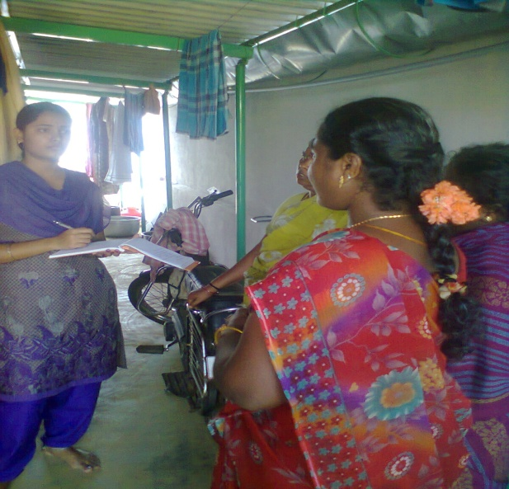

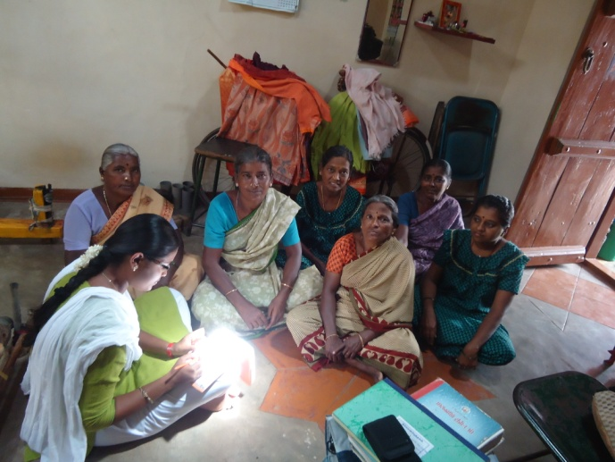
INTERVIEW IN PROGRESS
PLATE -1

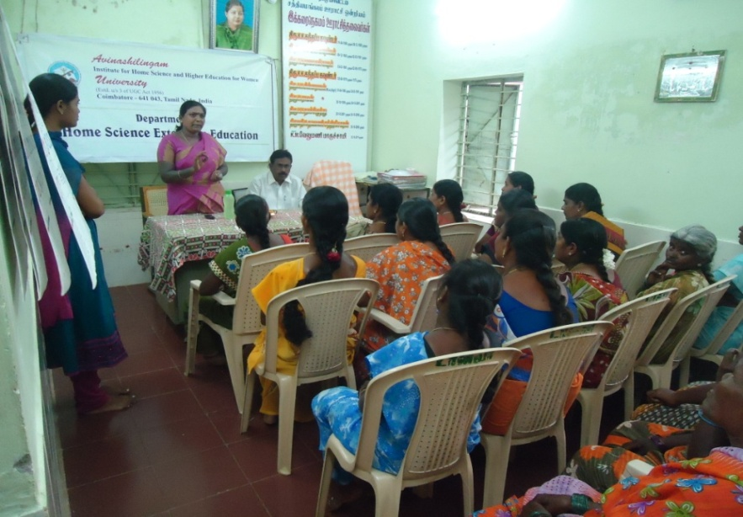
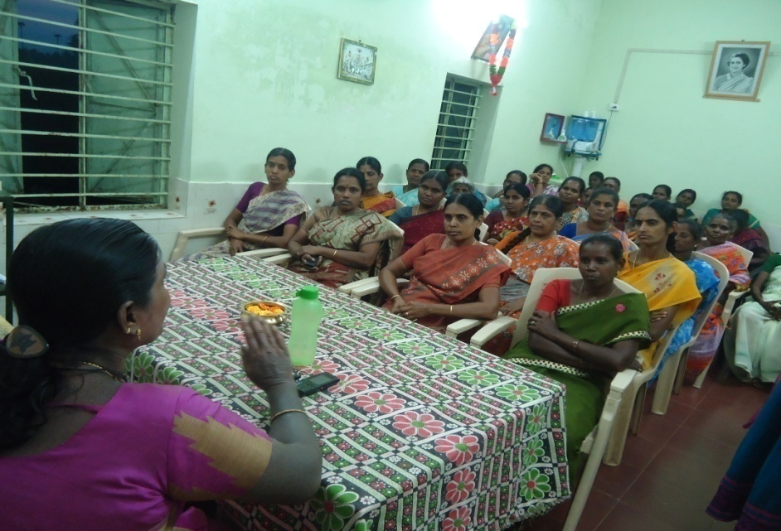
PROGRAMME ON LEGAL AWARENESS
PLATE-2

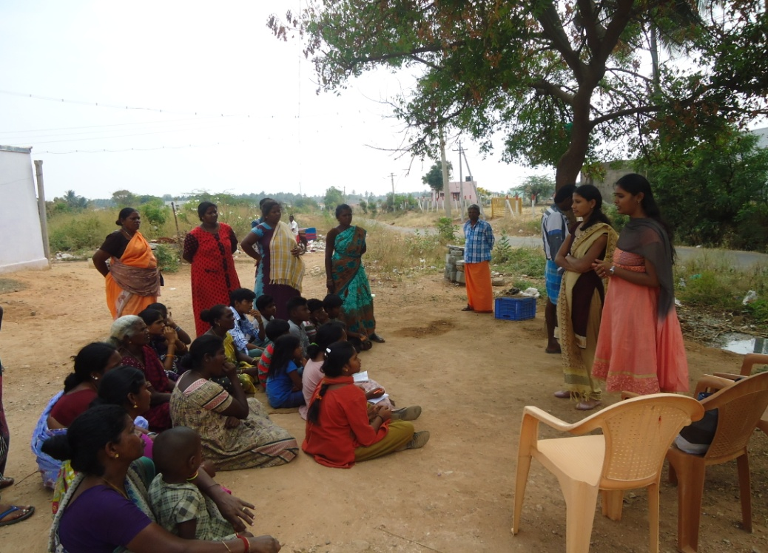
AWARENESS PROGRAMME AMONG WOMEN EMPOWERMENT
PLATE - 3

VI. RESULT AND DISCUSSION
The result and discussion pertaining to the study entitled “Developing leadership skill among rural women” is discussed under the following headings.

- Socio-economic characteristics of women
- Status of Women
- Daily activities performed by women
- Accounts and savings habits of women
- Health problems faced by women
- Challenges faced by women
C. Impact of Educational Intervention
    - Qualities possessed by women
    - Decision making capacity of women
    - Stress management
    - Awareness on Women Empowerment Programme and Rights

A. SOCIO-ECONOMIC CHARACTERISTICS OF WOMEN
Socio-economic characteristics of women is depicted in Table-VI
TABLE-VI
SOCIO-ECONOMIC CHARACTERISTICS OF WOMEN
S.NO | Characteristics |  | N=75
1 | Age( in year) | 20-25 | 7 (9)
1 | Age( in year) | 26-30 | 18(24)
1 |  | 31-35 | 24(32)
1 |  | 35-40 | 5(6)
1 |  | 41-50 | 21(28)
2 | Education | Illiterate | 37(49)
2 | Education | Elementary | 28(37)
2 | Education | Secondary | 5(9)
2 | Education | HSC | 3(4)
2 | Education | Graduate | 1(1)
3 | Marital status | Married | 68(91)
3 | Marital status | Unmarried | 2(2)
3 | Marital status | Widow | 5(7)
4 | Occupation | Coolies | 55(73)
4 | Occupation | Agriculture | 15(20)
4 | Occupation | House wife | 5(7)
5 | Monthly Income | Less than Rs5000 | 7(9)
5 | Monthly Income | Rs 5001-10,000 | 54(72)
5 | Monthly Income | Rs 10,001-15,000 | 4(5)
5 | Monthly Income | Rs 16,001-20,000 | 4(5)
5 | Monthly Income | Above Rs20,001 | 6(8)
6 | Type of the family | Nuclear family | 23(31)
6 | Type of the family | Joint family | 42(56)
6 | Type of the family | Extended family | 10(13)
7 | Size of the family | Up to 2 (small) | 10(13)
7 | Size of the family | 4-6 (medium) | 42(56)
7 | Size of the family | 6- 8 (large) | 23(31)
8 | House detail | Own house | 66(88)
8 | House detail | Rent house | 9(12)
Figures in the parentheses indicates percent
Thirty two percent of the women were between the age group of 31-35 years, followed by the age group 41-50 years twenty eight percent. This shows there is active participation of youth groups.
Regarding the educational qualification, forty nine percent of the women were illiterate and thirty seven percent had elementary school. Only one percent completed graduation.
Ninety one percent women were married, whereas only two percent of were unmarried.
Occupations of highest population of women were coolies (seventy three percent), followed by house wife (seven percent).
Seventy two percent of women monthly income ranges between Rs.5001-10,000 only five percent were earning more than Rs.10, 000.
Fifty six percent of the women belongs to joint family and also belong to medium size of the family.
Eighty eight percent of the women having own house and rest of them living in rented house.

B. STATUS OF WOMEN
Status of women discussed under the following headings:
i) Daily activities performed by women
ii) Accounts and savings habits of women
iii) Health problems faced by women
iv) Challenges faced by women

i) DAILY ACTIVITIES PERFORMED BY WOMEN
Table-VII indicate the daily activities performed by women

TABLE-VII
DAILY ACTIVITIES PERFORMED BY WOMEN
S.NO | Daily activities | N=75 *
1 | Cooking | 73(96)
2 | Taking care of children | 72(96)
3 | Washing | 72(96)
4 | Sweeping | 70(93)
5 | Interaction with neighborhood | 70(93)
6 | Visiting temple | 70(93)
7 | Cleaning | 68(91)
8 | Visiting neighbor house | 68(91)
9 | Watching TV | 58(78)
10 | Visiting farm | 58(78)
11 | Shopping | 49(64)
12 | Listening Music | 26(36)
*Multi Responses
Figures in the parentheses indicates percent

Majority (ninety six percent) of the women performed daily activities namely cooking and taking care of children. Only thirty six percent of the women listening music. The inference drawn from the research says that women spent maximum time for doing house hold task. They are not concentrating on personal development and recreational activities. This may create stress and also leads to lack of skills such as communication, self esteem and personal empowerment.

ii) ACCOUNTS AND SAVINGS HABITS OF WOMEN
Table-VIII shows the information about the accounts and savings habits of women

TABLE-VIII
ACCOUNTS AND SAVINGS
S.NO | Aspects | N=75 *
1 | Habit of saving money | 68(91)
2 | Bank account | 41(54)
3 | Asset with your name | 24(32)
4 | Having debt card and ATM | 24(32)
*Multi Responses
Figures in the parentheses indicates percent

Ninety one percent of women having the habit of saving money.Only thirty two percent of women had opportunity to own the asset in their name. This indicates that women spent maximum time for doing house hold activity and dependent of husband and family members for economical support.

iii) HEALTH PROBLEMS FACED BY WOMEN
WHO definition of health is the level of functional or metabolic efficiency of a living organism. In humans it is the ability of individuals or communities to adapt and self-manage when facing physical, mental or social challenges.
Table-IX shows the health problems faced by women
TABLE-IX
HEALTH PROBLEMS
S.NO | Health Problems | N=75*
1 | Back pain | 68(91)
2 | Ulcer | 68(91)
3 | Astuma | 58(78)
4 | Head ache | 58(78)
5 | Vision problem | 49(64)
6 | Diabetics | 45(60)
7 | Blood pressure | 40(53)
8 | Menstrual problem | 35(47)
9 | Hip pain | 24(32)
10 | Pain in spinal card | 24(32)
11 | Abdomen pain | 24(32)
12 | Joint pain | 22(29)
*Multi Responses
Figures in the parentheses indicates percent

The majority (ninety one percent) of the women got a back pain and ulcer. Only twenty nine percent of the women having a problem of joint pain. It is mostly due to lack of rest, improper eating habits and time management.

iv) CHALLENGES FACED BY WOMEN
Table-X indicates the challenges faced by women

TABLE-X
CHALLENGES FACED BY WOMEN
S.NO | Challenges | N=75 *
1 | Lack of self confident | 68(91)
2 | Lack of decision making capacity | 41(54)
3 | Lack of time management skill | 41(54)
4 | Inability to solve the problems | 41(54)
5 | Lack of self esteem | 24(32)
6 | Lack of public speaking skill | 24(32)
7. | Lack of communication skill | 22(29)
*Multi Responses
Figures in the parentheses indicates percent

The data indicates that the majorities (ninety one percent) of the women were lack of self confident and twenty nine percent do not have communication skill. These two qualities are important for a leader. Hence developing leadership skill among women is essentially.

C. IMPACT OF EDUCATIONAL INTERVENTION
Impact of education is discussed under the following headings:
i) Qualities possessed by women
ii) Decision making capacity of women
iii) Stress management
iv) Awareness on Women Empowerment Programme and Rights

i) QUALITIES POSSESSED BY WOMEN
Leadership development is a wide range of aptitudes and capabilities, all of which affect a person’s interactions with co-workers, constituents, or customers, personal qualities, moral commitments, and management skills. The effects of leaderships development are most directly felt in the social setting of an organization, where leaders and followers attempt to work together to attain common goals (Terry, 1993)
The information about the qualities possessed by women before and after the programme is presented in theTable-XI

TABLE-XI
QUALITIES POSSESSED BY WOMEN
S.NO | Qualities | N=75 *
S.NO | Qualities | Before | After
1 | Self confidence | 46(53) | 72(96)
2 | Trust worth | 68(91) | 72(96)
3 | Effective communication ability | 58(78) | 70(93)
4 | Skillful planning | 58(78) | 70(93)
5 | Positive attitude | 26(36) | 58(78)
6 | Helping others | 26(36) | 45(60)
7 | Rapport building | 26(36) | 45(60)
8 | Courage | 26(36) | 45(60)
9 | Creativity | 17(22) | 46(53)
10 | Delegation of responsibilities | 35(47) | 46(53)
11 | Think analytically | 26(36) | 46(53)
12 | Encourage others | 30(40) | 46(53)
13 | Punctuality | 35(47) | 46(53)
14 | Humility | 35(47) | 46(53)
15 | Good sense of humor | 19(25) | 30(40)
*Multi Responses
Figures in the parentheses indicates percent

The data reveals that after educational intervention a majority (ninety six percent) were gained the self confident and trust worth followed by communication ability, skillful planning respectively. Only forty percent enhanced sense of humor.

ii) DECISION MAKING CAPACITY OF WOMEN
a) Areas of decision making capacity
b) Techniques of decision making capacity
a) AREAS OF DECISION MAKING CAPACITY
Decision making is a process of selecting the best among the different alternatives. It is the act of making a choice.Decision making is defined as the selection of choice of one best alternative.
The areas of decision making capacity of the women shows in the Table-XII
TABLE-XII
AREAS OF DECISION MAKING CAPACITY
S.NO | Areas of decision making capacity | N=75*
S.NO | Areas of decision making capacity | Before | After
1 | Savings | 26(36) | 68(91)
2 | Cooking | 61(81) | 68(91)
3 | Inter village visiting | 58(78) | 68(91)
4 | Investment | 35(47) | 61(81)
5 | Visiting relatives | 58(78) | 61(81)
6 | Daily Expenditure | 46(53) | 58(78)
7 | Borrowing | 17(22) | 58(78)
8 | Family planning | 26(36) | 45(60)
9 | Shopping | 26(36) | 45(60)
10 | Overnight stay outside the village | 26(36) | 45(60)
11 | Health care | 35(47) | 46(53)
12 | Voting | 30(40) | 46(53)
13 | Children Education | 35(47) | 46(53)
14 | Building repairing house | 35(47) | 46(53)
15 | Entertainment | 19(25) | 30(40)
*Multi Responses
Figures in the parentheses indicates percent
A majority (ninety one percent) of the women have the capacity to take decision in areas such as cooking, saving and inter village visiting. This shows that after educational intervention positive changes occurred among women.
b) TECHNIQUES OF DECISION MAKING CAPACITY
Due to lack of decision making capacity of women , the techniques of decision making was imparted to women is presented in the Table-XIII
TABLE-XIII
TECHNIQUES OF DECISION MAKING CAPACITY
S.NO | Techniques of decision making capacity | N=75 *
S.NO | Techniques of decision making capacity | Before | After
1 | Identify the purpose of decision | 35(47) | 68(91)
2 | Transform decision into action | 34(47) | 66(88)
3 | Determine the best alternative | 58(78) | 61(81)
4 | Select the best solution | 30(40) | 61(81)
5 | Gather information | 26(36) | 58(78)
6 | Create a constructive environment | 17(22) | 58(78)
7 | Identify the decision into action | 35(47) | 58(78)
8 | Plan decision making to meet deadlines | 26(36) | 46(61)
9 | Evaluate each choice in term of its consequences | 35(47) | 45(60)
10 | Different Possible choices | 17(22) | 35(47)
*Multi Responses
Figures in the parentheses indicates percent
The education enhanced the ninety one percent women to identify the purpose of decision. Eighty eight percent were able to transform the decision into action. Only forty seven percent were able to the list out different possible choices.

iii) STRESS MANAGEMENT
Stress Management is present under the following heading
a) Stress experienced by women
b) Stress management techniques

a) STRESS EXPERIENCED BY WOMEN
Stress is the body’s automatic response to any physical or mental demand placed upon it. When pressures are threatening, the body rushes to supply protection by turning on ‘the juices’ and preparing to defend itself. It’s the ‘flight or fight’ response in action”. (Bowman,1998)
The stress experienced by the women shows in the Table-XIV
TABLE-XIV
STRESS EXPERIENCED BY WOMEN
S.NO | Stress Experienced by Women | N=75*
S.NO | Stress Experienced by Women | Before | After
1 | Negative feelings | 49(64) | 21(15)
2 | Muscle pains | 26(36) | 25(19)
3 | Irritability | 30(40) | 36(26)
4 | Loss of energy | 49(64) | 36(26)
5 | Loss of interest in daily activities | 58(78) | 40(30)
6 | Sleeplessness | 46(53) | 47(35)
7 | Restlessness | 46(53) | 47(35)
8 | Breathlessness | 22(29) | 47(35)
9 | Loneliness | 58(78) | 47(35)
10 | Concentration problem | 70(93) | 53(46)
*Multi Responses
Figures in the parentheses indicates percent
After educational intervention the women experience low level of stress and also reduce various types of stress such as negative feelings (twenty one percent) and muscle pain (twenty five percent) respecti

b) STRESS MANAGEMENT TECHNIQUES
Stress management refers to the wide spectrum of techniques and psychotherapies aimed at controlling a person's levels of stress, especially chronic stress, usually for the purpose of improving everyday functioning.(‎Richardson 2002)
The stress management techniques imparted to women is presented in the Table-XV
TABLE-XV
STRESS MANAGEMENT TECHNIQUES
S.NO | Stress management techniques | N=75*
S.NO | Stress management techniques | Before | After
1 | Way to relax mind | 46(53) | 72(96)
2 | Adopt healthy habits | 68(91) | 72(96)
3 | Way to avoid stress | 58(78) | 70(93)
4 | Way to do something you enjoy | 26(36) | 58(78)
5 | Develop personality | 35(47) | 58(78)
6 | Laugh it up | 26(36) | 46(61)
7 | Schedule regular times for healthy relaxing activity | 26(36) | 46(61)
8 | Watching TV | 26(36) | 46(61)
9 | Reading books | 26(36) | 46(61)
10 | Exercise regularly | 17(22) | 45(60)
11 | Gentle walk for 30 min | 35(47) | 45(60)
12 | Look at your life style | 26(36) | 45(60)
13 | Meditate focus on the present | 30(40) | 45(60)
14 | A hobby such as kitchen gardening | 35(47) | 45(60)
15 | Let the music play to relief stress | 19(20) | 30(40)
*Multi Responses
Figures in the parentheses indicates percent

The data shows that a majority (ninety six percent) of the women learnt the stress management techniques such as way to relax mind, adopt healthy habits, followed by (ninety three percent) way to avoid stress and learnt to relief stress by playing a listening music(forty percent).
iv) AWARENESS ON WOMEN EMPOWERMENT PROGRAMME
The table-XVI indicates the awareness created on women empowerment programme among women.

TABLE-XVI
AWARENESS ON WOMEN EMPOWERMENT PROGRAMME
S.NO | Name of the Programmes | N=75*
S.NO | Name of the Programmes | Before | After
1 | Young Women Political Leadreship Programme | 10(13) | 72(96)
2 | Training and Employment programme for women | 30(40) | 70(93)
3 | National Bank for Agriculture and rural development | 58(78) | 70(93)
4 | Mahatma Gandhi National Rural Employment Gurantee Act | 46(61) | 68(91)
5 | National Mission for Employment Women | 26(36) | 58(78)
6 | National Credit Fund for Women | 17(22) | 46(61)
7 | National Nutritional Policy Programme | 17(22) | 35(47)
8 | National Rural Livelihood Mission | 19(25) | 30(40)
*Multi Responses
Figures in the parentheses indicates percent

The awareness Programme enhanced the knowledge level on women empowerment programmes among women, ninety six percent of women gained knowledge on Young Women Political Leadreship Programme, followed by Training and Employment programme for women and National Bank for Agriculture and rural development(ninety three percent).

v) AWARENESS ON WOMEN RIGHTS
The awareness created on women rights is presented in the Table-XVII
TABLE-XVII
AWARENESS ON WOMEN RIGHTS
S.NO | Women Rights | N=75 *
S.NO | Women Rights | Before | After
1 | Rights to equality | 10(13) | 72(96)
2 | Dowry Prohibition Act | 58(78) | 70(93)
3 | Violence against women | 61(81) | 70(93)
4 | Widow re-marriage Act | 68(91) | 68(91)
5 | Equal property Rights | 30(40) | 66(88)
6 | Domestic Violence Act | 26(36) | 58(78)
7 | Women Reservation Bill | 17(22) | 46(61)
8 | Free of Sexual Violence | 17(22) | 35(47)
*Multi Response
Figures in the parentheses indicates percent

Majority (ninety six percent) of women gained knowledge on rights to equality, followed by violence against women, Dowry prohibited Act (ninety three percent) and (forty seven percent) aware of free of sexual violence.

V. SUMMARY AND CONCLUSION

The participation of women and their engagement in electoral process is an important marker of the maturity and efficacy of democracy in any country. It can be defined not only in terms of the equality and freedom with which they share political power with men, but also in terms of the liberty and space provided for women in the democratic framework of electoral politics.

The innovative study entitled “Developing leadership skill among rural women” was undertaken with main objectives are, to: Assess the socio-economic status and leadership qualities among rural women,Enhancing the leadership skill and Evaluating the impact of the programme carried out in three village namely Kenjanur, Thandampalayam and Veliampalayam of Sathyamangalampanchayat union, Erode district, Tamil Nadu, with a total sample of 75 rural women.
Interview schedule was used as a tool to elicit information on socio economic characteristic of developing leadership skill among rural women.

FINDINGS
Findings are given below:
SOCIO-ECONOMIC CHARACTERISTICS OF WOMEN
- Thirty two percent of the women were between the age group of 31-35 years.
- Forty nine percent of the women were illiterate.
- Ninety one percent women were married.
- Seventy three percent of women were coolies.
- Seventy two percent of women monthly income ranges between Rs.5001-10,000.
- Fifty six percent of the women belongs to joint family.
- Eighty eight percent of the women having own house.
STATUS OF WOMEN
- Ninety six percent of the women performed daily activities namely cooking and taking care of children.
- Thirty six percent of the women listening music.
- Ninety one percent of women having the habit of saving money.
- Thirty two percent of women had opportunity to own the asset in their name.
- Ninety one percent of the women got a back pain and ulcer.
- Twenty nine percent of the women having a problem of joint pain.
- Ninety one percent of the women were lacking self confident.
- Twenty nine percent do not have communication skill.

IMPACT OF EDUCATION
- Ninety six percent were gained the self confident and trust worth followed by communication ability, skillful planning.
- Forty percent enhanced sense of humor.
- Ninety one percent of the women have the capacity to take decision in areas like cooking, saving and inter village visiting.
- Ninety one percent women to identify the purpose of decision.
- Eighty eight percent were able to transform the decision into action.
- Forty seven percent were able to the list out different possible choices.
- After education intervention the women experience low level of stress and also reduce various types of stress such as negative feelings twenty one percent.
- Ninety six percent of the women learnt the stress management techniques such as way to relax mind, adopt healthy habits.
- Ninety three percent way to avoid stress.
- Forty percent learnt to relief stress by playing a listening music.
- Ninety six percent of women gained knowledge on Young Women Political Leadreship Programme.
- Ninety three percent on Training and Employment programme for women and National Bank for Agriculture and rural development.
- Ninety six percent of women gained knowledge on rights to equality.
- Ninety three percent of women gained knowledge on violence against women, Dowry prohibited Act.
- Forty seven percentaware of free of sexual violence.

SUGGESTION

- Motivate rural women to participate in election
- To organize programme to develop their skills among rural women.
- To conducting training programme for rural women regarding to their legal rights.
- Involve rural women in local development.
- Training programmes at all levels and in different subjects should be organized for rural women to upgrade their scientific knowledge and skills.
- The literacy levels of rural women are low and hence effort to enhance literacy level in the area should be given priority.
- Motivate rural women to reading newspaper and magazines to know about the current affairs.
- To participation of women in policy and decisionmaking process at domestic and public levels.
- Government should launch various schemes and policy for improving the status of rural women.

CONCLUSION

Rural women in India are less literate than rural men. There is a negative attitude of the family towards educating the girl child. In rural India, very few women have ownership over land or productive assets. Majority of the agricultural laborers are women.Women’s representation at the higher rungs of the decision-making positions has also been consistently low. Participation of rural women in election is very low. So this studies mainly focusing the rural womenfor developing the leadership skill. After educational intervention most of the women learning leadership skill, decision making capacity and qualities possessed. Awareness on leadership skill among rural women is very important to create education is the main key of the empowerment ofwomen to the nation. Education leads to the empowerment ofwomen improving economic growth, equal rights, political participation and other participationmay build up a better rural India.

BIBLIOGRAPHY

Albert, J. Della Bitta andMeginnis M.(2012), Women in the Boardroom and their Impact on Governance and Performance, Journal of Financial Economics, pp 291-309.
ApoorvaRathod (2014), Women’s Political Participation and Representation in India,Manas publication New Delhi pp.12-13.

Banerjee Shruti (2005), Role of women in Development Sector, Adhyayan Publishers, Delhi, pp 150-157.

BharadwajSangeeta (2009), Gender Social Structure and Empowerment, Rawat publication New Delhi,pp 120-125.

BoraianM. P. (2003), Empowerment of rural women: Towards reversal of gender relations, The Indian Journal of Social Work,pp521-532.

Brig ParmodhSain (2001), Training for Leadership, Manas Publications New Delhi pp106-107.

Brooke Shannan(2006), Employment and Women’s Empowerment in India, ArEmm International publication in New Delhi, pp.89-91.
Costantini, E. (1990), Political Women and Political Ambition, Closing the Gender Gap, American Journal of Political Science, pp: 741-770.
Craig M. Watson (1995), Dynamics of Leadership, KEND Publishing oxford & New York in. pp:22-24.
Dayle M. Smith (2003), The Eleven Keys to Leadership, published by Tata McGraw- Hill publishing company Ltd New Delhi, pp. 22-25.

Dewan (2005), Management skill and application, McGraw-Hill/Irwin, New York, pp. 259-256

Eagly, A. andCaril, L. (2003),The Female Leadership Advantage: An Evaluation of the Evidence. The LeadershipQuarterly, pp: 807-834.
Elisabeth Porter (2013), “Rethinking Women's Empowerment”,Journals of peace building and Development, vol 8, pp159-168

Ester Boserup (2008), “Women’s Role in Economic Development”, Earth scan publication, London, pp 59-60.

EswarappaKasi (2013), “Role of Women in Sericulture and Community Development”, SAGE Journals, vol 1, pp 237-248.

Government of India (1975), “Towards Equality” Report of the Committee on the Status of Women in India, pp 356.
Government of India (1992), Eighth Five Year Plan 1992 - 97, Planning Commission, New Delhi, pp. 291-292.
HendrieWeisinger (2006), Emotional Intelligence at work, ArEmm International, published in New Delhi, pp 67-72.

JayantySinh,(2006),Status of women in India, Visataar publications, New Delhi, pp.182-183.

Julia Wiklander(2010), “Determinants of Women’s Empowerment in Rural IndiaUB publication New Delhi, pp.54-59.
JorisLammers and Dario Bombari(2013),“Successful female leaders empower women's behavior in leadership tasks”, Vol 49, pp 444-448.

Kala S. and Singal S. (2003).A study on decision making pattern of tribal women entrepreneurs, pp52-57.

KanakalathaMukund(1990),“Women Welfare Programmes”, CESS, Hyderabad, pp 204-205.
Kitchlu T.N (1991), Women rights, Legislative Measuresin Yojana, Nov. 15, , vol. 35, No. 20, Publication Division, Government of India, New Delhi, pp 16-18.

MahapatraSubhasini (2006), “Status of Women towards Empowerment”, Rajat Publication, New Delhi, India, pp.35-40.

Maya Majumdar (2005),Enhancing Women’s Political Participation: Legislative Recruitment and Electoral Systems. Women and Parliament: Beyond Numbers, Chapter 3, pp. 99-110.

Narayan, D. (2012), “Elections and Political Development” The South Asian Experience, Vikas Publishing House, New Delhi, pp. 50-57.

Norris, P. (1985), Women’s Legislative Representation in Western Europe. West European Politics, 90-101.

PaulChowdari, (2004), Empowering rural women, Publishing house, New Delhi, pp-29-30.

PillaiKhothari Jaya (2003), “Women and Empowerment”, Gyan Publication House, New Delhi, India, pp. 25-30.

Peter G. North House (2012), Leadership, This South Asian Edition Published inSAGE publication pvt Ltd New Delhi, pp 6-7.
Praveen Rai(2011), “Electoral Participation of Women in India “,Bombay Allied Publishers Private Ltd pp 210-214.

PurusottamNayak and BidishaMahanta (2009), “Women Empowerment in Assam”, SSRN electronic Journal, vol -10, pp.460-465.

R.K.Sahu&PragyaBhart (2009), Strategic Leadership, Published by Anurag Jain for Excel Books. New Delhi, pp 407-409.

Robert E Dowse (1972), “Political Sociology”, John Wiley and Sons publication, London, pp.290-292

Rost (2000), Leadership for the twenty – first century published in Himalaya publication House New Delhi, pp. 101-108.

Safilios (2001), Factors Effect on Women Autonomy and Decision-Making Power within the Household in Rural Communities, Journal of Applied Sciences Research, pp. 18-21.
Sahu and pragyabharti (2009), Women education, Rajat Publication, New Delhi, pp. 323-324.

Saraf V.K. (1994), How to become a good leader, UB Publishers Distributors PVT.LTD
New Delhi pp53-56.

Sheetalmundra&jaishree Sharma (2014), “A Comparative Analysis of the Status of Women Entrepreneurship”, International Journal of Social Science and Management, vol-1, pp 69-73.

Silvia Erzeel(2015), “Explaining Legislators, Journal of Women politics and policy, vol-36,
pp 128-135.

Singh, K. (1992), Women entrepreneurs. Ashish publishing house, New Delhi pp 56-58.

Singh IndraBhushan (2005), “Rural Development and Women Empowerment”, Authors press publication, New Delhi pp. 102-106.

Tanya Jakimow and Patrick Kilby(2006), Empowering Women Indian Journal of gender studies volume 5, pp. 140-142.
Tata MC Graw (2004), Leadership through People Skills. Published by Tata MC Graw Hill Publishing Company Limited, New Delhipp11-12.

AVINASHILINGAM INSTITUTE OF HOME SCIENCE AND HIGHER EDUCATION
FOR WOMEN
DEPARTMENT OF HOME SCIENCE EXTENSION EDUCATION
INTERVIEW SCHEDULE ON DEVELOPING LEADERSHIP SKILL AMONG
RURAL WOMEN
A. SOCIO-ECONOMIC CHARACTERISTICS OF WOMEN
S.NO | Characteristics
1 | Age( in year) | 20-25
1 | Age( in year) | 26-30
1 |  | 31-35
1 |  | 35-40
1 |  | 41-50
2 | Education | Illiterate
2 | Education | Elementary
2 | Education | Secondary
2 | Education | HSC
2 | Education | Graduate
3 | Marital status | Married
3 | Marital status | Unmarried
3 | Marital status | Widow
4 | Occupation | Coolies
4 | Occupation | Agriculture
4 | Occupation | House wife
5 | Monthly Income | Less than Rs5000
5 | Monthly Income | Rs 5001-10,000
5 | Monthly Income | Rs 10,001-15,000
5 | Monthly Income | Rs 16,001-20,000
5 | Monthly Income | Above Rs20,001
6 | Type of the family | Nuclear family
6 | Type of the family | Joint family
6 | Type of the family | Extended family
7 | Size of the family | Up to 2 (small)
7 | Size of the family | 4-6 (medium)
7 | Size of the family | 6- 8 (large)
8 | House detail | Own house
8 | House detail | Rent house

B. STATUS OF WOMEN
i) Daily activities performed by women
S.NO | Daily activities | Yes | No
1 | Cooking
2 | Taking care of children
3 | Washing
4 | Sweeping
5 | Interaction with neighborhood
6 | Visiting temple
7 | Cleaning
8 | Visiting neighbor house
9 | Watching TV
10 | Visiting farm
11 | Shopping
12 | Listening Music

ii) Accounts and savings habits of women
S.NO | Aspects | Yes | No
1 | Habit of saving money
2 | Bank account
3 | Asset with your name
4 | Having debt card and ATM

iii) Health problems faced by women
S.NO | Health Problems | Yes | No
1 | Back pain
2 | Ulcer
3 | Astuma
4 | Head ache
5 | Vision problem
6 | Diabetics
7 | Blood pressure
8 | Menstrual problem
9 | Hip pain
10 | Pain in spinal card
11 | Abdomen pain
12 | Joint pain

iv) Challenges faced by women
S.NO | Challenges | Yes | No
1 | Lack of self confident
2 | Lack of decision making capacity
3 | Lack of time management skill
4 | Inability to solve the problems
5 | Lack of self esteem
6 | Lack of public speaking skill
7. | Lack of communication skill

C IMPACT OF EDUCATION
i) Qualities possessed by women
S.NO | Qualities | Yes | No
1 | Self confidence
2 | Trust worth
3 | Effective communication ability
4 | Skillful planning
5 | Positive attitude
6 | Helping others
7 | Rapport building
8 | Courage
9 | Creativity
10 | Delegation of responsibilities
11 | Think analytically
12 | Encourage others
13 | Punctuality
14 | Humility
15 | Good sense of humor

ii) DECISION MAKING CAPACITY OF WOMEN
a) Areas of decision making capacity
S.NO | Areas of decision making capacity | Yes | No
1 | Savings
2 | Cooking
3 | Inter village visiting
4 | Investment
5 | Visiting relatives
6 | Daily Expenditure
7 | Borrowing
8 | Family planning
9 | Shopping
10 | Overnight stay outside the village
11 | Health care
12 | Voting
13 | Children Education
14 | Building repairing house
15 | Entertainment

b) Techniques of decision making capacity
S.NO | Techniques of decision making capacity | Yes | No
1 | Identify the purpose of decision
2 | Transform decision into action
3 | Determine the best alternative
4 | Select the best solution
5 | Gather information
6 | Create a constructive environment
7 | Identify the decision into action
8 | Plan decision making to meet deadlines
9 | Evaluate each choice in term of its consequences
10 | Different Possible choices

iii) STRESS MANAGEMENT
a) Stress experienced by women
S.NO | Stress experienced by women | Yes | No
1 | Negative feelings
2 | Muscle pains
3 | Irritability
4 | Loss of energy
5 | Loss of interest in daily activities
6 | Sleeplessness
7 | Restlessness
8 | Breathlessness
9 | Loneliness
10 | Concentration problem

b) Stress management techniques
S.NO | Stress management techniques | Yes | No
1 | Way to relax mind
2 | Adopt healthy habits
3 | Way to avoid stress
4 | Way to do something you enjoy
5 | Develop personality
6 | Laugh it up
7 | Schedule regular times for healthy relaxing activity
8 | Watching TV
9 | Reading books
10 | Exercise regularly
11 | Gentle walk for 30 min
12 | Look at your life style
13 | Meditate focus on the present
14 | A hobby such as kitchen gardening
15 | Let the music play to relief stress

iv) Awareness on Women Empowerment Programme
S.NO | Name of the Programmes | Yes | No
1 | Young Women Political Leadreship Programme
2 | Training and Employment programme for women
3 | National Bank for Agriculture and rural development
4 | Mahatma Gandhi National Rural Employment Gurantee Act
5 | National Mission for Employment Women
6 | National Credit Fund for Women
7 | National Nutritional Policy Programme
8 | National Rural Livelihood Mission

v) Awareness on Women Rights
S.NO | Women Rights | Yes | No
1 | Rights to equality
2 | Dowry Prohibition Act
3 | Violence against women
4 | Widow re-marriage Act
5 | Equal property Rights
6 | Domestic Violence Act
7 | Women Reservation Bill
8 | Free of Sexual Violence

