

Avinashilingam Institute for Home Science and Higher Education for Women
(Deemed to be University under Category ‘A’ by MHRD, Estd. u/s 3 of UGC Act 1956)
Re-accredited with ‘A+’ Grade by NAAC. Recognised by UGC Under Section 12B
Coimbatore - 641 043, Tamil Nadu, India

Master’s Degree Examination – November 2019
Semester- I
Class : I P.G Time: 3 hours Major : Tourism and Travel Management Max. Marks: 60

17MTAC03 - HUMAN RESOURCE MANAGEMENT IN TOURISM

C01: Understand the nature and functions of Human Resource Management in the Organization.
CO2: Familiar with Recruitment methods, Selection process, Training and Performance Appraisal.
CO3: Learn about Human Resource Planning and Development.
C04: Aware of key issues between management and employees.
CO5: Understand the significance of Tourism Industry in Economic and Employment aspect.
Part A 10 x ½ = 5
Choose the correct answer

- HRM is___________ CO1 K1
  - A staff functions b. A line function
- A staff function, line function and accounting function
- All of the above

- The business side of the process begins with the strategic _____ as the guiding framework.
  - HR b. Plan c. Policy d. None of the above CO1 K1
- ________ is considered as a strategic activity.
  - Recruitment b. Planning c. Productivity d. All of the above CO2 K1
- _______ is defined as the record of outcomes produced on a specific job function or activity during a specific time period.
  - Performance b. Work function c. Evaluation d. None of the above CO2 K1
- HR professional should apply risk management techniques to the different aspects of ________.
  - HR Strategies b. HR Competencies c. Both (A) and (B)
- None of the above CO3 K1

- HR professionals has to be skilled in the art of ________.
  - Clarifying b. Handling people c. Both (A) and (B)
d. None of the above CO3 K1

- Which of the following is not an approach to industrial relations?
  - Unitary approach b. Pluralistic approach
c. Marxist approach d. Employee’s approach CO4 K1

- Parties to industrial relations are
  - ILO, Government, Association of employers b. ILO, Government, IMF
- ILO, Board of Directors, Association of employers
d. Government, Board of Directors, Association of employers CO4 K1

- Which of the following is an integral element of Tourism Product:
  - Hotels and restaurants b. Transportation
c. Entertainment and recreational facilities d. All of the above CO5 K1

- Dachigam Wildlife sanctuary is situated in which state?
  - Uttarakhand b. Assam c. Jammu & Kashmir d. Himachal Pradesh CO5 K1

Part B 5 * 4=20
Answer the following
Answer should not exceed 200 words or one page
11(a) State the Nature, scope and importance of HRM. CO1 K1
(Or)
11(b) Name and explain the functions of HR Department. CO1 K1

12(a) Enumerate the methods of recruitment. CO1 K1
(Or)
12(b) Discuss the purpose and Process of Selection. CO1 K2

13(a) Explain the importance of Human resource Planning. CO1 K3
(Or)
13(b) Illustrate the role of Human Resource Development Professionals. CO1 K3

14(a) indicate the essential conditions for sound industrial relations. CO1 K2.
(Or)
14(b) Explain causes of Industrial disputes. CO1 K3

15(a) Establish the importance of Tourism Sector. CO1 K3
(Or)
15(b) Evaluate the environmental aspect of Tourism Sector. CO1 K4

Part C 5 * 7 = 35
Answer the following
Answer should not exceed 600 words or three pages
16(a) Explain the System approach to HRM. CO1 K3
(Or)
16(b) Illustrate the functions and qualities of HR Manager. CO1 K3

17(a) Discuss the sources of recruitment. CO2 K2
(Or)
17(b) Explain the methods of performance appraisal. CO2 K3

18(a) Evaluate the responsibility for HRP. CO3 K4.
(Or)
18(b) Describe about Human Resource Development in India. CO3 K1

19(a) Summarize the approaches to Industrial Relations. CO4 K5
(Or)
19(b) Explain the forms of industrial disputes in India. CO4 K3

20(a) Evaluate the case study of Jet Airways. CO5 K4
(Or)
20(b) Infer the planned tourism development of Indian Tourism. CO5 K6

*************

AVINASHILINGAM INSTITUTE FOR HOME SCIENCE AND HIGHER EDUCATION FOR WOMEN,
Coimbatore — 641 043
MASTER'S DEGREE EXAMINATION — November 2019
Semester I
Class : I PG Time : 3 Hours
Major: MBA (Tourism and Travel Management) Max. Marks: 60
C01: Understand the nature and functions of Human Resource Management in the Organization.
CO2: Familiar with Recruitment methods, Selection process, Training and Performance Appraisal.
CO3: Learn about Human Resource Planning and Development.
C04: Aware of key issues between management and employees.
CO5: Understand the significance of Tourism Industry in Economic and Employment aspect.
17MTAC03 - HUMAN RESOURCE MANAGEMENT IN TOURISM
Part — A 10x1/2=5
Circle the correct answer
- HRM is___________
  - A staff functions
  - A line function
  - A staff function, line function and accounting function
  - All of the above CO1 K1
- The business side of the process begins with the strategic _____ as the guiding framework.
  - HR
  - Plan
  - Policy
  - None of the above CO1 K1
- ________ is considered as a strategic activity.
  - Recruitment
  - Planning
  - Productivity
  - All of the above CO2 K1
- _______ is defined as the record of outcomes produced on a specific job function or activity during a specific time period.
  - Performance
  - Work function
  - Evaluation
  - None of the above CO2 K1
- HR professional should apply risk management techniques to the different aspects of ________.
  - HR Strategies
  - HR Competencies
  - Both (A) and (B)
  - None of the above CO3 K1
- HR professionals has to be skilled in the art of ________.
  - Clarifying
  - Handling people
  - Both (A) and (B)
  - None of the above CO3 K1
- Which of the following is not an approach to industrial relations?
  - Unitary approach
  - Pluralistic approach
  - Marxist approach
  - Employee’s approach CO4 K1
- Parties to industrial relations are
  - ILO, Government, Association of employers
  - ILO, Government, IMF
  - ILO, Board of Directors, Association of employers
  - Government, Board of Directors, Association of employers CO4 K1
- Which of the following is an integral element of Tourism Product:
  - Hotels and restaurants
  - Transportation
  - Entertainment and recreational facilities
  - All of the above CO5 K1
- Dachigam Wildlife sanctuary is situated in which state?
  - Uttarakhand
  - Assam
  - Jammu & Kashmir
  - Himachal Pradesh CO5 K1

Part B
Answer the following 5 * 4 =20
Answer should not exceed 200 words or three pages
11(a) State the Nature, scope and importance of HRM.CO1 K1 (Or)
Human ResourceManagement is a process of bringing people and organizations together so that the goals of each are met. The various features of HRM include:
It is pervasive in nature as it is present in all enterprises.
Its focus is on results rather than on rules.
It tries to help employees develop their potential fully.
It encourages employees to give their best to the organization.
It is all about people at work, both as individuals and groups.
It tries to put people on assigned jobs in order to produce good results.
It helps an organization meet its goals in the future by providing for competent and well-motivated employees.
It tries to build and maintain cordial relations between people working at various levels in the organization.
It is a multi-disciplinary activity, utilizing knowledge and inputs drawn from psychology, economics, etc.

The scope of HRM is very wide:
Personnel aspect-This is concerned with manpower planning, recruitment, selection, placement, transfer, promotion, training and development, layoff and retrenchment, remuneration, incentives, productivity etc.
Welfare aspect-It deals with working conditions and amenities such as canteens, cr?ches, rest and lunch rooms, housing, transport, medical assistance, education, health and safety, recreation facilities, etc.
Industrial relations aspect-This covers union-management relations, joint consultation, collective bargaining, grievance and disciplinary procedures, settlement of disputes, etc.

11(b) Name and explain the functions of HR Department.CO1 K1
The key functions an HR department include labor law compliance, recruiting, staff training and development, payroll, record keeping and employee relations.
12(a) Enumerate the methods of recruitment.CO1 K1(Or)
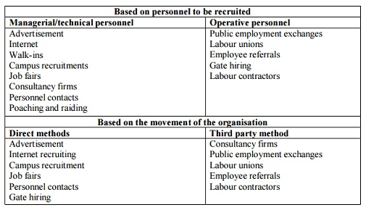
12(b) Discuss the purpose and Process of SelectionCO1 K2.
Purposes of Selection. The select means to choose. Selection is the process of picking individuals who have relevant qualifications to fill jobs in an organization. The basic purpose is to choose the individual who can most successfully perform the job, from the pool of qualified candidates
The selection process can be defined as the process of selection and shortlisting of the right candidates with the necessary qualifications and skill set to fill the vacancies in an organisation.
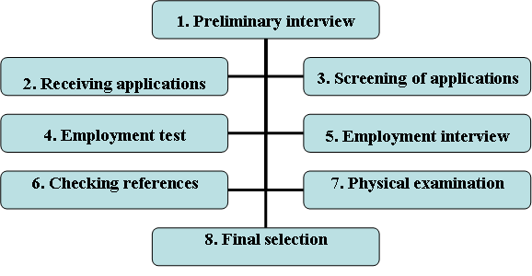
13(a) Explain the importance of Human resource Planning.CO1 K3 (Or)
In striking a balance between demand-for and supply-of resources, HRP helps in the optimum usage of resources and also in reducing the labor cost. Cautiously forecasting the future helps to supervise manpower in a better way, thus pitfalls can be avoided.
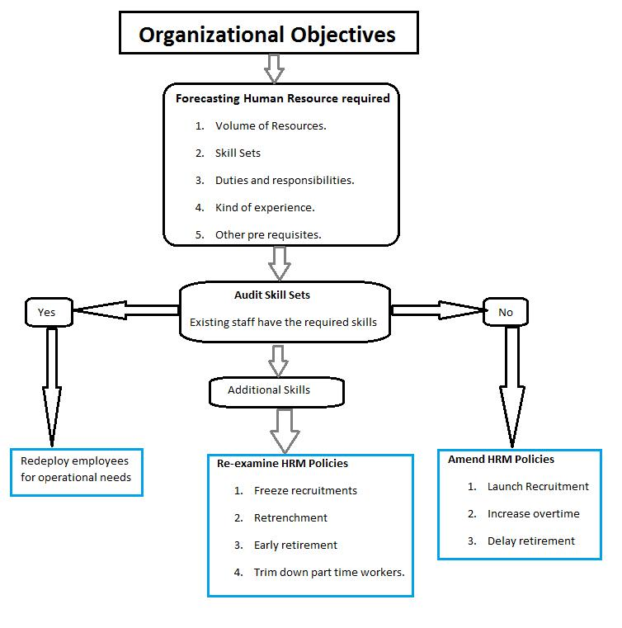
13(b) Illustrate the role of Human Resource Development ProfessionalsCO1 K3.
Role of an HRD Manager • A searcher on a voyage of discovery • Researcher to bring in best practices • In-sight based person • Strategic planner to be a co-partner with management • Agent of change • Counselor • Advisor • Developer
Role of HRD • Planning • Staffing • Appraising and compensating • Training and development • Employee relations • Organizational Environment
New HRD Role • Business Strategy Formulation • HR Policy Formulation • Culture building • Creation of knowledge (and skill) wealth • Agents of change

14(a) indicate the essential conditions for sound industrial relationsCO1 K2. (Or)
Proper democratic environment. Proper democratic environment in any enterprise is essential in order to maintain a sound IR.
Efficient management
Existence of strong, organized trade unions
Existence of sound, organized employers' unions
Spirit of collective bargaining.

14(b) Explain causes of Industrial disputesCO1 K3.
Wage Demands. By far, the most important cause for disputes is related to wages.
Union Rivalry. Multiplicity of unions leads to inter-union rivalries.
Political Interference. Major trade unions are affiliated to political parties.
Unfair Labour Practices.
Multiplicity of Labour Laws.

15(a) Establish the importance of Tourism SectorCO1 K3 (Or)
Tourism industry is important for the benefits it brings and due to its role as a commercial activity that creates demand and growth for many more industries. Tourism not only contributes towards more economic activities but also generates more employment, revenues and play a significant role in development
15(b) Evaluate the environmental aspect of Tourism SectorCO1 K4.
Air, road, and rail transportation are the main means of travel among tourists, and the transport sector of tourism accounts for ~75% of total global emissions. Unfortunately, the burning of fossil fuels have impacts globally and contribute to climate change.
Part C
Answer the following 5 * 7 = 35
Answer should not exceed 600 words or three pages
16(a) Explain the System approach to HRM. CO1 K3 (Or)
It is inter-related set of elements function as a whole is called system or system is a combination of different components or parts for being a complex organ. An organization is a system where as HRM is a sub-system. If HRM is taken a system other components that come under HRM are elements or sub-systems of HRM system. HRM system is a system which transforms employees into productive human resources. The input components are transformed into refined output throughout managerial process. Various sub-systems like; employment, training and development, compensation, maintenance, personnel resources are activated in HRM system. HRM system should adopt environmental changes like; political, economical, socio-cultural , and technological goal. HRM system is the open system that consists of input, processing/transformation and output relationship
16(b) Illustrate the functions and qualities of HR Manager. CO1 K3
Qualities of HR Manager are Sympathetic Attitude, Quick Decisions, Integrity, Patience, Formal Authority, Leadership, Social Responsibility, Good Communication Skills. HR Manager's role is to interview and hire candidates based on their skills and talents.
17(a) Discuss the sources of recruitment CO2 K2 (Or)
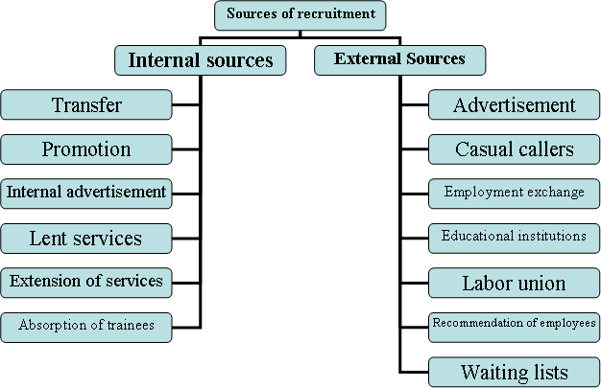
17(b) Explain the methods of performance appraisalCO2 K3.
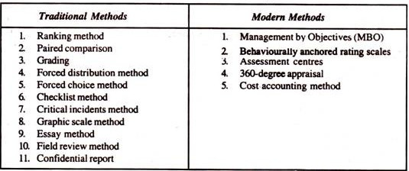
18(a) Evaluate the responsibility for HRPCO3 K4. (Or)
Responsibility for HRP. Top level executives are responsible for manpower planning as it is one of the important factors influencing the success of an organization. ... They should undertake their own appraisal of future needs in such a way as to provide a concrete basis for organization wide forecasting and planning.
18(b) Describe about Human Resource Development in IndiaCO3 K1.
Human Resource Development is based on the concept that every human being has some potential to do remarkable things. If an organisation has to be effective then the task of an executive is to multiply performance capacity of the staff by putting available natural resources, like strength, health, aspirations, etc.
Human resource development is a process by which the employees of an organisation are continuously helped in a planned way to:
(i) Acquire capabilities (knowledge, perspectives, attitude, values and skills) required to perform various tasks or functions associated with their present or future expected roles,
(ii) Develop capabilities and utilize their potential for their own or organisation development process, and
(iii) Develop an organisational culture where superior-subordinate relationship, teamwork and collaborations among different sub-units are strong and can contribute to the organisational health dynamism and pride of employee.
Technological advancement and changes are taking place very rapidly. To meet effectively, these requirements of the changing environment, human resources need to be refreshed, to be imparted training from time to time.19(a) Summarize the approaches to Industrial RelationsCO4 K5 (Or)
19(b) Explain the forms of industrial disputes in IndiaCO4 K3.
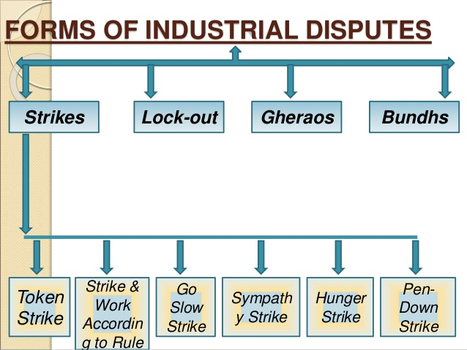
20(a) Evaluate the case study of Jet Airways.CO5 K4 (Or)
Recipient of several business and leadership awards, Company founder Naresh Goyal completed his graduation in Commerce in 1967 and joined the travel business at the age of 18 as a general sales agent(GSA) for the Lebanese International Airlines. From 1967 to 1974 he learnt the intricacies of the travel business through his association with several foreign airlines. In May 1974, he formed his own company, Jetair (Private) Limited, to market other foreign airlines in India. Naresh Goyal was involved in developing studies of traffic patterns, route structures, operational economics and flight scheduling. Jet air eventually grew to a network of 60 branch offices. After three and a half decades of monopoly by Air India and Indian Airlines, the Indian government reopened the domestic aviation market to private carriers in April 1989. This provided an opportunity to Goyal who established Jet Airways (India) Private Limited in 1991. It commenced commercial operations on May 5, 1993. At that time, Jet Airways claimed to be the only profitable privately owned airline in India.
20(b) Infer the planned tourism development of Indian Tourism.CO5 K6
- The objectives of this landmark plan for tourism planning in India were:
- To improve the economy category domestic tourism
- To develop the tourist areas socially and economically
- To preserve the environment and the national heritage
- To encourage international tourism
- To improve in world tourism India's share
- To increase opportunities for employment in this sector
India tourism planning increased with the seventh five year plan India (1985-1989). The various polices advocated by the seventh plan for tourism planning in India are:
- To promote aggressively domestic tourism
- It laid stress on creating more beach resorts
- To conduct conferences, trekking, conventions, and winter sports so that various options are available to the foreign tourists
These polices of the seventh five year plan gave a boost to the tourism planning India. To further encourage tourism planning in India, the eighth five year plan (1992- 1997) mentioned that the private sector should increase its participation in the sector. The various polices advocated by the eighth plan for tourism planning in India are:
To develop the tourists places
- To develop winter sports, beach resort, and wildlife tourism
- To restore the projects of national heritage
- To provide in tourists centers economy class accommodation
Tourism planning in India has increased by leaps and bounds in the last few years and the government and Department of Tourism needs to make continuous efforts to ensure that tourism planning in India takes the tourism sector of the country to greater heights on a sustainable basis.

AVINASHILINGAM INSTITUTE FOR HOME SCIENCE AND HIGHER EDUCATION FOR WOMEN,
Coimbatore — 641 043
MASTER'S DEGREE EXAMINATION — November 2019
Semester I
Class : I PG Time : 3 Hours
Major: MBA (Tourism and Travel Management) Max. Marks: 60

C01: Understand the nature and functions of Human Resource Management in the Organization.
CO2: Familiar with Recruitment methods, Selection process, Training and Performance Appraisal.
CO3: Learn about Human Resource Planning and Development.
C04: Aware of key issues between management and employees.
CO5: Understand the significance of Tourism Industry in Economic and Employment aspect.
17MTAC03 - HUMAN RESOURCE MANAGEMENT IN TOURISM
Part — A 10x1/2=5
Circle the correct answer
1) HRM is___________
a. A staff functions
2) The business side of the process begins with the strategic _____ as the guiding framework.
b. Plan
3) ________ is considered as a strategic activity.
a. Recruitment
4) _______ is defined as the record of outcomes produced on a specific job function or activity during a specific time period.
a. Performance

5) HR professional should apply risk management techniques to the different aspects of ________.
a. HR Strategies

6) HR professionals has to be skilled in the art of ________.
a. Clarifying

7) Which of the following is not an approach to industrial relations?
d. Employee’s approach
8) Parties to industrial relations are
a. ILO, Government, Association of employers
9) Which of the following is an integral element of Tourism Product:
d. All of the above CO5 K1
10) Dachigam Wildlife sanctuary is situated in which state?
c. Jammu & Kashmir
Part B
Answer the following 5 * 4 =20
Answer should not exceed 200 words or three pages
11(a) State the Nature, scope and importance of HRM. CO1 K1 (Or)
Human ResourceManagement is a process of bringing people and organizations together so that the goals of each are met. The various features of HRM include:
It is pervasive in nature as it is present in all enterprises.
Its focus is on results rather than on rules.
It tries to help employees develop their potential fully.
It encourages employees to give their best to the organization.
It is all about people at work, both as individuals and groups.
It tries to put people on assigned jobs in order to produce good results.
It helps an organization meet its goals in the future by providing for competent and well-motivated employees.
It tries to build and maintain cordial relations between people working at various levels in the organization.
It is a multi-disciplinary activity, utilizing knowledge and inputs drawn from psychology, economics, etc. The scope of HRM is very wide:
Personnel aspect-This is concerned with manpower planning, recruitment, selection, placement, transfer, promotion, training and development, layoff and retrenchment, remuneration, incentives, productivity etc.
Welfare aspect-It deals with working conditions and amenities such as canteens, cr?ches, rest and lunch rooms, housing, transport, medical assistance, education, health and safety, recreation facilities, etc.
Industrial relations aspect-This covers union-management relations, joint consultation, collective bargaining, grievance and disciplinary procedures, settlement of disputes, etc.
11(b) Name and explain the functions of HR Department. CO1 K1
The key functions an HR department include labor law compliance, recruiting, staff training and development, payroll, record keeping and employee relations.
12(a) Enumerate the methods of recruitment. CO1 K1 (Or)
12(b) Discuss the purpose and Process of Selection CO1 K2.
Purposes of Selection. The select means to choose. Selection is the process of picking individuals who have relevant qualifications to fill jobs in an organization. The basic purpose is to choose the individual who can most successfully perform the job, from the pool of qualified candidates
The selection process can be defined as the process of selection and shortlisting of the right candidates with the necessary qualifications and skill set to fill the vacancies in an organisation. 13(a) Explain the importance of Human resource Planning. CO1 K3 (Or)
In striking a balance between demand-for and supply-of resources, HRP helps in the optimum usage of resources and also in reducing the labor cost. Cautiously forecasting the future helps to supervise manpower in a better way, thus pitfalls can be avoided.
13(b) Illustrate the role of Human Resource Development Professionals CO1 K3.
Role of an HRD Manager • A searcher on a voyage of discovery • Researcher to bring in best practices • In-sight based person • Strategic planner to be a co-partner with management • Agent of change • Counselor • Advisor • Developer
Role of HRD • Planning • Staffing • Appraising and compensating • Training and development • Employee relations • Organizational Environment
New HRD Role • Business Strategy Formulation • HR Policy Formulation • Culture building • Creation of knowledge (and skill) wealth • Agents of change
14(a) indicate the essential conditions for sound industrial relations CO1 K2. (Or)
Proper democratic environment. Proper democratic environment in any enterprise is essential in order to maintain a sound IR.
Efficient management
Existence of strong, organized trade unions
Existence of sound, organized employers' unions
Spirit of collective bargaining.
14(b) Explain causes of Industrial disputes CO1 K3.
Wage Demands. By far, the most important cause for disputes is related to wages.
Union Rivalry. Multiplicity of unions leads to inter-union rivalries.
Political Interference. Major trade unions are affiliated to political parties.
Unfair Labour Practices.
Multiplicity of Labour Laws.
15(a) Establish the importance of Tourism Sector CO1 K3 (Or)
Tourism industry is important for the benefits it brings and due to its role as a commercial activity that creates demand and growth for many more industries. Tourism not only contributes towards more economic activities but also generates more employment, revenues and play a significant role in development
15(b) Evaluate the environmental aspect of Tourism Sector CO1 K4.
Air, road, and rail transportation are the main means of travel among tourists, and the transport sector of tourism accounts for ~75% of total global emissions. Unfortunately, the burning of fossil fuels have impacts globally and contribute to climate change.
Part C
Answer the following 5 * 7 = 35
Answer should not exceed 600 words or three pages
16(a) Explain the System approach to HRM. CO1 K3 (Or)
It is inter-related set of elements function as a whole is called system or system is a combination of different components or parts for being a complex organ. An organization is a system where as HRM is a sub-system. If HRM is taken a system other components that come under HRM are elements or sub-systems of HRM system. HRM system is a system which transforms employees into productive human resources. The input components are transformed into refined output throughout managerial process. Various sub-systems like; employment, training and development, compensation, maintenance, personnel resources are activated in HRM system. HRM system should adopt environmental changes like; political, economical, socio-cultural , and technological goal. HRM system is the open system that consists of input, processing/transformation and output relationship
16(b) Illustrate the functions and qualities of HR Manager. CO1 K3
Qualities of HR Manager are Sympathetic Attitude, Quick Decisions, Integrity, Patience, Formal Authority, Leadership, Social Responsibility, Good Communication Skills. HR Manager's role is to interview and hire candidates based on their skills and talents.
17(a) Discuss the sources of recruitment CO2 K2 (Or)
17(b) Explain the methods of performance appraisal CO2 K3.
18(a) Evaluate the responsibility for HRP CO3 K4. (Or)
Responsibility for HRP. Top level executives are responsible for manpower planning as it is one of the important factors influencing the success of an organization. ... They should undertake their own appraisal of future needs in such a way as to provide a concrete basis for organization wide forecasting and planning.
18(b) Describe about Human Resource Development in India CO3 K1.
Human Resource Development is based on the concept that every human being has some potential to do remarkable things. If an organisation has to be effective then the task of an executive is to multiply performance capacity of the staff by putting available natural resources, like strength, health, aspirations, etc.
Human resource development is a process by which the employees of an organisation are continuously helped in a planned way to:
(i) Acquire capabilities (knowledge, perspectives, attitude, values and skills) required to perform various tasks or functions associated with their present or future expected roles,
(ii) Develop capabilities and utilize their potential for their own or organisation development process, and
(iii) Develop an organisational culture where superior-subordinate relationship, teamwork and collaborations among different sub-units are strong and can contribute to the organisational health dynamism and pride of employee.
Technological advancement and changes are taking place very rapidly. To meet effectively, these requirements of the changing environment, human resources need to be refreshed, to be imparted training from time to time. 19(a) Summarize the approaches to Industrial Relations CO4 K5 (Or)
19(b) Explain the forms of industrial disputes in India CO4 K3.
20(a) Evaluate the case study of Jet Airways. CO5 K4 (Or)
Recipient of several business and leadership awards, Company founder Naresh Goyal completed his graduation in Commerce in 1967 and joined the travel business at the age of 18 as a general sales agent(GSA) for the Lebanese International Airlines. From 1967 to 1974 he learnt the intricacies of the travel business through his association with several foreign airlines. In May 1974, he formed his own company, Jetair (Private) Limited, to market other foreign airlines in India. Naresh Goyal was involved in developing studies of traffic patterns, route structures, operational economics and flight scheduling. Jet air eventually grew to a network of 60 branch offices. After three and a half decades of monopoly by Air India and Indian Airlines, the Indian government reopened the domestic aviation market to private carriers in April 1989. This provided an opportunity to Goyal who established Jet Airways (India) Private Limited in 1991. It commenced commercial operations on May 5, 1993. At that time, Jet Airways claimed to be the only profitable privately owned airline in India.
20(b) Infer the planned tourism development of Indian Tourism. CO5 K6
• The objectives of this landmark plan for tourism planning in India were:
• To improve the economy category domestic tourism
• To develop the tourist areas socially and economically
• To preserve the environment and the national heritage
• To encourage international tourism
• To improve in world tourism India's share
• To increase opportunities for employment in this sector

India tourism planning increased with the seventh five year plan India (1985-1989). The various polices advocated by the seventh plan for tourism planning in India are:
• To promote aggressively domestic tourism
• It laid stress on creating more beach resorts
• To conduct conferences, trekking, conventions, and winter sports so that various options are available to the foreign tourists

These polices of the seventh five year plan gave a boost to the tourism planning India. To further encourage tourism planning in India, the eighth five year plan (1992- 1997) mentioned that the private sector should increase its participation in the sector. The various polices advocated by the eighth plan for tourism planning in India are: To develop the tourists places
• To develop winter sports, beach resort, and wildlife tourism
• To restore the projects of national heritage
• To provide in tourists centers economy class accommodation

Tourism planning in India has increased by leaps and bounds in the last few years and the government and Department of Tourism needs to make continuous efforts to ensure that tourism planning in India takes the tourism sector of the country to greater heights on a sustainable basis.

