ECO-FRIENDLY DYEING AND FINISHING ON SILK FABRIC

By
A.PRIYADARSHINI
(10PFA09)

A THESIS SUBMITTED TO
AVINASHILINGAM DEEMED UNIVERSITY FOR WOMEN, COIMBATORE.
IN PARTIAL FULFILMENT OF THE REQUIREMENTS FOR THE MASTER OF SCIENCE IN TEXTILES AND CLOTHING

APRIL - 2012

ACKNOWLEDGEMENT
Develop an attitude of gratitude, and give thanks for everything that one achieves knowing that every step forward is a step towards achieving something bigger than your current situation.
First and foremost the researcher acknowledges the abundant grace and presence of “Lord Almighty” through the different phases of her project and its successful completion.
The researcher also extend her profound gratitude to
Dr. (Thiru) Meenakshi Sundaram Anna Avl., Chancellor, Avinashilingam Institute for Home Science and Higher Education for Women, Coimbatore, for providing opportunity to expose herself to the world of knowledge.
The researcher would like to express her sincere gratitude to
Dr. (Tmt) Sheela Ramachandran, M.Sc., P.G. Dip., Ph.D (Avinashilingam), Vice-Chancellor, Avinashilingam Institute for Home Science and Higher Education for Women, Coimbatore, for giving the permission to commence this project in the first instances, and providing the infrastructural facilities and amenities for the conduct of the study.
The researcher expresses her heartful gratitude to Hon. Colonel.
Dr. (Tmt) Saroja Prabhakaran, M.A., Dip.Ed. (Madras), PhD (Mother Teresa), former Vice-Chancellor, director, Hall of residence, Avinashilingam Institute for Home Science and Higher Education for Women, Coimbatore, for her encouragement and manual support for the successful conduct of the study.
The researcher renders her deepest sense of gratitude to
Dr. (Tmt) Gowri Ramakrishnan, M.Sc., (Madras), M.Phil., PhD, (Avinashilingam), Registrar, Avinashilingam Deemed University For Women, Coimbatore, for providing all the administrative support and help required to carry out the project.
The researcher renders her deepest sense of gratitude to
Dr. Mrs. S. Prema Kumari, M.Sc., Dip.Ed., M. Phil., Ph.D., (Avinashilingam), Dean Faculty of Home Science, Avinashilingam Institute for Home Science and Higher Education for Women, Coimbatore, for her valuable support and motivation.
The researcher expresses her respectful regards to her beloved professor Dr.(Mrs.) N. Vasugi, M.Sc., M. Phil., Ph.D., (Avinashilingam), Professor and Head of the Department, Department of textiles and clothing, Avinashilingam Institute for Home Science and Higher Education for Women, for her constant help and support for the research study.
The researcher deeply is indebted and it gives her an immense pleasure and proudness to offer profound gratitude to her guide Dr.(Mrs.) N. Vasugi, M.Sc., M. Phil., Ph.D.,(Avinashilingam), Professor and Head of the Department, Department of textiles and clothing, Avinashilingam Institute for Home Science and Higher Education for Women, Coimbatore, whose stimulating support, constructive suggestions, inspiring guidance and encouragement helped her in all the times of research documenting the thesis.
The researcher owes her sincere thanks to all the staff members of the Department of Textiles and Clothing, Avinashilingam Institute for Home Science and Higher Education for Women, Coimbatore, for being supportive and understanding.
The researcher is thankful to Avinashilingam Deemed University, South Indian Textile Research Association (SITRA) and South Indian Mills Association (SIMA) for providing the library facilities and guidance provided.
The researcher is very much thankful to all her friends for their support, understanding and co-operation for the successful completion of the study.
A special word of thanks to graphics and printers for sparing their valuable time in designing and editing the thesis.
No words are sufficient to express her deep sense of gratitude to her beloved and respected Family members for their affection, care, blessings, and co-operation in all walks of her life.

CONTENTS

CHAPTER | TITLE | PAGE NO.
 | LIST OF TABLES
 | LIST OF FIGURES
 | LIST OF PLATES
 | LIST OF APPENDICES
1 | INTRODUCTION | 1
2 | REVIEW OF LITERATURE | 6
 | 2.1. Eco –Friendly Textiles | 7
 | 2.2. Silk | 9
 | 2.3 Plasma Treatment | 13
 | 2.4 Dyeing | 17
 | 2.5 Synthetic Dyes | 18
 | 2.6 Natural Dyes | 19
 | 2.7 Onion Skin | 24
 | 2.8 Finishing | 24
 | 2.9 Fragrance Finishing | 26
 | 2.10 Essential Oils | 27

CHAPTER | TITLE | PAGE NO.
3 | EXPERIMENTAL PROCEDURE | 29
 | 3.1 Selection of Material | 30
 | 3.2 Pretreatment of Fabric | 30
 | 3.3 Plasma Treatment | 31
 | 3.4 Selection and collection of natural dyeing | 32
 | 3.5. Extraction of Colorant | 33
 | 3.6. Mordanting of Fabric | 33
 | 3.7. Optimisation of dyeing Parameters | 34
 | 3.8. Selection of dyeing parameter | 34
 | 3.9 Procedure for Dyeing | 34
 | 3.10 Selection of Finishing | 35
 | 3.11 Optimization of Finishing Parameters | 37
 | 3.12 Selection of Finishing Agent | 37
 | 3.13. Method of Finishing | 38
 | 3.14 Evaluation of the Sample | 38
 | 3.15 Color Fastness Test | 42
4 | RESULTS AND DISCUSSION | 47
 | 4.1 Evaluation | 47
 | 4.1.1 Visual inspection | 48
 | 4.1.2 Assessment of physical properties | 49
 | 4.1.3 Assessment of mechanical properties | 52
 | 4.1.4. Assessment of comfort properties | 60
5 | SUMMARY AND CONCLUSION | 68
 | BIBLIOGRAPHY
 | APPENDIX

LIST OF TABLES
TABLE NO. | TITLE | PAGE NO.
I | KINDS OF PLASMA TREATMENT | 14
II | CHEMICAL CLASSIFICATION OF NATURAL DYES | 21
III | OPTIMIZATION PARAMETERS | 37
IV | NOMENCLATURES | 38
V | VISUAL INSPECTION (RATING SCALE) | 48
VI | FABRIC WEIGHT | 49
VII | FABRIC THICKNESS | 50
VIII | TENSILE STRENGTH [WARP] | 52
IX | TENSILE STRENGTH [WEFT] | 53
X | ELAGNATION-WARP | 55
XI | ELAGNATION-WEFT | 56
XII | ABRASION RESISTANCES | 58
XIII | FABRIC STIFFNESS [WARP] | 60
XIV | FABRIC STIFFNESS [WEFT] | 61
XV | CREASE RECOVERY-WARP | 63
XVI | CREASE RECOVERY-WEFT | 64
XVII | DROP TEST | 66
XVIII | SINKING TEST | 66
XIX | CAPILLARY TEST | 67

LIST OF FIGURES

FIGURE NO. | TITLE | PAGE NO.
I | FABRIC WEIGHT | 51
II | FABRIC THICKNESS | 51
III | TENSILE STRENTH-WARP | 54
IV | TESILE STRENTH-WEFT | 54
V | ELONGATION-WARP | 57
VI | ELONGATION-WEFT | 57
VII | ABRAISON RESISTENSE | 59
VIII | FABRIC STIFFNESS-WARP | 62
IX | FABRIC STIFFNESS-WEFT | 62
X | CRESE RECOVERY-WARP | 65
XI | CREASE RECOVERY-WEFT | 65

LIST OF PLATES
PLATE NO. | TITLE | PAGE NO.
I | PLASMA EQUIPMENT | 36
II | ONION SKIN | 36
III | EXTRACTION OF DYE | 36
IV | DYE SOLUTION | 36
V | EUCALYPTUS OIL | 36
VI | SANDALWOOD OIL | 36
VII | GSM CUTTER | 44
VIII | FABRIC THICKNESS | 44
IX | PICK GLASS | 44
X | TENSILE TESTER | 44
XI | FABRIC ABRASION TESTER | 44
XII | STIFFNESS TESTER | 44
XIII | CREASE RECOVERY TESTER | 45
XIV | DROP TESTER | 45
XV | SINKING TEST | 45
XVI | CAPILLARY TESTER | 45
XVII | CROCK METER | 45
XVIII | PERSPIROMETER | 45
XIX | PADDINGMANGLE | 45

I. INTRODUCTION

Textile industries are facing a challenging condition in the field of quality and productivity, due to the globalization of the world market. The highly competitive atmosphere and as the ecological parameters becoming more stringent, it becomes the prime concern of the textile processor to be conscious about quality and ecology. Again the guidelines for the textile processing industries by the pollution control boards create concern over the environment-friendliness of the processes. This in turn makes it essential for innovations and changes in the processes. As a result, the research and development strategies of the textile processors will be highly focused and the challenges will force many changes in the textile industry.

Silk is synonymous with the word elegance. Silk fabrics have a natural sheen and can be worn on all occasions. It sets of the figure to perfection and is a pleasure to wear. Comfort levels exceed even that of cotton and it is perhaps the only natural fibre which has as strength beyond imagination. The advantage with silk fabrics is that it is ideal for any kind of weather. As it is a very good absorbent of moisture and can retain heat, it can be worn both in summer and in winter. It is said that the Chinese were the first people to use silk and silk kimonos look fabulous. It is a very versatile fabric (http://texmin.nic.in/aptcf). Silk is the most beautiful of all natural filaments, acclaimed as the queen of textiles and identified as one of the fast growing foreign exchange earners for the country. Sericulture has tremendous potentiality in helping the rural people to make their economy viable, especially in developing countries and so has the natural dyeing of raw silk explains Mahale(2002).

The textile industry is searching for innovative production techniques to improve the product quality, as well as society requires new finishing techniques working in environmental respect. Plasma surface treatments show distinct advantages, because they are able to modify the surface properties of inert materials, sometimes with environment friendly devices. For fabrics, cold plasma treatments require the development of reliable and large systems. Such systems now exist and the use of plasma physics in industrial problems is rapidly increasing. On textile surfaces, three main effects can be obtained depending on the treatment conditions: the cleaning effect, the increase of micro roughness .and the production of radicals to obtain hydrophilic surfaces. Plasma polymerization, that is the deposition of solid polymeric materials with desired properties on textile substrates, is under development.

Gas plasma treatments of materials alter their surface character without affecting their bulk properties. The depth of the surface treatment is only a few nanometres. The surface of the material is roughened and surface chemical properties may also be changed. So, for textiles, gas plasma treatment offers an alternative method of surface treatment to the coating technologies conventionally applied. The idea of treating materials with gas plasma is by no means new (gas plasmas were introduced in the 1960s!), but it is only recently that it has become possible to treat textiles in this way on a commercial scale.
Gas plasmas are complex mixtures of positive and negative ions, electrons, free radicals, ultra-violet radiation and many different electronically excited molecules. Their nature depends on the gas (or gas mixture) used for the desired plasma treatment. There are striking everyday examples of gas plasmas: the solar corona, “neon” lights (which are not always neon!) and flashes of lightning. The mixture of species comprising any particular gas plasma is complex, and all of them can interact with the textile surface.

Eco-friendly dyes help the world by its non allergic character and environmental friendly nature. Nature is a very good source for dyes to textile industry which is provided from various forms such as leaves, roots, skins, stems etc says Murugajothi (2008). In the recent trends natural dyes have attracted the attention of the entire world. In almost all the industrial countries there has been accelerated evaluation of environmental legislation. With the increase of the world wide concern for the environmental circumstances many are anxious for the possibility of the natural dyes. Natural dyes have several advantages over synthetic dyes from the point of view of health, safety and ecology. Natural dyes are eco-friendly, user friendly, bio-degradable, non-toxic, non-carcinogenic and easily available from natural resources denotes Rajashri (2008).

The outer skin of onion is one of the most useful and readily available dyestuffs. It is ideal for a novice dyer's first experiments since it reliably produces rich, vibrant shades of orange, yellow, rust, and brown on all fibers, and does not impart any odor to the dyed materials.

Innovations resulting from technological advancements represent the best strategy for success in the increasingly competitive textile industry. The fabric production rate is very tremendous and the market has limited scope which can be multiplied by value added finishing to textiles like fragrance finish which counts more value in the current scenario of market. The maintenance and improvement of current properties and the creation of new material properties are the most important reasons for the fictionalization of textiles. Recently, fragrances have become available that can be readily added on the textiles and after finishing and fixation; they emit a pleasant fragrance which is sometimes used as a medicine renowned with the term of “Aroma-chology. The approach is to assess marketing possibilities of incorporating fragrance into textile material which are commonly used for the apparel purposes as per consumer willingness states Bolenware.(2008)
Quality product was the only criterion to eye a product by a consumer. Earlier were the times when sheer competitiveness in the domestic market was very confined. But, during some past years with the emergence of globalization, competitive atmosphere and quality consciousness, has reached a new mark. With the steady improvement in technology & application standards, a gradual rise was observed in consumer demands and to reach up to that mark, manufacturers have to add something to their products to get market value for their products. A product must be able to encompass something more with it & therefore this has taken today’s market to a platform where it seems very difficult for a manufacturer to market his product until he satisfy the consumer with something new which not only rewards him for his novel concept but also lures him with considerable increase in profit . The role of the textile finisher has become increasingly demanding, and now requires a careful balance between the compatibility of different finishing products and treatments and the application processes used to provide textiles with desirable properties. Growing trends and escalating standards leave no stone unturned to boast the current scenario of textile industry. Performance with beauty describes the potential of textile finishing. Fragrance finishing of textiles is one such immaculate magnanimous entry into any textile culture. Points out Sheware (2008).
Eucalyptus oil is the multipurpose oil found in nature. It is obtained from the fresh or partially dried leaves and young twigs. Its aroma is clear, sharp, fresh and very distinctive. It works for sinus relief, sore throats, chest-colds, topical antiseptics for skin injuries, rubs for arthritis and inhalants for asthma, bronchitis and other respiratory conditions. In Aromatherapy, Eucalyptus oil is of great value. Eucalyptus is also known as Tasmanian blue gum or blue gum and it is extracted from Eucalyptus globulus of the Myrtaceae family.
Sandalwood's name is derived from the Sanskrit chandana. It has always been valued for its fragrance and its resistance to insects and grew to be a vital accessory in Hindu rituals. Sandalwood essential oil provides perfumes with a striking wood. Sandalwood smells somewhat like other wood scents, except it has a bright and fresh edge with few natural analogues. When used in smaller proportions in a perfume, it is an excellent fixative to enhance the head space of other fragrances. It is applied in silk fabric by padding mangle method.

OBJECTIVES

The following are the objectives of the study.
- Selection of mulberry silk fabric and application on plasma treatment.
- Extraction and optimization of natural dye and application on the same plasma treated fabric.
- To enhance the properties of plasma and dyed silk fabric by application of fragrance finishing.

2. REVIEW OF LITERATURE
The Review of literature pertaining to “Eco-friendly Dyeing and Finishing on Silk Fabric” are discussed under following headings
2.1 Eco-Friendly Textiles
2.2 Silk
2.2.1 History of Silk
2.2.2 Kinds of Silk
2.2.3 Properties of Silk
2.2.4 Degumming Of Silk
2.2.5 Advantages of Silk
2.2.6 Disadvantages of Silk
2.2.7 Uses of Silk
2.3 Plasma Treatment
2.3.1 Kinds of Plasma Treatment
2.3.2 Plasma Equipments
2.3.3 Plasma Process
2.3.4 Advantages of Plasma Treatment
2.4 Dyeing
2.4.1 Classification of Dyeing
2.5 Synthetic Dyes
2.5.1 Types of Synthetic Dyes
2.6 Natural Dyes
2.6.1 History of Natural Dyes
2.6.2 Classification of Natural Dyes
2.6.3 Mordants
2.6.3.1 Types of Mordants
2.6.3.2 Mordanting Methods
2.6.4 Dyeing Techniques
2.6.4.1 Conventional Dyeing
2.6.4.2 Sonicator Dyeing
2.6.4.3 Microwave Dyeing
2.6.5 Advantages of Natural Dyes
2.6.6 Limitation of Natural Dyes
2.7 Onion Skin
2.8 Finishing
2.8.1 Classification of Finishing
2.8.2 Functional Finishes
2.9 Fragrance Finishing
2.9.1 Importance of Fragrance Finishing
2.9.2 Advantages of Fragrance Finishing
2.10 Essential Oils
2.10.1 Sandal Wood Oil
2.10.2 Eucalyptus Oil

2.1. ECO –FRIENDLY TEXTILES
The increasing public awareness and sense of social responsibility related to environmental issues have led the textile industry to manufacture products with improved environmental profiles. An analysis of the measures the textile industry has taken to reduce the adverse environmental impacts is provided. Finally, the textile industries and consumers' responsibilities in moving toward the production of environmentally sound textile products are discussed. The assessment of the environmental impact of a product is a complex issue, and solutions cannot be achieved without action by the government, industry, and the consumers states Chen (2011).
Water is used as a solvent in many textile pretreatment and finishing processes, such as washing, scouring, bleaching, and dyeing. Water scarcity and increased environmental awareness are global concerns. Textile coloring and treatment accounts for between 17 percent and 20 percent of global industrial pollution, according to The World Bank, including 72 toxic chemicals in water solely from textile dyeing, 30 of which are cannot be removed using conventional treatment techniques suggests Makower (2012) The control of water pollution has become of increasing importance in recent years. The release of dyes into the environment constitutes only a small proportion of water pollution, but dyes are visible in small quantities due to their brilliance. Tightening government legislation is forcing textile industries to treat their waste effluent to an increasingly high standard. Currently, removal of dyes from effluents is by physio-chemical means. Such methods are often very costly and although the dyes are removed, accumulation of concentrated sludge creates a disposal problem. There is a need to find new natural source for dyeing explain Robinson, Mullan (2001).
The apparel industry has a big pollution problem. The World Bank estimates that 17 – 20 percent of industrial water pollution comes from textile coloration and treatment. They’ve also identified 72 toxic chemicals in our water solely from textile dyeing, 30 of which are permanent. This represents an appalling environmental issue for the industry. Water pollution from dye houses and coloration treatments could be a major hurdle for apparel manufacturers. Some companies have taken action, and removed dyes from certain garments, but there is no denying that consumers want color and variety in their clothing. When creating eco-friendlier apparel, it is important not to forget the role dye plays as an environmental ill. Consumers are becoming quite conscious of traditional dyeing (natural dyeing) is safe for the environment explains Raybin (2009).
.

2.2. SILK
According to Gowda (2007) silk the queen of textiles is distinguished for luxury, elegance and comfort. Naveen (2007) says silk is produced by the silkworm bombyx mori; it is the only organic fiber that is in the form of filament. Silk has been defined as “smooth, lustrous, elastic fiber of small diameter and of animal origin”. As in well known, ordinary commercial silk is secreted or ‘spun’ by the silk worm the caterpillar form a moth known as bombyx mori says Pellew (2003). Silk is a structure less secretion in the form of a cocoon consisting of continuous filament. It is a smooth, lustrous, elastic and fine filament, the length of which varies from cocoon to cocoon and from species to species expresses Mishra (2000). The unique properties of silk like the natural sheen, inherent, affinity for dyes, vibrant color, high absorbance, light weight, resilience and excellent drape have made it highly sought after it has been utilized for apparel for centuries, reveals Sudhakar (2007).
2.2.1. History of silk
Silkworm spins into a cocoon was first discovered in China about 2600 B.C. Legend tells us that a cocoon accidentally dropped into a cup of tea that a Chinese princess was having in her garden. The hot liquid softened and loosened the fiber, which the princess pulled and drew away from the cocoon as a continuous strand another story cites empress Si-Ling-Chi as the first producer of silk fiber, from which she made a silk robe for her husband. She was venerated as the goddess of the silk worm describes Corbman (2004). Rastogi (2009) affirms the Japanese supposedly abducted four Chinese maidens who were experts in sericulture and forced them to disclose the process. Another princess carried silkworm eggs and the seeds of the mulberry tree in her head dress when she left China to marry a prince of another kingdom. Even as late as the sixth century A.D, the secrets of silk manufacture were sought by the Byzantine emperor Justinian, who sent monks to the east to discover how to produce and weaver handsome fabric. The monks returned from a lengthy trip with silkworm eggs in their hollow bamboo walking sticks. From these seeds flourishing silk industry developed in Byzantium. The activation of the silk worm spread to Italy and later to France declares Collier (2001).
In seventeenth century France was challenging Italy’s leadership and the silk looms established in the Lyons area of that time are still famous today for the unique beauty of their weaving perfumes Sheila Jefferson (2009). Barker (2007) communicates silk industry was practically limited to China and Japan, in which countries the silkworm was rigorously guarded, some missionaries, however, in the year 552 managed to bring some eggs to Constantinople, and eventually the industry was firmly established upon the north shores of the mediterraean. The United States established a most complete silk industry from the worm to the finished product. Sushma (2008) delivers India learned of silk culture when a Chinese princess married an Indian prince.
2.2.2. Kinds of silk
Mulberry silk is the best known type of silk is obtained from cocoons made by the larvae of the mulberry silkworm bombyx mori reared in captivity. Mulberry silk has low static current generations having high natural lecture, sheen of a white or cream color conveys Frank (2001).Tasar silk is mainly produced in the chifu region of china. Tasar silk, when collected from the cocoon, has Yellowish brown color. One fiber of it is formed by the adhesion of two fibers. Subrata (2011) tells muga is derived from the assamese word muga meaning yellowish. Muga silk is famous for its natural golden color, luster and durability. This silk is the product of the silk worm Antheraea assamensis Helfer endemic to Assam. Eri silk is got from the domesticated silk worm, “philosamiaricini” that feeds mainly on the castor leaves. The end cocoons are open-mouthed views Rastogi (2009).
2.2.3. Properties of silk
Silk is extruded by the silkworm in the form of a double filament cemented by gum. So it is the longest natural fiber. The length is around thousand meters for unbroken filament. The diameter is around 0.013 mm to 0.08 mm the denier in the raw stated is 2-3 denier and 1.0 – 1.3 denier in the boiled stage reveals Mishra (2000). Natural silk is one of the strongest textile fibers which is accounted for the stretched out molecular form when de-gummed it has a tensile strength of 4-5 gms per denier, where as softened silk has only 3 grams suggests Stoney [2000].Silk has a moderate degree of resilience creases will hang out of silk, particularly under moist conditions, but its wrinkle recovery is slower and hot as good as that of wool Presumes Collier (2ooo). The elastic recovery of silk after spinning is not as good as that of wool but is superior to that of cotton or rayon once it has stretched by about 2% of its original length, silk tends to remain permanently stretched. There is a slow elastic recovery or creep after extension, but the silk does not regain its original length denotes Gorden (2004). According to Corbman (2007) because of the straightness of the filament, smooth-surfaced silk fabrics have only a normal shrinkage. Nakamura (2000) tells If silk is wrinkled or rubbed, it generates a sound special to the silk and this is called scroop. The casually said term ‘sound of silk rustle’ means the faint sound of scroop, this property gets promoted if silk is soaked in a verified thin organic acid, for e.g. Acetic acid and then dried. Sakthivel (2011) suggests silk can absorb up to 30% of its weight in moisture without creating a damp feeling. When moisture is absorbed it generated “wetting heat” which helps to explain why silk is comfortable to wear next to the skin. The extent to which silk has been weakened by light depends upon its p^{H} other factors remaining constant. The maximum stability is found at about p^{H} 10, conveys Mishra (2000). Mildew is not a problem with silk. Moths do not harm clean silk, but carpet beetles will attack the fabric, explains Tortora (2001).

2.2.4. Advantages of silk
Wrinkle resistant with stain- and odor-defying properties, silk is an all-purpose fabric. Silk is strong, resilient and handles repeated washings well. Silk accepts dye well, so it is available in a wide variety of colors and patterns. Says Goddard (2009).Besides its luxurious softness and lustrous beauty, there are various other benefits of silk that other fabrics that man-made fabrics simply cannot match. These advantages of silk have rightly earned silk its reputation as the queen of fabrics. Because of its natural protein structure, silk is the most hypoallergenic of all fabrics. An all-climate fabric, silk is warm and cosy in winter and comfortably cool when temperatures rise. Its natural temperature-regulating properties give silk this paradoxical ability to cool and warm simultaneously. Silk garments thus outperform other fabrics in both summer and winter. Silk worn as a second layer warms without being bulky. http://www.demurelook.com/. Silk fabric can be made into suits for men and women. Evening gowns made of silk are absolutely matchless. Nightgowns and pajama suits are made from silk. In the orient silk fabric is made into gowns and kimonos. In Asian countries dress suits and saris made of silk are resplendent. Silk looks expensive, is stunningly elegant and the wearer feels great. It is a wonderful fabric and one can never thank the Chinese concubine enough. http://texmin.nic.in/aptcf/.Silk is highly absorbent it can absorb up to 30% of its weight in moisture without feeling damp. Silk will absorb perspiration while letting your skin breathe. In spite of its delicate appearance, silk is relatively robust. Its smooth surface resists soil and odors well. Silk is wrinkle and tear resistant, and dries quickly. While silk abrasion resistance is moderate, it is the strongest natural fiber and, surprisingly, it easily competes with steel yarn in tensile strength. Silk takes color well washes easily and is easy to work with in spinning, weaving, knitting, and sewing. Silk mixes well with other animal and vegetable fiber. https://texeresilk.com/main/ cms/benefits_of_silk.
2.2.5. Disadvantage of silk
Washing silk it is very important to use non-alkaline soap and water. To dry the silk take a towel and roll it in, then take it out and let it lay on a flat surface. One big disadvantage with silk is that it gets destroyed in high temperatures, so silk can’t Iron in high temperatures says Samhälle (2009).
2.2.6. Uses of silk
Silk is highly prized as the raw material of luxury fabrics since it is soft and has a beautiful sheen. It is easy to dye, has surprisingly good insulating properties and is strong enough to have been used in the manufacture of parachutes reveals Gillow (2002).
2.3. PLASMA TREATMENT
According to Mullani (2011) Plasma is a gaseous of matter that contains excited species, such as ions, free electrons and large amounts of visible, UV and IR ration.The coupling of electromagnetic power into process gas volume generates the plasma medium comprising a dynamic mix of ions, electron, neutrons, photons, free radicas,meta-stable excited species and molecular and polymeric fragments, this allow the surface functionalization of fibers and textiles without affected their bulk properties says Shishoo(2011).Grapam (2009) states the unique physical and chemical characteristic of the plasma environment make it attractive for textile processing. According to Stegmajer (2011), growing demands on the functionality of technical textiles as well as on the environmental friendliness of finishing processes increase the interest in physically induced techniques for surface modification. Dinaelemahn (2012) says, the application of water based finishing systems, the textiles needs to be dired, the removing of water is energy intensive and therefore expensive, in contrast to conventional wet finishing process, and a plasma treatment is a dry process. Arnim (2011) views, plasma treatment represent, energy efficient, and economic alternatives to classical textile finishing processes. Rani denotes (2007) plasma is a Greek origin word meaning ‘collective’. It can exist over an extremely wide range of temperature and pressure, some scientist has dubbed plasma as “the fourth state of matter”, because the plasma is neither gas nor liquid, its properties are similar to those of both gases and liquids plasma can be defined as a partially or wholly ionized gas with a roughly equal of positive or negative charged particles in enticed states, radicals, metastables and vacuum ultra violet radiations.
2.3.1. Kinds of plasma treatment
Nalankilli (2007) tabulates plasma treatment
TYPES OF PLASMA | REQUIREMENTS | CHARACTERISTICS
Glow discharge | Formed by applying direct current (DC), microwave (50HZ), RF-ST (40 KHz), 3.56 (MHz) over a pair of series of electrodes. | Produced at low pressure offers high possible uniformity & flexibility
Vacuum glow discharge | Microwave (GHz) power supply | Produced at low pressure & high possible uniformity & flexibility
OAVGDP | RF frequency | Uniform active species high average concentration
Corona discharge | Formed at atmospheric pressure using low frequency a pulsed high voltage over an electrode a pair | Corona consists of small lightning type discharge non-homogeneous high local energies level
Dielectric barrier discharge filamentary | Formed by applying a pulse voltage over an electrode pair with one covered by a dielectric material | Lightning type discharges are created provides uniform treatment.

Amayappan et al (2012) classifies, there are two types of gases used for plasma treatment polymer forming or deposit plasma and none depositing or non-polymer forming plasma.Plasma of such gases of D₂,N₂,H₂,NH₃ etc. are non-polymer forming, they import surface modification by abstraction of hydrogen atom from the polymer chain of the fiber surface, creating free radicals which get further oxidized into oxygenated polar groups (-OH,>C=b,-COOH etc) on exposure to air and may lead to improved interfacial shear strength (IFSS), surface texture, gloss and dye ability of the fibers. Polymer forming plasmas are provided by either most organic gases like acetone, methanol, they lead to polymer formation by radical / ionic mechanisms and depositions of the polymeric film on fiber surface containing reactive functional groups.
Sundar (2009) says plasma can also be calssified as hot plasma and cold plasma. Here the word “cold” expresses the low energy content of the plasma. It is a non-thermal or non-equilibrium plasma, with the gas atoms at ordinary temperature and electrons at considerably high temperatures. The hot plasma is the thermal or equilibrium plasma, with all components approaching complete or local thermodynamic equilibrium
2.3.2. Plasma equipments
Ramachandran (2004) describes plasma is a partially ionized gas containing ions, electrons, atoms and neutral species to enable the gas to be ionized in a controlled and qualitative manner. The process is carried out under vacuum conditions. Plasma systems generally comprise of 5 main components are the vacuum vessel, pumping group, gas introduction, Gas control system, high frequency generator, micro processor based system controller. Karthick (2004) states a vacuum vessel is first pumped down via rotary and root blowers, sometimes in conjunction with high-vacuum pumps, to a low to medium vacuum presser in the range of 10-2 to 10-3 mbar. The gas is then introduced into the vessel by means of mass flow controllers and valves. Shetty (2004) says a high-frequency generator which can be in the KHz, MHz or microwave range then ionizes the gas into plasma, forming an environment that has been referred to as “the fourth state of matter” the formed reactive particles react in a direct way with the surface without damaging the bulk properties of the treated part. Prabhu (2009) explains micro-processer based system controls all the process variables type of gas, pressure, gas flow rate, power level and processing time. Reactor centre is the “heart” of the plasma system. It can be adapted to the process. The material for processing can be treated as both, semi-continuous or air-to-air.
2.3.3. Plasma process
Karthikeyan (2009) says the plasma process can be carried out in different manners. The substrate can be treated directly in the plasma zone. The substrates can be positioned outside the plasma; this process is called the remote process. The substrate can be activated in the plasma followed by a subsequent grafting. The substrate can be treated with a polymer Solution or gas, which will be fixed or polymerized by a subsequent plasma treatment
2.2.4. Advantage of plasma treatment
Surface modification
Sparavign (2008) says the textile industry is searching for innovative production techniques to improve the product quality, as well as society requires new techniques working in environment respect plasma surface treatments show distinct advantages, because they are able to modify the surface properties of inert materials, sometimes with environment friendly devices.
Adhesion promotion
Many polymers have a low to medium surface energy; examples include polypropylene, polyethylene and Teflon. This characteristic makes it difficult to effectively apply adhesives or coatings. Through the use of oxygen plasma, one can modify the surfaces of these materials such as they obtain the best possible contact with the adhesive or coating reveals Prabhu (2009).
Surface cleaning
Sundar (2009) views a clean surface on a device is deceptively difficult or attain conventional cleaning methods can be incapable of removing certain surface films, leaving a thin contamination layer. It is possible to achieve out gassing and to completely remover contaminant films.

Enhancement of hydrophilic and hydrophobic properties
Bhat (2007) states it is possible to enhance both these properties, which depend on the conditions of operation and are widely studies for gaining hydrophilicity, i.e. increasing the wettability of synthetic polymers, like polyester. Plasma is generated using gases such as oxygen, air, ammonia etc. on the other hand, hydrophobic finishing of fibers, likes cottons and silk has been achieved by using siloxanes etc.
To save water materials and energy
Karthik (2004) says this environmental aspect is without doubt the most exposed advantage of plasma technology. It wins in importance every day due to ever increasing environment-related costs. The largest advantage will be experienced when a plasma treatment can replace an existing wet process completely.
Karthikyan (2009) denotes ¾ reduction of the amount of chemicals needed in wet treatment following the plasma treatment; better exhaustion of chemicals from the bath;
Reduced BOD/COD of discharged processing water; shortening of the wet processing time; reduction in temperature needed for wet processing; saving heating energy. Extra advantages can be that the finished textile shows better performance and improved fastness properties
2.4. DYEING
Dyeing is the application of color to the whole body of a textile material with some degree of color fastness. Dyeing is the physical process of imparting color, especially permanent color, to an object or material. http://www2.intota.com/ Dyeing operations are used at various stages of production to add color and intricacy to textiles and increase product value. Most dyeing is performed either by the finishing division of vertically integrated textile companies, or by specialty dye houses. A dye can generally be described as a colored substance that has an affinity to the substrate to which it is being applied. Dyes can be defined as the different type of coloring particles which differ in each type from the other in chemical composition and are used for coloring fabrics in, http://www.textileschool.com/
2.4.1. Classification of Dyes
There are several ways for classification of dyes. It should be noted that each class of dye has a very unique chemistry, structure and particular way of bonding. While some dyes can react chemically with the substrates forming strong bonds in the process, others can be held by physical forces. Dyes can be classified into organic/Inorganic, and Natural/Synthetic
2.5. SYNTHETIC DYES
Synthetic dyes are man-made polymers, made up of monomers with specific characteristics. The polymers most commonly used for clothing are polyesters, polyamide (nylons), and acrylics. Polyesters, and cellulose acetate (a semi-synthetic polymer) are dyed with disperse dyes. Polyamides have functional groups similar to proteins, so may be dyed with acid dyes or with disperse dyes. For the dyeing of acrylic fibers, basic dyes are primarily used². www.chm.bris.ac.uk/webprojects2002/price/synthetic.htm
2.5.1 Types of synthetic dyes
Basic dyes are very bright, but not very fast to light, washing, perspiration. Fastnessis improved if they are given an after-treatment or steaming. Acid dyes are acidified basic dyes, intended for use on protein fibres but can be used on nylon and acrylics. They have a fair light fastness but poor wash fastness. Direct dyes substantive dyes colour cellulose fibres directly in a hot dye bath without a mordant, to give bright colours. Direct dyes are generally any dyes which use salt as their only fixative, e.g. Dylon dyes. Azoic (naphthol) dyesThese are another sort of direct dye, but ones that are extremely fast to washing, bleach and light. They are intended for cellulose fibres and can be used successfully on protein fibres, although the colours are different. Disperse dyes Originally developed for acetate fibres, these are now the major dyes for synthetics. They are not soluble in water, but in the actual fibres themselves. They require a carrier to swell the fibres so that the finely ground particles can penetrate. Vat dyes are the fastest for cellulose fibres. The dye is made soluble with alkali, put in a 'vat' with a reducing agent, usually sodium hydro sulphite, which removes all oxygen from the liquid, and the fabric is dyed, then oxidized in the air to achieve the true colour. Synthetic indigo is a characteristic vat dye, but there are many colours available. Reactive dyes are the most recent of dyes. The dye actually reacts with the fibre molecules to form colour and is, as a result, extremely fast to both light and washing.
2.6. NATURAL DYES
The nature expresses itself in a wide spectrum of rainbow colors all around us. The colour not only give a pleasant dimension to the substrate but also express emotions and ideas makes human life aesthetic and fascinative natural dyes have been parts of men’s life since time immemorial deliver Preeti and Gupta (2008). Color is an element, which transforms the entire fabric of life. It is the property that is noticed and is the first factor governing choice of the fabric, affirms Kishore (2010).
The importance of color in textile has been recognized from thousands of years; ancient writing contains frequent references for it, India has the distinction of being a color box of the ancient world in the past presumes Singh (2010). Colouring matter derived from different organs of a plant, such as root, leaf, bark, fruit are known as vegetable dyes, while the colouring matter obtained from the animal kingdom is known as animal dye prefomes Mandal (2010).Natural dyes become increasingly popular with consumers because synthetic colourants are frequently perceived as undesirable or harmful affirm Sudhaker (2011). Srivastava (2011) explains many of the natural dyes used render color as well as anti-microbial properties to the fabrics. Some such dyes or plant parts which provide such dual properties can be named as pomegranate peel, babool, walnut rind, onion skin.
2.6.1. History of natural dyes
In every civilization from ancient ages to the present day, color has played an important role in developing the beauty to the world views Bandomi (2012). The use of natural dye stuffs dates back to remote antiquity the art of dyeing was believed to know in India as early as in the Indus valley period. The dyeing of textile is also mentioned in the “Vedas” Red, Yellow, Blue, were the main colours conveys Bhuyan (2004). According to Salkia (2004) Archaeological evidence shows dyeing was an widespread industrial enterprise in Egypt, India and Mesopotamia about third B.C. The art of dyeing presumably resulted from the accidental staining of the skin or fabric by the vegetable or animal material. A purple colored piece of cotton was found in Mohanjodaro excavation (3000BC) which from recent chemical examinations suggests to be dyed with Indian madder. Bandomi (2012) delivers the end of Nineteenth century, dyeing with natural sources was the only means. In the beginning of nineteenth century with the development of cheaper, easy to use and multishaded synthetic colourants, natural dyes were completely replaced and the cultivation of dye plants came to the end. Kumar (2012) conveys synthetic dyes produced by the action of acids or alkalis at high temperature from the petroleum products. Soon the textile market felt the hazardous effects of synthetic dyes, as these cause various skin problems like allergy, skin cancer also. The non-degradable by products are discharged into the rivers, ponds, resulting in severe water pollution. This greatened the ecological balance and drew the attention of environmentalists to develop eco-friendly and modern technologies to revive the age-old procedure of dyeing with natural resources. Natural dyes are non-toxic, bio-degradable and produce various colours with different mordants.

2.6.2. Classification of natural dyes
Natural dyes are either substantive or adjective, substantive dyes need no mordant to fix the color to the cloth and sources include certain linchens. The bark and heart wood of trees and indigo shurb, adjective dyes require a mordant for any degree of permanency. Mordants include the metallic salts of alum, chrome iron; caustic soda says Barnard (2008). Plants are the major source of natural colorants and the different parts such as leaves, flowers, petals, bark, root, fruit, and rinds are used during extraction. The principal vegetable dyes are Indigo. Safforn, Brazil wood, conveys Maylic (2010). According to Katewells (2000) they were known to ancient man, but due to their rarity, these were always expensive and used only by rich-animal dyes was the “Turian Purple “extracted from shellfish used by the Phoenicians. Various inorganic metal salts and metal oxides like iron, buff, chrome, Yellow, tan, state Mundal (2010).
TABLE-II: CHEMICAL CLASSIFICATION OF NATURAL DYES
COLOURS | CHEMICAL CLASSIFICATION | COMMON NAMES
Yellow and Brown | Flavones dyes | Weld, quercitron, fustic,osage, chamomile, tesu, marigold, cutch
Yellow | ISO quinoline dyes | Barberry
Orange – Yellow | Chromene Dyes | Kamala
Brown and Purple grey | Naphthoquinone dyes | Henna, Walnut
Red | Anthraquinone dyes | Lac, Cochineal, Madder.
Purple and Black | Benzophyrone dyes | Log wood
Blue | Indigold dyes | Indigo
Neturals | Vegetable Tannis:  Gallotannis, ellagitannis and Catechol tannis diarylol methane | Wattle,myrobalan,pomegranate
Says Prabair (2010)
2.6.3. Mordants
Gillow (2008) states the secret of this fast colouring of vegetable fibers lay in sensitive and intelligent use of metal oxides as an intermediary substance such a substance is known as “mordant”, a word derived from the Latin “mordere”, meaning “to bite”. The mordant “bites” the fiber in combination with the dye stuff to fix the colour. Gulurajani (2004) describes mordants are considered as an integral part of the natural dyes or to be more precise, the natural dyeing process by the most dyer of natural dyes. Most natural dyes are known as “adjective dyes which means that they require the presence of a mordant to fix them to the fibers of the cloth.
2.6.3.1. Types of mordants
Nadiger (2004) affirms mordants are classified into three categories are Metallic mordant, Tannins and tannic acid, Oils or oil mordant. Metallic mordants are originally only naturally occurring metal salts were used as mordants. Nowadays metal salts of aluminum, chromium, iron, copper and tin are used points out Sharma (2004). Among natural mordants tannins from the main category the word tannin come from the early French word 'Tan' which means bark of an oak. Tannins are universally secreted by plant tissues. Their quantity may be enough for their economic exploitation Views Singh (2005). Oil mordants are used mainly in dyeing of Turkey red color from madder. Oil mordant forms a complex with the metal salts present sulphonated oil possesses better metal binding capacity that the natural Oil, conveys Prabhakar (2004).
2.6.4. Dyeing techniques
Chakkrabory (2010) delivers conventional dyeing is carried out by boiling the fabric in dye bath for 4-5 hours and often the dye uptake is still not complete. Enormous amount of heat is consumed for heating the dye bath.The ultra sound energy gives rise to caustic cavitations the dye bath. The cavitations occurring hear a solid surface which generates micro jets; effect facilitates the liquid to move with a high speed resulting in increased diffusion of dye molecules inside the pores of the fabric States Rakhishaker [2008]. Supriya [2010] presumes, microwave dyeing takes into account only the dielectric and the thermal properties. The dielectric property refers to the intrinsic electrical properties that affect dyeing by dipolar rotation of the dye and the influence of microwave field upon dipole.
2.6.5. Advantages of natural dyes
Natural dyes are deep and soft in colour shades compared to synthetic dyes. Besides, with the increase of the worldwide concern for the environment, the possibility of using natural dyes being studied because natural dyes may overcome the defects of synthetic dyes such as harmfulness to human body, pollution and waste water states Be Ong-il [2004]. Deapali [2009] delivers with natural dyes the results from any given dye bath will differ from year to year, with variation in sunshine, rainfall and soil conditions, thus giving the product a unique characteristics feature based on extreme uncertainly of results, where in lies its charm and challenge.Natural dyes are believed to be safe because of their non-toxic, non-carcinogenic and bio-degradable nature, further, natural dyes do not cause pollution and waste water problems, tells Bhuyan [2005]. Natural dyes offer an important alternative as these or safe in use with minimum health hazards and cause less disposal problems reveal Shukla [2005]. Sachan [2004] points out presently there is trend toward the use of natural dyes throughout world. It is due to the eco-friendly nature of these colors as their production and applications do not disturb our eco-system. Moreover they obtained from renewable sources. Deepali [2009] suggest some of the natural dyes are enhanced with age, while synthetic dyes fade with time. Natural dyes bleed but do not stain other fabrics.
2.6.6. Limitations of natural dyes
Besides the demand of natural dyes, there are having some limitations like availability color yield, and reproducibility of shade and high cost. View Chinta (2007). These limitations will overcome only after the new sources of various colors. It will help to create new shades with improved properties, with this regard the application of alliums cepa shows very good fastness on textile substrate. By considering limitations of common natural dyes the alliums cepa offer some advantages.
- Ease of availability throughout the year
- No health hazard
- Low cost
2.7. ONION SKIN
According to Choyu Chen [2007] onion (Alliums cepa) belongs to Alliums family and is mainly composed of water [85-90 Grams/100Gms] fructose, glucose, vitamin, B1,B2,C, Flavonoids, and organosurfur containing several studies have proved that its flovonoids and organosurfur containing components can provide antibacterial and anti fungal properties. Wen-Ya-Chang [2007] describes in ancient time, before synthetic dye developed, onion was also used for natural plant dyes. The yellow-Brownish color is primarily derived from the onion's dry papery skin called Quercetin, which is one kind of flavonids, also names as C.I. Nature Yellow 10; it gives the brownish orange color with mordant alum, reddish brown with mordant chrome, and bright orange with mordant tin. Deo and Paul [2006] successfully used onion extract with natural mordant, such as tannic acid, tartaric acid and combinations to dye euro denim and got wash and light fastness ratings of 4 and 5-6 respectively.
2.8. FINISHING
Textile Finishing is any operation (other than preparation and coloring) that improves the appearance and/or usefulness of fabric after it leaves the loom or knitting machine. Finishing is the final series of operations that produces finished textile fabric from grey goods. http://www.textileschool.com . Finishing is the general term for a multitude of processes and treatments which a fabric may undergo after it has been made (woven or knitted) and coloured (dyed or printed). It is the final processing of the cloth and its purpose is to make the fabric suitable for its intended end use. That may mean. for example, making the fabric shrink proof, softer, stiffer, water repellent, crease resistant or a combination of these properties. mytextilenotes.blogspot.com/2007. Textile finishing includes various efforts to improve the properties of textile fabrics, whether for apparel, home, or other end uses. These processes are directed toward modifying either the fiber characteristics or the gross textile end properties Calamari (2000). Lacasse (2004) states the term finishing covers all those treatments which serve to impart to the textile the desired end-use properties. These can include properties relating to visual properties relating to visual effect, handle, and special characteristics. Textile finishing covers an extremely wide range of activities, which performed on textiles before they reach the final customer. All finishing process is designed to increase the attractiveness or service ability of the textile product. Says Michael (2006)
2.8.1. Classification of finishing
Textile finishes and finishing are classified in several ways. Persons concerned with end products (designers, merchandisers and sales personnel) usually categorize finishes as aesthetic finishes and functional finishes. The former modify the appearance and/or hand (feel) of fabrics, while the latter improve the performance of a fabric under specific end use condition describes Priyanka (2007).
2.8.2. Functional finishing
The importance for functional finishes has been increasing rapidly textile market because of competition, gaining added values and increasing market share. The consumer’ demands are not only defined by aesthetic properties; but also their functional properties Affirms Sudha(2005).

2.9. FRAGRANCE FINISHING
Pure fragrance compounds and essential oils have been used traditionally in folk medicine for a long time. states Wang (2008) The term aromacholgy was coined in 1982 to dente the science that I dedicated to the study of the interrelationship between psychology and fragrance technology to elicit a variety of specific feelings and emotions such as relaxation, exhilaration, sensuality, happiness and wellbeing through odours via the stimulation f olfactory pathway in the brain, especially the limbic system Karthikayan (2008). According to Joeph (2007) the world of fragrance is highly varied and fascinating of about 1800 plant species in India, about 1500 are aromatic producing essential oil in one or another plant organ may be root, leaves, flowers and sometimes bark or wood. In Some cases, whole plant is aromatic. They are so diverse in their aroma owing the characteristic volatile oil constituents. Wellniz (2012) suggest Fragrance finish is a process where the substrate is subjected to inclusion of fragrance/essential oil which gives effects such as sedation, hypogynies, curing hyper tension. A new branch of textiles called “Aromatherapy textiles”, involves the incorporation of these essential oils on the textiles substrate for daily use.
2.9.2. Importance of fragrance finishing
Fragrance finish prevents the fabric from body odour after long use. It makes the garment as well as environment fresh. Apart from fragrance it also imparts softness to the fabric delivers Menezes (2005).
2.6.2. Advantages of fragrance finishing
Fragrance finishing provides potential benefits to the consumer through promoting a feeling of comfort and wellbeing. Different fragrances are used to stimulate different moods like relaxing, encouraging sleep, using fragrances for bedding and night wear. Clear thinking and confidence building by using fragrance to formal business wear. Today the most popular use of essential oils is for aromatherapy. Each oil is attributed with wide range of properties that help achieve physical and emotional balance profound Ganesan, Sasikala (2012).
2.10. ESSENTIAL OILS
2.10.1. Eucalyptus oil
The word Eucalyptus has been derived from the Greek words ‘eu’ and ‘kalypto’, which means ‘well’ and ‘covered’. There are near about 500 species of Eucalyptus plant, which bear long narrow blue-green leaves along with creamy white flowers and smooth pale bark. Eucalyptus leaves contain tannins, flavonoids and volatile oils. The active ingredient in the eucalyptus leaf, a chemical called eucalyptol, is believed to be effective both in treating respiratory problems and, because of its antiba cterial action, as a topical antiseptic. Eucalyptus oil is a rich source of the antiseptic substance cineole. It is generally made from the ingredients such as camphene, cineole, globulol, limonene, pinene and pinocarvone. It is transparent and has a thin consistency. Its strong woody, earthy, camphoric scent is soothing and refreshing and works as strong aromatherapy oil, is the most notable characteristic of this oil. Www.sweetadditions.net. Eucalyptus essential oil has a clear, thin appearance that provides a fresh, cooling, and soothing application with a soft earthy aroma: http://www.aromatherapy-at-home.com
2.10.2. Sandal wood oil
Sandal wood (Santalum album) belongs to Santalaceae family. The term sandal wood, in the world market, is frequently used for a variety of woods that yield oils similar in smell to that of the East Indian sandal wood which is the true sandal wood explains Sharia(2007). Sandal wood oil is used primarily in perfumery because of its outstanding fixative properties delivers Samuel (2007). The term sandalwood has been applied at various times to oils from several different sources. Today, almost all the sandalwood oil traded internationally is so-called East Indian sandalwood oil distilled from the heartwood and roots of Santalum album. Australian sandalwood oil from S. spicatum . Sandalwood oil has a characteristic sweet, woody odour which is widely employed in the fragrance industry, but more particularly in the higher-priced perfumes. It has excellent blending properties and the presence of a large proportion of high-boiling constituents in the oil (about 90 percent santalols) also makes it valuable as a fixative for other fragrances. In India, where it is produced, it is used in this manner for the manufacture of traditional attars such as rose attar; the delicate floral oils are distilled directly into sandalwood oil. http://www.fao.org/docrep/v5350e/V5350e08.html.

3.EXPERIMENTAL PROCEDURE
The experimental procedure pertaining to “Eco-friendly Dyeing and Finishing on Silk Fabric” are discussed under following headings:
3.1 Selection of Material
3.2 Pretreatment of Fabric
3.2.1 Degumming of silk fabric
3.3 Plasma Treatment
3.3.1 Selection of Plasma Treatment
3.3.2 Procedure for Plasma Treatment
3.4 Selection and collection of natural dyeing
3.5. Extraction of Colorant
3.6. Mordanting of Fabric
3.6.1 Selection of Mordant
3.7. Optimisation of dyeing Parameters
3.8. Selection of dyeing parameter
3.9 Procedure for Dyeing
3.9.1 Pre-mordanting and Dyeing
3.9.2 Simultaneous mordanting and Dyeing
3.9.3 Post mordanting and Dyeing
3.10 Selection of Finishing
3.11 Optimization of Finishing Parameters
3.11.1 Optimization of Temperature
3.11.2 Optimization of Time
3.12 Method of Finishing Process
3.12.1 Padding Mangle Method
3.13 Evaluation
3.13.1 Evaluation of Samples
3.13.2 Physical Property Test
3.13.3 Mechanical Property
3.13.4 Comfort Property Test
3.13.5 Conducting Wettability and Absorbency Test
3.14 Color Fastness Test
3.1. SELECTION OF MATERIAL
Silk is the strongest natural fibre at 2.6 to 4.8 grams per denier. Silk absorbs moisture which makes it cool in the summer and warm in the winter because of its high absorbency. It is easily dyed in many deep colors, says Judith [2011]. Five meters of mulberry silk fabric was purchased from khadhi shop in Coimbatore for this study. One meter of this was kept aside as original fabric. Remaining material was used for plasma application, dyeing and finishing of silk fabric.
3.2. PRETREATMENT OF THE SILK FABRIC
Shenai (2000) points out the sericin content of mulberry and muga is in the range of 25-30% tassar about 20% and Eri about 11%. Removal of the gum or sericin is termed as degumming. Dandin [2007] reveals raw silk consists of silk fibroin, sericin and minor constituents like pigments, war and fatty materials; sericin is responsible for imparting a harsh and stiff feel of silk. It is essential to remove sericin. The silk fabric was degummed by optimal degumming process.
3.2.1. Degumming of silk fabric
Removing sericin from the selected fabric was done using the following ingredients.
Silk fabric - 23.6grams
Water - 100ml
Detergent solution - 2ml
Temperature - 50˚C
Time - 30minutes
A detergent solution contains 0.5ml per l00ml of water was prepared. It was heated to 50⁰C. Silk fabric was dipped into this solution and stirred gently for about 30 minutes. It was squeezed in the soup solution and then rinsed under tap water till free from traces of detergent. After that, fabric partially dried and ironed.
3.3. PLASMA TREATMENT
3.3.1. Selection of plasma treatment on silk fabric
Plasma is defined as a partially or wholly ionized gas with equal number of positively and negatively charged particles. In any piece of material if energy is supplied continuously, the temperature of the material increases and it passes from liquid state to the gaseous state. If more energy is supplied, the kinetic energy of the elementary particles increases to the point at which the automatic shell disintegrates and produces negatively and positively charged electrons and radicals. This mixture is referred to as plasma and is often called the fourth state of matter. The plasma can also be created artificially by exposing the gases such as oxygen to high frequency electrode magnetic fields in a vacuum chamber and causing them to discharge. According to Bhat (2007), when a fabric is immersed in the plasma it gets bombarded by ions/electrons resulting in profound modifications of the surface. Depending on the conditions, the fabric gets cleaned (removal of contaminants), etched (removal of material), activated (enhancement of surface energy) or coated (deposition of thin film). It is thin capability to control the conditions of plasma that gives the tremendous processing power which makes the plasma processing and appealing tool
3.3.2. Procedure for plasma treatment
The degummed silk fabric in the dimension of 55centimeter in length and 45 centimeter width of samples was used for plasma treatment. The mechanism used in plasma treatment is activation method. In this activation, the plasma breaks down surface bonds in the polymer and generates highly reactive groups such as carbonyl and hydroxyl groups. The way of plasma application to treat the sample is by in-situ plasma treatment. In this treatment the fabric was passed through the plasma zone and the above procedure followed for application of plasma on the fabric.
Procedure for plasma application in this study atmospheric pressure plasma reactor was used. Plasma chamber is having acrylic sheet was inside chamber and it is transparent to light. It is having two electrodes in these reactor two electrodes in the size of 13 centimeter in length and 5cenimeter in width. The gap between the two glass plates two millimeters to start the plasma discharge under oxygen gas zone which is working on the principle of glow discharge method. The power necessary to generate plasma depends on the size of the electrodes and gap between the electrodes. The application of plasma in the presence of oxygen gas in this chamber the plasma chamber is operating in the flow of oxygen in the rate of 0.15 SLPM (Standard Liter per Minute) and RF (Radio Frequency) discharge was varied between 400w and 700w for 5to 6 minutes. Distance between the electrodes where fabric passes through was changed 0.28 to 0.38 cm.
3.4. Selection and collection of the dye source
Dyestuffs and dyeing are as old as textiles themselves. Nature provides a wealth of plants which will yield their colour for the purpose of dyeing, many having been used since antiquity. The natural dyes present in plants and animals are pigment molecules, which impart colour to the materials. These molecules containing aromatic ring structure coupled with a side chain are usually required for resonance and thus to impart colour (Purrohit 2011). Onion skin is a member of the allium family. The onion’s dry papery skin called Quercetin, which is one kind of flavonids, it gives the brownish Orange color. These are usually thrown as a waste. The dried skin was collected and it was used as a natural dye source.
3.5. EXTRACTION OF COLOURANT
The following of the ingredients for natural colorant of silk
Ingredients
Fabric - 20grams
Onion skin - 100 grams
Water - 1000ml
Temperature -100◦C
Time - 60minutes
In this water 100grams of crushed onionskin was added in the boiling water and allowed to boil for 1 hour the same temperature was maintaind. Then the dye solution was filtered with tea filter.
3.6. MORDANTING OF FABRIC
Mordant is considering as an integral part of natural dyeing process to improve the affinity, uptake as well as hue. Few natural dyes are colour-fast with fibres. Mordants are substances which are used to fix a dye to the fibres. They also improve the take-up quality of the fabric and help improve colour and light-fastness. The term is derived from the Latin mordere, to bite. Some natural dyes, indigo for example, will fix without the aid of a mordant; these dyes are known as ‘substantive dyes’. The term mordant describe any substance that fixes onto a fiber to enable colouring. Different mordants will often yield different colours from the same natural dye type denotes Katewells (2000).
3.6.1. Selection of mordanting
Alum is effective and readily available and partly because it is much less toxic than other metal mordants. Alum as its name suggests, is an aluminum compound, packaged as a white powder. But it is possible to obtain mordanting effects from aluminum objects. Alum is cheap, easily available and safe to use mordant. It usually produce pale version of the prevailing dye color in the plant. Aluminium sulphate (Alum) was selected for this study.
3.7. OPTIMIZATION OF DYEING PARAMETER
3.7.1 Optimization of temperature
To optimize the soluble temperature for the dyeing 60 minutes in different temperature such as 60⁰c, 80⁰ and 100⁰c from the pilot study 80⁰c which gives better than the other temperature were given. Hence the investigator dyeing selects the temperature at 80⁰c for the final study.
3.7.2. Optimization of time
The fabric samples were treated with dye solution and kept in different time intervals such as 60 minutes and 90minutes. From the pilot study 90minutes gives the better results than 60 minutes.
3.8. SELECTION OF PARAMETERS FOR DYEING
The above optimized parameters were selected for dyeing of the silk fabric in the liquor ratio of 1:20, 10 percent dye concentration at 100˚C for 1 hour. Then the dye liquor was used for further study.
3.9. PROCEDURE FOR MORDANTING AND DYEING
There are three types of modanting techniques such as pre-mordanting, simultaneous mordanting, post mordanting. Those three mordanting techniques were done with Alum and dye extract.
3.9.1. Pre mordanting a annd dyeing
Half meter of degummed silk fabric and plasma treated silk fabric were dipped in the water, the material: liquor ratio was 1:10. 2 percent alum was added in the dye bath. The process was carried out for 30 minutes at 100˚C. Then remove the fabric and washed thoroughiy.
3.9.2. Simultaneous mordanting and dyeing
The both 2 percent Alum and extracted dye solution were mixed together in stainless steel vessels in the liquor ratio of 1:10 .half meter of degummed silk fabric and plasma treated silk fabric were dipped in to the dye bath and boiled for 30 minute at 100˚ C. Then remove the fabric at 30 minutes and washed properly with clean water than dried.
3.9.3. Post mordanting and dyeing
The degummed silk fabric and plasma treated silk fabric were boiled in extracted dye solution and 2 percent alum at the liquor ratio of 1: 10 boiled for 30 minutes at 100⁰C then fabric was removed and washed thoroughly with clean water.
From the above optimized mordanting techniques, post mordantig techniques was more suitable and more dye absorption, after visuals inspection the investigator selected post mordanting technique. The same procedure which was carried out for pilot study .
3.10. SELECTION OF FINISHING
Finishing of textile fabric is carried out to increase attractiveness and/or serviceability of the fabric. Different finishing treatments are available to get various effects, which add value to the basic textile material.

 | 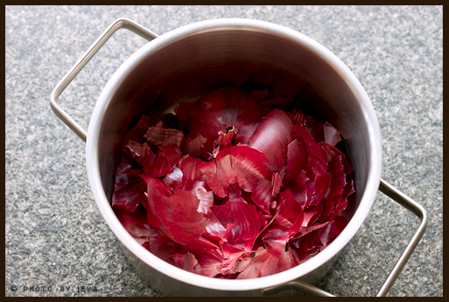
PLATE – I  PLASMA EQUIPMENT | PLATE – II  ONION SKIN
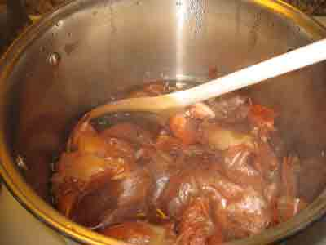 | 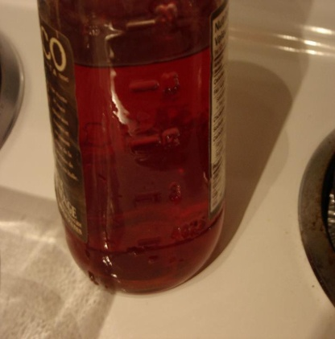
PLATE – III  EXTRACTION OF DYE | PLATE – IV  DYE SOLUTION
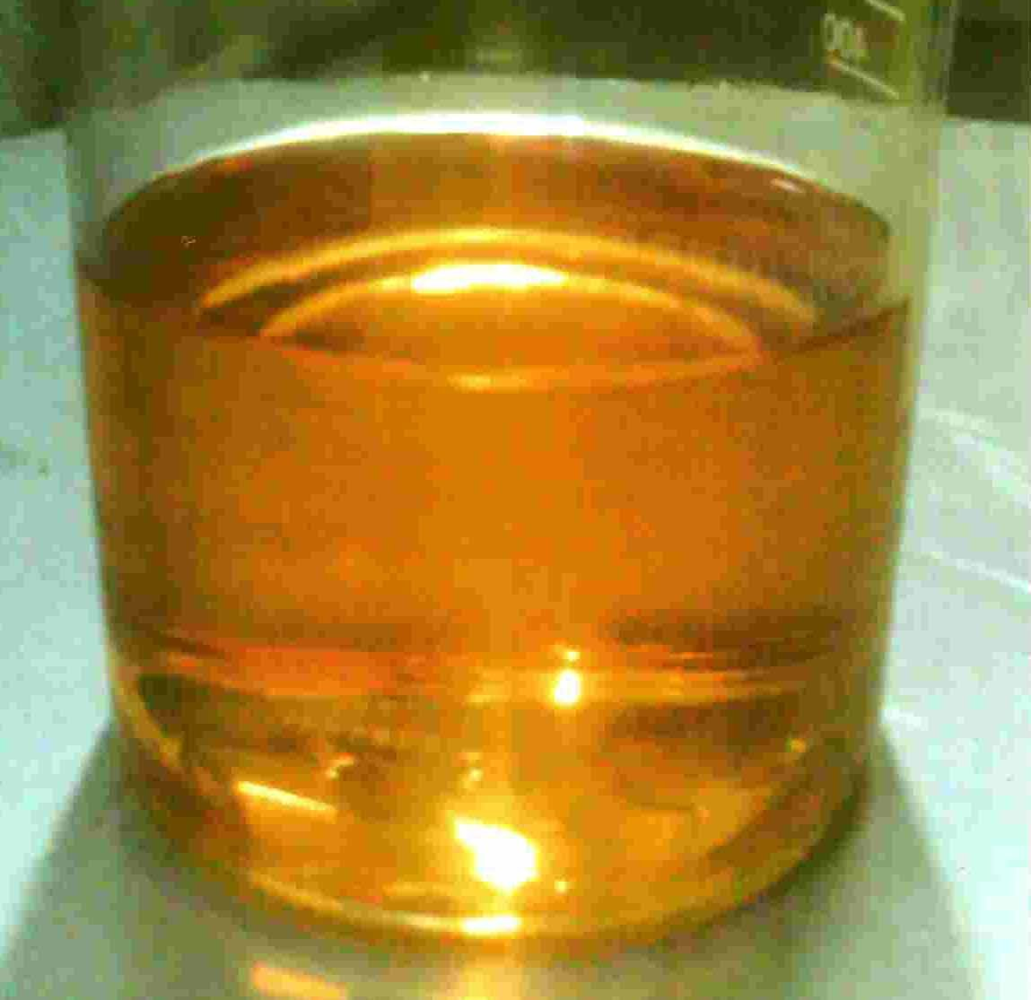 | 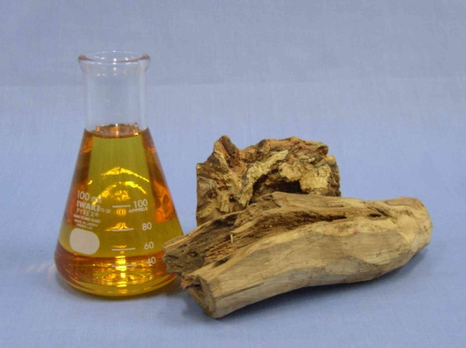
PLATE – V  EUCALYPTUS OIL | PLATE – VI  SANDALWOOD OIL

3.11. OPTIMIZATION OF FINISHING PARAMETERS
3.11.1. Optimization of temperature
To optimize the soluble temperature for the finishing “5*5”fabric samples when treated with 2:2 ratio for 90 minutes in different temperature such as 60⁰c, 80⁰ and 100⁰c from the pilot study,80⁰C which gives better finishing than the other temperature were given. Hence the investigator selects the temperature at 80⁰c for the final study.
3.11.2. Optimization of time
The fabric samples were treated with 2:2 ratio mixed sources and kept in different time intervals such as30minutes, 60 minutes and 90minutes. From the pilot study 90minutes gives the better results than 30 and 60 minutes. The optimization parameters are given in the table.
TABLE-III
OPTIMIZATION PARAMETERS
S. No | Name | Concentration (%) | Temperature (⁰c) | Time (minutes)
1  2 | Santalum album  (Sandal wood oil)  Eucalyptus oil | 50%  50% | 80  80 | 90  900

3.12. SELECTION OF FINISHING AGENT
For this study sandal wood oil and eucalyptus oil were selected for fragrance finishing and applied on the dyed and plasma treated dyed silk fabric .for this study 25 grams of sandal wood oil and eucalyptus oil were used .

3.13. METHOD OF FINISHING
3.13.1. Padding mangle method
The selected finishing agents were applied using padding mangle techniques. In the machine three rollers with sponch which is rotating on opposite direction techniques. In this machine selected finishing agent was applied on the tray .the temperature for curing the fabric will set according to the nature of the cloth and finishing agent .hence the selected temperature were 60˚ C ,80˚C and 100˚C ,time 30, 60 , 90 minutes respectively. Pilot study was done for find out the exact parameters needed for finishing after the pilot study, it was concluded that 90⁰C and 6 minutes were chosen for this study .thee two parameter will help for curing and filtration of finishes in the fabric properly .
TABLE-IV
NOMENCLATURES
Name of the samples | Nomenclatures
Original Fabric  Plasma Treated Fabric  Plasma treated, dyed and finished Fabric  Dyed and finished Fabric | O  PF  PDFF  DFF

3.14. EVALUATION OF THE SAMPLE
The evaluation is very important in research. In this study elected raw silk fabric was degummed, plasma treated , natural dyed and fragrance finished the above said four samples such as original ,plasma treated ,plasma treated dyed and finished .and dyed finished fabrics were evaluated by visual inspection, physical properties mechanical properties ,comfort properties and wettability .
3.14.1. Visual inspection
The O, PF , PDFF, DFF fabric were analysed visually by elected 50 juries who are having textile knowledge for this rating scale was used to evaluated general appearance , evenness, texture and fragrance this was evaluated Performa was compared with this original to find out the difference after dyeing , finishing
3.14.2. Physical property test
Fabric thickness:
The thickness of a fabric is one of its basic properties giving information on its warmth, heaviness or stiffness in use. In practice thickness measurements are rarely used as they are very sensitive to the pressure used in the measurement, affirms Matsudara [2000]. Thickness gauge is used to measure the fabric thickness. A smooth, un wrinkled, conditioned fabric is placed flat on the base of instrument and compressed as a weighted pressure foot is lower slowly. Thickness is measured as the final distance between the base and pressure foot (BS EN 2010).For this study the samples O, PF, PDFF, DFF were evaluated five times each and the average was taken for this test.
Fabric weight
The weight of a fabric can be described in the two ways, weight per unit area in terms of ounces per square yard or grams per square meter, weight per unit length in terms of ounces per yard or grams per meter. Weight of the fabric was determining using G.S.M cutter. It is a device to cut circular specimen of the 100 square cm of fabric. The samples were cut using G.SM rotating the handle with pressure. The cut sample was weighted using digital balance. The values obtained directly from the reading on the balance. The value in grams multiplied by 100 gives to final value mechanical properties.

3.14.3. Mechanical Property Test
Tensile strength of the fabric
Tensile strength is defined as the force or load per unit area required to rapture a material. The british standard for fabric tensile strength involves extending a strip of fabric to its breaking points by a suitable mechanical means which can record the breaking load and extendion. Fabric samples are extended in a direction parallel to the warp and parallel to the weft. The specimens are cut to size of 60mm*300 mm and then frayed down in the width equally at both sides to give samples which are exactly 50mm wide. The rate of extension is set to 50mm per minutes and the distance between the jaws is set of 200 mm. the mean breaking force and mean extension as a percentage of initial length are reported explains Saville [2004].
Abrasion Resistance
Abrasion is one aspect of wear it is rubbing away of the component fibers, yarns of the fabrics views Booth (2004). Abrasion is measured by subjecting to specimen to rubbing motion in the form of geometric figure that is a straight line, which becomes gradually widened ellipse, until its forms another straight line in the opposite direction and traces the same figure again under known conditions of pressure and abrasion action cities ASTM standards [2005].
3.14.4. Comfort Property Test
Stiffness of the fabric
Stiffness is an important characteristic of fabric. The stiffness is important elements on the end use of the fabric. The most commonly used instrument for measurement of stiffness of a fabric is shirly stiffness tester. A rectangular strip of fabric, 6 inches * 1 inch is mounted on a horizontal platform in such a way that it over hangs, like a cantilever, and bends downward. From the length ‘1’ and angle @ number of values are determined.

Crease recovery of fabric
Creasing of a fabric during wear is not a change in appearance that is generally desired. The ability of fabric to resist creasing is in the first instance dependent on the type of fibre used in its construction. The basic principle of this test is that a small fabric specimen is folded in two and placed under a load for a given length of time to form a crease and it is then allowed to recover for a further length of time and the angle of crease that remains is measured. The magnitude of this crease recovery angle is an indication of the ability of a fabric to recover from accidental creasing.
3.14.5. Wettability and Absorbancy test
The wettability and absorbency tests included drop test, sinking test and capillary rise test.
Drop test:
The ability of fiber or a fabric to take up moisture is termed as absorbency, according to Skinkle [1998]. Wettability is the time taken in seconds for a drop of water to sink into the fabric, if any fabric takes more than 200 seconds to absorb water the same is considered to be UN wet table.
Sinking test:
In this test, a small square sample of size “X” is cut and drops it to the surface of the water in a beaker. The time taken for the specimen to sink below the surface is observed. The shorter the time, the greater the wettablility remarks Booth(2005).
Capillary rise test:
Paul (2000) points out that the capillary travel method measures the rapidity of absorption. The sample was cut into the size of 15cm length and 2.5c.m width. One end of the sample was plated with a glass rod and on the other end, two grams. Weight was attached to keep the sample straight both the ends of the glass rod were placed in heavy wooden block. At the weight ends two of the same fabric was allowed to immense in a tray of distilled water the rate of the distilled water level in the sample was measured after 5 minutes.
3.15. COLOR FASTNESS TEST

Colour fastness is a term used in dyeing of textile materials means resistance of colour to fading, i.e it refers to the notion of an object having colour that retains its original hue without fading or running. The term is usually used in the context of clothes. The first known use of the word colorfast was in 1916. In general, clothing should be tested for colour fastness before one uses bleach, or another type of strong cleaning product Light fastness, wash fastness, and rub fastness are the main ones that standardized. The light fastness of textile dye is categorized from one to eight and the wash fastness from one to five. The higher the number the better fastness is obtained. Clothing is colorfast if its colors and dyes do not bleed or run from the clothing. Clothing should be tested for colorfastness before using any type of bleach or bleaching solution, or strong cleaning product.

Wash fastness Test

The wash fastness test methods are all run using AATCC Test Method 61 titled "Colorfastness to Laundering, Home and Commercial: Accelerated". The purpose of this test method is to simulate the fabric color loss and change in fabric surface after 5 home launderings.

Wet and Dry Crocking
Crocking is simply the transfer of color from a fabric onto another white test fabric. The more color is transferred, the more the fabric "crocks". The preferred testing will be done by AATCC Test Method 8, which is linear crocking. The Rotary Method, AATCC Test Method 116 will be used if necessary for patterns and stripes. If the textile to be tested is a fabric, two pieces, each not less than 14 cm x 5 cm for dry rubbing and two pieces for wet rubbing should be drawn from the sample. One specimen of each pair should have the direction parallel to the yarn yarns and other parallel to the weft or filling yarn. If the textile to be tested is yarn or thread, same should be knitted or woven into fabric to provide 4 specimens each of minimum size of 14 cm x 5 cm, two for dry rubbing and two for wet rubbing. Alternatively 4 specimens should be prepared by forming a layer of parallel strand by wrapping it lengthwise on a rectangular card board of suitable dimension.. The test specimen should be fixed on the rubbing device by means of clamps such that the long direction of the specimen follows track of the device. 5. In case of multicoloured textiles, care should be taken to position the specimen in such a way that all colors of the design are rubbed in the test. If the areas of colors are sufficiently large, more test specimens should be taken and individual colours should be assessed separately. With the dry rubbing cloth flat in place over the end of the finger of the crock meter, same should be rubbed 10 times to and fro in a straight line along a track 10 cm long on the dry specimen in 10 seconds and with a downward force of 9 N. The wet rubbing cloth should be prepared by soaking a fresh rubbing cloth in distilled water and squeezing the same to contain its own weight of water. The staining of the rubbing cotton cloth should be assessed with the help of a grey scale.
Fastness to Perspiration
Perspiration testing uses AATCC test method 15. It is intended to check the colorfastness of the sock sample to the effects of perspiration. It is applicable to dyed hosiery to check for color transfer. Whites will be evaluated for yellowing. The evaluation will be done using the AATCC Gray Scale for Staining.

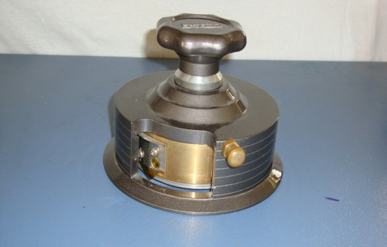 |  | 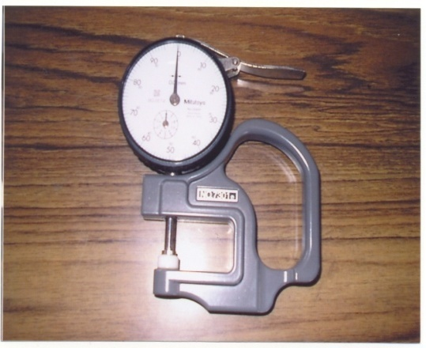
PLATE – VII  GSM Cutter |  | PLATE – VIII  Fabric Thickness
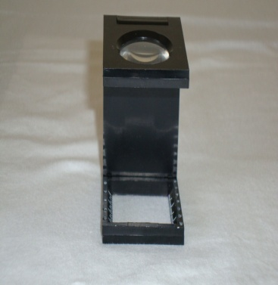 |  | 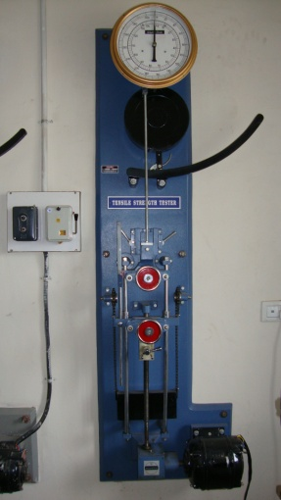
PLATE – IX  Pick Glass |  | PLATE – X  Tensile Tester
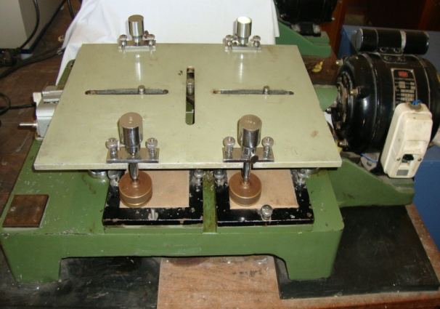 |  | 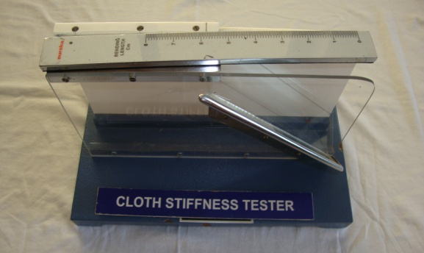
PLATE – XI  Fabric Abrasion Tester |  | PLATE – XII  Stiffness Tester
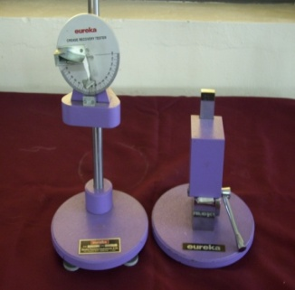 | 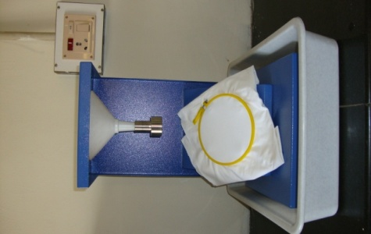
PLATE – XIII  CREASE RECOVERY TESTER | PLATE – XIV  DROP TESTER
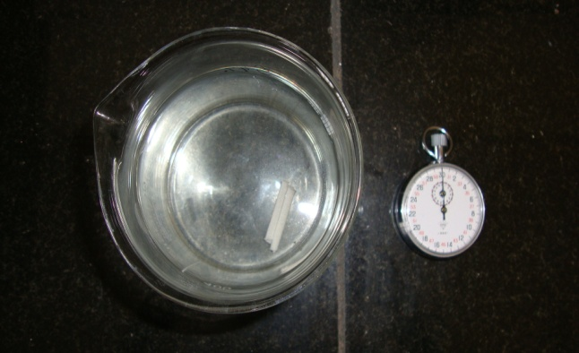 | 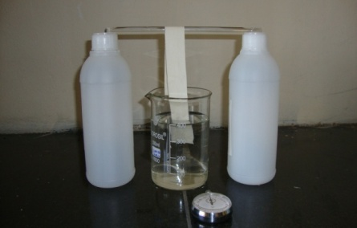
PLATE – XV  SINKING TEST | PLATE-XVI  CAPILLARY TESTER
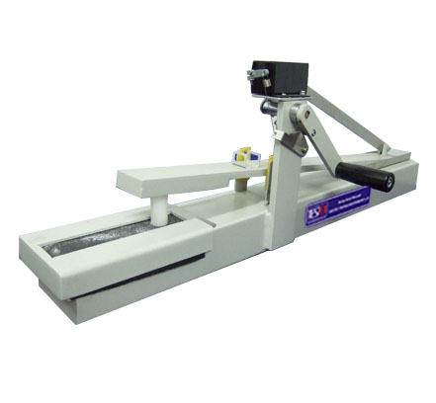 | 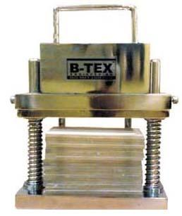
PLATE – XVII  CROCK METER | PLATE – XVIII  PERSPIROMETER
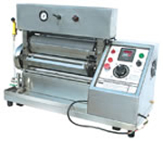
PLATE – XIX
PADDINGMANGLE

Colorfastness to Light
The purpose of this test is to determine how much the color will fade when exposed to a known light source. The proper test method is AATCC Test Method 16. Option A uses a Carbon Arc light source while Option E uses the more popular Xenon light source. The option used will depend on the equipment available. The test duration will be 10 AATCC fade units minimum for both colors and whites unless otherwise specified. Ten AATCC fade units are the equivalent to 2.5 to 3 continuous twenty four hour days of direct sunlight while 20 AATCC fade units are equivalent to 5-6 days of direct sunlight. The evaluation will be done as described in the test method with the exception of whites. Whites will be evaluated with the AATCC Gray Scale for Staining because the issue is more often yellowing of the white color.

4. RESULTS AND DISCUSSION
The Result and discussion pertaining to “Eco-friendly Dyeing and Finishing on Silk Fabric” are discussed under following headings
4.1 Evaluation
4.1.1 Visual inspection
4.1.2 Assessment of physical properties
4.1.2.1. Fabric weight
4.1.2.2. Fabric thickness
4.1.3 Assessment of mechanical properties
4.1.3.1. Tensile strength and elongation
a. Tensile strength – warp
b. Tensile strength – weft
c. Elongation – warp
d. Elongation – weft
4.1.3.2. Abrasion resistance
4.1.4. Assessment of comfort properties
4.1.4.1. Fabric stiffness
a. Fabric stiffness – warp
b. Fabric – stiffness – weft
4.1.4.2. Crease recovery
a. Crease recovery – warp
b. Crease recovery - weft
4.1.5 Absorbency test
4.1.5.1. Drop test
4.1.5.2. Sinking test
4.1.5.3. Capillary test
4.1.6. Color fastness test
4.1.6.1. Color fastness to washing
4.1.6.2. Color fastness to light
4.1.6.3. Color fastness to perspiration

TABLE-V
Visual Inspection (Rating Scale)
Sample  No | Colour |  |  | Evenness In Dyeing |  |  | Texture |  |  | Fragrance
Sample  No | Excellent | Good | Fair | Excellent | Good | Fair | Excellent | Good | Fair | Excellent | Good | Fair
1 | 46 | 3 | 1 | 44 | 6 | - | 41 | 6 | 3 | 48 | 2 | -
2 | 39 | 10 | 1 | 40 | 5 | 5 | 43 | 5 | 2 | 46 | 4 | -
3 | 49 | 1 | - | 50 | - | - | 49 | 1 | - | 50 | - | -
4 | 41 | 6 | 3 | 38 | 9 | 3 | 40 | 7 | 3 | 45 | 4 | 1
5 | 42 | 6 | 2 | 40 | 8 | 2 | 43 | 6 | 1 | 47 | 2 | 1
6 | 45 | 4 | 1 | 46 | 3 | 1 | 41 | 7 | 2 | 43 | 5 | 2
7 | 47 | 2 | 1 | 48 | - | 2 | 44 | 3 | 3 | 44 | 5 | 1
8 | 44 | 6 | - | 47 | 2 | 1 | 48 | 2 | - | 45 | 3 | 2
9 | 42 | 7 | 1 | 43 | 5 | 2 | 46 | 3 | 1 | 47 | 3 | -
10 | 38 | 2 | 10 | 44 | 3 | 3 | 43 | - | 3 | 44 | 2 | 4
11 | 47 | - | 3 | 46 | 3 | 1 | 48 | 2 | - | 46 | 3 | -

From the table -v, it was clear that, the color of sample 3 was rated as excellent by 49 judges. The samples 7, 11, 1, 6 were rated as excellent by 47, 46, 45. The samples 8, 5, 9, 4 were rated as excellent by 44, 43, 41 persons. 2, 10 were rated as excellent by 39, 38 judges.
Evenness in dyeing: Among the 11 samples, sample 3 rated as excellent by 50 judges. The samples 7, 8, 11, 6 were rated as excellent by 48, 47, 46 members. The samples 1, 10, 9, 2, 5 were rated as excellent by 44, 43, 40 judges.
Texture: Again the sample 3 was rated as excellent by 49 judges. The samples 8, 11, 9, 7 were rated as excellent by 48, 46, 44. The samples 10, 2, 1 were rated as excellent by 43, 41 judges.
Fragrance: The sample 3 was rated as excellent by 50 judges. The samples 1, 4, 9,2,11 were rated as excellent by 48, 47, 46 members. The samples 4, 8,7,20.6 were rated as excellent by 45, 44, 43 judges.
To conclude that the plasma treated silk fabrics to be excellent in the criteria such as color, evenness in dyeing, texture and fragrance.
4.1.2. Assessment of physical property test
4.1.2.1. Fabric weight
The fabric weight of O, PF, PDFF, DFF, samples statistical analysis is presented in table VI and figure – I
TABLE VI
FABRIC WEIGHT
S.No | Samples | Mean ± SD | Gain / Loss | % of  Gain / Loss | CD (P<0.05)
1  2  3  4 | O  PF  PDFF  DFF | 0.66 ± 0.02^{d}  0.81 ± 0.02ª  0.78 ± 0.03^{b}  0.71 ± 0.03^{c} | 0.15  0.12  0.05 | 0.22.7  18.1  7.5 | 0.036

From the above table VI and figure – I, it is evident that the PF and PDFF samples had significant increase in weight about 18.1 percent than the original. The PF sample has gained weight of 7.5 percent when compared to respective original. The maximum weight has gained by PF and PDFF samples due to plasma. The statistical analysis also proved that there were significant difference in fabric weight in PF, PDFF and DFF samples when compared to its original with annova DMRT test value of 0.036 at 5 percent level. Among all the sample PF Shows more weight when compare with all other samples.
4.1.2.2 Fabric thickness

The fabric thickness of the O, PF, PDFF, DFF statistical analysis is presented in Table VII and figure II.
TABLE VII
FABRIC THICKNESS
S.No | Samples | Mean ± SD | Gain / Loss | % of Gain / Loss | CD (P<0.05)
1  2  3  4 | O  PF  PDFF  DFF | 0.14 ± 0.01^{c}  0.17 ± 0.01ª  0.17 ± 0.00ª  0.16 ± 0.01^{b} | 0.03  0.03  0.02 | 21.4  21.4  14.2 | 0.092

Table VII and figure II depicts that the fabric thickness of O, PF, PDFF, DFF samples. The PF and PDFF samples increase about 21.4 percent. After plasma treatment, when compared with original. The DFF samples also increase in thickness about 14.2 percent due to dye up take. It shows that the dye uptake is more in both PDFF and DFF samples. Statistical analysis of the data when compared with its original the fabric thickness of PF and PDFF samples is not having significant difference, but the sample DFF samples both PF and PDFF has significant difference.

FIGURE-I
FABRIC WEIGHT

FIGURE-II
FABRIC THICKNESS

4.1.3. Assessment of mechanical properties
4.1.3.1 Tensile strength and elongation
4.1.3.1. a. Tensile strength warp
The tensile strength of O, PF, PDFF, DFF samples with statistical analysis is presented in table VIII and figure III
TABLE VIII
TENSILE STRENGTH [WARP]
S.No | Samples | Mean ± SD | Gain / Loss | % of Gain / Loss | CD (P<0.05)
1  2  3  4 | O  PF  PDFF  DFF | 40.80 ± 2.39^{b}  50.60 ± 3.91ª  52.00 ± 4.85ª  43.00 ± 4.53^{b} | 9.80  11.20  2.20 | 2.4  27.4  5.3 | 5.40

Table VIII and figure III shows the fabric strength along warp direction of O, PF, PDFF and DFF. It was proved that all the samples showed gain in tensile strength along warp direction, when compared with its original. The maximum gain was found in PDFF sample. Statistical analysis proved that there is significant difference in strength in PF and PDFF samples when compared to its original with annova DMRT test value of 0.036 at 5 percent level.PF and PDFF samples had significant increase in strength along warp direction due to plasma treatment. DFF sample was not having significant difference with its original.

4.1.3.1. b. Tensile strength-weft
The tensile strength of the O, PF, PDFF,DFF samples with statistical analysis is presented in table IX and figure-IV
TABLE IX
TENSILE STRENGTH [WEFT]
S.No | Samples | Mean ± SD | Gain / Loss | % of Gain / Loss | CD (P<0.05)
1  2  3  4 | O  PF  PDFF  DFF | 34.20 ± 2.39^{b}  40.80 ± 4.15ª  41.00 ± 2.86ª  34.20 ± 1.48^{b} | 6.60  7.60  0.00 | 19.2  19.8  0 | 3.86

From the above table viii and figure IV was proved that PF and PDFF samples have gain in tensile strength along weft direction when compared with its original. PDFF has maximum gain of 19.8 percent along weft direction. There is no difference in DFF sample with its original.
It was statistically proved that PF and PDFF samples had significant gain in strength along weft direction.

40.80
50.60
52.00
43.00
0.00
10.00
20.00
30.00
40.00
50.00
60.00
O
PF
PDFF
DFF
FIGURE-III
TENSILE STRENTH-WARP

FIGURE-IV
TESILE STRENTH-WEFT

4.1.3.1.c. Elongation – warp
The fabric elongation of the O, PF, PDFF and DFF samples with statistical analysis is presented in Table X and figure V.
TABLE X
ELAGNATION-WARP
S.No | Samples | Mean ± SD | Gain / Loss | % of Gain / Loss | CD (P<0.05)
1  2  3  4 | O  PF  PDFF  DFF | 5.20 ± 0.29^{b}  6.26 ± 0.29ª  6.20 ± 0.25ª  4.92 ± 0.56^{b} | 1.06  1.00  -0.28 | 20.3  19.2  5.76 | 0.55

It was evident from table ix and figure v that sample PF and PDFF has increased in elongation of 20.3 percent and 19.2 in warp direction when compared with original. DFF sample has tremendous loss in elongation of 5.76 and in case of warp elongation.
Statistically also proved that elongation of the PF and PDFF samples showed significant difference at 5% level and DFF samples not having significant difference when compared to its original.

4.1.3.1.d. Elongation – weft
The fabric elongation of the o, PF, PDFF, and DFF samples with statistical analysis of variance is presented in table x and figure VI
TABLE XI
ELAGNATION-WEFT
S.No | Samples | Mean ± SD | Gain / Loss | % of Gain / Loss | CD (P<0.05)
1  2  3  4 | O  PF  PDFF  DFF | 4.72 ± 0.24^{b}  5.90 ± 0.57ª  5.76 ± 0.34ª  4.00 ± 0.39^{c} | 1.18  1.04  -0.72 | 25  22  15 | 0.53

The Table X and figure VI depicts that the fabric elongation in weft direction. The PF and PDFF samples have increased in elongation of 25 percent and 22 percent weft direction when compared with original. DFF sample has tremendous loss in elongation of 13 percent, in case of weft elongation.

5.20
6.26
6.20
4.92
0.00
1.00
2.00
3.00
4.00
5.00
6.00
7.00
O
PF
PDFF
DFF
FIGURE-V
ELONGATION-WARP

4.72
5.90
5.76
4.00
0.00
1.00
2.00
3.00
4.00
5.00
6.00
7.00
O
PF
PDFF
DFF
FIGURE-VI
ELONGATION-WEFT

4.1.3.2. Abrasion resistance
The abrasion resistance of the O, PF, PDFF and DFF samples with statistical analysis of variance is presented in table XII and figure VII
TABLE XII
ABRASION RESISTANCES
S.No | Samples | Mean ± SD | Gain / Loss | % of Gain / Loss | CD (P<0.05)
1  2  3  4 | O  PF  PDFF  DFF | 0.08 ± 0.00^{c}  0.10 ± 0.00ª  0.10 ± 0.00ª  0.09 ± 0.00b | 0.02  0.02  0.01 | 2.0  2.0  1.2 | 0.0036

The table XII and figure IX shows that two plasma treated samples has gain its weight than original fabric. DFF samples also gain its weight at 1.2 percent among those samples PF; DFF sample has 100 percent abrasion resistance.
Statistical analysis of shows that abrasion resistance of PF and PDFF sample have shown difference at 5 percent level with its original

0.08
0.10
0.10
0.09
0.00
0.02
0.04
0.06
0.08
0.10
0.12

O
PF
PDFF
DFF

FIGURE-VII
ABRAISON RESISTENSE

    - Assessment of comfort properties
4.1.4.1. a. Fabric stiffness – warp
The fabric stiffness of the Original, PF, PDFF, DFF samples with statistical analysis of variance is presented in table XIII and figure VIII.
TABLE XIII
FABRIC STIFFNESS [WARP]
S.No | Samples | Mean ± SD | Gain / Loss | % of Gain / Loss | CD (P<0.05)
1  2  3  4 | O  PF  PDFF  DFF | 1.68 ± 0.19^{c}  2.45 ± 0.19ª  2.05 ± 0.16^{b}  1.50 ± 0.16^{c} | -0.77  -0.37  0.18 | -45.8  -22.0  10.7 | 0.32

The table XIII and figure VIII reveals that PF and PDFF simples had gain in stiffness along warp direction about 45.8 percent and 22 percent. DFF sample has loss maximum stiffness of 10.7 percent in warp direction.
4.1.4.1. b. Fabric stiffness – weft
The fabric stiffness of the O, PF, PDFF and DFF samples with statistical analysis is presented in table XIV and figure IX.

TABLE XIV
FABRIC STIFFNESS [WEFT]
S.No | Samples | Mean ± SD | Gain / Loss | % of Gain / Loss | CD (P<0.05)
1  2  3  4 | O  PF  PDFF  DFF | 1.61 ± 0.24^{b}  2.16 ± 0.24ª  2.00 ± 0.16ª  1.43 ± 0.17^{b} | -0.55  -0.39  0.18 | -34.2  -24.2  11 | 0.27

The table xiii and figure ix states that the PF sample has maximum gain about 34.2 percent in stiffness along weft direction. The PDFF sample also increased in stiffness about24.2 percent. The maximum loss found in DFF sample about 11 percent when compared to its original.
It was statistically proved that stiffness of the PF and PDFF simples showed significant difference at five percent level. There is no difference between DFF and O sample

FIGURE-VIII
1.68
2.45
2.05
1.50
0.00
0.50
1.00
1.50
2.00
2.50
O
PF
PDFF
DFF

FABRIC STIFFNESS-WARP

1.61
2.16
2.00
1.43
0.00
0.50
1.00
1.50
2.00
2.50
O
PF
PDFF
DFF
FIGURE-IX
FABRIC STIFFNESS-WEFT

4.1.4.2.Crease recovery – warp
The crease recovery of the o, PF, PDFF and DFF samples with statistical analysis of variance is presented in table XV and figure X
TABLE XV
CREASE RECOVERY-WARP
S.No | Samples | Mean ± SD | Gain / Loss | % of Gain / Loss | CD (P<0.05)
1  2  3  4 | O  PF  PDFF  DFF | 127.00 ± 2.74^{b}  131.60 ± 3.05ª  131.80 ± 4.44ª  132.80 ± 4.21ª | -4.60  -4.80  -5.80 | -3.6  -3.7  -4.5 | 4.93

It was evident from table XV and figure XII that all PF, PDFF, DFF samples has gain increase recovery along warp direction about 3.6 percent, 3.7 percent, and 4.5 percent. Both dyed samples have significant gain increase recovery.
Statistical analysis showed that increase recovery property test significant difference found in PF, PDFF and DFF samples
4.1.4.2. a. Crease recovery – weft
The crease recovery of the O, PF, PDFF and DFF simples with statistical analysis of variance is presented in Table XVI and Figure XI.

TABLE XVI
CREASE RECOVERY-WEFT
S.No | Samples | Mean ± SD | Gain / Loss | % of Gain / Loss | CD (P<0.05)
1  2  3  4 | O  PF  PDFF  DFF | 126.20 ± 1.92^{c}  131.40 ± 2.70^{b}  135.60 ± 2.61ª  126.80 ± 2.86^{c} | 5.20  9.40  0.60 | 4.1  7.4  0.4 | 3.41

It was evident from table XIV and figure XII that all PF, PDFF, DFF samples has gain increase recovery along warp direction about 3.6 percent,
3.7 percent, and 4.5 percent. Both dyed samples have significant gain increase recovery.
Statistical analysis showed that increase recovery property test significant difference found in PF,PDFF and DFF samples at 5% level.

FIGURE-X
CRESE RECOVERY-WARP

FIGURE-XI
CREASE RECOVERY-WEFT

TABLE-XVII
DROP TEST
S.NO | NAME OF THE SAMPLE | MEAN (Seconds)
1  2  3  4 | O  PF  PDFF  DFF | 50.8  22.8  12.6  26.8

The table XVII and figure XII shows PDFF sample has maximum absorbency than other samples. Original sample takes more time about
50.8 seconds. It was evident that plasma treatment improved the wet ability of the fabric.

TABLE-XVIII
SINKING TEST
S.NO | NAME OF THE SAMPLE | MEAN(Seconds)
1  2  3  4 | O  PF  PDFF  DFF | 55  22.6  14  35.8

The table XVIII and figure XIII shows that PF and PDFF samples have maximum absorbency than other samples. Original sample takes more time about 55 seconds. It was evident that plasma treatment improved the wet ability of the fabric.
TABLE-XIX
CAPILLARY TEST
S.NO | NAME OF THE SAMPLE | MEAN(cm)
1  2  3  4 | O  PF  PDFF  DFF | 8.9  15.8  22.8  10.5

The table XIX and figure XIII states PF and PDFF samples have maximum absorbency than other samples. It was evident that plasma treatment and dyeing improved the wet ability of the fabric.

5. SUMMARY AND CONCLUSION:
The queen of textiles silk is a wonderful gift of nature. It is a unique product that has fascinated every part of the blue green globe especially women. An aura of luxury has always surrounded and still surrounds, cloth made of silk. All Indian religious rituals are incomplete without the use of silk. Silk is a part of every Indian life. It is described as elegant, beauty, soft, shine, smooth and rich fabric.
Silk fabric remains a dream in every Indian womanhood with the increase demand for silk products worldwide and the call for eco-friendly natural products. Considering these facts, the present research is focused to select an effective method of extracting, dyeing and finishing silk with onion skin, eucalyptus oil and sandal wood oil.
Plasma is a unique state of matter having several species like electrons, ions, radicals, ultra violet radiation etc. Any material exposed to such plasma gets affected in several ways. Surface properties can be modified in beneficial ways by properly choosing plasma parameters. Traditionally a number of steps are involved in processing of textiles. Often they involve hazardous chemicals which are not environment friendly. Efforts are being made to replace some of these steps by plasma techniques which are safe. In the present work some effects of exposing silk – fibre and fabric –to low pressure glow discharge plasma have been studied. Initial results of modification dyeing properties of silk would be presented.
Environmental awareness throughout the world now seems to rescue the total ‘full’ of vegetable dyes. Hazards of the chemicals industry in general and dyes in particular have forced environmentalists to think in terms of natural product. Trends of greater use of synthetic substitute of natural substances has been reversed, of course, economic and availability factors are serious impediments in this switch over but the time is not far off when this hurdle is removed and vegetable dyes retain their lost glory.

Color in clothing dates back to Old Stone Age, color has transformed the entire fabric into expressions of emotions, and moods. It is the major aspect which governs ones personality. Dyeing technique has played an important role in applying color to textiles from the early times. Coloring has increased the commercial value of textile products ancient writing and for calls has proved the usage of natural colors. Natural colors are obtained from flowers, fruits, leaves, seeds, roots, skins barks of plants and certain insects. Natural colors catered need for colors until 1856, when the synthetics of mauvine by Perkin layed the foundation stone for synthetic dye industry, which grow at a vigorous rate eradicating the use of natural dyes.

The dry skin of onion products natural dye which has been used for dyeing textiles. In the present study, innovative dyeing with onion has been shown to give good results. It showed very good fastness properties for plasma treated silk fabric. For effective natural dyeing by conventional method of dyeing was carried out using metal mordants. The purpose of using this source was with an idea to produce value addition dyed product from kitchen waste as the dye has very good potential of uptake, adherence to the fabric and has good wash and light fastnesses. Results shows very attractive hue colors

Fragrance finishing of textiles is the process where we enhance the value of the product by adding some incentives to it. The world market place is continuously changing and so is demand of people changing .Every person desires for some change .i.e. something new and unique. The successful effective implementation of change has to be done to in the market by value added finish with the incorporation of different scents into fabrics, leading to the production of scented fabrics and the psychology of acceptance of natural in textile goods.

OBJECTIVES

The following are the objectives of the study.
- Selection of mulberry silk fabric and application on plasma treatment.
- Extraction and optimization of natural dye and application on the same plasma treated fabric
- To enhance the properties of plasma and dyed silk fabric by application of fragrance finishing.
METHODOLOGY
The selected mulberry silk fabric was degumming by soaking the material in boiling water for 35 minutes. The fabric was then rinsed thoroughly and dried in sunlight. The plasma treatment was given to the degummed fabric by glow discharge method. The plasma treatment is used to improve dye ability of the fabric. A pilot study was conducted to select the dye, mordant and mordanting techniques. Based on the pilot study, the onion skin was selected as dye source, Alum as mordant, post mordanting techniques for the final study. The optimized parameter for dye concentration was 10 percent, dye extraction time was 60 minutes and mordanting time was 30 minutes. The dyeing was conducted based on the optimized parameters. The fragrance finishing was carried out on dyed fabric by padding mangle method. The sandal wood oil and eucalyptus oil were selected for fragrance finishing. The optimized parameters for finishing concentration 50 percent, finishing time was 90 minutes. The finishing was conducted based on the optimized parameters.
The plasma treated, dyed and finished samples were evaluated visually by a panel of judges. The plasma treated, dyed and finished samples were then tested in the laboratory for fabric weight, tesile strength in comparison with original samples and the results were analysed statistically. Colour fastness test were carried out for the dyed samples.
Findings
- In the visual inspection, the plasma treated, dyed and finished (PDFF) sample was rated as excellent in colour, evenness in dyeing, texture, fragrance.
- The objective evaluation such as weight and thickness were high in plasma treated sample (PF) where as crease recovery, elongation, stiffness, tensile strength, abrasion resistance were higher in plasma treated dyed and finished samples (PDFF) than original sample.
- Colour fastness property was rated as excellent in PDFF and DFF samples. The PDFF sample was rated higher than DFF sample.
- It will be concluded that silk fabrics can be enhanced by the application of plasma treatment, natural dyeing and fragrance finishing from the selected source and their performance is highly satisfactory even after repeated washing.
RECOMMENDATIONS
Plasma treatment of silk has many beneficial effects such as increased wet ability, Increased K/S ratio and smoothening of the fibres. These effects can reduce the use of Chemicals in the processing of silk leading to reduced environmental pollution and health risks of the workers. These are compelling enough reasons for trying out plasma treatment of silk on industrial scale. The preference of using easily and cheaply available material for dyeing by conventional dyeing lowers the cost of natural dyeing and enhances resources productivity and as a result, reduces waste. This makes onion scale one of the easily available materials for natural dyeing industry.

BIBLIOGRAPHY

- Akira Nakamur [200], fibre science and technology oxford and B.H. Publishing co-pvt ltd. Page no:-56.
- Alexsandarsubic [2012], sustainable automotive technologies, Springer publications.
- Barker.A.F [2007], Hand book of textiles, Abhishek Publications page no:-32-33.
- Barnard, john Gillow [2008], Indian textile, ohm books international publication, p-38.
- Bernard, p. corbman, [2001], textiles fiber to fabric McGraw, hill book.co, page no:-301.
- Billie.J.Collier, [2001], understanding textiles, upper sanddle river publication, page no:-117.
- Booth J.F.[2005], principles of textile testing, introduction to physical method of testing fibre, yarn, fabric,C.B.C Publisher page no:-20-25
- Booth J.K [2006], principles of textile testing CBE publisher distribution page no:-558
- Braddock chrke, [2005], techno textile, Thames and Hudson 99-30.
- Gordern cook.J, [1999], hand book of textile fibres, marrow publishing co-ltd page no:-159
- John E.berkowitch,(2006), trends in Japanese wood head publishing limited, page no:-31-35
- Joyce stoney, 920060, dyes and fabric, Thames and Hudson publication page no:-57-59
- Katia la cusse [2004], textiles chemicals: environmental data and facts, Springer publications, page no:-13
- Meenakshi Rastogi, [2009], animal textiles, sonali publications, page no:-212
- Mishra S.P [200], a textbook of fibre science and technology, new age international limited publisher, page no:-121
- Paul,[2005], “fabric science, fair child publication, page no:-14
- Pillow C.E [2007], fibers and yarn, sonali publications, first edition, page no:-69,164
- SamUvel, Sharsa [2007], aromatic plants, new India publishing page no:-182.
- Savvile B.P,[2004], physical testing of textiles, wood head publishing limited
- Shenai.V.A [2000], technology of textile processing , sevak publications, page no:-143
- Shishoo [2007], plasma technologies for textiles, wood head publishing limited, page no:-31- 35.
- Smith.J.L. [2006], textile processing, Abhishek Publication, page no:-122.39.

Journal
- Ahmed khan, ibrahim khan, [2011], natural dye shade on woolen yarn dyed with kamala using friendly metal mordants, colourage, november, volume no:1, pg 38
- Ammayappan et al [2012], plasma treatment on textiles, asian dyer, january, vol-8, page no:-12-13.
- Anjalikarolia [2007], imparting antimicrobial and fragrance finish on cotton using chitosan, indian of fiber trade and research journal. Kapoor V.P [2004], caliphs bark dye: standardization of extraction and eco – friendly dyeing profiles, colourage, September, vol.LI.No-9, pg: 41.
- Aroras and avita rani, [2007], plasma technology on eco-friendly approach, january, vol no-1, page no:-7-9.
- Bhat.n.v [2007], indian textile fiber trade and research journal, march, vol-32,page no:-45
- Bhuyan.r and shikia d.c [2004], natural dyes: present scenario in north east india, colourage, vol no:5, may, pg-27
- Chen L.S [2008], aromachology and its application in the textile field, journal of industrial textiles, January, vol – 32, pg : 263-274
- Chinta s.k [2008], application and properties of natural dye on cotton phyllanthus reticulate, colourage, june, vol-lv.no-6,pg-52
- Desi a [2008], plasma technology, the indian textile journal volo.118 no.4, pg-26-28
- Edward menezes, [2005], developments in silk finishing, indian textile journal, march, vol.no:cxv-22, pg-121
- Geetha mahale, Sakashi [2008], dyeing of cotton silk with areca nut extract – an eco friendly approch,colourage, January vo.LV.NO.1, pg : 84
- Husen k. Mullani and wasif, [2011], application of plasma technologies in textiles, colourage, september, vol-lvii, no-9, pg-41.
- Jayalakshmi [2008], dyeing wool using bio-mordents, colourage, july, vol-v, no:7, pg:102
- Kakd g.s [2006], plasma treatment for textiles man made textiles in india, vol-ii, no: 5, pg: 85-89.
- Kumerasan [2011], application of eco-friendly natural dye on silk using combination of mordants, international journal of chemistry research, august, vol-2, pg-144.
- Lipika chakraborty and prabirkar [2010], an insight to natural dyes, asian dyer, july, vol-7 no: 3, pg-30-33.
- Mahapatra [2010], application of plasma in textile industries colorage, september, vol-lvii, pg: 49-50.
- Mandal and sankar raw mulkin [2010], asian dyer, may, vol no: 49, pg: 129-131.
- Manish Gahlot [2008], jatropha flowers, natural colourant for dyeing of cotton, wool and silk, colourage, February, vol-IV-2,pg : 96
- Nadiger, sharma p [2004], colourage, april, vol no: ii, no: 8, pg: 124-125.
- Ninge gowda [2011], a natural colorant from fiche racemes for silk, colourage, september, vol-lvii, pg: 69
- Padma.s.vankar, rakshishaker [2008], colourage november, vol-iv no:11, pg:82
- Peter.j. Hauser [2005], plasma treatment on textiles: changing fiber surface, new market, august, vol.no-19, pg: 7-12.
- Preeti udwat, srivastava and richugupta [2008], eco-friendly dye from marinade citrifolia lin, textile trends, march vol.li no.12, pg-27
- Ramachandran.j, karthik and shetty [2004], non-aqueous plasma fabric finishing process, indian textile journal, vol-9, no.17, pg-23-27.
- Ruchi bandomi and deepak kumar [2012], evaluation of natural dyes, asian textiles journal, october, vol – 56, pg: 11-14.
- Sakthivel et al [2011], silk- the queen of textiles, asian textile journal, october, vol -56, pg: 35-37
- Saravan.d and nalankilla [2008], plasma technology for fabric preparation and finishing, asian dyer, vol-5, no-6, pg: 52-54
- Shukla s.r [2004], dyeing of wool with acacia pennata, indian journal fiber trade and research, vol-29,pg:350-352
- Singh o.p [2005], dyeing wool with natural dyes and natural mordant , january vol –lii, pg : 153-155
- Sparavigan a, wolf r.n [2005], the plasma advantage, textile world, vol – 9 no -11,pg : 49-51
- Srivastave & mohammad [2004], natural dyeing on wool with tesu, dolu, colourage, may, vol.IV- 2, pg : 33
- Storeg j [2006], eupatorium an excellent natural dyes source for mulberry silk, colourage, january, vol.no – 1, pg:25-28
- Subrabhimahajan [2007], comparison of color fastness properties of silk dyed with mango dye, colorage, august, vol-54, pg : 253-256
- Subrata mondal [2004], the effect of dyeing conditions on fastness properties of natural dyes on silk fabric, colourage, August, vo.LI no.8 pg-33
- Subrath das [2011], processing of muga silk, asian textile journal, october, vol – 56, pg: 31
- Sudha s [2005], micron capsulation : an overview, indian textile journal, september, vol : cxv, pg :104
- Vohnoer V [2009], Glow discharge treatments for the modification of technical textiles, new cloth market, march, pg : 21-23

WEBSITE
http://www.aromatherapy-at.home.com
http://www.chm.bris.ac/uklwepage no: projects 200/
http://www.demurelook.com
http://www.fao.org/docnep
http://www.fibre2fashion.com/industrialarticle
http://www.intota.com
http://www.mytextilenotes.blogspot.com/2007.
http://www.sweetaadditions.net
http://www.texersesilk.com
http://www.texmin.nic.in/aptcf/
http://www.textileformation.blog.spot.com
http://www.textileschool.com
http://www.wikipedia.com
www.sciogxci.net

APPENDIX - I

Original Fabric
Name of the Fabric - Silk
Fabric Weight - 0.11grams
Ends per Inch - 54
Picks Per Inch - 46
Fabric Count - 144*72
Cost - 280/-Per Meter

Degummed Fabric

Plasma Treated Fabric

APPENDIX – II
Pilot study
Pre Mordanting Method

DFF PDFF
Simultaneous mordanting Method

DFF PDFF
Post Mordanting

DFF PDFF

DFF PDFF

APPENDIX-III
pilot study

Pre-Mordanting

DFF PDFF
Simulantanious Mordanting

DFF PDFF
Post Mordanting

DFF PDFF
Without Mordanting

DFF PDFF

Selected Dyed and Finished Samples

DFF

PDFF

