YOGA CENTRE MANAGEMENT SYSTEM
Submitted By
SM.SHANMATHI (19PCC013)
Under the guidance of
Mrs. V. YASODHA, M.Com (CA)., MBA., M.Phil., NET.,

In the partial fulfilment of the requirements for the award of the degree of
MASTER OF COMMERCE WITH COMPUTER APPLICATIONS

2020-2021
DEPARTMENT OF COMMERCE
AVINASHILINGAM INSTITUTE FOR HOME SCIENCE AND
HIGHER EDUCATION FOR WOMEN
COIMBATORE-641043

CERTIFICATE

CERTIFICATE
This is to certify that the project work entitled “YOGA CENTRE MANAGEMENT SYSTEM”, submitted to Department of Commerce, Avinashilingam Institute for Home Science and Higher Education for Woman, Coimbatore, in partial fulfilment of MASTER OF COMMERCE WITH COMPUTER APPLICATIONS, is the record of the original project work done by SM.SHANMATHI (19PCC013) during the period of her study, under my supervision and guidance.

Signature of the Guide

Signature of the Head of the Department

Submitted for the viva voice examination held on________________________

Internal Examiner External Examiner



DECLARATION

DECLARATION
I hereby declare that this project work entitled “YOGA CENTRE MANAGEMENT SYSTEM” submitted to Department of Commerce, Avinashilingam Institute for Home Science and Higher Education for Women, Coimbatore, in partial fulfilment of the requirement for the award of the DEGREE OF MASTER OF COMMERCE WITH COMPUTER APPLICATIONS is the bonafide record of original project work done by SM.SHANMATHI (19PCC013) during the period of her study under the supervision and guidance of Mrs. V. YASODHA, M.Com(CA)., MBA., M.Phil., NET., Department of Commerce.

Place: Coimbatore Signature of the candidate
Date: SM.SHANMATHI

ACKNOWLEDGEMENT

ACKNOWLEDGEMENT
I would like to express my sincere thanks to God Almighty, for his constant love and grace that he has showed upon me, which kept me in good health, and sound mind without which my project would not have reached a successful end.
I would like to express my deep sense of reverential gratitude and sincere thanks to Prof.S.P. Thyagarajan, D.Sc., Ph.D., M.D., Chancellor, Avinashilingam Institute for Home Science and Higher Education for Women, for the opportunity given to me for undertaking this study and for providing the needed facility during the course of my study.
I owe my great deal of my gratitude to Dr.Premavathy Vijayan, M.sc.,M.Ed.,Dip.Spl.Edn., M.Phil., Ph.D., Vice Chancellor, Avinashilingam Institute for Home Science and Higher Education for Women, for extending all resources that facilitated the conduct of the present study.
I express my gratitude to Dr.S.Kowsalya, M.sc., M.Phil., Ph.D., Registrar, Avinashilingam Institute for Home Science and Higher Education for Women, for providing all facilities necessary for the study.
I would express my boundless thanks to Dr.P.Chitramani, M.B.A., M.Phil., Ph.D., NET., SLET Dean, School of Commerce and Management, Avinashilingam Institute for Home Science and Higher Education for Women, for granting the facility required.
I am also thankful to Dr. (Mrs).D.Geetha, M.Com., Dip.Ed., M.Phil., Ph.D., Professor and Head, Department of Commerce, Avinashilingam Institute for Home Science and Higher Education for Women, for giving necessary help and support for completing the project successfully.
I express my heartfelt gratitude to my mentor Mrs. V. YASODHA M.Com (CA)., MBA., M.Phil., NET., Department of Commerce, Avinashilingam Institute for Home Science and Higher Education for Women, for the valuable guidance and for her timely support, suggestions and motivation throughout the project.
I have a great pleasure in expressing my deep sense of my gratitude to all other staff members and non-teaching staffs that helped us to complete the project.
I would extend our thanks to one and all helped us directly and indirectly for successful completion of our project. Last yet importantly, we would like to thank our parents, friends and all our well-wishers for their kind inspiration.

CONTENT
CONTENT
CHAPTER | TITLE | PAGE NO
I | INTRODUCTION  Introduction  About the institution | 1  2
II | REQUIREMENT ELICITATION  Requirement Elicitation  Existing System  Proposed System  Feasibility Study | 4  5  6  9
III | SYSTEM REQUIREMENT SPECIFICATION  Hardware Specification  Software Specification  Software Prototyping  Prototyping model | 12  13  13  14
IV | SYSTEM DESIGN AND DEVELOPMENT  System Design  System flow design  Input design  Output design  Data flow design  ER Diagram  Table Design  Code Design  Form Design | 20  20  23  24  26  30  33  37  71
V | SYSTEM TESTING  Integrated testing  Acceptance Testing | 77  78
VI | SYSTEM IMPLEMENTATION AND MAINTENANCE.  Implementation procedure  System Maintenance | 80  81
VII | CONCULUSION  Conclusion  Future enhancement | 82  83
 | BIBLIOGRAPHY | 84

ABSTRACT

ABSTRACT
The Manavala Kalai Yoga centre in Kaniyur, founded on 2000. The yoga centre is a smaller concern it is located in Kaniyur, 3rd street, Lakshmi Nagar, Karumathampatti, Coimbatore. The primary aim of the yoga centre is to attain the world peace through individual peace. Transform your life with health, peace, happiness and prosperity. Doing meditation for inner peace. The process of analyzing and getting a total understanding of oneself .There are many practical sessions and it is of simplified physical exercise. By doing the yoga regularly it helps in making the body physically and mentally healthier. All works they are maintaining manually in paper pen works like, registering a course, maintaining attendances for staffs and trainers, fees collection process etc... Main aim of this project is to move toward systematic & reduce their work load and make it easier. It is a window based software application to maintain the overall yoga centre management system.
As the increasing Learners to the yoga centre, it is difficult to maintain the records manually. So new system arises. This newly proposed system is entitled on “YOGA CENTRE MANAGEMENT SYSTEM’’, which is developed using Microsoft VISUAL STUDIO 2012 as front end and SQL SERVER 2008 as back end. VB.NET provides the easiest, most productive language and tool for rapidly building Windows and Web applications. Visual Basic .NET comes with enhanced visual designers, increased application performance and a powerful integrated development environment (IDE). It also supports creation of applications for wireless, Internet-enabled hand-held devices. VB.NET is the multiple document interface format (MDI). SQL Server comes with a number of tools to help you with your database administration and programming tasks. SQL Server is a powerful database management system and the user can create applications that require little or no programming.
In feasibility study I have analyzed and found that, the technical, operational and economic feasibility are capable. It proved user friendly input such as device independent inputs and getting proper solution for the problem. In System Requirement Specifications I have describe the features and behavior of a proposed system. In that hardware and software specifications have been given, by using the incremental prototyping model I have made a software prototype. After the successful completion of prototyping, next is creation of the system design with necessary controls. I have used my sql as back end application and created the required tables with necessary fields. Connect the front end and back end applications by Using data base connection.
In system testing, To identify errors and to execute, i have choose unit testing, integration testing, acceptance testing and validation testing After all the test results are arrived, the proposed system is implemented. The users were trained to use this system. Training helps the users to add, update and delete the records. To restore, adding and modifying the code to the system is helpful the maintenance. And it may also avoid future problems. The proposed system has been developed to overcome the existing system problems and with good amount of flexibility without compromising on the response time.

The systematized work helps in more accuracy and reduces major part of clerical works and it is fast, clear and legible reports can be generated within short period of time. Hence, by developing a system that is user friendly in nature, and many users are able to work on the system with little computer knowledge of training. The project has been developed and the objectives are achieved successfully. It can have an enhancement on proper in the future according to the user’s requirements.

This project has been developed with front end as VB.Net and backend as SQL Server. And in future enhancements the frontend can also be changed. ASP.Net can replace the front-end tool such as HTML and CSS for more speed. To provide better facility regarding security, it uses security provider software and we access any place and any where use that.

INTRODUCTION

CHAPTER I
INTRODUCTION

INTRODUCTION TO YOGA CENTRE MANAGEMENT SYSTEM

The project work entitled as” YOGA CENTRE MANAGEMENT SYSTEM “has been developed for “KANIYUR MANAVALA KALAI YOGA CENTRE” located at Coimbatore. It provides all yoga courses and meditations for learners. Most of the learners from nearby areas have come across this yoga centre and learn yoga. Main aim of this project is to move toward systematic & reduce their work load and make it easier. It is a window based software application to maintain the overall yoga centre management system. The project totally binds 8 forms.

The “YOGA CENTRE MANAGEMENT SYSTEM “developed using VB. Net as frontend SQL server as backend. The yoga centre is a smaller concern, here the maintaining all works by manually in paper & pen works like, registering a course, maintaining attendances for staffs and trainers, fees collection process etc.The proposed system is a complete tool for maintaining yoga centre management system for the users in which it helps to reduce the manual works, it saves time and it helps to maintain the larger data’s and can easily find the data’s whenever it is necessary. This newly proposed system helps the users to make the work systemized with login and student’s course registration, fees payment, attendance and trainers profile & their attendance forms. By using this project the user can know how many number of students are learning currently, their attendance and their fees payment details, they can also view the trainers profile with their attendances details.
Finally the system will produce the different types of reports regarding the current status and its update, The “YOGA CENTRE MANAGEMENT SYSTEM” is fully integrated with requirement and enhances the capability of the current system, since the new system is a graphical user interface oriented application. It allows security features by providing various right and privileges in according the data.

ABOUT THE INSTITUTION
The Kaniyur Manavala Kalai Yoga centre founded on 2000, and it is located in Kaniyur, 3rd street, Lakshmi Nagar, Karumathampatti, Coimbatore. The primary aim of the yoga centre is to attain the world peace through individual peace. Transform your life with health, peace, happiness and prosperity. Doing meditation for inner peace. The process of analyzing and getting a total understanding of oneself .There are many practical sessions and it is of simplified physical exercise. It activates the energy in the body. By doing the yoga regularly it helps in making the body physically and mentally healthier.
In this Manavala kalai yoga centre, they taught some courses like simplified yoga and physical exercise for health, meditations on practices for inner peace, one month camp, and Arulnithiyar courses. It is a smaller concern. The amount of fees is very comfortable. This yoga centre is mainly runs in the basis of services. They have conducted yogas in nearby government schools. Nearly accommodated peoples come and learn this yoga and they are very satisfied and happy in learning this yoga. In this yoga centre, they have classes in both morning and evening. It is full of practical sessions for the learners, easy and comfortable exercise for being fit and healthy and doing meditation for sound mind.
In this yoga centre they are maintain all the detail like learners name their courses, fees and attendance details and mainly they get to know about the medical details of the learners , whether they are fit or they have undergone any surgery before, they get all details manually through a written format. They used to maintain separate notes for all theses entries and same as for the yoga trainers also. It is very difficult to view a single person’s detail. No possibilities of getting reports in this system. Due to some mishandling of data, chances of getting datas lost or get lost. As the increasing Learners to the yoga centre, it is difficult to maintain the records manually. So in this newly proposed system is developed using Microsoft VISUAL STUDIO 2012 as front end and SQL SERVER 2008 as back end.

YOGA CENTRE PROFILE

YOGA CENTRE NAME | Kaniyur Manavala kalai Yoga centre
ADDRESS | LakshmiNagar, Thattampudur, Kaniyur (po), Karumathampatti- 641659.Coimbatore
MANAGER NAME | Mohankumar .M
MOBILE NO | 8300610732
FOUNDED | 2000
OWNERSHIP | Private
COURSES PROVIDED IN YOGA CENTRE | Gendral Yoga  Meditation  1Month Camp  Foundation Course  Master Reference Course  Arulnithi Course  Assistant Professor course

REQUIREMENT ELICITATION

CHAPTER II
REQUIREMENT ELICITATION
REQUIREMENT ELICITATION
Requirement elicitation is concerned with learning and understanding the needs of users and project sponsors with the ultimate aim of communicating these needs to the system developers. It is the practice of researching and discovering the requirements of a system from users, it involves studying a procedure or business in order to identify its goals and purposes and create system and procedures that will achieve them in an efficient way. Use cases are a widely used system modelling tool for identifying and expressing the functional requirements of a system. It studied the problem, identify the alternate solution, evaluating the problem and finally give the best solution.
Requirements elicitation is the collection of the requirements of any given system or product from users, customers and other important stakeholders. While you will be using the information from customers, you can find that an elicitation process is far more dedicated and widespread than usual information gathering. It uses a wealth of different forms of study to gain information from interviews and questionnaires handed out en masse to observation, long-term study, workshops, professional brainstorming, role playing and even prototyping. This huge wealth of different features means that elicitation can provide a business with a far wider spectrum of information to learn from. It gives you a much greater wealth of data, opinion and feedback levels to build from – and with this information, getting a far more developed and integrated business becomes much easier than before.
REQUIREMENT ELICITATION ANALYSIS PROCESS
It’s a process of interacting with customers and end-users to find out about the domain requirements, what services the system should provide, and the other constrains. It is the practice of researching and discovering the requirements of a system from users, customers, and other stakeholders. The practice is also sometimes referred to as "requirement gathering".

REQUIREMENT ELICITATION ANALYSIS PROCESS

BUILD A PROTOTYPE

REVIEW
PROBLEM
DEVELOP SPECIFICATION
REQUIREMENTS ELICITATION

CREATE ANALYSIS MODEL

EXISTING SYSTEM
The existing system is manual one. Mostly nowadays the computers place main role. The existing system has been manual one and it has been burden on various activities where all needed to carry out the existing system. In the existing system, the operation is done in traditional manner which takes place in physical form. They are maintaining different types of notes (Manual Entry Notes) such as,
    - Course registration details
    - Fees payment details
    - Medical details
    - Student’s attendance details
    - Trainers profile
    - Trainers attendance details
It consumes more time, and involves more risk and it requires more man power. There may be chances of missing and getting confused. In this traditional manner it takes more time to complete the work. Here they maintain all details in separate notes by hand written mode. Chances of making mistakes are more in calculation and it data may get erased and chances of getting lost are more. Cannot view all the details in a single form. There is no option to find or print the records due to hand written data. There is no security anybody can view the note and, also there is no reports. These are the main drawbacks that are faced in existing system.
DRAWBACKS OF EXISTING SYSTEM
- Only small amount of data can be stored
- Security of information is low
- Time consumption
- Maintenance of records is risky.
- High manpower required.
- High use of paper and pen.

PROPOSED SYSTEM
The proposed system is developed in such a way to solve the above problems faced by the present normal system by using latest technology. The drawbacks, which are faced during existing system, can be eradicated by using the proposed system. The main objective of the existing system is to provide a user-friendly interface. The system, which is proposed, now computerizes all the details that are maintained manually. Once the details are fed into the computer there is no need for various persons to deal with separate sections. Only a single person is enough to maintain all the reports. The security can also be given as per the requirement of the users. The system use less amount of time to produce report.
In the computerization of the concern, the errors can be rectified. The new system will replace the existing manual processing to overcome the drawbacks. It maintains all the ccourse registration details, Trainers profile, fees details, medical details and attendance details the checking process through the system. The major part is for its flexibility and compatibility.
The proposed system uses SQL Server as back end, which has powerful querying functions, easy accessing methods and user – friendly, enough securities are provided to the database and the new system. This system helps to access all information regarding the course registration, fees payment and attendances details can be able to share the necessary information. So that, it saves time and helps to make the decision quickly and reduces errors, there are no chances of getting data mishandled or lost. Mainly can view reports at a lesser amount of time.
ADVANTAGES OF PROPOSED SYSTEM
- It can store larger amount of data i.e., memory is very large and can have a back up copy when needed.
- Security of information is high.
- Time saver.
- Maintenance of records is easy.
- Less manpower required.
- Reduced paper work.

DEVELOPMENT OF A PROTOTYPE
Prototyping is an important part of any digital design process. It allows you to emulate interface designs, explore different user experiences, and test outflows of the projects. With a prototype development, you know exactly how the product is going to look and behave on the particular device if the project scope is well defined. It starts with the client coming up with a new idea to bring it to life. The development team and client brainstorm to list down all the possible elements, features, design, flow, costing, and more that are crucial for the project. Prototypes are created to give an exact idea as to how the project would look if given life to it.
With necessary feedback and changes, what then comes out of it is the final project scope definition. For a smooth flow that can be executed to address the project requirements, the project managers create a prototype for each stage that will eventually lead to the final product. As a working model of project, prototyping allows limited functionality and users can evaluate the proposed plans for its feasibility. As a basic characteristic, prototyping helps you understand the requirements of the project and eliminate barriers by reviewing and sharing feedback on the flow and design of the project.

DEVELOPMENT OF A PROTOTYPE

STUDENT ATTENDANCE
MEDICAL DETAILS

TRAINERS PROFILE
FEES PAYMENT DETAILS

TRAINERS ATTENDANCE
COURSE REGISTRATION
YOGA CENTRE MANAGEMENT SYSTEM

TRAINERS PROFILE REPORT

COURSE REGISTRATION REPORT

FEES PAYMENT REPORT
STUDENT ATTENDANCE REPORT

FEASIBILITY STUDY
A system is a feasible system only if it is feasible within limited resource and time. In this system each and every process is feasible for the user and the developer. It proved user friendly input such as device independent inputs and getting proper solution for the problem. The objective of the feasibility study is to establish the reasons for developing a software that is acceptable to users, adaptable to change, and comfortable to standards. Feasibility is a practical extent to which a project can be performed successfully. To evaluate feasibility, a feasibility study is performed, which determines whether the solution considered to accomplish the requirements is practical and workable in the software or not. Such information as resource availability, cost estimate for software development, benefits of the software to organization, and cost to be incurred on its maintenance are considered.

TYPES OF FEASIBILITY
- Technical feasibility
- Operational feasibility
- Economic feasibility.

TECHNICAL FEASIBILITY
Technical Feasibility is the assessment of the technical view of the system. The system is developed for Dot net environment- a platform independent tool is used to develop the system. The consideration that are normally associated with the technical feasibility include the following
- Development risk
- Resource availability
- Technology
A technical feasibility study can provide relevant context to the different aspects of your project and serve as a great planning tool by providing an overhead view of how your project can evolve during the course of its development, troubleshooting and tracking the progress of your project from concept to reality. Technical Feasibility assesses the current resources and technology, which are required to accomplish user requirement in the software within the allocated time and For this, the software development team ascertains whether the current resources and technology can be upgraded or added in the software to accomplish specified user requirements. It ascertains that the technology chosen for software development has large number of user so that they can be consulted when problems arise, or when improvements are required. It analyses the technical and capabilities of the software development team members. It determines whether the relevant technology is stable and established.

OPERATIONAL FEASIBILITY
Operational feasibility assesses the extent to which the required software performs a series of steps to solve business problems and user requirements. Operational Feasibility deals with the study of prospects of the system. This system operationally eliminates all the tensions of the administrator and helps in effectively tracking the project progress. Operational feasibility is dependent on human resources available for the project and involves projecting whether the system will be used if it is developed and implemented.
Operational feasibility is mainly concerned with issues like whether the system will be used if it is developed and implemented. Operational feasibility is a measure of how well a proposed system solves the problems, and takes advantage of the opportunities identified during scope definition and how it satisfies the requirements identified in the requirements analysis.
Operational feasibility reviews the willingness of the organization to support the proposed system.
ECONOMIC FEASIBILITY
Economic feasibility determines whether the required software is capable of generating financial gains for an organization. It involves the cost incurred on the software development team, estimated cost of hardware and software, cost of performing feasibility study, and so on. For this, it is essential to consider expenses made on purchases and activities required to carry out software development.
In economic feasibility, the most important is cost-benefit analysis. As the name suggests, it is an analysis of the costs to be incurred in the system and benefits derivable out of the system. In addition it is necessary to consider the benefits that can be achieved by developing the software. Cost of hardware, software, development team and training.

FEASIBILITY STUDY PROCESS

INFORMATION ASSESSMENT

The feasibility assessment is typically conducted at a point in the project where alternative solutions are being compared prior to selecting a single go-forward solution or approach. If there is only one potential solution or approach being considered, it is still beneficial to conduct a feasibility assessment in order to verify the viability of that solution before investing fully. Identifies information about whether the system helps in achieving the objectives of the organization. It also verifies that the system can be implemented using new technology and within the budget, and whether the system can be integrated with the existing system.

INFORMATION COLLECTION

Specifies the sources from where information about software can be obtained. Generally, these sources include users, and the software development team. Information collection brings objectivity in decision making. Data will also help you to do Cost Benefit analysis and look for yourself. If solution is costing more than the problem. A good data collection simplifies your problem solving ability and when combined with statistics it gives you the firepower to move faster in your project.

REPORT WRITING

Uses a feasibility report, which is the conclusion of the feasibility by the software development team. In includes the recommendation whether the software development should continue or not. A feasibility report is a testimony that attempts to create some sort of action. A feasibility report also determines whether or not the investigated task can be done with the amount of resources available OR how many resources will be necessary in order to complete the task.

SYSTEM REREQUIREMENT SPECIFICATION

CHAPTER III
SYSTEM REREQUIREMENT SPECIFICATION

SYSTEM REREQUIREMENT SPECIFICATION
A System Requirements Specification (SRS) (also known as a Software Requirements Specification) The System Requirements Specification (SRS) document describes all data, functional and behavioural requirements of the software under production or development. Every software has specific goals and serves particular purposes. Each goal and purpose translates a process or several processes that the software aims to solve or to automate. To deliver the right product, we should define it well from the beginning. System requirements specification or SRS frameworks development, it documents every operation and dictates how software should behave, it can be as detailed as what a button should do and should be as complete and correct as possible. The purpose of a system requirements document is to describe the behaviour as well as the different functionalities of an application or software in a specific environment.

System Requirements Specification is a document or set of documentation that describes the features and behaviour of a system or software application. It is the official statement of what the system developers should implement. And it is a complete description of the behaviour of the system to be developed. It includes both a definition of user requirements and a specification of the system requirements. The system requirement specification fully describes what the software will do and how it will be expected to perform.

HARDWARE SPECIFICATION
The hardware must suit the application and development. It stores all the information and data permanently. So hardware must be reliable and cost effective. It is the fast enough to complete and it works effectively and efficiently. Computer hardware specifications are technical descriptions of the computer's components and capabilities. Processor speed, model and manufacturer. Processor speed is typically indicated in gigahertz (GHz). The higher the number, the faster the computer. Random Access Memory (RAM), this is typically indicated in gigabytes (GB). The more RAM in a computer the more it can do simultaneously. Hard disk (sometimes called ROM) space. This is typically indicated in gigabytes (GB) and refers generally to the amount of information (like documents, music and other data) your computer can hold.

PROCESSOR : DUAL CORE
HARD DISK CAPACITY : 500 GB
MONITOR : 18.5 “ZEBION MONITOR
INTERNAL MEMORY C : 4 GB
KEYBOARD : LOGITECH OF 108 KEYS
CPU CLOCK : 2.08 GHz
MOUSE : LOGITECH MOUSE

SOFTWARE SPECIFICATION
The software is an application to be used for the development of the proposed system
OPERATING SYSTEM : WINDOWS 7 ULTIMATE
FRONT END : VB.NET 2012
BACK END : SQL SERVER 2008
SOFTWARE PROTOTYPE
Software prototyping is the activity of creating prototypes of software applications, making complete versions of the software program being developed. It is an activity that can occur in software development and is comparable to prototyping as known from other fields .The Software Prototyping refers to building software application prototypes which displays the functionality of the product under development, but may not actually hold the exact logic of the original software.
Software prototyping is becoming very popular as a software development model, as it enables to understand customer requirements at an early stage of development. It helps get valuable feedback from the customer and helps software designers and developers understand about what exactly is expected from the product under development.
PROTOTYPING MODEL
The Prototyping Model is one of the most popularly used Software Development Life Cycle Models (SDLC models).This model is used when the customers do not know the exact project requirements beforehand. In this model, a prototype of the end product is first developed, tested and refined as per customer feedback repeatedly till a final acceptable prototype is achieved which forms the basis for developing the final product. In this process model, the system is partially implemented before or during the analysis phase thereby giving the customers an opportunity to see the product early in the life cycle. The process starts by interviewing the customers and developing the incomplete high-level paper model. This document is used to build the initial prototype supporting only the basic functionality as desired by the customer. Once the customer figures out the problems, the prototype is further refined to eliminate them. The process continues until the user approves the prototype and finds the working model to be satisfactory.
IS USED TO
DEVELOP / REFINED PROTOTYPE
CUSTOMER FEEDBACK

RESULTS INTO
IS USED FOR

TESTING OF PROTOTYPE BY THE CUSTOMER

INCREMENTAL PROTOTYPING
Incremental model the whole requirement is divided into various builds. Multiple development cycles take place here, making the life cycle a “multi-waterfall” cycle. Cycles are divided up into smaller, more easily managed modules. Incremental model is a type of software development model like V-model, Agile model etc .In this model, each module passes through the requirements, design, implementation and testing phases. A working version of software is produced during the first module, so you have working software early on during the software life cycle. Each subsequent release of the module adds function to the previous release. The process continues till the complete system is achieved.
In incremental Prototyping, the final expected product is broken into different small pieces of prototypes and being developed individually. In the end, when all individual pieces are properly developed, then the different prototypes are collectively merged into a single final product in their predefined order. It’s a very efficient approach which reduces the complexity of the development process, where the goal is divided into sub-parts and each sub-part is developed individually. The time interval between the projects begin and final delivery is substantially reduced because all parts of the system are prototyped and tested simultaneously. Of course, there might be the possibility that the pieces just not fit together due to some lack in the development phase – this can only be fixed by careful and complete plotting of the entire system before prototyping starts.
WINDOWS 7
Windows 7 is an operating system that Microsoft has produced for use on personal computers. An operating system allows your computer to manage software and perform essential tasks. It is also a Graphical User Interface (GUI) that allows you to visually interact with your computer’s functions in a logical, fun, and easy way. Microsoft announced it was developing a new OS that would become Windows 7. The company revealed the name Windows 7 in October 2008, and made the OS generally available on Oct. 22, 2009. Windows 7 is an operating system that was produced by Microsoft and released as part of the WINDOWS NT family of operating systems. Each edition of windows 7 includes all of the capabilities and features of the edition below it, and adds additional features oriented towards their market segments. Windows 7 edition is best known for its reliability, compatibility, and performance. It contains all the features and applications that are not available on other editions of windows 7.
Other additions include libraries for storing files.. In addition, Windows 7 was the first version of Windows to support multitouch capabilities. It also features more accurate handwriting recognition. Windows 7 introduced the Snap and Shake capabilities. Snap enables a user to drag an open window to the left or right side of the screen and have it automatically resize to take up half the screen. A user can automatically maximize a window by dragging it to the top of the screen. With Shake, users can hide all inactive windows to reveal the desktop by clicking the top of an open window and quickly dragging it back and forth. Users can also easily reach the desktop with the Show Desktop button on the bottom right of the screen, which minimizes all open windows.
FEATURES
- Action Centre: Users can see the alerts Windows 7 shows, which is a handy way to control annoying UAC messages from the desktop while not having to disable the feature.
- Home Group: Users can quickly create home networks between computers using Windows 7.
- Networking The improved taskbar widget allows for quick network connection and configuration.
- Performance: Sleep mode reconnects with wireless networks, background processes are limited to those needed for currently used devices, faster desktop searching, and easier setup for external devices are all improvements.
- Taskbar: Pin favourite programs anywhere on the taskbar. Rearrange programs in any way you like by clicking and dragging. Point to a taskbar icon to see a thumbnail preview of open files or programs. Then, move your mouse over a thumbnail to preview the window full screen
VISUAL STUDIO 2012
The system is developed using Visual studio , which is a very popular Microsoft Product developed by Microsoft Corporation. This is one of the improved languages from basic language. Visual studio includes a variety of open active controls for user interfaces to design application forms. Visual Studio provides the easiest, most productive language and tool for rapidly building Windows and Web applications. Visual studio comes with enhanced visual designers, increased application performance and a powerful integrated development environment (IDE). It also supports creation of applications for wireless, Internet-enabled hand-held devices. Visual Studio is the multiple document interface format (MDI).
The user interface is the part of the program that responds to the key press and mouse clicks. The action is referred to as events of the form and controls in the form. Visual Studio provides vast properties and methods for each control, which helps to utilize all those, functions for record manipulations. Like all other .NET languages, Visual Studio has complete support for object-oriented concepts. Everything in Visual Studio is an object, including all of the primitive types (Short, Integer, Long , String, Boolean etc) and user-defined types, events, and even assemblies. All objects inherit from the based class object.

The following reasons make Visual Studio a widely used professional language- Modern, general purpose.
- Object oriented
- Component oriented
- Easy to learn
- Structured language
- It produces efficient programs
- It can be compiled on a variety of computer platforms
- Part of .Net framework

FEATURES OF VISUAL STUDIO 2012
- Visual studio is an ideal programming language for developing sophisticated professional application for Microsoft windows
- Visual Studio features background compilation (also called incremental compilation).As code is being written, Visual Studio compiles it in the background in order to provide feedback about syntax and compilation errors, which are flagged with a red wavy underline.
- Warnings are marked with a green underline. Background compilation does not generate executable code, since it requires a different compiler than the one used to generate executable code.
- In Visual Studio parlance, a solution is a set of code files and other resources that are used to build an application. The files in a solution are arranged hierarchically, which might or might not reflect the organization in the file system. The Solution Explorer is used to manage and browse the files in a solution.
- It makes use of the graphical user interface for creating powerful applications, which enables the user to interact easily within an application.
- Visual Studio provides many aspects such as easier comprehension, user friendliness and faster application development, which help the developer to design the application more effectively.
- Visual Studio provides the facilities such as log in dialog form, browser form, query form, option dialog form and wizard from which enable the developer design the application more effectively.

SQL SERVER 2008
Microsoft SQL Server is a Relational Database Management System (RDBMS) designed to run on platforms ranging from laptops to large multiprocessor servers. SQL Server can also be run as a desktop database system; it is most commonly used as a server database system. MS SQL Server is a powerful database management system and the user can create applications that require little or no programming. The MS SQL database can act as a back end database for .NET as a front end, MS SQL supports the user with its powerful database management functions.
A beginner can create his/her own database very simply by some mouse clicks. Another good reason to use SQL as backend tool is that it is a component of the overwhelmingly popular Microsoft office software suite. SQL Server is commonly used as the backend system for websites and corporate and can support thousands of concurrent users. SQL Server comes with a number of tools to help you with your database administration and programming tasks. SQL Server is much more robust and scalable than a desktop database management system.
FEATURES OF SQL SERVER
The OLAP Services feature available in SQL Server Version 7.0 is now called SQL Server 2008 Analysis Services. The term OLAP Services has been replaced with the term Analysis Services. Analysis Services also includes a new data mining component. The Repository component available in SQL Server Version 7.0 is now called Microsoft SQL Server 2008 Meta Data Services. References to the component now use the term Meta Data Services. The term repository is used only in reference to the repository engine within Meta Data Services

SYSTEM DESIGN AND DEVELOPMENT

CHAPTER IV
SYSTEM DESIGN AND DEVELOPMENT
System design is the process of defining the architecture, modules, interfaces, and data for a system to satisfy specified requirement. System design could be seen as the application of system theory to product development. It is the process of defining, developing and designing systems which satisfies the specific needs and requirements of a business or organization. It is meant to satisfy specific needs and requirements of a business or organization through the engineering of a coherent and well-running system.
SYSTEM FLOW DIAGRAM
YOGA CENTRE MANAGEMENT SYSTEM
COURSE REGISTRATION

FEES PAYMENT
START
MEDICAL FORM
REPORTS
LOGIN
MDI
STUDENT ATTENDANCE

TRAINERS PROFILE

TRAINERS ATTENDANCE
STOP

MODULES
- Course Registration
- Fees Payment
- Medical Form
- Students Attendance
- Yoga Trainer Profile
- Trainer Attendance
- Report

MODULE DESCRIPTION

LOGIN FORM
The login form have picture boxes, labels ,Textboxes & buttons by clicking the buttons for login button entering into the main MDI form .
MDI FORM
The Mdi form consist for course registration, fees payment, medical form , trainers profile , student and trainers attendance forms .By clicking the menus , it enters into the form directly.
COURSE REGISTRATION FORM
In course registration , I have added details like course, course id , name, course joined on, address, mobile no, age, batch these all in labels and create accordingly the user input boxes like textboxes , list boxes or combo boxes & option buttons. Add buttons like add, delete, update, clear, view to view the table in grid view.

MEDICAL FORM
Next is medical form, here I have collected details of students that they have an issues like, student name, course id, referral contact name, referral contact number, select do u have any health issues, do u have undergone any surgery, if s specify these all in labels and create accordingly the user input boxes like textboxes, list boxes or combo boxes & option buttons. Add buttons like add, delete, update, clear, view to view the table in grid view.

FEES PAYMENT FORM
In fees payment form , I have included details like name, course name, course id, fees amount, payment date, cash/ net banking, pending amount, mobile no, Age, payment status , these all in labels and create accordingly the user input boxes like textboxes , list boxes or combo boxes & option buttons & option button . Add buttons like add, delete, update, clear, view to view the table in grid view.

STUDENTS ATTENDANCE FORM
In student attendance form , I have included details like name, course, course id, date, batch, status, mail id, mobile no these all in labels and create accordingly the user input boxes like textboxes , list boxes or combo boxes & option buttons . Add buttons like submit and reset to view the table in grid view.
TRAINERS PROFILE
In trainers profile I have included details of name, age, trainer id , joined on , mobile no , mail id , address , batch type , working status these all in labels and create accordingly the user input boxes like textboxes , list boxes or combo boxes & option buttons. Add buttons like add, delete, update, clear, view to view the table in grid view.

TRAINERS ATTENDANCE FORM
In staff attendance form I have included details like course , course id , trainer id , date , name , mobile no , batch type , status type these all in labels and create accordingly the user input boxes like textboxes , list boxes or combo boxes & option buttons. Add buttons like add, delete, update, clear, view to view the table in grid view.
REPORTS
All the data record information show in grid view finally information retrieves from database

FILE DESIGN
A code generator is a suite of programs that matches the input to an appropriate code template and from these produces modules of code. The code is made simple in such a way that another programmer can easily understand and work on that in future. The crucial phase in the system development life cycle is the successful implementation of the new system design. The process of converting as new or revised system into an operational one is known as system implementation. This includes all those activities that take place to convert from an old system to a new system. The system can be implemented only after a through testing is done and if it is found to work according to the specifications.

INPUT DESIGN
Input Design is the process of converting a user oriented description of the inputs to a computer-based business system into a programmer-oriented specification.. Input data were found to be available for establishing and maintaining master and transaction files and for creating output records. Input Design deals with what data should be given as input, how the data should be arranged or code, the dialog to guide the operating personnel in providing input, methods for preparing input validations and steps to follow when error occur. Input design is the process of connecting the user-originated inputs into a computer to used formats. The goal of the input design is to make data entry Logical and free from errors. Errors in the input database controlled by input design this application is being developed in a user-friendly manner.
The forms are being designed in such a way that during the processing the cursor is placed in the position where the data must be entered. An option of selecting an appropriate input from the values of validation is made for each of the data entered. Concerning clients comfort the project is designed with perfect validation on each field and to display error messages with appropriate suggestions. Help managers are also provided whenever user entry to a new field he/she can understand what is to be entered. Whenever users enter a error data error manager displayed user can move to next field only after entering a correct data.

OUTPUT DESIGN
The design of output is the most important task of any system. During output design, developers identify the type of outputs needed, and consider the necessary output controls and prototype report layouts. A quality output is one, which meets the requirements of the end user and presents the information clearly. The primary consideration in design of output is the information requirement and objectives of the end users. The major formation of the output is to convey the information and so its layout and design need a careful consideration.
There is an output display screen for showing the compressed/ decompressed file or folder details. Computer output is the most important and direct source of information to the user. Efficient intelligible output design should improve the system's relationship with the user and admin in decision-making. Output design generally refers to the results generated by the system. For many end users on the basis of the output evaluate the usefulness of the application. Efficient software must be able to produce and efficient effective reports.

DATA FLOW DIAGRAM
A data Flow diagram (DFD) are used to graphically represent the flow of data in a business information system. DFD describes the processes that are involved in a system to transfer data from the input to the file storage and reports generation. It is a process-orientation representation of an application system. It is a picture of the movement of data between external entities and the process and data stores within a system. It is a graphical representation of the "flow" of data through an information system. DFDs can also be used for the visualization of data processing. It provides no information about the timing of processes, or about whether processes will operate in sequence or in parallel. It is an element of structured analysis. It is graphical representation of a system or a system or a portion of a system.. DFD in software engineering is a way of representing flow of data of a process or a system. A DFD uses defined symbols like circles, arrows and rectangles to represent data input, output, storage points and routs between each destination.
The components of a typical dataflow diagram are as follows,
- The process.
- The entity
- The flow.
- The data Base

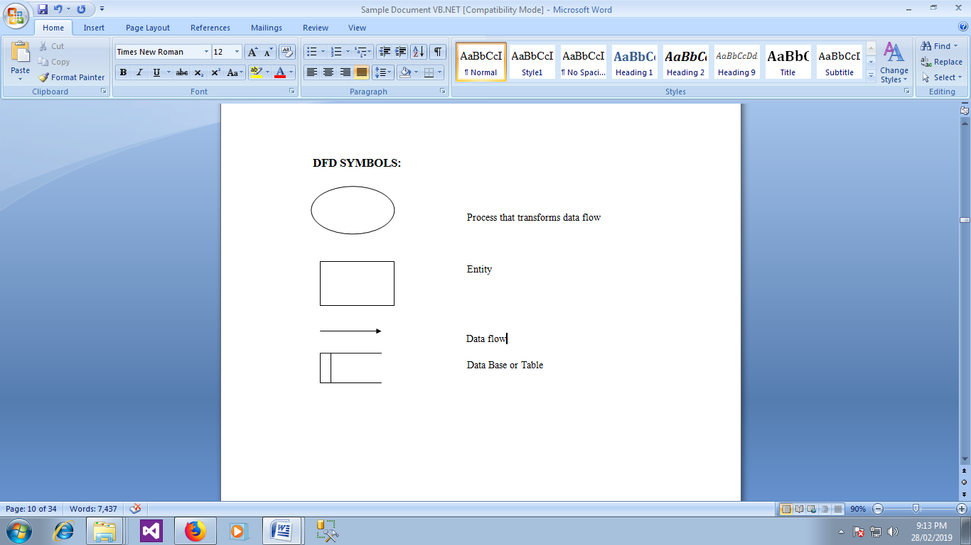
PROCESS
A process receives input data and process output data with a different form or content. Every process has a name that identifies the function it performs. Process can be as simple as collecting input data and saving in the database or it may be as complex as producing monthly sales report of any particular product in any selected region.

EXTERNAL ENTITY
External entities are objects outside the system with which system communicates. These are sources and destinations of the system inputs and outputs. They are also known as terminators, sinks, sources or actors.

DATA FLOW
Data flow is the path for data to move from one part of the system to another. It may be a single data element or set of data element. The symbol of data flow is the arrow. The arrow shows the flow direction.
DATA BASE
Data store are repositories of data in the system. They sometimes also referred as files. Each data store receives a simple label such as Orders

DATA FLOW DIAGRAM

Yoga Centre Management System
Level-0
Admin
Provide Service Yoga _Centre
Password

Level-1
Admin
User Not Authenticate
Login
Username Wrong
Password Password Password
Course Registration
Success Login Course

Fees Payment
Process Fees

Medical Form
Process Medical

Student Attendance
Process Attendance

Trainer & Attendance
Process Trainer
Report

ENTITY RELATIONSHIP DIAGRAM
An entity relationship diagram (ERD) shows the relationships of entity sets stored in a database. An entity in this context is an object, a component of data. An entity set is a collection of similar entities. These entities can have attributes that define its properties. By defining the entities, their attributes, and showing the relationships between them, an ER diagram illustrates the logical structure of databases. ER diagrams are used to sketch out the design of a database. The Entity-Relationship (ER) model is a conceptual data model that views the real world as entities and relationships. A basic component of the model is the Entity-Relationship diagram, which is used to visually represent data objects.
The model has been extended and today it is commonly used for database design. The entity relationship diagram is based on a perception of real world that consists of a collection of basic objects, called entities and of relationship among the objects. Entities are described in a database by a set of attributes. The set of all entities of the same type, and the set of all relationships of the same type, are termed as an entity set, and relationship set respectively. The overall logical structure of a database can be expressed graphically by an entity relationship diagram, which is built up using the notations
DATA MODEL
Entity Relationship Diagram is a model that describes the stored data layout of a system at high level of abstraction. Entity Relationship Diagram enables us to examine and highlight data structures and relationship independent of the processes or control flow. The participation of the entities in the relationship and cardinality ratio are indicated in the entity relationship diagram to provide further information .The Entity Relationship Diagram shows the relationship and types of relationship between the entities.. The major components are

Rectangle - represent the entity sets
- Ellipses - which represents attributes
- Diamond - which represent relationship set
- Line - which links the attributes to entity sets and entity sets to relationship set

FEATURES OF ER MODEL
- It maps well to relational model.
- It is simple and easy to understand with minimum of training. Therefore, database designer to communicate with the end user can use the model.
- In addition, the model can be used as a design plan by the database to implement a data model in specific database management software.

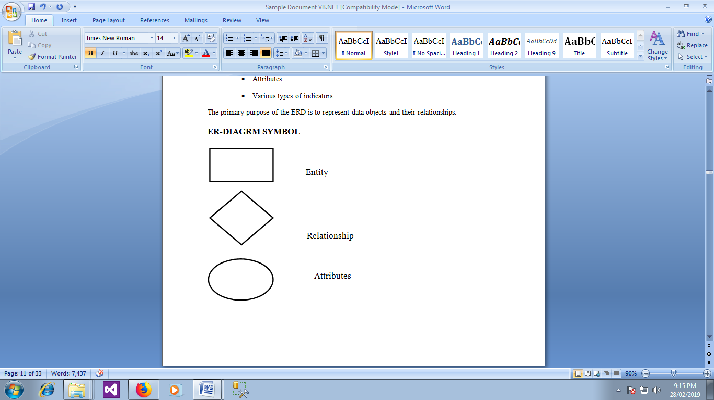

ENTITY REALTIONSHIP DIAGRAM
LID
ADDR
CNAME

CNO
Course Registration

AMOUNT
Medical
View
Given
LID
Fees Payment
CNAME

LID

CNAME
HEALTH ISSUE

To

TID
LID
Students Attendance
TNAME
Trainer
Provide
DESI
STATUS
NORMALIZATION
Database Normalization is a technique of organizing the data in the database. Normalization is a systematic approach of decomposing tables to eliminate data redundancy (repetition) and undesirable characteristics like Insertion, Update and Deletion Anomalies. It is a multi-step process that puts data into tabular form, removing duplicated data from the relation tables. Normalization is the process of efficiently organizing data in a database. There are two goals of the normalization process: eliminating redundant data (for example, storing the same data in more than one table) and ensuring data dependencies make sense (only storing related data in a table). Both of these are worthy goals as they reduce the amount of space a database consumes and ensure that data is logically stored. There are several benefits for using Normalization in Database.
BENEFITS
- Eliminate data redundancy
- Improve performance
- Query optimization
- Faster update due to less number of columns in one table
- Index improvement
FIRST NORMAL FORM
First normal form (1NF) sets the very basic rules for an organized database: Eliminate duplicative columns from the same table. Create separate tables for each group of related data and identify each row with a unique column or set of columns (the primary key).
- Remove repetitive groups
- Create Primary Key
- All the columns in a table should have unique names.
- And the order in which data is stored, does not matter.

SECOND NORMAL FORM
Second normal form (2NF) is a normal form used in database normalization. ... A relation is in the second normal form if it fulfils the following two requirements: It is in first normal form. It does not have any non-prime attribute that is functionally dependent on any proper subset of any candidate key of the relation.
- Second Normal Form (2NF)Second normal form (2NF) further addresses the concept of removing duplicative data
- Meet all the requirements of the first normal form.

THIRD NORMAL FORM
A relation is in third normal form, if there is no transitive dependency for non-prime attributes as well as it is in second normal form. Third normal form (3NF) goes one large step further:
- Meet all the requirements of the second normal form.
- Remove columns that are not dependent upon the primary key.

TABLE DESIGN

TABLE NAME: COURSE FREGISTRATION
PRIMARY KEY: COURSEID
COU RSE REGISTRATION TABLE
S.No | Colum Name | Data Type | Description
1 | Course ID | Varchar(50) | Contains course id
2 | Course name | Varchar(50) | Contains course name
3 | Fees | Varchar(50) | Contains course fees
4 | Lname | Varchar(50) | Contains name
5 | Age | Varchar(50) | Contains student age
6 | Mobile | Bigint | Contains student mobile no
7 | Address | Varchar(max) | Contains student address
8 | Batch | Varchar(50) | Contains batch type
9 | Doj | Varchar(50) | Contains student doj.

TABLE NAME: MEDICAL FORM
MEDICAL FORM
S.No | Colum Name | Data Type | Description
1 | Course ID | Varchar(50) | Contains course id
2 | Course name | Varchar(50) | Contains course name
3 | Cname | Varchar(50) | Contains Name
4 | Contact | Bigint | Contains contact name
5 | Referral | Varchar(50) | Contains referral name
6 | Refcontact | Bigint | Contains referral mobile no
7 | Health issues | Varchar(max) | Contains student health issues
8 | Surgery issues | Varchar(max) | Contains about surgery issues
9 | Specify it | Varchar(max) | Contains if any specify

TABLE NAME: ATTENDANCE FORM
ATTENDANCE FORM
S.No | Colum Name | Data Type | Description
1 | Course ID | Varchar(50) | Contains course id
2 | Course name | Varchar(50) | Contains course name
3 | Cname | Varchar(50) | Contains Name
4 | Contact | Bigint | Contains contact name
5 | Batch | Varchar(50) | Contains batch type
6 | Status | Varchar(50) | Contains status
7 | Date | Varchar(50) | Contains date.

TABLE NAME: FEES PAYMENT FORM
FEES PAYMENT FORM

S.No | Colum Name | Data Type | Description
1 | Course ID | Varchar(50) | Contains course id
2 | Course name | Varchar(50) | Contains course name
3 | Cname | Varchar(50) | Contains Name
4 | Contact | Bigint | Contains contact name
5 | Courseamount | Varchar(50) | Contains course amount
6 | Payamt | Varchar(50) | Contains the amount paid
7 | Balance amt | Int | Contains the balance amount to be paid.
8 | Paymod | Varchar(50) | Contains the payment mode
9 | Cashtype | Varchar(50) | Contains the cash type

TABLE NAME: TRAINERS ATTENDANCE FORM
TRAINERS ATTENDANCE FORM
S.No | Colum Name | Data Type | Description
1 | TID | Varchar(50) | Contains trainers id
2 | Course name | Varchar(50) | Contains course name
3 | Cname | Varchar(50) | Contains Name
4 | Contact | Bigint | Contains contact name
5 | Batch | Varchar(50) | Contains batch type
6 | Status | Varchar(50) | Contains status
7 | Date | Varchar(50) | Contains date.

TABLE NAME: TRAINERS PROFILE TABLE
TRAINERS PROFILE TABLE
S.No | Colum Name | Data Type | Description
1 | TID | Varchar(50) | Contains Trainers id
2 | Tname | Varchar(50) | Contains trainers name
3 | Gender | Varchar(50) | Contains gendre
4 | Desig | Varchar(50) | Contains designation
5 | Age | Varchar(50) | Contains trainers age
6 | Mobile | Bigint | Contains trainers mobile no
7 | Address | Varchar(max) | Contains trainers address
8 | Salary | Int | Contains salary
9 | Doj | Varchar(50) | Contains trainers doj.

PROGRAM CODINGS
LOGIN FORM
Public Class Form1

Private Sub Button1_Click (sender As Object, e As EventArgs) Handles Button1.Click
If TextBox1.Text = "" Or TextBox2.Text = "" Then
MsgBox ("Enter All Fields")
Else If TextBox1.Text = "admin" And TextBox2.Text = "admin" Then
MsgBox ("Welcome to Yoga Center")
Main. Show ()
Me. Hide ()
Else
MsgBox ("Invalid Username or Password")
TextBox1.Text = ""
TextBox2.Text = ""
TextBox1.Focus ()
End If

End Sub
End Class

MDI FORM

Public Class Main

Private Sub LOGOUTToolStripMenuItem_Click (sender As Object, e As EventArgs) Handles LOGOUTToolStripMenuItem.Click
End
End Sub

Private Sub COURSEREGISTRATIONToolStripMenuItem_Click (sender As Object, e As EventArgs) Handles COURSEREGISTRATIONToolStripMenuItem.Click
Course_registration.Show ()

End Sub

Private Sub FEESPAYMENTToolStripMenuItem_Click (sender As Object, e As EventArgs) Handles FEESPAYMENTToolStripMenuItem.Click
Feespayment.Show ()
End Sub

Private Sub MEDICALFORMToolStripMenuItem_Click (sender As Object, e As EventArgs) Handles MEDICALFORMToolStripMenuItem.Click
Medical.Show ()
End Sub

Private Sub STUDENTSATTENDANCEToolStripMenuItem_Click(sender As Object, e As EventArgs) Handles STUDENTSATTENDANCEToolStripMenuItem.Click
Attendance.Show()
End Sub

Private Sub YOGATRAINERPROFILEToolStripMenuItem_Click(sender As Object, e As EventArgs) Handles YOGATRAINERPROFILEToolStripMenuItem.Click
Yogatrainer.Show()
End Sub

Private Sub ATTENDANCEToolStripMenuItem_Click(sender As Object, e As EventArgs) Handles ATTENDANCEToolStripMenuItem.Click
StaffAttendance.Show()
End Sub

Private Sub CourseReportToolStripMenuItem_Click(sender As Object, e As EventArgs) Handles CourseReportToolStripMenuItem.Click
course_rpt.Show()
End Sub

Private Sub FeesPaymentReportToolStripMenuItem_Click(sender As Object, e As EventArgs) Handles FeesPaymentReportToolStripMenuItem.Click
Feespaymentrpt.Show()
End Sub

Private Sub YogaTrainerReportToolStripMenuItem_Click(sender As Object, e As EventArgs) Handles YogaTrainerReportToolStripMenuItem.Click
Yogatrainerrpt.Show()
End Sub

Private Sub StudentsAttendanceReportToolStripMenuItem_Click(sender As Object, e As EventArgs) Handles StudentsAttendanceReportToolStripMenuItem.Click
studentattrpt.Show()
End Sub
End Class
COURSE REGISTRATION FORM
Imports System.Data.SqlClient
Public Class Course_registration
Dim con As New SqlConnection("Data Source=HP-PC; Initial Catalog=yoga_center;Integrated Security=True")
Dim com As New SqlCommand
Dim adp As New SqlDataAdapter
Dim ds As New DataSet
Dim qry As String
Dim i As Integer
Private Sub Course_registration_Load(sender As Object, e As EventArgs) Handles MyBase.Load
Try
Dim p As String
qry = "Select courseid from course_tb"
com = New SqlCommand(qry, con)
adp = New SqlDataAdapter(com)
ds = New DataSet
adp.Fill(ds, "course_tb")
i = ds.Tables(0).Rows.Count
p = ds.Tables(0).Rows(i - 1)(0)
p = Mid(p, 1)
p = Val(p) + 1
TextBox1.Text = +p
Catch ex As Exception
TextBox1.Text = "100"
End Try
End Sub
Private Sub Button1_Click(sender As Object, e As EventArgs) Handles Button1.Click
If TextBox1.Text = "" Or TextBox2.Text = "" Or TextBox3.Text = "" Or TextBox4.Text = "" Or TextBox5.Text = "" Or TextBox6.Text = "" Or TextBox7.Text = "" Then
MsgBox("Enter All Fileds")
Else
qry = "Insert into course_tb values('" + TextBox1.Text + "','" + ComboBox1.Text + "','" + TextBox2.Text + "','" + TextBox3.Text + "','" + TextBox4.Text + "','" + TextBox5.Text + "','" + TextBox6.Text + "','" + TextBox7.Text + "','" + DateTimePicker1.Text + "')"
com = New SqlCommand(qry, con)
con.Open()
com.ExecuteNonQuery()
MsgBox("Sucessfully Saved")
con.Close()
End If

TextBox2.Text = ""
TextBox3.Text = ""
TextBox4.Text = ""
TextBox5.Text = ""
TextBox6.Text = ""
TextBox7.Text = ""
ComboBox1.Text = "Select"
DateTimePicker1.Text = Date.Today

Try
Dim p As String
qry = "Select courseid from course_tb"
com = New SqlCommand(qry, con)
adp = New SqlDataAdapter(com)
ds = New DataSet
adp.Fill(ds, "course_tb")
i = ds.Tables(0).Rows.Count
p = ds.Tables(0).Rows(i - 1)(0)
p = Mid(p, 1)
p = Val(p) + 1
TextBox1.Text = +p
Catch ex As Exception
TextBox1.Text = "100"
End Try

End Sub

Private Sub Button2_Click(sender As Object, e As EventArgs) Handles Button2.Click
If TextBox1.Text = "" Or TextBox2.Text = "" Or TextBox3.Text = "" Or TextBox4.Text = "" Or TextBox5.Text = "" Or TextBox6.Text = "" Or TextBox7.Text = "" Then
MsgBox("Enter All Fileds")
Else
qry = "Update course_tb set coursename='" + ComboBox1.Text + "',fees='" + TextBox2.Text + "',cname='" + TextBox3.Text + "',age='" + TextBox4.Text + "',mobile='" + TextBox5.Text + "',address='" + TextBox6.Text + "',batch='" + TextBox7.Text + "',doj='" + DateTimePicker1.Text + "' where courseid='" + TextBox1.Text + "'"
com = New SqlCommand(qry, con)
con.Open()
com.ExecuteNonQuery()
MsgBox("Sucessfully Updated")
con.Close()
End If

TextBox2.Text = ""
TextBox3.Text = ""
TextBox4.Text = ""
TextBox5.Text = ""
TextBox6.Text = ""
TextBox7.Text = ""
ComboBox1.Text = "Select"
DateTimePicker1.Text = Date.Today

Try
Dim p As String
qry = "Select courseid from course_tb"
com = New SqlCommand(qry, con)
adp = New SqlDataAdapter(com)
ds = New DataSet
adp.Fill(ds, "course_tb")
i = ds.Tables(0).Rows.Count
p = ds.Tables(0).Rows(i - 1)(0)
p = Mid(p, 1)
p = Val(p) + 1
TextBox1.Text = +p
Catch ex As Exception
TextBox1.Text = "100"
End Try
End Sub

Private Sub Button3_Click(sender As Object, e As EventArgs) Handles Button3.Click
If TextBox1.Text = "" Or TextBox2.Text = "" Or TextBox3.Text = "" Or TextBox4.Text = "" Or TextBox5.Text = "" Or TextBox6.Text = "" Or TextBox7.Text = "" Then
MsgBox("Enter All Fileds")
Else
qry = "Delete from course_tb where courseid='" + TextBox1.Text + "'"
com = New SqlCommand(qry, con)
con.Open()
com.ExecuteNonQuery()
MsgBox("Sucessfully Deleted")
con.Close()
End If

TextBox2.Text = ""
TextBox3.Text = ""
TextBox4.Text = ""
TextBox5.Text = ""
TextBox6.Text = ""
TextBox7.Text = ""
ComboBox1.Text = "Select"
DateTimePicker1.Text = Date.Today

Try
Dim p As String
qry = "Select courseid from course_tb"
com = New SqlCommand(qry, con)
adp = New SqlDataAdapter(com)
ds = New DataSet
adp.Fill(ds, "course_tb")
i = ds.Tables(0).Rows.Count
p = ds.Tables(0).Rows(i - 1)(0)
p = Mid(p, 1)
p = Val(p) + 1
TextBox1.Text = +p
Catch ex As Exception
TextBox1.Text = "100"
End Try
End Sub

Private Sub Button4_Click(sender As Object, e As EventArgs) Handles Button4.Click

Try
qry = "Select * from course_tb where courseid='" + TextBox1.Text + "'"
com = New SqlCommand(qry, con)
adp = New SqlDataAdapter(com)
ds = New DataSet
adp.Fill(ds, "course_tb")
'i = ds.Tables(0).Rows.Count
TextBox1.Text = ds.Tables("course_tb").Rows(0)(0)
ComboBox1.Text = ds.Tables("course_tb").Rows(0)(1)
TextBox2.Text = ds.Tables("course_tb").Rows(0)(2)
TextBox3.Text = ds.Tables("course_tb").Rows(0)(3)
TextBox4.Text = ds.Tables("course_tb").Rows(0)(4)
TextBox5.Text = ds.Tables("course_tb").Rows(0)(5)
TextBox6.Text = ds.Tables("course_tb").Rows(0)(6)
TextBox7.Text = ds.Tables("course_tb").Rows(0)(7)
DateTimePicker1.Text = ds.Tables("course_tb").Rows(0)(8)

Catch ex As Exception
MsgBox("Enter Valid Member ID")
End Try
End Sub

Private Sub Button5_Click(sender As Object, e As EventArgs) Handles Button5.Click
TextBox2.Text = ""
TextBox3.Text = ""
TextBox4.Text = ""
TextBox5.Text = ""
TextBox6.Text = ""
TextBox7.Text = ""
ComboBox1.Text = "Select"
DateTimePicker1.Text = Date.Today
End Sub

Private Sub ComboBox1_SelectedIndexChanged(sender As Object, e As EventArgs) Handles ComboBox1.SelectedIndexChanged
If ComboBox1.Text = "Gendral Yoga" Then
TextBox2.Text = "500"
ElseIf ComboBox1.Text = "Meditation" Then
TextBox2.Text = "800"
ElseIf ComboBox1.Text = "1Month Camp" Then
TextBox2.Text = "1000"
ElseIf ComboBox1.Text = "Foundation Course" Then
TextBox2.Text = "1500"
ElseIf ComboBox1.Text = "Master Reference Course" Then
TextBox2.Text = "2000"
ElseIf ComboBox1.Text = "Arulnithi Course" Then
TextBox2.Text = "2500"
ElseIf ComboBox1.Text = "Assistant Professor course" Then
TextBox2.Text = "3000"
End If
End Sub
End Class
FEES PAYMENT FORM
Imports System.Data.SqlClient
Public Class Feespayment
Dim con As New SqlConnection("Data Source=HP-PC;Initial Catalog=yoga_center;Integrated Security=True")
Dim com As New SqlCommand
Dim adp As New SqlDataAdapter
Dim ds As New DataSet
Dim qry As String
Dim i As Integer
Private Sub Feespayment_Load(sender As Object, e As EventArgs) Handles MyBase.Load
qry = "Select courseid from course_tb"
com = New SqlCommand(qry, con)
adp = New SqlDataAdapter(com)
ds = New DataSet
adp.Fill(ds, "course_tb")
i = ds.Tables(0).Rows.Count
For j = 0 To i - 1
ComboBox1.Items.Add(ds.Tables(0).Rows(j)(0))

Next
End Sub

Private Sub ComboBox1_SelectedIndexChanged(sender As Object, e As EventArgs) Handles ComboBox1.SelectedIndexChanged
Try
qry = "Select * from course_tb where courseid='" + ComboBox1.Text + "'"
com = New SqlCommand(qry, con)
adp = New SqlDataAdapter(com)
ds = New DataSet
adp.Fill(ds, "course_tb")

TextBox1.Text = ds.Tables("course_tb").Rows(0)(1)
TextBox2.Text = ds.Tables("course_tb").Rows(0)(3)
TextBox3.Text = ds.Tables("course_tb").Rows(0)(5)
TextBox4.Text = ds.Tables("course_tb").Rows(0)(2)

Catch ex As Exception
MsgBox("Enter Valid ID")
End Try
End Sub

Private Sub TextBox6_Layout(sender As Object, e As LayoutEventArgs) Handles TextBox6.Layout

End Sub

Private Sub TextBox6_LostFocus(sender As Object, e As EventArgs) Handles TextBox6.LostFocus

End Sub

Private Sub TextBox6_TextChanged(sender As Object, e As EventArgs) Handles TextBox6.TextChanged

End Sub

Private Sub TextBox5_LostFocus(sender As Object, e As EventArgs) Handles TextBox5.LostFocus
TextBox6.Text = Val(TextBox4.Text) - Val(TextBox5.Text)
End Sub

Private Sub TextBox5_TextChanged(sender As Object, e As EventArgs) Handles TextBox5.TextChanged

End Sub

Private Sub Button1_Click(sender As Object, e As EventArgs) Handles Button1.Click
If TextBox1.Text = "" Or TextBox2.Text = "" Or TextBox3.Text = "" Or TextBox4.Text = "" Or TextBox5.Text = "" Or TextBox6.Text = "" Then
MsgBox("Enter All Fileds")
Else
qry = "Insert into feespayment_tb values('" + ComboBox1.Text + "','" + TextBox1.Text + "','" + TextBox2.Text + "','" + TextBox3.Text + "','" + TextBox4.Text + "','" + TextBox5.Text + "','" + TextBox6.Text + "','" + ComboBox2.Text + "','" + ComboBox3.Text + "')"
com = New SqlCommand(qry, con)
con.Open()
com.ExecuteNonQuery()
MsgBox("Sucessfully Saved")
con.Close()
End If

TextBox1.Text = ""
TextBox2.Text = ""
TextBox3.Text = ""
TextBox4.Text = ""
TextBox5.Text = ""
TextBox6.Text = ""
ComboBox1.Text = "Select"
ComboBox2.Text = "Select"
ComboBox3.Text = "Select"

End Sub

Private Sub Button2_Click(sender As Object, e As EventArgs) Handles Button2.Click
If TextBox1.Text = "" Or TextBox2.Text = "" Or TextBox3.Text = "" Or TextBox4.Text = "" Or TextBox5.Text = "" Or TextBox6.Text = "" Then
MsgBox("Enter All Fileds")
Else
qry = "Update feespayment_tb set courseamt='" + TextBox4.Text + "',payamt='" + TextBox5.Text + "',balanceamt='" + TextBox6.Text + "',paymode='" + ComboBox2.Text + "',cashtype='" + ComboBox3.Text + "' where contact='" + TextBox3.Text + "'"
com = New SqlCommand(qry, con)
con.Open()
com.ExecuteNonQuery()
MsgBox("Sucessfully Updated")
con.Close()
End If

TextBox1.Text = ""
TextBox2.Text = ""
TextBox3.Text = ""
TextBox4.Text = ""
TextBox5.Text = ""
TextBox6.Text = ""
ComboBox1.Text = "Select"
ComboBox2.Text = "Select"
ComboBox3.Text = "Select"
End Sub

Private Sub Button3_Click(sender As Object, e As EventArgs) Handles Button3.Click
If TextBox1.Text = "" Or TextBox2.Text = "" Or TextBox3.Text = "" Or TextBox4.Text = "" Or TextBox5.Text = "" Or TextBox6.Text = "" Then
MsgBox("Enter All Fileds")
Else
qry = "Delete from feespayment_tb where contact='" + TextBox3.Text + "'"
com = New SqlCommand(qry, con)
con.Open()
com.ExecuteNonQuery()
MsgBox("Sucessfully Deleted")
con.Close()
End If

TextBox1.Text = ""
TextBox2.Text = ""
TextBox3.Text = ""
TextBox4.Text = ""
TextBox5.Text = ""
TextBox6.Text = ""
ComboBox1.Text = "Select"
ComboBox2.Text = "Select"
ComboBox3.Text = "Select"
End Sub

Private Sub Button4_Click(sender As Object, e As EventArgs) Handles Button4.Click
Try
qry = "Select * from feespayment_tb where contact='" + TextBox3.Text + "'"
com = New SqlCommand(qry, con)
adp = New SqlDataAdapter(com)
ds = New DataSet
adp.Fill(ds, "feespayment_tb")

ComboBox1.Text = ds.Tables("feespayment_tb").Rows(0)(0)
TextBox1.Text = ds.Tables("feespayment_tb").Rows(0)(1)
TextBox2.Text = ds.Tables("feespayment_tb").Rows(0)(2)
TextBox3.Text = ds.Tables("feespayment_tb").Rows(0)(3)
TextBox4.Text = ds.Tables("feespayment_tb").Rows(0)(4)
TextBox5.Text = ds.Tables("feespayment_tb").Rows(0)(5)
TextBox6.Text = ds.Tables("feespayment_tb").Rows(0)(6)
ComboBox2.Text = ds.Tables("feespayment_tb").Rows(0)(7)
ComboBox3.Text = ds.Tables("feespayment_tb").Rows(0)(8)

Catch ex As Exception
MsgBox("No Payment pay Immedietly")
End Try
End Sub

Private Sub Button5_Click(sender As Object, e As EventArgs) Handles Button5.Click
TextBox1.Text = ""
TextBox2.Text = ""
TextBox3.Text = ""
TextBox4.Text = ""
TextBox5.Text = ""
TextBox6.Text = ""
ComboBox1.Text = "Select"
ComboBox2.Text = "Select"
ComboBox3.Text = "Select"
End Sub

End Class

MEDICAL FORM
Imports System.Data.SqlClient
Public Class Medical
Dim con As New SqlConnection("Data Source=HP-PC;Initial Catalog=yoga_center;Integrated Security=True")
Dim com As New SqlCommand
Dim adp As New SqlDataAdapter
Dim ds As New DataSet
Dim qry As String
Dim i As Integer
Private Sub Medical_Load(sender As Object, e As EventArgs) Handles MyBase.Load
qry = "Select courseid from course_tb"
com = New SqlCommand(qry, con)
adp = New SqlDataAdapter(com)
ds = New DataSet
adp.Fill(ds, "course_tb")
i = ds.Tables(0).Rows.Count
For j = 0 To i - 1
ComboBox1.Items.Add(ds.Tables(0).Rows(j)(0))

Next
End Sub

Private Sub ComboBox1_SelectedIndexChanged(sender As Object, e As EventArgs) Handles ComboBox1.SelectedIndexChanged
Try
qry = "Select * from course_tb where courseid='" + ComboBox1.Text + "'"
com = New SqlCommand(qry, con)
adp = New SqlDataAdapter(com)
ds = New DataSet
adp.Fill(ds, "course_tb")

TextBox1.Text = ds.Tables("course_tb").Rows(0)(1)
TextBox2.Text = ds.Tables("course_tb").Rows(0)(3)
TextBox3.Text = ds.Tables("course_tb").Rows(0)(5)
'TextBox4.Text = ds.Tables("course_tb").Rows(0)(2)

Catch ex As Exception
MsgBox("Enter Valid ID")
End Try
End Sub

Private Sub Button1_Click(sender As Object, e As EventArgs) Handles Button1.Click
If TextBox1.Text = "" Or TextBox2.Text = "" Or TextBox3.Text = "" Or TextBox4.Text = "" Or TextBox5.Text = "" Or TextBox6.Text = "" Then
MsgBox("Enter All Fileds")
Else
qry = "Insert into medical_tb values('" + ComboBox1.Text + "','" + TextBox1.Text + "','" + TextBox2.Text + "','" + TextBox3.Text + "','" + TextBox4.Text + "','" + TextBox5.Text + "','" + ComboBox2.Text + "','" + ComboBox3.Text + "','" + TextBox6.Text + "')"
com = New SqlCommand(qry, con)
con.Open()
com.ExecuteNonQuery()
MsgBox("Sucessfully Saved")
con.Close()
End If

TextBox1.Text = ""
TextBox2.Text = ""
TextBox3.Text = ""
TextBox4.Text = ""
TextBox5.Text = ""
TextBox6.Text = ""
ComboBox1.Text = "Select"
ComboBox2.Text = "Select"
ComboBox3.Text = "Select"
End Sub
Private Sub Button2_Click(sender As Object, e As EventArgs) Handles Button2.Click
If TextBox1.Text = "" Or TextBox2.Text = "" Or TextBox3.Text = "" Or TextBox4.Text = "" Or TextBox5.Text = "" Or TextBox6.Text = "" Then
MsgBox("Enter All Fileds")
Else
qry = "Update medical_tb set referral='" + TextBox4.Text + "',refcontact='" + TextBox5.Text + "',healthissue='" + ComboBox2.Text + "',surgeryissues='" + ComboBox3.Text + "',specifyit='" + TextBox6.Text + "' where contact='" + TextBox3.Text + "'"
com = New SqlCommand(qry, con)
con.Open()
com.ExecuteNonQuery()
MsgBox("Sucessfully Updated")
con.Close()
End If

TextBox1.Text = ""
TextBox2.Text = ""
TextBox3.Text = ""
TextBox4.Text = ""
TextBox5.Text = ""
TextBox6.Text = ""
ComboBox1.Text = "Select"
ComboBox2.Text = "Select"
ComboBox3.Text = "Select"
End Sub

Private Sub Button3_Click(sender As Object, e As EventArgs) Handles Button3.Click
If TextBox1.Text = "" Or TextBox2.Text = "" Or TextBox3.Text = "" Or TextBox4.Text = "" Or TextBox5.Text = "" Or TextBox6.Text = "" Then
MsgBox("Enter All Fileds")
Else
qry = "Delete from medical_tb where contact='" + TextBox3.Text + "'"
com = New SqlCommand(qry, con)
con.Open()
com.ExecuteNonQuery()
MsgBox("Sucessfully Deleted")
con.Close()
End If

TextBox1.Text = ""
TextBox2.Text = ""
TextBox3.Text = ""
TextBox4.Text = ""
TextBox5.Text = ""
TextBox6.Text = ""
ComboBox1.Text = "Select"
ComboBox2.Text = "Select"
ComboBox3.Text = "Select"
End Sub

Private Sub Button4_Click(sender As Object, e As EventArgs) Handles Button4.Click
Try
qry = "Select * from medical_tb where contact='" + TextBox3.Text + "'"
com = New SqlCommand(qry, con)
adp = New SqlDataAdapter(com)
ds = New DataSet
adp.Fill(ds, "medical_tb")

ComboBox1.Text = ds.Tables("medical_tb").Rows(0)(0)
TextBox1.Text = ds.Tables("medical_tb").Rows(0)(1)
TextBox2.Text = ds.Tables("medical_tb").Rows(0)(2)
TextBox3.Text = ds.Tables("medical_tb").Rows(0)(3)
TextBox4.Text = ds.Tables("medical_tb").Rows(0)(4)
TextBox5.Text = ds.Tables("medical_tb").Rows(0)(5)
ComboBox2.Text = ds.Tables("medical_tb").Rows(0)(6)
ComboBox3.Text = ds.Tables("medical_tb").Rows(0)(7)
TextBox6.Text = ds.Tables("medical_tb").Rows(0)(8)

Catch ex As Exception
MsgBox("No Information Here check your contact no")
End Try
End Sub

Private Sub Button5_Click(sender As Object, e As EventArgs) Handles Button5.Click
TextBox1.Text = ""
TextBox2.Text = ""
TextBox3.Text = ""
TextBox4.Text = ""
TextBox5.Text = ""
TextBox6.Text = ""
ComboBox1.Text = "Select"
ComboBox2.Text = "Select"
ComboBox3.Text = "Select"
End Sub
End Class
STUDENT ATTENDANCE FORM
Imports System.Data.SqlClient
Public Class Attendance
Dim con As New SqlConnection("Data Source=HP-PC;Initial Catalog=yoga_center;Integrated Security=True")
Dim com As New SqlCommand
Dim adp As New SqlDataAdapter
Dim ds As New DataSet
Dim qry As String
Dim i As Integer
Private Sub Attendance_Load(sender As Object, e As EventArgs) Handles MyBase.Load
qry = "Select courseid from course_tb"
com = New SqlCommand(qry, con)
adp = New SqlDataAdapter(com)
ds = New DataSet
adp.Fill(ds, "course_tb")
i = ds.Tables(0).Rows.Count
For j = 0 To i - 1
ComboBox1.Items.Add(ds.Tables(0).Rows(j)(0))

Next
End Sub
Private Sub ComboBox1_SelectedIndexChanged(sender As Object, e As EventArgs) Handles ComboBox1.SelectedIndexChanged
Try
qry = "Select * from course_tb where courseid='" + ComboBox1.Text + "'"
com = New SqlCommand(qry, con)
adp = New SqlDataAdapter(com)
ds = New DataSet
adp.Fill(ds, "course_tb")

TextBox1.Text = ds.Tables("course_tb").Rows(0)(1)
TextBox2.Text = ds.Tables("course_tb").Rows(0)(3)
TextBox3.Text = ds.Tables("course_tb").Rows(0)(5)
TextBox4.Text = ds.Tables("course_tb").Rows(0)(7)

Catch ex As Exception
MsgBox("Enter Valid ID")
End Try
End Sub
Private Sub Button1_Click(sender As Object, e As EventArgs) Handles Button1.Click
If TextBox1.Text = "" Or TextBox2.Text = "" Or TextBox3.Text = "" Or TextBox4.Text = "" Then
MsgBox("Enter All Fileds")
Else
qry = "Insert into attendance_tb values('" + ComboBox1.Text + "','" + TextBox1.Text + "','" + TextBox2.Text + "','" + TextBox3.Text + "','" + TextBox4.Text + "','" + ComboBox2.Text + "','" + DateTimePicker1.Text + "')"
com = New SqlCommand(qry, con)
con.Open()
com.ExecuteNonQuery()
MsgBox("Sucessfully Saved")
con.Close()
End If

TextBox1.Text = ""
TextBox2.Text = ""
TextBox3.Text = ""
TextBox4.Text = ""
ComboBox1.Text = "Select"
ComboBox2.Text = "Select"

End Sub

Private Sub Button5_Click(sender As Object, e As EventArgs) Handles Button5.Click
TextBox1.Text = ""
TextBox2.Text = ""
TextBox3.Text = ""
TextBox4.Text = ""
ComboBox1.Text = "Select"
ComboBox2.Text = "Select"
End Sub
End Class
YOGA TRAINERS PROFILE FORM
Imports System.Data.SqlClient
Public Class Yogatrainer
Dim con As New SqlConnection("Data Source=HP-PC;Initial Catalog=yoga_center;Integrated Security=True")
Dim com As New SqlCommand
Dim adp As New SqlDataAdapter
Dim ds As New DataSet
Dim qry As String
Dim i As Integer
Private Sub Yogatrainer_Load(sender As Object, e As EventArgs) Handles MyBase.Load
Try
Dim p As String
qry = "Select tid from trainer_tb"
com = New SqlCommand(qry, con)
adp = New SqlDataAdapter(com)
ds = New DataSet
adp.Fill(ds, "trainer_tb")
i = ds.Tables(0).Rows.Count
p = ds.Tables(0).Rows(i - 1)(0)
p = Mid(p, 1)
p = Val(p) + 1
TextBox1.Text = +p
Catch ex As Exception
TextBox1.Text = "300"
End Try
End Sub

Private Sub Button1_Click(sender As Object, e As EventArgs) Handles Button1.Click
If TextBox1.Text = "" Or TextBox2.Text = "" Or TextBox3.Text = "" Or TextBox4.Text = "" Or TextBox5.Text = "" Or TextBox6.Text = "" Or TextBox7.Text = "" Then
MsgBox("Enter All Fileds")
Else
qry = "Insert into trainer_tb values('" + TextBox1.Text + "','" + TextBox2.Text + "','" + ComboBox1.Text + "','" + TextBox3.Text + "','" + TextBox4.Text + "','" + TextBox5.Text + "','" + TextBox6.Text + "','" + DateTimePicker1.Text + "','" + TextBox7.Text + "')"
com = New SqlCommand(qry, con)
con.Open()
com.ExecuteNonQuery()
MsgBox("Sucessfully Saved")
con.Close()
End If

TextBox2.Text = ""
TextBox3.Text = ""
TextBox4.Text = ""
TextBox5.Text = ""
TextBox6.Text = ""
TextBox7.Text = ""
ComboBox1.Text = "Select"
DateTimePicker1.Text = Date.Today

Try
Dim p As String
qry = "Select tid from trainer_tb"
com = New SqlCommand(qry, con)
adp = New SqlDataAdapter(com)
ds = New DataSet
adp.Fill(ds, "trainer_tb")
i = ds.Tables(0).Rows.Count
p = ds.Tables(0).Rows(i - 1)(0)
p = Mid(p, 1)
p = Val(p) + 1
TextBox1.Text = +p
Catch ex As Exception
TextBox1.Text = "300"
End Try

End Sub

Private Sub Button2_Click(sender As Object, e As EventArgs) Handles Button2.Click
If TextBox1.Text = "" Or TextBox2.Text = "" Or TextBox3.Text = "" Or TextBox4.Text = "" Or TextBox5.Text = "" Or TextBox6.Text = "" Or TextBox7.Text = "" Then
MsgBox("Enter All Fileds")
Else
qry = "Update trainer_tb set tname='" + TextBox2.Text + "',gender='" + ComboBox1.Text + "',desi='" + TextBox3.Text + "',age='" + TextBox4.Text + "',mobile='" + TextBox5.Text + "',addr='" + TextBox6.Text + "',doj='" + DateTimePicker1.Text + "',salary='" + TextBox7.Text + "' where tid='" + TextBox1.Text + "'"
com = New SqlCommand(qry, con)
con.Open()
com.ExecuteNonQuery()
MsgBox("Sucessfully Saved")
con.Close()
End If

TextBox2.Text = ""
TextBox3.Text = ""
TextBox4.Text = ""
TextBox5.Text = ""
TextBox6.Text = ""
TextBox7.Text = ""
ComboBox1.Text = "Select"
DateTimePicker1.Text = Date.Today

Try
Dim p As String
qry = "Select tid from trainer_tb"
com = New SqlCommand(qry, con)
adp = New SqlDataAdapter(com)
ds = New DataSet
adp.Fill(ds, "trainer_tb")
i = ds.Tables(0).Rows.Count
p = ds.Tables(0).Rows(i - 1)(0)
p = Mid(p, 1)
p = Val(p) + 1
TextBox1.Text = +p
Catch ex As Exception
TextBox1.Text = "300"
End Try

End Sub

Private Sub Button3_Click(sender As Object, e As EventArgs) Handles Button3.Click
If TextBox1.Text = "" Or TextBox2.Text = "" Or TextBox3.Text = "" Or TextBox4.Text = "" Or TextBox5.Text = "" Or TextBox6.Text = "" Or TextBox7.Text = "" Then
MsgBox("Enter All Fileds")
Else
qry = "Delete from trainer_tb where tid='" + TextBox1.Text + "'"
com = New SqlCommand(qry, con)
con.Open()
com.ExecuteNonQuery()
MsgBox("Sucessfully Saved")
con.Close()
End If

TextBox2.Text = ""
TextBox3.Text = ""
TextBox4.Text = ""
TextBox5.Text = ""
TextBox6.Text = ""
TextBox7.Text = ""
ComboBox1.Text = "Select"
DateTimePicker1.Text = Date.Today

Try
Dim p As String
qry = "Select tid from trainer_tb"
com = New SqlCommand(qry, con)
adp = New SqlDataAdapter(com)
ds = New DataSet
adp.Fill(ds, "trainer_tb")
i = ds.Tables(0).Rows.Count
p = ds.Tables(0).Rows(i - 1)(0)
p = Mid(p, 1)
p = Val(p) + 1
TextBox1.Text = +p
Catch ex As Exception
TextBox1.Text = "300"
End Try
End Sub
Private Sub Button4_Click(sender As Object, e As EventArgs) Handles Button4.Click
Try
qry = "Select * from trainer_tb where tid='" + TextBox1.Text + "'"
com = New SqlCommand(qry, con)
adp = New SqlDataAdapter(com)
ds = New DataSet
adp.Fill(ds, "trainer_tb")

TextBox1.Text = ds.Tables("trainer_tb").Rows(0)(0)
TextBox2.Text = ds.Tables("trainer_tb").Rows(0)(1)
ComboBox1.Text = ds.Tables("trainer_tb").Rows(0)(2)
TextBox3.Text = ds.Tables("trainer_tb").Rows(0)(3)
TextBox4.Text = ds.Tables("trainer_tb").Rows(0)(4)
TextBox5.Text = ds.Tables("trainer_tb").Rows(0)(5)
TextBox6.Text = ds.Tables("trainer_tb").Rows(0)(6)
DateTimePicker1.Text = ds.Tables("trainer_tb").Rows(0)(7)
TextBox7.Text = ds.Tables("trainer_tb").Rows(0)(8)

Catch ex As Exception
MsgBox("Enter Valid Trainer ID")
End Try
End Sub

Private Sub Button5_Click(sender As Object, e As EventArgs) Handles Button5.Click
TextBox2.Text = ""
TextBox3.Text = ""
TextBox4.Text = ""
TextBox5.Text = ""
TextBox6.Text = ""
TextBox7.Text = ""
ComboBox1.Text = "Select"
DateTimePicker1.Text = Date.Today
End Sub
End Class
TRAINERS ATTENDANCE FORM
Imports System.Data.SqlClient
Public Class StaffAttendance
Dim con As New SqlConnection("Data Source=HP-PC;Initial Catalog=yoga_center;Integrated Security=True")
Dim com As New SqlCommand
Dim adp As New SqlDataAdapter
Dim ds As New DataSet
Dim qry As String
Dim i As Integer
Private Sub StaffAttendance_Load(sender As Object, e As EventArgs) Handles MyBase.Load

qry = "Select tid from trainer_tb"
com = New SqlCommand(qry, con)
adp = New SqlDataAdapter(com)
ds = New DataSet
adp.Fill(ds, "trainer_tb")
i = ds.Tables(0).Rows.Count
For j = 0 To i - 1
ComboBox1.Items.Add(ds.Tables(0).Rows(j)(0))
Next

End Sub
Private Sub ComboBox1_SelectedIndexChanged(sender As Object, e As EventArgs) Handles ComboBox1.SelectedIndexChanged
Try
qry = "Select * from trainer_tb where tid='" + ComboBox1.Text + "'"
com = New SqlCommand(qry, con)
adp = New SqlDataAdapter(com)
ds = New DataSet
adp.Fill(ds, "trainer_tb")

TextBox1.Text = ds.Tables("trainer_tb").Rows(0)(3)
TextBox2.Text = ds.Tables("trainer_tb").Rows(0)(1)
TextBox3.Text = ds.Tables("trainer_tb").Rows(0)(5)

Catch ex As Exception
MsgBox("Enter Valid ID")
End Try
End Sub

Private Sub Button1_Click(sender As Object, e As EventArgs) Handles Button1.Click
If TextBox1.Text = "" Or TextBox2.Text = "" Or TextBox3.Text = "" Then
MsgBox("Enter All Fileds")
Else
qry = "Insert into trainer_att values('" + ComboBox1.Text + "','" + TextBox1.Text + "','" + TextBox2.Text + "','" + TextBox3.Text + "','" + ComboBox3.Text + "','" + ComboBox2.Text + "','" + DateTimePicker1.Text + "')"
com = New SqlCommand(qry, con)
con.Open()
com.ExecuteNonQuery()
MsgBox("Sucessfully Saved")
con.Close()
End If

TextBox1.Text = ""
TextBox2.Text = ""
TextBox3.Text = ""
ComboBox1.Text = "Select"
ComboBox2.Text = "Select"
ComboBox3.Text = "Select"
End Sub
Private Sub Button5_Click(sender As Object, e As EventArgs) Handles Button5.Click
TextBox1.Text = ""
TextBox2.Text = ""
TextBox3.Text = ""
ComboBox1.Text = "Select"
ComboBox2.Text = "Select"
ComboBox3.Text = "Select"
End Sub
End Class
COURSE REGISTRATION REPORT
Imports System.Data.SqlClient
Public Class course_rpt
Dim con As New SqlConnection("Data Source=HP-PC;Initial Catalog=yoga_center;Integrated Security=True")
Dim com As New SqlCommand
Dim adp As New SqlDataAdapter
Dim ds As New DataSet
Dim qry As String
Dim i As Integer
Private Sub course_rpt_Load(sender As Object, e As EventArgs) Handles MyBase.Load
qry = "Select * from course_tb"
com = New SqlCommand(qry, con)
adp = New SqlDataAdapter(com)
ds = New DataSet
adp.Fill(ds, "course_tb")
'i = ds.Tables(0).Rows.Count
DataGridView1.DataSource = ds.Tables("course_tb")

End Sub
End Class
FEES PAYMENT REPORT
Imports System.Data.SqlClient
Public Class Feespaymentrpt
Dim con As New SqlConnection("Data Source=HP-PC;Initial Catalog=yoga_center;Integrated Security=True")
Dim com As New SqlCommand
Dim adp As New SqlDataAdapter
Dim ds As New DataSet
Dim qry As String
Dim i As Integer
Private Sub Feespaymentrpt_Load(sender As Object, e As EventArgs) Handles MyBase.Load
qry = "Select * from feespayment_tb"
com = New SqlCommand(qry, con)
adp = New SqlDataAdapter(com)
ds = New DataSet
adp.Fill(ds, "feespayment_tb")
'i = ds.Tables(0).Rows.Count
DataGridView1.DataSource = ds.Tables("feespayment_tb")
End Sub
End Class
STUDENT ATTENDANCE REPORT
Imports System.Data.SqlClient
Public Class studentattrpt
Dim con As New SqlConnection("Data Source=HP-PC;Initial Catalog=yoga_center;Integrated Security=True")
Dim com As New SqlCommand
Dim adp As New SqlDataAdapter
Dim ds As New DataSet
Dim qry As String
Dim i As Integer

Private Sub studentattrpt_Load(sender As Object, e As EventArgs) Handles MyBase.Load
qry = "Select * from attendance_tb"
com = New SqlCommand(qry, con)
adp = New SqlDataAdapter(com)
ds = New DataSet
adp.Fill(ds, "attendance_tb")
'ables(0).Rows.Count()
DataGridView1.DataSource = ds.Tables("attendance_tb")

End Sub
End Class
YOGA TRAINERS PROFILE REPORT
Imports System.Data.SqlClient
Public Class Yogatrainerrpt
Dim con As New SqlConnection("Data Source=HP-PC;Initial Catalog=yoga_center;Integrated Security=True")
Dim com As New SqlCommand
Dim adp As New SqlDataAdapter
Dim ds As New DataSet
Dim qry As String
Dim i As Integer
Private Sub Yogatrainerrpt_Load(sender As Object, e As EventArgs) Handles MyBase.Load
qry = "Select * from trainer_tb"
com = New SqlCommand(qry, con)
adp = New SqlDataAdapter(com)
ds = New DataSet
adp.Fill(ds, "trainer_tb")
DataGridView1.DataSource = ds.Tables("trainer_tb")
End Sub
End Class

FORM DESIGNS
LOGIN FORM
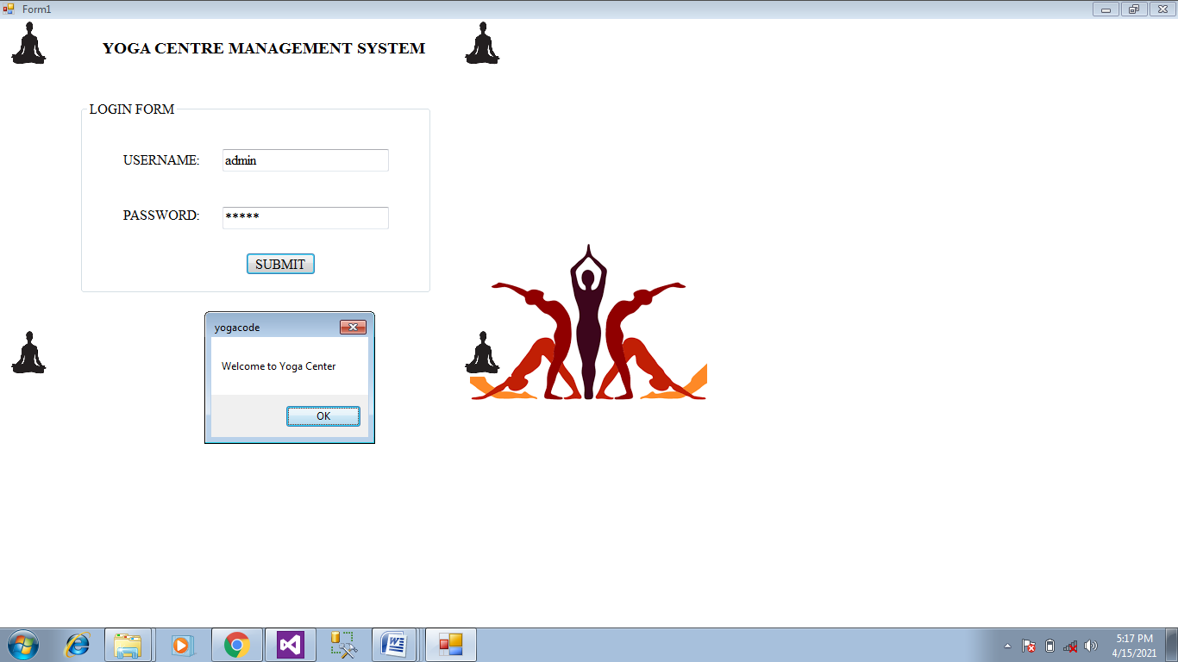
MDI FORM


COURSE REGISTRATION FORM
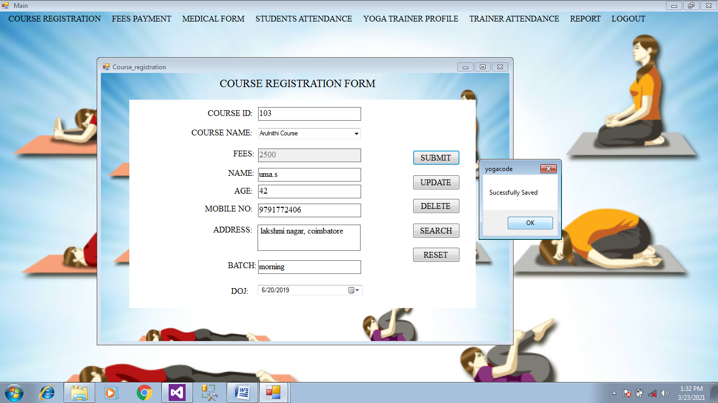

FEES PAYMENT FORM
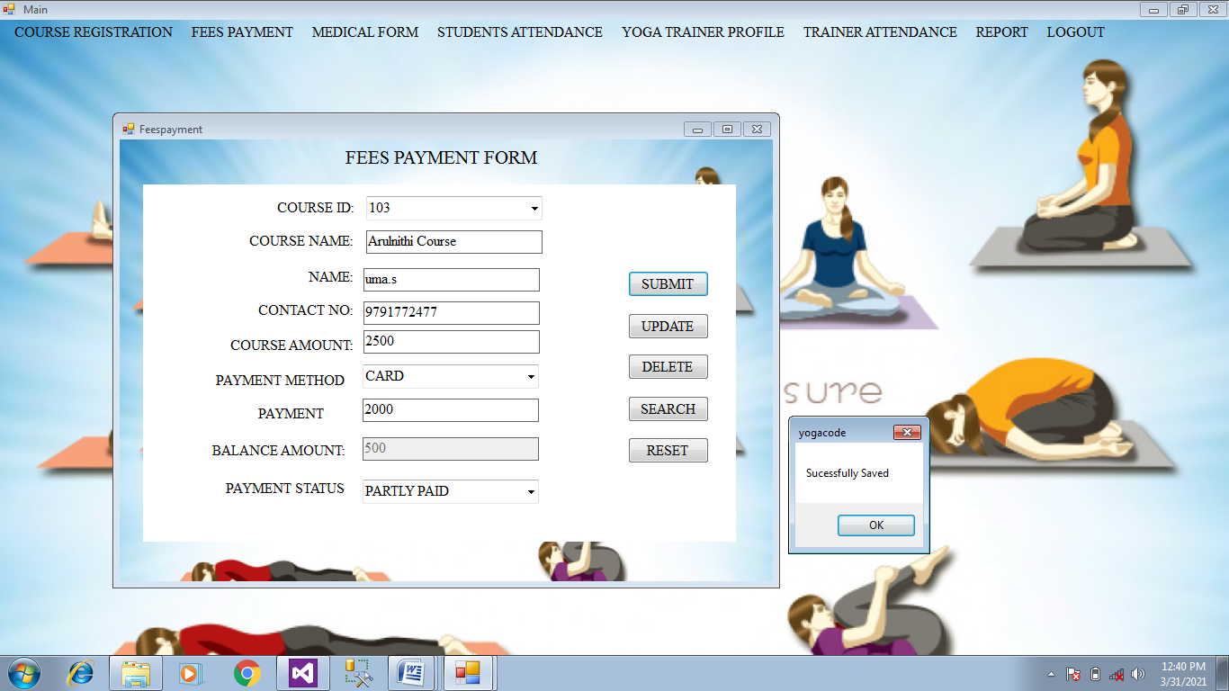
MEDICAL FORM
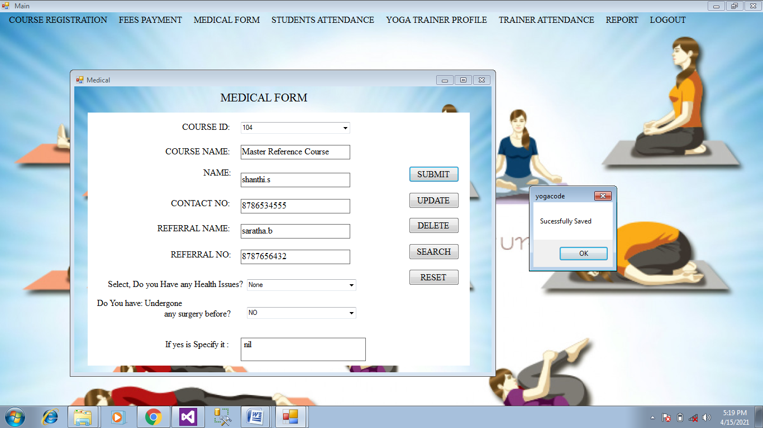

STUDENT ATTENDANCE FORM
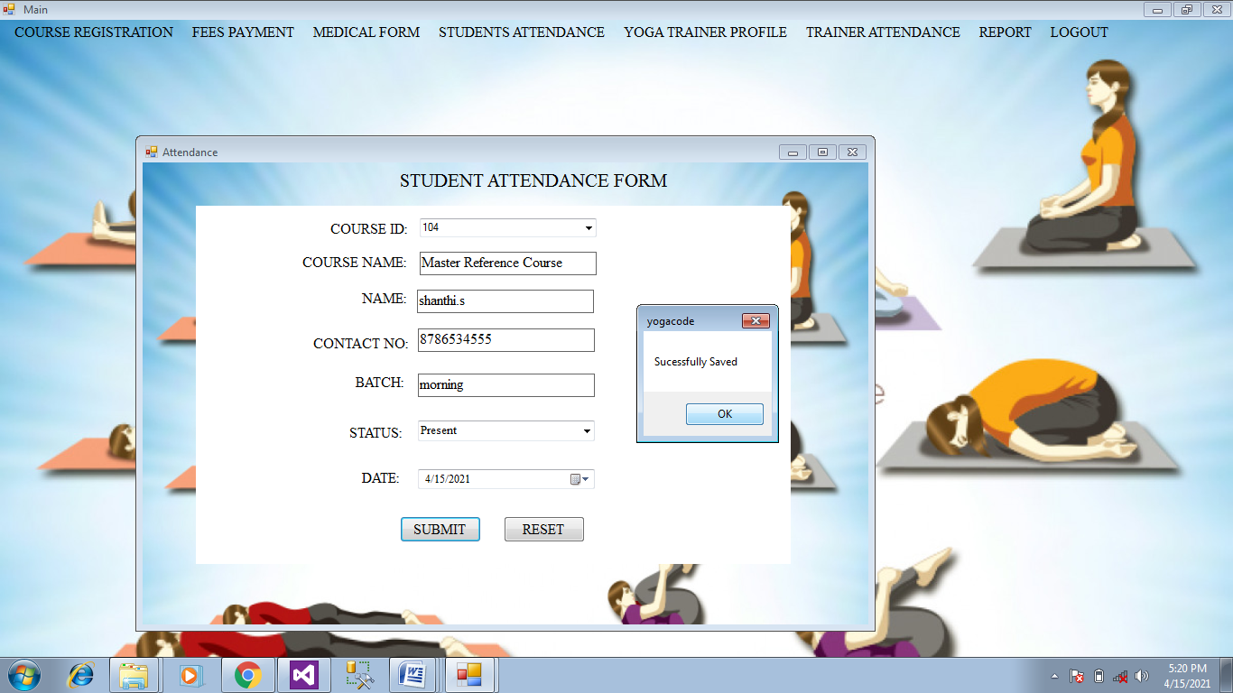
TRAINERS PROFILE FORM
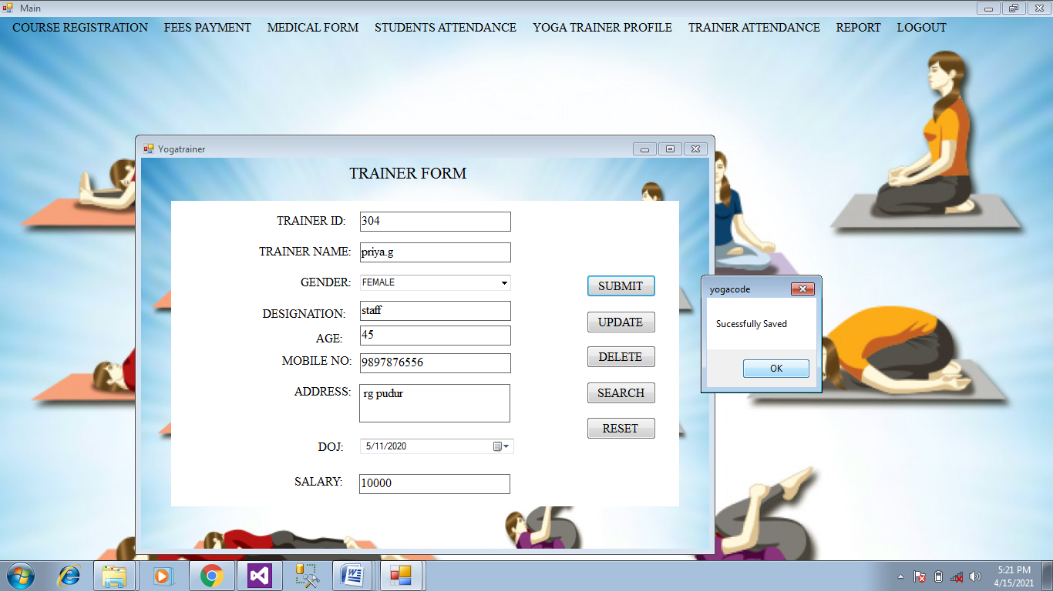

TRAINERS ATTENDANCE FORM
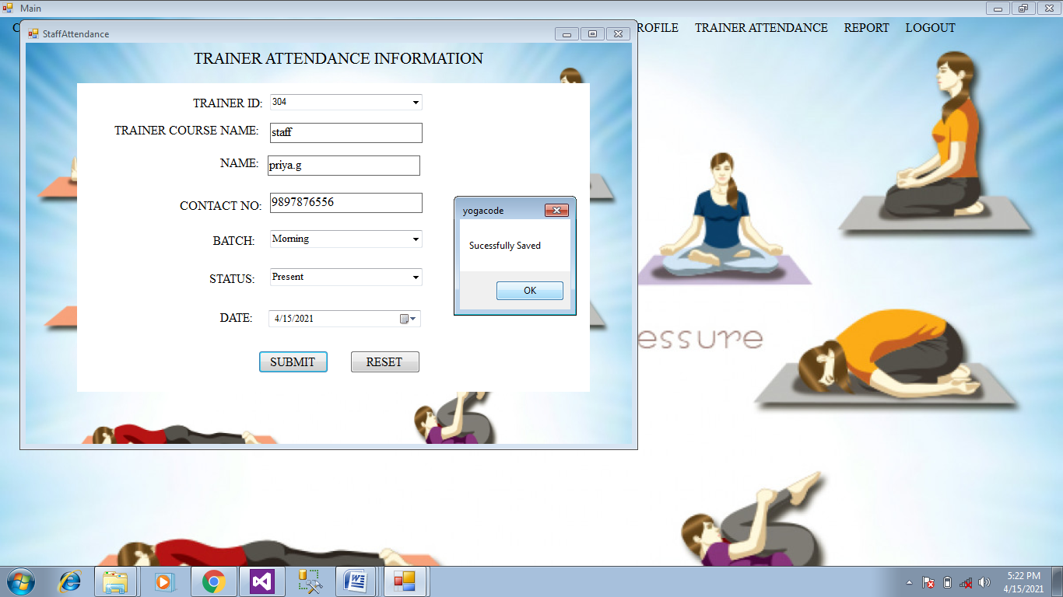
COURSE REGIATRATION REPORT
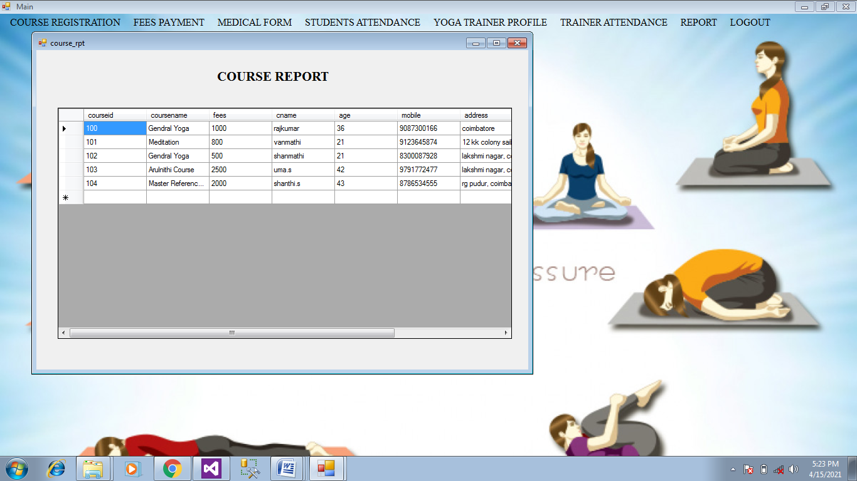

FEES PAYMENT REPORT
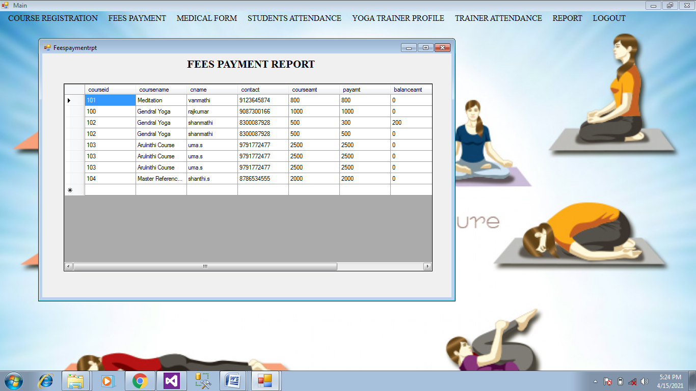
YOGA TRAINERS REPORT
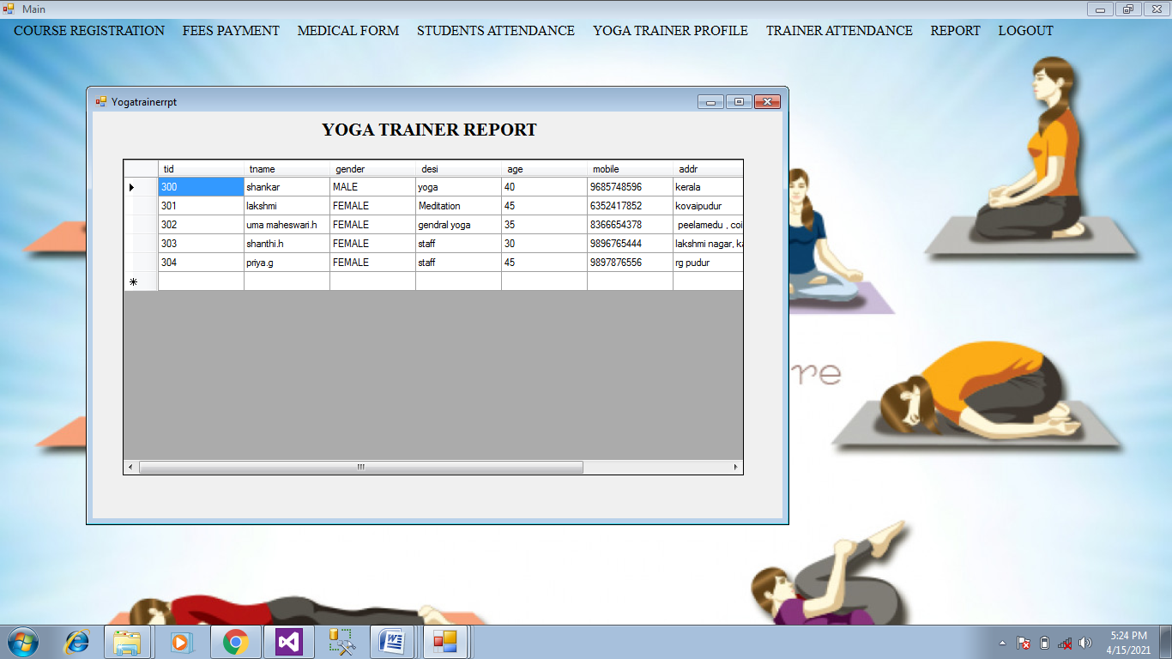

STUDENT ATTENDANCE REPORT
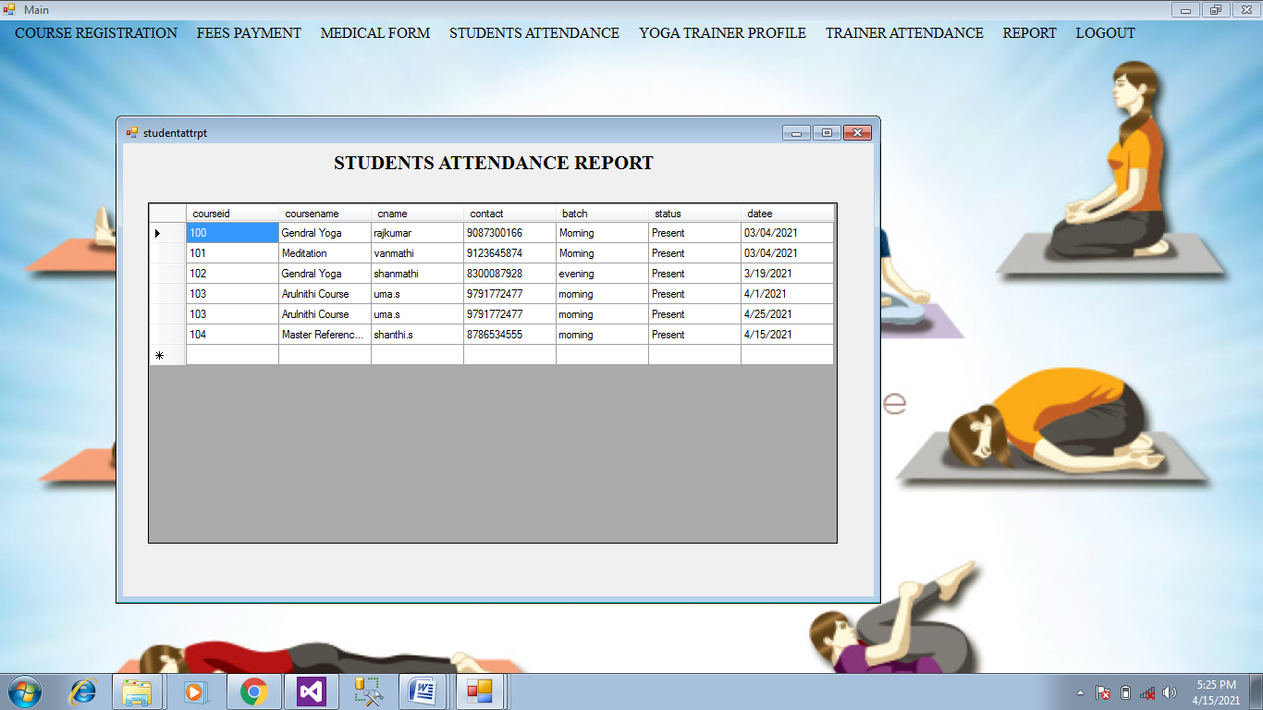

SYSTEM TESTING

CHAPTER V
SYSTEM TESTING
SYSTEM TESTING
System testing is a level of testing that validates the complete and fully integrated software product. The purpose of a system test is to evaluate the end-to-end system specifications. Usually, the software is only one element of a larger computer-based system. Ultimately, the software is interfaced with other software/hardware systems. System Testing is actually a series of different tests whose sole purpose is to exercise the full computer-based system. System testing is the state of implementation, which is aimed at ensuring that the system works accurately and efficiently. It certifies that the whole set of programs hang together.
System testing requires a test plans, that consists of several key activities and steps for run program, string, system and user acceptance testing.. Testing phase is the development phase that validates the code against the functional specifications. The objective of testing is to discover errors. To fulfil this objective a series of test step such as the unit test, integration test, validation and system test where planned and executed. In the system testing the whole system is tested for interface between each module and program units are tested and recorded. This testing is done with sample data.

It involves two kinds of activities namely
- Integrated testing
- Acceptance testing

INTEGRATED TESTING
Integration testing is the phase in software testing in which individual software modules are combined and tested as a group. Integration testing is conducted to evaluate the compliance of a system or component with specified functional requirements. Integrated testing is a systematic technique for constructing tests to uncover errors associated with interface. Objective is to take unit tested modules and build a program structure that has been dictated by design

ACCEPTANCE TESTING
Acceptance testing, a testing technique performed to determine whether or not the software system has met the requirement specifications. The main purpose of this test is to evaluate the system's compliance with the business requirements and verify if it is has met the required criteria for delivery to end users. Acceptance testing involves planning an execution of a functional test, and performance test to verify that the implemented system satisfies the requirement. The acceptance testing is the final stage of the user the various possibilities of the data are entered and the results are tested.

UNIT TESTING
Here each program is tested individually so any error apply unit is debugged. The sample data are given for the unit testing. The unit test results are recorded for further references. During unit testing the functions of the program unit validation and the limitations are tested. Unit testing is testing changes made in a existing or new program this test is carried out during the programming and each module is found to be working satisfactorily.
For example in the registration form after entering all the fields we click the submit button. When submit button is clicked, all the data in form are validated. Only after validation entries will be added to the database. Unit testing comprises the set of tests performed by an individual prior to integration of the unit into large system. The situation is illustrated in as follows
Coding-> Debugging ->Unit Testing -> Integration testing->Output Testing
The four categories of test that a programmer will typically perform on a program unit
- Functional test
- Performance test
- Structure test

Functional test involve exercising the code with nominal input values for which the expected results are known as well as boundary values and special values. Performance testing determines the amount of execution time spent in various parts of unit program through put and response time and device utilization by the program. Structured testing is concerned with a exercising the internal logic of a program and traversing paths. Functional testing, performance testing are referred as “black box” testing and structure testing is referred as “white box” testing

OUTPUT TESTING
The determination of output based on the function's specifications. The execution of the test case. The comparison of actual and expected outputs. To check whether the application works as per the customer need. Asking the user about the format required by them tests the output generated by the system under consideration .It can be done in two ways, One on screen and other on printer format. The output format on the screen is found to be correct as the format designed in system test.

VALIDATION TESTING
The process of evaluating software during the development process or at the end of the development process to determine whether it satisfies specified business requirements. Validation Testing ensures that the product actually meets the client's needs. Software validation is achieved through a series of test that demonstrates the conformity and requirements. Thus the proposed system under consideration has to be tested by validation and found to be working satisfactorily. For example in customer enters phone number field should contain number otherwise it produces an error message similarly in all the forms the fields are validated.

SYSTEM IMPLEMENTATION

CHAPTER VI

SYSTEM IMPLEMENTATION
Systems implementation is the process of defining how the information system should be built (i.e., physical system design), ensuring that the information system is operational and used, ensuring that the information system meets quality standard (i.e., quality assurance). Implementation is the stage in the project where the theoretical design is turned into a working system. The most crucial stage is achieving a successful new system and giving a user confidence in that the new system will work efficiently and effectively in the implementation stage. The stage consist of
- Testing a developed program with sample data
- Detection and correction of error
- Creating whether the system meets a user requirements
- Making necessary changes as desired by users.
- Training user personal
IMPLEMENTATION PROCEDURES
Implementation is the carrying out, execution, or practice of a plan, a method, or any design, idea, model, specification, standard or policy for doing something. ... For an implementation process to be successful, many tasks between different departments need to be accomplished in sequence. The implementation phase is less creative than system design. A system design may be dropped at any time prior to implementation, although it becomes more difficult when it goes to the design phase. The final report of the implementation phase includes procedural flowcharts, record layouts, and a workable plan for implementing the candidate system design into a operational design.

USER TRAINING
User training can truly help with implementation of a new system at a company and ensure maximum efficiency right from the start. User training - User training helps the user in operating the system in efficient way. During the training a manual is given to every user so that they can understand the problem and solved it. The content of training is about the use of data that how they can edit, add, query and delete the records. If a user have not sufficient capability of working on system then many kind of errors and problems can occur.
SYSTEM MAINTENANCE
System maintenance is an ongoing activity, which covers a wide variety of activities, including removing program and design errors, updating documentation and test data and updating user support. ... Thus, in corrective maintenance, processing or performance failures are repaired. The modification of a system to correct faults, to improve performance, or to adapt the system to a changed environment or changed requirements. Maintenance is expensive .One way to reduce the maintenance costs are through maintenance mgt and software modification audits Types of maintenance are
- Perfective maintenance
- Preventive maintenance

PERFECTIVE MAINTENANCE
Perfective maintenance is Modification of a software product after delivery to improve performance or maintainability. Preventive maintenance: Modification of a software product after delivery to detect and correct latent faults in the software product before they become effective faults. Changes made to the system to add features or to improve the performance. In future any more features can be added in “DOT NET Communication” and it can easily adopt the changes.
PREVENTIVE MAINTENANCE
Preventive maintenance refers to maintenance action performed to keep or retain a machine/equipment or asset in a satisfactory operating condition through periodic inspections, lubrication, calibration, replacements and overhauls. Changes made to the system to avoid future problems. Any changes can be made in the future and our project can adopt the changes

CONCLUSION

CHAPTER VII
CONCLUSION
The goal of the project “YOGA CENTRE MANAGEMENT SYSTEM” already defined has been successfully achieved. The application is tested very well and errors are properly debugged. This proposed system is to provide an easy way of maintain course registration details, fees payment, attendance and trainers profile , attendance details and systematic way to get the details easily. This project is developed to provide the easy access for admin to maintain records in the efficient manner. Here almost all work is computerized. So the accuracy is maintained.
The project is used for the course registration , fees payment , attendances for both students and trainers and trainers profile , So it will reduce the time. The entire system is documented and can be easily understood by the end users. The forms are very user friendly and also easy to handle even by the beginners with very little efforts and guidance.
The main aim of the project is to bring a full-fledged computerized organization, and to enable the transaction details to maintain records, which makes of their work easier. Thus, the proposed system has been developed with good amount of flexibility without compromising on the response time. Computerization of the entire system will enhance more accuracy and reduces major part of clerical works. Fast, clear and legible reports can be generated without any ambiguity. Integrated database design and ease of maintenance is a major advantage of the system. User friendliness is a unique feather of the system. Hence by developing a system that is user-friendly in nature, many users are able to work on the system with little of computer knowledge and training.

FUTURE ENHANCEMENT

The project tittle” YOGA CENTRE MANAGEMENT SYSTEM” is developed successfully with all the modules. Every application has its own merits and demerits. The project has covered almost all the requirements. Further requirements and improvements can easily be done since the coding mainly structured or modular in nature. Changing the existing modules or adding new modules can append improvements.

The project has been developed and the goals are achieved successfully. The project has been developed with front end as VB.Net and backend as SQL Server. The frontend can also be changed. ASP.Net can replace the front-end tool such as HTML and CSS for more speed. The system is currently developed and ready for implementation to include the system is highly feasible and user friendly. To provide better facility regarding security, it uses security provider software and we access any place and any where use that. It can have an enhancement on proper in the future according to the user’s requirements.

BIBLIOGRAPHY

- .Elias Awath, “SYSTEM ANALYSIS AND DESIGN”,Tata Mc Graw Hill Publication, Sixth Edition,2003
- .S.Ramachandran,”COMPUTER AIDED DESIGN”, Air Walk Publication, Third Edition,2003
- .Richard Fairley,”SOFTWARE ENGINEERING CONCEPTS”,Tata Mc Graw Hill Publication, Second Edition,1997
- .Distributed .NET Programming in VB .NET by Tom Barnaby
- Professional VB.NET, 2nd Edition by Fred Barwell, et al
- The .NET Languages: A Quick Translation Guide by Brian Bischof
- Programming VB.NET: A Guide for Experienced Programmers
by Gary Cornell, Jonathan Morrison
- Learning Visual Basic.NET Through Applications by Clayton Crooks II
- Visual Basic .NET How to Program (2nd Edition) by Harvey M. Deitel, Paul J. Deitel, Tem R. Nieto

