Enzymatic Extraction of Natural Dye from Arnebia nobilis and its Application on Cotton

Sankaragomathy, G
(12PBX004)

Thesis submitted to
Avinashilingam Institute for Home Science and Higher Education for Women,
Coimbatore – 641 043

In Partial Fulfillment of the Requirements for the
Degree of Master of Science in Bio Textiles

March, 2014
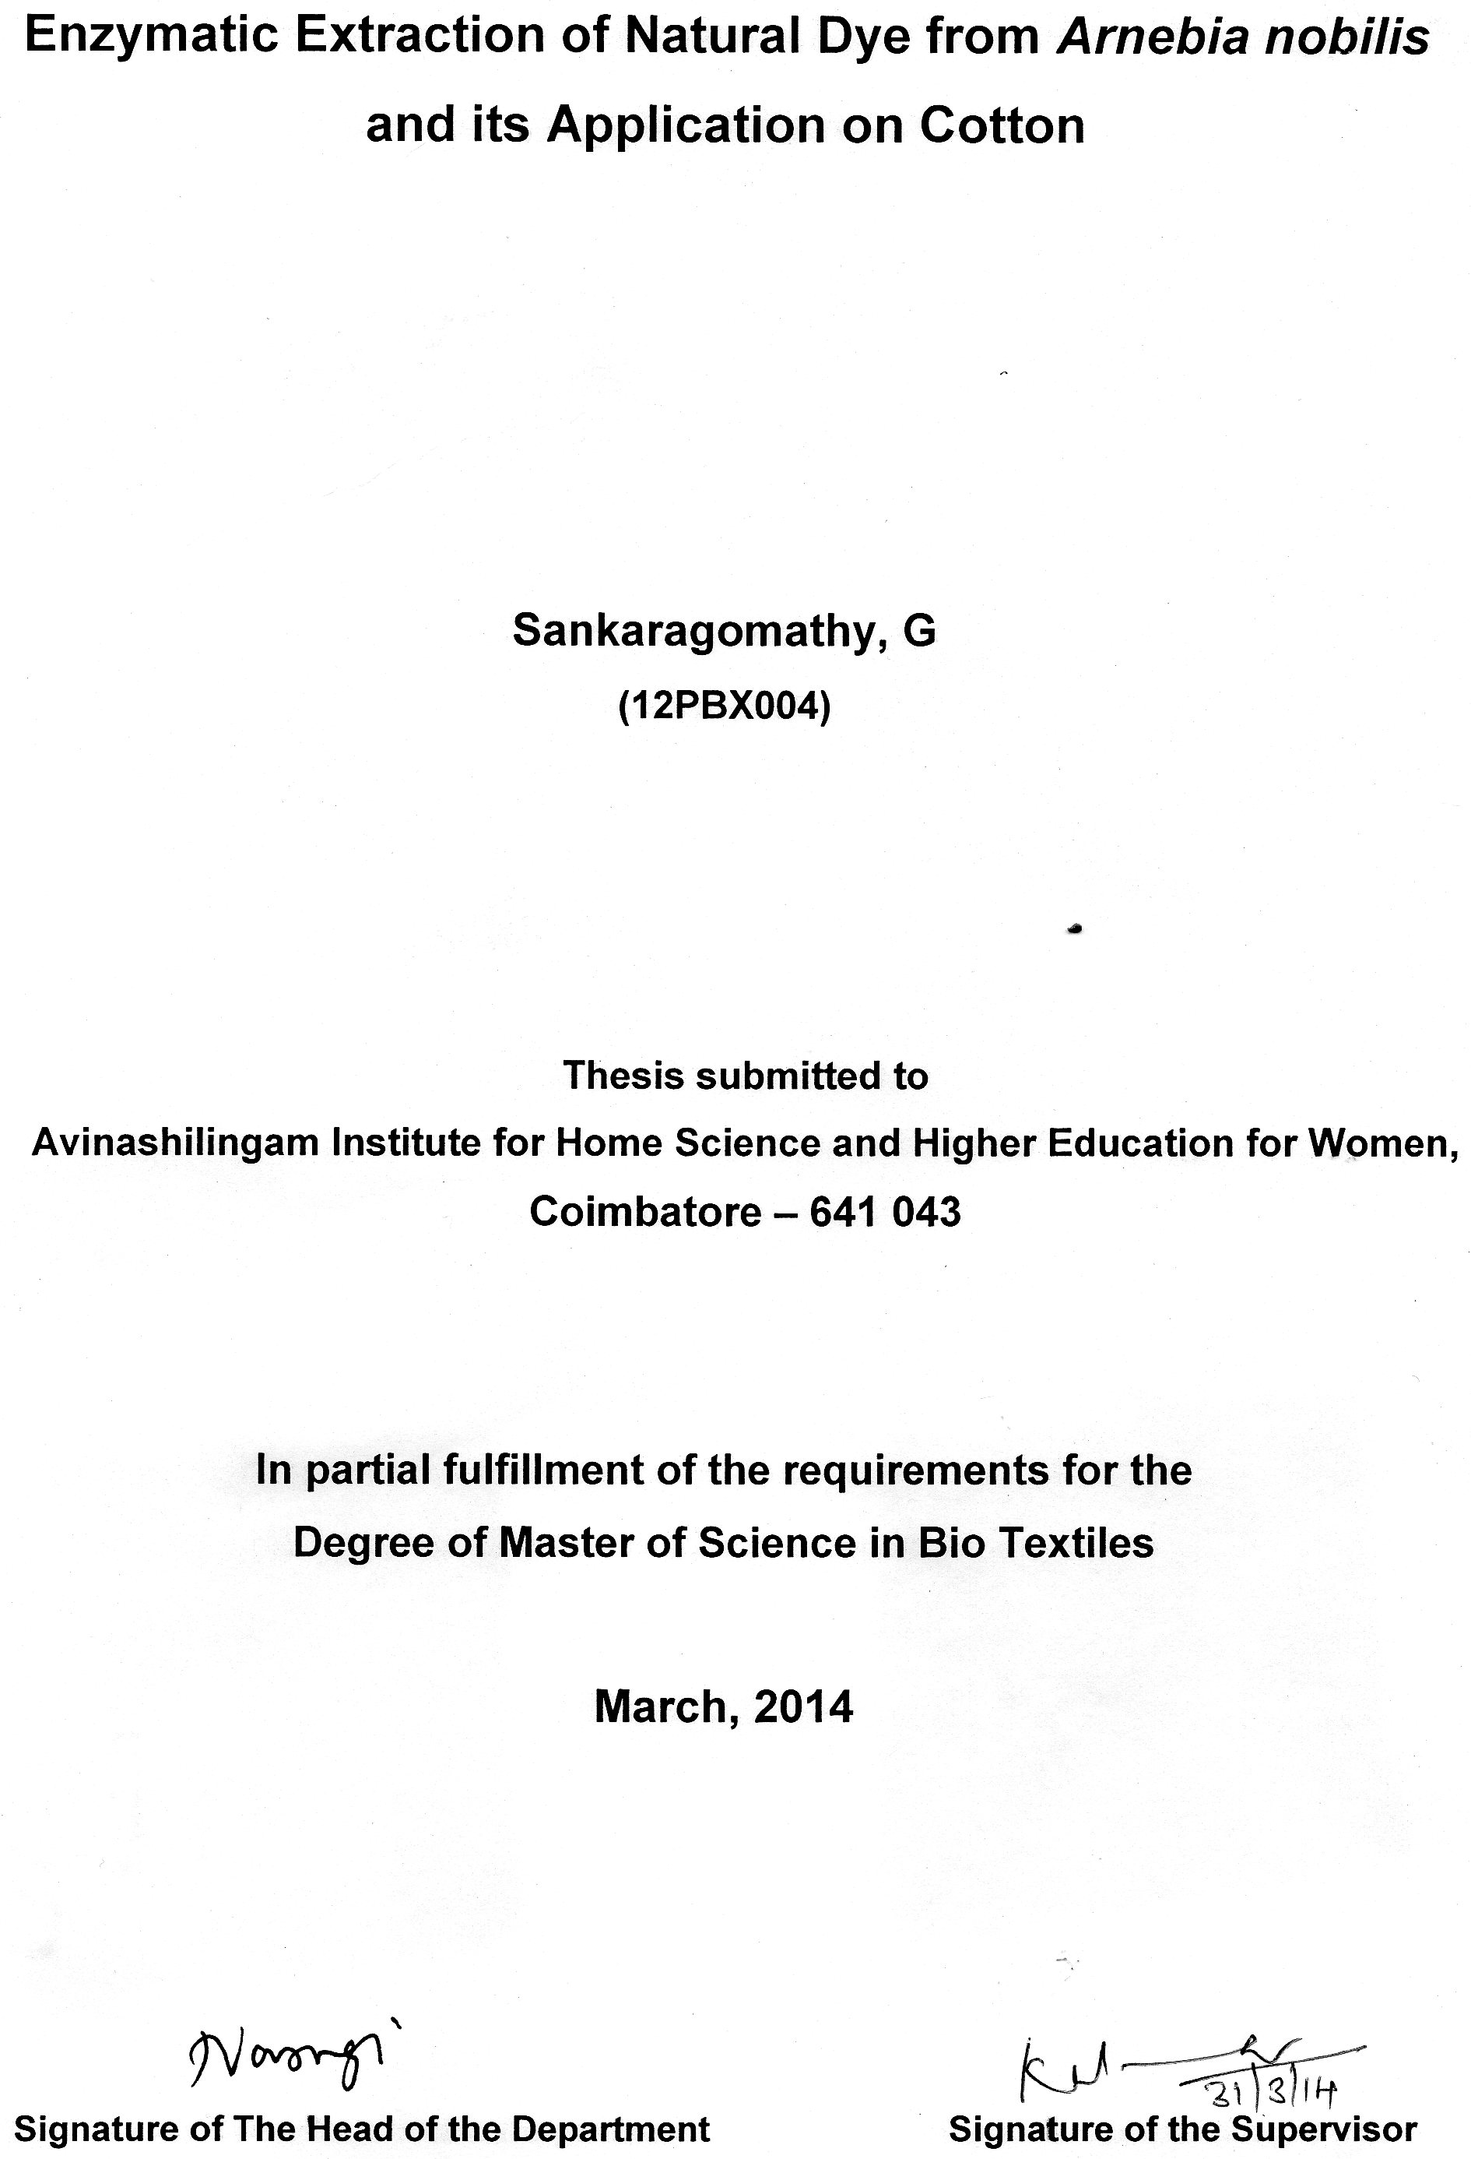

ACKNOWLEDGEMENT

The investigator places her humble salutations and prayer to the ALMIGHTY GOD for his uncountable blessings showered upon her throughout the study.
The investigator expresses her sincere thanks to the former chancellors of Avinashilingam Institute for Home Science and Higher Education for Women, Coimbatore, AYYA THIRU.Dr.T.S. AVINASHILINGAM and HONY.COL.PADMASHRI, AMMA, Dr.(Tmt.) RAJAMMAL P. DEVADAS, M.A., M.Sc., Ph.D. (Ohio State), Hon. D.Sc. (Azad Agri. University, Kanpur), Avinashilingam Institute for Home Science and Higher Education for Women, Coimbatore, for heavenly blessings.
The investigator expresses her sincere thanks to (THIRU) T.S.K.MEENAKSHI SUNDARAM, M.A., M.Phil., Ph.D., Chancellor, Avinashilingam Institute for Home Science and Higher Education for Women, Coimbatore, for providing the infrastructural facilities required for the conduct of the study.
The investigator is indebted to Dr.(Tmt.) SHEELA RAMACHANDRAN, M.Sc., P.G.Dip., Ph.D., Vice-Chancellor of Avinashilingam Institute for Home Science and Higher Education for Women, Coimbatore, for providing all the amenities required for the conduct of the study.
The investigator records her gratitude to Dr.(Tmt.) GOWRI RAMAKRISHNAN, M.Sc. (Madras), M.Phil., Ph.D. (Avinashilingam), Registrar, Avinashilingam Institute for Home Science and Higher Education for Women, Coimbatore, for providing all the help for the smooth conduct of the study.
The investigator records her respectful regards and tribute to Dr.(Tmt.) K.THANGAMANI, M.Sc., Dip. Ed., M.Phil., Ph.D., former Dean, Faculty of Home Science and Dr. U. K. LAKSHMI, M.Sc., Dip. Ed. M.Phil., Ph.D., Dean, Faculty of Home Science and Professor & Head, Department Food Science and Nutrition, Avinashilingam Institute for their Home Science and Higher Education for Women, Coimbatore, for their constant support, guidance and encouragement rendered to complete the research work.
She records her deep sense of gratitude to Dr.(Tmt.)N.VASUGI RAAJA, M.Sc., M.B.A., M.Phil. (Madras), Ph.D. (Avinashilingam), Professor and Head, Department of Textiles and Clothing, Avinashilingam Institute for Home Science and Higher Education for Women, Coimbatore, for her concern and encouragement which have helped in the successful completion of this study.
The investigator feels extremely proud and privileged for having worked under the guidance of her esteemed guide Dr.(Tmt.)K.KALAIARASI, M.Sc., M.Phil., Ph.D., Assistant Professor, Department of Textiles and Clothing, Avinashilingam Institute for Home Science and Higher Education for Women, Coimbatore, for her constant motivation, keen interest, restless support, untiring patience, innovative ideas, suggestion, constant love and easy approach throughout the study.
The investigator gratefully acknowledges the encouragement, timely help and support received from her friends. She expresses her deepest sense of gratitude to her FATHER M. GOWRISANKAR, MOTHER G. BHUVANESHWARI AND BROTHER G. MALAIAPPAN for extending their support without them the study would never have seen to the light of the day.

CONTENTS

CHAPTER | TITLE | PAGE NO.
 | LIST OF TABLES
 | LIST OF FIGURES
 | LIST OF PLATES
1 | INTRODUCTION | 1
2 | REVIEW OF LITERATURE | 4
3 | METHODOLOGY | 14
4 | RESULTS AND DISCUSSION | 29
5 | SUMMARY AND CONCLUSION | 53
6 | BIBLIOGRAPHY | 57
7 | APPENDIX | 62

LIST OF TABLES

TABLE  NO. | TITLE | PAGE  NO.
1 | Dye source concentration | 30
2 | Time | 31
3 | Temperature | 32
4 | Ph | 33
5 | Mass liquor ratio | 33
6 | Optimized conditions for the extraction of dye from Arnebia nobilis | 34
7 | Dye concentration | 35
8 | Time | 35
9 | Temperature | 36
10 | Subjective evaluation | 37
11 | Fabric thickness | 38
12 | Fabric weight | 39
13 | Fabric strength(warp) | 40
14 | Fabric strength(weft) | 41
15 | Fabric elongation (warp) | 42
16 | Fabric elongation (weft) | 43
17 | Abrasion resistance | 44
18 | Pilling resistance | 45
19 | Drapability | 46
20 | Fabric stiffness (warp) | 47
21 | Fabric stiffness (weft) | 48
22 | Drop test | 49
23 | Sinking test | 50
24 | Wicking test | 51
25 | Color fastness to sunlight, crocking and washing | 52

LIST OF FIGURES

FIGURE  NO. | TITLE | PAGE  NO.
1 | Fabric thickness | 38
2 | Fabric weight | 39
3 | Fabric strength(warp) | 40
4 | Fabric strength(weft) | 41
5 | Fabric elongation (warp) | 42
6 | Fabric elongation (weft) | 43
7 | Abrasion resistance | 44
8 | Pilling resistance | 45
9 | Drapability | 46
10 | Fabric stiffness (warp) | 47
11 | Fabric stiffness (weft) | 48
12 | Drop test | 49
13 | Sinking test | 50
14 | Wicking test | 51

LIST OF PLATES

PLATE NO. | TITLE | PAGE  NO.
1 | Arnebia nobilis- (ratanjot) bark | 18
2a | Ratanjot powder | 18
2b | Conventional extraction of ratanjot powder | 18
3a | Commercial cellulose | 18
3b | Cellulase sprayed ratanjot powder | 18
3c | Enzymatic extraction of ratanjot powder | 18
4 | Dye source concentration | 20
5 | Time | 20
6 | Temperature | 20
7 | Ph | 20
8 | Mass liquor ratio | 20

LIST OF APPENDIX

APPENDIX NO. | TITLE PAGE NO
1 | Original and Dyed Fabric Samples 62

1.0 INTRODUCTION
Colour plays an impeccable role in life. The materials which cause colour are present everywhere particularly in plants and trees. The chemistry of colour has never failed to fascinate and intrigue. Colour is integral to the interface between people and nature. Humans have traditionally preferred natural sources to add colours to clothing. Colour is a powerful tool that can change mood and attitude, as well as enhance everyday life. Each colour has certain signals, and each signal permeates through human’s neurological system, mental and psychological state. It is believed that colours can change the opinion and make a difference in the life. (Jahan and Bhargava, 2013).
Materialistic growth of science has made it possible to obtain many colourants in the laboratory with the invention of human ingenuity. However the colourants obtained from biological sources – the bio colourants – have also remained a central theme of investigation for several reasons. In the recent years the availability and the use of natural colourants has greatly increased as a consequence of perceived consumer preference for the reason of health and quality. Moreover, artificial colourants tend to impact undesirable taste and are harmful to human beings (Sekar, 2013).
One can get colouring matter from almost all vegetable matter. However, only a few of these sources yield colourants which can be extracted and work out to be commercially viable. Basically, three primary colours are required to get any given hue (or colour). This type of approach has been worked out for synthetic dyes. However in the case of natural dyes, the dyeing procedures are different for different dyes and they cannot be blended to get the required colour easily (Gulrajani, 1999).
Some synthetic dyes cause skin allergies. Natural dyes due to their eco friendly nature serves a superior value to textile material and apparel because of their biodegradable nature which are safe to flora, fauna, ecology and to our skin. Environmental issues are becoming more crucial all over the world. The concern for environment worldwide has again revived interest in natural dyes (Dinesh and Jayalakshmi, 2011). The increasing awareness of environmental issues has driven increased interest in environmentally friendly techniques of dyeing (Adivarekar et al., 2013).
In the past, at the dawn of civilization, the old people tried to ornament their surroundings similar to that of natural colours observed in soil, plant and other sources. They started to dye their clothes with the dyes obtained from natural sources. This gave new science of colours from natural origin. The art of dyeing was as old as human civilization. India was forerunner in the art of natural dyeing. In the beginning there were only dyes derived from natural dyes. Natural dyes are comprised of those colourants that are obtained from natural sources without any chemical processing. Natural dyes have been classified into major categories including plant or vegetable origin, animal origin and mineral origin (Jahan and Bhargava, 2013).
Most of the natural dyes are non substantive dyes, as they require the aid of mordants to penetrate the yarns or fibres. The mordants are considered as an integral part of the natural dyes. The mordant is usually applied in a separate process after dyeing. But in some cases, the mordant and dye are used together (Mahale et al., 2003). Arnebia nobilis of the family Boraginaceae and its local name is seemai vembalam pattai can be used as a dyeing agent for cotton (Subramanian, 2008).
The textile industry has been quick to adopt new textile enzymes. Enzymes for textile application were first developed for stonewashing jeans in 1987 (Kanipriya et al., 2009). The term enzyme was coined by Kuhne in 1877. The activities of enzymes have been introduced since thousand years (Ganguly and Mal, 2013). Enzymes have been used in textile industry for over 35 years for desizing, scouring, polishing, washing, degumming etc (Kan and Yuen, 2005).
Enzymes mainly applied in textile processing are cellulases, amylases, proteases, esterases, nitrilases, catalases, peroxidases, laccases, lipases and pectinases (Swati, 2013). The introduction of enzyme in textile industry enhanced the development of environmental friendly technology in textile processing. Uses of enzymes rapidly gaining global recognition because of their non-toxic, eco-friendly characteristics (Ganguly and Mal, 2013).
Enzymes are specialised protein molecules which catalyse biochemical reactions in all living cells. Enzymes are bio-polymers of about twenty amino acids with molecular weight ranging from 12,000 to 15,000 (Rani and Mishra, 2007). The most important characteristic of the enzyme is their specificity. They act upon a very specific substrate, under a narrow range of conditions of temperature, agitation. Every enzyme has a particular range of pH and temperature for optimum activity in combined pre-treatment operations (Srivastav and Butola, 2009).
The main enzymes are amylases, proteases, cellulases, xylanases, glucoamylase, pectinase and catalase. They can be used for desizing, scouring, finishing etc. (Mahapatra, 2010). Cellulases are widely used in textile application (Trotman, 2005). It is ecofriendly and biodegradable (Mahapatra, 2010).
In the present investigation an attempt has been made to extract the dyes with the help of enzymes and to optimize the dyeing condition of colourants (Arnebia nobilis - bark). Enzyme assisted extraction have been used to improve yield. Hence the objective of the present study entitled “Enzymatic Extraction of Natural Dye from Arnebia nobilis and its Application on Cotton” is
- To extract natural dye from Arnebia nobilis (bark) using cellulase enzyme
- To dye cotton fabric using extracted dye
- To evaluate the characteristics of the dyed fabrics.

2.0 REVIEW OF LITERATURE
The review of literature pertaining to the study entitled “Enzymatic Extraction of Natural Dye from Arnebia Nobilis and its Application on Cotton” is discussed under the following headings.
2.1 Natural Dyes
2.1.1 Introduction
2.1.2 Advantages
2.1.3 Disadvantages
2.1.4 Importance
2.1.5 Classification
2.2 Extraction of Natural Dyes
2.2.1 Traditional Method of Extraction
2.2.2 Aqueous Extraction
2.2.3 Solvent Extraction
2.2.4 Enzymatic Extraction
2.3 Arnebia nobilis
2.3.1 Applications
2.3.2 Extraction
2.4 Enzymes
2.4.1 Cellulase
2.4.2 Application
2.5 Mordants
2.6 Cotton
2.6.1 History
2.6.2 Types of Cotton
2.6.3 Properties
2.6.4 Quality
2.6.5 Advantages
2.6.6 Dyeing of Cotton with Natural Dyes

2.1 NATURAL DYES
2.1.1 Introduction
Textile material is coloured for value addition, look and desire of the customers. In the past this purpose of colouring textiles was initiated using colours of natural source until synthetic colours/dyes were invented and commercialised. However all the synthetic colourants being synthesised from petrochemical sources through hazardous chemical processes pose concerns regarding their eco-friendliness. Hence, worldwide, growing products is being generated and a renewed interest of consumers towards use of textiles dyed with eco-friendly natural dyes is on the rise (Chinta and Indi, 2007).
Natural dyes are ecofriendly, biodegradable, nontoxic and non allergic in comparision to synthetic dyes. Natural dyes are gaining importance not only for the safety of health but also for the lustrous and production of varied colours (Das et al., 2010). In natural dyes, the dyeing procedures are different for different dyes and they cannot be blended to get the required colour easily (Gulrajani, 1999).
Besides ecofriendliness, natural dyes have many more technical advantages, including their uncommon and soothing shades. However, the common drawbacks of natural dyes are their non reproducible and non uniform shades, poor to moderate colour fastness and lack of scientific information on the chemistry of dyeing and standardised dyeing methods (Datta et al., 2007).
2.1.2 Advantages
The shades produced by natural dyes/colourants are usually soft, lustrous and soothing to the human eye. Natural stuff can produce a wide range of colours by mix and match system. A small variation in the dyeing technique or the use of different mordants with the same dye (polygenetic type natural dye) can shift the colours to a wide range or create totally new colours, which are not easily possible with synthetic dyestuffs. Natural dyestuffs produce rare colour ideas and are automatically harmonizing (konar and samanta, 2011).
Unlike non-renewable basic raw materials for synthetic dyes, the natural dyes are usually renewable, being agro-renewable/vegetable based and at the same time biodegradable. Many plants thrive on wastelands. Thus, wetland utilization is an added merit of the natural dyes. Dyes like madder grow as host in tea gardens. So there is no additional cost or effort required to grow it. Some of its constituents are anti-allergens, hence prove safe for skin contact and are mostly non-hazardous to human health. Natural dyes bleed but do not stain other fabrics, turmeric being an exception (konar and samanta, 2011). Unlike the non renewable peterochemicals, the basic raw material for synthetic dyes, the vegetable based natural dyes are replaceable and at the same time, biodegradable (Ghosh et al., 2011).
2.1.3 Disadvantages
Natural materials played vital role in industrial and commercial life during past centuries but complete rejection of these dyes depend on many factor such as the dyes were difficult to store and extracting dye from the raw material was time consuming and dyeing that on the fabric and to get the required shade was also difficult. The artificial dyes could be manufactured in any seasons unlike natural dyes. They need not to be chipped and grounded before use. They are made in pure form and their colours are not affected by impurities that fade dyes of natural origin (Hemalatha, 2013).
Main disadvantages of natural dyes are their limited availability, low colour yield, complexity of dyeing process and reproducibility of shade. Besides these there are some technical drawbacks of natural dyes, they are: limited number of suitable dyes, allow only silk, natural silk, linen and cotton to be dyed, great difficulty in blending dyes, non-standardised, inadequate degree of fixation, inadequate fastness properties (Hemalatha, 2013).
2.1.4 Importance
The environmental impact of synthetic dyes is raising global concern. National and international awareness about depletion of natural resources, ecological imbalance, pollution problems and disturbed environment due to the usage of hazardous chemicals and synthetic dyes have forced us to think of a much safer alternative. These factors have brightened the scope of utilisation of natural dyes. So in recent years, natural dyes are seen as more eco-friendly, unlike their synthetic counterparts, as they are all derived from nature. Each plant provides on amazing diversity of shades. From one plant, one may obtain between 5-15 varying colours and shades are subtle and tend to harmonise with each other (kedar et al., 2011).
2.1.5 Classification
Dyes can be obtained from natural sources or synthesized from chemicals (Arora, 2010). Natural dyes are of two types: substantive or non mordant dyes, which produce fast shades at boil (Chakraborty et al., 2010). They are classified based on colour, chemical structure and source (Kedar et al., 2011).
2.2 EXTRACTION OF NATURAL DYES
Commercialisation of natural dyes can be done successfully by systematic and scientific approach towards extraction and purification by minimising the investment cost of natural dyes. Generally natural colourants are soluble in water in its original state, however in the raw form; it requires extraction from the source. Based on solubility of natural colourants, different extracting methods are being adopted (Chakraborty et al., 2013).
2.2.1 Traditional Method of Extraction
The traditional method to extract the dyestuffs from dye yielding plants includes grinding of the dye part and adding it directly to the dye bath for dyeing. The requirement of dye is more compared to shade obtained in the finished fabric. The shade was so poor because the dyestuff with chromophores contains other matters which do not colour the fabric, so dyestuff requirement increases (Chakraborty et al., 2010).
2.2.2 Aqueous Extraction
Dye yielding parts were soaked in water and heated at 60$℃$ for a certain time. The colourants present in plant part were transferred to the aqueous solution. Then the dye solution extracted from the sources was filtered and collected for dyeing.
2.2.3 Solvent Extraction
Sometimes colourants which are present in natural sources do not come in the aqueous medium. The common solvents like methanol, acetone, etc are used for the extraction of colouring materials. Here the natural source is kept in the solvent for 4 – 24 hours to get the optimum yield (Chakraborty et al., 2010).
2.2.4 Enzymatic Extraction
Biological enzyme functions at the bark surface, destructs cell wall, reduces the resistance of extracting colourant from the cells, so as to improve the extract yield, with low temperature, high purity and less pollution characteristics (Ren et al., 2009).
2.3 Arnebia nobilis (ratanjot)
The name ratanjot is attributed to the roots of various Boraginaceous plant species. The genuine ratanjot is Arnebia nobilis which was imported into India from Afghanistan. It can be used as dyeing materials to colour fibres (Gupta et al., 2009).
2.3.1 Application
Dye from Arnebia nobilis (ratanjot) is a natural dye which can be used as dyeing agent for colouring textile fibres like cotton. Shikonin is the component extracted from the bark can be used as colouring agent however it is not the major colouring component. The purple-brown pieces of barks or rootstocks are 5-10cm long and 3-6 cm in diameter and are covered with several papery layers of the same colour with the characteristic odour (Gupta et al., 2009). Mordants are used to fix the colour in dyeing process. The fabric is impregnated with the mordant, and then during the dyeing processes, the dye reacts with the mordant forming a chemical bond and attaching it firmly to the fabric (Vijayeendra et al., 2011).
2.3.2 Extraction
A 6% solution of cellulase was sprayed on Arnebia nobilis bark (8g) for better soaking and contact and left overnight. The enzyme treated material was taken out and 100ml of water was added to it and kept for boiling for 60 min at 90$℃$. Extraction was carried out through Whatman No. 1 filter paper. The colourants get extracted (Srivastava et al., 2010).

2.4 ENZYMES
Enzymes are the biological catalysts and are responsible for synthesis and modification of various substances required in and outside the body of an organism (Sridhar et al., 2011). Enzymes integrate the cellular chemical reactions and provide the order without which the complex processes of life would not be possible (Bianchi, 2009). Enzymes are naturally occurring proteins capable of catalysing specific chemical reactions and being catalysts, facilitate reaction without being consumed. Enzymes have a protein like structure with primary, secondary and are susceptible to denaturing (Karmakar, 1999).
The enzymes are large protein molecules made up of a long chain of amino acids which are produced by living cells in plants, animals and micro-organisms such as bacteria and fungi (Prabhu et al., 2007).
2.4.1 Cellulase
Cellulose is one of the most widely available polymers in nature. It is generally accompanied by hemi-cellulose and lignin. Wood / bark are the most widely used cellulosic material. It is found all over the world. Generally there are two types of wood, hard wood and soft wood. The hard woods are composed of closely packed cells with thick walls. On the other hand, soft woods are usually composed of large cells with thin walls. Woods are mainly cellulose, lignin and hemicelluloses (Mishra, 2000). The cellulases are enzymes, hydrolyzing bonds in the cellulose. The cellulases are produced as a multi component enzyme system, typically consisting of three enzymes, which acts synergetically in the hydrolysis of cellulose: endoglucanase, cellobiohydrolase and beta glucosidase (Mitsulov et al., 2007).
Cellulases are high molecular colloidal protein catalysts in metabolic form and are commonly produced by soil dwelling fungi and bacteria (Trotman, 2005). Industrial cellulases are complexes of a number of cellulases, cellobiases and related enzymes in non-uniform composition, with molecular weight ranging from 10,000 to 4, 00,000 (Geake and Clibbens, 2001).
Cellulases comprise a multi-component enzyme system, including endoglucanases that hydrolyse cellulose chains randomly, cellobiohydrolases that split cellubiose from cellulose ends and cellobiases that hydrolyse cellobiose to glucose (Little and Clibbens, 2006).
In general there are two major commercial classifications of cellulase. Classification of cellulase enzymes based on optimum ranges: “acid cellulases” exhibit the most activity within the pH range 4.5 – 5.5, at a temperature of 45 - 55$℃$; while “neutral cellulases”, are more effective in the 5.5 -8.0 pH range at 50 - 60$℃$. Currently, acid cellulase and neutral cellulase are more commonly used (Karmakar, 2000).
The mechanism of enzymatic hydrolysis of cellulosic materials is complicated and not yet fully understood (Raven and Earland, 2007). Endocellulases hydrolyse cellulose polymers randomly along the chains, preferably at tacking non-crystalline region (Pressley and Crewther, 2001).
Coupled with the binding domains associated with the enzyme, exo-cellulases may assist in degradation of cellulose by disrupting the local crystalline cellulose structure, which makes the region more susceptible to subsequent hydrolysis by endo-cellulases (Soc and Worth, 2003). The three types of cellulase component act synergistically in degrading cellulose to glucose (Viertel, 2006). Synergism of different components in the cellulase complex and inhibition mechanisms further complicate the reaction (Anon, 2010).
2.4.2 Application
Cellulase is used in textile processing mainly for depilling, to obtain stone wash effects, as part of detergent formulations. Besides, cellulase is used for improving the colour yield (Swati et al., 2013). Cellulase produced by fungi, are used for washing cotton fabrics and cellulase can be used for bio-polishing (Mishra and Kashyap, 2011).

2.5 MORDANTS
The word “mordant” is derived from French word “mordre which means “to bite” (Arora, 2010). Natural dye needs a substance such as metallic salts, tannins and oils to create an affinity between the fibre and pigment. These pigments are called mordants and are used to fix the colour in dyeing process. Mordant dyes require one or more metallic salts of aluminium, iron, chromium, copper and other for ensuring reasonable fastness of the colour to sunlight and washing (Sable et al, 2010).Whenever mordant dyes are applied, a pre-treatment of the fibre with a mordant material designed to bind the dye is essential. The mordant becomes attached to the fibre and then combines with the dye to form an insoluble complex called a lake (Smith, 2009).
There are three choices of mordanting, pre mordanting, post mordanting and simultaneous mordanting. In pre mordanting, the sample is impregnated with mordant and then dyed. In post mordanting, the sample is first dyed and then mordanted. In simultaneous mordanting, mordanting and dyeing are carried out at the same time (Jacob, 1999).
2.6 COTTON
2.6.1 History
Cotton fibre is defined as white fibrous substance covering seeds harvested from cotton plant. Nobody seems to know exactly when people first began to use cotton, but there is evidence that it was cultivated in India and Pakistan and in Mexico and Peru 500 years ago. In these two widely separated parts of the world, cotton must have grown wild. Then people learned to cultivate cotton plants in their fields (Kaplan, 2012).
Cotton is one of the chief crops that have received human curiosity and attention all the time from early civilizations spotting the Gossypium species and contributing to continuous evolution of cotton for effective use in societal advancement. Wild or cultivated cotton has been used as a textile fibre for several thousands of years and India is considered as the birth place of cotton cloth, a fragment about 3000 years old having survived (Storey, 1992).
2.6.2 Types of Cotton
Different kinds and types of cotton are grown in various parts of the world. Some of their basic characteristics differ. Variations among cotton fibre also occur because of growth conditions including such factors as soil, climate, fertilizers and pests. The better known kinds and types of cotton used in the United Sates are Upland, American Pinna, Egyptian and Asiatic cotton (Singh, 2008).
2.6.3 Properties
It has the ability to absorb a great deal of moisture, which makes the fabric very good for wearing in hot weather (Storey, 1992). Among the important natural fibres, cotton has the lowest lustre and is the least resistant to exposure to light, weather etc. Cotton fabrics are affected by ordinary light, when exposed to prolonged period; they lose their strength (Shenai, 2000).
No other material is quite like cotton. It is the most important of all natural fibres, accounting for half of all the fibres used by the world’s textile industry. Cotton fabric is soft and comfortable to wear close to skin because of its good moisture absorption qualities (Kaplan, 2012).
2.6.4 Quality
Fibre is the combination of those properties of the fibre that improve the spinnability of fibre. The first attempts to identify fibre quality were through visual observations and feel of the fibres. Conventional fibre quality is measured in terms of length, strength and fineness (Basra, 2009).
2.6.5 Advantages
Easy availability, agro-renewability, biodegradability, good moisture regain, good dye receptivity, high comfort, excellent fitness and softness are the major advantages of cotton fibre (Datta et al., 2007).

2.6.6 Dyeing of Cotton with Natural Dyes
The essential process of dyeing requires soaking the material containing the dye in water, adding the textile to be dyed to the resulting solution and bringing the solution to a simmer for an extended period, often measured in days or even weeks, stirring occasionally until the colour has evenly transferred to the textiles. In the past decades, however, the use of natural dyes in the textile industries has been growing in popularity because many consumers have developed the taste for natural colours (Poolperm et al., 2009).

3.0 METHODOLOGY
The methodology pertaining to the study “Enzymatic Extraction of Natural Dye from Arnebia Nobilis and its Application on Cotton” is discussed under the following headings:
3.1 Extraction of Natural Dye
3.1.1 Selection of Dye Source
3.1.2 Selection of Fabric
3.1.3 Conventional Extraction
3.1.4 Enzyme Assisted Extraction
3.2 Optimization of Various Parameters for Dye Extraction
3.2.1 Dye Concentration
3.2.2 Time
3.2.3 Temperature
3.2.4 pH
3.2.5 Mass:Liquor
3.3 Dyeing
3.3.1 Selection of Mordants
3.3.2 Selection of Mordanting Techniques
3.3.3 Dyeing Parameters
3.4 Dyeing of Selected Fabric Using Dyes Extracted by Conventional and Enzyme Assisted Methods
3.5 Evaluation of Dyed Fabrics
3.5.1 Subjective Evaluation – Visual Inspection
3.5.2 Objective Evaluation
3.5.2.1 Physical Properties
3.5.2.1.1 Fabric Weight
3.5.2.1.2 Fabric Thickness
3.5.2.2 Mechanical properties
3.5.2.2.1 Breaking strength and Elongation
3.5.2.2.2 Pilling
3.5.2.2.3 Abrasion resistance

3.5.2.3 Comfort properties
3.5.2.3.1 Fabric stiffness
3.5.2.3.2 Drapability
3.5.2.4 Absorbency test
3.5.2.4.1 Drop test
3.5.2.4.2 Sinking test
3.5.2.4.3 Wicking test
3.5.2.5 Colour fastness tests
3.5.2.5.1 Fastness to Sunlight
3.5.2.5.2 Fastness to Washing
3.5.2.5.3 Fastness to Wet and Dry Crocking
3.6 Statistical Analysis

3.1 EXTRACTION OF NATURAL DYE
3.1.1 Selection of Dye Source
Natural dyes are known for their use in colouring of natural fibres like cotton. Natural dyes may have a wide range of shades and can be obtained from various parts of plants including roots, bark, leaves, flowers and fruit. The use of non-toxic and ecofriendly natural dyes on textiles has become a matter of significant importance because of the increased environmental awareness in order to avoid some hazardous synthetic dyes (Allen, 1991). The bark of Arnebia nobilis (ratanjot) shown in (Plate -1) was selected for the study.
3.1.2 Selection of Fabric
Cotton is the most important natural textile fiber as well as cellulosic textile fibre (French et al., 2007). It is a comfortable fibre. Appropriate for year round use and most preferred for many furnishings and for warm weather clothing, especially when the climate is hot and humid. Cotton makes very comfortable fabrics for skin contact because of its high absorbency, soft hand and good heat conductivity. It has no surface characteristics that irritate the skin (Sara and Kadolph, 2009). Plain weave Is the simplest and most popular weave. They are easy to sew. Plain weave garments can be washed successfully (Shaeffer, 2008). Plain weave can be strong and durable depending on the way the yarns laced together (Heinemann, 2002). So combed cotton fabric made out of plain weave was selected for present study.
3.1.3 Conventional Extraction
Eight grams of ratanjot powder which was shown in (Plate – 2 a) was taken in a beaker containing 100 ml of water and allowed to boil for one and half an hour at 90°C. The resulting liquid was used as dye solution. The optical density of the dye solution was measured using a nano uv visible spectrophotometer at 256 nm (Plate – 2 b).

3.1.4 Enzyme Assisted Extraction
A six per cent solution of cellulase shown in (Plate – 3 a) was sprayed on 8 g of ratanjot and left overnight (plate 3 b). After that 100 ml of water was added to it and placed in a water bath for one and half an hour. Colour intensity was determined using nano uv visible spectrophotometer at 256 nm (Plate - 3 c).
3.2 OPTIMIZATION OF VARIOUS PARAMETERS FOR DYE EXTRACTION
3.2.1 Dye Concentration
To determine the optimum concentration of the dye source ratanjot bark powder at various concentrations such as (1-10%) were taken individually and placed in conventional dye bath for one hour. The optical density of the dye solution was analyzed spectrophotometrically at 256 nm. The concentration at which the absorbance was maximum was fixed for the subsequent study (plate 4). The same procedure was carried out for enzymatic extraction.
3.2.2 Time
To determine the optimum extraction time, the dye extraction was carried out at different time intervals such as 30 – 150 min in conventional dye bath. The dye solutions were analyzed spectrophotometrically at 256 nm. The time at which the absorbance was maximum was selected as optimum time (Plate - 5). The same process was followed for enzymatic extraction.
3.2.3 Temperature
To determine the optimum temperature for dye extraction, the temperature of the solvent was adjusted to 50, 60, 70, 80, 90 and 100$℃$. Optical density of the dye solution was determined (Plate - 6). The same procedure was carried out for enzymatic extraction.

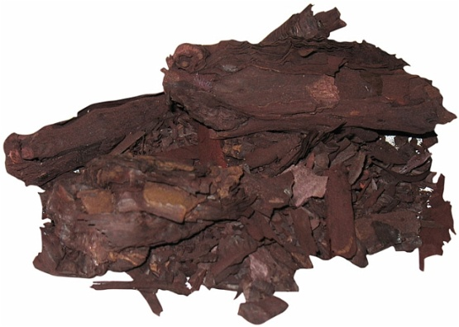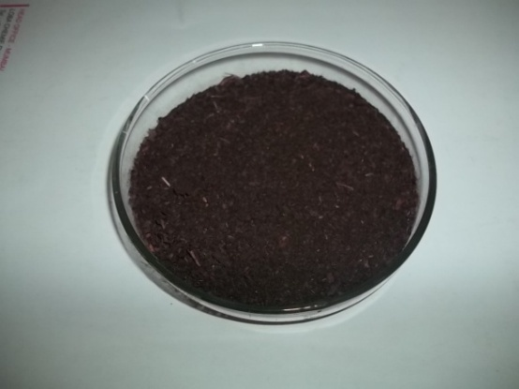
PLATE 1
Arnebia nobilis (ratanjot)– Bark

PLATE 2 a
Ratanjot - Powder

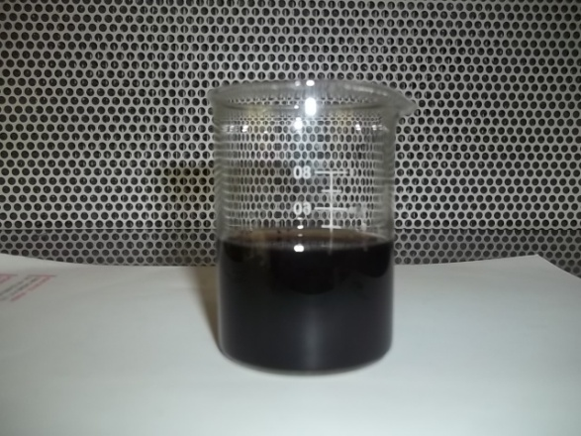
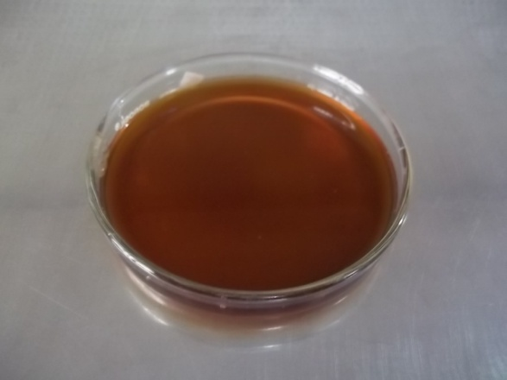
PLATE 2 b - Conventional Extraction of Ratanjot Powder

PLATE 3 a
Commercial Cellulase

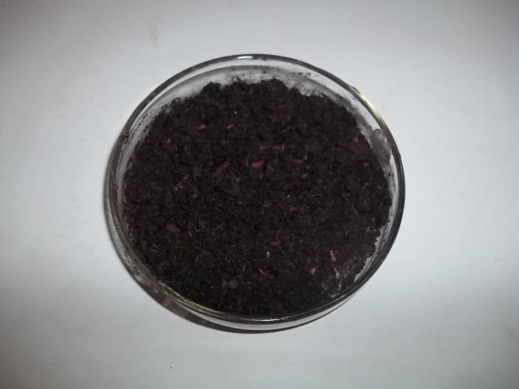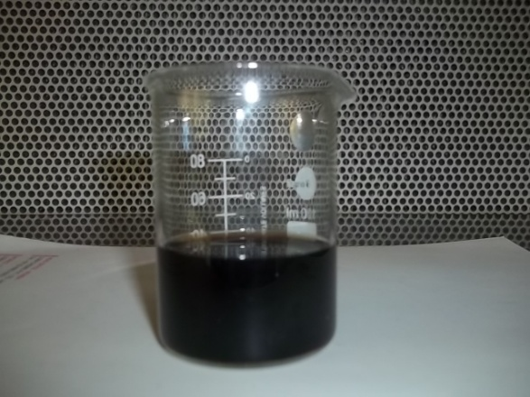
PLATE 3 c –Enzymatic Extraction of Ratanjot Powder
PLATE 3 b - Cellulase Sprayed Ratanjot Powder

3.2.4 pH
To determine the optimum pH of dye extraction, the pH of the solvent was adjusted to 4, 5, 6, 7, and 8 using 1N HCl or 1 N NaOH. Optical density of the dye solution was determined (Plate 7). The same process was followed for enzymatic extraction.
3.2.5 Mass:Liquor
To determine the optimum mass liquor ratio for dye extraction, three grams of ratanjot powder was mixed with different volumes of water individually and extraction was carried out (1:10, 1:20, 1:30, 1:40 and 1:50). Optical density of the dye solution was determined (Plate 8).
3.3 DYEING
3.3.1 Selection of Mordant
A mordant is a substance used to fix dyes on fabric. A mordant may have different effects on the shade obtained after dyeing and also broaden the range of shades and improve colour fastness properties (Mussak, 2009). The selected metal mordant for this study was alum.
3.3.2 Selection of Mordanting Techniques
A mordant is a separate chemical that combines with the dye in such a way as to attach the colouring matter to the fibre with lasting chemical bonds, thereby making the colour stand fast against light and washing. It will also change the hues of certain dyes (Barber, 1991). In most cases, mordant dyeing requires an additional step in which the mordant has to be applied to the fiber (usually cotton) before dyeing can begin (pre-mordanting) or more often, the mordant has to be applied to the dyeing as a final processing step (post-mordanting) or the mordant is added along with dye (simultaneous mordanting) (Aspland, 1997).
Among these three mordanting techniques, the pre-mordanting technique gave better results. Hence it was selected for the present study.

OPTIMIZATION OF VARIOUS PARAMETERS
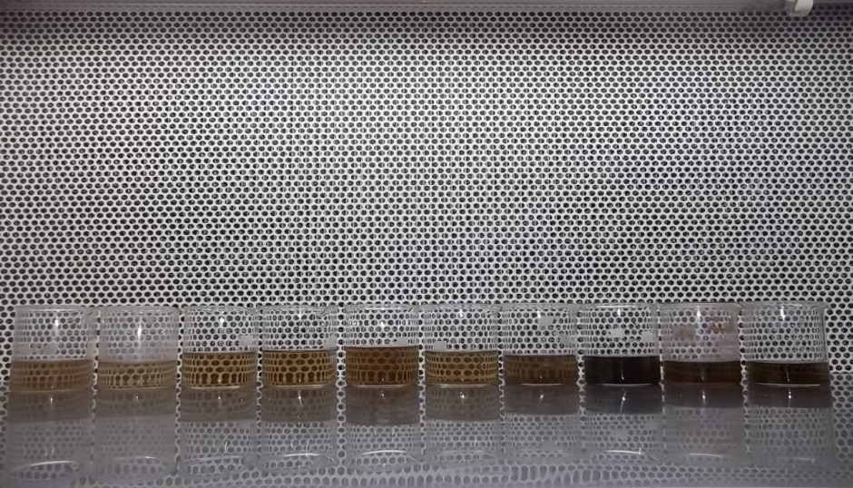
PLATE 4 - Dye Source Concentration

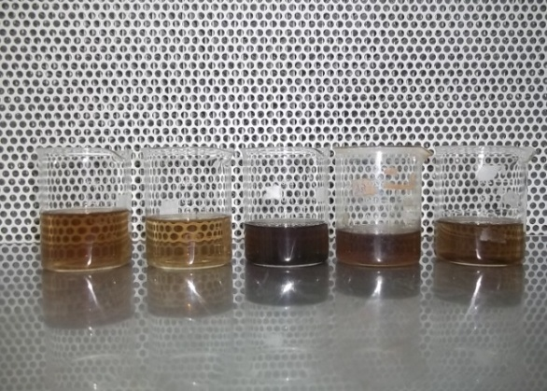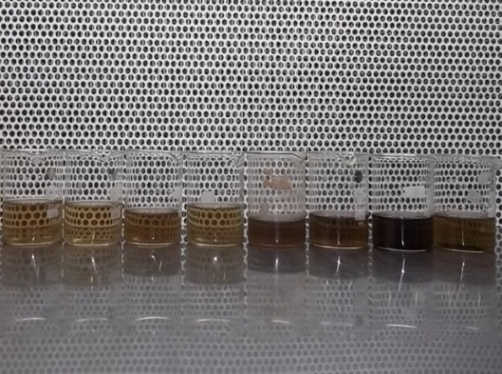
PLATE 6
TEMPERATURE
PLATE 5
TIME

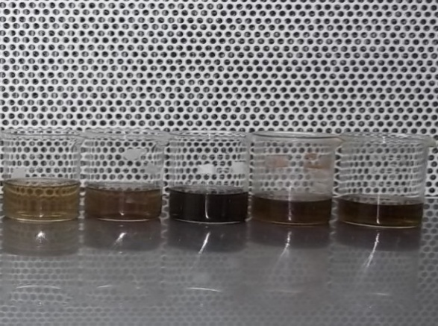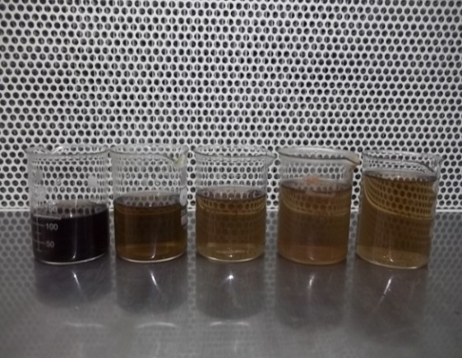
PLATE 7
pH
PLATE 8
MASS: LIQUOR

3.3.3 Dyeing Parameters
Dyeing parameters namely dye concentration, dyeing time, mordant concentration and mordanting time were optimized. Cotton fabric was dyed with different percentage of dye extract and optimum concentration was selected based on the dye uptake. To determine the optimum dyeing time, dyeing was carried out at different time intervals. Dyeing was also carried out at different temperatures. The optimum time and temperature was selected based on the colour developed on the fabric.
Desized cotton fabrics were dyed using the aqueous colouring extract of Arnebia nobilis bark under optimized conditions of dyeing parameters by conventional and enzymatic method.
The parameters for dyeing the selected desized cotton fabric are as follows:
 | Conventional dye | Dyeing using  enzyme assisted dye extract
Mass liquor ratio  (Extract : water) | 40:10 | 40:10
Dye soaking time | 90 mins | 60 mins
Dyeing temperature | 90 $℃$ | 90 $℃$
Mordant soaking time | 1hour | 1 hour
Mordanting temperature | 90 $℃$ | 90 $℃$

3.4 DYEING OF SELECTED FABRIC USING DYES EXTRACTED BY CONVENTIONAL AND ENZYME ASSISTED METHODS
The dye solution extracted from conventional and enzyme assisted method was filtered. Dyeing was carried out for 90 mins at 90°C with a m:l ratio of 40:10 for conventional dyeing and 60 mins for dyeing by enzyme assisted dye extract at 80°C.

3.5 EVALUATION OF DYED FABRICS
3.5.1 Subjective Evaluation – Visual Inspection
The fabric samples dyed with ratanjot was evaluated visually by the panel members comprising of 30 PG students specializing in the field of Textiles and Clothing, evaluated the fabric for general appearance, evenness of dyeing and brilliancy of shade.
3.5.2 Objective Evaluation
Fabric testing plays a crucial role in gauging product quality, ensuring regulatory compliance and assessing the performance of textile materials. It provides information about the physical or structural, chemical and performance properties of the fabrics.
3.5.2.1 Physical Properties
3.5.2.1.1 Fabric Weight
The weight of a fabric can be expressed in two ways, either as the ‘weight per unit area’ or the ‘weight per unit length’; the former is self explanatory but the latter requires a little explanation because the weight of a unit length of fabric will obviously be affected by its width. Fabric weight of the original and dyed samples was determined using GSM cutter.
A GSM cutter is used to cut the fabric and weight is taken in electronic weighing balance. The GSM of fabric is one kind of specification of fabric which is very important for a textile engineer for understanding and production of fabric. ‘GSM’ means ‘Grams per square meter’ that is the weight of fabric in gram per one square meter. By this we can compare the fabrics in unit area which is heavier and which is lighter. The samples were weighed for five times and the mean value was calculated and recorded.
3.5.2.1.2 Fabric Thickness
Fabric thickness is defined as perpendicular distance through the fabric, which determines the dimension between the upper and lower side of the fabric (Srikova, 2012). The determination of the thickness of a compressible material such as a textile fabric consists of the precise measurement of the distance between two plane parallel plates as the pressure foot and the other as the anvil. The readings were taken from different places of the same material and the mean value was calculated. Similarly, mean value of five readings from the original and dyed materials were taken and thus recorded the fabric thickness of each material separately.
3.5.2.2 Mechanical Properties
3.5.2.2.1 Tensile Strength and Elongation
Tensile strength is the force required to break the fabric when it is under tension Elongation is the extent to which the fabric under tension extends, till it gets cut off. Tensile strength is the measure of resistance of the fabric to a tensile load or stress in both warp and weft direction. Elongation measures the extent of deformation along the axis of a material under a tensile stress and expressed in units of length of the fabric when loaded.
The original and dyed fabrics were tested for tensile strength using Eureka Cloth Tensile Strength Tester. 12 inches x 2 inches specimen from each samples were cut in warp and weft direction of the fabric, 2 inches apart from selvedge. The specimen was placed between the upper and lower clamp. The dial reading was set to zero by adjusting the pendulum over the quadrant scale. The elongation pointer was checked for its position zero. Before starting the machine the pendulum lock was released and the machine was started to run. At certain point the fabric starts to break, the machine was switched off and the dial reading in lb was taken. The five specimens of both directions from each sample were tested and readings were noted.
3.5.2.2.2 Pilling
Pilling is the fabric surface fault characterized by little ‘pills’ of entangled fibre clinging to the cloth surface and giving the garment, an unsightly appearance. The pills are formed during wear and washing by the entanglement of loose-fibres which protrude from the fabric surface. Pilling resistance is defined as the resistance to the formation of pills on a textile fabric. The pills are formed during wash and wear by the entanglement of loose fibres which protrude from the fabric surface. Due to rubbing action these loose fibres develop into small, spherical bundles anchored to fabric by few unbroken fibres (Basu, 2006). The samples were cut according to the template and the face sides of each specimen were marked. Each specimen was folded face sides kept inward, so that the notches coincide exactly at their points. They were sewn exactly along the line between the pairs of notches. The samples were mounted on the rubber tubes and placed inside the box with lids closed. The machine is set to run for half an hour. Then the fabrics was removed from the rubber tube and assessed compared with standard photographs.
3.5.2.2.3 Abrasion Resistance
Abrasion is the rubbing away of the component fibers and yarns of the fabrics. Abrasion causes deformation or disturbance to the yarns and their constituent fibers leading to change in appearance and loss of mechanical properties. The Europe Martindale Abrasion Resistance Tester was used to determine abrasion resistance of the sample. Five samples were cut from different places of the same material at random using the template. The initial weight of the each sample was found out, recorded and then the sample was mounted on the sample holder. The sample holder with 200 gms weight was used for this test. The rubs were standardized to 10 rotations the sample were made to rub against the abrasive surface. After rotations, the sample was removed and the final weight of the sample was found out. Weight loss due to abrasion was calculated.
The abrasion resistance was measured as weight loss % as follows:
Weight loss % = (w1 - w2) / w1
Where w1 is the wt. of sample before abrasion and w2 is the wt. of sample after abrasion.

3.5.2.3 Comfort Properties
The fabrics was tested for the comfort properties namely stiffness, drapability.
3.5.2.3.1 Fabric Stiffness
Fabric stiffness test is conducted to measure the stiffness of fabrics. The Shirley’s stiffness tester is used to measure stiffness of textile materials. A rectangular strip of size 6 inch x 1 inch was cut using the template. The sample mounted on a horizontal platform in such a way that it overhangs like a cantilever and bends downward. Both were slowly pushed forward until the leading edges of the sample and the template project beyond the edge of the platform. The sliding of the sample was stopped when it cut both the index lines. Then the bending length of the sample read from the scale opposite a datum line engraved on the side of the platform, five readings were taken for the desized original and dyed samples both in warp and weft direction were recorded.
3.5.2.3.1 Drapabillity
Drape is one of the subjective performance characteristics of fabrics that contribute to aesthetic appeal. It is a complex property involving bending and shearing deformations. According to (Basu, 2006) drape is the ability of the fabric in which it hanged down in folds. Samples and brown papers were cut into circular form using the template and sandwiched between the two horizontal discs of smaller diameter and the unsupported annual ring of fabric was allowed to hang down under the action of gravity. The outer glass cover was closed and brown paper was placed on the glass lid. A planar projection of the counter of draped specimen was recorded on the brown paper and the outside was measured using pencil. It was trimmed accordingly and weighted. The readings were recorded and mean values were calculated. The drape coefficient was calculated using the formula.
A_{D} – A_{s}
Drape Coefficient = --------------- x 100
A_{D} – A_{d}

3.5.2.4 Absorbency Test
3.5.2.4.1 Drop test
The ability of a fabric to take up moisture is determined as absorbency. Wettability is the time taken in seconds for a drop of water to be absorbed into the fabric. If it takes more than 200 seconds to absorb the water through fabric, it is considered as unwettable.
A burette filled with distilled water was clamped in a stand. The sample was mounted in an embroidery frame and it was placed at the base of the stand. The distance between the sample and nozzles of burette was kept constant. The nozzle of the burette was opened just to allow a drop of water to fall on the sample. The stop watch was started simultaneously and it was stopped when the drop of the water gets fully absorbed into the material. The same procedure was repeated for all the samples and the mean values were calculated.
3.5.2.4.2 Sinking Test
Sinking test is a simple test to find the wettability of fabric. The time taken for the material to sink completely is observed. The shorter the time, greater is the wettability. For the sinking test the samples were cut with the size of 5 cm 5 cm square. A 1000 ml beaker was filled with distilled water and the sample was dropped on surface of the water from a standard height. The stop watch was started when the fabric struck the surface of water and stopped when the last corner sank below the water surface and the time required for the sample to sink was noted. The same procedure was repeated for all the samples. The mean values were calculated from the readings.
3.5.2.4.3 Wicking Test
The capillary travel method measures the rapidity of absorption. Five fabrics were cut into sizes of 15cm length and 2.5cm width from the original fabric, dyed fabrics. One end of the sample strip was pasted with a glass rod which was placed on heavy wooden blocks and at the other end, two grams weight was attached to keep the fabric straight. At the weighted end 2 cm of the sample was allowed to immerse in a tray of distilled water. The rise of the water level in the strip was noted by keeping length of the fabric as 5cm constant. The same procedure was repeated for five samples from the same fabric and the mean value was calculated and the capillary rise of each fabric was recorded carefully.
3.5.2.5 Colour Fastness Tests
Colour fastness is a term used in the dyeing of textile materials that is the resistance of the material's colour to fading or running. The colour fastness measures the resistance of the textiles when they are exposed to various parameters. The textile material supposed to have certain fastness property to washing, sunlight, crocking, pressing. The usual practice is to apply the dye on the fabric in specified strength and subjected to the various a parameter. For this a grey scale of 1-5 is employed. In this scale; 1 means poor fastness while 5 means excellent (Smith, 2006).
3.5.2.5.1 Fastness to Sunlight
Fastness to light is one of the most important property of a dyed fabric needs in order to fulfill its utilization purpose over a period of time (Paul, 2003).
To test the fastness to light, a sample size of 16cm x 5cm was taken from each of the dyed sample and divided into 8 equal parts measured. The entire samples were divided into eight parts by marking distance of two inches in the larger side. Each sample was covered with black paper to prevent the sample from direct sunlight. The first portion was exposed to direct sunlight for eight hours and remaining parts of the samples were kept away from direct sunlight, for the successive seven days the other portions were exposed accordingly along with first portion. The first portion got 7 days exposure and the 7th portion got was exposed for a day. The last portion was not exposed to sunlight and considered as standard. The changes in colour of the dyed samples were compared with the original and the specimens were rated with grey scale.
3.5.2.5.2 Fastness to Washing
Colour fastness to washing is the common quality parameter, which is considered very important from the point of view of consumers. This test determines the loss & change of colour in the washing process by a consumer and the possible staining of other garments or lighter portion that may be washed with it.
In this test method, the test specimens are laundered under appropriate conditions of temperature and abrasive action, the wash fastness of all the dyed samples were tested according to ISO (1994) washing test in a launderometer. The wash fastness of the dyed sample is attached together with an equal quality of white cloth. Due to the high alkali sensitivity at natural dyes it is recommended that these textiles be washed with non- alkaline soap only.
The composite sample, measured 10 x 4cm was washed along with 1 gram of detergent per 100 ml of water at 400C for 45 minutes. The changes in colour of staining of the adjacent undyed fabrics were evaluated using grey scale. The colour transfer from the dyed sample and straining of the two adjacent undyed fabrics were assessed using AATCC grey scale. The same procedure was repeated for all the dyed samples. Thus, the colour fastness of each dyed material to washing was carefully observed and recorded separately.
3.5.2.5.3 Fastness to Wet and Dry Crocking
This test method is designed to determine the amount of colour transferred from the surface of coloured textile materials to other surfaces by rubbing. Sasmira crockmeter was used to determine the fastness to crocking. It is applicable to textiles made from all fibres in the form of yarn or fabric whether dyed, printed or otherwise coloured. Test procedures employing white test cloth squares, both dry and wet with water, are given. As washing, dry cleaning, shrinkage, ironing, finishing, etc., may affect the degree of colour transfer from a material, the test may be made before, after, or before and after any such treatment. A coloured test specimen is rubbed with white crock test cloth under controlled conditions. Colour transferred to the white test cloth is assessed by a comparison with the Gray Scale for staining and the grade is assigned. The colour fastness of each dyed material was carefully observed and recorded separately.
3.6 Statistical analysis
Analysis work was carried out generally to see whether the test results vary due to difference in the dyes, mordants and proportions. ANOVA was used to test variation between the means of numerous independent groups.

4.0 RESULTS AND DISCUSSION
The results of the present study are discussed under the following headings:
4.1 Optimization of Various Parameters for Extraction of Dye
4.1.1 Dye Source Concentration
4.1.2 Time
4.1.3 Temperature
4.1.4 pH
4.1.5 Mass Liquor ratio
4.2 Extraction of Natural Dye under Optimized Conditions
4.3 Optimization of Dyeing Parameters
4.3.1 Dye Concentration
4.3.2 Time
4.3.3 Temperature
4.4 Evaluation of Dyed Fabrics
4.4.1 Subjective Evaluation- Visual Inspection
4.4.2 Objective Evaluation
4.4.2.1 Fabric Thickness
4.4.2.2 Fabric Weight
4.4.2.3 Fabric Strength
4.4.2.4 Fabric Elongation
4.4.2.5 Abrasion Resistance
4.4.2.6 Pilling Resistance
4.4.2.7 Drapability
4.4.2.8 Fabric Stiffness
4.4.2.9 Drop Test
4.4.2.10 Sinking Test
4.4.2.11 Wicking Test
4.4.2.12 Colour Fastness Test
- Fastness to sunlight
- Fastness to washing
- Wet and dry crocking

4.1 OPTIMIZATION OF VARIOUS PARAMETERS FOR EXTRACTION OF DYE
4.1.1 Dye source concentration
The effect of various concentrations of Arnebia nobilis bark was studied and the results are presented in Table 1.
TABLE 1
DYE SOURCE CONCENTRATION
Concentration of  Arnebia nobilis bark (%) | Optical density at 256 nm
Concentration of  Arnebia nobilis bark (%) | Conventional extraction | Enzymatic extraction
1 | 1.189 | 1.312
2 | 1.217 | 1.324
3 | 1.225 | 1.406
4 | 1.196 | 1.399
5 | 1.182 | 1.382
6 | 1.160 | 1.387
7 | 1.186 | 1.366
8 | 1.156 | 1.372
9 | 1.147 | 1.384
10 | 1.132 | 1.362

From Table1, it is clear that the optimum dye source concentration is 3 per cent with the colour intensity of 1.225 in conventional extraction and 1.406 in enzymatic extraction.

    - Time

The effect of time on the extraction of Arnebia nobilis bark was determined and the results are presented in Table 2.
TABLE 2
TIME
Time (min) | Optical density at 256 nm
Time (min) | Conventional extraction | Enzymatic extraction
30 | 1.753 | 1.225
60 | 1.880 | 1.325
90 | 1.927 | 1.265
120 | 1.886 | 1.292
150 | 1.877 | 1.287

From Table 2, it is evident that the colour intensity increases with increasing time and reaches maximum at 90 mins (1.927) in conventional method. Hence the optimum time for extraction of dye was selected as 90 mins for conventional method. With regard to enzymatic method, 60 min was found to be optimum (1.325). Increase in time above 60 mins. does not found to produce significant increase in colour intensity. Hence 60 mins was fixed for enzymatic extraction of dye.
    - Temperature
The effect of temperature on the extraction of dye was determined and the results are shown in Table 3.

TABLE 3
TEMPERATURE
Temperature ($℃$) | Optical density at 256 nm
Temperature ($℃$) | Conventional extraction | Enzymatic extraction
50 | 1.097 | 1.297
60 | 1.107 | 1.354
70 | 1.126 | 1.416
80 | 1.099 | 1.321
90 | 1.111 | 1.316
100 | 1.099 | 1.301

Table 3, clearly indicates that the rise in temperature increases the dye yield and maximum dye yield was observed at 70⁰C for both the extraction methods. Hence 70⁰C was fixed as the optimum temperature for the extraction of dye from Arnebia nobilis irrespective of the methods.
    - pH
To determine the optimum pH, dye extraction was carried out at different pH (4 – 10) and the results are shown in Table 4.

TABLE 4
pH
pH | Optical density at 256 nm
pH | Conventional extraction | Enzymatic extraction
4 | 1.32 | 1.12
5 | 1.49 | 1.26
6 | 1.52 | 1.56
7 | 1.26 | 1.48
8 | 1.46 | 1.43

From Table 4, it is clear that pH 6 is the optimum pH for dye extraction by both the methods. Increase in pH above 6 was found to decrease the colour yield. Hence pH 6 was maintained for the extraction of dye from Arnebia nobilis.
    - Mass Liquor Ratio
The effect of mass liquor ratio on dye extraction was studied and results are presented in Table 5.
TABLE 5
MASS LIQUOR RATIO
Mass liquor ratio (Dye:water) | Optical density at 256 nm
Mass liquor ratio (Dye:water) | Conventional extraction | Enzymatic extraction
1:10 | 1.74 | 2.60
1:20 | 1.82 | 2.72
1:30 | 1.72 | 2.68
1:40 | 1.67 | 2.51
1:50 | 1.61 | 2.43

From Table 5, it is clear that mass liquor ratio affects the dye yielding capacity. Maximum colour yield was shown in mass liquor ratio of 1:20 irrespective of the methods.
  - EXTRACTION OF NATURAL DYE UNDER OPTIMIZED CONDITIONS

Various parameters such as dye source concentration, time, temperature, pH and mass liquor ratio were optimized and the results are summarized in Table 6.
TABLE 6
OPTIMIZED CONDITIONS FOR THE EXTRACTION OF DYE FROM Arnebia nobilis
Parameters | Optimized conditions
Parameters | Conventional method | Enzymatic method
Dye source concentration | 3% | 3%
Time | 90 mins | 60 mins
Temperature | 70˚ C | 70˚ C
pH | 6 | 6
Mass:liquor | 1:20 | 1:20

The dye was extracted from Arnebia nobilis bark at a concentration of 3%, pH of 6 at 70˚C for 90 mins in conventional method and 60 mins in enzymatic method.
4.3 OPTIMIZATION OF DYEING PARAMETERS
4.3.1 Dye concentration
The optimization of dye concentration for dyeing was carried out and the results are presented in Table 7.

TABLE 7
DYE CONCENTRATION
Dye extract : water | Optical density at 256 nm
Dye extract : water | Conventional extraction | Enzymatic extraction
10:40 | 0.827 | 0.992
20:30 | 1.012 | 1.128
30:20 | 1.027 | 1.232
40:10 | 1.112 | 1.356
50 | 1.108 | 1.246

From Table7, it is clear that the optimum dye concentration is 40:10 ratio with the colour intensity of 1.112 and 1.356 respectively in conventional and enzymatic extraction. It was found that the colour shade of the fabrics dyed using the enzymatic method was higher than the strength achieved using the conventional method.
4.3.2 Time
The effect of time on the optimization of dyeing was determined and the results are presented in Table 8.
TABLE 8
TIME
Time (min) | Optical density at 256 nm
Time (min) | Conventional extraction | Enzymatic extraction
30 | 1.746 | 1.657
60 | 1.754 | 1.886
90 | 1.827 | 1.825
120 | 1.801 | 1.808
150 | 1.812 | 1.814
From Table 8, it is evident that there was not much difference in optical density between 120, and 150 mins. Hence, the optimum dyeing time was selected as 90 mins for conventional extraction method. In the case of enzymatic extraction method 60 mins was found to be optimum dyeing time.
4.3.3 Temperature
The effect of temperature on dyeing was determined and the results are shown in Table 9.
TABLE 9
TEMPERATURE
Temperature  ($℃$) | Optical density at 256 nm
Temperature  ($℃$) | Conventional extraction | Enzymatic extraction
50 | 0.126 | 0.317
60 | 1.131 | 1.268
70 | 1.109 | 1.321
80 | 1.162 | 1.359
90 | 1.153 | 1.332
100 | 1.159 | 1.346

From Table 9, it is clear that, increase in dyeing temperature, increases the dye uptake from 50°C to 90°C and reaches maximum at 80$℃$. Increase in temperature of dyeing inevitably supplies more energy for transportation of dye molecules. The optimum dyeing temperature was found to be 80⁰C with the colour intensity of 1.162 and 1.359 respectively in conventional and enzyme assisted dye extract.

  - EVALUATION OF DYED FABRIC
    - Subjective Evaluation - Visual Inspection
Subjective evaluation of fabrics dyed using dyes extracted by conventional and enzymatic methods were carried out and the results are presented in Table 10.
TABLE 10
SUBJECTIVE EVALUATION
S.No. | Samples | Presented in percentage |  |  |  |  |  | Evenness of dyeing
S.No. | Samples | General appearance |  |  | Brightness of shade
S.No. | Samples | Excellent | Good | Fair | Bright | Medium | Dull | Even | Uneven
1. | CDCE | 70 | 20 | 10 | 77 | 13 | 10 | 100 | -
2. | CDEE | 80 | 10 | 10 | 81 | 11 | 8 | 100 | -
OC – Original cotton
CDCE – Cotton dyed with conventional extract
CDEE – Cotton dyed with enzymatic extract
From Table 10, it is clear that the CDEE sample was rated as excellent in general appearance by 80 percent of the judges followed by CDCE. With regard to brightness of shade CDEE was rated as bright by 80 percent of judges. With respect to evenness of dyeing all the samples were rated to be evenly dyed.
4.4.2 Objective Evaluation
4.4.2.1 Fabric Thickness
The fabric thickness and analysis of variance of the samples CDCE and CDEE are shown in Table 11 and Figure 1.

TABLE 11
FABRIC THICKNESS
S.No. | Sample | Mean value  (mm) | Loss or gain over original | % loss or gain over original | ‘F’ Test
1. | OC | 0.282 | - | - | 5.4783 **
2. | CDCE | 0.276 | -0.006 | -2.1 | 5.4783 **
3. | CDEE | 0.294 | 0.012 | 4.2 | 5.4783 **
** - Significant at 1% level

FIGURE 1
FABRIC THICKNESS

From Table 11 and Figure 1, it is clear that the thickness of the sample CDEE increased by 4.2% when compared to control. The fabric thickness was found to be decreased in CDCE sample when compared over the original. The results indicate that the dye absorption was high in CDEE sample and the increase in fabric thickness was found to be significant at 1% level when compared between the samples.
4.4.2.2 Fabric Weight
The fabric weight and analysis of variance of the samples OC, CDCE, CDEE are given in Table 12 and Figure 2.
TABLE 12
FABRIC WEIGHT
S.No. | Sample | Mean value (gm) | Loss or gain over original | % loss or gain over original | ‘F’ Test
1. | OC | 1.069 | - | - | 1.6904 ^{NS}
2. | CDCE | 1.066 | 0.003 | 0.280 | 1.6904 ^{NS}
3. | CDEE | 1.073 | -0.004 | 0.374 | 1.6904 ^{NS}
NS- Not Significant
FIGURE 2
FABRIC WEIGHT
From Table 12 and Figure 2, it is clear that, the fabric weight of the sample increased in CDEE sample when compared to original. This result indicates that the dye absorption is higher in fabric dyed with enzymatic dye extract.
4.4.2.3 Fabric Strength (Warp)
Fabric strength and analysis of variance of the samples OC, CDCE and CDEE in warp direction are presented in Table 13 and Figure 3.
TABLE 13
FABRIC STRENGTH (WARP)
S.No. | Sample | Mean value (lbs) | Loss or gain over original | % loss or gain over original | ‘F’ Test
1. | OC | 109.0 | - | - | 263.4384**
2. | CDCE | 76.0 | 33 | 30.27 | 263.4384**
3. | CDEE | 76.0 | 33 | 30.27 | 263.4384**
** - Significant at 1% level
FIGURE 3
FABRIC STRENGTH (WARP)

From Table 13 and Figure 3, it is clear that the strength of the original fabric was found to be higher, when compared with the dyed samples. Statistical analysis proved that there was a significant difference at 1% level between the samples.
Fabric Strength (Weft)
Fabric strength and the analysis of the variance of the samples OC, CDCE and CDEE in the weft direction are shown in Table 14 and Figure 4.
TABLE 14
FABRIC STRENGTH (WEFT)
S.No. | Sample | Mean value (lbs) | Loss or gain over original | % loss or gain over original | ‘F’ Test
1. | OC | 106.6 | - | - | 143.9205**
2. | CDCE | 63.80 | -42.8 | -40.15 | 143.9205**
3. | CDEE | 76.60 | -30 | -28.14 | 143.9205**
** - Significant at 1% level
FIGURE 4
FABRIC STRENGTH (WEFT)

From Table 14 and Figure 4, it is evident that the fabric strength was found to be high in original sample. Fabric strength was found to be decreased in dyed samples with maximum decrease in CDCE sample. There was a significant difference at 1% level when compared between the samples.
4.4.2.4 Fabric Elongation (Warp)
Fabric elongation and analysis of variance of the samples OC, CDCE and CDEE in warp direction are shown in Table 15 and Figure 5.
TABLE 15
FABRIC ELONGATION (WARP)
S.No. | Sample | Mean value (cm) | Loss or gain over original | % loss or gain over original | ‘F’ Test
1. | OC | 2.902 | - | - | 115.2431**
2. | CDCE | 3.760 | 0.858 | 29.56 | 115.2431**
3. | CDEE | 3.720 | 0.818 | 28.18 | 115.2431**
** - Significant at 1% level
FIGURE 5
FABRIC ELONGATION (WARP)

From Table 15 and Figure 5, it is clear that the elongation of CDCE and CDEE sample was increased by 29.56 percent, 28.18 percent respectively. The increase in fabric elongation when compared with the original was found to be significant at one percent level.
Fabric Elongation (Weft)
Fabric elongation and analysis of variance of the samples OC, CDCE and CDEE in weft direction are shown in Table 16 and Figure 6.
TABLE 16
FABRIC ELONGATION (WEFT)
S.No. | Sample | Mean value (cm) | Loss or gain over original | % loss or gain over original | ‘F’ Test
1. | OC | 2.140 | - | - | 85.4684**
2. | CDCE | 3.260 | 1.12 | 52.33 | 85.4684**
3. | CDEE | 3.340 | 1.2 | 56.07 | 85.4684**
** - Significant at 1% level
FIGURE 5
FABRIC ELONGATION (WEFT)

From Table 16 and Figure 6, it is clear that the fabric elongation in weft direction is increased by 52.33 per cent and 56.07 per cent for CDCE and CDEE respectively. The increase in fabric elongation was found to be maximum in CDEE fabric in weft direction. The increase in fabric elongation when compared with the original was found to be significant at one per cent level.
4.4.2.5 Abrasion resistance
The results of the abrasion resistance tests are presented in Table 17 and Figure 7.
TABLE 17
ABRASION RESISTANCE
S.No. | Sample | Mean value (gm) | Loss or gain over original | % loss or gain over original | ‘F’ Test
1. | OC | 98.736 | - | - | 10.5117**
2. | CDCE | 89.840 | 8.896 | 9.00 | 10.5117**
3. | CDEE | 86.166 | 12.57 | 12.73 | 10.5117**
** - Significant at 1% level
FIGURE 7
ABRASION RESISTANCE

From Table 17 and Figure 7, it is clear that the abrasion resistance of original fabric is high, when compared to CDCE and CDEE. The decrease in abrasion resistance of the CDCE sample was found to be 9.00% and CDEE sample was found to be 12.73%. There was a significant difference at 1% level when compared between the samples.
4.4.2.6 Pilling Resistance
The results of the pilling tests for the OC, CDCE and CDEE are presented in Table 18 and Figure 8.
TABLE 18
PILLING RESISTANCE
S.NO | SAMPLES | MEAN
1 | OC | 4.8
2 | CDCE | 4.8
3 | CDEE | 4.6

TABLE 18
PILLING RESISTANCE

From the above Table 18 and Figure 8 it is clear, that the OC and CDCE samples have severe pilling. CDEE has low pilling. Thus it could be concluded that there was decrease in pilling in CDEE.

4.4.2.7 Drapability
The drapability of OC, CDCE and CDEE are presented in Table 19 and graphically represented in Figure 9.
TABLE 19
DRAPABILITY
S.No. | Sample | Mean value (%) | Loss or gain over original | % loss or gain over original | ‘F’ Test
1. | OC | 1.814 | - | - | 2363.3677**
2. | CDCE | 1.243 | - 0.571 | -31.47 | 2363.3677**
3. | CDEE | 1.926 | 0.112 | 6.17 | 2363.3677**
** - Significant at 1% level
FIGURE 9
DRAPABILITY

From Table 19 and Figure 9, it is evident that the drapability of CDEE sample decreased when compared over the original. Statistical analysis proved that there was one per cent significant difference between the samples.

4.4.2.8 Fabric Stiffness (Warp)
Fabric stiffness and analysis of variance of the samples OC, CDCE and CDEE in warp direction are shown in Table 20 and Figure 10.
TABLE 20
FABRIC STIFFNESS (WARP)
S.No. | Sample | Mean value (cm) | Loss or gain over original | % loss or gain over original | ‘F’ Test
1. | OC | 1.50 | - | - | 0.1860^{NS}
2. | CDCE | 1.50 | 0 | 0 | 0.1860^{NS}
3. | CDEE | 1.54 | -0.04 | -2.66 | 0.1860^{NS}
NS- Not Significant
FIGURE 10
FABRIC STIFFNESS (WARP)

From Table 20 and Figure 10, it is clear that the stiffness of the fabric CDEC increased when compared with the original.

Fabric Stiffness (Weft)
Fabric stiffness and the analysis of variance of the samples OC, CDCE and CDEE in weft direction are presented in Table 21 and Figure 11.
TABLE 21
FABRIC STIFFNESS (WEFT)
S.No. | Sample | Mean value (cm) | Loss or gain over original | % loss or gain over original | ‘F’ Test
1. | OC | 1.480 | - | - | 1.3571 ^{NS}
2. | CDCE | 1.320 | 0.16 | 10.810 | 1.3571 ^{NS}
3. | CDEE | 1.380 | 0.1 | 6.75 | 1.3571 ^{NS}
NS- Not Significant
FIGURE 11
FABRIC STIFFNESS (WEFT)

From Table 21 and Figure 11, it is clear that the fabric stiffness of the dyed samples decreased when compared over the original and maximum decrease was found in CDEC sample.
Absorbency test
4.4.2.9 Drop test
The results of drop test and analysis of variance of the samples OC, CDCE and CDEE are shown in Table 22 and Figure 12.
TABLE 22
DROP TEST
S.No. | Sample | Mean value (sec) | Loss or gain over original | % loss or gain over original | ‘F’ Test
1. | OC | 37.8 | - | - | 4.1579*
2. | CDCE | 36.4 | 1.4 | 3.70 | 4.1579*
3. | CDEE | 38.4 | -0.6 | -1.58 | 4.1579*
* - Significant at 5% level
FIGURE 12
DROP TEST

Table 22 and Figure 12, indicates that the absorption of water by CDCE sample increased when compared over the original. In sample CDEE, absorption rate was found to be decreased. This indicates higher uptake of dye when compared to CDCE sample. The statistical analysis showed that there was 5% significance exists between the samples.
4.4.2.10 Sinking test
The results of sinking test and analysis of variance of the samples OC, CDCE and CDEE are shown in Table 23 and Figure 13.
TABLE 23
SINKING TEST
S.No. | Sample | Mean value (sec) | Loss or gain over original | % loss or gain over original | ‘F’ Test
1. | OC | 1.16 | - | - | 5.8519**
2. | CDCE | 1.76 | -0.6 | -51.72 | 5.8519**
3. | CDEE | 1.78 | -0.62 | -53.44 | 5.8519**
** - Significant at 1% level
FIGURE 13
SINKING TEST

From the above Table 23 and Figure 13, it is clear that the decrease in absorbance was maximum in CDEE samples by 53.44 followed by CDCE samples by 51.72% when compared with OC. Statistical analysis also proved that there was 1 percent significant difference between the samples.
4.4.2.11 Wicking test
The result of wicking test and analysis of variance of the samples OC, CDCE and UDC are shown in Table 24 and Figure 14.
TABLE 24
WICKING TEST
S.No. | Sample | Mean value (cm) | Loss or gain over original | % loss or gain over original | ‘F’ Test
1. | OC | 3.24 | - | - | 650.2800**
2. | CDCE | 5.78 | -2.54 | -78.39 | 650.2800**
3. | CDEE | 5.80 | -2.56 | -79.01 | 650.2800**
** - Significant at 1% level
FIGURE 14
WICKING TEST

From the above Table 24 and Figure 14, it is clear that the absorbancy was found to increase in CDEE sample by 79.01%, followed by CDCE sample by 78.39%, when compared with the original. Statistical analysis also proved that there was 1 percent significant difference between the samples.
4.4.2.6 Colour Fastness Test
Colour fastness of the dyed fabrics to sunlight, crocking and washing was determined and the results are presented in Table 25.
TABLE 25
COLOUR FASTNESS TO SUNLIGHT, CROCKING AND WASHING
S.No. | Sample | Sunlight |  | Washing |  | Crocking
S.No. | Sample | Colour change | Staining | Colour change | Staining | Dry |  | Wet
 |  |  |  |  |  | Colour change | Staining | Colour change | Staining
1. | CDCE | 4 | 5 | 4 | 4 | 5 | 4 | 4 | 5
2. | CDEE | 5 | 4 | 5 | 5 | 5 | 5 | 5 | 4
5 – Excellent; 4 – Very Good;
From the Table, it is evident that all the dyed samples showed good fastness to sunlight, washing and crocking. When compared to CDCE, CDEE showed excellent colour fastness to all the colour fastness tests.

5.0 SUMMARY AND CONCLUSION
Natural dyes emerged as an important alternative to potentially harmful synthetic dyes. Over the last few years synthetic dyes have been losing good reputation because of the risk of toxicity, negative influence on the environment and high allergic potential. Consequently, an increasing demand has naturally developed. The use of non toxic and ecofriendly natural dyes on textiles has become a matter of significant importance because of the increased environmental awareness in order to avoid some hazardous synthetic dyes. Recently there has been revival of the growing interest on the application of natural fibres due to worldwide environmental consciousness. The rich and subtle variations of tone and colour derived from plants may mellow and soften with time but never will lose their natural harmony.
In the current study, extracted colourants from the barks of the Arnebia nobilis have been chosen for its dyeability. Arnebia nobilis, commonly known as ratanjot have good application properties in textile industry. It is regarded as one of the important herbal drugs of indigenous system of medicine. It is also used for imparting pleasing red colour to foodstuff, oils and fats. Arnebia nobilis, colourants are also used for the colouration of cotton. The cotton fabric dyed with Arnebia nobilis, have good colour shades.
There is an increasing demand for developing suitable extraction techniques for more effective extraction of obtainable active matters from the plant materials. The main objective of the current study is to determine the suitable method for the extraction of dye from Arnebia nobilis.
Cellulases enzymes are widely used in textile industry for the manufacturing and finishing of cellulose containing materials. The use of cellulases in the textile industry confers variety of advantages because they are easy to use. They are completely biodegradable and will not accumulate in the environment. They are an economical as they save chemicals and energy and also reduce processing time.
Hence the current study “Enzymatic Extraction of Natural Dye from Arnebia nobilis and its Application on Cotton” was carried out with the following objectives:
- To extract natural dye from Arnebia nobilis using cellulase enzyme
- To dye cotton fabric using extracted dye
- To evaluate the characteristics of the dyed fabrics
METHODOLOGY ADOPTED
- Dye from Arnebia nobilis (bark) were extracted by two different methods – conventional and enzyme assisted extraction.
- Optimization of dye extraction
- Various parameters such as dye concentration, time, temperature, pH and mass:liquor ratio were optimized for the extraction of dye.
- Optimization of dyeing
- Dyeing parameters such as dye concentration, time, temperature and mordanting techniques were optimized for effective dyeing of the fabric.
- The dyed fabrics were evaluated both subjectively and objectively.
FINDINGS
- Arnebia nobilis – bark powder at a concentration of 3 per cent was found to be the optimum concentration for conventional and enzymatic dye extraction.
- A contact time of 90 mins and 60 mins resulted in maximum dye yield in conventional and enzymatic extraction method respectively.
- Maximum per cent dye yield was noticed at 70°C for both methods.
- The optimum pH for dye extraction was found to be 6.
- Maximum colour yield was noticed in mass liquor ratio of 1:20.
- 40:10 percent of dye concentration to water ratio was found to be the optimum concentration for dyeing.
- Dyeing time of 90 and 60 minutes resulted in maximum dye absorption by the fabric dyed with conventional extract and enzymatic extract.
- Maximum colour uptake was noticed at 80°C for both the methods.
- The results of visual evaluation of dyed fabric revealed that the dyed fabrics were rated excellent in appearance, brighter in shade and evenly dyed irrespective of the methods.
- Fabric thickness was found to be maximum for the fabric dyed with enzyme assisted dye extract.
- Fabric weight was recorded to be higher in CDEE sample when compared with CDCE sample.
- Fabric strength was found to be maximum in original sample when compared to the dyed samples in warp directions.
- Fabric strength was found to be decreased in dyed sample with maximum decrease in CDCE sample in weft directions.
- Fabric elongation was found to be maximum in CDCE followed by CDEE in warp directions.
- Fabric elongation was found to be maximum in CDEE followed by CDCE sample in weft direction.
- Abrasion resistance was recorded to be high in CDCE when compared with CDEE.
- CDEC has low pilling when compared to other samples.
- Drapability of CDEE was found to be higher when compared to CDCE.
- The increase in fabric stiffness was maximum in CDEC sample in warp direction whereas in weft, the stiffness is maximum in OC.
- In drop test, the absorbance was maximum in CDEE followed by CDCE.
- In sinking and wicking test, the absorbance was found to be maximum in CDEE sample compared to CDCE sample.
- CDEE sample exhibited excellent colour fastness to sunlight, washing and crocking when compared to CDCE sample.
CONCLUSION
The current study reveal that the dye extraction can be done from Arnebia nobilis. The enzyme was found to have considerable improvement in the extraction efficiency of colourant. Therefore, the present study had thrown a new method of extraction from natural dye resources.
SCOPE FOR FURTHER STUDY
Enzymatic extraction method could be carried out for other natural dye sources.

BIBLIOGRAPHY
Books
- Allen, R.L.M., (1991), “Color Chemistry”, ISBN Publishes, P. 35.
- Amarjit, B.S., (2009), “Cotton fibres”, CBS Publishers, P. 170.
- Arora, V., (2000), “Textile Chemistry”, Abhishek Publications, P. 30.
- Barber, W.J.E., (1991), “Prehistoric Textiles”, Princeton University Press, P. 231.
- Bianchi, D. And Phillip, S., “Cell and molecular biology”, Willey student edition, P. 169.
- Butterworths Publications, P. 134.
- Claire, S., (2008), “Claire Shaeffer’s fabric sewing”, Krause Publications Craft, P. 140.
- Earland, C. and Raven, J.D., (2007), “experiments in textile and fibre chemistry”,
- Ghosh. B., Samresh, C. and Sriram, S., (2011), “The textbook of enzymes”, Wisdom Press Publishers, P. 1.
- Gulrajani, L.M., (1999), “Chemical processing of handloom yarns and fabrics”, IIT,
- Heinemann., (2002), “Home economics in action”, Caribbean Association Staff, P. 102.
- Jacob., (1999), “Natural dyes”, IIT, P. 67.
- Kaplan, N.S., (2012), “A practical guide to fibre science” Abhishek Publications, P. 93.
- Karmakar, R.S., (2000), “Chemical technology in the pre treatment processes of textiles”, Elsevier Publications, pp. 69-79.
- Konar, A. and Samanta, A., (2011), “Dyeing of textile with natural dye”, InTech Publishers, P. 30.
- Mishra, P.S., (2000), “A textbook of fibre science and technology”, New age International limited Publishers, pp. 1-7.
- Phillip, W.J., Noelie, B.R. and Alfred, F.D., (2007), “Cotton Fibre Chemistry and Technology”, Devron Publishes, pp. 1-4.
- Presseley. A.T. and Crewther, G.W., (2001), “Wool science”, Shirely Publications, P. 26.
- Richard, A., (1997), “Textile Dyeing and coloration”, American association of textile color and chemists, P. 43.
- Rita, M., (Handbook of natural colorants), Thomas Bechtold, John Wiley and sons, P. 363.
- Sara K.J, Kadolph., (2009), “Textiles” Pearson Education, pp. 17-24.
- Shenai, K V.P., (2000), “The cotton fibre”, Sevak Publications, pp. 28-34.
- Singh V.P., (2008), “Introduction to textiles”, Kalyani Publications, P. 85.
- Smith, L.J., (2006), “Textile Processing”, Abhishek Publications, P. 65.
- Storey, J., (1992), The Thames and Hudsan manual of dyes and fabrics, Thames and Hudsan Publications, P. 9.
- Trotman, R.E., (2005), “Textile scouring and bleaching” Griffin, P. 18.

Journals
- Adivarekar, R.V., Anindya Chandra, Chet Ram Meena and Girendra Pal Singh., (2013), “Cationising of cotton for reduced electrolyte consumption in dyeing with ME reactive dye”, Colourage, Vol. 5, P. 30.
- Anon., (2010), “Cellulase and its uses”, Journal of Textile Institutions, Vol. 52, P.81.
- Basu, A., (2006), “Indian and Important cotton”, Colourage, Vol. 5, P. 23.
- Chakraborthy, S., Ammayappan, L. and Seiko, J., (2013), “Colouration of textiles by natural dyes“, Asian Dyer, Vol. 10, pp. 30-34.
- Chakraborty, S., Lipika, C. and Prabikrkar., (2010), “An insight to natural dyes”, Asian Dyer, Vol. 7, pp. 31-32.
- Chinta, K.S. and Indi, M.Y., (2007), “Application and properties of natural dyes on cotton using Phyllanthus reticulantus”, Colourage, Vol. 8, pp. 62-66.
- Das, B.N., Prusti, K.A., Purohit, A. and Nayak, A., (2010), “Waste leaves of Tectona grandis as a suitable natural dye for textile”, Colourage, Vol. LVIII, P. 55.
- Datta, S., Ashis, K.S. and Priti, A., (2007), “Dyeing of jute and cotton fabrics using jack fruit extract”, Indian Journal of Fibre and Reaseach, Vol. 32, P. 467.
- Dinesh, B. and Jayalakshmi, I., (2011), “Antimicrobial and mechanical activity of epotorium dye on tencel and tencel-viscose fabrics”, Colourage, Vol. 7, P. 49.
- Ganguly. D. and Mal. P., (2013), “ Enzymes and its importance in textile wet processing”, Asian Textile Journal, Vol. 22, pp. 78-81.
- Geake, A. and Clibbens, A.D., (2001) “Cellulase”, Journal of Textile Institutions, Vol. 19, P. 77.
- Gupta, D., Anjali, A. and Gulrajani, L.M., (2009), “Identification and characterization of ratanjot”, Natural Product Radiance, Vol. 8, pp. 142-145.
- Hemalatha, J., (2013), “Dyeing of cotton fabrics with extracts of jamun tree and its by-products using natural colourants”. Colourage, Vol. 11, P. 40.
- Jahan. S and Bhargava.D., (2013), “Microbial dyes: A new dimension to natural dyes”, Colourage, Vol. 5, P. 42.
- Kan, W.C. and Yuen, W.C., (2005), “Enzymes at work” Textile Asia, Vol. 12, pp. 46-49.
- Kanipriya, M., Lenin, V., Kandasamy. N., and Karthick., (2009), “Enzymes in textile finishing”, Manmade Textile in India, Vol. LII, pp. 7-9.
- Kedar, V., Shivankar, S.V., Vyas, K.S. and Ojha, R., (2011), “Extraction of natural dyes”, Asian Dyer, Vol. 8, pp. 57-58.
- Little, A.A. and Clibbens, A.D., (2006) “Enzymes”, Journal of Textile Institutions, Vol. 27, P. 285.
- Mahale, Sunanda and Sakshi., (2003). “Colorfastness of dyed silk”, Textile Industry and Trade Journal, Vol. 41, P. 49.
- Mahapatra, N.N., (2010), “Uses of enzymes in textile processing”, Asian Dyer, Vol.7, pp. 53-56.
- Mitsulov, A., Snezhana, T. and Nikolay, S., (2007), “Influence of cellulose enzyme on chemical and structural changes of cellulose”, Manmade Textiles in India, Vol. 5, pp.141-144.
- Padma, S.S., Saravana, G. A., and Yogaraj, M., (2008), “Indigenous knowledge or natural dyeing of korai grass mat in pattamadai”, Natural Product Radiance, Vol. 8, pp. 542–545.
- Poolperm, S., Wimonart, S., Preechaya, R. and Wanvichit, P., (2009), “Effect of enzymatic treatment on the dyeing of pineapple leaf fibre with natural dyes”, Science Asia, Vol. 35, pp. 31-36.
- Prabhu, K.H., Shyam, S.R., Surjit, K.B. and Karthikeyan, N., (2007) “Enzyme applications in textiles”, The Indian Textile journal, Vol. 6, P. 25.
- Pratibha, M. and Radha, K., (2011), “Application of enzymes in textile processing”, Textile trends, Vol. LIII, P. 34.
- Rani, A. and Mishra. A., (2007), “ Enzymes and textile sector”, Asian Dyer, Vol. 6, P.31.
- Ren, S., Wen, J.L., Yong, Z. and Lei, Z., (2009), “Study on extracting natural plant dyestuff by enzyme-ultrasonic method and its dyeing ability”, Journal of Fibre Bioengineering and Informatics, Vol. 2, P. 25.
- Sabale, G.A., Teli, D.M. and Shah, R., (Dyeing of nylon with natural colourants), Vol. LVII, P. 96.
- Sekar. N., (2013), “Natural dyes in food coloration”, Colourage, Vol.3, P. 62.
- Soc and Worth., (2000), “Cellulase enzymes”, Dyers Colourist, Vol. 68, P. 207.
- Srikova, B.K., (2012) “Description of fabric thickness and roughness on the basis of fabric structure parametres”, AUTEX Research Journal, Vol. 12, P. 22.
- Srivastav, A. and Butola, S.B., (2009), “Enymatic scouring of cotton”, Asian Dyer, Vol. 6, pp. 31-39.
- Srivatsava, P., Harish, T.C., Prathiba, S. and Pradeep, K.M., (2010), “Evaluation of various techniques for extraction of natural colourants from pomegranate rind-ultrasound and enzyme assisted extraction”, Indian Journal of Textile and Fibre Reasearch, Vol. 35, pp. 272-276.
- Swati., Chakraborthy, N.J., Tharakeswari, S., (2013), “Enzymatic colouration of textiles”, Asian Textile Journal, Vol. 22, P. 49.
- Vijayendra, K.M., Mamatha, H.G. and Kauvery, B., “Mordanting of ahimsa mulbreey silk fabrics with Gracinia indica fruit extract”, Colourage, Vol. 6, P. 73.

Net References
- www.naturals.com
- www.wisegeek.com
- www.textileblog.com

