APPLICATION OF NATURAL DYE USING TIE-DYE METHOD AND CONVERTING INTO FOLDABLE CARRY BAGS

By

M.RAMYA

(17PTBX007)

A Thesis submitted to the

Avinashilingam Institute For Home Science And Higher Education For

Women

Coimbatore-641043

In Partial Fulfillment of the Requirement For The

Master of Science

In

BIOTEXTILES

APRIL, 2019

Application of Natural Dye Using Tie-Dye Method and Converting into Foldable Carry Bags

BY

M.RAMYA

(17PTBX007)

A Thesis submitted to the

Avinashilingam Institute For Home Science And Higher Education For

Women

Coimbatore-641043

In Partial Fulfillment of the Requirement For The

Degree of Master of Science

In

BIOTEXTILES

APRIL, 2019

SIGNATURE OF THE HOD SIGNATURE OF THE GUIDE

ACKNOWLEDGEMENT

The investigator places her humble salutations and prayer to the ALMIGHTY GOD for his uncountable blessings showered upon her throughout the study.

The investigator expresses her sincere thanks to the former chancellors of Avinashilingam Institute for Home Science and Higher Education for Women, Coimbatore, Padmabushan. Dr. T.S. AVINASHILINGAM and HON. COL. Padmashri, Dr. (Tmt.) RAJAMMAL P. DEVADAS, M.A., M.Sc., Ph.D. (Ohio State) Hon, D.Sc, (Azad Agri, University, Kanpur) for heavenly blessing.

The investigator expresses her sincere thanks to Padmashri Dr.P.R.KRISHNAKUMAR, Chancellor of Avinashilingam Institute for Home Science and Higher Education for Women, Coimbatore, for providing the infrastructural facilities for the conduct of the study.

The investigator records her gratitude to Dr.(Mrs.)PREMAVATHY VIJAYAN, M.Sc., M.Ed., Dip. Spl. Edn., M.Phil.., Ph.D., Vice Chancellor, Avinashilingam Institute for Home Science and Higher Education for Women, Coimbatore, for providing all the amenties required for the conduct of the study.

The investigator records her gratitude to Dr. (Mrs.) S. KOWSALYA, M.Sc., M.Phil., Ph.D., Registrar, Avinashilingam Institute for Home Science and Higher Education for Women, Coimbatore, for providing all the help for the smooth conduct of the study.

The investigator records her respectful gratitude to Dr. (Tmt) N. VASUGIRAAJA, M.Sc., M.B.A., M.Phil, (Madras), Ph.D. Dean, school of Home Science, Professor in Textiles and Clothing, Avinashilingam Institute for Home Science and Higher Education for Women, Coimbatore, for constant encouragement which have helped in the successful completion of this study.

The investigator records her gratitude to Dr. (Tmt.) G. BAGYALAKSHMI, M.Sc., M.Phil., Ph.D., Associate Professor and Head, Department of Textiles and Clothing.

Avinashilingam Institute for Home Science and Higher Education for Women, Coimbatore, for constant guidance and encourage which have helped in the successful completion of this study.

The investigator feels extremely proud and privileged for having worked under the guidance of her esteem guide, Dr.(Mrs.) S. AMSAMANI M.Sc., Ph.D., (Avinashilingam)., Associate Professor, Department of Textiles and Clothing, Avinashilingam Institute of Home Science and Higher Education for Women, Coimbatore, for her constant motivation, keen interest, untiring patience, innovative ideas, suggestion, constant love and easy approach throughout the study.

She also wishes to thank all the TEACHING, NON-TEACHING, STAFF and STUDENTS of the department of Textiles and Clothing who helped her to carry out the research work. She acknowledges her special thanks to Avinashilingam Institute of Home Science and Higher Education for Women, for the library facilities and guidance provided.

I extend my sincere thanks to Dr. PRAKASH VASUDEVAN, Director – South Indian Textile Research Association (SITRA) and Dr. KETAN KUMAR VADODARIA Head of the Department- Coe Medical Textiles SITRA for permitting to carry out the project and for timely help for the study.

It’s the privilege and honor to record my extend of gratitude to Dr. VEERA SUBRAMANIYAM Senior scientific officer department of physics- COE (center of excellence for medical textiles), South Indian Textile Research Association (SITRA), for his guidance’s, encouragement, motivation and inspiration throughout the course of study.

I take immense pleasure to thank Mr. SUDHARSAN, COE- polymer lab and other staff members of COE SITRA for their incredible help, encouragement, patient and cooperation in carrying out the thesis work. Their support and timely help have been a great value for complete the research work.

The investigator gracefully acknowledges the encouragement, timely help and support received from her friends. She expresses her deepest sense of gratitude to her Beloved Parents, Faculty Members and Friends for extending their support without them the study would never have been seen the light of the day

S.NO | CONTENT | PAGE

NO

LIST OF TABLES

LIST OF FIGURES

LIST OF PLATES

- INTRODUCTION
- REVIEW OF LITERATURE

2.1 NATURAL FIBER

2.1.1 Classification of Natural Fibers

2.1.1.1 Plant Fiber

2.2 BAMBOO

2.2.1 History

2.2.2 Botanical classification of bamboo

2.2.3 Bamboo properties

2.2.4 Advantages

2.2.5 Disadvantages

2.3 PRE-TREATMENT OF THE FABRIC

2.3.1 Desizing

2.3.2 Bleaching

2.4 MORDANT

2.4.1 Mordanting techniques

2.4.1.1 Pre-mordanting

2.4.1.2 Simultaneous mordanting

2.4.1.3 Post-mordanting

2.5 DYE

2.5.1 History

2.5.2 Classification of dye

2.6 NATURAL DYES

2.6.1 Advantages

2.6.2 Disadvantages

2.7 PLANT DYES

2.8 SAPPAN WOOD

2.8.1 Scientific classification

2.8.2 History

2.8.3 properties

2.8.4 Uses

2.9 TURMERIC

2.9.1 Scientific classification of turmeric

2.10 TIE AND DYE

2.10.1 Historical perspective

2.10.2 Important centres of tie and dye in india

2.10.3 Dyes used for tie and dye

2.10.4 Process of tie and dye

- METHODLOGY

3.1 SELECTION OF FABRIC

3.2 PRE-TREATMENT OF THE FABRIC

3.2.1 De-sizing

3.2.2 Bleaching

3.3 SELECTION OF DYE SOURCE

3.4 SELECTION OF MORDANT

3.5 FABRIC TIEING

3.6 PREPARATION AND DYEING OF FABRIC

3.7. EVALUATION OF BAMBOO FABRIC

3.7.1 Physical evaluation

3.7.1.1 Fabric weight

3.7.1.2 Fabric thickness

3.7.2 Mechanical evaluation

3.7.2.1 Fabric Strength

3.7.2.2 Fabric Elongation

3.7.3 Comfort

3.7.3.1 Fabric stiffness

3.7.4Wettability absorbency test

3.7.4.1 Spray Test

3.7.4.2 Wicking Test

3.7.4.3 Sinking Test

4

5

RESULTS AND DICUSSION

4.1 Fabric weight of the original, de-sized, bleached and dyed fabric

4.2 Fabric thickness of the original, de-sized, bleached and dyed fabric

4.3 Tearing strength of the original, de-sized, bleached and dyed fabric in warp direction

4.4 Tearing strength of the original, de-sized, bleached and dyed fabric in weft direction

4.5 Fabric elongation of the original, de-sized, bleached and dyed fabric in warp direction

4.6 Fabric elongation of the original, de-sized, bleached and dyed fabric in weft direction

4.7 Absorbency test

4.7.1 Spray test

4.7.2 Wicking test

4.7.3 Sinking test

SUMMARY AND CONCLUSION

BIBLOGRAPHY

APPENDICES

LIST OF TABLES

TABLE | TITLE | PAGE
NO |  | NO
I | Physical Properties Of Bamboo Fibre
II | Bamboo Fiber Fineness
III | Dyeing Perameters
IV | Nomenclature Of The Sample
V | Fabric weight of the original, de-sized, bleached and dyed fabric
VI | Fabric thickness of the original, de-sized, bleached and dyed fabric
VII | Tearing strength of the original, de-sized, bleached and dyed fabric in
 | warp and weft direction
VIII | Fabric elongation of the original, de-sized, bleached and dyed fabric
 | in warp and weft direction
IX | Spray test
X | Wicking test
XI | Sinking test

LIST OF FIGURES

TABLE | TITLE | PAGE
NO |  | NO
1 | Classification Of Natural Fibre
2 | Classification Of Plant Fibres
3 | Structure Of Bamboo Culm
4 | Pretreatment Of Fabric
5 | Classification Of Natural Dyes

LIST OF PLATES

TABLE | TITLE | PAGE
NO |  | NO
I | Bamboo
Ii | Caesalpinia (Sappan Wood)
Iii | Curcuma (Turmeric)
Iv | Alum
V | Dye Source
Vi | Tied Fabric
Vii | Dyed Fabric
Viii | Gsm Tester
Ix | Thickness Tester
X | Tensile Strength Tester
Xi | Sinking Teste

LIST OF APPENDICES

TABLE | TITLE | PAGE
NO |  | NO
I | Original Bamboo Fabric
II | Desized Bamboo Fabric
III | Bleached Bamboo Fabric
IV | Dyed Bamboo Fabric

1. INTRODUCTION

Natural dyes find use in the colouration of textiles, food, drugs and cosmetics. Small quantities of dyes are also used in colouration of paper, leather, shoe polish, wood, cane, candles, etc. In the beginning, there were dyes derived only from natural. Natural dye is more relevant worldwide in the context of increasing environment consciousness. The non-toxic, biodegradable and eco-friendly properties make them exceedingly popular amongst nature loving and health awarded people.

Natural dyeing of the textile is an old practice. It is the result of the quest of man for beauty of colour which made him discover the colouring matter from natural sources such as plants and animals. But the invention of synthetic dyes has limited the application of natural dyes. Natural dyes are considered to be very good for their colour experimentation, quality, excellent for their endurance and soft lustrous colouring. They do not pollute the environment as they are applied with simple chemical reactions. The natural dye has several advantages over synthetic dyes from the point of view of health, safety and ecology (Prabhavathi and sharadadevi, 2006).

Many of the natural dyes have poor affinity fortextile materials unless they are treated with mordant (Osabohien, 2009). Mordants are chemical agents whichallow a reaction to occur between the dye and the fabric thereby aid in fixing the colour to the fabric. Mordants fix the dye to a substrate by combining with the dye pigment to form aninsoluble compound (Wipplinger, 2004). Mordant is anessential part in the dyeing process. It is very essential except for plants which contain a lot oftannin and do not necessarily require mordants. The extraction was aimed as using different solvents and different methods ofextraction to ascertain the most effective means of extracting the dye pigment from the plant (Obenewaa, 2010).

Sappan wood tree or east Indian red wood is a multipurpose tree. It is botanically know as caesalpinia sappan L. It is a natural dye yielding medicinal plant and is a small thorny spreading tree which grows upto 30 feet in height and its wood reaches 15-30 cm in diameter.

Flower are golden yellow in colour and are cross pollinated by bees, butterflies and insects. At the time of flowerings the side branches are cut for flowerings and healthy growth of the tree. Fruit set starts after 5-15 day of flowering. They come to maturity in three months time but only few seeds nature.

Sappan wood is cultivated as a horticultural plant for its wood, bark and large compound leaves and bright yellow flowers. Its branches when interlaced mare a strong barrier, hence, it is considered as a live fencing plant. They impart uniform tan and soft touch to the leather. The seed extracted with petroleum yield an orange colour fixed oil.

Turmeric is one of the oldest natural colouring agents used throughout the world from ancient time. The rhizomes of the perennial turmeric are the source of colour. It is cultivated in almost all the parts of india. Curcumin is the prime principal constituent of yellow dye, along with other constituents like monodesmethoxcurcumin and bisdesmethoxcurcumin, Which also contributes fewer amounts of pigment and flavour.

A mordant is a chemical usually a metal, which is used in treating the fabric while applying natural dyes, mordanting improve the affinity of natural dyes to the fabric. Synthetic mordants may result in pollution hence it is necessary to use natural mordants will reduce the usage of chemicals and reconstruct the revival of the traditional dyeing. Alum (potassium aluminum sulfate) is the most common mordant. It is usually used with cream of tartar, which helps evenness and brightens slightly. (Sharma et al., 2007)

Bamboo plants are commonly cultivated in Asian countries. It is one kind of grass with hallow and woody stem. There are so many varieties of bamboo plant across the world. Nowadays, bamboo is widely used in the field of building and construction because of its toughness and other properties.Bamboo fiber is a natural, eco-friendly fibre. It is regenerated cellulosic fibre produced from pulp of bamboo stem, most commonly cultivated in Asian countries. It possesses unique properties such as anti-UV radiation; anti-bacterial, breathable, cool and soft handle etc.Due to various micro gaps and micro holes in cross section it has better moisture absorption.

Bamboo fabric absorbs and evaporates sweat very easily hence it gives comfortable feel. It can be spun into 100% bamboo yarn and also blended with natural and manmade fibres like cotton, polyester, silk etc. Fabric made of bamboo fibre possesses better moisture transmission

property, softer handle, drapability and easy drying. It has many applications such as apparels, sweaters, bath suits, mats, towels, t-shirts and socks etc. Bamboo fibre has unique function of anti-bacteria which make it suitable for underwear, t-shirt and socks. It has also wide scope in the field of hygiene materials such as sanitary napkin, masks, mattress, bandages, surgical cloths, surgical gown, absorbent pads and food packing etc. (www.technicaltextile.net)

Tie-dye is a modern version of traditional dyeing methods used in many cultures throughout the world. "Tie-dye" can also describe the resulting pattern or an item which features this pattern. The whole point of tie dyeing is to prevent the dye from reaching the fabric evenly.

Keeping the above facts in mind, the investigator has taken up a study on the topic entitled

‘Application of Natural Dye Using Tie-Dye Method and Converting into Foldable Carry

Bags’with the following objectives:

- To Select the fabric

- To select the natural source –for dyeing

- Create tie and dye designs

- To tie the fabrics in

- different patterm

- To dye the tied fabric using selected source

2. REVIEW OF LITRATURE

2.1. NATURAL FIBER

Natural fibers can be classified according to their origin. The vegetable or cellulose

base, class includes important fibers such as hemp , cotton , flax and jute. The animal or

protein base fibers include wool and silk. An important fiber in the mineral class is asbestos.

Natural fiber is a type of renewable sources and a new generation of reinforcements and

supplements for polymer based material. This development of natural fiber has beenincreasing

the environmental awareness(Sanjay , 2011).The strength of natural fiber is not as great as glass

,but some of the specificproperties are comparable. The individual percentage of these

components varies with thedifferent type of fibers. Pectin , whose function is to hold the fiber

together(Simmons, 2010). The increase in environmental consciousness and community interest,

the new environmental regulations and unsustainable consumption of petroleum, led to thinking

of the use of environmentally friendly materials. Natural fiber is considered one of the

environmentally friendly materials which have good properties compared to synthetic fiber. (

May-pat, 2013)

Natural fibers in simple definition are fibers that are not synthetic or manmade. They can be sourced from plants or animals.(Ticoalu andCardona,2010).The use of natural fiber from both resources, renewable and non-renewable such as oil palm, sisal, flax, and jute to produce composite materials, gained considerable attention in the last decades, so far. The plants, which produce cellulose fibers can be classified into bastfibers (jute, flax, ramie, hemp, and kenaf), seed fibers (cotton, coir, and kapok), leaf fibers (sisal, pineapple, and abaca), grass and reed fibers (rice, corn, and wheat), and core fibers (hemp, kenaf, and jute) as well as all other kinds (wood and roots) ( Faruk and Sain, 2010).

2.1.1. Classification of Natural Fibre :

Fibers are a class of hair-like material that are continuous filaments or are in discrete elongated pieces, similar topieces of thread. They can be spun into filaments, thread, or rope. They can be used as a component of compositesmaterials.They can also be matted into sheets to make

products such as paper or felt. Fibers are of two types: naturalfiber and man made or synthetic fiber (Mussig, 2001). (Figure 1)
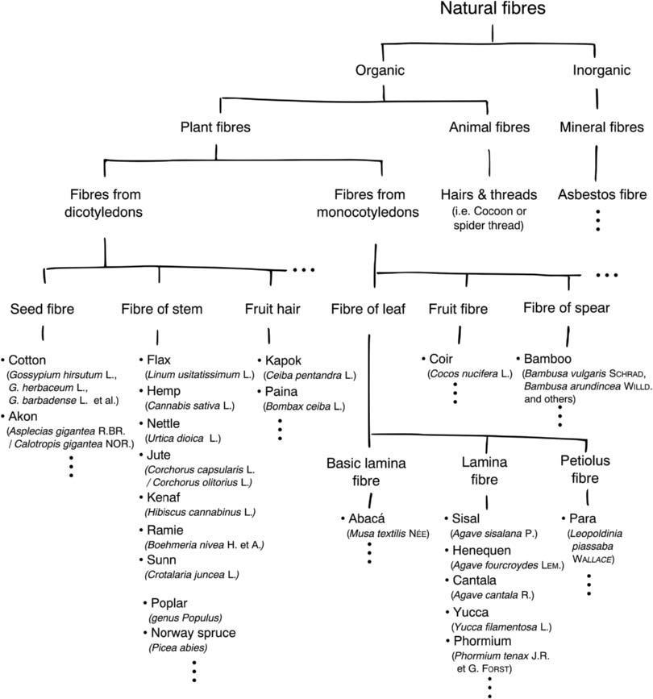

Figure 1

Classification of fibres

2.1.1.1 Plant fibers:

Plant fibers are generally comprised mainly of cellulose examples include cotton, jute, flax, ramie, sisal and hemp. This fiber can be further categorized into the following as Seed fibers the fibers collected from the seed and seed case e.g., cotton and kapok. Leaf fibers are the fibers collected from the leaves e.g., sisal and agave. Skin fibers are the fibres collected from the skin or bast surrounding the stem of the respective plant. Some examples are flax, jute, banana hemp and soya been.

Fruit fibers collected from the fruit of the plant, e.g., coconut (coir) fiber. Stalk fibers are actually the stalks of the plant. Some of the examples are straws of wheat rice, barley and other crops including bamboo and grass. Many useful fibers have been obtained from various parts of plants including leaves, stems(bast fibers), fruits and seeds. plant fibers are made up of mainly cellulose, they are categorized as “natural cellulosic fibers”, which many consist of one plant cell or an aggregate of cells cemented together by non-cellulose materials. Bast fibers are produced and used to manufacture a wide range of traditional and novel products including ropes, nets, carpets, mats, brushes, mattresses, paper, and board materials. (Mohini, 2011)

2.1.1.2 Plant fibers are classified into two groups:

- Soft fibers

- Hard fiber

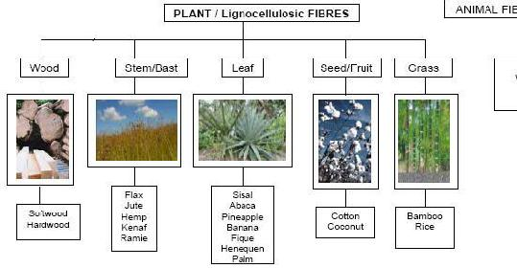

Figure 2

Classification of plant fibres

Soft fibers

The process of preparing soft fibers for weaving is laborious. The plant is selected and harvested, partially dried, and then pounded with a stone mallet and scraped to clean the fibers. The material is then washed and dried in the sun. later, the artists comb the fibers with their fingers.The fibers are now ready to be spun or twisted into thread or cord on the artist’s leg. Some fibers, including palm, grass, wheat chaff, and to rote, are prepared by drying and pounding, after which they are cut to size and braided. Soft fibers are used to make ropes, string, nets, bags, and hammocks.

Hard fibers:

Hard fibers are subjected to successive phases of cutting , drying, cleaning, and soaking before they can be woven. These strong, naturally flexible fibers are used to make furniture, birdcages, toys, baskets, and mats. (Chandramohan &Marimuthu, 2011)

2.2 BAMBOO FIBER:

The fastest growing woody plant on this planet is bamboo. It grows one third faster than the fastest growing tree. Some species can grow up to 1 meter per day. Bamboo is just grass, but it varies in height from dwarf, one foot (30 cm) plants to giant timber bamboos that can grow to over 100 feet (30 m). It grows in many different climates, from jungles to high on mountainsides. Bamboos are further classified by the types of roots they have. Some, called runners, spread exuberantly, and others are classified as clampers (sympodial), which slowly expand from the original planting. There are also varieties of root systems that are a mixture of these types. Generally, the tropical bamboos tend to be clumpers and the temperate bamboos tend to be runners.Bamboo fiber and starchy pulp are made from bamboo that grows widely through Asian countries. Starchy pulp is a refined product of bamboo stems and leaves through a process of hydrolysis-alkalization and multi-phase bleaching. Chemical fiber factories then process it into bamboo fiber.( Chandramohan &Marimuthu, 2011)

Bamboo is both decorative and useful. In many parts of the world it is food, fodder, the primary construction material and is used for making great variety of useful objects from kitchen tools, to paper to dinnerware.Generally bamboos are commonly used for furniture, construction, musical instruments and many more things. Bamboo is not only highly fashionable for decorative purposes but useful too. As it is a viable replacement for wood, in Far Eastern countries, it is the primary building material. Bamboo is in fact one of the strongest building materials available and even provided the first re-greening in Hiroshima after the atomic blast in 1945. Bamboo's tensile strength is 28,000 per square inch versus 23,000 for steel.

2.2.1. History:

One of the earliest engineering practices involved the use of scientific principles to extract and manufacture textiles for practical applications. Between 1900 and 1950, total fiber production grew almost three times as selected years from 1964 to 1982.The cotton industry and the creation of bamboo fiber for textiles are historically interconnected. The earliest record of U.S.Patents concerning bamboo textiles wasPatent & Trademark Office 2008). This patent outlined the

invention of a new and useful Process for Disintegrating the Fiber of Bamboo, so that it may be used in manufacturing cordage, cloth, mats, or pulp for paper (Lichtenstadt 1864).

The English cotton textile industry began in the early 18th century. As the expansion of the industry reached the limits of the pre-existing English domestic market, stagnation ensued. This stagnation was resolved through the exploitation of export opportunities in the transatlantic slave trade from Africa and in the slave-based economy of the Atlantic system (Inikori 1989). After U.S. independence, large areas of the South were turned into cotton plantations, worked by slaves to supply British mills (Farnie and Jeremy 2004).

The U.S. Civil War between the North and South lasted from 1861 to 1865. Beginning in 1862, then President Abraham Lincoln issued the Emancipation Proclamation, which called for the freedom of slaves. The freedom of slaves, however, depended on Northern military victory and thus influenced the goals of the Civil War. An end to the slave system would threaten the U.S. cotton industry in the South. It is thus fitting that during this civil war period (whose Northern victory could mean free slaves and thus a downturn in cotton production that benefited from slave labour), a U.S. patent was awarded for otherforms of textile materials-namely bamboo.

2.2.2. Botanical classification of bamboo:

KINGDOM : Plantae

DIVISION : Magnoliophyta

CLASS : Liliopsida

SUBCLASS : Commelinidae

ORDER : Cyperales

FAMILY :Gramineae(Poaceae)

SUBFAMILY : Bambusoideae

TRIBE : Bambuseae

SUBTRIBE : Bambusinae

2.2.3 Properties:

Bamboos are tapered, cylindrically shaped grasses with mostly hollow forms (though some species are solid cylinders). Bamboos normally have a final height of 20-25 meters (Magel, Kruse et al., 2005). The biomass is produced within a growing season of about 3-5 months. Bamboo is 26-43% cellulose, 21-31% lignin, and 15-26% hemicelluloses (Mwaikambo, 2006). Theoretically, the mechanical properties of bamboos mainly depend on the (1) species, (2) age,

- moisture content, (4) position along the culm (top or bottom), and (5) positions of the nodes and the internodes (Janssen, 1995). (Table 2)

The culm is the main axis, or stem, of the bamboo. Itcan be divided into the (a) cavity, (b) diaphragm,(c) node, (d) branch, (e) internode, and (f) wall (Figure 3).

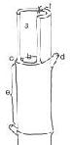

Figure 3

Structure of Bamboo Culm

(Janssen 1995)

Table 1

Physical Properties of Bamboo Fibre

 | Properties |  |  | Bamboo
Strength (gm/tex) |  |  |  | 34.3
Elongation (%) |  |  | 16.0
Short Fibre Index |  |  |  | 5.58
Uniformity Index (%) |  |  | 92.7
UHML(mm) |  |  |  | 38.745
ML(mm) |  |  | 35.62
Moisture (%) |  |  |  | 6.5
Micronaire |  |  | 4.0

It's a common fact that bamboo can thrive naturally without using any pesticide. It is seldom eaten by pests or infected by pathogen. Bamboo owns a unique anti-bacteria and bio-agent named "bamboo Kun". This substance combined with bamboo cellulose molecular tightly all along during the process of being produced into bamboo fiber.

Bamboo fiber has particular and natural functions of anti-bacteria, bacteriostasis and deodorization It is validated by Japan Textile Inspection Association that, even after fifty times of washing, bamboo fiber fabric still possesses excellent function of anti-bacteria, bacteriostasis. Its test result shows over 70% death rate after bacteria being incubated on bamboo fiber fabric. Bamboo fiber's natural anti-bacteria function differs greatly from that of chemical antimicrobial. The later often tend to cause skin allergy when added to apparel

2.2.3.1. Bamboo fiber fineness:

 | Table 2
 | Description
 | Fineness (dtex) |  | Length(mm)
 | 1.33 / 1.56 / 1.67 |  | 38
 | 2.00 |  | 45
 | 2.22 |  | 51
 | 2.78 |  | 51
 | 3.33 |  | 64
 |  |  | 76
 | 5.56 |  | 38

2.2.3.2. Breathable and Cool

What's notable of bamboo fiber is its unusual breathability and coolness. Because the cross-section of the bamboo fiber is filled with various micro-gaps and micro-holes, it has much better moisture absorption and ventilation. With this unparalleled micro-structure, bamboo fiber apparel can absorb and evaporate humans sweat in a split second. Just like breathing, such garments make people feel extremely cool and comfortable in the hot summer. It is never sticking to skin even in hot summer. According to authoritative testing figures, apparels made from bamboo fibers are 1-2 degrees lower than normal apparels in hot summer. Apparel made from bamboo fiber is crowned as Air Conditioning Dress.

2.2.3.3. Green & Biodegradable

As a regenerated cellulose fiber, bamboo fiber was 100% made from bamboo through high-tech process. The raw material bamboo is well-selected from non-polluted region. They are all 3-4 year old new bamboo, of good character and ideal temper. The whole distilling and producing process in our plant is green process without any pollution. Our company manufactures bamboo fiber strictly according to ISO9000 and ISO 14000. It produces natural and eco-friendly fiber without any Chemical additive.

What's more, bamboo fiber is biodegradable textile material. As a natural cellulose fiber, It can be 100% biodegraded in soil by microorganism and sunshine. The decomposition process doesn't cause any pollution environment. "Bamboo fiber comes from nature, and completely returns to nature in the end".Bamboo fiber is praised as "the natural, green, and eco-friendly new-type textile material of 21st century". (Saravanan, 2008)

2.2.4.Advantages

- High strength, health care

- Anti- bacteria

- Moisture management and

- Soft hand feel

- Anti-static

- Perfect for sensitive skin

2.2.5. Disadvantages

- Poor spinability

- High cost(30 to 40% higher than cotton)

2.3. PRE-TREATMENT OF THE FABRIC

Natural fibres and synthetic fibres contain primary impurities that arecontained naturally, and secondary impurities that are added during spinning, knitting and weaving processes. Textile

pretreatment is the series of cleaning operations. All impurities which causes adverse effect during dying and printing is removed in pretreatment process. (Figure 4)
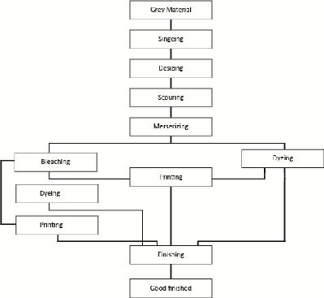

Figure 4

Pretreatment of fabric

2.3.1. Desizing:

Desizing is the process of removal of size material applied on warp threads of a fabric to facilitate the process of weaving. Size forms a stiff, hard and smooth coting on warp yarns to enable them to withstand the cyclic tensions during weaving and reduce breakage.

2.3.2. Bleaching:

Textile bleaching is a chemical treatment process. In this process, destructing natural coloring matters and remaining trace impurities are removed from the gray fabric. Bleaching process is done to impart a pure permanent and basic white effects which is suitable for the production of white finishes, level dyeing and desired printed shade with minimum or no degrading or without diminishing the tensile strength. Chemicals that are widely used in the conventional bleaching process may include some of the following chemicals: sodium chlorite and hypochlorite, detergents, wetting agent, optical brighteners, urea, trisodium phosphate, oxalic acid, formic acid sodium nitrate and peroxides.(Ramadan 2008)

2.4. MORDANT:

Natural dyes also refferedas mordant dyes, do not really adhere to bamboo to mortdants are used. Mordants are neede to set the color when using natural dyes. Different mordants will give different hue colr with the same dye. In textile mordants are used to fix the color in dyeing of fabric printing, especially for fabrics of plant origin. Mordant is metallic salt that facilitate the bonding of the dyestuff to the fibre. Natural dyes need to use the mordants for colour fixation.

The percentage of chemicals and the weight of the material to be dyed are very important. The details of chemicals to be used for various mordantswith their quantity, fixed temperature is to be maintained, duration of time and the procedure to be followed after mordantingand before dyeing have to be followed strictly. There are three ways of mordanting. Mordantsand dyes may be applied in three ways. They are as follows:

2.4.1. Mordanting Techique:

Three different mordanting techniques were used.

- Pre-mordanting

- Simultaneous mordanting

- Post-mordanting

2.4.1.1. Pre-Mordanting (onchrome):

The substrate is treated with the mordant and then the dye. The complex between the

mordant and dye is formed on the fibre. where the mordant is applied first, followed by

dyeing.

2.4.1.2. Simultaneous Mordanting (metacrome):

The mordant is added in the dye bath itself. The process is simpler then pre-or post-mordanting, but is applicable to only a few dyes. Mordant red 19 shown above is applied in this manner.where the dyeing is done first and then mordantingis carried out.

2.4.1.3. POST MORDANTING (afterchrome):

The dyed material is treated with a mortant. The complex between the mortant and dye is formed on the fibre.

- The type of mordant used affects the shade obtained after dyeing and also affects the fastness property of the dye. The Each dye can have different reaction to each mortant. Residual iron mortant can damage or fade fabric, producing dye rot. where mordant and dye are mixed together and applied.

2.5. DYE:

Substances that add color to textiles. They are incorporated into the fiber by chemical reaction, absorption, or dispersion. Dyes differ in their resistance to sunlight, perspiration, washing, gas, alkalies, and other agents; their affinity for different fibers; their reaction to cleaning agents and methods; and their solubility and method of application.

2.5.1. History

Until the 1850s virtually all dyes were obtained from natural sources, most commonly from vegetables, such as plants, trees, and lichens, with a few from insects. Solid evidence that dyeing methods are more than 4,000 years old has been provided by dyed fabrics found in Egyptian tombs. Ancient hieroglyphs describe extraction and application of natural dyes. Countless attempts have been made to extract dyes from brightly colour plants and flowers; yet

only a dozen or so natural dyes found widespread use. Undoubtedly most attempts failed because most natural dyes are not highly stable and occur as components of complex mixtures, the successful separation of which would be unlikely by the crude methods employed in ancient times. Nevertheless, studies of these dyes in the 1800s provided a base for development of synthetic dyes, which dominated the market by 1900.

2.5.2. Classification of dye:

The dyes are classified into natural and synthetic dyes. These are further classified (Figure 5).
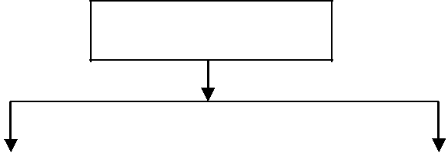

Dyes

Natural Dyes |  |  | Synthetic Dyes

From plants |  | From animals |  | Azo dyes |  | Non-Azo dyes

Figure 5

Classification of natural dyes

2.6 NATURAL DYES:

Dye, substance used to impart colour to textiles, paper, leather, and other materials such that the colouring is not readily altered by washing, heat, light, or other factors to which the material is likely to be exposed. Dyes differ from pigments, which are finely ground solids

dispersed in a liquid, such as paint or ink, or blended with other materials. Most dyes are organic compounds (i.e., they contain carbon), whereas pigments may be inorganic compounds (i.e., they do not contain carbon) or organic compounds. Pigments generally give brighter colours and may be dyes that are insoluble in the medium employed.The fact that colour is directly related to the molecular structure of the dye.

Natural dyes are dyes or colorants derived from plants, invertebrates,a or minerals. The majority of natural dyes are vegetable dyes from plant sources from roots, berries, bark, leaves, and wood and other organic sources such as fungi and lichens Natural Dyes are those obtained from natural sources (both plant and animal). Natural. Plant dyes are obtained from the leaves, bark, stem, root, seeds, fruits, etc of the plant eitherin dried form or in raw form. The demand for natural dyes is increasing day by day due to the following merits it has when compared to the synthetic dyes:

Less toxic effect on humans and environment when compared to the synthetic dyes. Many natural dyes have pharmacological effects and possible health benefits. They are obtained from renewable sources. Natural dyes cause no disposal problems, as they are biodegradable. Practically no or mild reactions are involved in their preparation. They are unsophisticated and harmonized with nature.Many natural dyes have the advantage they do not stain the adjacent fabrics in thewashing process because of the non-substantive nature of the dye towards thefabric.It is possible to obtain a full range of colours using various mordants.Currently, there are no true environmentally friendly synthetic dyes available, andnatural dyes, used considerately, are the only true green option to replace the negativeeffects of synthetic dyes. Natural dyes being biodegradable and renewable are a goodsubstitute for synthetic dyes as they are in harmony with nature.( Shivani Verma and Gunjan Gupta,2012)

2.6.1 Advantages:

- natural dyes are not 100% safe they are less toxic than their synthetic counterparts. Many of the natural dyes like turmeric, annatto and saffron are permitted as food additives. Many natural dyes have pharmacological effects and possible health benefits.

- They are obtained from renewable sources.

- Natural dyes cause no disposal problems, as they are biodegradable.

- Practically no or mild reactions are involved in their preparation.

- They are unsophisticated and harmonized with nature.

- Many natural dyes have the advantage that even though they have poor wash fastness ratings, they do not stain the adjacent fabrics in the washing process because of the non-substantive nature of the dye towards the fabric. An exception to this is turmeric, which shows substantivity for cotton.

- Natural dyes are cost effective

- It is possible to obtain a full range of colours using various mordant.

2.6.2 Disadvantages:

- Availability

- Colour yield

- Complexity of textile dyeing process

- Reproducibility of shade

- Limited number of suitable dyes

- Great difficulty in blending dyes

- Non-standardized

- Inadequate degree of fixation

- Inadequate fastness properties except few exceptions

- Water pollution by heavy metals and large amounts of organic substances.

2.7 Plant Dyes

There is a whole variety of plants which can be used to make plant dyes. Different parts of plants are used to make dyes – for example, the leaves, the skins of fruit, the bark, roots or wood. Lichens are very small plants which grow on rocks. There are many colours of lichens and they are very good for making dyes.

2.8 Caesalpinia

The caesalpinia sappan extracted from its heart wood is useful to color fabric and also preparing red ink. Sappan wood (casalpinia sappan) or (sumu) in Chinese also known as east Indian red wood , come from a tree that has both ornamental and medicinal properties.it is a small thorny tree; it can reach a height of more than 30 feet. It is found in the world throughout china, india and in the Philippines. It is also cultivated in gardens and nurseries, express(badami and moorkoth, 2003). A large guantity of sappan, or buckum wood the produce of caesalpinia sappan is grown in malabar, and its cultivation might be still further extended. (Valeeratana Kalani Sinsawasdi, 2012)

The sappan tree (puttingay, hindoo) is cultivated in paulghaut, madras, for the purpose of dyeing the straw used in mat-marking. This dye is much used in pegu, where silk dyed by means of it of a dark red colour the wood of the trunk and also of the root, are rendered available(simmonds, 2006).the pods of coriara or sumach, a small tree are used as a tanning material, casalpinia, paniculata, sappan yields one of the brazil wood of commerce, (balfour 2006). It has highly medicinal value and commercial value. It is used in various medicinal industry like allopathy, homeopathy, ayurveda,siddha, unani as anti-oxidant, antibiotioc, antibacterial ect.,(gehring, 2011). Sappan wood yields a yellowish colour like that of brazil wood (brasil- lensis) but it does not afford of dye matter so much in quantity or so good in quality (strousbery,2010)

2.8.1 Secintific Classification

Indian redwood, Sappan wood, Brazil wood, Pathimukham (Malayalam), Patamg

(Hindi)

Kingdom | : Plantae
Subkingdom | : Tracheobionta
Division | : Mangnoliophyta
Class | : Mangoliopsida
Order | : Fabales
Family | : Fabaceae or Leguminosaceae
Genus | : Caesalpinia.
Species | : sappan L.(https://www.bimbima.com)

2.8.2 History :

The brazil-wood of commerce is however , fee considers the sappan wood of east india (caesalpinia sappan) to be wood of the Brazil-wood of the merchants (balfour, 2007). Sappan wood is native to india malya, and sri lanka. It is cultivated though out the asian tropics. The wood was imported into Europe since medieval time, only in limited quantities. The dye was a beautiful red , the colour of burning coal (in old French and English brazilin)and was called bresil by the early Portuguese traders. The closely related sappan wood, the valuable dye from brazil-wood (called brazilin become a popular agent especially for dyeing cotton and wool cloth and to make red (www. Naturalpigment.com).

The tree commonly grows is dry places and amid rocks and seldom exceeds 30 feet in hight (Bradford, 2010). The flowers in this sub order are irregular but not papilionaceous and upwards of seven haundred species have been described. It embraces many genera, some of them containing plants valuable as meadicines dyes and timber. The genus casalpinia , which given the name to the family, consists of trees or shrubs growing in the tropical parts of asia, Africa and America(baird, 2006). Sappan wood (casalpinia wood ) has been used from time immemorial in the india and china introduced to thewest by the venetians while trading with the east, it was first transported by land and then later by sea. An armed climbing shrub planted in garden or other fences, it is easily reared from seeds in almost any soil, if the plants are watered during the dry weather. After ten or twelve years the wood of the plant becomes valuable for its red dye and is exported extensively from the western coast(patango, 2011). In the 15th and 16th centuries brazil wood was highly valued in europe and quite difficult to get coming fromasia.

2.8.3 Properties :

- The colouring matter of this species of caesalpinia, differs but little from that of brazil wood in its properties and effects, or in regard to the mordants required to produce these effects; but there is a considerable difference in regard to the relative quantities of colouring matter which these woods afford (Bancroft, 2007).

- The wood possesses much the same properties of the preceding and constitutes an article of very important trade to Calcutta(hogg, 2011).

- Senna is their most remarkable product. Some of them yield dyes. The locusi trees of north America belong to this order, and are celebrated for their gigantic stature,natural

products have provided a variety of lead structures, which serve as templates for the development of new drugs. The water kept in caesalpinia(sappan lignum) heart wood is being used in kerala as herbal drinking water for its anti-thirst, blood purifying, anti-diabetic, improvement of complexion and several other properties is also blood purifying and is a good drink for persons with diabetes it cures jaundice, cough and respiratory problems.

2.8.4 Uses :

- the wood of caesapinia sappan is the wood-dye that is known to have been used at a large international scale throughout world history. Hundreds of tones were expoted annually to the Islamic and Mediterranean worlds and Europe from the middle ages onwards. It

remained a major source of red dye upto the end of the 19th century. It is still used for dyeing textiles, but only on a smaller scale by craftsmen and artists silk, wood, cotton, matting and basket fibers can be dyed red with it and it is also used occasionally to color food.

- On oxidation yields a red dye called brazile in the most valuable dye used, it coloring leather, silk, cotton, wool, fibers of different kinds, batik, calico, printing, furniture, floors, feather, medicine, wiskey and several handicraft(www.xenonindia.com)

- As the chemical dye are restricted for human by WTO and WHO the need of sappan wood dye will be increased a lot (http//www.agricultureinformation.com).

- Brazilin is found to be the main constituent of the plant responsible for several of its biological activities. The use of heart wood as a coloring agent for win , meat fabric etc,. is well established.

2.8.5 Curcuma

Curcuma longa L., which belongs to the Zingiberaceae family, originates from the Indiansub-continent and possibly neighbouring areas of Southeast Asia, but it is nowadays widelygrown throughout the tropics. It is a small perennial herbaceous plant that measures up to1m high with a short stem and rhizomes, which show oblong, ovate, pyriform, often shortbranchedforms, from where the pigments are extracted. Curcuma thrives in a hot, moisttropical climate with rainfall of

1000–2000 mm/year, preferably in a rich well-drainedloam soil. Cultivation is possible from sea level up to about 1500m

Turmeric is one of the oldest natural colouring agents used throughout the world from ancient time. The rhizomes of the perennial turmeric are the source of colour. It is cultivated in almost all the parts of india. Curcumin is the prime principal constituent of yellow dye, along with other constituents like monodesmethoxcurcumin and bisdesmethoxcurcumin, Which also contributes fewer amounts of pigment and flavour.

2.9.1. SCIENTIFIC CLASSIFICATION OF TURMERIC

Kingdom : plantae

Clade : angiosperms

Clade: commelinids

Order : zingiberales

Family : zingiberaceae

Genus :curcuma

Species : curcuma longa

2.9.2. HISTORY OF TURMERIC

Turmeric has been used in asia for thousands of year and is a major part of ayurveda, siddha medicine, traditional Chinese medicine, unani, (chattopadhyay 2004)and the animistic rituals of austronesian peoples. It was first used as a dye, and then later for its supposed properties in folk medicine.

2.9 TIE AND DYE:

Tie and dye, like Batik is a resist-dyeing process for creating attractive coloureddesigned on fabrics. However, while in Batik, resistance to dye penetrations is provided by

a coated layer of wax, in the case of tie and dye, this is achieved by knotting, binding, folding or sewing certain parts of the cloth in such a way that the dye cannot penetrate into these

areas when the cloth is dyed. It is a hand process by which intricate and attractive patterns can be produced.

In India, the tie dye method is generally a cottage industry and is known as Bandhanior Bandhej. It is often used for T-shirts, dresses, skirts, stoles and other garments and alsoin furnishings like pillow covers, table cloths, bed sheets etc.Tying the cloth or knotting is called bandhej or tie and dye. In this procedure thecloth is tied with a thread of thickness greater than that of the cloth. After the tied cloth isdyed and dried, the ties and knots are opened. As a result we get different colourfulpatterns on the cloth. The art of tie- dyeing is most popular in various regions of Gujarat,Kathiawar and Rajasthan.It is a modern version of traditional dyeing methods used in many cultures throughout the world. "Tie-dye" can also describe the resulting pattern or an item which features this pattern. The whole point of tie dyeing is to prevent the dye from reaching the fabric evenly (D. Frick, 2003)

2.9.1 HISTORICAL PERSPECTIVE:

The tie and dye technique of creating design on fabric has been practiced from very early times in many parts of the world. The fresco paintings in Ajanta caves in Maharashtra in India (6th– 7th century A.D.) depict people wearing clothes with beautiful tie and dye designs. There is an evidence that tie-dye technique was practiced in China during the Tan’gdynasty (618-906) from where it moved to Japan in the Nara period.

It is difficult to trace the origins of this craft to any particular area in India. According to some references it first developed in Jaipur in the form of leheriya. But it is widelybelieved that it was brought to Kutch from Sindh by Muslim Khatri’s who are still the largest community involved in the craft. Bandhani was introduced in Jamnagar when city wasfounded 400 years ago. This city has now become one of the principle centres of Bandhani, creating new patterns and experimenting with colours. The tie-dye is a village craft carried on mostly by women in

villages of India. The workers are known as Bandhanaris who always grow the nails of their thumbs or fore fingers for tying knots on cloth. The designs can be tied in different ways. They are set in stylized floral pattern or motifs of lotus flowers, dancing women and elephants or smart geometrical patterns.

Tie and Dye is a village craft carried on mostly by women in villages of India. Theworkers are known as Bandhanaris who always grow the nails of their thumbsor fore fingers for tying the knots on cloth.Designs can be tied in different ways. They are set in stylized floral pattern ormotifs of lotus flowers, dancing women and elephants or smart geometrical patterns

2.9.2 IMPORTANT CENTRES OF TIE AND DYE IN INDIA:
- Coarse Bandhani work is carried out in Madhya Pradesh.

- The centres for line work, as well as for much of the simpler work are in Kutch and saurashtra.

- Bhuj is a town with great many Bandhani workers.

- In the port of mandavi, some of the finest Bandhani in India is tied.

The art of tie- dye is practised at many places, which have good river water available like Porbander, Ahembabad, Morvoi, Rajkot, Bikaner, Rajasthan and Gujarat are known for their productions , which is very fine and prolific.

The finest Bandhini works of Rajasthan come from Jaipur, Jodhtur, Barmer, Plai, Udaipur and Nathdwara. Rajasthan is well known for leheriya pattern, literally meaning waves. Pochampalli is also one of the three main traditional yarn dyeing centres in India.

The process of making Bandhani varies from Gujarat and Rajasthan.

2.9.3 DYES USED FOR TIE-DYE:

The dyes used in good old days were vegetable dyes like madder, saffron, weld, Persian berries and Indigo. The wide range of dyes was originally from the ancestry of MorindaCardifobia, in combination with a double sulphate of Aluminium and Potash for the fast red,kasum from the petals of sunflower, chhach for yellow and Gali Indigo from the leaves of the FeraTintria for blue. Today modern synthetic dyes are better suited to our fabrics. The patterns and designs created with these dyes on the present day fabrics have visual excitement and tactile appeal.The

dyes of all types of Bandhani work used today are almost artificial. Dyeing always starts with lighter shades and the darkest shades are always at the end. After each successive dyeing, the cloth is untied and dried.

2.9.4 THE PROCESS OF TIE-DYEING:

The main steps involved in tie-and-dye are as follows:

i. Wash the fabric, dry it and then iron it.

- Prepare the cloth for tie-dyeing by knotting, binding, folding, sewing, etc. or a combination of these by always keeping right side on the top.

- Prepare dye and test for colour.

- Wet sample, if necessary and place it in the dye bath for the required length of time.

- Remove the fabric from the dye bath and squeeze out surplus water and hang up to dry.

- Rinse the dyed fabric in water and keep on rinsing till the water is clear.

- Squeeze out the surplus water and hang up to dry.

- When second or third colour is to be dyed, tie up the sample again or add more binding where the previous colour is to be preserved. Repeat the dyeing process for each subsequent colour. After final dyeing and rinsing, the fabric should be dried quickly.

- Untie the sample. Rinse again, if necessary and partially dry. Iron the fabric while still

damp.

- Collect and tie together any lengths of threads which can be used again. Keep coarse and fine binding threads separately.

3. EXPERIMENTAL PROCEDURE

Experimental procedure pertaining to the study Extraction and application of

caesalpinia sappan wood and curcuma longa (turmeric) natural dye on bamboo fabric is

discussed under the following headings:

3.1 Selection of fabric

3.2 Pre-treatment of the fabric

3.2.1 De-sizing

3.2.2 Bleaching

3.3 Selection of dye source

3.4 Selection of mordant

3.5 Fabric tieing

3.6 Preparation and dyeing of fabric

3.7. Evaluation of bamboo fabric

3.7.1 physical evaluation

3.7.1.1 fabric weight

3.7.1.2 fabric thickness

3.7.2 mechanical evaluation

3.7.2.1 Fabric Strength

3.7.2.2 Fabric Elongation

3.7.3 comfort

3.7.3.1 Fabric stiffness

3.7.4 Wettability absorbency test

3.7.4.1 Spray Test

3.7.4.2 Wicking Test

3.7.4.3 Sinking Test

3.1. Selection of fabric

Bamboo textiles have many fantastic properties that combined make this a truly amazing fabric. It is breathable and cool, has a nice luster; performance; and anti-bacterial. Absorbent-bamboo fabric approximately 60% more water absorbent than cotton. This makes it similar in absorption to hemp. Silky- bamboo fabric though is luxuriously soft with what has been described as a similar feel to cashmere. Bamboo cloth is an indulgence with its wonderful silky softness. Bamboo fabric is a unique biodegradable textile material. As a natural cellulose fiber, bamboo fabric can be 100% biodegraded in soil by micro organisms and sunlight. The decomposition process does not cause any pollution in the environment. “Bamboo fiber comes from natural in the end”. Bamboo fabric take up colour well when dyed. Bamboo fiber is paised as “the natural, green and eco-friendly new-type textile material of the 21st century” (www.bamboofabricstore.com)

3.2. Pre-Treatment of The Fabric

The pretreatment of the bamboo fabric includes:

3.2.1. De-sizing

A woven bamboo fabric of 345gms was taken and soaked in the solution containing soap powder and water. 1:10 ml of liquor ratio of was taken and the bamboo fabric was boiled for about 1hr at 60⁰ C. After then, the fabric was rinsed thoroughly using plain water to remove soap and other trace matters.

3.2.2. Bleaching

Chemicals that are widely used in the conventional bleaching process may include some of the following chemicals: sodium chlorite and hypochlorite, detergents, wetting agent, optical brighteners, urea, trisodium phosphate, oxalic acid, formic acid sodium nitrate and peroxides.

3.3. Selection of dye source

Natural dye were eco-friendly and do not cause environmental pollution during their production and use. Also some unique shades can be obtained by suitable combination of natural dyes and mordants ( Rameshwar et al., 2007). Today in the world of environmental and ecology conservance, natural colourants have attracted the attention of the whole world(katyayini and Jacob, 1999). According to(leano, 2008) chemical dyes have been banned in Europe because these are found to be toxic or carcinogenic. Synthetic dye was selected as the source for dyeing the selected bamboo fabric.

There are the two natural source used for dying the fabric

Caesalpinia

curcuma

3.4. Selection of mordant

Mordanting is the fixing agent, prevents the colour fading with exposure to light or washing to help dye adhere to the material being dyed (papita and siddhartha, 2008). Mordants can be of synthetic or natural origin. The most commonly used synthetic mordants with natural dyes were chrome, copper and tennic acid (Rathi and Godbak, 1999). Natural mordants include myrobaln, sour butter milk, alum and pomegranate.

Alum(potassium aluminum sulfate) is the most common mordant. If you are not sure what you want to do, mordant with alum, and use the others as additives. Alum does not affect color. It is usually used with cream of tartar, which helps evenness and brightens slightly. Three 3:1 of alum: cream of tartar is a good start; if heavy wool is used 4 of alum can be used safely. Too much alum makes wool sticky.

3.5. Fabric Tieing

Spirals

Lay your material on a flat surface. Place your thumb and a couple of fingers together on the cloth at the point which will be the center of the design. Using the weight of your fingers to hold the cloth in place, start twisting. After each twist, flatten the material with the palm of your

hand to keep the folds from rising. With your other hand, bring the loose ends into the circle and continue to twist until the whole thing looks like a fat pancake.

Now take rubber bands, and without disturbing the shape of the pancake slide the bands under the cloth so that they intersect at the center. Use as many as necessary to retain the circular shape, about twice the number shown in the illustration at right for most tie-dyes. If you decide to immerse, instead of squirting, just set the cloth gently in the dye bath, do not stir. For an interesting effect, prevent the cloth from submerging, either by using less water or by placing the cloth on a prop to hold it out of the dye a little. Some materials will float automatically. Then sprinkle a different color dye in powder form over the top of the cloth, being careful not to get any in the other dye solution.(kadokawa Shoten, 1998)

Stripes

Roll the cloth very loosely, forming a long tube. The stripes will be at right angles to the tube.Tie at one intervals or as far apart as you want the stripes to run. Loop rubber bands or wrap string around the tube a few times and knot. Make sure the ties are very tight. Now you can either immerse or squirt the dye on, alternating your colors,

Pleats

Lay cloth on flat surface. Place thumbs of both hands together firmly on the cloth. Position fingers about an inch or two in front of your thumbs, and pinch the fabric to raise a fold. Continue to pinch up more pleats until you reach the end of the cloth. You can change directions as often as you want by gathering more material in one hand than in the other. Be careful not to lose any pleats. Loop rubber bands or string very tightly around all the pleats several times and knot. You can use as many ties as you want. This useful technique is also employed in tying ovals, squares, diamonds or any shape you can imagine which has symmetry(Limmatvapirat, 2002)

3.6. Preparation and dying of fabric

curcuma

The dye is extracted from the fresh or dried rhizomes of turmeric. It is a substantive dye capable of directly dyeing bamboo fabric the dye was prepared by the extracted turmeric powder

and mixing it with deionized water at neutral pH, at 95º c for 1.5 hours. The obtained turmeric solution (dye solution) had a yellowish color.(www.sildeshare.net)

Caesalpinia

Extraction of natural dyes: Sappan woods were soaked in the 20 times of water, heated and extracted for 60minutes, and filtered. This process was repeated two times. The first and second extracts were combined and used as a solution for dyeing.

Dyeing Procedure:Fabrics were dyed at 90ºfor 30min. while maintaining a bath ratio

1:50. The dyed fabrics were then washed and air dried( Jin soun jung, 2017)

SELECTION OF FABRIC :
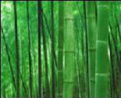

PLATE -I
BAMBOO

A plain weave woven bamboo fabric was taken for the study

SELECTION OF SOURCES :
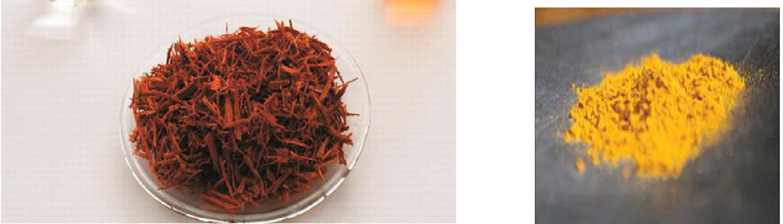

PLATE –II PLATE – III

Caesalpinia(Sappan Wood ) CURCUMA (Turmeric)

SELECTION OF MORDANT:
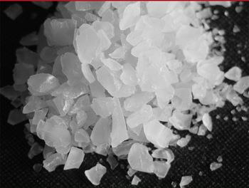

PLATE -IV

ALUM

PREPARATION AND DYEING OF FABRIC
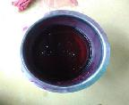
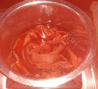

PLATE -V

Dye Source
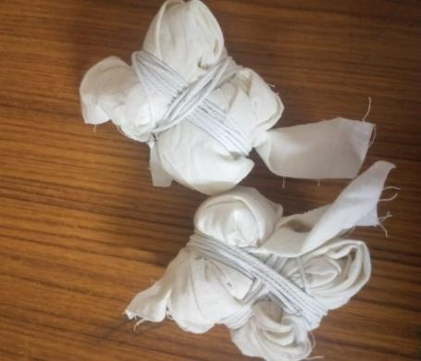

PLATE-V(a)
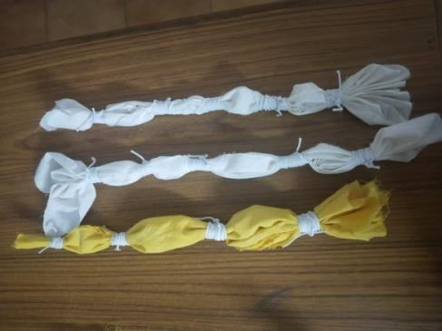

PLATE -VI PLATE-VI(a)

Tied fabric
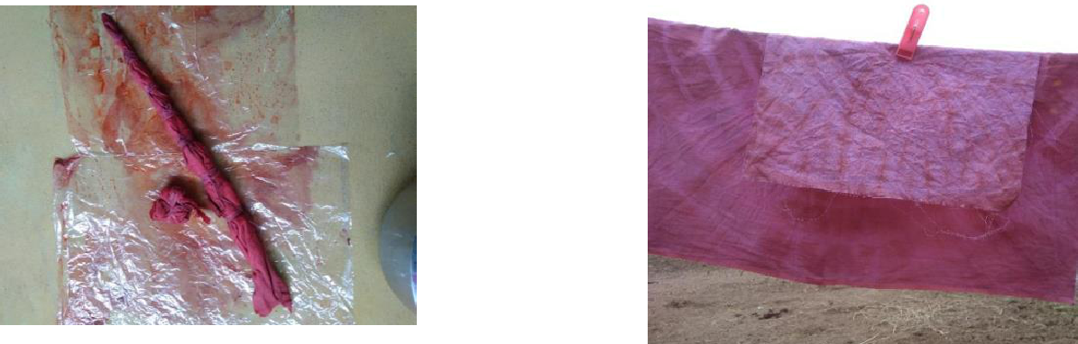

PLATE-VII PLATE-VII(a)

Dyed Fabric

TABLE - III

DYEING PERAMETERS

Nomenclature | Concentration | Dyeing | Dyeing | Material | Types of | Mordanting
of the dyeing | of dye | time | temperature | liquor | mordant | technique
 |  | (min) |  | ratio
D2 | 50(gm) | 30 | 90º | 1:50 | Alum | Simultaneous
 |  |  |  |  |  | mordanting

TABLE –IV

NOMENCLATURE OF THE SAMPLE

S.NO | NOMENCLATURE OF SAMPLE | PARTICULARS
1 | O | Original
2 | D1 | Desized fabric
3 | B | Bleached fabric
4 | D2 | Dyed fabric

3.7. Evaluation of bamboo fabric

The sample of any research is based upon the utilization of end product which in turn will be the result of their properties.

3.7.1 Physical evaluation

3.7.1.1 Fabric Weight

Fabric weight is an important component for comparing the two similar fabrics construction (Saini, 2004). The fabric weight is the relative weight of the fabric and express as the weight of a particular size of piece such as grams per square meter. It is a device to cut circular specimens of

100 square centimeters of a fabric very accurately. It has four blades that cut the fabric when the nano wheel is rotated by applying light pressure. Three samples for each of O,D1,B and D2were carried out. Then these were weighted accurately using digital balance having 0.01sensitivity. The value obtained in grams multiplied by 100 gives grams per square meter (GSM) of the fabric. Thus fabric weight was analysed for all the samples. Three samples for each of the concentrations was calculated and to be tabulated.

3.7.1.2 Fabric Thickness

Fabric thickness is defined as the distance between the upper and the lower surface of the material where measured under a standard pressure using Shirley’s Thickness Tester with an accuracy of 0.01mm. (Stoker et al., 2005).The fabric was placed between the pressure foot and anvil the reading was noted from the dial. Five readings were taken from different places of the O,D1,B and D2fabrics. Thus fabric thickness was analysed for all the untreated and treated samples. Five readings for each of the concentrations was calculated and to be tabulated.

(Plate IX)

3.7.2 Mechanical evaluation

3.7.2.1 Fabric Strength

The strength of a fabric is defined as its ability to withstand an applied load without failure. Two rectangular specimens of size 3inches × 8inches were cut both in warp and weft direction of the fabrics O,D1,B and D2 were placed in between the jaws of the tensile strength tester. One side of the cut end is clamped into the upper jaw and the other end into the lower jaw. When the tester was started, the jaws move apart at a constant rate until the fabric begins to tear. At that moment, the tester was stopped the readings shown in the dial of the tester are to be noted.(Plate IX)

3.7.2.2 Fabric Elongation

Fabric elongation is the increase in the length of the specimen from its starting length expressed in units of length. The distance that a material will extend under a given force is proportional to its original length, therefore elongation is usually quoted as strain or percentage extension. This, test is be conducted in tensile strength tester, with the same procedure that was

followed for the fabric strength test. But, the readings for the samples were shown clearly on the elongation scale placed at the left side of the tensile tester. Thus, the samples of the fabrics O,D1,B and D2were tested and the readings are to be noted.(Plate-X)

3.7.3 Comfortproperties

3.7.3.1 Fabric stiffness

Fabric stiffness is the tendency of fabric to keep standing without any support. It is the key factor in the study of handle and drape of the fabric. A strip of fabric, 6in. X 1in. with the aid of the template. Both the template and specimen are transferred to the platform with the fabric underneath. Now both are slowly pushed forward. The strip of the fabric will commence to droop over the edge of the platform and the movement of the template and the fabric is continued until the tip of the specimen viewed in the mirror cuts both index lines. The bending length can immediately be read off from the scale mark opposite a zero line engraved on the side of the platform. Each specimen is tested four times, at each end and again with the strip turned over. In this way three samples are tested. Finally mean values for the bending length in warp and weft directions can be calculated.(plate-XII)

3.7.4 Absorbency test

Absorbency is one of the several factors that influence textile processing such as fabric preparation, dyeing and the application of finishes, states AATCC (2007). Water and moisture transportation of the fabric is an in, portant aspect of my fabric. This factor decides the comfort of fabric and really an important feature of fabric as it transports water from the body surface and makes them feel comfortable(sarkar et al., 2005). Spray, wicking and Sinking test were conducted to study the absorbency properties of the original bamboo, de-sized, bleached and dyed(D2) sample.

3.7.4.1 Spray Test

The spray rating test is one used to measure the resistance of a fabric to surface wetting but not to penetration of water. It is therefore a test which is particularly used a shower proof finishes. It is often the case that water proof coating are applied to the inner surface of a material and a water repellent finish is then applied to the outer surface to stop it absorbing water as it

would otherwise become waterlogged. In such cases the test is used on the outer layer of fabrics which are otherwise considered as waterproof. (BS EN, 2002)

In the test five specimens O,D1,B and D2are tested. Each sample is 180mm in square. Each specimen in turn is held over a 150mm diameter embroidery frame which is mounded at 45º to the horizontal. A funnel which is fitted with a standard nozzle containing 19 holes of a specified diameter is held 150mm above the fabric square. 250 ml of distilled water is poured into funnel at 25 ± 2⁰C the shower is continued onto the fabric. After the water spraying is stopped the frame and sample is removed and it is tapped twice smartly against a solid object in an opposite points of the frame, the fabric being kept horizontal. This removes any large drops of water. The fabric is then assigned a spray rating either wing the written grading.

The ratings are as follows:

- 100 - No sticking or wetting of the upper surface

- 90 - Slight sticking or wetting of the upper surface

- 80 - Wetting of the upper surface at spray points

- 70 - Partial wetting of whole of upper surface

- 50 - Complete wetting of whole of upper surface

- 0 - Complete wetting of whole of upper and lower surfaces. (Seville, 2002) Thus spray test was analysed for all the samples.

3.7.4.2 Wicking Test

A strip of fabric is suspended vertically with its lower edge in a reservoir of distilled water. The rate of rise of the leading edge of the water is then monitored. To detect the position of the water line a dye can be added to the water or in the case of dark colour fabrics, the conductivity of the water may be used to complete an electrical circuit. The measured height of raise in a given time is taken as a direct indication of the wick ability of test fabric.

The simple form of the test does not take into account the mass of the water that is taken up. This will depend on the height. The water has risen to the thickness of the fabric and the water holding power of the fabric structure one way of allowing for this is to weight the fabric at the end of the test and hence obtain the mass of the water taken up by the fabric. The mass then

can be expressed as a percentage of the mass of the length of dry fabric. This is equivalent to the measure height of water rise.(Harnettet al, 1985)

Thus, the samples of O,D1,B and D2 were tested for wicking and the readings were recorded.

3.7.4.3 Sinking Test

A 200ml beaker was filled with distilled water. Samples of size 25mm × 25mm were cut from the O,D1,B and D2fabrics and were dropped on the surface of the water from a standard height. The stop watch was started when the fabric stuck the surface of the water and stopped when the last corner sank below the water surface and the time required for each of the sample of O,D1,B and D2 to sink sample was to be noted. If the sample does not sink within 1minute then, the sample is considered to as having floated (Saville, 2002).Thus the sinking test was analysed for all the untreated and treated samples. (Plate XI)



PLATE-VIII

GSM TESTER
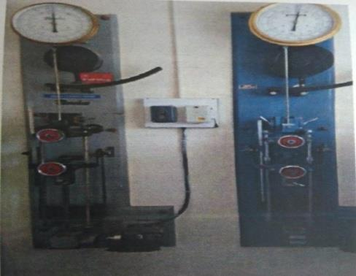

PLATE-IX
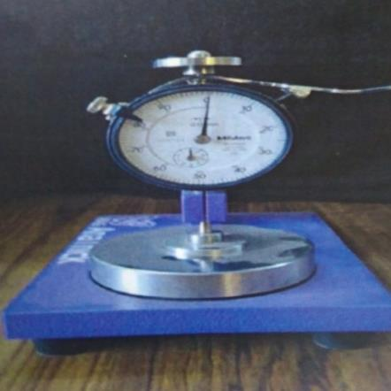

THICKNESS TESTER
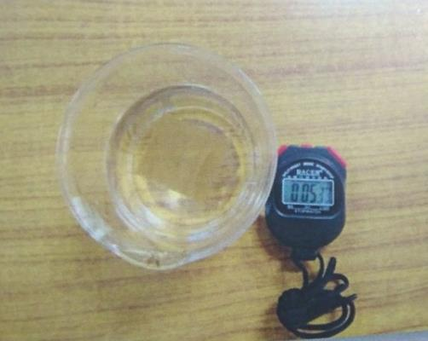

PLATE-X

TENSILE STRENGTH

TESTER

PLATE-XI

SINKING TESTER


PLATE-XII

STIFFNESS TESTING

4 RESULTS AND DICUSSION

The results and discussion of the research work is presented under following side headings:

4.1 Fabric weight of the original, de-sized, bleached and dyed fabric

4.2 Fabric thickness of the original, de-sized, bleached and dyed fabric

4.3 Tearing strength of the original, de-sized, bleached and dyed fabric in warp direction

4.4 Tearing strength of the original, de-sized, bleached and dyed fabric in weft direction

4.5 Fabric elongation of the original, de-sized, bleached and dyed fabric in warp direction

4.6 Fabric elongation of the original, de-sized, bleached and dyed fabric in weft direction

4.7 Absorbency test

4.7.1 Spray test

4.7.2 Wicking test

4.7.3 Sinking test

4.1 FABRIC WEIGHT OF THE ORIGINAL, DE-SIZED, BLEACHED AND DYED FABRIC

The results obtained from the fabric weight analysis is expressed in the Table V.

Table V

Fabric weight

S.no | Sample | Weight (GSM)
1. | O | 104
2. | D1 | 103
3. | B | 102
4. | D2 | 101

From the Table V, it is clear that the fabric weight of the sample O was highest with 104 GSM and it is followed by the samples D1 of 103 GSM, B 100 GSM and D2101GSM.

Hence, it could be concluded that the fabric weight of the original sample was high.

4.2 FABRIC THICKNESS OF THE ORIGINAL, DE-SIZED, BLEACHED AND DYED FABRIC

The results obtained in the fabric thickness test are expressed in Table VI.

Table VI

Fabric Thickness

S.no | Sample | Thickness (mm)
1. | O | 0.100
2. | D1 | 0.090
3. | B | 0.070
4. | D2 | 0.080

From the Table VT, it is clear that the fabric thicknessof the sample O was highest 0.100(mm) and it is followed by the samples D1 of 0.090 mm, B 0.070 mm, and D2 0.080 mm.

Hence, it could be concluded that the fabric thicknessof the original sample was high.

4.3 TEARING STRENGTH OF THE ORIGINAL, DE-SIZED,

BLEACHED AND DYED FABRIC IN WARP AND WEFT DIRECTION

The fabric strength in warp and weft directions is presented in Table VII.

 |  | Table VII
 |  | Fabric strength
S.no | Sample |  | WarpStreng | Weft
 |  |  | th (kgs) | Strength (kgs)
1. | O |  | 40 | 65
2. | D1 |  | 38 | 63
3. | B |  | 35 | 59
4. | D2 |  | 37 | 61

Warp direction

From Table VII,it is obvious thatthe fabric strength of the sample O was noted to be 40kgs in warp direction. But, this strength was reduced due to the wet processing of the fabric. The fabric strength was thenhighest in the sample D1 of around 38 followed by the samples D2and B of 37 and 35 kgs respectively.

Weft direction

In weft direction the fabric strength of the sample O was 65 kgs. In weft direction also the fabric lost its strength in pretreated and dyed fabrics of which it was the maximum in sample D1 of around 65 kgs followed by the samples D2 andB of 61 and59 percents respectively.

Hence, it could be concluded that there exists a slighter loss in strength in samples of which it was the minimum in sampleB in warp and weft directions.

4.4 FABRIC ELONGATION OF THE ORIGINAL, DE-SIZED, BLEACHED AND DYED FABRIC IN WARP AND WEFT DIRECTION

The fabric elongation is expressed in the Table VIII.

 |  |  | Table VIII
 |  | Fabric Elongation
S.no | Sample |  | WarpElongation | Weft
 |  |  | (%) | Elongation
 |  |  |  | (%)
1. | O |  | 17.6 | 23
2. | D1 |  | 29.4 | 23.5
3. | B |  | 27.0 | 24
4. | D2 |  | 29.4 | 25

Warp direction

From Table VIII, it is obvious thatthe elongation of the fabric in sample O was noted to be 17.6 percent in warp direction, which was increased in all the pre treated and dyed samples29.4 percent in both the samples D1 and D2. The sample B has also exhibited an increase in elongation of 27.0 percent.

Weft direction

From Table VIII, it is obvious that the elongation of the fabric in sample O was noted to be 23percent in warp direction, which was increased in all the pre treated and dyed samples25 percent in the sample D2. The sample Band D1has also exhibited an increase in elongation of 24 and 23.5 percent respectively.

Hence, it could be concluded that there exists a slighter increase ofelongation in the pretreated and dyed samples in both the warp and weft direction.

4.5 ABSORBENCY TESTS

4.5.1 SPRAY TEST

The observations obtained in the spray test are presented in the Table IX.

 |  | Table IX
 |  | Spray Test
S.no | Sample |  | Result
1. | O |  | 50
2. | D1 |  | 0
3. | B |  | 0
4. | D2 |  | 0

From Table IX,it was obvious that the sample O exhibited the complete wetting of the whole upper surface with the rating of 50 whereas, all the pretreated and dyed samples showed complete wetting of the whole upper and lower surface of the fabric with the rating of 0.

4.5.2 FABRICWICKING

The results of wick ability of the fabric are expressed in the Table X.

Table X

 |  | Wicking Test
S.no | Sample |  | Wicking Height (cm)
1. | O |  | 1.1
2. | D1 |  | 1.2
3. | B |  | 1.0
4. | D2 |  | 1.4

From theTable X, it is clear that the wickability of the sample O was 1.1cm. Where as, all the pretreated and dyed samples exhibited absorbency of which it was the highest in sample D2 of 1.4 cm followed by samples D1 and B with 1.2 cm and 1.0 cm respectively.

Hence, it could be concluded that wicking was highest in sample D2, showing more absorbency and it was the least in the sample B.

4.5.3 FABRIC SINKING

The results obtained in the sinking test are presented in the Table XI.

 |  | Table XI
 |  | Sinking Test
S.No | Sample | Time seconds
1. | O | 43
2. | D1 | 39
3. | B | 40
4. | D2 | 41

From the Table XI, it is clear that the sinking time was 43 seconds in sample HS. The sinking of the samples was almost similar in the pretreated and dyed ones of which it was the

quickest in sample D1 (39 seconds) followed by the samples D2 (0.08 seconds) and B (40 seconds).

Hence, it could be concluded that the sinking of the fabric was the quick in all the treated samples and was the quickest in sample HST1 depicting highest absorbency and the least absorbency was exhibited in the sample HST2among all the samples.

5. SUMMERY AND CONCLUSION

Natural dyes find use in the colouration of textiles, food, drugs and cosmetics. Small quantities of dyes are also used in colouration of paper, leather, shoe polish, wood, cane, candles, etc. In the beginning, there were dyes derived only from natural. Natural dye is more relevant worldwide in the context of increasing environment consciousness. The non-toxic, biodegradable and eco-friendly properties make them exceedingly popular amongst nature loving and health awarded people.

Many of the natural dyes have poor affinity fortextile materials unless they are treated with mordant (Osabohien, 2009). Mordants are chemical agents whichallow a reaction to occur between the dye and the fabric thereby aid in fixing the colour to the fabric. Mordants fix the dye to a substrate by combining with the dye pigment to form aninsoluble compound (Wipplinger, 2004). Mordant is anessential part in the dyeing process. It is very essential except for plants which contain a lot oftannin and do not necessarily require mordants..

Bamboo fabric absorbs and evaporates sweat very easily hence it gives comfortable feel. It can be spun into 100% bamboo yarn and also blended with natural and manmade fibres like cotton, polyester, silk etc. Fabric made of bamboo fibre possesses better moisture transmission property, softer handle, drapability and easy drying. It has many applications such as apparels, sweaters, bath suits, mats, towels, t-shirts and socks etc. Bamboo fibre has unique function of anti-bacteria which make it suitable for underwear, t-shirt and socks. It has also wide scope in the field of hygiene materials such as sanitary napkin, masks, mattress, bandages, surgical cloths, surgical gown, absorbent pads and food packing etc. (www.technicaltextile.net)

Tie-dye is a modern version of traditional dyeing methods used in many cultures throughout the world. "Tie-dye" can also describe the resulting pattern or an item which features this pattern. The whole point of tie dyeing is to prevent the dye from reaching the fabric evenly.

Keeping the above facts in mind, the investigator has taken up a study on the topic entitled

‘Application of Natural Dye Using Tie-Dye Method and Converting into Foldable Carry

Bags’with the following objectives:

- To Select the fabric

- To select the natural source –for dyeing

- Create tie and dye designs

- To tie the fabrics in

- different patterm

- To dye the tied fabric using selected source

METHODOLOY

Selection of fabric

Bamboo textiles have many fantastic properties that combined make this a truly amazing fabric. It is breathable and cool, has a nice luster; performance; and anti-bacterial. Absorbent-bamboo fabric approximately 60% more water absorbent than cotton. This makes it similar in absorption to hemp. Silky- bamboo fabric though is luxuriously soft with what has been described as a similar feel to cashmere.

Pre-Treatment of the Fabric

The pretreatment of the bamboo fabric includes:

De-sizing

A woven bamboo fabric of 345gms was taken and soaked in the solution containing soap powder and water. 1:10 ml of liquor ratio of was taken and the bamboo fabric was boiled for about 1hr at 60⁰ C. After then, the fabric was rinsed thoroughly using plain water to remove soap and other trace matters.

Bleaching

Chemicals that are widely used in the conventional bleaching process may include some of the following chemicals: sodium chlorite and hypochlorite, detergents, wetting agent, optical brighteners, urea, trisodium phosphate, oxalic acid, formic acid sodium nitrate and peroxides.

Selection of dye source

Natural dye were eco-friendly and do not cause environmental pollution during their production and use. Also some unique shades can be obtained by suitable combination of natural dyes and mordants.

Selection of mordant

Mordanting is the fixing agent, prevents the colour fading with exposure to light or washing to help dye adhere to the material being dyed (papita and siddhartha, 2008). Mordants can be of synthetic or natural origin. The most commonly used synthetic mordants with natural dyes were chrome, copper and tennic acid.

Fabric Tieing

Spirals

Lay your material on a flat surface. Place your thumb and a couple of fingers together on the cloth at the point which will be the center of the design. Using the weight of your fingers to hold the cloth in place, start twisting. After each twist, flatten the material with the palm of your hand to keep the folds from rising.

Stripes

Roll the cloth very loosely, forming a long tube. The stripes will be at right angles to the tube.Tie at one intervals or as far apart as you want the stripes to run. Loop rubber bands or wrap string around the tube a few times and knot. Make sure the ties are very tight. Now you can either immerse or squirt the dye on, alternating your colors,

Pleats

Lay cloth on flat surface. Place thumbs of both hands together firmly on the cloth. Position fingers about an inch or two in front of your thumbs, an

Preparation and dying of fabric

curcuma

The dye is extracted from the fresh or dried rhizomes of turmeric. It is a substantive dye capable of directly dyeing bamboo fabric the dye was prepared by the extracted turmeric powder and mixing it with deionized water at neutral pH, at 95º c for 1.5 hours. The obtained turmeric solution (dye solution) had a yellowish color.d pinch the fabric to raise a fold. Continue to pinch up more pleats until you reach the end of the cloth.

Caesalpinia

Extraction of natural dyes: Sappan woods were soaked in the 20 times of water, heated and extracted for 60minutes, and filtered. This process was repeated two times. The first and second extracts were combined and used as a solution for dyeing.

Dyeing Procedure: Fabrics were dyed at 90ºfor 30min. while maintaining a bath ratio

1:50. The dyed fabrics were then washed and air dried.

SELECTION OF FABRIC:

A plain weave woven bamboo fabric was taken for the study.

Evaluation of bamboo fabric

The sample of any research is based upon the utilization of end product which in turn will be the result of their properties.

Fabric Weight

Fabric weight is an important component for comparing the two similar fabrics construction (Saini, 2004). The fabric weight is the relative weight of the fabric and express as the weight of a particular size of piece such as grams per square meter. It is a device to cut circular specimens of 100 square centimeters of a fabric very accurately. It has four blades that cut the fabric when the nano wheel is rotated by applying light pressure.

Fabric Thickness

Fabric thickness is defined as the distance between the upper and the lower surface of the material where measured under a standard pressure using Shirley’s Thickness Tester with an accuracy of 0.01mm.

Fabric Strength

The strength of a fabric is defined as its ability to withstand an applied load without failure. Two rectangular specimens of size 3inches × 8inches were cut both in warp and weft direction of the fabrics O,D1,B and D2 were placed in between the jaws of the tensile strength tester.

Fabric Elongation

Fabric elongation is the increase in the length of the specimen from its starting length expressed in units of length. The distance that a material will extend under a given force is proportional to its original length, therefore elongation is usually quoted as strain or percentage extension.

Fabric stiffness

Fabric stiffness is the tendency of fabric to keep standing without any support. It is the key factor in the study of handle and drape of the fabric. A strip of fabric, 6in. X 1in. with the aid of the template.

Absorbency test

Absorbency is one of the several factors that influence textile processing such as fabric preparation, dyeing and the application of finishes, states AATCC (2007). Water and moisture transportation of the fabric is an in, portant aspect of my fabric.

Spray Test

The spray rating test is one used to measure the resistance of a fabric to surface wetting but not to penetration of water. It is therefore a test which is particularly used a shower proof finishes.

Wicking Test

A strip of fabric is suspended vertically with its lower edge in a reservoir of distilled water. The rate of rise of the leading edge of the water is then monitored. To detect the position of the water line a dye can be added to the water or in the case of dark colour fabrics, the conductivity of the water may be used to complete an electrical circuit.

Sinking Test

A 200ml beaker was filled with distilled water. Samples of size 25mm × 25mm were cut from the O,D1,B and D2fabrics and were dropped on the surface of the water from a standard height.
FINDINGS OF THE STUDY

- The fabric weight of the sample O was highest with 104 GSM and it is followed by the samples D1, B 100 and D2.

- The fabric thickness of the sample O was highest and it is followed by the samples D1, B and D2

- The fabric strength in warp direction was highest in the sample D1 of around 38 next to sample O and is followed by the samples D2 and B. In weft direction also the fabric lost its strength in pretreated and dyed fabrics of which it was the maximum in sample D1 of around followed by the samples D2.

CONCLUSION

The result of the study provides that the sappen wood, turmeric could be used to extract dye for bamboo fabric. The use of toxic and eco friendly natural dyes on textiles become an matter of significant importance because of the increased environmental awareness. The selected source proved to be an effective natural dye for bamboo fabric. It has good medicinal properties. Hence it can be used in the area of medical textiles.

BIBLIOGRAPHY

- Ticoalu, T. Aravinthan, and F. Cardona, “A review of current development in natural fiber composites for structural and infrastructure applications,” in

Proceedings of the Southern Region Engineering Conference (SREC '10), pp.

- Faruk, A. K. Bledzki, H.-P. Fink, and M. Sain, “Biocomposites reinforced with natural fibers: 2000–2010,” Progress in Polymer Science, vol. 37, no. 11, pp.

1552–1596, 2012. View at Publisher · View at Google Scholar · View at Scopus)

- Lichtenstadt, P. (1864). Improvement inpreparing fiber from the bamboo. U. S. P.Office. United States. 41,627: 1.

- Farnie, D. A. and D. J. Jeremy (2004). Thefibre that changed the world: the cottonindustry in international perspective, 1600-1900s. Oxford, Oxford

- Mwaikambo, L. Y. (2006). "Review of the history, properties and application of plant fibres." African Journal of Science and Technology 7(2): 120 -133.

- Magel, E., S. Kruse, et al. (2005). "Solublecarbohydrates and acid invertases involvedin the rapid growth of developing culms in Sasa Palmata (Bean) Camus." Journal of the American Bamboo Society 19(1): 23-29.

- FAO/WHO, Major colourants and dyestuffs mainly produced in horticultural systems, in NaturalColourants and Dyestuffs, Non-Wood Forest Products Series, Rome, 1995.

- Oktaf Rina, SanusiIbrahim (2017) Stabilities natural colorant of Sappan wood

(Caesalpinia sappan. L) for food and beverages in various pH, temperature, and matrices of food, West Sumatera, Indonesia.
- Tie-Dye Techniques: Free Tie-Dye Patterns eBook, 2O14

- Jin Soun Jung (2017),Making of Natural Dyeing Scarves by Tie-Dyeing

- A.C. Dweck, Int. J. Cosmet. Sci., 24, 287-302 (2002).

- D. Frick, The coloration of food. Rev. Prog. Color,33, 15-32 (2003).

- D. Grifoni, L. Bacci, G. Zipoli, L. Albanese, F.Sabatini, Dyes Pigm., 91, 279-285 (2011).

- Hofenk de Graaf JH., The colorful past: origins,chemistry and identification of

natural dyestuff,London: Archetype Publications, (2004)

- Introduction to tie and dye process ofornamentation of textiles (lesson 7)

- Valeeratana Kalani Sinsawasdi, (2012), Sappanwood Water Extract:Evaluation Of Color Properties, Functional Properties, And Toxicity.

- Saravanakumar S., Chandra JH, 2013, Screening of Antimicrobial Activity and Phythochemical Analysis of Caesalpinia sappan L., Journal of Chemical and Pharmaceutical Research, Volume 5(2),pp. 171-175.

- Saraya S., et al., 2009, Sappan Wood Extract Used as Preservative in Chili Paste,

Mahidol University Journal of Pharmaceutical Science, Volume 36(1-4),pp. 13-21.

- Armstrong WP. 1992. Logwood and Brazilwood: Trees That Spawned 2 Nations. 53(1):38-43.

- Badami S, Geetha B, Sharma SV, Rajan S, Suresh B. 2007. Microwave-assisted rapid extraction of red dye from Caesalpinia sappan heartwood. Natural Product

- Badami S, Moorkoth S, Rai SR, Kannan E, Bhojraj S. 2003. Antioxidant activity of Caesalpinia sappan heartwood. Biological & Pharmaceutical Bulletin

26(11):1534-1537.

- Chanoknart Mayusoh / Procedia - Social and Behavioral Sciences 197 ( 2015 ) 1472 – 1480

- Chanoknart Mayusoh,(2015), The art of designing, fabric pattern by tie-dyeing with natural dyes

- Yupinsri Saithong. (1989). Batik and tie-dye pattern design. Bangkok: D.D.Bookstore.

- Ajay Rathod and Dr. Avinash Kolhatkar,Ultra Violet Protection Property of Bamboo & Cotton Fabric

- D. Chandramohan and K. Marimuthu, (2011),A Review On Natural Fibers

- Kiran sachan and V P Kapoor-Optimization Of Extraction And Dreing Conditions For Traditional Turmeric Dye, Vol. 6(2), April 2007,Pp.270-278.

- Kapoor V P, Dye Yielding Plants –Extraction And Application, In:Advances In

- Gulrajani M L, Present Status Of Natural Dyes, Convention On Natural Dyes, Indian Institute Of Technology, Delhi, December 9-10th, 1999.

- Shivani Verma and Gunjan Gupta,Natural Dyes And Its Applications: A Brief Review, VOLUME 4,Oct. 9, 2017

APPENDIX

ORIGINAL BAMBOO FABRIC

DESIZED BAMBOO FABRIC

BLEACHED BAMBOO FABRIC


DYED BAMBOO FABRIC

