BIO – DEGUMMING OF SILK FABRIC USING PROTEASE
AND LIPASE ENZYME

NAKKA. NIVYA
(10PBS07)

A THESIS SUBMITTED TO THE AVINASHILINGAM DEEMED UNIVERSITY FOR WOMEN, COIMBATORE
IN PARTIAL FULFILMENT OF THE REQUIRMENT FOR THE
MASTER OF SCIENCE IN
BIO - TEXTILES

APRIL, 2012

BIO – DEGUMMING OF SILK USING PROTEASE ENZYME

NAKKA. NIVYA
(10PBS07)

A THESIS SUBMITTED TO THE AVINASHILINGAM DEEMED UNIVERSITY FOR WOMEN, COIMBATORE
IN PARTIAL FULFILMENT OF THE REQUIRMENT FOR THE
MASTER OF SCIENCE IN
BIO – TEXTILES

APRIL, 2012

Signature of the Signature of the
Head of the Department Supervisor
ACKNOWLEDGEMENT
The investigator expresses her thanks to Almighty God for the abundant blessing for carrying out the study.
The investigator wishes to express her reverential gratitude to Dr. T.S.Avinashilingam, Founder First Chancellor Avinashilingam Deemed University for Women, Coimbatore and Dr. Padmashree colonel, Dr.Rajammal. P. Devadas, M.Sc., Ph.D.,(Ohio State), Hon. D.Sc. (Madras), Hon. DHL, D.Sc (Northern Ireland), Former Chancellor, Avinashilingam Deemed University for Women, Coimbatore for the blessings and inspiration.
The investigator expresses her sincere thanks to Dr. T.S.K. Meenakshi Sundaram, M.A., M.Phil., Ph.D., (Honoris caussa), Chancellor, Avinashilingam Deemed University for Women, Coimbatore for granting permission and providing opportunity for the conduct of the study.
The investigator expresses her hear felt gratitude to Dr. (Mrs). Sheela Ramachandran, M.sc., M.Phil. Dip. Ed., Ph.D.(Avinashilingam), Vice Chancellor, Avinashilingam Deemen University for Women, Coimbatore for providing all the amenities required for the study.
The investigator records her sincere gratitude to Dr. (Tmt). Gowri RamaKrishnan, M.Sc (Madras), M.Phil, Ph.D. (Avinshilingam), Registrar, Avinashilingam Deemen University for Women, Coimbatore for the facilities in connection with the research work.
The researcher expresses her sincere thanks to Dr. (Tmt). S.Prema Kumari, M.Sc, Dip. Ed, M.Phil, Ph.D (Madras), Dean, Faculty of Home Science, Avinashilingam Deemed University for Women, Coimbatore for her constant encouragement.
The investigator is delighted to express her sincere thanks to Hon. Colonel. Dr. (Tmt). Saroja Prabhakaran, M.A., Dip.Ed. (Madras), Ph.D., (Mother Theresa), Former Vice Chancellor and Director, Halls of Residence, Avinashilingam Deemed University for Women, Coimbatore for providing all the necessities required for the conduct of study.
The investigator expresses her profound sense of gratitude to Dr.N.Vasugi, M.Sc., M.Phil (Madras), Ph.D. (Avinashilingam). Professor and Head of the Department of Textile and Clothing, Avinashilingam Deemed University for Women, Coimbatore, for her continued motivation, endured support and gentle caring rendered throughout the successful completion of the study.
The investigator feels immensely indebted and extremely privileged to have worked under the supervision of her esteemed guide, Dr. G.Bagyalakshmi, M.Sc., M.Phil., Ph.D. (Avinashilingam), Assistant Professor (Senior Scale), Textile and Clothing, Avinashilingam Deemed University for Women, Coimbatore, for her valuable guidance, technical support, timely help and constant encouragement throughout the study.
The investigator expresses her deep sense of gratitude to all the STAFF MEMBERS of the department of textile and clothing, Avinashilingam Deemed University for Women, Coimbatore, for their inspiration, encouragement and support. The investigator also wishes to thank all the non- teaching staffs of the department who helped her during the course of study.
The investigator expresses her thanks to Mr. Selva Kumar, Euro Infomatics, for the help in the documentation work of the study.
The researcher expresses her deepest thanks to her parents, entire family members for providing a loving environment, their unflagging love and support throughout life, their constant prayers and continuous encouragement that helped in the immense blessing of the study.
The researcher is indeed grateful to all friends, relatives, and well wishers for their encouragement, support and inspiration to complete the study.
Her sincere thanks to everyone who directly and indirectly helped to complete the study.
CONTENTS

CHAPTER  NO. | TITLE |  |  |  |  | PAGE NO.
 | LIST OF TABLES
 | LIST OF FIGURES
 | LIST OF PLATES
 | LIST OF APPENDICES
1 | INTRODUCTION |  |  |  |  | 1
2 | REVIEW OF LITERATURE |  |  |  |  | 2
 | 2.1 | Silk |  |  |  | 2
 |  | 2.1.1 | History |  |  | 2
 |  | 2.1.2 | Classification |  |  | 4
 |  | 2.1.3 | Production |  |  | 5
 | 2.2 | Properties of silk |  |  |  | 7
 |  | 2.2.1 | Physical Properties |  |  | 7
 |  | 2.2.2 | Chemical Properties |  |  | 7
 |  | 2.2.3 | Uses |  |  | 7
 | 2.3 | Silk Degumming |  |  |  | 8
 |  | 2.3.1  2.3.2  2.3.3  2.3.4  2.3.5  2.3.6 | History  Conventional Degumming |  |  | 8  9  9  9  11  13  14  14
 |  | 2.3.1  2.3.2  2.3.3  2.3.4  2.3.5  2.3.6 | 2.3.2.1  2.3.3.1 | Natural method of Degumming  Enzymatic Degumming
 |  | 2.3.1  2.3.2  2.3.3  2.3.4  2.3.5  2.3.6 | Enzymes on silk  Advantages  Limitations  Future Trends
 | 2.4  2.5 | Natural dyes |  |  |  |  | 14  15  15  16  17  17  18  19  19  20  21
 | 2.4  2.5 | 2.4.1  2.4.2  2.4.3  2.4.4  2.4.5  2.4.6  2.4.7 | History of natural dyes  Characteristics  Classification  Dyeing techniques  Advantages  Disadvantages  Uses |  |  |  | 14  15  15  16  17  17  18  19  19  20  21
 | 2.4  2.5 | Mordants |  |  |  |  | 14  15  15  16  17  17  18  19  19  20  21
 | 2.4  2.5 | 2.5.1  2.5.2 | Types of mordants  Mordanting techniques |  |  |  | 14  15  15  16  17  17  18  19  19  20  21
3 | EXPERIMENTAL PROCEDURE |  |  |  |  |  | 23
 | 3.1 | Selection of Silk fabric |  |  |  |  | 23
 | 3.2 | Selection of source  3.2.1 Enzyme |  |  |  |  | 23  23
 | 3.3 | Optimization of Selected Parameters for Degumming |  |  |  |  | 26
 |  | 3.3.1 | Enzyme Concentration |  |  |  | 26
 |  | 3.3.2 | Incubation Time |  |  |  | 27
 |  | 3.3.3 | pH |  |  |  | 27
 |  | 3.3.4 | Temperature |  |  |  | 27
 | 3.4 | Selection of Natural dye |  |  |  |  | 27
 |  | 3.4.1 | Commercial Enzymatic Degumming |  |  |  | 28
 |  | 3.4.2 | Conventional Degumming |  |  |  | 28
 | 3.5 | Nomenclature of the Samples |  |  |  |  | 29
 | 3.6 | Evaluation |  |  |  |  | 29
 | 3. | 3.3.6.1 | Subjective Inspection -Visual Evaluation  3.6.2 Objective evaluation  3.6.2.2Weight  3.6.3 Physical property  3.6.3.1 Fabric weight  3.6.3.2 Fabric thickness  3.6.4 Mechanical property  3.6.4.1 Fabric tensile strength and elongation  3.6.5 Absorbency test  3.6.5.1 Drop test  3.6.5.2 Sinking test  3.6.5.3 Capillary rise test |  |  |  | 29  29  30  30  30  31  31  31  34  34  34  35
4 | RESULTS AND DISCUSSION |  |  |  |  |  | 38
 | 4.1 | Optimization of Protease Source |  |  |  |  | 38
 |  | 4.1.1 | Optimization of Source Concentration |  |  |  | 38
 |  | 4.1.2 | Optimization of Incubation Time |  |  |  | 39
 |  | 4.1.3 | Optimization of pH |  |  |  | 41
 |  | 4.1.4 | Optimization of Temperature |  |  |  | 42
 | 4.2 | Evaluation of Degummed Silk Fabric |  |  |  |  | 43
 |  | 4.2.1 | Subjective Evaluation-Visual Evaluation |  |  |  | 43
 |  | 4.2.2 | Objective Evaluation |  |  |  | 45
 |  |  | 4.2.2.1 | Weight Loss |  |  | 45
 |  |  | 4.2.2.2 | Physical Property Test |  |  | 46
 |  |  |  | 4.2.2.2.2 | Fabric Weight |  | 49
 |  |  |  | 4.2.2.2.3 | Fabric Thickness |  | 51
 |  |  | 4.2.2.3 | Mechanical Property Test |  |  | 52
 |  |  |  | 4.2.2.3.2 | Fabric Tensile Strength and Elongation |  | 58
 |  |  | 4.2.2.4 | Comfort Property Test |  |  | 63
 |  |  |  | 4.2.2.4.1 | Fabric Stiffness |  | 63
 |  |  |  | 4.2.2.4.2 | Fabric Crease Recovery |  | 66
 |  |  | 4.2.2.5 | Absorbency Test |  |  | 69
 |  |  |  | 4.2.2.5.1 | Drop Test |  | 68
 |  |  |  | 4.2.2.5.2 | Sinking Test |  | 70
 |  |  |  | 4.2.2.5.3 | Capillary Rise Test |  | 72
5 | SUMMARY AND CONCLUSION |  |  |  |  |  | 76
 | BIBLIOGRAPHY |  |  |  |  |  | 80
 | APPENDICES |  |  |  |  |  | 88

LIST OF TABLES

TABLE  NO. | TITLE | PAGE  NO.
I  II  III  IV | Statistical Analysis of Silk In India  Enzyme Life Cycle Stage  Chemical Classification of Dyes  Commercial Enzymatic Degumming Recipe | 8  11  17  25
V | Conventional Acid Degumming Recipe | 26
VI | Dyeing parameters | 28
VII | Nomenclature of the Samples | 29
VIII | Optimization of Enzyme Concentration | 39
IX | Optimization of Incubation Time | 41
X | Optimization of pH | 43
XI | Optimization of Temperature | 45
XII | Visual Evaluation of Degummed Silk Fabric | 47
XIII | Weight Loss of the Degummed Silk Fabric | 48
XIV | Fabric Weight | 50
XV | Fabric Thickness | 52
XVI  XVII | Tensile Strength-warp  Tensile strength-weft | 54  56
XVIII  XIX | Elongation-Warp  Elongation-Weft | 58  60
XX | Crease Recovery – Warp | 62
XXI  XXII  XXIII | Crease Recovery – Weft  Fabric stiffness – Warp  Fabric Stiffness - Weft | 64  66  68
XXIV | Drop Test | 70
XXV | Sinking Test | 72
XXVI | Capillary Rise Test | 74

LIST OF FIGURES

FIGURE  NO. | TITLE | PAGE  NO.
1  2 | Classification of mordants  Optimization of Source Concentration | 20  40
3 | Optimization of Incubation Time | 42
4 | Optimization of pH | 44
5 | Optimization of Temperature | 46
6 | Weight Loss of the Degummed Silk Fabric | 49
7 | Fabric Weight | 51
8 | Fabric Thickness | 53
9 | Fabric Elongation – Warp | 55
10 | Fabric Elongation – Weft | 57
11 | Fabric Tensile Strength – Weft | 59
12 | Fabric Tensile Strength – warp | 61
13 | Fabric Stiffness – Warp | 63
14 | Fabric Stiffness – Weft | 65
15 | Fabric Crease Recovery – Warp | 67
16 | Fabric Crease Recovery – Weft | 69
17 | Drop Test | 71
18 | Sinking Test | 73
19 | Capillary Rise Test | 75

LIST OF PLATES

PLATE  NO. | TITLE | PAGE  NO.
I | Papaya Leaves | 24
II | Paste of Papaya Leaves | 24
III | Buffers | 24
IV | Filtration of Protease | 24
V | Protease Enzyme | 24
VI | Electronic Weighing Balance | 32
VII | Pick Glass | 32
VIII | Fabric Thickness Tester | 32
IX | Fabric Strength Tester | 32
X | Fabric Stiffness Tester | 33
XI | Crease Recovery Tester | 33
XII | Drop Test | 36
XIII | Sinking Test | 36
XIV | Capillary Rise Test | 36

1. INTRODUCTION

Silk the Queen Fabric is the most beautiful and lustrous fibers. Silk has been known and used as a textile material for thousands of years. Silk is mainly constitued of fibroin, a soft mucous substance. Fibrin hardness into filament shape and becomes a genuine fibre, strong, bright, and flexible and elastic. The threads of silk combine in fabrics of impenetrate density, impervious to light; moisture or heat, Murphy (2003)Silk is a way of life in Indian. Over thousands of years, it has become an inspirable part of Indian culture and tradition no ritual is complete without silk apparel. The Indian silk are known for their fine quality, lustrous sheen and traditional colours.
Indian occupies a unique position in the world producing all the four commercial silk, mulberry, tasar, eri and muga .Silk is a luxurious and comfortable fabric possessing a unique lusture, Excellent Softness as well as good drape.
Silk is composite material formed by two fibroin filaments surrounded by a cementing layer of sericin. Fibroin constitutes about 75-80% by weight of the raw fibre and the remaining is mostly sericin, the silk gum is gluing the fibroin filaments, along with small proportions of minerals & fatty substance. Degumming is the essential step during which sericin is totally removed and silk fibers gain the typical and shiny aspect, soft handle and elegant drape highly appreciated by the consumers.
Successful removal of seriein from fibroin for silk degumming requires the selection of suitable proteases in order to limit the enzymatic degradation to seriein to avoid damage to silk fibers. Various proteolytic enzymes (alkaline, neutral and acidic prolears) have investigated for silk gumming. (Feddi et al, 2003). Among them, alkaline protease performed better than neutral and acidic proteas. The degradation of seriein in terms of weight loss up to 24% has linear relationship with the amount of alkaline protease used during the enzymatic degumming. Therefore the enzymatic degumming can be controlled through the enzyme dosage and treatment times says Fossry (2005)
Degumming of silk involves the cleavage of peptide bonds of sericin, either by hydrolytic or by enzymatic treatment methods and the subsequent removal of sericin from the silk fibroin. Based on the degree of degumming, lustrous raw silk with yellowish
brown colour has maximum degumming loss of 4%and completely degumming silk, with a soft handle & high luster degumming loss 18-30%. Silk Fibres are composed mainly of a double filament of fibroin surrounded by a layer called sericin. Both sericin and fibroin are proteins that have almost no cysteine residues after hydrolysis. The amount of sericin, in terms of weight loss after degumming varies between 17 – 38 %. Sericin is mainly composed of serine (33%), aspartic acid (17%), glycine (14%) and quantities of other residues. Sericin is more accessible to chemicals than fibroin and it is removed during perspirations. An ideal degumming agent would specifically attack peptide bonds near serine residues. However, several methods have been developed for degumming silk, such as extraction with water, boiling with detergent, with alkali, acids and enzymes bacterial proteases is more affective than using tryprin and papain. Proteases can also be used to alter the silk fibroin surface to give an aged look in a similar way to enzyme washing of denim garments. It has also been recently reported that proteases may provide improved softness and wetability of silk fabrics says Paulo, (2003)
The global demand for natural textile fibre had been raised despite growth of manmade with their diversified properties and cheaper prices; and world consumption of silk is also increasing despite its limited, stagnant production and high prices. Its popularity is no more confined to super rich or haute couture; silk is now an affordable Luxury for the middle class in Europe and USA silk continuous to hold its way in Asia as a traditional ceremonial wear as well as casual wear in recent days.
Demand for silk materials and their production will increase continuously year by year. The textile industry will continue to explore the use of enzyme to improve the efficiency of silk gumming and the quantity of fibre views Mivhie (2007).Research efforts will be made to extract the silk proteins, seriein, or for biomedical uses says Kishore. (2003).The design of processing using various available enzymes will be studied for silk degumming & their finishing. Integrated bioprocess might be able to achieve multipurpose preparation & finishing of protein fibers. Innovation of enzyme based process needs to be brought into industrial production by Chand (2000).
The world trade in the silk garments and furnishing articles is growing with change, on global production and trade in silk. The silk apparel trade once dominated by Europe is now increasingly handled in China, India, Thailand, Hong Kong and Korea. Another significant change in the world silk trade is that the demand for silk once restricted to high cost luxury items for a select group at the upper income levels has expanded in recent years to lowest price goods with reach of consumers in middle income groups, according to ITC fields investigation.
The number of environmental regulations are to be fulfilled to safeguard the natural resources and this had led to growth in the use of enzyme in the in the textile industry for the greener processing of textile, Gupta (2003). Enzymes are biodegradable and it clean up the polluted environment. The drawbacks of using synthetic auxiliary can be virtually eliminated by the use of enzymes in the textile process. The degumming of silk by using protease enzyme is a well known process by Gowda (2007).Enzymatic treatment which improves surface properties of fabrics by digesting loose, is gaining popularity because of its beneficial effects on the environment reports Mishra (2008).
Dyeing may also called as finishing process, which brings a variety of colors to the fabrics. Textile materials are colored, when dye molecule enter the amorphous region of the polymer system. The dyes & chemicals used in the textile industry contain toxic & hazardous substances, which not only affect the consumer but also cause severe damage to the environment, remark Adivarekar et al (2004).“Eco friendly” is the first step in the direction to improve this situation, which was worsen over the recent years, states Clark (1980).
Natural dyes are obtained from natural sources such as vegetable matters, minerals and insects. These dyes are finding use in the coloration of textiles, remarks Gulrajani (2001). Any part of the planet which can yield from 1-4 percent can be considered as potential nature dye source, state Shankar et al (2003). They are fairly non-polluting challenging, have rare colour ideas and unlimited scope to generate new shade. Various types of natural dyes extract are suitable for dyeing of silk fabrics.
Objectives:
- To extract protease enzyme from papaya leaves.
- To compare the conventional and enzymatic degumming processes on silk.
- To dyed the bio degummed fabric with a natural source.
- To evaluate the performance of the silk fabric.

2. REVIEW OF LITERATURE

2.1 SILK
The standard of textile excellence is silk. What Gold is to the metal, Diamond to precious stones, silk is to fabrics. Most precious and beautiful of cloths, it is also most beautiful and durable. A piece of plain silk is a pleasant thing, soft to the eye, grateful to touch by Murphy (2009).
2.1.1 HISTORY
The year 2,600 BC is believed to the discovery of silk by a Chinese princess. Silk is made up of two continuous filaments connected together and used to form the cocoon of the silk. The Chinese closely guarded Secrets of silk cultivation and fabrics manufacturing for about 3000 years, view Thomas (2006), India learned of silk culture when a Chinese princess married an Indian prince.

India occupies the position in the world producing all four commercial silks, mulberry, tasar, eri and muga itself is unique with its golden lusture and so far confined to the north eastern region of India, Pandey et al (2009). There are two varieties of silk i.e. domestic and wild silk.Domesticated silks are normally used for textiles production, which comes from the genus ‘Bombyx’ the common worm that feeds on the leaves of mulberry trees. This is also known as ‘bombyx silk’. The major states that produce raw domesticated silks are Karnataka, Andhra Pradesh, Tamil Nadu and Bengal says Mishra (2000).
2.1.2 CLASSIFICATION OF SILKS
TYPES OF SILK FABRICS: There are innueumerable varieties of silk moths, but only four main commercial valuable natural silks are as follows:
- Mulberry silk.
- Tasar silk.
- Muga silk.
- Eri silk.
MULBERRY SILK:
Silk is a natural protein fibre. The best known type of silk is mulberry silk obtained by cocoons produced from silk worm larvae, which are cultivated in provided habitats and fed with fresh Mulberry leaves. It has continuous strand (about 300-500 m) of two fibroin filaments connected together by a gummy substance called sericin or silk gum Says, Gordon, (1998)Silk fibroin filament is the fibrous component that gives silk provides protection during processing and so is usually retained until the yarns of fabric stage. Removal of harsh and stiff sericin from silk fibroin leaves the silk fibre lustrous and with a soft handle.Silk is regarded as a luxury fibre and widely used for texile fabrics, garments and bedding materials including silk filled duvets.
Tasar silk :
Silk is a copperish coloured. It is coarse and used mainly for furnishings. It is produced by the silkworm. “Antheroea Mulitta”, which mainly thrives on the plants asan and arjun. It is reared on trees in the open by Pandyan (2004)
Muga silks: Silk is a golden yellow coloured silk that is produced in Assam. It is obtained from the semi domesticated silk worm, “ Antherara Assamensis” which feeds on the aromatic leaves and plants.
Eri Silks:
Silk is got from the domesticated silkworm, “philosamia ricini”, that feeds mainly on cartor leaves. Silks eri cocoons are open mouthed by Rastogi (2009).
2.1.3 Production process of silk:
Silk is an animal protein fiber produced by certain insects to build cocoons and webs. Many different types of silks are produced by huge variety and different types of insects’ caterpillars, says Iyer (2004).The commercial process of silk making is highly complex and labour intensive. The following is the basic information on how silk made. Sericulture, hatching of eggs, the feeding period, spinning the cocoon, reeling the filament views Ibrahim (2007).

Sericulture:
Cultivation of silkworm is known as sericulture. Although many insects produce silk, only the filaments produced by bombyx mori, the mulberry silk moth and few other in the same genus is used by commercial silk industry, says Mishra, (2000)
Hatching of eggs:
The female deposits 300-400 eggs at a time. 100 moths would deposit 4000 eggs each about the size of a pinhead. The female dies almost immediately after depositing the egg and the male lives only for short time after. The tiny eggs of silk worms moth are incubated (about 10 dates) until they hatch into larvae. At this point the larva is about a quarters of an inch long, states Barker (2009)
The feeding period; once hatched, the larvae are placed under a fine layer of gauze and fed huge amounts of mulberry leaves, during which they shed their skin four times. For about growing to its maximum size, at around six weeks, it stops eating, change colour and is about 1000 times heavier than when hatched.
Spinning the Cocoon:
Silkworm secret a liquid from two large glands and form the spinneret, a single exit tube in the head. The secretion hardens on exposure to air and form twin filaments composed of fibrion, a protein material. A second pair of glands secrets a gummy binding fluid called sericin which bonds the two filaments together, Chakravorty (2009)
Reeling the filament:
At this stage the cocoon is treated with hot air, steam or boiling water. The silk is then unbound from cocoon by softening the sericin delicately and carefully unwinding or reeling the filament from 4-8 cocoons at once sometimes with a slight twist to create a single strand. As the sericin protects the silk fiber during processing, this is often left in until the yarn or even fabric stage. Raw silk is a silk that still contain sericin. Once this is washed out ( In soap and boiling water) the fabric is left soft, lustrous and up to 30% higher by Murphy, (2003)

2.2 Properties:
2.2.1 Physical Properties:
Silk fiber form bombyx mori silk worm have a triangular cross section with rounded corners, the fibroin- heavy chain is composed mortly of beta sheets due to 59-mer amino angles, giving silk a natural shine.Silk has a smooth soft texture that is not slippery, unlike many synthetic fibers. Its denier is 4.5 g/d when dry and 2.8-4.8 g/d when moist, views Kirusur et al. (2003)Silk is one of the strongest naturl fibres but loses upto 20% of its strength when wet. It has a good moisture regain of 11%. Its elasticity is moderate to poor: if elongated even a small amount it remains stretched. It can be weekend if exposed to sunlight. It may also be attacked by insects, especially if left dirty. Silk is a poor conductor to elasticity and thus susceptible to static cling.
2.2.2 Chemical properties
Silk is made up of amino acids gly-ser-gly-ala and form beta pleated sheets. It bonds form between chains, and side chains from above and below plane of it H- bond network, says Sonwalker (2001). The high proportion(50%) of glycine, which is small amino acid allows tight packing and the fibers are strong and resistant to stretching. The tensile strength is due to the many inter reeled hydrogen bond. Since the protein forms a beta sheet, when stretched the force is applied to these strong bonds and they do not break. Silk is resistant to most mineral acids except sulfuric acid which dissolves it. It is yellowed by perspiration.
2.2.3 Uses of Silk : Silk is famous for its lightness with strength, luster and beauty. The silk fabrication yarn will be perfect for years together in both structure and color. It is also a very hygienic fabrics. It is naturally dust proof and does not favour growth of bacteria, by Sheker, (2003) Silk has a wide variety of application in the apparel and upholstery fabrics in terms of satin, crepe, printed crepe, georgette, taffeta, Voile, Chiffon, damask, muslin, velvet and brocade.
Industrial Uses: It include typewriter ribbons, dental floss, parachute cloth and artificial ligaments, bathroom Linen inform Thomas et al., (2004). Silk has a remarkable application in the field of medical textiles. The products such as such as Suture threads, wipes, bandages, collagens, artificial ligaments are being used worldwide.
Production of silk in India is very high when compare to other countries, most of the production takes places in traditional states like Andhra Pradesh, Jammu Kashmir, Karnataka, Tamil Nadu and West Bengal. The production statistics are given in the table:I
Table I
production in india during last 4 years .
S.No | States Unit | 2001 - 2002 |  | 2002 - 2003 |  | 2003 - 2004 |  | 2004 - 2005
S.No | States Unit | Area | Raw silk | Area | Raw silk | Area | Raw silk | Area | Raw silk
Traditional States
1 | Andhra Pradesh | 52225 | 4775 | 54384 | 5629 | 57231 | 6054 | 44885.00 | 5084.00
2 | Jammu & Kashmir | 5740 | 80 | 5986 | 100 | 6057 | 85 | 6059.00 | 90.00
3 | Karnataka | 116158 | 8728 | 88903 | 79778 | 79778 | 5949 | 77998.00 | 7301.00
4 | Tamil Nadu | 13096 | 655 | 5394 | 4025 | 4025 | 285 | 5073.00 | 443.00
5 | West Bengal | 18794 | 1407 | 12569 | 1450 | 12970 | 1453 | 13424.00 | 1520.09
 | Subtotal | 206013 | 15645 | 167236 | 14429 | 160061 | 13826 | 147439.00 | 14438.99

[ Unit : Tones ] |  | [ % share]
India | 12954 14260 14432 14617 | 142620 | 13.77
2.2Degumming
2.2.1 History of Degumming:
A process of degumming slik by steam is first described by Samuel brierly in the year 1821. The skeins of silk are hung on wooden rods in a strong soap (30%) bath at a temperature of 145 to 150°F being turned until they are thoroughly wet, is reported by Hurt, (2004). Then hung in a large box and steamed for 20-30 minutes to dissolve the silk gum. Then the silk is again boiled for 20 minis to remove whatever sericin is left in it, after that it is well warmed and dried.
2.2.2 Conventional Method:
Pretreatment and finishing procedures applied in the textile industry are often characterized by high concentrations of chemicals, alkaline or acidic PH and high temperature with consequent high consumption of energy Staneseu (2000).The separation of the double filaments (degumming) by removal of sericin has conventionally been achieved by immersion of the fibers in alkaline solution and soap. This process results in considerable weight loss (upto 20%), state Rajesh Reddy (2005).
Degumming with commercially available like alkaline detergent are most commonly used as commercial sources. Using of these chemical auxiliaries’ may weakness the fabric and also losses their properties like strength and stretch ability. After degumming with their commercial sources also some amount of waxes are still present in the fabric, that will lead to poor absorbency of dyes and results in uneven dyeing by Maulik (2004)
2.2.3 Natural sources:
Hence systems are the only natural source which are obtained form the plants and animals does not cause any pollution to environment and also to the fabric, Now-a-days bio degumming place a leading role in silk industries. Degumming with commercially available barterial proteases is more effective, than using trypesin and papain, views Sugino (2002).Protease can also be used to alter the silk fibroin surface to give an aged look in a similar way to enzyme washing of denim garments. It has also been recently reported that protease may provide improved softness and wetability of silk fabric by Worh (2000).
Enzymatic degumming with bacteria or fungal protease leads to improved dyeing and hand properties with weight loss.
2.2.3.1 Extraction of enzymes
Enzymes can be isolated from use of many natural source However, for industrial application, the required enzymatic quantities are such that they have to be produced artificially this is done by fermentation using microganisms containing the gene(s) encoding the derived enzyme. The industrial production of an enzyme can be segmented into there major processing stages explain Okada et al.,(2008)
1. Synthesis of the enzyme by fermentation.
2. Downstream processing of the fermentation broth.
3. Formulation of the crude enzyme product.
In the fermentation phase, the microorganisms are multiplied and induced for production and excretion of the enzyme production into the fermentation medium. In the subsequent down streaming process the enzyme production is isolated from the broth and partially purified. Often common laboratory protein purification method are used which have been scaled up to industrial level. Techniques used include precipitation, (ultra)filtration, various chromatography techniques and (spray) drying opines Yuzuriha (1999)
The crude enzyme product derived form this downstreaming process can be either a liquid or a solid preparation. After isolation, the crude enzyme production in turned into the final enzyme production via formulation. Formulation is executed for three reasons (i) to obtain the dosage form which allows (relative) easy handling during application (ii) to show optimal performance in the application and (iii) to enzyme production is stored at the production facility before distribution, expresse Medina et al.,(2000)
In all the stages of the enzyme life cycle, the enzyme should be stable. In practice, 100% stability will not be obtained at certain stages, but inactivation of the enzyme product should be minimized as much as possible by use of all means available. Actual inactivation percentages will be different for each enzyme, the largest percentage of inactivation are seen in the application stage, especially when an enzyme will be used once in a fixed time fame and in down streaming stage where condition is harmful to the enzyme can be applied regularly defines Janin (2000) Enzyme stability has a crucial impact on the economics of both enzyme production and application formulation of the crude enzyme product is applied to maximize both stability and safe handling, denote Herrara et al.,(2006)

Table II
Enzyme Life Cycle Stages:
Life Cycle Stage | Duration | Typical inactivation (%)
Fermentation | Hours - Days | 5 to 15
Downstream processing | Hours - Days | 10 to 25
Formulating | Minutes - Hours | 3 to 10
Storage and distribution | Weeks - Months | 5 to 20
Application | Minute - Days | 10 to 50

2.3.3 2 Enzyme on Silk :
Silk Fibres are composed mainly of a double filament of fibroin surrounded by a layer called sericin. Both sericin and fibroin are proteins that have almost no cysteine residues after hydrolysis. The amount of sericin, in terms of weight loss after degumming varies between 17 – 38 %. Sericin is mainly composed of serine (33%), aspartic acid (17%), glycine (14%) and quantities of other residues. Sericin is more accessible to chemicals than fibroin and it is removed during perspirations. An ideal degumming agent would specifically attack peptide bonds near serine residues. However, several methods have been developed for degumming silk, such as extraction with water, boiling with detergent, with alkali, acids and enzymes bacterial proteases is more affective than using tryprin and papain. Proteases can also be used to alter the silk fibroin surface to give an aged look in a similar way to enzyme washing of denim garments. It has also been recently reported that proteases may provide improved softness and wetability of silk fabrics says Paulo, (2003).
successful removal of sericin form fibroins for silk degumming requires the selection of suitable to proteases in order to limit enzymatic degradation to sericin to avoid damage of the silk fibre various proteolytic enzymes (alkaline, neutral and acidio proteases) have been investigated for silk degumming (fuddi et al, 2003; gulrajani etat., 1996). Among them, alkaline proteases performed better than neutral and acidic proteases. The degradation of sericin in terms of weight loss upto 24% has a linear relationship with the amount of alkaline protease used during the enzymatic degumming. Meine (2000)
Therefore the enzymatic process can be controlled through the enzyme treatment, the enzyme dosage and treatment time. After enzyme treatment , the enzyme is inactivated at 80°C for a short time and this enhances dissolution from the partially hydrolyzed sericin fractions from the silk. Enzyme have been used to remove sericin from fibroin in silk fabrics. Extended enzyme treatment might cause damage to the warp yarn fibers. A certain level of mechanical agitation enhance enzyme penetration and to make sericin removable complete, Hollifelder (1998). Successful removal of seriein from fibroin for silk degumming requires the selection of suitable proteases in order to limit the enzymatic degradation to seriein to avoid damage to silk fibers. Various proteolytic enzymes (alkaline, neutral and acidic prolears) have investigated for silk gumming. Feddi et al, (2003). Among them, alkaline protease performed better than neutral and acidic proteas. The degradation of seriein in terms of weight loss up to 24% has linear relationship with the amount of alkaline protease used during the enzymatic degumming. Therefore the enzymatic degumming can be controlled through the enzyme dosage and treatment times says Fossry (2005)
After enzyme treatment the enzyme is inactivated at 80ºC for a short time and this enhances dissolution of the partially hydrolyzed seriein fractions from the silk. A certain level of mechanical agitation is needed during the degumming process might be needed to enhance the enzyme penetration and to make seriein remove completely. Enzymes have been used to remove seriein from fibroin is silk fabrics by Bishop (2003)Among them the expensive Marseilles soap is the outstanding for silk degumming. In alkaline conditions, soap makes seriein swells. It is then emulsified and removed form the fibroin filaments.
Seriein gum can be removed by using water only, but a high temperature, around 110-120ºC, and pressure is required to obtain complete degumming views Namethy, (2006)
Sericin is different from fibroin. Bombyx seriein is rich in serine, glycerin and aspartic amino acids with together comprises about two-thirds of total residues. These are approximately 75% of amino acids residues with polar side chains and 25% of non polar side chains. Komatru, (1979) has reported that four stratified seriein fractions (I, II, III, and IV) form different layer from the outside to the inside to cover the fibroin Robson, (1985). These four layer constitute 41, 38.6, 17.6, & 3.1, respectively in the content of differ in their rate of dissolution in hot water. According to Kurokawa(2008), The remaining fractions, which are increasingly more difficult to solublize in hot water, showed a progressive increase in the proportion of their β-conformations and an increase in the degree of crystallinity. The crystallinity of whole seriein is about 15% with the fractions I 3%, II 18.2%, III 32.5%, & IV 37.6%. The hydrophilic nature of seriein protein accounts for the relative rare with which it can be solublized during the degumming and its respectively to protolytic enzymes states Konishi, (1999) As proteins, both silk fibroins are susceptible to degradation by protease enzymes. Most protease enzymes can hydrolyse the mainly amorphous seriein without much difficulty by visualizes Perasso (2000)
After degumming also, some amount of gummy substance will present in the weft yarns. To get rid from the sericin lipase can also be used. It can be obtained from the pseudonomase bacteria which can be obtained from the olive oil and can be kept in auto clave for about 24 hours by adding chemical substrates to it. Most probably lipase is used to remove waxy substances from fabric, hence it is useful in the method of degumming.
2.3.4 ADVANTAGES OF ENZYMATIC DEGUMMING:
- The use of enzymes in the chemical processing of textiles in gaining wider recognition because of their non-toxic, eco-friendly, & biodegradable characteristics coupled with specifying of action.
- They can be safely used in circle selection of textile process such as degumming, scouring, biopolishing and finishing, where the conventional process makes use of the harsh chemicals whose disposal in environment leads to many problems, quotes Kondo(2003)
- Conventional degradation of silk fabrics, by use of the hard chemicals may weaken the fabric strength and also wetability.
- Protease are thus among the most important industrial enzyme and are of greater significance in the present days biotechnology applications because it is non-toxic and reduce pollution, reports Casal(2008)
2.3.5 LIMITATIONS:
- One major overall limitation for the applications of enzymes process in the textile industry is that the public recognition of the benefits is not wide spread even in developed countries by Biedendieck (2007).
- The high investment in the tone and costly cleaning in combination with an often narrow substrate spectrum of enzymes can delay the rapid development of biocatalyst says Arnace (2006).
- It is very Important to provide information about the urgent need to reduce the use of chemicals in the use of textile industry to preserve environmental quality and protect biodiversity, thus also bringing economic advantages by Arujo (2008).
2.3.6 FUTURE TRENDS:
Natural silk is remained a luxury fibre. In the future silk material will not only be widely used for textile fabrics, garments and bedding materials including silk filled duvets but also used in the development of biomedical devices and applications said Nakazaway (2005).
Demand for silk materials and their production will increase continuously year by year. The textile industry will continue to explore the use of enzyme to improve the efficiency of silk gumming and the quantity of fibre views Mivhie (2007).Research efforts will be made to extract the silk proteins, seriein, or for biomedical uses says Kishore. (2003).
The design of processing using various available enzymes will be studied for silk degumming & their finishing. Integrated bioprocess might be able to achieve multipurpose preparation & finishing of protein fibers. Innovation of enzyme based process needs to be brought into industrial production by Chand (2000).
2.4. NATURAL DYES
National dyes have welcome a part of human life since time immemorial. India has a rich culture heritage and the tradition of using dyes obtained from natural sources, remark sharma et .al (2008) There has been increasing realization in the textile industry as well as among the textile consumers to develop & demand eco- friendly methods of dyeing textiles, by pardeshi et.al (2000) Natural days offer an important alternatives, these are safe in use within minimum health hazards and cause less disposal problem, remark Paul et.al(2003)

2.4.1 HISTORY OF NATURAL DYES
The old age of art of dying with natural dye was common in India. Natural dyes are dyes and pigments that are obtained from natural sources without chemical processing, remarks Gupta Deeph (2000). The Indian dyes were famous for creating variety of shades with the help of natural & metallic mordant therefore, India was fore runner in the art of dyeing with natural dye, quotes comen (2003) in ancient time India enjoyed monopoly in the production of natural dyed, printed and painted textiles, denotes Gautam (2008)
Histroically, natural dyes were used to colour clothing or other textiles and by mid 1880’s chemists began to produce synthetic substitutes. The art of dyeing dates back to very early age, it was known in India as early as Indus valley ciriliglion 3500 B.C says Mukundhan et.al (2008), Indigo and pomegranate dyeing were used as early as 2500B.C in Egypt, quotes kharbade (1999)It also has a lot of influence from the invasion, trade and cultural contacts with various Mushals, Portuguese , Dutch et, Till 18th century India was a largest exports of textiles, obviously hand woven and hand processed with natural dyes, in the world.
2.4.2 Characteristics
Natural dyeing is a practice in society in tune with nature. Only plant extracts was used as dyes, so no water pollution instead the waste after dyeing can be used as manure, says Deepak Kumar (2000)
Natural dyes are produced from natural wealth like plants and minerals tells Bancroft (2009). They are environmental friendly & their production and consumption will help in maintaining the ecological balance, the dyes are also bio degradable. Commercial use of natural dyes shall definitely minimize the environmental pollutions and it can influence the textile trade in India and abroad thus increasing the report & foreign exchange.
2.4.3 Classification of natural dyes
According to, Gularajini (1999), natural dyes are classified into two groups as substantive dyes, and adjective dyes. The adjective dyes are nothing but mordant dyes, which applied on textile materials moderated with metallic salts. In stantive dyes, the colourant is done directly to the fibers. Natural days are classified into two classes. Monogenetic dyes produce only one color, irrespective of the mordants, while color generated on the fibre by the polygenetic dye depends on the mordent used says Ramakrishna (1999),
Natural dyes can broadly classified as natural organic dyestuff of vegetables, animal origin and mineral dyestuff or inorganic pigments. The dyestuffs obtained from animals, such as cochineal and lac dyes, belong to the formers category, while dyes like indigo and logwood are vegetable origin. Natural dyes can be classified in various ways, some of the natural dyes based on application, class and based on chemical class, reveal Nadiger et al (2005)
Based on origin:
Vegetable origin:
Plants are the major source of natural colourants and the different parts such as leaves, flowers, petals, bark, root, fruit, seeds are used during extraction. The principal vegetable dyes are indigo , saffron , brazil wood.
Animal origin
They were known to ancient man, but due to this variety they were always expensive. They were more intense and has a greater colour fastness and some of these are shelfish, kermes and cochineal.
Mineral origin
Various inorganic salts and metal oxide like iron buff, chrome yellow, tan falls under this origin. The adjective dyes can only dye mordanted material or with addition of a mordant to the dye bath, views Baneroft(2009)

TABLE III
Chemical classification of dyes
Colours | Chemical Classification | Common Names
Purple & Black | Benzophyrones dyes | Logwood
Blue | Indigold dyes | Indigo
Neutrals | Vegetable Tannis:  Gallotannis, ellagitannis & catechol tannis | Wattle myrobalan pomegranate, sumach, chestnut, eucalyptus
Yellow | Diarylol methane | Turmeric

2.4.4 Dyeing techniques
Conventional dyeing -It is carried out by boiling the fabric in dye bath for 4-5 hours & often the dye uptake is still not complete. Enormous amount of heat is consumed for heating the dye bath.
Sonicator dyeing :Utilization of ultrasound energy to acid wet processing of fabrics particularly in the process of increasing dye transfer from the dye-bath to ferric using ultra sound energy which is function of the aquatic characteristic of the fabrics views Adivarekar (2004)
Micro wave dyeing :Microwave dyeing takes into account only the dielectric and the thermal properties. The dielectric property refers to the intrinsic electrical properties that affect dyeing by dipolar rotation of the dye & the influence of microwave field upon dipoles, as said by Jacob (1999)
2.4.5 Advantage of natural dyes
- Natural dyes are generally more eco-friendly than synthetic dyes. Almost all natural dyes are free azo compounds, which are carcinogenic mort natural dyes are known antioxidants states sanjay patil (2008). Though all natural dyes are not 100% safe, they are less toxic than their synthetic counterparts, say Rulian Dumitrescu et.al (2004)
- Many of the natural dyes have pharmalogical effects and possible health benefits. They are obtained from renewable sources. Natural dyes cause no disposal problems, as they are biodegradable. They have their own advantages, even though they have poor wash fastness (www.occi.ab.ca)
- Natural dyes are popularly perceived, as an inferior alternative to synthetic dyes. Natural dyes are cost effective. A natural dye bearing eco-mark or eco-friendly and it is acceptable in today’s world. (www.naturaldyes.html)
- Natural dye stuffs are soft, lustrous & smoothing to the human dye. They produce a wide range of colours. A small variations in the dyeing technique and the use of different mordant with the same dye can totally generate new colours, which are not provided with synthetic dyestuffs, views Stuart (1982)
- Some natural dyes with colouring effects also have healing, antimicrobial & antioxidant properties.
- Unlike the non- renewable petrochemicals, the basic raw material for synthetic dyes, the vegetable based natural dyes are replaceable and at the same time, biodegradable, states Ghosh (2003)
- Some of its constituents are anti allergens, when it comes contact to body and mostly non- toxic. Therefore, they are non- hazardous to health.
- Some natural dyes does not need mordants and have good color fastness such as berries, onion skin, says Robinson (1982)
- A dye based on animal sources provide rich red & some plant such as indigo, logwood provides dark shades of blue, violet and brown.
2.4.6 Disadvantages:
- Natural dyes have poor colour fastness when exposed to direct sunlight.
- While washing, colour will bleed due to using alkali soaps or detergents, only mild detergents can be used.
- Most probably pastel shades are obtained and hence this has poor abrasion resistance.
- Poor perspiration resistance especially acidic perspiration will result in patches.
- One of the major disadvantage is that, cannot able to produce more bright and shading of colours like synthetic dyes.

Natural dyes have limited availability. The natural dyed fibers tend to fade quicker than fabrics colored with synthetic dyes (www.maiwa.com). Although some fibres such a silk, and wool, can be colored simply by being dipped in dye, other fibers such as cotton requires a mordant. some mordant may present unacceptable levels of toxicity.
2.4.7 Uses of natural dyes:
A natural dye is any dye that is derived from nature through organic and inorganic materials or sources. Weavers have used these dyes for thousands of years. The trade in natural dyes was also an excellent source of transaction for government (www.nuraldyes.com). The dyes are used for textiles and even in cosmetic. Pigments and dyes have artistic and decorative uses (www.dyeman.com)
2.5 Mordant:
The name mordant being derived from Latin word “modere” to bite According to Deulkar (2000), a mordent is regarded as a chemical which can itself be fixed on the fiber & which also contains with the dyestuff. A mordant helps to fix the colors, it bites to the fabric & the natural dyes need no mordant as they can be strong enough to fix to the fabric. The mordent used for enhancement in colour, state Dheeraj et.al (2003)
Most natural dyeing is done with the use of mordants, most commonly heavy metal ions, but sometimes tannins. The mordant allows many natural dyes, which would otherwise just wash out to attain acceptable wash fastness. However, there are plenty of natural mordant were available for natural dyes (www.en.wikipitiya.org)
According to, Hema sati et.al (2006), the mordants are of three types namely metal salts or metallic mordant, oil and oil mordant and tannin. Several metallic salts are used as mordant alum, potassium dichromate, ferrous sulphate, copper sulphate, stannous sulphate &and stannic chloride are few examples. Tannic from banks also be used for dyeing natural colouring matter to ensure fastness.

2.5.1 Types of mordent
Mordents are classified into three categories

Metallic mordents Tannis & Tannic acid mordents Oil mordants

Brightening Mordents Dulling mordant
(a) Alum (a) copper
(b) Chrome (b) Iron
(c) Tin
FIGURE I
Types of mordant
Metallic mordant:Originally only naturally occurring metal salts were used as mordant. Now-a-days metal salts of aluminum, Chromium, iron, copper & tin are used. The metallic mordants are of two types (i) Brightening mordant (ii) Dulling mordant reports, Dheeraj et al.,(2003)
Brightening Mordant
Alum: It is cheap, easily available & safe to use mordant. It usually produces pale version of the prevailing dye colour in the plant.
Chrome: It is also referred to as red chromate. It is easily available but more expensive. It is balanced by far small amounts needed to achieve the desire shade. It is poisonous and harmful to skin. The solutions of dichromate are light sensitive and it should be stored in dark states Rajashree et al.,(2007)
Tin: They are difficult to get & are poisonous, however, they are brighter colors than any other mordant. However, they are oxidized on exposure to air & may impart a stiff hand to the fiber substrate.
Dull mordant:
Copper:It is known as blue vitriol, it is readily soluble in water & 100 parts of water dissolve 49 parts of copper sulphate at 30°C. It is easy to produce, but is poisonous. It is rather erratic in the color it produces Gaholt (2002)
Iron:It is also known as green vitriol and is readily soluble in water. Hundred parts of water dissolve 115 parts of the crystallized salt. It is easily available and one of the oldest mordant known. It is poisonous but is still extensively used.
Tannin and Tannic Acid: Tannic are primarily used in the preservation of leather. They are also used as glues, Stains and mordant. A number of tannic containing substances are employed as mordant in the dyeing of textile fibers. Some of these are used on account of their lower prices as a substitute for tannic acid ion mordanting, says Gulrajani (2001)
Oil mordant: Oil mordants are used mainly in the dyeing of turkey red colour from madder. The main function of the oil mordant is to form a complex with alum when used as the main mordant, by singh(2009).
2.5.2 Mordanting Techniques
The mordants are considered as an integral part of the natural dyes. The mordant is usually applied in a separate process after dyeing. But in some cases, the mordant & dye are used together, say Mahale et.al (2003).
There are three choices of mordanting, pre-mordanting, Post-mordanting & simultaneous mordanting. The pre- mordanting, in which the sample is mordant & then dyed, port-mordant sample is mordent and then dyed, post-mordanting in which the sample is first dyed and then mordanted, simultaneous in which mordanting and dyeing are carried out at the same time, remark katyayini and Jacob(1998). Premordanting method is suitable for producing lighter shades & post mordanting method for producing darker shade with alum mordant. Simultaneous mordanting was recommended for lighter & darker shades as examined by Devi et.al. (2011)

3. experimental procedure
3.1 Selection of silk fabric
Silk is a soft, durable and strong it has greater absorbency and a naturally texture and can withstand high temperature (www.silkpromotion.org/benifits). Silk is a wonderful gift of nature extracted from species of insect, not to be found anywhere in the world except in the north eastern region of India, informs Reddy (2008).It is popularly known for its natural shimmering and its sumptuous royal, heavenly and sensual look, reports Carobni (1999). Hence silk is chosen for the present study (Appendix I )
3.2 SELECTION OF SOURCE
3.2.2 Enzyme
Enzymes are large protein molecules made up of long chain amino acids which are produced by living cells in plants, animals and microorganism such as bacteria or fungal. Today enzymes have become an integral part of the textile processing, like silk degumming, bio-polishing, carbonsing of wool, peroxide removal etc., state, Nangai et al. (2005). Enzymes are secretion of living organisms, which catalyze biochemical reactions. Enzymes are the obvious choice for silk degumming because it is biodegradable and work under mild conditions also saving the precious energy.
Protease is a class of enzymes that converts the complex proteins into simple proteins, amino acids and other non protein parts by catalyzing the hydrolysis processes, define Dhaka et al. (1998). Proteases occur naturally in all organisms and constitute 1 per cent to 5 per cent of the gene content. Proteases can also extract from papaya leaves which can work in different pH and temperature. The application of enzymes for silk degumming not only provides better control over the degumming process but also reduce the load on effluent. The proteolytic enzymes are soft on fiber, visualizes Gokarneshan (2003). Hence easily available papaya leaves are selected for extracting protease enzyme for the study. (PLATE - I), These leaves were pasted with the help of pistol and mortar (PLATE - II), then buffers such as Di sodium hydrogen sulphate and Sodium di hydrogen sulphate (PLATE - III), after adding the buffers, the content was filtered with watt’s man filter paper (PLATE - IV), and clear liquid of protease enzyme is obtained (PLATE - V) Later this liquid is used for degumming fabric.

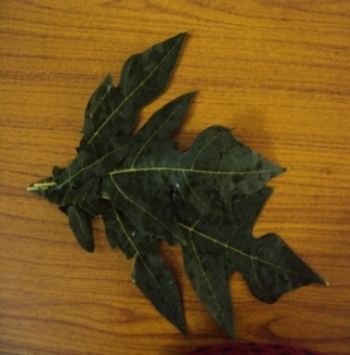
d 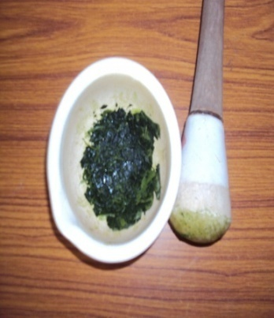
PLATE – I PLATE – II
FRESH PAPAYA LEAVES PAPAYA LEAVES PASTE

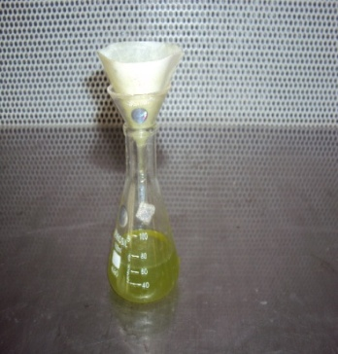
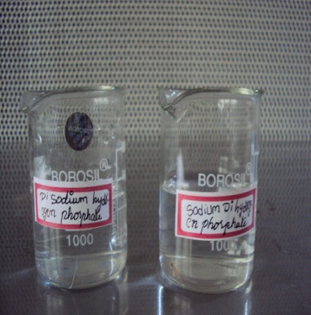
PLATE – III PLATE – IV
BUFFERS FILTERED ENZYME

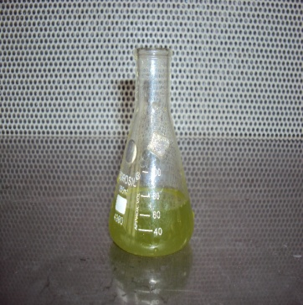
PLATE – V
PROTEASE ENZYME

3.2.2.1Enzymatic Degumming
The enzyme used for degumming of silk was proteolytic enzyme obtained by papaya leaves was taken. A pilot study was conducted for silk degumming followed by bulk production recipe given below
TABLE IV
enzymatic degumming Recipe
particulars
Enzyme | 3 gms/l
Di sodium hydrogen phosphate | 7.8 gms/50
sodium di hydrogen phoshate | 7.2 gms/50
pH | 5
Temperature | 70°C
Duration | 30 minutes
M : L | 5:95

The original raw silk was taken and weighed. The material to liquor ratio was maintained as 5:95. The enzyme solution was prepared and the temperature was raised to 37°C. After the silk fabric were immersed in the enzyme solution beaker for 15 minutes. Di sodium hydrogen sulphate and sodium di hydrogen phosphate was also added in to the enzyme solution. The pH was maintained as 6. Finally the fabric was thoroughly rinsed in cool water for 5 minutes .The samples were dried and then the degumming per cent was calculated.

3.2.3 Conventional Degumming
Based on the standard procedure, the fabric was degummed using the following recipe:
TABLE V
CONVENTIONAL ACID DEGUMMING RECIPE
Citric acid | 3 gms/l
Temperature | 100°C
Duration | 60 minutes
M:L | 1:20
The raw silk fabric was taken and weighed. The material to liquor ratio was maintained as 1:20. The acid solution was prepared and the temperature was raised to 100°C. After the silk fabric was dipped into acid solution taken in beaker for a period of 60 minutes. The non-ionic wetting agent was added to the acidic solution. Finally the fabric was thoroughly rinsed in hot water for 5 minutes and then rinsed with luke warm water. The sample was dried and then the per cent gum loss was calculated by weighing the sample before and after degumming.
3.3 Optimization of selected parameters for degumming
The process of elimination of gum or sericin from raw silk is known as “degumming of silk”. Degumming is carried out to remove sericin and other impurities present in silk to imapart a lustrous and softness effect on silk, opines Somashekar (2002). In order to obtain the best result for the silk fabric for degumming, various physical parameters for degumming were optimized.
3.3.1 Effect of Enzyme Concentration on Degumming
The optimum concentration of enzyme source was determined by taking different concentration of protease enzymes such as 5, 6, 7, 8 and 9 ml. One gram of silk fabric were added to the beakers containing different concentration of the enzyme source and degummed at 37°C for 30 minutes separately. The degummed fabric was removed and washed thoroughly with cold water and dried. The optimum enzyme concentration was obtained by calculating the weight loss of the fabric before and after degumming. Electronic Weighing Balance (Plate VI) was used to measure the weight.
3.3.2 Incubation Time on Degumming
Degumming of 1 gm of silk yarn and fabric were carried out under different incubation period. To optimize the incubation time for degumming, the enzyme was incubated at 37°C at different time intervals such as 20, 25, 30, 35 and 40 minutes. After each incubation period the silk fabric was washed with cold water and dried. Degumming efficiency was found by calculating the weight loss of fabric.
3.3.3 Effect of pH on Degumming.
The optimum pH for degumming was determined at different pH such as 4, 5, 6, 7, 8 and 9 by keeping the temperature as content at 37°C. The pH of enzyme was adjusted using buffer such as 7.8 g of disodium hydrogen phosphate and 7.1g of sodium hydrogen phosphate. One gram of silk fabric was added separately to the enzyme at different pH. The degumming bath was incubated at 37°C for 30 minutes. After the incubation period the fabric were washed with cold water and the weight loss of dried fabric was recorded.
3.3.4 Effect of Temperature on Degumming
One gram of silk fabric was added to the individual test tubes containing enzyme at different temperature such as 27°C, 37°C, 47°C, 57°C and 67°C for 30 minutes. After incubation period, the weight loss of the silk fabric was noted.
3.4 SELECTION OF NATURAL DYE
Michelia champak a fully grown tree attains a to height of about 8 feet. The flower contains a orange dye, and it is grown longitudinal. A dye can generally described as coloured substance that has an affinity to the substrate to which it is being applied. The dye is generally applied in an aqueous solution, and may require a mordant to improve the fastness of the dye against washing, light and perspiration on the fibre.

3.4.1 EXTRACION OF DYE SOLUTION
The fine powder was mixed with required amount of water and boiled for 30 minutes along with alum and boiled for 15 minutes then the fabric is immersed inside the dye solution and left for 30 minutes.
3.4.2 SELECTION OF DYEING PARAMETERS FOR THE STUDY
The details of selected proportions of dyeing parameters for dyeing silk material are given in table III:
TABLE VI
DYEING PARAMETERS
S.NO | DYEING VARIABLE | SELECTED PROPORTIONS
1 | Dye concentration | 5%
2 | Dye time | 30 min
3 | Mordanting time | 30 min
3.5 MORDANTING
Mordanting can be done by various stages, namely pre, simultaneous and post mordanting. Among thes, simultaneous mordanting selected in the study. Though metallic mordants produces bright and fast colours but they are not eco-friendly, hence bio mordants namely alum is selected for the study.

3.6 NOMENCLATURE OF THE SAMPLES
Nomenclature of degummed silk fabric (Appendices II ) are given in the Table VII
TABLE VII
Nomenclature OF THE SAMPLE
S.No. | Nomenclature | Sample Code
1 | OF | Original Fabric
2 | EDF | Enzymatic Degummed Fabric
3 | EDDF | Enzymatic Degummed Dyed Fabric
4 | CDF | Conventional Degummed Fabric
5 | CDDF | Conventional degummed Dyed fabric
3.7 Evaluation
Evaluation is defined as the making of judgment about the value for some purpose, ideas, works, solutions, methods and material, opines Bhatice (1984). Yarn is an intermediate stage between fiber and fabric whose properties are directly influenced by the raw material and influences the fabric quality. Hence it is necessary to evaluate the fabric for an effective end use.
3.7.1Subjective Inspection – Visual Evaluation
All the enzymatic degummed dyed sample and conventional degummed dyed samples were mounted on black sheet and evaluated visually for its colour; luster and hand by a panel of judges consisted of 50 post graduate students, using a performa which is given in Appendix III .
3.7.2 Objective Inspection
Standard yarn and fabric tests such as weight loss, physical property test, mechanical property test, comfort property test and absorbency test were carried out for the (raw) original sample, conventionally degummed samples and enzymatically degummed sample.
3.7.2.1 Weight
The fabric sample were weighed accurately using Ohaus Electronic Weighing Machine (Plate VI ). It has the powerful features of convenient portable package that makes weighing easy. It measures weight in grams/ pounds/ ounces. It has a high contrast display which is easily operated. Using this machine, before and after the treatment and the weight loss is calculated according to Gularjani et al. (1996) as,
Weight loss (%) = [(W₁-W₂) / W₁] × 100
where, W₁ and W₂ are the weights of samples before and after the degumming treatment.
3.7.2.2 Physical Property Test
3.7.2.2.1 Fabric Count
The fabric count refers to the closeness of the ends and picks of the fabric i.e., number of threads per inch. It is also referred to as thread count which is measured by one inch Pick Glass (Plate VII ) and counted through the small microscope and the numbers per square inch are recorded.
3.7.7.2.2 Fabric Weight
Saini (2004) describes fabric weight as the relative weight of the fabric and expressed as the weight of a particular size of piece as grams per sequare meter or ounces per square yard. Weight of the fabric is determined as weight per unit area, State Stoker et al. (2005). A sample (10 cm × 25 cm) was cut using a GSM Cutter (Plate VIII ) and Electronic Weighing balance was used to find the weight of the samples. The inference obtained is calculated using the formula :
Grams per Square Metre (GSM) =
Weight of the fabric = × (g)
Square of the fabric = 100 cm × 100 cm = 10000 cm²
Area of square = length × breadth square unit
The same procedure was followed to find the fabric weight of original silk and degummed silk fabrics. They were carefully recorded and the mean value was calculated.
3.7.7.2.3 Fabric Thickness
Thickness of the fabric is defined as the distance between the upper and lower surface of the fabric measured under a specified pressure, states Tailor (1998).
Baty Thickness Tester (Plate IX) was used to measure the thickness of the fabric. It is a hand operated instrument, which has a dial that reads the thickness of the fabric. Two clamps are attached to the dial. Each of the samples was placed between the two clamps and pressed. Thickness was measured at random. The mean value was calculated and recorded.
3.7.2.3 Mechanical Property Test
3.7.2.3.1Fabric Tensile Strength and Elongation
AATCC (1995) describes, elongation as the increase in length of a specimen during tension test, expressed in units of length of the fabric when loaded. Breaking length or elongation of the specimen were mass is equal to the breaking force, define Textile Institute (1991). Breaking strength is a measure of resistance of the fabric to a tensile load in a warp or weft direction, states Angappan (2002). The Eureka model Tensile Strength Tester (Plate X ) was used for the study. The late of traverse and capacity of the machine was 48 cm/min and 90 kg respectively. The gauge length was kept as 25 cm. The dial of the machine was calibrated in pounds and kilogram. The samples of different material were taken for testing. The length and width of the sample was 33 cm and 7 cm respectively. Each sample was clamped firmly between the two jaws. Care was taken that the fixed sample was perpendicular to the load. The load was applied until the sample was broken. The dial reading in kilograms and elongation in centimeters were noted. Five readings were noted for each category.

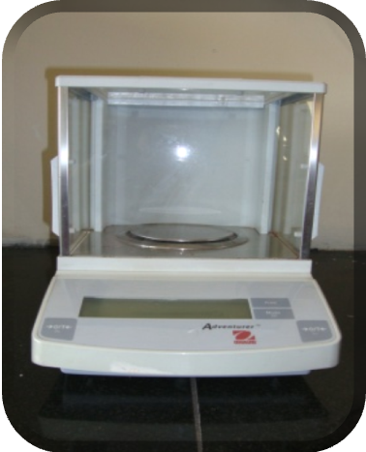 | 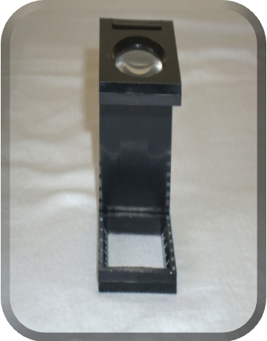
PLATE -VI  ELECTRONIC WEIGHING BALANCE | PLATE - VII  PICK GLASS
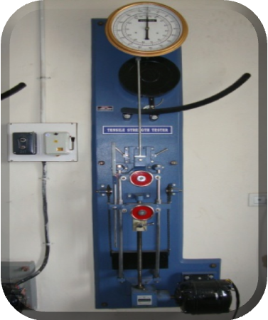 | 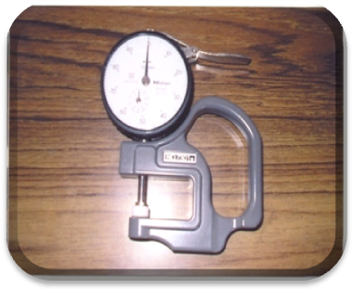
PLATE – VIII  FABRIC STRENGTH TESTER | PLATE -IX  FABRIC THICKNESS TESTER

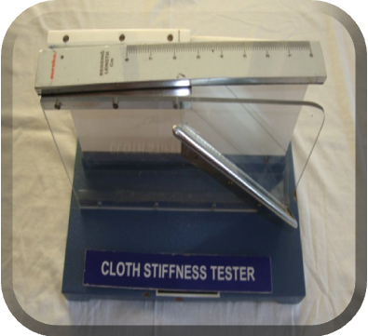
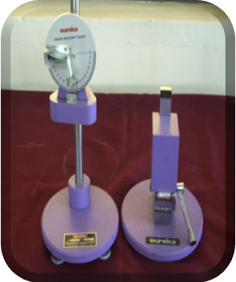
PLATE X PLATE XI
FABRIC STIFFNESS TESTER CREASE RECOVERY TESTER

3.7.2.4Comfort Property Test
3.7.2.4.1 Fabric Stiffness
Stiffness is an important characteristic of a fabric. The principle behind the stiffness test is to measure a particular length of a fabric specimen of specified dimensions which when used as a cantilever bends to a constant angle under its own weight, explains Visnu (2000).
As per the view of Basu (2007) the stiffness of the sample is determined by Shirely Stiffness Tester (Plate XI). The specimens from original silk fabric and degummed silk fabric of six inch were cut using template provided with the tester. Each rectangular strip was mounted over a horizontal platform until the edge of the fabric was co-inside with the index line, the reading was noted in centimeters pointed in the template. Five readings were taken from each specimen with each slide up, first at one end than the other. The mean value of the five readings was calculated as single readings. Five specimens from original silk fabric and degummed silk fabric were tested for five times.
3.7.2.4.2 Crease Recovery
Crease recovery is one of the desized properties in cloth, says Shailaja (1999). Crease recovery is the ability of a fabric to recover from unwanted creases. It is the property of the material to resist wrinkling and to restore the initial state after the force causing its crease is removed, says Kori (1998). Creasing of textile material is a complex effect involving tensile, flexing, compressive and other stresses. The ability of the fabric to resist creasing is depending on the type of fiber used for its construction, says Seine (2004). Creasing of a fabric during wear is not a change in appearance that is generally desired. The ability of a fabric to resist creasing is in the instance dependent on the type of fiber used in constructions. Shirley Crease Recovery Tester (Plate XII) was used for the study. The instrument consisted of a circular dial, which carries the clamp for holding the sample. A knife edge and an index line are seen directly under the centre of the dial to measure the recovery angle. Ten fabric each of 5 × 2.5 cm size were cut both in the warp and weft directions at random using a template from original silk sample and degummed silk samples. Each sample was transferred to the fabric clamp on the instrument and allowed to recover, from the crease. After two minutes, the dial was rotated to keep the free edge of the sample coincide with the knife edge. The crease recovery angle in degrees was read directly from the engraved scale. The mean values were calculated and recorded for the original silk fabric and degummed silk fabric.
3.7.2.5 Absorbency Test
3.7.2.5.1 Drop Test
A burette filled with distilled water was clamped in a stand. The sample was mounted in an embroidery frame and was placed at the base of the stand. The distance between the fabric and burette nozzle was kept constant as shown in Plate XIII. The nozzle of the burette was opened just to allow a drop of water to fall on the sample. The stop watch was started simultaneously and it was stopped when the drop of water fully sank into the material the time taken for this was noted. The same procedure was repeated for five times for the original silk fabric and degummed silk fabric. The mean value was calculated and recorded.
3.7.2.5.2 Sinking Test
Sinking test is a simple test that helps to measure the wettability of a fabric (Booth, 1996). Five samples were cut into the size 5 cm × 5 cm square original silk fabric and degummed silk fabric. A 1000 ml beaker was filled with distilled water and few drops of wetting agent were added into the distilled water. The sample was dropped on the surface of the water from a standard height.
The Stop Watch was started when the fabric struck the surface of water and stopped when the last corner sank below the water surface as shown in Plate XIV and the time required for the sample to sink was noted. The sample procedure was repeated for five samples. The mean value was calculated for the above samples. Similarly, the mean values of the original silk fabric and degummed silk fabrics were calculated and sinking time of each fabric was recorded separately.
3.7.2.5.3 Capillary Test
Paul (2005) points out that, the capillary travel method measures the rapidity of absorption. Five fabrics were cut into sizes of 15 cm length and 2.5 cm width from the original silk fabric and degummed silk fabrics. One end of the sample strip was pasted with a glass rod which was placed on heavy wooden blocks and at the other end, two grams weigh was attached to keep the fabric straight. At the weighted end 2 cm of the sample was allowed to immerse in a tray of distilled water as shown in Plate XV. The rise of the water level in the strip was noted by keeping length of the fabric as 5 cm constant. The same procedure was repeated for five samples from the same fabric and the mean value was calculated and the capillary rise of each fabric was recorded carefully.

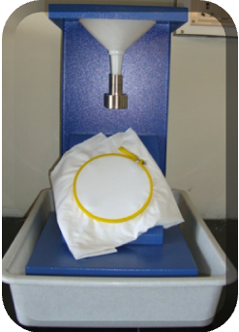 | 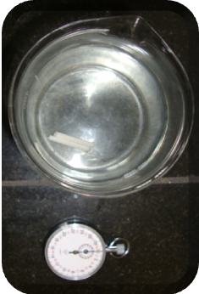
PLATE -XII  DROP TEST | PLATE -XIII  SINKING TEST
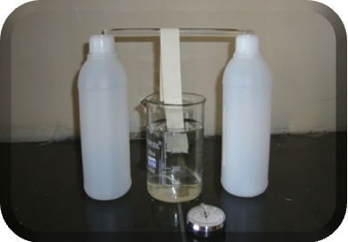
PLATE -XIV
CAPILLARY RISE TEST

3.8 STATISTICAL ANALYSIS
Statistical methods are the mathematical techniques used to facilitate the interpretation of numerical data secured from group of individuals or groups of observation from a single individuals, states Saravanavel (2007). The evaluation results of the experimental study were statistically analysed following one way ANOVA (‘F’ test) and the significance rating were discussed further.
4. Result and discussion

The results pertaining to this study is presented under the following headings :
4.1 Optimization of Protease Source
4.2 Evaluation of Degummed Silk Fabric
4.2.1 Subjective Evaluation
4.2.2 Objective Evaluation
4.2.2.1 Weight Loss
4.2.2.2 Physical Property Test
4.2.2.3 Mechanical Property Test
4.2.2.4 Comfort Property Test
4.2.2.5 Absorbency Test

4.1 Optimization of protease source
4.1.1 Optimization of Enzyme Concentration
The results of different enzyme concentration on the degumming of silk fabric are tabulated in Table VIII

Table VIII
Optimization of enzyme concentration
S.No. | Enzyme concentration | weight of the raw silk (gms) | Weight of degummed silk (gms) | Percentage of Weight loss
1 | 1 | 1 | 0.92 | 8
2 | 2 | 1 | 0.90 | 10
3 | 3 | 1 | 0.90 | 10
4 | 4 | 1 | 0.86 | 14
5 | 5 | 1 | 0.84 | 16

From the Table VII and Figure 2, it evident that when the concentration of papain enzyme increased from 1, 2 and 3 g, the per cent weight loss of silk fabric had also increased as 8, 10, 10 and 14, and 16 per cent respectively. The weight loss coincides with the results of Gulrajani et al. (1996) who stated that weight loss is directly proportional to concentration. While an increased concentration of enzyme beyond 3 per cent had no effect on the weight reduction of silk fabric after degumming. The result prove that the maximum amount of sericin removal is noted on using 3 gms of papain enzyme and optimum concentration was determined in terms of weights loss. The standard weight of the source was taken as 5 gms.

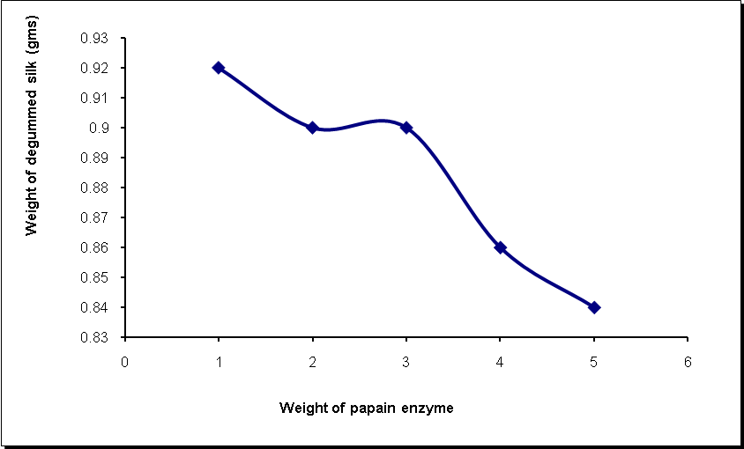
FIGURE 2
Optimization of enzyme concentration

4.1.2 Optimization of Incubation Time
The results of different incubation time on weight loss silk fabric are tabulated in Table IX
Table IX
Optimization of incubation time
S.No. | Incubation  time | weight of the raw silk (gms) | Weight of degummed silk (gms) | Percentage of Weight loss of fabric
1 | 20 | 1 | 0.90 | 10
2 | 25 | 1 | 0.88 | 12
3 | 30 | 1 | 0.88 | 12
4 | 35 | 1 | 0.85 | 15
5 | 40 | 1 | 0.82 | 18
From the Table VIII and Figure 3 , it is obvious that increase in time increased the weight loss of the silk fabric. The increase in time from 20-35 minutes exhibited a gradual weight loss in fabric as 12 to 18 per cent. However, prolonged exposure may bring down the enzyme activity and loss of strength and thus bring down the efficiency of degumming. Hence, the incubation time of 30 minutes was taken as standard time for silk fabric.

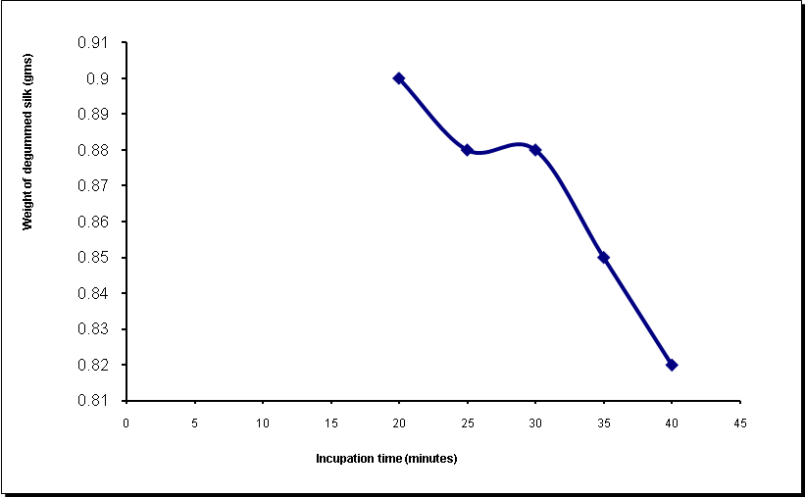
FIGURE 3
Optimization of incubation time

4.1.3 Optimization of pH
The results of pH on the degumming of silk fabric is tabulated in Table X
Table X
Optimization of pH
S.No. | pH | weight of the raw silk (gms) | Weight of degummed silk (gms) | Percentage of Weight loss of fabric
1 | 4 | 1 | 0.99 | 10
2 | 5 | 1 | 0.94 | 6
3 | 6 | 1 | 0.89 | 11
4 | 7 | 1 | 0.86 | 14
5 | 8 | 1 | 0.92 | 10

From the Table IX and Figure 4, it is evident that the enzyme activity on degumming was good at pH 6, 7 and 8 and the per cent weight loss recorded was 11 and 14 for fabric and yarn respectively. Krishnan et al. (2007) detail, that degumming sample with papain enzyme show better efficiency of degumming process in terms of gum loss and strength at an optimum pH of 6–7 . Hence pH 6 was taken as standard for this study.

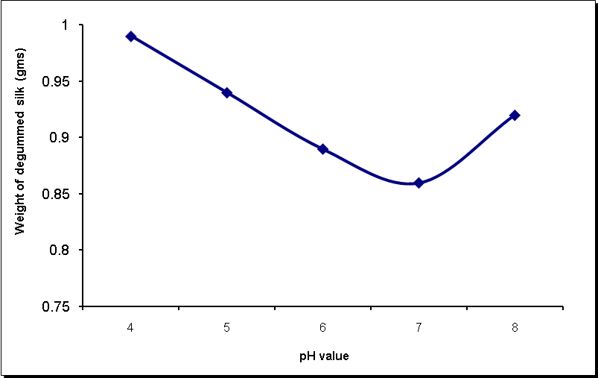
FIGURE 4
Optimization of pH

4.1.4 Optimization of Temperature
The results of different temperature on weight loss of silk fabric are tabulated in Table XI
Table XI
Optimization of temperature
S.No. | Temperature | weight of the raw silk (gms) | Weight of degummed silk (gms) | Percentage of Weight loss of fabric
1 | 27 | 1 | 0.94 | 6
2 | 37 | 1 | 0.89 | 11
3 | 47 | 1 | 0.84 | 16
4 | 57 | 1 | 0.70 | 30
5 | 67 | 1 | 0.68 | 32

From the Table X and Figure 5 , it is clear that there is no change in the weight of degummed silk at 27°c and shows that removal of sericin has not taken place. As the temperature was increased from 37, 47, 57 and 67°C, there was an increase in weight loss of fabric as 11, 16, 30 and 32 per cent respectively, Gulrajani et al., (2000) explains that, treatment of enzyme should be carried out at much lower temperature and the optimum temperature for silk degumming using enzyme is about 57 °C – 67°C. Hence considering the above facts 67°C was taken as the optimum temperature.

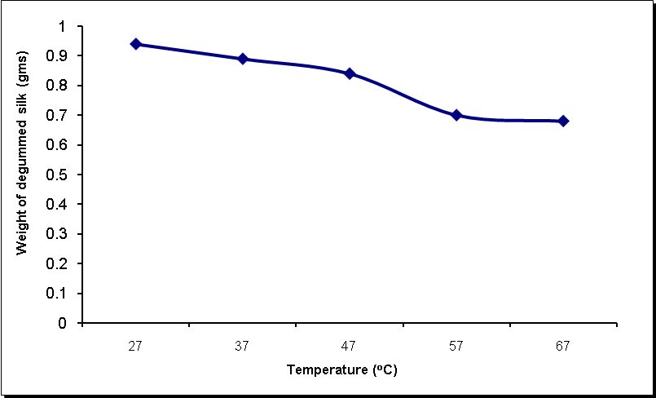
FIGURE 5
Optimization of temperature

4.2 EVALUATION OF DEGUMMED SILK FABRIC
4.2.1 Subjective Evaluation – Visual Evaluation
The subjective evaluation of silk fabric was done through visual inspection and the findings are given in the Table XII
Table XII
Visual evaluation of degummed silk fabric
Code of Samples | Judges rating (in number) (N : 50)
Code of Samples | General appearance |  |  | Colour |  |  | Texture |  |  | Luster
Code of Samples | G | F | P | B | M | D | S | M | R | H | M | L
EDF | 40 | 10 | - | 27 | 13 | 10 | 37 | 11 | 02 | 39 | 05 | 06
EDDF | 30 | 16 | 04 | 30 | 22 | 08 | 40 | 04 | 06 | 36 | 08 | 06
CDF | 23 | 10 | 07 | 21 | 08 | 21 | 31 | 09 | 10 | 31 | 09 | 10
CDDF | 30 | 18 | 02 | 20 | 19 | 11 | 41 | 03 | 06 | 30 | 11 | 09
G-Good F-Fair P-Poor B-Bright M-Medium D-Dull S-Smooth R-Rough H-High L-Low.
[
From the Table XI it is concluded that EDF was rated to be good by 40 judges for the general appearance, followed by DDF,CDF and CDD by 30, 23 and 30 judges respectively. While considering the texture, EDF is rated to be smooth as expressed by 37 judges. While looking for luster the same sample EDF rated to be high by 39 judges. Hence it could be concluded the silk degummed using papain enzymes was good in general appearance, colour, luster and texture.

4.2.2 Objective Evaluation
4.2.2.1 Weight loss
The weight of the sample was recorded before and after enzyme treatment and the weight loss was calculated and Tabulated in Table XIII.
TABLE XIII
WEIGHT LOSS
S.NO | Sample | Weight before treatment  (gms) | Weight after treatment  (gms) | Weight loss  (gms) | Weight loss (%)=[(W1-W2)/W1]x100
1 | EDF | 0.33 | 0.26 | 0.07 | 21.21
2 | EDDF | 0.36 | 0.32 | 0.04 | 11.11
3 | CDF | 0.40 | 0.35 | 0.05 | 12.5
4 | CDDF | 0.46 | 0.41 | 0.05 | 10.86
From the Table XII and Figure 6 , it is evident that when comparing the weight of conventional and enzymatic fabrics after degumming the percent weight loss due to enzymatic degumming seemed to be higher for enzymatic treated fabric as 21.21 per cent. While the weight loss in conventional degumming is relatively low, indicating inefficient degumming process. CDF and CDDF samples show moderate weight loss when compared to EDF and EDDF.

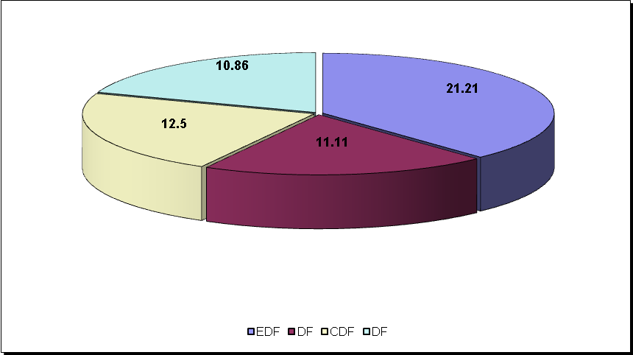

FIGURE 6
Weight loss of the degummed fabric

Fabric weigh samples OF,EDF,EDDF,CDF,CDDF is present in the table XIV

TABLE XIV
FABRIC WEIGHT
S.No | Samples | Mean weight ± SD | Gain / Loss over original | %  Gain / Loss  Over original | ‘F’ value
1  2  3  4  5 | OF  EDF  EDDF  CDF  CDDF | 0.31 ± 0.01  0.24 ± 0.03  0.25 ± 0.03  0.27 ± 0.02  0.29 ± 0.02 | 0.07  0.06  0.04  0.02 | 22.58  19.35  12.9  6.45 | 8.07

* - Significant at 5%

From the Table XIV and Figure 7, it is evident that the weight loss exerted by the fabric is about -6.45 per cent and in enzymatic degumming it is -22.58 percent. This shows that the enzyme degummed fabric has a maximum weight loss compared to other fabrics.
Statistical and analysis of data pertaining to fabric weight reveal that there was a significant difference at 1 per cent level between the processes such as enzyme and acid degumming.

FIGURE 7
FABRIC WEIGHT

Fabric Thickness
The fabric thickness and analysis of variance of conventional degummed silk fabric and enzymatic degummed silk fabrics are shown in Table XV and Figure 8
TABLE XV
THICKNESS TEST
S.No | Samples | Mean thickness ± SD | Gain / Loss over original | % of  Gain / Loss over original | ‘F’ value
1  2  3  4  5 | OF  EDF  EDDF  CDF  CDDF | 0.19 ± 0.02  0.21 ± 0.02  0.23 ± 0.02  0.24 ± 0.02  0.23 ± 0.02 | 0.02  0.04  0.05  0.04 | 10.53  21.05  26.32  21.05 | 4.10

* - Significant at 5%

From the Table XV and Figure 8, it is clear that the conventional degummed fabric thickness increased when compared with enzymatic method. Thickness was maximum in acid treated fabric (CDF) and minimum as 10.53 in enzymatic degummed fabric (EDF) 21.05 per cent in (CDDF) respectively. The variation in fabric thickness among the fabric may be due to the disintegration of yarn during degumming process.
Statistical and analysis of data pertaining to fabric thickness reveal that there was a significant difference at 5 per cent level between the processes such as enzyme, and acid degumming.

FIGURE 8
FABRIC THICKNESS

Mechanical Property Test
Tensile Strength
The yarn tensile strength and analysis of variance of conventional and enzymatic degummed silk fabric are shown in Table XVI and Figure 9.
TABLE XVI
FABRIC STRENGTH - WARP
S.No | Samples | Mean strength warp ± SD | Gain / Loss over original | % of  Gain / Loss over original | ‘F’ value
1  2  3  4  5 | OF  EDF  EDDF  CDF  CDDF | 108.00 ± 2.92  119.20 ± 2.59  147.00 ± 10.25  115.00 ± 3.08  141.40 ± 8.76 | 11.20  39.00  7.00  36.40 | 10.37  36.11  6.48  30.93 | 35.39

* - Significant at 5%

From Table XVI and Figure 9 , it is evident that the enzymatic degummed and dyed sample strength is higher than the conventional method. The strength was maximum in enzymatic degummed fabric as 10.37 per cent and minimum in conventional degummed fabric as 6.48 per cent respectively. Hence it could be concluded that enzyme treated fabric had better strength along warp direction than the other samples.
Statistical and analysis of data pertaining to fabric strength (warp) reveal that there was a significant difference at 1 per cent level between the processes such as enzyme, and acid degumming

FIGURE 9
Fabric tensile strength – warp

FABRIC STRENGTH – WEFT
The strength and analysis of variance of conventional method and enzymatic degummed silk fabrics are shown in Table XVII and Figure 10 .
TABLE XVII
FABRIC STRENGTH - WEFT
S. No | Samples | Mean strength weft ± SD | Gain / Loss over original | % of  Gain / Loss over original | ‘F’ value
1  2  3  4  5 | OF  EDF  EDDF  CDF  CDDF | 109.80 ± 3.56  125.40 ±1.95  167.60 ± 5.03  120.60 ± 1.82  160.60 ± 2.41 | 15.60  57.80  10.80  50.80 | 14.21  52.64  9.84  46.27 | 32.73
* - Significant at 5%

From Table XVII and Figure 10 it is evident that the enzymatic treated silk strength is higher than the degummed 14.21 and minimum of 9.84 in conventional method . The strength of EDDF is higher by 52.6, percent while the strength of the CDDF is 46.27.
Statistical and analysis of data pertaining to fabric strength reveal that there is a significant difference at 5 per cent level between the processes such as enzyme and acid degumming.

FIGURE 10
FABRIC STRENGTH

TABLE XVIII
FABRIC ELONGATION – WARP

S.No | Samples | Mean elongation warp± SD | Gain / Loss over original | % of  Gain / Loss over original | ‘F’ value
1  2  3  4  5 | OF  EDF  EDDF  CDF  CDDF | 1.70 ± 0.37  2.62 ± 0.41  4.14 ± 0.31  2.08 ± 0.53  3.74 ± 0.48 | 0.92  2.44  0.38  2.04 | 54.12  143.53  22.35  120 | 13.90

* - Significant at 5%
From Table XVIII and Figure 11, it is evident that the fabric elongation is higher than the original fabric in case of enzyme degummed fabric. The maximum elongation of0.92 per cent was shown by the fabric EDF. The maximum in EDDF along warp direction and the sample CDDF has shown 120 per cent increase along warp. It is clear that both EDDF and CDDF exhibits maximum elongation then the original.
Statistical and analysis of data pertaining to fabric elongation (warp) reveal that there was a significant difference at 5 per cent level between the processes such as enzymatic and acid degumming.

FIGURE 11
Fabric ELONGATION – WARP TABLE XIX
FABRIC ELONGATION - WEFT

S.No | Samples | Mean Elongation weft± SD | Gain / Loss over original | % of  Gain / Loss over original | ‘F’ value
1  2  3  4  5 | OF  EDF  EDDF  CDF  CDDF | 2.48 ± 0.59  2.44 ± 0.44  4.76 ± 0.34  2.98 ± 0.20  4.72 ± 0.32 | 0.04  2.28  0.50  2.24 | 1.61  91.94  20.16  90.32 | 30.05

* - Significant at 5%
It is evident from Table XIX and Figure 12 that, the silk fabric elongation is noted to be higher in case of enzyme degummed and dyed fabric 91.94 than the original fabric. The elongation was maximum in enzyme degummed 1.61 percent when comparing to the conventional degummed fabrics 20.16. Conventionally degummed and dyed fabric also exhibits 90.32 per cent increasing elongation along weft direction when compare to the original. Hence it could be concluded that enzyme treated fabric had better elongation along weft direction than the others.
Statistical and analysis of data pertaining to fabric elongation (weft) reveal that there was a significant difference at 5 per cent level between the processes such as enzymatic and acid degumming.

FIGURE 12
Fabric ELONGATION – WEFT

Table XX
Fabric stiffness – WARP
S.No | Samples | Mean Stiffness Warp ± SD | Gain / Loss over original | % of  Gain / Loss over original | ‘F’ value
1  2  3  4  5 | OF  EDF  EDDF  CDF  CDDF | 2.80 ± 0.10  2.44 ± 0.34  2.10 ± 0.31  2.10 ± 0.14  1.84 ± 0.21 | 0.36  0.70  0.70  0.96 | 12.86  25  25  34.29 | 12.26

* - Significant at 5%
From Table XX and Figure 13, it is evident that the stiffness of degummed silk fabrics is lower than the original fabric in case of enzyme degummed fabric. The maximum stiffness reduction in enzymatic degummed fabric and minimum reduction in conventional amine degummed fabrics were 12.86 and 34.29 per cent respectively. Hence it could be concluded that enzyme treated fabric had better flexibility along warp direction than the others.
Statistical and analysis of data pertaining to fabric stiffness (warp) reveal that there was a significant difference at 5 per cent level between the processes such as enzymatic and conventional degumming.

FIGURE 13
Fabric stiffness - WARP

Fabric Stiffness – Weft
The fabric stiffness (weft) and analysis of variance of original silk fabric and degummed silk fabrics are shown in Table XXI and Figure 14.
TABLE XXI
FABRIC STIFFNESS - WEFT
S.No | Samples | Mean Stiffness Weft ± SD | Gain / Loss over original | % of  Gain / Loss over original | ‘F’ value
1  2  3  4  5 | OF  EDF  EDDF  CDF  CDDF | 2.50 ± 0.32  2.58 ± 0.29  1.86 ± 0.11  1.88 ± 0.19  1.68 ± 0.18 | 0.08  0.64  0.62  0.82 | 3.2  25.6  24.8  32.8 | 15.92

* - Significant at 5%

From Table XXI and Figure 14, it is evident that the stiffness enzyme degummed fabric is better than the original fabric. A maximum of 3.2 per cent reduction is shown by enzyme degummed fabric and a minimum of 24.8 per cent by conventional method. Hence it could be concluded that enzyme degummed fabric had better flexibility along weft direction than the others.
Statistical and analysis of data pertaining to fabric stiffness (weft) reveal that there was a significant difference at 5 per cent level between the processes such as enzymatic and acid degumming.

FIGURE 14
Fabric stiffness – WEFT

Fabric Crease Recovery – Warp
The fabric crease recovery (warp) and analysis of variance of original silk fabric and degummed silk farbic are shown in Table XXII and Figure 15 .

TABLE XXII
GREASE RECOVERY-WARP
S.No | Samples | Mean Crease Recovery warp ± SD | Gain / Loss over original | % of  Gain / Loss over original | ‘F’ value
1  2  3  4  5 | OF  EDF  EDDF  CDF  CDDF | 122.4 ± 2.30  122.40 ± 2.30  129.0 ± 2.24  118.20 ± 1.48  123.0 ± 2.65 | 0.00  -6.60  4.20  -0.60 | 0  5.39  -3.43  0.49 | 15.06

* - Significant at 5%
From Table XXIIand Figure 15, it is evident that the crease recovery angle is reduced in case of enzyme degummed and dyed fabric than the original fabric. The per cent crease recovery angle in enzyme degummed fabric was 5.39 per cent and in conventional degummed fabric it was -3.43. per cent respectively. Hence it could be concluded that enzyme degummed fabric had better crease recovery along warp direction than the others.
Statistical and analysis of data pertaining to fabric crease recovery reveal that there was a significant difference at per cent level between the processes such as enzyme, acid and amine degumming.

FIGURE 15
FABRIC Crease recovery – WARP

FIGURE 15
CREASE RECOVERY WARP

TABLE XXIII
CREASE RECOVERY-WEFT
S.No | Samples | Mean Crease Recovery weft ± SD | Gain / Loss over original | % of  Gain / Loss over original | ‘F’ value
1  2  3  4  5 | OF  EDF  EDDF  CDF  CDDF | 118.80 ± 1.70  120.20 ± 2.28  125.20 ± 2.86  113.60 ± 3.36  119.60 ± 1.67 | 1.40  6.40  5.20  0.80 | 1.18  5.39  4.38  0.67 | 13.90
* - Significant at 5%

From Table XXIII and Figure 16 , it is evident that the crease recovery angle is reduced in case of enzyme degummed and dyed fabric than the original fabric. The per cent crease recovery EDDF angle along weft is 5.39 per cent where in conventional fabric it is 0.80. per cent. Hence it could be concluded that enzyme degummed fabric has better crease recovery along weft direction than the others.
Statistical and analysis of data pertaining to fabric crease recovery reveal that there was a significant difference at 5 per cent level between the processes such as enzyme, acid and amine degumming

FIGURE 16
CREASE RECOVERY WEFT

Absorbency Test
4.2.2.5.1 Drop Test
The results of drop test and analysis of variance of original conventional silk fabric and degummed silk fabrics are shown in Table XXIV and Figure 17 .

TABLE XXIV
DROP TEST
S.No | Samples | Mean for Drop Test ± SD | Gain / Loss over original | % of  Gain / Loss over original | ‘F’ value
1  2  3  4  5 | OF  EDF  EDDF  CDF  CDDF | 31.20 ± 1.64  27.00 ± 2.12  25.80 ± 1.30  21.80 ± 1.79  24.80 ± 1.48 | 4.20  5.40  9.40  6.40 | 13.46  17.31  30.13  20.51 | 42.92

* - Significant at 5%

From Table XXIV and Figure 17, it is evident that the absorbency is higher between EDDF and CDDF mean time taken to absorb a drop of water is only one second though the EDF has lesser absorbency, it could absorb more when dyed.
Statistical and analysis of data pertaining to fabric absorbency reveal that there was a significant difference at 5 per cent level between the processes such as enzyme, and acid degumming.

FIGURE 1
Drop test

Sinking Test
The fabric sinking test and analysis of variance of conventional silk fabric and degummed silk fabrics are shown in Table XXIV and Figure 18.
TABLE XXV
SINKING TEST
S.No | Samples | Mean for Sinking ± SD | Gain / Loss over original | % of  Gain / Loss over original | ‘F’ value
1  2  3  4  5 | OF  EDF  EDDF  CDF  CDDF | 41.80 ± 1.48  24.00 ± 2.00  32.80 ± 2.28  35.60 ± 1.82  34.20 ± 2.59 | 17.80  9.00  6.20  7.60 | -42.58  -21.53  -14.83  -18.18 | 48.00

* - Significant at 5%
From Table XXV and Figure 18, it is evident that the silk fabric absorbency is higher in case of enzyme degummed fabric than the conventional degummed fabric. The per cent absorbency is increase by 42.58 cent as the fabric EDC only 24 seconds to absorb a droplet of water. Comparatively all the degummed fabric had better absorbency than the original.
Statistical and analysis of data pertaining to fabric absorbency reveal that there was a significant difference at 5 per cent level between the processes such as enzyme, and acid degumming.

FIGURE 18
Sinking test

Capillary Rise Test
The fabric capillary rise test and analysis of variance of conventional silk fabric and degummed silk fabrics are presented in Table XXVI and Figure 19.
TABLE XXVI
CAPILLARY TEST
S.No | Samples | Mean for Capillary Test ± SD | Gain / Loss over original | % of  Gain / Loss over original | ‘F’ value
1  2  3  4  5 | OF  EDF  EDDF  CDF  CDDF | 77.80 ± 3.70  52.40 ± 2.97  57.20 ± 2.59  61.20 ± 2.59  58.20 ± 4.09 | 25.40  2.60  16.60  19.60 | -32.65  -26.48  -21.34  -25.19 | 44.89
*Significant at 5% level,
From Table XXVI and Figure 19, it is evident that the capillary rise higher in the enzymatic degummed fabric. All the samples have exhibited better capillary rise when when compare to original.
Statistical and analysis of data pertaining to fabric absorbency reveal that there was a significant difference at 5 per cent level between the processes such as enzyme, and acid degumming.

FIGURE 19
Capillary rise test

Among all the samples enzymatic degumming with protease enzyme had better weight loss and absorbency, where as with lipase weight loss cannot be seen. Hence Protease enzyme alone was taken for the study.

5. SUMMARY AND CONCLUSION
The Indian textiles and clothing business covers a wide scale of activities and processes ranging from production to basic fiber required to the finished value added product such as fabrics made up and apparels.
The beauty of silk fabrics is legendary. For many centuries, silk was synonymous with luxury. It is most cherished fabric and always considered exclusive top fashion fabric. It is inseparable part of India is culture and traditional over thousands of years. Silk has all desirable properties of textile fiber like strength, softness, draping quality, elasticity, comfort, luster, natural crease resistance and affinity to dyes. It is well known that India rank second in the world in silk production, so it is high time for bringing new methods to take a serious look at queen silk.
Silk contains gummy substance called sericin, without removing this further process cannot able to achieve. Using of so many chemicals for degumming causing pollution. Highly specialized biocatalysts ie. enzymes, for the chemical processing as well as for physic-chemical modifications of textile fibers. Enzymes being natural products are completely bio-degradable and accomplish their work quietly and efficiently without leaving pollutants behind. It can be successfully used for carrying out the degumming of silk.
The biggest damage to the environment is supposed to be done by the textile industry due to some wetting process. Silk has been the inseparable pat of Indian culture and tradition. Therefore, if one could degum silk using enzymes, we could have peaceful celebration without polluting our green globe.
In order to reduce pollution causing by using chemical aunxillaries, the investigator has selected the study on “Bio-Degumming of Silk Fabric Using Protease and Lipase Enzyme”.
- To extract protease enzyme from papaya leaves.
- To compare the conventional and enzymatic degumming processes on silk.
- To dyed the bio degummed fabric with a natural source.
- To evaluate the performance of the silk fabric.

EXPERIMENTAL PROCEDURE
Selection of Source
For the enzymatic degumming fresh papaya leaves protease and crushed the leaves with the help of pistol and mortar. Buffers such as Di sodium hydrogen sulphate and sodium di hydrogen sulphate was added in order to maintain pH, then the liquid was filtered with watt’s man filter paper. a clear liquid of protease enzyme is obtained and that is subjected to the fabric for 30 minutes at 37°C
Optimization for Degumming
Optimization is needed to improve the enzymatic degumming process. In order to acquire the best results for the silk fabric degumming, various physical parameters like source concentration, incubation time, pH, temperature were optimized. The optimized parameters are given as follows.
- Different concentrations of the source like 1, 2, 3, 4 and 5 gms respectively were taken and among the various concentrations 5 gms yielded the highest result and thus chosen as the optimum concentration.
- Degumming was carried at different incubation time such as 20, 25, 30, 35 and 40 minutes were selected. Based on the results the optimum incubation time for degumming of silk fabric was chosen as 30 minutes.
- The optimum pH for the degumming process was found by calculating the weight loss of the silk fabric degummed at different pH such as 4, 5, 6, 7, 8 and 9. The optimum pH was found to be 6.
- The temperature was varied as 27, 37, 47, 57 and 67°C. The weight loss of the silk fabric degummed under these temperatures was calculated and the optimum temperature for the process was found to be at 67°C.

Evaluation of Degummed Fabric
The silk fabric were evaluated to determine the degumming effect on the properties.
- The visual evaluation proved that the degummed fabric using enzymatic were rated as good in appearance, bright in colour, medium in texture and high in luster.
- As far as weight loss is concerned, all the samples showed decrease in weight. The sample EDF showed maximum weight loss as 21percent.
- Fabric count in warp direction was found to be equal in EDF and CDF samples. In the weft direction all the samples exhibited the same count.
- Fabric thickness was found to be maximum in EDDF.
- Fabric tensile strength was found to be maximum in enzyme degummed sample when compared with original, and conventional degummed samples.
- Fabric elongation was found to be maximum in EDF as 54 per cent.
- Increase in fabric tensile strength per cent was found to be maximum in both EDF and EDD Fdirection as 10 and 36 per cent.
- The maximum fabric elongation in warp direction was found in degummed sample EDF as 43 per cent.
- Fabric stiffness in both warp and weft direction of EDF was lesser by 38 and 37 per cent than the original.
- The reduction in crease recovery in both warp and weft direction of enzymatic sample EDF was 12 per cent.
- The absorbency tests proved that all the EDF samples were rated be good when compared to conventionally degummed sample and original sample.

CONCLUSION
It clearly evident from results that the bio degumming scoring maximum percentage. This modern enzyme technology utilizes protease enzyme degumming specially to retain the strength and luster of silk. Hence this study, which was based upon the use of enzymes for silk degumming has thrown light on reduction of cost, time and energy. The use of photolytic enzymes is a better method because they remove the sericin without attacking the fibroin. Tests with higher concentrations of enzymes show that there is no damage to the silk fabric were stronger than with conventional degumming method. The results of the study prove the potentiality of enzymes in producing green label products, which in turn would be the right solution to solve environmental issues. The textile industry will continuous to explore the use of enzyme to improve the efficiency of silk degumming and also to reduce pollution.
BIBLIOGRAPHY
JOURNALS
- Adivareka, Teli M.D, Pardeshi. P.D., (2004)., “ Dyeing of pretreated silk subrtrate with madder extract,” colourage, colour publications, P.Ltd., Mumbai, Vol. L1, No.: 1-4, February, Pp:23,24.
- Adivarkar, teli, M.D., Pardeshi.P.D., (2004)., “ Dyeing of pretracted silk subrate”, Colourage, Colour publications, P.Ltd., Mumbai, Vol.L1, No:1-4, February, PP:23-24.
- Ampama mishra, S. (2008). Effect of alkaline degumming of tasar silk, Asian Textile Journal, Vol. 14, Pp.52-54.
- Ansari A.A. & Thakur, B.D., (2000)., “ Extraction & Characterization & application of natural dyes, the eco-friendly textiles”, Colourage, colour publications, p.ltd, Mumbai, Vol.XLVII, No:7, June, PP:16.
- Ansari.A.A, & Thakur, B.D., (2000)., “ Extraction & Characterization & Application of natural dyes, the eco-friendly textiles”, colourage, colour publications, P-Ltd, Mumbai, Vol XLVII,No:7, June, PP:16.
- Anshu sharma, Extra grover & Dr. Susan paul., G,B plant, (2008)., “ Juglan rasia and Excellent source of brown colour,” Textile trends, Eartland publications, vol: LV, No: 7-12, November, P: 41.
- Clark., (1990)., “ Eco- friendly of natural dyes”, Colourage, colour publications, P-Ltd, Mumbai, vol: 50, No:7-12, July, PP: 35.
- Collis., & Toltola G. Phyllis, (2001)., “ understanding textiles”, Hall of India, New Delhi, P: 73,76.
- Collis., J. Billie & EPPS M.Helen (1999)., “ Textile testing & Analysis”, Merill an imprient of prentie Mall, New jenrcy, P:240.
- DR. Asha mukunan & sujata.R., Kawlekar, (2009)., “ Dyeing cotton with national colourant”, Textile trends, Eartland publications, pLtd.., Mumbai, Vol:50No:7-12, February, P:23.
- Dr. Linton & Mr. Pizzuto., (1998)., “ Testing program”, Ephraim, freedman, PLtd., London, P.45.
- Dr. Milan sharma., (2006)., Textile Industry of India & Pakistan”. APH. Publishing company New Delhi, P:44
- Dr. Rajashree plukon & Dr. A. Phykan., (2007)., “ Silk Yarn dyeing with national dyes extrcted from the back of eugenia tambolana lam”, Textile trends, eartland publications, P.ltd., Mumbai, Vol: 69,No: 7-12, February, PP:33.
- Further. R., Ghorashi, H.& Schleth. A., (2007)., “ Cloth classification is bark for quality arressment & price determination”, textile Magazine, gopal & co., Publichers, Chennai, vol:48, June, PP:12
- Further.R.,Ghorarhi. H.& Schleth. A., (2007), “ Cloth classification is basic for quality assessment & price determination”, Publihers, Chennai, vol:48, June, PP:12.
- Gaholt. M.& Singh. A., (2002), “ OPtimisation of dyeing parameters for Batik silk”, Man-made textiles in India, April, PP: 124-126.
- Gautam., (2008), “ dicing of eri silk with acid & reactive days” textile trends, eastland publication Pvt, Ltd., Mumbai, March, Vol :50, no: 7-12, P:37
- Ghosh, S.S., Sreenivasa, D., Bengupta and Thangavelu, K. (2001). Applications of Lac dye on Tasar Silk, Inidan Silk, Vol.40, No.4, Pp.27-29.
- Giridhar, K., Mahanta, J.C. and Deole, A.L.R. (2007). Raw silk production 2006-2007, Indian Silk, Vol. 46, No.6, Pp.43-44.
- Gordon cook, (1993)., “ silk yarn dyeing with natural dyes extracted from the bank of Eugenia tamboana lam”, Textile trends, eastland publications, P-Ltd, Mumbai, vol:69, No: 7-12, February, PP:33.
- Gordon cook.G.,(1993), “handbook of fiber science”, merrow publishing England, p:144
- Gowda, K.N., Padaki, N.V. and Sudhakar, R. (2007). Eco-friendly preparatory process for silk: Degumming by protease enzyme, Manmade Textile in Inida. Vol.XX, Pp.28-30.
- Guangrong, H., Tieing, and Jiaxing, J. (2006). Purification and characterization of a protease from thermophitic bacillus strain HSO8. African Journal of Biotechology, Vol5, No.24, Pp.2433-2435.
- Gulbrajani. M.L.,(1999)., “Present status of natural dyes”, colourage, colour publications P.Ltd, Mumbai, vol: XLVI, No:7 July, PP:19,20.
- Gulrajani and Sen (1999). Efficacy of protease on degumming of dupion silk, Indian Journal of fiber and textile research, Vol.23, Pp.52-58.
- Gulrajani, M.L. (1999). Present status of Silk reeling, Colourage, Vol. XLVI, No.7, Pp.36-38.
- Gulrajani, M.L. and Gupta, S.V. (1996). Degumming of silk with different protease enzymes. Indian Journal fiber and textile Res, Vol.21 Pp270-275.
- Gulrajani, M.L., and Agarwal, R. (2000). Degumming of silk with lipase and protease, Indian Journal of fiber and Textile Research, Vol 25, Pp.69-74.
- Gulrajani., (2001).,” Dyring properties of natural dyes, some practical & theoretical aspects”, NCUTE, IIT Delhi, P: 15)
- Gupta deeph, (2000)., “ Neehanism of dyeing synthetic fibers with natural dyes”, Colorage, color publications P-ltd., Mumbai, Vol:XLVIII, No:3, April, P:23.
- Gupta, R. (2003). Statistical media optimization and alkaline protease productin from Bacilus mojavansis in a bio-reaction, Proc. Biochem. 39:203-209.
- Gupta, R., Rakshit, S.K. (2003). Developments in industrially important themostable enzymes: a review, Bioresour. Technol, 89:177-180
- Hall A.J., (2004)., “The standard Hand book of textiles”, Wood head Publishing limited 19. P: 27.
- Jacob , M.R.V., Subramanian, T.V. and Jayaman, K. (1999). Prodcution of protease by Bacillus amyloliquefaciens in solid-state fermentation and its application in the un lairing of hides and skins, Process Biochem. 30:457-462.
- Jacob., (1999), “ Natural dyes,classificarion & source, Convention, on natural dyes”. IIT Delhi, P:67
- JAya paliwal., (2011)., “Effect of mordants on henna, dyed cotton & Silk fabrics,” Textile magazine, gopal & Co publishers, Chennai, vol: 42,NO : 11, July, PP:9
- Johnson.H. & Louis V., (1995)., “ The textile Arts”, Macmillan Company P:53 Milar., CE & Turk, L.M (2001)., “ Fundamentals of soil science”, Biotech Books Publishing , Delhi, P:12
- Joy OOmen .P., (2003)., “ Dye extraction from mort a calys & its assessment”, Colourage, color publications p-ltd., Mumbai vol:XLVI, No:7, September, PP:8,9
- Kumar, P.E., Kulandaivelu, A.R., & Boopathi. T.S., (2005)., “ Eco-friendly natural dyes from hubricus vitiyolins & Sestania acgyptica for dyeing”. Colourage, colour publications, pvt. Ltd.,, Mumbai, vol: L11, No:10, May, P:31.
- Mahale & Sunanada, (2006)., “ Colour fastness, characteristics of natural dyes from kamala leaves”, (Mallotus phillipensis) & Kilmora flowers, (Rumex Martatus)., Textile trends, eartland publications, P-Ltd, Kolkatta, Vol: 69, No:7-12, December, PP:29.
- Mahale. Sunanda., Sakshi., (2003)., “ Colourfartness of dyed silk”, Textile Industry & Trade Journal Industry & trade publishers, Pvt. Ltd., Mumbai, Vol:41, No: 1-12, September, PP:49.
- MS. Sunitha Dixit & Shahnaz Jahan, (2008), “ Colour fartness properties of plum (ZIZIPHUS JUJUBA) leaves dyes of silk fabric”, Textile trends, Eastland publications, P.Ltd., Mumbai, Vol:50,No:7-12, febraury, PP:31.

- Muthu (2005). Production of alkaline protease in low cost medium by alkalophutlic Bacillus sp. And Properties of the enzymes, J.Terment Technol, Vol.65, Pp.345-348.
- Paul., (2005)., “ Textile Testing”, APH Pubilishing corporation, New Delhi, P.140.
- Ravel, H. and Banerjee, S.E. (2003). Effect of enzyme and chemical pretreatments on the properties of silk, Journal of the Textile Association, Vol.64, No.2, Pp.65-69
- Rulian dumitrescu., Emitia., et al .,(2004)., “natural dyes obtained from plants & vegetables wasles”, colourage, colour publication, P Ltd., Mumbai, vol : 11, No: 10-12, December, PP : 121
- Shankar ., Turwari., vantar.S., (2003), “dyeing cotton, wool textile and silk with ticona leaves dye “,G.P.S Kwalra publications, Mumbai, Vol : 12, No: 4, September P: 87
- Shankar.,(2003)., “Ecofriendly of natural dyes”, Colourage, color publications, p-ltd., Mumbai, Vol:50,No:7-12, July, PP:35.
- Shenai., V.A. (2000)., “ Textile Industry”, Ammol Publications, New Delhi, P:98. Tracy Bicane & Tom Carridy, (2005)., “ Colour fore- carting”, Black well Publishing, Australia, P:45.
- Teli M.D., Paul ., pardeshi., P.D. (2001)“ natural days, classification chemistly & extaction methods,” colurage, colour publication Pvt. Ltd Mumbai, Vol : 48, No 1-6, April 17, 2012 .PP: 52
- Vaishnar., N.A& Jothi., H.D., (2000), “ Textile testing & Analysis,” Popular prakarhan publications, seerat, P240.
- Vishnu vardhini (2006), “ A study on the effect of both pH on exhaustion & softness deering the finishing textiles”, Colourage, Vol-XLVII, No.10 P:18.
Books
- AATCC, (1994), Technical Manual of the American Textile Chemists and Colourists, American Association of Textile Chemists and Colourists, USA, Pp. 17-19.
- AATCC, (1995), Technical Manual of the American Textile Chemists and Colourists, American Association of Textile Chemists and Colourists, USA, Vol. LXX, Pp. 17, 23-26.
- Ashenhurst. (2007). Understanding Textiles, Upper Saddle River, New Jersey, Pp.29, 412.
- Barker., A.F. (2007), “ Handbook f textiles”, Abhishek publications, Chandigarh, P: 425.
- Bishop.,(2003)
- Chacravorty. (2009). Artificial silk It’s manufacture, Woodhouse Abhishek Publishing, New Delhi, Pp56-67.
- Gahlot.M.& Singh. A., (2002)., “ Optimization of dyeing parameters for batik silk”, Man –Made Textiles in India, April, pp: 124-126.
- Ibrahim., (2011). Sericulture Extension Principles and Management, A.P.H Publishing, New Delhi, Pp.69-98.
- Kamal Jaiswl, Sunil. P., Trivedi, B.N., Pandy. and R.K., Khatri, S.B. (2005). Mariculture Nangai Publishing, New Delhi, Pp.45-47.
- Kirusur ., (2003)“ Fibre science & Technology”, oxford & IBH Pubishing Company Pvt Ltd Calcutta, P. 151-194.
- Koshy, T.D. (2003). Silk Export and Developments, Ashish Publishing House, New Delhi, P.33.
- Krishna Rao. R.K. (2009). Oak Tasar culture, A.P.H Publishing, New Delhi, Pp.79-102.
- Mahadevan.,M.G., (2008), “Textile colouring”, Abhishek Publications, Chandigarh, pp: 30.
- Medina. N.,(2000), “Fine organization of bombyx mori fibroin heavy chain”, pp:28
- Meenakshi rastog., (2009), “Animal Textiles”, sonia Publishing, New Delhi, Pp.89-134
- Meenakshi Rastogi. R. (2009). Fiber and yarn, Sonali Publication, New Delhi, Pp.69-98.
- Mishra, S.P. (2000). A Text Book of Fibre Science and Technology, New Age Internation (P) Ltd., New Delhi, Pp. 79-83.
- Mishra,s.p, (2000), “A Text book of fiber science and technology”, Gupta Publications, New Delhi, pp2.
- Murphy, W.S. (2003). Preparation of Textile Fiber, Abhishek Publishing, New Delhi, Pp.32,98,102-107.
- Murphy.,W.s, (2003), “Elements of fiber science”, Abhishek publications, chandighar, pp:60
- Ojha, N.G and Panday, P.N. (2004). Silk Production, A.P.H Publishing Co-operation, New Delhi, Pp.57-70.
- Okada M., kimura., y., et al.,(2008), “SEM images of silk fibers cross section etched by means of protease digesion”, Gakkaishi Publications, pp:118
- Pandy, P.N. and Sharan, S.K. (2008). Silk Culture (A Biochemical Approach ), A.P.H Publishing Co-operation, New Delhi, Pp.79-109.
- Patnaik, R.K. (2008). Sericulture Manual, Biotech Books Publishing, New Delhi, Pp.102-107.
- Rajendra Reddy, J.P. (2005). Sericulture Ajay Verma for common wealth Publishing, New Delhi, Pp.99-114
- Rajendra Reddy, J.P. (2005). Sericulture Ajay Verma for common wealth Publishing, New Delhi, Pp.99-114
- Raul, J. (2005). Textile Testing, APH Publishing Corporation, New Delhi, Pp. 74, 75.
- Raul, J. (2005). Textile Testing, APH Publishing Corporation, New Delhi, Pp. 74, 75.
- SomaShekar, T. H. and Kavakami, K. (2003). Manual on Bioltine Silk Reeling, CSTRI, JICA Offset Publishing, Pp.34, 55-62.
- SomaShekar, T. H. and Kavakami, K. (2003). Manual on Bioltine Silk Reeling, CSTRI, JICA Offset Publishing, Pp.34, 55-62.
- Staneseu (2000). Artificial silk It’s manufacture, Woodhouse Abhishek Publishing, New Delhi, Pp56-67.
- Sunil, P. N., Kamal Jaiswal and Panday, B. N. (2008). Mulbery Sericulture (Problem and Prospects), A.P.H Publishing, New Delhi, Pp.89,127.
- Sunil, P. N., Kamal Jaiswal and Panday, B. N. (2008). Mulbery Sericulture (Problem and Prospects), A.P.H Publishing, New Delhi, Pp.89,127.
- Thomas, (2004), “Textiles Fibres, Dyes, Finishes & Processes”, Noyes Publications, U.S.A. P” 39,69.
- Weels kali, (2000)., “ Fabric dyeing & Printing”, Conran octpus limited, P:69.
- Worh., P., (2004)., “ Fibre science & Technology”, Tata MCGRAM Mill publishing company, New Delhi, P:37

WEBSITES
(www.occi.ab.ca)
(www.naturaldyes.html)
(www.en.wikipidiya.org)
(www.silk promotors.org/benifits)
(www.novozymes.com)
www.highbeam.com

APPENDIX – i

FABRIC TYPE : 100 % MULBERY SILK
FABRI C OUNT : 110
WEAVE : Plain Weave
WIDTH : 24 cms
PRICE PER METER : 760/-

APPENDIX- ii

Original Silk Fabric

EDF EDDF

CDF CDDF
APPENDIX – iii
PROFOMA FOR VISUAL EVALUATION OF
DEGUMMED SILK YARN AND FABRIC

Code of Samples | Judges rating (in number)
Code of Samples | General appearance |  |  | Colour |  |  | Texture |  |  | Luster
Code of Samples | G | F | P | B | M | D | S | M | R | H | M | L
EDF
EDDF
CDF
CDDF

KEY: G– Good B – Bright F – Fair M – Medium
P– Poor D – Dull

S – Smooth H – High
M – Medium M – Medium
R – Rough L – Low

1-19,21,22,23,25-31,34,35,37-39,41,43,45,47,48,59,52,54,56,58,60,62,64,66,68,70,72,74,76-90

20,40,42,44,46,49,51,53,55,57,59,61,63,65,67,69,71,73,75

