HUMAN RESOURCE MANAGEMENT SYSTEM FOR MERWIN GARMENTS

Submitted By
SANTHEYA S (19PCC010)

Under the Guidance of
Ms. S. SARANYA , M.COM (CA) ., M.Phil.,
In partial fulfilment of the requirement for the award of the degree of
Master of commerce with Computer Applications

DEPARTMENT OF COMMERCE
Thesis submitted to
AVINASHILINGAM INSTITUTE FOR HOME SCIENCE
AND HIGHER EDUCATION FOR WOMEN.
COIMBATORE- 641043.

MAY 2021

CERTIFICATE
This is to certify that the project work entitled “HUMAN RESOURCE MANAGEMENTSYSTEM FOR MERWIN GARMENTS”, submitted to Department of Commerce, Avinashilingam Institute for Home Science and Higher Education for Woman, Coimbatore, in partial fulfilment of MASTER OF COMMERCE WITH COMPUTER APPLICATIONS, is the record of the original project work done by SANTHEYA S (19PCC010) during the period of her study, under my supervision and guidance.

Signature of the Supervisor

Signature of the Head of the Department

Submitted for the viva voice examination held on________________________

Internal Examiner External Examiner

DECLARATION
I hereby declare that this project work entitled “HUMAN RESOURCE MANAGEMENT SYSTEM FOR MERWIN GARMENTS” submitted to Department of Commerce, Avinashilingam Institute for Home Science and Higher Education for Women, Coimbatore, in partial fulfilment of the requirement for the award of the degree of MASTER OF COMMERCE WITH COMPUTER APPLICATIONS is the bonafide record of original project work done by SANTHEYA S (19PCC010) during the period of her study under the supervision and guidance of Ms.Saranya.S,M.Com(CA), M.Phil., teaching assistant, Department of Commerce.

Place:
Date: Signature of the candidate

ACKNOWLEDGEMENT
I would like to express my sincere thanks to God Almighty, for his constant love and grace that he has showed upon me, which kept me in good health, and sound mind without which my project would not have reached a successful end.
I would like to express my deep sense of reverential gratitude and sincere thanks to Prof. S. P. Thyagarajan , Chancellor, Avinashilingam Institute for Home Science and Higher Education for Woman, Coimbatore- 43 for the opportunity given to me for undertaking this study and for providing the needed facility during the course of my study.
I owe my great deal of my gratitude to Dr. Premavathy Vijayan, M.sc., M.Ed., Dip.Spl.Ed., M.Phil., Ph.D., Vice Chancellor, Avinashilingam Institute for Home Science and Higher Education for Woman, Coimbatore- 43, for extending all resources that facilitated the conduct of the present study.
I express my gratitude to Dr.S.Kowsalya, M.sc., M.Phil., Ph.D Registrar, Avinashilingam Institute for Home Science and Higher Education for Woman, Coimbatore, for providing all facilities necessary for the study.
I would express my boundless thanks to Dr. (Mrs) P.Chitramani
MBA, M.Phil., Ph.D., SLET, NET, Dean, School of Commerce and Management, Avinashilingam Institute for Home Science and Higher Education for Woman, Coimbatore, for granting the facility required.
I am also grateful to Dr. (Mrs). D. Geetha M.Com., Dip.Ed., M.Phil., Ph.D., Professor and Head of the Department of Commerce for giving necessary help and support for completing the project successfully.
I express my heart full gratitude to my mentor Ms. Saranya. S M.Com(CA)., M.Phil., Department of Commerce, for the valuable guidance and for her timely support, suggestions and motivation throughout the project.
I have a great pleasure in expressing my deep sense of my gratitude to all other staff and non-teaching staff that helped us to complete the project.
I would extend our thanks to one and all helped us directly and indirectly for successful completion of our project. Last yet importantly, we would like to thank our parents, friends and all our well-wishers for their kind inspiration.

ABSTRACT

ABSTRACT
The project entitled “HUMAN RESOURCE MANAGEMENT SYSTEM” is developed by using Microsoft Visual Studio.net 2012 as front end and SQL Server 2008 as back end.This project combines various human resource functions, including that benefits administration, recruiting, training, attendance analysis and review into one package. With the help of this application the administrator can store huge amount of data of the employees working and other details related to the human resource of the organization. The system is user-friendly and is designed in such a way that even people with limited programming skills and training would be able to use it. The contribution of the report will assist management in overcoming the challenges of keeping track of the employee’s data in the organization.

CONTENTS

CONTENTS

CHAPTER NO | TITLE | PAGE NO
I | INTRODUCTION
I | 1.1 Overview of the project
I | 1.2 Objective of the Project
I | 1.3 Company Profile
II | SYSTEM SPECIFICATION
II | 2.1 System Configuration
II | 2.2 Software Features
III | SYSTEM STUDY AND ANALYSIS
III | 3.1 Existing System
III | 3.2 Proposed System
III | 3.3 Feasibility Study
IV | SYSTEM DESIGN AND DEVELOPMENT
IV | 4.1 System design
IV | 4.2 Data Flow Diagram
IV | 4.3 Entity Relationship Model
IV | 4.4 Table design
V | SYSTEM TESTING AND IMPLEMENTATION
V | 5.1 System Testing
V | 5.2 System Implementation
VI | CONCLUSION AND FUTURE ENHANCEMENT
 | BIBLIOGRAPHY

INTRODUCTION

CHAPTER - I
INTRODUCTION

  - OVERVIEW OF THE PROJECT

The “Human Resource Management System” is an application software developed to record and maintain various functions performed by human resource department that benefits administration. Human Resource Management System provides information regarding the employee in the organization. This system facilitates a user-friendly environment among the employee and the HR administration.

This system helps to store the complete details of the employee, qualifications of the employee, working hours and their payroll details. The admin can enter all the details required by the HR department and updates the details when needed. Admin can also delete the record if necessary. The application also provides facility of a payroll system which enables admin to generate pay slips too. HRMS helps in viewing a detailed report of employees.

1.2 OBJECTIVES OF THE PROJECT :

To develop a user-friendly system.

To reduce record-keeping effort and eradicate human error.

To enable faster updating and retrieval of information.

To provide security on information.

To generate accurate and precised report.

MODULES :

Admin login

Application details

Interview details

Training details

Employee details

Attendance details

Payroll details

Report generation

ADMIN LOGIN:
This is the initial module in which admin can login. Admin has all right to view and modify the details in the system. Admin log into the system by specifying unique username and password. Admin has to enter all the details subjected to the employee and has the full authority to add, delete and update information.

APPLICATION DETAILS

This Form is used to enter Candidate Personal details like Qualification, Experience etc., It is used to easily go through her/his status for future reference. It contains Candidate Id, Name, Address, Qualification, age and other necessary details. Add, modify, and delete the records from the database are possible.

INTERVIEW DETAILS
This form is used to record the candidate interview details for future reference. This module contains the interview details, job Designation, expected salary and Experience , date of the interview etc.,
TRAINING DETAILS
This training details form contains all the details regarding the trainer of the candidate, performance level of the trainee, training period and so on. The admin can add , modify and delete the record.

EMPLOYEE DETAILS
This form is used to enter Employee Details who comes of our concern. It contains an Emp ID, Name, Designation, and other necessary details. Add, modify, delete, and view the records from the database as possible.
ATTENDANCE DETAILS
The Employees attendance Details is used to know who is present in the office and helps to calculate payroll for the employee. It Contains Emp ID, Emp Name, Status (If the Employee was Present or Not), total no.of days worked in a month, leave days etc,.
PAYROLL DETAILS
Employee Payroll Details have Emp ID, Emp Name, total no.of days worked, leave days, and total salary of current month. According to every month performance , appraisal is increased for the employee in their salary and finally this information stored in database.
REPORT:
Reports will be generated to about the details employee, training, attendance, payroll etc., which can be accessed by the management for future references .

  - COMPANY PROFILE
COMPANY NAME : Merwin Garments
YEAR OF ESTABLISHMENT : 1995
FOUNDER NAME : late Mr. K. Sivakumaravel
OWNER’S NAME : Mrs. S. Hemalatha
ADDRESS : Sf.No.289/2A,PunniyavathiSalai, Kangayam Road, Vijiyapuram Post,
Tirupur 641606
PHONE NO : 9944197770
EMAIL ID : hema@merwin.in
ANNUAL TURNOVER : 5 crores

Merwin Garments was established in the year 1995 by late Mr. K. Sivakumaravel founder of the company. This company has all the facilities such as cutting, sewing, ironing, packing and much more. They produce t-shirt’s, pyjama set, night wears, etc. for all age groups and is an upcoming and a leading exporter in Tirupur. We have a well and modernized infrastructural facility, which enables us to carry out our business in a very successful manner. In order to maintain hassle-free business operations, we have segregated entire infrastructural unit into varied departments, which are handled by the experienced staff.

SYSTEM SPECIFICATION

CHAPTER-II
SYSTEM SPECIFICATION

2.1 SYSTEM CONFIGURATION
HARDWARE AND SOFTWARE REQUIREMENTS
A System Requirements Specifications (SRS) is a document or set of documentation that describes the features and behaviour of a software application or system.

HARDWARE REQUIREMENTS
Processor : Dual core
Ram: 4GB
Hard disk : 500 GB

SOFTWARE REQUIREMENTS
Operating system : Windows XP
Front End : VB.NET 2012
Back End : SQL Server 2008

2.2 SOFTWARE FEATURES
2.2.1 WINDOWS OPERATING SYSTEM
The Windows operating system is available as home and professional edition and are similar suitable for the use on standalone computers. The home edition is suitable for the users who worked with Windows 9x/ME till now and don’t need special network or security features in their environment. If the users have used Windows NT/2000 private in business or both, the Professional Edition is designed not only with a view to administering the system optimally. So far Microsoft has enclosed 10000 drivers on the installation media of Windows XP; about the Windows update furthermore 2000 drivers are available. The Professional Edition of Windows XP have more network features than the Home Edition. An update of Windows 9x/ME is possible with Windows NT/2000 but still only the Professional Edition can be used for update. Optional FAT32 and NTFS are available as file system for the installation partition.

Windows XP (Windows version 5.1) becomes a forerunner of Windows 9x/ME as well as Windows NT/2000 and is available for 32-bits CPUs in the following versions:

- Embedded
- Home Edition (1 CPU) for private user (Oct 2001)
- Professional Edition (2 CPU) for business user (Oct 2001)
- Media Center (1 CPU) especially for Tablet PCs (Nov 2002)
- Tablet PC Edition especially for Tablet PCs (Nov 2002)
- Server Edition (4 CPU)

A 64-bit version of Windows of XP was announced officially of Microsoft in April 2003. The RC2 was available in February 2005. Windows XP Professional x64 was published in April 2005. At most 16 gbyte RAM are utilized with that, the virtual address range enlarges to 16 tbyte. Same will be the product activation at all versions, which is needed at every new installation or extensive upgrade of the PC devices. Company customers can use and so-called Corporate version by a special licensing option without this product activation.
As the most visual innovation the revised Windows interface with new design is well done, the design called Luna as (as of beta 2428) can display windows elements in high color. The return to interface as of Windows 2000 is further possible. The representation and organization of the central registry is quit the same as used in Windows 2000.

FEATURES:
- Fast user switching
- Network assistant
- Remote control for the diagnosis(Remote assistant)
- Simplified user interface
- Windows Media Player
- Internet Explorer 6.0
- Windows
- Movie Maker

The Graphics Device Interface (GDI) in the version GDI+ can take advance of grammar correction and 3D interfaces in high colour depth. Windows XP is based on HTML than previous versions. The system control was designed completely in HTML. Another system modification in Security Centre , which shows the status and settings of the firewall, automatic updates and one additional antivirus program.
The new memory functions “data execution prevention” protects software code in the memory in front of manipulation like the insert of malicious program code to be executed, the protection works only with 64-bit processors. Now the improved firewall can detect waiting ports for connections and the definitions of exception rules for various network services. The browser was extended by a pop-up blocker; the file execution protection with information about the used download zone was revised generally.
2.2.2 VISUAL BASIC.NET 2012
The system is built by using Visual Basic. NET, a popular Microsoft Product developed by Microsoft Corporation. It is one of the language that has evolved from basic language. Visual basic .NET comes with a number of active controls for designing forms with user interfaces.
VB.NET is the most easiest and productive language and a tool for building up Windows and Web applications. Enhanced visual designers, improved application performance, and a powerful integrated development environment are included in the Visual Basic.NET (IDE). It also enables user to develop applications for wireless, Internet-connected handheld devices.
VB.NET is the multiple-document interface (MDI).The user interface is the part of the program that reacts to the key press and mouse clicks. This activity is referred to as form events and controls. Each control in VB.NET has a large number of properties and methods, which makes it easier to use all of those functions for record manipulations.
VB.NET supports object-oriented frameworks in the same way as the other.NET languages do. In VB.NET, everything is an object, including primitive types (Short, Integer, Long, String, Boolean, and so on) as well as user-defined types, events, and even assemblies. All the objects are inherited from the base class object.

- VB.Net is a commonly used technical language for the following reasons: - Modern, general purpose.
- Object oriented
- Component oriented
- Easy to learn
- Structured language
- It produces efficient programs
- It can be compiled on a variety of computer platforms
- Part of .Net framework

OBJECTIVES:
The.NET system is a platform for developing and deploying next-generation applications and XML web services. The.NET framework was created with the following objectives:
- To provide a reliable object-oriented programming environment whether object code is stored and executed locally, executed locally but disturbed through internet or executed remotely.
- To provide a code-execution environment that reduces software development and versioning conflicts.
- To provide a code-execution environment that encourages the secure execution of code, including code written by anonymous or semi-trusted third parties.
- To provide a code-execution environment that eliminates scripted or interpreted environments' performance issues.
- To keep the developer experience consistent across a broad range of apps , including Windows and web-based applications.
- To ensure that code written with the.NET Framework fits with other code, also communication should be built on industry standards.

FEATURES VB.NET:
- VB.NET is an excellent programming language for creating advanced technical Microsoft Windows applications .
- It allows use of the graphical user interface (GUI) to create powerful applications that enable users to interact within the application easily.

- VB.NET offers many benefits to developers, including simpler comprehension, user friendliness, and faster application development.
- VB.NET includes features such as a log in dialogue form, a browser form, a query form, an option dialogue form, and a wizard that help the developer create a more effective application.

The common language runtime (CLR) and the.NET Framework class library are the two components of the.NET Framework. The common language runtime is the basics of the .NET Framework. View the runtime to be an agent that handles code at runtime, offering essential services like memory management, thread management, and remoting while also implementing strict type safety and other types of code accuracy that promote security and

robustness. In reality, code management is a core runtime concept. Managed code is code
that targets the runtime, while unmanaged code is code that does not target the runtime. The class library is an object-oriented set of reusable types that you can use to create apps that range from conventional command-line or graphical user interface (GUI) apps to web apps to apps based on the latest innovations provided by ASP.NET, such as web forms and XML Web services.
The .NET Framework can be hosted by unmanaged components by loading the common language runtime into their processes and starting managed code execution, resulting in a software environment that uses both managed and unmanaged features. The.NET Framework not only provides a number of runtime hosts, and it also encourages the development of third-party runtime hosts.

.NET FRAMEWORK CLASS LIBRARY:
The.NET Framework class library is a collection of interchangeable types that operate in combination with the Common Language Runtime. The class library is object-oriented, including types that your managed code can use to extract functionality. This not only makes the.NET Framework types easier to use, but it also reduces the time spent learning new.NET Framework features.Furthermore, third-party components integrate seamlessly with.NET module classes.
The NET framework collection classes, for example, implement a set of interfaces where you can use to create your own collection classes. Your collection classes function in accordance with the NET framework's classes.

The.NET Network is a collection of tools and technologies for developing Windows, Web, and enterprise applications. It primarily consists of two components,
    - Common Language Runtime (CLR)
    - .NET Framework Class Library

Common Language Runtime (CLR)
The Common Language Runtime (CLR) is a runtime environment provided by the .NET Framework . It offers a platform for all .Net programmes to run. Managed code is the type of code that runs under the CLR. If the programmes are running under the CLR, there is no need for programmers to think about memory management because the CLR takes care of it for them.

.NET Framework Class Library (FCL)
This is also known as the Base Class Library, and it is used in many types of applications. For example, the way you access the Library Classes and Methods in VB.NET is the same way you access them in C#, and it is the same for all other.NET languages.
The various types of applications that can use the.net class library are mentioned below.
  - Windows Application
  - Console Application
  - Web application
  - XML Web Services
  - Windows Services
To summarise, developers simply need to import the BCL into their language code and use its predefined properties and methods to implement common and complex functions such as file reading and writing, graphic rendering, database connection, and XML document manipulation.

2.2.3 MICROSOFT SQL SERVER
Microsoft SQL Server is a softwareapplications first launched with Microsoft SQL Server 2005 that is used for configuring, managing and administering all components within Microsoft SQL Server. The tool includes both script editors and graphical tools which work with objects and features of the server.
The object explorer, which allows the user to search, select, and act on any of the server's objects, is a key feature of SSMS. It also included a separate express edition that

could be downloaded for free; however, recent versions of SSMS can connect to and manage any SQL Server Express case. Microsoft has included backwards compatibility with previous versions of Windows.

FEATURES OF SQL SERVER:
The OLAP Services feature available in SQL Server Version 7.0 is now called SQL Server 2008 Analysis Services. The concept OLAP Services has been replaced by the term Analysis Services. A new data mining component has been added to Analysis Services. The Repository component available in SQL Server Version 7.0 is now called Microsoft SQL Server 2008 Meta Data Services. The term Meta Data Services is now used to refer to the variable. The word repository is only used in Meta Data Services to refer to the repository engine.

The SQL SERVER database has six different types of objects.
They are,
    - Table
    - Query
    - Form
    - Report
TABLE:
A database is a collection of data on a specified topic.

VIEWS OF TABLE:
Two types of table are,
    - Design view
    - Datasheet view
Design view:
To create or modify the structure of the table we work in the table design view that can specify what kind of data will be hold.

Datasheet view:
Working in tables datasheet view mode allows us to add, edit, and analyse data.

QUERY:
A query is a question that the data must be asked. Access collects data from one or more tables to answer the query. The data in the answer is either dynaset (if you want to edit it) or a snapshot (if cannot be edited). We get the most recent details in the dynaset each time we run query. Access either shows us the dynaset or snapshot so that we can look
at it or take action on it, such as removing or modifying it.

FORMS:
The information in the database is viewed and edited record by record using a form. A form just shows us the details we want to see in the format we want. Textboxes and checkboxes are common controls found in forms. This makes it simple to display and enter data.

VIEWS OF FORM:
The Two types of views in form,
      - Design view
      - Form view
Design View:
To build or alter the structure of the form, we work in forms design view. Textboxes, choice buttons, graphs, and pictures are examples of controls that can be added to a form that are attached to fields in a table or query.

Form View:
The form view, which shows the entire form design.

REPORT:
A report is a tool for viewing and printing data from a database. The report will break down records into multiple levels and compute sums and averages by comparing values from multiple records at the same time. We also have control over the report's size and presentation, making it appealing and distinct.

SYSTEM STUDY AND ANALYSIS
CHAPTER-III
SYSTEM STUDY AND ANALYSIS

The process of gathering facts about a system and breaking them down into elements and their relationships is known as system analysis. It provides a framework for visualising the organisational and environmental factors that influence a system's operation. The quality of work performed by a machine is usually uniform, neat and more consistent when compared to doing the same operations manually.

3.1 EXISTING SYSTEM
Currently, the company keeps track of its documents using both the manual process and Microsoft Excel.There is a high risk of making mistakes and errors, which can lead to making false claims to management. Creating reports is always a difficult task. Another significant flaw in the current system is the time factor.The above issues are being resolved with VB.NET.
DRAW BACKS OF THE EXISTING SYSTEM
- It requires a lot of manual Work.
- Security of information is low.
- It takes up more time.

3.2 PROPOSED SYSTEM
The limitations of the existing system can be eliminated by implementing the proposed system. The current system's main goal is to have a user-friendly interface. The proposed system now computerises all of the data that are kept computerised. There is no need for many people to deal with different parts once the information is entered into the computer. All the reports can be managed by a single individual. Security can also be given depending on the requirement of the users.
BENEFITS OF THE PROPOSED SYSTEM:
- Large volumes of data can be stored in the case, and file maintenance is versatile.
- Records stored are updated on a regular basis.
- Data and procedures that have been saved can be easily modified.

- Reports can be produced with case.
- There is a reduction in the amount of manpower required.

3.3 FEASIBILITY STUDY:
The preliminary investigation determined that the requested system is feasible, which is an important outcome. The feasibility analysis is conducted to determine the best system for meeting the performance requirements. A feasibility analysis is both important and wise for determining the project's feasibility as soon as possible.It entails conducting preliminary research into the project and determining if the proposed system will be useful. Every step is feasible for both the user and the developer in this framework.
The following are the various types of feasibility:
  - Technical feasibility
  - Behavioural feasibility
  - Economical feasibility
  - Operational feasibility

TECHNICAL FEASIBILITY:
The term "technical feasibility" refers to both hardware and software requirements. The development of type systems is not limited by technology. The assessment of the system's technological viability is known as technical feasibility. The system was created in a dot net environment, and it was created using a platform-independent tool. The development risk is concerned with the probability, function, and performance of all elements in all platforms and in the system that is being developed.
Windows XP was used to build this framework, Visual Studio Dot Net was used to construct the application runtime, and SQL was used to help create the application backend. These components are also useful in providing interactivity to java applications.

BEHAVIORAL FEASIBILITY:
Computer illustrations are well-known to have something to do with employee turnover, retraining, and changes in consumer or developer status. Customer support and intimate interactions with customers are prioritised. The proposed system achieves the best outcomes and performs well. It is simple to enforce.

ECONOMICAL FEASIBILITY:
Economic feasibility refers to the financial impact that implementing a new structure would have on the organisation. The financial benefits must be equal or greater than the expenses. The cost of running a complete system, including software and hardware, for the proposed system in question should be assessed..
Economic feasibility in this project:
    - The cost of conducting a complete device investigation is feasible in this project
    - . There is no need for extra manpower.
    - Maintaining the proposed system would not incur any extra costs.

OPERATIONAL FEASIBILITY:
The measure of solving problems with the aid of a new proposed system is known as operational feasibility. It aids in the utilisation of opportunities and meets the requirements identified during the project's development. This kind of automation will surely reduce the time and energy, which previously consumed in manual work.

SYSTEM DESIGN AND DEVELOPMENT

CHAPTER-IV
SYSTEM DESIGN AND DEVELOPMENT
4.1 SYSTEM DESIGN
The process of defining the architecture, modules, interfaces and data for a system in order to meet a specific requirement is known as system design. It is the application of system theory to product development.
INPUT DESIGN:
The process of converting user-oriented inputs to a computer-based format is known as input design. The input design's aim is to make data entry as easy, logical, and error-free as possible.
The entire data entry screen is interactive, allowing the user to enter data directly in response to prompt messages.The users are also provided with option of selecting an appropriate input from a list of values. This will reduce the number of error, which are otherwise likely to arise if they were to be entered by the user itself.

OUTPUT DESIGN:
In a computerised system, output design is an important factor; without reliable output, the consumer can believe the system is unnecessary and stop using it. In any system, proper output design plays an important role and encourages successful decision-making. This system's output design includes a variety of reports. The most significant and direct source of knowledge for the consumer is output. Efficient, easily understandable output design should strengthen the system's user relationships and aid decision-making. During the system analysis, output requirements are specified. The data flow diagram is a good starting point when designing the output.

DATABASE DESIGN
The general theme behind a database is to handle information in an integrated manner. There is none of the artificiality that is normally embedded in separate files or applications. A database is collection of interrelated data stored with minimum redundancy to serve many users quickly and efficiently. The general objective is to make information access easy, quick, inexpensive and flexible for the user.

In a database environment, common data are available which several authorized users can use. The concept behind a database is an integrated collection of data and provides a centralized access to the data from the program. It makes possible to treat data as a separate resource.
While designing database, several objectives must be considered:
- Controlled redundancy
- Data Independence
- More information at low cost
- Accuracy and Integrity
- Recovery from failure
- Privacy and security
- Performance
Steps for Database Design
- State what kind of information we need to handle to get the desired output.
- Find out what information is needed for fields (i.e.) field type, size etc.
- Remove any data items, which is redundant.
- Table have one to one relationship needs a primary key field.
- Tables have one to many relationship needs to add a foreign key field to the table to match the primary key field table.

4.2 DATA FLOW DIAGRAM
A data Flow diagram (DFD) is a representation of an application system that shows how it works in terms of processes. It depicts the flow of data between external entities and the system's processes and data stores. It's a flow chart the "flow" of data through a software system. DFDs can be used to visualise data processing as well. It provides no details about the order in which processes will run or whether they could run in parallel. It's a part of the structured analysis process. It is a graphical representation of a system, a part of a system, or both.

The following are the elements of a typical dataflow diagram:
- The entity process.
- The flow.
- The data store.

The following symbols that feature in the DFD have been explained:

- Which shows data flow

- Represent the process

- - Designation of the data

- Shows data source

Level-0
Human Resource

Admin
Provide Service HR_DB

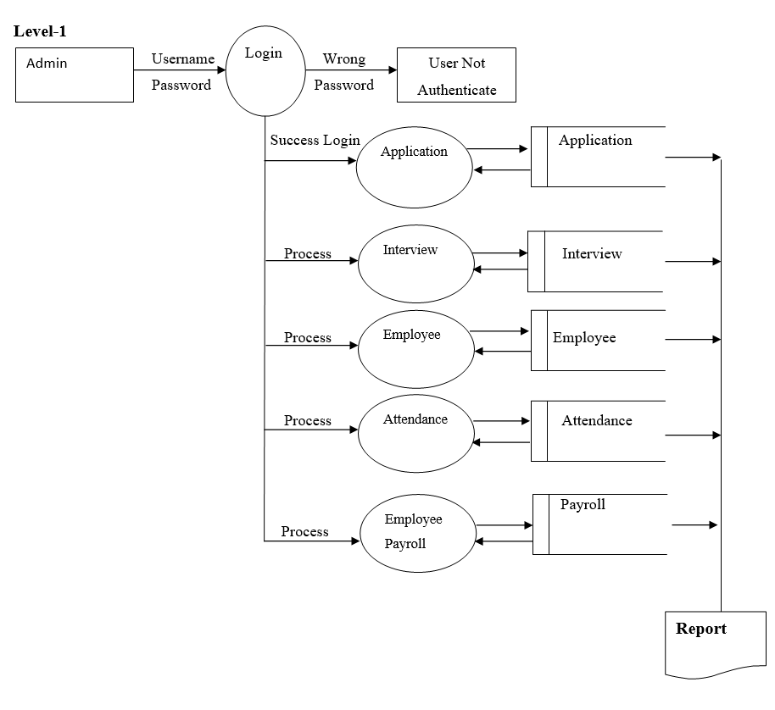

4.3 ENTITY RELATIONSHIP MODEL
The Entity-Relationship (ER) model is a conceptual data model in which the real world is represented by entities and relationships. The Entity-Relationship diagram, which is used to visually describe data objects, is a key component of the model. The model has been developed further, and it is now widely used in database design. The entity relationship diagram is based on a view of the real world as a set of basic objects known as entities, as well as relationships between objects. A collection of attributes describes an entity in a database. An entity set is a collection of all entities of the same type, and a relationship set is a collection of all relationships of the same type. An entity relationship diagram, which is built using the notations, can visually express the overall logical structure of a database.

Features Of ER Model Are:
- It maps well to relational model.
- It is basic and easy to understand with minimal preparation. As a result, database designers may use the model to connect with end users.
- Moreover, the model can be used by the database as a design plan for implementing a data model in particular database management applications.

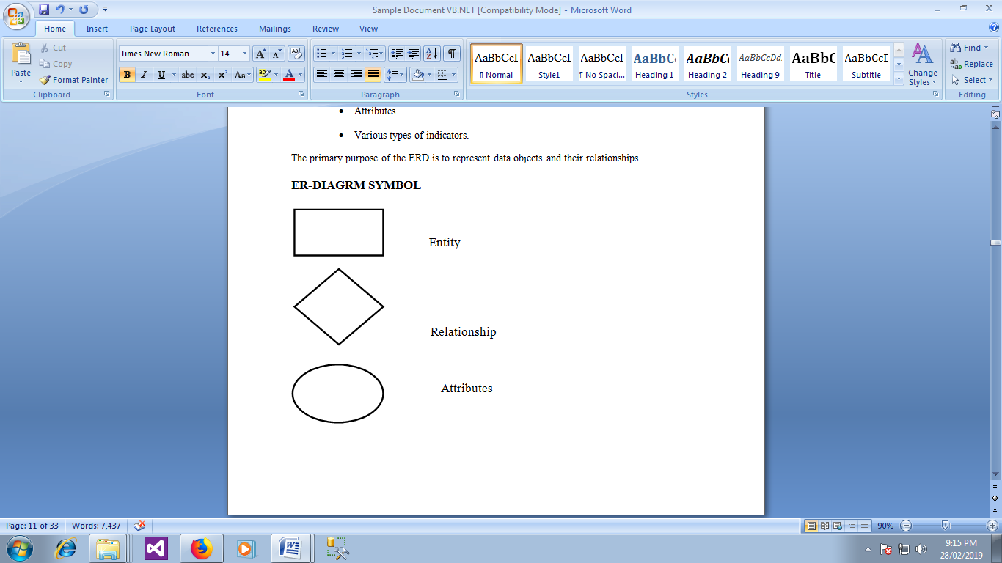

ENTITY RELATIONSHIP DIAGRAM

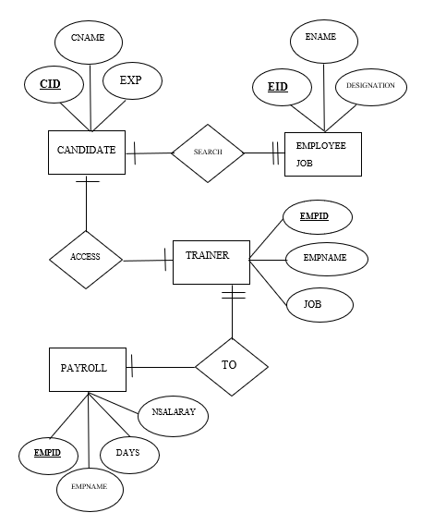

4.4 TABLE DESIGN

Table name :Login
COLUMN NAME | DATA TYPE | DESCRIPTION
Username | varchar,(50) | User name of the admin
Password | varchar,(50) | Password information

Table name : candidate details
Primary key : candid
COLUMN NAME | DATA TYPE | DESCRIPTION
Candid | varchar(50) | Candidate Id
Candname | varchar(50) | Candidate name
Gender | varchar(50) | Gender of the candidate
Dob | varchar(50) | Date of Birth
Email | varchar(50) | Email id
Education | varchar(50) | Educational qualification
Experience | varchar(50) | Experience
Address | varchar(50) | Address information

Table name : job interview
Primary key : candid
COLUMN NAME | DATA TYPE | DESCRIPTION
Candid | varchar(50) | Candidate Id
Candname | varchar(50) | Candidate name
Gender | varchar(50) | Gender of the candidate
Qualif | varchar(50) | Qualification
Jobtitle | varchar(50) | Job Title
Experience | varchar(50) | Experience
Depart | varchar(50) | Department
Exsalary | varchar(50) | Expected salary
date | varchar(50) | Date of the interview

Table name : training details
Primary key : empid
COLUMN NAME | DATA TYPE | DESCRIPTION
Empid | varchar(50) | Employee Id
Empname | varchar(50) | Employee name
Job | varchar(50) | Job title
Depart | varchar(50) | Department
Trainer | varchar(50) | Trainer name
Duration | varchar(50) | Duration of the training
Performance | varchar(50) | Performance level
Date | varchar(50) | Date

Table name : employee job
Primary key : empid
COLUMN NAME | DATA TYPE | DESCRIPTION
Empid | varchar(50) | Employee Id
empname | varchar(50) | Employee Name
Gender | varchar(50) | Gender
designation | varchar(50) | Designation
department | varchar(50) | Department
Salary | varchar(50) | Salary
Shift | varchar(50) | Shift
Timing | varchar(50) | Timing
Doj | varchar(50) | Date of joining

Table name : employee attendance
Primary key : empid
COLUMN NAME | DATA TYPE | DESCRIPTION
Empid | varchar(50) | Employee Id
empname | varchar(50) | Employee Name
Shifts | varchar(50) | Total no.of shifts
Days | varchar(50) | Total no.of days
medical | varchar(50) | No.of Medical leave
Leave | varchar(50) | No.of leave days
totalnodays | varchar(50) | Total no.of days

Table name : employee payroll
Primary key : empid
COLUMN NAME | DATA TYPE | DESCRIPTION
empid | varchar(50) | Employee Id
empname | varchar(50) | Employee name
designation | varchar(50) | Designation
department | varchar(50) | Department
days | varchar(50) | Total no.of days
basicpay | Int | Basic pay
deduction | decimal(18,2) | Deduction
pf | Int | Provident fund
incentive | Int | Incentive
date | varchar(50) | Date
nsalary | decimal(18,2) | Net salary

CODE DESIGN :
LOGIN FORM
Public Class Form1

Private Sub Button1_Click(sender As Object, e As EventArgs) Handles Button1.Click
If TextBox1.Text = "" Or TextBox2.Text = "" Then
MsgBox("Please Enter All Fields")
ElseIf TextBox1.Text = "admin" And TextBox2.Text = "admin" Then
MsgBox("Welcome to HR Management")
Main.Show()
Me.Hide()
Else
MsgBox("Invalid Username & Password")
TextBox1.Text = ""
TextBox2.Text = ""
TextBox1.Focus()
End If
End Sub

Private Sub Form1_Load(sender As Object, e As EventArgs) Handles MyBase.Load
Dim boundWidth As Integer = Screen.PrimaryScreen.Bounds.Width
Dim boundHeight As Integer = Screen.PrimaryScreen.Bounds.Height
Dim x As Integer = boundWidth - Me.Width
Dim y As Integer = boundHeight - Me.Height
Me.Location = New Point(x / 2, y / 2)
End Sub
End Class

MAIN DETAILS
Public Class Main
Private Sub CUSTOMERToolStripMenuItem_Click(sender As Object, e As EventArgs)
Handles CUSTOMERToolStripMenuItem.Clickcustomer_det.Show()
End Sub
Private Sub JOBVACANCYToolStripMenuItem_Click(sender As Object, e As EventArgs) Handles JOBVACANCYToolStripMenuItem.Click
Jobvacc.Show()
End Sub

Private Sub EMPLOYEEToolStripMenuItem_Click(sender As Object, e As EventArgs) Handles EMPLOYEEToolStripMenuItem.Click
Employee.Show()
End Sub

Private Sub ATTENDANCEToolStripMenuItem_Click(sender As Object, e As EventArgs) Handles ATTENDANCEToolStripMenuItem.Click
Attendance.Show()
End Sub

Private Sub PAYROLLToolStripMenuItem_Click(sender As Object, e As EventArgs) Handles PAYROLLToolStripMenuItem.Click
payroll.Show()
End Sub

Private Sub EXITToolStripMenuItem_Click(sender As Object, e As EventArgs) Handles EXITToolStripMenuItem.Click
End
End Sub

Private Sub TRAINToolStripMenuItem_Click(sender As Object, e As EventArgs) Handles TRAINToolStripMenuItem.Click
Training.Show()
End Sub

Private Sub EMPLOYEEToolStripMenuItem1_Click(sender As Object, e As EventArgs) Handles EMPLOYEEToolStripMenuItem1.Click
Employeerpt.Show()
End Sub

Private Sub ATTENDANCEToolStripMenuItem1_Click(sender As Object, e As EventArgs) Handles ATTENDANCEToolStripMenuItem1.Click
Attendancerpt.Show()
End Sub
End Class

CUSTOMER DETAILS

Imports System.Data.SqlClient
Public Class customer_det
Dim con As New SqlConnection("Data Source=MYPC-PC\SQLEXPRESS;Initial Catalog=HR_Servicess;Persist Security Info=True;User ID=sa;pwd=sql;")
Dim com As New SqlCommand
Dim adp As New SqlDataAdapter
Dim ds As New DataSet
Dim qry As String
Dim i As Integer
Private Sub customer_det_Load(sender As Object, e As EventArgs) Handles

MyBase.Load
Dim boundWidth As Integer = Screen.PrimaryScreen.Bounds.Width
Dim boundHeight As Integer = Screen.PrimaryScreen.Bounds.Height
Dim x As Integer = boundWidth - Me.Width
Dim y As Integer = boundHeight - Me.Height
Me.Location = New Point(x / 2, y / 2)
Try
Dim p As String
qry = "Select candid from candidate_tb"
com = New SqlCommand(qry, con)
adp = New SqlDataAdapter(com)
ds = New DataSet
adp.Fill(ds, "candidate_tb")
i = ds.Tables(0).Rows.Count
p = ds.Tables(0).Rows(i - 1)(0)
p = Mid(p, 1)
p = Val(p) + 1
TextBox1.Text = +p
Catch ex As Exception
TextBox1.Text = "100"
End Try
End Sub

Private Sub Button1_Click(sender As Object, e As EventArgs) Handles Button1.Click
If TextBox1.Text = "" Or TextBox2.Text = "" Or TextBox3.Text = "" Or TextBox4.Text = "" Or TextBox5.Text = "" Or TextBox6.Text = "" Then
MsgBox("Enter All Fileds")
Else
qry = "Insert into candidate_tbvalues('" + TextBox1.Text + "','" + TextBox2.Text + "','" + ComboBox1.Text + "','" + DateTimePicker1.Text + "','" + TextBox3.Text + "','" + TextBox4.Text + "','" + TextBox5.Text + "','" + TextBox6.Text + "')"
com = New SqlCommand(qry, con)
con.Open()
com.ExecuteNonQuery()
MsgBox("Sucessfully Saved")
con.Close()
End If
TextBox2.Text = ""
TextBox3.Text = ""
TextBox4.Text = ""
TextBox5.Text = ""
TextBox6.Text = ""
ComboBox1.Text = "Select"
DateTimePicker1.Text = Date.Today
Try
Dim p As String
qry = "Select candid from candidate_tb"
com = New SqlCommand(qry, con)
adp = New SqlDataAdapter(com)
ds = New DataSet
adp.Fill(ds, "candidate_tb")
i = ds.Tables(0).Rows.Count
p = ds.Tables(0).Rows(i - 1)(0)
p = Mid(p, 1)
p = Val(p) + 1
TextBox1.Text = +p
Catch ex As Exception
TextBox1.Text = "100"
End Try
End Sub

Private Sub Button2_Click(sender As Object, e As EventArgs) Handles Button2.Click
If TextBox1.Text = "" Or TextBox2.Text = "" Or TextBox3.Text = "" Or TextBox4.Text = "" Or TextBox5.Text = "" Or TextBox6.Text = "" Then
MsgBox("Enter All Fileds")
Else
qry = "Update candidate_tb set candname='" + TextBox2.Text + "',gender='" + ComboBox1.Text + "',dob='" + DateTimePicker1.Text + "',email='" + TextBox3.Text + "',education='" + TextBox4.Text + "',experience='" + TextBox5.Text + "',addresss='" + TextBox6.Text + "' where candid='" + TextBox1.Text + "'"
com = New SqlCommand(qry, con)
con.Open()
com.ExecuteNonQuery()
MsgBox("Sucessfully Updated")
con.Close()
End If
TextBox2.Text = ""
TextBox3.Text = ""
TextBox4.Text = ""
TextBox5.Text = ""
TextBox6.Text = ""
ComboBox1.Text = "Select"
DateTimePicker1.Text = Date.Today
Try

Dim p As String
qry = "Select candid from candidate_tb"
com = New SqlCommand(qry, con)
adp = New SqlDataAdapter(com)
ds = New DataSet
adp.Fill(ds, "candidate_tb")
i = ds.Tables(0).Rows.Count
p = ds.Tables(0).Rows(i - 1)(0)
p = Mid(p, 1)
p = Val(p) + 1
TextBox1.Text = +p
Catch ex As Exception
TextBox1.Text = "100"
End Try
End Sub

Private Sub Button4_Click(sender As Object, e As EventArgs) Handles Button4.Click
If TextBox1.Text = "" Or TextBox2.Text = "" Or TextBox3.Text = "" Or TextBox4.Text = "" Or TextBox5.Text = "" Or TextBox6.Text = "" Then
MsgBox("Enter All Fileds")
Else
qry = "Delete from candidate_tb where candid='" + TextBox1.Text + "'"
com = New SqlCommand(qry, con)
con.Open()
com.ExecuteNonQuery()
MsgBox("Sucessfully Deleted")
con.Close()
End If
TextBox2.Text = ""
TextBox3.Text = ""
TextBox4.Text = ""
TextBox5.Text = ""
TextBox6.Text = ""
ComboBox1.Text = "Select"
DateTimePicker1.Text = Date.Today

Try
Dim p As String
qry = "Select candid from candidate_tb"
com = New SqlCommand(qry, con)
adp = New SqlDataAdapter(com)
ds = New DataSet
adp.Fill(ds, "candidate_tb")
i = ds.Tables(0).Rows.Count
p = ds.Tables(0).Rows(i - 1)(0)
p = Mid(p, 1)
p = Val(p) + 1
TextBox1.Text = +p
Catch ex As Exception
TextBox1.Text = "100"
End Try
End Sub

Private Sub Button3_Click(sender As Object, e As EventArgs) Handles Button3.Click
Try
qry = "Select * from candidate_tb where candid='" + TextBox1.Text + "'"
com = New SqlCommand(qry, con)
adp = New SqlDataAdapter(com)
ds = New DataSet
adp.Fill(ds, "candidate_tb")
TextBox1.Text = ds.Tables("candidate_tb").Rows(0)(0)
TextBox2.Text = ds.Tables("candidate_tb").Rows(0)(1)
ComboBox1.Text = ds.Tables("candidate_tb").Rows(0)(2)
DateTimePicker1.Text = ds.Tables("candidate_tb").Rows(0)(3)
TextBox3.Text = ds.Tables("candidate_tb").Rows(0)(4)
TextBox4.Text = ds.Tables("candidate_tb").Rows(0)(5)
TextBox5.Text = ds.Tables("candidate_tb").Rows(0)(6)
TextBox6.Text = ds.Tables("candidate_tb").Rows(0)(7)
Catch ex As Exception

MsgBox("Enter Valid Candidate ID")
End Try
End Sub

Private Sub Button5_Click(sender As Object, e As EventArgs) Handles Button5.Click
TextBox2.Text = ""
TextBox3.Text = ""
TextBox4.Text = ""
TextBox5.Text = ""
TextBox6.Text = ""
ComboBox1.Text = "Select"
DateTimePicker1.Text = Date.Today
Try
Dim p As String
qry = "Select candid from candidate_tb"
com = New SqlCommand(qry, con)
adp = New SqlDataAdapter(com)
ds = New DataSet
adp.Fill(ds, "candidate_tb")
i = ds.Tables(0).Rows.Count
p = ds.Tables(0).Rows(i - 1)(0)
p = Mid(p, 1)
p = Val(p) + 1
TextBox1.Text = +p
Catch ex As Exception
TextBox1.Text = "100"
End Try
End Sub

End Class

ATTENDANCE DETAILS

Imports System.Data.SqlClient
Public Class Attendance
Dim con As New SqlConnection("Data Source=MYPC-PC\SQLEXPRESS;Initial Catalog=HR_Servicess;Persist Security Info=True;User ID=sa;pwd=sql;")
Dim com As New SqlCommand
Dim adp As New SqlDataAdapter
Dim ds As New DataSet
Dim qry, k, l As String
Dim i As Integer

Private Sub Attendance_Load(sender As Object, e As EventArgs) Handles MyBase.Load
Dim boundWidth As Integer = Screen.PrimaryScreen.Bounds.Width
Dim boundHeight As Integer = Screen.PrimaryScreen.Bounds.Height
Dim x As Integer = boundWidth - Me.Width
Dim y As Integer = boundHeight - Me.Height
Me.Location = New Point(x / 2, y / 2)
qry = "Select empid from employeejob_tb"
com = New SqlCommand(qry, con)
adp = New SqlDataAdapter(com)
ds = New DataSet
adp.Fill(ds, "employeejob_tb")
i = ds.Tables("employeejob_tb").Rows.Count
For j = 0 To i - 1
ComboBox1.Items.Add(ds.Tables("employeejob_tb").Rows(j)(0))
Next
End Sub

Private Sub ComboBox1_SelectedIndexChanged(sender As Object, e As EventArgs) Handles ComboBox1.SelectedIndexChanged
qry = "Select * from employeejob_tb where empid='" + ComboBox1.Text + "'"
com = New SqlCommand(qry, con)
adp = New SqlDataAdapter(com)
ds = New DataSet
adp.Fill(ds, "empid")
TextBox1.Text = ds.Tables("empid").Rows(0)(1)
End Sub

Private Sub Button1_Click(sender As Object, e As EventArgs) Handles Button1.Click
If TextBox1.Text = "" Or TextBox2.Text = "" Or TextBox3.Text = "" Or TextBox4.Text = "" Or TextBox5.Text = "" Or TextBox6.Text = "" Then
MsgBox("Enter All Fileds")
Else
qry = "Insert into empattendance_tbvalues('" + ComboBox1.Text + "','" + TextBox1.Text + "','" + TextBox2.Text + "','" + TextBox3.Text + "','" + TextBox4.Text + "','" + TextBox5.Text + "','" + TextBox6.Text + "')"
com = New SqlCommand(qry, con)
con.Open()
com.ExecuteNonQuery()
MsgBox("Sucessfully Saved")
con.Close()
End If
ComboBox1.Text = "Select"
TextBox2.Text = ""
TextBox3.Text = ""
TextBox4.Text = ""
TextBox5.Text = ""
TextBox6.Text = ""
End Sub

Private Sub Button2_Click(sender As Object, e As EventArgs) Handles Button2.Click
If TextBox1.Text = "" Or TextBox2.Text = "" Or TextBox3.Text = "" Or TextBox4.Text = "" Or TextBox5.Text = "" Or TextBox6.Text = "" Then
MsgBox("Enter All Fileds")
Else
qry = "Update empattendance_tb set shifts='" + TextBox2.Text + "',days='" + TextBox3.Text + "',medical='" + TextBox4.Text + "',leave='" + TextBox5.Text + "',totalnoday='" + TextBox6.Text + "' where empid='" + ComboBox1.Text + "'"
com = New SqlCommand(qry, con)
con.Open()
com.ExecuteNonQuery()
MsgBox("Sucessfully Updated")
con.Close()
End If
ComboBox1.Text = "Select"
TextBox2.Text = ""
TextBox3.Text = ""
TextBox4.Text = ""
TextBox5.Text = ""
TextBox6.Text = ""
End Sub

Private Sub Button4_Click(sender As Object, e As EventArgs) Handles Button4.Click
If TextBox1.Text = "" Or TextBox2.Text = "" Or TextBox3.Text = "" Or TextBox4.Text = "" Or TextBox5.Text = "" Or TextBox6.Text = "" Then
MsgBox("Enter All Fileds")
Else
qry = "Delete from empattendance_tb where empid='" + ComboBox1.Text + "'"
com = New SqlCommand(qry, con)
con.Open()
com.ExecuteNonQuery()
MsgBox("Sucessfully Deleted")
con.Close()
End If
ComboBox1.Text = "Select"
TextBox2.Text = ""
TextBox3.Text = ""
TextBox4.Text = ""
TextBox5.Text = ""
TextBox6.Text = ""
End Sub

Private Sub Button3_Click(sender As Object, e As EventArgs) Handles Button3.Click
Try
qry = "Select * from empattendance_tb where empid='" + ComboBox1.Text + "'"
com = New SqlCommand(qry, con)
adp = New SqlDataAdapter(com)
ds = New DataSet
adp.Fill(ds, "empid")
TextBox1.Text = ds.Tables("empid").Rows(0)(1)
TextBox2.Text = ds.Tables("empid").Rows(0)(2)
TextBox3.Text = ds.Tables("empid").Rows(0)(3)
TextBox4.Text = ds.Tables("empid").Rows(0)(4)
TextBox5.Text = ds.Tables("empid").Rows(0)(5)
TextBox6.Text = ds.Tables("empid").Rows(0)(6)

Catch ex As Exception
MsgBox("No Record Found Check Employee ID")
End Try
End Sub

Private Sub TextBox5_LostFocus(sender As Object, e As EventArgs) Handles TextBox5.LostFocus
k = Val(TextBox4.Text) + Val(TextBox5.Text) TextBox6.Text = Val(TextBox3.Text) - k
End Sub

Private Sub Button5_Click(sender As Object, e As EventArgs) Handles Button5.Click
ComboBox1.Text = "Select"
TextBox2.Text = ""
TextBox3.Text = ""
TextBox4.Text = ""
TextBox5.Text = ""
TextBox6.Text = ""
End Sub
End Class

JOB VACCANCY DETAILS

Imports System.Data.SqlClient
Public Class Jobvacc
Dim con As New SqlConnection("Data Source=MYPC-PC\SQLEXPRESS;Initial Catalog=HR_Servicess;Persist Security Info=True;User ID=sa;pwd=sql;")
Dim com As New SqlCommand
Dim adp As New SqlDataAdapter
Dim ds As New DataSet
Dim qry As String
Dim i As Integer

Private Sub Jobvacc_Load(sender As Object, e As EventArgs) Handles MyBase.Load
Dim boundWidth As Integer = Screen.PrimaryScreen.Bounds.Width
Dim boundHeight As Integer = Screen.PrimaryScreen.Bounds.Height
Dim x As Integer = boundWidth - Me.Width
Dim y As Integer = boundHeight - Me.Height
Me.Location = New Point(x / 2, y / 2)
End Sub

Private Sub TextBox1_LostFocus(sender As Object, e As EventArgs) Handles TextBox1.LostFocus
qry = "Select * from candidate_tb where candid='" + TextBox1.Text + "'"
com = New SqlCommand(qry, con)
adp = New SqlDataAdapter(com)
ds = New DataSet
adp.Fill(ds, "candidate_tb")
TextBox2.Text = ds.Tables("candidate_tb").Rows(0)(1)
TextBox3.Text = ds.Tables("candidate_tb").Rows(0)(2)
TextBox4.Text = ds.Tables("candidate_tb").Rows(0)(5)
End Sub

Private Sub Button1_Click(sender As Object, e As EventArgs) Handles Button1.Click
If TextBox1.Text = "" Or TextBox2.Text = "" Or TextBox3.Text = "" Or TextBox4.Text = "" Or TextBox5.Text = "" Or TextBox6.Text = "" Or TextBox7.Text = "" Or TextBox8.Text = "" Then
MsgBox("Enter All Fileds")
Else
qry = "Insert into job_tbvalues('" + TextBox1.Text + "','" + TextBox2.Text + "','" + TextBox3.Text + "','" + TextBox4.Text + "','" + TextBox5.Text + "','" + TextBox6.Text + "','" + TextBox7.Text + "','" + TextBox8.Text + "','" + DateTimePicker1.Text + "')"
com = New SqlCommand(qry, con)
con.Open()
com.ExecuteNonQuery()
MsgBox("Sucessfully Saved")
con.Close()

End If
TextBox2.Text = ""
TextBox3.Text = ""
TextBox4.Text = ""
TextBox5.Text = ""
TextBox6.Text = ""
TextBox7.Text = ""
TextBox8.Text = ""
DateTimePicker1.Text = Date.Today
End Sub

Private Sub Button2_Click(sender As Object, e As EventArgs) Handles Button2.Click
If TextBox1.Text = "" Or TextBox2.Text = "" Or TextBox3.Text = "" Or TextBox4.Text = "" Or TextBox5.Text = "" Or TextBox6.Text = "" Or TextBox7.Text = "" Or TextBox8.Text = "" Then
MsgBox("Enter All Fileds")
Else
qry = "Update job_tb set candname='" + TextBox2.Text + "',gender='" + TextBox3.Text + "',quali='" + TextBox4.Text + "',jobtitle='" + TextBox5.Text + "',experience='" + TextBox6.Text + "',dept='" + TextBox7.Text + "',exsalary='" + TextBox8.Text + "',datee='" + DateTimePicker1.Text + "' where candid='" + TextBox1.Text + "'"
com = New SqlCommand(qry, con)
con.Open()
com.ExecuteNonQuery()
MsgBox("Sucessfully Updated")
con.Close()
End If
TextBox2.Text = ""
TextBox3.Text = ""
TextBox4.Text = ""
TextBox5.Text = ""
TextBox6.Text = ""
TextBox7.Text = ""
TextBox8.Text = ""
DateTimePicker1.Text = Date.Today
End Sub

Private Sub Button4_Click(sender As Object, e As EventArgs) Handles Button4.Click
If TextBox1.Text = "" Or TextBox2.Text = "" Or TextBox3.Text = "" Or TextBox4.Text = "" Or TextBox5.Text = "" Or TextBox6.Text = "" Or TextBox7.Text = "" Or TextBox8.Text = "" Then
MsgBox("Enter All Fileds")
Else
qry = "Delete from job_tb where candid='" + TextBox1.Text + "'"
com = New SqlCommand(qry, con)
con.Open()
com.ExecuteNonQuery()
MsgBox("Sucessfully deleted")
con.Close()
End If
TextBox2.Text = ""
TextBox3.Text = ""
TextBox4.Text = ""
TextBox5.Text = ""
TextBox6.Text = ""
TextBox7.Text = ""
TextBox8.Text = ""
DateTimePicker1.Text = Date.Today
End Sub

Private Sub Button3_Click(sender As Object, e As EventArgs) Handles Button3.Click
Try
qry = "Select * from job_tb where candid='" + TextBox1.Text + "'"
com = New SqlCommand(qry, con)
adp = New SqlDataAdapter(com)
ds = New DataSet
adp.Fill(ds, "job_tb")
TextBox1.Text = ds.Tables("job_tb").Rows(0)(0)
TextBox2.Text = ds.Tables("job_tb").Rows(0)(1)
TextBox3.Text = ds.Tables("job_tb").Rows(0)(2)
TextBox4.Text = ds.Tables("job_tb").Rows(0)(3)
TextBox5.Text = ds.Tables("job_tb").Rows(0)(4)
TextBox6.Text = ds.Tables("job_tb").Rows(0)(5)
TextBox7.Text = ds.Tables("job_tb").Rows(0)(6)
TextBox8.Text = ds.Tables("job_tb").Rows(0)(7)
DateTimePicker1.Text = ds.Tables("job_tb").Rows(0)(8)
Catch ex As Exception
MsgBox("Invalid JOB-Id")
End Try
End Sub
End Class

REPORT
Imports System.Data.SqlClient
Public Class Attendancerpt
Dim con As New SqlConnection("Data Source=MYPC-PC\SQLEXPRESS;Initial Catalog=HR_Servicess;Persist Security Info=True;User ID=sa;pwd=sql;")
Dim com As New SqlCommand
Dim adp As New SqlDataAdapter
Dim ds As New DataSet
Dim qry, k, l As String
Dim i As Integer
Private Sub Attendancerpt_Load(sender As Object, e As EventArgs) Handles

MyBase.Load
Dim boundWidth As Integer = Screen.PrimaryScreen.Bounds.Width
Dim boundHeight As Integer = Screen.PrimaryScreen.Bounds.Height
Dim x As Integer = boundWidth - Me.Width
Dim y As Integer = boundHeight - Me.Height
Me.Location = New Point(x / 2, y / 2)
qry = "Select * from empattendance_tb"
com = New SqlCommand(qry, con)
adp = New SqlDataAdapter(com)
ds = New DataSet
adp.Fill(ds, "empattendance_tb")
DataGridView1.DataSource = ds.Tables("empattendance_tb")
End Sub
End Class

FORM DESIGN :
LOGIN FORM
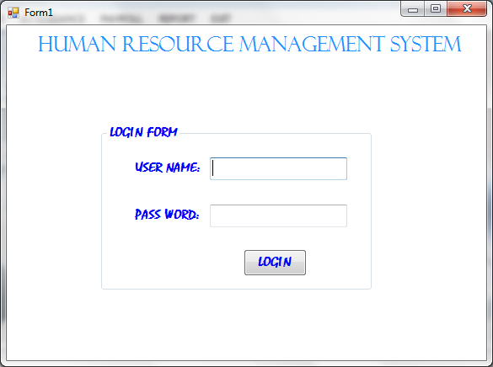

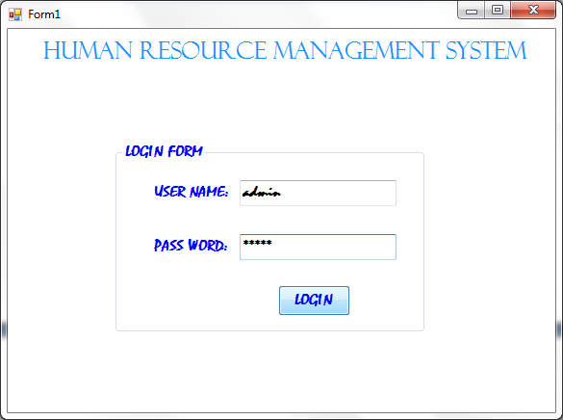

MAIN PAGE


APPLICATION DETAILS
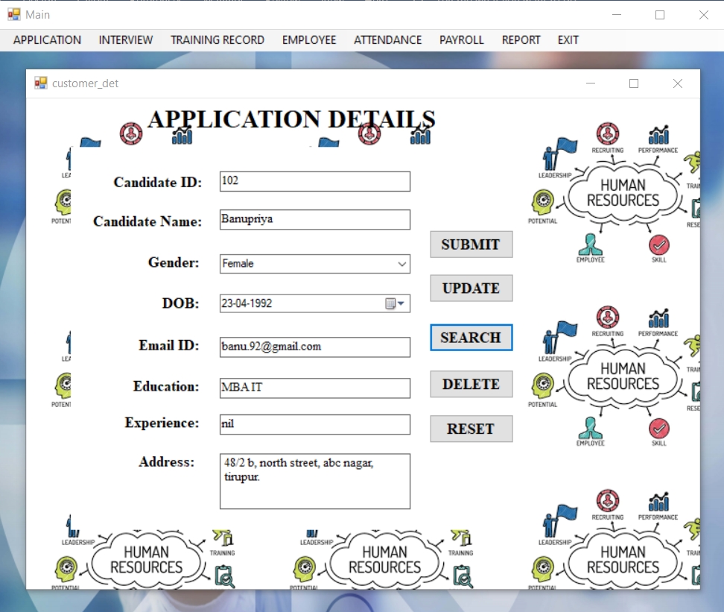

INTERVIEW DETAILS
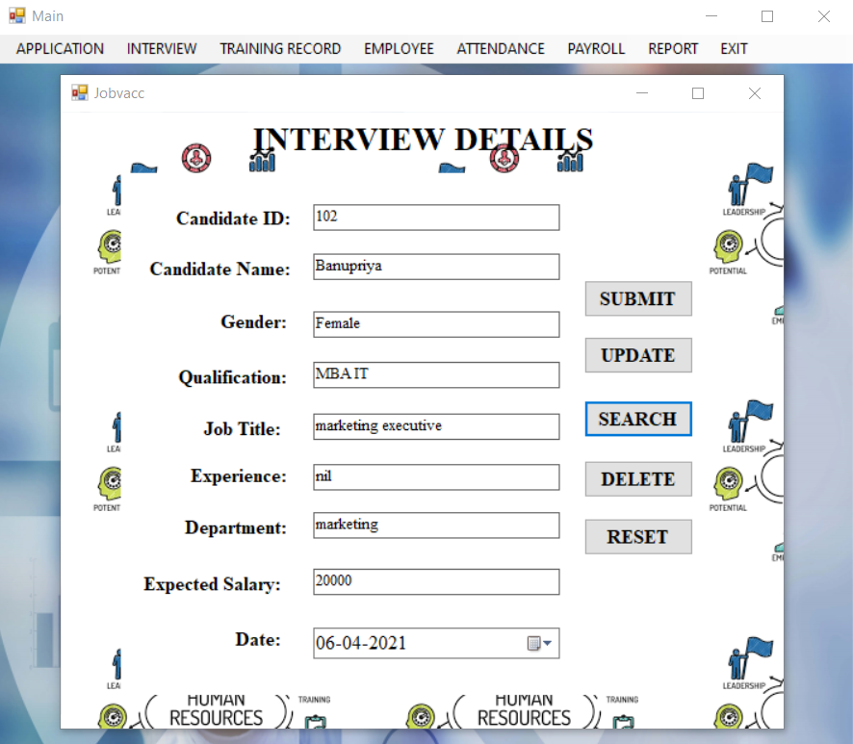

EMPLOYEE TRAINING DETAILS
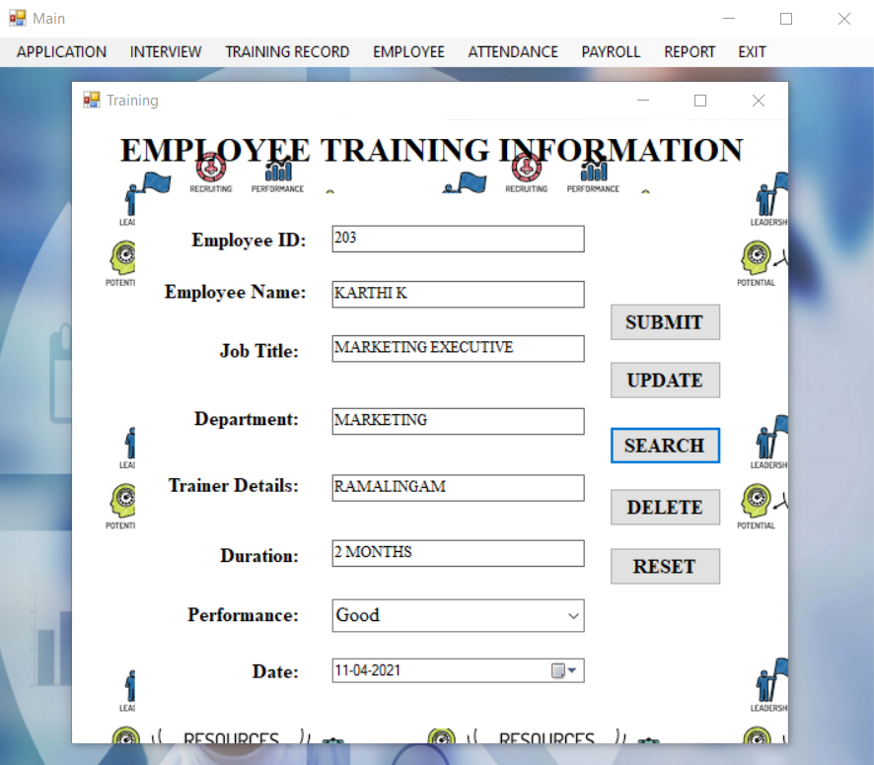

EMPLOYEE JOB DETAILS
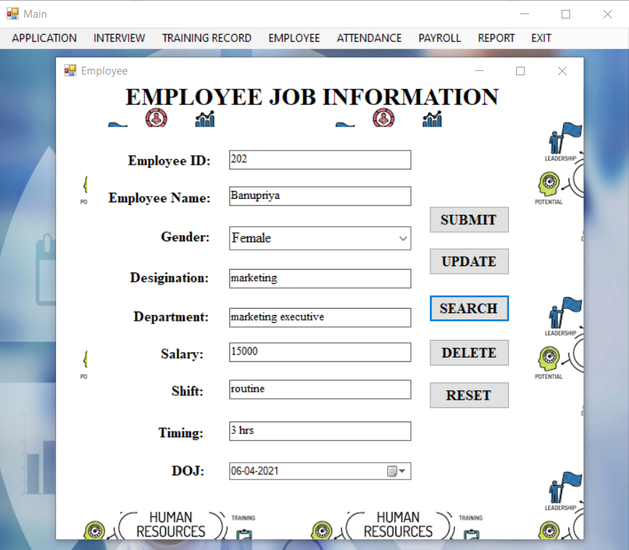

EMPLOYEE ATTENDANCE DETAILS
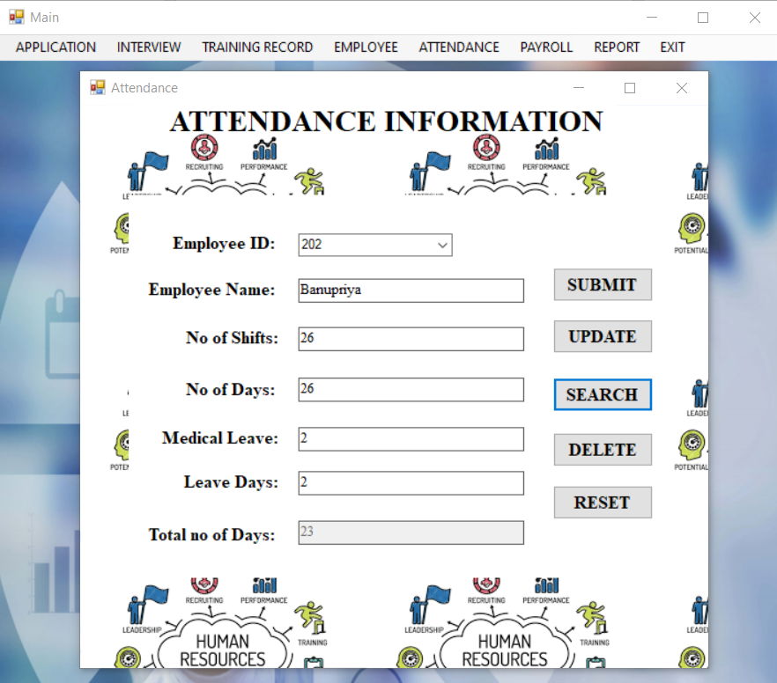
EMPLOYEE PAYROLL DETAILS
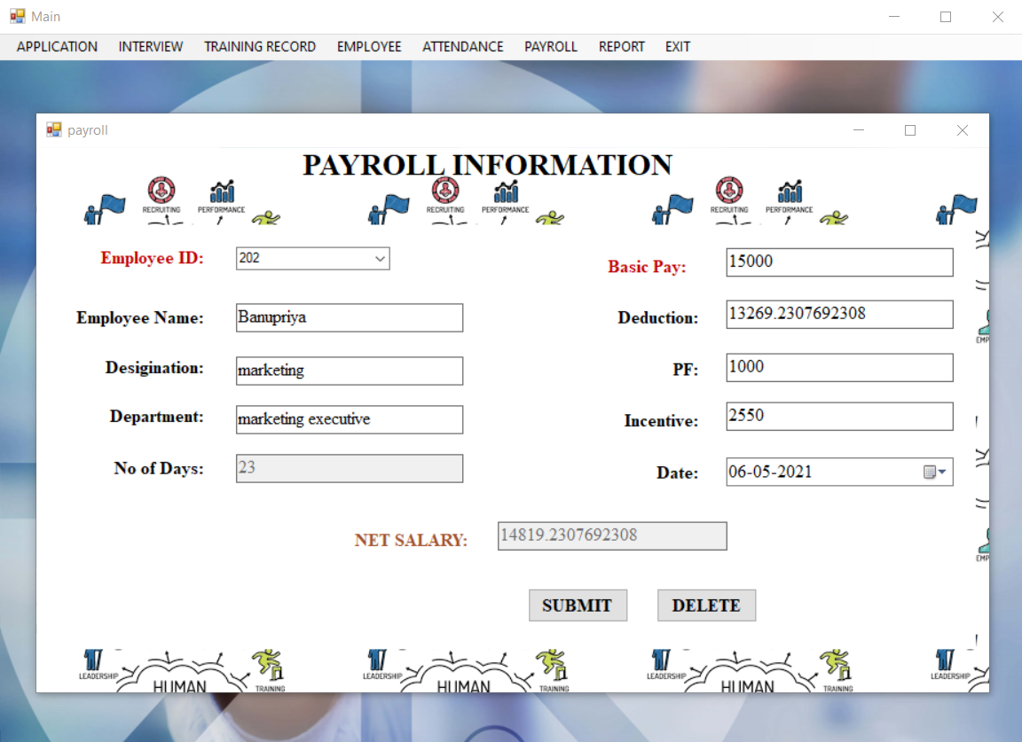

APPLICATION REPORT
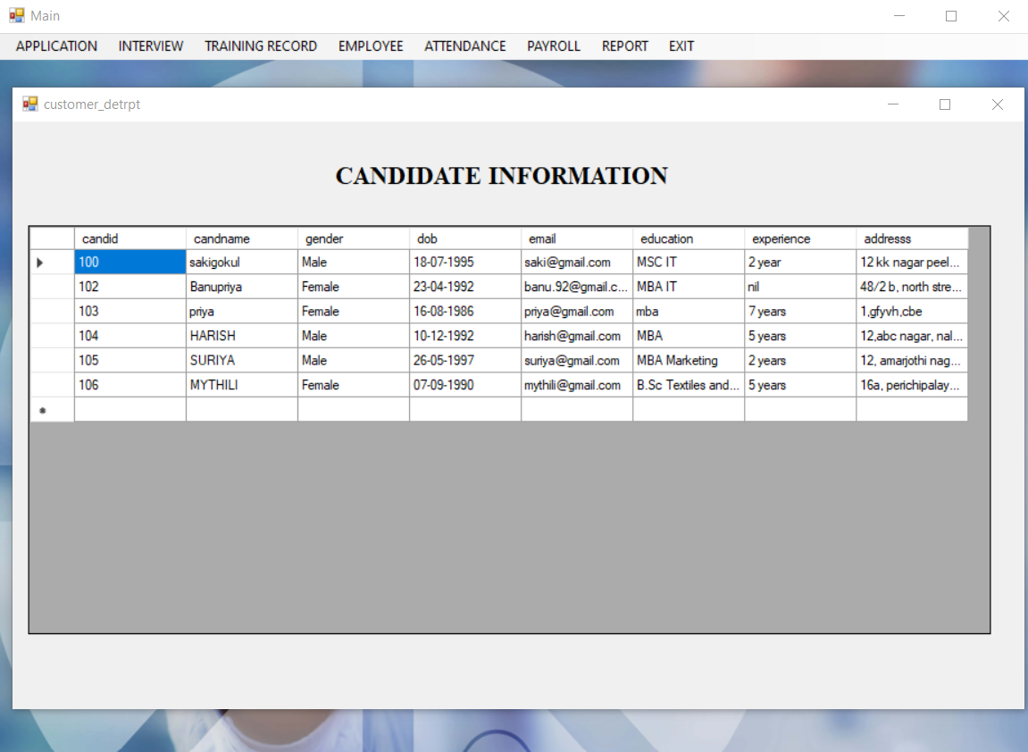

INTERVIEW REPORT
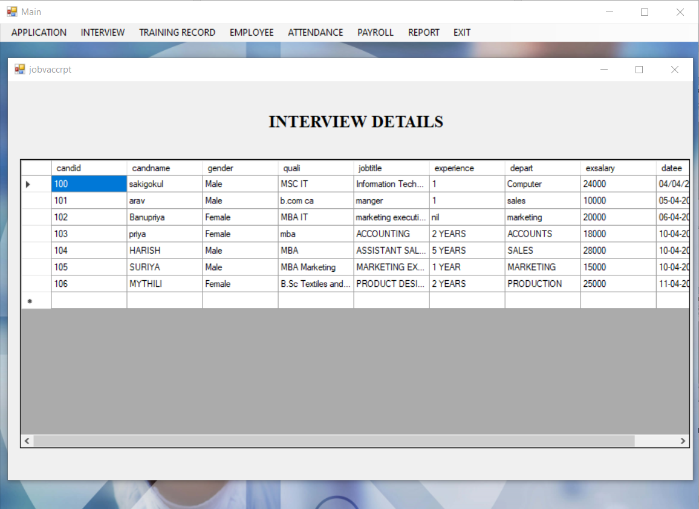
TRAINING REPORT
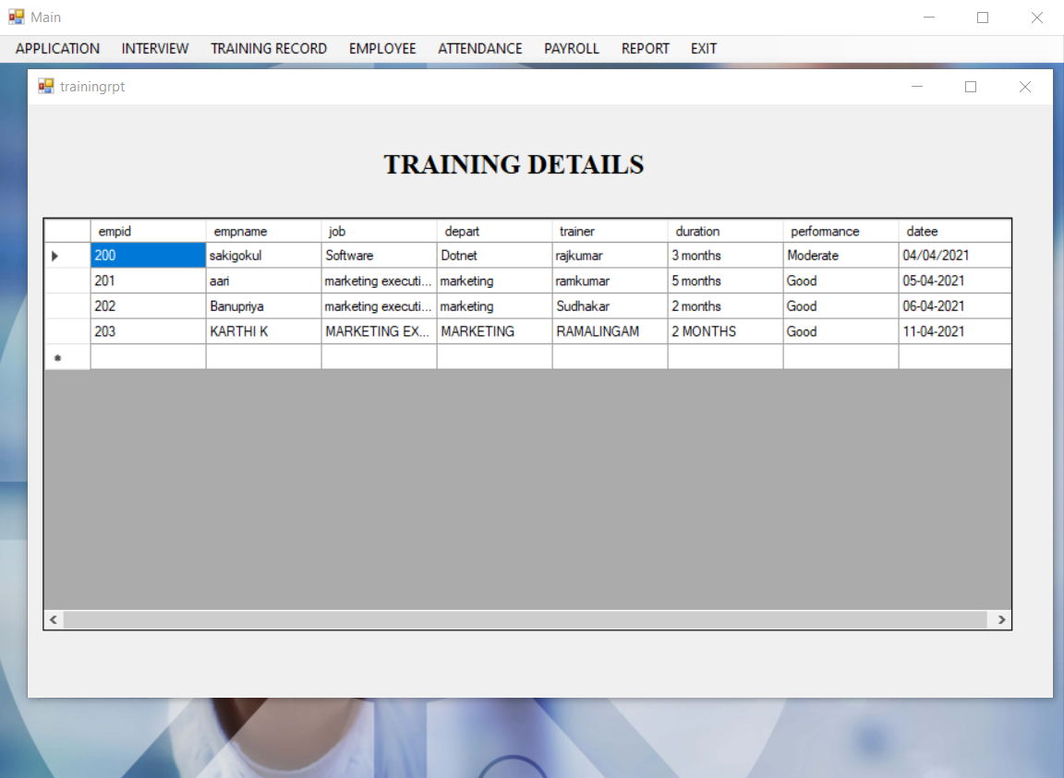

EMPLOYEE REPORT
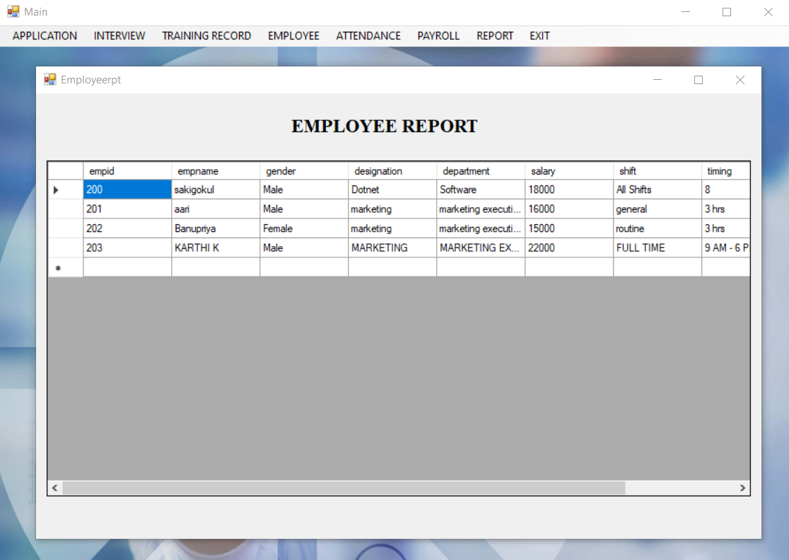
EMPLOYEE ATTENDANCE REPORT
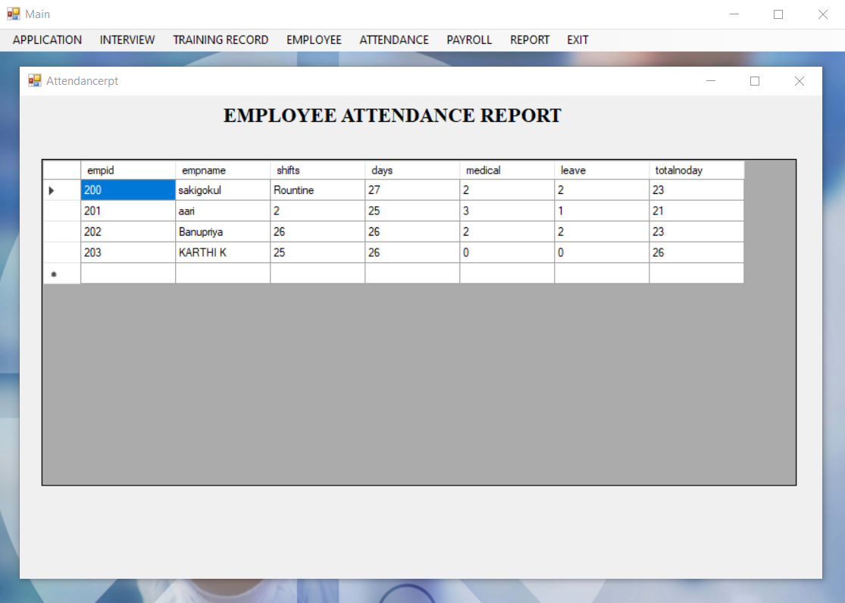

EMPLOYEE PAYROLL REPORT
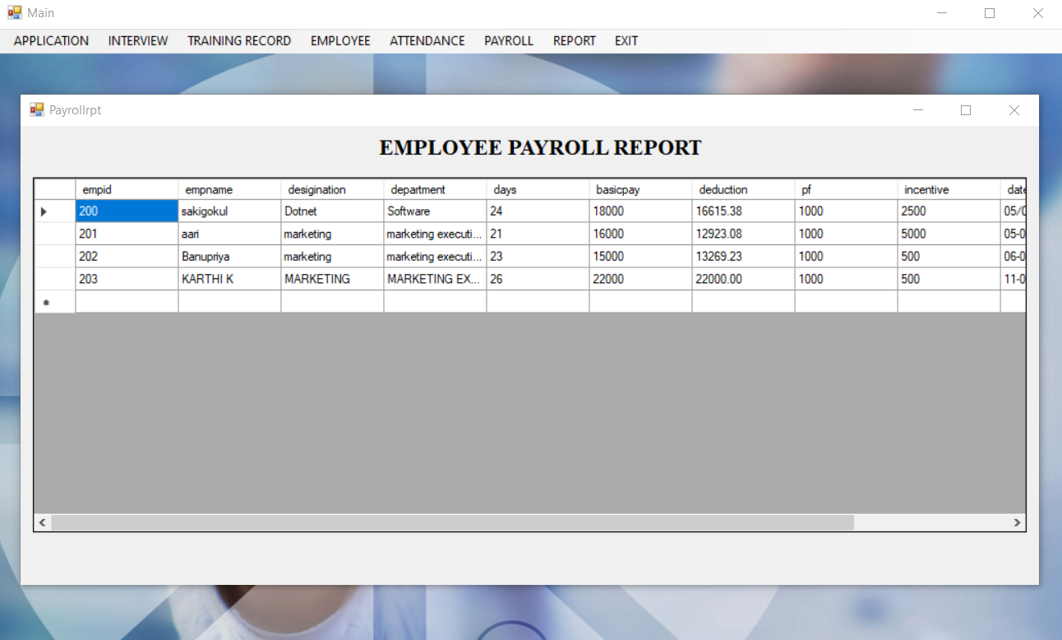

SYSTEM TESTING AND IMPLEMENTATION

CHAPTER-V
SYSTEM TESTING AND IMPLEMENTATION
5.1 SYSTEM TESTING
System testing is the state of implementation, which is aimed at ensuring that the system works accurately and efficiently. It certifies that the whole set of programs hang together. System testing requires a test plans, that consists of several key activities and steps for run program, string, system and user acceptance testing. Testing phase is the development phase that validates the code against the functional specifications. The objective of testing is to discover errors. To fulfil this objective a series of test step such as the unit test, integration test, validation and system test where planned and executed.
UNIT TESTING
The unit testing was conducted during the development phase. we test their specific functionality individually or with other units. However, unit testing is designed to test small pieces of functionality rather than the system as a whole. This allows us to conduct the first round of testing to eliminate bugs before the other major tests.
BLACK BOX TESTING
This test demonstrates that all software function is operational, input is properly accepted, correct output is generated and integrity of external information is maintained. Black Box testing was conducted to detect errors in the following categories.
- Incorrect or missing function
- Interface errors
- Error external database
- Performance and termination testing
All independent paths within a module have been exercised at least once.
WHITE BOX TESTING
White box testing of software is predicated on close examination of Procedural details providing test that exercise specific tests of conditions and or loops test logical path through the software. This testing attempts to guarantee that All independent paths within a module have been exercised at least once.
VALIDATION TESTING
At the end of Integration Testing, software is completely assembled as a package, interfacing errors have been uncovered and correction testing begins. Software Testing and Validation is achieved through serried of black box tests that demonstrate conformity with the requirements. A test plan outlines the classes of tests to be conducted and a test procedure defines specific test cases that will be used to demonstrate conformity with requirements.
INTEGRATED TESTING
Integration testing is a systematic technique for constructing the program Structure. While at the same time conducting tests to uncover errors associated with Interfacing. The objective is to take unit tested components and built a program Structure that has been dictated by design. There is a often attempt non – incremental integration that is to construct the program using a “Big bang “approach. All components are combined in advance. The entire program is tested as a whole incremental integration is the antithesis of the bang approach.
- Top – down integration testing is an incremental approach to construct of program structure.
- The integration process is performed is a series of five steps
- The main control module is used to test drive and stubs are substituted for all components directly subroutine to the main control module.
- Depending on the integration approach selected subroutine stubs are replaced on at a time with actual components.
- Tests are conducted as each component is integrated.
- On completion of each set of tests another stubs is replaced with the real components.

5.2 SYSTEM IMPLEMENTATION

The project's implementation stage is when the theoretical concept is transformed into a working system. As a result, it can be regarded as the most crucial stage in ensuring the success of a new system and giving the user confidence that the system will work and be successful.
The implementation stage entails meticulous planning, investigation of the existing system and its implementation constraints, design of changeover methods, and evaluation of changeover methods. The process of putting a new system design into action is known as implementation.
It is the phase of the installation process that focuses on user training, site preparation, and file conversion. The most important factor to consider here is that the conversion does not affect the organization's operations.
Microsoft Visual Basic 6.0 is used for the front end, and Microsoft SQL Server is used for the back end.
The objective of a user training analysis is on two things:
  - User capabilities
  - Nature of the system

The objective of a user training analysis is on two things.
Users vary from the naive to the sophisticated. As a result, they should be trained how to use software. In the case of a power outage, the user should take precautions to ensure that.

SYSTEM MAINTENANCE
Maintenance is the actual implementation of the review plan, as important as it is for programmers and analysts to conduct or identify with maintenance. This is related to psychological, personality, and technical factors. Analysts and programmers devote much more effort to managing software than to writing them. Maintenance takes up 50-80% of overall device development time. Maintenance costs a lot. Maintenance management and program modification audits are two ways to reduce maintenance costs.

Maintenance may be of different types.
- Perfective maintenance
- Preventive maintenance

PERFECTIVE MAINTENANCE:
Changes made to the system in order to add features or boost performance. More enhancements can be added to "DOT NET Communication" in the future, and it will easily adapt to the changes.

PREVENTIVE MAINTENANCE:
Changes made to the framework in order to prevent potential issues. Any improvements can be made in the future, and our project will be able to accommodate them.

CONCLUSION

CHAPTER-VI
CONCLUSION & FUTURE ENHANCEMENTS

CONCLUSION
The project's main objective is to create a fully computerized organization with the ability to track activity information and make it easier for employees to work. As a result, the proposed system has been designed with a high level of versatility without compromising response time. The computerization of the entire system would improve accuracy and eliminate a significant portion of clerical work. Without any ambiguity, reports can be produced quickly, clearly, and legibly. A major benefit of the system is its integrated database architecture and ease of maintenance. The system's user friendliness is really a unique characteristic. As a result, by designing a system that is user-friendly, even people with limited programming skills and training would be able to use it.

FUTURE ENHANCEMENT
The project has been developed and the objectives have been accomplished. The project is built using VB.Net as front end and SQL Server as backend. The frontend can also be changed. For faster performance, ASP.Net may replace front-end tools like HTML and CSS.To have better protection, it employs security provider tools, which we can access from any location and at any time. It is possible that it can also be improved in the future to meet the needs of the organization.

BIBLIOGRAPHY

BIBLIOGRAPHY

BOOKS REFERRED:
- Elias Awath, “System Analysis And Design”,Sixth Edition,2003
Tata Mc Graw Hill Publication
- S.Ramachandran,”Computer Aided Design”,Third Edition,2003
Air Walk Publication.
- Richard Fairley,”Software Engineering Concepts”,Second Edition,1997
Tata Mc Graw Hill Publication,
- Tom Barnaby ,”Distributed .NET Programming in VB .NET”
- Fred Barwell ,”Professional VB.NET”, 2nd Edition
- Brian Bischof ,“The .NET Languages: A Quick Translation Guide”
- Gary Cornell, Jonathan Morrison,“Programming VB.NET: A Guide for Experienced Programmers”
- Clayton Crooks II, “Learning Visual Basic.NET Through Applications”
- Harvey M. Deitel, Paul J. Deitel, Tem R. Nieto, “Visual Basic .NET How to Program”, (2nd Edition)

Websites:
- https://www.tutorialspoint.com/vb.net/
- https://en.m.wikipedia.org/wiki/visualbasic.net
- https://www.techopedia.com
- https://www.javatpoint.com
- https://www.techonthenet.com
- https://www.smartdraw.com

