EFFECTS OF GARLIC AND ONION INCORPORATED FEED ON THE GROWTH, NUTRITIONAL STATUS AND ENZYMES ON THE FRESH WATER FISH TILAPIA, OREOCHROMIS MOSSAMBICUS

BY
VIGNESHPRIYA. D
[Reg.No.11PZO09]

THE THESIS SUBMITTED TO THE AVINASHILINGAM INSTITUTE FOR HOMESCIENCE AND HIGHER EDUCATION FOR WOMEN
COIMBATORE-641043

In partial fulfillment of the requirements for the Degree of
MASTER’S DEGREE IN ZOOLOGY

MAY 2013

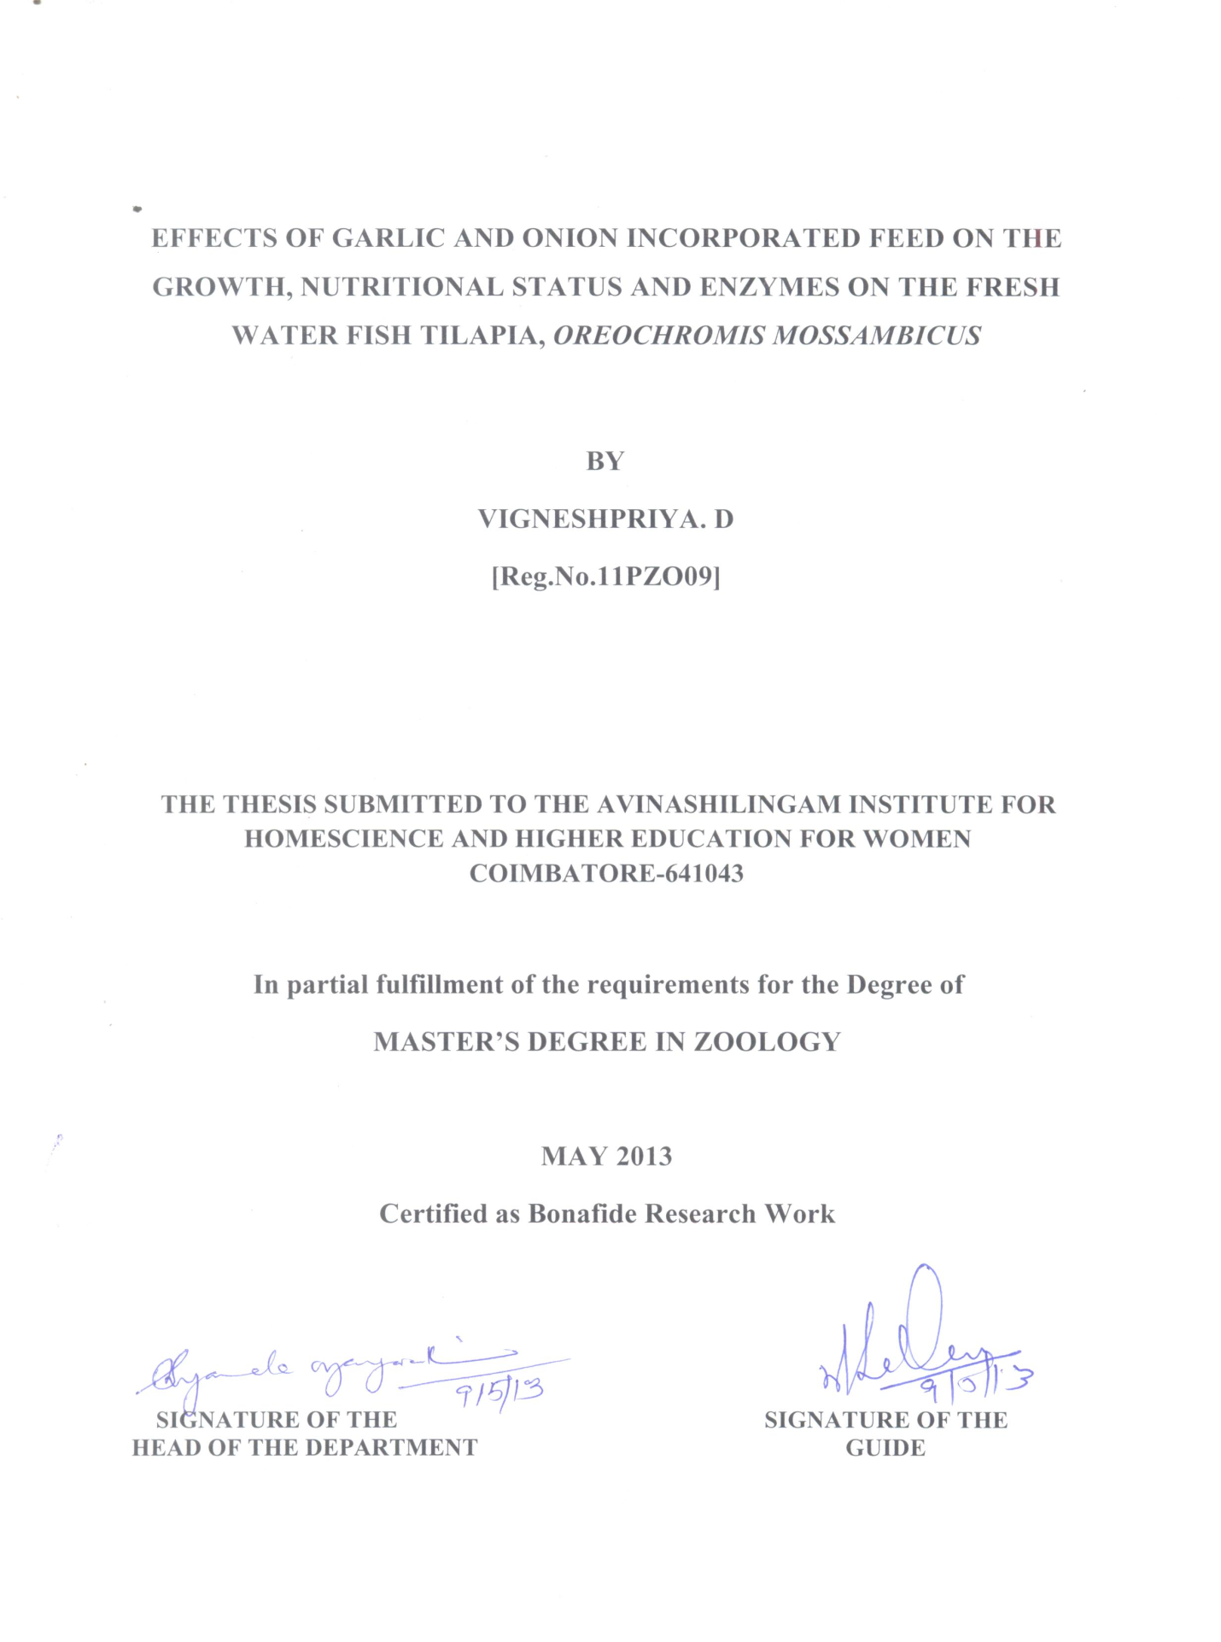

CONTENTS

CHAPTER | TITLE | PAGE NO
I  II  III  IV  V | LIST OF TABLES  LIST OF FIGURES  INTRODUCTION  REVIEW OF LITERATURE  MATERIALS AND METHODS  RESULTS AND DISCUSSION  SUMMARY AND CONCLUSION  BIBLIOGRAPHY | 1  7  23  35  65

LIST OF TABLES

TABLE NO | TITLE | PAGE NO
1.  2.  3.  4.  5.  6.  7.  8. | WEIGHT GAIN ( % ) IN OREOCHROMIS MOSSAMBICUS DURING DIFFERENT DAYS OF THE EXPERIMENT IN THE CONTROL AND FOUR DIFFERENT TREATMENTS  LENGTH GAIN ( % ) IN OREOCHROMIS MOSSAMBICUS DURING DIFFERENT DAYS OF THE EXPERIMENT IN THE CONTROL AND FOUR DIFFERENT TREATMENTS  PROTEIN, CARBOHYDRATE AND FAT CONTENT ( mg % ) IN THE CONTROL AND FOUR DIFFERENT FEEDS  WATER CONTENT IN THE MUSCLE TISSUE OF OREOCHROMIS MOSSAMBICUS DURING DIFFERENT DAYS OF THE EXPERIMENT IN THE CONTROL AND FOUR DIFFERENT TREATMENTS  PROTEIN CONTENT IN THE MUSCLE TISSUE OF OREOCHROMIS MOSSAMBICUS DURING DIFFERENT DAYS OF THE EXPERIMENT IN THE CONTROL AND FOUR DIFFERENT TREATMENTS  CARBOHYDRATE CONTENT IN THE MUSCLE TISSUE OF OREOCHROMIS MOSSAMBICUS DURING DIFFERENT DAYS OF THE EXPERIMENT IN THE CONTROL AND FOUR DIFFERENT TREATMENTS  FAT CONTENT IN THE MUSCLE TISSUE OF OREOCHROMIS MOSSAMBICUS DURING DIFFERENT DAYS OF THE EXPERIMENT IN THE CONTROL AND FOUR DIFFERENT TREATMENTS  DIGESTIVE ENZYMES IN THREE DIFFERENT REGIONS OF OREOCHROMIS MOSSAMBICUS DURING THE EXPERIMENTAL PERIOD | 50  51  52  53  54  55  56  57

LIST OF FIGURES

FIGURE NO | TITLE | PAGE NO
1.  2.  3.  4.  5.  6.  7.  8.  9.  10.  11.  . | FRESH WATER FISH OREOCHROMIS MOSSAMBICUS  ACCLIMATIZATION OF FISH OREOCHROMIS MOSSAMBICUS IN THE LABORATORY CONDITION  FISH FEED PREPARED FROM WHEAT FLOUR, COCONUT OIL CAKE WITH GARLIC AND ONION IN DIFFERENT CONCENTRATION  EXPERIMENTAL SET UP SHOWS OREOCHROMIS MOSSAMBICUS IN CONTROL AND FOUR DIFFERENT TREATMENTS  WEIGHT GAIN (%) IN OREOCHROMIS MOSSAMBICUS DURING DIFFERENT DAYS OF THE EXPERIMENT IN THE CONTROL AND FOUR DIFFERENT TREATMENTS  LENGTH GAIN ( % ) IN OREOCHROMIS MOSSAMBICUS DURING DIFFERENT DAYS OF THE EXPERIMENT IN THE CONTROL AND FOUR DIFFERENT TREATMENTS  PROTEIN, CARBOHYDRATE, AND FAT CONTENT ( mg % ) IN THE CONTROL AND FOUR DIFFERENT FEEDS  WATER CONTENT IN THE MUSCLE TISSUE OF OREOCHROMIS MOSSAMBICUS DURING DIFFERENT DAYS OF THE EXPERIMENT IN THE CONTROL AND FOUR DIFFERENT TREATMENTS  PROTEIN CONTENT IN THE MUSCLE TISSUE OF OREOCHROMIS MOSSAMBICUS DURING DIFFERENT DAYS OF THE EXPERIMENT IN THE CONTROL AND FOUR DIFFERENT TREATMENTS  CARBOHYDRATE CONTENT IN THE MUSCLE TISSUE OF OREOCHROMIS MOSSAMBICUS DURING DIFFERENT DAYS OF THE EXPERIMENT IN THE CONTROL AND FOUR DIFFERENT TREATMENTS  FAT CONTENT IN THE MUSCLE TISSUE OF OREOCHROMIS MOSSAMBICUS DURING DIFFERENT DAYS OF THE EXPERIMENT IN THE CONTROL AND FOUR DIFFERENT TREATMENTS | 31  32  33  34  58  59  60  61  62  63  64

ACKNOWLEDGEMENT
First and foremost the investigator wishes to thank God Almighty for endowing the investigator with the immense blessings which helped to overcome the hurdles, paving way for the successful completion of the study. .
The investigator also record her profound thanks to Thiru. Dr. T.S.K. MEENAKSHI SUNDARAM, M.A.,M.Phil.,Ph.D., Chancellor, Avinashilingam Institute for Home science and Higher Education for Women, Coimbatore, for providing opportunity to undertake this research investigation.
The researcher would like to express her sincere gratitude to Dr (Mrs.) SHEELA RAMACHANDRAN, M.Sc., P.G. Dip., Ph.D (Avinashilingam), Vice-Chancellor, Avinashilingam Institute for Home science and Higher Education for Women, Coimbatore, for providing facility to carry out the study.
The researcher expresses her Heartful thanks to Dr. (Mrs.) GOWRI RAMAKRISHNAN M.Sc., (Madras), M.Phil., Ph.D (Avinashilingam), Registrar, Avinashilingam Institute for Home science and Higher Education for Women, Coimbatore, for providing all the administrative support and help required to carry out the project.
The investigator noble her indebtedness, deep respect to Dr. (Mrs.) R. PARVATHAM, M.Sc., Dip. ED., M.Phil., (Madras),Ph.D (Avinashilingam), Dean, Faculty of Science, Avinashilingam Institute for Home science and Higher Education for Women, Coimbatore, for constant support to complete the research work.
The investigator expresses her sincere thanks to Dr. (Mrs.) B. SHYAMALA VIJAYAVATHI,M.Sc., Dip.Ed., (Madras), M.Phil., (Bharathiar), Ph.D. (Avinashilingam) Professor and Head, Department of Zoology, Avinashilingam Institute for Homescience and Higher Education for Women, Coimbatore, for propounding all the help needed for the study.
The investigator records her indebtedness, deep respect and heartful thanks to her honorable guide Dr. (Tmt.) N.KRISHNAVENI, M.Sc., (Madras), B.Ed.,Ph.D. (Annamalai), Associate professor, Department of Zoology , Avinashilingam Institute for Homescience and Higher Education for Women, Coimbatore, without her deep insight and sustained enthusiasm and encouragement, and constant support and guidance helped the investigator towards the successful completion of the study.
The researcher would like to express her sincere thanks to BELOVED TEACHING STAFFS AND LAB ASSISTANTS in the Department of Zoology for their valuable support.
The investigator wishes to thank her PARENTS Mr. G. Dhanapal, Mrs. S. Parvathy, and her siblings for their constant prayers, moral support and motivation, without their support would not have been able to reach this height.
The researcher wish to record her deep sense of gratitude to Friends for their motivation and timely help during the course of study.

I. INTRODUCTION
Aquaculture is an important source of human food and like all other agricultural and animal farming activities its productivity also totally depends on the provision and supply of nutrient inputs (AL-Asgah et al., 2011). However, we need fish farming to meet the demands of food and nutrition values need for human beings which seafood best provides. It is become increasingly important source of fish available for human consumption. As a result, it has become an important resource for human worldwide and in addition, it is one of the cheapest sources of animal protein (93.2% - fish protein; (93.7% - fat)) which is easily digestable (Onusiriuka, 2002).
In addition, fish contains essential fatty acids, this gives fish an uncomparable nutritional merit overall other animal meat which are rich in saturated fatty acid (Sarkar, 2002). For culturing fish in captivity, nothing is important than adequate feeding. When fish have no balanced diet to eat, they do not grow fast and stay healthy. There is an urgent need to compensate the nutritional requirements of fish. Thus the nutritional requirements changes as animal’s age, the composition of fish diets alters as the fish goes through its various developmental stages.
Aquafeeds accounts for about 40 to 60% of the total cost of aquaculture operations. It is therefore necessary to look for non-traditional low cost feed stuffs to decrease the overall cost of fish production. The use of alternate feed resources for the development of aquafeed has therefore gained significance as the traditional ingredients are either becoming costly or less available (Goddard et al., 2008).
The role of aquaculture in ensuring a consistent supply of aquatic species for human consumption cannot be overstated. Medical research into the health benefits of frequently eating fish is plentiful. One popular buzz word within the healthy eating monument is omega-3 fatty acids, which are typically found in most fish. Multiple research studies indicate these fatty acids help reduce many forms of cancer and promote healthy brain tissue. Eating fish regularly has also been shown to reduce the risk of heart disease through reducing the probability of clot formulation, lowering blood pressure and increasing the good cholesterol levels in the blood stream. (Arthur, 2011)
Aquaculture is becoming increasingly important source of fish available for human consumption. Fish depend on protein and minerals supplied through feed and from the pond environment for fast and healthy growth.
Fish food consists of natural food and artificial (supplementary) feeds. When fish have balanced diet to eat, they grow fast and stay healthy. Supplementary feeds that are acceptable to fish are rice bran, cassava leaves, oil seed cakes, coconut oil cake, wheat flour or other agricultural products and by products.
The world trend to improve food security and to use natural products which will drive the chemically synthesized antibiotics and growth promoters out of use. The search for alternative, the attention was focused on natural solutions like medicinal plants (Gabor et al., 2010). Thus the present study, an attempt has been made on the comparative effectiveness of garlic (Allium sativum) and onion (Allium cepa).
To maximize the growth of fish in normal condition, severalresearches have been carried out. One such study carried out by Salah et al., 2008 using garlic (Allium sativum) on the Aeromonas hydrophila infected Nile tilapia (Oreochromis niloticus) conveyed the anti-bacterial activity of garlic on the infected fishes. Phyto-additives are obtained from medicinal plants or plants extract and are being used on a wide range, by humans as well as by animals, including fish. Recent studies tried to show the effects of phytoadditives usage in all farmed animals. The main advantage of using this phytoadditives is that they are natural substances that do not pose any threat to fish health, human health or to the environment (Florian et al., 2011).
Garlic (Allium sativum) is probably one of the earliest known medicinal plants. It’s native to central Asia, it belongs to the family Liliaceae and genus Allium (Zohary and Hopf, 2000).
Garlic has been used as both food and medicine and it is found to have antibacterial, antiviral,antifungal activity(Moore and Atkins,1977), antioxidant (Metwally, 2009), potent cardiovascular benefits (Kleijmen et al., 1989) and significant hepto protective role in detoxification (Harris et al., 2001).Garlic also contains sulfur containing compounds: Allicin (responsible for the distinctive odor) diallyl-disulfide, diallyl- trisulfide (Benkeblia, 2004), and also vitamin A,C and F (Dragon et al., 2008).
Onion (Allium cepa) contains many organic di-sulfides (Lukes, 1971). Allium cepa which also has potential anti inflammatory, anticholesterol, anti oxidant and anticancer properties. Garlic and Onion has several beneficial actions including antihypertensive, antithrombotic, antibiotic and anticarcinogenic effects (Sivam, 2001). It also contains small quantities of sugar, fats, vitamin, C and B complex, high content of Mg, K and Cu. Simultaneously, it have been considered as a digestive material and used to improve the appetite.
Growth improvements in aquaculture, which have led to the uses of synthetic antibiotics. Many antibiotics are commonly used in aquaculture to promote growth and health in carp trout and Nile Tilapia. Recently,due to uncontrolled and repeated use of antibiotics in aquaculture to promote growth for a longtime has been incriminated carcinogenic, considering the potential threat on human and animal healthy current growth management therefore, looking for less harmful approaches and more environmentally friendly treatments become of premium importance (Ibrahem et al.,2010).
Aquaculture, however, is an increasingly important option in animal protein production. This activity requires high-quality feeds with a high protein content, which should contain not only the necessary nutrients but also complementary additives to keep organisms healthy and promote favourable growth. Fish selected for the present study is Oreochromis mossambicus.
Taxonomical Hierarchy
Kingdom : Animalia
Phylum : Chordata
Subphylum : Vertebrata
Class : Pisces
Order : Perciformes
Family : Cichilidae
Genus : Oreochromis
Species : mossambicus
Common name : Tilapia
Oreochromis mossambicus (Tilapia) belongs to the family Cichlidae family and is a common inhabitant of freshwater and some brackish waters.Tilapia is not only the second most important farmed fish globally next to carps but is also described as the most important aquaculture species of the 21st century (Shelton,2002). It is an important and popular source of food and animal protein.
The demand for animal protein for human consumption is currently on the rise and is largely supplied from terrestrial farm animals. Today’s world population is estimated to be about 6.5million, but is predicated to reach 9billion by 2050 (United Nations, 2006). To feed this mass of people, society must develop creative methods to provide a sufficient amount of fish seed, guard against disease outbreak and wastage (Jegede, 2021).
Hence the present study has been undertaken to increase the growth and nutritional status of edible fish Oreochromis mossambicus by feeding garlic and onion supplemented feed.

THE OBJECTIVES OF THE PRESENT STUDY ARE:
- To estimate the growth rate (length, weight) of Oreochromis mossambicus by feeding wheat flour and coconut oil cake (control) and also in formulated feeds using Garlic and Onion.
- To estimate the biochemical contents such as protein, carbohydrate and fat in the prepared feeds.
- To estimate the comparison of the growth rate (length and weight) of Oreochromis mossambicus in the control and four different treatments during 15days, 30 days,45days and 60days respectively.
- To estimate and compare the biochemical composition (protein, carbohydrate and fat) in control feed and four different treatments feeds.
- To investigate the presence of enzymes (amylase, maltase, invertase and protease) in foregut, midgut and hindgut in the fish Oreochromis mossambicus.

II. REVIEW OF LITERATURE
FISH FEED FORMULATION AND ITS EFFECT ON GROWTH AND NUTRIENT UTILIZATION:
The available literature pertaining to the present study entitled “Effects of garlic and onion incorporated feed on the growth, nutritional status and enzymes on the fresh water fish Tilapia, Oreochromis mossambicus”.
El-Sayed et al., (1984) studied the seasonal variations of total lipids, free fatty acids, triglycerides, phospholipids and cholesterol content of the freshwater fish Tilapia nilotica and the marine fish Sparus auratus. The results of this study reported that the male fish of S. auratus showed higher muscular and hepatic total lipids and hepatic free fatty acids than those of T. nilotica (P less than 0.05). The mean differences in gonadal male lipids of the two species were not significant. Tilapia nilotica female fish showed a significantly higher content of hepatic free fatty acids, phospholipids and cholesterol (P less than 0.01, 0.01, 0.05 respectively) and gonadal total lipids, triglycerides and cholesterol (P less than 0.05) than those of S. auratus females. In contrast S. auratus females exhibited higher muscular total lipids, triglycerides, phospholipids and cholesterol content (P less than 0.01, 0.05, 0.02, 0.05, respectively) and gonadal phospholipids (P less than 0.05) than those of the T. nilotica females. In general hepatic and gonadal lipids of freshwater fish T. nilotica were higher than those of the marine fish S. auratus, and in contrast the marine fish contained higher muscular lipids than the freshwater fish.
Johny et al., (2000) studied the effect of dietary protein content of growth food conversion and body composition of Oreochromis niloticus fingerlings fed with fish meal diet.They found that specific growth rates and body protein content increased with higher dietary protein.
Al-Hafedh (2001) investigated the effects of dietary protein (25% 30% 35% 40% 45%) on growth, survival, feed conversion ratio(FCR), protein efficiency ratio (PER) and body composition for four sizes (0.51 45 96 and 24kg) of Nile tilapia, Oreochromis niloticus L. In all four experiments there was a progressive in case in growth with increasing dietary protein. The results of their experiments indicate that Oreochromis niloticus (0.51g) should be reared on a practical diet containing 40% protein, and larger tilapia (96-264kg) on a diet containing 30% protein.
Lee et al., (2001) investigated the effects of dietary herbs on growth and body composition of juvenile Abalones, Haliotis discus hannai. Sivam (2001) reported that the garlic has several beneficial effects including antioxidant, antihypertensive and antimicrobial properties. Diab et al., (2002) reported that incorporation of Allium sativum in tilapia diets improved feed intake and feed conversion ratio. They added that incorporation of garlic or fennel in Nile tilapia diets improved feed conversion ratio and protein efficiency ratio significantly compared to the control unsupplemented group.
Shah et al., (2002) investigated that the effects of dietary arginine and lysine levels on growth performance and biochemical parameters of juvenile Japanese flounder Paratichthys olivaceus. In this study, growth performance and biochemical parameters were evaluated by feeding five test diets, comprising different levels of arginine and lysine, to triplicate groups of juveniles (initial bodyweight 1.85 g) for 40 days. Crystalline amino acids were supplemented to test diets to correspond to the amino acid pattern found in the whole body protein of the Japanese flounder, except for arginine and lysine. After the feeding trials, plasma arginine, lysine and urea levels, excreted ammonia-N, and liver arginase activity were analysed. Survival, specific growth rate, feed conversion efficiency, and apparent protein retention were adversely affected (P < 0.05) by the deficiency in dietary arginine or lysine concentrations. An excess of either lysine or arginine in the diet did not depress growth when the diets contained adequate levels of either arginine or lysine, proving that there is no evidence for an arginine, lysine antagonism. Results for plasma arginine, lysine and urea levels, excreted ammonia, and liver arginase activity also demonstrated that Japanese flounder juveniles are not sensitive to excess dietary levels of lysine and arginine.
Al-Salahy and Mahmoud (2003) studied the metabolic and histological effect of garlic administration on the carnivorous fish Chrysichthys auratus. Chrysichthys auratus fish were orally administered with doses of garlic (Allium sativum) juice equivalent to 2g per kg body wt, as a single dose or the same dose every 48h for 5 and 11 days. The results showed a hypoglycaemia, hypolipidaemia, hypercholesterolemia, hypotriglyceridaemia and drop in serum TFAA as well as promotion of lipogenesis and glycogenesis in white muscle in response to repeated doses of garlic. Such results may correlate with elevation of insulin release in the fish following garlic administration. Histological and biochemical studies confirmed liver glycogen depletion and liver histopathological changes including vacuolation, hypertrophy and degeneration of some hepatocytes, and dilatation and congestion of some blood vessels. Histopathological changes of the kidney were vacuolation and rupture of some renal tubules, and degeneration of the parietal cells of some Malpighian corpuscles. Garlic decreased the amount of collagenous fibres in both liver and kidney, and reduced carbohydrate content in the kidney. Inspite of some cell degeneration in the liver and renal tubules, serum AST and ALT did not show any significant changes, while serum ALP was decreased..
Anholt and van (2004) studied the dietary fatty acids and the stress response of the fish, arachidonic acid in sea bream and tilapia. The result indicates that short feeding period with a relatively minor dietary change in a single fatty acid, arachidonic acid, is sufficient to considerable alter several physiological functions in Mozambique tilapia and gilthead sea bream. The two spices showed completely opposite responses to a stressor after their diets were supplemented with arachidonic acid, while it had a positive effect on the osmoregulatory capacity of both species.
Shalaby et al., (2006) investigated the effects of garlic in Nile tilapia. The result reported that incorporation of garlic in Nile tilapia diets at 10:20:30 and 40g/kg diet increased significantly final weights and specific growth rate and the increase was more pronounced at higher incorporation levels.
Ibiyo et al., (2006) studied the effects of vitamin C supplementation on the growth of Heterobranchus longifilis fingerlings and reported that fish receiving the vitamin C supplemented diet had significantly improved weight gain, protein efficiency ratio, specific growth rate, feed efficiency ratio and survival rate. And they concluded that vitamin C is essential in the nutrition of these fishes.
Ji et al., (2007) investigated the effects of dietary medicinal herbs on growth and some specific immunity in juvenile red sea bream pagrus major. They found that the fish (mean body weight 24.0 0.2 g) were fed fish meal diets supplemented with either Massa medicata (Mm), Crataegi fructus (Cf), Artemisia capillaries (Ac), Cnidium officinale (Co), or a mixture of all the herbs (HM), and a control diet without medicinal herbs, for 12 weeks. Survival, specific growth rate, feed efficiency, condition factor and hemoglobin levels were higher in fish given herbal diets than fish given the control diet without herbs. Significantly higher serum high density lipoprotein-cholesterol level and lysozyme activity were detected in HM and Co diet groups, and alternative complement pathway activity was detected in the HM diet group. However, significantly lower serum alanine aminotransferase and aspartate aminotransferase activities were obtained in all herbal diet groups compared with the control diet group.Pathogen challenge test by intra peritoneal injection of Vibrio anguillarum indicated that highest survival was obtained in the HM diet group followed by Ac, Co, Cf, and Mm diet groups. The lowest survival was obtained in the control group. These results reveal that medicinal herbs in diets enhance growth and some non-specific immunity of red sea bream.
Onion bulb can be used as a growth promoters and health management in African cat fish, Clarias gariepinus. The results of the study showed that onion bulb could increase body weight gain, feed intake and feed efficiency and it does not cause any damage to the physiological system and organelles of the organism. Kumar and Anantharaja (2007).
Sahu et al., (2007) reported that garlic has many beneficial health properties which are attributed to organo-sulphur compound, particularly to thio-sulfinates present or formed in crushed garlic.
Abo-Esa (2008) investigated a Study on Some Ectoparasitic Diseases of Catfish, Clarias gariepinus with their Control by Ginger, Zingiber officiale. This study reported that Zingiber officiale revealed skin and gill infestation with ectoparasitic protozoan Trichodina and Epistylis and Monogenean gyrodactylus spp. with average 20, 15 and 25%, respectively. The average of the total ectoparasitic infestation in the examined catfish was 60%.The significance of herbal control measures using ginger Zingiber officiale as a new method to eradicate such parasites was evaluated. A bioassay of 96 hours LC50 of ginger emphasized that its value was 192mg/L. The herbal control with ginger was safe and effective to treat the ectoparasitic protozoa Trichodina and Epistylis spp. at dose 20mg/L, but not suitable for treating the Monogenean gyrodactylus spp. The estimation of dissolved oxygen, pH and total ammonia of aquarium water pre and during treatment was indicated that the use of ginger in aquaculture operation will improve its water quality especially the total ammonia.
Diab et al., (2008) conducted an experiment to determine the effect of garlic, black seed and biogen as immuno stimulants on the growth and survival of Nile tilapia, Oreochromis niloticus (Teleostei: cichlidae) and their response to artificial infection with Pseudomonas fluorescens. Results of the experiments showed that mortalities following challenge with Pseudomonas fluorescens were lower in the group that received garlic compared to the other two treatments.
Hakim et al., (2008) studied the effects of replacing soybean meal protein by other plant protein sources on growth performances and economical efficiency of monosex Nile tilapia (Oreochromis niloticus) cultured in tanks. The results of their experiment showed that replacement of 30% of soybean meal protein by sesame seed cake protein improved significantly final body weight of Nile tilapia.
Soltan and Laithy (2008) conducted an experiment to determine the effects of probiotics and some spices as feed additions on the performance and behavior of the Nile tilapia, Oreochromis niloticus. Results of the experiment indicated that, supplementation of the based diets with probiotics Bacillus subtilis and spices (garlic) significantly improved survival rate of tilapia. Feed intake, feed utilization and growth performance of Nile tilapia including final body weight, final body length and protein efficiency ratio, were significantly high.
Novoa et al., (2008) investigated the effect of the use of the microalgae Spirulina maxima as a protein source in diets for tilapia, Oreochromis mossambicus (peters). Animal protein was replaced with algae protein at ratios of 20%, 40%, 60%, 80%and 100% and the substitution effects was compared with a control diet in which fish meal was the sole protein.The six treatments were tested in triplicate in a closed- circulating system where the fish were fed by and at 6% of their body weight. After weeks feeding period, the growth rate and protein utilization of fish fed the diet with 20%, 40%, spirulina were elevated and non -significantly different (p>0.05) from there fed the control diet. The addition of p to the 100% spirulina diet slightly improved performances in composition to the same diet without p.
Aly et al., (2008) carried out an experiment to determine the effects of garlic on survival, growth, resistance and quality of Oreochromis niloticus.It was proved that the doses rates of garlic induced a similar effect enhancing immunity and health status. Consequently garlic improved the growth performances. Moreover fish quality and shelf life was improved.
El-Daka et al., (2008) studied the effects of different levels of dried basil leaves (DBL) on performance, body composition and cost-benefit analysis of hybrid tilapia, Oreochromis niloticus x Oreochromis aureus. Four experimental isonitrogenous and isoenergitic diets were formulated to contain 0, 0.5, 1.0 and 2.0% of DBL. Eight glass aquaria (96-L) were used in duplicates to stock ten fish having the same initial weight (13g/fish) in each. Fish were fed 3% of the body weight three times daily, six days a week for 112 days. The dried basil leaves improved digestibility of protein and energy and declined the digestion of lipid and carbohydrates. Incorporation of DBL in test diets improved significantly (P<0.05) growth rate than the control diet especially at 2% DBL which achieved the best inclusion level. Palatability index increased as DBL levels increased and resulted in a reduction in feed waste percent from 33.48% with the control diet to 8.43% with diet contained 2% DBL level. Consequently, low incidence cost and high profit index were significantly (P<0.05) with the diet containing 2% DBL level. There is a positive impact for growth and feed efficiency to use DBL in Tilapia feeds.
Nya et al., (2009) studied the use of garlic, Allium sativum to control Aeromonas hydrophila infection in rainbow trout, Oncorhynchus mykiss (walbaum). The results of this study showed the use of garlic controls the mortality rate and increase the growth, feed conversion and protein efficiency. There was a stimulant of the number of erythrocytes and leucocytes, a significantly higher haematocrit, enhancement of phagocytic activity respiratory burst, lysozyme, anti-protease and bacterial activities following feeding with garlic.
Metwally (2009) studied the effect of garlic (Allium sativum) in some antioxidant activities in Tilapia nilotica (Oreochromis niloticus) .The results showed that, weight gain and growth performances of Oreochromis niloticus significantly increased in all group fed on garlic with addition of garlic in any form to fish diet can promote growth rate, decrease mortality rate and increase the antioxidant activity in fish was suggested.
Metwally (2009) conducted an experiment to investigate the effect of treatment with garlic oil (Allium sativam) on some heavy metal (copper and zinc) toxicity in Oreochromis niloticus. Groups of Nile tilapia fed on six different diets, the concentration 250mg/kg diet, experiment was extended for three months. The results of the experiment indicated that garlic treatment has some beneficial effect in preventing heavy metal (copper and zinc) induced alteration of lipid profile.
Tank culture experiment was conducted by Hakim et al., (2010) aimed to study the effect of dietary fresh or dried garlic (Allium sativum) supplementation in the Nile tilapia (Oreochromis niloticus) diets at different levels, on growth performance, nutrients utilization and whole bodies chemical composition. Results obtained are specific growth rate and survival rate were increased with garlic fed and protein efficiency also high supplementation of Nile tilapia diets with dried garlic had no significant effects on moisture, dry matter and also showed significant effects on tilapia serum total protein, total albumin, total globulin and total lipids.
Gabor et al., (2010) studied the effects of some phytoadditives on growth, health and meal quality on different species of fish. The result reported that the effect of phytoadditives (garlic, onion, oregano etc) modulators, immune stimulants, bio-productivities, antioxidant, antimicrobials, stimulants to fish and also do not pose any threat to fish.
Citarasu (2010) reported that hormones antibiotics, vitamins and several other chemicals have been tested in the aquaculture operations for various remedies and the alternative herbal bio-medicinal products in the aqua cultural operation, that have the characteristics of growth promoting ability and tonic to improve the immune system acts as appetite stimulants. They increase consumption, include maturation and have antimicrobial capability and also anti stress characteristics that will be of immense use in the culture of shrimps and other fin fishes without any environment and hazardous problems.
Tank culture experiment was conducted by Vasquez et al., (2010) to determine the dietary fatty type affects the growth, body composition, fatty acids and stress responsible in Nile tilapia. Four isoenergetic and isoproteic extruded diets (pellet diameter 3.00mm) were formulated and contained oil fish oil (FO), sunflower oil (SO), linseed oil (LO), and oil sun flower high oleic (OSH).The result of this experiment showed, the dietary fatty acid type has significant differences (p<0.05) between treatments. The profile of muscle fatty acids in tilapia after 55 days trial can be observed .The deposition of fatty acids in fish tissues was generally influenced by the fatty acids profile of the diets.
Chhay et al., (2010) studied the effect of sun-dried and fresh cassava leaves on growth of Tilapia (Oreochromis niloticus) fish fed based diets of rice bran or rice bran mixed with cassava root meal. The experiment was conducted for 100 days. Daily gain in weight and length, and the ratio weight length after 100 days of growth, did not differ among treatments, water quality parameter were not affected by the treatments.
Al-Asgah et al., (2011) investigated an experiment to evaluate as a substitute ingredient for wheat bran in tilapia (Oreochromis niloticus) diets. Five experimental diets viz., 0 (control), 25, 50, 75, 100% olive waste (OW) replaced with wheat bran were prepared and randomly allotted to triplicate groups with 10 fish in each group. Fish were reared in aquaria at a water temperature of 29±1˚c with a dark/light cycle of 12h. Fish were fed at 3% of body weight twice daily for a period of 70 days. The results showed that the substitutes of olive waste with wheat bran at all levels did not affect (p>0.05) the moisture and crude protein contents of fish muscles.
Florian et al., (2011) determined the influence of some phytoadditives on growth performances and meal quality in rainbow trout, Oreochromis mykiss. The additives used of this experiment were garlic, ginger, oregano and Echinacea. The results of this experiment showed that the garlic fed group has highest chemical composition and increase in dry matter compared with the control group. The greatest weight gain was recorded in the oregano used group. The highest specific growth rate and protein value increasing recorded in Echinacea used group .Fat content was recorded in the garlic used group.
Ndong and Fall (2011) studied the effect of garlic (Allium sativum) on growth and immune responses of hybrid tilapia (Oreochromis niloticus x Oreochromis aureus). They found that garlic at 0.5% in diet stimulates the immunity of hybrid Tilapia. In addition, body weight gain in juvenile hybrid Tilapia that received a diet supplemented with garlic has no growth improvement.
Fazlolahzadeh et al., (2011)studied the effects of garlic (Allium sativum) on hematological parameters and plasma activities of ALT and AST of rainbow trout in temperature stress.The result indicated that lymphocyte count increased significantly in fish fed on diets containing all garlic doses compared with the control group. In conclusion, use of garlic balanced and formulated in suitable doses can decrease mortality rate and increase immunity.
Harikrishnan and Balasundaram (2011) studied an impact of plant products on innate and adaptive immune system of cultured finfish and shellfish. He reported that the application of antibiotics and chemicals in culture is often expensive and undesirable since it leads to antibiotic and chemical resistance and consumer reluctance. Therefore immunostimulants such as glucan, chitin, lactoferrin, levamisole, and some medicinal plant extracts or products have been used to control fish and shellfish diseases. In this regard the medicinal plant extracts and their products act as immunostimulants modulating the immune response to prevent and control fish and shellfish diseases. The immunostimulants mainly facilitate the function of phagocytic cells, increase their bactericidal activities, and stimulate the natural killer cells, complement, lysozyme activity, and antibody responses in fish and shellfish which confer enhanced protection from infectious diseases. Plants or their byproducts are preferred since they contain several phenolic, polyphenolic, alkaloid, quinone, terpenoid, lectine and polypeptide compounds many of which have been shown to be very effective alternatives to antibiotics, chemicals, vaccines and other synthetic compounds. In aquaculture the herbal medicines are also known to exhibit anti-microbial activity, facilitate growth, and maturation of cultured species besides under intensive farming the anti-stress characteristics of herbs will be of immense use without posing any environmental hazard. Administration of herbal extracts or their products at various concentrations through oral (diet) or injection route enhance the innate and adaptive immune response of different freshwater and marine fish and shellfish against bacterial, viral and parasitic diseases. Even an overdose of immunostimulants may induce immunosuppression without side effects but helps to reduce the losses caused by disease in aquaculture.
Mabrouk, et al., (2011) conducts an experiment to determine the effect of garlic onion on growth and response of Nile tilapia (Oreochromis niloticus) fingerlings to different replacement levels of fish meal with soybean meal using garlic and onion. The result of their experiment indicate that the diet contain of 50% FM+ 50% SBM with 10% mixture of garlic and onion for 84 days had enhanced growth performances, diet utilization efficiency Nile tilapia monosex fingerlings.
Lee et al., (2012) carried out experiment to investigate effects of dietary garlic extracts on whole body Amino acid and fatty acid composition, muscle free amino acid profiles and blood plasma changes in juvenile Sterlet sturgeon, Acipenser ruthenus. In the first experiments, fish with an average body weight of 59.6g were randomly allotted to each of 10 tanks (two groups of fine replicates, 20 fish /tanks) and fed diets with (0.5%) or without (control GE respectively, at the level of 2%, of fish body weight per day for 5 weeks. In the second experiments, the effects of dietary garlic extracts on blood plasma changes were investigated using 6 months old juvenile Sterlet sturgeon averaging 56.59. Fishes were randomly allotted to each of 2 tanks (300 fish/tank) and fed diets with (0.5%) or without (control) GE respectively at the rate of 2% of body weight per day for 23 days. The result of this experiment showed that dietary garlic extracts could increase dietary glucose utilization through the insulin secretion, which results in improved fish body quality and feed utilization by juvenile starlet sturgeon.
Yilmaz (2012) investigated the effects of garlic and ginger oils on hematological and biochemical variables of sea bass Dicentrarchus latex. Results showed that the red blood cell count, hematocrit, haemoglobin, concentration, mean corpuscular volume, mean corpuscular haemoglobin, and concentration were not significantly affected by herb oil exposure. And sea bass exposed to the 0.005 –ml/l garlic oil –garlic oil mixture (0.005 or 0.01ml/l) or to garlic oil at 0.02-ml/l garlic oil or to the 0.01-ml/l mixture. The serum lipase level decreased and the cholesterol level increased in fish that were exposed to 0.02-ml\l garlic oil.
Jegede (2012) was conducted an experiments to determine the effect of garlic on growth, nutrient utilization resistance and survival of Tilapia zillii fingerlings. Results showed that the garlic diet increased the better growth rate and also the survival rate of Tilapia zillii was significantly higher in all the treatments. Apparent protein digestibility (APD) increases with increase in the inclusion level of garlic diet.
Gabor et al., (2012) studied the use of phyto-additives in rainbow trout (Oncorhynchus mykiss) nutrition. He reported that fodder additives have been used for a long time with notable effects. Most of them are chemically synthesized and are antibiotics derivatives. The biggest problem following their use is the development of drug-resistant bacteria. In order to overcome this downside and to abide to the new food safety regulations, a search for natural alternatives has begun and the attention has been focused on plants or plants extracts, some used for millennia as natural remedies. As they are natural substances the negative impact on fish health and environment is negligible. Phyto-additives are a relatively new class of additives and the knowledge regarding their use or mode of action is sometimes partially or totally lacking. They have multiple effects most notable being the antimicrobial, antioxidant, immune stimulating and bioproductive effects. Phyto-additives are a heterogeneous group of additives being extracted from bulbs, roots, leaves or fruits of different plants species they are available in many forms dry and/or crushed or as liquids (essential oils). Research has been carried out world-wide, focusing on cultured species (rainbow trout, tilapia, and catfish) using a wide variety of plants (garlic, onion, ginger, Echinacea, nettle, sage, cinnamon) demonstrating the positive effects of the phyto-additives used. Even if they exhibit a positive influence on many parameters, their use is dose dependent, as higher or lower doses could have inhibitory effect or no effects at all.
Hamid and Soliman (2012) conducted a tank culture experiment to determine the possibility of using dried leaves of guava and camphor trees in tilapia diets. The obtained results confirmed the significant gradually (with increasing the feed additive level) improvements in fish final weight, weight gain (total and daily), growth rates (relative and specific), feed utilization (feed and protein intakes, feed conversion, protein productive value, protein efficiency ratio, energy retention) by increasing GTLM or CTLM levels. These feed additives, also, significantly improved fish carcass composition (protein, ether extract, energy content). So, it could recommend the dietary inclusion of 2 % GTLM or CTLM to Nile tilapia. So, it could recommend the addition of 2 % GTLM or CTLM to Nile tilapia fish diets, but it may need more research on the effect of such feed additives on the organoleptic test of the fish meat.
Tank culture experiment was conducted by Bello et al., (2012) to assess the growth responses and nutrient utilization of walnut leaf and onion Bulb residues in Clarias gariepinus. Results showed that the fish on onion bulb and walnut residue-based diets increase significantly the growth rate and nutrient utilization respectively.
Kasthuri et al., (2012) studied the immunemodulatory effect of Adhatoda vasica in Oreochromis mossambicus. This study attempted to identify the possible immune stimulatory activity of the medicinal plant Adhatoda vasica, so that it can be applied to aquaculture industry for the maintenance of health in the cultivable fishes. The active principle of A. vasica responsible for the immune modulatory effect of the extract is yet to be identified. After confirming the immune modulatory properties of A.vasica in studies involving other immunological parameters particularly those of nonspecific immunity and sufficient field trails, the plant extract can be used in finfish aquaculture farms. Results of this study showed that use of immunostimulants, adjuvants and vaccine carriers in fish culture offers a wide range of attractive methods for inducing and building up protection against diseases.
Oyebamiji et al., (2013) carried out an experiment to assess the water parameter and biochemical composition of two fish species (Tilapia niloticus and Sardinella aurita) obtained from Azikwe River, Nigeria. The results were compared with the standard levels recommended for the various nutrients and metals and thereafter statistically analyzed of variance (ANOVA) at 5% probability level.
Rad et al., (2013) conducted on experiment to evaluate the effect of different levels of dietary supplementation of Saccharomyces cerevisiae on growth performances, feed utilization body biochemical composition of (Oreochromis niloticus) fingerlings. Four diets containing supplementation at levels 0, 0.5, 1 and 29 kg fed to fingerlings of Nile tilapia (5.01± 0.21g) in replicate tanks twice daily to apparent satiation for 56 days. The result of this experiment indicated clearly that the supplementation of Saccharomyces cerevisiae (1.0g yeast Kg diet) enhanced the growth performance and feed utilization of Oreochromis niloticus fingerlings.

III. MATERIALS AND METHODS

Experimental Animal
Freshwater fish, Oreochromis mossambicus were collected from the Palakkad district, Kerala. The fishes were kept in large aquarium tanks and acclimatized to laboratory conditions for two weeks prior to the beginning of the experiment. During this period they were fed with control feed (wheat flour and coconut oil cake). The tanks were cleaned periodically and water was infused at regular intervals to ensure sufficient oxygen supply to fish.
Experimental feed and feed formulation
Fish feeds were prepared by adding equal proportions of wheat flour, coconut oil cake. The ingredients of each diet were mixed thoroughly and ground into fine powder. These substances were mixed with hot water and made into dough and boiled for 30 minutes. Then the boiled feed was taken outside and cooled. Finally multivitamin mineral tablet were added and made into noodles. The moist noodles were dried for 2-3 days in the sun and were broken into pieces of 0.5cm in length. Four different diets and with control were prepared for the present investigation.
- Control - Wheat Flour and coconut oil cake 100%(control)
- T1 - Wheat flour (47.5%), coconut oil cake (47.5%) and garlic
powder(5%).
- T2 - Wheat flour (45%), coconut oil cake (45%) and garlic
Powder (10%).
- T3 - Wheat flour (47.5%), coconut oil cake (47.5%) and onion powder (5%).
- T4 - Wheat flour (45%), coconut oil cake (45%) and onion powder (10%)

Experimental Design
The experiment was carried out in four different treatments in three replications and control. Each trough contained about six individuals in the control and in four treatments. Prior to stocking, biochemical composition were analyzed in the fish Oreochromis mossambicus. The water level in each trough was maintained throughout the experimental period.
During this time, experimentally prepared garlic and onion added feed was given to the fishes. Before feeding biochemical composition such as protein, carbohydrate and fat were calculated in prepared fish feeds. Every fifteen days, growth performance were analyzed in terms of length and weight (%) and Biochemical composition such as water content, protein, carbohydrate and fat were calculated in the muscle tissues of the fishes grown in control and four different treatments before and after the experiments. The medium was changed daily in order to remove the faecal and unconsumed wastes.
Growth Measurement
Growth performance of fish was determined in terms of initial and final individual fish weight (g) and length (cm).
Biochemical Analysis
For bio-chemical analysis, muscle tissues were taken and water content, protein, carbohydrate and fat were analyzed. The enzymes like amylase, maltase, invertase and protease were analyzed on every fifteen days for two months in the foregut midgut and hindgut.

1. Water content
Water content was calculated in the muscle tissues of Oreochromis mossambicus in control and in the replicates. The dissected tissue were placed in separate vials (weighed to 100mg) and dried in hot air oven for 24hours at 80˚C until attaining constant weight.
The weight difference between wet and dried body tissue, elucidates the water content present in the particular tissue and its percentage was calculated.
2. Estimation of total protein
The protein was estimated by adopting the method of Lowry et al. (1957)
Reagents
- 2% sodium carbonate in 0.1N sodium hydroxide (Reagent A)
- 0.5% copper sulphate and 1g of potassium sodium tartarate (Reagent B).
- Alkaline copper solution:
50ml of A and 1ml of B was mixed prior to use. (Reagent C)
- Folin-ciocalteau reagent:
Folin phenol reagent was diluted with equal volume of distilled water (Reagent D)
- Protein solution (Stock standard):
50mg of bovine serum albumin was weighed, dissolved in 0.1N sodium hydroxide and made up to 50ml in a standard flask.
- Working standard:
10ml of the stock solution was diluted to 50ml with distilled water.

Extraction of protein
100mg of muscle, liver tissue of the fish sample were homogenized separately with 1ml of 0.9% sodium chloride solution; 1ml of 5% trichloroacetic acid was added and then centrifuged at 8000rpm for 20minutes. The precipitate was dissolved in 1ml of 0.1N sodium hydroxide and 0.1ml of aliquot was taken and made upto a find volume of 1ml. From this 0.5ml of solution was pipetted out and poured in a clean dry test tube. To this, 4ml of carbonate copper solution was added. It was mixed well and kept as such in folinciocalteau phenol reagent was added. The test tubes were shaken well for uniform mixing and kept in room temperature for another 30minutes. The blue colour was developed. It was read at 640nm, in a Uv-Vts- spectrophotometer-118. The standard graph was obtained by using bovine serum albumin and the protein content was expressed in mg/g wet tissue.
Estimation of protein
The working standard ranging from 0.1 to 1ml was pipetted out into a series of test tubes. 0.2 ml of the extracted sample was pipetted out in a separate test tube and the solution was made up to 1ml in all the test tubes. A tube with 1ml of water served as the blank. Five millilitre of Reagent C was added to each tube including the blank, mixed well and allowed to stand for 10 minutes. 0.5ml of Reagent D was added, mixed well and incubated at room temperature in dark for 30 minutes and the blue colour developed was observed at 660nm. A standard graph was drawn and the amount of protein in the samples was calculated. The amount of protein was expressed in mg/g of sample.

3. Estimation of Carbohydrate
Carbohydrate was estimated in the feeds and fishes in control and in replicates fed with treatments by Hedge and Hofreiter (1962).
Reagents:-
- 5% trichloroacetic acid.
- Anthrone reagent:
200mg of Anthrone was dissolved in 100ml of ice cold 95% Sulphuric acid prepared freshly before use.
- Stock standard Glucose:
100mg of glucose was dissolved in 100ml of distilled water.
- Working standard Glucose:
10ml of stock was diluted to 100ml with distilled water.
Extraction of carbohydrates from sample
100mg of muscle and liver tissue from the fish sample was homogenized separately in 1ml of 0.9% sodium chloride solution, 1ml of 5% Trichloroacetic acid was added to 1ml of each extract. The homogenate was centrifuged at 8000rpm for 20 minutes and the supernatant was analyzed for the presence of carbohydrate. The standard graph was obtained by using glucose, and the values were expressed in (mg/g) wet tissue.
Estimation of carbohydrate
The working standard ranging from 0.1 to 1ml was prepared and a blank was maintained. 0.2ml of the extracted sample was pipetted in a test tube and made up the volume to 1ml in all the tubes including the sample tubes by adding distilled water. Then 4ml of anthrone reagent was added and heated for 8 minutes in a boiling water bath. The contents were cooled rapidly and read the green to dark green colour at 630nm. A standard graph was drawn by plotting concentration of the standard on the X axis versus absorbance on the Y axis. From the graph the amount of carbohydrates present in the samples were calculated.
4. Estimation of Fat
Total fat was resolute by gravimetric method using chloroform methanol mixture (3:1) (Folch et al., 1957) in tissues feeds of Oreochromis mossambicus in the control and four treatments.
Reagents
Chloroform- methanol mixture (3:1)
Procedure
100mg of different organs (muscles, liver) of fish sample was weighed separately and ground well with 5ml of chloroform methanol mixture. The homogenate was centrifuged, taken in a small weighed beaker and this beaker was placed inside a large beaker filled with water along the sides and kept overnight in hot air oven without any disturbance. In between the methanol (with dissolved protein layer) and chloroform (with dissolved fat) a white precipitate was formed. The methanol layer was removed without disturbing the chloroform layer. The chloroform was evaporated in oven at about 60˚C. The beaker was weighed and the difference between the final and initial weight of the beaker gives the lipid content of the tissue.
Enzyme Analysis
The enzymes like amylase, maltase, invertase and protease were analyzed in the foregut, midgut and hindgut regions of (Tilapia) Oreochromis mossambicus. The fish was dissected out, the alimentary canal was taken and separated into foregut, mindgut and hindgut region.
They were ground well separately by adding distilled water centrifuged at 3000 rpm 10minutes. The supernatant was removed then the enzyme analysis carried out. In each enzyme analysis two test tubes were used. One served as control and another was served as experiment.
1. Amylase
For this, two test tubes were taken 2ml of 1% starch was taken in one test tube and 2ml of distilled water was added. In another test tube 2ml of enzyme was taken. The test tubes were placed in water bath for 30minutes. A drop of Iodine was added in both the test tubes.
2. Maltase
Two test tubes were taken and added 2ml of 1% starch, 2ml of distilled water is added in one tube and 2ml of enzyme extract was added in another tube. Now 2ml of Benedicts reagent was added in both the test tubes and it was heated gently .Then the two test tubes were kept in a water bath for about an hour.
3. Invertase
For analysis of invertase, two test tubes were taken and added 1ml of 5% sucrose. In the experimental tube 3 drops of enzyme extract was added. Both the tubes were kept in a water bath for an hour. Then a drop of Fehling A and B were added in both the tubes. Once again they were kept in water bath for an hour.
4. Protease
For protease analysis two tubes were taken and added 3ml for 2% Allumin. In one tube 5ml of distilled water was added. In another tube 5ml of enzyme extract was added. Both the tubes were kept in a water bath for an hour at 38˚C. Then the content of the two tubes were divided equally and taken in another two test tubes. Two test tubes were carried out namely conjugation and biurette test.
i.Conjugation test
For conjugation test, 1ml of mercuric chloride was added in the both control and experimental tubes.
ii.Biurette test
For biurette test, 1ml of biurette reagent was added in the both experimental and control tubes.
Evaluation of growth performance
Growth performance of fish was determined in terms of initial and final individual fish weight and length.
Final weight - Initial weight x 100
Percentage weight gain = Initial weight

Final weight - Initial weight x 100
Percentage length gain = Initial weight

Statistical Analysis
Results were subjected to two way ANOVA (P<0.05) of variance to evaluate the mean differences among individual diet treatments in fish Tilapia (Oreochromis mossambicus) at 0.05 level of significance.

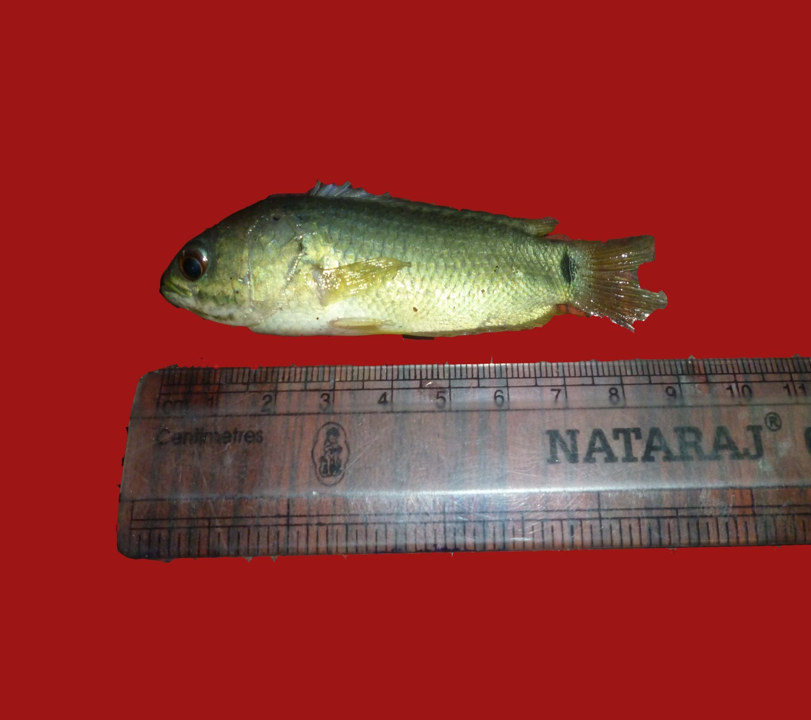

Figure. 1. Fresh water fish Oreochromis mossambicus

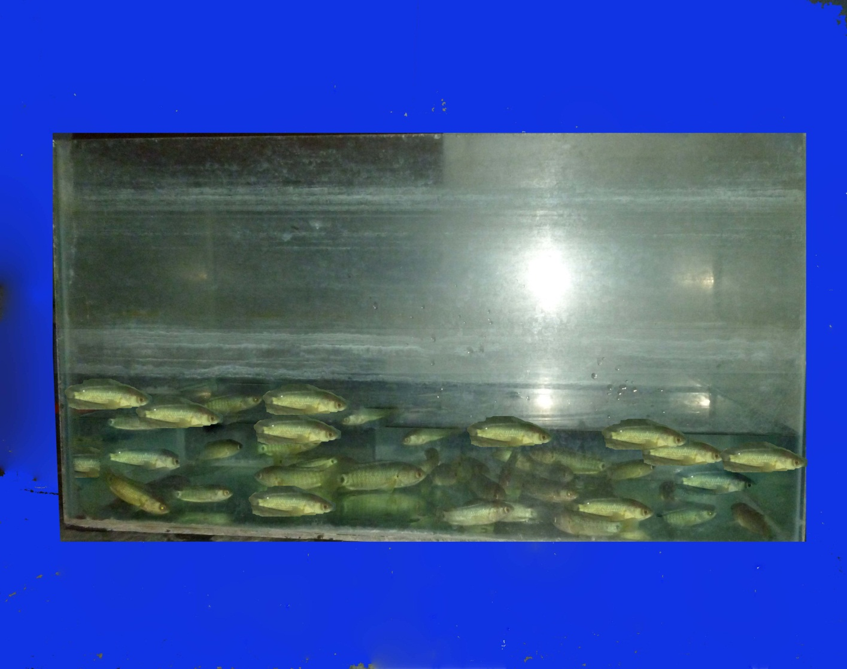
Figure. 2. Acclamatization of Oreochromis mossambicus in the laboratory condition

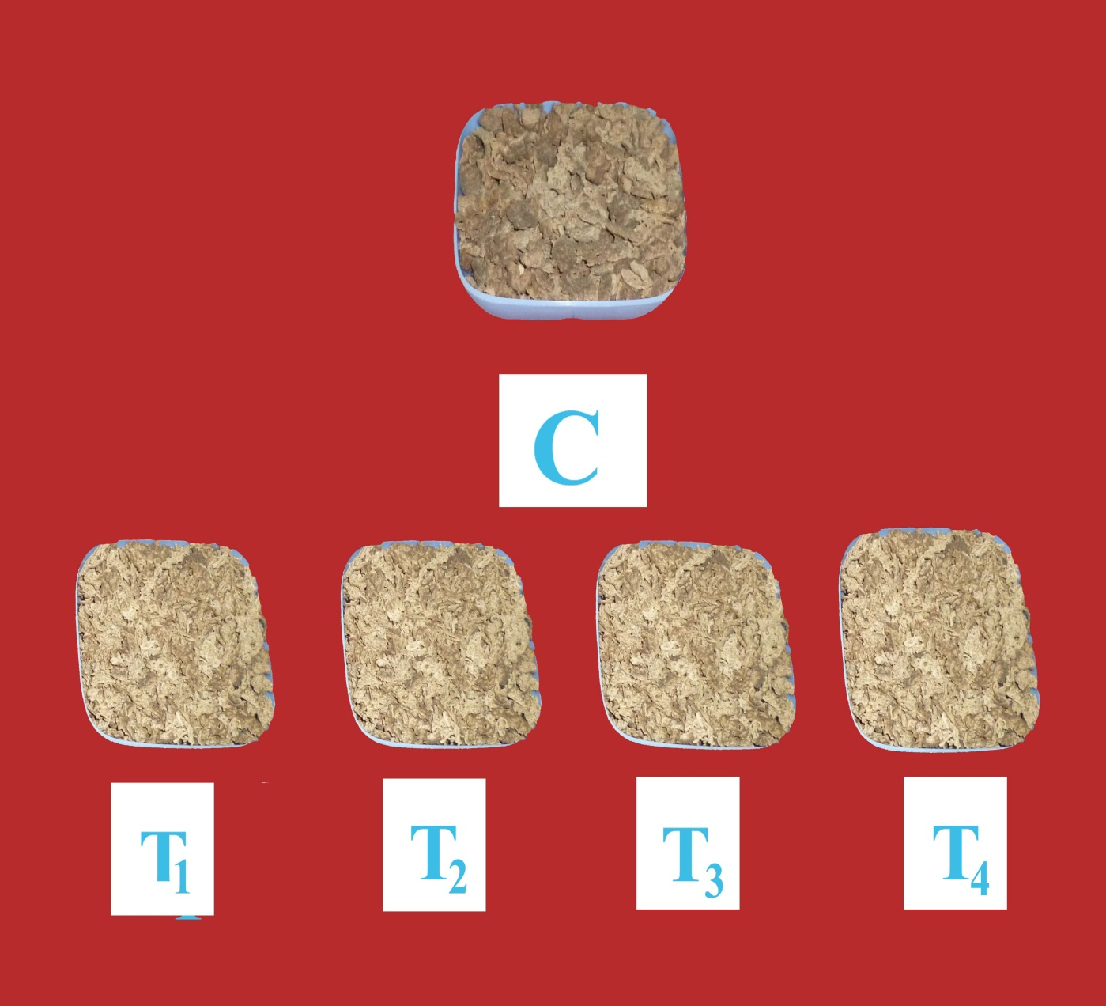

Figure. 3. Fish feed prepared from wheat flour, coconut oil cake with garlic and onion in different concentration

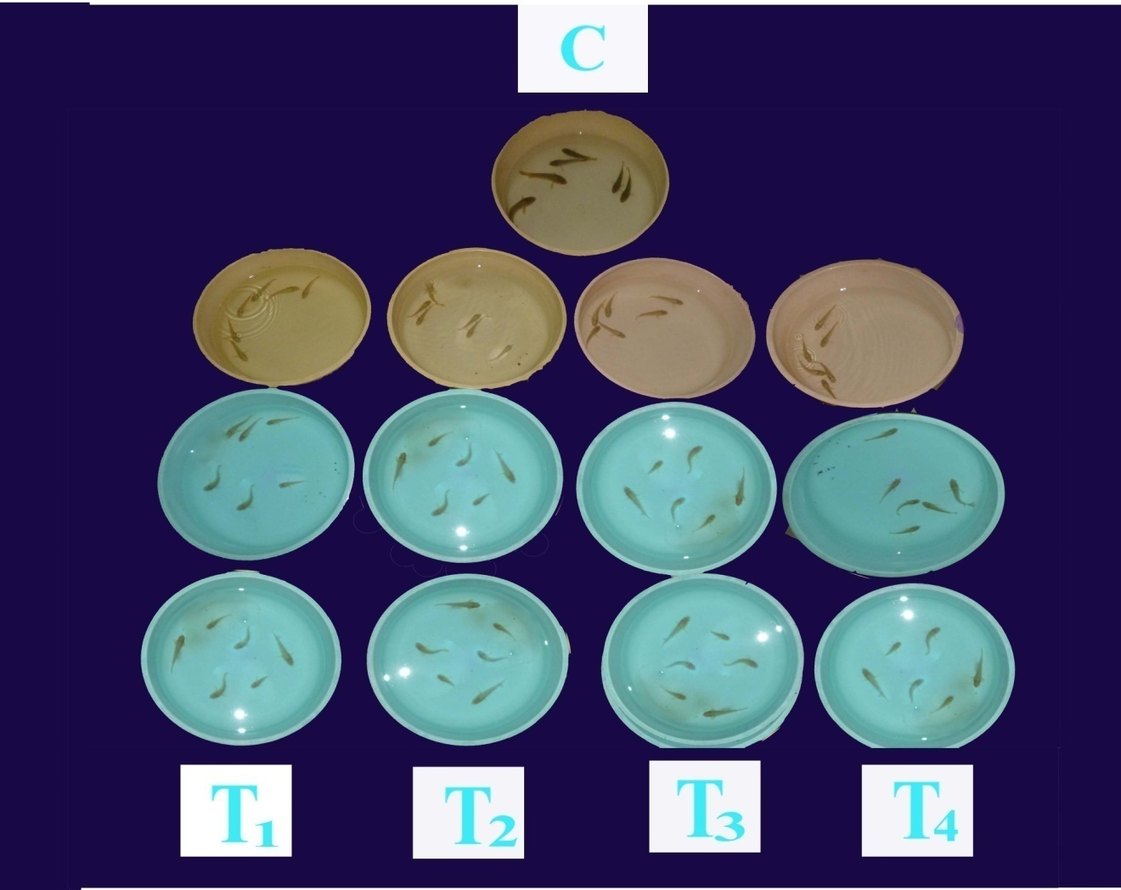
Figure. 4. Experimental set up shows fresh water fish Oreochromis mossambicus in control and four different treatments

IV. RESULTS AND DISCUSSION
The results of present investigation on the “Effects of garlic and onion incorporated feed on the growth, nutritional status and enzymes on the fresh water fish Tilapia, Oreochromis mossambicus” are presented below.
A. Growth performances
- Weight gain
Weight gain (%) in Oreochromis mossambicus during different days of the experiment in the control and four different treatments are present in Table 1 and figure 5
On the 15th day of the experiment the maximum weight gain was recorded in the fish grown in T2 (8.02%) followed by T3 (4.90%) T4 (4.43%) and T1 (3.80%). The minimum weight gain (1.3%) was recorded in the control fish fed with wheat flour and coconut oil cake in the ratio of 1:1. On the 30th day of the experiment, maximum weight gain (16.28%) was recorded in the fishes grown in T2 followed by T3 (15.87%), T4 (15.35%) and T1 (13.83%) and in the control minimum weight was recorded (0.81%)
On the 45th day of the experiment, the maximum weight gain was estimated in T2 (25.73%) followed by T1 (23.70%) T4 (23.13%) and T3 (16.30%). Lowest weight gain (20.0%) was noticed in the control fishes.
On the 60th day of the experiment, the weight gain was maximum in T2 (35.68%) followed by T3 (32.04%) T1 (31.87%) and T4 (30.88%) and minimum weight gain (31.40%) was recorded in the control.
During the experimental period (15, 30, 45, 60 days), four different treatments and the control showed the maximum weight gain in T2 fishes fed with wheat flour and coconut oil cake (90%) and garlic powder (10%). The growth indices showed significantly differences from those produced by the diet.
- Length gain
Length gain (%) in Oreochromis mossambicus during different days of the experiment in the control and four different treatments are present in Table 2 and figure 6.
On the 15th day of the experiment, the maximum length gain was recorded in T1 (10.11%) followed by T2 (7.93%), T3 (7.27%) and T4 (4.73%). Minimum length was recorded in the control fishes (2.53%). On the 30th day of the experiment, the maximum length gain was recorded in T2 (17.58%) followed by T1 (17.10%), T4 (14.30%) and T3 (7.27%). Minimum length gain was recorded in the control fishes (9.00%).
On the 45th day of the experiment, the maximum length gain was recorded in T1 (29.14%) followed by T2 (25.68%), T3 (14.40%) and T4 (17.66%). Minimum length gain was recorded in the control fishes (11.47%). On the 60th day of the experiment, the maximum length gain was observed in T2 (42.22%) followed by T1 (37.13%), T4 (17.66%) and T3 (16.63%). Minimum length gain was noticed in the Oreochromis mossambicus grown in the control (15.25%).
During the experimental period, in four different treatments and in the control, the maximum length gain was estimated in T2 fishes fed with 45% wheat flour and 45% coconut oil cake with garlic powder 10%. On 30th, 45th, and 60th day and minimum length was recorded in the control fishes. On 15th day, the maximum length gain was recorded in T1 fishes fed with wheat flour 47.5% and coconut oil cake 47.5% with 5% garlic powder.
The present finding was supported by Metwally (2009) who studied the effects of garlic on some antioxidant activities in Nile Tilapia. Fishes were fed on diets containing different form of garlic: natural garlic, garlic oil capsules (strongus) and garlic powder tablets. At the end of the experimental period a significant increase had been observed in growth performances and weight gain and also a significant decrease of the mortality rates. The final weight gain increased significantly in all treated groups Allium sativum.
The present investigation showed the highest growth performance in fish fed on garlic containing diets. The highest growth performance in Oreochromis niloticus with 2.5% garlic/Kg diet was also reported by Diab et al., (2002) which supports the present study in Oreochromis mossambicus. The higher values obtained in the garlic treated groups may be due to the presence of growth stimulants or constituents in garlic (organo sulfur compounds).
The growth performance in the fishes fed with garlic incorporated feed showed minimum growth rate than the Oreochromis mossambicus fed with onion incorporated diet, may be due to onion containing growth stimulants or constituents (flavonoids and thiosulfinates) as reported by Shalaby et al. (2006) whose studies also showed highest growth performance with the combination of onion with 30g garlic/ Kg. These properties could contribute to improving the digestion and nutrient absorption with a subsequent increase in the fish- weight.
The presence of vitamins such as vitamin C in onion bulb hypothetical possibility of the growth factor or antioxidant property that enhance growth in the treated groups compared to the control.
El-Ebiary (2003) found that 3g dry garlic/Kg diet is recommended as growth promoters for mono-sex Nile Tilapia. Zeid (2002) and Aly et al.(2008) and Saidy and Gaber (1997) supported the present findings were reported increased growth performance in Nile Tilapia fed with garlic incorporated feed which coincide with the present findings. The growth promoting effect of garlic may be due to the increase of glucose inflow into tissues and its thyroid like activity (Nawawy, 1991).
Afify (1997) also reported that the sulfur compounds in the garlic are considered as active antimicrobial agents and improve immunity and therefore stimulate growth. The improvements may be due to its many beneficial health properties of garlic are attributed to organosulfur compounds, particularly to thiosufinates (Block, 1992)
Soltan and Laithy (2008) are in agreement with the results of the present study. They reported that incorporation of garlic into Nile Tilapia diets containing 1% level improved survival rate and improved significantly final weight, final body length and weight gain. The improvements due to garlic may be due to its antimicrobial, antioxidant and anti-hypersensitive properties (Konjufca et al., 1997).
The survival rate at the end of the experiment was significantly greater in all garlic supplemented groups when compared with control group and onion incorporated diet.
The result of the present investigation suggests that the increasing growth may be due to the garlic contains a variety of organosulfur compounds such as allicin, ajoene, S-allycysteine, diallyldisulfide, and S-methylcysteinesulfoxide. These result were in close congruence with the studies carried out by Chi et al. (1982).
The present findings were also supported by Khalil et al., (2001) who reported that garlic contains allicin, which promotes the performance of the intestinal flora, thereby improving digestion and enhancing the utilization of energy, leading to improved growth.
B. Estimation of biochemical composition (Protein, Carbohydrate and Fat) in control and four different feeds are presented.
The Protein, Carbohydrate and Fat in control and four different feeds are shown in Table 3 and figure 7.
1. Protein
The Protein content was maximum in T2 feed (38%) followed by T1 (37%) T3 (34%) and T4 (32%). Minimum protein content was noticed in control feed (30%) prepared from 100% wheat flour and coconut oil cake.
The protein content was high in T2 feeds when compared to other feeds and control.
2. Carbohydrate
Carbohydrate content was maximum in T2feed (12%), followed by T1 (10%) T3 (18%) and T4 (6%) and the minimum Carbohydrate content was recorded in control feed (4%).

3. Fat
Fat content was maximum in T2 (17%) followed by T1 (15%) T3 (14%) and T4 (13%). Minimum protein content was noticed in control feed (8%).
C. Estimation of biochemical composition water content, protein, carbohydrate, and fat content in Oreochromis mossambicus are presented below.
1. Water content
Water content in the muscle tissue of Oreochromis mossambicus in the control and four different treatments are presented in Table 4 Figure 8.
Water content in the muscle tissue of Oreochromis mossambicus during 15days, maximum in T1 (70.20%), followed by T2 (70.17%) T3 (70.13%) and T4 (66.10%). Lowest value (60%) was recorded in control fishes. During 30days, maximum water content was observed in T2 (71.80%) followed by T1 (71.70%), T3 (71.27%) and T4 (66.27%) and minimum value was observed in control fishes (61.20%)
During 45days maximum value was observed in T2 (73.07%) followed by T1 (71.50%), T3 (71.50%) and T4 (66.50%) and minimum value was observed in control fishes (62.30%). During 60 days, maximum value was observed in T2 (74.07%) followed by T1 (71.27%), T3 (71.60%) and T4 (66.80%) and minimum value (64.00%) as observed in control fishes.
The water content in the muscle tissue of Oreochromis mossambicus in the four different treatments was estimated. The maximum value (74.07) was observed in T2 during the experimental period and minimum value (60.00) was observed in the control treatment.
Water content increases in relation to the body weight which agree with the increased levels of water content in Oreochromis niloticus by Kumar et al. (1994)reported that the nutrient level increase in relation to the body weight. The increased water content was due to the presents of garlic 10% concentration.
2. Protein
Protein content in the muscle tissue of Oreochromis mossambicus in the control and four different treatments are presented in Table 5 and Figure 9.
Protein content in the muscle tissue of Oreochromis mossambicus during 15days, maximum in T2 (18.10%)), followed by T1 (17.87%) T4 (18.10%) and T3 (17.10%) and the in control fishes (16.27%).
During 30 days, maximum protein content was observed in T2 (18.40%) followed by T1 (18.30%), T4 (17.70%) and T3 (17.33%) and minimum value was observed in control fishes (16.90%)
During 45 days maximum value was observed in T2 (18.87%) followed by T1 (18.57%), T4 (18.00%) and T3 (17.50%) and minimum value was observed in control fishes (17.02%).
During 60 days maximum value was observed in T2 (19.57%) followed by T1 (18.77 %), T4 (18.20 %) and T3 (17.80%) and minimum value was observed in control fishes (17.30%).
Protein content in the muscle tissue of Oreochromis mossambicus among the four different treatments the maximum value was observed in T2 during 15, 30, 45, 60 days and the minimum value was observed in the control treatment.
In this study, the results showed that the increased protein content may be due to the presence of organosulfur compounds. Similar results of Salaby (2002) who reported that onion and garlic dietary administration for Clarias lazera caused a rise in liver free amino acids, meanwhile, the garlic fed fish presented a rise in muscle free amino acid levels and according to enhance muscle uptake of free amino acids may enhance protein synthesis.
The results of the present study coincide with the findings of Goddard and Mclean (2001) and Khatlab (2001) reported that apparent protein digestibility was improved with increasing levels of garlic in fish diet.
The present study are also in agreement with the investigation of Mbahinzireki et al.(2001) and Soltan (2005) reported that fish fed with garlic and onion mixture recorded the highest feed intake, protein efficiency ratio, protein productive value.
Fish and animals need a constant source of amino acids for tissue protein synthesis and for synthesis of other compounds associated with metabolism, including hormones, neurotransmitters, purines and metabolic enzymes (Harlver and Hardy, 2002). Fish body proteins cannot be stored in major quantities and are continuously renewed through degradation and synthesis, free amino acids pool changes in its composition (profile) and concentrations, depending on the tissue frequency and time after feeding and temperature and food.
Sullivan (2008) studied the effect of different replacement levels of fish meal (FM) by soybean meal (SBM) using garlic (Allium sativum) and onion (Allium cepa) as feed additives of Nile Tilapia (Oreochromis niloticus) fingerlings. The result showed that fish fed 50% FM and 50% SBM diet grow better than the other groups (different concentration). He reported that lycine as a limiting amino acid for growth and its role as a necessary building block for all protein in the body and also plays a major role in calcium absorption and building muscle protein.
The present findings were supported by Nya (2009) who used garlic to control anAeromonas hydrophila infection in rainbow trout (Oreochromis mykiss). At an inclusion level of 0.5 and 1.0mg/g feed a 4% reduction in mortality was observed compared to the control group also there was a significant increase in protein efficiency.
The higher body protein deposition and increased weight gain is an indicative of the adequacy of the protein content and higher protein intake. This result agree with the findings of Fagbenro et al.(1992) who reported that higher body deposition and weight gain 40% crude protein for Heterobranchus bidosalis fingerlings fed compound diets. In this connection, Afify (1997) reported that sulfur containing compounds in garlic are considered as active antimicrobial agents and therefore stimulate growth and improve nutrient utilization..
3. Carbohydrate
Carbohydrate content in the muscle tissue of Oreochromis mossambicus in the control and four different treatments are presented in Table 6 and Figure 10.
The Carbohydrate content in the muscle tissue of Oreochromis mossambicus after 15days treatment, the maximum value was observed in T2 (12.03%)), followed by T1 (11.20%) T4 (10.60%) and T3 (10.17%) and the minimum value (9.30%) was observed in control fishes. After 30 days of the experimental period, maximum carbohydrate content was observed in T2 (12.07%) followed by T1 (11.40%), T4 (10.83%) and T3 (10.37%) and minimum value (9.30%) was observed in control fishes.
After 45 days maximum value was observed in T2 (12.84%) followed by T1 (12.07%), T4 (11.00%) and T3 (10.67%) and minimum value (9.80%) was observed in control fishes. After 60 days of the experimental period Oreochromis mossambicus showed maximum value in T2 (13.20%) followed by T1 (12.40%), T4 (11.20%) and T3 (10.87%) and minimum value (10.10%) was observed in control fishes.
The Carbohydrate contents in the muscle tissue of Oreochromis mossambicus among the four different treatments the maximum value was observed in T2 during 15, 30, 45 and 60 days and the minimum value was observed in the control fishes.
The present findings were also in agreement with the findings of Xiaojie et al. (2003) where L-ascarbyl-2-glucose and L-as-carbyl-2-monophosphate-Na/Ca source Vitamin C showed highest weight gain and feed efficiency ratio when diet contain 200mg ascorbic acid (AA) Kg-1 diet in the form of L-ascarbyl-2-glucose and L-as-carbyl-2-monophosphate-Na/Ca for 12 weeks supported by the present study.
Carbohydrates are utilized by the cells mainly in the form of glucose. A major part of dietary glucose is converted into glycogen for storage. These results suggest that both onion and garlic enhanced the process of glycogenesis in white muscle of fish. Such finding may be due to the rise in white muscle uptake of glucose in Clarias lazera fed onion or garlic juice. These digest probably increased insulin release. This concept is in agreement with the elevation in insulin level in garlic fed rate as reported by Chang and Johnson in (1980).
4. Fat
Fat content in the muscle tissue of Oreochromis mossambicus in the control and four different treatments are presented in Table 7 and Figure 11.
The Fat content in the muscle tissue of Oreochromis mossambicus during 15days of the experiment, the maximum value was observed in T2 (1.30%), followed by T1 (1.23%), T3 (1.10%) and T4 (1.03%) and the minimum value was observed in control fishes (1.10%). During 30 days experiment, maximum fat content was observed in T2 (1.87%) followed by T1 (1.50%), T3 (1.27%) and T4 (1.23%) and minimum value was observed in control fishes (1.28%)
During 45 days maximum value was observed in T2 (2.10%) followed by T1 (1.90%), T3 (1.50%) and T4 (1.50%) and in control fishes (1.50%). The fishes in the experimental set up after 60 days showed maximum fat in T2 (2.50%) followed by T1 (2.10%), T3 (1.70%) and T4 (1.60%) and in control fishes (1.70%).
The Fat content in the muscle tissues of Oreochromis mossambicus among the four different treatments the maximum value was observed in T2 during 15, 30, 45 and 60 days and the minimum value was observed in the control fishes.
The present finding were supported by Salahy (2002) who reported that the garlic increased the level of total lipids in the liver, 5hours and 5 days (Repeated doses) after treatment, inspite of unchanged levels of triglycerides and cholesterol or in the liver total lipids and triglycerides in the serum. Such results may be due to an increased accumulation of free fatty acids in liver in Clarias lazera treated with garlic daily for 5 days. On the contrary, onion treatment significantly decreased the liver total lipid when compared to garlic fed fishes.
The higher lipid content was observed in the muscles of fish fed with garlic incorporated feed (10%). The fish fed on garlic diet showed significantly (P<0.05 ) higher lipid contents in their muscles as compared to fish fed with all other diets ( 5% garlic and onion, 10% onion).
Similar studies of Amrita et al., (2008) reported that triglycerides in blood serum was significantly increased in fish groups fed on Cu or Zn ( copper or zinc) supplemented diets compared to control or garlic treated groups (Allium sativum). The rise in serum triglycerides is possibly due to hypo activity of lipo protein lipase in blood vessels which breaks up triglycerides.
The results of the present study falls in accordance with the findings of Liu et al.(1997) Who reported that the rise in serum lipid profile may also be attributed to increased nor epinephrine release which act through interferons with the intracellular functions of Ca+2 in the cytoplasm.
D. Enzyme Analysis
Digestive enzymes in three different regions of Oreochromis mossambicus are presented in Table 8.
Enzyme plays an important role in digestive process. The Enzymes like Amylase, Maltase and Invertase were found in foregut, midgut and hindgut region and the Enzyme Protease was found only in the midgut region of Oreochromis mossambicus.
1. Amylase
The absence of the enzyme amylase was confirmed by the colour change (blue) in the control samples, which indicated the presence of starch. Whereas, there was no significant colour change in the experimental samples which pointed out the presence of amylase, which converted the starch into the hydrolyzed form.
In coherence to the results obtained from the experimental samples of the present study, the incidence of starch was confirmed by its degradation which is the characteristic feature of the enzyme Amylase. Charles (1932) reported that among the various criteria been used for the progress of starch degradation, the production of reducing sugar can be most accurately measured in the presence of amylase
2. Maltase
The presence of maltase in the experimental samples was confirmed by the development of brown colour, which indicated that maltose was converted into glucose by the enzyme maltase. Whereas, in the control; no significant colour change was observed which pointed out the absence in it.
Consumption of different sources of carbohydrates in the chosen plant products such as (Allium sativum and Allium cepa) processed by various feed formulations perhaps modified the carbohydrate digestion, absorption and uptake of monosaccharides (glucose) in plasma of Tilapia. This may help the fish to modulate the plasma glucose concentrations and, thus, improve carbohydrate utilization.
3. Invertase
The presence of invertase in the experimental sample was confirmed by the appearance of yellow precipitate in the experimental samples. Whereas, there was no significant colour change in the control samples.
Invertase is other disaccharide that works to catalyzes tile hydrolysis of sucrose to glucose and fructose. Supplemental invertase can increase the assimilation and utilization of this sugar and allowing greater absorption of this energy-giving sugar.
4. Protease
i.Conjugation Test:
The presence of protease in the experimental sample was confirmed by the no clot of enzyme. Whereas, in the control tube clotting of enzyme was noticed, it showed the absence of enzyme protease.
ii.Biurette Test:
The presence of protease in the experimental sample was confirmed by the nonappearance of violet colour, it showed the absence of enzyme protease. But in the control tube violet colour was appeared, it showed the absence of enzyme protease.
Proteases, also known as proteinases or proteolytic enzymes, are a large group of enzymes which catalyze the reaction of hydrolysis of various bonds with the participation of a water molecule.
The results of the present study clearly stated that the supplementation of garlic 10% with wheat flour 45% coconut oil cake 45% increased the growth performance, nutrient utilization and enzyme activities. Therefore, in Aquaculture field Garlic and Onion plays an important role for their development.

TABLE – 1
WEIGHT GAIN IN OREOCHROMIS MOSSAMBICUS DURING DIFFERENT DAYS OF THE EXPERIMENT IN THE CONTROL AND FOUR DIFFERENT TREATMENTS
TREATMENTS | NO OF DAYS DURING EXPERIMENT
TREATMENTS | 15 | 30 | 45 |  |  | 60
CONTROL  T1  T2  T3  T4 | 1.67±0.25  3.80±1.12  8.02±0.59  4.90±1.30  4.43±2.04 | 9.07±1.10  13.83±1.88  16.28±0.39  15.87±2.06  15.35±1.09 |  | 20.0±1.47  23.70±3.23  25.73±2.57  16.30±2.52  23.13±1.54 | 31.40±0.96  31.87±2.89  35.68±0.93  32.04±2.12  30.88±1.43
SEd | 1.5602
CD ( P<0.05) | 2.9321

Values are mean ± SD of three samples in each group
C -Wheat Flour and Coconut Oil Cake 100 per cent (control)
T1 -Wheat Flour 47.5 per cent and Coconut Oil Cake 47.5 per cent with 5 per cent Garlic Powder
T2 -Wheat Flour 45 per cent and Coconut Oil Cake 45 per cent with 10 per cent Garlic Powder
T3 -Wheat Flour 47.5 per cent and Coconut Oil Cake 47.5 per cent with 5 per cent Onion Powder
T4 -Wheat Flour 45 per cent and Coconut Oil Cake 45 per cent with 10 per cent Onion Powder
TABLE – 2
LENGTH GAIN IN OREOCHROMIS MOSSAMBICUS DURING DIFFERENT DAYS OF THE EXPERIMENT IN THE CONTROL AND FOUR DIFFERENT TREATMENTS
TREATMENTS | NO OF DAYS DURING EXPERIMENT
TREATMENTS | 15 | 30 | 45 |  |  | 60
CONTROL  T1  T2  T3  T4 | 2.53±0.21  10.11±2.67  7.93±0.76  7.27±1.32  4.73±0.86 | 9.00±0.95  17.10±2.50  17.58±0.75  13.73±1.25  14.39±0.98 |  | 11.47±1.20  29.14±2.16  25.68±1.97  14.40±3.45  15.25±1.02 | 15.25±1.36  37.13±0.02  42.22±1.36  16.63±1.42  17.66±1.84
SEd | 2.09878
CD ( P<0.05) | 4.24187

Values are mean ± SD of three samples in each group
C -Wheat Flour and Coconut Oil Cake 100 per cent (control)
T1 -Wheat Flour 47.5 per cent and Coconut Oil Cake 47.5 per cent with 5 per cent Garlic Powder
T2 -Wheat Flour 45 per cent and Coconut Oil Cake 45 per cent with 10 per cent Garlic Powder
T3 -Wheat Flour 47.5 per cent and Coconut Oil Cake 47.5 per cent with 5 per cent Onion Powder
T4 -Wheat Flour 45 per cent and Coconut Oil Cake 45 per cent with 10 per cent Onion Powder
TABLE - 3
PROTEIN, CARBOHYDRATE AND FAT CONTENT (%) IN THE CONTROL AND FOUR DIFFERENT FEEDS

FEED | PROTEIN | CARBOHYDRATE | FAT
CONTROL  T1  T2  T3  T4 | 30  37  38  34  32 | 4  10  12  8  6 | 8  15  17  14  13

C -Wheat Flour and Coconut Oil Cake 100 per cent (control)
T1 -Wheat Flour 47.5 per cent and Coconut Oil Cake 47.5 per cent with 5 per cent Garlic Powder
T2 -Wheat Flour 45 per cent and Coconut Oil Cake 45 per cent with 10 per cent Garlic Powder
T3 -Wheat Flour 47.5 per cent and Coconut Oil Cake 47.5 per cent with 5 per cent Onion Powder
T4 -Wheat Flour 45 per cent and Coconut Oil Cake 45 per cent with 10 per cent Onion Powder
TABLE – 4
WATER CONTENT IN THE MUSCLE TISSUE OF OREOCHROMIS MOSSAMBICUS DURING DIFFERENT DAYS OF THE EXPERIMENT IN THE CONTROL AND FOUR DIFFERENT TREATMENTS
TREATMENTS | NO OF DAYS DURING EXPERIMENT
TREATMENTS | 15 | 30 | 45 |  |  | 60
CONTROL  T1  T2  T3  T4 | 60.00±2.00  70.20±0.20  70.17±0.35  70.13±0.15  66.10±0.20 | 61.20±2.00  71.70±0.20  71.80±0.20  71.27±0.25  66.27±0.25 |  | 62.30±2.00  71.50±1.22  73.07±0.95  71.50±0.20  66.50±0.30 | 64.00±2.00  72.27±0.02  74.07±1.01  71.60±0.20  66.80±0.20
SEd | 0.83193
CD ( P<0.05) | 1.68143

Values are mean ± SD of three samples in each group
C -Wheat Flour and Coconut Oil Cake 100 per cent (control)
T1 -Wheat Flour 47.5 per cent and Coconut Oil Cake 47.5 per cent with 5 per cent Garlic Powder
T2 -Wheat Flour 45 per cent and Coconut Oil Cake 45 per cent with 10 per cent Garlic Powder
T3 -Wheat Flour 47.5 per cent and Coconut Oil Cake 47.5 per cent with 5 per cent Onion Powder
T4 -Wheat Flour 45 per cent and Coconut Oil Cake 45 per cent with 10 per cent Onion Powder
TABLE – 5
PROTEIN IN THE MUSCLE TISSUE OF OREOCHROMIS MOSSAMBICUS DURING DIFFERENT DAYS OF THE EXPERIMENT IN THE CONTROL AND FOUR DIFFERENT TREATMENTS
TREATMENTS | NO OF DAYS DURING EXPERIMENT
TREATMENTS | 15 | 30 | 45 |  |  | 60
CONTROL  T1  T2  T3  T4 | 16.27±0.15  17.87±0.25  18.10±0.10  17.10±2.10  17.50±0.20 | 16.90±0.20  18.30±0.20  18.40±0.20  17.35±1.46  17.70±0.20 |  | 17.20±1.65  18.57±0.15  18.87±0.15  17.50±0.20  18.00±0.10 | 17.30±1.80  18.77±0.15  19.57±0.25  17.80±0.20  18.20±0.20
SEd | 0.66020
CD ( P<0.05) | 1.33434

Values are mean ± SD of three samples in each group
C -Wheat Flour and Coconut Oil Cake 100 per cent (control)
T1 -Wheat Flour 47.5 per cent and Coconut Oil Cake 47.5 per cent with 5 per cent Garlic Powder
T2 -Wheat Flour 45 per cent and Coconut Oil Cake 45 per cent with 10 per cent Garlic Powder
T3 -Wheat Flour 47.5 per cent and Coconut Oil Cake 47.5 per cent with 5 per cent Onion Powder
T4 -Wheat Flour 45 per cent and Coconut Oil Cake 45 per cent with 10 per cent Onion Powder
TABLE – 6
CARBOHYDRATE CONTENT IN THE MUSCLE TISSUE OF OREOCHROMIS MOSSAMBICUS DURING DIFFERENT DAYS OF THE EXPERIMENT IN THE CONTROL AND FOUR DIFFERENT TREATMENTS
TREATMENTS | NO OF DAYS DURING EXPERIMENT
TREATMENTS | 15 | 30 | 45 |  |  | 60
CONTROL  T1  T2  T3  T4 | 9.00±0.50  11.20±0.20  12.03±0.15  10.17±0.25  10.60±0.20 | 9.30±0.30  11.40±0.20  12.47±0.25  10.37±0.25  10.83±0.25 |  | 9.80±0.10  12.07±0.21  12.84±0.21  10.67±0.25  11.00±0.30 | 10.10±0.20  12.40±0.20  13.20±0.30  10.87±0.15  11.20±0.20
SEd | 0.20180
CD ( P<0.05) | 1.68143

Values are mean ± SD of three samples in each group
C -Wheat Flour and Coconut Oil Cake 100 per cent (control)
T1 -Wheat Flour 47.5 per cent and Coconut Oil Cake 47.5 per cent with 5 per cent Garlic Powder
T2 -Wheat Flour 45 per cent and Coconut Oil Cake 45 per cent with 10 per cent Garlic Powder
T3 -Wheat Flour 47.5 per cent and Coconut Oil Cake 47.5 per cent with 5 per cent Onion Powder
T4 -Wheat Flour 45 per cent and Coconut Oil Cake 45 per cent with 10 per cent Onion Powder
TABLE – 7
FAT CONTENT IN THE MUSCLE TISSUE OFOREOCHROMIS MOSSAMBICUS DURING DIFFERENT DAYS OF THE EXPERIMENT IN THE CONTROL AND FOUR DIFFERENT TREATMENTS
TREATMENTS | NO OF DAYS DURING EXPERIMENT
TREATMENTS | 15 | 30 | 45 |  |  | 60
CONTROL  T1  T2  T3  T4 | 1.10±0.65  1.23±0.15  1.30±0.20  1.10±0.20  1.03±0.25 | 1.28±0.82  1.50±0.20  1.87±0.31  1.27±0.25  1.23±0.25 |  | 1.50±0.59  1.90±0.20  2.10±0.20  1.50±0.20  1.50±0.20 | 1.70±0.64  2.10±0.20  2.50±0.20  1.70±0.20  1.60±0.20
SEd | 0.29391
CD ( P<0.05) | 0.59403

Values are mean ± SD of three samples in each group
C -Wheat Flour and Coconut Oil Cake 100 per cent (control)
T1 -Wheat Flour 47.5 per cent and Coconut Oil Cake 47.5 per cent with 5 per cent Garlic Powder
T2 -Wheat Flour 45 per cent and Coconut Oil Cake 45 per cent with 10 per cent Garlic Powder
T3 -Wheat Flour 47.5 per cent and Coconut Oil Cake 47.5 per cent with 5 per cent Onion Powder
T4 -Wheat Flour 45 per cent and Coconut Oil Cake 45 per cent with 10 per cent Onion Powder
TABLE – 8
DIGESTIVE ENZYMES IN THREE DIFFERENT REGIONS OF
OREOCHROMIS MOSSAMBICUSDURING THE EXPERIMENTAL PERIOD

ENZYMES | FOREGUT | MIDGUT | HINDGUT
AMYLASE  MALTASE  INVERTASE  PROTEASE | +  +  +  - | +  +  +  + | +  +  +  -

FIGURE 5
WEIGHT GAIN IN OREOCHROMIS MOSSAMBICUS DURING DIFFERENT DAYS OF THE EXPERIMENT IN THE CONTROL AND FOUR DIFFERENT TREATMENTS

FIGURE 6
LENGTH GAIN IN OREOCHROMIS MOSSAMBICUS DURING DIFFERENT DAYS OF THE EXPERIMENT IN THE CONTROL AND FOUR DIFFERENT TREATMENTS

FIGURE 7
PROTEIN, CARBOHYDRATE, AND FAT CONTENT ( %) IN THE CONTROL AND FOUR DIFFERENT FEEDS

FIGURE 8
WATER CONTENT IN THE MUSCLE TISSUE OF OREOCHROMIS MOSSAMBICUS DURING DIFFERENT DAYS OF THE EXPERIMENT IN THE CONTROL AND FOUR DIFFERENT TREATMENTS

FIGURE 9
PROTEIN IN THE MUSCLE TISSUE OF OREOCHROMIS MOSSAMBICUS DURING DIFFERENT DAYS OF THE EXPERIMENT IN THE CONTROL AND FOUR DIFFERENT TREATMENTS

FIGURE 10
CARBOHYDRATE CONTENT IN THE MUSCLE TISSUE OF OREOCHROMIS MOSSAMBICUS DURING DIFFERENT DAYS OF THE EXPERIMENT IN THE CONTROL AND FOUR DIFFERENT TREATMENTS

FIGURE 11
FAT IN THE MUSCLE TISSUE OF OREOCHROMIS MOSSAMBICUS DURING DIFFERENT DAYS OF THE EXPERIMENT IN THE CONTROL AND FOUR DIFFERENT TREATMENTS

V. SUMMARY AND CONCLUSION
The effect of garlic and onion incorporated feed on the growth, nutritional status and enzymes on Oreochromis mossambicus has been studied. In the present investigation fishes were fed with different concentration of garlic and onion mixed feed for 60 days and the results were recorded for 15, 30, 45 and 60 days.
The bio-growth parameters such as weight gain (%) and length gain (%) in Oreochromis mossambicus for 15, 30, 45 and 60 days were studied. The biochemical composition includes water content, protein, carbohydrate and fat content in the control and four different treatments. Biochemical composition includes protein, carbohydrate and fat content in the control and four different feeds.
The detail of the study is summarized below
- Garlic and onion mixed feed improved the growth performance, feed utilization and bio chemical content in the Oreochromis mossambicus.
- On 15th, 30th, 45th and 60th day of the experiment the weight gain was maximum in T2 fishes (8.02%) fed with wheat flour (45%) and coconut oil cake (45%) and garlic powder (10%). Minimum weight gain was recorded in the control (0.81 per cent) fishes.
- The length gain (%) in Oreochromis mossambicus, was maximum in T1 fishes during 15th day (10.11%), 45thday (29.14%) fed with (47.5%) wheat flour and (47.5%) coconut oil cake with (5%) garlic powder, 30thday (17.58 %), 60thday (42.22 %) of the experiment followed by fishes grown in T2. The minimum length gain was recorded in the control (15.25 %) fishes.
- Among all the treatments maximum weight gain (35.68%) and length gain (42.22%) was observed in fishes grown in T2 treatments.
- Maximum protein content (38%), carbohydrate content (12%) and fat content (17%) was found in T2 feed and minimum protein (30%), carbohydrate (4%) and fat (8%) were recorded in the control feed.
- On 15th day of the experimental period the water content increased gradually in T2 fed fishes (70.20% to 72.27%). On 30th, 45th and 60thday of the experiment the maximum water content was recorded in T2 (71.80% to 74.07%) followed by T3 (71.27% to 71.60%) and T4 (66.27% to 66.80%). Minimum water content was recorded in the control fed fishes (60.00% to 64.00%). During the experimental period water content showed maximum increase (74.07%) in T2 fed fishes.
- On 15th,30th,45th and 60thday of the experiment, maximum protein content was found in T2 fed fishes (18.10% to 18.77%) followed by T1 (17.87% to 18.77%), T4 (17.50% to 18.20%) and T3 (17.10% to 17.80%). Minimum protein content was observed in the control fishes (16.27% to 17.30%). During the experimental period the maximum protein content (19.57%) was recorded in T2 fed fishes.
- On 15th, 30th, 45th and 60th day of the experiment, maximum carbohydrate content was in T2 (12.03% to 13.20%) followed by T1 (11.20% to 12.40%), T4 (10.60% to11.20%), T3 (10.17%to 10.87%). Minimum carbohydrate content was recorded in control fed fishes (9.00% to 10.10%).
- During 15, 30, 45 and 60 days of the experiment, maximum fat content was recorded in T2 fed fish (1.30% to 2.50%) followed by T1 (1.23% to 2.10%), T3 (1.10% to 1.70%), T4 (1.30% to 1.60%) and minimum fat content was in the control fed fishes (1.10% to 1.70%).
- The enzymes like amylase, maltase, invertase and protease were observed in foregut, midgut and hindgut region and the enzyme protease was found only in midgut region.
- The results were subjected to two-way ANOVA to show the significant value of biogrowth parameter, biochemical composition in Oreochromis mossambicus grown in T2 fed diet.
In conclusion of the present study, it was observed that, 10% supplementation of garlic (Allium sativum) had significantly improved the growth rate in terms of weight and length gain. Furthermore the supplementation of garlic (Allium sativam) and onion (Allium cepa) also increased the biochemical composition and the enzyme activities which facilitated digestion process. In coherence to the above obtained results, supplemented nutrients from garlic (Allium sativum) and onion (Allium cepa) provided sustainable growth for the fish Oreochromis mossambicus. Moreover, the study provided a new dimension for using medicinal plants as supplementation to fish food to improve the growth as well as nutrients utilization.
Finally it was proved that the garlic and onion as feed additives represent alternatives solutions in aquaculture feed as growth promoters. More clearly,it showed the significant increase in growth performance, feed utilization and biochemical composition.

BIBLIOGRAPHY
Abd- El- Hamid, A.M., Khalil, F.F., El-Barbery, M.I.,Zaki, V.H and Husien, H.S. (2002), Feeding Nile tilapia on biogen to detoxify aflatoxin diet. In annual scientific conference of animal and fish production. 1.Proceedings Mansoura University, pp:207-230.
Abdel- Warith, A.A. (2008), Effect of dietary protein levels on growth performance, feed utilization and body composition of monosex Nile Tilapia (Oreochromis niloticus) fingerlings. J.Agric.Sci.Mansoura University, 33:8011-8023.
Abo-Esa,J F. K (2008), Study on Some Ectoparasitic Diseases of Catfish, Clarias gariepinus with their Control by Ginger, Zingiber officiale J F. Mediterranean Aquaculture Journal 1(1); 1-10.
Abou-Zeid, S.M. (2002), The effect of some medicinal plant on reproductive and productive performance of Nile Tilapia fish. Cairo: Cairo University, facility of agriculture, 212p.
Al – Salahy, M.B. (2002), Some physiological studies on the effect of onion and garlic juices on the fish, Clarias lazera. Fish physiology and Biochemistry, 27:129-142.
AL- Asgah,N.A., Younis, E.M., Warith- A.A.A., EL-Khaldy, A.A. and Ali, A. (2011), Effect of feeding olive waste on growth performance and muscle composition of Nile tilapia (Oreochromis niloticus). International Journal of Agriculture and biology., 13: 239- 244
Al- Hafedh, Y.S. (2001), Effects of dietary protein on growth and body composition of Nile tilapia, Oreochromis niloticus (L.). Aquaculture Research, Vol. 30, PP. 385-393.
Al- Salahy,M. B. (2002), Some physiological studies on the effect of onion and garlic juices on the fish, Clarias lazera, Fish physiology and biochemistry, 27:129-142.
Alam, MD Shah., Teshima, Shin-Ichi., Ishikawa, Manabu., Koshio and Shunsuke. (2002), the effects of dietary arginine and lysine levels on growth performance and biochemical parameters of juvenile Japanese flounder Paratichthys olivaceus. Fisheries Science, Vol. 68 p509.
Al-Salahy,M.B and Mahmoud,A.A.B (2003), Metabolic and histological studies on the effect of garlic administration on the carnivorous fish Chrysichthys auratus. Egyptian Journal of Biology, Vol. 5, pp 94-107.
Aly, S.M. and Atti, N.M.A and Mohamed, M.F (2008), Effect of garlic on the survival, growth, resistance and quality of Oreochromis niloticus. International symposium on Tilapia in Aquaculture, 2 (1): 277-294.
Amrita,D.G., Das,S.N., Dhundasi,S.A. and Das,K.K. (2008), Effect of garlic (Allium.sativum) on heavy metal (Nickel II and Chromium III) induced alteration of serum lipid profile in male Albino Rats. Intl. J. Environ. Res.Public Health, 5:147-151.
Anholt., Van, R.D. (2004), Dietary fatty acids and the stress response of fish arachidonic acid in Seabream and tilapia. PhD thesis, Radboud University of Nijmegen, the Netherlands. ISBN 90-9018292-6, PP.168.
Bello,O.S., Olaifa, F.E. and Emikpe, B.O. (2012), The effect of walnut (Tetracarpidium conophorum) Leaf and Onion ( Allium cepa) bulb
residues on the growth performance and nutrient utilization of Clarias gariepinus Juviniles, Journal of Agricultural Science ; Vol. 4, No.12.
Benkeblia, N. (2004), Antimicrobial activity of essential oil extracts of various onions (Allium cepa) and garlic (Allium sativum). Lebensm.-Wiss. u.-Technol. 37, 263–268
Block, E. (1985). The chemistry of garlic and onions a number of curious sulphur compounds underline the adour of garlic and the crying brought on by slicing an onion. Sci. Am. 252 : 114- 119.
Chang, M.W. and Johnson,M. (1980), Effect of garlic on carbohydrate metabolism and lipid synthesis in rats. J.Nutr.110:931-936.
Charles Samuel.(1932), the effect of starch concentration upon the velocity of hydrolysis by the amylase of germinated barley. Studies on plant amylases. From the Botany School, Cambridge.
Chhay, Ty., Borin, K., Sopharith, N., Preston, T.R. and Aye, T.M. (2010). Eefect of sun dried and fresh cassava leaves on growth of Tilapia (Oreochromis niloticus) fish fed basal diets of rice bran mixed with cassava root meal. Live stock Research for Rural development 22(3).
Chi,M.S., Koh,E.T. and Steward,T.J.(1982), Effects of garlic on lipid metabolism in rats fed cholesterol or lard. J.Nutr.112:241-248.
Citarasu, T. (2010). Herbal biomedicines, a new opportunity for aquaculture industry, Aquaculture International, Volume 18, Issue 3, pp 403- 414.
Diab, A.S., Aly, S.M., John, G., Hadi, Y.A. and Mohammed, M.F. (2008), Effect of garlic, black seed and biogen as immunostimulants on the growth and survival of Nile tilapia, Oreochromis niloticus, and their response to artificial infection with Pseudomonas fluorescent. African Journal of Aquatic science. Pages 63-68.
Diab,A.S., El-Nagar,G.O. and Abd- El-hady, Y.M. (2002). Evaluation of Nigella sativa (L.) (black seeds ; baraka), Allium sativa (L.) ( garlic) and
biogen as feed additives on growth performance and immunostimulants of Oreochromis niloticus fingerlings. Suez canal vet, Med., 745-75.
Dragon,S., Gergen,I and Socaciu,C. (2008), Alimmentatia functional Cu components bio active natural in sindromal metabolic, Ed, Eurostampa, Timisoara, p.200-202,160-161,314.
El- Afifty, S.F. (1997). Nutritional studies on onion and garlic supplement to poultry feed. Ph.D. Thesis, Fac. Agric,Ain- Shams University.
El- Dakar,A.Y., Hassanien1,G.D., Gad,S.S and Sakr,S.E (2008), Use of Dried Basil Leaves as a Feeding Attractant for Hybrid Tilapia, Oreochromis niloticus X Oreochromis aureus, Fingerlings. Mediterranean Aquaculture Journal 1(1); 35- 44.
El- Sayed, A.M. (2006), Tilapia culture. CABI publishing, CABI International willingford, oxfordshine, UK.
El-Ebiary,E.H. and Zaki,M.A. (2003), Effect of supplementing active yeast to the diets on growth performance, nutrient utilization, whole body composition and Blood constituents of monosex Tilapia (Oreochromis niloticus). Egypt.J.Aquat.Biol. and Fish., 7(1):127-139.
El-Nawawy,H.(1991), some of non conventional ingredients in broiler ration .M.Sc. Thesis, Fac, of Agriculture Ain – Shams University.
El-Saidy,D.M and Gaber,M.M. (1997), Effect of different levels of dry garlic meal supplemented to the diets on growth performances, survival and body composition of nile tilapia Oreochromis niloticus fingerlings. Annuals of Agric.Sci., Moshtor,35 (3):1197-1209.
El-Sayed, M.M., Ezzat, A.A., Kandeel, K.M and Shaban, F.A (1984), Biochemical studies on the lipid content of Tilapia nilotica and Sparus auratus. Comp Biochem Physiol B. 79(4):589-94.
El-Sayed,M.M., Ezzat,A.A., Kandeel,K.M., and Shaban,F.A. (1984), Biochemical studies on the lipid content of Tilapia nilotica and Sparus auratus. Comp Biochem Physiol [B] 79, 589-94.
Fagbenro, O.A., Balogun, O.M. and Anyanwu, C.N. (1992), Optimal dietary protein level for Heterobranchus bidosalis fingerlings fed compound diets. The Israeli Journal of Aquaculture- Bamidgeh, 44(3), 87-92.
Fagbenro, O.A., Jegede, T. And Fasasi, O.S. (2010). Tilapia aquaculture in Nigeria. Applied Tropical Agriculture, 15: 49-55.
Fazlolahzadeh., Keramati, F., Nazifi, K., Shirian,S. and Seifi,S. (2011). Effect of garlic (Allium sativum) on hematoligical parameters and plasma activities of ALT and AST of rainbow trout in temperature stress, Australian Journal of Basic and Applied Sciences, 5 (9) : 84-90.
Florian,G.E., Şara,A., Molnar,F and Benţea,M. (2011), Animal Science and Biotechnologies, 44 (2).
Folch,J.M., Lees and Sanley, G.W.(1957). A simple method of isolation and purification of total lipids from animal tissues, J.Biol.Chem., 226:497-508.
Gabor,E.F., Oana Ichim and Mihai Şuteu (2012), Phyto-additives in rainbow trout (Oncorhynchus mykiss) nutrition. Biharean Biologist 6 (2): pp.134-139.
Gabor,E.F., Sara, A. and Barbu, A. (2010), The effects of some phytoadditives on growth, health and meat quality on different species of fish. Animal Science and Biotechnologies, 43 (1).
Goddard, J.S and Mclean, E. (2001), Acid insoluble ash as an inert reference material for digestibility studies in tilapia Oreochromis aureus, Aquaculture, 194, 93-98.
Goddard,S.J., Al-Shagaa,G. and Ali,A. (2008), Fisheries by catch and processing waste meals as ingredients in diets for Nile Tilapia, Oreochromis niloticus. Aquaculture. Res., 39:518-525.
Hakim, N.F.A., Lashin, M.M.E., Al- Azab, AL.A.A. and Nazmi, H.M. (2008). Effect of replacing soybean meal protein by other plant protein sources on growth performance and economical efficiency of Monosex Nile Tilapia (Oreochromis niloticus) cultured in tanks. International symposium on tilapia in Aquaculture.
Hakim, N.F.A., Lashin, M.M.E., Al-Azab, A.D.A.M. and Ashry,A.M., (2010). Effect of fresh or dried garlic as a natural feed supplement on growth performance and nutrient utilization of the Nile Tilapia (Oreochromis niloticus). Egypt J. Aquat. Biol and fish., Vol. 14, No. 2:19.
Hamid, A. M. and Soliman,A.A.A. (2012), Possibility of Using Dried Leaves of Guava and Camphor Trees in Tilapia Diets. Journal of the Arabian Aquaculture Society. Vol. 7 No 1.
Harikrishnan,R and Balasundaram,C (2011). Impact of plant products on innate and adaptive immune system of cultured finfish and shellfish. Aquaculture, Volume 317, Issues 1–4, 4,Pages 1–15.
Harlver,J.E. and Hardy,R.W. (2009),Fish nutrition,3rd edition. Academic press. San Diego, California, pp. 763-765.
Harris,J.C., Cottrell, S.L., Plummer, S. and Lloyd, D. (2001). Antimicrobial properties of Allium sativum (garlic). Applied microbiology and biotechnology, 57, 282-286.
Hedge, J.E. and Hofreiter, B. T. (1962), Determination of reducing sugars , methods in carbohydrate chemistry, M.L,Academic Press, Newyork,1:388-389.
Ibiyo., Lement and Madu. (2006), Effects of vitamin C supplementation on growth of Heterobranchus longifilis fingerlings. Archives of Animal Nutrition, 60(4):325-332.
Ibrahem, M.D., Fathi, M., Masalhy, S. and Abd El- Aty, A.M. (2010), Effect of dietary supplementation of insulin and vitamin C on the growth, haematology, innate immunity, and resistance of Nile tilapia (Oreochromis niloticus). Fish and shellfish immunology, 29, 241- 246.
Jegede,T. (2012). Effect of garlic (Allium sativum) on growth, nutrient utilization, resistance and survival of Tilapia zillii ( Gervais 1852) fingerlings. Journal of Agricultural Sciences., Vol. 4, No. 2.
Ji seung- cheol., Gwan – sik jeon., Gwang- soon, M., Si- woo Lee., Jin- Hyung yoo. And Kenji Takii. (2007). Dietary medicinal herbs improve growth performance, fatty acid utilization and stress recovery of Japanese founder. Fisheries science, 73: 70-76.
Johnny., O. Ogunji and Monfred Writh. (2000), Effect of dietary protein content on growth, food conversion and body composition of tilapia Oreochromis niloticus fingerlings fed fish meal diet. J. Aqua Trop 15 (4) 381-389.
Kasthuri, N.,Thangamani,R and Govindarajan, B. (2012). Immunomodulatory effect of Adhatoda vasica in Oreochromis mossambicus. J. B io s c i. Res.Vol. 3(2):90-99.
Khalil,R., Naida, B., and Sodium, M. M. (2000). Effects of biogen and Levamisol Hcl on the immune response of cultived on to Aeromonas hydrophila vaccine. Beni-Suif veterinary Medicine Journal Egypt XI, 2: 381-392.
Khattab,Y.A. (2001), Effect of substituting black seed cake (Nigella sativa L.) for soybean meal in diets of Nile Tilapia (Oreochromis niloticus L.) on growth performance and nutrient utilization. Egypt J. Aquat.Biol. and Fish., (5):31-46.
Kleijmen,J. (1989), Garlic, onions and cardiovascular risk factors. A review of the evidence from human experiments with emphasis on commercially available preparation. Br. J.Clin Pharmacol 28:535-544.
Konjufca, V.H.,Pesti, G.M.and Bakalli, R.I.(1997), Modulation of Cholesterol levels in broiler meat by dietary garlic and copper. Poultry Science, 76: 1264-1271.
Kumar,J.S.S. and Anantharaja, K. (2007). Herbal health in aquaculture- the Indian experience. Aquaculture 12- 16.
Kumar,M. (1994), Effect of two commercially available feed additives on growth and survival of cultivable Carbs, Ph.D. Thesis, University of Agricultural Sciences, Bangalore.
Lee, D.H., Lim, S.R., Ra, C.S and Kim, J.D. (2012). Effects of dietary garlic extracts on whole body amino acid and fatty acid composition, muscle free amino acid profiles and blood plasma changes in juvenile Sterlet sturgeon, Acipenser ruthenus. Asian- Aust. J. Anim. Sci. Vol. 25( 10):1419-1429.
Lee, S.M., Park, C.S. and Kim, D.S.C. (2001). Effects of dietary herbs on growth and body composition of Juvenile abalone, Haliotis discus Lannai, J. Korean Fish Soc., 34: 570-575.
Liao, I.C. (1998), The state of finish diversification in Asian Aquaculture. Pp.109-125.
Liu, P.S. and M.K, Lin.(1997), Biphasic effects of chromium compounds on catecholamine secretion from bovine adrenal medullary cells, Toxicology, 117:45-53.
Lowry,O.H., Resenbrough,N.J., Far,A.L. and Randall, R.J. (1957). Protein measurements with Folin-phenol reagent, J.Biol. Chem., 193: 265-267
Lukes, T.M. (1971). Thin layer chromatography of cysteine derivatives of onion flavour compounds and the lacrimatory factor. J. Ed.Sci. 36: 662- 664.
Mabrouk,H.A., Labib,M.H and Zaki, M.A. (2011), Response of Nile Tilapia (Oreochromis niloticus) fingerlings to different replacement levels of fish meal with soybean meal using Garlic and Onion. Garlic and onion on growth of Tilapia. Aquaculture, 199-208.
Mbahinzireki, G.B., Dabrowski, K., Lee, K.J., El- Saidy, D and Wisner, E.R. (2001), Growth, feed utilization and body composition of tilapia (Oreochromis niloticus) fed with cotton seed meal based diets in a recirculating system. Journal of Aquaculture (Allium sativum) on some heavy metal (copper and zinc) induced alteration in serum Nutrition 7: 189-200.
Metwally, M.A.A, (2009), Effect of garlic (lipid profile of Oreochromis niloticus. World Journal of fish and Marine Sciences 1(1): 01-06.
Metwally, M.A.A. (2009). Effect of garlic (Allium sativum) on some Antioxidant activities in Nile tilapia Oreochromis niloticus, World Journal of fish and marine Sciences, 1( 1) : 56-64.
Moore, G. S. and Atkins, R. D. (1977), The fungicidal and fungistatic effects of an aqueous garlic extract on medically important yeast-like fungi. Mycologia , 69, 341-348.
Ndong, D and Fall,J (2011). The effect of garlic (Allium sativum) on growth and immune responses of hybrid tilapia (Oreochromis niloticus x Oreochromis aureus).Journal of Clinical Immnunology and Immunopathology Research Vol. 3(1), pp. 1-9.
Novoa,M.A.O., Cen,L.J.D., Castilo,L.O and Palacios,C.A.M. (2008), Effect of the use of the microalga Spirulina morima as fish meal replacement in diets for tilapia, Oreochromis mossambicus. Aquaculture Reearch. Volume 29, PP. 709-715.
Nya,C.J. and Austin, B.(2009). Use of garlic Allium sativum, to control Aeromonas hydrophila infection in rainbow trout, Oncorhynchus mykiss (Walbaun). Journal of fish diseases.32(11); 963-970.
Onusiriuka, B.C. (2002), The effect of parasitism on the protein and fatty acid content of the Nile tilapia, Oreochromis niloticus and African catfish ( Clarias gariepinus) in river Kaduna, Nigeria. Journal of aquatic science, 17 ( 2), 128- 30.
Oyebamiji, O.F. and Damilare, T.A. (2013), Water parameters and biochemical composition of two fish species (Tilapia niloticus and Sardinella aurila) obtained from Azikwe river, Nigeria. Academia Journal of Scientific research 1(1):010-015.
Rad, M.A., Zakeri,M., Yavari,V and Mosavi, S.M. (2013),Effect of different levels of dietary supplementation of Saccharomyces cerevisiae on growth performance, feed utilization and biochemical composition of Nile tilapia (Oreochromis niloticus) fingerlings. World Journal of fish and Marine Sciences 5 (1): 88-95.
Sahu, S., Das,B.K., Mishra,B.K., Pradhan, J and Sarangi, N. (2007), Effect of Allium sativum on the immunity and survival of Labeo rohita infected with Aeromonas hydrophila. J. Appl. Ichthyol., 23: 80-86.
Salahy,M.B. (2002), Some physiological studies on the effect of garlic and onion juices on the fish, Clarias lazera. Fish physiology and biochemistry, 27:129-142.
Sarkar, S.K.(2002), Freshwater Fish Culture,1:523-542.
Shalaby,A.M., Khattab,Y.A. and Abdel Rahman,A.M. (2006), Effects of garlic (Allium sativum) and chloramphenical on growth performance, physiological parameters and survival of Nile tilapia (Oreochromis niloticus). J. Venom. Anim. Toxins Incl. Trop. Dis., 12 ( 2) : 178pp.
Shelton, W.L. (2002), Tilapia culture in the 21st centuary. In Gurrero. R.D. III and M.R. Guerrero- del Castillo (eds). Proceedings of the International Forum on tilapia farming in the 21st centuary. Philippine- Fisheries Association. P. 1-20.
Sivam, G.P. (2001), Recent advances on the nutritional effects associated with the use of garlic as supplement. American society for Nutritional sciences, pp: 1106-1108.
Sivaram, V., Babu,M.M., Citarasu, T., Immanuel, G., Murugadass, S and Marian, M.P. (2004), Growth and immune response of juvenile greasy groupers (Epinephelus tauvina) fed with herbal antibacterial active principle supplemented diet against Vibrio harveyi infections. Aquaculture 237: 9-20.
Soltan, M.A., Radwan, A.A. and Samra,I.M. (2002), Effect of varying protein, energy and protein to energy ratio on growth, feed efficiency and body composition of Nile Tilapia (Oreochromis niloticus). Proc.,1st Conf.Aqua.El-Arish,pp:145-166:13-15.
Soltan,M.A. (2005), potential of using raw and processed canola seed meal as alternative fish meal protein source in diets for Nile Tilapia Oreochromis niloticus. Egyptain.J.Nutrition and feeds, 8(1):1111-1128.
Soltan.M.A and Laithy, S.M. (2008), Effect of probiotics and some spices as feed additives on the performance and behaviour of the Nile tilapia, Oreochromis niloticus, Egypt. J. Aquat. Biol and Fish., Vol.12, No. 2: 63-80.
Sullivan, K.B. (2008), Replacement of fish meal by alternative protein sources in diets for juvenile black bass. University of North Carolina Wilmington, Department of biology and Marine biology, M.Sc. Thesis 75p.
United Nations (2006), World population prospects: the 2004 revision population database. United Nations Department of Economics and Social Affairs. http://esa.un.org/unpp.
Vasquez, L., Nicodemis, N., Tupac- Yupanqui, I., Dunner, S., Ortiz, L., Rodriguez, M . and Villarroel, M. (2010), Dietary fatty type affects the growth, body composition, fatty acids and stress response in Nile tilapia. Conference paper Proceedings of the 3rd Global Fisheries and Aquaculture Research Conference, Foreign Agricultural Relations (FAR), Egypt, pp. 77-82.
Xiaojie wang., Kang-woong kim, Gun Jun pak, Se min choi, Hong-ki Jun and Sungehul C. Bai. (2003), Evaluation of L-ascoryl-2 glucose as the source of vitamin C for Juvenile Korean Rock fish Seabastes schlegeli (hilgendorf), Aquaculture Research, 34:1337-1341.
Yilmaz, S and Ergun, S. (2012) Effects of garlic and ginger oils on haematological and biochemical variables of sea Bass Dicentrarchus labax. Journal of aquatic animal health. 24(4);219-224.
Zohary, D. And Hopf, M. (2000), Domestication of plants in the old world, third edition, oxford university, p.197.

