

Avinashilingam Institute for Home Science and Higher Education for Women
(Deemed to be University under Category ‘A’ by MHRD, Estd. u/s 3 of UGC Act 1956)
Re-accredited with ‘A+’ Grade by NAAC. Recognised by UGC Under Section 12B
Coimbatore - 641 043, Tamil Nadu, India

Master’s Degree Examination – November 2019
III Semester

Class : II PG Time: 3 hours Major : Food Science and Nutrition Max. Marks: 60

17MFNC18 Functional Foods and Nutraceuticals

Part A (10* ½ = 5)
Choose the Correct Answer
1. Name the foods, which are normal foods fortified with health promoting ingredients. (CO1, K1)
a. Designer foods b. Fortified foods
c. Functional Foods d. All of these
2. Select one used to manage the cardiovascular disease & hypertension. (CO1, K1)
a. Omega 3 fatty acid b. Conjucatedlinolenic acid
c. Selenium d. Probiotics

3. Analyse the foods rich in Isoflavones. (CO2, K4)
a. Tomato b. Soy c. Fish d. Milk
4. Identify the source of Zeaxanthin. (CO2, K3)
a. Rice b. Tappiaco c. Corn d.Oats
5. Define Functional foods. (CO3, K1)
a. Food containing health-giving additives
b. Any nutritious substance that people or animals eat or drink or that plants absorb in order to maintain life and growth
c. The liquid obtained from or present in fruit or vegetables.
d. A compound manufactured for use as a medicinal drug.

6. Discover the amount of protein present in Spirulina. (CO3, K2)
a. 30-40% b. 30-50% c. 50-60% d. 50-70%
7. Tell ________ & ______ can promote Insulin sensitivity and bring the blood sugar normal. (CO4, K1)
a. Soy and Omega-3 fatty acids b. Tea & lycopene
c. Lutein & lycopene d. Melatonin& L- Carnitine
8. Write the explanation of FOSHU. (CO4,K3)
a. Functional foods for Specific Health Uses
b. Formulation of Healthy Useful foods
c. Food for Specified Health Uses d. Foods for Human Uses
9. Cite the organization given guidelines for probiotics. (CO5, K2)
a. ICDS b. ICMR c. ICAR d. CFTRI
10. Define Biomarker. (CO5, K1)
a. The synthesis of substances by living organisms.
b. A naturally occurring molecule, gene, or characteristic by which a particular pathological
or physiological process, disease, etc. can be identified.
c. The study of living organisms, divided into many specialized fields that cover their
morphology, physiology, anatomy, behaviour, origin, and distribution.
d. The total quantity or weight of organisms in a given area or volume.

Part B (5*4=20)
Answer the following
Answer should not exceed 200 words or one page

11.a. Describe about designer foods. (CO1, K2)
(OR)
11.b. Explain the components of Functional foods. (CO1, K3)

12.a. Classify nutraceuticals based on food source. (CO2, K2)
(OR)
12.b. Analyse terpenoids with nutraceutical examples. (CO2, K4)
13.a. Give examples of probiotics and prebiotics. (CO3, K2)
(OR)
13.b. Pointout the functions of probiotic microflora. (CO3, K4)

14.a. Discuss the role of Omega 3 and 6 fatty acids in health and disease. (CO4, K2)
(OR)
14.b. Interpret the role of functional foods to treat diabetes mellitus. (CO4, K3)

15.a. Write a short note on national regulatory aspects of functional foods. (CO5, K3)
(OR)
15.b. Determine the biomarkers in the efficacy of functional components. (CO5, K5)

Part C (5*7=35)
Answer all questions
Answer should not exceed 600 words or three pages

16.a. Summarize the stages involved in development of Functional Foods. (CO1, K5)
(OR)
16.b. Criticize the history of functional foods. (CO1, K5)
17.a. Categorize the nutraceuticals based on its chemical nature. (CO2, K4)
(OR)
17.b. Explain about tocotrienols and simple terpenes. (CO2, K4)
18.a. Spirulina as a bioactive component- Justify (CO3, K5)
(OR)
18.b. Write a detailed note on Human gastrointestinal tract and its microbiota. (CO3, K3)

19.a. Determine the role of Nutraceuticals to treat CVD and Cancer (CO4,K3)
(OR)
19.b. Discriminate about FOSHU foods. (CO4,K5)

20.a. Enumerate the ICMR guidelines for probiotics. (CO5,K5)
(OR)
20.b. Research frontiers in functional foods- Explain. (CO5,K4)
**********

SET I - SCHEME

Avinashilingam Institute for Home Science and Higher Education for Women
Coimbatore 641043

Masters Degree Semester Examination – November 2019
III Semester

Major: Food Science and Nutrition Time : 3 Hours
Class: II PG Marks :60
17MFNC18 Functional Foods and Nutraceuticals
Part A (10* ½ = 5)
Choose the Correct Answer
1. d. All of these
2. a. Omega 3 fatty acid
3. b. Soy
4. c. Corn
5. a. Food containing health-giving additives
6. d.50-70%
7. a. Soy and Omega-3 fatty acids
8. c. Food for Specified Health Uses
9. b. ICMR
10. b. A naturally occurring molecule, gene, or characteristic by which a particular
pathological or physiological process, disease, etc. can be identified.
Part B (5*4=20)
Answer should not exceed 200 words or one page
11.a. Describe about designer foods (CO1, K2)
Designer food refers to the food that's designed to possess some health advantages apart from its traditional nutritional value. ‘Designer food’, ‘functional food’ and ‘fortified food’ are synonym, that refers to the food fortified or enriched with nutrient content already present in them or different complementary nutrient. With the advances in the biotechnology, biofortification of foods using technologies like Recombinant DNA Technology and fermentation procedures are gaining an advantage within the industry.
- Genetically modified foods
- Functional foods
- Therapeutic foods
- Textured foods
- Minimally processed foods
- Specialty foods
Designer foods are gaining in popularity as consumers become aware of the benefits they offer in terms of disease prevention and their perceived role in enhancing immunity. While many types of designer foods cater to different market segments and address requirements, such as enhanced protein, vitamin, and micronutrient content; higher incidences of lifestyle-associated diseases have focused attention on foods tailored toward reducing or preventing conditions, such as obesity, cancer, diabetes, neurodegenerative disorders, and cardiovascular diseases. Many of these diseases also affect the growing geriatric population. Increasing healthcare costs and developing economies with disposable incomes add to the consumer interest in designer foods. Free radicals have been implicated (directly or indirectly) in many of these lifestyle-associated diseases through oxidative stress. Antioxidants are naturally generated in the body to counter the toxic free radicals; however, a better balance between free radicals and antioxidants can be initiated by the intake of food enriched with antioxidants. Although plants are the most studied producers of antioxidants, bacteria and fungi have also been documented to produce these compounds and antioxidants from microbial sources have started to be well characterized.
(OR)
11.b. Explain the components of Functional foods. (CO1, K3)
Functional components are non-conventional biomolecules that occur in food which possess the capacity to modulate one or more metabolic processes or pathways in the body, resulting to health benefits and promotion of well-being. Research has proved a relationship between functional components in food, health and well-being. Consequently, functional components have health-promoting roles at various stages of disease control that are associated with multiple progressive steps, from initiation to development. Thus, they can be effectively applied in the treatment and prevention of diseases.
Functional components include phytochemicals which are plant-derived, non-nutritive and biologically active chemicals that function in the body to prevent the onset of certain non-communicable diseases. There are over 900 phytochemicals found in foods. One serving (about 120 g) of a fruit or vegetables may have as many as 100 different phytochemicals. Previously, it was thought that functional components occur predominantly only in plant foods including whole grains, fruits, and vegetables as phytochemicals. However, probiotics, conjugated linolenic acid, long-chain omega-3, −6 and −9 polyunsaturated fatty acids, and bioactive peptides are equally found in animal products such as milk, fermented milk products and cold-water fish.

Some functional ingredients of food, their sources and potential benefits
Bioactive components | Source | Potential benefits
Carotenoids
Alpha-carotene/beta-carotene | Carrots, Fruits, Vegetables | Neutralize free radicals which may cause damage to cells.
Lutein | Green vegetables | Reduce the risk of muscular degeneration.
Lycopene | Tomato products (ketchup, sauces) | Reduce the risk of prostate cancer.
Non-starchy polysaccharide
Fucoidan (fucose) | Mushrooms (maitake and reshi), brown seaweeds. | Immune modulation; apoptosis of cancer cells; stimulates brain development; anti-clotting effect; lower blood cholesterol levels; decrease high blood pressure, stabilize blood sugar.
Insoluble dietary fibre | Wheat bran | Reduces risk of breast or colon cancer.
Soluble dietary fibre (β-Glucans) | Oats, barley | Reduces risk of cardiovascular disease; protects against heart disease and some cancers; lower LDL and total cholesterol.

12.a. Classify nutraceuticals based on food source. (CO2, K2)
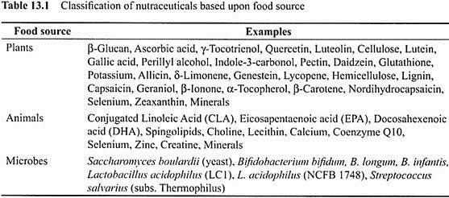
(OR)
12.b. Analyse terpenoids with nutraceutical examples. (CO2, K4)
The terpenoids ,sometimes called isoprenoids, are a large and diverse class of naturally occurring organic chemicals derived from terpenes. Most are multicyclic structures with oxygen-containing functional groups. About 60% of known natural products are terpenoids.^{[1]} Although sometimes used interchangeably with "terpenes", terpenoids contain additional functional groups, usually O-containing.^{[2]} Terpenes are hydrocarbons.
Plant terpenoids are used for their aromatic qualities and play a role in traditional herbal remedies. Terpenoids contribute to the scent of eucalyptus, the flavors of cinnamon, cloves, and ginger, the yellow color in sunflowers, and the red color in tomatoes.^{[3]} Well-known terpenoids include citral, menthol, camphor, salvinorin A in the plant Salvia divinorum, the cannabinoids found in cannabis, ginkgolideand bilobalide found in Ginkgo biloba, and the curcuminoids found in turmeric and mustard seed.
The steroids and sterols in animals are biologically produced from terpenoid precursors. Sometimes terpenoids are added to proteins, e.g., to enhance their attachment to the cell membrane; this is known as isoprenylation.

13.a. Give examples of probiotics and prebiotics. (CO3, K2)

some examples of Probiotics:
- Probiotics that are naturally found in your intestines include: Saccharomyces boulardii (a yeast) and bacteria in the Lactobacillus and Bifobacterium families of microorganisms. (Outside of the body, Lactobacillus acidophilus is the probiotic that is found in some yogurts.)
- Foods that contain probiotics include: some juices and soy drinks; fermented and unfermented milk; buttermilk; some soft cheeses; miso; tempeh; kefir; kimchi; sauerkraut; many pickles; and yogurt (probably the most well-known food product that contains probiotics).
- Supplements: Dietary probiotic supplements -- which are available in capsules, tablets, powders and liquid extracts -- each contain a specific type of probiotic. These products are available at health food and natural food stores, vitamin shops, and other stores. As an example, one commonly used supplement is Acidophilus, which is available from several supplement manufacturers.

Prebiotics :are a type of fiber. They are undigestable plant fibers that feed the probiotics or the good bacteria already live inside the large intestine. The more food, or prebiotics, that probiotics have to eat, the more efficiently these live bacteria work and the healthier your gut will be.
- Chicory Root. Chicory root is popular for its coffee-like flavor
- Dandelion Greens. Dandelion greens can be used in salads and are a great source of fiber
- Jerusalem Artichoke
- Garlic
- Onions
- Leeks
- Asparagus
- Banana
(OR)
13.b. Point out the functions of probiotic microflora. (CO3, K4)
- Bifidobacteria are used as a probiotic
- To improve intestinal flora balance,
- Inhibit harmful bacteria,
- Promote good digestion,
- Boost immune function,
- And increase resistance to infection.
14.a. Discuss the role of Omega 3 and 6 fatty acids in health and disease. (CO4, K2)
Omega-3 fatty acids (v-3 FAs) are important essential fatty acids that should be included in the human diet for maintenance of normal health and nutrition. c v-3 FAs reduce cardiovascular morbidity and mortality by reducing arrhythmia risk, decreasing blood pressure, improving the atherogenic lipid profile and reducing platelet aggregation. c v-3 FAs have proven beneficial effects in patients with metabolic syndrome, obesity, type 2 diabetes mellitus, depression, degenerative disorders of the eyes and pain associated with arthritis. c Maternal intake of v-3 FAs reduces risk of premature birth and enhances intellectual development of the fetus and infant. c About two portions of fish a week or an equivalent of 1 g v3 FAs a day from other dietary sources amounting to 0.6–1.2% of total energy requirement per day is recommended for a healthy adult.
(OR)
14.b. Interpret the role of functional foods to treat diabetes mellitus. (CO4, K3)
Nutraceuticals& Diabetes
Diabetes is a chronic metabolic disorder, where the body is unable to utilize carbohydrate due to absolute or relative lack of insulin, a hormone naturally produced by the ß cell of the islets of langerhans in pancreas. Soy and Omega-3 fatty acids can promote Insulin sensitivity and bring the blood sugar normal. E.g. Cinnamon tea and green tea can help people suffering with diabetes. Usually Diabetes and Obesity are linked with each other and (if they are not treated) they may cause cardio-vascular problems.
High isoflavone intake (20–100 mg/day) is associated with lower incidence and mortality rate of type II diabetes, heart disease, osteoporosis and certain cancers. Omega-3 fatty acids reduce glucose tolerance in diabetes. Coffee is another great nutraceutical. Lipoic acid is a universal antioxidant, now used in Germany for the treatment of diabetic neuropathy.
Nutraceuticals and Natural Supplements for Treating Type 2 Diabetes
Nutraceuticals help to treat your diabetes. Caffeic acid can reduce elevated plasma glucose in the insulin-resistant patient. Cinnamon contains water-soluble compounds, known as polyphenols that can increase glucose metabolism, which helps lower blood levels. Bitter melon may activate an enzyme that is responsible for regulating metabolism and transporting glucose from the blood into the cells. Pomegranate is an antioxidant that keeps the body strong and is good for any disease state.

15.a. Write a short note on national regulatory aspects of functional foods. (CO5, K3)
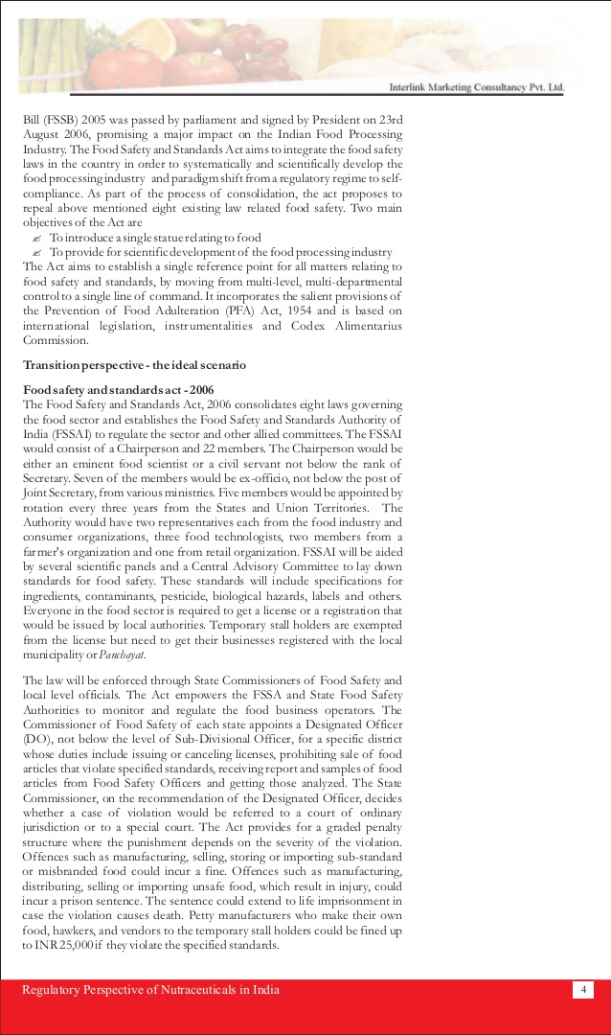
(OR)
15.b. Determine the biomarkers in the efficacy of functional components. (CO5, K5)
Biomarker (medicine): More generally a biomarker is anything that can be used as an indicator of a particular disease state or some other physiological state of an organism. A biomarker can be a substance that is introduced into an organism as a means to examine organ function or other aspects of health.
Part C (5*7=35)
Answer should not exceed 600 words or three page

16.a. Summarize the stages involved in development of Functional Foods. (CO1, K5)
- Idea Generation
- Idea Screening
- Concept Development & Testing
- Business Strategy Analysis & Development
- Product Development
- Test Marketing
- Commercialization

(OR)
16.b. Criticize the history of functional foods (CO1, K5)

History
Over two thousand years ago Hippocrates said, "Let food be thy medicine." Although the concept of functional foods is not entirely new, it has evolved considerably over the years. In the early 1900s food manufacturers in the United States began adding iodine to salt in an effort to prevent goiter, representing one of the first attempts at creating a functional food through fortification.
Other twentieth-century examples include vitamin A and D fortification of milk and niacin and folic acid fortification of grains. These early fortification examples, however, focused on reducing the risk of diseases of deficiency. In the latter part of the twentieth century, consumers began to focus on wellness and the reduction of chronic disease. Research now focuses frequently on the promotion of health through many lifestyle factors, including the consumption of an optimal diet. As of 2002, researchers have identified hundreds of food components with functional qualities, and they continue to make new discoveries surrounding the complex benefits of phytochemicals in foods.

17.a. Categorize the nutraceuticals based on its chemical nature. (CO2, K4)
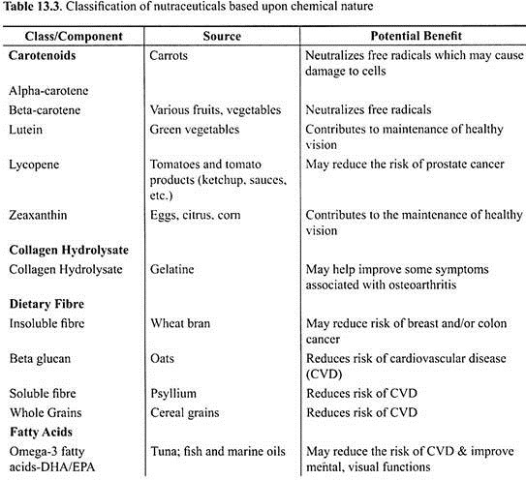
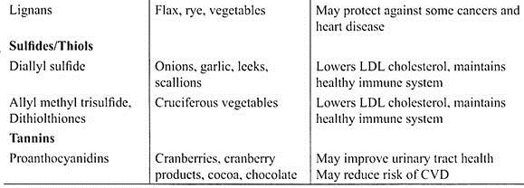
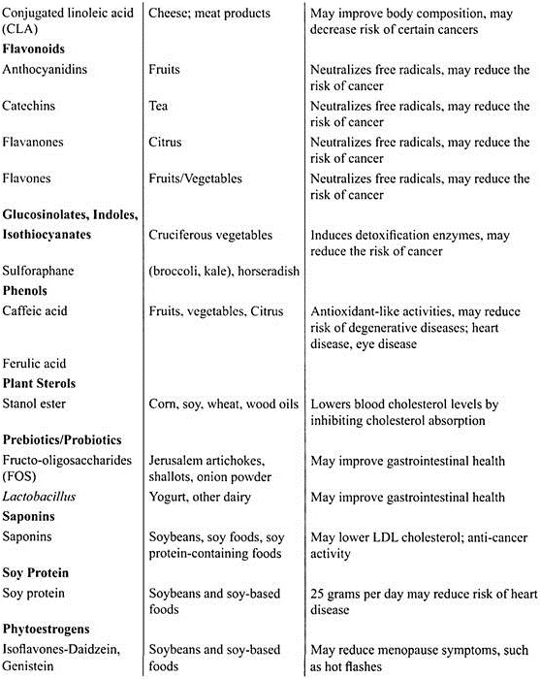
(OR)
17.b. Explain about tocotrienols and simple terpenes. (CO2, K4)
Tocotrienols are a group of chemicals that are part of the vitamin E family. Most vitamin E supplements are higher in tocopherols than tocotrienols. Tocotrienolsmay help fight free radical damage to the gastrointestinal system.
Terpenes
- Terpenes commonly occur in the oils that give plants their fragrance.
- Originally the term terpene was resricted to hydrocarbons, it is now used to include substituted derivatives too.
- The fundamental building block of terpenes is the isoprene unit, C₅H₈

18.a. Spirulina as a bioactive component- Justify (CO3, K5)
Spirulina is a nature’s gift as super food to mankind. It is a photosynthetic filamentous microalga which has emerged as a potent food supplement because of its rich micro- and macronutrient contents. The body of Spirulina is smooth and with weak cell wall that makes it easily digestible. It is a valuable source of proteins, vitamins, minerals, β-carotene, fatty acids, etc. which makes it perfect as food and fodder. NASA has stated that the nutritional value of 1000 kg of fruits and vegetables equals to 1 kg of Spirulina. In 1992 WHO has declared Spirulina as “Best food for future” to redress malnutrition especially in children. Apart from being a food supplement, Spirulina has gained considerable popularity and paramount importance due to the presence of certain pigments and secondary metabolites. It shows pharmacognosic properties like immuno-protective, anticancer, antidiabetic, antiviral, anti-obesity, etc. it is the most nutritionally concentrated compact whole food known which owe a potential to drastically lower the chances of developing cancer, heart disease, or stroke or of contracting a life-threatening virus such as HIV and prevent eyes from cataract formation. Many animal studies in vivo and in vitro and human trials have proved Spirulina to be commercialized and sold for therapeutic purposes. It appears to have a considerable potential for developing a key crop in coastal and alkaline regions where traditional agriculture struggles. Thus, looking at its global nutritional significance, more should be done in culture isolation, purification, and quality control of Spirulina and its products.
(OR)
18.b. Write a detailed note on Human gastrointestinal tract and its microbiota. (CO3, K3)
Human gastrointestinal microbiota, also known as gut flora or gut microbiota, are the microorganisms that live in the digestive tractsof humans. Many non-human animals, including insects, are hosts to numerous microorganisms that reside in the gastrointestinal tract as well. The human gastrointestinal metagenome is the aggregate of all the genomes of gut microbiota.^{[1]} The gut is one niche that human microbiota inhabit.
The human gastrointestinal (GI) tract harbours a complex and dynamic population of microorganisms, the gut microbiota, which exert a marked influence on the host during homeostasis and disease. Multiple factors contribute to the establishment of the human gut microbiota during infancy.
Diet is considered as one of the main drivers in shaping the gut microbiota across the life time. Intestinal bacteria play a crucial role in maintaining immune and metabolic homeostasis and protecting against pathogens. Altered gut bacterial composition (dysbiosis) has been associated with the pathogenesis of many inflammatory diseases and infections.
The interpretation of these studies relies on a better understanding of inter-individual variations, heterogeneity of bacterial communities along and across the GI tract, functional redundancy and the need to distinguish cause from effect in states of dysbiosis
19.a. Determine the role of Nutraceuticals to treat CVD (CO4, K3)
Cardiovascular disease (CVD) ranks among the most common health-related and economic issues worldwide. Dietary factors are important contributors to cardiovascular risk, either directly, or through their effects on other cardiovascular risk factors including hypertension, dyslipidemia and diabetes mellitus. Nutraceuticals are natural nutritional compounds, which have been shown to be efficacious in preventative medicine or in the treatment of disease. Several foods and dietary supplements have been shown to protect against the development of CVD.
The management, prevention and treatment of cardiovascular diseases, such as hypertension, are based on lifestyle, hereditary factors and physical activity. The nutritional supplementation represents a possible strategy for management and prevention of hypertension and other cardiovascular diseases. The nutraceuticals act not only direct by antioxidant or anti-inflammatory properties but also indirectly, via modulation on various physiological pathways. A lot of the nutraceuticals that was described, such as oil extracts, plants, fruits and vegetables as well as botanical extracts, have shown beneficial effects on the cardiovascular system through substances such as phenolic compounds or polyphenols, lycopene and flavonoids.
(OR)
19.b. Discriminate about FOSHU foods. (CO4, K5)
Food for Specified Health Uses (FOSHU)
FOSHU refers to foods containing ingredient with functions for health and officially approved to claim its physiological effects on the human body. FOSHU is intended to be consumed for the maintenance / promotion of health or special health uses by people who wish to control health conditions, including blood pressure or blood cholesterol. In order to sell a food as FOSHU, the assessment for the safety of the food and effectiveness of the functions for health is required, and the claim must be approved by the MHLW.
Requirements for FOSHU Approval
• |  | Effectiveness on the human body is clearly proven
• |  | Absence of any safety issues (animal toxicity tests, confirmation of effects in the cases of excess intake, etc.)
• |  | Use of nutritionally appropriate ingredients (e.g. no excessive use of salt, etc.)
• |  | Guarantee of compatibility with product specifications by the time of consumption
• |  | Established quality control methods, such as specifications of products and ingredients, processes, and methods of analysis
In addition to "regular" FOSHU, following types of FOSHU are available.: Qualified FOSHU and Standardized FOSHU were introduced to facilitate applicants for FOSHU approvals.
(1) |  | Qualified FOSHU:  Food with health function which is not substantiated on scientific evidence that meets the level of FOSHU, or the food with certain effectiveness but without established mechanism of the effective element for the function will be approved as qualified FOSHU.
(2) |  | Standardized FOSHU:  Standards and specifications are established for foods with sufficient FOSHU approvals and accumulation of scientific evidence. Standardized FOSHU are approved when it meets the standards and specifications.
(3) |  | Reduction of disease risk FOSHU  Reduction of disease risk claim is permitted when reduction of disease risk is clinically and nutritionally established in an ingredient.
Proper combination of diet, exercise and rest is important for healthier life. Concerning diet in particular, proper balance of nutrient intake and avoidance of its excess or deficiency are essential to keep good health and thus, not to induce risks leading to lifestyle-related diseases. Even nutrients and functional ingredients in foods are chemical substances but we need to draw a line of demarcation between such substances based on long history of dietary habits and novel substances and/or xenobiotics. However, even FOSHU contains highly purified or concentrated functional ingredients present in ordinary foods and thus, it is very important to take safety issues into consideration. FOSHU is the only type of food product (not ingredients) that can carry health claims and is composed of functional ingredients that affect the structure/function (physiological functions) of the body. These food products are intended to be consumed for the maintenance/promotion of health or special health uses by people who wish to control specified health conditions, such as gastrointestinal conditions and blood pressure. Therefore, FOSHU products target healthy people and people in a preliminary stage of a disease or a borderline condition. When the products are manufactured or distributed, permission or approval from the government is required after rigorous evaluation of the safety and effectiveness of proposed specified health uses.
20.a. Enumerate the ICMR guidelines for probiotics. (CO5, K5)
1: Guidelines for evaluation of candidate probiotic strains Screening of Potential Probiotic Strains • In vitro Tests In vivo studies in validated animal models for: • Safety • Efficacy Strain Identification by Phenotypic and Genotypic Methods • Genus, Species and Strain • Deposit strain in an Internationally Recognized collection In vivo studies in humans for clinical evaluations • Phase1 (safety) • Phase 2 (efficacy) • Phase 3 (effectiveness)* PROBIOTIC FOODS Labeling Requirements • Genus, Species, Strain • Minimum viable numbers of probiotics at the level at which efficacy is claimed and at the end of shelf- life. • Health claim(s) • Serving size for efficacy • Storage conditions
(OR)
20.b. Research frontiers in functional foods- Explain. (CO5, K4)

The Role of Research in Functional Food Development
Research currently underway at academic, industry and government facilities will reveal how a myriad of substances can be used as functional food components. Although additional research is necessary to validate efficacy and establish appropriate dietary levels, researchers have identified functional food components that may improve memory, reduce arthritis, reduce cardiovascular disease and provide other benefits typically associated with drugs.
Functional foods and molecular nutrition represent novel scientific paradigms that challenge traditional nutrition approaches. The risk of adhering rigidly to current paradigms is that health benefits from a broader approach to diet and nutrition will be slow to arrive on our plates. Speeding the arrival of these health benefits requires innovative and paradigm-shifting approaches to nutrients and their role in health, and funding to expand the knowledge base of molecular nutrition.

- Nutrigenomics and Function of Bioactive Components
- Policies Regarding Ethics, Regulatory, and Legal Implications of Nutrigenomics and Molecular Nutrition Research
- Expanded Incentives for Health and Nutrition Research
- Nutrients and Bioactive Substances

***********

