

Avinashilingam Institute for Home Science and Higher Education for Women
(Deemed to be University under Category ‘A’ by MHRD, Estd. u/s 3 of UGC Act 1956)
Re-accredited with ‘A+’ Grade by NAAC. Recognised by UGC Under Section 12B
Coimbatore - 641 043, Tamil Nadu, India

Master’s Degree (Supplementary) Examination – January 2021
I Semester

Batch : 2019 Time : 3 Hrs
Major : Extension & Communication Max. Marks: 60

17MEXCO4 – Diffusion and Adoption of Innovations

Part A (10 x1/2 =5)
Choose the correct answer

1. Who is the fore father of diffusion theory?
a) E.M.Rogers b) Shoemaker c) Gabriel Tarde d) Jessica Waddell

2. The 4 main elements of Diffusion are:
a) Innovation, Communication Channels, Social System, Observability
b) Initiation, Communication Channels, Social System, Observability
c) Innovation, Communication Channels, Social Systems, Time
d) Innovation, Community Involvement, Social Services, Thyme

3. What determines the speed and extent that an Innovation is diffused?
a) Observability b) Social contacts
c) Intelligence Quotient d) Educational qualification

4. The __________________ of an innovation refers to the extent to which the innovation is consistent with present needs, motives, values, beliefs, and behaviours.
a) Complexity b) Consumption paradigms
c) Compatibility d) Adoption process

5. Which of the following is not the basic element of the diffusion process
a) Innovation b) Communication c) Social System d) Culture

6. Diffusion is a concept that refers to
a) Source of innovation b) Adopters of innovation
c) Communicators of innovation d) Transmitters of innovation

7. Which of the following is the rate at which a social system adopts an innovation?
a) Diffusion process b) Adoption process c) Differentiation process d) Adoption lifecycle

8. Which of the following is not one of the stages that farmers through in the process of adopting a new innovation?
a) Desire b) Awareness c) Interest d) Evaluation

9. What percent of the adopters the innovators comprise?
a) 13.5 b)16 c) 2.5 d) 34

10. The person who start the process of communication
a) Communicator b) Innovator c) Adopter d) Evaluator

Part B (5x4=20)
Answer all questions
Each answer should not exceed 200 words or one page

11. a) Explain the concept of Adoption.
Or
b) Elucidate the attributes of innovaton.

12. a) Explain the forms and functions of innovations.
Or
b) Explicate the characteristics of opinion Leadership.

13. a) Examine the three types of knowledge.
Or
b) Explain the models of communication flow.

14. a) Explicate the role and efforts of change agents in innovation decisions.
Or
b) Sketch the role of IT input dealers in innovation decisions.

15. a) Describe on technology clusters.
Or
b) Elucidate the social construction of technology.

Part C (5x7=35)
Answer all questions
Each answer should not exceed 600 words or three pages

16. a) Elaborate on the different stages of innovation decision process.
Or
b) Explain the classification of consequences.

17. a) Discriminate on the types of innovation-decision.
Or
b) Explain the characteristics of adopter categories.

18. a) Interpret on the factors affecting adoption of practices in the community.
Or
b) Distinguish between Homophily and Heterophily and Monomorphic and
Polymorphic leaders with suitable examples.

19. a) Explain the elements of diffusion.
Or
b) Examine the suitable communication methods in different stages of Innovation-
decision process.

20. a) Distinguish between Diffusion and innovation.
Or
b) Elucidate the Skills acquired to transfer the innovation.

Set II
Answer key
- A
- D
- A
- C
- B
- A
- D
- B
- D
- A
- aDefine Adoption process.
Adoption is a micro process that focuses on the stages through which an individual consumer passes when deciding to accept or reject a new product.
b. What is meant by Over adoption?
Overadoption is the adoption of an innovation by an individual when experts feel that he or she should reject. Overadoption occurs because of insufficient knowledge about the new idea on the part of adopter, an inability of predict the innovation's consequences, and/or the status-conferring aspect of a new idea.
- a) Paraphrase innovation- development process.
Steps in innovation-development process:
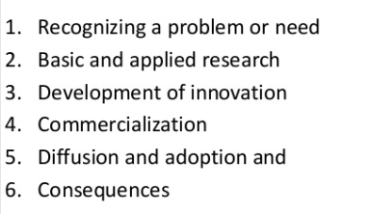
b) Review on the social construction of technology.
SCOT argue that technology does not determine human action, but that rather, human action shapes technology. They also argue that the ways a technology is used cannot be understood without understanding how that technology is embedded in its social context. SCOT is a response to technological determinism and is sometimes known as technological constructivism.
- a) Examine the types of knowledge.
Proportional knowledge, Non proportional knowledge, Explicit knowledge, logical, semantic, empirical etc
b) Explain the models of communication.
Shanon and weaver:
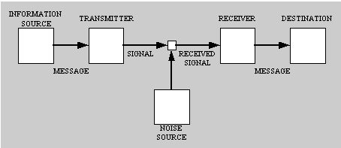
Interactive model of communication:
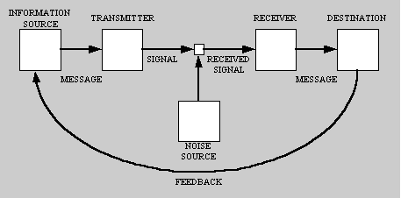
Transactional model of communication:
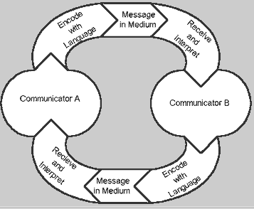
Aristotle model: Speaker – Speech- Audience
Berlo’s model: Communication source- Encoder- Message- Channel- Decoder- Communication receiver.
Rogers and Shoemaker: S-M-C-R-E model

- a) Estimate the role of Opinion leaders in the process of adoption.
Opinion leaders are individuals who obtain more media coverage than others and areespecially educated on a certain issue. They seek the acceptance of others and are especially motivated to enhance their social status. In the jargon of public relations, they are called thought leaders. Research has also found that opinion leaders tend to be boundary spanners.
Or
b) Sketch the role of input dealers in innovation.
15. a) Describe on technology clusters.
Technology clusters, also referred to as industry or innovation clusters, are an important part of organizing and understanding the economic activity in a region. A regional technology cluster represents a geographic concentration of interconnected companies and institutions in a particular field.
b) Review on monomorphic and polymorphic leaders.
Monomorphic leaders A type of leadership in communication and media that leads to the spread of information concerning one particular, highly specialized topic rather than a broadly-based set of information. This can be a very narrow point of view and can lead to making decisions based on lack of full information. opposite of polymorphic opinion leadership.
Polymorphic opinion leaders are able to influence others in a broad range of domains. Variants of polymorphic opinion leadership include market mavenism,[6] personality strength [7]and generalized opinion leadership.

Part C
Answer all questions (5x7=35)
Each answer should not exceed 600 words or three pages
- a)Review on the different stages of innovation decision process.
5 stages:
Knowledge – This part sounds like when you see a new innovation, but don’t have a lot of information on it.
Persuasion – At this point, the innovation sparks enough interest for someone to try to get more information. Like us, in our class, trying to learn more about certain forms of media we never heard about… but we’re persuaded (by the power of the grading scale) to examine things further, explore, and become more familiar with it.
Decision – Finally, a part of the tree that progresses to something else. We finally have a fork in the road: accept or reject the new innovation.
Implementation – This is the stage that the innovation is utilized, and an assessment may be made about its utility.
Confirmation – Sustainability for the user: the individual will decide if they want to continue using this innovation or not!

b) Justify the classification of consequences.
Consequences are the changes that occur to an individual or to a social system as a result of the adoption or rejection of an innovation. × Desirable vs. Undesirable consequences: Depending on whether the effects of an innovation in a social system are functional or dysfunctional. × Direct vs. Indirect consequences: Depending upon whether the changes to an individual or to a social system occur in immediate response to an innovation or a as a second-order result of the direct consequences of an innovation. × Anticipated vs. Unanticipated consequences: Depending on whether the changes are recognized and intended by the members of a social system or not.
17.a) Discriminate on the types of innovation-decision.
Types of Innovation-Decisions × Operational innovation-decision: These are choices to adopt or reject an innovation that are made by an individual independent of the decisions of the other members of the system. × Collective innovation-decisions: These are choices to adopt or reject an innovation that are made by consensus among the members of a system. × Authority innovation-decisions: These are choices to adopt or reject an innovation that are made by a relatively few individuals in a system who possess power, status, or technical experience.
b) Illustrate on the adopter categories
Innovators: These individuals adopt new technology or ideas simply because they are new. Innovators tend to take risks more readily and are the most venturesome.
Early Adopters: This group tends to create opinions, which propel trends. They are not unlike innovators in how quickly they take on new technologies and ideas but are more concerned about their reputation as being ahead of the curve.
Early and late majority: If an idea or other innovation enters this group, it tends to be widely adopted before long. This group makes decisions based on utility and practical benefits over coolness. The late majority shares some traits with the early majority but is more cautious before committing, needing more hand-holding as they adopt. Those who study Diffusion of Innovations consider the early and late majorities two separate categories.
Laggards: This group is slow to adapt to new ideas or tech. They tend to adopt only when they are forced to or because everyone else has already.

- a) Interpret on the factors affecting adoption of practices in the community.
- Readiness to try to new products
- Effect of personal influence
- Characteristics of the innovation
b) Discriminate between Homophily and Heterophily and Monomorphic and Polymorphic leaders with suitable examples.
Homophily is the degree to which a pair of individuals who communicate are similar. The similarity may be in certain attributes, such as beliefs, education, social status, and the like. Homophily occurs frequently because communication is more effective when source and receiver are homophilous. When two individuals share common meanings, beliefs, and mutual understandings, communication between them is more likely to be effective. Individuals enjoy the comfort of interacting with others who are similar. Talking with those who are markedly different from ourselves requires more effort to make communication effective. Heterophilous communication between dissimilar individuals may cause cognitive dissonance because an individual is exposed to messages that are inconsistent with existing beliefs, an uncomfortable psychological state. Homophily and effective communication breed each other. The more communication there is between members of a dyad, the more likely they are to become homophilous.The more homophilous two individuals are, the more likely that their communication will be effective. Individuals who depart from the homophily principle and attempt to communicate with others who are different from themselves often face the frustration of ineffective communication. Differences in technical competence, social status, beliefs, and language lead to mistaken meanings, thereby causing messages to be distorted or to go unheeded.
Heterophily is the degree to which pairs of individuals who interact are different in certain attributes. Heterophily is the opposite of homophily.
Monomorphic leaders A type of leadership in communication and media that leads to the spread of information concerning one particular, highly specialized topic rather than a broadly-based set of information. This can be a very narrow point of view and can lead to making decisions based on lack of full information. opposite of polymorphic opinion leadership.
Polymorphic opinion leaders are able to influence others in a broad range of domains. Variants of polymorphic opinion leadership include market mavenism, personality strength and generalized opinion leadership.

- a) Explain the models of diffusion.
Mention about the model given by Rogers or any other models that the candidate learned
b) Examine the suitable communication methods in different stages of Innovation- decision process.
Individual/ group/Mass – identify according to prupose
- a) Justify the role of IT in innovation process.
The use of information technologies (IT) and increase of innovation activities within Small and Medium Sized Enterprises (SMEs) which can easily adapt to the dynamics and changes can contribute to the regional development process. In the world of globalization, information technologies playing the key role of change and actuality are also undertaking the basis of innovation. Organizations dealing with the IT management should tend to innovation efforts and need to work on different models and methods in order to differentiate themselves against global competition. In our globalized world where the growth and development no longer depend on individual factors, the rapid increase of technological improvement reveals the importance of innovation and informatics. The concept of innovation which is both one of the most critical factors of both micro and macro - economic growth and development and providing a competitive advantage has a connection with information systems and its effect in management level occur as a phenomenon emerging in all areas.

b) Criticise on the concept, meaning and elements of diffusion.
Rogers argues that diffusion is the process by which an innovation is communicated over time among the participants in a social system. The origins of the diffusion of innovations theory are varied and span multiple disciplines.
The four main elements influence the spread of a new idea: the innovation itself, communication channels, time, and a social system. This process relies heavily on human capital. The innovation must be widely adopted in order to self-sustain. Within the rate of adoption, there is a point at which an innovation reaches critical mass.
Elements: Innovation, Adopters, Communication channels, time, social system
………………………………………………………………………………………………………

