WATERMARKING RELATIONAL DATABASES USING OPTIMIZATION BASED TECHNIQUES

BY

S.KIRUTHIGA

07PCA09

PROJECT WORK SUBMITTED IN PARTIAL FULLFILLMENT OF THE REQUIREMENTS FOR THE DEGREE OF

MASTER OF COMPUTER APPLICATIONS

DEPARTMENT OF COMPUTER SCIENCE
AVINASHILINGAM DEEMED UNIVERSITY FOR WOMEN,
COIMBATORE-43

APRIL-2010

CERTIFICATE

This is to certify that this project entitled “WATERMARKING RELATIONAL DATABASES USING OPTIMIZATION BASED TECHNIQUES”, done by S.KIRUTHIGA (07PCA09) has been submitted to Avinashilingam Deemed University for Women, Coimbatore - 43 in partial fulfillment of the requirement for the award of the degree of Master of Computer Applications. This project has not found the basis for the award of any Degree / Diploma / Associate ship / Fellowship or similar title to any candidate of this University.

Certified as a bonafide record of the work submitted for the viva voce held on ___________2010.

Head of the Department Guide

Internal Examiner External Examiner

DECLARATION

I hereby declare that this project work entitled “WATERMARKING RELATIONAL DATABASES USING OPTIMIZATION BASED TECHNIQUES”, is a record of the original work done by me under the guidance of Mrs N.VALLIAMAL M.Sc., M.Phil. Assistant Professor, Department of Computer Science, Avinashilingam Deemed University for Women, Coimbatore-43, in partial fulfillment of the award of the degree of Master of Computer Applications. It is also declared that this does not form the basis for the award of any Degree / Diploma / Associate ship / Fellowship in any other University and it is not similar to the one submitted by any other candidate.

Signature of the Guide Signature of the Candidate

ACKNOWLEDGEMENT

I would like to express my sincere thanks to God Almighty, for his constant love and grace that he has showed upon me, which kept me in good health, and sound mind without which my project would not have reached a successful end.

I would like to express my deep sense of reverential gratitude and sincere thanks to Thiru. T.K.SHANMUGANANTHAM B.A., B.L. Chancellor, Avinashilingam Deemed University for Women, Coimbatore-43, for the opportunity given to me for undertaking this study and for providing the needed facility during the course of my study.

My sincere thanks to Dr. (Mrs) SAROJA PRABHAKARAN, M.A., Dip.Ed., (Madras), Ph.D (Mother Teresa), Vice Chancellor, Avinashilingam Deemed University for Women, Coimbatore-43, for providing all resources necessary for the study.

I would express my humble gratitude to Dr. (Mrs) GOWRI RAMAKRISHAN, M.Sc. (Madras), M.Phil., Ph.D., Registrar, for providing all facilities necessary for this study.

I would express my boundless thanks to Dr.R.PARVATHAM, M.Sc., M.Phil., Ph.D., the Dean of Science of our University for her encouragement.

I wish to place on record my deep sense of gratitude to Dr.G.PADMAVATHI M.Sc., M.Phil. (Bharathiar), Ph.D., Professor and Head, Department of Computer Science for providing all the facilities to complete the project.

I express my heart full gratitude to my internal Guide Mrs. N.VALLIAMAL, M.sc., M.Phil. (Computer Science), Assistant professor in Department of Computer Science, for guidance and timely suggestions shown in aiding me to consummate this project work successfully.

I am grateful to the project coordinator Dr. (Mrs.) B.KALPANA, M.Sc. (Bharathidasan), M.Phil., Ph.D. (Avinashilingam), Associate Professor in Department of Computer Science who was instrumental in granting me the facilities required for doing project.

I like to thank Mrs UMA BE, Programmer In INetz Solutions Chennai, for providing all the necessary support for the successful completion of this project.

Finally, yet importantly, I would like to thank my parents, my brother and sister for their support, encouragement and prayers, which were instrumental in the successful completion of this project.

SYNOPSIS

The project entitled “Watermarking Relational Databases Using Optimization Based Techniques” has been developed for the concern Inetz Solutions, Chennai.

Watermarking is defined as “a faded image or text used as a background of a slide”. This project is mainly used to secure embedding of a robust imperceptible watermark in relational data. A watermark describes information that can be used to prove the ownership of data such as the owner, origin or recipient of the content.

In this project, Data Partitioning algorithm is used to split the database data tables into 3 by 3. After partitioning, collapse the data tables into single table, at the same time encrypts the data tables by using Triple DES Encryption algorithm. After encryption, watermark the index key value on the image based on the opacity value. Then remove the original data tables from the database and save secured data in the database. If hackers try to hack the database, never get the original data source. So the database is very secured. In pixilated image decryption, if enter the proper index value means, the system compare the pixilated values and then give the exact decrypted data tables, otherwise no one can access the database.

CONTENTS

S.NO | PARTICULARS | PAGE NO
1  2  3  4  5  6  7  8  9 | INTRODUCTION  - ORGANIZATION PROFILE  - PROJECT OVERVIEW  SYSTEM CONFIGURATION  2.1 HARDWARE SPECIFICATION  2.2 SOFTARE SPCIFICATION  2.3 ABOUT THE SOFTWARE  2.3.1 INTRODUCTION TO .NET FRAMEWORK  2.3.2 DATA ACCESS WITH ADO.NET  2.3.3 VISUAL STUDIO .NET  2.3.4 VISUAL BASIC .NET  2.3.5 SQL-SERVER  SYSTEM STUDY AND ANALYSIS  3.1 SYSTEM STUDY  3.2 EXISTING SYSTEM  3.3 PROPOSED SYSTEM  3.4 FEASIBILITY STUDY  3.4.1 TECHNICAL FEASIBILITY  3.4.2 ECONOMICAL FEASIBILITY  3.4.3 SOCIAL FEASIBILITY  SYSTEM DESIGN  4.1 DESIGN OVERVIEW  4.1.1 INPUT DESIGN  4.1.2. OUTPUT DESIGN  4.1.3 DATABASE DESIGN  4.2 SYSTEM FLOW DIAGRAM  SYSTEM DEVELOPMENT  5.1 INTRODUCTION TO SYSTEM DEVELOPMENT  5.2 MODULE DESCRIPTION  SYSTEM TESTING AND IMPLEMENTATION  6.1 TESTING  6.1.1 UNIT TESTING  6.1.2 INTEGRATION TESTING  6.1.3 VALIDATION TESTING  6.2 SYSTEM IMPLEMENTATION  CONCLUSION  SCOPE FOR FURTHER DEVELOPMENT  BIBLIOGRAPHY | 1  2  4  4  5  5  8  10  11  13  17  18  18  19  19  19  20  20  21  21  22  23  23  24  25  25  26  26  28  29  30

1. INTRODUCTION

  - ORGANIZATION PROFILE

ABOUT THE COMPANY

“INetz Solutions” is a premier software solution provider in India. In brief stint, grown and developed many customized solutions across various domains/verticals. The team works cooperatively to produce success for our clients. Gaining their trust and building a long-lasting affiliation. This tie up helps us to give in the best and generate good results and accomplishing the goals in a well-premeditated structure. The solutions not only productive but also have valued affordably for all the clients ranging from start ups, small business to leading corporations. The team of experts provides a variety of best services on Sustainability, Focus, Dedication, and Cost Effectiveness. One can explore it into all the major facets of corporate information technology. INetz is a custom software development and Solutions Company based in Kovai, India. I-Net possesses an experience in providing complex and diverse enterprise software development solutions to a large range of clients.

SERVICES

INetz providing allows flexibility and reliability to clients in multiple areas. To strongly activist the role of Information Technology as a key enabler of business processes. To helping our client's current IT business, accelerate its challenging schema to support their vibrant growing business. One can design cost effective forceful software solutions with excellent usability characteristics for each client. The custom software development services that will condense your time to advertise, fill the expertise break, and help to control run-away development expenses. The experts are talented, enthusiastic, and dedicated in their work with their sufficient experience and technology skills we design a scalable, customized solution for the business needs.
1.2. PROJECT OVERVIEW

The rapid growth of the Internet and related technologies has offered an unprecedented ability to access and redistribute digital contents. In such a context, enforcing data ownership is an important requirement, which requires articulated solutions, encompassing technical, organizational, and legal aspects. Although one can still far from such comprehensive solutions, in the last years, watermarking techniques have emerged as an important building block that plays a crucial role in addressing the ownership problem. Such techniques allow the owner of the data to embed an imperceptible watermark into the data.

A watermark describes information that can be used to prove the ownership of data such as the owner, origin, or recipient of the content. Secure embedding requires that the embedded watermark must not be easily tampered with, forged, or removed from the watermarked data. Imperceptible embedding means that the presence of the watermark is unnoticeable in the data. Furthermore, the watermark detection is blinded, that is, it neither requires the knowledge of the original data nor the watermark. Watermarking techniques have been developed for video, images, audio, and text data and also for software and natural language text. By contrast, the problem of watermarking relational data has not been given appropriate attention.

Watermark embedding for relational data is made possible by the fact that real data can very often tolerate a small amount of error without any significant degradation with respect to their usability. In this paper, we present a watermarking technique for relational data that is highly resilient. In particular, our proposed technique is resilient to tuple deletion, alteration, and insertion attacks. The main contributions of the paper are summarized as follows: We formulate the watermarking of relational databases as a constrained optimization problem and discuss efficient techniques to handle the constraints.

Data set D is transformed into a watermarked version DW by applying a watermark encoding function that also takes as inputs a secret key Ks only known to the copyright owner and a watermark W. Watermarking modifies the data. However, providing usability constraints referred to by the set G controls these modifications. These constraints limit the amount alterations that can be performed on the data; such constraints will be discussed in detail in the following sections.

The following steps can summarize the watermark encoding: Step E1. Data set partitioning: By using the secret key Ks, the data set D is partitioned into m nonoverlapping partitions. Step E2. Watermark embedding: A watermark bit is embedded in each partition by altering the partition statistics while still verifying the usability constraints. Step E3. Optimal threshold evaluation: The bit embedding statistics are used to compute the optimal threshold T that minimizes the probability of decoding error.

The watermarked version DW is delivered to the intended recipient. Then, it can suffer from unintentional distortions or attacks aimed at destroying the watermark information. Note that even intentional attacks are performed without any knowledge of Ks or D, since these are not publicly available. Watermark decoding is the process of extracting the embedded watermark using the watermarked data set DW, the secret key Ks, and the optimal threshold T.

The decoding algorithm is blind as the original data set D is not required for the successful decoding of the embedded watermark. The watermark decoding is divided into three main steps: Step D1. Data set partitioning: By using the data-partitioning algorithm used in E1, the data partitions are generated. Step D2. Threshold-based decoding: The statistics of each partition are evaluated, and the embedded bit is decoded using a threshold-based scheme based on the optimal threshold T. Step D3. Majority voting: The watermark bits are decoded using a majority voting technique.

2. SYSTEM CONFIGURATION

2.1. HARDWARE SPECIFICATION

- Processor : PENTIUM III 866 MHz
- Ram : 128 MD SD RAM
- Monitor : 15” COLOR
- Hard Disk : 20 GB
- Keyboard : STANDARD 102 KEYS
- Mouse : 3 BUTTONS

2.2. SOFTWARE SPECIFICATION

- Operating System : Windows XP Professional
- Environment : Visual Studio .NET 2005
- Language : VB.NET
- Back end : MS-SQL-Server 2000

2.3. ABOUT SOFTWARE

2.3.1. INTRODUCTION TO .NET FRAMEWORK

The .NET Framework is a new computing platform that simplifies application development in the highly distributed environment of the Internet. It includes a large library of coded solutions to common programming problems and a virtual machine that manages the execution of programs written specifically for the framework. It is a Microsoft offering and is intended to be used by most new applications created for the windows platform.The framework's base class library provides a large range of features including user interface, data access, database connectivity, cryptography, web application development, numeric algorithms, and network communications.

The class library is used by programmers, who combine it with their own cod to produce applications. Programs written for the .NET Framework execute in a software environment that manages the program's runtime requirements. Also part of the .NET Framework, this runtime environment is known as the Common Language Runtime (CLR). The CLR provides the appearance of an application virtual machine so that programmers need not consider the capabilities of the specific CPU that will execute the program. The CLR also provides other important services such as security, memory management, and exception handling. The class library and the CLR together constitute the .NET Framework.

OBJECTIVES OF .NET FRAMEWORK

1. To provide a consistent object-oriented programming environment whether object codes is stored and executed locally on Internet-distributed, or executed remotely.
2. To provide a code-execution environment to minimizes software deployment and guarantees safe execution of code.
3. Eliminates the performance problems.
There are different types of application, such as Windows-based applications and Web-based applications. To make communication on distributed environment to ensure that code be accessed by the .NET Framework can integrate with any other code.

COMPONENTS OF .NET FRAMEWORK
THE COMMON LANGUAGE RUNTIME (CLR)

The common language runtime is the foundation of the .NET Framework. It manages code at execution time, providing important services such as memory management, thread management, and remoting and also ensures more security and robustness. The concept of code management is a fundamental principle of the runtime. Code that targets the runtime is known as managed code, while code that does not target the runtime is known as unmanaged code.

FEATURES OF THE COMMON LANGUAGE RUNTIME (CLR)

The common language runtime manages memory, thread execution, code execution, code safety verification, compilation, and other system services these are all run on CLR.
- Security
- Robustness
- Productivity
- Performance
SECURITY

The runtime enforces code access security. The security features of the runtime thus enable legitimate. Internet-deployed software to be exceptionally feature rich. With regards to security, managed components are awarded varying degrees of trust, depending on a number of factors that include their origin to perform file-access operations, registry-access operations, or other sensitive functions.

ROBUSTNESS

The runtime also enforces code robustness by implementing a strict type- and code-verification infrastructure called the common type system (CTS). The CTS ensures that all managed code is self-describing. The managed environment of the runtime eliminates many common software issues.

PRODUCTIVITY

The runtime also accelerates developer productivity. For example, programmers can write applications in their development language of choice, yet take full advantage of the runtime, the class library, and components written in other languages by other developers.

PERFORMANCE

The runtime is designed to enhance performance. Although the common language runtime provides many standard runtime services, managed code is never interpreted. A feature called just-in-time (JIT) compiling enables all managed code to run in the native machine language of the system on which it is executing.

THE .NET FRAME WORK CLASS LIBRARY

It is a comprehensive, object-oriented collection of reusable types used to develop applications ranging from traditional command-line or graphical user interface (GUI) applications to applications based on the latest innovations provided by ASP.NET, such as Web Forms and XML Web Services. The .NET Framework can be hosted by unmanaged components that load the common language runtime into their processes and initiate the execution of managed code, thereby creating a software environment that can exploit both managed and unmanaged features.

The .NET Framework not only provides several runtime hosts, but also supports the development of third-party runtime hosts. Internet Explorer is an example of an unmanaged application that hosts the runtime (in the form of a MIME type extension). Using Internet Explorer to host the runtime to enables embeds managed components or Windows Forms controls in HTML documents.

2.3.2. DATA ACCESS WITH ADO.NET

As we develop applications using ADO.NET, we will have different requirements for working with data. We might never need to directly edit an XML file containing data - but it is very useful to understand the data architecture in ADO.NET.

ADO.NET offers several advantages over previous versions of ADO

- Interoperability
- Maintainability
- Programmability
- Performance Scalability

INTEROPERABILITY

ADO.NET applications can take advantage of the flexibility and broad acceptance of XML. Because XML is the format for transmitting datasets across the network, any component that can read the XML format can process data. The receiving component need not be an ADO.NET component. The transmitting component can simply transmit the dataset to its destination without regard to how the receiving component is implemented. The destination component might be a Visual Studio application or any other application implemented with any tool whatsoever. The only requirement is that the receiving component be able to read XML. SO, XML was designed with exactly this kind of interoperability in mind.

MAINTAINABILITY

In the life of a deployed system, modest changes are possible, but substantial, Architectural changes are rarely attempted because they are so difficult. As the performance load on a deployed application server grows, system resources can become scarce and response time or throughput can suffer.

Faced with this problem, software architects can choose to divide the server's business-logic processing and user-interface processing onto separate tiers on separate machines. In effect, the application server tier is replaced with two tiers, alleviating the shortage of system resources. If the original application is implemented in ADO.NET using datasets, this transformation is made easier.ADO.NET data components in Visual Studio encapsulate data access functionality in various ways that help you program more quickly and with fewer mistakes.

PERFORMANCE

ADO.NET datasets offer performance advantages over ADO disconnected record sets. In ADO.NET data-type conversion is not necessary.

SCALABILITY

ADO.NET accommodates scalability by encouraging programmers to conserve limited resources. Any ADO.NET application employs disconnected access to data; it does not retain database locks or active database connections for long durations.

2.3.3. VISUAL STUDIO .NET

Visual Studio .NET is a complete set of development tools for building ASP Web applications, XML Web services, desktop applications, and mobile applications. In addition to building high-performing desktop applications, one can use Visual Studio's powerful component-based development tools and other technologies to simplify team based design, development, and deployment of Enterprise solutions. Visual Basic .NET, Visual C++ .NET, and Visual C# .NET all use the same integrated development environment (IDE), which allows them to share tools and facilitates in the creation of mixed-language solutions.

Visual Studio .NET is Microsoft's visual programming environment for creating Web services based on use of the Extensible Markup Language (XML). The product suite provides a visual interface for identifying a program as a Web service, forms for building a user interface (including support for mobile device interfaces), features for integrating existing application data, and for debugging.

In addition, these languages leverage the functionality of the .NET Framework and simplify the development of ASP Web applications and XML Web services. Visual Studio supports the .NET Framework, which provides a common language runtime and unified programming classes; ASP.NET uses these components to create ASP Web applications and XML Web services. Also it includes MSDN Library, which contains all the documentation for these development tools.

2.3.4. VISUAL BASIC .NET

Visual Basic .NET is an object-oriented computer programming language that can be viewed as an evolution of Microsoft's Visual Basic (VB) which is generally implemented on the Microsoft .NET Framework. It is sometimes shortened to VB.NET. It can make complete programs for Windows very easily.It includes many new features. The Visual Basic supports interfaces but not implementation inheritance. Visual basic.net supports implementation inheritance, interfaces and overloading. In addition, Visual Basic .NET supports multithreading concept.

COMMON LANGUAGE SPECIFICATION (CLS)

Visual Basic.NET is also compliant with CLS (Common Language Specification) and supports structured exception handling. CLS is set of rules and constructs that are supported by the CLR (Common Language Runtime). CLR is the runtime environment provided by the .NET Framework, it manages the execution of the code and also makes the development process easier by providing services. Visual Basic.NET is a CLS-compliant language. Any objects, classes, or components that created in Visual Basic.NET can be used in any other CLS-compliant language. In addition, we can use objects, classes, and components created in other CLS-compliant languages in Visual Basic.NET. The use of CLS ensures complete interoperability among applications, regardless of the languages used to create the application.

IMPLEMENTATION INHERITANCE

Visual Basic.NET supports implementation inheritance. This means that, while creating applications in Visual Basic.NET, one can drive from another class, which is know as the base class that derived class inherits all the methods and properties of the base class. In the derived class, one can either use the existing code of the base class or override the existing code. Therefore, with help of the implementation inheritance, code can be reused.

CONSTRUCTORS AND DESTRUCTORS

Constructors are used to initialize objects, whereas destructors are used to destroy them. In other words, destructors are used to release the resources allocated to the object. In Visual Basic.NET the sub finalize procedure is available. The sub finalize procedure is used to complete the tasks that must be performed when an object is destroyed. The sub finalize procedure is called automatically when an object is destroyed. In addition, the sub finalize procedure can be called only from the class it belongs to or from derived classes.

FEATURES OF VISUAL BASIC.NET

GARBAGE COLLECTION

Garbage Collection is another new feature in Visual Basic.NET. The .NET Framework monitors allocated resources, such as objects and variables. In addition, the .NET Framework automatically releases memory for reuse by destroying objects that are no longer in use. In Visual Basic.NET, the garbage collector checks for the objects that are not currently in use by applications. When the garbage collector comes across an object that is marked for garbage collection, it releases the memory occupied by the object.

OVERLOADING

Overloading is another feature in Visual Basic.NET. Overloading enables us to define multiple procedures with the same name, where each procedure has a different set of arguments. Besides using overloading for procedures, one can use it for constructors and properties in a class.

MULTITHREADING

Visual Basic.NET also supports multithreading. An application that supports multithreading can handle multiple tasks simultaneously, one can use multithreading to decrease the time taken by an application to respond to user interaction. To decrease the time taken by an application to respond to user interaction, it can ensure that a separate thread in the application handles user interaction.

STRUCTURED EXCEPTION HANDLING

Visual Basic.NET supports structured handling, which enables us to detect and remove errors at runtime. In Visual Basic.NET, to create exception handlers by using Try, Catch and Finally statements. Using Try, Catch and Finally statements, one can create robust and effective exception handlers to improve the performance of our application.

2.3.5. SQL-SERVER

Microsoft SQL Server is a specific implementation of a relational database server from Microsoft. It was originally developed by Sybase and also sold by Microsoft for OS/2 and Windows NT. It supports symmetric multiprocessing hardware; SNMP (Simple Network Manegement Protocol), ODBC (Open Database Connectivity), and major open standard communications protocols. It has Internet integration, data replication, and data warehousing features. SQL Server enables us to store data from structured, semi-structured and unstructured documents, such as images and music, directly within the database. And it includes integrated services that enable you to query, search, synchronize, report and analyze the data.

Features of SQL-SERVER

The OLAP Services feature available in SQL Server version 7.0 is now called SQL Server 2000 Analysis Services. The term OLAP Services has been replaced with the term Analysis Services. Analysis Services also includes a new data-mining component. The Repository component available in SQL Server version 7.0 is now called Microsoft SQL Server 2000 Meta Data Services. References to the component now use the term Meta Data Services. The term repository is used only in reference to the repository engine within Meta Data Services.

SQL-SERVER database consist of six types of objects,
They are,
1. TABLE
2. QUERY
3. FORM
4. REPORT
5. MACRO
6.MODULE

1. TABLE
A table is a set of data elements that is organized using a model of vertical columns and horizontal rows. A table has a specified number of columns, but can have any number of rows. Each row is identified by the values appearing in a particular column subset which has been identified as a candidate key. Table is another term for relations, although there is the difference in that a table is usually a multi-set of rows whereas a relation is a set and does not allow duplicates. Besides the actual data rows, tables generally have to associated with some meta-information, such as constraints on the table or on the values within particular columns. The data in a table does not have to be physically stored in the database.
VIEWS OF TABLE

There are two views to work with table. They are
1. Design View
2. Datasheet View

Design View

To build or modify the structure of a table one can work in the table design view. One can specify what kind of data will be hold.

Datasheet View

A datasheet is a document summarizing the performance and other technical characteristics of a product. It is used to add, edit or analyses the data itself to work in tables datasheet view mode.

2. QUERY

A query is a question that has to be asked the data. Access gathers data that answers the question from one or more table. The data that make up the answer is either dynaset or a snapshot. Each time when run the query, one can get the latest information in the dynaset. Access either displays the dynaset or snapshot for us to view or perform an action on it, such as deleting or updating.

3. FORMS

A form is used to view and edit information in the database record by record. Forms use the familiar controls such as textboxes and checkboxes. This makes viewing and entering data easy.

Views of Form

There are two views to work with forms. They are,
1. Design View
2. Form View

Design View
To build or modify the structure of a form, one can work in forms design view. To add control to the form that are bound to fields in a table or query, includes textboxes, option buttons, graphs and pictures.

Form View
The form view which display the whole design of the form.

4. REPORT

A report is used to view and print information from the database. The report can ground records into many levels and compute totals and average by checking values from many records at once. Also the report is attractive and distinctive because one can control over the size and appearance of it.

5. MACRO

A macro is a set of actions. Each action in macros does something. Such as opening a form or printing a report. To write on macros is easy to work and save the time.

6. MODULE

Modules are units of code written in access basic language. We can write and use module to automate and customize the database in very sophisticated ways.

3. system STUDY AND ANALYSIS

3.1. SYSTEM STUDY

System study is the first stage of system development cycle. In the system study the problem is identified and the proposed system is designed. The proposed system contains the findings of the present system and recommendations to overcome the limitations and problems of the system in the light of user’s requirements. This section deals with the concept of system analysis, which is the primary phase of the software development. The purpose is to identify the new system and establish what the new system is to accomplish. Moreover a brief review of requirement determination, a feasibility report is presented. The proposed system was subject to thorough analysis and findings are recorded core.

System analysis is an important activity that takes place when new system in being. It is the central intact of system development and it includes gathering necessary data and developing a plan to the new system. System analysis should be creative and imaginative in producing new solutions to meet the user requirements.

3.2 EXISTING SYSTEM

Watermarking techniques have emerged as an important building block that plays a crucial role in addressing the ownership problem. Such techniques allow the owner of the data to embed an imperceptible watermark into the data. A watermark describes information that can be used to prove the ownership of data such as the owner, origin, or recipient of the content. Secure embedding requires that the embedded watermark must not be easily tampered with, forged, or removed from the watermarked data.

3.3. PROPOSED SYSTEM

To present a watermarking technique for relational data is highly resilient. Formulate the watermarking of relational databases as a constrained optimization problem and discuss efficient techniques to handle the constraints. Proposed system present a data partitioning technique that does not depend on marker tuples to locate the partitions and, thus, it is resilient to watermark synchronization errors. To develop an efficient technique for watermark detection that is based on an optimal threshold. The optimal threshold is selected by minimizing the probability of decoding error.

3.4. FEASIBILITY STUDY

On the basis of result of the initial study, feasibility study takes place. The feasibility study is basically the test of the proposed system in the light of its workability, effective use of resources and of course, the cost effectiveness. The main goal of feasibility study is not to solve the problem but to achieve the scope. In the process of feasibility study, the cost and benefits are estimated with greater accuracy.

Three key considerations are involved in the feasibility. They are

- Technical feasibility
- Economical feasibility
- Social feasibility

3.4.1. TECHNICAL FEASIBILITY

This study is carried out to check the technical feasibility, that is, the technical requirements of the system. Any system developed must not have a high demand on the available technical resources. This will lead to high demands on the available technical resources. This will lead to high demands being placed on the client. The developed system must have a modest requirement, as only minimal or null changes are required for implementing this system.

3.4.2. ECONOMICAL FEASIBILITY

This study is carried out to check the economic impact that the system will have on the organization. The amount of fund that the company can pour into the research and development of the system is limited. The expenditures must be justified. Thus the developed system as well within the budget and this was achieved because most of the technologies used are freely available. Only the customized products had to be purchased.

3.4.3. SOCIAL FEASIBILITY

The aspect of study is to check the level of acceptance of the system by the user. This includes the process of training the user to use the system efficiently. The user must not feel threatened by the system, instead must accept it as a necessity. The level of acceptance by the users solely depends on the methods that are employed to educate the user about the system and to make him familiar with it. The user level of confidence must be raised to make some constructive criticism, which is welcomed, as if is the final user of the system.

4. system design

4.1. Design Overview

Design is multi-step process that focuses on data structure software architecture, procedural details, (algorithms etc.) and interface between modules. The design process also translates the requirements into the presentation of software that can be accessed for quality before coding begins. Computer software design changes continuously as new methods; better analysis and broader understanding evolved. Software Design is at relatively early stage in its revolution.

Therefore, Software Design methodology lacks the depth, flexibility and quantitative nature that are normally associated with more classical engineering disciplines. However techniques for software designs do exist, criteria for design qualities are available and design notation can be applied.

4.1.1. INPUT DESIGN

Input design is the process of converting user-originated inputs to a computer-based format. Input design is one of the most expensive phases of the operation of computerized system and is often the major problem of a system. In the project, the input design is made in various window forms with various methods.
In this project, following are the three inputs given to the system

- User name and password
- Encryption key
- Opacity value

4.1.2. OUTPUT DESIGN

Output design generally refers to the results and information that are generated by the system for many end-users; output is the main reason for developing the system and the basis on which they evaluate the usefulness of the application. In any system, the output design determines the input to be given to the application.

The following three are the output of this project

- Encrypted and collapsed table
- Watermarked table
- Decrypted datatable

4.1.3. DATABASE DESIGN
Database design is the process of producing a detailed data model of a database. The database design is a must for any application developed especially more for the data store projects. The term database design can used to describe many different parts of the design of an overall database system. Principally, and most correctly, it can be thought of as the logical design of the base data structures used to store the data. In the relational model these are the tables and views.
In an object database the entities and relationships map directly to object classes and named relationships. However, the term database design could also be used to apply to the overall process of designing, not just the base data structures, but also the forms and queries used as part of the overall database application within the database management system (DBMS).In the project, admin table is designed to be unique in accepting the username and the length of the username and password should be greater than zero.

4.2. SYSTEM FLOW DIAGRAM

View Original Tables
Save Tables In
Data Base
Admin
Embed Image
Opacity Value
Creation
Opacity Value
Watermark Text / Font
Selection
Data Table Selection
Encrypt Data Tables
Collapse Data Tables
In Database
Decrypt Data Tables
Image Selection(collapsed
Table View)

Pixel Partitioning

Image Analysis

Enter Decrypt Key

5. SYSTEM DEVELOPMENT
5.1. INTRODUCTION TO SYSTEM DEVELOPMENT
System development is a series of operations performed to manipulate data to produce output from a computer system. The principle activities performed during the development phase can be divided into a major related sequence. They are

- Internal
- External

The major internal system development activities done for the system are computer program development and performance testing. The major external system development activities done are planning and implementation.

5.2. MODULE DESCRIPTION

The system can be broadly divided into 4 modules. They are

- Data Table Partition

- Indexing & Database Collapsing

- Watermark Embedding

- Pixilated Image Decryption

5.1.1 DATA TABLE PARTITION

In this module after login analyze the database structure, to partition the database data tables into 3 by 3 by using Data Partitioning algorithm. Some databases are having the large no of data tables and collapsing the data tables is too difficult. That will make an optimization problem.

5.1.2. INDEXING & DATABASE COLLAPSING

In this module after the datatable partition, to collapse the datatables, partitioned 3 by 3 datatables are combined into a single table, so the columns and rows of the tables are relocated. At the time of collapsing, encrypt the datatable data using Triple DES Encryption algorithm.

5.1.3. WATERMARK EMBEDDING

In this module since the tables are encrypted watermarking process is difficult.
So to perform the watermarking the encrypted tables are converted into images. Using the Water Embed Algorithm based on the opacity values (0 to 255(RGB)) watermark the index key value on the image. At the time we are analyzing the image pixilated formats. After that image cannot be saved directly in the database, it is converted into bytes of codes and then saved in the database, at the same time one can remove the original tables. If hackers try to hack the database they never get the original data source. So the database is very secured.

5.1.4. PIXILATED IMAGE DECRYPTION

The owner of the database can access the database by entering the proper index value means our system compare the pixilated values and then give the exact decrypted data table otherwise no one can access the database.

6.SYSTEM TESTING AND IMPLEMENTATION

6.1. TESTING

Testing is the process of checking whether the developed system works according to the actual requirement and objectives of the system. Testing is a series of different tests that whose primary purpose is to fully exercise the computer based system. Although each test has a different purpose, all work should verify that all system element have been properly integrated and performed allocated function.

The philosophy behind testing is to find the errors. A good test is one that has a high probability of finding an undiscovered error. A successful test is one that uncovers the undiscovered error. Test cases are devised with this purpose in mind. A test case is a set of data that the system will process as an input. However the data are created with the intent of determining whether the system will process them correctly without any errors to produce the required output.

Types of Testing

- Unit testing
- Integration testing
- Validation testing

6.1.1. UNIT TESTING
Unit testing is a software verification and validation method in which a programmer tests if individual units of source code are fit for use. A unit is the smallest testable part of an application. The procedure level testing is made first. By giving improper inputs, the errors occurred are noted and eliminated. Then the web form level testing is made. For example storage of data to the table in the correct manner. In the company as well as seeker registration form, the zero length username and password are given and checked. Also the duplicate username is given and checked. Wrong email-id and password is given and checked.

6.1.2. INTEGRATION TESTING
Integration testing is a logical extension of unit testing. Testing is done for each module. After testing all the modules, the modules are integrated and testing of the final system is done with the test data, specially designed to show that the system will operate successfully in all its aspects conditions. Thus the system testing is a confirmation that all is correct and an opportunity to show the user that the system works.

6.1.3. VALIDATION TESTING

The final step involves Validation testing, which determines whether the software function as the user expected. The end-user rather than the system developer conduct this test most software developers as a process called “Alpha and Beta Testing” to uncover that only the end user seems able to find.

The compilation of the entire project is based on the full satisfaction of the end users. In the project, validation testing is made in various forms. In decrypt form, the correct key only will be accepted. The other keys are not accepted.

6.2. IMPLEMENTATION

Implementation is the process of converting a new or revised system design into an operational one. The implementation is the final and important phase. It involves system testing and successfully running of developed proposed system. The user tests the developed system and changes are made according to their needs. The testing phase involves the testing of developed system using various kinds of data.

Each program is tested individually at the time of development using the data and has verified that this program linked together in the way specified in the programs specification, the computer system and its environment is tested to the satisfaction of the user. The system that has been developed is accepted and proved to be satisfactory for the user. And so the system is going to be implemented very soon. A simple operating procedure is included so that the user can understand the different functions clearly and quickly. Initially as a first step the executable form of the application is to be created and loaded in the common server machine, which is accessible to the entire user, and the server is to be connected to a network. The final stage is to document the entire system, which provides components and the operating procedures of the system.

7. CONCLUSION

To presented a resilient watermarking technique for relational data that embeds watermark bits in the data statistics. The watermarking problem was formulated as a constrained optimization problem that maximizes or minimizes a hiding function based on the bit to be embedded. Furthermore, one can presented a data partitioning technique that does not depend on special marker tuples to locate the partitions and proved its resilience to watermark synchronization errors. To developed an efficient threshold-based technique for watermark detection that is based on an optimal threshold that minimizes the probability of decoding error. Moreover, the watermark resilience was improved by using multiple attributes. A proof of concept implementation of our watermarking technique was used to conduct experiments using both synthetic and real-world data. A comparison our watermarking technique with previously posed techniques shows the superiority of our technique to secure the database.

8. SCOPE FOR FUTURE DEVELOPMENT

Every application has its own merits and demerits. This project has covered almost all the requirements. Further requirements and improvements can easily be done since the coding is mainly structured or modular in nature. Changing the existing modules or adding new modules can append improvements. Further enhancements can be made to the application, so that the web site functions very attractive and useful manner than the present one.

9. BIBLIOGRAPHY

[1] Prasannakumari, V., “A Robust Tamperproof Watermarking for Data Integrity in Relational Databases” Res. J. Inform. Technol., 1: 115-121 2009.
[2] Burepalli V.S. Rao and Munaga V.N.K. Prasad “Digital watermarking for relational databases using traceability parameter” Proc .2009.
[3] Sukriti Bhattacharya and Agostino Cortesi “A distortion free watermarking frame-
work for relational databases” In Proc., 2009.

[4]Ali Al-Haj and Ashraf Odeh “Robust and blind watermarking of relational database
systems”, 2008.

[5] Zhang, Yong; Yang,Bian; Niu,Xia-Mu “Reversable Watermarking for Relational Database Authentication” Proc,2008.
[6] Mohamed Shehab, Elisa Bertino and Arif Ghafoor “Watermarking Relational Databases Using Optimization-Based Techniques” Proc.2008.
[7] Bhatti, Rafae; Samuel, Arjmand; Eltabakh, Mohamed Y.; Amjad, Haseeb; Ghafoor, Arif “Engineering a policy-based system for federated healthcare databases” Knowl. Data Eng. 19, No. 9, 1288-1304 ,2007.
[8] Shafiq, Basit; Samuel, Arjmand; Bertino, Elisa; Ghafoor, Arif “Technique for optimal adaptation of time-dependent workflows with security constraints ICDE 119,2006.

ANNEXURE

LOGIN PAGE

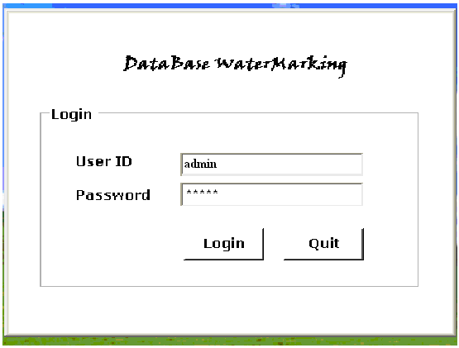

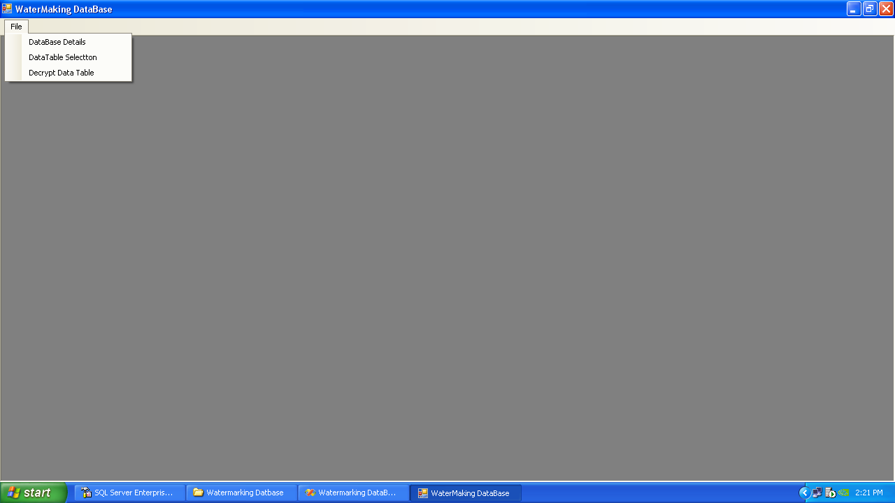

DATABASE SELECTION

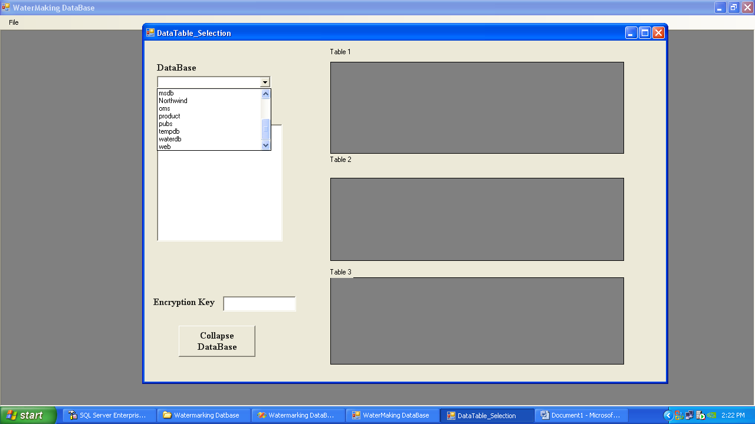

DATATABLE SELECTION

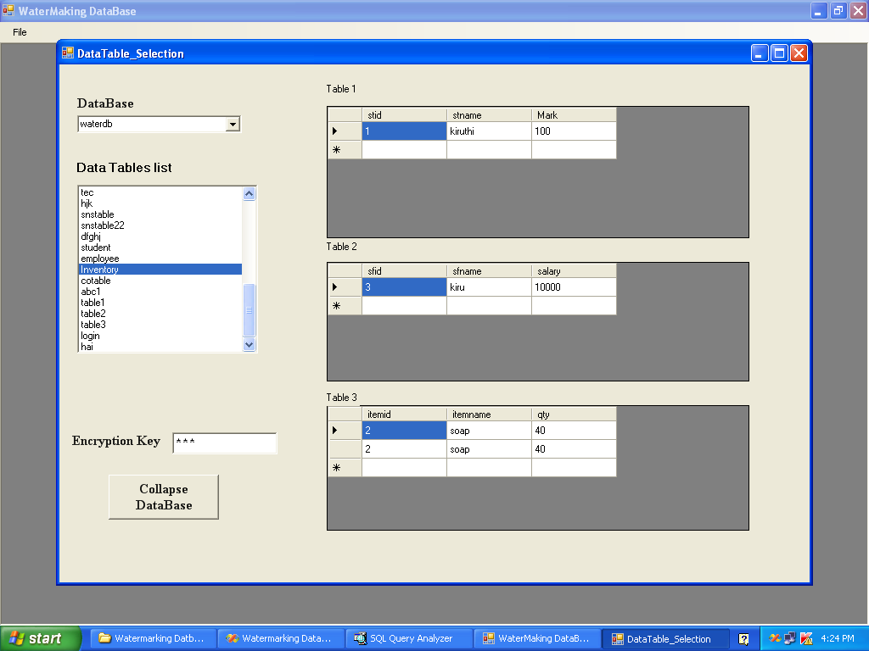

COLLAPSED TABLE VIEW

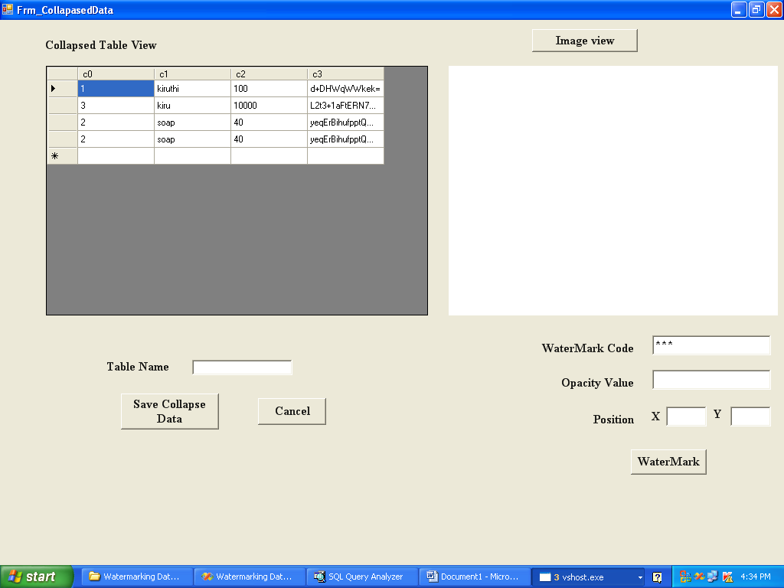

IMAGE VIEW

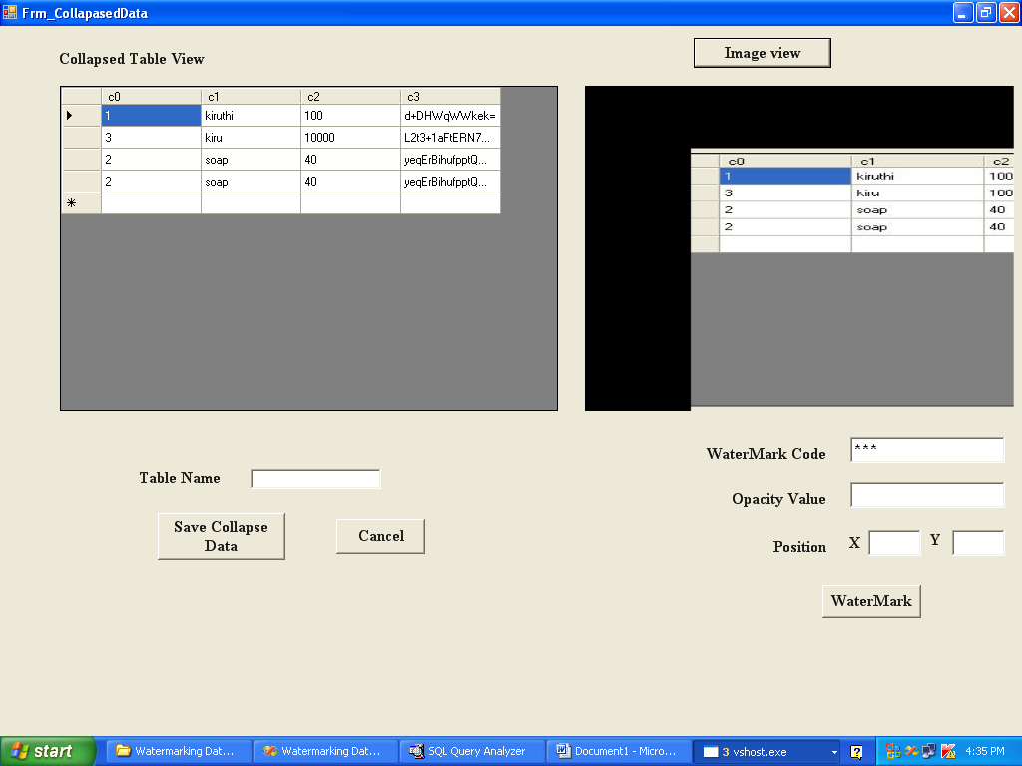

APPLY WATERMARK WITH OPACITY VALUE

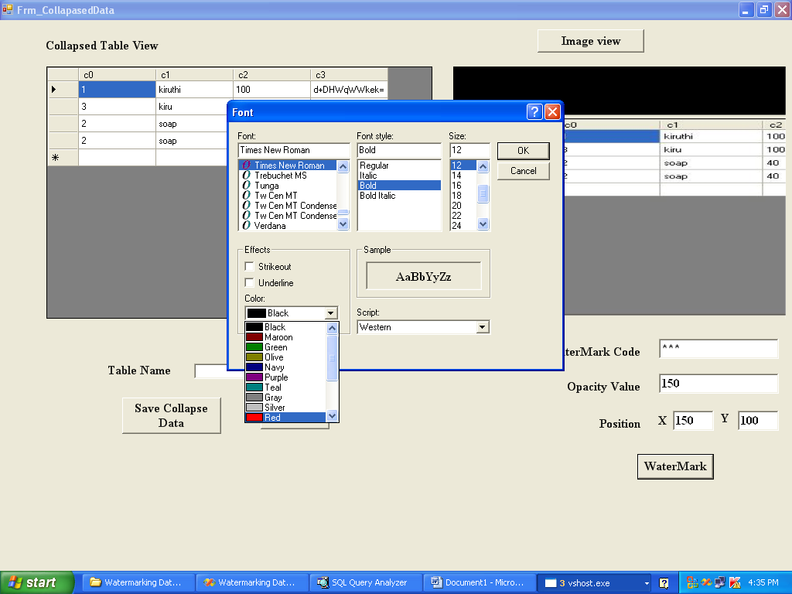

WATERMARKED DATABASE

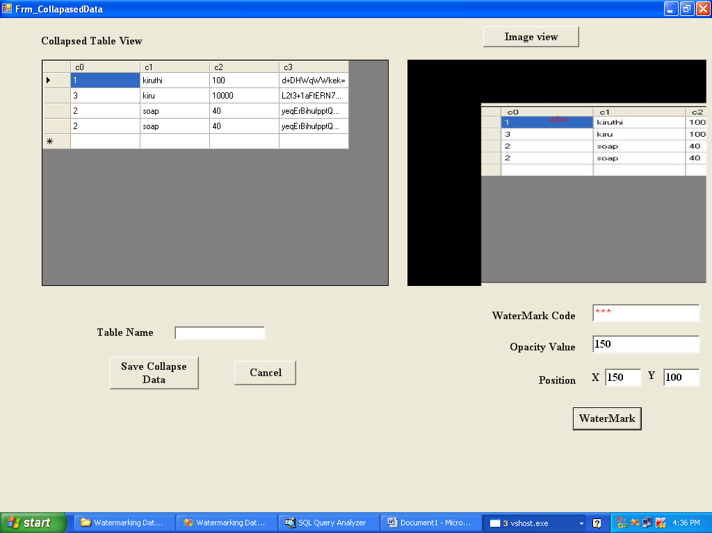

SAVE COLLAPSED TABLE IN DATABASE

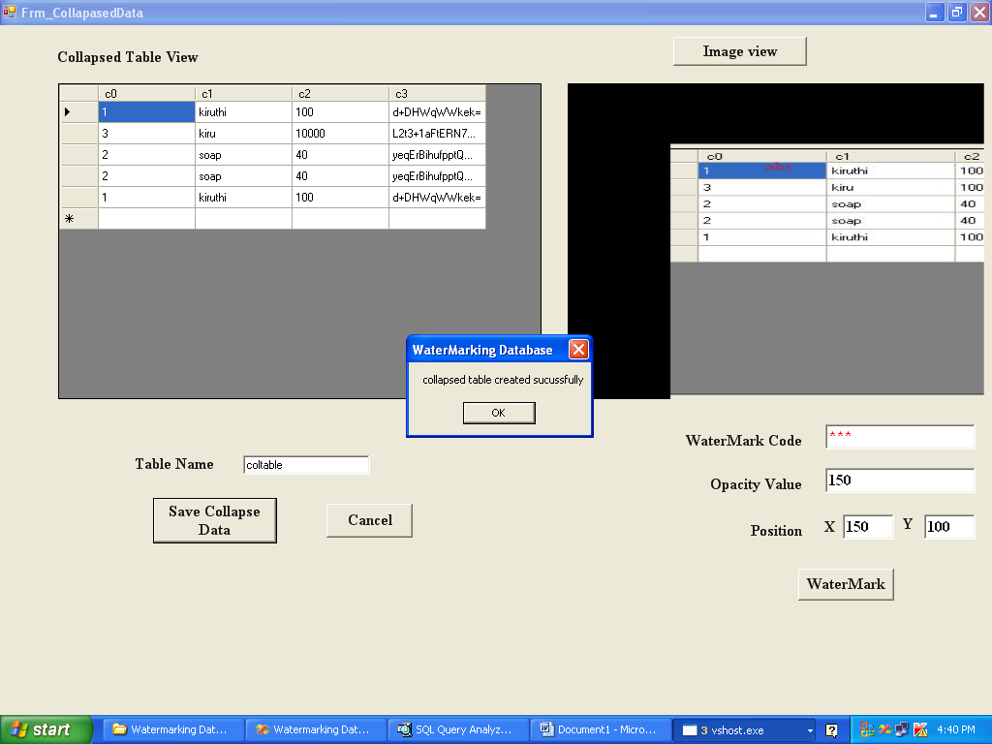

SAVE IMAGE TABLE IN DATABASE

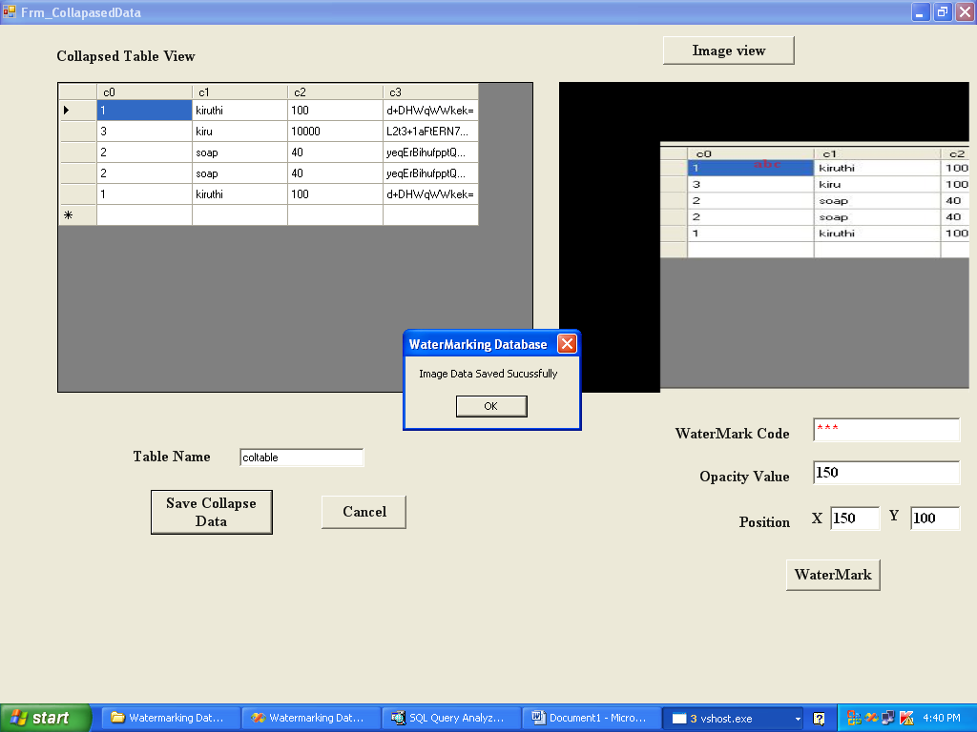

DATABASE TABLE AFTER COLLAPSE AND ENCRPTED VIEW

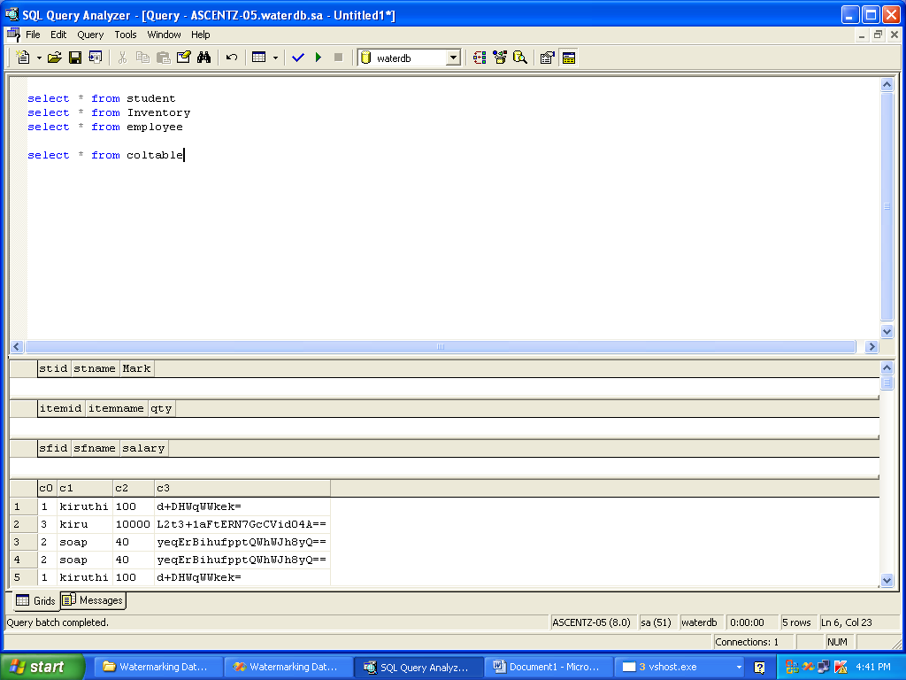

BINARY DATAVIEW OF AN IMAGE

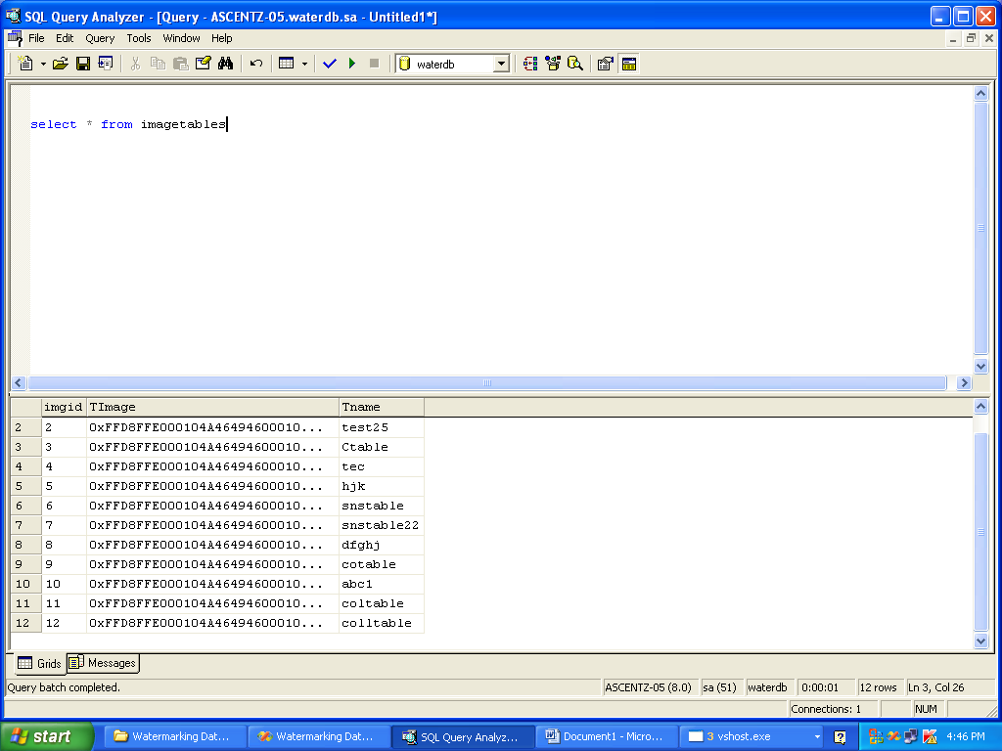

DECRYPT FORM

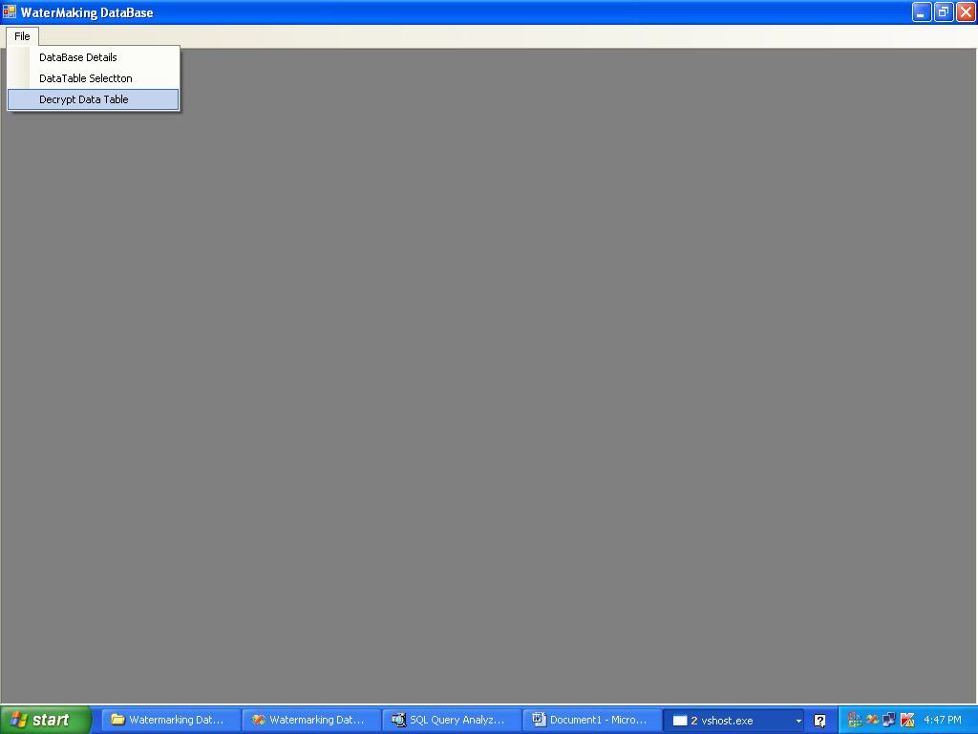

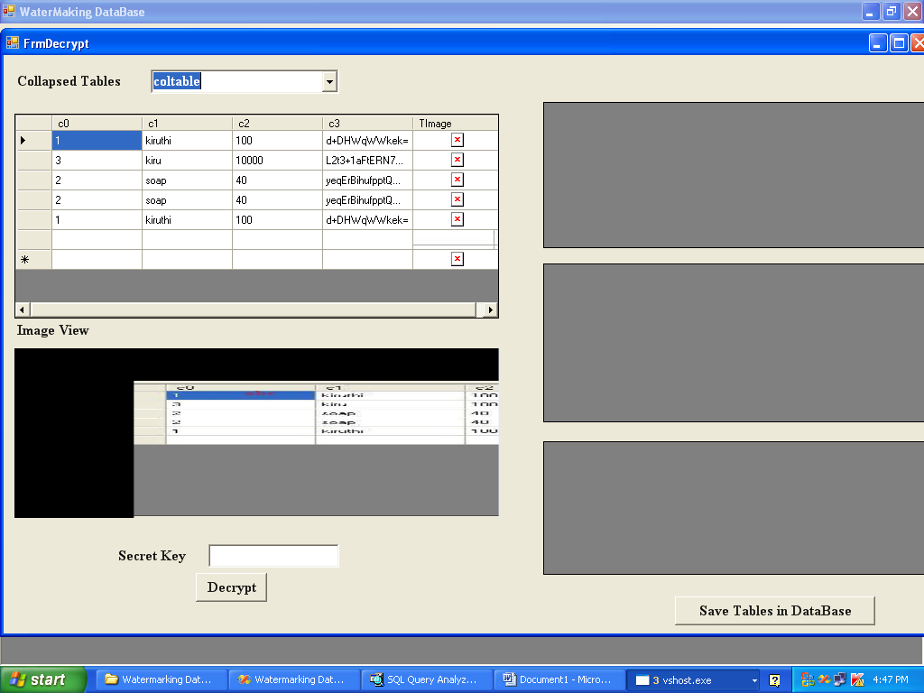

ANALYZE PIXEL PARTITION

ENTERING INVALID PASSWORD

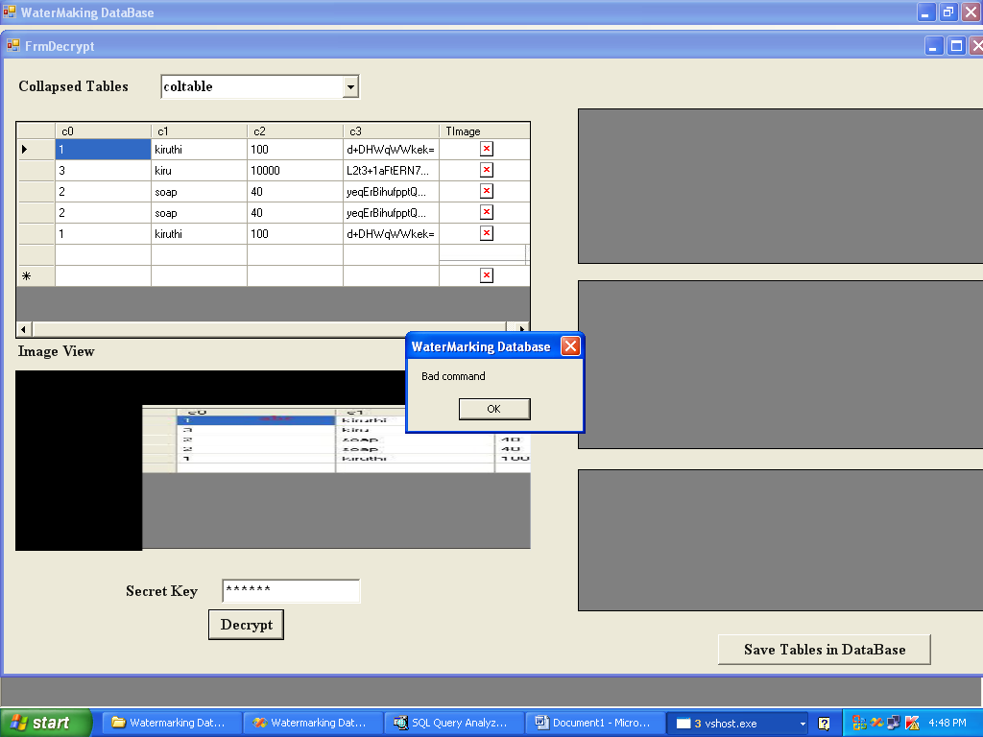

ENTERING VALID PASSWORD

