TIMESHEET PORTAL MANAGEMENT

P. SANGEETHA
10PCR14

A Project Report submitted to Avinashilingam Deemed University for Women, Coimbatore in partial fulfillment of the requirements for the Master’s Degree in Computer Science.

April,2012

ACKNOWLEDGEMENT

I would like to express my sincere thanks to God Almighty, for His constant love and grace that He has showered upon me.

I am very grateful to Dr.T.S.K.Meenakshi Sundaram, M.A., M.Phil., Ph.D., Chancellor, Avinashilingam Institute for Home Science and Higher Education for Women, Coimbatore, for his support and encouragement during the course of my study.

I heartily thank Dr. (Mrs).Sheela Ramachandran M.Sc., P.G. Dip., Ph.D., Vice Chancellor, Avinashilingam Institute for Home Science and Higher Education for Women, Coimbatore, for extending all resources that facilitated the conduct of the present study.

I express my humble gratitude to Dr. (Mrs). Gowri Ramakrishnan M.Sc., M.Phil., Ph.D., Registrar, Avinashilingam Institute for Home Science and Higher Education for Women, Coimbatore, for providing all facilities necessary for the study.

I am also thankful to Dr. (Mrs). R. Parvatham M.Sc., Dip.Ed. M.Phil., Ph.D., Dean Faculty of Science, for granting the facility required.

I wish to place on record my deep sense of gratitude to Dr.(Mrs).G.Padmavathi M.Sc., M.Phil., Ph.D., Professor and Head, Department of Computer Science, for providing all the facilities to complete the project.

I owe great deal of gratitude to my esteemed Dr. (Mrs).S.N.Geetha Lakshmi, MCA., M.Phil., Ph.D., Assistant Professor , Department of Computer Science, for imparting the tremendous assistance and well timed support for triumph of my project.

I take this unique opportunity to express my sincere thanks to my project Coordinator Dr.(Mrs).P.Subashini, MCA., M.Phil., Ph.D., Associate Professor, Department of Computer Science, for her kind advice and knowledgeable suggestion, which helped me to complete my project successfully.

I would extend my hearty thanks to one and all who helped me directly or indirectly for successful completion of my project.

SYNOPSIS

The “Timesheet Portal” records the number of hours an employee spends in completing a certain task. The “Timesheet Portal” is a very crucial tool in maintaining employee records, project status/track and regarded as an important time management tool that helps improving the overall productivity of the organization.
The Portal has three types of user privileges. It allows the Administrator to add the users and import the project details from spreadsheet files. The Portal allows the Project manager to add Team members and modules for a particular project. The Time sheet approval is performed by the Project manager and the reports can be generated in spreadsheet format.
Employee enters the tasks in the online Timesheet Portal. Employee shall view the timesheet reports. The Portal provides an easy interface to enter the task details. The System is developed using PHP as front end and MYSQL as back end.

CONTENTS

S.NO PARTICULARS PAGE NO

1. INTRODUCTION 1
1.1 Problem Definition 1
1.2 Overview of the project 1
1.3 Organization Profile 2
2. SYSTEM CONFIGURATION 4
2.1 Hardware Configuration 4
2.2 Software Configuration 4
2.3 About the Software 5
3. SYSTEM STUDY AND ANALYSIS 8
3.1 Existing System 8
3.2 Proposed System 9
3.3 Feasibility Study 10
4. SYSTEM DESIGN 12
4.1 Input Design 12
4.2 Output Design 13
4.3 Database Design 14
4.4 Program Structure 15
5. SYSTEM DEVELOPMENT 18
5.1 Module Description 18

6. SYSTEM TESTING AND PLAN 23
6.1 Unit Testing 23
6.2 Integration Testing 23
6.3 Validation Testing 24
6.4 Acceptance Testing 24
6.5 Component Test Plans and Procedures 24 6.6 System Test Plans and Procedures 38
6.7 Acceptance Test and Preparation for Delivery 40
7. CONCLUSION 41
8. SCOPE FOR FURTHER DEVELOPMENT 42
BIBLIOGRAPHY APPENDIX A Block Diagram
B Dataflow Diagram
C Table Design
D Screen Shots

- INTRODUCTION

1.1 Problem Definition
The main aim of the Timesheet Portal is to measure the employee performance by recording the number of hours an employee spends in completing the tasks throughout the project. In Project management, calculating the efficiency of an employee for a particular task is time consuming and inaccurate.
The Timesheet portal provides an easy interface to enter the task details. The number of hours spent for a project will be mentioned along with the modules. The various reports help the project manager to analyze the performance of employee. The reports can be exported to a spreadsheet file.
The Project manager will add the team members and the modules will be added for a particular project. As it is web application, it can be accessed by the users anywhere. The goal of the system is to provide an easy and efficient way for managing employee’s task every day.

1.2 Overview of the project
The Project Manager always expects the employee to give their best performance for any task assigned to them. The Employee is responsible for the quality output within the target date. The method of manual task breakdown and the performance calculations are time consuming and tedious. Timesheet portal management is meant for effort calculation, schedule and to keep track of project status and monitoring.
Timesheet Portal Management will be used for organizations, requiring time tracking of employees and contractors on projects. Timesheet Portal will run on any standard browser. It will also work on most mobile phone browsers.

1.3 Organization Profile
Pricol Technologies is a leading engineering solutions provider, helping businesses to realize their products quicker & reduce time to market through its integrated engineering ecosystem.
Pricol Technologies is a part of the globally diversified $350 Million Pricol Group, whose flagship company Pricol Limited (www.pricol.com) is one of India's largest auto ancillary companies.
Pricol take pride in our people who power the cutting edge technology of our clients from different industries like Automotive, Consumer Durable, Medical Equipment & Industrial Products. Our core expertises are Embedded System, Mechanical Design & Product realization services. Pricol offer support services in the area of Sourcing, Mfg engineering, Prototyping, Tool design & Testing.
Headquartered in Coimbatore India, our offices are globally spread across USA (Detroit & New Jersey) , Europe (UK ,Germany & Sweden)
Our value proposition is to offer high value - low cost engineering services to its customers by leveraging its development centers and engineering infrastructure in India. We have developed a very successful delivery model that enables its clients to concurrently develop products with Pricol Technologies with an "Engineer Next Door" experience although the engineers are located offshore.
Profile offer Mechanical and Electronic Design & Development Services to Automotive OEMs & Tier 1 suppliers. Pricol Technologies provides an integrated engineering environment, comprising of testing labs, tool rooms, prototype facilities, virtual reality studio, manufacturing plants and vendors for its customers to realize a product from concept to prototype and tooling.

Pricol technologies have sound experience in the design and development of various avionics systems using cutting-edge technology and support for manufacturing of high precision devices. We have a proven track record for system integration and configuration of various mission critical systems like electro mechanical actuators, on-board computing systems and data acquisition systems. A strong in-house design and engineering team and highly skilled manufacturing personnel are our core strength which help us execute high-end turnkey projects.
Our multi disciplinary capabilities gives us the depth and width to handle various technologies like BLDC motor, transmission mechanism for linear and rotary drives, control algorithms for precision closed loop control systems, DSP based hardware development for real time function execution and system integration for low form factor. Our in-house CAD lab, CFD & FEA capabilities and Environmental test facilities provide us the infrastructural support to handle fundamental research and product engineering. We provide end-to-end solutions from system architecture design to product certification.
Pricol Technologies is well versed with flow control industry for design and development of control valves, valve positioners, valve actuators and sensors and programmable logic control systems. We work very close with our customers design house and develop turnkey products to meet their market needs.
Pricol technologies has a proven design and integration team for flow control industry needs with specialized skill set in explosion proof, submersible proof and NEMA standards to build any kind of products. Good knowledge in materials and manufacturing process are the key tools for our success.
Our customized PLC development and software integration set up helps us to generate standard interfaces like command control, mod-bus, hart protocol and profi-bus. Our design team has developed critical products like I-P, Re-transmission Module and Switch module with advanced MEMs based proportional valve and pressure sensor.

- SYSTEM CONFIGURATION

The system configuration includes the requirements that are needed for a system to work efficiently and smoothly. This consists of both hardware and software configuration.
2.1 Hardware configuration
Hardware configuration denotes the system features that fall on the hardware part. It includes mainly Processor, RAM, HardDiskDrive, Monitor etc.
Processor : Pentium 2.4 GHz or higher
RAM : 1GB
HDD : 80GB
Monitor : Color Monitor
Pointing device : Scroll Mouse
2.2 Software configuration
Software configuration includes the software features that are needed for the implementation of the project.
Operating System : Windows or Linux
Front-end : PHP/HTML
Back-end : MySQL
Browser : Any compatible browsers

2.3 About the Software
About PHP 5.2.9
PHP is a general-purpose server-side scripting language originally designed for Web development to produce dynamic Web pages. It is one of the first developed server-side scripting languages to be embedded into an HTML source document, rather than calling an external file to process data. Ultimately, the code is interpreted by a Web server with a PHP processor module which generates the resulting Web page. It also has evolved to include a command-line interface capability and can be used in standalone graphical applications. PHP can be deployed on most Web servers and also as a standalone shell on almost every operating system and platform free of charge. A competitor to Microsoft's Active Server Pages (ASP) server-side script engine and similar languages, PHP is installed on more than 20 million Web sites and 1 million Web servers.
The main implementation of PHP is now produced by The PHP Group and serves as the formal reference to the PHP language. PHP is free software released under the PHP License, which is incompatible with the GNU General Public License (GPL) due to restrictions on the usage of the term PHP.
PHP Features:
- Improved support for object-oriented programming
- The PHP Data Objects (PDO) extension (which defines a lightweight and consistent interface for accessing databases)
- Numerous performance enhancements

MySQL 5.1.33
MySQL Server is a powerful database management system and the user can create application that requires little or no programming. It supports GUI features and an entire programming language. There are quite few reasons, the first being that SQL is a feature rich program that can handle any database related task. It can create places to store the data build tools that make it easy to read and modify the database contents, and ask the questions of the data.
SQL is a relational database, which stores information about related objects. In MySQL, database means a collection of tables that hold data. It collectively stores all the other related objects such as queries, forms and reports that are used to implement function effectively.
MySQL database can act as a backend database for PHP as a front end; it supports the user with its powerful database management functions. A beginner can create their own database very simply by some mouse clicks. Another good reason to use SQL as backend tool is that it is a component of the overwhelmingly popular Microsoft office software suite.
MySQL however is a relational database, which means that can define relationships among the data it contain. Relational database, are superior to flat file databases because it can store discrete information.

MySQL includes a complete set of graphical tools and command prompt utilities that allow users, programmers, and administrators to:
- Administer and configure SQL Server.
- Determine the catalog information in a copy of SQL Server.
- Design and test queries for retrieving data.
- Copy, import, export, and transform data.
- Provide diagnostic information.
- Start and stop SQL Server.
MySQL is a full-featured relational database management system (RDBMS) that offers a variety of administrative tools to ease the burdens of database development, maintenance and administration.
WAMP Server
WAMPs are packages of independently-created programs installed on computers that use a Microsoft Windows operating system. WAMP is an acronym formed from the initials of the operating system Microsoft Windows and the principal components of the package: Apache, MySQL and one of PHP, Perl or Python. Apache is a web server. MySQL is an open-source database. PHP is a scripting language that can manipulate information held in a database and generate web pages dynamically each time content is requested by a browser. Other programs may also be included in a package, such as phpMyAdmin which provides a graphical user interface for the MySQL database manager, or the alternative scripting languages Python or Perl.

- SYSTEM STUDY AND ANALYSIS

The major areas of effort for system study and analysis are problem evaluation and solution synthesis.

3.1 Existing System
The existing system in the organization is not completely computerized. The Current system doesn’t extend its functionality for Online Service Process. In existing system, the project based onsite activity and offsite activity cannot be measured. It is not possible to take the project based reports. The data are entered by employee in spreadsheet. Analyzing the performance in spreadsheet is inaccurate and time consuming. This process model and business approach is inefficient and not dynamic for the future growth of the organization.

- Existing system is implemented as manual.
- Existing system is used only inside a closed LAN.
- Existing system cannot calculate employee efficiency.
- Project based onsite activity and offsite activity cannot be measured.
- Existing system cannot deliver project-based reports.
- Existing system cannot import and export the spreadsheet format.

Drawbacks of Existing System:

- Manual implementation:
With the manual implementation, the employee and the project manager are unaware of the quality in the completed tasks and it’s not possible to identify the best performance and worst performance. It is not possible to identify the problematic tasks which will affect the final output.
In existing system, whenever a record is to be updated or to be deleted lot of cutting and overwriting needs to be done on all the registers that are concerned with the deleted or updated record, which makes the work very complex.

- Portability:
The current system was less portable. One has to carry the loads of so many registers to take the data from one place to another. A big problem was that the system was less flexible and if one wanted to make a change would need to change in all the registers that would also prove to be big headache. For instance, a project which involve both online and offline activities cannot be measured manually.

- Processing Speed:
In manual system, analyzing will take lot of time, which may affect the performance of the organization as well as hamper the progress of the organization. For instance, if the project manager wants to analyze the last one year performance based on manual timesheet entry, it will take lot of time to calculate and the final result also inaccurate. This affects the speed of working in the organization and the work that should have been performed in very short duration can take a large amount of time.

3.2 Proposed System
This is an integrated web based online system. This application connects all the team members with secured access and privileges. The proposed system will track employee efficiency, project billing based on efforts of the employee and this system will identify problematic tasks. The proposed system will be able to compare planned costs versus actual costs.

Advantages of Proposed System:
- Integrated web based application which will connect all the users.
- The open source solutions like PHP and MySQL, reduces software cost.
- Employee-wise, project-wise or date-wise Time Report can be generated.
- Option to export the Timesheet report in excel format.
- Option to import the Timesheet report from excel format.
- Admin privilege and user privilege improves the security and helps project manager to gain more control.
- Interface differs according to the type of the user.
- Multiple reports help the customer and project manager to forecast the future time delay and expenses. The current progress of the development can be easily viewed by various reports.
- Unauthorized users cannot login to the system. This avoids the major security risk.
- Option to compare planned costs versus actual costs.

3.3 Feasibility Study
The system investigation stage requires a preliminary study called a “Feasibility study. Feasibility study is a process which is required for analyzing the cost in developing system. A “Feasibility study” is a preliminary study, which investigates the information, needs of prospective users and determines the resource requirements, costs, benefits and feasibility of a proposed project.
Feasibility study lets the developer to foresee the future of the project and its usefulness.
- Finding out whether a new system is required or not.
- Determining the potentials and drawbacks of the existing system.
- All software requirements can be identified.
- Finding out the various alternatives available.
- Knowing what should be incorporated in the new system.
- Defining the ingredients and objectives involved in the project.
- Identifying whether the proposed system could meet the end needs of the users.
- Proving technical, economic, operational feasibility of the proposed system.
There are three aspects in the feasibility study portion of the preliminary investigation.
- Technical Feasibility
- Economic Feasibility
- Operational Feasibility
The proposed system must be evaluated from the technical point of view. If compatible, operational system can be devised. Then they must be tested for economic feasibility.

Technical Feasibility
Technical Feasibility emphasis on to the existing system and to what extent it can support the existing system. All the resources needed for research work of the project was available in the company. All the components were available and were working perfectly. MySql, PHP and Apache server are compatible for working environment. All the required backend database, scripting language, web server are installed in the windows platform. So this project is a technically feasible system.

Economic Feasibility
Economic analysis is the most frequently used method for evaluating the effectiveness of a candidate system. More commonly known as cost/benefit analysis, the procedure is to determine the benefits and savings that are expected from a candidate system and compare them with costs, if benefits outweigh costs, the decision is made to design and implement the system. The project has been analyzed for its economic feasibility. The scripting language PHP , the database backend MySql, the web server Apache, database GUI tool phpMyAdmin are open source products , hence the development is affordable and beneficial.

Operational Feasibility
The proposed project would be beneficial to satisfy the objectives when developed and installed. The main problems faced during development of a new system are accepted by user. There is support from the management towards the development of the online Timesheet portal. All the operational aspects are considered carefully. Thus the project is operationally feasible.

- SYSTEM DESIGN

System design is the process which includes the system architecture, components, modules, interfaces, and data for a system to satisfy specified requirements. It evaluates the actual functionality of the system in relation to expected or intended functionality, including all integration aspects. System design is to deliver the requirements as specified in the feasibility report. The main objectives of the design are
- User friendliness
- Efficient architecture
- Cost effective
- Flexibility in analyzing the data
- Security enhancements
System design includes the design based on the limitations of the existing system and the requirements specification gathered in the phase of system analysis.

4.1 Input Design
Input design is to design the various inputs needed into a machine oriented format. The main objective is to create an input layout that is easy to follow and to avoid operator errors. The design phase includes designing of various input files used to develop the system.

The input forms used in the system are
- Login Form
- Add Users
- Add Team
Login Form
User provides the required details like user name and password to login in to the system. The unauthorized person cannot access the system
Add Users
To register a new user the Employee ID, name, date of birth, email id, phone number has to be provided by the user.
Add Team
By providing the name, role, start date and end date of the project, the team members for the particular project will be added.
4.2 Output Design
Output is the most important and direct source of information to the user. Efficient intelligible output design should improve the system’s relationship with the user and in decision-making.
Output design generally refers to the results generated by the system. For many end users on the basis of the output to evaluate the usefulness of the application. Efficient software must be able to produce effective reports.

- Profile
- User Details
- Project Details
Profile
The page is displayed according to the individual users of the system and the session is started. The username and password is verified from the database. If valid the corresponding page will be displayed or it will remain in the same page.
User Details
All the users’ details such as Employee ID, first name, email, extension number will be displayed in the report form.
Project Details
All the project details such as Project ID, project name, start date, end date will be displayed in the report form.
4.3 Database Design
The database design phase involves the design of the database and constituent tables that are used by the system for storage and retrieval of data. Data elements and data structures to be stored have been identified at analysis stage. They are structured and put together to design the data storage and retrieval system.
A database is a collection of interrelated data, stored together in such a way to minimize redundancy and to serve a multiplicity of applications. Database design runs parallel with the system design. Database is designed to meet the overall goal of the project. Care should be taken while designing to avoid unnecessary duplication.

4.4 Program Structure:
Two-tier architecture in which the user interface, functional process logic, computer data storage and data access are developed and maintained as independent modules, most often on separate platforms. The two-tier model is considered to be software architecture and a software design pattern.

User Interface Design:
Section Overview
The Interface Design Rules Section provides the set of rules and regulations to be followed for designing the user interface.
Interface Design Rules
- The system has been designed by using Dream Weaver.
- Standard Screen Size: minimum of 1200 pixels by 600 pixels (1200x600).
- Fonts: Times New Roman, Bookman Old Style and Verdana.
- Font Size: 24, 16 and 12.
GUI Components
Providing for easy access and usability of the systems are the usages of the Graphical User Interface (GUI) components are listed below,
- Labels, Text Field, Text Area
- Buttons
- Check Box
- Menus
- List Box
Detailed Description
The entire system is menu driven and provided with buttons. The menus and sub-menus allow the user to get the information from the system. The interface helps to interact with the user and the system. The system consists of various screens.

User Login Components
Description: user logs into the application by entering the user id, password.
Method:
Login ()-validates the user name and password and creates session.
Logout ()-Destroy the session.
ResetPassword ()-this method is used to reset the password.
ChangePassword ()-this method is used to change the password.

User Management Components
Description: Management of the users for the system.
Method:
AddUser ()-this method creates the user account with their details.
EditUser ()-enables to edit the details of user.
ViewUser ()-enables to view the details of user.
SearchUser ()-Search for the users.

Project Management Components
Description: Managing the project details.
Method:
AddProject ()-this method is used to add the project details.
EditProject ()-enables to edit the project details.
ViewProject ()-enables to view the project details.
AddResoure ()-The team members are allocated for the project.
EditResoure ()-The team members can be edited for the project.
AddModule ()-Add modules for the project.
EditModule ()-Edit modules for the project.

Timesheet Components
Description: Working with timesheet.
Method:
TimesheetEntry ()-This method to enter the task details.
TimesheetApproval ()-To approve the timesheet entries.

Report Components
Description: Report view and generate.
Method:
TimesheetReport ()-used to view the timesheet report.
Export ()-used to export the report in spreadsheet format.

- SYSTEM DEVELOPMENT

5.1 Module Description

This section describes in detail the various features of this software. They are listed below,

User Management

Description and Priority

This module is used by the Admin to add the users in the Timesheet Portal.

Functional Requirements
Purpose | Admin can add, edit, disable and view users.
Inputs | User Information.
Processing | Validating user details, retrieving from database and updating in database.
Outputs | Users are managed successfully by Admin.

Project Management

Import Project

Description and Priority

This module is accessed by the Admin to import the excel file and store the data in database directly from excel.

Functional Requirements
Purpose | Import the excel file and the store the data in database.
Inputs | The file name is selected and imported.
Processing | The project details in the excel file is transferred into the database.
Outputs | Excel file is imported and stored the data in database.

Add Modules

Description and Priority

This module is accessed by the Moderator to add the modules in the database to be accessed in Timesheet.

Functional Requirements
Purpose | Moderator adds the modules.
Inputs | The lists of modules are selected.
Processing | The various modules are being added in the database.
Outputs | Modules are added for the project.

Allocate Team

Description and Priority

This module is accessed by the moderator to allocate the team of members for a particular project.

Functional Requirements
Purpose | A team of members is added for every project.
Inputs | The members are added one by one.
Processing | The members are being added to database.
Outputs | Team members are allocated successfully.

Timesheet

Timesheet Entry

Description and Priority

This module is accessed by all the users for the Timesheet entry. It can be entered on daily basis. Suppose if it is not entered for previous days, options are available to put entry for earlier fifteen days.

Functional Requirements
Purpose | To enter each day task and efforts.
Inputs | The various parameters like module, efforts and remarks.
Processing | All the entries are loaded onto the database.
Outputs | Tasks are entered.

Timesheet Approval

Description and Priority

This module is accessed by the moderator to approve the Timesheet entries for all the users. It can also disapproved by the moderators. The pending state will be shown if it is not approved.

Functional Requirements
Purpose | To validate the timesheet entries.
Inputs | Checkbox option is given for approval.
Processing | The approval and disapproved details are updated in the database.
Outputs | The status will be shown to the user.

Reports

Timesheet Report

Description and Priority

This module is accessed by moderator and users to view the reports based on the projects.

Functional Requirements
Purpose | To view the project reports.
Inputs | Project ID and date are the inputs.
Processing | The reports are generated with the help of database.
Outputs | The report is generated.

Export

Description and Priority

This module is accessed by moderator and users to export the project report as an excel file.

Functional Requirements
Purpose | To export the reports as excel sheet.
Inputs | A button is clicked with export option.
Processing | The timesheet reports are being exported as an excel file.
Outputs | Reports are exported as excel file.

Search

Description and Priority

This module is accessed by all the users to search for the details of an employee.

Functional Requirements
Purpose | To search the details of an employee.
Inputs | First name and last name.
Processing | The search is made in the database with first name and last name.
Outputs | The search results appear.

6. SYSTEM TESTING AND IMPLEMENTATION
The System testing is an iterative process of both validating functionality and finding the threats to break the security in the developed system. The System testing is performed under the logical assumption that all the parts of the system are correct. After the completion of the development of the proposed system, the Testing phase begins.
The objective of system testing is to find the problems, fix them to improve quality and remove the security threats. While testing tends to be considered a part of the development, it should be tracked as its own project. The testing steps are as follows
6.1 Unit testing
6.2 Integration testing
6.3 Validation testing
6.4 Acceptance testing
6.1 Unit testing
Unit testing focuses verification effort on the smallest unit of the software. This testing was carried out during programming stage itself. In this project each button is tested from private sub to end sub. Each module was tested individually and the corresponding errors generated were reviewed and rectified.

6.2 Integration testing
An Integration testing is carried out using integrated test plans in the design phase of the development, to ensure the behavior of functions with live data. Integration testing is conducted to remove errors associated with interface. All the modules in the system are combined together and are tested for the overall performance of the system.

6.3 Validation testing
This testing ensures the basic validation in user entry forms. It provides final assurances that software meets all functional, behavior and performance requirement. In this project, validation testing is made in login form and in other data entry forms. For instance, in login form, only the valid user can access the system and invalid login data will be rejected.

6.4 Acceptance testing
Acceptance testing involves planning and execution of functional tests, performance tests and stress tests in order to demonstrate that the implemented system satisfies its requirements. Acceptance testing ensures whether all the user requirements are fulfilled and covered in the developed system. In Timesheet portal, the important requirement is to import the data from spreadsheet files. This comes under acceptance testing.
6.5 Component Test Plans and Procedures
This section describes about the verification and validation which is involved in this project.
    - Component Test Strategy Overview:
This section contains five specific points that will be used to describe each component of the "Timesheet Portal" project. They are
- Test case group identification: Describes where this particular test case group fits in the system structure and in the overall test plan.
- Functions to be tested: Describes the functions and combinations of functions that are being tested. These features should be traced to the software requirement specifications or software design specifications for confirmation.
- Testing approach: Describes specific test strategies and techniques to be used on this test case group and the methods that will be used to analyze the results.
- Pass/Fail criteria: Describes the detailed criteria that the product must satisfy to pass this test case group.
- Individual test cases: Includes test case identifier, input, expected output, environment, special procedures, precedence and dependencies, references.

    - Component Intro Page

Component 1: Login
Test case group identification | Login Form
Functions to be tested | Functions tested include:  - Buttons available  - Login  - Cancel
Testing approach | Testing whether Menu appears according to the users who logs in to the system
Pass/Fail criteria | User has to enter username and password, which is valid and user should be an authorized person.
Individual test cases | Test case 1:  Test case identifier: Login.  Input  - User Enter the username and password.  Expected output  - The page is displayed according to the users of the system and sessions are started.  Environment  - Windows Xp or Higher.  Precedence and dependencies  - The username and password is verified from the database. If it is valid the corresponding page will display or it will remains in the same page.  Test case 2:  Test case identifier: Cancel  Input  - No input is required.  Expected output  - The textbox will be cleared.  Environment  - Windows Xp or Higher.

Component 2: Add Users
Test case group identification | Add Users
Functions to be tested | Functions tested include:  - Buttons available  - Back  - Confirm  - Reset
Testing approach | Testing whether Menu appears according to the users who log in to the system
Pass/Fail criteria | User can apply for the order or clear the application.
Individual test cases | Test case 1:  Test case identifier: Confirm  Input  - Employee id, Name, DOB , Email id, Phone no etc.  Equivalence Class Partitioning:  Name  - EC1: Alphabets(a-z, A-Z) , Valid  - EC2: Special Character Invalid  - EC3: Length Maximum 20 and Minimum 3, Valid  - EC4: Blank Space , Invalid  Equivalence Class Partitioning:  Employee Id.  - EC1: Numeric, Valid  - EC2: Special Character, Invalid  - EC3: Length only 10 to 15, above 15 Invalid  - EC4: Zero alone, valid  - EC5: Blank Space , Invalid  Equivalence Class Partitioning:  E- mail ID  - EC1: Alphanumeric, Special characters , Valid  - EC2: Special Character with @, two “.”, Valid  - EC3: Other than @ and “.” Special character, Invalid  - EC4: More than one @, More than two “.”, Invalid  - EC5: Blank Space , Invalid  Equivalence Class Partitioning:  Phone Number  - EC1: Numeric, Valid  - EC2: Special Character, Invalid  - EC3: Length only 10 to 15, above 15 Invalid  - EC4: Zero alone, valid  - EC5: Blank Space , Invalid  Expected output  - User details are added to the database  Environment  - Windows Xp or Higher

Component 3: Disable User
Test case group identification | Disable User
Functions to be tested | Functions tested include:  - Button available  - Disable User
Testing approach | Testing whether Menu appears according to the users who log in to the system
Pass/Fail criteria | The user can be disabled in the user list by admin.
Individual test cases | Test case 1:  Test case identifier: Disable  Input  - The checkbox is selected to disable.  Expected output  - The disabled user cannot login.  Environment  - Windows Xp or Higher.  Precedence and dependencies  - When the user is disabled, the table is updated and should be available in the user list.

Component 4: Import project
Test case group identification | Import project
Functions to be tested | Functions tested include:  - Buttons available  - Save  - Cancel
Testing approach | Testing whether Menu appears according to the users who log in to the system
Pass/Fail criteria | Admin gives the project ID and the project details are imported to database
Individual test cases | Test case 1:  Test case identifier: Save  Input  - Excel Sheet, Filename  Equivalence Class Partitioning:  Filename  - EC1: XLS(97-2003) Format, Valid  Expected output  - All the imported details will get stored in the database and messages are displayed.  Environment  - Windows Xp or Higher
Component 5: Change Password
Test case group identification | Change password
Functions to be tested | Functions tested include:  - Buttons available  - Confirm  - Cancel
Testing approach | Testing whether Menu appears according to the users who log in to the system
Pass/Fail criteria | User can change the password
Individual test cases | Test case 1:  Test case identifier: Change password  Input  - Old password, New Password, Retype new password  Expected output  - New password should be successfully stored in the database.  Environment  - Windows Xp or Higher  Precedence and dependencies  - The “old password” must be present in the database.

Component 6: Timesheet Entry
Test case group identification | Timesheet Entry
Functions to be tested | Functions tested include:  - Buttons available  - Save  - Cancel
Testing approach | Testing whether Menu appears according to the users who log in to the system
Pass/Fail criteria | User have to enter their task details
Individual test cases | Test case 1:  Test case identifier: Save  Input  - Date, shift, project id, module, activity, remarks and efforts.  Equivalence Class Partitioning:  - All the input fields are required  Expected output  - These entries are stored in the database.  Environment  - Windows Xp or Higher  Precedence and dependencies  - These entries are approved by the moderators.

Component 7: Timesheet Approval
Test case group identification | Timesheet Approval
Functions to be tested | Functions tested include:  - Buttons available  - Approve  - Rejected  - View
Testing approach | Testing whether Menu appears according to the users who log in to the system
Pass/Fail criteria | Timesheet entries of the user have to be approved or rejected by the moderators.
Individual test cases | Test case 1:  Test case identifier: View  Input  - Project ID and date.  Equivalence Class Partitioning:  - All the input fields are required  Expected output  - Those entries are retrieved from the database.  Environment  - Windows Xp or Higher  Test case 2:  Test case identifier: Approve  Input  - Checkbox.  Equivalence Class Partitioning:  - Checkbox should be selected, then only it is approved.  Expected output  - Approved entries are stored in the database.  Environment  - Windows Xp or Higher  Precedence and dependencies  These entries are approved by the moderators.

Component 8: Timesheet Report
Test case group identification | Timesheet Approval
Functions to be tested | Functions tested include:  - Buttons available  - Print  - View
Testing approach | Testing whether Menu appears according to the users who log in to the system
Pass/Fail criteria | Reports are generated are based on the employees.
Individual test cases | Test case 1:  Test case identifier: View  Input  - Project ID and date.  Equivalence Class Partitioning:  - All the input fields are required  Expected output  - Efforts are retrieved from the database and are calculated.  Environment  - Windows Xp or Higher  Precedence and dependencies  - Only approved entries will be available in the report

Component 9: Search
Test case group identification | Search
Functions to be tested | Functions tested include:  - Buttons available  - Search.
Testing approach | Testing whether Menu appears according to the users who log into the system.
Pass/Fail criteria | User information can be searched.
Individual test cases | Test case 1:  Test case identifier: Search  Input  - First name or Last name.  Equivalence Class Partitioning:  First name or Last name  - EC1: Alphabets (a-z, A-Z), Valid.  - EC2: Special Character Invalid.  - EC3: Blank space is not allowed.  Expected output  - The matched names will be displayed from the database  Environment  - Windows Xp or Higher

Component 10: Add Team Members
Test case group identification | Add Team
Functions to be tested | Functions tested include:  - Buttons available  - Add  - Reset  - Cancel
Testing approach | Testing whether Menu appears according to the users who log in to the system
Pass/Fail criteria | User information can be searched
Individual test cases | Test case 1:  Test case identifier: Add  Input  - Name, Role, Start date and End date.  Equivalence Class Partitioning:  - All the input fields are required  Expected output  - The team members for that particular project will be added.  Environment  - Windows Xp or Higher

  - System Test Plans and Procedures:
The entire software product is tested to ensure that the interfaces between the components are defined and functions properly, after each individual component has already been tested. The integration tests ensure that the system components work together as well as they works individually.

6.6.1 Linking Integration
a. Login Form
Test Case Group | Login
Features Tested | After a successful login User will be directed to the User home page, which contains a menu and the user will be able to perform various tasks such as view vehicle, search vehicle, select and order vehicle etc.
Testing Approach | Functional Testing.
Pass/Fail Criteria | The user will be directed to the User home page with the necessary privileges or redirected to login page again.

b. User Management
Test Case Group | Add users, disable users.
Features Tested | The users are added into the system and the details are stored for login.
Testing Approach | Functional Testing.
Pass/Fail Criteria | The user details are stored for login.

c.Password
Test Case Group | Changing Password.
Features Tested | User can change their password.
Testing Approach | Functional Testing.
Pass/Fail Criteria | The new password is updated and old password will also be available.

d. Project Management
Test Case Group | Add project, view project, edit project, add team and modules.
Features Tested | The projects are added into the system and it can be edited like adding members and modules.
Testing Approach | Functional Testing.
Pass/Fail Criteria | The project details are stored for timesheet.

e.Timesheet
Test Case Group | Timesheet entry, approval, report.
Features Tested | Users can enter their tasks, gets the approval and view the report.
Testing Approach | Functional Testing.
Pass/Fail Criteria | The timesheet is updated once it is approved.

f. Search
Test Case Group | Search.
Features Tested | Search for the user information.
Testing Approach | Functional Testing.
Pass/Fail Criteria | The related search result appears.

    - Coherence and Accuracy of Information
Test Case Group | Coherence and accuracy of Information
Features Tested | Information content of each page
Testing Approach and flow | Inspection of the information its organization, accuracy, and flow.
Pass/Fail Criteria | The information must be correct and accurate, yet simple enough. The organization and flow must be logical so that the concepts can be understood easily.

6.7 Acceptance Test and Preparation for Delivery:
This section describes about the procedure and scenario which is involved in this project.
6.7.1 Procedure by which the software product had been acceptance tested
Before the product is presented to the client, it had been acceptance tested in the following manner:
- The team member has verified the product by going through the test cases.
- The component at the highest levels of the system is tested first. Then each sub-component has been tested until the most detailed components at the lowest levels had been tested.
- The product has been evaluated to ensure that it meets design specifications stated in the SRS and SDS.
- Our client participated in acceptance testing throughout product development.
    - Specific acceptance criteria
- The portal should be tested for invalid inputs.
- The portal should work efficiently by leading the user to appropriate pages.
- The portal displays all the information that user needs.
- The portal runs from the internet, has an interactive graphical user interface.
- The portal is tested for incorrect or missing functions, interface errors; exercise all logical decisions on their true and false sides.

6.7.3 Scenario by which the software product will be installed

Timesheet Portal will be organized, deployed and accessed from organization system and database. To work with this application, MySQL server should be installed.

7. CONCLUSION

The “Timesheet Portal” runs efficiently after implementation. The online application helps the project team to connect with each other in a secured way. This product facilitates various reports which help to improve the performance of the employee and for cost monitoring of the project.
The “Timesheet Portal” can be used by a business organization to maintain online project based activities. This application avoids the problems in the manual system and helps to improve in every area related to Time Management in a project. The spreadsheet import option helps to avoid the reentry of the existing data.

8. SCOPE FOR FURTHER DEVELOPMENT

There is always a room for improving any software package, however good or efficient it may be. But the important fact is that the system should be flexible enough for future modification whenever needed. Keeping in consideration about this important factor, the system is designed in such a way that the modules are efficient enough to introduce any change in the software to get more information. The enhancement of this project is the important factor for the administrator. The scope for further developments are listed below,
- Visual tools to analyze the employee data.
- Email notifications to Employee and Manager.
- Online spreadsheet solution shall improve user friendliness.

BIBLIOGRAPHY

BOOK REFERENCES

- Luke Welling and Laura Thomson, “PHP and MySQL Web Development (4th Edition)”, Kindle Edition.
- Chris Lea, Christopher Scollo, and Deepak Thomas, “Beginning PHP4 Databases”, Andrew Hill.

WEBSITE REFERENCES

- http://www.phpclasses.org/package/2971-PHP-Display-MySQL-database-query-data-in-an-HTML-grid.html
- http://www.w3schools.com/php/
- http://www.smartdraw.com/tutorials/software/dfd/tutorial_01.html

APPENDIX
APPENDIX A

Data Flow Diagram: Level 0

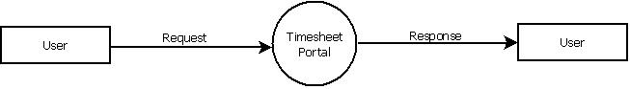

Fig: I

Data Flow Diagram: Level 1

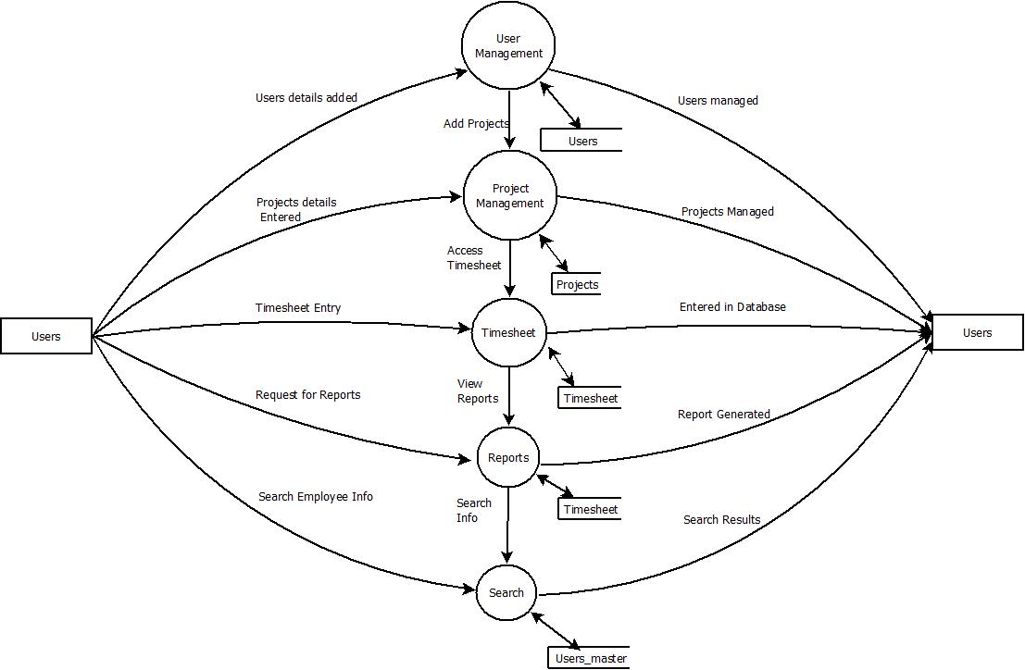

Fig: II

CLASS DIAGRAM

Fig: III

SEQUENCE DIAGRAM

Fig: IV

ER DIAGRAM

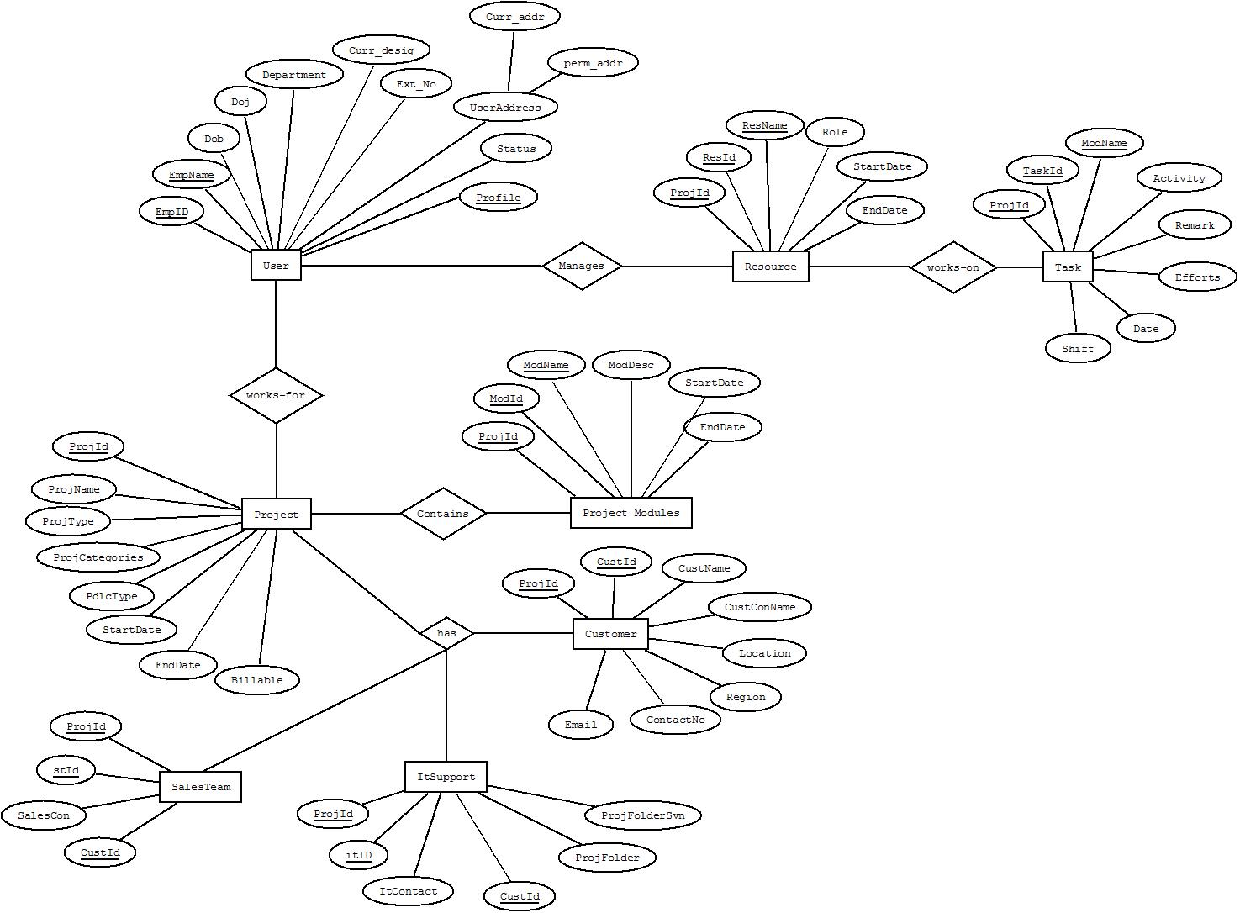

Fig: V

APPENDIX B
Table Structure
Table 1: User
Description: Stores user information
Field Name | DataType | Size | Constraints | Description
EmpId | nvarchar | 5 | Primary key | Employee id
EmpName | nvarchar | 20 | Not Null | Employee name
Dob | dates |  | Not Null | Date of birth
Doj | date |  | Not Null | Date of joining
Dept | nvarchar | 15 | Not Null | Department
Curr_Desig | nvarchar | 15 | Not Null | Current designation
Extn_no | nvarchar | 10 | Not Null | Extension number
Status | nvarchar | 15 | Not Null | Status
Profile | nvarchar | 15 | Not Null | User level

Table 2: User Address
Description: Stores Address
Field Name | Data Type | Size | Constraints | Description
EmpId | nvarchar | 5 | Foreign Key | Retrieves employee id
Curr_addr | nvarchar | 75 | Not Null | Stores Current address
Perm_addr | nvarchar | 75 | Not Null | Stores Permanent address

Table 3: User Login
Description: Authentication
Field Name | Data Type | Size | Constraints | Description
EmpId | nvarchar | 5 | Foreign Key | Retrieves employee id
UserName | nvarchar | 15 | Not Null | Stores User Name
Password | nvarchar | 15 | Not Null | Stores User Password
Profile | nvarchar | 15 | Not Null | Retrieves user level

Table 4: Project
Description: Stores Project details
Field Name | DataType | Size | Constraints | Description
ProjId | nvarchar | 5 | Primary key | Project Id
ProjName | nvarchar | 30 | Not Null | Project name
ProjType | nvarchar | 15 | Not Null | Type of project
ProjCategories | nvarchar | 15 | Not Null | Project category
PdlcType | nvarchar | 20 | Not Null | Life cycle type
StartDate | Date |  | Not Null | Start date of project
EndDate | Date |  | Not Null | End date of project
Billable | nvarchar | 5 | Not Null | Billable

Table 5: Project Modules
Description: Stores Module details
Field Name | DataType | Size | Constraints | Description
ProjId | nvarchar | 5 | Foreign key | Project Id
Modid | nvarchar | 5 | Primary key | Module id
ModName | nvarchar | 20 | Not null | Module name
ModDesc | nvarchar | 50 | Not Null | Module description
StartDate | date |  | Not Null | Start Date
EndDate | date |  | Not Null | End Date

Table 6: Project Resource
Description: Stores Resource details
Field Name | DataType | Size | Constraints | Description
ProjId | nvarchar | 5 | Foreign key | Project Id
ResId | nvarchar | 5 | Primary key | Resource id
ResName | nvarchar | 50 | Not null | Resource name
Role | nvarchar | 10 | Not Null | Role
StartDate | date |  | Not Null | Start Date
EndDate | date |  | Not Null | End Date

Table 7: Customer
Description: Stores Customer details
Field Name | DataType | Size | Constraints | Description
ProjId | nvarchar | 5 | Foreign key | Project ID
CustId | nvarchar | 5 | Primary key | Customer ID
CustName | nvarchar | 20 | Not Null | Customer name
CustConName | nvarchar | 20 | Not Null | Person name
Location | nvarchar | 15 | Not Null | Customer place
Region | nvarchar | 15 | Not Null | Customer region
Contactno | nvarchar | 15 | Not Null | Contact number
Email | nvarchar | 20 | Not Null | Customer mail id

Table 8: Delivery Team details
Description: Stores Delivery Team details
Field Name | DataType | Size | Constraints | Description
DeliTeamId | nvarchar | 5 | Primary key | Delivery team Id
ProjId | nvarchar | 5 | Foreign key | Project ID
CustId | nvarchar | 5 | Foreign key | Customer ID
Domain | nvarchar | 50 | Not Null | Appropriate domain
ProjMan | nvarchar | 50 | Not Null | Project manager

Table 9: Sales Team details
Description: Stores Sales Team details
Field Name | DataType | Size | Constraints | Description
ProjId | nvarchar | 5 | Foreign key | Project ID
StId | nvarchar | 5 | Primary key | Sales team ID
CustId | nvarchar | 5 | Foreign key | Customer ID
SalesCon | nvarchar | 15 | Not Null | Sales contact name

Table 10: IT Support details
Description: Stores IT Support details
Field Name | DataType | Size | Constraints | Description
ProjId | nvarchar | 5 | Foreign key | Project ID
itId | nvarchar | 5 | Primary key | It details id
CustId | nvarchar | 5 | Foreign key | Customer ID
Itcontact | nvarchar | 20 | Not Null | Contact person
Projfolder | nvarchar | 5 | Not Null | Project folder in server
ProjFoldersvn | nvarchar | 5 | Not Null | Project folder in svn

Table 11: Task
Description: Stores Task details
Field Name | DataType | Size | Constraints | Description
ProjId | nvarchar | 5 | Foreign key | Project Id
TaskId | nvarchar | 5 | Primary Key | Task Id
Modname | nvarchar | 20 | Not Null | Module name
Activity | nvarchar | 20 | Not Null | Activity
Remark | nvarchar | 50 | Not Null | Remarks
Efforts | nvarchar | 5 | Not Null | Efforts
Date | Date |  | Not Null | Date for entry
Shift | nvarchar | 5 | Not Null | Shift type

APPENDIX C

Screen Layouts

Login Form:

Screen: I

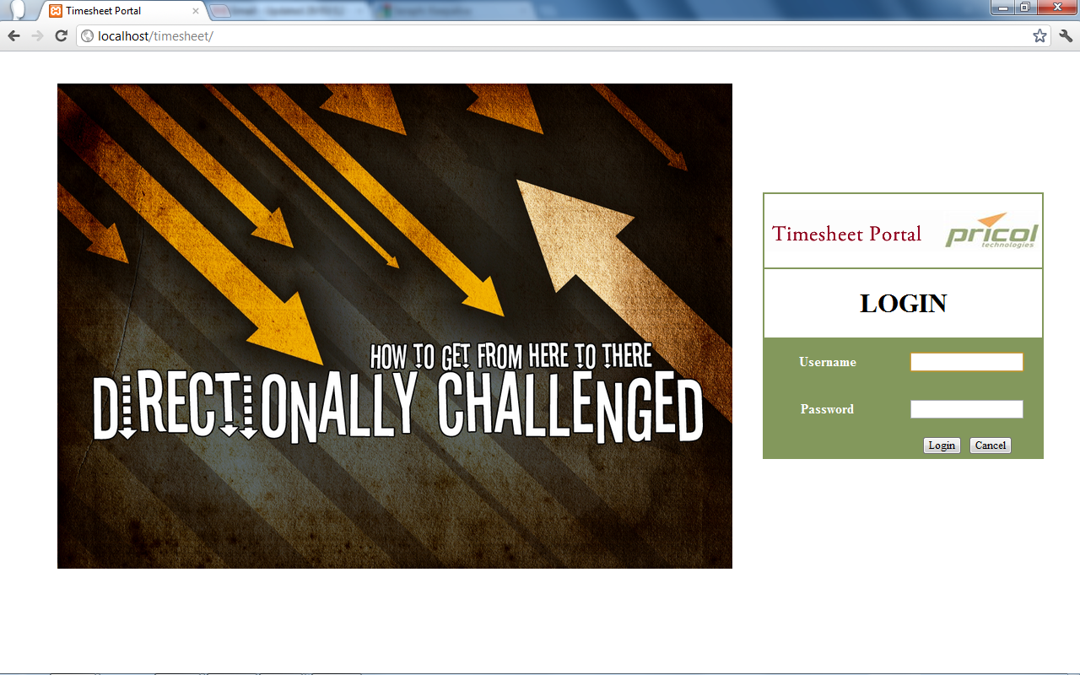

Profile:

Screen: II

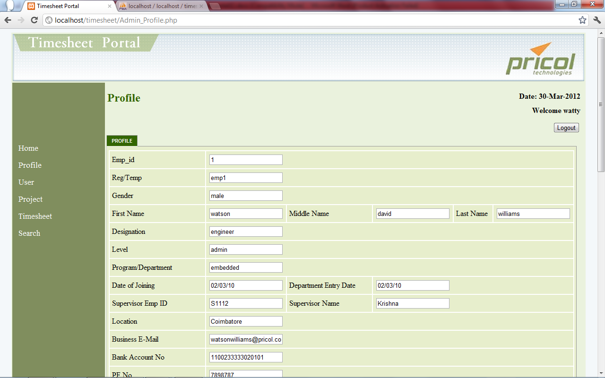

UserList

Screen: III

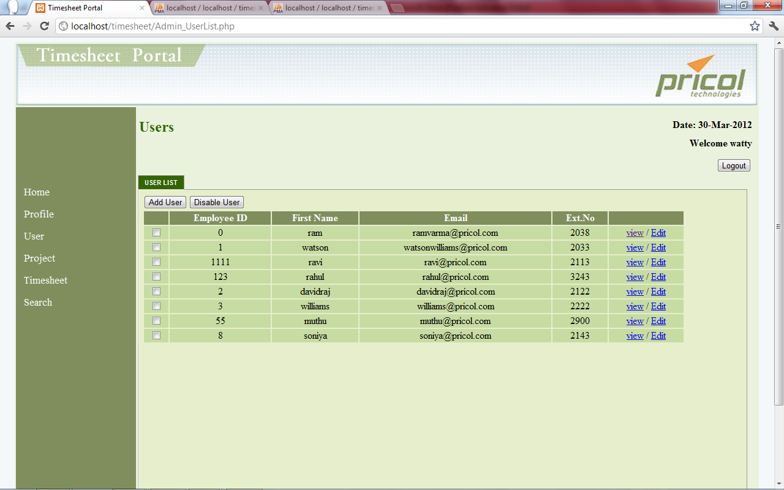

ProjectList

Screen: IV

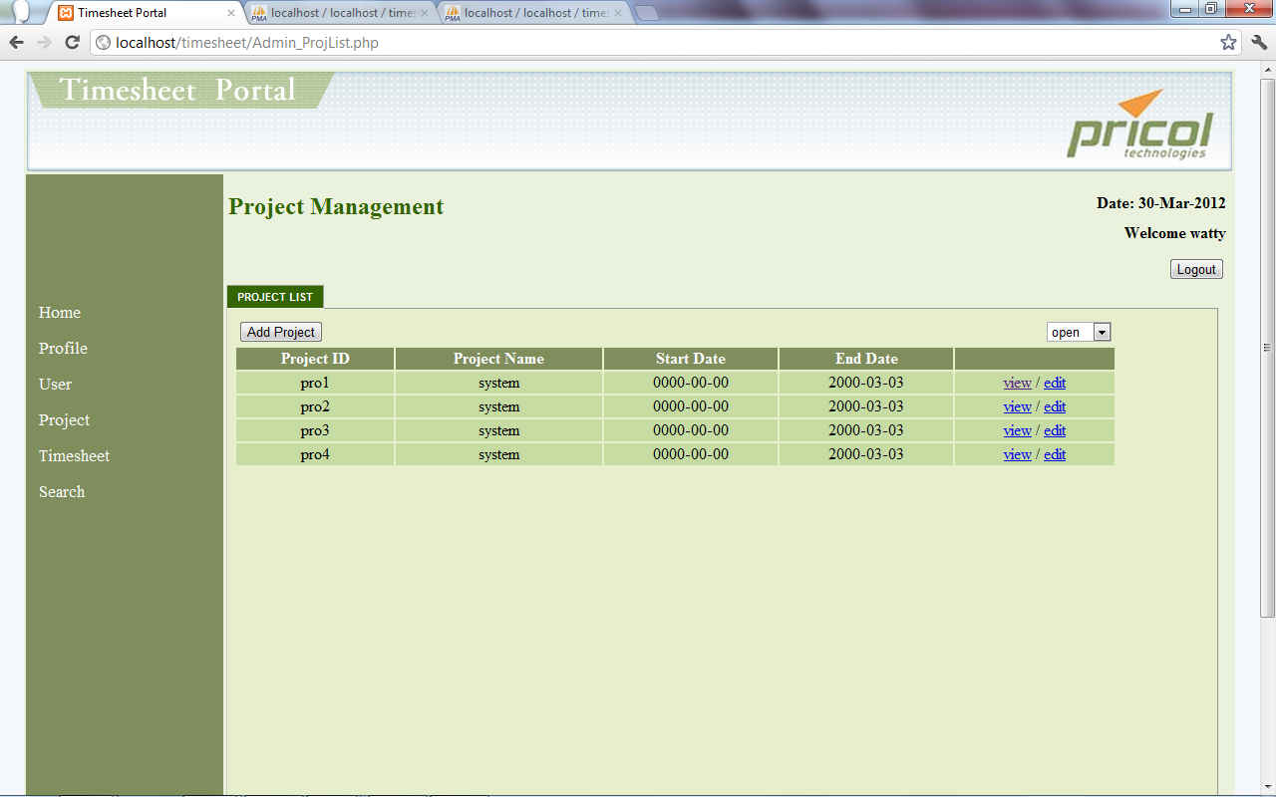

Timesheet Entry

Screen: V

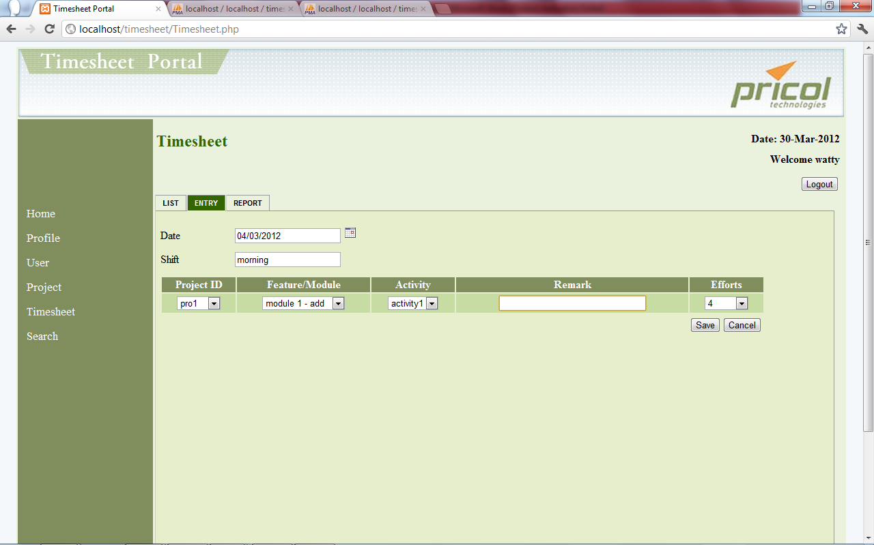

Edit Project Details

Screen: VI

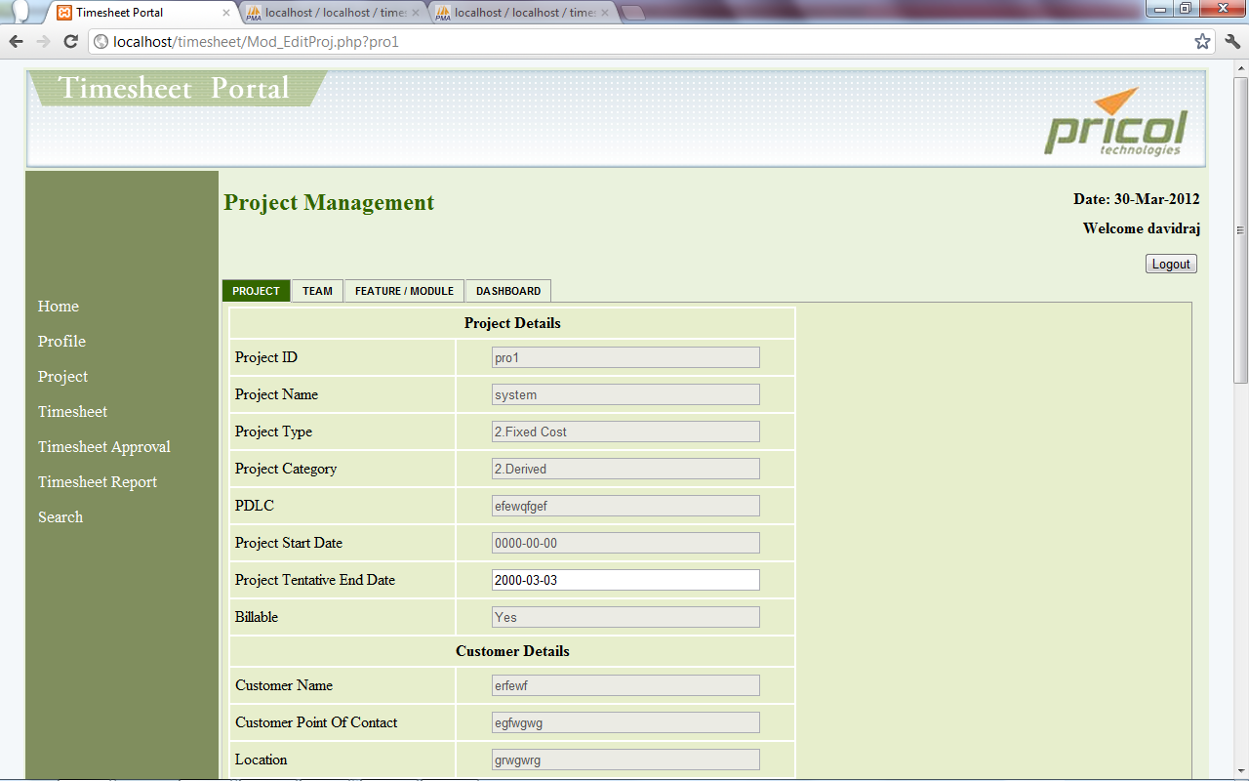

Add Team

Screen: VII

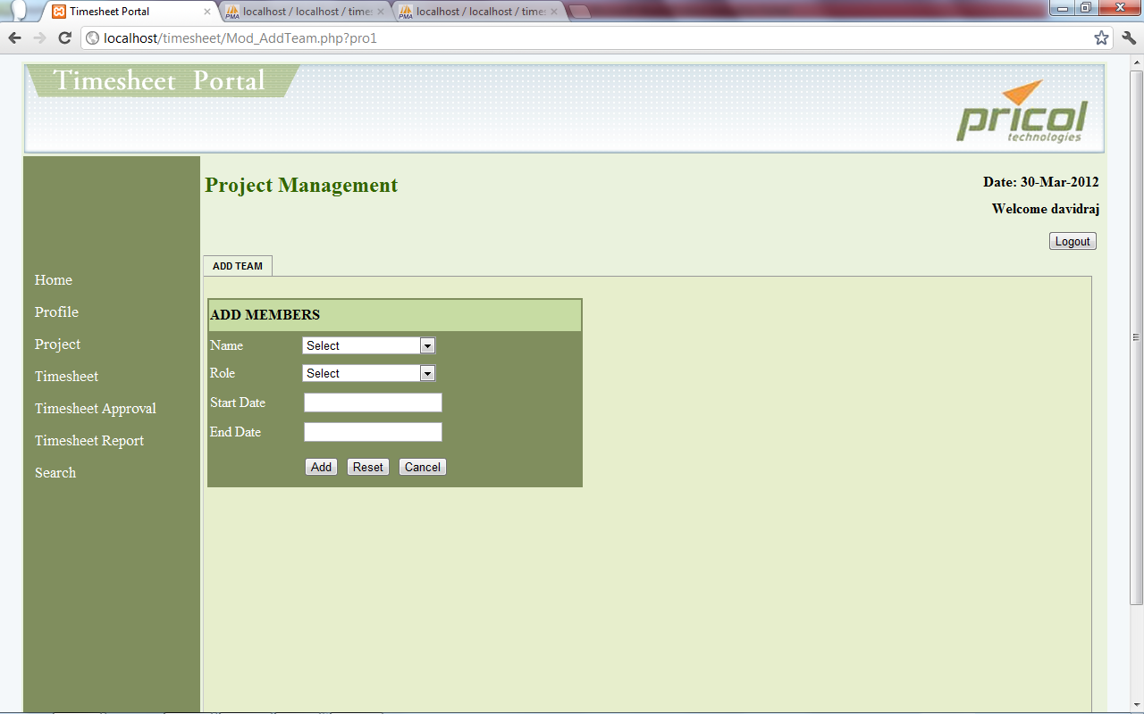

Timesheet Approval

Screen: VIII

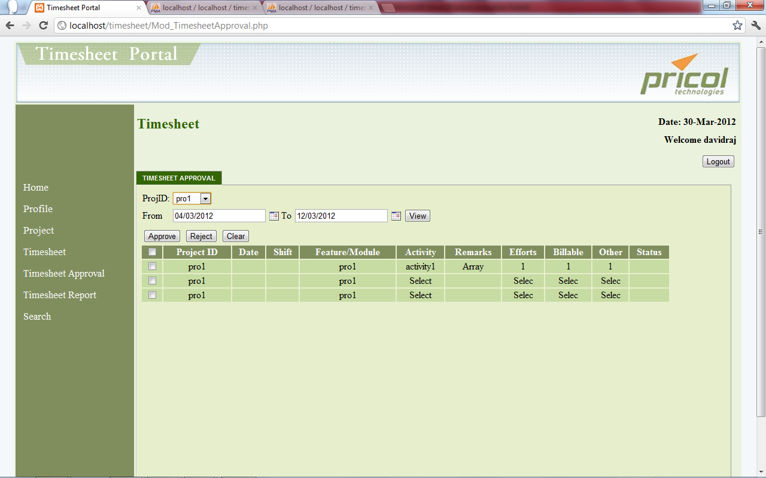

Timesheet Report

Screen: IX

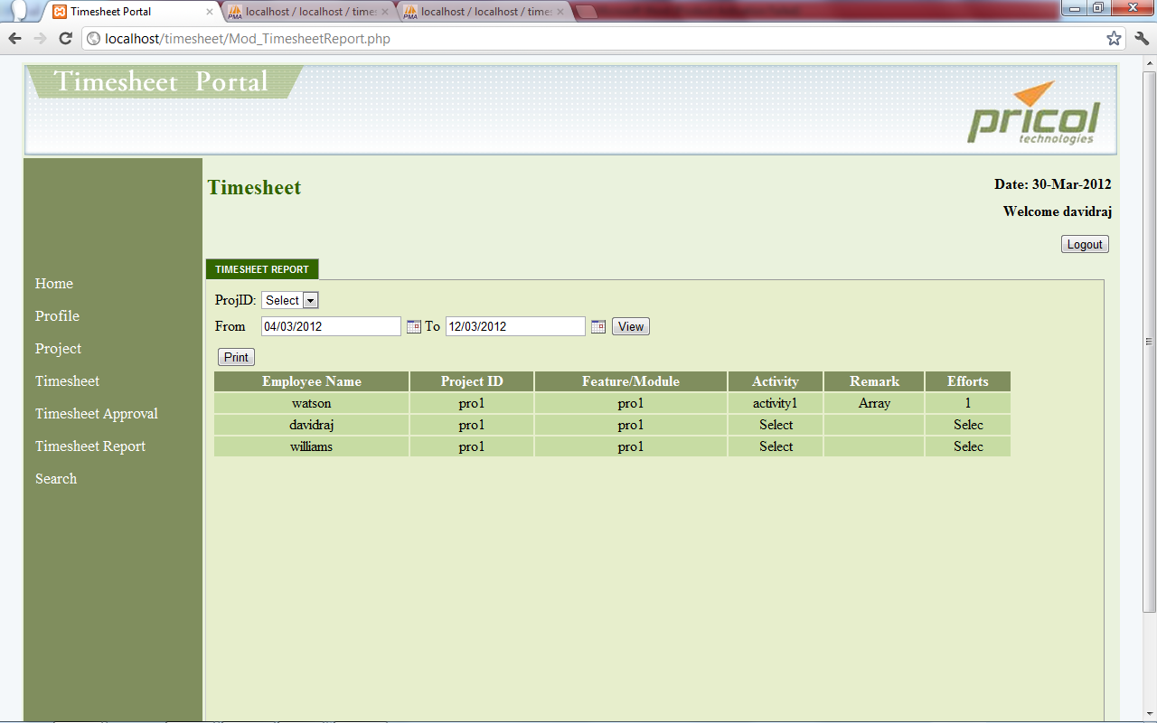

Search User Details

Screen: X

