Effect of Filtration Behaviour of Sustainable Fibre Made Nonwovens

By

Channa V S Vimala Bharathi Deepthi
(17PBX001)

A Thesis Submitted To The
Avinashilingam Institute for Home Science and
Higher Education for Women
Coimbatore-641 043

In partial fulfillment of the requirement for the degree of
MASTER OF SCIENCE
IN
BIOTEXTILES

April 2019

Effect of Filtration Behaviour of Sustainable Fibre Made Nonwovens

Channa V S Vimala Bharathi Deepthi
(17PBX001)

A Thesis Submitted To The
Avinashilingam Institute for Home Science and
Higher Education for Women
Coimbatore-641 043

In partial fulfillment of the requirement for the degree of
MASTER OF SCIENCE IN BIOTEXTILES
APRIL, 2019

Certified as Bonafide Research Work

Signature of the Signature of the Supervisor
Head of the Department

ACKNOWLEDGEMENT

The investigator places her humble salutations and prayer to the ALMIGHTY GOD for his uncountable blessings showered upon her throughout the study.
The investigator expresses her sincere thanks to the former chancellors of Avinashilingam Institute for Home Science and Higher Education for Women, Coimbatore,
Padmabushan. Dr.T.S.AVINASHILINGAM and HON. COL.Padmashri. Dr.(Tmt.) RAJAMMAL P. DEVADAS, M.A., M.Sc., Ph.D. (Ohio State) Hon. D.Sc. (Azad Agri. University, Kanpur) for heavenly blessing.
The investigator expresses her sincere thanks to Padmashri Dr.P.R.KRISHNAKUMAR, chancellor of Avinashilingam Institute for Home Science and Higher Education for Women, Coimbatore, for providing the infrastructural facilities for the conduct of the study.
The investigator records her gratitude to Dr. (Mrs.) PREMAVATHY VIJAYAN, M.Sc., M.Ed., Dip. Spl.Edn. M.Phil., Ph.D., Vice chancellor, Avinashilingam Institute for Home Science and Higher Education for Women, Coimbatore, for providing all the amenities required for the conduct of the study.
The investigator records her gratitude to Dr. (Mrs.) S. KOWSALYA, M.Sc., M.Phil., Ph.D., Registrar, Avinashilingam Institute for Home Science and Higher Education for Women, Coimbatore, for providing all the help for the smooth conduct of the study.
The investigator records her respectful gratitude to Dr. (Tmt) N. VASUGIRAAJA, M.Sc., M.B.A., M.Phil. (Madras), Ph.D. Dean, Faculty of Home Science, Professor and Head of Department of Textiles and Clothing, Avinashilingam Institute for Home Science and Higher Education for Women, Coimbatore, for constant encouragement which have helped in the successful completion of this study.
The investigator records her gratitude to Dr.(Tmt.) G.BAGYALAKSHMI, M.Sc., M.Phil., Ph.D., Professor and Head, Department of Textiles and Clothing, Avinashilingam Institute for Home Science and Higher Education for Women, Coimbatore, for constant guidance and encouragement which have helped in the successful completion of this study.
The investigator feels extremely proud and privileged for having worked under the guidance of her esteemed guide, Dr. (Tmt.) R.SUNITHA, M.Sc., M.Phil., Ph.D., (Avinashilingam), Assistant Professor (Senior Scale), Department of Textiles and Clothing, Avinashilingam Institute of Home Science and Higher education for Women, Coimbatore, for her constant motivation, keen interest, untiring patience, innovative ideas, suggestion, constant love and easy approach throughout the study.
She also wishes to thank all the TEACHING, NON-TEACHING STAFF and STUDENTS of the department of Textiles and Clothing who helped her to carry out the research work. She acknowledges her special thanks to Avinashilinam Institute of Home science and Higher Education for Women, South Indian Textile Research Association (SITRA) for the library facilities and guidance provided.
I extend my sincere thanks to Dr. PRAKASH VASUDEVAN, Director – South Indian Textile Research Association (SITRA) and Dr. KETAN KUMAR VADODARIA Head of the Department- Coe Medical Textiles SITRA for permitting to carry out the project and for timely help for the study.
It’s the privilege and honor to record my extend of gratitude to Dr. VEERA SUBRAMANIYAM Senior scientific officer department of physics- COE (center of excellence for medical textiles), South Indian Textile Research Association (SITRA), for his guidance’s, encouragement, motivation and inspiration throughout the course of study.
I take immense pleasure to thank Mr.T. SURESHRAM Senior scientific officer department of physics - COE, Mr. S. RAVICHANDRAN, Ms. V.S. DHARSINIandMs. SHREE PRIYAand other staff members of COE SITRA for their incredible help, encouragement, patient and cooperation in carrying out the thesis work. Their support and timely help have been a great value for complete the research work.
The investigator gracefully acknowledges the encouragement, timely help and support received from her friends. She expresses her deepest sense of gratitude to her Beloved Parents, Faculty Members and Friends for extending their support without them the study would never have been seen the light of the day.

CONTENTS

CHAPTER | CONTENT | PAGE NO
 | LIST OF TABLES
 | LIST OF FIGURES
 | LIST OF PLATES
 | LIST OF APPENDICES
I | INTRODUCTION | 1
II | REVIEW OF LITERATURE  2.1 POLYESTER  2.1.1 Background of Polyester  2.1.2 History of Polyester  2.1.3 Manufacturing of polyester  2.1.4 Types of polyester  - Properties of polyester  2.1.6 Advantages of polyester  2.1.7 Disadvantages of polyester  2.1.8 Role of Recycled PET in nonwovens  2.1.9 Features of polyester needle punched fabric  2.1.10 Application of polyester needle punched fabric in filtration  2.2 NONWOVENS  2.2.1 History of nonwovens  2.2.2 Manufacturing process of Nonwovens  2.2.3 Uses of Nonwoven fabric  2.3 NEEDLE-PUNCHING  2.3.1 Principle of Needle-punching Process  2.3.2 Development of needle-punching  2.3.3 Characteristics of Needle-punched Nonwovens Fabric  2.3.4 Uses of needle-punched fabrics  2.3.5 Application of needle-punched material  2.4 CALENDERING  2.4.1 History of calendering  2.4.2 Procedure of calendering  2.4.3 Advantages of calendaring  2.4.4 Disadvantages of calendering  2.5 FILTRATION  2.5.1 Objectives of filtration  2.5.2 Methods of filtration  - Types of Filtration  - Filtration at constant rate  2.5.3.2 Filtration at constant pressure  2.5.4 Advantages of nonwoven Filters  2.5.5 Nonwovens in Filtration | 5  7  11  15  19  21
III | METHODOLOGY  3.1 PROCUREMENT OF FABRIC  3.2 CALENDERING  3.3 EVALUATION OF POLYESTER CALENDERED NONWOVENS  3.3.1 Fabric weight  3.3.2 Fabric Thickness  3.3.3 Fabric strength  3.3.4 Fabric Elongation  3.3.5 Spray test  3.3.6 Wicking Test  3.3.7 Sinking Test  3.3.8 Air permeability (ASTM D737-04)  3.3.9 Particulate filtration efficiency (ASTM F2299)  3.3.10 Index puncture resistance test (ASTM D4833)  3.3.11 Capillary Flow Porometer  3.3.12 Fourier Transform Infrared Spectroscopy  3.3.13 Roughness test  3.3.14 Thermo Gravimetric Analysis (TGA)  3.4 NOMENCLATURE | 25  26  27  27  35
IV | RESULTS AND DISCUSSION  4.1 FABRIC WEIGHT  4.2 FABRIC THICKNESS  4.3 FABRIC STRENGTH  4.4 FABRIC ELONGATION  4.5 SPRAY TEST  4.6 FABRIC WICKING  4.7 FABRIC SINKING  4.8 AIR PERMEABILITY (ASTM D737-04)  4.9 PARTICULATE FILTRATION EFFICIENCY (ASTM F2299)  4.10 INDEX PUNCTURE RESISTANCE (ASTM D4833)  4.11 CAPILLARY FLOW POROMETER  4. 12 FOURIER TRANSFORM INFRARED SPECTROSCOPY (FTIR)  4.13 ROUGHNESS TEST  4.14 THERMO GRAVIMETRIC ANALYSIS (TGA) | 41  42  43  44  45  47  48  49  50  51  52  53  54  60  64
V | SUMMARY AND CONCLUSION | 71
VI | BIBILOGRAPHY | 75

LIST OF TABLES

TABLE NO | TITLE | PAGE NO
I | Types of polyester | 9
II | Nomenclature | 35
III | Fabric weight | 42
IV | Fabric Thickness | 43
V  V (a) | Fabric strength  T Test for Fabric Strength | 44  45
VI  VI (b) | Fabric Elongation  T Test for Fabric Elongation | 45  46
VII | Spray Test | 47
VIII | Wicking Test | 48
IX | Sinking Test | 49
X | Air permeability Test | 50
XI | Particulate filtration efficiency | 51
XII | Index puncture resistance | 52
XIII | Capillary Flow Porometer | 53
XIV | FTIR - Sample A | 54
XV | FTIR - Sample B | 55
XVI | FTIR - Sample C | 56
XVII | FTIR - Sample D | 57
XVIII | FTIR - Sample E | 58
XIX | FTIR - Sample F | 59
XX | Roughness test- sample A | 60
XXI | Roughness test- sample B | 61
XXII | Roughness test- sample C | 62
XXIII | Roughness test- sample D | 62
XXIV | Roughness test- sample E | 63
XXV | Roughness test- sample F | 64
XXVI | Thermo gravimetric analysis (TGA) | 64

LIST OF FIGURES

FIGURE NO | TITLE | PAGE NO
1 | Nonwoven Technologies | 12
2 | Principle of needle-punching | 17
3 | Schematic diagram of Calendering | 20
4 | Filtration | 22
5 | Methodology of the study | 26
6 (a)  6 (b)  6 (c)  6 (d)  6 (e)  6 (f) | FTIR - Sample A  FTIR - Sample B  FTIR - Sample C  FTIR - Sample D  FTIR - Sample E  FTIR - Sample F | 55  56  57  58  59  60
7 (a)  7 (b)  7 (c)  7 (d)  7 (e)  7 (f) | Roughness Test sample of A  Roughness Test Graph of Sample A  Roughness Test sample of B  Roughness Test Graph of Sample B  Roughness Test sample of C  Roughness Test Graph of Sample C  Roughness Test sample of D  Roughness Test Graph of Sample D  Roughness Test sample of E  Roughness Test Graph of Sample E  Roughness Test sample of F  Roughness Test Graph of Sample F | 66  66  67  67  68  68
8 (a)  8 (b)  8 (c)  8 (d)  8 (e)  8 (f) | TGA Graph of Sample A  TGA Graph of Sample B  TGA Graph of Sample C  TGA Graph of Sample D  TGA Graph of Sample E  TGA Graph of Sample F | 68  69  69  69  70  70

LIST OF PLATES

PLATE NO | TITLE | PAGE NO
1 | Calendering of polyester nonwoven fabric | 36
2 (a)  2 (b) | r-PET calendered nonwoven fabric  Virgin polyester calendered nonwoven fabric | 36  36
3 | Fabric weight | 37
4 | Fabric Thickness test | 37
5 | Fabric strength and elongation | 37
6 | Spray test | 37
7 | Wicking test | 38
8 | Sinking test | 38
9 | Air permeability test | 38
10  10 (a)  10 (b) | Index puncture resistance test  test specimen and clamp  puncture test plunger | 39  39  39
11 | Capillary Flow Porometer tester | 39
12 | FTIR tester | 39
13 | Roughness tester | 40
14 | TGA tester | 40

APPENDIX

APPENDIXNO | TITLE | PAGENO
I | 100 GSM r-PET double layered 190⁰ C calendered fabric | 79
II | 100 GSM r-PET double layered 200⁰ C calendered fabric | 79
III | 100 GSM r-PET double layered 210⁰ C calendered fabric | 79
IV | 200GSM virgin single layered 190⁰ C calendered fabric | 79
V | 200GSM virgin single layered 200⁰ C calendered fabric | 80
VI | 200GSM virgin single layered 210⁰ C calendered fabric | 80

1 INTRODUCTION

Polyester is a chemical term which can be broken into poly, meaning many, and ester, a basic organic chemical compound (https://encyclopedia.com> polyester). Polyester is a category of polymers that contain the ester functional group in their main chain. As a specific material, it most commonly refers to a type called polyethylene terephathalate (PET). Polyesters include naturally occurring chemicals, such as in the cutin of plant cuticles, as well as synthetics such as polybutyrate. Natural polyesters and a few synthetic ones are bio-degradable, but most of the synthetic polyesters are not. The material is extensively used in clothing. Polyester fibres are sometimes spun together with natural fibres to produce a cloth with blended properties (Mendelson and Cheryl, 2005).
The project for polyester was revived by British scientists Whinfield and Dickson, who patented polyethylene terephthalate (PET) or PETE in 1941. Polyethylene terephthalate forms the basis for synthetic fibres like Dacron, Terylene and polyester. In 1946, duPont bought all legal rights from Imperial Chemical Industries (ICI) (https://en.m.Wikipedia.org> wiki > polyester). The polyester fibre has high strength modulus, creep resistance and general chemical inertness due to which it is more suitable for geotextiles. It is attacked by polar solvent like benzyl alcohol, phenol, and meta-cresol. At pH range of 7 to 10, its life span is about 50 years. It possesses high resistance to ultraviolet radiations. However, the installation should be undertaken with care to avoid unnecessary exposure to light (Agrawal, 2007).
Depending upon the chemical structure, polyester can be a thermoplastic or thermoset. There are also polyester resins cured by hardeners; however, the most common polyesters are thermoplastics. Polyesters as thermoplastics may change the shape after the application of heat, polyesters tend to shrink away from flames and self-extinguish upon ignition. Polyester fibres have high tenacity and E-modulus as well as low water absorption and minimal shrinkage in comparison with other industrial fibres (Rosato et.al., 2004).
The usage of recycled PET ﬁbres in nonwovens contributes to decrease in environmental pollution, prevention of the decrease in petroleum supplies, and decrease in raw material cost of nonwovens. By applying convenient operating conditions during mechanical recycling, recycled polyester (r-PET) ﬁbres can be obtained with unique combined properties such as high strength and high extensibility together and with lower cost (Gurudattet al., 2014).
Polyester fabric features good anti-acid, good anti-alkali, good hydrolysis stability and excellent anti-anrasion. Polyester needle punched fabric is used to make filter bags, they are widely used for air filtration in cement industry, chemical industry, Aluminium industry and Carbon powder industry (Gopalakrishnan, 2010).
The term “Nonwovens” was applied to new modern techniques, which were totally based on new principles, by U.S.A. in 1965. “Nonwovens” is being defined into different ways by different literatures; the term defined by “Textile oregano” in 1965 is “Nonwovens are products made of parallel laid, cross laid or randomly laid webs bonded with application of adhesive or thermoplastic fibres under application of heat and pressure” (Patel and Bhrambhatt, 2001).
Nonwoven emerged from the textile, paper and plastic industries and has, for over 40 years, evolved into a distinct industry. As the demand for nonwovens has steadily increased, it has been met by the technology and ingenuity of raw materials and equipment suppliers, and nonwoven producers and converters. The production of nonwovens can be described as taking place in three stages, although modern technology allows an overlapping of some stages, and in some cases all three stages can take place at the same time. (Horrocks and Anand, 2000).
Nonwoven materials have been among the most demanded textile materials in many application areas in recent years. The easy and lower number of processes in manufacturing line, higher production rates, and lower costs compared to the similar woven or knitted products and diverse characteristics and properties have been main reasons for their preferences (EDANA, 2012).
Needle-punched nonwoven fabric is a sheet of fibres made by mechanical entanglement, penetrating barded needles into fibrous mat. Such fabric is extensively used in technical applications. In such applications, fabric is subjected to normal compressive loads, and the physical, tensile and hydraulic properties change with these loads, depending on the compressional behaviour of the fabric (Purdy, 1980).
Needle-punched nonwoven materials with the required combination of functional properties are widely used in numerous technical applications, including, filters, composites, protective clothing, packaging, geo-textiles, home furnishings, heat and noise insulating, etc. As the properties of nonwovens depend on the structure of the material, a structure-property relationship will provide a tool to manipulate the nonwoven structure to achieve satisfactory product performance by both establishing appropriate manufacturing parameters and selecting proper fibre specifications (Maity and Singha, 2012). Needled / felted nonwoven filters are generally thick and the spun bonded fabrics are quite thin but provide better filtration (Nagraj, 2009).
The term ‘calender’ is derived from the Greek kylindros (cylinder), and according to Webster’s International Dictionary. It means ‘to press (as cloth, rubber, paper) between rollers or plates in order to make smooth and glossy or glazed or too thin into sheets’. In particular, the calendering of polymers is a process for the production of continuous sheet or film by squeezing the melt between a pair of heated counter-rotating rolls (Mitsoulis, 2009). Calendering is a high - speed ironing process that primarily imparts lustre and is usually the final treatment for the fabrics in the finishing sequence. The basic principle of calendering is to expose the cloth to the combined effect of moisture, heat and pressure until the fabric acquires a very smooth and light-reflecting surface with a good lustre (Choudhury, 2012).
Thermal bonding process is the application of heat on nonwoven materials either with pressure by calendaring or without pressure by ovens where thermoplastic ﬁbres/materials melts with heat energy and constructs bond bridges between base material. The bonding temperature, bonding pressure, quench rate, contact time, and calendar pattern are the main process variables in calendering method which alters the product properties (Dharmadhikary et al., 1995).
The term ‘filtration’ has been defined as the separation of particles from a fluid-solid suspension of which they are a part by passage of most of the fluid through a septum or membrane that retains most of the solids on or within itself. The septum is called a filter medium, and the equipment assembly that holds the medium and provides space for the accumulated solids is called a filter. The fluid may be a gas or a liquid (Anon, 2007). Objective of filter medium is to maximize the possibility of collision and the subsequent retention of the suspended particles with fibrous structures while minimizing the energy loss of the system. The efficiency of filtration in industrial fabrics are affected by their porosity. Knowledge of air permeability is also important for suitability for use (Kotte, 2011).
There is a wide spread application of ‘nonwovens’ in various filtration applications including geoengineering. The critical pore size corresponds to the diameter of nominally spherical solid particle that will pass through this pore. This minimum pore is not identical throughout the nonwoven hence pore size variation is also considered. Higher the number of fibre strata and consequently the greater the thickness of nonwoven, the higher the probability of encountering the pores of minimum size at least once throughout the nonwoven (Nagraj, 2009). Nonwoven materials occupy a large ratio in filtration fabrics due to its better filtration efficiency. The structure of the nonwoven fabric helps in accurate filtration. Different variety of textile fibres is used as nonwoven in filtration process (Nagraj, 2009).
Keeping the above facts in mind, the investigator has taken up a study on the topic entitled ‘Effect of Filtration Behaviour of Sustainable Fibre Made Nonwovens’ with the following objectives:
- To develop a nonwoven filter fabric using recycled and virgin polyester
- To assess the effect of calendering on nonwovens
- To evaluate the properties of the developed nonwoven fabrics.

2 REVIEW OF LITERATURE

The literature review carried out for the study is expressed under the following heads:

2.1 POLYESTER
2.1.1 Background of Polyester
2.1.2 History of Polyester
2.1.3 Manufacturing of polyester
2.1.4 Types of polyester
    - Properties of polyester
2.1.6 Advantages of polyester
2.1.7 Disadvantages of polyester
2.1.8 Role of Recycled PET in nonwovens
2.1.9 Features of polyester needle punched fabric
2.1.10 Application of polyester needle punched fabric in filtration
2.2 NONWOVENS
2.2.1 History of nonwovens
2.2.2 Manufacturing process of Nonwovens
2.2.3 Uses of Nonwoven fabric
2.3 NEEDLE-PUNCHING
2.3.1 Principle of Needle-punching Process
2.3.2 Development of needle-punching
2.3.3 Characteristics of Needle-punched Nonwovens Fabric
2.3.4 Uses of needle-punched fabrics
2.3.5 Application of needle-punched material
2.4 CALENDERING
2.4.1 History of calendering
2.4.2 Procedure of calendering
2.4.3 Advantages of calendaring
2.4.4 Disadvantages of calendering
2.5 FILTRATION
2.5.1 Objectives of filtration
2.5.2 Methods of filtration
    - Types of Filtration
      - Filtration at constant rate
2.5.3.2 Filtration at constant pressure
2.5.4 Advantages of nonwoven Filters
2.5.5 Nonwovens in Filtration

2.1 POLYESTER
Polyester is a chemical term which can be broken into poly, meaning many, and ester, a basic organic chemical compound. The principle ingredient used in the manufacture of polyester is ethylene, which is derived from petroleum. The ethylene is the polymer, the chemical building block of polyester and the chemical process that produces the finished polyester is called polymerization (https://encyclopedia.com> polyester).
Polyester is a category of polymers that contain the ester functional group in their main chain. As a specific material, it most commonly refers to a type called polyethylene terephathalate (PET). Polyesters include naturally occurring chemicals, such as in the cutin of plant cuticles, as well as synthetics such as polybutyrate. Natural polyesters and a few synthetic ones are biodegradable, but most synthetic polyesters are not. The material is extensively used in clothing. Polyester fibres are sometimes spun together with natural fibres to produce a cloth with blended properties. Cotton-polyester blends (polycotton) can be strong, wrinkle and tear-resistant, and reduce shrinking. Synthetic fibres using polyester have high water, wind and environmental resistance compared to plant-derived fibres. They are less fire resistant and can melt when ignited (Mendelson and Cheryl, 2005).
The polyester fibre has high strength modulus, creep resistance and general chemical inertness due to which it is more suitable for geotextiles. It is attacked by polar solvent like benzyl alcohol, phenol, and meta-cresol. At pH range of 7 to 10, its life span is about 50 years. It possesses high resistance to ultraviolet radiations. However, the installation should be undertaken with care to avoid unnecessary exposure to light (Agrawal, 2007).
Polyester is very popular among Athletes for its moisture-wicking properties, strong fibres, and light weight feel. It is usually temperature sensitive. Polyester has a tendency to cause dye migration between the fabric dye and the decoration (Sujon, 2004).

2.1.1 Background of Polyester
Polyester is a synthetic fibre derived from coal, air, water and petroleum. Polyester has developed in a 20th century and these fibres are formed from a chemical reaction between an acid and alcohol. In this reaction two or more molecules combine to make a large molecule whose structure repeats throughout its length (Rosato et.al., 2004).
2.1.2 History of Polyester
In 1926, United states-based E.I. dupont de Nemours and Co. began research on large molecules and synthetic fibres. This early research, headed by W.H. Carothers, centered on what became nylon, which was the first synthetic fibre. Carothers was working for DuPont at that time. Carother’s research was incomplete and had not advanced to investigating the polyester formed from mixing ethylene glycol and terephthalic acid. The project was revived by British scientists Whinfield and Dickson, who patented polyethylene terephthalate (PET) or PETE in 1941. Polyethylene terephthalate forms the basis for synthetic fibres like Dacron, Terylene and polyester. In 1946, duPont bought all legal rights from Imperial Chemical Industries (ICI) (https://en.m.Wikipedia.org> wiki > polyester).
2.1.3 Manufacturing of polyester
Polyester is manufactured by one of the several methods. The one used depends on the form the finished polyester will take. The four basic forms are filament, staple, tow and fiberfill (www.madehow.com > Volume 2).
2.1.4 Types of polyester
Depending upon the chemical structure, polyester can be a thermoplastic or thermoset. There are also polyester resins cured by hardeners; however, the most common polyesters are thermoplastics. Polyesters as thermoplastics may change the shape after the application of heat, polyesters tend to shrink away from flames and self-extinguish upon ignition. Polyester fibres have high tenacity and E-modulus as well as low water absorption and minimal shrinkage in comparison with other industrial fibres (Mohammadi et al., 2003).
Unsaturated Polyesters (UPR) are thermosetting resins. They are used in the liquid state as casting materials, in sheet molding compounds as fibreglass laminating resins and non-metallic auto-body fillers. They are also used as the thermoset polymer matrix in pre-pregs. Fibre glass-reinforced unsaturated polymers find wide application in bodies of yachts and as body parts of cars.

According to the composition of the main chain, polyesters can be classified as in the Table: I
Table: I
Types of polyester
Main chain composition | Type | Examples of
Main chain composition | Type | Polyesters | Manufacturing methods
Aliphatic | Homopolymer | Polyglycolide or polyglycolic acid (PGA) | Polycondensation of glycolic acid
Aliphatic | Homopolymer | Polylactic acid (PLA) | Ring-opening polymerization of lactide
Aliphatic | Homopolymer | Polycaprolactone (PCL) | Ring-opening polymerization of caprolactone
Aliphatic | Homopolymer | Polyhydroxyalkanoate  (PHA)
Aliphatic | Homopolymer | Polyhydroxybutyrate (PHB)
Aliphatic | Copolymer | Polyethylene adipate (PEA)
Aliphatic | Copolymer | Polybutylene succinate (PBS) | Polycondensation of succinic acid with 1,4-butanediol
Aliphatic | Copolymer | Poly (3- hydroxybutyrate-co-3-hydroxyvalerate)  (PHBV) | Copolymerization of 3-hydroxybutanoic acid and 3-hydroxypentanoic acid, butyrolactone and valeroactone (oligomeric aluminoxanes as a catalyst)
Semi-aromatic | Copolymer | Polyethylene terephthalate (PET) | Polycondensation of terephthalic acid with ethylene glycol
Semi-aromatic | Copolymer | Polybutylene terephthalate (PBT) | Polycondensation of terephthalic acid with 1,4-butanediol
Semi-aromatic | Copolymer | Polytrimethylene terephthalate (PTT) | Polycondensation of terephthalic acid with 1,3-propanediol
Semi-aromatic | Copolymer | Polyethylene naphthalate (PEN) | Polycondensation of at least one naphthalene dicarboxylic acid with ethylene glycol
Aromatic | Copolymer | Vectran | polycondensation of 4-hydroxybenzoic acid and 6-hydroxynaphthalene-2-carboxylic acid

Over the past 15-20 years there has been a major shift in the type of polymer used in manufacturing of needle-punched nonwoven geotextiles. In the past majority were from Polyester (PET) resin whereas presently polypropylene (PP) resin is used almost extensively (Koerner and Koerner, 2010).
2.1.5 Properties of polyester
Tensile properties
Polyester fibres are available in four tenacity levels:
- Low pill fibres - usually in 2.0 / 3.0 D for suiting the end use with tenacities of 3.0 to 3.5 gpd (grams per denier). These fibres are generally used on worsted system and 1.4D for knitting
- Medium Tenacity - 4.8 to 5.0 gpd
- High tenacity – 6.0 to 6.4 gpd range and
- Super high tenacity – 7.0 gpd and above
Both medium and high tenacity fibres are used for apparel end use. The super high tenacity fibres are used for spinning 100% polyester sewing threads and other industrial yarns. The higher tenacities are obtained by using higher draw ratios and higher annealer temperatures upto 225 to 230⁰ C and a slight additional pull of 2% or so at the zone in annealing (https://textilelearner.blogspot.com)
2.1.6 Advantages of polyester
Polyester tends to be an inexpensive fabric, because it comes from artificial rather than natural sources. Therefore, its components are not subjected to nature’s extremes such as drought or storms. It does no shrink or crease easily. On the other hand, the material tends to be shiny, which is not always a desired characteristic. Polyester is recyclable. During the recycling process, little water is required, and toxic chemicals used are recycled back into the system. The re-manufactured fabric has the same quality as the original material. The colour of polyester does not fade in the sun. Because it is not an inorganic substance, it is resistant to mildew. It also resists shrinking, so it holds its shape well (https://www.reference.com).

    - Disadvantages of polyester
The disadvantages of the polyester are it tends to stick perspiring skin and clammy in humid weather, not as breathable, temperature sensitive, stain removal is often difficult and subject to dye migration (https://blog.transferexpress.com).
2.1.8 Role of Recycled PET in nonwovens
The usage of recycled PET ﬁbres in nonwovens contributes to decrease in environmental pollution, prevention of the decrease in petroleum supplies, and decrease in raw material cost of nonwovens. By applying convenient operating conditions during mechanical recycling, recycled polyester (r-PET) ﬁbres can be obtained with unique combined properties such as high strength and high extensibility together and with lower cost (Gurudatt et al., 2014). Owing to presence of co-monomer in the structure and higher molecular weight, r-PET polymer obtained from bottle waste displays different behavior when heat is applied (Gurudatt et al., 2003). Thus, the r-PET ﬁbre produced from bottle waste may present different thermal property after calendaring process, accordingly.
2.1.9 Features of polyester needlepunched fabric
Polyester needlepunched fabric features good anti-acid, good anti-alkali, good hydrolysis stability and excellent anti-anrasion (Gopalakrishnan, 2010).
2.1.10 Application of polyester needle punched fabric in filtration
Being a filter fabric, polyester needle punched fabric is used to make filter bags, they are widely used for air filtration in cement industry, chemical industry, Aluminium industry, Carbon powder industry (Sztuk et al., 2016).

2.2 NONWOVENS
A fibre segment can be considered for better understanding the characteristic behaviour of nonwoven structure. Fibre segments are considered as fibre sections between any two crossover points and which can be treated as minimal units in a web. Owing to fibre bonds or surface contacts at crossover points, even the segments on the same fibre may differ significantly in their mechanical performance. The influence of a fibre segment on the stress-strain property of the fabric depends mainly on its structural characteristics: length, thickness, curl, and orientation. A thin nonwoven fabric can be treated as a two dimensional fibre network in which fibres (staple or filament) lie in various directions and are bonded or in contact with one another at fibre crossover points. Here fibre-to-fibre bonds maintain fabric integrity. Fibre or fibre bundle thickness has a direct influence on web mechanical properties (Xu and Ting, 1995).
The term “Nonwovens” was applied to new modern techniques, which were totally based on new principles, by U.S.A. in 1965. “Nonwovens” is being defined into different ways by different literatures; the term defined by “Textile oregano” in 1965 is as follows:
“Nonwovens are products made of parallel laid, cross laid or randomly laid webs bonded with application of adhesive or thermoplastic fibres under application of heat and pressure.”
In other words nonwovens can be simply defined as a fabric those can be produced by variety of processes other than weaving and knitting.
The nonwoven fabric properties depends on following particulars to an great extent,
- The choice of fibres
- Technology which determines how the fibres are to be arranged
- The bonding process and the bonding agent (Patel and Bhrambhatt, 2001).

Fromstaple fibres From polymer

Preparation of fibre materials Melting of polymer

Forming fibre layer Forming fibres and fibre layer

Bonding fibre layer
Figure 1 Nonwoven Technologies
Source: Horrocks and Anand, 2000
Nonwoven technology excludes the spinning of yarn for manufacturing the fabric. Nonwoven fabrics are made from both natural as well as man-made fibres and mostly used man-made fibres for manufacturing nonwoven fabrics are polyester, polypropylene and rayon (Luitel and Hudson et al., 2015). (Figure 1)
Nonwoven materials have been among the most demanded textile materials in many application areas in recent years. The easy and lower number of processes in manufacturing line, higher production rates, and lower costs compared to the similar woven or knitted products and diverse characteristics and properties have been main reasons for their preferences (EDANA, 2012).

2.2.1 History of nonwovens
In the 19th century, (when England was the leading textile producing country), realizing that large amounts of fibre were wasted as trim, a textile engineer named Garnett developed a special carding device to shred this waste material back to fibrous form. This fibre was used as filling material for pillows. The Garnett Machine, though greatly modified, today still retains his name and is a major component in the non-woven industry. Later on, manufacturers in Northern England began binding these fibres mechanically (using needles) and chemically (using glue) into batts. These were the precursors of today's nonwovens. This art remained the same into the middle of the 20th century and patents as late as the 1930's depict such batts specially made to insulate railroad box cars in the U.S. Now in the 21st century, though some fillings and paddings are still made as they were in England almost 2 centuries ago, nonwovens have progressed beyond Garnett's dreams. Non-woven fabric was used between the Space Shuttle Discovery's heat resistant tiles and the spaceship's skin and nonwovens were part of the space suits worn to the moon. The limits to the use of nonwovens remains only in the imagination of man, and new innovations are developed on a steady basis (Radko, 1971).
- 1936 Dr. Carl Nottebohm starts development of Nonwovens in Weinheim
- 1948 Start of dry-laid staple fibre Nonwovens production, introduction of Vliesline garment interlinings and Vildea window cloth
- 1950 Joint Venture to produce dry-laid Nonwovens in USA (Pellon)
- 1960 Joint Venture to produce dry-laid Nonwovens in Japan (Japan Vilene Company)
- 1965 Introduction of spun bonded polyamide Nonwovens technology developed by Dr. Ludwig Hartmann
- 1973 Production start of wet-laid Nonwovens. Production start of polyester spun bond at new Kaiserslautern plant
- 1982 Production start of lightweight Polypropylene Nonwovens.
- 1984 Start-up of the first non-European facility to produce polyester spun bonded Nonwovens in North Carolina (USA)
- 1985 Acquisition of a leading producer of staple fibre Nonwovens in Brazil (Sujon, 2004).
2.2.2 Manufacturing process of Nonwovens
Nonwoven emerged from the textile, paper and plastic industries and has, for over 40 years, evolved into a distinct industry. As the demand for nonwovens has steadily increased, it has been met by the technology and ingenuity of raw materials and equipment suppliers, and nonwoven producers and converters. The production of nonwovens can be described as taking place in three stages, although modern technology allows an overlapping of some stages, and in some cases all three stages can take place at the same time (Horrocks and Anand, 2000).
The three stages of the nonwoven are:
- Web Formation
- Dry laid - Carded and Air laid
- Spun melt - Spun laid (or spun bonded) and Melt blown
- Wet laid
- Other technologies - Electrostatic spinning and Flash spun
- Web Bonding
- Chemical
- Thermal
- Mechanical - Needle punching, hydro-entanglement, stitch bonding
- Finishing Treatments (Radko, 1971).
2.2.3 Uses of Nonwoven fabric
The uses of the nonwoven fabric are:
- It can be applied as disposable nappies
- It can be utilized as sanitary napkins
- It can be utilized as sterile wraps, caps, gowns, masks and drappings
- It can be employed as household and personal wipes (Kim and Pourdeyhimi, 2001)
- It can be utilized as laundry tools for example fabric dryer-sheet
- It can be employed as household and personal wipes
- It can be utilized as laundry tools for example fabric dryer-sheet
- It can be employed as apparel interlining
- It can be used as carpets and upholstery fabrics, padding and backing
- It can be employed as wall covering in building construction (Erth et al., 2005)
- It can be utilized as automotive headliner and upholstery filters
- It can be employed as tags, labels, insulation etc
- It can be applied as house wraps and roofing items
- It can be applied in civil engineering fabric as geotextile (Amrit, 2013).

2.3 NEEDLE-PUNCHING
Needle-punching is a physical method of mechanically interlocking fibres webs by using barbed needles to reposition some of the fibres from a horizontal to a vertical orientation. Thousands of needles interlock fibres in a web (www.fibre2fashion.com).
Needle-punched nonwoven fabric is a sheet of fibres made by mechanical entanglement, penetrating barded needles into fibrous mat. Such fabric is extensively used in technical applications. In such applications, fabric is subjected to normal compressive loads, and the physical, tensile and hydraulic properties change with these loads, depending on the compressional behaviour of the fabric (Purdy, 1980).
Needled / felted nonwoven filters are generally thick and the spun bonded fabrics are quite thin but provide better filtration. Moreover some recent developments in melt blown process enables the finest fibres (20m-50m) to be used individually or in line with spun laid process gives SMS structure of spun bonded nonwoven used in high performance filter product sector viz. ‘leg cuff’ protection in nappies, protective medical clothing and filter applications like swimming pool water filters. SMS structures are more efficiency for most barrier and filtration requirements. The market potential of this fine fibre nonwoven is good due to economic and technical dimensions (Nagraj, 2009).
Needle-punched nonwoven materials with the required combination of functional properties are widely used in numerous technical applications, including, filters, composites, protective clothing, packaging, geo-textiles, home furnishings and heat and noise insulating. As the properties of nonwovens depend on the structure of the material, a structure-property relationship will provide a tool to manipulate the nonwoven structure to achieve satisfactory product performance by both establishing appropriate manufacturing parameters and selecting proper fibre specifications. This requires quantification of the degree of bonding among the fibres and the establishment of relationships between the process parameters corresponding fabric properties (Maity and Singha, 2012).
2.3.1 Principle of Needle-punching Process
A needle-punched nonwoven is a fabric made from webs or batts of fibres in which some of the fibres have been driven upward or downward by barbed needles. This needling action binding point is a set of fibres with various orientation, which are bonded by friction forces.
The needle board is the base unit into which the needles are inserted and held. The needle board then fits into the needle beam that holds the needle board into place. The feed roll and exit roll are typically driven rolls and they facilitate the web motion as it passes through the needle loom. The web passes through two plates, a bed plate on the bottom and a stripper plate on the top. Corresponding holes are located in each plate and it is through these holes the needles pass in and out. The bed plate is the surface the fabric passes over which the web passes through the loom. The needles carry bundles of fibre through the bed plate holes. The stripper plate does what the name implies; it strips the fibres from the needle so the material can advance through the needle loom (Kumar et al., 2009). (Figure 2)
Appearance and degree of compression of a needle felt are mainly influenced by:
- needle arrangement in the needle board
- needle parameters (gauge, form of barb, number of barbs)
- needling parameters (penetration depth and density, draft) and
- direction of needling (from top, from bottom or from both sides) (Hearle et al., 1968).
The number of needles in the needle board varies from 1500 to 5000 needles per meter and per board of 200 mm width. The needle selection should be depends upon the fineness of the fibre. The proper selection of gauge, barb, point type and blade shape (pinch blade, star blade, conical) can often give the needle punch the added edge needed in this competitive industry (Russell, 2006).

Figure 2 Principle of needle-punching
Source: Dhanabalan, 2013
Needle-punched nonwoven fabrics are the most common fabrics used as geotextiles and can perform four main functions: reinforcement, filtration, drainage and separation (Askari et al., 2012).
2.3.2 Development of needle-punching
There are evidences to suggest that needle punching is more than 100 years old (Purdy et al., 1980). The first commercial needle loom was produced around 1870. It was invented by Mr.Windson and manufactured by water Ltd., Leeds, U.K. In that machine the needles were inserted from the bottom. In the late 1940's Bywater Ltd., obtained the design of a needle loom from Australia in which the needles were inserted from the top.
In the early 1930’s, low quality jute needled fabrics entered the automobile industry as a soundproof medium in automobile (Cannity, 1962). In the early days of development only jute or cattle hair was used, but with the invention of man-made fibres the whole needled fabric market underwent a complete change. Nowadays, it is also possible to produce needled fabrics from mineral and ceramic fibres. Needle looms are also available to produce tubes, seamless belts, patterned design (Debnath et al.,2009).
2.3.3 Characteristics of Needle-punched Nonwovens Fabric
Generally important characteristics of needle felts are the degree of felt compression, the strength-elongation ratio and the permeability characteristics.
- Longer fibre lengths result in higher strength, higher felt density and less air permeability
- Finer fibres lead to smaller felt thickness and to lower air permeability. The needling of finer fibres requires inevitably also the use of finer needles to achieve sufficient strength characteristics (Fangueiro et al., 2008)
- Higher crimp results in a higher tear resistance and elongation and a better dimensional stability of the needle felts
- The characteristics and the structure of needle felts also depend on the web structure and the area mass. Machine oriented web results in a high strength in the longitudinal direction and predominantly cross oriented webs result in a high strength in cross direction.
- The web area mass has a great influence on air permeability.
- The area ratio of the fibre plugs in the needle felt is in the range of 2–12%. The fibre length of the plug is 6–20 % and the fibres are more densely packed in the fibre plug than in the needle felt (Kumar et al., 2009).
2.3.4 Uses of needle-punched fabrics
Needle-punched fabrics find its applications as blankets, shoe linings, paper markers felts, coverings, heat and sound insulation, medical fabrics, filters and geotextiles ((Patel and Bhrambhatt, 2001).
2.3.5 Application of needle-punched material
i) Geotextiles:
Road and railway construction, dams, roofing felts, drain felts, shore protection, reinforcing felts.
ii) Automotive fabrics:
Head liners, carpets, door trim, parcel shelves, moulded components, insulation felts
iii) Hometex:
Carpets, wall coverings, decor felts, wipes, blankets (Miao and Glassey, 2004).
iv) Synthetic leather:
Shoe, automotive and upholstery industry, luggage, bags, sports goods
v) Clothing and furniture:
Shoulder pads, waddings, mattresses
vi) Filters for gases and liquids,
vii) Other technical felts:
Polishing felts, abrasive felts, mineral fibre felts for insulation (Gopalakrishnan, 2010).

2.4 CALENDERING
The term ‘Calender’ is derived from the Greek kylindros (cylinder), and according to Webster’s International Dictionary. It means ‘to press (as cloth, rubber, paper) between rollers or plates in order to make smooth and glossy or glazed or too thin into sheets’. Thus, calendering (sometimes also written as ‘calendaring’) is a process used in many industries, such as the paper, plastics, rubber and steel industries, for the production of rolled sheets of specific thickness and final appearance. In particular, the calendering of polymers is a process for the production of continuous sheet or film by squeezing the melt between a pair of heated counter-rotating rolls (Mitsoulis, 2009).
Thermal bonding process is the application of heat on nonwoven materials either with pressure by calendaring or without pressure by ovens where thermoplastic ﬁbres/materials melts with heat energy and constructs bond bridges between base material. The bonding temperature, bonding pressure, quench rate, contact time, and calendar pattern are the main process variables in calendering method which alters the product properties (Dharmadhikary and Gilmore, et al., 1995).
2.4.1 History of Calendering
Historically calendering was done by hand with huge pressing stone. For example in china huge rocks were brought from the north of the Yangtze River. The pressing stone was cut into bowl shape, and the surface of the curved bottom made perfectly smooth. After a piece of cloth was placed underneath the stone the worker would stand on the stone and rock it with his two feet in order to press the cloth (Chao and Kang, 1977).
Industrial calenders consists usually of 3-6 rotating in a Z or L arrangement. The basic forming operation is completely by the calender itself and is normally followed by additional treatment of the plastic sheet or film produced (Marshall, 1959).
The modern technological developments in the calendering of thermoplastic materials are offshoots of the art of fabric and rubber calendering, which dates back to the early 1800s. Elden and Swan present a short history and a detail account of the major technological developments up to about 1968 (Elden and Swan, 1968).
2.4.2 Procedure of Calendering
Calendering is a high - speed ironing process that primarily imparts lustre and is usually the final treatment for the fabrics in the finishing sequence. The basic principle of calendering is to expose the cloth to the combined effect of moisture, heat and pressure until the fabric acquires a very smooth and light-reflecting surface with a good lustre (Kopitar et al.,2014).
The procedure of calendering includes:
- The fabric batch is fed to the machine
- The fabric through the guider and tension roller comes to the blower section, to clean the fabric
- Through the polymer/ Teflon roller, it is passed between the steel roller and cotton roller
- Three rollers were given hydraulic pressure. Pressure varies with the quality of fabric
- Due to contact of the fabric with the steel roller, it gets shine and due to the contact of cotton roller with the fabric with the fabric it gets smoothness (Choudhury, 2012). (Figure 3)
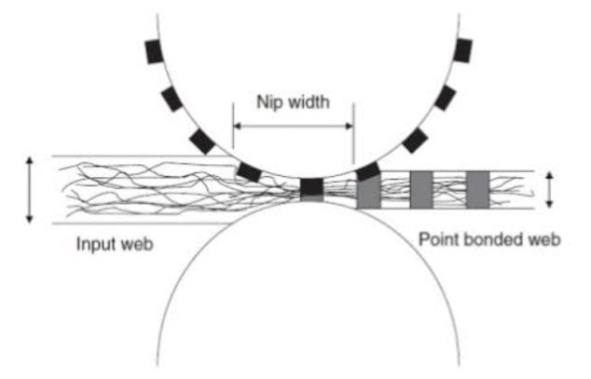
Figure 3 Schematic diagram of Calendering

2.4.3 Advantages of Calendering
- Improved appearance - Lustre, whiteness etc.,
- Improved feel which depends on the handle of the fabric and its softness, suppleness, fullness etc.,
- It improves the wearing qualities - Nonsoiling, Anti-crease
- It gives special properties required for particular uses - water proofing, flame proofing etc., (Mueller and Kochmann, 2004)
- It covers the faults of the original cloth
- It increases the weight of the fabric
- It increases the sale value of the material
- It improves the natural attractiveness of the fabric
- It improves the serviceability of the fabric (https://www.textilemates.com> calendering).
2.4.4 Disadvantages of Calendering
Although the calendering process produces a better product than the extruding process there are a couple of disadvantages. One disadvantage is that the process is more expensive to perform which is not as at too high of gauges or too low of gauges. If the thickness is below 0.006 inches then there is a tendency for pinholes and voids to appear in the sheets (Eighmy, 1983). If the thickness is greater than about 0.06 inches though there is a risk of air entrapment in the sheet (Nutter and James, 1991). Any desired thickness within that range though would turn out much better using a calender process.

2.5 FILTRATION
The term ‘filtration’ has been defined as the separation of particles from a fluid-solid suspension of which they are a part by passage of most of the fluid through a septum or membrane that retains most of the solids on or within itself. The septum is called a filter medium, and the equipment assembly that holds the medium and provides space for the accumulated solids is called a filter(Figure 4). The fluid may be a gas or a liquid (Anon, 2007).
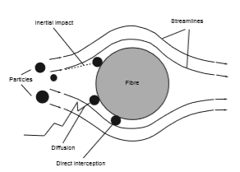
Figure 4Filtration
Source:Zobel, 2010

2.5.1 Objectives of filtration
Objective of filter medium is to maximize the possibility of collision and the subsequent retention of the suspended particles with fibrous structures while minimizing the energy loss of the system. The efficiency of filtration in industrial fabrics are affected by their porosity. Knowledge of air permeability is also important for suitability for use (Kotte, 2011).
2.5.2 Methods of filtration
There are many different methods of filtration; all aim to attain the separation of substances. Separation is achieved by some form of interaction between the, substance or objects to be removed and the filter. The substance that is to pass through the filter must be a fluid, i.e, a liquid or gas. Methods vary depending on the location of the targeted material, whether it is in the fluid phase or not (Shrinivasan and Katharvelu, 2006).
The different methods of filtration can be:Solid - Solid Filtration - when two different types solids are mixed together, one solid is to be separated by interposing a filtering media, Solid - liquid Filtration - when a solid to liquid filtration is carried out the solid particles may be dissolved or in form of suspension, this solid particles are to be separated this is done by interposing a filtering media between them (Sakpal et al., 2013), Solid - Gas Filtration - in this, solid particles are separated from the gas by interposing a filtering media between them and Liquid - Liquid Filtration - in this type of filtration, two different types of fluids are separated with the help of their molecular weight. To achieve this filtration a filtering media is manufactured through which a liquid is passed and separation of two different liquid is achieved (Chaudhary and kumar, 2009).
2.5.3 Types of Filtration
Following are the two important types of filtration.
- Filtration at constant rate
- Filtration at constant pressure

      - Filtration at constant rate
In this method a constant rate is maintained by starting at low pressure and continuously increasing the pressure to overcome the increasing resistance of the cake until maximum pressure is reached at the end of the run. The difficulty with this method is that maximum pressure is reached only at end of the run and hence the whole cycle is less than the maximum capacity(Hutten, 2007).
If initial pressure is low the initial layer of precipitated will be more open so that rates of filtration will be higher and this layer will not be crowded into the filter cloth, with the result that the cake will separate more cleanly from the cloth. A low initial pressure may mean that the first running from the press will not be clear (Lydall, 2007).
      - Filtration At constant pressure
In this method full pressure is applied at the start of filtration and this pressure is maintained constant throughout the run. A serious disadvantage of this method is that if the initial pressure is high the first particle caught will be compacted into a tight mass that largely fills the pores of the cloth and results in a low rate of filtration throughout the rest of the cycle. If the sludge into the interstices between the granular portion and greatly decreases the rate of filtration (Jha and Deshmukh, 2015).
2.5.4 Advantages of nonwoven Filters
The advantages of the nonwoven filters are it have high filtration efficiency, high permeability, less binding tendency, no yarn spillage as in woven media, there is no limitation for thickness, high production rate and Continuous process line (http://best-filter.com/product/application-of-woven-filter-cloth).
Nonwovens are growing at a very fast rate help filter media manufactures to offer improved efficiency, better pressure drops and also overall better performance (Chaudhary and Kumar, 2009).
2.5.5 Nonwovens in Filtration
Compared to other filtration media like membranes, wire cloth and monofilament fabrics, nonwovens offer a thicker cross-section and bulk. This provides the opportunity to use nonwovens as a structure that can fulfil the requirements and boundary conditions of all types of applications. To influence the structure of the nonwoven media, different manufacturing methods are used to manufacture filters for diverse applications. Nonwovens offer high permeability and surface area, which are further enhanced by pleating of the material. Also the wide range of fibre materials available offers good mechanical, chemical and physical thermal properties. Thus, the production of nonwovens for filtration applications is very efficient and can be very economic depending on the fibre material and process steps used (Gregor, 2004).
Nonwoven materials occupy a large ratio in filtration fabrics due to its better filtration efficiency. The structure of the nonwoven fabric helps in accurate filtration. Different variety of textile fibres is used as nonwoven in filtration process (Nagraj, 2009).
This is wide spread application of ‘nonwovens’ in various filtration applications including geoengineering. The critical pore size corresponds to the diameter of nominally spherical solid particle that will pass through this pore. This minimum pore is not identical throughout the nonwoven hence pore size variation is also considered. Higher the number of fibre strata and consequently the greater the thickness of nonwoven, the higher the probability of encountering the pores of minimum size at least once throughout the on woven. The homogeneity of the nonwoven is all-greater, the lower the variation between lowest and highest pore diameters (Nagraj, 2009).

3 EXPERIMENTAL PROCEDURE

The Experimental procedure pertaining to the study is presented under the following heads:

3.1 PROCUREMENT OF FABRIC
3.2 CALENDERING
3.3 EVALUATION OF POLYESTER CALENDERED NONWOVENS
3.3.1 Fabric weight
3.3.2 Fabric Thickness
3.3.3 Fabric strength
3.3.4 Fabric Elongation
3.3.5 Spray test
3.3.6 Wicking Test
3.3.7 Sinking Test
3.3.8 Air permeability (ASTM D737-04)
3.3.9 Particulate filtration efficiency (ASTM F2299)
3.3.10 Index puncture resistance test (ASTM D4833)
3.3.11 Capillary Flow Porometer
3.3.12 Fourier Transform Infrared Spectroscopy
3.3.13 Roughness test
3.3.14Thermo Gravimetric Analysis (TGA)
3.4 NOMENCLATURE

Single layered fabric

Needle-punched polyester fabric

r-PET (100 GSM needle-punched fabric)

Virgin polyester (200 GSM needle-punched fabric)

Calendering

Double layered fabric

Evaluation

Calendering

Temperature Temperature

190⁰ C 200⁰ C 210⁰C 190⁰ C 200⁰ C 210⁰C

Figure 5 Methodology of the study

The materials and methods utilized for the study are explained under the following heads:

3.1 PROCUREMENT OF FABRIC
The recycled polyester and virgin polyester are produced into nonwovens at basis weight of 100 and 200GSM respectively through processes including opening, blending, carding, lapping, and needle-punching.

3.2 CALENDERING
The nonwovens of two different GSM’s 100 and 200 of recycled and virgin polyester respectively are passed between calender rolls which are heated to 190⁰ C, 200⁰ C, 210⁰ C with a surface speed of 0.5m/min, forming hot-pressed calendered nonwovens. The gap between the top and the bottom roller is constant as 0.5mm. But, the 100 GSM recycled polyester was passed as a double layered fabric in the above 3 different temperatures in order to obtain a GSM of around 200. (PLATE 1)
Thus, double layered 100 GSM 190⁰ C, 200⁰ C and 210⁰ C recycled polyester calendered nonwovens and single layered 200 GSM 190⁰ C, 200⁰ C and 210⁰ C virgin polyester calendered nonwovens are obtained. (PLATE 2)
After calendaring process, the calendered nonwoven samples were conditioned at standard atmospheric conditions for 24hrs before testing procedure.

3.3 EVALUATION OF POLYESTER CALENDERED NONWOVENS
The nonwoven polyester fabrics calendered with different temperatures were evaluated for salient properties such as fabric weight, thickness, strength, elongation, spray, wicking, sinking, air permeability test, particulate filtration efficiency, index puncture resistance, capillary Flow Porometer, FTIR, roughness, Thermogravimetric analysis (TGA) tests.
Thus, the test methods for the recycled and virgin polyester calendered nonwovens were as follows:

3.3.1 Fabric weight
Fatbric weight is an important component for comparing the two similar fabrics construction (Saini, 2004). The fabric weight is the relative weight of the fabric and express as the weight of a particular size of piece such as grams per square meter.Many properties of nonwovens, including strength, thickness, porosity, strength, and other are influenced by change in Mass per unit area.
In simple, GSM is the weight of 1meter x 1meter fabric. It means 100cm x 100 cm = 10,000 sq.cms. For, finding out the GSM using manual method we have to follow the below steps:
- cut the sample of 5 cm x 5 cm
- Measure the fabric weight
- Calculate the fabric sample area by multiplying length and width.
The formula to be followed for finding out the GSM is as follows:
Sample weight x 10,000
Fabric GSM = …………………………………….
Area of sample fabric
Five samples for each of A, B, C, D, E and F were carried out. The GSM of each sample was calculated using the above formula and to be tabulated. (PLATE 3)
3.3.2 Fabric Thickness
Measurement of fabric thickness is essentially measuring the distance between the two parallel plates separated by the cloth & a known arbitrary pressure is applied and maintained. Thickness is one of the basic physical properties of nonwoven fabric. In certain industrial applications, the thickness may require rigid control with in specified limits. Bulk and warmth properties of nonwoven fabric are often estimated from their thickness values, and
thickness also useful in measuring performance characteristics, such as, before and after abrasion and shrinkage.
The thickness values of most nonwoven fabric will vary considerably depending on the pressure applied to the specimen at the time the thickness measurement is taken. In all cases, the apparent thickness varies inversely with the pressure applied. For this reason, it is essential that the pressure be specified when discussing or listing any thickness value. The fabric was placed between the pressure foot and anvil the reading was noted from the dial. Ten readings were taken from different places of the A, B, C, D, E and F fabrics. Thus, fabric thickness was analysed for all the recycled and virgin polyester calendered nonwovens. Ten readings for each of the recycled and virgin polyester calendered nonwovens was calculated and to be tabulated. (PLATE 4)

3.3.3 Fabric strength
The strength of a fabric is defined as its ability to withstand an applied load without failure. Two rectangular specimens of size 3inches × 8inches were cut both in warp and weft direction of the fabrics A, B, C, D, E and F were placed in between the jaws of the tensile strength tester. One side of the cut end is clamped into the upper jaw and the other end into the lower jaw. When the tester was started, the jaws move apart at a constant rate until the fabric begins to tear. At that moment, the tester was stopped the readings shown in the dial of the tester are to be noted. (PLATE 5)
3.3.4 Fabric Elongation
Fabric elongation is the increase in the length of the specimen from its starting length expressed in units of length. The distance that a material will extend under a given force is proportional to its original length; therefore elongation is usually quoted as strain or percentage extension. This, test is be conducted in tensile strength tester, with the same procedure that was followed for the fabric strength test. But, the readings for the samples were shown clearly on the elongation scale placed at the left side of the tensile tester. Thus, the samples of the fabrics A, B, C, D, E and F were tested and the readings are to be noted. (PLATE 5)
3.3.5 Spray test
The spray rating test is one used to measure the resistance of a fabric to surface wetting but not to penetration of water. It is therefore a test which is particularly used a shower proof finishes. It is often the case that water proof coating is applied to the inner surface of a material and a water repellent finish is then applied to the outer surface to stop it absorbing water as it would otherwise become waterlogged. In such cases the test is used on the outer layer of fabrics which are otherwise considered as waterproof. (BS EN, 2002)
In the test six specimens A, B, C, D, E and F are tested. Each sample is 180mm in square. Each specimen in turn is held over a 150mm diameter embroidery frame which is mounded at 45º to the horizontal. A funnel which is fitted with a standard nozzle containing 19 holes of a specified diameter is held 150mm above the fabric square. 250 ml of distilled water is poured into funnel at 25 ± 2⁰ C the shower is continued onto the fabric. After the water spraying is stopped the frame and sample is removed and it is tapped twice smartly against a solid object in an opposite point of the frame, the fabric being kept horizontal. This removes any large drops of water. The fabric is then assigned a spray rating either wing the written grading.
The ratings are as follows:
- 100 - No sticking or wetting of the upper surface
- 90 - Slight sticking or wetting of the upper surface
- 80 - Wetting of the upper surface at spray points
- 70 - Partial wetting of whole of upper surface
- 50 - Complete wetting of whole of upper surface
- 0 - Complete wetting of whole of upper and lower surfaces. (Seville, 2002)
Thus, spray test was analysed for all the recycled and virgin polyester calendered nonwovens. (PLATE 6)
3.3.6 Wicking Test
A strip of fabric is suspended vertically with its lower edge in a reservoir of distilled water. The rate of rise of the leading edge of the water is then monitored. To detect the position of the water line a dye can be added to the water or in the case of dark colour fabrics, the conductivity of the water may be used to complete an electrical circuit. The measured height of raise in a given time is taken as a direct indication of the wick ability of test fabric.
The simple form of the test does not take into account the mass of the water that is taken up. This will depend on the height. The water has risen to the thickness of the fabric and the water holding power of the fabric structure one way of allowing for this is to weight the fabric at the end of the test and hence obtain the mass of the water taken up by the fabric. The mass then can be expressed as a percentage of the mass of the length of dry fabric. This is equivalent to the measure height of water rise. (Harnett et al., 1985)
Thus, the samples of A, B, C, D, E and F were tested for wicking and the readings were recorded. (PLATE 7)
3.3.7 Sinking Test
A 200ml beaker was filled with distilled water. Samples of size 25mm × 25mm were cut from the A, B, C, D, E and F fabrics and were dropped on the surface of the water from a standard height. The stop watch was started when the fabric stuck the surface of the water and stopped when the last corner sank below the water surface and the time required for each of the sample of A, B, C, D, Eand F to sink sample was to be noted. If the sample does not sink within 1minute then, the sample is considered to as having floated(Saville, 2002).Thus, the sinking test was analysed for the samples of A, B, C, D, E and F and the readings were tabulated. (PLATE 8)
3.3.8 Air permeability (ASTM D737-04)
Air permeability is the rate of air flow passing perpendicularly through a known area under a prescribed air pressure differential between the two surfaces of a material of textile fabrics and is applicable to most fabrics including woven fabrics, air bag fabrics, blankets, napped fabrics, knitted fabrics, layered fabrics and pile fabrics. The air permeability was tested based on ASTM D737-04. The air amount needs to be firstly adjusted at testing pressure of 125 MPa in order to receive more accurate air permeability value which is expressed as air amount per cm³ through per cm² samples, namely cm³/ cm²/sec. Five regions, sized as 25×25 cm², were tested respectively for each sample (Ting Li et al., 2014) i.e, all samples of A, B, C, D, E and F and the readings were tabulated. (PLATE 9)
3.3.9 Particulate filtration efficiency (ASTM F2299)
The particulate filtration efficiency test evaluates the nonviable particle retention or filtration efficiency of filter media and other filtration devices at sub-micron levels. This test was conducted according to ASTM F2299. Monodispersed polystyrene (latex) microscopes of a particle size 0.097±0.003 μm. These particles were nebulized, dried and passed through the r- PET and virgin calendered needle punched nonwovens namely, A, B, C, D, E and F. The particles passing through the samples A, B, C, D, E and F were enumerated using a laser particle counter. Three one-minute counts were determined for each sample of A, B, C, D, E and F and the results averaged. Three one-minute control counts were performed, without a test sample in the system, before and after each test sample run. More specifically, an aliquot of the latex spheres was transferred to particle measuring system (PMS). The latex aerosol was mixed with additional filtered, dried air and passed through the test system. The flow rate through the test system was maintained at 1 cubic foot per meter (CFM) ± 5%. The particles delivered were collected and enumerated using a PS lased based particle counter. Extraneous particulate “background noise” through the sample holder produced an average of <1 particle at 1 CFM with the nebulizer output clamped off. The samples of A, B, C, D, E and F were placed into the sample holder, the system was allowed to stabilize, and then triplicate one-minute counts were recorded. Control count averages were maintained at a level of 10,000-15,000 particles per cubic foot. The percent filtration efficacy for the sample was determined using the following equation:
Average C – Average T
Filtration efficacy (%) = ………………………………….
Average C
Where; C = particle count counts with no test sample in system and T = particle counts with the test sample in system. Thus, the readings of each of the samples were tabulated.
3.3.10 Index puncture resistance test (ASTM D4833)
This test method is an index test for determining the puncture resistance of geomembranes and related products. The use of this test method is to establish an index value by providing standard criteria and a basis for uniform reporting” (ASTM Standard D4833/D4833M, 2013). Here the clamp consisted of two circular plates with inner diameters of 45±0.25 mm. The indenter was smaller and its shape was different. The indenter diameter was 8±1 mm, having a flat end with a 45° (0.8 mm) chamfered edge that contacted the specimen surface. The recycled and virgin polyester calendered nonwoven samples was held and secured between these plates by six screws. Then the indenter and the clamp were installed on the Zwick Universal Testing Machine, and ran at a constant rate of elongation, as was mentioned before. (Plate 10)
Five specimens were tested for each layer, 30 total specimens, at a standard speed of 300 mm/min (Askari, 2012). Thus, the readings were tabulated.
3.3.11 Capillary Flow Porometer
Capillary Flow Porometer (CFP), also known as porometry, is a characterization technique based on the displacement of a wetting liquid from the sample pores by applying a gas at increasing pressure. It is widely used to measure minimum, maximum (or first bubble point) and mean flow pore sizes and pore in membranes, nonwovens, paper, filtration and ultrafiltration media, hollow fibres and ceramics (Agarwal et al., 2012). Prior to a capillary flow porometry measurement it is necessary to impregnate the samples with a wetting liquid. An inert gas, normally N2, is used to displace this wetting liquid from the porous network. The pressure required to empty a pore corresponds to the pressure necessary to evacuate the liquid from the most constricted part of it. This most constricted part is the most challenging one and it offers the highest resistance to remove the wetting liquid. The Young-Laplace formula permits calculating the pore diameter from the measured pressure:
P = 4γcos θ/D
Where D is the pore size diameter, P is the measured pressure, γ is the surface tension of the wetting liquid and θ is the contact angle of the wetting liquid with the sample. Thus, the readings of each of the samples were tabulated. (PLATE 11)
3.3.12 Fourier Transform Infrared Spectroscopy (FTIR)
Fourier Transform Infrared Spectroscopy, also known an FTIR Analysis or FTIR Spectroscopy, is an analytical technique used to identify organic, polymeric and in some cases inorganic materials. The FTIR analysis uses infrared light to scan test samples and observe chemical properties.
The samples for FTIR were prepared and the FTIR instrument send infrared radiations of about 10,000 to 100 cm⁻¹ through a sample namely, A, B, C, D, E and F with some radiation absorbed and some passed through. The absorbed radiation is converted into rotational and or vibrational energy by the samples molecules. The resulting signal at the detector present as a spectrum, typically from 4000cm⁻¹ to 400 cm⁻¹, representing a molecular finger print of the sample. Each molecule or chemical structure will produce a unique spectral fingerprint, making FTIR analysis a great tool for chemical identification. Thus, all the samples of A, B, C, D, E and F were analysed for FTIR. (PLATE 12)
3.3.13 Roughness test
The Zeta 2.0 optical microscope is a fully integrated microscope based system that provides 3D imaging and metrology capability in a small and cost effective package. Based on proprietary technology, the Zeta 2.0 enables imaging of surfaces with low reflectivity and very high roughness. Conventional microscopes have a very limited depth of focus. The zeta system scans a sample over a user specified vertical (or Z) range. At each Z positions it records the XY location and the precise Z height of the pixels using Zeta optics module. The Zeta 3D software can be used to ascertain dimensional and roughness information.
- CCD Camera: To capture sample images and focus map data
- Zeta Optics Module: Contains a focus map signal generator a high intensity while light LED source to prevent Sample colour and optics to optimize illumination.
- Precision Z drive mechanism: For sub-micron level resolution
- Zeta control box: Contains the controller for Z drive and optics module electronics.
- Substrate holder: To place the sample with X-Y and angular adjustment.
- Computer System: Contains Zeta 3D imaging and analyzing software.
It will be working in the distance of 3.1m with 0.5 Z resolution and 0.45 XY resolution and 0.75 optical resolution.(PLATE 13)
Thus, all the recycled and virgin polyester calendered nonwovens samples, assessed for Roughness by using above instrument.
3.3.14 Thermo Gravimetric Analysis (TGA)
Thermo Gravimetric Analysis (TGA) is a technique in which the mass of a substance is monitored as a function of temperature or time as the sample specimen is subjected to a controlled temperature program in a controlled atmosphere. A Simple TGA Concept to remember is that TGA measures a sample’s weight as it is heated or cooled in a furnace. The testing procedure of TGA is; connect the module to the serial part of the PC station and turn on the module power. Click the Muse Jobs shortcut on the desktop to open the Job gallery. Double click the measure icon in the job gallery to the measurement window. Select open the (communication port) from the file menu or click the icon on the toolbox, 6000 series = (open COM Port) and 7000 series = (open the USB port). After a short period of time, the module is linked and the measurement window is displayed. Individual tools are prepared for editing the scale. Enter the measurement conditions on the method and sample condition tab of the condition editor. Enter the sample name, sample weight and data file name in the sample condition tab. Open the method tab and enter the temperature program. Click OK on the condition Editor window to close. Click the measure button to start the measurements. Click the stop button to stop the measurement while in progress. Once the measurement begins, the status display changes to measuring and the data during the measurement is displayed on the graph. When the measurement is complete, waiting is displayed in the status display. Measurement data can be viewed on the real time and profile windows. To toggle the windows, use the icon or function F7 and F8 keys. Once the measurement is complete, use the analysis window to perform analysis. Turnoff the module. Select close COM port from the file menu or click the icon on the follows. Click OK on the confirmation message. The module turns off. Exit the measurement window select exit from the file menu. Thus, the readings of each of the samples were tabulated. (PLATE 14)

3.4 NOMENCLATURE
The nomenclature used for the samples are presented in the following Table II.
Table II
Nomenclature
S.no | Nomenclature of Sample | Details of Samples
1 | A | 100GSM r-PET double layered 190⁰ C calendered fabric
2 | B | 100GSM r-PET double layered 200⁰ C calendered fabric
3 | C | 100GSM r-PET double layered 210⁰ C calendered fabric
4 | D | 200GSM virgin single layered 190⁰ C calendered fabric
5 | E | 200GSM virgin single layered 200⁰ C calendered fabric
6 | F | 200GSM virgin single layered 200⁰ C calendered fabric

(PLATE 1) Calendering of polyester nonwoven fabric
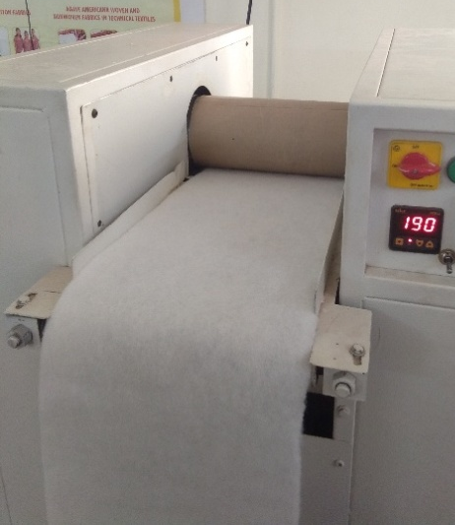

(PLATE 2)
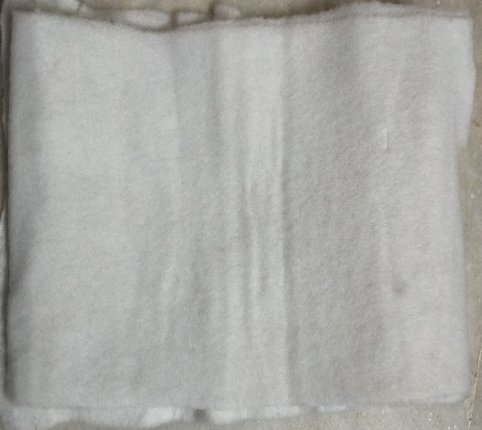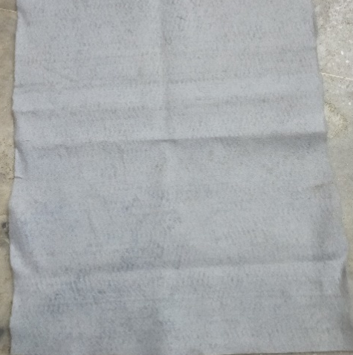
2 (a) r-PET 2 (b) Virgin polyester
calendered nonwoven fabric calendered nonwoven fabric

(PLATE 3) Fabric weight (PLATE 4) Fabric Thickness test
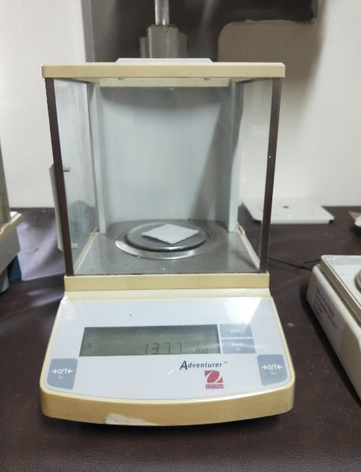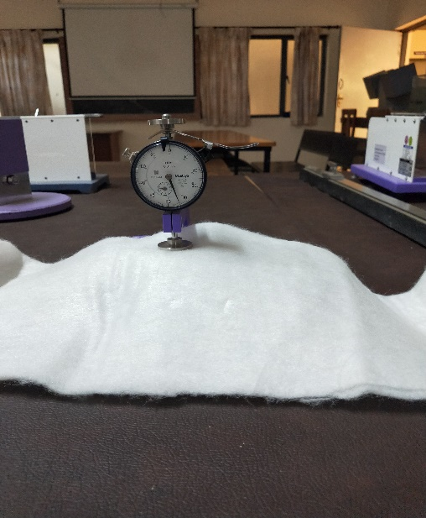

(PLATE 5) Fabric strength and elongation (PLATE 6) Spray test
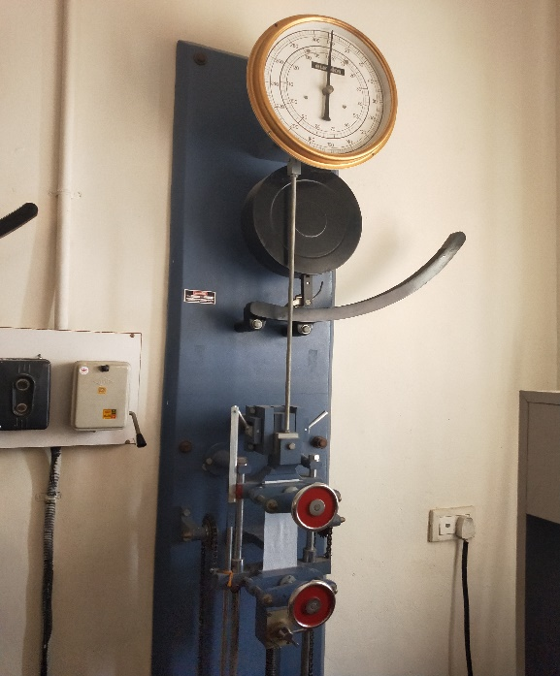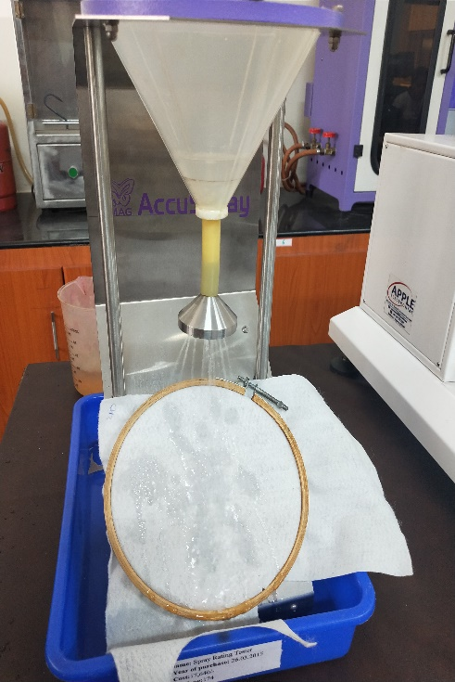

(PLATE 7) Wicking test (PLATE 8) Sinking test
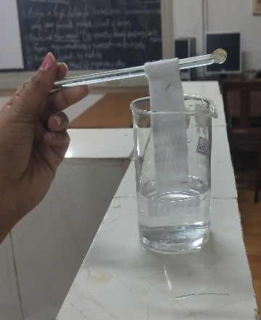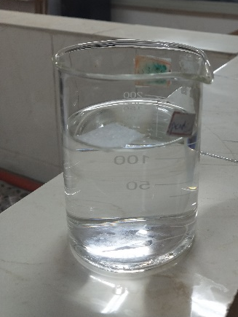

(PLATE 9) Air permeability test
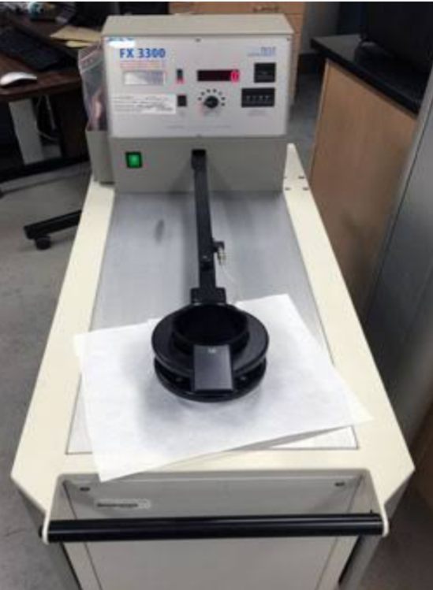

(PLATE 10) Index puncture resistance test
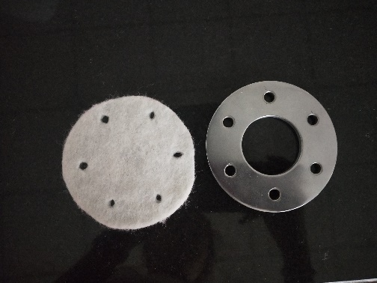
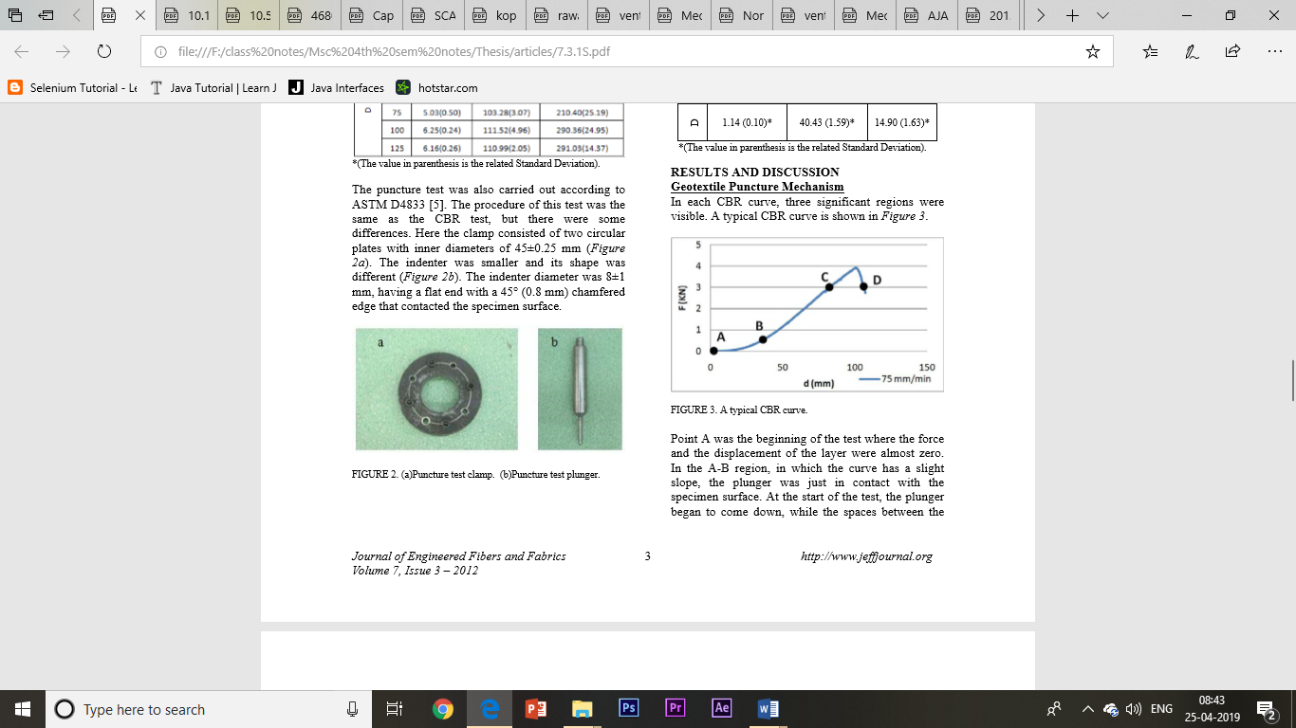
10 (a) test specimen and clamp 10 (b) puncture test plunger

(PLATE 11) Capillary Flow (PLATE 12) FTIR tester
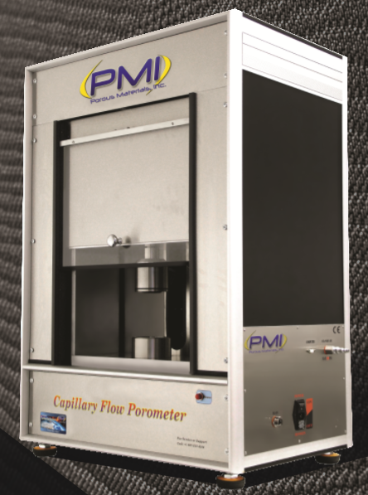
Porometer tester
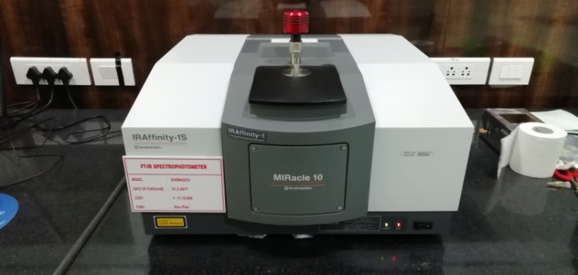

(PLATE 13) Roughness tester
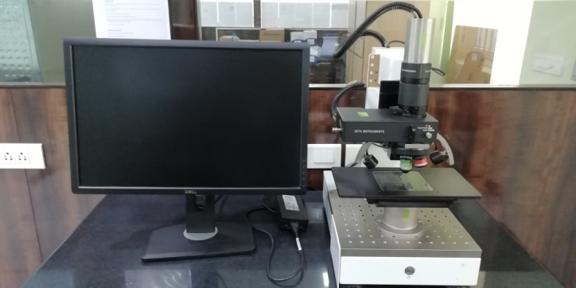

(PLATE 14) TGA tester
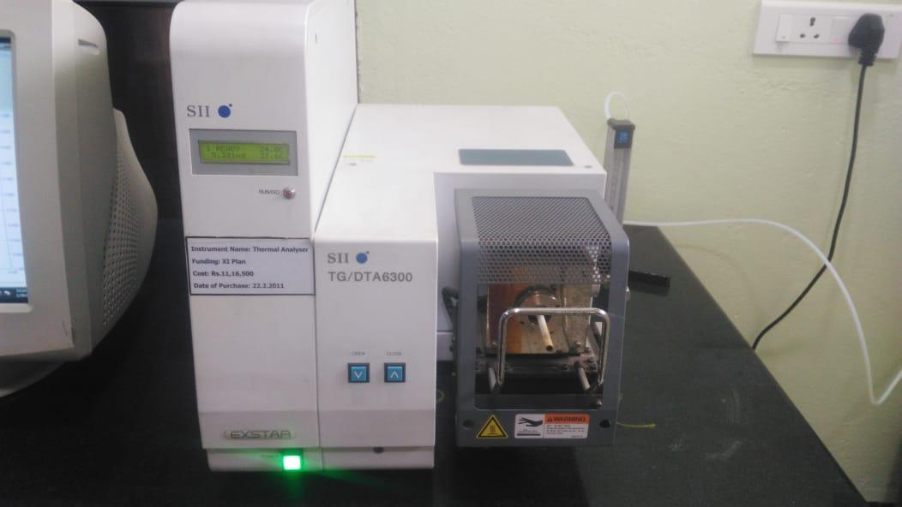

4 RESULTS AND DISCUSSION

The results and discussions of the study are expressed under the following heads:

4.1 FABRIC WEIGHT
4.2 FABRIC THICKNESS
4.3 FABRIC STRENGTH
4.4 FABRIC ELONGATION
4.5 SPRAY TEST
4.6 FABRIC WICKING
4.7 FABRIC SINKING
4.8 AIR PERMEABILITY (ASTM D737-04)
4.9 PARTICULATE FILTRATION EFFICIENCY (ASTM F2299)
4.10 INDEX PUNCTURE RESISTANCE (ASTM D4833)
4.11 CAPILLARY FLOW POROMETER
4. 12 FOURIER TRANSFORM INFRARED SPECTROSCOPY (FTIR)
4.13 ROUGHNESS TEST
4.14 THERMO GRAVIMETRIC ANALYSIS (TGA)

4.1 FABRIC WEIGHT
The results obtained from the fabric weight analysis are expressed in the Table III.
Table III
Fabric weight
S.no | Sample | Weight (GSM)
1. | A | 180
2. | B | 173
3. | C | 201
4. | D | 203
5. | E | 200
6. | F | 204

From the Table III, it is clear that the weight of the sample A, B, C, D, E, and F was 180, 166, 201, 203, 200 and 204 GSM respectively.
Hence, it could be concluded that the fabric weight of the samples C and F is high with 201 and 204 GSM respectively when compared to other samples. Thus, virgin polyester calendered nonwovens exhibited highest GSM values when compared to the r-PET polyester calendered nonwovens.

4.2 FABRIC THICKNESS
The results obtained in the fabric thickness test are expressed in Table IV.
Table IV
Fabric Thickness
S.no | Sample | Thickness (mm)
1. | A | 1.576
2. | B | 1.03
3. | C | 1.249
4. | D | 0.707
5. | E | 0.721
6. | F | 0.707

From Table IV, it is clear that the thickness of the sample A, B and C are high with 1.576mm, 1.03mm and 1.249 mm respectively. The thickness was noted to be high in all the samples of recycled polyester calendered fabrics when compared to virgin polyester calendered fabrics of D, E and F with 0.707 mm, 0.721 mm and 0.707 mm respectively.
Hence, it could be concluded that the r-PET nonwovens exhibited highest thickness when compared to the virgin polyesters after the calendaring process.

4.3 FABRIC STRENGTH
The nonwoven fabric strength in warp and weft directions is presented in Table V.
Table V
Fabric strength
S.no | Sample | Machine direction Strength (kgs) | Cross direction Strength (kgs)
1. | A | 7 | 7
2. | B | 8 | 9
3. | C | 9 | 8
4. | D | 30 | 29
5. | E | 24 | 25
6. | F | 26 | 26
Machine direction
From Table V, it is obvious thatthe fabric strength of the sample D, E and F was maximum with 30, 24 and 26 kgs respectively when compared to the sample A, B and C with 7, 8 and 9 respectively.
Cross direction
From Table V, it is obvious that the fabric strength of the sample D, E and F was maximum with 29, 25 and 26 kgs respectively when compared to the sample A, B and C with 7, 9 and 8 respectively.
Hence, it could be concluded that both the machine and cross direction fabric strengths was almost similar in both the r-PET and virgin calendered nonwovens. The virgin calendered polyesters exhibited highest fabric strength when compared to the r-PET calendered nonwovens.

TABLE V (a)
T Test for Fabric Strength
(between ABC and DEF of Warp Strength and Weft Strength)
Variables |  | Mean | SD | SE | T-value | Sig
Warp and Weft Strength | ABC | 8.00 | .89 | .36 | -18.265 | .000*
Warp and Weft Strength | DEF | 26.67 | 2.34 | .95 | -18.265 | .000*
*=Significant at 1% level
The above table shows the output of the Independent T-Test analysis, that the significance value is 0.000 which is <.005 therefore, there is statistical significant difference between the variables.

4.4 FABRIC ELONGATION
The nonwoven fabric elongation is expressed in the Table VI.
Table VI
Fabric Elongation
S.no | Sample | Machine direction Elongation (%) | Cross direction Elongation (%)
1. | A | 55 | 55
2. | B | 38 | 29
3. | C | 55 | 28
4. | D | 45 | 31
5. | E | 46 | 35
6. | F | 44 | 36

Machine direction
From Table VI, it is obvious that the elongation of the nonwoven fabric in sample A, B, C, D, E and F was found to be 55, 38, 55, 45, 46 and 44 respectively. The Sample A and C exhibited highest elongation percentages when compared to all the other samples.
Cross direction
From Table VI, it is obvious thatthe elongation of the nonwoven fabric in sample A, B, C, D, E and F was found to be 55, 29, 28, 31, 35 and 36 respectively. The Sample A exhibited highest elongation percentages when compared to all the other samples.
Hence, it could be concluded that all the samples exhibited highest elongation in Machine direction when compared to the cross direction. Thus the elongation was showed highest in r-PET calendered nonwovens.

TABLE VI (a)
T Test for Fabric Elongation
(between ABC and DEF of Warp Elongation and Weft Elongation)
Variables |  | Mean | SD | SE | T-value | Sig
Warp and Weft Elongation | ABC | 43.33 | 13.25 | 5.41 | .640 | .542^{NS}
Warp and Weft Elongation | DEF | 39.50 | 6.28 | 2.57 | .640 | .542^{NS}
NS= Not Significant
The above table shows the output of the Independent T-Test analysis, that the significance value is.542 which is >.005, therefore, there is no statistical significant difference between the variables.

4.5 SPRAY TEST
The observations obtained in the spray test are presented in the Table VII.
Table VII
Spray Test
S.no | Sample | Result
1. | A | 90
2. | B | 90
3. | C | 90
4. | D | 70
5. | E | 70
6. | F | 70

From Table VII, it was obvious that the sample A, B, and C exhibited the slight sticking or wetting of the upper surface of the nonwoven fabric with the rating of 90 whereas, all the samples of virgin polyester calendered nonwovens namely, D, E and F showed partial wetting of whole of upper surface the rating of 70.
Hence, it could be concluded that the virgin calendered nonwoven fabrics exhibited highest absorbency (spray rating) when compared to the r-PET calendered nonwovens.

4.6 FABRIC WICKING
The results of wickability of the nonwoven fabric are expressed in the Table VIII.
Table VIII
Wicking Test
S.no | Sample | Wicking Height (cm)
1. | A | 0
2. | B | 0
3. | C | 0
4. | D | 0.2
5. | E | 0.4
6. | F | 0.3

From the Table VIII, it is clear that the wickability of the sample A, B and C was nil. Whereas, all the virgin polyester calendered nonwoven samples exhibited wickability of which it was the highest in sample E of 0.4 cm followed by samples F and D with 0.3 cm and 0.2 cm respectively.
Hence, it could be concluded that the wickability of the virgin calendered polyester nonwovens was high in comparison with the r-PET calendered nonwovens.

4.7 FABRIC SINKING
The results obtained in the sinking test are presented in the Table IX.
Table IX
Sinking Test
S.no | Sample | Sinking Time (sec)
1. | A | No sinking
2. | B | No sinking
3. | C | No sinking
4. | D | No sinking
5. | E | No sinking
6. | F | No sinking

From the Table IX, it is clear that the sinking time of all the samples was nil.
Hence, it could be concluded that all the r-PET and virgin polyester nonwovens exhibited poor sinking property. Thus, these samples were considered to be floated in water.

4.8 AIR PERMEABILITY (ASTM D737-04)
The results obtained in the Air permeability test are presented in the Table X.
Table X
Air permeability Test
S.no | Sample | Air permeability (cm³/cm²/sec)
1. | A | 403
2. | B | 393.4
3. | C | 349
4. | D | 143.8
5. | E | 127.8
6. | F | 145.6

From the Table X, it is clear that the sample A exhibited high amount of air permeability with 403 cm³/cm²/sec when compared to the samples B, C, D, E and F with
Hence, it could be concluded that all the r-PET calendered nonwovens exhibited highest air permeability when compared to the virgin polyester calendered nonwoven fabrics.

4.9 PARTICULATE FILTRATION EFFICIENCY (ASTM F2299)
The results obtained in the Particulate filtration efficiency are presented in the Table XI.
Table XI
Particulate filtration efficiency
S.no | Sample | Without specimen | With specimen | Efficiency (%)
1. | A | 11,161 | 8,320 | 25.45
2. | B | 10,770 | 7,377 | 31.50
3. | C | 10,895 | 6,731 | 38.22
4. | D | 10,999 | 8,063 | 26.70
5. | E | 11,057 | 9,847 | 10.94
6. | F | 11,939 | 9,261 | 22.44
From the Table XI, it is clear that the Sample C exhibited highest particulate filtration efficiency with 38.22% followed by the sample B (31.50%), D (26.70%), A (25.45%), F (22.44%) and E (10.94%) respectively.
Hence, it could be concluded that the r-PET calendered nonwovens exhibited highest filtration efficiency when compared to the virgin calendered nonwovens.

4.10 Index puncture resistance (ASTM D4833)
The results of Index puncture resistance of the nonwoven fabric are expressed in the Table XII.
Table XII
Index puncture resistance
S.no | Sample | Peak weight (kgs) | Deflected length(mm)
1. | A | 2.335 | 10.5
2. | B | 2.89 | 9
3. | C | 2.47 | 10.5
4. | D | 14.56 | 12.5
5. | E | 14.215 | 13.5
6. | F | 12.77 | 11

From Table XII, it is clear that the Peak weight of the Sample D (14.56kgs) is high and it is followed by the sample E (14.215kgs), F (12.77kgs), B (2.89kgs), C (2.335kgs) and A (2.335kgs) respectively.
While considering the deflected length the Sample E exhibited highest deflected length of about 13.5 mm and it is followed by the Sample D, F, A, C and B with the deflected lengths of 12.5 mm, 11mm, 10.5mm, 10.5mm and 9 mm respectively.
Hence, it could be concluded that the virgin calendered polyesters exhibited highest puncture resistancy when compared to the r-PET calendered nonwovens.

4. 11 CAPILLARY FLOW POROMETER
The results of Capillary Flow Porometer of the nonwoven fabric are expressed in the Table XIII.
Table XIII
Capillary Flow Porometer
S.no | Sample | Mean Flow Pore Diameter  (Microns) | Bubble Point Pore Diameter  (Microns)
1. | A | 68.0597 | 67.537
2. | B | 68.5792 | 68.735
3. | C | 67.0481 | 68.675
4. | D | 67.647 | 68.735
5. | E | 67.9978 | 68.914
6. | F | 66.8274 | 67.619

From the Table XIII, it was concluded that the Mean flow pore diameter and Bubble point pore diameter is almost similar in all the samples A, B, C, D, E and F. The sample B exhibited highest Mean flow pore diameter with 68.5792 microns and the sample E exhibited highest Bubble point pore diameter with 68.914microns.
Hence, it could be concluded that the Mean flow pore diameter was higher in r-PET calendered nonwovens and the Bubble point pore diameter was higher in case of virgin calendered nonwovens.

4.12 FOURIER TRANSFORM INFRARED SPECTROSCOPY (FTIR)
The results of FTIR spectra of the Samples A, B, C, D, E and F are presented in the Table XIV, XV, XVI, XVII, XVIII, XIX and Figure 6.
Table XIV
FTIR - Sample A
Frequency (cm⁻¹) | Assignment | Functional groups
3741.90 | C−H Strong | Alkanes
2360.87 | C≡N Strong | Stretch
1712.79 | C=O Strong | Ketone
1242.16 | C−X Strong | fluoride
1095.97 | C−X Strong | fluoride
717.52 | C−X Strong | chloride
486.06 | C−X Strong | Bromide, iodide

From the Table XIV and Figure 6 (a), it is clear that the FTIR spectra of Sample A contains the peaks at 3741.90 cm⁻¹, 2360.87 cm⁻¹, 1712.79 cm⁻¹, 1242.16 cm⁻¹, 1095.97 cm⁻¹, 717.52 cm⁻¹and 486.06 cm⁻¹correspond to deformation, bending and stretching. Characteristic peaks of Sample A corresponding to C−H strong deformations (3741.90 cm⁻¹), C≡N Strong (2360.87 cm⁻¹), C=O Strong (1712.79 cm⁻¹), C−X Strong (1242.16 cm⁻¹), C−X Strong (717.52 cm⁻¹) and C−X Strong (486.06 cm⁻¹) deformations. Hence it could have conducted that the Sample A contains the following functional groups namely; alkanes, stretch, ketone, fluoride, chloride, bromide and iodide.

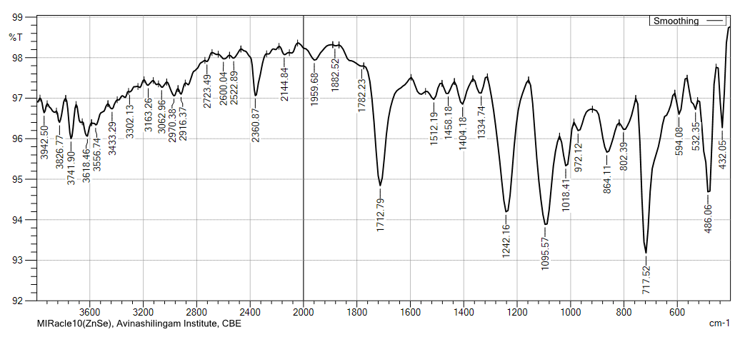
Figure 6 (a) FTIR -Sample A

Table XV
FTIR – Sample B
Frequency (cm⁻¹) | Assignment | Functional groups
3741.90 | C−H Strong | Alkanes
1705.07 | C=O Strong | Ketone
1519.91 | N=O Strong | Nitro (R-NO₂)
1242.16 | C−N Medium-Weak | Amines
1095.57 | C−N Medium-Weak | Amines
717.52 | C−X Strong | chloride
432.05 | C−X Strong | Bromide, iodide

From the Table XV and Figure 6 (b), it is clear that the FTIR spectra of Sample B contains the peaks at 3741.90 cm⁻¹, 1705.07 cm⁻¹, 1519.91 cm⁻¹, 1242.16 cm⁻¹, 1095.97 cm⁻¹, 717.52 cm⁻¹and 432.05 cm⁻¹correspond to deformation, bending and stretching. Characteristic peaks of Sample B corresponding to C−H strong deformations (3741.90 cm⁻¹), C=O Strong (1705.07 cm⁻¹), N=O Strong (1519.91 cm⁻¹), C−N Medium-Weak (1242.16 cm⁻¹), C−N Medium-Weak (1095.57 cm⁻¹), C−X Strong (717.52 cm⁻¹) and C−X Strong (432.05 cm⁻¹) deformations. Hence it could have conducted that the Sample B contains the following functional groups namely; alkanes, ketone, nitro (R-NO₂), amines, chloride, bromide and iodide.

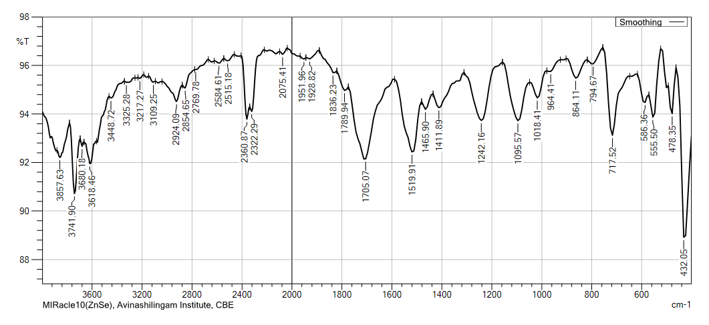
Figure 6 (b) FTIR - Sample B
Table XVI
FTIR - Sample C
Frequency (cm⁻¹) | Assignment | Functional groups
2353.16 | C≡N Strong | Stretch
1720.50 | C=O Strong | Ketone
1597.06 | N=O Strong | Nitro (R-NO₂)
1242.16 | C−N Medium-Weak | Amines
1095.57 | C−N Medium-Weak | Amines

From the Table XVI and Figure 6 (c), it is clear that the FTIR spectra of Sample C contains the peaks at 2353.16 cm⁻¹, 1720.50 cm⁻¹, 1597.06 cm⁻¹, 1242.16 cm⁻¹and 1095.57 cm⁻¹correspond to deformation, bending and stretching. Characteristic peaks of Sample C corresponding to C≡N Strong deformations (2353.16 cm⁻¹), C=O Strong (1720.50 cm⁻¹), N=O Strong (1597.06 cm⁻¹), C−N Medium-Weak (1242.16 cm⁻¹) and C−N Medium-Weak (1095.57 cm⁻¹) deformations. Hence it could have conducted that the Sample C contains the following functional groups namely; stretch, ketone, nitro (R-NO₂) and amines.

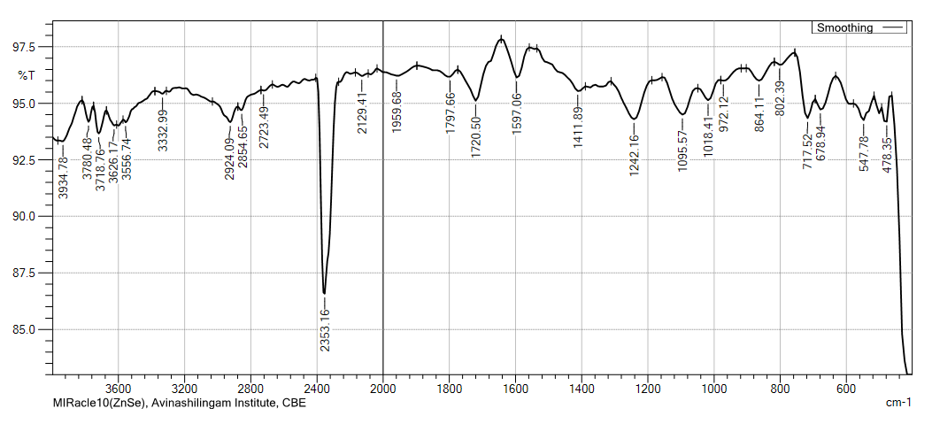
Figure 6 (c) FTIR - Sample C

Table XVII
FTIR - Sample D
Frequency (cm⁻¹) | Assignment | Functional groups
2353.16 | C≡N Strong | Stretch
1597.06 | N=O Strong | Nitro (R-NO₂)
1242.16 | C−N Medium-Weak | Amines
1095.57 | C−N Medium-Weak | Amines
478.35 | C−X Strong | Bromide, iodide
424.34 | C−X Strong | Bromide, iodide

From the Table XVII and Figure 6 (d), it is clear that the FTIR spectra of Sample D contains the peaks at 2353.16 cm⁻¹, 1597.06 cm⁻¹, 1242.16 cm⁻1, 1095.57 cm⁻¹, 478.35 cm⁻¹and 424.34 cm⁻¹correspond to deformation, bending and stretching. Characteristic peaks of Sample D corresponding to C≡N Strong deformations (2353.16 cm⁻¹), N=O Strong (1597.06 cm⁻¹), C−N Medium-Weak (1242.16 cm⁻¹), C−N Medium-Weak (1095.57 cm⁻¹), C−X Strong (478.35 cm⁻¹) and C−X Strong (424.34 cm⁻¹) deformations. Hence it could have conducted that the Sample C contains the following functional groups namely; stretch, nitro (R-NO₂), amines, bromides and iodides.

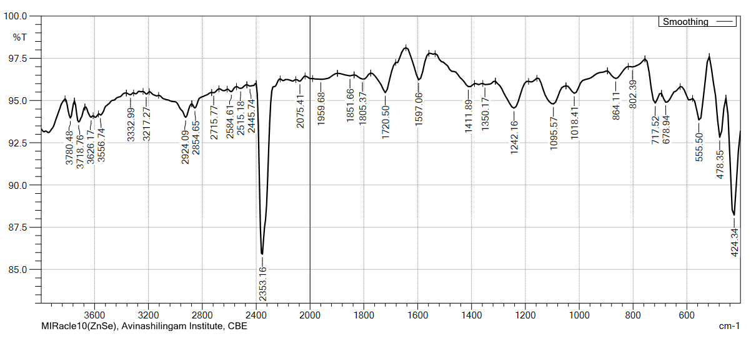
Figure 6 (d) FTIR - Sample D

Table XVIII
FTIR – Sample E
Frequency (cm⁻¹) | Assignment | Functional groups
2353.16 | C≡N Strong | Stretch
1720.50 | C=O Strong | ketone
1242.16 | C−N Medium-Weak | Amines
1095.57 | C−N Medium-Weak | Amines
717.52 | C−X Strong | chloride
432.05 | C−X Strong | Bromide, iodide

From the Table XVIII and Figure 6 (e), it is clear that the FTIR spectra of Sample E contains the peaks at 2353.16 cm⁻¹, 1720.50 cm⁻¹, 1242.16 cm⁻1, 1095.57 cm⁻¹, 717.52 cm⁻¹and 432.05 cm⁻¹correspond to deformation, bending and stretching. Characteristic peaks of Sample D corresponding to C≡N Strong deformations (2353.16 cm⁻¹), C=O Strong (1720.50 cm⁻¹), C−N Medium-Weak (1242.16 cm⁻¹), C−N Medium-Weak (1095.57 cm⁻¹), C−X Strong (717.52 cm⁻¹) and C−X Strong (432.05 cm⁻¹) deformations. Hence it could have conducted that the Sample E contains the following functional groups namely; stretch, ketone, amines, chloride, bromides and iodides.

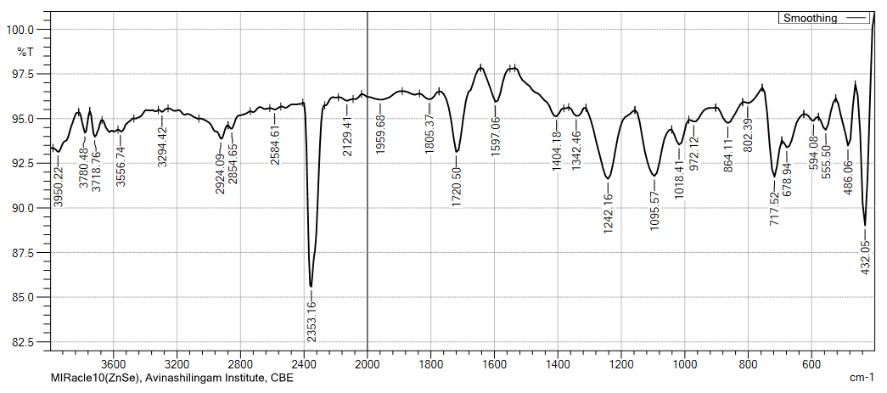
Figure 6 (e) FTIR - Sample E

Table XIX
FTIR – Sample F
Frequency (cm⁻¹) | Assignment | Functional groups
2353.16 | C≡N Strong | Stretch
1597.06 | N=O Strong | Nitro (R-NO₂)
1242.16 | C−N Medium-Weak | Amines
1095.57 | C−N Medium-Weak | Amines
478.35 | C−X Strong | Bromide, iodide
432.05 | C−X Strong | Bromide, iodide

From the Table XIX and Figure 6 (f), it is clear that the FTIR spectra of Sample F contains the peaks at 2353.16 cm⁻¹, 1597.06 cm⁻¹, 1242.16 cm⁻1, 1095.57 cm⁻¹, 478.35 cm⁻¹and 432.05 cm⁻¹correspond to deformation, bending and stretching. Characteristic peaks of Sample F corresponding to C≡N Strong deformations (2353.16 cm⁻¹), N=O Strong (1597.06 cm⁻¹), C−N Medium-Weak (1242.16 cm⁻¹), C−N Medium-Weak (1095.57 cm⁻¹), C−X Strong (478.35 cm⁻¹) and C−X Strong (432.05 cm⁻¹) deformations. Hence it could have conducted that the Sample F contains the following functional groups namely; stretch, nitro (R-NO₂), amines, bromides and iodides.

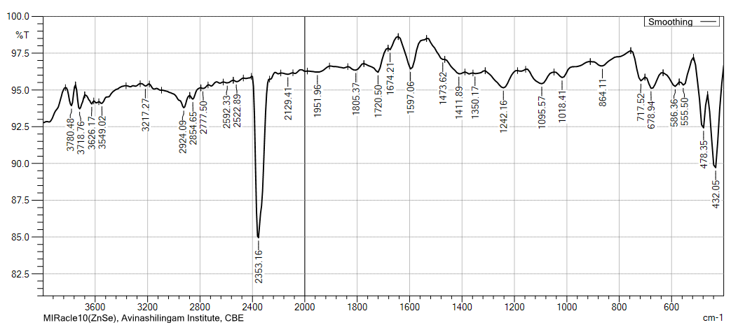
Figure 6 (f) FTIR - Sample F
From FTIR analysis, r-PET and virgin polyester calendered nonwovens comprised of the functional groups namely Amines, chlorides, bromides and iodides.

4.13 ROUGHNESS TEST
The results of the roughness test are presented in the Table XX, XXI, XXII, XXIII, XXIV, XXV and Figure 7.
Table XX
Roughness test- sample A (µ_{m})
S.no | Sample | Ra | Rq | Rpv | Rp | Rv | Rsk | Rz | Rku
1 | A | 118.76 | 145.53 | 628.12 | 368.28 | 259.84 | 0.6874 | 422.90 | 2.674
 |  | 144.55 | 164.26 | 685.54 | 342.42 | 343.12 | -0.2129 | 373.89 | 1.980
 |  | 133.21 | 167.69 | 683.00 | 335.74 | 347.26 | -0.1581 | 241.70 | 2.689
 | Min | 118.76 | 145.53 | 628.12 | 335.74 | 259.84 | -0.2129 | 241.70 | 1.980
 | Max | 144.55 | 145.53 | 685.54 | 368.28 | 347.26 | 0.6874 | 422.90 | 2.689
 | Mean | 132.17 | 159.16 | 665.55 | 348.81 | 316.74 | 0.1055 | 346.16 | 2.448
 | SD | 10.56 | 9.739 | 26.49 | 14.03 | 40.27 | 0.4121 | 76.53 | 0.3309
 | Var% | 7.99% | 6.12% | 3.98% | 4.02% | 12.7% | 390.8% | 22.1% | 13.5%

From the Table XX and Figure 7 (a), it is clear that in sample A the maximum peak Rp was 368.28 and the minimum Rp was 335.74. The value Rv ranged between 347.26 to 259.84 in sample A. The mean Rp was 348.81μ_{m}and Rv was 316.74μ_{m}in sample A.

Table XXI
Roughness test- sample B (µ_{m})
S.no | Sample | Ra | Rq | Rpv | Rp | Rv | Rsk | Rz | Rku
1 | B | 50.15 | 58.94 | 245.89 | 144.98 | 100.91 | 0.4491 | 143.88 | 2.079
 |  | 63.70 | 84.19 | 355.25 | 126.90 | 228.35 | -0.9236 | 174.46 | 3.370
 |  | 88.92 | 105.99 | 477.40 | 240.94 | 236.46 | 0.6124 | 200.60 | 2.413
 | Min | 50.15 | 58.94 | 245.89 | 126.90 | 100.91 | -0.9236 | 143.88 | 2.079
 | Max | 88.92 | 105.99 | 477.40 | 240.94 | 236.46 | 0.6124 | 200.60 | 3.370
 | Mean | 67.59 | 83.04 | 359.51 | 170.94 | 188.57 | 0.0460 | 72.98 | 2.620
 | SD | 16.06 | 19.23 | 94.56 | 50.04 | 62.08 | 0.6888 | 23.18 | 0.5472
 | Var% | 23.8% | 23.2% | 26.3% | 29.3% | 32.9% | 1498.5 | 13.4% | 20.9%

From theTable XXI and Figure 7 (b), it is clear that in sample B the maximum peak Rp 240.94 was and the minimum Rp was126.90. The value Rv ranged between 236.46 to 100.9 in sample B. The mean Rp was 170.94 μ_{m}and Rv was 188.57 μ_{m}in sample B.

Table XXII
Roughness test- Sample C (µ_{m})
S.no | Sample | Ra | Rq | Rpv | Rp | Rv | Rsk | Rz | Rku
1 | C | 57.26 | 78.61 | 358.84 | 149.93 | 208.92 | -0.2128 | 142.73 | 2.993
 |  | 67.92 | 86.57 | 464.00 | 328.27 | 135.73 | 0.9408 | 185.72 | 3.861
 |  | 81.98 | 105.55 | 468.06 | 95.09 | 372.97 | -1.549 | 326.93 | 4.567
 | Min | 57.26 | 78.61 | 358.84 | 95.09 | 135.73 | -1.549 | 142.73 | 2.993
 | Max | 81.98 | 105.55 | 468.06 | 328.27 | 372.97 | 0.9408 | 326.93 | 4.567
 | Mean | 69.05 | 90.24 | 430.30 | 191.10 | 239.21 | -0.2736 | 218.46 | 3.807
 | SD | 10.12 | 11.30 | 50.56 | 99.55 | 99.19 | 1.017 | 78.68 | 0.6435
 | Var% | 14.7% | 12.5% | 11.7% | 52.1% | 41.5% | -371.8% | 36.0% | 16.96%

From theTable XXII and Figure 7 (c), it is clear that in sample C the maximum peak Rp was 328.27 and the minimum Rp was 95.09. The value Rv ranged between 372.97 to 135.73 in sample C. The mean Rp was 191.10μ_{m}and Rv was 239.21μ_{m}in sample C.
Table XXIII
Roughness test- Sample D (µ_{m})
S.no | Sample | Ra | Rq | Rpv | Rp | Rv | Rsk | Rz | Rku
1 | D | 15.75 | 22.53 | 163.19 | 63.22 | 99.97 | -0.7704 | 49.61 | 6.139
 |  | 18.73 | 26.99 | 195.84 | 72.00 | 123.84 | -0.4172 | 65.58 | 4.844
 |  | 59.17 | 66.16 | 243.04 | 120.41 | 122.62 | 0.0636 | 129.0 | 1.637
 | Min | 15.75 | 22.53 | 163.19 | 63.22 | 99.97 | -0.7704 | 49.61 | 1.637
 | Max | 59.17 | 66.16 | 243.04 | 120.41 | 123.84 | 0.0636 | 129.0 | 6.139
 | Mean | 31.22 | 38.56 | 200.7 | 85.21 | 115.48 | -0.3747 | 81.40 | 4.207
 | SD | 19.80 | 19.60 | 32.78 | 25.15 | 10.98 | 0.3418 | 34.29 | 1.892
 | Var% | 63.4% | 50.8% | 16.3% | 29.5% | 9.51% | -91.2% | 42.1% | 45.0%
From theTable XXIII and Figure 7 (d), it is clear that in sample D the maximum peak Rp 120.41 was and the minimum Rp was 63.22. The value Rv ranged between 123.84 to 99.97 in sample D. The mean Rp was 85.21μ_{m}and Rv was 115.48μ_{m}in sample D.

TableXXIV
Roughness test- Sample E (µ_{m})
S.no | Sample | Ra | Rq | Rpv | Rp | Rv | Rsk | Rz | Rku
1 | E | 43.97 | 54.91 | 311.49 | 144.28 | 167.20 | -0.4941 | 202.21 | 3.217
 |  | 58.46 | 71.15 | 317.63 | 167.10 | 150.53 | -0.2089 | 269.86 | 2.415
 |  | 93.14 | 141.59 | 942.20 | 707.3 | 234.87 | 2.005 | 430.88 | 10.46
 | Min | 43.97 | 54.91 | 311.49 | 144.28 | 150.53 | -0.4941 | 202.21 | 2.415
 | Max | 93.14 | 141.59 | 942.20 | 707.3 | 234.87 | 2.005 | 430.88 | 10.46
 | Mean | 65.19 | 89.22 | 523.77 | 339.57 | 184.20 | 0.4339 | 300.99 | 5.366
 | SD | 20.63 | 37.62 | 295.88 | 260.21 | 36.47 | 1.117 | 95.91 | 3.620
 | Var% | 31.6% | 42.2% | 56.5% | 76.6% | 19.8% | 257.4% | 31.9% | 67.5%

From the TableXXIV and Figure 7 (e), it is clear that in sample E the maximum peak Rp 707.3 was and the minimum Rp was 144.28. The value Rv ranged between 234.87 to 150.53 in sample E. The mean Rp was 339.57μ_{m}and Rv was 184.20μ_{m}in sample E.

Table XXV
Roughness test- Sample F (µ_{m})
S.no | Sample | Ra | Rq | Rpv | Rp | Rv | Rsk | Rz | Rku
1 | F | 36.95 | 46.52 | 208.12 | 92.55 | 115.58 | 0.3779 | 112.79 | 2.695
 |  | 24.3 | 29.66 | 134.82 | 55.59 | 79.23 | -0.3490 | 101.15 | 2.577
 |  | 38.46 | 58.00 | 336.19 | 244.34 | 91.85 | 2.292 | 128.83 | 9.894
 | Min | 24.3 | 29.66 | 134.82 | 55.59 | 79.23 | -0.3490 | 101.15 | 2.577
 | Max | 38.46 | 58.00 | 336.19 | 244.34 | 115.58 | 2.292 | 128.83 | 9.894
 | Mean | 33.25 | 44.73 | 226.38 | 130.82 | 95.55 | 0.7735 | 114.26 | 5.055
 | SD | 6.335 | 11.64 | 83.22 | 81.67 | 15.07 | 1.114 | 11.35 | 3.422
 | Var% | 19.1% | 26.0% | 36.8% | 62.4% | 15.8% | 144.0% | 9.93% | 67.7%
From theTable XXV and Figure 7 (f), it is clear that in sample F the maximum peak Rp 244.34 was and the minimum Rp was 55.59. The value Rv ranged between 115.58 to 79.23 in sample F. The mean Rp was 130.82μ_{m}and Rv was 95.55μ_{m}in sample F.

4.14 THERMO GRAVIMETRIC ANALYSIS (TGA)
The results of the TGA are presented in the Table XXV and Figure 8.
Table XXVI
Thermo gravimetric analysis (TGA)
S.no | Sample | Temperature  (Celcius) | Decomposition  (%)
1 | A | 408.0 | 97.4
2 | B | 408.1 | 98.8
3 | C | 410.04 | 98.5
4 | D | 404.9 | 97.1
5 | E | 406.5 | 97.7
6 | F | 408.3 | 98.1

From the Table XXVI and Figure 8, it was obvious that the temperature required for the decomposition was highest in the sample C of 410⁰ C followed by the sample F 408.3⁰ C, B 408.1⁰ C, E 408.0⁰ C and D 404.9⁰ C respectively. The decomposition percentage was highest in the sample B with 98.8% followed by the sample C 98.5%, F 98.1%, E 97.7%, A 97.4% and D 97.1%.
Hence, it could be concluded that the decomposition temperature of the r-PET calendered nonwovens was high compared to the virgin calendered nonwovens.

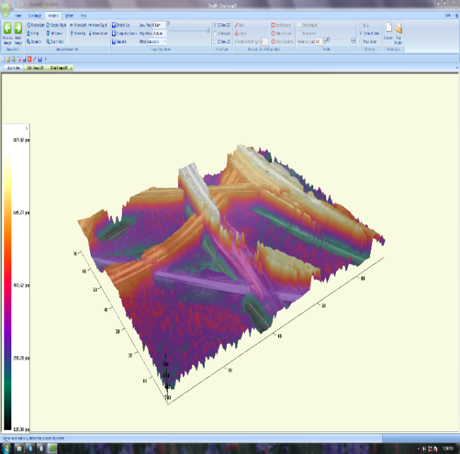
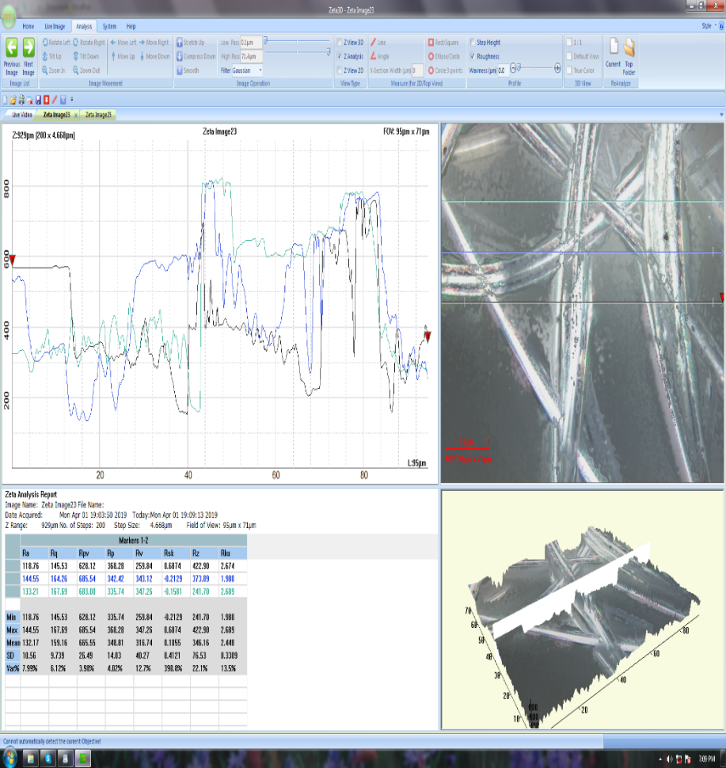
Roughness test sample A Roughness Test Graph of Sample A
Figure 7 (a)

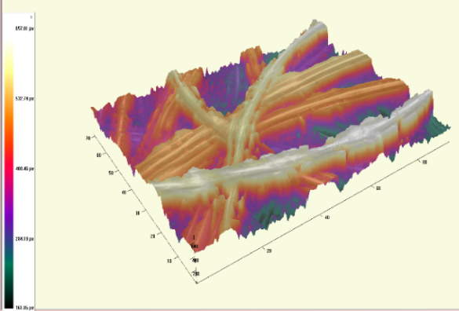
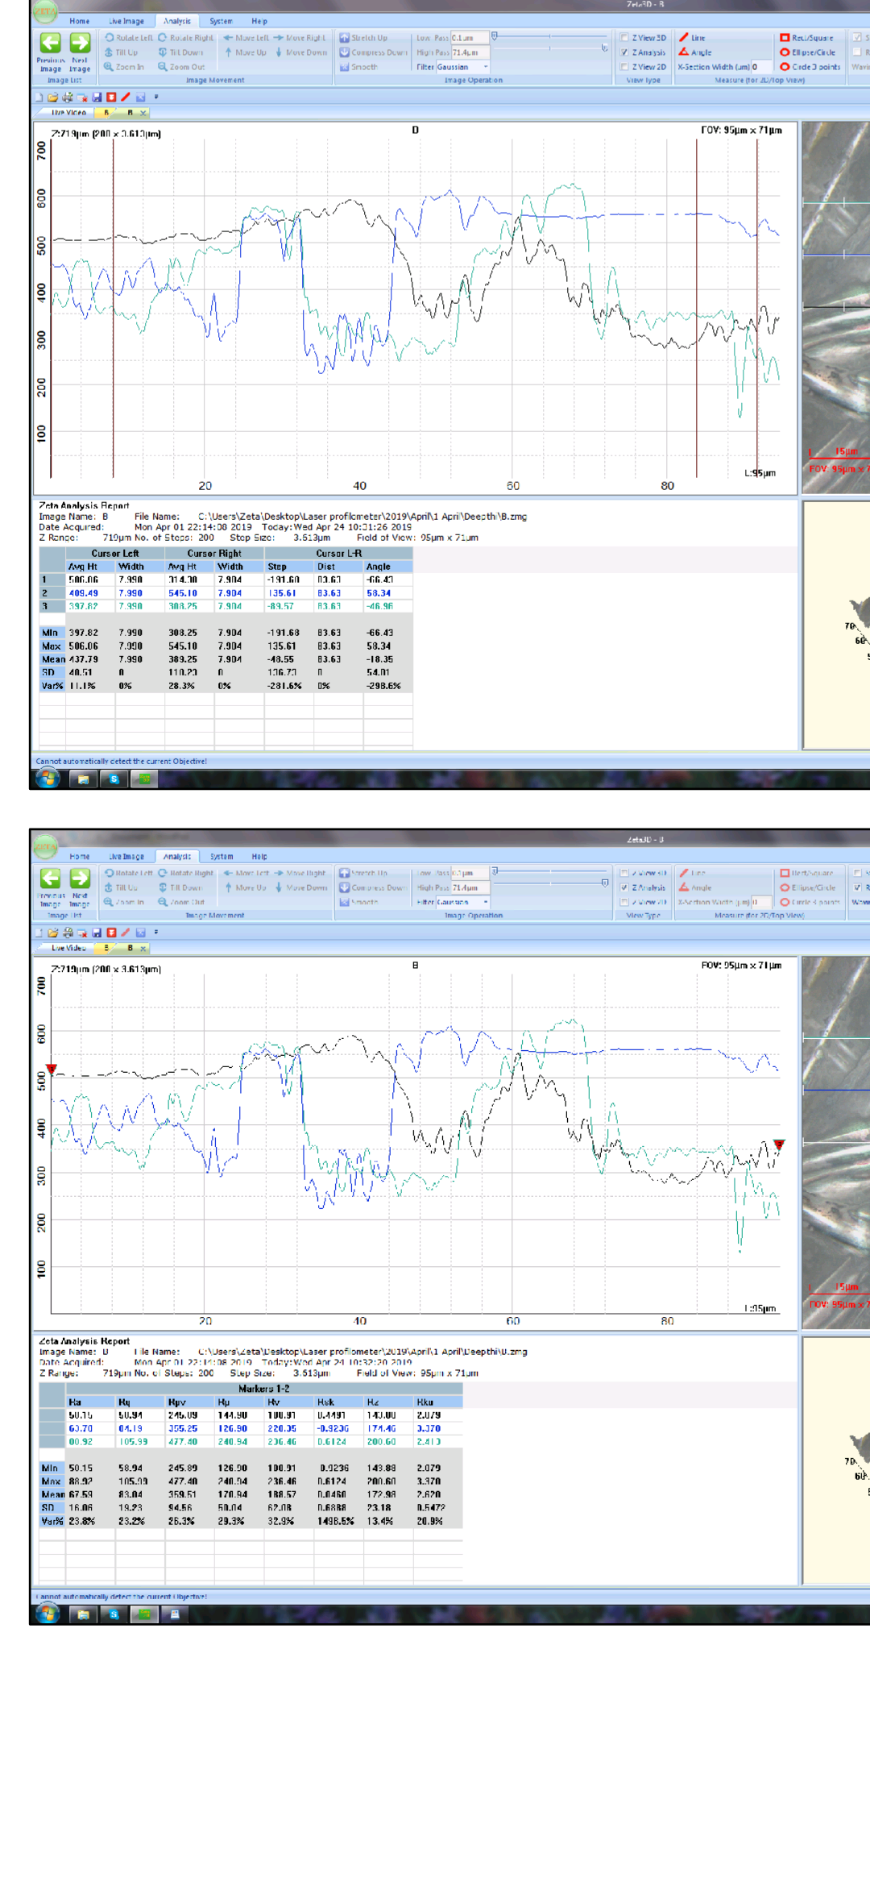 Roughness test sample B Roughness Test Graph of Sample B
Figure 7 (b)

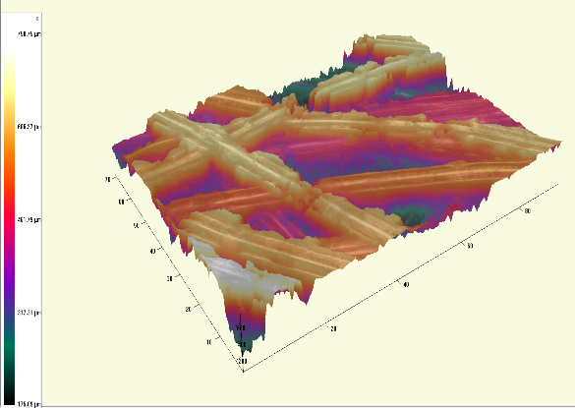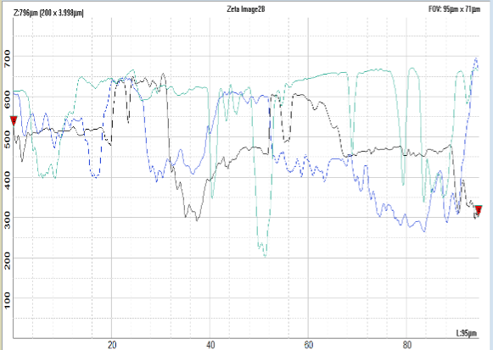
Roughness test sample C Roughness Test Graph of Sample C
Figure 7 (c)
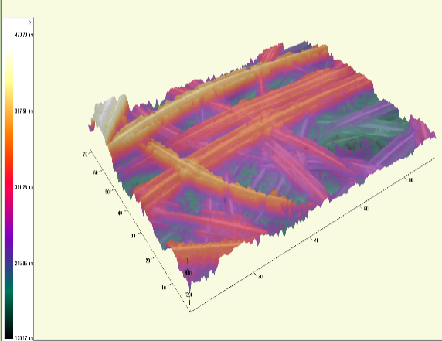
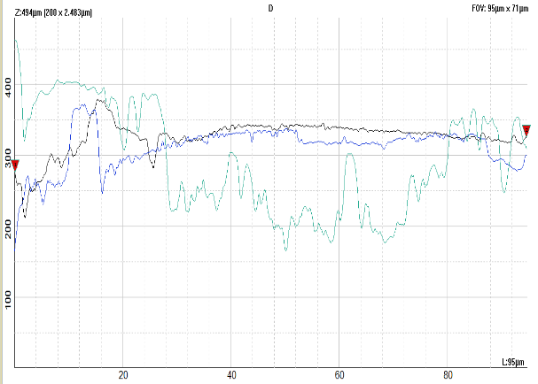
Roughness test sample D Roughness Test Graph of Sample D
Figure 7 (d)

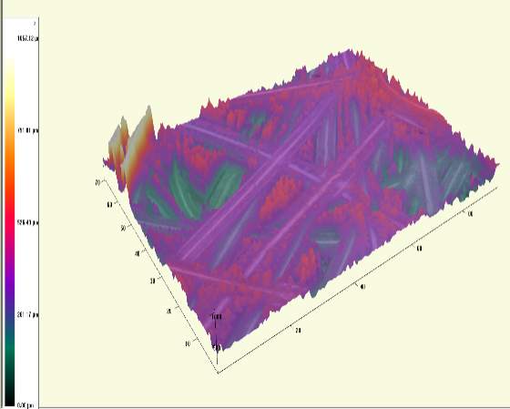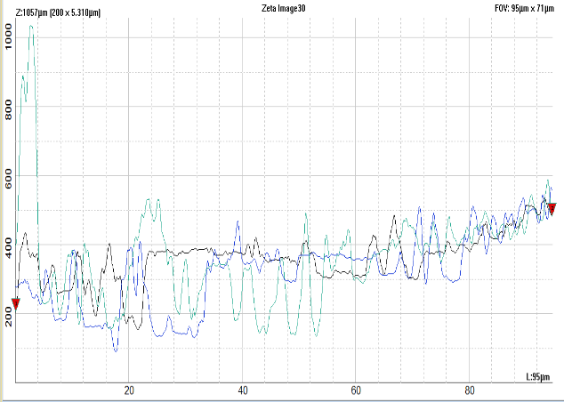
Roughness test sample E Roughness Test Graph of Sample E
Figure 7 (e)

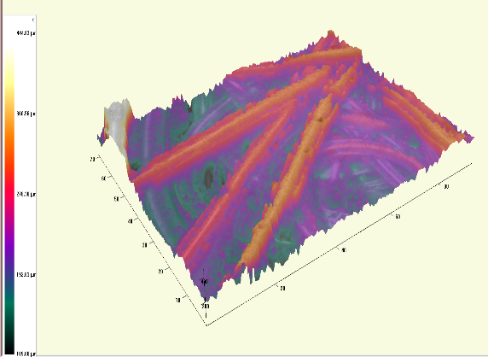
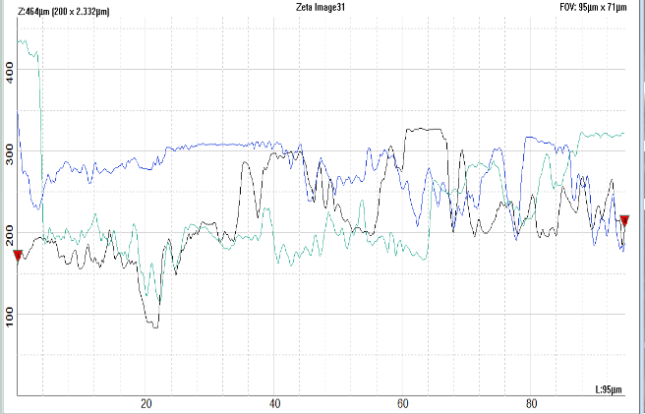
Roughness test sample F Roughness Test Graph of Sample F

Figure 7 (f)
Figure 8 (a) TGA Graph of Sample A

Figure 8 (b) TGA Graph of Sample B

Figure 8 (c) TGA Graph of Sample C
Figure 8 (d) TGA Graph of Sample D

Figure 8 (e) TGA Graph of Sample E

Figure 8 (f) TGA Graph of Sample F

5 SUMMARY AND CONCLUSION

SUMMARY
Polyester is a synthetic fibre derived from coal, air, water and petroleum. Polyester has developed in a 20th century and these fibres are formed from a chemical reaction between an acid and alcohol. The polyester fibre has high strength modulus, creep resistance and general chemical inertness due to which it is more suitable for geotextiles. The usage of recycled PET ﬁbres in nonwovens contributes to decrease in environmental pollution, prevention of the decrease in petroleum supplies, and decrease in raw material cost of nonwovens. Polyester needle-punched fabric features good anti-acid, good anti-alkali, good hydrolysis stability and excellent anti-anrasion. Being a filter fabric, polyester needle punched fabric is used to make filter bags, they are widely used for air filtration in cement industry, chemical industry, Aluminium industry, Carbon powder industry.
The term “Nonwovens” was applied to new modern techniques, which were totally based on new principles, by U.S.A. in 1965. Nonwoven technology excludes the spinning of yarn for manufacturing the fabric. Nonwoven fabrics are made from both natural as well as man-made fibres and mostly used man-made fibres for manufacturing nonwoven fabrics are polyester, polypropylene and rayon. Nonwoven materials have been among the most demanded textile materials in many application areas in recent years.
Needle-punched nonwoven fabric is a sheet of fibres made by mechanical entanglement, penetrating barded needles into fibrous mat. Needle-punched nonwoven materials with the required combination of functional properties are widely used in numerous technical applications, including, filters, composites, protective clothing, packaging, geo-textiles, home furnishings and heat and noise insulating. Such fabric is extensively used in technical applications.
The term ‘Calender’ is derived from the Greek kylindros (cylinder). Calendering is a high - speed ironing process that primarily imparts lustre and is usually the final treatment for the fabrics in the finishing sequence. Thermal bonding process is the application of heat on nonwoven materials either with pressure by calendaring or without pressure by ovens where thermoplastic ﬁbres/materials melts with heat energy and constructs bond bridges between base material.
The term ‘filtration’ has been defined as the separation of particles from a fluid-solid suspension of which they are a part by passage of most of the fluid through a septum or membrane that retains most of the solids on or within itself. Objective of filter medium is to maximize the possibility of collision and the subsequent retention of the suspended particles with fibrous structures while minimizing the energy loss of the system. There are many different methods of filtration; all aim to attain the separation of substances. Nonwovens are growing at a very fast rate help filter media manufactures to offer improved efficiency, better pressure drops and also overall better performance. This is wide spread application of ‘nonwovens’ in various filtration applications including geoengineering.
- The objectives of the study were:To develop a nonwoven filter fabric using recycled and virgin polyester
- To assess the effect of calendering on nonwovens
- To evaluate the properties of the developed nonwoven fabrics.

Experimental Procedure
The methodology pertaining to the study is presented in the following steps:
- The nonwovens of two different GSM’s 100 and 200 of recycled and virgin polyester respectively are passed between calender rolls which are heated to 190⁰ C, 200⁰ C, 210⁰ C with a surface speed of 0.5m/min, forming hot-pressed calendered nonwovens.
- The gap between the top and the bottom roller is constant as 0.5mm.
- But, the 100 GSM recycled polyester was passed as a double layered fabric in the above 3 different temperatures in order to obtain a GSM of around 200.
- Thus, double layered 100 GSM 190⁰ C, 200⁰ C and 210⁰ C recycled polyester calendered nonwovens and single layered 200 GSM 190⁰ C, 200⁰ C and 210⁰ C virgin polyester calendered nonwovens are obtained.
- The prepared polyester calendered nonwovens was evaluated for essential properties namely fabric weight, thickness, strength, elongation, spray, wicking, sinking, air permeability test, particulate filtration efficiency, index puncture resistance, capillary flow porometer, FTIR, roughness, Thermogravimetric analysis (TGA) tests.

Findings of the Study
- The fabric weight of the 100GSM r-PET double layered 210⁰ C calendered fabric and 200GSM virgin single layered 200⁰ C calendered fabric is high when compared to other samples. Thus, virgin polyester calendered nonwovens exhibited highest GSM values when compared to the r-PET polyester calendered nonwovens.
- The fabric thickness of the 100GSM r-PET double layered 190⁰ C calendered fabric is high. The thickness was noted to be high in all the samples of recycled polyester calendered nonwoven fabrics when compared to virgin polyester calendered nonwovens.
- In both the machine and cross direction the fabric strength of 200GSM virgin single layered 190⁰ C calendered fabric, 200 GSM virgin single layered 200⁰ C calendered fabric and 200GSM virgin single layered 200⁰ calendered fabric was maximum. The virgin calendered polyesters nonwovens exhibited highest fabric strength when compared to the r-PET calendered nonwovens.
- In both the machine and cross direction the fabric elongation of 100GSM r-PET double layered 190⁰ C calendered fabric was maximum. The elongation was showed highest in r-PET calendered nonwovens than in virgin polyester calendered nonwovens.
- All the r-PET caelndered nonwovens exhibited same spray rating. Similarly, all the virgin polyester caelndered nonwovens exhibited same spray rating. The virgin calendered nonwovens exhibited highest absorbency (spray rating) when compared to the r-PET calendered nonwovens.
- The wickablity of the virgin calendered polyester nonwovens was high in comparision with the r-PET calendered nonwovens.
- All the r-PET and virgin polyesters calendered nonwovens were considered to be floated in water.
- The air permeability of the 100GSM r-PET double layered 190⁰ C calendered fabric was maximum. All the r-PET calendered nonwovens exhibited highest air permeability when compared to the virgin polyester calendered nonwoven fabrics.
- 100 GSM r-PET double layered 210⁰ C calendered nonwoven fabric exhibited highest particulate filtration efficiency. The r-PET calendered nonwovens exhibited highest filtration efficiency when compared to the virgin calendered nonwovens.
- 200 GSM virgin single layered 190⁰ C calendered nonwoven fabric exhibited highest index puncture resistance property. The virgin calendered polyesters exhibited highest puncture resistancy when compared to the r-PET calendered nonwovens.
- The Mean flow pore diameter was higher in r-PET calendered nonwovens and the bubble point pore diameter was higher in case of virgin calendered nonwovens.
- From FTIR analysis, r-PET and virgin polyester calendered nonwovens comprised of the functional groups namely Amines, chlorides, bromides and iodides.
- The samples of r-PET calendered nonwovens exhibited highest decomposition temperature in comparison with the virgin calendered nonwovens.

CONCLUSION
Though the virgin polyester calendered nonwovens exhibited more weight,strength and index puncture resistance, the air permeability and particulate filtration efficiency of the 100GSM r-PET double layered calendered fabric was higher. The same sample showed better result in Capillary Flow Porometer and temperature stability for decomposition. So, these r-PET fiber made nonwovens may be applicable for filtration purposes in industries. It is also cost effective and can be widely used for filtration.

RECOMMENDATIONS
Study may be made in preparation of products in the field of aspect of indu tech.

6 BIBILOGRAPHY

JOURNAL REFERENCES
Advanced Research in Management and Social Sciences, Vol.2 (2), pp.28-47.
Agrawal, 2007, GEOTEXTILE: IT’S APPLICATION TO CIVIL ENGINEEERING – OVERVIEW, p.2.
Agarwal et al., 2012, Neck-size distributions of through-pores in polymer membranes, Journal of Membrane Science, pp.608-615.
Amrit, 2013, Filtration Fabric, p.9.
Anon, 2007, The Columbia Electronic Encyclopedia®, Copyright © 2007, Columbia University Press, Licensed from Columbia University Press.
Askari et al., 2012, Study the Effect of Test Speed and Fabric Weight on Puncture Behaviour of Polyester Needlepunched Nonwoven Geotextiles, Journal of engineered fibres and fabrics, Vol - 7, p.3.
Askari et al., 2012, Study the Effect of Test Speed and Fabric Weight on Puncture Behavior of Polyester Needlepunched Nonwoven Geotextiles, p.1.
Chao and Kang, 1977, The Development of Cotton Textile Production in China, East Asian Research Center, Harvard University, p.34.
Chaudhary and kumar, 2009, characterization of pore size and air permeability of nonwoven filter media, p.19.
Choudhury, 2012, Principles of textile finishing, pp.302-304.
Debnath et al.,2009, Compression properties of polyester needle-punched fabric. Journal of Engineered Fibers and Fabrics, 4, pp.14 -19.
Dharmadhikary et al., 1995, Thermal bonding of nonwoven fabrics. Vol. 26. New York, NY: The Textile Institute, Textile Progress, p.327.
Eighmy, 1983, Coated fabrics calenders: Technology, uses, comparisons, trouble shooting, Journal of coated fabrics, Vol - 12.
Emel Cincik and Emirhan Gunaydin, 2016, The influence of calendering parameters on performance properties of needle-punched nonwoven cleaning materials including r-PET fiber, The Journal of the Textile Institute, p.4.
Elden and Swan, 1968, Calendering of Plastics, New York, American Elsevier.
Erdem and Emel, 2015, An investigation on bursting strength of polyester/viscose blended needle-punched nonwovens, p.622.
Erth et al., 2005, Basic Investigations in to nonwovens in technical application – the demand of research for the next decade” 5th World Textile Conference AUTEX (), pp. 27-29.
Evan Mitsoulis, 2009, Calendering of Polymers, p.312.
Fangueiro et al., 2008, Study on the influence of the production parameters on the properties of needlepunched nonwovens for technical applications, p. 22.
Gopalakrishnan, 2010, Manufacturing of Needlepunched Nonwoven.
Gregor, 2004, ‘Versatile nonwoven filtration media’, Allgemeiner Vliesstoffreport, 2, pp.26–27.
Gurudatt et al., 2014, Spinning ﬁbers from poly(ethylene terephthalate) bottlegrade waste. Journal of Applied Polymer Science, 90, pp.3536–3545.
Hearle et al., 1968, A study of needled fabrics. Part II: Effects of the needling process, The Journal of The Textile Institute, 59, pp.103-116.
Jahangir Alam Sujon, 2004, Nonwovens Technology, 1st edition, published by Textile Bulliten.
Jha and Deshmukh, 2015, Advancement of Nonwoven Technology in Filter, p.4-5.
Kim and Pourdeyhimi, 2001, The role of structure on mechanical properties of nonwoven fabrics. International Nonwovens Journal, 10, pp.32-37.
Koerner, R. M, 2005, Designing with Geosynthetic”, p.171.
Koerner et.al., 2010, Puncture resistance of polyester (PET) and polypropylene (PP) needle-punched nonwoven geotextiles, p.360.
Kopitar et al.,2014, Impact of calendering process on nonwoven geotextiles hydraulic properties. Textile research journal:1, pp.69-80.
Kotte, 2011, filtration'in textile: A review, pp.3-4.
Kumar et al., 2009, Needle Punching Process - A Technological Review, p.40.
Luitel and Hudson et al., 2015, Economics and Marketing Evaluating Cotton Utilization in Nonwoven Textiles, The Journal of Cotton Science.
Lydall, 2007, Indian textile journal, p.45.
Marshall, 1959, Processing of Thermoplastic Materials, New York.
Maity and Singha, 2012, Structure-Property Relationships of Needle-Punched Nonwoven Fabric, Frontiers in science.
Malkiewiczet al., 2012, Analysis of the Main Properties of Geotextiles Manufactured by Mechanical Two-Sided Needle Punching and by Two-Layered Needle Punching on the Fabric Underlay, FIBRES & TEXTILES in Eastern Europe, Vol. 20.
Mendelson and Cheryl, 2005, Home Comforts: The Art and Science of Keeping House.
Miao and Glassey, 2004, An Experimental Study of the Needled Nonwoven Process: Part I: Fiber Geometry Before Needle Punching. Text. Res. J; 74, (4), pp.329-332.
Milin Patel and Dhruvkumar Bhrambhatt, 2001, Nonwoven Technology, p.5.
Mohammadi et al., 2003, Determining Eﬀective Thermal Conductivity of Multilayered Nonwoven Fabrics. Textile Research Journal, pp.802-808.
Mueller and Kochmann, 2004, Numerical Modeling of Thermobonded Nonwovens, International Nonwovens Journal, 13, pp.56-62.
Nagraj, 2009, Application of Nonwoven in Filtration, pp.4-6.
Purdy et al., 1980, Needle-punching (The Textile Institute, Manchester), p.49.
Radko, 1971, Manual of Nonwovens, p.65.
Rosato et al., 2004, Plastic product material and process selection hand book”, p.85.
Shrinivasan and Katharvelu, 2006, Nonwoven Fabric Filtration Media, p.4.
Sztuk et al., 2016, Biofouling reduction for improvement of depth water filtration, filter Production and testing”, Chemical and Process Engineering, Vol.37 (3), 319-330, doi: 10.1515/cpe-2016-0026, pp.273-274.
Ting Li et al., 2004, Effects of Needle-Punching and Thermo - Bonding on Mechanical and EMI Shielding Properties of Puncture - Resisting Composites Reinforced with Fabrics, Fibres and Polymers, Vol.15, p.317.
Xu and Ting, 1995, Measuring Structural Characteristics of Fibre Segments in Nonwoven Fabrics. Textile Research Journal, 65: 41-48.

BOOK REFERENCES
A.R. Horrocks and S.C Anand, 2000, Hand book of technical textiles.
Hutten, 2007, Handbook of nonwoven filter media, p.18.
Russell, 2006, Hand book of Nonwovens, Textile Institute, Woodhead Publishing.

NET REFERENCES
- https://encyclopedia.com> polyester
- https://en.m.Wikipedia.org> wiki > polyester
- www.madehow.com > Volume 2
- https://textilelearner.blogspot.com
- https://www.reference.com
- https://blog.transferexpress.com
- www.fibre2fashion.com
- https://www.textilemates.com> calendaring
- http://best-filter.com/product/application-of-woven-filter-cloth.

APPENDIX – I

100 GSM r-PET double layered 200⁰ C calendered fabric
100 GSM r-PET double layered 190⁰ C calendered fabric

200GSM virgin single layered 190⁰ C calendered fabric
100 GSM r-PET double layered 210⁰ C calendered fabric

APPENDIX – II

200GSM virgin single layered 200⁰ C calendered fabric
200GSM virgin single layered 210⁰ C calendered fabric

