COMPARATIVE STUDY OF SLUB AND PLAIN SINGLE JERSEY COTTON KNITTED FABRIC

SUBMITTED BY
S.SURYA
(09PFA15)

A DISSERTATION SUBMITTED TO THE
AVINASHILINGAM DEEMED UNVERSITY FOR WOMEN
COIMBATORE – 641 043

IN PARTIAL FULFILLMENT OF THE REQUIREMENTS FOR THE DEGREE OF
MASTER OF SCIENCE IN
TEXTILES AND FASHION APPAREL
MAY 2011

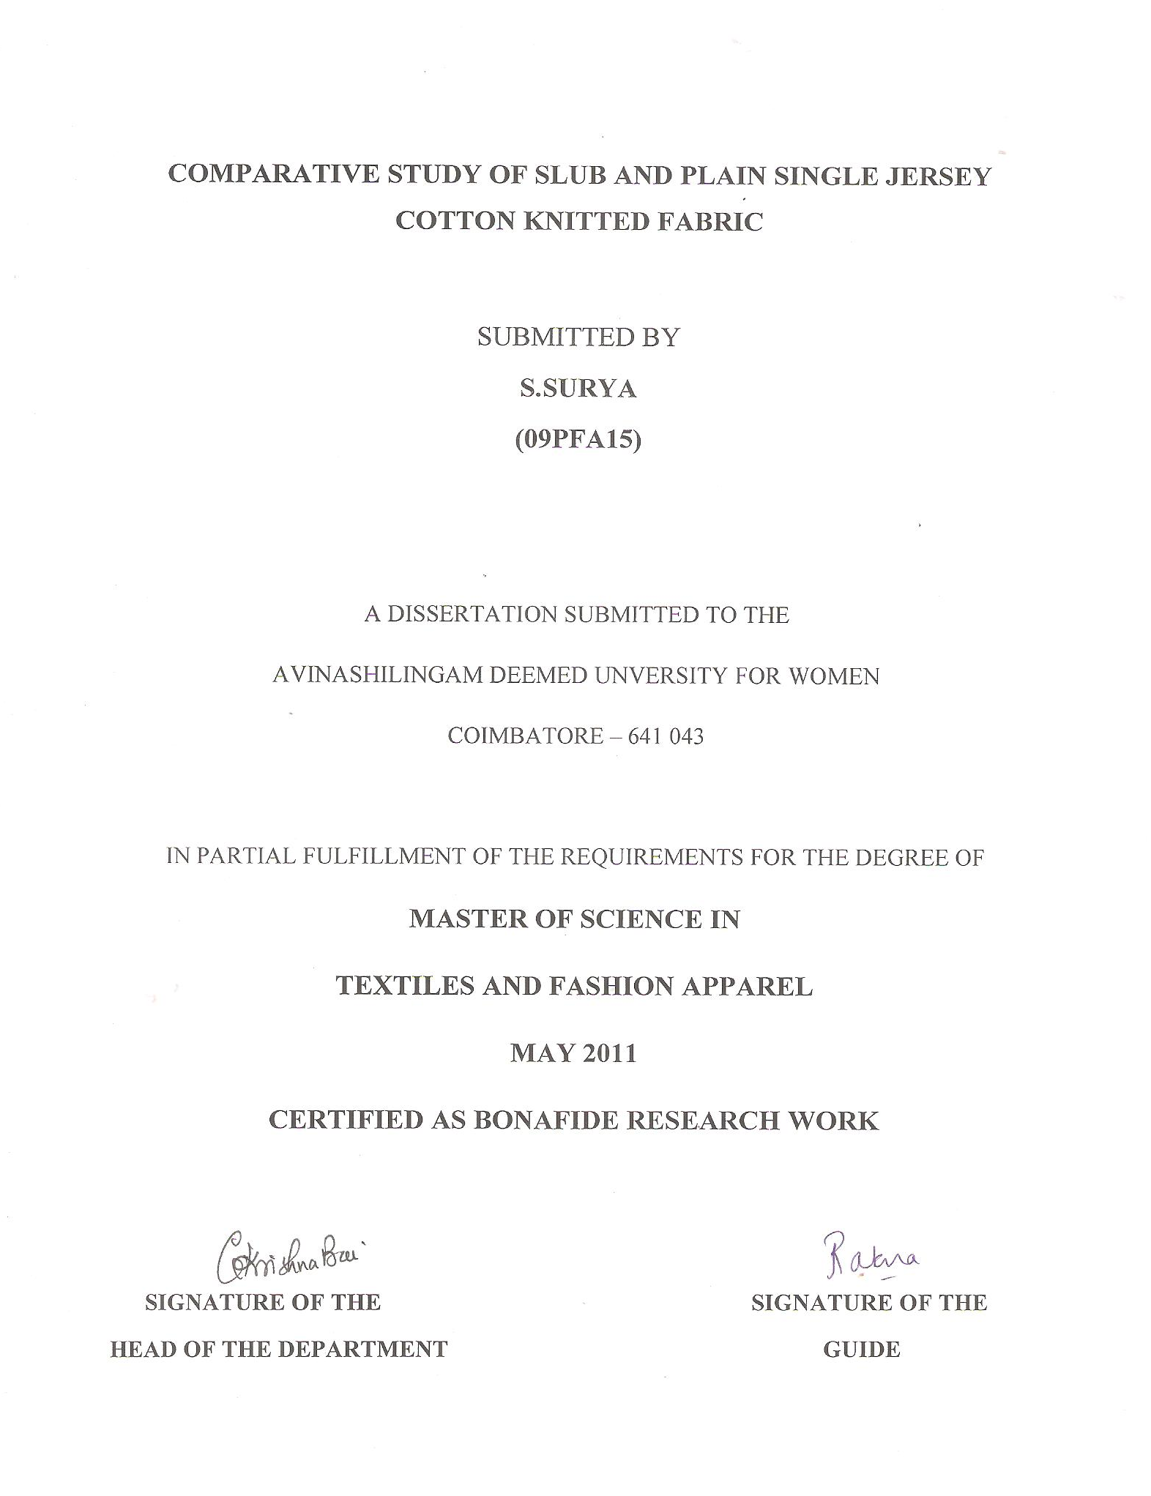
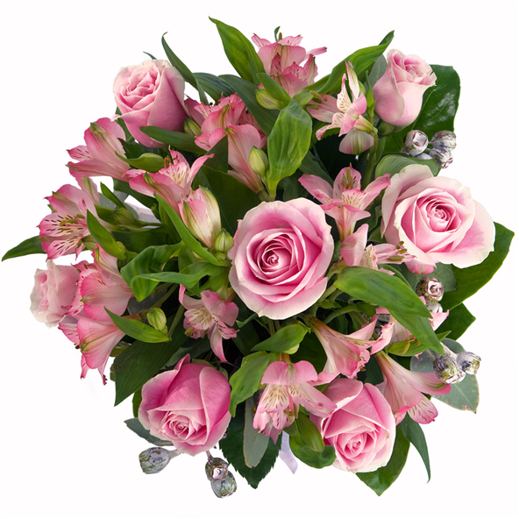
DEDICATED TO MY LOVABLE PARENTS

 ACKNOWLEDGEMENT

ACKNOWLEDGEMENT
First and foremost, the investigator places her humble salvations at the feet of God Almighty who has given sound wisdom, knowledge, strength and opportunity to do the investigation effectively.
The investigator wishes to manifest her reverential gratefulness to Dr Thiru. T.S.K. MEENAKSHI SUNDRAM M.A., M.Phil., Ph.D., Avinashilingam University for Women, Coimbatore, for providing infrastructural facilities to conduct this study.
The investigator expresses her humble credit to Dr. (Tmt). SHEELA RAMACHANDRAN M.Sc., P.G. Dip., Ph.D. (Avinashilingam) Vice Chancellor, Avinashilingam University for Women, Coimbatore, for providing all amenities required for the conduct of the study.
The investigator wishes to place on record her genuine thanks to Dr. (Tmt). GOWRI RAMAKRISHNAN, M.Sc (Madras), M.Phil, Ph.D (Avinashilingam), Registrar, Avinashilingam University for Women, Coimbatore, for providing all the help for the harmonious conduct of the study.
The investigator is immensely thankful and grateful to Dr. (Tmt). KRISHNABAI M.Sc., Dip. Ed., M.Phil (Madras), Ph.D.(Mother Teresa), Dean, Faculty of Home Science, Professor and Head of the Department of Textiles and Clothing, Avinashilingam Deemed University for Women, Coimbatore, for her valuable guidance, technical support, timely help and constant encouragement throughout the study.
The investigator feels supremely privileged and blessed to have worked under the care and esteemed leadership of Dr. (Tmt). U. RATNA, M.Phil, Ph.D.(Avinashilingam), Professor, Department of Textiles and Clothing, Avinashilingam University for Women, Coimbatore, for help her superb, valuable judgment guidance, unfailing console, seasonable hints at each step throughout the process of investigation, heartfelt inspiration, enthusiasm, valuable views and almost modification throughout the study.
She conveys her eternal gratitude to the entire faculty remembers of the Department of Textiles and Clothing, Avinashilingam University for Women, Coimbatore, of their everlasting blessings, keep interest, support and encouragement.
The investigator is also thankful to SITRA, SIMA, for providing library facilities. The investigator also records her heartfelt thanks to the librarian, Avinashilingam University for Women, Coimbatore, for providing library facilities.
Last but not least the investigator expresses heartfelt thanks to her parents Thiru. S.SUBRAMANIAN and Tmt. S.SAROJINI and her Brother, all the family members and friends for their constant prayers, moral support and help rendered for the completion the study.


CONTENTS

LIST OF CONTENTS

CHAPTER NO. TITLE PAGE NO.
LIST OF TABLES
LIST OF FIGURES
LIST OF PLATES
LIST OF APPENDICES
1 INTRODUCTION 1
2 REVIEW OF LITERATURE 4
2.1 Cotton 6
2.1.1. Introduction 6
2.1.2. History 6
2.1.3 Structure of cotton fiber 7
2.1.4 Characteristics and Properties of Cotton 8
2.1.5 Advantages of Cotton 9
2.1.6 Uses of Cotton 10
2.2 Slub Yarns 10
2.2.1 Definition 10
2.2.2 Introduction 10
2.2.3 Structure of Slub yarn 11
2.2.4 Types of Slub yarn 12
2.2.5 Manufacturing process of Slub yarn 12
2.2.5 Challenges for Slub yarns spinners 13
2.2.6 Advantages 13
2.3 Knitting 14
CHAPTER NO. TITLE PAGE NO.

2.3.1. Introduction 14
2.3.2 Importance of Knitting 14
2.3.3 Classification of Knitting 15
2.3.4 Single Jersey fabric 16
2.3.5 Properties and characteristics
of Single Jersey knitted fabrics 16
2.4 Dyeing 17
2.4.1 Introduction 17

2.4.2 Classification of Dyes 18
2.4.3 Reactive Dyes 19
2.4.4 Advantages of Reactive Dyes 19
2.4.5 Uses of Reactive Dyes 20
3 METHODOLOGY 21
3.1 Selection of yarns 23
3.2 Selection of knitting structure 23
3.3 Knitting 23
3.4 Pre-Treatments 25
3.5 Selection of Dyes 26
3.6 Dyeing 27
3.7 Finishing 29
3.8 Fabric Evaluation 30
3.9 Wettability and Absorbency Tests 34

CHAPTER NO. TITLE PAGE NO.

3.10 T- Shirt Constructions 36
3.11 Statistical Analysis 36
4 RESULTS AND DISCUSSIONS 44
4.1 Subjective Evaluation 45
4.1.1 Visual Evaluation 45
4.2 Objective Evaluation 47
4.2.1 Wales and Courses 47
4.2.2 Fabric Weight 49
4.2.3 Fabric Thickness 51
4.2.4 Fabric Drapability 53
4.2.5 Bursting Strength 55
4.2.6 Abrasion Resistance 59
4.2.7 Pilling Test 63
4.2.8 Tensile and Elongation 67
4.2.9 Wettability and Absorbency Tests 70
4.2.10 Wear Study 72
5 SUMMARY AND CONCLUSION 73
6 BIBLIOGRAPHY 76
7 APPENDICES 84

LIST OF TABLES

TABLE NO. TITLE PAGE NO.
I Types Of Slub Yarn 12
II Knitting Machine Specifications 24
III Scouring Parameters 25
IV Bleaching Parameters 26
V Nomenclature 45
VI Visual Evaluation 45
VII Wales And Courses 47
VIII Fabric Weight 49
IX Fabric Thickness 51
X Fabric Drapability 53
XI Bursting Strength 55
XII Bursting Strength (After 5 Washes) 57
XIII Abrasion Resistance 59
XIV Abrasion Resistance (After 5 Washes) 61
XV Pilling Test 63
XVI Pilling Test (After 5 Washes) 65
XVII Tensile And Elongation 67
XVIII Wettability And Absorbency Tests 70

LIST OF FIGURES

FIGURE NO. TITLE PAGE NO.
I Wales And Courses 48
II Fabric Weight 50
III Fabric Thickness 52
IV Fabric Drapability 54
V Bursting Strength 56
VI Bursting Strength (After 5 washes) 58
VII Abrasion Resistance 60
VIII Abrasion Resistance (After 5 washes) 62
IX Pilling Test 64
X Pilling Test (After 5 washes) 66
XI Tensile Strength 68
XII Elongation Strength 69
XIII Wettability And Absorbency Tests 71

LIST OF PLATES

PLATE NO. TITLE PAGE NO.

I Slub Spinning Machine 37
II Slub Spinning Process 37
III Single Jersey Knitting
Structure 38
IV Front And Back View Of
Knit Structure 38 38
V High Speed Circular
Knitting Machine 39
VI Winch Dyeing Machine 40
VII Sewing Machines 41
VIII Sewing Process 42
IX Wear Study 43

LIST OF APPENDICES

APPENTIX NO. TITLE PAGE NO.

I Selected Fabrics 84
II Final Study Samples 85
III Proforma for Visual Evaluation 86


INTRODUCTION

- INTRODUCTION
Clothing is one of the basic necessities of the mankind. The art of clothing dates back to centuries, start from a primitive way of wearing leaves, barks, animal skin and later on using the nature’s gift of cotton, wool, linen, jute and so on. History of the textile industry is very rich and starts with the history of ancient India. Our ancestors were expert in fiber, fabric and garment technology states Gokulnathan and Thomas (2005).
Clothing, “The Artificial Second Skin”, is always being in intimate contact with us in our day to day life, since pre-historic times. In the very beginning it fulfilled the functional, essentially protective, insulating as well as cultural requirements quotes Richardson(2004). Clothing protects the fur-less human body from its outside environmental impact and it enhances the protective functions of our skin especially in situation and environments in which the body’s own protective mechanism proved insufficient to maintain all vital functions says Ross (2008).
Cotton has many qualities that make it the best choice for countless uses. It is the most important of all natural fibers, as Kaplan (2002). The unique physical and aesthetic properties of the fiber, combined with its natural generation and biodegradability are reasons for its universal appeal and popularity. High moisture absorbency, high wet modulus and good handle are some of the more important properties of cotton fiber states James (2009).
Vardhini (2006) describes cotton as “King of fibers” because of its superior properties. Cotton is the fiber that has very good antistatic properties on its own and presents few problems. This is because the natural water content of cotton is high which provides the fiber with sufficient conductivity of any charge that might accumulate says Horrocks and Anand (2000).
A Slub yarn is one in which slubs have been deliberately created to produce the desired discontinuity of effect. Slubs are thick places in the yarn. They can take the form of a very gradual change, with only a slight thickening of the yarn at its thickest point. The Slub effect can be produced by a variety of means, each offering its own benefits and challenges describes Gong (2002). A slub yarn is another single, spun fancy yarn. Slub yarn used in garments by knitting and weaving. The effect of slub is easily felt from the fabric texture states Kadolph (2009).
Knitting is one of several ways to turn thread or yarn into cloth. Unlike woven fabric, knitted fabric consists entirely of parallel courses of yarn. The courses are joined to each other by interlocking loops in which a short loop of one course of yarn is wrapped over the knot of another course. Knitting is a very efficient and versatile method of making fabric. This versatility has resulted from the use of computer aided design systems. The major advantages of knits are comfort, elasticity and appearance retention, reveals Anbumani (2007). Excellent comfort properties of weft knits have made their entry into formal wears for men and women.
Today customers demands more value for money through different levels of comfort, durability and functionality. The challenge for business today is to invent new products that will enable it to survive in the globalized competitive environment, green minded consumers are prepared to pay more for eco-friendly products, highlight Manickan and Prasad (2005). In recent years there is an increasing interest in value addition to textiles by the use of natural products. “Indian consumers expect much more than style from their clothes”, while fashion, comfort, easy care attributes and practical daily use will always be the drives for selecting clothes, reports Lead (2006).
Today fabrics are expected to meet the entire requirements related to health-care, handle, and easy care and comfort which may be defined as a state of pleasant, psychological and physical harmony between human and the environment. Consumers are demanding more functions, higher quality and more added values. Consumer desire garments that enable them to be comfortable and feel good in whatever activity they happen to be engaged upon.
Hence an attempt has been made to study the “COMPARATIVE STUDY OF SLUB AND PLAIN SINGLE JERSEY COTTON KNITTED FABRIC” with the following objectives:
- Knit the Plain cotton yarns into Single Jersey structure.
- Knit the Slub yarns into Single Jersey structure.
- Dye the knitted fabrics using reactive dye.
- Convert the knitted fabrics into T-Shirts.
- Evaluating and comparing the physical, mechanical and comfort properties of plain and slub yarn knitted T-Shirts.


REVIEW OF LITERATURE

2. REVIEW OF LITERATURE
The review of literature pertaining to the current study on “COMPARATIVE STUDY OF SLUB AND PLAIN SINGLE JERSEY COTTON KNITTED FABRIC” is presented as follows:
2.1. COTTON
2.1.1. Introduction
2.1.2. History
2.1.3 Structure of cotton fiber
2.1.4 Characteristics and Properties of Cotton
2.1.5 Advantages of Cotton
2.1.6 Uses of Cotton
2.2 SLUB YARNS
2.2.1 Definition
2.2.2 Introduction
2.2.3 Structure of Slub yarn
2.2.4 Types of Slub yarn
2.2.5 Manufacturing process of Slub yarn
2.2.5 Challenges for Slub yarns spinners
2.2.6 Advantages

2.3 KNITTING
2.3.1. Introduction
2.3.2 Importance of Knitting
2.3.3 Classification of Knitting
2.3.4 Single Jersey fabric
2.3.5 Properties and characteristics of Single Jersey knitted fabrics
2.4 DYEING
2.4.1 Introduction

2.4.2 Classification of Dyes
2.4.3 Reactive Dyes
2.4.4 Advantages of Reactive Dyes
2.4.5 Uses of Reactive Dyes

2.1. COTTON
2.1.1. Introduction
Cotton is known as “Silver fiber” quotes Alam (2006). Evidence of first literature on cotton trade was found in the beginning of Christian era which referred to the perennial type of cottons says Ravikesavan et al (2000). Cotton is a “Miracle fiber” express Mendlenson (2005). According to Akira(2002), the raw cotton is being used as the materials for clothing since long time in India, China and USA are the three major cotton producing countries of the world views Natarajan (2004). At one time cotton was our greatest single export fiber. Approximately seventy percent of all the raw fibers produced in the world are cotton, point out Hess (2000).
Cotton enjoys a unique position among textiles and is often referred to as the “King of Textiles” says Sekar (2001). Cotton is the back bone of the textile market and occupies almost half of the world’s total consumption of the textiles, remarks Chavan (2001). Cotton has high degree of acceptability to wear next to skin such as shirts, blouses, skirts, singlet’s, shorts, Bermudas, jackets and trousers because of its high absorption and swelling capacity regarding aqueous solution, informs Gienandt (2006). The cotton is strong and reasonably low in price says Mahadevan (2006).
2.1.2. History
According to Kaplan (2008) seems to know exactly when people first began to use cotton, but there is evidence that it was cultivated in India, Pakistan, Mexico and Peru 5000years ago. In these parts of the world, cotton must have grown wild. Then people learned to cultivate the cotton plants in their fields.
Kamath et al (2004) says cotton cultivation first spread from India to Egypt, China and the South Pacific. Even though cotton fiber had been known already in Southern America, the large-scale cotton cultivation in Northern America began in the 16th century with the arrival of colonists to southern parts of today's United States.
The Raw cotton is being used as the material for clothing since long and its origin can be traced to 2300BC. In the beginning, the natural wild cotton was used but gradually, it was cultivated says Akira (2002). In the fourteenth century cotton was grown in Mediterranean countries and shipped from there to mills in the Netherlands in Western Europe for spinning and weaving.
Cotton fiber is a seed hair consisting of a single cell. It comes from a variety of plant species included in the Gossypium family. The cotton grows on the plant as long hairs attached to the seeds inside the cotton boll. Cotton is the most widely used fiber in the world and has been in use for more than 5000years. It is a seed fiber and is composed mostly of cellulose. Cotton is typically cultivated in warm climates. The fiber used for fabric is grown on the seeds that form the flowers of the cotton plant. Both the seed and the fiber are encapsulated in a boll, which opens at maturity to reveal the cotton fiber.
2.1.3 Structure of cotton fiber
According to Dahiya (2004) the cross section of a cotton fiber consists of a number of concentric layers. They can be broadly classified as belonging to either the outermost region catches the primary wall or the inner region designated as the secondary wall. The surface properties of cotton fibers are largely the result of a cellulosic structure. This surface layer constitutes approximately five percent of the total fiber weight.
It is this outer region, in contact with the physical environment that largely determines the processing behavior of the fiber.
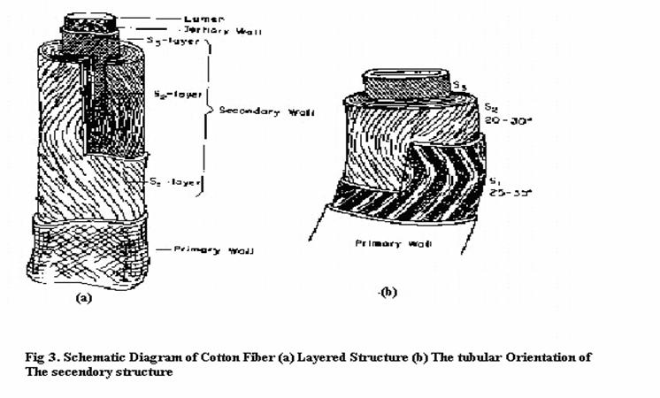
2.1.4 Characteristics and Properties of Cotton
Cotton is one of the most commonly abundant natural fibers having many textile related properties. In a tropical country like India, cotton is most desirable for making apparels because of its easy available, comfort, excellent heat conductivity and hydroscopic nature says Samantha et al (2003). Cotton is the back bone of the world’s textile trade, it have many qualities and countless end uses. It is the most abundantly used textile fiber in the world says Shamey and Hussein (2005). Cotton is one of the oldest and most important textile fibers know for its comfortable apparel and other consumer product applications, states Manjrekar et al (2002).
According to watze and Eisenacher (2002), cotton is characterized by excellent properties like absorbency, biodegradable, breathable, non allergic, heat resisting, high wet strength and water retaining capacity. Roger (2000) states cotton as “hygrophilous” which means “Friend of water”. According to Mayekar (2002) cotton breathes naturally and allows gas and water vapor to pass freely.
Cotton fabric is soft and comfortable to wear close to skin because of its good moisture absorption qualities, charges of static electricity do not build up readily on the clothes says Alat and Saraf (2005). Cotton is cool, soft, comfortable, absorbs perspiration quickly, good color retention, strong and durable.
Cotton enjoys an extremely positive image due to its naturalness and gentleness to the human skin, says Shriveleela et al (2004).According to Narayanan (2003) the versatility of cotton has been under stiff challenge from synthetic fibers, which offer many new properties to user needs. Cotton has many versatile intrinsic that makes it a fiber for all masses and occasions, remarks, Narayanan (2005).
2.1.5 Advantages of Cotton
Cotton is a versatile material that many manufacturers use in clothing because of several advantages. It is highly breathable and helps keep the body cool. Cotton clothing is often more comfortable than other types of fabric. One of the best advantages of cotton is that it is environmentally friendly. It is durable and Bio-degradable. It is easy to laundry and economical (www.mademan.com).
Cotton can be easily dyed with various colours because of its high absorbent property. Cotton is a good conductor of heat. Cotton does not contain any chemicals and therefore is a natural product, denote Devi et al (2002).

2.1.6 Uses of Cotton
The major end uses of cotton fiber include wearing apparel, home furnishings and other industrial uses, states sudha et al (2006). Cotton fabrics have special application which includes fire proof resistant, apparel professional uses and provides effective protection, says hall (2004).
Cotton is used to make blouses, skirts, singlets, shorts, Bermudas, jackets and pants. It can also be made into bedspreads, pillowcases, carpets and curtains. Most T-shirts are made from cotton. Cotton also finds special applications in medical and hygienic uses, quotes Narayanan (2006).
2.2 SLUB YARNS
2.2.1 Definition
Slub yarns or fancy yarns structure or fiber composition is differ from the normal smooth yarn. Fancy yarn usually has a multitude of thick places or thin places are so called Slubs. Slub yarns of this variety are made by twisting the slub yarn around a core thread as many times as it takes to make the thickness of the desired size. As the yarn flows it gets thicker in places and thinner in other to create a distinctive effect states Sandra (2007).
2.2.2 Introduction
Slub yarns are used for all kinds of textile products. Today, therefore, there is a requirement to have a standardized and accurate method to measure slub yarns (http://articles.textileclass.com). The knowledge of the slub yarn manufacturers vary greatly. Some are in the business for many years and know this area very well. Others have just started producing slub yarns and are still building up their experience. Some spinners might have slub test instruments for the analysis of the slub yarns, whereas, most spinners use parameters of regular yarn measurement to analyze their slub yarns roughly or check the yarn just by cutting and weighting. Such methods make it difficult to discuss objectively about the parameter of slub yarns.
The consumer’s desire for ornamental effects has popularized the production of yarns that are given only a small amount of drawing out. Such yarns, called slub yarns have soft, untwisted areas at frequent intervals throughout their length. They are coarse with slight twist, having varying diameters that show irregularities typical of all incomplete spinning operation (www.indiantextilemagazine.com).
According to Singh (2008) the spinning process can produce decorative effects by varying the amount of twist or by twisting together yarns of different diameters, each of which may have different amounts of twist in them. Such yarns can give fabrics almost limitless textural effects of various colour combinations. Fabrics made of uniform yarns that have been evenly spun. A safe rule for the consumer is to remember that longer service may be expected from flat, smooth fabrics made from evenly spun yarns rather than from novelty yarns of complex character.
2.2.3 Structure of Slub Yarn


2.2.4 Types of Slub Yarn
The different slub yarn types according to uster Technologies AG are given in Table - I.
TABLE – I
TYPES OF SLUB YARN
Designation | Twist | Twist multiplier | Mass | Slub length
Slub yarn | Constant | Variable | Variable | Smaller than 2 meters
Slub yarn with twist correction | Variable | Constant | Variable | Smaller than 2 meters
Multi count | Variable | Constant | Variable | Larger then 2meters
Multi twist | Variable | Variable | Constant | Any

2.2.5 Manufacturing process of Slub yarns
The production of the ground and injected Slub yarns was considered in this process. The roving is replaced as a profile component, roving periodically stop and start accordingly to the required Slub length and spacing. The Slub thickness is determined by the roving count states Ramesh kumar (2005).
The Slub yarn contains varying thickness which is produced by changing the speed of the bottom rollers on the spinning frame. We can achieve the various size and irregularly of Slub yarn by slightly modifying the production process. Slub yarn began to be used in the creation of slub silk. It is generally used to make upholstery, lace, net curtains and household fabrics. It is widely been used to produce denim fabrics and more vivid casual wear.
The setting for the Slub insertion systems on to the ring spinning and open end spinning machines vary greatly for a variety of reasons. Basically the system is “open loop” and no quantifiable method exists within the system to assure that the desired effect is being created. The type and the length of spinning frame, count of roving, count of yarn, raw material, combed or carded process will all include a need to modify settings. Therefore, objective and quick measurement of the final Slubs in vital says Gao (2004). All these influencing factors show the need for a standardized measurement and standard parameters for a clear communication between spinners, weavers, knitters, traders and retailers.
2.2.6 Challenges for Slub yarns spinners
Besides the challenges of the Slub yarns industry today, discussions with many Slub yarns spinners revealed the most frequent problems they have to face in the daily production of slub yarns.
- Slub yarns not meeting the requirements or sets standards.
- Randomness of the intended Slub effect.
- Yarn mix-up (wrong bobbins).
- Repeat patterns/wrong setting of slub programme.
- Mass decreases before or after the slub.
- Definition of the settings for different slub insertion systems that should produce the same slub yarn.
- Relating the settings of the slub insertion system to characteristics or parameters of a slub yarn and eventually relating them to the fabric appearance.
2.2.6 Advantages
- Reliable quality and competitive price.
- Good colour fastness.
- Soft hand feel and Smooth Texture.
- Tear-resistant, Shrink-resistant
- It is one of the most innovative products, soft, higher hygroscopicity and pilling resistance.
2.3 KNITTING
2.3.1. Introduction
The term “Knitting” is derived from the Sanskrit Word “Nahayati” views Ahmed (2000). Knitting is an art of using yarn or thread to make fabric from interlocking loops says Johnson (2006). Knitting is the second most widely used process of producing fabric states Kemp and Barbara (2009).
Knitting is the process of making cloths with a single yarn or set of yarns moving in only one direction says Dedhia and Charankar (2001). Ahmed and Ganger (2002) says the ancient knitting by hand was practiced since 1000BC. The history of machine knitting is traceable from the 16th century in England.
Knitting is a fabrication process in which needles are used to form a series of interlocking loops from one or more yarns or from a set of yarns states Adaner (2004). In 1789 the first circular machine was invented in France and there after enormous modification, efficiency, easy operation, easy designing, using the computer aided designing and automation have taken places state Anitha and Duripadian (2007).
2.3.2 Importance of Knitting
Knitting is the second most important invention besides the advent of the man-made fabrics, views Nadkarni (2001). Kothari (2001) states hosiery knitting industry occupies a vitally important position in respect of huge employment contribution to the country’s foreign exchange earnings. Ahmed (2000) views knit wears are becoming popular due to their economy and inherent favorable qualities for human body. The knitted textiles are exclusive in their nature and they are well suited for specific use for which they are meant for states Venkatraj (2006). In recent days, knitted goods have occupied the prominent position in the garment sector which amounts for 76% of the total garment production quotes Sharmin (2010).
2.3.3 Classification of Knitting
According to Gordon and heish (2007) knitting technology is classified into two main groups: weft and warp knitting.
Knitting
- Tricot knit
- Simplex knit
- Raschel knit
- Ketten Raschel knit
- Milanese knit
- Crochet knit
Warp Knitting
- Plain or Single Jersey
- Rib stitch
- Purl stitch
Weft Knitting

Venkatraj (2000) defines warp knitting as a loop forming process in which a warp yarn is fed into the knitting zone parallel to the fabric selvedge. Filling or weft knitting is a process in which one yarn or yarn set is carried back and under needles to form a fabric, says Kothari (2001).Warp knitting produces a knitting structure with simultaneous feeding of yarn and loop formation on each needle in the needle bar during the same knitting cycle, opine Naveen et al (2006).
Weft knit goods is made by feeding a multiple number of ends into the machines. Each loop is progressively made by the needle or needle bar, views sears (2005). Weft knit fabric is generally elastic and readily droppable says Sivakumar (2000). According to Spencer (2001) weft knitting and weft knit fabric can be classified as single or double depending upon the number of independent needle sets required to produce them. Although both bearded and latch needles can be found in weft knitting, the vast majority of weft knitting is done using latch needles.
2.3.4 Single Jersey fabric
The simplest of all weft knit structures is the single jersey. It is composed entirely of face loops for entirely back loops, reports NIIR Board (2004). Plain single jersey is the simplest weft knitting structure that is possible to produce on one set of needle and the fabric can be uncovered from either end if a stitch is broken, the wale will disintegrate causing the stitches in the line to ladder, reveals padma and Subramanian (2003). The plain knit can be produced in flat-knit or in tubular form. The knitting is done with rows of latch or a beards needle arranged in a linear position on a needle plate or in circular position on a cylinder, says Singh (2004).

2.3.5 Properties and characteristics of single knit fabrics
According to Ahmed (2000), the general properties of single jersey fabrics are,
- Simple knit structure
- Face side smooth and shine
- Back side rough and shine
- Lighter fabric
- Highly extensive in length or width
- Laddering is very common
- Unravels at both ends
Single knit fabric characteristics are,
- The appearance of the face and back differ.
- Extensibility widthwise is approximately twice that of the length direction.
- The edges of the fabric tend to curl or roll.
- A run collapse of a wale which occurs if a cut or exposed loop is stressed. The direction of collapse can be either from top to bottom or vice versa.
- The fabric can be unraveled, course by course, from either end.
- The fabric thickness is approximately two times the diameter of the yarn used.
2.4 DYEING
2.4.1 Introduction

A dye is a colored substance that has an affinity to the substrate to which it is being applied. The dye is generally applied in an aqueous solution, and may require a mordant to improve the fastness of the dye on the fiber states Yadav (2001).

According to Smith (2006) a dye is usually a colored organic compound or mixture that may be used for imparting color to a substrate. Such as cloth, paper, plastic or leather in a reasonably permanent fashion. Previously dyes were obtained from animal and vegetable sources. Today most of the available dyes are synthetic dyes prepared from automatic compounds which are obtained from coal tar or petroleum quotes Singh (2002).

2.4.2 Classification of Dyes

Dyes are classified based on their origin, application, and chemical properties. Dye manufacturers classify dyes according to their chemical properties, while dyers classify dyes based on the method of application states Howard (2004).

Classification Based on Origin of Dyes
Most dyes are organic molecules and are complex in nature. The synthesis of organic dyes began with aquiline synthesis. Before that, colors were made from pigments. As a result, dyes can be classified as natural and synthetic, according to their sources of origin.( www.indiantextilemagazine.com)

Natural Dyes

Natural dyes are derived from nature through organic and inorganic materials or sources. Logwood is a natural dye obtained from plants. It saturates silk, wool, cellulose acetate, and nylon with a deep black color. Tyrian purple is obtained from animals and Prussian blue is an inorganic dye obtained from naturally occurring minerals explains Liles (2006).

Synthetic Dyes

According to Eiri (2005) Synthetic dyes became popular because they were easy-to-use, less expensive and had wider range of colors. Synthetic dyes are obtained by adding chemicals to natural dyes. For example, artificial alizarin is a synthetic dye synthesized from coal tar anthracene. Synthetic dyes are used for modern clothing.
2.4.3 Reactive Dyes
Reactive dyes utilize a chromophore attached to a substituent that is capable of directly reacting with the fiber substrate. The covalent bonds that attach reactive dye to natural fibers make them among the most permanent of dyes says Spring (2009). "Cold" reactive dyes, such as Procion MX, Cibacron F, and Drimarene K, are very easy to use because the dye can be applied at room temperature. Reactive dyes are by far the best choice for dyeing cotton and other cellulose fibers at home or in the art studio (www.scribd.com).
According to the Kolonko (2005) reactive dyes are form a covalent bond with the fiber, usually cotton, wool and nylon. This class of dyes, first introduced commercially in 1956, made it possible to achieve extremely high wash fastness properties by relatively simple dyeing methods. A marked advantage over direct dyes is that their chemical structures are much simplex, their absorption spectra show narrower absorption bands and the dyeing are brighter. The principal chemical classes reactive dyes are azo, anthraquinone, and phthalocyonine states NIIR Board.
Reactive dyes an entirely class of dye introduced to the market in 1956. They react chemically with the fiber being dyed and if correctly applied, cannot be removed by washing or boiling. The main feature of the dyestuff is its low affinity to cellulose; therefore large amounts of salt are required to force its deposition on the fabric. Basically there are two types of reactive dyes: the cold dyeing and hot dyeing types.
2.4.4 Advantages of Reactive Dyes
- Easy application
- Moderate price
- Complete colour range
- Good fastness due to direct reaction with fibers.
- Commonly used for all cellulosic goods especially in knitted fabric batch wise dyeing
- Selective dyes can also be applied on wool, silk & rayon
- Increasingly used in printing due to good fastness says Daniel (2004).
2.4.5 Uses of Reactive Dyes
- Reactive dyes are used where bright dyeing with high light fastness and wash fastness is required.
- Cold dyeing is used extensively in batik work.
- Although some reactive dyestuffs have been specially modified to dye wool, their main usage is in dyeing cotton linen & viscose rayon.
- Cold water fiber reactive dyes, suitable for dyeing on cotton, silk, jute, rayon.
- Cannot be used on synthetics or fabric that has been coated with resin or drip-dry finish.


METHODOLOGY

3. METHODOLOGY
The methodology pertaining to the study is presented under the following headings:
3.1 Selection of yarns
3.2 Selection of knitting structure
3.3 Knitting
3.3.1 Knitting parameters

3.3.2 Circular Knitting Machine

3.4 Pre-Treatments
3.4.1 Scouring
3.4.2 Bleaching
3.5 Selection of Dyes
3.6 Dyeing
3.6.1 Dye Recipes
3.6.2 Winch Dyeing
3.6.3 Advantages
3.7 Finishing
3.7.1 Mercerization
3.7.2 Compacting
3.7.3 Calendaring
3.8 Fabric Evaluation
3.8.1 Subjective Evaluation
3.8.1.1 Visual Evaluation
3.8.2 Objective Evaluation
3.8.2.1 Wales and Courses
3.8.2.2 Fabric Weight
3.8.2.3 Fabric Thickness
3.8.2.4 Fabric Drapability
3.8.2.5 Bursting Strength
3.8.2.6 Abrasion Resistance
3.8.2.7 Pilling Resistance
3.8.2.8 Tensile and Elongation
3.9 Wettability and Absorbency Tests
3.9.1 Drop Test
3.9.2 Sinking Test
3.9.3 Capillary Rise Test
3.10 T- Shirt Constructions
3.10.1 Wear Study
3.11 Statistical Analysis
3.11.1 ANOVA Test

3.1 SELECTION OF YARNS
Slub yarn is a yarn containing varying thicknesses which is produced by changing the speed of the bottom rollers on the spinning frame. We can achieve the various size and irregularity of slub yarn by slightly modifying the production process.(www.fineweavetextile.com). A Slub yarn is another single, spun fancy yarn. This thick and thin yarn can be made in two ways: 1) the amount of twist in the yarn can be varied at regular intervals for a true slub yarn; 2) the thicker part of the yarn is twisted less and the thinner part of the yarn is twisted more. True slub yarns are found in drapery and upholstery fabrics and in hand knitting states Sara (2009).
The finer slubs produced in the surface appearance of a plain fabric and used in both upholstery and apparel fabrics. The heavier slub effect produce stronger variations in the fabric surface. It can be used knitted and woven fabrics says Rachel(2002).
3.2 SELECTION OF KNITTING STRUCTURE
Knitting is a process of fabric forming by the intermeshing of loops of yarn. Single Jersey is a weft knitted fabric produced with one set of needles is called Single Jersey or plain knitted fabric quotes Priyankgoyal (2010). Hence Single Jersey Structure was selected for the study.
3.3 KNITTING
The basic form of knitting can be produced in flat knit or in tubular or circular form. It is also called jersey stitch or balbriggan stitch. A row of latch or beard needles is arranged in a linear position on a needle plate or in a circular position on a cylinder. The side by side evenly spaced needles are moved by cams, which act on the needle butts. The spacing of the needles is called gauge, gage or cut which refers to the number of needles in one and a half inches, for example, a 60 gauge machine will have 40 needles per inch.
The needles intermesh loops drawn to one side of the fabric, forming vertical herringbone like ribs or wales on the right side or technical face of the fabric. On the reverse side or the technical back, courses are visible as interlocking rows of opposed half circles. These fabrics have the tendency of curling up at the edges which is controlled to a level through certain finishes.
The production rate of Single Jersey is higher, about 5 times more than weaving. It is inexpensive and a variety of designs may be produced including stripes, multicolored patterns, textured surfaces produced by raised designs and pile effects. Plain-knit fabrics stretch more in the width than in the length and as such, they are widely used for making underwear, gloves, hosiery and sweaters (www.teonline.com).
3.3.1 Knitting parameters
TABLE - II
KNITTING MACHINE SPECIFICATIONS

Model Number | TF-S3F2
Cylinder Dia | 18"- 40"
Feeder | 54F-204F
Gauge | 14G-36G
Speed | 25 – 40 rpm

3.3.2 Circular Knitting Machine
High speed circular knitting machine is one of the latest developments of the circular knitting machines from the factory with excellent capacity and high quality. The strict and high precision machine can ensure the quality of the output Single jersey knitted fabrics (Plate-V). Hence Circular Knitting Machine was used.
3.4 PRE-TREATMENTS
Cotton, whether present as fiber or yarn or hosiery or woven fabric requires some form of pretreatment to make it suitable for dyeing and finishing and the basic function of the pretreatment is to impart uniform, good absorbency and whiteness without chemically damaging the cotton, says Alat (2001). Hence the investigator planned to do scouring and bleaching for all knitted fabric based on the weight of the fabric.
3.4.1 Scouring
Scouring is the process of thoroughly cleansing the fabric prior to proceeding with the dyeing (NIIR Board). The scouring process removes much of the non-cellulosic compounds naturally found in cotton. Therefore the selected fabric was subjected to scouring. The parameters and operational ranges adopted for scouring are given in Table – III.
TABLE-III
SCOURING PARAMETERS
Parameters | Operational ranges
Weight of material  Sodium hydroxide  Sodium carbonate  Wetting agent  Soft water  Time  Temperature | 100g  3%  2%  few drops  1:20(MLR)  30minutes  85°C

3.4.2 Bleaching
Bleaching is to impart whiteness to the fabric by removing the natural coloring matter from the fabric, explains Pardeshi (2006). The parameters and operational range adopted for bleaching are given in Table – IV.
TABLE-IV
BLEACHING PARAMETERS
Parameters | Operational ranges
Weight of material  Sodium silicate  Caustic soda  Hydrogen peroxide  Soft water  Time  Temperature | 100g  2%  1%  3%  1:20(MLR)  1½ hours  90-95°C

3.5 SELECTION OF DYES
Reactive Dyes have gained importance in dyeing, on account of their brilliancy, ease of application and good wash fastness properties, states Marial and Kottani (2001). Hence reactive dye was selected for the study. Yellow colour were selected for dyeing.

3.6 DYEING
The selected knitted fabrics can be dyed with reactive dyes by winch dyeing method. The Dye recipes and procedure are given below:
3.6.1 Dye Recipes
Weight of the fabric : 4kg
Dye stuff : 224gm
Wetting oil : 12ml
Peroxide : 8ml
Stabilizer : 3ml
Caustic soda : 200gm
Acetic acid : 40ml
Killer : 20ml
Salt : 750gm
Soda ash : 480gm
Acetic acid : 40ml
Fixing oil : 40ml
Softener : 20ml
Material liquor ratio : 1:20
3.6.2 Winch Dyeing
- Winch bath (Plate - VI) was filled with wetting oil along with each of the fabrics. Wetting oil was added to remove the impurities, oil stains and also to wet the fabric.
- After one hour peroxide, stabilizer and caustic soda were added in solution form. The temperature was maintained as 85°C. The machine was run for 1½ hours. The fabric was bleached.
- In another bath, the fabric was washed in hot water, to remove the chemicals. The temperature was maintained as 60°C.
- Acetic acid was added and pH value was checked. When the pH reached 7, killer was added to remove this chemical.
- Then, dye powder was added first and then after half an hour salt was added. Later soda ash was added with through stirring. It was allowed to stand for 1 hour.
- The fabrics were rinsed thoroughly.
- Acetic acid was added to remove remaining dye stuffs, salt and soda ash and allowed to stand for one hour. The fabrics were thoroughly rinsed to remove acetic acid.
- In the finishing stage, fabric was dipped in fixing oil to fix the dye. Softener was added last to make the fabric smooth. Samples were removed after half an hour.
3.6.3 Advantages of Winch Dyeing
      - Construction and operation of winch are very simple.
- The winch dyeing machines are suitable for a types of wet processing operations from desizing to softening.
- The winch dyeing machine is suitable for practically all types of fabrics, which can withstand creasing in rope form processing.
- The tension exerted on winch is less than jigger, the material thus dyed is with fuller hand.
- The appearance of the dyed goods is clean and smooth when dyed on winch dyeing machines.

3.7 FINISHING
Final treatment given for the knitted fabrics includes mercerization, compacting and calendaring.
3.7.1 Mercerization
Lyle (2002) states that mercerization is a process where by cotton is treated under tension to reduce shrinkage and increase strength. Mercerized cotton offers a smooth surface and is more lustrous than cotton. Mercerization includes saturating cotton cloth with Sodium hydroxide, stretching it on a tester frame, and washing it while still in the stretched position. A permanent luster resulted on mercerization.
3.7.2 Compacting
The knitted fabrics are finally given a mechanical finishing treatment by compacting machine to control the shrinkage and to bring dimensional stability to the fabrics. The steamed fabric was introduced to the compacting rolls and the retarding rolls. Compacting is done for shrinkage control.
3.7.3 Calendaring
Calendaring is a mechanical finishing process of pressing fabric between rollers. Various conditions of heat, pressure and tension will produce different effects, says Padma and Subramaniam (2003). Calendaring is done to remove creases. The fabric was fed into the calendaring machine and allowed to pass between two rollers, where as the pressing of the fabric was done. The rollers supplied heat to press the fabric. There was a rotating guide to feed and unload the fabric from the machine.

3.8 EVALUATION
3.8.1 Subjective Evaluation
Subjective assessment is the method of describing fabric handle based on the experience and variable sensitivity of human beings. Textiles are touched, squeezed, rubbed or handled to obtain information about physical parameters, point out Mandal and Zhiming (2006).
3.8.1.1 Visual Evaluation
The samples were evaluated by a panel of 20 post graduates majoring in the area of Textiles and Fashion Apparel, Avinashilingam Deemed University for Women. The characteristic features like general appearance, texture, brilliancy of whiteness and fragrance were taken into consideration. The Performa used for evaluation is given in Appendix – III.
3.8.2 Objective Evaluation
The physical tests for objective evaluation were carried out in the laboratory. The suitable tests for knitted fabrics are as follows:
3.8.2.1 Wales and Courses
A wale is predominantly vertical column of needle loops produced by same needle knitted at same successive knitting cycle whereas course is predominantly horizontal row of loops produced by adjacent needle during the same knitting cycle, defines Rajkumar (2001). Hence the number of Wales and Courses present in 2.5cm² inches at five different places in each sample is counted using the Pick Glass and recorded.
3.8.2.2 Fabric Weight
Fabric weight is an important component for comparing the two similar fabric constructions. Saini (2004) describes fabric weight as the relative weight of the fabric and expressed as the weight of a particular size of piece such as grams per square meter.
The paramount GSM cutter is a specialized instrument to determine the GSM of the fabric. It has four blades that cut the fabric when the hand wheel is rotated by applying slight pressure. The samples were cut at five different places using the cutter and had been weighted using Ohaus AdventureTM Balance. The readings were noted and the mean was calculated and is expressed in grams per square meter.
3.8.2.3 Fabric Thickness
Fabric thickness is defined as the distance between the upper and lower surface of the material measured under a standard pressure, using the Shirley’s Thickness Tester with accuracy of 0.01mm, as explained by Stock et al (2005). Saville (2001) says that thickness of a fabric is one of its basic properties to give information on its heaviness or stiffness in use.
The fabric was placed between the pressure foot, and anvil, the reading was noted from the dial of the Thickness Gauge. The readings were taken at five different places of the fabric and care was taken to see the places were away from the selvedges and free from wrinkle. Five readings were taken and the mean was calculated for all the test samples.
3.8.2.4 Fabric Drapability
The drape of the fabric is defined in terms of the shape or the way in which the fabric hangs down in folds, reveals Lord and Mohammed (2001).
Drapability of a fabric can be determined using the instrument Drape Meter. The fabric was taken and cut using template. The cut fabric was supported on a circular dish about five inches in diameter and the unsupported area drapes over gramophone. The material will assume some folded configurations and the shape of the protected area will not be circular. The projected portion was traced in the brown paper and was cut. The same procedure was followed five times for all fabrics. Mean value was calculated and recorded.
The Drapability of the fabric can be determined using the drape-co-efficient formula. The drape coefficient F, is the ratio of the projected area of the drape specimen to its undraped area after deduction of the area of the supporting disc.
Thus, (As-Ad)
F =
(AD-Ad)
Where AD = The area of the specimen
Ad = The area of the supporting disc
As = The actual projected area of the specimen.
3.8.2.5 Bursting Strength
Bursting strength is the strength of a fabric against a multi directional flow of pressure, state Angappan and Gopalakrishnan (2002).
Eureka Hydraulic Bursting Strength Tester was used to test the strength of the fabric samples. Five specimens were cut each measuring ½” greater in diameter than the outside diameter of clamp ring. Specimen was clamped by a ring over a thin flexible rubber diaphragm. The pressure in the liquid (glycerin) was increased by screw driven piston. Due to this increase, the diaphragm bulged, along with the specimen. At one point the fabric bursted and the pressure indicated by the pressure gauge was noted accurately in kilograms per centimeter square. For all the samples the five readings were noted and their mean was calculated and recorded.
3.8.2.6 Abrasion Resistance
Abrasion is one of the major criteria to assess the durability of the fabric, states Basu (2006). Abrasion is definitely a repeated stem application, usually caused by forces like bending, tensioning, compressing and bursting which are relatively low order repeated stresses and occurs many times during the life time of those material, point out Tarafder and Basak (2002). Abrasion is the wearing away of any part of a material by rubbing against another surface (ASTM 2000).
The Instrument used for the study was the Eureka Martindale Abrasion Resistance Tester standard (No.320). Emery paper was used as abrading surface and fitted to the reciprocating abrader head. The samples were cut to the size of template and weighted using Ohaus AdventureTM Balance then it was mounted to the sample holder and the revolution was standardized as 50. The machine was switched on and allowed for 50 revolutions. The sample were taken from the sample holder and weighted again. The same procedure was repeated to get five initial and final readings. Five readings were taken and average was calculated.
3.8.2.7 Pilling Resistance
The pills are defined as bunches or bolls of tangled fibers that are held to the surface of a fabric by one or more fibers and the pilling resistance are defined as the resistance to the formation of pills on a textile fabric. The pills are formed during wear and washing by the entanglement of loose fibers which protrude from the fabric surface. Due to rubbing action these loose fibers develop into small spherical bundles anchored to fabric by a few unbroken fibers, says Basu (2006).
The Pilling resistance test can be carried out in the ICI Pilling Box. The samples were cut according to the template. The fare side of each specimen was marked. Each specimen was folded, keeping face side inwards, so that the notches coincide exactly at their points. They were sewn exactly along the line between the pairs of notches. Then the sample was mounted on a rubber tube. Ten samples of each fabric were placed into box and the lids were closed. The machine was set to run for four hours. Then the fabric was removed from the rubber tube and assessed against standard photographs. Readings were noted and mean value was calculated.
3.9 WETTABILITY AND ABSORBENCY TESTS
Absorbency is one of the several factors that influence textile processing such as fabric preparation, dyeing and the application of finishes, states AATCC (2007). Water and moisture transportation of the fabric is an important aspect of any fabric. This decides the comfort of fabric as it transports water from the body surface and makes the person feel comfortable, expresses Sarker et al (2005). Drop test, Sink test and Capillary test were conducted to study the absorbency properties of all the samples.
3.9.1 Drop Test
The drop test is a count of number of drops required to penetrate through the fabric when all the drops fall on the same spot defines Booth (2005). The ability of a fiber to take up moisture is determined as absorbency. According to Shrinkle (2002), wettability is the time taken in seconds for a drop of water to sink into the fabric. Fabric that takes more than 200 seconds to absorb water are considered as unwettable. This is known as ‘Drop Test’.
A drop of water is allowed to fall from a fixed height into the taut surface of a test specimen. The time required for the specular reflection of the water drop to disappear is measured and recorded as wetting time, states AATCC (2007). A burette filled with distilled water was clamped in a stand. The sample was mounted in an embroidery frame and placed at the base of the stand. The distance between the sample and burette nozzle was kept constant. The nozzle of the burette was opened to allow a drop of water to fall on the sample. The stop watch was started simultaneously and it was stopped when the drop of the water fully sank into the material.
The water droplets disappears immediately, record as zero, when wetting time exceeds 60 seconds, record the time as 60s. This test was done five times for all the samples and seconds were noted. Mean value is calculated and recorded.
3.9.2 Sinking Test
For this test specimen of 2.5 x 2.5 cm from all samples were cut. A clean glass beaker was filled with 1000ml of distilled water. First one sample was taken, put into the beaker. The time taken by the fabric to sink into the water completely was noted. This procedure was done for five times to all samples and time taken was systematically recorded. The mean value was calculated and recorded.
This test involves a simple test of wettability of fabric. In this test small specimen of about 1” x 1” is cut and dropped into the surface of the water in a beaker. The time taken for the specimen to sink below the surface is observed. The shorter the time, the greater the wettability remarks Booth (2005).
3.9.3 Capillary Rise Test
The capillary test method measures the rapidity of absorption states Paul (2005). Five specimens were cut into size of 15cm length and 2.5 cm width from all the samples. One end of the sample strip was passed with a glass rod which was placed on the heavy wooden blocks and at the other end, two grams weight was attached to keep the sample straight. At the weighted end 2cm of the sample was allowed to immerse in a tray of distilled water. The rate of the water level in the sample was measured after 60 seconds. The time taken for rise of the water level in the strip was noted by keeping length of the water rise 2.5cm as constant. The same procedure was repeated for five reading of all the samples were recorded.

3.10 T- Shirt Constructions
The body measurements are standardized and based on that, T-Shirt was constructed. The sewing machines are shown in Plate – VII and VIII.
3.10.1 Wear Study
An observation was made among middle school boys in an informal situation, revealed that “T-Shirt” is the fascinating garment. Hence it was decided to convert each of the knitted fabrics into a T-Shirt. T-Shirts were worn by middle school boys who were selected for subjects (Plate - IX). They have worn the garment for a period of eight hours from morning 10am to evening 6pm for five days. The T-Shirts were washed after each wear dried in the shade and pressed well before the next wear.
3.11 STATISTICAL ANALYSIS
Statistics group of methods are used to collect, analyze, present and interpret data and to make decisions, says Mann (2004). Statistics is used for presenting facts in a definite form and simplifies mass of figure facilities comparison. Statistics helps in prediction and in formulating hypothesis, points out Gupta (2004).
3.11.1 ANOVA Test
ANOVA is a statistical technique that can be used to evaluate whether there are difference between the average value and mean, across several population groups (http://www.answers.com/topic/analysis) of variance and two way ANOVA evaluates the effects of two factor (http://unc.edu.au). ANOVA is commonly used to test difference among the means of several and is dependent of groups. Hence the investigator selected appropriate methods of statistical support based on the samples and comparisons states Gupta (2004).

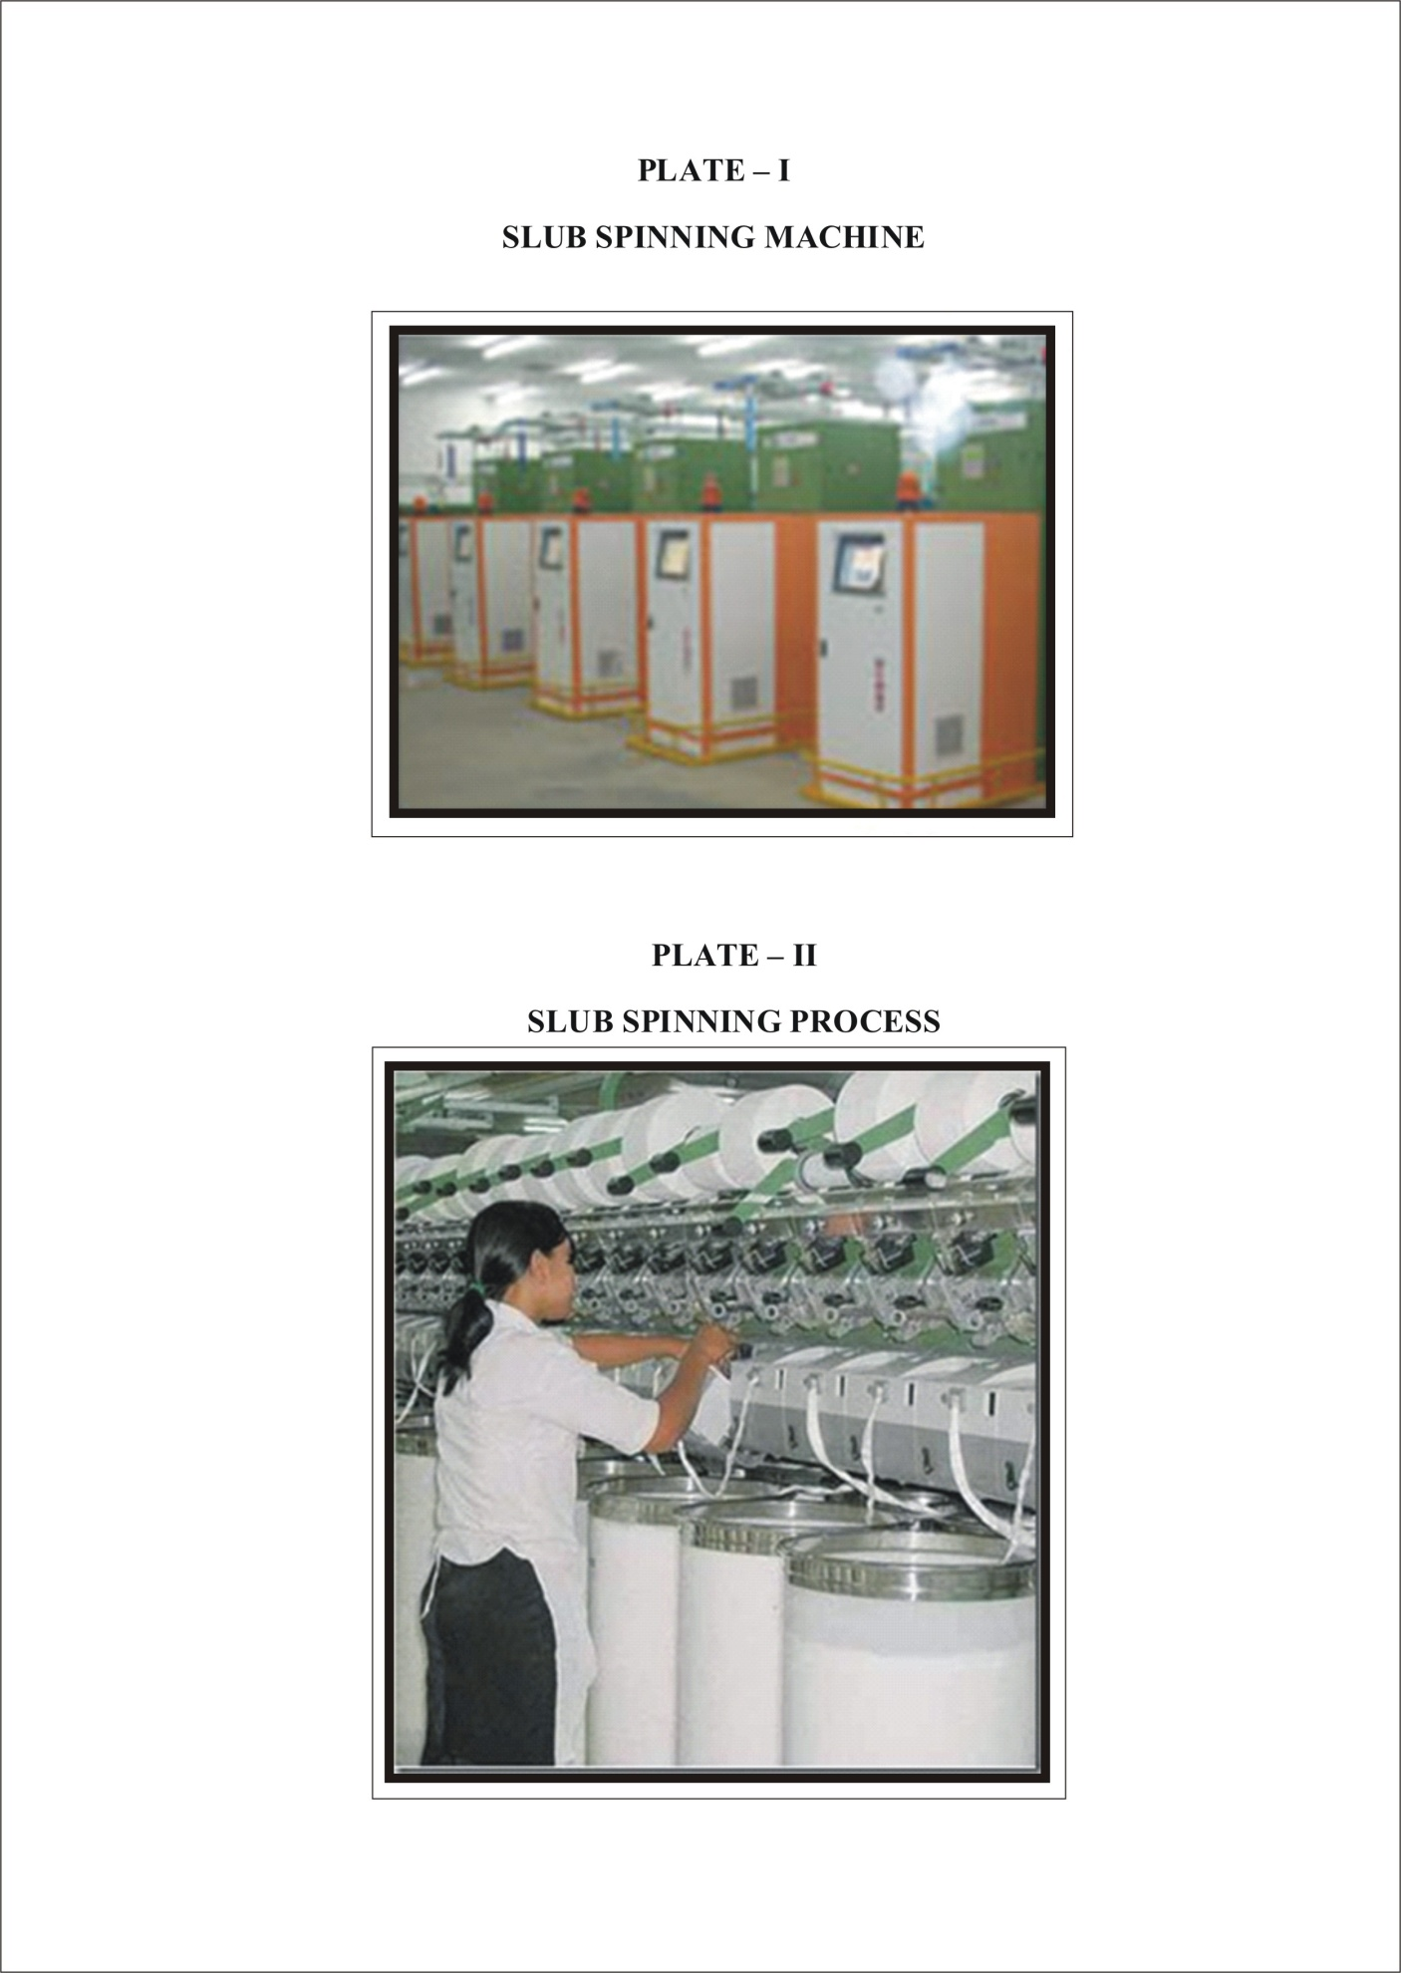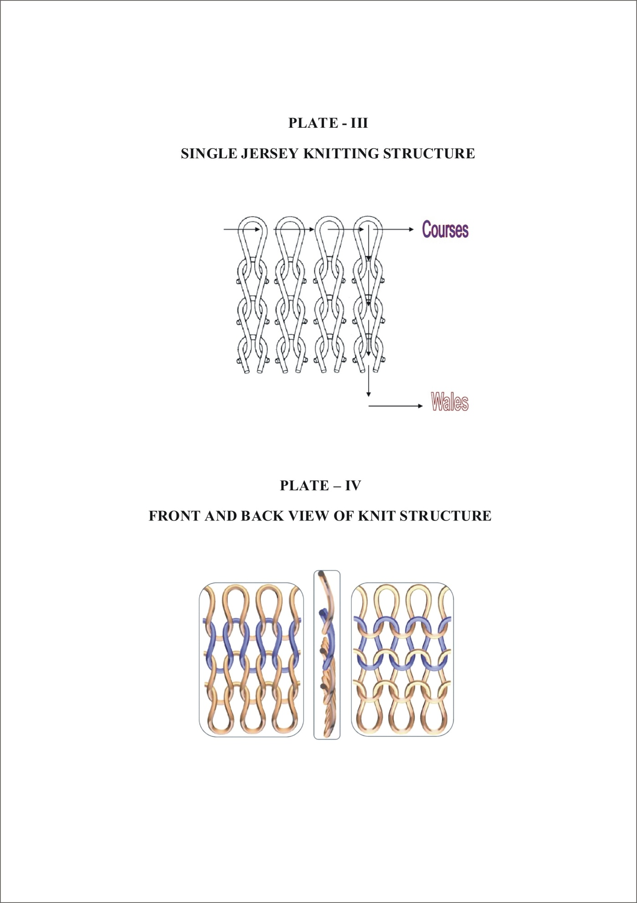
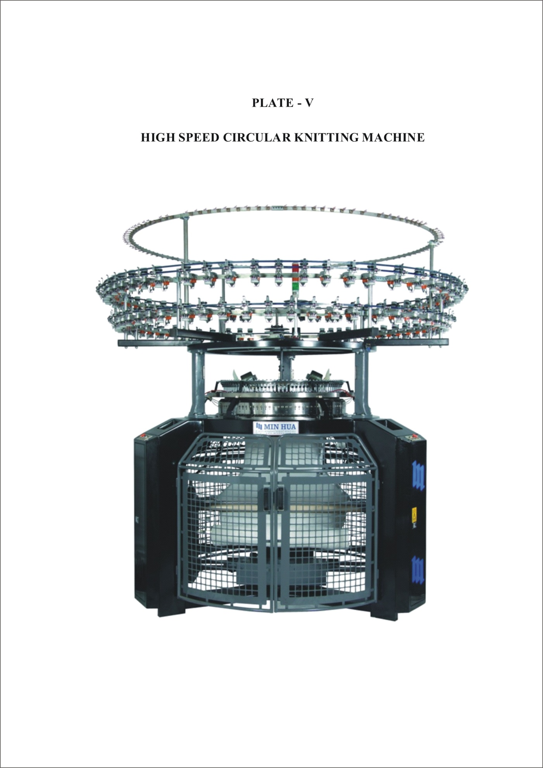
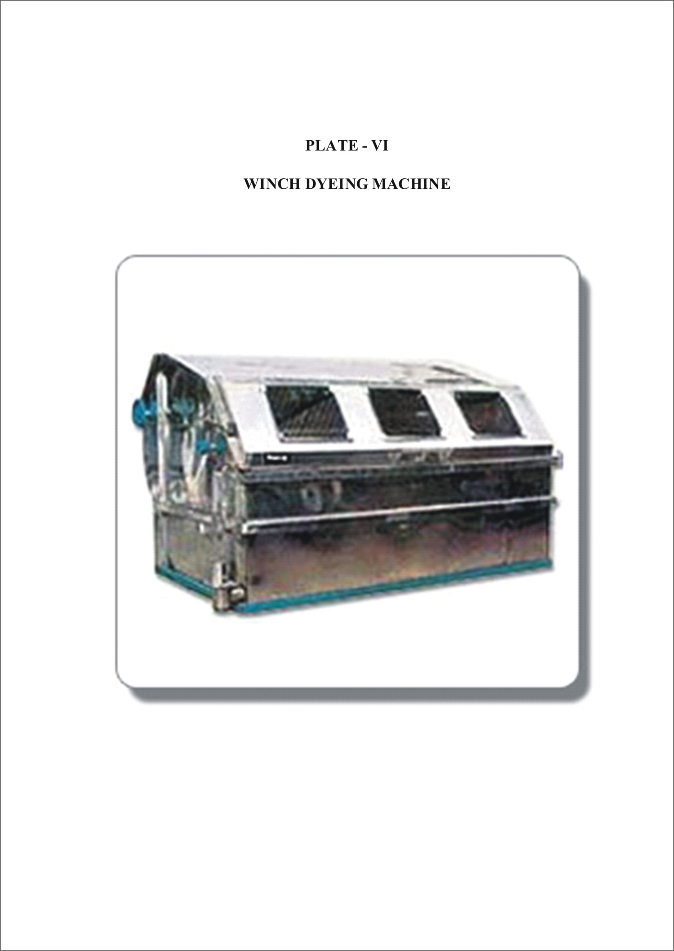
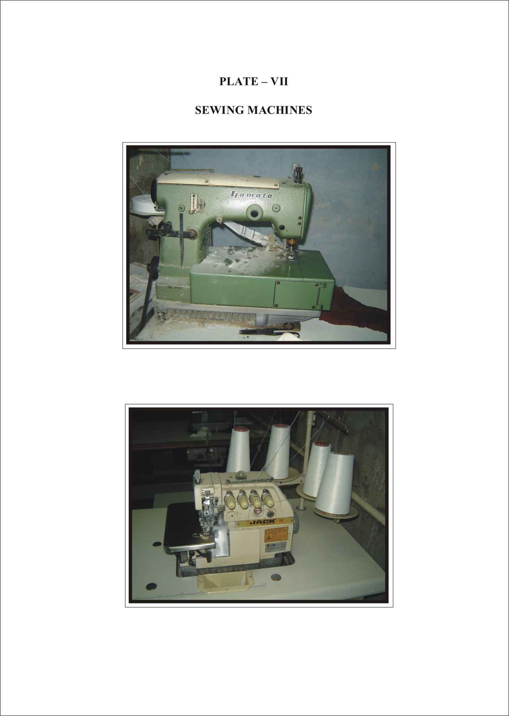
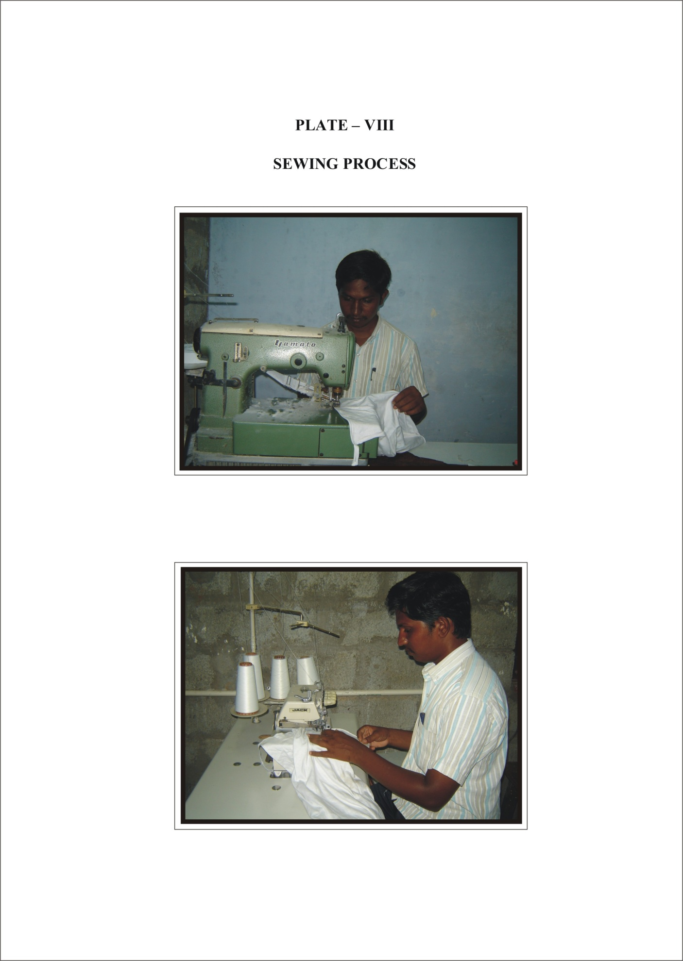
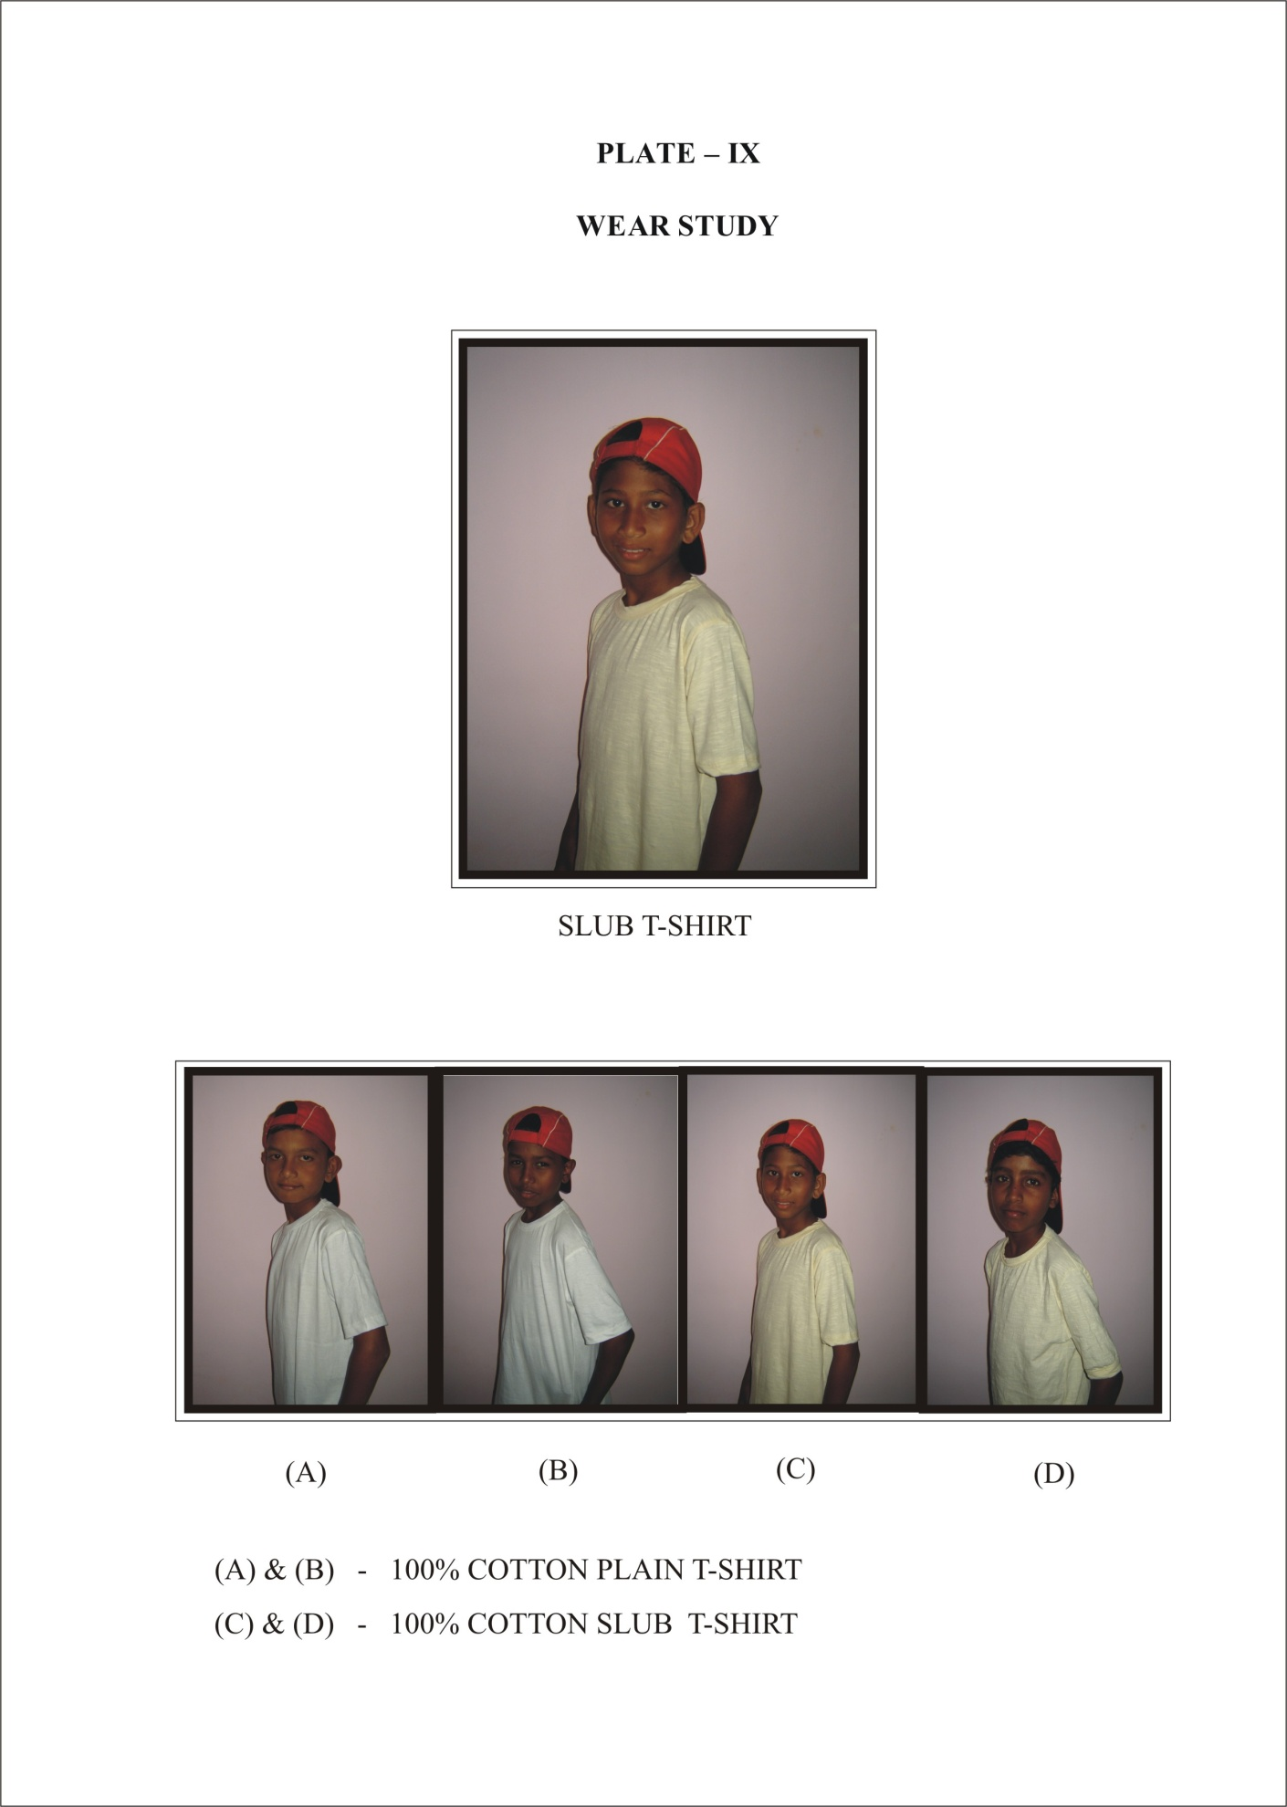


RESULT AND DISCUSSION

4. RESULTS AND DISCUSSION
The results of the study on “COMPARATIVE STUDY OF SLUB AND PLAIN SINGLE JERSEY COTTON KNITTED FABRIC” are discussed under the following headings:
4.1 Subjective Evaluation
4.1.1 Visual Evaluation
4.2 Objective Evaluation
4.2.1 Wales and Courses
4.2.2 Fabric Weight
4.2.3 Fabric Thickness
4.2.4 Fabric Drapability
4.2.5 Bursting Strength
4.2.6 Abrasion Resistance
4.2.7 Pilling Resistance
4.2.8 Tensile and Elongation
4.2.9 Wettability and Absorbency Tests
4.2.10 Wear Study

TABLE V
NOMENCLATURE
S.No | Sample | Nomenclature
1 | Cotton Plain | CP
2 | Cotton Slub | CS

4.1 SUBJECTIVE EVALUATION
The samples were evaluated subjectively and the results are discussed under following headings.
4.1.1 Visual Evaluation
The cotton plain and slub fabric samples were evaluated visually by the panel of judges. The results are presented in Table VI
TABLE VI
VISUAL EVALUATION
S.No | Sample | General Appearance |  |  | Texture |  |  | Evenness Of Dyeing
S.No | Sample | G | F | P | C | M | S | W | HW | Y
1 | CP | 95 | 5 | - | - | 11 | 89 | 86 | 14 | -
2 | CS | 91 | 9 | - | 5 | 18 | 72 | - | - | 100

From the Table VI it is evident that the general appearance of the cotton plain and slub fabric was rated as good by 90 – 100 percent of the judges. The cotton plain sample has obtained good rating of 95percent.
With regard to texture of the cotton plain was rated as soft textured fabric by 89 percent judges. Regarding the brilliancy of whiteness, the sample cotton plain was rated by 86 percent judges. The sample cotton slub was rated high in yellow by 100percent judges.

4.2 OBJECTIVE EVALUATION
The objective evaluation results are discussed below.
4.2.1 Wales and Courses
The Mean number of Wales and Course for the selected samples of Cotton plain and Slub single jersey fabrics are given in Table VII and Figure I.
TABLE VII
WALES AND COURSES
S.No | Samples | Wales |  |  |  | Courses
S.No | Samples | Number ( in 2.5 cm²) | Loss or gain over original | Percentage loss or gain | F ratio | Number ( in 2.5 cm²) | Loss or gain over original | Percentage loss or gain | F ratio
1 | CP | 58 | - | - | 1.232NS | 80 | - | - | 10.538**
2 | CS | 40 | -18 | -31.03 | 1.232NS | 69 | -11 | -13.75 | 10.538**
** - one percent significant difference
Table VII proves that the number of Wales and Course of cotton slub has decreased when compared with the cotton plain fabric.
The statistical analysis proves that there is no significant difference for the Wales are concerned and one percent significant difference for the course.

FIGURE - I
WALES AND COURSE

4.2.2 Fabric Weight
The fabric weight of the selected knitted samples of cotton plain and slub fabrics are given in Table VIII and figure II.
TABLE VIII
FABRIC WEIGHT
S.No | Samples | Mean weight in grams | Loss or gain over original | Percentage loss or gain | F ratio
1 | CP | 1.232 | - | - | 6.871*
2 | CS | 1.494 | 0.262 | 21.266 | 6.871*
* - five percent significant difference
The Table VIII reveals that the fabric weight of the cotton slub fabric showed an increased in weight when compared with cotton plain fabric. The reason being the thickness of slub yarn.
The statistical analysis also reveals that there is five percent significant difference between the cotton plain and slub fabrics.

FIGURE - II
FABRIC WEIGHT

4.2.3 Fabric Thickness
The thickness of the fabric for the selected knitted samples of cotton plain and slub fabrics are given in Table IX and figure III.
TABLE IX
FABRIC THICKNESS
S.No | Samples | Mean thickness in mm | Loss or gain over original | Percentage loss or gain | F ratio
1 | CP | 44.2 | - | - | 48.738**
2 | CS | 53.6 | 9 | 20.18 | 48.738**
** - one percent significant difference
It is evident from the Table IX and Figure III that the fabrics have exhibited an increased thickness. The cotton slub showed 20 percent increase than the plain fabric.
The statistical analysis also supports the result that the fabric had significant difference at one percent level between the fabrics.

FIGURE - III
FABRIC THICKNESS

4.2.4 Fabric Drapability
The mean Drape co-efficient of the fabric for selected knitted samples of cotton plain and slub fabrics are given in Table X and figure IV.
TABLE X
FABRIC DRAPABILITY
S.No | Samples | Mean Drape Co-efficiency (%) | Loss or gain over original | Percentage loss or gain | F ratio
1 | CP | 2.246 | - | - | 14.07**
2 | CS | 2.134 | -0.112 | -4.986 | 14.07**
** - one percent significant difference
From the Table X and Figure IV it is evident that the drape co-efficient of the cotton slub fabric showed percentage loss when compared to plain fabric. So that the cotton slub fabric has good Drapability.
The statistical analysis also supports the result that there is one percent significant difference between the cotton plain and slub fabrics.

FIGURE - IV
FABRIC DRAPABILITY

4.2.5 Bursting Strength
The Bursting strength of the fabric for selected knitted fabric samples of cotton plain and slub fabrics are given in Table XI and figure V.
TABLE XI
BURSTING STRENGTH
S.No | Samples | Mean strength in kg/cm² | Loss or gain over original | Percentage loss or gain | F ratio
1 | CP | 0.615 | - | - | 1.0028NS
2 | CS | 0.792 | 0.177 | 28.78 | 1.0028NS
NS – Not Significant
The Table XI and Figure V present the bursting strength of the cotton plain and slub fabrics. The percentage increased to 28 percent. Cotton slub fabric has good bursting strength when compared with the cotton plain fabric.
The statistical analysis shows that there is no significant difference between the cotton plain and slub fabrics.

FIGURE - V
BURSTING STRENGTH

The Table XII and Figure VI present the bursting strength of the cotton plain and slub fabrics after five washes.
TABLE XII
BURSTING STRENGTH (After 5 washes)
S.No | Samples | Mean strength in kg/cm² | Loss or gain over original | Percentage loss or gain | F ratio
1 | CP | 0.449 | - | - | 3.1368NS
2 | CS | 0.562 | 0.113 | 25.16 | 3.1368NS
NS – Not Significant
The percentage gain was 25 percent for cotton slub fabric. The cotton slub fabric showed the maximum gain percent when compared with the cotton plain fabric. After five washes also cotton slub fabric has good bursting strength.
The statistical analysis shows that there is no significant difference between the cotton plain and slub fabrics.

FIGURE - VI
BURSTING STRENGTH
(After 5 washes)

4.2.6 Abrasion Resistance
The Table XIII and Figure VII present the Abrasion Resistance Test of the cotton plain and slub fabrics.
TABLE XIII
ABRASION RESISTANCE
S.No | Samples | Mean difference in grams | Loss or gain over original | Percentage loss or gain | F ratio
1 | CP | 0.148 | - | - | 6.3488NS
2 | CS | 0.174 | 0.026 | 17.56 | 6.3488NS
NS – Not Significant
From the Table XIII and Figure VII expresses the Abrasion Resistance of the cotton plain and slub fabrics. The percentage has increased to (17 percent) when compared with the cotton plain fabric. Cotton slub fabrics have good abrasion resistance.
The statistical analysis shows that there is no significant difference between the cotton plain and slub fabrics.

FIGURE - VII
ABRASION RESISTANCE

The Table XIV and Figure VIII present the Abrasion Resistance of the cotton plain and slub fabrics after five washes.
TABLE XIV
ABRASION RESISTANCE (After 5 washes)
S.No | Samples | Mean difference in grams | Loss or gain over original | Percentage loss or gain | F ratio
1 | CP | 0.068 | - | - | 1.1051NS
2 | CS | 0.099 | 0.031 | 45.58 | 1.1051NS
NS – Not Significant
The percentage has increased to 45 percent. The cotton slub fabric showed the cotton slub fabric. After five washes also Cotton slub fabrics have good abrasion resistance when compared with the cotton plain fabric.
The statistical analysis shows that there is no significant difference between the cotton plain and slub fabrics.

FIGURE - VIII
ABRASION RESISTANCE (After 5 washes)

4.2.7 Pilling Test
The Table XV and Figure IX shows Pilling resistance of cotton plain and slub fabrics.

TABLE XV
PILLING TEST
S.No | Samples | Pilling
1 | CP | 3
2 | CS | 4

1 - Very Severe Pilling 2 - Severe Pilling
3 - Moderate Pilling 4 - Slight Pilling

From the Table XV and Figure IX it is clear that the cotton slub fabric had slight pilling compared with plain fabric. The cotton plain fabric has moderate pilling. This proves that slub yarn knitted fabrics have good pilling resistance.

FIGURE – IX
PILLING RESISTANCE

The Table XVI and Figure X pilling resistance of cotton plain and slub fabrics shown after five washes.

TABLE XVI
PILLING TEST (After 5 washes)

S.No | Samples | Pilling
1 | CP | 3
2 | CS | 4

After five washes also the cotton slub fabric has slight pilling. The cotton slub fabrics have a excellent pilling resistance when compared with cotton plain.

FIGURE – X
PILLING RESISTANCE (After 5 washes)

4.2.8 Tensile and Elongation
The Tensile and Elongation strength of the fabric for selected knitted samples of cotton plain and slub fabrics are given in Table XVII and Figure XI.
TABLE XVII
TENSILE AND ELONGATION
S.No | Samples | Tensile Strength |  |  |  | Elongation
S.No | Samples | Mean Strength in lb | Loss or gain over original | Percentage loss or gain | F ratio | Mean Strength in inches | Loss or gain over original | Percentage loss or gain | F ratio
1 | CP | 50 | - | - | 50.5556** | 5.28 | - | - | 1.3832NS
2 | CS | 34.8 | -15.2 | -30.4 | 50.5556** | 9.36 | 4.08 | 77.27 | 1.3832NS
** - one percent significant difference NS – Not Significant
The Table XVII and Figure XI exhibited the Tensile Strength of the cotton slub fabric showed percentage loss. The statistical analysis also supports the result that there is significant difference the cotton plain and slub fabrics at one percent level.
The Table XVII and Figure XII, reveals the Elongation Strength of the cotton slub fabric showed percentage increased. The statistical analysis shows that there is no significant difference between the cotton plain and slub fabrics.

FIGURE – XI
TENSILE STRENGTH

FIGURE – XII
ELONGATION STRENGTH

4.2.9 Wettability and Absorbency Tests
The Table XVIII and figures XIII present the Wettability and Absorbency Tests results.
TABLE XVIII
WETTABILITY AND ABSORBENCY TESTS
S.No | Samples | Drop Test  (Seconds) | Sinking Test (Seconds) | Capillary rise Test (Seconds to wick 2.5cm)
1 | CP | 25 | 63 | 150
2 | CS | 31 | 70 | 165

Based on the results presented in the Table XVIII both the fabrics possess good absorbency. In each three tests the maximum time taken by the cotton slub fabric when compared with the plain fabric.

FIGURE – XIII
WETTABILITY AND ABSORBENCY TESTS

4.2.10 Wear Study
The cotton plain and slub T-shirts were worn by middle school boys who were selected for subjects (Plate - IX). They had worn T-shirts for eight hours from morning 10am to evening 6pm. T-Shirts were washed after each wear dried in the shade and pressed well before the next wear. This was continued for five days.
According to the wearer personal opinion the slub T-shirts are comfortable to wear, low shrinkage and highly sweat absorbing when compared to plain T-shirts. The slub T-shirts are the main advantages of the wearer says its skin friendly, good stretch ability, highly durable and breathable. The reactive dyes used Slub T-shirts are color fastness to wash and light. So the cotton slub T-shirts are given excellent results when compared with cotton plain T-shirts.


SUMMARY AND CONCLUSION

5. SUMMARY AND CONCLUSION
Clothing is one of the basic necessities of the mankind. Textile products play a vital role in meeting human basic needs. Cotton is one of the most common and abundant natural fibers having many advantages textile related properties. Knit wears are becoming popular due to their economy and inherent favorable qualities for human body. Excellent comfort properties of weft knits have made their entry into formal wears for men and women.
Fancy yarns are intentionally produced to have a distorted or irregular construction. Fancy yarns can be used in hand knitting, flat knitting as well as circular knitting. Slub yarn is characterized by having, alternating short places of thin is firm twist yarn, and with places of very thick is loose twist yarn. The different areas can be at regular or irregular intervals. The use of `effect' yarn as fancy yarn is gaining ground among textile producers making value-added knitwear, home textiles or high-end shirting materials.
The Slub knitting yarn used for knitting shirt, muffler, excellent to knit shirt, shoes and hats. Slub knitting is one of the most innovative knitting process. At present more and more t-shirt companies are offering Slub t-shirts. Slub yarn are used mainly in fashion industry, ready made garment industry,
Considering the above, the investigator felt the study was conducted with the following objectives:
- Knit the Plain cotton yarns into Single Jersey structure.
- Knit the Slub yarns into Single Jersey structure.
- Dye the knitted fabrics using reactive dye.
- Convert the knitted fabrics into T-Shirts.
- Evaluating and comparing the physical, mechanical and comfort properties of plain and slub yarn knitted T-Shirts.
FINDINGS OF THE STUDY
Evaluations of selected samples of cotton plain and slub fabric were made by subjective evaluation such as visual inspection, objective evaluation such as mechanical, physical and comfort properties. The results of the laboratory tests were analyzed statistically.
SUBJECTIVE EVALUATION
In visual evaluation most of the judges said that the Cotton Plain and Slub fabric was good in general appearance, texture and evenness of dyeing. Particularly Slub fabric was good in all the above mentioned criteria when compared with cotton plain fabric.
OBJECTIVE EVALUATION
- Wales and Course of cotton slub has decreased when compared with the cotton plain fabric.
- Fabric weight of the cotton slub fabric showed an increased in weight compared with cotton plain fabric. The reason is being the thickness of slub yarn.
- The drape co-efficient of the cotton slub fabric percentage decreased when compared to cotton plain fabric.
- Bursting strength of the cotton slub fabric has increased when compared to cotton plain fabric.
- Abrasion Resistance of the cotton slub fabric has increased when compared to cotton plain fabric.
- The cotton slub had slight pilling compared with plain fabric. This proves that slub yarn knitted fabrics have good pilling resistance.
- The Tensile and Elongation strength of the cotton slub fabric has decreased in tensile strength percentage. Elongation has increased when compared to cotton plain fabric.
- The cotton slub fabric had good absorbency when compared to cotton plain fabric.
Wear Study
According to the wearer personal opinion the Slub T-shirts are comfortable to wear, low shrinkage and highly sweat absorbing when compared to plain T-shirts. The Slub T-shirts are skin friendly, good stretchability, highly durable and breathable. The Slub T-shirts are color fastness to wash and light. So the Cotton Slub T-shirts excellent results when compared with cotton plain T-shirts.
CONCLUSION
From this study Cotton Slub fabric has given good results. The Slub yarn used for knitted fabric is the most innovative process. The Cotton Slub T-shirt possess reliable quality and competitive price. It has good colour fastness, soft hand feel and smooth texture, good air permeability, higher hygroscopicity and excellent pilling resistance. Good stretch ability, highly durable and breathable. Cotton Slub fabrics had good Tear and Shrink resistance from used for the apparel and accessories. The Cotton Slub knitted T-shirts adds more when grace to the personality of the wearer and well suited for the summer season.


BIBLIOGRAPHY

BIBLIOGRAPHY
BOOKS
- AATCC (2006). “Technical Manual of American Association of Textile chemists and colorists”, USA, Vol.8, P, 12, 23, 90.
- Adaner.S. (2004), “Wellington Sears handbook of industrial textiles”, CRC press, New York, P.266, 274
- Ajgnokar, D.B., (1998), “Knitting Technology”, Universal Publishing Corporation, Mumbai, P.6, 7, 8
- Akira, N., (2000), Fiber Science and Technology, “Oxford and IBH publishing private Ltd. New Delhi, P.6
- Anbumani, N., (2007), “Knitting – Fundamentals machines, structure and development”, New age International publishers, New Delhi, PP, 15, 17.
- Angappan, P and Gopalakrishnan, R., (2002), “Textile Testing”, S.S.S. Institute of textile technology, Komarapalayam, P.2, 69,273
- ASTM (2000), “Annual book of ASTM standards “American society for testing Material, Philadelphia, P.26-33.
- Basu.A. (2006), “Textile Testing of fiber, yarn, fabric”, The south Indian Textile Research Association, Coimbatore, P.25
- Bhat, S.V., Nagasampagi, B.A and Sivakumar, M., (2005). “Chemistry of natural products”, Narosa Publishing house, P.39.
- Bhattacharjee, S.K., (2004), “Handbook of medicinal Plants”. Pointer publications, New Delhi P.34.
- Collier, J.B and Torton, G.P., (2001), “Understanding Textiles”, Prentice hall, New jerky, P.329.
- Eiri., (2005), “Technology Of Synthetic Dyes, Pigments And Intermediates”, Engineers India Research, India, P.28
- Gohl, E.P.G and Vilensky, L.D., (1999), “Textile Science”, CBS Publications and Distributors, New Delhi.P.No41.
- Gong, R. H and Rachel M. Wright., (2002), “Fancy yarns: their manufacture and application”, Woodhead Publishing., Textile Institute, England,P.47.
- Gordon, S and Hsieh, Y.L (2007), “Cotton Science and Technology”, Wood head publishing limited. England, P.275
- Hall, A.J., (2004), “The Standard handbook of Textiles”, Wood head publishing, Cambridge, England, P.29.
- Hess, K.P., (2000), “Textile fiber and their Uses”, Oxford and IBH Publishing corporation, New Delhi, P.104
- Horrocks, R.A. and Anand, S., (2000), “Handbook of Technical Textiles”, Wood head publishing, Cambridge, England, P 25.
- James McD Stewart, Derrick Oosterhuis, James J. Heitholt., (2009), “Physiology of Cotton”., Springer Publications., London, P.400.
- Johnson.H., (2006), “Introduction to knitting Technology”, Bharat Bhushan Abhishek publication, Chandigarh, P.1
- Kadolph Sara J.,(2009), “Textiles”, Dorling Kindersley Pearson Education, India, P.203.
- Kaplan, N.S., (2002), “A practical guide to fiber science”, Abhishek publications, Chandigarh, P.94,
- Kirtikar, K.R, and Basu, B.P., (1995), “Indian Medicinal plants”, International Book Distributors, New Delhi, P 25.
- Kumar, S., (2002), “The Medicinal plants of North East India”, Scientific Publishers, Jodhpur, P.4.
- Lord and Mohammed, (2001), “Weaving Conversion of yarn to fabric”, Wood head publishing Ltd. New Delhi, P.136.
- Lockett, A.P., (2003), “Mechanical Finishing – Traditional and Modern in textile Finishing”, Hey wood, Society of Dyers and colorists, Mumbai, P.114.

Liles, J.N., (2006), “The art and craft of natural dyeing: traditional recipes for modern use”, University of Tennessee Press, USA, P.4
- Manisha and Vibna, (2004), “Medicinal plants”, Isha Books, Delhi, P.44
- Mendleson.C. (2005), “Home comforts – The Art and Science of keeping house”, Scriber publisher, New York, P.240
- Mishra, S.P., (2000), “A text book of fiber science and technology ”, New Age publications, New Delhi, P.70
- Muntazir Ahmed (2000), “Basics of knitting”, NCUTE programme, Delhi, P.1
- Nelson.S.S, (2003). “From cotton to T-shirt”, Lemer publications, USA, P.4
- NIIR Board (2004), “Complete Technology book on Textile spinning, weaving, and Finishing” National Institute of industrial Research, P.7, 231.
- Rajbir Singh., (2002), “Synthetic Dyes”, Mittal Publications, India, P.1
- Roger, G.D.P., (2000), “Encyclopedia of medicinal plants”, Vol2, Spain, P.710 Saville, B.P.,(1999), “Physical Testing of Textiles”, Wood Head Publishing limited, Cambridge, England, P.265
- Robert Ross., (2008), “Clothing A global History”, Polity Press, Cambridge, England, P.16
- Richardson.C., (2004), “ Clothing Culture 1350-1650”, Ashgate Publishing, Ltd., England., P.3
- Shamey,R and Hussein,T., (2005), “Critical solutions in the Dyeing of cotton Textile materials”, The Textile Institute, Wood Head Publishing limited, Cambridge, England, P.1.

Shen,G and Xiong Huang.,(2011), “Advanced Research on Electronic Commerce, Web Application, and Communication: International Conference, ECWAC 2011, Guangzhou, China, April 16-17, 2011. Proceedings, Part 2”, Springer Publications., London, P.115.
- Shenai, V.A., (2002), “Technology of textile processing –Textile fibers”, Sevak Publication, Mumbai, Volume-I, P.33
- Shrivastava,A.K., (2006), “Medical Plants”, A.P.H Publishing Corporation, New Delhi, P.146, 162.
- Singh, K.V., (2004), “Fabric Studies”, Kalyani Publishers, New Delhi, P.62, 67.
- Smith, C.W and Cothern, J.T., (1999), “Cotton: Origin, history, technology and production”, John Wiley and sons, New York, P.6, 8.
- Soni, P.L and Chawla, H.M., (1999), “Text book of organic chemistry”, Sultan Chand and sons, New Delhi, P.394.
- Spencer, D.J., (2001), “Knitting Technology”, Wood Head Publishing limited, Cambridge, England, P.7,16.
- Thames and Hudson. (1992), “The Thames and Hudson Manual of Dyes and Fabric, Thames and Hudson limited, London, P.10-11.
- Thomas, K., (2006), “Know about Fabrics and their manufacture”, Abhishek Publications, Chandigarh, P.12.
- Tyagi, O.D and Yadav, M.,(2001), “A Textbook of Synthetic Dyes”, Anmol Publications, Delhi, P.1

Von Moody, Howard L., (2004), “Tufted carpet: textile fibers, dyes, finishes, and processes”, William Andrew Publishing, Norwich. P.162

JOURNALS
- Alam, S.M, (2006), “Cotton in textiles”, Pakistan Textile Journal, P.40-41.
- Alat, D.V., (2001), “Recent development in the processing of textiles” Colourage, November, Vol.XXX1, No.1, P.33
- Alat .D.V and Saraf, N, M., (2005), “Processing cotton – solutions providers- sarex”, Colourage, November, Vol.LM, No.11, P.73
- Amsamani, S and Kamala Ranganathan (2007), “Green Technology for safe Textiles”, Textile Magazine “, January, Vol.48, P.14.
- Chavan, R.B., (2001), “Environmental friendly dyeing processes for cotton”, The Indian Journal of fiber and Textile research, Marsh, Vol.XXVI, P.93.
- Chavan, R.B., (2005), “Asian Textile Journals”, November, Vol.14, No, 11, P. 39
- Gayathri, K.G and Krishna Bala, S., (2006), “Non-Traditional natural textile fibers” Asian Textile Journal, November, Vol.25, P.63
- Gienandt, D., (2006), “Cotton items outlast others”, The Indian Textile Journal, March, Vol.47, No.9, P.74
- Gokum consultants (2007), Colourage, February, Vol.Liv, No.2, P.68.
- Gopalakrishnan, D and Nithyakumar, (2008), “Organic cotton: an over view”, Asian Textile journal, January, Vol, 17, No.1, P.356
- Hayavadana,J., Shesha Chala,D and Kulkarni,S,K., (2007), “Modification in the properties of weft knit: De-weighted fabric produced from 100% cotton” , The manmade Textiles in India, February, Vol.L,No.2,P.44
- Jeff Owens., (2007), “Execute Pages’, New cloth market, November, Vol.21, No.11, P.22.
- Kothari, D.D., (2001), “Problems and prospects of hosiery industry”, Indian Textile Journal, March, Vol.X, No.3, P.137
- Kulkarni, K., (2001), International Dyers, June, P.13
- Mahalingam, N., (2001), “cotton textile offer under opportunities”, Textile Magazine, July, Vol.XLII, No.9, P.22
- Manickan, M., and Prasad,G.J., (2005), “Greater focus on eco-friendly textiles”, Textile Magazine, June, Vol.46, P.89.
- Narayanan, S.S., (2003), "Genetic Enhancement of cotton and product Quality", Asian Textile Journal, December, Vol.l2, No.l, P.50.
- Narayanan, S.S., (2005), "Strategies for Global Leadership in cotton", Asian Textile Journal, December, Vol.14, P.81-83
- Natarajan, S., (2004), "Bt Cotton", The Indian Textile Journal, January, Vol.CXIV, No.3, P.9
- Padma, A and Subramanian, V, (2003), "Principles of weft knitting", The Indian Textile Journal, February, Vol.CXIII, No.5, P.48, 49.
- Pal.S and Rao.M., (2003),"Indian cotton: Present status, Bottle Neck and Reasons", The Indian Textile Journal, July, Vol.CXIII, N.10, P.23
- Prasad, K.A., (2007), "Tex summit 2007", 1st International Textile conference by UICT (UDCT), New cloth market, February, P.38.
- Pardeshi, P.D., (2006), "Recent development in bleaching of cotton", Colourage, March, Vol.Lll, No.3, P-41-45.
- Raghavan, R.V.,(2001), "Cotton and Blended Textiles", Colourage, Vol. LI1, No.l, January, P. 13
- Rahbaran, (2002), "A cellulosic fiber with functionality", Textile Bulletin, Vol.48, No.3, March, P.38.
- Rajkumar, (2001), "Silk knitted fabrics for outer garments", The Indian Textile Journal, July, Vol.CXI, No 10, P. 128
- Rao, J.V., (2001), "Development in Grey processes of cotton Textile Materials" Indian Journal of Fiber and Textile Research, April, Vol.XXVI, P.73.
- Rawat.S and Goel.A, (2001), "Effect of blending on physical properties of yarn”, Textile Magazine, August, Vol42, No. 10, PP 51-52.
- Rodrigues, E., (2002),"Processing of knit fabrics", Asian Textile Journal, July, Vol.11, No.7, P.29.
- Samanta, A.K., Singhee, D and Sethia, M., (2003), "Application of Single and Mixture of Selected Natural Dyes on Cotton Fabric: A Scientific approach", Colourage, October, Vol.LX, No. 10, P.29.
- Sandra E.P., (2007), “Measurement of the Slub Yarns with the Uster Technologies”, Asian Textile Journal, April, P.27.
- Schatz, K., (2001), International Dyer, June, P. 17 .
- Sekar, N. (2001), "Highlights of cotton", Colourage, December, Vol.XLVIII, No.12,P.37.
- Shriveleela, M.M., Shailaja, D.N and Khadi, B.M., (2004), "Cotton - The history", The Textile Journal of Fiber and Fabric, January, P.29
- Shukla, S.R., (2005), "Quality of Raw Materials - The Fibers", Colourage, August, Vol.LII, No.8, P.66
- Shukla, S.R., (2006), "Developments in Manmade Fibers", Supplement to Colourage, April, Vol.LIII, No.4, P.156.

WEBSITES

- www.indiantextilemagazine.com
- www.scribd.com
- www.authorstream.com
- www.pdfbar.com
- www.fibre2fashion.com
- http://158.132.122.156/itc/macau/defects/tsld003.htm
- http://articles.textileclass.com
- http://thetextileport.com
- www.fineweavetextile.com
- www.apparelsearch.com
- www.encyclopedia.com
- www.resil.com
- www.ntcresearch.org
- www.indiantextilejournal.com
- www.questia.com
- www.teonline.com
- www.fabrics.net
- www.wisegeek.com


APPENDICES

APPENTIX – I
SELECTED FABRICS

Fabric : 100% Cotton Plain Knit (Bleached and compacted)
Knit Structure : Single Jersey
Yarn : 30^{s} combed
GSM : 130

Fabric : 100% Cotton Slub Knit (Bleached and compacted)
Knit Structure : Single Jersey
Yarn : 30^{s} combed
GSM : 160

APPENTIX – II
FINAL STUDY SAMPLES

Cotton Plain (After 5 washes)

Cotton Slub (After 5 washes)

APPENTIX – III
PROFORMA FOR VISUAL EVALUATION
S.No | Sample | General Appearance |  |  | Texture |  |  | Evenness Of Dyeing
S.No | Sample | G | F | P | C | M | S | W | HW | Y
1 | CP
2 | CS

G – Good C – Course W – White
F – Fair M – Medium HW – Half White
P – Poor S – Soft Y – Yellow

