Analysis of Work Life Balance of Employees
(With Special Reference to Suguna Industries, Coimbatore)

A.UMA MAHESWARI
REG.NO 11PIT32

A Major Project Report submitted to Avinashilingam Institute for Home Science and Higher Education for Women, Coimbatore in partial fulfillment of the requirements for the Masters Degree in Business Administration.
May, 2013

Analysis of Work Life Balance of Employees
(With Special Reference to Suguna Industries, Coimbatore)

A.UMA MAHESWARI
REG.NO 11PIT32

A Major Project Report submitted to Avinashilingam Institute for Home Science and Higher Education for Women, Coimbatore in partial fulfillment of the requirements for the Masters Degree in Business Administration.
May, 2013

CERTIFIED AS BONAFIDE RESEARCH WORK

------------------------------ ------------------------------ -----------------------------
Signature of the HOD Signature of the External Examiner Signature of the Guide



ACKNOWLEDGEMENT
The researcher is greatly obliged to the Chancellor Dr. T. S. K. Meenakshisundaram, the Vice Chancellor Dr. SheelaRamachandran, and the Registrar Dr. GowriRamakrishnan, of Avinashilingam Institute for Home Science and Higher Education for Women, Coimbatore for having given an opportunity to undertake this project work which forms part of the curriculum.
It gives the researcher great pleasure to express her deep sense of gratitude and profound thanks to the Dean, Faculty of Business Administration, Dr. U. Jerinabi.
The researcher expresses her sincere thanks to the Dr. P. Chitramani, HOD and all the faculty members of Avinashilingam School of Management Technology for their valuable support and encouragement to complete the project work.
It gives immense pleasure for the researcher to acknowledge with thanks, her faculty guide Dr. J. Arthi, Asst. Professor(SG), Avinashilingam School of Management Technology for timely advice, able guidance and encouragement in bringing this project to a good shape.
The researcher is obliged to The Reliance Life Insurance, Coimbatore and particularly acknowledges the profound gratitude for giving an opportunity to undertake this project in this esteemed organization.
The researcher also wishes to thankMr. N.S.ANNADURAI, Manager, Suguna Industries, Coimbatore.for having given the researcher an opportunity to have a practical exposure in the required field.

CHAPTER NO | PARTICULARS | PAGE NO
 | Synopsis
 | List of tables
 | List of charts
I | Introduction
 | 1.1Pump industry | 1
 | 1.2Suguna Industries | 5
 | 1.3Work life balance | 8
 | 1.4Frame work of project | 12
 | 1.5Scope | 13
 | 1.6 Objectives | 14
 | 1.7Limitations | 15
II | Review of literature | 16
III | Research Methodology | 36
IV | Analysis and Interpretation | 40
V | Summary
 | 5.1Findings | 105
 | 5.2Suggestions | 108
 | 5.3Conclusion | 113
 | Bibliography
 | Annexure
CONTENTS

SYNOPSIS
The study entitled “Analysis Work life balance” was carried out at Suguna Industries, Coimbatore. Work life balance means creating and sustaining a supportive and healthy work environment, which will help them to maintain a balance with their personal responsibilities.
The primary objective of the study was to identify the work life balance of the employees at Suguna Industries and also to find out the various factors affecting work life balance of the employees. The study is descriptive in nature and the sample size consisted of 140 respondents.
The Primary data was collected with the help of a structured questionnaire. The secondary data was collected from journals, company records and websites. The sampling method used for the study was non-probability convenient sampling.
The data collected through questionnaire had been analyzed using simple percentage method t-test, Anova and Weighted average method. The data analyzed was represented using bar diagrams.
This study has found that there was a moderate level of work life balance among the employees. Suggestions were also made for improving the work life of the employees and also for improving the productivity and morale of the employees.
Since the employees were moderately able to manage their work life, to improve their work life balance suggestions like to take time off from their job, to expand their community/friend group and also to establish and maintain internal congruence. Steps were also given to manage their work life problems.

LIST OF TABLES
TABLE NO | PARTICULARS | PAGE NO
 | PERSONAL VARIABLES
1 | Age | 40
2 | Gender | 41
3 | Qualification | 42
4 | Marital status | 43
4.1 | Spouse employment | 44
5 | Number of children | 45
5.1 | Baby Sitting | 46
5.2 | Hours spent with children | 47
 | ORGANISATION VARIABLES
6 | Working days | 48
7 | Working hours | 49
8 | Time spent in travelling | 50
9 | Work shifts | 51
10 | Clarity of the goals | 52
11 | Set clear expectation | 53
12 | Distribute task efficiently | 54
13 | Equip before assignment | 55
14 | Maintain good communication | 56
15 | Plan routine task | 57
16 | Flexi schedule | 58
17 | Over time in the industry | 59
18 | Think about work | 60
19 | Time spent at work | 61
 | WORK LIFE BALANCE VARIABLES
20 | Quality time with family | 62
21 | Working hours | 63
22 | Travel | 64
23 | Unpaid time off | 65
24 | Children rearing | 66
25 | Family commitment | 67
26 | Shift work | 68
27 | Time spent at trainings/meetings | 69
28 | Work life policies | 70
29 | Support from manager/supervisor | 71
30 | Support from colleagues | 72
31 | Support from team members | 73
32 | Support from parents | 74
33 | Support from in-laws | 75
34 | Support from spouse | 76
35 | Managing stress | 77
36 | Health care package | 78
37 | Work life conflict | 79
38 | Mental and physical health | 80
39 | Life satisfaction | 81
40 | Level of stress | 82
41 | Level of emotional exhaustion | 83
42 | Less physical exercise | 84
43 | Anxiety and depression | 85
44 | Appetite and fatigue | 86
45 | Employee job satisfaction | 87
46 | Absenteeism | 88
47 | Performance | 89
48 | Job stress levels | 90
49 | Stress related disease | 91
50 | Family tour | 92
51 | Work life balance | 93
52 | Difficult nature of the job | 94
53 | No time for home commitment | 95
54 | Good day on job has a good emotion at home | 96
55 | Responsibilities at home | 97
56 | Personal worries distract | 98
57 | Stress at home makes | 99

LIST OF CHARTS
CHART NO | PARTICULARS | PAGE NO
 | PERSONAL VARIABLES
1 | Age | 40
2 | Gender | 41
3 | Qualification | 42
4 | Marital status | 43
4.1 | Spouse employment | 44
5 | Number of children | 45
5.1 | Baby Sitting | 46
5.2 | Hours spent with children | 47
 | ORGANISATION VARIABLES
6 | Working days | 48
7 | Working hours | 49
8 | Time spent in travelling | 50
9 | Work shifts | 51
10 | Clarity of the goals | 52
11 | Set clear expectation | 53
12 | Distribute task efficiently | 54
13 | Equip before assignment | 55
14 | Maintain good communication | 56
15 | Plan routine task | 57
16 | Flexi schedule | 58
17 | Over time in the industry | 59
18 | Think about work | 60
19 | Time spent at work | 61
 | WORK LIFE BALANCE VARIABLES
20 | Quality time with family | 62
21 | Working hours | 63
22 | Travel | 64
23 | Unpaid time off | 65
24 | Children rearing | 66
25 | Family commitment | 67
26 | Shift work | 68
27 | Time spent at trainings/meetings | 69
28 | Work life policies | 70
29 | Support from manager/supervisor | 71
30 | Support from colleagues | 72
31 | Support from team members | 73
32 | Support from parents | 74
33 | Support from in-laws | 75
34 | Support from spouse | 76
35 | Managing stress | 77
36 | Health care package | 78
37 | Work life conflict | 79
38 | Mental and physical health | 80
39 | Life satisfaction | 81
40 | Level of stress | 82
41 | Level of emotional exhaustion | 83
42 | Less physical exercise | 84
43 | Anxiety and depression | 85
44 | Appetite and fatigue | 86
45 | Employee job satisfaction | 87
46 | Absenteeism | 88
47 | Performance | 89
48 | Job stress levels | 90
49 | Stress related disease | 91
50 | Family tour | 92
51 | Work life balance | 93
52 | Difficult nature of the job | 94
53 | No time for home commitment | 95
54 | Good day on job has a good emotion at home | 96
55 | Responsibilities at home | 97
56 | Personal worries distract | 98
57 | Stress at home makes | 99

CHAPTER-I
PUMPS INDUSTRY

The pump industry in India is worth Rs 2,500 crore and yet when compared to the US market it is merely 7 per cent of its size. Thereare500manufacturers in the market and together they produce 1.2 million pumps every year. Also the industry meets 95 per cent of the domestic demand. They cater to a range of sectors from agriculture to industries including nuclear power generation. The global market for pump sales is estimated to be around $32 billion. The size of the market in the US and America is slated to be around $ 7 billion, while Germany and the other major countries command a market size of another $7.5 billion. Japan and other countries in the Asia also have a market size of $ 7.5 billion. The top three companies in the world enjoy a market share of 19 to 20 per cent, while the next 25 companies in the league command 25 per cent of the market share. The next 800 companies in the tier enjoy 90 per cent of the market share.

THE BACKDROP
Tracing the invention of pumps would take one back to as far as 200BC. In India, Kirloskar Brothers was established in 1888 and today the market is replete with medium and small manufacturers. Traditionally, the industry had catered to the internal market as pumps were required mainly for pumping water from wells. The agricultural sector was the main focus area and the manufacturers pushed their goods in this sector. The trend started to change with the liberalization of the economy in the 1990s. The manufacturers set their sights abroad and started exporting to foreign countries. Abroad pumps are used in industrial sectors like oil refineries, mines and steel mills and today exports have definitely reached a high.

The pump industry comprises many small-scale sector units, large manufacturers and also foreign companies. In fact, India is the outsourcing hub of the manufacturers abroad who have found India to be not only a cheap source of skilled labour but also the market to be an expansive one. Many multinational companies are establishing a base in India to take advantage of the work conditions India. They have either entered into a joint venture or made direct investment with the companies.

THE GLOBAL PIE
The manufacturers, who have already created a dent in the global market, are all set to capture a greater share of the pie. In fact, the Indian market is growing at a high rate of six to 7 per cent which is higher than the global average of 4 per cent. The world market is now estimated to be Euro 10 billion. It may be pointed out that amongst the machinery pumps are produced and used the most, second only to electric motors. According to industry estimates, India currently produces around one million pumps of various kinds and uses pumps worth around Rs 35 billion.

The exports have also touched a high. India has been exporting to as many as 60 to 65 countries around the world, including developed countries. The total export figure is to the tune of Rs 600 crore. By 2015, the exports are expected to grow by $1.25 billion.There have also been buy-back contracts with MNCs which is a proof of the technological and economic competence of the Indian pump industry. Although India has made significant inroads in Egypt, UK, US, Singapore, Ghana, Germany, Nepal, UAE, Netherlands, Italy, yet the US will remains the largest purchaser over the next five years. In Chile, the largest pumps purchasing segment is the copper industry whereas in Germany it is the chemical industry. The market in West Asia is also a commendable one due to the presence of oil and gas industries in theregion.

The Canadian market is distinguished by a large pulp and paper industry requiring different pumps. What is interesting, the sale of different types of pumps will increase in the five years. Fifty per cent of total sales will be of the centrifugal pumps, five per cent of total sales will be of submersible effluent pump and four per cent of sales will be of submersible domestic pumps. Forty one percent of total sales will be of other categories. A deterrent in the export growth could be the high cost of inputs that could stand in the way of economies of scale of production. That could prevent Indian pump manufacturers from establishing a stronger base in the foreign market.

THE KEY PLAYERS
There are 500 players in the market and most of them are medium and small manufacturers. Thirty of them have already invaded foreign markets like Egypt, US, West Asia, Greece and Italy. Some of the big names are Kirloskar Copeland, Tecumesh Products (India) Ltd., BHEL, Ingersoll- Rand, Elgi Equipment, CRI Pumps, Sharp Pumps, Aqua Sub Pumps, Suguna Motors & Pumps, Texmo Pumps, and Mahendra Pumps. There are also otherslike Grundfos Pumps, ITT Corporation India, Heidelberg ProMinent Fluid Controls, Nan fang Pumps India, Kirloskar Pumps, Peco Valves, Audco India Limited (AIL) and Cenlub Systems. Kirloskar Copeland, which is a51:49joint venture between Kirloskar Brothers and the US-based Copeland Corporation, has already positioned itself as a leader in the segment. Next in the rank is Ingersoll- Rand which is a major solutions provider for industries as diverse as manufacturing, transportation, construction and agriculture since 1871. Elgi Equipment is the market leader in the manufacture of air compressors.

The products are used in a wide range of applications in areas ranging from mining, defence, transport, pharmaceuticals, power,, oil, railways, chemicals, textiles, printing to ship building, paper, electronics, telecommunications, medical, food and beverages and plastics. Sharp Pumps is also a leading player in the segment. Based in Coimbatore, Sharp Pumps has emerged as a leading manufacturer of domestic water pumps andagricultural water pumps. The company exports its products to countries like Bangladesh, Burma, Australia and New Zealand. Mahendra Pumps, too, has carved out niche in the market. Established in the year 1960 in Coimbatore, today Mahendra Pumps is a well-known name abroad. The company manufactures about 650 varieties of pumps for domestic, industrial and agricultural needs. It has also got the credit for getting 1SO 9001:2000 from BVQI, London. In fact, this is the first company in South India to have received the certificate.

FUTURE OF PUMP INDUSTRY

The low availability of water and the increasing demand for delivery and, treatment of water will give a boost to the water-treatment industry and in turn the demand for pumps. The rising consumption and decreasing supply of uncontaminated, water is pushing up the market of desalination plants for treating seawater, in which pumps play a major role.The urbanization of the country has witnessed over a billion migrations from villages to major cities thus creating a pressure on existing infrastructures including delivery of utility water after removal and treatment of wastewater. Also the government likely to increase its spending on infrastructure projects like irrigation and drinking water schemes. This would give a boost to the pump industry and the demand for specialized and efficient pumps will increase. With global warming a great concern, the central and state governments are laying emphasis on optimum utilization of power. Thus, several measures for energy conservation are being adopted. Companies manufacturing energy-efficient submersible pumps are in for great profits as it helps save about 40 percent energy, compared to conventional water pumps. With the country set to add new capacity at more than 10000 megawatt per year for the next decade, the pumps industry would see good opportunities.The industry is expected to grow in size in the next few years. The key sectors that will give a major push to theindustry are water handling/sewage treatment, oil and refineries, and power witha market size of 35 percent, 45 per cent and 20 per cent respectively.

SUGUNA INDUSTRY
The parent company, Suguna Industries was established in the year 1958 under the stewardship of Sri.G.Ramaswamy the Founder and Chairman of the Suguna Group of Industries. With his experience and leadership, the company has grown leaps and bounds and has created a name for itself as a leader in the electric Motor and Pump Industry in India with a group Turnover of about Rs.100 Crores.
A MULTI-FACETED GROUP
The Suguna enterprising spirit led it to branch out into diverse industrial fields. The Suguna group today comprises the following companies
- Suguna Industries (Parent Company Established in 1958)
- Suguna Machines Works Pvt.Ltd.
- Suguna Agencies
- Archana Industries
- Laxmi Industries
- Sri Ramakrishna Corporation
- Anish Kumar Spinning Mill
The Suguna Group also has their own fully mechanized Foundry where the cast iron body and certain other components are manufactured to the state of the Art Technology and to a high precision.

The Widest Range of Products
Suguna Pumps specializes in electric motors and water pumps, which find wide application in the domestic and industrial sectors. The vision to develop a pump for every application has today given the company the distinction of having the widest range of water pumps in India. Suguna pumps are manufactured to international specification standards for agriculture, industrial application, water distribution systems and aquaculture applications.

Product Range:
We manufacture the entire range of motors & pumps from our factories. The product range includes :
1. “SUGUNA” Electric Motors both Single Phase & Three Phase in 720 RPM, 960, 1420, 1440, 2850, 2880 RPM from 1/5 Hp to 30 HP
2. “SUGUNA” Single Phase Domestic Pumps, Self-Priming Pumps, High Speed Centrifugal Pumps, Jet Pumps, Minimonoblocs
3. “SUGUNA” Agriculture Monobloc, Open well Submersible Monobloc Pumps, Vertical & Horizontal up to 20HP and Single Phase Open well Submersible Monobloc
4. “SUGUNA” Borewell Submersible Pumps 4", 6" & 8" in both Single Phase and Three Phase to lift water from 1000 feet suction
5. “SUGUNA” Borewell Compressors, Air Compressors, Piston Pumps, Monobloc Compressors, Two Wheeler, Three Wheeler & Car Washers
6. Grinder Motors in Aluminium& C.I body
7. Self-priming Pumps for boiler feeders and high head applications
8. Coupled Pumps in 1440 RPM, 1500 RPM. Coupled with oil engines & electric motors
9. We are marketing SUGUNA brand Diesel Engines, Generators and Electrical Starters top

The Suguna Security
The Suguna group is characterized by its drive for superiority, excellence and customer satisfaction. This philosophy is well applied at all its concerns and is largely responsible for the healthy reputation the name Suguna enjoys.

Suguna Pumps holds out the Quality Assurance of an ISO 9001 certification from TUV Rheinland, Stringent Quality Control Measure together with imported CNC machinery, modern self-dependent foundries with the latest induction furnaces and automated casting process, and a 600-strong trained employee strength ensure qualitatively superior products
Suguna Pumps also extends the security of a sound sales & services network. Branchh offices, distributors, authorized dealers & sub-dealers across India ensure smooth sales and efficient after sales service support. Trained mechanics stationed at all Suguna outlets provide installation, repair & maintenance services to customers in their area.

Company Direct Branches :
The products are sold in almost all the parts of the country.
TamilNadu - Coimbatore, Chennai, Madurai
Kerala - Cochin, Calicut
Karnataka - Bangalore, Hubli
Andhra Pradesh - Chittoor, Vijayawada, Secunderabad, Vizag
Maharashtra - Pune, Nagpur
Madhya Pradesh - Indore
Rajasthan - Jaipur
Distributors - Delhi, Punjab, Ahmedabad, West Bengal, Haryana, Bihar, U.P., Orissa
Export
The products are available in other countries like Sri Lanka, Singapore, Abudabi, (UAE), and Nigeria etc

WORK LIFE BALANCE
The ideal work-life balance is a very personal concept. It isn’t an obvious, tangible, or static state that one can readily identify, achieve, and then expect to sustain. It’s dynamic and has different elements for different individuals at different times. Work-life balance is sometimes confused with finding ways to work less or to work flexibly, because for some people fewer hours or more flexibility are the most important elements of a good balance. In concept, work-life balance is the feeling of being in control of your life, able to exercise choice and find equilibrium between your own needs and those of others, whether at work or at home.

The concept of work-life balance is based on the notion that paid work and personal life should be seen less as competing priorities than as complementary elements of a full life. The way to achieve this is to adopt an approach that is conceptualized as a two way process involving a consideration of the needs of employees as well as those of employers

Importance of work life balance
- Easier ability to participate more fully in paid work as well as other activities that are important, e.g. spending time with family, leisure, and personal development and community activities.
- Improved self-esteem, health, concentration, confidence, loyalty and commitment.
- Not bringing problems at home to work and vice versa.
- Greater control of their working lives.
- Happier at home as well as:
  - Greater responsibility and a sense of ownership.
  - Better relations with management.
  - Ability for women in paid work to take time off rather than resign from their jobs to stay at home, or to return to work too early after childbirth.

Importance of work life balance toemployers
- Business will attract and retain the best people.
- Increased employee retention.
- Reduced absenteeism.
- Employer loyalty.
- Increased productivity and profit.
- Maximized available labour.
- Making employees feel valued.
- The reputation of being an employer of choice.

Achieving work-life balance:
A workforce consisting of both men and women means greater demands on parents to juggle job and family. Increasing longevity means growing numbers of workers caring for elderly relatives. More pressure and longer hours at work, intensified by ever-present technology, mean people burn out younger and faster. In fact, however, research shows that workforces in countries with longer working hours aren’t always as productive as those in countries with shorter hours! So, while people are spending more time at work, they aren’t necessarily achieving more. The rationale for greater balance and flexibility at work is compelling: Greater satisfaction among employees means fewer stress-related illnesses, less time off for sickness, lower staff turnover, and higher productivity. People able to balance their work with other responsibilities and interests tend to get motivated and productive.

Current Practices to Achieve Work Life Balance:

Employers are becoming increasingly aware of the cost implications associated with over-worked employees such as: operating and productivity costs, absenteeism, punctuality, commitment and performance. There are five main reasons why companies participate in work life balance programs: high return on investment, recruitment and retention of employees, legislation, costs and union regulations.
There are a wide variety of practices currently being used to help employees achieve work-life balance. It is important to note that some work-life balance programs help employees handle stress and otherwise cope more effectively while other programs help to reduce the absolute stress levels by rebalancing work life.
A growing number of employers have implemented wellness programs or pay for their employees’ gym membership as part of a benefits package. Some companies invite fitness trainers or yoga instructors into the office to hold lunchtime sessions.
Some companies undertake initiatives to improve employees’ healthy eating habits. Others offer stress management programs which include stretching, yoga, counseling, as well as bringing in Registered Massage Therapists to work.
Many employers are offering longer vacation times than the mandatory 2 weeks per year imposed by Canadian legislation. Additionally, some companies will offer “flex” days. Interestingly, sick days tend to go down once some is “entitled” to three weeks or more a year of holidays.
Human resources policies that can be used to increase work-life balance include implementing time off in lieu of overtime pay arrangements, providing a limited number of days of paid leave per year for child care, elder care or personal problems, or having policies around weekend and evening use of laptops and BlackBerrys.
There are some issues that arise when employees have flexible work hours such as lack of face-time with other staff and not being as available to clients; these issues can be solved by ensuring employees discuss scheduling with supervisor and let clients and other employees know their hours of availability.

Sometimes in order to accommodate workers need for work life balance, firms may need to reduce the amount of work given to each employee. To accomplish this, employers can hire new people, reduce time spent in job-related travel, allow for job sharing, or reevaluate the work itself and how it is structured and organized with work process improvements and/or reengineering of work.
To improve the work life balance employees should try to manage their work easily, manage the stress arising out of the work and take time off from work and try to expand the community, maintain an internal congruence and try to spend time with the children after your working hours.
Ways to Promote Work Life Balance
- Involve employees in devising flexible solutions. Customised solutions work best for employees. This also provides opportunities for greater employee partnership, initiative and autonomy
- Review the overall organisation of work, rather than bolting on flexible working
- Ineffective and low productivity working practices carry out rigorous cost-benefit analyses of employee relocation to test that it is necessary, as well as finding ways of alleviating some of the bad effects on families of this policy
- Allow flexibility to both men and women in order to avoid discriminating in favour of one group
- Encourage the spread of multi-skilling, teamwork, rotating sabbaticals in other teams, and systems of explicit reciprocity between employers and employees
- Encourage better communication between employers, managers and employees and transparent policies so that employees and line managers are aware of organisational policies.

FRAME WORK OF PROJECT
OBJECTIVES
To determine the work life balance of the employees at suguna industries

FACTORS
Individual Factors
Organisational Factors
Work life balance Factors
ANALYSIS
Work life balance of the employees were analysed through structured questionnaire
Tools: Percentage analysis, T-test, Anova and weighted average method

FINDINGS
Moderate level of work life balance were found among the employees
SUGGESTIONS
A Model on work life balance was designed to improve the level of work life balance among the employees

SCOPE
Scope of the study is the general outline of what the study will cover and defines the boundaries of the study. It states the extent of the study and hence is very vital to a project. The objective of this study is to identify the work life balance of employees working in suguna industries.
Work-life balance is about creating and maintaining supportive and healthy work environments, which will enable employees to have balance between work and personal responsibilities and thus strengthen employee loyalty and productivity.
The researcher will be able to identify the factors that influence the work life balance of employees on the success of the organization.
The study helps the employees of the organization to identify the status of the work life balance. They will be able to understand the work life balance, Quality of work and work satisfaction.
The study is helpful to the organization to conduct further research on the topic and gives an idea about the prevailing working conditions and how to improvise them. The organization can identify the effects of work life balance on the success of the organization and the study guides the company to take better decisions in order to enhance the work life balance of the employees.
This study helps to know about the importance of work life balance of the employees and the significance of work life policies and practices.

OBJECTIVES
Primary
To evaluate the work life balance of employees in suguna industries.
Secondary
To assess the factors determining the work life balance of the employees.
To understand the factors affecting the work life balance.

LIMITATIONS

1. The work life balance involves a wider range. The present study examines it from identified and selected dimensions only. However it is possible that there may be other factors which might not have been covered in this study.
2. This study is relevant only to Suguna Industries Coimbatore and does not apply to other organizations.
3. The results obtained from this study may not be applicable for any other industry.
4. This study is purely based on the opinion of the worker which may change in the future.

CHAPTER -II
REVIEW OF LITERATURE

Review of related literature is an important step in undertaking research. It helps in clarifying and defining the problem, stating objectives, formulating hypotheses, selecting appropriate design and methodology of research as well as interpreting the results in the light of the research work already undertaken. In this chapter, an endeavor has been made to provide an overview of various aspects of this study through the review of existing literature. The sources referred include various journals, books, doctoral theses, working papers, reports, magazines related to human resource, internet sites, newspapers etc.

Bardoel et al. (2008) identified the major themes and research methods that have dominated work life research in Australia and New Zealand between the period 2004-07. The identified themes were grouped in eight categories, i.e., organization approaches to work life and work family issues, work characteristics, occupations/industries, government policy and legislation, health outcome issues related to work life, family structure and children, gender and other additional themes. With regard to the research methods, out of the total 86 papers examined, 73% of the papers were empirical while 27% were conceptual. Majority of the empirical papers used quantitative methodology. As many as 51% used survey method for data collection while the remaining 49% were fairly split among case studies, focus group and interviews. Out of 63 empirical papers, 20 were classified priori with variables

Identified and relationships proposed before any theory was apparent. The remaining 43 articles were classified as post hoc as there were no specific relationships proposed before data collection and analysis.

In order to have a justified and in-depth review of the literature, the studies have been classified under the following headings:

- Work family conflict/work life balance studies

- Individual related variables and Work life balance/work family conflict

- Outcomes of work family conflict/work life balance

- Organizations’ strategies for work life balance

- Organizations’ initiatives and programmes for work life balance

2.1 WORK FAMILY CONFLICT/ WORK LIFE STUDIES
Some researchers like gutek et al. (1991),Foren et al. (1992) Williams alliger (1994),Egale et al (1997) Hammer etal. (2005), Wesley and Muthuswamy (2005), Kinnunen and Mauno (2007) and Rajadhyaksha and Ramadoss (2010) have focused on assessing work family conflict/ work life balance among employees in various settings and also identified the direction of spillovers. Gutek et al. (1991) conducted a study using two separate samples of employed people with families, a systematically selected sample of psychologists and a volunteer sample of managers. The findings indicated that the two types of perceived work family conflict (work interference with family and family interference with work) were clearly separable and relatively independent of each other. The people perceived less family interference with work than work interference with family. However, when Frone et al. (1997) developed and tested an integrative model of work family interface using a sample of 372 employed adults who were married and/or parents, the findings supported the indirect reciprocal relation between work to family and family to work conflict. Family to work conflict was found to have indirect influence on work to family conflict via work distress and work overload. Work to family conflict had indirect impact on family to work conflict via increased parental overload. Rajadhyaksha and Ramadoss (2010) tested the model given by Frone et al. (1997) on a sample of 405 women in India and found that Indian data moderately supported within and cross domain relationship hypothesized in the mode
Hammer et al. (1997) collected the data from 399 dual-earner couples and found that work family conflict had strong crossover effects for both males and females, indicating that individual’s level of work family conflict was a significant predictor of their partner’s level of work family conflict.
Frone et al. (1992a) in a study of randomly drawn sample of 631 employed adults (278 men and 353 women) also found that work to family conflict is more prevalent than family to work conflict, suggesting that family boundaries are more permeable to work demands than are work boundaries to family demands. Williams and Alliger (1994) also found that work interfered with family more than family interfered with work in a study of 41 full time working parents (13 men and 28 women). Eagle et al. (1997) found that work and family boundaries were asymmetrically permeable with work to family conflict being significantly more prevalent than family to work conflict. In a study of Taiwanese managers, Hsieh et al. (2005) found that very few Taiwanese managers had difficulty balancing work and personal lives and work interfered with personal life more frequently than personal life did with the work.

Wesley and Muthuswamy (2005) in a study of 230 teachers in an engineering college in Coimbatore, India, found that work to family conflict was more prevalent than family to work conflict, thus indicating that permeability of work into family was more than permeability of family into work. Kinnunen and Mauno (2007) collected data from a sample of 501 employees working in four organizations, i.e., municipal and social healthcare, manufacturing for exports, a bank and a supermarket. The results indicated that interference from work to family was more prevalent than interference from family to work among both sexes. However, there were no gender differences in experiencing either work to family or family to work conflict.

The findings of the studies reported above suggest that wok to family conflict is more frequent than family to work conflict. However,Baral (2010) in a study of 485 employees working in varied organizations in India found that working men and women in India experience more work family enrichment than the work family conflict. It was also found that there were no gender differences in the employee perception of work family enrichment.

2.2 OUTCOMES OF WORK FAMILY CONFLICT/ WORK LIFE BALANCE

A number of researchers like Adams et al. (1996), Duxbury and Higgins (2001), Martins et al. (2002), Fisher-McAuley et al. (2003), Schieman et al. (2003), Ezzedeen and Swiercz (2002), Grzywacz and Bass (2003), Sandhu and Mehta (2006), Pal and Saksvik (2007), and Haar and Bardoel (2008) found that work life balance /work family conflict affects job satisfaction, family satisfaction, life satisfaction, career satisfaction and job stress.

Adams et al. (1996) found that relationships between work and family can have an important effect on job and life satisfaction and the level of involvement the worker assigns to work and family roles is associated with this relationship. Duxbury and Higgins (2001) examined the effects of three types of work family conflict - role overload (having too much to do), work to family interference and family to work interference on the organizational performance and quality of life of employees. It was found that work-life conflict had a negative impact on organizational performance and on employees. Employees who are overloaded or whose work interfered with family (vice-versa) were highly stressed, experienced burnout, expressed dissatisfaction with life, and were in poor mental/ physical health.
Martins et al. (2002) examined the moderating effects of individual differences (gender, age, marital status, parental status) and sources of support (coworkers, community, financial resources) on the negative relationship between work- family conflict and career satisfaction. Data was collected from 975 managers and professionals from over 100 companies in over 26 industries and from various functional backgrounds. The results indicated that career satisfaction of women and that of elder individuals of both genders was most adversely affected by work-family conflict. Whereas women’s career satisfaction was negatively affected by work-family conflict throughout their lives, men showed such adverse effects only later in career. It was also found that relationship was stronger for individuals who were in the minority gender in their work groups, but it was weaker for those who had strong communities.

Fisher-McAuley et al. (2003) examined the relation between employees’ beliefs about having a balance between work and personal life, and the feeling of job stress, job satisfaction, and reasons why one might quit his/her job. The data was collected from two independent, heterogeneous samples of employees. The first sample comprised of 603 fitness professionals while the second consisted of 545 managers employed in a variety of organizations spanning many industries and functional departments. The findings indicated that having a lack of work/life balance was an occupational stressor that leads to strains, including feeling of overall work strain, job dissatisfaction, non-work related reasons for leaving and turnover intentions

Schieman et al. (2003) undertook a study with three aims: (a) to test if home to work conflict is associated with symptoms of anxiety and depression among women and men (b) to determine if those effects are moderated by work qualities such as autonomy, routinization and noxiousness; and (c) to explore variation among those patterns by gender. The data was collected through face to face interviews of 1393 adult residents of metropolitan Toronto. The results showed that positive relationship between home to work conflict and both anxiety and depression were stronger when job autonomy was higher, although the effects were somewhat stronger for men. It was further found that positive relationship between home to work conflict and anxiety was significantly stronger when women occupied jobs with greater routinization. Ezzedeen and Swiercz (2002) found that cognitive intrusion of work results in lower job satisfaction, less happiness, a greater incidence of work/life conflict, and more frequent burnout. It was also found that the experience of intrusion transcends demographics and personality, and is rooted instead in the design of the job and the organization culture of the employer.

Grzywacz and Bass (2003) studied the effects of work family conflict and work family facilitation on mental health among working adults. The higher levels of both work to family and family to work conflict were found to be associated with poor mental health. The results also showed the repeated protective effects of work family facilitation, particularly family to work facilitation. The work family facilitation contributed to “work family fit” by eliminating or offsetting the negative potential of work family conflict. Hence it was suggested that work family fit is more than the absence of conflict.

Sandhu and Mehta (2006) in a study of 271 women working in service sector in Punjab found that gender role attitude and spillover between work and family roles was the most important factor that affected the career of these women. It was also found that nature of organization and education had a significant impact on work family conflict. Pal and Saksvik (2008) in a cross cultural study of 27 doctors and 328 nurses from Norway and 111 doctors and 136 nurses from India, found that predictors of job stress were different for doctors and nurses in India and Norway. In the case of Norwegian nurses, work family conflict was one of the predictors of job stress while in the case of Indian nurses high family work conflict was one of the predictors of job stress.

Haar and Bardoel (2008) used structural equation modelling to test positive spillover on 420 Australian public and private sector employees. They found work family positive spillover was negatively associated with psychological distress and turnover intentions, while family work positive spillover was negatively associated with psychological distress, and positively associated with family satisfaction. The domain specific positive spillover was found to have the strongest effects on outcomesassociated with the same domain (e.g. work family spillover to turnover intentions and family work spillover to family satisfaction). Bagger et al. (2008) examined the interactive effects of family identity salience, family interference with work and gender on two outcome variables- job satisfaction and job distress. Data was obtained from 160 employees at a small national architectural firm. The results suggested that family identity salience acts as a buffer between family interference with work and job satisfaction and job distress. It was found that increase in family interference with work was related to more job distress and less job satisfaction, but only for those who were low on family identity salience.

The mediating role of negative work home interference (NWI) was examined by Janssen et al. (2004) in a study of 115 US and 260 Dutch nurses and nurse assistants to test a theoretically derived model of specific relationships between work characteristics and two outcomes (i.e. emotional exhaustion and job satisfaction). The results in the Dutch sample showed that emotional exhaustion was only related to psychological job demands and workplace social support. Job satisfaction was found to be associated with job control and with workplace social support. In the US sample, similar associations were found. The results also revealed that the association between psychological job demands and emotional exhaustion was partially mediated by NWI. NWI was more clearly associated with the ‘negative’ outcome emotional exhaustion.
Bhargava and Baral (2009) examined the antecedents and outcomes of work family enrichment. The sample comprised of 245 employees from manufacturing andinformation technology sector in India. It was found that core self-evaluations, family support and supervisor support were positively related to family-to-work enrichment whereas job characteristics (autonomy, skill variety, task identity, task significance) were positively related to work- to- family enrichment. Further, both family-to-work enrichment and work-to-family enrichment were found to be positively related to job satisfaction, affective commitment and organizational citizenship behavior. However, only family-to-work enrichment was found to be related to family satisfaction.

2.3 INDIVIDUALS’ STRATEGIES FOR WORK LIFE BALANCE

Individuals adopt strategies such as accommodation, negotiation to enhance their work life balance or reduce work family conflict. Singh (2001) in his qualitative study used ‘work/life border theory’ to explore how British and Swedish managers dealt with competing commitments. A sample of 35 managers (18 Swedish, 17 British ; 18 males and 17 females) ranging from directors to project managers, aged between 28 to 59 years, was taken and semi-structured interviews were held on site in UK and Sweden. The study showed a tension between managers’ own needs for more balanced work lives and corporate attitudes to balance - seekers and career choices. Findings suggested that four kinds of strategies were used by the managers for maintaining work life balance. These included accommodating family terms, negotiating with the family, accommodating the organization and staggering commitments. The study showed that managers enact their work life balance strategies with both their employer and their family, particularly their partner, who also enacts boundaries between home and employer, so there are four parties to the negotiation or accommodation of needs. Somemanagers use their own views as reference points for dealing with subordinates’ need for work life balance.

Powell and Greenhaus (2006) examined how individuals manage incidents of work-family conflict that pose difficult choices for them. The study examines two interrelated processes: a) the actions that individuals take to avoid conflict in such incidents; and b) the choices they make when the conflict cannot be avoided. First, they may try to mobilize tangible support from a role sender in either the work or family domain to reschedule one of the activities. If successful, this strategy avoids work– family conflict by enabling individuals to participate fully in both activities.

2.4 ORGANIZATIONS’ STRATEGIES FOR WORK LIFE

BALANCE

Organizations adopt strategies such as ‘separation’ and ‘integration’ as responses to non-work. Kirchmeyer (1995) identified three types of organizational responses to non-work (separation, integration, respect) and used the data collected from 221 managers, active in multiple domains, to assess the effectiveness of these organizational responses. “Separation” was a response where employers were concerned mainly with workers’ fulfilling their work responsibilities, and viewed workers’ non work lives as solely the concern of workers themselves. In the case of “integration” response, employers treated work and non-work as related worldsthataffected one another, and acted to reduce the gap between them in an effort to help workers manage their multiple domains. “Respect” referred to the employer acknowledging and valuing the non-work participation of workers, and committing to support it. The effectiveness of these responses was assessed in terms of their ability to reduce the negative spillover from non-work, and to enhance both organizational commitment and the positive side of spillover. Integration and respect responses revealed positive correlations with organizational commitment, whereas separation response showed a negative correlation. It was found that the type that enhanced the flexibility of the work- non work boundary and involved the employer in providing resources for workers to fulfill non-work responsibilities themselves proved most effective.

  - ORGANIZATIONS’ INITIATIVES AND PROGRAMMES FOR WORK LIFE BALANCE

A number of work life balance initiatives/ programs have been undertaken by the organizations and various researchers like Kossek et al., 1994; Osterman, 1995 ; Thomas and Ganster, 1995; Milliken et al., 1998; Newman and Mathews, 1999; Maxwell and McDougall, 2004; and Doherty, 2004 have attempted, to identify these programs and to study reasons for provision of these programs, benefits accruing to employees and organizations as a result of these programs and barriers in implementation of these programs.

The organizations make a wide variety of work life arrangements to enhance the work life balance of employees.Kossek et al. (1994), Kirchmeyer (1995), Osterman, (1995), Galinsky and Johnson (1998), Konard and Mangel (2000), Guest (2002),Maxwell and McDougall (2004), Coughlan (2005), and Cieri et al. (2005) studied and identified different work life arrangements. These included: parental leave, paternity leave, maternity leave, adoption leave, sabbaticals, flexible work timings, job sharing, job splitting, flexi time, compressed working week, annual hours system, banking of hours, telecommuting, supervisory training in work family sensitivity, on site day care, emergency child care, elder care arrangements.

A number of studies have highlighted the reasons for the provision of work life balance programs by various organizations. Kossek et al. (1994) forwarded three reasons for provision of employer sponsored child care. It was argued that child care problems interfering with work efficiency could be eliminated by provision of child care programmes and it enhanced management’s control over the workforce. Another reason was to follow the actions of other successful organizations and give a signal that the organization is progressive and cares about employees’ needs.
Osterman (1995) explained variation across firms in the implementation of work/family programmes by examining how these are related to the employment strategy of organizations. The data was collected from an original survey of American private sector establishments and its labour force. The survey collected data on the presence or absence of a variety of work/family programmes, as well as on a broad range of characteristics of the establishment and its labour force. It was found that organizations whose core employees were professional or technical workers were significantly more likely to provide work/family programmes than the organizations with service workers or blue collar employees. The results also showed that the firmsthat wanted to implement high performance or high commitment work systems were more likely to adopt work/family programmes.

Milliken et al. (1998) explored why organizations vary in the degree to which they adopt policies designed to help employees manage their work and family lives. The data was collected from 175 human resources executives of companies throughout United States. It was found that organizations were more likely to offer benefits when work and family issues were salient to senior human resource staff and were thought to impact the organizations performance. It was further found that the percentage of women in an organization’s workforce did not explain the variance in work-family responsiveness. Again, the presence of women or people having experience with elder care or dual career families, in the top management was also found not to have any significant effects on the company’s work-family responsiveness. However, Galinsky and Johnson (1998) found that having a larger proportion of top executive positions filled by women was associated with greater provision of work life balance policies. They also found that companies with a larger proportion of women in them workforce were more likely to invest in policies such as job sharing, part time work, flexible time off policies and child care.

Dex and Scheibl (2001) in a study of ten small and medium-sized enterprises and four large organizations reported the reasons/motives for introducing flexible working arrangements. These included the need to keep abreast of legislation, business benefits and considerations of employee wellbeing. It was found that the motivesvaried by the type of arrangements as well as by the size of the organization and the way employee relations were structured.

Maxwell and McDougall (2004) conducted seven case studies (five in public sector and two in voluntary sector) and found that parental leave, study leave, flexitime, part time working, job sharing, emergency leave, and extra maternity leave were the most frequently accruing forms of flexibility offered by these case study organizations. Further, two rationales for introducing work life balance were found to be consistent across all the case studies. First was to improve the recruitment of the best people and second was to improve retention of staff.

A number of studies have reported the benefits that accrue to the organizations that provide work life programs/policies. Thomas and Ganster (1995) examined the direct and indirect effects of organizational policies and practices that are supportive of family responsibilities on work family conflict and psychological, physical and behavioral measures of strain. Data was collected from 398 health care professionals who represented all acute health care facilities. The results of the study suggested that family supportive work policies and practices produce significant benefits in terms of employees attitudes and wellbeing. Supportive practices, flexible scheduling and supportive supervisors, were found to have direct positive effects on employee perception of control over work and family matters. Control perceptions in turn, were associated with lower levels of work family conflict, job dissatisfaction, depression, somatic complaints and blood cholesterol.

Konrad and Mangel (2000) examined the adoption of work life programs and the impact of work life programs on firm productivity. The findings suggested that the productivity impact of work life programs depended on the type of workers employed by the firm. It was found that firms employing higher percentage of professionals and higher percentage of women showed a stronger relationship between the provision of extensive work life benefits and productivity.

Perry-Smith and Blum (2000) undertook a study of 527 US firms and found that organizations with more extensive work family policies had higher firm-level performance. It was further found that the relationship between work family policies and firm performance was stronger for older firms and for the firms employing greater proportions of women. Maxwell and McDougall (2004) found that work life balance initiatives helped in the management of stress and also improved performance. The results indicated that individuals who accessed work life balance policies were more motivated at work, more loyal to the organization and repaid through increased commitment and improved performance.

Forsyth and Polzer-Debruyne (2007) conducted a survey of 1187 employees of organizations in New Zealand and found that employees perception that employers were providing support for work life balance, improved their job satisfaction and reduced work pressures. This, in turn, reduced their intentions to leave. The study provided evidence that initiatives which staff interprets as supporting their work life balance can have consequences for the organization, staff turnover is likely to reduce as a consequence of reduced intention to leave.

Dyne et al. (2009) developed a cross level model specifying facilitating work practices that enhance group processes and effectiveness. The model proposed that work practices that support work life flexibility: collaborative time management, redefinition of work contributions, proactive availability and strategic self-presentation enhance overall awareness of others need in the group and overall caring about group goals, reduce process losses and enhance group level organization citizenship behavior (OCB).

Some researchers have studied the barriers that limit the use of work family policies / programmes. Newman and Mathews (1999) in a survey of 14 government departments examined the utilization of family friendly workplace policies within the US federal government and concluded that a number of barriers affected the overall implementation of such policies. The findings indicated that policies such as part time work, flexible work schedules and compressed work hours remain underutilized due to mistrust by management, workaholic culture, limited communication and training, stretching scarce resources and an incompatibility with the job design
Lacy (2002) conducted a job market survey of 300 job seekers in the New York area and found that 75% of the respondents reported that work stress had an impact on their decision to look for a new job. It was also found that there was a general presumption among employees that working long hours is important for career advancement. This notion, and the pay and promotion policies that supported it, undermined the attempts to promote work life balance.

Doherty (2004) used evidence from a piece of action research conducted in the UK hospitality industry to explore the effectiveness of work life balance initiatives in helping women progress to senior management. She explored the main barriers to women progression. Results highlighted the long hours associated with managerial roles as a major problem. It was found that the business case which underpins diversitymanagement and a voluntary approach to work life balance may only deliver positive benefits to women when the labour market is tight, and even then, the benefits to women in management are far from demonstrated. Hyman and Summers (2004) examined major problems with work life policies in UK and found that policies were unevenly distributed and small organizations were less likely to have these work life policies.

Another problem was that the policies were informal and unwritten and were under the direct control of line managers who were untrained and did not understand work life balance issues. Yet another problem was that employees had no say in establishment or implementation of the policies. Lastly, the policies were introduced primarily to meet business needs rather than the needs of the employees and there was no evidence of reduction in working hours.

Cieri et al. (2005) explored the range and usage of work life balance strategies in Australian organizations and identified the barriers to those strategies. The study was based on three surveys conducted in 1997, 1998 and 2000. The most frequently cited work life balance strategies across all the three surveys were part time work, study leave, flexible starting and finishing times, working from home on ad hoc basis and job sharing. The results showed that 50% of the organizations had less than 20% of their employees using work life balance strategies that were available and only 6% of organizations had more than 80% of their employees using work life balance strategies. The factors which created major difficulties for development and implementation of work life balance strategies were found to be increased work demand that overshadowed personal needs, focus on programs rather than on culture change, insufficient involvement of and communication with senior management, not getting the line managers involved in effective implementation and lack of communication tostaff.

Waters and Bardoel (2006) used qualitative data gathered from focused group interviews from 76 participants (56 women, 20 men) to investigate the factors that influenced employees decision to use or not to use work family policies in an Australian University. A number of barriers that limited the use of work family policies were identified and included, lack of communication about the policies, high workloads, management attitude, career repercussions, influence of peer and administrative processes. The study highlighted that organizational commitment to an environment that supports work and family is not merely about providing policies but about creating a work place culture that supports and encourages the use of policies.

In addition to the above discussed studies, two studies – one meta-analytical and another, a review of work family research in India were undertaken. Kossek and Ozeki (1998) in their meta-analytical study examined the relationship among work-family (w-f) conflict, policies, and job and life satisfaction. The results showed that there was a negative relationship between all types of w-f conflict and job and life satisfaction. This relationship was stronger for work to family conflict as compared to family to work conflict. Slight gender differences were found, with the relationship appearing to be stronger for women. Review further showed that research on w-f policies had been disconnected from studies on individuals’ experiences with w-f conflict and future research needed to be aimed at studying w-f policy variables that affect work to family and family to work conflict and other job and non job outcomes. Rajadhyaksha and Smita (2004) examined work and family research in the Indian context from independence till mid 2000. According to them, work and family research in India appeared to have followed two separate and disconnected paths. Women study centres focused on rural and underprivileged women while the other psychosocial researchersexamined work and family relations within urban setting and there has been little cross pollination between the two streams.
Major conclusions drawn included: After independence, the government and/or organizational policies appeared to be in favour of working men rather than working women and were more in nature of welfare measures for the worker and his family. During mid-1970s to mid-1980s, plight of working women (especially underprivileged) was deteriorating and nature of family organization was contributing to their deprivation, and at the same time, the picture of urban educated women was emerging. During mid-1980s to mid-1990s gender differences in work and family research were examined. Working status was not a guarantee of equitable relationships within the family.
In the mid-1990s to 2000 liberalization impacted the work family research. Organizations in the new economy sectors (e.g. IT and ITES industry) started family friendly measures, more as an imitation of western organizational practices than as a felt need to help employees balance their work and life.
CONCLUSION
Work life conflict is more prevalent among families and Emotional exhaustion is more related to work life balance Job related variables have been found to be positively related to work life balance.
Since the approach of work life balance was initially conceived in terms of work family conflict / work family balance, and work life balance concept has come to the fore recently, hence much research is focused on work family conflict rather than work life balance which is a broader term and includes work and rest of the life including family

CHAPTER-III
RESEARCH METHODOLOGY
Research methodology is the systematic way to solve the research problem. It gives an idea about various steps adopted by the researcher in a systematic manner. The research method of the study explains the systematic way of the findings to the predetermined objectives. This provides the clear path to accomplish and achieve clear solution for the problem stated.
RESEARCH DESIGN
A research design is considered as the framework or plan for a study that guides as well as helps data collection and analysis of data. The research design adopted for this project is descriptive in nature since it describes analyses and interprets the prevailing situation.
SOURCES OF DATA
Any study must have data for the purpose of analysis. Without data there is no means of the study. Data collection plays an important role in any study. It can be collected from various sources. For the purpose of the study the following sources of the data are used:
Primary data
Primary data refers to the collection of fresh data. Data is collected through questionnaire. A structured questionnaire is prepared and circulated to the employees of the Suguna Industries.
Secondary data
Secondary data refers to the data, which is not newly generated but rather than obtained from:
- Published sources
- Review of literature

METHODOLOGY
A study is conducted to know the work life balance of the employees; data is collected through structured questionnaire. The questionnaire consists of multiple choice questions. The questionnaire is designed for the employees working at suguna industries, Coimbatore.
SAMPLING UNIT
As the above objective of the project is to study the work life balance of the employees, the respondents were the employees working at the suguna industries.
SAMPLING DESIGN:
In this project, the samples have been collected from the population using convenient sampling technique. Questionnairewas distributed by the researcher on her convenience of meeting the employees.
SIZE OF THE RESPONDENTS
The sampling size of the respondents is 140 employees working at suguna industries.
RESEARCH INSTRUMENT
The researcher has used a structured questionnaire as a research instrument tool which consists of multiple choice questions in order to get data. Thus, questionnaire is the data collection instrument used in the study.
STATISTICAL TOOL USED FOR DATA ANALYSIS
After the data have been collected it has to be analysed the data obtained from the questionnaire is consolidated. Tabulation is a part of technical procedure where the classified data are put in the form of tables. The tables thus obtained should be analysed with statistical techniques and tools so that the interpretation would be precise.

After interpreting the results, suitable suggestions are made to the company to improve and maintain the work life balance of the employees. The statistical tools used for the data collected are percentage method, Cross tabulation, T-test, Annova and Weighted average method.
PERCENTAGE ANALYSIS:
Percentage analysis method was used for the purpose to tabulate the collected data and calculate the percentage. The values are plotted using pie and bar charts.
T-TEST
The test statistic in the t-test is known as the t-statistic. The t-test looks at the t-statistic, t-distribution and degrees of freedom to determine a p value (probability) that can be used to determine whether the population means differ. The t-test is one of a number of hypothesis tests.
ANOVA:
Analysis of variance (ANOVA) is a collection of statistical models used to analyze the differences between group means and their associated procedures (such as "variation" among and between groups), in which the observed variance in a particular variable is partitioned into components attributable to different sources of variation. In its simplest form, ANOVA provides a statistical test of whether or not the means of several groups are all equal.
WEIGHTED AVERAGE METHOD:
Weighted average calculation is an important tool in descriptive statistics. If all quantities are weighted equally, while calculating the weighted average, it is equal to the arithmetic mean. It comes handy when you have to combine the average of two different sets of values and get an overall average value.

PATTERN OF ANALYSIS
FACTORS | TOOLS APPLIED
DEMOGRAPHIC DETAILS
AGE | PERCENTAGE ANALYSIS
GENDER | “
QUALIFACTION | “
MARITAL STATUS | “
FACTORS | TOOLS APPLIED
ORGANISATIONAL DETAILS
WORKING DAYS | PERCENTAGE ANALYSIS
WORKING HOURS | ”
TIME SPEND IN TRAVELLING | ”
WORK SHIFTS | ”
MANAGE YOUR WORK | ”
OVER TIME | ”
THINK ABOUT WORK | ”
TIME SPEND AT WORK | ”
FACTORS | TOOLS APPLIED
WORK LIFE BALANCE
QUALITY TIME WITH FAMILY | PERCENTAGE ANALYSIS
FACTORS IMPACT ON WORK LIFE BALANCE | ”
WORK LIFE POLICIES | ”
BALANCE WORK LIFE COMMITMENTS | ”
MANAGING STRESS | ”
HEALTH CARE PACKAGE | ”
WORK LIFE CONFLICT | T-TEST WITH MARATIAL STATUS
STRATGIES FOE WORK LIFE BALANCE | RANK USING WEIGHTED AVERAGE METHOD
FACTORS ARISING DUE TO CONFLICT | ”
STRESS RELATED DISEASE | ”
FAMILY TOUR | ”
WORK LIFE BALANCE | ANNOVA WITH AGE
IMAPCT OF PROFESSIONAL AND PERSONAL LIFE | ANNOVA WITH AGE

DEMOGRAPHIC DETAILS
TABLE NO: 1
AGE
Age is a demographic factor that shows the number of employees working in each specific age group. This helps the researcher to find out the impact of work life balance among the different age group
AGE (in Years) | RESPONDENTS | PERCENTAGE
Below 20 | 9 | 06
21-25 | 32 | 23
26-30 | 45 | 32
31-35 | 42 | 30
Above 35 | 12 | 09
TOTAL | 140 | 100

CHART NO: 1
AGE
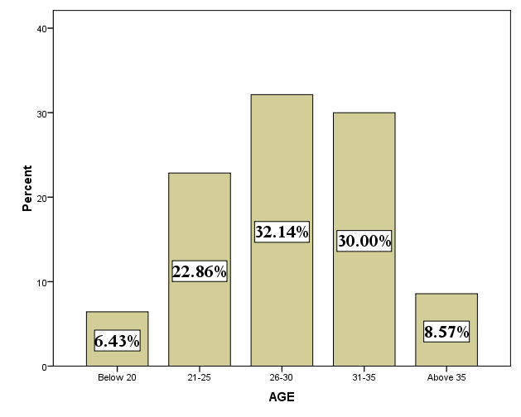

It is interpreted from the above table that 6% of the respondents belong to the age group of below 20.23% of the respondents belong to the age group of 21-25.32% of the respondents belong to the age group of 26-30.30% of the respondents belong to the age group of 31-35 and 9% of the employees belong to the age group of above 35.It is inferred from the above table that maximum of the respondents belong to the age group of 26-30.

TABLE NO: 2
GENDER
Gender is the demographic variable which reflects their work life balance and this help to identify the impact of work life balance between the genders.
GENDER | RESPONDENTS | PERCENTAGE
Male | 119 | 85
Female | 21 | 15
TOTAL | 140 | 100

CHART NO: 2
GENDER
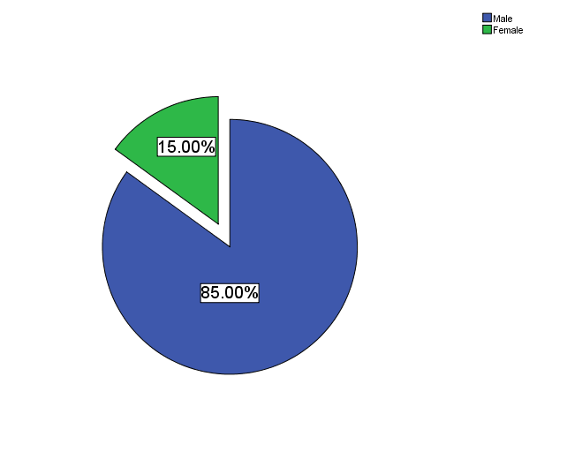

It is interpreted from the above table that 85% of the respondents are male and 15% of the respondents are female. It is inferred from above table that maximum of the respondents are male.

TABLE NO: 3
QUALIFICATION
Qualification is the educational qualification of the employees working in the organization.
QUALIFACTION | RESPONDENTS | PERCENTAGE
Schooling | 12 | 09
Under Graduate | 35 | 25
Post Graduate | 17 | 12
Diploma | 76 | 54
Others | 0 | 0
TOTAL | 140 | 100

CHART NO: 3
QUALIFICATION
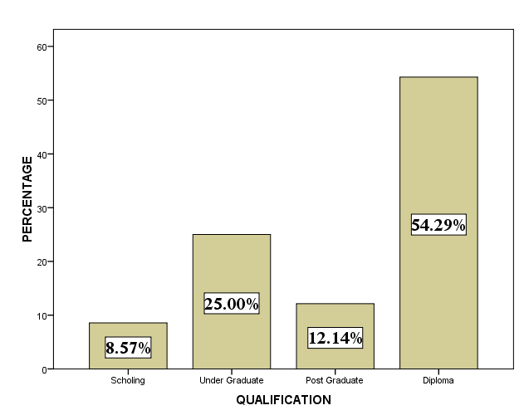

It is interpreted from the above table that 9% of the respondents have completed their schooling. 25% of the respondents have completed their under graduation.12% of the respondents have completed their post-graduation and 54% of the respondents have completed their diploma. It is inferred from the above table that maximum of the respondents have completed their diploma.

TABLE NO: 4
MARITAL STATUS
The marital status is the civil status of each individual in relation to the marriage laws and customs of the country and this helps the researcher to know about the impact of work life conflict.
MARATIAL STATUS | RESPONDENTS | PERCENTAGE
Married | 105 | 75
Unmarried | 35 | 25
TOTAL | 140 | 100

CHART NO: 4

MARATIAL STATUS

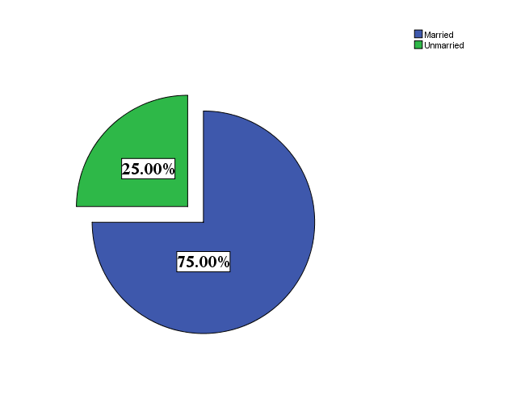

It is interpreted from the above table that 75% of the respondents are married and 25% of the respondents are unmarried. It is inferred from the above table that maximum of the respondents are married.

TABLE NO: 4.1
EMPLOYMENT OF THE SPOUSE
The table belowexplains whether the employees spouse is employed or not. Thus it helps to identify the level of work life balance
STATUS OF EMPLOYMENT | RESPONDENTS | PERCENTAGE
Yes | 116 | 83
No | 24 | 17
TOTAL | 105 | 100

CHART NO: 4.1
EMPLOYMENT OF THE PARTNER
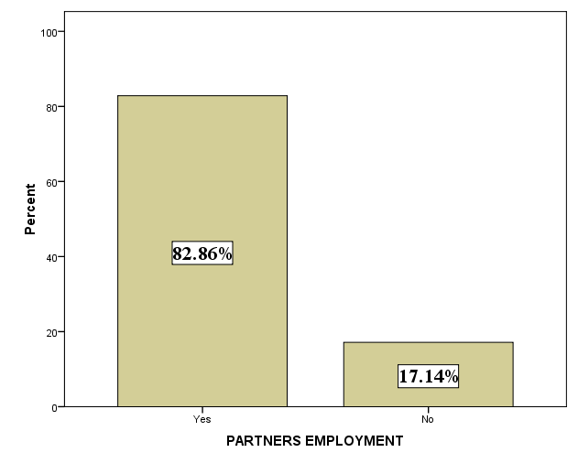

It is interpreted from the above table that 58% of the employees’ partners are employed and 25% of the employees’ partners are not employed. It is inferred from above table that maximum number of employees’ partner is employed.

TABLE NO: 5
NUMBER OF CHILDREN
The Number of children of employees will have an effect on their work life balance.
CHILDREN | RESPONDENTS | PERCENTAGE
Yes | 92 | 88
No | 12 | 12
TOTAL | 104 | 100

CHART NO: 5
NUMBER OF CHILDREN
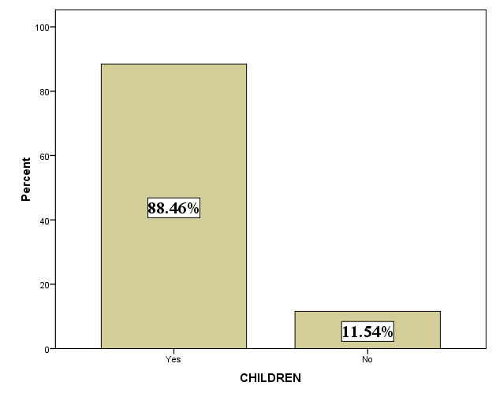

It is interpreted from the above table that 88% of the employees’ have children and 12% of the employees have no children. It is inferred from the above table that maximum of the respondents have children.

TABLE NO: 5.1
TAKING CARE OF CHILDREN
When both the partners are employed at home children has to be taken care to have a level of work life balance and also helps to know about the people supporting them to have a work life balance.
BABY SITTING | RESPONDENTS | PERCENTAGE
Spouse | 26 | 28
In-Laws | 23 | 25
Parents | 43 | 47
Servants | 0 | 0
Day care centers | 0 | 0
TOTAL | 92 | 100

CHART NO: 5.1
CHILDREN CARE
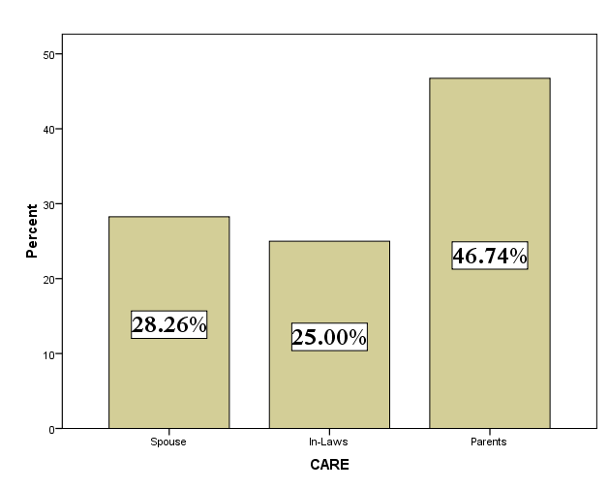
It is interpreted from the above table that 28% of the children are taken care by the spouse 25% of the children are taken care of by the in-laws 47% of the children are taken care of by the parents.

TABLE NO: 5.2
TIME SPENT WITH CHILDREN
When both the parents are employed they should have time to spent with children after work which will help them to have a balance in life.
TIME WITH CHILDREN | RESPONDENTS | PERCENTAGE
Less than 2 hours | 0 | 0
2-4 hours | 6 | 07
4-6 hours | 75 | 81
More than 6 hours | 11 | 12
TOTAL | 92 | 66

CHART NO: 5.2
TIME SPENT WITH CHILDREN
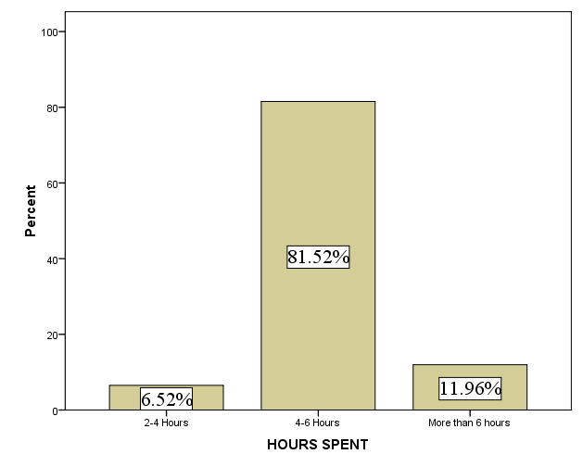

It is interpreted from the above table that 7% of the employees’ spend 2-4 hours with their children 81% of the employees spend 4-6 hours with their children and 12% of the employees spend more than 6 hours with their children. It is inferred from the above table that maximum of the respondents spend more than 6 hours with their children.

TABLE NO: 6
WORKING DAYS OF THE EMPLOYEES
Working days of the employees is the number of days the employee has to work in a week and that havea major impact on the stress level of the employees.
WORKING DAYS | RESPONDENTS | PERCENTAGE
Less than 5 days | 0 | 0
5 days | 0 | 0
6 days | 140 | 100
7 days | 0 | 0
TOTAL | 140 | 100

CHART NO: 6
WORKING DAYS OF THE EMPLOYEES
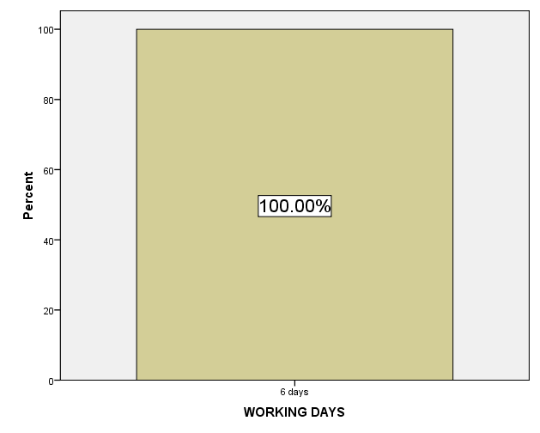

It is interpreted from the above table that 100% of the respondents’ works for 6 days and none of the respondents work more than 6 days and it is inferred from the above table that all the respondents’ work for 6 days.

TABLE NO: 7
WORKING HOURS OF EMPLOYEES
Hours spent by the employees at the work and this directly have an impact of work life balance.
HOURS OF WORK | RESPONDENTS | PERCENTAGE
7-8 hours | 19 | 14
8-9 hours | 63 | 45
9-10 hours | 55 | 39
10-12 hours | 3 | 2
More than 12 hours | 0 | 0
TOTAL | 140 | 100

CHART NO: 7
WORKING HOURS OF THE EMPLOYEES
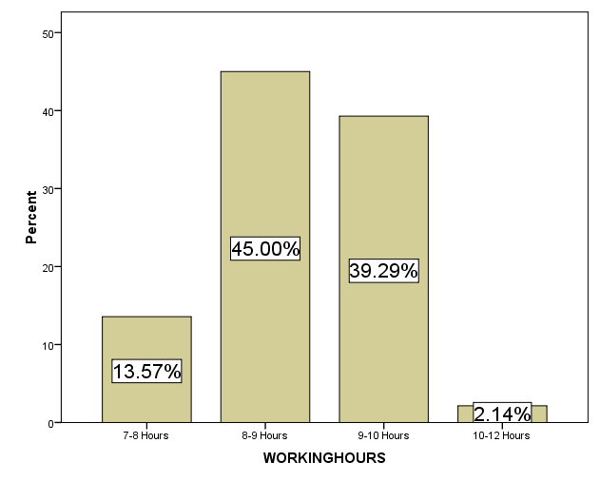

It is interpreted from the above table that 14% of the work for 7-8 hours, 45% of the respondents works for 8-9 hours, 39% of the respondents work for 9-10 hours and 2 % of the respondents work for 10-12 hours and it is inferred from the above table that 45% of the respondents work for 8-9 hours.

TABLE NO: 8
TRAVELLING FOR WORK
Time spent at travelling for work by the employees which has an impact on the work life conflict.
TRAVELLING FOR WORK | RESPONDENTS | PERCENTAGE
Less than half an hour | 14 | 10
Nearly one hour | 97 | 69
Nearly two hours | 25 | 18
More than two hours | 4 | 03
TOTAL | 140 | 100

CHART NO: 8
TRAVELLING FOR WORK
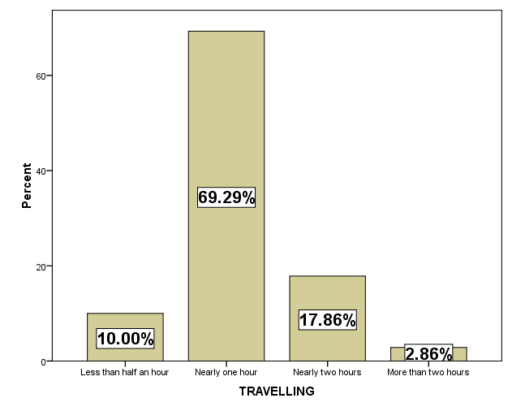

It is interpreted from the above table that 10% of the respondents travels less than half an hour for work.69% of the employees travel nearly one hour work.18% of the employees travel nearly two hours for work and 3% of the employees travel more than 2 hours for work. It is inferred from the above table that maximum of the respondents travel nearly one hour for work.

TABLE NO: 9
WORK SHIFT OF EMPLOYEES
Work shift of the employees is the difference in the working hours of the employees which has an impact on work life balance of the employees.
SHIFT WORK | RESPONDENTS | PERCENTAGE
General shift /Day shift | 59 | 42
Night Shift | 32 | 23
Rotational | 49 | 35
TOTAL | 140 | 100

CHART NO: 9
WORK SHIFT OF EMPLOYEES
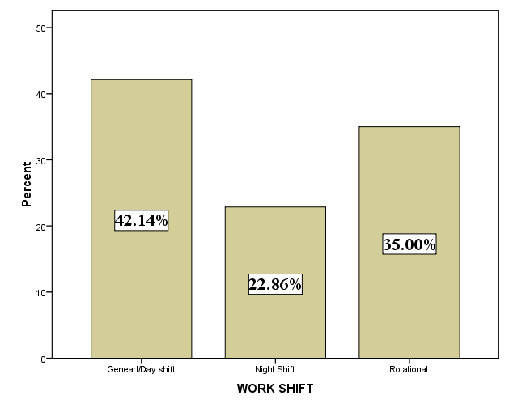

It is interpreted from the above table that 42% of the employees work in the day shift.23% of the employees work in the night shift and 35% of the employees work in the rotational shift. It is inferred from the above table that maximum of the employees work in the day shift.

TABLE NO: 10
CLARITY OF THE GOALS
Work management of the employees is that how the employees manage their task that is assigned to them and that impact their time spent in the organization.
RESPONSE | RESPONDENTS | PERCENTAGE
Strongly Agree | 99 | 71
Agree | 31 | 22
Neutral | 10 | 07
Disagree | 0 | 0
Strongly Disagree | 0 | 0
TOTAL | 140 | 100

CHART NO: 10
CLARITY OF THE GOALS
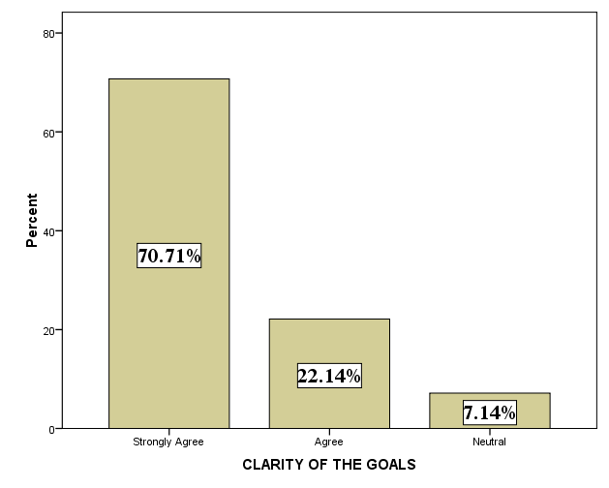

The above table describes the work management of the employees through clarity of the goals.71% of the employees strongly agree that work can be easily managed through clarity of the goals.22% of the employees agree that work can be managed through clarity of the goals.7% of the employees are neutral with their response. It is inferred from the above table that 71% of the respondents strongly agree that work can be easily manage their work through clarity of the goals.

TABLE NO: 11
SET CLEAR EXPECTATION
Employees manage their work through having a clear expectation about the task given to them.
RESPONSE | RESPONDENTS | PERCENTAGE
Strongly Agree | 47 | 34
Agree | 76 | 54
Neutral | 17 | 12
Disagree | 0 | 0
Strongly Disagree | 0 | 0
TOTAL | 140 | 100

CHART NO: 11
SET CLEAR EXPECTATION
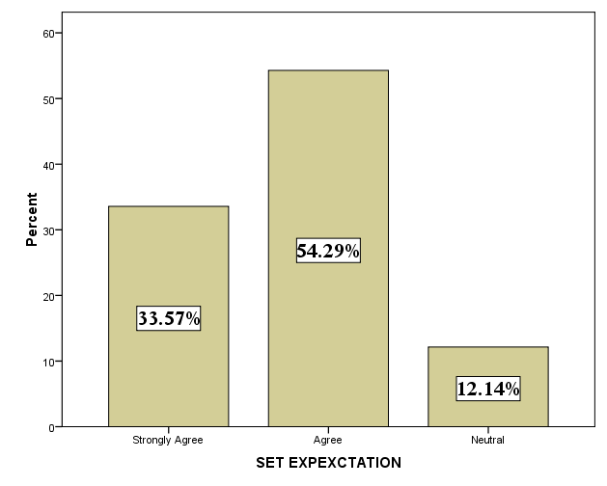

From the above table it is interpreted that 34% of the respondents strongly agree that they manage their work by setting clear expectation.54% of the respondents agree that they manage their work by setting clear expectation.12% of the employees were neutral with their response. It is inferred from the above table that 34% of the respondents strongly agree that they can manage their work by setting clear expectation.

TABLE NO: 12
DISTRIBUTE TASK EFFICIENCY
Employees can easily manage their through distributing their task to subordinates.
RESPONSE | RESPONDENTS | PERCENTAGE
Strongly Agree | 56 | 40
Agree | 64 | 46
Neutral | 20 | 14
Disagree | 0 | 0
Strongly Disagree | 0 | 0
TOTAL | 140 | 100

CHART NO: 12
DISTRIBUTE TASK EFFICIENCY
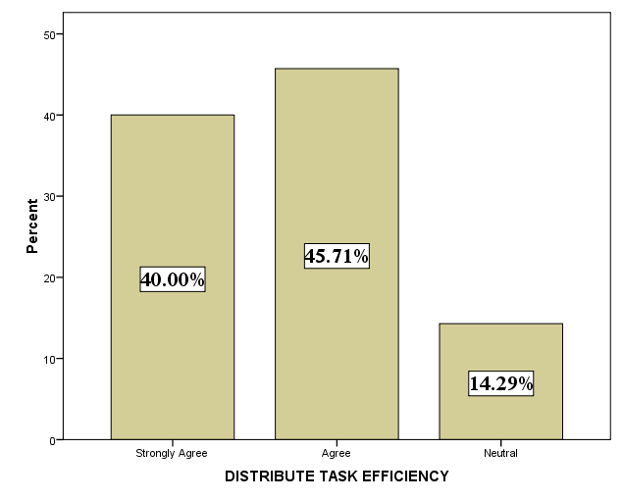

From table it is interpreted that the 40% of the respondents strongly agree that manage their work by distributing the task efficiently.46% of the respondents agree that manage their work by distributing the task efficiently.14% of the respondents are neutral with their response. It is interpreted from the above table that 40% of the respondents strongly agree that they manage their work by distributing the task efficiently.

TABLE NO: 13
EQUIP BEFORE ASSIGNMENT
Employees can manage their work in a better way if they are equipped before the task is assigned to them.
RESPONSE | RESPONDENTS | PERCENTAGE
Strongly Agree | 41 | 29
Agree | 67 | 48
Neutral | 32 | 23
Disagree | 0 | 0
Strongly Disagree | 0 | 0
TOTAL | 140 | 100

CHART NO: 13
EQUIP BEFORE ASSIGNMENT
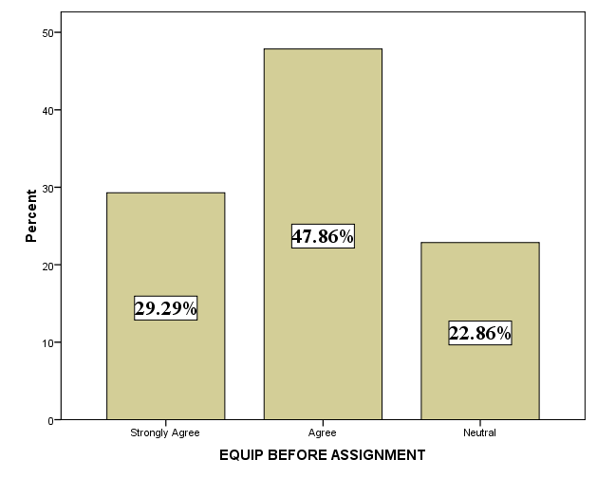

It is interpreted from the above table that 29% of the respondents strongly agree that they can manage their work by being equipped before the assignment.48% of the respondents strongly agree that they can manage their work by being equipped before the assignment.23% of the respondents are neutral with their response and it is inferred from the above table that majority of the respondents agree that they can manage their work by being equipped before the assignment.

TABLE NO: 14
COMMUNICATION
Employees can manage their through having a proper communication with their team members regarding the task.
RESPONSE | RESPONDENTS | PERCENTAGE
Strongly Agree | 66 | 47
Agree | 57 | 41
Neutral | 17 | 12
Disagree | 0 | 0
Strongly Disagree | 0 | 0
TOTAL | 140 | 100

TABLE NO: 14
COMMUNICATION
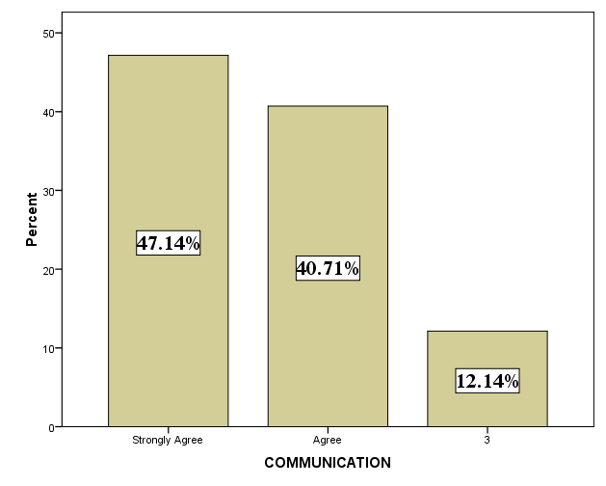
It is interpreted from the above table that 47% of the respondents strongly agree that they can manage their by communication.41% of the respondents agree that they can manage their by communication.12% of the respondents are neutral with their response and it is inferred from above table that 47% of the respondents strongly agree that they can manage their by communication.

TABLE NO: 15
PLAN ROUTINE TASK
Planning their routine task will help the employees to manage their work in a better way.
RESPONSE | RESPONDENTS | PERCENTAGE
Strongly Agree | 57 | 41
Agree | 72 | 51
Neutral | 11 | 08
Disagree | 0 | 0
Strongly Disagree | 0 | 0
TOTAL | 140 | 100

TABLE NO: 15
PLAN ROUTINE TASK
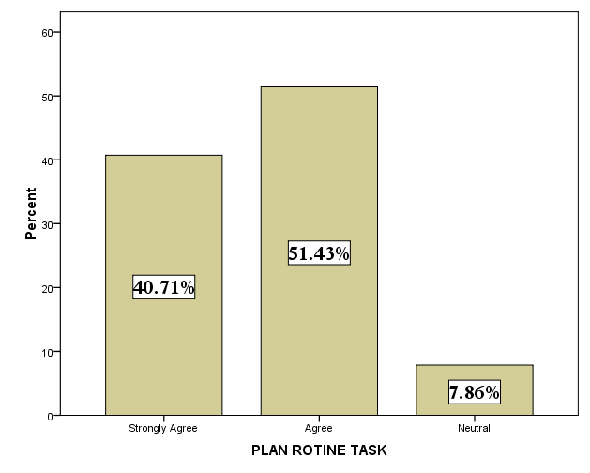

It is interpreted from the above table that 41% of the respondents strongly agree that they can manage their work by planning their routine task.51% of the respondents agree that they can manage their work by planning their routine task.8% of the respondents are neutral with their response. It is inferred from the above table that majority of the respondents agree that they can manage their work by planning their routine task.

TABLE NO: 16
FLEXI SCHEDULE
Flexible schedule will help the employees to manage their work in better way.
RESPONSE | RESPONDENTS | PERCENTAGE
Strongly Agree | 76 | 54
Agree | 56 | 40
Neutral | 8 | 06
Disagree | 0 | 0
Strongly Disagree | 0 | 0
TOTAL | 140 | 100

CHART NO: 16
FLEXI SCHEDULE
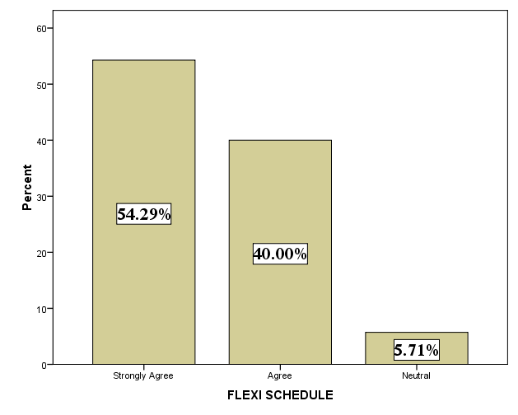

It is interpreted from table that 54% of the respondents can manage their work with flexible schedule.40% of the respondents can manage their work with flexible schedule.6% of the respondents are neutral with their response. It is inferred from the above table that 54% of the respondents strongly agree that they can manage their work with flexible schedule.

TABLE NO: 17
WORKING OVER TIME IN THE INDUSTRY
Employees work over time in the organization which will have an impact on work life balance.
RESPONSE | RESPONDENTS | PERCENTAGE
Yes | 117 | 84
No | 23 | 16
TOTAL | 140 | 100

TABLE NO: 17
WORKING OVER TIME IN THE INDUSTRY
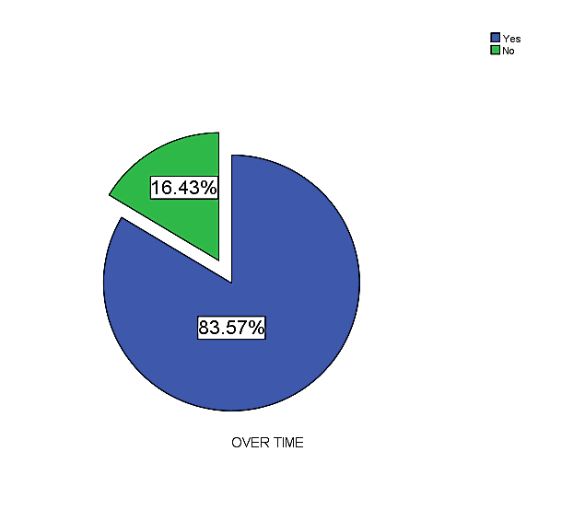

It is interpreted from above table that 84% of the respondents work overtime.16% of the respondents does not work over time and it is inferred from above table that the majority of the respondents work over time.

TABLE NO: 18
THINKING ABOUT WORK
Thinking about work at home this help the researcher to find out the level of commitment of the respondents towards work life balance.
RESPONSE | RESPONDENTS | PERCENTAGE
Never think about work | 0 | 0
Rarely | 42 | 30
Often | 79 | 56
Always | 19 | 14
TOTAL | 140 | 100

CHART NO: 18
THINKING ABOUT WORK

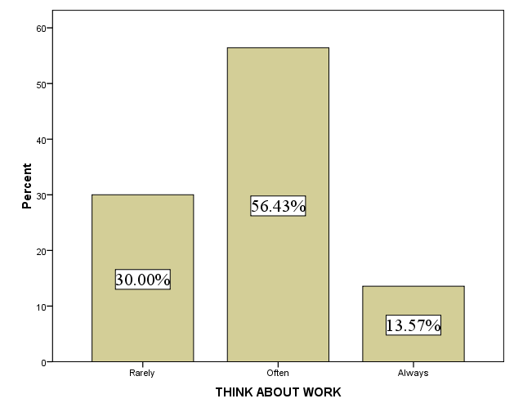

It is interpreted from the above table that 30% of the respondents rarely think about work. 56% of the respondents often think about work.14% of the respondents always think about work and it is inferred from the above table that maximum of the respondents often think about work.

TABLE NO: 19
TIME SPENT AT WORK
Time spend at work is the amount of time of time spend by the each respondent at work and this has an impact on the work life balance of the employees.
RESPONSE | RESPONDENTS | PERCENTAGE
Very Happy | 24 | 17
Happy | 116 | 83
Very Unhappy | 0 | 0
Unhappy | 0 | 0
TOTAL | 140 | 100

CHART NO: 19
TIME SPENT AT WORK
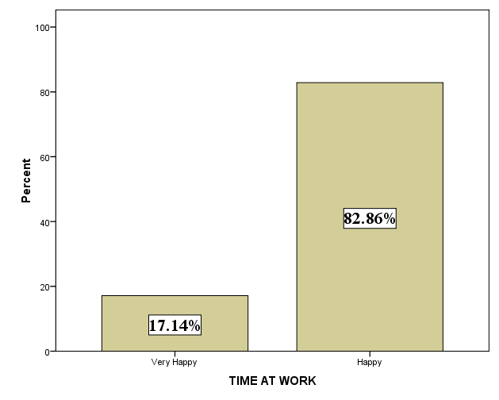
It is interpreted from above table that 17% of the respondents are very happy with time at work.83% of the respondents are happy with the time at work and it is inferred from the table that majority of the respondents are happy with time at work.

TABLE NO: 20
QUALITY TIME WITH FAMILY
Time spend with the family by the employees has an impact in the work life balance of the employees.
RESPONSE | RESPONDENTS | PERCENTAGE
Never | 3 | 02
Rarely | 101 | 72
Often | 36 | 26
Always | 0 | 0
TOTAL | 140 | 100

CHART NO: 20
QUALITY TIME WITH FAMILY
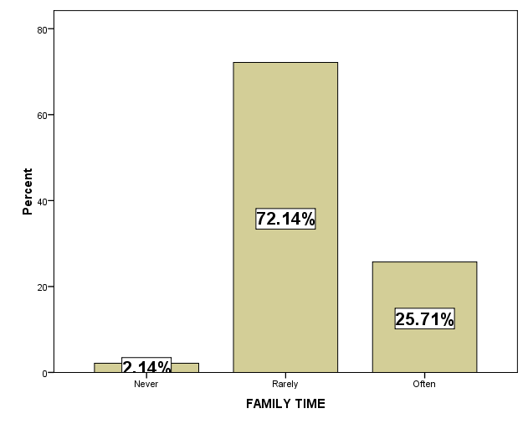

It is interpreted from the above table that 3% of the respondents never miss their quality time with the family.72% of the respondents rarely miss their quality time with the family.26% of the respondents often miss their quality time with the family and it is inferred from the above table that majority of the respondents rarely miss their quality time with family.

IMPACT ON WORK LIFE BALANCE
TABLE NO: 21
WORKING HOURS
There a lot of factors affecting the work life balance of the respondents. Working hours is one the factor that affects the work life balance of the employees.
RESPONSE | RESPONDENTS | PERCENTAGE
Strongly Agree | 88 | 63
Agree | 45 | 32
Neutral | 7 | 05
Disagree | 0 | 0
Strongly Disagree | 0 | 0
TOTAL | 140 | 100

CHART NO: 21
WORKING HOURS
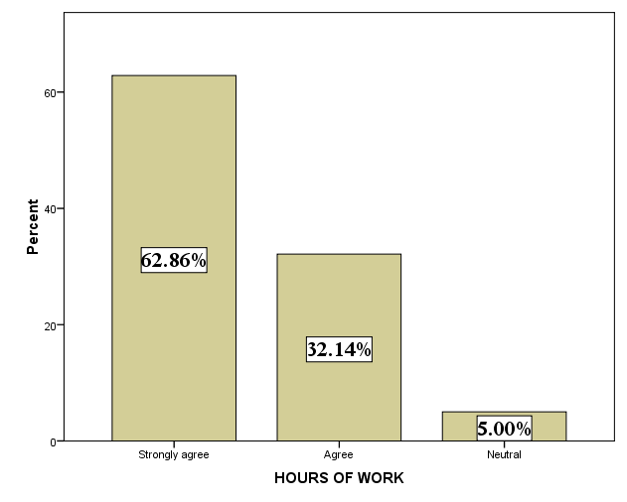

It is interpreted from the above table that 63% of the respondents strongly agree that working hours have an impact on the work life balance. 32% of the respondents agree that working hours have an impact on the work life balance.5% of the employees are neutral with their response and it is inferred from table that majority of the respondents agree that working hours have an impact on work life balance.

TABLE NO: 22
WORK TRAVEL
Travelling for work by the employees is one of the factors that have an impact on the stress level and the work life balance of the employees.
RESPONSE | RESPONDENTS | PERCENTAGE
Strongly Agree | 39 | 28
Agree | 84 | 60
Neutral | 14 | 10
Disagree | 3 | 02
Strongly Disagree | 0 | 0
TOTAL | 140 | 100

CHART NO: 22
WORK TRAVEL
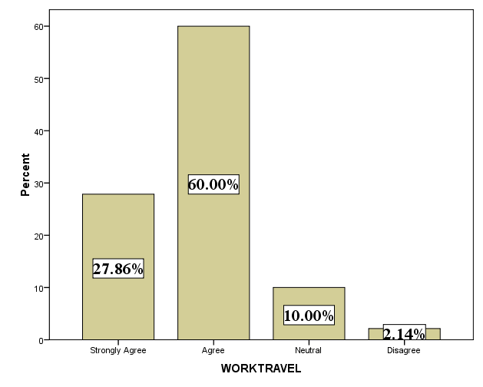

It is interpreted from the above table that 28% of the respondents strongly agree that work travel has an impact on the work life balance.60% of the respondents agree that work travel has an impact on the work life balance. 10% of the respondents are neutral with their response.2% of the respondents disagree that work travel has an impact on the work life balance. It is inferred from the above table that majority of the respondents agree that that work travel has an impact on the work life balance.

TABLE NO: 23
UNPAID TIME OFF
Unpaid time off is that taking time off during the working days in the organization for which the employee will not be paid
RESPONSE | RESPONDENTS | PERCENTAGE
Strongly Agree | 34 | 24
Agree | 63 | 45
Neutral | 42 | 30
Disagree | 1 | 01
Strongly Disagree | 0 | 0
TOTAL | 140 | 100

TABLE NO: 23
UNPAID TIME OFF
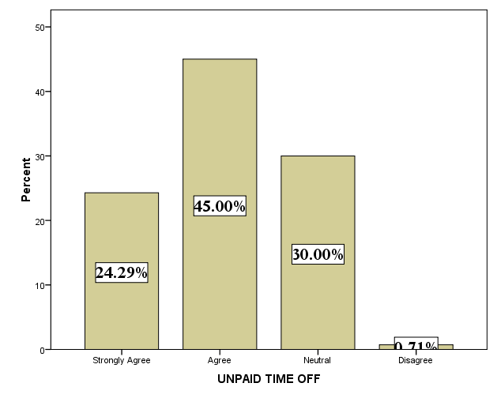

It is interpreted from above table that 24% of the respondents strongly agree that unpaid time off has an impact on work life balance.45% of the respondents agree that unpaid time off has an impact on work life balance.30% of the respondents are neutral with their resonse.1% of the respondents disagree that unpaid time off has an impact on work life balance and it is inferred from the above table that majority of the respondents agree that unpaid time off has an impact on work life balance.
TABLE NO: 24

CHILDREN REARING
Taking care of the children is the most important task which has a direct impact on the work life balance
RESPONSE | RESPONDENTS | PERCENTAGE
Strongly Agree | 41 | 29
Agree | 75 | 54
Neutral | 24 | 17
Disagree | 0 | 0
Strongly Disagree | 0 | 0
TOTAL | 140 | 100

TABLE NO: 24
CHILDREN REARING
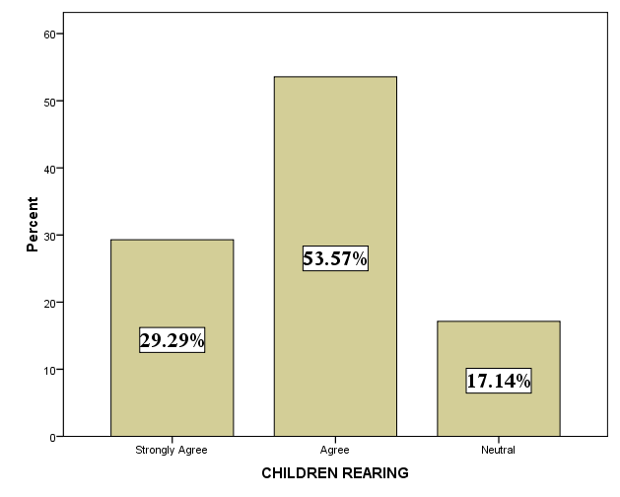
It is interpreted from table 24% of the respondents strongly agree that child rearing has an impact on the work life balance.54% of the respondents agree that child rearing has an impact on the work life balance.17% of the respondents are neutral with their response and if is inferred from the above table that majority of the respondents agree that child rearing has an impact on the work life balance.

TABLE NO: 25
FAMILY COMMITMENT
Commitment towards family this factor has a major role in the impact of work life balance and this helps the researcher to know about the level of the work life balance.
RESPONSE | RESPONDENTS | PERCENTAGE
Strongly Agree | 55 | 39
Agree | 70 | 50
Neutral | 15 | 11
Disagree | 0 | 0
Strongly Disagree | 0 | 0
TOTAL | 140 | 100

CHART NO: 25
FAMILY COMMITMENT
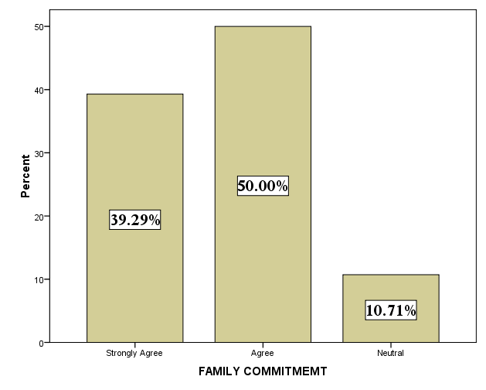

It is interpreted from above table that 39% of the respondents strongly agree that family commitment has an impact on work life balance.50% of the respondents agree that family commitment has an impact on work life balance. 11% of the respondents are neutral with their response and it is inferred from above table that majority of the respondents agree that family commitment has an impact on work life balance.

TABLE NO: 26
SHIFT WORK
Shift work is that changes in the working time of the employees some employees may have day shift and others night shift this has a direct impact on the work life balance of the employees.
RESPONSE | RESPONDENTS | PERCENTAGE
Strongly Agree | 59 | 42
Agree | 66 | 47
Neutral | 13 | 09
Disagree | 1 | 01
Strongly Disagree | 1 | 01
TOTAL | 140 | 100

CHART NO: 26
SHIFT WORK
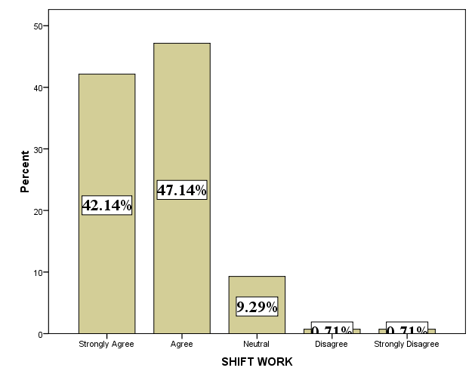

It is interpreted from above table that 42% of the respondents strongly agree that shift work has an impact on work life balance.47% of the respondents agree that shift work has an impact on work life balance.9% of the respondents are neutral with their response.1% of the disagree that shift work has an impact on work life balance. 1% of the respondents strongly disagree that shift work has an impact on work life balance and it is inferred from above table that majority of the respondents agree that shift work has an impact on work life balance.

TABLE NO: 27
TIME SPENT ON MEETINGS/TRAINING
Training and meeting in the organization taken time, since it will beyond the working hours in the organization. This will have an impact on the work life balance.
RESPONSE | RESPONDENTS | PERCENTAGE
Strongly Agree | 66 | 47
Agree | 61 | 44
Neutral | 12 | 08
Disagree | 1 | 01
Strongly Disagree | 0 | 0
TOTAL | 140 | 100

TABLE NO: 27
TIME SPENT ON MEETINGS/TRAINING
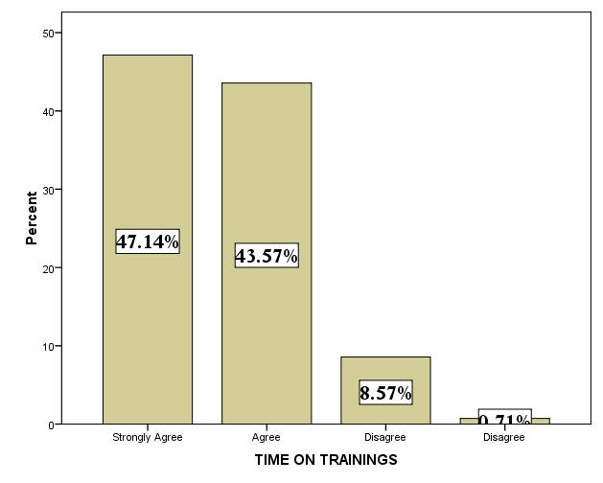

It is interpreted from above table that 47% of the respondents strongly agree that time spent on training /meetings have an impact on the work life balance.44% of the respondents agree that time spent on training /meetings have an impact on the work life balance.8% of the respondents disagree that time spent on training /meetings have an impact on the work life balance.1% of the respondents strongly disagree that time spent on training /meetings have an impact on the work life balance and it is inferred from above table that majority of the respondents agree that time spent on training /meetings have an impact on the work life balance.

TABLE NO: 28
WORK LIFE POLICIES
Work life policies are the programs offered by the organization or the welfare measures to help the employees to balance their work life.
RESPONSE | RESPONDENTS | PERCENTAGE
Yes | 140 | 100
No | 0 | 0
TOTAL | 104 | 100

CHART NO: 28
WORK LIFE POLICIES
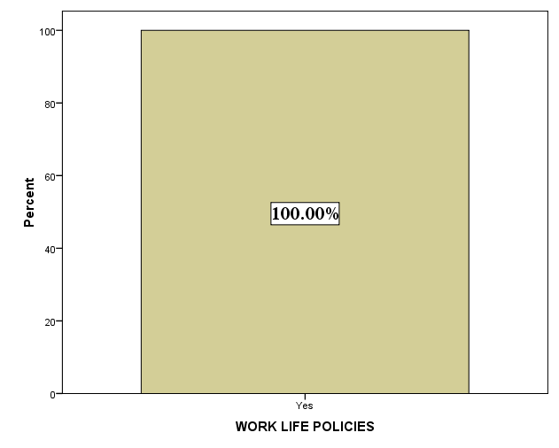

It is interpreted from the above table that 100% of the respondents use the work life policies provided by the organization.

TABLE NO: 29
BALANCING WORK LIFE COMMITMENTS
SUPPORT FROM MANAGER
Balancing work life commitments as an individual is difficult thus lot of people help us in our day today life to balance our work life commitments.
RESPONSE | RESPONDENTS | PERCENTAGE
Yes | 140 | 100
No | 0 | 0
Not available to me | 0 | 0
Not applicable to me | 0 | 0
TOTAL | 140 | 100

CHART NO: 29
SUPPORT FROM MANAGER
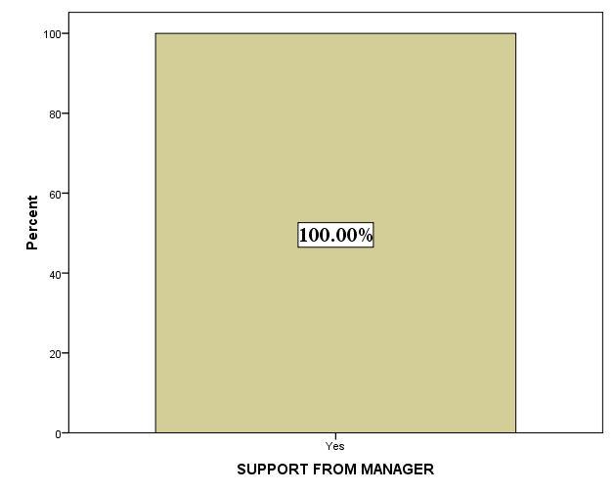

It is interpreted from the above table that 100% of the respondents require the support of the manager for balancing work life commitments.

TABLE NO: 30
SUPPORT FROM COLLEAGUES
Colleagues are members of the organization who work along with the employees in the organization and help the employees to balance the work life commitments.
RESPONSE | RESPONDENTS | PERCENTAGE
Yes | 129 | 92
No | 8 | 06
Not available to me | 3 | 02
Not applicable to me | 0 | 0
TOTAL | 140 | 100

TABLE NO: 30
SUPPORT FROM COLLEAGUES
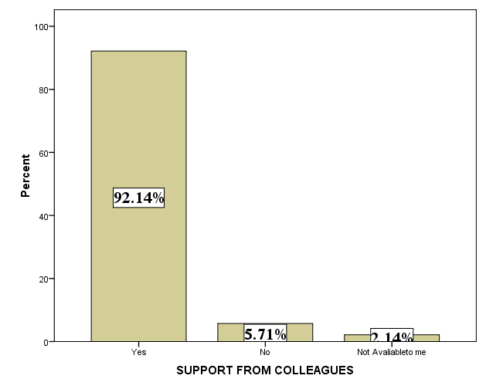

It is interpreted from above table that 92% of the respondents requires the support of colleagues for balancing work life commitments.6% of the respondents do not require the support of the colleagues. 2% of the respondents say that support of colleagues are not available to them and it is inferred from above table that majority of the respondents requires the support of the colleagues.

TABLE NO: 31
SUPPORT FROM TEAM MEMEBERS
Team members are people who work with the employees in the same department and help the employees to balance the work life commitments.
RESPONSE | RESPONDENTS | PERCENTAGE
Yes | 125 | 89
No | 9 | 07
Not available to me | 6 | 04
Not applicable to me | 0 | 0
TOTAL | 140 | 100

CHART NO: 31
SUPPORT FROM TEAM MEMEBERS
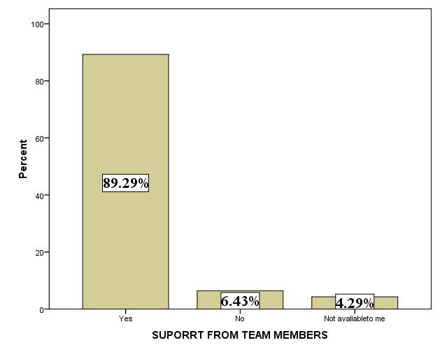

It is interpreted from the above table that 89% of the respondents require the support of the team members for balancing work life commitments.7% of the respondents say that they do not require the support of team members for balancing work life commitments.4% of the respondents say that support of the team members is not available for them for balancing work life commitments and it is inferred from the above table that majority of the respondents require the support of team members for balancing work life commitments.

TABLE NO: 32
SUPPORT FROM PARENTS
Employees working have to have a support from the parents who will help the employees to balance their work life commitments.
RESPONSE | RESPONDENTS | PERCENTAGE
Yes | 136 | 98
No | 2 | 01
Not available to me | 2 | 01
Not applicable to me | 0 | 0
TOTAL | 140 | 100

CHART NO: 32
SUPPORT FROM PARENTS
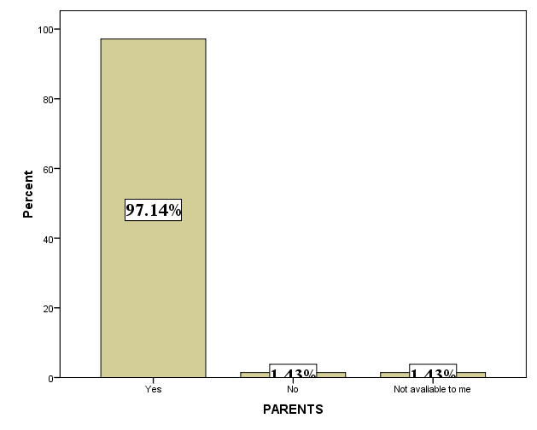

It is interpreted from above table that 98% of the respondents require the support of parents for balancing work life commitments.1% of the respondents do not require the support of the parents for balancing work life commitments.1% of respondents do not have the support of parents for balancing work life commitments and it is inferred from the above table that 98% of the respondents require the support of parents for balancing work life commitments.

TABLE NO: 33
SUPPORT FROM IN-LAWS
Employees to have a balance in their work life commitments require the help of the in-laws.
RESPONSE | RESPONDENTS | PERCENTAGE
Yes | 76 | 54
No | 10 | 07
Not available to me | 23 | 17
Not applicable to me | 31 | 22
TOTAL | 140 | 100

CHART NO: 33
SUPPORT FROM IN-LAWS
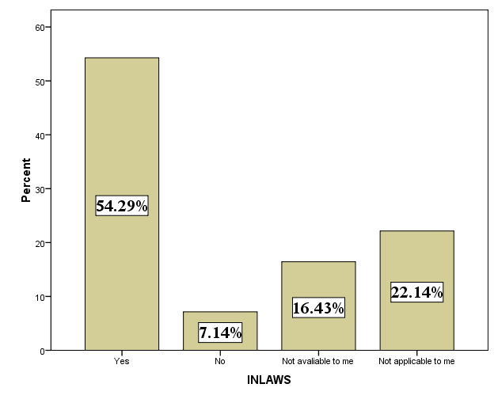

It is interpreted from above table that 54% of the respondents requires the support of the in-laws for balancing work life commitments.7% of the respondents do not require the support of in laws for balancing work life commitments.17% of the respondents says that In-laws support is not available to them.22% of the say that In-laws support is not applicable to them and it is inferred from above table that majority of the respondents require the support of In-laws for balancing work life commitments.

TABLE NO: 34
SUPPORT FROM SPOUSE
Employees working have to have the support of their spouse for better balance of their work life commitments.
RESPONSE | RESPONDENTS | PERCENTAGE
Yes | 100 | 71
No | 7 | 05
Not available to me | 9 | 07
Not applicable to me | 24 | 17
TOTAL | 140 | 100

CHART NO: 34
SUPPORT FROM SPOUSE
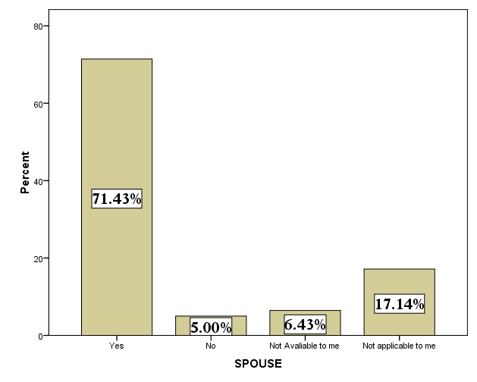

It is interpreted from above table that 71% of the respondents require the support of spouse for balancing work life comitments.5% of respondents do not require the support of spouse balancing work life commitments.7% of the respondents says that support of spouse is not available to them.17% of the respondents says that support of spouse is not applicable to them and it is inferred from above table that 71% of the respondents require the support of spouse for balancing work life commitments.

TABLE NO: 35
MANAGING STRESS
Stress management is managing their stress rising out of work through various ways in order to have better work life balance.
MANAGING STRESS OPTIONS | RESPONDENTS | PERCENTAGE
Yoga | 5 | 04
Meditation | 39 | 28
Entertainment | 58 | 41
Music | 32 | 23
Others | 6 | 04
TOTAL | 140 | 100

CHART NO: 35
MANAGING STRESS
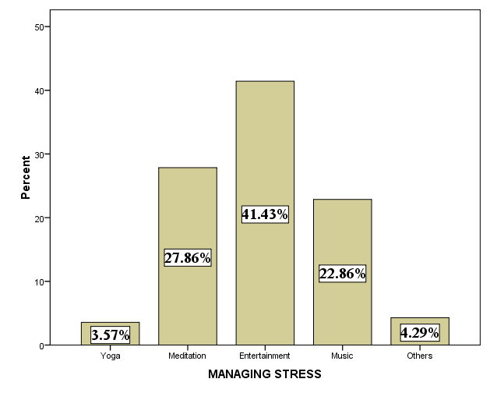

It is interpreted from the above table that 4% of the respondents do yoga to manage their stress. 28% of the respondents meditate to manage their stress.41% of the respondents has entertainment as their choice to manage their strees.23% of the respondents choose music has their medium to manage stress.4% of the respondents use other medium to manage their stress and it is inferred from the above table that majority of the respondents use entertainment as the medium to manage stress.

TABLE NO: 36
HEALTH CARE PACKAGE
All the organization provides health care packages to the employees working in their organization.
RESPONSE | RESPONDENTS | PERCENTAGE
Yes | 140 | 100
No | 0 | 0
TOTAL | 104 | 100

CHART NO: 36
HEALTH CARE PACKAGE

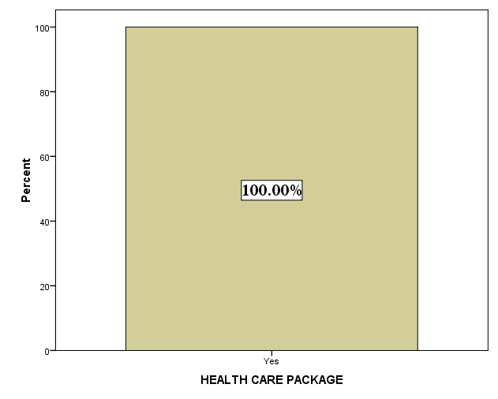

It is interpreted from above table that 100% of the respondents use the health care package provided by the organisation.

TABLE NO: 37
WORK LIFE CONFLICT
Every individual in life could have come across the work life conflict that has a direct impact on the work life balance of the employees.
RESPONSE | RESPONDENTS | PERCENTAGE
Yes | 140 | 100
No | 0 | 0
TOTAL | 140 | 100

CHART NO: 37
WORK LIFE CONFLICT
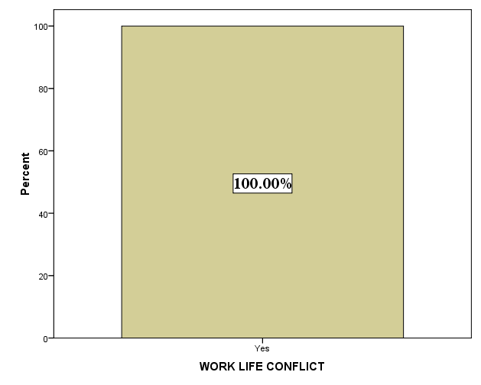

It is interpreted from above table that 100% of the respondents have experienced work life conflict.

TABLE NO: 38
FACTORS ARISING DUE TO WORK LIFE CONFLICT
PERSONAL FACTORS
MENTAL AND PHYSICAL HEALTH
There a lot of factors arising due to the work life conflict and one of the factors are that poor mental and physical health.
RESPONSE | RESPONDENTS | PERCENTAGE
Strongly Agree | 52 | 38
Agree | 74 | 53
Neutral | 13 | 09
Disagree | 1 | 01
Strongly Disagree | 0 | 0
TOTAL | 140 | 100

CHART NO: 38
MENTAL AND PHYSICAL HEALTH

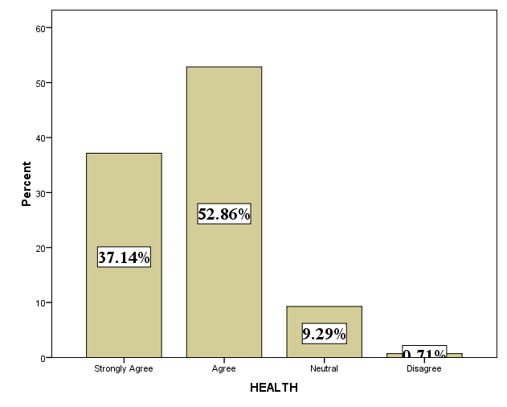

It is interpreted from above table that 38% of the respondents strongly agree that mental and physical health is a factor arising due to work life conflict.53% of the respondents agrees that mental and physical health is a factor arising due to work life conflict.9% of the respondents are neutral with their response.1% of the respondents disagree that mental and physical health is a factor arising due to work life conflict and it is inferred from the above table that 53% of the respondents agrees that mental and physical health is a factor arising due to work life conflict.

TABLE NO: 39
LIFE SATISFACTION
Life satisfaction is a factor that arises out of the work life conflict that has an impact on the work life balance of the employees.
RESPONSE | RESPONDENTS | PERCENTAGE
Strongly Agree | 64 | 46
Agree | 55 | 40
Neutral | 19 | 13
Disagree | 2 | 1
Strongly Disagree | 0 | 0
TOTAL | 140 | 100

CHART NO: 39
LIFE SATISFACTION
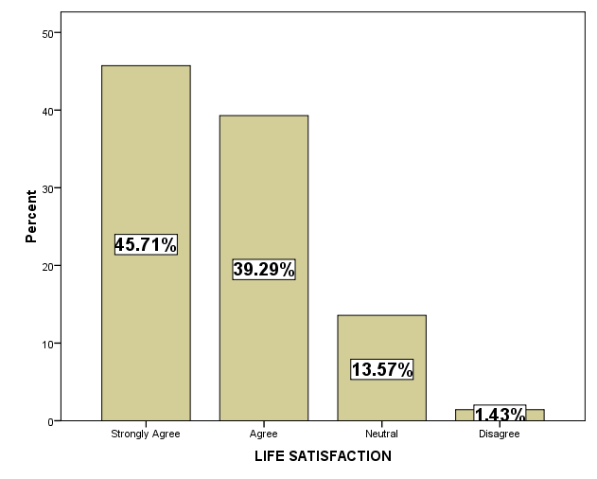

It is interpreted from above table that 46% of the respondents strongly agree that life satisfaction is a factor arising due to work life conflict.40% of the respondents agrees that life satisfaction is a factor arising due to work life conflict.13% of the respondents are neutral with their response.1% of the respondents disagree that life satisfaction is a factor arising due to work life conflict and it is inferred from above table that majority of the respondents strongly agree that life satisfaction is a factor arising due to work life conflict.

TABLE NO: 40
STRESS
Stress is the main factor that arises from the work life conflict and also has an impact on the work life balance.
RESPONSE | RESPONDENTS | PERCENTAGE
Strongly Agree | 56 | 40
Agree | 51 | 36
Neutral | 33 | 24
Disagree | 0 | 0
Strongly Disagree | 0 | 0
TOTAL | 140 | 100

CHART NO: 40
STRESS

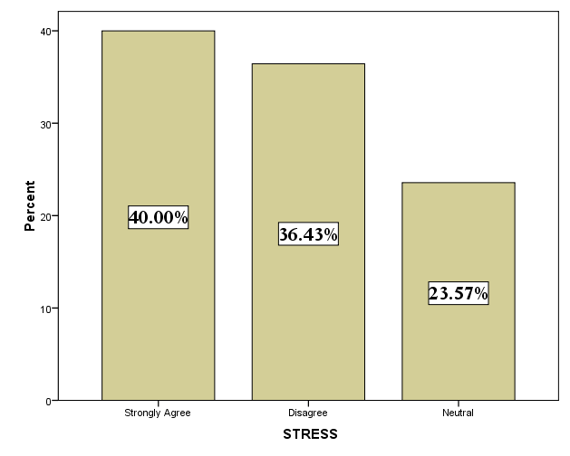

It is interpreted from above table that 40% of the employees strongly agree that stress is a factor arising due to work life conflict. 36% of the employees agree that stress is a factor arising due to work life conflict and 24% of the employees are neutral with their opinion and it is inferred from the above table that majority of the employees strongly agree that stress is a factor arising out of work life conflict,

TABLE NO: 41
EMOTIONAL EXHAUSTION
Higher level of the emotional exhaustion is factor that arising due to work life conflict when the employee is not able to manage the conflict there is a higher level emotional exhaustion
RESPONSE | RESPONDENTS | PERCENTAGE
Strongly Agree | 39 | 28
Agree | 74 | 53
Neutral | 27 | 19
Disagree | 0 | 0
Strongly Disagree | 0 | 0
TOTAL | 140 | 100

CHART NO: 41
EMOTIONAL EXHAUSTION
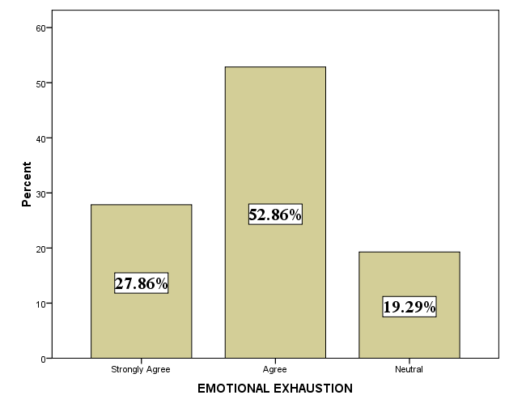

It is interpreted from above table that 28% of the respondents strongly agree that emotional exhaustion is a factor arising due to wok life conflict.53% of the respondents agrees that is a factor arising due to wok life conflict.19% of the respondents are neutral with their response and from the table it is inferred that majority of the respondents agrees that is a factor arising due to wok life conflict.

TABLE NO: 42
LESS PHYSICAL EXECRISE
Less physical exercise is a factor that arises due to the work life conflict and also has an impact on the work life balance.
RESPONSE | RESPONDENTS | PERCENTAGE
Strongly Agree | 47 | 34
Agree | 68 | 49
Neutral | 22 | 16
Disagree | 3 | 01
Strongly Disagree | 0 | 0
TOTAL | 140 | 100

CHART NO: 42
PHYSICAL EXECRISE
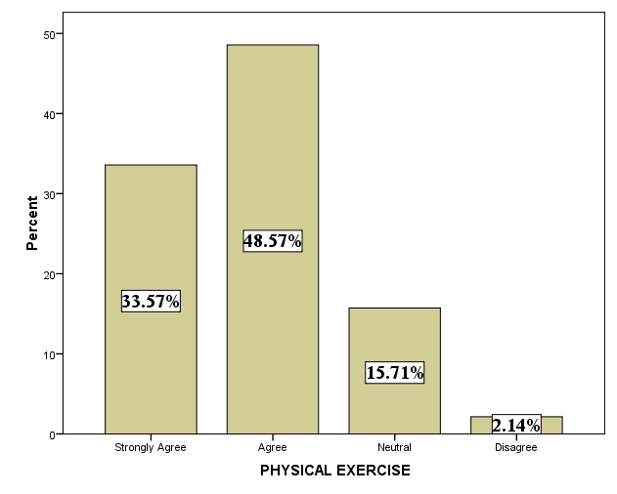

It is interpreted from above table that 34% of the respondents strongly agree that physical exercise is a factor arising due to work life conflict.49% of the respondents agrees that less physical exercise is a factor arising due to work life conflict.16% of the respondents are neutral with their opinion.1% of the respondents disagree that less physical exercise is a factor arising due to work life conflict and it is inferred from above table that majority of the respondents agrees that less physical exercise is a factor arising due to work life conflict.

TABLE NO: 43
ANXIETY AND DEPRESSION
Anxiety and depression is a state of fear and a concern that arises among the employees and it is reaction to a stressor.
RESPONSE | RESPONDENTS | PERCENTAGE
Strongly Agree | 59 | 42
Agree | 54 | 38
Neutral | 26 | 19
Disagree | 1 | 01
Strongly Disagree | 0 | 0
TOTAL | 140 | 100

CHART NO: 43
ANXIETY AND DEPRESSION
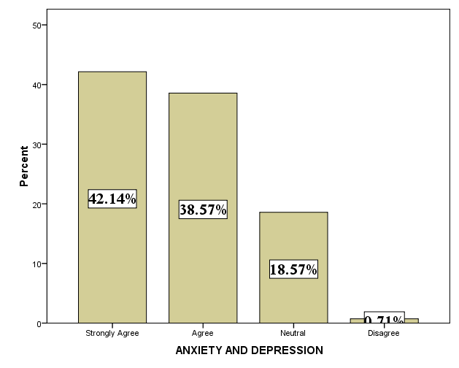

It is interpreted from above table that 42% of the respondents strongly agree that anxiety and depression is a factor arising due to work life conflict.38% of the respondents agrees that anxiety and depression is a factor arising due to work life conflict.19% of the respondents are neutral with their opinion.1% of the respondents disagree that anxiety is a factor arising due to work life conflict and it is inferred from above table that majority of the respondents strongly agree that anxiety and depression is a factor arising due to work life conflict.

TABLE NO: 44
APPETITE AND FATIGUE
Employees suffer from appetite and fatigue due to depression as a result of work life conflict
RESPONSE | RESPONDENTS | PERCENTAGE
Strongly Agree | 39 | 28
Agree | 75 | 54
Neutral | 26 | 18
Disagree | 0 | 0
Strongly Disagree | 0 | 0
TOTAL | 140 | 100

CHART NO: 44
APPETITE AND FATIGUE
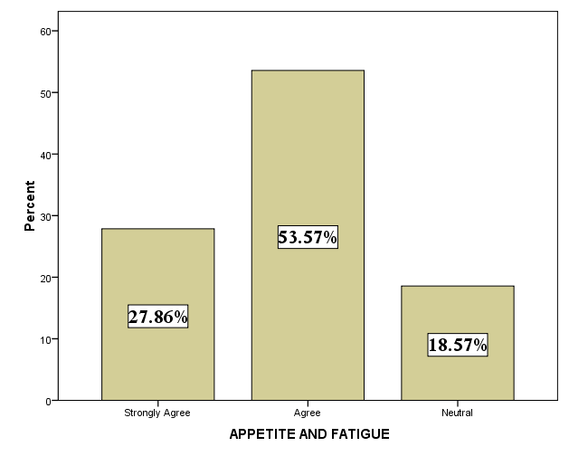

It is interpreted from above table that 28% of the respondents strongly agree that appetite and fatigue is a factor arising due to work life conflict.54% of the respondents agrees that appetite and fatigue is a factor arising due to work life conflict.18% of the respondents are neutral with their opinion and it is inferred from above table that majority of the respondents strongly agree that appetite and fatigue is a factor arising due to work life conflict.

TABLE NO: 45
ORGANISATIONAL FACTORS
JOB SATISFACTION
Employees when they are not happy with their personal life that automatically gets reflected in the work life of the employees thus results in decreased job satisfaction
RESPONSE | RESPONDENTS | PERCENTAGE
Strongly Agree | 63 | 45
Agree | 55 | 39
Neutral | 22 | 16
Disagree | 0 | 0
Strongly Disagree | 0 | 0
TOTAL | 140 | 100

CHART NO: 45
ORGANISATIONAL FACTORS
JOB SATISFACTION
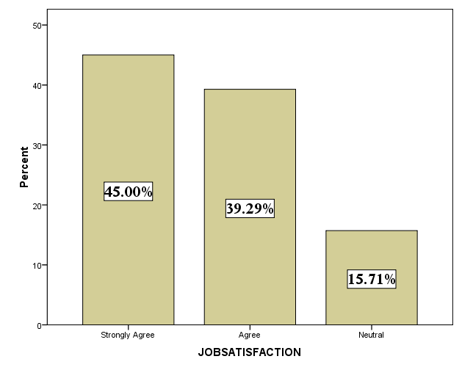
It is interpreted from above table that 45% of the respondents strongly agree that job satisfaction decreased is a factor arising due to work life conflict.39% of the respondents agrees that job satisfaction decreased is a factor arising due to work life conflict.16% of the respondents are neutral with their opinion and it is inferred from above table that majority of the respondents strongly agree that job satisfaction decreased is a factor arising due to work life conflict.

TABLE NO: 46
ABSENTEEISM
Absenteeism is a factor that arises due to the work life conflict which has a habitual evasion at work
RESPONSE | RESPONDENTS | PERCENTAGE
Strongly Agree | 44 | 31
Agree | 81 | 58
Neutral | 15 | 11
Disagree | 0 | 0
Strongly Disagree | 0 | 0
TOTAL | 140 | 100

CHART NO: 46
ABSENTEEISM
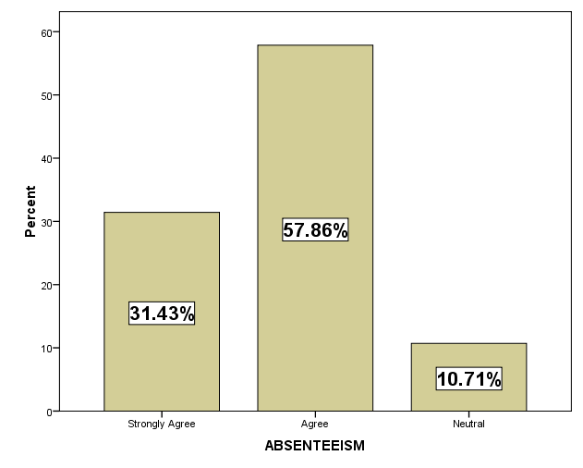

It is interpreted from above table that 31% of the respondents strongly agree that absenteeism is a factor arising due to work life conflict.58% of the respondents agrees that absenteeism is a factor arising due to work life conflict.11% of the respondents are neutral with their opinion and it is inferred from above table that majority of the respondents agrees that absenteeism is a factor arising due to work life conflict.

TABLE NO: 47
PERFORMANCE
Performance is the factor that arises due to the work life conflict which has an impact on the work life balance
RESPONSE | RESPONDENTS | PERCENTAGE
Strongly Agree | 63 | 45
Agree | 62 | 44
Neutral | 15 | 11
Disagree | 0 | 0
Strongly Disagree | 0 | 0
TOTAL | 140 | 100

CHART NO: 47
PERFORMANCE
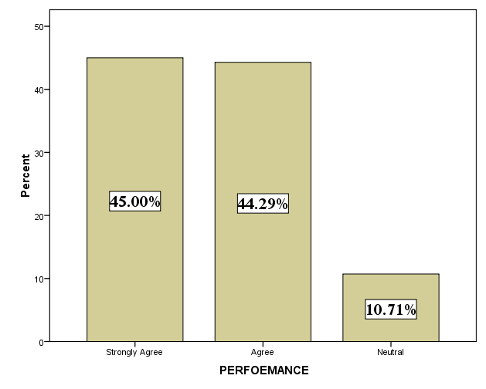
It is interpreted from above table that 31% of the respondents strongly agree thatperformance is a factor arising due to work life conflict.58% of the respondents agrees that performance is a factor arising due to work life conflict.11% of the respondents are neutral with their opinion and it is inferred from above table that majority of the respondents agrees that performance is a factor arising due to work life conflict.

TABLE NO: 48
JOB STRESS
Employees when they are not satisfied with personal and professional life there is a increased stress which leads to imbalance in their work life balance.
RESPONSE | RESPONDENTS | PERCENTAGE
Strongly Agree | 69 | 49
Agree | 59 | 42
Neutral | 12 | 09
Disagree | 0 | 0
Strongly Disagree | 0 | 0
TOTAL | 140 | 100

CHART NO: 48
JOB STRESS
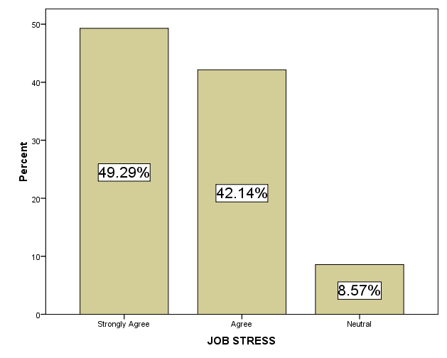
It is interpreted from above table that 49% of the respondents strongly agree thatjob stress is a factor arising due to work life conflict.42% of the respondents agrees that job stress is a factor arising due to work life conflict.9% of the respondents are neutral with their opinion and it is inferred from above table that majority of the respondents strongly agree that job stress is a factor arising due to work life conflict.

TABLE NO: 49
STRESS RELATED DISEASE
Employees when they are prone to stress suffer from any stress related diseases
STRESS DISEASE | RESPONDENTS | PERCENTAGE
Hypertension | 26 | 18
Obesity | 5 | 04
Frequent Headaches | 21 | 15
Diabetes | 52 | 37
None | 36 | 26
TOTAL | 140 | 100

CHART NO: 49
STRESS RELATED DISEASE
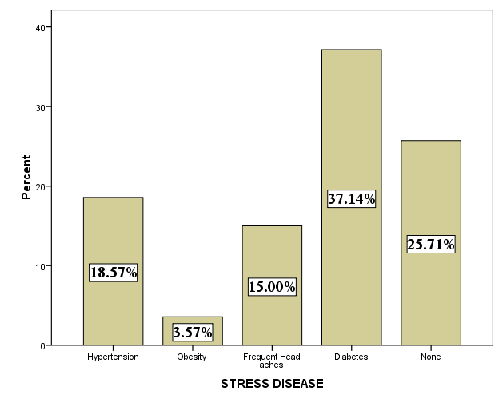

It is interpreted from above table that 18% of the respondents suffer hypertension as a stress related disease.4% of the respondents has obesity.15% of the respondents suffer from frequent headaches.37% of the respondents suffer from diabetes.26% of the respondents do not suffer from none of the stress related diseases and it is inferred from above table that majority of the respondents suffer from diabetes.

TABLE NO: 50
FAMILY TOUR
Employees get refreshed after a family tour which will have increased level of work life balance
RESPONSE | RESPONDENTS | PERCENTAGE
Yes | 140 | 100
No | 0 | 0
TOTAL | 104 | 100

CHART NO: 50
FAMILY TOUR
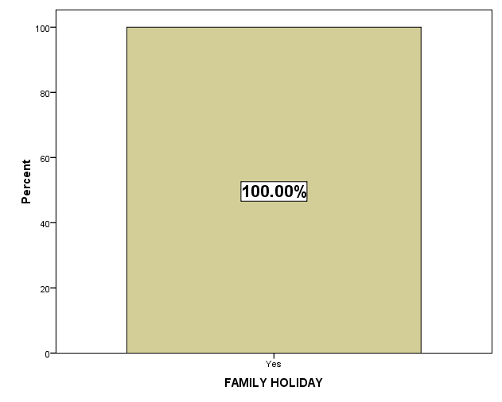

It is interpreted from the above table that all the respondents get refreshed after a family tour which has an increase in their level of work life balance

TABLE NO: 51
WORK LIFE BALANCE
Work life balance is that when a person is able to manage the personal and professional life a balanced manner.
RESPONSE | RESPONDENTS | PERCENTAGE
Yes | 47 | 34
No | 93 | 66
TOTAL | 104 | 100

CHART NO: 51
WORK LIFE BALANCE
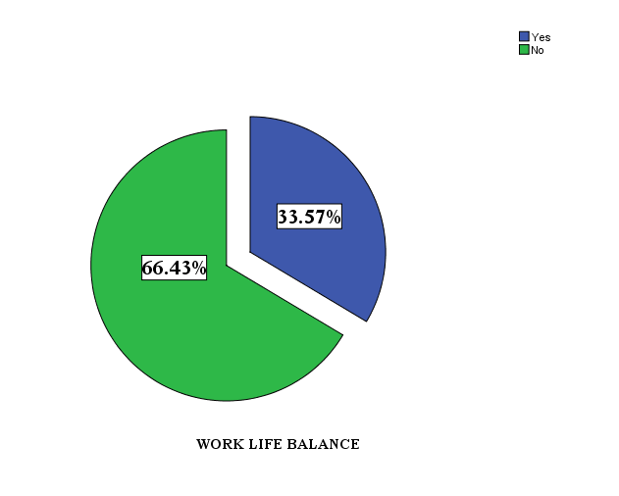

It is interpreted from above table that 34% of the respondents are able to balance their work life and 66% of the respondents are not able to balance their work life and it is inferred from the above table that majority of the respondents are not able to balance their work life.

TABLE NO: 52
IMPACT ON PROFESSIONAL AND PERSONAL LIFE
IMPACT OF WORK AT HOME
NATURE OF THE JOB
Employees feel difficult to balance their work life if the nature of the job they do is difficult.
RESPONSE | RESPONDENTS | PERCENTAGE
Strongly Agree | 37 | 26
Agree | 91 | 65
Neutral | 12 | 09
Disagree | 0 | 0
Strongly Disagree | 0 | 0
TOTAL | 140 | 100

CHART NO: 52
NATURE OF THE JOB
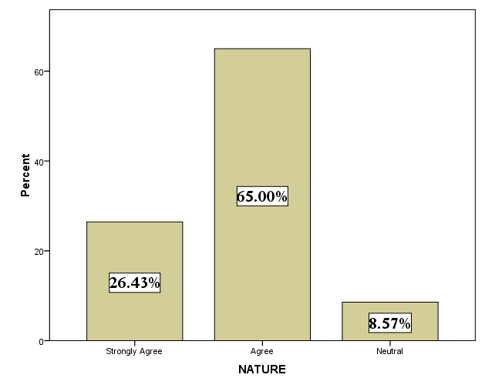

It is interpreted from above table that 26% of the respondents strongly agree that nature of the job has an impact on the personal life .65% of the respondents agrees that nature of the job has an impact on the personal life.9% of the respondents are neutral with their opinion and it is inferred from above table that majority of the respondents agrees that nature of the job has an impact on the personal life.

TABLE NO: 53
NO TIME FOR HOME COMMITMENTS
Employees working may not proper time to spend with the family and there is reduce in the level of work life balance.
RESPONSE | RESPONDENTS | PERCENTAGE
Strongly Agree | 76 | 54
Agree | 47 | 34
Neutral | 16 | 11
Disagree | 1 | 01
Strongly Disagree | 0 | 0
TOTAL | 140 | 100

CHART NO: 53
NO TIME FOR HOME COMMITMENTS
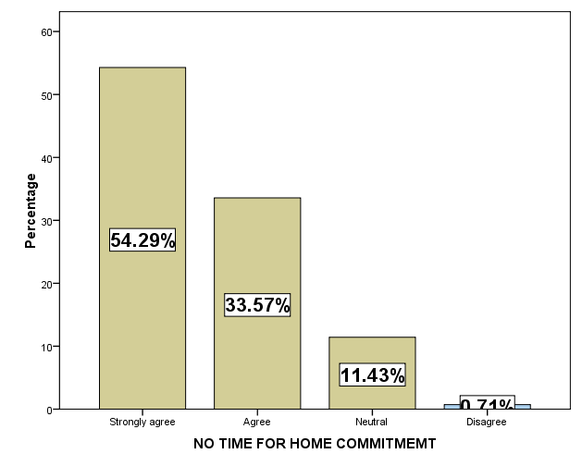

It is interpreted from above table that 54% of the respondents strongly agree that no time for home commitment has an impact on the personal life .34% of the respondents agrees that that no time for home commitment has an impact on the personal life.11% of the respondents are neutral with their opinion.1% of the respondents disagree that no time for home commitment has an impact on the personal life and it is inferred from above table that majority of the respondents agrees that difficult nature of the job has an impact on the personal life.

TABLE NO: 54
GOOD DAY ON JOB HAS A GOOD EMOTION AT HOME
Employees may have a good day at work which has reflection of good emotion at home and this has impact in the work life balance of the employees.
RESPONSE | RESPONDENTS | PERCENTAGE
Strongly Agree | 42 | 3
Agree | 63 | 45
Neutral | 35 | 25
Disagree | 0 | 0
Strongly Disagree | 0 | 0
TOTAL | 140 | 100

CHART NO: 54
GOOD DAY ON JOB HAS A GOOD EMOTION AT HOME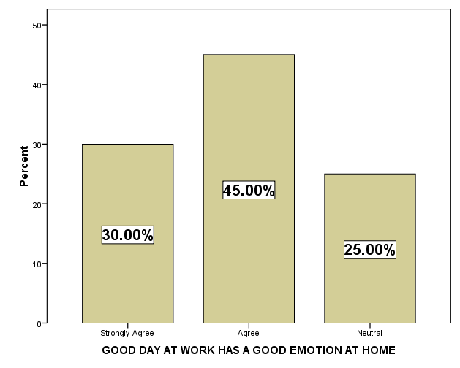

It is interpreted from above table that 3% of the respondents strongly agree that good day on job has a good emotion at home has an impact on the personal life .45% of the respondents agrees that that good day on job has a good emotion at home has an impact on the personal life.25% of the respondents are neutral with their opinion and it is inferred from above table that majority of the respondents agrees that that good day on job has a good emotion at home has an impact on the personal life.

TABLE NO: 55
IMPACT OF WORK AT HOME
RESPONSIBLITES AT HOME
Employees when they have more responsibilities at home that will have an impact in the work life of the employees.
RESPONSE | RESPONDENTS | PERCENTAGE
Strongly Agree | 34 | 24
Agree | 82 | 59
Neutral | 22 | 16
Disagree | 2 | 01
Strongly Disagree | 0 | 0
TOTAL | 140 | 100

CHART NO: 55
RESPONSIBLITES AT HOME

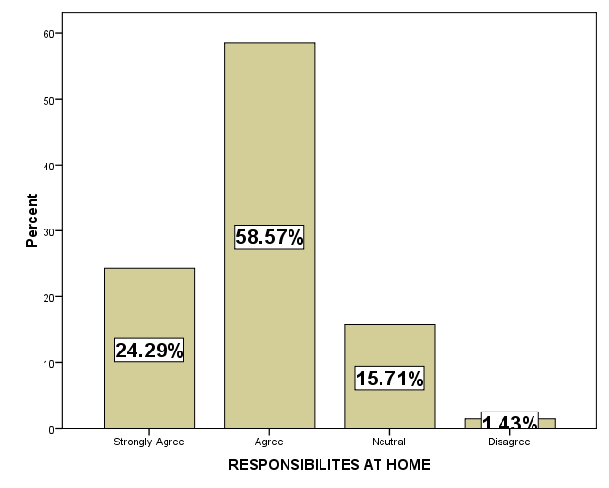
It is interpreted from above table that 24% of the respondents strongly agree that responsibilities at home reduce job efforts.59% of the respondents agree that responsibilities at home reduce job efforts.16% of the respondents are neutral with their opinion.1% of the respondents disagree that responsibilities at home reduce job efforts and it is inferred from above table that majority of the respondents agree that responsibilities at home reduce job efforts has an impact on the professional life.

TABLE NO: 56
PERSONAL OR FAMILY WORRIES DISTRACT WORK
Employees may not work properly if they have personal worries in their mind and this result in the distraction of work
RESPONSE | RESPONDENTS | PERCENTAGE
Strongly Agree | 72 | 52
Agree | 58 | 41
Neutral | 9 | 06
Disagree | 1 | 01
Strongly Disagree | 0 | 0
TOTAL | 140 | 100

CHART NO: 56
PERSONAL OR FAMILY WORRIES DISTRACT WORK
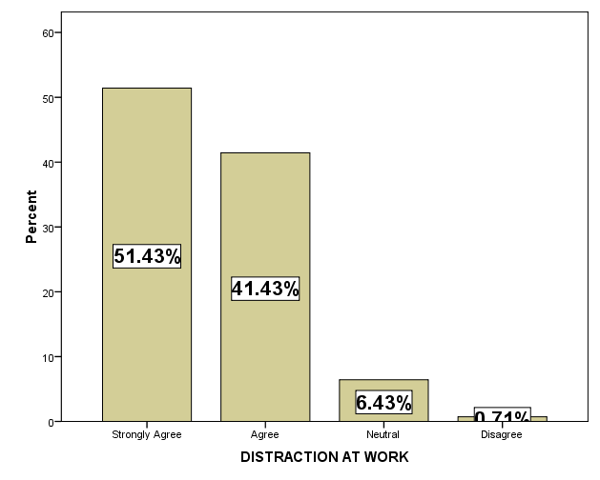
It is interpreted from above table that 52% of the respondents strongly agree that personal or family worries distract at work.41% of the respondents agrees that personal or family worries distract at work.6% of the respondents are neutral with their opinion.1% of the respondents disagree that personal or family worries distract at work and it is inferred from above table that majority of the respondents strongly agree that personal or family worries distract at work.

TABLE NO: 57
STRESS AT HOME
Employees when they suffer from a higher level of stress at home make them irritable at work
RESPONSE | RESPONDENTS | PERCENTAGE
Strongly Agree | 61 | 44
Agree | 66 | 47
Neutral | 13 | 09
Disagree | 0 | 0
Strongly Disagree | 0 | 0
TOTAL | 140 | 100

CHART NO: 57
STRESS AT HOME MAKES IRRITABLE AT WORK
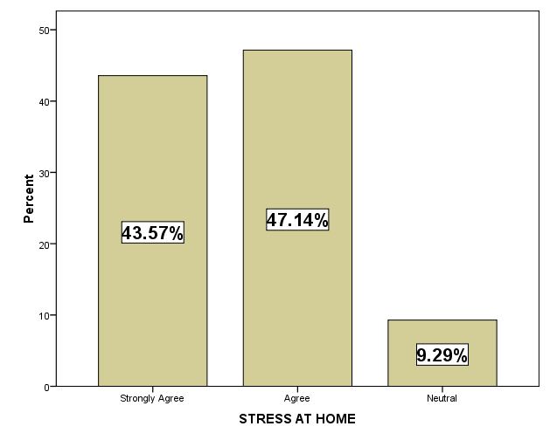

It is interpreted from above table that 44% of the respondents strongly agree that stress at home makes irritable at work.47% of the respondents agrees stress at home makes irritable at work.9% of the respondents are neutral with their opinion and it is inferred from above table that majority of the respondents agree that stress at home makes irritable at work.

RESULTS AT A GLIMPSE
The researcher had found from the study that stress ,home commitment ,working hours and job performance are the major factors that affect the work life balance of the employees

.RANKING-WEIGHTED AVERAGE METHOD
There a lot of strategies for improving the work life balance of the employees. In this project the employees were given six strategies and were asked to rank the strategies as per their preference.
STRATEGIES | I | II | III | IV | V | VI | ∑WX | ∑WX/N | RANK
Take time off | 84 | 260 | 148 | 57 | 10 | 13 | 572 | 95 | 1
Exercise | 180 | 75 | 112 | 93 | 38 | 17 | 515 | 86 | 3
Take up new challenge | 294 | 65 | 44 | 99 | 36 | 16 | 554 | 92 | 2
Learn new things | 114 | 110 | 80 | 40 | 88 | 21 | 455 | 76 | 5
Promote friendship | 90 | 75 | 84 | 60 | 40 | 49 | 398 | 66 | 6
Use resources Efficiently | 114 | 110 | 116 | 69 | 50 | 22 | 481 | 80 | 4

From the above table it is interpreted that employees to promote a proper work life balance they have ranked the “Take Time Off” as first which is mostly preferred by the employees. Secondly followed by Take up new challenge, thirdly by Exercise, forth as Use resources efficiently, fifth as Learn new things and finally sixth as Promote friendship

t-TEST WITH MARITAL STATUS AND IMPACT OF WORK LIFE BALANCE

H◦ = There is no significance between marital status and impact of work life balance.
Ha = There is no significance between marital status and impact of work life balance.
Independent Samples Test
 |  | Levene's Test for Equality of Variances |  | t-test for Equality of Means
FACTORS |  | F | Sig. | t | Df | Sig. (2-tailed) | Mean Difference | Std. Error Difference | 95% Confidence Interval of the Difference
 |  |  |  |  |  |  |  |  | Lower | Upper
HOURS OF WORK |  | 192.327 | .000 | -5.358 | 138 | .000 | -.562 | .105 | -.769 | -.355
HOURS OF WORK |  |  |  | -9.302 | 104.000 | .000 | -.562 | .060 | -.682 | -.442
WORKTRAVEL |  | 24.873 | .000 | -13.211 | 138 | .000 | -1.152 | .087 | -1.325 | -.980
WORKTRAVEL |  |  |  | -22.938 | 104.000 | .000 | -1.152 | .050 | -1.252 | -1.053
UNPAID TIME OFF |  | 257.964 | .000 | -15.667 | 138 | .000 | -1.390 | .089 | -1.566 | -1.215
UNPAID TIME OFF |  |  |  | -24.059 | 137.997 | .000 | -1.390 | .058 | -1.505 | -1.276
CHILDREN REARING |  | 43.859 | .000 | -13.590 | 138 | .000 | -1.171 | .086 | -1.342 | -1.001
CHILDREN REARING |  |  |  | -23.596 | 104.000 | .000 | -1.171 | .050 | -1.270 | -1.073
FAMILY COMMITMEMT |  | 22.771 | .000 | -9.722 | 138 | .000 | -.952 | .098 | -1.146 | -.759
FAMILY COMMITMEMT |  |  |  | -16.880 | 104.000 | .000 | -.952 | .056 | -1.064 | -.840
SHIFT WORK |  | 35.899 | .000 | -8.808 | 138 | .000 | -.886 | .101 | -1.085 | -.687
SHIFT WORK |  |  |  | -15.293 | 104.000 | .000 | -.886 | .058 | -1.001 | -.771
TIME ON TRAININGS |  | 54.947 | .000 | -7.796 | 138 | .000 | -.829 | .106 | -1.039 | -.618
TIME ON TRAININGS |  |  |  | -13.536 | 104.000 | .000 | -.829 | .061 | -.950 | -.707

It is interpreted from the above table that there is a significant difference between the marital status and the factors affecting the work life balance.

ANNOVA WITH AGE AND WORK LIFE BALANCE OF THE EMPLOYEES
Each individual has difference in their work life balance and age is also a factor that has an impact on the work life balance. The researcher has used annova to know about the difference between the age and the work life balance of the employees.

Work Life Balance | AGE | RESPONDENTS | MEAN | F | SIGNIFICANCE
Work Life Balance | Below 20 | 9 | 1.00 | 168.889 | .000
Work Life Balance | 21-25 | 32 | 1.00 | 168.889 | .000
Work Life Balance | 26-30 | 45 | 1.87 | 168.889 | .000
Work Life Balance | 31-35 | 42 | 2.00 | 168.889 | .000
Work Life Balance | Above 35 | 12 | 2.00 | 168.889 | .000
Work Life Balance | Total | 140 | 1.66 | 168.889 | .000
It is interpreted from the above table that there is a significant difference between the age and work life balance of the employees.

FACTORS | AGE | RESPONDENTS | MEAN | F | SIGNIFICANCE
NATURE | Below 20 | 9 | 5.00 | 395.702 | .000
NATURE | 21-25 | 32 | 4.88 | 395.702 | .000
NATURE | 26-30 | 45 | 4.00 | 395.702 | .000
NATURE | 31-35 | 42 | 4.00 | 395.702 | .000
NATURE | Above 35 | 12 | 3.00 | 395.702 | .000
NATURE | Total | 140 | 4.18 | 395.702 | .000
NO TIME FOR HOME COMMITMEMT | Below 20 | 9 | 5.00 | 137.035 | .000
NO TIME FOR HOME COMMITMEMT | 21-25 | 32 | 5.00 | 137.035 | .000
NO TIME FOR HOME COMMITMEMT | 26-30 | 45 | 4.78 | 137.035 | .000
NO TIME FOR HOME COMMITMEMT | 31-35 | 42 | 3.88 | 137.035 | .000
NO TIME FOR HOME COMMITMEMT | Above 35 | 12 | 3.08 | 137.035 | .000
NO TIME FOR HOME COMMITMEMT | Total | 140 | 4.43 | 137.035 | .000
GOOD DAY | Below 20 | 9 | 5.00 | 193.522 | .000
GOOD DAY | 21-25 | 32 | 5.00 | 193.522 | .000
GOOD DAY | 26-30 | 45 | 4.02 | 193.522 | .000
GOOD DAY | 31-35 | 42 | 3.45 | 193.522 | .000
GOOD DAY | Above 35 | 12 | 3.00 | 193.522 | .000
GOOD DAY | Total | 140 | 4.05 | 193.522 | .000
RESPONSIBILITES AT HOME | Below 20 | 9 | 5.00 | 84.370 | .000
RESPONSIBILITES AT HOME | 21-25 | 32 | 4.78 | 84.370 | .000
RESPONSIBILITES AT HOME | 26-30 | 45 | 4.00 | 84.370 | .000
RESPONSIBILITES AT HOME | 31-35 | 42 | 3.71 | 84.370 | .000
RESPONSIBILITES AT HOME | Above 35 | 12 | 3.17 | 84.370 | .000
RESPONSIBILITES AT HOME | Total | 140 | 4.09 | 84.370 | .000
DISTRACTION AT WORK | Below 20 | 9 | 5.00 | 115.642 | .000
DISTRACTION AT WORK | 21-25 | 32 | 5.00 | 115.642 | .000
DISTRACTION AT WORK | 26-30 | 45 | 4.69 | 115.642 | .000
DISTRACTION AT WORK | 31-35 | 42 | 4.00 | 115.642 | .000
DISTRACTION AT WORK | Above 35 | 12 | 3.25 | 115.642 | .000
DISTRACTION AT WORK | Total | 140 | 4.45 | 115.642 | .000
STRESS AT HOME | Below 20 | 9 | 5.00 | 126.920 | .000
STRESS AT HOME | 21-25 | 32 | 5.00 | 126.920 | .000
STRESS AT HOME | 26-30 | 45 | 4.44 | 126.920 | .000
STRESS AT HOME | 31-35 | 42 | 3.98 | 126.920 | .000
STRESS AT HOME | Above 35 | 12 | 3.00 | 126.920 | .000
STRESS AT HOME | Total | 140 | 4.34 | 126.920 | .000
ANOVA USING AGE AND IMPACT OF PERSONAL AND PROFESSIONAL LIFE

It is interpreted form the above table that there is a significant difference between the age and their impact on personal and professional work life balance.

FINDINGS
The findings from the research will help the organization to know about how the employees are balancing their work and life. Hence, the researcher identified the following findings.
FACTORS | INTREPRETATION
PERSONAL VARIABLES
Age | 32%of the respondents belong to the age group of 26-30
Gender | 85%of the respondents are male
Qualification | 54% of the respondents have completed their diploma
Marital status | 75% of the respondents are married
Spouse employment | 83% respondents partners are employed
Number of children | 88% of the respondents have children
Baby Sitting | 47% of the respondents parents take care of the children
Hours spent with children | 81% of the respondents spend 4-6 hours with children
ORGANISATIONAL VARIABLES
Working days | All the respondents work for 6days
Working hours | 45% of the respondents work for 8-9hours
Time spent in travelling | 69% of the respondents travel nearly one hour for work
Work shifts | 42% of the respondents work in day shift
Clarity of the goals | 71% of the respondents strongly agree that work can be easily manage their work through the clarity of the goals
Set clear expectation | 34% of the respondents strongly agree that they can manage their work by setting clear expectation.
Distribute task efficiently | 40% of the respondents strongly agree that they manage their work by distributing the task efficiently
Equip before assignment | 48% respondents agree that they can manage their work by being equipped before the assignment
Communication | 47% of the respondents strongly agree that they can manage their by communication.
Plan routine task | 51% of the respondents agree that they can manage their work by planning their routine task.
Flexi schedule | 54% of the respondents strongly agree that they can manage their work with flexible schedule.
Over time in the industry | 84% of the respondents work over time
Think about work | 56% of the respondents think about work often
Time spent at work | 83% of the respondents are happy with the time spend at work
WORK LIFE BALANCE VARIABLES
Quality time with family | 72% of the respondents rarely miss their quality time with the family
Working hours | 63% of the respondents agree that working hours have an impact on work life balance.
Travel | 60% of the respondents agree that that work travel has an impact on the work life balance.
Unpaid time off | 45% of the respondents agree that unpaid time off has an impact on work life balance.
Children rearing | 54% of the respondents agree that child rearing has an impact on the work life balance.
Family commitment | 50% of the respondents agree that family commitment has an impact on work life balance.
Shift work | 47% of the respondents agree that shift work has an impact on work life balance.
Time spent at trainings/meetings | 47% of the respondents agree that time spent on training /meetings have an impact on the work life balance
Work life policies | All the respondents use the work life policies provided by the organization
Support from manager/supervisor | All the respondents requires the support of managers for balancing work life commitments
Support from colleagues | 92% of the respondents require the support of the colleagues.
Support from team members | 89% of the respondents require the support of team members for balancing work life commitments.
Support from parents | 98% of the respondents require the support of parents for balancing work life commitments.
Support from in-laws | 54% of the respondents require the support of In-laws for balancing work life commitments.
Support from spouse | 71% of the respondents require the support of spouse for balancing work life commitments.
Managing stress | 41% majority of the respondents use entertainment as the medium to manage stress.
Health care package | All the respondents use health care package provided by organization
Work life conflict | All the respondents have come across the work life conflict
Mental and physical health | 53% of the respondents agrees that poor mental and physical health is a factor arising due to work life conflict
Life satisfaction | 46% of the respondents strongly agree that less life satisfaction is a factor arising due to work life conflict
Stress | 40% of the respondents strongly agree thatstress is a factor arising out of work life conflict.
Emotional exhaustion | 53% of the respondents agree that emotional exhaustion is a factor arising due to wok life conflict.
Physical exercise | 48% majority of the respondents agrees that physical exercise is a factor arising due to work life conflict.
Anxiety and depression | 42% of the respondents strongly agree that anxiety and depression is a factor arising due to work life conflict
Appetite and fatigue | 54% of the respondents strongly agree that appetite and fatigue is a factor arising due to work life conflict.
Employee job satisfaction | 45% of the respondents strongly agree that job satisfaction decreased is a factor arising due to work life conflict.
Absenteeism | 58% of the respondents agree that absenteeism is a factor arising due to work life conflict.
Performance | 45% of the respondents agree that absenteeism is a factor arising due to work life conflict.
Job stress | 49% of the respondents strongly agree that job stress is a factor arising due to work life conflict.
Stress related disease | 37% the respondents suffer from diabetes.
Family tour | All the respondents feel refreshed after a family tour
Work life balance | 66% of the respondents are not able to balance their work life.
Nature of the job | 65% of the respondents agree that nature of the job has an impact on the personal life.
No time for home commitment | 54% of the respondents agree that difficult nature of the job has an impact on the personal life.
Good day on job has a good emotion at home | 45% of the respondents agrees that that good day on job has a good emotion at home has an impact on the personal life
Responsibilities at home | 59% of the respondents agree that responsibilities at home reduce job efforts has an impact on the professional life.
Personal worries distract work | 51% of the respondents strongly agree that personal or family worries distract at work.
Stress at home | 47% of the respondents agree that stress at home makes irritable at work.

SUGGESTIONS
Work life balance on an individual level can bring phenomenal changes in his life and can also heavily impact a society. A balanced work life is of advantage to an employee's health. Stress levels decline drastically to healthy levels. Individuals derive more value from their work and from life that leads to greater satisfaction and is also seen as a mode of self-actualization.
Expand your community

Establish and maintain internal congruence

Work life balance strategies

Practice positivity

Relax

Establish and maintain internal congruence

A lot of our frustrations and stress are the result of conflict between our emotions, expressions, and actions. So, realign what to say and what the employees feel. It may sound difficult at first, but can begin at home and extend this to your social relationships and work. This doesn’t mean being confrontational or abrupt, it simply means recognizing your ‘self’, individual needs and emotions and expressing them in a gentle non-offensive manner.
Realign your goals and objectives
Aiming for the impossible is not an act of courage; it simply sets up for failure and frustration. So re-examine your goals and restate them so they are compatible with the personality and individual needs and preferences as well as your circumstances and resources.
Practice positivity
Good and bad mood are contagious and self-reinforcing so employees can influence the environment and the workgroup. Therefore, establish positive patterns of behavior to generate positive emotions. Employees can easily develop many simple habits to surround with positivity and to lighten up your day/mood. For instance, take 2 minutes a day to send an email to share a positive thought or to praise a colleague or someone in your team/organization, and make it a habit to smile, it is contagious.
Relax
In the rush of everyday life, employees often juggle multiple demands and have to adapt and multitask. However, research suggests that a multitasking brain has a harder time falling asleep, and has less energy, and experiences more stress. So take time to relax our mind as often as you can, by refocusing on a single thing. For instance, take 2 minutes to practice deep breathing and focus on breathing as you inhale and exhale. This slows your heartbeat, relaxes your brain, and reduces anxiety.

Expand your social capital and healthy relationships
Social capital and healthy relationships are a source of happiness and longevity. Therefore, strengthen your social network and build positive relationships. Networks such as LinkedIn can help develop and maintain the professional relationships and help enhance social capital and career success. Although, a focus on “success” may not bring us happiness, happiness can lead to success via positive emotions.

STEPS TO IMPROVE WORK LIFE BALANCE OF EMPLOYEES
Wellness Programs

Job sharing
Alternative work schedules
WORK LIFE BALANCE
Job-redesign
Balancing work and life is one of the important factors in life of the employees. Organisation can also help the employees to have a right balance of work life through the following methods:

Compressed work week
Assistance programs
Alternative work schedules:
Employees work for full day but can vary the start and end of the work day within defined guidelines. There is usually a “core” of the work hours when all the employees are expected to be present.

Compressed work week
Employees work the full number of hours in their regularly scheduled work week or cycle, but these hours are compressed into fewer days. For example, an employee working one extra hour a day earns approximately one day off in every two-week cycle; an employee adding a certain number of minutes to each workday every third Friday off.

Employee assistance programs
Employee assistance programs assist employees and family members with a range of personal concerns that may negatively affect employee’s job performance, mental health issues, family, financial or marital problems, and legal or emotional stress.

Wellness programs
Wellness programs exist to assist with and educate employees about achieving and maintaining good physical, mental, emotional and social health A broad range of information, service including health-related education and training, health screenings, stress management and work place safety.

Job sharing
Job sharing is forms of permanent part time work were two people share the responsibilities, hours, salary and benefits of the employees.

Job redesign
Job redesign focuses on changing the responsibilities or processes significantly in order to achieve a more balanced set of responsibilities. Job redesign requires a careful look at job tasks, expected results and how you measure success.

CONCLUSION
Work life balance of the employees play an important role in every organisation.Having a high level of satisfaction will result in high retention of the employees and it ultimately leads to organizational success.
The objective of this study is to know about the work life balance of the employees at Suguna industries.
The respondents were 140 employees who were employed at suguna industries at different shifts. The data collected was primary data by using the questionnaire. All the possible information regarding the employees’ demographic details, organizational information and work life balance factors of the employees were collected.
Moderate level of work life balance were found among the employees and having a low level of work life balance will result in high stress level, less life satisfaction, poor mental and physical health and lack of concentration at work due to work life commitments.
Suggestions to take time off from work, meditation, expand your community and spent more time with children and do not take work to home these suggestions were made to employees for balancing work life.
Work life balance is important for the employees that will increase their ability to participate in work and also this will increase their self-esteem, health, concentration, loyalty and commitment. This will also have a depict at home having a greater responsibility and ownership. Thus, work life balance is an important factor in employees’ life to lead a happy and peaceful life at work and home.

BIBLIOGRAPHY
JOURNALS
Adams, G.A., King, L.A., & King, D.W. (1996).Relationships of job and family involvement, family social support, and work-family conflict with job and life satisfaction.Journal of Applied Psychology, 81(4), 411-420.

Alam, M.S., Biswas, K., & Hassan, K. (2009). A Test of association between working hour and work family conflict: A glimpse on Dhaka’s female white collar professionals. International Journal of Business and Management, 4(5), 27-35.

Aryee, S. (1992). Antecedents and outcomes of work-family conflict among married professional women: Evidence from Singapore. Human Relations, 45(8), 813-835.

Aryee, S., &Luk, V. (1996). Balancing two major parts of adult life experience: work and family identity among dual-earner couples. Human Relations, 49(4), 465-487.

Aryee, S., Fields, D., &Luk, V. (1999a).A cross-cultural test of a model of the work-family interface.Journal of Management, 25(4), 491-511.

Aryee, S., Luk, V., Leung, A. & Lo, S. (1999b). Role stressors, interrole conflict and well being: the moderating influence of spousal support and coping behaviors among employed parents in Hong Kong. Journal of Vocational Behavior, 54, 259-278.

Bagger, J., Li, A., &Gutek, B.A. (2008). How much do you value your family and does it matter? The joint effects of family identity salience, family-interface-with-work and gender.Human Relations, 61(2), 187-211.

Baral, R. (2010).Work-family enrichment: Benefits of combining work and family. Retrieved October 7, 2010,
Bardoel, E.A ., Cieri, H.D., & Santos, C. (2008). A review of work-life research in Australia and New Zealand.Asia Pacific Journal of Human Resources, 46(3),
316-333.

Bhargava, S. &Baral, R. (2009). Antecedents and consequences of work–family enrichment among Indian managers.Psychological Studies, 54, 213-225.

Butler, A.B., Grzywacz, J.G., Bass, B.L., &Linney, K.D. (2005). Extending the demands control model: a daily diary study of job characteristics, work family conflict and work- family facilitation. Journal of Occupational andOrganizational Psychology, 78, 155-169.

Carlson, D.S. (1999). Personality and role variables as predictors of three forms of work- family conflict.Journal of Vocational Behavior, 55, 236-253.

Carlson, D.S. and Kacmar.K.M. (2000). Work-family conflict in the organization: Do life role values make a difference? Journal of Management 26 (5), 1031-1054.

Carmeli, A. (2003). The relationship between emotional intelligence and work attitudes, behavior and outcomes–An examination among senior managers.
Journal of Managerial Psychology, 18(8), 788-813.

Cieri, H.D., Holmes, B., Abbott, J., & Pettit (2005). Achievements and challenges for work/life balance strategies in Australian organizations. International Journalof Human Resource Management 16(1), 90-103.

WEBSITES:
Alberta human resources and employment “Betterbalance.pdf”www.alis.alberta.ca/pdf/cshop/betterbalance.pdf
Robert Taylor “future of worklifebalance” www.societytoday.net/_images/future_of_work_life_balance_tcm8-13554.pdf
www.ucm.es/info/Psyap/enop/guest.htm‎
SimonettaManfredi and Michelle Holliday “wlb_report”www.wlb_report.pdf
“SCU Work,Family and Life Balance Framework”www.SCU Work,Family and LifeBalanceFramework.pdf
“Work-life balance pdf” www.Work-life balance pdf.pdf

