A SECURE TRANSACTION VIA WIRELESS TOOLKIT

RESHMA .K.C
09PCA18

A Project Report submitted to Avinashilingam University for Women, Coimbatore in partial fulfilment of the requirements for the Master’s Degree in Computer Applications

April, 2012

A SECURE TRANSACTION VIA WIRELESS TOOLKIT

RESHMA .K.C
09PCA18

A Project Report submitted to Avinashilingam University for Women, Coimbatore in partial fulfilment of the requirements for the Master’s Degree in Computer Applications

April, 2012

Signature of the Signature of the
Head of the Department Supervisor

Signature of the
External Examiner

ACKNOWLEDGEMENT

ACKNOWLEDGEMENT

I would like to express my sincere thanks to God Almighty, for his constant love and grace that he has showered upon me.
I am very grateful to Dr.T.S.K.Meenakshi Sundaram, M.A., M.Phil., Ph.d., Chancellor, and Avinashilingam Institute for Home science and Higher Education for Women, Coimbatore, for his support and encouragement during the course of my study.
I heartily thank Dr.(Mrs).Sheela Ramachandran M.Sc., P.G Dip., Ph.D Vice-Chancellor, and Avinashilingam Institute for Home science and Higher Education for Women, Coimbatore, for extending all resources that facilitated the conduct of the present study.
I express my humble gratitude to Dr.(Mrs). Gowri Ramakrishnan M.Sc., M.Phil., Ph.D., Registrar, and Avinashilingam Institute for Home Science and Higher Education for Women, Coimbatore, for providing all facilities necessary for the study.
I am greatly indebted to respected madam, Dr.(Mrs).Saroja Prabhakaran, M.A., and Dip Ed., Ph.D., Director, Hall Of Residence., for her moral support who helped me to complete this project a successful one.
I am also thankful to Dr.(Mrs). R. Parvatham M.Sc., Dip.Ed. M.Phil., Ph.D., Dean Faculty of Science, for granting the facility required.
I wish to place on record my deep sense of gratitude to Dr.(Mrs).G.Padmavathi M.Sc., M.Phil., Ph.D., Professor and Head, Department of Computer Science, for providing all the facilities to complete the project.
I owe great deal of gratitude to my esteemed guide Dr.(Mrs).V.Radha, M.Sc., PGDOR., PGDCA, B.Ed., M.Phil.,Ph.D. Associate Professor, Department of Computer Science, for her kind advice and knowledgeable suggestion, which helped me to complete my project successfully.

I take this unique opportunity to express my sincere thanks to my project Coordinator Dr.(Mrs).P.Subashini, M.C.A., M.Phil., Ph.D., Department of Computer Science, for imparting the tremendous assistance and well timed support for her triumph of our project.

We have great pleasure in expressing our deep sense of gratitude to all other staffs and non-teaching staffs who stood behind the screen in making of project.
I would extend my hearty thanks to one and all who helped me directly or indirectly for successful completion of my project.
Last yet importantly, I would like to thank my parents, my sister and all my well-wishers for their kind inspiration.

SYNOPSIS

SYNOPSIS

Anonymity has received increasing attention in the literature due to the users awareness of their privacy now-a-days. Anonymity provides protection for users to enjoy network services without being traced. While anonymity-related issues have been extensively studied in payment-based systems such as e-cash and peer-to-peer (P2P) systems, little effort has been devoted to wireless mesh networks (WMNs). On the other hand, the network authority requires conditional anonymity such that misbehaving entities in the network remain traceable.

A security architecture to ensure unconditional anonymity for honest users and traceability of misbehaving users for network authorities in WMNs is proposed. The proposed architecture strives to resolve the conflicts between the anonymity and traceability objectives, in addition to guaranteeing fundamental security requirements including authentication, confidentiality, data integrity, and no repudiation. Thorough analysis on security and efficiency is incorporated, demonstrating the feasibility and effectiveness of the proposed architecture.

CONTENTS

CONTENTS

Chapter No Title Page No

1 INTRODUCTION 1
1.1 About the system 1 1.2 Overview of the project 2

2 SYSTEM CONFIGURATION 3
2.1 Hardware specification 3
2.2 Software specification 3
2.3 About the software 4
3 SYSTEM STUDY AND ANALYSIS 13
3.1 Existing system 13
3.2 Proposed system 14
4 SYSTEM DESIGN 15
4.1 Input design 15
4.2 Output design 16

5 SYSTEM DEVELOPMENT 18
5.1 Wireless Mesh Networks 18
5.2 Blind Signature 18
5.3 Ticket Issuance 19
5.4 Fraud Detection 19
5.5 Fundamental Security Objectives 20
6 TESTING 21
6.1 Unit testing 21
6.2 Integration testing 22

7 CONCLUSION 23

8 SCOPE FOR FUTURE ENHANCEMENT 24

APPENDIX

BIBLIOGRAPHY

INTRODUCTION

- INTRODUCTION

This section describes the Wireless Mesh Network (WMN) is a promising technology and is expected to be widespread due to its low investment feature and the wireless broadband services it supports, attractive to both service providers and users. However, security issues inherent in WMNs or any wireless networks need be considered before the deployment and proliferation of these networks, since it is unappealing to subscribers to obtain services without security and privacy guarantees.

  - About The System

Wireless security has been the hot topic in the literature for various network technologies such as cellular networks, wireless local area networks (WLANs), wireless sensor networks, mobile ad hoc networks (MANETs), and vehicular ad hoc networks (VANETs). Anonymity and privacy issues have gained considerable research efforts in the literature, which have focused on investigating anonymity in different context or application scenarios. One requirement for anonymity is to unlink a user’s identity to his or her specific activities, such as the anonymity fulfilled in the untraceable e-cash systems and the P2P payment systems, where the payments cannot be linked to the identity of a payer by the bank or broker. Anonymity is also required to hide the location information of a user to prevent movement tracing, as is important in mobile networks and VANETs.
In wireless communication systems, it is easier for a global observer to mount traffic analysis attacks by following the packet forwarding path than in wired networks. Thus, routing anonymity is indispensable, which conceals the confidential communication relationship of two parties by building an anonymous path between them. Nevertheless, unconditional anonymity may incur insider attacks since misbehaving users are no longer traceable. Therefore, traceability is highly desirable such as in e-cash systems, where it is used for detecting and tracing double-spenders.

1.2 Overview Of The Project

A multi-hop wireless network with multiple source-destination pairs, given routing and traffic information is analyzed. Each source injects packets in the network, which traverses through the network until it reaches the destination. For example, a multi-hop wireless network with three flows. The exogenous arrival processes correspond to the number of packets injected in the system at time. A packet is queued at each node in its path where it waits for an opportunity to be transmitted.

Since the transmission medium is shared, concurrent transmissions can interfere with each others’ transmissions. The set of links that do not cause interference with each other can be scheduled simultaneously, and it is called as activation vectors (matchings). Any priori restriction on the set of allowed activation vectors is not imposed, i.e., it can characterize any combinatorial interference model. For example, in a K-hop interference model, the links scheduled simultaneously are separated by at least K hops. Each link has unit capacity; i.e., at most one packet can be transmitted in a slot. For the above example, assume a 1-hop interference model.

The delay performance of any scheduling policy is primarily limited by the interference, which causes many bottlenecks to be formed in the network. The use of exclusive sets for the purpose of deriving lower bounds on delay for a wireless network with single hop traffic is demonstrated.

SYSTEM CONFIGURATION

2. SYSTEM CONFIGURATION

This section describes the hardware and software specification needed for both development and implementation phases of this project.

  - Hardware Specification

- Processor : Pentium IV 2.4 GHz.
- Hard Disk : 40 GB.
- Monitor : 15 VGA Colour.
- Mouse : Logitech.
- RAM : 1 Gb.

  - Software Specification

- Operating system : Windows XP Professional
- Front End : JAVA, Swing(JFC),J2ME
- Tool : j2me wireless toolkit 2.5.2

2.3 About the Software

Java Technology
Java technology is both a programming language and a platform.

The Java Programming Language

The Java programming language is a high-level language that can be characterized by all of the following buzzwords:

      - Simple
      - Architecture neutral
      - Object oriented
      - Portable
      - Distributed
      - High performance
      - Interpreted
      - Multithreaded
      - Robust
      - Dynamic
      - Secure

With most programming languages, its either compile or interpret a program so that can run it on the computer. The Java programming language is unusual in that a program is both compiled and interpreted. With the compiler, first translate a program into an intermediate language called Java byte codes —the platform-independent codes interpreted by the interpreter on the Java platform. The interpreter parses and runs each Java byte code instruction on the computer.

Compilation happens just once; interpretation occurs each time the program is executed. The following figure illustrates how this works.

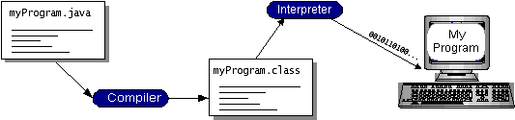

Figure 1. JVM Compilation

Think of Java byte codes as the machine code instructions for the Java Virtual Machine (Java VM). Every Java interpreter, whether it’s a development tool or a Web browser that can run applets, is an implementation of the Java VM. Java byte codes help make “write once, run anywhere” possible. Compile a program into byte codes on any platform that has a Java compiler. The byte codes can be run on any implementation of the Java VM. That means that as long as a computer has a Java VM, the same program written in the Java programming language can run on Windows 2000, a Solaris workstation, or on an iMac.
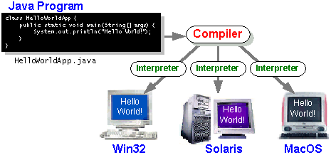
Figure 2. Java program run on different platform

The Java Platform

A platform is the hardware or software environment in which a program runs. It has already mentioned some of the most popular platforms like Windows 2000, Linux, Solaris, and MacOS. Most platforms can be described as a combination of the operating system and hardware. The Java platform differs from most other platforms in that it’s a software-only platform that runs on top of other hardware-based platforms.

The Java platform has two components:
- The Java Virtual Machine (Java VM)
- The Java Application Programming Interface (Java API)

It is already introduced to the Java VM. It’s the base for the Java platform and is ported onto various hardware-based platforms.
The Java API is a large collection of ready-made software components that provide many useful capabilities, such as graphical user interface (GUI) widgets. The Java API is grouped into libraries of related classes and interfaces; these libraries are known as packages.

The following figure depicts a program that’s running on the Java platform. As the figure shows, the Java API and the virtual machine insulate the program from the hardware.

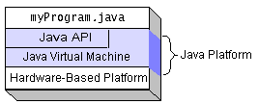

Figure 3. A program in Java platform
Native code is code that after compile it, the compiled code runs on a specific hardware platform. As a platform-independent environment, the Java platform can be a bit slower than native code. However, smart compilers, well-tuned interpreters, and just-in-time byte code compilers can bring performance close to that of native code without threatening portability.

What Can Java Technology Do?
The most common types of programs written in the Java programming language are applets and applications. If surfed the Web, probably already familiar with applets. An applet is a program that address to certain conventions that allow it to run within a Java-enabled browser. However, the Java programming language is not just for writing cute, entertaining applets for the Web. The general-purpose, high-level Java programming language is also a powerful software platform. Using the generous API, can write many types of programs.
An application is a standalone program that runs directly on the Java platform. A special kind of application known as a server serves and supports clients on a network. Examples of servers are Web servers, proxy servers, mail servers, and print servers. Another specialized program is a servlet. A servlet can almost be thought of as an applet that runs on the server side. Java Servlets are a popular choice for building interactive web applications, replacing the use of CGI scripts.
Servlets are similar to applets in that they are runtime extensions of applications. Instead of working in browsers, though, servlets run within Java Web servers, configuring or tailoring the server.
How does the API support all these kinds of programs? It does so with packages of software components that provides a wide range of functionality. Every full implementation of the Java platform gives you the following features:

The essentials: Objects, strings, threads, numbers, input and output, data structures, system properties, date and time, and so on.
Applets: The set of conventions used by applets.

Networking: URLs, TCP (Transmission Control Protocol), UDP (User Data gram Protocol) sockets, and IP (Internet Protocol) addresses.
Internationalization: Help for writing programs that can be localized for users worldwide. Programs can automatically adapt to specific locales and be displayed in the appropriate language.
Security: Both low level and high level, including electronic signatures, public and private key management, access control, and certificates.
Software components: Known as JavaBeans, can plug into existing component architectures.
Object serialization: Allows lightweight persistence and communication via Remote Method Invocation (RMI).
Java Database Connectivity (JDBC): Provides uniform access to a wide range of relational databases.
The Java platform also has APIs for 2D and 3D graphics, accessibility, servers, collaboration, telephony, speech, animation, and more. The following figure depicts what is included in the Java 2 SDK.
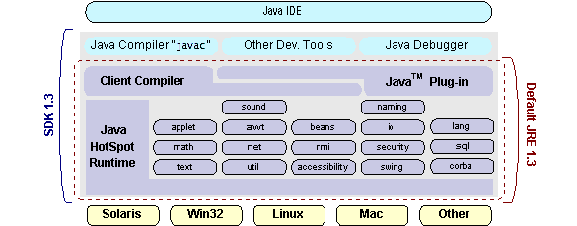

Figure 4. Java 2 SDK
J2ME (Java 2 Micro edition):-
Sun Microsystems defines J2ME as "a highly optimized Java run-time environment targeting a wide range of consumer products, including pagers, cellular phones, screen-phones, digital set-top boxes and car navigation systems."
Announced in June 1999 at the Java One Developer Conference, J2ME brings the cross-platform functionality of the Java language to smaller devices, allowing mobile wireless devices to share applications. With J2ME, Sun has adapted the Java platform for consumer products that incorporate or are based on small computing devices.
1. General J2ME architecture
J2ME uses configurations and profiles to customize the Java Runtime Environment (JRE). As a complete JRE, J2ME is comprised of a configuration, which determines the JVM used, and a profile, which defines the application by adding domain-specific classes. The configuration defines the basic run-time environment as a set of core classes and a specific JVM that run on specific types of devices. The profile defines the applications specifically, it adds domain-specific classes to the J2ME configuration to define certain uses for devices. The following graphic depicts the relationship between the different virtual machines, configurations, and profiles
Figure 5. J2ME Architecture
It also draws a parallel with the J2SE API and its Java virtual machine. While the J2SE virtual machine is generally referred to as a JVM, the J2ME virtual machines, KVM and CVM, are subsets of JVM. Both KVM and CVM can be thought of as a kind of Java virtual machine -- it's just that they are shrunken versions of the J2SE JVM and are specific to J2ME.
2. Developing J2ME applications
This application go over some considerations need to keep in mind when developing applications for smaller devices.The compiler is invoked when using J2SE to compile J2ME applications. Finally, explore packaging and deployment and the role pre-verification plays in this process.
3. Design considerations for small devices
Developing applications for small devices requires to keep certain strategies in mind during the design phase. It is best to strategically design an application for a small device before begin coding. Correcting the code because it failed to consider all of the "gotchas" before developing the application can be a painful process. Here are some design strategies to consider:
Keep it simple. Remove unnecessary features, possibly making those features a separate, secondary application.
Smaller is better. This consideration should be a "no brainer" for all developers. Smaller applications use less memory on the device and require shorter installation times. Consider packaging your Java applications as compressed Java Archive (jar) files.
Minimize run-time memory use. To minimize the amount of memory used at run time, use scalar types in place of object types. Also, do not depend on the garbage collector.

4. Configurations overview
The configuration defines the basic run-time environment as a set of core classes and a specific JVM that run on specific types of devices. Currently, two configurations exist for J2ME, though others may be defined in the future:
Connected Limited Device Configuration (CLDC) is used specifically with the KVM for 16-bit or 32-bit devices with limited amounts of memory. This is the configuration (and the virtual machine) used for developing small J2ME applications. Its size limitations make CLDC more interesting and challenging (from a development point of view) than CDC. CLDC is also the configuration that will use for developing our drawing tool application. An example of a small wireless device running small applications is a Palm hand-held computer.
Connected Device Configuration (CDC) is used with the C virtual machine (CVM) and is used for 32-bit architectures requiring more than 2 MB of memory. An example of such a device is a Net TV box.
J2me Profiles
What is a J2ME profile?
A profile defines the type of device supported. The Mobile Information Device Profile (MIDP), for example, defines classes for cellular phones. It adds domain-specific classes to the J2ME configuration to define uses for similar devices. Two profiles have been defined for J2ME and are built upon CLDC: KJava and MIDP. Both KJava and MIDP are associated with CLDC and smaller devices. Profiles are built on top of configurations. Because profiles are specific to the size of the device (amount of memory) on which an application runs, certain profiles are associated with certain configurations.
A skeleton profile upon which create the own profile, the Foundation Profile, is available for CDC.

Profile 1: KJava
KJava is Sun's proprietary profile and contains the KJava API. The KJava profile is built on top of the CLDC configuration. The KJava virtual machine, KVM, accepts the same byte codes and class file format as the classic J2SE virtual machine. KJava contains a Sun-specific API that runs on the Palm OS. The KJava API has a great deal in common with the J2SE Abstract Windowing Toolkit (AWT). However, because it is not a standard J2ME package, its main package is com.sun.kjava.
Profile 2: MIDP
MIDP is geared toward mobile devices such as cellular phones and pagers. The MIDP, like KJava, is built upon CLDC and provides a standard run-time environment that allows new applications and services to be deployed dynamically on end user devices. MIDP is a common, industry-standard profile for mobile devices that is not dependent on a specific vendor. It is a complete and supported foundation for mobile application development. MIDP contains the following packages, the first three of which are core CLDC packages, plus three MIDP-specific packages.

* java.lang
* java.io
* java.util
* javax.microedition.io
* javax.microedition.lcdui
* javax.microedition.midlet
* javax.microedition.rms

SYSTEM STUDY AND ANALYSIS

- SYSTEM STUDY AND ANALYSIS

System analysis is the general term that refers to an orderly and structured procedure for identifying and solving problems. It involves the study of existing system to understand how they function. This knowledge will helps to identify what the new system should include.

3.1 Existing System
In wireless communication systems, it is easier for a global observer to mount traffic analysis attacks by following the packet forwarding path than in wired networks. Thus, routing anonymity is indispensable, which conceals the confidential communication relationship of two parties by building an anonymous path between them. Nevertheless, unconditional anonymity may incur insider attacks since misbehaving users are no longer traceable. Therefore, traceability is highly desirable such as in e-cash systems where it is used for detecting and tracing double-spenders.

Drawbacks of Existing System
- In the existing systems, there exist conflicts between the anonymity and traceability.
- The fundamental security requirements including authentication, confidentiality, data integrity, and non-repudiation are not achieved in the existing systems.

3.2 Proposed System
This is motivated by resolving the above security conflicts, namely anonymity and traceability, in the emerging WMN communication systems. The proposed initial design of our security architecture, where the feasibility and applicability of the architecture were not fully understood.
As a result, provide detailed efficiency analysis in terms of storage, communication, and computation to show that the SAT is a practically viable solution to the application scenario of interest.
The system borrows the blind signature technique from payment systems, and hence, can achieve the anonymity of unlinking user identities from activities, as well as the traceability of misbehaving users. Furthermore, the proposed pseudonym technique renders user location information unexposed.
Merits of Proposed System
It differs from previous work in that WMNs have unique hierarchical topologies and rely heavily on wireless links, which have to be considered in the anonymity design.
As a result, the original anonymity scheme for payment systems among bank, customer, and store cannot be directly applied. In addition to the anonymity scheme, other security issues such as authentication, key establishment, and revocation are critical in WMNs to ensure the correct application of the anonymity scheme. Moreover, although employ the widely used pseudonym approach to ensure network access anonymity and location privacy, our pseudonym generation does not rely on a central authority, e.g., the broker , the domain authority , the transportation authority or the manufacturer, and the trusted authority can derive the user’s identity from his pseudonyms and illegally trace an honest user. The system is not intended for achieving routing anonymity, which can be incorporated as an enhancement.

SYSTEM DESIGN

4. SYSTEM DESIGN

Design is the first process in the development phase of any engineered system. The inputs to the design are the software requirements and the output will be the design specification applicable to all software design.
4.1 Input Design
The input design is the link between the information system and the user. It comprises the developing specification and procedures for data preparation and those steps are necessary to put transaction data in to a usable form for processing can be achieved by inspecting the computer to read data from a written or printed document or it can occur by having people keying the data directly into the system. The design of input focuses on controlling the amount of input required, controlling the errors, avoiding delay, avoiding extra steps and keeping the process simple. The input is designed in such a way so that it provides security and ease of use with retaining the privacy. Input Design considered the following things:
- What data should be given as input?
- How the data should be arranged or coded?
- The dialog to guide the operating personnel in providing input.
- Methods for preparing input validations and steps to follow when error occur.
Objectives of Input Design
1. Input Design is the process of converting a user-oriented description of the input into a computer-based system. This design is important to avoid errors in the data input process and show the correct direction to the management for getting correct information from the computerized system.
2. It is achieved by creating user-friendly screens for the data entry to handle large volume of data. The goal of designing input is to make data entry easier and to be free from errors. The data entry screen is designed in such a way that all the data manipulates can be performed. It also provides record viewing facilities.
3. When the data is entered it will check for its validity. Data can be entered with the help of screens. Appropriate messages are provided as when needed so that the user will not be in maize of instant. Thus the objective of input design is to create an input layout that is easy to follow.
4.2 Output Design
A quality output is one, which meets the requirements of the end user and presents the information clearly. In any system results of processing are communicated to the users and to other system through outputs. In output design it is determined how the information is to be displaced for immediate need and also the hard copy output. It is the most important and direct source information to the user. Efficient and intelligent output design improves the system’s relationship to help user decision-making.
1. Designing computer output should proceed in an organized, well thought out manner; the right output must be developed while ensuring that each output element is designed so that people will find the system can use easily and effectively. When analysis design computer output, they should Identify the specific output that is needed to meet the requirements.
2. Select methods for presenting information.
3. Create document, report, or other formats that contain information produced by the system.
Objectives Of Output Design
- Convey information about past activities, current status or projections of the future.
- Signal important events, opportunities, problems, or warnings.
- Trigger an action.
- Confirm an action.

SYSTEM DEVELOPMENT

5. SYSTEM DEVELOPMENT
Module Description
The project consists of five main modules namely
- Wireless mesh networks (WMNs)
- Blind Signature
- Ticket Issuance
- Fraud Detection
- Fundamental security objectives

5.1 Wireless Mesh Networks (WMNs)
The wireless mesh backbone consists of mesh routers (MRs) and gateways (GWs) interconnected by ordinary wireless links (shown as dotted curves). Mesh routers and gateways serve as the access points of the WMN and the last resorts to the Internet, respectively.
Each WMN domain, or trust domain (to be used interchangeably) is managed by a domain administrator that serves as a trusted authority the central server of a campus WMN.
5.2 Blind Signature
In general, a blind signature scheme allows a receiver to obtain a signature on a message such that both the message and the resulting signature remain unknown to the signer. It refer the readers for a formal definition of a blind signature scheme, which should bear the properties of verifiability, unlinkability, and unforgeability.
Blind signature scheme, where the restrictiveness property is incorporated into the blind signature scheme such that the message being signed must contain encoded information.
As the name suggests, this property restricts the user in the blind signature scheme to embed some account-related secret information into what is being signed by the bank (otherwise, the signing will be unsuccessful) such that this secret can be recovered by the bank to identify a user if and only if he double-spends. The restrictiveness property is essentially the guarantee for traceability in the restrictive blind signature systems.
5.3 Ticket Issuance
In order to maintain security of the network against attacks and the fairness among clients, the home server manager may control the access of each client by issuing tickets based on the misbehavior history of the client, which reflects the server manager’s confidence about the client to act properly.
Ticket issuance occurs when the client initially attempts to access the network or when all previously issued tickets are depleted. The client needs to reveal his real ID to the server manager in order to obtain a ticket since the server manager has to ensure the authenticity of this client.
  - Fraud Detection
Fraud is used interchangeably with misbehavior, which is essentially an insider attack. Ticket reuse generally results from the client’s inability to obtain tickets from the TA when network access is desired, primarily due to the client’s past misbehavior, which causes the server manager to constrain his ticket requests.
  - Fundamental Security Objectives
It is trivial to show that our security architecture satisfies the security requirements for authentication, data integrity, and confidentiality, which follows directly from the employment of the standard cryptographic primitives, message authentication code, and encryption, in our system.
A fraud can be repudiated only if the client can provide a different representation, knows of message from what is derived by the server manager. If the client has misbehaved, that knows will be the same as the one derived by the server Manager which ensures non repudiation.

SYSTEM TESTING

6. SYSTEM TESTING

The purpose of testing is to discover errors. Testing is the process of trying to discover every conceivable fault or weakness in a work product. It provides a way to check the functionality of components, sub assemblies, assemblies and/or a finished product.
It is the process of exercising software with the intent of ensuring that the software system meets its requirements and user expectations and does not fail in an unacceptable manner. There are various types of test. Each test type addresses a specific testing requirement.

Types of Tests

6.1. Unit Testing
Unit testing involves the design of test cases that validate that the internal program logic is functioning properly, and that program inputs produce valid outputs. All decision branches and internal code flow should be validated. It is the testing of individual software units of the application .it is done after the completion of an individual unit before integration.
This is a structural testing, that relies on knowledge of its construction and is invasive. Unit tests perform basic tests at component level and test a specific business process, application, and/or system configuration. Unit tests ensure that each unique path of a business process performs accurately to the documented specifications and contains clearly defined inputs and expected results.

6.2 Integration Test

Integration tests are designed to test integrated software components to determine if they actually run as one program. Testing is event driven and is more concerned with the basic outcome of screens or fields.

Integration tests demonstrate that although the components were individually satisfaction, as shown by successfully unit testing, the combination of components is correct and consistent. Integration testing is specifically aimed at exposing the problems that arise from the combination of components.

CONCLUSION

7. CONCLUSION
A security architecture mainly consisting of the ticket-based protocols, which resolves the conflicting security requirements of unconditional anonymity for honest users and traceability of misbehaving users are proposed in this work. By utilizing the tickets, self-generated pseudonyms, and the hierarchical identity-based cryptography, the proposed architecture is demonstrated to achieve desired security objectives and efficiency.

SCOPE FOR FUTURE ENHANCEMENT

8. SCOPE FOR FUTURE ENHANCEMENT
In the WMNs considered here, the uplink from the client to the mesh router may rely on multi-hop communications. Peer clients act as relaying nodes to forward each other’s traffic to the mesh router, which forms a P2P network. The notorious problem common in P2P communication systems is the free-riding, where some peers take advantage of the system by providing little or no service to other peers or by leaving the system immediately after the service needs are satisfied. Peer cooperation is thus the fundamental requirement for P2P systems to operate properly. Since peers are assumed to be selfish, incentive mechanisms become essential to promote peer cooperation in terms of both cooperativeness and availability. Typical incentive mechanisms for promoting cooperativeness include reputation and payment-based approaches. In the reputation-based systems, peers are punished or rewarded based on the observed behavior. However, low availability remains an unobservable behavior in such systems, which hinders the feasibility of the reputation-based mechanism in improving peer availability. By contrast, the payment-based approach provides sufficient incentives for enhancing both cooperativeness and availability, and thus, is ideal to be employed in multi-hop uplink communications among peer clients in our WMN system.

APPENDIX

APPENDIX
SYSTEM FLOW DIAGRAM

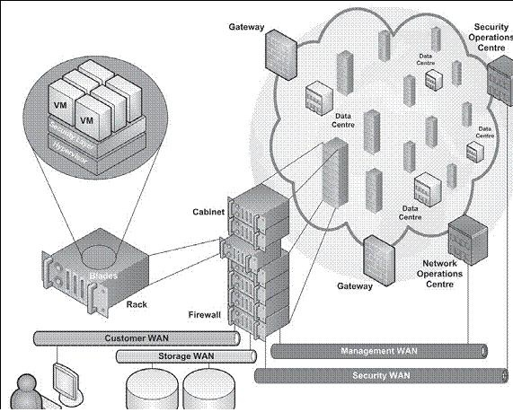
System Architecture

UML DIAGRAMS

UML DIAGRAMS
Data Flow Diagram
Admin

User
a) Data flow diagram
A data flow diagram (DFD) is a graphical representation of the "flow" of data through an information system. DFDs can also be used for the visualization of data processing (structured design).On a DFD, data items flow from an external data source or an internal data store to an internal data store or an external data sink, via an internal process. A DFD provides no information about the timing of processes, or about whether processes will operate in sequence or in parallel. It is therefore quite different from a flowchart.
Use Case Diagram
Admin

User

b)Use Case Diagram

A Use case diagram in the Unified Modeling Language (UML) is a type of behavioral diagram defined by and created from a Use-case analysis. Its purpose is to present a graphical overview of the functionality provided by a system in terms of actors, their goals (represented as use cases), and any dependencies between those use cases.
The main purpose of a use case diagram is to show what system functions are performed for which actor. Roles of the actors in the system can be depicted.
Admin
User
c) Sequence Diagram
A sequence diagram shows, as parallel vertical lines (lifelines), different processes or objects that live simultaneously, and, as horizontal arrows, the messages exchanged between them, in the order in which they occur. This allows the specification of simple runtime scenarios in a graphical manner.
UML sequence diagrams model the flow of logic within your system in a visual manner, enabling you both to document and validate your logic, and are commonly used for both analysis and design purposes. Sequence diagrams are the most popular UML artifact for dynamic modeling, which focuses on identifying the behavior within your system. Other dynamic modeling techniques include activity diagramming, communication diagramming, timing diagramming, and interaction overview diagramming. Sequence diagrams, along with class diagrams and physical data models are in my opinion the most important design-level models for modern business application development.
Admin
c) Activity diagram

Activity diagrams are graphical representations of workflows of stepwise activities and actions with support for choice, iteration and concurrency.
Admin

User
d) Component Diagram
Component-based development (CBD) and object-oriented development go hand-in-hand, and it is generally recognized that object technology is the preferred foundation from which to build components. an architecture-level artifact, either to model the business software architecture, the technical software architecture, or more often than not both of these architectural aspects. Components are wired together by using an assembly connector to connect the required interface of one component with the provided interface of another component.

SCREEN SHOTS

SCREEN SHOTS

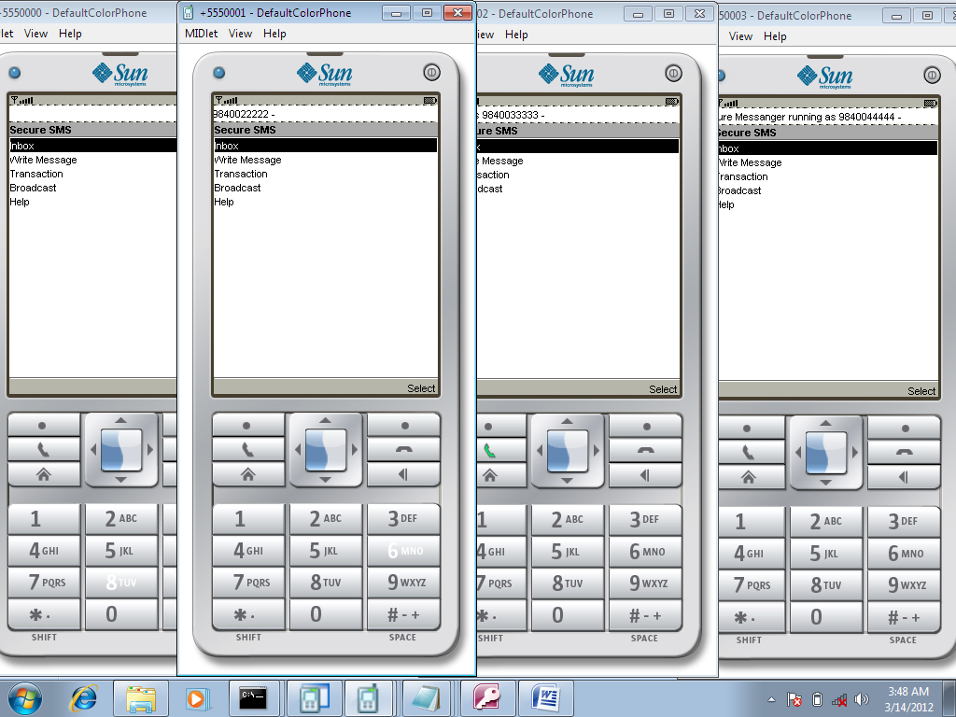
A multi-hop wireless network with multiple source – destinations pairs

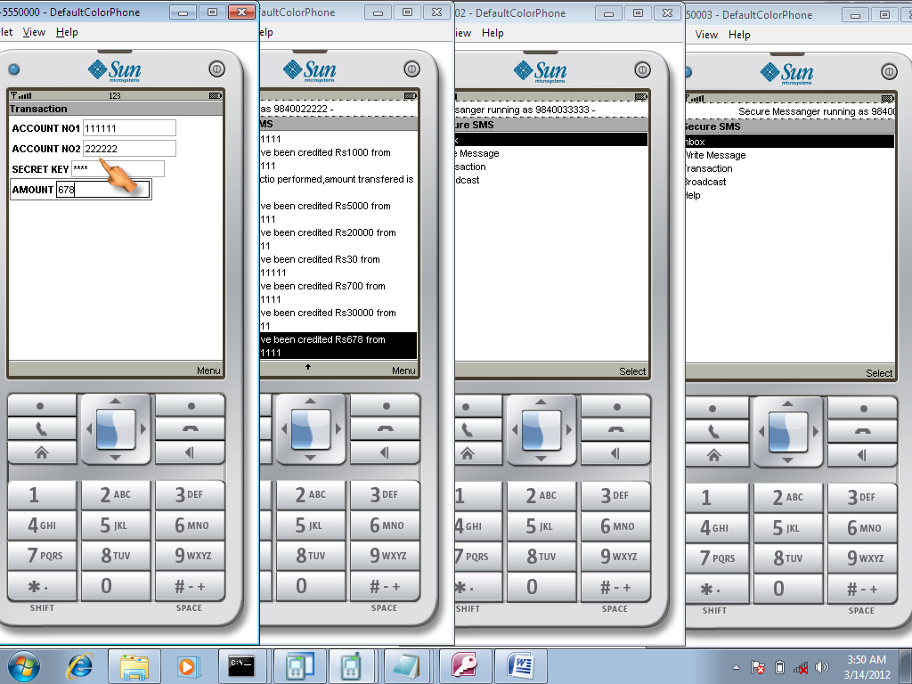
Transaction betweeen client1 and client2

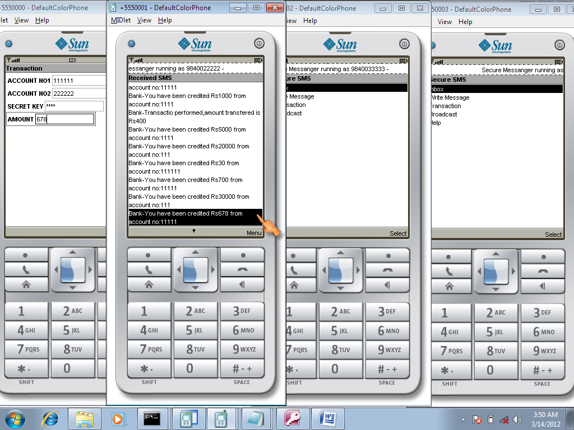
Viewing message regarding transaction credit from client1

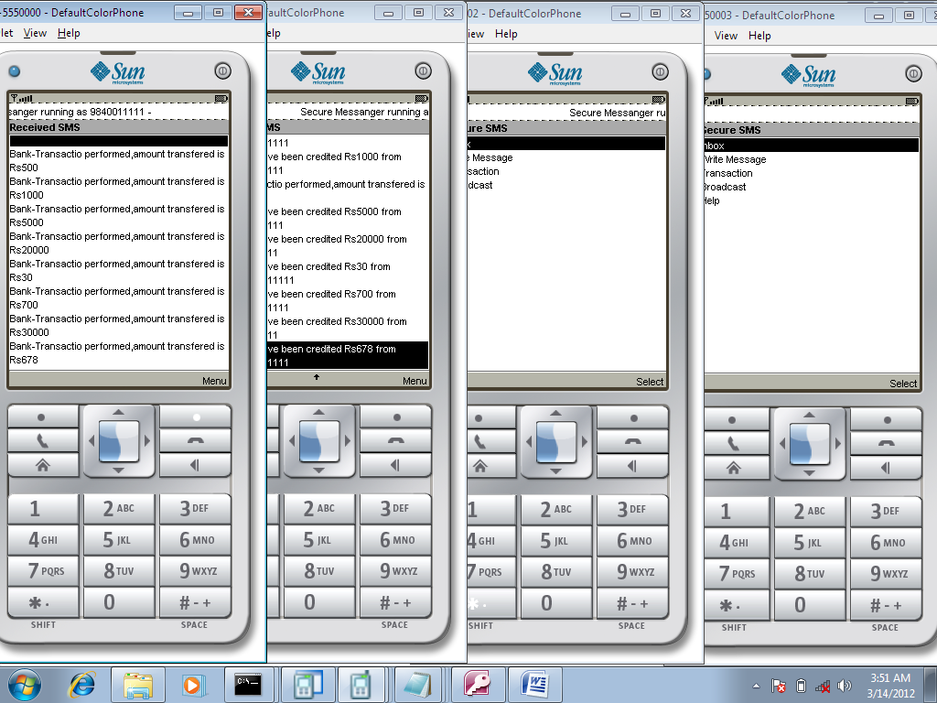
Viewing message regarding transaction debited to client2

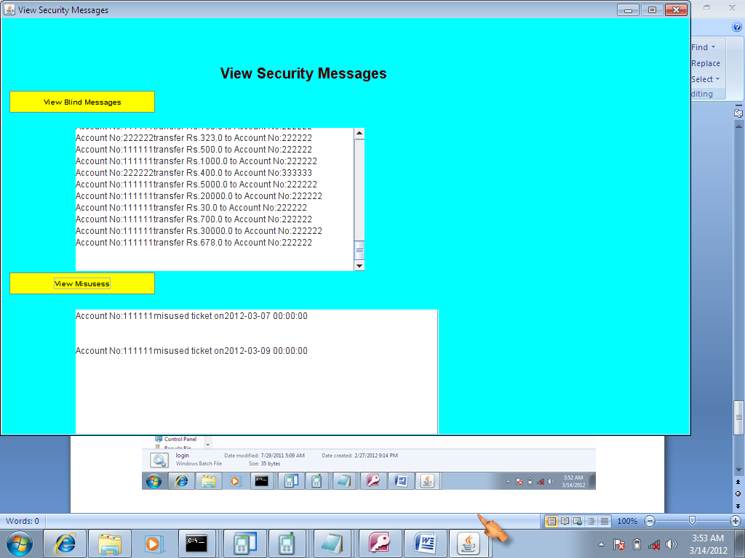
View blind messages and Mis-uses

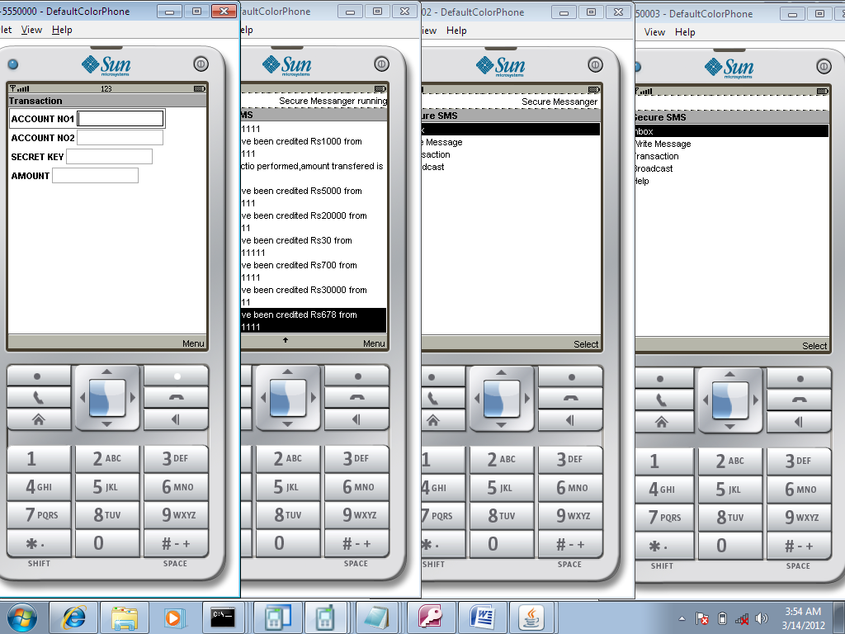
Wrong authentication

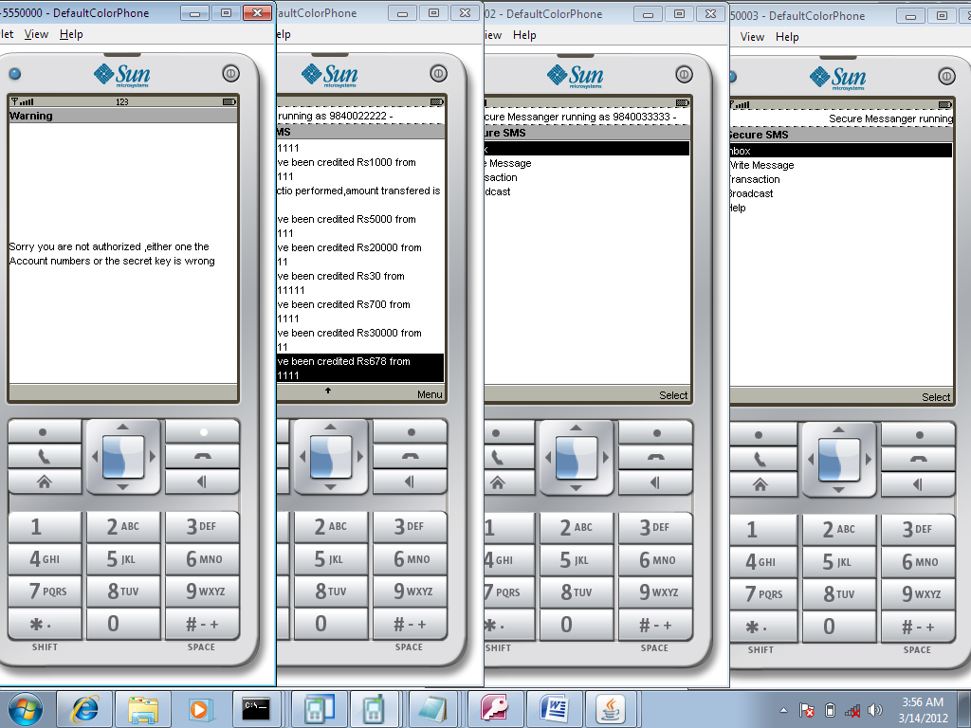
Authentication failed

BIBILIOGRAPHY

BIBILIOGRAPHY

Good Teachers are worth more than thousand books, we have them in Our Department.

References Made From

[1] H. Balakrishnan, C. Barrett, V. Kumar, M. Marathe, and S. Thite.,(2004) ,The distance-2 matching problem and its relationship to the maclayer capacity of ad hoc networks. IEEE Journal on Selected Area in Communications, 22.

[2] L. Bui, R. Srikant, and A. L. Stolyar,( 2009), Novel architectures and algorithms for delay reduction in back-pressure scheduling and routing. INFOCOM Mini-Conference.

[3] P. Chaporkar, K. Kar, and S. Sarkar, (2005)Throughput guarantees through maximal scheduling in wireless networks. In 43rd Annual Allerton Conference on Communication, Control, and Computing.

[4] J. G. Dai and W. Lin, (2005), Maximum pressure policies in stochastic processing networks. Operations Research, 53:197–218.

[5] J. G. Dai and W. Lin.,(October 2007), Asymptotic optimality of maximum pressure policies in stochastic processing networks.

[6] H. Dupuis and B. Hajek., (1994) A simple formula for mean multiplexing delay for indep endent regenerative sources. Queueing Systems Theory and Applications, 16:195–239.

[7] A. Feldmann, N. Kammenhuber, O. Maennel, B. Maggs, R. D. Prisco, and R. Sundaram.,
( 2004), A methodology for estimating interdomain web traffic demand. In IMC.

[8] L. Georgiadis, M. J. Neely, and L. Tassiulas,( 2006.), Resource Allocation and Cross-Layer Control in Wireless Networks, Foundations and Trends in Networking, volume 1. Now Publishers,

[9] G. R. Gupta,( 2009), Delay Efficient Control Policies for Wireless Networks. Ph.D. Dissertation, Purdue University.

[10] G. R. Gupta, S. Sanghavi, and N. B. Shroff,( June 2009), Node weighted scheduling. SIGMETRICS-Performance’09.

[11] G. R. Gupta, S. Sanghavi, and N. B. Shroff.,( June 2009.), Workload optimality in switches without arrivals. MAthematical performance Modeling and Analysis Workshop.

[12] G. R. Gupta and N. B. Shroff.,( April 2010), Delay analysis for wireless networks with single hop traffic and general interference constraints. IEEE Transactions on Networking, 18:393 – 405.

[13] S. Jagabathula and D. Shah,( June 2008), Optimal delay scheduling in networks with arbitrary constraints. In ACM SIGMETRIC/Performance.

[14] K. Jain, J. Padhye, V. Padmanabhan, and L. Qiu,( 2003), Impact of interference on multi-hop wireless network performance.

Website
- http://java.sun.com
- http://www.sourcefordgde.com
- http://www.networkcomputing.com/
- http://www.ilog.com/products/cplex/.
- http://www.roseindia.com/
- http://www.java2s.com/

