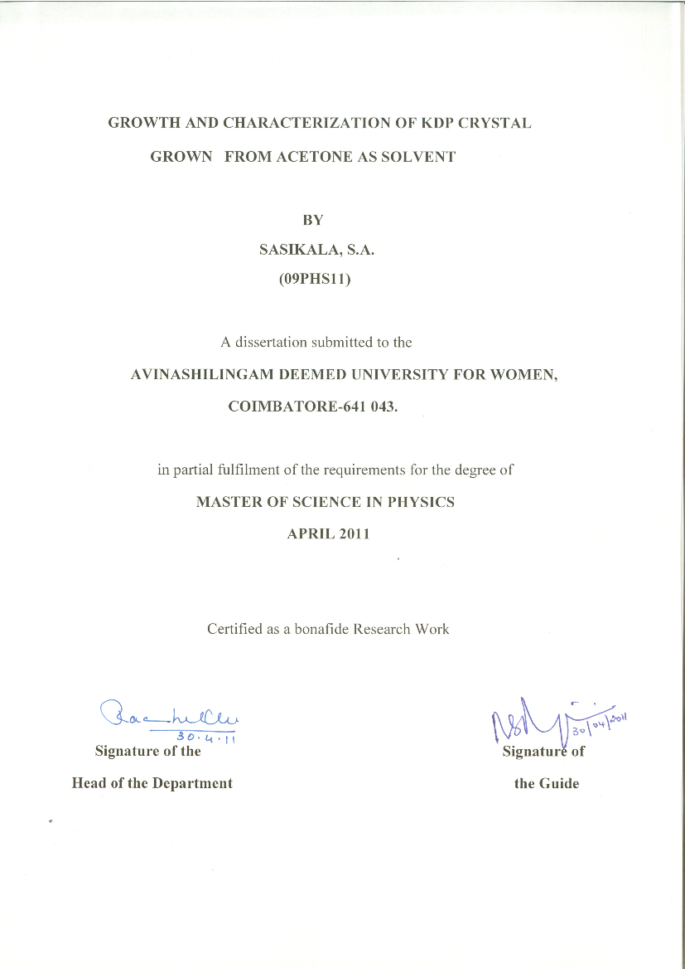
ACKNOWLEDGEMENT

I owe my sincere thanks to Lord Almighty and my parents without whom I would have been nothing and showering their generous blessings upon me in all my endeavors.

I wish to express my heartfelt and deep sense of reverential gratitude to Thiru. T.S.K. Meenakshisundaram M.A., M.Phil., Chancellor, Avinashilingam Deemed University for Women, Coimbatore, for providing the facilities to conduct this study.

I extend my thanks to Dr. (Mrs.) Sheela Ramachandran M.Sc., P.G.Dip, Ph.D., Vice Chancellor, Avinashilingam Deemed University for Women, Coimbatore, for providing flamboyant help towards the completion of the study.

I record my deep sense of gratitude and indebtedness to Dr. (Tmt.) Gowri Ramakrishnan, M.Sc., M.Phil., Ph.D., Registrar, Avinashilingam Deemed University for Women, Coimbatore, for providing adequate help for the study.

I also wish to express my gratitude to Dr. (Tmt.) R. Parvatham, M.Sc., Dip.Ed., M.Phil., Ph.D., Dean, Faculty of Science, Avinashilingam Deemed University for Women, Coimbatore, for timely help rendered throughout the course.

I whole heartedly thank HON.COL.Dr. (Tmt.) Saroja Prabhakaran, M.A., Dip.Ed., Ph.D., Director, Hall of Residence, Avinashilingam Deemed University for Women, Coimbatore, for providing adequate help and valuable advice for the completion of the study.

I whole heartedly thank Dr. (Tmt.) Rachel Oommen, M.Sc., Dip.Ed., B.Ed., M.Phil., Ph.D., Professor and Head, Department of Physics, Avinashilingam Deemed University for Women, Coimbatore, for her encouragement and generous help which was of great value.

I am very much grateful and indebted to my Guide Tmt. N.S.Rajaeswari M.Sc., M.Phil., M.C.A, Assistant Professor(s.s), Department of Physics, Avinashilingam Deemed University for Women, Coimbatore, for her excellent, outstanding guidance, constructive criticism, motivation, valuable advice, untiring support, timely suggestions, constant encouragement, and inspiration throughout the study, holding me strong in all the places I faltered.

I whole heartedly thank Dr.R.Arunkumar, Assistant professor, Department of physics, PSG College of technology, Coimbatore, for his kind advice, and being supportive throughout this study.

I sincerely thank all the Staff members of the Department of Physics, Avinashilingam Deemed University for Women, Coimbatore, for their support for the successful completion of the study.

I thank all my friends and my family members especially to my Akka, uncle N.Balakrishnan, my lovable Anna, Abinaya and my brother Ponnarivu for their support, understanding and co-operation for the successful completion of the study.

S.A.SASIKALA

CONTENTS

List of tables Page No

List of figures

List of plate

CHAPTER I 1-12

Introduction

1.1. Introduction

1.2. Solid-state physics

1.3. Solids

1.4. Crystal

1.5. Space Lattice: Basis and Crystal Structure

1.6 Crystal Systems

1.7. Crystallography

1.8. Crystal Growth

1.9. Solution Growth

1.10 Objectives of the study

CHAPTER II 13-21

Review of literature

2.1. Introduction

CHAPTER III 22-35

Materials and Methodology

3.1. Introduction

3.2. Low temperature solution growth

3.3. Potassium dihydrogen phosphate (KDP)

3.4. X- ray crystallography

3.5. Spectroscopy

3.5.1 Fourier transform infrared spectroscopy

3.6. Ultraviolet-visible spectroscopy

3.7. Non linear optics

CHAPTER IV 41-43

Results and discussion

4.1. Introduction

4.2. Synthesis of the compound material using slow evaporation method
4.3. Fourier Transform Infrared Spectroscopy (FTIR)
4.4 Ultraviolet Visible Spectrometry (UV-vis)

4.5. Non-linear optical study

CHAPTER V

Summary and conclusion 48-49

Reference

CHAPTER – I
1.1 INTRODUCTION
Matter, consisting of one or more elements or their chemical compounds exists in nature in the solid, liquid and gaseous states. As the atoms or molecules in solids are attached to one another with strong forces of attraction, the solid maintain a definite volume and shape. The solid-state physics is the branch of physics dealing with physical properties of solids, particularly crystals, including the behavior of electrons in these solids. The solids may be broadly classified as crystalline and non-crystalline depending upon the arrangement of atoms or molecules [1].
1.2 SOLID STATE PHYSICS
Solid-state physics is the branch of physics that deals with the physical properties of solid materials, especially the electromagnetic, thermodynamic, and structural properties of crystalline solids. Also called condensed matter physics. Solid-state physics emphasizes the properties common to large classes of compounds rather than the dependence of properties upon compositions, the latter receiving greater emphasis in solid-state chemistry. In addition, solid-state chemistry tends to be more descriptive, while solid-state physics focuses upon quantitative relationships between properties and the underlying electronic structure.Many of the scientists who study the physics of liquids identify with solid-state physics, and the term “condensed-matter physics” has been used by some researchers to replace “solid-state physics” as a division of physics. It includes non-crystalline solids such as glass as well as crystalline solids.
1.3 SOLIDS
Solids are usually composed of atoms, molecules or ions arranged in a rigid, repeating geometric pattern of particles known as crystal lattice. Solids are the substances, which maintain their definite shapes, against mild distorting forces. Example of solids are NaCl, KCl etc., A solid possesses the following characteristics [2],
- A sharp melting point
- A characteristic heat of fusion
- General incompressibility
- A definite three-dimensional arrangement.
Solids may also be classified into the following two types.
- Amorphous solids.
- Crystalline solids.
Amorphous solids:
In amorphous solids atoms or molecules are strongly bonded yet there is no geometric arrangement on periodicity in the way in which atoms are arranged in space. These amorphous solids possess incompressibility and rigidity but no geometric shape. Examples of the solids are glass, rubber and polymers of high molecular masses [2].
Crystalline solids:
Some solids have incompressibility and rigidity but they possess a definite geometric shape. These solids are known as crystalline solids. A crystalline solid possess a definite and regular geometry due to definite and orderly arrangement of molecules, atoms or ions in a three dimensional space [2]. Examples of the crystalline solids are NaCl, KCl etc,
1.4 CRYSTAL
A crystal is a solid composed of atoms, molecules or ions arranged in an orderly repetitive array. In other words, a crystal may also be defined as a homogeneous anisotropic substance having a definite geometric shape with in well-defined surfaces known as planes. A crystal also has the characteristics of the solids [2]. The crystals appear when a substance changes from one state to another state (i.e.) in phase transformation. The basic condition for the formation of crystalline matter that takes place is as follows:
- A change from the liquid phase to solid crystallization occurs by sublimation.
- When a change from one solid phase to another solid phase takes place, there is an alteration of the shape of the crystal structure and recrystallization appears.
- A change from the gaseous phase to the solid crystallization occurs by sublimation [3].
1.5 SPACE LATTICE: BASIS AND CRYSTAL STRUCTURE
Crystals are made up of regular and periodic three-dimensional pattern of atoms in space. It is defined as a three dimensional collection of points is called a space lattice. The crystal structure is formed by associating with every lattice point a unit assembly of atoms or molecules (i.e. one or more atoms or molecules) identical in composition, arrangement and orientation. This unit assembly is called the basis or pattern, when repeated with correct periodicity in all direction gives the actual crystal structure.
Lattice + basis = crystal structure.
A unit cell is the smallest geometric figure, the repetition of which in three dimensions will give the actual crystal structure [3]. The unit cell may also be defined as the fundamental elementary of group of molecules, which present fully all the characteristics of the crystal.
1.6 CRYSTAL SYSTEMS
It has divided into seven crystal systems. The systems were called: triclinic, monoclinic, orthorhombic, tetragonal, trigonal, hexagonal, and cubic [4].
1.7 CRYSTALLOGRAPHY
The crystal can exist in a wide range of size and the size of the crystal depends on the rate at which it is formed. The study of the geometrical form and other physical properties of crystalline solids by using X-rays, electron beams, neutron beams etc., constitute the science of crystallography. Crystallographers had made remarkable studies about the crystals before the discovery of X-rays but their observations were limited to the external features of crystals. Now X-rays provide a tool for studying the ultimate structure of crystal and thus help to look inside the crystal.
Crystallography is a tool that is often employed by materials scientists. In single crystals, the effects of the crystalline arrangement of atoms are often easy to see macroscopically, because the natural shapes of crystals reflect the atomic structure. In addition, physical properties are often controlled by crystalline defects. Crystallography is useful in phase identification [3]. When performing any process on a material, it may be desired to find out what compounds and what phases are present in the material. Each phase has a characteristic arrangement of atoms. Techniques like X-ray diffraction can be used to identify which patterns are present in the material, and thus which compounds are present. Crystallography covers the enumeration of the symmetry patterns, which can be formed by atoms in a crystal, and for this reason has a relation to group theory and geometry.
1.8 CRYSTAL GROWTH
Producing good quality crystals of a suitable size is the first and most important step in crystallography. Crystallization is the process of arranging atoms or molecules that are in a fluid or solution state into an ordered solid state. This process occurs in two steps--nucleation and growth. Nucleation may occur at a seed crystal, but in the absence of seed crystals usually occurs at some particle of dust or at some imperfection in the surrounding vessel. Crystals grow by the ordered deposition of material from the fluid or solution state to a surface of the crystal.
The shapes of crystals depend on both the internal symmetry of the material and on the relative growth rate of the faces. In general, the faces of the crystal that grow most rapidly are those to which the crystallizing particles are bound most securely. These rapidly growing faces are usually the smaller, less well-developed faces. The larger faces are usually associated with directions in the crystal where there are only weak intermolecular interactions.

1.8.1 Nucleation
Nucleation is the most fundamental requirement for crystal growth. In a super saturated solution, when a few atoms or molecules join together and form a cluster, a reduction in the free energy takes place. The cluster consistent of a group of atoms or molecules is normally continued to grow to form a crystal provided it acquires a critical nucleus. Thus the birth of a critical nucleus is an important event in crystal growth. To form a stable nucleus in four stages,
- The development of supersaturated stage: This can be achieved by chemical reaction, change in pressure, and change in temperature or any other physical or chemical conditions.
- The generation of critical nucleus: This can be achieved by homogeneous process or by heterogeneous process.
- The birth of critical nucleus: This can be achieved when the cluster continues to grow from an unstable or metastable state to a state of critical size.
- The relaxation stage: At this stage, newly formed nucleus starts taking a shape of crystal lattice.
Thus nucleation may occur spontaneously or it may be induced artificially. They are referred to as homogeneous and heterogeneous nucleation, respectively [5].
1.8.2 Methods of Crystal Growth
The methods of crystal growth may be divided into three categories.
- Solution growth
  - Aqueous solution method
  - Flux method
  - Hydrothermal method
- Melt growth
  - Bridgeman-stockbarger method
  - Czochralski method
  - Zone-refining method
  - Floating zone method
- Vapour growth
  - Chemical vapour deposition
  - Verneuil method
Before this methods of crystal growth, it is necessary to check whether the particular method follow a general criteria or not. The general criteria for assessing a method are:
- The universality, i.e., the number of materials to which the method may be applied.
- The size and quality of the grown crystals.
- The requirement of chemicals and apparatus.
- The requirement of experience and time.
- Industrial application and cost of per acceptable crystal [5].
1.9 SOLUTION GROWTH
The expression “solution” is most commonly used to describe the homogeneous mixture of two or more substances. It is usually convenient to think of the bulk liquid solvent- the dissolving substances as the solute and the resultant mixture as solution. The solute material is crushed and made in powder form so that it quickly gets dissolved in the solvent. Stirring or vigorous shaking helps to promote the rapid mixing of the two components. The solubility of substances depends on the temperature of the solvent at that of time. It can be increased by raising the temperature.
A solution that is in equilibrium with the solid phase (solute) is said to be saturated with respect to that solid. If it has more dissolved solid than that represented by saturated condition, it is known as supersaturated solution. This is achieved when the temperature of the solution is raised slightly above the normal dissolution temperature. This can also be achieved by allowing the solution to evaporate without disturbance in a dust free atmosphere. The rate of evaporation will increase the rate of super saturation. In fact, this is an essential feature of all crystallization [5].
- Aqueous Solution Method
Crystal growth from aqueous solution is probably the oldest and easiest method. This method has vast industrial applications [5]. Once a homogeneous solution is prepared, the crystals can grow by two different methods:
(i) Slow cooling method
This method involves the cooling of a solution of the compound to be crystallized. Any solvent can be used except water and benzene. This saturated solution is usually prepared at or close to the boiling point of the solvent solution of our choice. Cooling of the solution normally takes place in a freezer. There are solutions that can also be slowly cooled to room temperature. This method is commonly used for moderately soluble substances. One of its advantages is that it is easy to carry out. However, the method requires high temperatures, which can cause disordered or twinned crystals. These are crystals with molecules, which differ randomly in different unit cells.
(ii) Slow evaporation method
This method entails evaporating the solvent from the saturated solution of the compound being crystallized until it reaches the saturation point. It is at this point that formation of crystals occurs. In some cases, two solvents are used. The material to be crystallized is soluble in solvent one and insoluble in solvent two. Examples of solvent one choice can be ether, methylene chloride and pentane. Examples of solvent two choices are heptanes, methanol, ethanol and toluene. One of the solvents (solvent one) is usually volatile, and when it evaporates the solution reaches a point where the compound to be crystallized can no longer be soluble. Crystallization should be stopped on time to prevent solvate loss. This is a simple and common method of crystallization.

- Flux Method
Flux growth is the term, which is most commonly used to describe the growth of crystals form molten solvents at high temperatures. Single crystals of some important materials like Al₂O₃ (ruby gem), BATIO₃ (ferroelectric materials) and YIG (yttrium iron garnet) are grown by this method on large scale .One of the important aspects of this method is the choice of the suitable flux for a given solute material. The flux should have high solubility for solute and very low solubility for the crucible material, low melting point. Flux growth involves high temperature furnace, temperature controller, temperature measuring device and crucibles [5].
- Hydrothermal Method
The materials, which are nearly in solute at ordinary conditions, can be grown by hydrothermal method using aqueous solvents at high temperature and high pressure. Some of the important materials like quartz, calcite, alumina, etc. can be grown by this method. Hydrothermal growth involves an autoclave, heating system, temperature controller and temperature measuring devices [5]. Since the growth is carried at high temperature and high pressure using aqueous solvents, an autoclave becomes most important part of the system.
- Thermal Gradient Method
Thermal gradient methods usually produce very high quality crystals. Such methods include slow cooling of sealed, saturated solutions, refluxing of saturated solutions, sublimation, and zonal heating. Zonal heating is used primarily for crystallizing solid solutions or mixtures. Small crystals may sometimes be grown larger by zonallys refluxing a saturated solution. Sublimation may be carried out in a variety of tubes or vessels. Sealed vessels offer an advantage for sublimation in that the chamber may be evacuated or a partial pressure of some inert gas may be introduced before sealing the sample in the apparatus. Sublimation methods consistently produce very high quality crystals. Larger crystals may be grown either by decreasing the thermal gradient or by cyclic heating and cooling of the sample.
1.9.1 Melt Growth
The materials to be grown by melt should have
- low melting point,
- Melt congruently and without decomposition.
- No solid state transformation below its melting point [5].
(i) Bridgeman –Stokbarger Method
In this technique, materials to be grown is to be taken in a vertical cylinder container, trapped conically with a point bottom and made to melt using a furnace. The container is lowered from hot zone to cold zone, crystallization begins in the tip and continues usually from the first formed nucleus. Metals, semiconductors, alkali and alkaline earth halides are mostly grown using this technique. Largest commercial application has been to alkali and alkaline earth halides.
(ii) Czochralski Method
This is another widely used method for growing crystals from melt. The material to be grown as single crystal is crushed and kept in a crucible, which is placed in the furnace and it producing the desired temperature so that a congruent melt is obtained. The seed is simultaneously rotated and slowly pulled from the melt to occur the perfect single crystal.
(iii) Zone Refining Method
Zone refining is a simple and convenient method of purifying those solid materials, which can be melted without decomposition. W.G. Pfann first developed this process in 1952 for the purification of inorganic semiconductor materials. This process involves repeated passage of a narrow molten zone along the length of the material to be purified [5].
(iv) Float Zone Method
Keek and Goblay first developed this technique in 1953 for the purification of silicon rod initially grown by some other methods such as Bridgeman- Stockbarger method or Czochralski method. In this case, a cylindrical rod to be purified is held vertically. Then a small section of the rod is heated to molten zone. A slow movement of the rod along the leads to a progressive melting on one side of the zone and a corresponding solidification on the other side. Then the whole rod can be converted into a single crystal [5].
1.9.2 Vapour Growth
Single crystals can be grown from the vapour phase by sublimation and chemical vapour deposition (CVD). Crystal growth from vapour phase is suitable for materials which sublime before melting [7].
(ii) Chemical Vapour Deposition
The growth of crystals by chemical transport reaction. Experimentally this will be carried out in a closed reaction chamber, in which there is a temperature gradient. In an evacuated quartz ampoule, the constituents (M) of the required crystal are placed at the hot end and mixed with a low-pressure gaseous transport reagent (N). M and N react at the high temperature to form a volatile species. At the cold end, the reaction is reversed. The gaseous product decomposes at the lower temperature to deposit material. The transporting agents diffuse to the hotter end and again react with the charge [6].
(ii) Verneuil Method
The verneuil technique is important crystal growth techniques from vapour phase. Powders of the crystalline material are thrown into a hot flame or an electric arc. A seed crystal is placed just below the hottest region. Intense heat makes the powder to atomize. As the surface of the growing crystal is brought near the melting point, the atoms or molecules will have high mobility on the growing surface. Synthetic rubies and sapphires are grown by this technique [6].
1.9.3 Advantages
- In evaporation method, crystal growth occurs at high temperature. This avoids the formation of any compound, which is possible at low temperature.
- Crystals having small variation of solubility with temperature can be grown.
- If carried to completion, nearly 100% yield of the solute phase is obtained [5].
1.9.5 Application of Crystals
- Today, crystals are the pillars of modern technology. Without crystals there would be no electronics industry, no photonic industry, and no fibre-optic communications [7].
- Crystals are used for the several important areas such as production of high-efficiency photovoltaic cells, and detectors for alternative energy and medicine and traffic lights.
- The wide application of crystal are used in semiconductor based electronics creates an enormous demand for high quality semiconducting, ferroelectric, piezoelectric, single oxide crystals.
- The photonic device revolution is due to semiconductor crystal like GaAs, InP, InSb, etc.,
- The applications of alkali halide single crystal are used for the Radiation detectors. Example NaI: TI; the scintillation crystals are used for the scientific studies such as UV applications, IR, optics, scintillators [7].
- Detectors made on the base of scintillation crystals are used for medical radiology equipment and particle physics experiments.
- Much better the frequency stability and lower acoustic losses can be achieved in single crystals. Piezoelectric crystals such as quartz are used for frequency control element.
- The conductivity and mobility requirement dicate single crystal, semiconductor for transistors. Such as Si, Ge, GaAs. Single crystals are essential in the electrical conductivity.
- The existence of LASER and MASERS has created sever new demands for single crystals for research and application [7].
- Pyroelectric crystals are mainly in infrared radiation detectors. Piezoelectric crystals are used as transducers for converting mechanical to electrical energy [8].
- The solar cells for space applications, the integrated circuits in our computers, cellular phones and communication systems are based on the good quality crystalline materials [9].
- Crystals has a wide application in laser systems, in Ruby laser the active components Cr⁺³ ions which are present in single crystal Al₂O₃ likewise Nd: YAG laser, neodymium- glass lasers, tunable titanium- sapphire lasers, etc [10].
- The developments of micro electro mechanical systems (MEMS), which are for high tech applications, are realized with a clear understanding of the crystallography of the materials are used [12].
- The energy field of this quartz, called piezoelectricity, is a major contributor to our communication systems. Computers, sonar, watch, radio stations—all use this amazing and constant, undeviating energy field.
- The piezo-electrical property of crystals means that they are capable of holding an electrical charge, and because of this quality, these minerals amplify healing work or meditation, which in turn speeds up the process.
- In laser system, the crystals are used to remove many kinds of benign lesions, tumors, and precancerous tissues.
1.10 OBJECTIVES OF THE STUDY
The ultimate aim is to grow the Potassium dihydrogen phosphate (KDP) crystals by slow evaporation method and the grown crystals are subjected to the characterization studies.

They are,
- Fourier transforms infrared spectroscopy (FTIR)
- UV-Visible spectroscopy
- NLO optical studies are carried out.

CHAPTER-II
REVIEW OF LITERATURE
2.1 INTRODUCTION
A literature review discusses published information in a particular subject area, and sometimes information in a particular subject area within a certain time period. It can be just a simple summary of the sources, but it usually has an organizational pattern and combines both summary and synthesis. Here, this literature review deals with growth and characterization study of KDP crystals.
Dave D J et al., (2010) [11] have studied that potassium dihydrogen phosphate (KDP) was an excellent inorganic nonlinear optical (NLO) material with different device applications. In their study, amino acid L-alanine doped KDP crystals were grown by slow aqueous solvent evaporation technique. The doping of L-alanine was confirmed by the paper chromatography, the CHN analysis and the FT-IR spectroscopy. The powder XRD was carried out to assess the single-phase nature of the samples. The effect of doping on thermal stability of the crystals was studied by TGA and the kinetic and thermodynamic parameters of dehydration were evaluated. As the amount of doping increased the thermal stability of crystals decreased. However, the second harmonic generation (SHG) efficiency and the UV-Vis spectroscopy studies indicated that as the L-alanine doping increased the SHG efficiency and optical transmission percentage increased. The dielectric behavior of the samples has been studied. The variation of dielectric constant, dielectric loss, a.c.resistivity and a.c.conductivity with frequency of applied field in the range from 100 Hz to 100 kHz was studied. The dielectric constant and dielectric loss decreased with increase the value of frequency of applied field. The dielectric constant and the dielectric loss values of L-alanine doped KDP crystals were lower than the pure KDP crystals.
S.Dinakaran et al., (2010) [12] have investigated that potassium dihydrogen phosphate (KDP) crystals along the type-II phase-matching direction for crystalline and optical perfection. High-resolution X-ray diffraction (HRXRD) technique was used for investigating crystalline perfection. UV-vis transmission, Mach-Zehnder interferometry, birefringence interferometry and conoscopy were performed for optical characterization. HRXRD results show that the grown crystals have good structural perfection. A uniform transmittance of 92% was observed in the visible region of the spectrum. Straight and parallel fringes were observed in Mach-Zehnder interferometric studies. A symmetrical fringe pattern was obtained in conoscopy images. The interferometric results show that the crystals have excellent optical homogeneity.
R.Robert et al., (2010) [13] have observed that transparent single crystals of potassium dihydrogen phosphate (KDP) were grown by modified Sankaranarayanan–Ramasamy (SR) method. The band gap energy for the KDP crystals was calculated from optical transmission spectrum. The theoretical calculations to determine the optical constants of the material and a technique for photonic band gap tuning, which is essentially required to develop the optoelectronic devices, were determined using the optical studies. The Vickers’s micro hardness as well as parameters such as fracture toughness (Kc), brittleness index (B) and yield strength (σv) were presented.
G.R.Ramkumaar et al., (2009) [14] have studied the ferroelectric potassium Dihydrogen Phosphate (KDP) crystals which were widely used in modern short wavelength laser techniques, non-linear and integrated optics. The pure and α-Histidine doped KDP crystals were procured. The presence of additive in the doped KDP crystal was confirmed through X-Ray diffraction patterns and the lattice parameters were evaluated. Also, Fourier Transform Infrared spectrum confirms the presence of α-Histidine in the doped crystals. The dielectric behaviors of the pure and doped crystals have been studied in the microwave region using K-band microwave bench equipped with the Gunn oscillator and guided with rectangular wave-guide.
P.M.Anbarasan et al., (2008) [15] have studied amino acids (l-glutamic acid, l-histidine, l-valine) doped potassium dihydrogen phosphate crystals, which were grown by solution growth technique. Slow cooling as well as slow evaporation methods were employed to grow these crystals. The concentration of dopants in the mother solution was varied from 0.1 mol% to 10 mol%. The solubility data for all dopants concentration were determined. There is variation in pH value and hence, there is habit modification of the grown crystals which were characterized with UV–VIS, FT-IR studies, SHG trace elements and dielectric studies reveal slight distortion of lattice parameter for the heavily doped KDP crystals. UV–Visible spectra confirm the improvement in the transparency of these crystals on doping metal ions. FT-IR spectra revealed strong absorption band between 1400 and 1600 cm⁻¹ for metal ion doped crystals. TGA–DTA studies revealed good thermal stability. The dopants increase the hardness value of the material and it also depends on the concentration of the dopants. Amino acids doping improved the NLO properties.
C.Justin Raj et al., (2008) [16] have studied the growth of bulk nonlinear optical (NLO) single crystals, which gained new significance with the advent of solid-state laser sources for opto-electronic applications. An optically transparent crystal of potassium dihydrogen phosphate (KDP) has been grown from aqueous solution along (001) plane with the aid of modified growth assembly of Sankaranarayanan-Ramasamy (SR) Method. The evaporation rate was controlled and single crystals of 5 mm diameter and 60 mm length with a growth rate 5 mm per day have been grown successfully. The improved transparency of grown crystal was investigated using DRS UV transmittance spectral analysis and the presence of functional groups in the grown crystal is confirmed using FTIR analysis.
P.Kumaresan et al., (2008) [17] have studied the organic dyes (Amaranth, Rhodamine B and Methyl Orange) doped in potassium dihydrogen phosphate crystals. Influences of supersaturation and dye concentration in the solution, on the color and crystal habit of potassium dihydrogen phosphate, were observed. Amaranth in the solution at low super saturation and high dye concentration colored the pyramidal section (101) of the crystals. The highly super saturated solutions produce entirely colored crystals. Dyes doped potassium dihydrogen phosphate crystals were also grown by solution growth technique. The concentration of dopants in the mother solution was varied from 0.1 to 10 mol%. The studies on pure and doped potassium dihydrogen phosphate crystals clearly indicate the effect of dopants on the crystal structure, in the absorption of IR frequencies and the non-linear optical property. The frequencies with their relative intensities were obtained in Fourier Transform-Infrared spectra of pure and doped potassium dihydrogen phosphate. The very weak bands for dopants indicate its presence in low concentration. The absence of even such a weak band in the case of potassium dihydrogen phosphate doped with Amaranth indicates the strong interaction with O–H groups. The calculated IR frequency 3333 cm−1 for O–H stretching was in close agreement with the experimentally obtained one for pure Potassium Dihydrogen Phosphate at 3340 cm−1. Thes doped crystals show good second harmonic generation efficiency. The dopants increase the hardness value of the material, which also depends on the concentration of the dopants. Dye doping improves the Nonlinear Optical properties of the grown crystals. The dielectric constant and the dielectric loss values of L-alanine doped KDP crystals were lower than the pure KDP crystals.
M.Meena et al., (2008) [18] have studied that the potassium dihydrogen orthophosphate (KDP) and ammonium dihydrogen orthophosphate (ADP) single crystals added with L-arginine have been grown by the solution methods. DC and AC electrical measurements were carried out at various temperatures along both a- and c- directions. Results indicate an increase of the electrical parameters with the increase of temperature, which can be attributed mainly to the increase of thermally, generated hydrogen bond vacancies (L. defects). Also, this study indicates that L-arginine addition leads to reduction of electrical parameters of KDP and ADP single crystals, which can be attributed mainly to the decrease of L-defects due to creation of additional hydrogen bonds by the impurity in random directions.
S.Parthiban et al., (2008) [19] have observed that the1,10-Phenanthroline (Phen) was added into the solutions of KH₂PO₄ (KDP) and NH₄H₂PO₄ (ADP) in a small amount and the crystals were grown from the aqueous solutions of pH 4.5 at constant temperature by solvent evaporation technique. It leads to an increase in metastable zone width and assists the bulk growth process. The growth rate of crystals in the presence of Phen decreases considerably with an increase in impurity concentration. Not much variation was observed in FTIR and XRD of pure and doped ADP/KDP. Higher optical transmittance was observed in the presence of the dopant. The Microhardness studies of ADP crystals reveal the anisotropy in the hardness behaviour. Scanning electron microscope (SEM) photographs exhibit the effectiveness of the impurity in changing the surface morphology of ADP/KDP crystals.
M.D.Shirsat et al., (2008) [20] have studied the influence of lithium ion (Li+) on NLO properties of KDP crystal. Single crystal of Lithium ion doped Potassium Dihydrogen Phosphate (KDP) was grown by slow evaporation technique. The enhancement in SHG efficiency after addition of ion Lithium (Li+) was observed by Kurtz Powder SHG test. It was found that the SHG efficiency of KDP after addition of Lithium ion was 1.33 times more than pure KDP. The crystal structure and cell parameters of grown crystal were determined by X-ray diffraction. The Energy Dispersive X-ray analysis (EDAX) gives the chemical composition of grown crystal. The functional groups were identified by FT-IR spectral analysis. The presence of Lithium in the material of grown crystal was detected by Atomic absorption spectroscopy (AAS). The optical absorption and transmission studies were done by UV-visible spectral analysis. The grown crystal was subjected to thermo gravimetric analysis (TGA) and Differential Scanning Calorimetry (DSC).

Zheng, G et al., (2008) [21] have grown KDP crystals from solution doped with different Ba²⁺ concentrations. The effect of Ba²⁺ on the growth rate, morphology and quality of KDP crystals was discussed. Significant changes in shapes and volume of the grown crystals have been observed. During the growth process, defect region expands gradually with the increasing Ba²⁺ concentration. Samples were cut from different parts of the as-grown crystals for investigating the optical quality, including transmission spectrum, scattering centers. Through comparison, it was found that the non uniform distribution of Ba²⁺ ions causes remarkable difference in optical quality between prismatic and pyramidal sectors.
M.Badrouj et al., (2007) [22] have reported on the dependence of the pH value on the growth rates of KDP single crystals. Extensive experimental work has been carried out in order to find the optimum pH ranges for growing KDP single crystals with suitable sizes and high optical quality. Different techniques including micro-Raman back-scattering spectroscopy, UV-vis/IR transmission spectroscopy and X-ray diffraction have been employed for this investigation. Deuterated substituted single crystals of KDP and DKDP also have been grown for the investigation of growth rates and Raman active mode identification purposes. The molecular vibration modes of the grown crystals, including internal modes of PO₄ tetrahedrons molecular vibrations, external modes of optical phonons and hydrogen bonding modes have been determined exactly by micro-Raman back-scattering spectroscopy. The best pH values of the solution for the KDP crystal growth with reasonably higher growth rates from aqueous solutions that have been supersaturated at a temperature range of 30-50 °C have been found to be in the pH range of 3.2 to 5.4.
Jianqin Zhang et al., (2007) [23] have grown KDP crystals from the aqueous solution with different concentrations of sulphate by both the traditional temperature-lowering method and the rapid growth method. Sulphate showed a great effect on the growth and the properties of KDP crystals. With the rise of the dopant concentration, many defects occur such as mother liquid inclusions, parasite crystals and cracks. When the dopant concentration of sulphate reaches certain value, the ultraviolet transmittance of crystals decreases a lot compared with crystals at low dopant concentration.
N.Balamurugan et al., (2006) [24] have reported a system for evaporation-controlled crystal growth of potassium dihydrogen phosphate (KDP) from aqueous solution by the Sankaranarayanan-Ramasamy (SR) method. KDP (KH₂PO₄) single crystals of 10-, 20-, and 40-mm diameter and 60-mm height have been grown at an average growth rate of 5 mm/day from the point seed in a glass crystallizer. The growth rate formula was derived for the SR method. The grown crystals were characterized by UV-vis, laser Raman, second harmonic generation efficiency, and laser damage threshold studies. The SR method was an efficient method to grow crystals of good optical quality.
S.Goma et al., (2006) [25] have studied potassium dihydrogen orthophosphate (KDP) having superior nonlinear optical properties. They have grown KDP single crystals added with urea by the slow evaporation method from aqueous solutions. Dielectric measurements were carried out along both the unique axis and perpendicular directions at various temperatures ranging from 313 to 423 K by the conventional parallel plate capacitor method. In their study indicates that the dielectric parameters increase with the increase in temperature but do not vary systematically with respect to impurity concentration.

Xun Sun et al., (2006) [26] have grown KDP crystals from aqueous solution doped with different concentration of Sn⁴⁺ dopant by using the traditional temperature-reduction method. They examined the XRD pattern, detected light scatter and measured the transmission of these KDP crystals. They found that the dopant of Sn⁴⁺ ion could greatly improve the stability of the KDP growth solution, and reduce the crystal growth rate. The effects of Sn⁴⁺ ion on the growth habit and optical properties of KDP crystal were studied.
Guohui Li et al.,(2005) [27] have grown potassium chloride (KCl) was added into the potassium dihydrogen phosphate (KDP) solutions in a small amount. The solubility curve and metastable zone width of KDP solution with KCl were determined and explained the mechanism of rapid growth of KDP-type crystals with KCl and NH₄Cl as additives, respectively. The clear transparent crystal of KDP with a dimension of 54×54×42 mm³ were grown rapidly by the cooling solution method in 2 days. KDP-type crystals grown were polished at face (001) for optical measurements. The transmission spectra, Raman spectra, electronic conductivity and the damage thresholds of the crystals were determined and compared, respectively.
J.Podder (2002) [28] have studied potassium dihydrogen phosphate is a well-known non-linear optical material and its uses in solid-state laser source devices. The higher non-linear responses and good optical, thermal, mechanical properties as well as fast growth rate. An attempt has been made to grow potassium dihydrogen phosphate separately doped with urea and KCl in different molar ratios. The effect of impurities on the growth, nucleation kinetics, and surface morphology, structural, optical and mechanical properties has been investigated. With increasing impurity concentration the growth rate was found to increase. Vicker's micro hardness study shows higher mechanical stability in urea doped KDP crystals than KCl. Moreover, the addition of KCl improves the quality of the crystal surface and yields highly transparent crystals with well-defined features.
Benjamin Penn et al., (2001) [29] have investigated growth rate and effects of doping sodium in potassium dihydrogen phosphate (KDP) solution, grown by solution evaporation and slow cooling methods. The crystals were grown in a KDP solution doped with different concentrations of sodium ions. The rates of growth along the thickness and width of the crystals were independent of sodium incorporation into the grown crystals and dependent on temperature reduction by a factor of 10. The concentration of sodium in the crystals (C-s) measured and the concentrations of sodium in the KDP solution(C-1) showed C-s/C-1 to be constant.
I.M.Pritula et al., (2001) [30] have studied the effects of Pb, Ca, and Si impurities on the laser damage threshold and UV absorption of KDP crystals. The laser damage threshold was found to be 6 × 1011 W/cm2 in crystals containing 5 × 10–5 wt % and to decrease nonlinearly at higher impurity contents.
N.Zaitseva et al., (2001) [31] have analyzed growth of KDP-type crystals on the point seed made possible to accelerate growth rates from traditional 1 mm/day up to 50 mm/day. This acceleration gave base to a development of the rapid growth technique for production of single crystals with the linear sizes up to 90 cm to obtain plates for laser radiation conversion in world-largest lasers. Scientific bases and technological principles of the method are considered and analyzed.
S.Sengupta et al., (1999) [32] have analyzed that the full series of compositions of KDP-ADP mixed crystals, which were grown by slow evaporation method. Crystal having habitual faces were grown from the end composition-ray topography of pure KDP, pure ADP and mixed KDP-ADP were taken by Lang transmission method. And dislocations growth imperfections such as growth bands, lattice deformation at the boundary between two growth sectors (prismatic and pyramidal) were observed and analyzed.
G.Ravi et al., (1999) [33] have grown tetragonal phase deuterated potassium dihydrogen phosphate (DKDP) with higher deuterium concentration was optimized for the growth of large size crystals. The variation of lattice parameter values of the crystal in comparison with potassium dihydrogen phosphate (KDP) crystal was found. Etching studies have been done for both monoclinic and tetragonal phases of the DKDP crystals. The percentage and range of transmission of KDP and DKDP crystals were found from UV – visible spectroscopy. And the X –ray diffraction studies were carried out.
S.Matsuo et al., (1997) [34] have analyzed the medium-size crystal of potassium dihydrogen phosphate (KDP) which were grown for one day from the 8 mm cubic seed crystal with a growth rate over 30 mm/day. The spectral transmittance, second-harmonic generation (SHG) property and laser damage threshold of the rapidly grown crystals were measured. The comparison with those of conventionally grown KDP crystal (2 mm/day) showed the prismatic sector included more impurities resulting in UV absorption. No difference was detected between the SHG properties. The lower laser damage threshold of the rapidly grown crystal was improved by a thermal conditioning to be 17 J/cm² of 1 ns pulse at 1 mm wavelength.
A.Abdel-kader et al., (1990) [35] have studied single crystals of potassium dihydrogen phosphate (KDP), which were grown by slow evaporation from supersaturated aqueous solution. The crystal structure of KDP was identified by X-ray diffraction analysis. Simultaneous TG, DTG and DTA thermal analysis of KDP crystals over the temperature range 25–600° C. DTA studies at the higher heating rates of 50 and 100° C min⁻¹ showed a clear resolution of the first peak into two peaks; the first was attributed to a phase transition at 200 °C and the second was due to the decomposition of the sample. It is interesting to note that the high-temperature phase transition for KDP was also obtained at 175° C by DSC studies at 2° C min⁻¹. The activation energies for the thermal processes of KDP were calculated by the Kissinger method and Ozawa method. X-ray diffraction and infrared absorption spectra confirmed the high-temperature phase transition obtained by DTA and DSC as well as the thermal decomposition of the KDP samples.

CHAPTER-III
MATERIALS AND METHODOLOGY
3.1 INTRODUCTION
A crystal or crystalline solid is a solid material whose constituent atoms, molecules, or ions are arranged in an orderly repeating pattern extending in all three spatial dimensions. The scientific study of crystals and crystal formation is known as crystallography. The process of crystal formation via mechanisms of crystal growth is called crystallization or solidification. Crystallization by solution growth can be divided into following categories.
- Low temperature solution growth
- High temperature solution growth
This chapter describes the experimental techniques used in the present investigation for crystal growth. Crystallization has been done by various techniques. In the present work the KDP crystals are grown by slow evaporation technique and the characterization studies are carried out.
3.2 LOW TEMPERATURE SOLUTION GROWTH
Growth of crystals from aqueous solution is one the ancient methods of crystal growth. The method of crystal growth from low temperature aqueous solutions is extremely popular in the production of many technologically important crystals. The growth of crystals by low temperature solution growth involves weeks, months and sometimes years. Materials having moderate to high solubility in temperature range, ambient to 100⁰C at atmospheric pressure can be grown by low temperature solution method. Solution growth at low temperature occupies a prominent place owing to its versatility and simplicity [36].

3.2.1 Methods of Crystallization
Low temperature solution growth can be subdivided into the following methods.
- Slow cooling method
- Slow evaporation method
- Temperature gradient method
3.2.2 Solvent Evaporation Method
In this method, an excess of a given solute is established by utilizing the difference between the rates of evaporation of the solvent and the solute. The total mass of the system remains constant, in the solvent evaporation method, the solution loses particles, which are weakly bound to other components, and therefore the volume of the solution decreases. in almost all cases, the vapor pressure of the solvent above the solution is higher than the vapour pressure of the solute and therefore, the solvent evaporates more rapidly and the solution becomes supersaturated (petrov 1969).This is the oldest method of crystal growth and technically it is very simple. The evaporation method is frequently used for aqueous and organic solutions [36].
Solvent evaporation method is having the following advantages:
- Permits the direct growth of low temperature polymorphs.
- Minimizes thermal gradients, and hence defects brought about by strain.
- Reduces vacancy concentration and lower the solubility of impurities.
3.2.3 High Temperature Solution Growth
In the growth of crystals from high temperature solutions the constituents of the materials to be crystallized are dissolved in a suitable solvent and crystallization occurs if the solution becomes critically supersaturated .The super saturation may be promoted by evaporation of the solvent, by slow cooling the solution or by a transport process in which the solute is made to flow from a hotter to a cooler region. The high temperature crystal growth can be divided into the major categories.
- The growth from single component systems.
- The growth from multi-components.
In the single component method, only the chemical component forming the crystal is present in the growth system, while the multi-component method another component is added to the growth system [36].
3.2.4 Solution and Solubility
A solution is a homogeneous mixture of a solute in a solvent. Solute is the component, which is present in a smaller quantity and that one which gets dissolved in the solution. A solvent choice is chosen in such a way that it possess certain characteristics.
- a good solubility for the given solute
- a good temperature coeffient of solute solubility
- less viscosity
- less volatility
- less corrosion and non-toxicity
- small vapour pressure
- cost advantage
Solvents commonly used include water, ethanol, methanol, acetone, acetonitrile, haxene etc., Almost 90% of the crystals produced from low temperature solutions are grown by using water as a solvent. For crystal growth, high purity water is needed [36].
3.3 POTASSIUM DIHYDROGEN PHOSPHATE
Potassium Dihydrogen Phosphate (KDP) crystal is one of the most widely-used commercial NLO materials, they feature good UV transmission, high damage threshold and high birefringence, though their NLO coefficients are relatively low. They are commonly used for doubling, tripling and quadrupling of Nd:YAG laser at the room temperature.
In addition, they are also excellent electro-optic crystals with high electro-optic coefficients, widely used as electro-optical modulators, Q-switches, and Pockels Cells, etc. Potassium dihydrogen phosphate and its isomorphs are representative of hydrogen bonded materials which possess important piezoelectric, ferroelectric, electro-optic, and nonlinear optical properties. The room temperature structure of KDP was determined by west (1930) and it was latter confirmed by Frazer and Pepinsky (by X-ray diffraction studies). KDP belongs to the class 4 2m of the tetragonal system; space group is I4 2d.the unit cell dimensions are a=b=7.434A⁰and c=.945A⁰ KDP has a phase transitions to ferroelectric from its Para electric state at 123K [36].
- Molecular Formula - KH₂PO₄
- Molar mass - 136.086g/mol
- Appearance - white powder deliquescent
- Density - 2.338g/cm³
- Melting point - 252.6°C
- Boiling point - 400°C
- Solubility in water 22g/100ml(25°C)
- Solubility insoluble in alcohol
- Acidity (pK_{a}) - 4.4-4.7.
3.4 X-RAY CRYSTALLOGRAPHY
The oldest and most precise method of X-ray crystallography is single crystal X-ray diffraction, in which a beam of X-rays strikes a single crystal which is mounted and exposed to an intense beam of X-rays; it scatters the X-rays into a pattern of spots or reflections that can be observed on a screen behind the crystal. A similar pattern may be seen by shining a laser pointer at a compact disc. The relative intensities of these spots provide the information to determine the arrangement of molecules within the crystal in atomic detail. The intensities of these reflections may be recorded with photographic film, an area detector. The peaks at small angles correspond to low-resolution data, whereas those at high angles represent high-resolution data. For single crystals of sufficient purity and regularity, X-ray diffraction data can determine the mean chemical bond lengths and angles to within a few thousandths of an Ångström and to within a few tenths of a degree, respectively. The atoms in a crystal are not static, but oscillate about their mean positions, usually by less than a few tenths of an Ångström. X-ray crystallography allows measuring the size of these oscillations.
3.4.1 Bragg’s Diffraction
Crystals are regular arrays of atoms, and X-rays can be considered waves of electromagnetic radiation. Atoms scatter X-ray waves, primarily through the atoms' electrons. An X-ray striking an electron produces secondary spherical waves emanating from the electron. This phenomenon is known as elastic scattering, and the electron is known as the scatterer. A regular array of scatterers produces a regular array of spherical waves. Although these waves cancel one another out in most directions through destructive interference, they add constructively in a few specific directions, determined by Bragg's law:
2dsinθ = nλ
Here d is the spacing between diffracting planes, θ is the incident angle, n is any integer, and λ is the wavelength of the beam. The Bragg’s diffraction of X –rays are shown in Figure 3.1.
3.4.2 Single Crystal X-Ray Diffraction
Max von Laue, in 1912, discovered the single crystal x-ray diffraction. Single-crystal X-ray Diffraction is a non-destructive analytical technique which provides detailed information about the internal lattice of crystalline substances, including unit cell dimensions, bond-lengths, bond-angles, and details of site-ordering. Directly related is single-crystal refinement, where the data generated from the X-ray analysis is interpreted and refined to obtain the crystal structure.
3.4.3 Single-Crystal X-Ray Diffraction Instrumentation
X-ray diffractometer consist of three basic elements, an X-ray tube, a sample holder, and an X-ray detector. X-rays are generated in a cathode ray tube by heating a filament to produce electrons, accelerating the electrons toward a target by applying a voltage, and impact of the electrons with the target material. When electrons have sufficient energy to dislodge inner shell electrons of the target material, characteristic X-ray spectra are produced. The specific wavelengths are characteristic of the target material. Filtering, by foils or crystal monochrometers, is required to produce monochromatic X-rays needed for diffraction.
Molybdenum is the most common target material for single-crystal diffraction, with MoK_{α} radiation = 0.7107Å. These X-rays are collimated and directed onto the sample. When the geometry of the incident X-rays impinging the sample satisfies the Bragg Equation, constructive interference occurs. A detector records and processes this X-ray signal and converts the signal to a count rate which is then output to a device such as a printer or computer monitor. X-rays may also be produced using a synchotron, which emits a much stronger beam.

X-rays leave the collimator and are directed at the crystal. Rays are either transmitted through the crystal, reflected off the surface, or diffracted by the crystal lattice. A beam stop is located directly opposite the collimator to block transmitted rays and prevent burn-out of the detector. Reflected rays are not picked up by the detector due to the angles involved. Diffracted rays at the correct orientation for the configuration are then collected by the detector. The single crystal X-ray diffractometer is shown in Figure 3.2.
3.4.4 The Laue Method
The Laue method is one of the most convenient and quickest methods of determing the orientation and symmetry of a crystal hence is widely used to orient crystals in various solid state experiments. However, since white radiation is used to get the Laue photograph. This method is hardly used for crystal structure determination.
3.4.5 Rotating Crystal Method
In this method a small and well-formed single crystal is mounted perpendicular to the beam. The film is generally held in a cylindrical camera. When the crystal is rotated slowly, and during the time of exposure, successive planes pass through orientation, which are necessary for Bragg’s reflection, each producing a spot on the film. The position on the film when developed indicates orientation of the crystal at which the spot was formed. The data obtained from these spots give information about the structure of ordinary and complex molecules [37].
3.4.6 Applications
Single-crystal X-ray diffraction is most commonly used for precise determination of a unit cell, including cell dimensions and positions of atoms within the lattice. Bond-lengths and angles are directly related to the atomic positions. The crystal structure of a mineral is a characteristic property that is the basis for understanding many of the properties of each mineral. Specific applications of single-crystal diffraction include:
- New mineral identification, crystal solution and refinement
- Determination of unit cell, bond-lengths, bond-angles and site-ordering
- Characterization of cation-anion coordination
- Variations in crystal lattice with chemistry
- With specialized chambers, structures of high pressure and/or temperature phases can be determined.
- Determination of crystal-chemical vs. environmental control on mineral chemistry
- Powder patterns can also be derived from single-crystals by use of specialized cameras.

3.5 SPECTROSCOPY
Spectroscopy is a science that deals with transitions in a chemical species induced by its interaction with the photons of electromagnetic radiation. The plot of absorption or transmittance of electromagnetic radiation as a function of wavelength (or wave number) is called spectrum. The measurement of absorption and emission of electromagnetic radiation by materials is called spectrophotometry or spectrometry. Spectrophotometry uses electromagnetic radiation to measure chemical concentrations [38]. Spectroscopic methods are generally used to measure the energy difference of various molecular energy levels and to determine the atomic and molecular structure [39].

3.5.1 Fourier Transform Infrared Spectroscopy
FTIR stands for Fourier Transform Infrared. Fourier transform spectroscopy is a measurement technique whereby spectra are collected based on measurement of the coherence of a radiative source, using time domain or space domain measurement if the electromagnetic radiation or other type of the radiation. It can be applied to a variety of types of spectroscopy including optical spectroscopy, infrared spectroscopy, (FTIR, FT-NIRS) Fourier transform (FT) nuclear resonance, mass spectroscopy and electron spin resonance spectroscopy [40]. FTIR was first developed by astronomers in 1950. It is a simple mathematical technique to resolve a complex wave into its frequency components [41].
FTIR can
    - Identify unknown materials.
    - Determine the quality or consistency of a sample
    - Determine the amount of components in a mixture.
Simple diatomic molecules have only one bond, which may stretch. More complex molecules have many bonds, and vibrations can be conjugated, leading to infrared absorptions at characteristic frequencies that may be related to chemical groups [40].
3.5.2 Instrumentation
The interferometer consists of a beam splitter, a fixed mirror, and a mirror that translates back and forth, very precisely. The beam splitter is made of a special material that transmits half of the radiation striking it and reflects the other half. Radiation from the source strikes the beam splitter and separates into two beams. One beam is transmitted through the beam splitter to the fixed mirror and the second is reflected off the beam splitter to the moving mirror. The fixed and moving mirrors reflect the radiation back to the beam splitter. Again, half of this reflected radiation is transmitted and half is reflected at the beam splitter, resulting in one beam passing to the detector and the second back to the source.
From this, a transmittance, or absorbance spectrum can be produced, showing at which wavelength the sample absorbs. Analysis of these absorption characteristics reveals details about the molecular structure of the sample. This technique works almost exclusively on samples with few IR active bonds and high levels of purity.
More complex molecular structures lead to more absorption bands and more complex spectra. The technique has been used for the characterization of very complex mixtures [40]. The Fourier transform interferometer is shown in Figure 3.3.
3.5.3 FTIR Advantages
- FTIR instruments can have very high resolution (≤0.001cm⁻¹)[42]
- FTIR technique has rapid scanning, data processing, signal to noise (S/N) ratio, and high sensitivity.
- The high sensitivity helps to investigate species absorbed on metal oxide and supported metal catalysis, pharmaceuticals, proteins, etc.,
- A high resolution FTIR spectrum has used to measure the presence of components in the atmosphere to the level of a few parts per billion [41].

3.5.4 FTIR Applications
- FTIR is one of the most widely used analytical tools.
- Identification of molecular constituents is done by assigning the experimentally observed bands to possible functional groups, stretching and bending vibrations of bonds [41].
3.6 UV VISIBLE SPECTROSCOPY
UV visible spectroscopy deals with the measurement of energy absorbed when electrons are promoted to higher energy levels. A molecule contains electronic, vibrational and rotational energy levels. Each electronic level, within a molecule is associated with a number of vibrational levels with less energy separations and each vibrational level in turn is associated with a set of rotational levels with even less energy separations .Thus the ultraviolet spectrum of a molecule results from transitions between electronic levels accompanied by changes both in vibrational and rotational states. A large amount of energy is associated with ultraviolet radiation and hence the radiation is capable of including electronic excitations as well as rotational and vibrational transitions. UV visible spectroscopy is also referred to as electronic spectroscopy [39].
3.6.1 UV-visible Spectrum
Most organic molecules and functional groups are transparent in the portions of the electromagnetic spectrum which are called as ultraviolet (UV) and visible (vis) regions.-i.e, the regions where wavelengths range from 190nm to 800nm [43]. The UV visible spectrum can be divided into three regions.
- Far or vaccum ultraviolet region (10nm-200nm)
- Near or quartz ultraviolet (200nm-380nm)
- Visible region (380nm-780nm) [38]
3.6.2 Beer-Lambert Law
The Beer-Lambert law states that the absorbance of a solution is directly proportional to the concentration of the absorbing species in the solution and the path length. Thus, for a fixed path length, UV-vis spectroscopy can be used to determine the concentration of the absorber in a solution. It is necessary to know how quickly the absorbance changes with concentration. The method is most often used in a quantitative way to determine concentrations of an absorbing species in solution, using the Beer-Lambert law:
A = Log₁₀ (I₀/I) = є.c.L
Where, A is the measured absorbance, I₀ is the intensity of the incident light at a given wavelength, I is the transmitted intensity, L the path length through the sample, and c the concentration of the absorbing species. For each species and wavelength, ε is a constant known as the molar absorptivity or extinction coefficient. This constant is a fundamental molecular property in a given solvent, at a particular temperature and pressure, and has units of 1 / M * cm or often AU / M * cm. The absorbance and extinction ε are sometimes defined in terms of the natural logarithm instead of the base-10 logarithm. The Beer-Lambert Law is useful for characterizing many compounds but does not hold as a universal relationship for the concentration and absorption of all substances. A second order polynomial relationship between absorption and concentration is sometimes encountered for very large, complex molecules such as organic dyes.
UV-vis spectroscopy is routinely used in analytical chemistry for the quantitative determination of different analytes, such as transition metal ions, highly conjugated organic compounds, and biological macromolecules. Determination is usually carried out in solutions.
Solutions of transition metal ions can be colored (i.e., absorb visible light) because d electrons within the metal atoms can be excited from one electronic state to another. The colour of metal ion solutions is strongly affected by the presence of other species, such as certain anions or ligands. For instance, the colour of a dilute solution of copper sulfate is a very light blue; adding ammonia intensifies the colour and changes the wavelength of maximum absorption (λ_{max}).
Organic compounds, especially those with a high degree of conjugation, also absorb light in the UV or visible regions of the electromagnetic spectrum. The solvents for these determinations are often water for water soluble compounds, or ethanol for organic-soluble compounds. (Organic solvents may have significant UV absorption; not all solvents are suitable for use in UV spectroscopy. Ethanol absorbs very weakly at most wavelengths) Solvent polarity and pH can affect the absorption spectrum of an organic compound. The UV-visible spectrometer is shown in Figure 3.4.
3.6.3 UV-visible Spectroscopy Application
UV absorption spectroscopy is one of the best methods for determination of impurities in organic molecules. Additional peaks can be observed due to impurities in the sample and it can be compared with that of standard raw material. The absorption spectrum is used to identify the functional groups present in the compound. Identification is done by comparing the absorption spectrum with the spectra of known compounds. It is an analytical tool [44].
3.7 NON LINEAR OPTICS
Light is nothing but the electromagnetic radiation in the frequency range 10¹⁵hz. When it passes through any optical materials, due to the oscillating electric and magnetic fields, the atoms or molecules of the materials experience oscillating force. Since the magnitude of the magnetic field is small it may be ignored. With the conventional light sources the electric fields strength is in the order 10³V/cm. Since the interatomic field strength is in the range 10⁷to 10¹⁰V/cm, the field due to the light does not affect the atoms. The material behaves linearly. Instead when intense laser radiation when generates field of strength 10⁸to 10⁹V/cm passes through the materials, the atoms are influenced by this high field. This result induced dipoles oscillating with higher amplitudes. Only when the amplitude of oscillation is small linear effect is observed when amplitude is large, higher harmonic terms involved. Under this condition nonlinear effects originate. At such high fields, the optical properties depend on intensity of light. Few of the nonlinear phenomena observed are higher harmonic generation, optical conjugation, parametric amplification, optical phase conjugation, etc [45].
3.7.1 Second Harmonic Generation
Only in crystals lacking inversion symmetry, second harmonic generation is possible (SHG). SHG crystals are quartz, potassium dihydrogen phosphate (KDP), ammonium dihydrogen phosphate (ADP), barium titanate (BaTio₃), and lithium iodate (LiIo₃). When the fundamental radiation from a laser is sent through SHG crystal, due to SHG, conversion to double the frequency i.e., half the wavelength takes place. For example 1.064µm radiation from Nd:YAG laser gets converted to 0.532µm on passing through crystals like KDP,ADP etc., in optical mixing ,there will be frequency up conversion and frequency down conversion.
KDP, ADP Crystals which are used in this optical mixing nonlinear phenomenon. KDP, ADP used for up conversion while LiNbo₃, quartz used for down conversion. Arrangement for observing second harmonic generation is shown in Figure 3.5
Second harmonic generation (SHG; also called frequency doubling) is a nonlinear optical process, in which photons interacting with a nonlinear material are effectively "combined" to form new photons with twice the energy, and therefore twice the frequency and half the wavelength of the initial photons.
Second harmonic generation was first demonstrated by P. A. Franken, A. E. Hill, C. W. Peters, and G. Weinreich at the University of Michigan, Ann Arbor, in 1961. The demonstration was made possible by the invention of the laser, which created the required high intensity monochromatic light. They focused a ruby laser with a wavelength of 694 nm into a quartz sample. They sent the output light through a spectrometer, recording the spectrum on photographic paper, which indicated the production of light at 347 nm.

3.7.2 Types of SHG
Second harmonic generation occurs in two types, denoted I and II. In Type I SHG two photons having ordinary polarization with respect to the crystal will combine to form one photon with double the frequency and extraordinary polarization. In Type II SHG, two photons having orthogonal polarizations will combine to form one photon with double the frequency and extraordinary polarization. For a given crystal orientation, only one of these types of SHG occurs.
3.7.3 Applications
In biological and medical science, the effect of second harmonic generation is used for high-resolution optical microscopy. Because of the non-zero second harmonic coefficient, only non-centrosymmetric structures are capable of emitting SHG light. One such structure is collagen, which is found in most load-bearing tissues. SHG microscopy has been used for extensive studies of the Cornea. Second harmonic generation is used by the laser industry. SHG signals have well-defined polarizations, and thus SHG polarization anisotropy can be used to determine the orientation of proteins in tissue.

Figure 3.1
Bragg’s diffraction pattern

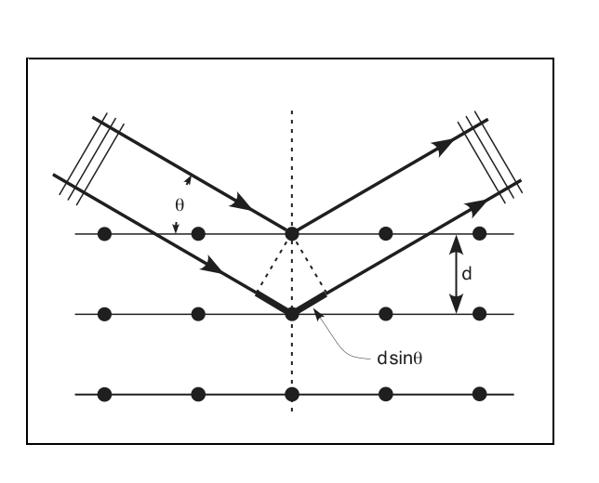

Figure 3.2
Single crystal X-ray diffractometer

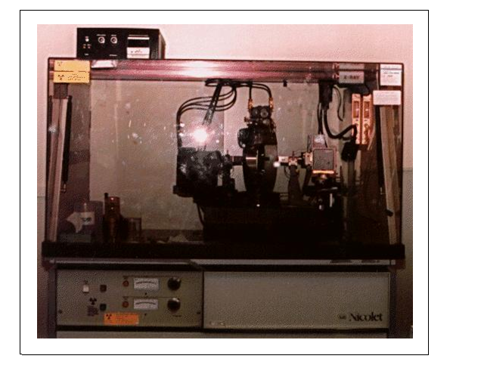

Figure 3.3
Fourier transform infrared spectrometer
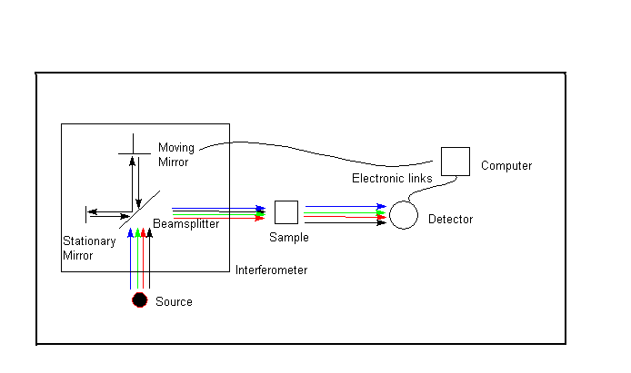

Figure 3.4
Uv visible spectrometer

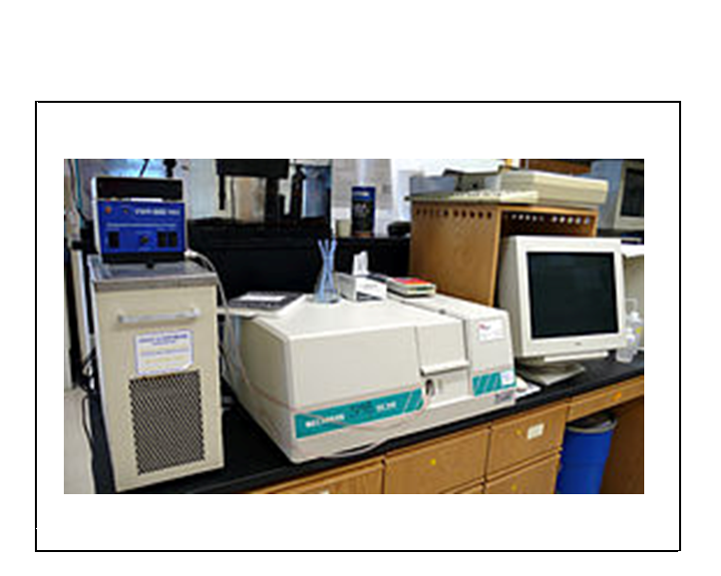

Figure 3.5
Second harmonic genaration

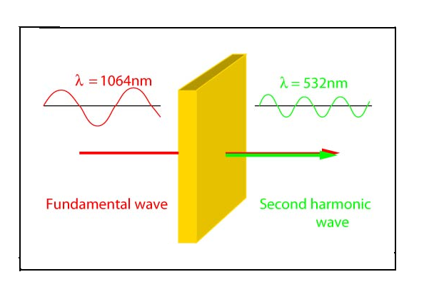

CHAPTER-IV
RESULTS AND DISCUSSION
4.1 Introduction
A crystal is a solid in which the atoms are arranged in a three dimensional periodic manner. The crystallography is the science of crystals, which is devoted to the study of their development and growth, their external form, internal structure and physical properties [2]. Crystal has wide applications in the production of high efficiency photovoltaic cells, and detectors for alternative energy and medicine. Good quality crystalline materials are used in space applications. The results pertaining to the study entitled “Growth and characterization of KDP crystal grown from acetone as solvent” are analyzed under the following subheadings.
- Synthesis of the compound material using slow evaporation method
- Fourier transform infrared spectrometry (FTIR)
- Ultraviolet visible spectrometry. (UV-vis)
- Non –linear optical study.
4.2 Synthesis of the Compound Material Using Solution Method
Potassium dihydrogen phosphate crystal was grown by evaporation technique. Distilled acetone is taken as solvent in a beaker. Potassium dihydrogen phosphate was added in 2gm, into the solvent. The stirring is performed under the condition of moderate heat and speed. KDP was added till the solution became saturated. After the saturation, the solution was filtered and kept in a beaker. Its mouth covered tightly using filter paper with holes for slow evaporation without any disturbance. The KDP crystals are grown at room temperature within two weeks.
The grown crystal is taken for a characterization studies using the Fourier transform analysis, UV-visible spectrometry, and the non-linear optical study. The photograph of the synthesized crystal is shown in Plate 1.

4.3 Fourier Transform Infrared Spectroscopy (FTIR)
FTIR stands for Fourier Transforms Infrared. It is a type of spectroscopy that used infra red light. IR radiation is passed through a sample. Some of the infrared radiation absorbed by the sample and some of it is passed through (transmitted). The resulting spectrum represents the molecular absorption and transmission of the sample.
The grown KDP crystal was studied by Perkin Elmer FTIR 8000 spectrometer RXI model and the band assignments are presented in Figure 4.1. The FTIR spectra were for the KDP crystal to study their optical behavior at IR wavelengths. The FTIR spectrum is recorded in the wave number ranging from 4000-400cm⁻¹. The broad envelopes between 2300 and 3600cm⁻¹ is due to the P-OH stretching of H₂PO₄. The broadness is generally attributed to the hydrogen bonding interaction of H₂PO₄. The absorption peaks occurring near 910cm⁻¹ is due to the P-OH stretching. The absorption peak near 535cm⁻¹ is due P-OH deformation. Further, the as grown sample is fairly transparent in the IR region (%T ranging between 20 to 50%)
4.4 Ultraviolet-Visible Spectroscopy (UV-vis)
UV visible spectroscopy deals with the measurement of energy absorbed when electrons are promoted to higher energy levels. Generally, the electronic excitations occur in the range from 200 to 780nm. It is also referred to as electronic spectroscopy.
The UV-visible spectroscopy of the grown KDP crystals was performed by using UV-Visible spectrophotometer, in the wavelength range at 190nm to 2500nm. The UV-Visible spectrum is obtained by the absorption of the sample at each wavelength. The UV-Visible absorption pattern of the crystals shown in Figure 4.2. The absorption values in the range from 190-2100nm are listed in Table 4.1.
The UV –visible spectrum was recorded for the KDP crystals grown from acetone as solvent. The spectrum is recorded from 190-2500nm. The KDP crystals exhibit higher transparency in these regions. The lower cut off wavelength of the crystals occurs at 200nm. The absorption further decreases as the wavelength goes beyond 800nm. The crystals possess very low absorption in these regions and hence these crystals can be used for frequency conversion applications over a wide wavelength range.

4.5 Non-Linear Optical Study
Non linear optics is the branch of optics that describes the behavior of light in non linear media, that is media in which the dielectric polarization P responds nonlinearly to the electric field E of the light. Non-linear optical behavior exhibited by each material depends upon its atomic structure and composition. This nonlinearity is typically only observed at very high intensities by pulsed laser [47].
The grown crystals were subjected to the NLO study to measure the SHG efficiency. To characterization the crystals, Kurtz and Perry method was used. In this experiment, a high intensity Nd: YAG laser is used, as a source and directed on to sample of KDP .The SHG efficiency is confirms from the output of intense beam green light emission (λ=532nm) from the grown crystal.

TABLE 4.1

Relation between wavelength and absorption by the crystal using Ultraviolet Visible spectroscopy

Wavelength (nm) | Absorption (a.u)
190 | 0.338320
200 | 0.326141
300 | 0.307347
400 | 0.299357
500 | 0.295772
600 | 0.292549
700 | 0.295712
800 | 0.291112
900 | 0.266353
1000 | 0.265768
1100 | 0.263763
1200 | 0.263898
1300 | 0.262362
1400 | 0.261933
1500 | 0.261568
1600 | 0.262418
1700 | 0.266265
1800 | 0.268210
1900 | 0.269040
2000 | 0.270252
2100 | 0.271784

Plate 1
Solution grown KDP crystals with acetone as solvent

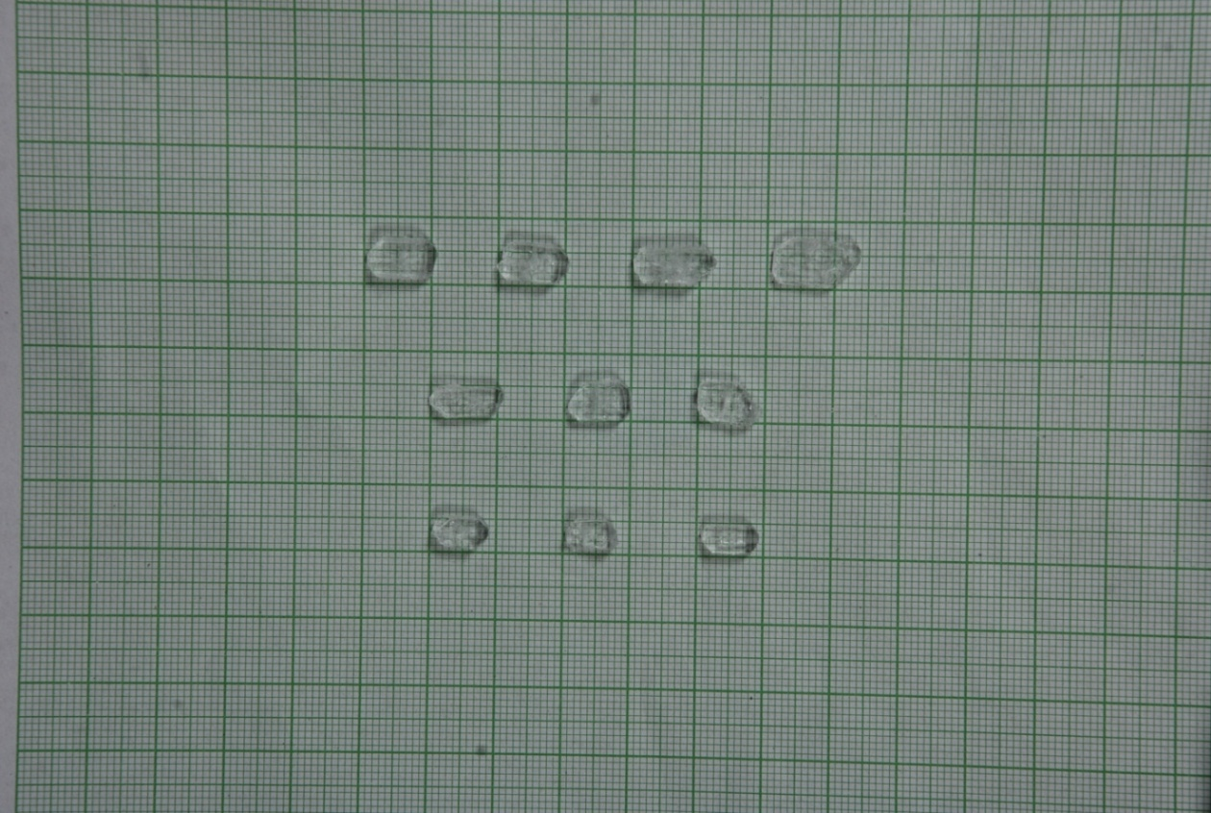

Figure 4.1
Fourier transform infrared spectrum

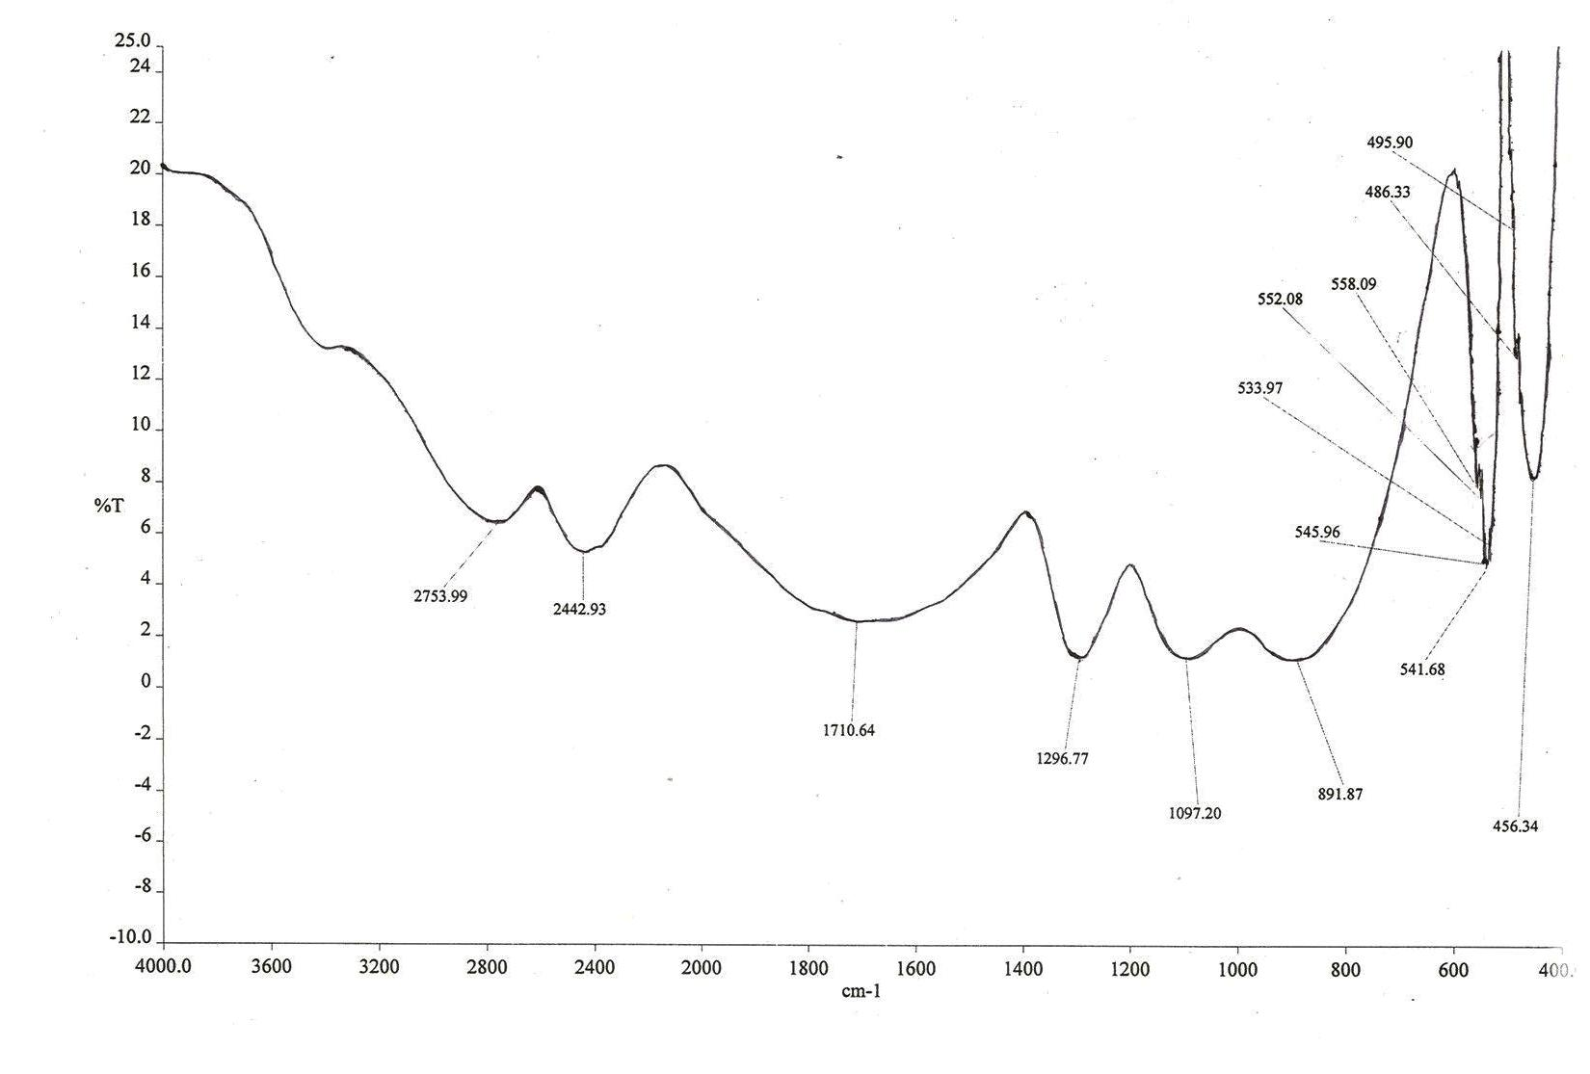

Figure 4.2
UV- visible absorption pattern

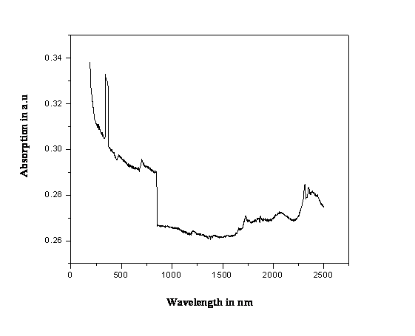

CHAPTER-V

SUMMARY AND CONCLUSION

Crystals are extremely important in many of our modern technologies. Especially in the electronic microcircuits (intergraded circuits) such as, cellular phones, communication systems, the tiny LED’s in TV monitor, and large scales in the traffic signals are all realized with good quality crystalline materials. Crystalline materials are of much importance due to their reliable and dependable functional properties because of the periodic arrangement of atoms. Crystals are used as semiconductor devices for transistors. Potassium dihydrogen phosphate single crystals have a high laser damage threshold, a large non-linear optical coefficient, good structural quality and mechanical properties. Good quality crystals can be obtained from various techniques. They are growth from solution, growth from melt, growth from vapour, etc.

In this study, crystals are grown by employing the solution growth technique. Potassium dihydrogen phosphate crystals are grown by using diluted acetone as a solvent. The saturated solution is prepared. The saturated solution is filtered and kept for growth. The crystal is grown. The crystals are characterized by using Fourier transform spectrometry, Ultraviolet-visible spectrometry and Non-linear optical study.

Fourier transform is a mathematical technique and it is used to predict the functional groups present in the synthesized materials. The grown crystals are subjected to Fourier transform infrared (FTIR) study, which reveals the various functional groups in the range 4000-400cm⁻¹. The functional group P-OH stretching of H₂PO₄ is between 2300 and 3600cm⁻¹. The peak absorption of P-OH stretching is at 910cm⁻¹. The P-OH deformation is at near 535cm⁻¹.

The ultraviolet visible spectrum reveals the optical nature of the crystal. The UV –visible spectrum of absorption of the sample is taken in the wavelength range 190nm-2500nm. The lower cut off wavelength of the crystal occurs at 190nm in the UV region. Crystals exhibit higher transparency in visible regions. The absorption is only 0.338 a.u for 190 nm.

Optical non linearity is defined simply as any deviation from the linear relationship between materials polarization response and an applied electric field. Second harmonic generation (SHG) measurement is used to confirm the non-linear optical properties of the grown crystals. The output of green light emission from the grown KDP crystals confirms it as a NLO material.

To conclude, KDP crystal with acetone as solvent is synthesized using slow evaporation technique. The FTIR reveals, which is possess P-OH stretching-OH deformation are present in the grown material. It absorbs the light of wavelength is at 2300 and 3600cm⁻¹. The UV –visible spectrum is recorded from 190-2500nm. The low absorption shows the higher transparency in entire visible region makes this crystal a good candidate for optoelectronic application. The synthesized material possess NLO property which is confirmed using Nd: YAG laser. KDP crystal with large SHG efficiency may be useful for laser fusion experiment and frequency conversion applications. The grown crystals have its applications in the vast field of modern technology.

REFERENCE

1. R.K. Puri, V.K. Babbar- Solid State Physics, S.Chand and Company ltd.1997, pp:1.
2. M.G. Arora- Solid State Chemistry, Anmol Publication Pvt Ltd.1997, pp: 1,4-5,108.
3. Dr.S.L. Gupta, Dr.V. Kumar -Solid State Physics. K.Nath &Co. Meerut.1973, pp: 2-4.
4. W.L. Bond- Crystal Technology, Stanford University, John Wiley & Sons, pp-1.
5. M.A.Wahab- Essentials of Crystallography, Narosa Publishing House, 2009,pp: 150-161,227.
6. R. Murugeshan, Kiruthiga Siva Prasath- Modern Physics, S.Chand &Company Ltd.pp: 959-961.
7. Dr.P. Ramasamy -Crystal Growth & its process, KRU Publication. pp: 1,4-5.
8. B. Viswanathan- Structure & Properties of Solid State Materials, Narosa Publishing House.pp: 2,51-52,2006.
9. Dr.J. Kumar, Dr.S. Vasudevan, Dr.S. Moorthy babu-Engineering Physics, Vijay Nicole Imprints Private Ltd, 2006,pp: 161.
10. Joesph H. Simmons, Kelly S. Potter -Optical Materials, Academic Press, 2006,pp: 297-305.
11. K. D. Parikh, D. J. Dave, B. B. Parekh, and M. J. Joshi- Growth and characterization of L-alanine doped KDP crystals, Crystal. Res. Technol. 45, No. 6, year: 2010.

12. S. Dinakaran; Sunil Verma; S. Jerome Das; G. Bhagavannarayana; S. Kar; K. S. Bartwal- Investigations of Crystalline and Optical Perfection of SHG Oriented KDP Crystals, Applied Physics A: Materials Science & Processing. Vol 99; No 2; Year 2010. 445-450.

13. R. Robert, C. Justin Raj, S. Krishnan and S. Jerome Das - Growth, theoretical and optical studies on potassium dihydrogen phosphate (KDP) single crystals by modified Sankaranarayanan–Ramasamy (mSR) method ,Physica B:Condensed Matter, Volume:405,Issue 1, 1 January 2010, Pages 20-24.

14. S. Gunasegaran and G. R. Ramkumaar- Analysis on suitability of pure and α-Histidine doped KDP crystals in high speed applications ,Indian Journal of Physics, Volume 83, Number 11, 1549-1555, 2009.

15. P. Kumaresan , S. Moorthy Babu and P.M. Anbarasan- Thermal, dielectric studies on pure and amino acid (l-glutamic acid, l-histidine, l-valine) doped KDP single crystals, Optical Materials, Volume 30, issue 9,May 2008, Pages 1361-1368.
16. C. Justin Raj; S. Krishnan; S. Dinakaran; R. Uthrakumar; S. Jerome Das- Growth and Optical Absorption Studies on Potassium Dihydrogen Phosphate Single Crystals, Crystal Research and Technology. Vol 43; No 3; Year 2008. 245-247.
17. P. Kumaresan, S. Moorthy Babu and P.M. Anbarasan-Effect of irradiation of swift heavy ions on dyes-doped KDP crystals for laser applications, Journal of Crystal Growth, Volume :310, Issues 7-9, April 2008, Pages 1999-2004.
18. M. Meena, C. K. Mahadevan -Growth and electrical characterization of L-arginine added KDP and ADP single crystals, Crystal Research and Technology, Volume 43, Issue 2, pages 166–172, February 2008.
19. S.P. Meenakshisundaram, S. Parthiban, G. Madhurambal, R. Dhanasekaran and S.C. Mojumdar, Chemistry and Materials Science, Journal of Thermal Analysis and Calorimetry, Volume 94, Number 1, 15-20,2008.
20. M. D. Shirsat; S. S. Hussaini; N. R. Dhumane; V. G. Dongre-Influence of Lithium Ions on the NLO Properties of KDP Single Crystals, Crystal Research and Technology. Vol 43; No 7; Year 2008. 756-761.
21. Zheng, G., Su, G., Zhuang, X., Lin, X. and Li, Z. – Growth and Properties of Ba-doped KDP crystals. Crystal Research and Technology. Volume 43, Issue 8, pages 811–816.
22. M. Badrouj, R. Malekfar-The Ph Effects on the Growth Rate of KDP (KH2po4) Crystal by Investigating Raman Active Lattice Modes, Journal of Raman Spectroscopy. Vol 38; No 9; Year 2007. 1089-1096.
23. Jianqin Zhang, Shenglai Wang ,ChangShui Fang, Xun Sun, Qingtian Gu, Yiping Li, Bo Wang, Bing Liu and Xiaoming Mu-Growth habit and transparency of sulphate doped KDP crystal , Materials Letters, Volume 61, Issue 13, May 2007, Pages 2703-2706.
24. N. Balamurugan ; P. Ramasamy-Investigation of the Growth Rate Formula and Bulk Laser Damage Threshold KDP Crystal Growth from Aqueous Solution by the Sankaranarayanan-Ramasamy (SR) Method, Crystal Growth & Design. Vol 6; No 7; Year 2006. 1642-1644.
25. S. Goma, C.M. Padma and C.K. Mahadevan-Dielectric parameters of KDP single crystals added with urea, Materials Letters, Volume 60, Issues 29-30,December 2006, Pages 3701-3705.
26. Bo Wang, Chang-shui Fang, Sheng-lai Wang, Xun Sun, Qing-tian Gu, Yi-ping Li, Xin-guang Xu, Jian-qin Zhang, Bing Liu, Xiao-ming Mou-The effects of Sn⁴⁺ ion on the growth habit and optical properties of KDP crystal, Journal of Crystal Growth, Volume 297, Issue 2, 29 December 2006, Pages 352-355.
27. Guohui Li , Xue Liping, Genbo Su, Xinxin Zhuang, Zhengdong Li and Youping He-Study on the growth and characterization of KDP-type crystals , Journal of Crystal Growth, Volume 274, Issues 3-4, 1 February 2005, Pages 555-562 .

28. J. Podder-The Study of Impurities Effect on the Growth and Nucleation Kinetics of Potassium Dihydrogen Phosphate,Journal of Crystal Growth.Vol 237-239; No P1; Year 2002. 70-75.

29. Selemani Seif; Jiann-Min Chang; Kamala Bhat; Benjamin Penn; R. B. Lal-Investigation of Temperature Dependence and Impurity Content on the Growth Rate of KDP Crystals, Crystal Growth & Design. Vol 1; No 5; Year 2001. 359-362.
30. I. M. Pritula; V. I. Salo; M. I. Kolybaeva-Laser Damage Threshold and Uv Absorption of Doped Potassium Dihydrogen Phosphate Crystals, Inorganic Materials. Vol 37; No 2; Year 2001. 184-185.

31. N. Zaitseva and L. Carman- Rapid growth of KDP-type crystals ,Progress in crystal growth and characterization of Materials, Volume 43.Issue 1,2001, Pages 1-118.

32. S. Sen Gupta, T.kar and S.P. Sengupta -Growth defects in pure and mixed crystals of KDP-ADP by x-ray Lang Topography, Indian Journal of physics, 1999 ,vol.73 A(3), pp-337-341.

33. G. Ravi, A. S. Haja Hameed, P. Ramasamy-Effect of temperature and deuterium concentration on the growth of deuterated potassium dihydrogen phosphate (DKDP) single crystals, Journal of Crystal Growth, Volume 207, Issue 4, 15 December 1999, Pages 319-324.

34. K. Fujioka, S. Matsuo, T. Kanabe, H. Fujita and M. Nakatsuka -Optical properties of rapidly grown KDP crystal improved by thermal conditioning ,Journal of Crystal Growth
Volume 181, Issue 3, 1 November 1997, Pages 265-271.

35. A. Abdel-Kader, A. A. Ammar and S. I. Saleh-High-temperature phase transition in potassium dihydrogen phosphate crystals, Thermochimica Acta, Volume 167, Issue 2, 10 October 1990, Pages 225-233.
36.Dr.P. Ramasamy , Dr.P. Santhanaragavan-Crystal Growth Process and its Methods,pp:151-157,164 ,179-182.KRU Publication.
37. S.O. Pillai- Solid State Physics,New Age International (p)limited,2002.pp:169
38. R.Wilfred Sugumar -Molecular and Atomic Spectroscopy, MSP Publishers, 2008,pp: 1,8.
39. Jag Mohan -Organic Spectroscopy, Principles and Applications, 2nd edition, Narosa publishing house, and 200.pp: 1,119-120.
40. James Vergeese -Analytical Spectroscopy, Pacific Books International, 2010, pp: 208-209,214-215.
41. G. Aruldhas -Molecular Structure and Spectroscopy, pp: 195,197-203.
42. Robert M.SILVERSTEIN, Francis X.WEBSTER-Spectrometric Identification of Organic Compounds, Wiley Student Edition, 2002, pp: 77.
43. Pavia, Lampman, Kriz -Introduction to Spectroscopy, pp: 353, Thomson brooks/cole.
44. P.S. Kalsi -Spectroscopy of Organic Compounds, 5th edition, New age International Publishers, 2002, pp: 13.
45. P.K. Palanisamy -Materials Science (2nd edition) SciTech Publications (India) pvt ltd., 2002.pp: 6.28-6.31.
46. M.A. Wahab-Solid State Physics, Structure and Properties of Materials, 2nd edition, 1999, pp: 50.
47. B.B. Laud-Laser and Non-Linear Optics, New Age International Publishers, pp: 182.
WEB SITES
- www.free dictionary.com/solid state physics.
- http://www.answers.com/topic/solid-state-physics#ixzz1I3O9j2cH,McGraw-Hill Science &Technology encyclopedia : Solid-state physics
- http://en.wikipedia.org/wiki/Crystallography
- http://www.gamdan.com/KDP ,2008 ,GAMDAN Optics
- http://en.wikipedia.org/wiki/Monopotassium_phosphate
- .http://serc.carleton.edu/research_education/geochemsheets/techniques/SXD.html
- http://en.wikipedia.org/wiki/Ultraviolet%E2%80%93visible_spectroscopy
- http://mmrc.caltech.edu/FTIR/FTIRintro.pdf,2001,ThermoNicoletCorporation,www.thermonicolet.com
- http://en.wikipedia.org/wiki/Second-harmonic_generation

LIST OF TABLES

Table No | Title | Page No
4.1 | Relation between wavelength and absorption by the crystal using Ultraviolet Visible Spectrometry | 44

LIST OF FIGURES

Figure No | Title | Page No
3.1  3.2  3.3  3.4  3.5  4.1  4.2 | Bragg’s diffraction pattern  Single crystal X-ray diffractometer  Fourier transform infrared spectrometer  UV-visible spectrometer  NLO study-Second harmonic genaration  Fourier transform infrared spectrum  UV-visible absorption pattern | 36  37  38  39  40  46  47

LIST OF PLATE

Plate No | Title | Page No
1 | Solution Grown KDP Crystals with Acetone as Solvent | 45

