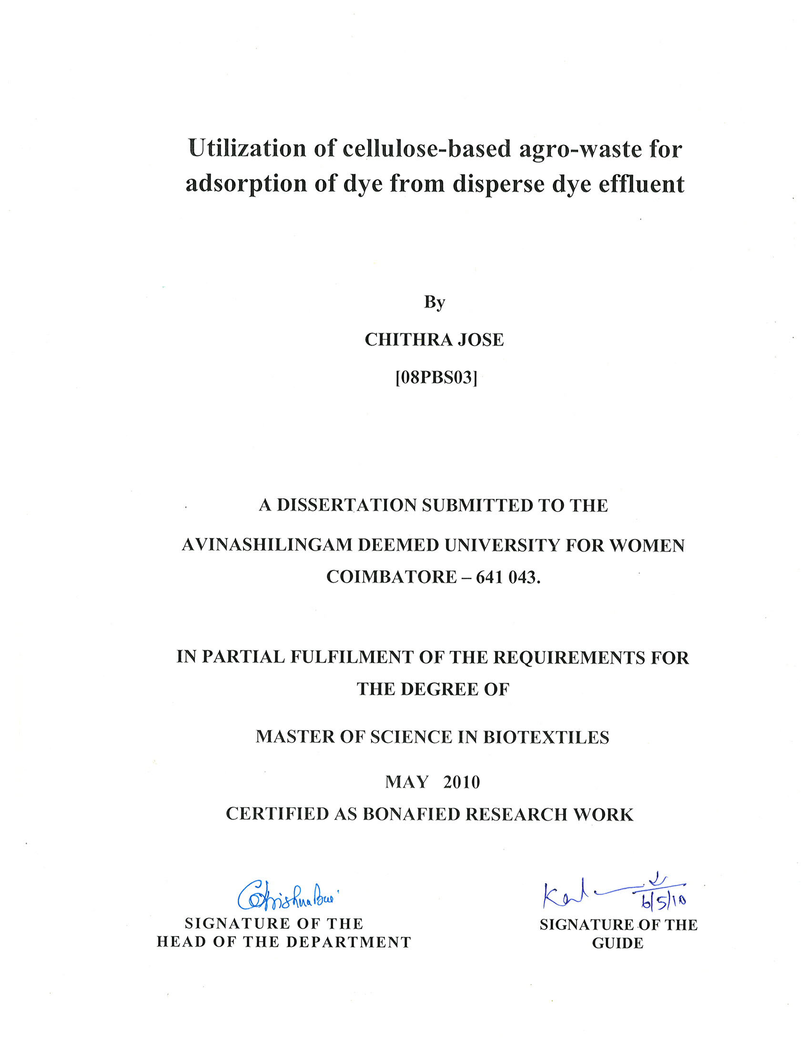

Utilization of cellulose-based agro-waste for adsorption of dye from disperse dye effluent

By
CHITHRA JOSE
[ 08PBS03]

A DISSERTATION SUBMITTED TO THE
AVINASHILINGAM DEEMED UNIVERSITY FOR WOMEN COIMBATORE – 641 043.

IN PARTIAL FULFILMENT OF THE REQUIREMENTS FOR THE DEGREE OF
MASTER OF SCIENCE IN BIOTEXTILES

MAY 2010

Acknowledgement
ACKNOWLEDGEMENT
The investigator places her humble salutations and prayer to the almighty god for his uncountable blessings showered upon her throughout the study.
The investigator expresses her sincere thanks to the former Chancellor of Avinashilingam Deemed University for Women, Coimbatore, Ayya Thiru. T.S. AVINASHILINGAM, and Hony. Col. Padmashri, Amma, Dr. (Tmt). RAJAMMAL P. DEVADAS, M.A., M.Sc., Ph.D., (Ohio State), Hon. D.Sc. (Azad Agri. University, Kanpur), Avinashilingam Deemed University for Women, Coimbatore.
The investigator records her sincere thanks to Thiru T.K. Shanmuganandam B.A., B.L., Chancellor, Avinashilingam Deemed University for Women, Coimbatore, for providing the infrastructural facilities for the conduct of the study.
The investigator is indebted to Hony. Col. Dr. (Tmt). Saroja Prabhakaran, M.A., Dip.Ed. (Madras), Ph.D. (Mother Teresa), Vice-Chancellor, Avinashilingam Deemed University for Women, Coimbatore, for providing all the amenities required for the conduct of the study.
The investigator records her gratitude to Dr. (Tmt). GOWRI RAMAKRISHNAN, M.Sc., (Madras), M.Phil., Ph.D. (Avinashilingam), Registrar, Avinashilingam Deemed University for Women, Coimbatore, for providing all the help for the smooth conduct of the study.
She records her deep sense of gratitude to Dr. (Tmt). G. KRISHNABAI, M.Sc., M.Phil., Dip.Ed., (Madras), Ph.D. (Mother Teresa), Professor and Head, Department of Textiles and Clothing, Dean, Faculty of Home Science, Avinashilingam Deemed University for Women, Coimbatore, for her concern and encouragement which have helped in the successful completion of this study.
The investigator records her sincere gratitude and heartfelt thanks to Dr. (Tmt). S. AMSAMANI, M.Sc., (Bharathiar), M.Phil., Ph.D. (Avinashilingam), Associate Professor, Department of Textiles and Clothing, Avinashilingam Deemed University for Women, Coimbatore, the real source of inspiration whose constant encouragement, love – worthy guidance and suggestions has shaped this study to final form.
The investigator feels extremely proud and privileged for having worked under the guidance of her esteemed guide Tmt. K. KALAIARASI, M.Sc., (Avinashilingam), M.Phil. (Madras), Assistant Professor, Department of Textiles and Clothing, Avinashilingam Deemed University for Women, Coimbatore, for her constant motivation, keen interest, relentless support, untiring patience, innovative ideas, suggestion, constant love and easy approach throughout the study.
She also wishes to thank all the TEACHING AND NON TEACHING STAFF of the department who helped her to carry out the research work.
She is thankful to Avinashilingam Deemed University for Women, SIMA and SITRA for the library facilities and guidance provided. And also thankful to Textile Committee for their support to effluent analysis.
The investigator gratefully acknowledges the encouragement, timely help and support received from her Friends. She expresses her deepest sense of gratitude to her Beloved Parents I.A. Jose, Reethama P.A. and Family Members for extending their support without which the study would never have seen the light of the day.

Contents
LIST OF TABLES

Table No. | Title | Page No.
1 | Characteristics of wet processing waste water | 7
2 | Exhaustion range of various dye classes | 9
3 | List of banned allergenic disperse dyes. | 15
4 | List of additional allergic disperse dyes | 16
5 | Decolorisation of selected synthetic dyes by various agro-wastes. | 52
6 | Effect of different sized agro-wastes on the decolorization of disperse dye effluent | 54
7 | Effect of agro-waste concentration on the decolorization of disperse dye effluent. | 56
8 | Effect of pH on the decolorization of disperse dye effluent | 59
9 | Effect of contact time and temperature on the decolorization of disperse dye effluent | 61
10 | Percentage of adsorption shown by secected agro-residues. | 63
11 | Characteristics of raw and treated effluent | 65
12 | Germination percentage of green gram plants on 7th and 14th day | 67
13  14  15  16 | Vigor index of green gram plants on 7th and 14th day  Total chlorophyll content of green gram plants on 7th and 14th day  Total protein content of green gram plants on 7th and 14th day  Total carbohydrate content in green gram plants on 7th and 14th day | 68  69  71  72
LIST OF FIGURES
Figure No. | Title | Page No.
1 | Effect of different sized agro-wastes on the decolorization of disperse dye effluent | 53
2 | Effect of agro-waste concentration on the decolorization of disperse dye effluent | 55
3 | Effect of pH on the decolorization of disperse dye effluent. | 58
4 | Effect of temperature on the decolorization of disperse dye effluent | 60
5 | Effect of contact time on the decolorization of disperse dye effluent using agro-waste | 62
6 | Germination percentage of green gram plants on 7th and 14th day | 67
7 | Vigor index of green gram plants on the 7th and 14th day | 68
8 | Total chlorophyll content of green gram plant on 7th and 14th day after seeding | 70
9 | Total protein content of green gram plants on 7th and 14th day | 71
10 | Total Carbohydrate in green gram plants on the 7th and 14th day after sawing the seeds | 72

LIST OF PLATES
Plate No. | Title | Page No.
1 | UV – Visible Spectrophotometer | 31
2 | pH meter | 31
3 | BOD Incubator | 32
4 | Different sized agro-wastes used for decolorization | 41
5 | Green gram plants on 7th day | 43
6 | Green gram plants on 14th day | 43
7 | Measuring the root and shoot length of greengram plant | 43
8 | Extracted chlorophyll | 46
9 | Centrifuge | 46
10 | Decolorization of disperse dye effluent using various concentrations of mosambi peel | 57
11 | Decolorization of disperse dye effluent using various concentrations of orange peel | 57
12 | Decolorization of disperse dye effluent using various concentrations of lemon peel | 57
13 | Decolorization of disperse dye effluent using mosambi peel at optimum conditions | 64

Introduction
1.0. INTRODUCTION
The textile industry has a great economic significance by virtue of its contribution to overall industrial output and employment generation. It has a unique position as a self reliant industry from the production of raw materials to the delivery of finished products with substantial value addition at each stage of processing. While considering environment and textiles, the textile industry cause the maximum environmental damage by solid waste and liquid effluent. The huge amounts of polluted effluents are discharged to surface water bodies and ground water aquifers.
Textile industry uses wide range of dyes, auxilliaries and processes to engineer the required shape and properties of the final product. Waste stream generated in this industry is essentially based on water-based effluent generated in the various activities of wet processing of textiles. The main cause of generation of this effluent is the use of huge volumes of water either in the actual chemical processing or during re-processing in preparatory, dyeing, printing and finishing. The effluent generated in different steps is well beyond the standard and thus it is highly polluted and dangerous, states sivaramakrishnan (2008). Effluent water is discharged into natural streams along with appreciable quantities of dyes and chemicals creating series ecological effluent problems say, Anandapriya et al. (2007).
Color is very crucial in textile industry. Dyes and pigments have been used in many industries for coloration purpose. Over 7x10⁵ tones and approximately10, 000 different types of dyes and pigments are produced worldwide annually and the volume is steadily increasing report, Iqbal and Ashiq (2005). It has been estimated that about 10 % of the dye stuff used during the dyeing process do not bind to fibers and are therefore released into the environment.
The presence of even a small fraction of dye in water is highly visible due to the color and affects the streams and other water bodies. Hatch (2003) reports that some dyes can cause allergy, dermatitis, skin irritation, mutation and cancer in humans. The discharge of colored wastewater into natural streams has caused many significant problems such as increasing the toxicity and COD of the effluent, and also reducing the light penetration which has a derogatory effect on photosynthetic phenomenon, state Chen et.al. (2003). Despite this carcinogenic and mutagenic effects, 50,000 tons of dyes are discharged into environment annually say, Heredia et al. (2009). Most dyes used in textile industry are stable to light and are not biodegradable.
Intensive irrigation of agricultural lands with water polluted from various industrial effluents, severely affect soil fertility and plant growth. Dissolved substances in industrial effluents alter the chemical and biological status of the soil and water, which may affect growth and productivity of plants. Effluents also affect susceptibility of plants to various pathogens, explain Rajendran and Gunasekaran (2006).
Various methods of dyes/color removal such as aerobic and anaerobic microbial degradation, coagulation, chemical oxidation, membrane separation process, filtration, reverse osmosis have been proposed to time to time. How ever, all of these methods suffered with one or other limitations and none of these were successful in removing color from waste water completely. The removal of dyes from effluent in an economic fashion remained a major problem. Therefore, there is a need for the development of low cost, easily available materials which can absorb dyes from effluent.
The removal of dyes from effluent using adsorption provides an attractive alternate treatment, especially if the adsorbent is inexpensive and readily available, states Reddy (2006). The utilization of agro-waste as adsorbent is currently receiving wide attention because of their availability and low-cost owing to relatively high fixed carbon content and presence of porous structure, view Bhatnagar et al. (2009). Use of agricultural wastes is of great significance in India, where more than 200 million tons of agricultural residues are generated annually. The utilization of agricultural waste provides additional employment and income to marginal farmers and landless agricultural labourers especially in developing countries, says Reddy (2006).
A number of agro-residues used as adsorbents for dye removal include sugar cane bagasse (Tsai et al., 2001), coir pith (Namasivayam and Kavitha, 2002), orange peel (Rajeswarisivaraj et al., 2001), wood sawdust (Ho and Mckay, 1998), neem leaves (Battacharya et al., 2003) and de-oiled soya (Gupta et al., 2006).
Bearing in mind the toxicological impacts of dye effluent, the present study on “Utilization of cellulose-based agro-waste for adsorption of dye from disperse dye effluent” has been designed with the following objectives,
- To assess the physical characteristics of the dispersed dye effluent before and after treatment.
- To screen various agro-wastes for their suitability in decolorizing the textile dye effluent.
- To select the most effective agro-waste for decolourisation of dispersed dye effluent.
- To optimize the experimental conditions for maximal and efficient removal of dye from the effluent.
- To assess the reusability of treated effluent water for irrigation.

Review of literature

2.0. Review of Literature
The review of literature pertaining to the study are discussed under the following headings
2.1. Indian textile industry
2.1.1. Wet processing industry and water pollution
2.1.2. Dyeing and Environmental concerns
2.1.2.1. Colored textile effluents and issues
2.1.3. Government policies to abate pollution
2.1.3.1. The Water (prevention and control of pollution) Act, 1974 Am.1978, 1991
2.1.3.2. The Environment (Protection) Act, 1986
2.1.3.3. Environmental Audit Report
2.1.3.4. Environmental Standards
2.2. Dyes
2.2.1. Disperse dyes
2.2.1.1. Introduction
2.2.1.2. History
2.2.1.3. Classification
2.2.1.4. Advantages
2.2.1.5. Disadvantages
2.3. Color removal methods
2.3.1. Chemical methods
2.3.1.1. Oxidation
2.3.1.1.1. Ozone
2.3.1.1.2. Hydrogen peroxide
2.3.1.1.3. Sodium hypochlorite
2.3.1.2. Photochemical Treatment
2.3.1.3. Electro-chemical treatment
2.3.1.4. Flocculation/Coagulation
2.3.1.5.Fenton’s reagent process
2.3.2. Physical and physico-chemical treatments
2.3.2.1. Adsorption
2.3.2.2. Filtration (membrane technology)
2.3.2.2.1. Micro filtration (MF)
2.3.2.2.2. Ultra filtration
2.3.2.2.3. Nano-filtration
2.3.2.2.4. Reverse osmosis
2.3.3. Biological methods
2.3.3.1. Aerobic treatment
2.3.3.2. Microbial/enzymatic treatment
2.4. Importance of agro-waste in the decolorisation of dye effluent
2.5. Recycling of treated effluent water for irrigation

2.1. Indian textile industry
Textile industry is the mother of Indian industrialization. It is the second largest employment generator after agriculture report, Athalye and Shirke (2008).The Indian textile industry is one of the oldest industries in the world. Evidences exist that trade in textiles began as far back as the 15th century. Indian textiles have always been a major player in global trade over the past few decades explain Nimkar and Bhajekar (2006).
Indian textile industry contributes about 14 per cent to industrial production, 4 per cent to the country’s domestic product (GDP) and 17 per cent to export earnings. Nearly 40 per cent of the textile produced in the country is exported. The sector targets about 6 billion foreign direct investments (FDI) by 2015 to be invested in green field units in textiles, machinery and fabric and garment manufacturing as well as technical textiles (www.ibef.org).
2.1.1. Wet processing industry and water pollution
India is the global competitor in textiles. Nearly 25 m³/ton of water is used for cotton cloth as against 100 m³/ton in developed countries, states Lakshmanan (2005). Water is a main ingredient for wet processing with its requirement going as high as 150 liters/kg of the textile materials to be processed. The amount of a composite mill’s effluent discharge varies up to 10 million liters/day depending on the quality and type of textile and its manufacturing process, reports Shukla (2006).
The textile industry, which uses up to 600 chemicals in production from raw material to disposal, is generally reared among the most polluting. Waste stream generated in this industry is essentially based on water – based effluent generated in the various activities of wet processing of textiles. Wet processing operations such as desizing, scouring, bleaching, dyeing, printing and finishing are the major contributors of water pollution say, Joshi et al. (2004). The characteristics of wet processing waste water are shown in Table 1.
Table 1. Characteristics of wet processing waste water
Characteristics of wet processing waste water
Characteristics | De-sizing | Kiering | Bleaching | Mercerizing | Dyeing | Printing
pH | 8.6-10.0 | 10.9-11.8 | 8.4-10.9 | 8.1-9.8 | 9.2-11.0 | 6.7-8.2
TDS (mg/l) | 5580-6250 | 12260-38500 | 2780-7900 | 2060-2600 | 3230-6180 | 1870-2360
SS (mg/l) | 2290-2670 | 1960-2080 | 200-340 | 160-430 | 360-370 | 250-390
BOD 5 days, 20⁰C (mg/l) | 1000- 1080 | 2500-3480 | 87-535 | 100-1222 | 130-820 | 135-1380
COD (mg/l) | 1650-1750 | 12800-19600 | 1350-1575 | 246-381 | 465-1400 | 410-4270
Source - Shivaramakrishnan (2008)

The greatest waste water problems arise in dyeing and printing the textiles. Textile dyeing plants, particularly those involving finishing process are the major sources of water pollution. Waste water stream from the textile dyeing operations contain unused dyes and auxillary chemicals report, Cristovao et al. (2009). A wide variety of dyes are used, which differs greatly in physical and chemical properties observe Tongeren et al. (2005). Banat et al. (1997) report that the presence of very small amounts of dye in water (less than 1ppm for some dyes) is highly visible and affects the aesthetic merit, water transparency and gas solubility in lakes, rivers and other water bodies. The removal of color from waste water is often more important than the removal of the soluble colorless organic substances, which usually contribute the major fraction of the biochemical oxygen demand.
2.1.2. Dyeing and Environmental concerns
Dyeing is a water intensive process. Most dye bath has three major pollutants namely, the dye that is unabsorbed, heavy metals incorporated in dyes and large amounts of salts that are often used to improve the dye fixation. Apart from these, color in effluents is aesthetically objectionable. The dye house effluents are high on BOD, COD, temperature, pH and aquatic toxicity reports, Nayak (2006).
2.1.2.1. Colored textile effluents and issues
A major contribution to color in textile waste water is usually the dyeing and washing operation after dyeing during which, as much as 50% of the dye might be released in to the effluent. During dyeing most of the dye is exhausted on the fiber, but the unfixed dyes goes into waste water causing deep color, observe Joshi et al. (2004). Table 2 represents exhaustion range of various dye classes

Table 2. Exhaustion range of various dye classes
Exhaustion range of various dye classes
Dye class | Fiber | Degree of fixation (%) | Loss in effluent (%)
Acid  Basic  Direct  Disperse  Metal-complex  Reactive  Sulphur  Vat | Polyamide  Acrylic  Cellulose  Polyester  Wool  Cellulose  Cellulose  Cellulose | 80-95  95-100  70-95  90-100  90-98  50-90  60-90  80-95 | 5-20  0-5  5-30  0-10  2-10  10-50  10-40  5-20

Source - Joshi et al. (2004).
Although dyes constitute a small portion of the total volume of waste discharged in textile processing, color removal from effluent is a major problem for textile industry because of several reasons:
- The presence of even a small fraction of dye in water is highly visible due to high tinctorial value of dyes and affects the aesthetic merit of streams and other water resources.
- Most dyes have complex aromatic structure resistant to light, biological activity, ozone and other degradative environments and hence not readily removed by typical waste treatment processes.
- The possible long term effects of few dyes and dye degradation products are of increasing concern. The possible mutagenic, carcinogenic and or allergic effects of dyes have been established. Over 90% of some 4000 dyes tested in an ETAD survey had LD 50 (lethal dose at 50%) survival values greater than 2x10³mg/kg. the highest rates of toxicity were found amongst basic and diazo dyes.
- Unless and otherwise properly treated , dyes can significantly affect photosynthetic activity in aquatic life due to reduced light penetration and may also be toxic to certain forms of aquatic life due to presence of metals and chlorides in them.
- Dyes have also been known to interfere with certain municipal waste water treatment operations i.e., UV disinfection, etc. report, Joshi et al. (2004).
Reducing color is important for the public image and international buyers are increasingly setting discharge standards for color. Color is defined as either true or apparent color. True color is the color of water from which all turbidity has been removed. Apparent color includes any color that is due to suspended solids in the water sample. Color and turbidity, both cause aesthetic and real hazard to environment. The real hazard caused by color and solids in water are dye toxicity and the ability of the dye to interfere with the transmission of light through the water. Thus, as a health and environmental issue, color too is a serious issue than other parameters like BOD, COD, PDS etc. explains, Shivaramakrishnan (2008).
In recognition of these problems, the following section reviews emerging concepts that have had some developmental history and show strong promise of effective textile dye color treatment.
2.1.3. Government policies to abate pollution
The government of India (GOI) realizing the importance of highly polluting nature of the textile and other chemical based industries has enacted various laws concerning the environmental pollution. While there are no specific laws regarding the textile industry, the following laws are applicable to the sector.
      - The Water (prevention and control of pollution) Act, 1974 Am.1978, 1991
The Act meant for prevention and control of water pollution and maintaining the wholesomeness of water. The Act lays down restriction on effluents ad prohibits use of streams or wells for disposal of polluting water.
The industries are required to obtain consent from the respective board for the discharge of sewage and /or trade effluent. The consent regulates what and how much should be discharged and prescribes a time-bound programme for installation of waste water treatment plants to comply with the prescribed effluent standards reports, Trivedy (2004).
2.1.3.2. The Environment (Protection) Act, 1986
This Act is an umbrella provides for the protection and improvement of environment and for the prevention of hazards to human beings, other living creatures, plants and property observes, Trivedy (2004).
      - Environmental Audit Report
The ministry of environment and forests has issued in 1992 a notification under which each industry is required to submit every year an environmental audit report to the concerned State Pollution Control Board. In the audit report, the industry is required to submit information in respect of water and raw material consumption, pollution generated, hazardous and solid waste along with their disposal practices state, Nimkar and Bhajekar (2006).
      - Environmental Standards
For effective enforcement of various legislations, there have to be guidelines in terms of allowable standards of quality of environment by way of prescribing concentration of various pollutants. The standards applicable in India are the following:
- Standards specified by the Government of India in the Environmental (Protection) Rules.
- Minimal National Standards (MINAS) and Emission Regulations evolved by Central Pollution Control Board.
- Standards specified by Indian Standards (IS:2490.(Part-1) -1981) - second revision
- Standards evolved by Pollution Control Boards.
These standards prescribe limits for pH, suspended solids, BOD, oil and grease, Bio-assay test, phenolic compounds, heavy metals, chlorides, sulphates etc. for discharge of effluents.
Effective monitoring and control of the raw materials, coloration chemicals, processing and speciality chemicals will be necessary to achieve the specifications that are today required for global trade observe, Nimkar and Bhajekar (2006).
2.2. Dyes
A dye is usually a colored organic compound or mixture that may be used for imparting color to a substrate such as cloth, paper, plastic or leather in a reasonably permanent fashion states, Chatwal (2002). Dyes are classified in to natural dyes and synthetic dyes based on origin. Natural dyes are obtained from nature and synthetic dyes are manufactured ones (www.globalspec.com).
Synthetic dyes are classified under the categories of anionic, cationic and nonionic types. Anionic dyes mostly include the direct, acid and reactive dyes. Basic dyes are the only class of cationic dyes used in textile industry. Nonionic dyes referred to as disperse dyes, do not ionize in an aqueous medium. The use of dyes depend upon the characteristics of the fibers, the specific color to be applied and the desired finish required on the fiber, explain Joshi et al.(2004).

2.2.1. Disperse dyes
2.2.1.1. Introduction
Disperse dyes are organic coloring substances of low molecular weight and low water solubility. These dyes are suitable for dyeing hydrophobic fibers from colloidal dispersion report Sekar and Mahajan (2007). The semi-synthetic and synthetic fibers like cellulose, acetate, nylon, polyester, rayon etc. are hydrophobic fibers. Hence they cannot be dyed by aqueous solutions of dyes observes, Sing (2002).Disperse dyes are insoluble but they are finely ground and dispersed in water using suitable dispersing agents. These micro fine dispersions are applied to fibers by using organic carriers or by using high temperature and pressure reports, Sing (2002). The dye molecules are not bound to the fiber, instead a variety of electrostatic interactions (dipole- dipole, Wander Vaals and hydrogen bonds) increase affinity for the fiber resulting in fixation explain, Walter et al. (2006).
2.2.1.2. History
The first disperse dye was reported for cellulose acetate rayon by British Celanese Corporation in 1920. None of the other classes of dyes been good for dyeing cellulose acetate. With the introduction of polyester fibers in 1950, rapid development occurred in the field of disperse dyes to make it suitable for polyester fibers and several modifications have been carried out explains, Sing (2002). Historically, disperse dyes were selected mosty from anthraquinone, azo, methane, ortho nitroarylamine, quinophthalone and a few miscellaneous classes. Large number of disperse dyes comes from azo class and these ranks first with anthraquinone class, observes Sekar (2008).

2.2.1.3. Classification
Disperse dyes are be classified according to their application on different fibers such as polyester, polyamide, polyacrylonitrile etc. but chemically it can be classified in to 3 well defined groups according to National Institute of Industrial Research board.
- Monoazo derivatives
Azo dyes provide an entire gamut of colors and have the advantage of color strength, ease of manufacture and economy. Azo disperse dyes are the most important ones. The monoazo disperse dyes have been reported to give almost a complete range of shades. These dyes are largely used for cellulose acetate and polyester fibers and their blends with cotton, polyamides, polyacrylonitriles and cellulose triacetate views Sing (2002).
- The anthroquinone derivatives
The anthroquinone disperse dyes have their major use in coloring synthetic fabrics. Even though the anthraquinone based disperse dyes have lower value and generally are more expensive, they continue to dominate certain parts of the market because of their brightness and combination of light fastness and dyeing properties.
- The nitrodiphenylamine derivatives

2.2.1.4. Advantages
Polyester is dyed exclusively with disperse dyes of which more than 50 per cent are azo compounds and another 25 per cent are anthraquinone (IPPC 2003).
2.2.1.5. Disadvantages
The fine particles of the disperse dye diffuse into the fabric and are held by adsorption. The lack of a strong chemical bond permits a degree of migration out of the fiber. This account for the high incidence of contact dermatitis associated with disperse dye stuffs, observe Walter et al. (2006). The oko-tex ecolabel lists 26 dye-stuffs classified as allergens, all of which are disperse dyes. Such allergenic disperse dyes are banned from use, report Nimkar and Bhajekar (2006). Table 3 contains the list of banned allergenic disperse dyes.
Table 3. List of banned allergenic disperse dyes.
Banned allergenic disperse dyes
Sl.No. | Dyestuff classified to be allergenous | C.I. structure number
1.  2.  3.  4.  5.  6.  7.  8.  9. | C.I. Disperse Blue 1  C.I. Disperse Blue 35  C.I. Disperse Blue 106  C.I. Disperse Blue 124  C.I. Disperse Yellow 3  C.I. Disperse Orange 3  C.I. Disperse Orange 11  C.I. Disperse Orange 37/76  C.I. Disperse Red 1 | C.I. 64500  C.I. 42500  Not available  Not available  C.I. 11855  C.I. 11005  Not available  Not available  C.I. 11110
Source - Nimkar and Bhajekar (2006)

A few additional disperse dyes are suspected to have allergic potential. These dyes are also banned by the buyers and eco-labels. Table 4 shows list of additional allergic disperse dyes.

Table 4. List of additional allergic disperse dyes
List of additional allergic disperse dyes
Sl.No. | Dyestuff classified to be allergenous | C.I. structure number
1.  2.  3.  4.  5.  6.  7.  8.  9.  10.  11.  12. | C.I. Disperse Blue 3  C.I. Disperse Blue 7  C.I. Disperse Blue 26  C.I. Disperse Blue 102  C.I. Disperse Yellow 1  C.I. Disperse Yellow 9  C.I. Disperse Yellow 39  C.I. Disperse Yellow 49  C.I. Disperse Orange 1  C.I. Disperse Red 11  C.I. Disperse Red 17  C.I. Disperse Brown 1 | C.I. 61505  C.I. 62500  C.I. 63305  Not available  C.I. 10345  C.I. 10375  Not available  Not available  C.I. 11080  C.I. 62015  C.I. 11210  Not available
Source - Nimkar and Bhajekar (2006)
2.3. Color removal methods
Color removal is a pertinent problem for all categories of textile effluent due to the variety of chemicals used in dyeing and printing of fiber, yarn or fabric. Color pollution can be most efficiently controlled by good source reduction practices, administrative and engineering controls, processes and product design and work practices report, Joshi et al. (2004).
Shukla (2006) explains that, various decolorization processes are used for getting the textile waste water free from color prior to its discharge in to the environment or prior to reuse. Various decolorization techniques include chemical methods, physical and physico –chemical methods and biological methods.
2.3.1. Chemical methods
Different chemical methods like oxidation, photochemical treatment, electro chemical treatment, flocculatin/coagulation, Fenton reagent process are used for the decolorization of textile dye effluent.
2.3.1.1. Oxidation
In oxidation process, the chromophore is destroyed or converted into biodegradable form such as Carbon dioxide, water, nitrogen, acids, sulphates, etc., by attacking weak bond in the dye molecules with suitable oxidizing agents. Advanced oxidation process has the potential to decolorize and detoxify textile-dye effluents. Different oxidizing agents used are as follows:
2.3.1.1.1. Ozone
Ozone or O₃ is Mother Nature’s purifier and disinfectant. The third oxygen atom of ozone makes it extremely reactive. The main purpose is not only disinfection, but also the elimination of organic substances and color compounds states, Sivaramakrishnan (2008). Water soluble dyes react rapidly with ozone. Ozone cleaves the azo chromophore leading to color removal and enhances its bio-degradability. In the alkaline region, ozone attacks non-specifically almost all carbon compounds whereas in acid media, it reacts specifically reports, Baban et al. (2003).
2.3.1.1.2. Hydrogen peroxide
Salem (2001) states that, hydrogen peroxide partially oxidizes the dyes in waste water simultaneously increasing the amount of oxygen content of water and decreasing the COD. The disadvantage is longer reaction time and the cost. Color removal is greater at higher temperature.
        - Sodium hypochlorite
It is a high redox potential oxidant. It requires further de-chlorination of waste water to prevent toxic effects in further biological process reports, Shukla (2006).
2.3.1.2. Photochemical Treatment
This method degrades dye molecules into carbon dioxide and water by UV treatment. Degradation is caused by the production of high concentrations of hydroxyl radicals. UV light may be used to activate chemicals, such as hydrogen peroxide and the rate of removal is influenced by the intensity of the UV-radiation, pH, dye structure and dye bath composition. This may be setup in a batch or continuous column unit. The advantage of this process is elimination of sludge and significant reduction in foul odours explains, Sivakumar (2002).
      - Electro-chemical treatment
The electro-chemical treatment of various types of dyes through electro-oxidation or by electro – coagulation causes decolourization leading to the formation of corresponding amines. The electro-chemical reduction of dyes is also possible. Although the azo dyes are readily decolourized by reduction, the resulting aromatic amines are carcinogenic. In the case of anthroquinone dyes, reduction may be reversible. A disadvantage of reduction process with sulphur is the formation of sulphite and sulphate reports Shukla (2006).
      - Flocculation/Coagulation
The primary treatment in a conventional waste water treatment scheme consist of coagulation and flocculation, which removes the colloidal particles of color, turbidity and bacteria, state Joshi et al. (2004). Coagulants neutralize the repulsive electrical charges surrounding particles allowing them to “stick together”, creating clumps or flocks. Thus coagulation is the destabilization of colloids by neutralizing the forces that keep them apart. The most widely used coagulants are aluminium sulphate (alum), poly aluminium chloride (PAC), ferrous sulphate, sodium aluminate, silicon derivatives, lime and synthetic polymers states, Vandevivere (1998). Factors affecting flocculation are polymer charge, ionic strength, pH, solids, flocculant dilution, shear, molecular weight and process conditions. There are two types of flocculants; natural flocculants (polymeric flocculants) and synthetic flocculants (aluminum and silicon derivatives) explains, Shivaramakrishnan (2008).
      - Fenton’s reagent process
Fenton’s reagent is the most economical and effective ecologically safe process that possesses the advantages of both oxidation and coagulation simultaneously increasing the amount of oxygen in water. The hydroxyl radicals generated up to pH 3.5 destroy the chromophore of the dye molecule and decolorize it. The remaining dye molecules in waste water can be coagulated and precipitated. In presence of UV irradiation, activity of Fenton Process increases, states Shukla (2006).

    - Physical and physico-chemical treatments

Physical and physico-chemical methods followed for the decolorization of effluents are adsorption and filtration.
      - Adsorption
The adsorption process at solid/liquid interface has been extensively employed for many reasons, mainly due to its efficiency and economy. Several adsorbent materials have been employed to remove colorants from waste water. The use of clays, fly ash, agricultural by products, microorganisms, activated carbon and sand have been reported. Recently hybrid silica based xerogels have been used as adsorbents for dye removal from aqueous solutions. Removal of basic dyes by adsorption using carbons derived from peach stone by phosphoric acid activation has been studied, reports Sekar (2008).
2.3.2.2. Filtration (membrane technology)
Filtration uses media which allow water to pass through them and retain the solids of the wastewater view, Sinha and Greenway (2004). The four major membrane filtration methods are:
        - Micro filtration (MF)
Micro filtration is used to separate colloids with pores of 0.1 micron. The process differs in pore size. Micro filtration membranes are made of several polymers, including poly (ether sulfone), poly (vinylidine fluoride) and poly (sulfone). Micro filtration shows 90% reduction in turbidity. The microfiltration process removes particulate materials from feed water including colloids, residual suspended solids, protozoan cysts, oocytes etc. report, Sinha and Greenway (2004).
2.3.2.2.2. Ultra filtration
Ultra filtration is used to separate polymers from salts and low molecular weight materials, with pores of 0.001 – 0.1 micron. Turbidity is sharply reduced by 99%. Colored waste water is almost completely decolorized by this method. Ultra filtration finds application in removal of large molecular weight and water soluble dyes and pigments. Ultra filtration is capable of separating many dyes such as vat, acid and pre-metalized dispersed dyes from the brine. Some dye manufacturers use ultra filtration to wash excess salts out of the dyer reports, Menezes (2009).
2.3.2.2.3. Nano-filtration
Nano-filtration removes the smallest solute molecules in 0.001 micron range. Nano-filtration membrane has two separate parts. A thin barrier layer (membrane) which acts as the separating layer and a micro porous sub layer (base filter) to support the barrier. Nano-filtration is a liquid separation membrane technology positioned between reverse osmosis and ultra filtration. The application in textile industry include , individual dye bath separation and concentration, bulk dye house effluent treatment, salt recovery of treated dye house effluent etc. views, Shivaramakrishnan (2008).
        - Reverse osmosis
Systems purify water by forcing pressurized water through a very fine, plastic membrane. More modern filtration systems use carbon as the main constituent material of the filter says, Menezes (2009). Dye house waste water may be treated in a reverse osmosis module for water recycling .it provides possibilities for reverse of specific dyes or chemicals, as this can be readily isolated from waste water explains, Shukla (2006).
2.3.3. Biological methods
Biological treatment of effluent is termed as secondary treatment. The objective of treatment is to achieve bio-flocculation. The micro- organisms convert the colloidal and dissolved carbonaceous matter into various gases and cell tissues. The cell tissues have a specific gravity slightly higher than that of water and hence can be removed by gravity settling. The various biological methods followed are aerobic/anaerobic treatment and microbial/enzymatic treatment ststes, Anjeneyalu et al. (2005)
2.3.3.1. Aerobic treatment
Bio- aeration is ineffective in removing the color from many types of dye wastes and is mainly used because of its efficiency in reducing the biological oxygen demand from the textile effluent. Aerobic process is not exclusively used to decolorize azo dye containing waste water. It is coupled with anaerobic treatment. The azo chromophore is non-specifically reduced under anaerobic conditions followed by aerobic oxidation of the generated carcinogenic and mutagenic aromatic amines. The main advantage of aerobic systems over anaerobic are cost savings that result from smaller capital investment, cost for the process equipment, its running cost, low sludge generation reports, Ong et al. (2005).
2.3.3.2. Microbial/enzymatic treatment
The utilization of microbiotic consortium offers considerable advantages over the use of pure cultures in the degradation of synthetic dyes. The individual strains may attack the dye molecule at different positions or may use decomposition products produced by another strain for further decomposition. As the catabolic activities of microorganisms in mixed consortia complement each other, syntrophic interactions present in mixed communities can lead to complete mineralization of azo dyes explains, Shukla (2006).
Among the several treatment technologies mentioned above, adsorption is arguably one of the most suitable techniques for treating wastewater effluents containing toxic wastes including dyes observe, Bhatnagar et al., (2009). Adsorption techniques for wastewater treatment have become more popular in recent years owing to their efficiency in the removal of pollutants too stable for conventional methods. Adsorption can produce high quality products while also being a process that is economically feasible. Decolorization of dye wastewater by adsorption is influenced by many factors including dye, sorbent interaction, sorbent surface area, particle size, temperature, pH, and contact time explain, Allen et al. (2005).

  - Importance of agro-waste in the decolorisation of dye effluent
Various treatment technologies for dye removal from the water and waste water have been reported in the past such as coagulation/flocculation, chemical oxidation, ozonation, ion exchange process, solvent extraction, photo catalytic degradation and adsorption, state, Bhatnagar et al. (2010). Many physico - chemical methods have been tested but only that of adsorption is considered to be superior to the other technique. This is attributed to its easy availability, simplicity of design, high efficiency, ease of operation and ability to treat dyes in a more concentrated form. Activated carbons are widely used as adsorbents because of their high adsorption abilities for a large number of organic compounds. However, the price of activated carbon is relatively high which limits their usages explain, Cui et al. (2009).
Residues from agricultural and agro-industries are the non-product outputs from the growing and processing of raw agricultural products such as rice, corn, bean etc. while such residues may contain valuable materials, their current economic values are less than the apparent cost of collection, transportation and processing for beneficial use. Therefore, they are often discharged as waste, state Allen et al. (2005).It is estimated that agriculture residues can provide a significant part of farm’s energy need and it is a recurring renewable source observes, Bhatia (2002).
Bhatnagar et al. (2009) report that various low-cost adsorbents derived from agricultural waste, industrial by-products and natural materials have been investigated so far for the removal of dyes from water. The utilization of plant residues for the waste water treatment has the following advantages:
- Plant residues are agricultural wastes available abundantly at no or low cost.
- They are cellulosic materials which have an inherent ability to adsorb waste chemicals such as dyes and cations in water due to the coulombic interaction state, Sun and Xu (1997).
Use of Moriga oleifera seed extracts (Heredia et al., 2009), papaya seeds (Hameed, B.H., 2009), guava leaf powder (Ponnusami et al., 2008), banana and orange peels (Anandadurai et al., 2002), lemon peel (Bhatnagar et al., 2010), tamarind fruit shell (Reddy, 2005), peanut hulls (Allen et al., 2005) and sunflower stalks (Sun et al., 1997) are reported to be successful in decolorizing textile dye effluent.
Orange peel has been investigated as a low-cost adsorbent for biosorption of methylene Blue, (Cui et al., 2008), methyl orange, methylene blue, Rhodamine B, Congo red, methyl violet and amido black, (Annadurai et al., 2002).
India is the largest producer of lemon in the world (an average of 1.5 million tons of lemon production per year). Lemon is of agronomic importance because the lemons are consumed as an ingredient in cooking, as garnish and as juice in lemonade, carbonated beverages and other drinks. To make better use of this cheap and abundant agricultural waste, lemon peel after juice extraction, can be utilized as an inexpensive adsorbent for dye removal from water. Methyl red and Congo red have been successfully removed using lemon peel (Bhatnagar et al., 2010).
2.5. Recycling of treated effluent water for irrigation
Irrigation is an old art-as old as civilization, but for the whole world, it is a modern science, the science of survival, states Sivanappan (2005). Agriculture is considered as backbone of Indian economy and rural development since 50 per cent GDP is attributed to agriculture production and greater than 70 per cent of the people are dependent, directly or indirectly on rural activities, reports Gahukal (2005).
Water reuse and recycling are becoming much more common as demand for water exceed supply states, Bhatia (2002).The waste water after tertiary treatment may be used for irrigation. Textile waste normally has high sodium content usually in the range of 80-90 per cent which is detrimental to crops. To counteract the effects of high content of sodium, addition of gypsum (calcium sulphate) is recommended according to National Institute of Industrial Research board.
Irrigational use of waste water is not to be regarded as just a primitive and inferior method of getting rid of sewage or sludge. Irrigation can be considered as a convenient and low cost method, comparable with tertiary treatment and capable of satisfying environmental criteria. Furthermore, the cost of waste water disposal can be at least partly offset by the sale value of the treated effluent supplied to the farm observes, Arcevala (2004).

Experimental procedure
3.0. EXPERIMENTAL PROCEDURE
The experimental procedure adopted for the present study “Utilization of cellulose-based agro-waste for adsorption of dye from disperse dye effluent” is discussed under the following headings.
3.1 Screening of different agro-waste and synthetic dye
3.2 Collection of dye effluent
3.3 Determination of physical and chemical characteristics of disperse dye effluent
3.3.1. Color
3.3.2. Turbidity
3.3.3. Total suspended solids (TSS)
3.3.4. Total dissolved solids (TDS)
3.3.5. pH
3.3.6. Biological oxygen demand (BOD)
3.3.7. Chemical oxygen demand
3.3.8. Total hardness
3.3.9. Estimation of Inorganic phosphorus (Fiske and Subbarow method)
3.3.10. Chloride
3.4. Optimization of various parameters for the adsorption of dye from disperse dye effluent
3.4.1. Effect of different sized agro-wastes for the decolorization of disperse dye effluent.
3.4.2. Effect of agro-waste concentration on the decolorization of disperse dye effluent.
3.4.3. Effect of pH on the decolorization of disperse dye effluent
3.4.4. Effect of temperature on the decolorization disperse dye effluent
3.4.5. Effect of contact time on the decolorization of disperse dye effluent
3.5. Decolorization of disperse dye effluent using selected agro-waste under optimized conditions
3.6. Characterization of physical and chemical parameters of treated disperse dye effluent
3.7. Utilization of treated effluent for growing green gram plant
3.7.1. Determination of biometric parameters of green gram plants
3.7.2. Biochemical parameters of green gram plants
3.7.2.1. Estimation of Chlorophyll
3.7.2.2. Determination of total carbohydrate
3.7.2.3. Estimation of protein
3.1 Screening of different agro-waste and synthetic dye
Various agro-wastes such as guava leaf (Ponnusami et al., 2008), papaya seed (Hameed, 2009), banana peel (Annadurai et al., 2002), orange peel (Cui et al., 2008), lemon peel ( Bhatnagar et al., 2010) and mosambi peel were selected for the pilot study to decolorize different synthetic dyes. About 2g of each agro-residue was added separately into a series of beakers containing various synthetic dye baths made of crystal violet, reactive magenta, acid yellow, disperse red and direct orange prepared at a concentrstion of .02%. The per cent of adsorption of each agro-waste was calculated for 5 days using UV – Visible spectrophotometer (Plate 1). The percentage of decolorization was calculated by the following formula.
initial absorbance – observed absorbance
Per cent decolorization = x100 Initial absorbance
Among the cellulosic agro-wastes tested, orange peel, lemon peel and mosambi peels showed maximum adsorption per cent of dye molecules from disperse red dye bath and hence were selected for the main study.
3.2 Collection of dye effluent
The disperse dye effluent was collected in a plastic container from a dyeing unit situated at Erode and stored at 4⁰C until analysis was carried out.
3.3 Determination of physical and chemical characteristics of disperse dye effluent
Different physical and chemical parameters such as color, turbidity, total suspended solids, total dissolved solids, pH, biological oxygen demand, chemical oxygen demand, total hardness, inorganic phosphorous, and chloride of raw effluent were determined.
3.3.1. Color
Surface water may become colored by pollution with highly colored waste water. Notably among these are wastes from dyeing operations in the textile industry and from pulping operations in the paper industry. Dye wastes may impart colors of wide variety that are readily recognized and traced observe, Sawyer et al., (2006). Color of the raw effluent was determined with standard color solutions prepared by using potassium chloro- palatinate and cobaltous chloride. The result was expressed in Hazen units.
3.3.2. Turbidity
The term turbid is applied to water containing suspended matter that interferes with the passage of light through the water or in which visual depth is restricted. The turbidity may be caused by a wide variety of suspended materials that range in size from colloidal to coarse dispersions, depending upon the degree of turbulence views, Sawyer et al., (2006). Turbidometer was used to calculate turbidity of the samples.
Turbidity (NTU) = Nephelometer reading x 0.4 x dilution factor
3.3.3. Total suspended solids (TSS)
To determine the total suspended solids present in the raw effluent, 10ml of each sample was filtered through a pre-weighed Whatman No.1 filter paper and the filter paper was kept in a hot air oven at 105 ⁰C till dried to constant weight. Increase in weight of the filter paper gives the amount of total suspended solids. Total suspended solids were calculated by the following formula
Total suspended = final weight of the paper – initial weight x 1000
solids in mg/l volume of the sample
3.3.4. Total dissolved solids (TDS)
The high content of dissolved solids increases the density of water and influences osmoregulation of fresh water organisms. They reduce solubility of gases (like oxygen) and utility of water for drinking, irrigational and industrial purposes state, Gupta (2004).
Total dissolved solids in the untreated effluent sample were estimated by the following procedure. 10 ml of untreated sample was filtered through Whatman No.1 filter paper. The filtrate was collected in a pre-weighted silica crucible and evaporated to dryness at 105⁰C for one hour in a hot air oven. The increase in dish weight represents the total dissolved solids. Total dissolved solids present in the sample was calculated by the following formula.
Total dissolved = final weight of the crucible – initial weight x 1000
solids (mg/l) volume of the sample
3.3.5. pH
pH is a term used rather universally to express the intensity of the acid or alkaline conditions of a solution. It is a way of expressing the hydrogen ion concentration or more precisely, the hydrogen ion activity view, Sawyer et al. (2006).
pH meter was used to calculate the pH of effluent sample (Plate 2). The instrument was standardized with buffer solutions of known pH values such as pH 4 and pH 7. Then the sample was measured for pH by immersing the glass electrode of the pH meter into it. Each time, the glass electrode was washed with distilled water and blotted with tissue paper. Direct pH readings were noted from digital display of pH meter
3.3.6. Biological oxygen demand (BOD)
The amount of oxygen required to oxidize a given quantity of an organic material is called biological oxygen demand or BOD. If water contains low level of organic pollutants, a relatively small amount of oxygen is consumed during the self purification phenomena. If the pollution load is massive, large quantities of oxygen are consumed during self purification and the BOD of water is said to be high, explains Sodhi (2005).
Plate 1. UV – Visible Spectrophotometer
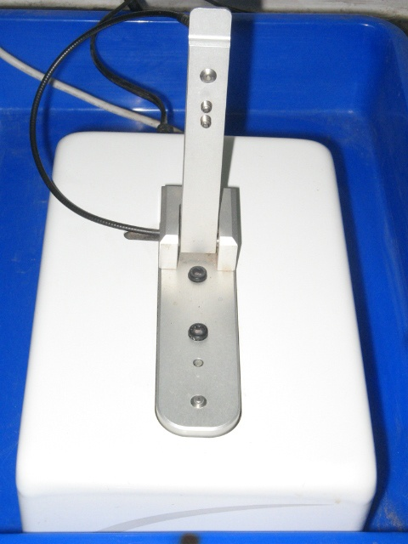

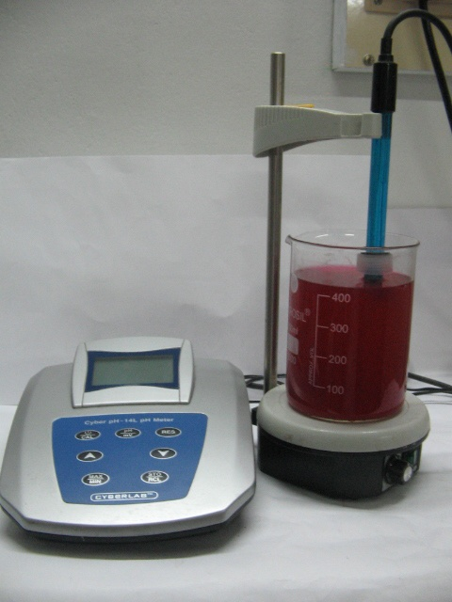
Plate 2. pH meter

Plate 3. BOD Incubator
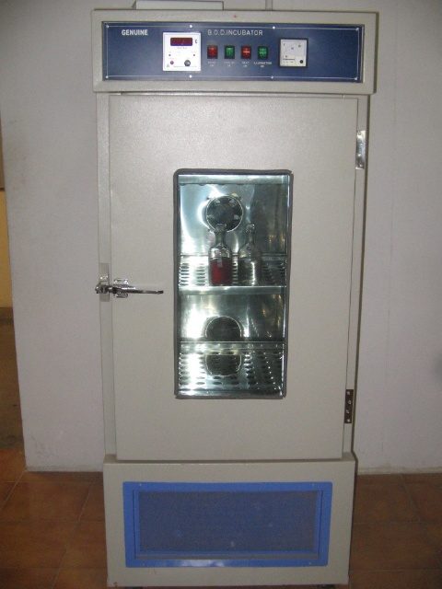

Principle
The dissolved oxygen content of the sample is determined before and after five days of incubation at 20⁰C. The amount of oxygen depleted is calculated as BOD.
Reagents
1) Phosphate buffer solution
1.7 g of ammonium chloride, 33.4 g of disodium hydrogen phosphate, 21.75 g of dipotassium hydrogen phosphate and 8.5 g of potassium dihydrogen phosphate were dissolved in 1000ml of distilled water in a volumetric flask and pH was adjusted to 7.2.
2) Dilution water
1ml of phosphate buffer, 1ml of MgSO₄ (22.5g/l), 1ml of CaCl₂ (27.5g/l) and 1ml of FeCl₃ (0.25g/l) were added to double distilled water that was previously aerated.
Procedure
The raw effluent sample was diluted (measured dilution) with seeded dilution water and is taken in two BOD bottles. One was used for the immediate determination of the dissolved oxygen (DO₀) and the other was kept for incubation at 20⁰C for five days in BOD incubator (Plate 3). After 5 days the dissolved oxygen of the incubated sample was determined (DO₅). One set of blank was also prepared and the immediate determination of the dissolved oxygen and the quantity of dissolved oxygen after 5 days at 20⁰C were also calculated.
Calculation
BOD (mg/l) = (DO₀–DO₅ – BC) x 100
Percentage dilution of sample
Where, BC – blank correction
3.3.7. Chemical oxygen demand (COD)
Reagents
1) 0.25N potassium dichromate
12.25g of potassium dichromate in 1000ml of distilled water.
2) 0.1N ferrous ammonium sulfate (FAS)
39.2 g of ferrous ammonium sulfate and 20 ml of conc. H₂SO₄ was added to 1000ml of distilled water. The solution was standardized with 0.25 N potassium dichromate solution.
3) Ferroin indicator
1.485 g phenenthroline and 0.695 g ferrous sulfate were dissolved in 100 ml distilled water.
Procedure
10 ml of raw effluent was taken in a COD flask and 30 ml of conc. H₂SO₄ and 10 ml of 0.25 N potassium dichromate were added. The contents were refluxed for 2 hours in a hot plate at 60 ⁰ C, diluted with distilled water and made upto 140ml. Two drops of ferroin indicator was added and titrated against 0.1 N FAS. The color change from blue green to reddish brown was taken as the endpoint. The entire procedure was repeated for blank.
COD of the raw effluent sample was calculated using the formula,
COD (mg/l) = V x Normality of FAS x 8 x 1000
Volume of the sample
3.3.8. Total hardness
Hardness is deemed to be the capacity of water for reducing and destroying the lather of soap. Calcium and magnesium are the principle cations causing hardness. The term total hardness indicates the concentration of calcium and magnesium ions only. The total hardness is expressed in terms of calcium carbonate. EDTA titrimetric method was followed to estimate the total hardness of raw disperse dye effluent ( Manivasakam,1995).
Principle
Calcium and magnesium salts react with EDTA to form soluble complexes and the completion of the reaction is indicated by the color change of a soluble indicator such as Erichrome black-T.
Reagents
- Calcium standard solution
Weighed 1 g of pure calcium carbonate (previously dried at 105⁰C) was taken in a 250ml conical flask and dissolved in 50 ml distilled water. Added 20.5 ml of 1N HCl and heated. After cooling, the solution was transferred into a 1000ml volumetric flask and made upto the mark with distilled water.
2) Standard EDTA titrant 0.02N
Weighed 3.725g of AR grade disodium ethylene diamine tetra acetate dihydrate (EDTA) and dissolved in distilled water then made upto 1000ml. The solution was standardized against standard calcium carbonate solution.
3) Ammonium chloride buffer
Weighed 16.9g ammonium chloride and dissolved in 143ml of concentrated liquid ammonia (solution 1). Dissolved 1.179g disodium salt of EDTA and 780 mg of MgSO₄.7H₂O in 50ml distilled water (solution 2). Solution1 is poured into solution 2 and diluted to 250ml with distilled water.
4) Erichrome black- T indicator
0.5 g Erichrome black-T was mixed with 100mg sodium chloride to obtain a dry powder mixture.

Procedure
Taken 50 ml of the effluent sample in a 250ml conical flask and diluted to 100 ml with distilled water.1ml of buffer was added. After adjusting the pH to10, 1ml of sodium sulfide inhibitor was added followed by a pinch of indicator powder. The sample was titrated with standard EDTA solution slowly, until a reddish tinge appeared. Blue color developed was taken as the end point. The amount of hardness was calculated by the following formula.
Hardness (as CaCO₃) mg/l = ml EDTA titrant x 1 x 1000
ml of sample taken for estimation
3.3.9. Estimation of Inorganic phosphorus (Fiske and Subbarow method)
Principle
Acid- molybdate reagent reacts with inorganic phosphate to form phosphomolybdic acid. The hexavalent molybdenum of the phosphomolybdic acid is reduced by 1,2,4 – amino naphthol sulphonic acid to give a blue color which is estimated colorimetrically at 640 nm.
Reagents
1) Stock standard solution
Weighted 0.351g of pure potassium dihydrogen phosphate and dissolved in distilled water. 10ml of concentrated sulfuric acid was mixed and the solution was diluted to 1000ml with distilled water.
Working standard
10ml of stock standard solution was diluted to 100 ml in a standard flask.
2) Acid molybdate solution
2.5% ammonium molybdate in 10 N H₂SO₄.
3) 1,2,4- amino naphthol sulphonic acid (ANSA) reagent
Dissolved 0.5 g of dry powder was in 97.5ml of 15% sodium bisulphate and 2.5ml of 20% sodium sulphite.
Procedure
Five test tubes were taken and labeled as s₁, s₂, s_{3,} s₄ and s₅ .0.5 to 2.5 ml of working standards were pipetted out into the test tubes. 0.5 ml of effluent sample was taken in a test tube marked as T_{1.} The solutions were made up to 8.5 ml with distilled water. A blank was also prepared by taking 8.5ml of distilled water.1ml of acid molybdate reagent was added to all the test tubes followed by 0.5ml ANSA. The contents of the test tubes were mixed well. After 5 minutes, readings were taken in a colorimeter at 640 nm. A graph was drawn with concentration of phosphorus at X-axis and O.D. values on Y-axis. The amount of phosphorus was calculated from the standard graph.
3.3.10. Chloride
Chloride is a common anion found in all industrial effluents. Textile processing effluents contain significant quantities of chlorides.
Principle
Silver nitrate reacts with chloride ions to form silver chloride. The completion of the reaction is indicated by the red color produced by the reaction of silver nitrate with potassium chromate solution which is added as an indicator.
Reagents
Standard silver nitrate titrant
4.791g of silver nitrate is dissolved in distilled water and was made up to 1000ml in a volumetric flask. The titrant was standardized against 0.028 N sodium chloride solution and stored in an amber bottle.

1) Standard sodium chloride, 0.028N
Dissolved 1.648g of sodium chloride in distilled water and made up to 1000ml in a volumetric flask.
2) Potassium chromate indicator solution
Weighted 25g of potassium chromate was dissolved in 100ml distilled water. The silver nitrate solution was added drop wise until a slight red precipitate was formed. It was allowed to stand for 12 hours.
3)Aluminium hydroxide suspension
Dissolved 100mg of aluminium ammonium sulphate in 1000ml distilled water. It was warmed to 60⁰C and 55ml of concentrated ammonia solution was added with constant stirring. The precipitate was allowed to stand for I hour and washed with distilled water to make the precipitate free from chloride. The precipitate was diluted to 1000ml with distilled water.
Procedure
100ml of effleunt sample was taken in a 250 ml conical flask and 3ml of aluminium hydroxide solutions was added and stirred well. After the precipitate was settled, it was filtered and washed with chlorine free distilled water. A blank was also prepared. The pH of the sample was adjusted to the range of 7.5-9. One ml of potassium chromate solution was added to the sample, and it was titrated against standard silver nitrate solution with constant stirring until a slight reddish precipitate was appeared. Volume of titrant was noted and the amount of chloride was calculated from the following formula
Chloride (mg/l) = ml AgNO₃ for sample – ml AgNO₃ for blank x 1 x 1000 ml of sample taken for determination

3.4. Optimization of various parameters for the adsorption of dye from disperse dye effluent
3.4.1. Effect of different sized agro-wastes for the decolorization of
disperse dye effluent
100ml of disperse dye effluent was taken in fifteen 500ml beakers. 2.5g of fine, coarse, and large sized orange, mosambi and lemon peels were added to the beakers (Plate 4). The percentage of absorption was calculated at 547 nm for 5 days using UV visible spectrophotometer. Mosambi peel showed 97% adsorption at fine size, orange peel showed 96% of adsorption at medium size and lemon showed maximum adsorption of 95% at large size (Plate 4). The optimum sizes were selected for each agro-waste for further study.
3.4.2. Effect of agro-waste concentration on the decolorization of
disperse dye effluent.
To determine the optimum quantity of agro-waste required to decolorize disperse dye effluent 0.5%,1%, 1.5%, 2% and 2.5% of orange peel, lemon peel and mozambi peels were added separately to beakers containing 100ml of disperse dye effluent. Absorbance was measured at 547 nm for 5 days in UV visible spectrophotometer. For all the three agro-wastes, the percentage of adsorption increased with increase in adsorbent concentration. Mosambi peel showed 97.3%, orange peel showed 96.4% and lemon showed 96% of adsorption. Based on the results, 2.5% of adsorbent concentration was selected for the further study.
3.4.3. Effect of pH on the decolorization of disperse dye effluent
Three sets of fifteen 500ml beakers were taken and 100ml of disperse dye effluent was added to each one. The pH was adjusted to 3, 4, 5, 6, 7, 8 in each set of beakers using 1N HCl or 1N NaCl. Then, 2.5% of finelly ground mosambi peel and 2.5% of coarse orange peel and 2.5%of large sized lemon peels were added to different beakers, having different pH. The percentage absorbance was estimated for five days.
3.4.4. Effect of temperature on the decolorization disperse dye
effluent
Three sets of fifteen, 500ml beakers were taken and 100ml of disperse dye effluent was poured to each one. Orange, mosambi and lemon peels of optimum size and quantity were added to their respective set of beakers. Then pH was adjusted to optimum. The representative beakers, from each set were kept at different temperatures such as 30⁰C, 40⁰C, 50⁰C, 60⁰C and 70⁰C. Percentage of absorption was calculated for 5 days at 547 nm using UV- visible spectrophotometer.
3.4.5. Effect of contact time on the decolorization of disperse dye effluent
Three sets of fifteen, 500ml beakers were taken and 100ml of disperse dye effluent was poured to each one. Orange, mosambi and lemon peels of optimum size and quantity were added to three sets of beakers. Then pH and temperature were also kept at optimum. The percentage of adsorption was calculated after 24hrs, 48hrs, 72hrs, 96hrs, and 120hrs at 547 nm using UV- visible spectrophotometer.
3.5. Decolorization of disperse dye effluent using selected agro-
waste under optimized conditions
Disperse dye effluent was decolorized using finely powdered mosambi peel at a concentration of 2.5% and at pH 3. The effluent was incubated for 120 hours at 30⁰C. The treated effluent was collected in a plastic can (Plate 4).

Plate 4

Different sized agro-wastes used for decolorization

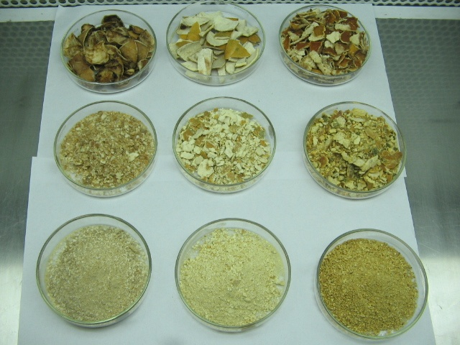
Lemon Mosambi Orange

3.6. Characterization of physical and chemical parameters of treated disperse dye effluent
Similar to raw effluent, all the physical and chemical parameters such as color, turbidity, total dissolved solids, total suspended solids, pH, biological oxygen demand, chemical oxygen demand, total hardness, inorganic phosphorous and chloride of treated disperse dye effluent were analyzed.
3.7. Utilization of treated effluent for growing green gram
plants
Selection of the plant for pot culture
Selection of crops to be grown on waste water must be geared to the quality of the waste water when selecting among the likely crops that can be normally grown in the given area. Crops grown on waste water farm include field crops like corn, maize, wheat, barley, rice, pulses, millets etc. reports Arceivala (2004). Considering the economic value and consumption rates, green gram was selected for the present study.
Design of experiment
Six pots were filled with a mixture of red soil and sieved sand, taken in equal proportions. Into the pots, 15 uniform sized surface sterilized (with 0.1% mercuric chloride solution for two minutes) green gram seeds were sown per pot. Then the pots were numbered from 1 to 6 (Plate 6). Pots marked with 1, 2 and 3 were watered with plain water, untreated and treated effluent respectively. Different dilutions such as 25%, 50%, 75% of treated effluent were used to water the seeds in the pots marked as 4, 5 and 6 respectively. The plants were grown for 14 days (plate 5,6).
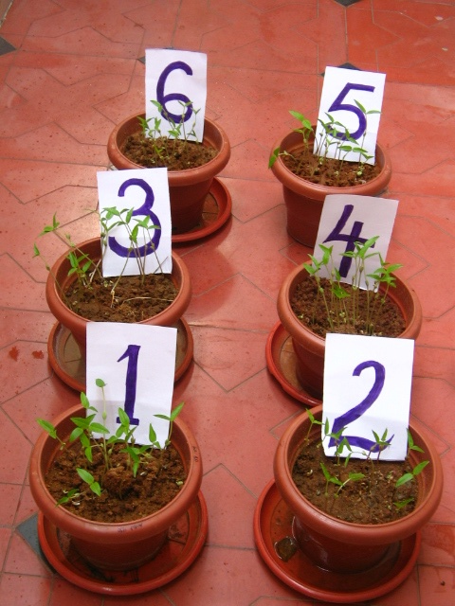
Plate 5. Green gram plants on 7th day

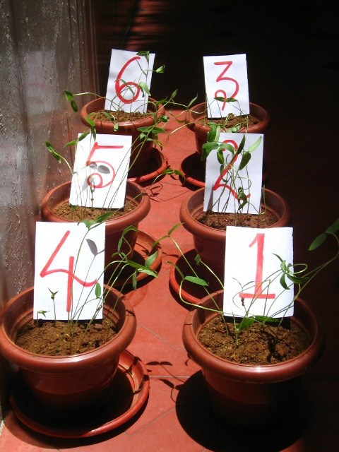
Plate 6. Green gram plants on 14th day

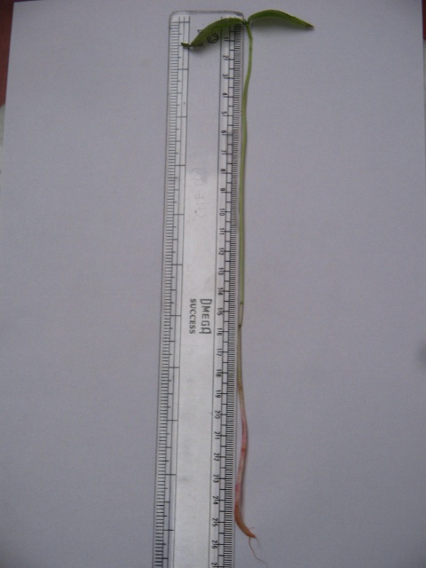
Plate 7 Measuring the root and shoot length of greengram plant

3.7.1. Biometric parameters of greengram plants
After sowing the seeds, germination percentage and vigor index were calculated for on 7th and 14th days.
Germination percentage = number of seeds germinated x100
number of seeds sown
Vigor index=germination percentage x (root length + shoot length)
On seventh and fourteenth day shoot length and root length of representative plant samples were measured (Plate 7).

3.7.2. Determination of biochemical parameters of green gram plants
On 7th and 14th day after sowing, all the samples were tested for parameters like chlorophyll, total carbohydrate and protein content.
3.7.2.1. Estimation of Chlorophyll
The chlorophylls are the essential components for photosynthesis and occur in chloroplasts as green pigments in all photosynthetic plant tissues. They are bound loosely to proteins but are readily extracted in organic solvents such as acetone. There are at least 5 types of chlorophylls in plants. Chlorophyll a and b occur in higher plants, ferns and mosses. Chlorophyll c and e are only found in algae and in certain bacteria.
Reagents
- 80% acetone (pre chilled)

Procedure
Procedure explained by Arnon (1949) and Witham et al. (1971) is followed to estimate chlorophyll content of green gram plants. Weighed 500mg of leaves from each pot and ground separately in to fine pulp in a mortar with the addition of 10ml of 80% acetone. The supernatants were centrifuged (5000rpm for 5 minutes) and transferred to a 100ml volumetric flask. The procedure was repeated until the residue becomes colorless and the supernatants after centrifugation were collected in the same volumetric flask (Plate 8). Then the volume was made up to 50 ml with 80% acetone and the adsorptions were read at 663nm and 645nm in a spectrophotometer. Using the adsorption coefficient, the amount of chlorophyll was calculated with the following formula.
mg chlorophyll a /g tissue = 12.7 (A₆₆₃) - 2.69 (A₆₄₅) x V
1000xW
mg chlorophyll b /g tissue = 22.9 (A₆₄₅)- 4.68 (A₆₆₃) x V
1000xW
mg total chlorophyll /g tissue = 20.2 (A₆₄₅) + 8.02 (A₆₆₃) x V
1000xW
Where,
A = absorbance at specific wave lengths
V = final volume of chlorophyll extract in 80% acetone
W = fresh weight of tissue extracted

Plate 8. Extracted chlorophyll
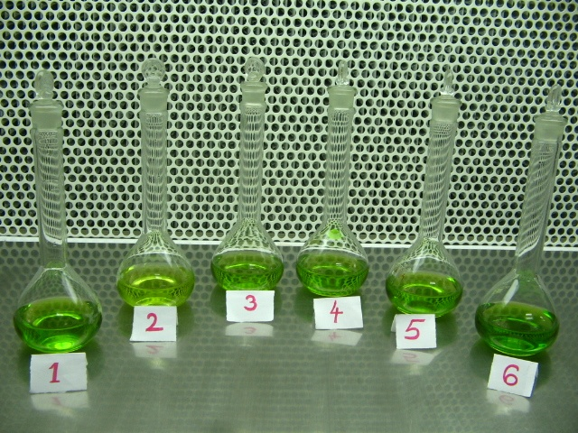

Plate 9. Centrifuge
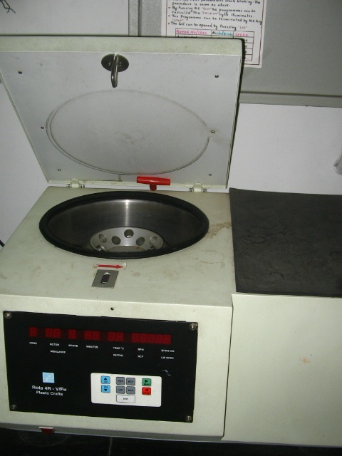

3.7.2.2. Determination of total carbohydrate (Anthrone method)
Carbohydrates are the important components of storage and structural materials in the plants. They exist as free sugars and poly saccharides. The basic units of the carbohydrates are the monosaccharides which cannot be split by hydrolysis in to simpler sugars. The carbohydrate content can be measured by hydrolyzing the polysaccharides in to simple sugars by acid hydrolysis and estimating the resultant monosaccharides.
Reagents
- 2.5 N HCl
- Anthrone reagent : 200mg of anthrone was dissolved in 100ml of 95% H₂SO₄.
- Standard glucose
Stock: 100mg of glucose was dissolved in 100ml of water.
Working standard: 10ml of stock solution was diluted to 100ml with distilled water.
Procedure
The method explained by Hodge and Hofreiter (1962) was followed to determine the total carbohydrate content of geen gram plants. Weighed 100 mg of samples in to a boiling tube and hydrolysed by keeping them in a boiling water bath for 3 hours with 5 ml of 2.5 N HCl and cooled to room temperature. The solutions were neutralized with solid sodium carbonate and made up the volume to 100ml and centrifuged (Plate 9). After centrifugation, 0.5 and 1ml aliquots were taken from each sample. Standards were prepared by taking 0.2, 0.4, 0.6, 0.8, and 1ml of working standards. A blank was also kept. Then, the volumes were made up to 1ml in all the test tubes by adding distilled water. Then added 1ml of anthrone reagent to all the test tubes. The test tubes were heated for eight minutes. After the time period, all the samples were cooled rapidly and the green to dark green color was read at 630nm in a spectrophotometer. A standard graph was drawn by plotting concentration of standard on the x axis versus absorbance on the y axis. From the graph, the amount of carbohydrate present in the sample tubes were calculated by using the following formula:
Amount of carbohydrate present = mg of glucose x 100
in 100mg of the sample volume of test sample
3.7.2.3. Estimation of protein (Lowry’s method)
Proteins are the building blocks of protoplasm and comprise the structure of cells. They are also concerned with metabolic activities of the cell like respiration, catalysis of enzyme reaction, transport of materials, control of movement and defense reactions. They are composed of repeating units, the amino acids and have high molecular weight ranging from few thousands to many millions view, Kumar and Purohit (2003).
Principle
The blue color developed by the reduction of the phosphomolybdic-phosphotungstic components in the Folin-ciocalteau reagent by the amino acid tyrosin and tryptophan present in the protein plus the color developed by the biuret reaction of the protein with the alkaline cupric tartarate are measured in the Lowry’s method.
Reagents
1) 2% sodium carbonate in 0.1N sodium hydroxide (Reagent A)
- 0.5% copper sulphate in 1% potassium sodium tartarate (Reagent B)
- Alkaline copper solution: 1ml of reagent A and 2ml of reagent B were mixed prior to use.
- Folin- ciocalteau reagent
- Protein solution
Stock standard: 50mg of bovine serum albumin was dissolved in distilled water and made up to 50ml in a standard flask.
Working standard: 10ml of the stock solution was diluted to 50ml with distilled water in a standard flask. 1ml of working standard contains 200µg protein.
- Phosphate buffer- 6.8 pH
Solution A: weighted 3.12g of NaH₂PO₄.2H₂O and dissolved in 100ml of distilled water.
Solution B: Dissolved 2.83g of NaH₂PO4 in 100ml.
51ml of solution A and 49ml of solution were mixed to prepare phosphate buffer of pH 6.8.
Procedure
The technique reported by Lowery et al., (1951) and Mattoo (1970) was followed to estimate the total protein of green gram plants. Weighted 500mg of the sample and ground well with a pestle and mortar by adding 5-10ml of phosphate buffer. After centrifugation, 0.1ml and 0.2ml of each extracts was pipette out. Centrifuged and the supernatant was used for the protein estimation. 0.2, 0.4, 0.6, 0.8 and 1ml of the working standards were also pipetted out into a series of test tubes. In all the test tubes the volumes were made up to 1ml by adding distilled water. A tube with 1ml of distilled water was kept as blank. Added 5ml of copper sulphate solution into all the test tubes including blank. The samples were mixed well and allowed to stand for 10 minutes. Then, added 0.5ml of folin-ciocalteau reagent all the test tubes and incubated at room temperature in the dark for 30 minutes. After the development of a blue color, readings were taken at 660nm in a spectrophotometer. A standard graph was drawn and from graph, amount of protein present in each sample was determined. The amount of protein was expressed in mg/g.

Result and Discussion
4.0. Result and Discussion
The results of the study are discussed under the following headings.
4.1. Screening and selection of agro-wastes
4.2. Optimization of different parameters for the decolorization of disperse dye effluent using selected agro-waste adsorbents
4.2.1. Effect of different sized agro-wastes on the decolorization
of disperse dye effluent
4.2.2. Effect of agro-waste concentration on the decolorization of
disperse dye effluent.
4.2.3. Effect of pH on the decolorization of disperse dye effluent
4.2.4. Effect of temperature on the decolorization of disperse dye
effluent.
4.2.5. Effect of contact time on the decolorization of disperse dye
effluent.
4.3. Selection of an effective adsorbent for the decolorisation of
disperse dye effluent.
4.4. Characteristics of raw and treated effluent
4.5. Utilization of treated effluent for growing green gram plants
4.5.1. Effect of raw and treated effluent on the biometric
parameters of green gram plants
4.5.2. Effect of raw and treated effluent on the bio-chemical
parameters of green gram plants.
4.5.2.1. Chlorophyll
4.5.2.2. Total protein
4.5.2.3. Total carbohydrate

4.1. Screening and selection of agro-wastes
The efficiency of various agro residues such as banana peel, guava peel, orange peel, mosambi peel, lemon peel, papaya seed, and cassava peel were screened for the decolorization of synthetic dyes such as crystal violet, reactive magenta, direct orange, disperse red, acid yellow and porcion red and the results are presented in Table 5.
Table 5. Decolorisation of selected synthetic dyes by various agro- wastes.
Agro-waste | Per cent adsorption
Agro-waste | Crystal violet | Direct orange | Acid yellow | Disperse red | Procion red | Reactive magenta
Banana peel powder | 80 | 80 | 60 | 76 | 71 | 69
Cassava peel powder | 88 | 54 | 70 | 89 | 64 | 58
Guava leaf powder | 52 | 48 | 46 | 54 | 50 | 49
Lemon peel powder | 86 | 89 | 88 | 90 | 87 | 85
Mosambi peel powder | 90 | 86 | 90 | 97 | 76 | 84
Orange peel powder | 70 | 89 | 90 | 94 | 86 | 71
Papaya seed powder | 46 | 50 | 55 | 61 | 44 | 68
* Values are mean of triplicates
Among these agro-wastes, powdered orange peel, mosambi peel, and lemon peel were found to be effective in the adsorption of disperse dye from its aqueous solutions and were selected for the further study.
4.2. Optimization of different parameters for the decolorization of disperse dye effluent using selected agro-wastes.
4.2.1. Effect of different sized agro-wastes on the
decolorization of disperse dye effluent
The effect of different adsorbent sizes namely finely powdered, medium crushed and largely chopped pieces of selected agro–wastes on dye adsorption were studied and the results are presented in Table 6 and Figure 1.
Figure 1. Effect of different sized agro-wastes on the decolorization of disperse dye effluent

From Table 6 and Figure 1, it is clear that finely powdered form of orange peel, mosambi peel and lemon peel are more effective than other sizes for the decolorization of disperse dyes from effluent. Maximum adsorption was observed for mosambi peel with 97% and minimum adsorption was observed for lemon peel with 90%. Orange peel showed medium adsorption of 94.6%.
Similar trend was reported by Gupta et al. (2006) who have reported that the dye uptake is greatly affected by adsorbent size in the recovery of azo-dye acid orange 7 through adsorption over bottom ash and de-oiled soya.
Table 6. Effect of different adsorbent sizes on decolorization of disperse dye effluent
Days | Per cent adsorption by various Agro- wastes
Days | Mosambi Peel powder |  |  | Orange Peel powder |  |  | Lemon Peel powder
Days | Fine | Medium | Large | Fine | Medium | Large | Fine | Medium | Large
1 | 34.13 | 32.52 | 30.64 | 30.10 | 34.13 | 32.52 | 27.41 | 27.95 | 29.30
2 | 60.215 | 58.87 | 54.56 | 59.67 | 62.36 | 50.26 | 50.80 | 59.13 | 56.98
3 | 84.13 | 86.29 | 69.62 | 90.86 | 85.21 | 65.86 | 56.98 | 70.43 | 82.52
4 | 92.47 | 87.63 | 81.45 | 86.82 | 89.24 | 66.39 | 85.75 | 84.40 | 88.17
5 | 97.04 | 96.23 | 90.05 | 96.50 | 94.62 | 81.45 | 95.16 | 92.20 | 90.05

4.2.2. Effect of agro-waste concentration on the decolorization
of disperse dye effluent.
The effect of agro-waste concentration on the decolorization of the disperse dye was studied and the results are presented in Table 7 and Figure 2.
Figure 2. Effect of adsorbent concentration on the decolorization of disperse dye effluent

From Table 7 and Figure 2, it is clear that the per cent of dye adsorption increased with increase in adsorbent concentration from .5% to 2.5%. At 2.5% adsorbent concentration, mosambi peel showed maximum percentage of dye adsorption (97.3%), followed by orange peel which showed an adsorption percentage of 97.%. Lemon showed 96.23% per cent adsorption. Allen et al. (2005) have reported concurrent observations
Table 7. Effect of adsorbent concentration for decolorization of disperse dye effluent

Days | Per cent adsorption by various Agro- waste
Days | Mosambi peel powder |  |  |  |  | Orange peel powder |  |  |  |  | Lemon peel powder
Days | .5g | 1g | 1.5g | 2g | 2.5g | .5g | 1g | 1.5g | 2g | 2.5g | .5g | 1g | 1.5g | 2g | 2.5g
1 | 15.54 | 25.80 | 29.03 | 32.52 | 34.94 | 15.86 | 27.41 | 30.37 | 33.33 | 35.75 | 12.63 | 23.92 | 25.80 | 27.95 | 32.25
2 | 33.o6 | 41.93 | 46.23 | 59.67 | 60.75 | 34.13 | 44.35 | 46.50 | 60.75 | 63.70 | 31.18 | 39.78 | 45.43 | 57.25 | 60.75
3 | 59.67 | 75.26 | 77.68 | 81.98 | 84.67 | 45.43 | 55.10 | 72.58 | 85.48 | 93.81 | 41.39 | 74.46 | 77.95 | 83.87 | 89.24
4 | 62.90 | 77.68 | 80.37 | 87.90 | 90.86 | 51.88 | 72.31 | 80.91 | 93.27 | 95.43 | 44.08 | 77.68 | 88.55 | 88.70 | 93.01
5 | 69.89 | 84.13 | 86.55 | 95.69 | 96.23 | 56.98 | 76.61 | 84.13 | 96.23 | 97.31 | 50.53 | 88.97 | 94.62 | 95.69 | 96.23

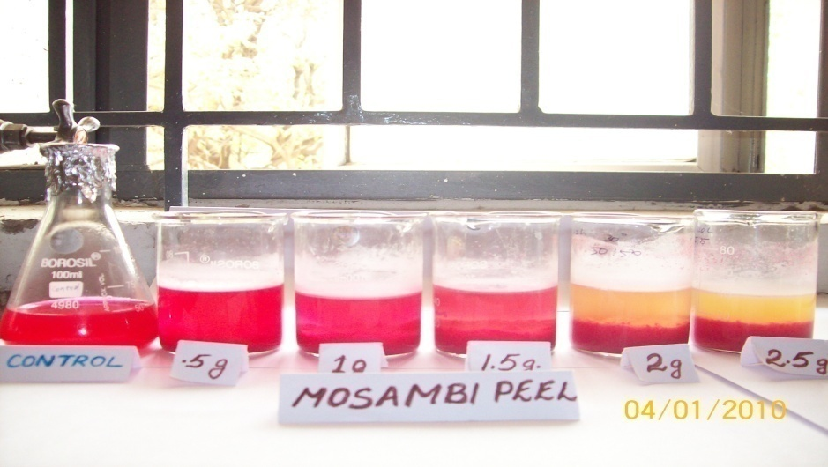
Plate 10. Decolorization of disperse dye effluent using various concentrations of mosambi peel

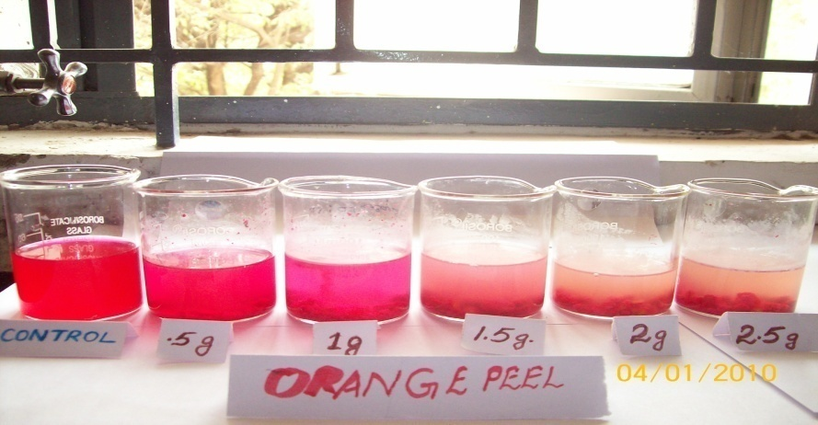
Plate 11. Decolorization of disperse dye effluent using various concentrations of orange peel

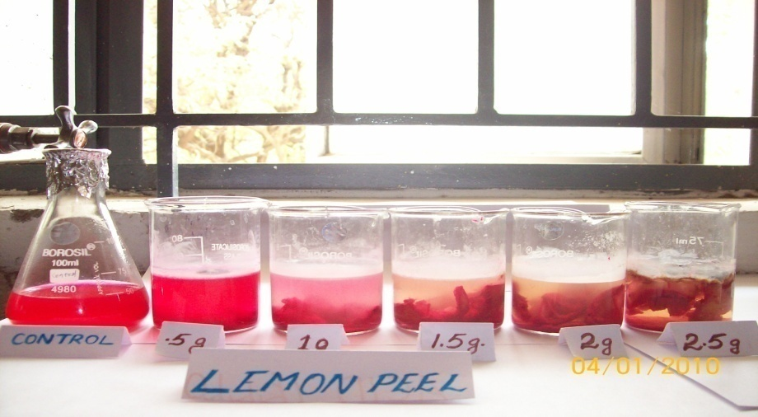
Plate 12. Decolorization of disperse dye effluent using various concentrations of lemon peel

in the adsorption of basic dyes by peanut hulls. The rate of dye adsorption depends on the driving force per unit area and since the initial concentration of dye solution was constant, increasing the mass adsorbent increased the surface area for adsorption and hence the rate of dye adsorption increased. Since the particle size is constant, the surface area is directly proportional to the mass of adsorbent. Hence, the optimum adsorbent concentration of 2.5% was used for subsequent studies.
4.2.3. Effect of pH on the decolorization of disperse dye effluent
To determine the optimum pH for the effective adsorption of disperse dye, the adsorption capacities of all the adsorbents were studied at various pH range from 3-8 and the results are shown in Table 8 and Figure 3.
Figure 3. Effect of pH on the decolorization of disperse dye effluent

Table 8. Effect of pH on the decolorization of disperse dye effluent
Day | Per cent adsorption by various Agro- wastes
Day | Mosami peel Powder |  |  |  |  |  | Orange peel powder |  |  |  |  |  | Lemon peel powder
 | pH 3 | pH 4 | pH 5 | pH 6 | pH 7 | pH 8 | pH 3 | pH 4 | pH 5 | pH 6 | pH 7 | pH 8 | pH 3 | pH 4 | pH 5 | pH 6 | pH 7 | pH 8
1 | 35.75 | 32.25 | 30.64 | 29.56 | 26.34 | 22.23 | 34.94 | 33.33 | 30.03 | 27.95 | 24.19 | 21.23 | 32.25 | 30.10 | 27.95 | 26.63 | 24.41 | 23.11
2 | 63.70 | 62.23 | 60.02 | 58.87 | 56.96 | 52.95 | 60.07 | 59.13 | 55.59 | 54.43 | 55.49 | 50.80 | 55.37 | 54.30 | 52.41 | 50.33 | 49.73 | 48.92
3 | 93.81 | 86.55 | 83.33 | 81.11 | 79.03 | 76.88 | 89.24 | 87.70 | 86.02 | 83.87 | 83.06 | 81.98 | 84.67 | 83.60 | 82.25 | 81.18 | 80.37 | 79.30
4 | 95.54 | 87.63 | 85.72 | 83.33 | 79.83 | 77.68 | 90.86 | 86.30 | 85.21 | 81.98 | 79.30 | 76.88 | 89.95 | 87.08 | 84.13 | 78.76 | 77.74 | 76.61
5 | 97.50 | 89.8 | 88.87 | 84.94 | 83.33 | 82.25 | 96 | 88.7 | 87.09 | 84.40 | 82.22 | 81.11 | 95 | 87.70 | 85.48 | 83.06 | 80.03 | 78.22

Table 8 and Figure 3 clearly indicates that pH 3 is the optimum pH for maximum dye adsorption for all the three adsorbents and further increase in pH decreased the percentage of dye uptake. Maximum percentage of absorption was reported for mosambi (97.5%)(plate 11) and minimum percentage of adsorption was seen for lemon (96.2%)(Plate 12). Orange showed an adsorption percentage of 96(Plate 13). The results are in concurrence with Gupta et al., (2006) who have reported maximum uptake of acid orange 7 onto bottom ash and de-oiled soya at a pH of 2. Annadurai et al., (2002) view that solution pH would affect both aqueous chemistry and surface binding-sites of the adsorbents. Hence, further studies are carried out at a pH of 3.
4.2.4. Effect of temperature on the decolorization of disperse dye effluent
Effect of temperature on the decolorization of disperse dye effluent was examined at various temperatures namely 30⁰C, 40⁰C, 50⁰C, 60⁰C and 70⁰C maintaining the size and quantity of agro-wastes at their optimum levels. Observations are reported in Table 9 and Figure 4.
Figure 4. Effect of temperature on the decolorization of disperse dye effluent

Time  (hrs) | Per cent adsorption by various Agro- wastes
Time  (hrs) | Mosambi peel powder |  |  |  |  | Orange peel powder |  |  |  |  | Lemon peel powder
Time  (hrs) | 30⁰C | 40⁰C | 50⁰C | 60⁰C | 70⁰C | 30⁰C | 40⁰C | 50⁰C | 60⁰C | 70⁰C | 30⁰C | 40⁰C | 50⁰C | 60⁰C | 70⁰C
24 | 37.36 | 35.48 | 33.06 | 30.91 | 29.03 | 38.70 | 35.75 | 33.60 | 31.18 | 26.61 | 35.21 | 31.98 | 27.68 | 25.80 | 23.92
48 | 66.39 | 62.63 | 61.55 | 56.98 | 54.83 | 67.47 | 63.97 | 62.09 | 56.98 | 53.76 | 62.90 | 60.21 | 57.79 | 53.76 | 50.53
72 | 94.89 | 93.01 | 88.70 | 85.75 | 82.79 | 91.66 | 89.24 | 85.21 | 83.06 | 80.91 | 90.86 | 86.82 | 82.79 | 76.61 | 75
96 | 95.96 | 94.89 | 89.78 | 86.82 | 84.40 | 96.23 | 94.89 | 86.55 | 84.13 | 81.72 | 94.89 | 92.74 | 84.13 | 81.18 | 77.41
120 | 97.849 | 95.967 | 91.12 | 88.97 | 86.55 | 97.31 | 96.50 | 87.63 | 85.75 | 83.87 | 97.04 | 94.08 | 86.02 | 82.25 | 80.37
Table 9. Effect of contact time and temperature on the decolorization of disperse dye effluent

From the Table 9 and Figure 4, it is clearly understood that the percentage of dye adsorption was maximum at 30⁰C for all the adsorbents. At higher temperatures, the adsorption rate has apparently decreased. The result coincides with that of Bhatnagar et. a. (2010) who have reported 25⁰C as more effective than 45⁰C for the adsorption of anionic dyes from water using citrus limonum.
4.2.5. Effect of contact time on the decolorization of disperse dye effluent
Effect of contact time on the decolorization of disperse dye effluent was studied and the results are shown in Table 9 and Figure 5.
Figure 5. Effect of contact time on the decolorization of disperse dye effluent
Maximum rate of adsorption was noticed on the fifth day of incubation and further increase in contact time has negligible effect on the amount of adsorption. Similar observations on the contact time versus adsorption rate was reported by Fery et al. (2009) for the adsorption of copper (II) by chemically modified orange peel at 30⁰C. Hence, a contact time of 120 hours (5days) was used for the further study.
4.3. Selection of an effective adsorbent for the decolorisation of disperse dye effluent.
Table 10 represents the maximum percentage of adsorption shown by the three agro-residues. Among the three agro-wastes, mosambi peels shown maximum rate of decolorisation (97.8%) at optimal conditions followed by orange peel (97.3%) and finally lemon peel (97%).
Table 10. Percentage of adsorption shown by the selected agro- residue.
Parameters | Percentage of adsorption
Parameters | Mosambi peel | Orange peel | Lemon peel
Adsorbent size | 97.0 | 96.5 | 95.2
Adsorbent concentration | 97.3 | 97.31 | 97.1
pH | 97.5 | 89.8 | 95.0
Temperature | 97.8 | 97.3 | 97.0
Contact time | 97.8 | 97.3 | 97.0

Based on the results, mosambi peel powder was found to show maximum decolorization per cent and hence, selected for the decolorisation of disperse dye effluent. Decolorization was carried out under optimized conditions (Plate 13).
4.4. Characteristics of raw and treated effluent
The raw and treated effluent samples were tested for various physical and chemical parameters and the results are presented in Table 11.
Plate 13. Decolorised effluent using mosami peel at optimum conditions

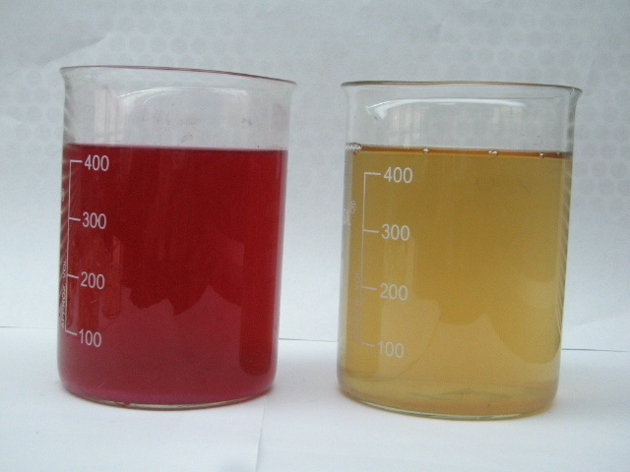

Table 11. Characteristics of raw and treated effluent
S.No. | Parameters | Raw effluent | Treated effluent
1 | Color (Hazen units) | 760 | 280
2 | Turbidity (NTU) | 2810 | 960
3 | pH | 6 | 5
4 | Total suspended solids (mg/l) | 3200 | 1200
5 | Total dissolved solids (mg/l) | 2880 | 920
6 | Biological oxygen demand (mg/l) | 2200 | 301
7 | Chemical oxygen demand (mg/l) | 1916 | 560
8 | Total hardness (mg/l) | 680 | 150
9 | Inorganic phosphorous (mg/l) | .6 | .4
10 | Chloride (mg/l) | 268 | 208
* Values are mean of triplicates
From Table 11, it is clear that powdered mosambi peel can be successfully used for the decolorisation of disperse dye effluent.
Observation of color is the simplest test to determine the effectiveness of treatment of an effluent. It serves as a guide in deciding the quantity of chemicals to be used for the removal of color and ensures economical treatment. The color of the effluent has reduced from 760Hazen units to 280 Hazen units.
Turbidity is yet another physical parameter which influences the quality of water. Turbidity in water may be due to the presence of finely divided organic and inorganic matter in suspended colloidal forms. After treatment, the turbidity level of the effluent has decreased to 229 NTU from 2810 NTU.
pH is one of the most important feature as it indicates the acid or alkaline conditions of an effluent. All the treatment processes are based on pH values only. The pH of the treated effluent was has reduced from6 to 5 which might be due to the acidic nature of mosambi peel.
The estimation of the total suspended solid reveals the pollution potential of the effluent. Total dissolved solids and total suspended solids in the raw effluent were 2880 mg/l and 3200 mg/l respectively. Both values have been found to be reduced after treatment to 920 mg/l and 1200 mg/l respectively.
Similarly, total hardness has been reduced to 150 mg/l in treated effluent, which was 680 mg/l in the raw effluent. According to Manivasakam (1995), the treated water’s hardness comes within moderate hardness limits.
Biological oxygen demand (BOD) and Chemical oxygen demand (COD) are taken as the direct measure of water quality. BOD of the treated effluent has reduced to 301 mg/l from 2200 mg/l and COD has reduced to 560 mg/l from 1916 mg/l.
4.5. Utilization of treated effluent for growing green gram plants
Effect of colored and treated effluent on the biometric parameters of green gram plant such as, vigor index and germination percentage and bio- chemical parameters like chlorophylls, total carbohydrates and total protein were determined to find out the significance of recycled dye effluent for irrigation purpose.
4.5.1. Effect of raw and treated effluent on the biometric parameters of green gram plant
Biometric parameters such as germination percentage and vigor index were determined on the 7th and 14th day after seeding and the results are shown in Tables 12, 13 and Figures 6 and 7.
Table 12. Germination percentage of green gram plants on 7th and 14th day
Samples | Number of seeds sown | 7th day |  | 14th day
Samples | Number of seeds sown | Number of seeds germinated | Germination percentage | Number of seeds germinated | Germination percentage
1 | 15 | 15 | 100 | 15 | 100
2 | 15 | 12 | 80 | 10 | 67
3 | 15 | 15 | 100 | 15 | 100
4 | 15 | 15 | 100 | 1 | 100
5 | 15 | 14 | 93 | 13 | 87
6 | 15 | 13 | 87 | 12 | 80

Figure 6. Germination percentage of green gram plants on 7th and 14th day

From Table 12 and Figure 6, it is clear that all the samples showed good germination per cent except for Sample 2 and sample 6 which have been watered with pure effluent and 75 per cent treated effluent respectively.
Table 13. Vigor index of green gram plants on 7th and 14th day
Samples | 7th day |  |  | 14th day
Samples | Root length (cm) | Shoot length (cm) | Vigor index | Root length (cm) | Shoot length (cm) | Vigor index
1 | 2.8 | 10.9 | 1370 | 4.4 | 19.9 | 2430
2 | 2.1 | 10.1 | 1220 | 3.2 | 18.5 | 1736
3 | 2.6 | 10.5 | 1310 | 4.1 | 19.5 | 2360
4 | 2.5 | 10.5 | 1300 | 3.6 | 19.4 | 2300
5 | 2.3 | 10.4 | 1270 | 3.4 | 18.8 | 2230
6 | 2.5 | 10.4 | 1290 | 3.4 | 19 | 1940

Figure 7. Vigor index of green gram plants on 7th and 14th day

It can be observed from Table 13 and Figure 7 that vigor index increased in the order, Sample 2 < Sample 6 < sample 5 < sample 4 < saple3 < sample 1. Maximum vigor index was seen in sample 1 which had been watered with plain water and minimum growth was observed in sample 2, which had been watered with raw effluent.
4.5.2. Effect of raw and treated effluent on the bio-chemical parameters of green gram plant.
Biochemical parameters like chlorophylls, total protein and total carbohydrate of green gram plant were estimated on 7th and 14th day.
4.5.2.1. Chlorophylls
The effect of raw and treated effluent samples on total chlorophyll content (chlorophyll a + chlorophyll b) of green gram plant was estimated on 7th and 14th day and the results are expressed in Table 14 and Figure 8.
Table 14. Total chlorophyll content of green gram plants on 7th and 14th day
Sample no. | 7th day |  |  | 14th day
Sample no. | Chlorophyll a (mg/g) | Chlorophyll b (mg/g) | Total chlorophyll (mg/g) | Chlorophyll a (mg/g) | Chlorophyll b (mg/g) | Total chlorophyll (mg/g)
1 | 0.017 | 0.025 | 0.043 | 0.023 | 0.024 | 0.047
2 | 0.009 | 0.013 | 0.022 | 0.011 | 0.012 | 0.023
3 | 0.016 | 0.025 | 0.04 | 0.022 | 0.015 | 0.037
4 | 0.015 | 0.023 | 0.037 | 0.019 | 0.016 | 0.036
5 | 0.015 | 0.013 | 0.028 | 0.017 | 0.01 | 0.027
6 | 0.012 | 0.016 | 0.026 | 0.013 | 0.013 | 0.026

Figure 8. Total chlorophyll content of green gram plants on 7th and 14th day

From Table 14 and Figure 8, it is evident that total chlorophyll content was high in sample 1 and sample 3 which have been watered with plain water and treated effluent water. All other samples showed lesser chlorophyll content in the order, sample 4 > sample 5 > sample 6 > sample 2.
Total chlorophyll content in plants watered with 25 per cent and 50 per cent treated effluent were comparable with that of control plant. Hence, treated effluent can be effectively utilized for irrigating crops.
4.5.2.2. Total protein
The total protein content of all the samples were determined on 7th and 14th day after sowing the seeds and the values are mentioned in Table 15 and Figure 9.

Table 15. Total protein content of green gram plants on 7th and 14th day
Sample no. | Total protein (mg/g)
Sample no. | 7th day | 14th day
1 | .252 | .488
2 | .092 | .268
3 | .240 | .464
4 | .212 | .460
5 | .200 | .408
6 | .160 | .392

Figure 9. Total protein content of green gram plants on 7th and 14th day

Table 15 and Figure 10 show a study increment of protein contents in all the samples. Maximum protein content was reported in sample 1, which had been watered with plain water and minimum value was observed in sample 2, which had been watered with raw effluent. For all other samples, the protein content followed the following order; sample 3> sample 4 > sample 5 > sample 6.

4.5.2.3. Total carbohydrate
Total carbohydrate content of each representative samples were calculated on 7th and 14th day using anthrone method and the results are depicted in Table 16 and Figure 10.
Table 16. Total carbohydrate content in green gram plants on 7th and 14th day
Sample no. | Total Carbohydrate (mg/g)
Sample no. | 7th day | 14th day
1 | 33.5 | 37
2 | 5.3 | 8.6
3 | 28 | 32.2
4 | 22.1 | 27
5 | 22.1 | 15.2
6 | 9.8 | 13.2

Figure 11. Total Carbohydrate in green gram plants on the 7th and 14th day

By analyzing the values presented in Table 16 and Figure 10, it is understood that carbohydrate content of all the samples has increased on 14th day than 7th day. Maximum carbohydrate content was observed in sample 1 on both the days and minimum carbohydrate content was observed in sample 2 which was watered with raw effluent.

Summary and Conclusion
5.0. SUMMARY AND CONCLUSION
The textile industry, mother of Indian industrialization and second large employment generator after agriculture accounts for about 20% industrial production. It not only generates jobs in its own area, but also opens up scopes for the other ancillary sectors. India earns about 27% of its total foreign exchange through textile exports. Textile industry as a unique position as a self reliant industry from the production of raw materials to the delivery of finished products with substantial value addition at each stage of processing.
Rapid industrial development of the textile sector has resulted in economic advancement, but at the cost of environmental degradation. Textile industry consumes huge amounts of water for various wet processing operations such as sizing, bleaching, scouring, desizing, mercerizing and dyeing, waste water generated at various stages of textile processing differs in its composition, strength as well as volume.
The high pollution load of textile effluent arises from the spent dye baths that are mainly composed of unexhausted, hydrolyzed and surface deposited dyes as well as various unexhausted chemicals and auxiliaries which have been washed away from the dyed materials. These effluents are characterised by their intense colour, high COD, salinity and variable pH. Over 50,000 tons of dyes are discharged into effluent annually. The presence of these dye effluent in water is aesthetically undesirable, but has a more serious environmental impact.
Many synthetic dyes are harmful to human being, so the removal of colour from waste effluents is environmentally important. Several physical, chemical and biological methods have been used for decolourisation of the dye effluent. However, many of these technologies are cost prohibited and suffered with one or other limitations when applied for treating in large quantities.
In recent years, there has been considerable interest in the use of biological materials , including algae, bacteria, fungi, agricultural by products and residues as absorbents to remove toxic dye molecules from aqueous solution by adsorption. Among these materials, agricultural by products and biomass are relatively cheap an exhibit very high adsorption capacities.
In order to remove hazardous materials like dyes, adsorption is a method that has gained considerable attention in the recent past. The advantages of adsorption method are its simplicity of operation, low cost and eco-friendliness. Adsorption removes the complete molecule, leaving no fragments in waste water; this is particularly relevant for metal containing dyes, where the coordination metal would remain in the effluent after non-adsorptive treatments, potentially in a more hazardous uncomplexed form.
The mechanism of dye adsorption on the agro residues in colour removal process is similar to dyeing textile material which may involve in the following steps such as diffusion of dye molecules through the solution to the surface of adsorbents, adsorption of dye molecules on the surface of the materials through molecular interactions and diffusion of dye molecules from the surface into the interior of the adsorbent materials.
Bearing in mind the toxicological impacts of dye effluent on environment and the advantages of adsorption technique, the present study on “ Adsorption of disperse dye from textile effluent using cellulose- based agro- waste” has been designed with the following objectives.
- To assess the physical chemical characteristics of the disperse dye effluent before and after treatment.
- To screen various agro- wastes for their suitability for decolourizing the textile dye effluent.
- To select the most effective agro-waste for the decolourization of disperse dye effluent.
- To optimize the experimental conditions for maximal and efficient removal of dye from the effluent.
- To assess the reusability of treated effluent water for irrigation.
With the above objectives, a trail has been made out to decolourize the effluent water and also to reuse the same for further processing.
Experimental Procedure
Various agro-wastes were screened for their relative adsorption capacities of different dyes. Based on the results, three cellulosic agro-wastes such as orange peel, lemon peel and mosambi peel were selected and for the decolourization of disperse dye effluents. Disperse dye effluent was collected from a dyeing unit situated at Erode. Analysis of the raw effluent was carried out for the physical and chemical characteristics such as colour, turbidity, pH, TSS, TDS, BOD, COD, total hardness, inorganic phosphate and chloride.To decolourize the effluent, dried (5 days in sun lights), finely powdered peels of orange, mosambi, and lemon were used. Various experimental conditions like adsorbent size, adsorbent concentration, pH, temperature and contact time were optimized for effective decolourization of disperse dye effluent by orange peel, mosambi peel and lemon peel. The percentage of adsorption was estimated using UV- Visible spectrophotometer.
Among the three agro – residues studied, mosambi peel powder was chosen for the decolourization of disperse dye effluent. The physical and chemical characteristics of treated effluent were studied and decrease in pollution load was observed. In order to assess the reusability of treated effluent, it was utilised for pot culture study. The treated water was diluted to 25%, 50% and 75% to water green gram plants. The biometric parameters such as germination percentage, vigour index and biochemical parameters such as chlorophyll, total protein and total carbohydrate of green gram plant were determined.
Findings
- Among the agro residues, finely powdered mosambi peel, orange peel and lemon peel were observed to be more efficient for the decolourization of disperse dye effluent.
- An adsorbent concentration of 2.5% was found to be optimum for the decolourization of disperse dye effluent, using orange peel, mosambi peel and lemon peel.
- The optimum pH for decolourization of disperse dye effluent was found to be 3.
- Maximum percentage of decolourisation was noticed at 30 ⁰C.
- A contact time of 120 hours , increased the percentage of adsorption of dye molecule from disperse dye effluent by orange peel, mosambi peel and lemon peel.
- Among the three agro- residues mosambi peel has apparently decreased the pollution load of disperse dye effluent. Hence it was selected.
- The decolourised disperse dye effluent using mosambi peel can be successfully reused.
The physiochemical characteristics of the treated effluent was found to show an appreciable decrease in pollution load.
- The colour of the treated effluent has decreased to 280 Hazen units from 760 Hazen units of untreated effluent.
- Turbidity of the treated effluent has brought down to 229 NTU from 2810 NTU of untreated effluent.
- Treated effluent has a pH of 6 which was 5 for untreated effluent.
- TDS and TSS of decolourised effluent have reduced to 920 mg/l and 1200mg/l which was 2880mg/l and 3200mg/l respectively.
- Total hardness was found to reduce to 150mg/l from 680mg/l.
- Inorganic phosphorous content of treated effluent has reduced to 0.4 from 0.6 of the untreated effluent.
- Chloride content has reduced from 268mg/l to 208 mg/l.
- BOD of the effluent has reduced to 301mg/l from 2200 mg/l
- COD of the effluent has reduced to 560 mg/l from 1916 mg/l
The green gram plant watered with the various dilutions of treated effluent shown apparent growth against the control which had been watered with plain water. Germination percentage of sample 3, which was watered with treated effluent, was similar to control and vigor index of the sample 3 has shown a slight increment than control. Total chlorophyll, total protein and total carbohydrate of sample 3 were nearer to control.

Conclusion
It is evident from, the study that effective decolorization of disperse dye could be done using dried and powered peels of mosambi. The pollution load of the effluent was also reduced by mosambi peel. It can be concluded that mosambi peel can be used as an effective, low-cost, eco-friendly adsorbent for the adsorption of dye from disperse dye effluent and the resultant decolorized water could be used for irrigation.

Suggestions
- The efficiency of cellulosic agro –wastes for the adsorption of anionic and cationic dyes can be studied.
- The effectiveness of chemically pretreated cellulosic fruit peels could be tried for decolorization of textile dye effluent.

Limitations
- Continuous availability of mosambi peel is required for decolorizing huge quantities of dye effluent.
- The contact time required for decolorization is greater.

Bibliography
BIBLIOGRAPHY

JOURNALS

Allen, S.J., Gan, Q., Matthews, R. and Johnson, P.A. (2005). Mass Transfer Processes in the Adsorption of Basic Dyes by Peanut Hulls, Industrial Engineering and Chemical Research, Vol.44, Pp.1942 – 1949.

Anandapriya, A.S., Raja, R.S., Vivekanandan, S and Kumar, A.R. (2007). Recovery of Sodium sulphate from Reactive Dye Effluent by Thermal Evaporator, Colourage, Vol.54, Pp.41-50.

Annadurai, G., Juang, R.S. and Lee, D.J. (2002). Use of Cellulose- based Wastes for Adsorption of Dyes from Aqueous Solutions. Journal of Hazardous Materials, Vol.92, Pp.263-274.

Ansari, A.A. and Thakur, B.D. (2002). Bio-chemical reactor for Treatment of Concentrated Textile Effluent. Colourage, Vol.49, Pp.27-30.

Athalye, A., Charabarti, A and Shirke, V (2008). The Art of ‘Dyeing’ – continuously. Colourage, Vol. 55, P.82.

Baban, A., Yediler, A., Linert, D. Kemerdere, N., and Kettrup, A. (2003). Ozonation of high Strength Segregated effluents form a wollen textile dyeing and finishing plant. Dyes Pigments, Vol.58 P.93.

Banat, I.M., Nigam, P., Sing, D., and Marchant, R., (1996) Microbial decolorization of textile dye-containing effluent : A review. Bioresource Technology. Vol.58,Pp.217-227.

Bhatnagar, A., Kumar, E., Minocha, A.K., Jeon, B., Song, H., and Seo, Y. (2009). Removal of Anionic Dyes from water using Citrus limonum (Lemon) Peel : Equilibrium Studies and Kinetic Modeling. Separation Science and Technology,Vol.44 Pp.315-334.

Bhattacharya, K.G., and Sarma, A., (2003). Adsorption Characteristics of the dye, Brilliant Green, on Neem Leaf Powder, Dyes Pigments,Vol.57, Pp.211-222.

Chen, K.C. Wu, H.Y., Huang, C.C. Liang, Y.M. and Hwang, S.C.J. (2003). Decolourization of azo dye using PVA – immobilized microorganisms. Journal of Biotechnology, 101, pp.241-252.

Cristovao, O.R. Tavares, A.P.M., Ferreira, L.A. Loureiro, J.M., Boaventure, R. A.R. and Maeedo, E.A. (2004). Modeling the discoloration of a mixture of reactive textiles dyes by commercial lacccose. Bioresource Technology,Vol.100, Pp.1094-1099.

Cui, L., Liu, c. and Wu, G. (2008). Performance and Mechanism of Methylene Blue Biosorption on Orange Peel. Environmental Technology, Vol.29, Pp.1021-1030.

Feng, N., Guo, X and Liang, S., (2009). Adsorption Study of Copper (II) by Chemically Modified Orange Peel. Journal of Hazardous Material, 164, PP.1286-1292.

Gahukar, R.T. (2005). Indian Agriculture and Environment. Kisan World, Vol.32, P.28
Ghani, A.A., Santiagoo, R., Johnson, A.C., Ibrahim, N and Selamat, S (2007). Dye Removal from Aqueous Solutions using Egg Shell Powder. ICOSM, Pp. 109-111.

Gupta, V.K. Mittal, A., Gajbe, V., and Mittal, J., (2006). Removal and Reovery of the Hazardous Azo Dye acid Orange 7 through Adsorption Over Waste Materials : Bottom Ash and De-oiled soya. Industrial Engineering and Chemical Research, Vol.45, Pp.1446-1453.

Hameed, B.H. (2009). Evaluation of Papaya Seeds as a Noval, Non-conventional low-cost Adsorbent for Removal of Methylene Blue. Jounral of Hazardous Materials, 162(2-3) Pp.939-944.

Heredia, J.B., Martin, J.S and Regalado, A.D. (2009). Removal of Carmine Indigo Dye with Moringa Olefera Seed Extract, Industrial Engineering and Chemical Research, Vol. 48, Pp.6512-6520.

Ho, Y.S., and Mckay, G. (1998). Kinetic Models for the Sorption of Dye Dye from Aqueous solutions by Wood. Trans. I Chem E, Vol.76, Pp.183.

Iqbal, M.J. and Ashiq, M.N. (2005). Adsorption of Dyes from Aqueous Solutions on Activated Chercol. Journal of Hazardous Materials, Vol.139, Pp.57-66.

Joshi, M. Bansal, R. and Purwar, R. (2004). Colour Removal from Textile Effluents, Indian Journal of Fibre and Textile Research, Vol.29, Pp.239-259.

Lakshmanan, K.K. (2005). Industrial Water Use Misuse or Overuse? Kisan World, Vol.32, Pp.31.
Lowry, O.H., Rosebrough, N.J., Farr, A.L. and Rendall, R.L. (1951). Protein Measurement with folin-phenol reagent. Journal of Biological Chemistry, Vol.193, Pp.265-275.

Menezes, E., (2009). RO membrane in textile industry. Colourage, Vol.56, Pp.77-81.

Namasivayam, C., and Kavitha, D., (2002). Removal of Congo Red from Water by Adsorption onto Activated Carbon Prepared from Coir
Pith, an Agricultural Solid Waste. Dyes Pigments,Vol. 54, Pp.47.

Nayak, L. (2006). Clean Technologies for Textile Processing. Suppliement to Colourage, Vol.53, Pp.128-143.

Nimkar, U. and Bhajekar, R., (2006). Ecological Requirements for the Textile Industry. Suppliment to Colourage, Vol.53, No.4, Pp.135-143.
Ong, S.A.,Toorisake,E., Hirata,M. and Hano, T. (2005). Treatment of Azo-Dye Orange 11 in Aerobic and Anaerobic – SBR Systems. Processing Biochemistry, Vol. 40, Pp. 2907-2914.

Ponnusami, V., Vikram, S. and Srinivastava, S.N. (2008) Guava (Psidium guajava) leaf powder : noval adsorbent for removal of methylene blue from aqueous solutions. Journal of Hazardous Materials, Vol.152, Pp.276-286.

Rajeshwarisivaraj, Namasivayam, C. and Kadirvelu, K. (2001). Orange Reel and as Adsobent in removal of acid violet-17 from Aqueous Solutions. Waster Management, Vol.21, Pp.105-115.

Reddy, M.C.S. (2006). Removal of Direct Dye from Aqueous Solutions with an Adsorbent made from Tamarind Fruit Shell, an Agricultural Solid Waste, Journal of Scientific and Industrial Research, Vol.65 Pp. 443-446. \

Salem, I.A. (2001). Activation of H₂O₂ by Amberlyst-15 Resin Supported with Copper (II) Complexes Towards Oxidation of Crystal Violet. Chemosphere, Vol.44, P-1109.

Sekar, N and Mahajan, S.S. (2007). Synthesis and Application of Anthraquinone. Azo Disperse Dyes. Colourage, Vol.54, Pp.64-65.

Sekar, N. (2008), Blue Disperse Dyes – Structural Derivatives, Colourage, Vol. 55, P.36.

Sekar, N. (2008). Colour Removal from Effluents. Asian Dyer, Vol. 61, Pp.51-53.

Shukla, S.R. (2006). Decolourisation of Waster Water. Colourage, Vol.53, Pp.56-60.

Sivanappan, R.K. (2005). Need for a Persective plan for Sprinkler and Drop Irrigation in Tamilnadu. Kisan World, Vol.32, P.47.

Sivaramakrishnan, C.N. (2008). Effluent Treatment: Flocculation, Colourage, Vol.55, Pp.42-44.
Sivaramakrishnan, C.N. (2008). Effluent Treatment: Coagulation Colourage, Vol.55, Pp.44-46.

Sivaramakrishnan, C.N. (2008). Effluent Treatment: Ozonization, Colourage, Vol.LV, no.5, pp.42.

Sivaramakrishnan, C.N. (2008). Effluent Treatments: A Review. Colourage, Vol.LV, No.1, Pp.:42-46.

Sivaramakrishnan, C.N. (2008). Membrane Technologies: Nano filtration.Colourage, Vol.55, Pp.50-52.

Sivaramakrishnan, C.N.(2008). Effluent Treatment: Membrane Technologies. Colourage, Vol.55, Pp.42-46.

Sivramakrishnan, C.N. (2008). Membrane Technologies: Reverse Osmosis. Colourage, Vol.55, Pp.56-58.

Sun, G and Xu, X. (1997). Sunflower Stalks as Adsorbent for Colour Removal from Textile Wastewater. Industrial Engineering and Chemical Research,Vol. 36, Pp.808-812.

Tongeren, W.V., and Luiken A. (2005). Removal of dyes from textile waste water. Melliand, Vol.86, Pp.57-61.

Tsai, W.P., Chang, C.Y., Lin, M.C., Chien, S.F., and Hsieh, M.F. (2001). Adsorption of Acid Dye onto Activated Carbon Prepared from Agricultural Waste Bazasse by ZnCl₂ Activation. Chemosphere, Vol.45, Pp.51-63.

Vandevinere, P.C., Bianchi, R., and Verstaete, W. (1998). Review : Treatment and reuse of wastewater from the textile wet processing industry. Journal of Chemical Technology and Biotechnology, Vol.72, P.289.

Walters, A., Santillo, D. and Johnson, P. (2006). An Overview of Textiles Processing and Related Environmental Concerns. New Cloth Market, Vol.20, Pp.39-45.

