CRIME RATE PREDICTION USING K-MEANS CLUSTERING ALGORITHM

BY
C.TAMILARASI
(16PCA006)

Project Report Submitted
In Partial fulfillment of the requirements for the award of
Master Degree in Computer Applications

Department of Computer Science,
Avinashilingam Institute for Home Science and Higher Education for Women, (Deemed to be University),
Coimbatore-641043
APRIL – 2019
CRIME RATE PREDICTION USING K-MEANS CLUSTERING ALGORITHM

BY
C.TAMILARASI
(16PCA006)

Project Report Submitted
In Partial fulfillment of the requirements for the award of
Master Degree in Computer Applications
Department of Computer Science,
Avinashilingam Institute for Home Science and Higher Education for Women, (Deemed to be University),
Coimbatore-641043

Signature of the Head of the Department Signature of the Supervisor

Viva Voce Examination Held on: ______________

Signature of the Examiners
ACKNOWLEDGEMENT
I would like to express my sincere thanks to God Almighty, for His constant love and grace that he showered upon me during my project.
My deep sense of gratitude are due to Padma Shri Dr.P. R. Krishnakumar, Chancellor, Avinashilingam Institute for Home Science and Higher Education for Women, Coimbatore, for all his support and encouragement during the course of my study.
My sincere thanks are due to Dr. (Mrs.) V.Premavathy Vijayan,Vice Chancellor, Avinashilingam Institute for Home Science and Higher Education for Women, Coimbatore, for extending all resources that facilitated the conduct of the present project.
My gratitude to Dr. (Mrs.) S. Kowsalya, Registrar, Avinashilingam Institute for Home Science and Higher Education for Women, Coimbatore, for providing all facilities necessary to carry my work.
My thanks are to Dr. (Mrs.) K. Udaya Chandrika, Dean School of Physical Sciences & Computational Sciences, Avinashilingam Institute for Home Science and Higher Education for Women, Coimbatore, for granting the facilities required.
My gratitude are due to Dr. (Mrs.) V. Radha, Professor and Head, Department of Computer Science, for all the help given to complete the project.
My thanks are to my project co-ordinator Dr. (Mrs.)G.Padmavathi, Professor, Department of Computer Science, for her advice and knowledgeable suggestions.
My heartfelt thanks to my esteemed project guide Dr. Mrs. Vasantha Kalyani David, Professor, Department of Computer Science, for imparting tremendous knowledge and well-timed support in completing the project.
I would like to extend my heartfelt thanks to one and all especially my family members and friends who helped me directly or indirectly by their support and prayers in completing the project.
ABSTRACT

Crime analysis and prediction is a systematic approach for analyzing and identifying different patterns, relationships and trends in crime occurrences. The regions with high probability of crime occurrence are predicted by the system. The system developed will help to speed up the process of solving crimes for the law enforcement agencies.
K means clustering algorithms and data mining techniques are used to extract unknown but useful information from unstructured data. The current data from the police is used which after using different clustering and prediction algorithms provides an insight that will help to predict the likelihood of crimes, track criminal activities and help the law enforcement authorities to deploy resources and also solve crime cases at a faster rate.
The crime data available at present is in different forms and is both structured form (written criminal record) as well as in unstructured form (image and audio data from surveillance and different forms of communication). The collected data will be brought together and the volume of the data will contribute to the understanding of the events happened in the past and based on the patterns what is more likely to happen in future.
The accuracy of the results obtained by prediction will help to a great extent to curb crime and take measures accordingly. Different types of crime records are needed to be evaluated to develop an efficient crime analysis tool.

CONTENTS

S.NO PARTICULARS PAGE NO

1. INTRODUCTION 1 1.1. MOTIVATION OF THE PROJECT
1.2 OBJECTIVE OF THE PROJECT
2. SYSTEM CONFIGURATION 2
2.1. HARDWARE SPECIFICATION
2.2. SOFTWARE SPECIFICATION
2.3. ABOUT THE SOFTWARE
3. METHODOLOGY 7
3.1. OVERVIEW OF THE PROJECT
3.2. ABOUT THE DATASET
3.3. PROPOSED SYSTEM
3.4. DATA PREPOCESSING
3.5. CLASSIFICATION
3.6. PERFORMANCE MEASURES
3.7. SYSTEM DESIGN
4. EXPERIMETAL RESULTS AND ANALYSIS 20
5. CONCLUSION 23
6. SCOPE OF FUTURE ENHANCEMENT 24
7. BIBLIOGRAPHY 25
8. APPENDIX 26
- DATA FLOW DIAGRAM
- TABLE STRUCTURE
- SAMPLE CODING
- SAMPLE INPUT AND OUTPUT

1. INTRODUCTION
1.1 MOTIVATION OF THE PROJECT
Crime rate is increasing now-a-days in many countries. In today’s world with such higher crime rate and brutal crime happening, there must be some protection against crimes. A system has been introduced by which crime rate can be reduced. Crime data must be fed into the system. We introduced data mining algorithm to predict crime.
K-means algorithm plays an important role in analyzing and predicting crimes. K-means algorithm will cluster co-offenders, collaboration and dissolution of organized crime groups, identifying various relevant crime patterns, hidden links, link prediction and statistical analysis of crime data. This system will prevent crime occurring in society. Crime data is analyzed which is stored in the database.
1.2 OBJECTIVE OF THE PROJECT
Data mining algorithm will extract information and patterns from database. System will group crime. Clustering will be done based on places where crime occurred, the gang who involved in crime and the timing the crime took place. This will help to predict crime which will occur in future. Admin will enter crime details into the system which is required for prediction.
Admin can view criminal historical data. Crime incident prediction depends mainly on the historical crime record and various geospatial and demographic information.

2. SYSTEM SPECIFICATION
2.1 HARDWARE SPECIFICATION

- Processor : Intel dual core
- Ram : 2GB
- Hard disk : 20 GB

  - SOFTWARE SPECIFICATION

- Operating system : Window 7
- Development Tools : Visual Studio Code
- Front End : PHP
- Back End : Sql Server 2008

  - ABOUT THE SOFTWARE
FRONT END: PHP
The PHP stands for Hypertext Preprocessor. PHP scripts run inside Apache server or Microsoft IIS. PHP and Apache server are free. PHP code is very easy. PHP is the most used server side scripting language. PHP files contain PHP scripts and HTML. PHP files have the extension “php”, “php3”, “php4”, or “phtml”.

USING PHP
- Generate dynamic web pages. PHP can display different content to different user or display different content at different times of the day.
- Process the contents of HTML forms. We can use a PHP to retrieve and respond to the data entered into an HTML form.
- Can create database-driven web pages. A PHP can insert new data or retrieve existing data from a database such a MySQL.

WORKING OF PHP
The PHP is a standard HTML file that is extended with additional features. Like a standard HTML file, PHP contains HTML tag that can be interpreted and displayed by a web browser. Anything we could normally place in an HTML file Java applets, Blinking text, server side scripts .we can place in PHP. However, PHP has three important features that make it unique.
- PHP contains server side scripts.
- PHP provides several built-in objects.

HYPER TEXT MARKUP LANGUAGE (HTML)
The HTML is an application of the Standard Generalized Markup Language (SGML), which was approved as an international standard in the year 1986. SGML provides a way to encode hyper documents so they can be interchanged. SGML is also a Meta language for formally describing document markup system. Infact HTML uses SGML to define a language that describes a WWW hyper document’s structure and inter connectivity.
The Following the rigors of SGML, TBL bore HTML to the world in 1990. Since then, many of us have it to be easy to use but sometimes quite limiting. These limiting factors are being addressed but the World Wide Web Consortium (aka W3c) at MIT. But HTML had to start somewhere, and its success argues that it didn’t start out too badly.
DATABASE:
A database is simply a collection of used data just like phone book. MySQL database include such objects as tables, queries, forms, and more.

BACKEND: MYSQL-SERVER
MYSQL
MySQL Server is a powerful database management system and the user can create application that requires little or no programming. It supports GUI features and an entire programming language, Phpmyadmin which can be used to develop richer and more developed application. There are quite a few reasons, the first being that MySQL is a feature rich program that can handle any database related task you have. You can create places to store your data build tools that make it easy to read and modify your database contents, and ask questions of your data. MySQL is a relational database, a database that stores information about related objects. In MySQL that database means a collection of tables that hold data. The MySQL database can act as a back end database for PHP as a front end, MySQL supports the user with its powerful database management functions. A beginner can create his/her own database very simply by some mouse clicks. Another good reason to use MySQL as backend tool is that it is a component of the overwhelmingly popular Open source software.
TABLES:
In MySQL tables are collection of similar data. With all tables can be organized differently, and contain mostly different information- but they should all be in the same database file. For instance we may have a database file called video store. Containing tables named members, tapes, reservations and so on. These tables are stored in the same database file because they are often used together to create reports to help to fill out on screen forms.
RELATIONAL DATABASE:
MySQL is a relational database. Relational databases tools like access can help us manage information in three important ways.
- Reduce redundancy
- Facilitate the sharing of information
- Keep data accurate.

PRIMARY KEY AND OTHER INDEXED FIELDS:
MySQL use key fields and indexing to help speed many database operations. We can tell MySQL, which should be key fields, or MySQL can assign them automatically.
CONTROLS AND OBJECTS:
Queries are access objects us display, print and use our data. They can be things like field labels that we drag around when designing reports. Or they can be pictures, or titles for reports, or boxes containing the results of calculations.
QUERIES AND DYNASTS:
Queries are request to information. When access responds with its list of data, that response constitutes a dynaset. A dynamic set of data meeting our query criteria. Because of the way access is designed, dynasts are updated even after we have made our query.
FORMS:
Forms are on screen arrangement that make it easy to enter and read data. we can also print the forms if we want to. We can design form our self, or let the access auto form feature.
REPORTS:
Reports are paper copies of dynaset. We can also print reports to disk, if we like. Access helps us to create the reports. There are even wizards for complex printouts.
PROPERTIES:
Properties are the specification we assigned to parts of our database design. We can define properties for fields, forms, controls and most other access objects.

3. METHODOLOGY
3.1 OVERVIEW OF THE PROJECT
The crime data available is present in different forms and is in structured form (written criminal record) as well as in unstructured form (image and audio data from surveillance and different forms and communication). The collected data will be brought together and the volume of the data will contribute to the understanding of the events happened in past and based on the patterns what is more likely to happen in future. With such kind of prediction available, it can help the law enforcement agencies and take actions by understanding the following:
- Identify areas typically frequented by violent criminals.
- Match trends in regional or national gang activity with local incidents.
- Profile crimes to identify similarities and match the crimes to known offenders.
- Identify the conditions most likely to trigger violent crime, and predict when and where these crimes may occur in the future.

3.1.1 MODULES
The modules in this project are:
- Login Module
- Allocate Module
- Crime Control View Module
- Document Submitted Module
- Close the Case Module
- Predicate the Crime Module

MODULE DESCRIPTION

1. Login Module
There are two types of Login. Once is User Login can be used to Number of Police station Name and Police station Password. Add FIR details enter in the criminals Name, criminals Id, criminal Description, Location, data and Time, crime Type. View FIR can we open the details in FIR details. It is also called the police station.
And another once is Admin Login can be User Name and Password enter in the crime rate. It is also called the Head of Department of the police station. Example IG.
3. Allocated Module
The Allocate Module can be used to find the crime details allocation and Admin details allocation. The details such as the Crime Id, Crime Name and Crime Description.
4. Crime Control View Module
The Crime Control View Module can be used to case status in what are Status and Current Status day to day update. The Result is Display of Graphical method. The Crime Rate can be implemented to View Graphical Representation of the Crime Control View.
5. Document Submitted Module
There are Three Types of Document Submitted in the Module. Theft, Sexual assault and drunken brawl in the Register of the Document Submitted.
6. Close the Case Module
The Close the case is to the completed Police cases will be sent to the Police Station by the Head of the Department.
7. Predict the crime
The Predict the crime can be used to find the accurate place and predicate the crime details in the Google map and Plot chat using K means Clustering algorithm.

3.2 ABOUT THE DATASET

The selected area is Perumanallur Police Station crime data 2019 to demonstrate the crime Category prediction. The dataset has the following nine attributes:
1. Date - timestamp of the crime incident (Timestamp)
2. Category - category of the crime incident (String)
3. Descript - description of the incident (String)
4. Day Of Week - day of the week of the incident (String)
5. Pd District - District of Police Department which the incident occurred (String)
6. Resolution - how the incident was resolved (String)
7. Address - approximate street address of the incident (String)
8. X - Longitude (double)
9. Y - Latitude (double)

The Criminology theories state that the population also has a significant effect on Crimes. Therefore, block- wise population of Perumanallur Police Station in 2019 was aggregated with the crime data set. The data set was collected from Coimbatore City Police Station. The population dataset has the following attributes:
1. STATEF - State ID (Integer)
2. COUNTYFP - County ID (Integer)
3. TRACTCE - Census tract ID (Integer)
4. BLKGRPCE - Census Block ID (Integer)
5. POPULATION - Population of respective Block (Integer)
6. LATITUDE - Latitude (double)
7. LONGITUDE - Longitude (double)

After combining data from the above two datasets an aggregated dataset with the following attributes was created:
- Year -(integer)
- Month- (integer)
- Day -(integer)
- Category - (String)
- Day Of Week -(String)
- Police District - (String)
- Resolution - (String)
- Longitude (double)
- Latitude (double)
- Population - (integer)

3.3 PROPOSED SYSTEM
The steps for the work flow of the proposed system are as follows:
- Select the crime details
- Choose the clustering method
- K-Means clustering
- Plotting of Graph
- Execution of prediction
- Display Result
- Plotting of map

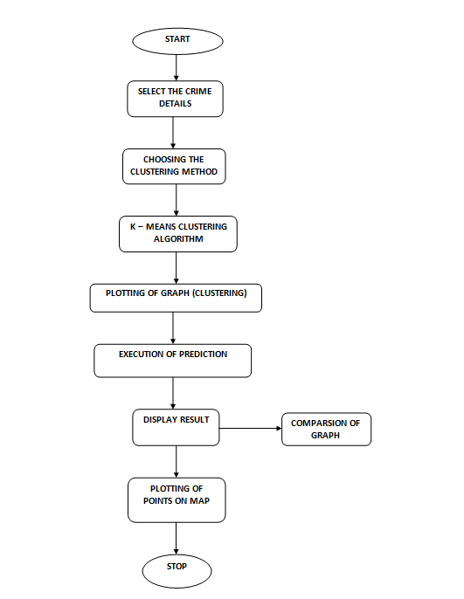
1. Select the crime details:
The first step is to select the crime details from the list of attributes available. The dataset is available to use. From the dataset select the desired attributes as such.
2. Choose the clustering method
The next step is to select the clustering method. K-means clustering algorithm.The clustering algorithms are well efficient. So it's totally on the user to select which one to be used for clustering of data.
3. K-means
This algorithm uses k clusters and centroids from the dataset. It then calculates the distance between the clusters and accordingly places the points in the respective data clusters based on the closest distance.
4. Plotting of graph
The Based on the clustering algorithms, the result is generated and is plotted and is shown in pictorial way in the form of graph.
5. Execution of Prediction
The next step after clustering is prediction .This is a very important process in data mining. The crime is predicted by using the k means clustering prediction algorithm.
6. Display Result
After the prediction step, the data will be displayed on the screen and will show all the details related to the crimes.
7. Plotting of data points on map
After getting the clusters from clustering algorithm. The data points are geospatially plotted. The data points are plotted on the map which also shows crime details at that particular location.

ADVANTAGES OF THE PROPOSED SYSTEM:
- Helps to prevent crime in society
- System will keep historical record of crime.
- System is user friendly
- Saves time

3.4 DATA PREPROCESSING
The module Preprocessor which is used by all other modules consists of the features and functionalities which are needed to preprocess the data before feeding them into other modules such as Data mining technique using K-Means clustering algorithm.
Within this module, functionalities needed to preprocess the input data have been implemented. After receiving the CSV data file from the user specified location, the data extracted from that file will be processed in three stages.
1. Data Cleaning: Data is cleansed through processes such as filling in missing values, smoothing the noisy data, or resolving the inconsistencies in the data.
2. Data Integration: Data with different representations are put together and conflicts within the data are resolved.
3. Data Transformation: Data is normalized, aggregated and generalized.
These have been implemented using K-Means clustering algorithm. The processed dataset will be given to the other module as Spark data frames.

3.5 CLASSIFICATION

Clustering in crime is mainly used to identify the patterns in crime and also used to predict the crime. Classification is a technique of data analysis that is used to extract and predicts future trends in data based on similarity measures. There are steps in doing Crime Analysis:
1) Data Collection
2) Classification
3) Pattern Identification
4) Prediction
5) Visualization
1) Data Collection:
Large amount of crime data is collected at police records. This data is made available by National Crime Bureau of Records. This data is in the form of number of cases recorded all over the nation throughout the year. The data is in unprocessed form and contains some wrong as well as missing values. Hence preprocessing of data is crucial task in order to bring the data in proper and clean form. Pre-processing of data includes data cleansing and Preprocessing.
2) Classification:
The dataset is classified into various groups based on certain characteristics of the data object. Grouping of crimes is done according to states & cities. Classification of the crime is done on the basis of different types of crime. K-mean algorithm can be used to group or cluster data with similar characteristics.
3) Pattern Identification
In these phase proposed system have to identify trends and patterns in crime. The result of this phase is the crime pattern for a particular place. Here corresponding to each location we take the attributes of that place like weather attributes, area sensitivity, notable event, presence of criminal groups etc. Information regarding patterns helps police officials to facilitate resources in an effective manner.
4) Prediction
Corresponding to each place it builds a model. So for getting the crime prone areas we pass current date and current attributes into the prediction software. The result is shown using some visualization mechanisms.

5) Visualization
The crime prone areas can be graphically represented using a heat map which indicates level of activity, usually darker colors to indicate low activity and brighter colors to indicate high activity.

3.6 PERFORMANCE MEASURES

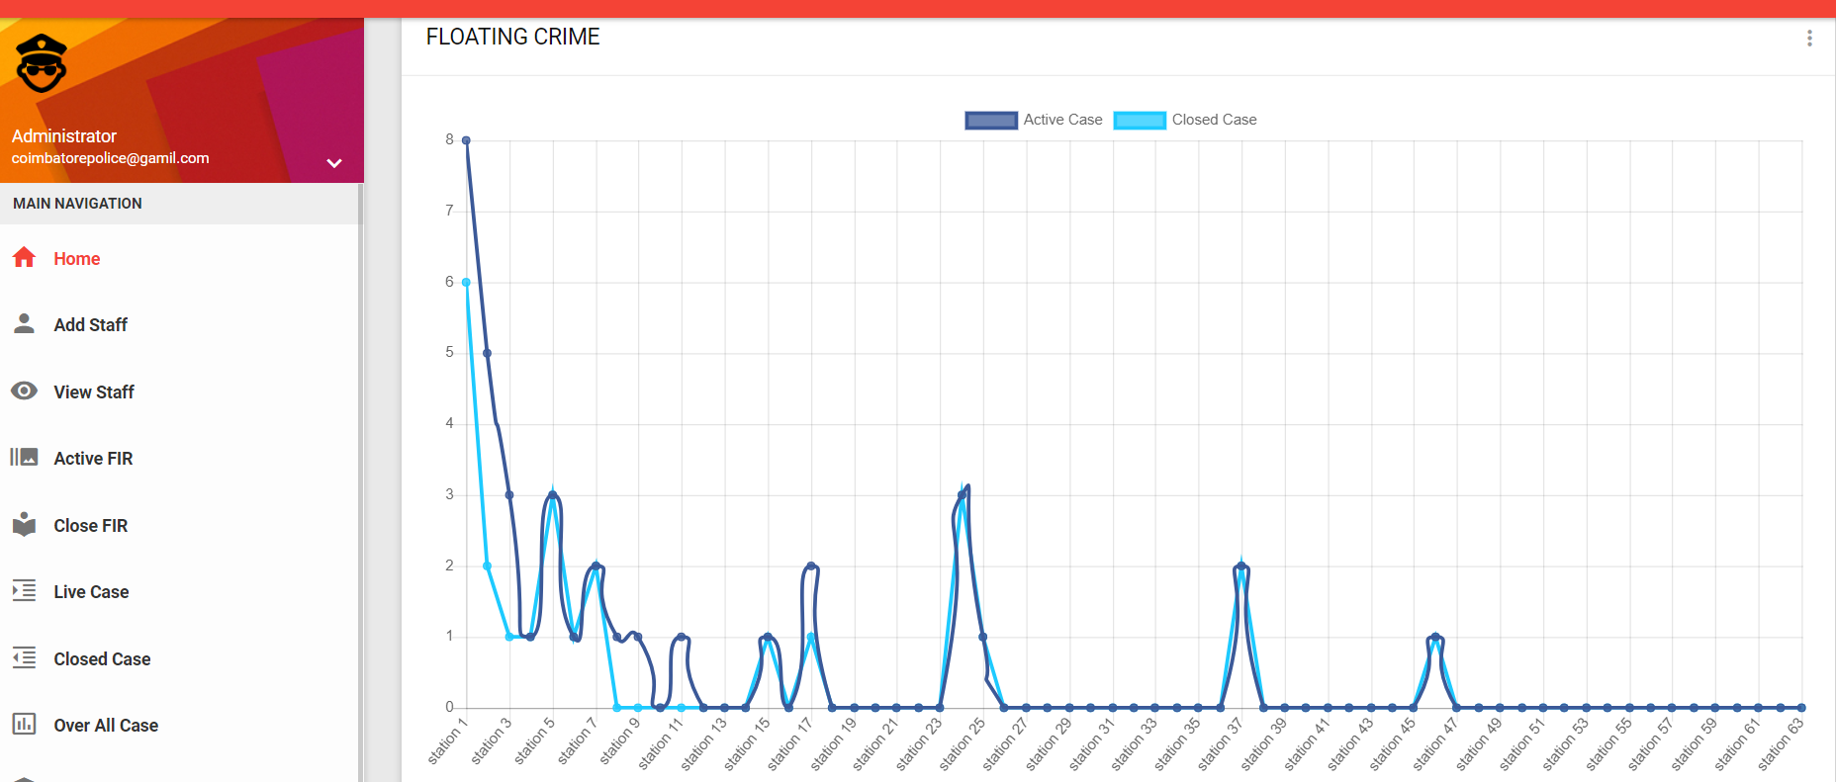

First we take crime dataset and filter dataset according to requirement. The performed k means clustering on resultant dataset and execute. Perform plot view and get cluster. Perform crime rate on cluster formed.

3.7 SYSTEM DESIGN
3.7.1. INPUT DESIGN
Input Design converts the user-oriented inputs to computer-based formats. Inaccurate input data are the most common cause of errors in data processing. Error data entered by the data operator can be controlled by the input design. The goal of designing input is to make the data entry easy, logical and as free from errors as much as possible.
The proposed system is completely menu-driven. It is a powerful tool for interactive design. It helps the user comprehend the range of alternatives available and also prevents them from making an invalid selection. All entry screens are interactive in nature. It has been designed taking into account all the constraints of the end-user.
Some other features included are:
- The form title clearly states the purpose of the form
- Adequate space is given for data entry
- Data Validation is done for eliminating duplicate entries
3.7.2. OUTPUT DESIGN
The Outputs are the most important and direct source of information to the customer and management. Intelligent output design will improve the system's relationship with the user and help in decision making. Outputs are used to make permanent hard copy of the results for later consultation. The output generated by the system is often regarded as the criteria for evaluating the performance of the system. The output design was based on the following factors.
- Usefulness determining the various outputs to be printed to the system user.
- Differentiating between the outputs to be displayed and those to be printed.
- The format for the presentation of the output.

3.7.3. DATABASE DESIGN
The general theme behind a database is to handle information in an integrated manner. There is none of the artificiality that is normally embedded in separate files or applications. A database is collection of interrelated data stored with minimum redundancy to serve many users quickly and efficiently. The general objective is to make information access easy, quick, inexpensive and flexible for the user.
In a database environment, common data are available which several authorized users can use. The concept behind a database is an integrated collection of data and provides a centralized access to the data from the program. It makes possible to treat data as a separate resource.

While designing database, several objectives must be considered:
- Controlled redundancy
- Data Independence
- More information at low cost
- Accuracy and Integrity
- Recovery from failure
- Privacy and security
- Performance
Steps for Database Design
- State what kind of information we need to handle to get the desired output.
- Find out what information is needed for fields (i.e.) field type, size etc.
- Remove any data items, which is redundant.
- Table have one to one relationship needs a primary key field.
- Tables have one to many relationship needs to add a foreign key field to the table to match the primary key field table
3.7.4. FILE DESIGN
The file system is used to control how data is stored and retrieved. Without a file system, information placed in a storage area would be one large body of data with no way to tell where one piece of information stops and the next begins. By separating the data into individual pieces, and giving each piece a name, the information is easily separated and identified. Taking its name from the way paper-based information systems are named, each group of data is called a file. The structure and logic rules used to manage the groups of information and their names are called a "file system”. There are many different kinds of file systems. Each one has different structure and logic, properties of speed, flexibility, security, size and more. Some file systems have been designed to be used for specific applications
1. Code Design
Code is an ordered collection of symbols designed to provide unique identification of an attribute. Codes can be used for various purposes. They can specify object’s physical or performance characteristics and they can be used to give operational instructions.
They also can show inter relationships and may sometimes used to achieve secrecy or confidentiality. Codes are designed for optimum human-oriented use and machine efficiency. Codes posses uniqueness, expandability, conciseness, uniform nets, simplicity, versatility, sort ability, meaningfulness and operability.
Sufficient effort and time is spent in the preliminary study of the problem to design an efficient code. Activate serve scripting is object oriented. The source code is designed so that it can do transaction efficiently. It is the code that dose all the updating, modifications, etc. for all object used in the project there exist an associated source code, which explains the work of that object. It also describes the flow of the project.
Source code is enhanced by structured coding techniques by good internal comments and features provided by the language.
The code design in this project is made modular. The modular behavior enables easy debugging and testing. Inserting comment statement wherever enhances the coding. This is done during the documentation process coding is done in such a way that errors can be trapped easily. Also modifications can easily be appended due to the codes modular behavior.
2. Database Design
The first step in the database design was to analyze the data that would be collected and determine the expected uses of the data. For consistency, each data group is defined as a group of related data tables. Data from one or more surveys may be included in a group. Analysis of the datasheets and data collection methods identified several different data groups.
Once the groups where identified, the commonalities between the datasheets within each group where identified. These commonalities would be in one table, to which all of the other tables in the group would be linked. This would provide a connection between the various tables within a group. To aid in the management of the data and tables, each table would have at least one field that contained a unique identifier for that record, a field to identify who was doing the data entry, and another field to track when the data was entered.
3.Test case design
Test case design focuses on a set of techniques, which meets all testing objectives, which are mentioned below.
- Testing is a process of executing a program with the intent of finding an error.
- A successful test is one that uncovers as yet undiscovered error.
Testing demonstrates that software functions work according to specifications. In addition data collected from testing provides a good indication of software reliability and some indication of software quality as a whole.
Testing results in the deduction in the numbers of errors. Critical modules are tested as early as possible.

4. EXPERIMENTAL RESULTS AND ANALYSIS

4.1 APPROACH USED
4.1.1 k-means algorithm
K-means clustering is one of the methods of cluster analysis which aims to partition n observations into k clusters in which each observation belongs to the cluster with the nearest mean.

Process
1. Initially, the number of clusters must be known let it be k
2. The initial step is the choose a set of K instances as centers of the clusters.
3. Next, the algorithm considers each instance and assigns it to the cluster which is closest.
4. The cluster centroids are recalculated either after whole cycle of re-assignment or each instance assignment.
5. This process is iterated.

K means algorithm complexity is O (tkn), where n is instances, c is clusters, and t is iterations and relatively efficient. It often terminates at a local optimum. Its disadvantage is applicable only when mean is defined and need to specify c, the number of clusters, in advance. It unable to handle noisy data and outliers and not suitable to discover clusters with non-convex shapes.

4.2 DATASET USED
Crime dataset used for crime analysis is an offences recorded by the Coimbatore City Police in Perumanallur Police Station by offence and police force area 2019 In Table 1 sample crime dataset is shown.

Year | Homicide | Attempted murder | Child destruction | Causing death by careless driving
2019 | 10 | 19 | 0 | 7
2019 | 6 | 10 | 0 | 5
2019 | 6 | 8 | 0 | 9
2019 | 6 | 2 | 0 | 15
2019 | 10 | 5 | 0 | 1

4.3 K - MEANS CLUSTER ANALYSIS

- First we take Home page in Figure 1.1. There are two type of login pages. One is Commissioner and another one is Police Station.
- User Login Page: There are 63 police stations in Coimbatore city police crime rate department. The selected one was Perumanallur police station and password sign in. Figure 1.2
- Add FIR details enter in the criminals Name, criminals Id, criminal Description, Location, data and Time, crime Type. Figure 1.3. View FIR can we open the details in FIR details. Figure 1.4.
- Admin Login Page can be User Name and Password enters in the crime rate. It is also called the Head of Department of the police station. Example IG. Figure 1.5
- The Allocate Page can be used to find the crime details allocation and Admin details allocation. The details such as the Crime Id, Crime Name and Crime Description.
Figure 1.10
- The Close the case is complete case in the Head of the Department of the sent the Document to police Station. Figure 1.12
- The Crime Control View Module can be used to case status in what are Status and Current Status day to day update. The Result is Display of Graphical method. The Crime Rate can be implemented to View Graphical Representation of the Crime Control View. Figure 1.13
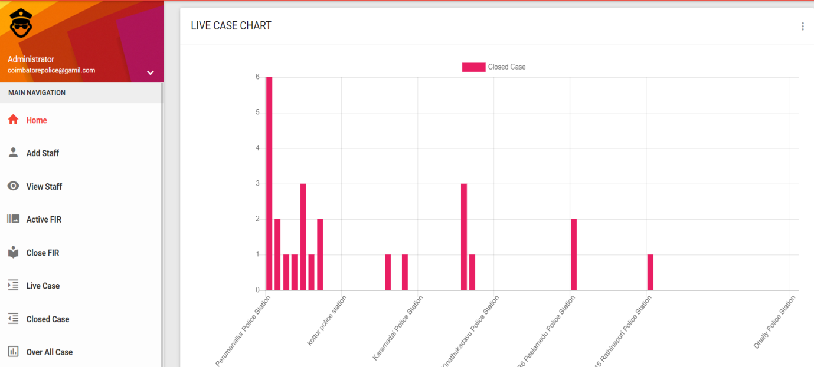
Figure 1.13
- The Predict the crime can be used to accurate place predicate to crime details in the Google map and Plot chat using K means Clustering algorithm. Figure 1.14
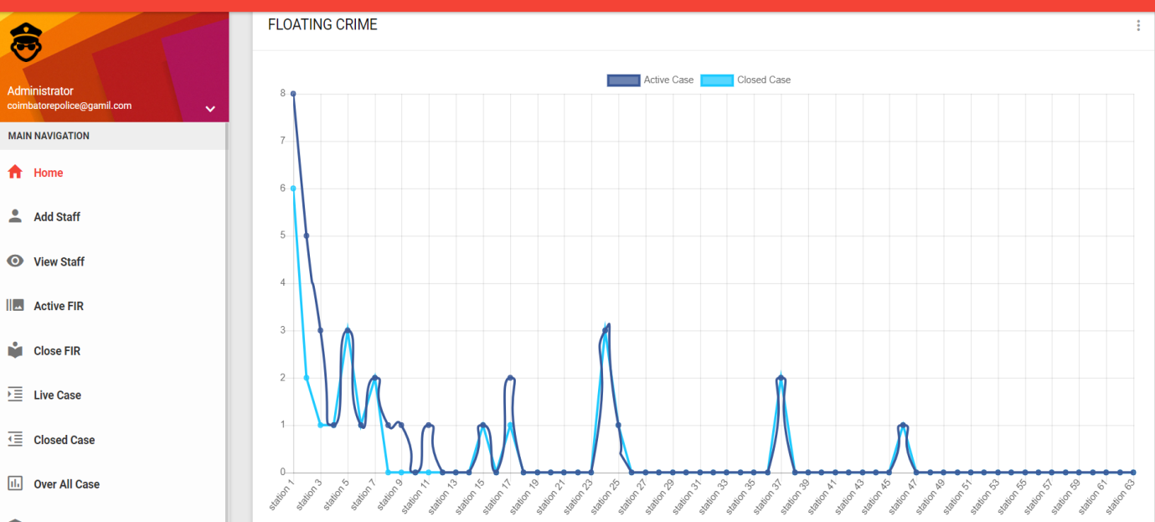
Figure 1.14

Number of Cases Registered in a Period of One Month and for a Particular day was around 78 Cases and was registered. In these Three Months Maximum Cases were 40 and Minimum Cases 38 were Recordered per Month and 40 Police Personnel were allocated work. The Crimes of Theft, Sexual assault and drunken brawl were registered. The Entire Cases for three months were taken into consideration. The Results are shown in Screenshots in Page Numbers 34, 35, 36, 37, 38, 39, 40, and 41.

- CONCLUSION

It is concluded that the application works well and satisfies the needs. The application is tested very well and errors are properly debugged. It also acts as valuable resources because of sharing the files.
We used K-Means clustering algorithms to cluster the data. The clustered crime data is then used to make a prediction and is made to handle changing crime patterns. Crime patterns cannot be static since patterns change over time, so different clustering techniques like K-Means clustering algorithm are used to handle the changing crime patterns. More in depth inputs will provide better and accurate results.

- SCOPE OF FUTURE ENHANCEMENT

Every application has its own merits and demerits. The project has covered the requirements. Further requirements and improvements can easily be done since the coding is mainly structured or modular in nature. Changing the existing modules or adding new modules can append improvements. Further enhancements can be made to the application, so that the system will be immediately blocked while attacks take place. In future all transaction will be processed in a secured manner and can find the intruders activity by getting all relevant details. In future it will capture all actions of the intruder by using screen capturing mechanism.

- BIBLIOGRAPHY
7.1 REFERENCES

- Jyoti Agarwal , Renuka Nagpal , Rajni Sehgal , Crime Analysis using K-Means Clustering, International Journal of Computer Applications, December 2013.
- Ms. Vrushali Pednekar, Ms. Trupti Mahale, Ms. Pratiksha Gadhave, Prof. Arti Gore, Crime Rate Prediction using KNN, International Journal on Recent and Innovation Trends in Computing and Communication ISSN: 2321-8169.
- J. Agarwal, R. Nagpal, and R. Sehgal, “Crime analysis using k-means clustering,” International Journal of Computer Applications, Vol. 83 No4, December 2013.
- Malathi , A; Santhosh Baboo , S, 2011 An Enhanced Algorithm to Predict a Future Crime using Data Mining
- Navjot Kaur : Data Mining Techniques used in Crime Analysis:- A Review, International Research Journal of Engineering and Technology (IRJET) Volume: 03 Issue: 08 Aug-2016.

7.2 WEBSITES

- https://www.researchgate.net/publication/280722606_Crime_Analysis_and_Prediction_Using_Data_Mining
- https://www.leadingindia.ai/downloads/projects/CM/cm_2.pdf
- https://acadpubl.eu/hub/2018-118-22/articles/22a/87.pdf
- http://www.grdjournals.com/uploads/article/GRDJE/V02/I05/0176/GRDJEV02I050176.pdf
- http://projectideas.co.in/crime-rate-prediction-using-k-means/

- APPENDIX

- DATA FLOW DIAGRAM

LEVEL 0:

Login

Profile

Admin
View Profile
User
Emergency Contact

FIR Registration
IR

FIRView Profile

RESULT

LEVEL 1: USER LOGIN

Stop
Result
Update Case Status
Document Submitted
Find Crime
Allocate Inspector
Case View
Case Register FIR
Login
Police Station
Start

ADMIN LOGIN
Start
IG Officer

Login

Register New Police Station

Case View DeTAILS

No
Case Status

Case Close
Document Verification
Yes
Allocate Inspector New Case

Predict the Crime Rate

Result

Result
ER DIAGRAM:

CRIME ID
CRIME NAME
CRIME TYPE
LOCATION
DAY, DATE & TIME
JOB
AGE
CRIMINAL ID
GENDER
IMAGE
RECORDS

PASSWORD
USER NAME
CONTAINS
USER NAME
CRIME RATE PREDFICTION USING K – MEANS
REGISTER
ADMIN
POLICE
LOGIN

DO WORK
PASSWORD
FEEDBACK
VIEW CRIMINAL DETAILS
COMMON PEOPLE
FILL CRIMINAL DATA
MANAGE

- TABLE STRUCTURE

- ADMIN TABLE
PRIMARY KEY: USER_ID
Field | Data Type
user _id | Navrchar (20)
user _name | Varchar(20)
password | Varchar(20)
user_type | Varchar(20)

- FIR DETAILS

PRIMARY KEY: FIR _ID

Field | Data Type
Admin _id | int(11)
Police station _id | int(11)
Name | varchar(50)
Address | varchar(50)
City | varchar(50)
Mobile | varchar(30)
Reason | varchar(100)
Against | varchar(50)
Date | varhcar(15)
Description | varchar(500)
Officer | varcahr(30)
Status | Tinyint(4)

- PERUMANALLUR POLICE STATION TABLE

PRIMARY KEY: POLICE STATION _ID

Field | Data Type
user _id | int(11)
user _name | Varchar(50)
password | Varchar(50)
Address | Varchar(100)
Contact no | Varchar(50)
Location | Varchar(500)
Status | Tinyint(4)

- STAFF INFORMATION TABLE

PRIMARY TABLE: STAFFINFO_ID

Field | Data Type
Id | int(11)
Name | Varchar(50)
Posting | varchar(50)
E-mail | varchar(50)
Police station _id | int(11)
Mobile | varchar(50)
Staff_id | int(11)
Address | varchar(100)
City | varhcar(50)
Status | tinyint(11)

- SAMPLE CODING:
<?php
class DataSet{
public $x;
public $y;
function __construct($x, $y){
$this->x = $x;
$this->y = $y;
}
}
class Wrapper{
public $set;
public $limit;
public $k;
}
function distance($p1, $p2){
return abs($p1->x - $p2->x)+abs($p1->y - $p2->y);
}
function dump($table, $centroid, $k){
$cluster = array();
foreach($table as $row){
$minValue = 999999;
$minID = 0;
for($i=0; $i<$k; $i++)
{
$dist = distance($row, $centroid[$i]);
if($minValue > $dist){
$minID = $i;
$minValue = $dist;
}
}
$cluster[] = $minID;
}
return $cluster;
}
function dump_group($centroid, $group, $k){
for($i=0; $i<$k; $i++){
$x = 0;
$y = 0;
$c = 0;
foreach($group[ $i ] as $set){
$c++;
$x += $set->x;
$y += $set->y;
}
$x /= $c;
$y /= $c;
$centroid[$i] = new DataSet($x, $y);
}
return $centroid;
}
function kmeans($json){
$obj = json_decode($json);
$k = 2;
if(isset( $obj->k )){
$k = $obj->k;
}
$table = array();
foreach($obj->set as $row){
$table[] = new DataSet($row->x, $row->y);
}

$centroid = array();
for($i=0; $i<$k; $i++)
$centroid[] = new DataSet($table[$i]->x, $table[$i]->y);
$iteration_limit = 10;
if(isset( $obj->limit )){
$iteration_limit = $obj->limit;
}
for($iteration = 0; $iteration < $iteration_limit; $iteration++){
$cluster = dump($table, $centroid, $k);
$group = array();
for($i=0; $i<$k; $i++){
$group[] = array();
}
$i = 0;
foreach($table as $row){
$group[ $cluster[$i] ][] = new DataSet( $row->x, $row->y );
$i++;
}
$new_centroid = dump_group($centroid, $group, $k);
// CHECK CHANGED IN NEW CENTROID AND BREAK
$flag = true; //ASSUME SAME VALUES EXIST
$i = 0;
foreach($new_centroid as $g){
if( $centroid[$i]->x != $new_centroid[$i]->x || $centroid[$i]->y != $new_centroid[$i]->y) {
$flag = false;
break;
}
$i++;
}
if($flag){
break; }
// COPY NEW_CENTROID TO CENTROID
$i = 0;
foreach($new_centroid as $g){
$centroid[$i] = new DataSet( $g->x, $g->y );
$i++; }
}
class Output{
public $centroid;
public $iteration;
public $success;
public function __construct(){
$this->success = true; } }
$output = new Output();
if($flag){
}
else{
$output->success = false; }
$output->centroid = array();
foreach($centroid as $g){
$output->centroid[] = new DataSet($g->x, $g->y);
}
$output->iteration = $iteration;
return json_encode( $output );
}
?>
<?php
session_start();
include_once('../../db/dpconfig.php');
$close = $_REQUEST['close'];
$station = $_REQUEST['station'];
$query = "UPDATE `firdetails` SET `status`='0' WHERE id='$close'";
$result=mysqli_query($conn, $query);
if ($result)
{
$sql = "SELECT * FROM policestation WHERE id='$station' AND status ='1'";
$result = $conn->query($sql);
if ($result->num_rows > 0) {
while($row = $result->fetch_assoc()) {
$id = $row["id"];
$closedcase = $row["closedcase"];
}
}
$active = $closedcase + 1;
$queryes = "UPDATE `policestation` SET `closedcase`='$active' WHERE id='$station'";
$output=mysqli_query($conn, $queryes);
$_SESSION['fir']['success'] = "<center><span class='col-teal'>Case Close Successfully..!</span></center>";
header("Location: ../viewfir.php");
}
else
{
$_SESSION['fir']['err'] = "<center><span class='col-pink'>Please Try Again..!</span><center>";
header("Location: ../viewfir.php");
}
?>

- SAMPLE INPUT:
HOME PAGE
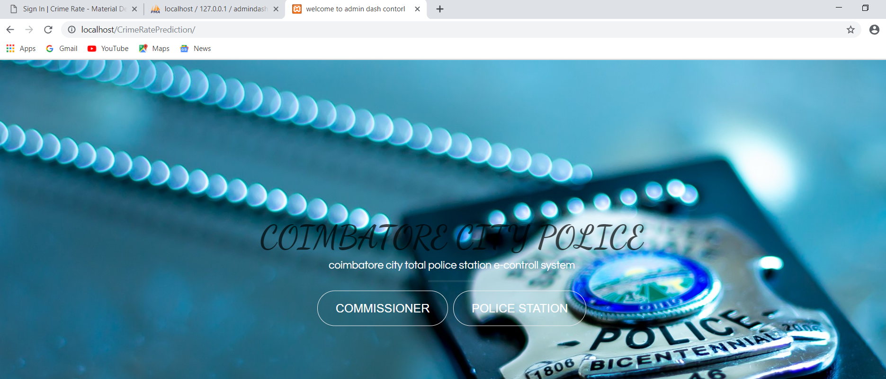
FIGURE 1.1
USER LOGIN PAGE
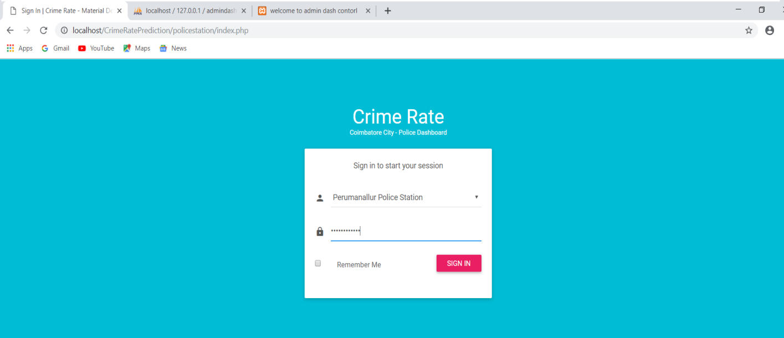
FIGURE 1.2

ADD FIR PAGE
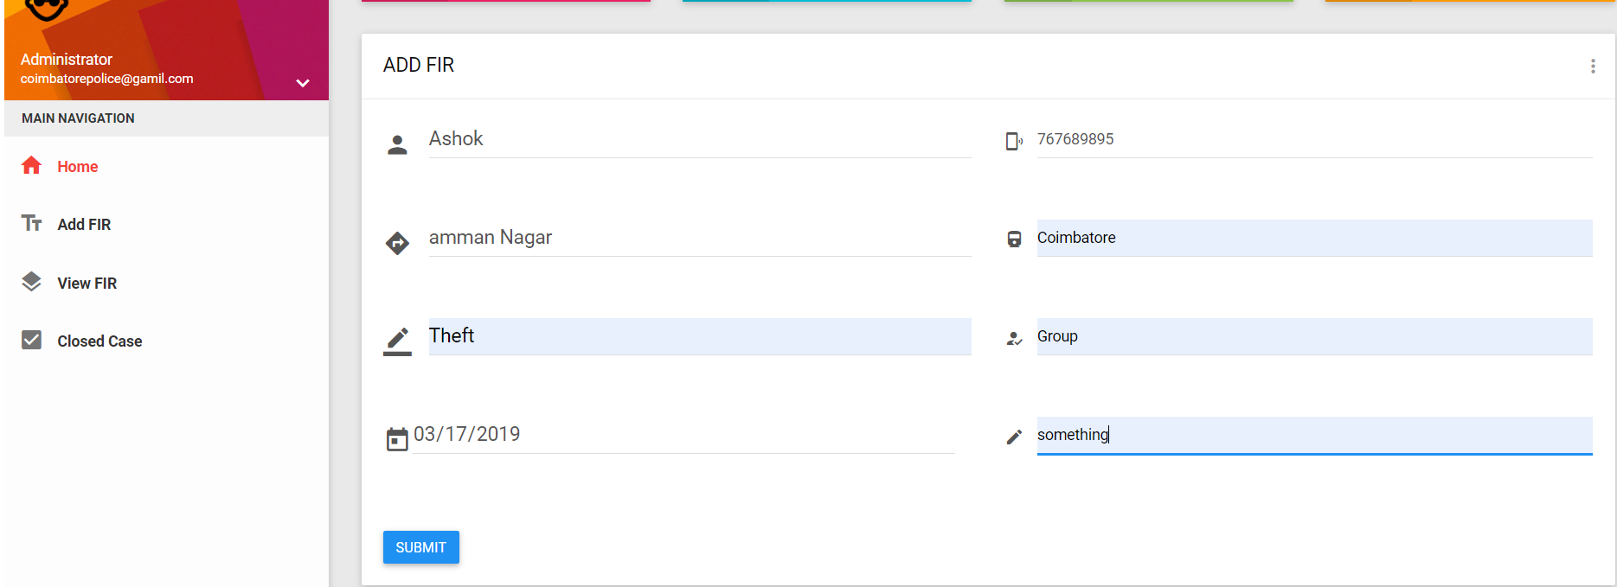
FIGURE 1.3

VIEW FIR PAGE
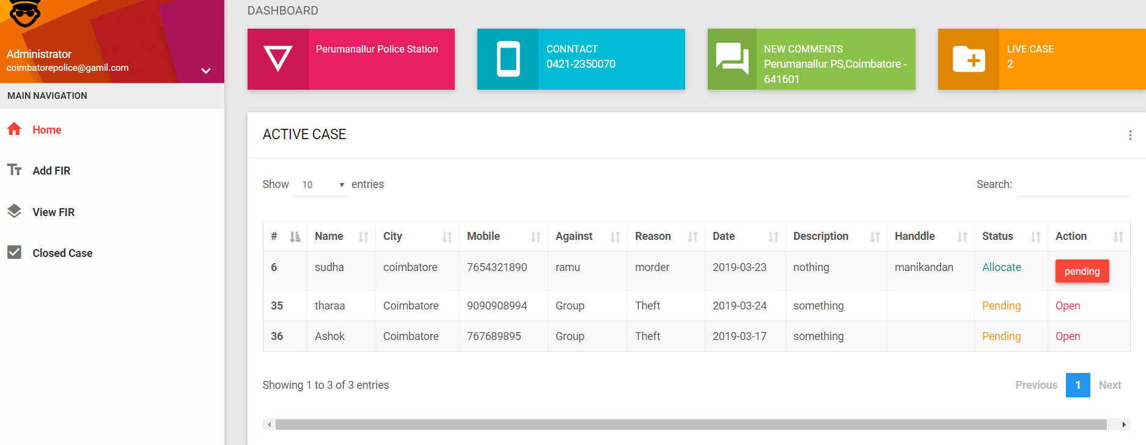FIGURE 1.4

ADMIN LOGIN PAGE
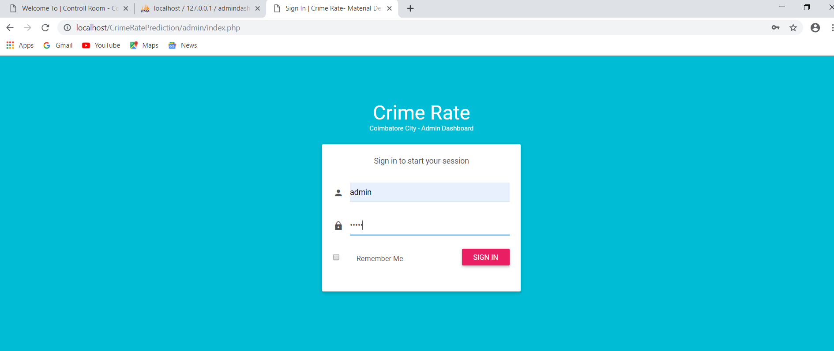
FIGURE 1.5
HOME PAGE
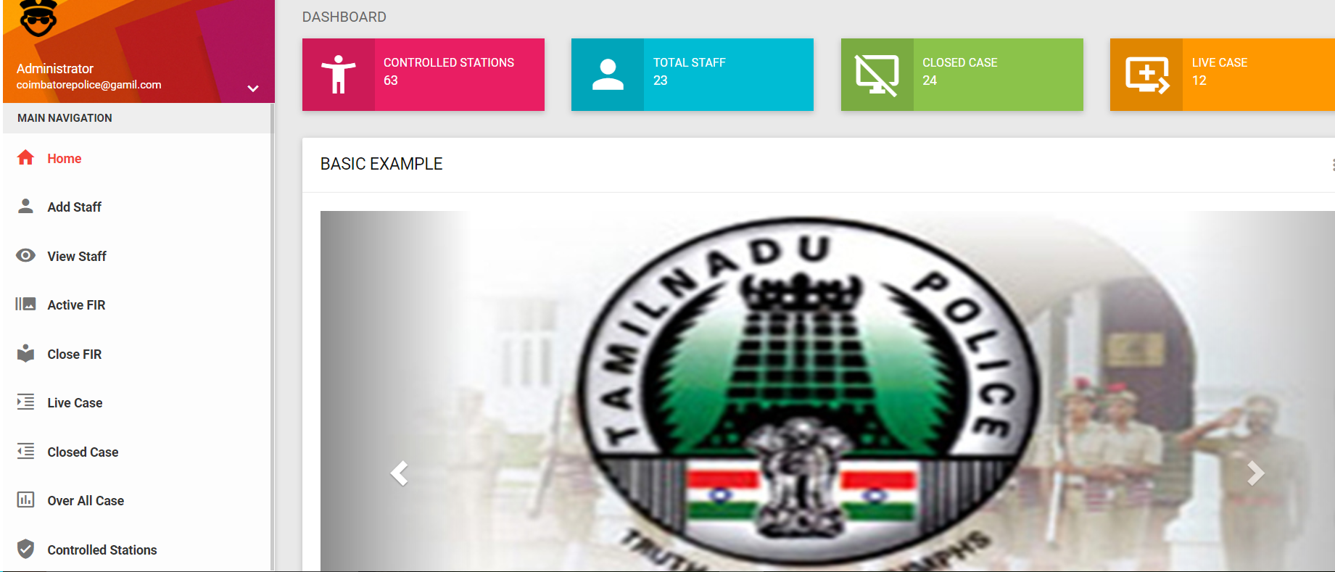
FIGURE 1.6

ADD NEW STAFF
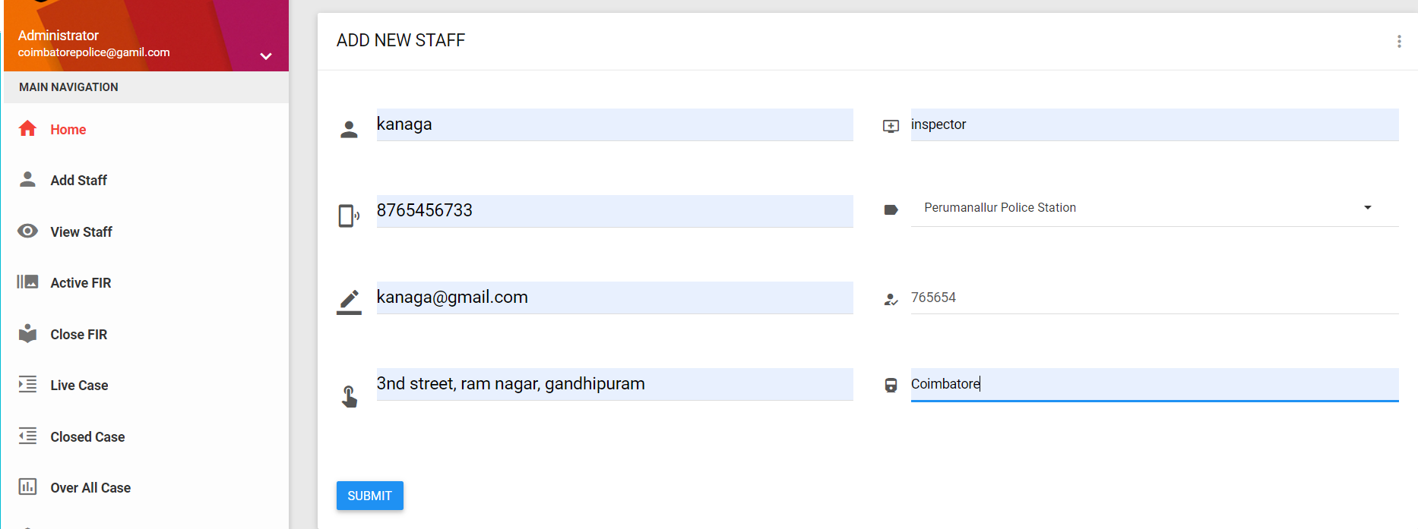
FIGURE 1.7

VIEW STAFF
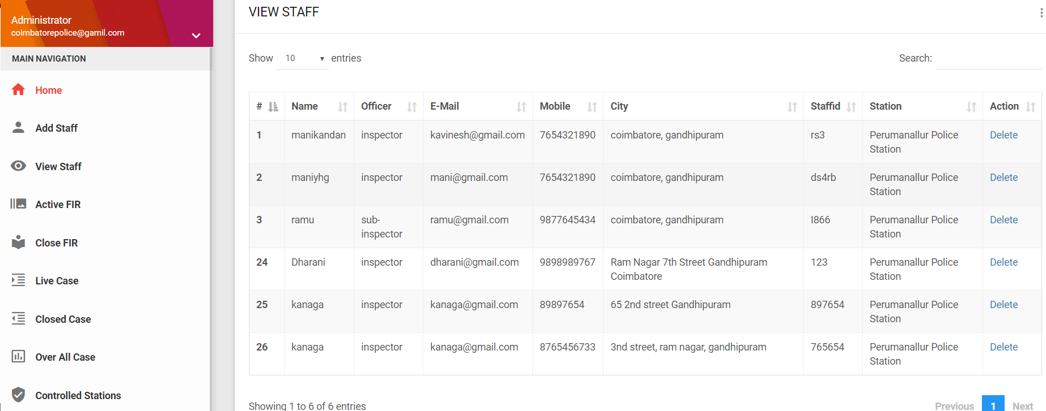FIGURE 1.8

ACTIVE FIR
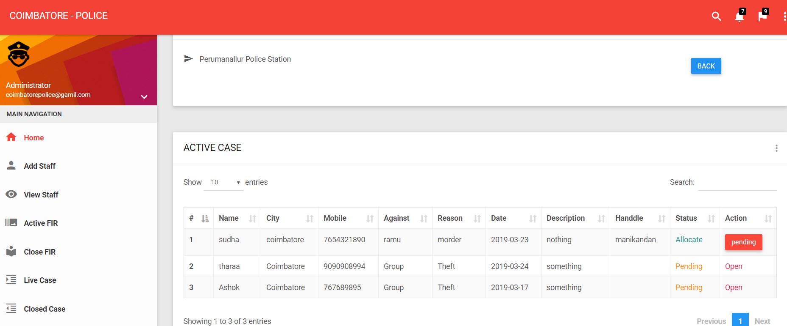

FIGURE 1.9
ALLOCATE PAGE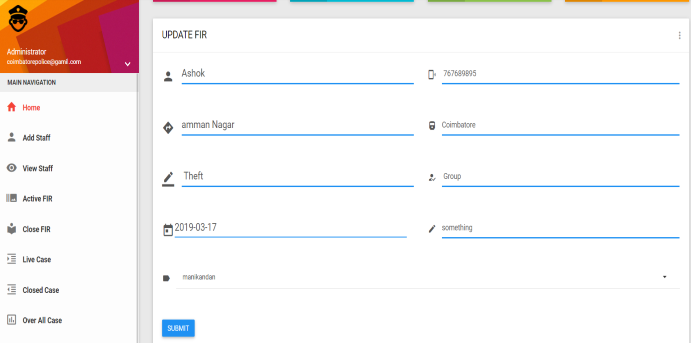
FIGURE 1.10
ALLOCATE AND CLOSE CASES
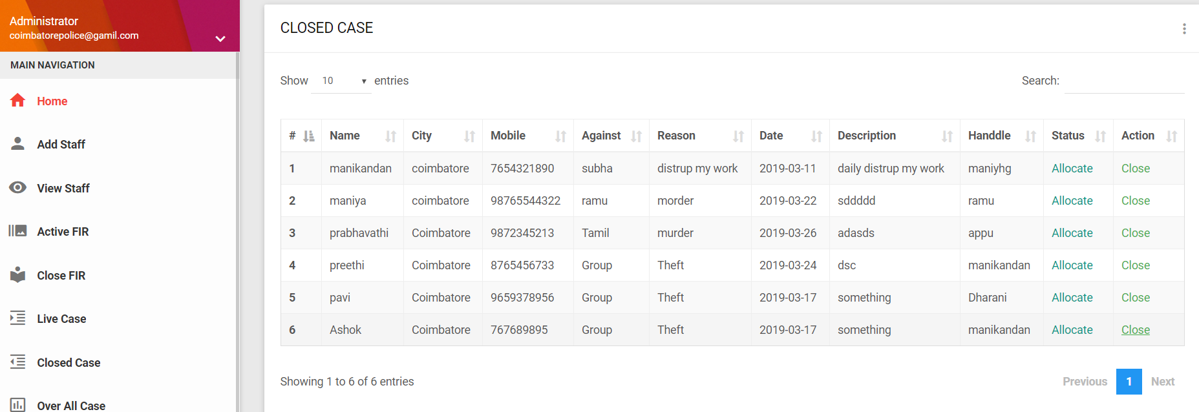
FIGURE 1.11

CLOSED CASES
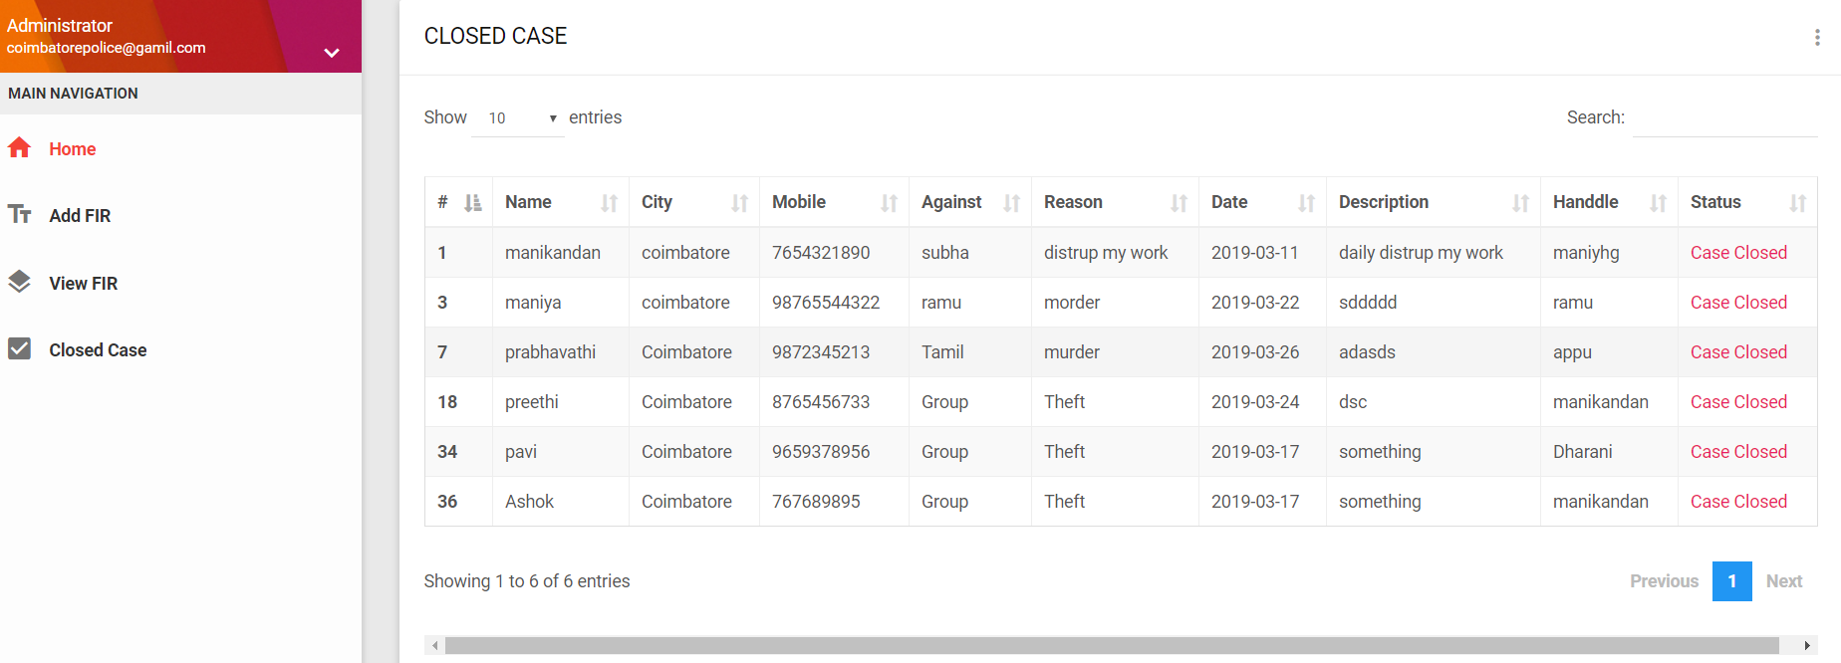
FIGURE 1.12

SAMPLE OUTPUT:
LIVE CASE STATUS
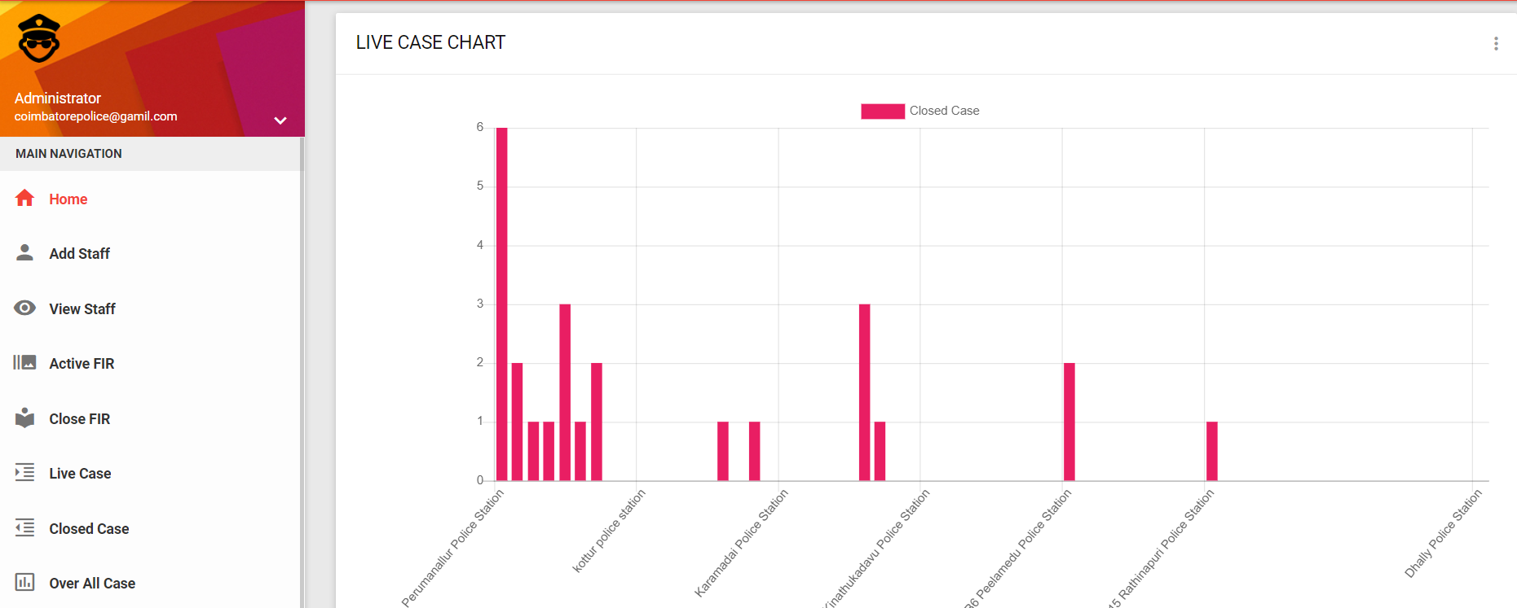

FIGURE 1.13

PREDICT THE CRIME
FIGURE 1.14

