Decolourization of Selected Reactive Dye using
Isolated Bacterium for Reutilization

PRIYADHARSHINI, S.V.
[Reg. No. 10PBS09]

A THESIS SUBMITTED TO THE AVINASHILINGAM DEEMED UNIVERSITY FOR WOMEN, COIMBATORE – 641 043

IN PARTIAL FULFILMENT OF THE REQUIREMENTS FOR THE DEGREE OF
MASTER OF SCIENCE IN BIOTEXTILES

APRIL 2012

ACKNOWLEDGEMENT
First and foremost, the investigator places her humble salvations at the feet of GOD ALMIGHTY who has given sound wisdom and desertion knowledge, strength and opportunity to do the investigation effectively.
The investigator expresses her immense gratitude and thanks to
Thiru. T. S. AVINASHILINGAM AYYA, founder and first chancellor of Avinashilingam Institute for Home Science and Higher Education for Women, Coimbatore and Dr. (Tmt.) RAJAMMAL P. DEVADAS, M.A., M.Sc., Ph.D., former chancellor, Avinashilingam Institute for Home Science and Higher Education for Women, Coimbatore for providing and shaping this temple
of learning.
The investigator wishes to express her immense gratitude to
Thiru. T.S.K. MEENAKSHI SUNDARAM, M.A., M.Phil., Chancellor, Avinashilingam Institute for Home Science and Higher Education for Women, Coimbatore, for the opportunity to conduct research in this esteemed university.
The investigator expresses this opportunity to reveal thanks to
HON. COLONEL. Dr. SAROJA PRABAKARAN, M.A., Dip.Ed. (Madras) Ph.D. (Mother Terasa), Former Vice Chancellor, Avinashilingam Institute
for Home Science and Higher Education for Women, Coimbatore, for her encouragement and constructive suggestions for the successful conduct of
the study.
The investigator owes her deep sense of gratitude and thankful to
Dr. (Tmt.) SHEELA RAMACHANDRAN, M.Sc., P.G. Dip., Ph.D. (Avinashilingam), Vice Chancellor, Avinashilingam Institute for Home Science and Higher Education for Women, Coimbatore, for the amenities provides for
the successful completion of the study.
The investigator expresses her respectful regards and sincere thanks to
Dr. (Tmt.) GOWRI RAMAKRISHNAN, M.Sc. (Madras), M.Phil. (Bharathiar), Ph.D. (Avinashilingam), Registrar, Avinashilingam Institute for Home Science and Higher Education for Women, Coimbatore, for her encouragement towards
the research.
The investigator expresses immensely indebted and extremely privileged to have worked under the supervision of her esteemed guide,
Dr. (Tmt.) K. KALAIARASI, M.Sc., M.Phil., Ph.D. (Avinashilingam), Assistant Professor, Department of Textiles and Clothing, Avinashilingam Institute for Home Science and Higher Education for Women, Coimbatore, for her valuable guidance, technical support, timely help and constant encouragement throughout the study.
The investigator expresses her deep sense of gratitude to all the
STAFF MEMBERS of the Department of Textiles and Clothing, Avinashilingam Institute for Home Science and Higher Education for Women, Coimbatore, for being supportive, suggestive, understanding and encouragement rendered towards the completion of her study.
Last but not least the investigator expresses her heartfelt thanks to her PARENTS, FAMILY MEMBERS and FRIENDS for their constant prayers, moral support help rendered for the completion of the study.

CONTENTS

CHAPTER NO. | TITLE | PAGE NO.
 | LIST OF TABLES
 | LIST OF FIGURES
 | LIST OF PLATES
1 | INTRODUCTION | 1
2 | REVIEW OF LITERATURE | 4
3 | EXPERIMENTAL PROCEDURE | 17
4 | RESULTS AND DISCUSSION | 42
5 | SUMMARY AND CONCLUSION | 75
 | REFERENCES | 80
 | APPENDIX | 87

LIST OF TABLES

Table No. | Title | Page No.
I | Biochemical characteristics of bacterial isolate | 21
II | Percent decolourization by different bacterial isolates | 43
III | Morphological and biochemical characteristics of selected isolate | 44
IV | Inoculum concentration | 46
V | Dye concentration | 47
VI | Time | 48
VII | pH | 49
VIII | Temperature | 50
IX | Carbon source | 52
X | Lactose concentration | 53
XI | Nitrogen source | 54
XII | Ammonium sulphate concentration | 55
XIII | Salinity | 56
XIV | Visual inspection of fabrics | 58
XV | Fabric Weight | 58
XVI | Fabric Count (Warp) | 60
XVII | Fabric Count (Weft) | 61
XVIII | Fabric Thickness | 62
XIX | Fabric Strength (Warp) | 63
XX | Fabric Strength (Weft) | 64
XXI | Fabric Elongation (Warp) | 65
XXII | Fabric Elongation (Weft) | 66
XXIII | Fabric Stiffness (Warp) | 67
XXIV | Fabric Stiffness (Weft) | 68
XXV | Abrasion resistance | 69
XXVI | Crease recovery (Warp) | 70
XXVII | Crease recovery (Weft) | 71
XXVIII | Drape co- efficient | 72
XXIX | Absorbancy Test | 73
XXX | Colour Fastness Test | 74

LIST OF FIGURES

Figure No. | Title | Page No.
I | Inoculum concentration | 47
II | Dye concentration | 48
III | Time | 49
IV | pH | 50
V | Temperature | 51
VI | Carbon source | 52
VII | Lactose concentration | 53
VIII | Nitrogen source | 54
IX | Ammonium sulphate concentration | 56
X | Salinity | 57
XI | Fabric Weight | 59
XII | Fabric Count (Warp) | 60
XIII | Fabric Count (Weft) | 61
XIV | Fabric Thickness | 62
XV | Fabric Strength (Warp) | 63
XVI | Fabric Strength (Weft) | 64
XVII | Fabric Elongation (Warp) | 65
XVIII | Fabric Elongation (Weft) | 66
XIX | Fabric Stiffness (Warp) | 67
XX | Fabric Stiffness (Weft) | 68
XXI | Abrasion resistance | 69
XXII | Crease recovery (Warp) | 70
XXIII | Crease recovery (Weft) | 71
XXIV | Drape co- efficient | 72
XXV | Absorbancy Test | 73
LIST OF PLATES

Plate No. | Title | Page No.
I | Autoclave | 20
II | Incubator | 20
III | Nano UV - Vis spectrophotometer | 20
IV | Experimental setup for optimization study | 28
V | Reactive dye solution - before and after treatment | 28
VI | Thickness gauge | 35
VII | Tensile strength tester | 35
VIII | Abrasion resistance | 35
IX | Fabric stiffness tester | 36
X | Drape | 36
XI | Crease recovery | 36
XII | Drop test | 38
XIII | Wickability test | 38
XIV | Sinking test | 38
XV | Biochemical characteristics of Bacillus species | 45

1. INTRODUCTION
Water is life but now-a-days advancement of industrialization resulted in discharge of large amount of waste to the environment, which in turn creates more pollution. Water pollution control is at present one of the major areas of scientific activity.
Textile industries are large industrial consumers of waters as well as producers of waste waters. With the increased demand for textile products, the textile industry and its wastewaters have been increasing proportionally, making it one of the main sources of severe pollution problems worldwide.
The diversity in composition of chemical reagents used in textile industries contributes to much of the water pollution. The reagents range from inorganic compounds to polymers and organic products. Waste water generated by different production steps of a textile mills have high pH, temperature, detergents, oil, suspended and dissolved solids, dispersants, leveling agents, toxic and non-biodegradable matter, color and alkalinity.
Important pollutants in textile effluent are mainly recalcitrant organics, color, toxicants and surfactants. The textile waste waters are characterized by extreme fluctuations in many parameters such as Chemical Oxygen Demand (COD), Biochemical Oxygen Demand (BOD), pH, color and salinity. The process of adding color to fibers is known as dyeing which normally requires large volumes of water not only in the dye bath, but also during the sensing step. The process of dyeing involves the use of different chemicals like salt, metals, surfactants, organic processing assistants, sulphide and formaldehyde.
First synthetic dye was reported in the year 1856. There are more than 1,00,000 commercially available dyes with over 7x10⁷ tons of dyestuff produced annually worldwide. Among them approximately 10,000 commercial dyes are used in the coloring industries. As more than 10% of the dyestuff used during dyeing processes does not bind to the fibers, large amount of dyes are released into the environment, resulting in serious environmental pollution.
Reactive dyes, including many structurally different dyes, are extensively used in textile industry because of their wide variety of colour shades, high wet fastness profiles, ease of application, brilliant colours and minimal energy consumption. Reactive dyes are widely used in textile finishing and have become of concern in wastewater treatment because of their color, bio recalcitrance and potential toxicity to animals and humans. Thus, wastewater with reactive dyes must be decolorized and further more mineralized in appropriate systems.
Dyes can be removed from wastewaters by chemical and physical methods including adsorption, coagulation- flocculation, oxidation and electrochemical methods. However, both physical and chemical methods have many disadvantages in application, such as high-energy costs, high-sludge production, formation of by- products. Conversely, bio processing can overcome these defects because it is cost saving and environmentally benign. Fungi and algae have been used in dye Decolourization. Adsorption rather than degradation plays a major role during the Decolourization process by fungi and algae as a result the dyes remain in the environment. It is well known that bacteria can degrade and even completely mineralize many reactive dyes under certain conditions.
The general approach of bioremediation is to improve the natural degradation capacity of the native organism. Several microorganisms have been reported by a number of investigators which have the capacity to decolorize various textile azo dyes.

The degradation of reactive dyes produces aromatic amines which are carcinogenic and mutagenic. Recently, several reports appeared showing that the micro organism has the ability not only to decolorize dyes but also to detoxify it. The process of biodegradation is a well established powerful technique for treating domestic and industrial effluents. Microbial populations have an amazing and extensive capacity to degrade a variety of organic compounds.
Currently, extensive research is being focused on finding an optimal microbial biomass that would be as cheap as possible for the removal of contaminating dyes from large volume of polluted water. Hence, the present study “Decolourization of selected reactive dye using isolated bacterium for reutilization” is carried out with the following objectives.
- To isolate and identify the reactive dye decolorizing bacterium from textile effluent discharged soil.
- To optimize various parameters such as pH, inoculum concentration, incubation period, temperature, carbon and nitrogen source for decolourization using selected bacterial strain.
- To reuse the decolorized water for dyeing selected cotton fabrics.
- To evaluate and compare the fabrics dyed using soft and treated water.

2. REVIEW OF LITERATURE

The review of literature pertaining to the study "Decolourization of selected reactive dye using isolated bacterium for reutilization" is discussed under the following headings.

2.1. Dyes

2.1.1. Classification

2.1.2. Properties

2.1.3. History of synthetic dyes

2.1.4. Environmental Issues and concern

2.2. Reactive dyes

2.2.1. Advantages

2.2.2. Uses

2.2.3. Environmental Issues and concern

2.3. Dye Decolourization
  - Microbial Decolourization
  - Enzymatic Decolourization

2.4. Recycling of textile wastewater

2.5. Cotton
2.5.1. History of cotton
2.5.2. Properties of cotton
- physical properties
- chemical properties
2.5.3. Advantages of cotton
2.5.6. Dyeing of cotton

2.1. Dyes
A dye is a colored substance that has affinity to the substrate to which it is being applied. The dye is generally applied in an aqueous solution, and requires a mordant to improve the fastness of the dye on the fiber. Naik and Wilson (2006) define dyeing as the method of colouring the fiber (stock), sliver yarn warp beams and fabric by dipping in the coloured solution, at estimated percent shade, concentration, time and temperature. Dyeing implies some affinity between the fiber and the dye states Barker (1998).
Dyed flax fibers have been found in the Republic of Georgia dated back in a prehistoric cave to 36,000 BP report. Archaeological evidence shows that, particularly in India and Phoenicia, dyeing has been widely carried out for over 5000 years. The dyes were obtained from animal, vegetable or mineral origin, with no or very little processing. By far the greatest source of dyes has been from the plant kingdom, notably roots, berries, bark, leaves and wood, but only a few have ever been used on a commercial scale inform Hunger (2003).
2.1.1. Classification
Natural dyes
Natural dyes are dyes and pigments that are obtained from natural sources without chemical processing inform Gupta (2000). Natural dyes have been parts and parcel of men’s life since time immemorial. The age old art of dyeing with natural dye was common in India. The Indian dyes were famous for creating variety of shades with help of natural and metallic mordant. Therefore, India was fore runner in the art of dyeing with natural dye.
In ancient time India enjoyed monopoly in the production of naturally dyed, printed and painted textiles. Natural dyes which had lost their importance in the last 150 years are now staying a comeback due to ecological consideration and their non hazardous nature. They exhibit better biodegradability and generally have a better compatibility with the environment. Dyeing with natural dye stuff is a traditional craft of India. Until the later half of the 19th century almost all the dyes were vegetable or animal in origin. Colouring matter was extracted from the roots, stems, leaves, berries and flowers of various plants and from certain insects view Kvavadze and Meshveliani (2009).
In recent years lot of awareness and concern has developed over the environmental issues. Health hazards caused by synthetic dyes continue to be a serious problem observes Kang (2005).
Synthetic dyes
All aromatic compounds absorb electromagnetic energy but only those that absorb light with wavelengths in the visible range (~350-850 nm) are colored. Dyes contain chromophores (delocalized electron systems with conjugated double bonds) and auxochromes (electron-withdrawing or electron-donating substituents that intensify the color of the chromophore
by altering the overall energy of the electron system). Usual chromophores are -C=C-, -C=N-, -C=O, N=N-, -NO₂ and quinoid rings. Usual auxochromes are –NH₃, COOH, -SO₃H and –OH (Zee 2002). Based on chemical structure of chromophores, 20-30 different groups of dyes can be discerned. Azo (monoazo, diazo, triazo, polyazo), anthraquinone, phthalocyanine and triarylmethane dyes are quantitatively the most important groups.
Most of the commercially available azo dyes are formulations of several components in order to improve the technical properties of the dyeing process. The majority of industrially important azo dyes belong to the following classes: Acid dyes, Basic dyes, Direct dyes, Disperse dyes, Mordant dyes, Reactive dye and Solvent dyes. The acid, basic, direct and reactive azo dyes are ionic dyes.
Synthetic dyes are extensively used in textile dyeing, paper printing, color photography, pharmaceutical, food, cosmetics and other industries state Rafi et al. (1990). Approximately, 10,000 different dyes and pigments are used in industries and over 7x10⁵ tons of synthetic dyes are produced annually worldwide. In 1991, the world production of dyes was estimated 668,000 tons view Ollgaard et al. (1998) of which reactive dyes contributed 70% (ETAD, 1997). During dyeing process, a substantial amount of reactive dye is lost in wastewater view Ollgaard et al. (1998). Zollinger, (1987) reported that about 10-15% of dyes were lost in effluent during dyeing process.
Major classes of synthetic dyes include reactive, anthraquinone and triarylmethane. Many of them are toxic or even carcinogenic compounds with long turnover times. With the increased use of a wide variety of dyes, pollution by dye wastewater is becoming increasingly alarming Inform Zollinger (1987).
2.1.2. Properties of dyes
Dyes used for textile materials must possess principle properties like intense colour, solubility in water, affinity towards textile fibers and adequate fastness points out Choudhury (2006). Gupta (2001) remarks that the dye should have the following features namely,
- Intense colour,
- Solubility in water,
- Substantivity to the fiber,
- Durability to wet treatments,
- Safe, easy to handle and reasonably priced.

2.1.3. History of synthetic dyes
Archaeologists have found evidence of textile dyeing dating back to the Neolithic period. The earliest surviving evidence of textile dyeing was found at the large Neolithic settlement at Çatalhöyük in southern Anatolia, where traces of red dyes, possibly from ochre, an iron oxidepigment derived from clay), were found (Barbar, 1991). In China, dyeing with plants, barks and insects has been traced back more than 5,000 years.
Early evidence of dyeing comes from Sindh (Pakistan), where a piece of cotton dyed with a vegetable dye has been recovered from the archaeological site at Mohenjo-daro (3rd millennium BCE) view Hunger (2003). The dye used in this case was madder, which, along with other dyes such as indigo, was introduced to other regions through trade.
Natural insect dyes such as Tyrian purple and kermes and plant-based dyes such as woad, indigo and madder were important elements of the economies of Asia and Europe until the discovery of man-made synthetic dyes in the mid-19th century. The first synthetic dye was William Perkins's mauveine in 1856, derived from coal tar. Alizarin, the red dye present in madder, was the first natural pigment to be duplicated synthetically in 1869. The development of new, strongly colored synthetic dyes followed quickly and during 1870's commercial dyeing with natural dyestuffs was disappearing.
2.1.4. Environmental Issues and concern
Wastewater from the textile industry is a complex mixture of many polluting substances ranging from organochlorine-based pesticides to heavy metals associated with dyes or the dyeing process view Correia et al. (1994). Many dyes are visible in water at concentrations as low as 1mg/l. Textile- processing wastewaters, typically with dye content in the range 10-200mg -l are therefore usually highly colored and discharge in open waters presents an aesthetic problem. As dyes designed to be chemically and photolytically stable, they are highly persistent in natural environments.
The majority of dyes pose a potential health hazard to all forms of life inform Prakash and Solank. These dyes may cause allergic responses, skin dermatoses, eczema report Su and Horton (1998), and may affect the liver (Jaskot and Costa), the lungs, the vasco-circulatory system, the immune system and the reproductive system of experimental animals as well as humans state Nikulina et al. (1995). Textile dyes are found to be toxic, genotoxic and mutagenic in various test systems. Dyes with azo bonds nitro- or amino-groups are carcinogenic, causing tumors of liver and urinary bladder in experimental animals.
However, reduction of azo dyes, i.e. cleavage of the dye's azo linkage(s), leads to formation of aromatic amines and several aromatic amines are known mutagens and carcinogens. Various other organs, especially the liver and the kidneys, can, reduce azo dyes inform Zee (2002).
The toxicity of aromatic amines depends on the nature and location of other substituents. As an example the substitution with nitro, methyl or methoxy groups or halogen atoms may increase the toxicity; whereas substitution with carboxyl or sulphonate groups generally lower the toxicity view Chung and Cerniglia (1992). As most soluble commercial azo dyestuffs contain one or more sulphonate groups, insight in the potential danger of sulphonated aromatic amines is particularly important. Sulphonated aromatic amines, in contrast to some of their unsulphonated analogues, have generally no or very low genotoxic and tumorigenic potential.
2.2. Reactive dyes
Reactive Dyes represent an important class of dyes for the colouration of cellulosic textiles views Sekar (2000). Reactive dyes react chemically with the fibre to form covalent bonds. They are easy to apply can produce a wide range of colours. According to Bandyopadhy (1997) and Cheetham (1966) reactive dyes are cheap and give uniform dyeing.
Dyeing with reactive dyes is based on a chemical linkage between the dye and the fibre and hence the name reactive dye. Most reactive dyes fall in the category of azo dyes. Reactive dyes form a staple and direct chemical linkage with cellulosic fibers to produce brilliant colours with maximum all-round fastness properties put forth Sekar (2002). Reactive dyes are fast to wash and have good affinity towards jute fibre. Trotman (1990) points out that reactive dye produce wide range of colours with different shades. Reactive dyes constitute the largest group of dyes both on monetary and bulk basics.
2.2.1. Advantages
- A full spectrum of shades is possible, as reactive groups can be easily introduced into a large number of chromogens.
- Bright shades on cotton unattainable with other classes of dyes. The brilliance of the resultant dyeing is due to the ability to use chromogens characteristics of low molecular weight acid dyes.
- Moderate cost, which has enable them to gain their market share.
- High solubility allows easy preparation of dye solutions at concentrations of importance to printers and continuous dyers. High reactivity coupled with rapid diffusion allows level dyeing to be achieved at room temperature in practical dyeing times.
- Reactive dyes can also be applied using a variety of commercial machines with no major alterations in the machine used points out storey (1992).
2.2.2. Uses
The popularity of reactive dyes are by its virtue of brilliancy, easy to apply and good all round fastness properties. Dyeing obtained with these dyes show high stability to different conditions to storage and washing.
Reasons for using reactive dyes on cellulosic fibres are, they provide fast dyeing in a relatively simple manner and are able to give almost the whole gamunt of hues required, state Sekar (2001). According to a survey carried out in 1996, over 80 percent of the dyes used for dyeing cotton and viscose rayon were reactive dyes. Many of the reactive dyes are now produced in India and even exported report Sule and Sawant (2003).
2.2.3. Environmental Issues and Concern
Reactive dyes have been identified as the most problematic compounds in textile dye effluents inform Jamwal, et al. (2006). They are characterized by their ready water solubility as well as high stability and persistence essentially due to their complex structure and synthetic origin. Since they are intentionally designed to resist degradation they consequently offer a large resistance against chemical and photolytic degradation. Moreover many of the reactive dyes are usually non biodegradable under typical aerobic conditions found in conventional biological treatment systems. Among them, the reactive azo dye family is of special interest. Although they are usually of non toxic nature, they may generate, under anaerobic conditions (e.g. in an aerobic sediments and in intestinal environments), breakdown products as aromatic amines which is potentially carcinogenic, mutagenic and toxic observed (Mittal, et al., 2008)
2.3. Dye Decolourisation
Microbial decolourization
The microbial decolourization and degradation of azo dyes has been of considerable interest since it is inexpensive, eco-friendly and produces a less amount of sludge say Kalyani et al. (2008). The effectiveness of microbial decolourization depends on the adaptability and the activity of selected microorganisms. Wide range of microorganisms including bacteria, fungi, yeasts, actinomycetes and algae capable of degrading reactive dyes have been reported (Chen et al., 2003).
Many microorganisms can degrade azo dyes under anaerobic conditions but few organisms can withstand the high effluent pH 9.5 and temperature 65° C. Many microorganisms are capable of decolourizing the azo dyes including Gram positive and Gram negative bacteria
(Kodam et al., 2005 and Moosvi et al. 2005), and fungi (Balan and Monteneiro, 2001 and Verma and Madamwar, 2005).
Some efficient aerobic microorganisms for decolourizing textile waste water are Bacillus subtilus, Aeromonas hydrophilia and Sphaerotilus natans. A recent study reported the isolation of an alkali – thermostable azo reductase and a catalase – peroxidase from Bacillus sp. and dye biodegradation with the aid of immobilized alkali – thermostable laccase produced by Bacillus sp. (Gudelj, 2001 and Maider, 2004). The decolourization of sulfonated azo dyes by different Pseduomonas species under static conditions has been reported by Puvaneshwari et al. (2002).
Several researchers have reported on decolourization of synthetic dyes by white rot fungi (Selvam et al., 2003 and Revankar and Lele, 2007).
Other fungal species eg. Plueotus cestreatus Cerrena unicolour and Greotrichum species have been tested for reactive dye decolourization reveals Neurd (2004).
Enzymatic decolourization
Purified laccasses from fungus are able to degrade indigo, azo and anthraquinonie dyes says Abadulla (2000). Hirschioporus larincinus, Phlebia tremellosa, Coridus versicolour, Klyueromyces marxianus and Sphingomonas sp. are shown to decolorize dyes remarks Kirby (1999).
Peroxidase in white rot fungi has a very effective capacity to degrade wide range of recalcitrant organic compounds such as poly aromatic hydrocarbons, chlorophenols, polychlorinated biphenyls and various azo, polymeric dyes. Laccase is an enzyme which catalyses the oxidation of phenolic and non-phenolic compounds. The decolourization rate of this Laccase increases with the rise in temperature from 50° C to 60° C. Various microbes like Trametes modesta, Trametes hirsute, Trametes versicolor can decolourize synthetic dyes observes Arun (2003).
2.4. Recycling of textile Waste water
It is economical to use recycled water to pay for consuming fresh and washing waste water reveals Sivaramakrishna (2004). Textile waste treatment and recycling plus reusing the water need to be the foundation for textile industry suggest Naikm et al. (2002)
According to NIIR Board (2002), textile industry is listed one among the industries that consume large quantities of water. As the fresh water becomes scarce and its treatment costs are escalating, the two possible means to solve the crisis are
- To cut down the consumption of freshwater at possible stages of processing and
- Reuse of waste water in place of freshwater in certain operations. The latter way is gaining importance due to the twin advantages in-curred reduction in water consumption and lower quantities of effluent generated.
The main advantages of recovery and reuse concept in textile processing industry are
- Low implement cost
- Cost saving
- Ecofriendliness
- Shorter payback period
- Potential for wide spread use state Rathod et.al (2006).
The best method of managing the waste is to produce value added products from waste that would enable reusing of waste itself. Waste that cannot be reused may have the potential to be recycled reveals Nandhini (2008).
Recycled water can satisfy most water demands, as long as it is adequately treated to ensure water quality appropriate for the use. As the cost of water supplied to industry keeps increasing, recycling schemes become more attractive with good payback period says Shukla (2005).
2.5. Cotton
Cotton is one of the most important fibers in the world of textiles, says Sekar (2001). Mishra (2000) says that, cotton is the oldest fibre used for textile purposes. In tropical countries, it is important fibre. Cotton is the most important apparel fibre throughout the world. Corbman (1983) remarks that the cotton is a single elongated cell that is flat twisted and ribbon like with a wide inner hollow.
2.5.1. History of cotton
According to, Tiwari (2000), cotton has been cultivated for more than 5000 years. Archeological findings indicate that cotton was grown and used for textile purposes in the Indus Valley well before 2100 BC, in Mexico by 3500 BC, in Peru by 2500 BC, and in the southern United States by 5000 BC, states Corbman (1983). The word “Cotton” comes from the Arabic word “Qutum”. The use of cotton in England is mentioned, in writings of the thirteenth century.
According to, Kalidasan (2008), in ancient past people most of the countries were not aware about the cotton fibre. They were dependent only on animal’s fibres for apparel as well as other requirements. In fact climatic conditions in India and constituents of soil in areas nearby to Indus River were considered as some of the major conductive factors for the growth of cotton, express Pan et al. (2000).
The term “Voile” originates from the French word “Veil” which is derived from the latin term “Vela” meaning “Covering”. The finest voiles are produced in England and France. Voile is also called “Voile de laine” meaning wool voile. It was originally made from 100% cotton or cotton blends including linen or polyester.
2.5.2. Properties of cotton
Physical properties
The quality of cotton is based on the length and brightness of the fibre. Mishra (2000), remarks that, cotton fabrics have a pleasant feel or handle. They are cool in hot weather and versatile in its use. Needles (1986), says that, the properties of cotton fabrics are such that it serves as nature’s ability. The superior absorbency of cotton, coupled with its ability to absorb moisture, makes it very comfortable fabric to wear. The resistance to cotton is used common household chemicals, sunlight and heat makes it durable in most textile applications.
Cotton fibre have 8-5 percent of moisture, it has ability to absorb, remarks Gienandt (2006). Cotton offers an excellent resistance to heat as well as dimensional stability and strength even at temperatures of up to 175ºC usually cotton with a staple length of 7.25mm and ranges from about 1.2 to 1.8 denier, states Watzl (2002). Cotton can be dyed successful by a wide variety of dyes.
Chemical Properties
Dantyagi (1996), says that, cotton absorbs moisture and long exposure to water or moisture has no harmful effect on cotton. Thus if worm next to the skin, it absorbs perspiration readily and soon gives a sense of chillness. Deulkar and Bai (1988), say that, cotton fabric’s shrink to an extent. They are not affected by moisture content. Cotton has great affinity to dyes. Gohl and Vilensky (1999), say that, cotton is weakened and destroyed by acid. They are resistant to alkali and acid, are relatively unaffected by normal laundering. Cotton is considered to be a relatively easy to dye.
Cotton is cellulosic in nature. Cotton chemically consists of 88-96% of pure cellulose along with protein, pectic substances, state Naik and Wilson (2006). Cotton is attacked by hot dilute or cold concentrated acid solution. Acid hydrolysis of cellulose produces hydrocellulose, expresses Lait (2000).
2.5.3. Advantages of cotton
Cotton can be easily dyed various colors because of its high absorbent property. Cotton is a good conductor of heat. Cotton does not contain any chemicals and therefore is a natural product; denote Devi et.al (2002)
The advantages of working with voile are that it creases well and sews easily. Voile ranges from gauzy to ultra fine. It also can be dyed. Voile has a clear surface, which is achieved by singeing. Voile is best characterized its ability to drape and gather particularly.
2.5.4. Dyeing of cotton
Dyeing of textile is considered at most important and expensive step in manufacturing of textile fabrics and garments view Djordjevich and Djordjevich (2004).
Generally cotton dyeing may take place at different stages of its development from fibre into fabric. Dyeing of cotton is carried out in 3 forms, fiber, yarn and fabric says Srivastava and Keskar (2006).

3. EXPERIMENTAL PROCEDURE
The experimental Procedure adopted for the present study ‘’Decolourization of selected reactive dye using isolated bacterium for reutilization’’ is discussed under the following headings.
3.1. Isolation of reactive dye decolourizing bacteria
3.1.1 Collection of sample
3.1.2. Preparation of Media
3.1.3 Screening and Isolation of dye decolourizing bacteria
3.1.4 Identification of selected bacterium
3.1.5 Preparation of inoculum
3.2. Optimization of different parameters for decolourization of reactive dye by isolated bacterium under static conditions.
3.2.1 Inoculum concentration
3.2.2. Dye concentration
3.2.3. Time
3.2.4 pH
3.2.5. Temperature
3.2.6. Carbon source
3.2.7. Lactose concentration
3.2.8. Nitrogen source
3.2.9. Ammonium sulphate concentration
3.2.10. Salinity
3.3. Optimization of different parameters for decolourization of reactive dye by isolated bacterium under shaking conditions.
3.3.1 Inoculum concentration
3.3.2 Dye concentration
3.3.3 Time
3.3.4. pH
3.3.5. Temperature
3.3.6. Carbon source
3.3.7 Lactose concentration
3.3.8 Nitrogen source
3.3.9. Ammonium sulphate Concentration
3.3.10. Salinity
3.4. Reuse of decolourized solution for dyeing selected fabric.
3.4.1. Selection of fabric
3.4.2. Selection of dye
3.4.3. Preparation of dye bath
3.3.4. Dyeing Procedure
3.5. Evaluation
3.5.1. Subjective Evaluation
3.5.2. Objective Evaluation
3.5.3. Physical Property Test
- Fabric weight
- Fabric count
- Fabric thickness
3.5.4. Mechanical property test
- Tensile strength and Elongation
- Abrasion resistance
3.5.5. Comfort Property Test
- Fabric stiffness
- Drape
- Crease recovery
3.5.6. Absorbency test
- Drop test
- Capillary rise test
- Sinking test.
3.5.7. Colour fasteness test
- Sunlight
- Washing
- Dry and wet crocking
- Dry and Wet Pressing
3.1. Isolation of reactive dye decolourizing Bacteria
3.1.1. Collection of sample
Soil contaminated with textile dye effluent was collected from selected dyeing unit in Erode District, TamilNadu, India. The soil sample was collected in a sterile polythene bag and stored at 4ºC until analysis was done.
3.1.2. Preparation of media
Nutrient broth was prepared as suggested by Nehra et al. (2008) as given below.
Peptone – 5.0g
Beef extract – 3.0g
Dye – 100mg
pH – 7.0
Distilled water – 1000ml

3.1.3 Screening and Isolation of dye decolourizing bacteria
One gram soil sample was mixed with 10ml distilled water. Serial dilutions were made up to 10⁻⁹. One ml of each dilution was poured into Petri dishes followed by sterile Nutrient broth medium (Plate I). The plates were incubated for 24 hours at 37C in an incubator (Plate II).
After incubation period, well grown colonies were picked up, purified by repeated streaking and maintained in nutrient agar slants. All the isolated colonies were screened for their dye decolourizing effects by inoculating a loop full of each isolated colonies individually in 100ml of nutrient broth medium containing 0.01% of reactive Golden yellow in 250ml Erlenmeyer flasks. The flasks were incubated at 37C for 24hrs. Absorbance was measured at 533nm using nano UV-Visible Spectrophotometer (Plate III).
PLATE I. AUTOCLAVE  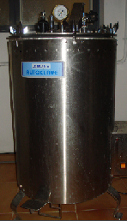 | PLATE II. INCUBATOR  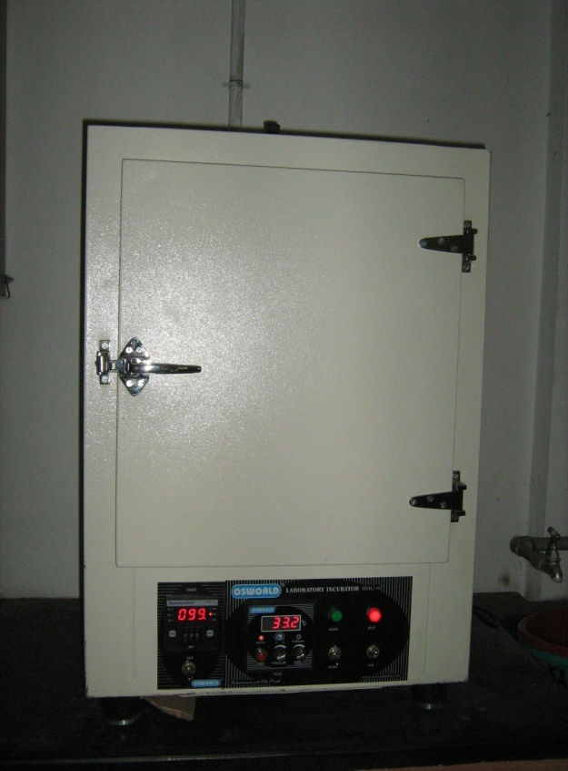
PLATE III. NANO UV-VIS SPECTROPHOTOMETER
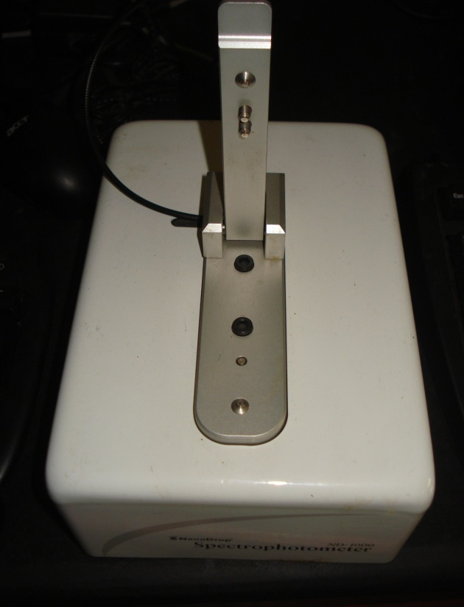
Percent decolourization was determined as follows,
Initial absorbance - Observed absorbance
Per cent Decolourization = ____________________________________________ X 100
Initial absorbance
Based on the percent decolourization, the bacterial strain which showed maximum decolourization percentage was selected for the present study.
3.1.4. Identification of selected bacterium
The bacterium was identified based on Gram’s staining, motility and other biochemical characteristics as stated by Kannan (2002). The following biochemical tests were carried out to identify the bacteria (Table I).
Table 1- Bio chemical Characteristics of bacterial isolate
BIO CHEMICAL CHARACTERISTICS |  | APPENDIX NUMBER
Gram’s staining |  | 1
Motility Test |  | 2
Iodole production Test |  | 3
Methyl red Test |  | 4
Voges Proskauer Test |  | 5
Citrate untilization Test |  | 6
Catalase Test |  | 7
Oxidase Test |  | 8
Urea Hydrolysis Test |  | 9
Nitrate Reduction Test |  | 10
Strach Hydrolysis Test | 11
Gelatin Hydrolysis Test | 12
3.1.5. Preparation of inoculum
One loop full of the selected bacterial strain was inoculated in nutrient broth medium containing peptone - 5g, Beef extract – 3g, dye -100mg, Distilled water – 1000ml, pH -7.0. The media was incubated for
24 hours at 37C in an incubator. The broth was used as inoculum medium.
3.2. Optimization of different parameters for decolourization of reactive dye by isolated bacterium under static conditions
3.2.1. Inoculum concentration
Nutrient broth medium containing 0.01% of reactive dye was incubated with different concentrations of inoculum such as 2%, 4%, 6%, 8%, 10%, 12% and 14%. The flasks were incubated for 24 hours at 37ºC. After incubation period percent decolourization was determined.
3.2.2. Dye concentration
To determine the effect of dye concentration, reactive golden yellow at varying concentrations such as 1%, 2%, 3%, 4%, 5%, 6%, and 7% was added individually to nutrient broth medium. The medium was inoculated with 10% inoculum and incubated for 24 hours at 37º C. After incubation period, percent decolourization was determined.
3.2.3. Time
Effect of time on decolourization was determined by incubating nutrient broth medium containing 0.01% reactive dye for different time intervals such as 8hrs, 16hrs, 24hrs, 32hrs, 40 hrs, 48hrs and 56hrs at 37º C. Percent decolourization was calculated after the incubation period.
3.2.4. pH
To determine the effect of pH on decolourization, the pH of nutrient broth medium was adjusted to 4, 5, 6, 7, 8, 9, and 10 using IN HCl or in NaOH. It was added with 10% inoculum and incubated for 24 hours at
37º C. After incubation period, percent decolouization was determined.
3.2.5. Temperature
Nutrient broth medium containing 0.01% Reactive dye was incubated at various temperatures such as 30 C, 35C, 40C, 45C, 50C, 55C and 60C. After incubation period, the percent decolourization was determined.
3.2.6. Carbon source
To determine the effect of various carbon sources on decolourization, Beef extract in nutrient broth medium was replaced by different carbon sources such as starch, maltose, sucrose, fructose, lactose, galactose and dextrose at a concentration of 1%. The flasks were incubated for 24hrs at 50ºC. After incubation period, percent decolourization was determined.
3.2.7. Lactose concentration
To determine the optimum concentration of lactose for decolourization, lactose at varying concentrations such as 1%, 2%, 3%, 4%, 5%, 6%, and 7% was added individually to nutrient broth medium. The medium was inoculated with 10% inoculum and incubated for 24hrs at 50ºC. After incubation period, percent decolourization was determined.
3.2.8. Nitrogen source
Peptone in nutrient broth medium was replaced by different nitrogen sources, such as urea, ammonium chloride, ammonium sulphate, sodium nitrate, yeast extract and ammonium nitrate at a concentration of 1%. The flasks were incubated for 24hrs at 50ºC. After incubation period, percent decolourization was determined.

3.2.9. Ammonium sulphate concentration
Ammonium sulphate at varying concentrations such as 1%, 2%, 3%, 4%, 5%, 6%, and 7% was added individually to nutrient broth medium. The medium was inoculated with 10% inoculum and incubated for 24 hrs at 50ºC. After incubation period, Percent decolourization was determined.
3.2.10. Salinity
To determine the effect of salt concentration on decolourization, sodium chloride of varying concentrations such as 1%, 2%, 3%, 4%, 5%, 6%, and 7% was added to nutrient broth medium. The medium was inoculated with 10% inoculum and incubated for 24 hours at 50C. After incubation period, percent decolourization was determined.
3.3. Optimization of different parameters for decolouization of reactive dye by isolated bacterium under shaking conditions.
3.3.1. Inoculum concentration
Nutrient broth medium containing 0.01% of reactive dye was inoculated separately with different concentrations of inoculum such as 2%, 4%, 6%, 8%, 10%, 12%, and 14% and incubated for 24 hrs under agitation at 180rpm at 37º C. After incubation period percent decolourization was determined.
3.3.2. Dye concentration
To determine the effect of dye concentration on decolourization, Reactive golden yellow at varying concentrations such as 1%, 2%, 3%, 4%, 5%, 6%, and 7% was added individually to nutrient broth medium. The medium was inoculated with 10% inoculum and incubated under agitation at 180rpm and temperature of 37ºC for 24hrs. After incubation period percent decolourization was determined.
3.3.3. Time
Effect of time on decolourization was determined by incubating nutrient broth medium containing 0.01% reactive dye under agitation at 180rpm at 37ºC with different time intervals such as 8hrs, 16hrs, 24hrs, 32hrs, 40hrs, 48hrs, 56hrs. Percent decolourization was calculated after the incubation period.
3.3.4. pH
To determine the effect of pH on decolourization, the pH of nutrient broth medium was adjusted to 4, 5, 6, 7, 8, 9,10 using IN HCl or IN NaOH. It was added with 10% inoculum and incubated under agitation at 180rpm and temperature of 37C for 24hrs. After incubation period, the Percent decolourization was determined.
3.3.5. Temperature
Nutrient broth medium containing 0.01%. Reactive dye was inoculated under agitation at 180rpm at various temperatures such as 30ºC, 35ºC, 40ºC, 45ºC, 50ºC, 55ºC, 60ºC. After incubation period, the percent decolourization was determined.
3.3.6. Carbon source
To determine the effect of various carbon source on decolourization, Beef extract in nutrient broth medium was replaced by different carbon sources such as Starch, Maltose, Sucrose, Fructose, Lactose, Galactose and Dextrose at a concentration of 1%. The flasks were incubated under agitation at 180rpm and temperature of 50C for 24hrs. After incubation period, percent decolourization was determined.

3.3.7. Lactose concentration
To determine the optimum concentration of lactose for decolourization, Lactose at varying concentrations such as 1%, 2%, 3%, 4%, 5%, 6%, and 7% was added individually to nutrient broth medium. The medium was inoculated with 10% inoculum and incubated under agitation at 180rpm and temperature of 50C for 24hrs. After incubation period, percent decolourization was determined.
3.3.8. Nitrogen source
Peptone in nutrient broth medium was replaced by different nitrogen sources such as urea, yeast extract, ammonium sulphate, sodium nitrate, ammonium chloride, ammonium nitrate at a concentration of 1%. The flasks were incubated under agitation at 180rpm and temperature of 50C for 24hrs. After incubation period, percent decolourization was determined.
3.3.9. Ammonium sulphate concentration
Ammonium Sulphate at varying concentrations such as 1%, 2%, 3%, 4%, 5% 6% and 7% was added individually to nutrient broth medium. The medium was inoculated with 10% inoculum and incubated under agitation at 180rpm and temperature of 50C for 24hrs. After incubation period, percent decolourization was determined.
3.3.10 Salinity
To determine the effect of salt concentration on decolourization, sodium chloride at varying concentrations such as 1%, 2%, 3%, 4%, 5%, 6% and 7% was added to nutrient broth medium. The medium was inoculated with 10% inoculum and incubated under agitation at 180rpm and temperature of 50C for 24hrs. After incubation period, percent decolourization was determined.

3.4. Reuse of treated water for dyeing cotton fabric
As the cost of water supplied to industry keeps increasing, recycle schemes become more attractive with good payback periods state Rani and Negi (2007). Increasing demand for water in industry and to control the pollution of environment, recycling or reuse of water is essential. Hence in this study the treated dye solution was again used for dyeing (Plate V).
3.4.1 Selection of fabric
Natural cellulosic fibers are biodegradable fibers. Cotton as "King of fibers" has occupied prime position reveal Amsamani and Veena (2005). Cotton is exclusively used in apparel fabrics for men and women wears and household fabrics by the people in all levels observe Jindal and Jindal (2006). Plain weave is relatively inexpensive for construction and can be extensively used for cotton fabrics. They ravel less than comparative fabric of the other weaves (Kalpan, 2002). So, cotton fabric made out of plain weave was selected for the present study.
3.4.2. Selection of dyes
Cellulosic fibers are predominantly dyed with reactive dyes in the presence of considerable amount of salt and fixed under alkaline conditions report Kannan et al. (2005).
Reactive dyes are most popularly used for the colouration of cellulose because they provide good wet fastness properties to the fabrics view Sekar (2001) and Sule (2003). Hence, in the present study reactive dye was selected for dyeing.

PLATE IV
EXPERIMENTAL SETUP FOR OPTIMIZATION STUDY
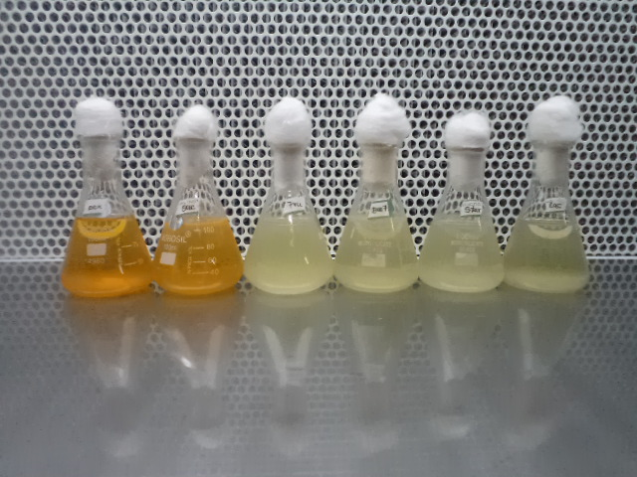
PLATE V
REACTIVE DYE SOLUTION - BEFORE AND AFTER TREATMENT
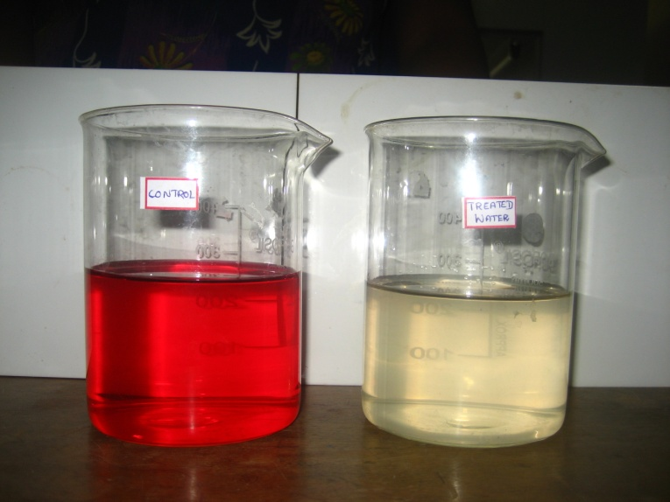

3.3.3. Preparation of dye bath
One meter of desized cotton fabric (A) was cut and weighed. Based on the weight of fabric the dye required for 5% shade was calculated and dissolved in the beaker containing small amount of soft water at room temperature. The dissolved dye solution was thoroughly mixed in calculated amount of soft water at 60ºC. Later 2% of NaCl was added to the prepared dye bath.
Similarly, another one meter of desized cotton fabric (B) was cut and weighted .Based on the weight of fabric the dye required for 5% shade was calculated and dissolved in the beaker containing small amount of treated water at room temperature. The dissolved dye solution was thoroughly mixed in calculated amount of treated water at 60C. Then 2% of NaCl was added to the prepared dye bath.
3.3.4. Dyeing procedure
Desized cotton fabric was dyed with soft water. The following steps are involved in dyeing.
- Exhaustion of the dye bath by the addition of salt
- Fixation of the exhausted dye bath by the addition of alkali
- Washing off the unfixed dye reports Sekar (2004)

Cotton fabric was soaked in soft water for 30 mins and squeezed out. The wet fabric was immersed in dye bath and kept for 15minutes. The fabric was taken out and NaCl was added and dissolved thoroughly. The removed fabric was immersed into the dye bath once again and kept for 30 minutes. The fabric was taken out and soda ash was added in the dye bath. The sample was reentered and again kept for 30 minutes. Then the sample was taken out and washed thoroughly by changing water thrice. Later the fabric was rinsed in soft water and washed thoroughly. Finally the sample was taken out and squeezed and dried in shade.
The same procedure was followed to dye the fabric using treated water where instead of soft water, treated water was used.
Dyeing parameters
Parameters Amount
Fabric 1 Meter
Shade 5%
M : L (Material : Liquor Ratio) 1:30
Caustic Soda 2%
Sodium Chloride 20%

3.5. Evaluation
Evaluation is defined as the marking of judgement about value for some purpose, ideas, works, solutions, methods and materials, opines Bhatia (1984).
3.5.1 Subjective evaluation
The soft water dyed and treated water dyed samples were evaluated visually by a panel of 25 members, which comprises of PG students specializing in the field of Textiles and Clothing. General appearance, brilliancy of shade and evenness of dyeing were the main aspects taken into consideration for visual evaluation.
3.5.2. Objective evaluation
Textile Testing as a whole refers to the vigour testing done on textile materials which may be inside the laboratory as well as in natural setting views Paul (2005).
3.5.3. Physical property test
Fabric weight
Fabric weight is the relative weight of the fabric and expressed as the weight of a particular size of piece as grams / square meter or ounces / square yard state Angappan and Gopalakrishnan (2006).
Fabric weight of the original and dyed samples was determined using GSM cutter. It is a device to cut circular specimen of 100 square centrimeters of a fabric very accurately. It has 4 blades that cut the fabric when the hand wheel is rotated by applying light pressure. The samples were cut and weighed accurately using digital balance having 0.01 sensitivity. The value in gms multiplied by 100 gives grams / square meter of the fabric.
The samples were weighed for five times and the mean value was calculated and recorded.
Fabric count
The determination of fabric count measures the number of warp yarns per inch and the number of weft yarns per inch, remarks Angappan (2002) and ASTM (D.3775 – 03). The fabric count is the number of warp and weft yarns per unit distance. The fabric is kept without tension and is free from folds and wrinkles. The determination of the number of threads per inch may be made by counting glass (Pick glass). The counting glass is a small magnifying glass in a stand over a square exactly one inch way. The number of threads in the field directly gives the number of threads per inch. This is the method generally used for fabric count. The number of ends and
picks per inch were counted in ten different places and recorded for the samples A, B and C.
Fabric thickness
Thickness of the fabric is defined as the distance between the upper and lower surface of the fabric measured under a specified pressure, states Tailor (1972).
Hungarian Thickness gauge (Plate VI) was used to measure the thickness of the fabric. It is a hand operated instrument, which has a dial that roads the thickness of the fabric. Two clamps are attached to the dial. Each of the samples was placed between the two clamps and pressed. Thickness was measured at ten different places of each sample at random. The mean value was calculated and recorded.
3.5.4. Mechanical property test
Tensile Strength and Elongation
The strength required for a fabric depends on its end use. Tensile strength is the maximum tensile force recorded by extending the test piece to breaking point. Elongation is the increase in length of the specimen from its starting length expressed in units of length inform Saville (1999).
The samples of original and dyed fabrics were tested for tensile strength using Euerka cloth Tensile Strength Tester (Plate VII). 12" x 12" Specimen from each samples were cut both in warp and weft direction of the fabric two inches apart from selvedge. Cut specimens did not have same warp or weft threads. The specimen was placed between the upper and lower clamp. The dial reading was set to Zero by adjusting the pendulum over the quadrant scale. The elongation pointer was checked for its position in zero. Before starting the machine the pendulum lock was released and machine was switched on to run. At the point of fabric started to break the machine was switched off and the dial reading in Kg was taken. Elongation readings were noted from the elongation scale. The specimen was removed and the machine positioned back to original. Five specimens of both directions from each samples were tested and readings were noted.
Abrasion resistance
Abrasion is the wearing away of any part of a material by rubbing against another (ASTM, 2005). Abrasion is one of the major criteria to assess the durability of the fabric states Basu (2001). Abrasion is just one aspect of wear and is the rubbing away of the components fibers and yarns of the fabric define Angappan and Gopalakrishnan (1993).
The Eureka martindale Abrasion resistance tester (Plate VIII) was used to determine the fabric resistance to friction. The severity of abrasion varies with the nature of the abradant. Ten samples were cut at random from each of the dyed materials and original using a template. The initial weight of each sample was measured using an electronic balance. The samples were mounted on sample holders. The sample holders with 200 grams weight were used for this purpose. The rubs were standardized to 20. After 20 rotations, the samples were removed and the final weight of each sample was found out. Weight loss due to abrasion was calculated. The same procedure was repeated for all other samples and the mean value was calculated. Each time, a fresh abradant was used. Similarly the mean value of the ten readings for each of the sample was calculated and thus the loss in weight of each material was recorded separately.
3.5.5. Comfort property test
Fabric stiffness
Stiffness is an important characteristics of a fabric. The Principle behind the stiffness test is to measure a particular length of a fabric specimen of specified dimensions which when used as a cantilever bends to a constant angle under its own weight, BIS (2000)
The stiffness of the samples were determined by Shirley Stiffness tester (Plate IX). The specimens from original dyed samples of six inches were cut using template provided with the tester. Each rectangular strip was mounted over a horizontal platform and pushed along with the template to overhead until the edge of the fabric were coincide with the index line. The readings were taken from each specimen with each side up, first at one end than the other .The Mean value of the four readings were calculated as a single readings. Five specimens from each samples were tested for five times.
Drape
Drape is the ability of bending behaviour of a fabric under its own weight to assume a graceful appearance in use, reviews Saini (2004). Eureka drape meter (Plate X) was used to determine drapability. Five samples were cut using a template from all these samples. A brown paper was also cut to the same size and was weighed using an electronic balance. Each sample was placed on the circular disc and the drape meter operated image of the draped sample, found on the brown paper was traced and cut along traced outline. It was than weighed using an electronic balance. The drape co-efficient was calculated for each sample.
Initial weight of brown paper - Final weight of brown paper
Drape co- efficient = _________________________________________________________________
Initial weight of brown paper
Crease recovery
Crease recovery is one of the desired properties in cloth, say Vastrad and Shailaja (1995). Crease recovery is the ability of a fabric to recover from unwanted creases. It is the property of the material to resist wrinkling and to restore the initial state after the force causing its crease is removed, says, Kori (1996). Creasing of textile material is a complex effect involving tensile, flexing, compressive and other stresses. The ability of the fabric to resist creasing is depends on the type of fiber used for its construction (Saini, 2004).
Shirley crease recovery tester (Plate XI) was used for the study. The instrument consisted of a circular dial, which carries the clamp for holding the sample. A knife edge and an index line are seen directly under the centre of the dial to measure the recovery angle. Ten samples each of 5 x 2.5cm size were cut both in the warp and weft directions at random using a template from each of the dyed materials. Each sample was carefully creased by folding it into half weight was lifted and the sample was transferred to the fabric clamp on the instrument and allowed to recover from the crease. After two minutes the dial was rotated to keep the free edge of the sample coincide with the knife edge. The crease recovery angle in degrees was read directly from the engraved scale. The mean values were calculated and recorded.

PLATE VI  THICKNESS GAUGE  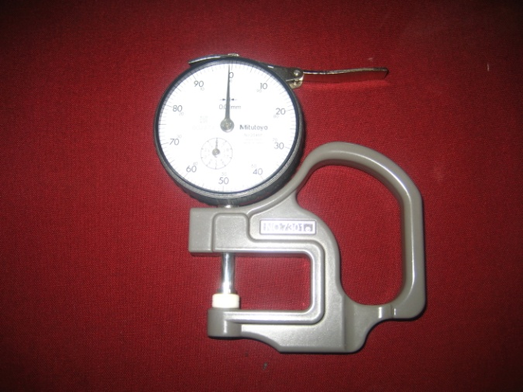 | PLATE VII  TENSILE STRENGTH TESTER  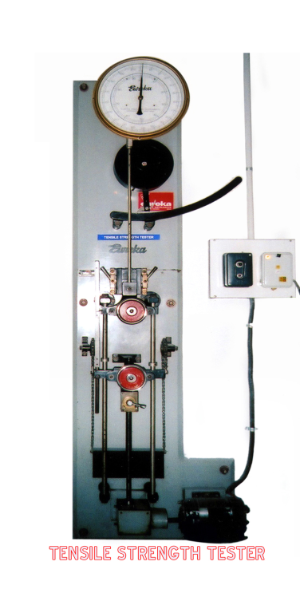
PLATE VIII
ABRASION RESISTANCE
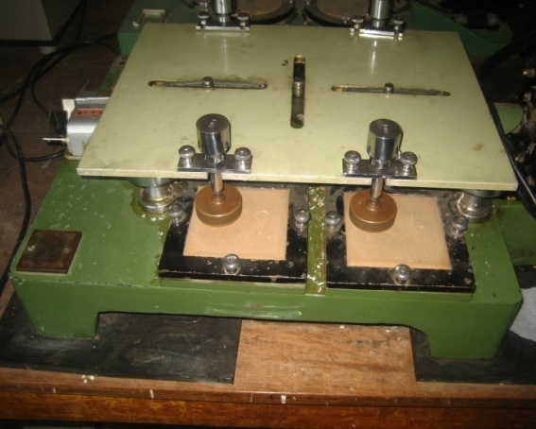

PLATE IX  FABRIC  STIFFNESS TESTER  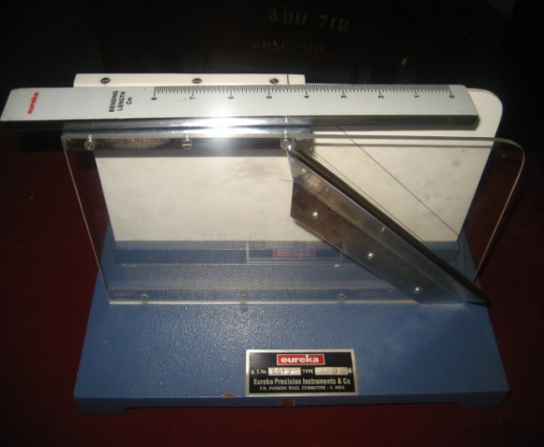 | PLATE X  DRAPE  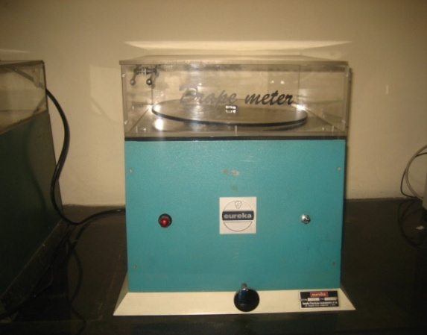
PLATE XI
CREASE RECOVERY
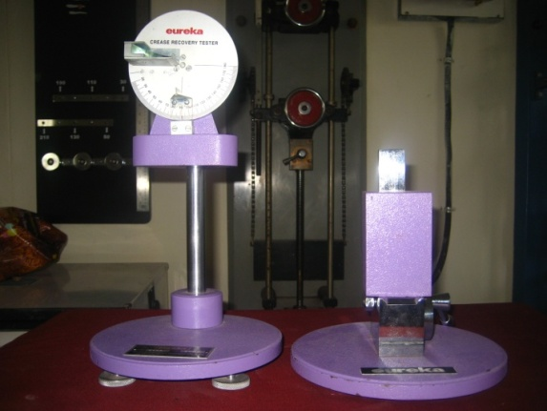

3.5.6. Absorbency test
Drop test
The drop test (Plate XII) is a count of the number of drops required to penetrate through the underside of the fabric when all the drops fall on to the same spot expresses Basu (2006). The dyed samples were fixed onto the embroidery frame and burette was used to drop water in the center of the fabric. Time and number of drops were noted down for all the samples.
Capillary rise test
A rectangular strip of fabric (15 cm x 3 cm) was suspended vertically with its bottom edge in a beaker of water. The rate of rise of the water in
the leading edge was noted. The measured height of the water (2.5 cm) in
a provided time was noted as the Wickability of the test fabric. Similarly
all the samples were tested for Wickability and five readings were taken down (Plate XIII).
Sinking test
Sinking test (Plate XIV) is a simple test that helps to measure the Wettability of a fabric reports AATCC Technical Manual (2008).
In this method, conditioned sample A was cut into a number of equal sized squares of 1" x 1" and added to a 1000 ml beaker which was filled with distilled water. The stop watch was started when the fabric struck the surface of water and stopped when the last corner sank below the water surface. The test was carried out for the samples and the mean time for sinking was calculated and recorded.

PLATE XII  DROP TEST  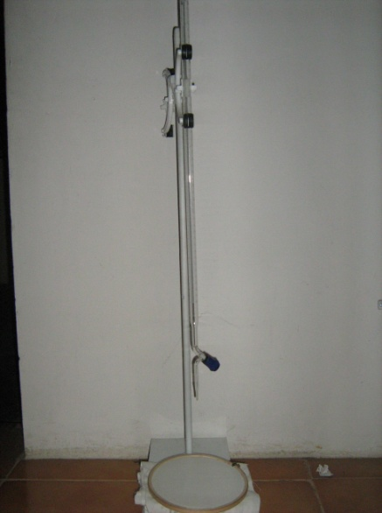 | PLATE XIII  WICKABILITY TEST  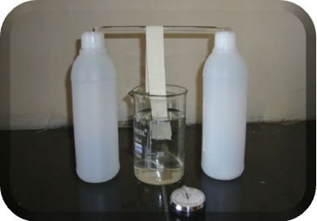
PLATE XIV
SINKING TEST
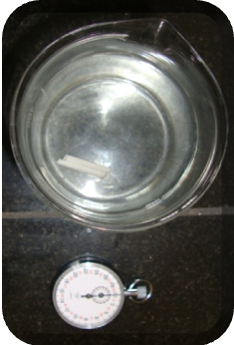

3.5.7. Colour fastness test
Colour fastness of a textile material is its resistance to change by light, washing and rubbing, state Singh (2000). Colour fastness is the resistance of a material to change in any of its colour characteristics to transfer of its colourants to adjacent materials of both as a result of the exposure of the material to any environment that might be encountered during the processing, testing, storage or use of the material (AATCC,1988). When a colour material is subjected to particular conditions e.g., light, washing, milling and bleaching, the colour may change in depth, hue or brightness. The resistance of a coloured material to any such change in colour is termed as its colour fastness, remarks Gupta (1995). A fabric
that retains its colour during use and care is said to be colour fast, say Agarwal et al. (1993)
The following tests were conducted to assess fastness to sunlight, washing, wet and dry crocking, wet and dry pressing.
Fastness to sunlight
The colour fastness of textile material to day light is very important property, view Alikhan et al. (2006). AATCC (2007) defines the colour fastness as the resistance of a material to a change in its colour characteristics as a result of exposure of the material to sunlight or an artificial light source. AATCC (16 – 2004) records the resistance of a material to a change in colour characteristics as a result of exposure of the material to sunlight or an artificial light.
To test the fastness to light the specimen of 16 cm x 3 cm were cut from each sample of dyed fabrics and divided into 8 equal parts measured
as 2 cm each. The specimens were covered with black chart. For successive seven days the specimens were exposed to direct sunlight. First day first portion of the specimens were exposed and accordingly seven portions are exposed to light. The first portion was exposed for seven days and the last seventh portion was exposed for a day. The last portion was not exposed to sunlight and considered as standard for comparison. Comparisons were done using grey scale and the specimens were rated.
Fastness to washing
Major loss of colour from the fabric is done to washing and results staining over the adjacent fabric. This phenomenon is used in wash fastness of colour.
Launderometer was used to test the wash fastness of colour. Launderometer consists of central axis with four rods with eight stainless steel jars with lids which rotates inside the hot water bath in forward direction when the machine is in working condition. The non alkaline soap detergent of four gm was mixed in 1000ml of water at 40° C. The specimens from each dyed fabric measured 10 cm x 4 cm were washed separately in soap solution for 45 minutes. The coloured fabric was half covered by white fabric stitched over it. The colour change of the dyed sample was measured by evaluating the tow adjacent to white fabrics using grey scale (Appendix – 13).
Fastness to crocking (wet and dry)
Crocking is the rubbing fastness of dyes. AATCC (1995) describe crocking as the transfer of colourant from the surface of the coloured fabric to an adjacent area of same fabric or to another surface, principally by rubbing action. Fastness to crocking is important in both apparel fabric as well as upholstery. Crocking test determines the extent to which colour may be transferred from the surface of the dye fabric to another by rubbing states Adanur (1995).
Sasmira crock meter was used to determine the fastness to crocking. Each of dyed samples was cut in the measurement of 25 x 20 cm and mounted on flat base. The desized white cotton fabric was mounted in a ring on the rubbing finger. Each sample was given 10 rubs based on standardization. The colour transfer from the dyed sample to the white material was used for wet crocking. The procedure adopted was same as that of dry crocking. The colour transfer from the dyed sample to the white material was assessed using grey scale.
Wet and dry pressing
Colour fastness of the samples to pressing was measured following the specifications of Bureau of Indian standards (1989). Two specimens measuring 10 cm X 10 cm from each dyed samples were cut and one set of specimens covered at either side with 5 cm X 5 cm of desized white fabric. The prepared specimens were pressed for 5 seconds to assess its colour fastness to dry pressing while the others were covered with wet white cloth and pressed for 5 seconds to assess its colour fastness to wet pressing for 5 seconds. The same procedure was repeated for 5 specimens. The colour change in the dyed fabrics was graded using grey scale.

4. RESULTS AND DISCUSSION
The results of the present study are discussed under the following headings.
4.1. Screening and Isolation of reactive dye decolourizing bacteria
4.2. Identification of selected bacterial strain
4.3. Optimization of different parameters for decolourization of reactive dye by Bacillus sp. under shaking and static conditions
4.3.1. Inoculum concentration
4.3.2. Dye concentration
4.3.3. Time
4.3.4 pH
4.3.5. Temperature
4.3.6. Carbon source
4.3.7. Lactose concentration
4.3.8. Nitrogen source
4.3.9. Ammonium sulphate concentration
4.3.10. Salinity
4.4. Evaluation of dyed fabrics
4.4.1. Subjective evaluation
4.4.2. Objective evaluation
4.4.2.1. Fabric weight
4.4.2.2. Fabric count
4.4.2.3. Fabric thickness
4.4.2.4. Fabric strength
4.4.2.5. Fabric elongation
4.4.2.6. Fabric stiffness
4.4.2.7. Abrasion Resistance
4.4.2.8. Crease Recovery
4.4.2.9. Drape
4.4.2.10. Absorbency tests
4.4.2.11. Colour fastness test
4.1. Screening and Isolation of reactive dye decolourizing bacteria
A total of 8 well grown colonies of bacteria were isolated from the textile dye effluent discharged soil in specific nutrient medium. Table II shows the percent decolourization of reactive dye solution by the isolated bacterial strains.
Table – II. Decolourization of reactive dye solution by different bacterial isolates
Bacterial Isolates | Percent Decolourization
B₁ | 84
B₂ | 89
B₃ | 96
B₄ | 93
B₅ | 98
B₆ | 76
B₇ | 90
B₈ | 91

From Table II, it is evident that the bacterial isolate B₅ showed maximum percent decolourization. Hence strain B₅ was selected for the present study.
4.2. Identification of selected bacterial strain
Table- III shows the biochemical characteristics of the selected isolate (Plate XV). Based on the colony morphology, Gram staining and biochemical characteristics, the isolated bacterium were identified as Bacillus sp.
Table – III. Morphological and biochemical characteristics
of selected isolate
S.No | Parameters | Characteristics
1. | Cellular Characteristics  Morphology  Staining Characteristics | Straight, Rod Shape  Gram Positive
2. | Cultural Characteristics  Nutrient Agar Colonies | Finger like  Projections
3. | Motility | Motile
4. | Bio Chemical Characteristics  Indole Production Test  Methyl Red Test  Voges Proskauer Test  Citrate utilization Test  Catalase Test  Oxidase Test  Urea Hydrolysis Test  Nitrate Reduction Test  Strach Hydrolysis Test  Gelatin hydrolysis Test | Negative  Negative  Positive  Negative  Positive  Positive  Positive  Positive  Positive  Positive

PLATE XV
BIOCHEMICAL CHARACTERISTICS OF Bacillus species

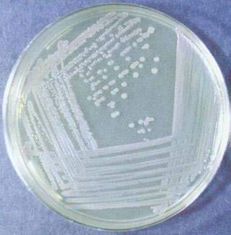 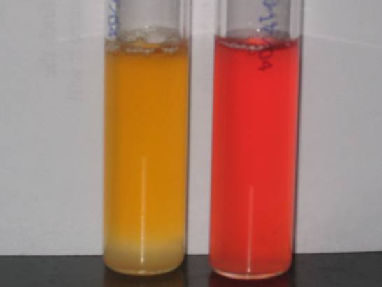
Bacillus sp. on nutrient agar Indole test

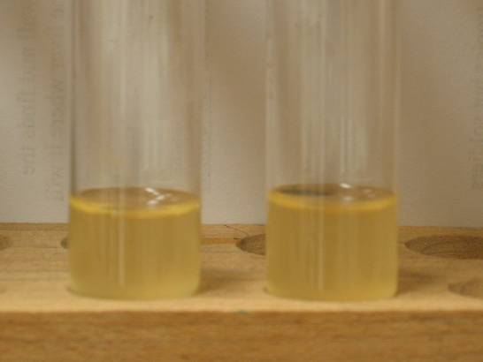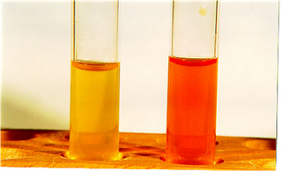
Voges proskauer Methyl red test

4.3. Optimization of different parameters for decolourization of reactive dye by Bacillus sp. under shaking and Static conditions.
4.3.1. Inoculum concentration
The effect of inoculum concentration on decolourization is presented in Table IV and Figure I.
Table – IV. Inoculum concentration
Inoculum concentration (%) | Decolourization(%)
Inoculum concentration (%) | Shaking conditions | Static conditions
2 | 56.04 | 40.34
4 | 68.32 | 52.10
6 | 82.10 | 70.10
8 | 88.04 | 72.39
10 | 96.64 | 88.56
12 | 94.32 | 80.04
14 | 84.40 | 74.18

From Table IV and Figure I, it is clear that increase in inoculum concentration increases percent decolourization and reaches maximum at
10 % in both static and shaking conditions. Above 10 % decrease in percent decolourization was noticed. This might be due to the shortage of carbon source at higher inoculum levels. Hence an optimum inoculum concentration of 10% was fixed for further decolourization.

Figure I - Inoculum concentration
4.3.2. Dye concentration
The effect of dye concentration is presented in Table V and Figure II.
Table – V. Dye concentration
Dye Concentration (%) | Decolourization (%)
Dye Concentration (%) | Shaking conditions | Static conditions
0.5 | 94.39 | 88.07
1.0 | 98.46 | 92.18
1.5 | 96.04 | 90.86
2.0 | 94.50 | 90.32
2.5 | 94.16 | 88.14
3.0 | 90.16 | 86.02
3.5 | 88.56 | 84.84
Figure II - Dye concentration

From Table V and Figure II, it is clear that increase in dye concentration increases percent decolourization and reaches maximum at 1% in both static and shaking conditions. Above 1%, decrease in percent decolourization was noticed. Hence an optimum dye concentration of 1% was fixed for further decolourization studies.
4.3.3. Time
The effect of time on decolourization by Bacillus sp. is presented in Table VI and Figure III.
Table – VI. Time
Time (Hrs) | Decolourization (%)
Time (Hrs) | Shaking conditions | Static conditions
8 | 56.02 | 40.22
16 | 78.88 | 62.08
24 | 96.46 | 88.84
32 | 94.84 | 86.46
40 | 92.18 | 84.28
48 | 90.43 | 81.19
56 | 90.06 | 80.03

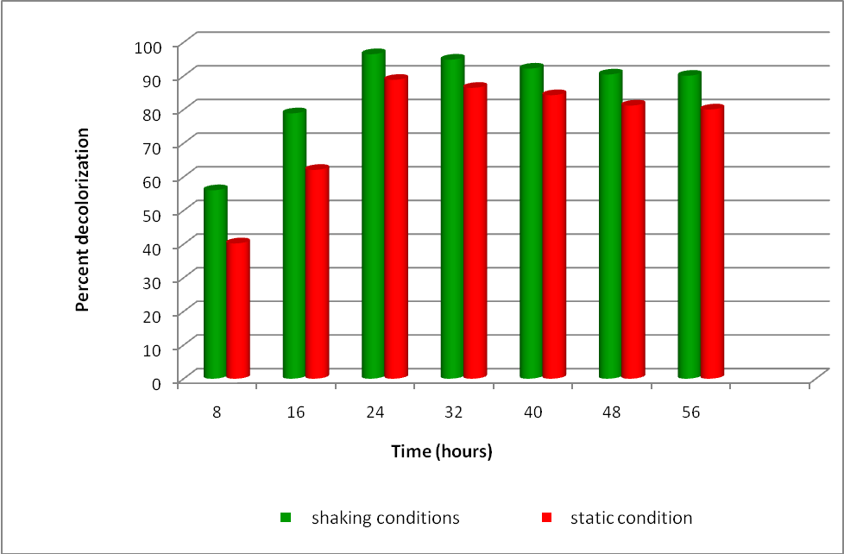
Figure – III. Time

From Table VI and Figure III, it is obvious that increase in incubation period increases percent decolourization and reaches maximum at 24 hrs for both static and shaking conditions. Further increase in incubation period does not increase decolourization.
4.3.4. pH
The effect of pH on decolourization is presented in Table VII and Figure IV.
Table – VII. pH
pH | Decolourization (%)
pH | Shaking conditions | Static conditions
5 | 78.41 | 72.10
6 | 88.04 | 86.18
7 | 95.10 | 91.30
8 | 91.30 | 88.43
9 | 90.14 | 86.17
10 | 89.03 | 85.24
12 | 88.38 | 82.03
Figure – IV. pH

From Table VII and Figure IV, it is evident that increase in pH from 5 to7 increases percent decolourization with optimum at pH 7.0 for both static and shaking conditions. The obtained results are in agreement with Yatome et al. (1981), who has reported maximum decolourization of triphenylmethane dyes by pseudomonas Pseudomallei at pH 7 and Gopinath et al. (2009) has also reported that there was improved bio-degradation of congo red by using Bacillus sp at pH 7.
4.3.5. Temperature
The effect of temperature on decolourization is presented in Table VIII and Figure V.
Table – VIII. Temperature
Decolourization Temperature (ºC) | Decolourization (%)
Decolourization Temperature (ºC) | Shaking conditions | Shaking conditions
30 | 72.7 | 70.03
40 | 82.80 | 78.48
50 | 96.30 | 88.18
60 | 93.34 | 84.48
70 | 90.04 | 80.14
Figure – V. Temperature
From Table VIII and Figure V, it is evident that, increase in temperature from 30C to 50C increased percent decolourization. Maximum decolourization was achieved at 50C for both static and shaking conditions. Increase in temperature above 50C result in decreased percent decolourization. Increase in temperature of the reaction has linear relationship with reaction rate where as in present investigation the reactions are biological which depend on the living organisms. Since the living organisms are more sensitive towards temperature such reactions are also more sensitive towards variations in temperature. Further the enzymatic reactions are temperature sensitive because the enzymes being protein in nature are not stable at high temperature (more than 50C). Hence decolourization was performed at 50C.
4.3.6. Carbon source
The effect of different carbon sources on decolourization by isolated bacterium was depicted in Table IX and Figure VI.

Table – IX. Carbon Source
Carbon Sources (1%) | Decolourization (%)
Carbon Sources (1%) | Shaking conditions | Static conditions
Dextrose | 74.18 | 62.28
Fructose | 86.48 | 56.06
Lactose | 96.19 | 88.48
Galactose | 93.8 | 86.22
Starch | 92.01 | 84.43
Maltose | 90.04 | 80.14
Sucrose | 88.24 | 78.38

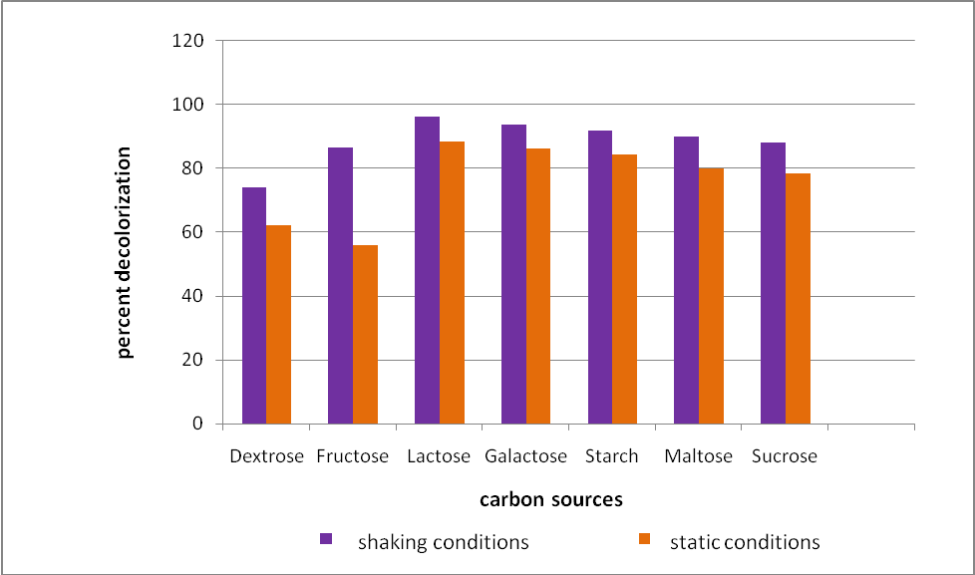
Figure – VI. Carbon source
From Table IX and Figure VI, it is clear that Lactose addition has increased decolourization by 96.19% under shaking conditions followed by galactose, starch, maltose, sucrose. Carbon source is needed for the growth of bacteria. Hence, carbon supplementation increased bacterial growth thereby increases percent decolourization.
4.3.7. Lactose concentration
The effect of different concentration of lactose on decolourization by isolated bacterium was depicted in Table X and Figure VII.
Table – X. Lactose concentration
Lactose Concentration (%) | Decolourization (%)
Lactose Concentration (%) | Shaking conditions | Static conditions
0.5 | 88.10 | 82.24
1.0 | 96.43 | 94.24
1.5 | 94.18 | 93.06
2.0 | 93.03 | 90.31
2.5 | 90.24 | 88.07
3.0 | 89.18 | 86.04
3.5 | 88.08 | 85.18

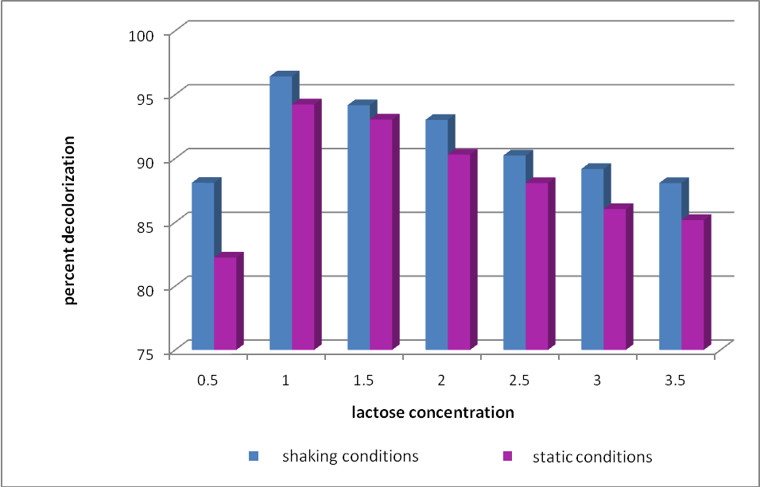
Figure – VII. Lactose concentration
From Table X and Figure VII, it is clear that increase in lactose concentration increases percent decolourization and reaches maximum at 1% in both static and shaking conditions. Above 1% decrease in percent decolourization was noticed. Hence an optimum lactose concentration of 1% was fixed for further decolourization.
4.3.8. Nitrogen source
The effect of nitrogen source on decolourization is presented in
Table XI and Figure VIII.
Table – XI. Nitrogen source
Nitrogen Sources (%) | Decolourization (%)
Nitrogen Sources (%) | Shaking conditions | Static conditions
Peptone | 70.52 | 72.12
Urea | 82.24 | 80.48
Yeast extract | 88.08 | 88.06
Ammonium Sulphate | 96.92 | 90.62
Ammonium Nitrate | 90.12 | 88.48
Ammonium Chloride | 86.17 | 84.16
Sodium Nitrate | 82.48 | 80.24

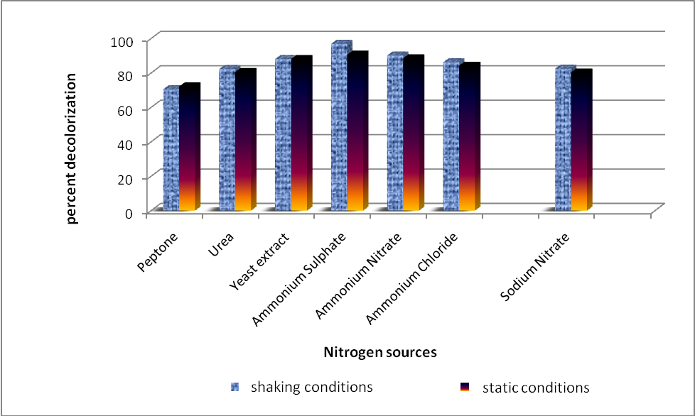
Figure – VIII. Nitrogen source
From Table XI and Figure VIII, it is obvious that addition of ammonium sulphate increased percent decolourization of reactive dye by 96.92% under shaking condition and 90.62% at static condition, followed by ammonium nitrate, ammonium chloride, sodium nitrate. Nitrogen source is required for the normal metabolism of cell. Addition of nitrogen sources increased bacterial cell growth and metabolism thereby increasing the removal of dyes. The result concluded that ammonium sulphate is the best nitrogen source for decolourization of reactive dye.
4.3.9. Ammonium sulphate concentration
The effect of ammonium sulphate concentration on decolourization is presented in Table XII and Figure IX.
Table – XII. Ammonium sulphate concentration
Ammonium Sulphate Concentration (1%) | Decolourization (%)
Ammonium Sulphate Concentration (1%) | Shaking conditions | Static conditions
0.5 | 92.01 | 88.04
1.0 | 98.24 | 90.48
1.5 | 94.08 | 88.32
2.0 | 92.44 | 86.18
2.5 | 90.63 | 82.52
3.0 | 88.18 | 80.2
3.5 | 86.63 | 78.14

From Table XII and Figure IX, it is clear that increase in ammonium sulphate concentration increases percent decolourization and reaches maximum at 1% in both static and shaking conditions. Above 1% decrease in percent decolourization was noticed. Hence an optimum ammonium sulphate concentration of 1% was fixed for further decolourization.
Figure – IX. Ammonium sulphate concentration
4.3.10. Salinity
The effect of salinity on decolourization by isolated bacterium is depicted in Table XIII and Figure X.
Table – XIII. Salinity
Salt Concentration (%) | Decolourization (%)
Salt Concentration (%) | Shaking conditions | Static conditions
1 | 94 | 90.07
2 | 96.7 | 93.48
3 | 92.98 | 92.14
4 | 90.64 | 90.73
5 | 90.06 | 88.46

Figure – X. Salinity
From Table XIII and Figure X, it is evident that increase in salinity from 1% to 2% increased percent decolourization with optimum percent decolourization at 2%. Increase in salinity above 2% decreases percent decolourization.
NOMENCLATURE OF SAMPLES
Samples | Code
Original desized fabric | O
Soft water dyed sample | SWD
Treated water Dyed sample | TWD

4.4. Evaluation of dyed Fabrics
4.4.1. Subjective Evaluation
Visual inspection
The results of visual inspection are presented in Table XIV. The details of the panel ratings include General appearance, evenness of dyeing and luster.
Table – XIV. Visual inspection of fabrics
Samples | General appearance |  |  | Eveness of dyeing |  | Luster
Samples | Good | Fair | Poor | Evenly Dyed | Unevenly Dyed | Bright | Medium | Dull
SWD | 60 | 40 | - | 100 | - | 80 | 20 | -
TWD | 65 | 35 | - | 100 | - | 90 | 10 | -

From Table XIV, it is clear that the general appearance of the sample dyed with soft water was rated good by 60% of judges whereas TWD was rated good by 65% of judges.
Both the samples were rated to be evenly dyed by 100 percent of the judges. With regard to luster 80% of judges rated the SWD sample as bright whereas 90% of judges rated TWD as bright.
Hence, it could be concluded that the sample dyed using treated water was better than the sample dyed with soft water.
4.4.2. Objective evaluation
4.4.2.1. Fabric weight
The fabric weight of original and dyed samples and analysis of variance are presented in Table XV and Figure XI.
Table – XV. Fabric Weight
S. No | Samples | Mean Wt in (GSM) | Loss/Gain Over original | % Loss/Gain over original | F Value
1. | O | 0.839 | 0 | 0 | 19.54**
2. | SWD | 0.767 | 0.072 | 8.58 | 19.54**
3. | TWD | 0.816 | 0.0231 | 2.74 | 19.54**
** Significant at 1% Level
Figure – XI. Fabric Weight
From Table XV, it is clear that the fabric weight of dyed samples SWD and TWD decreased by 8 percent and 2 percent respectively when compared with original fabric.
Statistical analysis indicates that there is a significant difference
at 1 per cent level between the samples SWD and TWD.
The decrease in fabric weight is less in sample dyed with reused water (TWD) when compared with SWD. Hence it could be concluded that treated water can be efficiently used for dyeing purpose.
4.4.2.2. Fabric count
Fabric Count (Warp)
The fabric count of original and dyed samples and analysis of variance in warp direction are given in Table XVI and Figure XII.
From Table XVI and Figure XII it is evident that the fabric count decreased in both the samples by 81% when compared with their original.

Table – XVI. Fabric Count (Warp)
S. No | Samples | Mean (Yarns Per inch) | Loss/Gain Over original | % Loss/Gain over original | F Value
1. | O | 74 | 0 | 0 | 19.01**
2. | SWD | 68 | 6 | 81.08 | 19.01**
3. | TWD | 68 | 6 | 81.08 | 19.01**
** Significant at 1% Level
Figure XII- Fabric count (Warp)
Statistical analysis indicates that there is a significant difference in fabric count in warp direction among the samples at 1% level.
The results of fabric count were similar for both SWD and TWD samples. This shows that the treatment was effective and the treated water can be effectively replaced for soft water.
Fabric Count (Weft)
The fabric count of original and dyed samples in weft direction and analysis of variance are presented in Table XVII and Figure XIII.
Table – XVII. Fabric Count (Weft)
S. No | Samples | Mean (Yarns Per inch) | Loss/Gain Over original | % Loss/Gain over original | F Value
1. | O | 52 | 0 | 0 | 2.70^{ns}
2. | SWD | 53 | 1 | 1.92 | 2.70^{ns}
3. | TWD | 54 | 2 | 3.82 | 2.70^{ns}

ns- Not Significant
Figure – XIII. Fabric count (Weft)
From Table XVII and Figure XIII, it is clear that the fabric count increased by 3% for TWD in weft direction and 1% for SWD sample when compared with their original.
Statistical analysis indicates that there was no significant difference in fabric count between original and dyed samples.
Hence, it could be concluded that there is an increase in the closeness of the weft yarns due to dyeing, irrespectively of the water used.
4.4.2.3. Fabric Thickness
The fabric thickness of original and dyed samples and analysis of variance are presented in Table XVIII and Figure XIV.
Table – XVIII. Fabric Thickness
S. No. | Samples | Mean Thickness (mm) | Loss/Gain Over original | % Loss/Gain over original | F Value
1. | O | 0.28 | 0 | 0 | 4.56**
2. | SWD | 0.28 | 0 | 0 | 4.56**
3. | TWD | 0.30 | 0.02 | 7.14 | 4.56**

** Significant at 5% Level
Figure – XIV. Fabric Thickness
From Table XVIII and Figure XIV, it is evident that the thickness of the fabric increased by about 7% in treated water dyed (TWD) sample whereas in SWD sample there was no increase when compared with their original. The increase in thickness in TWD sample may be due to increased absorption of dye molecules.
Statistical analysis indicated that there is a significant difference at 5% level between the samples. The obtained results proved that the treated water is superior than soft water for dyeing.
4.4.2.4. Fabric Strength
Fabric strength (Warp)
The fabric strength of the samples in warp direction for original and dyed samples and analysis of variance are presented in Table XIX and
Figure XV.
Table – XIX. Fabric Strength (Warp)
S. No | Samples | Mean Strength (Kg) | Loss/Gain Over original | % Loss/Gain over original | F Value
1. | O | 24 | - | - | <1
2. | SWD | 24 | 0 | - | <1
3. | TWD | 25 | 1 | 4.16 | <1

Figure – XV. Fabric strength (Warp)
From Table XIX and Figures XV, it is evident that the strength of TWD sample increased by 4% when compared to original whereas the strength remains the same for SWD sample.
The result proved that the treated water can be effectively utilized for dyeing purpose as the strength of TWD is higher than SWD.
Fabric Strength (Weft)
The Fabric strength of the samples in weft direction for original and dyed samples and analysis of variance are presented in Table XX and
Figure XVI.
Table – XX. Fabric Strength (Weft)
S. No | Samples | Mean Strength (Kg) | Loss/Gain Over original | % Loss/Gain over original | F Value
1. | O | 16 | 0 | - | 1.65^{ns}
2. | SWD | 15 | 1 | 6.25 | 1.65^{ns}
3. | TWD | 14 | 2 | 12.5 | 1.65^{ns}
ns- not significant
Figure – XVI. Fabric strength (Weft)
From Table XX and Figure XVI, it is evident that the strength of SWD sample decreased by 6% in weft direction and TWD sample decreased by 12% when compared to original. There was no significant difference in tensile strength between original and dyed samples.
The results proved that SWD sample had better strength in the weft direction when compared to TWD.
4.4.2.5. Fabric Elongation
Fabric Elongation (Warp)
The elongation of original and dyed samples in warp direction and analysis of variance are presented in Table XXI and Figure XVII.
Table – XXI. Fabric Elongation (Warp)
S. No | Samples | Mean Elongation (Inches) | Loss/Gain over original | % Loss/Gain over original | F Value
1. | O | 2.23 | 0 | 0 | 279.10**
2. | SWD | 1.00 | 1.23 | 55.15 | 279.10**
3. | TWD | 0.71 | 1.52 | 68.16 | 279.10**

** Significant at 1% Level
Figure – XVII. Fabric Elongation (warp)
From Table XXI and Figure XVII, it is obvious that when compared with original, SWD decreased in elongation by 55% and TWD by 68% in warp direction.
Statistical analysis indicates that the original and dyed samples have a significant difference at 1% level in elongation in the warp direction. Hence, it could be concluded that the elongation of the dyed samples decreased irrespective of the type of water used.
Fabric Elongation (Weft)
The elongation of original and dyed samples in weft direction and analysis of variance are presented in Table XXII and Figure XVIII.
Table – XXII. Fabric Elongation (Weft)
S. No | Samples | Mean Elongation (inches) | Loss/Gain over original | % Loss/Gain over original | F Value
1. | O | 1.14 | 0 | 0 | 20.77*
2. | SWD | 1.83 | 0.69 | 6.05 | 20.77*
3. | TWD | 1.65 | 0.51 | 4.47 | 20.77*

* Significant at 1% Level
Figure – XVIII. Fabric Elongation (Weft)
From Table XXII and Figure XVIII it is evident that SWD and TWD increased in elongation by 6% and 4% respectively in weft direction when compared with original.
Statistical Analysis indicates that there is a significant difference at 1% level between samples. Hence, it could be concluded that elongation has increased irrespective of the type of water used for dyeing.
4.4.2.6. Fabric Stiffness
Fabric Stiffness (Warp)
The fabric stiffness of original and dyed samples in warp direction and analysis of variance are presented in Table XXIII and Figure XIX.
Table – XXIII. Fabric Stiffness (Warp)
S. No | Samples | Mean Bending Length(cm) | Loss/Gain over original | % Loss/Gain over original | F Value
1. | O | 2.63 | 0 | 0 | 4.64**
2. | SWD | 2.07 | 0.56 | 2.12 | 4.64**
3. | TWD | 0.28 | 0.35 | 13.30 | 4.64**

** Significant at 5% Level
Figure – XIX. Fabric stiffness (Warp)
From Table XXIII and Figure XIX, it is evident that when compared with the original, there is a decrease in stiffness by 2% in SWD in warp direction whereas TWD decreased by 13%.
Statistical analysis indicates that there is a significant difference at 5% level between the samples. Hence, it could be concluded that stiffness has decreased irrespective of the type of water used for dyeing.
Fabric Stiffness (Weft)
The fabric stiffness of original and dyed samples in weft direction and analysis of variance are presented in Table XXIV and Figure XX.
Table – XXIV. Fabric Stiffness (Weft)
S. No | Samples | Mean Bending Length(cm) | Loss/Gain over original | % Loss/Gain over original | F Value
1. | O | 1.88 | 0 | 0 | 3.08^{ns}
2. | SWD | 1.58 | 0.3 | 15.95 | 3.08^{ns}
3. | TWD | 1.73 | 0.15 | 7.97 | 3.08^{ns}

** ns – not significant
Figure – XX. Fabric Stiffness (Weft)
From Table XXIV and Figure XX, it is evident that when compared with the original there is a decreased in stiffness by 15% in SWD sample in weft direction whereas TWD sample decreased by 7% respectively.
Statistical analysis indicates that there is no significant difference between the samples. Hence, it could be concluded that stiffness of the fabric has increased irrespective of the type of water used for dyeing.
4.4.2.7. Abrasion Resistance
Abrasion resistance of original and dyed samples and analysis of variance are presented in Table XXV and Figure XXI.
Table – XXV. Abrasion resistance
S. No | Samples | Mean Weight (gm) | Loss/Gain over original | % Loss/Gain over original | F Value
1. | O | 0.002 | 0 | 0 | 2.01^{ns}
2. | SWD | 0.004 | 2 | 100 | 2.01^{ns}
3. | TWD | 0.003 | 1 | 50 | 2.01^{ns}
** ns – not significant.
Figure – XXI. Abrasion Resistance
From Table XXV and Figure XXI, it is evident that when compared with the original, the dyed samples (SWD and TWD) showed increase in abrasion resistance. Maximum abrasion resistance was showed by SWD sample as 100% followed by TWD as 50%.
Statistical analysis indicates that there was no significant difference among the samples. The obtained results and statistical analysis proved that dyeing increased abrasion resistance irrespective of the water used.
4.4.2.8. Crease Recovery
Crease Recovery (Warp)
The crease recovery angle of original and dyed samples in the
warp direction and analysis of variance are shown in Table XXVI and Figure XXII.
Table – XXVI. Crease Recovery (warp)
S. No | Samples | Mean Weight (GSM) | Loss/Gain over original | % Loss/Gain over original | F Value
1. | O | 106 | 0 | 0 | <1
2. | SWD | 106 | 0 | - | <1
3. | TWD | 109 | 3 | 2.8 | <1

Figure - XXII. Crease Recovery (Warp)
From Table XXVI and Figure XXII, it is clear that when compared with the original, SWD sample has no loss/gain over original whereas TWD showed an increased of 3% in warp direction.
There was no significant difference between original and dyed samples. The result proved that there is an increase in recovery in warp direction when dyed with treated water.
Crease Recovery (Weft)
The crease recovery angle of original and dyed samples in the
weft direction and analysis of variance are shown in Table XXVII and Figure XXIII.
Table – XXVII. Crease Recovery (Weft)
S. No | Samples | Mean Recovery (Degree) | Loss/Gain over original | % Loss/Gain over original | F Value
1. | O | 115 | 0 | 0 | 2.28^{ns}
2. | SWD | 111 | 4 | 3.47 | 2.28^{ns}
3. | TWD | 108 | 7 | 6.08 | 2.28^{ns}
ns- not significant
Figure – XXIII. Crease Recovery (Weft)
From Table XXVII and Figure XXIII, it is evident that SWD and TWD samples decreased in crease recovery by 3% and 6% respectively in weft direction when compared with the original.
Statistical analysis indicates that there is no significant difference between original and dyed samples. To conclude, the SWD sample showed higher crease recovery angle when compared with TWD in weft direction.
4.4.2.9. Drape
Fabric drape co-efficient of original and dyed samples are presented in the Table XXVIII and Figure XXIV.
Table – XXVIII. Drape Co- Efficient
S.No | Samples | Mean (g) | Loss/Gain Over original
1. | O | 0.50 | 0
2. | SWD | 0.55 | 1.79
3. | TWD | 0.66 | 1.49

Figure – XXIV. Drape co-Efficient
From Table XXVIII and Figure XXIV, it is evident that drape co- efficient increased in all the samples. Increase in drape co- efficient in SWD and TWD Samples were found to be 1.7% and 1.5% respectively. Hence it could be concluded that there was not much difference in drape co-efficient between SWD and TWD samples, which proves the efficiency of the treatment.
4.4.2.10. Absorbancy Tests
The results related to absorbancy of the samples are presented in Table XXIX and Figure XXV.
Table – XXIX. Absorbancy Test
S.No | Samples | Mean Wickability Test (60se) (cm) | Drop  Test(Sec) | Sinking  Test(Sec)
1. | O | 4.9 | 4 | 4
2. | SWD | 2.8 | 20 | 28
3. | TWD | 2.1 | 16 | 25

Figure – XXV. Absorbancy Test
From Table XXIX and Figure XXV, it could be concluded that in all the absorbancy tests, treated water dyed samples took minimum time for absorption when compared with soft water dyed sample. Hence, treated water could be effectively replaced for soft water in dyeing.
4.4.2.11. Colour fastness Test
Colour fastness results of dyed fabric to sunlight, pressing, crocking and washing are presented in Table XXX.
Table – XXX. Colour Fastness Test
S. No | Samples | Sunlight | Pressing |  | Crocking |  | Washing
S. No | Samples | Sunlight | Dry Staining | Wet Staining | Dry Staining | Wet Staining | Colour Change | Staining
1. | SWD | 5 | 5 | 4 | 5 | 4 | 5 | 5
2. | TWD | 5 | 5 | 5 | 5 | 5 | 5 | 5

SWD- Soft Water Dyed Sample
TWD – Treated Water Dyed Sample
1 - Very Poor 2 - Poor 3 - Fair 4 - Good 5 - Excellent
From Table XXX, it is evident that both the dyed samples SWD and TWD had good fastness to sunlight, excellent fastness to pressing in dry condition. In wet state, TWD sample had excellent fastness. The sample SWD and TWD had excellent fastness to dry crocking. In wet crocking, TWD sample had excellent fastness to crocking when compared to SWD sample. Both the dyed sample had excellent fastness to washing.
To conclude, TWD sample had showed good colour fastness
.

5. SUMMARY AND CONCLUSION
Colour is the greatest joy of life, which extends to unlimited usage in various fields of life, art, design, lifestyle and fashion. The application of colour to textile material is to give aesthetic value and improves the value of the product. In every civilization the art of applying colour through dyeing has played an important role. Dyeing of textile material not only changes colour but also aid to retain the dye effectively. Natural colours were used in the ancient times. These dyes were obtained from natural sources such as flowers, fruits, leaves, seeds, roots, bark of plants and certain animals. After 1856, the dye industry transformed from natural dyes to synthetic dyes, which grow vigorously. Today synthetic dyes are extensively used in the textile industry. These dyes include several structural varieties such as acidic, reactive, basic, disperse, azo, diazo, antharaquione based and metal complex dyes.
The textile industry produces and uses approximately 1.3 million tons of dyes, pigments and dye precursors, valued at around $23 billion almost all of which is manufactured synthetically. Among the Synthetic dyes, reactive dyes are most popular for dyeing cellulosic fabrics. It is known that 90% of reactive textile dyes entering activated sludge sewage treatment plants will pass through unchanged and will be discharged in to rivers. Brightly colored water- soluble reactive dyes are the most problematic as they tend to pass through conventional treatment systems unaffected. Color can be removed from effluent by chemical and physical methods including adsorption, coagulation, flocculation, ion exchange, oxidation and electrochemical methods. The above ways for clean up are expensive, which limits their application. Because of high cost and disposal problems, most of the chemical and physical methods for treating dye waste were not widely applied in the textile industries. Currently bioremediation is becoming important because it is cost effective, environmental friendly and produces less sludge.
Hence, the present study "Decolourization of selected reactive dye using isolated bacterium for reutilization" was carried out with the following objectives.
- To screen and isolate the dye decolourizing bacteria.
- To optimize various parameters such as inoculum, dye concentration, pH, temperature, incubation period, carbon sources, nitrogen sources and salinity on dye decolourization.
- To compare the fabrics dyed using treated and soft water.
- To evaluate the dyed samples.
Methodology Adopted
- Dye decolourizing bacteria was isolated from textile dye effluent discharged soil by serial dilution technique and identified.
- Various parameters like pH, temperature, inoculum concentration, carbon source, nitrogen source, salinity, dye concentration were optimized for effective decolourization of reactive dye solution.
- Decolourization of reactive dye solutions was carried out under optimized conditions. The treated water was used for dyeing selected cotton fabrics. The selected cotton fabric was also dyed using soft water. The original and dyed samples were evaluated both subjectively and objectively.
FINDINGS
- Dye decolorizing bacteria was isolated from textile dye effluent discharged soil by serial dilution technique and identified.
- About 8 well grown distinct bacteria colonies were isolated. Among them the bacteria which showed maximum decolourization of reactive golden yellow was selected and identified as Bacillus sp. based on biochemical tests and Gram staining.
- The optimum pH for decolourization of reactive dye by
Bacillus sp. was found to be 7.0.
- Percent decolourization was found to be maximum at an inoculum concentration of 10%.
- An incubation time of 24 hours resulted in maximum decolourization.
- The optimum temperature for decolourization by Bacillus sp. was found to be at 50C.
- Lactose at a concentration of 1% was found to support the growth of Bacillus sp. and there by enhances decolourization of reactive dye.
- Ammonium sulphate was found to be the optimum nitrogen source for Bacillus sp. and enhances decolourization of reactive dye.
- Colour of the reactive dye has been removed by 97% by
Bacillus sp. under shaking conditions. When compared to 85% under static condition. Reactive dye solution was decolourized by Bacillus sp. under optimized conditions.
- Samples dyed using decolourized reactive dye solution was rated as good in appreance, bright in shade and evenly dyed in comparison with soft water dyed sample.
- Fabric weight of the samples dyed using soft water and treated water decreased when compared over original. There was no significant difference in fabric weight between SWD and TWD samples.
- Thickness of the sample TWD was increased when compared with original.
- The strength of the sample TWD has increased by 4% when compared over original. There was no difference between original and SWD sample along warp direction. With regard to weft direction, the strength of all the dyed samples decreased over original.
- With regard to elongation SWD and TWD samples decreased by 88% and 55% when compared over original.
- The stiffness of sample TWD decreased by 13 % after dyeing where as SWD sample decreased by 2% in warp direction. With regard to weft direction stiffness of all the dyed samples decreased over original.
- The abrasion resistance of all the dyed samples was found to be better when compared over original.
- There was no change in drape co-efficient of dyed samples when compared over original.
- Absorbancy nature of the samples was found to be increased after dyeing the samples with treated water.
- All the samples subjected to colour fastness tests exhibited excellent fastness properties.

CONCLUSION
Today the term eco-friendly sounds everywhere in order to bring back the lost world. Here is an attempt to join our hands with ecofriendly environment. It is evident from the study that decolourization of reactive dye could be done using Bacillus species and the treated water has improved the performance qualities of the fabric. This proves that Bacillus sp. possessed high biosorption efficiency. Hence, the results of this study will form the basis for the development of cost effective dye decolourization.
SUGGESTIONS
- Enzymes responsible for decolourization could be extracted from Bacillus sp. and used for effluent treatment.
- Trials could be made to treat other dyes and dye effluent.
- Efficiency of fungi could be tried for decolourization.
LIMITATIONS
Because of lack of time decolourization could not be carried out in other synthetic dyes and dye effluent using Bacillus species.

REFERENCES
AATCC (1995), Technical manual of American Association of Textiles Colourists and Chemist, Canada, Vol. 70, pp: 23 – 26.
AATCC (2007), Technical Manual of American Association of Textiles Chemist and colourists, American Association of Textile Chemist and Colourist, USA., Vol. 70. pp:23, 99.
AATCC Review (2008), Covalent fixation of Reactive Dyes on cotton under Neutral Conditions – Lewis, D.M., Broadbent P-T-R, Vol. T.T.8,
No. 1, Jan, pp: 35 – 45
Abadulla, E., Tzanov, T., Costa, S., Robra, K., Cavaco, A. and Crubitz, G. (2000), Applied and Environmental Microbiology, Vol. 66, No. 8,
p: 3357.
Adanur, S. (1995), Wellington sears Hand book of Industrial Textiles Johnson Industries Group, U.S., p:70
Adedayo, O., Javadpour, S. and Taylor, C. (2004), Decolourization and detoxification of methyl red by aerobic bacteria from a waste water treatment plant world, J. Biotechnol. Microbiol., 20: 545 – 550
Agarwal, A., Susan Paul, Gupta, K.C. (1993), Effect of Mordants on natural dyes, The Indian Textile Journal, Vol. CIII, No. 4
Alikhan, Khan, M., Srivatsa, R.K. and Mohammed, F. (2006), Extraction of Natural Dyes from catch Rajan at and Maddle and their application on wool, Colourage Vol. XLIX No.2, p: 64.
Amsamani, S. and Veena, P. (2005), Jute Cotton union Fabric for Apparel, Textile Trends, Vol. XLVII, No. 9, p: 49.
An. S.Y., S.K. Min, I.H. Cha, V.L. Choi, (2002), Decolourization of triphenylmethane and azo dyes by citrobacter sp. Biotechnol. Lett., 24: 1037 – 1040.
Angappan and Gopalakrishnan, R. (1993), Textile Testing SSM Institute of Textiles Technology, Kumarapalayam, pp:302 – 305.
Angappan and Gopalakrishnan, R. (2006), Textile Testing, SSM Institute of Textile Technology, Kumarapalayam, pp:271 – 31.
Annual book of ASTM standards section seven Textiles (2005), ASTM International, USA, pp:248, 430.
Arun, M. (2003), use of Biotechnology and other means to reduce the
colour effluent in Textile/Dye factory, Asian Dyer, Vol. 2, No. 4,
pp: 55 – 57.
Barber (1991), Indian Dyes and Industry during 18th -19th Century, Indian Journal of History of Science 17(11): 70 – 81.
Barker, A.F. (1998), Hand Book of Textiles, Abishek Publications, Chandigarh, p: 34.
Basu, A. (2001), Textile Testing of Fibre, Yarn and Fabric, SITRA,
pp: 294 – 296, 308.
Basu, A. and Chellaman, P. (2006), Cotton Fibre selection and grading, SITRA, pp: 131, 298, 300
BIS (2000), Hand book on textile testing, Part 2, Testing of Yarn and Fabrics, Excluding Colour Fastness, I Edition, New Delhi, p.125
Bureau of Indian Standards (1989), Hand Book of Textile Testing. Part -4, Identification and Testing of Dyestuffs and their colour fastness of Textile materials, New Delhi, pp: 181, 193.
Chen, K.C., Wua, J.V., Lious, D.J., Hwange ands John, H. (2003), Decolourization of the Textile Dyes by newly isolated bacterial strains, J. Biotechnol., Vol. 101, pp: 57 – 58.
Choudury, A.K.R. (2006), Textile Preparation and Dyeing, Oxford IBH Co. Pvt. Ltd. New Delhi. p. 54.
Chung, K.T. and Cerniglia, C.E. (1992), Mutagenicity of azo dyes: Mutat. Res., 277:201 – 220.
Corbman. P. (1983), Textiles Fibre to Fabric, NC Graw Hill Book Company, Singapore, p:246.
Correia, V.M., Stephenson, T. and Judd, S.J. (1994), Characterization of Textile wastewaters. Environ. Technol., 15(917 – 919).
Dantyangi Susheela (1996), Fundamentals of Textiles and their care, Orient Longman Publishers, New Delhi, p: 35, 36.
Deulkar and Tarabai (1988), House hold Textiles and Laundry work, ATMA and RAM Sons Publishers, Delhi, p:132.
Devi. S.A., Sumathy, B.S. and Katyayiji, V.K.L.T. (2002), A Fast natural colour of cotton Amaltas, New Cloth Market, IIMS Publishers,
Vol: 15, pp: 27 – 30.
Gienandt. D. (2006), Cotton items outlast others, Textile Magazine, Gopal and Co publishers, Chennai, Vol: 47, Issue: 9, July , pp:74.
Gohl., E.P.G. and Vilensky., L.D. (1999), Textile Science, C.B.S. Publications, Delhi, P:41, 45, 48.
Gopinath, K.P., Meerasahib, H.A. and Muthukumar, K. (2009), Improved Biodegradation of congored by using Bacillus Sp. Bioresource Technology, Vol. 100, p:672.
Gupta Deeph (2000), Mechanism of dyeing synthetics fibers with natural dyes, Colourage, Vol XLVIII, No. 3, P – 23.
Gupta, D. (2001), NCUTE workshop of Dyeing and printing with Natural Dyes, Delhi, pp: 15,19.
Gupta, V.B. (1995), Physical Characteristics and structure of Indian Silk, Indian Journal of Fibre and Textile Research, CSIR Publications, New Delhi, Vol. 29, No.1 – 4, pp: 69 – 71.
Hunger, K., ed. (2003), Industrial Dyes Chemistry, Properties, Applications, Weinhein : Wiley – VCH.
Janwal, Priyanka, Mittal, Atul K., Moucher, J.M. (2006), Study of the effect of different factors on fate of indicator micro-organisms in urban sewer systems, Environ Engineering and Management Journal,
5(3), 351 – 357.
Jindal, A. and Jindal, R. (2006), Textile Raw materials 1st edition. Abhishek Publications, Chandigarh. P: 49
Kalyani, D.C., Patil, P.S., Jadhav, J.P. and Govindwar, S.P. (2008),
Bio degradation of reactive Textile Dye Rd BL1 by an isolated Bacterium Pseudomonas SP Suki Bioresource Technologies,
pp: 99, 4635 – 4641
Kannan, S., Subramanian, M. and Nithyanandhan, R. (2005), Salt and Alkali and Free Reactive Dyeing on Cotton Fabric, Indian Textile Journal, Vol. 114, No.2, P:3
Kannan. N. (2002), Laboratory Manual in General Microbiology, Panima Publishing Corporation, New Delhi, P: 121 – 146
Kirby, N. (1999), Ph.D. Thesis, University of Ulster, Coleraine, U.K. July.
Kodam, K.M., Soojhawon,I., Lokhande, P.D. and Gawai, K.R. (2005), Microbial Decolourization of reactive Azo Dyes under Aerobic conditions, world Journal Microbiology, Biotechnology, Vol;. 21,
pp: 367 – 370.
Kori, M.E., (1996), Testing equipments and methods, The Indian Textile Journal, Business Press Publications, Mumbai,, Vol. 101, No.3, P21.
Kulpan, N.S. (2002), Textile Fibre, Abishek Publications, Chandigarh,
pp:1, 2,130,131.
Manogari, R., D. Daniel and A.Krastanov, (2008), Biodegradation of rice mill effluent by immobilized pseudomonas sp. cells. Ecol. Eng. Environ. Prot., 1:30 – 35.
Mishra., S.P. (2000), A Test book of Fibre Science and Technology, New Age International P. Ltd., New Delhi, P: 70.
Mittal, Atul, K. and Pant Anju (2008), Wastewater Disinfection in India:
A review, water digest.
Moosvi, S., Keharia, H. and Madanwar, D. (2005), Decolourization of Textile Dye Reactive violets by a newly isolated Bacterial consortium RVM 11.1, World Journal Microbiology and Biotechnology, Vol. 21, pp:667 – 672.
Naik, S.D.R. and Wilson, J.A. (2006), Surface Designing of Textile Fabrics, Newage International (P) Ltd. Publishers, Ranchi, Ist Edition. p:33.
Nandhini Chemical Journal (2008), Talk of the Month, Need for Many waste management companies, Vol. 14, No. 5, February , p:2.
Needles., L. Howards, (1986), Textile Fibres, Dyes, finishes and Processes, Noyes Publications, U.S.A. p: 39, 69.
Nehra, K., Anju, Meenakshi and Malik, K. (2008), Isolation and optimization of conditions for maximum Decolourization by Textile-Dye Decolourizing Bacteria, Pollution Research. Vol 27, No.2. pp:257 – 264.
Neurd, F. (2004), Biocatalysis and Biotransformation, Vol. 22, No. 5-6. December, pp: 325 – 330.
NIIR Board (2002), The complete Technology book on Textile Processing with Effluent Treatment, Asia Pacific Business press Inc. Delhi.
pp:8, 10, 57, 60.
Nikulina, G.L., Deveikis, D.N and Psychnov, G. (1995), Toxicity dynamics of anionic dyes in air of a work place and long term effects after absorption through skin. Med. Tr. Prom. Ekol., 6(25 – 28).
Ollgoard, H., Frost, L., Galster, J. and Hasen, O.C. (1998), Survey of azocolorants in Denmark: environ. Technol. 21(123 – 138).
Paul. S., Sharma, A. and Crrover, G. (2005), Fastness Properties of Natural Dye Hamelia on Cotton, Textile trends, Eastland Publication Pvt Ltd, Kolkata, September, Vol. XLV, No. 6, p:27.
Puvaneshwari, N., Muthukrishnan, J and Gunashekaran, P. (2002), Biodegradation 07 Benzidine Based Azo Dyes Direct Red and Direct Blue by the immobilized cells of Pseudomonas Fluorosems D41. Indian J. Exp. Biol. Vol. 40, pp:1131 – 1136.
Rafi, F., Franklin, W. and Cerniglia C.E. (1990), Environ. Microbiol.,
56: 2146 – 2151.
Rani. A. and Negi, A. (2007), Clean Technologies for Textile processing, Golden Jubilee year, p:31.
Rathod, A.P., Kakad, G.S. and Suman, B. (2006), Textile Effluents: Treatment and Control, Vol. 4, Vo 2, pp: 291 – 292.
Saini, M.S. (2004), Quality testing of Fabrics – A must for survival and growth, The Indian Textile Journal Business Press Publications, Mumbai, Vol. CXIV, No. II, pp. 74 – 75.
Saville, S.P. (1999), Physical testing on Textiles, The Textile Institute, Woodhead Publishing limited, England, pp. 118, 126.
Sekar (2004), Towards Safer Dyes in Textile Processing Part-I. Colourage,
Vol. L1, No. 3, pp: 47, 63.
Sekar, N. (2001), Environmental Friendly Reactive dyeing conceptual Developments, Colourage, Vol., XLVIII. No. 7, p:37.
Selvam, K.K., Swaminathan and Keon-Sang, C (2003), Decolourization of Azo dyes and a Dye industry Effluent by a white rot fungus Thelephora sp. Bioresource Technology, Vol. 88, pp: 115 – 119.
Shailaja, D.N. and Bhavani (1995), Effect on cleaning agents on Stain removal, Textile Dyers and Printers, Vol. XXXL, No. 5, p.12.
Shukla, S.R. (2005), Environmental Aspects of Textile wet processing, Colourage, Vol. L11, No.1. January, p: 53.
Sivaramakrishnan, C.N. (2004), Effluent Treatment – Waste water treatment in Textile process, Colourage, Vol. L11, No. 8, pp:27.
Su, J.C. and Horton, J.J. (1998), Alergic Contact dermatitis from azo dyes. Autralus J. Dermatorl., 39(1): 48 – 49.
Sule (2003), Reducing pollution from Exhaust dye Liquor 07 Reactive
Dyes – II. Colourage, Vol. 3, No. 8, p:31.
Tailor, A.M. (1972), Technology of Textile properties, Forbes Publications Ltd., London, p. 72.
Tiwari Sathish., (2000), “Textile Industry”, Anmol Publication, New Delhi, p: 98.
Uatome, C., Yamanda, S., Ogawa, T., Koza, D. and Idaka, E. (1981), Biodegradation of Azo and Triphemyl methane Dyes by Pseudomonas Pseudomallic 13NA, J.Soc. Dyes Colourists. Vol. 97. pp: 166 – 169.
Youssef, A.S., F.M. EI-Sherif and A.S. EI – Assar, (2008), Studies on the decolourization of malachite green by the local isolate Aremonium Kiliense, Biotechnology, 7: 213 – 223.
Zee, F.P. (2002), Anaerobic azo dye reduction. Ph.D thesis. Wageningen University.
Zollinger, H. (1987), Color chemistry: Synthesis, properties and Applications of organic dyes and Pigments, VCH Publishers, New York, pp:92 – 102.

APPENDIX – 1
GRAM STAINING
PROCEDURE
Thin smears of the bacterial isolates were added on glass slides, air dried and then heat fixed. Added crystal violet for 30 seconds and washed the slides with distilled water. Then the slides were flooded with Grams iodine solution for 30 seconds and washed with distilled water. Decolourised the smear with ethanol until no more colour flows from the smear and counter stained with safranine for 1 minute and washed with water. After drying, the slide was examined microscopically under oil immersion.
APPENDIX – 2
MOTILITY TEST
PRINCIPLE
This technique is meant for microscopic observation of living bacteria. Due to their small size and close refractive index to that of water, they cannot be observed readily under unstained condition. Motility of the bacteria due to flagella can be seen using this technique
PROCEDURE
A drop of unknown bacteria was placed on the center of the cover slip with the four corners covered by Vaseline. Place the depression slide on the cavity slide in such a way that the drop does not move or contact the sidewall of the well. Examine the preparation under low power and high power objective.

APPENDIX – 3
INDOLE PRODUCTION TEST
PRINCIPLE
Tryptophan present in peptones of the culture media is acted upon
by the enzyme tryptophanase and converted into indole, pyruvic acid
and ammonia. Indole reacts with Kovac’s reagent (Para dimethyl aminobenzaldehyde) to produce a cherry red colour product.
PROCEDURE
Peptone broth was taken in a test tube, sterilized, cooled, inoculated with the bacterial culture and incubated at 37C for 24 hours. After incubation period, kovac’s reagent was added. Cherry red ring formation indicates indole positive, absence of red ring indicates negative result.
APPENDIX – 4
METHYL RED TEST
PRINCIPLE
Organisms belonging to enterobacteriaceae ferment glucose via pyruvate and produce mixed acids such as acetic acid, lactic acid, succinic acid, formic acid, ethanol, CO₂ and H₂. Because of the abundant acid production, the final pH of the broth drops to less than 4.5 which can be detected by pH indicators.
PROCEDURE
MR-VP broth was inoculated with the bacterial culture and incubated at 37C for 24 hrs. Methyl red solution was added after incubator period. Change in colour of the broth from yellow to red indicates a positive result. Absence of red colour indicates negative result.
APPENDIX – 5
VOGES PROSKAUER TEST
PRINCIPLE
One group of becteria belonging to enterobacteriaceae ferment glucose to produce butylene glycol, and acetone which are more neutral in nature. The end products are detected by VP reagent.
PROCEDURE
MR-VP broth was sterilized, inoculated with bacterial cultural and incubated at 37C for 24 hrs. 40% KOH solution (VP reagent 1) and Barrit’s alpha napthol solution ( VP reagent 2) was added after incubation period. Gently shakes the tube for 30 seconds with the caps off to expose the media to oxygen. Change in the colour of broth from yellow to pink indicates the positive result. No colour change indicates the negative result
APPENDIX – 6
CITRATE UTILIZATION TEST
PRINCIPLE
Certain organisms can utilize citrate as sole carbon and grow. During the growth acetate and other alkaline carbonates are produced. This reaction is shown by the change in colour of the indicator [Bromothymol blue]. Bromothymol blue is green when acidic (pH 6.9 and below) and blue when alkaline (pH 7.6 and higher).
PROCEDURE
The organism was streaked onto simmon’s citrate agar slants. The tubes were incubated at 37C for 24-48 hours. Following incubation period the citrate tubes turns from green to deep Prussian blue colour which indicates positive result. No colour change indicates negative result.
APPENDIX – 7
CATALASE TEST
PRINCIPLE
Some organisms possesses the enzyme catalase that splits hydrogen peroxide into oxygen and water in presence of catalase is indicated by bubbles of free oxygen gas.
PROCEDURE
To 1ml of bacterial culture 0.5ml of 3% Hydrogen Peroxide was added. Immediate liberation of air bubbles indicates that the organism is catalase positive and no liberation of air bubbles indicates that the organism is catalase negative.
APPENDIX – 8
OXIDASE TEST
PRINCIPLE
The enzyme oxidase that forms the part of electron transport system is possessed by some bacterial. Cytochrome oxidase catalyses the oxidation of a reduced cytochrome by molecular oxygen, resulting in the formation of water or hydrogen peroxide.
PROCEDURE
A piece of filter paper was taken in a clean petri dish and 2 or 3 drops of freshly prepared oxidase reagent was added. A loopful of bacteria culture was placed onto the filter paper. The presence of purple colour within
10 to 15 seconds indicates that the suspected organism was oxidase positive.
APPENDIX – 9
UREA HYDROLYSIS TEST
PRINCIPLE
Urea is a waste nitrogenous material excreted out by animals. Some bacteria degrade the nitrogen and carbon bond in urea to form carbon dioxide and ammonia in the presence of a hydrolytic enzyme urease. The carbon dioxide and ammonia reacts to form ammonium carbonate, an alkaline end product, which increase the pH of the medium. This can be detected by incorporating a pH indicator in the medium, which changes the colour during alkaline conditions.
PROCEDURE
Sterile chrristensen’s Urea Agar tubes were prepared and the tubes were inoculated with the bacterial culture and incubated at 37C for 24-48 hours. Following incubation period, urease positive tubes are deep pink in colour. No colour change indicates negative result.
APPENDIX – 10
NITRATE REDUCTION TEST
PRINCIPLE
Certain bacteria use nitrates in the place of oxygen as an external terminal electron acceptor. Nitrate can easily be reduced to nitrate by nitrate reductase. In case of aerobic bacteria, oxygen is first used to prevent nitrite reduction and then utilize .The nitrite may further give to nitrogen, ammonia and nitrogen oxide.
PROCEDURE
Nitrate broth was sterilized, inoculated and incubated at the 37C
for 18-24. After incubation, 0.5ml of alpha napthalamine reagent and 0.5ml of sulfanilic acid was added. Red colouration indicates the positive results and absence of red colour indicates the negative result.
APPENDIX – 11
STARCH HYDROLYSIS TEST
PRINCIPLE
Starch is an insoluble polymer of glucose, which acts as a source of carbon and nitrogen for microorganism, which has an ability to degrade them. Strach degrading microorganism transports the degraded form across the cytoplasmic membrane of the cell. Some bacteria possess the ability to produce amylase that breaks starch into maltose. The amylase is an extra cellular enzyme, which is released from the cells of microorganism.
PROCEDURE
Sterile starch agar plates were prepared and the bacterial cultural was streaked onto the plates. The plates were incubated at 37C for 48 hours. The surfaces of the plates were flooded with iodine solution. A clear zone surrounding the organism indicates the positive result. Dark blue colouration of the medium with no clear zone formation indicates the negative result.
APPENDIX – 12
GELATIN HYDROLYSIS TEST
PRINCIPLE
Gelatin is an incomplete protein present as liquid above 25C and solidified when cooled below 25C. Large protein molecules are hydrolyzed by exoenzymes an the smaller products of hydrolysis are transported into all the cell. Hydrolysis (liquefaction) of gelatin is brought about by microbes producing proteolytic exoenzymes known as geletinase, which acts on gelatin in the medium. It can be detected by observing liquefaction ( i.e. even very low temperature at 4C will not restore the gelatin characteristics) or testing with a protein precipitating material i.e. flooding the gelatin agar medium with mercuric chloride solution and observing the plates of clearing around the line of growth. Liquefaction of gelatin being the commonest proteolytic property is used as an index to determine the proteolytic activity of an organism.
PROCEDURE
About 20ml of the sterilized medium (KH₂PO₄-0.5g, K₂PO₄₋1.5g, gelatin-4g, glucose -0.05g, distilled water-1000ml) was poured into the sterile plates and was allowed to solidity. Each isolate was inoculated into the medium as single streak. The plates were then kept in inverted position and incubated at 37C for 24 hrs. Then the plates were flooded with mercuric chloride (15g of HgCl₂ in 100ml of distilled water, 20ml of HCL was added and mixed well the solution and the zone of hydrolysis was observed.
APPENDIX – 13
Grey scale used to evaluate the dyed samples
The dyed samples were rated by using the AATCC (American Association of Textiles Colourists and Chemicals) grey scale to measure the extent of colour change the extent of colour change and staining. The grey ratings envisaged the following standards for colour fastness to reactive dyes samples using soft water and treated waters.
Nomenclature | Used for Colour Change
5 | No Change (Excellent)
4 | Slightly Changed (Good)
3 | Noticeable Changed (Fair)
2 | Considerably Changed (Poor)
1 | Much changed (Very Poor)

APPENDIX – 14

Original and dyed fabric samples

Pre - treated fabric (O)
Fabric – Cotton
Weave – Plain Weave

Soft water dyed sample (SWD)

Fabric – Cotton
Weave – Plain Weave
Dye used – Reactive Golden yellow

Treated water dyed sample (TWD)

Fabric – Cotton
Weave – Plain Weave
Dye used – Reactive Golden yellow

