IN VITRO ANTI-OXIDANT TESTING AND ANTI-MICROBIAL ACTIVITY OF POLY HERBAL FORMULATIONS OF WATERHYACINTH

BY
SARANYA.K.V
(10PCM12)

A Thesis submitted to
Avinashilingam Deemed University for Women,
Coimbatore in partial fulfilment of the requirements for the

MASTER’S DEGREE IN CHEMISTRY
APRIL-2012

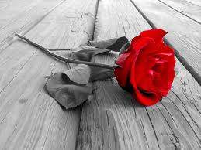
ACKNOWLEDGEMENT

ACKNOWLEDGEMENT

At the outset, I would like to express my praise and gratitude to God Almighty for his supreme guidance, strength and grace for accomplishing this project successfully.
I owe my respectful gratitude and sincere thanks to Dr.T.S.K. MEENAKSHI SUNDARAM M.A.,M.Phil., Chancellor, Avinashilingam Institute for Home Science and Higher Education For Women universityCoimbatore, for providing facilities to carry out this research programme successfully.
I express my sincere gratitude to Dr. Sheela Ramachandran, M.Sc., P.G. Dip., Ph.D. (Avinashilingam), Vice-Chancellor, Avinashilingam Institute for Home Science and Higher Education for Women, University Coimbatore, for all the amenities provided for the conduct of the study
I extend my grateful thanks to Dr. (Tmt.) Gowri Ramakrishnan, M.Sc., (Madras), M.Phil., Ph.D., (Avinashilingam), Registrar, Avinashilingam Institute for Home Science and Higher Education For Women, Coimbatore university, for rendering adequate help required to carryout the work.
I express my sincere gratitude to Dr. (Tmt.) Saroja Prabhakaran, M.A., and Dip.Ed. (Madras), Ph.D (Mother Teresa), The Director, Hall of residence, Avinashilingam Institute for Home Science and Higher Education for Women university Coimbatore, for all the amenities provided for the conduct of the study.
I owe my gratitude to Dr. (Tmt.) R.Parvatham M.Sc., Dip.Ed, M.Phil., (Madras), Ph.D.,(Avinashilingam), Dean, Faculty of Science, Avinashilingam Institute for Home Science and Higher Education For Women university Coimbatore, for providing the opportunity and for your never ending support.
I owe a special debt of gratitude to Dr. (Tmt.) R.Shyamala M.Sc., Dip.Ed.,(Madras), M.Phil.,(Bharathiar), Ph.D., (Avinashilingam), Head of the Department, Department of chemistry, Avinashilingam Institute for Home Science and Higher Education For Women, University Coimbatore, for extending all possible support for the successful completion of the study.
I thank my guide Dr. P.Lalitha M.Sc. M.Phil , PhD ((Avinashilingam) Asst. Professor(SS) Department of chemistry Avinashilingam Institute for Home Science and Higher Education For Women University,Coimbatore, who has been there until the successful completion of my thesis .
I also wish to thank all the staff members of department for timely help.
I express my thanks to Jayanthi.P, P. Arulpriya (Ph.D Scholars) and A.Tamaraiselvi, Sujitha.R (MPhil, Scholars) for their support.
I owe special debt and gratitude to my beloved parents to my sister and brother and to my friends.

SARANYA.K.V



CONTENTS

CONTENTS

Chapter | Title | Page No.
 | ABBERVIATIONS AND ACRONYMS
 | LIST OF TABLES
 | LIST OF FIGURES
 | LIST OF PLATES
1 | INTRODUCTION | 1
2 | REVIEW OF LITERATURE | 9
3 | MATERIALS AND METHODS | 26
4 | RESULT AND DISCUSSION | 43
5 | SUMMARY AND CONCLUSION | 72
6 | REFERENCES | 75
7 | BIBLIOGRAPHY | 80

ABBREVIATIONS AND ACRONYMS

DPPH 1, 1 diphenyl-2-picryl hydrazyl
W Waterhyacinth
T Tulsi
M Methi
C Coriander
B Broccoli
A Aloe Vera
F Formulation
Sec seconds
Min minutes
G gram
Kg kilogram
Mg milligram
Ml millilitre
Cm centimetre
M meter
V volt
% percentage
nm nanometer

std standard
µm micrometer
TEAC Trolox equvqlent antioxidant capacity
VCEAE Vitamin C equivalent antioxidant capacity
FR Free radical
ROS Reactive oxygen species

LIST OF TABLES
S.NO | NAME OF THE TABLES | PAGE.NO
1 | Aqueous extraction of herbs by sonication | 44
2 | Formulations of water hyacinth prepared | 45
3 | Phytochemical screening of formulations F1 to F6 | 46
4 | Phytochemical screening of formulations F7-F13 | 47
5 | Phytochemical screening of formulations F14 –F24 | 48
6 | Phytochemical screening of formulations F25 -31 | 49
7 | DPPH assay | 52
8 | Reducing power assay capacity of ascorbic acid | 58
9 | Reducing power assay capacity of ascorbic acid | 59
10 | Antibacterial activity of selected polyherbal formulations | 61
11 | Antifungal activity of selected polyherbal formulations | 65

LIST OF FIGURES
S.NO | NAME OF THE FIGURES | PAGE.NO
1 | Waterhyacinth in a water body | 9
2 | Salmonella paratyphie Figure | 21
3 | Staphyloccus albus | 21
4 | Monascuspurpureus | 21
5 | Aspergillus parasiticus | 21
6 | Candida albicans | 21
7 | Free floating water hyacinth in a water body | 27
6 | Tulsi used in preparation of polyherbal formulation | 28
7 | Methi leaves used in the study | 28
8 | Coriander leaves used in the study | 29
9 | Broccoli | 30
10 | Aloe vera | 30
11 | Free radical scavenging ability of polyherbal formulations of  water hyacinth F1-F6 | 54
12 | Free radical scavenging ability of polyherbal formulations of water hyacinth F1,F7-16 | 55

13 | Free radical scavenging ability of polyherbal formulations of water hyacinth F1,F17-F25 | 56
14 | Free radical scavenging ability of polyherbal formulations of water hyacinth F1,F26-F31 | 57
15 | Antibacterial activity of Salmonella paratypi. | 61
16 | Antibacterial activity Salmonella paratypi.plate | 62
17 | Antibacterial activity Staphylococcus albus | 63
18 | Antibacterial activity Staphylococcus albus | 64
19 | Antifungal activity Aspergillus paracitus | 66
20 | Antifungal activity Aspergillusparacitus | 67
21 | Antifungal activity Candidaalbicans | 68
22 | Antifungal activity Candidaalbicans | 69
23 | Antifungal activity Monosu purpureus | 70
24 | Antifungal activity Monosu purpureus | 71
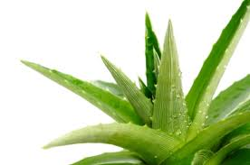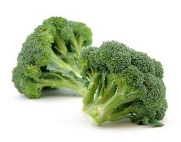
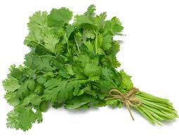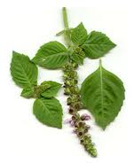

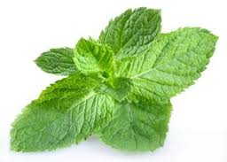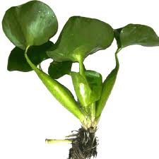

INTRODUCTION

1. INTRODUCTION

Use of plant as a source of medicine has been inherited and is an important component of health care system (Sharijf et al., 2006). Herbal medicine is main stay of about 75 -80 % of the whole population, mainly developing countries for primary healthcare because of better cultural acceptability better compatibility with human body and fewer side effect (Jadeja et al.,2005).Traditional medicine still remains as a main source for a large majority of the people for treating health problems. Traditional medicine consultancy, including the consumption of the medicinal plants has much lower cost than modern medicinal attention (Teklehaymanot and Giday, 2007). This makes phytochemistry more significant in the field of research. Hence the interest in phytochemistry.
India is a varietals emporium of medicinal plant and is one of richest countries in the world in regard to genetic resources of medicinal plant. The agrodimatic conditions are conducive for introducing and domesticating new exotic plant varieties (Parekh and Chanda, 2006). Traditional healers and their plants medicines provide the only health care to the majority of people in a curative rather than preventive approach in developing countries for common ailments. The ready availability and economy of plants as direct therapeutic agents make plants more attractive when compared to modern medicine (Agbor et al., 2005). Polyherbal formulations are on an increase recently, owing to the added pharmaceutical effects of herbs in a single formulation.
Hence it was decided in the present work to choose plants and study their medicinal uses by way of preparing poly herbal formulations.
Antioxidants are a type of complex compounds found in our diet that act as a protective shield for our body against certain disastrous(diseases),cataract and also premature ageing along with several chronic diseases(Mishra et al .,2007) . They can delay inhibit or prevent the oxidation of oxidizable matters by scavenging free radicals and diminish oxidative stress, retard the progress of many chronic diseases associated with risk of cancer, diabetes and ageing (Ani et al.,2006).
Characteristic feature of medicine of medicinal plants is the formation of a wide variety of natural products, so called secondary metabolites. Antioxidant defence mechanisms counteract free radical formation and reactions. in free radicals caused pathology , antioxidant neutralize the free radicals and increasing levels of antioxidants should decrease pathology combination of different natural antioxidants which are found in different medicinal plants work better than separate antioxidant alone. Many epidemiological studies also support the idea that antioxidant are interdependent (Kery et al., 2001).
It has long been recognised that plat poly phenols are an important class of define antioxidants this compounds are widespread in virtually are plants and they include phenols phenolic acids, flavonoids, tannins and lignans. Recently there has been growing interest in the field of free radicals in biological system and implied to development of degenerative diseases. These radicals may also be contributory factors in progressive decline in functional of immune system (Pike and Chanclres, 2005). Reactive oxygen species (ROS) is a metabolic side products of oxidative stress process which causes several diseases like atherosclerosis, cancer etc. It defense ROS anti-oxidants play a key role in combating them. As the process of aging increases the level antioxidant in our body decreases and thereby needs ut most attention for it repair process which is generally administered extremely plant product serve a best source of for controlling activities by it own metabolic pathway. Antioxidants activity is determined by different models, Nitric oxide scavenging activity and DPPH scavenging activity etc.(Dipen N vadalia et al., 2010).Hence in the present work the poly herbal formulations prepared are tested for their antioxidant activity.
Medicinal plant represents a rich source of antimicrobial agent and natural oxidant.The bacterial infections are the worlds leading killing diseases. In recent years drug resistance to human pathogenic bacteria has been commonly reported are over the world. The situation is alarming in both developing as well as developed countries due to indiscriminable use antibiotics’. The present scenario of emergence of multiple drug resistance to human pathogenic microorganisms has been necessitated a search for antimicrobial substance from other source including plants.
The quest for solution to the global problems of antibiotic resistance in pathogenic bacteria has been focused on the isolation and characterization of new antimicrobial compounds from varity of source including medicinal plant. Hence the prepared polyherbal formulations have been tested for the antimicrobial activity agent Salmonella paratyphi, Staphylococcus albus, Monoscus purpureus, Aspergillus paracitus and Candida albicans.
Waterhyacinth, Eicbhornia crassipes (Mart) solms, originating in the Amazonians basin is a warm water aquatic plant. Water hyacinth is considered one of the most productive plants on earth and accordingly, is considered on of the top ten world’s worst weeds water hyacinth spread to other tropical and subtropical regions by humans. It invaded about 62 countries in Africa, Asia and North America, and propagated extremely serious ecological, economical and social problem in region between 40 degree north and 45 degree south. The dense weeds of water hyacinth forms dense monocultures that can threaten local native species diversity and change the physical and chemical aquatic environment thus altering ecosystem structure and function by districting food chain and nutrients cycle (Ahmed M et al., 2011).
The English common names of the plants are Waterhyacinth, and water-hyacinth. Waterhyacinth is the standardized spelling adopted by the Weed Science Society of America to denote that it is not an aquatic relative of true “hyacinth”(Hyacinthus spp.), as the two-word spelling suggests (WSSA,1984). Taking into accounts the vast availability of waterhyacinth and the urgent need to utilize it, in order to protect our water bodies, an attempt has been made in the present work to utilize the weed. Our survey of literature, on the potential uses of water hyacinth revealed that certain groups of tribes use the weed for treatment of wounds and goitre. Hence it was decided to exploiting its medicinal value and analyse its pharmaceutical significance.
Additive effects or synergistic effects of herbs are well – known as evidenced by the mushrooming herbal formulations in the market. Hence, to increase the pharmaceutical value of waterhyacinth herbs of reported medicinal value have been added in selected quantities to observe synergistic effect of added herbs. Herbs like Tulsi, Coriander, Pudina, Broccoli and Aloe vera have been selected based on the chemical constituents present in them.
Tulsi is an erect 30-60cm much branched annual herb. Root is thin and stem is erect herbaceous branched and hairy leaves aromatic odours and characteristic taste flower are purplish and crimson colored and fruit is a group of 4 nutlets each having one seed. Traditionally Ocimam sanctumis used in hepatic infections. Ocimam sanctum leaves are also used in bronchitis, ringworm and other cutaneous diseases and to alleviate earache. The leaves are used as a nerve tonic and then sharpen memory (Sharma, 2011).
Mentha aruensis Linn (Family. Limiaceae)is known as pudina in Hindi, Sanskrit and Kannada. It is widely distributed throughout India and leaves of plant are extensively used in traditional system in medicine of various ailments like carminative digestive, expectorant, cardiotonic, diuretic ,jaundice, hepatalgia, inflammation of liver, peptic ulcer, diarrhoea, bronchitis and skin diseases (Rajesh kowti et al, 2010) .
Broccoli could protect against cancer (Byers et al., 2001) and there are reports that a compound sulforaphane has been isolated and identified from broccoli (Zhange et al., 1992). Sulforaphane is able to include some enzymes, such as quinine reductase and glutathione s-transferases, to metabolize xenobiotics. Research on broccoli has focused on its edible parts; flower and tender stem part .In edible part are usually disposed of or used as a organic fertilizers (Jiin-tzong guo et al., 2001).
Coriandrum sativum family umbelliferae is highly repeated ayurvedic medicinal tree commonly known as the Dhanyakes. Dhanyaka consist of dried ripe fruits of Coriandrum sativum umbelliferae (Evans et al., 2002). It is an annual herbal originating from the Mediterranean countries (Vaidya et al., 2000).
The whole plant and especially the unripe fruit, is characterized by a strong disagreeable odour, when the name coriander (from the greek ‘op’s a bug) giving characteristic aroma when rubbed (Gruenwaldedjoerg et al., 2004). All part of the plants is edible, but the fresh leaves and the dried seeds are the most common part used in cooking. In the Indian traditional medicine coriander is used in the disorder of digestive, respiratory and urinary system, as it has diaphonetic, diuretic, carminative and stimulates activity (Bemjumea et al., 2005).
Aloevera product has been long been used in health food for medicinal and preservative purpose. There are more than 360 different species of Aloes grown in the dry regions of North America and Asia. There are many studies showing that resistance to inflection is enhanced by Aloe either in humans or in animals. Aloe vera has also been shown to be a potential therapeutic agent for the treatment of sepsis and hepalotoxicity(Tin a Knairyet al., 2011).
Many medicinal, industrial and allelopathic uses of Waterhyacinth have been reported. The natives of Chhattisgarh use this to treat their health problems. In order to list out the existing medicinal uses, a survey was conducted during year 2000 in six selected districts of Chhattisgarh state. The survey revealed that many natives are using the water hyacinth as medicinal plant. It is mainly used as a remedy to treat the goiter disease. Two basic formulations were identified as the mostfrequentlyusedformulation.
(1) Fresh plant of waterhyacinth, table salt and Pippali a common herb, are mixed in equal quantity. 12 Gms of this mixture are prescribed for a patient daily till the relief.
(2) Air dried plant of water hyacinth when burnt and taken with fresh cow urine is also believed to cure the goiter.
In Chhattisgarh, waterhyacinth is also used as styptic. The natives apply the fresh juice of this weed in fresh wounds. It is believed that it stops further spread of infection. For rice farmers it is one of the best first aid remedies for minor injuries. In septic wounds, it is appliedwithvinegar.
Back in folklore medicine, water hyacinth has been used to ease swelling, burning, emorrhage, and goiters. In the animal kingdom, it has been used as a tonic for the skin of horses, for irritation and inflammation. Either way, the whole plant is what has typically been used in those situations. Whether there is any validity to that remains to be seen.The above mentioned uses of water hyacinth have not been reported in available literatures. The survey suggested that there is a strong need to identify the potential medicinal uses of this obnoxious weed so that it can be used for the welfare of human beings.
The leaves of waterhyacinth were extracted with water. Traditionally extraction is carried by refluxing the plant material with suitable solvent in round bottom flask.Conventional methods typically involve pulverising the plant material and refluxing using suitable solvents(Hagerman, 1998. Hagerman and Hutler, 1989).In order to increase the productivity several intensification techniques like ultrasonic waves, supercritical fluid or microwaves are used to improve the yield and quality of extracted product.Ultrasound is cyclic sound pressure with a frequency greater than the upper limit of human hearing. The production of ultrasound is used in many different fields. Sound penetrates a medium and is a measure of the reflection energy. Ultrasound assisted extraction seems to be economically most promising (inexpensive simple and efficient).The main benefits of use of ultrasound in solid – liquid extraction include the increase of the extraction yield and faster kinetics (Keil, 2007).
Hence in the present study attempted extraction using ultrasonic bath has been carried out for enhancing yield of extraction of waterhyacinth in a short time.

  - OBJECTIVES OF THE STUDY
The present study on “Invitro antioxidant testing and anti microbial activity of polyherbal formulations of waterhyacinth” is carried out with the following objectives:
- To collect the leaves of waterhyacinth, Tulsi, Coriander, Methi, Brocooli and Aloe vera.
- To prepare aqueous extracts of foresaid samples by sonication in a sonic bath.
- To prepare different formulations of waterhyacinth
- To screen the variesformulations for the presence of phytochemicals –alkaloids, flavonoids, terpenoids, steroids,tannins, carbohydrate, quinine, saponins, anthraquinone, phenols, glycosides and protein.
- To analyze thein vitro antioxidant activity of the prepared formulations by DPPH scavenging assay and reducing power assay.
- To study the antimicrobial activity of the prepared formulations against Salmonella paratyphie, Staphylococcus albus, Monosus purpereus, Aspergilus paracitus and Candida albicans.
- To analyze the pharmaceutical application of the prepared formulations of water hyacinth and compare its pharmaceutical value with the formulations of added herbs.

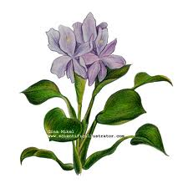

REVIEW OF LITERATURE

2. REVIEW OF LITERATURE
2.1. Waterhyacinth
Waterhyacinth is a free-floating perennial aquatic plant native to tropical and sub-tropical South America. With broad, thick, glossy, ovate leaves, waterhyacinth may rise above the surface of the water as much as one meter in height. The leaves are 10–20 cm across, and float above the water surface. They have long, spongy and bulbous stalks. The feathery, freely hanging roots are purple-black. An erect stalk supports a single spike of 8-15 conspicuously attractive flowers, mostly lavender to pink in colour with six petals.
2.1.1 Botanical description
Family: pontederiaceae
Genus: Eichhornia

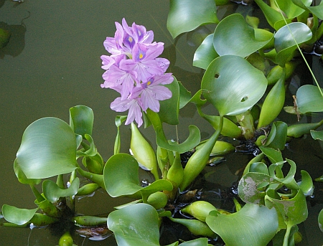
Figure 1. Water hyacinth in a water body

2.1.2 Control of Waterhyacinth

Waterhyacinth can be controlled using three methods:
2.1.2.1. Chemical Control
The application of herbicides for controlling water hyacinth has been carried out for many years and it has been found that there is a good success rate when dealing with small infestations. A main concern when using herbicides is the environmental and health related effects, especially where people collect water for drinking and washing.
2.1.2.2. Physical Control
Physical control is performed by land based machines such as bucket cranes, draglines, or boorm or by water based machinery such as aquatic weed harvester, dredges, or vegetation shredders. Mechanical removal is seen as the best short-term solution to the proliferation of the plant. It is however costly and requires the use of both land and water vehicles.

2.1.3. Industrial utilization

The plant has abundant nitrogen content, it can be used a substrate for biogas production and the sludge obtained from the biogas. However, due to easy accumulation of toxins, the plant is prone to get contaminated when used as feed

2.1.4.Exogenous.
The plant is extremely tolerant of, and has a high capacity for, the uptake of heavy metals, including Cd, Cr, Co, Ni, Pb and Hg, which could make it suitable for the biocleaning of industrial wastewater (Upadhyay, Alka et al., 2007) In addition to heavy metals, Eichhornia crassipes can also remove other toxins, such as cyanide, which is environmentally beneficial in areas that have endured gold mining operations (Ebel, Mathias et al., 2007).Waterhyacinth is also observed to enhance nitrification in waste water treatment cells of living technology. Their root zones are superb micro-sites for bacterial communities (Todd et al., 1996).
2.2 Antioxidant activity
Antioxidants are substances or nutrients present in our foods and can increase cellular defence and help prevent oxidation damage to cellular component of our bodies in the hope of maintaining health and preventing diseases such as cancer and coronary heart disease in addition to many other uses in medicine and industrial field, for instance cosmetic and food preservation and colorant (Mervat et al., 2009).
Plant is potential source of natural antioxidants that could have great importance as therapeutic agent in preventing, or slowering the progresses of ageing and age associated oxidative stress related degenerative diseases such as cancer and various human ailments (Prachetaet al., 2010). Therefore the importance of searching for and exploiting natural antioxidants has increased greatly in recent years (Patil et al., 2009).
Plant antioxidant may vary based on time of harvest, storage temperatures and extraction methods, seasonal changes, environmental factors and stage of plant. Plant antioxidant may vary based on time of harvest, storage temperatures and extraction methods. Seasonal changes, environmental factors and stage of plant development effect the production and distribution of bioactive constituents in the plant. Other factors affecting capture of active phyto-chemicals are the plant organ being extracted, the types of solvents, and the extraction period and extraction conditions. Even with these challenges, screening native plants is useful for revealing the antioxidant activity that may lead to the development of new products for use as nutritional (antioxidants) and pharmaceutical agents (Borchardt et al., 2008).
The reducing capacity of a compound may serves as a significant indicator of its potential antioxidant activity (Arulmozhi et al., 2010). Phenolic compounds are known as powerful chain breaking antioxidants. Phenols are very important plant constituents because of their scavenging ability due to their hydroxyl groups and may contribute directly to antioxidative action (Vadnere et al., 2012). It is suggested that polyphenolic compounds have inhibitory effects on mutagenesis and carcinogenesis in humans (Sawant et al., 2009).
2.3 Roles of medicinal plants on antioxidant activity
The medicinal effects of Allium sativum L. in treating a wide variety of human diseases are well-known. Garlic enhances immune function and shows antibacterial, antifungal, antivirus and antioxidant activities of fresh Allium sativum L. Fresh garlic extracted containing stable and water soluble organ sulphur compounds that prevent oxidative damage by scavenging free radicals . Leaves of A. roseum displayedthe strongest radical scavenging activity (IC50:6.59±0.26 g/ml and 7.21±0.39 mg/ml respectively) and antioxidant activity then flower aged extract (Cristina Nencini et al., 2008).
Melastoma malabathricumis known as as Melabar Melastone , Indian Rhododendron and Singapore Rhododendron (www.Wikipedia.com). The aqueous and methanol extract of M. malabathricum, produced high antioxidant activity aqueous and methanol extract exhibited high activity for the the 2, 2-diphenyl -1-picrylhydrazyl radical scavenging assay. The M. malabathricum leaves possessed potential antiproliferative and antioxidant activities that could be attributed to its high content of phenolic compounds (Z.A.Zakaria et al., 2011).
Anacardium occidentale is atree in family ancadiaceae. A. occidentale was the most potent reducing agent and radical-scavengers compared to the other two extracts. The ethyl acetate extract exhibited some antioxidant activities whereas the hexane extract is the least reactive. The order of the antioxidant potency of the plant extract is methanol>ethylacetate>hexane. The result suggest that the shoots of A.occidentale are a source of natural antioxidants (Zakaria et al., 2011).
The antioxidant properties of extracts ofleaf extracts of Mitragyna speciosawere evaluated using the DPPH (2,2-diphenyl-1-picrylhydrazyl) radical scavenging method. The amount of total phenolics and flavanoidcontents were also estimated. The antioxidant activities were correlated with the total phenolic content.This result suggests that the relatively high antioxidant activity of the methanolic extract compared to aqueous and alkaloid extract could be possibly be due to its high phenoliccontent. The aqueous, alkaloid and methanolic extracts were screened for antimicrobial activity. The extracts showed antimicrobial activity against Salmonella typhi and Bacillussubtilis. The minimum inhibitory concentrations (MICs) of extracts determined by thebroth dilution method ranged from 3.12 to 6.25 mg/mL. The alkaloid extract was found tobe most effective against all of the tested organisms(Suhanya Parthasarathy et al.,2009).

2.4 Review of literature pertaining to water hyacinth
The administration of the ethanol extract of water hyacinth (Eichhornia crassipes) on rats was found to ameliorate arsenic from arsenic-treated rats. Treatment with either extract 50% or with α-tocopherol was applied singly and in combination to find out result for comparison of effectiveness on arsenic removal. The reduction of arsenic and MDA was not dose dependent and not parallel. Water hyacinth, at the dose of 50% extract was observed to be most effective (Shaheen Lipika Quayum , 2007).
Reducing power assay of solvent extracts of Eichhornia crassipes (Mart.)Solms at different concentrations and time delay was evaluated. Reducingpower was linearly proportional to the concentration and time and was found to increase with increase in concentration and time. The extracts were compared to standard antioxidant. The results suggest the potential of development of useful natural antioxidants(Jayanthi and Lalitha, 2011).
Diabet, a polyherbal formulation intended to use for diabetic patients has been screened for antioxidant activity. For antioxidant studies, Diabet was administered orally for 30 days at a dose of 500 mg/kg body weight to alloxan induced diabetic male Wistar rats. The formulation exhibitedsignificant antioxidant activity showing increased levels of superoxide dismutase (SOD), catalase (CAT), glutathione peroxidase (GPx), reduced glutathione (GSH) and decreased level of lipid peroxidation. These results showed that treatment with Diabet lowers Alloxan induced LPO and alters SOD, CAT, GPx and GSH enzymes to reduce oxidative stress(Umamaheswari et al., 2009).
Literature survey revealed that phyllanthin and hypophyllanthin from Phyllanthus niruri, wedenolactone from Eclipta alba, and kutkin from Picrorhiza kurroa are responsible for hepatoprotective activity, The antioxidant activity was compared with ascorbic acid (ASC) and Rutin as standard. The hepatoprotective activities in carbon tetrachloride induced hepatotoxicity were studied. Assessment of liver function was made by estimating the activities of SGOT, SGPT, ALP, Cholesterol, Bilirubin and Total protein. From the study it was seen that formulation exhibited significant hepatotoxicity (Vilas et al., 2010).
The antioxidative properties of waterhyacinth leaves were investigated by evaluating the scavenging capacity of liquid extracts in a competitive protective process against oxygenated free radicals (OFRs) released via electrolysis in a phosphate buffer with a Pt electrode. Colorimetric measurements carried out at 515 nm, through a N, N-diethyl-1, 4-phenylenediamine (DPD) assay, showed a decreased absorbance of the sample, as compared to the blank obtained by electrolysis of the buffer without plant extract, revealing, thereby, the presence of antioxidizing agents in the liquid extracts. Glutathione (ca. 40 nmol eg/gdp) was found in the hyacinth leaves, making this plant to be regarded as an alternative and convenient low-cost raw material for antioxidizing agent recovery (Bodon Ruben et al., 2008).
Whole plants of Eichhornia crassipes and Pistia stratiotes were exposed to various concentrations of 8 heavy metals (Ag, Cd, Cr, Cu, Hg, Ni, Pb and Zn) hydroponically for 21days. Spectrometric assays for the total activity of catalase, peroxidase, and superoxide dismutase in the leaves were studied. The results showed that E. crassipes tolerated higher metal concentrations in a greater number of metals than P. stratiotes. (Odjegba and Fasidi, 2007).
Many oxidative stress related diseases are as a result of accumulation of free radicals in the body. The in vitro antioxidant activities and phytochemical screeining of the extracts of Helichrysumlongifolium DC.aqueous crude extract are reported. Flavonoids,proanthocyanidin and phenolic contents of the extract were also determined using standard phytochemical reactionmethods.Phytochemical analyses revealed the presence of tannins, flavonoids, steroids and saponins. The totalphenolic content of the aqueous leaf extract was 0.499 mg gallic acid equivalent/g of extract powder. The total flavonoid and proanthocyanidin contents of the plant were 0.705 and 0.005 mg gallic acid equivalent/g of extractpowder respectively. The percentage inhibition of lipid peroxide at the initial stage of oxidation showed antioxidantactivity of 87% compared to those of BHT (84.6%) and gallic acid (96%). Also, the percentage inhibition ofmalondialdehyde by the extract showed percentage inhibition of 78% comparable to those of BHT (72.24%) and Gallic (94.82%)(Olayinka and Anthony , 2010).
The in vitro antimicrobial activity of crude ethanolic, methanolic and water extracts of the stem bark ofJatropha curcas were investigated. The extracts exhibited antimicrobial activities with zones ofinhibition ranging from 5 to 12, 8 to 20 and 0 to 8 mm for ethanol, methanol and water extracts respectively.The minimum inhibitory concentration (MIC) of the ethanol extract was between 0.5 and 6.25mgml-1 while that of methanol extract ranged from 0.5 to 10 mgml⁻¹. The minimum bactericidal concentration (MBC) for ethanol extract ranged between 2.0 and 12.50 mgml-1, while that of methanol rangedfrom 2.0 to 20 mgml⁻¹. All the extracts exhibited appreciable activity against all the fungal species investigated. The zones of inhibition exhibited by the extracts against the test fungal species rangedbetween 15 and 18, 15 and 20 and 5 and 10 mm for ethanol, methanol and water extracts respectively.Phytochemical screening revealed the presence of saponin, steroids, tannin, glycosides, alkaloids andflavonoids in the extracts. The ability of the crude stem extracts of J. curcas to inhibit the growth ofbacteria and fungi is an indication of its broad spectrum antimicrobial potential which may be employedin the management of microbial infections (Igbinosa et al., 2009).
2.5 Review of literature pertaining to phytochemical screening of plant extracts
The stem bark of Croton zambesicus was collected, gabbled, pulverized air dried and subjected to gradient extraction with soxhlet apparatus and the methanol extract (MTE) was screened phytochemically for its chemical components. This revealed the presence of alkaloids, reducing compounds (carbohydrates), cardiac glycosides, flavonoids, saponins, terpenes and steroids in moderate concentration. In vitro antibacterial assay of the extract by the use of agar plate-hole diffusion and nutrient broth dilation techniques revealed the extracts to have broad spectrum activity on grams positive, negative organisms and fungalstrain respectively. The highest activity was shown in S. aureus and E. coli with the sameMIC and MBC values of 1.560mg/ml and least activity on S. pyogens with the same MICand MBC values of 50mg/ml showing the extract to be antimicrobial. This studyprovides some scientific bases for the use of this plant as a remedy for stomach, urinarytract, skin and fungal infections in folkloric medicine whose causative agents are some ofthe pathogens studied. The activities observed could be attributed to the presence of someof the phytochemicals detected which have been associated with antibacterial activity(Reuben et al, 2008;).
Oxidative stress has been shown to play an important role in the development of anaemia inmalaria. Indeed, increase in total antioxidant status has been shown to be important in recovery frommalaria. The antioxidant activities of four medicinal plants traditionally used in the treatment of malaria in southwestern Nigeria were determined.The ethanolic extracts of the leaves of Carica papaya Linn. [Caricaceae] , stem bark of Mangifera indica Linn. [Anacardiaceae], leaves of Psidium gujava Linn. [Myrtaceae] and the leaves of Vernonia amygdalinaDel. [Compositae], were screened for the presence of phytochemicals and, their effect on 2,2-Diphenyl-1-picryl-hydrazyl radical (DPPH) was used to determine their free radical scavenging activity. Phytochemical screening of the plants showed the presence of flavonoids, terpenoids,saponins, tannins and reducing sugars. All the plants showed potent inhibition of DPPH radical scavenging activity, P. gujavabeing the most potent. The free radical scavenging (antioxidant) activities of these plants probably contribute to the effectiveness of the above plants in malaria therapy ( Ayoolaet al.,2008).
The various extracts of stem bark of Bauhinia racemosa L. (Caesalpiniaceae), were investigated forits physicochemical and phytochemical screening. Ash value (total ash, acid insoluble ash and water soluble ash) and extractive values were studied dry weight. Ash content analysis showed totalash, acid insoluble ash and water soluble ash (13.77, 0.073, and 4.803 respectively). The moisture content was found to be 9.84 % and at the same time heavy metals was found to be with in the permissible limits. Preliminary phytochemical analysis test showed the presence of steroids, flavonoids, alkaloids, coumarins, triterpenoids, tannins and carbohydrate (Yadav Shiv Kumar, 2011).
The medicinally active substances present in solvent extract obtained from leaves of Butea monosprema are reported.The active substance were isolated by Soxhlet extractor and identified by phytochemical test. The Soxhlet extraction of leaves, in powdered form, wasperformed using petroleum ether and followed by chloroform and methanol. The results of analyses of each extract confirm the active substance were sterols, triterpenes, glycosides flavonoids and proteins.The evaluation of leaf powder was supported by physico-chemical analysis. The microbial test of isolated substances were performed with microorganisms like Escherichia coli, Pseudomonas aeruginosa, Bacillus subtilis,Staphylococcus aureus, Proteus vulgaris and Klebsiella pneumonia. The observation of microbial test of methanol- extract supports antibacterial activity to the greater extent than petroleum ether and chloroform-extract(Rajput et al.,2011).

2.6 Reviews of literature pertaining to antioxidant activity (DPPH and reducing power assay studies) of plant extracts
The reaction mechanisms of three antioxidants are proposed in order to explain experimental results obtained from a kinetic study using the free radical 2,2-diphenyl-1-picrylhydrazyl (DPPH) method. In its radical form, DPPH shows an absorbance maximum at 515 nm which disappears upon reduction by an antiradical compound. BHT, asynthetic antioxidant, slowly reacts with DPPH reaching a steady state within 5 h. This stoichiometric complete reaction follows a 1.5-order with respect to DPPH and 0.5 to BHT. The kinetic rate constant, k, is estimated to be 5.0 L/(mol·s) at 20 ° Cand the energy of activation, Ea, is equal to 35 kJ/mol in methanol. Eugenol reacts with DPPH reaching a steady state within2 h. The eugenol mechanism may involve a dimerization between two phenoxyl radicals. The reaction with isoeugenol is rapid and reversible, with a stoichiometry of 1.1. It is first order with respect to isoeugenol with k (direct reaction) equal to 8.9 3 10–2 s–1 at 10 °C. This reaction is consistent with a pseudo-monomolecular mechanism(Bondet, et al., 2007).
The possible antioxidant activity of various extracts of Phellinus merrillii (PM) has been investigated and reported. The explored items include: ABTS free radical scavenging assay, determination of totalphenolics contents (TPC), ferric reducing antioxidant power assay (FRAP), rapid screening of antioxidant bydot-blot DPPH (1, 1-diphenyl-2-picrylhydrazyl) staining, DPPH radical-scavenging activities and reducing power measurement. This indicated that PM did contain the active ingredient hispolon. Both the IC50 of DPPH radical scavenging activity for hispolon and BHT were 42.4 ± 2.9 and 81.2 ± 3.2 μM, respectively. These findings mean that hispolon was most important in antiradical activities. It was suggested that hispolon might contribute to its antioxidant activities in PM( Heng-Yuan et al.,2007).
Antioxidant studies were performed on the ethanolic extract of Tagetes erecta flowers. During the study preliminary phytochemical analysis carried out on the ethanolic extract of flowers of Tagetes erecta showed the presence of alkaloids, flavonoids, proteins, steroids and tannins. For the study of in vitro antioxidant activity three different assays like DPPH, reducing power and super oxide radical scavenging activity at different concentrations were used. In the entire three assays, Tageteserecta showed better reducing power than the standard (i.e. ascorbic acid), and superoxide anion scavenging activity and DPPH antioxidant activity showed less than standard (Basavaraj et al., 2011).
Major cause of conversion of normal cells to cancerous cell , are generated as a consequence of a number of endogenous metabolic processes involving redox enzymes and bioenergetic electron transfer and exposure to aplethora of exogenous chemicals(Rajkumar et al.,2011).
The antioxidant properties of water, methanolic andalkaloid M. speciosa leaf extracts were evaluated using the DPPH (2,2-diphenyl-1-picrylhydrazyl) radical scavenging method. The amount of total phenolics and flavanoidcontents were also estimated.The result suggests that the relatively high antioxidant activity of the methanolic extractcompared to aqueous and alkaloid extract which is reported possibly due to its high phenoliccontent(Suhanya Parthasarathy et al., 2009).
2.7. Antimicrobial activity
An antimicrobe is a substance that kills or inhibits the growth of microorganisms such as bacteria, fungi, or protozoans. Antimicrobial drugs either kill microbes (microbiocidal) or prevent the growth of microbes (microbiostatic). Disinfectants are antimicrobial substances used on non-living objects or outside the body(Wikepedia).

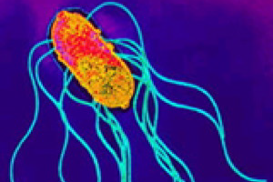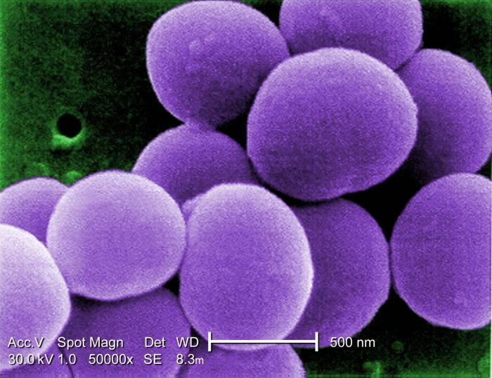
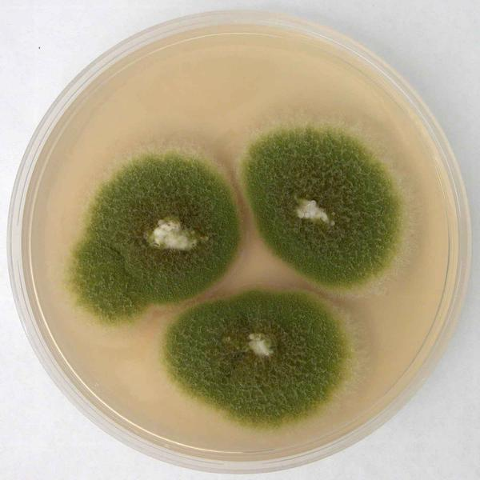
Figure 2.Salmonella paratyphie Figure 3.Staphyloccus albus
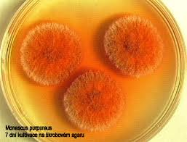
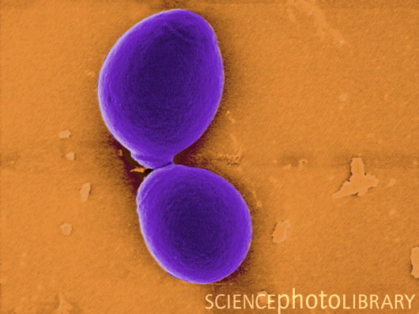
Figure 4.Monascus purpureusFigure 5. Aspergillus parasiticus

Figure 6.Candida albicans

2.7.1. Salmonella paratyphi
An infection caused by bacteria from the Salmonella genus which causes typhoid fever, with symptoms such as gastroenteritis. Infection is caused by consuming contaminated food or drinks (Wikepedia).
2.7.2. Staphylococcus albus
Staphylococcus albus is a gram positive, cocci (spheroid), bacterium normally found on the skin which can cause urinary tract infections. Staphylococcus albus is a very old (not used anymore) name for Staphylococcus epidermidis, a common skin bacterium. Growth conditions are very similar for those of Staphylococcus aureus, so 37 degrees Celcius, pH 7.0. Staph.albus is now called Staph. Epidermis. S. epidermidis causes bio films to grow on plastic devices place within the body. This occurs most commonly on intravenous catheters and on medical prostheses. Infection can also occur in dialys(http://wiki.answers.com).
2.7.3. Monascus purpureus
This fungus is most important because of its use, in the form of red yeast rice, in the production of certain fermented foods in China. However, discoveries of cholesterol-lowering statins produced by the mold have prompted research into its possible medical uses. It produces a number of statins. The naturally occurring lovastatins and analogs are called monacolins K, L, J, and also occur in their hydroxyl acid forms along with dehydroxymonacolin and compactin (devastating). The prescription drug lovastatin, identical to monacolin K, is the principal statin produced by Monascus purpureus. Only the open-ring (hyroxyl acid) form is pharmacologically active (Wikipedia).
2.7.4. Aspergillus parasiticus
Aspergillus parasiticus is a type of aspergillus mold usually found in cultivated soils and is considered as allergenic. It is difficult to differentiate this kind of mold from aspergillus flavus, which is why there is a lack of reported isolations associated with this mold, although it is frequently isolated from seeds, insects, insects and some plants. Studies have shown that some strains of Aspergillus parasiticus can produce a group of mycotoxins, usually in the aflatoxin group. It should be understood that Aflatoxins are animal carcinogen, but there are limited evidence suggesting that this type of toxin is human carcinogen. However, this same toxin is found to be poisonous to humans, especially when ingested and can be toxic to the liver.
2.7.5. Candida albicans
Candida albicans is a diploid fungus that grows both as yeast and filamentous cells and a causal agent of opportunistic oral and genital infections in humans.Systemic fungal infections (fungemias) including those by C. albicans have emerged as important causes of morbidity and mortality in immunocompromised patients (e.g., AIDS, cancer chemotherapy, organ or bone marrow transplantation). C. albicans biofilms may form on the surface of implantable medical devices. In addition, hospital-acquired infections by C. albicans have become a cause of major health concerns(Ryan and Hube, 2007).
Candida albicans, the most common cause of invasive fungal infections in humans, morphological plasticity is its defining feature and is critical for its pathogenesis. Unlike other fungal pathogens that exist primarily in either yeast or hyphal forms, C. albicans is able to switch reversibly between yeast and hyphal growth forms in response to environmental cues. Candida albicans adapts to the varied host environments in pathogenesis. Such temporally linked regulation of promoter chromatin by different signalling pathways provides a unique mechanism for integrating multiple signals during development and cell fate specification(Myerset al., 2007).
An experiment was carried out to study the antimicrobial activity of petroleum ether, ethanol, chloroform, n- hexane and water extracts of Centella asiatica herb by agar well diffusion assay. The tested bacterial strains were Proteus vulgaris, Staphylococcus aureus, Bacillus subtilis and Escherichia coli and fungal strains were Aspergillus nigerand Candida albicans. Zone of inhibition produced by different extracts against the selected strains was measured and compared with standard antibiotic ciprofloxacin (10μg) and ketocanozole (10μg). The present study demonstrated that the petroleum ether, ethanol and chloroform extracts of Centella asiatica have higher antimicrobial activities (average 12-19 mm zone of inhibition) than n-hexane and water extracts (average 8-14 mm zone of inhibition) whereas n-hexane extract showed no activity against E. coli. All the extracts showed better results against the tested fungal strains comparing with ketocanozole(10μg). The results obtained in the present study suggest that the different extracts of Centella asiatica revealed a significant scope to develop a novel broad spectrum of antibacterial and antifungal herbal formulations(Dash et al.,2011).
The antimicrobial activities of Mitragyna speciosaleaf extracts showed good activity against Salmonella typhi and Bacillussubtilis. The minimum inhibitory concentrations (MICs) of extracts determined by thebroth dilution method ranged from 3.12 to 6.25 mg/mL. The alkaloid extract was found tobe most effective against all of the tested organisms(Suhanya Parthasarathy et al.,2009).
The anti-Candida potentials of 12 Korean medicinal plants were explored: methanol extracts from Coptis rhizoma and Phellodendron amurense caused significant inhibition of growth of Candida albicans,Candida glabrata,Candida krusei and Candida parapsilosis.The result suggests that sterol 24-methyl transferase (24-SMT) as one of the cellular targets for the antifungal activity of the protoberberines. In vitro 24-SMT activity in microsomes from the yeast growth form of C. albicans was inhibited by both berberine (inhibition constant (K_{i}) 232 µM) and palmatine (K_{i} 257 µM) in a non-competitive manner; inhibition of 24-SMT was more marked for the mycelial form than for the yeast growth form of this organism. Palmatine inhibited chitin synthesis from both the yeast and mycelial growth phases of C. albicans in a non-competitive manner (K_{i} 780 µM). The effects of protoberberines, extracted from established medicinal plants, on both sterol and cell wall biosyntheses in pathogenic fungi, indicate that the potential of these compounds, or their semi-synthetic derivatives, as a novel class of antifungal agents should be investigated more fully (Kang-sik Parka et al.,1998).
Candida albicans contains homologues of the transcriptional repressors ScTup1, ScMig1 and ScNrg1 found in budding yeast. In Saccharomyces cerevisiae, ScMig1 targets the ScTup1/ScSsn6 complex to the promoters of glucose repressed genes to repress their transcription. ScNrg1 is thought to act in a similar manner at other promoters. The data revealed that CaNrg1 and CaTup1 regulate a different set of C. albicans genes from CaMig1 and CaTup1. This is consistent with the idea that CaMig1 and CaNrg1 target the CaTup1 repressor to specific subsets of C. albicans genes. However, CaMig1 and CaNrg1 repress other C. albicans genes in a CaTup1-independent fashion. The targets of CaMig1 and CaNrg1 repression, and phenotypic analyses of nrg1/nrg1 and mig1/mig1 mutants, indicate that these factors play differential roles in the regulation of metabolism, cellular morphogenesis and stress responses. Hence, the data provide important information both about the modes of action of these transcriptional regulators and their cellular roles (Muradet al, 2008).

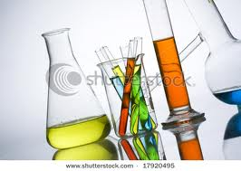
MATERIALS AND METHODS

3. MATERIAL AND METHODS

The methodology consist of the following
- Collection of plant material
- Extraction of plant material by sonication
- Phytochemical analysis of extract
- Evaluation of antioxidant activity by invitro techniques
- Antimicrobial studies

3.1 General
The plant material was refluxed using water in sonic bath. The extracts were distilled with Rota evaporator Equitron Model. Antioxidant study like reducing power assay and DPPH assay was carried out using different solvent was followed by spectrophotometer.

3.2 Collection of plant material
The leaves of water hyacinth, tulsi, methi , aloe vera , broccoli, and coriander were collected from Coimbatore and was used in the study. The aqueous extracts of all the foresaid herbs was used. The plant materials were individually sonicated with water in sonic bath. After filtration, the extracts were distilled to remove water, after which , it was dried and used in the preparation of forumulations.
3.2.1. Waterhyacinth comprises the genus Eichhornia. Waterhyacinth are a free-floating perennial aquatic plant native to tropical and sub-tropical South America. With broad, thick, glossy, ovate leaves, waterhyacinth may rise above the surface of the water as much as 1 meter in height. The leaves are 10–20 cm across, and float above the water surface. They have long, spongy and bulbous stalks. The feathery, freely hanging roots are purple-black. An erect stalk supports a single spike of 8-15 conspicuously attractive flowers, mostly lavender to pink in colour with six petals(Shaheen Lipika Quayum,2007).

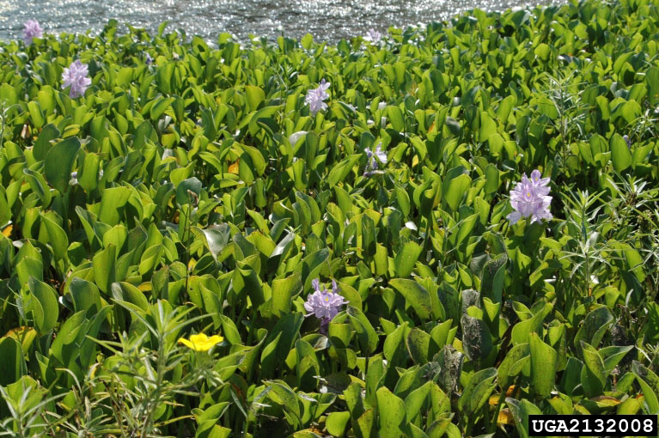
Figure 7. Free floating water hyacinth in a water body in Coimbatore
3.2.2. Tulsi(Ocimum sanctum) is a widely grown, sacred plant of India.Tulsi is a branched, fragrant and erect herb having hair all over. It attains a height of about 75 to 90 cm when mature. Its leaves are nearly round and up to 5 cm long with the margin being entire.Tulsi entire is used in Ayurvedic preparations for treating various ailments.
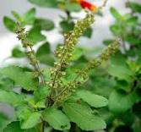
Figure 8. Tulsi used in preparation of polyherbal formulation
3.2.3. Pudina or Mint (Mentha Arvesi) is the erect plant with dark green leaves with pleasant flavours. Pudina is an herbaceous perennial herb that grows to a height of 10 to 60 cm. This downy herb has running rootstocks and a rigid branching stem. The lanceolate oblong leaves are simple and sharply toothed, paired in opposites with minute hair. They are 2 to 6.5 cm in length and 1 to 2 cm in width. The pale purple flowers (sometimes white or pink) are found in clusters at the stem where each flower measures 2 to 4 mm in length.
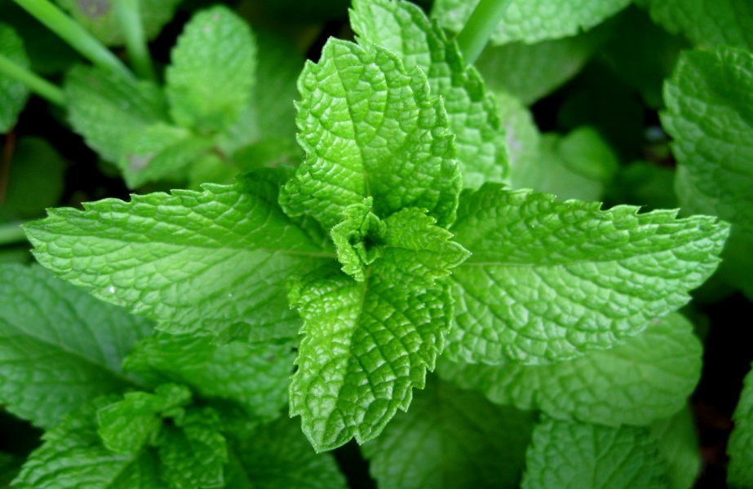

Figure 9. Methi leaves used in the study

3.2.4. Coriander (Coriandrum sativu), also called cilantro, ordhania is an annual herb in the family Apiaceae. Coriander is native to southern Europe and North Africa to southwestern Asia. It is a soft, hairless plant growing to 50 centimetres (20 in) tall. The leaves are variable in shape, broadly lobed at the base of the plant, and slender and feathery higher on the flowering stems. The flowers are borne in small umbels, white or very pale pink, asymmetrical, with the petals pointing away from the center of the umbel longer (5–6 mm) than those pointing towards it (only 1–3 mm long). The fruit is a globular, dry schizocarp 3–5 mm diameter(Courtesy :Google scholar)
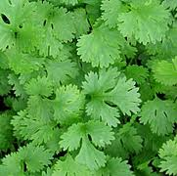
Figure 10. Coriander leaves used in the study
3.2.5. Broccoli is a hardy vegetable of the cabbage family that is high in vitamins A and D. - When looking for signs of when to pick broccoli, pay close attention to the colour of the florets. They should be a deep green.
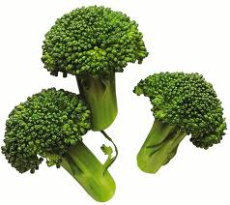
Figure 11 . Broccoli
3.2.6.Aloe vera is a species of succulent plant that probably originated in northern Africa.. The species is frequently cited as being used in herbal medicine since the beginning of the first century AD. Extracts from Aloe Vera are widely used in the cosmetics and alternative medicine industries(Spinkerlink).
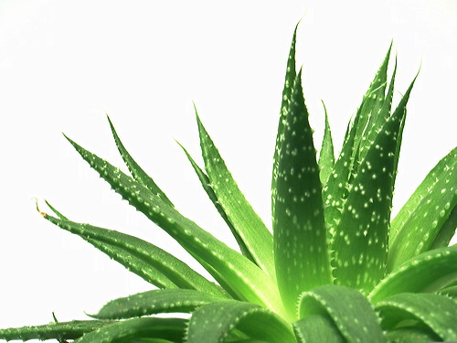
Figure 12. Aloe vera

3.3 Extraction Of Plant Material
3.3.1 Extraction of plant material using sonic bath
3.3.1.1 Plant material used for extraction
Waterhyacinth (20g) was extracted successively with ethyl acetate (250mL),water (250mL) twice for 6 hours and desolvetised yielding crude ethyl acetate extract.
117.1 g of Tulsi made into pieces and 100 ml of micro purifier distilled water was added and then sonicated for an hour. 175ml of extract was obtained and then distilled using Rota evaporator when adark brown extract was obtained, which was dried to yield 17.8g .
68.4 g of Methi leaves was sonicated with 100 ml of micro purifier distilled water for an hour.200ml of extract was obtained and then distilled using Rota evaporator, when a dark brown extract was obtained. The extract on drying gave 17.0g which was refrigerated and used in the preparation of formulation.
23.6 g of Broccoli made into a paste and 40 ml of micro purifier distilled water is added in to a paste and then sonicated for an hour. 70ml of extract was obtained and then distilled using Rota evaporator light green extract was obtained and it was dried to get 1.20g.
75 g of Coriander made into a paste and 100 ml of micro purifier distilled water is added in to a paste and then sonicated for an hour. 200ml of extract was obtained and then distilled using Rota evaporator dark brown extract was obtained. Drying yielded 1.28 g.
106.9 g of Aloe Vera was sonicated with 40 ml of micro purifier distilled water for an hour. 75ml of extract was obtained and then distilled using Rota evaporator to give a light green extract, which on drying yielded 0.21g.

3.4 Phytochemical analysis

All the prepared formulations were screened for their phytochemical constituents.There are general plant constituents that can be performed with standard tests. Normally plant extracts are screened forAlkaloids, Saponin glycosides, Cardenolides and Bufadionolides, Flavonoids, Tannins and Polyphenolic compounds, Anthraquinones, Cyanogenic glycosides,Carbohydrates, Fixed oils, Fats, and Volatile oils.

The following tests were performed:

3.4.1 Test for Alkaloids (Raman,2008)
Mayer’s test
A fraction of extract was treated with Mayer’s test reagent [ 1.36 g of mercuric chloride and 5 g of potassium iodide in 100 ml of water] and observed for the formation of cream coloured precipitate. (Evans 1997).
Wagner’s test
A fraction of extract was treated to Wagner’s reagent [1.27 g of iodine and 2 g of potassium iodide in 100 ml water] and observed for the formation of reddish brown colour precipitate. (Evans 1997).
Hager’s test
A few ml of extract was treated with Hager’s reagent (saturated aqueous solution of picric acid) and observed for the formation of prominent yellow precipitate. (Evans 1997).

3.4.2 Test for Flavonoids (Trease and Evans (1983) and Ayoola et al. (2008))
NaOH test
A small amount if extract was treated with aqueous NaOH and Hcl, observed for the formation of yellow orange colour.
H₂SO₄ test
A fraction of extract was treated with concentrated H₂SO₄ and observed for the formation of orange colour.
Shinoda test
About 0.5 of each portion was dissolved in ethanol, warmed and then filtered. Three pieces of magnesium chips was then added to the filtrate followed by few drops of conc. Hl. A pink, orange, or red to purple colouration indicates the presence of flavonoids.
Lead acetate test
A small amount of extract was treated with lead acetate and observed for the formation of f white precipitate.
3.4.3 Test for Tannin
The plant extract was dissolved in water, it was heated on a water hath for 1 hour and the filtrate was treated with ferric chloride and observed for the formation of dark green colour.
Braymer’s test
Few ml of extract was treated with 10% alcoholic ferric chloride solution was added and observed for the formation of blue or greenish gray colour solution.

3.4.4. Test for Sapanin
Foam test
A small amount of extract was shaken with water and persistent foam is formed
3.4.5 Test for Carbohydrates
Molisch's test for Carbohydrates
Few drops of Molisch's reagent was added to each of the portion dissolved in distilled water, this was then followed by addition of 1 ml of conc. H₂SO₄ by the side of the test tube. The mixture was then allowed to stand for two minutes and then diluted with 5 ml of distilled water. Formation of a red or dull violet colour at the interphase of the two layers was a positive test (Sofowora, 1993).
Barfoed's test for monosaccharide
About 0.5 g each portion was dissolved in distilled water and filtered. 1 ml of the filtrate was then mixed with 1 ml of Barfoed's reagent in a test tube and then heated on a water bath for a period of 2 minutes. Reddish precipitate of cuprous oxide was considered as a positive test (Sofowora, 1993).
Fehling's test for free reducing sugar
About 0.5 g each portion was dissolved in distilled water and filtered. The filtrate was heated with 5 ml of equal volumes of Fehling's solution A and B. Formation of a red precipitate of cuprous oxide was an indication of the presence of reducing sugars (Sofowora, 1993).
3.4.6 Test for Quinone
A small amount of extract was treated with concentrated Hcl and observed for the formation of yellow colour precipitate.

3.4.7 Test for Terpenoids
Chloroform test
Plant extract was taken in a test tube with few ml oh chloroform and add concentrated sulphuric acid carefully to form a layer and observed for presence of reddish brown colour.
Liebermann-Burchard test
To 1ml extracts was treated with chloroform, acetic anhydride and add drops of H₂SO₄ and observed for the formation of dark green colour.
3.4.7 Test for Sterols
Liebermann-Burchard test
To 1ml extracts was treated with chloroform, acetic anhydride and add drops of H₂SO₄and observed for the formation of dark pink or red colour.
H₂SO₄test
The fraction of extract was treated with ethanol and H₂SO₄and observed for the formation of violet blue or green colour.

3.4.8 Test for Phenols
Ferric chloride test
The fraction of extract was treated with 5% ferric chloride and observed for the formation of deep blue or black colour
Liebermann’s test
The extracts was heated with sodium nitrite, add H₂SO₄solution diluted with water and add excess of dilute NaOH and observed for the formation of deep red or green or blue colour.

3.4.9 Test for Anthroquinones
Borntrager’s test
About 50 mg of pulverised extract was heated with 10% ferric chloride solution and 1 ml concentrated HCl. The extract was cooled, filtered and the filtrate was shaken with diethyl ether. The ether extract was further extracted with strong ammonia; pink or deep red colourations of aqueous layer indicate the presence of anthraquinone.
3.4.10 Test for Anthocyanin
The extract of alcohol was treated with HCl and observed for the same colour means Anthocyanin or vanishes means beta cyanine.
NaOH test
A small amount of extract was treated with 2m NaOH and observed for the formation of blue green colour.

3.4.11 Test for Glycosides(Raman,2008)
Legal’s test
Dissolved the extract (0.1g) in pyridine, added sodium nitro prusside reagent and made alkaline with NaOH solution. Pink to red colour solution indicates the presence of glycosides
Borntrager’s test
The extract is hydrolyzed with concentrated HCl for 2 hours on a water bath, filtered and it was used for test. Few ml of above filtrate was shaken with chloroform, chloroform layer was separated and add 10% ammonia and pink colour indicates the presence of glycosides.

3.4.12 Test for Phlobatanin
The extract was dissolved with distilled water and filter. The filtrate was boiled with 2% Hl solution and observed for a red precipitate.
3.4.13 Test for Rotenone
The extract was dissolved in acetone, it was treated with 1:1 HNO₃ and it was undisturbed for 30 sec, then add 8ml 0f H₂O and 1ml of ammonia. The blue colour indicates the presence of Rotenone.

3.4.14 Proteins and Amino acids(Raaman,2008)
Ninhydrin test (aq)
The extract was treated with aqueous ninhydrin, blue colour indicates the presence of amino acid and purple colour indicates the presence of protein.
Ninhydrin (acetone)
Ninhydrin was dissolved in acetone; the extract was treated with ninhydrin and observed for the formation of purple colour.

Biuret test
The extract was heated in distilled water and filtered; the filtrate is treated with 2% copper sulphate solution, to this adds 95% ethanol and potassium hydroxide and observed for the formation of pink ethanolic layer.

3.5 Evaluation of Antioxidant activity by in vitro Techniques:
3.5.1 Reducing power assay (Nikhat F et al., 2009)
3.5.11 Principle:
The reducing power of different solvent and fractions extract of skeel was determined by the method of Oyaizu 1986. Substances, which have reduction potential, react with potassium ferricyanide (Fe³⁺) to form potassium Ferro cyanide (Fe²⁺), which then reacts with ferric chloride to form ferric ferrous complex that has an absorption maximum at 700 nm.
Antioxidants
Potassium ferricyanide + Ferric chloride Potassium ferrocyanide + Ferrous chloride

3.5.1.1.2 Materials required:
1. Potassium ferricyanide (1% w/v)
2. Phosphate buffer (0.2 M, pH 6.6)
3. Trichloro acetic acid (10%)
4. Ferric chloride (0.1%)
5. Ascorbic acid 1%.

3.5.1.1.3 Procedure:
Various concentrations of the formulations in 1.0 ml of deionized water were mixed with phosphate buffer (2.5 ml) and potassium ferricyanide (2.5 ml). The mixture was incubated at 50⁰C for 20 min. Aliquots of trichloroacetic acid (2.5 ml) were added to the mixture, which was then centrifuged at 3000 rpm for 10 min. The upper layer of solution (2.5 ml) was mixed with distilled water (2.5 ml) and a freshly prepared ferric chloride solution (0.5 ml). The absorbance was measured at 580 nm. A blank was prepared without adding extract Ascorbic acid at various concentrations (1to 16 μg/ml) was used as standard. Increased absorbance of the reaction mixture indicates increase in reducing power.
A test
% increase in Reducing Power = - (1 X 100)
A blank
A test is absorbance of test solution; a blank is absorbance of blank. The antioxidant activity of the formulation was compared with standard.

3.6 DPPH assay: (2, 2-diphenyl-1-picrylhydrazyl) (Nikhat F et al. 2009)
3.6.1 Principle:
The scavenging reaction between (DPPH.) and an antioxidant (H-A) can be written as:
(DPPH) + (H-A) DPPH-H + (A)
(Purple) (Yellow)
Antioxidants react with DPPH, which is a stable free radical and is reduced to the DPPHH and as consequence the absorbance’s decreased from the DPPH radical to the DPPH-H form. The degree of discoloration indicates the scavenging potential of the antioxidant compounds or extracts in terms of hydrogen donating ability.
3.6.1.1 Materials required:
1. Methanolic solution of DPPH (0.1 mm): 39.4 mg of DPPH was dissolved in one liter of analytical grade methanol.
2. Ascorbic acid 1%.

3.6.1.2 Procedure:
0.1 mm solution of DPPH in methanol was prepared and 1.0 ml of this solution was added to 3.0 ml of formulation solution in methanol at different concentration. Thirty minutes later, the absorbance was measured at 517 nm. A blank was prepared without adding formulation. Ascorbic acid at various concentrations was used as standard. Lower the absorbance of the reaction mixture indicates higher free radical scavenging activity. The capability of the polyherbal formulations to scavenge the DPPH radical was calculated using the following equation:

A control– A test
DPPH Scavenged (%) = X 100
A control
where A control is the absorbance of the control reaction and A test is the absorbance in the presence of the sample of the formulations. The antioxidant activities of the formulations are expressed compared with standard.

3.7 Antibacterial activity of the formulations of water hyacinth
3.7.1 Sensitivity studies
3.7.1.1 Preparation of inoculum
The inoculums for the experiment were prepared in fresh nutrient broth from preserved slant culture. The inoculums were standardized by adjusting the turbidity of the culture to that of McFarland standards. The turbidity of the culture may be adjusted by the addition of sterile saline or broth or by further incubation to get required turbidity (Indulatha et alet.al, 2011)

3.7.1.2 Preparation of sterile swabs
Cotton wool swab on wooden applicator were prepared and sterilized by autoclaving by packing the swabs in culture tubes.
3.7.1.3 Sterilization of forceps
Sterilize forceps by dipping in alcohol and burning off the alcohol.
3.7.1.3 Experiment
Each quadrant was smeared with the agar medium with the help of sterile forceps. Then Petri dishes are placed in the refrigerator at 4º C or at room temperature for 1 hour for diffusion and incubated at 37 º C for 24 hours. The standardized inoculums are inoculated in the plates prepared earlier (aseptically) by dipping a sterile in the inoculums removing the excess of inoculums by passing by pressing and rotating the swab firmly against the side of the culture tube above the level of the liquid and finally streaking the swab all over the surface of the medium 3 times rotating the plate through an angle of 60ºC after each application. Finally passed the swab round the edge of the agar surface.Left the inoculums to dry at room temperature with the lid closed.
Each Petri dish is divided into 4 quadrants, in 3 quadrants extract discs such as I (100µg), II (100µg), III (100µg) discs (discs are soaked overnight in extract solution) and one quadrant for Standard Ciprofloxacin 10µg, are placed in Observe the zone of inhibition produced by different Antibiotics. The zone of inhibition was measured using a scale and recorded the average of two diameters of each zone of inhibition.
3.8 Anti fungal activity of prepared formulations of water hyacinth
3.8.1 Sensitivity studies
3.8.1.1 Procedure
3.8.1.2 Preparation of inoculum
The inoculum for the experiment was prepared in fresh Sabouraud’s broth from preserved slant culture. The inoculums were standardized by adjusting the turbidity of the culture to that of McFarland standards. The turbidity of the culture may be adjusted by the addition of sterile saline or broth (if excessive or by further incubating to get required turbidity(Indulatha et alet.al, 2011).

3.8.1.3 Preparation of sterile swabs
Cotton wool swab on wooden applicator or plastics were prepared and sterilized by autoclaving by packing the swabs in culture tubes.

3.8.1.4 Sterilization of forceps
Sterilize forceps by dipping in alcohol and burning off the alcohol
3.8.1.5 Experiment
The standardized inoculums is inoculated in the plates prepared earlier (aseptically) by dipping a sterile in the inoculums removing the excess of inoculums by passing by pressing and rotating the swab firmly against the side of the culture tube above the level of the liquid and finally streaking the swab all over the surface of the medium 3 times rotating the plate through an angle of 60º C after each application. Finally passed the swab round the edge of the agar surface. Left the inoculums to dry at room temperature with the lid closed. Each Petri dish was divided into 4 quadrants , in 4 quadrants extract discs such as 1 to 3 discs ,(discs are soaked overnight in extract solution) and one quadrant for Std clotrimazole 10μg, are placed in each quadrant with the help of sterile forceps. Then Petri dishes are placed in the refrigerator at 4º C or at room temperature for 1 hour for diffusion and incubated at room temperature for 24 - 48 hours. Observe the zone of inhibition produced by different Antibiotics. The zone of inhibitions were measured it using a scale calipers and recorded the average of two diameters of each zone of inhibition.

RESULTS AND DISCUSSION

4. RESULTS AND DISCUSSION

The results of the study on “Invitro antioxidant testing and antimicrobial activity of polyherbal formulations of waterhyacinth” along with relevant discussions is given in the following pages.
4.1 Poly herbal formulations with water hyacinth
Recently it has been reported that phytotherapy is considered to be less toxic and minimal or no side effects in comparison to the modern allopathic medicines. About 30% of population belonging to developing countries use traditional medicines of plant origin and continue to be important for their primary health care needs. Hence the significance and need for the present work. Water hyacinth is one of the world’s worst weeds and costs more in cleaning the water bodies. It blooms over a short period of time and covers the entire water body making it unfit for any constructive purpose like boating, industrial, hydro power etc. Hence the government has been spending lots of money to clear off the water bodies. The cleared waste is dumped on the grounds and generally not used. Our survey of literature revealed that in Chattisgarh tribes use this plant for curing certain ailments. Also there are sparse reports on the use of waterhyacinth in pharmaceuticals. If the pharma potentials of water hyacinth is harnessed and revealed , it would facilitate removal of water hyacinth from water bodies as many entrepreneurs would show interest in this plant. Hence an attempt has been made in the present study to exploit the pharmaceutical significance of water hyacinth by way of preparation of formulations. To bring an additive effect to the properties studied, selected herbs already used in formulations have been used in the preparation of formulations of water hyacinth. Using five herbs along with water hyacinth, 31 formulations have been prepared in varying proportions and studied.
4.2. Extraction of plant material
4.2.1. Extraction of plant material using ultrasonic bath
Five different herbs commonly used in ailments and in different recipes have been taken up for preparation of water hyacinth formulations. The aqueous extract of these herbs were prepared by sonicating the plant material with water for one hour. The dried aqueous extract in selected quantities were mixed with ethyl acetate extract of fresh water hyacinth and preserved in refrigerator for further use. The exact quantities of the extracts prepared are given in Table 1.

Table .1. Aqueous extraction of herbs by sonication

Time : 1 hour

S.no | Name of the plant | Volume of the solvent  (ml) | Colour of the extract | Yield of the extract
1 | Tulsi | 100 | dark brown | 17.8g
2 | Methi | 100 | dark brown | 17.0g
3 | Coriander | 100 | dark brown | 9.8g
4 | Broccoli | 40 | Light green | 1.28g
5 | Aloe vera | 40 | Light green | 0.21g

The different formulations prepared and the exact quantities of each extract added to water hyacinth are given in Table 2.The formulationsare labelled F1 to F31. The herbs added are given the designated T, M, C, B and A for Tulsi, Methi, Coriander, Broccoli and Aloe vera respectively.
Table 2. Formulations of water hyacinth prepared

S.No | F | Plant | Amount  (mg) | S.No | F | Plant | Amount  (mg)
 | F1 | W | 85 | 16 | F16 | W+B+A | 91
 | F2 | W+T | 88 | 17 | F17 | W+T+M+C | 94
 | F3 | W+M | 88 | 18 | F18 | W+T+M+B | 94
 | F4 | W+C | 88 | 19 | F19 | W+T+M+A | 94
 | F5 | W+B | 88 | 20 | F20 | W+T+C+B | 94
 | F6 | W+A | 88 | 21 | F21 | W+T+C+A | 94
 | F7 | W+T+M | 91 | 22 | F22 | W+M+B+A | 94
 | F8 | W+T+C | 91 | 23 | F23 | W+M+C+A | 94
 | F9 | W+T+B | 91 | 24 | F24 | W+M+C+A | 94
 | F10 | W+T+A | 91 | 25 | F25 | W+C+B+A | 97
 | F11 | W+M+C | 91 | 26 | F26 | W+M+T+B+C | 97
 | F12 | W+M+B | 91 | 27 | F27 | W+M+T+B+A | 97
 | F13 | W+M+A | 91 | 28 | F28 | W+T+B+C+A | 97
 | F14 | W+C+B | 91 | 29 | F29 | W+C+B+A+M | 97
 | F15 | W+C+A | 91 | 30 | F30 | W+C+M+A+T | 97
 |  |  |  | 31 | F31 | W+M+T+B+C+A | 100
4.3 Phytochemical screening of the prepared formulations of water hyacinth
The various formulations of water hyacinth prepared, were screened for the presence of phytochemicals using standard colour tests. The phytochemical screening of ethylacetate extract of water hyacinth showed the presence ofphenol ,anthroquinone(Table 3). The phytochemicals present in the formulation of two herbs - water hyacinth and one of the five selected herbs is given in Table 3.It was noted that in the formulations F2 to F6 secondary metabolites like alkaloids, flavonoids, Saponins and steroids were additionally present. In formulations F4 and F6 terpenoids, carbohydrates and anthraquinones were absent. Also Anthraquinone present in F1 was found to be absent in F3-F6. This may be due to the interaction of these metabolites with other molecules of the extract.
Table 3. Phytochemical screening of formulations F1 to F6

TEST | F1 | F2 | F3 | F4 | F5 | F6
Alkaloids | - | - | - | - | - | +
Flavonoids | - | + | + | - | - | +
Tannins | - | - | -- | - | - | -
Saponins | - | + | - | + | + | -
Carbohydrate | - | + | + | - | + | -
Quinone | - | - | - | - | - | -
Terpenoids | - | + | + | - | + | -
Steroids | - | - | - | + | - | -
Anthraquinone | + | + | + | - | - | -
Phenols | + | - | - | - | - | -
Glycosides | - | - | - | - | - | -
Proteins | - | - | - | - | - | -
The results of the phytochemical screening of the formulations F7 to F13 is given in Table 4.
Table 4. Phytochemical screening of formulations F7-F13
TEST | F7 | F8 | F9 | F10 | F11 | F12 | F13
Alkaloids | - | - | - | + | + | - | +
Flavonoids | + | + | - | + | - | - | +
Tannis | - | - | - | - | - | - | -
Saponins | + | - | - | - | + | - | -
Carbohydrate | + | - | - | - | + | + | +
Quinone | - | - | - | - | - | - | -
Terpenoids | + | - | - | - | + | + | +
Steroids | - | + | - | - | + | - | -
Anthraquinone | - | - | - | - | + | - | -
Phenols | - | - | - | - | - | - | -
Glycosides | - | - | - | - | - | - | -
Proteins | - | - | - | - | - | - | -

The metabolites present in these formulations are of pharmaceutical significance. Secondary metabolites are not directly involved in the plants growth and metabolism but in long-term, affects the organism’s survivability, fecundity, aesthetics or perhaps no change at all.
Hence the presence of metabolites in the formulation indicates its importance. Additional metabolites means enhancement in the property caused by the presence of a particular metabolite. For instance, presence of flavonoids or phenolic compounds might increase the antioxidant property of the plant extract or in this case the formulation.
The results of the phytochemical screening of formulations F14 -24 is given in Table 5.
Table 5. Phytochemical screening of formulations F14 -F24
TEST | F14 | F15 | F16 | F18 | F19 | F20 | F21 | F22 | F23 | F24
Alkaloids | + | + | + | - | + | - | - | + | - | +
Flavonoids | - | - | + | - | - | - | + | + | - | -
Tannins | - | - | - | - | + | - | + | - | - | -
Saponins | + | + | - | - | - | + | + | + | - | +
Carbohydrate | - | - | - | + | + | - | - | - | + | +
Quinone | - | - | + | - | - | + | - | - | - | +
Terpenoids | - | - | - | + | + | + | + | + | - | -
Steroids | + | + | - | - | - | - | - | - | - | -
Anthraquinone | + | - | - | + | + | + | - | - | - | -
Phenols | + | - | + | + | + | + | - | + | - | -
Glycosides | - | - | - | - | - | - | - | - | - | -
Proteins | - | - | - | - | - | + | + | - | - | -

The number of metabolites present in the formulation increased as the number of herbs used in the formulation increased. Metabolites like tannins, phenolics and proteins were additionally seen in the formulations F14-F24

The results of the phytochemical screening of formulations F25 to F31 are given in Table 6.
Table 6. Phytochemical screening of formulations F25 -31
TEST | F25 | F26 | F31 | F28 | F29 | F30 | F31
Alkaloids | - | - | + | + | - | + | +
Flavonoids | - | - | - | + | + | - | +
Tannins | - | - | - | - | - | - | -
Saponins | - | - | - | - | - | - | -
Carbohydrate | - | + | + | - | - | - | +
Quinone | + | + | + | + | - | -
Terpenoids | - | - | - | - | - | - | -
Steroids | - | - | + | + | - | + | -
Anthraquinone | - | - | - | - | - | - | -
Phenols | - | - | + | - | + | - | -
Glycosides | - | - | - | - | + | - | -
Proteins | + | - | - | - | - | - | -

Depending on the chemical constituents, it is anticipated that the antioxidant and other properties like antimicrobial may vary. Hence the selection of herbs, in the preparation of polyherbal formulations.
4.4. Antioxidant activity of polyherbal formulations of waterhyacinth
Different assays have been introduced to measure antioxidant capacity of foods and biological samples. The concept of antioxidant capacity first originated from chemistry and was later adapted to biology, medicine, epidemiology and nutrition ( Cao and Prior, 1998; Floegel et al., 2010;Pellegrini et al., 2003). It describes the ability of redox molecules in foods and biological systems to scavenge free radicals. This concept provides a broader picture of the antioxidants present in a biological sample as it considers the additive and synergistic effects of all antioxidants rather than the effect of single compounds, and may, therefore, be useful to study the potential health benefits of antioxidants on oxidative stress-mediated diseases(Brighenti et al., 2005; Puchau et al.,2009).
In recent years, a wide range of spectrophotometric assays has been adopted to measure antioxidant capacity of foods, the most popular being 2,2′-azino-bis-3-ethylbenzthiazoline-6-sulphonic acid (ABTS) and 1,1-diphenyl-2-picrylhydrazyl (DPPH) assay, among others such as oxygen radical absorbance capacity (ORAC) and ferric reducing ability of plasma (FRAP) assay (Brand-Williams et al, 1995; Kim et al., 2002; Ou et al, 2002 ; Re et al, 199 ; Thaipong et al., 2006 ; va den Berg et al., 1999; van den Berg et a, 2001). Most of the assays employ the same principle: a synthetic colored radical or redox-active compound is generated; and the ability of a biological sample to scavenge the radical or to reduce the redox-active compound is monitored by spectrophotometer, applying an appropriate standard to quantify antioxidant capacity, e.g. as Trolox equivalent antioxidant capacity (TEAC) or vitamin C equivalent antioxidant capacity (VCEAC). Furthermore, there are two types of assays. One approach is based on an electron transfer and involves reduction of a colored oxidant, e.g. in ABTS, DPPH and FRAP assay. The other approach involves a hydrogen atom transfer, like ORAC assay, in which antioxidants and substrate compete for thermally generated peroxyl radicals(Dudonné et al., 2009 ;Rodriguez-Amaya, 2010). In specification, the ABTS assay is based on the generation of a blue/green ABTS^{·+} that can be reduced by antioxidants; whereas the DPPH assay is based on the reduction of the purple DPPH· to 1,1-diphenyl-2-picryl hydrazine. Both assays are convenient in their application and thus most popular; nevertheless they are limited as they use non physiological radicals. The FRAP assays is different from the others as there are no free radicals involved but the reduction of ferric iron (Fe³⁺) to ferrous iron(Jayanthi and Lalitha ,2011).
Waterhyacinth (Eicbbornia crassipes) ameliorates arsenic from arsenic treated rates. The reduction of arsenic and malondialdehyde (MDA) was not close dependent and not parallel water hyacinth at the close of 50% extracts was observed to be most effective (Shabeen Lipker Quayam ,et al 2007). Hence in the present work the antioxidant capacity of the prepared poly herbal formulations of water hyacinth have been assessed by two methods: DPPH assay and reducing power assay.
4.4.1. Evaluations of antioxidant activity by in invitro techniques
The traditional medicine all over the world in nowadays revalued by an extensive activity of research on different plant species and their therapeutic principles. Experiment evidence suggest that free radical (FR) and reactive oxygen species (ROS) can be involved in a high number of diseases (Richards and Sharma ,1991, Niwa , 1991). As plant produce a lot of antioxidants to control the antioxidants stress caused by sunbeams and oxygen. They can represent a source of new compounds with antioxidant activity.
Numerous physiological and biochemical process in the human body many produce oxygen- centered free radical and other reactive oxygen species as by products overproduction of such free radical can cause oxidative damage to biomolecules(e.g. lipids, proteins,DNA) eventually leading to many chronic diseases such as atherosclerosis, cancer diabetes , aging and other degenerative diseases in human (Halliwell,1994; Paulson and Loft.,1998).
4.4.1.1. DPPH assay
The free radical scavenging activity was measured in terms of hydrogen donating or radical scavenging ability using the stable radical DPPH. The resultof the study is expressed in percentage (%) of inhibition of DPPH free radical of ascorbic acid used as a reference compound. The results of the DPPH assay are given in Table 7.

Table 7.DPPH scavenging activity of polyherbal formulations of water hyacinth

S.No | F | Plant | Absorbance | % inhibition
1 | F1 | W | 0.31 | 0.54
2 | F2 | W+T | 0.66 | 18.5
3 | F3 | W+M | 0.68 | 16.0
4 | F4 | W+C | 0.74 | 8.6
5 | F5 | W+B | 0.74 | 8.6
6 | F6 | W+A | 0.78 | 3.8
7 | F7 | W+T+M | 0.61 | 24.6
8 | F8 | W+T+C | 0.63 | 22.3
9 | F9 | W+T+B | 0.63 | 22.3
10 | F10 | W+T+A | 0.69 | 14.8
11 | F11 | W+M+C | 0.63 | 22.3
12 | F12 | W+M+B | 0.64 | 20.9
13 | F13 | W+M+A | 0.64 | 20.9
14 | F14 | W+C+B | 0.77 | 4.9
15 | F15 | W+C+A | 0.64 | 20.9

S.NO | F | Plant | Absorbance | % inhibition
16 | F16 | W+B+A | 0.57 | 29.7
17 | F17 | W+T+M+C | 0.59 | 27.1
18 | F18 | W+T+M+B | 0.55 | 32.0
19 | F19 | W+T+M+A | 0.59 | 27.1
20 | F20 | W+T+C+B | 0.48 | 40.7
21 | F21 | W+T+C+A | 0.70 | 13.5
22 | F22 | W+M+B+A | 0.65 | 19.7
23 | F23 | W+M+C+A | 0.68 | 16.0
24 | F24 | W+M+C+A | 0.75 | 7.4
25 | F25 | W+C+B+A | 0.65 | 19.7
26 | F26 | W+M+T+B+C | 0.68 | 18.7
27 | F27 | W+M+T+B+A | 0.74 | 8.6
28 | F28 | W+T+B+C+A | 0.66 | 18.5
29 | F29 | W+C+B+A+M | 0.65 | 21.6
30 | F30 | W+C+M+A+T | 0.75 | 7.4
31 | F31 | W+M+T+B+C+A | 0.70 | 13.5

The results show that only waterhyacinth extract at a low concentration of F1 shows 0.54% inhibition. But when other poly herbs are added the % inhibition increased several times than that of water hyacinth. In the case of F20, maximum of 41% was obtained which might
be attributed to the synergistic effect of the chemical constituents present in F20. Previous studies in our laboratory, on the antioxidant activity of the leaves of water hyacinth 69% inhibition at 15 micro gram /ml (Jayanthi and Lalitha,2012). This might be because of the interaction between the phytochemicals that render the hydrogen atom unavailable for the DPPH radical. Leaves of waterhyacinth contain antioxidizing agents and glutathione, andthis antioxidant was determined by an enzymatic assay using glutathionereductase (Bodo et al, 2004). Methanol leaf extract (Ali et al,2009) and ethanol extract of waterhyacinthshows good DPPH radical scavenging ability and ethanol extract ofwaterhyacinth shows good reducing capacity (Liu et al,2010).

Figure .13 Free radical scavenging ability of polyherbal formulations of waterhyacinth F1-F6

Figure.14.Free radical scavenging ability of polyherbal formulations of waterhyacinth F1,F7-F16

Figure.15.Free radical scavenging ability of polyherbal formulations of waterhyacinth F1,F17-F25

Figure 16.Free radical scavenging ability of polyherbal formulations of waterhyacinth F1,F26-F31
4.4.2 Reducing power assay
The reducing power of synthesized compound was determined according to the method of Oyaizu (Oyaizu et al; 1989).
In this assay the yellow color of the test solution changes to various shade of green and blue depending up on the reducing power of each compound. The presence of each radical (i.e. antioxidant) causes the convention of the Fe³⁺/ ferric cyanide complex used in this method to that ferrous form. Therefore by measuring the formation of Pearls Prussian blue at 680nm. the Fe²⁺ concentration can be monitored.

Table 8.Reducing power assay capacity of ascorbic acid
S.NO | ML | ABSORBANCE
1 | 1 | 0.09
2 | 2 | 0.23
3 | 3 | 0.28
4 | 4 | 0.34
5 | 5 | 0.39
6 | 6 | 0.42
7 | 7 | 0.59
8 | 8 | 0.69
9 | 9 | 0.76
10 | 10l | 0.88

It is seen from the results that compared to water hyacinth , all the formulations had higher or comparable absorbance which indicates higher reducing power and hence higher antioxidant capacity. The results show that water hyacinth and the herbs used in the study have significant antioxidant capacity. Increase in concentration of the formulation, increased the absorbance. Further studies on optimisation of concentration and dosage of the different herbs is warranted. The main aim of the present study is to prove the antioxidant capacity of water hyacinth and synergistic enhancement of its antioxidant capacity by other plant extracts. Standardisation procedures will help in bringing out the usefulness of water hyacinth and hence increase interest in removal of the weed from water bodies.
Table 9.Reducing power assay capacity of ascorbic acid
Z | F | Absorbance  (5mg) | Absorbance  (10 mg) | S.NO | F | Absorbance  (5mg) | Absorbance  (10 mg)
1 | F1 | 0.72 | 0.81 | 17 | F17 | 0.66 | 0.89
2 | F2 | 0.31 | 0.71 | 18 | F18 | 0.70 | 0.81
3 | F3 | 0.28 | 0.44 | 19 | F19 | 0.38 | 0.57
4 | F4 | 0.31 | 0.62 | 20 | F20 | 0.42 | 0.63
5 | F5 | 0.37 | 0.58 | 21 | F21 | 0.48 | 0.74
6 | F6 | 0.49 | 0.60 | 22 | F22 | 0.63 | 0.78
7 | F7 | 0.20 | 0.71 | 23 | F23 | 0.58 | 0.69
8 | F8 | 0.77 | 0.82 | 24 | F24 | 0.62 | 0.81
9 | F9 | 0.49 | 0.79 | 25 | F25 | 0.52 | 0.78
10 | F10 | 0.51 | 0.73 | 26 | F26 | 0.48 | 0.69
11 | F11 | 0.43 | 0.61 | 27 | F27 | 0.67 | 0.80
12 | F12 | 0.26 | 0.44 | 28 | F28 | 0.69 | 0.82
13 | F13 | 0.28 | 0.42 | 29 | F29 | 0.58 | 0.79
14 | F14 | 0.56 | 0.78 | 30 | F30 | 0.40 | 0.73
15 | F15 | 0.21 | 0.49 | 31 | F31 | 0.40 | 0.73
16 | F16 | 0.36 | 0.57
4.5 Antibacterial activity of the polyherbal formulations of water hyacinth
The polyherbal formulations made of water hyacinth , Tulsi , Methi, Coriander, Broccoli and Aloe Vera were tested for antibacterial and anti fungal activity against two bacteria Salmonella paratypi, Staphylococcus albus and three fungi M. purpureus, Candida albicans,A.parasites.
The result of the antimicrobial studies of the extracts are given in table 10.
4.5.3Antibacterial activity
The formulationscontaining 5 combinations of herbs methi, coriander, tulsi, broccoli, aloe vera were screened for their antibacterial activity against Salmonella paratypiand Staphylococcus albus. 100 μg solution of the formulation was taken for the study and compared with(10 μg) standard ciprofloxancin. The zone of inhibition produced by the formulations and the standard was measured using scale.
The zone of inhibition were analysed used the table below:
Zone of inhibition(mm) | Type of antimicrobe
>13 | Highly sensitive or susceptible
8-13 | Moderatly sensitive or intermediate
<8 | Resistant

(Ref: Prabhavati , 1993)
It is seen from the results of the zone of inhibition of the polyherbal formulations against the studied bacteria, that the formulations exhibited good antibacterial activity. The formulation F31 showed highest activity against Salmonellatyphi whereas F6 showed highest antibacterial activity against Staphylococcusalbus. The activity was half that of standard Ciprofloxacin. Water hyacinth formulation without any added herbs did not show any antibacterial activity.

Table 10. Antibacterial activity of selected polyherbal formulations

Bacteria | Samples (100 μg) |  |  |  |  |  | Std ciprofloxacin  (10μg/disc)
Bacteria | F1 | F6 | F16 | F25 | F29 | F31 | Std ciprofloxacin  (10μg/disc)
Salmonella paratypi | 0 | 12 | 13 | 07 | 15 | 16 | 22
Staphylococcus albus | 08 | 12 | 13 | 10 | 08 | 08 | 25

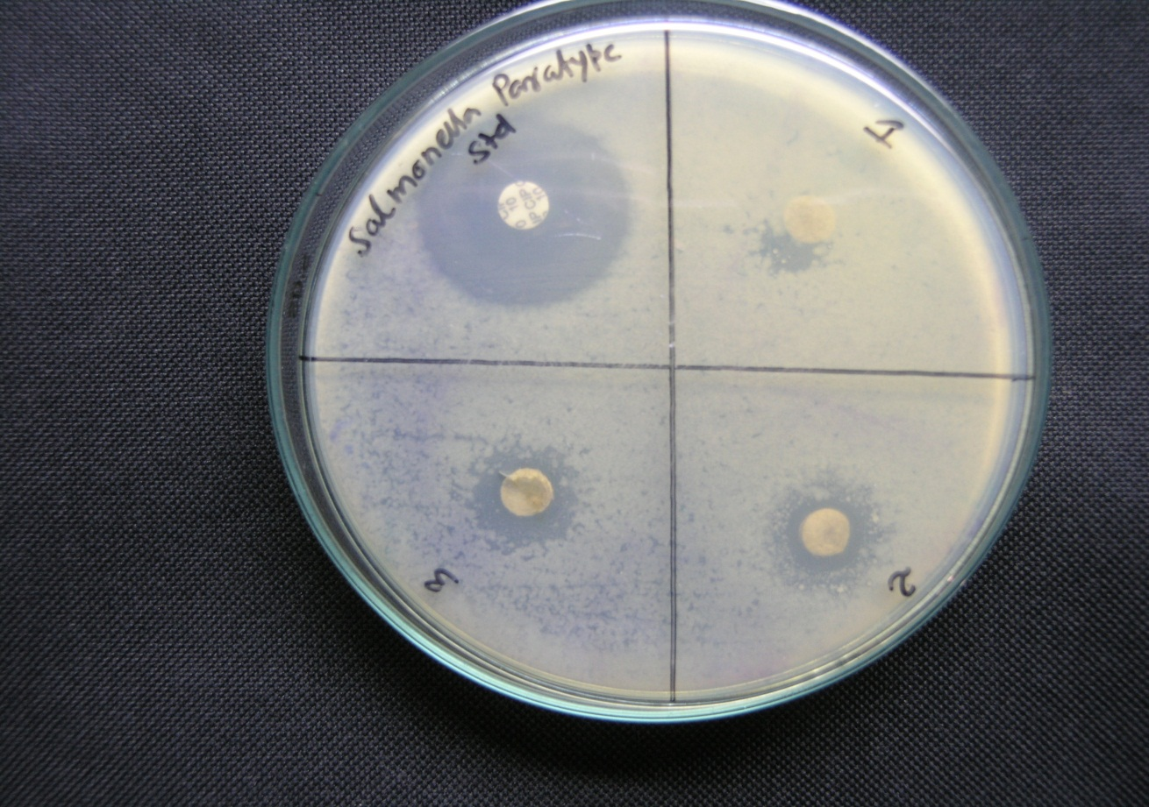
Figure 17. Antibacterial activity of 1) F1 2)F6 3) F16 against Salmonella paratypi.
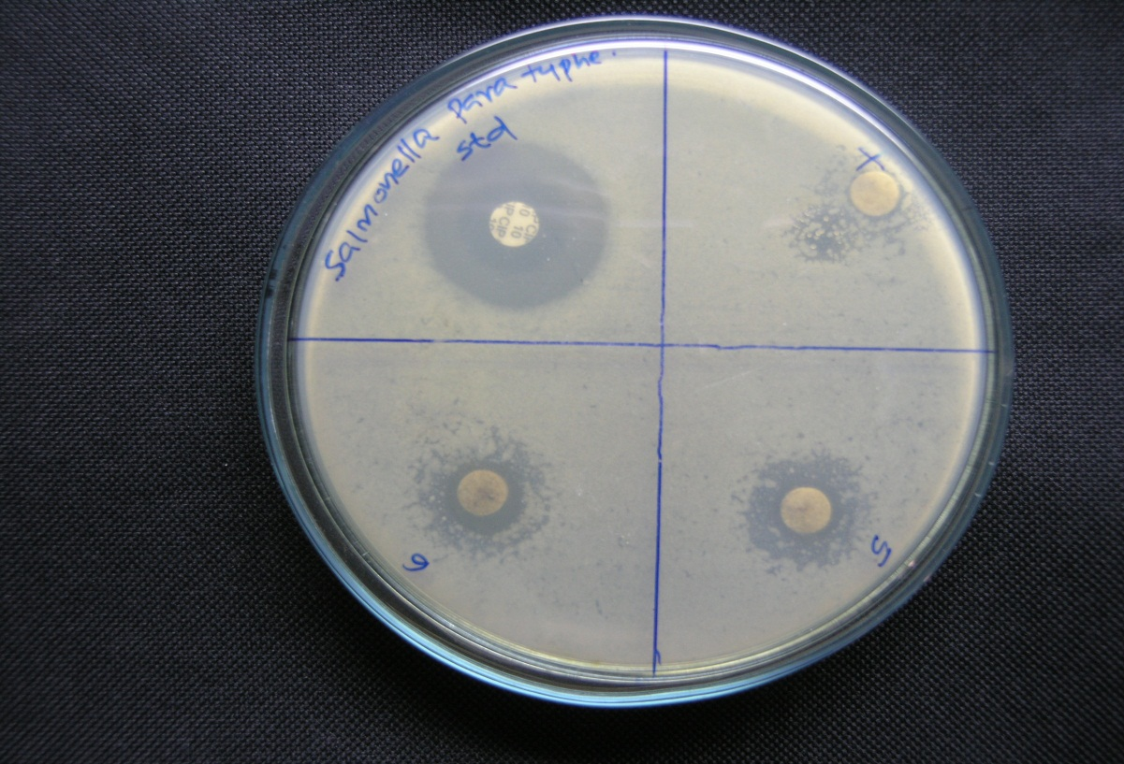

Figure 18. Antibacterial activity of 4) F25 5)F29 6)F31 against Salmonella paratypi.
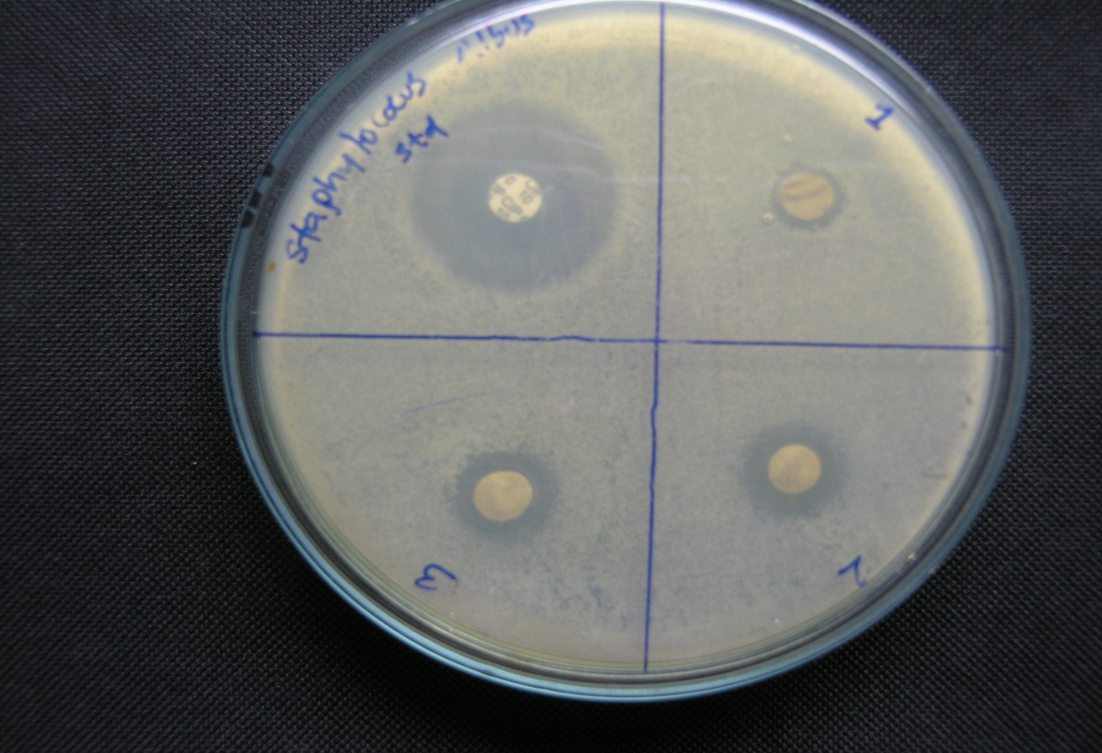

Figure 19. Antibacterial activity of against 1) F1 2) F6 3) F16 Staphylococcus albus .

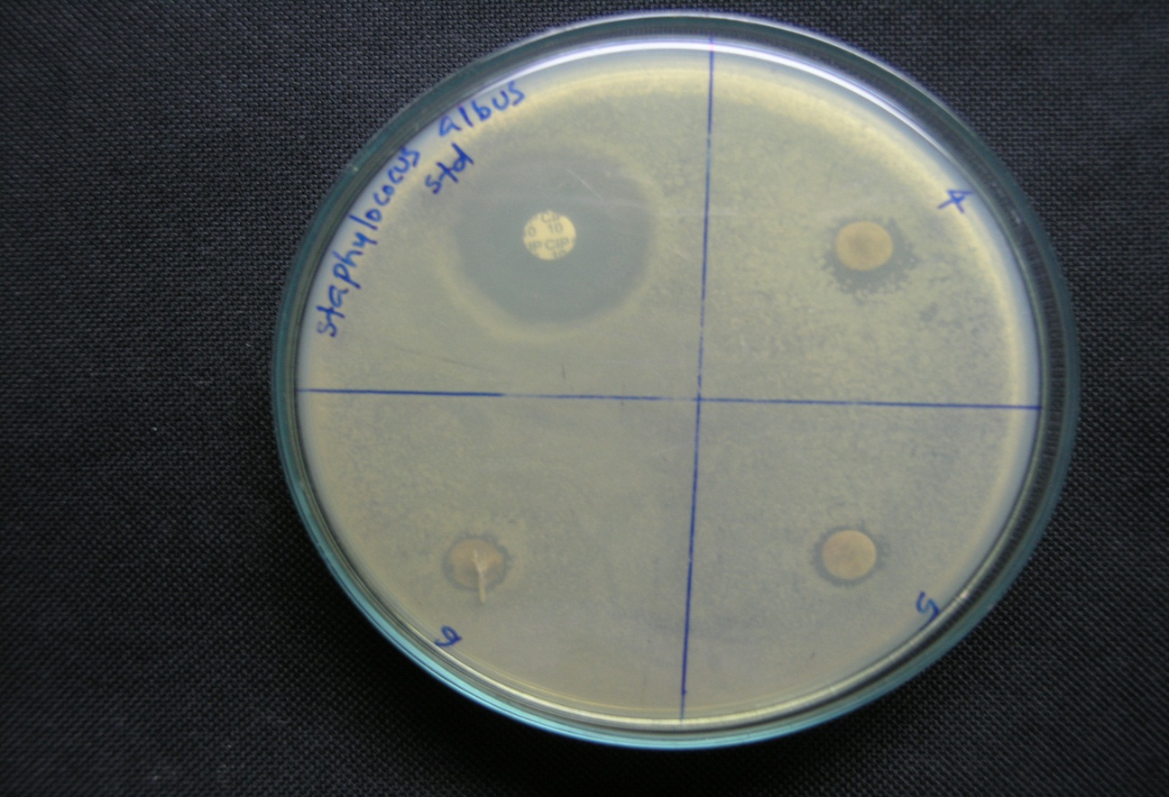
Figure 20. Antibacterial activity of 4) F25 5) F29 6) F31 against Staphylococcus albus
4.6Anti fungal activity
The various plant extract were screened for their anti fungal activity against M.purpureus, C.albicans, A.paracitus. 100 μg solution of extract were compared with (10 μg) standard ciprofloxancinand observed the zone of inhibition produced by different antibiotics. Measured using a scale and record the average of two and diameters of each zone of inhibition. The zone of inhibition of standard and that of polyherbal formulations were compared and analysed as per standards (Prabavathi,1993).
It is well evident from the results (Table 11) that the formulation F6 had highest antifungal activity against M.Purpureus and Candida albicans. The percentage antifungal activity of F29 was found to be that of the standard at the studied concentrations. These suggest the good antifungal activity of the formulations and hence water hyacinth which is normally considered a menace can be well exploited for its pharmaceutical significance.Table 11. Table antifungal activity of 1) F1 2) F6 3) F16 4) F25 5) F29 6)31
Fungi | Samples (100 μg)  (mm) |  |  |  |  |  | STD  Clotrimazole  (10μg/disc)  (mm)
Fungi | F1 | F6 | F16 | F25 | F29 | F31
M.purpureus | 08 | 11 | 10 | 08 | 08 | 10 | 15
C.albicans | 10 | 12 | 09 | 09 | 09 | 10 | 12
A.paracitus | 10 | 10 | 09 | 07 | 11 | 09 | 11
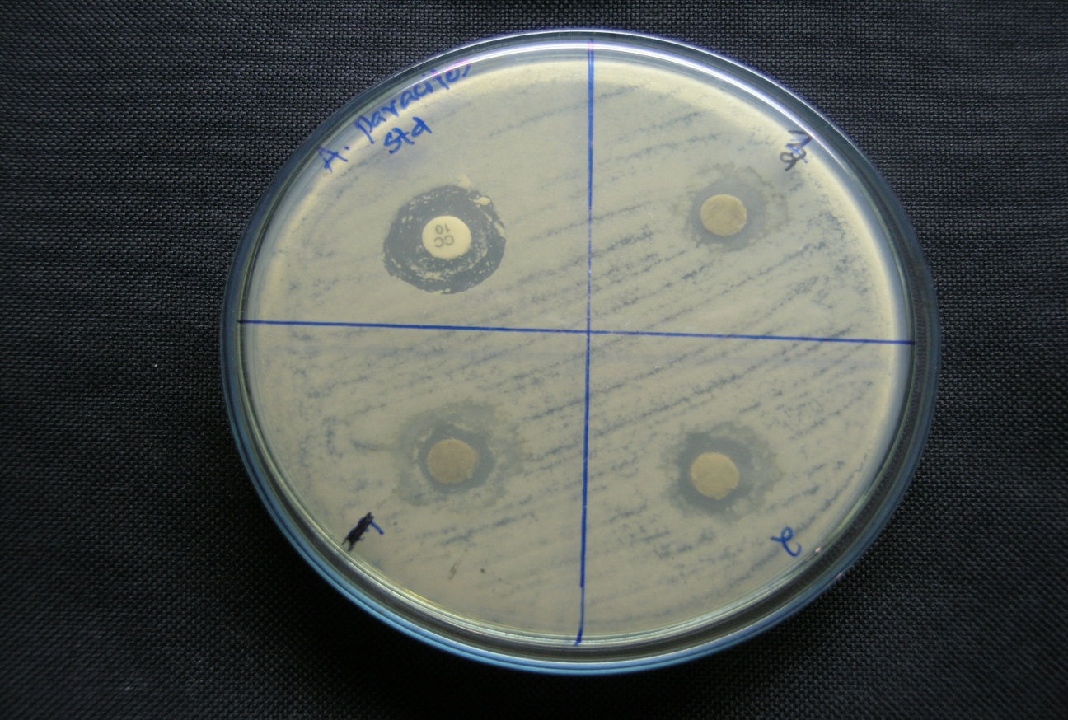

Figure 21. Antifungal activity of 1) F1 2) F6 3) F16 of against Aspergillus paracitus
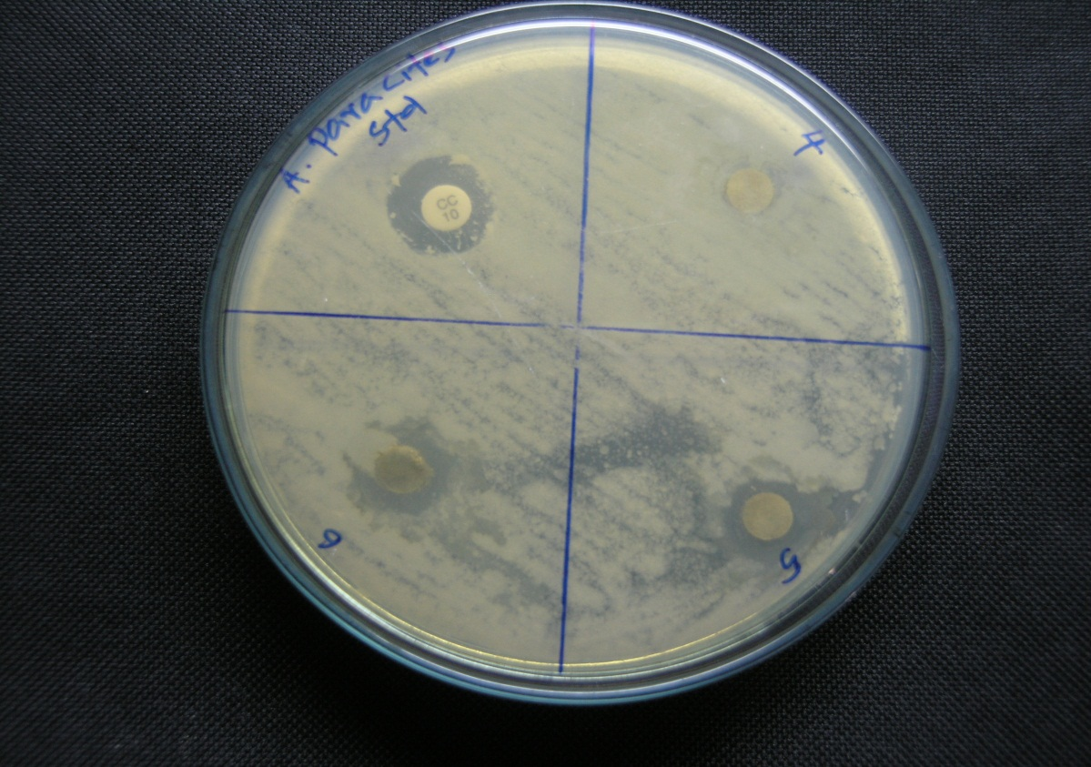

Figure 22. Antifungal activity of 4) F25 5) F 29 6) F31 against Aspergillus paracitus
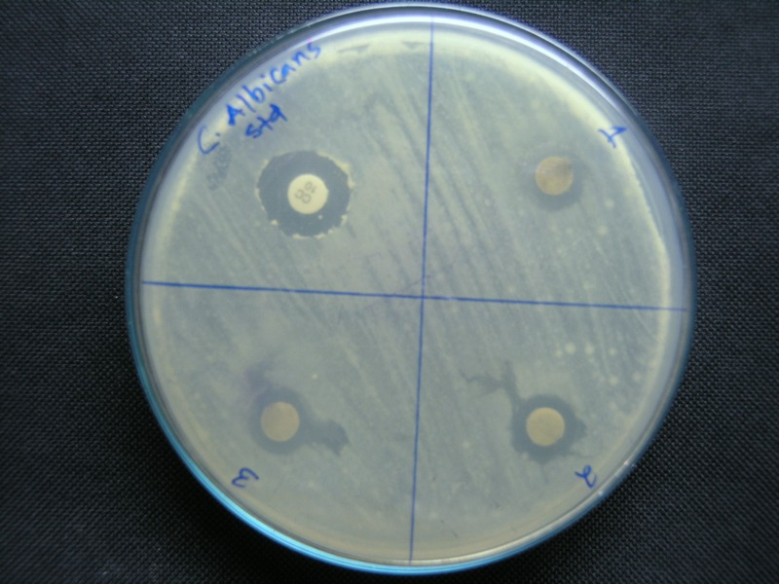

Figure 23. Antifungal activity of 1) F1 2) F6 3) F16 of against Candida albicans

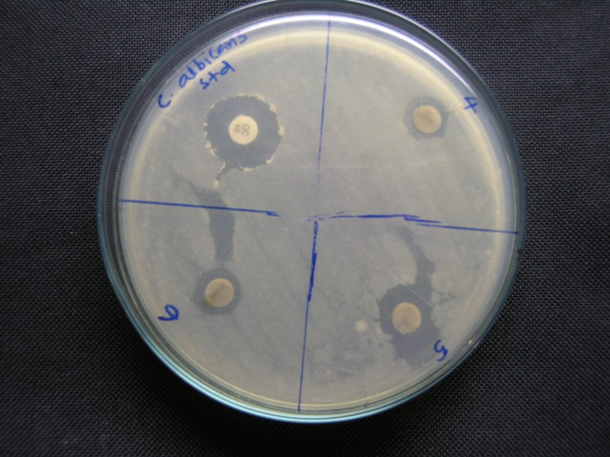

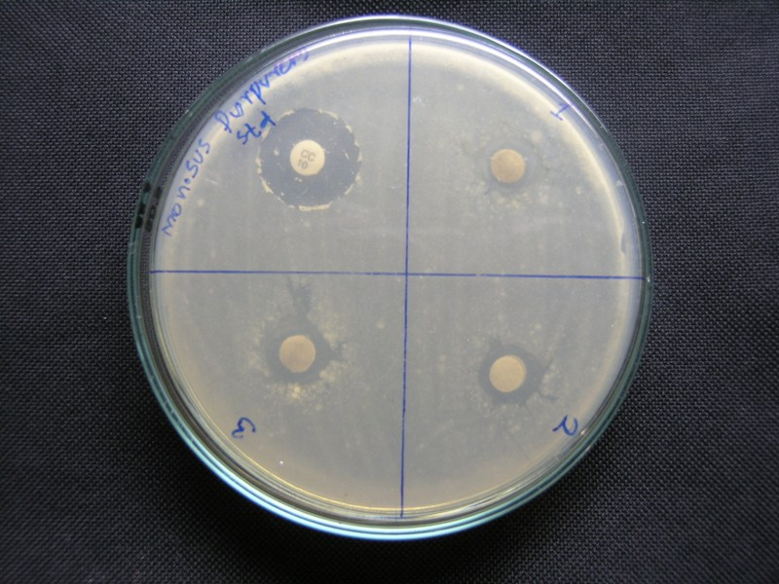
Figure 24. Antifungal activity of 4) F25 5) F 29 6) F31 against s Candida albicans

Figure 25. Antifungalactivity of 1) F1 2) F6 3) F16 of against Monosu purpureus
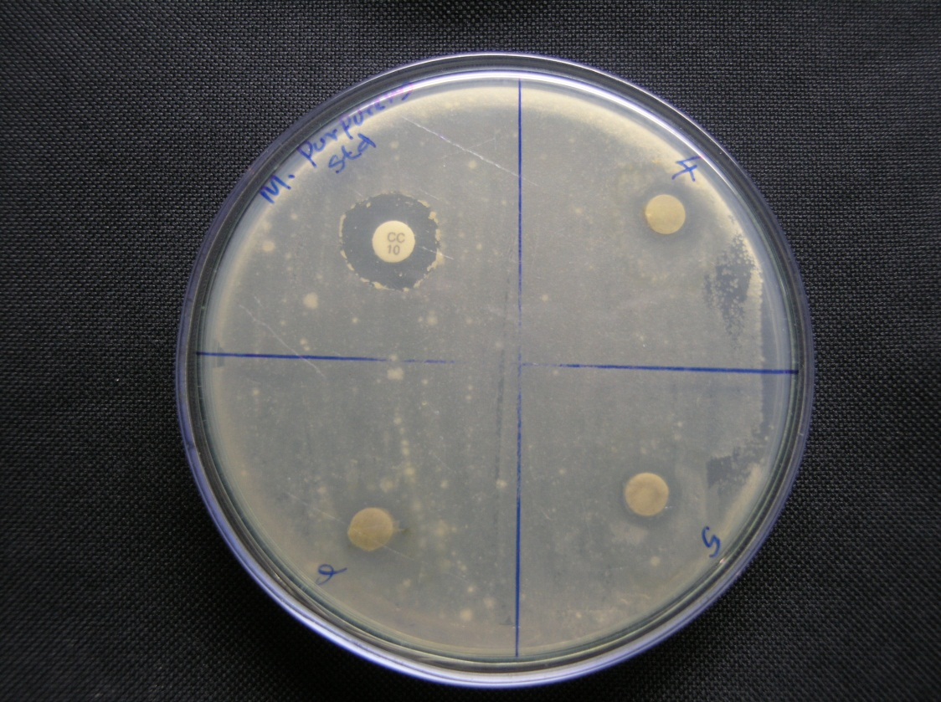

Figure 26. Antifungal activity of 4) F25 5) F 29 6) F31 againstMonosu purpureus

SUMMARY AND CONCLUSION

5. SUMMARY AND CONCLUSION

The summary of the present work on “Invitro antioxidant testing and antimicrobial activity of polyherbals formulation of waterhyacinth” and relevant conclusions are given below:

- Thirty one polyherbal formulations were prepared out of the extracts of water hyacinth (85%) and 15% other herbs like tulsi, methi, aloevera, broccoli, coriander were prepared using water as solvent.
- The aqueous extract of these herbs were prepared by sonicating the plant material with water for one hour which yielded 200mg to 17g of aqueous extract.
- The various formulations of water hyacinth prepared, were screened for the presence of phytochemicals using standard colour tests. The phytochemical screening of ethylacetate extract of water hyacinth showed the presence of phenol and anthraquinone.
- It was noted that in the formulations F2 to F6 secondary metabolites like alkaloids, flavonoids, Saponins and steroids were additionally present. In formulations F4 and F6 terpenoids, carbohydrates and anthraquinones were absent. Also Anthraquinone present in F1 was found to be absent in F3-F6. This may be due to the interaction of these metabolites with other molecules of the extract.
- The antioxidant capacity of the prepared poly herbal formulations of water hyacinth have been assessed by two methods: DPPH assay and reducing power assay.
- The results show that only waterhyacinth extract showed very less antioxidant activity while in all polyherbal formulations the activity increased several times which is attributed to the synergistic effect of the chemical constituents present in the formulations.
- The reducing power assay of the formulations showed better absorbance compared to water hyacinth.
- The polyherbal formulations made of water hyacinth , Tulsi , Methi, Coriander, Broccoli and Aloe Vera were tested for antibacterial and anti fungal activity against two bacteria Salmonella paratypi, Staphylococcus albus and three fungi M. purpureus, Candida albicans, A.parasites.
- The activity of the extract increased depending upon the concentration of the extract.
- Water extract showed significant activity against Salmonella paratyphi, Staphylococcus albus,Monosus purpereus,Aspergilus paracites,Candida albicans.
It can be concluded that the polyherbal formulations of water hyacinth (85%) and 15 % of other herbs gave synergistic antioxidant effect. Thus these extract mixtures gave a promising result for antioxidant activity and in future they can be subjected for treatment of disease where the basis of disease has oxidative stress mechanism.



REFERENCES

REFERENCES
- Agbor A., Dieudonne K., Julius E., (2007) “Medicinal Plants Can Be Good Source of Antioxidants: Case Study in Cameroon” Pakistan journal of biological science, vol 10: 537-544.
- Ahmad M., Aboul-Enein., Ahmad M., Emad A, Shalabay., Faten Abul-Ela., Nasar-Allah A., Mahmound A., and Hany A.El-Shemy., (2011), ”Eichhornia crassipes(mart)Solms from water parasite to potential medicinal remedy”, Plant signaling and behavior, 6(6): 834-836.
- Ali H, Ganesh N, Ahi JD, Antioxidant activities of Eichhornia crassipes (waterhyacinth) leaf extract by the DPPH free radical method: The World’s worst aquatic plant, J of Ultrachemistry, 5, 2009.
- Anna Floegel M, Dar-Ok Kim., Sang-jinching., Sung I., Ki Chun O., (2011), ”comparison of ABTS/DPPH assay to measure antioxidant capacity in popular antioxidant –rich U.S foods” Journal of food comparison and analysis, 24: 1043-1048.
- Bafna P.A., and Balaraman R., (2004), “Anti-ulcer and antioxidant activity of DHC-1*, an herbal formulation’’ Journal of Ethnopharmacology, Journal of Pharmaceutical and Biomedical Analysis, 40 (2006): 460–464.
- Balaraman R., (2004) “Anti-ulcer and antioxidant activity of DHC-1*, a herbal formulation’’” Journal of Ethnopharmacology ,90: 123-127.
- Bhat Vishnu,Asuti Naveen., Kamat Akshay.,Sikarwar Mukesh., Patel -M.B., (2010), ”Antioxidant activity of insulin plant leaf extract in diabetic rats”, Journal of pharmacy research, 3(3): 608-611.
- Bodo R, Azzouz A, Hausler R, Antioxidative activity of waterhyacinth components, Plant Science, 166, 2004, 893–899.
- Byers N.T., and Guerrero N., (1995)., "Epidemilogic evidence for vitamin C and vitamin E in cancer prevention” American J. Clin.Nutr, 62: 1385-1392.
- Chandrasekar D., Madhusudhana K., Ramakrishna S., Prakash V., (2006), ’’Determination of DPPH free radical scavenging activity by reversed-phase HPLC: A sensitive screening method for polyherbal formulations Journal of Pharmaceutical and Biomedical Analysis’’ Biomedical Analysis, 40(2006) :460–464.
- Dash B.K., Faruquee H.M., Biswas S.K., Alam M.K., Sisir S.M., Prodhan U.K., 2011, “Antibacterial and Antifungal Activities of Several Extracts ofCentella asiatica’’Journal of Experimental Pharmacology , 2011: 19–27.
- Dash H.M., Faruquee S.K., Biswas M.K., Alam S.M., Sisir., and UK Prodhan, (2011), “Antibacterial and Antifungal Activities of Several Extracts of Centella asiatica L. against Some Human Pathogenic Microbes” Journal of Experimental Pharmacology, 2010(2): 19–27.
- Dipen N., Anil V., Pethe M., and Chakraborthy G., (2010), “antioxidant activity of polyherbal formulation” Journal of pharmacy research, 3(8):1756-1758.
- Indulatha V.N., Gopal N., Jayakar B, 2011, Screening of antibacterial activity of some newly synthesised N-(4’oxo-2’-(aryl/alkyl substituted) thiazolidin-2-one) -3-carboxamido-2H-chromen-2-ones, Der Chemica Sinica, 2011, 2(6):48-57.
- Ilavarasan R., Mallika M., and Venkataraman S., 2005’’ Anti-inflammatory and antioxidant activities of cassia fistula linn extracts’’ Research article ,2 (1): 70 - 85.
- Jadeja D., Jigna P., Sumithra C. ,(2005), “ Efficiency of aqeous extract Journal of Tibitak, 29(2005): 203 210.
- Jain. P.K., and Agarwal R.K., (2008), ”Antioxidant and free radical scavenging properties of developed mono and polyherbal formulations”, Asian j.exp.sci,22: 213-220.
- Jayanthi P and P.Lalitha, DPPH scavenging assay of the solvent extracts and fractionates of Eichhornia crassipes (Mart.) Solms, 2012, Journal of Pharmacy Research , 5(2):946-948.
- Khaing T. A., (2011) “Evaluation of the antifungal and antioxidant activities of the leaf extract of Aloe Vera” World academy of science, engineering and technology75: 610-612.
- Kirzhner F., ZimmelsY., Malkovskaja A., Starosvetsky J., (2008), “Removal of microbial biofilm on Water Hyacinth plants roots by ultrasonic treatment Ultrasonics’’ ScienceDirect , 49 (2009): 153–158.
- Kumar. B.A., Lakshman K., Narayan Swamy V., Khan S., Tripathi M.S., and Deep L., (2009), ’’Free Radical Scavenging and Antibacterial Activities of Amrycard Powder (A Ayurvedic Formulation)’’ The Internet Journal of Alternative Medicine, 7: 11141-1148,
- Lai W Chan., Emily L.C., Saw L.L.,Wanyu W., and Paul W.S ., (2008), “Antimicrobial and antioxidant activities of Cortex Magnoliae Officinalis and some other medicinal plants commonly used in South-East Asia’’ Chinese Medicine,1749(8546): 3-15.
- Liu CC, Zhao GL, Li YN, Ding ZP, Liu QG, Li JL, Contribution of phenolics and flavonoids to anti-oxidant activity and of ethanol extract from Eichhornia crassipes ,Adv Mater Res, 156 – 157, 2010, 1372-1377
- Meera.S., Guptha A., and N.S.Kumar., (2008), ’’Immuno modulatory and Antioxidant Activity of poly herbal formulation’’ International Journal of Pharmacology, 4(4): 287-291.
- Mitra, S.K., Venkataranganna, M.V., Sundaram, R., and Gopumadhavan S., (2008), ’’Antioxidant Activity of AO-8*a herbal formulation in vitro and in vivo experimental models’’ Journal of food and drug analysis,13: 300-303.
- Odjegba. V.J. and Fasidi I.O., (2007), ’’ Changes in antioxidant enzyme activities in Eichhornia crassipes’’Rev. Biol. Trop. (Int. J. Trop. Biol. ISSN, 55 (3-4): 815-823.
- Pathak Nimish L., Kastura Sanjay B., Bhatt Nayana Mand R., (2011), ”Phytopharmacolgical properties of coriander sativum as a potential medicinal tree:an overview” Journal of applied pharmaceutical science, 01(04): 0-25.
- Priyabrata P., ,Prithwiraj M., ,Rajat k., Sathyabrata B. ,Debendra M., (2010) ”Antiulcer and antioxidant activity of alcoholic extract of poly herbal formulation” Journal of pharmacy research 3(2): 405-410.
- Prabavathi Nagarajan, 1993, Ph.D Thesis, Bharadhidasan University, Tiruchirapalli, South India.
- Rahul V., MandlikV.R., Sandya K., Desai and Suresh R.,(2008), ”Antioxidant activity of polyherbal formulation (DRF/AY/5001)” Indian journal of experimental biology46: 599-606.
- Rejesh K., Satish K., Harsha B.P., Dinesha.R, Iyan A M., Thammana Gowda S.S., and Hareesh A.R., (2010), ”In vitro antioxidasnt activity leaves of menthja trevensis linn” Journal of pharmacy research, 3(8): 1951-1954.
- SajeethC., Manna P., Manavalan R., Jolly C., (2010), “Antidiabetic activity of a polyherbal formulation,esf/ay/500 in streptozotocin induced diabetic malealbino rats: a research’’ International Journal of Drug Formulation & Research, 1(1): 311-322.
- Satyakumar V., Puttanarasaiah M.,,Pralhad S Patki., (2009), ’’ Cystone – An ayurvedic polyherbal formulation inhibits adherence of uropathogenic E. coli and modulates H2O2-induced toxicity in NRK-52E cells’’ Journal of experimental pharmacy, 2010(2): 19-27.
- Shaheen Lipika Quayum ,(2007), ”Effect of water hyacinth root extract on arsenic level in different organs of arsenic-treated rat ’’ Bangladesh J Pharmacol, 2: 73-80 .
- Silvane V., Jose C., Cleberson R., Juraci A., Oliveira., Marco A., Oliva., (2011), ’’Cadmium induced Oxidative Stressand Antioxidative Enzyme Response in WaterHyacinth and Salvinia’’ Plant Physiol., 23(2): 131-139.
- Sudhakar Pemminati, Gopalakrishna H.N., Ashok K Shenoy, Sudhanshu Sekhar Sahu, ShishirMishra, Vinayak Meti, Nair Vinod,2010.’’antidepressant activity of aqueous extract of fruits of emblica officinalis in mice’’ ISSN 0976-4550.
- Suhanya Parthasarathy , Juzaili Bin Azizi , Surash Ramanathan , Sabariah Ismail Sreenivasan Sasidharan , Mohd Ikram Mohd. Said and Sharif Mahsufi Mansor ,2009’’ Evaluation of Antioxidant and Antibacterial Activities of Aqueous, Methanolic and Alkaloid Extracts from Mitragyna Speciosa (Rubiaceae Family) Leaves’’ Molecules 14, 3964-3974.
- Sweety Lanjhiyana,Debapriya Garabadu,Dheeraj Ahirwar,Avyar chanal rana,Bharati Ahirwar and Sanjay Kumar Lanjhiyana,”Pharmacognistic standardization and hypoglycemic evaluation of novel polyhedral formulation”
- Teklehaymanot T., and Giday M., (2007), “Ethnobotanical study of medicinal plants used by people in ZegiePeninsula, North Western Ethiopia”Journal of ethnomedicne, 1746(4269): 3-12.
- Tembhurne. S.V., A.G. Jagtap1, D.M. Sakarkar, 2009’’ notropic effect of mp-1: a polyherbal formulationon cognitive deficit induced by hypoxia and itsantioxidant potential’’, Journal of Herbal Medicine and Toxicology, 3 (2) 67-72.
- Tzong J., Lien Lee H., Chiang S.H., Fang-Ilen., and Yue Chang C., (2001), ”Antioxidant properties of the extracts from different parts of broccoli in Taiwan” Journal of food and drug analysis l9: 96-101.
- Ummamaheswari S., Prathiba D., Srikanth.A., Ummamaheshwari R., (2009), “Antioxidant potential of polyherbal formulation(diabetes) an alloxan induced oxidative stress in rats” Drug invention today 1(1): 46-49.
- Vyas. J.C., Itankar P.R., Agrawal M.N., . Kelkar A.J. and Patil A.T., (2007), ’’Pharmacological standardization of triphala guggul tablets - a polyherbal formulation’’ Journal of research education indian medicinal plants, 3(2): 87-95.
- Weed Science Society of Amercia (WSSA). (1984) “Composite list of weeds” Weed science, 32: 1.
- Zhang Y., Talala p., Cho C., and Posner G.H .,(1992), “A major inducer of anti-carcinogenic protective enzyme from broccoli: isolation and elucidation of structure” Proc.Natl.Acad.Sci. 89: 2399-2403.
BIBLIOGRAPHY
- Dure,James A.1083.Handbook of Energy Crops.
- Kokate.CK,1994,Practical pharmacognosy Ed 4,Vallabh Prakashan
- Phytochemical methods, a guide to modern techniques of plant analysis
  - By Jeffrey B.Harborne,2007.
- Phytochemical Techniques by Raaman,N.2008 by New India Publishing
  - Agency.
- Trease.G.EandW.C Evans,1984,”Text book of pharmacognosy”, Edition
  - 12,Balliere Tinad,London-257.
- http://www.wikipedia.com
- http://www.springerlink.com

