

Avinashilingam Institute for Home Science and Higher Education for Women
(Deemed to be University under Category ‘A’ by MHRD, Estd. u/s 3 of UGC Act 1956)
Re-accredited with ‘A+’ Grade by NAAC. Recognised by UGC Under Section 12B
Coimbatore - 641 043, Tamil Nadu, India

Master’s Degree Examination – November 2019
III -Semester

Class : II PG Time: 3 hours Major : Information Technology Max. Marks: 60

17MITC17–Digital Image Processing
Course Outcomes:
- Understand the principles and application of digital image processing.
- Gain knowledge on properties and various image transformation techniques.
- Evaluate various image enhancement and restoration techniques.
- Analyze various compression techniques and standards.
- Use different segmentation approaches to digital image processing.

Part A 10 x ½ =5
Choose the correct answer

1. 1024 x 1024 image has a resolution of____ . CO1K2
a. 1048576 b. 1148576 c. 1248576 d. 1348576

2. In the Visible spectrum the ______ colour has the maximum wavelength. CO1K1
a. Violet b. Blue c. Red d. Yellow

3. ___ transform is developed to explain the temperature and heat conduction. CO2K2
- Slant b.Haar c. Fourier d. Hotelling
4. _______is used to increase or decrease the size of an image. CO2K1
- Scaling b. Conjugate c. Rotation d. Folding
5. The smallest discernible change in intensity level is called ____________. CO3K3 a. Intensity Resolution b. Contour c. Saturation d. Contrast
- Intensity between the highest and the lowest intensity levels in an image is ___ CO3K2
a. Noise b. Saturation c. Contrast d. Brightness
7. Every run length pair introduce new_______. CO4K1
a. pixels b. matrix c. frames d. intensity

8. Compression is done for saving __________ . CO4K4
a. Storage& Bandwidth b. Time c. Effort d. Money

9. Points other than exceeding threshold in output image are marked as____ CO5K4
a. 0 b. 1 c. 11 d. x

10. Image segmentation is also based on_______. CO5K1
a. morphology b. set theory c. extraction d. recognition

Part B 5 x 4 = 20
Answer ALL questions
Each answer should not exceed 200 words or one page

11.a.Define Digital Image Processing along with its applications. CO1K1
(or)
11.b. Demonstrate luminance, brightness and contrast with suitable image. CO1K3

12.a. Illustrate the steps involved in Discrete Wavelet Transform. CO2K3
(or)
12.b. Summarize the usage of Slant Transform. CO2K5

13.a. Review the impact of Spatial Averaging in enhancing the image quality. CO3K2 (or)
13.b. Survey the need for Blur removal in the existing image. CO3K4

14.a. State the executional process of Arithmetic Coding . CO4K1
(or)
14.b. Express MPEG Coding in brief. CO4K6

15.a. Discuss Feature Threshold in brief. CO5K4
(or)
15.b. Recall the methods exist to select Threshold. CO5K1

Part C 5 x 7 = 35
Answer ALL questions
Each answer should not exceed 600 words or three pages

16.a. Describe the elements of Digital image Processing. CO1K2
(or)
16.b. List out the advantages and implementation procedure of Fourier transform. CO1K3

17.a.Analyze the functionality of Hotelling Transform. CO2K4
(or)
17.b.Represent the applicability of SVD Transform in detail. CO2K2

18.a. Explain the process of Intensity Level Slicing method. CO3K2
(or)
18.b. Discuss the process of Wiener Filtering. CO3K2

19.a.Generalize the process of Huffman Coding. CO4K6
(or)
19.b.Outline the procedure defined for Run Length Coding. CO4K4

20.a.Write short notes Optimum Threshold with example. CO5K2
(or)
20.b. Examine the Region Splitting and Region Merging with example. CO5K1

*********

Class : PG Time: 3 hours Major : Information Technology Max. Marks: 60

17MITC17 – DIGITAL IMAGE PROCESSING ( SCHEME – SET A)
Part A
- A) 1048576
- C) Red
- C) Fourier
- A) Scaling
- A) Intensity Resolution
- C) Contrast
- D) Intensity
- A)Storage & Bandwidth
- A) 0
- A) Morphology

Part B
- A)A digital image is a representation of a two-dimensional image as a finite set of digital values, called picture elements or pixels.
Digital image processing focuses on two major tasks
  - Improvement of pictorial information for human interpretation
  - Processing of image data for storage, transmission and representation for autonomous machine perception.
Applications:
  - Imaging modalities
  - Image Enhancement
  - The Hubble Telescope
  - Artistic Effects
  - Medicine
  - Geographic Information Systems
  - Industrial Inspection
  - Printed Circuit Board (PCB) inspection
  - Law Enforcement
B)Luminance
  - It is often used to characterize emission or reflection from flat, diffuse surfaces. Luminance levels indicate how much luminous power could be detected by the human eyelooking at a particular surface from a particular angle of view. Luminance is thus an indicator of how bright the surface will appear. In this case, the solid angle of interest is the solid angle subtended by the eye's pupil.

Image Brightness
Brightness of a grayscale image is the average intensity of all pixels in image
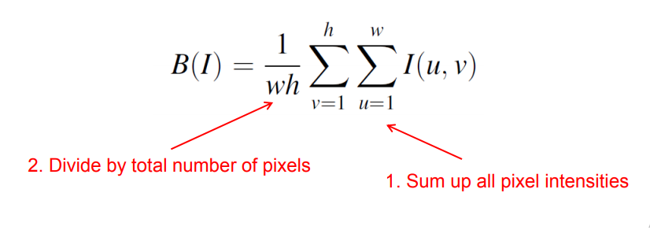
Image Contrast
The contrast of a grayscale image indicates how easily objects in the image can be distinguished .
High contrast image: many distinct intensity values
Low contrast: image uses few intensity values
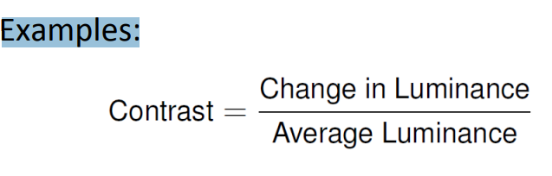
- A)Discrete Wavelet Transform
Wavelet series expansion

where j₀ is an arbitrary starting scale is called the approximation or scaling coefficients

called the detail or wavelet coefficients .

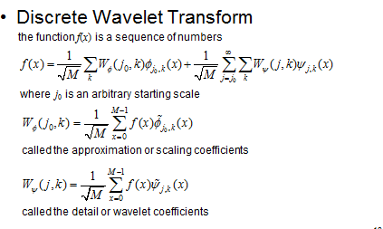

B) Slant Transform

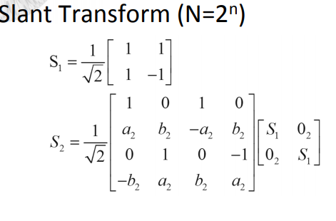

Slant Transform Properties:
– Real and Orthogonal S=S* S-1=ST
– Fast
– Very Good Compactness

- A) Spatial Averaging

One of the simplest spatial filtering operations we can perform is a smoothing operation
  - Simply average all of the pixels in a neighbourhood around a central value
  - Especially useful in removing noise from images
  - Also useful for highlighting gross detail
  - It is classified as Simple averaging filter and Weighted averaging filter
- Spatial smoothing may be viewed as a process for estimating the value of a pixel from its neighbours.

B) Removal of Blur
In contrast to image enhancement, in image restoration the degradation is modelled. This enables the effects of the degradation to be (largely) removed.
The objective is to restore a degraded image to its original form. An observed image can often be modeledas:
where the integral is a convolution, h is the point spread function of the imaging system, and n is additive noise. The objective of image restoration in this case is to estimate the original image f from the observed degraded image g.
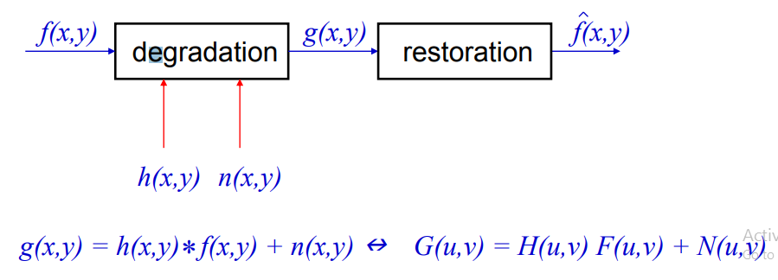
f(x, y) - source image (non-blurred)
h(x, y) - blurring function
n(x, y) - additive noise
g(x, y) - blurring result image
Form the blurring process model in the following way:
g(x, y) = h(x, y) * f(x, y) + n(x, y)
- A) Arithmetic coding

Sequence: S1 S2 S3 S4 ….
Each possible sequence gets mapped to a unique number in [0,1)
The mapping depends on the prob. of the symbols
Need not to a priori determine all possible mappings
The Mapping is “built” as each new symbol arrives
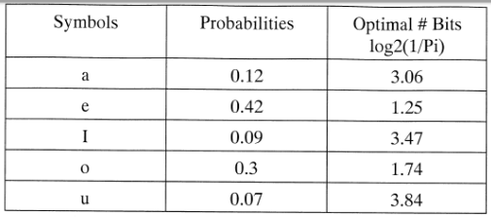
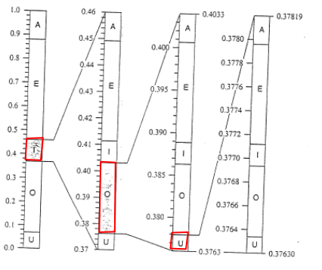
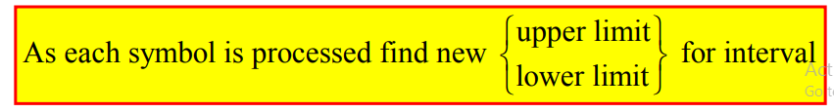
Advantages
Efficiency:
Higher Order Models

B)MPEG Coding
- A sequence of 2D images
- Temporal correlation as well as spatial correlation
- TV broadcast
  - Frame-based
  - Field-based
- Moving Picture Experts Group
- Standard for video compression
- Similarities with JPEG
- Design is a compromise between
  - Bit rate
  - Encoder/decoder complexity
  - Random access capability
- Images
  - Spatial redundancy
  - Perceptual redundancy
- Consider a sequence of n frames of video.
- It consists of:
  - I-frames
  - P-frames
  - B-frames
- A sequence of one I-frame followed by P- and B-frames is known as a GOP
  - Group of Pictures
  - E.g. IBBPBBPBBPBBP
- A)Feature Threshold:

Individual pixels in an image are marked as “object” pixels if their value is greater than some threshold value and as “background” pixels otherwise → threshold above

– assuming an object to be brighter than the background
– Variants
• threshold below, which is opposite of threshold above;
• threshold inside, where a pixel is labeled "object" if its value is between two thresholds
• threshold outside, which is the opposite of threshold inside
– Typically, an object pixel is given a value of “1” while a background pixel is given a value of “0.”
Finally, a binary image is created by coloring each pixel white or black, depending on a pixel's label.

- Histogram shape-based methods
- Clustering-based methods
- Entropy-based methods
- Object attribute-based methods
- Stochastic methods
- Local methods

B) Threshold Selection Methods
unimodal image is an algorithm for automatic image threshold selection in image processing.unimodal image threshold selection algorithms are
T-point algorithm
maximumdeviation algorithm
Rayleigh distribution model algorithm

Part C
- A)Elements of Digital Image Processing

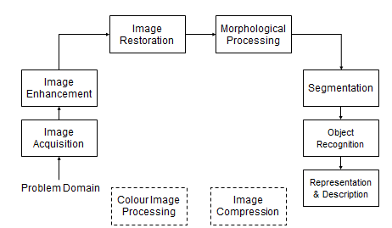
B) Fourier Transform
The Fourier transform G(k) and the original function g(x) are both in general complex.
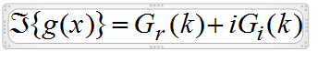
The Fourier transform can be written as,
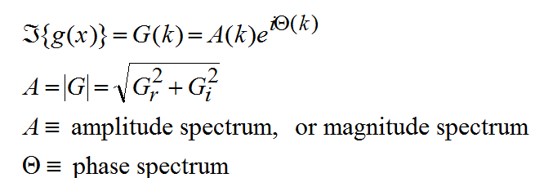
The Fourier transform G(k) has a particularly simple form when g(x) is purely real
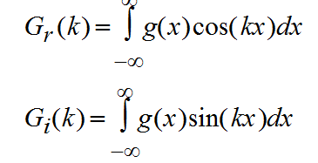
So the real part of the Fourier transform reports on the even part of g(x) and the imaginary part on the odd part of g(x).

- A)Hotelling Transform

  - It is also called as KL Transform or Principle Component Analysis (PCA)
  - Eigen decomposition of R_{x}: R_{x}u_{k} = λ_{k}u_{k}
  - Recall the properties of R_{x}
    - Hermitian (conjugate symmetric R^{H} = R);
    - Nonnegative definite (real non-negative eigen values)
Karhunen-LoeveTransform (KLT)
y = U^{H} xx = U y withU = [ u₁, …u_{N}]
  - KLT is a unitary transform with basis vectors in U being the orthonormalized eigenvectors of R_{x}
  - U^{H} R_{x} U = diag{λ₁, λ₂, … , λ_{N}} i.e. KLT performs decorrelation
  - Often order {u_{i}} so that λ₁≥λ₂≥ … ≥λ_{N}
Properties
- Decorrelation

  - E[ yy^{H} ]= E[ (U^{H} x) (U^{H} x)^{H} ]= U^{H} E[ x x^{H}] U= diag{λ₁, λ₂, … , λ_{N}}

- Minimizing MSE under basis restriction

  - If only allow to keepm coefficients for any 1≤ m ≤N, what’s the best way to minimize reconstruction error?

B)SVD
A technique for handling matrices (sets of equations) that do not have an inverse. This includes square matrices whose determinant is zero and all rectangular matrices.
Common usages include computing the least-squares solutions, rank, range (column space), null space and pseudoinverse of a matrix.The Singular Value Decomposition (SVD) of a rectangular matrix A is a decomposition of the form A = U S V^{T},U and V are orthogonal matrices and S is a diagonal matrix
The singular vectors form orthonormal bases, and the important relation A v_{i} = s_{i}u_{i} shows that each right singular vectors is mapped onto the corresponding left singular vector, and the "magnification factor" is the corresponding singular value.
SVD is sufficient and is the most optimal in given image. It is packed with energy in a given number of transformation coefficients is maximized.Easy to calculate.
Derivative steps :
    - Reduce the initial matrix to bidiagonal form using Householder transformations
    - Diagonalize the resulting matrix using QR transformations

- A)Intensity Level Slicing

Contrast Stretching:
improves the contrast in an image by stretching the range of intensity values to span a desired range of values.
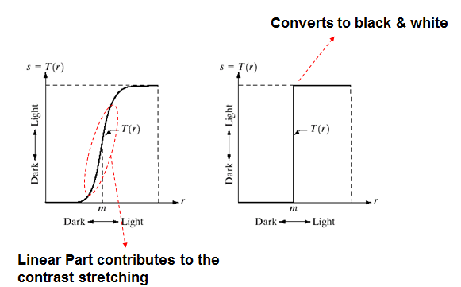

B)Weiner Filtering
The Wiener filtering is optimal in terms of the mean square error.
In other words, it minimizes the overall mean square error in the process of inverse filtering and noise smoothing.
The Wiener filtering is a linear estimation of the original image.
The approach is based on a stochastic framework.

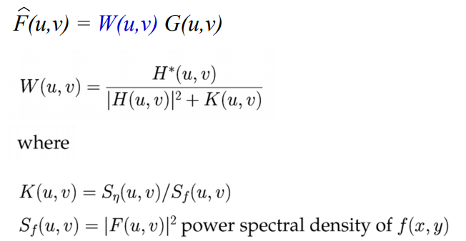

Frequency behaviour
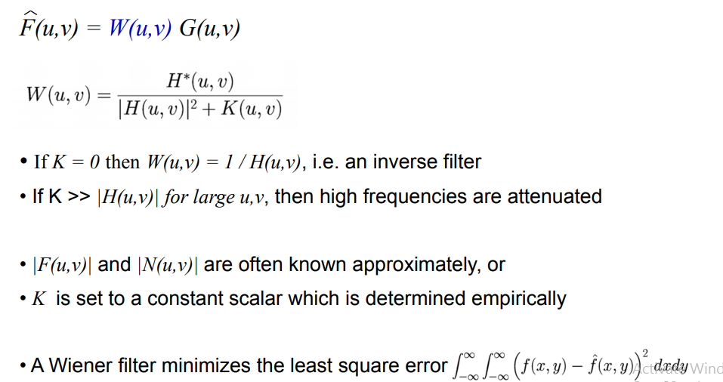
- A)Huffman Coding
A variable-length coding technique.
Source symbols are encoded one at a time!
There is a one-to-one correspondence between source symbols and code words.
Optimal code - minimizes code word length per source symbol.

  - Forward Pass
1. Sort probabilities per symbol
2. Combine the lowest two probabilities
3. Repeat Step2 until only two probabilities remain.
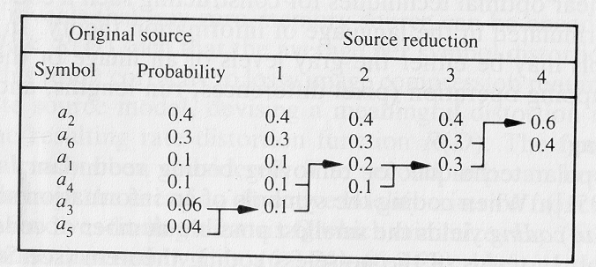
- Coding/Decodingcan be implemented using a look-up table.
- Decoding can be done unambiguously.

B)Run Length Coding
Reduce the size of a repeating string of symbols (i.e., runs):

1 1 1 1 1 0 0 0 0 0 0 1 (1,5) (0, 6) (1, 1)
aaa b bbbbb c c (a,3) (b, 6) (c, 2)
- Encodes a run of symbols into two bytes: (symbol, count)
- Can compress any type of data but cannot achieve high compression ratios compared to other compression methods.
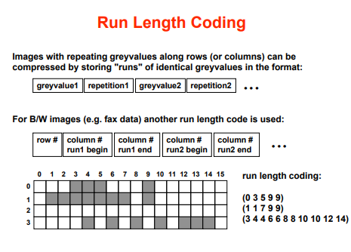
- A) optimum thresholding

  - Thresholding is a technique for partitioning image directly into region based on intensity value and/or property of these valueBecause of intuitive property ,Simplicity of implementation and Computational speed
Property
- equal to the average of the mean levels of two classes partitioned by this threshold
- biases toward the component with larger within class variance.
Suppose that the pixels in a given image be represented in L gray levels 1,2,3, ⋯𝐿
Let 𝑛𝑖 denote the number of pixels at level 𝑖, and 𝑁 denote the total number of pixels, 𝑁 = 𝑛1 + 𝑛2 + ⋯ + 𝑛𝐿
– Let ans image be divided into two classes𝐶0 and 𝐶1 by threshold T.
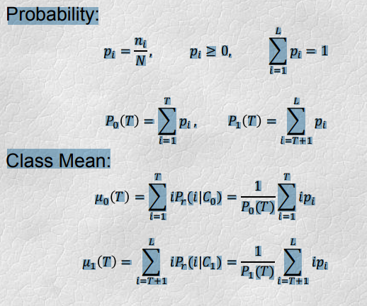

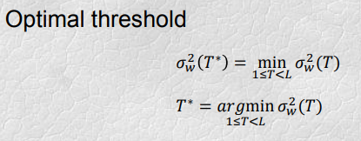
B)Region Splitting and Merging
There are three primary methods for region based segmentation of image.
Region growing methods
Region split methods
Region merge methods
Split and Merge Image segmentation technique is based on a quad tree data representation whereby a square image segment is broken (split) into four quadrants if the original image segment is non-uniform in attribute. If four neighboring squares are found to be uniform, they are replaced (merge) by a single square composed of the four adjacent squares.
Splitting and merging attempts to divide an image into uniform regions The basic representational structure is pyramidal, i.e. a square region of size m* m at one level of pyramid having four sub regions of same size below it.
Initially algorithm starts from the assumptions of an image as single region.
Computes homogeneity criterion to split the square region
Repeat the same steps until no splitting is needed
Process terminates when no more merging requires

Region Splitting – Region growing starts from a set of seed points. – An alternative is to start with the whole image as a single region and subdivide the regions that do not satisfy a condition of homogeneity. • Region Merging – Region merging is the opposite of region splitting. – Start with small regions (e.g. 2x2 or 4x4 regions) and merge the regions that have similar characteristics (such as gray level, variance). – Typically, splitting and merging approaches are used iteratively.
