Adsorption of Malachite green using a low-cost activated carbon obtained from
Caesalpinia pulcherrima

By
SUMITHRA.R
(09 PCM 19)

A Dissertation Submitted to the
AVINASHILINGAM DEEMED UNIVERSITY FOR WOMEN,
COIMBATORE-641043.

In Partial fulfilment of the Requirements
FOR THE DEGREE OF MASTER OF SCIENCE IN
CHEMISTRY
APRIL-2011
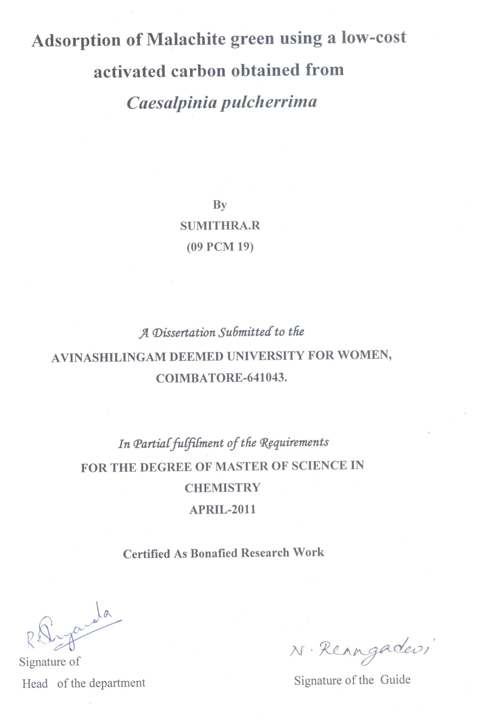
DEDICATED TO MY PARENTS
&
GUIDE




ACKNOWLEDGEMENT

ACKNOWLEDGEMENT
“Success lies not only in being the best but also in doing the best
I owe my sincere thanks to GOD Almighty and my parents without whom I would have been nothing and showering their generous blessings upon me in all endeavors.
I record my heartful thanks to (Thiru.)T.S.K.Meenakshi Sundram M.A., M.Phil, Chancellor Avinashilingam Deemed University for Women, Coimbatore, for providing adequate help required to carry out the work.
I express my sincere thanks to late (Thiru.)T.K.Shanmuganandan.B.A., B.L., former Chancellor Avinashilingam Deemed University for Women, Coimbatore, for providing adequate help required to carry out the work.
My special dept of gratitude goes to Dr. (Tmt.) Sheela Ramachandran M.Sc., P.G.Dip., Vice Chancellor, Avinashilingam Deemed University for Women, Coimbatore for providing flamboyant help towards the completion of the study.
I express my sense of faithfulnesss and sincere thanks to Dr.(Tmt.)Gowri Ramakrishnan M.Sc.(Madras), M.Phil., Ph.D.,(Avinashilingam), Registrar,Avinashilingam Deemed University for Women,Coimbatore, for providing adequate help for the study.
I express my special thanks to Dr.Saroja Prabhakaran, M.A., Dip.Ed. (Madras)., Ph.D (Mother Teresa) ,Director hall of Residence, Avinashilingam Deemed University for Women for providing adequate help and for her kind support.
I wish to express my deep sense of gratitude to Dr. Parvatham M.Sc., Dip. Ed., M.Phil., (Madras).Ph.D., (Avinashilingam), Dean, Faculty of Science, Avinashilingam Deemed University for Women,Coimbatore, for her kind support and help.

I whole heartily thanks Dr.(Tmt.)R.Shyamala M.Sc.,Dip.Ed (Madras),M.Phil.,(Bharathiar),Ph.D. (Avinashilingam),Professor and Head of the Department of Chemistry,Avinashilingam Deemed University for Women,Coimbatore, for her encouragement and generous help which was of great value.
I am highly obliged to my esteemed guide Dr.(Tmt.) N.Renugadevi M.Sc.(Madras),M.Phil., Ph.D.(Bharathiar),Reader,Department of Chemistry, Avinashilingam University for Women,Coimbatore, for suggesting the topic, inspiring guidance, constant encouragement, patience, meticulous care and useful suggestions through out this work.
I am thankful to all the staff of the Department of Chemistry ,Avinashilingam Deemed University for Women who rendered their help whenever required during the study period.
I am thankful to the members of the Laboratory for their help in the completion of this work.
I am highly obliged to my beloved parents, lovable brother, lovable sister & lovable brother -in-law for their active co-operation, moral support and kind blessings.
I am highly thankful to Miss.Kavitha, Research Scholar for her help and support throughout this work.
I express my special thanks to my friends for their constant encouragement, co-operation and help throughout this work.
I express my thanks to Sharfunisha my thesis partner for her sincere support through out this work.
I am grateful to each and every soul who had helped me in one or other way in making this study a great success.

SUMITHRA.R

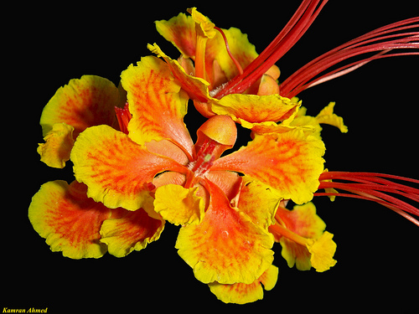
CONTENTS
CONTENTS
S.No Description Page No
List of tables
List of figures
- Introduction 1
2 Review of Literature 6
3 Materials and Methods 19
4 Results and Discussion 26
5 | Summary and Conclusion | 60
 | Bibliography

LIST OF TABLES
S.No | Title | PageNo
1 | Adsorption of Malachite green with variation of Initial concentration of malachite green solution | 28
2 | Adsorption of Malachite green with variation of pH | 31
3 | Adsorption of Malachite green with variation of Adsorbent dosage | 33
4 | Kinetic modeling for malachite green adsorption Using Lagergren equation (variation of initial Concentration of dye solution) | 36
5 | Intra particle diffusion rate equation for adsorption of Malachite green | 40
6 | Interpretation of results of adsorption of malachite green in terms of Langmiur adsorption isotherm.(Variation of initial concentration of the dye solution) | 45
7 | Interpretation of results of adsorption of malachite Green in terms of Freundlich adsorption isotherm (variation of initial concentrations of the solution) | 53
LIST OF FIGURES

S.No | Title | Page No
1 | Adsorption of Malachite green with variation of initial concentration of malachite green solution | 29
2 | Adsorption of Malachite green with variation of pH | 32
3 | Adsorption of Malachite green with variation of adsorbent dosage | 34
4 | Kinetic modeling for Malachite green adsorption using Lagergren equation (variation of initial concentration of dye solution) | 37
5 | Intra particle diffusion rate equation for Adsorption of Malachite green | 41
6 | Langmuir adsorption isotherm plots | 47
7 | Freundlich adsorption isotherm plots | 55

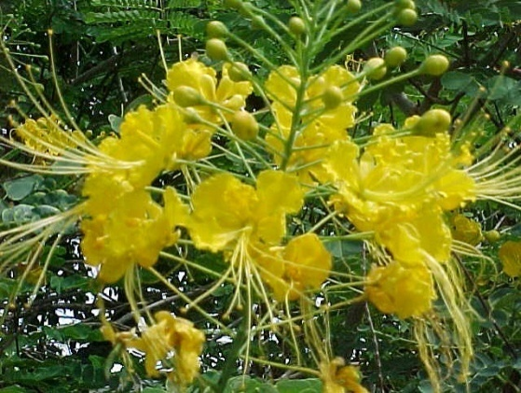

INTRODUCTION
1.INTRODUCTION

The dyestuff usage has been increased day by day because of tremendous increase of industrialization and man’s urge for color (Amany Youssef et al.,2008).The synthetic dyes are largely used in industries like textiles, paints, pulp and paper, carpet and printing(Neha Gupta et al., 2011 ).

According to an estimate more than 1,00,000 commercially available dyes with over 7,00,000 tonnes of dyestuff are produced and used annually.The discharge of effluents from industries using these dye stuffs is one of the potential sources of their contamination and pollution.These industrial discharges are highly colored with high biochemical oxygen demand as well as chemical oxygen demand(Sharma eal.,2009).

Malachite green is a cationic dye of triphenyl methane type, that exist as a cation in aqueous medium.This dye is traditionally used for dyeing cotton, jute, silk, wool leather and as an antifungal, antibacterial and antiparasitical therapeutic agent (NehaGupta et al.,2011).

Malachite green cause severe effects on nervous system, brain, reproductive system, liver and kidney (Sharma et al., 2009). The reduced form of Malachite green, leucomalachitegreen persist in fish tissues for longer period of time and its consumption may alarm health hazards a gainst human being (Xiangliang pan et al.2008).

Malachite green is a popular dye and is used extensively in textiles. It also finds applications in medical sciences. Malachite green is highly toxic to flora and fauna. It induces risk of cancer and acts as a liver-tumour enhancing agent (Sharma et al., 2009).
Structure of Malachite green

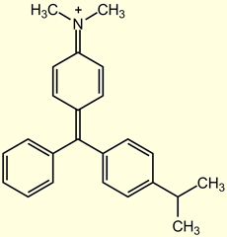
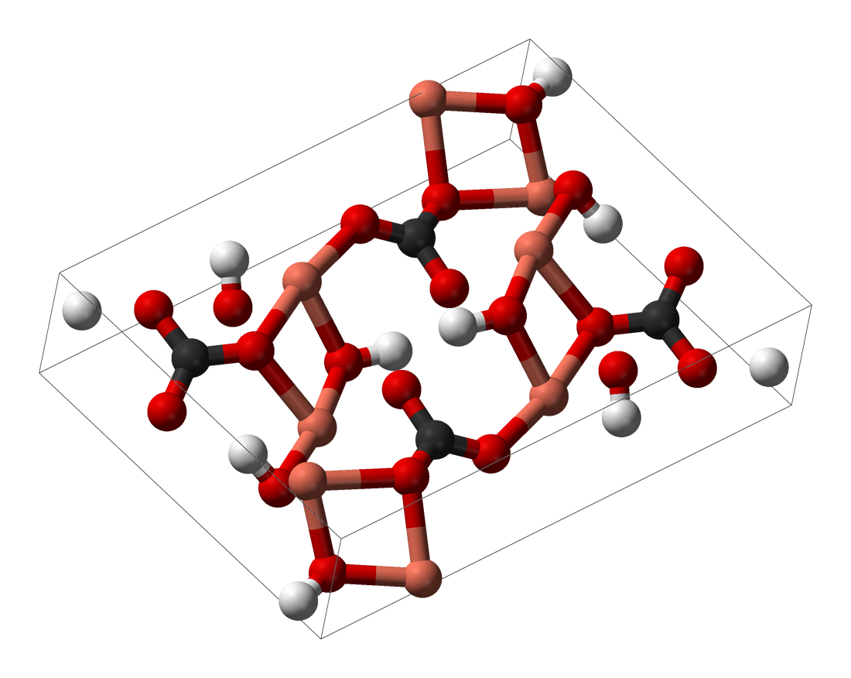
The intense colour of the cation results from a strong absorption band at 621 nm. Other names of Malachite green are Aniline green, Basic green 4, Diamond green B and Victoria green B .It is a green crystalline solid.

Despite its industrial importance, malachite green poses several risks to the consumers, including its effects on the immune system and reproductive system as well as its genotoxic and carcinogenic potentials. Therefore effective removal of malachite green from wastewater is necessary (Sarawat Srikhun et al., 2009).

Precipitation, coagulation, flocculation, ion exchange are conventional methods used for the removal of dyes (Sharma et al., 2009). Adsorption is one of the method which is gaining more attention because of its easy operation and versatility (Alok Mittal et al., 2006). Adsorption characteristics of malachite green were studied in order to find ways to remove it from water and waste water (Santhi et al.,2009)

Many investigators have studied the feasibility of using inexpensive alternative materials like Pearl millet husk, Date pits, Saw dust, Buffing dust of leather industry, Coir pith, and Crude oil residue, Tropical grass, Olive stone and Almond shells, Pine bark.Wool waste, Coconut shell etc as carbonaceous precursors for the removal of dyes from water and waste water.However the adsorption capacities of these adsorbents are not very high (Rajeshkanan et al.,2009).

The use of low- cost locally available and eco-friendly adsorbents has been investigated as an ideal alternative to the current expensive methods of removing dyes (Santhi et al.,2009).

Nowadays numerous low cost adsorbents such as coal, fly ash, wood, silica gel, clay materials, agricultural wastes, cotton wastes and cellulose based wastes such as orange, lemon, banana and lychee had been used for dye removed(Neha Gupta et al., 2011)
Hence in this study a low cost carbon adsorbent prepared from Ceasalpinia using concentrated sulphuric acid for activation, tested for its ability to remove malachite green from aqueous solution.

The adsorption potential of the low-cost adsorbent prepared and used in this study was investigated by varying the initial concentration of the dye, adsorbent dosage and pH.



REVIEW OF LITERATURE

2. REVIEW OF LITERATURE
Dyes are used in textiles, leather, rubber, plastic, cosmetics, pharmaceutical, paper and pulp industries. Dyes are considered to be particularly dangerous organic compounds for the environment. Most of them are completely resistant to biodegradation process. For this reason physico – chemical process for their pre treatment are recommended . Due to the toxic nature of most of the dyes to plants and microorganisms, coloured waste water cannot be discharged without adequate treatment (Klimiuk et al.,1998).

2.1 Waste water Treatment
Various techniques have been employed for the removal of dyes from waste water. These methods include adsorption, nanofiltration, electro kinetic coagulation, coagulation and precipitation, flocculation, sedimentation, flotation, filtration etc (Rajeshkannan et al., 2009). The treatment processes are generally divided into three categories.
- Primary treatment process
- Secondary treatment process
- Tertiary treatment process

2.1.1 Primary treatment process
In this treatment most of the settleable solids are separated or removed from the waste water by physical processes of sedimentation and flotation(http://www.water.siemens.com).

Sedimentation
It is a physical phenomenon relating to the settling of solids by gravity. Sedimentation for solid separation is a very common process and is routinely employed at the beginning and end of waste water treatment operation (http://en.wikipedia.org/wike/sedimentation).

Flotation
Dissolved air flotation is a water treatment process that clarifies waste water by the removal of suspended matter such as oil or solids (http://www.google.co.in/url?q=http://en.wikipedia).

Filtration
Waste water is passed through a filter medium to separate solids. An example would be the use of sand filters to further remove entrained solids from treated waste water.(http://en.wikipedia.org/wiki/filtration).

2.1.2 Secondary treatment process
The process consists of removing or reducing contaminants or growth that are left in the waste water from the primary treatment process .
Chlorination
It is a commonly used chemical process. Chlorine is a strong oxidizing chemical which is used to kill bacteria and to slow down the rate of decomposition of the waste water.

Coagulation
It consists of addition of a chemical that through a chemical reaction forms an insoluble end product that serves to remove substances from waste water (http://water.me.vecs.edu/courses\ENV149/methods.htm).

2.1.3 Tertiary treatment process
Tertiary treatment is the final treatment meant for polishing the effluents from the secondary treatment process (www.water.siemens.com).
Reverse osmosis
It is a filtration method that removes many types of large molecules and ions from solutions by applying pressure to the solution when it is one side of the selective membrane (http://en.wikipedia.org/wiki/reverse_osmosis).

Ion- exchange
It is a reversible chemical reaction where in an ion from solution is exchanged for a similarly charged ion attached to an immobile solid particle. These solid ion exchange particles are either naturally occurring inorganic zeolites or synthetically produced organic resins.
(http: //www remco.com/ix.htm).

Adsorption
It is one of the efficient method to remove dyes from effluents. Activated carbon or charcoal is considered as a most suitable adsorbing media for such purpose. Hydrocarbons, Organic acids, Esters, Ketone and heavy metals get readily adsorbed on activated carbon (Rajeshkannan et al., 2009).

Agricultural products used as adsorbents

- Maize cob powder used for the adsorption of Malachite green. The results demonstrated that the maize cob powder is a low–cost alternative in waste water treatment for dye removal. Equilibrium adsorption data followed both Langmuir and Freundlich (Sonawane et al., 2009).

- Baskaran et al.,(2010)studied the ability of Zea mays dust carbon to remove Malachite green from aqueous solution .The results showed that adsorption on Zea mays dust carbon followed Langmuir and Freundlich adsorption isotherm. The kinetic data indicated that intra-particle diffusion process with sorption being first order.

- Ground nut shell activated using ZnCl₂ was used for Malachite green removal. It’s adsorption properties was compared with commercially available powdered activated carbon. The results of comparative adsorption capacity of both carbons indicated that ground nut shell can be used as a low-cost alternative to commercial powdered activated carbon in aqueous solution for Malachite green removal (Malik et al., 2006).

- Rajeshkannan et al., (2010) successfully removed Malachite green from aqueous solution using low-cost adsorbent, tamarind seed. The adsorption process followed pseudo first order and intra particle diffusion was found to be the rate-controlling step.

- The removal of textile dye Malachite green was studied Xavier et al.,(2011) by adsorption technique using adsorbents such as rose apple carbon, coconut shell carbon and saw dust carbon. The percentage of dye adsorbed increases with decrease in initial concentration and particle size of adsorbent and increased with increase in contact time, temperature and dose of adsorbent.

- Adsorption of Malachite green on treated ginger waste was carried out by Rais Ahmed et al., (2010). The effect of various factors such as initial dye concentration, contact time, pH and temperature were studied. The maximum adsorption of Malachite green was observed at pH 9. The pseudo second order kinetic model fitted well in correlation to the experimental results.

- Hameed et al., (2008) studied the adsorption of Malachite green on activated carbon prepared from bamboo by chemical activation with K₂CO₃ and physical activation with CO₂. Equilibrium data fitted well with the Langmuir model with maximum adsorption capacity. The rate of adsorption were found to confirm to pseudo second order kinetics with good correlation and confirm to pseudo second order kinetics with good correlation and the overall rate of dye uptake was found to be controlled by pore diffusion.

- Xing et al., (2009) reported that adsorption capacity of ethylene diamine tetra acetic dianhydride (EDTAD) modified sugarcane baggase for Malachite green showed a significant increase compared with sugarcane baggase. Kinetic studies showed better correlation coefficient for a pseudo- second order kinetic model confirming that the sorption rate was controlled by a chemisorptions process.

- Nethaji et al., (2010) studied the removal of Malachite green from aqueous solution by batch adsorption on Borassus aethiopum (African fan, palm) flower. The results showed that the adsorption followed pseudo second order model and the adsorption was both by film diffusion and by intra particle diffusion.
- Nirgudi leaf powder used for the Malachite green adsorption has been investigated by Ratna Shelke et al., (2010). Experimental adsorption kinetic data were fitted to be Lagergren first order. Equilibrium data were well represented by the Freundlich and Langmuir isotherm model for all tested adsorption system.

- Santhi et al., (2010) investigated the potential use of activated carbon prepared from Annona squmosa (Custard apple) seed. The experimental results indicated that the Annona squmosa seed an attractive option for dye removal made on dyeing waste water. The results showed better removal percentage of Malachite green.

- Hema et al., (2009) examined the ability to remove Malachite green from aqueous solution using an activated carbon prepared from Borassus (palm) bark. The temperature variation study showed that the dye adsorption was endothermic and spontaneous with increased randomness at the solid solution interface.

- Garg et al., (2003) successfully removed Malachite green from aqueous solution using Prosopis cineraria saw dust .The adsorbents included formaldehyde treated saw dust (PCSD) and sulphuric acid treated saw dust (PCSDC). The adsorption efficiency was compared with commercially available coconut based activated carbon. The experimental studies indicated that PCSD and PCSDC can be employed as a low-cost alternative in waste water treatment for the removal of Malachite green.

- Hameed et al., (2008) studied the adsorption of Malachite green on rattan (stems of climbing palm) saw dust at 30⁰C. The results indicated that rattan saw dust can be used as low-cost adsorbents for the removal of Malachite green from aqueous solution.
- The banana pseudo stem fiber was used as an adsorbent for the removal of Malachite green. The adsorption process followed pseudo second order kinetics and intra particle diffusion rate model. Equilibrium data were fitted to Langmuir and Freundlich isotherm (Neha Gupta et al., 2011).

- Mendez et al., (2006) studied the removal of Malachite green in waste water using the carbon based adsorbents obtained from pyrolysis of waste material from paper industry and pine bark. Results showed that percentage of Malachite green removal were higher with the carbon based material prepared from paper industry than from pine bark.

- Activated carbon developed from rice husk for the removal of Malachite green from aqueous solution and waste water. Equilibrium studies were performed and the data fitted with in Langmuir and Freundlich adsorption isotherm equation. The monolayer adsorption capacity of rice husk activated carbon for the adsorption of the dye was found to be 63.85mg/g at room temperature (Sharma et al., 2009).

- Xiang Liang Pan et al., (2008) reported that wood fiber of phoenix tree is an effective adsorbent for Malachite green. The results showed that it follows pseudo second order equation. The Freundlich isotherm described the adsorption data.

- Sarwat Srikhun et al., (2009) investigated activated carbon prepared from durian peel by physical activation with CO₂. The conditions employed were nitrogen atmospheric and vaccum pyrolysis. The results showed that activated carbon synthesized under vaccum pyrolysis exhibited better properties than synthesized under nitrogen atmospheric pyrolysis.
- Activated carbon prepared from tamarind fruit shells by direct carbonization was used for the removal of Rhodamine B and Malachite green dyes from aqueous solutions .Increase in pH of the solution resulted in increased adsorption of both the dyes. Kinetic studies indicate that the pseudo-second order model can be used for describing the dynamics of the sorption processes (Edwin Vasu 2008).

- Santhi et al., (2010) investigated the potential use of activated carbon prepared from the epicarp of Ricinus communis for the removal of Malachite green dye from simulated wastewater. The results showed that as the amount of the adsorbent increased, the percentage of dye removal increased accordingly. Optimum pH value for dye adsorption was 7.0. Maximum dye was sequestered within 50 minutes of the start of every experiment. The adsorption of Malachite green followed the pseudo-second-order rate equation and fits the Langmuir, Freundlich, Dubinin-Radushkevich (D-R) and Tempkin isotherm equations well. The maximum removal of Malachite green was obtained at pH 7 as 99.04% for adsorbent dose of 1 g 50 mL⁻¹ of initial dye concentration at room temperature.

- Batch adsorption experiments were carried out for the removal of Malachite green from aqueous solution using Arundo donax root carbon (ADRC) as adsorbent. Equilibrium experimental data at 293, 303 and 313 K were better represented by Langmuir isotherm than Freundlich isotherm using linear and non-linear methods. . Adsorption kinetics was determined using pseudo-first-order model, pseudo-second-order model and intraparticle diffusion model. The results showed that the adsorption of Malachite green onto ADRC followed pseudo-second-order model (Zhang et al., 2007).

- Oil palm trunk fiber (OPTF) an agricultural solid waste was used as a low-cost adsorbent to remove Malachite green from aqueous solution. Equilibrium adsorption data were analyzed by three isotherms, namely the Freundlich isotherm, the Langmuir isotherm, and the Multilayer adsorption isotherm. The best fit to the data was obtained with the Multilayer adsorption. The monolayer adsorption capacity of OPTF was found to be 149.35 mg/g at 30⁰C. Adsorption kinetic data were modeled using the Lagergren pseudo-first-order, Ho's pseudo-second-order and Elovich models. It was found that the Lagergren's model could be used for the prediction of the system's kinetics. . It was found that with increasing the initial concentration of Malachite green, the pore-diffusion coefficient increased while the film-diffusion coefficient decreased. (Hameed et al., 2008).

- Hameed et al., (2007) investigated the potential feasibility of rice straw-derived char (RSC) for removal of Malachite green. The equilibrium process was described well by the Langmuir isotherm model. The maximum RSC sorption capacity was found to be 148.74 mg/L at 30⁰C. The kinetics of Malachite green sorption on RSC followed the Lagergren's pseudo-first-order model and the overall rate of dye uptake was found to be controlled by external mass transfer at the beginning of adsorption, while intraparticle diffusion controlled the overall rate of adsorption at a later stage. The results indicated that RSC was an attractive adsorbent for removing basic dye Malachite green from aqueous solutions.

Industrial by-products as adsorbent
- Suchithra et al., (2008) studied the removal of cationic dyes (Malachite Green(MG) Methylene Blue (MB) and Crystal Violet (CV)) from aqueous solutions using Humic acid-immobilized amine modified polyacrylamide/bentonite composite (HA-Am-PAA-B) .The result shows that more than 99.0% removal of dyes was detected at pH range6.0–8.0 . The capacity of HA-Am-PAA-B was found to decrease in the following order:
MG > MB > CV. The kinetic and isotherm data were interpreted by pseudo-second order rate equation and Freundlich isotherm model respectively.

- Oxalic acid and citric acid modified silica gel used for the removal of Malachite green dye from aqueous solution. Kinetic studies shows that the adsorption follows pseudo-second order kinetics and intraparticle diffusion model (Atul Kumar Kushwaha et al., 2010).

- The surfactant-modified alumina (SMA) was used for the removal of Malachite green from aqueous solution. All the studies were carried out in batch mode. The kinetic studies showed that 1 h contact time was sufficient to attain equilibrium. SMA was very efficient to remove Malachite green up to 99%. The isotherm studies showed that it follows Langmuir model better than the Freundlich model (Das et al., 2009).

- Shamik chowdhury et al.., (2010) have reported that alkali treated fly ash is a potential low-cost adsorbent for removal of Malachite green from aqueous solution. The Langmuir isotherm model showed good fit to the equilibrium adsorption data at all temperatures. The kinetic data were found to follow the pseudo second order kinetic model.

- Perlite was utilized as an adsorbent for the removal of Malachite green from the aqueous solution. The negative values of energy of adsorption and positive values of enthalpy change suggested that the adsorption process is spontaneous and exothermic. The adsorption process obeyed the pseudo first order kinetic model (Vijayakumar et al., 2010).

- Lugun et al., (2009) investigated the adsorption of Malachite green using Mahua oil cake. The results indicated that Mahua oil cake is an attractive adsorbent for removing basic dye from aqueous solution.

- Removal of some reactive dyes from textile effluents using Sorel’s cement. The adsorption isotherms including Langmuir constant and Freundlich constant for the dyes decrease with increase of temperature (Hassan et al., 2009).

- Back et al., (2009) reported the feasibility of employing degreased coffee beans as adsorbent for Malachite green removal in dyeing waste water. The adsorption reaction well fitted with the Freundlich and Langmuir isotherm models. Thermodynamic studies revealed that the adsorption process is spontaneous and endothermic in nature.

- Hiroshi Kominami et al., (2003) developed a photo catalytic decolourization and mineralization of Malachite green in aqueous suspension of titanium (IV) oxide nano particles under aerated conditions. Longer irradiation was required for mineralization of Malachite green. Total organic carbon in the suspension with improved crystallinity continuously decreased.

Bioadsorbents used as an adsorbent
- Pine tree root decayed by brown-rot fungi tried for the first time for the removal of Malachite green from aqueous solution. The results showed that Malachite green adsorption was mainly a spontaneous, endothermic and chemisorptions process (Hong Zhang et al., 2011).

- Amany Youssef et al., (2008) studied the decolourization of Malachite green by the local isolate Acremonium kiliense. Decolurization rate for Malachite green dye in shacked culture were found to be more than the static culture and also depends on biomass concentration.

- The sorption of Malachite green (MG) on Hydrilla verticillata biomass, a submerged aquatic plant was investigated in a batch system. The Langmuir and Freundlich isotherm models were applied to the equilibrium data. The maximum monolayer coverage capacity of Hydrilla verticillata biomass for Malachite green was found to be 91.97 mg/g at an initial pH 8.0.It was found that external diffusion as well as intra particle diffusion contributes to the actual sorption process. The pseudo-second order kinetic model described the MG’S sorption process with a good fitting (Rajeshkannan et al., 2010).

- The removal of a cationic dye Malachite green from aqueous solution using chitosan bead was carried out. Langmuir equation showed higher conformity than Freundlich equation. Ninety-nine percent removal of Malachite green was reached at the optimum pH value of 8. From kinetic experiments, it was observed that sorption process followed the pseudo-second-order kinetic model. This study showed that chitosan beads can be excellent adsorbents at high pH values (Bekçi et al., 2007).

Clay used as an adsorbent
- Hajira Tahir et al., (2010) have reported the removal of Malachite green on Mont morillonite clay adsorbent under optimized conditions. The percentage removal data shows that Malachite green Mont morillonite clay system shows about 95% adsorption tendency.
- Papita Saha et al., (2010) investigated the adsorption potential of clayey soil towards Malachite green removal from aqueous solution. A negative enthalpy value indicated that the adsorption process was exothermic. The results showed that clayey soil can be used as an effective and low cost adsorbent.

- Abdil Ozdemir et al., (2009) carried out the adsorption of dye mixtures namely Malachite green and Congo red by bentonite. The result shows that the pH of the dye solution is strongly affected by the chemistry of both the dye molecules and of the adsorbent in an aqueous solution.

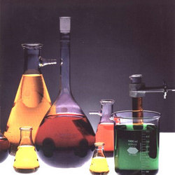
MATERIALS AND METHODS
3. MATERIALS AND METHODS

3.1 Project plan
The present investigation has been taken to study the efficiency of a low-cost,
eco- friendly adsorbent in the removal of a basic dye, Malachite green by adsorption. Batch adsorption studies carried out by varying the initial concentration of dye solution, pH and adsorbent dosage.

3.2 Description of the adsorbent

COMMON NAME : Peacock flower, Pride of Barbide
BOTANICAL NAME : Caesalpinia pulcherrima
FAMILY : Caesalpiniaceae

Eco-friendly low –cost carbon adsorbent used in this study for the removal of Malachite green was prepared from the fruits of Caesalpinia pulcherrima.

Caesalpinia pulcherrima
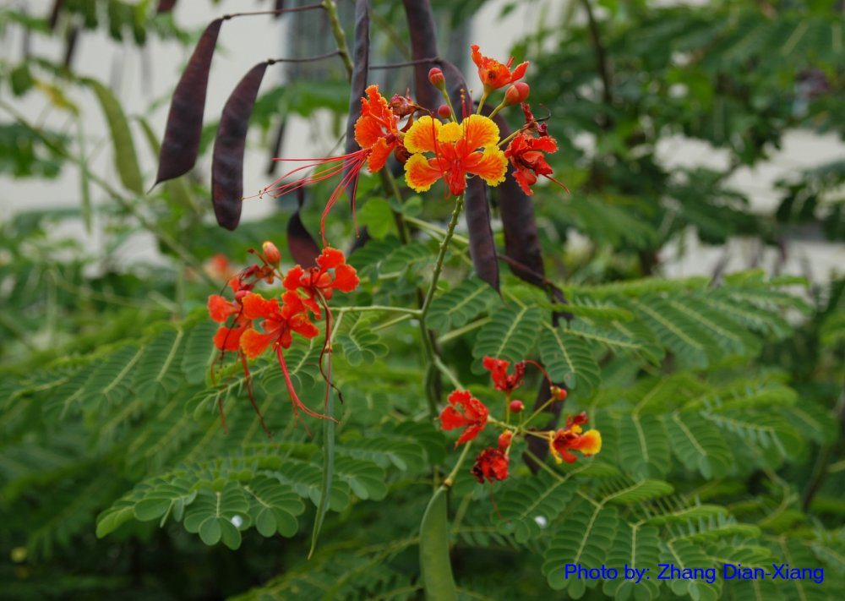

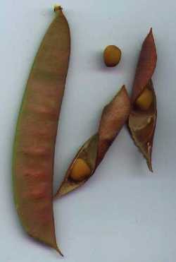

3.3 Parameters studied
Batch studies were conducted with the activated carbon prepared from the fruits of Caesalpinia pulcherrima. The adsorption technique was used owing to its simplicity and ease of evaluating some basic parameters which influence the adsorption process.
- Determination of the effect of variation of initial concentration of dye solution on the percentage adsorption of dye from aqueous solution.
- Determination of the effect of variation of pH on the effective removal of dye from aqueous solution.
- Determination of the effect of variation of adsorbent dosage on the percentage removal of dye from aqueous solution.
- The experimental data obtained in the adsorption of dye was interpreted using the Langmuir and Freundich adsorption isotherm and Lagergren first order kinetic equation and intraparticle diffusion rate equation.

3.4 Preparation of the adsorbent
Fruits of Caeslpinia pulcherrima were collected from Avinashilingam Deemed University Campus, Coimbatore. The collected pods were cut into small pieces, dried in sunlight for 5 days and further dried in a hot air oven at 60 ⁰C for 24 hours.The completely dried material was powdered well.The powdered raw material was chemically activated by treating with concentrated sulphuric acid with constant stirring and kept for 24 hours.The carbonized material was washed with plenty of water several times to remove excess acid and dried at 105-110 ⁰ C in a hot air ove for 24 hours.The adsorbent thus obtained was ground well and sieved through a 250 mesh and kept in an air tight container for further use.

3.5 REAGENTS
The dye solution was prepared by dissolving 5gm of malachite green in distilled water and diluted to 100 ml. The stock solution was diluted to appropriate
concentration.

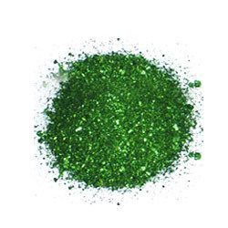

3.6 Equipment
- Elico pH meter was used to measure
- Photo colorimeter was used for spectrocolorimetric work
- Genuine equipment manufacture’s mechanical horizontal bench shaker was used for shaking of solution containing adsorbent and adsorbate.

EQUIPMENTS

PHOTOCOLORIMETER
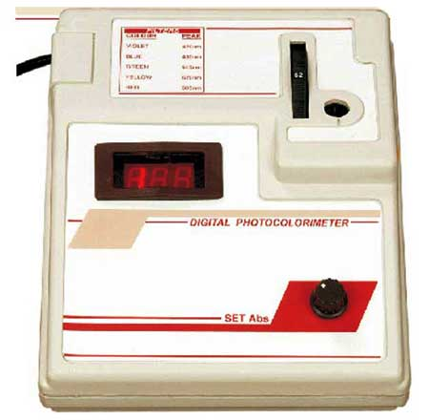

HORIZONTAL BENCH SHAKER pH METER
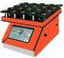
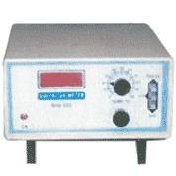

3.7 Effect of variation of initial concentration of the dye on the adsorption
The dye solution of different concentrations containing 10,20,30,and 40 mg of dye in100ml was added with 300 mg of the adsorbent taken in a Pyrex bottles and shaken in a bench shaker for various time intervals(10,20,30,40,50,60,90,120,150 and 180 minutes) at room temperature. The solution were filtered and the dye concentration of the filtrates were estimated calorimetrically at 620nm.
3.8 Effect of variation of pH on the adsorption of dye
The optimum pH for the maximum dye adsorption was found by varying the pH from 7 to 10. The pH of the prepared original dye solution was 2.87.Therefore pH of the solution for this pH variation study was adjusted using dilute sodium hydroxide.100ml of the dye solution containing 40mg of the dye were contacted with 300mg of the adsorbent and batch mode experiments conducted by varying the pH from 7 to 10.These solution were shaken using mechanical horizontal bench shaker for various time intervals(10,20,30,40,50,60,90,120,150 and 180 minutes) .The solutions were filtered and the filtrates obtained were analysed colorimetrically to find the amount of dye adsorbed.

3.9 Effect of variation of adsorbent dosage on the adsorption of dye
100 ml of the dye solution containing 400 mg of the dye were taken in Pyrex bottles and batch adsorption studies conducted by varying the adsorbent dosage(300,400,500,600mg).The Pyrex bottles containing adsorbent and adsorbate were shaken using mechanical horizontal bench shaker at room temperature for various time intervals (10,20,30,40,50,60,90,120,150 and 180 minutes).Then solution were filtered and the filtrates were analysed colorimetrically to find out the amount of dye adsorbed.



RESULTS AND DISCUSSION
4 . RESULTS AND DISCUSSION

The experimental data obtained and the findings of the present study are presented and discussed in the light of the objectives set forth. Batch experiments were carried out for the removal of Malachite green by adsorption. The results were used to evaluate the optimum conditions for the removal of the dye, Malachite green and to examine the efficiency of the low-cost adsorbent prepared in this study for the treatment of aqueous solution containing Malachite green. The parameters which influence the extent of adsorption such as concentration of the adsorbate, contact time, pH and adsorbent dosage were investigated.

4.1 EFFECT OF VARIATION OF INITIAL CONCENTRATION OF MALACHITE GREEN SOLUTION ON ADSORPTION ON OF MALACHITE GREEN FROM AQUEOUS SOLUTION
The adsorbate concentrations were varied from 100 mg/L to 400mg/L and batch experiments were performed to optimize the initial concentration of the adsorbate.The percentage removal of malachite green with the variation in initial concentration of malachite green solution is depicted in figure1 and the data is given in table 1.An increase in percentage removal (24.05 to 28.81%) of malachite green noticed when the initial concentration of adsorbate was varied from 400mg/L to100 mg/L .This may be probably due to the fact that for a fixed adsorbent dose, the total available adsorption sites are limited there by adsorbing almost the same

amount of Malachite green corresponding to an increased initial concentration of the adsorbate.
  - EFFECT OF CONTACT TIME ON ADSORPTION OF MALACHITE GREEN

Effect of agitation time on adsorption is one of the factors affecting the adsorption potentials. It can be seen from the results of varying contact time, the percentage adsorption of Malachite green increases with increase in contact time ,when the initial concentration of the dye solution used was 100,200,300,400mg/L.From the Table1,it is evident that for maximum removal of dye by the adsorbent, the solution should be equilibrated for 180 minutes and consequently it was decided that to maintain 180 minutes for all other studies.The Malachite green removal curves (Figure1) are smooth and continuous indicating the formation of monolayer coverage of adsorbate on outer surface of adsorbent .The percentage of the dye removed by adsorption increased from 8.47 to 28.81%, when the contact time was varied from 10 to 180 minutes using 100ml of the dye solution of initial concentration 100mg/L with 300 mg adsorbent.

Table 1
ADSORPTION OF MALACHITE GREEN WITH VARIATION OF INITIAL CONCENTRATION OF MALACHITE GREEN SOLUTION
Conditions:
Adsorbent dosage : 300mg
pH : 2.87
Temperature : 37⁰C
Contact time : 10 to 180 minutes

Time in  minutes | % Adsorption of Malachite Green
Time in  minutes | Initial concentration of Malachite green
Time in  minutes | 100mg/L | 200mg/L | 300mg/L | 400mg/L
10 | 8.47 | 7.69 | 6.94 | 6.32
20 | 10.17 | 9.23 | 8.33 | 7.59
30 | 11.86 | 10.77 | 9.72 | 8.86
40 | 13.56 | 12.31 | 11.11 | 10.12
50 | 15.25 | 13.84 | 12.50 | 11.39
60 | 16.95 | 15.38 | 13.89 | 12.65
90 | 20.34 | 18.46 | 15.28 | 13.92
120 | 22.03 | 21.53 | 19.44 | 16.45
150 | 23.73 | 23.07 | 22.22 | 20.25
180 | 28.81 | 27.69 | 25 | 24.05

  - EFFECT OF pH VARIATION ON ADSORPTION OF MALACHITE GREEN

In order to optimize the pH for maximum Malachite green removal experiments were conducted with 100ml of aqueous solution of the dye containing 400mg/L of Malachite green solution with 300mg adsorbent by varying the pH from 7 to 10 at various contact time (10,20,30,40,50,60,90,120,150 and 180 minutes) and the results are depicted in Table 2 and Figure 2.The percentage adsorption of dye increased from 28.40 to 44.68%,when the pH is varied from 7 to 10.The results indicated a maximum adsorption of dye(~ 44.68%) at pH 10.

  - EFFECT OF ADSORBENT DOSAGE ON ADSORPTION OF MALACHITE GREEN

The effect of variation of adsorbent dosage was determined by varying the adsorbent dosage from 300 to 600 mg. The results have been tabulated in Table 3.it is evident from the table that adsorption potential of the adsorbent increases with increasing adsorbent dosage. The dye adsorbed increased from 24.05 to 32.94 % when the adsorbent dose was varied from 300 to 600mg.Figure 3 is a plot of dosage of adsorbent Vs dye adsorption potential.The increase in percent adsorption of dye with increase in the adsorbent dosage may be due to the availability of more surface area of the adsorbent for adsorption of more number of Malachite green species.

Table 2
ADSORPTION OF MALACHITE GREEN WITHVARIATION OF pH
Conditions:
Adsorbent dosage : 300mg
Temperature : 37 º C
Concentration of dye solution : 400mg/L
Contact time : 10 to 180 minutes
Time in  minutes | % Adsorption of malachite green
Time in  minutes | pH 7 | pH 8 | pH 9 | pH 10
10 | 9.09 | 12.5 | 13.26 | 15.95
20 | 10.22 | 13.54 | 15.30 | 17.02
30 | 11.36 | 14.58 | 18.36 | 21.27
40 | 12.5 | 16.66 | 20.40 | 25.53
50 | 13.63 | 17.70 | 22.44 | 27.65
60 | 15.90 | 18.75 | 24.49 | 31.91
90 | 19.31 | 20.83 | 27.55 | 35.10
120 | 22.72 | 23.95 | 30.67 | 38.29
150 | 26.13 | 27.08 | 33.67 | 41.48
180 | 28.40 | 30.20 | 36.73 | 44.68

Figure 2

Table 3

ADSORPTION OF MALACHITE GREEN WITH VARIATION ADSORBENT DOSAGE
Conditions:
Temperature : 37 º C
pH : 2.87
Concentration of dye solution : 400mg/L
Contact time : 10 to 180 minutes

Time in  minutes | % Adsorption of Malachite Green
Time in  minutes | Adsorbent dosage
Time in  minutes | 300mg | 400mg | 500mg | 600mg
10 | 6.32 | 8.24 | 9.41 | 10.58
20 | 7.59 | 10.59 | 11.76 | 12.94
30 | 8.86 | 12.94 | 14.11 | 15.29
40 | 10.12 | 14.11 | 15.29 | 16.47
50 | 11.39 | 15.29 | 16.47 | 17.64
60 | 12.65 | 16.47 | 17.64 | 18.82
90 | 13.92 | 21.17 | 22.35 | 23.53
120 | 16.45 | 23.52 | 24.71 | 27.06
150 | 20.25 | 27.06 | 28.23 | 30.59
180 | 24.05 | 30.59 | 31.76 | 32.94

Figure 3

4.5 KINETIC MODELLING FOR MALACHITE GREEN ADSORPTION USING LAGERGREN EQUATION (VARIATION OF INITIAL CONCENTRATION OF DYE SOLUTION)

The chemical kinetics describes reaction pathways, along times to reach the equilibrium whereas chemical equilibrium gives no information about pathways and reaction rates. In order to investigate the mechanism of adsorption various kinetic models have been suggested. In recent years, adsorption mechanisms involving kinetics - based models have been reported. In this study some of these models were investigated to find the best fitted model for the experimental data obtained. Adsorption kinetic data of Malachite green are analyzed using the Lagergren pseudo-first –order rate equation
log (q_{e} – q_{t}) = log q_{e} – k_{a} t / 2.303
Where q_{e} and q_{t} are the amount of Malachite green adsorbed at time‘t’ and at equilibrium time. K_{a} is the rate constant. The rate constant K_{a} could be calculated from the slopes of the linear plots of log (q_{e} – q_{t}) verses‘t’ . The Lagergren plots of dye adsorption are shown in Figure 5 (Santhi et al., 2009).The rate constants K_{a} for different concentrations of dye solution is given below. The K_{a} value indicates that the adsorption of the dye followed first order Lagergren kinetics.
Concentration  of dye in mg/L | Ka X 10 ⁻²  minutes⁻¹
100 | 0.660
200 | 0.9334
300 | 1.132
400 | 1.090
Table 4
KINETIC MODELLING FOR MALACHITE GREEN ADSORPTION USING LAGERGREN EQUATION (VARIATION OF INITIAL CONCENTRATION OF DYE SOLUTION)
Conditions:
Adsorbent dosage : 300mg
pH : 2.87
Temperature : 37 º C
Time in  minutes | log (q_{e} -q )
Time in  minutes | 100mg/L | 200mg/L | 300mg/L | 400mg/L
10 | 0.3083 | 0.602 | 0.7337 | 0.8505
20 | 0.270 | 0.567 | 0.698 | 0.8183
30 | 0.2291 | 0.529 | 0.661 | 0.7836
40 | 0.188 | 0.4881 | 0.619 | 0.7458
50 | 0.132 | 0.442 | 0.574 | 0.7044
60 | 0.0742 | 0.3911 | 0.522 | 0.6586
90 | -0.0718 | 0.2662 | 0.464 | 0.6075
120 | -0.1687 | 0.0901 | 0.2218 | 0.4825
150 | -0.2937 | -0.0347 | -0.0794 | 0.1815
180 | _ | _ | _ | _
Intercept log qe | 0.2814 | 0.6384 | 0.8105 | 0.9420
Slope  -Ka/2.303 x 10 ⁻³ | -2.867 | -4.056 | -4.917 | -4.735
Ka | 0.660 | 0.934 | 1.132 | 1.090

  - INTRA PARTICLE DIFFUSION RATE EQUATION FOR ADSORPTION OF MALACHITE GREEN

Due to rapid stirring in batch reactors there is a possibility of transport of Malachite green species from the bulk into pores of the adsorbent as well as adsorption at the outer surface of the adsorbent. The rate limiting step may be either film diffusion or intraparticle diffusion. As they act in series, the slower of the two will be the rate determining step. The possibility of Malachite green species to diffuse into the interior sites of the particles of adsorbent was tested with
Weber-Morris equation given as follows:
q = K_{p}t^{1/2}
Where q is the amount of Malachite green adsorbed in mg, K_{p} is the intraparticle diffusion rate constant and‘t’ is the time (agitation time) in minutes.

In order to study the diffusion process, batch adsorption experiments were carried out with the adsorbent used in this study at 37⁰C and at pH 2.87 by varying the initial concentration of Malachite green solution. The results are given in the Table 5 graphically shown in the Figure 5.

The rate constants (K_{p}) for intraparticle diffusion for various initial concentrations of Malachite green solution was determined from the slope of respective plots drawn between square root of time (t^{1/2} ) and the amount of adsorbate adsorbed(q).
The plots are straight lines but not passing through the origin and thus indicating the intraparticle diffusion is not the sole rate limiting factor for the adsorption of Malachite green (Santhi et al., 2009).The values of K_{p} obtained in this study for the adsorption of Malachite green is shown in Table 5.

Table 5
INTRAPARTICLE DIFFUSION RATE EQUATION FOR ADSORPTION OF
MALACHITE GREEN
Conditions:
Adsorbent dosage : 300mg
pH : 2.87
Temperature : 37 º C
Time in  Minutes | t 1/2 | Initial concentration of malachite green in mg/L
Time in  Minutes | t 1/2 | Amount of dye adsorbed (q) in mg
Time in  Minutes | t 1/2 | 100  (mg) | 200  (mg) | 300  (mg) | 400  (mg)
10 | 3.162 | 8.47 | 7.69 | 6.94 | 6.32
20 | 4.472 | 10.17 | 9.23 | 8.33 | 7.59
30 | 5.472 | 11.86 | 10.77 | 9.72 | 8.86
40 | 6.324 | 13.56 | 12.31 | 11.11 | 10.12
50 | 7.071 | 15.25 | 13.84 | 12.50 | 11.39
60 | 7.745 | 15.95 | 15.38 | 13.89 | 12.65
90 | 9.486 | 20.34 | 18.46 | 15.28 | 13.92
120 | 10.954 | 22.03 | 21.53 | 19.44 | 16.45
150 | 12.247 | 23.73 | 23.07 | 22.22 | 20.25
180 | 13.416 | 28.81 | 27.69 | 25 | 24.05
Intercept |  | 1.8565 | 0.6633 | 0.299 | 0.0277
Slope (Kp)x 10 ⁻⁴ ) |  | 1.8988 | 1.908 | 1.7602 | 1.6343

  - ADSORPTION ISOTHERMS

The results obtained in the study by varying the initial concentration of Malachite green solution were interpreted in terms of Langmuir and Freundlich adsorption isotherms.

4.7.1 LANGMUIR ADSORPTION ISOTHERMS
Langmuir adsorption isotherm is based on the assumption that points of valency exists on the surface of the adsorbent and that each of these site is capable of adsorbing one molecule. The Langmuir model assumes that uptake of Malachite green molecules occurs on a homogeneous surface by monolayer adsorption (Sharma et al., 2009). Thus the adsorbed layer will be one molecule thick. Further, it is assumed that all the adsorption sites have equal affinities for the adsorbent and that the presence of adsorbed molecules at one site will not affect the adsorption of a molecule at an adjacent site. The Langmuir adsorption isotherm is commonly given by,
x/m = (k₁¹C_{e}/1+ k₁C_{e})

where,
x = amount of Malachite green adsorbed (mg/L)
m = weight of adsorbent (mg)
C_{e} = concentration of Malachite green at equilibrium
k₁¹ and k₁ = Langmuir constants (adsorption capacity and energy of adsorption)
on rearranging, 1 = 1 + 1
x/m k₁¹/ k₁ k₁¹C_{e}
The plot of 1/(x/m) Vs 1/ C_{e} is linear with slope equal to 1/ k₁¹ and intercept [1/ ( k₁¹ /k₁)].
The slope, intercept and separation factor values are calculated and given in the Table 6.
The linear plots of 1/ C_{e} Vs m/x (Figure 6) shows the applicability of Langmuir adsorption isotherm model for the present system indicating the formation of monolayer coverage of adsorbate on the surface of the adsorbent.
4.7.2 SEPARATION FACTOR - R_{L}
The essential characteristics of Langmuir adsorption isotherm can be expressed in terms of a dimension less constant, separation factor or equilibrium parameter ‘R_{L}’ which is defined by,

R_{L} = 1/ (1+b c_{i})
c_{i} = initial concentration of the dye in mg/L
b = Langmuir constant (k₁¹)
R_{L} value | Type of isotherm
R_{L} > 1 | Unfavourable
R_{L} = 1 | Linear
R_{L} < 1 | Fovourable

The R_{L} values obtained in this study was below one (Table 6) and this shows the feasibility of the adsorption process at all initial concentrations of Malachite green used in this study.

Table 6
INTERPRETATION OF RESULTS OF ADSORPTION OF MALACHITE GREEN IN TERMS OF LANGMIUR ADSORPTION ISOTHERM FOR VARIATION IN INITIAL CONCENTRATION OF THE DYE SOLUTION

Time in  minutes | Initial  Conc.ofdye  mg/L | Amount of dye left(Ce) |  | 1/Ce | m/x | Separation factor R_{L} | Intercept  K₁/K₁¹ | Slope  1/K₁¹
10 | 100  200  300  400 | 9.152  18.461  27.916  37.468 |  | 0.1092  0.0541  0.0358  0.0266 | 0.3539  0.1949  0.1439  0.1184 | 0.0277  0.0140  0.0094  0.0070 | 0.0416 | 2.8553
20 | 100  200  300  400 | 8.983  18.153  27.5  36.962 |  | 0.113  0.0550  0.036  0.027 | 0.294  0.162  0.12  0.098 | 0.022  0.0115  0.0070  0.0057 | 0.0351 | 2.3308
30 | 100  200  300  400 |  | 8.813  17.846  27.5  36. 455 | 0.113  0.056  0.036  0.027 | 0.252  0.139  0.102  0.084 | 0.0192  0.0096  0.0064  0.0048 | 0.0304 | 1.9581
40 | 100  200  300  400 |  | 8.646  17.538  26.66  35.949 | 0.1156  0.057  0.037  0.027 | 0.221  0.121  0.089  0.074 | 0.0165  0.008  0.0056  0.0041 | 0.0269 | 1.6784
50 | 100  200  300  400 |  | 8.474  17.230  26.25  35.443 | 0.118  0.058  0.038  0.028 | 0.196  0.108  0.08  0.065 | 0.0143  0.0072  0.0048  0.0036 | 0.0243 | 1.4579

Table-6
INTERPRETATION OF RESULTS OF ADSORPTION OF MALACHITE GREEN IN TERMS OF LANGMIUR ADSORPTION ISOTHERM FOR VARIATION IN INITIAL CONCENTRATION OF THE DYE SOLUTION

Time in  minutes | Initial  Conc.ofdye  mg/L | Amount of dye left(Ce) | 1/Ce | m/x | Separation factor R_{L} | Intercept  K₁/K₁¹ | Slope  1/K₁¹
60 | 100  200  300  400 | 8.305  16.923  26.25  35.443 | 0.1204  0.0590  0.0387  0.0286 | 0.1769  0.0974  0.0719  0.0592 | 0.0126  0.0063  0.0042  0.0031 | 0.0224 | 1.2837
90 | 100  200  300  400 | 7.966  16.307  25.416  34.430 | 0.125  0.061  0.039  0.029 | 0.147  0.081  0.065  0.053 | 0.0095  0.0048  0.0032  0.0024 | 0.02537 | 0.9652
120 | 100  200  300  400 | 7.796  15.692  24.166  33.417 | 0.1282  0.063  0.041  0.029 | 0.136  0.069  0.051  0.045 | 0.009  0.004  0.0031  0.0023 | 0.0135 | 0.9435
150 | 100  200  300  400 | 7.627  15.384  23.333  31.898 | 0.131  0.065  0.042  0.0313 | 0.126  0.0649  0.044  0.037 | 0.0089  0.0045  0.0030  0.0022 | 0.007118 | 0.9063
180 | 100  200  300  400 | 7.1181  14.461  22.5  30.379 | 0.1404  0.0691  0.044  0.03118 | 0.1041  0.0541  0.04  0.0311 | 0.0067  0.0036  0.0022  0.0016 | 0.00896 | 0.6745

FIGURE-6
LANGMIUR ADSORPTION ISOTHERM PLOTS

4.7.3 FREUNDLICH ADSORPTION ISOTHERM
Attempts were made to fit the data in to Freundlich adsorption isotherm (Table 7).
The equilibrium data at room temperature has been processed in accordance with Freundlich adsorption isotherm given by the equation,
x/m =K_{F}C_{e}1/n
log x/m = log K_{F} +1/n logC_{e}
Where x/m is the amount of Malachite green adsorbed on unit weight of adsorbent at equilibrium (Jambulingam et al., 2005).
The linear form of Freundlich adsorption isotherm at room temperature is plotted between log x/m Vs C_{e} for different initial concentrations of the aqueous solutions of Malachite green solution with the 300mg of the adsorbent. K_{F} and 1/n values are evaluated from the slope and intercept respectively (figure 7)
The Freundlich parameters K_{F} and 1/n are indicators of adsorption capacity and adsorption intensity respectively. The values have been incorporated in Table 7.

Table7
INTERPRETATION OF RESULTS OF ADSORPTION OF MALACHITE GREEN IN TERMS OF FREUNDLICH ADSORPTION ISOTHERM FOR VARIATION IN INITIAL CONCENTRATION OF THE DYE SOLUTION
Time in  minutes | Initial  Conc.ofdye  mg/L | log Ce | log x/m | intercept | Slope  1/n | n
10 | 100  200  300  400 | 0.9615  1.2662  1.4458  1.5736 | 0.4511  0.7101  0.8416  0.9266 | -0.2922 | 0.7810 | 1.2802
20 | 100  200  300  400 | 0.9534  1.2589  1.4393  1.5677 | 0.5303  0.7894  0.9208  1.0056 | -0.2036 | 0.7780 | 1.2853
30 | 100  200  300  400 | 0.9451  1.2515  1.4327  1.5677 | 0.5972  0.8563  0.9880  1.0724 | -0.1275 | 0.7751 | 1.2900
40 | 100  200  300  400 | 0.9367  1.2439  1.4259  1.5556 | 0.6554  0.9141  1.0462  1.1307 | -0.0060 | 0.7726 | 1.2943
50 | 100  200  300  400 | 0.9281  1.2360  1.4259  1.5495 | 0.7064  0.9650  1.096  1.1817 | -0.0033 | .7660 | 1.3054

Table7
INTERPRETATION OF RESULTS OF ADSORPTION OF MALACHITE GREEN IN TERMS OF FREUNDLICH ADSORPTION ISOTHERM FOR VARIATION IN INITIAL CONCENTRATION OF THE DYE SOLUTION

Time in  minutes | Initial  Conc.ofdye  mg/L | log Ce | log x/m | intercept | Slope  1/n | n
60 | 100  200  300  400 | 0.9193  1.2284  1.4121  1.5432 | 0.7522  1.0114  1.1432  1.2276 | 0.0556 | 0.7665 | 1.3045
90 | 100  200  300  400 | 0.9012  1.212  1.4051  1.536 | 0.8310  1.0902  1.1844  1.2692 | 0.2309 | 0.6826 | 1.4649
120 | 100  200  300  400 | 0.8919  1.1956  1.3832  1.5239 | 0.8661  1.1573  1.2888  1.3419 | 0.1392 | 0.8715 | 1.1473
150 | 100  200  300  400 | 0.8823  1.1870  1.3679  1.5037 | 0.8982  1.1871  1.3460  1.4310 | 0.1392 | 0.8715 | 1.1473
180 | 100  200  300  400 | 0.8523  1.1602  1.3521  1.482 | 0.9820  1.2660  1.3970  1.5061 | 0.2890 | 0.8243 | 1.2131

FIGURE 7

FREUNDLICH ADSOTPTION ISOTHERM PLOTS



SUMMARY AND CONCLUSION

5. Summary and conclusion

- The low-cost activated carbon derived from the fruit of Caesalpinia pulcherrima can be used as an efficient adsorbent for the removal of a basic dye, Malachite green from aqueous solution.

- The percentage removal of Malachite green increases from 24.05 to 28.81 in 180 minutes of contact time when the concentration of the dye solution was varied from 400 to 100 mg/L at pH 2.87with 300 mg of the adsorbent used in this study. The adsorption of Malachite green was found to be concentration dependent.

- Removal of Malachite green dye increases with increase in pH. The percentage removal of the dye by adsorption increased from 28.40 to 44.68,when the pH of the dye solution was varied from 7 to 10 in 180 minutes of contact time using 100ml of the dye solution of initial concentrationof 400 mg/L with 300mg of the low-cost adsorbent prepared and used in this study.

- Removal of Malachite green increased from 24.05% to 32.94% with increasing adsorbent dosage from 300 to 600 mg in 180 minutes of agitation time,using 100ml of dye solution of initial concentration of 400mg/L

- The adsorption kinetics of Malachite green onto the low-cost adsorbent used in this study followed first order Lagergren rate equation.
\
- The intraparticle diffusion study shows that the rate constants for Intraparticle diffusion (K_{p}) increased with the increase in initial concentration of Malachite green solution.

- Langmiur adsorption isotherm plots obtained by plotting 1/Ce Vs m/x are linear showing the applicability of Langmiur adsorption isotherm of Malachite green adsorption. R_{L} values obtained in this study are below one, indicating the feasibility of the dye adsorption process at all initial concentrations of the Malachite green solution used in this study.

- Freundlich adsorption isotherm plots obtained in this study are linear showing the applicability of this adsorption for the adsorption of Malachite green onto the low-cost adsorbent used in this study.


___________________________________________ BIBLIOGRAPHY
BIBLIOGRAPHY

- Abdil Ozdemir, Can Serkan Keskin; (2009), “Removal of binary dye mixture of Congo red and Malachite green from aqueous solution using a bentonite adsorbent”,Clay and clay minerals, 57(6),695-705.
- Amany s.youssef,Mervat F.El-shetrif and Samy A.El-Assar; (2008), “Study on the Decolouration of malachite green by the Local isolate Acremonium kiliense ,” Biotechnology Journal 7(2),213-223.
- Atul Kumar Kushwaha,Neha Gupta ,Chattopadhyaya M.C;(2010), “Enhanced adsorptionof Malachite green dye on chemically modified silica gel”,Journal of chemical and pharmaceutical research,2(6),34-45.
- Back M.H,Liaqbemi C.O,OSJ.Kim DS;(2010), “Removal of Malachite green from aqueous solution using degreased coffee bean”, Journal of Hazardous material,176(1-3),820-828.
- Baskaran P.K.,Venkataraman B.R and Arivoli .S;(2010), “Adsorption of Malachite green dye by acid activated carbon-Kinetic, Thermodynamic and equilibrium Studies(zea mays)”,E-Journal of Chemistry,8(1),9-18.
- Becki Z, Ozveri C, Seki Y ,Yurdokac.K;(2008), “Sorption of Malachite green on chitosan bead”, Journal of Hazardous material, 154(1-3):254-61.
- Das.K, Sandip Saha, Anjali Pal, Sanjoy K. Maji ;(2009), “Removal of malachite green from surfactant modified alumina,” Journal of Environmental Science and Health, 44(9), 896-905.
- Edwin Vasu;(2008), “Studies on the removal of Rhodamine B and Malachite
green from aqueous solutionby activated carbon (tamarind fruit shell)”,E-Journal
of chemistry,5(4),844-852.

- Garg v.k, Rakesh Kumar , Renuka Gupta;(2003), “ Removal of malachite green dye
from aqueous solution using prosopis cineraria saw dust”, Dyes and pigments ,
62(1),1-10.
- Hajira Tahir, Uzma Hammed,Muhammad Sultan,Qazi Jahanzeb;(2010), “Batch adsorption technique for the removal of Malachite green and fast green dyes by using montmorillonite clay as adsorbent”,African Journal of Biotechnology,9(48),8206-8214.
- Hameed B.H,El-khaiary Ml;(2008), “Batch removal of malachite green from aqueous solution by adsorption on oil palm trunk fiber-Equilibrium,isotherm and kinetic studies ,Journal of Hazardous material,154(1-3),237-244.
- Hameed B.H,El-khaiary Ml;(2008), “Equilibrium kinetics and mechanism of Malachite green adsorption on activated carbon prepared from bamboo by K₂CO₃ activation and subsequent gastification with CO₂ ,Journal of Hazardous material,157(2-3),344-351.
- Hameed B.H,El-khaiary Ml;(2008), “Kinetics and equilibrium studies of Malachite green adsorption on rice straw derived char”, Journal of Hazardous material,153(1-2),701-708.
- Hameed B.H,El-khaiary Ml;(2008), “Malachite green adsorption by rattan saw dust:isotherm,kinetic and mechanism model “,Journal of Hazardous material,159(2-3), 574-579.
- Hassan S.M ,Nasser S.Awaad, Aboterika;(2009), “Removal of synthetic reactive dyes from textile waste water by Sorel’ s cement” Journal of Hazardous material,152(2-3),994-999.
- Hema M,Martin Deva Prasath P Arivoli S;(2009) , “Adsorption of Malachite green onto carbon prepared from Borassus bark”, The Arabian Journal for Science and Engineering,34(2),31-41.
- Hiroshi Kominami, Hisayuki Kumamoto, Yoshiya Kera and Bunsho ; (2003), “Photocatalytic decolorization and mineralization of malachite green in an aqueous suspension of titanium(IV) oxide nano-particles under aerated conditions”,Journal of photochemistry and photobiology,160 (1-2),99-104.
- Hong Zhang, Yi Tang, Xianan Liu, Zhigang Ke, Xi Su, Dongqing Ca, Xiangqin Wang, Yongding Liu, Qing Huang, Zengliang Yu; (2011),” Improved adsorptive capacity of pine wood decayed by fungi Poria cocos for removal of malachite green from aqueous solutions”,Original Research Article, Desalination, 273( 2-3),235-460.
- Jambulingam M, Renugadevi N, Karthikeyan S , Kiruthika J, Patabhi S; (2005), “Adsorption of Cr(VI) from aqueous solution using a low-cost activated carbon”, IJEP,25(5),458-463.
- Klimiuk.E,Filipkowska.u.Libecki.B; “coagulation of waste water containing reactive dyes with the use of poly alumi
- Lugun, Nirmala; (2009), “ Removal of Malachite Green using Mahua Oil Cake”BTec thesis,National Institute of Technology Rourkela,1-43.
- Malik R, Ramteke DS, Wate SR ;(2006), “Adsorption of malachite green on groundnut shell waste based powdered activated carbon”,Waste management,27(9),1129-11.
- Mendez .A,Fernandez F,Gasco.G ;(2006), “Removal of malachite green using carbon based adsorbents obtained from pyrolysis of waste material from paper industry and pine bark”,Desalination (206),147-153.
- Neha Gupta,Atul K.Kushwaha and M.C.Chattopadhyaya;(2011), “Kinetics and thermodynamics of malachite green adsorption on banana pseudo-stem fibers”,Journal of chemical and pharmaceutical Res.,3(1),284-296.
- Nethaje S, Sivasamy A , Thennarasu G; (2010), “Adsorption of Malachite green dye onto activated carbon derived from Borassus aethiopum flower biomass”, Journal of Hazardous material, 181(1-3),271-280.
- Papita saha,Shamik Chowdhury,Suyash Gupta,Indresh Kumar; (2010), “Insight in to adsorption equilibrium, Kinetics and Thermodynamics of Malachite green onto clayey soil of Indian origin”, Chemical engineering Journal ,165 (3), 874-882.
- Rais Ahmad,Rajeev Kumar;(2010), “Adsorption studies of hazardous Malachite green onto treated ginger waste”,Journal of Environmental Management,91(4),1032-1038.
- Rajeshkannan.R, Rajasimmann.M, Rajamohan .N;(2010), “Decolorisation of Malachite green using tamarind seed :optimization ,isotherm and kinetic studies”, Chemical Industry and Chemical Engineering Quarterly, 17(1) ,67−79.
- Rajeshkannan.R, Rajasimman.M, Rajmohan.N ;(2009), “Removal of Malachite green from aqueous solution using Hydrilla verticillata-optimization,equilibrium and kinetic studies,” International Journal of Civil and Environmental Engineering, 2(4).
- Ratna Shelke ,Jagadish Bharad, Balaji Madje,Milind Ubale; (2010), “Adsorption of acid dyes from aqueous solution onto surface of acid activated Nirgudi leaf powder”,International Journal of Chem Tech Research,2(4),
2046-2051.
- Santhi.T,Manonmani.S,Smitha.T;(2009), “Removal of malachite green from aqueous solution by activated carbon prepared from the Annona squmosa seed by adsorption ,” Electronic journal of chemistry,2(2).
- Santhi.T,Manonmani.S,Smitha.T;(2010); “Removal of malachite green from aqueous solution by activated carbon prepared from the epicarp of Ricinus communis by adsorption ,”JHazard Matter,179(1-3),178-86.
- Sarawut Srikhun,Samoran Hirunpraditkun,Kamachai Nuithitikul;(2009) , “Adsorption of Malachite Green dye onto Activated Derived from Durian peel”,Journal of Taiwan Institute of Chemical engineer,41(5),591-598.
- Shamik Chowdhury,Papita Saha;(2010), “Adsorption thermodynamics and kinetic of malachite green onto Calcium hydroxide treated fly ash”,journal of environmental Engineering,2(4),24-35.
- Sharma Y.C,Singh.B,Uma;(2009), “Fast removal of Malachite green by adsorption of rice husk activated carbon”,The Open Environmental Pollution and Toxicology Journal,1,74-78.
- Sonawane G.H, Shrivastava ;(2009),” Kinetics of decolourization of Malachite green from aqueous medium by maize cob (zea mays)” ,Original Research article-Desalination, 247(1-3) ,430-441.
- Suchithra P.S,Anirudhan T.S;(2008), “Adsorption characteristics of humic acid-immobilized amine modified polyacrylamide/bentonite composite for cationic dyes in aqueous solutions,” Journal of Environmental Sciences 21(7),884-891.

- Vijayakumar Govindasamy, Renganathan Sahadevan,Sivanesan SubramanianDharmendira Kumar Mahendradas;(2010), “Removal of Malachite Green from Aqueous Solutions by Perlite “ ,International Journal of Chemical reactor Engineering,7.
- Xavier A,Usha.D,Gandhi, Rajan.J,Malarvizhi.M;(2011), “Studies on the removal of Malachite green dyes by adsorption onto activated carbons.rose apple carbon,coconut shell carbon and saw dust carbon”,Materials Science forum,671,165-186.
- Xiangliang Pan,Daoyong Zhang;(2008), “Removal of Malachite green from water by Firmiana simplex wood fiber” , Electronic Journal of Biotechnology,12(4).
- Yun xing,Dehua Deng;(2009), “Enhanced adsorption of Malachite green by EDTAD-modified sugarcane bagasse”,Separation Science and Technology,44(9),2117-2131.
- Zhang J, Li Y, Jing Y;(2007), “Adsorption of malachite green from aqueous solution onto carbon prepared from Arundo donax root,”Journal of Hazardous matter, 150(3),774-82.
- http://www.water.siemens.com
- http://en.wikipedia.org/wike/sedimentation
- http://www.google.co.in/url?q=http://en.wikipedia
- http://water.me.vecs.edu/courses\ENV149/methods.htm
- www.water.siemens.com
- http://en.wikipedia.org/wiki/reverse_osmosis.
- http: //www remco.com/ix.htm

