

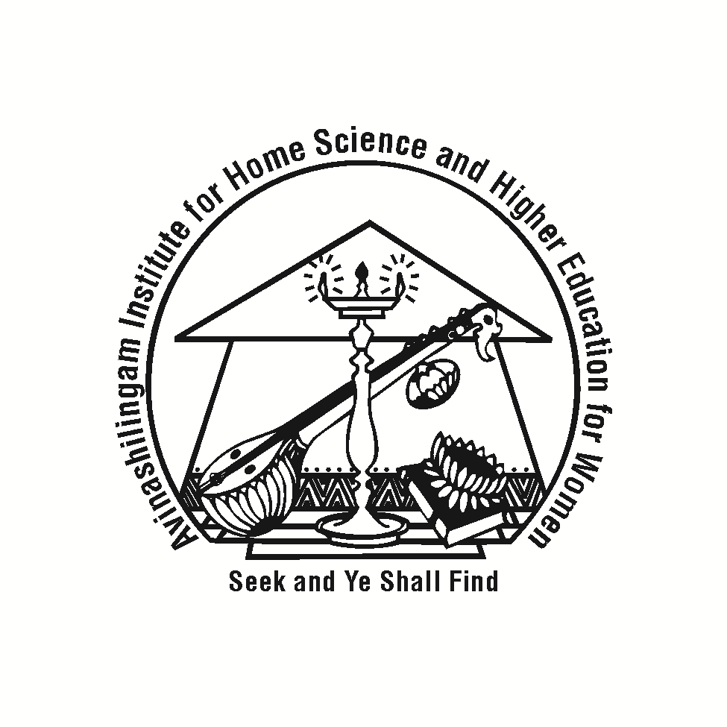

Avinashilingam Institute for Home Science and Higher Education for Women
(Deemed to be University under Category ‘A’ by MHRD, Estd. u/s 3 of UGC Act 1956)
Re-accredited with ‘A+’ Grade by NAAC. Recognised by UGC Under Section 12B
Coimbatore - 641 043, Tamil Nadu, India

Master’s Degree Examination – January 2021
III Semester

Class : II M.Sc. Time: 3 Hours Major : Botany Max. Marks: 100

17MBOC19 Ethnobotany (Self Study)

PART A 10 x 1 = 10
Choose the Correct Answer

1. The dried, pressed plants preserved on sheet for future reference is known as _______ a. Photograph b. Herbarium c. Cartoon d. Hotspot

2. The largest number of tribes inhabits in__________ state of India
a. Tamil Nadu b. Karnataka c. Maharashtra d. Madhya Pradesh

3. Cinchona bark is used to treat _____________ a. Cholera b. Fever c. Malaria d. Diarrhoea

4. The common name for Acorus calamus is_________ a. Sweet flag b. Omavalli c. Sarsaparilla d. Spanish Cherry

5. Murraya koenigii belongs to _____________family a. Sterculiaceae b. Acanthaceae c. Rutaceae d. Malvaceae

6. Pergularia daemia is used to treat ________ a. Diabetes b. Rheumatism
c. Respiratory ailments d. Lactation

7. The vernacular name for Tribulus terrestris is ------------------ a. Nerijil b.Manjal c. Vasampu d. Nochi

8. The prominent ethnobotanical use of Acalypha indica is to treat a. Rheumatism b. Skin disease c. Tooth ache d. digestive disorders

9. The largest tribal population in Nilgiris is a. Irulas b. Badagas c. Todas d. Paniyars

10. Of the total use of plants by Tribal people, the largest use recorded so far is---------- a. edible b. medicinal
c. fiber and cordage d. fodder

Part B 5 x 6 = 30
Answer ALL questions
Each answer should not exceed 400 words or two pages

11.a. Briefly explain the scope and objectives of ethnobotany. (or)
11.b. Write a critical account on Andamanese tribe.
12.a. Comment on the uses of Cinnamon and sandal wood by ethnic tribes in India. (or)
12.b. Write a critical account on the uses of clove and pepper by Indian tribes.

13.a. How Euphorbia hirta is useful to mankind? (or)
13.b. Explain the mentioned uses and mode of application of Adhatoda vasica
14.a. Briefly explain the role of two medicinal plants to bring dandruff under control.
(or)
14.b. Describe the medicinal properties and mode of use of Andrographis paniculata.
15.a. Comment on folklore medicine. (or)
15.b. Explain the tribal population in Coimbatore district.

Part C 5 x 12 = 60
Answer ALL questions
Each answer should not exceed 800 words or four pages

16.a. Comment on the major tribes in Tamil Nadu. (or)
16.b. Describe the methods of ethnobotanical studies.
17.a. With the help of suitable example explain the ethnobotanical practices of rhizomes
and roots.
(or)
17.b. Describe the ethnobotanical significances of Eucalyptus, Coleus and Betel leaves.
18.a. Describe in detail the medicinal properties and drug preparation of Eugenia jambolana. (or)
18.b. Explain the method of preparation of drug and uses by Cissus quadrangularis and
Tribulus terrestris.
19.a. How jaundice is cured by medicinal plants? (or)
19.b. Explain the principle and method of control of skin diseases with Neem.

20.a. Discuss the role of participatory forest management in conservation. (or)
20.b. Write a critical account on the recent trends and applications in ethnobotany.

*****

