Effect of Intervention Strategies using Low Glycemic Recipes

Apoorva N Gururaj
(12PFN002)

Thesis submitted to
Avinashilingam Institute for Home Science and Higher Education for Women
Coimbatore- 641043

In Partial fulfilment of the Requirements for the
Degree of Master of Science in Food Science and Nutrition

March, 2014

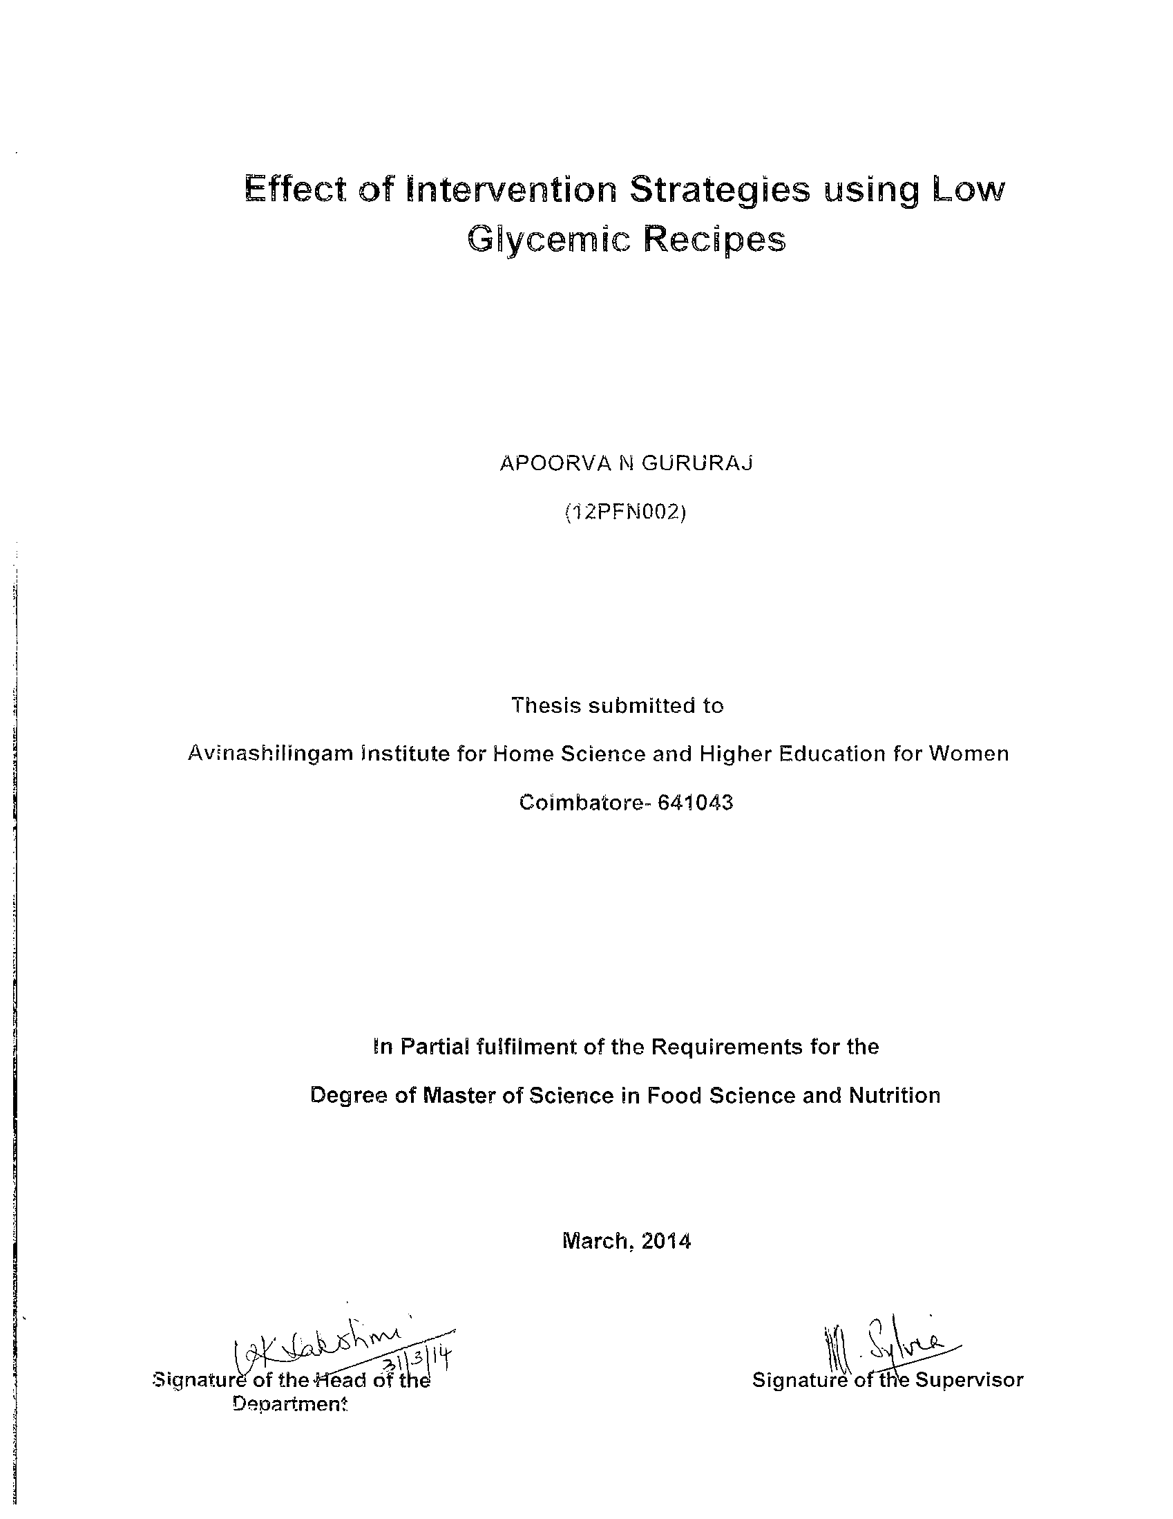
ACKNOWLEDGEMENT
The investigator thanks GOD ALMIGHTY for giving strength, courage and ability to successfully complete this research study.
The investigator fondly remembers Ayya Dr. T.S. Avinashilingam, Founder President – First Chancellor and Amma Dr. (Mrs.) Rajammal .P. Devadas Former Chancellor, Avinashilingam Institute for Home Science and Higher Education for Women, Coimbatore.
The investigator expresses her reverential gratitude to Dr. T.S.K. Meenakshisundaram, M.A., M.Phil, Ph.D., Chancellor, Avinashilingam Institute for Home Science and Higher education for Women, Coimbatore, for providing the infrastructural facilities for the conduct of the study.
The investigator is indebted to Hon. Col Dr. (Mrs.) Sheela Ramachandran, M.sc, P.G. Dip.Fsc & P., Ph.D, (Avinashilingam), Vice Chancellor, Avinashilingam Institute for Home Science and Higher Education for Women, Coimbatore, for providing all amenities required and for her immense support in the conduct of the study.
The investigator records her gratitude to Dr. (Mrs.) Gowri Ramakrishnan, M.Sc (Madras), M.Phil, Ph.D (Avinashilingam), Registrar, Avinashilingam Institute for Home Science and Higher Education for Women, Coimbatore, for providing all the help for smooth conduct of the study.
The investigator owns her heartfelt thanks to Dr. (Mrs.) U.K. Lakshmi, M.Sc., Dip.Ed., M.Phil. (Madras), Ph.D(Avinashilingam), Dean Faculty of Home Science, Professor and Head of the Department of Food Science and Nutrition, Avinashilingam Institute for Home Science and Higher Education for Women, Coimbatore, for her concern and guidance rendered during the course of the investigation.
The investigator conveys her special thanks, utmost gratitude and feels extremely privileged to have worked under the supervision of her esteemed guide Dr. (Mrs.) P.A. Raajeswari, M.Sc, M.Phil, Ph.D (Avinashilingam), Assistant Professor (SS) Department of Food Science and Nutrition, Avinashilingam Institute for Home Science and Higher Education for Women, Coimbatore, for her dynamic guidance, patience, constant encouragement, valuable and amicable suggestions and help for the study.
The investigator is deeply indebted to her guide Dr. (Mrs.) M. Sylvia Subapriya, M.Sc, M.Phil, B.Ed, Ph.D. (Avinashilingam), Associate Professor , Department of Food Science and Nutrition, Avinashilingam Institute for Home Science and Higher Education for Women, Coimbatore, for her supportive wisdom, patience, perfectionism and untiring enthusiasm
The investigator would also like to place on record her sincere thanks to Dr. (Mrs.) Thangaleela, Professor of Physiology, Department of Food Science and Nutrition, Avinashilingam Institute for Home Science and Higher Education for Women, Coimbatore, for her constant inspiration and positive enthusiasm to carry out the study successfully.
The investigator extends her heartfelt thanks to Dr. (Mrs.).S.Gandhimati, Associate Professor, Department of Economics, Avinashilingam Institute for Home Science and Higher Education for Women, Coimbatore for her valuable help and suggestions in statistical analysis for the study.
The investigator takes this opportunity to extend her thanks to all the faculty members of the Department of Food Science and Nutrition, Avinashilingam Institute for Home Science and Higher Education for Women, Coimbatore, for their support extended to her for the study.
The investigator is whole heartedly is thankful to all the volunteers who willingly co-operated from the beginning to the final step of the study and for the prompt compliance to the guidelines issued regarding the intervention that has made the researcher reach this stage.
The investigator is deeply indebted and expresses her gratitude and thanks to her entire family, especially her dear father N Gururaj, brother Anoop and sister in law Vinaya for their constant, moral support, prayers and help rendered throughout the study without which it would not have been a successful one
The investigator also wishes to thank all her classmates especially her friends V. Sujithra, K.P Krishnapriya, M. Vijayalakshmi, Chhandika Roy, T.Kavipriya, Bandini J Patel, Vidya S Baddi, V. Pavitra, Nidhi, Meera, Shewasangry, Jahnabi and Sara for their constant encouragement and motivation, untiring help in all aspects.
The investigator expresses her sincere thanks and gratitude to Dr. (Mrs.). Sangeeta Pandey and Mrs. Mary Regi for their constant support and valuable suggestions.
Last but not the least, on a personal note, the investigator fondly remembers her beloved mother Sandhya Gururaj and her aunt N Rekha and takes immense pleasure in dedicating the first record of her research work to them without whom this would have been a distant reality.

CONTENTS
Chapter No | Title | Page No.
 | List of Tables
 | List of Figures
 | List of Plates
 | List of Appendices
I. | INTRODUCTION | 1
II.  A.  B.  C.  D.  E. | REVIEW OF LITERATURE  Lifestyle Disease – An Overview  Significance of Glycemic Index and Therapeutic effects of Low Glycemic foods.  Role of Minor Millets and Pulses as low Glycemic Ingredients.  Intervention strategies to combat lifestyle disorders.  Nutrition Education on Low Glycemic Index Recipes. | 6  6  9  10  12  13
III.  A.  B.  C.  D.  E.  F. | METHODOLOGY  Identification and Selection of Millets and Pulses with Low Glycemic Index.  Formulation and Standardization of Recipes with Low Glycemic Index.  Determination of Glycemic Index for the Developed Recipes with Maximum Acceptability.  Preparation of Tools and Modules for Nutrition Education  Imparting and Evaluating Nutrition Education  Statistical Analysis and Data Interpretation. | 15  15  18  22  24  28  31
IV.  A.  B.  C.  D. | RESULTS AND DISCUSSION  Acceptability of the Formulated Low Glycemic Index Recipes  Glycemic Index of the Recipe with Maximum Acceptability.  Nutrition Education Modules Developed and Used.  Impact of Nutrition Education Programme. | 33  33  51  59  67
V. | SUMMARY AND CONCLUSION | 72
 | BIBLIOGRAPHY | 76
 | APPENDICES | 84

LIST OF TABLES
S.NO | Titles | Page no
1 | Details of 1:1 combination of millets and pulses | 23
2 | Mean organoleptic scores of the developed recipes | 34
3 | Mean organoleptic scores of the developed recipes | 35
4 | Mean organoleptic scores of dosa | 39
5 | ANOVA for Overall acceptability | 40
6 | ANOVA for Colour | 41
7 | ANOVA for Flavour | 42
8 | ANOVA for Texture | 43
9 | ANOVA for Taste | 44
10 | Coefficient of Covariation (%) for all recipes | 45
11 | T Test results for all the recipes | 46
12 | Percent mean score of Overall Acceptability for all 250 Recipes | 48
13 | Serving Size of Recipes Providing 50g of Available Carbohydrate | 51
14 | Glycemic Response of Dosa | 52
15 | Mean Score of Knowledge, Attitude and Practice | 67
16 | KAP scores with Impact (%) | 68
17 | KAP scores with Impact (%) | 69

LIST OF FIGURES

S.no | Titles | Page no
1 | Glycemic index of selected ingredients | 16
2 | Research design | 32
3 | Mean organoleptic of the developed recipes | 38
4 | Coefficient of Covariation of all Recipes | 47
5 | T Test results of all recipes | 47
6 | Percent Mean Acceptability of all Recipes | 50
7 | Glycemic Index of Dosa | 53
8 | Blood Glucose Response | 54
9 | Blood Glucose Response | 55
10 | Blood Glucose Response | 56
11 | Blood Glucose Response | 57
12 | Blood Glucose Response | 58
13 | Impact of Nutrition Education | 70

LIST OF PLATES

S.no | Title | Page no.
1 | Selected Minor Millets and Pulses with Low Glycemic Index | 20
2 | Recipes developed using Low Glycemic combination of Millets and Pulses | 25
3 | Determination of Glycemic Index | 30
4 | Pamphlet | 62
5 | Poster | 64
6 | Booklet | 65
7 | Power Point Presentation | 66

LIST OF APPENDICES

S.no | Title | Page no.
1 | KAP Questionnaire | 84-86
2 | Sensory Evaluation Score Card | 87
3 | Ethical Approval Letter | 89
4 | Informed Consent Form | 90-91

I. INTRODUCTION
The World Health Organization (1986) defined health in its broader sense as "a state of complete physical, mental, and social well-being and not merely the absence of disease or infirmity." Generally, the context in which an individual lives is of great importance for both his health status and quality of life. It is increasingly recognized that health is maintained and improved not only through the advancement and application of health science, but also through the efforts and intelligent lifestyle choices of the individual and society.
India is one of the world’s largest developing economies. According to a recent study, it is seen that as with other developing countries, India is presently in the epidemiological transition phase. Mortality risk factors include both poverty and lifestyle related risk factors. Hence strategies should be developed for modifying rapidly changing life style behavior among its residents. (Goel, (2012). India's Nutrition Challenges call for urgent action, as a critical development in order to improve nutritional and health status of the population. The challenge for India, as elsewhere, is clearly to counteract the seeming inevitability of the degenerative phase of the nutrition transition. (Parulkar,(2009). According to Gupta (2012), “Total calorie intake of an average youth has increased over the past many years. Diet has gone for a transition from simple homemade food to easily available processed food”. Unhealthy, processed food has become much more accessible following India's continued integration in global food markets.
Lifestyle diseases (also sometimes called diseases of longevity or diseases of civilization interchangeably) are diseases that appear to increase in frequency as countries become more industrialized and people live longer. They include Alzheimer's disease, Arthritis, atherosclerosis, asthma, some kinds of cancer, Type 2 diabetes, heart disease, metabolic syndrome, chronic renal failure, osteoporosis, stroke, depression and obesity.
India is facing the double burden of chronic under nutrition at one end of the spectrum and the epidemic of obesity and its related disorders (Diabetes Mellitus, Poly Cystic Ovarian Syndrome, and CVD) at the other end. PCOS is the most common endocrine disorder among women of reproductive age, affecting approximately four per cent of women. Prevalence of PCOS in Indian adolescents is 9.13 per cent. (Nidhi et al.,2011). Obesity has reached epidemic proportions in India in the 21st century, with morbid obesity affecting 5% of the country's population. India is following a trend of other developing countries that are steadily becoming more obese.
Diabetes is a major cause of heart disease and stroke. Death rates for heart disease and the risk of stroke are about 2–4 times higher among diabetics than among non diabetics. The estimates were of 246 million people worldwide with diabetes for 2007, and an anticipated 380 million for 2025. Being home to around 40 million diabetics, India is emerging as the ‘diabetic capital’ of the world. In the next 17 years, India, China and the US would have the largest number of diabetics. It is estimated that every fifth person with diabetes will be an Indian. As per WHO estimates, mortality from diabetes, heart disease and stroke cost about $210 billion in India in 2005. (IDF report 2011).
The link between lifestyle disorders and diet has been well documented, as has the importance of diet in conjunction with medical interventions for these diseases. Therefore one of the most appropriate dietary approaches would be to develop and propagate Low Glycemic Foods. Nutrition plays a very important role in the management of diabetes and helps to maintain blood glucose level. Though carbohydrates are the body's main energy source and should be part of a well-balanced meal plan, yet the kinds of carbohydrates consumed are important in the management of blood glucose levels. It is well known that a food with a low Glycemic Index (GI) typically raises blood sugar levels only moderately, while a food with a high GI may cause blood sugar levels to increase more than desired. For diabetics, controlled intake of carbohydrates is one of the important factors in diet management. The blood sugar (glucose) that is delivered to the cells throughout our bodies via our bloodstream is partly derived from the carbohydrates in the foods that are consumed through diet.
GI values help to predict the functional effects in the body and hence is an important tool to selection of right foods to stabilize blood glucose levels. (www.health.harvard.esdu). Over the past 15 years, low-GI diets have been associated with decreased risk of cardiovascular disease, type 2 diabetes, metabolic syndrome, stroke, depression, chronic kidney disease, formation of gall stones, neural tube defects, formation of uterine fibroids, and cancers of the breast, colon, prostate, and pancreas. Taking advantage of these potential health benefits can be as simple as sticking with whole, natural foods that are either low or very low in their GI value. (www.whffoods.com). A food is generally considered to have a high GI if it is rated above 60. Individuals who have problems with maintaining proper blood sugar levels should restrict their selection to foods with a GI of 40 or less. These include those who have low blood sugar (hypoglycemia) and high blood sugar (hyperinsulemia) as well as those who have a high sensitivity to sugar. Sugar includes not just simple sugars, honey and maple syrup but also fruits, fruit juices, starchy vegetables and grain products or foods with a high Glycemic Index. (www.glycemicindex.com).
Clinical Trials and research have shown that diets with low Glycemic Index improves glycemic control in Diabetes, increased insulin sensitivity and cell function, reduce food consumption and body weight, influence memory and may reduce serum cholesterol. As we grapple with a slew of lifestyle diseases, it might be pertinent to re-evaluate our food choices. Millets are consumed as whole grain foods, in their unpolished state. Rice and wheat on the other hand not only lose out on their nutritional value while being polished but are also high on the Glycemic Index. Millets release a less percentage of glucose and over a longer period of time, thus lowering the risk of diabetes.
Millets are highly nutritious, non-glutinous and non-acid forming foods. They are hence soothing and easy to digest. By all nutritional parameters, millets seem to race ahead of rice and wheat. Millets have more fiber than rice or wheat. They are storehouses of calcium and iron. Most importantly they provide us with micro-nutrients which are missing in mainstream diets today.
Diets with low Glycemic Index value improve the prevention of coronary heart disease in diabetic and healthy subjects. In obese or overweight individuals, low-Glycemic Index meals increase satiety and facilitate the control of food intake. Selecting low Glycemic Index foods has also demonstrated benefits for healthy persons in terms of post-prandial glucose and lipid metabolism. (Urszula et al, 2012)
Several public health organizations have recently integrated consideration of the Glycemic Index in their nutritional recommendations for patients with metabolic diseases and for the general population. (www.ncbi.nlm.nih.gov). the nutritional characteristics of carbohydrates deserve special attention. As noted, there are many different starches which depend on a number of factors. Starches differ due to their original molecular structure (amylose and amylopectin) and also because of the nature of the additional nutrients they contain (proteins, fibers.). The physico-chemical properties of starches evolve when they come in contact with water, undergo temperature variations and as time passes hydrothermal, industrial or culinary processing transform the food.
The glycemic Index of foods is the result of several parameters which must be considered while making food choices. By disregarding these scientific notions, discovered during the past 20 years, traditional diets have allowed the food industry to develop suspect botanic varieties as well as industrial processing cooking and conservation technologies, which contribute to indirectly hiking postprandial glycemia to alarming levels for consumers of modern foods. These perverse metabolic effects result in hyperinsulinism leading to obesity, diabetes and many cardiovascular illnesses.
Small adjustments in dietary intake with regard to the GI may yield significant results. When both patients and providers recognize this and educate them, those different carbohydrates may have different effects on blood glucose levels and this can result only with effective dietary changes that not only will improve glycemic control but also provides long term health benefits. This can turn into reality only with effective nutrition education.
Daniel (2010) defined Nutrition Education as “any combination of educational strategies, accompanied by environmental supports, designed to facilitate voluntary adoption of food choices and other food- and nutrition-related behavior”. Nutrition education is delivered through multiple venues and involves activities at the individual, community, and policy levels.
There has been a growing interest in tailored nutrition education on GI foods over the previous decades and a number of literature reviews suggest that this intervention strategy is more consistent and holds considerable potential for the management of Diabetes mellitus. Hence this strategy needs to be exploited to achieve the maximum potential benefits.
The quest for low GI foods has been on from time immemorial. Scientists, dieticians, diabetologists and patients alike experiment to derive that ‘magic concoction’ that can bring and maintain euglycemia.
The present study is a small step in this direction and is designed with following objectives:
- Identify ingredients, formulate, standardise and organoleptically evaluate the developed recipes.
- Determine the Glycemic Index (Gl) of the formulated recipes with maximum acceptability.
- Develop modules including ICT enabled modules on GI and
- Impart and evaluate the effect of nutrition education on KAP.

II. REVIEW OF LITERATURE
The review of literature to the present study “Intervention strategies using low Glycemic Index recipes” undertaken is presented under the following headings:
- Lifestyle Disease – An Overview
- Significance of Glycemic Index and Therapeutic effects of Low Glycemic foods.
- Role of Minor Millets and Pulses as low Glycemic Ingredients.
- Intervention strategies to combat lifestyle Disorders.
- Nutrition Education on Low Glycemic Index Recipes.
- LIFESTYLE DISEASES– AN OVERVIEW
Lifestyle diseases such as hypertension, atherosclerosis, Coronary Heart disease and Type -II Diabetes mellitus are non communicable diseases leading to premature sickness, disability and death (Mane et al., 2014).
In India, life style changes are linked to urbanization, industrialization and westernization which have remarkable influences on health practices, dietary and behaviour patterns and so on. The most important factors influencing the life style are the nutrition and environmental factors (Bhaskar, (2013).
According to Prema (2010) India is undergoing a rapid nutrition and health transition. During last two decades the country has witnessed a steep increase in over nutrition and associated non- communicable diseases.
Ankita Chakrabarty (2012) opined that India has managed to control communicable diseases like malaria, cholera and polio. However, the nation now has to deal with a new breed of developed world obesity-fuelled diseases like diabetes and cardiovascular ailments. Coupled with a sedentary urban lifestyle, increased alcohol consumption and smoking, the urban youth are particularly prone to the aforementioned lifestyle diseases.

Pappachan (2012) reported that cardiovascular diseases (CVD) continue to be the major cause of mortality representing about 30 per cent of all deaths worldwide. Lifestyle diseases like hypertension, diabetes mellitus, dyslipidaemia and overweight/obesity are the major risk factors for the development of CVD. With rapid economic development and increasing westernization of lifestyle in the past few decades prevalence of these diseases has reached alarming proportions among Indians in the recent years.
Incidence of obesity was estimated to be 300 million and 115 million people in developing countries which are alarming. With healthy lifestyle factors, it was possible to identify men and women with substantially lower relative risks of incident CVD and death, regardless of BMI and educational level (Carlsson,et al., 2013).
A common endocrine disorder that affects 5-10 per cent of women today is PCOD. The major factors causing PCOS are obesity and complex changes taking place in the hypothalamus, pituitary and ovary resulting in the over production of male hormones (Ravindra and Kawade, 2012).
A cohort study by Louie et al,. (2014) revealed that diagnosis of CVD or DM may act, along with possible effects of medical treatment, as a trigger to adopt a healthier lifestyle in terms of smoking cessation, healthier diet and weight loss. According to the Global Atlas on cardiovascular disease prevention and control 2011, death rate due to ischemic heart disease. In India is 1658 per 100,000. Around 1164 per 100,000 people in India die due to cerebrovascular disease.
Lower-GI energy-restricted diets achieved through a specific differential food selection can improve the energy adaptations during obesity treatment, favouring weight loss and probably weight maintenance compared with higher-GI hypocaloric diets.(Itziar Abete et al., 2007).
Coleman et al., (2014) showed relationship between consumption of low Glycemic foods and decreased risk of endometrial cancer. Jamurtas et al., (2013) established the relation of consuming low Glycemic foods on exercise performance on a long run. A case control study showcased that consuming high Glycemic Index diet is associated with increased risk of esophageal squamous cell carcinoma, Ghazaleh Eslamian et al., (2013).
Parks et al., revealed the relationship between the Glycemic Index of a food and indicators of a food's Glycemic Index and that food's ability to stimulate lipogenesis in humans. (2009). Schwingshack et al., revealed that consuming low GI foods has an effect on parameters of Obesity and obesity related disorders (2014).
An isocaloric Low Glycemic Index diet improves insulin sensitivity in women with Polycystic Ovary Syndrome (Angeliki Papadaki, 2013).Diets with low glycaemic index value prevent coronary heart disease in diabetic and healthy subjects. In obese or overweight individuals, low-glycaemic index meals increase satiety and facilitate the control of food intake,(Rizkalla et al., (2012).
Slama (2012) stated that selecting low glycaemic index foods has also demonstrated benefits for healthy persons in terms of post-prandial glucose and lipid metabolism. Elliot (2009) reported that consuming a low Glycemic food decreases the risk for complications in diabetics.
Acheson (2010) opines that emphasizing low Glycemic Index foods in the diet may facilitate weight loss and weight management. Frederique et al., (2012) showcased that eating disorders are relatively common in young women and have an elevated mortality risk; anorexia nervosa being the most striking.
Buscem et al., (2011) opines that adolescents are at an increased risk for weight gain as they begin college and this is the underlying implications for the onset of future health consequences. A study carried out in South Asia by Kumarapelli et al., (2009) reveals that prevalence of PCOS to be 6.7 % in women aged 15-39 yrs.
Egan et al., (2011) suggests that dietary modification using a low Glycemic Index diet could specifically reduce risks associated with PCOS including endometrial cancer when compared to other diets. Many studies from different Indian States showed that the prevalence of pre-hypertension in the country is about 40-50 per cent; a prevalence much higher than that in the West.( Ray et al ,. 2013).
B. SIGNIFICANCE OF GLYCEMIC INDEX AND THERAPEUTIC EFFECTS OF LOW GLYCEMIC FOODS.
Jenkins et al., (1981) revealed Glycemic Index as a quantitative assessment of foods based on post prandial blood glucose response expressed as a percentage of the response to an equivalent portion of a reference food, white bread or glucose.
Glycemic Index (GI) a system of classifying carbohydrates containing foods according to glycemic response operates on the principle that the slower the rate of carbohydrates absorption, the lower the rise of blood glucose level and lowers the Glycemic Index value (Brand et al,. 1991).
A Glycemic Index value of > or = 70 is considered high. A Glycemic Index value of 56 – 69 inclusive is medium and < or =50 is low where as GI of glucose = 100. (Miller et al,. 2007).
Low GI foods by virtue of their slow digestion and absorption produce gradual rise in blood sugar and insulin levels and have proven benefits for health. Low GI diets also reduce insulin levels and insulin resistance (htpp://www.glycemicindex.com)
Livingstone et al., (2013) has shown the association of dietary pattern and glycemic load with food and nutrient intake as well as central obesity. Increase in acidity lowers the Glycemic Index of the food. Amanda (2011) reported sourdough bread, prepared using lactobacillus or lactic acid culture as part of the leavening process, had Glycemic Index than white bread.
Radhika G et al.,(2010) strongly expressed that there is a need to determine the Glycemic Index of locally available foodstuff using standardised methodology. Long term use of low Glycemic Index foods has shown to have an effect on plasma glucose and lipid concentration levels in normal and diabetic adults Metzger et al., (2007).
Riccardi et al., showcased the importance of Glycemic Index and Glycemic load to maintain health and prevent early onset of Diabetes Mellitus in prediabetics (2009).Generally, the less processed the food, the lower its GI value. Whole grain products, such as whole-wheat pasta or bread, score low on the GI index. White bread and white rice score high. (http://www.brighamandwomens.org)
Pignone (2011) reported presence of decreased fatty acid oxidation in obese individuals. A low Glycemic Index diet resulted in more successful weight management. Frost and Dornhorst (2013) opines that minimal disruption of whole foods from their natural, unprocessed state is one of the key principle in lowering the Glycemic Index.
Murakami et al., showcased Glycemic Index is positively associated with serum homocysteine concentration (2014). Scazzina (2011) reported that Low-GI lead to a moderate increase in glucose response. A similar effect was observed on insulin levels. Inclusion of low-GI food into the diets of COPD patients may be useful in diet planning, mainly when steroids are used as a means of treatment.
The goal of the low-glycemic diet is to eat unprocessed, unrefined carbohydrates in combination with healthy proteins and fats to improve satiety by keeping digestion slow, (Mayo Clinic).
C. ROLE OF MINOR MILLETS AND PULSES AS LOW GLYCEMIC INGREDIENTS
Epidemiological studies find that whole-grain intake is protective against cancer, CVD, diabetes, and obesity. Despite recommendations to consume three servings of whole grains daily, usual intake in Western countries is only about one serving per day. Whole grains are rich in nutrients and phytochemicals with known health benefits (Pankow,. et al (2011).
Whole grains have high concentrations of dietary fiber, resistant starch, and oligosaccharides. Whole grains are rich in antioxidants including trace minerals and phenolic compounds and these compounds have been linked to disease prevention. Other protective compounds in whole grains include phytate, Phyto-estrogens such as lignin, plant sterols and sterols, and vitamins and minerals. (Jeffrey et al,. 2012).
Published whole-grain feeding studies report improvements in biomarkers with whole-grain consumption, such as weight loss, blood-lipid improvement, and antioxidant protection.( Ross et al,. 2012). Although it is difficult to separate the protective properties of whole grains from dietary fibre and other components, the disease protection seen from whole grains in prospective epidemiological studies far exceeds the protection from isolated nutrients and phytochemicals in whole grains, (Slavin 2008).
Trinidad et al., (2010) explored the potential health benefits of legumes in terms of mineral availability, Glycemic Index and hypolipidemic effect. This makes legumes to possess a significant role in disease control as well as in disease management. Oboh A. et al.,( 2009) reported that Glycemic Index of some commonly consumed foods in Nigeria in healthy subjects. The legumes evaluated include cowpeas, pigeon peas, peas, yam bean (African) and ground nut and they were found to have GI of less than 40.
Anju Thathola et al., (2010) have reported supplementation of low Glycemic Index foxtail millet biscuits and burfi for a period of 30 days caused significant reduction from baseline value by 23% for serum glucose, 6% for serum cholesterol and 20% for LDL (Low Density Lipoprotein) while 23% increase in HDL (High Density Lipoprotein). Mendosa (2009) opines that soya bean have a Glycemic Index of 16. The low GI of soy goods appears to be an additional benefit to improve control over blood glucose and insulin levels.
Shobana (2010) reported that Finger millet (Eleusine coracana) is extensively cultivated and consumed in India and Africa. The millet seed coat is a rich source of dietary fibre and phenolic compounds. The effect of feeding a diet containing 20 % finger millet seed coat matter (SCM) for 6 weeks exhibited a lesser degree of fasting hyperglycaemia and partial reversal of abnormalities in serum albumin, urea and creatinine compared with the diabetic control (DC) group.
D. INTERVENTION STRATEGIES TO COMBAT LIFESTYLE DISORDERS
Whenever multidisciplinary lifestyle intervention is planned for patients with obesity, it is of the utmost importance to tailor the approach while taking the following key aspects into account: motivation, barriers and/or facilitators in lifestyle change, patients’ perceptions of obesity and relationship with food, diet and exercise.
Emphasizing the need to spread awareness to tackle lifestyle diseases, Dr Kumeran (2011) at Obesity Foundation India said, “Parents should be aware and should be responsible to guide their children to eat the right kind of food
Glycemic Index values are now available for a number of food products consumed in Europe, America, Asia, Australia and China including breakfast, lunch and dinner items, also all categories of foodstuffs like cereals, pulses, nuts, fruits and dairy products (Henry et al., 2007).
Hoffmann et et al., (2013) stated that effects of long-term interventions administering a low Glycemic Index diet with respect to fasting insulin and pro-inflammatory markers such as c- reactive protein is beneficial.
Dietary intervention in early pregnancy had a positive influence on maternal GI, food and nutrient intakes and gestational weight gain . Following a low GI diet may be particularly beneficial for women at risk of exceeding the gestational weight gain goals for pregnancy (Ciara et al, 2013). Emily et al,. (2011) reposted that a low-GL diet intervention resulted in longer pregnancy duration, greater infant head circumference, and improved maternal cardiovascular risk factors.
Diana et al,. (2010) indicated that the maternal diet composing low Glycemic Index has a direct impact on foetal fat mass and resulting birth weights. Weight-bearing maternal exercise also influences the placental volume, which has also been correlated to birth weight. A foetal energy balance equation, based on the first law of thermodynamics, that incorporates maternal diet and exercise is developed.
Kate et al,. (2009) opined that in individuals with diabetes, intervention studies have shown improvements in insulin sensitivity and glycosylated hemoglobin concentration with low Glycemic Index diets.
E. NUTRITION EDUCATION ON LOW GLYCEMIC RECIPES
Amanda et al, (2011) reported that the ability to achieve optimal glycemic control in diabetes management is highly influenced by food intake and focus for nutrition education is aimed for consistency in both type and quantity of carbohydrates consumed.
Nutrition education plays an important role in generating social understanding as well as acceptance of broader interventions to elevate nutritional status and give a better understanding to maintain a healthy life.
According to Melinda et al, (2011), using the GI in meal planning improves diabetes control and other health parameters hence understanding the benefits of the Glycemic Index and how it can be implemented it into the diet, allow health care practitioners to educate patients about their role in diet.
Xavier (2012), suggested that foods with a high Glycemic Index are detrimental to health and that healthy people should be told to avoid these foods and to launch a public health campaign to disseminate the recommendation for potential benefits.
Marsh et al, (2010) suggested that Glycemic Index should be an important aspect in dietary management and in prevention of obesity and chronic diseases, considered while counseling clients and patients.

Lisa et al., (2011) lifestyle interventions, including weight management through diet and exercise was successful in reducing the risk for GDM; and provide recommendations for future lifestyle intervention programs with a focus on translation and dissemination of research findings.
A study conducted by Yusoff et al., (2012) reveals that nutrition education along with supplementation of for a period of six months improved the Knowledge, Practice and Attitude as well as haemoglobin status of young women. This shows that intervention along nutrition education is more effective.
III. METHODOLOGY
The methodology adopted for the present study titled “Effect Intervention Strategies Using Low Glycemic Recipes” is discussed under the following headings:
A) Identification and Selection of Millets and Pulses with Low Glycemic Index.
B) Formulation and Standardisation of Recipes with Low Glycemic Index.
C) Determination of Glycemic Index for the Developed Recipes with Maximum Acceptability.
D) Preparation of Tools and Modules for Nutrition Education
E) Imparting and Evaluating Nutrition Education
F) Statistical Analysis and Data Interpretation.

- IDENTIFICATION AND SELECTION OF MILLETS AND PULSES WITH
LOW GLYCEMIC INDEX

Selection refers to the food groups chosen for the study which are millets and pulses. Research has shown that millets are low in Glycemic Index and increase in protein content further decreases the Glycemic Index which is the reason for including pulses in combination with millets. (Slavin et al.,.2004). The GI of the millets and pulses selected for the study according to International Table of Glycemic Index and Glycemic Load (2012) is depicted in Figure 1. The identified and selected minor millets and pulses (Plate –I) for the study are as follows:
Pisum sativum (Peas)
Peas have a Glycemic Index of 35, are starchy, high in fibre, protein, vitamins, minerals and lutein. Peas have a fractional ability to scavenge free radicals than glutathione but greater ability to chelate metals and inhibit linoleic acid oxidation (Manyasa et al., 2012).

FIGURE 1
GLYCEMIC INDEX OF SELECTED INGREDIENTS

Panicum miliaceum (Proso Millet)
Proso millet is one of the very few types cultivated. It is sold as a health food. Due to its lack of gluten it is considered to be a good substitute for wheat for people who cannot tolerate gluten or wheat products. It has a Glycemic Index of 48 (MINI, 2011).
Setaria italica (Foxtail Millet)
Foxtail millet is the second mostly widely planted species of millet and the most important East Asia. Foxtail millet was procured from the local market, cleaned to remove stones and make it dirt or filth free. They have a Glycemic Index of 34.( MINI, 2011).
Lens esculenta (Lentils)
Lentils have the highest content of protein by weight compared to any legume or nut. Lentils have a Glycemic Index of 28. Lentils are an essential source of inexpensive protein in many parts of the world. Lentils also contain dietary fibre, folate, vitamin B and minerals especially rich in iron (Prabha, 2009).
Macrotyloma uniflorum (Horse gram)
Horse gram is an excellent source of iron and molybdenum. It also contains phenolic acids and has a Glycemic Index of 53 (Singh, 2001).
Phaseolus vulgaris (Kidney Beans)
Kidney beans are an integral part of the cuisine in northern region of India commonly known as rajma as well as red peas in New Orleans. They are good sources of protein and fibre. They have a Glycemic Index of 29 (Devi, 2005).
Glycine max (Soya bean)
Soya bean is a cheap source of protein and also a complete protein. They are a good source of phytoestrogens. Soya bean has a Glycemic Index of 15. It has a biological value of 74 and is considered as a gold standard for measuring protein quality since 1990 as PDCAAS value is very high. Soya is developed into lots of fermented products like tofu, soy milk, soy sauce etc. (Duke, 2011).
Pennisetum glaucum (Pearl Millet)
Pearl millet is commonly known as Bajra. It has a high tolerance to difficult growing conditions and a Glycemic Index of 48. It is a good source of protein and iron. It also forms a part of the staple diet.(MINI)
Echinochloa (Barnyard Millet)
Barnyard millet is rarely used or less exploited millet, but nevertheless nutrient dense millet. Its commonly used in northern part of India, contains high calcium and zinc. It has a Glycemic Index of 24.(MINI).

- FORMULATION AND STANDARDISATION OF RECIPES WITH LOW GLYCEMIC INDEX
1) Preparation and Formulation
The raw materials were exposed to certain pre-processing before methods such as cleaning, soaking, grinding, sprouting etc.
Good quality dried ingredients was procured from the local market, cleaned and washed (to remove dirt, extraneous matter to make it dirt and filth free), soaked for few hours and sprouted. The sprouted grains were shade dried and once dried they were slightly dry roasted, cooled and powdered. The powder was stored in an air tight for further use in product development.
Ten different recipes were developed with twenty five (25) variations in each recipe. On the whole 250 recipes were developed. These variations were formulated in 1:1 (50g+50g) proportion of the selected minor millets and pulses. All the ingredients were accurately weighed in each and every product preparation and mixed together. The products prepared were Dosa, idly, Adai, Kozhukattai, Khakra, Upma, Dhokla, Idiappam, Chappati and Puttu. The combination of millets and pulses and the product code assigned to each combination is given in Table I.
2. DEVELOPMENT OF RECIPES FROM THE PREPARED MIX
Traditional recipes which are the most popular breakfast item in most parts of India were selected and modified by the addition of millets and pulses to lower their Glycemic Index and thus provide a more judicious choices for breakfast. Recipes prepared (Plate-II) from the formulated mix were as follows:
- DOSA
100g of the formulated flour was taken and 65ml of water was added to get a batter consistency. Salt was added to taste. Laddle full of batter was poured on a pre-heated griddle and shallow fried on both sides on a medium flame till golden brown.
- IDLI
100g of the formulated flour was taken and 55 ml water and 10ml of sour curd (for fermentation) was added. Salt was added to taste. Laddle full of the batter was poured on greased idli moulds placed in an idli steamer and steamed for 10 minutes.
3. KHAKRA
100g of the formulated flour was taken, to this salt, chilli powder and one teaspoon of cumin seeds were added and mixed well. Thirty milliliters of water was added to the flour and kneaded into a stiff dough. Divided the dough into balls and rolled into chapatti (thin as possible) and cooked on a preheated griddle applying pressure with a hot sand bag so as to not allow it to puff up, in order to make it crisp.
4. DHOKLA
The formulated mix (100g) was taken in a bowl, a pinch of soda bicarbonate was added with 2- 3 teaspoon of curd and mixed well. Thirty five milliliters of lukewarm water was added to make a batter of thick consistency. The batter was poured onto a flat plate and steamed for 15 minutes.
5. UPMA
One teaspoon of oil was added and in a pre heated frying pan, spluttered a teaspoon of mustard, added ½ teaspoon of finely chopped ginger juliennes, one finely chopped green chilly and about 50g of chopped vegetables. Sauted well for a few minutes and added 50 ml of water. As soon as the mixture began to boil, added formulated flour slowly and stirred in order to avoid lumps. Cooked on a low flame for five minutes and garnished with chopped coriander leaves

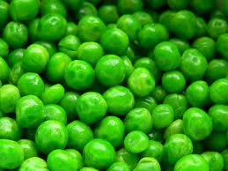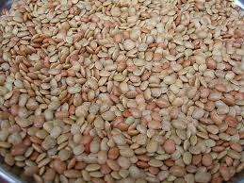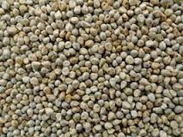
PEAS HORSE GRAM PEARL MILLET

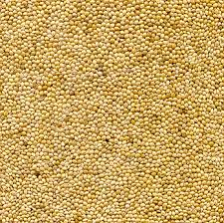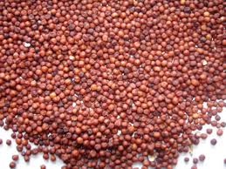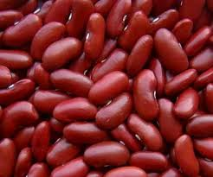

FOXTAIL MILLET FINGER MILLET KIDNEY BEAN
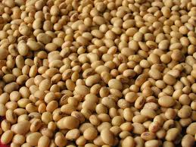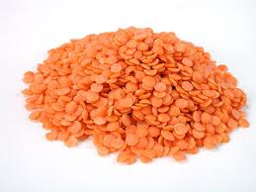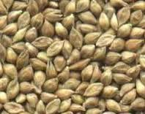

SOYA BEAN LENTILS BARNYARD MILLET

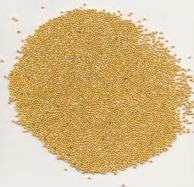

PROSO MILLET

PLATE- I – SELECTED MINOR MILLETS AND PULSES WITH LOW GLYCEMIC INDEX
6. IDIAPPAM
The formulated flour was made into a stiff dough using hot water, put into idiappam moulds and extruded to form thin strings, spread on iddli moulds and steamed for 5- 10 minutes
7. CHAPPATI
The formulated flour was mixed with water to form a soft dough. Divided into balls and rolled into chappathis and shallow fried on a pre-heated griddle.
8. PUTTU
The formulated flour was slightly roasted sprinkled with a little hot water and was mixed into a coarse crumb consistency to retain the grainy structure. The mixture was filled into the puttu mould alternating with grated coconut and steamed for about 10 minutes.
9. KOZHUKATTAI
The formulated flour was mixed with hot water and made into balls of dough, flattened on the greased palm of the hands. A spicy filling of mixed vegetables was placed in the centre. The Kozhukattai was sealed tightly and steamed till done.
10. ADAI
The formulated flour 100 g was taken in a bowl. To this add chopped green chilies, 55ml of water, finely chopped onions and salt to taste were added and mixed well to a batter consistency. A laddle full of batter was poured on a hot griddle and shallow fried on a medium flame till golden brown.
3) ORGANOLEPTIC EVALUATION
All the developed recipes were subjected to organoleptic (sensory) evaluation by thirty semi- trained panelists. A sensory evaluation score card(Appendix-II) was provided to each panelist to rate from a minimum score of one to a maximum score of five. The scores were given to the recipes based on characteristics such as taste, flavor, texture and overall acceptability.
C). DETERMINATION OF GLYCEMIC INDEX FOR THE DEVELOPED RECIPES WITH MAXIMUM ACCEPTABILITY
This study was approved by the Institutional Human Ethical Committee of Avinashilingam Institute for Home Science and Higher Education for Women, Coimbatore and the letter for the same is attached. (Appendix III) The approval number for the study is AUW/IHEC-20-13/XPD-02.
Glycemic Index test was conducted using internationally recognized Glycemic Index methodology (Jenkins et al.,(1981), which has been validated by results obtained for small experimental studies and large multi-centre research trials. The study volunteers (10 women 30-40 years of age) were first oriented on the concept of Glycemic Index. The Glycemic Index test procedure was also explained to them in detail. Written Consent (Appendix IV) was taken from the volunteers. Their health status and details on medication for inclusion/ exclusion in the study or any other complications were ascertained.
The subjects were given general instructions to avoid any physical exertion medication, fast or feast during the experimental period. The oral glucose tolerance test (OGTT) was carried on women on overnight fasting at 7:00 a.m. with a glucose load of 50g of pure glucose.
Pure glucose was given in the form of powder. This was administered on the first day. Fasting blood glucose level was checked prior to administration on the first day. Fasting blood glucose level was checked prior to administration of reference food as well as the list food. Blood sample (0.1 ml) was drawn after the initiation of food at specific intervals at 30 minutes, 60 minutes, 90 minutes and 120 minutes by finger prick method. A time interval of 48 hours was maintained between the administration of the reference food and test food.

TABLE I
DETAILS OF 1:1 COIMBINATION OF MILLETS AND PULSES
Product Code | Millet and Pulse Combination
PFO | Foxtail Millet + Peas
PFI | Finger Millet + Peas
PPE | Pearl Millet + Peas
PBA | Barnyard Millet + Peas
PPR | Proso Millet + Peas
KFO | Foxtail Millet + Kidney bean
KFI | Finger Millet + Kidney bean
KPE | Pearl Millet + Kidney bean
KBA | Barnyard Millet + Kidney bean
KPR | Proso Millet + Kidney bean
LFO | Foxtail Millet + Lentils
LFI | Finger Millet + Lentils
LPE | Pearl Millet + Lentils
LBA | Barnyard Millet + Lentils
LPR | Proso Millet + Lentils
HFO | Foxtail Millet + Horse gram
HFI | Finger Millet + Horse gram
HPE | Pearl Millet + Horse gram
HBA | Barnyard Millet + Horse gram
HPR | Proso Millet + Horse gram
SFO | Foxtail Millet + Soya bean
SFI | Finger Millet + Soya bean
SPE | Pearl Millet + Soya bean
SBA | Barnyard Millet + Soya bean
SPR | Proso Millet + Soya bean

The recipes standardized in the present study were cooked and served to the subjects in a fixed test portion containing 50g digestible (available) carbohydrates. (Table X).Fasting blood glucose levels were checked prior to administration of test food. Blood samples (0.1ml) were collected in the same manner. Therefore a total of four blood samples were collected from each subject on the same day. The subjects were asked not to consume any sweetened drinks during the course of the test and avoid physical exertion. Totally ten products were evaluated for Glycemic Index.
The Glycemic Index of the standardised recipes was calculated by taking the average of the glycemic response of both the reference and list food at 30, 60, 90 and 120 minutes and a glycemic response curve was constructed. The incremental area under blood glucose response curve (iAUBGR) was calculated. (Appendix-V) The Glycemic Index value of each individual was calculated as:
GI value for test food (%) = iAUBGR curve after test food x 100
iAUBGR curve after reference food
The average Glycemic Index of the ten subjects was taken as the Glycemic Index value of each (formulated mix) recipe or product.
D) PREPARATION OF TOOLS AND MODULES FOR NUTRITION EDUCATION
1. Preparation of KAP Questionnaire
The three tools namely, the Knowledge test, the Aptitude scale and Practice check-list questionnaire were developed to measure the Knowledge (what they know), Attitude (what they feel) and Practices (what they do) –KAP of the healthy adults before (pre-test) and after (post-test) nutrition education. To develop the KAP questionnaire, the investigator made a thorough review of literature.

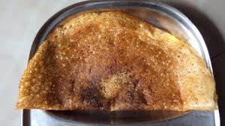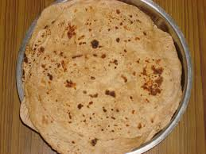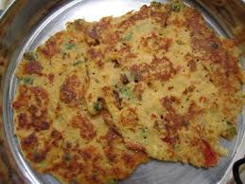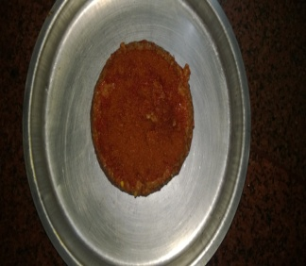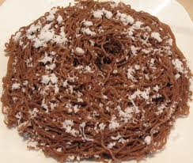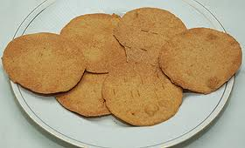
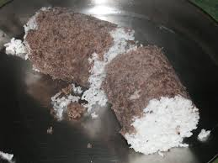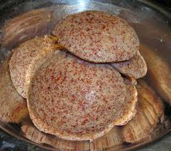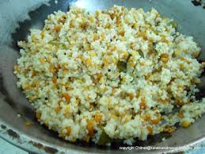

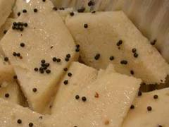

PLATE- II- RECIPES DEVELOPED USING LOW GLYCEMIC COMBINATION OF MILLETS AND PULSES

The questionnaire comprised of 15 questions each related to Knowledge, Attitude, and Practice. Some of these questions were given with four alternatives (Multiple choices) and majority of them were with two alternative responses (yes/no). (Appendix - I).
The knowledge test was conducted to assess the knowledge of the healthy adults and its consequences.
The attitude scale was based on the technique of Likert (2009) of summated ratings. This technique responses and assumes that final score is an average estimate that is obtained by the application of the number of different statements, each one of which extends to the whole length of the attitude continuum. It is said to be characterized by an “a posterior” approach with an “empirical baseline”.
It involves a pre-test by administering the items to a group of subject representative of those with whom the scale is to be tested. This scale is relatively more reliable and valid, better understood and easy to fill-in.
This scale is claimed to provide more information about the attitude of the subject, since responses would be given to each of the many items.
Moreover, the items in a Likert scale can be made to serve a dual function, to provide data on the opinions and attitudes of individuals regarding about specific issues covered by the single items as well as the total scale on the attitude or the opinion dimension being studied. For the reasons said above, the attitude scale constructed was used to measure the attitude of the selected healthy adults based on the Likert’s technique.
2. Scoring Pattern
The investigator developed a test and the scoring pattern of the test was evaluated by using the answer key for the test. In scoring the test, a credit of one mark for the correct answer and zero for the wrong answer was given. The minimum and maximum scores on the test were 0 and 15 which aids easy evaluation of KAP status. The questions were made clear, concise and free from ambiguity. The items thus developed were administered on a random sample of healthy adults with necessary information. The questionnaire was used to evaluate the KAP of the healthy adults.
3. Preparation of Educational Modules
A package of educational modules such as booklet, pamphlet, danglers, posters, power point presentation and were prepared. ICT (Information and Computer Technology) enabled module was also created.
- Booklet
A booklet titled “Glycemic Index’’ consisting the following chapters was designed and used to impart nutrition education (Plate -IV)
Chapter I - Glycemic Index and its role in health.
Definition, importance, role in maintaining healthy lifestyle
Chapter II - Minor Millets and Pulses.
Why minor millets and pulses? , Standardised recipes and their Glycemic Index
- Pamphlet
Pamphlet is defined as an unbound booklet. It may consist of a single sheet of paper that is printed on both sides and folded in half, in thirds, or in fourths (called a leaflet), or it may consist of a few pages that are folded in half and saddle stapled at the crease to make a simple book. A pamphlet comprising of three folds with illustrations titled” Glycemic Index” on what is Glycemic Index all about and its role in maintaining health, was designed and used to impart nutrition education (plate -V )
- Posters
Posters are used in various fields today for effective disseminating of information. They are considered as grey literature. A poster was made on the theme: Glycemic Index and its importance in Diabetes mellitus (Plate - VI)
- Power Point Presentation
A power point presentation was made using Microsoft Office PowerPoint Presentation 2010 software which presents information on Glycemic Index and Its Role in Leading a Healthy Life and Low Glycemic Recipes (Plate -VII).
- Blog
It is a personal website, packed with features. It is an information site which was published on the World Wide Web using Word press software. All relevant information pertaining to Glycemic Index was uploaded with illustrations for better understanding.

- Website
A webpage is a document, typically written in plain text interspersed with formatting instructions of Hypertext Markup Language (HTML, XHTML). A webpage may incorporate elements from other websites with suitable markup anchors. Webpages are accessed and transported with the Hypertext Transfer Protocol (HTTP). The pages of a website can usually be accessed from a simple Uniform Resource Locator (URL) called the web address. The home page is a 'master guide' which will lead into to all the other pages of the site. It is a set of related web pages served from a single web domain. A website was hosted under a sub domain registration using Windows and Linux Web Hosting software. The website illustrates low Glycemic recipes, Importance of GI in dietary management, Low GI foods.
E) IMPARTING AND EVALUATING NUTRITION EDUCATION
- Conduct of Pre –KAP Test
In order to gain confidence and to get their whole – hearted involvement in the study, the investigator established a good rapport with all the women. Before the pre-tested KAP questionnaire was administered, instructions were read out loudly and clearly to the respondents and they were asked to read the each of the statements carefully and to indicate their answers.
Thereafter pre KAP test was carried out on 50 women of 30-40 years of age to assess their initial nutritional knowledge. The purpose of the study undertaken was made clear to them and they were requested to give their answers to the questionnaires distributed to them. Thereafter the respondents were requested to indicate the correct answers according to them by putting a “tick” (√) mark against the answer. Every care was taken to make the respondents respond to the scale and tests without any hesitation on their part.

The respondents were allowed to sit freely while responding. They were given adequate time to fill up the questionnaire. The doubts raised from them were cleared. Soon after administering the questionnaires, the duly filled in questionnaire were collected by the investigator after checking whether all the questions were answered by the respondents.
- Conduct of Health and Nutrition Education
The health and nutrition education was given using the prepared educational modules to the adults for a period of one month. The prepared education materials were distributed among them by the investigator. Through power point presentation information on Glycemic Index and its role in leading a healthy life was taught. Posters were displayed during the health and nutrition education. Pamphlets and booklets were distributed at the end of nutrition education programme enclosing messages and tips on Glycemic Index.
- Conduct of Post KAP Test
The respondents were again given the same KAP questionnaire to assess the knowledge acquired through nutrition education. Scores for KAP were evaluated after the nutrition educational programme was given. The scores of before and after was consolidated and the impact of nutrition education was calculated by using the formula post KAP- Pre KAP divided by 100.
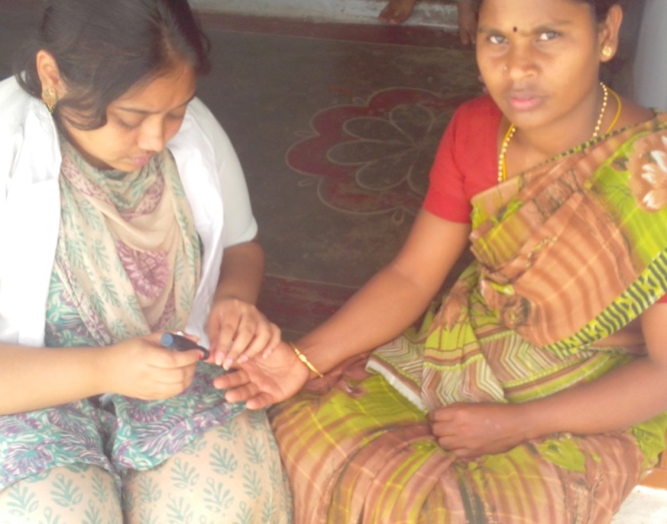
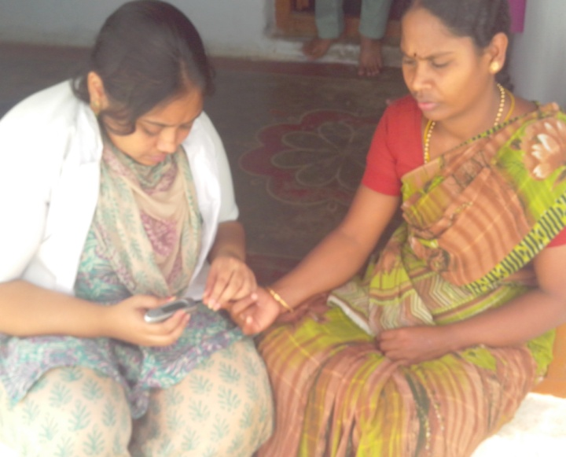
a- Drawing of Blood Sample
b – Analysis of Glycemic Index

PLATE III DETERMINATION OF GLYCEMIC INDEX

F) V - Statistical Analysis and Data Interpretation.
Statistical analysis was carried out using Statistical Software SPSS 17.0. Mean and standard deviation was calculated for the sensory scores of the product. The evaluated results of the samples were also compared and analysed statistically using Two- Way Analysis of Variance (ANOVA). ANOVA is a method to test for differences among the means of population by examining the amount of variation within each of these samples, relative to the amount of variation within each of these samples and relative to the amount of variation between the samples (Kothari, 2007)
In this procedure, the significance of the equality of the mean scores between the variations is tested. If the variations differ significantly in their mean values, then in the value < 0.01 it means the mean value differs significantly at 1per cent level of significance.
If P value lies between 0.05 and 0.01 then the mean value of variations differ significantly at 5 per cent level. If P value lies between 0.05 and 0.1 then the mean value of variations are significant at 10 per cent level of significance. If the variation is significant then the variation for which the mean score is highest is the best variation.
Co-efficient of variation is the percentage variation in mean, standard deviation being considered as the total variation in the mean. Co-efficient of variation is used to compare the variability between two or more series. The series of data for which the co-efficient of variation is large indicates that the group is more variable and it is less stable or less uniform.
Coefficient of Variation (Cv) = Standard Deviation/ Mean

The Research Design of the study is presented in Figure 2

RESEARCH DESIGN
EFFECT OF INTERVENTION STRATEGIES USING LOW GLYCEMIC RECIPES
Lifestyle diseases
SELECTION OF GEOGRAPHIC LOCALE- COIMBATORE
COIMBATORE
Urbanisation
Identification of low glycemic minor millets and pulses
Literature

Formulation of millet pulse flour in 1:1 ratio

Product development using the formulated flour

Organoleptic evaluation of the developed recipes

Determination of Glycemic Index of the maximum accepted recipe

Nutrition education and ICT enabled modules and evaluation of KAP

Statistical analysis and data interpretation

Figure - 2

IV. RESULTS AND DISCUSSION
The results of the study entitled “Effect of Intervention Strategies using Low Glycemic Recipes” are dealt under the following major headings:
- Acceptability of the Formulated Low Glycemic Index Recipes
- Glycemic Index of the Recipe with Maximum Acceptability.
- Nutrition Education Modules Developed and Used.
- Impact of Nutrition Education Programme.

- Acceptability of the Formulated Low Glycemic Index Recipes
As outlined in the methodology, the formulated and developed Low Glycemic recipes were subjected to standardisation and organoleptic evaluation for all variations in each recipe. Table II and III presents the mean organoleptic scores of all the developed recipes.

TABLE II
MEAN ORGANOLEPTIC SCORES OF THE DEVELOPED RECIPES
S.NO | VARIATIONS | PUTTU | DOSA | DHOKLA | KHAKRA | UPMA
1 | PFO | 2.60 ±0.89 | 4.20±0.84 | 2.20±0.48 | 2.60±0.89 | 3.20±0.84
2 | PFI | 2.40 ±1.14 | 4.60±0.89 | 2.40±0.52 | 2.40±1.14 | 3.40±1.52
3 | PPE | 2.40 ±1.14 | 4.40±0.89 | 2.80±0.52 | 2.40±1.14 | 3.00±1.00
4 | PBA | 2.40 ±0.55 | 4.60±0.89 | 2.40±0.53 | 2.40±0.55 | 3.20±0.84
5 | PPR | 2.40 ±0.89 | 4.40±0.89 | 2.60±0.97 | 2.40±0.89 | 3.40±0.55
6 | KFO | 2.00 ±1.14 | 3.20±1.79 | 2.20±1.25 | 2.00±1.41 | 2.60±1.34
7 | KFI | 2.00 ±1.14 | 3.20±1.79 | 2.40±1.25 | 2.00±1.41 | 2.60±1.34
8 | KPE | 2.20 ±1.64 | 3.20±1.79 | 2.20±1.25 | 2.20±1.64 | 2.60±1.34
9 | KBA | 2.20 ±1.64 | 3.20±1.79 | 2.40±1.25 | 2.20±1.64 | 2.60±1.34
10 | KPR | 2.40 ±0.55 | 3.20±1.79 | 2.20±0.97 | 2.20±1.64 | 2.80±1.30
11 | LFO | 2.40 ±0.55 | 4.20±0.84 | 2.60±0.48 | 2.40±0.55 | 3.20±0.84
12 | LFI | 2.60 ±0.89 | 4.40±0.55 | 2.80±0.42 | 2.60±0.89 | 3.20±0.84
13 | LPE | 2.60 ±0.89 | 4.00±1.22 | 2.80±0.52 | 2.60±0.55 | 3.40±0.55
14 | LBA | 1.80 ±1.30 | 4.20±0.84 | 2.40±0.53 | 2.60±0.89 | 2.80±1.10
15 | LPR | 2.00 ±1.41 | 4.20±0.84 | 2.60±0.67 | 2.60±0.89 | 3.20±0.84
16 | HFO | 1.60 ±0.89 | 3.60±1.67 | 2.00±0.74 | 1.80±1.30 | 3.20±0.84
17 | HFI | 1.80 ±1.30 | 3.60±1.67 | 1.80±0.82 | 2.00±1.41 | 3.20±0.84
18 | HPE | 2.00 ±1.41 | 3.40±1.82 | 1.60±0.84 | 1.80±1.30 | 2.80±1.10
19 | HBA | 1.80 ±1.30 | 3.60±1.67 | 1.60±0.92 | 1.60 ±0.89 | 3.00±1.00
20 | HPR | 2.80±0.84 | 3.40±1.82 | 2.00±0.74 | 1.80±1.30 | 3.00±1.00
21 | SFO | 2.80±0.84 | 3.60±1.67 | 2.20±0.63 | 2.80±0.84 | 3.20±0.84
22 | SFI | 3.00±1.00 | 3.80±1.64 | 2.20±0.67 | 3.00±1.00 | 2.80±1.30
23 | SPE | 3.00±1.00 | 3.60±1.67 | 2.40±0.52 | 3.00±1.00 | 3.40±0.89
24 | SBA | 3.20±1.30 | 3.60±1.67 | 2.80±1.25 | 3.20±1.30 | 3.20±0.84
25 | SPR | 3.20±1.10 | 3.80±1.64 | 3.80±1.38 | 3.20±1.10 | 3.20±0.84

TABLE III
MEAN ORGANOLEPTIC SCORES OF THE DEVELOPED RECIPES
SL.NO | VARIATIONS | IDAYAPPAM | CHAPPATI | ADAI | KOLKATTAI | IDLY
1 | PFO | 2.80±1.10 | 2.40±1.14 | 2.80±1.30 | 2.80±1.10 | 3.00 ± 1.00
2 | PFI | 2.80±1.10 | 2.40±1.14 | 3.00±1.22 | 3.20±1.30 | 3.00 ± 1.00
3 | PPE | 2.80±1.10 | 2.40±1.14 | 2.80±1.30 | 3.00±1.41 | 3.00 ± 1.00
4 | PBA | 2.80±1.10 | 2.40±1.14 | 2.80±1.30 | 3.00±1.00 | 3.20± 1.30
5 | PPR | 2.80±1.10 | 2.40±1.14 | 2.80±1.30 | 3.20±1.30 | 3.00± 1.00
6 | KFO | 2.60±1.34 | 2.00±1.22 | 3.00±1.22 | 3.20±1.30 | 2.60± 1.82
7 | KFI | 2.60±1.34 | 1.80±1.30 | 2.60±1.34 | 3.00±1.41 | 2.60± 1.82
8 | KPE | 2.60±1.34 | 1.80±1.30 | 2.80±1.79 | 2.80±1.64 | 2.60± 1.82
9 | KBA | 2.60±1.34 | 1.80±1.30 | 2.80±1.82 | 2.80±1.64 | 2.60± 1.82
10 | KPR | 2.60±1.34 | 1.80±1.30 | 2.60±1.52 | 2.80±1.64 | 2.60± 1.82
11 | LFO | 2.80±1.10 | 2.00±1.22 | 2.60±1.82 | 2.80±1.10 | 3.40± 0.55
12 | LFI | 2.80±1.10 | 2.40±1.14 | 2.80±0.84 | 3.00±1.41 | 3.40± 0.55
13 | LPE | 2.80±1.10 | 2.20±1.10 | 3.00±1.22 | 2.80±1.10 | 3.60±0.89
14 | LBA | 2.80±1.10 | 2.40±1.14 | 2.80±0.84 | 3.20±1.30 | 3.40± 1.64
15 | LPR | 2.80±1.10 | 2.20±1.10 | 2.80±1.30 | 2.80±1.10 | 3.60± 1.64
16 | HFO | 2.60±1.34 | 2.60±1.14 | 2.60±1.52 | 2.80±1.64 | 2.20± 1.64
17 | HFI | 2.60±1.34 | 1.80±1.30 | 1.80±1.30 | 2.80±1.64 | 2.20± 1.64
18 | HPE | 2.60±1.34 | 1.80±1.30 | 2.60±1.52 | 2.60±1.34 | 2.20± 1.64
19 | HBA | 2.60±1.34 | 1.80±1.30 | 1.80±1.30 | 2.60±1.34 | 2.20±1.00
20 | HPR | 2.60±1.34 | 2.00±1.22 | 2.00±1.22 | 2.60±1.34 | 2.20±1.30
21 | SFO | 2.80±1.10 | 2.00±1.22 | 2.20±1.30 | 2.80±1.10 | 3.00±1.00
22 | SFI | 2.80±1.10 | 2.20±1.10 | 2.20±1.30 | 2.60±1.34 | 3.20±1.30
23 | SPE | 2.80±1.10 | 2.40±1.14 | 2.80±0.84 | 3.00±1.41 | 3.00±1.41
24 | SBA | 2.80±1.10 | 2.40±1.14 | 3.00±1.00 | 3.20±1.30 | 3.20±1.30
25 | SPR | 2.80±1.10 | 2.40±1.14 | 3.40±089 | 2.80±1.10 | 3.00±1.41

Dosa obtained the highest mean score for all the organoleptic aspects taken into consideration, making it the most acceptable recipe. The highest mean among all the variation was 4.60 obtained by variations PFI (finger millet and peas) and PBA (barnyard millet and peas). However variation 3 (PPE), 5(PPR) and 12 (LFI) had a mean of 4.40. These were the second most accepted variations in dosa.
In puttu the highest mean was obtained by variation 24 (SBA) and 25 (SPR) made of barnyard millet and soya bean and proso millet and soya bean respectively with a mean of 3.20 making it the most accepted variation. Second in line was a mean of 2.80 obtained by variations HPR (proso millet and horse gram) and SFO (foxtail millet and soya bean). Next highest mean in puttu was 2.60 scored by variation LFI (finger millet and lentils), LPE (pearl millet and lentils) and PFO (foxtail millet and peas). These variations rank third in their acceptability with respect to puttu. A mean of 2.40 and 2.00 was obtained by many variations such as 2, 3, 4, 5, 7, 10, 11, 15 and 18 showing no significant variability among them. The least accepted variation was HFO with a mean of 1.60.
In the case of dhokla all variations had the lowest mean within a range of 1.60- 3.80. The highest accepted variation in dhokla had a mean of 3.80 made of soya bean with barnyard and proso millet. The lowest mean recorded was 1.60 for variation 18 and variation 19 which consists of horse gram and barnyard millet and horse gram and pearl millet respectively.
In khakra highest and lowest mean recorded was 3.20 and 1.60 respectively. Highest mean was obtained by variation 24 (SBA) and variation 25 (SPR). The least acceptable variation in dhokla was HBA (horse gram barnyard millet) and HPE (horse gram and pearl millet) with a mean of 1.60. The most acceptable variation was SPR (soya bean and proso millet) with a mean acceptability of 3.80.
In upma among variations 1 to 5 (PFO, PFI, PPE, PBA and PPR) the highest mean was recorded for PFI and PPR with a mean of 3.40, when PFO and PBA obtained a mean of 3.20. Variation 3 i.e. PPE scored a mean of 3.00. This shows that peas in combination with finger millet and proso millet were the most accepted variation. The variations from 6- 10 scored a mean of 2.60, revealing This denotes that there was no significant difference in upma made of kidney bean with millets. Only variation 11 i.e. KPR kidney bean and proso millet scored 2.80 making it more acceptable by a marginal mean difference of 0.20.
Variations in idiappam scored a mean of 2.80 and 2.60. Out of 25 variations, 15 of them namely PFO, PFI, PPE, PBA, PPR, LFO, LFI, LPE, LBA, LPR, SFO, SFI, SPE, SBA and SPR scored 2.80 containing mainly peas, lentils and soybean with the millets in combination. The other 10 variations containing the pulses horse gram and kidney bean obtained a score of 2.60. This shows that 60 per cent of the variations of idiappam were accepted with a minimal mean of 2.80.
In case of Chappati the most accepted variation was pearl millet and horse gram (HPE) with a mean of 2.60. Most of the other variations obtained a mean of 2.40, 2, 20 and 2.00. The lowest mean of 1.80 was obtained by variation KFI, KPE, KBA, KPR, HFI, HPE and HBA making them the least accepted variations in Chappati.
Adai had a highest mean of 3.00 shared by three variations namely PFI, KFO and LPE. The lowest mean recorded for adai was 1.80 by variation 17 and 19 i.e. HFI (horse gram and finger millet) and HBA (horse gram and barnyard millet).
Kozhukattai had the highest mean of 3.20 obtained by variation 2 PFI (peas and finger millet) and variation 6 KFO (kidney bean and foxtail millet). All these three variations became the most acceptable variations in this recipe. A mean of 3.00 was obtained by variation PPE, PBA, KFI, LFI and SPE making it the second most acceptable variation. This shows that horse gram variation was not very well accepted in the recipe. A mean of 2.80 and 2.60 was scored by rest of the variations where as the least accepted variations were those with 2.60 as their mean. They are HPE, HBA, HPR and SFI. This shows the horse gram variation was not very well accepted in the recipe.
In idly highest mean 3.60 was scored by variation 13 (lentils and finger millet). Variations 11 LFO (Lentils and foxtail millet), 12 LFI (lentils and finger millet) and 14 LBA (lentils and barnyard millet) scored a mean acceptability of 3.40 unlike others making it the second most acceptable variation in idly. Most of the variations obtained a mean score in the range of 2.20- 3.20. This shows that there was no great marginal difference in all the variations in the recipe
Thus Dosa with all its variations was the most acceptable recipe developed in the study. Mean scores of the individual organoleptic parameters of dosa is presented in table IV
Figure III present the mean consolidated organoleptic scores of the ten recipes developed in the study.

FIGURE III
MEAN ORGANOLEPTIC OF THE DEVELOPED RECIPES

TABLE IV
MEAN ORGANOLEPTIC SCORES OF DOSA
SL  NO | VARIATIONS | COLOUR | FLAVOUR | TEXTURE | TASTE | OVERALL ACCEPTABILITY
1 | PFO | 0.80±0.71 | 0.60±1.41 | 5.00±0.00 | 4.50±0.71 | 5.00±0.00
2 | PFI | 1.00±0.00 | 0.60±1.41 | 5.00±0.00 | 5.00±0.00 | 5.00±0.00
3 | PPE | 1.00±0.00 | 0.60±1.41 | 5.00±0.00 | 4.50±0.71 | 5.00±0.00
4 | PBA | 1.00±0.00 | 0.60±1.41 | 5.00±0.00 | 5.00±0.00 | 5.00±0.00
5 | PPR | 1.00±0.00 | 0.60±1.41 | 5.00±0.00 | 4.50±0.71 | 5.00±0.00
6 | KFO | 1.00±0.00 | 0.20±2.83 | 5.00±0.00 | 3.50±2.12 | 5.00±0.00
7 | KFI | 1.00±0.00 | 0.20±2.83 | 5.00±0.00 | 3.50±2.12 | 3.00±1.41
8 | KPE | 1.00±0.00 | 0.20±2.83 | 5.00±0.00 | 3.50±2.12 | 3.00±1.41
9 | KBA | 1.00±0.00 | 0.20±2.83 | 5.00±0.00 | 3.50±2.12 | 3.00±1.41
10 | KPR | 1.00±0.00 | 0.20±2.83 | 5.00±0.00 | 3.50±2.12 | 3.00±1.41
11 | LFO | 1.00±0.00 | 0.60±1.41 | 5.00±0.00 | 4.50±0.71 | 3.00±1.41
12 | LFI | 1.00±0.00 | 0.80±0.71 | 5.00±0.00 | 4.50±0.71 | 4.00±0.71
13 | LPE | 1.00±0.00 | 0.40±2.21 | 5.00±0.00 | 4.50±0.71 | 4.00±0.71
14 | LBA | 1.00±0.00 | 0.60±1.41 | 5.00±0.00 | 4.50±0.71 | 4.00±0.71
15 | LPR | 1.00±0.00 | 0.60±1.41 | 5.00±0.00 | 4.50±0.71 | 4.00±0.71
16 | HFO | 1.00±0.00 | 0.60±1.41 | 5.00±0.00 | 3.00±2.83 | 4.00±0.71
17 | HFI | 1.00±0.00 | 0.60±1.41 | 5.00±0.00 | 3.00±2.83 | 4.00±0.71
18 | HPE | 1.00±0.00 | 0.40±2.21 | 5.00±0.00 | 3.00±2.83 | 4.00±0.71
19 | HBA | 1.00±0.00 | 0.60±1.41 | 5.00±0.00 | 3.00±2.83 | 4.00±0.71
20 | HPR | 1.00±0.00 | 0.40±2.21 | 5.00±0.00 | 3.00±2.83 | 4.00±0.71
21 | SFO | 1.00±0.00 | 0.60±1.41 | 5.00±0.00 | 3.00±2.83 | 4.00±0.71
22 | SFI | 1.00±0.00 | 0.80±0.71 | 5.00±0.00 | 3.00±2.83 | 4.00±0.71
23 | SPE | 1.00±0.00 | 0.60±1.41 | 5.00±0.00 | 3.00±2.83 | 4.00±0.71
24 | SBA | 1.00±0.00 | 0.60±1.41 | 5.00±0.00 | 3.00±2.83 | 4.00±0.71
25 | SPR | 1.00±0.00 | 0.80±0.71 | 5.00±0.00 | 3.00±2.83 | 4.00±0.71

Dosa with peas i.e. PFO, PFI, PPE, PBA and PPR had the highest acceptability in terms of colour, flavour, texture, taste and overall acceptability. Variations with horse gram, soya bean obtained a mean score of 4.00 for overall acceptability making them the second in line to peas variations.
The least acceptable variation in dosa was that of kidney bean with an overall mean of 3.00 and 3.50 for taste. This shows that kidney bean was the least accepted variation in dosa. However it scored a maximum of 5.00 for texture.
Table V presents the results of ANOVAs for overall acceptability of all the developed recipes
TABLE V
RESULTS OF ANOVA FOR OVERALL ACCEPTABILITY
S.no | Name of the recipe | F- value | Significance
1 | PUTTU | 16.00 | 0.0531 ns
2 | DOSA | 5.634 | 0.0267**
3 | DHOKLA | 12.050 | 0.0410 ns
4 | KHAKRA | 16.00 | 0.0531 ns
5 | IDLY | 11.135 | 0.0473**
6 | IDAIAPPAM | 16.123 | 0.0223**
7 | CHAPPATI | 19.530 | 0.0212 ns
8 | ADAI | 15.396 | 0.0192**
9 | KOZHUKOTTAI | 9.347 | 0.0673*
10 | UPMA | 11.43 | 0.00297***
*** Significant at1% level; ** significant at 5% level; * significant at 10% level ns – not significant

Dosa, adai, idly and idiappam are significant at 5 per cent level. Kozhukattai was significant at 10per cent level where as Chappati, khakra and dhokla were found to be not significant at any level.

TABLE VI
RESULTS OF ANOVA FOR COLOUR
S.no | Name of the recipe | F- value | Significance
1 | PUTTU | 13.964 | 0.0036***
2 | DOSA | 7.824 | 0.00212 ^{ns}
3 | DHOKLA | 12.050 | 0.00392***
4 | KHAKRA | 13.964 | 0.0036***
5 | IDLY | 43.890 | 0.0038***
6 | IDAIAPPAM | 13.118 | 0.0134***
7 | CHAPPATI | 19.530 | 0.0212**
8 | ADAI | 43.930 | 0.000ns
9 | KOZHUKOTTAI | 45.004 | 0.00022***
10 | UPMA | 10.1 | 0.004***
*** Significant at1% level; ** significant at 5% level; * significant at 10% level ns – not significant

Table VI depicts the results of analysis of variance calculated for the colour of all the developed recipes in the study. It is inferred from the above data that Kozhukattai, idly, Khakra, dhokla, puttu and idiappam had significant colour variation at 1per cent level. Chappati was the only recipe which was significant at 5 per cent level and where as dosa had no significant colour variation.

TABLE VII
RESULTS OF ANOVA FOR FLAVOUR
S.no | Name of the recipe | F- value | Significance
1 | PUTTU | 9.381 | 0.0167**
2 | DOSA | 3.361 | 0.0317ns
3 | DHOKLA | 24.711 | 0.000 ns
4 | KHAKRA | 9.381 | 0.0167***
5 | IDLY | 15.492 | 0.00284***
6 | IDAIAPPAM | 10.474 | 0.0042***
7 | CHAPPATI | 11.658 | 0.0330**
8 | ADAI | 14.826 | 0.0514***
9 | KOZHUKOTTAI | 12.035 | 0.0424**
10 | UPMA | 14.142 | 0.00259***
*** Significant at1% level; ** significant at 5% level; * significant at 10% level ns – not significant

Table VII presents the results of analysis of variance calculated for the flavour of all the developed recipes in the study. It is inferred from the above data that idly, Khakra, upma and idiappam had significant variation in flavour at 1per cent level. Kozhukattai and puttu were the only recipe which was significant at 5 per cent level and where as dosa and dhokla did not record any significant variation with respect to flavour.

TABLE VIII
RESULTS OF ANOVA FOR TEXTURE
S.no | Name of the recipe | F- value | Significance
1 | PUTTU | 37.151 | 0.00274***
2 | DOSA | 4.359 | 0,0859*
3 | DHOKLA | 18.767 | 0.00103***
4 | KHAKRA | 9.381 | 0.0167**
5 | IDLY | 12.626 | 0.0541*
6 | IDAIAPPAM | 16.885 | 0.0713*
7 | CHAPPATI | 12.728 | 0.00274
8 | ADAI | 9.656 | 0.00116***
9 | KOZHUKOTTAI | 16.140 | 0.00341***
10 | UPMA | 21.952 | 0.00191***
*** Significant at1% level; ** significant at 5% level; * significant at 10% level ns – not significant

Adai, dhokla, upma and Kozhukattai showed statistically significant variation at 1 per cent level (p < 0.01) and Khakra was the only recipe which was significantly different at 5 per cent level and dosa, idly and idiappam recorded significance at 10 per cent level with respect to texture.

TABLE IX
RESULTS OF ANOVA FOR TASTE
S.no | Name of the recipe | F- value | Significance
1 | PUTTU | 16.000 | 0.0531 ns
2 | DOSA | 1.565 | 0.0015*
3 | DHOKLA | 11.135 | 0.0745***
4 | KHAKRA | 16.000 | 0.0531ns
5 | IDLY | 10.954 | 0.0327***
6 | IDAIAPPAM | 13.394 | 0.00510***
7 | CHAPPATI | 10.864 | 0.0592***
8 | ADAI | 18.751 | 0.0307**
9 | KOZHUKOTTAI | 12.124 | 0.0527 ns
10 | UPMA | 20.699 | 0.0623ns
*** Significant at1% level; ** significant at 5% level; * significant at 10% level ns – not significant

Dhokla, idly and idiappam showed taste differences at 1 per cent (p < 0.01) level. Adai was the only recipe which was significant at 5 per cent level and where as dosa recorded significance at 10 per cent level with respect to taste. Khakra, upma, puttu and kozhukattai were not significant.
Table X presents the coefficient of covariation of all the developed recipes. In which dhokla has a value of 47.28 and idly with 44.90. Dosa has 20.10 with the highest value for taste of 60.62. It scored 36.82 for flavour. These values indicate that dosa has more stable values in terms of mean and standard deviation compared to all other recipes.

TABLE X
S.NO | RECIPES | COLOUR | FLAVOUR | TEXTURE | TASTE | OVERALL ACCEPTABILITY
1 | PUTTU | 35.81 | 53.30 | 13.46 | 31.25 | 31.25
2 | DOSA | 4.03 | 36.82 | 0.00 | 60.62 | 20.10
3 | DHOKLA | 44.41 | 22.78 | 12.99 | 28.34 | 47.68
4 | KHAKRA | 35.81 | 53.30 | 13.46 | 31.25 | 31.25
5 | IDLY | 11.38 | 32.27 | 0.00 | 45.64 | 44.90
6 | IDAYAPPAM | 0.00 | 0.00 | 0.00 | 31.25 | 0.00
7 | CHAPPATI | 0.00 | 42.89 | 39.28 | 0.00 | 0.00
8 | ADAI | 11.38 | 33.72 | 51.78 | 26.67 | 32.48
9 | KOLKOTTAI | 11.11 | 41.54 | 0.00 | 0.00 | 0.00
10 | UPMA | 4.95 | 35.36 | 0.00 | 22.78 | 24.16
COEFFICIENT OF COVARIATION (%) OF THE RECIPES

In terms of overall acceptability idiappam and Chappati recorded a value of zero, which implies that it was very uniform. Upma scored 24.16 which are second to dosa at 20.10 followed by puttu with 31.25.
In terms of colour dhokla got a value of 44.41, followed by a mean of 35.81 obtained by puttu and khakra.
Idly and Adai obtained 11.38 and kozhukattai scored11.11 where as dosa scored 4.03. Upma got a value of 4.95. This clearly shows that in terms of colour dosa and upma did not have high variability but dhokla exhibited increased variation in colour.
The series of data for which the co-efficient of variation is large indicates that the group is more variable and it is less stable or less uniform. (Kothari 2007).

TABLE XI
T TEST RESULT FOR ALL RECIPES**
SL.NO | VARIATION | COLOUR | FLAVOUR | TEXTURE | TASTE | OVERALL ACCEPTABILITY
1 | PUTTU | 49.41 | 71.80 | 293.64 | 171.22 | 599.52
2 | DOSA | 4.53 | 57.86 | 0.00 | 171.22 | 16.65
3 | DHOKLA | 72.67 | 193.11 | 4.53 | 167.77 | 59.27
4 | KHAKRA | 51.14 | 51.14 | 293.64 | 599.52 | 599.52
5 | IDLY | 15587.76 | 0.00 | 0.00 | 0.00 | 599.92
6 | IDAYAPPAM | 0.00 | 0.00 | 0.00 | 599.92 | 0.00
7 | CHAPPATI | 0.00 | 59.48 | 55.91 | 0.00 | 0.00
8 | ADAI | 15587.76 | 57.04 | 67.97 | 126.06 | 1709.76
9 | KOLKOTTAI | 1709.76 | 54.45 | 0.00 | 0.00 | 0.00
10 | UPMA | 0.00 | 23.05 | 0.00 | 146.25 | 108.23
** NS- not significant
Table XI shows the T test results, where all the recipes in terms of colour, texture, taste, flavour and overall acceptability did not have significant values. The values obtained were not significant at 0.05% or 1.00% or 10.00% level.
Since the group priority is a necessity in the follow up study where the supplementation aspect must go on with a particular group. So based on the inferences taking the variables under analysis as a robust free variable the Fried Man’s two way analysis of the variance taking the group as the treatments and experimental individuals as conditions was thought as the correct methodology.

Figure IV
Coefficient of Covariation (%)

Figure V
T TEST RESULT FOR ALL RECIPES

TABLE XII
PER CENT MEAN SCORES OF OVERALL ACCEPTABILITY OF ALL 250 RECIPES
SL.NO | VARIATIONS | PUTTU | DOSA | DHOKLA | KHAKRA | IDLY | IDAYAPPAM | CHAPPATI | ADAI | KOLKATTAI | UPMA
1 | PFO | 55 | 80 | 45 | 55 | 65 | 60 | 50 | 65 | 60 | 65
2 | PFI | 50 | 90 | 50 | 50 | 65 | 60 | 50 | 65 | 70 | 65
3 | PPE | 50 | 85 | 55 | 50 | 65 | 60 | 50 | 60 | 65 | 60
4 | PBA | 50 | 90 | 45 | 50 | 70 | 60 | 50 | 60 | 65 | 65
5 | PPR | 50 | 85 | 50 | 50 | 65 | 60 | 50 | 60 | 70 | 70
6 | KFO | 45 | 65 | 50 | 45 | 60 | 55 | 40 | 65 | 70 | 55
7 | KFI | 45 | 65 | 55 | 45 | 60 | 55 | 35 | 55 | 65 | 55
8 | KPE | 50 | 65 | 50 | 50 | 60 | 55 | 35 | 65 | 60 | 55
9 | KBA | 50 | 65 | 55 | 50 | 60 | 55 | 35 | 65 | 60 | 55
10 | KPR | 50 | 65 | 50 | 50 | 60 | 55 | 35 | 60 | 60 | 60
11 | LFO | 50 | 85 | 55 | 50 | 70 | 60 | 40 | 60 | 60 | 65
12 | LFI | 55 | 90 | 55 | 55 | 70 | 60 | 50 | 60 | 65 | 65
13 | LPE | 50 | 80 | 55 | 50 | 75 | 60 | 45 | 60 | 60 | 70
14 | LBA | 55 | 85 | 50 | 55 | 70 | 60 | 50 | 65 | 70 | 60
15 | LPR | 55 | 85 | 55 | 55 | 75 | 60 | 45 | 60 | 60 | 70
16 | HFO | 40 | 70 | 45 | 40 | 50 | 55 | 55 | 60 | 60 | 65
17 | HFI | 45 | 70 | 40 | 45 | 50 | 55 | 35 | 55 | 60 | 65
18 | HPE | 40 | 65 | 35 | 40 | 50 | 55 | 35 | 40 | 55 | 60
19 | HBA | 35 | 70 | 35 | 35 | 50 | 55 | 35 | 60 | 55 | 65
20 | HPR | 40 | 65 | 45 | 40 | 50 | 55 | 40 | 45 | 55 | 65
21 | SFO | 60 | 70 | 45 | 60 | 60 | 60 | 40 | 50 | 60 | 65
22 | SFI | 65 | 75 | 40 | 65 | 65 | 60 | 45 | 50 | 55 | 60
23 | SPE | 65 | 70 | 50 | 65 | 65 | 60 | 50 | 60 | 65 | 65
24 | SBA | 70 | 70 | 55 | 70 | 65 | 60 | 50 | 65 | 70 | 65
25 | SPR | 70 | 75 | 75 | 70 | 65 | 60 | 50 | 75 | 60 | 65

Table XII gives the mean percentage (%) of overall acceptability of all the recipes developed in the study. As mentioned in the methodology earlier, 10 recipes were developed with 25 variations in each of the recipe so overall 250 recipes were subjected to organoleptic evaluation. The overall acceptability maximum score was 20. The mean percentage calculated shows that highest accepted product was dosa in which variation II( peas + finger millet) and variation IV ( peas + barnyard millet) with 90%.
In puttu the most acceptable variation was SBA (V 24 ie soya bean and barnyard millet) and SPR ( soya bean + proso millet) with 70% score. Variation 25 SPR ( soya bean + proso millet) was the most accepted in dhokla with 75%. 70% acceptability was noted in khakra in variation 24 SBA (V 24 ie soya bean + barnyard millet) and 25 SPR ( soya bean and proso millet).
Idly got 75% scored for variation 13 and 15 which consists of (LPE) lentils and pearl millet and (LPR) lentils and proso millet. 60% score was seen in idayappam for most of its variations.( 1,2,3,4,5,11,13,14,15,21,22,23,24 and 25). This shows its stability in all its variations.
Chappati got 50% acceptability score for 10 of its variations PFO, PFI, PPE, PBA, PPR, LFI, LBA, SPE, SBA and SPR). When the highest accepted variation in chappati made out of HFO ( horse gram and foxtail millet) got only 55%. In adai highest score was 75% for SPR (soya bean + proso millet) making it the most accepted variation in adai. In kolkattai and upma variation 5 PPR got a score of 70% making it the most acceptable variation
Figure VI depicts the per cent mean of overall acceptability of the recipes.

Figure VI
Per cent Mean Acceptability of all Recipes

Table XVII describes the available carbohydrate content and serving size which provides 50g of available carbohydrate.

TABLE XIII
SERVING SIZE RECIPES PROVIDING 50g OF AVAILABLE CARBOHYDRATE
S.no | Name of the recipe | Serving size
1 | PUTTU | 205
2 | DOSA | 118
3 | DHOKLA | 45
4 | KHAKRA | 29
5 | IDLY | 50
6 | IDAYAPPAM | 49
7 | CHAPPATI | 80
8 | ADAI | 116
9 | KOLKOTTAI | 90
10 | UPMA | 197

Khakra with a mere serving size of 29g, followed by dhokla with 45g and idiappam with 49g could provide 50g of available carbohydrate. It shows that with very meager serving size of 50g of carbohydrate are liberated causing rapid rise of blood glucose (Hyperglycemia). Only 205g of puttu provided 50g of available carbohydrate. However dosa had a serving size of 118g. From this it is seen that processing of ingredients has an effect on Glycemic Index of the food. Hence from the above table it can be concluded that carbohydrate content is inversely proportional to the serving size.
The Glycemic responses of dosa in all ten selected subjects are given in the Table XI

TABLE XVI
GLYCEMIC RESPONSE OF DOSA
GLYCEMIC RESPONSE( mg/dl)
Sample | 1 | 2 | 3 | 4 | 5 | 6 | 7 | 8 | 9 | 10
30 minutes
Test | 113 | 89 | 123 | 96 | 123 | 119 | 113 | 108 | 114 | 102
60 minutes
Test | 92 | 96 | 98 | 76 | 94 | 108 | 90 | 93 | 88 | 109
90 minutes
Test | 117 | 109 | 96 | 89 | 97 | 92 | 82 | 92 | 70 | 95
120 minutes
Test | 92 | 92 | 89 | 79 | 99 | 92 | 84 | 102 | 87 | 91
iAUBGR | 357.9 | 385 | 382.2 | 306.6 | 377.8 | 354.9 | 306.6 | 305.6 | 329.3 | 300.5

The mean Glycemic Index from the data calculated for the developed dosa was found to be 56.21. According to the International classification any food lesser than 55 is considered to be low glycemic.
The above figure VIII depicts the Glycemic Index values for dosa in ten samples.

Figure- VII
Glycemic Index of Dosa in ten samples

The prepared dosa is low glycemic and the slight increase in value is accounted to the process involved. Temperature and the particle size causes rupture of cell walls leading to high glycemic response (Guillon et al, 2010).
Figure VIII to XII are the graphical representation of the glycemic responses in the randomly selected ten samples. The graph shows the blood glucose response curve from which the mean iAUBGR values were calculated and were found to be 357.9, 385, 382.2, 306.6, 377.8, 354.9, 306.6, 305.6, 329.3 and 300.5 in the respective samples.

Figure- VIII
Blood Glucose Response Curve

Figure- IX
Blood Glucose Response Curve

Figure- X
Blood Glucose Response Curve

Figure- XI
Blood Glucose Response Curve

Figure- XII
Blood Glucose Response Curve

From Figure VIII – XII it is noted that pure glucose (reference food) has reached a peak immediately after consumption. This is because of rapid absorption and utilization of glucose in the body.
The iAUBGR curve of dosa which is the test food in this study had reached a peak of 113 at 30 minutes and decreased at 60 minutes further shooting to 117 at 90 minutes followed by gradual decrease in sample 1.
In sample 2 and 4 a gradual increase in blood glucose curve was noticed at all intervals till120 minutes whereas, a sharp rise to 123mg/dl was noticed in sample 3 and 5 at 30 minutes and a gradual decrease to 89mg/dl at 120 minutes.
A similar pattern was observed in the rest four samples at 30 minutes after consumption of dosa and then gradually decreased at each interval.
- Nutrition Education Modules Developed and Used.
These modules were selected to change people’s attitudes regarding wrong lifestyle practices and also in conjunction with dietary interventions how it can be easily tackled. This study also attempts to encourage ICTs that will help to make the society a healthy one by offering real opportunities to improve the quality of community life. A healthy informed society is one which is a well informed one. In today's time of internet popularity and globalization, a web page or website and blog are dynamic tools which aids in effective education.

- Pamphlet

Pamphlets are relatively easy and cheap to produce and can be distributed widely fairly cheaply .Therefore, they have become a very popular and widely-used intervention, especially in the health promotion field. Pamphlets were focused on all about Glycemic Index and its role in maintaining health distributed after the nutrition education so that people take back with them the summed up of the important points. This helps in re-stressing the importance of what was communicated during the nutrition education. (Plate V)
- Website
It is simply a virtual location in the 'cyberspace'. The website created is user friendly and touches on all aspects of GI in relation to lifestyle diseases. This module was attracted more attention than other communication means because of its illustrations. This website can be accessed on URL www.glycemicaction2014.com.
- Blog
Blog forms an exceptional tool for outreach and opinion forming in the society, these results in mass reachability and this is the prime reason for choosing this ICT enabled module in the study. Blog created for this study can be accessed at URL apoorvagururaj.wordpress.com with the blog titled as “GLYCIFOODS”. There were posts posted every week with importance of Glycemic Index in particular reference to low GI foods and their role id disease prevention.
- Poster
Posters are used in various fields today for effective disseminating of information. They are considered as grey literature. The poster emphasised on Glycemic Index and its importance in Diabetes mellitus. It showcased what is Diabetes mellitus, its complications and how a simple dietary intervention of including low Glycemic foods in daily diet can control blood glucose and help in preventing the onset of macro complications (Plate VI).
- Booklet
Booklet consisted of 15 bound pages with chapters included on GI and its role in healthy life, Minor millets and Pulses as low glycemic ingredients. It also included ten recipes of traditional breakfast items prepared all over India but with a twist in it by adding millets and pulses making it low glycemic breakfast. (Plate IV).

- Power Point Presentations
Low glycemic recipes that were developed in the study were showcased re- emphasizing the importance of Glycemic Index. Power point presentations were made as attractive as possible to make the audience clinger to the topic and made sure the message was imparted in an effective way. (Plate VII)



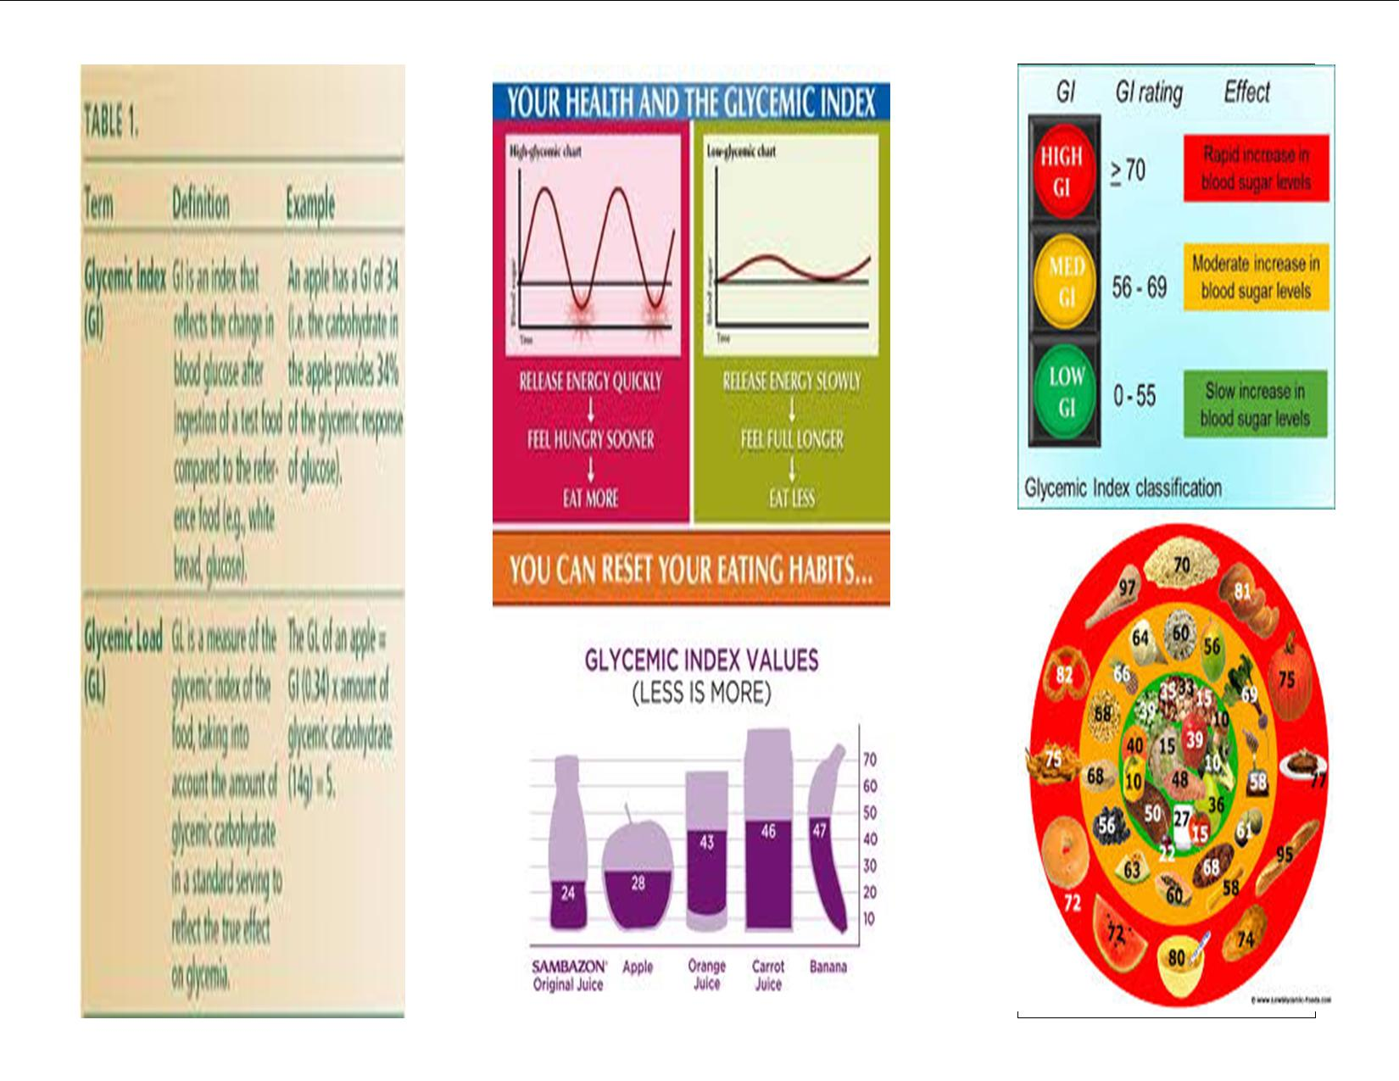

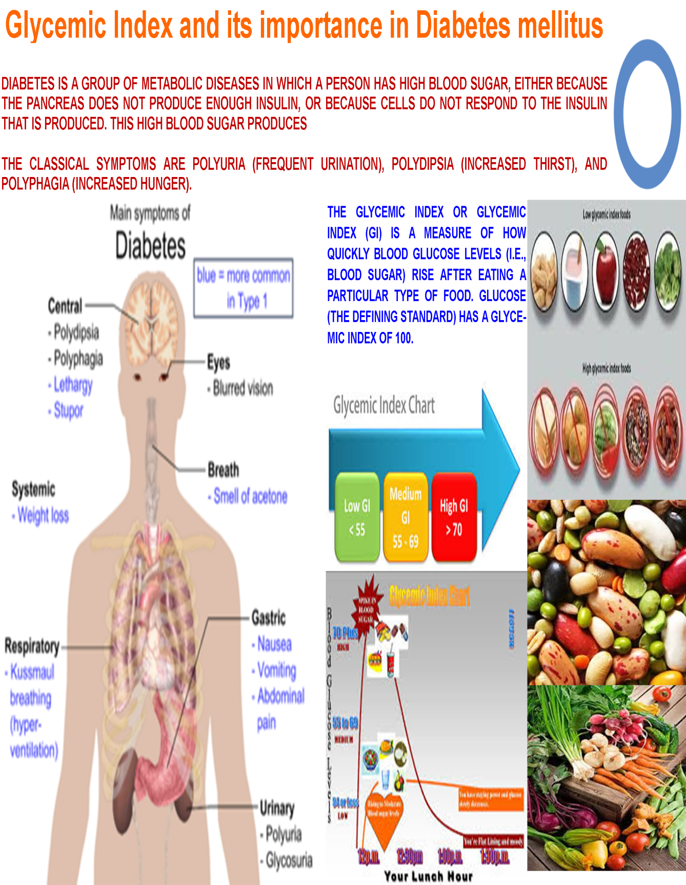

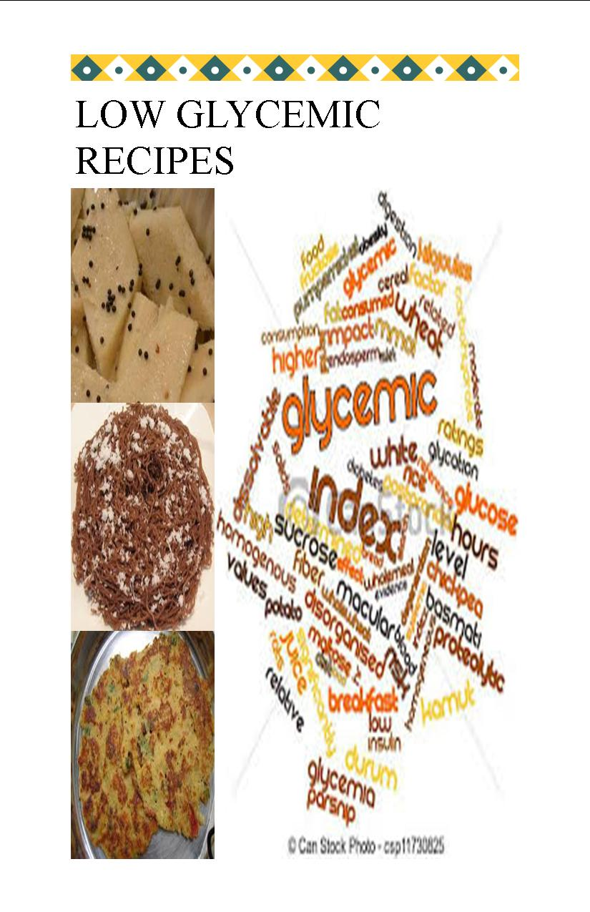

- Impact of Nutrition Education Programme
Table XV presents the mean score of knowledge, attitude and practice pre and post education.
Table XV
MEAN SCORE OF KNOWLEDGE, ATTITUDE AND PRACTICE

S.No | Parameters | Pre-KAP | Post-KAP
1 | Knowledge | 3.20±1.84 | 9.80
2 | Attitude | 4.34±1.50 | 9.41
3 | Practice | 3.13±1.32 | 8.63

Out of 50 subjects the mean pre- KAP scores for knowledge, attitude and practice was 3.20, 4.34 and 3.13 respectively. Post education the scores for the same were 9.80, 9.41 and 8.63 respectively, which shows remarkable improvement in all three aspects.

Table XVI and XVII presents the impact of KAP in per cent.

Table XVI
KAP SCORES WITH IMPACT (PERCENTAGE)

S.NO | Pre-KAP Score (A) | Post- KAP Score (B) | Impact in per cent
1 | 6 | 20 | 67
2 | 7 | 21 | 70
3 | 15 | 25 | 83
4 | 9 | 24 | 80
5 | 5 | 23 | 77
6 | 7 | 26 | 87
7 | 8 | 25 | 83
8 | 9 | 27 | 90
9 | 14 | 28 | 93
10 | 7 | 27 | 90
11 | 8 | 26 | 87
12 | 3 | 29 | 97
13 | 9 | 30 | 100
14 | 10 | 29 | 97
15 | 12 | 27 | 90
16 | 18 | 30 | 100
17 | 20 | 30 | 100
18 | 18 | 29 | 97
19 | 16 | 28 | 93
20 | 12 | 27 | 90
21 | 14 | 27 | 90
22 | 15 | 28 | 93
23 | 16 | 29 | 97
24 | 15 | 27 | 90
25 | 17 | 26 | 87

Table XVII
KAP SCORES WITH IMPACT (PERCENTAGE)

S.NO | Pre-KAP Score (A) | Post- KAP Score (B) | Impact in per cent
26 | 16 | 26 | 87
27 | 7 | 29 | 97
28 | 16 | 25 | 83
29 | 23 | 30 | 100
30 | 8 | 23 | 77
31 | 14 | 26 | 87
32 | 9 | 25 | 83
33 | 9 | 27 | 90
34 | 18 | 29 | 97
35 | 17 | 27 | 90
36 | 10 | 26 | 87
37 | 13 | 29 | 97
38 | 11 | 30 | 100
39 | 10 | 29 | 97
40 | 12 | 30 | 100
41 | 18 | 30 | 100
42 | 20 | 30 | 100
43 | 9 | 29 | 97
44 | 15 | 28 | 93
45 | 12 | 27 | 90
46 | 12 | 27 | 90
47 | 18 | 27 | 90
48 | 13 | 29 | 97
49 | 15 | 27 | 90
50 | 17 | 26 | 87

Figure XIII
IMPACT OF NUTRITION EDUCATION

Out of 50 subjects the mean pre-KAP for knowledge, Attitude and Practice was 3.20, 4.34 and 3.13 respectively. Post education the scores for the same were 9.80, 9.41 and 8.63 respectively which shows improvement in all aspects.
Similar findings were reported by Vasant et al., (2013)in their study on 50 women that there was a significant change in knowledge, practice and attitude post nutrition education. Nutrition education improved the nutrition knowledge of women and slowly changed their attitude.
In the present study, the maximum score in pre KAP was found to be only 67 per cent whereas 74 per cent of the subjects recorded more than 90 per cent score in post- KAP. The least score obtained in pre-KAP was three and in post-KAP was 67. Thirty two per cent of women obtained a score of less than 10 in pre-KAP implying a low degree of awareness about Glycemic Index in these subjects. However, 44 per cent of women managed to score 50 and above in pre-KAP. The least score obtained in post –KAP was 20 (66.67 %). Full score (hundred per cent) was obtained by 16 per cent of women in post- KAP indicating positive effect of nutrition education.
According to Rekha ( 2012) health and nutrition education provides constructive opportunities for knowing and involving some communication designed to improve health and nutrition literacy thereby improving their knowledge and helps to develop skills which are conducive to community and the individual involved (Rekha, 2012).
A study by Miejinru et al (2010), on hundred adolescent girls in Korea on healthy nutritional practices showcased that teaching was effective in increasing the nutritional attitude, knowledge and practice of the learners.

V. SUMMARY AND CONCLUSION
“Health is wealth”
In recent years, India appears to have finally internalized this old adage to apply the much-needed and long-awaited focus on the health of its citizenry.
Today when India ranks first among prevalence for most of the lifestyle diseases it needs a timely intervention to eleviate this disastrous problem from its roots. Hence the most immediate and cost effective intervention strategy can be made in diet and education which has an important relationship with health status. Diets centered mostly on low-GI foods can make it easier to achieve and maintain a healthy weight, since these foods keep us feeling fuller, longer. Low-GI diets have also been shown to improve insulin resistance, and lower glucose, cholesterol and triglyceride levels in people with type II diabetes. The Glycemic Index, simply put, is a measure of how quickly a food causes our blood sugar levels to rise.
The present study entitled “Effect of Intervention Strategies Using Low Glycemic Recipes” aimed Identify ingredients, formulate, standardize and organoleptically evaluate the developed recipes, determine the Glycemic Index (Gl) of the formulated recipes with maximum acceptability, Develop modules including ICT enabled modules on GI and Impart and evaluate the effect of nutrition education on KAP.
Two hundred and fifty recipes were developed. (Ten recipes were developed with twenty five variations in each recipe). Six nutrition education modules were created and impact of nutrition education on KAP of fifty women of 30- 40 years of age was evaluated.
The salient findings of the study are as follows:
- The most organoleptically accepted recipe was dosa with the highest mean among all the variation was 4.60 obtained by variations PFI (finger millet and peas) and PBA (barnyard millet and peas).
- Second best Variations in dosa were with horse gram, soya bean obtained a mean score of 4.00 for overall acceptability
- Kidney bean was the least accepted variation in dosa. However it scored a maximum of 5.00 for texture.
- Recipes namely dosa, adai, idly and idiappam are significant at 5% level. Kozhukattai was significant at 10% level where as Chappati, khakra and dhokla were found to be not significant at any level in ANOVA.
- Analysis of variance calculated for the colour of all the developed recipes in the study showed that Kozhukattai, idly, Khakra, dhokla, puttu and idiappam had significant colour at 1% level...
- Chappati was the only recipe which was significant at 5% level and where as dosa had no significant colour variation.
- Idly, Khakra, upma and idiappam had significant colour at 1% level. Kozhukattai and puttu were the only recipe which was significant at 5% level and where as dosa and dhokla did not record any significance with respect to flavour.
- Adai, dhokla, upma and Kozhukattai were significant at 1% level and Khakra was the only recipe which was significant at 5% level and where as dosa and idly and idiappam recorded significance at 10% level with respect to texture.
- Dhokla, idly and idiappam were significant at 1% level. Adai was the only recipe which was significant at 5% level and where as dosa recorded significance at 10% level with respect to taste. Khakra, upma, puttu and kozhukattai were not significant.
- Coefficient of covariation of all the developed recipes. In which dhokla has a value of 47.28 and idly with 44.90. Dosa has 20.10 with the highest value for taste of 60.62. It scored 36.82 for flavour.
- In terms of colour dosa and upma did not have high variability but dhokla exhibited increased variation in colour when coefficient of co- variation was seen.
- T test results, where all the recipes in terms of colour,texture, taste, flavour and overall acceptability did not have significant values. The values obtained were not significant at 0.05% or 1.00% or 10.00% level.
- The best accepted variation in dosa is PFI (peas + foxtail millet), PBA ( peas + barnyard millet) and LFI( lentils + finger millet) with 90 per cent .
- In Puttu SBA (soya bean + barnyard millet) and SPR (soya bean + proso millet) scored 70 per cent.
- Per cent mean scores of dhokla and khakra revealed that overall khakra fared better when compared to dhokla by a marginal difference.
- Sixty four per cent of the variations in dhokla achieved 50% acceptability where as in the case of khakra it was 88%.
- The striking observation in idli and idiappam is that both recipes recorded greater than or equal to 50 per cent acceptability for all twenty five variations.
- 75 per cent was the highest mean recorded in idly by LPE and LPR.
- When per cent means are compared with no doubt adai surpassed Chappati in all variations.
- The best accepted variation in adai is SPR (soya bean + proso millet) HFO (horse gram + foxtail millet) is the best accepted in chappati with 55 per cent.
- Processing of ingredients has an effect on Glycemic Index of the food and carbohydrate content is inversely proportional to the serving size.
- The mean Glycemic Index from the data calculated for the developed dosa was found to be 56.21.
- Dosa was found to a low glycemic breakfast item.
- Pamphlets were focused on all about Glycemic Index and its role in maintaining health distributed after the nutrition education so that people take back with them the summed up of the important points
- .Website was accessed for information low glycemic recipes and its role in disease management.
- Blog was a forum for exchange and sharing of ideas everything related to Glycemic Index. Through this link for GI values for common ingredients was accessed.
- Poster focussed mainly on Diabetes Mellitus and low glycemic foods.
- The power point presentation was used to teach traditional recipes only with addition of low glycemic ingredients for a more judicious choice.
- Emphasising the importance of low glycemic foods to combat various lifestyle disorders was also featured in power point presentations.
- Under exploited minor millets were emphasized due to their low Glycemic Index to be used regularly.
- There is a significant change in knowledge, practice and attitude post nutrition education.
- Out of 50 subjects the mean in pre- KAP for knowledge, attitude and practice was 3.20, 4.34 and 3.13 respectively.
- Post education the scores for the same were 9.80, 9.41 and 8.63 which shows improvement in all three aspects.
- Full score (hundred) was obtained by 16 per cent of women in post- KAP indicating a high degree of positive effect of nutrition education.
- Seventy four per cent of the subjects recorded more than 90 per cent score in post- KAP
The low glycemic recipes formulated and evaluated in the present study are an effective strategy that can be used in dietary intervention, to ensure better health especially for diabetics.

The recommendations for further study includes:
- Packaging, shelf life and microbial quality analysis of the developed recipes.
- Supplementation of low Glycemic Index recipes on long term basis on euglycemics and hyperglycemics.
- Incorporation of fibre rich foods such as oats, barley etc and nuts with the minor millets to formulate low Glycemic foods.
- Effect of supplementation of low Glycemic Index foods on all age groups starting from pre-schoolers to old age.
- Effect of different cooking methods on Glycemic Index

BIBLIOGRAPHY
- A meta-analysis of interventional trials. Am J Clin Nutr 2010, 92:678-687.
- A.Thatola, S. Shrivatsava, G. Singh (2011) serstica italica supplementation on serum glucose, serum lipids and glycosylated haemoglobin in type II diabetics, 40-1,23-28
- Achenson K(2010) Carbohydrate for weight and metabolic control: where do we stand? Nutrition 26:141-145, Agency report 47.04,29
- American Diabetes Association. Postprandial blood glucose. Diabetes Care 2001; 24:775–8.
- Atkinson FS, Foster-Powell K, Brand-Miller JC: International tables of Glycemic Index and glycemic load values: 2008.Diabetes Care 2008, 31:2281-2283.
- Barker DJ: Maternal nutrition, fetal nutrition, and disease in later life. Nutrition 1997, 13:807-813.
- Black AE, Goldberg GR, Jebb SA, Livingstone MB, and Cole TJ, Prentice AM: Critical evaluation of energy intake data using fundamental principles of energy physiology: 2. evaluating the results of published surveys. Eur J Clin Nutr 1991, 45:583-589.
- Brand-Miller J, Thomas M, Swan V, Ahmad Z, Petocz P, Colagiuri S. Physiological validation of the concept of glycemic load in lean young adults. J Nutr 2003;133:2728–32.
- Clapp J III. Diet, exercise, and feto-placental growth. Arch Gynaecol Obstetric 1997; 261:101–7.
- Clapp J III. Effect of dietary carbohydrate on the glucose and insulin response to mixed caloric intake and exercise in both nonpregnant and pregnant women. Diabetes Care 1998; 21(suppl):107–12.
- Combs C, Gunderson E, Kitzmiller J, et al. Relationship of foetal macrosomia to maternal postprandial glucose control during pregnancy. Diabetes Care 1992; 15:1251–7.
- Committee on Obstetric Practice: ACOG committee opinion. Exercise during pregnancy and the postpartum period. American college of obstetricians and gynecologists. Int J Gynaecol Obstetric 2002, 77:79-81.
- Commonwealth Department of Health and Aged Care. Australian guide to healthy eating. Canberra, Australia: Australian Government Publishing Service, 1998.
- Dale S. Hardy, Deanna M. Hoelscher, Corinne Aragaki, June Stevens, Lyn M. Steffen, James S. Pankow, Eric Boerwinkle Annals of Epidemiology, Volume 20, Issue 8, August 2010, Pages 610-616
- Dan Lukaczer, J. Liska DeAnn, Robert H. Lerman, Gary Darland, Barbara Schiltz, Matthew Tripp, Jeffrey S. Bland Nutrition, Volume 22, Issue 2, February 2011, Pages 104-113
- Department of Health and Children: Food Pyramid. Dublin: Health Promotion Unit; 2005. Irish Nutrition and Dietetic Institute:
- Du H, Van Der ADL, Feskens EJN: Dietary glycaemic index: a review of the physiological mechanisms and observed health impacts. Acta Cardiol 2006, 61:383-397.
- Encyclopaedia of Human Nutrition (Third Edition), 2013, Pages 393-398 G. Frost, A. Dornhorst
- Food Chemistry, Volume 138, Issues 2–3, 1 June 2013, Pages 1414-1420 Michał Świeca, Barbara Baraniak, Urszula Gawlik-Dziki
- Food Standards Agency: Food Portion Sizes. (Crawley H Ed). 3rd edition. London: TSO; 2006.
- Food Standards Agency: McCance and Widdowson’s The Composition of Foods. Sixth summary edition. Cambridge: Royal Society of Chemistry; 2002.
- Foster-Powell K, Holt SH, Brand-Miller JC. International table of Glycemic Index and glycemic load values: 2002. Am J Clin Nutr 2002; 76:5–56.
- Foster-Powell K, Holt SH, Brand-Miller JC: International tables of Glycemic Index and glycemic load values: 2002. Am J Clin Nutr 2002, 76:5-56.
- Gardner B, Wardle J, Poston L, Croker H: Changing diet and physical activity to reduce gestational weight gain: a meta-analysis.
- Goldberg GR, Black AE, Jebb SA, Cole TJ, Murgatroyd PR, Coward WA, et al.: Critical evaluation of energy intake data using fundamental principles of energy physiology: 1. Derivation of cut-off limits to identify under-recording. Eur J Clin Nutr 1991, 45:569-58
- Grant SM, Wolever TMS, O’Connor DL, Nisenbaum R, Josse RG: Effect of a low glycaemic index diet on blood glucose in women with gestational hyperglycaemia. Diabetes Res Clin Prac 2011, 91:15-22.
- Gupta N, Kochar and GK (2012) The internet journal of nutrition and wellness, volume 7- number 1.
- Hanley B, Dijane J, Fewtrell M, Grynberg A, Hummel S, Junien C, et al.: Metabolic imprinting, programming and epigenetics – a review of present priorities and future opportunities.
- Healthy Eating for Pregnancy booklet. 2006.
- Hearty AP, Gibney MJ: Comparison of cluster and principal components analysis techniques to derive dietary patterns in Irish adults. Br J Nutr 2009, 101:598-608.
- http://www.gestation.net Gillen L, Tapsell L, Martin G, Daniells S, Knights S, Moses R. The type and frequency of consumption of carbohydrate rich foods may play a role in the clinical expression of insulin resistance during pregnancy. Nutr Diet 59;59: 135-43.
- Institute of Medicine, Committee on Nutrition Status during Pregnancy and Lactation: Nutrition during Pregnancy. Washington DC: National Academy Press; 1990.
- J. Ma, W. Yang, N. Fang, W. Zhu, M. We Nutrition, Metabolism and Cardiovascular Diseases, Volume 19, Issue 9, November 2009, Pages 596-603
- Jenkins DJ, Wolever TM, Taylor RH, Barker H, Fielden H, Baldwin JM, et al.: Glycemic Index of foods: a physiological basis for carbohydrate exchange. Am J Clin Nutr 1981, 34:362-366.
- Jenkins DJ, Wolever TM, Taylor RH, et al. Glycemic Index of foods: a physiological basis for carbohydrate exchange. Am J Clin Nutr 1981;34:362–6.
- Jimmy Chun Yu Louie, Tania P. Markovic, Glynis P. Ross, Deborah Foote, Jennie C. Brand-Miller Nutrition Research, Volume 33, Issue 4, April 2013, Pages 259-265
- Jovanovic-Peterson L, Peterson C, Reed G, et al. Maternal postprandial glucose levels and infant birth weight: the Diabetes in Early Pregnancy Study. Am J Obstetric Gynaecol 1991;164:103–11.
- Kate A Marsh, Katherine S Steinbeck, Fioonna S Atkinson, Peter Petoz Am J Clin Nutr 2009, 92:83:92
- Krassas G, Tzotzas T. Do obese children become obese adults: childhood predictors of adult disease. Pediatr Endocrinol Rev 2004;1:455–9.
- L. Schwingshackl, G. Hoffmann c Nutrition, Metabolism and Cardiovascular Diseases, Volume 23, Issue 8, August 2013, Pages 699-706
- L. Schwingshackl, G. Hoffmanncombination in NIDDM patients. J Nutr Med 4: 321-32
- Lewis S, McGowan CA, McAuliffe FM: Methodology for adding and amending Glycemic Index values to a nutrition analysis package. Br J Nutr 2010, 105:1117-1132.
- Lock D, Bar-Eyal A, Voet H, Madar Z. Glycemic indices of various foods given to pregnant diabetic subjects. Obstet Gynecol 1988;71:180–3.
- Louie JC, Brand-Miller JC, Markovic TP, Ross GP, Moses RG: Glycemic Index and pregnancy: a systematic literature review. J Nutr Metab 2010, 2010:282464.
- Ma Y, Olendzki B, Chiriboga D, et al. Association between dietary carbohydrates and body weight. Am J Epidemiol 2005;161:359–67.
- Ma Y, Olendzki B, Chiriboga D, Hebert JR, Li Y, Li W, et al.: Association between dietary carbohydrates and body weight. Am J Epidemiol 2005, 161:359-367.
- Mane UV, Parulkar J, Iyer UM, Prabhu B, Rai V, Kurian E, Mukherjee N, Mani I , Mehta NC, Patel KH and Desikachar HSR (2014)Glycemic Index of cereal-pulse mix (diabetic mix) in NIDDM subjects. Int J Fd Sci Nutr 65: 131-135.
- Mani UV, Pradhan SN, Thackur D, Mehta NC, Iyer UM and Mani I (1993)
Glycemic Index of conventional carbohydrate meals. Br J Nutr 68: 445-450.
- Marsh k (2010) Diet for women with PCOS, British journal of Nutrition 94, 154-165
- Matthews DR, Hosker J, Redenski A, Naylor B, Treacher D, Turner R. Homeostasis model assessment: insulin resistance and beta-cell function from fasting plasma glucose and insulin concentrations in man. Diabetologia 1985;28:412–9.
- McGowan CA, McAuliffe FM: Maternal nutrient intakes and levels of energy underreporting in early pregnancy. Eur J Clin Nutr 2012, 66:906-913.
- McGowan CA, McAuliffe FM: The influence of maternal glycaemia and dietary Glycemic Index on pregnancy outcome in healthy mothers. Br J Nutr 2010, 104:153-159.
- McMillan-Price J, Petocz P, Atkinson F, et al. Comparison of 4 diets of varying glycemic load on weight loss and cardiovascular risk reduction in overweight and obese young adults: a randomised controlled trial. Arch Intern Med 2006;166;1466–75.
- Meijuru et al (2010) Nutrition education among adolescent girls in korea, Nutrition research, 102, 67-74.
- Moses R, Calvert D. Pregnancy outcomes in women without gestational diabetes mellitus related to the maternal glucose level. Is there a continuum of risk? Diabetes Care 1995;18:1527–33.
- Moses R, Griffiths R, McPherson S. The incidence of gestational diabetes in the Illawarra area of New South Wales. Aust N Z J Obstet Gynaecol 1994;34:425–7.
- Moses R, Lucas E, Knights S. Gestational diabetes mellitus. At what time should the postprandial glucose level be monitored? Aust N Z J Obstet Gynaecol 1999;39:458–60.
- Moses RG, Barker M, Winter M, Petocz P, Brand-Miller JC: Gestational diabetes; can a low Glycemic Index diet reduce the need for insulin? A randomised trial. Diabetes Care 2009, 32:996-1000.
- Moses RG, Luebcke M, Davis WS, Coleman KJ, Tapsell LC, Petocz P, et al.: Effect of low-glycemic-index diet during pregnancy on obstetric outcomes. Am J Clin Nutr 2006, 84:801-812.
- Nadine Najjar, Nada Adra, Nahla Hwall Nutrition Research, Volume 24, Issue 12, December 2004, Pages 993-1004
- Nicholas Russo Anesthesiology Clinics, Volume 30, Issue 3, September 2012, Pages 445-46
- Obes Rev 2011, 12:e602-e620. • Walsh J, Mahony R, Foley M, McAuliffe FM: A randomised control trial of low Glycemic Index carbohydrate diet versus no dietary intervention in the prevention of recurrence of macrosomia. BMC Pregnancy Childbirth 2010, 10:16.
- Oboh Henrietta Ayodele and Erema Victor Godwin (2010) Glycemic Clinical indices of processed unripe plantain( Musa paradisiacal) m,eals, African Journal of food science Vol 4(8) pp 514- 521.
- Parretti E, Mecacci F, Papini M, et al. Third-trimester maternal glucose levels from diurnal profiles in non-diabetic pregnancies: correlation with sonographic parameters of foetal growth. Diabetes Care 2001; 24:1319–23.
- Pignone M, (2011) high protein and low glycemic diets improve weight maintainence among overweight adults. Clinical Diabetes 29:73-74.
- Pi-Sunyer FX. Glycemic Index and disease. Am J Clin Nutr 2002; 76:290S–8S.
- Prema (2010) Burden of Non- communicable Disease, wholesome nutrition challenges scope and management, Mumbai, pg 39.
- Raffaele Marfella, Clara Di Filippo, Michele Portuguese, Franca Ferraraccio, Maria Rosaria Rizzo, Mario Siniscalchi, Emilio Musacchio, Michele D'Amico, Francesco Rossi, Giuseppe Paolisso Journal of the American College of Cardiology, Volume 53, Issue 16, 21 April 2009, Pages 1425-1436
- Ray. B (2013) Fundamentals of nutrition
- Rhodes ET, Pawlak DB, Takoudes TC, Ebbeling CB, Feldman HA, Lovesky MM, et al.: Effects of a low-glycemic load diet in overweight and obese pregnant women: a pilot randomized controlled trial. Am J Clin Nutr 2010, 92:1306-1315.
- Royal College of Obstetricians and Gynecologists: Exercise in Pregnancy (RCOG Statement 4). 2006.
- S. Shobana, K. Krishnaswamy, V. Sudha, N.G. Malleshi, R.M. Anjana, L. Palaniappan, V. Mohan, Advances in Food and Nutrition Research, Volume 69, 2013, Pages 1-39
- Schofield WN: Predicting basal metabolic rate, new standards and review of previous work. Hum Nutr Clin Nutr 1985, 39:5-41.
- Scholl T, Chen X, Khoo C, Lenders C. The dietary Glycemic Index during pregnancy: influence on infant birth weight, foetal growth and biomarkers of carbohydrate metabolism. Am J Epidemiol 2004;159:467–74.
- Scholl TO, Chen X, Khoo CS, and Lenders C: The dietary Glycemic Index during pregnancy: influence on infant birthweight, fetal growth, and biomarkers of carbohydrate metabolism. Am J Epidemiol 2004, 159:467-474.
- Streuling I, Beyerlein A, von Kries R: Can gestational weight gain be modified by increasing physical activity and diet counseling?
- Tinuviel Software: WISP Users Manual. Version 3.0. Intake, Recipe and Menu Nutritional Analysis System. Warrington, UK; 2003.
- University of Sydney. GI database- http://www.glycemicindex.com
- Wallace T, Levy J, Matthews DR. Use and abuse of HOMA modelling. Diabetes Care 2004;27:1487–95.
- Walsh J, Mahony R, Byrne J, Foley M, McAuliffe FM: The association of maternal and fetal glucose homeostasis with fetal adiposity and birthweight. Eur J Obstet Gynaecol 2011, 159:338-341.
- Walsh JM, McGowan CA, Mahony R, Foley ME, McAuliffe FM: Low glycaemic index diet in pregnancy to prevent macrosomia (ROLO study): randomised control trial. BMJ 2012, 345:e5605.
- WHO/FAO: Report of the Joint WHO/FAO Expert Consultation on Diet, Nutrition and the Prevention of Chronic Diseases. Geneva: World Health Organisation; 2002.
- Willett W, Manson J, Liu S. Glycemic Index, glycemic load, and risk of type 2 diabetes. Am J Clin Nutr 2002; 76:274S–80S.
- Wolever T, Yang M, Zeng X, Atkinson F, Brand-Miller J. Food Glycemic Index, as given in Glycemic Index tables, is a significant determinant of glycemic responses elicited by composite breakfast meals. Am J Clin Nutr 2006; 83:1306–12.

Websites
- http://www.glycemicindex.com
- http://www.indi.ie/docs/18_hefp.pdf
- http://www.rcog.org.uk/womens-health/clinicalguidance/exercise
- www.mendosa.com/gilists.com

QUESTIONNAIRE TO ASSESS THE KNOWLEDGE, ATTITUDE AND
PRACTICE (KAP)

Assessment of Knowledge
Have you heard about Glycemic Index? YES/NO
A low glycemic food has a role in weight loss diets? YES/ NO
Choose the low Glycemic Index foods from the following
Rice/ Soy/ Potato/ Onion & carrot
Do pregnant women have to eat low GI foods? YES / NO
How relevant is the GI for athletes? Very much/ Little/ No relavance
Does fat and fibre lower Glycemic Index of each food involved? YES/ NO
Some vegetables like pumpkin appear to have a high GI. Does this mean a person with diabetes should avoid eating them?YES /NO
How much food you need to estimate Glycemic Index?50g/100g/200g/500g
A low glycemic food has a role in weight loss diets? YES/NO
Is there a difference between Glycemic Index (GI) and glycemic load (GL)?
YES/NO
List few low GI foods?
Do I need to eat only low GI foods at every meal to see a benefit? YES/NO
Low glycemic foods are not cost effective? TRUE/FALSE
A Low Glycemic food has a role in preventing lifestyle diseases .TRUE/FALSE
What is the value of a food will make it low Glycemic? < 67 / >55 / <55 / >67

Assessment of Practice
Do you go for regular health check-up? YES /NO
Do you exercise? YES /NO
How often you consume junk food? Daily/Weekly/Monthly
Do you look for nutritional labelling when you shop for foodstuffs? YES/NO
Do you include high fibre foods in your diet? YES /NO
Of what of the following will you suggest a diabetic Ragi/ Dosa /Oats
Will you prefer soy based foods? YES/NO
Which method of cooking do you prefer more while cooking?
Steaming /Pressure Cooking /Frying
Do you prefer eating fruits every day? YES /NO
Do you consume vegetables as salads in your meal? YES /NO
How often do you eat out? Everday/Weekends/ Weekly Once /Monthly Once
Can blood glucose be maintained by consuming low Glycemic Index? YES/ NO
Will you prefer oats and soya based products than unrefined food products?
YES /NO

Assessment of Attitude

Do you think that insulin resistance will lead to diabetes mellitus? YES /NO
Do you think consumption of junk foods leads to cardiovascular diseases?
YES /NO
Fasting or skipping of meals does not harm health? TRUE/ FALSE
Which is the best way to eat a fruit? Juice / Whole/ Mock tail
Is there any connection between GI and Diabetes, PCOD or Obesity? YES/ NO
Healthy choices of food group are: nuts & fruits/ ice cream & fruits /milk & fruits
Is PCOD a hereditary disease? YES/NO
GI is not related to health. TRUE /FALSE
GI estimation cannot help in the management of Diabetes. TRUE /FALSE
Do I need to eat only low GI foods at every meal to see a benefit? YES /NO

SENSORY EVALUATION SCORE CARD
Product Name: Date:
Name of the Panelist: Time:
Sample code | Colour | Texture | Flavour | Taste | Overall acceptability

Comments:
Signature:
Excellent 5
Very Good 4
Good 3
Fair 2
Not Acceptable 1

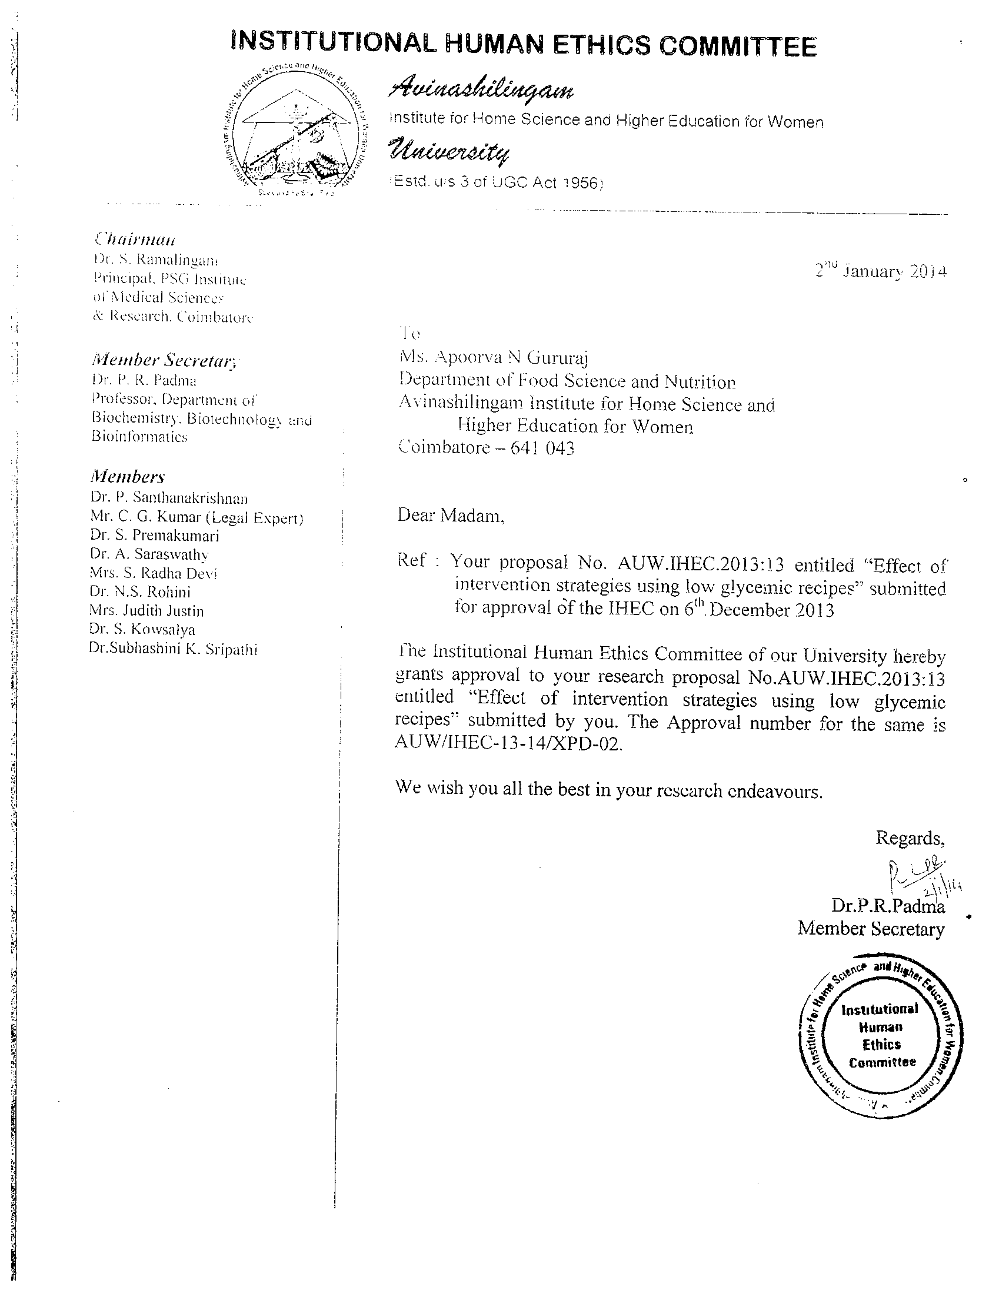

AVINASHILINGAM INSTITUTE FOR HOME SCIENCE AND HIGHER EDUCATION FOR WOMEN
COIMBATORE – 641043, India
Application for Review of Project Proposal by the Institutional Human Ethics Committee
For Student research projects and non- student, non – Clinical Trial projects (except radiotherapy and device studies)
___________________________________________________________________________ INFORMED CONSENT FORMAT FOR RESEARCH PROJECTS
(strike off items that are not applicable)

I / We (write name of the investigator (s) here) Apoorva N Gururaj am / are carrying out a study on the topic: Effect of intervention strategies using low glycemic index foods, as part of my / our research project being carried out under the aegis of the Department of: Food Science And Nutrition

(Applicable to students only) My / our research guide is: Dr. (Mrs.) PA Raajeshwari

The justification for this study is:

The objectives of this study are:

Primary Objective: To identify low glycemic foods and formulate recipe.

Secondary Objective: To develop ICT enabled intervention using low glycemic foods

Sample size: ___10_______.

Study volunteers / participants are (specify population group & age group): Healthy adults (20-25 yrs)

Location: ___Coimbatore____________.

We request you to kindly cooperate with us in this study. We propose collect background information and other relevant details related to this study. We will be carrying out:

Initial interview (specify approximate duration):_NA___ minutes.

Data collected will be stored for a period of fifteen years. We will / will not use the data as part of another study.

Health education sessions: Number of sessions: _____5________. Approximate duration of each session: ________60______ minutes.

Clinical examination (Specify details and purpose): Blood Glucose

Blood sample collection: Specify quantity of blood being drawn: ___1.0________ml.

No. of times it will be collected: _______Once________.

Whether blood sample collection is part of routine procedure or for research (study purpose):

- Routine Procedure
AVINASHILINGAM INSTITUTE FOR HOME SCIENCE AND HIGHER EDUCATION FOR WOMEN
COIMBATORE – 641043, India
Application for Review of Project Proposal by the Institutional Human Ethics Committee
For Student research projects and non- student, non – Clinical Trial projects (except radiotherapy and device studies)
Specify purpose, discomfort likely to be felt and side effects, if any: NIL

Whether blood sample collected will be stored after study period: No, it will be destroyed

Whether blood sample collected will be sold: No

Whether blood sample collected will be shared with persons from another institution: No

Medication given, if any, duration, side effects, purpose, benefits: NA

Whether medication given is part of routine procedure: Yes / No (If not, state reasons for giving this medication) NA

Whether alternatives are available for medication given: Yes / No (If not, state reasons for giving this particular medication) NA

Final interview (specify approximate duration):______NA___ mts. If photograph is taken, purpose:

Benefits from this study, if any: Identification of low glycemic index foods for to control blood sugar

Risks involved by participating in this study: NIL

How the results will be used:

If you are uncomfortable in answering any of our questions during the course of the interview / biological sample collection, you have the right to withdraw from the interview / study at anytime. You have the freedom to withdraw from the study at any point of time. Kindly be assured that your refusal to participate or withdrawal at any stage, if you so decide, will not result in any form of compromise or discrimination in the services offered. You will continue to have access to the regular services offered to a patient. You will NOT be paid any remuneration for the time you spend with us for this interview / study. The information provided by you will be kept in strict confidence. Under no circumstances shall we reveal the identity of the respondent or their families to anyone. The information that we collect shall be used for approved research purposes only. You will be informed about any significant new findings – including adverse events, if any, - whether directly or indirectly related to you or to other participants of this study, developed during the course of this research which may relate to your willingness to continue participation

Consent: The above information regarding the study, has been read by me/ read to me, and has been explained to me by the investigator/s. Having understood the same, I hereby give my consent to them to interview me. I am affixing my signature / left thumb impression to indicate my consent and willingness to participate in this study (i.e., willingly abide by the project requirements)

Signature / Left thumb impression of the Study Volunteer / Legal Representative:
Signature of the Interviewer with date Witness:

