

Avinashilingam Institute for Home Science and Higher Education for Women
(Deemed to be University under Category ‘A’ by MHRD, Estd. u/s 3 of UGC Act 1956)
Re-accredited with ‘A+’ Grade by NAAC. Recognised by UGC Under Section 12B
Coimbatore - 641 043, Tamil Nadu, India

Master’s Degree Examination – November 2019
Semester I
Class : I PG Time: 3 hours Major : Information Technology Max. Marks: 60

17MITC02 ADVANCED JAVA PROGRAMMING
Part A 10 x 1/2 = 5
Choose the correct answer
1. ________ is the process of defining two or more methods within same
class that have same name but different parameters declaration.
a) method overloading b) method overriding
c) method hiding d) none of the mentioned

2. ______cannot be inherited from a base class in Java programming.

a) Constructor b) final method c) Both d)None

3. RMI, the objects are passed by _____.
a) Value b) Reference
c) Value and Reference d) None of the above

4. Which is a one-way communication only between the client and the server,
which is not only a reliable but also there is no confirmation regarding reaching
the message to the destination?
a) TCP/IP b) UDP c) Both a & b d. None of the above
5. Event class is defined in which of these libraries?
a) java.io b) java.lang c) java.net d) java.util
6. Which of these methods are used to register a keyboard event listener?
a) KeyListener() b) addKistener()
c) addKeyListener() d) eventListener()
7. Which of these packages contains all the classes and methods required
for even handling in Java?
a) java.applet b) java.awt
c) java.event d) java.awt.event

8. The JDBC-ODBC bridge is
a)Multithreaded b) Singlethreaded c) Both of above d) None of above

9. Which tag is used to execute java source code in JSP?
a) Declaration Tag b) Scriptlet tag
c) Expression tag d) None of the above

10. A JSP page consists of which tags?
a) HTML tags b) JSP tags c) Both A & B d) None of the above
Part B 5 x 4 = 20
Answer ALL questions
Each answer should not exceed 200 words or one page
11. a) Define OOPs.
(OR)
11.b) Discuss about Swing features.
12. a) Explain about RMI.
(OR)
12.b) Illustrate JVM.
13.a) Review on applets.
(OR)
13.b) Explain about event handling.
14.a) Compare JDBC and ODBC.
(OR)
14.b) Explain about Servlet.
15. a) List the advantages of JSP.
(OR)
15.b) Examine the benefits of EJB.
Part C 5 x 7 = 35
Answer ALL questions
Each answer should not exceed 600 words or three pages
16. a) Explain about Inheritance.
(OR)
16.b) Differentiate Swing and AWT Components.
17. a) Summarize about RMI Architecture.
(OR)
17.b) Compose Java Serialization.

18. a) Generalize about HTML applet tags.
(OR)
18.b) Express in detail about delegation event model.

19. a) Construct the types of JDBC drivers.
(OR)
19.b) Justify the Servlet lifecycle service.

20.a) Organize about JSP tags.
(OR)
20 b) Explain in detail about Session bean with types.

***********

Avinashilingam Institute for Home Science and Higher Education for Women
Coimbatore-641043.

Master Degree Examination – NOV 2019
Semester I

Class : PG Time: 3 hours Major : IT Max. Marks: 60

17MITC02 ADVANCED JAVA PROGRAMMING(SCHEME I)

Set-1
Part-A
1. a
2. a
3. a
4. b
5. d
6. c
7. d
8. c
9. b
10. c
Part B
11. a) OOP:-
- Object-oriented programming (OOP) refers to a type of computer programming (software design) in which programmers define not only the data type of a data structure, but also the types of operations (functions) that can be applied to the data structure.
- In this way, the data structure becomes an object that includes both data and functions. In addition, programmers can create relationships between one object and another. For example, objects can inherit characteristics from other objects.
11. b) Swing Features:-
Swing provides many new features; two of its popular features are:
• Lightweight components
• Pluggable look and feel
Lightweight components
Swing components are lightweight as they are written entirely in Java and do not depend on native peers (platform specific code resources). Rather, they use simple drawing primitives to render themselves on the screen. The look and the feel of the component is not controlled by the underlying operating system but by Swing itself. Thus, they are not restricted to platform-specific appearance like, rectangular or opaque shape.
Pluggable look and feel
The pluggable look arid feel feature allows us to tailor the look and feel of the application and applets to the standard looks like, Windows and Motif. We can even switch to different look and feel at runtime. Swing has the capability to support several look and feels, but at present, it provides support for the Windows and Motif. As the look and feel of components is controlled by Swing rather than by operating system, the feel of components can also be changed. The look and feel of a component can be separated form the logic of the component. Thus, it is possible to "plug in" a new look and feel for any given component without affecting the rest of the code.

12. a) RMI:-
- The RMI (Remote Method Invocation) is an API that provides a mechanism to create distributed application in java. The RMI allows an object to invoke methods on an object running in another JVM.
- The RMI provides remote communication between the applications using two objects stub and skeleton.
- RMI uses stub and skeleton object for communication with the remote object.
- A remote object is an object whose method can be invoked from another JVM. Let's understand the stub and skeleton objects:

Stub
The stub is an object, acts as a gateway for the client side. All the outgoing requests are routed through it. It resides at the client side and represents the remote object. When the caller invokes method on the stub object, it does the following tasks:
- It initiates a connection with remote Virtual Machine (JVM),
- It writes and transmits (marshals) the parameters to the remote Virtual Machine (JVM),
- It waits for the result
- It reads (unmarshals) the return value or exception, and
- It finally, returns the value to the caller.

Skeleton
The skeleton is an object, acts as a gateway for the server side object. All the incoming requests are routed through it. When the skeleton receives the incoming request, it does the following tasks:
- It reads the parameter for the remote method
- It invokes the method on the actual remote object, and
- It writes and transmits (marshals) the result to the caller

12. b) JVM:-
The Java Virtual Machine is called JVM, is an abstract computing machine or virtual machine interface that drives the java code.
- JVM stands for Java Virtual Machine.
- JVM is the engine that drives the java code.
- Mostly in other Programming Languages, compiler produce code for a particular system but Java compiler produce Bytecode for a Java Virtual Machine.
- Bytecode is an intermediary language between Java source and the host system.
- It is the medium which compile Java code to bytecode which get interpret on different machine and hence it makes it Platform/Operating system independent.
13. a) Applets:-
- Applet is a special type of program that is embedded in the webpage to generate the dynamic content. It runs inside the browser and works at client side.

Advantage of Applet
There are many advantages of applet. They are as follows:
- It works at client side so less response time.
- Secured
- It can be executed by browsers running under many plateforms, including Linux, Windows, Mac Os etc.

Drawback of Applet
- Plugin is required at client browser to execute applet.

13. b) Event Handling:-

Event and Listener (Java Event Handling) Changing the state of an object is known as an event. For example, click on button, dragging mouse etc. The java.awt.event package provides many event classes and Listener interfaces for event handling.

14. a) JDBC Vs ODBC:-

Key Differences Between JDBC and ODBC
- The most basic difference between JDBC and ODBC is that JDBC is language and platform dependent. On the other hand, the ODBC is language and platform dependent.
- Java Database Connectivity is an acronym for JDBC, and on the other hand, Open Database Connectivity is an acronym for ODBC.
- The code for ODBC is complex and is hard to learn. However, the code for JDBC is simpler and easy to run.
14. b) Servlets:-
Servlet can be described in many ways, depending on the context.
- Servlet is a technology i.e. used to create web application.
- Servlet is an API that provides many interfaces and classes including documentations.
- Servlet is an interface that must be implemented for creating any servlet.
- Servlet is a class that extend the capabilities of the servers and respond to the incoming request. It can respond to any type of requests.
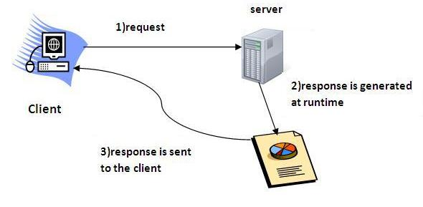

15. a) Advantages of JSP:-
- Learning JSP doesn’t need strong knowledge of Java, because writing a program in JSP is nothing but making use of tags or we can say that it is meant for using tag based approach of programming.
- JSP programming is easy to learn and easy to implement for Non-Java programmers also.
- JSP programming environment provides the separation between presentation logic and business logic.
- JSP programming environment provides parallel development of web applications.
- JSP programming has implicit objects.
- JSP programming eliminates the repeated deployment problems i.e. as and when we change the JSP, we need to save the JSP and makes a request and automatic deployment is taken care by container – JASPER [JSP Execution Environment].
- JSP provides optional mechanism in configuring web application file (web.xml).
- JSP environment provides implicit/global exception handling mechanism.
- JSP programming provides and additional concept called Custom Tags Development.
- JSP programming environment provides page compilation automatically.

15. b) Benefits of EJB:-
EJB is an acronym for enterprise java bean. It is a specification provided by Sun Microsystems to develop secured, robust and scalable distributed applications.
To run EJB application, you need an application server (EJB Container) such as Jboss, Glassfish, Weblogic, Websphere etc. It performs:
- life cycle management,
- security,
- transaction management, and
- object pooling.
EJB application is deployed on the server, so it is called server side component also.
EJB is like COM (Component Object Model) provided by Microsoft. But, it is different from Java Bean, RMI and Web Services.
Part-C

16. a) Inheritance:-
Inheritance can be defined as the process where one class acquires the properties (methods and fields) of another. With the use of inheritance the information is made manageable in a hierarchical order.
The class which inherits the properties of other is known as subclass (derived class, child class) and the class whose properties are inherited is known as superclass (base class, parent class).

extends Keyword
extends is the keyword used to inherit the properties of a class.

The super keyword
The super keyword is similar to this keyword. Following are the scenarios where the super keyword is used.
- It is used to differentiate the members of superclass from the members of subclass, if they have same names.
- It is used to invoke the superclass constructor from subclass.
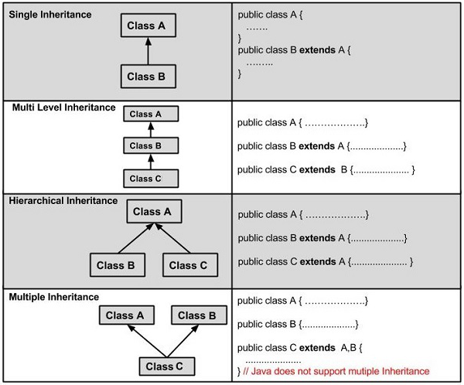

16.b) Swing and AWT Components:-
AWT | Swing
AWT stands for Abstract windows toolkit. | Swing is also called as JFC’s (Java Foundation classes).
AWT components are called Heavyweight component. | Swings are called light weight component because swing components sits on the top of AWT components and do the work.
AWT components require java.awt package. | Swing components require javax.swing package.
AWT components are platform dependent. | Swing components are made in purely java and they are platform independent.
This feature is not supported in AWT. | We can have different look and feel in Swing.
These feature is not available in AWT. | Swing has many advanced features like JTabel, Jtabbed pane which is not available in AWT. Also. Swing components are called "lightweight" because they do not require a native OS object to implement their functionality. JDialog and JFrame are heavyweight, because they do have a peer. So components like JButton, JTextArea, etc., are lightweight because they do not have an OS peer.
With AWT, you have 21 "peers" (one for each control and one for the dialog itself). A "peer" is a widget provided by the operating system, such as a button object or an entry field object. | With Swing, you would have only one peer, the operating system's window object. All of the buttons, entry fields, etc. are drawn by the Swing package on the drawing surface provided by the window object. This is the reason that Swing has more code. It has to draw the button or other control and implement its behavior instead of relying on the host operating system to perform those functions.
AWT is a thin layer of code on top of the OS. | Swing is much larger. Swing also has very much richer functionality.
Using AWT, you have to implement a lot of things yourself. | Swing has them built in.

17. a) RMI Architecture:-
The RMI Architecture (System) has a FOUR layer,
(1) Application Layer
(2) Proxy Layer
(3) Remote Reference Layer
(4) Transport Layer
RMI Architecture Diagram:
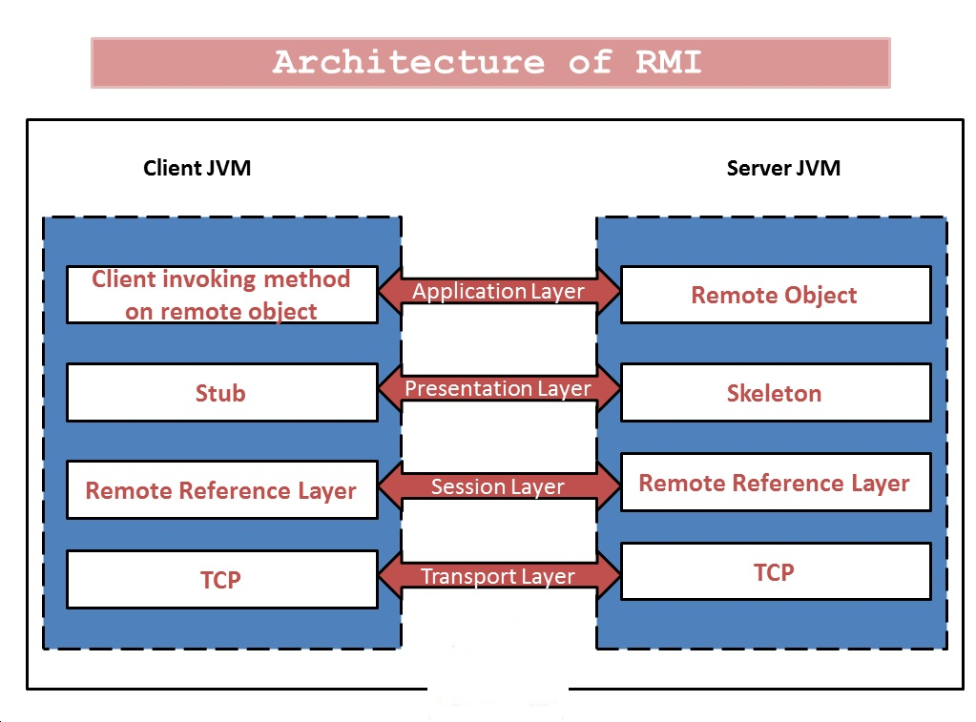
(1) Application Layer:
It’s a responsible for the actual logic (implementation) of the client and server applications.
Generally at the server side class contain implementation logic and also apply the reference to the appropriate object as per the requirement of the logic in application.
(2) Proxy Layer:
It’s also called the “Stub/Skeleton layer”.
A Stub class is a client side proxy handles the remote objects which are getting from the reference.
A Skeleton class is a server side proxy that set the reference to the objects which are communicates with the Stub.
(3) Remote Reference Layer (RRL):
It’s a responsible for manage the references made by the client to the remote object on the server so it is available on both JVM (Client and Server).
The Client side RRL receives the request for methods from the Stub that is transferred into byte stream process called serialization (Marshaling) and then these data are send to the Server side RRL.
The Server side RRL doing reverse process and convert the binary data into object. This process called deserialization or unmarshaling and then sent to the Skeleton class.
(4) Transport Layer:
It’s also called the “Connection layer”.
It’s a responsible for the managing the existing connection and also setting up new connections.
So it is a work like a link between the RRL on the Client side and the RRL on the Server side.

17. b) Java Serialization:-
Java provides a mechanism, called object serialization where an object can be represented as a sequence of bytes that includes the object's data as well as information about the object's type and the types of data stored in the object.
After a serialized object has been written into a file, it can be read from the file and deserialized that is, the type information and bytes that represent the object and its data can be used to recreate the object in memory.
Most impressive is that the entire process is JVM independent, meaning an object can be serialized on one platform and deserialized on an entirely different platform.
Classes ObjectInputStream and ObjectOutputStream are high-level streams that contain the methods for serializing and deserializing an object.
The ObjectOutputStream class contains many write methods for writing various data types, but one method in particular stands out −
public final void writeObject(Object x) throws IOException
The above method serializes an Object and sends it to the output stream. Similarly, the ObjectInputStream class contains the following method for deserializing an object −
public final Object readObject() throws IOException, ClassNotFoundException
This method retrieves the next Object out of the stream and deserializes it. The return value is Object, so you will need to cast it to its appropriate data type.
To demonstrate how serialization works in Java, I am going to use the Employee class that we discussed early on in the book. Suppose that we have the following Employee class, which implements the Serializable interface −

Example
public class Employee implements java.io.Serializable {
public String name;
public String address;
public transient int SSN;
public int number;

public void mailCheck() {
System.out.println("Mailing a check to " + name + " " + address);
}
}
Notice that for a class to be serialized successfully, two conditions must be met −
- The class must implement the java.io.Serializable interface.
- All of the fields in the class must be serializable. If a field is not serializable, it must be marked transient.
If you are curious to know if a Java Standard Class is serializable or not, check the documentation for the class. The test is simple: If the class implements java.io.Serializable, then it is serializable; otherwise, it's not.

Serializing an Object
The ObjectOutputStream class is used to serialize an Object. The following SerializeDemo program instantiates an Employee object and serializes it to a file.
When the program is done executing, a file named employee.ser is created. The program does not generate any output, but study the code and try to determine what the program is doing.
Note − When serializing an object to a file, the standard convention in Java is to give the file a .ser extension.

Example
import java.io.*;
public class SerializeDemo {

public static void main(String [] args) {
Employee e = new Employee();
e.name = "Reyan Ali";
e.address = "Phokka Kuan, Ambehta Peer";
e.SSN = 11122333;
e.number = 101;

try {
FileOutputStream fileOut =
new FileOutputStream("/tmp/employee.ser");
ObjectOutputStream out = new ObjectOutputStream(fileOut);
out.writeObject(e);
out.close();
fileOut.close();
System.out.printf("Serialized data is saved in /tmp/employee.ser");
}catch(IOException i) {
i.printStackTrace();
}
}
}

Deserializing an Object
The following DeserializeDemo program deserializes the Employee object created in the SerializeDemo program. Study the program and try to determine its output −

Example
import java.io.*;
public class DeserializeDemo {

public static void main(String [] args) {
Employee e = null;
try {
FileInputStream fileIn = new FileInputStream("/tmp/employee.ser");
ObjectInputStream in = new ObjectInputStream(fileIn);
e = (Employee) in.readObject();
in.close();
fileIn.close();
}catch(IOException i) {
i.printStackTrace();
return;
}catch(ClassNotFoundException c) {
System.out.println("Employee class not found");
c.printStackTrace();
return;
}

System.out.println("Deserialized Employee...");
System.out.println("Name: " + e.name);
System.out.println("Address: " + e.address);
System.out.println("SSN: " + e.SSN);
System.out.println("Number: " + e.number);
}
}
This will produce the following result −

Output
Deserialized Employee...
Name: Reyan Ali
Address:Phokka Kuan, Ambehta Peer
SSN: 0
Number:101
Here are following important points to be noted −
- The try/catch block tries to catch a ClassNotFoundException, which is declared by the readObject() method. For a JVM to be able to deserialize an object, it must be able to find the bytecode for the class. If the JVM can't find a class during the deserialization of an object, it throws a ClassNotFoundException.
- Notice that the return value of readObject() is cast to an Employee reference.
- The value of the SSN field was 11122333 when the object was serialized, but because the field is transient, this value was not sent to the output stream. The SSN field of the deserialized Employee object is 0.
18. a) HTML Applet tags:-
The HTML <applet> tag specifies an applet. It is used for embedding a Java applet within an HTML document. It is not supported in HTML5.

Example
An embedded Java applet:
<applet code="Bubbles.class" width="350" height="350">
Java applet that draws animated bubbles.
</applet>

Definition and Usage
The <applet> tag is not supported in HTML5. Use <embed> or <object> instead.
The <applet> tag defines an embedded applet.

Required Attributes
Attribute Value Description
code URL Specifies the file name of a Java applet
object name Specifies a reference to a serialized representation of an applet
18.b) The Delegation event model:-
The event model is based on the Event Source and Event Listeners. Event Listener is an object that receives the messages / events. The Event Source is any object which creates the message / event. The Event Delegation model is based on – The Event Classes, The Event Listeners, Event Objects.
There are three participants in event delegation model in Java;
Event Source – the class which broadcasts the events
Event Listeners – the classes which receive notifications of events
Event Object – the class object which describes the event.
An event occurs (like mouse click, key press, etc) which is followed by the event is broadcasted by the event source by invoking an agreed method on all event listeners. The event object is passed as argument to the agreed-upon method. Later the event listeners respond as they fit, like submit a form, displaying a message / alert etc.

19. a) Types of JDBC drivers:-
JDBC Driver is a software component that enables java application to interact with the database.There are 4 types of JDBC drivers:
- JDBC-ODBC bridge driver
- Native-API driver (partially java driver)
- Network Protocol driver (fully java driver)
- Thin driver (fully java driver)
- JDBC-ODBC bridge driver
The JDBC-ODBC bridge driver uses ODBC driver to connect to the database. The JDBC-ODBC bridge driver converts JDBC method calls into the ODBC function calls. This is now discouraged because of thin driver.

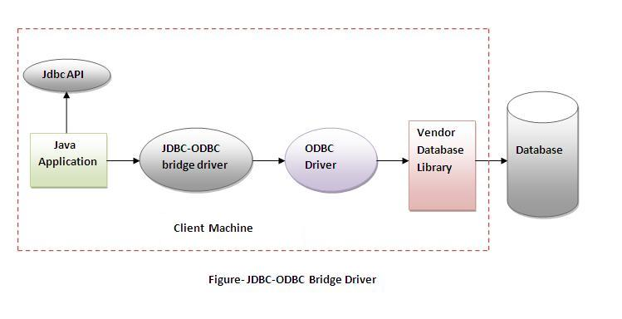

Advantages:
- easy to use.
- can be easily connected to any database.

Disadvantages:
- Performance degraded because JDBC method call is converted into the ODBC function calls.
- The ODBC driver needs to be installed on the client machine.

2) Native-API driver
The Native API driver uses the client-side libraries of the database. The driver converts JDBC method calls into native calls of the database API. It is not written entirely in java.
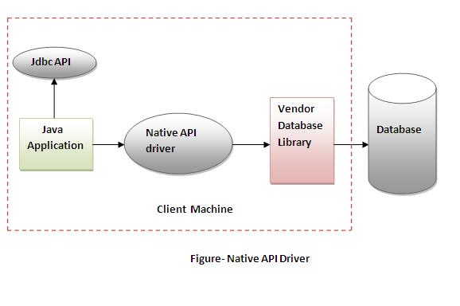

Advantage:
- performance upgraded than JDBC-ODBC bridge driver.

Disadvantage:
- The Native driver needs to be installed on the each client machine.
- The Vendor client library needs to be installed on client machine.

3) Network Protocol driver
The Network Protocol driver uses middleware (application server) that converts JDBC calls directly or indirectly into the vendor-specific database protocol. It is fully written in java.
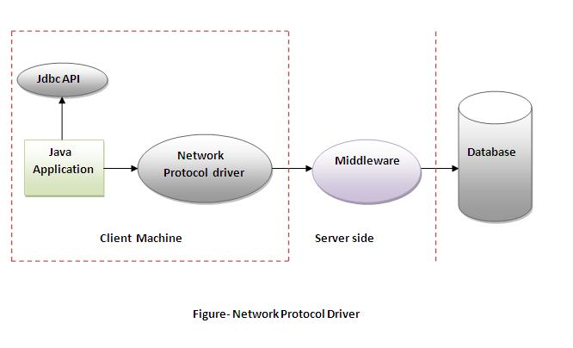

Advantage:
- No client side library is required because of application server that can perform many tasks like auditing, load balancing, logging etc.

Disadvantages:
- Network support is required on client machine.
- Requires database-specific coding to be done in the middle tier.
- Maintenance of Network Protocol driver becomes costly because it requires database-specific coding to be done in the middle tier.

4) Thin driver
The thin driver converts JDBC calls directly into the vendor-specific database protocol. That is why it is known as thin driver. It is fully written in Java language.

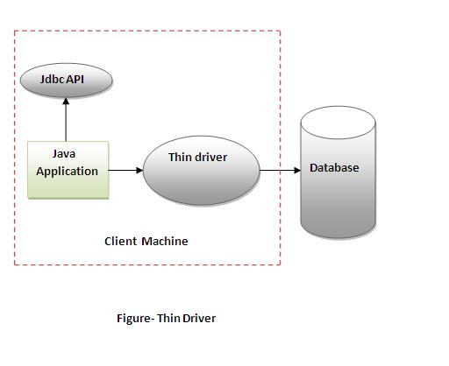

Advantage:
- Better performance than all other drivers.
- No software is required at client side or server side.

Disadvantage:
- Drivers depends on the Database.

19. b) Servlet lifecycle service:-

Life Cycle of a Servlet (Servlet Life Cycle)
A servlet life cycle can be defined as the entire process from its creation till the destruction. The following are the paths followed by a servlet.
- The servlet is initialized by calling the init() method.
- The servlet calls service() method to process a client's request.
- The servlet is terminated by calling the destroy() method.
- Finally, servlet is garbage collected by the garbage collector of the JVM.
Now let us discuss the life cycle methods in detail.

The init() Method
The init method is called only once. It is called only when the servlet is created, and not called for any user requests afterwards. So, it is used for one-time initializations, just as with the init method of applets.
The servlet is normally created when a user first invokes a URL corresponding to the servlet, but you can also specify that the servlet be loaded when the server is first started.
When a user invokes a servlet, a single instance of each servlet gets created, with each user request resulting in a new thread that is handed off to doGet or doPost as appropriate. The init() method simply creates or loads some data that will be used throughout the life of the servlet.
The init method definition looks like this −
public void init() throws ServletException {
// Initialization code...
}

The service() Method
The service() method is the main method to perform the actual task. The servlet container (i.e. web server) calls the service() method to handle requests coming from the client( browsers) and to write the formatted response back to the client.
Each time the server receives a request for a servlet, the server spawns a new thread and calls service. The service() method checks the HTTP request type (GET, POST, PUT, DELETE, etc.) and calls doGet, doPost, doPut, doDelete, etc. methods as appropriate.
Here is the signature of this method −
public void service(ServletRequest request, ServletResponse response)
throws ServletException, IOException {
}
The service () method is called by the container and service method invokes doGe, doPost, doPut, doDelete, etc. methods as appropriate. So you have nothing to do with service() method but you override either doGet() or doPost() depending on what type of request you receive from the client.
The doGet() and doPost() are most frequently used methods with in each service request. Here is the signature of these two methods.

The doGet() Method
A GET request results from a normal request for a URL or from an HTML form that has no METHOD specified and it should be handled by doGet() method.
public void doGet(HttpServletRequest request, HttpServletResponse response)
throws ServletException, IOException {
// Servlet code
}

The doPost() Method
A POST request results from an HTML form that specifically lists POST as the METHOD and it should be handled by doPost() method.
public void doPost(HttpServletRequest request, HttpServletResponse response)
throws ServletException, IOException {
// Servlet code
}

The destroy() Method
The destroy() method is called only once at the end of the life cycle of a servlet. This method gives your servlet a chance to close database connections, halt background threads, write cookie lists or hit counts to disk, and perform other such cleanup activities.
After the destroy() method is called, the servlet object is marked for garbage collection. The destroy method definition looks like this −
public void destroy() {
// Finalization code...
}

Architecture Diagram
The following figure depicts a typical servlet life-cycle scenario.
- First the HTTP requests coming to the server are delegated to the servlet container.
- The servlet container loads the servlet before invoking the service() method.
- Then the servlet container handles multiple requests by spawning multiple threads, each thread executing the service() method of a single instance of the servlet.
20. a) JSP Tags:-
There are four types of JSP tags, which are important and often required.

1. Directives
- These types of tags are used primarily to import packages. Altenatively you can also use these tags to define error handling pages and for session information of JSP page.
- <%@page language="java" %>

2. Declarations
JSP declarations starts with '<%!' and ends with '%>'. In this you can make declarions such as int i = 1, double pi = 3.1415 etc. If needed, you can also write Java code inside declarations.
<%!
int radius = 7;
double pi = 3.1415;
%>
3. Scriptlets
JSP Scriptlets starts with '<%' and ends with '%>'. This is where the important Java code for JSP page is written.
<%
String id, name, dob, email, address;
id = request.getParameter("id");
name = request.getParameter("name");
dob = request.getParameter("dob");
email = request.getParameter("email");
address = request.getParameter("address");
sessionEJB.addClient(id, name, dob, email, address);
%>

4. Expressions
JSP expressions starts with '<%=' and ends with '%>'. If you want to show some value, you need to put it in between these tags.
<%!
double radius = 7;
double pi = 22/7;
double area()
{
return pi*radius*radius;
}
%>
<html>
<body>
Area of circle is <%= area() %>
</body>
</html>

20. b) Session bean with types:-
A session bean encapsulates business logic that can be invoked programmatically by a client over local, remote, or web service client views. To access an application that is deployed on the server, the client invokes the session bean’s methods. The session bean performs work for its client, shielding it from complexity by executing business tasks inside the server.
A session bean is not persistent. (That is, its data is not saved to a database.)

Types of Session Beans
Session beans are of three types: stateful, stateless, and singleton.

Stateful Session Beans
The state of an object consists of the values of its instance variables. In a stateful session bean, the instance variables represent the state of a unique client/bean session. Because the client interacts (“talks”) with its bean, this state is often called the conversational state.
As its name suggests, a session bean is similar to an interactive session. A session bean is not shared; it can have only one client, in the same way that an interactive session can have only one user. When the client terminates, its session bean appears to terminate and is no longer associated with the client.
The state is retained for the duration of the client/bean session. If the client removes the bean, the session ends and the state disappears. This transient nature of the state is not a problem, however, because when the conversation between the client and the bean ends, there is no need to retain the state.

Stateless Session Beans
A stateless session bean does not maintain a conversational state with the client. When a client invokes the methods of a stateless bean, the bean’s instance variables may contain a state specific to that client but only for the duration of the invocation. When the method is finished, the client-specific state should not be retained. Clients may, however, change the state of instance variables in pooled stateless beans, and this state is held over to the next invocation of the pooled stateless bean. Except during method invocation, all instances of a stateless bean are equivalent, allowing the EJB container to assign an instance to any client. That is, the state of a stateless session bean should apply across all clients.
Because they can support multiple clients, stateless session beans can offer better scalability for applications that require large numbers of clients. Typically, an application requires fewer stateless session beans than stateful session beans to support the same number of clients.
A stateless session bean can implement a web service, but a stateful session bean cannot.

Singleton Session Beans
A singleton session bean is instantiated once per application and exists for the lifecycle of the application. Singleton session beans are designed for circumstances in which a single enterprise bean instance is shared across and concurrently accessed by clients.
Singleton session beans offer similar functionality to stateless session beans but differ from them in that there is only one singleton session bean per application, as opposed to a pool of stateless session beans, any of which may respond to a client request. Like stateless session beans, singleton session beans can implement web service endpoints.
Singleton session beans maintain their state between client invocations but are not required to maintain their state across server crashes or shutdowns.
Applications that use a singleton session bean may specify that the singleton should be instantiated upon application startup, which allows the singleton to perform initialization tasks for the application. The singleton may perform cleanup tasks on application shutdown as well, because the singleton will operate throughout the lifecycle of the application.

When to Use Session Beans
Stateful session beans are appropriate if any of the following conditions are true.
- The bean’s state represents the interaction between the bean and a specific client.
- The bean needs to hold information about the client across method invocations.
- The bean mediates between the client and the other components of the application, presenting a simplified view to the client.
- Behind the scenes, the bean manages the work flow of several enterprise beans.
To improve performance, you might choose a stateless session bean if it has any of these traits.
- The bean’s state has no data for a specific client.
- In a single method invocation, the bean performs a generic task for all clients. For example, you might use a stateless session bean to send an email that confirms an online order.
- The bean implements a web service.
Singleton session beans are appropriate in the following circumstances.
- State needs to be shared across the application.
- A single enterprise bean needs to be accessed by multiple threads concurrently.
- The application needs an enterprise bean to perform tasks upon application startup and shutdown.
- The bean implements a web service.

************

