REAL ESTATE MANAGEMENT SYSTEM

SUBMITTED BY

ABINAYA.A
19PCC001

Under the Guidance of

Dr.(Mrs.) A.R. Rihana Banu M.Com(CA), PGDCA, SET, Ph.D
In partial fulfillment of the requirement for the award of the degree of

Master of commerce with Computer Applications

MAY 2021

DEPARTMENT OF COMMERCE

AVINASHILINGAM INSTITUTE FOR HOME SCIENCE
AND HIGHER EDUCATION FOR WOMEN. COIMBATORE- 641043.

CERTIFICATE

This is to certify that the project work entitled “REAL ESTATE MANAGEMENT SYSTEM”, submitted to Department of Commerce, Avinashilingam Institute for Home Science and Higher Education for Woman, Coimbatore, in partial fulfillment of MASTER OF COMMERCE WITH COMPUTER APPLICATIONS, is the record of the original project work done by ABINAYA A (19PCC001) during the period of her study, under my supervision and guidance.

Signature of the Head of the Department

Signature of the Supervisor

Submitted for the viva voice examination held on

Internal Examiner External Examiner

DECLARATION

I hereby declare that this project work entitled “REAL ESTATE MANAGEMENT SYSTEM” submitted to Department of Commerce, Avinashilingam Institute for Home Science and Higher Education for Women, Coimbatore, in partial fulfilment of the requirement for the award of the degree of MASTER OF COMMERCE WITH COMPUTER APPLICATIONS is the bonafide record of original project work done by ABINAYA A (19PCC001) during the period of her study under the supervision and guidance of Dr.(Mrs.) A.R. Rihana Banu M.Com(CA), PGDCA, SET, Ph.D, Department of Commerce.

Place: (ABINAYA A)
Date: Signature of the candidate

ACKNOWLEDGEMENT
I would like to express my sincere thanks to God Almighty, for his constant love and grace that he has showed upon me, which kept me in good health, and sound mind without which my project would not have reached a successful end.
I would like to express my deep sense of reverential gratitude and sincere thanks to Prof. S. P. Thyagarajan , Chancellor, Avinashilingam Institute for Home Science and Higher Education for Woman, Coimbatore- 43 for the opportunity given to me for undertaking this study and for providing the needed facility during the course of my study.
I owe my great deal of my gratitude to DR. Premavathy Vijayan, M.sc., M.Ed., Dip.Spl.Edn., M.Phil., Ph.D., Vice Chancellor, Avinashilingam Institute for Home Science and Higher Education for Woman, Coimbatore- 43, for extending all resources that facilitated the conduct of the present study.
I express my gratitude to Dr.S.Kowsalya, M.sc., M.Phil., Ph.D Registrar, Avinashilingam Institute for Home Science and Higher Education for Woman, Coimbatore, for providing all facilities necessary for the study.
I would express my boundless thanks to Dr. (Mrs) P.Chitramani MBA, M.Phil., Ph.D., SLET, NET, Dean, School of Commerce and Management, Avinashilingam Institute for Home Science and Higher Education for Woman, Coimbatore, for granting the facility required.
I am also grateful to Dr. (Mrs). D. Geetha M.Com., Dip.Ed., M.Phil., Ph.D., Professor and Head of the Department of Commerce for giving necessary help and support for completing the project successfully.
I express my heart full gratitude to my mentor Dr.(Mrs.) A.R. Rihana Banu M.Com(CA), PGDCA, SET, Ph,D, Department of Commerce, for the valuable guidance and for her timely support, suggestions and motivation throughout the project.
I have a great pleasure in expressing my deep sense of my gratitude to all other staff and non- teaching staff that helped us to complete the project.
I would extend our thanks to one and all helped us directly and indirectly for successful completion of our project. Last yet importantly, we would like to thank our parents, friends and all our well-wishers for their kind inspiration.

ABSTRACT
The project entitled “REAL ESTATE MANAGEMENT SYSTEM” is developed by using the Microsoft Visual Studio.net 2012 as front end and SQL Server 2008 as back end. The aim of this project has been to present real estate management system. Real Estate Management system is a program designed to the LNR Groups. They purchase the lands and convert them into sites. To manage the whole process this software is developed. All the employees can work on single software which maintains construction details, property details, payroll and many more. The real estate management give the functionality for buyers, allowing them to search for houses by features or address. It provides functionality for the seller.
This system will provide facility to the user to search Residential and Commercial property and view property. This system will provide facility to view the property by admin and user. User will able to upload the property information to the site and able to manage it. This system will provide facility to the user to fill up their requirement and according to their Requirement Admin can add the Requirement property. This system will provide facility to the user to publish advertise to the Site and view.

TABLE OF CONTENTS

CHAPTER NO | PARTICULARS | PAGE NO
1 | INTRODUCTION  1.1 OVERVIEW OF THE PROJECT  1.2 MODULES DESCRIPTION  1.3 COMPANY DETAILS
2 | SYSTEM STUDY  2.1 EXISTING SYSTEM  2.2 PROPOSED SYSTEM
3 | SYSTEM SPECIFICATION  3.1 HARDWARE SPECIFICATION  3.2 SOFTWARE SPECIFICATION  - SOFTWARE DESCRIPTION
4 | SYSTEM DESIGN
 | 4.1 DATA FLOW DIAGRAM
 | 4.2 INPUT DESIGN
 | 4.3 OUTPUT DESIGN
4.4 DATABASE DESIGN
4.5 ENTITY RELATIONSHIP DIAGRAM
4.6 TABLE DESIGN
4.7 CODING DESIGN
4.8 FORM DESIGN
5 | SYSTEM TESTING AND IMPLEMENTATION
 | 5.1 SYSTEM TESTING
 | 5.2 SYSTEM IMPLEMENTATION
6 | CONCLUSION
 | BIBLIOGRAPHY

CHAPTER 1

INTRODUCTION
1.1 OVERVIEW OF THE PROJECT

The project on Real Estate Management System is used to keep the record of the complete details of the various parameters such as Broker commission, Broker’s personal information, and cancellation of buying of plot details, collection details, Details of the lucky draws conducted, Customers details, Plot details and the Registration details. A compete record of the availability and demand of the plots and the contact person is obtained easily using the real estate automation. The process of getting details is simple and easy.

The Brokers commission depends on the Plot, Group identification, Customers details etc., The Brokers details contains the personal information of the Broker such as name, address and the number of customers. The cancellation of buying of plot details contains the detailed information of the cancelled proposal. The Collection detail contains the information of the customer Identification, Amount, Current Due, Collection Date.

The group details includes the information of the Plot Number, Area Size per Plot, Group Identification number, Number of Dues, Plot Dues Amount per Plot etc., For the purpose of entertainment a Lucky Draw is also conducted. The Lucky Draw form includes the details of the winners of the Lucky Draw. The customer Details included the name, address, contact number, Broker code, which tells which customer belongs to which group.

The plot details include the information of the number of plots and their Document information. If the plot is liked by the customers then the plot can be registered. The Registration Details are included in the Registration Details form of the Land Management System.

1.2 MODULES DESCRIPTION:

Customer Details:
This module is used to manage the customer details including customer Id, name, address and their phone numbers, this section reviews the process whereby customers can be set up and all of the controls that relate to that customer defined. And finally we can store the information in particular database.
Registration Details:
This module is used to manage the registration details including user id, password, name, address and their phone, this section reviews the process whereby admin can be setup and all of the controls that relate to that admin defined. And finally we can store the information in particular database.
Land Details:
This module is used to manage the land details including and number, location, square feet and their amount, this section reviews the process where by admin can be set up and all of the controls that relate to that admin defined. And finally we can store the information in particular database.
Broker Details:
This module is used to manage the broker details including broker id, name, phone, commission, allot area and their address, this section reviews the process whereby admin can be setup and all of the controls that relate to that admin defined. And finally we can store the information in particular database.
Sales details:
This module is used to manage the sales details including customer id, name, contact number, date of registration, allotted area, total amount, broker id, broker name, this section reviews the process whereby admin can be setup and all of the controls that relate to that admin defined. And finally we can store the information in particular database.
Collection Details:
This module is used to manage the collection details including collection id, collection name, amount, due, paid amount, balance, etc., this section reviews the process whereby admin can be setup and all of the controls that relate to that admin defined. And finally we can store the information in particular database.
Lucky draw details:
This module is used to manage the lucky draw details including customer id, name, contact number, email-id, this section reviews the process whereby admin can be setup and all of the controls that relate to that admin defined. And finally we can store the information in particular database.
Cancellation Details:
This module is used to manage the cancellation details including broker id, name, phone no, phone, commission, allot area, address etc., this section reviews the process whereby admin can be setup and all of the controls that relate to that admin defined. And finally we can store the information in particular database.

1.3 ABOUT THE COMPANY “LNR GROUPS”
LNR (CARNEGIE RESIDENCY) is a perfect place for living and investment. It is strategically designed by keeping your needs in mind. We make your livelihood more comfortable with CARNEGIE RESIDENCY. The residential Township that offers with wide range of conveniences that have been chosen to let you enjoy an outstanding life style. CARNEGIE RESIDENCY city is in very close proximity to school, collage, IT hug , SEZ, Airport ect. Get the pride of having a villa of your own
Located in Saravanampatti, Coimbatore, Carnegie Residency is a premium housing project launched by LNR Groups. The project offers Villa in 2, 3 BHK configurations available from 1735 sqft to 1975 sqft. The project is Completed project and possession in Dec 19. Carnegie Residency has many amenities, such as Fire Sprinklers, Gated Community, Children's play area, Earthquake Resistant Structure, 24 Hours Water Supply etc.

COMPANY PROFILE

Company Name : LNR GROUPS
Operating since : 2017
Dealing in : Sale/purchase of Independent Houses
Areas of operation : Coimbatore, Saravanampatti
Contact person : LNR GROUPS (Business development manager)
Address : CARNEGIE RESIDENCY, Saravanampatti, Coimbatore, Tamilnadu – 641 035.
Phone : 91_ 422_2977275
Member since : Aug 23,2017

CERTIFICATE OF THE COMPANY
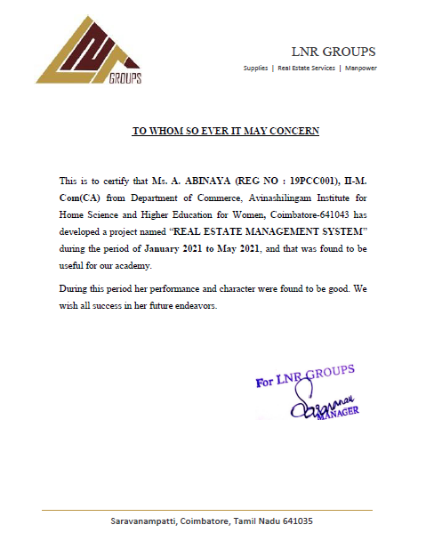
OBJECTIVE OF THE STUDY:
- To maintain high quality and accurate in records
- To reduce the time consumption
- To reduce the manual Work
- Easy and quick retrieval of data

CHAPTER 2

SYSTEM STUDY

2.1 EXISTING SYSTEM
The existing system is manual one .The major activities are related to clients or customers are usually carried out in a hectic way. The number of customer’s arrival is on a alarming rate on the manual calculations always results in a errors which are great loss to the store. Even though mostly nowadays the computers find the replace everywhere. Here, there has been confusion on the installation of system and what kind of software they were going to use. And of lately this package which was proposed that they have thought of implementing a change so the existing system has been manual one and it has been burden on various activities where all needed to carry out the existing system.

DISADVANTAGES
- Erroneous data entry due to human errors.
- Searching and verifying of exact data are more time consuming.
- Reports are not in a presentable form.
- Loss of past records due to mishandling and improper storage facilities.
- Slow processing.

2.2 PROPOSED SYSTEM
In order to conduct a success project we must understand the scope of work to be done, the risk to be incurred the resources, the required task to be accomplished the mile stones to be tracked the fort it be expended and the schedules to be followed. It begins before technical work starts, continues as software evolutes from the concept of reality and only on the software is retired. The system use less amount of time to produce report. In the computerization of the concern, the errors can be rectified. The proposed system is used mainly to maintain the organization. The new system will replace the existing manual processing to overcome the drawbacks. It maintains all the customer details, order details and the checking process through the system.

ADVANTAGES
- It is very accurate
- It can store larger amount of data i.e., memory is very large and can have a back up copy when needed.
- Very good at repeated calculations.
- All the process has done at high speed.
- It does the work very efficiently.
- It is cost effective.
- Reduced paper work.

MODULES:
- Customer Details
- Registration Details
- Land Details
- Broker Details
- Sales details
- Collection Details
- Lucky draw Details
- Cancellation Details
- Reports

CHAPTER 3
SYSTEM SPECIFICATION
3.1 HARDWARE CONFIGURATION
PROCESSOR : DUAL CORE
HARD DISK CAPACITY : 500 GB
MONITOR : 18.5 “ACER MONITOR
INTERNAL MEMORY CAPACITY : 4 GB
KEYBOARD : LOGITECH OF 104 KEYS
CPU CLOCK : 2.3 GHz
MOUSE : LOGITECH MOUSE

3.2 SOFTWARE CONFIGURATION
OPERATING SYSTEM : WINDOWS 7
FRONT END : VB.NET
BACK END : SQL Server

3.3 SOFTWARE DESCRIPTION

INTRODUCTION TO VISUAL BASIC .NET

The system is developed using Visual Basic. NET, which is a very popular Microsoft Product developed by Microsoft Corporation. This is one of the improved languages from basic language. Visual basic .NET includes a variety of open active controls for user interfaces to design application forms.VB.NET provides the easiest, most productive language and tool for rapidly building Windows and Web applications. Visual Basic .NET comes with enhanced visual designers, increased application performance and a powerful integrated development environment (IDE). It also supports creation of applications for wireless, Internet-enabled hand-held devices.VB.NET is the multiple document interface format (MDI).The user interface is the part of the program that responds to the key press and mouse clicks. The action is referred to as events of the form and controls in the form. VB.NET provides vast properties and methods for each control, which helps to utilize all those, functions for record manipulations. Menu driven is one of the most effective controls in the VB.NET. In this menu driven the menu names in a program appear in the menu bar when the user selects a menu, that menu open. Each menu usually contains items arranged in a vertical list.
Powerful Windows-based Applications
Visual Basic .NET comes with features such as a powerful new forms designer, an in-place menu editor, and automatic control anchoring and docking. Visual Basic .NET delivers new productivity features for building more robust applications easily and quickly. With an improved integrated development environment (IDE) and a significantly reduced startup time, Visual Basic .NET offers fast, automatic formatting of code as typing, improved IntelliSense, an enhanced object browser and XML designer, and much more.

Simplified Deployment
Visual Basic .NET can be used to build applications more rapidly and deploy and maintain them with efficiency. Visual Basic .NET and .NET Framework makes "DLL Hell" a thing of the past. Side-by-side versioning enables multiple versions of the same component to live safely on the same machine so that applications can use a specific version of a component. XCOPY-deployment and Web auto-download of Windows-based applications combine the simplicity of Web page deployment and maintenance with the power of rich, responsive Windows-based applications.

Powerful, Flexible, Simplified Data Access
You can tackle any data access scenario easily with ADO.NET and ADO data access. The flexibility of ADO.NET enables data binding to any database, as well as classes, collections, and arrays, and provides true XML representation of data. Seamless access to ADO enables simple data access for connected data binding scenarios. Using ADO.NET, Visual Basic .NET can gain high-speed access to MS SQL Server, Oracle, DB2, Microsoft Access, and more.

Improved Coding
Code can be builder faster and more effectively. A multitude of enhancements to the code editor including enhanced IntelliSense, smart listing of code for greater readability and a background compiler for real-time notification of syntax errors transforms into a rapid application development

Direct Access to the Platform
Visual Basic developers can have full access to the capabilities available in .NET Framework. can easily program system services including the event log, performance counters and file system. The new Windows Service project template enables to build real Microsoft Windows NT Services.

Full Object-Oriented Constructs
You can create reusable, enterprise-class code using full object-oriented constructs. Language features include full implementation inheritance, encapsulation, and polymorphism. Structured exception handling provides a global error handler and eliminates spaghetti code.XML Web Services. An XML Web service enables to call components running on any platform using open Internet protocols. Working with XML Web services is easier where enhancements simplify the discovery and consumption of XML Web services that are located within any firewall. XML Web services can be built as easily as building any class in Visual Basic 6.0. The XML Web service project template builds all underlying Web service infrastructure.

COM Interoperability
Existing code can be maintained without the record. COM interoperability enables you to leverage existing code assets and offers seamless bi-directional communication between Visual Basic 6.0 and Visual Basic .NET applications.

Reuse Existing Investments
Reusing all existing ActiveX Controls is possible. Windows Forms in Visual Basic .NET provide a robust container for existing ActiveX controls. In addition, full support for existing ADO code and data binding enable a smooth transition to Visual Basic .NET.

Visual Basic .NET COMPONENTS:
Visual basic .NET preserves VB’s general approach to programming with a SDK development environment and click through forms to get at the underlying code. The Visual Basic IDE is made up of a number of components given below:
- Forms
- Toolbox
- Tabs
- Properties windows
- Solution explorer
- Output windows
- Task list window
Forms
A form is one of the most basic objects in which the application code and acts as a container for the controls placed on it thus providing a visual interface. VB.NET initially includes a default form; form1 file in each new project .Every form object has its properties, events and methods associated with it.
Toolbox
The toolbox is an important window, which contains a set of controls. It contains the controls to create our forms non-graphical components such as database connections and code fragments that can be dragged directly from the toolbox into the code window.

Properties Window
The properties window appears beneath the solution explorer on the right-hand of the VS.NET main window. It displays the properties for the currently selected object in the main window. Pressing key F4 also displays the properties window for the selected object.
Solution Explorer
Solution explorer window is similar to the project explorer window in the Bathe solution explorer is a bit more advanced, since it allows us to construct solutions out of several different projects – including those written in different languages.
Class View
The class view window is somewhat similar to the solution explorer, in the it provides a view into our solution and project. A view of classes, methods and properties rather than a view of files are provided by the class view in the world of object-oriented world of .NET.
Output Window
The output window is similar to the immediate window available in the previous version of visual basic. The immediate window is used to view debug output from the application, and to interact with the environment by entering bits of code or even calling procedures within the user’s code.
Task List Window
Task list window is a feature that is used to provide a quick list of all the current build and syntax errors in our application. The main advantage of using the task list is that by double-clicking on an error listed in the window will take us right to the troublesome point in our code.

FEATURES OF VISUAL BASIC. NET
- VB.NET is an ideal programming language for developing sophisticated professional application for Microsoft windows
- It makes use of the graphical user interface for creating powerful applications, which enables the user to interact easily within an application.
- VB.NET provides many aspects such as easier comprehension, user friendliness and faster application development, which help the developer to design the application more effectively.
- VB.NET provides the facilities such as log in dialog form, browser form, query form, option dialog form and wizard from which enable the developer design the application more effectively.

MS-SQL SERVER 2008
MS SQL Server is a powerful database management system and the user can create application that requires little or no programming. It supports GUI features and an entire programming language, Visual Studio Application which can be used to develop richer and more developed application. There are quite a few reasons, the first being that SQL is a feature rich program that can handle any database related task you have. You can create places to store your data build tools that make it easy to read and modify your database contents, and ask questions of your data. SQL is a relational database, a database that stores information about related objects. In MS SQL that database means a collection of tables that hold data. It collectively stores all the other related objects such as queries, forms and reports that are used to implement function effectively. The MS SQL database can act as a back end database for .NET as a front end, MS SQL supports the user with its powerful database management functions. A beginner can create his/her own database very simply by some mouse clicks. Another good reason to use SQL as backend tool is that it is a component of the overwhelmingly popular Microsoft office software suite.MS SQL however is a relational database, which means that you can define relationships among the data it contains. Relational database, are superior to flat file databases because you can store discrete information. Microsoft SQL Server 2005 is a full-featured relational database management system (RDBMS) that offers a variety of administrative tools to ease the burdens of database development, maintenance and administration. In this article, we'll cover six of the more frequently used tools: Enterprise Manager, Query Analyzer, SQL Profiler, Service Manager, Data Transformation Services and Books Online. Let’s take a brief look at each.
Enterprise Manager is the main administrative console for SQL Server installations. It provides you with a graphical "birds-eye" view of all of the SQL Server installations on your network. You can perform high-level administrative functions that affect one or more servers, schedule common maintenance tasks or create and modify the structure of individual databases.
Query Analyzer offers a quick and dirty method for performing queries against any of your SQL Server databases. It’s a great way to quickly pull information out of a database in response to a user request, test queries before implementing them in other applications, create/modify stored procedures and execute administrative tasks.
SQL Profiler provides a window into the inner workings of your database. You can monitor many different event types and observe database performance in real time. SQL Profiler allows you to capture and replay system "traces" that log various activities. It's a great tool for optimizing database with performance issues or troubleshooting particular problems.
Service Manager is used to control the MSSQL Server (the main SQL Server process), MSDTC (Microsoft Distributed Transaction Coordinator) and SQL Server Agent processes. An icon for this service normally resides in the system tray of machines running SQL Server. You can use Service
Manages to start, stop or pause the resources.
Data Transformation Services (DTS) provide an extremely flexible method for importing and exporting data between a Microsoft SQL Server installation and a large variety of other formats. The most commonly used DTS application is the "Import and Export Data" wizard found in the SQL Server program group. .

SQL SERVER ARCHITECTURE
Microsoft SQL Server data is stored in databases. The data in a database is organized into the logical components visible to users. A database is also physically implemented as two or more files on disk. When using a database, you work primarily with the logical components such as tables, views, procedures, and users. The physical implementation of files is largely transparent. Typically, only the database administrator needs to work with the physical implementation.
Each instance of SQL Server has four system databases (master, model, temped, and mad) and one or more user databases. Some organizations have only one user database, containing all the data for their organization. Some organizations have different databases for each group in their organization, and sometimes a database used by a single application. For example, an organization could have one database for sales, one for payroll, one for a document management application, and so on. Sometimes an application uses only one database; other applications may access several databases.
It is not necessary to run multiple copies of the SQL Server database engine to allow multiple users to access the databases on a server. An instance of the SQL Server is capable of handling thousands of users working in multiple databases at the same time. Each instance of SQL Server makes all databases in the instance available to all users that connect to the instance, subject to the defined security permissions.
When connecting to an instance of SQL Server, your connection is associated with a particular database on the server. This database is called the current database. You are usually connected to a database defined as your default database by the system administrator.
SQL Server allows you to detach databases from an instance of SQL Server, then reattach them to another instance, or even attach the database back to the same instance. If you have a SQL Server database file, you can tell SQL Server when you connect to attach that database file with a specific database name.
Software design sits at the technical kernel of the software engineering process and is applied regardless of the development paradigm and area of application. Design is the first step in the development phase for any engineered product or system. The designer’s goal is to produce a model or representation of an entity that will later be built. Beginning, once system requirement have been specified and analyzed, system design is the first of the three technical activities -design, code and test that is required to build and verify software.
The importance can be stated with a single word “Quality”. Design is the place where quality is fostered in software development. Design provides us with representations of software that can assess for quality. Design is the only way that we can accurately translate a customer’s view into a finished software product or system. Software design serves as a foundation for all the software engineering steps that follow. Without a strong design we risk building an unstable system – one that will be difficult to test, one whose quality cannot be assessed until the last stage.
During design, progressive refinement of data structure, program structure, and procedural details are developed reviewed and documented. System design can be viewed from either technical or project management perspective. From the technical point of view, design is comprised of four activities – architectural design, data structure design, interface design and procedural design.
FILE DESIGN
A code generator is a suite of programs that matches the input to an appropriate code template and from these produces modules of code. The code is made simple in such a way that another programmer can easily understand and work on that in future. The crucial phase in the system development life cycle is the successful implementation of the new system design. The process of converting as new or revised system into an operational one is known as system implementation. This includes all those activities that take place to convert from an old system to a new system. The system can be implemented only after a through testing is done and if it is found to work according to the specifications.

CHAPTER 4
SYSTEM DESIGN
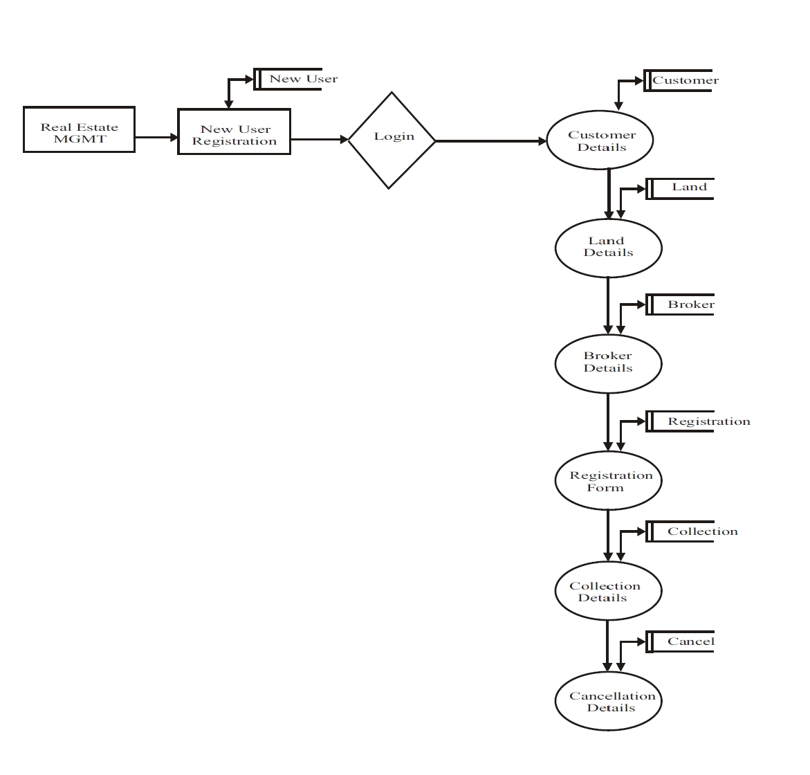
SYSTEM FLOW DIAGRAM

4.1 DATA FLOW DIAGRAM
A data Flow diagram (DFD) is a process-orientation representation of an application system. It is a picture of the movement of data between external entities and the process and data stores within a system. It is a graphical representation of the "flow" of data through an information system. DFDs can also be used for the visualization of data processing. It provides no information about the timing of processes, or about whether processes will operate in sequence or in parallel. It is an element of structured analysis. It is graphical representation of a system or a system or a portion of a system.
The components of a typical dataflow diagram are as follows;
- The entity process.
- The flow.
- The data store.

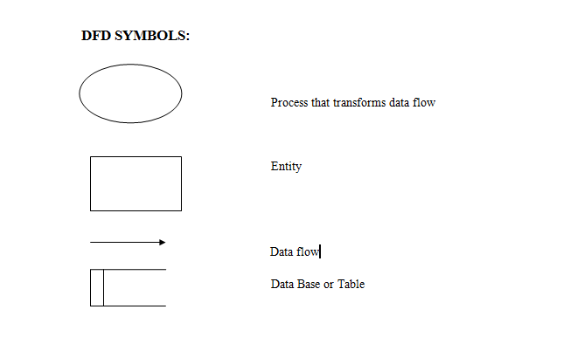

ENTITY RELATIONSHIP DIAGRAM

4.2 INPUT DESIGN
Input design is the process of connecting the user-originated inputs into a computer to used formats. The goal of the input design is to make data entry Logical and free from errors. Errors in the input database controlled by input design this application is being developed in a user-friendly manner. The forms are being designed in such a way that during the processing the cursor is placed in the position where the data must be entered. An option of selecting an appropriate input from the values of validation is made for each of the data entered. Concerning clients comfort the project is designed with perfect validation on each field and to display error messages with appropriate suggestions. Help managers are also provided whenever user entry to a new field he/she can understand what is to be entered. Whenever user enter a error data error manager displayed user can move to next field only after entering a correct data

4.3 OUTPUT DESIGN
Computer output is the most important and direct source of information to the user. Efficient intelligible output design should improve the system's relationship with the user and admin in decision-making. Output design generally refers to the results generated by the system. For many end users on the basis of the output the evaluate the usefulness of the application. Efficient software must be able to produce and efficient effective reports.

4.4 DATABASE DESIGN
The database design involves creation of tables that are represented in physical database as stored files. They have their own existence. Each table constitute of rows and columns where each row can be viewed as record that consists of related information and column can be viewed as field of data of same type. The table is also designed with some position can have a null value. The database design of project is designed in such a way values are kept without redundancy and with normalized format. Refer the appendix for screen shots of Database Design.

4.5 ENTITY RELATIONSHIP DIAGRAM
The Entity-Relationship (ER) model is a conceptual data model that views the real world as entities and relationships. A basic component of the model is the Entity-Relationship diagram, which is used to visually represent data objects. The model has been extended and today it is commonly used for database design. The entity relationship diagram is based on a perception of real world that consists of a collection of basic objects, called entities and of relationship among the objects. Entities are described in a database by a set of attributes. The set of all entities of the same type, and the set of all relationships of the same type, are termed as an entity set, and relationship set respectively. The overall logical structure of a database can be expressed graphically by an entity relationship diagram, which is built up using the notations
FEATURES OF ER MODEL ARE
- It maps well to relational model.
- It is simple and easy to understand with minimum of training. Therefore, database designer to communicate with the end user can use the model.
- In addition, the model can be used as a design plan by the database to implement a data model in specific database management software.
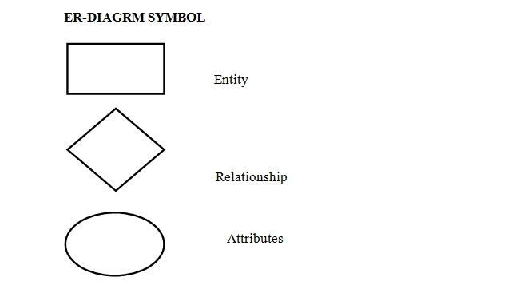
NORMALIZATION
Normalization is the process of efficiently organizing data in a database. There are two goals of the normalization process: eliminating redundant data (for example, storing the same data in more than one table) and ensuring data dependencies make sense (only storing related data in a table). Both of these are worthy goals as they reduce the amount of space a database consumes and ensure that data is logically stored. There are several benefits for using Normalization in Database.
BENEFITS:
- Eliminate data redundancy
- Improve performance
- Query optimization
- Faster update due to less number of columns in one table
- Index improvement
FIRST NORMAL FORM (1NF)
First normal form (1NF) sets the very basic rules for an organized database: Eliminate duplicative columns from the same table. Create separate tables for each group of related data and identify each row with a unique column or set of columns (the primary key).
- Remove repetitive groups
- Create Primary Key

SECOND NORMAL FORM
Second Normal Form (2NF) Second normal form (2NF) further addresses the concept of removing duplicative data:
- Meet all the requirements of the first normal form.
- Remove subsets of data that apply to multiple rows of a table and place them in separate tables.
- Create relationships between these new tables and their predecessors through the use of foreign keys.
- Remove columns which create duplicate data in a table and related a new table with Primary Key – Foreign Key relationship
THIRD NORMAL FORM (3NF)
- Third normal form (3NF) goes one large step further:
- Meet all the requirements of the second normal form.
- Remove columns that are not dependent upon the primary key
- Country can be derived from State also… so removing country

4.6 TABLE DESIGN
TABLE NAME : NEW USER REGISTRATION
PRIMARY KEY : USERID
COLUMN NAME | DATA TYPE | SIZE | DESCRIPTION
User Id | Varchar | 20 | User Id
Password | Varchar | 20 | Password
Name | Varchar | 30 | Name
Address | Varchar | 400 | Address
Phone | Varchar | 20 | Phone

TABLE NAME : CUSTOMER DETAILS
PRIMARY KEY : CUSTOMER CODE
COLUMN NAME | DATA TYPE | SIZE | DESCRIPTION
Customer Code | Varchar | 20 | Customer Code
Customer Name | Varchar | 40 | Customer Name
Customer Phone | Varchar | 20 | Customer Phone
Email | Varchar | 20 | Email
Address | Varchar | 400 | Address
Date 1 | Varchar | 20 | Date 1

TABLE NAME : LAND DETAILS
PRIMARY KEY : LANDNUMBER
COLUMN NAME | DATA TYPE | SIZE | DESCRIPTION
Land Number | Varchar | 20 | Land Number
Location | Varchar | 30 | Location
Sqr Feet | Numeric | 18,0 | Sqr Feet
Nearer city | Varchar | 20 | Nearer city
Amount | Numeric | 18,0 | Amount
Date 1 | Date time | - | Date 1
Address | Varchar | 400 | Address

TABLE NAME : BROKER DETAILS
PRIMARY KEY : BROKERID
COLUMN NAME | DATA TYPE | SIZE | DESCRIPTION
Broke ride | Varchar | 20 | Broke rid
Name | Varchar | 30 | Name
Phone | Varchar | 18 | Phone
Commission | Varchar | 18 | Commission
Allotted Area | Varchar | 40 | Allotted Area
Address | Varchar | 400 | Address

TABLE NAME : SALES DETAILS
PRIMARY KEY : RNO
COLUMN NAME | DATA TYPE | SIZE | DESCRIPTION
Rno | Varchar | 50 | Roll Number
Ccid | Varchar | 50 | Customer ID
Ccname | Varchar | 50 | Customer Name
Ccno | Varchar | 50 | Customer Number
Dor | Varchar | 50 | Date of Registration
Aa | Varchar | 50 | Allotted Area
Ta | Varchar | 50 | Total Amount
Bbid | Varchar | 50 | Broker Id
Bbname | Varchar | 50 | Broker name

TABLE NAME : COLLECTION DETAILS
PRIMARY KEY : NUMBER
COLUMN NAME | DATA TYPE | SIZE | DESCRIPTION
Number | Varchar | 20 | Number
Id | Varchar | 20 | Id
Name | Varchar | 20 | Name
Amount | Varchar | 20 | Amount
Due | Varchar | 20 | Due
Paid amount | Varchar | 20 | Paid amount
Bal | Varchar | 20 | Balance

TABLE NAME : LUCKY DRAW
FOREIGN KEY : CID
COLUMN NAME | DATA TYPE | SIZE | DESCRIPTION
Cust id | Varchar | 50 | Customer Id
Cust name | Varchar | 50 | Customer Name
Contact | Bigint | - | Contact
Email | Varchar | 50 | Email

TABLE NAME : CANCELLATION DETAILS
PRIMARY KEY : NUMBER
COLUMN NAME | DATA TYPE | SIZE | DESCRIPTION
Number | Varchar | 50 | Number
Id | Varchar | 50 | Id
Cus Name | Varchar | 50 | Customer Name
Date 1 | Varchar | 50 | Date 1
Allotted area | Varchar | 50 | Allotted Area

4.7 CODING DESIGN
LOGIN FORM
PublicClassForm1
Dim a AsString
PrivateSub Button1_Click(ByVal sender As System.Object, ByVal e As System.EventArgs) Handles Button1.Click
If uname.Text = ""Or pwd.Text = ""Then
MsgBox("Please Enter Username and Password Then Login", MsgBoxStyle.Information)
ElseIf uname.Text = "admin"And pwd.Text = "admin"Then
Dim f AsNewMain
f.Show()
Me.Hide()
Else
MsgBox("Invalid Username And Password", MsgBoxStyle.Information)
uname.Text = ""
pwd.Text = ""
uname.Focus()
EndIf
EndSub
PrivateSub Button2_Click(ByVal sender As System.Object, ByVal e As System.EventArgs) Handles Button2.Click
End
EndSub
PrivateSub uname_KeyPress(sender AsObject, e AsKeyPressEventArgs) Handles uname.KeyPress
IfNotChar.IsLetter(e.KeyChar) AndAlsoNotChar.IsControl(e.KeyChar) Then e.KeyChar = ""
EndSub
EndClass

MAIN REPORT
PublicClassMain
PrivateSub Button1_Click(ByVal sender As System.Object, ByVal e As System.EventArgs) Handles Button1.Click
Dim f AsNewSupplier
f.Show()
EndSub
PrivateSub Button2_Click(ByVal sender As System.Object, ByVal e As System.EventArgs) Handles Button2.Click
Dim f AsNewPurchase
f.Show()
EndSub
PrivateSub Button3_Click(ByVal sender As System.Object, ByVal e As System.EventArgs) Handles Button3.Click
Dim f AsNewStock
f.Show()
EndSub
PrivateSub Button7_Click(ByVal sender As System.Object, ByVal e As System.EventArgs) Handles Button7.Click
Dim f AsNewProduct
f.Show()
EndSub
PrivateSub Button9_Click(ByVal sender As System.Object, ByVal e As System.EventArgs) Handles Button9.Click
Dim f AsNewCustomer
f.Show()
EndSub
PrivateSub Button8_Click(ByVal sender As System.Object, ByVal e As System.EventArgs) Handles Button8.Click
Dim f AsNewBilling
f.Show()
EndSub
PrivateSub Button4_Click(ByVal sender As System.Object, ByVal e As System.EventArgs) Handles Button4.Click
Dim f AsNewSupreport
f.Show()
EndSub
PrivateSub Button5_Click(ByVal sender As System.Object, ByVal e As System.EventArgs) Handles Button5.Click
Dim f AsNewpurchasereport
f.Show()
EndSub
PrivateSub Button6_Click(ByVal sender As System.Object, ByVal e As System.EventArgs) Handles Button6.Click
Dim f AsNewProductreport
f.Show()
EndSub
PrivateSub Button12_Click(ByVal sender As System.Object, ByVal e As System.EventArgs) Handles Button12.Click
Dim f AsNewcusreport
f.Show()
EndSub
PrivateSub Button11_Click(ByVal sender As System.Object, ByVal e As System.EventArgs) Handles Button11.Click
Dim f AsNewBillReport1
f.Show()
EndSub
PrivateSub Button10_Click(ByVal sender As System.Object, ByVal e As System.EventArgs) Handles Button10.Click
End
EndSub
PrivateSub Button13_Click(ByVal sender As System.Object, ByVal e As System.EventArgs) Handles Button13.Click
Dim f AsNewoffernot
f.Show()
EndSub
PrivateSub Button14_Click(ByVal sender As System.Object, ByVal e As System.EventArgs)
Dim f AsNewservicenot
f.Show()
EndSub
PrivateSub Main_Load(sender AsObject, e AsEventArgs) HandlesMyBase.Load
EndSub
EndClass
Imports System.Data
Imports System.Data.SqlClient
PublicClassSupplier
Dim con AsNewSqlConnection("Data Source=DOTNET\SQLEXPRESS;Initial Catalog=flower;Persist Security Info=True;User ID=sa;pwd=sql;")
Dim com AsSqlCommand
Dim qry AsString
Dim adp AsSqlDataAdapter
Dim ds AsDataSet
Dim i AsInteger
PrivateSub bclear_Click(ByVal sender As System.Object, ByVal e As System.EventArgs) Handles bclear.Click
curdate.Text = Date.Today
sname.Text = ""
compname.Text = ""
compaddr.Text = ""
mno.Text = ""
phno.Text = ""
fno.Text = ""
Try
Dim p AsString
qry = "select scode from supdet"
com = NewSqlCommand(qry, con)
adp = NewSqlDataAdapter(com)
ds = NewDataSet
adp.Fill(ds, "supdet")
i = ds.Tables("supdet").Rows.Count
p = ds.Tables("supdet").Rows(i - 1)(0)
p = Mid(p, 2)
p = Val(p) + 1
If Len(p) = 1 Then
p = "000" + p
ElseIf Len(p) = 2 Then
p = "00" + p
ElseIf Len(p) = 3 Then
p = "0" + p
EndIf
scode.Text = "S" + p
Catch ex AsException
scode.Text = "S0001"
EndTry
Try
qry = "select * from supdet"
com = NewSqlCommand(qry, con)
adp = NewSqlDataAdapter(com)
ds = NewDataSet
adp.Fill(ds, "supdet")
DataGridView1.DataSource = ds
DataGridView1.DataMember = "supdet"
Catch ex AsException
EndTry
EndSub
PrivateSub bsave_Click(ByVal sender As System.Object, ByVal e As System.EventArgs) Handles bsave.Click
If curdate.Text = ""Or sname.Text = ""Or compname.Text = ""Or compaddr.Text = ""Or mno.Text = ""Or phno.Text = ""Or fno.Text = ""Then
MsgBox("Please Fill All Details Then Save", MsgBoxStyle.Information)
Else
qry = "insert into supdet values('" + curdate.Text + "','" + scode.Text + "','" + sname.Text + "','" + compname.Text + "','" + compaddr.Text + "','" + mno.Text + "','" + phno.Text + "','" + fno.Text + "')"
com = NewSqlCommand(qry, con)
con.Open()
com.ExecuteScalar()
con.Close()
MsgBox("Successfully Saved", MsgBoxStyle.Information)
EndIf
curdate.Text = Date.Today
sname.Text = ""
compname.Text = ""
compaddr.Text = ""
mno.Text = ""
phno.Text = ""
fno.Text = ""
Try
Dim p AsString
qry = "select scode from supdet"
com = NewSqlCommand(qry, con)
adp = NewSqlDataAdapter(com)
ds = NewDataSet
adp.Fill(ds, "supdet")
i = ds.Tables("supdet").Rows.Count
p = ds.Tables("supdet").Rows(i - 1)(0)
p = Mid(p, 2)
p = Val(p) + 1
If Len(p) = 1 Then
p = "000" + p
ElseIf Len(p) = 2 Then
p = "00" + p
ElseIf Len(p) = 3 Then
p = "0" + p
EndIf
scode.Text = "S" + p
Catch ex AsException
scode.Text = "S0001"
EndTry
Try
qry = "select * from supdet"
com = NewSqlCommand(qry, con)
adp = NewSqlDataAdapter(com)
ds = NewDataSet
adp.Fill(ds, "supdet")
DataGridView1.DataSource = ds
DataGridView1.DataMember = "supdet"
Catch ex AsException
EndTry
EndSub
PrivateSub bsearch_Click(ByVal sender As System.Object, ByVal e As System.EventArgs) Handles bsearch.Click
Try
Dim s AsString
s = InputBox("Enter Supplier Code:")
qry = "select * from supdet where scode='" + s + "'"
com = NewSqlCommand(qry, con)
adp = NewSqlDataAdapter(com)
ds = NewDataSet
adp.Fill(ds, "supdet")
curdate.Text = ds.Tables("supdet").Rows(0)(0)
scode.Text = ds.Tables("supdet").Rows(0)(1)
sname.Text = ds.Tables("supdet").Rows(0)(2)
compname.Text = ds.Tables("supdet").Rows(0)(3)
compaddr.Text = ds.Tables("supdet").Rows(0)(4)
mno.Text = ds.Tables("supdet").Rows(0)(5)
phno.Text = ds.Tables("supdet").Rows(0)(6)
fno.Text = ds.Tables("supdet").Rows(0)(7)
Catch ex AsException
MsgBox(ex.Message)
EndTry
EndSub
PrivateSub bedit_Click(ByVal sender As System.Object, ByVal e As System.EventArgs) Handles bedit.Click
If curdate.Text = ""Or sname.Text = ""Or compname.Text = ""Or compaddr.Text = ""Or mno.Text = ""Or phno.Text = ""Or fno.Text = ""Then
MsgBox("Please Fill Search Any One Detail Then Edit", MsgBoxStyle.Information)
Else
qry = "update supdet set curdate='" + curdate.Text + "',sname='" + sname.Text + "',compname='" + compname.Text + "',compaddr='" + compaddr.Text + "',mno='" + mno.Text + "',email='" + phno.Text + "',website='" + fno.Text + "' where scode='" + scode.Text + "'"
com = NewSqlCommand(qry, con)
con.Open()
com.ExecuteScalar()
con.Close()
MsgBox("Successfully Updated", MsgBoxStyle.Information)
EndIf
curdate.Text = Date.Today
sname.Text = ""
compname.Text = ""
compaddr.Text = ""
mno.Text = ""
phno.Text = ""
fno.Text = ""
Try
Dim p AsString
qry = "select scode from supdet"
com = NewSqlCommand(qry, con)
adp = NewSqlDataAdapter(com)
ds = NewDataSet
adp.Fill(ds, "supdet")
i = ds.Tables("supdet").Rows.Count
p = ds.Tables("supdet").Rows(i - 1)(0)
p = Mid(p, 2)
p = Val(p) + 1
If Len(p) = 1 Then
p = "000" + p
ElseIf Len(p) = 2 Then
p = "00" + p
ElseIf Len(p) = 3 Then
p = "0" + p
EndIf
scode.Text = "S" + p
Catch ex AsException
scode.Text = "S0001"
EndTry
Try
qry = "select * from supdet"
com = NewSqlCommand(qry, con)
adp = NewSqlDataAdapter(com)
ds = NewDataSet
adp.Fill(ds, "supdet")
DataGridView1.DataSource = ds
DataGridView1.DataMember = "supdet"
Catch ex AsException
EndTry
EndSub
PrivateSub bexit_Click(ByVal sender As System.Object, ByVal e As System.EventArgs) Handles bexit.Click
Me.Close()
EndSub
PrivateSub Supplier_Load(ByVal sender As System.Object, ByVal e As System.EventArgs) HandlesMyBase.Load
curdate.Text = Date.Today
sname.Text = ""
compname.Text = ""
compaddr.Text = ""
mno.Text = ""
phno.Text = ""
fno.Text = ""
Try
Dim p AsString
qry = "select scode from supdet"
com = NewSqlCommand(qry, con)
adp = NewSqlDataAdapter(com)
ds = NewDataSet
adp.Fill(ds, "supdet")
i = ds.Tables("supdet").Rows.Count
p = ds.Tables("supdet").Rows(i - 1)(0)
p = Mid(p, 2)
p = Val(p) + 1
If Len(p) = 1 Then
p = "000" + p
ElseIf Len(p) = 2 Then
p = "00" + p
ElseIf Len(p) = 3 Then
p = "0" + p
EndIf
scode.Text = "S" + p
Catch ex AsException
scode.Text = "S0001"
EndTry
Try
qry = "select * from supdet"
com = NewSqlCommand(qry, con)
adp = NewSqlDataAdapter(com)
ds = NewDataSet
adp.Fill(ds, "supdet")
DataGridView1.DataSource = ds
DataGridView1.DataMember = "supdet"
Catch ex AsException
EndTry
EndSub
PrivateSub curdate_TextChanged(ByVal sender As System.Object, ByVal e As System.EventArgs) Handles curdate.TextChanged
EndSub
PrivateSub sname_KeyPress(sender AsObject, e AsKeyPressEventArgs) Handles sname.KeyPress
IfNotChar.IsLetter(e.KeyChar) AndAlsoNotChar.IsControl(e.KeyChar) Then e.KeyChar = ""
EndSub
PrivateSub sname_TextChanged(sender AsObject, e AsEventArgs) Handles sname.TextChanged
EndSub
PrivateSub mno_KeyPress(sender AsObject, e AsKeyPressEventArgs) Handles mno.KeyPress
IfNotChar.IsNumber(e.KeyChar) AndAlsoNotChar.IsControl(e.KeyChar) Then e.KeyChar = ""
EndSub
EndClass
Imports System.Data
Imports System.Data.SqlClient
PublicClassProduct
Dim con AsNewSqlConnection("Data Source=DOTNET\SQLEXPRESS;Initial Catalog=flower;Persist Security Info=True;User ID=sa;pwd=sql;")
Dim com AsSqlCommand
Dim qry AsString
Dim adp AsSqlDataAdapter
Dim ds AsDataSet
Dim i AsInteger
PrivateSub Product_Load(ByVal sender As System.Object, ByVal e As System.EventArgs) HandlesMyBase.Load
curdate.Text = Date.Today
iname.Text = ""
itype.Text = ""
Try
Dim p AsString
qry = "select pcode from product"
com = NewSqlCommand(qry, con)
adp = NewSqlDataAdapter(com)
ds = NewDataSet
adp.Fill(ds, "product")
i = ds.Tables("product").Rows.Count
p = ds.Tables("product").Rows(i - 1)(0)
p = Mid(p, 2)
p = Val(p) + 1
If Len(p) = 1 Then
p = "000" + p
ElseIf Len(p) = 2 Then
p = "00" + p
ElseIf Len(p) = 3 Then
p = "0" + p
EndIf
pcode.Text = "P" + p
Catch ex AsException
pcode.Text = "P0001"
EndTry
Try
qry = "select * from product"
com = NewSqlCommand(qry, con)
adp = NewSqlDataAdapter(com)
ds = NewDataSet
adp.Fill(ds, "product")
DataGridView1.DataSource = ds
DataGridView1.DataMember = "product"
Catch ex AsException
MsgBox(ex.Message)
EndTry
EndSub
PrivateSub bclear_Click(ByVal sender As System.Object, ByVal e As System.EventArgs) Handles bclear.Click
curdate.Text = Date.Today
iname.Text = ""
itype.Text = ""
Try
Dim p AsString
qry = "select pcode from product"
com = NewSqlCommand(qry, con)
adp = NewSqlDataAdapter(com)
ds = NewDataSet
adp.Fill(ds, "product")
i = ds.Tables("product").Rows.Count
p = ds.Tables("product").Rows(i - 1)(0)
p = Mid(p, 2)
p = Val(p) + 1
If Len(p) = 1 Then
p = "000" + p
ElseIf Len(p) = 2 Then
p = "00" + p
ElseIf Len(p) = 3 Then
p = "0" + p
EndIf
pcode.Text = "P" + p
Catch ex AsException
pcode.Text = "P0001"
EndTry
Try
qry = "select * from product"
com = NewSqlCommand(qry, con)
adp = NewSqlDataAdapter(com)
ds = NewDataSet
adp.Fill(ds, "product")
DataGridView1.DataSource = ds
DataGridView1.DataMember = "product"
Catch ex AsException
MsgBox(ex.Message)
EndTry
EndSub
PrivateSub bsave_Click(ByVal sender As System.Object, ByVal e As System.EventArgs) Handles bsave.Click
If curdate.Text = ""Or pcode.Text = ""Or iname.Text = ""Or itype.Text = ""Then
MsgBox("Please Fill All Details Then Save", MsgBoxStyle.Information)
Else
Dim q AsString
q = "0"
qry = "insert into product values('" + curdate.Text + "','" + pcode.Text + "','" + iname.Text + "','" + itype.Text + "'," + q + ")"
com = NewSqlCommand(qry, con)
con.Open()
com.ExecuteScalar()
con.Close()
MsgBox("Successfully Saved", MsgBoxStyle.Information)
EndIf
curdate.Text = Date.Today
iname.Text = ""
itype.Text = ""
Try
Dim p AsString
qry = "select pcode from product"
com = NewSqlCommand(qry, con)
adp = NewSqlDataAdapter(com)
ds = NewDataSet
adp.Fill(ds, "product")
i = ds.Tables("product").Rows.Count
p = ds.Tables("product").Rows(i - 1)(0)
p = Mid(p, 2)
p = Val(p) + 1
If Len(p) = 1 Then
p = "000" + p
ElseIf Len(p) = 2 Then
p = "00" + p
ElseIf Len(p) = 3 Then
p = "0" + p
EndIf
pcode.Text = "P" + p
Catch ex AsException
pcode.Text = "P0001"
EndTry
Try
qry = "select * from product"
com = NewSqlCommand(qry, con)
adp = NewSqlDataAdapter(com)
ds = NewDataSet
adp.Fill(ds, "product")
DataGridView1.DataSource = ds
DataGridView1.DataMember = "product"
Catch ex AsException
MsgBox(ex.Message)
EndTry
EndSub
PrivateSub bsearch_Click(ByVal sender As System.Object, ByVal e As System.EventArgs) Handles bsearch.Click
Try
Dim s AsString
s = InputBox("Enter Product Code:")
qry = "select * from product where pcode='" + s + "'"
com = NewSqlCommand(qry, con)
adp = NewSqlDataAdapter(com)
ds = NewDataSet
adp.Fill(ds, "product")
curdate.Text = ds.Tables("product").Rows(0)(0)
pcode.Text = ds.Tables("product").Rows(0)(1)
iname.Text = ds.Tables("product").Rows(0)(2)
itype.Text = ds.Tables("product").Rows(0)(3)
Catch ex AsException
MsgBox(ex.Message)
EndTry
EndSub
PrivateSub bedit_Click(ByVal sender As System.Object, ByVal e As System.EventArgs) Handles bedit.Click
If curdate.Text = ""Or pcode.Text = ""Or iname.Text = ""Or itype.Text = ""Then
MsgBox("Please Search Any One Details Then Edit", MsgBoxStyle.Information)
Else
qry = "update product set curdate='" + curdate.Text + "',iname='" + iname.Text + "',itype='" + itype.Text + "' where pcode='" + pcode.Text + "'"
com = NewSqlCommand(qry, con)
con.Open()
com.ExecuteScalar()
con.Close()
MsgBox("Successfully Updated", MsgBoxStyle.Information)
EndIf
curdate.Text = Date.Today
iname.Text = ""
itype.Text = ""
Try
Dim p AsString
qry = "select pcode from product"
com = NewSqlCommand(qry, con)
adp = NewSqlDataAdapter(com)
ds = NewDataSet
adp.Fill(ds, "product")
i = ds.Tables("product").Rows.Count
p = ds.Tables("product").Rows(i - 1)(0)
p = Mid(p, 2)
p = Val(p) + 1
If Len(p) = 1 Then
p = "000" + p
ElseIf Len(p) = 2 Then
p = "00" + p
ElseIf Len(p) = 3 Then
p = "0" + p
EndIf
pcode.Text = "P" + p
Catch ex AsException
pcode.Text = "P0001"
EndTry
Try
qry = "select * from product"
com = NewSqlCommand(qry, con)
adp = NewSqlDataAdapter(com)
ds = NewDataSet
adp.Fill(ds, "product")
DataGridView1.DataSource = ds
DataGridView1.DataMember = "product"
Catch ex AsException
MsgBox(ex.Message)
EndTry
EndSub
PrivateSub bexit_Click(ByVal sender As System.Object, ByVal e As System.EventArgs) Handles bexit.Click
Me.Close()
EndSub
EndClass

FORM DESIGN
NEW REGISTRATION
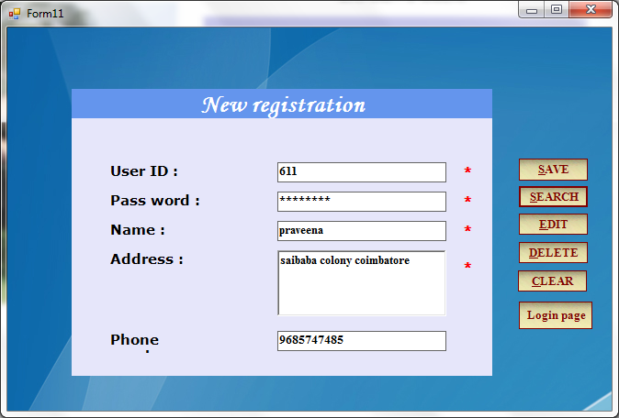

LOGIN FORM

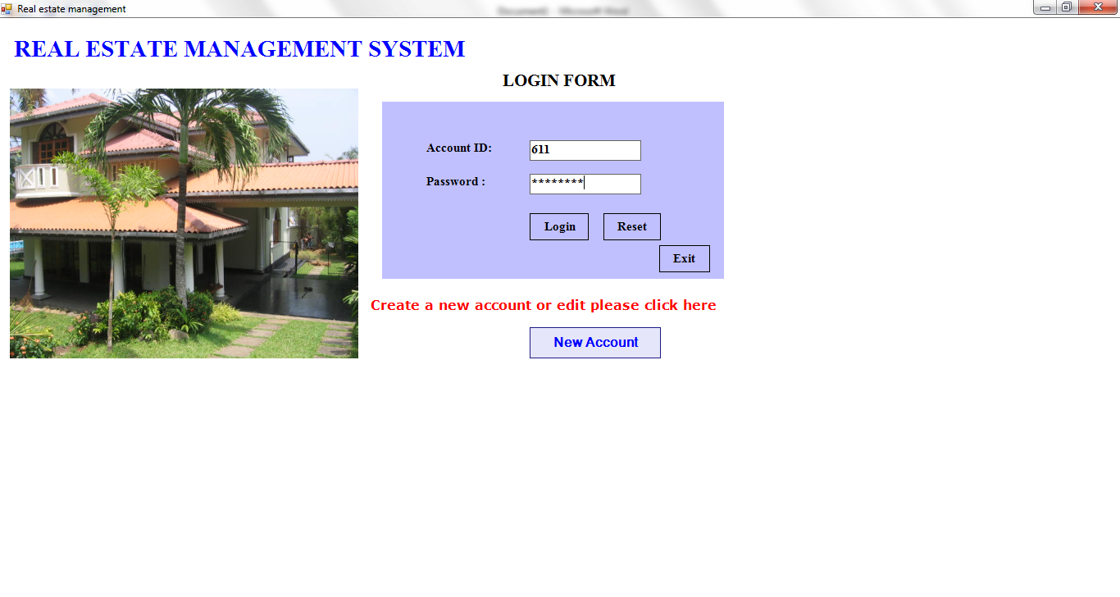
MAIN FORM
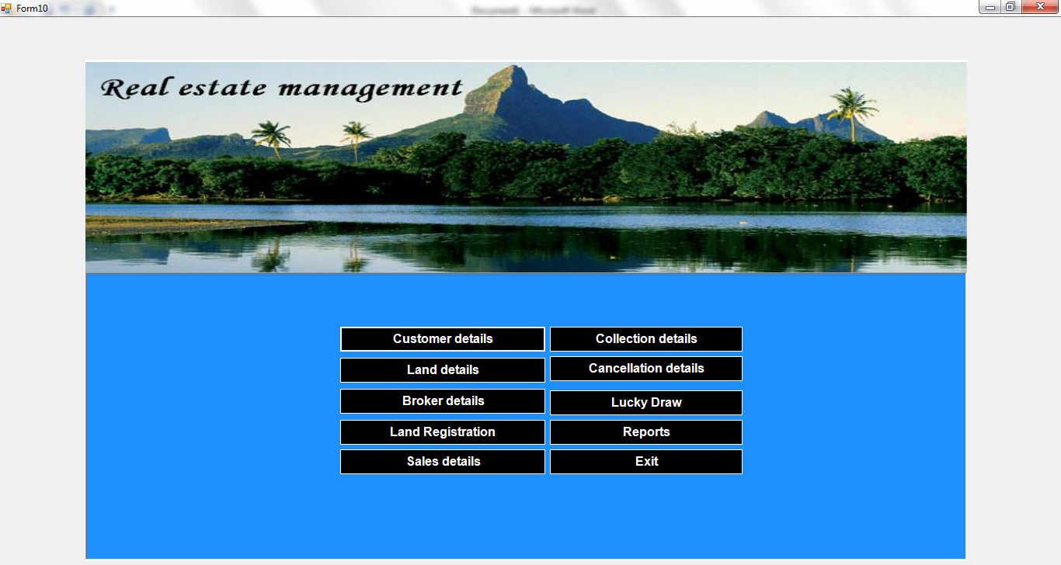

CUSTOMER DETAILS
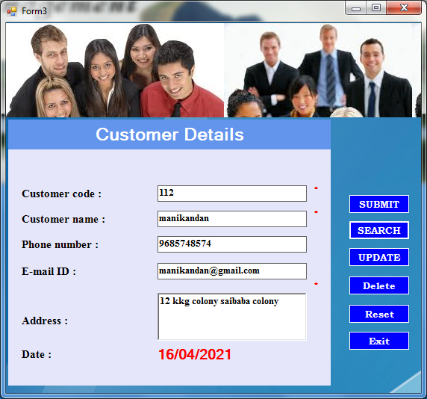

CUSTOMER REPORT

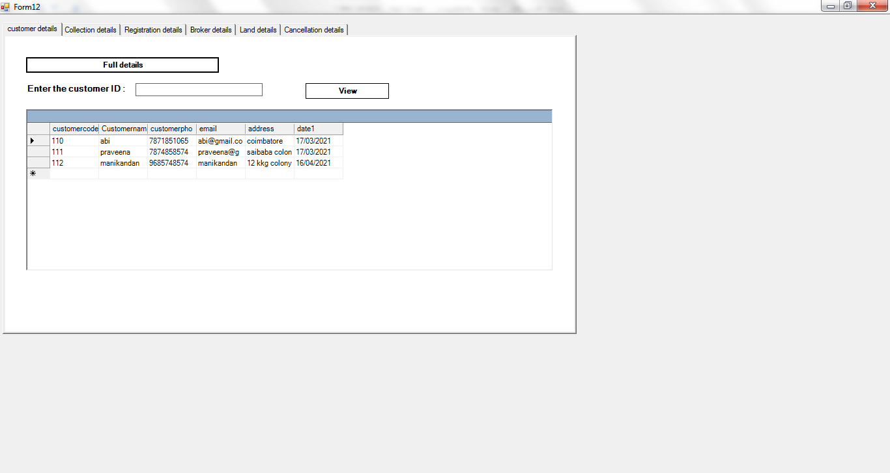
LAND DETAILS

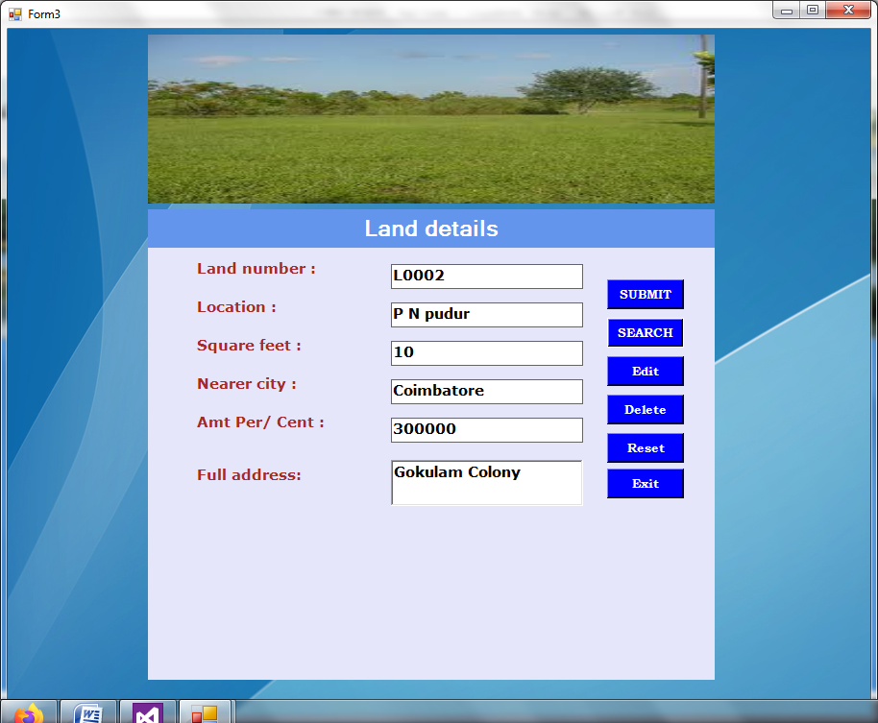
LAND REPORT

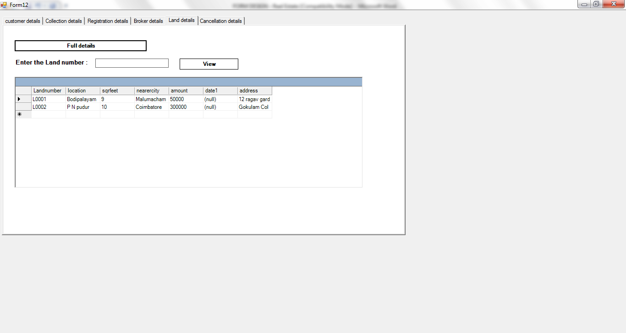
BROKER DETAILS

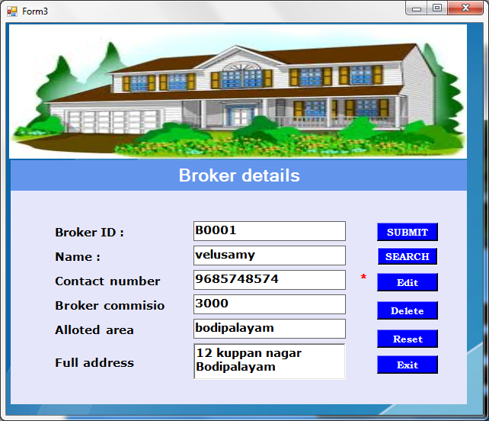

BROKER REPORT

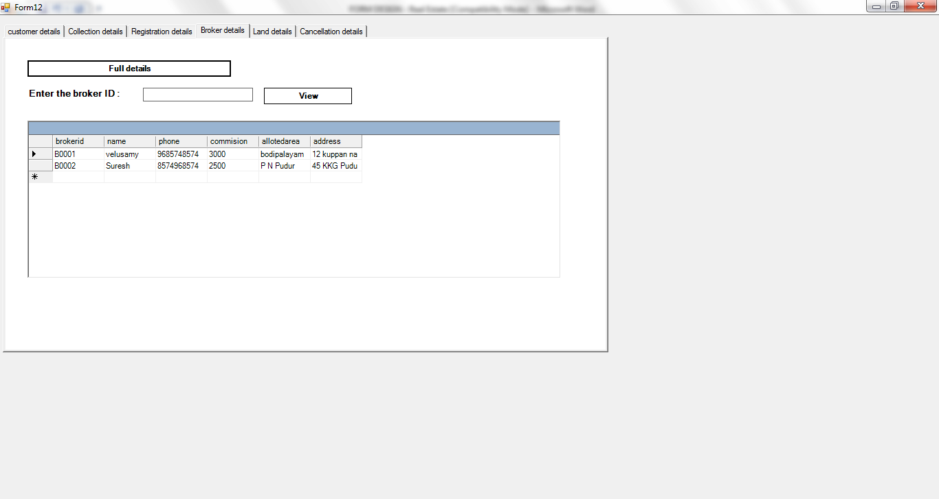
SALES DETAILS

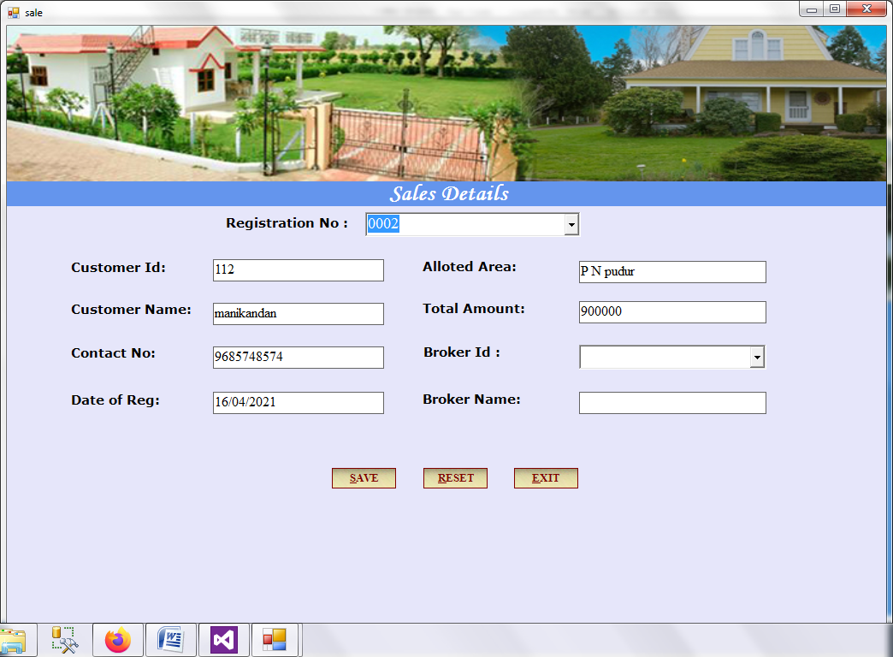

COLLECTION DETAILS

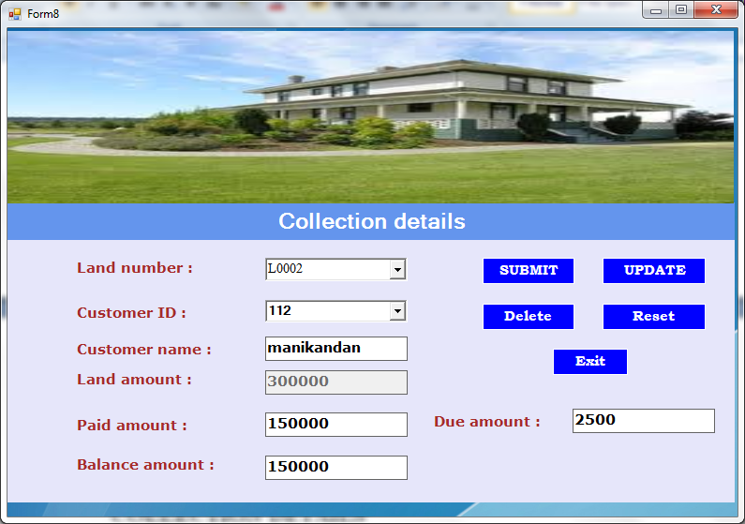

COLLECTION REPORT

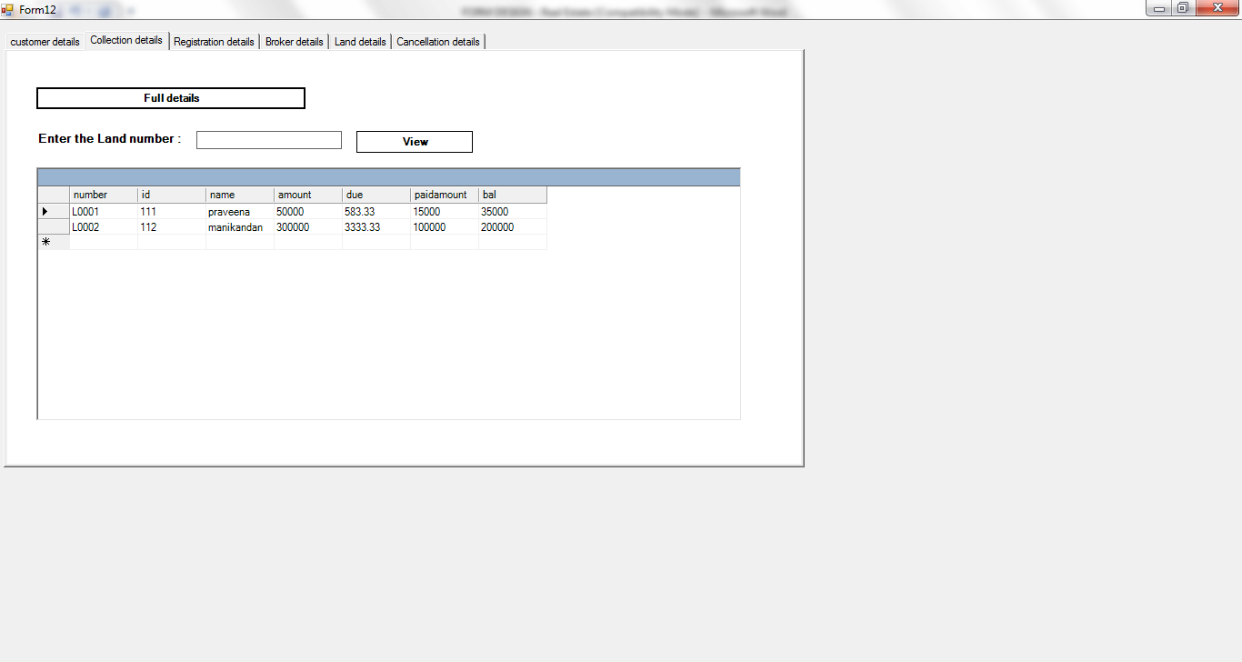
LUCKYDRAW DETAILS

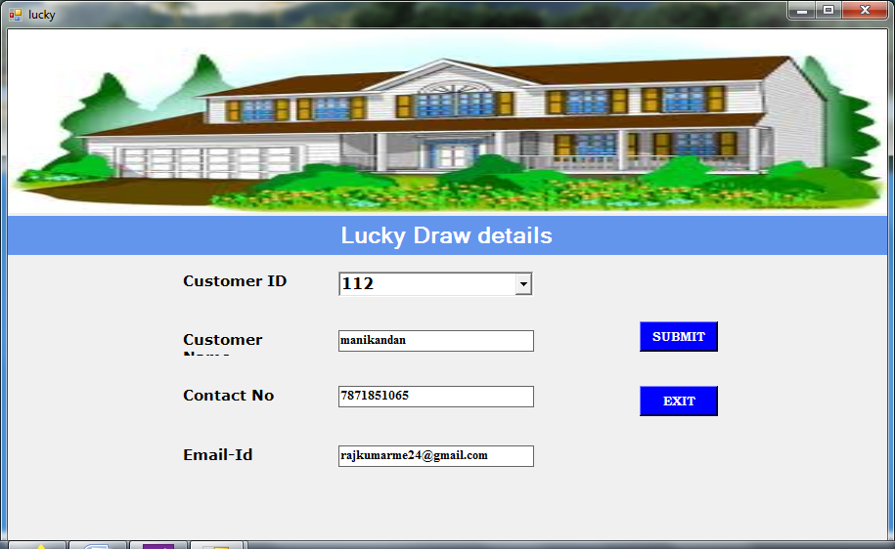

CANCELLATION DETAILS

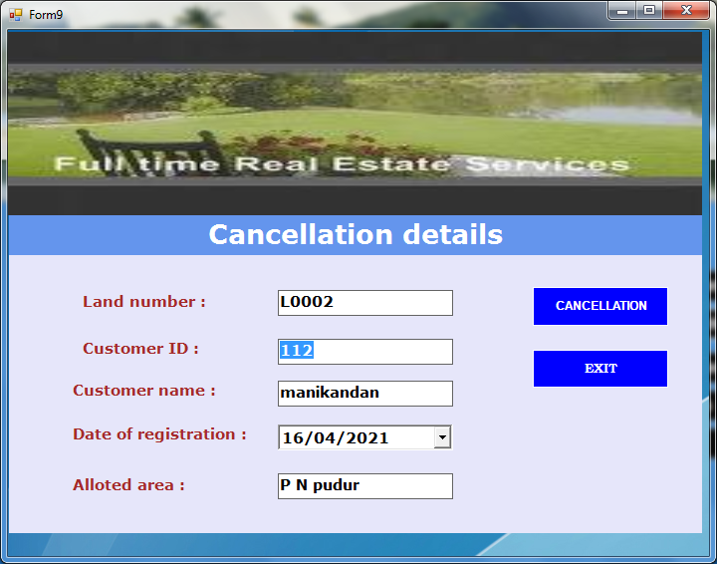

CANCELLATION REPORT

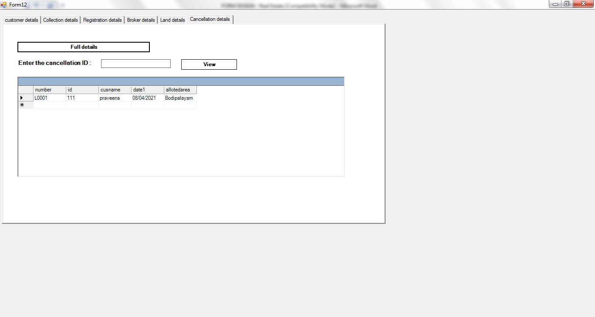

CHAPTER 5

SYSTEM TESTING AND IMPLEMENTATION

5.1 SYSTEM TESTING
System testing is the state of implementation, which is aimed at ensuring that the system works accurately and efficiently as expect before live operation, commences. It certifies that the whole set of programs hang together System testing requires a test plan, that consists of several key activities and steps for run program, string, system and user acceptance testing. The implementation of newly design package is important in adopting a successful new system Testing is important stage in software development. System test is implementation should be a confirmation that all is correct and an opportunity to show the users that the system works as they expected It accounts the largest percentage of technical effort in software development process. Testing phase is the development phase that validates the code against the functional specifications. Testing is a vital to the achievement of the system goals. The objective of testing is to discover errors. To fulfill this objective a series of test step such as the unit test, integration test, validation and system test where planned and executed.
5.1.1UNIT TESTING
Here each program is tested individually so any error apply unit is debugged. The sample data are given for the unit testing. The unit test results are recorded for further references. During unit testing the functions of the program unit validation and the limitations are tested. Unit testing is testing changes made in a existing or new program this test is carried out during the programming and each module is found to be working satisfactorily. For example in the registration form after entering all the fields we click the submit button. When submit button is clicked ,all the data in form are validated. Only after validation entries will be added to the database. Unit testing comprises the set of tests performed by an individual prior to integration of the unit into large system. The situation is illustrated in as follows:
Coding-> Debugging ->Unit Testing -> Integration testing->Output Testing
The four categories of test that a programmer will typically perform on a program unit
• Functional test
• Performance test
• Stress Test
• Structure test
Functional test involve exercising the code with nominal input values for which the expected results are known as well as boundary values and special values. Performance testing determines the amount of execution time spent in various parts of unit program through put and response time and device utilization by the program. A variation of stress testing called sensitivity testing in same situations a very small range of data contained in a the bounds of valid data may cause extreme and even erroneous processing or profound performance degradation. Structured testing is concerned with a exercising the internal logic of a program and traversing paths. Functional testing, stress testing performance testing are referred as “black box” testing and structure testing is referred as “white box” testing
5.1.2 OUTPUT TESTING
Asking the user about the format required by them tests the output generated by the system under consideration .It can be done in two ways, One on screen and other on printer format. The output format on the screen is found to be correct as the format designed n system test.
5.1.3 SYSTEM TESTING
In the system testing the whole system is tested for interface between each module and program units are tested and recorded. This testing is done with sample data. The securities, communication between interfaces are tested System testing is actually a series of different tests whose primary purpose is to fully exercise the computer based system although each test has a different purpose all work to verify that all system elements properly integrated and perform allocate function.
It involves two kinds of activities namely:

- Integrated testing
- Acceptance testing

INTEGRATED TESTING
Integrated testing is a systematic technique for constructing tests to uncover errors associated with interface. Objective is to take unit tested modules and build a program structure that has been dictated by design
ACCEPTANCE TESTING
Acceptance testing involves planning an execution of a functional test, performance test and stress test to verify that the implemented system satisfies the requirement.
The acceptance testing is the final stage of the user the various possibilities of the data are entered and the results are tested.
5.1.4 VALIDATION TESTING
Software validation is achieved through a series of test that demonstrates the conformity and requirements. Thus the proposed system under consideration has to be tested by validation and found to be working satisfactorily. For example in customer enters phone number field should contain number otherwise it produces an error message similarly in all the forms the fields are validated
5.2 SYSTEM IMPLEMENTATION
Implementation is the stage in the project where the theoretical design is turned into a working system. The most crucial stage is achieving a successful new system and giving a user confidence in that the new system will work efficiently and effectively in the implementation stage. The stage consist of

- Testing a developed program with sample data
- Detection and correction of error
- Creating whether the system meets a user requirements
- Making necessary changes as desired by users.
- Training user personal
IMPLEMENTATION PROCEDURES
The implementation phase is less creative than system design. A system design may be dropped at any time prior to implementation, although it becomes more difficult when it goes to the design phase. The final report of the implementation phase includes procedural flowcharts, record layouts, and a workable plan for implementing the candidate system design into a operational design.
USER TRAINING
It is designed to prepare the users for testing & converting the system. There is several ways to trail the users they are:
• User manual
• Help screens
• Training demonstrations.
User manual:
The summary of important functions about the system & software can be provided as a document to the user. User training is designed to prepare the user for testing and convening a system. They summary of important functions about the system and the software can be provided as a document to the user
• Open http page
• Dot net is opened existing user the type the username and password
• Click the submit button
Help Screens:
This features now available in every software package, especially when it is used with a menu. The user selects the “Help” option from the menu. The System success the necessary description or information for user reference.

TRAINING DEMONSTRATION:
Another user training element is a training demonstration. Live demonstration with personal contact is extremely effective for training users.
OPERATIONAL DOCUMENTATION:
Documentation means of communication; it establishes the design and performance criteria of the project. Documentation is descriptive information that portrays the use and /or operation of the system. The user will have to enter the user name and password if is valid he participate in auction. Otherwise if it is new user he needs to register Documentation means of communication; it establishes design & performance criteria for phases of the project. Documentation is descriptive information that portrays he use &/or operation of the system.
DOCUMENTATION TOOLS:
Document production & desktop publishing tool support nearly every aspect of software developers. Most software development organizations spend a substantial amount of time developing documents, and in many cases the documentation process itself is quite inefficient. It is not use unusual for a software development effort on documentation. For this reason, Documentation tools provide an important opportunity to improve productivity.

DOCUMENT RESTRUCTURING:
Creating document is far too time consuming. If the system works, we’ll live with what we have. In some cases, this is the correct approach. It is not possible to recreate document for hundreds of computer programs. Documentation must be updated, but we have limited resources. It may not be necessary to fully re document an application. Rather, those portions of the system that are currently undergoing change are fully documented. The system is business critical and must be fully re documented. Even in this case, an intelligent approach is to pare documentation to an essential minimum.
SYSTEM MAINTENANCE
Maintenance is actually implementation of the review plan as important as it is programmers and analyst is to perform or identify with him or herself with the maintenance. There are psychologically personality and professional reasons for this. Analyst and programmers spend fair more time maintaining programmer then they do writing them Maintenances account for 50-80% of total system development. Maintenance is expensive .One way to reduce the maintenance costs are through maintenance mgt and software modification audits Types of maintenance are:
• Perfective maintenance
• Preventive maintenance

PERFECTIVE MAINTENANCE:
Changes made to the system to add features or to improve the performance. In future any more features can be added in “DOT NET Communication” and it can easily adopt the changes.
PREVENTIVE MAINTENANCE:
Changes made to the system to avoid future problems. Any changes can be made in the future and our project can adopt the changes.

CHAPTER 6
CONCLUSION
The Real Estate Management System was successful created and stored all the , customer details, registration details, land details, broker details, sales details, collection details, lucky details, cancellation details and report into using this application. The application was tested very well and errors were properly debugged. Testing also concluded that the performance of the system is satisfactory. All the necessary output is generated.
The main objective of the project is to bring a full-fledged computerized organization, and to enable the transaction details to maintain records, which makes of the employees easier. Thus, the proposed system has been developed with good amount of flexibility without compromising on the response time. Computerization of the entire system will enhance more accuracy and reduces major part of clerical works. Fast, clear and legible reports can be generated without any ambiguity. Integrated database design and ease of maintenance is a major advantage of the system. User friendliness is a unique feather of the system. Hence by developing a system that is user-friendly in nature, many users are able to work on the system with little of computer knowledge and training.

SCOPE OF FUTURE ENHANCEMENT
The project has been developed and the objectives are achieved successfully. The project has been developed with front end as VB.Net and backend as SQL Server. The frontend can also be changed. ASP.Net can replace the front-end tool such as HTML and CSS for more speed. The system is currently developed and ready for implementation to include the system is highly feasible and user friendly. To provide better facility regarding security, it uses security provider software and we access any place and any where use that. It can have an enhancement on proper in the future according to the user’s requirements.

BIBLIOGRAPHY
•.Elias Awath, “SYSTEM ANALYSIS AND DESIGN”, Tata Mc Graw Hill Publication, Sixth Edition, 2003.
•.S.Ramachandran,”COMPUTER AIDED DESIGN”, Air Walk Publication, Third Edition, 2003.
•.Richard Fairley,”SOFTWARE ENGINEERING CONCEPTS”, Tata Mc Graw Hill Publication, Second Edition, 1997.
•.Distributed .NET Programming in VB .NET by Tom Barnaby.
•Professional VB.NET, 2nd Edition by Fred Barwell, et al
•The .NET Languages: A Quick Translation Guide by Brian Bischof
•Programming VB.NET: A Guide for Experienced Programmers
by Gary Cornell, Jonathan Morrison
• Learning Visual Basic.NET Through Applications by Clayton Crooks II
• Visual Basic .NET How to Program (2nd Edition) by Harvey M. Deitel, Paul J. Deitel, Tem R. Nieto

