


Avinashilingam Institute for Home Science and Higher Education for Women
(Deemed to be University under Category ‘A’ by MHRD, Estd. u/s 3 of UGC Act 1956)
Re-accredited with ‘A+’ Grade by NAAC. Recognised by UGC Under Section 12B
Coimbatore - 641 043, Tamil Nadu, India

Master’s Degree Examination – March 2021
I Semester
Class : I M.Sc Time : 3 Hours Major : Computer Science Max. Marks: 100

20MCSC01 Discrete Structures and Optimization

PART A 10 x 1 = 10
Choose the Correct Answer

- Let us consider a square matrix A of order n with Eigen values of a, b, c then the Eigen
values of the matrix A^{T} could be.
a. a, b, c b. –a, -b, -c c. a-b, b-a, c-a d. a⁻¹, b⁻¹, c⁻¹

2. The less-than relation, <, on a set of real numbers is ______
a. a partial ordering since it is asymmetric and reflexive
b. a partial ordering since it is anti-symmetric and reflexive
c. not a partial ordering because it is not asymmetric and irreflexive equals anti-symmetric
d. not a partial ordering because it is not anti-symmetric and reflexive

3. Consider the statement form p ⇒ q where p =“If Tom is Jane’s father then Jane is Bill’s niece”
and q =“Bill is Tom’s brother.” Which of the following statements is equivalent to this
statement?
a. If Bill is Tom’s Brother, then Tom is Jane’s father and Jane is not Bill’s niece.
b. If Bill is not Tom’s Brother, then Tom is Jane’s father and Jane is not Bill’s niece.
c. If Bill is not Tom’s Brother, then Tom is Jane’s father or Jane is Bill’s niece.
d. If Bill is Tom’s Brother, then Tom is Jane’s father and Jane is Bill’s niece.
4. Which rule of inference is used in each of these arguments, “If it hailstoday, the local office will
Be closed. The local office is not closed today. Thus, it did not hailed today.”
a. Modus tollens b. Conjunction
c. Hypothetical syllogism d. Simplification

5. What is the identity element In the group G = {2, 4, 6, 8) under multiplication modulo 10?
a. 5 b. 9 c. 6 d. 12

6. Which of the following is not an integral domain?
a. ( N, +, . ) b. ( c, +, . ) c. ( O, +, . ) d. ( R, +, . )
7. In graphical method of linear programming problem if the ios-cost line coincide with a side of
Region of basic feasible solutions we get __________.
a. Unique optimum solution b. unbounded optimum solution
c. no feasible solution d. Infinite number of optimum solutions
8. In primal-dual solutions, the dual problem solution can be obtained by solving other problems
classified as ______
a. unrestricted problem b. double problem
c. restricted problem d. original problem

9. The particular task performance in CPM is known
a. Dummy b. Event c. Activity d. Contract

10. Activities A, B, and C are the immediate predecessors for Y activity. If the earliest finish
times for the three activities are 12, 15, and 10, then the earliest start time for Y will be_____
a. 10 b. 15 c. 12 d. 14

Part B 5 x 6 = 30
Answer ALL questions
Each answer should not exceed 400 words or two pages

11. a. List out and explain matrix operations.
(or)
11. b. Illustrate equivalence relations with an instance.
12. a. Explicate normal forms with example.
(or)
12. b. State the rules of inference.

13. a. Distinguish between Isomorphism and Homomorphism.
(or)
13. b. What are the applications of group theory? Give examples.
14. a. Write down the Characteristics of General LPP.
(or)
14. b. Define Simplex method II with an example.

15. a. Mention the Rules for construction of network.
(or)
15. b. Distinguish between PERT and CPM.

Part C 5 x 12 = 60
Answer ALL questions
Each answer should not exceed 800 words or four pages

16. a. Find the inverse matrix of the matrix:
A=[112920503]using the Cayley–Hamilton theorem. (or)
16. b. Suppose R is a partial order on a set A. Prove that R−1 is also a partial order.
17. a. Define Propositional Equivalences with suitable examples. (or)
17. b. Using predicate symbols and appropriate quantifiers, write the symbolic form of the
following English statement: –
i. D(x) is “x is a day”; M is “Monday”; T is “Tuesday”.
ii. S(x) is “x is sunny”; R(x) is “x is rainy”.
iii. Some days are sunny and rainy
iv. It is always a sunny day only if it is a rainy day
v. It rained both Monday and Tuesday
vi. Every day that is rainy is not sunny

18. a. Show that the set of all positive rational numbers forms an abelian group under the
composition * defined by a * b = (ab)/2 .
(or)

18. b. Let R be a ring. The cancellation law holds in R if, for all r, s, t ∈ R such that t 6= 0, if tr =
ts, then r = s. Then prove the Lemma: A ring R 6= {0} is an integral domain ⇐⇒ the
cancellation law holds in R.
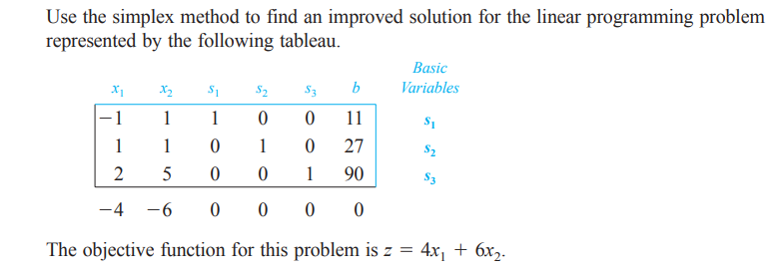
19. a. (or)
19. b. Solve the following using dual simplex method.
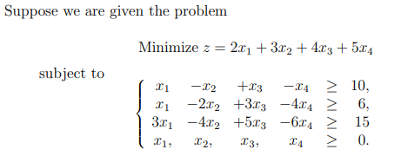
20. a. What is critical path analysis? Give a detailed note on working with CPA. (or)
20. b. Give a descriptive note on three different estimates of activity duration in PERT with
relevant examples.
*****

