EXTRACTION AND APPLICATION OF DYES FROM SELECTED MEDICINAL HERBS – INDIGOFERA TINCTORIA, MIMOSA PUDICA ON
KHADI COTTON FABRIC

By

SANGEETHA, D.
(Reg. No. 10BPS14)

A DISSERTATION SUBMITTED TO
AVINASHILINGAM DEEMED UNIVERSITY FOR WOMEN
COIMBATORE – 641 043.

In Partial Fulfilment of the Requirements for the Degree of
MASTER OF SCIENCE
IN
BIO-TEXTILES

APRIL 2012

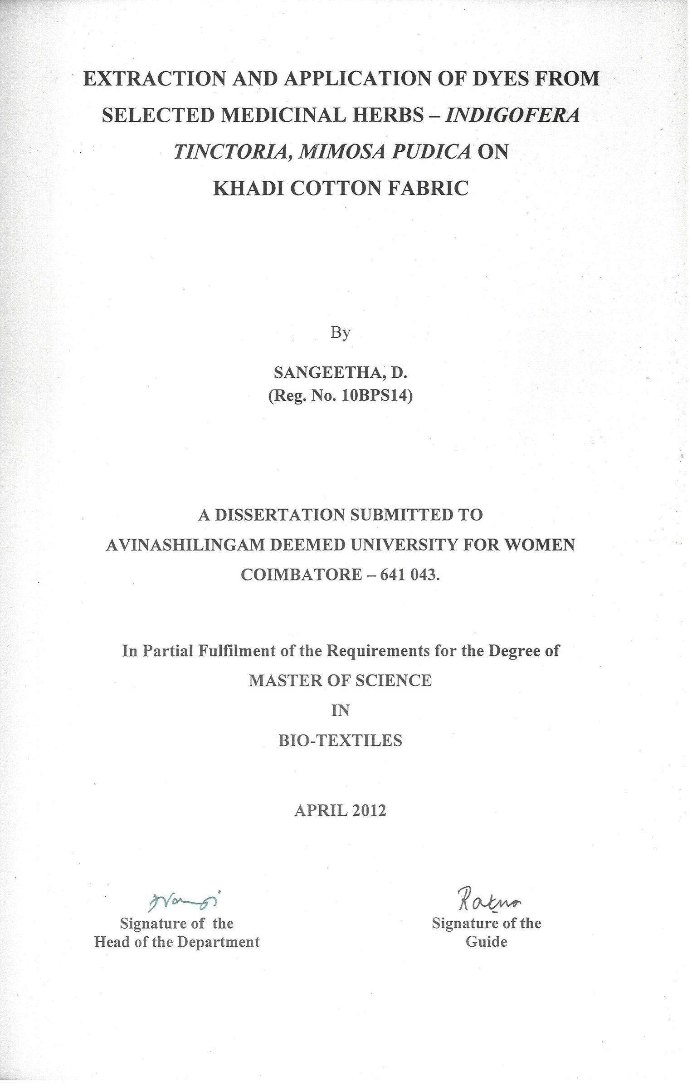
ACKNOWLEDGEMENT

First and foremost the investigator wishes to thank “GOD ALMIGHTY” for endowing the investigator with his immense blessings which helped to overcome the hurdles, paving way for the successful completion of the study.
The investigator owes her reverential gratitude to Dr.T.S.AVINASHILINGAM, Founder and First Chancellor of Avinashilingam Deemed University for Women, Coimbatore, for providing the temple of learning. She also owes her sincere gratitude to HONY. COLONEL PADMASHRI Dr.(Tmt.) RAJAMMAL P. DEVADAS, M.A., M.Sc., Ph.D. (Ohio State), Hon. D.Sc. (Azad Agri. University, Kanpur), Former Chancellor, Avinashilingam Deemed University for Women, Coimbatore, for heavenly blessings.
The researcher also extend her profound gratitude to
Dr. (Thiru) MEENAKSHI SUNDARAM, M.A., M.Phil., Ph.D. (Honoris Caussa) Anna Avl., Chancellor, Avinashilingam Deemed University for Women, Coimbatore, for providing opportunity to expose herself to the world of knowledge.
The researcher would like to express her sincere gratitude to Dr. (Tmt) SHEELA RAMACHANDRAN, M.Sc., P.G. Dip., Ph.D (Avinashilingam), Vice-Chancellor, Avinashilingam Deemed University for Women, Coimbatore, for providing all the amenities required and for her immense support in the conduct of the study.
The researcher expresses her heartful gratitude to Hon. Colonel.
Dr. (Tmt) SAROJA PRABHAKARAN, M.A., Dip.Ed. (Madras), Ph.D (Mother Teresa), The Director, Halls of Residence, Avinashilingam Deemed University for Women, Coimbatore, for, for constant support, guidance and encouragement rendered to enable us to complete the research work.
The researcher renders her deepest sense of gratitude to
Dr. (Tmt) GOWRI RAMAKRISHNAN, M.Sc., (Madras), M.Phil., Ph.D, (Avinashilingam), Registrar, Avinashilingam Deemed University For Women, Coimbatore, for providing all the administrative support and help required to carry out the project.
The investigator is extremely obliged and thankful to
Dr. Mrs. S. PREMA KUMARI, M.Sc., Dip.Ed., M. Phil., Ph.D., (Avinashilingam), Dean Faculty of Home Science, Avinashilingam Deemed University for Women, Coimbatore, for constant support, guidance and encouragement rendered to enable us to complete the research work.
The investigator expresses sincere thanks to her Head of the Department Dr. (Mrs). N. VASUGI RAAJA, M.Sc., MBA., M.Phil (Madras), Ph.d. (Avinashilingam), Department of Textiles and Clothing, Avinashilingam Deemed University for Women, Coimbatore for propounding all the help needed for the study.
The investigator records her indebtedness, deep respect and heartful thanks to her esteemed and honourable guide Dr.(Tmt.)U. RATNA, M.Sc., M.Phil., Ph.D. (Avinashilingam), Assistant Professor, Department of Textiles and Clothing, Avinashilingam Deemed University for Women, Coimbatore, without whose faith, forbearance and persistence, this research would not have seen the light of this day. Her deep insight and sustained enthusiasm and encouragement, valuable suggestion and constant support and guidance helped the investigator towards the successful completion of the study.
The investigator expresses her sincere thanks to SITRA, SIMA and AVINASHILINGAM DEEMED UNIVERSITY for providing library facilities to carry out the investigation successfully.
The investigator expresses her sincere thanks to BELOVED TEACHING STAFFS and NON TEACHING STAFFS in the Department of Textiles and Clothing for their valuable advice and support.
Last but not least, the investigator wish to record her deep sense of gratitude to all her AMMA (D. MOHANESHWARI), APPA
(T. DHARMILINGAM), AKKA, THAMBI, BROTHER-IN-LAW AND DEAR FRIENDS and all well wishers constant prayers, moral support, motivation and loving are which have been the source of her strength without which her would not have been able to reach to this height.

CONTENTS

CHAPTER | TITLE |  | PAGE NO.
 | LIST OF TABLES
 | LIST OF FIGURES
 | LIST OF PLATES
 | LIST OF APPENDICES
1 | INTRODUCTION |  | 1
2 | REVIEW OF LITERATURE |  | 5
 | 2.1. | Cotton | 6
 | 2.2. | Khadi | 11
 | 2.3. | Herbal Textiles / Ayurvastra | 12
 | 2.4. | Idigofera Tinctoria (Indigo) | 13
 | 2.5. | Mimosa pudica (Touch-me-not) | 14
 | 2.6. | Dyeing | 16
3 | EXPERIMENTAL PROCEDURE |  | 19
 | 3.1. | Selection of Fabric | 20
 | 3.2. | Pretreatment of Fabric | 20
 | 3.3. | Pilot study | 22
 | 3.4. | Dyeing of fabric | 22
 | 3.5. | Evaluation | 27
 | 3.6. | Statistical Analysis | 37
 | 3.7. | Nomenclature | 37
4 | RESULTS AND DISCUSSION |  | 38
5 | SUMMARY AND CONCLUSION |  | 63
 | BIBLIOGRAPHY
 | APPENDIX

LIST OF TABLES

TABLE NO. | TITLE | PAGE NO.
I | Dyeing Recipe (Indigofera tinctoria) | 22
II | Dyeing Recipe (Mimosa pudica) | 24
III | Visual Inspection | 39
IV | Wear Study | 40
V | Fabric Count (warp) | 40
VI | Fabric Count (weft) | 41
VII | Fabric Weight | 43
VIII | Fabric Thickness | 45
IX | Tensile Strength (Warp) | 47
X | Tensile Strength (Weft) | 48
XI | Fabric Elongation (warp) | 50
XII | Fabric Elongation (Weft) | 51
XIII | Abrasion Resistance | 53
XIV | Drop test | 54
XV | Sinking Test | 56
XVI | Capillary Rise Test | 57
XVII | Crease Recovery (Warp) | 59
XVIII | Crease Recovery (Weft) | 60
XIX | Colour Fastness to Sunlight, Washing and Crocking | 62

LIST OF FIGURES

FIGURE NO. | TITLE | PAGE NO.
 | Fabric Count (warp) | 42
 | Fabric Count (weft) | 42
 | Fabric Weight | 44
 | Fabric Thickness | 46
 | Tensile Strength (Warp) | 49
 | Tensile Strength (Weft) | 49
 | Fabric Elongation (warp) | 52
 | Fabric Elongation (Weft) | 52
 | Abrasion Resistance | 55
 | Drop test | 55
 | Sinking Test | 58
 | Capillary Rise Test | 58
 | Crease Recovery (Warp) | 61
 | Crease Recovery (Weft) | 61

LIST OF PLATES

PLATE NO. | TITLE | PAGE NO.
I | Khadi Fabric Weaving | 21
II | Khadi Cotton Fabric | 21
III | Herbal Textile | 21
IV | Indigo Plant | 26
V | Touch-me-not Plant | 26
VI | Dye Extract | 26
VII | Alum | 26
VIII | Wear Study | 28
IX | Electronic Weighing Balance | 32
X | Pick Glass | 32
XI | GSM Cutter | 32
XII | Fabric Thickness Tester | 32
XIII | Fabric Tensile Strength Tester | 32
XIV | Abrasion Resistance Tester | 32
XV | Crease Recovery Tester | 36
XVI | Drop Test | 36
XVII | Sinking Test | 36
XVIII | Capillary Rise Test | 36

LIST OF APPENDICES

APPENDIX NO. | TITLE
1. | Details of the Fabric Samples

INTRODUCTION
The first clothes were made from natural elements like animal skins, furs, grasses, leaves, bones and shells. Clothing was earlier designed only for protection. Now fashion is incorporating many performance oriented functions to enhance human living in a different ways says Burnett (2011).
The properties of clothing material critically affect the comfort and performance of the wearer. Clothing is not only a cover for the skin but also interacts with and modifies the heat regulating function of the skin and these are influenced by the environment opines Davis (2008).
India has a very rich tradition of using natural dyes. The art and craft of producing natural dyed textiles is being practiced in many villages in the country, but there is no organized effort to revive and improve the methods of dyeing and printing with natural dyeing. The use of natural dyes has increased substantially during the last couple of years because of the carcinogenic nature of the synthetic dyes. The production of synthetic dyes involves many violent reactions and during the manufacturing process chemicals are used which causes environmental pollution express Manisha et al., (2008).
The textile industry has become some what conscious about its negative contribution to the environment pollution through textile. Chemicals are used in its various manufacturing processes. As a result many textile manufacturers have opted for herbal textiles. When the textile is dyed with extractions obtained from various herbs, they are used in its dyeing process (http://www.fiber2fashion.com).

When dyeing with vegetable dyes some chemicals are used as catelysts, where as when dyeing with herbal extraction, none of the chemicals are used. Herbal dyes also come in almost all the colours and shades states Kumar (2011). “The entire process of herbal dyeing is organic”. The cloth is bleached with cow’s urine, which has high medicinal value. The dyeing gum too is herbal. It does not pollute like synthetic dyes and the waste is used as bio manure and to generate bio gas, express Jain (2010).
The textiles are the largest items of application next only to engineering goods. The textiles have found wider acceptance in industrial, household, aerospace and apparel fields. They are also gaining importance in medical field. The textile materials are employed in various segments of the medical field.
Since early ages, natural dye stuffs were used for dyeing the fabric and almost until 19th century all the dyes were natural in origin. But as the science and technology progressed synthetic dyes were invented and the world quickly adopted them because of certain advantages like brilliance of shades easy availability, easy reproducibility of shades as compared to natural dyes.
The harmful aspect of synthetic dyes come up when the world realized that they are highly toxic, carcinogenic, pollutative and non-bio degradable. Thus it is high time that the use of natural dyes revived in the contact of health of the people and also safety of the environment. The natural dyes do not create any problem in ecology as they are bio degradable, non-toxic and eco-friendly. Natural dyes are soft in colour, cool to eyes and good to skin says Mahajan et al., (2007).
India has about 45,000 plant species among them several thousand have been claimed to possess medicinal properties. Over the past decade, substantial progress has been made in research on the natural products for the treatment of several dreaded diseases, like AIDS and cancer says Sumitra et al., (2011).
Ayurvastra is a branch of Ayurveda, the ancient 5,000 year old Indian system of vedic healthcare. The Sanskrit word ‘Ayur’ means LIFE and ‘Vastra’ means DRESS. Ayurvastra is the garment that ensures the Ayurvedic principle that regular contact with a cloth made from the yarns infused with organic herbs and medicinal plant extracts will relieve metabolic disorders and threads a new line of healthy living (http://ayurvastraonline.com).
Ayurvedic clothing is used by practitioners for treatment of a variety of diseases such as diabetes, skin infection, ecozema, proriasis hypertension and even some form of cancer. Ayurvedic clothing are produced by dyeing the fabric with herbal extracts. Ayurvastra are not only eco-friendly but they leave certain residues that can be further used for making other environmental friendly products.
Khadi, the word derived from ‘khadder’ means hand spun, hand woven cotton fabric. Khadi evokes a sense of nationalism, peace and simplicity among Indians as it is closely associated with Indian’s freedom movement led by Mahatma Gandhi says Padmini et al., (2006). A major strength of Khadi is that it is 100 per cent cotton and it is 100 per cent manually prepared.
Khadi is our heritage, connected with our soil and life style and it has lived on for hundreds of years across generation. It represents a way of life as well as a model for economic development of Indian villages. Khadi is natural, ethnic, it’s breathe, easy features has made fashion enthusiasts to led their imagination soar by combining and co-ordinating Khadi to a bold fashion statement says Gayal et al., (2012).
Moses (2003) remarks that cotton fabric is mostly considered for its natural aesthetic and is suitable for all weathers. Cotton is able to withstand high temperatures, which allows it to be laundered repeatedly. Cotton fabric has the advantage of showing good affinity towards many of the natural dyes, state Ansari et al., (2000).
The textiles were also made attractive with the addition of colours, available from natural sources especially of vegetable origin. Simple dyeing can be carried out on the cotton fabric with the help of variety of natural dyes, remark Mitra et a., (2006).
Only few studies were conducted on application of dyes produced from medicinal plants. Hence the investigator has selected the topic on “Extraction and Application of Dyes from Selected Medicinal Herbs – Indigofera tinctoria, Mimosa pudica on Khadi Cotton Fabric” with following objectives:
- To extract dyes from indigo and touch-me-not plant.
- Application of the selected dye on 100 per cent Khadi cotton fabric
- To construct the dyed fabric into ladies top.
- Subjective and objective evaluation of the dyed fabric were carried out.

2. REVIEW OF LITERATURE
2.1. Cotton
2.1.1. Introduction
2.1.2. History
2.1.3. Properties of Cotton
2.1.3.1. Physical Properties
2.1.3.2. Chemical Properties
2.1.4. Advantages of Cotton
2.2. Khadi
2.2.1. Introduction
2.2.2. History
2.2.3. Advantages of Khadi
2.3. Herbal Textiles / Ayurvastra
2.4. Indigofera tinctoria (Indigo)
2.4.1. Description
2.4.2. Medicinal Uses
2.4.3. Chemical Constituents
2.5. Mimosa pudica (Touch-me-not)
2.5.1. Description
2.5.2. Medicinal Uses
2.5.3. Chemical Constituents
2.6. Dyeing
2.6.1. Classification
2.6.2. Natural Dyeing
2.6.2.1. History
2.6.2.2. Sources
2.6.2.3. Advantages of Natural Dyes
2.1. COTTON
2.1.1. Introduction
Cotton is important natural vegetable fibre says Nimkar (2006) cotton is a strong and reasonably is by far the most commonly used textile fibre reveals Mahadevan (2001). Cotton is the purest form of cellulose that can be found in nature and excels the physical and chemical homogeneity of any other vegetable fibre views Gopalakrishnan and Aravindhan (2005).
Cotton is the oldest fibre used for textile purpose. India was the centre for world’s cotton industry as well as for variety of fine fabric till 1600 AD reports Mishra (2000). Cotton is the backbone and basic foundation of the world’s textile trade and Industry says Ajay (2007), Cotton is a dead fibre because it has little luster wrinkle resistance and elasticity. However all these qualities can be greatly improved by special fabric construction and finishes remarks Vidyasagar (2002).
Cotton is the most important commercial crop of India cultivated mainly for its fibre and other by products reveal Arboretum et al., (2005). It is considered as a chief international commodity and plays a crucial role in several sectors of the national economy remarks Narayanan (2006). Cotton is the fabric for every home and is one of the most widely produced textile fabric inform Deshwal and Khambra (2006). In a tropical country like India, cotton is the most desirable for making apparels because of its easy availability comfort, excellent heat conductivity and hygroscopic nature express Samantha et al., (2003) and Moses (2003).
2.1.2. History
Nobody seems to know exactly when people first began to use cotton, but there is evidence that it was cultivated in India and Pakistan and in Mexico and Peru 5000years ago. In these two widely separated parts of the world, cotton must have grown wild. Then people learned to cultivate cotton plants in their fields reports Ajay and Rakesh (2007).
The history of cotton dates from about 3500 B.C. in India mentioned by Frank (2007). The earliest evidence of actual woven cotton fabrics was found in India during the excavation of mohenjo-dara city from third millennium B.C. mentioned by collier (2001). In the fourteenth century cotton was grown in Mediterranean countries and shipped from there to mills in the Netherlands in Western European for shipping and weaving until the mid eighteenth century informs Kaplan (2002).
2.1.3. Properties of Cotton
Cotton chemically consists of 88.96 per cent pure cellulose along with protein, pectin substances state Nair et al., (2009). Cotton fibres are made up of cellulose. The fibre length varies with type and quality within the ranges from 11μ to 20μ says Gienandt (2006).
2.1.3.1.Physical Properties
- Composition
Cotton fibres are made up of cellulose, which constitutes approximately 90 per cent. In addition to this water in 5-8 per cent and the rest weight is contributed by other natural impurities says Gupta et al., (2005).
- Structure
It is cotton fibres are seen through the microscope, they show a formation of the shape like a fine braid. If the cotton is fine, the number of strands is more explains Nakamura (2000).

- Strength
According to Mishra (2000) the strength of the fibre increases at higher humidity or at higher moisture. In general, the tensile strength increases upto a relative humidity of 60 per cent and then it remains mostly constants.
- Moisture
Mostly cotton fibres consist of 8.5 per cent moisture but it has the ability to absorb 15 per cent to 20 per cent of the moisture due to this properties it takes time while dying reports Gupta et al., (2005).
- Shrinkage
When cotton fibre is wet, it tends to contract or shrink as it dries. As a result, cotton yarns fabrics can shrink considerably, particularly those that are loosely constructed. However, preshrinking finishing processes minimize shrinkage in cotton fabrics explains Singh (2004).
- Heat conductivity
Cotton fibres have the ability to conduct heat energy, minimizing any destructive heat accumulation. Thus they cannot withstand ironing temperature. Excessive application of heat energy causes the cotton fibre to char and burn, without any prioer melting interprets Gohl and Vilensky (2000).
2.1.3.2. Chemical Properties
- Action of Acids
Cotton fibres are weakened and destroyed by acids. Acidic conditions hydrolyse the cotton polymer at the glucoside oxygen atom which links the two glucose units to form the cellobiose unit. Mineral or inorganic acids, being stronger than organic acids will hydrolyse the cotton polymer more rapidly states Gohal and Vilensyk (2000).

- Action of Alkalies
Cotton fibres are resistant to alkalies and are relatively unaffected by normal laundering. The resistance is attributed to the lack of attraction between the cotton polymers and alkalies views Raul (2005).
- Action of light
Exposure to air in presence of sunlight for a long period will have an effect on cotton like that of heat describes Misha (2000). Cotton fabrics should therefore be shaded from direct sunlight expresses Sing (2004).
- Action of Microorganisms
Many micro organisms attack cotton. Numerous fungi cause mildew. The mildew discolours rots and weakens the fibre. Most fungi reproduce by means of spores, largely present in air and are attracted to cotton microbiological rotting, and appear to be its main cause under water logged conditions says Mishra (2000).
2.1.4. Advantages of Cotton
Cloth made up of cotton is more comfortable, durable and suitable to resist all kinds of weather. It traps air with in the fabric structure and help for a thermal insulation process, resulting protection.
- Moisture Control
Cotton fabric is breathable and transmits moisture away from the body and is absorbent and removes liquid from the skin, like a towel, according to Cotton Incorporated. Cotton allows you to remain comfortable as you exercise, keeping moisture from building up between your skin and clothing. The International Forum for Cotton Promotion states that cotton can take up to one-fifth of its weight in water before feeling damp (www.fibretofabric.com).

- Insulation
Cotton clothing protects against from heat in the summer and cold in the winter by providing thermal insulation as the cotton fabric traps air between the fabric fibers. The cotton fibers in clothing hold the fabric away from the skin, further allowing for more air to be trapped between the skin and fabric which helps with insulation and comfort.
- Hypoallergenic
Cotton fabric rarely causes allergic reactions and wearing cotton is often recommended for those with skin allergies, notes Cotton Incorporated. Because cotton is hypoallergenic and does not irritate skin, it is used in medical products like bandages and gauze, and is the fabric of choice when it comes to baby clothing.
- Weatherproof
Cotton fabrics can easily be manufactured into weather-resistant garments through construction and finishing of the fabric. For example, cotton can be made into a tight, dense fabric with a weather-repellent finish to make weather resistant clothing, yet the cotton fabric retains its comfort and breathability.
- Comfort
Cotton clothing is soft and easily stretches, making it a comfortable fabric to wear. Due to its softness and comfort, it is often used in underwear and undershirts, according to the International Forum for Cotton Promotion.
- Durability
The International Forum for Cotton Promotion states that cotton has a high tensile strength, making it strong, durable and less likely to rip or tear. It is 30 percent stronger when wet, withstanding many washings in hot water.
2.2. KHADI
2.2.1. Introduction
Khadi is natural and durable. The production of Khadi fabric is labour intensive process as all the process are done manually. The yarn is produced from the natural cotton by conventional methods using Charka. It brings employment to million of rural artisan’s at their doorsteps reports Ratna (2006).
Khadi is hand spun from natural fibre thus, making it eco friendly, pure and fully bio-degradable. This has made it popular in the overseas market says Gayal et al., (2012).
2.2.2. History
India’s rendezvous with textile dates back to ancient times when the Aryans in the vedic period produced their own cloth. Infact, Khadi had a most religions role in marriages when brides in India were presented with a Khada Charkha in their wedding trousseau to encourage spinning of the yarn says Padmini and Venmathi (2006).
Khadi has its roots in the freedom struggle of India. Khadi, was central to Gandhi’s vision of self-reliance and self-rule. Gandhi wanted Indians to spin their own cotton thread and to weave Khadi, thereby providing employment to many Indians and contributing to the country’s self-sufficiency. Hence, he was the first true Indian designer.
According to Gandhi, Swaraj (Self rule) without Swadeshi (country made goods) is a lifeless corpse and if Swadeshi is the soul of Swaraj, Khadi is the essence of Swadeshi. Therefore, Khadi became not only a symbol of revolution and resistance but part of an Indian identity (www.apo-tokyo.org).
Even though Khadi symbolized the political ideas and independence it self, but to this day most politicians in India are seen only in Khadi clothing. The Indian Flag is also allowed to be made from this material only (www.thehindu.com).
2.2.3. Advantages of Khadi
- The social advantages is providing employment.
- It creates self-reliance amongst the people and building up of a strong rural community spirit.
- Fine fabrics upto 500s count are available which are otherwise impossible to weave in mechanized looms.
- It is the only fabrics where the play of texture is so unique that no two fabrics will be absolutely identical, thus lending it exclusivity ad inimitability in terms of feel and texture.
- Khadi is a versatile fabric, cool in summer and warm in winter being a cruder form of materials it crumples much faster than other preparation of cotton. In order to improve the look, Khadi is often starched to have a stiffer shape express Saranya and Rinsey Antony (2006).
2.3. HERBAL TEXTILES / AYURVASTRA
Ayurveda is an ancient medical treatise summarizing art of healing and prolonging life. Ayurveda is the knowledge of life, to live a vigorous and disease-free life. Ayurveda treats man as a whole which is a combination of body, doshas. Vata, Pitta and Kapha, which govern the internal and external health of the body explains Jain (2010).
Conventional western medicine and traditional Eastern medicine recognize the skin as being the body’s largest organ. The skin can act as a barrier but also as a conduct for outside substances it enter the body. Many environmental toxins and chemicals in conventional clothing are assimilated into the body through the skin. Anything which can improve the skin’s natural ability to block and resist harmful chemicals and toxins from entering the body will be beneficial to health.
Ayurveda identifies seven unique layers comprising the skin. Each layer has a distinct function and supports the layers about it. Starting at the outer most layer, the seven layers defined by Ayurveda are Avabhasini, Lohita, Shweta, Tamra, Vedini, Rohini and Mamsadhara. The fourth layer, Tamra, supports the immune system and performs the function of acting as barrier. According to Maharishi Ayurveda, “Skin infections reflect an imbalance in this layer”. If Ayurvastra cloth and clothing can improve the skin’s ability to act as a barrier to external and environmental toxins, the wearers health might be improved.
2.4. INDIGOFERA TINCTORIA (INDIGO)
2.4.1. Description
A small shrub 4-6 feet high, with slender spreading rather angular branches, rough with short adpressed white hairs. Laves alternate, 3 or 4 inches long shortly stalked, unequally pinnate, with small, setaceous stipules, rachis / stiff, tapering, hairy, leaflets in 4 to 6 opposite pairs and an odd one, very shortly stalked, each with a minute stipolla at the base, oval or obovate-oblong, entire, ½-¾ inch long glabrous and bluish green above silky with white adpressed hairs and poler beneath reports Sivarajan (2002).
Flowers small, shortly stalked, rather closely arranged in erect, tapering, spicate stalked recemes from the axils of the leaves and shorter than them, rachis silky, bracts subulate calyxsubbliabiate, when in full flower almost flat, silky externally, cut into 5 nearly equal triangular teeth, the two upper erect. Petals papilionaceous, the standard ova, obtuse, erect, greenish wings oblong spalhulate, pink, keel petals about as long as the wings united except the long claws, with a backward spur on the sides says Bhallacharjee (2004) and Bentley (2006).
A branching shrub upto 2m high, leaves with 7-13 leaflets, green when fresh and grayish black on drying, tender branches bluish red in colour, flowers may in nearly sessile lax spicate recemes which are much shorter than the leaves, red or pink, fruits cylindric pods, pale greenish grey when young and dark brown on ripening with 10-12 seeds reports (Trivedi, 2006).
2.4.2. Medicinal Uses
The roots, stems and leaves are bitter, thermogenic, laxative, trichogenous expectorant, anthelmintic, tonic and diuretic and useful for promoting the growth of hair and in gastropathy splenomegaly, cephalalgia, cardiopathy, chronic bronchitis, asthma, ulcers and skin diseases. The juice expressed from the leaves are useful in the treatment of hydrophobia. An extract of the plant is good for epilepsy and neuropathy. The plant possess anti-toxic property says Trivedi (2010).
Plant used as antiseptic, hepato protective, hypogly caemic nervine toxic used in enlargement of liver and spleen, skin diseases, leucoderma, burns, ulcers, piles, nervous disorders epilepsy, asthma. Anti inflammation used in blennorrhagin. Root used in hepatitis root and stem laxative, expectorant, febrifuge anti-cephalalgic, anti-tumour, anthelmintic, promote growth of hair. The plant is used in the treatment of endogenous depression reports Khare (2007).
2.4.3. Chemical constituents
Nitrogen, phosphoric acid, potash and lime. It is a rich source of potash, the ash containing as much as 9.5 per cent of soluble potassium salts reports Prajapati and Purohit (2004).
2.5. MIMOSA PUDICA (TOUCH-ME-NOT)
2.5.1. Description
Semi prostrate, prickly coarse herb or sub shrub upto 0.5m tall. Leaves alternate, bipinnately compound which fold up when disturbed. Flowers pink with several stamens upto 8mm. Long, borne on globose heads. Fruits a flat, hariy legume (pod) breaking into 2-4 one seeded segments states Prajapati et al., (2009).
A diffuse or spreading undershrub, 50-90cm high stem and rachis covered with prickles. Leaves bipinnate, very sensitive, collapse on touching pinnae 2-4, digitately arranged, with 10-20 pairs of leaflets. Flowers as soft as cotton, borne is pinkish globose heads, pedunde 5.1cm long. Pods flat, small, strew-colourd provided with many bristles, 1.3-1.9cm long, seeds 3-5, flowers and fruits throughout the year reports Faroog (2005).
2.5.2. Medicinal Uses
Lajjalu is astringent, cooling, antiseptic, alternative and blood purifier. It is resolent, alternative and carminative. It is used in burning sensation of body, diarrhea, dysentery, haemophilic conditions, leucorrhoea, morbid conditions of vegina, root is aphrodiasiac, cooling, vulnerary, cures kapha, asthma, biliousness, vaginal and uterine complaints. Decoction of root is useful in gravellish complaints. Leaves and root are used in piles and fistula. Leaves rubbed into paste applied hydrocle. Leaf and stem in scorpion sting states Joshi (2000).
Leaf juice is given to treat rabies, epilepsy and nervous disorders. Leaf paste is applied over the swelling, sores, wounds and boils. Leaf paste is given as an antidote for snake bite. Leaf and root extract is given along with honey to treat jaundice states Ramesh (2005). A spoonful of shade dried plant powder is given during early morning to control diabetes. Whole plant extract is mixed with honey given to treat menorrhagia. Leaf paste is applied to stop blood flow and to heal fresh cuts and wounds, it is applied to treat swelling of joints and given to treat mouth ulcers, throat inflammations and diabetes. Root extract is given to treat kidney stones and other urinary tract infections reports Raveendra and Martin (2006).

2.5.3. Chemical Constituents
Mimosa pudica consists of Amino acid (Mimosine), norepine phrine, gentisic acid, jasmojic acid and D. Panitol states Prajapati et al., (2009). β-sitosterol, D-pinotol and norepinephrine, crocetine dimethyl ester and tannin have been isolated fro the plant. The mucilage from the seeds is composed of D-xylose and D-glueuronic acid reports Sayed (2011).
2.6. Dyeing
Dyeing is the process whereby fibres, filaments or grey goods are completely saturated with colour says Koe (2007).
2.6.1. Classification
The dyes are classified into two types (Wells, 2000).
Classification of Dyes
Natural Dyes
Synthetic Dyes
Vegetable Dyes
Animal Dyes
Mineral Dyes
Log wood, Sumac Henna, Indigo, Madder, Alizaein and Catechu or Cutch.
Cochineal squid, Sepia Lac, Tyriahpurple
Prussiah blue, Chrome yellow, Iron buff
- Basic dyes
- Acid dyes
- Disperse dyes
- Sulfur dyes
- Vat dyes
- Reactive dyes
- Pigment dyes

CLASSIFICATION OF DYES
2.6.2. Natural Dyeing
2.6.2.1. History
The old age art of dyeing with natural dye was common in India. Natural dyes are dyes and pigments that are obtained from natural sources without chemical processing, remarks Gupta Deeph (2000). The Indian dyes were famous for creating variety of shades with the help of natural and metallic mordant. Therefore, Indian was fore runner in the art of dyeing with natural dye, quotes Oomen (2003). In ancient time India enjoyed monopoly in the production of natural dye, printed and painted textiles, denotes Gantam et al.,(2008).
According to, Usha et al., (2008),historically, natural dyes were used to colour clothing or other textiles and by mid 1800’s chemists began to produce synthetic substitute for them. The art of dyeing dates back to very early age. It was known in India as early as Indus valley citilization 3500B.C. Indigo and pomegranate dyeing were used as early as 2500 B.C. in Egypt, quotes Kharbade (1999).
2.6.2.2. Sources
The plants and trees are major sources of natural dyes. In India some 5000 varieties of plants are available that can yield natural colours. They can be obtained from any part of the plant like leaves, fruits, seeds flowers, bark and root, etc. the common examples of sources of natural dyes are jack fruit, turmeric, henna, indigo, kotha and manjisha explains Ansuri and Thakur (2000).
2.6.2.3. Advantages of Natural Dyes
Natural dyes do not create any problem in ecology, as they are biodegradable, non-toxic and eco-friendly. Natural dyes are soft in colour, cool to eyes and good to skin review Kale et al., (2007). These properties are making them exceedingly popular says Phukon and Phukah (2007).
Plant dyes are used to a considerable extent all over the world for their fastness and brightness explain Rose et al., (2007). The use of natural dyes in textiles industry is gaining importance due to reasons that they are obtained from renewable resources, no health hazards, no or mild chemical reactions are involved in processing and also there is no disposal problem say Pruthi et al., (2006).
The natural dyes are unsophisticated and harmonized with nature. They have good resistance to moth invasion, anti-allergens and safe for body contact and sometimes act as health cures describes Bagyalakshmi (2007).
Natural dyes are generally more eco-friendly than synthetic dye. Almost all natural dyes are free azo compounds, which are carcinogenic. Most natural dyes are known antioxidants, states Sanjay Papil (2008). Through all natural dyes are not 100% safe, they are less toxic than their synthetic counterparts, express Ruliah Dumitrescu et al., (2004).

3. EXPERIMENTAL PROCEDURE
3.1. Selection of Fabric
3.2. Pretreatment of Fabric
3.2.1. Bleaching
3.3. Pilot study
3.4. Dyeing of fabric
3.4.1. Indigofera tinctoria
3.4.1.1. Extraction of source
3.4.1.2. Dyeing Recipe
3.4.1.3. Dyeing procedure
3.4.1.4. Selection of mordant
3.4.1.5. Mordanting technique
3.4.2. Mimosa pudica
3.4.2.1. Extraction of source
3.4.2.2. Dyeing Recipe
3.4.2.3. Dyeing procedure
3.4.2.4. Selection of mordant
3.4.2.5. Mordanting technique
3.4.3. Method of washing
3.5. Evaluation
3.5.1. Subjective Evaluation
3.5.1.1. Visual Inspection
3.5.1.2. Wear study
3.5.2. Objective Evaluation
3.5.2.1. Fabric Test
3.5.2.1.1. Physical properties test
3.5.2.1.2. Mechanical Properties test
3.5.2.1.3. Comfort properties test
3.5.2.1.4. Colour fastness test
3.6. Statistical Analysis
3.7. Nomenclature
3.1. SELECTION OF FABRIC
Weaving is one of the oldest arts known and the most common method of making fabric. Weaving is probably the oldest art which was used originally for making baskets and mats says Seyam (2006). Weaving means an art of forming a fabric by interlacing two or more sets of yarns at right angle. Weaving can be carried out suing hand loom, power loom or by pit loom says Somaseker (2003).
Khadi is an eco friendly fabric. The process involves no environmental pollution and is extremely eco-friendly and skin friendly. The richness of khadi is indisputable has an aura of ethnicity and purity that draws attention of the people of all ages quotes Gayal et al., (2012).
Hence the investigator selected 100 per cent Khadi cotton fabric (Plate I & II).
3.2. PRETREATMENT OF FABRIC
3.2.1. Bleaching
Bleaching is to impart perfect whiteness to the fabric by removing the natural colouring matter from the fabric explain Patel et al. (2006).
The cloth was bleached with cow’s urine, which has high medicinal value. Many Ayurvedic doctors consider cow’s urine to be highly beneficial in balancing an individual’s ‘doshas’ or basic constituents of an individual’s physiology and psychology, strengthening the immune system and as an elixir in giving life express Jain (2010).
Ten meters of fabric was immersed in 10 litres of cow’s urine and 5 litres of water for 12 hours at room temperature. Then the fabric were rinsed thoroughly.

PLATE I
KHADI FABRIC WEAVING

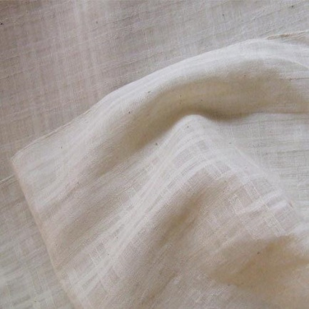 | 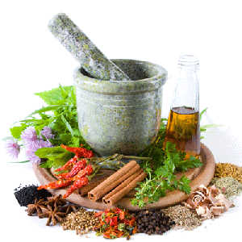
PLATE II  KHADI COTTON FABRIC | PLATE III  HERBAL TEXTILE

21
3.3. PILOT STUDY
The dyes made from colouring matters of flowers, plants, roots, leaves and rinds were selected. Based on availability, affordable cost and appealing colours. Indigo and Touch-me-not was selected for study. Based on their dyes up take, brilliancy of colour, colour fastness property, and medicinal value Indigo and touch-me-not was selected. The powdered form of Indigo and the fresh leaves and roots paste of touch-me-not was selected and used for dyeing.
3.4. DYEING OF FABRIC
3.4.1. Indigofera Tinctoria
3.4.1.1. Extraction of source
Soak the whole plant in hot water for 18 hours. It was oxidized until clear water comes on top. Then clear water was removed and the residue was dried in closed dark room. Then the dried cubes were used for dyeing (Plate IV).
3.4.1.2. Dyeing Recipe
TABLE I
Dyeing variables | Selected proportions
Indigo | 10gms
Caustic soda | 10%
Hydrosulphate | 20%
M:L:Ratio | 1:20
Alum | 5%

3.4.1.3. Dyeing procedure
The fabric was socked in cold water for 20 min. Indigo cakes was soaked in cold water for 72 hours. Then caustic and hydrose was added after 3 days. The fabric was dried in shade. To make it dark after dyeing, oxidation and washing the fabric was dipped in alum solution. Next day fabric was washed in 5% of soap solution (Neutral soap). Finally the fabric was rinsed and dried in shade.
3.4.1.4. Selection of mordant
A dye can generally described as coloured substance that has an affinity to the substrate to which it is being applied. The dye is generally applied in an aqueous solution, and may require a mordant to improve the fastness of the dye against washing, light and perspiration on the fibre interprets Hussain and Jahan (2011).
Alum (Aluminium Potassium Sulphate) is the most commonly used mordant. It does not affect colour. The use of too much of alum will leave the fibre feeling sticky and harsh. The use of alum is recommended as it softness. The use of alum and helps in evenness of dyeing. Hence alum was selected as mordant for the study (www.chemistryexplained.com).
3.4.1.5. Mordanting Technique
The metallic mordants produces bright and fast colours but they are not eco-friendly. Hence, there is a need to explore biomordants to minimize the use of metallic mordants. Inorder to produce eco-friendly natural dyeing, the biomordant alum was selected for the study.
Mordanting can be done by various stages, namely pre simultaneously and post Mordanting. Simultaneous Mordanting technique was selected. In simultaneous Mordanting technique, the fabric was treated in dye and the mordant solution at the same time (Kumar et al., 2005).

3.4.2. Mimosa pudica
3.4.2.1. Extraction of Source
Dye from touch- me-not leaves and roots were collected and ground into paste. The touch-me-not plant is shown in Plate V. The fine paste was mixed with required amount of water and boiled for 30 minutes at boiling temperature and kept for 48 hours at room temperature. Then the extracted dye was filtered and used for dyeing (Plate VI).
3.4.2.2. Dyeing Recipe
TABLE II
Dyeing variables | Selected proportions
Dye concentration | 5%
Dye extraction | 48 hours
Dyeing time | 45 mins.
Mordanting time | 30 mins.
Alum | 2%
M:L:Ratio | 1:20

3.4.2.3. Dyeing procedure
Five per cent dye concentration were prepared by boiling at 100ºC . The extracted dye solution was filtered in a vessel and it was allowed to boil to separate the fine crystals. The dyeing time was recorded after 45 minutes. The maximum dye absorption was selected as dyeing time and 2 per cent of mordant was used for fixation of the dye.

3.4.2.4. Selection of Mordant
A dye can generally described as coloured substance that has an affinity to the substrate to which it is being applied. The dye is generally applied in an aqueous solution, and may require a mordant to improve the fastness of the dye against washing, light and perspiration on the fibre interprets Hussain and Jahan (2011).
Alum (Aluminium Potassium Sulphate) (Plate VII) is the most commonly used mordant. It does not affect colour. The use of too much of alum will leave the fibre feeling sticky and harsh. The use of alum is recommended as it softness. The effects of alum and helps in evenness of dyeing. Hence alum was selected as mordant for the study (www.chemistryexplained.com).
3.4.2.5. Mordanting Technique
The metallic mordants produces bright and fast colours but they are not eco-friendly. Hence, there is a need to explore biomordants to minimize the use of metallic mordants. Inorder to produce eco-friendly natural dyeing, the biomordant alum was selected for the study.
Mordanting can be done by various stages, namely pre, simultaneously and post Mordanting. Simultaneous Mordanting technique was selected. In simultaneous Mordanting technique, the fabric was treated in dye and the mordant solution at the same time (Kumar et al., 2005). Normally the simultaneous Mordanting technique is used for dyeing. Because it gives a best result when compared to other Mordanting technique interprets Hussian and Jahan (2011).
3.4.3. Method washing
The Ayurvastra clothes were washed with herbal products like soap-nut and lime quotes Kumar et al., (2011). Hence, the Indigo and Touch-me-not fabrics were washed with soap nut.
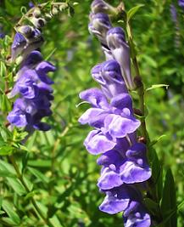 | 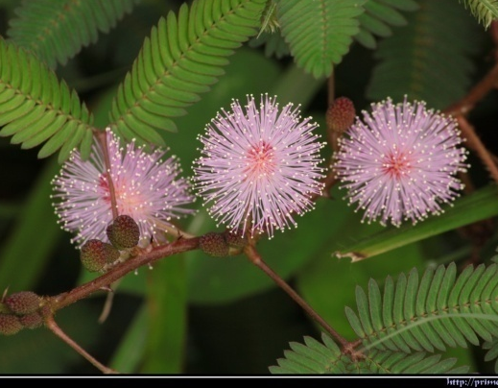
PLATE -IV  INDIGO PLANT | PLATE -V  TOUCH-ME-NOT PLANT
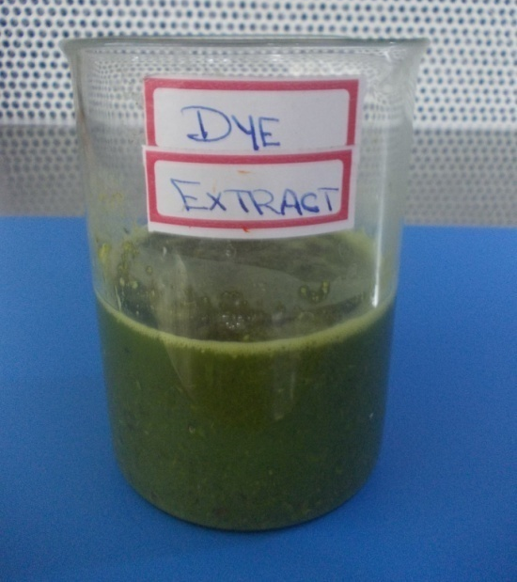
PLATE -VI
DYE EXTRACT
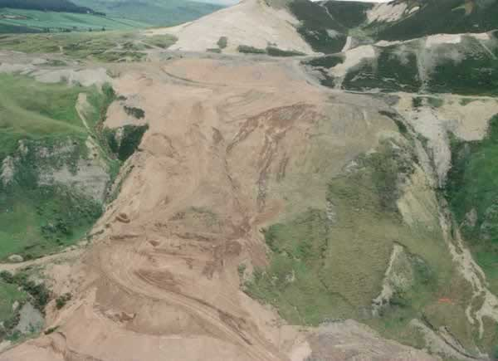 | 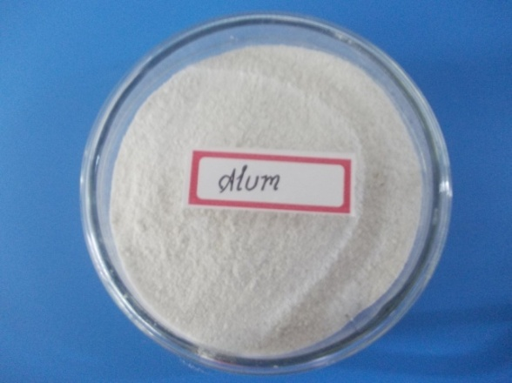
PLATE- VII
ALUM  26 | ALUM POWDER

3.5. EVALUATION
3.5.1. Subjective Evaluation
3.5.1.1. Visual Inspection
The dyed samples were evaluated by judges comprising of post graduate students (50) of textile and clothing, Avinashilingam University for Women, Coimbatore. The dyed samples were evaluated using rating scale which is given in Appendix (I). The scores were collected and consolidated for further discussion and are presented in the chapter results and discussions.
3.5.1.2. Wear Study
The dyed fabrics were consumed into ladies to for adolescents. The adolescents were asked to wear the ladies tops from 10.0 pm to 6.00 am for a period of one week. After each wear the garment was washed and given for next wear (Plate VIII). The most effective time to wear Ayurvastra clothing is when the body is mostly at rest such as during sleep or meditating because this is when the body is naturally healing and reestablishing balance interprets Jain (2010).
3.5.2. OBJECTIVE EVALUATION
Evaluation is defined as the making of judgment about the value for some purpose, ideas, works, solutions, methods and material. Yarn is an intermediate stage between fiber and fabric whose properties are directly influenced by the raw material and influences the fabric quality. Hence it is necessary to evaluate the yarn and fabric for an effective end use.

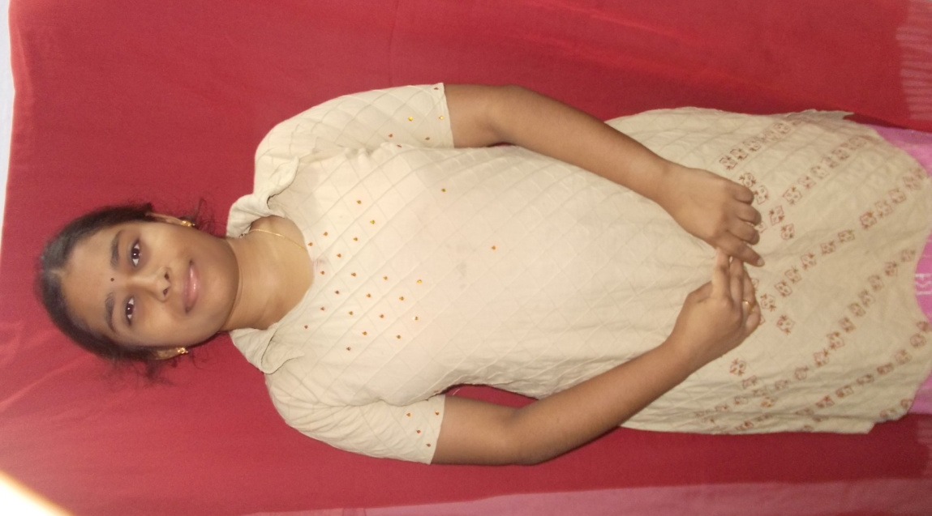 | PLATE VIII  WEAR STUDY  28
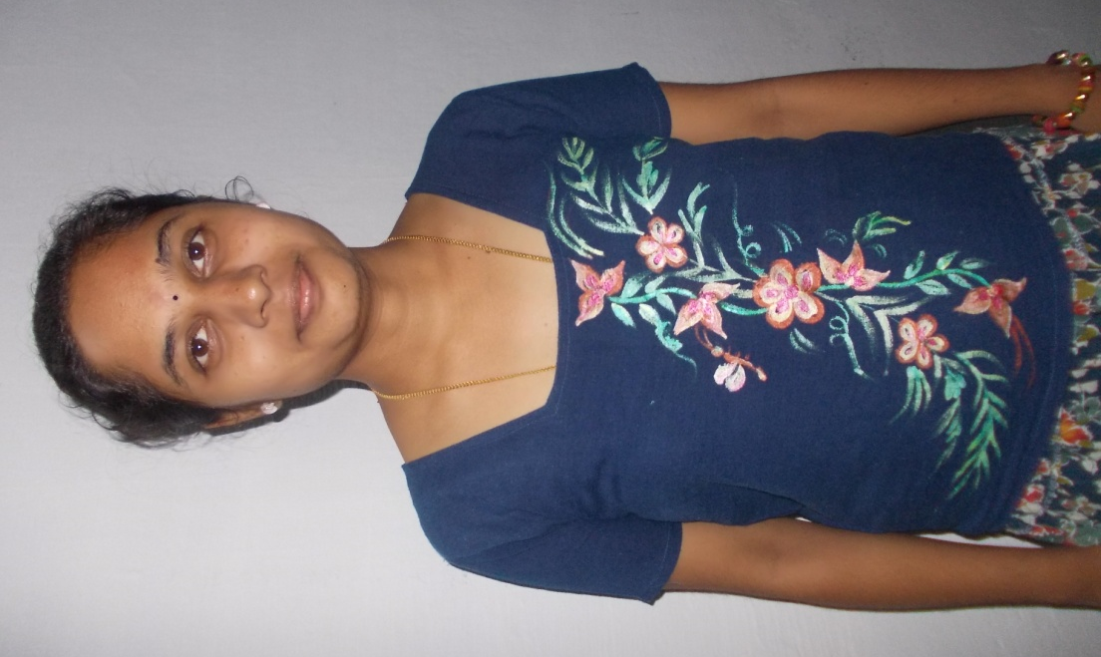 | PLATE VIII  WEAR STUDY  28

3.5.2.1 . Physical Property Test
3.5.2.1.1 Fabric Count
The fabric count refers to the closeness of the ends & picks of the fabric i.e., number of threads per inch. It is also referred to as thread count which is measured by one inch Pick Glass (Plate X) and counted through the small microscope and the numbers per square inch are recorded interprets Saini (2004).
3.5.2.1.2 Fabric Weight
Saini (2004) describes fabric weight as the relative weight of the fabric and expressed as the weight of a particular size of piece as grams per square meter or ounces per square yard.
Weight of the fabric is determined as weight per unit area, State Stoker et al. (2005). A sample (10 cm × 25 cm) was cut using a GSM Cutter (Plate XI) and Electronic Weighting balance was used to find out the weight of the samples (Plate XII). The inference obtained is calculated using the formula :
Grams per square metre (GSM) =
Weight of the fabric = × (g)
Square of the fabric = 100 cm × 100 cm = 10000 cm²
Area of square = length × breadth square unit
The same procedure was followed to find out the fabric weight of original and dyed fabrics were carefully recorded and the mean value was calculated.

3.5.2.1.3 Fabric Thickness
Thickness of the fabric is defined as the distance between the upper and lower surface of the fabric measured under a specified pressure, states Paul (2005).
Baty Thickness Tester (Plate XII) was used to measure the thickness of the fabric. It is a hand operated instrument, which has a dial that reads the thickness of the fabric. Two clamps are attached to the dial. Each of the samples was placed between the two clamps and pressed. Thickness was measured at random. The mean value was calculated and recorded.
3.5.2.2. Mechanical Property Test
3.5.2.2.1. Fabric Tensile Strength and Elongation
AATCC (2005) describes elongation as the increase in length of a specimen during tension test, expressed in units of length of the fabric when loaded. Breaking length or elongation of the specimen were mass is equal to the breaking force. Breaking strength is a measure of resistance of the fabric to a tensile load in a warp or weft direction, states Angappan (2002).
The Eureka model Tensile Strength Tester (Plate XIII) was used for the study. The late of traverse and capacity of the machine was 48 cm/min and 90 kg respectively. The gauge length was kept as 25 cm. The dial of the machine was calibrated in pounds and kilogram. The samples were tested. The length and width of the sample was 33 cm length and 7 cm width respectively. Each sample was clamped firmly between the two jaws. Care was taken that the fixed sample was perpendicular to the load. The load was applied until the sample was torn. The dial reading in kilograms and elongation in centimeters were noted. Five readings were noted for each sample.

3.7.2.2.2. Abrasion
Abrasion is one aspect of wear. It is rubbing away of the component fibers, yarn of the fabric. Abrasion is measured by subjecting the specimen to rubbing motion in the form of geometric figure that is, a straight line, which becomes a gradually widened ellipse, until if forms another straight line in the opposite direction and traces the same figure again under known conditions of pressure and abrasive action, explain ASTM Standards (2005).
Martindale Abrasion Resistance Tester (Plate XIV) was used to determine the abrasion resistance of the original, bleached, Indigo dyed and touch-me-not dyed fabrics. Thirty eight mm diameter specimen was cut from each sample using template providing along with the tester. The samples were weighted and mounted in the four sample holders mounted in the four sample holders separately. Again the abrading machine was started to run and number of rotation was set at 10. The specimen was examined at each five rotation intervals without removing it from holder. At the end of 8th rotation the specimens were observed with the presence of broken threads and holes in it. The abraded specimen were taken out from the holder and weighted to know the loss of weight. Five readings of original, bleached and dyed samples was carried out.

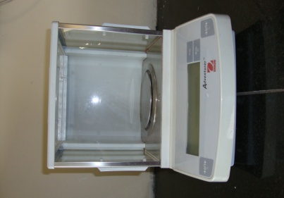 | 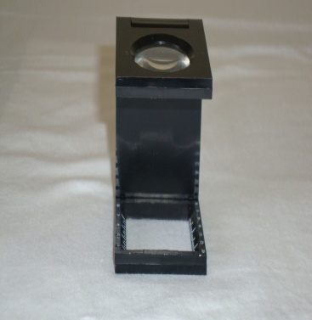
PLATE -IX  ELECTRONIC WEIGHING BALANCE | PLATE -X  PICK GLASS
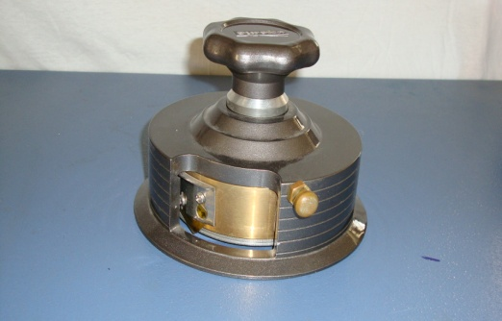 | 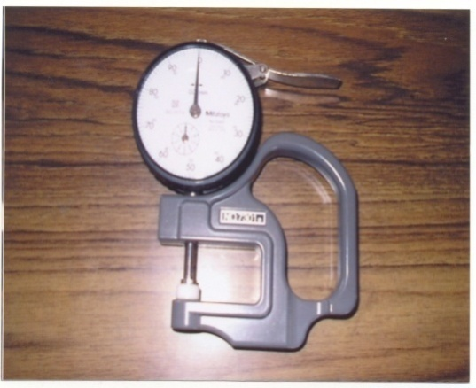
PLATE -XI  GSM CUTTER | PLATE -XII  FABRIC THICKNESS TESTER
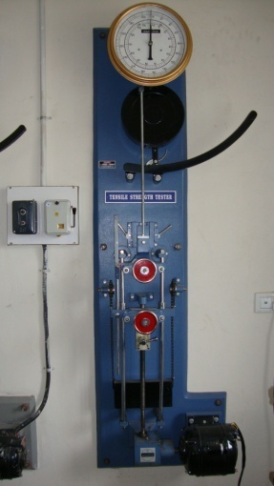 | 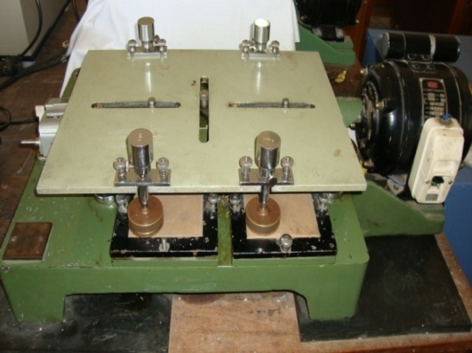
PLATE - XIII  FABRIC TENSILE STRENGTH TESTER  32 | PLATE - XIV  ABRASION RESISTANCE TESTER
3.5.2.3 Comfort Property Test
3.5.2.3.1 Crease Recovery
Crease recovery is one of the desized properties in cloth. Crease recovery is the ability of a fabric to recover from unwanted creases. It is the property of the material to resist wrinkling and to restore the initial state after the force causing its crease is removed. Creasing of textile material is a complex effect involving tensile, flexing, compressive and other stresses. The ability of the fabric to resist creasing is depending on the type of fiber used for its construction. Creasing of a fabric during wear is not a change in appearance that is generally desired. The ability of a fabric to resist creasing is in the instance dependent on the type of fiber used in constructions described Tuwel (2002).
Shirley Crease Recovery Tester (Plate XV) was used for the study. The instrument consisted of a circular dial, which carries the clamp for holding the sample. A knife edge and an index line are seen directly under the centre of the dial to measure the recovery angle. Then fabric each of 5 × 2.5 cm size were cut both in the warp and weft directions at random using a template from each samples. Each sample was transferred to the fabric clamp on the instrument and allowed to recover, from the crease. After two minutes, the dial was rotated to keep the free edge of the sample coincide with the knife edge. The crease recovery angle in degrees was read directly from the engraved scale. The mean values were calculated and recorded for the original, bleached and dyed samples.
3.5.2.4 Absorbency Test
Absorbency is one of the several factors that influence textile processing such as fabric preparation, dyeing and application of finishes, report AATCC (2004).

3.5.2.4.1 Drop Test
A burette filled with distilled water was clamped in a stand. The sample was mounted in an embroidery frame and was placed at the base of the stand. The distance between the fabric and burette nozzle was kept constant as shown in Plate XVI. The nozzle of the burette was opened just to allow a drop of water to fall on the sample. The stop watch was started simultaneously and it was stopped when the drop of water fully sank into the material the time taken for this was noted. The same procedure was repeated for five times for the original, bleached and dyed samples. The mean value was calculated and recorded.
3.5.2.4.2 Sinking Test
Sinking test is a simple test that helps to measure the wettability of a fabric. Five samples were cut into the size 5 cm × 5 cm square from the. A 1000 ml beaker was filled with distilled water and few drops of wetting agent were added into the distilled water. The sample was dropped on the surface of the water from a standard height remarks Booth (2005).
The Stop Watch was started when the fabric struck the surface of water and stopped when the last corner sank below the water surface as shown in Plate XVII and the time required for the sample to sink was noted. The procedure was repeated for all samples and the mean values of the all samples were calculated and sinking time of each fabric was recorded separately.
3.5.2.4.3 Capillary Test
Paul (2005) points out that, the capillary travel method measures the rapidity of absorption. Five fabrics were cut into sizes of 15 cm length and 2.5 cm width from the original, bleached and dyed cotton fabric. One end of the sample strip was pasted with a glass rod which was placed on heavy wooden blocks and at the other end, two grams weigh was attached to keep the fabric straight. At the weighted end 2 cm of the sample was allowed to immerse in a tray of distilled water as shown in Plate XVIII. The rise of the water level in the strip was noted by keeping length of the fabric as 5 cm constant. The same procedure was repeated for all samples. and the mean value was calculated and the capillary rise of each fabric was recorded carefully.

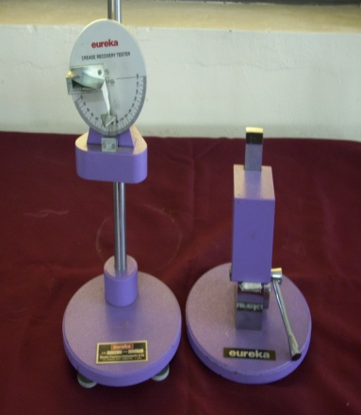 | 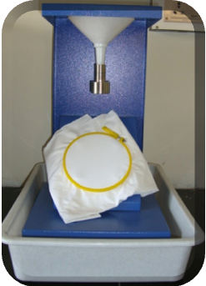
PLATE - XV  CREASE RECOVERY TESTER | PLATE – XVI  DROP TEST
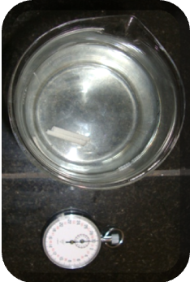 | 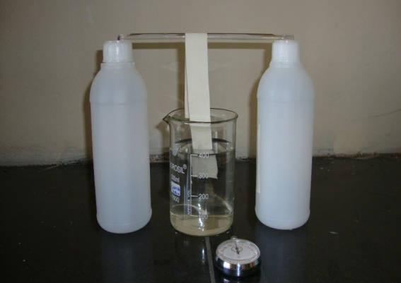
PLATE – XVII  SINKING TEST | PLATE – XVIII  CAPILLARY RISE TEST

35
3.5.2.5 Colour Fastness Test
When a dye is present on a textile materials it is supposed to have certain fastness properties like fastness to sunlight, washing and ironing different classes of dyes posses these fastness characteristic in different degree view Pant et al., (2001). The American Association of Textiles colourants and chemists (AATCC, 1995) have established standard terminology for rating colour fastness properties of fabric to different test methods and also for evaluating colour staining and transfer in fabric. The investigator followed the AATCC grey scales for the assessment of colour change and staining.
3.5.2.5.1 Colour Fastness to Sunlight
Fastness to light is one of the most important of a dyed fabric needs in order to fulfill its utilization process over a period of time. A sample of 16cm X 5cm of the Indigo and Touch-me-not dyed samples was cut. The entire samples were divided into eight parts by making distance with black paper to prevent samples from direct sunlight. For the successive seven days the other portions are exposed. The changes in colour of the dyed samples were compared with the original and the samples rated with the grey scale.
3.5.2.5.2 Colour fastness to washing
In service textile undergo a number of washing requires the use of good cleaning material like soaps and soap nuts. Soaps are earlier origin made of natural fats, oils and waxes have certain desirable properties like eco-friendliness opines Sarker (2001). A rectangular piece of 5Cm X 10CM were cut from each of dyed samples. Five per cent of soap solution was prepared and taken in respective beaker and soaked for 30 minutes. After that samples were taken out rinsed thoroughly in soft water, squeezed well and dried in shade. The colour transfers from the dyed samples were assessed using AATCC grey scale, the same procedure was repeated for all the samples of the dyed materials. Thus the colour fastness of each dye material to washing was carefully observed and recorded.
3.5.2.5.3 Colour Fastness to Wet and Dry Crocking
The Sasmira crockmeter consists of a platform over which the fabrics to be tested is fixed tightly using fabric holder. The center of the fabric holder has a rectangular slot through which the crank arm rubs the standard white fabric of size 2 inch X 1 inch was cut against the fabric to be tested. A load was applied on the crank such that rubbing takes places at a particular load. The instrument had automatic counter which can be set for predetermine to and fro strokes far the crocks. After completion of test cycle the rubbed area and the grey area are compared with ASTM grey scale. Grades are classified as 1,2,3,4 and 5 were grade 1 indicates poor rubbing fastness and grade five indicates good rubbing fastness. To determine the rubbing colour fastness test in wet condition the white fabrics was wetted and the test procedure was the same. In this manner the crocking fastness both in the wet and dry condition for condition for dyed fabrics were noted. The results were tabulated for both dry and wet crocking separately.
3.6. STATISTICAL ANALYSIS
Statistics is used for presenting facts in a definite form, statistics simplifies mass of figures facilitates comparison and also help in prediction and in formulating hypothesis, states Gupta (2004). Thus statistical analysis has been done for the parameters and the findings are presented in results and discussion chapter.
3.7 NOMENCLATURE
Samples | Abbreviation
GC | Gray cotton
BC | Bleached Cotton
IDC | Indigo Dyed Cotton
TDC | Touch- me –not Dyed Cotton

IV. RESULTS AND DISCUSSION

4.1. Subjective Evaluation
4.1.1. Visual inspection
4.1.2. Wear Study

4.2. Objective Evaluation
4.2.1. Physical properties test
4.2.2. Mechanical Properties test
4.2.3. Comfort properties test
4.2.4. Colour fastness test
4.1. SUBJECTIVE EVALUATION
4.1.1. Visual Inspection
The fifty post gradate stunets from textiles and clothing department were selected fro evaluating the dyed fabric as given in Table III.
TABLE III
VISUAL INSPECTION
Properties | Indigo | Touch-me-not
General Appearance  Excellent  Good  Fair | 40  10  - | 35  15  -
Brilliancy of colour  Good  Medium  Dull | 43  7  - | 34  12  4
Evenness in dyeing  Even  Partially Even  Uneven | 50  -  - | 50  -  -
Texture  Soft  Medium  Coarse | 47  3  - | 50  -  -
Luster  High  Medium  Low | 41  9  - | 46  4  -
4.1.2. Wear Study
The dyed fabrics were given to adolescents. The adolescents were asked to wear the ladies tops from 10.0 pm to 6.00 am for a period of one week. After each wear the garment washed and given for next wear. The wear study report shown in Table IV.
TABLE IV
WEAR STUDY REPORT
S.No. | Sample | Comfort |  |  | Feel |  |  | Fragrant
S.No. | Sample | Excellent | Good | Fair | Excellent | Good | Fair | Excellent | Good | Fair
1. | Indigo | 8 | 2 | - | 6 | 4 | - | 5 | 5 | -
2. | Touch-me-not | 7 | 3 | - | 8 | 2 | - | 6 | 3 | 1
4.2. OBJECTIVE EVALUATION
4.2.1. PHYSICAL PROPERTY TEST
- Fabric Count (Warp)
The fabric count (Warp) and analysis of variance of original cotton fabric, bealched fabric, Indigo and Touch-me-not dyed fabrics are shown in Table V and Figure I.
TABLE V
FABRIC COUNT (WARP)
S.No. | Sample | Mean Value (warp) | Loss or Gain over Orignal (warp) | Percentage of Loss or Gain over Original (warp) | ‘F’ test
1. | GC | 40 | - | - | 4.76*
2. | BC | 42 | -2 | -5 | 4.76*
3. | IDC | 38 | +2 | +5 | 4.76*
4. | TDC | 37 | +3 | +7.5 | 4.76*
* significant at five per cent level
From the Table V and Figure I, it is evident that the fabric count of bleached fabric (5%) is higher than the original fabric. The reason may be due to shrinkage of fabric. The fabric count of dyed fabric decreased when compared to original, Indigo (5%) and Touch-me-not (7.5%) respectively.
- Fabric Count (Weft)
The fabric count (weft) and analysis of variance of original cotton fabric, bleached, Indigo and Touch-me-not dyed fabric are shown in Table VI and Figure II.

TABLE VI
FABRIC COUNT (WEFT)
S.No. | Sample | Mean Value (weft) | Loss or Gain over Orignal (weft) | Percentage of Loss or Gain over Original (weft) | ‘F’ test
1. | GC | 38 | - | - | 5.02*
2. | BC | 39 | 1 | 2.63 | 5.02*
3. | IDC | 37 | -1 | 2.63 | 5.02*
4. | TDC | 36 | -2 | 5.26 | 5.02*
* significant at five per cent level
From the table VI and figure II, it is evident that the fabric count is higher than the original fabric incase of bleached fabric (2.63%). The reason may be due to shrinkage of fabric. The fabric count of dyed fabric decreased when compared to original, Indigo (2.63%) and Touch-me-not (5.26%) respectively.

FIGURE I
FABRIC COUNT (WARP)

FIGURE II
FABRIC COUNT (WEFT)
42
- Fabric Weight
The fabric weight andanslysis of variance of orignal cotton fabric, belached fabric, Indigo and Touch-me-not dyed fabric are shown in Table VII and Figure III.
TABLE VII
FABRIC WEIGHT
S.No. | Sample | Mean Weight of the fabric | Weight loss or gain of the orignal | Weight loss or gain percentage = (W₁-W₂/_{W1}]X100 | ‘F’ test
1. | GC | 48 | - | - | 49.6**
2. | BC | 44 | +4 | +8.33 | 49.6**
3. | IDC | 49 | -1 | -2.08 | 49.6**
4. | TDC | 47 | +1 | +2.08 | 49.6**
** significant at one per cent level
From the Table VII and Figure III, it is evident that the fabric weight of bleached farbic reduced when compared to original fabric. The fabric weight of dyed fabric (Indigo and Touch-me-not) increased when compared to bleached fabric.

FIGURE III
FABRIC WEIGHT

44
- Fabric Thickness
The fabric thickness and analysis of variance of orongal octton fabric bleached, indigo and Touch-me-not dyed fabric are shown in Table VIII and Figure IV.
TABLE VIII
FABRIC THICKNESS
S.No. | Sample | Mean thickness | Loss or Gain of Orignal | Percentage of Loss or Gain of Original | ‘F’ test
1. | GC | 33 | - |  | 17.44**
2. | BC | 31 | +2 | 6.060 | 17.44**
3. | IDC | 38 | -5 | -15.151 | 17.44**
4. | TDC | 36 | -3 | -9.090 | 17.44**

From the Table VIII and Figure IV, it is evident that the fabric thickness of bleached sample decrased when compared to original sample. The fabric thickness of dyed fabric increased when compared to original.

FIGURE IV
FABRIC THICKNESS

46
4.2.2. Mechanical Property Test
- Tensile Strength (Warp)
The fabric tensile strength (Warp) and analysis of variance of original cotton fabric, bleached, Indigo dyed and Touch-me-not dyed fabric are shown in Table IX and Figure V.
TABLE IX
TENSILE STRENGTH (WARP)
S.No. | Sample | Mean Value (Warp) | Loss or Gain over Orignal (Warp) | Percentage of Loss or Gain over Original (Warp) | ‘F’ test
1. | GC | 49 | - | - | 6.26**
2. | BC | 47 | +2 | +4.08 | 6.26**
3. | IDC | 53 | -4 | -8.16 | 6.26**
4. | TDC | 54 | -5 | -10.20 | 6.26**
** significant at one per cent level
From the Table IX and Figure V, it is evident that the fabric tensile bleached fabric decreased when compared to original sample. The fabric tensile strength of dyed sanoles indigo (8.16%) and Touch-me-not (10.20%) incerased when compared to original sample.

- Tensile Strength (Weft)
The fabric tensile strength (Weft) and analysis of variance of original cotton fabric, bleached, Indigo dyed and Touch-me-not dyed fabric are shown in Table X and Figure VI.
TABLE X
TENSILE STRENGTH (WEFT)
S.No. | Sample | Mean Value (Weft) | Loss or Gain over Orignal (Weft) | Percentage of Loss or Gain over Original (Weft) | ‘F’ test
1. | GC | 39 | - | - | 8.35**
2. | BC | 38 | +1 | +2.56 | 8.35**
3. | IDC | 42 | -3 | -7.69 | 8.35**
4. | TDC | 43 | -4 | -10.25 | 8.35**
** significant at one per cent level
From the Table X and Figure VI, it is evident that the fabric tensile of bleached sample decreased when compared to original sample. The fabric tensile strength of dyed fabric Indigo (7.69%) and Touch-me-not (10.25%) increased when comapred to original.

FIGURE V
TENSILE STRENGTH (WARP)

FIGURE VI
TENSILE STRENGTH (WEFT)
49

- Fabric elongation (Warp)
The fabric elongation and analysis of variance of original cotton fabric,bleached, Indigo dyed and Touch-me-not dyed fabric are shown in Table XI and Figure VII.
TABLE XI
FABRIC ELONGATION (WARP)
S.No. | Sample | Mean Value (warp) | Loss or Gain over Orignal (warp) | Percentage of Loss or Gain over Original (warp) | ‘F’ test
1. | GC | 2.53 | - | - | 4.95*
2. | BC | 2.7 | 0.17 | 6.719 | 4.95*
3. | IDC | 2.84 | 0.31 | 12.252 | 4.95*
4. | TDC | 2.87 | 0.34 | 13.438 | 4.95*
* significant at five per cent level
From the table XI and Figure VII, it is evident that the fabric elogation is higher than the original fabric for bleached fabric (6.7%), Indigo dyed fabric (12.25%) and Touch-me-not (13.4%) dyed fabric.

- Fabric elongation (Weft)
The fabric elongation and analysis of variance of original cotton fabric,bleached, Indigo and Touch-me-not dyed fabric are shown in Table XII and Figure VIII.
TABLE XII
FABRIC ELONGATION (WEFT)
S.No. | Sample | Mean Value (weft) | Loss or Gain over Orignal (weft) | Percentage of Loss or Gain over Original (weft) | ‘F’ test
1. | GC | 3.12 | - | - | 9.54**
2. | BC | 3.19 | -0.07 | -2.243 | 9.54**
3. | IDC | 3.25 | -0.13 | -4.166 | 9.54**
4. | TDC | 3.26 | -0.14 | -4.487 | 9.54**
** significant at one per cent level

From the Table XII and Figure VIII it is evident that the fabric elongation increased gradually when compared with the original fabric for bleached (2.243%), Indigo (4.16%) and Touch-me-not dyed fabric (4.48%).

FIGURE VII
FABRIC ELONGATION (WARP)

FIGURE VIII
FABRIC ELONGATION (WEFT)
52

- Abrasion Resistance
The fabric abrasion resistance level and analysis of variance of original cotton fabric, bleached, Indigo and Touch-me-not dyed fabric are shown in Table XIII and Figure IX.
TABLE XIII
ABRASION RESISTANCE
S.No. | Sample | Mean Value (sec) | Loss or Gain over Orignal | Percentage of Loss or Gain over Original | ‘F’ test
1. | GC | 0.17 | - | - | 28.20**
2. | BC | 0.18 | -0.01 | 5.8 | 28.20**
3. | IDC | 0.19 | -0.02 | 11.8 | 28.20**
4. | TDC | 0.19 | -0.02 | 11.8 | 28.20**
** significant at one per cent level
From the table XIII and figure IX it is evident that the fabric abrasion resistance level for bleached fabric (5.8%), Indigo (11.8%), touch-me-not dyed fabric (11.8%) increased gradually when compared with the original fabric.

4.2.3. Absorbency Test
- Drop test
The fabric drop level and analysis of variance of original cotton fabric, bleached fabric, Indigo and Touch-me-not dyed fabric are shown in Table XIV and Figure X.
TABLE XIV
DROP TEST
S.No. | Sample | Mean Value (sec) | Loss or Gain over Orignal | Percentage of Loss or Gain over Original | ‘F’ test
1. | GC | 6 | - | - | 81.61^{ns}
2. | BC | 13 | -7 | 116.6 | 81.61^{ns}
3. | IDC | 14 | -8 | 133.3 | 81.61^{ns}
4. | TDC | 14 | -8 | 133.3 | 81.61^{ns}
Ns- Not signifcant
From the table XIV and Figure X it was evident that the fabric drop level in second gradually increased for bleached (116.6%), Indigo (133.3%), Touch-me-not dyed fabric (133.3%) when compared to original sample.

FIGURE IX
ABRASION RESISTANCE

FIGURE X
DROP TEST
55
- Sinking test
The fabric sinking test and analysis of variance of original cotton fabric, bleached fabric, indigo and Touch-me-not dyed fabric are shown in Table XV and Figure XI.
TABLE XV
SINKING TEST
S.No. | Sample | Mean Value (sec) | Loss or Gain over Orignal (weft) | Percentage of Loss or Gain over Original (weft) | ‘F’ test
1. | GC | 10.60 | - | - | 27.87**
2. | BC | 8.2 | 2.4 | 22.64 | 27.87**
3. | IDC | 6.8 | 3.8 | 35.85 | 27.87**
4. | TDC | 6.6 | 4 | 37.73 | 27.87**
** significant at one per cent level
From the Table XV and Figure XI it is evidnet that the time for fabric sinking for bleached (22.64%), Indigo (35.85%), Touch-me-not (37.73%) dyed sample decreased when compared with the original sample.

- Capillary Rise Test
The fabric capillary rise test and analysis of variance of original cotton fabric, bleached, Indigo and touch-me-not dye fabric are shown in Table XVI and Figure XII.
TABLE XVI
CAPILLARY RISE TEST
S.No. | Sample | Mean Value | Loss or Gain over Orignal | Percentage of Loss or Gain over Original | ‘F’ test
1. | GC | 1.70 | - | - | 26.80**
2. | BC | 1.36 | 0.34 | 20.0 | 26.80**
3. | IDC | 1.14 | 0.56 | 32.941 | 26.80**
4. | TDC |  | 0.58 | 34.117 | 26.80**
** significant at one per cent level
From the Table XVI and Figure XII it is evident that the fabric capillary level for bleached (20%), indigo dyed (32.9%), Touch-me-not dyed samples (34.117%) decreased when compared with original sample.

FIGURE XI
SINKING TEST

FIGURE XII
CAPILLARY RISE TEST
58

4.2.4. Comfort Property Test
- Crease Recovery (Warp)
The fabric crease recovery (warp) and analysis of variance of original cotton fabric, bleached fabric, Indigo and Touch-me-not dyed fabric are shown in Table XVII and Figure XIII.
TABLE XVII
CREASE RECOVERYK (WARP)
S.No. | Sample | Mean Value | Loss or Gain over Orignal | Percentage of Loss or Gain over Original | ‘F’ test
1. | GC | 97 | - | - | 13.67**
2. | BC | 104 | -8 | 7.21 | 13.67**
3. | IDC | 136 | -51 | 60.00 | 13.67**
4. | TDC | 132 | -47 | 55.30 | 13.67**
** - Significant at one per cent level
From the Table XVII and Figure XIII it is evident that the fabric crease recovery (warp) of bleaced fabric, indigo & touch-me-not dyed fabric increased when compared to original sample.

- Crease Recovery (Weft)
The fabric crease recovery (weft) and analysis of variance of original cotton fabric, bleached fabric, Indigo and Touch-me-not dyed fabric are shown in Table XVIII and Figure XIV.
TABLE XVIII
CREASE RECOVERY (WEFT)
S.No. | Sample | Mean Value | Loss or Gain over Orignal | Percentage of Loss or Gain over Original | ‘F’ test
1. | GC | 91 | - | - | 16.24**
2. | BC | 94 | -3.0 | 3.30 | 16.24**
3. | IDC | 95 | -4.0 | 4.40 | 16.24**
4. | TDC | 97 | -6.0 | 6.65 | 16.24**
** - Significant at one per cent level
From the Table XVIII and Figure XIV, it is evident that the fabric crease recovery (weft) of bleached fabric, Indigo and Touch-me-not dyed fabric increased gradually when compared to original.

FIGURE XIII
CREASE RECOVERY (WARP)

FIGURE XIV
CREASE RECOVERY (WEFT)
61

4.2.5. Colour Fastness to Sunlight, Washing and Crocking
The Table XIX clearly shows that the colour fastness to sunlight, washing, dry crocking and wet crocking of dyed fabric.
TABLE XIX
COLOUR FASTNESS TO SUNLIGHT, WASHING AND CROCKING
S. No. | Samples | Sunlight |  | Washing |  | Crocking
S. No. | Samples | Colour change | Stainning | Colour change | Stainning | Dry crocking |  | Wet crocking
 |  |  |  |  |  | Colour change | Stainning | Colour change | Stainning
1 | Indigo | 5 | 4 | 5 | 5 | 4 | 4 | 4 | 4
2 | Touch-me-not | 5 | 4 | 5 | 5 | 3 | 4 | 3 | 3

V. SUMMARY AN CONCLUSION
The textiles are developing into disciplinary high tech products. It has become an intergral part of everyone’s life. It is associated with round the clock. Textiles are used to envelop human body thus protecting it from dust, sunlight, wind and other foreign matter present in the enviroment. Hence textiles in apparel has retained an important palce in human life starting from historical area to today’s modern world. In the past, textiles were considered primarily for economical and funcitonal point of view. But now end users in particular demands on the safety of textiles for a health care. Textiles are among one such smart application of samrt technology in textiles. Herbal textiles refers to those textiles products which have a fucntionity of giving production from soemthing in some or the other sense. The herbal dyeing are also a part of herbal textiles which help in health problems like anti septic, anitinflammation and blood purify, etc.
Study Findings:
Evaluation of samples
Evaluation of bleached, Indigo and Touch-me-not dyed samples of cotton were evaluated by subejctive and objecive methods such as mechanical, physical and comfort properties. The results of laboratory test were analyzed statistically.
Subjective Evaluation
Subejctive evaluation study reported that Indigo and Touch-me-not dyed garments shows better feel, than the orignal fabric. The developed herbal dyeing fabric is most preferable for anti-septic, anti inflammation and helps fighitng skin diseases.

Objective Evaluation
- Fabric weight of the bleached, Indigo and Touch-me-not dyed cotton fabrics are 8.33%, 2.08%, 2.08% respectively when compared with original fabric It is also statistically proved that there significant difference at one per cent level.
- Regarding fabric thickness bleached fabric decreased 6.6 per cent and weight increased by 15.15 per cent, 9 per cent respectively when compared to original at one per cent level significance.
- Thefabric count along warp and weft directon were studied. The fabric count for bleached fabric increased. The fabric count for the dyed fabric decrased when compared to original.
- The assessment of tensile strength of fabricinwarp and weft direction showed that the bleached cotton decreased by 4 per cent in warp and 2.5 per cent in weft and in case of IDC, TDC increased by 8 per cent and 10 per cent in warp, 7.6 per cent and 10 per cent in weft when compared to original.
- The fabric elongation results alone warp and weft direction were confirmed that the BC, IDC and DC increased respectively when compared with original samples.
- The abrasion resistance of BC (5.8%), IDC (11.8%), TDC (11.8%) increased at one per cent significnat level.
- The crease recovery had witnessed that the crease recovery property increased for BC, IDC, TDC in both warp and weft at one per cent significant level.
- The absorbency of the BC (110.6%), IDC (133.3%), TDC (133.3%) has increased when compared to original.
- The sinking test results shows the absorbency of the BC (22.6%), IDC (35.8%), TDC (37.7%) decreased when compared with original at one per cent significant level.
- The capillary rise test results showed, BC (20%), IDC(32.9%), TDC (34%) decreased when compared with original samples at one per cent signifiant level.
- The abrasion resistance of BC, IDC, TDC increased gradually when compared with original.
Conclusion
India has very rich tradition of using natural dyes. The art and craft of producing natural dyed textiles is being practiced in many villages and by some crafts men in the country, but there is no organized effort to revive and improve the methods of dyeing and printing with natural dyes. India has about 45,000 plant species among them several thousand have been claimed to possess medicinal properties. Ayurvedic clothing is used by practitioners for treatment of a variety of diseases such as diabetes, skin infection, ecozema, psoriasis and hypertension. Ayurvedic clothing are producing by dyeing the fabric which herbal extracts and it is not only eco-friendly but they leave certain residues that can be further used for making other environental friendly products. The medicinal plants can have other application than its medicinal value and it can be used for dyeing of cotton to produce different shades.
The Ayurvedic clothes are truly chemical free, naturally dyed apparel featuring cotton and colours made from medicinally rich botanicals and herbs from India. Allopathic medicine treats the symptoms where as Ayurveda that’s the underlying causes. Hence, the developed fabric has rich medicinal property which can be used to produce Ayurvedic garments. It is time for the Indian government and textile industries to wake up and give urgent encourageent to support precious heritage of India. Thus Ayurvedic textiles direct us to a new way of living a natural, disease-free and healthy life.

BIBLIOGRAPHY
BOOKS
- Aggarwal Reena Aggarwal (2010), “The Healing Touch of Herbal Textile”, Aug, Science Tech Magazine, No.8.
- Ajay Jindal and Rakesh Jindal (2007), “Textiles Raw Materials”, Abhishek Publications, Pg. 30.
- Akiranakamura (2000), “Fiber Science and Technology”, Oxford & IBH Publishing Co. Pvt. Ltd., Pg.13.
- Amrit Dhillon (2007), “Roll up for India’s miraculour healing herbal cloth, but where’s the rub?”, The age 15th, Sep, 2007, New Delhi.
- BBC News India’s healing herb-dyed cloth 25th January, 2008.
- Bentley, Robert, and Rimen Henry, (2006), “Medicinal plants”, Vol.1, Published by Ajay book service, New Delhi, Pp. 328-331
- Bhattacharjee, S.K. (2004), “Hand book of medicinal plants”, Pointer publishers, Pg.55.
- Callier, B.J. and Tortora, P.G. (2001), Understanding Textiles, Hall of India, New Delhi, Pg.73,76.
- Christie, M.R. (2007), “Environmental aspects of textile dyeing”, Wood head publishing limited and CRC press LLD, Pg. 45.
- Davis, J. (2008), “Fashion - Introduction, Lifestyle communication”, Abishek publication, First Edition, Pg. 129.
- Farooq, S. (2005), “555 medicinal plants”, published by International book distributors, Uttarunchal, India, P.230.
- Gupta, Neeru, Saini, R. and Sushma (2005), “Text Book of Clothing and Laundry”, Kalyani Publication, New Delhi, Pg.68.
- Joshi Shankar Gopal, (2000), “Medicinal Plants”, Oxford & IBH Publishing Co. Pvt. Ltd., Pg.277.
- Kaplan, N.S. (2002), “A Practical Guide to Fibre Science”, Abishek Publication, Chandigarh, Pg.112.
- Kharbade, B.V. (1999), “Extraction, Purification and Characterization of Some Indian Natural Dyes”, IIT Publishing Pvt. Ltd, Delhi, Pg. 297.
- Khare, C.P. (2007), “Indian Medicinal Plants”, An Illustrated Dictionary, Published by Springer (India) Private Limited, Pp. 416, 328.
- Mahadevan, M.G. (2001), “Textile Spinning Weaving and Designing”, Abhishek Publication, Chandigarh, First Edition, Pg.12.
- Mishra, S.P. (2000), “A Text Book of Fibre Science and Technology”, Abishek Publication, Pp.70-90.
- Nakamura, A. (2000), “Fibre Science and Technology”, Oxford and IBH Publishing Company Pvt. Ltd., Calcutta, Pp. 151-194.
- Organic Clothing Blogs 1st Feb, 2007.
- Padmini, S.D., Venmathi, A. (2006), “Khadi – The Freedom Fabric, Department of Textiles and Clothing & Gandhian Studies Centre”, Avinashilingam University for Women, Coimbatore, Pg.65.
- Prajapati et al., (2009), “A Handbook of Medicinal Plants: A Complete Source Book”, Agrobis (India), Publication, Pp.288,345.
- Prajapati Narayan Das, Purohit, S.S. (2004), “Agro’s Colour Atlas of Medicinal Plants”, published by Agrobios (India), Pg.537.
- Ramesh, R. (2005), “Ayurvedic Medicinal Plants”, Published by Arsha Vidhya Guru Kulam, USA, Pp. 271,159.
- Raul (2005), “Textile Testing”, APH Publishing Corporation, New Delhi, Pg.140.
- Raul Jewel, (2001), “Textile Testing”, APH Publishing Corporation, Pg. 115-121.
- Raul, J (2005), “Textile Testing”, APH publishing corporation, New Delhi, Pp. 74-75, 115-121.
- Raveendra Ratnam, K. and Martin, P. (2006), “Ethromedicinal Plants, Published by Updesh Purohit for Agrobios (India), Jodhpur, Pg.71.
- Sayed Nudrat (2011), “Medicinal Plants: Holishic Approaches / Zawar”, New India Publishing Agency.
- Singh, M. (2004), “Isolation and Characterization of Multi Drug Resistant Mutans in Mycobacterium Smegmatis”, M.Sc., Thesis, Barkatulh University, Bhopal, India.
- Sivarajan, V.V. and Indra Balachandran (2002), “Ayurvedic Drugs and their Plant Sources”, Oxford & IBH Publishing Co. Pvt. Ltd., New Delhi, Pp. 271, 327.
- Somashekar, T.H. and Kavakami, K. (2003), “Manual on Bioltine Silk Reeling”, CSTRI, JICA Offset Publishing, Pg.34.
- Time Magazine 12th Feb, (2006), Shoba Narayan Thubod.
- Trivedi P.C. (2010), “Herbal Drugs and Biotechnology”, Pointer Publishers, Jaipur, Pg.190.
- Trivedi Pravin Chandra (2006), “Medicinal Plants, Ethnobotical approach”, published by Updesh purohit for agrobios (India), Jodhpur, Pp. 247,225.
- Vidyasagar P.V. (2002), “Hand Book of Textiles”, Second Edition, A Mittal Publications, New Delhi, Pg.5.

JOURNALS
- Ansari, A.A. and Thakur, B.D. (2000), “Extraction and characterization and application of natural dyes, the eco-friendly textiles”, Colourage, Vol. XLVII, No.7, Pp. 15-20.
- Arboretum, G. et al., (2005), “Identification of potential combiners and combinations from eco-geo-graphical diverse genotypes of Asiatic cotton”, Journal of the Indian society for cotton improvement, April, Vol. 30, No.4, Pg.39.
- Burnett, H.F. (2011), Clothing textiles, Technical Textiles India, Vol.5, No.1, Pg.5.
- Deshwal, R. and Khambra, K. (2006), “Effects of soap and detergents to bending length of cotton fabric”, Colourage, Vol. LIII, No.10, Pg.29.
- Gayal, S.G., Nagarkar, R.D. and Khetarpal, D. (2012), “Enzymatic Processing of Khadi Fabric using Pectinase and Cellulose”, Asian Textile Journal, Feb, Pp.59-63.
- Gienadt, D. (2006), “Cotton items out last others”, Textile Magazine, Vol.47, Issue, 9, Pg. 74.
- Gohl, E.P.G. and Vilensky, L.D. (2000), “Textile Science”, CBS publishers and distributors, Delhi, Pp. 45-49.
- Gopalakrishnan, D. and Aravindhan, K.A. (2005), “Non-wovens for Medical Textiles”, Asian Textile Journal, No.4, Pp. 36-41.
- Gupta Deeph (2000), “Machanism of Dyeing Synthetic Fibers with Natural Dyes”, Colourage, Vol. XLVIII, No.4, April, Pg.23.
- Hussain Arshia and Jahan (2011), “Extraction of Natural Dye from Medicinal Plant and Dyeing of Silk”, China Textile Science, Pp.31,33.
- Jain Minakshi (2010), “Ayurvedic Textiles: A Wonderful Approach to Handle Disorders”, Colourage, Pp.45-50.
- Joy Onmen, P. (2003), “Dye Extraction from Most a Calys and Its Assessment”, Colourage, Vol. XLVI, No.9, Sep. Pp. 8-9.
- Kale, S., Deodhar, S. and Naik, S. (2007), “Pipal Bark Extract – A Natural Colourant for Wool Dyeing”, Colourage, March, Vol. LIV, No.3, Pp. 57-60.
- Kumar Deepak , Abhishek, Srivastava, Raghav vidyarthi, Dharmendra Gupta and Abhishek kumar (2011), “Herbal Textiles: Green Business, Green Earth”, Colourage, Pp.54-60.
- Kumar, P.E. Kulandaivelu, A.R. and Boopathi, T.S. (2005), Eco-Friendly Natural Dyes from Hibiscus Vitiyoins and Seabania Aegyptica for Dyeing”, Colourage, Vol. XLVI, No.5, Pg.31.
- Mahajans, Sidhu, S.P. and Greual, J. (2007), “Comparison of Colour Fastness Properties of Silk Dye with Mango (Mangifera indica) Dye using Individual Mordants and their Combinations”, Colourage, Vol. LIV, No.8, Aug., Pp. 58-66.
- Manisha Gahlot et al, (2008), “Tatropha Flowers: Natural Colourant for Dyeing of Cotton, Wool and Silk”, Colourage, No.2, Pg.96.
- Mitra, A. Choudhari, P.K., Mukher, A. and Mulik, S.R. (2006), “Evaluation of Handloom Technique”, Textile Trends, Vol. XLVII, No.1, Jan., Pg. 29.
- Moses, J. (2003), “A Novel in Situ Finishing Treatment on Cotton Fabric”, The Textile Industry and Trade Journal, Vol. 41, No.7, July, Pg.23.
- Nair, A.V. et al., (2009), “Comparative Study of Different Test Method Used for the Measurement of Physical Properties of Cotton”, Indian Journal of Fibre and Textile Research, Vol.34, No.12, Dec., Pg.352.
- Narayanan, S.S. (2005), “Strategies Global Leader in Cotton”, Asian Textile Journal, Vol.14, No.12, Dec., Pp. 81-83.
- Narayanan, S.S. (2006), “Dividents from Investments in Cotton Research in India”, Asian Textile Journal, Vol.15, No.2, Feb, P.41.
- Pant, S., Maskara, G. and Vidyapaith, D. (2001), “Fastness Characteristics of Natural and Direct Dyes Applied on Fabric”, The Textile Magazines, Vol. 47, No.5, Pg. 75.
- Phukon, R. and Phukon, A. (2007), “Silk Yarn Dyeing with Natural Dyes Extracted from the Bark of Eugenia Jambolana Lam”, Textile Trends, Vol. XLIX, No.2, Feb., Pg.33.
- Rulian Dumitrescu, Emitia Viscleanus and Morilena Niculesau (2004), “Natural Dyes Obtained from Plants and Vegetables Wastes”, Colourages, Vol. XLLI, No.12, Dec, Pg. 121.
- Saini, V.A. (2004), “Processing Natural Fibre Fabrics”, Indian Textile Journal, Vol. LX, No.3, Pg. 16-20.
- Samanta, A.K. et al., (2003), “Benefits of Cotton Fabric and Its Blends”, Indian Textile Journal, Vol. LX, No.3, March, Pg.16.
- Sapna Gautam and Alka Goel (2008), “Dyeing of Eri Silk with Acid and Reactive Dyes”, Textile Trends, March, Vol. 82, No.3, Pg. 37.
- Seyam, A.M. (2006), “Weaving Technology, Advances and Challenges II”, Journal of Textile and Apparel, Technology and Management, Vol.3, No.8, Pp.1-10.
- Singh, M.K. (2005), “Sun Protective Clothing”, Asian Textile Journal, Jan-Feb, Vol.14, Pp. 91,97.
- Stoker, S., Gara, R. and Mackay, L. (2005), “The Biological Treatment of Waste Water for Textile and Dyeing Industry”, Colourage, Vol. LII, No.12, Dec, Pg.45.
- Sujata, M.H. and Naisk, S.D. (2006), “Effect of Softener Treatment on Physical Properties of Naturally Coloured Cotton Khadi Fabric”, Textile Trends, Pp.27-30.
- Sumithra, M., Vasugi Raaja, N, (2011), “Investigation of Multi Functional Properties for the Herbal Finished Denim Variants”, Man-made Textiles in India, No.12, Dec., Pg.52.
- Surker, S.R. and Munshi, V.G. (2001), “Effect of Soap Detergent on the Strength of the Cotton Polynosic Blended Fabric”, The Textile Industry Trade Journal, Pg.71.
- Usha Mukundan and Sujata, R. and Kwlekar (2009), “Dyeing Cotton with Natural Colournat – Marigold, Textile Trends, Vol. 65, No. 2, Pg.33.

WEBSITES
- http://ayurvastraonline.com
- http://www.fibre2fasion.com
- www..fabrics-manfacturers.com
- www.chemistry.explained.com
- www.auraherbalwear.com
- www.fibretofabric.com
- www.thehindu.com
- igold”, Textile Trends, Vol. 65, No.2, Pg. 33.

APPENDIX-I
DETAILS OF THE FABRIC SAMPLES

GRAY COTTON BLEACHED COTTON

INDIGO DYED COTTON TOUCH-ME-NOT DYED COTTON

