ANTIMICROBIAL FINISH ON COTTON AGAVE FABRIC USING CASSIA AURICULATA

By

SARANYA.A
(Reg. No. 10PFA10)

A THESIS SUBMITTED TO THE
AVINASHILINGAM DEEMED UNIVERSITY FOR WOMEN
COIMBATORE – 641 043
IN PARTIAL FULFILMENT OF THE REQUIREMENTS FOR THE DEGREE OF MASTER OF SCIENCE IN TEXTILES AND FASHION APPAREL

APRIL 2012

ANTIMICROBIAL FINISH ON COTTON AGAVE FABRIC USING CASSIA AURICULATA

By

SARANYA.A
(Reg. No. 10PFA10)

A THESIS SUBMITTED TO THE
AVINASHILINGAM DEEMED UNIVERSITY FOR WOMEN
COIMBATORE – 641 043

IN PARTIAL FULFILMENT OF THE REQUIREMENTS FOR THE DEGREE OF
MASTER OF SCIENCE IN TEXTILES AND FASHION APPAREL

APRIL 2012

Certified as bonafide research work

SIGNATURE OF SUPERVISOR

SIGNATURE OF THE HEAD OF THE DEPARTMENT

ACKNOWLEDGEMENT
First and foremost the investigator wishes to place her humble salutations to the “GOD ALMIGHTY” for his manifold blessings which enabled her to being the study to successful completion.
The investigator expresses her immense gratitude and thanks to Thiru. T. S. Avinashilingam Ayya, founder and first chancellor of Avinashilingam Deemed University for Women, Coimbatore and Dr. Rajammal P. Devadas, M.A., M.Sc., Ph.D., former chancellor, Avinashilingam Deemed University for Women, Coimbatore for providing and shaping this temple of learning.
The investigator wishes to express her immense gratitude to Thiru.T.S.K. Meenakshi Sundaram, M.A., M.Phil., Chancellor, Avinashilingam Deemed University for Women, Coimbatore, for the opportunity to conduct research in this esteemed university.
The investigator owes her deep sense of gratitude and thankful to Dr. Sheela Ramachandran, M.Sc., P.G. Dip., Ph.D., Vice Chancellor, Avinashilingam Deemed University for Women, Coimbatore, for the amenities provides for the successful completion of the study.
The investigator expresses her respectful regards and sincere thanks to Dr. Gowri Ramakrishnan, M.Sc., M.Phil., Ph.D., Registrar, Avinashilingam Deemed University for Women, Coimbatore, for her encouragement towards the research.
The investigator expresses her heartfelt thanks and respectful regards to Dr. N.Vasugi Raaja, M.Sc., MBA.,M.Phil., P.hd., Head of the the Department, Department of Textile and Clothing, Avinashilingam Deemed University for Women, Coimbatore for her encouragement and motivation towards research.
The investigator expresses immensely indebted and extremely privileged to have worked under the supervision of her esteemed guide,Dr. R. SUNITHA, M.Sc.,M.Phil., Ph.D. (Avinashilingam), Assistant professor Department of Textiles and Clothing, Avinashilingam Deemed University for Women, Coimbatore, for her valuable guidance, technical support, timely help and constant encouragement throughout the study.
The investigator expresses her deep sense of gratitude to all the Staff Members of the Department of Textiles and Clothing, Avinashilingam Deemed University for Women, Coimbatore, for being supportive, suggestive, understanding and encouragement rendered towards the completion of her study.
The investigator expresses her special thanks to SITRA, SIMA, Avinashilingam Deemed University for Women for providing library facilities and guidance provided.
Last but not least the investigator expresses her heartfelt thanks to her beloved husband Mr. P. Saravana Kumar, Parents, Family Members and Friends for their constant prayers, moral support help rendered for the completion of the study.

LIST OF CONTENTS

CHAPTER NO. TITLE PAGE NO

LIST OF TABLES
LIST OF FIGURES
LIST OF PLATES
LIST OF APPENDICES
- INTRODUCTION 1
- REVIEW OF LITERATURE 4
2.1 Agave Americana 4
2.2 Cotton 5
2.3 Cassia Auriculata 5
2.4 FINISHING 6
2.4.1 Classification of Finishes 6
2.5 ANTIMICROBIAL FINISH 7
2.5.1 Antimicrobial Agents 9
2.5.2 Application Methods 10
2.5.3 Antimicrobial Activity Tests 10
2.5.4 Benefits of Antimicrobial Textiles 11
2.5.5 Requirement for Effective 12
Antimicrobial Finish
3. METHODOLOGY 13
3.1 Selection of Fabric 14
3.2 Preparation of the Fabric 14
3.2.1 Scouring 14
3.3 Selection, Collection & Processing of
Herbal Source 14
3.3.1 Selection of Herbal Source 15
3.3.2 Collection of the Selected Source 15
3.3.3 Processing of Flowers 15
3.4. Extraction of Cassia Auriculata Flowers 15
3.5 Selection of Binder 16
3.6 Finishing By Pad-Dry-Cure Method 16
3.7 Innovation of Enduse 16
3.8 Evaluation 16
3.8.1 Subjective Evaluation – Visual Inspection 17
3.8.2 Objective Evaluation – Laboratory Tests 17
3.8.2.1 Physical Property Test 17
3.8.2.2 Mechanical Property Test 19
3.8.2.3 Comfort Property Test 21
3.8.2.4 Absorbency Test 22
3.8.2.5 Performance of The Study 23
3.8.2.6 Antimicrobial Test 24
3.9 Evaluation of the Floor Mats 26
3.10 Cost Estimation 26
3.11 Nomenclature 26
3.12 Statistical Analysis 27
4. RESULTS AND DISCUSSION 32
4.1 Subjective Evaluation 33
- Visual Assesment 33
4.2 Objective Evaluation 35
4.2.1 Physical Property Test 35
4.2.1.1 Fabric Count 35
4.2.1.2 Fabric Weight 36
4.2.1.3 Fabric Thickness 37
4.2.2 Mechanical Property Test 38
4.2.2.1 Tensile Strength & Elongation 38
4.2.2.2 Abrasion Resistance 41
4.2.3 Comfort Property Test 42
4.2.3.1 Fabric Stiffness 42
4.2.3.2 Crease Recovery Test 44
4.2.4 Absorbency Test 45
4.2.4.1 Drop Test 46
4.2.4.2 Sinking Test 46
      - Wicking Test 47
4.2.5 Antimicrobial Test 49

4.2.5.1 Qualitative Analysis 49
4.2.5.2 Quantitative Analysis 51
4.2.5.3 Antifungal Activity 53
      - Performance Study 56

4.3 Cost Estimation 59
5. SUMMARY AND CONCLUSION 60
BIBLIOGRAPHY
APPENDICES

LIST OF PLATES

PLATE NO TILTLE PAGE NO

    - AGAVE AMERICANA 28
    - CASSIA AURICULATA 28
    - PREPARATION OF THE FABRIC 28
    - COLLECTION OF THE SOURCES 28
    - EXTRACTION OF THE SOURCES 29
    - APPLICATION OF FINISHES 29
    - FABRIC COUNT 29
    - FABRIC WEIGHT 29
    - FABRIC THICKNESS 29
    - TENSILE STRENGTH AND ELONGATION 29
    - ABRASION RESISTANCE 29
    - FARIC STIFFNESS 29
    - CREASES RECOVERY 30
    - DROP TEST 31
    - SINKING TEST 31
    - WICKING TEST 31

LIST OF TABLES

TABLE NO TITLE PAGE NO

    - DETAILS ABOUT SELECTED HERBS 15
    - NOMENCLATURE 27
    - FABRIC COUNT 35
    - FABRIC WEIGHT 36
    - FABRIC THICKNESS 37
    - TENSILE STRENGTH AND ELONGATION 38
    - ABRASION RESISTANCE 41
    - FARIC STIFFNESS 42
    - CREASES RECOVERY 44
    - DROP TEST 45
    - SINKING TEST 46
    - WICKING TEST 47
    - QUANTATIVE ANALYSIS BEFORE WASH 49
    - QUANTATIVE ANALYSIS AFTER WASH 50
    - QUALITATIVE ANALYSIS BEFORE WASH 51
    - QUALITATIVE ANALYSIS AFTER WASH 52
    - ANALYSIS ANTI FUNGAL BEFORE WASH 53
    - ANALYSIS ANTIFUNGAL AFTER WASH 55
    - PERFORMANCE STUDY 56
    - ESTIMATED COST 59

- INTRODUCTION
The challenge for business today is to invent new products that will enable it to survive in the globalised competitive environment, green minded consumers are prepared to pay more for the eco friendly products, highlight Manickan and Prasad (2005). Fibers are fundamental units used in fabrications of textile yarns and fabrics. Fibers are obtained from natural sources and also are made by man. Natural fibers can be of three types namely Vegetative fibers, animal fibers, and mineral fibers. Natural fibers are gaining progressive account as renewable environmentally acceptable, biodegradable, starting material for industrial application, technical textiles, pulp and paper, as well as for civil engineering and building activities.
According to the FAO, 4.5 to 5 million metric tons of vegetable fibers, excluding cotton and wood, are grown worldwide each year, stresses Bono (2009). Vegetable fibers are generally composed mainly of cellulose which includes cotton, jute, flax, ramie, sisal and hemp. Cellulose fibers serve in the manufacture of paper and cloth (Wikipedia.org).
Agave a natural leaf fiber obtained from the Agave Americana plant. The strength of agave fiber is more than other natural fibers. According to Watze and Eisenacher (2002). Cotton is characterized by excellent properties like absorbancy, biodegradable, breathable, non-allergic, heat resisting, high went strength and water retaining capacity. Mixture fabrics are produced to unite the different properties of two or more fibers in order to overcome the drawbacks in individual fiber.
Finishing is one of the essential process where bleached, dyed, printed materials are subjected before, they are put on the market. The aim of textile finishing is to render textile goods fit for their end uses. A finish is defined as anything that is done to fiber, yarn, fabric, before or after knitting to change the appearance, feel, serviceabilityand durability.
Nature provides a wealth of plants which is used for the purpose of treating fabrics. The natural sources yield luster, aromatic smell, soft texture and color soothing. They are also useful for human health because they have antibacterial, insecticidal and healthy properties. Unlike chemicals, natural sources are harmless to man and environment. They are least toxic, contain non-polluting waste effluents and less health hazardous. Most of the natural sources are biodegradable, renewable and eco-friendly. Plants and herbs are the main sources of finishing the fabrics and their different parts such as stems, barks, roots, leaves, fruits, seeds and rinds can be extracted and used for processing textile materials, reveal Sasikala et at (2008).
Microbes are small creatures that cannot be seen by the human eye. A variety of micro organisms like bacteria, fungi, algae and viruses come under this category. A bacterium is a unicellular organism which grows very rapidly under warmth and moisture. The bacteria family is further classified as gram positive (staphylococcus aureus), gram negative (E. coli), spore bearing or non-spore bearing types. Some specific types of bacteria are pathogenic and cause cross infection. Fungi, mould or mildew are complex organisms with slow growth rate they stain the fabric and deteriorate the performance properties of the fabric, express Sundar and Shukla (2008).
Growing awareness of health and hygiene among the people has increased the demand for antimicrobial textiles in the market. The function of the antimicrobial finish is to protect the wearer from micro organisms for aesthetic, hygiene or medical reasons and to protect the textile from deterioration caused by mould, mildew and fungi. Various antimicrobial agents are being discovered day by day. Each of them has their own special characteristics and application. Due to increasing environmental norms, eco-friendly antimicrobial finishes are upcoming today in textile industry.
Senna auriculata as an antimicrobial herbal and medicinal plant has very good property of microbial activity. It is used in the treatment of skin disorders and body odour. Considering all the facts the researcher decided to take up a study on “ANTIMICROBIAL FINISH ON COTTON AGAVE FABRIC USING CASSIA AURICULATA” with the following objectives.
- To identify antimicrobial property in a natural source
- To apply and evaluate the antimicrobial property on a natural fabric
- To innovate an end use for the fabric
2. REVIEW OF LITERATURE
2.1 AGAVE AMERICANA
Agave Americana is one of the largest agaves, 3-6 feet tall and with flower stalk more than 20 feet tall, describing Tull (2003).The leaves are 15-25 cms wide and 1-2 meters long. They are smooth and hard nearly rigid and mostly is of gray to gray blue leaves with significant amount of horizontal stripes on the back. Agave American inflorescence is a panicle that rises 16-26 feet above the plant. It has 15-35 branches with bloom on the upper half to third of the stalk. The flowers are yellow and occur from June-August. Plants usually bloom after about 10 years of growth in the ground particularly in warm climates, up to 35 years or more in cool climates. Agave Americana is a species of 6-10 feet and 13 feet, explains Gary (2004).(Pate 1)
High elongation, specific resistance and low density values of Agave Americana is appreciable when compared to other fibers of the same class, reveal Msahli et al. (2006). The chemical composition present in sisal fibers as Cellulose – 73.1 percent, Hemi cellulose – 13.3 percent, Lignin – 11 percent, Pectin – 0.9 percent, Wax – 0.3 percent and others – 1.4 percent, expresses Mishra (2000). When exposed to the influence of some external factors, the Agave Americana L. fibers globally present a high resistance to chemical agents such as acids and alkalis, as well as to UV rays for 108 hours. Nevertheless, it become very fragile when exposed to high temperatures up to 180°C. Their behavior after immersion in pure water or sea water is similar, and leads to classical softening, causing a decrease in initial modulus without any important loss in tenacity of failure strain. Thus, according to their properties, Agave Americana L. fibers can be used in technical applications such as reinforced materials and geotextiles – http://www.autexrj.org/no1-2006/0170.pdf.p.12.
2.2 COTTON
Cotton has always ruled the textile world and is highly known as the ‘king among fibers, say pant and Nayak (2004). Cotton is considered as a chief international commodity and plays a crucial role in several sectors of the national economy, excels the physical and chemical homogeneity of any other vegetable fiber, review Gopala Krishnan and Aravindhan (2005).
Cotton fibers are made of cellulose, which constitutes approximately 90 per cent. In addition to this water is 5 – 8 per cent and the rest of the weight is contributed by other natural impurities, indicate Gupta et al. (2005). If the cotton fibers are seen through the microscope, they show a formation of the shapes like a fine braid. If the cotton is fine, the number of strands is more, states Nakamura (2000).
2.3 CASSIA AURICULATA
Cassia Auriculata L. commonly known as tanner's cassia, also known as “avaram” in Tamil language is a shrub belongs to the Caesalpiniaceae family. The shrub is specially famous for its attractive yellow flowers which are used in the treatment of skin disorders and body odour. It is widely used in traditional medicine for rheumatism, conjunctivitis and diabetes. It has many medicinal properties. Its bark is used as an astringent, leaves and fruits anthelminthic, seeds used to treat in eye troubles and root employed in skin diseases ( Siva and Krishnamurthy,2005). It is also used for the treatment of ulcers, leprosy and liver disease ( Kumar et al., 2002). The antidiabetic, hypolipidemic ( Umadevi et al., 2006) and antioxidant ( Kumaran and Joel,2007) and hepatoprotective ( Kumar et al., 2003) effect of Cassia Auriculata have been reported. It was also observed that flower and leaf extract of Cassia Auriculata shown to have antipyretic activity (Vedavathy and Rao, 2006). The shrub is specially famous for its attractive yellow flowers which are used in the treatment of skin disorders and body odour. It is widely used in traditional medicine for rheumatism, conjunctivitis and diabetes. It has many medicinal properties. (Plate 2)

2.4 FINISHING
According to Amsamani and Ranganathan (2007) textile finishing makes the fabric more attractive, comfortable, serviceable and acceptable. Finishing , the final step of chemical processing of textiles is carried out to improve the aesthetic and functional appeal of the ready to use garments, define Goyal and Prabhu (2007). Finishing is done to fibre, yarn or fabric either before or after weaving or knitting to change the appearance, the handle and performance say Gokum Consultants (2007).
Finishing means any modification of fabric or fabric surface to meet certain desired needs or specifications, say Sampath (2003). It also indicates that these final operations which are necessary to bring the textile into a presentable attractive condition, states Hall (2004) and Nair (2001).
2.4.1 CLASSIFICATION OF FINISHES
According to Goyal and Deshpande (2006) finishing can be classified into functional and aesthetic finishes. Some finishes which are increasingly being used include antimicrobial, deodorant finishes , wrinkle resistance, easy care finish, stone wash, biofinishing , water proof, stain repellency but breathable finishes, moisture management, flame retardant finishes, mosquito repellent finish, state Adivarekar and kanooonga (2008). Aesthetic properties are not objective and very rarely stable across time and space. The endless changing aesthetic perspirations and expectations known as fashion which is associated with the world of textiles New Cloth Market (2007). Aesthetic finishes improve the look and feel of the fabric such as hand feel improvement, visual enhancement and surface smoothness, says Goyal and Deshpande (2006). Though wide range of functional finshes are available in the flat configuration fabrics , out limited options are due to complexity added in structure of the garment, briefs Saravanan(2007).
2.5 ANTIMICROBIAL FINISH
The use of antimicrobials dates back to ancient Egypt, where these were used in the treatment of mummies. The first antimicrobial textile material, in modern history, was developed by Lister in 1867. Over the last few years there has been increased interest in antimicrobial finishes. The main reasons for this increased interest include: the promotion of healthier and physically active lifestyle; an increased awareness of the harmful effects of organisms on textiles as well as on human hygiene and freshness, and the greater use of synthetic fibers and blends in items such as shirts, hosiery, blouses and underwear, which tend to cause greater ‘perspiration wetness’ because of poor moisture transport properties as compared to natural fibers.
Consumers are becoming more conscious of carpet odours created by bacteria, mold and mildew. Protection of fabrics, used in buildings, from fungi that cause staining, odour and damage is critical in the outdoor environment expresses Hussain (2001).
Goyal and Prabhu (2007) state that antimicrobial finish can control the microbial action prevent the transfer and spread of disease and protect human skin.
According to Achwal (2003), the term antimicrobial finishes indicate the limiting of the growth of bacterial colonies and their extinction. ‘Antimicrobials’ is a general one for any product that kills (microbiocide) or controls (microbiostatic) microbes.
Achwal (2005) points out that the objectives of an antimicrobial finish are to prevent loss of textile by antimicrobial finish are to prevent loss of textile by microbial fiber degradation, effective control of microbial action, check bad odour formation, and guard against transfer and spread of disease promoters. The textile product that has a negative influence on the vitality of microorganisms is generally termed as “antimicrobial”, define Tone and Wiley (2005). Sampath (2003) joins to add his view that the fabric remains fresh, eliminates off odour, controls staining due to microbial growth, increase life period of fabric, dominates skin irritation and hence no skin disease.
Antimicrobial finish creates a value addition to the product with a strong appeal for consumers. Treating a fabric with an antimicrobial agent means that, bacteria which have been transferred from the skin or environment do not reproduce in the fabric, spells Clemo (2005).
Bacteria are a unicellular organism which grows rapidly under warmth and moisture, says Schatz (2001). Bacteria from the skin grow quickly on the textiles. Attacks of microbes are more susceptible to natural fibers rather than manmade and synthetic fibers, define Aggarwal et al. (2006). In about 8 hours one bacterial cell can multiply up to 8 million bacteria to create odour. Thus the odour is not from the sweat and is due to the bacterial reproduction Kulkarni (2001).
The bacteria family are classified into gram positive (staphylococcus aureus), gram negative (E. coli), spore bearing and non spore bearing (www.microbes.com). Fungi, molds or mildew are complex organisms with growth rate scourer than bacteria. They cause stain and the performance of the bacteria. They cause stain and the performance of the fabric is deteriorated (www.fiber2fashoin.com). Algae are the microorganisms which grow in continuous water source and sunlight. The stains caused by algae are darker than the other stains, explains Gopalakrishnan (2006) and Shanmugasundaram (2007) adds to that the dust mites which feed on human skin cause allergic reactions and respiratory disorder.
According to Rani and Negi (2007), microorganisms are used in bio-degradation in which the microbes consume organic matter and finally give gaseous products which in turn cause bad odour. In the view of Teli et al. (2006), high relative humidity, warm temperatures and source of nutrient are the favorable conditions for the rapid growth of micro organisms which is provided by the natural fibers and this lead to degradation of textiles. Based on the activity against microorganisms the antimicrobial textiles are classified into 2 categories namely, passive and active, says Shanmugasundaram (2007).
2.5.1 ANTIMICROBIAL AGENTS
Non leaching type which bound to the products and control the growth of microbes, says Collier and Torifora (2005). A wide palette of antimicrobial compounds is now in use but differ in their mode of action. Rajendran and Anand (2002).
According to Patel and Chattopandya (2007), the antibacterial agents are quaternary ammonium compounds, and organo metallic compounds. Cassia Auriculata is an effective natural herbal flower used as antimicrobial agent. Natural herbal products such as Aloe vera, neem can also be used for antimicrobial finishes since there is a tremendous source of medicinal plants with antimicrobial composition, suggests Shanmugasundaram (2007).
2.5.2 APPLICATION METHODS
Methods of antimicrobial finish can be classified into two categories addition of an antimicrobial agent in the polymer before extrusion and post treatment of the fiber or the fabric during the finishing stage, says Sivaramakrishnan (2007). The antimicrobial agents can be applied to the textile substances by exhaustion, pad-dry-cure, coating, spray and foam techniques, describes Gokilavani and Gopalakrishnan (2007).
According to Sarkar et al. (2003), the antimicrobial substances can also be applied by directly adding into the fiber spinning dope. It is classified that the commercial agents can be applied during the dyeing and finishing equations. In the view of Menezes (2002), various methods for improving the durability of finish are insolubilisation of the active substances on the fiber.
2.5.3 ANTIMICROBIAL ACTIVITY TESTS
According to Huang and Leonas (2000) there are various methods to demonstrate the efficacy of an antimicrobial activity. Tests normally conducted are Agar diffusion, parallel streak, soil burrier test, humidity chamber test, fouling test. In addition quantative tests like challenge test and shake flask method are also conducted, explain Gendy and Shanshoury (2005). In the view of Thilagavathi et al. (2004) Agar diffusion test is a preliminary test to detect the diffusive antimicrobial finish. In addition to Krishnaveni et al (2007) describe that gram staining and turbidity test can also be used to identify the effectiveness.
A series of test procedures are given AATCC Technical Manual (2006), they are AATCC test 30 – 1993, 147 – 19993, 174 – 1993, and 90 – 1982. Chellamani et al (2007) point out the AATCC method 100 – 2004 which is quantitative to analyses microbial activity.
2.5.4 BENEFITS OF ANTIMICROBIAL TEXTILES
A wide range of textile product is now available for the benefit of the customer. The primary objective of the finish was to protect textiles from being affected by microbes particularly bacteria. Therefore uniforms, tents, defense textiles and technical textiles such as geo textiles have been finished using antimicrobial agent (www.resil.com). In the view of Gopalakrishnan (2006), the home textiles such as curtains, coverings, and bath mats come with antimicrobial finish. The application of the finish is now extended to textiles used for outdoor health care sector, sports and leisure. Novel technologies in antimicrobial finishing are successfully employed in non woven sectors especially in medical textiles. The microbial infection which cause obnoxious smell from inner garment, spread of disease, staining and degradation of textiles can be prevented, say Kan and Yuen (2006). It satisfies the major and important need in the medical field by the development of a versatile antimicrobial finish for textile materials for health care and hygiene applications (www.woodheadpublishing.com).
2.5.5 REQUIREMENTS FOR EFFECTIVE ANTIMICROBIAL FINISHES
The requirements for an effective antimicrobial finishing agents quick acting and effective in killing or inhibiting the growth of a broad spectrum of microorganisms, Safe and easy to apply, Minimal environmental impact, Compatible with other finishing agents, Low cost (Indian textile journal 2006).

3. METHODOLOGY
The methodology pertaining to the study is presented under the following headings:
3.1 Selection of Fabric
3.2 Preparation of the Fabric
3.2.1 Scouring
3.3 Selection, Collection and Processing of Herbal Source
3.3.1 Selection of Herbal Source
3.3.2 Collection of the Selected Source
3.3.3 Processing of Flowers
3.4. Extraction of Cassia Auriculata Flowers
3.5 Selection of Binder
3.6 Finishing by Pad-dry-cure Method
3.7 Innovation of End use
3.8 Evaluation
3.8.1 Subjective Evaluation – Visual Inspection
3.8.2 Objective Evaluation – Laboratory Tests
3.8.2.1 Physical Property Test
3.8.2.2 Mechanical Property Test
3.8.2.3 Comfort Property Test
3.8.2.4 Absorbency Test
3.8.2.5 Performance of the Study
3.8.2.6 Antimicrobial Test
3.9 Evaluation of the Floor Mats
3.10 Cost Estimation
3.11 Nomenclature
3.12 Statistical Analysis
3.1 SELECTION OF FABRIC
The fabric selected for the study was Cotton Agave ribbed structure as it is cent percent eco-friendly.
3.2 PREPARATION OF THE FABRIC
The fabric was prepared by scouring to remove the unwanted materials adhering to the fabric. Scouring is the process of thoroughly cleansing the fabric prior to proceeding with the finishing proper (NIIR Board). Prayag (2001) says that Scouring is used to remove foreign matter from or other impurities except the natural coloring matter. Scour bath usually contain alkalis, antistatic agents, lubricants, detergents and emulsifiers, state Gupta et al. (2005). Hence scouring was done using sodium carbonate (2%), wetting agent (0.1%), material liquor ratio (1.14) and temperature (60°C). (Plate-3).
3.3 SELECTION, COLLECTION and PROCESSING
3.3.1 Selection of Herbal Source
Herbs are available in nature abundantly. They play a dominant role in the primary health care of about 80 percent of the world’s population, remark Usha et al. (2006). Herbal source are eco-friendly and these are less costly. Herbs are great importance to the quality of an environment conditions under which it is grown. Hence the selected natural herbal source was Cassia Auriculata as it is known to have antimicrobial property.

TABLE- II
DETAILS ABOUT THE SELECTED HERBS
NAME | SCIENTIFIC NAME | FAMILY | PARTS USED
Avaram | Cassia Auriculata | Caesalpiniaceae | Flowers

Cassia Auriculata and it was also observed that flower and leaf extract of Cassia Auriculata show antipyretic activity stresses Vedavathy and Rao (2001). Hence the flowers of the plant were utilized for the study.
3.3.2 Collection of Source
The flowers of Cassia Auriculata were collected from Palladam, Tamilnadu, India and authenticated by the Institute of Forest Genetics and Tree Breeding, Coimbatore, the collected specimen was authentified in the IFGTB department. (Appendix 2). (Plate-4).
3.3.3 Processing of the Flowers
The flowers were examined carefully and old, infected, and fungus damaged flowers were removed. Extracts were prepared from dried and also from fresh flower. Healthy flowers were spread out and dried at room temperature for about ten days and ground into fine powder using electric blender.
3.4 EXTRACTION OF HERBAL FINISHING AGENT
Extraction refers to separating the desired material by physical or chemical means with the aid of solvent. For extraction, 3 grams of the powder was taken and mixed into 50ml of 80% Methanol as suggested by Christie et al. (2001). Methanol is used as the cross linking agent because it has highly time consuming process. Then the container was closed and kept for over night. After over night incubation, the extract was filtered through filter paper and evaporated to concentrate the extract. (Plate-5).
3.5 SELECTION OF BINDER
The binder is a film forming agent made up of long chain macromolecules which when applied to textile together with the pigments produces a three dimensionally linked network. The binder should be colorless, odourless, evenly thick, smooth and of good adhesion, feel Khoja et al. (2003). Methanol was used as binder.
3.6 APPLICATION OF FINISH
The ribbed woven Cotton Agave fabric sample immersed in the herbal microcapsules was passed through a padding mangle. The speed of padding mangle was 15 m/min and a mangle pressure was 15 kgf/cm². Then the padded fabric was air-dried and cured for 3 minutes at 140 ˚C. Thus antimicrobial finish was incorporated to Cotton Agave fabric. (Plate-6).
3.7 INNOVATION OF THE ENDUSE
The antimicrobial finished fabric was made into a floor mat of dimensions 2 feet x 1 feet. Three such samples were prepared and laid for the performance study.
3.8 EVALUATION
“Evaluation is defined as the making of judgment about the value for some purpose, ideas, works, solutions, methods and materials”, express Bhatia (2004). Textile testing is necessary to measure the properties of new fibers, fabric construction and finishes developed in it, states Taylor (2002). Therefore all the samples were evaluated both subjectively and objectively.
3.8.1 Subjective Evaluation
Subjective assessment is the method of describing fabric handle based on the experience and variable sensitivity of human beings. Textiles are touched, squeezed, rubbered or handled to obtain information about physical parameters, point out Mandal and Zhimming (2006).
- Visual Assessment
The original, scoured and finished samples were subjected to visual assessment. About twenty five judges belonging to under graduate course of department of textiles and clothing, Avinashilingam Deemed University for women was evaluated. The evaluation was carried to find the difference in the characteristics of general appearance, whiteness index, texture and evenness. The proforma utilized for evaluation is enclosed in (Appendix -1).
3.8.2 Objective Evaluation
The fabric was evaluated objectively for Physical, Mechanical, Comfort, Absorbency and Antimicrobial properties.
3.8.2.1 PHYSICAL PROPERTY TEST
- FABRIC COUNT
Randall (2006) expressed that the thread count is calculated by actual number of ends and picks per inch in a woven cloth. The fabric samples were tested as directed in test method ASTM D 3775-2003. The fabrics were preconditioned as directed in practice D 1776. Pick glass with magnifying lens was used to find out the fabric count of all the samples. Pick glass was placed in ten randomly spaced places diagonally across the width of the fabric and number of warp yarns and filling yarns per inch were counted and noted. Ten readings were taken and the mean value was calculated. The same procedure was carried out for all the samples. (Plate 7)
Calculation
Fabric Count = Warp count (Q₁) + Weft count (Q₂) (Yarns/sq. inch)
- FABRIC WEIGHT
The fabric weight was found according to ASTM test method D 3776 – 2002. The samples were preconditioned as directed in practice ASTM D 1776. The fabric samples were cut with GSM die cutter which is 100 cm². The samples were weighed in an electronic balance. The weight of the sample was measured in grams and multiplied with 100 to get grams per square meter value. Ten samples were tested for each fabric and the average was calculated. The same procedure was followed for all the samples. (Plate-8).
- FABRIC THICKNESS
Fabric thickness was determined in accordance with test method ASTM D 1777-2002 after preconditioning as specified in practice ASTM D 1776. The Hungarian thickness tester was used. It has two parts, the anvil and the presser foot, which works under a lever spring action. On the top, a dial indicated the thickness of the sample in the thousand of an inch. Each division on the dial read is 0.01 mm. The sample was placed on the anvil plate and the lever of the presser foot released very slowly and the presser foot pressed the sample. The dial indicated the thickness of the sample. Ten readings were taken from different places of the woven and fabric samples and the mean was calculated. (Plate-9).
3.8.2.2 MECHANICAL PROPERTY TEST
- TENSILE STRENGTH AND ELONGATION
The breaking force is defined as the maximum force applied to a material carried to rupture. Elongation is the ratio of the extension of a material to the length of the material prior to stretching, expressed as per cent (ASTM, 2005). Breaking strength was tested as per ASTM D 5035-2003. The fabrics were tested in both dry and wet conditions using raveled strip method. For preconditioning the samples method ASTM D 1776 was followed. For wet testing the samples were immersed in distilled water at room temperature for one hour, for thorough wetting. Wet sample strength test was completed within two minutes after its removal from the water.
The knowledge of tensile properties of fabrics also helps in predicting the suitability of both the raw material used and the end product. The analysis of tensile behaviour of the woven fabric is therefore extremely important, emphasize Kothari and Chitale (2003). (Plate-10).
The Eureka Pendulum Type Tensile Strength Tester was used to determine the breaking strength and elongation of the samples. Ten samples of each were cut from the warp and weft directions. Each sample was 35.5 cm in length and 3.8 cm in width. The length wise yarns from the sides of the strip were raveled out up to 0.6 cm from each side of the strip so that 2.5 cm width was maintained. Each sample was perpendicular to the load. The load was applied until the sample was broken. The dial readings in kilograms and elongation in centimeters were noted. Ten readings were taken for each material and the mean value was calculated. The elongation percentage was then found out.
- ABRASION RESISTANCE
Abrasion is the ability of the fabric to resist the action of abrasive force. It is one of the major criteria to take into account when assessing durability, says Basu(2006). The Europe Martindale Abrasion Resistance Tester was used to determine abrasion resistance of the sample. Five samples were cut from different places of the same material at random using the template. The initial weight of the each sample was found out, recorded and then the sample was mounted on the sample holder. The sample holder with 200 gms weight was used for this test. The rubs were standardised to 10 rotations. The samples were made to rub against the abrasive surface. After 10 rotations, the samples were removed and the final weight of the sample was found out. Weight loss due to abrasion was calculated. The test was repeated for five samples and one mean weight loss was calculated. (Plate-11)
Calculation
Weight loss = weight of sample before weight of the sample after
Percentage abrasion - abrasion .
weight of sample before abrasion

3.8.2.3 COMFORT PROPERTY TEST
- FABRIC STIFFNESS
Basu (2006) is of the opinion that the bending length is a measure of the interaction between fabric weight and fabric stiffness as shown by the way in which the fabric bends under its own weight. The samples were conditioned in the standard atmosphere as directed in ASTM D 1776. The fabric stiffness has bending length and flexural rigidity was determined as per ASTM test method D 1388 – 2002 cantilever test method was used.
Shirley stiffness tester was used to determine the stiffness of the samples. The sample was cut according to the template size and then both template and sample were transferred to the platform with the material underneath. Both were slowly pushed forward. The strip of the material commenced to drop over the edge of the platform and the movement of the template and the sample was viewed until the tip of the sample viewed in the mirror cut both index lines. The bending length was immediately read from the scale opposite to zero line, engraved on the sides of the platform. Each sample was tested four times at each end and again with the strip turned over. The same procedure was carried out for woven and fabric samples. (Plate-12).
- CREASE RECOVERY TEST
During the usage of a fabric, it will get creased. The ability of a fabric to resist creasing is known as crease recovery. Shirley recovery tester was used for this testing. Sample A was cut with a template (5cm×2.5cm). The sample was folded a face to face, end to end and held it with tweezers, gripping not more than 5mm from the ends. Avoid touching the specimen with anything other than the tweezers. Place the folded specimen between the two leaves of the loading device and immediately apply the weight. Start a timing device. After 5min+_ 5sec, quickly but smoothly, remove the weight from the specimen so that the specimen press does not spring open. Using tweezers transfer the folded specimen between the clamps on the specimen holder, leaving the other end to hang freely. While the specimen is in the holder, adjust the instrument to keep the free hanging end of the specimen in alignment with the vertical mark. Frequent adjustment for 5minutes is necessary to avoid gravitational effects.
Read and record the recovery angle from the circular scale 5min+_ 5 sec after inserting a specimen into a clamp. If the free end of the specimen twists, sight a vertical plan through its center and align it with the vertical mark on the circular scale as suggested by AATCC(TM66-2003). Repeat the process and note the value sample A. similarly, five readings were observed for warp wise direction for all the samples (Plate-13).
3.8.2.4 ABSORBENCY TEST
- DROP TEST
As per the AATCC (2006) TM 79, the conditioned fabric was spread over an embroidery hoop without wrinkles and kept 9.5mm below burette position to deliver 15-25 drops of water per milliliter. A drop of distilled water was allowed to fall on the cloth. The stop watch was started immediately and the time required for the drop of water to lose its spectacular reflectant and appears as a dull wet spot was noted in seconds. The same procedure was carried for all the samples.(plate14)
- SINKING TEST

Sinking test is a simple test that helps to measure the wet ability of a fabric Booth, (1996). About ten samples were cut into the size 5 cm x 5 cm square from the mercerized original and the dyed samples. A 1000 ml beaker was filled with distilled water and few drops of wetting agent were added into the distilled water. The sample was dropped on the surface of the water from a standard height. The stop watch was started when the fabric struck the surface of water and stopped when the last corner sank below the water surface and the time required for the sample to sink was noted in seconds. Ten such readings were taken and the mean value was calculated for all the 10 samples. The same method was carried out for all the samples and recorded separately. (plate15)
- WICKING TEST
The wicking test was conducted as per the procedure given by Saville (2002). A strip of fabric (30 cm x 2 cm) was suspended vertically with its lower edge in reservoir of distilled water. The rate of rise of the leading edge of water was then monitored. To detect the position of water line a dye was added to the water. After 30 minutes, the rise in the water line was noted. The measured height of rise in 30 minutes was taken as a direct indication of the test fabric and recorded in centimetres. (Plate-16).
3.8.2.5 PERFORMANCE STUDY:
After the evaluation of all the physical, mechanical and comfort properties, the best sample was determined. This sample was selected for further study in converting into an end product. The product produced was floor mat. The performance of the mat were assessed by various tests of Fabric Count, Fabric weight, Fabric Thickness, Tensile Strength and Elongation, Abrasion Resistance, Fabric Stiffness, Crease recovery test, Drop Test, Sinking Test and Wicking tests and this was compared with the treated and original sample.
3.8.2.6 ANTIMICROBIAL FINISHING:
- QUALITATIVE ANALYSIS FOR THE ANTIBACTERIAL PROPERTIES
The test method used was AATCC 147 Method. The fabric samples with the diameter of 2cm were taken for the analysis. All the samples were immersed into the herbal extract for 30 minutes and dried. Both the sides of samples were presterilized under ultra violet radiation for 15minutes. Sterile bacteriostasis agar was dispensed in sterile petridishes. Broth cultures (24 hours) of the test organisms were used as inoculum. Using sterile cotton swab the test organisms (Escherichia coli and Staphylococcus aureus) were swabbed over the surface of the agar plate. Presterilized samples were placed over the preswabbed agar surface by using sterile spatula. After placing the samples all the plates were incubated at 37ºC for 24 hours. After incubation, the plates were examined for the zone of bacterial inhibition around the fabric sample. The size of the clear zone was used to evaluate the inhibitory effect of the microcapsules.
- QUANTITATIVE ANALYSIS FOR THE ANTIBACTERIAL PROPERTIES
The Bacterial reduction Test was carried out as per AATCC test method 100 – 2004.
Test Organism Used:
- Escherichia coli ATCC 11229
- Staphylococcus aureus ATCC 6538
Initial inoculum:
- E. coli – 2.7 X 10⁹ cfu/ml
- S. aureus – 2.6 X 10⁹ cfu/ml
The fabric of 5.0 cm diameter of the treated by immersing in sterile AATCC broth with 0.1 ml inoculum of each culture (Staphylococcus aureus and Escherichia coli) and left overnight at 37 °C in shaker. Control was also maintained with untreated fabric.
AATCC broth with the fabric was taken for appropriate dilutions. The broth was spread plated on AATCC agar plates. The plates were incubated at 37°C for 24 hrs. After incubation results were interpreted. The percentage reduction of bacteria after incubation was calculated by the following formula R (%) = (B – A) x 100/ B. Where A is the number of bacteria colonies from treated specimen after inoculation over 24 hr contact period and B is the number of bacteria colonies from untreated control specimen.
- Analysis of Antifungal activity by Qualitative method

The anti fungal method was carried out as per AATCC 30. An inoculum of 1.0ml was evenly distributed over the surface of the agar. The fabric discs were pre wetted (not rubbed or squeezed) in water containing 0.05% of a non-ionic wetting agent (triton X- 100) and placed on the agar surface. The inoculum of 0.2 ml was distributed evenly over each disc by means of a sterile pipette. All the specimens were incubated at a temperature of 28ºC for seven days.
At the end of the incubation period the percentage of the surface area of the disc covered with the growth of the fungus was reported by observing visually and using a microscopic (40X) and interpreted.
3.9 EVALUATION OF THE FLOOR MATS FOR ANTIMICROBIAL ACTIVITY
The prepared sample was put on for two continuous days and were evaluated subjectively. The antimicrobial properties were analysed after six and nine washes individually.
3.10 COST ESTIMATION
The cost was estimated for the raw material, pretreated fabric, finished fabric and the product and recorded.
3.11 NOMENCLATURE
The nomenclature used for the study are given in Table-II.

Table-II
NOMENCLATURE
S.NO | SAMPLE | SAMPLE CODE
1. | Original Sample | OS
2. | Scoured Sample | SS
3. | Herbal finished with 120% concentration | HFC1
4. | Herbal finished with 90% concentration | HFC2
5. | Herbal finished with 60% concentration | HFC 3
6. | Herbal finished with 120% concentration after 6 wash | HFCW 1
7. | Herbal finished with 120% concentration after 9 wash | HFCW 2

3.12 STATISTICAL ANALYSIS:
All the found results were tabulated and analysed statistically, to find the significant changes incurred on various treatments in the fabric samples.

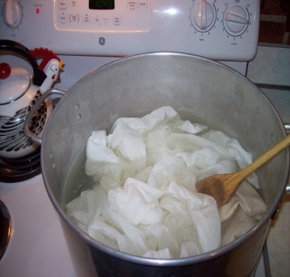

PLATE 1 PLATE 2
AGAVE AMERICANA PREPARATION OF THE FABRIC
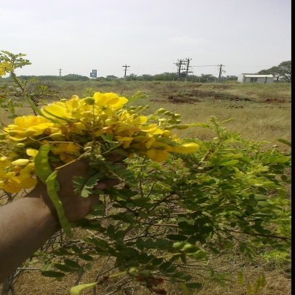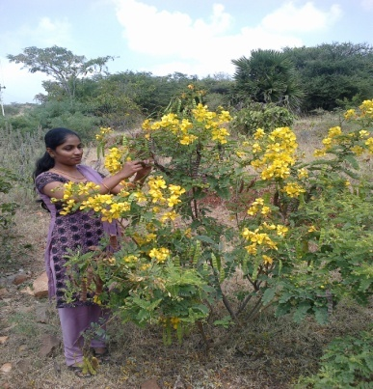
PLATE 3 PLATE 4
CASSIA AURICULATA FLOWERS EXTRACTION OF THE FLOWERS
PLATE 3
EXTRACTION OF THE SOURCE

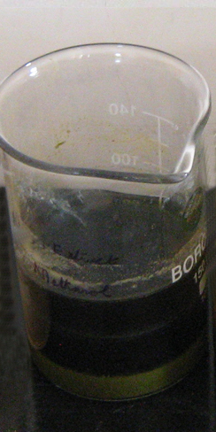
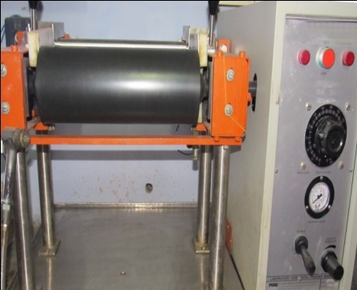 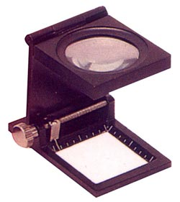 PLATE 6 PLATE 7
APPLICATION OF FINISH FABRICCOUNT (PICKGLASS)
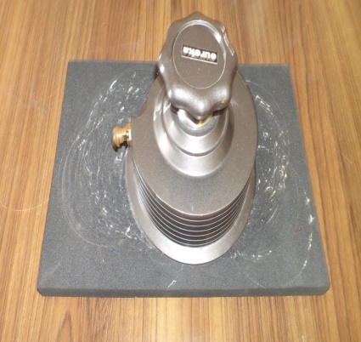
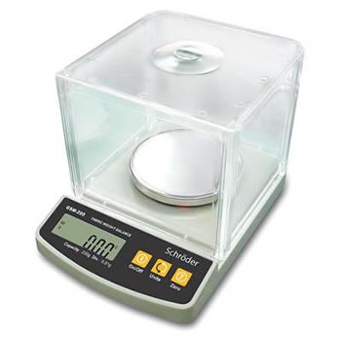
PLATE 8 PLATE 8
FABRIC WEIGHT GSM CUTTER
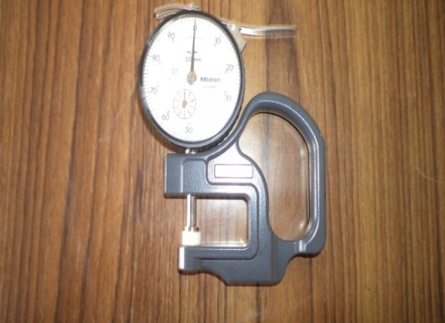

PLATE 9
THICKNESS GAUGE

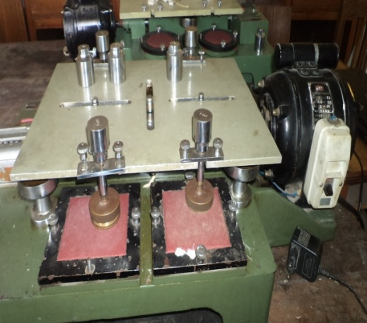
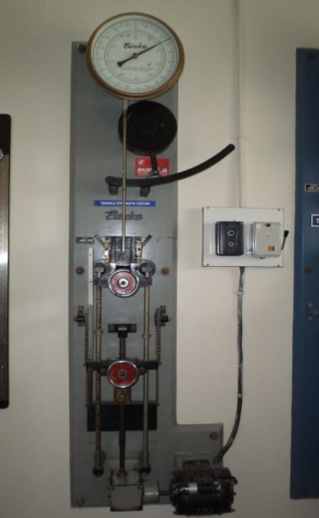

PLATE 11
ABRASION RESISTANCE

PLATE 10
STRENGTH TESTER

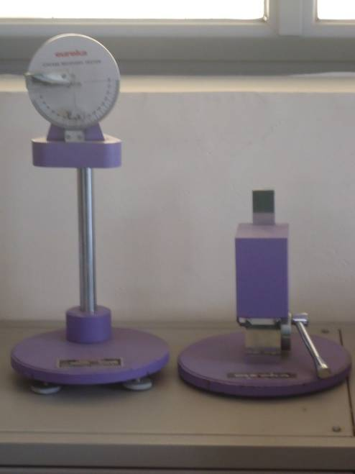
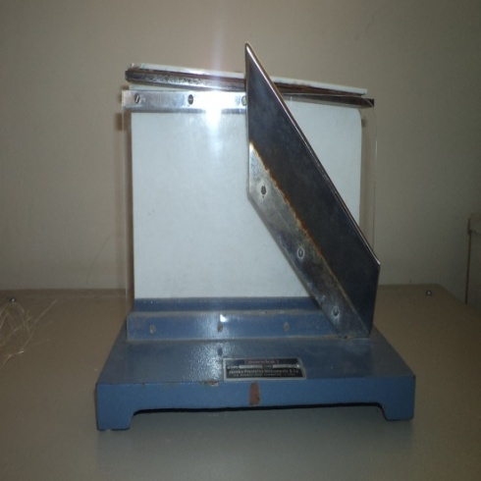

PLATE 12 PLATE 13
STIFFNESS TESTER CREASE RECOVERY TESTER

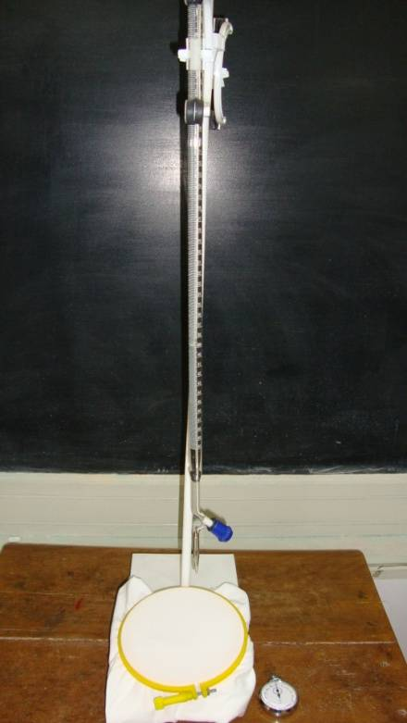

PLATE 14
DROP TEST

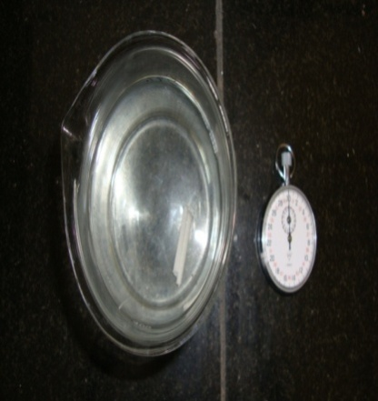
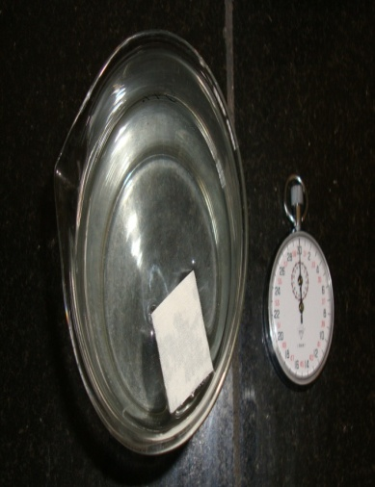

PLATE 15 PLATE 16
SINKING TEST WICKING TEST

4. RESULTS AND DISCUSSION
The findings of the study are presented under the following heads.
4.1 SUBJECTIVE EVALUATION
- Visual Assesment
4.2 OBJECTIVE EVALUATION
4.2.1 PHYSICAL PROPERTY TEST
4.2.1.1 Fabric Count
4.2.1.2 Fabric Weight
4.2.1.3 Fabric Thickness
4.2.2 MECHANICAL PROPERTY TEST
4.2.2.1 Tensile Strength and Elongation
4.2.2.2 Abrasion Resistance
4.2.3 COMFORT PROPERTY TEST
4.2.3.1 Fabric Stiffness
4.2.3.2 Crease Recovery Test
4.2.4 ABSORBENCY TEST
4.2.4.1 Drop Test
4.2.4.2 Sinking Test
4.2.4.3Wicking Test
    - ANTIMICROBIAL TEST
4.2.5.1 Qualitative Analysis
4.2.5.2 Quantitative Analysis
4.2.5.3 Antifungal Activity
4.2.5.4 Performance study
4.3 COST ESTIMATION
4.1 SUBJECTIVE EVALUATION
The fabric samples were analyzed subjectively visual assessment and the results are presented in Table II and in (Appendix 2).
- Visual Assessment
The results from the visual assessment are presented in the Table III.
TABLE III
VISUAL EVALUATION
S.NO | SAMPLES | GENERAL APPEARANCE |  |  | TEXTURE |  |  | WHITE INDEX |  |  | EVENNESS
1.  2.  3.  4.  5. | OS  SS  HFC 1  HFC 2  HFC 3 | E | G | F | S | M | C | H | M | L | E | U
1.  2.  3.  4.  5. | OS  SS  HFC 1  HFC 2  HFC 3 | 77  80  88  82  79 | 21  20  12  18  21 | 2  -  -  -  - | 34  40  11  13  16 | 14  36  89  87  84 | 52  24  -  -  - | 52  24  -  -  - | 48  56  89  85  82 | -  20  11  15  18 | 80  70  84  76  72 | 20  30  16  24  28

- GENERAL APPEARANCE
From the Table III it is clear that the maximum number of 88 percent of judges rated the sample HFC 1 as excellent in general appearance followed by samples HFC2, SS and HFC3 as 82, 80 and 79 percentages respectively.
- TEXTURE
The maximum number of 89 percent of judges rated sample HFC1 as medium as texture followed by samples HFC 2 HFC 3 of 87 and 84 percentages respectively.
- WHITENESS INDEX
As for the whiteness of the fabric maximum number of 52 percent of judges rated sample OS as high in whiteness index. Among the treated samples the Maximum number of judges rated sample HFC1 (89 percent) as medium followed by samples HFC2 (85 percent) and HFC3 (82 percent) .
- EVENNESS
As for the evenness of fabric the maximum of 80 percent of judges rated sample OS as even where as only 70 percent of judges rated sample SS as even. Among the treated samples the maximum ratings for evenness was for sample HFC1 followed by samples HFC2 and HFC3 of 76 and 72 percentages respectively.
Hence it could be concluded that the fabric treated with Cassia Auriculata at 120 percent concentration was excellent in general appearance, medium in texture and even in fabric surface. But as for whiteness index there was the adherence of color in all the finished fabrics of which it was the maximum in the sample HFC1.
4.2 OBJECTIVE EVALUATION- LABORATORY TEST
    - PHYSICAL PROPERTY TEST
The results of analysed for physical properties and discussed under the following headings.
4.2.1.1 FABRIC COUNT
The fabric count for the original and treated samples are given in Table- IV and Figure 1.
TABLE- IV
FABRIC COUNT IN WARP and WEFT DIRECTIONS
S.NO | WEAVE  DIRECTION | OS | SS |  | HFC1 |  | HFC2 |  | HFC3 |  | F value
S.NO | WEAVE  DIRECTION | OS | GAIN |  | LOSS |  | LOSS |  | LOSS |  | F value
S.NO | WEAVE  DIRECTION | OS | ^{VALUE} | % | ^{VALUE} | % | ^{VALUE} | % | ^{VALUE} | % | F value
1 | WARP | 22 | 24 | 9.09 | 24 | 13.18 | 24 | 13.18 | 24 | 13.18 | 51.67**
2 | WEFT | 27 | 29 | 7.40 | 24 | 11.11 | 24 | 11.11 | 23 | 14.81 | 28.36**
3 | FABRIC COUNT | 49 | 53 | - | 48 | - | 48 | - | 47 | -

From the Table – IV it is clear that the fabric count of sample OS was 49. It increased in sample SS to 53, but decreased in sample HFC 3 to 47 and both in samples HFC1 and HFC2 to 48. Hence it could be concluded that though the fabric count increased on scouring, it decreased on Antimicrobial finishing.
From the statistical analysis it is clear that the comparison between original and treated sample has 1% significance.
      - FABRIC WEIGHT
The fabric weight for the original and treated samples are given in Table – V and Figure. 2.

TABLE- V
FABRIC WEIGHT IN ORIGINAL and TREATED SAMPLES (gms)
S.NO | OS | SS |  | HFC1 |  | HFC2 |  | HFC3 |  | F value
S.NO | OS | LOSS |  | GAIN |  | GAIN |  | GAIN |  | F value
S.NO | OS | ^{VALUE} | % | ^{VALUE} | % | ^{VALUE} | % | ^{VALUE} | % | F value
1 | 361 | 324 | 10.24 | 361.96 | 0.26 | 361.64 | 0.17 | 361.28 | 0.07 | 8674.63**

From the Table V it is clear that the weight of sample OS is the maximum of 361 gms. A reduction in weight of 10.24% was observed in sample SS. The weight increased in finished samples of which the maximum increase was observed in sample HFC1 (10.26%), HFC2 and HFC3 of 0.17 and 0.07 percentages respectively.
Hence it could be concluded that there was a drastic reduction in fabric weight on scouring and gained weight on Antimicrobial Finishing
From the statistical analysis it is clear that the comparison between original and treated sample has 1% significance.
      - FABRIC THICKNESS
The fabric thickness for the original and treated samples are given in Table- VI and Figure 3.
TABLE- VI
FABRIC THICKNESS IN ORIGINAL and TREATED SAMPLES (mm)
S.NO | OS | SS |  | HFC1 |  | HFC2 |  | HFC3 |  | F value
S.NO | OS | LOSS |  | GAIN |  | GAIN |  | GAIN |  | F value
S.NO | OS | ^{VALUE} | % | ^{VALUE} | % | ^{VALUE} | % | ^{VALUE} | % | F value
1 | 1.19 | 0.97 | 18.48 | 1.49 | 25.21 | 1.48 | 24.36 | 1.48 | 24.36 | 424.09**

From the Table – VI it is clear that the thickness of the sample OS was 1.19 mm which reduced in weight on various treatments. A reduction in weight of 18.48 percent was observed in the scoured sample. An increase in thickness was noted in all the finished samples of which it was the maximum in sample HFC1 (25.21 percent) followed by both the sample HFC2 and HFC3 of 24.36 percent.
Hence it could be concluded that though there was a drastic reduction in thickness ON scouring, it was regained on finishing.
From the statistical analysis it is clear that the comparison between original and treated sample was significant at 1 per cent level.
    - MECHANICAL PROPERTY TEST
The evaluation results of the untreated and treated fabrics are dicussed under the following headings.
4.2.2.1 Tensile Strength and Elongation
The tensile strength and elongation for the original and treated samples are given in Table- VII and Figure 4 and 5.
TABLE- VII
TENSILE STRENGTH and ELONGATION OF THE FABRIC IN WARP DIRECTION
S.NO | SAMPLES | STRENGTH (KG) |  | F value | ELONGATION (%) |  | F value
S.NO | SAMPLES | LOSS/GAIN |  | F value | GAIN |  | F value
S.NO | SAMPLES | VALUE | % | F value | VALUE | % | F value
1 | OS | 66.8 | 6.28 | 13.16** | 32 | 9.37 | 57.05**
2 | SS | 62.6 | 6.28 | 13.16** | 29 | 9.37 | 57.05**
3 | HFC1 | 65.4 | 2.09 | 13.16** | 31.9 | 0.31 | 57.05**
4 | HFC2 | 65 | 2.69 | 13.16** | 29.7 | 7.18 | 57.05**
5 | HFC3 | 64.6 | 3.29 | 13.16** | 28.76 | 10.12 | 57.05**

Tensile Strength
From the Table – VII it is obvious that the strength of sample OS was 66.8 kg. It reduced drastically in sample SS to 62.6 kg. Among the treated sample, the maximum reduction in strength was noted in sample HFC3 of 3.29 per cent followed by samples HFC2 and HFC1 of 2.69 and 2.09 percentages respectively.
Hence, it could be concluded that though the finished samples gained strength than the scoured samples a slight reduction in strength was noted in all the finished samples over the original sample. Minimum reduction of strength was noted in sample HFC1.
From the statistical analysis it is clear that the comparison between original and treated sample has 1% significant.
Elongation
The elongation of the sample OS was 32 per cent which was reduced in sample SS of 29 percent. Among the antimicrobial finished samples, the maximum reduction in elongation was noted in sample HFC3 (10.12 percent) followed by sample HFC2 and HFC1 of 7.18 and 0.31 percentages respectively.
Hence it could be concluded that the elongation property if the Cotton Agave fabric reduced on scouring and antimicrobial finishing.
From the statistical analysis it is clear that the comparison between original and treated sample has 1% significant.

TABLE – VII
TENSILE STRENGTH and ELONGATION IN WEFT DIRECTION
S.NO | SAMPLES | STRENGTH (KG) |  | F value | ELONGATION (%) |  | F value
S.NO | SAMPLES | LOSS |  | F value | LOSS |  | F value
S.NO | SAMPLES | VALUE | % |  | VALUE | % | F value
1 | OS | 93.2 | 2.36 | 17.46** | 14 | 14.28 | 7.58**
2 | SS | 91 | 2.36 | 17.46** | 12 | 14.28 | 7.58**
3 | HFC1 | 92.8 | 0.42 | 17.46** | 13.8 | 1.42 | 7.58**
4 | HFC2 | 91.4 | 1.93 | 17.46** | 13.26 | 5.28 | 7.58**
5 | HFC3 | 90.3 | 3.11 | 17.46** | 12.38 | 11.57 | 7.58**

Tensile strength
From the Table – VII it is clear that in weft direction the strength in the sample OS was 93.2 kg. It reduced in sample SS to 2.36 percent. Among the antimicrobial samples, the maximum reduction was noted in sample. HFC3 of 3.11 percent followed by samples HFC1 of 1.93 and 0.42 percentages respectively. Hence it could be concluded that on scouring and antimicrobial finishing the strength of the fabric slightly decreased. But minimum reduction was noted in sample HFC1.
Elongation
The elongation of the sample OS was 14 percent. It reduced in sample SS to 14.28 percent. Among the antimicrobial finished fabrics, the maximum reduction in elongation was noted in sample. HFC3 (11.57 percent) followed by samples HFC2 and HFC1 of 5.28 and 1.42 percentages respectively. Hence it could be concluded that the elongation of the fabric reduced on scouring and antimicrobial finishing treatments.
From the statistical analysis it is clear that the comparison between original and treated sample has 1% significant.
4.2.2.2 Abrasion Resistance
The abrasion resistance for the original and treated samples are given in Table - VIII and Figure 6.
TABLE – VIII
ABRASION RESISTANCE (gms)
S.NO | OS | SS |  | HFC1 |  | HFC2 |  | HFC3 |  | F value
S.NO | OS | LOSS |  | LOSS |  | LOSS |  | LOSS |  | F value
S.NO | OS | ^{VALUE} | % | ^{VALUE} | % | ^{VALUE} | % | ^{VALUE} | % | F value
1 | 0.469 | 0.465 | 0.85 | 0.462 | 1.49 | 0.459 | 2.13 | 0.456 | 2.77 | 16.34**

From the Table – VII it is clear that the abrasion resistance was 0.469 gms in sample OS. The loss of abrasion resistance was the maximum in sample HFC 3 of 2.77 percent followed by samples HFC 2, HFC1 and SS of 2.13, 1.49 and 0.85 percentages respectively. Hence it could be concluded that the abrasion resistance in the fabric reduced on scouring and antimicrobial finishing.
From the statistical analysis it is clear that the comparison between original and treated sample has 1% significant.
    - COMFORT PROPERTY TEST
The comfort properties were analysed for the following testings.
4.2.3.1 Fabric Stiffness
The abrasion resistance for the original and treated samples are given in Table – IX and Figure 7.
TABLE – IX
FABRIC STIFFNESS IN WARP and WEFT DIRECTIONS (cms)
S.NO | WEAVE  DIRECTION | OS | SS |  | HFC1 |  | HFC2 |  | HFC3 |  | F Value
S.NO | WEAVE  DIRECTION | OS | LOSS |  | LOSS |  | LOSS |  | LOSS |  | F Value
S.NO | WEAVE  DIRECTION | OS | ^{VALUE} | % | ^{VALUE} | % | ^{VALUE} | % | ^{VALUE} | % | F Value
1 | WARP | 2.06 | 1.9 | 7.76 | 1.72 | 16.50 | 1.7 | 17.74 | 1.6 | 22.33 | 10.58**
2 | WEFT | 6.44 | 5.12 | 20.49 | 6.12 | 4.96 | 5.96 | 7.45 | 5.88 | 8.69 | 66.50**

Comparison within samples in warp and weft directions
From the Table – IX it is clear that there is a reduction in in stiffness in warp and weft directions in SS of 7.76% followed by further reduction in treated samples of HFC1, HFC2 and HFC3 with 16.50, 17.47 and 22.33 percentages respectively over the OS.
In weft direction also a reduction in stiffness was noted in the SS, HFC1, HFC2 and HFC3 of 20.49, 7.45 and 8.69 percentages respectively.
Comparison between warp and weft directions
The stiffness in warp and weft direction was 2.06cms where as in weft direction it was higher of 6.44 cms. In SS and HFC 1, HFC 2 and HFC 3 also the stiffness in warp direction was lower than the weft direction. This may be due to the Agave yarns running in the weft direction.
Hence, on treating with antimicrobial finish the stiffness has reduced and the highest reduction was noted in HFC 3.
From the statistical analysis it is clear that the comparison between original and treated sample has 1% significant.

4.2.3.2 CREASE RECOVERY TEST
The crease recovery of original and treated samples were observed by capillary rise test are given in Table - X and Figure 8.
TABLE – X
CREASE RECOVERY TEST IN WARP and WEFT DIRECTION IN PERCENTAGE
S.NO | ^{WEAVE DIRECTION} | OS | SS | HFC1 | HFC2 | HFC3 | F value
1 | WARP | 70.55 | 68.88 | 67.66 | 68.3 | 69.77 | 8.47**
2 | WEFT | 73.66 | 75.44 | 69.88 | 73.11 | 74.33 | 21.47**

Crese recovery among samples in warp direction
From Table – X it is obvious that in warp direction crease recovery percentage was 70.55%. It reduced in the sample SS 68.88%. Among the treated samples, it had the maximum reduction in samples HFC1 (67.66) where as in samples HFC 2 and HFC 3 it was 68.3% and 69.77% respectively. Hence it could be concluded that percentage of crease recovery reduced in the cotton Agave fabric on Antimicrobial finishing.
Crease recovery of sample in weft direction
Among samples in weft direction, the maximum crease recovery percent was noted in sample OS (73.66) followed by sample SS of (75.44). Among the treated samples, highest crease recovery was observed in sample HFC 3 (74.33) followed by samples HFC 2 and HFC 1 of 73.11 and 69.88 percentages respectively. Hence it could be concluded that crease recovery increased on treatment.
Crease recovery between warp and weft The crease recovery was higher in weft direction than in warp direction in all the samples, namely OS, SS, HFC1, HFC2 and HFC3. Hence it could be concluded that the fabric Cotton Agave had higher crease recovery capacity in warp direction.
From the statistical analysis it is clear that the comparison between original and treated sample has 1% significant.
    - ABSORBENCY TEST
The absorbency properties were analysed by drop test, sinking and wickability tests.
4.2.4.1 Drop Test
The absorbency test for the original and treated samples are given in Table - XI and Figure 10.
TABLE – XI
DROP TEST (sec)
S.NO | OS | SS |  | HFC1 |  | HFC2 |  | HFC3 |  | F value
S.NO | OS | LOSS |  | LOSS |  | LOSS |  | LOSS |  | F value
S.NO | OS | _{VALUE} | % | _{VALUE} | % | _{VALUE} | % | _{VALUE} | % | F value
1 | 23 | 21 | 8.69 | 17.2 | 25.2 | 18.8 | 18.26 | 19.7 | 14.34 | 35.15**

From the Table – XI it is clear that the time taken for the water droplet to penetrate into the fabric was 23 seconds. The maximum reduction in penetration time was noted in samples HFC1 (25.2 percent), HFC2 (18.26 percent) and HFC3 (14.34 percent) respectively.
Hence it could be concluded that the time taken by the drop to penetrate into the fabric reduced on scouring and antimicrobial finishing. This may be due to the increase in the absorbency characteristics of the fabric.
From the statistical analysis it is clear that the comparison between original and treated sample has 1% significant.
4.2.4.1 Sinking Test
The sinking time for the original and treated samples were observed by sinking test are given in Table – XII and Figure 11.
TABLE – XII
SINKING TEST (sec)
S.NO | OS | SS |  | HFC1 |  | HFC2 |  | HFC3 |  | F value
S.NO | OS | LOSS |  | LOSS |  | LOSS |  | LOSS |  | F value
S.NO | OS | _{VALUE} | % | _{VALUE} | % | _{VALUE} | % | _{VALUE} | % | F value
1 | 20 | 17 | 15 | 16.5 | 17.5 | 16.8 | 16 | 16.9 | 15.5 | 8.14**

From the Table – XI it is clear that t he sinking of the sample OS was 20 Seconds. The sample SS showed a reduction of 15 percent. Among the antimicrobial finished samples, the maximum reduction in sinking time was noted in sample HFC1 (16.5 sec) followed by samples HFC2 (16.8 sec) and HFC3 (16.9 sec). Hence it could be concluded that the sinking time reduced on scouring and antimicrobial finishing of Cotton Agave fabric due to the increase in absorbency.
From the statistical analysis it is clear that the comparison between original and treated sample has 1% significant.
4.2.4.2 WICKING TEST
The absorbency of original and treated samples were observed by capillary rise test are given in Table – XIII and Figure 13.
TABLE – XIII
WICKING TEST IN WARP and WEFT DIRECTIONS (cms)
S.NO | WEAVE  DIRECTION | OS | SS |  | HFC1 |  | HFC2 |  | HFC3 |  | F value
S.NO | WEAVE  DIRECTION | OS | GAIN |  | GAIN |  | GAIN |  | GAIN |  | F value
S.NO | WEAVE  DIRECTION | OS | _{VALUE} | % | _{VALUE} | % | _{VALUE} | % | _{VALUE} | % | F value
1 | WARP | 6.2 | 6.9 | 11.29 | 7.3 | 17.74 | 6.9 | 11.29 | 6.7 | 8.06 | 18.63**
2 | WEFT | 7.4 | 8 | 8.1 | 8.2 | 10.18 | 8.06 | 8.9 | 7.81 | 5.54 | 18.35**

Wickability among samples in warp direction
From the Table – XII it is clear that in warp direction the wicking was 6.2 cms in samples OS. On scouring, wickability increased by 11.29 % to (6.9 cms) over the original among the finished samples it was the maximum in sample HFC1 of 7.3 cms followed by samples HFC2 and HFC3 of 6.9 cms and 6.7 cms respectively.
Hence it could be concluded that scouring improve the wickability of the fabric and Antimicrobial finishing improved the wickability.
Wickability among samples in weft direction
Wickability of fabric in weft direction is 7.4 cms in sample OS which increased by 8.10% in sample SS. Among the finished samples, the maximum wickability was observed in sample HFC1 (8.2 cms), followed by samples HFC2 (8.06 cms) and HFC3 (7.81 cms).
Hence it could be concluded that wickability increased on scouring and further increased on Antimicrobial finishing.
Wickability of samples between warp and weft directions
All the samples showed higher wickability in weft direction than in warp direction. In all the samples namely OS, SS, HFC1, HFC2 and HFC . hence it could be concluded that wickabilty was higher in weft direction in cotton Agave fabric.
From the statistical analysis it is clear that the comparison between original and treated sample has 1% significant.

    - ANTIMICROBIAL TESTS
      - QUALITATIVE ANALYSIS
The qualitative analysis for treated samples were observed before and after wash are given in Table – XIV.

TABLE – XIV
QUALITATIVE ANALYSIS OF SAMPLE BEFORE WASH
S. NO | SAMPLES | ZONE OF BACTERIOSTASIS (mm)
S. NO | SAMPLES | ESCHERICHIA COLI | STAPHYLOCOCCUS AUREUS
1. | HFC1 | 29 | 27

From the table it is clear that the sample HFC 1 had good and Antibacterial agent in both the test organisms. (Appendix – 3).

ANTIBACTERIAL ACTIVITY ON FABRICS
QUALITATIVE ANALYSIS
AGAINST ESCHERICHIA COLI AGAINST STAPHYLOCOCCUS AUREUS
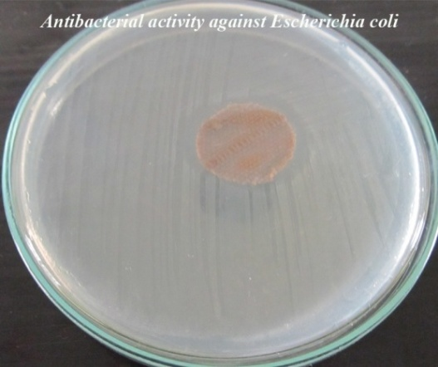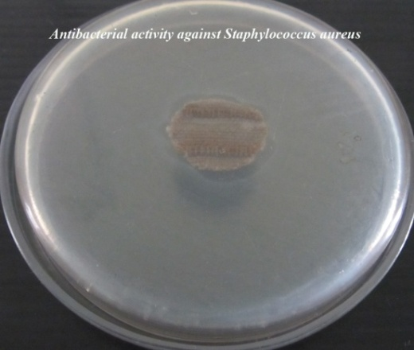

- QUALITATIVE ANALYSIS OF TREATED SAMPLE AFTER WASH
The qualitative analysis of a antimicrobial finish after wash is shown in Table – XV.
TABLE – XV.
EVALUATION OF THE ANTIBACTERIAL ACTIVITY OF THE FABRIC AFTER WASH
S. NO | SAMPLES | ZONE OF BACTERIOSTASIS (MM)
S. NO | SAMPLES | ESCHERICHIA COLI | STAPHYLOCOCCUS AUREUS
1. | HFC 1 | 29 | 27
2. | HFC1W1 | 22 | 20
3. | HFC1W2 | 18 | 16
The samples HFC1W1 and HFC1W2 showed reduction of 22 mm and 18mm in zone of bacteriosis to Escherichia coli than the original 29mm
The samples HFC1W1 and HFC1W2 showed a reduction of 20 mm and 16mm in zone of bacteriosis to Staphylococcus Aureus than the original 27mm.
- QUANTITATIVE ANALYSIS:
The analysis is shown in Table – XVI.

TABLE – XVI
QUANTITATIVE ANALYSIS OF SAMPLE BEFORE WASH
S. NO. | FABRIC SAMPLES | BACTERIAL REDUCTION ( %)
S. NO. | FABRIC SAMPLES | ESCHERICHIA COLI | STAPHYLOCOCCUS AUREUS
1. | HFC 1 | 95 | 92

From the Table it is clear that the sample HFC1 had excellent antibacterial activity in both the organisms with 95 and 92 percentages in E. coli and Staphlococcus Aureus.

ANTIBACTERIAL ACTIVITY OF FABRICS
QUANTITATIVE ANALYSIS
AGAINST ESCHERICHIA COLI AGAINST STAPHYLOCOCCUS AUREUS
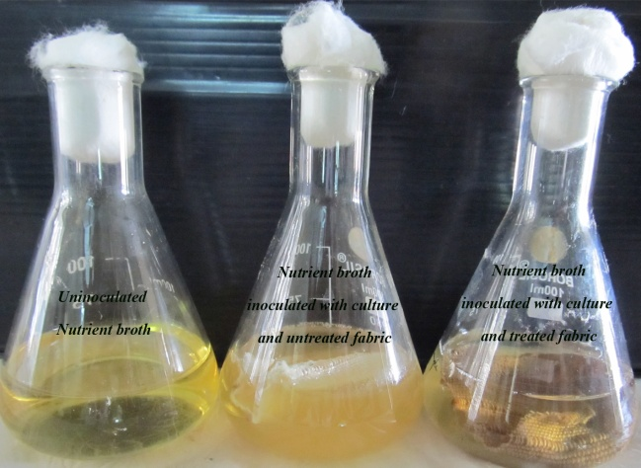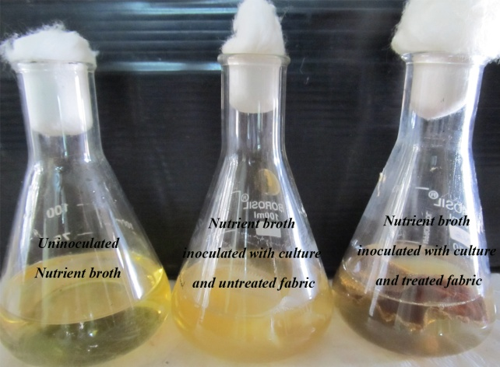
- QUANITATIVE ANALYSIS OF TREATED SAMPLE AFTER WASH
The qualitative analysis of a antimicrobial finish after wash is shown in Table – XVI
TABLE – XVII
QUANTITATIVE ANALYSIS OF SAMPLE AFTER WASH
S. NO | SAMPLES | BACTERIAL REDUCTION(%)
S. NO | SAMPLES | ESCHERICHIA COLI | STAPHYLOCOCCUS AUREUS
1. | HFC 1 | 95 | 92
2. | HFC1W1 | 85 | 80
3. | HFC1W2 | 71 | 64

In the samples HFC1W1 and HFC1W2 bacterial reduction was noted to 85 per cent, 71 per cent respectively as for the E coli, than the sample HFC1 95 per cent.
The sample HFC1W1 and HFC1W2 showed a bacterial reduction of 80 per cent and 64 per cent respectively for staphylococcus than the original 92 per cent.
4.2.5.3 ANTIFUNGAL ACTIVITY:
The anti fungal activity of the sample is shown in Table – XVII.
TABLE – XVII
EVALUATION OF THE ANTIFUNGAL ACTIVITY OF THE FABRIC 30
S. NO. | SAMPLE | ZONE OF MYCOSTASIS (mm)  ASPERGILLUS NIGER
1. | HFC 1 | 69

From the Table – XVII it is clear that the sample HFC 1 had GOOD antifungal activity in the zone of mycostasis with 69mm.

ANTIFUNGAL ACTIVITY OF THE FABRIC BY AATCC 30 AGAINST ASPERGILLUS NIGER
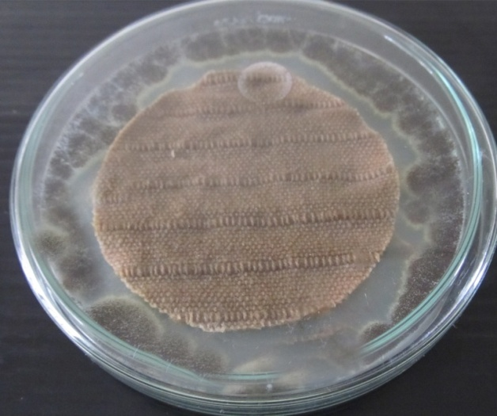
- Antifungal Activity After Wash:
The Antifungal Activity of a antimicrobial finish after wash is shown in Table – XVIII
TABLE – XVIII
EVALUATION OF THE ANTIFUNGAL ACTIVITY OF THE SAMPLE
AFTER WASH
S. NO. | SAMPLE | ZONE OF MYCOSTASIS (mm)  ASPERGILLUS NIGER
1. | HFC 1 | 69
2. | HFCIW1 | 22
3. | HFC1W2 | 0*

From the Table XVIII it is clear that the moderate Antifungal activity against the organisms after washes and against the organisms after 6 washes and had no activity after 9 washes.
Hence it could be concluded that Qualitative and Quantitative assessments, the best in the finished samples. But the effect diminished on washing.
4.2.5.4 PERFORMANCE STUDY
The performance study of the floor mat sample are shown in Table – XIX.
TABLE – XIX
PERFORMANCE STUDY

TESTS | HFC1 | HFC1W1 | LOSS/GAIN % | HFC1W2 | LOSS/GAIN %
STIFFNESS IN WARP AND WEFT (cm) | 1.72 | 1.60 | -91.3 | 1.00 | 56.41
STIFFNESS IN WARP AND WEFT (cm) | 6.12 | 5.42 | 18.33 | 5.46 | 94.54
WEIGHT (GSM) | 361.96 | 360.55 | 261.38 | 351.71 | 264.79
FABRIC COUNT IN WARP AND WEFT | 24 | 23 | 71.83 | 23 | 7.83
FABRIC COUNT IN WARP AND WEFT | 24 | 23 | 71.83 | 23 | 71.83
THICKNESS (mm) | 1.49 | 1.34 | 88.44 | 1.32 | 87.10
STRENGTH IN WARP AND WEFT (kgs) | 65.4 | 64 | 32.45 | 63.72 | 32.03
STRENGTH IN WARP AND WEFT (kgs) | 92.8 | 90.7 | 2.26 | 90.2 | 12.68
ELONGATION IN WARP AND WEFT (%) | 31.9 | 31.8 | 67.78 | 31.6 | 67.15
ELONGATION IN WARP AND WEFT (%) | 13.8 | 13.7 | 85.47 | 13.4 | 83.30
ABRASION (%) | 0.462 | 0.431 | 92.82 | 0.400 | 86.11
CREASE RECOVERY IN WAR AND WEFT | 67.66 | 66 | 29.88 | 65.74 | 29.50
CREASE RECOVERY IN WAR AND WEFT | 69.88 | 68.72 | 28.46 | 68.50 | 31.5
DROP (sec) | 17.2 | 16.1 | 76.4 | 15.4 | 72.33
SINKING (sec) | 16.5 | 15 | 74.4 | 14 | 68.3
WICKING IN WARP AND WEFT (cm) | 7.3 | 8 | 102.28 | 8.72 | 112.15
WICKING IN WARP AND WEFT (cm) | 8.2 | 8.9 | 100.33 | 9.5 | 90.5
- Fabric Stiffness
From the above Table - XIX, it is clear that the stiffness of the fabric in warp direction was reduced gradually on subsequent washing in samples HFC1W1 (1.60cms) and HFC2W2 (1.00 cm). the reduction was observed in weft direction in sample HFC1W1 (5.42 cms) and HFC1W2 (5.46 cms).
- Fabric Weight
The weight of fabric reduced in sample HFC1W1 to 360.55 GSM and in sample HFC1W2.
- Fabric Count
The fabric count warp and in weft direction in the washed sample was 24 which reduced in both the sample to 23.
- Fabric thickness
The thickness of the unwashed sample was 1.49 mm which showed a decrease to 1.34 mm in sample HFC1W2.
- Tensile Strength
In warp direction the strength was noted to be 65.4 kg in sample HFC 1 which reduced gradually in the washed samples namely HFC1W1 and HFC1W2 to 64.0 and 63.72 respectively. In weft direction, also a decreased in both the samples HFC1W1 and HFC1W2 to 90.7 and 90.2 respectively.

- Elongation
As for elongation, in warp direction, a slight decrease was noted in sample HFC1W1 and HFC1W2 of 31.8 and 31.6 respectively. In weft direction also a decrease from the elongation of sample HFC1 (13.8) to 13.7 per cent and 13.4 per cent in samples HFC1W1 and HFC1W2 respectively.
- Abrasion
The abrasion resistance per cent of the sample HFC1 (0.462) was reduced to 0.431 per cent in sample HFC1W1 and 0.400 per cent in sample HFC1W2.
- Crease recovery
The crease recovery per cent in warp direction in sample HFC 1 was 67.66 which decreased in sample HFC1W1 and HFC1W2 to 66 and 65.74 respectively.
The crease discovery per cent in weft direction in sample HFC1 was 69.88 which reduced in the washed samples HFC1W1 (68.72) and HFC1W2 (68.50).
- Drop test
As for the drop test, the water drop took 17.2 seconds and 15.4 seconds to penetrate into one fabric samples HFC1W1 and HFC1W2 respectively.
- Sinking
The sinking time of the fabric reduced on washing in the samples HFC1W1 to 15 seconds and HFC1W2 to 14 seconds.

- Wicking
In warp direction, the wicking height was noted to be 7.3 in sample HFC1 which was observed to be higher in sample HFC1W1 to 8 cms and HFC1W2 to 8.72 cms.
On weft direction also the wicking height in capillary movement of the washed samples HFC1W1 (8.9cm) over the unwashed sample HFC1W2 (8.2 cms).
Hence it could be concluded that the antimicrobial finished sample at 120 per cent concentration of Cassia Auriculata extract showed an increase in absorbency charaxteristics on washing though a slight reduction in the mechanical and physical properties in the fabric.
4.3 COST ESTIMATION
The estimated cost of the end product is shown in Table – XX.
TABLE – XX
ESTIMATED COST
S.NO | PARTICULARS | COST (RS)
1. | Ribbed woven cotton Agave fabric (2 meters). | 100/-
2. | Pretreatment | 5/-
3. | Finishing | 10/-
4. | Product | 7/-
 | Total | 122/-
From the above Table it is clear that the Cotton Agave finished floor mats cost Ra. 122/- which is noted to be economical.
SUMMARY AND CONCLUSION
The challenge for business today is to invent new products that will enable it to survive in the globalised competitive environment, green minded consumers are prepared to pay more for the eco friendly products. Fibers are fundamental units used in fabrications of textile yarns and fabrics. Natural fibers are gaining progressive account as renewable environmentally acceptable, biodegradable, starting material for industrial application, technical textiles, pulp and paper, as well as for civil engineering and building activities. Vegetable fibers are generally composed mainly of cellulose which includes cotton, jute, flax, ramie, sisal and hemp. Cellulose fibers serve in the manufacture of paper and cloth.
Agave a natural leaf fiber obtained from the Agave Americana plant. The strength of agave fiber is more than other natural fibers. Plants are also useful for human health because they have antibacterial, insecticidal and healthy properties. Unlike chemicals, natural sources are harmless to man and environment.
OBJECTIVES
- To identify antimicrobial property in a natural source
- To apply and evaluate the antimicrobial property on a natural fabric
- To innovate an end use for the finished fabric
METHODOLOGY
- Selection of Fabric
The fabric selected for the study was Cotton Agave ribbed structure as it is cent percent eco-friendly.
- Scouring
The fabric was prepared by scouring to remove the unwanted materials adhering to the fabric.
SELECTION, COLLECTION and PROCESSING
Natural herbal source was Cassia Auriculata as it is known to have antimicrobial property.
- Collection of Source
The flowers of Senna auriculata were collected from Palladam, Tamilnadu, India and authenticated by the Institute of Forest Genetics and Tree Breeding, Coimbatore, following identification a voucher specimen of the plant was deposited in the IFGTB department.
- Processing of the Flowers
The flowers were examined carefully and old, infected, and fungus damaged flowers were removed. Extracts were prepared from dried and also from fresh flower. Healthy flowers were spread out and dried at room temperature for about ten days and ground into fine powder using electric blender.
EXTRACTION OF HERBAL FINISHING AGENT
For extraction, 3 grams of the powder was taken and mixed into 50ml of 80% Methanol as suggested by Christie et al. (2001). Methanol is used as the cross linking agent because it has highly time consuming process. Then the container was closed and kept for overnight. After overnight incubation, the extract was filtered through filter paper and evaporated to concentrate the extract.
APPLICATION OF FINISH
The ribbed woven Cotton Agave fabric sample immersed in the herbal microcapsules was passed through a padding mangle. The speed of padding mangle was 15 m/min and a mangle pressure was 15 kgf/cm². Then the padded fabric was air-dried and cured for 3 minutes at 140 ˚C. Thus antimicrobial finish was incorporated to cotton agave fabric.

PREPARATION OF FLOOR MAT
The finished fabric was converted into floor mats. the fabrics were subjectively analysed by visual assessment and objectively evaluated by various lab test namely Fabric Count, Fabric weight, Fabric Thickness, Tensile Strength and Elongation, Abrasion Resistance, Fabric Stiffness, Crease recovery test, Drop Test, Sinking Test and Wicking tests.
- To assess the antimicrobial property, special test were done.
- The foot mats were evaluated by performance study.
COST ESTIMATION
The cost was estimated for the raw material, pretreated fabric, finished fabric and the product and recorded.
FINDINGS OF THE STUDY
- The fabric count increased decreased on Antimicrobial finishing
- Though there was a drastic reduction in thickness on scouring, it was regained on finishing.
- The finished samples gained strength than the scoured samples a slight reduction in strength was noted in all the finished samples over the original sample in warp direction. Minimum reduction of strength was noted in sample treated at 120 per cent concentration
- On scouring and antimicrobial finishing the strength of the fabric slightly decreased in weft direction minimum reduction was noted in sample HFC 1.
- The elongation property if the Cotton Agave fabric reduced on scouring and antimicrobial finishing and the minimum reduction was noted in sample HFC1.
- The elongation of the fabric reduced on scouring and antimicrobial finishing treatments.
- The abrasion resistance in the fabric reduced on scouring and antimicrobial finishing.
- The stiffness has reduced and the highest reduction was noted in HFC 3. Which is treated with 120 per cent concentration.
- One percentage of crease recovery reduced in the Cotton Agave fabric on Antimicrobial finishing in both warp and weft direction.
- Hence it could be concluded that the fabric Cotton Agave had higher crease recovery capacity in warp direction.
- The time taken by the drop to penetrate into the fabric reduced on scouring and antimicrobial finishing.
- The sinking time reduced on scouring and antimicrobial finishing of Cotton Agave fabric due to the increase in absorbency characteristics.
- Scouring improved the wickability of the fabric and Antimicrobial finishing improved the wickability into the warp and weft directions.
- In the Quantitative and Qualitative assessments, the antimicrobial activity was the best in the finished samples. But he effect diminished on washing.
CONCLUSION
Hence it could be concluded that the cotton Agave ribbed woven structure absorbs and reatains the antimicrobial finish incorporated by Cassia Auriculata flowers. Higher concentration of the extract proves to be more effective.
RECOMMENDATIONS
- Fabric dyeing in possible Cassia Auriculata flowers with an addition of a mordant.
- Many others home furnishing items also could be tried with the same fabric.
- The same method could be adopted for other natural vegetable fibers also.

BIBLIOGRAPHY

- “Antimicrobial dressing”, International Dyer, 5, 19 (2001).
- “Antimicrobial tights are a comfort to women”, International Dyer, 6, 28 (2001).
- “Putting nature on hold”, International Dyer, 2, 36-38 (2003).
- AATCC Test Method 100: Antibacterial finishes on textile materials: Assessment of. AATCC Technical Manual (149-151) 2003.
- AATCC Test Method 147: Antibacterial activity of textile materials: parallel streak method. AATCC Technical Manual (264-265) 2003.
- AATCC Test Method 174: Antimicrobial activity, assessment of carpets. AATCC Technical Manual (316-318) 2003.
- AATCC Test Method 30: Antifungal activity, assessment on textile materials: Mildew and rot resistance of textile materials. AATCC Technical Manual (81-84) 2003.
- Achwal, W.B.,(2003). “Antimicrobial finishes and their modification”, Colourage, Vol.50, No. 1, January, P.58.
- Achwal, W.B.,(2005). “Anti-microbial finishes and their modifications”, Colourage, Vol.LII,No. 1,P.58.
- Adivarekar, R.V. and Kanoonga , N., (2008).”Textile wet processing scenario in India”, The Indian Textile Journal, January,Vol. 118, No. 4, P .54.
- Aggarwal, J., Charee Gupta and Sunjed Singh, (2006). “Renewable antimicrobial finish for next to silk garments “,Colourage , January, P. 49.
- Akpulu, I.N., Dada, J.D., Odama, L.E. and Galadima, M. 1994. Antibacterial activity of aqueous extracts of some Nigerian medicinal plants, Nigerian J Botany 7: 45-48.
- Amsamani and Kamala Ranganathan ,(2007) . “The textile magazine”, Green Technology for Safe Textiles , Vol . 48, January , P . 14.
- Atata, R.F., Sani, A. and Ajewole, S.M. 2003. Effect of stem bark extracts of Enantia chloranta on some clinical isolates, Biokemistri 15(2): 84-92.
- Balasooriya, S.J., Sotheeswaran, S. and Balasubramanium, S. 1982. Economically useful plants of Srilanka, J of Nat Sci Congress SriLanka 10: 213-219.
- Bauer, A.W., Kirby, W.M.M., Sherris, J.C. and Turck, M. 1966. Antibiotic susceptibility testing by a standardized single disk method, American J of Clinical Pathology 45: 493-496.
- Böhringer, J. Rupp and A. Yonenaga, “Antimicrobial textiles”, International textile Bulletin, 5, 12-30 (2000).
- Booth, J.E., (1996). “Principles of textile testing”, CBS, publisher and distributor, Darya Ganj, New Delhi, pp. 263, 232, 332, 333.
- by Maya Jacob, K T Varughese, Sabu Thomas
- Chellamani, K.P., Nagarajan , G. and Vijayakumar , K.A.,(2007). “Application of nano finish on fabrics made out of compact and conventional ring spun yarns”, Asian Dyer ,October, P . 63.
- Clemo , B., (2005) . “Ultra fresh silpure a new generation of antimicrobials”, Colourage, May , Vol. LII, NO . 5, P . 131.
- E. Menzes, “Antimicrobial finish for specialty textiles”, International Dyer, 12, 13-16 (2002).
- Ebana, R.U.B., Madunagu, B.E., Ekpe, E.D. and Otung, I.N. 1991. Microbiological exploitation of cardiacglycosides and alkaloids from Garcinia kola, Borreria ocymoides, Kola nitida and Citrus aurantifolia, J of Applied Microbiology 71: 398-401.
- Edeoga, H.O., Okwu, D.E. and Mbaebie, B.O. 2005. Phytochemical constituents of some Nigerian medicinal plants, African J of Biotechnology 4: 685-688
- Faraz, M., Mohammad, K., Naysaneh, G. and Hamid, R.V. 2003 . Phytochemical screening of some species of Iranian plants, Iranian J of pharmaceutical Research : 77-82.
- G. Soares et al., “Studies of durability and effect on material properties of different antibacterial products”, ATC’04 – 31st Aachen Textile Conference, November 24-25, 2004.
- G. Sun and S. D. Worley, “Chemistry of durable and regenerable biocidal textiles”, Journal of Chemical Education, 1, 60-64 (2005)
- Gendy and Shanshoury , (2004) , “Factors affecting radiation grafting of N- vinylpyrrolisdone onto nylon and fabric”, Indian Journal of Fiber and Textile Research , Vol. December , pp . 440 ,441.
- Gokilavani, R. and Gopalakrishnan, D., (2007). “Biotechnology is textile”, Asian Dyer , June , P. 72
- Gokilavani, R. and Gopalakrishnan , D., (2007). “Biotechnology in textile”, Asian Dyer , June , P. 68.
- Gokum Consultants, (2007). “processing of denim”, colourage, February, Vol. LIV, No. 2 , P. 68.
- Gopalakrishnan, (2006). “Antimicrobial finishes” , Man –Made Textiles in India, October, pp. 372,375
- Gopalakrishnan, D., Mahendran, N. and Navindhan, K.A., (2007). “Medical textile - An overview” , Asian Textile Journal , Vol. 16, January , pp . 69, 72.
- Goyal, R. and Prabhu , C.N., (2007). “Finishing of knit fabrics “, Colourage, November, P. 814.
- Goyal, R. and Deshpande, R.V., (2006). “Change the way you look at softners”, Colourage , May , Vol. LIII, P .100.
- Goyal, R. and Prabhu, C.N., (2007). “Finishing of polyester blend fabrics”, Colourage, May , Vol. LIV, P. 82.
- Gupta, S.P., (2005). “Statistical Methods”, Sultan Chand and sons, New Delhi. P. 11.
- Hall, A.J., (2004). “The Standard Hand Book of Textiles”, 8th edition, Woodhead Publishing Ltd., England, Pp.29, 311, 387.
- Harborne, J.B. 1998. Phytochemical methods. In A guide to modern techniques of plant analysis 3rd ed., pp. 40-137. London: Chapman and Hall;
- Holm, “Antimicrobials impart durable freshness”, International Dyer, 12, 9-11 (2002).
- Hussain Tanveer (2001).., “Study on Antimicrobial finish on fabrics”, 12 – 16
- J. Mao, “Durable antimicrobial finish for cotton with new technology”, AATCC Review, 12, 15-17 (2002).
- Jayashree, A. and Maneemegalai, S. 2008 . Studies on the antibacterial activity of the extracts from Tridax procumbens L and Ixora coccinea L, Biomedicine 28: 190-194.
- K. Schatz, “All-round answers to problem microbes”, International Dyer, 6, 17-19 (2001).
- Kan , C.W. and Yuen, C.W.M., (2006). “Technical status of antimicrobial finishes”, Textile Asia, September, P . 32.
- Krishnaveni, (2006). “Antimicrobial finish on textiles”, National Conference on Innovative Trends in Apparel and Fashion , Fashion Snoops, P .21.
- Krishnaveni, G, Rajkumar and Shanmugam, S., (2007). “Antimicrobial finish on textile “, Colourage, December, pp . 47, 48.
- Kulkarni, K., (2001). InternationalDyer, June, P .13.
- Kumar, R.S., Ponmozhi, M. and Nalini, M. 2002 . Effect of Cassia Auriculata leaf extract on lipids in rats with alcoholic liver injury, Asia Pacific J of Clinical Nutrition 11: 157-163.
- Kumar, R.S., Ponmozhi, M., Viswanathan, P. and Nalini, N. 2003. Activity of Cassia Auriculata leaf extract in rats with alcoholic liver injury, J of Nutritional Biochemistry 14: 452-458.
- Kumaran, A., Joel Karunakaran, R. 2007. Antioxidant activity of Cassia Auriculata flowers, Fitoterapia 78: 46-47.
- M. Bossard, “Protection against microbial attack”, International Dyer, 10, 12-14 (2001).
- Manickan, M.M. and Prasad , G.J., (2005).”Greater focus on eco-friendly textile”, Textile Magazine, Vol. 46, P .89.
- Menezes, E., (2002). “Antimicrobial finishing of textiles”, The Textile Industry and Trade Journal, January- February, pp. 35-38.
- Nair, G.P., (2001). “Finishes” , Colourage, Vol.XLVIII , November, P. 69
- Narayanan, S.S., Ramkumar, K.M., Latha, M. and Rajeshkanna, V. 2007. Antimicrobial and free radical scavenging activity of Cassia Auriculata L flowers, International J of natural and Applied Sciences 3: 39-43.
- New Cloth Market, (2007). Executive Pages,”Chitin”, September, P. 20.
- P. Milner, “Preventing biological degradation of textiles”, International Dyer, 2, 31 (1997).
- Perumalsamy, R. and Ignacimuthu, S. 2000 . Antibacterial activity of some folklore medicinal plants used by tribals in Western Ghats of India, J of Ethnopharmacology 69: 63-71.
- Prakash, S.K. 2006. Effects of herbal extracts towards microbicidal activity against pathogenic E.coli in poultry, International J of Poultry Sciences 5: 259-261.
- Prayag, R.S, 2001. “Technology of Textile printing”, Jyothi Printers, Pp.222, 233
- Prayag, R.S., 2001. “Bleaching, Mercerizing and Dyeing of cotton materials”. published by author, Pune, Pp.16, 17.
- R. L. Gettings and B. L. Triplett, “A new, durable antimicrobial finish for textiles”, 4A1 Rev. 1 (2005). Accessed August 3, 2005.
- R. V. Casciani, “Antimicrobial finishes 101: A primer for fabric developers”, AATCC Review, 11, page (2003).
- Rajendra ,S.and Anand, S.C.,(2002) . “Development of versatile antimicrobial finish for textile materials for health care and hygiene applications, Bolton Institute, U.K., pp. 35-39.
- Rani, A., and Negi, A., (2007). “Clean Technology for textile processing”, Textile Trends, July, Vol. 4, P . 13.
- S. h. Lim and S. M. Hudson, “Application of a fibre-reactive cassia derivative to cotton fabric as an antimicrobial textile finish” Carbohydrate Polymers, 56, 227-234 (2004).
- Sabu, M.C. and Subburaju, T. 2002.Effect of Cassia Auriculata Linn. On serum glucose level, glucose utilization by isolated rat hemi diaphragm, J of Ethnopharmacology 80: 203-206.
- Sampath, (2003). “Finishing an Introduction”, Colourage, Vol. L, No. 6, June, P. 72.
- Saravanan, D., (2007). “Functional finishing of garments”, Asian Dyes , April, Vol. 4, No. 2, P .43.
- Sarkar, R.K.., Purushottam, D. and Cauhan, P.D., (2003). Indian Journal of Fibre and Textile Research, September, P .322.
- Schatz, K., (2001). International Dyer, June, P .17.
- Shanmugasundram, L., (2007). “Antimicrobial finish in textiles”, The Indian Textile Journal, August, pp. 53,55,58.
- Shukla , S.R. and Jawale, L.K., (2007). “Chintin and Chitosan”,Asian Dyer, June, P. 65.
- Siva, R. and Krishnamurthy, K.V. 2005. Isozyme diversity in Cassia Auriculata L, African J of Biotechnology 4: 772-775.
- Sivaramakrishnan, C.N., (2007). “Insights into specialty chemicals”, Colorage, September, volume. LIV, NO. 9,pp.50,52
- Soetan, K.O., Oyekunle, M.A., Aiyelaagbe, O.O. and Fafunso, M.A. 2006. Evaluation of the antimicrobial activity of saponins extract of Sorghum bicolour L. Moench, African J Biotechnology 5: 2405-2407.
- Teli, M.D. ,Adivarekar, R. V. and Pardesh, P.D., (2002). Journal of Textile Association , Vol. 63, No. 4, November-December, P. 167.
- Teli, M.D., Prabhu, K.H. and Psita, (2006), “Acid dyes and their antimicrobial effects on polyamide fabric”, Asian Dyes December, P. 30.
- Thilagavathi, G., Rajendra kumar, K. and Rajendran , R., (2004). “Development of eco – friendly antimicrobial textile finishes using herbs”, Indian Journal of fibre and textile research, vol. 30, December, p.431.
- Tone, S.P., John Wiley and Sons, (2005). ”Introduction to bacteria”, Colourage, June, P.80.
- Tsuchiya, H., Sato, M., Miyazaki, T., Fujiwara, S., Tanigaki, S., Ohyama, M., Tanaka, T. and Iinuma, M. 1996. Comparative study on the antibacterial activity of phytochemical flavones against methicillin-resistant Staphylococcus aureus, J of Ethanopharmacology 50: 27-34.
- Umadevi, P., Selvi, S., Suja, S., Selvam, K. and Chinnaswamy, P. 2006. Antidiabetic and hypolipidemic effect of Cassia Auriculata in alloxan induced diabetic rats, International J of Pharmacology 2: 601-607.
- Vedavathy, S. and Rao, K.N. 1991. Antipyretic activity of six indigenous medicinal plants of Tirumala hills, J of Ethanopharmacology 33: 193-196.
- W. C. White, “Antimicrobial treatments: technological, regulatory, and marketing considerations”, AATCC New England Regional Technical Conference, Mystic, CT., May 1-3, 2003.
- W. C. White, “Microbiological problems associated with carpeting”, Unisex First World Congress – Carpets, (Belgium) May 2002.
- W. D. Schindler and P. J.Hauser, “Chemical Finishing of Textiles”, Woodhead Publishing Limited, 157-164 (2004).
- Watze, A. and Eisenacher, J., (2002) ”Indian textile journal”, vol. CXIIV, no.1, October, Pp.15 – 16

JOURNALS:
- Dahal, K.R., Utomo, B.I. and Brink, M., 2003. Agave sisalana Perrine. In: Brink, M. and Escobin, R.P. (Editors). Plant Resources of South-East Asia No 17. Fibre plants. Backhuys Publishers, Leiden, Netherlands. pp. 68–75.
- Dharmshaktu, N.S., Prabhakaran, P.K. and Menon, P.K., 2001. Laboratory study on the mosquito larvicidal properties of leaf and seed extract of the plant Agave Americana. Journal of Tropical Medicine and Hygiene 90(2): 79–82.
- Duncan, A.C., Jäger, A.K., and van Staden, J., 2002. Screening of Zulu medicinal plants for angiotensin converting enzyme inhibitors. Journal of Ethnopharmacology 68: 63–70.
- Edwards, S. and Tesfaye, Y., 2009. Agavaceae. In: Edwards, S., Mesfin Tadesse, Demissew Sebsebe and Hedberg, I. (Editors). Flora of Ethiopia and Eritrea. Volume 6. Hydrocharitaceae to Arecaceae. The National Herbarium, Addis Ababa University, Addis Ababa, Ethiopia and Department of Systematic Botany, Uppsala University, Uppsala, Sweden. pp. 83–85.
- Gelfand, M., Mavi, S., Drummond, R.B. and Ndemera, B., 2001. The traditional medical practitioner in Zimbabwe: his principles of practice and pharmacopoeia. Mambo Press, Gweru, Zimbabwe. 411 pp.
- Gurib-Fakim, A., Guého, J. and Bissoondoyal, M.D., 2002. Plantes médicinales de Maurice, tome 1. Editions de l’Océan Indien, Rose-Hill, Mauritius. 495 pp.

- Gbolade, A.A., Olayemi, J.O., Elujoba, A.A., Sofowora, A. and Adesina, S.K., 2002. Factors affecting the levels of steroidal sapogenins in Nigerian Agave and Furcraea species. Fitoterapia 63(1): 45–48.
- Lorenza-Salinas, M., Ogura, T. and Soffchi, L., 2001. Irritant contact dermatitis caused by needle-like calcium oxalate crystals, raphides, in Agave tequilana among workers in tequila distilleries and agave plantations. Contact Dermatitis 44(2): 94.
- McDaniel, R.G., 2009. Field evaluations of Agave in Arizona. Desert Plants 7(2): 57–60.
- Nel, J.L., Richardson, D.M., Rouget, M., Mgidi, T.N., Mdzeke, N., Le Maitre, D.C., van Wilgen, B.W., Schonegevel, L., Henderson L. and Neser, S., 2004. A proposed classification of invasive alien plant species in South Africa: towards prioritizing species and areas for management action. South African Journal of Science 100: 53–64.
- Parmar, V.S., Jha, H.N., Gupta, A.K., Prasad, A.K., Gupta, S., Boll, P.M. and Tyagi, O.D., 2002. New antibacterial tetratriacontanol derivatives from Agave Americana L. Tetrahedron 48(7): 1281–1284.
- Sukumaran, D., Parashar, B.D. and Rao, K.M., 2004. Molluscicidal properties of Agave Americana and Balanites aegyptica. International Journal of Pharmacognosy 32(3): 232–238.
- Watt, J.M. and Breyer-Brandwijk, M.G., 2002. The medicinal and poisonous plants of southern and eastern Africa. 2nd Edition. E. and S. Livingstone, London, United Kingdom. 1457 pp.
- Yang, C.-R., Zhang, Y., Jacob, M.R., Khan, S.I., Zhang, Y.-J. and Li, X.-C., 2006. Antifungal activity of C-27 steroidal saponins. Antimicrobial Agents and Chemotherapy 50(5): 1710–1714.
- Chavez, P. I., L. A. Sanchez, F. A. Gonzalez, J. L. Rodriguez, and F. Axelrod. 2007. Cytotoxicty correlations of Puerto Rican plants using a simplified brine shrimp lethality screening procedure.International Journal of Pharmacognosy 35:4222–226. CrossRef, CSA
- Feldmann, J. M., C. M. Wiemann, L. Sever, and A. C. Herenroeder. 2008. Folk and traditional medicine use by a subset of Hispanic adolescents. Int. J. Adolesc. Med. Health 20:141–51. PubMed
- Huynh, H., A. Bohn, D. Cook, B. Johnson, L. Zuptick, P. Chavez, and W. P. Baker. 2007. In vitro antibacterial activity of herbal products used in a Mexican-American community. Journal of the Arizona-Nevada Academy of Science 39:146–47. BioOne
- Jones, R. N. 2006. Medium and supplement effects on the antimicrobial activity of Quinupristin/Dalfopristin tested by agar dilution and Etest methods. Diagn. Microbiol. Infect. Dis26:99–102. CrossRef, PubMed, CSA
- Kubo, I., H. Muroi, A. Kubo, S. K. Chaudhuri, Y. Sanchez, and T. Ogura. 2004. Antimicrobial agents fromHeterotheca inuloides. Planta Med 60:3218–221. CrossRef, PubMed
- Sasikala, L., Sundarsan, S., Kumar, M. P. and Vasugi , N., (2008). “textile fibers and the Environment”, Textile Magazine, Vol. 49, No. 1, January, P. 50.
WEBSITES
http://en.wikipedia.org/wiki/Sisal
http://urpjournals.com/tocjnls/44_1s1.pdf
http://wiki.answers.com/Q/What_are_the_advantages_of_sisal
http://www.autexrj.com/cms/zalaczone_pliki/2-06-1.pdf
http://www.fao.org/economic/futurefibres/fibres/sisal/en/
http://www.fao.org/economic/futurefibres/fibres/sisal/en/
http://www.herbal-supplement-resource.com/agave-americana.html
http://www.mendeley.com/research/study-moisture-sorption-characteristics-woven-sisal-fabric-reinforced-natural-rubber-biocomposites/
http://www.textileschool.com/School/Fiber/NaturalCellulosicLeaf/SisalFibers.aspx
http://www.worldjute.com/about_jute/sisal.html
http://www.worldjute.com/about_jute/sisal.html
http://www.microbeshield.com
http://en.wikipedia.org/wiki/Microorganism Accessed 27-07-2005.
http://www.bioone.org/doi/abs/10.2181/1533-6085-40.2.165

APPENDIX
PROFORMA TO EVALUATE THE SAMPLES
S.  No. | Samples | General appearance |  |  | Texture |  |  | Whiteness Index |  |  | Evenness
S.  No. | Samples | Excellent | Good | Fair | Soft | Medium | Course | High | Medium | Low | Even | Un even
1 | OS
2 | SS
3 | HFC1
4 | HFC2
5 | HFC3

- For all the categories of the samples, same proforma was used.

FIG. 2 FABRIC WEIGHT

FIG. 3 FABRIC THICKNESS

FIG. 4 TENSILE STRENGTH & ELONGATION OF THE FABRIC IN WARP DIRECTION

FIG. 5 TENSILE STRENGTH & ELONGATION IN WEFT DIRECTION

FIG. 6 ABRASION RESISTANCE

FIG. 7 CREASE RECOVERY

FIG. 8 DROP TEST

FIG. 9 SINKING TEST

FIG. 10 WICKING TEST

