Co-Morbidity Among the Endosulfan Victims in Selected Panchayath of Kerala

Vinduja. V
(15PFD012)

Thesis Submitted to

Avinashilingam Institute for Home Science and Higher Education for Women Coimbatore – 641043

In Partial Fulfillment of the Requirements for the Degree of
Master of Science in Food Service Management and Dietetics

April, 2017

Acknowledgement
ACKNOWLEDGEMENT
The investigator express her humble gratitude and dedicates her entire work to ‘GOD ALMIGHTY’ for his blessings that guided her in carrying out the research successfully.
Each and every work needs support and guidance for the successful achievement of its aims and objectives. This thesis work also had support and guidance from many people and the investigator’s endeavours stands incomplete without dedicating gratitude to them.
The investigator expresses her heartfelt thanks and deep sense of gratitude to Padmashri Dr.P.R. Krishna Kumar, Chancellor, Avinashilingam Institute for Home Science and Higher Education for Women, Coimbatore, for providing the infrastructural facilities for the smooth conduct of the study.
The investigator expresses her reverential gratitude to Dr.T.S.K. Meenakshisundaram, M.A.,M.Phil.,Ph.D., Former Chancellor, Avinashilingam Institute for Home Science and Higher Education for Women, and Managing Trustee, Sri Avinashilingam Educational Trust Institutions, Coimbatore, for providing the opportunity to conduct the study.
The investigator owes her special thanks and gratitude to Dr. (Tmt) Premavathy Vijayan, M.Sc., M.Ed., Dip.Spl.Edn., M.Phil., Ph.D (Avinashilingam), Vice Chancellor (I/C), Avinashilingam Institute for Home Science and Higher Education for Women, Coimbatore, for the amenities provided for the successful completion of the study.
The investigator records her sincere gratitude to Dr. (Tmt) S. Kowsalya, M.Sc., , M.Phil., Ph.D., Registrar, Avinashilingam Institute for Home Science and Higher Education for Women, Coimbatore, for providing all help in the smooth conduct of the study.
The investigator owes her heartfelt thanks and deep dense of gratitude to Dr. (Mrs.) Vasugi Raja M.Sc., M.Phil., Ph.D., Dean, Faculty of Home science, Avinashilingam Institute for Home Science and Higher Education for Women, Coimbatore, for her kind support and encouragement for the conduct of the study.
The investigator expresses her special thanks and sincere gratitude to Dr. (Tmt)
V. Saradha Ramadas M.Sc., M.Phil., Ph. D., MBA., Head, Department of Food Service Management and Dietetics, Avinashilingam Institute for Home Science and Higher Education for Women, Coimbatore, for her keen interest, valuable help, concern and encouragement which has helped in the successful completion of the study.
The researcher is deeply indebted and it gives her an immense pleasure and pride to offer profound gratitude to her guide Dr. (Tmt)PL. Sridevi Sivakami, M.Sc., M.Phil., Ph.D., Associate Professor, Department of Food Service Management and Dietetics, Avinashilingam Institute for Home Science and Higher Education for Women, Coimbatore, for her inspiring, ceaseless and dynamic guidance, supportive wisdom, continued motivation and enduring support from the initiation to the completion of the study.
The investigator expresses her heartfelt thanks to Dr.(Tmt) K.T. Geetha, Head of the Department of Economics ,Avinashilingam Institute for Home Science and Higher Education for Women, Coimbatore, for her valuable suggestions rendered in Statistics throughout the study.
The investigator owes her sincere thanks to all the Staff Members of the Department of Food Service Management and Dietetics , Avinashilingam Institute for Home Science and Higher Education for Women, Coimbatore, for being supportive and understanding.
No words are sufficient to express her deep sense of gratitude to her beloved and respected Parents, Sister, Brother, Family members and Friends for their affection, care, blessing and co-operation in all walks of her life.
I am grateful to each and every soul who had helped me in one or other way in making this study a great success.

Contents
CONTENTS
TITLE
CHAPTER PAGE NO
LIST OF TABLES
LIST OF FIGURES
LIST OF PLATES
LIST OF APPENDICES
I INTRODUCTION 1
II REVIEW OF LITERATURE 6
- Use of Pesticides – Global Scenario 6
- Toxicological Effects of Pesticides Content in
Food Commodities 7
- Devastating Effect of Endosulfan among Humans 8
- Organic Farming- Need of the Hour 9
- Biological Methods for the Treatment 10
III METHODOLOGY 12
- Conducting Socio Economic Survey of the Selected
Endosulfan Victims 12
- Assessing the Nutritional and Health Status of
Endosulfan Victims 15
- Chemical Analysis of the Sample from the Selected Area
Of Study 21
- Intervention Programme and Statistical Analysis 22
IV RESULTS AND DISCUSSION 27
- Eliciting Background Information of the Endosulfan
Victims 27
- Eliciting the Life Style Pattern of the Selected
Endosulfan Victims 31
- Anthropometric Assessment of Endosulfan Victims 35
- Clinical Examination of Endosulfan Victims 38
- General Health of the Endosulfan Victims 42
- Studying the Present Medical Background of the
Endosulfan Victims 44
- Dietary Pattern of the Selected Respondents 54
- Chemical Analysis of the Sample from the Selected Area 62
V SUMMARY AND CONCLUSION 75
BIBLIOGRAPHY 81
APPENDICES 81

LIST OF TABLES
TABLE NO | TITLE | PAGE NO
I | CLASSIFICATION OF BODY MASS INDEX | 16
II | PERCENTILE VALUES FOR CHILDREN AND ADOLESCENT | 17
III | WAIST HIP RATIO | 19
IV | AGE WISE DISTRIBUTION OF THE SELECTED RESPONDENTS | 27
V | DISTRIBUTION OF ENDOSULFAN VICTIMS ACCORDING TO AGE GROUP | 28
VI | EDUCATIONAL LEVEL OF PARENTS OF THE SELECTED RESPONDENTS | 29
VII | OCCUPATIONAL STATUS OF THE SELECTED RESPONDENTS | 30
VIII | DISTRIBUTION OF ENDOSULFAN VICTIMS BASED ON INCOME | 31
IX | DISTRIBUTION OF ENDOSULFAN VICTIMS BASED ON ACTIVITY | 32
X | RECREATIONAL HABITS AMONG THE SELECTEDD RESPONDENTS | 32
XI | HABIT OF WATCHING TELEVISION | 33
XII | SLEEPING PATTERN OF SELECTED RESPONDENTS | 34
XIII | EXERCISES PRACTISED BY THE RESPONDENTS | 34
XIV | DISTRIBUTION OF CHILDREN AND ADOLESCENTS ACCORDING TO PERCENTILE | 35
XV | DISTRIBUTION OF ADULT AND OLD AGE ACCORDING TO BMI | 36
XVI | DEPENDANCE OF BMI TO THE AGE OF THE SELECTED RESPONDENTS | 37
XVII | DISTRIBUTION OF ENDOSULFAN VICTIMS ACCORDING TO WAIST HIP RATIO | 37
XVIII | CLINICAL EXAMINATION OF THE SELECTED RESPONDENTS | 38
XIX | IDENTIFICATION OF SYMPTOMS AMONG THE ENDOSULFAN VICTIMS | 40
XX | PRESENCE OF ALLERGY AMONG THE SELECTED RESPONDENTS | 42
XXI | MEDICATIONS PATTERN AMONG THE SELECTED RESPONDENTS | 43
XXII | SURGERY UNDERGONE BY THE SELECTED RESPONDENTS | 43
XXIII | HEREDITARY PATTERN OBSERVED BY THE SELECTED RESPONDENTS | 44
XXIV | METABOLIC AND DEFICIENCY DISEASES AMONG THE SELECTED RESPONDENTS | 45
XXV | RESPIRATORY DISORDERS AMONG THE SELECTED RESPONDENTS | 47
XXVI | NEUROLOGICAL DISORDERS AMONG THE SELECTED RESPONDENTS | 48
XXVII | GASTROINTESTINAL DISORDERS AMONG THE SELECTED RESPONDENTS | 51
XXVIII | SEXUAL ABNORMALITIES AMONG THE SELECTED RESPONDENTS | 53
XXIX | OTHER DISEASES AMONG THE SELECTED RESPONDENTS | 53
XXX | OTHER PROBLEMS AMONG THE SELECTED RESPONDENTS | 54
XXXI | FOOD CONSUMPTION PATTERN OF THE SELECTED RESPONDENTS | 55
XXXII | SKIPPING MEALS AMONG THE RESPONDENTS OF SELECTED AREA | 55
XXXIII | FOOD PREFERRED BY THE SELECTED RESPONDENTS | 56
XXXIV | MEAN NUTRIENT INTAKE OF SELECTED RESPONDENTS FROM MUTHALAMADA PANCHAYATH | 57
XXXV | MEAN NUTRIENT INTAKE OF SELECTED RESPONDENTS FROM KOLLENGODE PANCHAYATH | 58
XXXVI | SOURCES OF DRINKING WATER USED BY SELECTED RESPONDENTS | 59
XXXVII | WATER USED FOR COOKING FROM DIFFERENT SOURCES | 60
XXXVIII | TREATMENT METHODS FOLLOWED FOR DRINKING WATER | 60
XXXIX | TREATMENT METHODS FOLLOWED FOR COOKING PURPOSE | 61
XL | TREATMENT METHODS FOLOWED FOR COOKING PURPOSE | 62
XLI | SOURCES OF PURCHASING THE PERISHABLES | 62
XLII | CHEMICAL ANALYSIS OF DRINKING WATER FROM SELECTED AREA | 63
XLIII | CHEMICAL ANALYSIS OF SOIL FROM SELECTED AREA | 66
XLIV | CHEMICAL ANALYSIS OF MILK FROM SELECTED AREA | 69
XLV | CORRELATION BETWEEN FAMILY INCOME, OCCUPATION, AREA AND SYMPTOMS AMONG THE ENDOSULFAN VICTIMS | 70
XLVI | ASSOCIATION OF STRESS WITH GENDER, AGE AND AREA OF THE RESPONDENTS | 71
XLVII | LOGISTICAL ANALYSIS OF THE PAST AND PRESENT HEALTH STATUS TO AGE, BODY MASS INDEX, STRESS AND SKIN ALLERGY OF THE SELECTED RESPONDENTS | 72
XLVIII | IMPACT OF ZERO ENERGY TABLE TOP BIO-CHARCOAL FILTER | 73

LIST OF FIGURES
FIGURE NO | TITLE | PAGE NO
I | PALAKKAD MAP SHOWING THE SELECTED AREAS FOR THE STUDY | 13
II(a) | MANGO ORCHARDS OF MUTHALAMADA | 14
II(b) | PADDY FIELD OF KOLLENCODE | 14
III | SAMPLES OF WATER COLLECTION FOR ANALYSIS | 22
IV | MODEL OF ZERO ENERGY TABLE TOP BIO-CHAR COAL FILTER | 24
V | RESEARCH DESIGN OF THE STUDY | 26
VI | DISTRIBUTION OF RESPONDENTS IN MUTHALAMADA PANCHAYATH AND KOLLENGODE PANCHAYATH ACCORDING TO INCOME | 31
VII(a) | PRESENCE OF SYMPTOMS AMONG THE DIFFERENT AGE GROUPS OF RESPONDENTS FROM MUTHALAMADA PANCHAYATH | 41
VII(b) | PRESENCE OF SYMPTOMS AMONG THE DIFFERENT AGE GROUPS OF RESPONDENTS FROM KOLLENGODE PANCHAYATH | 42
VIII(a) | METABOLIC AND DEFICIENCY DISORDERS AMONG THE RESPONDENTS OF MUTHALAMADA PANCHAYATH | 45
VIII(b) | METABOLIC AND DEFICIENCY DISORDERS AMONG THE RESPONDENTS OF KOLLENGODE PANCHAYATH | 46
IX(a) | RESPIRATORY DISORDERS AMONG THE RESPONDENTS OF MUTHALAMADA PANCHAYATH | 47
IX(b) | RESPIRATORY DISORDERS AMONG THE RESPONDENTS OF KOLLENGODE PANCHAYATH | 48
X(a) | NEUROLOGICAL DISORDERS AMONG THE RESPONDENTS OF MUTHALAMADA PANCHAYATH | 49
X(b) | NEUROLOGICAL DISORDERS AMONG THE RESPONDENTS OF KOLLENGODE PANCHAYATH | 50
XI(a) | GASTROINTESTINAL DISORDERS AMONG THE RESPONDENTS OF MUTHALAMADA PANCHAYATH | 51
XI(b) | GASTROINTESTINAL DISORDERS AMONG THE RESPONDENTS OF KOLLENGODE PANCHAYATH | 52

LIST OF PLATES
PLATE NO | TITLE | PAGE NO
I | Measuring the Height of the Selected Respondents | 18
II | Measuring the Waist Circumference of the Respondents | 18
III | Measuring the Hip Circumference of the Respondents | 18
IV | Victims of the Endosulfan from the Selected Area of Study | 20
V | Power point presentation on Intervention Programme | 25
VI | Planting Kitchen Garden | 25

LIST OF APPENDICES
APPENDIX NO | TITLE | PAGE NO
I | Questionnaire on Co-morbidity Among the Endosulfan Victims in Selected Panchayath of Palakkad in Kerala | 86
II | Clinical Examination | 89
III | Approval Letter From Ethical Committee | 90
IV | Chemical Analysis of Water | 91
V | Chemical Analysis of Soil | 92
VI | Chemical Analysis of Milk | 93
VII | Powerpoint presentation to give awareness on Food Safety and Hygiene practices | 94
VIII | Pamphlet and Audio-visual aids | 100

 Introduction

I INTRODUCTION
Agriculture with its allied sectors is the largest livelihood provider in India. It account for 13.7 percent of the GDP(Gross Domestic Product). The economic contribution of agriculture to India’s GDP is steadily declining. Still, agriculture is demographically the broadest economic sector and plays a significant role in the over-all socio-economic fabric of India. As per 2010, FAO world agriculture statistics, India is second largest producer of wheat and rice, the world’s major food staples.
Safe food supplies support national economic, trade and tourism, contribute to food and nutrition security and sustainable development of the country. Urbanization and changes in customer habits including travel have increased the number of people buying and eating foods prepared in public areas. Globalization has triggered growing consumer demand for wider variety of foods, resulting in an increasingly complex and longer global food chain. So in order to meet the growing demands in the food production, they started using pesticides and other chemicals.
According to WHO (2011),pesticides are substances meant for attracting, seducing and then destroying any pest. They are a class of biocide. The most common use of pesticide is as plant protection product which can be the chemical or biological agent. Endosulfan is a chemical product which kills the pests.
Pesticides have numerous beneficial effects which include crop protection, preservation of food and materials and prevention of vector-borne diseases Pesticides are toxic by design designed to kill, reduce or repel insects, weeds, rodents, fungi or other organisms that can threaten public health and the economy. Their mode of action is by targeting systems or enzymes in the pests which may be identical or very similar to systems or enzymes in human beings and therefore, they pose risks to human health and the environment. Pesticides are ubiquitous in the environment and most are synthetic(National Resource Council, 1993).
First use of pesticides was in 1940, later consumption increased substantially over time, for example, in the USA, the use of pesticides doubled from 1960 to 1980, but total use has since remained stable or fallen. Most pesticides are used in agriculture, but in 1999 about 74 percent of households in USA were reported to use at least one pesticide in the home. Use has risen in developing countries and the fastest growing markets in Africa, Asia, South and Central America, Eastern Mediterranean(Besbelli,2001). Although developing countries use only 25 percent of the pesticides produced worldwide, they experience 99 percent of the deaths. This is because use of pesticides tends to be more intense and unsafe and regulatory, health and education systems are weaker in developing countries(UNEP, 2002).
Global use of pesticides in different forms are herbicide, insecticide, fungicide and other.Insecticides are mostly used in developing countries and fungicides/herbicides in developed countries(www.epa.gov/oppbead1/pestsales/01pestsales/market_estimates, 2001)
Pesticides have different distribution and persistence patterns in the environment, even if all of them are distributed in some way through air, soil and water. When a pesticide is applied directly to a target pest (plant or animal) the whole site is affected including crop plants, soil organisms and potentially humans and wildlife in the immediate area. In addition, part of it goes to the air or to surface waters, due to emission or drift. Once on the target site, the pesticide may "drain” into surface waters or volatilize into the air. From the air it may deposit on humans, wildlife or plants or on the soil and may leak into groundwater level. Pesticides in surface water may go into aquatic organisms and by sedimentation into other organisms that remain in the sediment(Tomlin, 2000).
Even before 2000 BC, humans have utilized pesticides to protect their crops. Muller and Korte, (1975) discovered DDT as an effective insecticide. Organochlorines such as DDT were dominant but they were replaced in U.S. by organophosphates and carbamates. Since, then pyrethrin compounds have become the dominant insecticides. The first generation of pesticides introduced over 40 years ago includes the Organochloride compounds (OC) and Organophosporous (OP). Later they become unacceptably persistent in the environment, although at the time of their introduction, they seemed to be promising candidates. In 1940s manufacturers began to produce large amounts of synthetic pesticides and their use became widespread (Daly et al., 1998). Pesticide use has increased 50 folds and since 1950 and 2.3 million tons (2.5 million short tons) of industrial pesticides are now used every year .Seventy-five percent of all pesticides in the world are used in developed countries, but use of pesticides in developing countries is in an increasing trend (Miller, 2004).
Endosulfan an organochlorine pesticide, is a broad spectrum contact insecticide widely used in pest control. It is used in a wide range of crops including cereals, coffee, cotton, fruits, oil seeds, potato, tea and vegetables. There is a global concern over the acute toxicity of endosulfan. Technically endosulfan is a mixture of two isomers – alpha-endosulfan and beta-endosulfan a mixed proportion of 70 percent and 30 percent respectively. The endosulfan residues of toxicological concern are alphaendosulfan, betaendosulfan and endosulfan sulfate. The sulphate is regarded as being equally toxic and of increased persistence in comparison with the parent isomers (USEPA, 2010). World Health Organization (WHO) classifies endosulfan in Category 2 (moderately hazardous) (Pesticides Hazard and Guidelines to Classification, 2000–2002)
The health and ecological hazards caused by exposure to endosulfan has been a global concern .Endosulfan persists in the environment and bioaccumulates in animals and plants, leading to instances of food contamination and eventually dietary exposure in humans( Briz et al, 2011). Endosulfan's predominant toxicological effect is over stimulation of the centre nervous system, with little or no peripheral component. Endosulfan generally has been shown to have higher acute oral and inhalation toxicity than dermal toxicity(US EPA, 2010). Absorption of endosulfan through the gastrointestinal tract is extremely efficient around 90 percent is absorbed. Similarly, absorption through the skin can be high; as much as 50 percent(German Federal Environment Agency, 2007).
Acute endosulfan poisoning can cause convulsions, psychiatric disturbances, epilepsy, paralysis, brain oedema, impaired memory and death(Pesticide Action Network International , 2008). Endosulfan is highly toxic and can be fatal if inhaled, swallowed or absorbed through the skin. Acute oral toxicity is higher than dermal toxicity(Sang, 1999). Symptoms of poisoning include hyper activity, excitement, dyspnea (breathing difficulty), apnea (stoppage of breathing), salivation, loss of consciousness, diarrhea, anemia, nausea, vomiting, insomnia, blurred vision, cyanosis (bluish discoloration of skin due to want of oxygen), foaming at the mouth, tumor, dry mouth, lack of appetite, irritability, head ache, decreased respiration, loss of memory, haematuria, albuminuria, confusion, dizziness, imbalance and lack of coordination(Anon et al., 1989).
Exposure through certain conditions of use (e.g. lack of protective equipment), and ‘bystander’ exposure have been linked to congenital physical disorders, mental retardations and deaths in farm workers and villagers in developing countries(Persistant Organic Pollutants, 2009). The sub acute and chronic toxicity studies of endosulfan in animals suggest that the liver, kidneys, immune system, and testes are the main target organs. Long term exposure is linked to immunosuppression, neurological disorders, congenital birth defects, chromosomal abnormalities, mental retardation, impaired learning and memory loss(Pesticide Action Network International ,2008). There is mounting evidence that organochlorine compounds can act as hormones, these compounds, including DDT, PCBs and endosulfan, may also be part of the cause for the disease in the quality of semen, an increase in testicular and prostate cancer, an increase in defects in male sex organs, and increases incidence of breast cancer which has been observed in the last fifty years(Hileman, 1994)

The National Institute of Occupational Health in India have linked the higher prevalence of neurobehavioral disorders, congenital malformations in female children and abnormalities related to male reproductive systems to the continuous exposure to endosulfan spray. Endosulfan is implicated in the occurrence of adverse health effects particularly in rural communities in South East Asia, Southern Pacific and Sub Saharan Africa. Endosulfan was introduced at a time when environmental awareness and knowledge about the environmental fate and toxicology of such chemicals were low and not mandatory as per national laws. But now it is being detected as an important cause of pesticide poisoning in many countries.
India is one of the leading country who is using endosulfan still now, even after banning. They are available as different product and brand names in the market.It is available as formulations of Emulsifiable Concentrate (EC), Wettable Powder (WP), Ultra low Volume Liquid (ULV), Granules (G), Dust(D) and Smoke Tablets. In India it is available as Agrosulphan, Agiro Sulphan, Banej Sulphan, Cilo Sulphan, Endo Sulphan, E- Sulfan, Endo Chithin, Endocid, Endonit, Endomil, Endosol, Endostar, Endosun, Endotaf, Endostan, Endocing, Endocide, Endosulpher, Gaydan and so on(Chowdhiri, 2001).
Especially in South India is having mostly affected. Kerala is known as “God’s Own Country”for its greenery and most of the agriculture is done in Kerala. Kerala is known as agricultural land of India. Due to globalization and modernization, the agricultural land is converted into concrete roads and buildings. Due to increasing demands and decreased production, inorder to meet the growing demand, artificial chemicals are used. Endosulfan – the cheaply available pesticide is used by Indians in most cultivational area and many are facing the devastating effect of such chemicals. Kasargod is the first district in kerala who vitnessed the after effects of endosulfan.
Around 1963-1964, the Kerala Government brought cashew to Padre village in Kasargod district and planted cashew trees all over the wasteland in the area. In 1978, the Plantation Corporation of Kerala (PCK) took over the control of these cashew plantations, covering around 4,600 hectares, spread ov er Periye, Muliyarand Adhur in the Kasargod estate, Painikara, Kanady and Punathur in the Rajapuram estate and Cheemani estate. To prevent tea mosquitoes, which affect trees during flushing, flowering and fruit set, Plantation Corporation of Kerala started aerially spraying endosulfan thrice a year for almost two decades. With this continuous rain of poison, everything changed in Padre. Initially, the villagers noticed dead fish and that frogs, honey bees and butterflies all disappeared. Then their domestic animals died, calves were born with deformities and stunted growth. Children were born with deformities and miscarriages became more common ((David 2001; and The Hindu, 2001).
Similarly next to Kasaragod , the more number of suspected victims of Endosulfan were reported from Muthalamada panchayath of Palakkad district. A district health survey in Muthalamada and Kollengode panchayath in Palakkad district showed more cases of hydrocephalus. The exposure and use of endosulfan contaminated food and water is said to cause endocrine disruptions, reproductive system disorders, central nervous system disorders, liver and kidney dysfunctions in animals and human beings of Muthalamada and Kollengode panchayath. Even the traces of endosulfan is found in the air of the panchayath due to spraying of endosulfan in the hectares of the mango cultivation areas from where it reaches the water bodies, air and the soil. Due to high usage of chemical, the soil will loose it’s fertility and can be converted into plain land.
Cultivation plants uses this endosulfan which is exported from the Tamil nadu (Pollachi). Since they have found very effective and kills all the pests, and because of its cheap rate, it is used as pesticides for so long. Since it has very worse effect on humans, it was banned by the Government before, but still it is found to be used by the cultivators in this panchayath. There are around many people reported as victims from this area and the Government has provided various funds and packages by the State Government to protect them.
Shift to organic farming is very need of the hour. Biopesticides can be replaced by the chemical pesticides. Organic agriculture occupies only just one percent of the crop land across the world. Organic farming can boost soil quality and lower the green house gases emissions and has capacity to sustain both farmers and a healthy environment for health(Stevenson, 2017).
The aim and objectives of the study is to;
- To study the effect of endosulfan in causing diseases among the selected population in Kerala panchayath.
- To study the incidence of diseases due to the intake of endosulfan among the selected population
- To study the dietary intake, life style, medical history and family background
- To study the effect of endosulfan in soil, water and certain selected food samples.
- To study the knowledge, attitude and practice of the selected population and give awareness on food safety


Review of Literature

II REVIEW OF LITERATURE
The literature pertaining to the research study entitled “ Comorbidities Among the Endosulfan Victims in the Selected Panchayat of Palakkad in Kerala” is reviewed and presented under following headings:
- Use of pesticides – Global Scenario
- Toxicological Effect of Pesticides in Food Commodities
- Devastating Effect of Endosulfan Among Humans
- Organic Farming – Need of the hour.
- Biological Methods for Treatment

- Use Of Pesticides - Global Scenario
Endosulfan has been in world-wide use since its introduction in the 1950's. It was considered a safer alternative to other organochlorine pesticides in many countries in all regions since the 1970's. But in the last two decades many countries have recognized the hazards of wide application of this pesticide and have banned or restricted its use. Countries which have banned include Singapore, Belize, Tonga, Syria, Germany, Sweden, Philippines, Netherlands, St. Lucia, Columbia, Cambodia, Bahrain, Kuwait, Oman, Qatar, Saudi Arabia, United Arab Emirates, Sri Lanka and Pakistan. Restricted use is allowed in Australia, Bangladesh, Indonesia, Iran, Japan, Korea, Kazakhstan, Lithuania, Thailand, Taiwan, Denmark, Serbia & Montenegro, Norway, Finland, Russia, Venezuela, Dominican Republic, Honduras, Panama, Iceland, Canada, the United States and the United Kingdom(Saiyed., 2013)
United States Environmental Protection Agency (USEPA) classifies endosulfan as Category 1b – highly hazardous(US EPA,2007)The Industrial Toxicological Research Centre (ITRC) in India the nodal centre for the Regional Based Assessment of Persistent Toxic Substances (PTS) for the Indian Ocean region by the United Nations Environment Programme-Global Environment Facility (UNEP-GEF) classifies endosulfan as Extremely Hazardous(Anon, 1989). The Intergovernmental Forum on Chemical Safety (IFCS) identified endosulfan as an acutely toxic pesticide that poses significant health problems for developing countries and economies in transition(IFCS, 2003).
WHO estimated that the worldwide production of endosulfan was 10,000 MT in 1984. Current estimates of worldwide production or domestic formulations could not be located. Many countries that produced endosulfan in the 1970's and 80's do not produce it any more. For instance endosulfan has not been produced in the United States since 1982, but it is still used in chemical formulations.
Globally, there are large variety of pesticides designed to kill specific pests – those most widely used are Insecticides (for killing insects) such as organochlorines, organophosphates and carbamates. This category also includes insect repellents such as diethyltoluamide (DEET) and citronella (of natural origin).Herbicides or weedkillers (e.g. paraquat, glyphosate and propanil), Fungicides (to kill mould or fungi): when applied to wood, they are called wood preservatives., Rodenticides (to kill mice, rats, moles and other rodents), Fumigants are pesticides that exist as a gas or a vapour at room temperature and may be used as insecticides, fungicides or rodenticides, especially in closed storage places – as they kill every living organism. They are extremely toxic, due to their physical properties, rapid environmental dissemination and human or animal absorption (examples include cyanide, aluminium phosphate and methyl bromide),Other pesticides include algaecides (to kill algae), miticides (to kill moths) and acaricides (to kill ticks).(IPCS, 2002).
- Toxicological Effect of Pesticides in Food Commodities
Endosulfan is a pesticide that is widely available in global markets where the residues of it was found in food and in water and it causes an unacceptable risk. Endosulfan is acutely Neuro toxic to both insects and mammals. Exposure of food may lead to accumulation of these residues in food. Various studies related to toxicological effect of Endosulfan in foods were carried out(Kwon, 2002)
The USEPA(2010) has found that Endosulfan is high potential to bio-accumilate in fish, hence may affect animals higher in the food chain and finally targeted to Humans. Endosulfan deposits was found in tract of fish collected from the lakes in North America, Benin, Nigeria and Uganda.
A research study was undertaken by Appalanaidu et al (2015) to carry out isolation and identification of specific pathogens, presence of antibiotics, afflatoxins, pesticides, residues and industrial contaminants among the milk samples of selected coastal districts of Andhra Pradesh. It was found that the quality of milk can be effected by the presence of additional water, detergents, disinfectants, antibiotics, pesticides and pathogens, the milk samples were collected from the vendors of east and west of Godavari, Vishakapatanam, Vizianagaram, Sirikakulam districts. The pesticides and heavy metals in raw and chilled milk samples were detected by atomic absorption spectrometer. The pesticide residue found in the raw and chilled milk sample include Lindane, Endosulfan, Heptachlor, Methoxchlor. Thus, the study states that the hygienic quality of milk samples were poor due to exceeding standard limits of pesticides.
- Devastating Effect of Endosulfan Among Humans
Studies were carried out to find out the effects of endosulfan among humans. The toxicological studies and epidemiological investigations were carried out by various persons and were concluded in their studies. Lots of cases were also reported.
A study conducted by Stephan (2001) suggested that endosulfan impairs the immune system of the animals and humans. Endosulfan induced alterations in the test and also reduced the amount and quality of sperm. It also reduced the level of testosterone- a sex hormone in the blood was observed. Animal study also shows that swallowing Endosulfan in contaminated food through diet for long period mainly effects Kidney. Study of occupational and environmental exposure of humans provides conclusive evidence that endosulfan can cause cancer(Stephan., 2001)
Residues have been detected in human umbilical chord, blood, placental tissue , breast milk, fat blood and urine of pregnant ladies. The studies were conducted among the pregnant ladies of the countries who uses high dosage of Endosulfan like Columbia, Canada, Denmark, India, Egypt and Spain(Botella., 2004)
Harikumar et al (2013) conducted a study among the general population of Kasargode and the exposed communities selected were about 300 families living inside the plantations, 200 families living very close to the plantation, 300 workers who are handling pesticides and spraying equipments and others living downstream and down wind from spray site and found that environmental media/ routes of entry of Endosulfan into human body and found from mother’s body to feature via placenta (placenta exposure) which takes thirty six weeks, from mother’s milk to baby (maternal milk exposure)- thirty six months, from locally grown plant and animal foods – eggs, milk and meat, chronic and perennial – food borne exposure. From air through breathing and through skin few hours till the vapour remains suspended in air – short devasting – through Aerial exposure. Samples of humans who are exposed is selected and higher endpoints like studies of Hormones, DNA mutations and concentrations of toxin in nanogram levels are measured and shown was done for residents and 20 percent of people faces the after effects.Coronado et al(1995) found that severe metabolic acidosis with high anion gap was reported in humans after acute poisoning with Endosulfan.
Central Nervous system stimulation is the hallmark of acute over exposure to Endosulfan in humans was proved by Boyd et al(1969). The spectrum of effects includes Hyper-excitability, tremors, decreased respiration, tonic-clonic convulsions and ultimately death. Convulsions have been observed after single dose of 5mg/kg in rats and after 4 daily dosages of 1.8mg/kg/day in pregnant rabbits and observed face rubbing, flaccidity and hyper activity.
Endosulfan is known as an endocrine disruptor (the latest toxicological review of the pesticide disputes this argument), and is linked to cryptorchidism (undescended testis) in boys. However, according to the unrevealed data, more surgeries were performed in the unsprayed area to correct cryptorchidism. Sublethal doses of the pesticide are likely to affect the foetus during the first three months of pregnancy. However, the rate of congenital organ anomalies and congenital heart diseases is similar in both places(Park, 2004).
- Organic Farming – The Need Of The Hour
Experiencing the adverse effects of synthetic input dependent agriculture the concept of organic agriculture is gaining momentum. Almost 31 million hectares of land are currently managed organically by more than 6, 00, 000 farmers worldwide, constitutes 0.7 per cent of agriculture land. India had brought more than 2.5 m ha land under certification of organics. In these systems production is based in synergism with nature, which makes systems of unending life i.e. sustainable. Deteriorative effects of synthetic chemical inputs are obvious, but, at the same time we need to revive soil health and living which support to sustainable production system. Soil environment needs to be made congenial for living of useful microbial population, responsible for continuous availability of nutrients from natural sources.
Mahdi et al (2014) conducted study among total of 98,727 articles, we identified 12 relevant studies. A variety of different study designs were used; there were 8 reports (67 percent) of human studies, including 6 clinical trials, 1 cohort study, and 1 cross-sectional study, and 4 reports (33 percent) of studies in animals or human cell lines or serum. The results of the largest study suggested an association of reported consumption of strictly organic dairy products with a reduced risk of eczema in infants, but the majority of the remaining studies showed no evidence of differences in nutrition-related health outcomes that result from exposure to organic or conventionally produced foodstuffs.
Meta-analysis clearly shows that organic agricultural methods tend to increase species richness of weeds, plants in field margins and other agricultural habitats, and natural enemies such as carabids. On average, the increase in species richness was around 30% compared with conventional farming (Paoletti et al.,1992)
In central Sweden, the effect of landscape heterogeneity, at the scale of individual farms and larger areas, has been shown to be larger than the impact of organic or conventional agriculture on the diversity of butterflies, predatory insects and field margin plants (Weibull et al. 2000)
- Biological Method For Treatment
Certain biological methods were used for the treatment of Endosulfan in the water and soil. There are various methods for the treatment. Some of the studies related to biological methods for the treatment were as given through the studies.
Mattochova et al(2013) reviewed that nanotechnology has emerged for the removal of pollutants from environment, especially water.
Removal of heavy metal ions from water can be done with raw material even at low concentration. Magnetic nano particles coated with C-nano tube and other carbon based composites is well suited for removal of metal ions from water(Lange., 2009)
Removal of aromatic pollutants are also used for removal by using C-nano tubes, fullerness and their modified forms(Jiaz., 2003)
In affected areas of kasargode densely populated with tribal people who were illiterate and financially poor, bearing water purification is not affordable. So the author made use of silica nano composite which is environmentally beningn and cheaper and also is a good absorbent of Endosulfan is used to make filter. Silica is obtained from rice husk ash after processing of digestion, precipitation and regeneration were used for absorption of Endosulfan. Removal of Endosulfan using silica coated magnetic nano particles can be effective method which is economically bearable by rural people of kasargode(Misra., 2014)
Lim et al (2008)has found oil palm activated carbon and rice husk are better options to be used as an absorbent for Endosulfan. Endosulfan is found efficiently absorbed by oil palm shell activated Carbon and rice husk ash.Chemical oxidation with ozone, photo degradation, combined ozone and UV irradiation , Biological degradation and absorption have been used for removal of pesticides from water. Surfactants like triton X₁₀₀ , tween , surfactor etc has affinity towards Endosulfan which has been used for separation of Endosulfan from soil(Kong., 2011)
The bleaching step is common for both physical and alkali refining and concerns the decolouration and the removal of undesirable compounds through absorption. The usual material is fuller's earth or carbon and charcoals materials in combination with fuller's earth. For optimum adsorption of most undesirable components to be achieved, the reaction time usually ranges from 15 - 30 min at 90oC. In the field of pesticides, it has been reported that bleaching by activated earth is not affecting significant most pesticide residues transferred in crude oil from RAC. However, it has been reported that endrin (Vioque et al., 1973) and simazine (Ruiz Méndez et al., 2005) have been completely eliminated in bleached oil.
Zayed et al. (1998) reported carbofuran elimination at 20 percent during bleaching with Fuller’s earth at 80-100oC for 10 min and Morchio et al. (1992) reported that during docolorization, the percentage reduction of different organophosphates (dimethoate, diazinon, cis- and trans phosphamidon, parathion methyl, malathion, fenthion, and methidathion) varied from 95% (diazinon) to 30 percent (methidathion).
A new dynamic plant uptake model is presented to characterize health impacts of pesticides applied to food crops, based on a flexible set of interconnected compartments. We assess six crops covering a large fraction of the worldwide consumption. Model estimates correspond well with observed pesticide residues for 12 substance-crop combinations, showing residual errors between a factor 1.5 and 19.–Human health impacts vary up to 9 orders of magnitude between crops and 10 orders of magnitude between pesticides, stressing the importance of considering interactions between specific crop-environments and pesticides. Overall, leafy vegetables only contribute to 2 percent of the vegetal consumption, but due to later application times and higher intake fractions may nevertheless lead to impacts comparable or even higher than via the larger amount of ingested cereals(Peter,2011).
The phenomenon of ion suppression can lead to errors in the quantification of the analytes of interest, as well as can affect detection capability, precision, and accuracy of the method. Sample dilution is an easy and effective method to reduce interfering compounds, and so, to diminish matrix effects. In this work, matrix effects of 53 pesticides in three different matrices (orange, tomato and leek) were evaluated. Several dilutions of the matrix were tested in order to study the evolution of signal suppression. Dilution of the extracts led to a reduction of the signal suppression in most of the cases. A dilution factor of 15 demonstrated to be enough to eliminate most of the matrix effects, opening the possibility to perform quantification with solvent based standards in the majority of the cases. In those cases where signal suppression could not be reduced, a possible solution would be to use stable isotope-labelled internal standards for quantification of the problematic pesticides(Ferrer, 2011)

Methodology
III METHODOLOGY
The experimental procedure for the present study entitled “Co-Morbidity Among The Endosulfan Victims in Selected Panchayath of Palakkad in Kerala” , in order to satisfy the objectives of dissertion, a qualitative research was carried out in the systematic and theoretical analysis of the methods applied to the study is discussed under following headings.
Phase I : Conducting Socio Economic Survey Of The Selected Endosulfan Victims.
Phase II : Assessing The Nutritional And Health Status of the Endosulfan Victims.
Phase III : Chemical Analysis of the Sample from the Selected Area for the Study
Phase IV : Intervention Programme And Statistical Analysis

Phase I : Conducting Socio Economic Survey of the Selected Endosulfan Victims.
A. Selection of Area
Palakkad is an agricultural land and is named as “The granary of Kerala”. Muthalamada and Kollencode is the selected area for the study. Muthalamada is the biggest centre of mango cultivation in the country and the fruit varieties are the first to reach global markets much before the mangoes mature in the gardens of competitors. Muthalamada is a land spreaded of around 66.76Sqkm of plains and 285SqKm of forest land. Kollencode is full of green paddy fields. About 60 sq km in this region is under mango cultivation. In order to get more yields, the farmers and middle men allegedly use huge quantity of dealy pesticides. Pesticide spraying is rampant in the mango orchards in this area. A number of children died earlier and many are facing deadly diseases such as cancer, mental disability, genetic disorders, tuberculosis, and related respiratory diseases, blindness and skin diseases. The use of chemicals did not only spare plants or lands,but also on the animals and insects in this area. It resulted in the massive death of butterflies, beetles and birds. These two places have reported lot of endosulfan victims and hence this area was selected by convenience sampling technique.
Convenience sampling is a type of non probability sampling which involves the sample being drawn from that part of population which is handy, readily available and convienient. (Gupta, 2009)
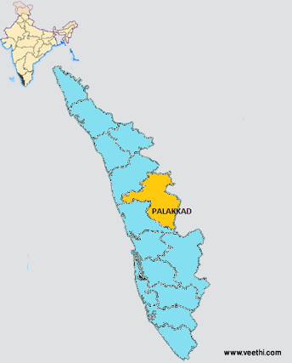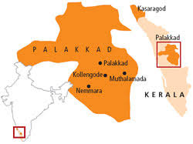
Figure 1
Palakkad Map Showing Selected Areas For The Study

B. Selection of Sample
The population of this two panchayath is censused around 34,167 (Panchayath census, 2001). They are using endosulfan for their cultivation to expel in the markets. Pesticide was sprayed in the paddy fields and also on individual trees with nozzles directed skywards. The person spraying gets affected almost instantly and also effects were transferred genetically to kids in their late life. Even the other people are battered and benumbed by the residuary harm caused by the endosulfan. Among 34,167 total residents in this area around 188 endosulfan victims reported by the medical survey conducted by the Primary Health Centre of the Panchayath in 2010. Endosulfan craves lives in Muthalamada “Mango City”and according to the health survey conducted by Ecological protection group(January ,2006)found one third of 500 families living in area are effected by deadly diseases such as Cancer, mental disability, genetic and related disorders(The Hindu, 2006). Therefore a total of 150 sample were selected from the affected victims of varying age groups were selected. These respondents were willing to participate in the study, so they were selected on Purposive sampling method , and the information concern were obtained from these respondents . The sampling here is confined to specific types of people who would provide the desired information either because they are the only one who have it or confirm to some criteria by the researcher (Sekaran, 2007). The present study was passed under Human Ethical Committee of Avinashilingham University .

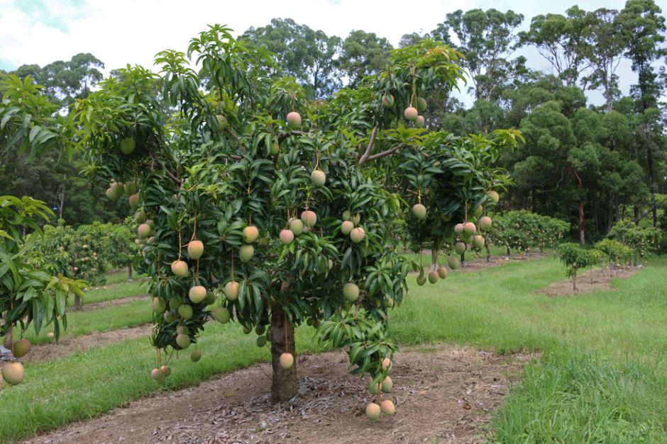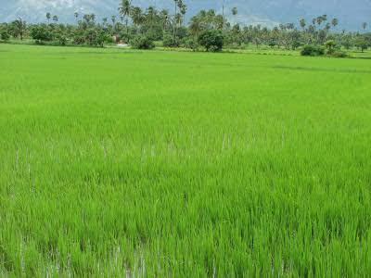
Figure 2
(b) Paddy fields of Kollengode
- Mango orchard of Muthalamada

D. Formulation of a Tool
An interview schedule as shown in the appendix with a set of well orchestrated and systematic questions was developed. A questionnaire is a research instrument consisting of series of questions and other prompts for the purpose of gathering information from the respondants. Questionnaires have advantages over some other types of surveys, in that they are cheap, donot require as much effort from the questioner as verbal or telephone surveys and often have standardised answers that make it simple to compile data (Foddy, 2001).
A well designed interview schedule was framed to elicit the information from the victims regarding socio-economic status, nutritional status, life style pattern, past and present medical issues, dietary intake (using food frequency method and 24 hour recall method), available sources of water and their intake, safety and hygienic practices followed by them before using any perishables and their knowledge about the use of pesticides as shown in Appendix I.
E. Conduct of Survey
A survey was conducted using the interview schedule to collect the data pertaining to the study from the selected 150 Endosulfan victims.
1.Socio Economic Status
Socioeconomic status is an individual’s or family’s economic and social position, based on income, education and occupation. When analyzing a family’s socioeconomic status, the household income, earners’ education and occupation are examined (National Center for Educational Statistics, 2008).
Collection of data regarding the details of the victims like family income, educational level and occupation of parents and personal details of the sample were taken to assess the living status of the endosulfan victims.

Phase II : Assessing the Nutritional and Health Status of the selected Endosulfan victims. F. Assessment of Health Status
In order to assess the health and nutritional status of the selected victims the anthropometric measurements and dietary survey was conducted.
1. Anthropometric Measurements
Anthropometric measurements like height and weight of the target groups were measured by following the standard process recommended by (Jelliffe, 1988).
Anthropometric involves obtaining physical measurements of an individual and relating them to standards that reflect the growth and development of an individual. These physical measurements are another component of then nutritional assessment and are useful for evaluating over nutrition or under nutrition(Krause, 2008). Anthropometric measurements such as measurements are height, weight, waist circumference and hip circumference were measured for victims.
The measurements taken on an individual are compared with standards specific for sex and age. Those standards in turn ideally are derived from measurements taken on large numbers of people of the same race and geographic location as those being measured. Height and weight are well recognized anthropometric other include fat fold measurements and various measures of lean tissue some are used in specific situations. Anthropometric are particularly useful when they are measured at interval overtime (Whitney, 1986)
1.1 Height
. When populations share genetic background and environmental factors, average height is frequently characteristic within the group. In regions of extreme poverty or prolonged warfare, environmental factors like chronic malnutrition during childhood or adolescent may account for delayed growth and marked reductions in adult stature even without the presence of any of these medical conditions (William, 2001)
The height of the subjects was taken by measuring tape fitted in the wall and the subjects were made to stand erect in a levelled surface with heels together and toes apart without shoes. Height of the subjects was measured as depicted in Plate I.
1.2 Weight
Body weight is the common general measure of physical growth. The weighing balance is useful and accurate tool for investigating the nutritional status. The subject in minimal clothing and without shoes, stands with weight evenly distributed on both feet and weight is recorded to the nearest 0.1Kg (Garg, 2006).The weight of the victims was measured by electronic weighing balance, depicted in Plate II.
1.3 Body Mass Index (BMI)
The Body Mass Index (BMI) estimates the ideal weight of a person based on its size and weight and is valid for an adult man or woman of 18 to 65 years. The BMI is also called index Quètelet invented by the Belgian Scientist Jacques Quètelet,2001. The World Health Organisation (WHO) defined this body mass index as the standard to measure the risks associated with the overweight in adults (Mackay, 2010). The BMI of the selected individuals were calculated to assess the nutritional status.
BMI = Weight (Kg) / Height in (m²)

Table I
Classification Of Body Mass Index
Indication | BMI
Severe thinness | <16.00
Moderate thinness | 16.00 – 16.99
Mild thinness | 17.00 – 18.49
Normal | 18.50 – 24.99
Over- weight | 25.00 – 29.99
Obese class I | 30.00 – 34.99
Obese class II | 35.00 – 39.99
Obese class III | >40.00

Source : World Health Organisation (2011)
The study includes all the age group and BMI is being age specific, so child’s and adolescent health status is determined using age and sex specific percentile for BMI rather than BMI categories used for adults.

Table II
Percentile Values for Children and Adolescent
Percentile | Category
1st to 4th percentile | Under weight
5th to 85th percentile | Normal
85th to 94th percentile | Over weight
95th to 100th percentile | Obese

Source : Center for Control and Disease prevention(2004)
  - Waist Circumference
Waist circumference is one way to determine the increased amount of fat around belly which is the indicator for health risk (Wade, 2011). National Institutes of Health indicates that a high waist circumference is associated with an increased risk for health conditions like hypertension, elevated blood lipids, type 2 diabetes and Cardio vascular diseases.
The WHO STEPS protocol for measuring waist circumference instructs that the measurement be made at the approximate mid point between the lower margin of the last palpable rib and the top of the iliac crest (WHO, 2008). Both the protocol described in NIH practised guide to obesity (NHCBI, Obesity Education Initiative, 2000) and NHANES III protocol (Westat Inc, 1998) recommends the use of stretch resistant tape that provides a constant 100g of tension through the use of special indicator buckle, that the measurement are made with the tape held snugly, but not constructing and at a level parallel to the floor.
The waist circumference was measured for the endosulfan victims by measuring tape is depicted in Plate III.
  - Hip Circumference
Hip circumference is one way to determine whether you have an increased amount of fat around hip portion and whether you are at increased health risk (Wade, 2011). According to WHO STEPS protocol, the hip circumference measurement should be taken around the widest portion of the buttocks.
The selected respondent is asked to remove clothing expect for light under wear and should stand straight with feet fairly close together. The measuring tape is held firmly and the

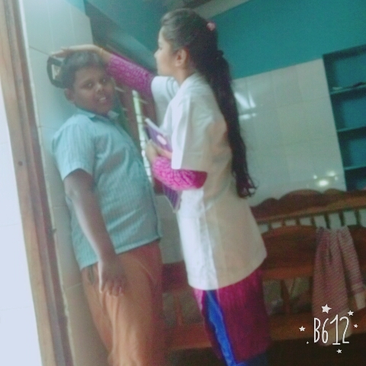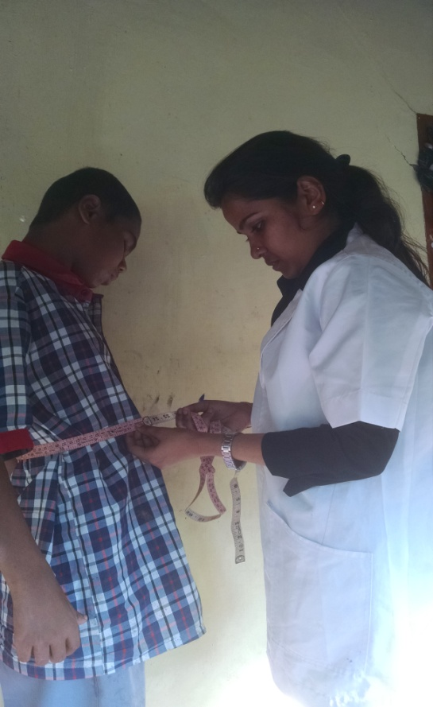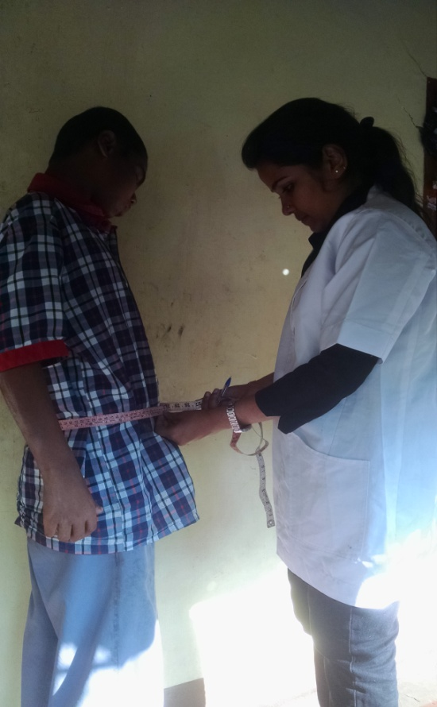
ANTHROPOMETRIC ASSESSMENT
Plate III : Measuring the Waist Circumference of the Selected Respondents
Plate II : Measuring the Hip Circumference of the Selected Respondents
Plate I
Mesuring the Height of the Selected Respondent

measurement is taken at the end of gentle exhaling. (FEHES, 2009).The hip circumference for the endosulfan victims was measured by measuring tape, depicted in Plate IV.
1.6 Waist Hip Ratio (WHR)
The Waist in relation to Hip is found out in the ratio using the formula;
Waist Hip Ratio = Waist Circumference ( cm)/ Hip Circumference ( cm)
The Waist Hip Ratio was found out to find the differences in body fat percentage and is better predictor of cardio vascular diseases, body fat distribution, hypertension in type 2 diabetes (Huxley, et al., 2010)
Table III
Waist Hip Ratio
Category | Women | Men
Normal weight  Over weight  Obesity | < 0.80  0.08 – 0.84  >0.85 | <0.90  0.90 – 0.99  >1.00
2. Clinical Assessment
Clinical assessment, sometimes referred to as a health assessment, is a documented process that is used to evaluate, diagnose and treat individuals. These assessments provide results that only take into account the individual who is being evaluated, rather than evaluating individuals based on the data that is compiled from multiple sources. Clinical examination was done to each selected victims for assessing the health of the skin, hair, mouth, teeth etc (Epstein, 2003). Clinical assessment of the victims is depicted in Plate V.
3.Life Style Pattern
Life style typically reflects an individual’s attitudes and values towards life. It is the way of living of individuals, families, and societies, which they manifest in coping with their physical, psychological, social and economic environments on a day to day basis. It is expressed in both work and leisure behavior pattern(www.apjor.com)The life style pattern of the victims was elicited through the questions that collects the information regarding the activity, sleeping pattern, habits and exercises done.
4. Medical History
The past and the present medical history of the selected endosulfan victim was collected to find out the co-incidence of the medical history with the present health status of the victims. The inheritance of the diseases from the parent to next generation was also
ENDOSULFAN VICTIMS FROM THE SELECTED AREA
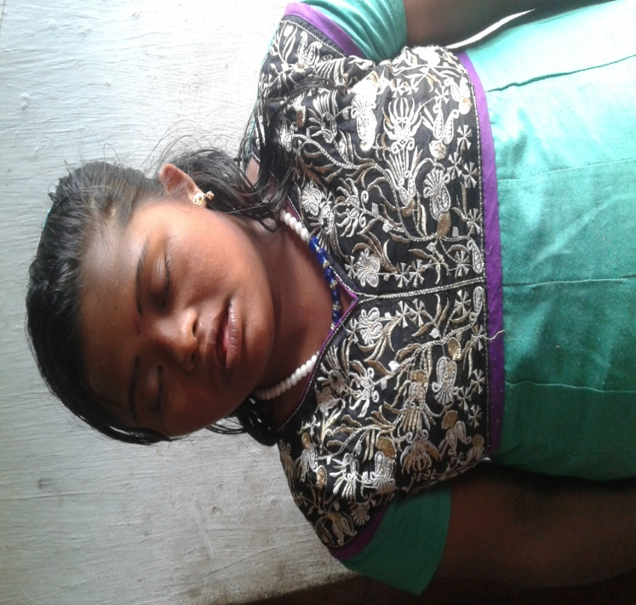
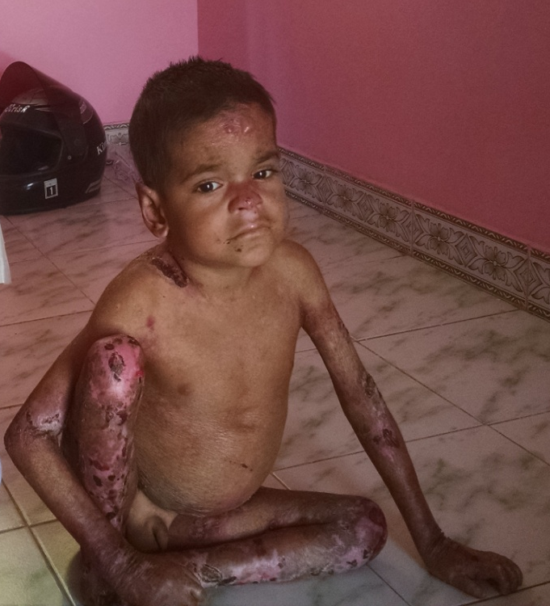

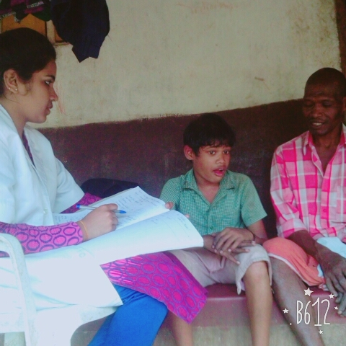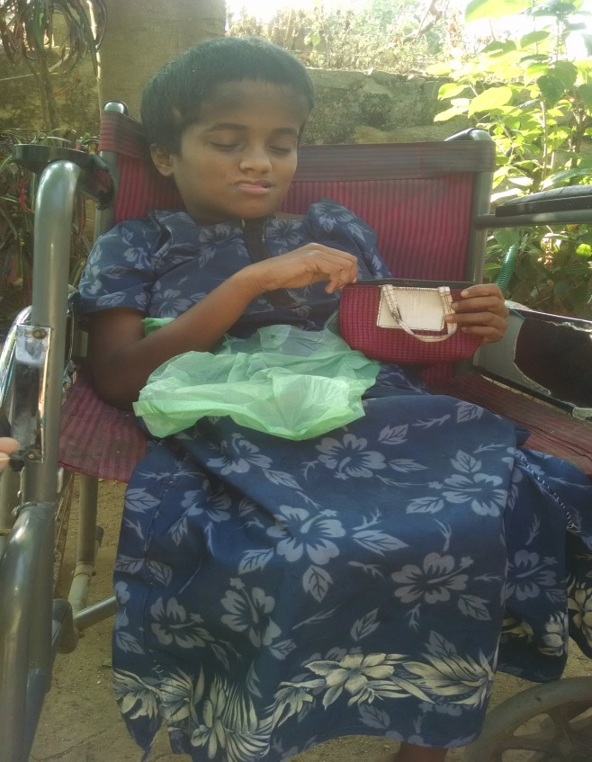
Plate IV : Victims of Endosulfan from the Selected Area of Study

collected. The surgeries carried out and the medications taken was also elicited from the selected endosulfan victim.
5. Dietary Method
A dietary assessment should be completed as part of the overall nutritional assessment. Poor micronutrient and macronutrient intake can have adverse effects on general health and immune function (Vivian, 2011). Many methods are used for assessing dietary intakes for clinical purposes and 24-hour diet recall method and food records are most common. Single 24 hour diet recall and food frequency questionnaire are most useful for estimating dietary intake of groups (Judith et al., 2008).
A twenty four hour recall is a dietary tool in which an individual is asked to recount all the food, beverages and nutritional supplements consumed during a 24 hour period. The twenty four hour period being recalled is usually from midnight to midnight from the previous day or over past 24 hours (Mandy, 2010). Using the 24 hour diet recall method , the food consumed by them for three days is being collected and the Nutritive value of the food is being used to calculate to find out whether they meet the recommended nutrients(Gopalan et al., 2001).
Food frequency questionnaire can provide information about the individuals’ food intake over a specified length of time. It consists of lists of food and a scale indicating the frequency of consumption of that food over a given period of time such as week or month (Rao, 2005). Food frequency questionnaire was used to find out the frequency of consumption of certain foods in the food group and also to find out the nutrient intake of the family.
Phase III : Chemical analysis of the sample from the selected area for the study
A. Chemical Analysis
1.Chemical Analysis of Drinking water
Water samples were collected from three different sources like Chulliyar dam water (used for irrigation), Meenkara dam water (available water source for the people for general use), bore well and the analysis is done using following parameters like pH, colour, taste, odour, electrical conductivity, carbonates and bicarbonates, chlorine following the standardised procedure as given in Appendix IV.
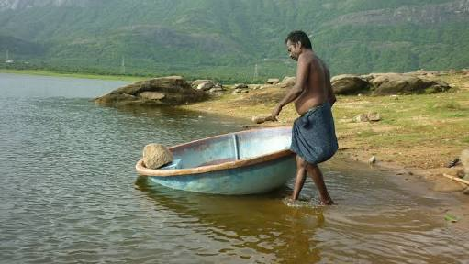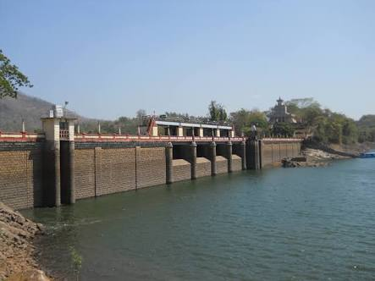
Figure 3: Samples of water collected for analysis

2.Soil Analysis
The soil sample was collected from cultivation area of the both the panchayath, just beneath the crop and from the normal plain land and the NPK test was done to find out the nutrient content and the present state of the soil. This test helps to find out whether the land is again fit for agriculture in future. The NPK test brings out the chemicals present in the soil. The standardised procedure followed for the testing is given in Appendix V.
3.Adulteration of Milk Sample
Sample of milk that people residing in this area is consuming is being collected from and is being tested. The milk is tested for the adulteration. The standardised procedure followed for the testing is given in Appendix VI.
Phase IV : Intervention programme and Statistical analysis
- Intervention Programme
It is realised that there is a need for creating awareness on the use of poisonous chemical and organic fertilizers in their panchayath for their agricultural purpose, hence intervention programme was planned to educate the young children of (9th and 10th students) of Muthalamada panchayath who is the future carriers of their hereditary land and the out runners. Methods of prevention of ingestion of chemicals through safety measures were discussed using different visual aids, Importance of having a kitchen garden were also taught. The introduction to endosulfan, its usage in their panchayath , sources and harmful effects of the living organism and the food chain and the victims of the Endosulfan is presented to them in the power point. Awareness on its demerits and its usage is created among them. The after effects of consuming the vegetables and foods that is cultivate through Inorganic method is presented to them through power point presentation. The video clippings on the hygienic practices to be followed before consuming food like hand washing clippings, cleaning and washing vegetables before cooking info-graphics were also presented during the intervention programme . As they are the future carries of their agricultural land and the future of the panchayath is in their hands, so awareness was created among them to change over from inorganic farming to organic farming. Kitchen garden with the seedlings of chillies, peas, ladies finger , tomato and brinjal was encouraged to be planned by them in the school campus and educated among them the importance of having home kitchen garden in their own homes and ask them to plant in their own homes also to follow up and maintain the kitchen garden planted in their own school without using any chemicals, only by using organic fertilisers.
During data collection, the diet of the victim is being studied and the deficiencies were also being observed and a diet counselling on the intake of healthy and nutritious food is being given to their parents of the selected endosulfan victims.
The water source from Meenkara dam water and borewell which is highly contaminated and is causing allergy and the portable. They does not follow any treatment for making water safe for drinking other them boiling and storing it for two days was observed according to the survey conducted, so a model of Zero energy table top bio charcoal filter was presented and explained to them which is highly efficient and highly feasible even for the common people was developed by the researcher and was demonstrated to respondents imparting the important use of water filter, how water is easily purified without investing more money. So that they can make their own filter and use for their daily purpose. The real model is depicted in plate VI
Since the people who are working in the agricultural land is highly infected by the use of pesticides and other chemicals, so the OSHA has already put forward certain hygienic and safety practices that they should follow in work place which they are not aware of, such as exposure sources and control measures, medical monitoring, work place monitoring and personal hygienes such as clothings and safety equipments to be used while working. So awareness of those safety and hygienic measures that is to be followed by the workers in the agricultural land is being explained and brochures is distributed to them mentioning the measures. Since most of the population in this area has agriculture, especially fertiliser and pesticide spraying as the only source of income and the educational status is very low, it is not possible for them to quit from its ill effects. So in order to prevent further exposure of humans to pesticides and contribute to grow a new bud of victim, an awareness was done to the farmers.
- Statistical Analysis
After the data has been collected, the researcher starts analyzing them. The analysis of data required a sample of closely related operations, such as establishment of categories, tabulation and statistical inferences (Kothari, 2005).
Using SPSS version 23, collected data is being consolidated and the statistical analysis is done using the tools like Chi²test, paired comparison test, ANOVA test, correlation and regression.

Impure water is taken inside
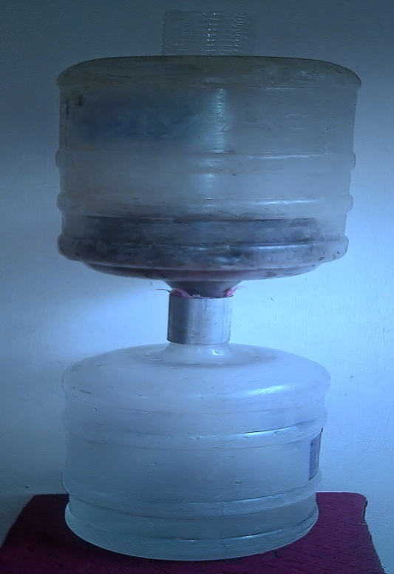
Pure water is collected
CTreated CharcoalTreated
charcoal

Fig 4. Model of Zero Energy Table Top Bio-Charcoal Filter

INTERVENTION PROGRAMME

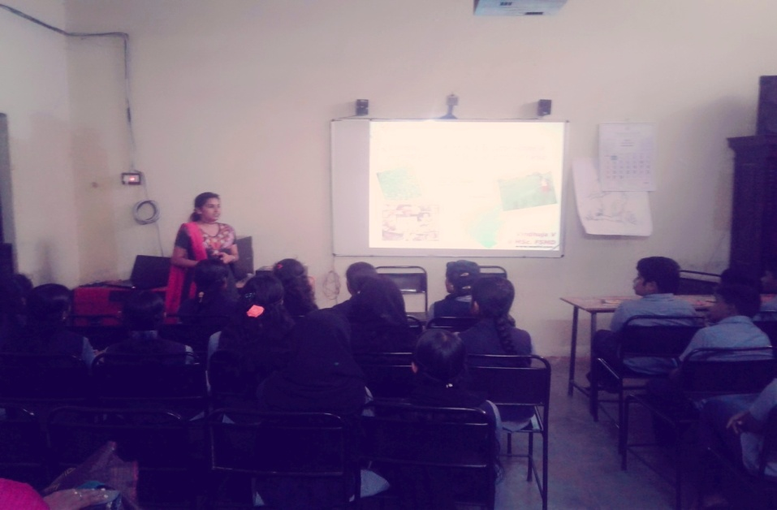
Plate V : Power point presentation for school children on Use and effect of Endosulfan in their Panchayath and Food safety and Hygiene Practices to be followed

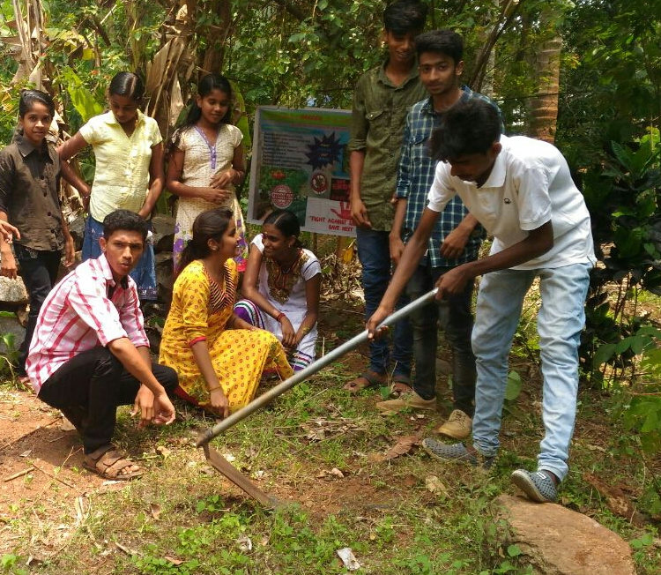
Plate VI : Planting Kitchen Garden in their School Campus

PHASE I
Selection of Topic
Co-Morbidity among Endosulfan Victims in Selected Panchayath of Kerala
Framing of Questionnaire
and
Ethical Committee
Approval

Selection of Area
Muthalamada and Kollengode Panchayath
Selection of Victims
Endosulfan Victims of all age groups

PHASE II
Screening of Endosulfan Victims
Socio Economic Status
Anthropometric Measurements
Dietary assessment

Medical History
Identification of Symptoms

PHASE III
Testing the
Quality of Land
and also the Drinking
water and milk
Chemical Analysis
Milk Sample from the Selected Area
Soil Sample from the Selected Area
Water Sample from Selected Area

PHASE IV
Awareness of Use of Endosulfan
Statistical Analysis
Nutritional Education
Impact of Zero Energy charcoal filter

Fig 5 ; Research Design of the Study

Results and Discussion
IV RESULTS AND DISCUSSION
The result and discussion pertaining to the study “Co-Morbidity Among The Endosulfan Victims in Selected Panchayath of Kerala”, is presented under following headings.
- Eliciting Background Information of the Endosulfan Victims
- Eliciting the Life style Pattern of the Selected Respondents
- Anthropometric Assessment of Endosulfan Victims
- Clinical Examination of Endosulfan Victims
- General Health of the Endosulfan Victims
- Studying the Present Medical Background of the Endosulfan Victims
- Dietary Pattern of the Selected Respondents

A.Eliciting the Background Information of the EndosulfanVictims
Socio economic factors are the economic and social position of an individual or family, based on income, education and occupation. In socio economic status, the household income, earner’s education and occupation are examined (National Center for Educational Statistics, 2008)
- Area Wise Distribution of the Selected Respondents
Area was taken as a criteria for assessing the influence and occurance of health issues and their consequences among the selected respondents. The area wise distribution of the endosulfan victims is tabulated in Table IV.
Table IV
Area Wise Distribution of the Selected Respondents

Panchayath of Kerala  District | No of respondents (N=150)
Panchayath of Kerala  District | Male |  | Female
Panchayath of Kerala  District | Number | Percentage | Number | Percentage
Muthalamada Panchayath | 48 | 32 | 54 | 36
Kollencode Panchayath | 18 | 12 | 30 | 20

For the present study, 150 endosulfan victims were selected, among them 32 percent males and 36 percent females were from Muthalamada Panchayath and 12 percent males and 20 percent females were from Kollencode Panchayath. Majority of the victims of 68 percent were from Muthalamada Panchayath and only 42 percent were from Kollencode Panchayath.
- Distribution of Endosulfan Victims According to Age Group
Age group was taken as criteria for the assessment of occurance of health problems regarding the infestation of endosulfan among the different age groups. Measuring of population in relation to age group is very important because they shape the perceptions of demographic trends (Fabrice Collard, 2013). Distribution of respondents based on age group is tabulated in Table V.
Table V
Distribution of the Selected Endosulfan Victims According to Age Group

Age group | No of respondents (N=150)
Age group | Muthalamada Panchayath |  |  |  | Kollencode Panchayath
Age group | Male |  | Female |  | Male |  | Female
Age group | Number | % | Number | % | Number | % | Number | %
Children | 23 | 15 | 18 | 12 | 4 | 4 | 8 | 5
Adolescent | 9 | 6 | 9 | 6 | 5 | 4 | 6 | 3
Adult | 12 | 8 | 21 | 14 | 7 | 5 | 10 | 6
Old age | 4 | 3 | 6 | 4 | 2 | 1 | 6 | 4

Among the 68 percent respondents from the Muthalamada Panchayath, 27 percent(15 percent boys and 12 percent girls) were children, 12 percent were adolescent. Among 12 percent adolescent(Five percent were boys and seven percent were girls) whereas in adult group 22 percent was contributed to the study 14 percent males and eight percent females. Incase of old age only four percent males and three percent females were included in the study.
Among the 42 percent of the respondents from Kollencode Panchayath, nine percent were children, seven percent were from adolescent, 12 percent from adult and five percent from old age. Among the nine percent of children, four percent were boys and five percent were girls. Four percent of adolescent boys and three percent adolescent girls was found as victims. Five percent of adults were males and six percent of adults were females. In case of old age group only one percent male and four percent females was noted to be endosulfan victims.
- Education Level of Parents of Selected Respondents
Education in its general sense is a form of learning in which the knowledge, skills and habits of a group of people are transferred from one generation to the next through teaching, training or research. Kerala is one of the most literate states in India. The state’s literacy rate is 94 percent in 2011, which is above the national average(TOI, 2013). The literacy rate of Palakkad district of Kerala is 94 percent(Census, 2011), where the selected area of study is located. The education level of parents was taken to find whether they can give proper guidance for their children about their health related issues. The education level of parents is depicted in Table VI.
Table VI
Educational Level of Parents of Selected Respondents

Education* | Muthalamada Panchayath |  |  |  | Kollencode Panchayath
Education* | Father |  | Mother |  | Father |  | Percentage
Education* | N | (%) | N | (%) | N | (%) | N | (%)
Primary | 64 | 43 | 58 | 39 | 26 | 17 | 28 | 19
High school level | 26 | 17 | 18 | 12 | 10 | 7 | 13 | 9
Higher secondary | 8 | 5 | 9 | 6 | 7 | 5 | 4 | 3
Under graduation | 4 | 3 | 13 | 9 | 5 | 3 | 3 | 2
Post graduation | - | - | 4 | 3 | - | - | - | -
*International Standard Classification of Education(ISCED), 2011
The data presented in Table VI shows that, parents of 150 respondents were literates and they were educated with minimum qualification of primary level up to post graduate level. A majority of 43 percent of fathers and 39 percent of mothers from Muthalamada Panchayath and 17 percent father and 19 percent mothers had education up to primary level. Only three percent mother’s and had education up to post graduation.
- Occupational Status of the Selected Respondents
The occupational status may reflect social networks, work based stress, control and autonomy and thereby affect the health outcomes through psychosocial processes. It also reflect specific toxic environment or work task exposures(Duncan et al., 2001). The occupational status of the respondents were tabulated in Table VII
Table VII
Occupational Status of the Selected Respondents

Type of Occupation | Muthalamada  Panchayath  (N = 102) |  | Kollencode  Panchayath  (N = 48)
Type of Occupation | Number | (%) | Number | (%)
Agriculture | 38 | 25 | 14 | 9
Mining | 8 | 5 | 2 | 1
Education | 2 | 1 | 2 | 1
Government | 6 | 4 | 4 | 3
Others | 15 | 10 | 8 | 5

Among the respondents 36 percent of the respondents were children and remaining 64 percent were adolescent category. Twenty five percent of the respondents from Muthalamada Panchayath and nine percent from Kollencode Panchayath are doing agriculture as their main occupation. Ten percent of respondents from Muthalamada and five percent of respondents from Kollencode Panchayath perform some other occupations like cattle rearer’s, vendors, house maids and fishing. Thirty six percent of children were going for special education school named Kiran Jhyothi in the Kollencode Panchayath.
- Distribution of Endosulfan Victims According To Income
Family income is a measure of the combined incomes of all people sharing a particular household or place of incidence. It includes every form of incomes like salaries, wages, retirement income etc. Average family income can be used as an indicator for the monitory well being of citizens of a country(http://stats.oecd.org). It has a cumulative effect over life course(Lynch , 2001).
Income levels of the selected respondents were categorized according to the HUDCO (Housing and Urban Development Corporation income classification, 2010).
The monthly income of the respondents and distribution according to income is depicted in Table VIII

Table VIII
Distribution of Endosulfan Victims Based on Income

Income Range*  (₹) | Muthalamada Panchayath |  | Kollencode Panchayath
Income Range*  (₹) | Number | (%) | Number | (%)
Less than 3000 | 34 | 23 | 18 | 12
3001 – 5000 | 26 | 17 | 10 | 7
5001 – 10,000 | 24 | 16 | 4 | 3
Above 10,000 | 18 | 12 | 16 | 11
*HUDCO (Housing and Urban Development Corporation, 2010)

Fig 6 : Distribution of respondents in Muthalamada Panchayath and Kollencode Panchayath According to Income

B. Eliciting the Life Style Pattern of Endosulfan Victims

Life style typically reflects an individual’s attitudes and values towards life. It is the way of living of individuals, families, and societies, which they manifest in coping with their physical, psychological, social and economic environments on a day to day basis. It is expressed in both work and leisure behavior pattern(www.apjor.com).

- Distribution of Endosulfan Victims Based on Activity
The distribution of the Endosulfan victims based on the activity is tabulated in Table IX

Table IX
Distribution of Endosulfan Victims Based on Activity
Types of activity | Muthalamada Panchayath |  | Kollencode  Panchayath
Types of activity | Male  (%) | Female  (%) | Male  (%) | Female  (%)
Sedentary | 6 | 10 | 3 | 11
Moderate | 13 | 6 | 4 | 3
Heavy | 18 | 13 | 7 | 4

Among the 68 percent of respondents in Muthalamada Panchayath, 18 percent of male and 13 percent of female respondents were heavy workers, six percent of male and 10 percent of female respondent were sedentary and 13 percent of male and six percent of female belong to moderate. Majority of the respondents were heavy worker and it was found mostly in the age group of adults as they are engaged in heavy work activities like agriculture and quarry workers.
Among 42 percent of the respondents in Kollencode Panchayath, three percent of male and 11 percent of female respondents were performing sedentary activity, four percent of male and three percent of female were moderate in activity and seven percent of male and four percent of female were heavy worker, majority of the respondents from this area were sedentary in nature.
- Recreational Habits Among the Selected Respondents
The recreational habits among the respondents is tabulated in Table X
Table X
Recreational Habits Among the Selected Respondents

Habits |  | Muthalamada  Panchayath |  | Kollencode  Panchayath
 |  | Number | (%) | Number | (%)
Smoking  (Beedi) | 1 – 10 nos | 3 | 2 | 3 | 2
Smoking  (Beedi) | >10 nos | 10 | 7 | 7 | 5
Alcohol | 100 – 200ml | 11 | 8 | 7 | 5
Alcohol | >200ml | 5 | 3 | 5 | 3
Tobacco chewing |  | 18 | 12 | 10 | 7

From the above table X, the lifestyle habits of the respondents showed that only 53 percent of the respondents had the habits of smoking, consuming alcohol and chewing tobacco. Among 32 percent of the Muthalamada Panchayath respondents, nine percent had habit of smoking, 11 percent had habit of consuming alcohol whereas 12 percent have habit of chewing tobacco. Among 21 percent of the Kollencode Panchayath respondents, seven percent smoked beedi daily, eight percent had habit of consuming alcohol and seven percent adults and old people chew tobacco daily. Majority of respondents had habit of chewing tobacco, even the adult and old age females had the habit of tobacco chewing.
3.Watching Television
The time spent by the respondents for watching television is tabulated in table XI
Table XI
Habit of Watching Television
Watching Timings  (Hours) | Muthalamada Panchayath |  |  |  | Kollencode Panchayath
Watching Timings  (Hours) | Children  (%) | Adolescent  (%) | Adult  (%) | Old age  (%) | Children  (%) | Adolescent  (%) | Adult  (%) | Old age  (% )
2 | 4 | 4 | 14 | 6 | 1 | 1 | 4 | 2
More than 2 | 10 | 7 | 4 | 6 | 6 | 3 | 2 | 1
Rarely | 1 | 1 | 5 | 3 | 1 | 1 | 2 | 3
Never | - | - | 2 | 1 | 1 | - | 3 | 1

From the data given in the table XI, 10 percent children of Muthalamada Panchayath and six percent of children of Kollencode Panchayath respondents had habit of watching television for more than 2 hours. In the adolescent age group seven percent from Muthalamada Panchayath and three percent from Kollencode Panchayath watches television for more than 2 hours. Fourteen percent of adults of Muthalamada Panchayath and four percent from Kollencode Panchayath spent their leisure time to watch television for 2 hours. Only six percent of old age from Muthalamada Panchayath and two percent from Kollencode Panchayath watch television for 2 hours. Majority of the children from both the area spent their time for watching television.

4.Sleeping Pattern of the Selected Respondents
The sleeping pattern of the respondents is noted in the table XII

Table XII
Sleeping Pattern of the Selected Respondents
Hours of Sleeping  (Hours) | Muthalamada Panchayath |  |  |  | Kollencode Panchayath
Hours of Sleeping  (Hours) | Children  (%) | Adolescent  (%) | Adult  (%) | Old age  (%) | Children  (%) | Adolescent  (%) | Adult  (%) | Old age  (%)
< 2 | 4 | 6 | 7 | 10 | 1 | 2 | 3 | 3
2 – 4 | 1 | 2 | 4 | 5 | 1 | 1 | 3 | 2
5 – 8 | 1 | 8 | 4 | 3 | 1 | 1 | 3 | 1
> 8 | 7 | 3 | 2 | 1 | 4 | 3 | 1 | -

In the children category normal sleeping pattern(more than 8 hours) was observed in two areas. In the adolescent category eight percent respondents from Muthalamada Panchayath sleep for 5-8 hours whereas from Kollencode Panchayath only one percent sleep for 5-8 hours. Seven percent and three percent adult category from Muthalamada Panchayath and Kollencode Panchayath area respectively sleep for less than 2 hours. In case of old age category, ten percent from Muthalamada Panchayath and three percent from Kollencode Panchayath also slept for less than two hours. Majority of the adults and old age had a complaint of sleeplessness.

5.Exercises Practiced by the Respondents
The exercises practiced by the respondents is tabulated in Table XIII
Table XIII
Exercise Practised by the Respondents
Types of Exercises | Muthalamada Panchayath |  | Kollencode  Panchayath
Types of Exercises | Number | (%) | Number | (%)
Aerobic | 4 | 2 | - | -
Yoga | 9 | 6 | - | -
Walking | 20 | 13 | 25 | 17
Swimming | 2 | 1 | 5 | 3

From the table XIII, 13 percent from Muthalamada Panchayath and 17 percent from Kollencode Panchayath have the habit of walking to work place, market etc. Two percent and six percent perform aerobic and yoga practices mainly performed by the children of Muthalamada Panchayath respectively as they are made compulsory to perform by their authorities of special school.
C. Anthropometric Assessments of Endosulfan Victims
1.Distribution of Endosulfan Victims According to BMI
The Body Mass Index (BMI), or Quetelet index, is a measure of relative weight based on an individual’s mass and height. It is also defined as the individual’s body mass divided by the square of their height – with the value universally being given in unit of Kg/m^{2.} The height and weight were measured for all the selected subjects to reduce their body mass index(Eknoyan, 2007).
The BMI was calculated for adult and old age and is arranged based on the classification of BMI by World Health Organization(2013).The distribution of endosulfan victims according to BMI is tabulated. The percentile categorization of the children and adolescent is tabulated in table XIV
Table XIV
Distribution of Children and Adolescents According to Percentile
Percentile | Muthalamada Panchayath |  | Kollencode Panchayath
Percentile | Children  (% ) | Adolescent  (%) | Children  (%) | Adolescent  (%)
1st to 4th percentile | 18 | 6 | 4 | 3
5th to 85th percentile | 6 | 1 | 2 | 2
85th to 94th percentile | 2 | 4 | 3 | -
95th to 100th percentile | - | 1 | - | 2
*Centre for disease control and prevention, 2004

The above table shows the distribution of children and adolescent according to percentile. From Muthalamada Panchayath, 18 percent of children were under weight with less than percentile 5, six percent were normal with percentile 5th to 85th and two percent were over weight. Six percent of adolescent were under weight, four percent were over weight and one percent were normal and obese. From Kollencode Panchayath, four percent of children were under weight, three percent were over weight and two percent of children were normal. Three percent of adolescent were under weight, two percent were normal and obese.
The distribution of adult and old age according to BMI is tabulated in table XV
Table XV
Distribution of Adult and Old age According to BMI
BMI | Muthalamada Panchayath |  |  |  | Kollencode Panchayath
BMI | Adult |  | Old age |  | Adult |  | Old age
BMI | M  (%) | F  (%) | M  (%) | F  (%) | M  (%) | F  (%) | M  (%) | F  (%)
Severe thinness | - | - | - | - | - | - | - | 1
Moderate thinness | - | 1 | - | - | - | 2 | - | 1
Mild thinness | 2 | 1 | - | 2 | 1 | - | 1 | -
Normal | 6 | 2 | 2 | 1 | - | 3 | - | -
Over weight | 4 | - | 1 | - | 3 | - | - | -
Obese class I | 2 | - | 1 | - | 1 | - | - | 1
Obese class II | - | - | - | - | - | - | - | -
*World Health Organization Classification, 2013
The above table shows the distribution of adults and old age respondents according to BMI. From Muthalamada Panchayath six percent of the adult male and two percent of adult female were categorized as normal with BMI (18.5-24.99). Two percent male from old age were categorized as normal and two percent of female were under mild thinness with BMI within 17.00-18.99. From Kollencode Panchayath, three percent adult male were categorized as over weight with BMI between 25-29.9 and three percent adult female were found to be normal. One percent of adult male were categorized as mild thinness and one percent of old age female were obese with BMI between 30.00-34.99.

1.1 Dependence of BMI to the Age of the Selected Respondents
The dependence of BMI to the age of the selected respondents is tabulated in table XVI

Table XVI
Dependance of BMI to the Age of the Selected Respondents
Dependence variable | Age group Factor | Mean ±SD | F | Significance
BMI | Children | 1.207±0.40 | 30.941 | 0.000*
BMI | Adolescent | 3.166±0.698 | 30.941 | 0.000*
BMI | Adult | 4.541±0.849 | 30.941 | 0.000*
BMI | Old age | 5.421±0.507 | 30.941 | 0.000*
*Significant at 0.01 percent level

Body Mass Index and age factors show 0.01 percent significant level of children, adolescents, adult and old age.

- Distribution of Endosulfan Victims According To Waist Hip Ratio
The distribution of adult and old age according to Waist hip ratio is tabulated in table XVII
Table XVII
Distribution of Endosulfan Victims According to Waist Hip ratio

Waist Hip Ratio | Muthalamada Panchayath |  |  |  | Kollencode Panchayath
Waist Hip Ratio | Adult (%) |  | Old age (%) |  | Adult (%) |  | Old age (%)
Waist Hip Ratio | M | F | M | F | M | F | M | F
Less than 1 | 4 | - | 2 | - | 3 | - | - | -
Greater than 1 | 2 | - | 1 | - | 1 | - | - | -
Less than 0.85 | 2 | 3 | - | 2 | - | 2 | 1 | 2
0.85 | - | 2 | - | 1 | - | 3 | - | -
Greater than 0.85 | 6 | - | 1 | - | 1 | 1 | - | 1

The above table shows that the waist hip ratio of selected respondents. It was taken as a parameter for measurement only for adult and old age to find the differences in body fat percentage. Among the adults from Muthalamada Panchayath, six percent of male had waist hip ratio greater than 0.85 by which they are normal in weight where as three percent adults from Kollencode Panchayath had waist hip ratio greater than 0.85 and less than 1 and are categorized as over weight. Three percent of female had waist hip ratio less than 0.85 and are categorized as normal in body weight, where as two percent of female were categorized as under-weight.
Among the old age, two percent of male has waist hip ratio less than 1 and is categorized as normal in weight, where as one percent male from old age had waist hip ratio less than 0.85 and is found as under weight. Two percent of female is under weight with waist hip ratio less than 0.85 from both the selected areas.

- Clinical Examination of the Endosulfan Victims
A clinical assessment is sometimes referred to as a health assessment. It is a documented process that is used to evaluate, diagnose, and treat individuals. The result also can be used to improve the health and productivity of individuals. The clinical examination carried out for the respondents is tabulated in table XVIII
Table XVIII
Clinical Examination of the Endosulfan Victims

Organs | Clinical signs | Children  (%) |  | Adolescent  (%) |  |  | Adult  (%) |  |  | Old age  (%)
Organs | Clinical signs | A1 | A2 | A1 |  | A2 | A1 |  | A2 | A1 |  | A2
General appearance | Loss of subcutaneous fat | 3 | 2 | 2 |  | 1 | - |  | - | 5 |  | 6
General appearance | Sunken or hollow cheeks | 1 | - | - |  | - | - |  | - | 5 |  | 6
Hair | Easily pluckable hair , alopecia | 2 | - | - |  | - | 5 |  | 4 | 4 |  | 5
Hair | Dry brittle hair, cork screw hair | 1 | - | 2 |  | 1 | 10 |  | 5 | 5 |  | 3
Nails | Spooning | - | - | 4 |  | 5 | - |  | - | 4 |  | 6
Nails | Transverse lines | 2 | 1 | 6 |  | 7 | - |  | - | - |  | -
Skin | Dry and scaly flaky paint | 2 | 1 | 4 |  | 2 | 4 |  | 6 | 4 |  | 2
Skin | Hyper pigmentation | 1 | 1 | - |  | - | 12 |  | 5 | - |  | -
Skin | Psoriasis form rash | 4 | 2 | 10 |  | 12 | 13 |  | - | 2 |  | 4
Skin | Perifollicular hemorrhage | - | - | - |  | - | - |  | - | 7 |  | -
Eyes | Night blindness | 4 | - | 4 |  | 3 | 4 |  | 6 | 7 |  | 5
Eyes | Photophobia | 3 | 2 | 5 |  | 2 | 8 |  | 7 | 7 |  | 5
Eyes | Retinal field defect | 2 | - | 4 |  | 8 | 5 |  | 6 | 4 |  | 5
Organs | Clinical signs | Children  (%) |  | Adolescent  (%) |  |  | Adult  (%) |  |  | Old age  (%)
Organs | Clinical signs | A1 | A2 | A1 |  | A2 | A1 |  | A2 | A1 |  | A2
Mouth | Bleeding gums | 7 | 5 | 4 |  | 5 | 14 |  | 11 | 4 |  | 1
Mouth | Angular stomatitis | 8 | 6 | 6 |  | 7 | 10 |  | 8 | 5 |  | 2
Mouth | Tongue fissuring | 6 | 4 | 5 |  | 4 | 6 |  | 7 | 4 |  | -
Mouth | Loss of tooth enamel | 4 | 3 | 2 |  | - | 5 |  | 4 | - |  | 5
Heart | High output failure | 2 | 1 | 1 | 4 |  | 4 | - |  | 7 | -
Abdomen | Hepatomegaly | - | 1 | - | - |  | - | - |  | 2 | -
Abdomen | Ascites | 2 | - | 7 | 5 |  | 10 | 5 |  | 7 | 3
 | Edema | 2 | 1 | - | - |  | 8 | - |  | 7 | 5
 | Muscle wasting and weakness | 1 | - | - | - |  | - | - |  | - | -
 | Joint pain | - | - | - | - |  | 20 | 10 |  | 5 | 4
Muscles | Atrophic muscles | - | - | 4 | 3 |  | 5 | 8 |  | 4 | 2
Muscles | Decreased grip strength | - | - | 3 | 3 |  | - | - |  | 1 | 2
Neurological | Dementia | 3 | - | - | - |  | 15 | 10 |  | 5 | 2
Neurological | Acute disorientation | 1 | - | - | - |  | - | - |  | 2 | -
Neurological | Tetany | - | - | 4 | 2 |  | 10 | 15 |  | - | -
Neurological | Paresthesias | 2 | - | - | - |  | - | - |  | 4 | 3
Neurological | Wrist or foot drop | - | - | - | - |  | - | - |  | - | -
Neurological | Diminished reflexes | - | - | - | - |  | - | - |  | 3 | 4
Neurological | Ophtalmoplegia | - | - | - | - |  | - | - |  | - | -
Neurological | Hyper activity | 2 | 1 | 5 | 4 |  | - | - |  | - | -
*A1- Muthalamada Panchayath, A2- Kollencode Panchayath
Children had a common symptom of psoriasis, angular stomatitis, bleeidng gum and tongue fissuring from both the selected areas are found to be deficient in vitamin A, vitamin C, pyridoxine and niacin. Adolescents from both the Panchayath had spooning and transverse nails, psoriasis and angular stomatitis as common symptom and was found deficient in iron, proteins, vitamin A and pyridoxine. From both the Panchayath , adult had dry brittle and cork screw hair, hyper pigmentation, dementia, bleeding gums, angular stomatitis ,photo phobia, joint pain as common issues and are found deficient in proteins, biotin, pyridoxine, niacin, vitamin A, thiamine, calorie. Old age from both the areas had joint pain, angular stomatitis, dementia, tetany, photo phobia, night blindess and retinal field defect as common problem and was found deficient in thiamine, niacin , calcium, vitamin A, calories, proteins and vitamin C. The commonly observed symptom for all the age group is angular stomatistis and psoriasis.
- Identification of Symptoms Among the Endosulfan Victims
Identification of symptoms by the selected endosulfan victims is depicted in table XIX
Table XIX
Identification of Symptoms among the Selected Endosulfan Victims

Symptoms | Muthalamada Panchayath |  |  |  | Kollencode Panchayath
Symptoms | Children  (%) | Adolescent  (%) | Adult  (%) | Old age  (%) | Children  (%) | Adolescent  (%) | Adult  (%) | Old age  (%)
Haemeturia | 10 | 15 | 14 | 12 | 8 | 7 | 15 | 18
Nausea | 18 | 12 | 17 | 16 | 12 | 19 | 15 | 19
Confusion | 21 | 10 | 8 | 12 | 21 | 16 | 10 | 28
Dizziness | 16 | 10 | 38 | 34 | 12 | 22 | 32 | 54
Blurred vision | 15 | 17 | 20 | 68 | 15 | 10 | 40 | 80
Salivation | 21 | 10 | 12 | 72 | 18 | 20 | 21 | 54
Insomnia | 18 | 9 | 25 | 88 | 12 | 54 | 10 | 82
Diarrhoea | 48 | 39 | 37 | 65 | 25 | 14 | 11 | 48
Imbalance | 15 | 54 | 18 | 4 | 24 | 15 | 12 | 55
Loss of appetite | 39 | 18 | 25 | 75 | 16 | 18 | 18 | 60
Irritability | 10 | 16 | 16 | 45 | 17 | 16 | 15 | 55
*Multiple response
From the above table, the presence of symptoms by the respondents can be observed. All the respondents had one or more symptoms. Salivation, diarrhea and loss of appetite were observed among 21 percent, 48 percent and 39 percent respectively in children from Muthalamada Panchayath, whereas salivation , imbalance and diarrhoea were observed 18 percent, 25 percent and 24 percent respectively among children from Kollencode Panchayath as common symptoms. Among the adolescents from Muthalamada Panchayath, imbalance, diarrhea and loss of appetite were observed as a common symptom among 54 percent, 39 percent and 18 percent respectively, whereas adolescents from Kollencode Panchayath had insomnia, diziziness as common symptoms of 54 percent and 22 percent respectively. Among adults of Muthalamada Panchayath, dizziness , diarrhea and loss of appetite were common symptoms of 38 percent, 37 percent and 25 percent respectively whereas adults from Kollencode Panchayath shows dizziness and blurred vision as common symptoms of 32 percent and 40 percent respectively. In case of old people from Muthalamada Panchayath had blurred vision,salivation, insomnia diarrhea and loss of appetite of 68 percent, 72 percent, 88 percent, 65 percent and 75 percent respectively as common symptoms, whereas elderly from Kollencode Panchayath had blurred vision, insomnia, loss of appetite as common symptoms of 80 percent, 82 percent and 60 percent respectively. The degree of presence of symptoms is observed higher in old age people.

Fig 7(a): Presence of Symptoms Among the Different Age Groups of Respondents from Muthalamada Panchayath
Kollencode Panchayath
Fig 7(b): Presence of Symptoms Among the Respondents of Different Age Group of Kollencode Panchayath

- General Health of the Endosulfan Victims

- Presence of Allergy Among the Selected Respondents
Presence of allergy among the respondents is tabulated in table XX
Table XX
Presence of Allergy Among the Selected Respondents
Types of Allergy | Muthalamada Panchayath |  | Kollencode  Panchayath
Types of Allergy | Number | % | Number | %
Food allergy | 20 | 13 | 28 | 19
Dust allergy | 72 | 48 | 8 | 5
Total | 92 | 61 | 36 | 24

Among the total respondents 85 percent showed presence of allergy. Forty eight percent of respondents from Muthalamada Panchayath had dust allergy which forms rashes in their skin and were found common among adults and in Kollencode Panchayath majority of the respondents showed food allergy of 19 percent which were found common among children.
- Medications Pattern Among the Selected Respondents
Medications pattern among the respondents of the different age group is tabulated in table XXI
Table XXI
Medications Pattern among the Selected Respondents

Age group | Muthalamada Panchayath |  | Kollencode Panchayath
Age group | Number | % | Number | %
Children | 9 | 6 | 10 | 6
Adolescent | 4 | 3 | 3 | 2
Adult | 10 | 6 | 7 | 5
Old age | 21 | 14 | 14 | 9
Total | 44 | 30 | 34 | 22

Among the total respondents, only 52 percent consume medicines and is still undergoing some treatment. Remaining 48 percent is not undergoing any treatment. Among the 52 percent majority of the old people of 14 percent and nine percent of Muthalamada Panchayath and Kollencode Panchayath respectively are consuming medicines. Children are attending special school for treatment in their Panchayath.
3.Surgery Undergone by the Selected Respondents
Surgery undergone by the selected respondents is given in table XXII
Table XXII
Surgery Undergone by the Selected Respondents
Age group | Muthalamada Panchayath |  | Kollencode Panchayath
Age group | Number | (%) | Number | (%)
Children | 23 | 16 | 4 | 3
Adolescent | 15 | 10 | 11 | 7
Adult | 4 | 3 | 4 | 3
Old age | 2 | 1 | - | -
From the table XXII, only 43 percent has undergone some surgery as treatment. Among 42 percent , 30 percent were from Muthalamada Panchayath and 13 percent were from Kollencode Panchayath. Majority of children and adolescent from Muthalamada Panchayath of 16 percent and 10 percent respectively has undergone spine surgery and tube insertion surgery from cerebellum to spinal cord for the removal of fluid from brain.
4.Hereditary Pattern Observed by the Selected Respondents
The hereditary pattern of the selected respondents is tabulated in table XXIII
Table XXIII
Hereditary Pattern Observed by the Selected Respondents

Heriditary Pattern | Muthalamada Panchayath |  | Kollencode Panchayath
Heriditary Pattern | Number | (%) | Number | (%)
Father | 5 | 4 | 4 | 3
Mother | 5 | 3 | 4 | 3
Siblings | 6 | 4 | 5 | 3
Grand parents | 3 | 2 | 6 | 4
Total | 19 | 13 | 19 | 13

Among the respondents, 26 percent children were genetically affected from their paternal, maternal, siblings and grand parents. Most of the children from father and siblings of four percent. Majority of the children from kollencode Panchayath were affected from their grand parents. The children who were genetically affected from hereditary may have their parents working in the agricultural sector and most of them were fertilizer sprayers.
F.Studying the Present Medical History Background of the Selected Victims
1. Metabolic Disorders Among the Selected Respondents
The metabolic disorders among the selected respondents is being categorized and tabulated in Table XXIV

Table XXIV
Metabolic and Deficiency Disorders Among the Selected Respondents

Disorders | Muthalamada Panchayath |  |  |  | Kollencode Panchayath
Disorders | Children  (%) | Adolescent  (%) | Adult  (%) | Old age  (%) | Children  (%) | Adolescent  (%) | Adult  (%) | Old age  (%)
Cardio vascular disease | 2 | 4 | 10 | 5 | 1 | 1 | 8 | 4
Diabetes mellitus | 6 | 3 | 8 | 1 | 4 | 1 | 4 | 2
Anemia | 2 | 6 | 1 | 2 | 3 | 10 | 3 | 2
Under weight | 8 | 4 | 4 | 7 | 4 | 5 | 2 | 3
Over weight | 6 | 6 | 2 | 2 | 5 | 4 | 1 | 1

Fig 8(a): Metabolic Disorders Among the Respondents of Muthalamada Panchayath

Fig 8(b): Metabolic Disorders Among the Respondents of Kollencode Panchayath

The above table depicts that only 64 percent of the respondents were having metabolic disorders. Thirty nine percent were from Muthalamada Panchayath and 25 percent were from Kollencode Panchayath. From Muthalamada Panchayath six percent of children were diabetic, four percent, 10 percent and five percent of adolescent, adult and old age respectively were suffering from cardio vascular diseases. Among the respondents from Kollencode Panchayath, four percent children were found to be diabetic and eight and ten percent of adult and old age respectively were suffering from cardio vascular diseases.
Among the respondents, 93 percent were suffering from nutritional deficiency diseases. Out of 93 percent, 50 percent were from Muthalamada Panchayath and 43 percent from Kollencode Panchayath. Among the selected respondents from Muthalamada Panchayath, eight percent of children were under weight, six percent of adolescent were anemic and overweight, four percent of adult and seven percent of old age were under weight. Among the respondents from Kollencode Panchayath, five percent children were under weight, 10 percent and three percent adolescent and adult were anemic and three percent old age were under weight. Only seven percent of the respondent were under correct nutritional status.

- Respiratory Disorders Among the Selected Respondents
Respiratory disorders present among the selected respondents is given in table XXV
Table XXV
Respiratory Disorders Among the Selected Respondents

Respiratory  disorders | Muthalamada Panchayath |  |  |  | Kollencode Panchayath
Respiratory  disorders | Children  (%) | Adolescent  (%) | Adult  (%) | Old age  (%) | Children  (%) | Adolescent  (%) | Adult  (%) | Old age  (%)
Asthma | 4 | 5 | 2 | 6 | 3 | 2 | 3 | 5
Wheezing | 2 | 3 | 2 | 4 | 2 | 1 | 6 | 4
Whooping cough | 4 | 2 | 3 | 5 | 1 | 1 | 1 | 5
Cold | 3 | 2 | 1 | 2 | 4 | 1 | 1 | 1

Fig 9(a): Respiratory Disorders Among the Respondents of Muthalamada Panchayath

Fig 9(b): Respiratory Disorders Among the Respondents of Kollencode Panchayath

Among the respondents, 91 percent (50 percent were from Muthalamada Panchayath and 41 percent from Kollencode Panchayath) were suffering from respiratory disorders.Among the 50 percent respondents from Muthalamada Panchayath, four percent children and three percent adult were suffering from whooping cough, five percent adolescents and six percent old age people were suffering from asthma.

- Neurological Disorders Among the Selected Respondents
Neurological disorders among the selected respondents is tabulated in table XXVI

Table XXVI
Neurological Disorders Among the Selected Respondents

Neurological  Disorders | Muthalamada Panchayath |  |  |  | Kollencode Panchayath
Neurological  Disorders | Children  % | Adolescent  % | Adult  % | Old age  % | Children  % | Adolescent  % | Adult  % | Old age  %
Autism | 4 | 2 | - | - | 2 | 4 | - | -
Dyslexia | 2 | 1 | - | 2 | 2 | 2 | - | 4
Hydrocerebelemia | 3 | 2 | - | - | 4 | - | - | -
Encephalitis | 2 | - | - | - | 2 | - | - | -
Hydrocephalus | 4 | 1 | - | - | 2 | 1 | - | -
Mental retardation | 4 | 2 | 2 | - | 4 | 2 | - | 1
Seizures | - | - | 4 | 1 | - | 1 | 4 | -

Fig 10(a): Neurological Disorders Among the Respondents of Muthalamada Panchayath

Fig 10(b): Neurological Disorders Among the Respondents of Kollencode Panchayath

Above table shows the neurological disorders among the selected respondents. Only 71 percent of the respondents were affected by neurological disorders. Among 71 percent , 36 percent were from Muthalamada Panchayath and 35 percent from Kollencode Panchayath. Among the respondents from Muthalamada Panchayath and Kollencode Panchayath, childrens are the majority age group affected. Most of the children ie four percent had autism, mental retardation and hydrocephalus as common disorder. Adolescent from Muthalamada Panchayath had two percent of autism, hydro cerebelemia and mental retardation., four percent of adult had seizures. More of autism were observed in adolescent from Kollencode Panchayath of four percent, adult of four percent had seizures and four percent old age had dyslexia.

- Gastrointestinal Disorders Among the Selected Respondents
Gastrointestinal disorders present among the selected respondents is tabulated in table XXVII

Table XXVII
Gastrointestnal Disorders Among the Selected Respondents

Gastro intestinal disorders | Muthalamada Panchayath |  |  |  | Kollencode Panchayath
Gastro intestinal disorders | Children  (%) | Adolescent  (%) | Adult  (%) | Old age  (%) | Children  (%) | Adolescent  (%) | Adult  (%) | Old age  (%)
Ulcer | - | 6 | 6 | 1 | - | 3 | 6 | 1
Diarrhea | 4 | 3 | 6 | 4 | 2 | 4 | 2 | 3
Constipation | 3 | 4 | 1 | 4 | 3 | 5 | 2 | 4
Irritable bowel syndrome | 1 | 1 | 1 | 3 | 1 | - | - | 2

Muthalamada panchayath
Fig 11(a): Gastrointestinal Disorders Among the Respondents of Muthalamada Panchayath

Kollencode panchayath
Fig 11(b): Gastrointestinal Disorders Among the Respondents of Kollencode Panchayath

The above table shows that among the selected respondents, 92 percent were suffering from gastro intestinal disorders out of which 48 percent were from Muthalamada Panchayath and 44 percent were from Kollencode Panchayath. Among the Muthalamada Panchayath respondents four percent children and old age and six percent adult were suffering from diarrhea, six percent adolescent and adult had ulcer because of work pressure and skipping of meals. Three percent children and five percent adolescent and four percent old age people from Kollencode Panchayath were suffering from constipation due to low fibre diet and six percent adult had ulcer as gastro intestinal disorders

- Sexual Abnormalities Among the Selected Respondents
. Sexual abnormalities present in the selected respondents is tabulated in table XXVII

Table XXVIII
Sexual Abnormalities Among the Selected Respondents

Sexual Abnormalities | Muthalamada Panchayath  Children (%) | Kollencode  Panchayath  Children (%)
Lack of sexual maturity | 5 | 4
Lack of sexual growth and behavior | 4 | 2
Lack of hormone synthesis | 3 | 1
From the selected respondents only 19 percent of the respondents from children had sexual abnormalities among which 12 percent were from Muthalamada Panchayath and seven percent from Kollencode Panchayath. Four percent children from both the areas had lack of sexual maturity.
- Other Diseases Among the Selected Respondents
The other diseases observed among the selected respondents are tabulated in table XXIX
Table XXIX
Other Diseases Among the Selected Respondents

Other diseases | Muthalamada Panchayath |  | Kollencode Panchayath
Other diseases | Adult (%) | Old age (%) | Adult (%) | Old age(%)
AIDS | 6 | - | 2 | 1
Cancer | 8 | 2 | 2 | 1
Renal diseases | 10 | 4 | 3 | 2

The table XXVIII depicts the other diseases suffered by the respondents and were observed only in adult and old age group. Ten percent of adult and four percent of old age from Muthalamada Panchayath had renal diseases. Only three percent of adult and two percent old age from Kollencode Panchayath had renal diseases. Small number of people were suffering from AIDS and cancer.
- Other Problems Among the Selected Respondents
Other problems among the selected respondents is given in table XXX

Table XXX
Other Problems Among the Selected Respondents

Other  Disorders | Muthalamada Panchayath |  |  |  | Kollencode Panchayath
Other  Disorders | Children  (%) | Adolescent  (%) | Adult  (%) | Old age  (%) | Children  (%) | Adolescent  (%) | Adult  (%) | Old age  (%)
Malaise | 10 | 15 | 16 | 14 | 15 | 18 | 5 | 18
Nausea | 5 | 14 | 15 | 10 | 10 | 11 | 10 | 9
Vomiting | 28 | 18 | 10 | 5 | 11 | 16 | 36 | 15
Weakness | 10 | 16 | 2 | 48 | 12 | 15 | 28 | 58
Dizziness | 9 | 18 | 12 | 54 | 14 | 12 | 18 | 56

The above table shows the multiple response from the respondents. From Muthalamada Panchayath, 28 percent children had a complaint of vomiting, 18 percent adolescent had vomiting and dizziness, 16 percent of adult had malaise and 48 percent of old age people were having a feeling of weakness. From Kollencode Panchayath, 15 percent children and 18 percent adolescent had malaise, 36 percent of adult were having the having the tendency of vomiting and 58 percent of old age were tired and weak.

- . Dietary Pattern of the Selected Respondents
- Dietary Pattern of Endosulfan Victims
Instead of looking at individual nutrients or foods, pattern analysis examines the effects of overall diet. Conceptually, dietary patterns represent a broader picture of food and nutrient content consumption, and may thus be more predictive of disease risk than individual foods of nutrients (Frank, 2008).
In the assessment of dietary pattern of respondents, the food consumption pattern, dietary practices, frequency of consumption of foods and twenty four hour diet recall method were assessed and the food and nutrient intake was computed using nutritive value for Indian foods (Gopalan et al., 2001).
1.1.Food Consumption Pattern of the Selected Respondents
The food consumption pattern of the selected respondents is given in table XXXI

Table XXXI
Food Consumption Pattern of Selected Respondents

Food consumption pattern | Muthalamada Panchayath |  |  |  | Kollencode Panchayath
Food consumption pattern | Children  (%) | Adolescen  (%) | Adult  (%) | Old age  (%) | Children  (%) | Adolescent  (%) | Adult  (%) | Old age  (%)
Vegetarian | 1 | 1 | 1 | 4 | 1 | 2 | 3 | 3
Non vegetarian | 8 | 16 | 12 | 4 | 7 | 10 | 4 | 2
Ova vegetarian | 1 | 4 | 1 | 1 | 2 | 3 | 1 | 1
Pisci vegetarian | 1 | 2 | 1 | - | 1 | - | 1 | -
Lacto vegetarian | - | - | - | 1 | - | - | - | 1

Among the 68 percent of respondents from Muthalamada Panchayath, eight percent of children, 16 percent of adolescent, 12 percent of adult and four percent of old age were non-vegetarian. Seven percent of children, 10 percent of adolescent, four percent of adult and two percent old age were non – vegetarian . majority of the population are non-vegetarians in both areas.
1.2 Skipping Meals Among the Respondents from the Selected Area
Regularity in consumption of meals of the respondents were given in table XXXII
Table XXXII
Skipping Meals Among the Respondents from the Selected Area
Types of Meals | Muthalamada Panchayath |  |  |  | Kollencode Panchayath
Types of Meals | Children  (%) | Adolescent  (%) | Adult  (%) | Old age  (%) | Children  (%) | Adolescent  (%) | Adult  (%) | Old age  (%)
Breakfast | 5 | 4 | 10 | 3 | 3 | 4 | 6 | 1
Lunch | 2 | 2 | 2 | 1 | - | 3 | 1 | -
Dinner | - | 1 | - | - | - | - | - | -
Non skippers | 2 | 5 | 12 | 10 | 4 | 1 | 3 | 2

Among the selected respondents 39 percent did not have the habit of skipping any meals, remaining 61 percent usually skip their meals. Five percent children, four percent adolescent, 10 percent adult and three percent old age from Muthalamada Panchayath skip their breakfast meals. Similarly , three percent children, four percent adolescent, six percent adult and one percent old age people from Kollencode Panchayath also skip their breakfast meals. Majority of them skip their breakfast meals from both the areas because of lack of time in a hurry to rush to routine job.
1.3 Food Preferred by the Selected Respondents
The most prefered food of the respondents are tabulated in table XXVII
Table XXXIII
Food Preferred by the Selected Respondents

Types of Foods | Respondents from selected area
Types of Foods | Muthalamada Panchayath |  |  |  | Kollencode Panchayath
Types of Foods | Children  (%) | Adolescent  (%) | Adult  (%) | Old age  (%) | Children  (%) | Adolescent  (%) | Adult  (%) | Old age  (%)
Bakery foods | 13 | 11 | 13 | 3 | 13 | 10 | 3 | 2
Fast foods | 7 | 7 | 20 | - | 8 | 5 | 5 | -
Home made foods | 9 | 3 | 20 | 7 | 3 | 3 | 10 | 5
Ready made foods | 9 | 7 | 10 | 5 | 5 | 2 | 10 | 4
Restaurant foods | 8 | 11 | 4 | 4 | 2 | 3 | 6 | 2
Road side vendors | 23 | 12 | 7 | 3 | 5 | 3 | 9 | 3

Among the respondents from Muthalamada Panchayath, 23 percent of children and 12 percent adolescent prefer foods from road side vendors. They also preferred bakery and restaurant foods. Twenty percent of adult prefer fast foods and home made foods, and seven percent of old people prefers home made foods because of their condition of intake. Among the respondents from Kollencode Panchayath, 13 percent of children and 10 percent of adolescent preferred bakery foods, 10 percent of adult preferred home made and ready made foods and five percent of old age preferred to take ready made foods.
  - Mean Nutrient Intake of the Selected Respondents
  - The mean nutrient intake of selected respondents from both the areas is tabulated in table XXXIV and XXXV
The above table XXXIV and table XXXV shows the mean nutrient intake of the selected victims from Muthalamada Panchayath and Kollencode Panchayath. Mean intake of energy, proteins, fats, calcium, thiamine and niacin from Muthalamada Panchayath is found excess for children. Adolescents from Muthalamada Panchayath has excess intake of proteins, fats, calcium and thiamine and has a deficit of iron and energy intake of -22.1 and -431 respectively. Adult has excess intake of calcium, thiamine, niacin and vitamin C. the proteins, energy and fat intake was found deficit of energy, proteins, fat intake was found deficit of -530, -10.3 and -8.55 respectively. Old age ws found deficit of energy, proteins, fats, calcium, iron, thiamine and vitamin C
Compared to RDA, mean intake of energy, proteins, fats, calcium, iron, thiamine and niacin was found deficit for children from Kollencode Panchayath. Vitamin c was found excess of +3.4. Adolescents was also found deficit in energy, proteins,calcium, thiamine. Adolescents was found excess in niacin of +0.6. adult mean intake of energy, proteins, fats, calcium, iron, thiamine and niacin of Kollencode Panchayath was found deficit, whereas it has excess intake of fat of +0.2. Old age from Kollencode Panchayath has deficit of energy, proteins, fats, calcium, iron and thiamine and has aa excess of niacin of +11.7
2. Source of Drinking Water Used by the Selected Respondents
Sources of water for consumption from the selected area by the respondents were tabulated in table XXXVI
Table XXXVI
Source of Drinking Water Used by the Selected Respondent

Sources of water | Muthalamada Panchayath  (N = 102) |  | Kollencode  Panchayath  (N = 48)
Sources of water | No | (%) | No | (%)
Meenkara dam water | 74 | 49 | 8 | 5
Bore well | 8 | 5 | 10 | 7
Pipe water | 10 | 7 | 18 | 12
Water supply of this area | 10 | 7 | 12 | 8

As per the table XXIX depicts majority of 48 percent respondents from Muthalamada Panchayath uses Meenkara dam water as source of portable water. Twelve percent of the respondents from Kollencode Panchayath uses pipe water for drinking purpose.
3. Water Used for Cooking from Different Sources
Water used for cooking from different sources are tabulated in table XXXVII
Table XXXVII
Water Used for Cooking from Different Sources

Cooking Water Sources | Muthalamada Panchayath  (N = 102) |  | Kollencode Panchayath  (N = 48)
Cooking Water Sources | No | (%) | No | (%)
Community water | 10 | 7 | 18 | 12
Bore well | 8 | 5 | 10 | 7
Dam water | 74 | 49 | 8 | 5
Water supply of this area | 10 | 7 | 12 | 8

Among the 68 percent of residents from Muthalamada Panchayath, 49 percent uses dam water for cooking whereas 12 percent of respondents from Kollencode Panchayath uses community water for cooking purpose.
3.Treatment Methods Followed For Drinking Water
The different methods adopted by them for treating the drinking water is given in table XXXVI
Table XXXVIII
Treatment Methods Followed for Drinking Water
Method of treatment | Muthalamada Panchayath  (N = 102) |  | Kollencode  Panchayath  (N = 48)
Method of treatment | No | (%) | No | (%)
Boiling | 76 | 51 | 28 | 19
Filtering | 12 | 8 | 10 | 7
Traditional method | 8 | 5 | 2 | 1

Among the respondents, 51 percent of respondents from Muthalamada Panchayath and 19 percent from Kollencode Panchayath treat their drinking water before using by boiling method. They usually boil the water for 5 minutes. Remaining nine percent drink water without treatment.

4. Treatment Methods Followed For Cooking Purpose
Treatment methods followed for cooking purpose is given in table XXXIX
Table XXXIX
Treatment Methods Followed For Cooking Purpose

Mode of treatment | Muthalamada Panchayath |  | KollencodePanchayath
Mode of treatment | No | (%) | No | (%)
Washing in hot water | 50 | 33 | 28 | 19
Washing in cold water | 30 | 20 | 10 | 7
Washing in salt water | 20 | 13 | 8 | 5
Others | 2 | 1 | 2 | 1

Among the selected respondents, 33 percent of them from Muthalamada Panchayath and 19 percent from Kollencode Panchayath wash the vegetables in hot water before cooking.Other methods adopted by them for treatment is washing in water with vinegar.

- Sources of Purchasing the Perishables by the respondents
The sources of purchasing the perishables by the respondents is tabulated in table XL

Table XL
Sources of Purchasing the Perishables by the Selected Respondents

Mode of Procurement | Muthalamada  Panchayath |  |  | Kollencode  Panchayath
Mode of Procurement | Number |  | (%) | Number | (%)
Vegetables Procurement
Their own farm  Kitchen garden  Vegetables from other states/places |  | 58  10  34 | 37  7  23 | 32  2  14 | 21  1  9
Fishes Purchase
Meenkara Dam  From fish market |  | 85  17 | 57  11 | 31  17 | 21  11
Roots and Tubers
Cultivated in their own land  Their own market  Exported from other markets | 71  8  18 |  | 47  9  5 | 28  12  8 | 19  8  5

From the above table, it shows that 37 percent of respondents from Muthalamada Panchayath and 21 percent from Kollencode Panchayath purchase vegetables from their own market, where it is cultivated in their own land.Majority of the fishes were purchased from the dam, both Meenkara and Chulliyar due to easy availability. Fifty seven percent of respondents from Muthalamada Panchayath and 21 percent from Kollencode Panchayath purchase fish from dam.Forty seven percent of the victims from Muthalamada Panchayath procure roots and tubers from their own cultivation land where lots of endosulfan is used visiously.

I. Chemical Analysis of Different Sample from the Selected Area
Different sample were collected from both the area for analysis to find out the chemical pollution of those sample which is an indicator for the persistence of chemical in the area and also to find out the degree of pollution.
- Chemical analysis of Drinking Water Sample from Selected Area
The chemical analysis of drinking water sample from selected area is being tabulated in table XLI
Table XLI
Chemical Analysis of Drinking Water from Selected Area

Parameters (Units) | BIS*  Limits | Chulliar dam  (Sample I) |  | Meenkara dam  (Sample II) |  | Bore well  (Sample III)
Parameters (Units) | BIS*  Limits | Expt  Value | %of  Diff | Expt  Value | %of  Diff | Expt  Value | %of  Diff
Ph | 6.5 – 8.5 | 5 | -41 | 3.01 | -64.5 | 4.86 | -43
Taste | - | Earthy | - | Salty | - | Metallic | -
Colour(Hazen) | - | Cloudy | - | Green | - | No | -
Odour | - | Sulfur | - | Fishy | - | No | -
EC(µs/L) | - | 148 | - | 160 | - | 150.8 | -
Alkalinity(mg/L) | 200 | 188 | -6 | 140 | -30 | 15 | -93
Chloride(mg/L) | 250 | 120 | -52 | 142 | -52 | 242.4 | -3
Hardness(mg/L) | 300 | 330 | +10 | 342 | +14 | 20 | -93
Calcium(mg/L) | 75 | 68 | -9 | 70 | -7 | 4 | -95
Magnesium(mg/L) | 30 | 30 | 0 | 34 | +13 | 2.42 | -92
*Bureau of Indian standards(1998)

The standard procedure was followed and the concordant values was observed and is tabulated above based on parameters like pH, taste, colour, odour, electrical conductivity, alkalinity, chloride, hardness, calcium and magnesium presence in the collected water from the three selected sample of both areas. Sources such as Chulliyar dam (sample I), Meenkara dam water(sample II), bore well water (sample III) from the selected study areas.
pH determination is useful for water classification on the basis of acidity and alkalinity. It indicates whether the water is acidic, neutral or alkaline in nature.
As the pH decreases, the acidity increases and the quality of water decreases(Singhn et al., 1970). Among the sample selected for the analysis, Meenkara dam water(sample II) has very low pH of 3.01(deficit of 64.5 percent) which shows it is more acidic and contains free acid in addition to carbonic acid.
Pure water does not have any taste, colour and odour. Only unpleasant water has such changes. Chulliar dam water (sample I)of the Kollencode Panchayath has earthy taste, which is due to the cause of bacteria growing in the water. Meenkara dam water(sample II) taken from Muthalamada Panchayath has salty taste which means that it contains high levels of naturally occurring sodium, magnesium or potassium. It is therefore a threat to consume such waster for human health concern. Bore well (sample III)has metallic taste as the minerals such as iron and copper may leach into water.
Colour of the Chulliar dam water (sample I) in Kollencode Panchayath was observed cloudy in appearance which is mainly due to air bubbles which may be due to extreme use of detergents and some other alkalines as this is the only water source in this Panchayath so that majority of the residents in this area take bath and clean their cattles in this dam water, so the water is polluted heavily. Meenkara dam water (sample II) is green in colour. The water with green colour indicates that certain metals that gets into drinking water from corrosion of metals such as copper and lead which is serious threat to human health concern. The bore water(sample III) has no significant colour.
Odour of the water is important factor to be considered ,as it indicates the acceptability of water. Chulliar dam water(sample I) has sulfur taste. It indicates that the presence of naturally occurring hydrogen sulfite. Meenkara dam water (sample II) has fishy odour which indicates the drain from organic matters such as plants, animals or bacterial growth.
Electrical conductivity is the conduction of electricity in water due to the presence of ions in water. It is fast and simple method of estimating amount of total salt. Pure water is bad conductor of electricity. But all the three sample had observable amount of electrical conductivity. Among the sample, Meenkara dam water (sample II) has high electrical conductivity and it indicates the presence of free ions in it as compared to other sample I and sample III.
Alkalinity is the quality analysis test which shows the alkaline nature of water. Chulliar dam water which is used for irrigation purposes in this area has increased alkalinity compared to other samples. Six percent deficit in alkalinity and is found more alkaline in nature. Meenkara dam water has the most deficit alkalinity which indicates it is more acidic in nature.
Chlorides being highly soluble are present in water, but the amount is often very low in natural water. Their contents are appreciable when the electrical conductivity is high(Devis et al., 1970). Bore well water (sample III)was analysed with three percent deficit of chloride level from the standard BIS limit, as they might have added chloride for bleaching because this is the source of water that they use for cooking purposes. The other sample Meenkara (sample II)and Chulliyar dam (sample I) has deficit of 52 percent than the BIS standard. Since the Meenkara dam water (sample II) has high electrical conductivity, it is quiet appreciable to have high amount of chloride, but it is found deficit of 52 percent.
The hardness of water is determined by the presence of carbonates and bicarbonates in the water. If the hardness increases the quality of water decreases and is found not acceptable for consumption. Meenkara dam water (sample II) has 14 percent excess amount of carbonates present as compared to BIS standard limits.
Through these parameters , the quality of water is analysed. The quality of water is tested to find the presence of chemicals in water and also to test the acceptability of water for human consumption and it was inferenced that among the collected three sample, the Meenkara dam water (sample II) is found highly polluted and is not fit for consumption as the chemical levels is found very high in this water sample. And it was also observed that majority of respondents as well as the population of these Panchayaths, 48 percent from Muthalamada Panchayath and five percent from Kollencode Panchayath use this water source as drinking water. Since it was also found and observed that the Endosulfan is being sprayed in the mango orchards in this area, spreading of this pesticides occurs through water. As this is one of the water source from that areas, the chance for the chemical pollution is high.
The present study test results also revealed that Meenkara dam water (sample II) which is the major water source for the population of this Panchayath, the mode of transmission and bioaccumulation of endosulfan residues to the respondents may be via this source. Drinking this water can aid in the entrance of the pesticides to next level , which is the final target organism in the food chain for human beings.

- Chemical Analysis of Soil from Selected Area
Chemical analysis of soil samples collected from the selected area is undergone through standard procedure and is tabulated in table XLII
Table XLII
Chemical Analysis of Soil from Selected Area

Parameters  (Units) | BIS*  Limits | Soil from under neath crop  (Sample I) |  | Soil from plain land  (Sample II) |  | Soil from organic crop land  (Sample III)
Parameters  (Units) | BIS*  Limits | Expt  Value | %of  deficit | Expt  Value | %of  deficit | Expt  Value | %of  Deficit
pH | 6.5 – 8.5 | 4.5 | +41 | 5 | -41 | 9 | +5
EC(µs/cm) | - | 4 | +96 | 3 | +50 | 1 | -
Nitrogen(mg/L) | 420 | 130 | -69 | 240 | -43 | 301 | -28
Phosphorus (mg/L) | 13-22 | 6 | -53 | 10 | -23 | 18 | -
Potassium (mg/L) | 180-240 | 110 | -38 | 160 | -11 | 185 | -
Calcium (mg/L) | 6.5 | 4 | -38 | 5 | -23 | 7 | +8
Magnesium(mg/L) | 1 | 0.4 | -60 | 0.8 | -20 | 1 | -
Sodium | 8.5 | 7.5 | -11 | 7 | -17 | 8 | -6
*Bureau of Indian Standards(1998)
The standard procedure was followed and the concordant values was observed and is tabulated in above table based on parameters like pH, electrical conductivity, carbonate, nitrogen, phosphorous, potassium, calcium, magnesium and sodium. The sources of soil sample were from the crop land underneath the land which uses endosulfan(sample I), from normal plain land(sample II), from organic crop land (sample III). Samples was chosen in such a way that it helps to identify and compare the lose of fertility of the soil depending up on the use endosulfan.
The determination of pH in soil is important role in availability of nutrients to plants. pH determination is useful for the soil classification on the basis of acidity or alkalinity(Davis, 1970). The ph values ranges from < 4.5 Extremely Acidic, 4.6 to 5.2 Strongly Acidic ,5.3 to 6.0 Moderately Acidic, 6.1 to 6.5 Slightly Acidic, 6.6 to 7.0 Neutral , .1 to 7.5 Slightly Alkaline, 7.6 to 8.3 Moderately Alkaline, 8.4 to 9 Strongly Alkaline, > 9 Extremely Alkaline(ICAR, 1999). The soil sample I which is taken from the underneath of the crop land , where the endosulfan is sprayed is found acidic and it is observed to have deficit of 41 percent of pH compared to normal standard value. Soil sample II is also acidic where as soil sample III is basic in nature. The present study parline with the above research study.
The Electrical conductivity of the water extract from the soil gives a measure of soluble salt content of the soil. It gives satisfactory indication of total concentration of ionized constituents. It gives information on the total amount of the soluble salt present in soil on the degree of salinity(Singhn, 1970). Soil sample I has electrical conductivity excess of 96 percent. Both the soil sample (I and II) has electrical conductivity whereas soil sample III doesnot have any electrical conductivity. Soil sample I has more electrical conductivity as compared to soil sample II and therefore , ions present in soil is more and thereby the absorption rate is very less. Due to this spraying of endosulfan, it destroys the absorption capacity of soil.
Soil nitrogen occurs largely in the organic form(97-99%). The availability of nitrogen is associated with the activity of microorganisms which develops the organic matter(NH₄N and NO – N ). The nitrification rate of soil is measure of the rate of release of available nitrogen from organic matter in soil. Soil sample I has deficit of 69 percent of nitrogen, which indicates the fertility of this soil is very less as compared to that of other sample.
Phosphorus is most crucial essential element in influencing the plant growth and production through out the world. The important effect of phosphorous in soil are photosynthesis, nitrogen fixation, crop maturation and protein synthesis.The phosphorous content of soil sample I is also low and deficit of 53 percent whereas soil sample III has normal phosphorous level. Good phosphorous level support the growth of crop which is found deficit in both soil sample I and II and more in soil sample I.
Potassium content is critically essential element in influencing the plant growth and production. It is an activator for dozens of enzymes responsible for plant process. It is essential for protein synthesis, starch formation and for translocation of sugars. It exerts a balancing effect on the effect of both nitrogen and phosphorous. The potassium of the sample I is deficit by 38 percent which indicates the quality of sample I is less compared to that of other sample. The potassium level is important for the enzyme activation that support plant growth.
Determination of calcium and magnesium serves as a plant nutrients in cation exchange capacity of soil. Calcium and magnesium clay possess excellent physical conditions. It gives good crumb structure by virtue of the flocculation and aggregation of primary particles which allow free movement of water without stagnation and contains sufficient sir for the proper aeration of plant roots. Such a soil is highly productive and supply necessary plant nutrients. The ratio of calcium and magnesium of soil should be 6.5:1, whereas the ratio for the soil sample I is 4:0.4 which is found deficit. It thereby indicates that this has reduced absorption rate and thereby this soil land cannot be fit for any crop cultivation.
Sodium affects the permeability of soil by causing swelling and dispersion of clay particles and clogging of soil pores. It can cause harm to crops. Alkali soil contain sufficient exchangeable sodium to cause soil dispersion and increase the pH thereby adversely affecting both the physical and nutritional properties of the soil with consequent reduction in crop growth significantly or entire soil sample II is found more saline in nature.
Comparing all the soil sample, soil sample I is found to be not fit for any crop cultivation. As it is known, the source of soil is from underneath the crop where the endosulfan is sprayed. Soil sample I has deficit of nitrogen, phosphorous, potassium and phosphorous which determines the quality of soil. Thereby this plot can be considered for land not fit for further cultivation and also any crop cultivation is done in this area, can have traces of the endosulfan in the output of its harvest. It can leach and bioaccumilate into the perishables when any crop is planted over the land which on further intake by human can affect their life.
- Chemical Analysis of Milk Sample from Selected Area
Chemical analysis of milk sample collected from selected area is undergone and the inference is tabulated in table XLIII

Table XLIII
Chemical Analysis of Milk Sample from Selected Area

Parameters (Units) | BIS*  Limits | Muthalamada Panchayath  (Sample I) |  | Kollencode Panchayath  (Sample II) |  | Milk Society  (Sample III)
Parameters (Units) | BIS*  Limits | Expt  Value | %of  deficit | Expt  Value | %of  deficit | Expt  value | %of  Deficit
Urea (mg/L) | 10-16 | 19 | +18 | 15 | - | 18 | +13
Nitrates (mg/L) | 5 | 9 | +26 | 6 | +20 | 4 | -20
Sulfates (mg/L) | 560-1980 | 960 | +51 | 400 | -28 | 880 | -
*Bureau of Indian standards(1998)
The quality of milk sample collected from the selected areas were analysed. Sources of milk sample I(Muthalamada), milk sample II(Kollencode), milk sample III(Milk society). Urea analysis is useful to find out the amount of urea present in milk and it can be correlated to concentration found in blood of cow due to feeding management practices, dry matter intake, degradable protein and water intakes. If cow intake more of polluted water containing chemicals, the chance for increase/ excess of urea in blood and is difficult to be degraded which in turn produces it in milk. Milk sample I which was collected from Muthalamada had higher traces of urea than the other sample. It shows red flag in protein synthesis of milk which when consumed by humans and enters into human body can effect their metabolism where urea gets deposited into blood and will not get absorbed / filtered by kidney and is not excreted also. There is a chance of adulteration in the milk by the addition of polluted water. As the table reveals that dam water is not fit for using because of high chemicals in it. Addition of this water can cause the chemicals to be transferred to milk(Sharma, 2012). Nitrate is the chemical found in most of the fertilizers and liquid waste. The nitrate level of the water is very high in selected area, so the presence of nitrate can be found in milk also as water is the major adulterant added to milk. Therefore , milk sample I from Muthalamada has high amount of nitrate than what is normal, thereby further intake can accumulate nitrates in blood .
Presence of sulfates salts added for adulteration of milk to raise the SNF level of milk have to be detected to find the chemicals present in milk(Rajput, 2012). Milk sample I has more sulfate salts and is found more adulterated by sulfate salts.
These tests were carried out to find the chemicals in milk. Presence of chemicals other than the endosulfan is found in milk. Milk sample I is more chemically adulterated which is collected from Muthalamada. Dam water added as adulterant is also found chemically polluted and addition of this water can be a major reason for chemical pollution of milk sample. But the sample is found adultered by manual addition of chemicals like sulfate salts were also analysed. So the chance for presence of endosulfan is also there as the quality of milk is determined by the quality of water added. So intake of this milk can reach the chemicals inside their body and affect their life harmfully.

- Correlation Between Family Income, Occupation, Area And Symptoms Among the Endosulfan Victims
Correlation between the family income, occupation, area and symptoms among the endosulfan victims is tabulated in table XLIV
Table XLIV
Correlation Between Family Income, Occupation, Area And Symptoms Among the Endosulfan Victims
Variables | Family income | Occupation | Area | Symptoms
Family income | - | 0.867** | 0.322** | 0.143**
Occupation | 0.867** | - | 0.877** | 0.240**
Area | 0.322** | 0.877** | - | 0.089**
Symptoms | 0.143** | 0.240** | 0.089** | -
**Correlation is significant at 0.01 level(2 tailed)

The Hindu (2011) quoted that, the endosulfan is more common among the people of low income status and also for those who are engaged in agricultural activities. Among the Panchayaths in palakkad, Muthalamada Panchayath has more number of endosulfan victims as compared to that of Kollencode Panchayath.
In correlation between the family income, occupation, area and victims, family income is correlated to occupation, area, symptoms at 0.01 percent level of significance. Respondents from low family income were from agriculture and the symptoms were more seen in those people who are working in agricultural sector. Area has correlation to occupation, income and symptoms at 0.01 percent level of significance. The respondents from Muthalamada is more affected as they are engaged in mango crop cultivation and are more exposed to endosulfan while spraying and the chances for occurrence of symptoms due to effect of endosulfan is also high among the residents in the Muthalamada.
From the statistical analysis, it was clear that most the respondents were observed from Muthalamada Panchayath as they had common agricultural practices as their source of income and since their family income is very less, they does not take any proper treatment and are thereby more prone to be the victims.

- Association of Stress with Gender, Age and Area of the Respondents
The association of area with the gender, age and stress level of the respondents is tabulated in table XLV
Table XLV
Association of Stress with Gender, Age and Area of the Respondents

Variables | Chi² value | df | Significance
Gender | 13.063 | 1 | 0.001*
Age | 77.082 | 3 | 0.000*
Area | 11.043 | 2 | 0.004*
*Chi² Value is significant at 0.01 percent level

Stress has an association with gender, age and area at 0.01 percent level of significance. Stress has significance with age, as age plays a major role in respondents undergoing stress. Majority of the adolescent and children respondents were found highly stressed during the survey. Stress has found association with gender. Female respondents are more stressed than male, because of more stress hormone synthesis. Stress has also found significance with area of the respondents. As more number of respondents were reported from Muthalamada Panchayath, the devastating effect of endosulfan is found more in this Panchayath and also more respondents from this Panchayath has high stress.

F. Logistical Analysis of the Past and Present Health Status to Age, Body Mass Index, Stress and Skin Allergy of the Selected Respondents
The logistical analysis of regression was calculated for past and present health status to the age, BMI, stress and skin allergy of the selected respondents and is given in the table XLVI
Table XLVI
Logistical Analysis of the Past and Present Health Status to Age, Body Mass Index, Stress And Skin Allergy Of The Selected Respondents

Variables | Beta value | SE | Wald | df | Significance | Expected percentage
Age | 0.836 | 0.208 | 16.173 | 1 | 0.000* | 2.308
BMI | 0.053 | 0.275 | 0.037 | 1 | 0.848* | 1.054
Stress | -1.290 | 0.468 | 7.586 | 1 | 0.006* | 0.275
Allergy | 1.177 | 0.407 | 8.344 | 1 | 0.004* | 3.244
*Significant at 0.01 percent level
Logistical analysis of the past and present health status to the age, BMI, stress and skin allergy of the selected respondents was found significant at 0.01 percent level of significance. BMI does not have significance with the health status of the selected of the selected respondents from both the Panchayaths. Age is significant to health status by 0.01 percent level of the significance. It reveals that 2.3 percent expectance of co-morbidities among the respondents as the age increases. As the age increases, expectancy for co-morbidity increases among the respondents. Stress has a negative beta value of -1.29 and shows significance. It thereby states that as the stress increases, the health status decreases. Stress is found more common among the age group of children , as depicted by the result of association of stress and age group. Skin allergy is has also significance of 0.01 percent because skin allergy is one of the symptoms of the effect of endosulfan. It states that as exposure to endosulfan increases, allergy increases and it causes decline of health status. It is also estimated that, if the exposure of respondents to the endosulfan increases, there is an expectancy of 3.24 percent of skin allergic condition which can decline the health status of the respondents.

Observed | Predicted
Observed | Health |  | Percentage corrected
Observed | Past | Present | Percentage corrected
Health present | 94 | 10 | 90.4
Past | 24 | 22 | 47.8
Overall percentage |  |  | 77.3

The above table shows that the data is consolidated and corrected at 77.3 percent.

- Impact of Zero Energy Table Top Bio-charcoal Filter
The Zero energy table top bio-charcoal filter which was developed during the intervention programme and its efficiency is tested by filtering the sample which is collected from both the Panchayath, taken as drinking water by the population of this area. The three water sample from Chulliar dam, Meenkara dam and bore well water which was analysed as chemically polluted in the laboratory was again taken for treatment and the carbonate level of the water is again tested before treatment and after treatment and their quality is being paired and tested.
The impact of the filter is tabulated in table XLVII
Table XLVII
Impact of Zero Energy Table Top Bio-charcoal Filter

Water  Sample | Filteration treatment |  | ‘t’ | Df | Significance
Water  Sample | Before  Mean±SD | After  Mean±SD | ‘t’ | Df | Significance
Meenkara dam (Sample I) | 320.60±11.48 | 226.80±32.26 | 5.821 | 4 | 0.000*
Chulliyar dam water  (Sample II) | 366±16.97 | 297.80±4.91 | 10.873 | 4 | 0.000*
Bore well water  (Sample III) | 347.6±13.27 | 300±0.00 | 8.016 | 4 | 0.001*
*significant at 0.01 percent level
There is a significant reduction in the carbonate level of the sample which is undergone treatment using the filter. So this filter has some impact in purifying the water sample of this area. Respondents can make a filter of their own in their own home. The water sample I(Meenkara dam water), sample II(Chulliyar dam water), sample III(Bore well water) is treated using the filter developed and the carbonate level of the water sample was tested for the three sample before and after treatment. The mean and standard deviation of the carbonate level before treatment and after treatment was taken and was compared using paired t-test and was found significant at 0.01 percent level of significance.


Summary and Conclusion
V SUMMARY AND CONCLUSION
The summary and conclusion for the present study entitled “Co-Morbidity Among The Endosulfan Victims in Selected Panchayath of Palakkad in Kerala” is discussed as follows:
Pesticides are toxic by design they are BIOCIDES, designed to kill, reduce or repel insects, weeds, rodents, fungi or other organisms that can threaten public health and the economy. Pesticides are ubiquitous in the environment and most are synthetic. Endosulfan is a pesticide belonging to the organochlorine group of pesticides, under the Cyclodiene subgroup.
Endosulfan is significantly associated with the neurobehavioural disorders, cognitive disorders, hydrocephalus, mental retardation, cortical blindness, seizure disorders and parkinson’s disease. Endosulfan causes number of effects on male reproductive system. It causes degeneration of epithelium cells, reduced sperm count, altered spermatogenesis and increased number of abnormal sperms. Endosulfan is an endocrine disruptor and has shown dose related decrease in testosterone, leuteninsing hormone and follicle stimulating hormone. Endosulfan is also associated with precocious puberty, cervical cancerendometriosis, recurrent abortions and other oestrogen dependent disorders. Endosulfan is associated to many congenital malformationsincludiing skeletal and neural abnormalities. It shows mutagenic and genotoxic effects in human lymphocytes and liver hepatoblastoma cells. Similarly the endosulfan causes various impacts in human health and causes various disorders.
Salient Features of the findings are
- Area was taken as a criteria for assessment as they influence the occurance of symptoms for the selected victims. For the present study, 150 respondents were selected. Among them 68 percent of the respondents were from Muthalamada panchaytath and 42 percent were from Kollengode panchaytath. Majority of them were from Muthalamada panchayath.
- Age was taken as another criteria. Major respondents from Muthalamada panchaytath were children 27 percent and 22 percent were from adult, 12 percent from adolescent and seven percent from old age. From Kollengode panchaytath, majority of them were from adult age group of 11 percent and nine percent were children, seven percent from adolescent and five percent were old person.
- The education level of the parents was assessed according to International Standard Classification of Education(ISCED) was taken. Parents of all the 150 respondents were literates and they were educated with a minimum qualification of primary school level up to post graduation level. Majority of the parents of 67 percent of father and 57 percent mothers had only primary education.
- Occupation of the selected respondents were considered as one of the variables of study among the 150 selected respondents. Majority(25 percent)of the respondents from Muthalamada panchayath and nine percent from Kollengode panchayath were agriculturist.
- Family income of the selected respondents was categorized according to HUDCO(Housing and Urban Development Corporation income classification, 2010). Most of the respondents of about 25 percent from Muthalamada panchayath and 12 percent from Kollengode panchayath had monthly income between 3000 rupees and they belonged to below poverty line category.
- Life style pattern was elicited from the respondents based on their activity. Majority of the respondents from Muthalamada panchayath were heavy workers of 18 percent from male and 13 percent from female and it was found mostly in the age group of adults as they are engaged in heavy activities like agriculture and quarry workers. Majority of the respondents from Kollengode panchayath were sedentary worker.
- The lifestyle habits of the respondents showed that only 53 percent of the respondents had the habits of smoking beedi, alcohol consumption and tobacco chewing. Majority of respondents had habit of chewing tobacco. From the collected data, it is revealed that even the adult and old age female had the habit of tobacco chewing
- Out of 150 selected respondents, 10 percent children from Muthalamada panchayath and six percent from Kollengode panchayath had the habit of watching television for more than 2 hours a day. Majority of 14 percent adult from Muthalamada panchaytath and four percent from Kollengode watch television for 2 hours a day.
- Majority of 13 percent of adult from Muthalamada panchayath and 17 percent from Kollengode panchayath do walking as a physical activity on daily basis, walking to workplaces, market etc. Six percent of children practice yoga in special school of their panchayath.
- BMI of the adult and old age was calculated and grouped based on the classification of BMI by World Health Organization. From Muthalamada panchayath six percent of the adult male and two percent of adult female were categorized as normal with BMI (18.5-24.99). Two percent male from old age were categorized as normal and two percent of female were under mild thinness with BMI (17-18) From Kollengode panchayath, three percent adult male were categorized as over weight with BMI (25-29) and three percent adult female were found to have normal BMI. One percent of adult male were categorized as mild thinness and one percent of old age female were obese with BMI between 30-34.
- Similarly BMI was calculated for children and adolescent and was grouped under percentiles by the Centre for Disease Control and prevention(2004). From Muthalamada panchayath, 18 percent of children were under weight with less than 5th percentile,.From Kollengode panchayath, four percent of children were under weight, Three percent of adolescent were under weight, two percent were normal and and obese.
- Body mass index and age factors shows 0.01 percent level of significance in children, adolescents, adult and old age.
- Waist Hip ratio of the adult and old age was calculated and was categorized based on the classification by World Health Organization. Among the adults from Muthalamada panchayath, six percent of male had Waist hip ratio greater than 0.85 by which they are normal in weight where as three percent adults from Kollengode panchayath had waist hip ratio greater than 0.85 and less than 1 and are categorized as over weight. Three percent of female has WHR less than 0.85 and are categorized as normal in body weight, where as two percent of female were categorized as under-weight.
- Clinical assessment of the 150 selected respondents were done and the deficiency in various micro and macro nutrients were observed by the head to toe examination of the respondents.
- Most of the symptoms observed among the children from Muthalamada panchayath and Kollengode panchayath were diarrhea of about 48 percent respondents and 25 percent respondents respectively.Common symptoms observed in the victims were insomnia, blurred vision, diarrhea, dizziness, weekness and constipation.
- General health of the respondents were assessed by observing the presence of allergy, medications consumed by them, surgery undertaken by them and the hereditary pattern for the occurance of symptoms among the victims.
- Among the total respondents 85 percent showed presence of allergy, majority of 48 percent of respondents from Muthalamada panchayath had dust allergy which forms rashes in their skin and were found common among adults and in Kollengode panchayath majority of the respondents showed food allergy of 19 percent which were found common among children.
- Fifty two percent consume medicines and is still undergoing some treatment.Among the 52 percent majority of the old people of 14 percent and nine percent of Muthalamada panchaytath and Kollengode panchaytath respectively are consuming medicines. Children are attending special school for treatment in their panchayath
- Forty two percent has undergone some surgery as treatment. Among 42 percent , 30 percent were from Muthalamada panchaytath and 13 percent were from Kollengode panchaytath. Majority of children and adolescents from Muthalamada panchaytath of 16 and 10 percent respectively has undergone some surgery. Surgery they have undergone were spine surgery and tube insertion surgery from cerebellum to spinal cord for the removal of fluid from brain
- Among the 150 respondents, 26 percent were genetically affected, most of the children were genetically affected from paternal, maternal, siblings and grand parents. Majority of the children from Kollengode panchayath were affected from grand parents, the children who were genetically affected from hereditary may have their parents working in the agricultural sector and most of them were fertilizer sprayers.
- Sixty four percent of the respondents were having metabolic disorders. Among 64 percent, 39 percent were from Muthalamada panchayath and 25 percent were from Kollengode panchayath. From both areas adult group is mostly affected to metabolic disorders like cardio vascular diseases and diabetes.
- Ninety three percent were suffering from nutritional deficiency diseases. Fifty percent were from Muthalamada panchayath and 43 percent from Kollengode panchayath. Most of the children were found to be under weight and over weight and adolescent were found to be anemic. Children were having more nutritional deficiency disorders.
- Fifty percent were from Muthalamada panchayath and 41 percent from Kollengode panchayath had respiratory problems. Asthma and whooping cough is common among them and is more common in old age. Majority of adult also showed wheezing as a respiratory disorder.
- Ninety two percent were suffering from gastro intestinal disorders out of which 48 percent were from Muthalamada panchayath and 44 percent were from Kollengode panchayath. Majority of them had diarrhea and constipation as gastro intestinal disorder among all the age group and peptic ulcer is found common among adults.
- Only 19 percent of the respondents from children had sexual abnormalities among which 12 percent were from Muthalamada panchayath and seven percent from Kollengode panchayath. Four percent children from both the areas had lack of sexual maturity
- Among the selected respondents, 10 percent had other diseases. Majority of the adults had AIDS and renal diseases. Most of them had weakness and malaise.
- Assessment of the dietary pattern of the selected respondents, food consumption pattern, dietary practices, food intake pattern and 24 hour diet recall method were assessed and the food and nutrient intake was calculated using Gopal.
- According to food consumption pattern, majority of 63 percent of them were non vegetarians, followed by 16 percent vegetarians and 14 percent ova vegetarians.
- The dietary practices were analyzed using the interview schedule. The habit of skipping meals 39 percent skip their meals. Majority of the breakfast skippers are from adolescent group and the usual meal skipped is breakfast because of nausea in them while some others due to hurry to their work places.
- Majority of 48 percent respondents from Muthalamada panchayath uses Meenkara dam water as source of portable water. Twelve percent of the respondents from Kollengode panchaytath uses pipe water for drinking purpose.
- Among the 68 percent of residents from Muthalamada panchayath, 49 percent uses dam water for cooking whereas 12 percent of respondents from Kollengode panchayath uses community water for cooking.
- Among the respondents, 51 percent of respondents from Muthalamada panchayath and 19 percent from Kollengode panchayath treat their water before using by boiling method
- Among the selected respondents, 33 percent of them from Muthalamada panchayath and 19 percent from Kollengode panchayath wash the vegetables in hot water before cooking as a hygienic practices.
- Majority of them purchase their food and other vegetables from those which are cultivated in their own land. Fishes are purchased from dam near their area. Roots and tubers were also procured from those cultivated in their own land.
- Chemical analysis was carried out for different sample collected from this area and the severity, presence and persistence of chemicals in the sample was observed
- Analysis of water sample collected from Meenkara dam, Chulliyar dam and bore well was analyzed by the standard procedure and find out that Meenkara water is very much affected and is not fit for consumption which is the major water supply for them. People are suffering from psoriasis and other dermal problem by using this water.Meenkara dam water sample collected from Muthalamada panchayath was found deficit and was cloudy in appearance, sulfurous odour and earthy in taste.
- Analysis of soil sample collected from organic land, underneath the crop land where chemicals are used and from the plain land was done and found that the soil collected from the crop land which is using chemicals had lower nitrogen, potassium and phosphorous content in them and the fertility of the soil is lost and is not suitable for any crop cultivation in this land.
- Analysis of milk sample consumed by the population in this areas is collected and is analyzed for adulteration, as water is major adulterant and water being polluted by the endosulfan ,chance for the presence of traces of endosulfan is there and thereby tests was conducted and found sample collected from Muthalamada is more adultered and chemicals are more found in this area. There is high level of urea, nitrates and sulfates than the standard value
- In the correlation between family income, occupation, area and symptoms , family income is correlated to area, occupation and symptoms and the correlation is at 0.01 percent level of significance.
- Stress level has an association with gender, age and area at 0.01 percent level of significance..
- Logistical analysis of present and past health status to age, body mass index, stress and skin allergy of the selected respondents shows that health status is significant to age, body mass index, stress and skin allergy of the selected respondents at 0.01 percent level of significance.
- The Zero energy table top bio-charcoal filter which was developed during the intervention programme and its efficiency is tested by filtering the sample which is collected from both the panchayath, taken as drinking water by the population of this area. There is a significant reduction in the carbonate level of the sample which is undergone treatment using the filter. So this filter has some impact in purifying the water sample of this area. Respondents can make a filter of their own in their own home
Conclusions
The invention of Zero energy table top bio-charcoal filter had resulted in decreased hardness level of water after treatment using the filter. Mean concentration level of carbonates was also found to be decreased. Planting a kitchen garden in their school compound will make them interested in growing their own crops in their homes without the use of chemical fertilizers and pesticides which can therefore reduce the use of it in the coming future. The study revealed a relationship between family income, occupation, area and presence of endosulfan symptoms and most of the victims are from low family income performing agriculture as major occupation. The study also revealed that interrelationship between present and past health status is dependant on age, area, stress and skin allergy and was found significant. It shows that the commorbidity among the victims is more if the present health status and the practices continues.

Recommendations
- Endosulfan should be banned completely from this area and the cultivators should be made aware of the consequences of the use of pesticides and should be encouraged to practice organic farming.
- The study can be conducted more effectively by checking the blood sample of the endosulfan victims to find out the traces of endosulfan in their blood.
- Periodic health camps and health assessments should be conducted to check the increase in number of the endosulfan victims, so that the effect of endosulfan can be reduced
- Establish a disease surveillance system with the short and long term screening

BIBLIOGRAPHY
- Anon (1989)., Pesticide-A. Industrial Toxicology Research Centre( Council of Scientific and industrial Research), Toxicity Data Hand Book. Vol:III. Pp no. 147
- Appalaniadu (2015) Revised findings on the health effects of the active ingredient: endosulfan; Office of Environmental Health HazardAssessment. Pp no. 210
- ATSDR (1993). Toxicological profile for endosulfan. Atlanta, GA: U.S. Department of. Health and Human Services, Public Health Service.Academy Press, Washington.
- ATSDR (2000). Toxicological Profile for Endosulfan. Agency of Toxic Substances and Disease Registry, Atlanta, USA.
- ATSDR(1993). Toxicological profile for endosulfan. Atlanta, GA: U.S. Department of. Health and Human Services, Public Health Service.
- Bajpayee M, Pandey AK, Zaidi S, Musarrat J, Parmar D, Mathur N, Serth PK, Dhawan A. 2006. DNA damage and mutagenicity. Pp no. 142.
- Besbeli (2001). Toxicity Data Hand Book. Vol:III, Pesticide-A. Industrial Toxicology Research Centre( Council of Scientific and Industrial Research). Pp no. 145
- Botella (2004). Endosulfan induces small but significant changes in the levels of noradrenaline, dopamine and serotonin in the developing rat brain and deficits in the operant learning performance. Pp no .91
- Boyed (1969) Naturo and Anthropogenic Environmental Estrogens– The Scientific Basis for risk Assessment. Endocrinedisruptors as environmental signalers- An Introduction to Pure and Applied Chemistry; Vol 70,No.9. Pp no. 1617-1631.
- Briz et al; Differential estrogenic effects of the persistent organochlorine pesticides dieldrin, endosulfan and lindane in primary neuronal cultures; ToxSci Advance Access published January 27, 2011
- Children: a CICH profile, 3rd ed. Canadian Institute of Child Health, 2000
- Chowdhari D K, Nazir A, Saxena D K (2001) Effect of Three Chlorinated Pesticides on hsromega stress gene in transgenic Drosophila melanogaster. J. Biochem. Mol. Toxicol.15(4); 173-186.
- Coronoda (1995).The Pesticides Endosulfan, Toxaphene and Dieldrin have estrogenic effect on human estrogen – sensitive cells. Environmental Health Perspectives – Vol 102,Iss 4; P 380-3.
- Daly (1998): Priority pollutants1: A perspective view. Environ. Sci. Technol., 13: 416-423.
- Daly, H., Doyen, J. T. and Purcell, A. H. (1998): Introduction to insect biology and diversity, 2nd edn. Oxford University Press, New York. 14: 279-300.
- Dav id, Stephan (2001 ). “Spray of Misery ”, India Today, 23 July
- David, Stephan (2001 ): “Spray of Misery ”, India Today, 23 July .
- Davis, J. and Freitas F., 1970, In Physical & Chemical Methods of Soil & Water Analysis, FAO of United Nations, Rome, Soil Bulletin, III-1 : 65-67.
- Endosulfan: Draft Risk Profile. Stockholm Convention on Persistent Organic Pollutants(POPs) Review Committee (POPRC).July 2009
- Food and agriculture organization, 2010, Joint FAO/WHO meeting on pesticide residues(JMPR)
- Galatone. V, Environment Canada (09/01/09) Endosulfan: Canada’s submission of information specified in Annex E of the Stockholm Convention pursuant to Article 8 of the Convention. M.K. Lakshamana, T.R. Raju(1991). Endosulfan induces small but significant changes in the levels of noradrenaline, dopamine and serotonin in the developing rat brain and deficits in the operant learning performance; Toxicology
- GFEA-U( 2007). Endosulfan. Draft Dossier prepared in support of a proposal of endosulfan to be considered as a candidate for inclusion in the CLRTAP protocol on persistent organic pollutants. German Federal Environment Agency
- Harikumar .,Devi, S. S., Krishnamurthi, K., Kanade, G. S. and Chakrabarti, T. (2013): Environment and isolation of endosulfan degrading and detoxifying bacteria. Chemo 68(3):479-488.
- Hileman, B. (1994). Environmental estrogens linked to reproductive abnormalities, cancer. C&EN (31 January). Pp no 19-23.
- Ibarluzea Jon J, Fernandez MF, Santa Marina L, Sasco AJ,Olea N (2004). Breast cancer risk and the combined effect of environmental estrogens. Pp no 591-600
- IFCS. 2003. Acutely Toxic Pesticides: Initial Input on Extent of Problem and Guidance for Risk Management. Forum Standing Committee Working Group. Forum IV Fourth Session of the Intergovernmental Forum on Chemical Safety, Thailand, Nov 1-7.
- Information for the consideration of Endosulfan, Provision of information to the Stockholm Convention Secretariat for use by the POPs Review Committee (POPRC), Pesticide Action Network (PAN) International, 30 June 2008’.
- IPCS. The WHO recommended classification of pesticides by hazard. Guidelines to Classification 2000-2002
- Jia. Z & Misra. H (2007). Developmental exposure to pesticides zineb and/or endosulfan renders the nigrostriatal dopamine system more susceptible to these environmental chemicals later in life. Neurotoxicology. Vol. 28 (4): p727-35
- Knauf. W., E.F. Schulze(1973)New finding on the toxicity of Endosulfan and its Metabolites to Acquatic Organisms.
- Kwon, G. S., Kim, J. E., Kim, T. K., Sohn, H. Y., Koh, S. C., Shin, K. S. and Kim, D. G. (2002): Klebsiella pneumonia KE-1 degrades endosulfan without formation of the toxic metabolite,endosulfan sulfate.
- Miller (2004), Endosulfan Fact sheet (ToxFAQs) Agency for Toxic Substances and Disease Registry (ATSDR), US Dept of Health and Human Services, Public Health Services, Division of Toxicology, Atlanta Georgia
- Misra, Savv y Saumy a (2010). “State of Endosulfan”, Down to Earth
- Muller, Korte (1975): Enrichment and isolation of a mixed bacterial culture for complete mineralization of endosulfan. J. Environ. Sci. Health, 41: 81-96.
- National Resource Council. Pesticides in the diets of infants and children. National
- PAN North America (13/06/00) Endosulfan Deaths in Benin. Pesticide Action Network Updates
- Park., Kaur, I., Matur, R. P., Tandon, S. N. and Dureja,P. (2004): Persistence of endosulfan (technical) in water and soil. Environ. Technol., 19: 115-119.
- Report of the committee to study and analyse the effects of aerial spray of Endosulfan in the cashew plantations of PCK Ltd. In Kasaragod district, 2006
- Rupa. D, Reddy. P, Reddi. O (1991) Reproductive performance in population exposed to pesticides in cotton fields in India. Environ Res. Vol. 55(2): p123-8
- Saiy ed, Habibullah, Aruna Dewan, Pradip Kulkarni, Bagalur Rajan and Bhadabhai Lakkad (2003).“Effect of Endosulfan on Male Reproductive Development”, Environmental Health Perspectives, December; 1 1 1 (16).
- Singh, Dhyan, Chhonkar, P.K. and Pande R.N., 1999, Soil Reaction in Soil, Plant, Water analysis Method Manual, IARI, ICAR, New Delhi, 1 : 4.2 (b) 11-13.
- Singh. N, Sharma. A, Dwivedi. P, Patil. R & Kumar. M (2007) Citrinin and endosulfan induced teratogenic effects in Wistar rats. J Appl Toxicol. Vol. 27 (2): p143-151
- Stevenson (2017), Environment Canada Endosulfan: Canada’s submission of information specified in Annex E of the Stockholm Convention
- Susan Sang and Sania Petrovic (1999) Endosulfan- A Review of its Toxicity and its Effects on the Endocrine System. Pp no. 154
- The WHO Recommended Classification of Pesticides by Hazard and Guidelines to Classification 2000–2002. Geneva:World Health Organization, International Programme on Chemical Safety/Inter-Organisation Programme for Sound Management of Chemicals.
- Tomlin C. The pesticide Manual, 12th ed. British Crop Protection Council Publications, 2000.
- UNEP United Nations Children´s Fund and WHO. Children in the new millennium: environmental impact on health. UNEP, UNICEF, WHO, 2002.
- US EPA (16/11/07) Endosulfan Updated Risk Assessments, Notice of Availability, and Solicitation of Usage Information. Federal Register Environmental Documents. USEPA
- US EPA (2010). Endosulfan. The Health Effects Divion’s Human Health Risk Assessment. EPA DP Barcode: D372569. Pp. 130
- US EPA (2010). Endosulfan. The Health Effects Divion’s Human Health Risk Assessment. EPA DP Barcode: D372569. June 2010. 134 pages. Docket No.: EPA-HQ-OPP-2002-0262-0178;
- US EPA (November 2002) Endosulfan RED Facts.
- US EPA Pesticides industry sales and usage: 2000 & 2001 market estimates:
- Víctor Briz et al.; Differential estrogenic effects of the persistent organochlorine pesticides dieldrin, endosulfan and lindane in primary neuronal cultures
- Wang XP, Gong P, Yao TD, Jones KC. Passive air sampling of organochlorine pesticides, polychlorinated biphenyls, and polybrominated diphenyl ethers across the tibetan plateau. Environ Sci Technol 2010; 44:2988-93.
- WHO , pesticides evaluation scheme”WHOPES”
- Yadav , Kushal Pal Singh (2003): “International Journal Vindicates Endosulfan Study ”,Down to Earth, 31 December.
Websites
- http://www.regulations.gov
- http://www.chm.pops.int
- (www.epa.gov/oppbead1/pestsales/01pestsales/market_estimates2001.pdf).
- https://en.m.wikipedia.org
- (http://www.cibrc.nic.in/rc.htm)

APPENDIX I
QUESTIONAIRE ON CO-MORBIDITY AMONG THE ENDOSULFAN VICTIMS IN SELECTED PANCHAYATH OF PALAKKAD IN KERALA

Name :
Age :
Gender : Male Female Transgender
Occupation : Agriculture Mining Education sector Govt sector others
Address :
Contact number
- SOCIO ECONOMIC STATUS

Total number of House hold members ( Name, Education, Family income)

- LIFE STYLE

Physical activity Sedentary Moderate Heavy

Life style habits Smoking Alcohol Tobacco
If Smokes , Number of Cigarettes per day __________________
If Drinks, Amount of Alcohol consumed daily _______________

Do you exercise regularly Yes No

If yes , Aerobic Yoga Walking Swimming

Do you have habit of watching Tv ? Yes No
How long do you watch ?
2 hours more than 2 hours Never Rarely

- GENERAL HEALTH
What level of stress do you routinely deal with? (0 = no stress, 10 = maximum stress)

0 1 2 3 4 5 6 7 8 9 10

List any allergies you have (seasonal, food, or otherwise) _____________________
List any medications you are currently taking _________________________
List any surgeries you have had and the year they were performed ______________________

- FAMILY HISTORY
Did any one of your family suffered from diseases caused by the use of Endosulfan?
Yes No
If yes :
Father Mother Siblings Grandparents

- PRESENT MEDICAL HISTORY

Do you have any Metabolic disorder ?

CVD’ s Diabetes mellitus

Do you suffer from any Nutritional disorders ?

Anemia Over weight Under weight Goitre

Do you have any Respiratory disorders ?
Asthma Wheezing Cold Whooping cough
Do you have any other disorders ?

Liver diseases HIV/ AIDS Renal diseases Cancer

Do you have any Neurological disorders ?

Autism Dyslexia Hydrocerebelemia Encepholitis

Do you suffer from any abnormalities in sex ? Yes No
If yes ; Delayed sexual maturity

Cryptochidism in males
Lack of sex hormone synthesis

Do you have any Gastro intestinal disorders ?

Peptic ulcer Diarrhoea Constipation Irritable bowel syndrome

Do you suffer from any of the Neurological symptoms ?

Malaise Nausea Vomiting Dizziness Weakness

- DIETARY

Are you _________________

Vegetarian Ova vegetarian Pisci vegetarian Non – vegetarian

Do you have the habits of skipping meals ? Yes No
If Yes, Mention __________________
Do you use the water from community source for cooking ? Yes No
What is the source of potable water ?

Pipe water Bore well Chulliar Dam water others

Do you use vegetables from ______________

Cultivated in their own place cultivated and imported vegetables

From their own garden Others

How often you consume roots and tubers cultivated in your panchayath ?
Rarely Never Daily Weekly once
How do you treat water for drinking ?
Boiling store traditionally in mud pots Filtering others
How do you treat vegetables before cooking ?
Wash in plain water Soak it in water before cooking for sometime Wash in hot water
- 3 DAY FOOD CONSUMPTION PATTERN
Days | Breakfast  (g/ No) | Mid morning | Lunch  (Qty) | Evening | Dinner  (Qty) | Bed time

APPENDIX II
CLINICAL EXAMINATION

Name Height Weight BMI Waist Hip
Waist Hip ratio
Sites | Sign | Signs they show | Deficiency
General appearance | Loss of subcutaneous fat  Sunken or hollow cheeks |  | Protein – energy
Hair | Easily pluckable hair , alopecia  Dry brittle hair, cork screw hair |  | Protein  Protein, biotin
Nails | Spooning  Transverse lines |  | Iron  Protein
Skin | Dry and scaly flaky paint  Hyper pigmentation  Psoriasis form rash  Perifollicular hemorrhage |  | Vitamin A, Zn  Niacin  Vitamin A, Zn  Vitamin A, Zn  Vitamin C
Eyes | Night blindness  Photophobia  Retinal field defect |  | Vitamin A, Zn
Mouth | Glossitis  Bleeding gums  Angular stomatitis  Tongue fissuring  Loss of tooth enamel |  | B12, Folic, Niacin , Pyridoxin  Vitamin C, Riboflavin  Niacin  Calcium
Neck | Goitre  Parotid enlargement |  | Iodine  Protein
Heart | High output failure |  | Thiamine
Chest | Respiratory muscle weekness |  | Protein , P
Abdomen | Hepatomegaly  Ascites |  | Protein energy  Protein
Extremities | Edema  Muscle pain  Muscle wasting and weakness  Joint pain  Joint swelling |  | Protein, Thiamine Thiamine  Protein, Calorie  Vitamin A, C  Vitamin C
Thorax | Thoraxic rosary |  | Vitamin D
Muscles | Atrophic muscles  Decreased grip strength |  | Protein  Protein
Neurological | Dementia  Acute disorientation  Tetany  Paresthesias  Wrist or foot drop  Diminished reflexes  Ophtalmoplegia |  | Thiamine , B12  P, Niacin  Ca, Mg  Thiamine , B12  Thiamine  Iodine  Thiamine

APPENDIX III
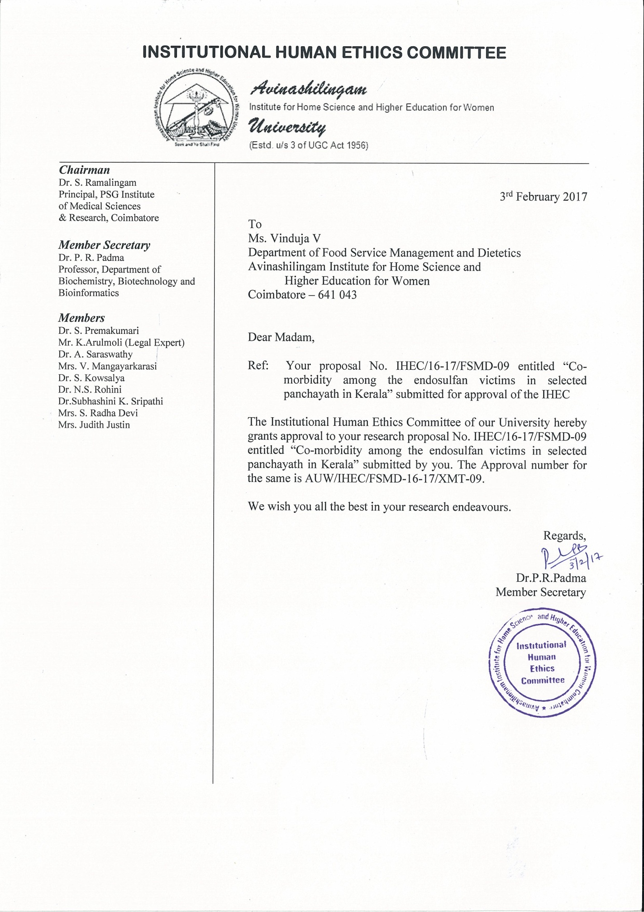
APPENDIX IV
CHEMICAL ANALYSIS OF WATER SAMPLE
- pH
Procedure
- Turn the pH meter ON and allow it to warm for 15 minutes.
- Standardize the glass electrode using standard buffer of pH 7.0 and calibrate with the buffer pH = 4 or pH = 9.2.
- Take 50 ml of filtered water sample in 10 ml beaker and immerse the glass and calomel electrodes or combined electrode of the pH meter. Never allow the lower portion of glass electrodes to touch the bottom of the beaker.
- While recording pH, switch the pH meter to pH reading, wait for 30 seconds and record the pH value to the nearest 0.1 unit. Put the pH meter in standby mode immediately after recording.
- Remove the electrodes after each determination and carefully blot them dry with filter paper before the next determination. Standardize the glass electrodes after every ten determinations.
- Keep the electrodes in distilled water, when not in use and ensure that the reference electrode always contains saturated potassium chloride solution in contact with solid potassium chloride crystals.
- Test for Electrical Conductivity (EC)
` Procedure
- Calibrate the conductivity cell with the help of standard KCL solution and determine the cell constant
- Dip the conductivity cell assembly in water sample taken in a 50 or 100 ml beaker and record the conductivity. If the value is too low, change the adjustment accordingly. Record the temperature of water during the test.
- Observed values of EC are multiplied by the cell constant (usually given on conductivity cell) and a temperature factor to express results at 25ºC.
- Remove the cell from water , clean with distilled water and dip into a beaker of distilled water. EC is expressed as dS/m.
- Keep the conductivity cell in distilled water when not in use.
- Test for Carbonates and Bicarbonates
Reagents :Saturated H2SO4 (0.01N) ,Standard Na2CO3 (0.01N), Phenolphthalein (0.25%), Methyl Orange
Procedure
- Transfer 25 ml of water sample to a 150 ml conical flask. Add 2-3 drops of Phenolphthalein.
- If pink red colour appears, titrate it against standard H2SO4 till colour disappears. The burette reading (volume used) is designated as Y ml.
- To this colourless solution or in original sample (25 ml) add 2-3 drops of methyl orange. This will develop the yellow colour. Again titrate with standard H2SO4 till colour changes from yellow to rosy red. Record the volume of H2SO4 as Z ml. This volume corresponds to initial carbonate changed to bicarbonates plus initial bicarbonates present in irrigation water.
- Run a blank (25 ml distilled water) and subtract from the titre value to avoid error due to any impurity of chemicals.
- Test for Chlorine
Reagents Standard sodium chloride solution (0.02N), Standard Silver Nitrate Solution (0.02N)
Potassium Chromate Indicator (5%) : Dissolve 5.0 g of K2CrO4 in 100 ml of distilled water.
Procedure
- Transfer 25 ml of water sample to a 150 ml of conical flask.
- Add 0.01N H2SO4 with methyl orange to neutralize the amount of carbonate and bicarbonate and provide 1 ml in excess.
- Add 5-6 drops of potassium chromate indicator making it dark yellow.
- Titrate the contents against 0.02N AgNO3 solution with continuous stirring till the first brick red tinge appears. Note the volume of the AgNO3 required (ml.)
- Run a blank of 25 ml of distilled water and subtract from the titre value to avoid error due to any impurity of chemicals.
- Determine the normality of AgNO3 by standardizing it against NaCl solution.

APPENDIX V
CHEMICAL ANALYSIS OF SOIL SAMPLE

- pH
Reagents
- Standard buffer solutions :.
- 0.05 M Potassium hydrogen phthalate (KHC3H4O4, Mol. Wt. 204.22) ,Buffer solution pH 6, Buffer solution pH 9.
Apparatus
pH meter with glass electrodes, Thermometer, Glass beaker (100 ml), Glass rod
Procedure
- Weigh 20 gm of 2.0 mm air dry soil into a beaker. Add 50 ml of distilled water and stir with a glass rod thoroughly for about 5 minutes and keep for half an hour.
- In the mean time turn the pH meter ON, allow it to warm up for 15 minutes. Standardize the glass electrode using standard buffer of pH = 7 and calibrate with the buffer pH = 4 or pH = 9.2.
- Dip the electrodes in the beakers containing the soil water suspension with constant stirring.
- While recording pH, switch the pH meter to pH reading, wait 30 seconds and record the pH value to the nearest 0.1 unit. Put the pH meter in standby mode immediately after recording.
- Remove the electrodes from soil suspension and clean the electrodes with distilled water.
- Rinse the electrodes after each determination and carefully blot them dry with filter paper before the next determination. Standardize the glass electrodes after every 10 determinations.
- Dip the electrodes in distilled water, when not in use and ensure that the reference electrode always contains saturated potassium chloride solution in contact with solid potassium chloride crystals.
- Three to four drops of toluene are added in standard buffer solutions to prevent growth of mould.
- Test for Elecetrical conductance
Apparatus : Digital conductivity meter, Conductivity cell, Glass beaker (100 ml), Glass rod
Reagent :
- 0.01N Potassium chloride solution : Dry a small quantity of A.R. grade Potassium chloride at 60oC for 2 hours. Weigh 0.7456 gm of it and dissolve in freshly prepared distilled water and make to one litre. This solution gives and electrical conductivity of 1411.8 x 10-3 i.e. 41 dS/m at 25ºC.
Procedure
- Calibrate the conductivity cell with the help of standard KCL solution and determine the cell constant.
- The soil water suspension of 20 gm : 50 ml ratio prepared for the determination of pH can also be used for conductivity measurements. After recording the pH, allow the soil water suspension in the beaker to settle for additional half an hour (the total intermittently shaking period is 1 hr.)
- After the calibration dip the conductivity cell in the supernatant liquid of the soil water suspension. Read the conductivity of test solution in proper conductance range.
- Remove the cell from soil suspension, clean with distilled water and dip into a beaker of distilled water. EC is expressed as dS.m–1
- Dip the conductivity
3. Test for Nitrogen
Apparatus : 100 ml conical flask, Funnels, filtration stands, 100 ml volumetric flask , Beaker , One lit round bottom flask, Distillation unit (Kheldhal Digestion Unit)
Reagents
- Potassiu m permanganate, KMnO4 (0.32%) : Dissolve 3.2 g of potassium permanganate in 1 lit distilled water with the intermittent shaking till it is completely dissolved. Store in amber coloured bottle and in the dark
- Sodium hydroxide solution, NaOH (92.5%) : Dissolve 25 g of pure sodium hydroxide pellets in one lit. distilled water.
- Boric Acid H3BO3 (2%) : Dissolve 20 g boric acid of AR grade in 800 ml distilled water by heating the content. Cool it and dilute to 1000 ml volume.
- Mixed indicator - Bromocresol green + Methyl red : Weigh out separately 99 mg of Bromocresol green and 66 mg of well powdered methyl red and dissolve them together in 100 ml ethyl alcohol.
- Working Boric Acid solution : Add 20 ml of the mixed indicator to one lit. of 2% boric acid solution and adjust the pH to 5.0 after shaking, or add 0.1N NaOH continuously until the solution assumes reddish purple tingeuine red colour. Standard sulphuric acid, H2SO4 (0.02N) : Standardise the H2SO4 solution using standard NaOH. NaOH be standardised against 0.02N H2C2O4 or 0.02N potassium pthalate.
- Liquid paraffin
- Glass beads
Procedure
- Transfer 20 g of sieved soil into 1lit. round bottom flask.
- Add little distilled water with the help of jet in such a way that the particles of soil do not remain stuck to the sides of the flask.
- Add 2 to 3 glass beads to present bumping and 1 ml of liquid paraffin to prevent frothing.
- Add 100 ml of potassium permanganate and 100 ml of sodium hydroxide solution to the flask (both the solutions should be prepared fresh).
- Distill and collect the distillate in a beaker containing 20 ml of boric acid working solution.
- Collect approximately 150 ml of distillate.
- Titrate the distillate with standard H2SO4 0.02N till the colour changes from green to red and record the burette reading.
- Carry out blank without soil.
4. Test for Phosphorous
Apparatus : Conical flask –150 ml., Funnel, Pipettes, Volumetric flask – 25 ml, Reagent bottles, Spectrophotometer
Reagents
- 0.5M NaHCO3 ,Activated Charcoal, Ammonium Paramolybdate [(NH4)6 MO7 O24 4H2O] ,Ascorbic Acid Solution ,P - nitrophenol indicator ,Standard P Solution (Stock Solution) ,P solution (5 ppm) Hydrochloric Acid (0.02 N) ,Standardization of sodium hydroxide (NaOH)
Procedure
- Weight 2.5 gm of soil sample in 150 ml plastic conical flask, add pinch (0.3 gm) of phosphate free activated charcoal AR grade. Add 50 ml of Olsen reagent and shake for 20 minutes exactly on platform type shaker at 180 rpm.
- Filter the contents immediately through filter paper. Transfer 5 ml of aliquot into 25 ml volumetric flask.
- Pipette out 5 ml of filtrate into 25 ml volumetric flask. Add 4 ml of the freshly prepared ascorbic acid and ammonium molybdate solution. Shake well and keep it for 30 minutes then make the volume
- Prepare the standard curve using 0, 1, 2, 3, 4 & 5 ml of 5 ppm standard P solution into 25 ml volumetric flask and develop the colour using the same procedure as above. The corresponding P concentration will be 0, 0.2, 0.4, 0.6, 0.8 & 1 ppm.
- Measure the absorbance and colour intensity at 882 nm after half an hour.
- Run a blank method sample with the extracting solution.
5. Test for Potassium
Reaction
Soil-K + NH4OAC ==== Soil-NH4 + K+ + Acetate–
Apparatus :100 ml Conical flask, Funnels, filtration stand, 100 ml volumetric flasks, Flame photometer, 50 ml volumetric flasks
Reagents :
- Neutral normal ammonium acetate solution ,Standard potassium stock solution (100 g K / ml) ,Working solution
Procedure :
- Add 25 ml of NH4OACextracting solution to a conical flask containing 5 gm air dry soil sample.
- Shake on a reciprocating shaker at 200 to 220 oscillations per minute for 5 min and filter.
- Determine potassium as indicated in preparation of standard curve, dilute if necessary.
6. Test for Calcium and Magnesium
.
Apparatus : 1 litre flaks, Porcelain dishes 3” to 4” diameter, Burette of 50 ml capacity, Pipette of 5 ml and 10 ml., Beaker of 100 ml, Centrifuge tubes / polythene shaking bottle.
Reagents
- Standard Ca solution, 0.01 N ,EDTA Solution,.,NH4Cl – NH4OH buffer solution ,NaOH 10%,.,NH2OH.HCL ,K4Fe(CN)6 , Triethanolamine ,EBT :,Calcon indicator ,Neutral normal ammonium acetate solution
Procedure
Extraction :
- Weigh 2 – 4 gm of soil sample (2mm sieved) in conical flask or polythene shaking bottle or 100 ml centrifuge tubes.
- Add 30 ml of NH4OAc and shake for 5 min and decant.
- Then add 30 ml of 0.5N HCl to each sample and agitate the contents, shake for 5 min. in a upright loosened position.
- Then filter the solution using whatman No. 1 filter paper.Collect the filtrate.
Estimation of Ca & Mg (determination of ca & Mg together) :
- Pipette out 20 ml of the filtrate into a 150 ml conical flask.
- Add 50 ml distilled water.
- Add 10-15 ml NH4Cl – NH4OH buffer solution and add 10 drops each of NH2OH.HCL, K4Fe(CN)6, TEA and EBT indicator.
- Titrate with standard EDTA to permanent blue colour.
- Test for Sodium

Apparatus : Flame Photometer, Beaker (250 ml), 100 ml.,Volumetric measuring flask – 50 ml capacity,Measuring flask – 1 lit capacity.
Reagents
- 1 N Ammonium Acetate ,Standard Sodium Solution
Procedure :
- Weigh 5 g of 2 mm sieved soil sample in 250 ml plastic conical flask.
- Add 25 ml of the neutral 1N ammonium acetate solution and shake for 30 minutes on mechanical shaker at 110 rpm. Filter through whatman No. 1 filter paper.
- Take the readings on flame photometer.
- Feed the working standard solution and prepare a standard curve.
- If the sample reading is not found within the standard reading range in that case the appropriate dilution of the filtrate may be made to bring the reading within standard range.

APPENDIX VI
CHEMICAL ANALYSIS OF MILK SAMPLE

- Test for Added Urea in milk sample
Urea is a natural constituent of milk and is present to the extent of 70 mg per 100 ml (700 ppm). The test based on the use of para-dimethylamino benzaldehyde can be used for the estimation of urea in milk after precipitation of milk proteins using trichloroacetic acid.
Apparatus : Spectrophotometer – Instrument with maximum band width 2.4 nm at 420 nm, with 1 cm cells Whatman filter paper: Grade 42. , Funnels,Test tubes.
Reagents :p-Dimethyl amino benzaldehyde (DMAB) solution , Phosphate Buffer pH 7.0, Trichloroacetic acid (TCA) , Diluting Reagent:,. Urea Standard Solution
Procedure
Preparation of standard curve
Pipette 5 ml aliquots of working standard solutions into 20 x150 mm (25 ml) test tubes and add 5 ml DMAB solution to each. Prepare reagent blank of 5 ml buffer and 5 ml DMAB solution. Shake tubes thoroughly and let stand for 10 minutes. Read A in 1 cm cell at 420 nm with reagent blank at zero A. Plot A against concentration urea Plot should be straight line.
Estimation
10 ml of milk sample is mixed with 10 ml of TCA to precipitate the proteins and filtered using Whatman 42 filter paper. 5 ml of filtrate is then treated with 5 ml of DMAB reagent to develop the colour. Blank is prepared by taking 5 ml of diluting reagent and treating with 5 ml of DMAB reagent. The optical density of the yellow colour is measured at 420 nm. From standard curve the amount of urea in milk is calculated.
3.Test for Sulfates in milk sample
Presence of sulfate salts, which may be added to milk to raise its SNF level in milk, can be detected by using barium chloride.
Reagents :Barium chloride (BaCl2.2H2O) 5% (w/v) aqueous solution, Trichloroacetic acid (TCA), 24% (w/v, aq.): Procedure
Take 10 ml of milk in a 50 ml stoppered test tube. Add 10 ml of TCA solution. Filter the coagulated milk through Whatman filter paper Grade 42. Take 5 ml of clear filtrate. Add few drops of barium chloride solution. Observe for any visible precipitates in the tube. Formation of milky-white precipitates indicates the presence of added sulfates like ammonium sulfate, sodium sulfate, zinc sulfate and magnesium sulfate etc. to milk. The limit of detection of method is 0.05%.
3.Tests for the presence of Nitrates in milk sample
Pond water is heavier than the tap water; some unscrupulous persons for adulteration in milk usually prefer it. However, it can be easily detected by the following method. This method actually detects nitrates present in the pond water. In the pond water nitrates may come from fertilizers used in the fields.
Reagent :Diphenylamine (2%, w/v, in sulfuric acid
Procedure
Take 2 ml of milk in a test tube. Rinse the tube with the milk and drain the milk from the test tube. Add two-three drops of the reagent along the side of the test tube. Note the developed colour. Deep blue colour will be formed in presence of nitrate in the milk sample. Pure milk sample will not develop any colour

APPENDIX VII
POWER POINT PRESENTATION ON AWARENESS OF AFTER EFFECTS OF ENDOSULFAN AMONG THE RESIDENTS IN THEIR PANCHAYATH AND ALSO FOOD SAFETY AND SANITARY PRACTICES

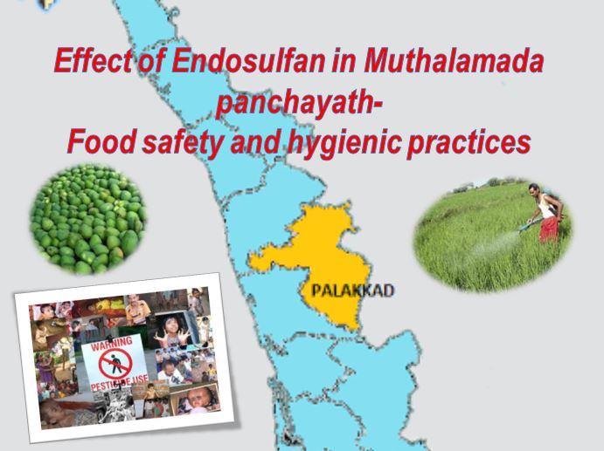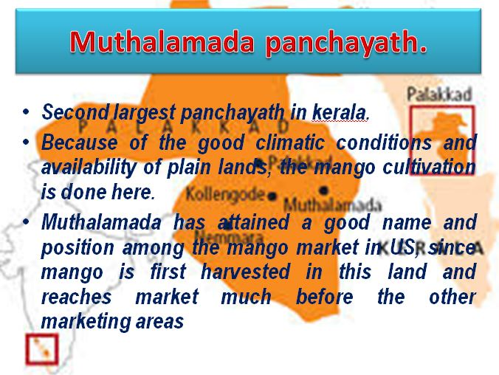

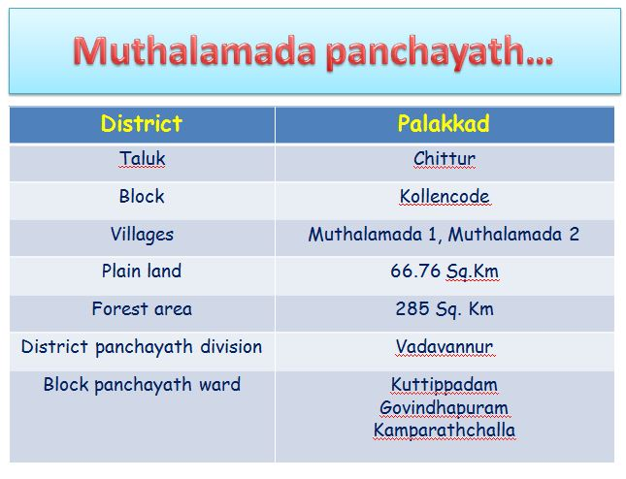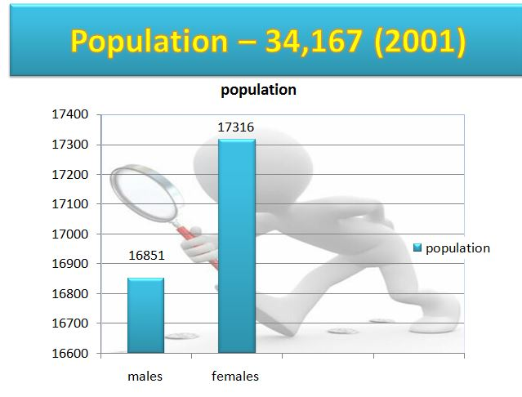

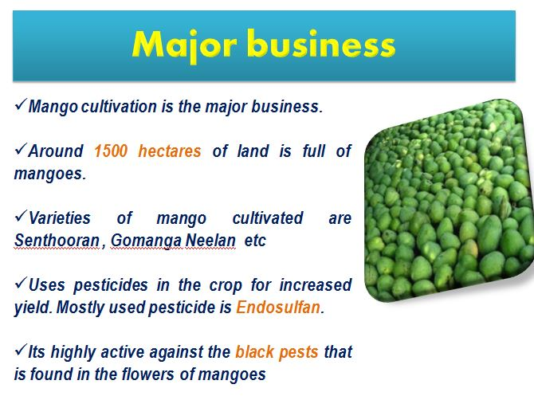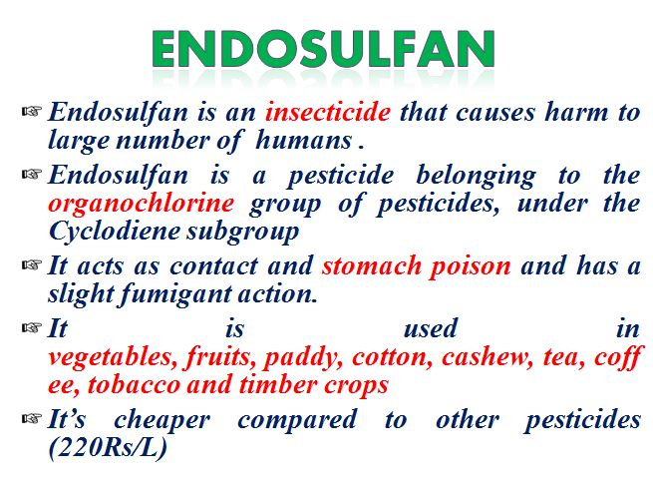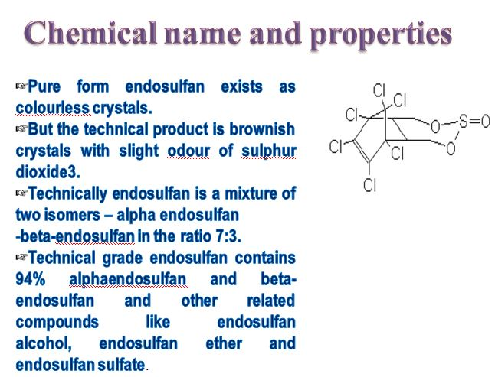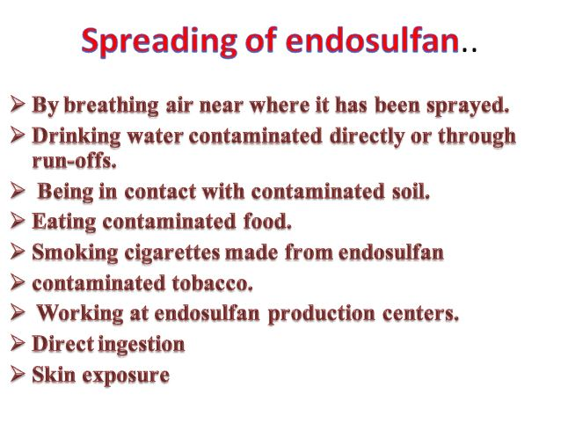
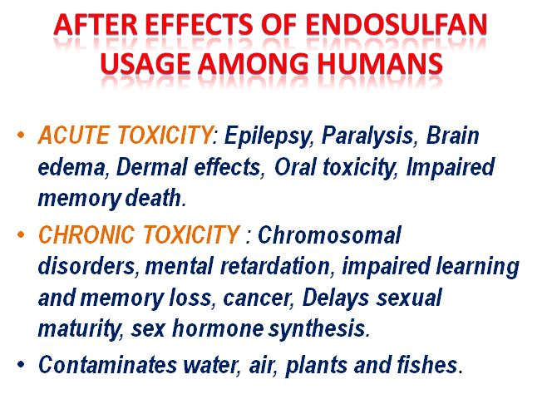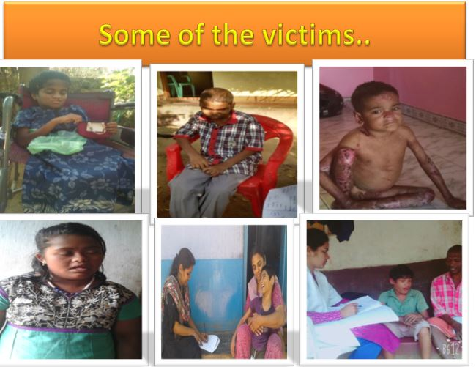

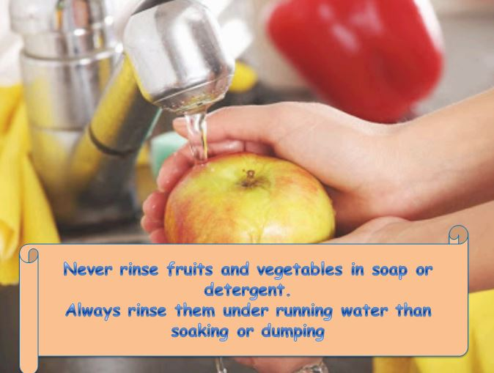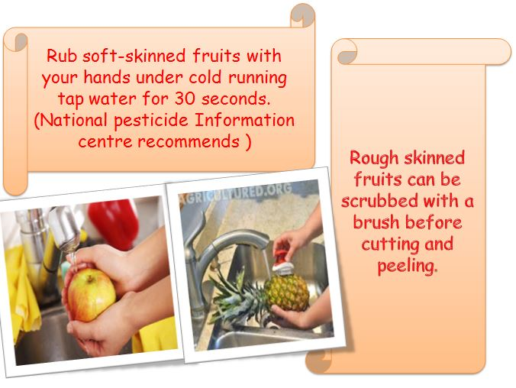
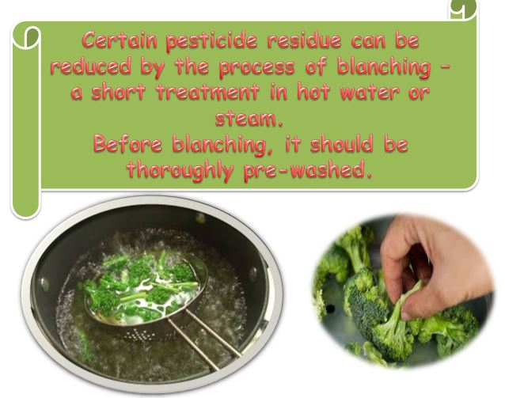

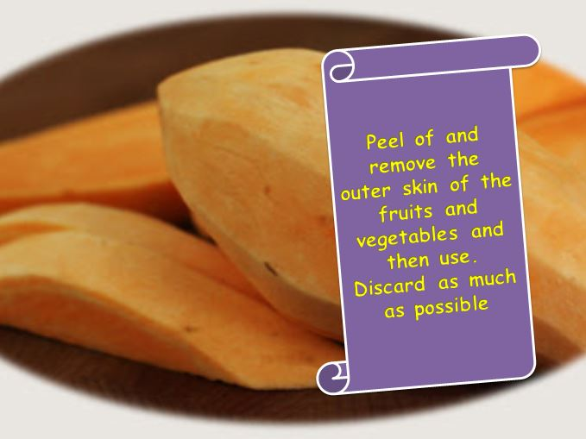
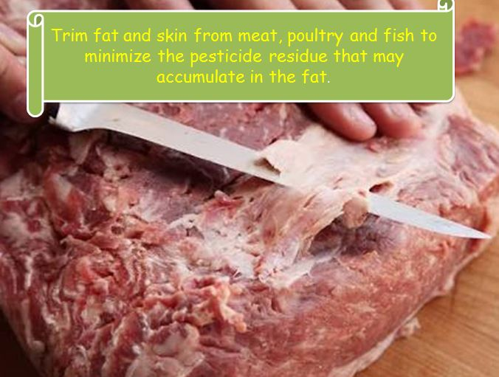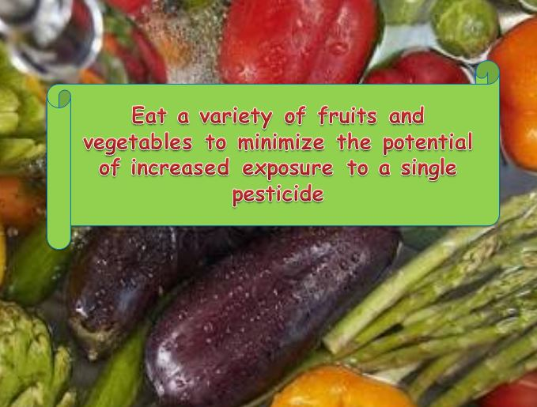
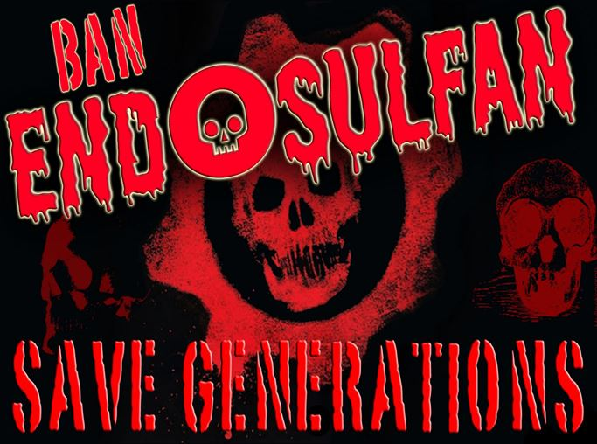

APPENDIX VIII
Pamphlet And Audio-Visual Aids Used For Awareness

