INCULCATING HUMAN VALUES AMONG SCHOOL CHILDREN

By
ANGELA JOICE. A
(14PIR003)

A THESIS SUBMITTED TO
AVINASHILINGAM INSTITUTE FOR HOME SCIENCE
AND HIGHER EDUCATION FOR WOMEN,
COIMBATORE - 641 043.

In partial fulfillment of the requirements for the Degree of
MASTER OF SCIENCE IN INTERIOR DESIGN AND RESOURC MANAGEMENT

APRIL 2016
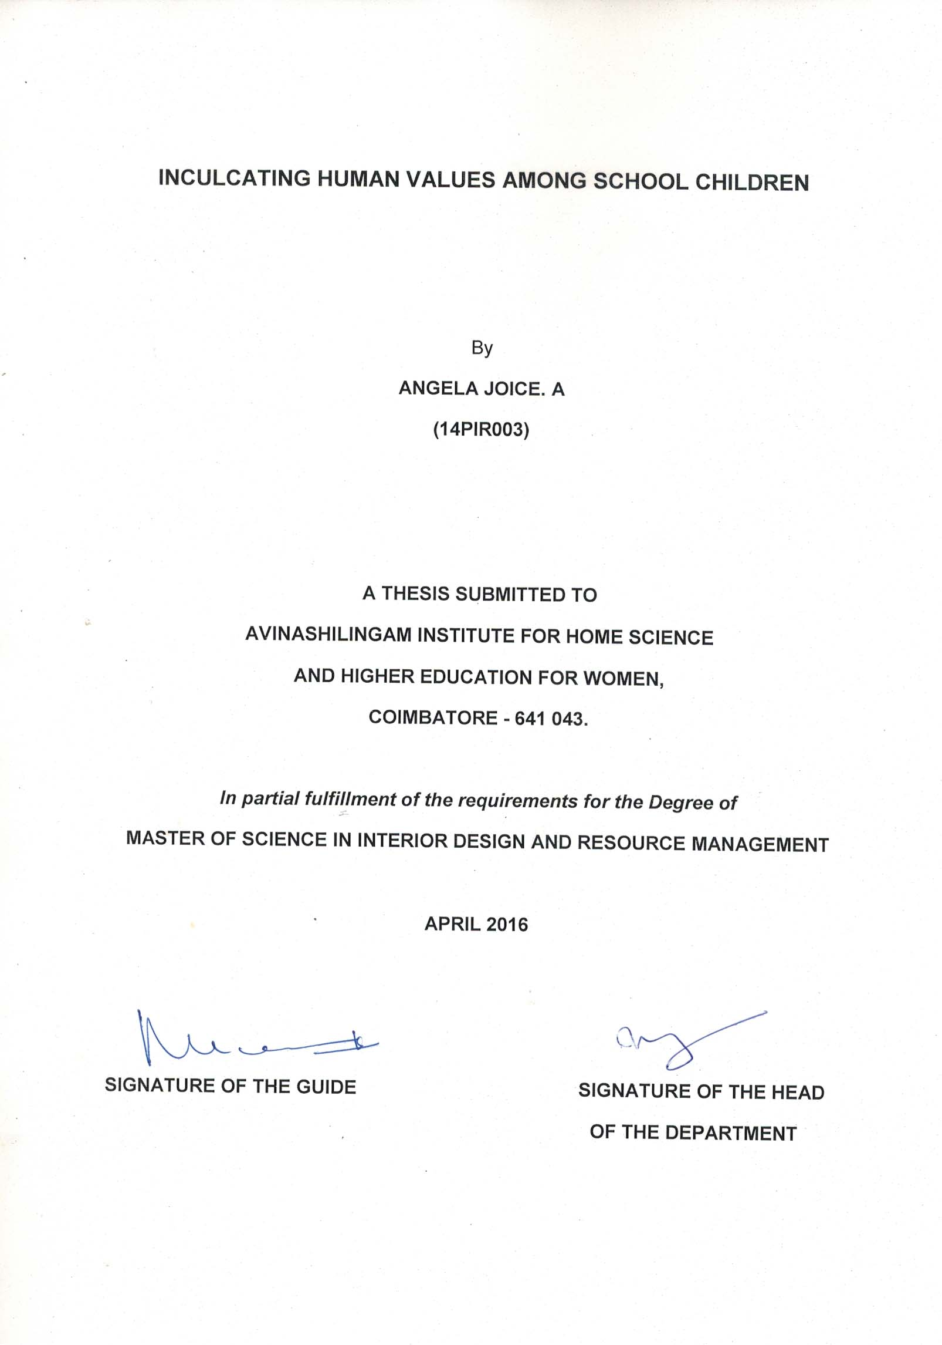
ACKNOWLEDGEMENT
First and foremost, praises and thanks to God, the Almighty, for His showers of blessings and perseverance that He has been bestowed upon me during this research work, and indeed, throughout my life.
The investigator owes her reverential gratitude to the Founder and the Former Chancellor of Avinashilingam Institute Home Science and Higher Education for Women, Coimbatore. Dr. (Thiru.) T.S. Avinashilingam and Former Chancellor Hon Colonel Padmashri Dr. (Tmt.) Rajammal.P.Devadas M.A, M.Sc., Ph.D., for their wishes and blessings.
The researcher expresses her thanks to Former Chancellor Dr. (Mr.) Thiru T. S. K. Meenakshisundaram, M.A., M.Phil., Ph.D. Present Chancellor Padmashri Dr. P. R. Krishnakumar, Avinashilingam Institute Home Science and Higher Education for Women, Coimbatore, for providing the facilities for the conduct of the study in this esteemed institution.
The researcher acknowledges her gratitude to Dr. (Tmt) Premavathi vijayan M.Sc., M.Ed., Dip.Spl.Edn., M.Phil., Ph.D. Vice Chancellor in charge Avinashilingam Institute Home Science and Higher Education for Women, Coimbatore, for being the central inspiration.
It is an honor for the researcher to thank Dr. (Tmt) A. Venmathi M.Sc., Dip. Ed., M.Phil., Ph.D., Registrar in charge, Avinashilingam Institute Home Science and Higher Education for Women, Coimbatore, for her kind help extended throughout the period of the study.
The investigator is immensely thankful to Dr (Tmt) N. Vasugi Raaja, M.Sc., M.B.A., M.Phil., Ph.D. Dean Faculty of Home Science, Avinashilingam Institute Home Science and Higher Education for Women, Coimbatore, for the encouragement and support for the study.
The researcher also indebted to Dr. (Tmt) S. Visalakshi Rajeswari M.Sc., M.Phil., Ph.D. Prof and Head , Department of Resource Mangement, Avinashilingam Institute Home Science and Higher Education for Women, Coimbatore, for her immense support for carrying the research.
The investigator owes her deepest gratitude to her caring and loving guide Dr. (Tmt) K. Manimozhi, M.Sc., B.Ed., M.Phil, Ph.D Associate Professor, Department of Resource Mangement, Avinashilingam Institute Home Science and Higher Education for Women, Coimbatore, for her encouragement, interest, guidance with suggestions and help rendered throughout the period of the research work and to complete it successfully.
The investigator expresses her profound thanks to all the Faculty Members of the Department of Resource Mangement, Avinashilingam Institute Home Science and Higher Education for Women, Coimbatore, for their everlasting blessing help, encouragement and support.

CONTENTS
CHAPTER | TITLE | PAGE NO
 | LIST OF TABLES
 | LIST OF FIGURES
 | LIST OF PLATES
 | LIST OF APPENDICES
I | INRODUCTION | 1 – 8
II | REVIEW OF LITERATURE | 9 – 37
A. | Importance of education | 9
B. | Meaning of value education | 14
C. | Need for value education among school children | 16
D. | Methods of inculcating values among the school children | 23
E. | Role of parents and teachers in inculcating human values | 30
III | METHODOLOGY | 38-52
A. | Assessing the human values possessed by the school children | 39
B. | Inculcating human values among the school children | 44
C. | Evaluating the impact of the educational programme conducted | 51
IV | RESULTS AND DISSCUSSION | 53 - 75
A. | Demographic profile of the school children | 53
B. | Knowledge on human values gained and developed by the school children | 59
C. | Acceptance and adoption of human values by the school children | 61
V | SUMMARY AND CONCLUSION | 76 - 82
 | BIBLIOGRAPHY
 | APPENDICES

LIST OF TABLES
TABLE  NO | TITLE | PAGE  NO
I | Number of children selected for the study | 41
II | Course content and plan of action for the educational programme | 46
III | Class and age wise distribution of the school children | 54
IV | Sex wise distribution of the school children | 55
V | Academic performance of the school children | 55
VI | Type, size and monthly income of the families of the school children | 56
VII | Educational status of parents | 57
VIII | Occupational status of parents | 58
IX | Basic amenities available in the house of the school children | 59
X | Knowledge on human values gained and developed by the school children | 60
XI | Personal values imbibed by the school children | 62
XII | Impact of educational programme on personal values imbibed by the school children | 63
XIII | Social values imbibed by the school children | 64
XIV | Impact of educational programme on social values imbibed by the school children | 65
XV | Emotional values imbibed by the school children | 66
XVI | Impact of educational programme on emotional values imbibed by the school children | 67
XVII | Spiritual values imbibed by the school children | 68
XVIII | Impact of educational programme on spiritual values imbibed by the school children | 69
XIX | Moral values imbibed by the school children | 70
XX | Impact of educational programme on moral values imbibed by the school children | 71
XXI | Opinion of parents regarding the human values imbibed by their children | 72
XXII | Opinion of teachers regarding the human values imbibed by the children | 74

LIST OF FIGURES
FIGURE  NO | TITLE | PAGE  NO
1 | Schematic representation | 38
2 | Knowledge on human values gained by the school children | 61
3 | Impact of educational programme on personal values imbibed by the school children | 63
4 | Impact of educational programme on social values imbibed by the school children | 65
5 | Impact of educational programme on emotional values imbibed by the school children | 67
6 | Impact of educational programme on spiritual values imbibed by the school children | 69
7 | Impact of educational programme on moral values imbibed by the school children | 71
8 | Impact of opinion of parents regarding their children before and after educational programme | 73
9 | Impact of opinion of teachers regarding the children before and after educational programme | 75

LIST OF PLATES
PLATE  NO | TITLE | PAGE  NO
1 | Explanation of the study and collection of data-class wise | 43
2 a. | Inculcation on personal values | 48
b. | Inculcation on social and moral values | 49
c. | Inculcation of stories related to emotional and spiritual values | 50

LIST OF APPENDICES
APPENDIX  NO | TITLE
I | Questionnaire for children to collect information regarding human values
II | Questionnaire for parents to elicit information regarding their children
III | Questionnaire for teachers to elicit information regarding the children
IV  V | Knowledge inventory to test the knowledge on human values by the children before and after the educational programme  Institutional Human Ethics Committee

- INTRODUCTION
“Education is a better safeguard of liberty than a standing army”
-Edward Everett
Education is the process of developing capabilities of the individuals so that they can adequately respond to their situation. Education is the production of desirable changes in human behavior and bringing about of desired changes in knowledge, attitude and skills, either in all, or one or more of them. “Education is a process in which human behavior is modified so as to be in closer agreement with some model or ideal determined by the values of society”. (Reddy, 2010 and Meenambigai, 2013).
According to John (2012) Education is a systematic process through which a child or an adult acquires knowledge, experience, skill and sound attitude. It makes an individual civilized, refined, cultured and educated. For a civilized and socialized society, education is the only means. Its goal is to make an individual perfect. Every society gives importance to education because it is a solution for all problems.
According to Sri Ramakrishna Pramahamsa, Education is the process that tells us how to live life well; how to find happiness; how to make others happy; how to manage all kinds of people and happiness as well; and how to grow and succeed in the right manner.
A person becomes perfect with education as he is not only gaining something from it, but also contributing to the growth of a nation. We must realize the importance of education. We must aim to ensure that each citizen of our nation is educated and independent. (Gaurav, 2013)
The major purpose of education is to shape the personality of the child in such a way that he becomes a better learner, a better person, a better worker, not only in terms of knowledge, understanding and skills but also in terms of values and motives which give meaning and significance to all his behavior. (Mikkili , 2014)

According to Huxley ( 2007) education should be humanized to redeem our society from the evil effect of widespread corruption, selfishness, exploitation, authoritarianism and nepotism. This calls for the infusion of human values in their operations. The core of the human value system consists of truth, goodness, beauty, honesty, sincerity, hard work, gratitude, forgiveness and tranquility, besides the ethical system leading to virtues which should be acquired and cannot be taught. Humanization of education lays stress on the all round development of personality of students.

Today’s modern era is era of globalization. Inclination of our youth toward western life style and culture is natural. This inclination is not only limited to youth, almost everybody in country is running a blind race of cut throat competition to accumulate more money and things of leisure and pleasure. In recent years increase in percentage of crimes committed by youth especially adolescents has created a line of concern on the face of parents. Root cause of the problem lies in the quality of education we are providing to our child. Parents are putting more emphasis on materialistic education based on educational achievements of child, neglecting the overall development of child. Not only parents but teachers and schools are also responsible for misdirecting the direction of education. Even our curriculum and syllabus is also not favorable for teaching moral values to child. But now parents and teachers both have recognized the importance of value education in life of an individual. In early childhood before going to school, it is responsibility of parents to incorporate essential human values in child. Once he or she is admitted to school it is expected that parents and teachers will jointly carry out their duty to teach him values for making him better man or woman who can stand tall in life even in worst situations. (Awasthi, 2014)

According to Jindal (2013) Future growth in any country depends on its youth. Unfortunately, youth in India is getting increasingly inclined towards violence, social evils and lack of respect towards world around them. We ourselves are to be blamed for this. Our existing environment including family system, education system and media including newspapers, T.V. etc is presenting them a skewed picture. Youth see that men with values are suffering in life. They are also getting swayed by modern sayings like, ‘All is Well that Ends Well ’. They care only about end results and give no importance to ‘means’. Under these circumstances, value education is essentially required to provide motivation and guidance to our youngsters. Recent crisis in ‘values’ in our youth has revived concern for value education in India. Concrete steps are now being taken by Indian society and we all must join this movement to see ‘Shining India ‘in a very near future.

Values permeate the whole of human existence and are a major factor in determining what sort of human beings they are and how one will behave. The word value is derived from the Latin root, “Valerie” meaning to be strong and vigorous. ‘To be of value’ is to have a certain virtue. Values in their nascent stage appear as needs, emotions and interests varying in specificity, intensity and depth. When these acquire certain definiteness, intensity and stability in the affective life of the individual and at the same time obtain objective social approval and validation these comprise the nuclei of value formation. (Mikkili, 2014)

Recent crisis in values that our country has been currently facing has revived the concern for value education. Government has projected this issue to be one of the priorities in the national education. The national policy of 1986 has taken note of erosion of the essential values and accordingly has stressed on the need for readjustment in the curriculum in order to make education a forceful tool for developing social and moral value in our youth. The national curriculum framework for school education (2000) has also given due stress for value education in schools. It has stressed that the school curriculum must contain components that may embed essential values in the fresh and pure minds of school children. This revival of interest in value education in recent years in our country has arisen from the growing realization that such values were earlier created by religious education but India, being a country of diverse culture, religions and creeds, cannot adopt any religious education. As such it has found the remedy by coining the idea of value education. Some more government constituted commissions and committees have recommended value education in different ways. (Jyoti, 2013)

The Indian Government currently promotes Values education in the schools. The Department of Human Resource has taken strong step to introduce values among schools and teachers training centers. Also India the land of introducing values. In India From the leadership of B. Shaji Kumar, New Golden Education Trust (NGET) - Values Based Education has progressing throughout the country among schools from first standard to twelve standard classes. (Das, 2016)

The field of value education is as broad as human life itself. In India during Ramayan or Mahabharat period values are taught to the child along with formal education in Gurukuls, where Guru or Priest teaches the students at their Ashrams through different methods and prepares them to face the life. In Modern days Gurukuls were replaced but formal school and colleges which are providing the formal education to children. Not only schools and colleges but family, society, mass media and other means of communications also affects the learning of child. Parents and teachers can utilize these instruments for incorporating essential values in child. The method and strategy in imparting value education depends upon the values chosen, age of the child and certain other factors. Curriculum can be used for providing value based education. Through various activities child can easily catch the attitude. Although values can be transferred to students through hidden or unplanned method, but it is a complex method and the teacher is neither competent nor trained enough to carry out such type of experiments. (Awasthi, 2014)

The student must be free to make mistakes and learn for itself without any fear. For this purpose 'Inquiry training model, brain storming, demonstration and discussion method etc. may be used in order to make students more active and creative. (Piaget, 1932) also emphasized that students should be made to learn values rationally. (Kohlberg, 1968) expended Piaget's work and advocates that children's value development is highly dependent on environment and social conditions. Therefore, opportunity of working with co-operation, joy and friendly, working hard without sense of rivalry an atmosphere of openness need to be promoted through teaching-learning process.
Teaching is a communication between the student and teacher. While dealing with students a teacher should observe with love, courtesy, patient and tolerance etc. Good communications lead to good understanding free from fear and favour. A teacher should communicate with purity and sanctity. While communicating, a teacher should keep the following points into the mind -Communication must be conducive to human relation. Provide equal opportunity to the students to express their views/opinion. Communicate impartially to students regardless of their religion, caste, political, social, economic and physical characteristics. Be affectionate to the students and not behave in a vindictive manner towards any of them for any reason. (Shahi, 2014)

Teacher does not simply transmit values and beliefs to children but these emerge from wide array of relationship between teacher and student. Often teachers are effective when they express how their own moral questions are related to children moral questions and when they model how to think through moral issues and dilemmas through stories, poetry, dramas. Fair, generous, caring, and empathetic teachers model these qualities and can effectively guide students in sorting out questions. At each school, teachers should encourage students work in groups, research, organise, create and design their own stories and identify the values, discuss the issues, explain the impact and demonstrate the behaviour in their environment. Teacher’s responsibility is to motivate students in community participation by planting trees, cleaning thrash and adapting new teaching strategies. They provide high quality teaching and learning to students within a safe, supportive and success oriented environment. (Ameta, 2015)

There are not to be one single method of inculcation of values. The best method is presentation of example of self, as we know the individual learns through imitation. Therefore teaching and behavior of the taught should be full of values which are to be developed among the individuals. The discussion of behavior patterns and activities may be conducted in the classroom. This develops habits of listening and speaking. Role playing activities may also help in developing values. Enacting a drama help an individual to understand the behavior expected. Film shows followed by discussion also help in value inculcation. Extension lectures and seminars on value education also prove beneficial. Value centered curriculum should be developed in order to inculcate values. Book exhibitions, use of mass media, value oriented magazines and value oriented projects also help in development of values.

A research study conducted in (2013) in two different countries (Sweden and Turkey) obtained the teachers views on Value education. The main method of teaching values reported by the teachers was to be a good role model in everyday interactions with students. Values education was largely described as an everyday practice embedded in the stream of social interactions.

Parents and Teachers are the two central points which makes maximum impact on personality of an individual but unfortunately parents and teachers have themselves forgotten the importance of values in life. Generally child imitates the behaviour of persons with whom they are in contact. If parents and teachers themselves demonstrate the values and its role in giving directions to life then child will automatically acquire the required values. Some of the parents are too caring and possessive while others are not much concerned about their child due their busy schedule or illiteracy. Similarly some of the parents are strict hardliners wants to grow their child in a disciplined environment while others are very reluctant. These attitudes of parents are not helpful in developing values in child. An ideal parent would be blend of all who reacts according to the situation. Extreme is never desirable. The experience ones face in his or her early childhood remains permanent for whole life. What parents do is more important than what parents say because child learns more by observing not by listening. An alcoholic or smoker never wants his or her child to consume alcohol or smoke but he has no words to express the same. In present situation it is better for parents to become role model for their child before they adopt an inappropriate role model from their surroundings. (Deepa, 2014)
According to Krishnan (2014) Human society anywhere has a set of core values to live by. These core values do not differ with culture, society, language or religion. The importance of inculcating these values in our children is acknowledged universally. It is also accepted universally that parents have a major role in teaching human values to their children. Over the years, schools have also taken on an important role in value education. It has become part of the curriculum with a time slot earmarked in the timetable for the inputs. Books on values are in the list of prescribed textbooks and children are expected to answer an exam like any other academic subject. It would be hard, almost impossible, to find a school that doesn’t have a set of values laid down in the school’s policy which is reiterated in the school motto.
Therefore, the present study was carried out after ethical clearance for which, number is (IHEC/15-16/RM08), is shown in Appendix V. It is an attempt to inculcate human values among selected school children with the following objectives:

General objective:
- To help the elementary school children to think about and reflect on different values and the practical implications of expressing them in relation to themselves, others, the community, and the world.
Specific objectives:
- To find out the existing values followed among school children.
- To inculcate human values among selected school children for their all round development.
- To evaluate the impact of human value education on children and their parents and teachers.
It is hoped that the study on inculcating human values will definitely help the children to open heart that transforms human nature’s life is filled with compassion and humility.

II. REVIEW OF LITERATURE
The literature pertaining to the study on in “Inculcating Human Values among School Children” is reviewed under the following headings.
- Importance of education
- Meaning of value education
- Need for human value education among school children
- Methods of inculcating human values among school children
- Role of parents and teachers in inculcating human values

- Importance of education
Education is most important among all of us. Education plays a very important role in our life. For living a luxurious life or for living a better life, everyone should be educated. Education is that which transforms a person to live a better life and even in a social well being. Education is the one that doing something constructive in our near future. It helps a person to show their best by their mind and spirit. It gives a lot of knowledge in whatever aspects. Education plays a vital role in our success in the personal growth. Being educated and earning a professional degree prepares us to be a part in reputed organizations, companies or institutions. For determining what is good or what is bad, education will help. A person who gets good education will become good citizen, more dependable worker. Without education a person is incomplete, so education makes man a right thinker and a correct decision maker.(https://myeducation services.wordpress.com)

The importance of education is undeniable for every single person. It goes without saying that education has a positive effect on human life. All people need to study. Only with the advent of education can people gain knowledge and enlarge their view over the world. For example, learning by watching TV or reading books gives people a huge amount of information about anything they are interested in such as mathematics, current news, exchange rates, other countries' cultures and so on. Apparently, people may become more useful and civilized if better educated. In areas where residents are not able to receive an appropriate education, life cannot be as thriving and prosperous as locations where there is a high standard for education.
Secondly, education plays such a rudimentary role on our society that we cannot even imagine a life without it. It is a determined element for the civilization of human society. Not only does it helps us develop healthy surroundings but it also generates an advance community. As a matter of fact, everything we create today is based on the knowledge that we obtain throughout our life by way of education. This assists scientists in inventing equipment and devices, resulting in a high technology nowadays. The more developed life becomes, the more necessary education is for everyone.(http://www.essayforum.com/)
Although education has a significant influence on life, the average education is not the same in different areas. As a result, strategies are being made to resolve the problems. Without education, life would be disastrous and detrimental. Consequently, to this day, we are trying our best to make education global and accessible for everyone particularly the poor and the disabled. There are still some places where the inhabitants are almost completely uneducated, causing a serious lack of knowledge. Additionally, every child should be given equal opportunities to learn and study. Because the development of a country depends vastly on the standard of education, it must do everything in its power to improve it.(http://www.essayforum.com/)
Education for All (EFA) is a global commitment to provide quality basic education for all children. EFA was launched at the World Conference on Education for All in 1990. Education for All is also goal of the Millennium Development Goals (MDGs) — eight internationally agreed-upon goals that serve as the blueprint for cutting extreme poverty in half. Of the 75 million primary-aged children not in school, 55 percent are girls, roughly three-quarters live in sub-Saharan Africa and South and West Asia, and some 40 million are in conflict-affected countries or emerging states. Tens of millions more children drop out of school before grade five because schools are overcrowded, unsafe, poorly equipped, poorly managed and have inadequately trained teachers. If current trends continue, 58 out of the 86 countries that have not yet achieved universal primary enrollment will fail to do so by (2015). Standing between these children and the classroom is a lack of funding for quality basic education to help them overcome the barriers to school such as tuition fees, disabilities, lack of sanitation, and poorly qualified teachers. The U.S. and other countries must do more to support countries to eliminate school fees and other barriers to education and work in closer partnership with poor countries that have committed to providing education for all children. (http://www.unfpa.org/ )
Education is a basic human right and a significant factor in the development of children, communities, and countries. Opening classroom doors to all children, especially girls, will help break the intergenerational chains of poverty because education is intrinsically linked to all development goals, such as supporting gender empowerment, improving child health and maternal health, reducing hunger, fighting the diseases of poverty, spurring economic growth, and building peace. Education Empowers Women and Girls Particularly for women and girls, the economic and personal empowerment that education provides allows them to make healthier choices for themselves and their families. Benefits of girls’ education include not only the reducing the impact of HIV/AIDS, but reduction of poverty, improvement of the health of women and their children, delay of marriage, reduction of female genital cutting, and increase in self-confidence and decision-making power. UNFPA. Women and HIV/AIDS: Confronting the Crisis. (http://www.unfpa.org/ )
Education is a methodical effort toward learning basic facts about humanity. And the core idea behind value education is to cultivate essential values in the students so that the civilization that teaches us to manage complexities can be sustained and further developed. It begins at home and it is continued in schools. Everyone accepts certain things in his/her life through various mediums like society or government.

Education is the training by which the current of expression and will are brought under control and become fruitful. Education may be described as a development of faculty, not of accumulation of words (Joshi, 2011). Education is the process of instruction aimed at the all round development of the boys and girls. Education dispels ignorance. It is the only wealth that cannot be robbed. It includes moral values and the improvement of character and methods to increase the strength of mind (Ambica, 2010)
Education is one of the most powerful instruments known for reducing poverty and inequality and for laying the basis for sustained economic growth. It is fundamental for the construction of democratic societies and dynamic, globally competitive economies. For individuals and for nations, education is the key to creating, applying and spreading knowledge. (Bruns, 2005)
Education develops the capacity to learn, to read and to use math, to acquire information and to think critically about that information. Education is also a gateway to all higher levels of education that train the scientists, teachers, doctors and other highly skilled professionals that every country, no matter how small or poor, requires. Research also indicates the contribution of education to better natural resource management, including conservation of the tropical forest (Godoy and Contreras, 2001)
According to Hunt (2009) and Rand (2009), education is a part of life, and clearly our questions about values and education are inseparably from questions of values in life. Values are embodied in educational practice. Education develops a sense of discrimination between good and bad.
Education is the vehicle of knowledge, self-preservation and success. Education not only gives a platform to succeed, but also the knowledge of social conduct, strength, character and self-respect. The greatest gift education gives us is the knowledge of unconditional love and a set of values. These values include the simple difference between right and wrong, a belief in God, the importance of hard work and self-respect. Education is a continuous learning experience, learning from people, learning from leaders and followers and then growing up to be the person we are meant to be.

To make the value aspect of our education programmes more prominent, the following ideas may be incorporated in the educational programmes.
- Developing self- respect, awareness of self- growth, one’s uniqueness, self-confidence.
- Promoting selflessness, cooperative spirit of sharing.
- Cultivating respect for property, one’s own and that of other.
- Understanding the contribution of home towards the physical, emotional, cultural and spiritual development of young people.
- Imparting clear direction on cleanliness, punctuality, use of refined language, courtesy, proper manner, respect for elders.
- Knowing of surroundings- visiting slims, villages, hospitals, orphanages, old people’s homes.
- Promoting civic scene, awareness of oneself as a member of a community, civic duties.
- Awareness of one’s strength and weakness, and also those of others.
- Love of friends, classmates, and the not so fortunate.
- Seeking to realize one’s potentialities and talents, disciplined learning in academics, sports, cultivating the scientific temper.
- Knowing the provision to promote human dignity and justice, patriotism, national integrity, international understanding.
- Dissemination of cultural heritage.
- Appreciating the useful views of others and their cultural traditions.
- Propagation of value philosophy.

B. Meaning of value education

According to Hornberger (2009) “A value is a belief upon which a man acts by preference”
According to Nalini (2009) defines values as “values are integrated experiences that touch simultaneously all dimensions of human adaption, organic, social and cultural and transcend them in all their propriety towards orientation”
Values refer to objects the human beings consider desirable and worthy of pursuits in their thoughts feelings and actions (Sheshadri, 2009) Value is defined as a “concept which is accepted by the sub- conscious mind, is understood by all and perceived by the individual”. Conceives value as in the broadest sense anything good or bad is a value” (Pepper, 2011)
The ideal of education has been very grand, noble and high in ancient India. Its aim, according to (Herbert Spencer) is the ‘training for completeness of life’ and the moulding of character of men and women for the battle of life. The history of the educational institutions in ancient India shows how old is her cultural history. It points to a long history. In the early stage it is rural, not urban. British Sanskrit scholar says “Some hundreds of years must have been needed for all that is found” in her culture. The aim of education was at the manifestation of the divinity in men, it touches the highest point of knowledge. In order to attain the goal the whole educational method is based on plain living and high thinking pursued through eternity.
Educational values are those related to those activities which are good, useful and valuable from the point of view of education and has already been pointed out that according to Adams, it is a bipolar process which has two parts the teacher and the child. The teacher in order to mould and modify the behavioural of the child employs various strategies and tactics to achieve the desired behavioural change in the child. They perform all these activities, because they think themselves as a valuable for the purpose of view. As he teacher provides an environment of utility and a value to the child, in the same manner, the child participates only in those activities which they consider useful and valuable to them.

According to these qualities, abilities and capacities are promoted in the individuals, which are inherently values of life. Brubacher speaks out this as “To state one’s aim of education is at once to state his educational values. (Shashi, 2005)

Value education means inculcating in the children sense humanism, a deep concern for the well-being of others and the nation. This can be accomplished only when we in still in the children a deep feeling of commitment to values that would build this country and bring back to the people pride in work that brings order, security and assured progress. A person with proper values will not be afraid to face problems. He or she will expect and accept them as part of life. He or she will not give un necessary importance to anything that happens in life. He or she will have complete faith in God. Such a person will be an example to the rest. Last but not least we must love our own values in life, to build a strong character. It will help us to lead our life as it should be lead. It is very necessary for the fulfillment of life’s purpose. In today’s scenario our values have been discarded by the new generation in the upcoming of the new fashion. In such a situation it is very important for someone to lay down basic principles for us so that we may lead a brightened life, no matter the stepping stones of success hit us hard we on the basis of these principles can guide our life. Thus value education completes this need very easily with an impact on the young minds making the world a better place to live in. (Indrani, 2012)

Value- based education is a threefold development of any individual of any gender and age, but most importantly of a child. Education tries to develop three aspects: physique, mentality and character. Even though physique and mentality are important, they are menaces without the third because character is the greatest of these. Education plays a huge role in precisely this area. (Indrani, 2012)

Value-based education is a tool which not only provides us a profession which we can pursue but also a purpose in life. The purpose of our life is undoubtedly to know oneself and be ourselves. We cannot do it unless we learn to identify ourselves with all that lives. The objective of education in a country like India, which has a glorious heritage and can boast of diversity in geography, culture, values and beliefs very rarely seen in this wide world, should be to educate a student of the value system which is indispensable to live successful life (Das and (Sayan, 2008).

According to Hipple “values are conscious or unconscious motivators and justifiers of the actions and judgements”. Values are the ideals, beliefs, or norms which a society or the large majorities of a society’s members hold. These ideals contain or express the judgement which people have the relative importance of things.

- Need for human value education among school children
‘Crisis’ means a time of difficulty, danger or anxiety about the future. There is a value crisis in our country. This is primarily because of a conflict in our culture. Today, the technological explosion is evident, literacy rate has increased, industrial revolution too is taking place but the life system is under jeopardy, crime rate is high and corruption in all walks of life is one the increase. This is because of lack of value in society especially among students. Value – crisis is deepening day by day with rapid advancement in knowledge, science and technology on the one hand and constant deterioration of values on the other. The very survival of man seems to be at sake (Santhanu, 2007).

The concern for value education is reflected in our key policy documents from time to time. After independence the National Commission of Secondary Education (1952-53) was a significant landmark in emphasizing character building as the defining goal of education. “The supreme end of the educative process should be the training of the character and personality of students in such a way that they will be able to realize their full potentialities and contribute to the well-being of the community.”

Our educationist have spent lot of ink in formalizing the curriculum regarding the natural and social world but very little has been brought about for the third, the mist subtle world - the moral world. Value education is to be looked upon as an aspect of overall qualitative improvement of education i.e. the full development of person’s consciousness. But today education has degenerated into a process of information transmission with the primary object of producing examination results. Hence there is a crisis of values (Jagannath, 2005).

The Report of the University Education Commission (1962) noted, “If we exclude spiritual training in our institutions, we would be untrue to our whole historical development.” The Report went on to make a case, not for religious or moral education, but for evolving “a national faith, a national way of life based on the Indian outlook on religion, free from dogmas, rituals and assertions.” The Education Commission of 1964-66 put the spotlight on “education and national development”, from which perspective it identified the “absence of provision for education in social, moral and spiritual values” as a serious defect in the curriculum. The Commission recommended that these values be taught “with the help, wherever possible, of the ethical teachings of great religions.” Agreeing with the Sri Prakasa Committee Report, it recommended “direct moral instruction” for which “one or two periods a week should be set aside in the school time-table.”

The National Policy on Education (1986) expressed concern over “the erosion of essential values and an increasing cynicism in society”. It advocated turning education into a “forceful tool for the cultivation of social and moral values.” Education should “foster universal and eternal values, oriented towards the unity and integration of our people”. The Programme of Action of 1992 tried to integrate the various components of value education into the curriculum at all stages of school education, including the secondary stage.

The Government of India’s report on Value Based Education (Chavan’s Committee Report, 1999) submitted in both houses of Parliament, provided impetus to resume work on value orientation of education. (DEPFE, NCERT )

While value education is important for children in schools, the curriculum includes various forms of value education by means of stories, power point programs, activities etc. Books, videos and source material on various topics of value education are provided to children. Several schools promote value education projects, and exposure trips. Schools run by the Mont ford Brothers like St. Columbus, and MSFS schools in India train children to be responsible and contributing citizens of the nation for a better world. The archdiocesan schools in Delhi impart value education, which is compulsory in all the seventeen schools. So to in the 150 archdiocesan schools in Mumbai value education takes prime place. (Indrani, 2012)

One of the major debates around value education is what values should be inculcated among students. While there is a kind of consensus as to what values are, there seems to be some confusion about which values and whose values need to be nurtured. There are varied ways of listing and classifying values using different terminologies. Any kind of arbitrary listing or classification without proper framework is likely to lead to confusion. (DEPFE, NCERT)
Values are complex mix of understanding, attitudes, beliefs, behaviours and skills. There are cluster of attitudes and beliefs associated with a particular value. For example, loyalty includes truth; peace is linked to commitment and justice. Moreover values are overlapping and interdependent. Not only this, values assume different connotations in a particular context. For example, justice as a value involves being just in one’s dealings with people. It also means commitment to social justice in general. Similarly, equality will have different connotations at teacher/school, school and society level. As values are interlinked and can also have different interpretation in different contexts, it is important to deal with the question of ‘what values’ in a particular a frame of reference. Attempt has been made to outline certain ‘Core Value Concerns’ with a cluster of attitudes and skills and the rationale for the same. Each school will identify values required to be nurtured keeping in view their own priority of value concerns which will be appropriate to their cultural conditions and settings. Each school can develop a clear vision and charter of values to be included in their own mission statements which may otherwise remain hidden and implicit as a matter of principle but not practice. (DEPFE, NCERT)
Value education has the capacity to transform a diseased mind into a very young, fresh, innocent, healthy, natural and attentive mind. The transformed mind is capable of higher sensitivity and a high level of perception. Today there is deterioration of values in the society. The values have been neglected not only at the social level but at the national level also. In the educational programmes only mental developments have been stressed. In the modern age, the aim of education is all round development of personality. In the present educational system, provision has been made for intellectual education by giving importance to intellectual development. Thus to successful in life, important human qualities along with intellectual development should be the aim of value education.
Value education is the positive effort towards bringing about a synthesis of different values in a human being. It is the teacher’s role to foster human values through hi teaching in the classroom and follow those values. To the youth of today, the classroom messages are love, safety, security, belonging and warmth. Einstein remarked once: “try not to become a man of success but try to become a man of values.”

Every aspect of man’s life has values. Values permeates the whole of human existence and is a major factor in determining what sort of human beings we are values are concepts, ideas and abstracts about which people think as important in life values are considered worthwhile. People care deeply about the things that they values (Avinash, 2011) and (Sulochana, 2011)
Values from a significant aspect of all areas of development. Values are inseparable from life of the individual. Moral or value development is continuous, cumulative and highly interdependent process toughing all the aspects of personality. Concern for value education is increasing in recent years as a result of crisis of Values that our society is currently experiencing (Parson, 2009) and (Saraf, 2009)
Value education maintain to strengthen positive forces for directing, social change to a desirable direction and to strengthen the social fabric that holds the people in a society together. The goal of living value education is to create generous people who are not self- centered, selfish and explosive, but are emancipated and magnanimous. Together they create family like society where people are emotionally inter- related, interdependent, concerned about one another, where they express mutual affection, respect love and contribute towards mutual wellbeing (Amareswaran, 2009)
Value education is important to help everyone in improving the value system that he/she holds and put them to use. Once, everyone has understood their values in life they can examine and control the various choices they make in their life. One has to frequently uphold the various types of values in his life such as cultural values, universal values, personal values and social values. Thus, value education is always essential to shape one's life and to give him an opportunity of performing himself on the global stage. The need for value education among the parents, children, teachers etc., is constantly increasing as we continue to witness increasing violent activities, behavioral disorder, lack of unity in the society etc.
The National Curriculum Framework for School Education (2009) (NCERT) observed that schools can and must strive to restore and sustain the universal and eternal values. Oriented towards the unity and integrated of the people their moral and spiritual growth enables them to realize the treasure within the school curriculum has to contain components that communicate essential values in their totality (NCERT, 2009)
In India, most value education programmes have been initiated by religious organizations. However, they are generally secular in nature and universal values like honesty, trust, responsibility, compassion etc., are given prime importance. Sathya Sai Organization, Ramakrishna Mission, Ananda Sangha, Art of Living, Brahma Kumaris, The Chinmayananda Mission and many others are actively involved in promoting value education in their schools or in the form of informal or formal classes. Gandhiji said that ‘formation of character should have priority over the alphabet’ and Swami Vivekananda said that teaching of religion must be part and parcel of education which, according to him was essential to teach values. Over the years, however, value education has taken the back seat. (Jyoti, 2012)
The family system in India has a long tradition of imparting value education. But with the progress of modernity and fast changing role of the parents it has not been very easy for the parents to impart relevant values in their wards. Therefore many institutes today conduct various value education programs that are addressed to rising problems of the modern society. These programs concentrate on the development of the children, young adults etc. focusing on areas like happiness, humility, cooperation, honesty, simplicity, love, unity, peace etc. (Indrani, 2012)

Education should help us to discover lasting value, unfortunately the present system of education is making us submissive, emotional and deeply thoughtless. The importance of education goes beyond the concept of being literate. Education today has become synonymous, with being a well- informed, thinking person. Education also provides opportunities to interact with people from different walks of life. Education means to go beyond the degree and continue to achieve by acquiring knowledge (Pankajam, 2010).

The present formal method of education, particularly in a developing country like India, are laying extra – territorial stress on the economic welfare of man ignoring that true education has to aim at the full or rather all round development of human personality by bringing out the best in him and burning up all dross that might be his psychological inheritance. To achieve this basic object of education, all educational efforts have to be graced round the philosophy of life. The contents of education have to be so devised that no one feels physically, mentally or spiritually displaced in society (Huxley, 2007).
Children are constantly bombarded with negative messages that adversely affect their mental, emotional and spiritual development. The live in a society in a society that continues to condition them to believe two particular myths the first is that if they work hard they will get a good job, which will pay them a lot of money and then they will be happy ever after. The second is that happiness is found in the world outside of them. If they feel unhappy, then the answer is to watch the television, go to a disco or buy something. Disillusionment soon sets in as pupils learn that no amount of temporary excitement or gratification can lead to a feeling of inner contentment. They are repeatedly being given the impression that happiness is totally obtainable from a material world (Hawkes and Heppenstall, 2002).
We are living in 21st century which is fully affected by different kinds of revolution like computer, information technology, economic liberalization, privatization and globalization. The world becomes a village in the era of globalization. So our values are surely affected by these events (Yadav and Yadav, 2008).

- Methods of inculcating human values among school children
The five approaches to value education stated by (Superka, Ahrens, & Hedstrom, 1976) are very important in this regard. They said that there were five basic approaches to values education including inculcation, moral development, analysis, values clarification, and action learning.

Educators like Kohlberg, Piaget, Erikson and others believe that moral thinking develops in stages through a specific sequence. This approach assumes that all students progress developmentally in their thinking about moral issues. Genetic structures of a person are mainly responsible how a person internalizes the content, and organizes and transforms it into personally meaningful data. The moral development technique presents a hypothetical or factual value dilemma story which is discussed in small groups. Students are presented with alternative
View points within these discussions which are assumed to lead to higher and more developed moral thinking. However the value dilemma story must present the following to make a dilemma appropriate: a real conflict for the central character, include a number of moral issues for consideration, and generate differences of opinion among students about the appropriate response to the situation.

The values clarification approach is based on the ideas and theories of (Gordon Allport, 1955), (Abraham Maslow, 1970), (Carl Rogers, 1969), and others. This approach requires students to use rational thinking and emotional awareness to examine personal behavior patterns and to clarify and actualize their values. This approach is based on the belief that valuing is a process of self-actualization that involves the sub processes of selecting alternatives, reflecting on the consequences of chosen alternatives, honoring, affirming, and acting upon the choices.

The value clarification approach relies on internal cognitive and affective decision making process to decide which values are positive and which are negative as opposed to the inculcation approach that relies mainly on outside standards and also the moral development and the analysis approaches that rely on logical and empirical processes.
A sevenfold process describing the guidelines of the values clarification approach was formulated by (Simon, 1972)
- choosing from alternatives;
- choosing freely;
- prizing one's choice;
- affirming one's choice;
- acting upon one's choice; and
- acting repeatedly, over time.
The teacher is required to design lessons in which the subject matter is used to develop character.
For example:
Science is intended to strengthen the commitment to free enquiry curiosity and objective scientific outlooks, open mindedness, search for the truth logical reasoning, critical thinking reflective thinking etc. science helps to develop appreciate of and respect for the environment and so on. The human and social science help to understand human behaviour and social environment. In the very act or process of acquiring knowledge however which is not the same as memorization and reproduction of information, certain attitudes, values, habits of thinking that concomitant to the pursuit of that particular knowledge get transmitted.

Social sciences at the school stage are intended to broaden children's vision of society to qualify to be good citizens. It also helps to impart the values of patriotism, loyalty, religious tolerance, national integration, Truth, honesty etc.,
Mathematics is associated with logical thinking, order, decision making, neatness, sharing and equal mindedness, accuracy, perseverance reasoning and analyzing etc., History portrays the value of tolerance, patriotism, compassion, bravery, co-operation, loyalty, justice, perseverance as evidenced from the lives of great people.

Geography communicates interdependence of countries, unity in diversity, environmental conservation etc., Crafts works to help to cultivate aesthetic beauty, perfection , dignity of labour, work ethics, cooperation, team spirit etc., Language, besides encouraging communication and listening skills is intended to inculcate imagination, creativity, sensitivity, beauty, appreciation and emotional development.

Meditation
Meditation helps to quieten the body and the mind and thus enables the student to focus his thoughts and become more concentrated. In order to achieve tangible results such as improvement in memory, concentration, intuitive power and the development of calm and balanced nature, students should practice meditation regularly and patiently

Prayers
In common parlance prayer means asking god for some favour, protection, help guidance etc but is not the real meaning of the prayer. The habit of prayer must be deeply inculcated in the student. Its benefits are numerous. It develops faith, devotion and self-confidence. It is a safe outlet for pent –up feelings and frustrations. It also improves memory and concentration and infuses strength and courage and confers mental peace. It should be undertaken more for the love of being in communication with the lord with feeling of complete surrender to his merciful will. It is the expression of noble thoughts and feelings. Practicing this daily in the school will be very helpful in inculcating the values of Truth Peace Love and Non violence

Religious celebration
The corporate life of school can be made an important medium of giving religious, especially moral education. Teachers and students get a golden opportunity of mutual relationship and listing and learning moral values.

Sports and playground
The activities of the playground affect value education lot. The qualities of cooperation, goodwill and equality can very easily be developed through sports activities. The value of punctuality and equality emerge in the playground so there should be joyous environment during the sport. The energy of the students should be utilized in ports. The degree of neatness and cleanliness of the school environment is an indication of the school's value.

Cultural programmes
Cultural programmes undoubtedly develop good and refined tastes and tell us about our culture. National, historical, social religious festivals can be celebrated. Folk-song, dramas, folk-dance comedy dramas, folk stories can be performed in such cultural programmes. Anniversaries of great person can be celebrated. In the Same manner literacy programmes may be staged through seminars, conferences and competitions etc

Role playing
As a particular play activity, role play is a type of imaginative play, where children assume roles outside their real world place. Role play allows children to construct proximities between themselves and others in their lives. When children use role enactment, they have to reach consensus about the play theme, the course of events and the transformation of roles and play materials. Children further build relationship with other children or adults with whom they play.

Group singing
Group singing transcends artificial barriers of gender, ethnicity, race, and socioeconomic distinctions and inspires a spirit of unified community and cooperation. Devotional singing will cultivate love for god and promotes harmony of body, mind and spirit. It also fills the mind with pure thoughts and purifies the atmosphere. Students should be encouraged to sing and play musical instruments as it helps develop self-confidence.

Group activities
Group activities that follow the story provide a broad scope of learning experiences necessary for children to process and integrate the values of the lesson in to their lives on all levels. Role-plays, service activities, drama and creative writing, attitude, tests, value games and other activities reinforce the value discussed in the story. Many of these allow the students to apply these values in their daily life. Students will realize that their life at home, at school, the community and the world is more peaceful and joyful when they practice these values. Values must be practiced in thought word and deed everyday in order to fully manifest and realize the values.
- Story telling
- Dramatization
- Episode writing
- Identification of values in learning prose and poetry
Radio
Prior to the emergences of television, radio is the major mass medium which in India has continued to be under the full control of the state. It therefore permits on environment which is controlled by the standard culture. The impact of radio relates therefore to social awareness, knowledge and role model besides entertainment.
Newspaper
It also motivates the development of regularity so that generally newspaper reading becomes the habit of the individual. It develops in readers’ awareness and knowledge of the events across the world the Social events which suggest how values are changing fast, of heroes and villains, in the various arenas of human enterprise. It further tends to drive persons towards a enterprise. It further tends to drive persons towards a critical analysis of the events sharing views with others

Magazines
A magazine creates a selective environment whether it is of animal and nature of fairies, of kings, of politics, of religion, of films or anything else. Consistent and persistent interest in a magazine gradually builds in the individual typical attitudes and values communicated through the magazines. It therefore, is an indicator and promoter of specific interest of the people. The mass media have a strong social cultural impact upon society. Similarly information available on computer and internet can be very useful for emotional development of children if they are exposed to right one.

The teaching of certain procedural values, such as logical or critical things, is essential to pedagogical effectiveness. In order to make students able to evaluate rationally various conclusions and recommendations and to which they are exposed during their life, there is a need to teach them the value of rational analysis and values among students. The description of these methods is given below:

- Lecture method
Lecture method is a traditional way of values inculcation. In this method, great personalities, professionalists and teachers deliver the lecture or talk on various value- laden topics of social importance. The lecture may be daily routine or at certain occasions. Though this way the students get the idea of what is good or bad in a particular situation or what values they should live by. The students get product rather than procedure. So, this is a passive approach of value imbibing among students (Ruhela, 2003).
- Providing religious education
According to Avinashilingam (1983), providing religious education is a way of imbibing values through oral preaching or sermoning among children. The emphasis is given to impart religious ethos and morality. But this type of education has become out-dated with the emergence of pluralistic societies. Even though, there is no denying of fact that teaching of religious helps in retaining values.

- Silent sitting
Silent sitting is an effective and powerful technique which leads to superior concentration, better receptivity, finer grasping power and improving memory. With the help of this technique, various values like truth, peace etc. can be developed among younger generation (Marlow, 2005).

- Role – playing
Role – playing is also a technique for the inculcation of values among students. Through this technique, children play different roles in various situations and they gain insight into values and feelings Role-playing requires students to take on and act out the roles of real or imaginary individuals in various situations. According to Shaftels, it involves nine steps. These are : (i)warm up (teacher introduction and reading of the story (ii) selecting role player, (iii) preparing the audience to observe (iv) setting the stage (v) the enactment (vi) discussion and evaluation, (vii) further enactment and (viii) further discussion (Reddy, 2010)

- Providing moral ideology and story telling
In this method, ideologies are put before the students. There may be from religious fundamentalism or social or political philosophy. The approach indoctrinates rather than educates (Heffer, 2005). Story telling is an easy, interesting and effective way of imbibing values among children. With the help of a story the children experience various situations of life and they get insight. But the limitation of this approach is that students get experiences through imagination rather in real situation. Moreover, it is effective at primary level rather than at higher Stages where students seek rationality before accepting any idea or value.

- Teacher behaviors and providing assembly programmes
This is based upon the assumption that ideal teacher and ideal teacher and ideal school are the most powerful instruments of creating values. They have great influence on the child and indeed. Constitute elements of value education acquisition is regarded as by-product-of the totality of education with the result it gets submerged in that totality. Programmes like morning prayers, meditation, talk on moral themes, quotations for today, narration of anecdotes from the biographies of great personalities etc. are the programme have religious outlook rather scientific one (Giridhar, 2005).

- Books, supplementary reading and activities.
According to Anilkumar (2008), states that books and reading materials essentially inspire and clarify the definition and nature of values. But the knowledge is more theoretical and is not likely to bring about desired behavioural change. Now-a-days, most emphasized aspect of teaching values are activities like stimulation, cultural activities, productive manual work-oriented activities help in moulding the character and bringing about behavioural change.

- Role of parents and teachers in inculcating human values
The most important school for character building is home. This is where children observe the behavior of their parents and their siblings and develop their own patterns of behavior either for good or bad. The initial training in values is received by every child at his home (Pankajam, 2005) .

According to Gandhi (1993) A centre o love and affection is the best place for education and first school of child”. Dynamic parenting is the right solution for the present value crisis. If the nation has to prosper improvement must begin with parents. Without the harmony at home, there is no peace at nation. It is an unfortunate fact that 90% of children are pampered and spoilt by the parents themselves. We have to give them a sense of inner peace and contentment and achievement so that they can look at external indicators of success, as not only measure of wealth. If home is filled with clear fragrance of contentment and peace, all its occupants will be happy and healthy. The elders have a great responsibility towards the generation that is coming up. In the upbringing of our children we have to give them an understanding of human values and a sense of control based spirituality. They should equip the children with certain factors such as: awareness of truth, a sense of responsibility, emotional maturity, communication skills, awareness of intellectual development, sense of judgement and observation, cultural awareness, development of personality, religious and spiritual values and leadership qualities.

The role of home, school and society cannot be neglected in the degradation of values. Definitely the living styles of parents leave deep impression on the minds of children. Even the dynamic society, values and standards do not change quickly and some of them, at any rate, have an abiding significance. The whole sociopolitical setting and physical environment in which they have to be worked out are in a state of constant transition and consequently, they have to be interrupted in the light of mew condition. Cultural values, the gracious fruit of centuries of cooperative efforts and moral values, which is distinguished, which distinguish men from animals, have been totally changed in these years. The modern youth receiving education are losing their idealism and living in spiritual vacuum. Moral values have no respect now. Man fails to distinguish between right and wrong, good and evil. Highest respect is being placed on wealth and power. Religious have now become a private affair and stress is being laid on secularization of social relationships. Human relations are becoming impersonal and secondary. The teacher should appreciate the children for developing pro-social behaviour, especially for any specific action they have done to help others. It is appraised that human values enhances person’s life but in present scenario, these values are deteriorated in several countries. This trend of weakening in human values does not only pose serious threat to the future course of development of the nation but even for its survival, respect and authority itself. However, change in social/human values in younger group is unavoidable with time but the decline in Indian youth group is at disturbing rate as compared to other country around the globe. It devolves on the parents, teachers and society to imbibe the desired human values in young age group. (Gandhi, 1993)
As character can best be imparted by the living example of the teacher, a high standard of ethics must become an indispensable part of the teaching profession. The teacher is an observer of the child’s development rather than a given of information, ideas, ideals and will power or a tool to mould the character. The teacher should provide perfect freedom to the child to foster natural development. Teacher must play a role in value development. The most important aspect is that they should set good examples of conduct and behaviour which the students may imbibe (Singh, 2008). They should therefore,
- Develop good manners and responsibilities among students.
- Develop a sense of human brotherhood.
- Develop qualities of character and leadership.
- Develop obedience, punctuality and duty boundedness .develop truthfulness and tolerance.
- Develop democratic way of thinking and living .develop spirit of patriotism and national integration.
- Should encourage students to participate in social activities.
- To become an animator rather than a mere lecture and to inspire much more than to instruct.
- To aid students to processes of consultation and suggestion and develop in them inner will to grow and progress.
According to Chandramani (1987) states that the educators should create a value based atmosphere in which all students can feel respected, valued, understood loved and safe. This approach is child centered, flexible and interactive and the educators act facilitators (Diane, 2003)
The teachers should evoke within the learner, the aspiration to lean and to find the truth by his own free exercise of faculties. When the pupil is at cross- roads, the teacher should not spoon feed him by taking decisions on his behalf. What the teacher is to do is to provide the learner with the world views. He has to supply the child with all the cons and pros of situation involving values. Once this is done, the child will learn to make his choice. Thus the teacher is to put the child on the right road to perception and to encourage his growth by watching, suggesting and helping and not by imposing his views or by interfering in decision making. They should in fact utilize all occasions to bring the child to the realization of ideals or truth (Dhill, 2002)
According to Tillman and Hsu (2003), states that if the children are trained in living values, they should develop the following characteristics,
- Children behaving more calmly and purposefully.
- Children able to concentrate and reflect more on their own behaviour.
- Children being more self-aware and self-accepting
- The improvement of listening skills.
- The improvement of self- confidence and self –esteem.
- Pupils knowing themselves better and being also to relate to others more effectively.
According to Uday Singh (2013) Family is the first and the most important school where good habits and values are nurtured in a child. Therefore parents must ensure that desired and right values should be developed among children. School, being first formal agency of education, also has equally important role to play in inculcating desired values among children. Foundation laid in the formative years of childhood plays a significant role in determining the development of organized personality of child and in developing him as a good citizen. It is the family, where a child learns different human values such as loving, sharing, living together, discipline, faithfulness, sincerity, kindness etc. Parents and guardians should do following to inculcate values in children;
- Love and care the child to inculcate the feeling of love.
- Promote the feeling of love through toys.
- Promote the value of living together through shared games and other activities.
- Respect your elders to teach the value of respecting elders.
- Ask child to share things with others.
- Develop the feelings of kindness in a child through your kind actions.
- Tell your children the stories that promote different social and moral values among them.
- Promote tolerance through games and your tolerant behavior towards kids.
- To develop discipline and obedience among your children be obedient and disciplined in your family life.
- Promote honesty, sincerity and faithfulness through your actions.
- Create congenial environment at home for promotion of values
A teacher can easily develop students into Compassionate and useful citizen by inculcating values that our society has cherished. Therefore a teacher must have a commitment to the nation, society and students. It must be ensured that the least restrictive and right kind of environment is created in schools for inculcating values Following steps ought to be taken to inculcate and strengthen values among students. (Uday Singh, 2013).
- Apply the strategies of learner centered and group activities like games, community work, and team work to develop discipline among students
- Teach students the Importance of unity through biographies, stories, moral stories, extracts from essays. Articles, classes and newspapers. Parables, proverbs, quotations and poems, classroom incidents, anecdotes and conflicts of individuals and groups.
- Deliver talk during the assembly on common fundamentals of all religions.
- Deliver talk on a selected value during the assembly on exemplary personalities from world history and different religions of the world.
- Each student should be given chance and encouraged at the same time to speak about himself or herself about his or her liking and disliking, his or her friends, their strengths and weaknesses and on selected topics depicting particular value or values.
- Values such as compassion, helping at the time of need, mercy, forgiveness, tolerance, love, sharing. Patriotism, responsibility, telling the truth, regularity and punctuality, dedication to commitments.
If contemporary education is to be value based it can never be done without the teachers themselves understanding, appreciating and upholding the life sustained moral values. The teacher cannot have excuse whatsoever. If one cannot practice these values, one should not dream of teaching a job.
The theoretical knowledge of virtue must be supplemented by adequate practice of good character, the school concepts like the school traditions, the tone of the school, co-ordination between the staff and students, activities and opportunities provided by the school. Co-curricular activities afford opportunities for the training of character. A set off moral and ethical value is internalized by him and form part of an enlightened conscience that acts as an internal control on his character. The institutes of teacher education should take responsibility to prepare their students to achieve these goals.
Every teacher is first a moral education teacher and then only a teacher in a subject of his specialization. This is the most fundamental and basic requirement for the growth and development of morality among the children in any educational institution. Role of teacher in organizing co-curricular activities in school as a Planner, Leader, an Organiser, a Recorder and Evaluator, a Manager, a Decision Maker, an Advisor, a Motivator, a Communicator, and a Coordinator. Considering Co-curricular activities a teacher has to make adjustment in the time table to provide for those activities encourage pupil participation and also provide guidance while participating, as an integral part of curriculum. Then these activities will have a wholesome effect and have great educational values too.
School usually has an elaborate system of activities and learning experiences which in its totality is called curriculum. It is with the help of this that schools bring about modification of behavior of their pupils in desired direction.
Parents and home plays a dominant role in educating a child. Parents are more accessible to the child than other family member. “Mother is the first teacher and Home is the first school”. The newly born baby is dependent on parents who nourish and bring it up. The elders at home teach the developing baby behavior, dress codes, customs, and aspirations and so on. The minds of children develop in the major way through the process of non formal education at home.
The mother and the father are the first examples in social behavior that children see before them and learn to imitate. It is only when parents show firmness in dealing with their children that they will develop along right lines. Children should not see their parents worried, helpless, discontented or distressed. Parents must be exemplars of the virtues, which they want their children to imbibe. When the child grows up into a responsible citizen, he/she contributes back to the society many times over.
The parents must guide their children to follow the example of an optimist, for whom, the glass is half full, but not half empty. Parents must join the company of the optimist’s eyes who see only flowers on the rose plant but not pessimist’s eyes who looks at only the thorns beneath the flowers. So the children must be guided to see the positive side of their life. Helping hands are holier than praying lips. The parents must train their children to be good, to do Good and see Good. Parents must guide their children to become practical heroes but not platform heroes. The parents must provide education, which inculcates universal and ethical values like compassion, courage, honesty, tolerance and truthfulness that will help in developing balanced individuals and in creating a human society

III. METHODOLOGY
The procedure pertaining to the study on “Inculcating Human Values among School Children” A schematic representation of the study is given.
Selection of School: 0ne
Selection of Area: Corporation Coimbatore. school Coimbatore

Selection of Samples: Class: Ist to Vth Std.
Age Group: 5-12years
PHASE I: SCHOOL SURVEY

Total Samples
a. Children - 50
b. Parents - 50
c. Teachers - All sections

School Survey

Developing monograph: Human values
Training for the children: 1st-Vth Std.
Training for the parents: All the parents

Training for the teachers: All sections, 1st –Vth Std.
PHASE II:
INCULCATING HUMAN
VALUES
Time Duration
Three months
Inculcating Human Values

PHASE III: EVALUATION
Impact on the children
- Knowledge gained
- Attitude developed
- Acceptance and practices of human values
Evaluation of the impact of Value Education programme conducted
Impact on the parents and teachers
- Acceptance of values by the parents and teachers
- Opinion and suggestions by the teachers and parents on value education

FIGURE 1: SCHEMATIC REPRESENTATION
The study comprises of the following phases.
- Assessing the human values possessed by the school children.
- Inculcating human values among the school children.
- Evaluating the impact of the educational programme conducted.

- ASSESSING THE HUMAN VALUES POSSESSED BY THE SCHOOL CHILDREN.
Before planning for inculcating human values education among school children it is important to know about the children’s perception of the concept of human values. Therefore the human values possessed by the school children were assessed. This included the following aspects.
- Selection of area
- Selection of sample
- Selection of tool
- Conduct of study
- Consolidation and presentation of data.

- Selection of Area
The area which was selected for the study is Corporation Elementary School, Ramalinga Colony, Coimbatore-43. Besides nearness to the residence, easy accessibility, approachability, willingness and Co-operation extended by the school authorities were also taken into consideration.
- Selection of Sample
According to Aggarwal (2009), sampling is a process of selecting a subset of randomized number of members of the population of the study and collecting data about their attributes.
According to Chaudhary (2011), and Gupta (2011) emphasised that, sampling is that one can hand pick the “right” cases to be included in the sample and thus develop samples that are satisfactory in relation to one’s research needs. Purposive sample is one which is selected according to investigators personal purpose. In other words, the investigator used her purpose in the choice and includes only those population in the sample which she considers are most typical of the convenience. Therefore the purposive sampling was used to select the sample for the study.
According to Borah (2014) Right to education is the fundamental right of the citizen where education is mandatory for the all children’s of age group 6-14 years. Past several years India is producing many talent professional who are best in the world and working hard for the Nations growth and are in great demand. This shows the strength of Indian education system. Indian constitution has committed to provide free and compulsory education to the children’s up to the age of 14.
The students must be inculcated about values from their small age this will inculcate and remember these human values in their future. At this age, they will try to develop good values that they imbibe and follow for the rest of their lives. Therefore all the 50 students studying from 1st standard to 5th standard with the age group of 5 to 11 were selected as sample for this study. The children selected for the study is shown in Table-I.

TABLE –I
TABLE- I SHOWS THE NUMBER OF CHILDREN SELECTED FOR THE STUDY
NUMBER OF CHILDREN SELECTED FOR THE STUDY
STANDARD | MALE | FEMALE
STD I | 2 | 2
STD II | - | 4
STD III | 4 | 8
STD IV | 4 | 14
STD V | 10 | 2
TOTAL | 20 | 30

- Selection of tool
According to Gupta (2011) the questionnaire is one where lists of questions are properly selected and arranged pertaining to the investigation. The main tool used for the collection of data was Questionnaire. A questionnaire which is simple and comprehensive in nature was prepared to collect information pertaining to the objectives of the study. It comprised of many aspects of human values such as personal, social, emotional, spiritual and moral values.
- Conduct of study
A pre-test of questionnaire was experimented for the study to help the investigator to gather information to large study in order to improve the validity and experience. Based on the experience in pretesting, the questionnaire was modified to avoid complexity. The questionnaire formed for the study is given in Appendix I.
With the finalized questionnaire, the children were met class-wise in the allotted time then the investigator explained the purpose of the study and the procedure for filling the questionnaire to the children. The questionnaire was distributed to all classes from I Standard to V Standard which helped the investigator in determining whether the responses obtained fulfilled the objectives of the study.
The investigator translated the scale in local language and administrated the questionnaire to each class separately during the allotted time. Explanation of the study and collection of data are presented in Plate 1.

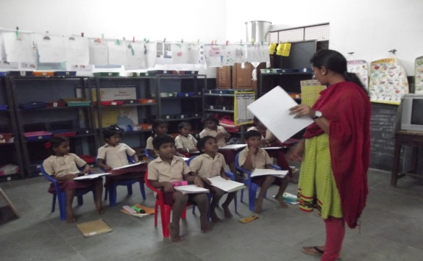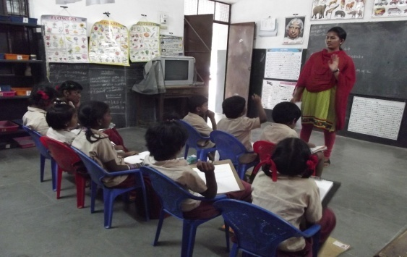
Standard I and II Standard III 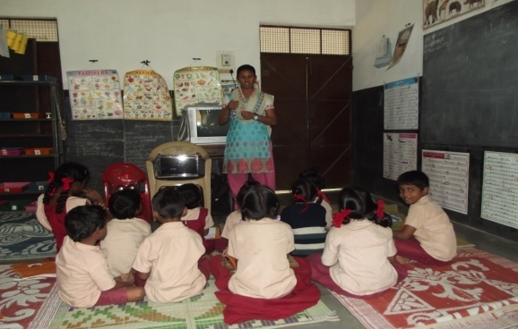 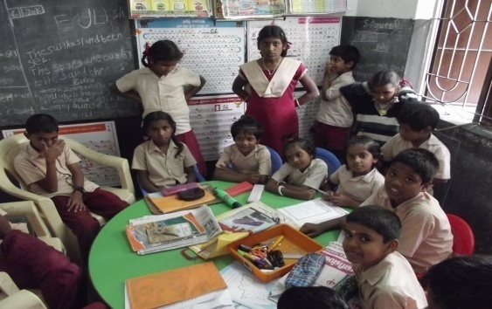
Standard IV Standard V

PLATE- 1
PLATE 1 : EXPLANATION OF THE STUDY AND COLLECTION OF DATA – CLASS WISE
5. Consolidation and presentation of data
The responses obtained from the children were coded and the information collected were consolidated, tabulated and analyzed statistically and the findings are discussed in Chapter IV Results and Discussions.

- INCULCATING HUMAN VALUES AMONG THE SELECTED SCHOOL CHILDREN
Values are general principles to regulate our day-to-day behaviour. They not only give direction to our behaviour but are also ideals and objectives in themselves. Values deal not so much with what is, but with what ought to be; in other words, they express moral imperatives. They are the expression of the ultimate ends, goals or purposes of social action. Our values are the basis of our judgements about what is desirable, beautiful, proper, correct, important, worthwhile and good as well as what is undesirable, ugly, incorrect, improper and bad.
The initial study on the level of human values possessed by the children in the selected school showed that only 12 per cent of students were aware of the importance of human values in their life. Hence, realizing the importance of inculcating human values among school children, the education programme was planned according to the following steps.
- Selection of the target group
- Development of course content
- Conduct of the programme

- Selection of the target group
According to Piaget (2010) Children in the concrete operations stage (6years to 11years) are able to take another's point of view and take into account more than one perspective simultaneously. They can also represent transformations as well as static situations. Concrete problems are understood. One important task that children learn during the concrete operational stage is to arrange things in order according to one attribute, such as size or weight. Logical inferences such as this are not possible until the stage of concrete operations, during which children develop the ability to make two mental transformations that require reversible thinking. A final ability that children acquire during the concrete operational stage is class inclusion; re-creating a relationship between a part and the whole. A child can now focus on two classes simultaneously.
The age group of 6 to 11 years is considered to be a starting step for their life. The children have a good grasping power during this age. This is the stage where they form manner, character, personality, etc; this in future will help them to nurture themselves. Hence the total strength of 50 from standard 1st to 5th at the age group of 5 to 11 years was selected for human values education programme.
- Development of course content
The investigator framed a course content based on (Reddy, 2010) the four values generally as personal, social, moral, spiritual and behavioural values, that has to be taken for the children. Keeping the children’s listening skill modification was made by the investigator to suit the conditions followed by the school. The course content and plan of action for educational programme drawn by the investigator is given in Table II.

TABLE-II
COURSE CONTENT AND PLAN OF ACTION FOR THE EDUCATIONAL PROGRAMME
S.No | Date | Topic | Course Content |  | Methods Used
 |  | Personal values
1. | 16.11.2015-  20.11.2015 | Responsibility | Punctuality, Caring our parents |  | Stories, skit.
2. | 14.12.2015-19.12.2015 | Love | Generosity |  | Lecture, skit and group activities.
 |  | Social values
3. | 04.01.2016-08.01.2016 | Unity | Teamwork |  | Group activities.
4. | 11.01.2016-13.01.2016 | Social responsibility | Health, Neatness |  | Skit and charts.
5. | 18.01.2016-22.01.2016 | Co-operation and Freedom | Coordination |  | Lecture, drawing and games.
 |  | Emotional values
6. | 25.01.2016-  29.01.2016 | Patience | Peacefulness, Kindness |  | Movies, charts.
7. | 15.02.2016- 19.02.2016 | Happiness | Helping others |  | Lecture, Stories and movies
 |  | Moral values
8. | 22.02.2016- 26.02.2016 | Honesty |  | Truthfulness | Lecture, charts and stories
9. | 29.02.2016- 04.03.2016 | Obedience |  | Respect | Lecture, stories and skit.

- Conduct of educational programme for the school children
Value education maintain to strengthen positive forces for directing, social change to a desirable direction and to strengthen the social fabric that holds the people in a society together. The goal of living value education is to create generous people who are not self- centered, selfish and explosive, but are emancipated and magnanimous. Together they create family like society where people are emotionally inter- related, interdependent, concerned about one another, where they express mutual affection, respect love and contribute towards mutual wellbeing (Amareswaran, 2009).
Based on the schedule prepared the educational program was conducted in the classes twice a week, one hour per day for a period of three months from December 2015 to February 2016, in the selected school. Many group activity and short films were used for the children to grasp attention to the values that will help them in future. Plate 2a, 2b, 2c represents the methods and aids used during human values educational programme.

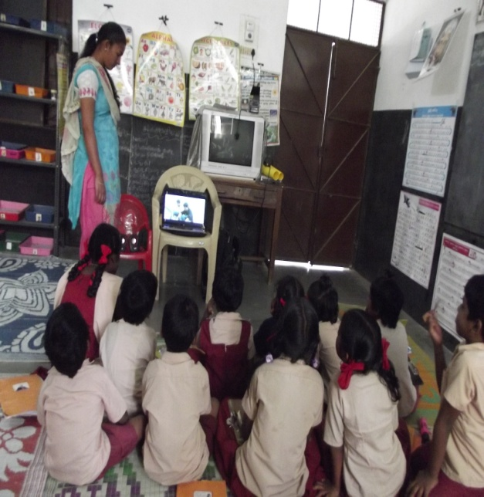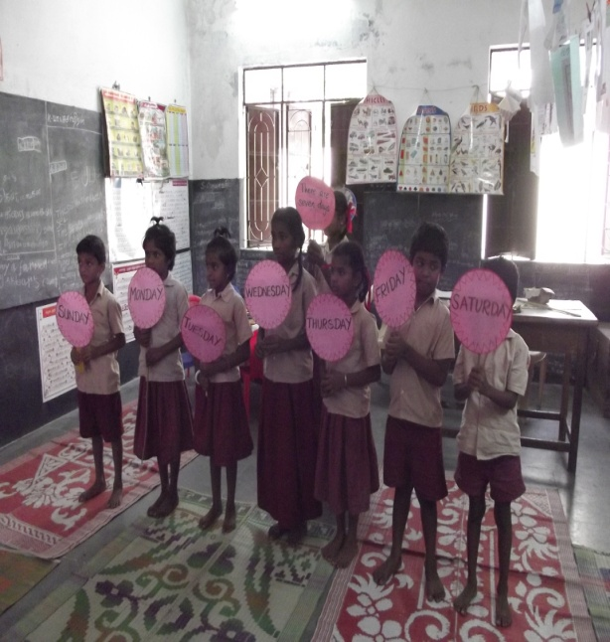
Showing short films for inculcating Using charts for inculcating
cleanliness unity 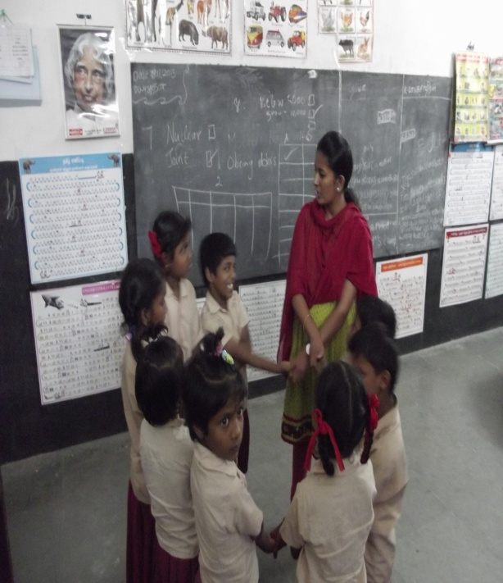 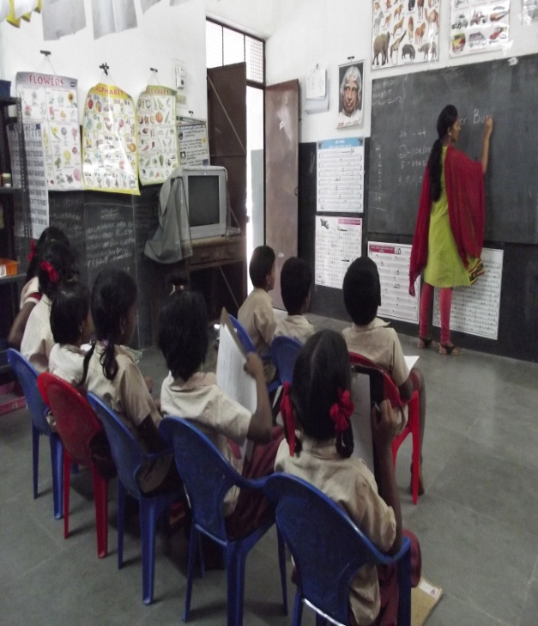
Lecture and stories related Stories and games
to obedience related to honesty
PLATE 2a - INCULCATION ON PERSONAL VALUES
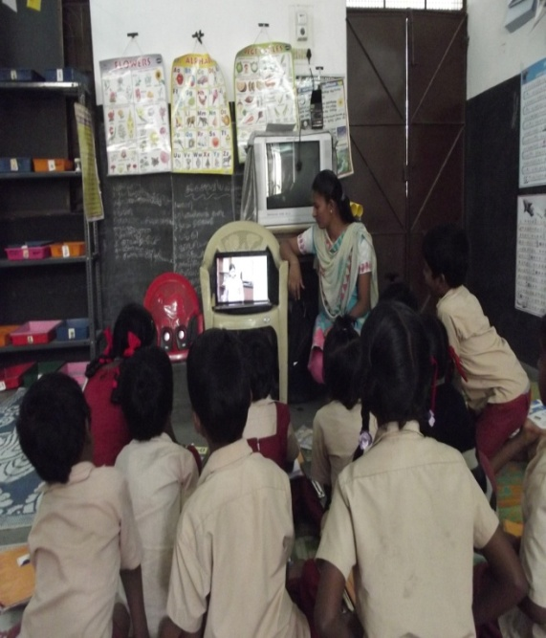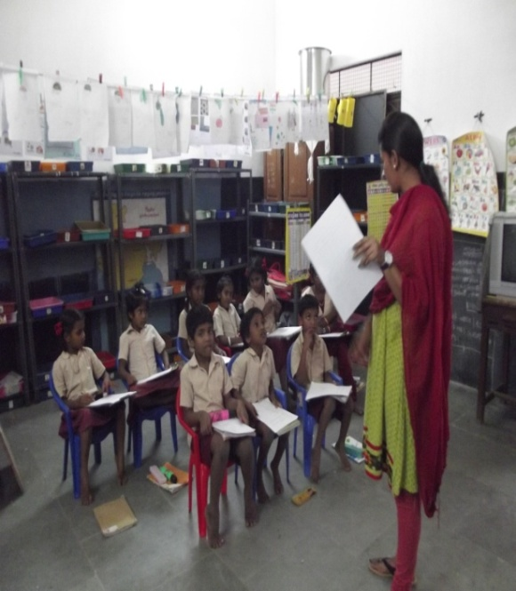
Stories and movies about love Charts and stories related to
Patience 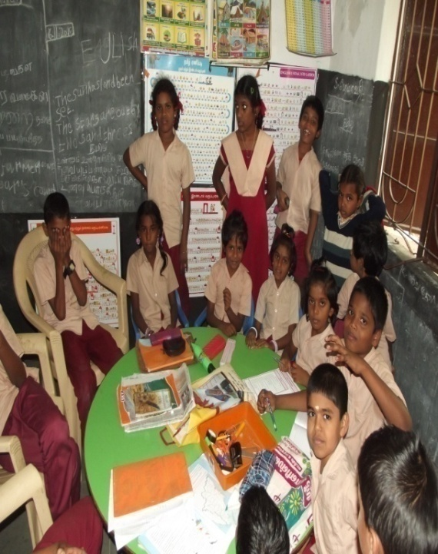 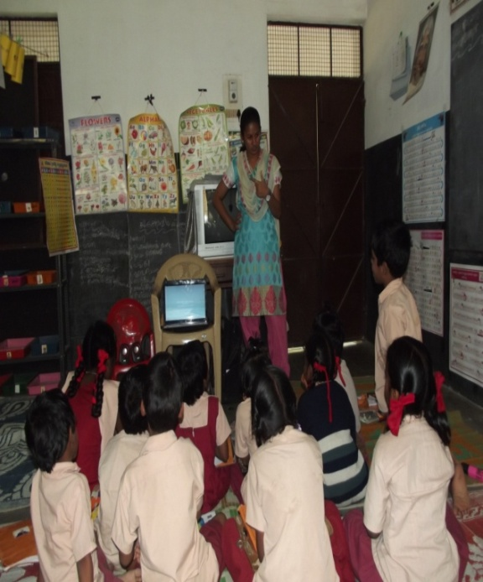
Lecture and stories related Group activity related to responsibility
to happiness
PLATE 2 b – INCULCATION ON SOCIAL AND MORAL VALUES
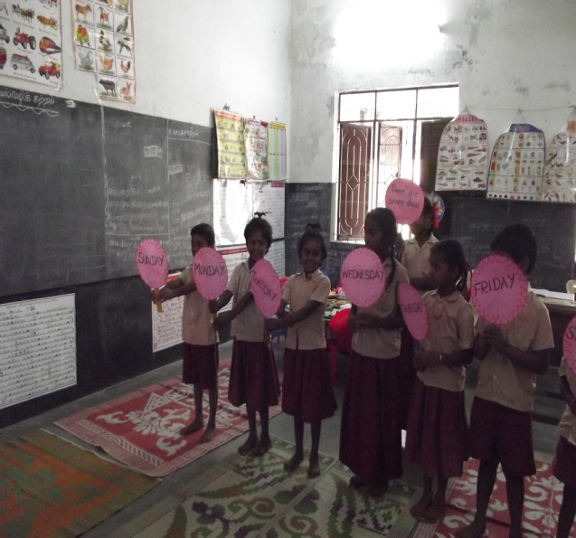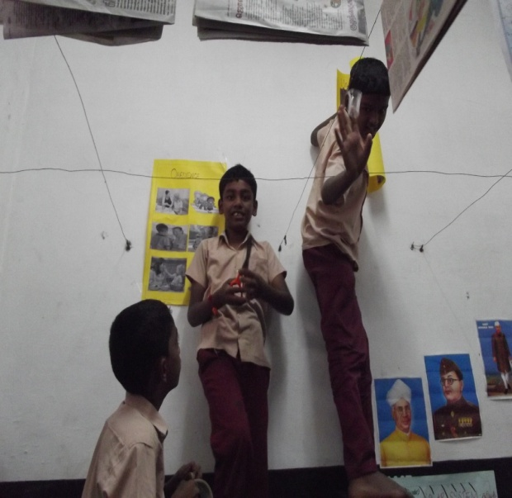
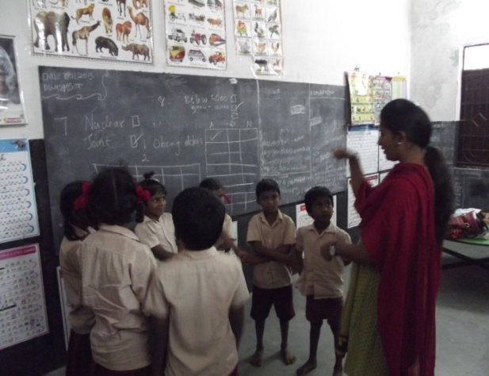

PLATE 2 c- INCULCATION OF STORIES RELATED TO EMOTIONAL AND SPIRITUAL VALUES
- EVALUATING THE IMPACT OF THE EDUCATIONAL PROGRAMME CONDUCTED.
According to Tufo (2011), evaluation is assessing and judging the value of a piece of work, an organization or a service. Its main purpose is to keep organizations reflect on what it is trying to achieve, assessing how far it is succeeding and identifying required changes.
The impact of educational programme on human values on selected school children was evaluated on the following basis.
- Knowledge gained by the school children
- Acceptance and adoption of human values by the school children.
- Parents and teachers opinion regarding human value educational programme.

- Knowledge gained
It was calculated according to the information that the school children possessed both prior to and after educational programme on human values. This was collected by framing questions related to various aspects of human values such as personal, social, emotional, spiritual and moral values. The result was analyzed and presented in Chapter IV, Results and Discussion. The questionnaire is presented in Appendix II.
- Acceptance and adoption of human values by the school children
The acceptance and adoption level was evaluated by administrating the same questionnaire, containing the same aspects of human values such as personal, social, emotional, spiritual and moral values which was mentioned and used before and after the educational programme. The results were statistically analyzed and presented in Chapter IV Results and Discussion.

- Parents and teachers opinion regarding human values educational programme
In order to find out the right reflection and opinion regarding human values among school children, the change in values, and behaviour among their children after the completion of human values educational programme were required from teachers and parents based on the following aspects.
- Opinion of parents about their children
The investigator arranged for a meeting with the parents before and after conducting the educational programme to collect details and opinions regarding their children and to know about the importance of their children’s education and future, the purpose of the study was to find out the children’s behaviour level and the values that they should carry throughout their life. In order to collect the details the investigator used questionnaire as a tool. The questionnaire was distributed to the parents and explained in the local language of how to fill in the information.
- Opinion of teachers about the educational programme among school children.
The same questionnaire was distributed to the teachers before and after the educational programme and collected the information. The purpose of this study was to find out the children’s behaviour level and the values that they should carry throughout their life.
The results were statistically analyzed and presented in Chapter IV Results and Discussion.

IV. RESULT AND DISCUSSION
The findings of the study on “Inculcating Human Values among School Children” are analysed and presented under the following headings:

- DEMOGRAPHIC PROFILE OF SCHOOL CHILDREN
- General profile of school children
- Family background of school children

- KNOWLEDGE ON HUMAN VALUES GAINED AND DEVELOPED BY THE SCHOOL CHILDREN
- Knowledge on human values gained and developed by the school children
C. ACCEPTANCE AND ADOPTION OF HUMAN VALUES BY THE SCHOOL CHILDREN
- Personal values imbibed by the school children
- Social values imbibed by the school children
- Emotional values imbibed by the school children
- Spiritual values imbibed by the school children
- Moral values imbibed by the school children
- Opinion of parents regarding the human values imbibed by their children
- Opinion of teachers regarding the human values imbibed by the children

- DEMOGRAPHIC PROFILE OF SCHOOL CHILDREN
The demographic profile of the school children are discussed under the following heads:

- General profile of the school children
- Family background of the school children

- General profile of the school children
General profile of the school children such as class and age wise distribution, sex and academic performance are presented in Table III, IV, V.

- Class and age wise distribution of the school children
Table III represents the class and age wise distribution of the school children.

TABLE- III
CLASS AND AGE WISE DISTRIBUTION OF THE SCHOOL CHILDREN

Class | Age | Number (50) | Percentage
I | 5-6 | 4 | 8
II | 6-7 | 4 | 8
III | 7-8 | 12 | 24
IV | 8-9 | 18 | 36
V | 9 and above | 12 | 24

Thirty six per cent of children were studying in IV standard, which belonged to the age group of 8-9 years. Twenty four per cent of each child was studying in III and V standard who were in the age group of 7 – 8 years and 9 years and above respectively. While eight per cent each of children were studying in I and II standard and they belonged to the age group of 5-6 and 6-7 years respectively.

- Sex wise distribution of the school children
Sex wise distribution of the selected school children is presented in Table IV.

TABLE- IV
SEX WISE DISTRIBUTION OF THE SCHOOL CHILDREN

Sex | Number (50) | Percentage
Male | 20 | 40
Female | 30 | 60

The percentages of female children are more than the male children who were 60 per cent and 40 per cent respectively. Thus the result shows that the growing importance given by parents in educating the children were high in female children to meet the day today challenges.

- Academic performance of the school children
The academic performance in the third term were recorded and assessed. The fact revealed in their performance in Table V.

TABLE-V
ACADEMIC PERFORMANCE OF THE SCHOOL CHILDREN
Average marks | Number | (in percentage)
30- 50 | 11 | 22
50- 70 | 13 | 26
70- 90 | 17 | 34
Above 90 | 9 | 18

It is observed from the table, that 34 percent of the school children had secured an average marks between 70- 90. Twenty six percent of the school children scored better marks between 50- 70. Eighteen per cent of the school children were excelling in their studies, they had secured above 90 marks in their third term. Twenty two per cent of the children secured below average marks. In general majority of the children had secured high marks in their studies.
- Family background of the school children
Family background of the school children were discussed under type, size, and monthly income of the family, education, occupation status of parents and basic amenities available in the house. The results are presented in Tables VI, VII, VIII, and IX.

- Type, size and monthly income of the families of the school children
Table VI represents the type, size and monthly income of the families of the school children.
TABLE- VI
TYPE, SIZE AND MONTHLY INCOME OF THE FAMILIES OF THE SCHOOL CHILDREN
Family Background | Number (50) | Percentage
Type of Family  Nuclear  Joint Family | 38  12 | 76  24
Size of the Family  1-4 members  4-6 members  Above 6 members | 21  24  5 | 42  48  10
Monthly income of the Family  Below Rs.5000  Rs.5000-10,000  10,000- 15,000 | 9  38  3 | 18  76  6
HUDCO, 2004
Regarding the type of family, majority of 76 per cent of children belonged to nuclear family. This shows the degeneration of joint family system in the society

The impact of all the effort taken by the government to control the population is bearing its fruits at present. This is shown in the study were 48 per cent of children belonged to medium size family (4-6 members), 42 per cent of children belonged to small size family (1-4 members), whereas only 10 per cent of children fall under large family system (above 6 members).

Seventy six per cent of family income of the children ranged between Rs.5000- Rs.10, 000. The family incomes of eighteen per cent were less than Rs. 5000, while only six per cent of family of the children earned up to 15,000 per month. Inspite of their low economic status it is great to know that 18 per cent of families educate their children which reveal the importance given for education by the families.

- Educational status of parents
Table VII emphasizes the educational status of parents of the school children.

TABLE-VII
EDUCATIONAL STATUS OF PARENTS
N=50
Educational status | Father | Percentage | Mother | Percentage
Illiterate | 16 | 32 | 6 | 12
Primary | 11 | 22 | 13 | 26
Secondary | 16 | 32 | 15 | 30
Higher secondary | 7 | 14 | 16 | 32

It is evident from the Table that 32 per cent of father’s of the school children were illiterate and 32 per cent of father’s of the school children were educated up to secondary level. Twenty two per cent of father’s of the school children were educated up to primary level while only 14 per cent of father’s of the school children were educated up to higher secondary level.

Thirty two per cent of mother’s of the school children were educated up to higher secondary level, 30 per cent of mother’s of the school children were educated up to secondary level, twenty six per cent of mother’s of the school children were educated up to primary level while only 12 per cent of mother’s were illiterate. This shows the fact that the higher the education, importance given for educating their children.

- Occupational status of parents
Table VIII gives the occupational status of parents of the school children.

TABLE –VIII
OCCUPATIONAL STATUS OF PARENTS

Occupational status | Father |  | Mother
Occupational status | Number (50) | Percentage | Number (50) | Percentage
Business | 7 | 14 | - | -
Skilled worker | 31 | 62 | - | -
House wife | - | - | 38 | 76
Servant | - | - | 6 | 12
Teacher | - | - | 4 | 8
Farmer | 12 | 24 | 2 | 4

It is clear from the Table that 14 per cent of father’s of the children respectively were doing business. Sixty two per cent father’s of the children respectively were skilled workers like, carpenter, driver, electrician and watchman. Twenty four per cent of the children’s father’s were farmers.
It is interesting to note that mother’s of 76 per cent of the children were house wives. Twelve per cent of mother’s of the children were servant maids. Only eight per cent of the mother’s of children were teachers and four per cent of mother’s were farmers.

- Basic amenities available in the house of the school children.
Table IX represents the basic amenities in the house that includes availability of food and clothing, drinking water, cleanliness, light, ventilation and sanitation.
TABLE IX
BASIC AMENITIES AVAILABLE IN THE HOUSE OF THE SCHOOL CHILDREN
Facilities | Number (50*) | Percentage
Food and clothing | 46 | 92
Drinking water | 41 | 82
Cleanliness | 43 | 86
Light | 40 | 80
Ventilation | 35 | 70
Sanitation | 32 | 64
*Multiple Response
From the above table, it could be noted that the facilities like food and clothing, drinking water, cleanliness, light and ventilation were satisfactory. Sixty four per cent of children felt that the sanitation facilities were not sufficient due to lack of disposal of waste.

- KNOWLEDGE ON HUMAN VALUES GAINED AND DEVELOPED BY THE SCHOOL CHILDREN
Knowledge on human values gained and developed by the school children were discussed in Table X.
Knowledge is information that changes something or somebody, either by becoming grounds for actions, or by making an individual capable of different or more effective action (Drucker, 2004)
Knowledge acquisition involves complex cognitive processes: perception, learning, communication, association and reasoning. The term knowledge is also used to mean the confident understanding of a subject with the ability to use it for a specific purpose if appropriate.
Table X and Figure 2 depict the knowledge on human values gained by the school children before and after the educational programme.
TABLE – X
KNOWLEDGE ON HUMAN VALUES GAINED AND DEVELOPED BY THE SCHOOL CHILDREN
VALUES | BEP |  | AEP
VALUES | Number (50) | percentage | Number (50) | Percentage
Participation in class activities | 13 | 26 | 47 | 94
Co-operation | 16 | 32 | 46 | 92
Sharing emotions | 19 | 38 | 45 | 90
Patience | 12 | 24 | 42 | 84
Caring for others | 15 | 30 | 43 | 83
Protecting school and national properties | 20 | 40 | 42 | 82
Appreciating others | 18 | 36 | 40 | 80

FIGURE 2: KNOWLEDGE ON HUMAN VALUES GAINED BY THE SCHOOL CHILDREN
The result reveals that the educational programme had positive impact in imbibing the human values among the school children. Majority 94 per cent of the children developed the values in participating in class activities, followed by co- operation 92 per cent, sharing emotions 90 per cent, patience 84 per cent, caring for others 83 per cent, protecting school and national properties 82 per cent, appreciating others 80 per cent.

- ACCEPTANCE AND ADOPTION OF HUMAN VALUES BY THE SCHOOL CHILDREN
Accepting and adopting the human values by the school children are discussed under the following heads:
- Personal values imbibed by the school children
- Social values imbibed by the school children
- Emotional values imbibed by the school children
- Spiritual values imbibed by the school children
- Moral values imbibed by the school children
- Opinion of parents regarding the human values imbibed by their children
- Opinion of teachers regarding the human values imbibed by the children

- Personal values imbibed by the school children
Personal values mean the desires of individual whatever they are in the social relationship. Some of the personal values are excellence, honesty, self-confidence, self-motivation, punctuality, ambition, courage, creativity, imagination etc.
Table XI represents the personal values imbibed by the school children before and after educational programme.
TABLE- XI
PERSONAL VALUES IMBIBED BY THE SCHOOL CHILDREN
N=50
Personal Values | Always |  | Sometimes |  | Never
Personal Values | BEP | AEP | BEP | AEP | BEP | AEP
Personal Values | (in percentage)
Cleanliness | 70 | 92 | 30 | 8 | - | -
Making Friends | 73 | 90 | 27 | 10 | - | -
Discipline | 74 | 86 | 26 | 14 | - | -
Obeying elders | 72 | 86 | 28 | 14 | - | -
Caring for others | 64 | 82 | 36 | 18 | - | -
Patience | 36 | 76 | 64 | 24 | - | -
Punctuality | 38 | 76 | 62 | 24 | - | -
Self-control | 60 | 70 | 38 | 30 | 2 | -
It is clear from the table that after the educational programme the personal values of the school children were improved in all the criteria. Especially more positive difference was noticed in the aspects of cleanliness, making friends, discipline, obeying elders, caring for others, patience, punctuality and self- control (range between 70 per cent to 92 per cent).
- Impact of educational programme on personal values imbibed by the school children
Table XII and Figure 3 represent the impact of educational programme on personal values imbibed by the school children before and after the educational program.
TABLE- XII
IMPACT OF EDUCATIONAL PROGRAMME ON PERSONAL VALUES IMBIBED BY THE SCHOOL CHILDREN
Personal Values | Number | Mean | S.D | ‘t’ value
BEP | 50 | 48.6 | 18.5 | 0.22**
AEP | 50 | 47.2 | 33.3 | 0.22**
**- Significant at 1 per cent level.

FIGURE 3: IMPACT OF EDUCATIONAL PROGRAMME ON PERSONAL VALUES IMBIBED BY THE SCHOOL CHILDREN
The’ t ‘ value is calculated to find out the significant differences of before and after the educational programme on personal value imbibed by the school children, it is clear that the’ t ‘value is higher than the table value were found to be significant at 1 per cent level. The educational programme on personal values among the school children had definitely molded their character such as making friends, caring for others and self control.
- Social values imbibed by the selected school children
Social values are more important for healthy, good environment for every organization. Individual cannot live in the world without having interaction with others.

Table XIII depicts the social values imbibed by the school children before and after the educational programme.
TABLE XIII
SOCIAL VALUES IMBIBED BY THE SCHOOL CHILDREN N=50
Social Values | Always |  | Sometimes |  | Never
Social Values | BEP | AEP | BEP | AEP | BEP | AEP
Social Values | (in percentage)
Sharing food with fellow mates | 80 | 92 | 18 | 8 | 2 | -
Enjoy to help others | 78 | 90 | 22 | 10 | - | -
Co-operation | 70 | 84 | 30 | 16 | - | -
Helping the parents | 68 | 84 | 32 | 16 | - | -
Making small decisions | 60 | 82 | 36 | 18 | 4 | -
Active participation in games | 70 | 80 | 30 | 20 | - | -
Keeping the classroom clean | 60 | 68 | 40 | 32 | - | -
Being afraid to take part in activities | 32 | - | 62 | 38 | 6 | 62
The table clearly reveals that after the educational programme maximum improvement of 68 per cent to 92 per cent was noticed that social values such as keeping classroom clean, active participation, making small decision, helping parents, co-operation, enjoy helping others and sharing food with fellow mates than before the educational program.
- Impact of educational programme on social values imbibed by the school children
Table XIV and Figure 4 represent the impact of educational programme on social values imbibed by the school children.
TABLE- XIV
IMPACT OF EDUCATIONAL PROGRAMME ON SOCIAL VALUES IMBIBED BY THE SCHOOL CHILDREN
Social Values | Number | Mean | S.D | ‘t’ value
BEP | 50 | 48 | 21.3 | 0.19**
AEP | 50 | 47.2 | 31.9 | 0.19**
**- Significant at 1 per cent level

FIGURE 4: IMPACT OF EDUCATIONAL PROGRAMME ON SOCIAL VALUES IMBIBED BY THE SCHOOL CHILDREN
The ’ t ‘ value is calculated to find out the significant differences of before and after the educational programme on social value imbibed by the school children, it is clear that the’ t ‘value is higher than the table value were found to be significant at 1 per cent level. The educational programme on personal values among the school children had definitely molded their character such as making friends, caring for others and self control.
- Emotional values imbibed by the school children
Table XV represents the emotional values imbibed by the school children before end after the educational programme.
TABLE XV
EMOTIONAL VALUES IMBIBED BY THE SCHOOL CHILDREN
N=50
Emotional Values | Always |  | Sometimes |  | Never
Emotional Values | BEP | AEP | BEP | AEP | BEP | AEP
Emotional Values | (in percentage)
Showing kindness | 66 | 86 | 32 | 14 | 2 | -
Compassion | 54 | 80 | 46 | 20 | - | -
Caring | 52 | 76 | 48 | 24 | - | -
Empathy | 53 | 70 | 47 | 30 | - | -
Self control | 51 | 62 | 49 | 38 | - | -
Expressing anger | 38 | 4 | 58 | 56 | 4 | 40

It is encouraging to note that after the educational programme on human values emotional values of the children shows a positive difference of 62 per cent to 86 per cent in the aspects of self control, empathy, caring, compassion and showing kindness and it is a marvelous difference of only 4 per cent of the children express their anger after the educational programme.
- Impact of educational programme on emotional values imbibed by the school children
Table XVI and Figure 5 represent the impact of educational programme on emotional values imbibed by the school children before and after the educational programme.
TABLE- XVI
IMPACT OF EDUCATIONAL PROGRAMME ON EMOTIONAL VALUES IMBIBED BY THE SCHOOL CHILDREN
Emotional Values | Number | Mean | S.D | ‘t’ value
BEP | 50 | 48.5 | 8.07 | 0.32**
AEP | 50 | 46.7 | 23.4 | 0.32**
**- Significant at 1 per cent level

FIGURE 5: IMPACT OF EDUCATIONAL PROGRAMME ON EMOTIONAL VALUES IMBIBED BY THE SCHOOL CHILDREN
The ’ t ‘ value is calculated to find out the significant differences of before and after the educational programme on emotional value imbibed by the school children, it is clear that the’ t ‘value is higher than the table value were to be found significant at 1 per cent level. The educational programme on personal values among the school children had definitely molded their character such as making friends, caring for others and self control.
- Spiritual values imbibed by the school children
The ultimate ethical value is called spiritual value. Spiritual values are piety, meditation, yoga, self-discipline, control, purity, and devotion to God etc. Spiritual values highlight the principles of self-restraint. Self discipline contentment, reduction of wants, freedom from general greed and austerity.
Table XVII shows the spiritual values imbibed by the school children before and after the educational programme.
TABLE XVII
SPIRITUAL VALUES IMBIBED BY THE SCHOOL CHILDREN
N=50
Spiritual Values | Strongly Agree |  | Agree |  | Strongly disagree
Spiritual Values | BEP | AEP | BEP | AEP | BEP | AEP
Spiritual Values | (in percentage)
Thanking god | 60 | 82 | 40 | 18 | - | -
Morning prayer | 62 | 78 | 38 | 22 | - | -
Praying for others | 42 | 62 | 57 | 38 | 1 | -
Praying for needs | 63 | 54 | 34 | 46 | 4 | -

The table shows that the spiritual values of the children has raised from 54 per cent to 82 per cent, the children have developed their spiritual values in the aspects especially thanking God for everything, daily prayer, praying for others and not praying only for their needs after the educational programme.

- Impact of educational programme on spiritual values imbibed by the school children
Table XVIII and Figure 6 represents the impact of educational programme on spiritual values imbibed by the school children before and after the educational programme.
TABLE- XVIII
IMPACT OF EDUCATIONAL PROGRAMME ON SPIRITUAL VALUES IMBIBED BY THE SCHOOL CHILDREN
N=50
Spiritual Values | Number | Mean | S.D | ‘t’ value
BEP | 50 | 48 | 12.2 | 0.37**
AEP | 50 | 45.4 | 21.4 | 0.37**
**- Significant at 1 per cent level

FIGURE 6: IMPACT OF EDUCATIONAL PROGRAMME ON SPIRITUAL VALUES IMBIBED BY THE SCHOOL CHILDREN
The ’ t ‘ value is calculated to find out the significant differences of before and after the educational programme on spiritual value imbibed by the school children, it is clear that the’ t ‘value is higher than the table value were to be found significant at 1 per cent level. The educational programme on personal values among the school children had definitely molded their character such as making friends, caring for others and self control.
5. Moral values imbibed by the school children
Moral values impart respecting others and ourselves, respecting the right of others, keeping promises avoiding unnecessary problems with others avoiding cheating and dishonesty, showing gratitude to others and encourage them to work.
Moral values imbibed by the school children before and after the educational programme are represented in Table XIX.
TABLE XIX
MORAL VALUES IMBIBED BY THE SCHOOL CHILDREN
N=50
Moral Values | Strongly Agree |  | Agree |  | Never
Moral Values | BEP | AEP | BEP | AEP | BEP | AEP
Moral Values | (in percentage)
Generosity | 48 | 64 | 34 | 30 | 18 | 6
Truthfulness | 40 | 62 | 58 | 36 | 2 | 2
Honesty | 30 | 60 | 68 | 38 | 2 | 2
Co-operation | 22 | 58 | 70 | 38 | 6 | 4
Respect | 34 | 58 | 60 | 40 | 6 | 2
Responsibility | 32 | 48 | 58 | 50 | 10 | 2
Obedience | 8 | 36 | 84 | 60 | 8 | 4

The table reveals the improvement of 36 per cent to 64 per cent of moral values of the children in the aspects of obedience, responsibility, respect, co- operation, honesty, truthfulness and generosity after the educational programme.

- Impact of educational programme on moral values imbibed by the school children
Table XX and Figure 7 represents the impact of educational programme on moral values imbibed by the school children before and after the educational programme.
TABLE- XX
IMPACT OF EDUCATIONAL PROGRAMME ON MORAL VALUES IMBIBED BY THE SCHOOL CHILDREN
Moral Values | Number | Mean | S.D | ‘t’ value
BEP | 50 | 31.8 | 23.4 | 0.15**
AEP | 50 | 32.5 | 25.8 | 0.15**
**- Significant at 1 per cent level

FIGURE 7: IMPACT OF EDUCATIONAL PROGRAMME ON MORAL VALUES IMBIBED BY THE SCHOOL CHILDREN
The ’ t ‘ value is calculated to find out the significant differences of before and after the educational programme on moral value imbibed by the school children, it is clear that the’ t ‘value is higher than the table value were to be found significant at 1 per cent level. The educational programme on personal values among the school children had definitely molded their character such as making friends, caring for others and self control.
6. Opinion of parents regarding the human values imbibed by their children
Table XXI and Figure 8 shows the opinion of parents regarding the human values imbibed by the children before and after the educational programme.

TABLE XXI
OPINION OF PARENTS REGARDING THE HUMAN VALUES IMBIBED BY THEIR CHILDREN
N=50
VALUES | BEP | AEP
VALUES | (in percentage)
Active participation in school competition | 63 | 100
Helping their parents | 73 | 95
Interest to pray God | 64 | 95
Sharing feeling with parents | 75 | 93
Doing homework on time | 47 | 84
Being obedient | 38 | 79
Being honest | 45 | 77
Giving respect to all elders | 56 | 77
Co-operation among siblings | 6 | 34
Sharing feelings with siblings | 9 | 34
It is clear from the table that the parents enthusiastically expressed that after the educational programme there was a positive improvement among the children in all aspects. Higher percentage of difference was shown in sharing feelings and co- operation with siblings, helping parents, in praying to God of 34 per cent to 95 per cent.

FIGURE 8: IMPACT OF OPINION OF PARENTS REGARDING THEIR CHILDREN BEFORE AND AFTER EDUCATIONAL PROGRAMME

7. Opinion of teachers regarding the human values imbibed by the children
Table XXII and Figure 9 represents the opinion of teachers regarding human values imbibed by the children.

TABLE- XXII
OPINION OF TEACHERS REGARDING THE HUMAN VALUES IMBIBED BY THE CHILDREN
N=50
Values | YES |  | NO
Values | BEP | AEP | BEP | AEP
Values | (in percentage)
Giving respect to all teachers | 70 | 96 | 30 | 4
Being obedient | 80 | 90 | 20 | 10
Being honest | 77 | 90 | 13 | 10
Completing homework on time | 40 | 90 | 60 | 10
Active participation in school competition | 60 | 80 | 40 | 20
Communicating without fear | 70 | 87 | 30 | 13
Co-operation among other students | 40 | 70 | 60 | 30
Attentive in class hours | 10 | 60 | 90 | 40
Helping other students | 10 | 40 | 90 | 60
Interest in taking responsibility | 30 | 40 | 70 | 60

The teachers happily expressed that the children were developed positive attitude through the human value educational programme. The children are actively participating in all activities, showing more interest in learning, and sharing their feeling in all aspects after the educational programme by 40 per cent to 96 per cent.

FIGURE 9: OPINION OF TEACHERS REGARDING THE HUMAN VALUES IMBIBED BY THE CHILDREN BEFORE AND AFTER EDUCATIONAL PROGRAMME

V. SUMMARY AND CONCLUSION
Education is not a preparation for life; education is life itself
-John Dewey

“Education is the creation of a sound mind in a sound body. It develops mans faculty, especially his mind so that he may be able to enjoy the contemplation of supreme truth, goodness and beauty of which perfect happiness essentially consists”. The function of education is to teach one to think intensively and to think critically. Intelligence and character is the goal of true education. Best of all this is character. Character is the crown. When the thoughts are words and the words are faithful to each other, it shines most.

Value education builds character which is beneficial for growth of both the individual youth and the society in general. It influences our decision making in life and helps us grow by building healthy relationships in society. People who become great statesmen, sports persons or business entrepreneurs have certain things in common. They are all vigilant about their surroundings. They all know how best to use what they have. They all believe in hard work and in doing things which are good for the society Creation of such values in our youth is the end product of Human value Education

The main aim of present study was to inculcate human values among the school children with the objectives of helping the elementary school children to think about and reflect on different values and the practical implications of expressing them in relation to themselves, others, the community, and the world. To find out the impact on the selected school children before and after the educational programme; to assess the level of significance in personal, social, emotional, spiritual and moral values and also to find out opinion of parents and teachers about their children before and after educational programme.

For the study Corporation Elementary School at Coimbatore was selected. The sample of the study comprised of 50 students ranging from I to V standard. The tool adopted for the present study was using questionnaire, it consists of demographic profile and different aspects of values such as personal, social, emotional, spiritual and moral values that included 7 points: obedience, honesty, responsibility, co- operation, respect, truthfulness and generosity.

The study was conducted with the help of systematic plan of work for the period of six months from September to February 2015-16. Short stories and charts were prepared and distributed during the educational programme.

Parents know their children better than anyone else and parents have the most complete understanding of their child’s physical, social, development and behaviour. Parents are the second teacher hence keeping this in mind parents meetings was conducted and their opinion on human value educational programme was collected.

The data collected were analysed statistically using parametric test such as ‘t’ test. The results are summarized below:

- Thirty six per cent of children were studying in IV standard, which belonged to the age group of 8-9 years. Twenty four per cent of each child was studying in III to V standard who were in the age group of 7 – 8 years and 9 years and above respectively. While eight per cent each of children were studying in I and II standard and they belonged to the age group of 5-6 and 6-7 years respectively.

- The percentages of female children are more than the male children who were 60 per cent and 40 per cent respectively. Thus the result shows that the growing importance given by parents in educating the children were high in female children to meet the day today challenges.

- Thirty four percent of the school children had secured an average marks between 70- 90. Twenty six percent of the school children scored better marks between 50- 70. Eighteen per cent of the school children were excelling in their studies, they had secured above 90 marks in their third term. Twenty two per cent of the children secured below average marks. In general majority of the children had secured high marks in their studies.

- The impact of all the effort taken by the government to control the population is bearing its fruits at present. This is shown in the study were 48 per cent of children belonged to medium size family (4-6 members), 42 per cent of children belonged to small size family (1-4 members), whereas only 10 per cent of children fall under large family system (above 6 members).

- Seventy six per cent of family income of the children ranged between Rs.5000- Rs.10, 000. The family incomes of eighteen per cent was less than Rs. 5000, while only six per cent of family of the children earned up to 15,000 per month. Inspite of their low economic status it is great to know that 18 per cent of families educate their children which reveal the importance given for education by the families.

- Thirty two per cent of father’s of the school children were illiterate and 32 per cent of father’s of the school children were educated up to secondary level. 22 per cent of father’s of the school children were educated up to primary level while only 14 per cent of father’s of the school children were educated up to higher secondary level.

- Thirty two per cent of mother’s of the school children were educated up to higher secondary level, 30 per cent of mother’s of the school children were educated up to secondary level, twenty six per cent of mother’s of the school children were educated up to primary level while only 12 per cent of mother’s were illiterate. This shows the fact that the higher the education, importance given for educating their children.

- Fourteen per cent of father’s of the children respectively were doing business. Sixty two per cent father’s of the children respectively were skilled workers like, carpenter, driver, electrician and watchman. Twenty four per cent of the children’s father’s were farmers.

- It is interesting to note that mother’s of 76 per cent of the children were house wives. Twelve per cent of mother’s of the children were servant maids. Only eight per cent of the mother’s of children were teachers and four per cent of mother’s were farmers.

- Regarding Basic Amenities available in the house, facilities like food and clothing, drinking water, cleanliness, light and ventilation were satisfactory. Sixty four per cent of children felt that the sanitation facilities were not sufficient due to lack of disposal of waste.

- Regarding knowledge on Human values the result reveals that the educational programme had positive impact in imbibing the human values among the school children. Majority 94 per cent of the children developed the values in participating in class activities, followed by co- operation 92 per cent, sharing emotions 90 per cent, patience 84 per cent, caring for others 83 per cent, protecting school and national properties 82 per cent, appreciating others 80 per cent.

- The educational programme on personal values of the school children were improved in all the criteria. Especially more positive difference was noticed in the aspects of cleanliness, making friends, discipline, obeying elders, caring for others, patience, punctuality and self- control (range between 70 per cent to 92 per cent).

- The educational programme on social value revealed that maximum improvement of 68 per cent to 92 per cent was noticed in the aspects such as keeping classroom clean, active participation, making small decision, helping parents, co-operation, enjoy helping others and sharing food with fellow mates than before the educational program.

- It is encouraging to note that after the educational programme on human values – emotional values of the children shows a positive difference of 62 per cent to 86 per cent in the aspects of self control, empathy, caring, compassion and showing kindness and it is a marvelous difference of only 4 per cent of the children express their anger after the educational programme.

- The spiritual values of the children has raised from 54 per cent to 82 per cent, the children have developed their spiritual values in the aspects especially thanking God for everything, daily prayer, praying for others and not praying only for their needs after the educational programme.

- Regarding moral values the improvement of 36 per cent to 64 per cent of moral values of the children in the aspects of obedience, responsibility, respect, co- operation, honesty, truthfulness and generosity after the educational programme.

- The parents enthusiastically expressed that after the educational programme there was a positive improvement among the children in all aspects. Higher percentage of difference was shown in sharing feelings, co- operation with siblings, helping parents, in praying to God of 34 per cent to 95 per cent.
- The teachers happily expressed that the children were developed positive attitude through the human value educational programme. The children are actively participating in all activities, showing more interest in learning, and sharing their feeling in all aspects after the educational programme by 40 per cent to 90 per cent.
CONCLUSION

In today’s scenario, values have been discarded by the new generation. In such a situation it is very important that basic principles are laid down for a brightened life, no matter the stepping stones of success hit hard. Thus value education completes this need very easily with an impact on the young minds making the world a better place to live in.

SUGGESTION

Here are some suggestions, which can be helpful in development of essential values in childhood if implemented with serious efforts and outmost care-

- Curriculum reform is urgently needed; especially curriculum of languages can be used for promoting value along with the learning of subject matter.
- Beside the subject matter teachers should try to figure out the value based messages hidden in text and communicate it to students.
- Parents should try to invest more time with the child rather than investing their time in earning money. Half the work is done if parents decide to teach one story every day to their child giving essential message.
- Teacher should understand their duty to impart value education to the child from very first day along with the formal education.
- Different type of extracurricular activities and other such programmes must be organized in school from time to time to promote values in students.

BIBLIOGRAPHY

- Aggarwal (2009), Education for values, Environment and Human Rights, Shipra publications, New Delhi, pp. 1 -19.
- Amareswaran (2009), “Value education : Need of the hour” Ph.D Thesis on progress.
- Ambica (2010), Higher education for girls, Shipra publications, New Delhi,Pp. 1-19.
- Ameta, D. (2015), A Study on the Role of School Curriculum and Teachers in Inculcation of Values among Elementary School Students, Journal of Education and Practice, Vol.6, No.31
- Anilkumar (2008), “Value Oriented Education”, New Frontiers in Education, International journal of education, Vol 41. No. 1 pp. 45-47.
- Avinash (2011). The Psychology of late childhood, journal of early intervention. Pp.431-448.
- Avinashilingam (1983), Ethical values in a changing world, Sriramakrishna mission vidyalaya industrial institute printing press. Pp. 24-32.
- Awasthi, D. (2014) Value based Education is the only Solution to the Problem of Crisis of Moral Values among the Youth of India, Vol. 3. Issue.9Volume-3, Issue-9,
- Borah (2014), A comparative study on Need for Value Based Education an Opinion Survey among School Teachers, Journal of Humanities & Social Science, Volume-I.
- Chandramani (1987), ethical values in a changing world, Sri Ramakrishna Mission vidyalaya industrial institute printing press, coimbatore, pp. 411-418.
- Chaudhary (2011), Silent sitting, Government of Himachal Pradesh, Shimla, P. 14- 25.
- Chavan’s Committee Report (1999)
- Das, M.(2016 ), A comparative study on Value Education among Primary and Secondary school Teacher, International Journal of Research in Economics and Social Sciences, vol. 6
- DEFPFE, (2009), Department Of Educational Psychology And Foundations Of Education.
- Dhill (2002), Justifying attitudes by appealing to values: A Functional perspective. British Journal of Social Psychology, Vol 27, pp. 247-256.
- Diane (2003), Living values Activities for Children 8- 13, Sterling publisher private limited, New Delhi, pp. 1- 25.
- Giridhar (2005), Teaching and Techniques, Technical education. Anmol Publications Pvt Ltd, New Delhi, pp. 11- 18.
- Gupta (2011), Statistical methods, sultan chand and sons, 36th edition. Pp- 65-72.
- Hawkes and Heppenstall (2002), “Education in human values”, California, corwin press, pp. 21-23.
- Heffer (2005), “Value development in higher education – The Indian tradition”. Bharatiya vidya Bhavan, Mumbai,pp. 37- 46.
- Hornberger (2009), Value orientation in higher education. Vol. 22, pp – 26-37.
- Hunt, (2009), Changing Values of Students, Elementray English, Vol, XLIX,(5).
- Huxley (2007), Education, Regression and liberation. London World University Service, Pp. 79-81.
- Indrani. B, (2012), Education India Journal: A Quarterly Refereed Journal of Dialogues on Education, ISSN 2278- 2435, Vol. 1, Issue- 3.
- Jagannath (2005), Teaching of Moral Values Development, New Trend and innovations, Deep & Deep Publications Private Limited, New Delhi, pp.12-17.
- Jindal, J. (2013), Value Based Education -- Need of the Day, International Journal of Emerging Research in Management &Technology, Volume-2, Issue-9
- Joshi, Kireet (2011), Inculcation of values, Journal of Indian Education, Pp. 33- 38
- Jyoti, J. (2013), Value Based Education -- Need of the Day, International Journal of Emerging Research in Management &Technology, Volume-2, Issue-9
- Kohlberg's theory of moral development to the social studies classroom. Social Education, 39, 16-22.
- Marlow, (2005), The Teacher, Parents and Reading, Experiments in Education, vol- XXXII,No.7 pp.9-15.
- Mikkili, N.R (2014), Value Education and Human Values: Analytical Views, Vol. 3, No. 7.
- National Commission of Secondary Education (1952-53)
- National Policy on Education (1986), Ministry of Human Resource Development, New Delhi, Government of India.
- NCERT (2009), National Council Of Educational Research And Training
- Pankajam, (2005), Know your child, Concept Publishing Company, New Delhi, pp.253.
- Pankajam, G. (2010), Know your child, Concept Publishing Company, New Delhi, P. 253.
- Parson (2002), Higher education and social responsibility, New Frontiers in Education, Vol. XXXVI (1), pp. 35-38.
- Pepper, S.C. (2011), The sources of values, University of California, Berkley.
- Piaget, J (2010), Moral judgement of the child, Harcourt, Brace, new York.
- Rand(2009) “Evaluation of Round Robin approach in teaching and reading” University Graduate School Journal, Vol, 11, pp. 43- 49.
- Reddy,N (2010), Importance of moral values in the present day situation.
- Ruhela (2003), “Human values and education”, Sterling Publishers Pvt Ltd, New Delhi, pp. 1-12, 144- 153.
- Santhanu, 2007, Value Education : The essence of life. Journal of Educational Research and Extension, Vol.44 (3), pp.43-51.
- Saraf, S. (2009), Programme Implementation on human values, Apeejay Education Foundation, New Delhi, Pp. 40-42.
- Shahi, R.S, (2014) Integrated Approach for Inculcating Human Values, Vol. 5
- Singh, (2008), Spiritual leadership in education, concept, training and challenges, New Frontiers in Education, Vol,XXVIII(1), PP. 38-47.
- Simon, S., Howe, L., & Kirschenbaum, H. (1972). Values clarification: A handbook of practical strategies for teachers and students. New York: Hart.
- Sulochana, T. (2011), Character development, Prasanthi Nilayam, P. 146.
- Superka, D., Ahrens, C., & Hedstrom, J. (1976). Values education sourcebook. Boulder, CO: Social Science Education Consortium.
- Uday Singh, (2013), value education and national reconstruction, Cognitive Discourses International Multidisciplinary Journal. Vol I.
- University Education Commission (1962)
- Yadav and Yadav, (2008), “A Study on the extent of value attainment among student teacher”. Journal of Educational Research and Extension. Vol (44). Pp. 17-23.

Websites
- (https://myeducationservices.wordpress.com)
- (http://www.unfpa.org/ )
- (http://www.essayforum.com/)

APPENDIX I
AVINASHILINGAM INSTITUTE FOR HOME SCIENCE AND HIGHER EDUCATION FOR WOMEN COIMBATORE-641043
QUESTIONNAIRE FOR CHILDREN TO COLLECT INFORMATION REGARDING HUMAN VALUES
I. Demographic profile
- Name :
- Class :
- Age :
- Sex :
- School name :

- Type of family : Nuclear
Joint Family

- Parents occupation : Father ___________________________
Mother ___________________________
- Family’s monthly income : Below Rs.5000
Rs.5000 to Rs.10,000
Above Rs.10,000

Read the following questions and mark your answers by putting a tick on a given scale
II. Personal values
S.No | Personal Values | Always | Sometimes | Never
1. | Obeying elders
2. | Caring for others
3. | Making Friends
4. | Punctuality
5. | Patience
6. | Cleanliness
7. | Discipline
8. | Self-control

III. Social Values
S.No | Social Values | Always | Sometimes | Never
1. | Making small decisions
2. | Co-operation
3. | Active participation while playing games
4. | Enjoy to help others
5. | Sharing food with fellow mates
6. | Helping the parents
7. | Keeping the classroom clean
8. | Being afraid to take part in activities

IV. Emotional Values
S.No | Emotional Values | Always | Sometimes | Never
1. | Expressing anger
2. | Showing kindness
3. | Compassion
4. | Empathy
5. | Caring
6. | Self control
V. Spiritual Values
S.No | Spiritual Values | Strongly Agree | Agree | Strongly disagree
1. | Do you pray every morning?
2. | Do you pray for others?
3. | Do you pray to God, only for your needs?
4. | Do you thank God every day?
VI. Moral Values
S.No | Moral Values | Strongly Agree | Agree | Never | Disagree | Strongly Disagree
1. | Obedience
2. | Honesty
3. | Responsibility
4. | Co-operation
5. | Respect
6. | Truthfulness
7. | Generosity

APPENDIX II
AVINASHILINGAM INSTITUTE FOR HOME SCIENCE AND HIGHER EDUCATION FOR WOMEN COIMBATORE-641043
QUESTIONNAIRE FOR PARENTS TO ELICIT INFORMATION REGARDING THEIR CHILDREN
Parents are requested to mark tick () on the relevant column, about your children’s attitude towards the given issues.
S.No | Issues | Yes | No
1. | Active participation in school competition
2. | Co-operation among siblings
3. | Doing homework on time
4. | Giving respect to all elders
5. | Helping their parents
6. | Interest to pray God
7. | Sharing feelings with parents
8. | Sharing feelings with siblings
9. | Being honest
10. | Being obedient

APPENDIX III
AVINASHILINGAM INSTITUTE FOR HOME SCIENCE AND HIGHER EDUCATION FOR WOMEN COIMBATORE-641043
QUESTIONNAIRE FOR TEACHERS TO ELICIT INFORMATION REGARDING THE CHILDREN
Teachers are requested to mark tick () on the relevant column, about children’s attitude towards the given issues.
S.No | Issues | Yes | No
1. | Active participation in school competition
2. | Co-operation among other students
3. | Completing homework on time
4. | Giving respect to all teachers
5. | Helping other students
6. | Interest in taking responsibility
7. | Attentive in class hours
8. | Communicating without fear
9. | Being honest
10. | Being obedient

APPENDIX IV
KNOWLEDGE INVENTORY TO TEST THE KNOWLEDGE ON HUMAN VALUES BY THE CHILDREN BEFORE AND AFTER THE EDUCATIONAL PROGRAMME
VALUES | YES | NO
Appreciating others
Caring for others
Co-operation
Sharing emotions
Participation in class activities
Patience
Protecting school and national properties

