“COMPARATIVE STUDY ON CAR RENTAL COMPANIES WITH E- MARKETED CAR RENTAL COMPANIES IN COIMBATORE”

By
PRIYA.A
(16PTA009)

Thesis Submitted To
Avinashilingam Institute for Home Science and Higher Education for Women, Coimbatore-641043
In partial fulfilment of the requirement for the degree of

MASTER OF BUSINESS ADMINISTRATION
(TOURISM AND TRAVEL MANAGEMENT)
April, 2018

ACKNOWLEDGEMENT

ACKNOWLEDGEMENT
The success of this project lies in the hands of many people who have helped and guide me in completing the project. The researcher takes this opportunity to express her thanks and gratitude to each and every one of them.
It gives me immense pleasure and pride to place on record my sincere gratitude to all inspired and help me in this endeavour. After all the academic pursuit has led me draw inspiration for many source.
My sincere thanks to our beloved Chancellor Padmashree Dr. P. R. KrishnakumarJi, Vice Chancellor Dr. Premavathy Vijayan Ma’am and the Registrar Dr. S. Kowsalya Ma’am Avinashilingam Institute for Home Science and Higher Education for Women, Coimbatore for giving us an opportunity to undertake the project work which forms part of the curriculum.
I would express my sincere thanks to Dr. Bindu V. T, MTA, M.Phil, PGDBA., Ph.D. Assistant Professor and Head of Department of Tourism Management, Avinashilingam Institute for Home science and Higher Education for Women, Coimbatore.
I wish to express my deep sense of gratitude and profound thanks to the project guide Mrs K. Sathiyabamavathy, MBA, MPil., Assistant Professor of Department of Tourism Management, Avinashilingam Institute for Home Science and Higher Education for Women, Coimbatore for my inspiration and well-wisher for her keen interest, valuable guidance and consultant encouragement without whom this would have not taken shape.
I am, also thankful to the respondents for their support in completing our research.
I would like to express my hearfelt gratitude and evelasting thanks to my parents and also to my relatives for their valuable suggestions to complete my project successfully.
Last but not the least I wish each and every one of my friends who have helped me in making this research a success.

TABLE OF CONTENTS
CHAPTER NO | TITLE | PAGE NO
I | Introduction
 | 1.1 Tourism
 | 1.2 Components Of Tourism
 | 1.2.1 Accessibility (Reachability/Transportation)
 | 1.2.2 Accommodation
 | 1.2.3 Attraction
 | 1.2.4 Ancillary
 | 1.3 Hospitality Industry
 | 1.3.1 Hospitality Services
 | 1.3.2 Tourism And Hospitality Industry In India
 | 1.4 Tourism In Tamil Nadu
 | 1.5 The Role Of Transportation In Tourism
 | 1.5.1 Modes Of Transport
 | 1.5.2 Road Transport
 | 1.5.3 Rail Transport
 | 1.5.4 Water Transport
 | 1.5.5 Air Transport
 | 1.6 Cab Industry
 | 1.7 E-Marketed Or App Based Taxi
 | 1.7.1 Benefits of using app based taxi services
 | 1.8 Cab Industry In India
 | 1.9 Influence Of Cab Services In Tourism Industry
 | 1.10 India Taxi Services Market
 | 1.11 Service Quality And Customer Satisfaction In Cab Industry
 | 1.12 Customer Satisfaction
 | 1.13 Taxi Firms In India
 | 1.14 Need For The Study
 | 1.15 Objectives Of The Study
 | 1.16 Scope For The Study
 | 1.17 Limitation For The Study
 | 1.18 Chapterisation
II | Review Of Literature
 | 2.1 Introduction
 | 2.2 Review Of Literature Related To Customer Satisfaction
 | 2.3 Cab Industry
 | 2.4 Customer Satisfaction
 | 2.5 Customer Perception
III | Research Methodology
 | 3.1 Introduction
 | 3.2 Research Design
 | 3.3 Sampling Design
 | 3.4 Source Of Data
 | 3.5 Data Collection
 | 3.6 Tools For Analysis
 | 3.7 Garrett’s Ranking technique
 | 3.8 Location Of Study Area
 | 3.8.1 Cab Services In Coimbatore
 | 3.8.2 Some Of The Car Rental Cab Service
 | 3.8.3 Some Of The E-Marketed Or App Based Taxi Service
IV | Analysis And Interpretation
V | Findings,Suggestions And Conclusion
 | 5.1 Findings
 | 5.2 Suggestions
 | 5.3 Conclusion
VI | Bibliography
VII | Annexure

LIST OF TABLES
Table N.O | Title | Page N.O
4.1 | Gender
4.1.1 | Age
4.1.2 | Education
4.1.3 | Occupation
4.1.4 | Marital Status
4.1.5 | Family Type
4.1.6 | Size of Family
4.1.7 | Children In The Family
4.1.8 | Family Member’s working
4.1.9 | Annual Income
4.1.10 | Credit/Debit Card
4.2.1 | ANOVA with Age
4.2.2 | ANOVA with Education qualification
4.2.3 | ANOVA with occupation
4.2.4 | ANOVA with size of the family
4.2.5 | ANOVA with Number of children
4.2.6 | ANOVA with Annual income
4.2.7 | ANOVA with other family working
4.2.8 | ANOVA with Frequency Of Taxi Booking
4.2.9 | ANOVA with Mode of payments
4.2.10 | ANOVA with Distance use on app based taxi
4.2.11 | ANOVA with do travel on app based call taxi usually
4.2.12 | ANOVA with purpose of use app based taxi
4.3.1 | T-TEST with Gender
4.3.2 | T-TEST with Marital status
4.3.3 | T-TEST with Family type
4.3.4 | T-TEST with Credit/Debit card
4.4.1 | Garrett’s scale ranking method for selected cab in Coimbatore
4.4.2 | Garrett’s scale ranking method for selected cab in Coimbatore

LIST OF FIGURES
Table N.O | Title | Page N.O
4.1 | Gender
4.1.1 | Age
4.1.2 | Education
4.1.3 | Occupation
4.1.4 | Marital Status
4.1.5 | Family Type
4.1.6 | Size of Family
4.1.7 | Children In The Family
4.1.8 | Annual Income
4.1.9 | Credit/Debit Card
4.4.3 | Garrett’s Scale Ranking

CHAPTER 1

INTRODUCTION
CHAPTER –I
INTRODUCTION
1.1 Tourism
Tourism is travel for pleasure; Tourism may be international, or within the traveller’s country. The World Tourism Organization defines tourism more generally, in terms which go "beyond the common perception of tourism as being limited to holiday activity only ", as people "travelling to and staying in places outside their usual environment for not more than one consecutive year for leisure, business and other purposes".
Tourism is now a global industry involving millions of people in international as well as domestic travel every year. The World Tourism Organization estimated that international tourist arrivals grew by 4.4 percent in 2015 to reach a total of 1,184 million in 2015, this amounts to approximately 12 per cent of the of the world’s population. Tourism comprised of the temporary movement of people to destinations outside of their normal places of work and residence, the activities undertaken during the stay in those destinations and the facilities created to cater for their needs. Tourism is multi-dimensional and can be compartmentalized in a number of ways. There are two major variables such as origin-destination relationship and the motivation for travel. Tourism can be divided into four categories such as international tourism, internal tourism, domestic tourism and national tourism. Major reasons for tourist travel are escape, from routine, relaxation, play, strengthening family bonding, prestige, social interaction, sexual opportunity, educational opportunity, self-fulfilment and shopping
Today, tourism is a major source of income for many countries, and affects the economy of both the source and host countries. In some cases tourism is of vital importance, due to the income generated by the consumption of goods and services by tourists, the taxes levied on businesses in the tourism industry, and the opportunity for employment and economic advancement by working in the industry. Travel activity of the foreign tourist brings lot of money to the countries where they travel. Hence, tourism has become a source of income for the countries. Tourism is now developing as a great industry .Not only make significant contribution to the foreign exchange earnings, employment, income generation and regional development but it also helps in the overall development of that area Tourism is as such a part of socio-economic development as any other related activity.
For these reasons NGOs and government agencies promote a specific region as a tourist destination, and support the development of a tourism industry in that area. The contemporary phenomenon of mass tourism result in over development, however alternative forms of tourism such as ecotourism seek to avoid such outcomes by pursuing tourism in a sustainable way.
1.2 Components of Tourism
A Tourism product can be defined as the sum of the physical and psychological satisfaction it provides to tourist during their travelling and route to the destination it can be seen as a composite product as the sum total of the country’s tourist attraction,transport,and accommodation and of entertainment which result in customer satisfaction. Each of the components of a tourist product is supplied by individual provider of service like hotel companies, Airline travel agencies,etc. The tourist product can be analyses in term of its attraction, accessibility and accommodation.
The following five a factor represent the essential requirements for successful tourism:
- Accessibility
- Accommodation
- Attractions
- Ancillary services and Amenities
1.2.1 Accessibility (Reachability/Transportation):-
One of the main components of tourism, accessibility, refers to the ability for tourists to get to the destination. Accessibility in tourism is how easy it is for the tourist to access or get to the desired destination. This mostly includes transportation, which needs to be regularly scheduled, economical, safe and comfortable. Depending on the destination, this includes cars and buses, boats and ships, trains and airplanes. The transportation should be there for all kinds of tourists and destinations. It is means by which a tourist reaches the area where the attractions are located.
1.2.2 Accommodation:-
The second component of tourism is accommodation. This means that tourists have a place to stay upon reaching the destination and a way to get food. Much like accessibility, accommodation also needs to be economical, safe and comfortable. The type of accommodation also varies according to the location. Other accommodations include hotels and motels. Accommodation plays a central role and is very basic to tourist destinations.
The demand for accommodation away from one’s home is met by a variety of facilities. There are various types of accommodation from seven star deluxe hotels to a normal budget class hotel. The accommodation and other facilities compliment the attractions. The range and type of accommodation is quiet varied and has undergone considerable change since the last half century. There has been a decline in the use of boarding houses and small private hotels.
1.2.3 Attraction:-
The third and arguably most important component of tourism is attraction. This means that the destination needs to have some draw that makes tourists want to visit. In some cases the draw is scenic, like mountains and lakes. In other cases the draw might be historical relevance. Unless there is an attraction, the tourist will not be motivated to go to a particular place. Attractions are those elements in a product which determine the choice made by particular tourist to visit one particular destination rather than another.
Attraction means anything that creates a desire in a person to travel in a specific tourist destination or attraction. Locale is basic component of tourism. The locale may be used to include the holiday destination and what it offers to the tourist. The holiday destination may offer natural attractions. The attractions could be like cultural sites and areas of archaeological interests, historical buildings and monuments, flora and fauna, beach resorts, mountains, national parks or events like trade fair, exhibitions, arts and music festivals, games etc.

1.2.4 Ancillary:-
Ancillary services necessary to support the transmission of electric power from seller to purchaser given the obligations of control areas and transmitting utilities within those control areas to maintain reliable operations of the interconnected transmission system."
Ancillary services are the specialty services and functions provided by the electric grid that facilitate and support the continuous flow of electricity so that supply will continually meet demand. These services generally include frequency control, spinning reserves and operating reserves. Traditionally ancillary services have been provided by generators, however, the integration of intermittent generation and the development of smart grid technologies have prompted a shift in the equipment that can be used to provide ancillary services.
1.3 Hospitality Industry
The hospitality industry is a broad category of fields within service industry that includes lodging, event planning, theme parks, transportation, cruise line, and additional fields within the tourism industry. The hospitality industry is a multibillion-dollar industry that depends on the availability of leisure time and disposable income. A hospitality unit such as a restaurant, consists of multiple groups such as facility maintenance and direct operations (servers, housekeepers, porters, Kitchen workers, bartenders, management, marketing, and human resources. Usage rate, or its inverse "vacancy rate", is an important variable for the hospitality industry.
1.3.1 Hospitality Services
The sectors in hospitality services include are Food and service management, Bars, Nightclubs, Amusement parks, hotels, Motels, Hostels, Restaurants, Self‐catering accommodation, Holiday centres and, Travel agent. The sector at present employs about 2.5 million people and provides support to other industries, like hotels and restaurants to educational establishments Hospitality Industry in India: The Indian tourism and hospitality industry has materialized

1.3.2 Tourism and Hospitality Industry in India
The terms tourism and hospitality are co-related and grouped together as a single industry. However these both hospitality and tourism industries are viewed as two individual sectors. There exist overlapping between these two. Tourism is defined as the persons travel and goes for the places outside of their usual environment for less than one year to accomplish their business purpose and for leisure; they are not employed there on visiting places.
The Indian tourism and hospitality industry has emerged as one of the key drivers of growth among the services sector in India. The Tourism and Hospitality industry is expected to generate 13.45 million jobs across sub-segments such as Restaurants (10.49 million jobs), Hotels (2.3 million jobs) and Travel Agents/Tour Operators (0.66 million). The Ministry of Tourism plans to help the industry meet the increasing demand of skilled and trained manpower by providing hospitality education to students as well as certifying and upgrading skills of existing service providers.
The Indian tourism and hospitality industry has materialized as one of the key drivers of growth among the services sectors in India. It contributes to 6.23 percent to the National GDP and 8.78 percent of the total employment in the country. Constant transformation, functional growth and improving standards have gained the hospitality industry of India approval all over the world.

1.4 Tourism in Tamil Nadu
Tamil Nadu is one of the 29 states of India. Its capital and largest city is Chennai (formerly known as Madras). Tamil Nadu lies in the southernmost part of the Indian Peninsula and is bordered by the union territory of Pondicherry and the South Indian states of Kerala, Karnataka, and Andhra Pradesh. It is bounded by the Eastern Ghats on the north, by the Nilgiri, the Anamalai Hills, and Kerala on the west, by the Bay of Bengal in the east, by the Gulf of Mannar and the Palk Strait on the southeast, and by the Indian Ocean on the south. The state shares a maritime border with the nation of Sri Lanka.
Tamil Nadu is the eleventh-largest state in India by area and the sixth-most populous. The state was ranked sixth among states in India according to the Human Development Index in 2011, and is the third-largest state economy in India with13,842 billion (US$210 billion) in gross domestic product after Uttar Pradesh and Maharashtra. Tamil Nadu was ranked as one of the top seven developed states in India based on a "Multidimensional Development Index" in a 2013 report published by the Reserve Bank of India. Its official language is Tamil, which is one of the longest-surviving classical languages in the world.
Tamil Nadu is home to many natural resources. In addition, its people have developed and continue to develop classical arts, classical music, and classical literature. The state is also home to a number of historic buildings and religious sites including Hindu temples of Tamil architecture, historic hill stations, multi-religious pilgrimage sites, and eight UNESCO World Heritage Sites.
1.5 The Role of Transportation in Tourism
Transportation and travel can be discussed without taking tourism into consideration, but tourism cannot thrive without travel. Transportation is an integral part of the tourism industry. It is largely due to the improvement of transportation that tourism has expanded.

Culpa (1987) identified transportation modes and management as the “important ingredients of the international tourism system,” acknowledging that linkage by air, sea and land modes is essential for the operations as well as the availability of support services such as fuel stations, auto repair, motels and rest facilities for land travel.

Transportation system of a tourist destination has an impact on the tourism experience which explains how people travel and why they choose different forms of holiday, destination, and transport. Accesses to tourist sites vary according to the nature of the site, the state of infrastructure, and the efficiency of the public transport system.

1.5.1 Modes of Transport
A mode of transport is a term used to distinguish substantially different ways to perform. The different modes of transport are air, water, and land transport, which includes rail, road and off-road transport. Other modes also exist, including pipelines, cable transport, and space transport. Human-powered transport and animal-powered transport are sometimes regarded as their own mode, but these normally also fall into the other categories. In general, transportation is used for the movement of people, animals, and other things. Each mode of transport has a fundamentally different technological solution, and some require a separate environment. Each mode has its own infrastructure, vehicles, and operations.
1.5.2 Road Transport
A road is an identifiable route of travel, usefully surfaced with gravel, asphalt or concrete and supporting land passage by foot or by a number of vehicles. The most common road vehicle in the developed world is the automobile; a wheeled passenger vehicle that carries its own motor. As of 2002, there were 591 million automobiles would wide. Other users of roads include motorcars, motorcycle, buses, trucks, bicycles and pedestrians, and special provisions are sometimes made for each of these. For example, the use of bus lanes give priority for public transport, and cycle lanes provide special areas of road for bicycles to use. Motorcars offer high flexibility, but are deemed with high energy and area use, and the main source of noise and air pollution in cities; buses allow for more efficient travel at the cost of reduced flexibility. Road transport by truck is often the initial and final stage of freight transport.
1.5.3 Rail Transport
Rail transport is a mean of conveyance of passengers and goods by way of wheeled vehicles running on rail track, known as a railway or railroad. The rails are anchored upright on railroad train consists of one or more connected vehicles that run on the rails. Propulsion is commonly provided by a locomotive that hauls a series of unpowered, cars, that can carry passengers or freight. The locomotive can be powered by steam, diesel r by electricity supplied by trackside systems. Alterntively, some or all the cars can be powered, known as a multiple unit. Also, train can be powered by horses, cables, gravity, pneumatics and gas turbines. Railed vehicle move with much less friction than rubber tires on paved roads, making train more energy efficient, through not as effect as ships. Intercity trains are long-haul services connecting cities modern high-speed rail is capable of speeds up to 430km.but this requires and surrounding areas, while intra-urban transport is performed by hig- capacity tramways and rapid transits, often making up the backbone of a city public transport. freight trains traditionally used box cars, requiring manuals loading and unloading of the cargo. since the 1960 container trains have become the dominant solution for general freight, while large quintiles of bulk are transported by dedicated trains.
1.5.4 Water Transport

Water transport is the process of transport that a watercraft, such as a barge, boat, ship or sailboat, make over a body of water, such as a sea, ocean , like canal or river. If a board or other vessel can successfully pass through a waterway it is known as a navigable waterway. The need for buoyancy unites watercraft, and makes the hull a dominant aspect of its construction, maintenance and appearance. When a board its floating on the water the hull of the boat is pushing aside water where the hull now is, this is known as displacement.

Although slow, modern sea transport is a highly effective method of transporting large quantities of non –perishable goods. Commercial vessels, nearly 35,000 in number, carried 7.4 billion tons of cargo in 2007. Transport by water is significantly less costly than air transport for transcontinental shipping short sea shipping and ferries remain viable in coastal areas.

1.5.5 Air Transport

Air transport is the second fastest method of transport, after space travel. Commercial jets reach speeds of up to 955 km per hour 9 ( 593 mph) and a considerably higher ground speed if there is a jet stream tailwind, while piston- powered general aviation aircraft may reach up to 55km per hour(345mph). this celerity comes with higher cost and energy use, and aviation impacts to the environment and particularly the global climate require consideration when comparing modes of transportation. Airline alone burned about 16.2 billion gallons of fuel during the twelve months between October 2013 and September 2014.The global trend has been for increasing number of people to travel by air, and individually to do so with increasing frequency and over longer distances, a dilemma that has the attention of climate scientists and other research’s the press, and the world wide web. The issue of impacts from frequent travel, particularly by air because of the longer distances that are easily covered in one or a few days, is called hyper mobility and has been a topic of research and government concern for many years.

1.6 Cab Industry

A taxicab, also known as a taxi or a cab, is a type of vehicle for hire with a driver, used by a single passenger or small group of passengers, often for a non-shared ride. A taxicab conveys passengers between locations of their choice. This differs from other modes of public transport where the pick-up and drop-off locations are determined by the service provider, not by the passenger, although demand responsive transport and share taxis provide a hybrid bus/taxi mode.There are four distinct forms of taxicab, which can be identified by slightly differing terms in different countries:
- Hackney carriages, also known as public hire, hailed or street taxis, licensed for hailing throughout communities
- Private hire vehicles, also known as minicabs or private hire taxis, licensed for pre-booking only
- Taxi buses, also come many variations throughout the developing countries as jitneys or jeepney, operating on pre-set routes typified by multiple stops and multiple independent passengers
- Limousines, specialized vehicle licensed for operation by pre-booking
1.7 E-Marketed or App Based Taxi

Taxi services internationally have started offering Apps which can be used by customers to order or book a taxi ride, whenever they want, by simply placing the details into the App. This adds convenience and ease to the process, increasing customer satisfaction and reducing effort. On the other hand, it is also a good way to secure data on the customers and also get all the required details, like phone number and address, so the service doesn’t lose any information while noting it down over the phone.
Having a website is also a must in today’s digital world, where customers like to learn about businesses and their processes. Upload all information and average rates on the website, the different ways to approach the service as well as frequently asked questions etc.
Having a strong digital presence not only provides more options to customers when searching for taxi services but also helps in business growth.
1.7.1 Benefits of using app based taxi services:
- Taxi booking app as per their requirement of taxi from anywhere & anytime with reducing fares.
- App gives Cab Users the convenience of booking cabs without having to wait on the road.
- The GPS enables the driver to find his/her location by the passenger and the passenger can track before the taxi has arrived to his location.
- Users can get updates on cab location and their approximate arrival time.
- Cashless ways of payment mean passengers need not fuss about cash and change.
- Taxi apps avail both cash and e-payments options that allow to transfer online.
- Also it is perfect for a time when you don’t have money on your phone but there’s wifi.
- Smart phone apps connect driver-partners and riders. In cities where these applications and car sharing services operate, one simply has to use their rider app to request a ride.
- Fares are automatically calculated and charged to the payment method linked to the user’s account.
- Passengers can rate drivers which make the system more transparent and trustworthy.
- Cab Users can rate drivers which will help to improve the quality, experience and safety aspects of future riding not only for the same Operator’s cabs but also across the entire cab industry.

1.8 Cab Industry in India
The taxi market in India is estimated at $9 billion; the organizes sector constitutes around 6% revenue share of the overall market. The taxi market in India is highly fragmented and unorganized the unorganized market is constituted of individual car owners and agencies which operate in one or few cities owned vehicles segment includes pure-play car rental companies (e.g. zoom car) and players like carzonrent and menu Aggregators are phenomenon driven by rise or star ups like ola, taxi for sure and recently in 2013, uber Affiators are associated with multiple car rental agencies and offer various packages/deals. The organized taxi market in India is a relatively nascent one; multiple aggregators have launched their service recently. The large number of vehicles in the unorganized segment provides a strong opportunity of affiators and aggregators to bring them under their fold. Price competitive alternative to regular public transport. High level of customer convenience. Players opting for aggregator based asset light model investment by global funds. Entry of multiple players. Trends in the Indian taxi market resemble trends in other taxi market and in the Indian e-commerce market; this is likely to throw up similar opportunities.
1.9 Influence of Cab Services in Tourism Industry
The taxi industry in India is governed by the central motor vehicles (MV) Act of 1998. The MV Act provides a broad framework which enables states to put in place rules for permits, regulate prices by setting maximum and minimum fares, limit the total working hours for drivers and so on. The states do so by bringing out various schemes the taxi can operate under. Each scheme governs a different part of the sector and, thus brings in a certain elements of choice for taxi operators with respect of the regulatory structure they want to come under. There is still an underlying assumption the planners have perfect knowledge of the market and so can fix prices themselves .there is also an assumption that there is a need to reduce uneconomic competition in the sector by introducing constrains on the supply via driver and car requirements. These regulations are remnants of the pre 1991 thinking.

1.10 India Taxi Services Market:
The India taxi services market is forecast to grow at a steady rate over the next couple of years. Lack of effective public transport options in most Indian cities is driving demand for affordable and comfortable cab services across the country.
Moreover, taxi operators offer a competitively priced alternative to three-wheelers and normal cabs plying across various Tier-I and Tier-II cities in India. A huge chunk of demand for taxis emanates from the corporate sector.
Enhanced security and a comfortable commute also lure working professionals to use taxi services instead of public transport and traditional taxis. Also, taxi booking through mobile applications has made cab booking a hassle-free process for Indian customers.
Companies such as Meru, OLA, Uber have witnessed huge surge in cab bookings through smart phone applications over the last few years. Increasing investments have also been assisting the service providers to upgrade their technology as well as their footprint across the country.
1.11 Service Quality and Customer Satisfaction in Cab Industry
The relationship between service and customer satisfaction has received considerable academic attention in this past few years. But the nature of the exact relationship between service quality and customer satisfaction (especially in the way the two constructs have been operational zed) is still shrouded with uncertainly. Many researchers have operational zed customer satisfaction by using a single item scale and many others have used multiple item scales. The present study adopt a different approach and views customer satisfaction as a multi dimensional construct just as service quality, bet argues that customer satisfaction should be operationlized along the same factors (and the corresponding items) on which service quality and customer satisfaction has been investigated. The results have indicated that two constructs are indeed independent but are closely related, implying that an increase in one is likely to lead to an increase in another.

1.12 Customer Satisfaction
Customer satisfaction is a term frequently used in marketing. It is a measure of how products and service supplied by a company meet or surpass customer expectation. Customer satisfaction is defined as the number of customer, or percentage of total customer, whose reported experience with a firm, its products, or its service (rating) exceeds specified satisfaction goals.
Customer satisfaction has important implication for the economic performance of firms because it has the ability to increase customer loyalty and usage behaviour and reduce customer complaints and likelihood of customer defection. The implementation of a CRM approach is likely to have an effect on customer satisfaction and customer knowledge foe a variety of different reasons.
Firstly, firms are able to customize their offering for each customer. By accumulating information across customer interaction and processing this information to discover hidden patterns, CRM application helps firm customize their customer. This customization enhances the perceived quality of product and service from a customer viewpoint, and because perceived quality is a dominant of customer satisfaction, it follows that CRM application indirectly affects customer satisfaction.
Customer satisfaction is a term frequently used in marketing. It is a measure of how products and service supplied by a company meet or surpass customer expectation. Customer satisfaction is defines as the number of customers, or percentage of total customer, whose reported experience with a firm, its product, or its service (rating) exceeds specified satisfaction goals.
The marketing accountability standards board (MASB) endorses the definitions, purposes and constructs of classes of measures that appear in marketing metrics as part of its on-going common language in marketing project. In a survey of nearly 200 senior marketing managers, 71 percent responded that they found a customer satisfaction metric very useful in managing and monitoring their business.
In researching satisfaction, firms generally ask customer whether t heir product or service has met or exceeded expectations. Thus, expectation is a key factor behind satisfaction. For this reason, a luxury resort, for example, might receive a lower satisfaction rating than a budget motel even through its facilities and service would be deemed superior in absolute terms.
They confirmed that, improved or superior service quality will boost customer satisfaction. Service quality determines the level of customer satisfaction and can be seen as the result of the service from offered by the firm. On the flipside, delivering superior quality service is not cost free. The overall effect will result in overpriced service that may lure away price sensitive customer hence reduce on company’s profitatability.
1.13 Taxi Firms in India
The taxi industry in India is not well documented. However according to a study done by the human population in was 4.5million with a day population of 3.2million people. The daily travelling needs of this population that was met through taxi mode of travelling was only 2%. This means that the current taxi business amounts to 95,080 trips per day and it is expected to grow to 165,600 trips per day in 2025.
The taxi firms in India fall under two broad categories; technology based firms and traditional taxi operators. The traditional taxi operators mainly consist of pioneer industry players who command fleets of taxi cabs under their name. They tend to offer corporate taxi services, car hiring as well as safaris and airport transfers. Under this category are individual taxi owners who park their cars at strategic joints to attract passengers. On the other hand, the technology based category is comprised of both local and international players who have transformed the taxi scene. New industry entrants, like UBER and Easy cab have overhauled the old system in the industry which platitude in decades, whereby riders had only two options; either wait on the streets or call taxi dispatcher. The use of the Smartphone’s has made it possible for the new entrants’ clients to get a taxi from wherever they are (“Daily Nation,”2016).
The taxi industry has witnessed a robust competition amongst its players with firms reducing their fare pricing significantly. The industry is flooded with firms who are scrambling to get their market share. Amongst the tactics employed by firms include; free rides, free chopper rides, free Wi-Fi on board and flexible payment mode. It’s not a case of one firm dominating the industry,
But rather a case of all firms struggling to keep their feet on the ground. Despite the innovative gains made in the taxi industry, amid the cut throat competition amongst players, firms are still faced with the challenge of satisfying rider’s needs due to their varying and changing tastes and preference. The riders are more informed than before hence they would not settle for a mediocre service. It is with this respect that service quality is emphasized. Service quality not only ensures that individual rider needs are identified and met; it also ensures that rider expectations are exceeded.
1.14 Need for the Study
Coimbatore being the second largest city, next to Chennai the business community throughout the country would like to focus on Coimbatore to increase the reach of their products to the western part of Tamil nadu and some parts of Kerala from Coimbatore. Large industrial house have a marketing office in Coimbatore confirming the importance of the city. Whether is personal or business, majoruity of people depend upon call taxi services for their travel. In this circumstances, need arise to know the facilities available in Coimbatore city, to know the basic infrastructure like connectivity with other Indian and international cities and necessity of cab services and E-marketed or app based taxi services facilities provided by the cab services to attract and retain their customer and also the customer need and expectation from the cab services providers in order to retain more satisfied customers.
1.15 Objectives of the Study
To study the most preferred cab service and awareness about E-marketed or app based cab services and around in Coimbatore.
To assess the facilities and services provided by cab services in around Coimbatore.
To analyze the level of satisfaction provided by both regular and E-marketed or app based taxi services.
To suggest appropriate promotional strategies to promote E-marketed cab services in Coimbatore.

1.16 Scope for the Study
Coimbatore city is one of the largest industrial hubs with lot of moving population ever day. The present study measures the quality of service delivered by the cab services awareness about E-marketed or app based and satisfaction level of most used customers. The results of this study can be used by the other regular and app based taxi services to improve their quality of service delivery and customer retention practices.
1.17 Limitation for the Study
Although the study was carried out with extreme enthusiasm and careful planning there are several limitations, which handicapped the research.
The limitations that could restrict the accuracy of the research finding are as follows:
- The research was carried out in the short span of time with a limited sample size 250 respondents.
- Respondent had marked the questionnaire which may be socially incorrect irrespective of the actual feeling cannot be accurate since the survey is subjected to the bias and prejudices of the respondents.
- Due to confidentiality of some information accurate response was not revealed by some of the respondents.
- The limitation of convenience sampling, hence the finding need not be generalized to the entire travelling communities.
1.18 CHAPTERISATION
The following chapter and content analysis will be applicable to the research study:
Chapter 1-Introduction:
The chapter provides brief introduction about Tourism industry. Tourism in India, tourism in tamilnadu, cab industry, E-market or app based taxi services in india,customer satisfaction need for the study, objectives of the study, scope for the study and the major limitations of the study.

Chapter 2- Review of literature:
In this chapter review of related literature is conducted on customer satisfaction, Service quality, cab industry, cab service in India and Customer satisfaction of cab service.
Chapter 3- Research methodology:
This chapter describes the research design used for this study. it briefs on data collection, sample and various tools used for the analysis and location of the study area. Local communities and their preferences.
Chapter 4-Analysis and Interpretation of Results:
In this chapter contains the analysis carried out in this study. The results of the analysis and its discussions are given to address the proposed research problem.
Chapter 5- Findings and Suggestion:
In this chapter the research is concluded. The finding of the study is summarized .It also proposes various suggestions for developing customer satisfaction and and service quality for the cab services.

CHAPTER 2
REVIEW OF LITERATURE

CHAPTER –II
REVIEW OF LITERATURE
2.1 INTRODUCTION
The research on customer satisfaction is an important component for service industry. It has been studied in several situation and environment from various industries both from national and international level. The concept of customer satisfaction is measured from various dimensions. In this research study, the researcher identified and review most influencing factors of customer satisfaction and also recognized different model of customer satisfaction in cab industries. The researcher suggested the review of literature part based on service quality related to low cost cab service and E-marketed or app based car rental companies.
2.2 REVIEW OF LITERATURE RELATED TO CUSTOMER SATISFATION
Peyton (2013) in their working paper submitted at the Allied Academies International conference presented a comprehensive review of the literature on various customer satisfaction and dissatisfaction (CS/D) theories proposed. the paper analysis four theories under the umbrella of consistency theory viz. assimilation theory, contrast theory, assimilation contrast theory, and negative theory. The authors argue that even though the satisfaction construct has been defined in a number of ways, satisfaction has been defined in terms of need fulfillment, pleasure/ displeasure, cognitive state, attribute or benefit evaluations, and subjective evaluation of experience by many researchers. The review concludes, “however, while researchers have used a number of different definition for satisfaction, they generally agree that satisfaction involved a set of inter- related variables rather than a single variable”
Vavra, T.G.(2011) In this suggests specific programmers to improve the measurement of customer satisfaction in an organization. The author describes five 36 critical skills required for this task viz. sampling/customer-participant selection, questionnaire design, interviewing/survey administration, data analysis, and quality function deployment- building action plans. The model proposed has three stages: antecedents, the satisfaction formation process, and consequences. The author further classifies the ‘performance’ of a product or service as ‘objective’ and ‘perceived’. Assimilation contrast Theory, contrast Theory, dissonance Theory, generalized negativity, and hypothesis testing.
Vavra, T.G.(2011) in his study stated as a satisfactory post-purchase experience with a product or service given an existing purchase expectation. The study also examines the level of complaints regarding service failure and remedies. When consumers complain about service, they eventually from a judgment, consequently uncorrected is direction proportional to the customers level of satisfaction.
Anton (2010) offers more elaboration: “customer satisfaction as a state of mind in which the customer’s needs, wants and expectations throughout the product or service life have been met or exceeded, resulting in subsequent repurchase and loyalty.” The study was conducted with a sample of 100 customer- show that customer behavior is affected by the length of time they have to wait. For this purpose the authors have defined value as customer perceptions that specific hotel attributes have fulfilled their needs during their hotel stay. It is pointed out that an effective distribution system that makes rooms easily available was the most frequently mentioned marketing factor driving purchase, followed by frequent- stay programmers.
Woodruff and guardian (2010) states that “satisfaction, then, is the evaluation or feeling that results from the disconfirmation process. Satisfaction has an emotional component”. Different type of customer data information, statistical analysis of sample dataset, and in the final chapter presents the conclusions. The authors suggest that web could be the first contact for collection of customer satisfaction data and this method facilitates continuous monitoring the opinion of the visitors to the site. May emerge from customers, who are satisfied with the service –where as negative word-of-month communication emerges from customers who have experienced dissatisfying experiences or encounters.
Fornell (2009) an overall evaluation that is built up over time, satisfaction typically mediates the effects of product quality, service quality, and price or payment equity on loyality.Examine “customer satisfaction across organizational” unit in their working paper. The authors argue that variation in the specific-general satisfaction relationship across organizational subunits also has important theoretical implication for satisfaction research and stress the importance of explaining the variation effects across units or subunits. i.e. for one subunit , some specific type of satisfaction may be strong predictor of overall satisfaction , while for another subunit the same specific type of satisfaction may have little or no relationship to overall satisfaction.
Johnson and formal (2009) this is overall satisfaction has a strong positive effect on customer loyalty intentions across a wide range of product and service categories, including telecommunications services. According to widely accepted opinion in service research, customer perceived service quality results fro how well customer expectations match actual experience of the service. To gain the level of customer satisfaction through the customer execration an customer perception level of Intramural’s service quality.
Berry and Parasuram (2008) Argues that since customer’ satisfaction is influenced by the availability of customer services, the provision of quality customer service has become a major concern of all businesses. Customer satisfaction is typically defined as a post consumption evaluative judgment concerning a specific product or service. Define customer satisfaction as a customer’s emotional response to the use of a product or service. Offers more elaboration: “customer satisfaction as a state of mind in which the customer’s needs, wants and expectations throughout the product or service life have been met or exceeded, resulting in subsequent repurchase and loyalty.”
Tse and Wilton (2008) analysis “the consumer’s response to the evaluation of the perceived discrepancy between prior expectations (or some other norm of performance) and the actual performance of the product/service as perceived after its consumption.” “Customer satisfaction is an ambiguous and abstract concept and the actual manifestation of the state of satisfaction will vary from person to person and produce/service to produce/service. “the reason for this, the authors substantiate are that “ customer satisfaction is a determinant of profitability and like other service industries hospitality research is focusing on the relationship between customer satisfaction, repeat sales, and business profits.
Baron and Kenny (2005) in their preliminary analysis include the effects of price and quality as latent variables on retention. When these constructs were examined on their own, they had a negative effect on churn. However, they included customer satisfaction in their churn equation, both price and quality became no significant. Because tests of mediation showed that the effects of price and quality on churn were completely mediated by satisfaction, they exclude these factors from further analysis.
Westbrook and reilly (2005) examined that customer satisfaction is “an emotional response to the experiences provided by, associated with particular” customer satisfaction depends upon the quality of service provided. Customer’ satisfaction leads to trustworthiness. Positive and significant association between the various constructs of service quality and satisfaction has been studied. Among all the constructs, assurance construct played a vital
role in influencing the customer’ satisfaction. Ways of achieving quality service could the administration of cab customer satisfaction surveys using the service quality dimensions involved; the improvement of the level of service performance where needed by filling the gaps and the management of expectations regarding quality of service.”
Engel and Blackwell (2003) the states that consumer satisfaction is “an evaluation that the chosen alternative is consistent with prior beliefs with respect to that alternative” service quality and satisfaction of consumer on banks situated in various countries indicated that earlier studies offered no consensuses over the subject, to confirm the issue and trends of these factors which regulate service quality and customer satisfaction. Now-a-days all public, private and foreign banks play a vital role in retail banking and provide lot of core banking service to all their rural and urban customers to maintain customer loyalty ,retention and providing 100% customer satisfaction.
Oliver (2003) put forward a definition as, “the summary psychological state resulting when the emotion surrounding disconfirmed expectation is coupled with the consumer’s prior feelings about the consumption experience.” “Comparison of expectations versus perception of experience.” These definitions suggest that an evaluative process is an important elements underlying customer satisfaction
Hung (2000), satisfaction is a kind of stepping away from an experience and evaluating it. One could have a pleasurable experience that caused dissatisfaction because even though it was pleasurable, it wasn’t as pleasurable as it was supposed to be. So satisfaction / dissatisfaction isn’t an emotion, it’s the evaluations of the emotion “satisfaction, then, is the evolutions or feeling that results from the disconfirmation process. It is not the comparison itself (i.e., the disconfirmation process), but it is the customer’s response to the comparison. Satisfaction has an emotional component.”
Oliver (2000) examined that “satisfaction is the customer’s fulfilment response. It is a judgment that a product or service feature, or the product of service itself provided (or is providing) a pleasurable level of consumption – related fulfilment, including level of under – or over –fulfilment” defines, “satisfaction is the consumer’s fulfilment response. “Customer satisfaction, a business term, is a measure of how products and services supplied by a company meet or surpass customer expectation.” “Customer satisfaction is an ambiguous and abstract concept and the actual manifestation of the state of satisfaction will vary from person to person and product/service to product/service.”
2.3 CAB INDUSTRY
Chang and chu (2016) continued the work of using a more generalized model with the welfare maximization objective for avoiding the elasticity constraint. Daniel (2003) models a taxi cab market in which fare and entry are regulated, testing it using the data obtained by Schaller (2007) .he find an inelastic relationship between vacant taxicabs and demand .he uses a demand function depending on the price of the service and the service and the number of vacant taxi cabs.
Wong (2015) and Yang (2013) assume a bidirectional function taking account the willingness to pay of customers, making it much more realistic. New technologies applied to the taxi market such as GPS, GIS and GPRS were also simulated in the different models, proving their benefits and justifying their use. The architecture that supports this new personalized public transit (PPT) service takes advantage of the heterogeneity of the networks environment and utilizes cellular and short- range communication in order to solve the problem locally and generate value for the user, the service provider ns the taxi driver.
Schaller (2011) proposes a very interesting representation of the situation of each city in relation to the operational modes, using a triangle with dispatch, Hank and Rail operational mode in each vertex. He represents each city as a point inside the triangle in relation to the situation of the taxi market (only dispatching centres, only rank points, only hail or a mix of them) explored patterns of taxi engagement and relationships between generated trips and taxi rank locations for optimizing the taxi rank distribution in relation to the demand patterns in a 3 level (country, town, and stand) model. He obtained a cost –benefit ratio of 1-11 for the construction of a new rank, and 1-3 for the relocation of an existing rank. Propose the creation of super zones for reducing the waiting time of clients in a dispatching centre environment.
Schaller (2010) proved that a free entrance to the market in the USA and Canada had as consequence the reduction of the level of service, because taxi drivers will only realize the most profitable trips. In order to diverge excess taxi supply from the airport to other areas, increasing that utilization of the taxi capacity and increasing the quality of the service. The statistical tools like correlation, regression and descriptive statistical are used for data analysis it is found from the study the consumers are interested to redeem coupons while selecting cab service. It is also revealed from the study that consumers are comfortable to redeem coupons through mobile apps while booking cab services.
Fernandez (2010) studied the characteristics of the curding taxi market, providing that a unique equilibrium exists for a deregulated market and it corresponds to a monopolistic equilibrium. They conclude that entry regulations are redundant with fare regulations, producing worse industry conditions. Taxi models presented in the literature are divided into aggregated and equilibrium models, with a very small presence of simulation models. Performance indicators are calculated for each operation mode and compared in term of driver earnings, user cost and vacant versus occupied time.
Fernandez (2009) used the generalized price for obtaining the demand; assumed a Poisson process of customer arrivals in a FIFO queue discipline for the rank market. In this paper, we propose to leverage on such infrastructure and build a service choice model that helps individual drivers in deciding whether to serve a specific taxi stand or not. We demonstrate the value of our model by applying it to a real – world scenario. We also highlight interesting new potential approaches that could significantly improve the quality of taxi services.
Fernandez et al. ( 2009) agree with the idea that fixed best does not cover costs, while second best covers operation costs and maximizes social welfare postulated that congestion can make profitable the first best, and that second best solution leads to a more efficient use of taxis (higher demand served with smaller fleet and fares). Aggregated and equilibrium models have focused exclusively on the taxi availability for calculating the customer waiting time, and therefore the demand resulted. Presented a matching function between the taxi availability and the taxi demand used a model of search for drivers and customers.
Yang and Wong (2006) presented a network model describing how vacant and occupied taxis will cruise in an urban network searching customers and providing transportation services to them. they assume stationary taxi movements and customer demand , no demand elasticity, no congestion, “all –or-nothing” routing behaviour and that each taxi tries to minimize its travel time when searching for a new client. They supposed that the expected searching time in each zone is identically distributed following a gamble density function and that the probability of a vacant taxi in a zero to meet a customer in another zone follows a legit model, using a parameter of information for taking into account the taxi driver experience (older drivers will find a ride faster), proving that with better knowledge of the supply smaller fleets can have better results for both, taxi drivers and customers.
Wong and Yang (2006) improved the algorithm for guarantying convergence in large scale application. Yang et al. (2000) analyzed the demand (taxi availability)-supply (taxi utilization) relationship in the taxi marked, developing a nonlinear simultaneous equations system of passenger demand, taxi utilization and level of service. The proposed model is based on the concept of queuing theory and demand- supply equilibrium, using the number of licenses, fare, income and occupied taxi time as exogenous variables, while demand, waiting time, taxi availability, utilization and waiting time of drivers are the endogenous variables. Their model using survey data, presenting the value of the endogenous variables listed above in relation to the number of taxi and the fares applied.
Arnott (2005) analyzed the shadow cost of taxi in this best, proposing subsidization for covering these costs in the vacant trips. He concluded that subsidization is necessary, justifying it with the decentralization of the social optimum, observing that the shadow cost is covered only when taxis are busy. In most large cities the taxi industry is subject to various types of regulation, such as entry restriction and price control, and the economic consequences of regulatory restraints have been examined in different ways
Horowitz (2005) they tested their model in a test network, generating demand at each node based on the demand rate at each peak period and the trip distribution pattern, proving drivers capacity in predicting passenger queues at modes. They also investigate the effectiveness of taxi information systems in reducing unnecessary travels, proving that using information systems is equivalent to an increase in the number of taxis by 20%in regard to the quality of the service. Afterwards, taxicab will drive to the next request assigned to them, or remain idle until the next request arrives.
Daganzo (2005) studied the optimal size of the taxi fleet using the queue theory proposed by De Little. This minimum fleet ensures a minimum level of service at the end of the desired region (bigger waiting times are unacceptable). Forester and studied the effects of regulation with in a framework of eight regulatory scenarios involving different prices, entry policies and type of industry concentration factors.
Daganzo (2003) was the first that studies the travel and waiting time as physical variables. He studied the optimal six of the taxi fleet using the queue theory proposed by De Little. Forester and Gilbert (1979) study the effects of regulation with in a framework of eight regulatory scenarios involving different prices, entry policies and type of industry concentration factors. They pointed out the following: in an un organized industry, price will not be regulated by the market, decreasing the utilization rate; if prices are fixed, monopoly will produce a lower level of output in relation to the level produced by the competitive industry.
Manski and Wright (2002) concluded that over a certain range, increasing the number of licenses will decrease expected waiting time and increase expected utilization rate developed a theoretical model in a regulated market where radio dispatch and airport cabstand are the primary modes of operation and applied his mythology to the Minneapolis taxi sector. The value of GPS-based dispatching service then is further analyzed through the case.
Vany (2000) proposed solution for different type of markets; the monopoly market (with entry and fares regulated), the competitive market (with free entry and regulated fares) and the medallion market. He proved that demand is maximized subject to a zero- profit constraint. In this paper, we describe the design, analysis, implementation, and operational deployment of a real-time trip information system that provides passengers with the expected fare and trip duration of the taxi ride they are planning to take.
2.4 CUSTOMER SATISFACTION OF CAB SERVICE
Hanif and Sager (2016) had states that there was demand for call –a-cab service offered by Meru cab. The cab services are proving security through global positioning system (GPS) and women passengers especially during night time the authors perceive the service encounter tantamount to interaction initiated by a customer between that customer and a service provider. The study was based on three hypotheses; “those individuals who perceived more control of the service encounter would say that they more satisfied with the exchange and would be more likely to patronize that enterprise again; those individuals who experienced more fairness in a service encounter would express greater satisfaction and the intent to return.
Horsu and Yeboach( 2015) had argued that deriver behaviour have negative impact on customer satisfaction in Ghana. The variables like continuous service, comfort, reliability and affordability have an impact on customer satisfaction with regard to minicab taxi. The study finds ‘location’ as the most important attribute for the business travellers of Manchester customer; car parking was less importance also identifies a number of differences in the expectations between the international and British business traveller. The author insists that customers should be known that they can influence the behaviour of service providers.
Lin, (2014) the self –service mobile technologies helps the commuters to access lot of data about cab service and such technologies had changed the role of both customers and companies. The study further illustrates that customer satisfaction with housekeeping as the only significant factor that determines customer locality. This argument is supported by an explanation that housekeeping, from a customer’s perspective, represents the core benefits of a service, while reception price are regarded as supporting factors. They study suggests that both image and customer satisfaction should be included when measuring customer loyalty.
Chen (2014) had explained the mobile apps both drivers and passengers to find each other. At present the mobile apps are helps the customers to find cabs. In the recent years the car rental industry in growing constantly especially in metropolitan cities in India. The business traveller has an important segment with the hotel industry. A preliminary review was made to identify the perceived importance of hotel attributes from the business traveler point of view.
2.5 CUSTOMER PERCEPTION
Bindu.V.T (2010) customer expectation means uncontrolled factor including past experience, personal need, world of mouth and external communication about the cab service. It is the pre- purchase belief of the particular service. Different customers have perception means customer feelings of pleasure or displeasure or the reaction of the customer in relation to the performance of the cab staff in satisfying or dissatisfying the service. In other words it is sum total of perceived performance.
Tsang & Qu (2000) measurement of this consider the gap between consumer expectation (before the use of the service) and consumer perception (after using the service) regarding to service quality delivery. Recently most of the scholars and academician use this gap ad a principle focus of their research to examine the service quality because with this analysis, the management was able to know well actual service performance compared with the expectation of the consumer.

CHAPTER 3
RESEARCH METHODOLOGY
CHAPTER –III
RESEARCH METHODOLOGY

3.1 INTRODUCTION

This chapter illustrates the way of the research has been conducted by presenting the methodologies and theories used. The technical details of the research are described and detailed. Important issues such as philosophy of the research, preparation of the research, the method and procedure of data collection, components of questionnaire, sampling decision are covered.
The first process is topic selection. The knowledge, observation and interest on a topic help to finalize the topic. After that theories and literatures have been searched to support the research. Next, the problem and the research question have been developed and research methods have been selected. The next step is to collect data with using the methods planned. After the data is collected, we analyze the data with selected theories. At last, the conclusion is drawn.
3.2 Research Design:
To start a research, there must be an understanding of in which way the research will be approached. Philosophies and approaches are the first and second layers of the ‘research onion’ respectively (Saunders, et al, 2008; cited in Saunders et al, 2009; 108).
To be clear about the theory in the early stages of the study, has brought out a decision, it is to decide in which the study should be conducted. There are two main research approaches have been using. Deductive approaches have been chosen for this study. The deductive approach attempts to figure the theory first and then moving from the theory, the collected data is tested. Moreover, the deductive approach is valid for quantitative data and since this study consists quantitative data, it is appropriate for this study.
The research philosophy reflects how and in which way we view the world furthermore how we figure the theory first and then moving from the theory, the collected data is tested. Moreover, the deductive approach is valid for quantitative data and since this study consists quantitative data, it is appropriate for this study.

The research philosophy reflects how and in which way we view the world furthermore how we view our research and it is helpful to explain research approaches when collecting and analyzing the data. Positivism is the philosophy which provides a natural science way to conduct the research.
The researcher does not affect or be affected by the subject of the research and the data can be collected free from the researcher’s values and feelings. This study will be managed by a positivity philosophy.
In order to collect data from viewpoint of consumers, the strategy of the research is the survey. To investigate consumer behaviours and purchasing decisions, a quantitative approach is used to analyze the results from the survey. Survey in the form of questionnaire is chosen for this research. A survey is a kind of research which are more rigid than interviews. They are usually used to gather ideas from a large population. Each respondent is asked to respond to the same set of questions, it provides an efficient way of collecting responses from a large sample prior to quantitative analysis (Saunders et al., 2009: 361). The questionnaire was prepared as self-administered and published electronically using the internet, internet-mediated questionnaires. Since the nature of the questionnaire help to reach a large population, internet-mediated questionnaire makes that one step further and it was possible to reach more respondents. After finalizing the questionnaire, before the distribution of them, the questionnaire presented to few participants to test it.
3.3 Sampling Design
Strategy
In order to address the research aim the participants were selected using a non-probability sampling method.
Types of universe
For the purpose of the study, the local communities in and around Coimbatore were selected as population.
Sample size
The sample size refers to the number of items to be selected from the universe to constitute a sample. The sample size of the study is 250 from selected cab service including both Regular and app based to access customer satisfaction of the respondents.

Sampling procedure
The sampling procedure used is convenience sampling. The sampling is selected on the basis of convenience in and around Coimbatore which served as main factor for the selection of the sampling procedures. The convenience sampling is a non-probability technique where subjects are selected because of their convenient.
  - Source of data
Primary data
Primary data are those collected are fresh for the first time and thus happen to be original in characters. The questionnaire is considered as the heart at the survey opinion. Thus the primary data has been collected as structured questionnaire and multiple choice questions. It covers in and around
Coimbatore.
Secondary data
Secondary sources are does which have already been collected by someone else and which have already been passed through the statistical such as articles, journals, internet and publish survey reports.
  - Data Collection
Questionnaire:
A questionnaire consists of a number of questions printed or typed in a definite order. Definite order on a form. The responders filled the multiple choice questions and likert’s 5 rating scale questions. The structured questionnaire consists of mainly two kinds of questions:
- Multiple choice questions
- Rating scale questions
3.5.1. Construct Measurement (Scale)
Likert Scale
Likert scales are often used in psychology questions and typically involved offering a response that ranges from strongly disagrees to strongly agree. In this research, we have used the Likert Scale to collect the responses and the opinions of respondents on each statement in the Section B of the questionnaire.

The questionnaire is administered in the following way:
SCALES SCORE
Strongly agree 5
Agree 4
Neutral 3
Disagree 2
Strongly disagree 1
3.5.2 Reliability Analysis:
Reliability measures the overall consistency of the items that are used to define a scale. Reliability analysis allows studying the properties of measurement scales and the items that compose the scales. The Reliability Analysis procedure calculates a number of commonly used measures of scale reliability and also provides information about the relationships between individual items in the scale. As a result, we are given sample size, number of items and reliability coefficients. Model- Alpha (Cronbach) is the most popular

Cronbach's Alpha | N of Items
.680 | 26

  - Tools For Analysis
Primary data is collected through questionnaire. Questionnaire used as the primary research instrument where distributed to respondents for their feedback. The statistical analysis was done through SPSS 16.0 version.
- Percentage Analysis
- Z Test
- ANOVA
- Garrett’s Ranking technique

3.6.1 Percentage Analysis
The percentage method is used for percentage of different demographic factors. The collected data represented in the form of tables and graphs in order to give effective visualization of comparision made. Percentage analysis is a statistical tool which used to identify the percentage from the respondents response to a single question which is accounted samples. It is used to compare the relative terms and distributions of two or more data.
Number of respondents
PERCENTAGE = ________________________ * 100
Total number of samples
The percentage analyses of this study are done on the gender, age, education, period of work and employment status.
3.6.2. Z-Test
Z-test is based on the normal probability distribution and is used for judging the significance of several statistical measures, particularly the mean. The relevant test statistics is worked out and compared with its probable value at a specified level of significance for judging the significance of the measure concerned. This test is used when binomial distribution or frequently used test in research studies. This test is used even when binomial distribution or t-distribution is applicable on the presumption that such a distribution tends to approximate normal distribution as ‘n’ becomes larger. Z-test is generally used for comparing the sample proportion to a theoretical value of population proportion or for judging the difference in proportions of two independent samples when n happens to be large. Besides, the test may be used for judging the significance of median, mode, coefficient of correlation and several other measures.
3.6.3 ANOVA
Analysis of variance (abbreviated as ANOVA) is an extremely useful technique concerning researches in the fields of economics, biology, education, psychology, sociology, and business/industry and in researches of several other disciplines. This technique is used when multiple sample cases are involved. ANOVA is essentially a procedure for testing the difference among groups of data for homogeneity. There may be variation between samples and also within sample items. The basic principle is to test for differences among the means of the population
by examining the amount of variation within each of these samples, relative to the amount of variation between samples.
3.6.3.1 One Way ANOVA:
- To obtain the each mean of each sample X1, X2, X3……….Xkwhen there are K samples
- Work out the mean of sample mean as follows:
X= X1+X2+X3+………..XK
No Of samples (k)
- To find out the sum of squares for variation between the samples (SS)
SS = n1(X1-X)2 + n2(X2-X)2 + …….. Nk (Xk-X)2
- To find Mean Square (MS)
MS = SS between
(k-1)
- So sum of squares within groups can be written as:
SS within = ∑ (x1i-X1 )² + ∑ (x2i-X2)² …… + ∑(Xki-Xk)²
Where I = 1,2,3……
- Mean square within sample:
MS within = SS within
(n-k)
- Sum of squares for total variance:
SS for total variance = ∑(Xij-X)
Where i = 1,2,3…. j = 1,2,3….
SS for total variance = SS between + SS within
- F ratio worked out as
F ratio = MS between
MS within
3.7 Garrett’s ranking technique
To find out the most significant factor which influences the respondent, Garrett’s ranking technique was used. As per this method, respondents have been asked to assign the rank for all factors and the outcomes of such ranking have been converted into score value with the help of the following formula:
Percent position = 100 (Rij – 0.5)
Nj
Where
Rij = Rank given for the ith variable by jth respondents
Nj = Number of variable ranked by jth respondents
With the help of Garrett’s Table, the percent position estimated is converted into scores. Then for each factor, the scores of each individual are added and then total value of scores and mean values of score is calculated. The factors having highest mean value is considered to be the most important factor.
3.8. Location of Study Area
Coimbatore district is a district in the Kongu Nadu Region of The State of Tamil Nadu. Coimbatore is the Administrative Headquarters of the district. It is one of the most industrialized districts and a Major Textile, Industrial, Commercial, Education, Information Technology, Healthcare and Manufacturing hub of Tamil Nadu. The Region is bounded by Tiruppur district in the east, Nilgiris district in the North; Erode district in the North – East, Palghat district and idukki district of Neighbouring State of Kerala In The West and South respectively.

Coimbatore is a major industrial city in Tamil Nadu, popularly known as the Manchester or Detroit of southern India. It’s a famous for the manufacture of motor pump sets and varied engineering goods. Coimbatore is known for its various industries, engineering goods, textile mills, educational institutions, health care facilities, pleasant weather, friendly culture and hospitality. It is situated on the banks of the Noyyal River in western Tamil Nadu and is surrounded by the Western Ghats on all sides. It is well connected by road, rail and air with major towns and cities in India. The total land area of Coimbatore is 23.5 square kilometres the population of this city is 1,446,034 .The altitudes is 411 meters above sea level.
Hence the researcher has taken some of the major car rental and e –marketed or app based car rental companies for the present study to evaluate the pre-purchase and post purchase of the service delivein cab industry.

3.8.1. Cab Services in Coimbatore
Coimbatore has a well –developed transport infrastructure. The city and its suburbs is travellers using its road networks. Coimbatore is well connected by Road, Rail and Air with most cities and towns in India except through water ways. The city has fairly better transport, infrastructure, though road infrastructures or not well maintained and development according to the growing needs of transport, making traffic congestion a major problem in the city. A comprehensive transport development plan is made part of Coimbatore master plan so part to ease mint of traffic problems Among those cab service are prominent in day to day life of Coimbatore people.
3.8.2 Some of the Car Rental cab Service:
S.No | Name Of The Taxi Service | Office Address
1 | Red Taxi | NSR Road Saibaba Colony,  Coimabore (0946158608)
2 | Go Taxi | 1226 Road, Saibaba Colony, Coimbatore  (810000231)
3 | Fast Track Taxi | 3, Puthiyavar Nagar Avarampalayam Road, New Siddapudhur Coimbatore (9463158608)
4 | South Zone | Bala 4th Street, Saibaba Colony, Coimbatore.  (91) 422 3373188
5 | Best Call Taxi | 527, First Floor, Db Road Rs Puram  Coimbatore.(0787931221)

3.8.3 Some Of The E-Marketed Or App Based Taxi service:
S.No | Name Of The Taxi Service | Office Address
1 | Ola cab | 4th Floor, Sunteck Centre, 37-40 Subhash Road, in Mumbai 022- 30947900
2 | Uber | 182 Howard streer, saibaba colony, coimbayore (8772238023)
3 | Easy cabs | E4Jhandewalan,extension,ranijhansi,road in Newdelhi  (011-43435678)
4 | Meru cab | Meru Cab Company Pvt.Ltd,128,1stFloor,Ijmima Tower in Mumbai 91(22-4052019)www.merucabs.com
5 | Mega cabs | 261, Ground Floor, Okhla Phase III, New Delhi info@megacabs.com(011-41516171)

CHAPTER 4
ANALYSIS AND INTERPRETATION

CHAPTER-IV
ANALYSIS AND INTERPRETATION
The chapter deals with the analysis of the data that has been collected from the respondents by administering questionnaire. The researcher analyzed and tabulated the data based on the demographic profile of the respondents, customer satisfaction and service quality. Analysis and Interpretation form the central part of the research process.
Analysis of the data includes studying the tabulated material in order to determine the inherent factors. It is a process of breaking down the complex factors into simpler forms and putting them together in new arrangement for the purpose of interpretation. Interpretation is a search for the process, to find meaning for the research .The analysis is to summaries the collected data in such a way that they provide answer to the questions. The analysis is to study the relationship among various items in detail and interpretation will be given for the explanation of real fact in the study.
Analysis is a systematic approach to problem solving. It refers of the computation of certain measures along with searching for patterns of relationship that exists among data collected. Complex problems are made by separating them into more understandable elements. This involves the identification of purpose and facts, the statement of defensible assumptions and the formulation of conclusion.
The data collected for the current study “comparative analysis of car rental companies and E-Marketed car rental companies in Coimbatore city” has been tabulated, analyzed, interpreted and presented in this chapter. The analysis is based on the following tools
- Simple percentage analysis
- Factor analysis
- ANOVA
- Descriptive statistics

TABLE NO.4.1 Demographic Details of Gender of the respondents

Gender | Frequency | Percent
Male | 137 | 54.8
Female | 113 | 45.2
Total | 250 | 100.0

FIGURE 4.1 Demographic Details of Gender of the respondents

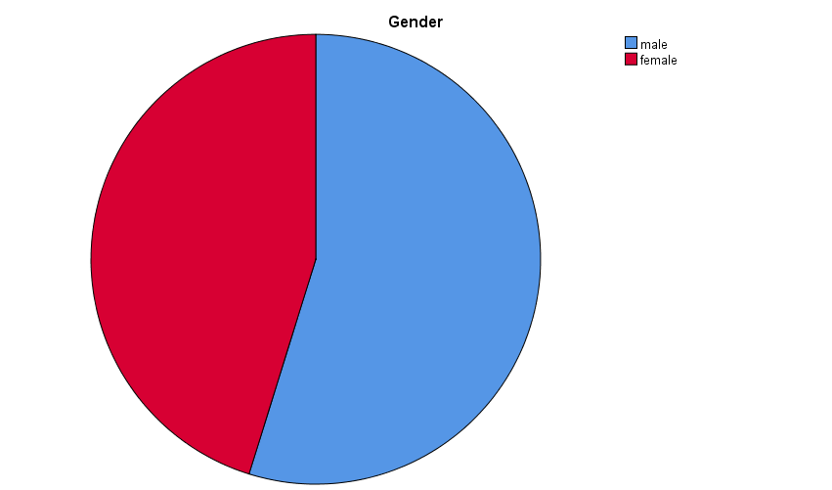

The above table (4.1) shows that 54.8 percent of respondents are male 45.2 percent of respondents are female. So it is inferred that majority of the respondents are female in Coimbatore.

TABLE NO. 4.1.1 Demographic Details of Age of the respondents

Age | Frequency | Percent
up to 20 years | 20 | 8.0
21-30 years | 86 | 34.4
31-40 years | 88 | 35.2
40-60 above | 45 | 18.0
61 above | 11 | 4.4
Total | 250 | 100.0

FIGURE 4.1.1 Demographic Details of Age of the respondents

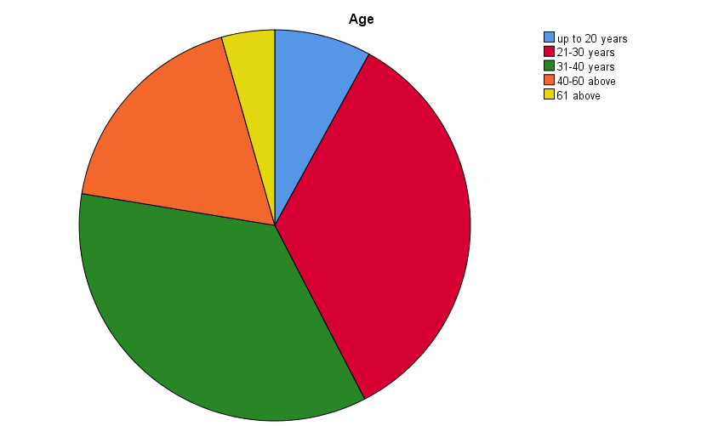

The above table (4.1.1) shows that 8.0 percent of respondents are from the age group up to 20 years, 34.4 percent of respondents are from the age group 21-30 years, 35.4 percent of respondents are from the age group 31-40 years, 18.0 percent of respondents are from the age group 40-60 above, 4.4 percent of respondents are from the age group 61 above. Hence it is inferred that majority of the respondents are from the age group 31-40 years.

Table No. 4.1.2 Demographic Details of Educational Qualification of the respondents

Educational qualification | Frequency | Percent
UP to SSLC | 16 | 6.4
HSC | 40 | 16.0
Graduation | 145 | 58.0
Post Graduation | 49 | 19.6
Total | 250 | 100.0

FIGURE 4.1.2 Demographic Details of Educational Qualification
Of the respondents

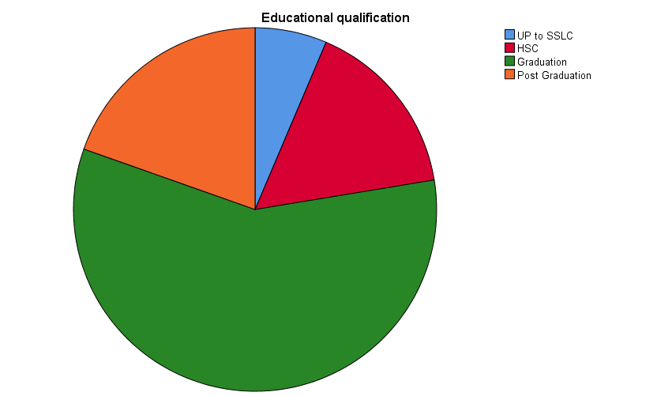

The above table (4.1.2) shows that 6.4 percent of respondents has completed UP to SSLC, 16.0 percent of respondents has completed HSC, 57.6 percent of respondents has completed Graduation,19.6 percent of respondents has completed Post Graduation. It is inferred that majority of the respondents has completed Graduation.
.

TABLE NO. 4.1.3 Demographic Details of Occupation of the respondents
Occupation | Frequency | Percent
Student | 65 | 26.0
Government | 45 | 18.0
Private | 80 | 32.0
self-employed | 39 | 15.6
Unemployed | 8 | 3.2
Retired | 13 | 5.2
Total | 250 | 100.0

FIGURE 4.1.3 Demographic Details of Occupation of the respondents
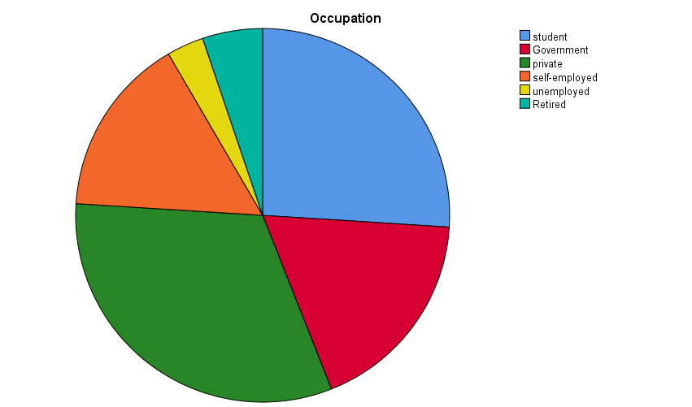

The above table (4.1.3)shows that26.0 Percent of respondents belong to Student,18.0 Percent of respondents belong to Government,32.0 Percent of respondents belong to Private,15.6 Percent of respondents belong to self-employed, 3.2percent of respondents belong to Unemployed,5.2 Percent of respondents are Retired. It is understood that majority of the respondents belong to students group.

TABLE NO. 4.1.4 Demographic Details of Marital Status of the respondents
Marital status | Frequency | Percent
Single | 88 | 35.2
Married | 162 | 64.8
Total | 250 | 100.0

FIGURE 4.1.4 Demographic Details of Marital Status of the respondents

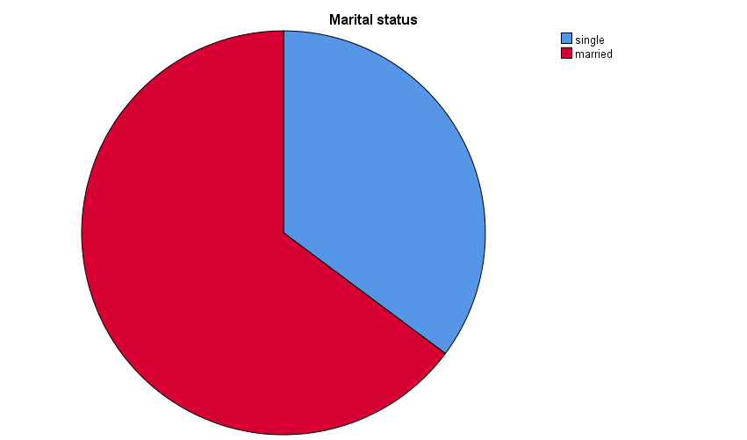

The above table (4.1.4) it is inferred that 35.2 percent of respondents are single and, 64.8 percent of respondents are married. Hence it is understood that majority of the respondents are married.

TABLE NO. 4.1.5 Demographic Details of Family type of the respondents
Family Type | Frequency | Percent
Nuclear family | 165 | 66.0
joint family | 85 | 34.0
Total | 250 | 100.0

FIGURE 4.1.5 Demographic Details of Family type of the respondents

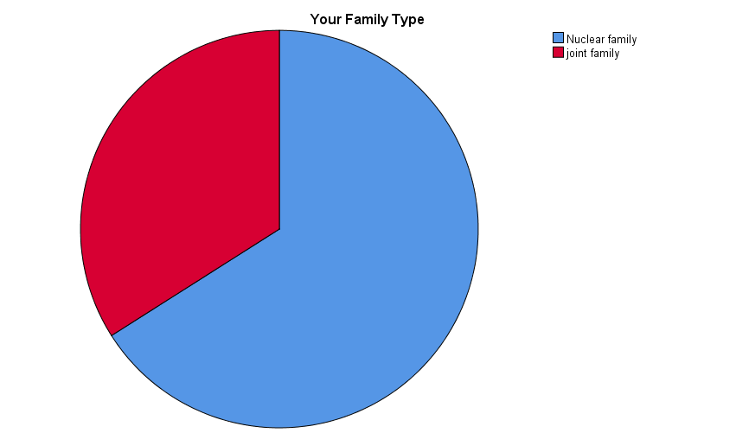

From the above table (4.1.5) it is inferred that 66.0 percent are nuclear family respondent and 33.2 percent are joint family respondent. Thus the result shows that majority of the respondent
are joint family.

TABLE NO. 4.1.6 Demographic Details of Size of the family of the respondent

Size of the family | Frequency | Percent
Up to 4 Members | 153 | 61.2
5-9 Members | 75 | 30.0
above 9 Members | 22 | 8.8
Total | 250 | 100.0

FIGURE 4.1.6 Demographic Details of Size of the family of the respondent
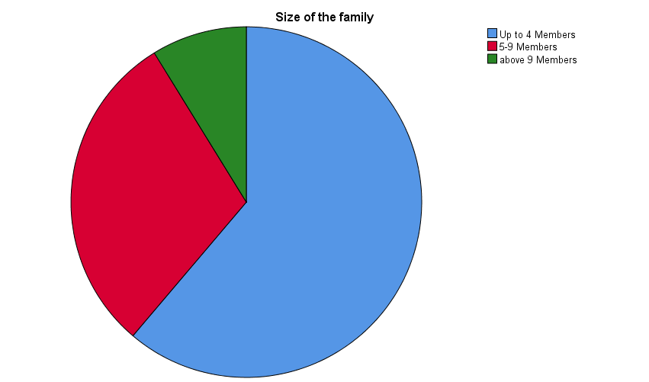

The above table (4.1.6) it is inferred that 61.2 percent of the respondents are Up to 4 Members, 29.2 percent of the respondents are 5-9 Members, 8.4 percent of the respondent are above 9 Members. It is clear that majority of the respondents have 4 members in their family.

TABLE NO. 4.1.7 Demographic Details Number.of.Children of The Respondents
No. of Children | Frequency | Percent
One | 34 | 13.6
Two | 82 | 32.8
More than Two | 58 | 23.2
None | 76 | 30.4
Total | 250 | 100.0

FIGURE 4.1.7 Demographic Details of Number.of.Children of the Respondents

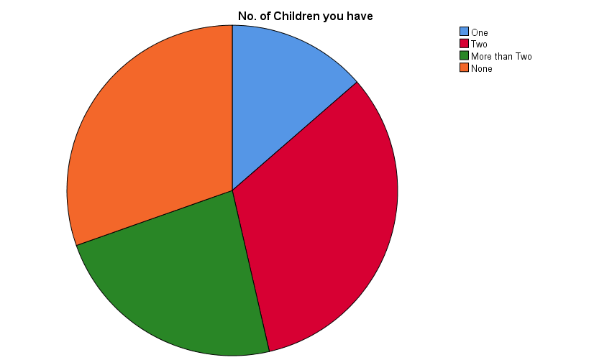

The above table (4.1.7) it is inferred that 13.6 percent of respondents have one child, 32.8 percent of respondents have two children, 32.2 percent of respondents have more than two children, 30.4 percent of respondents have no children. Hence it is inferred that majority of the respondents are having two children category.

TABLE NO. 4.1.8 Demographic Details of Annual Household Income in Respondents Family

Annual household income | Frequency | Percent
BelowRs.50, 000 | 8 | 3.2
Rs.51,000-80,000 | 25 | 10.0
81000-1,00,000 | 99 | 39.6
1akh above | 118 | 47.2
Total | 250 | 100.0

FIGURE 4.1.8 Demographic Details of Annual Household Income in Respondents Family

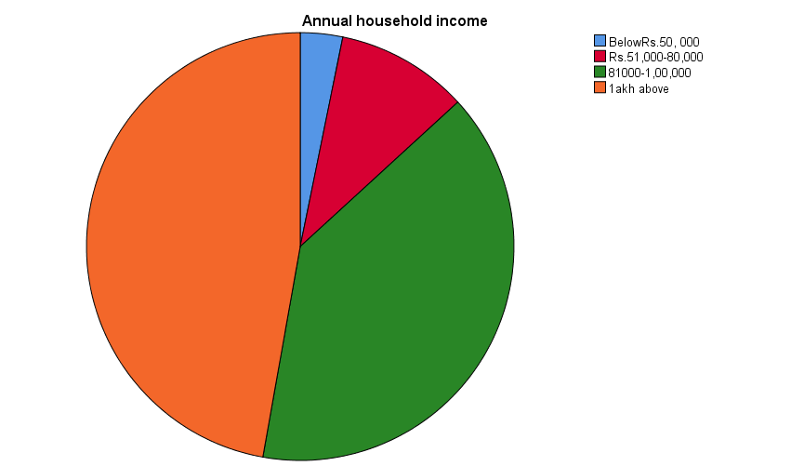

The above table (4.1.8) shows that 3.2 percent of respondents earn under Rs.50,000,10.0 percent of respondents earn Rs.51,000-80,000,39.6 percent of respondents earn 81000-1,00,000,47.2 percent of respondents earn1akh above. Thus it inferred that majority of the respondents earn 1akh above.

TABLE NO 4.1.9 Demographic Details of Other Family Members
Working in the Family

Family member is working | Frequency | Percent
Spouse | 141 | 56.4
Father | 74 | 29.6
Mother | 12 | 4.8
Children | 23 | 9.2
Total | 250 | 100.0

FIGURE 4.1.9 Demographic Details of Other Family Members
Working in the Family

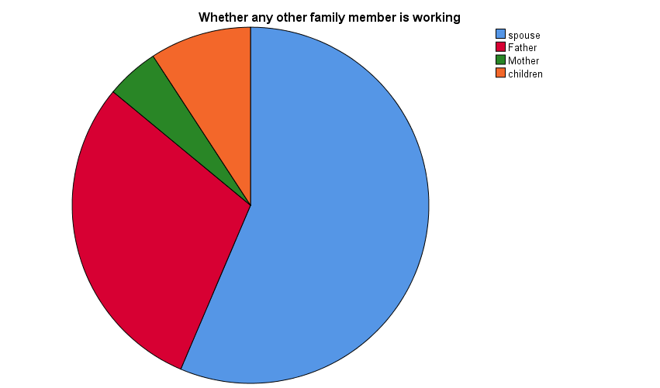

From the above table (4.1.10) it is inferred that 56.4 percent of the respondents are Spouse, 29.6 percent of the respondents are father,4.8 percent of the respondents are mother, 9.2 percent of the respondents are children. Thus the result shows that majority of the respondents spouse are working.

TABLE NO 4.1.10 Demographic Details of Credit/Debit Card Holders

Credit Card/Debit Card | Frequency | Percent
Yes | 224 | 89.6
No | 26 | 10.4
Total | 250 | 100.0

FIGURE 4.1.10 Demographic Details of Credit/Debit Card Holders

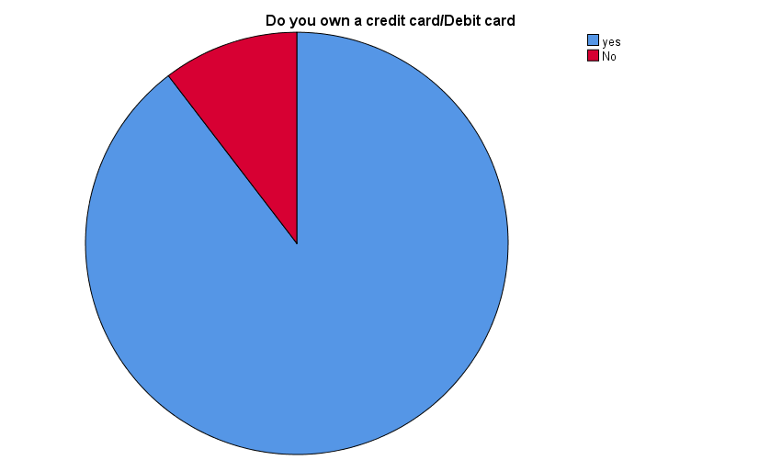

From the above table( 4.1.10) it inferred that 89.6 percent of respondents uses credit card/debit card and 10.4 percent of respondents does not uses credit card/debit card and also it is inferred that most of the respondents owns credit card/debit card.

4.2 ANOVA
4.2.1 Analysis of Age of The Respondents Car Rental Companies
H_{o}: Different age group of respondents has the same opinion towards the cab service
Factor | N | Df | Mean Square | F | Sig. | Null hypothesis
Cab service | Between Group | 4 | .023 | .452 | .771 | Accepted
Cab service | Within Groups | 245 | .050 |  |  | Accepted
Cab service | Total | 249 |  |  |  | Accepted
Service | Between Groups | 4 | .385 | 3.586 | .007 | Accepted
Service | Within Groups | 245 | .107 |  |  | Accepted
Service | Total | 249 |  |  |  | Accepted
Satisfaction | Between Groups | 4 | .187 | 1.298 | .272 | Accepted
Satisfaction | Within Groups | 245 | .144 |  |  | Accepted
Satisfaction | Total | 249 |  |  |  | Accepted
Opinion | Between Groups | 4 | .062 | .834 | .505 | Accepted
Opinion | Within Groups | 245 | .074 |  |  | Accepted
Opinion | Total | 249 |  |  |  | Accepted

From the above table (4.2.1), the table significance value is greater than (0.05), Hence the null hypothesis is accepted. Hence there is no significance difference between age and Cab service, service, satisfaction and opinion of cab.

4.2.2 Analysis of Influence of Educational Qualification of the
Respondents on Car Rental Companies.
H_{o}: Different Educational Qualification of respondents has the same opinion towards the cab Service
Factor | N | Df | Mean Square | F | Sig. | Null hypothesis
Cab service | Between Groups | 4 | .062 | 1.258 | .287 | Accepted
Cab service | Within Groups | 245 | .049 |  |  | Accepted
Cab service | Total | 249 |  |  |  | Accepted
Service | Between Groups | 4 | .088 | .781 | .538 | Accepted
Service | Within Groups | 245 | .112 |  |  | Accepted
Service | Total | 249 |  |  |  | Accepted
Satisfaction | Between Groups | 4 | .323 | 2.278 | .062 | Accepted
Satisfaction | Within Groups | 245 | .142 |  |  | Accepted
Satisfaction | Total | 249 |  |  |  | Accepted
Opinion | Between Groups | 4 | .013 | .173 | .952 | Accepted
Opinion | Within Groups | 245 | .075 |  |  | Accepted
Opinion | Total | 249 |  |  |  | Accepted
From the above table(4.2.2),the table significance value greater than (0.05), Hence the null hypothesis is accepted. Thus there is no significance difference between Educational Qualification and Cab service, service, satisfaction and opinion of cab.

4.2.3 Analysis of Influence of Occupation of the Respondents on Car
Rental Companies
H_{o}: Different Occupation of respondents has the same opinion towards the cab industry
Factor | N | Df | Mean Square | F | Sig. | Null hypothesis
Cab service | Between Groups | 5 | .060 | 1.218 | .301 | Accepted
Cab service | Within Groups | 244 | .049 |  |  | Accepted
Cab service | Total | 249 |  |  |  | Accepted
Service | Between Groups | 5 | .214 | 1.949 | .087 | Accepted
Service | Within Groups | 244 | .110 |  |  | Accepted
Service | Total | 249 |  |  |  | Accepted
Satisfaction | Between Groups | 5 | .174 | 1.206 | .307 | Accepted
Satisfaction | Within Groups | 244 | .144 |  |  | Accepted
Satisfaction | Total | 249 |  |  |  | Accepted
Opinion | Between Groups | 5 | .030 | .397 | .851 | Accepted
Opinion | Within Groups | 244 | .075 |  |  | Accepted
Opinion | Total | 249 |  |  |  | Accepted

From the above table(4.2.3),the table significance value greater than (0.05), Hence the null hypothesis is accepted. Hence there is no significance difference between Occupation and Cab service, service, satisfaction and opinion of cab.

4.2.4 Analysis of Influence of Size of the Family of the
Respondents on Car Rental Companies
H_{o}: Different Size of the Family of respondents has the same opinion towards the cab Sector
Factor | N | Df | Mean Square | F | Sig. | Null hypothesis
Cab service | Between Groups | 3 | .021 | .427 | .734 | Accepted
Cab service | Within Groups | 246 | .050 |  |  | Accepted
Cab service | Total | 249 |  |  |  | Accepted
Service | Between Groups | 3 | .038 | .333 | .802 | Accepted
Service | Within Groups | 246 | .113 |  |  | Accepted
Service | Total | 249 |  |  |  | Accepted
Satisfaction | Between Groups | 3 | .222 | 1.542 | .204 | Accepted
Satisfaction | Within Groups | 246 | .144 |  |  | Accepted
Satisfaction | Total | 249 |  |  |  | Accepted
Opinion | Between Groups | 3 | .032 | .436 | .727 | Accepted
Opinion | Within Groups | 246 | .074 |  |  | Accepted
Opinion | Total | 249 |  |  |  | Accepted

From the above table (4.2.4), the table significance value greater than (0.05), Hence the null hypothesis is accepted. Thus there is no significance difference between Size of the Family and cab service, service, satisfaction and opinion.

4.2.5 Analysis of Influence of Number of Children You Have Of the Respondents on Car Rental Companies
H_{o}: Different Number of children you have of respondents has the same opinion towards the cab Sector.
Factor | N | Df | Mean Square | F | Sig. | Null hypothesis
Cab service | Between Groups | 3 | .060 | 1.217 | .304 | Accepted
Cab service | Within Groups | 246 | .049 |  |  | Accepted
Cab service | Total | 249 |  |  |  | Accepted
Service | Between Groups | 3 | .079 | .707 | .548 | Accepted
Service | Within Groups | 246 | .112 |  |  | Accepted
Service | Total | 249 |  |  |  | Accepted
Satisfaction | Between Groups | 3 | .384 | 2.706 | .046 | Accepted
Satisfaction | Within Groups | 246 | .142 |  |  | Accepted
Satisfaction | Total | 249 |  |  |  | Accepted
Opinion | Between Groups | 3 | .029 | .396 | .756 | Accepted
Opinion | Within Groups | 246 | .074 |  |  | Accepted
Opinion | Total | 249 |  |  |  | Accepted

From the above table (4.2.5), the table significance value greater than (0.05), Hence the null hypothesis is accepted. Thus there is no significance difference between the Number of children the respondents have and cab service, service, satisfaction and opinion.

4.2.6 Analysis of Influence of Annual Income the Respondents on Car
Rental Companies
H_{o}: Different Annual Income of respondents has the same opinion towards the Cab Sector
Factor | N | Df | Mean Square | F | Sig. | Null hypothesis
Cab service | Between Groups | 3 | .003 | .055 | .983 | Accepted
Cab service | Within Groups | 246 | .050 |  |  | Accepted
Cab service | Total | 249 |  |  |  | Accepted
Service | Between Groups | 3 | .200 | 1.805 | .147 | Accepted
Service | Within Groups | 246 | .111 |  |  | Accepted
Service | Total | 249 |  |  |  | Accepted
Satisfaction | Between Groups | 3 | .031 | .215 | .886 | Accepted
Satisfaction | Within Groups | 246 | .146 |  |  | Accepted
Satisfaction | Total | 249 |  |  |  | Accepted
Opinion | Between Groups | 3 | .258 | 3.604 | .014 | Accepted
Opinion | Within Groups | 246 | .071 |  |  | Accepted
Opinion | Total | 249 |  |  |  | Accepted

From the above table (4.2.6), the table significance value greater than (0.05), Hence the null hypothesis is accepted. Thus there is no significance difference between the Annul income and cab service, service, satisfaction and opinion.

4.2.7 Analysis of Influence of other Family Member Are Working the Respondents on Cab Rental Companies
H_{o}: Different Other Family Members are working of respondents has the same opinion towards the Cab Sector.
Factor | N | Df | Mean Square | F | Sig. | Null hypothesis
Cab service | Between Groups | 3 | .042 | .849 | .468 | Accepted
Cab service | Within Groups | 246 | .050 |  |  | Accepted
Cab service | Total | 249 |  |  |  | Accepted
Service | Between Groups | 3 | .204 | 1.839 | .141 | Accepted
Service | Within Groups | 246 | .111 |  |  | Accepted
Service | Total | 249 |  |  |  | Accepted
Satisfaction | Between Groups | 3 | .271 | 1.891 | .132 | Accepted
Satisfaction | Within Groups | 246 | .143 |  |  | Accepted
Satisfaction | Total | 249 |  |  |  | Accepted
Opinion | Between Groups | 3 | .061 | .820 | .484 | Accepted
Opinion | Within Groups | 246 | .074 |  |  | Accepted
Opinion | Total | 249 |  |  |  | Accepted

From the above table (4.2.7), the table significance value greater than (0.05), Hence the null hypothesis is accepted. Thus there is no significance difference between other family members are working and cab service, service, satisfaction and opinion.

4.2.8 Analysis of Influence of Frequency of Taxi Booking of the
Respondents on Car Rental Companies
H_{o}: Different Frequently do you normally book taxis the cab of respondents has the same opinion towards the cab industry.
Factor | N | Df | Mean Square | F | Sig. | Null hypothesis
Cab service | Between Groups | 3 | .033 | .661 | .577 | Accepted
Cab service | Within Groups | 246 | .050 |  |  | Accepted
Cab service | Total | 249 |  |  |  | Accepted
Service | Between Groups | 3 | .206 | 1.857 | .137 | Accepted
Service | Within Groups | 246 | .111 |  |  | Accepted
Service | Total | 249 |  |  |  | Accepted
Satisfaction | Between Groups | 3 | .237 | 1.650 | .178 | Accepted
Satisfaction | Within Groups | 246 | .144 |  |  | Accepted
Satisfaction | Total | 249 |  |  |  | Accepted
Opinion | Between Groups | 3 | .023 | .308 | .820 | Accepted
Opinion | Within Groups | 246 | .074 |  |  | Accepted
Opinion | Total | 249 |  |  |  | Accepted

From the above table (4.2.8), the table significance value greater than (0.05), Hence the null hypothesis is accepted. Thus there is no significance difference between Frequently do you normally book taxis the cab and cab service, service, satisfaction and opinion
4.2.9 Analysis of Influence of Mode of Payments the
Respondents On Car Rental Companies
H_{o}: Different how do you make your payments of respondents has the same opinion towards the cab sector.
Factor | N | Df | Mean Square | F | Sig. | Null hypothesis
Cab service | Between Groups | 3 | .011 | .226 | .878 | Accepted
Cab service | Within Groups | 246 | .050 |  |  | Accepted
Cab service | Total | 249 |  |  |  | Accepted
Service | Between Groups | 3 | .040 | .353 | .787 | Accepted
Service | Within Groups | 246 | .113 |  |  | Accepted
Service | Total | 249 |  |  |  | Accepted
Satisfaction | Between Groups | 3 | .062 | .428 | .733 | Accepted
Satisfaction | Within Groups | 246 | .146 |  |  | Accepted
Satisfaction | Total | 249 |  |  |  | Accepted
Opinion | Between Groups | 3 | .094 | 1.274 | .284 | Accepted
Opinion | Within Groups | 246 | .073 |  |  | Accepted
Opinion | Total | 249 |  |  |  | Accepted

From the above table (4.2.9), the table significance value greater than (0.05), Hence the null hypothesis is accepted. Thus there is no significance difference between their respondent’s payments and cab service, service, satisfaction and opinion.

4.2.10 Analysis on Influence of the Typical Distance Use on App Based Cab Service for the Respondents on Car Rental Companies
H_{o}: Different frequently the typical distance you use this on app based cab service for the cab of respondents has the same opinion towards the cab sector.

Factor | N | Df | Mean Square | F | Sig. | Null  hypothesis
Cab service | Between Groups | 3 | .039 | .790 | .501 | Accepted
Cab service | Within Groups | 246 | .050 |  |  | Accepted
Cab service | Total | 249 |  |  |  | Accepted
Service | Between Groups | 3 | .083 | .741 | .529 | Accepted
Service | Within Groups | 246 | .112 |  |  | Accepted
Service | Total | 249 |  |  |  | Accepted
Satisfaction | Between Groups | 3 | .176 | 1.215 | .305 | Accepted
Satisfaction | Within Groups | 246 | .145 |  |  | Accepted
Satisfaction | Total | 249 |  |  |  | Accepted
Opinion | Between Groups | 3 | .022 | .291 | .832 | Accepted
Opinion | Within Groups | 246 | .074 |  |  | Accepted
Opinion | Total | 249 |  |  |  | Accepted

From the above table (4.2.10), the table significance value greater than (0.05, Hence the null hypothesis is accepted. Thus there is no significance difference between frequently the typical distance you use this on app based cab service for and cab service, service, satisfaction and opinion.
4.2.11 Analysis of How do You do Travel on App Based Call Taxi Usually to Cab The Respondents on Car Rental Companies
H_{o}: Different how do you do travel on app based call taxi usually to the respondents has the same opinion towards the cab Sector.
Factor | N | Df | Mean Square | F | Sig. | Null  Hypothesis
Cab service | Between Groups | 3 | .049 | .992 | .397 | Accepted
Cab service | Within Groups | 246 | .049 |  |  | Accepted
Cab service | Total | 249 |  |  |  | Accepted
Service | Between Groups | 3 | .016 | .141 | .935 | Accepted
Service | Within Groups | 246 | .113 |  |  | Accepted
Service | Total | 249 |  |  |  | Accepted
Satisfaction | Between Groups | 3 | .160 | 1.107 | .347 | Accepted
Satisfaction | Within Groups | 246 | .145 |  |  | Accepted
Satisfaction | Total | 249 |  |  |  | Accepted
Opinion | Between Groups | 3 | .042 | .573 | .633 | Accepted
Opinion | Within Groups | 246 | .074 |  |  | Accepted
Opinion | Total | 249 |  |  |  | Accepted

From the above table (4.2.11), the table significance value greater than (0.05), Hence the null hypothesis is accepted. Thus there is no significance difference between how do you do travel on app based call taxi usually and cab service, service, satisfaction and opinion.

4.2.12 Analysis of What Purpose Do You Use the App Based Cab Services Usually to Cab The Respondents on Car Rental Companies
H_{o}: Different what purpose do you use the app based cab service usually to the respondents has the same opinion towards the cab Sector.
Factor | N | Df | Mean Square | F | Sig. | Null  Hypothesis
Cab service | Between Groups | 4 | .051 | 1.036 | .389 | Accepted
Cab service | Within Groups | 245 | .049 |  |  | Accepted
Cab service | Total | 249 |  |  |  | Accepted
Service | Between Groups | 4 | .075 | .665 | .617 | Accepted
Service | Within Groups | 245 | .112 |  |  | Accepted
Service | Total | 249 |  |  |  | Accepted
Satisfaction | Between Groups | 4 | .025 | .171 | .953 | Accepted
Satisfaction | Within Groups | 245 | .147 |  |  | Accepted
Satisfaction | Total | 249 |  |  |  | Accepted
Opinion | Between Groups | 4 | .030 | .398 | .810 | Accepted
Opinion | Within Groups | 245 | .074 |  |  | Accepted
Opinion | Total | 249 |  |  |  | Accepted

From the above table (4.2.12), the table significance value greater than (0.05), Hence the null hypothesis is accepted. Thus there is no significance difference between purpose do you use the app based cab service usually and cab service, service, satisfaction and opinion.

4.3 T-TEST
ABLE NO 4.3.1
Factor | Gender | N | Mean | Df | Sig. (2-tailed) | Sig. | Null hypothesis
Cab service | Male | 137 | 4.2986 | 248 | .351 | .888 | Accepted
Cab service | Female | 113 | 4.3250 | 238.091 | .351 |  | Accepted
Service | Male | 137 | 4.3299 | 248 | .914 | .359 | Accepted
Service | Female | 113 | 4.3345 | 243.047 | .914 |  | Accepted
Satisfaction | Male | 137 | 4.2847 | 248 | .271 | .270
Satisfaction | Female | 113 | 4.3381 | 245.557 | .266
Opinion | Male | 137 | 4.4774 | 248 | .930 | .470
 | Female | 113 | 4.4743 | 234.273 | .930

INFERENCE
From the above table (4.3.1) it is inferred that the table shows the significance value is greater than (0.05), Hence the null hypothesis is accepted. Thus there is no significance difference between Gender and Cab service, service, satisfaction and opinion.

T-TEST
TABLE NO 4.3.2
Factor | Marital status | N | Mean | Df | Sig. (2-tailed) | Sig. | Null hypothesis
Cab service | Single | 88 | 4.2913 | 248 | .315 | .011 | Accepted
Cab service | Married | 162 | 4.3210 | 146.205 | .349 |  | Accepted
Service | Single | 88 | 4.3977 | 248 | .022 | .685 | Accepted
Service | Married | 162 | 4.2963 | 176.769 | .023 |  | Accepted
Satisfaction | Single | 88 | 4.3205 | 248 | .722 | .973
Satisfaction | Married | 162 | 4.3025 | 180.652 | .721
Opinion | Single | 88 | 4.4705 | 248 | .812 | .707
 | Married | 162 | 4.4790 | 182.325 | .811

INFERENCE
From the above table (4.3.2) it is inferred that the table shows the significance value is greater than (0.05), Hence the null hypothesis is accepted. Thus there is no significance difference between Marital Status and Cab service, service, satisfaction and opinion.

T-TEST
TABLE NO 4.3.3
Factor | Your Family Type | N | Mean | Df | Sig. (2-tailed) | Sig. | Null hypothesis
Cab service | Nuclear family | 165 | 4.2975 | 246 | .210 | .160 | Accepted
Cab service | Joint family | 83 | 4.3352 | 183.251 | .193 |  | Accepted
Service | Nuclear family | 165 | 4.3455 | 246 | .413 | .169 | Accepted
Service | Joint family | 83 | 4.3084 | 185.639 | .392 |  | Accepted
Satisfaction | Nuclear family | 165 | 4.2873 | 246 | .207 | .079
Satisfaction | Joint family | 83 | 4.3518 | 184.028 | .189
Opinion | Nuclear family | 165 | 4.4630 | 246 | .330 | .837
 | Joint family | 83 | 4.4988 | 173.056 | .321

INFERENCE
From the above table (4.3.3) it is inferred that the table shows the significance value is greater than (0.05),Hence the null hypothesis is accepted .thus there is no significance difference between Family Type and Cab service, service, satisfaction and opinion.

T-TEST
TABLE NO 4.3.4
Factor | Credit card/Debit card | N | Mean | Df | Sig. (2-tailed) | Sig. | Null hypothesis
Cab service | Yes | 224 | 4.3170 | 248 | .181 | .651 | Accepted
Cab service | No | 26 | 4.2552 | 32.262 | .161 |  | Accepted
Service | Yes | 224 | 4.3357 | 248 | .607 | .828 | Accepted
Service | No | 26 | 4.3000 | 31.960 | .592 |  | Accepted
Satisfaction | Yes | 224 | 4.3152 | 248 | .438 | .160
Satisfaction | No | 26 | 4.2538 | 29.512 | .494
Opinion | Yes | 224 | 4.4714 | 248 | .436 | .162
 | No | 26 | 4.5154 | 34.177 | .369

INFERENCE
From the above table (4.3.4) it is inferred that the table shows the significance value is greater than (0.05), Hence the null hypothesis is accepted. Thus there is no significance difference between Credit Card/Debit Card and Cab service, service, satisfaction and opinion.

4.4 GARRETTS RANKING ANALYSIS
Table4.4.Garretts Scale Ranking Method for Selected
Cabs of the Respondents

Factor | RANK1 | RANK2 | RANK3 | RANK4 | RANK5 | RANK6 | RANK7 | RANK8 | RANK9 | RANK10
Score | 82 | 70 | 63 | 57 | 52 | 47 | 42 | 37 | 30 | 18
Ola cab | 82 | 115 | 38 | 10 | 4 |  |  |  | 1
Uber taxi | 104 | 59 | 37 | 37 | 9 |  |  | 2 | 2
Easy cabs | 27 | 62 | 36 | 49 | 58 | 11 | 1 | 2 | 3 | 1
Tab cab | 28 | 11 | 43 | 45 | 36 | 57 | 15 | 6 | 7 | 2
Mega cabs | 1 | 2 | 36 | 30 | 27 | 46 | 57 | 34 | 13 | 4
Meru cabs | 4 | 3 | 20 | 25 | 21 | 23 | 33 | 56 | 41 | 24
Savaari cabs |  | 5 | 10 | 10 | 15 | 16 | 30 | 49 | 68 | 47
Wings radio cabs | 2 | 2 | 7 | 13 | 18 | 25 | 25 | 31 | 54 | 73
Tacabs | 2 | 1 | 13 | 14 | 23 | 23 | 47 | 27 | 35 | 65
Cel cabs | 3 |  | 6 | 15 | 37 | 48 | 40 | 40 | 29 | 32

The scores are obtained by the garrets ranking table.

TABLE NO 4.4.1 Garrett’s Scale Ranking Method for Selected
Cabs of the Respondents

Factor | RANK1 | RANK2 | RANK3 | RANK4 | RANK5 | RANK6 | RANK7 | RANK8 | RANK9 | RANK10 | Total
Score | 82 | 70 | 63 | 57 | 52 | 47 | 42 | 37 | 30 | 18
Ola cab | 6724 | 8050 | 2394 | 10 | 212 |  |  |  | 30 |  | 17420
Uber taxi | 8528 | 4130 | 2331 | 2109 | 468 |  |  | 74 | 60 |  | 97700
Easy cabs | 2214 | 4340 | 2268 | 2793 | 3306 | 2679 | 42 | 74 | 90 | 18 | 17824
Tab cab | 2296 | 770 | 2709 | 2565 | 1872 | 2679 | 630 | 444 | 210 | 36 | 14213
Mega cabs | 82 | 140 | 2268 | 1710 | 1404 | 2162 | 2394 | 1258 | 390 | 72 | 11805
Meru cabs | 328 | 210 | 1260 | 1425 | 1404 | 1081 | 1386 | 2072 | 1230 | 432 | 10828
Savaari cabs |  | 350 | 630 | 570 | 780 | 752 | 1260 | 1813 | 2040 | 846 | 9041
Wings  radio cabs | 164 | 140 | 441 | 741 | 936 | 1175 | 1050 | 1147 | 1620 | 1314 | 8728
Taxi for sure cabs | 164 | 70 | 819 | 798 | 1196 | 1081 | 1974 | 999 | 1050 | 1170 | 9321
Cel cabs | 246 |  | 378 | 855 | 1924 | 2256 | 1680 | 1480 | 870 | 576 | 10265

The scores are obtained by the Garrett’s ranking table. The analysis done by multiplying the number of respondent on each box with Garrett’s score. The maximum total after multiplying gives us the final most preferred cab of the respondents. The least total gives the not much preferred cab of the respondents.

FIGURE 4.4.2 Garrett’s Scale Ranking Method for Selected cabs of the Respondents

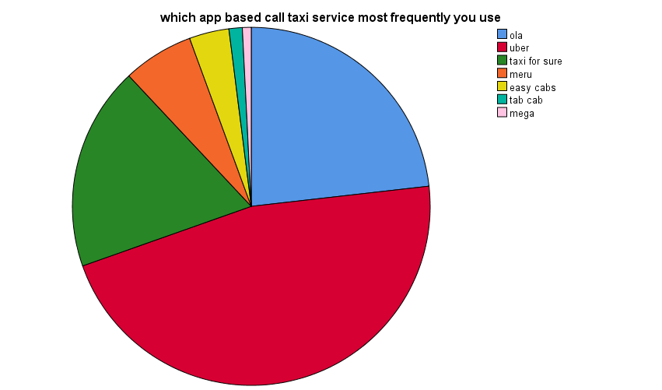

Hence from given Figure 4.4.2. it is understood that the most preferred taxi is Uber followed by Ola, Taxi for sure, Meru, Easy cab, the respondents does not prefer Tab cab, Mega.

FINDINGS,SUGGESTION
AND CONCLUSION
FINDINGS,SUGGESTION AND CONCLUSION
5.1. FINDINGS
Based on the above study, the following findings may be taken into account by the cab industry providers in and around destinations of Coimbatore.
- The data was collected from 250respondents and they were the cab Sector of Coimbatore.
Most of the cab industries selected for the study was in and around Coimbatore.
- The socio demographic profile of respondents shows that, 54.8 percent of respondents are male, and the majority of the age of the respondents was 31 to 40 years. 58.0 percent of respondents have completed graduation.32.0 percent of respondents occupation is private. 64.8 percent of respondents were married. 56.4 percent respondents spouse was working. 66.0 percent respondents’ family type is nuclear.61.2 percent of respondents of size of the family up to 4 members. 32.8 percent of respondents have two children.47.2 percent of respondents annual income is 1akh above. 89.6 percent of respondents paid by credit card.
- Majority of respondents preferred Uber than Ola and Meru cab. Respondents preferred to book Uber with same age group friends for cab. Majority of the respondent prefers to pay as Cash as well as Debit/Credit card and paytm.
- By the help of ANOVA, it is observed that the null hypothesis (0.05) is accepted for majority of factors. With the results obtained from the table the following inference were made:
- There is no significance difference between age and cab services, service,
Satisfaction and opinion of cab.
- There is no significance difference between educational qualification and cab service, service, satisfaction and opinion of cab.
- There is no significance difference between occupation and cab service, service satisfaction and opinion of cab.
- There is no significance difference between size of the family and cab service, service satisfaction and opinion.
- There is no significance difference between the number of children the respondents that have and cab service, service satisfaction and opinion.
- There is no significance difference between the annual income and cab service, service satisfaction and opinion.
- There is no significance difference between other family members are working and cab service, service satisfaction and opinion.
- There is no significance difference between frequently do your normally book taxis the cab and cab service, service satisfaction and opinion.
- There is no significance difference between their respondent’s payments and cab service, service satisfaction and opinion.
- There is no significance difference between the frequently of the travel distance you use this on app based cab service for and cab service, service satisfaction and opinion.
- There is no significance difference between how do you do travel on app based call taxi usually and cab service, service satisfaction and opinion.
- There is no significance difference between purpose do you use the app based cab service usually and cab service, service satisfaction and opinion.
- With the help of T-Test , it is inferred that the significance value is great then (0.05), hence the null hypothesis is accepted. Thus there is no significance difference between gender and cab service, service, satisfaction and opinion.
- There is no significance difference between marital status and cab service, service, satisfaction and opinion.
- There is no significance difference between family type and cab service, service , satisfaction, and opinion.
- By the help of Garrett scale ranking method, the most preferred E-marketed taxi is Uber followed by Ola, Taxi for sure, Meru, Easy cab. The respondents does not prefer Tab cab, Mega Cab.

5.1.2. SUGGESSTIONS
As the cab services are efficient to satisfy the customer with low fares and other attractive offers, few suggestion are offered by the researcher based on the current study.
- From the analysis it is found that most of the Coimbatore citizen’s depend on cab services. So cab services promptness can be improved so that delay in pickup drop can be compromised.
- The awareness about promotional offer of E-marketed or app based taxi services can be increased by newspaper advertisement and mass media. Also cab service providers can launch more attractive offers to attract more new customers to sustain in the market.
- Cleanliness of interior cab can be improved to retain the existing customers. The online procedure of the taxi service can be simplified.
- Concession fares can be provided for school students, college students and senior citizens by the cab service providers to prove their social responsibility.
- To retain the existing customers, the cab service providers can lunch loyalty program and other reward schemes can also provided to retain the existing customer.

5.3 CONCLUSSION
From the study the importance of car rental and E-marketed or app based car rental companies in Coimbatore city is analyzed. To know the customer requirements is essential because it provides the service provider a better understanding of the customers need and expectation. In this study the service quality, customer satisfaction and preferences of the customer is analyzed for both regular car rental and E-marketed or app based car rental companies and found that the majority of customers were satisfied with the current service in car rental companies than E-marketed or app based car rental companies.
It is also concluded that in order to retain their customers in a competitive cab industry, car rental and E-marketed or app based car rental companies in Coimbatore have to ensure customer satisfaction among their patrons.
Results from the present study revealed that among various E-marketed or app based car rental companies, Uber is mostly preferred followed by Ola, taxi for sure, Meru, Easy cab, respondents do not prefer tab cab and mega cab, they should revise their service strategy to sustain in the competitive cab industry.
Thus from this study it is concluded that Coimbatore is one the best destination with potential passengers for cab service industry as well as `E-marketed or App based car rental companies which helps to boost up the economic growth of the city.

BIBLIOGRAPHY

REFERENCE
- Agbor, M. J. (2011). The Relationship between Customer Satisfaction and Service Quality: A Stusy of three service sectors in Umea-published master’s thesis.
- Anderson, E.W. And V.Mittal (2010). "Strengthening the Satisfaction-Profit Chain. “journal of service research 3(2),107.
- Anton, (2010), Customer Relationship Management: Making Hard Decisions With Soft Number Soft Numbers. Prentice-Hall, Englewood Cliffs,Nj:P.73.
- Arnott. R (2005). Taxi Travel Should Be Subsidized. Journal Of Urban Economicsvol, 40, Pp.316-333.
- Bojanic, D. C. & Rosen, L. D. (2008). Measuring service quality in restaurants: an application of the Servqual instrument Journal of Hospitality & amp; tourism research,18(3),4-14.
- Berry, And Parasuraman (2007), Marketing Service: Competing Through Quality. The Free Press, New York, Ny: Pp.31.
- Chen,W. (2014). Technical Improvements On Mobile App Based Taxi Dispating System. International Conference On Computer Science And Service System Pp.281-284.
- Chen, L-D.(2014). A model of consumer acceptance of mobile payment. International Journal of Mobile Communications, 6(1) 32-52.
- Chang S.K.And Chu-Hsiao Chu (2016). Taxi Vacancy Rate, Fare and Subsidy With Maximum Social Willingness-To-Pay Under Log-Linear Demand Function. Transportation Research Record: Journal of The Transportation Research Board, No2111, Pp 90-99.
- Douglas (2013). Price Regulation and Optimal Service Standards. The Taxicab Industry.
- Daganzo (2005).An Approximate Analytic Model of Many-To-Many Demand Responsive Transportation Systems.
- Eshghi,A., Roy. S.K.,&Ganguli,S.(2008). Service quality and customer satisfaction: An empirical investigation in Indian mobile Telecommunications service, marketing management journal,18(2), 110-144.
- Fen, Y. S. &Meillian, K. (2011). Service quality and customer satisfaction: Antecedents of customer’s re-patronage, Sunway Academic Journal, 4, 60-73. Khalifa, M., V. Liu. 2002-3. Satisfaction with Internet-based services: The role of expectations and desires. International journal of electronic commerce,7(2) 31-49.
- Fernandez (2010). A Diagrammatic Analysis of the Market For Cursing Taxis, Transportation Research Vol.42 Pp. 498-526.
- Fjermestad,J.,&Robertso,N.C.(2015).Electronic customer relationship management.
- Hanif,K., & Sager, N. (2016). An Empirical Research on The Penetration Levels For A Call-A-Cab Service In Mumbai. Reflections Journal of Management.
- Horsu,E.N., & Yeboah, S.T.(2015). Influence Of Service Quality On Customer Satisfaction; A Study Of Minicab Taxi Services In Cape Coast, Ghana. International Journal Of Economics, Commerce And Management Vol(5), Pp 1451-1464.
- Horowitz (2006). The Stability of Stochastic Equilibrium In A Two-Link Transportation Network. Transportation Research B, Pp.13-28
- Hunt, (2000). “Consumer Satisfaction/Dissatisfaction and Complaining Behavior.” Proceedings Of The 2nd Annual Consumer Satisfaction/Dissatisfaction And Complaining Behavior Conference: Pp.20-22.
- Hyunmyung (2012).Effect Of Taxi Information System on Efficiency and Quality of Taxi Service. Transportation Research Record: Journal Of The Transportation Research Board, Voll,Pp.96-104.
- Johnoson &Fornell (2008), “ The Role Of Brand Affiliation In Hotel Market Value,” Cornell Hotel And Restaurant Administration Quarterly, 2006; Vol. 47,
- James &Blackwell, (2001). Engel Consumer Behavior, New York: Holt, Rinehart.
- Lin, Y.(2014). Exploring Factors Affecting The User Adoption Of Call Taxi App. 25th Australasian Conference On Information System. Auckland, New Zealand.
- Manski And Wright (2012).Nature Of Equilibrium in the Market for Taxi Services. Transportation Research Recordvol619, Pp.296-306.
- Oliver (2000). Satisfaction: A Behavioral Perspective On The Consumer. Boston: McGraw-Hill. Cited In An Overview Of Customer Satisfaction Models, RP Group Proceedings, California Community Colleges. Pp.101.
- Oliver, R. L. (2009).Effect Of Expectation And Disconfirmation On Post Exposure Product Evaluations - An Alternative Interpretation, journal of applied Psychology,62(4), 480-486.
- Oliver(2004), “Developing Better Measures Of Consumer Satisfaction: Some Preliminary Results,” In Advance In Consumer Research.
- Schroeter (2005), A Model Of Taxi Service Under Fare Structure All Fleet Size Regulation. The Rank Company, The Bell Journal Of Economics, Vol 14,Pp.81-96.
- Tse, David & Wilton, (2006), “Models Of Consumer Satisfaction: An Extension,” Journal Of Marketing Research, Vol125, Pp.204-212.
- Vavra, T.G. (2011), Improving Your Measurement Of Customer Satisfaction: “A Guide To Creating, Conducting, Analyzing, And Reporting Customer Satisfaction Measurement Programs.” American Society for Quality.
- Wong (2015) and Yang (2013). Network Model Of Urban Taxi Service. Improved Algorithm. Transportation Research Recordvo11623,Pp.27-30.
- Wanjiku, G. (2014).Effect of service quality on customer satisfaction in mobile telecommunication industry.MBA Project.
- Woodruff,& Gardial, (2010), Know Your Customer: New Approaches To Understanding Customer Value And Satisfaction. Wiley: Blackwell.
- Wong and Yang (2006). Network Model Of Urban Taxi Services. Improved Algorithm. Transportation Research Record Vol.1623,Pp.27-30
- Westbrook And Reilly (2003), “The Vicious Circle Of Customer Complaints,” Journal Of Markrting, Vol.48,(Summer).
- Yang and Wong (2006).A Network Model Of Urban Taxi Services. Transport Research B, Vol.32, Pp.235-246.

.

WEBSITES:
- www.elsevier.com/locate/trb
- http:// www.sganalytics.com/blog/reviewdemonetizationindia/
- http:// www.japantimes.co.jp/opinion/2016/11/27/commentary/world-
- https://www.cmie.com/ common/bin/sr.php
- https://www.irctc.co.in/mobilebooking.html.
- www.scientificamerican.com
- http:// www.jtlr.net/uploadfile/2013/0903/20130903023816682
- http://citeseerx.ist.psu.edu
- http:// reflections.rustomjee.com/index.php/reflections/issue/view/3/
- www.researchpublish.com
- http://www.jtle.net/uploadfile/2013/0903/20130903023816682
- http://www.cs.rutgers.edu/~dz220/paper/call cab.pdf
- http:// www.tkuir.lib.tku.edu.tw/dspace/retrieve
- http:// www.sganalytics.com/blog/reviewdemonetizationindia/
- http://www.japantimes.co.jp/opinion/2016/11/27/commentary/world-commentary/economic-political-risksindias-demonetization/
- http://www.globalresearch.ca/indiasdemonetizationtriggersextremepovertyandfamine/5567931
- www.bloombergquint.com
- http://www.schallererconsult.com/taxi/elastic.pdf
- http://www.scallerconsult.com/cab/elastic.pdf.

ANNEXURE

QUESTIONNAIRE
Dear Respondent!
I PRIYA.A II year MBA student( Tourism & Travel Management) Avinashilingam University For Home Science and Higher Education For Women, is conducting the survey to study the “A COMPARITIVE STUDY ON CAR RENTAL COMPANIES WITH E- MARKETED CAR RENTAL COMPANIES IN COIMBATORE CITY”, as part of my final year research work. Please be kind enough to answer the question honestly. This survey would be kept confidential and used for academic purpose only. Thank you!
Place: 1.Gender:
a) Male [ ] b) Female [ ] C) Others [ ]
2. Age
a) Up to 20 years [ ] b) 21-30 years [ ] c) 31-40 years [ ] d) 40-60 above [ ]
e) 61 above [ ]
3) Educational qualification:
a)UP to SSLC [ ] b) HSC [ ] c) Graduation [ ] d) Post Graduation [ ]
4) Occupation:
a) Student [ ] b) Government [ ]c) Private [ ] d) Self- employed [ ]
d)Unemployed[ ] e) Retired [ ]
5) Marital Status:
a) Single [ ] b) Married [ ]
6) Your Family Type:
a) Nuclear family [ ] b) joint family [ ]
7) Size of the family:
a) Up to 4 Members [ ] b) 5-9 Members [ ] c) above 9 Members [ ]
8) No. of Children you have:
a) One [ ] b) Two [ ] c) More than Two [ ] d) None [ ]
9) Annual household income?
a)BelowRs.50, 000[ ] b)Rs.51,000-80,000 [ ]
c) 81000-1,00,000[ ] d)1akh above [ ]
10) Whether any other family member is working?
a)spouse [ ] b )Father [ ] c) Mother [ ] d) children[ ]
11) Do you own a credit card/Debit card?
a) yes [ ] b) No [ ]
12) From the give list of cab services ,tick the once you are familiar with
S.No | Name of the cab service in local | Familiar/  Unfamiliar | S.No | Name of the cab service in local | Familiar/  unfamiliar
1 | Red taxi |  | 8 | JJ call taxi
2 | Taxi Taxi |  | 9 | Smart taxi
3 | Go taxi |  | 10 | KGS cabs
4 | Fast truck |  | 11 | South zone call taxi
5 | Abi taxi |  | 12 | Hello taxi
6 | Best call taxi |  | 13 | Comfort Carz
7 | City call taxi |  | 14 | Royal Travels  
13) From the give list of App BASED AND E-MARKET cab services ,tick the ones you are familiar with:
S.No | Name of the cab service | Familiar/  Unfamiliar | S.NO | Name of the cab service | Familiar/  Unfamiliar
1 | Ola cab |  | 6 | Meru cabs
2 | uber taxi |  | 7 | Savaari cabs
3 | Easy cabs |  | 8 | Wings radio cabs
4 | Tab cab |  | 9 | Taxi for sure cabs
5 | Mega cabs |  | 10 | Cel cabs

14) From the give list of App BASED AND E-MARKET cab services, which you would prefer most? Ranking 1 to 10
S.No | Name of the cab service | Rank | S.NO | Name of the cab service | Rank
1 | Ola cab |  | 6 | Meru cabs
2 | uber taxi |  | 7 | Savaari cabs
3 | Easy cabs |  | 8 | Wings radio cabs
4 | Tab cab |  | 9 | Taxi for sure cabs
5 | Mega cabs |  | 10 | Cel cabs

15 ) How do you normally book taxis?
a)Call a taxi company[ ] b)Taxi company website[ ] c)Taxi app[ ]
e) others____________________________
16) Does your phone allow you to download apps?
a)yes [ ] b) NO [ ]
17) Do you have a taxi application on your phone?
a) Yes, I use it regularly[ ] b) Yes, but rarely use it [ ] c) yes, but I have not used it [ ]
18) what is taxi app do you have?
a)______________b)______________c)____________e)__________

19) How do you make your payments?
a) cash [ ] b)credit card [ ] c) debit card [ ] d) others [ ] e) paytm [ ]
20) Which app based call taxi service most frequently you use?
a) ola[ ] b)uber[ ] c) taxi for sure[ ] d) others___________________
21) What is the typical distance you use this on app based cab service for?
a) 0-5 km[ ] b)5-10 km[ ] c)15-20km[ ] d) km and above[ ]
22) How do you do travel on app based call taxi usually?
a)Alone[ ] b)with an additional person[ ] c)in a group [ ] e)________________
23)For what purpose do you use the app based cab services usually?
a)daily commute towork [ ] b) airport and railway stations[ ] c)meetings[ ] d)personal trip[ ]
24) Do you use the app based cab service even with surge pricing?
a) yes [ ] b) No [ ]
25) Where; 5-Strongly agree 4-Agree 3-Neutral 2-Disagree 1-Strongly disagree )
Mark your answer:
S.NO | Statement | SA  5 | A  4 | N  3 | D  2 | SD  1
1 | The taxis are always available when in need
2 | I do not consider using competitor taxi services.
3 | I have positive attitude towards the company
4 | Iam satisfied with app based taxi services
5 | My expectations on quality of service is being met
6 | My reaction to the services offered by taxi is verygood
7 | The taxi is very modern (i.e. with mobile applications, wi-fi,GPS etc.)
8 | In case of any complaints the company handles promptly.
9 | Drivers have good communication skills.
10 | First class services on the first time clients.
11 | Drivers arrive on time

Where; 5-Strongly agree 4-Agree 3-Neutral 2-Disagree 1-Strongly disagree
26) Mark your opinion about the quality of service provided:
S.NO | Statement | SA  5 | A  4 | N  3 | D  2 | SD  1
1 | Good value for money paid
2 | Student offers
3 | Concession fare for senior citizens
4 | Discount offers
5 | Privilege card facilities to encourage frequent travellers

Where; 5-Strongly agree 4-Agree 3-Neutral 2-Disagree 1-Strongly disagree
27) Mark your opinion about the cab you travelled:
S.No | Statement | SA  5 | A  4 | N  3 | D  2 | SD  1
1 | Clean interior
2 | Pleasant smell
3 | Comfortable seating
4 | Enough boot space forLuggage
5 | Facility toaccommodate differently abled

Where; 5-Strongly agree 4-Agree 3-Neutral 2-Disagree 1-Strongly disagree
28) Mark your opinion about the cab driver:
S.No | Statement | SA  5 | A  4 | N  3 | D  2 | SD  1
1 | Smooth driving
2 | On time pickup
3 | Helped to reach the destination on time
4 | Safety
5 | Pleasant

29) Would you like to use app based cab services again to book taxis?
a) Yes[ ] b) No [ ]
30) Any suggestions you would like to provide to improve the quality of service provided by app based on cab services.
___________________________________________
31) Any other information you would like to furnish?
___________________________________________

