Availability and Use of Modern Labour Saving Devices by the Selected Homemakers

By
Vidhya. V
(11PIR13)

A thesis submitted to the
Avinashilingam Institute for Home Science and
Higher Education for Women
Coimbatore - 641 043.

In Partial Fulfilment of the requirements for the Degree of
Master of Science in Resource Management

May 2013
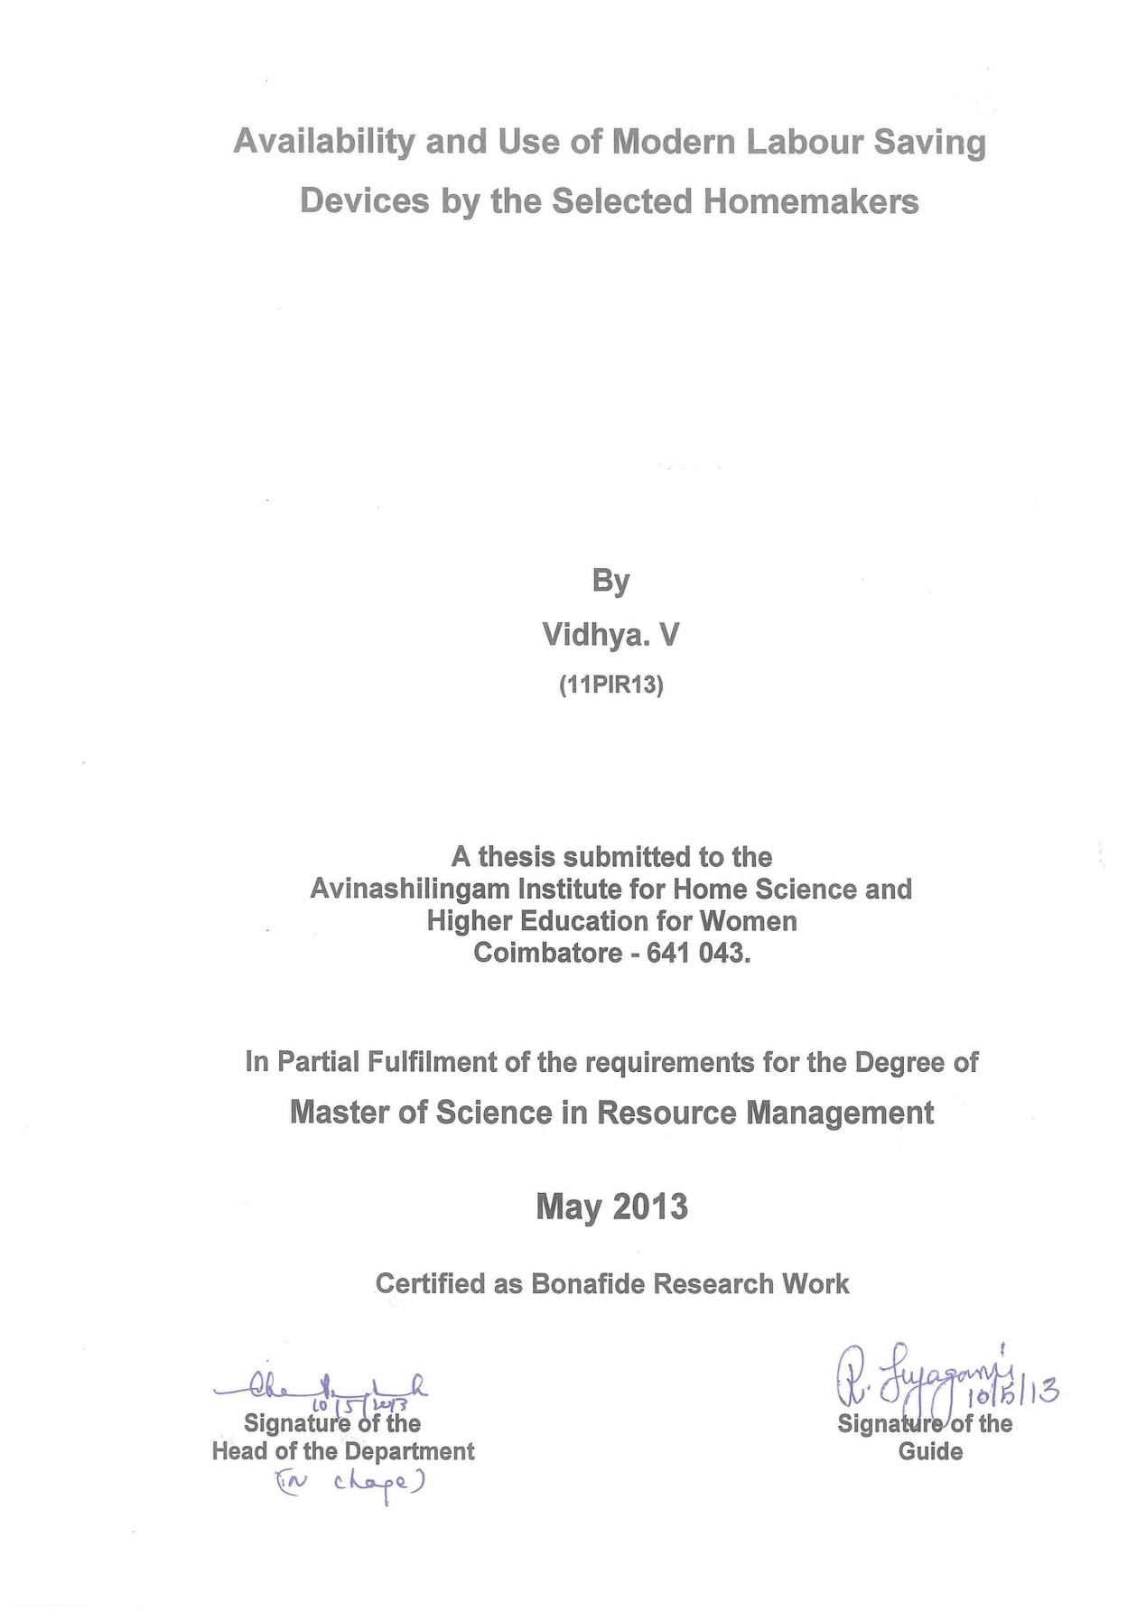

ACKNOWLEDGEMENT
“Acknowledging the good that you already have in your life is the foundation for all abundance.”
- Eckhart Tolly
Words would not suffice to express the gratitude the investigator feels for the immense blessings of God Almighty for his grace and mercy showered on her for carrying out the study successfully and blessing her with an empathetic family.
The investigator owes her reverential gratitude to the Founder and Former Chancellor of Avinashilingam institute for home science and higher education for Women, Coimbatore, Dr. (Mr.) T.S. Avinashilingam and Former Chancellor, Hon. Colonel Padmashri Dr. (Mrs.) Rajammal. P. Devadas, for their wishes and blessings.
The investigator owes her profound gratitude to Dr. (Mr.) T.S.K. Meenakshisundaram, M.A., M. Phil., Ph.D., Chancellor, Avinashilingam institute for home science and higher education for Women, Coimbatore, for providing the infrastructural facilities for the conduct of the study in this esteemed institution.
The author sincerely expresses her gratefulness to Hon. Colonel Dr. (Mrs.) Sheela Ramachandran, M. Sc., P.G.Dip., Ph.D., Vice Chancellor of Avinashilingam institute for home science and higher education for Women, Coimbatore, for endowing her with inspirational support and amenities required for undertaking the research work.
With great sense of sincerity, the investigator conveys her heartfelt thanks to Dr. (Mrs.) Gowri Ramakrishnan, M. Sc., M.Phil., Ph.D., Registrar, Avinashilingam institute for home science and higher education for Women, Coimbatore, for her kind help extended throughout the period of the study.
Her heartfelt regards and thanks are due to Dr. (Tmt) Venmathi M.sc., M.Phil., Ph.D., Professor and Head, Department of Resource Management , Avinashilingam Institute of Home Science and Higher Education for Women, Coimbatore, for her suggestions and consistent encouragement throughout the study.
The investigator feels extremely happy and fortunate to place herself under the able guidance of her esteemed guide Dr. (Mrs.) R. Jeyagowri, M. Sc., M.Phil., Ph.D., Associate Professor, Department of Resource Management, Avinashilingam institute for home science and higher education for Women, Coimbatore. She records her deep sense of gratitude and indebtedness to her guide for her adroit, innovative, excellent and impetus guidance, constant encouragement, steadfast support, untiring patience, unalloyed interest, meticulous supervision, valuable advice and constructive criticism rendered for the successful accomplishment of the research.
The investigator wishes to thank her beloved parents, other members of her family and her friends whose constant motivation; steady support and selfless help, care and concern were her backbone throughout the period of the study and, which is hard to express as,

“A thankful heart is not only the greatest virtue, but the parent of all other virtues”.
-Cicero

LIST OF CONTENTS
CHAPTER  NO. | TITLE | PAGE NO.
 | LIST OF TABLES
 | LIST OF FIGURES
 | LIST OF PLATES
 | LIST OF APPENDICES
I | INTRODUCTION
II | REVIEW OF LITERATURE  - Concept and Importance of Labour Saving Devices  - Classification of Labour Saving Devices  - Time and Energy Saving Techniques  - Role of Modern Labour Saving Devices on Time and Energy Saving Techniques
III | METHODOLOGY  Phase: 1 Market Survey  - Selection of the Area  - Selection of the Sample  - Selection of the Method  - Conduct of the Survey  - Consolidation and Presentation of Data  Phase: 2 Household Survey  - Selection of the Area  - Selection of the Sample  - Selection of the Method  - Selection of the Tool  - Conduct of the Survey  - Consolidation and Analysis of Data
IV | RESULTS AND DISCUSSION  Phase: 1 Findings of the Market Survey  - Modern Tools and Equipments for Food Preparation  - Modern Tools and Equipments for Cooking  - Modern Tools and Equipments for Cleaning  - Modern Tools and Equipments for Washing  Phase: 2 Findings of the Household Survey  - Socio-Economic Background of the Selected Homemakers  - General details on Labour Saving Devices  - Use, Care and Maintenance of Labour Saving Devices  - Benefits Accrued in using Modern Labour Saving Devices  - Problems faced in Using the Devices
V | SUMMARY AND CONCLUSION
 | BIBLIOGRAPHY
 | APPENDICES

LIST OF TABLES
TABLE NO. | TITLE | PAGE NO.
1  2  3  4  5  6  7  8  9  10  11  12  13  14  15  16  17  18  19  20  21 | Food Preparation Equipments (Non- Electrical)  Food Preparation Equipments (Electrical)  Non Electrical Cooking Equipments  Non Electrical Cooking Equipments  Cleaning Equipments  Washing Equipments  Type and Size of the Family  Age of the Heads of the Families and Homemakers  Educational Status of the Heads of the Families and the Homemaker  Occupational Status of the Heads of the Families and Homemakers  Monthly Income of the Families  Preparation Equipment (Non-Electrical) possessed by the Homemakers  Preparation Equipment (Electrical) Possessed by the Households  Cooking equipments possessed by the homemakers  Cleaning and Washing Equipments possessed by the Homemakers  Persons in charge for the Operation of the Equipments (electrical)  Frequency of Use of Labour Saving Devices (Electrical)  Frequency of Use of Labour Saving Devices Non-electrical Preparation Equi  pments  Frequency of Use of Non- Electrical Cooking and Cleaning Equipments  Benefits Accrued In Using Modern Labour Saving Devices  Problems Faced in Using Modern Labour Saving Devices

LIST OF FIGURES

FIGURE NO. | TITLE | PAGE NO.
1  2  3  4  5 | Type and Size of the Family  Age of the Heads of the Families and Homemakers  Educational Status of the Heads of the Families and the Homemaker  Occupational Status of the Heads of the Families and Homemakers  Monthly Income of the Families

LIST OF PLATES

PLATE NO. | TITLE | PAGE NO.
I  II  III | Electrical and non electrical food  Preparation equipments  Electrical and non electrical cooking equipments  Electrical and non electrical cleaning and washing equipments

LIST OF APPENDICES

APPENDIX NO | TITLE | PAGE NO.
I  II | An interview schedule to elicit information on the availability of modern labour saving devices  An interview schedule to elicit information regarding the extent use of modern labour saving devices by the selected homemakers

I. INTRODUCTION
“Religion is preserved by wealth, Knowledge by diligent practice, King by conciliatory words andA Home by dutiful Homemakers”.
- Chanakya
Home-making is a wonderful art. Now it is simplified with the help of science. We can easily define it as an art and science. In our society women are considered to be very intelligent persons. They are successfully playing their role in perfect homemaking with the help of the modern advancements.Women are integral part of any progress and development in the Family Management, planning, Co-ordinating the use of human and material resources for the welfare of the family. The management of time and energy in every work show the efficiency. Today most of the efficient homemakers use modern labour saving devices to conserve their time and energy in order to do multivarious tasks in the family and society.
The nuclear type of family, increasing number of women going out for jobs and industrialization are affecting the home in many ways. Women are carrying out the dual roles of being homemaker and employed worker. Women’s roles are demanding and time consuming. Homemakers therefore need to manage their time efficiently in order to meet all the demands of the home and career derive maximum satisfaction from discharging their duties without strain.
The socio-economic changes in our society brings so many changes in the family structure, role of men and women values with regard to their position, interests, attitudes, life style, work pattern in the home. Industrialization affects home in many ways. Women are in a position to manage their time efficiently to meet all the demands of home and work place. The most important thing to make a home out of a house is management and the prime crux of the management is giving maximum satisfaction to all family members.
Home is a workshop, where numerous household activities are carried out. All the resources are available to the family are to be managed for achieving the major objective of the household tasks. To fulfill all the functions, the homemakers need to be careful in the use of available human and mechanical resources. Home management is facilitated by the introduction of these multipurpose modern equipments.
The quality of managerial ability of an individual depends on their efficiency with which they use the resources. This knowledge of management helps them to work out their plans. Now-a-days women realize the significance of the need of work simplification in household work for achieving the goals.The main responsibility of the homemakers is to plan household tasks in such a manner to save time, energy and money. The management of time comes fromknowledge of the time spent on each activity and the use of work simplification principles which involved the labour saving equipment. The present century have to be planned to function according to the computerized system of programmed activities in the time and to modify certain practices in homemaking.The more usual techniques of planning energy are completely blended with those of planning time. Certain practical consideration in time planning may be equally energy planning.
Now-a-days we are in a situation to conserve energy and time. Careful organization of activities, simplifying work methods will help us to conserve energy. The conserved energy can be available for other uses. Application of work simplification practices helps to conserve energy. Work simplification means managing time and energy together accomplishing more work within a given amount of time and energy and also it emphasizes conscious seeking of simplest, easiest and quickest method of doing work.
In the present era, women realize the significance of the need of work simplification in the household work for achieving the goals. Modern equipments are boon to our society; they changed not only the home making practices, but also a complete change in physical set up.
A homemaker trained in home economics is expected to be an intelligent consumer user of equipment. There are so many labour saving devicesin the market which have tremendous advances to save time and energy. They are attractive and convenient for the homemaker to design their compact kitchen.
The major objective of household management is to develop in pupils an appreciation of management in the economical use of time, energy, money and other material goods, as well as the human resources to derive maximum joy in home life. Good management is getting what one wants, with what one has. It is concerned with all aspects of family life – managing food and time; planning activities to save energy and labour; to select and use utensils, use oflabour saving devices and modern equipments, etc (Khanna,2009).
Today we benefit from the technologies of modern appliances. We give little thought to these devices which, for the most part, function automatically and require little to no labor on our part. While it might seem to most of us that we have had the aid of these incredible machines for as long as we can remember, it’s important to know about the history of home appliances in order to appreciate the conveniences we have today in our own homes. In the scheme of things, we have only really had these appliances for a short time, and in that short time we have been saved hours upon hours of labour, stress, and time spent on washing, cooking, and preserving. Years ago, before these appliances existed, everything was done over time, by hand (www.ideafinder.com).
Labour saving devices were introduced to the home with tremendous feature announcing their various abilities to speed and ease of work of the women in the home and improve standards of cleanliness never mentioned in the publicity material and perhaps not even realized by manufacturers and advertisers in the early days was that labour saving appliances would only add to the amount of house work , partly by raising popularly accepted standards, and partly because these devices were to become the ‘domesticated monster’ whose operation was one woman job.
Labour saving devices are always being invented and it is well to keep up to date in these things, for much work and time may be saved in this way, and in the end, through the help that these labour saving devices give one can do with fewer servants (horsfield, 1998).
While some homemakers are "handy" with tools, the fact remains that most homemakers are unfamiliar with the different principles involved in mechanical tools and devices. The homemaker, however, is called to have knowledge of the principles of applied mechanics. With cheap labour, the need for the mechanical replacers of labour, or "mechanical servants," will not be keenly felt, however, the majority of homemakers perform their own household tasks. It is to this class of homemakers who are actively concerned in domestic work that the labour-saver and improved modern tool most appeal. The homemaker's time and effort are worth conserving by every means. Homemakers should, therefore, be eager to buy and use all the household tools that will save their strength and time and liberate them from household drudgery (http# www. Wikipedia.in).
The labour saving devices are classified into many categories like Electrical and Non-Electrical equipments. Major appliances (Refrigerator, Oven, Washing Machine, etc.,) and small appliances (which are used on tabletops and countertops) and also classified under the category of Kitchen Equipment and Cleaning Equipment (Prasad, 2011).
Your home is a major investment and an integral part of your life. When you set out to get your home organized, the kitchen has a distinct challenge as compared to the rest of the house. Unlike other rooms that may only require cleaning once a week, this room requires multiple cleanings a day. But with some organizational strategy, you can save time on these jobs and keep the clutter down.
If you were to take a look at a modern kitchen, you’ll probably find energy efficient appliances. Modern appliances are functional and efficient while some homemakers choose commercial grade appliances for their kitchens; it doesn’t meant that the kitchen needs to be plain and boring (Neelima, 2009)
According to Aggarwal (2006) the Kitchen Equipment and devices which suit one may not suit another. We have to be cautious in choosing a particular device for our use. A kitchen appliance is a major investment, not only in the initial purchase, but also in the life time of the appliances.
A kitchen without utensils is unthinkable and a well-equipped kitchen is every cook’s dream. But since cooks are also individuals, a list of kitchen equipment and utensils will conserve time and energy. There are certain essential items that every cook needs and as such are identified by the number of times they need.
Mullick (1997) opines that a new house is being established and all the numerous household equipments are needed for a new house. A piece of old household equipment now owned is to be replaced because it is worn out or less effective than the other models recently introduced household equipment not previously owned. It is not important why we need to purchase new household equipment, but in our view new household equipment should not be purchased until a proper analysis has been made of new household equipment’s efficiency for the work that is to be done.
Women always have a love and affair with technology. Women faced an unimaginable lifetime of drudgery and back burdening work. A long list of labour saving appliances and household items changed all that and significantly altering the way we live. The household appliances are so much a part of our everyday life that the only time we really become conscious of them is when the electricity goes off. We have become very complacent about buying any appliance to make life easier and expecting to have enough energy to operate it. With our decreasing energy supplies and the rising cost of energy, however, we need to examine our uses of appliances to determine which ones we can do without, and which ones we can use more efficiently (Luetzelschwab ,1980)
The secret of easy house cleaning lies in the use of good method and adequate equipment. Without these the cleaning routine becomes prolonged and irritation. It is essential that a supply of good cleaning tools should be provided in every household to enable the housewife to clean with the maximum efficiency and the minimum labour. Electrical appliances began to hit the market and revolutionized the way people kept house. This impacted the everyday lives of women, expected to devote themselves to household management.
Electrical appliances unquestionably made life easier and more comfortable for people. One of the most revolutionary implications of the wide scale introduction of electrical appliances was that due to their capacity for saving labour time. The freed women to move into the private workforce as never before a more generally recognized as a great step forward for women’s liberation (http#www.homemaking.org).
A kitchen can today be equipped with many efficient labour saving devices. Machines make tasks such as chopping, shredding easier and less time consuming. The housewives and the cooks no longer need to spend the day in the kitchen stirring food and soups as the modern and efficient equipments helps them to do the work much faster.A kitchen appliance is a major investment, not only in the initial purchase cost but also in the use, care, energy consumption and maintenance for the lifetime of the appliances. Major household appliances have relatively long durability.Different piece of cooking equipment exist for every purpose, while setting up a new kitchen. Certain amount of time and thought has to be given in choosing and buying equipment and utensils where utmost importance should be given to quality (Aggarwal, 2006).
Housecleaning by the homemaker is the systematic process of making a home neat and clean. This may be applied more broadly that just an individual home, or as a metaphor for a similar "clean up" process applied elsewhere such as a procedural reform. In the process of housecleaning general cleaning activities are completed, such as disposing of rubbish, storing of belongings in regular places, cleaning dirty surfaces, dusting and vacuuming.
The technologies that created on the 20th century’s labour saving household devices owe a huge debute to electrification, which bought light and power into the home. Then two major engineering innovations-resistance heating and small efficient motors led to electric stoves and irons, vacuum cleaners, washers, dryers and dish washer. In the second half of the century advances in electronics yielded appliances that could be set on times and even programmed further reducing the domestic workload by allowing washing and cooking to go on without the presence of the human launderer or cook.
Sharma (2005) states that many portable appliances are available with perfect cooking processes reduce the time and energy required or increases the pleasure of the process. The choice of any appliance should be made on the basis of the purpose for which it is needed. Once the appliance is chosen, the manufacturer’s directions for operation and care should be studied before it is used for the first time.
According to Khotarpaul and Grover (2000) in order to make the household work more comfortable, reduce drudgery and energy, increase work efficiency and effectiveness a large variety of household goods are available in the market. These range from small appliances as toasters, heaters, irons to bigger appliances as refrigerators, washing machines, microwave ovens, etc.
Technological advancements, liberalization and globalization have led to variety of products of Indian and foreign make in the market. The consumer is often confused when it comes to buying. Hence, she should think rationally and analytically before purchase of appliances.First of all analyze the need of the family for buying an appliance. This would depend on the size of the family, the budget and the space in the house. Also keep the future need of the family in mind.
Each day in the competitive market new household equipments are being introduced by the emerging entrepreneurs. Number of advertisements is given for each equipment. Due to lot of work pressure at home and work place women are unable to identify the latest proper equipments for their households. Thus the investigator has taken up the study on the “Availability and Use ofModern Labour Saving Devices by Selected Homemakers”.This study would be useful for both the sectors of women who are gainfully employed and full time homemakers to choose the correct equipment for their households in order to conserve their time and energy. The main objectives of the study are to:
- Find out the vailabilityof modernlabour saving devices in the market.
- Identify the availability of modern labour saving devices in the selected households.
- Elicit information on the extent of use of modern labour saving devices in the selected households.
- Analyse the benefits accrued in using labour saving devices by the selected households.
- Assess the problems faced in using the devices.

II REVIEW OF LITERATURE
The review of literature pertaining to the study on “Availability and Use of ModernLabour Saving Devices by the Selected Homemakers” is discussed under the following headings.
- Concept and importance of labour saving devices
- Classification of labour saving devices
- Time and energy saving techniques
- Role of modern labour saving devices on time and energy conservation.
A. Concept of Labour Saving Devices
Labour saving devices as the things that reduce the amount of effort required by people to accomplish a task. Modern labour saving devices should make a task easier to perform than a traditional method.Labour saving device is any apparatus that will permit a certain piece of work to be accomplished with less exertion that would be necessary to do the same thing without it.The apparatus with less labour involved and less time consumed in the process, results as good as or better than will another device, and when the cleaning and care of it do not consume so much time and labour is saved by using it, that it may be considered as a true labour saving device(http#www.wikipedia.org).
According to Prasad (2011) home appliances play vital role in our life, without home appliances our life is considered incomplete in metro cities. Household appliances are very helpful for the people and even they keep balance between household needs and professional work. The household appliances with better qualities and prices are efficient in power consumption.
Mullick (1997) states that it is essential that a supply of good cleaning tools should be provided in every household to enable the housewife to clean with the maximum efficiency and the minimum labour. The well chosen equipment can be of great labour saving value in the home.Sharma (2005) opines that many portable appliances are available with perfect cooking processes, reduce the time and energy required or increase the pleasure of the process. The choice of any appliance should be made on the basis of the purpose for which it is needed.
The amount to be invested in appliances and equipment is dependent upon several factors:
- The amount of use the equipment will have
- The kind of use of the equipment
- The quality of material desired
- The personal taste and the funds available for them
According to Neelima (2009) each piece of household equipment is designed with a means of reducing time and energy expenditure. A household appliance is something that performs work for us and makes us more comfortable.
The secret of easy house cleaning lies in the use of good method and adequate equipment. Modern equipment changed not only the homemaking practices, but it also made a complete change in the physical set up.
The different type of electrical equipment consists of new time saving conveniences, compactness and attraction. Intelligent selection and use of labour saving devices help in saving time which may be utilized for productive activities and also for energy conservation.
Importance of Labour Saving Devices
According to Prasad (2011) Home appliances play vital role in our life. Without home appliances our life is considered incomplete. Such household appliances are regarded as magic, as they release our domestic chores and cutting down our time.A family moved in to a larger home the increase area and furnishings would be much more difficult to manage without labour saving devices. Simple tools are usually operated manually while advanced need some form of fuel and mechanical power. Advanced tools are geared at reducing time and energy and usually give a better product or finishing to a product.(www.wikipedia.org)
Saving time by employing great kitchen gadgets is a choice that all people are most grateful for in modern day times. Where once upon a time a lot of kitchen activities and tasks took avery long time indeed, nowadays shoppers have a massive variety of devices, gadgets and appliances they can utilize to release much required spare time doing other things. A number of people might that are available to every one of us essentially make us more productive.
Making an investment in some convenient kitchen gadgets is also an investment in our own life, as these devices will help you work towards experiencing a more streamlined way of life. There are glorious devices out there to help us with cooking, washing and storing provisions in better ways. Many kitchen gadgets can also help you to lead healthier life style by helping you to create food from the start and not counting on store bought products (www.kitchengadgets.com).
Sharma(2005) opines that many portable appliances are available with perfect cooking processes, reduce the time and energy required or increase the pleasure of the process. The choice of any appliance should be made on the basis of the purpose for which it is needed. The possible choices in equipment have been determined each piece should be judged from the standpoint of its construction, its efficiency and the care required to keep it in order.The amount of time and effort required for operating the machine should also be checked. It should be made of suitable material of good design and of proper size and shape. Efficient operation is important.
Every homemaker has a standard of cleanliness for her home. She may not be conscious of the standard, but if it is high. She feels uncomfortable when her house is dirty. Usually working out a definite but a flexible plan and working system and checking on methods and equipment makes cleaning easier and simpler. Well chosen equipment can be of great labour saving value in the home (Mullick, 1997).
The use of electrical equipments in the home derives its stimulus from the concept of work simplification in the home. Modern utensils and labour saving devices permit a meal to be cooked in a fraction of time required (Borthakur,1988). Each piece of household equipment is designed with a means of reducing time and energy expenditure. Theimportance of labour saving devices enlisted by (Menon 1969) are as follows:
- Reduce time on given operations in work.
- Reduce the time and energy while doing a task.
- Reduce the frustration fatigue that arises while doing the work.
- Reduce the number of motions and movements while doing the task.
- Minimize the physical and psychological fatigue.
- Increase the efficiency of the work.
- The job is done with the least amount of effort.
- Simplify the work.
- Gives aesthetic look to the house.
- Reduce overall boredom resulting from long accustomed and routine habits of work.
B. Classification of Labour Saving Devices
According to Prasad (2011) home appliances are electrical / mechanical machines which accomplish some household functions, such as cooking or cleaning. Home appliances can be classified into:
    - Major appliances
    - Small appliances
A major appliance or domestic appliance is usually defined as a large machine which accomplishes some routine housekeeping task, which includes purposes such as cooking, food preservation or cleaning, whether in a household setting.
Major appliances may be divided as follows:
Refrigerator, stoves, cooker, oven, cooking plate, microwave oven, washing machine, etc.
Small appliances refer to home appliances that are portable or semi portable which are used on tabletops and countertops such items are contrasted with major appliances, which are typically fixtures that cannot be easily moved.
The home appliances that have traditionally been finished with wood are loosely grouped into the category of brown goods while those electrical appliances that are still enameled white come under the category of white goods.
Classification of household appliances in the world not yet unified. However according to the product’s features, uses the more common categories, divided into several categories. They are,
Refrigeration appliances – including household refrigerators, air conditioner, electric fans, ventilation fans and so on.
Cleaning appliances – including washing machines, dryers, electric irons, vacuum cleaners.
Kitchen appliances – including electric range, microwave oven, induction cooker, electric oven, electric cooker, food processor (http:// resources.alibaba.com).
Home appliances are electrical / mechanical machines which are classified into:
- Major appliances or white goods
- Small appliances or brown goods
This division is also noticeable in the maintenance and repair of these kinds of products. Brown goods usually require high technical knowledge and skills, while white goods may need more practical skills to manipulate the devices and heavy tools required to repair them (http://en.wikipedia.org/wiki/home appliance).
According to business dictionary, the term “equipment” refers to any tangible property which carries an operational purpose. Some household equipment examples may stand out more clearly, because we use them more on a daily basis. However, household equipment appears in several places around the home.
- Kitchen equipment
- Cleaning and maintenance equipment
Kitchen Equipment
The kitchen may be the one room in the home that has the most household equipment. The term includes the common electronic equipment, such as toasters, food processors, fridge, oven, stove, mixer, kettles and coffee makers. But the term also covers the non-electrical equipment that helps our way of life including food tools like graters, peelers, scissors, beaters, bowls, cups and common dining utensils.
Cleaning and Maintenance Equipment
Household equipment that pertains to cleaning includes vacuum cleaners, electronic carpet cleaners, scrubbers, and cleaning supplies (Types of Household Equipment / eHow.com http://www. ehow.com/).
Large household appliances are such household appliances that are not moveable or meant to stay at the place of usage.
Small household appliances that are moveable and on principle not meant to stay at the place of usage (http:// www.stiftung-ear .de).
Kitchen equipments can be classified into different categories according to its specific functions:

Mechanical equipments:
Different types of mechanical equipments are used in the kitchens which include grinders, vegetable choppers, peelers, beaters, serving utensils.
Gas appliances:
Gas stoves are quite essential for cooking food in every kitchen. Ovens and cooking range are the other two types of appliances which are used for cooking.
Electrical appliances:
A kitchen is incomplete without electrical appliances such as refrigerators, hot plates, toaster, mixer, kettle and electric cooker.
Cooking utensils:
Various kinds of cooking utensils are also required in a kitchen such as pressure cooker, milk boiler, rice cooker, non stick pans, steamers, baking utensils, frying pans, roasting pans, sauce pans and baking pans, etc.,
Chopping boards:
Various types of chopping boards are available in the markets, today. These boards are essential to chop vegetables and make bread or rotis.
Serving utensils:
Serving utensils such as bowls, glass wares, table knives, spoons, and forks, jugs and glass.
Grinding stones:
Electrical grinding stones are essential in every Indian kitchen to grind various spices and flours. Today there are a huge variety of grinding stones available in different sizes and prices.
Microwave ovens:
Every modern kitchen needs a microwave oven to cook food quickly and easily.
All these equipments and cooking instruments are essential in every kitchen to simplify the process of cooking (http://www.prlog.org).
Classification of Kitchen Equipments
I. Mechanical, Electrical and Gas Equipments:
- Mechanical appliances: used for chopping, grinding, beating, peeling, cooking and serving utensils.
- Electrical appliances: oven, refrigerator, mixer, toaster, hot plate, electric kettle.
- Gas appliances: Gas stove, cooking range and oven.
2. Major and MinorEquipments:
- Major Equipments: stoves, refrigerators, cooler, mixer, grinder and oven.
- Minor Equipments: various types of pans, trays, bowls, knives, chopping boards, measuring cups and spoons.
3. Cooking and Serving Utensils:
- Cooking utensils: pressure cooker, toaster, coffee percolator, idly steamer, rice cooker, milk boiler, baking pans and non- stick utensils.
- Serving utensils: glass wares, silver wares, cups, bowls, saucers, knives, forks and spoons.(http://www.preserve articles.com).
C. Time and Energy Saving Techniques
According to Mullick (2007) time and energy are two very important resources used for achieving work done in the home. They are closely related to each other. The use and abuse of one is reflected in the other. Using the right amount of energy to complete a task, saves time and energy for other activities in the home. Time is one resource that is available in equal amount for each and every member of the home.
Khanna (2009) states that in modern living planning the use of family resources and managing those to achieve with the family wants is a fundamental function of the homemaker and her family.
1. Time management:
Time management means doing maximum work in minimum time. In home management, the housewife should manage her time in such a way that she has leisure time for herself to take rest and entertainment after finishing her daily activities. For working women, time management is a big problem. Time management can be easier for a housewife if all family members co-operate with her in household activities.
Time management has different steps, like the management process,
- Planning
- Organization and control
- Evaluation
When allotting time periods, routine tasks like cooking, cleaning, washing, etc. need to be accommodated first and then time available allotted to other activities. The homemaker must always maintain a balance between estimated time and available time. There are a few activities that need to be carried on only at a fixed time. The school/office time determines the time of waking up, breakfast, etc. the availability and non availability of help whether hired or otherwise may place restriction on time for carrying out activities like cleaning, washing, cooking, etc.
Time plan is a plan of executing activities in a specific time. It is planned beforehand. Controlling in the management process is the activity that it aids inputting plans into action, in carrying them to successful completion and in conserving resources.
The evaluation is making judgement in relation to some purpose. Evaluation enters into making and carrying out plans, as well as reviewing the results. It is a flexible mental tool in time management (Mullick, 2007).
2. Energy management:
According to Mullick (2007) the energy management means doing maximum work by spending minimum energy without being fatigued. Energy management is more complex than time management because time can be measured in minutes, hours, where as it is difficult to measure energy of a person. Unlike time, energy varies from person to person. The amount of energy spent on an activity depends on the physical and mental health body composition and environment. Physical and mental energy is required for internal body activities like blood circulation, respiration, digestion, etc.
Sharma (2005) states that the main objectives of energy management are to enable the housewife to do her household jobs by the use of maximum amount of energy so that she does not feel tired. Energy management aims at reducing the amount of energy required for doing each job. The housewife should be able to accomplish her jobs without discomfort and fatigue.
The human body constitutes the most important item of household equipment. In order to be used effectively a study of body mechanics help in understanding he use of the muscles and skeleton to promote a feeling of comfort and avoiding discomfort.
Mullick (2007) enlists the major principles of body mechanics are as follows:
- Keeping the body parts in alignment to avoid extra strain in addition to the strain of the activity.
- Using muscles effectively by observing correct posture.
- Rhythm in movements.
- Both the body and the articles handled should be in consideration of the center of gravity.
- Taking advantage of momentum.

A homemaker is required to undertake a large variety of tasks in the home. All household and occupational activities involve efforts of the following kind:
- Mental Effort: Even routine tasks call for mental effort.
- Visual Effort: A continuous effort is made to look at the object, adjust to light and vision to direct our movements.
- Manual Effort: Carrying, pulling, holding, etc. involve manual effort.
- Torsal Effort: Bending, leaning, sitting, etc. involve movement of the torso.
- Pedal Effort: Any activity involving movement of legs includes pedal effort.
All activities are grouped into three classes:
- Light work: Sewing, knitting, cooking, talking, writing, etc.
- Moderate work: ironing, washing, household cleaning, etc.
- Heavy work: mopping, laundry, climbing stairs, lifting, etc.
Mullick (2007) opines that the motivation plays an important role in carrying out the work as planned. It has been found out that high motivation helps in making more energy available to the housewife for doing her jobs.
I. Body mechanics:
Body mechanics refers to the way we move during every day activities. Good body mechanics may be able to prevent or correct problems with posture. Body mechanics is the study of proper body movement to prevent and correct posture problems, reduces stress and enhance physical capabilities.

Principles of Good Body Mechanics:
- Maintain a stable center of gravity:
- Keep your center of gravity low.
- Keep your back straight.
- Bend at the knees and hips.
- Maintain a wide base support:
This will provide you with maximum stability while lifting.
- Keep your feet apart.
- Place one foot slightly ahead of the other.
- Flex your knees to absorb jolts.
- Turn with your feet.
c. Maintain the body momentum:
- Keep your back straight.
- Keeps the object being lifted close to your body.
d. Maintain proper body alignment:
- Pull your abdomen in and up
- Keep your back flat
- Keep your head up
- Keep your chin in
- Keep your weight forward and supported on the outside of your feet.
- Maintain rhythmic movement:
- Flow of hands continuously without conscious effort.
- Natural swing helps to make the work faster.
- It is less tiring.
- Utilize gravity to an extent to make work easy
- Requires less amount of energy.
(http://www.wikipedia.org)

II. Work Simplification:
According to Glanze et al., (1990) work simplification is defined as the use of equipment, ergonomics, functional planning and behavior modification to reduce the physical and psychological stress on the body of activities at home (or) work. By reducing the physical demands on the body during tasks acts to preserve the joints and reduce the risk of injury.
Mullick (2007)states that work simplification means working systematically to save on time and energy. Management of time and energy goes side by side. Energy is automatically saved when we save time. Time and energy are inter-related and both are limited resources. Following are the methods of work simplification,
- Changes in the hand and body movements
- Changes in the work and storage place and equipments
- Changes in finished product and use of new products
Changes in the hand and body movements:
- Minimizing the unnecessary movements
- Doing work in systematic order
- Developing skill in work
- Working in proper body posture.
Changes in storage, work place and equipments:
- Comfortable height and width of work place
- Storing supplies and equipments near the work place
- Storing supplies and materials in easy reach
- Using time and energy saving devices
- Convenient work place
- Arrangement if main appliances
Changes in finished product and use of new product:
- Using plastic table mats in place of cotton ones, which are easy to clean
- Use of paper plates ad paper napkins which do not require washing
- Using readymade dosa masala instead of cumbersome traditional method of its preparation.
D. Role of Modern Labour Saving Devices on Time and Energy Conservation:
The method and function of housework are different in the world, with the balance of convenience, labour saving devices and easier methods being in the homemaker’s favour. The reason for this is that mechanical invention has been applied extensively to different tasks of the home. Inventors have developed mechanical labour saving devices not only for the shop and office, but also for the home. There are, on the market, thousands of household tools, devices and equipment for every domestic need. It only remains for the homemaker to choose between them.
Another reason for the great supply and demand for household labour savers are that the homemaker has to face the increasingly complex problem of scarce domestic help. The gaining of knowledge concerning domestic tools may lead the homemaker to purchase good quality equipment, which may assist in saving time and labour. (http# www. Wikipedia.in).
Use of labour saving, alternate light and heavy jobs, rest in between work, preplanning of work were followed by full time and employed homemakers in order to alleviate fatigueFatigue is common in chronic illness. Managing fatigue is an important component of learning to live with a chronic illness. It can lead to depression, anger, a loss of physical and cognitive skills and a lack of motivation.
There are five strategies to help manage fatigue by conserving enegy and using it wisely – planning, positioning, pacing, prioritizing and adaptive equipment.
One needs to think things through and plan one”s time on a daily, weekly and monthly basis. Try to distribute strenuous work throughout the day rather than doing it all at one time. Plan specific tasks to do them most efficiently.
Use the body in good alignment and it will use less energy to do a task. Arrange work and storage areas to be more efficient.
Try to avoid a rush – it just uses up more energy. Rest before you tired. It is most efficient to rest ten minutes out of every hour, but most people have trouble fitting that into their daily routine. Spread work throughout the day with planned rest breaks. Alternate light / heavy, sitting / standing, fast / slow activities.
Be selective about activities .priorities’ which tasks are essential to get done, which can be eliminated and which can be delegated.
Use labour saving devices and adaptive quipment that will conserve energy. Changing habits for nergy conservation seem awkward at first but becomes easier over time (internaf. Org/ataxia/fatigue.html).
Principles of Time and Energy Conservation
Avoid Rushing
Prepare your work and schedule rest periods.
Spread heavy and light tasks throughout the day.
Set priorities and eliminate unnecessary tasks.
Avoid Unnecessary Motion
Sit instead of standing for any task that may last longer than 5 minutes.
Avoid holding or lifting heavy objects by sliding or using a wheeled cart.
Avoid reaching and bending by arranging your work area within normal reach.
Arranging Your Work Center
Place supplies and equipment at the point of first use.
Live simply, avoiding unnecessary cluttering of items.
Use modern labour saving equipment. For example, use a food processor for chopping or cutting.
Use good posture to prevent fatigue by keeping your trunk muscles in their best biomechanical position for function.
Use Proper Working Conditions
Adjust work areas to a proper height.
Use adequate ventilation.
Use good lighting.
There are many ways of making housekeeping easier. Some of them are simple little things that require no expenditure of money. There are other things that do require expenditure of money, but they prove to be worthwhile. The old-fashioned housewife was busy from morning until night, because she did all her work in the most laborious way. The modern housewife thinks of her housework as a problem to be solved and plans to do it in the most efficient and effective way. If she can afford it, she buys labour saving devices to save her time and energy. Sometimes it seems almost impossible to spend money for this labour saving equipment, but wise planning on the part of the house wife and the cooperation of the family often make it possible (http:// chest of books.com/ chapter-xii-some-labour-saving devices- for cleaning. html#).
Some of the labour saving devices which are used to conserve time and energy are:
Tools include the vacuum cleaner, broom and mop and cleaning solutions and sponges are used to complete the cleaning activities like disposing of rubbish, cleaning dirty surfaces, dusting and vaccuming. This type of cleaning equipments will decrease the homemaker’s burden and saves the time and energy of the homemaker (en. Wikipedia.org/wiki/homemaking).

Food Processor
- A food processor chops, dices and minces food usually in preparation for cooking. It is a high-powered appliance with a motor built into its base. The machine comes with a number of different blades that can cut food in a variety of ways. The blades and calibrated speed control allow you to chop heavy or light foods,

Rotisserie
- A rotisserie is an oven-like machine that slowly rotates meat, fish or poultry on a rod over heating coils until cooked. The machine cooks the meat slowly and keeps it from drying out. The food does not have to be basted or turned as in a regular oven.

Slow Cooker
- A slow cooker is a ceramic vat that rests inside a metal shell. A heating coil in the insulated shell heats slowly and stays at a low, even heat. The tool is used to make stews and roast meats and vegetables. It is safe to leave a slow cooker running while you are not in the house so a meal can cook while you are away.

Blender
- A blender is a glass or stainless steel jar with a tight-fitting lid. It rests on top of a small motor that spins a rotary blade inside the jar. The motor runs the rotor at a variety of speeds. Use the machine to blend and puree foods. You can make smoothies, cream soups, sauces and gravy and anything that requires food to be blended, pureed or whipped.

Pots and Pans
- Pots and pans in the kitchen come in various sizes and have different purposes. Frying pans are for stove-top use. You can sautee or fry food in these. You use pots on the stove top to boil food or water . Use them to simmer or stew foods. When you bake or broil you need pans, dishes and sheets that can go into the oven or under the broiler. Pots and pans are made of stainless steel, cast iron and a variety metal blends

Measuring Cups
- Liquid measuring cups indicate a range of quantities with printed or etched markings. There are two essential types of measuring cups: dry measuring cups and liquid measuring cups. Dry measuring cups usually look like stubby half-cylinders with thin handles sticking straight out from their sides. Each dry measuring cup's size corresponds to a particular measurement; for example, 1 cup or 1/2 cup. Liquid measuring cups are essentially small pitches. Like drinking mugs, liquid measuring cups have curved handles that protrude from one side of a slightly concave, cylindrical body. Unlike a dry measuring cup, this only measures a single quantity, a liquid measuring cup measure various quantities. A liquid measuring cup indicates units of measurements with markings printed or etched on its surface.

Knife and Cutting Board
- The indispensable team of knife and cutting board handles most food preparation tasks. Kitchen knives vary in size and shape according to application. While large, broad-bladed knives generally chop, dice and mince ingredients, small knives with thin blades perform intricate paring or decorative cutting. Regardless of appearance, kitchen knives are exceedingly sharp and capable of smoothly slicing through tough meats and vegetables. A cutting board is simply a clean, flat surface used as a temporary work surface. Cutting boards range from 12 inches square to several feet wide and from 1/8 inch to an inch or more thick. Cutting boards are commonly manufactured of glass, plastic or wood.

Mixing Bowls
- Typically made of glass or metal, mixing bowls provide the chef with a container for combining solid ingredients, dry ingredients and wet ingredients. Unlike serving bowls, mixing bowls have an extremely shallow bottom, sometimes only a few inches in diameter. Additionally, while the sides of many serving bowls are straight, like the sides of a cone, the sides of mixing bowls climb upward and outward in a gentle curve, like the interior of a globe. The unique shape of mixing bowls allows chefs to easily lift, toss and scrape ingredients from the bowls' sides (http# kitchen.co.in).
- Microwave ovens are convenient and very energy efficient. It is ideal for cooking small quantities of food or for reheating.
- Refrigerator has high energy efficiency.
- There is a worldwide need to reduce the amount of energy consumed. We must all make an effort to save energy by choosing household appliances wisely and developing habits that reduce energy consumption wherever we are ( www. Hk-phy.org/energy-is-print_ e. html).
Guidelines for Buying Household Appliances
Convenience:
- The appliance should be convenient to use and handle.
- Evaluate the design, material, finish, ease of cleaning and maintenance.
- Keep in mind the type and speed of motion involved while operating. The appliance must have proper grasp and be easy to push or pull.
- Keep in mind the type and amount of physical action involved. This is affected by appliance design. Also evaluate the body positions involved as standing, sitting, etc. while using the appliance.
Safety:
- Check the quality mark or quality control stamps on the appliance or on parts before making a choice.
- Look for safety information especially about hidden hazards and danger, check that on and off positions are easily distinguished.
- Check if indicator light is provided, as it will be advantageous to have one.
- Check that there is a three pin plug as this facility avoids the danger of electric shock.
Performance:
- Check the product effectively does the job for which it is being purchased.
- Keep in mind that how long the product can be operated trouble free to preserve its life and avoid accidents.
- Material should be rigid and durable where strength is needed.
Price:
- Price is an important but should not be the only criterion.
- Compare the price of the product from various authorized dealers before purchase. Price varies with model, quality, size, make, etc.
- Keep in mind the running cost, service and maintenance cost along with the initial cost.
- Dispatch warranty/ guarantee form for the genuine grievance if the shop keeper does not listen to your grievances and replace.

III METHODOLOGY
The procedure adopted for the study on “Availability and Use of Modern Labour Saving Devices by the Selected Homemakers” comprises of the following steps:
Phase 1: Market Survey
Phase 2: Household Survey
Phase 1: Market Survey
A market survey is a tool used to gather information about existing or potential customers in a certain market or population. Researchers select a sample of customers from the population. The information from the survey is then used to assess attitudes and beliefs and in turn predict market behaviour such as buying intentions (http://www.ehow.com).
Market survey was conducted by the investigator to know the availability of modern labour saving devices in the market. This survey would be helpful to find out the availability of the modern labour saving devices in the market and the detailed information about the devices, it would be very much helpful for full time homemakers as well as employed homemakers. These data would be more helpful for the modern homemakers who are doing multivarious tasks today.
The market survey consisted of the following steps:
- Selection of the Area
- Selection of the Sample
- Selection of the Method
- Conduct of the Survey
- Consolidation and Presentation of Data.

1. Selection of the Area:
The most famous and popular shops which have the Modern Labour Saving Devices located at Gandhipuram, Saibaba colony, R.S puram and Townhall in Coimbatore city were chosen to collect the required details on the different types of electrical and non- electrical modern labour saving gadgets which have come to the market within recent decade. These areas were selected by the investigator due to:
- Availability of various modern labour saving devices.
- Easy accessibility to the investigator and
- Familiarity of the shops.
2. Selection of the Sample:
Ten famous shops such as Ideal Stores in North Coimbatore, Kamala Stores in Gandhipuram, Ravi Metal Mart in Saibaba Colony, Thirumalai Electronics and Home Appliances in Velandipalayam, Giriyas in Tatabad, Vasanth&Co in Oppanakara Street, JaiSri Electronics in Gandhipuram, Vijay Electronics in Kavundampalayam, Kitchen Paradise, North Coimbatore and Secom, Electronics and Home Appliance Stores, Peelameduwhich are having the new modern labour saving gadgets were purposively selected by using purposive sampling method. These shops should have recent modern household activities such as preparation for cooking, cooking, cleaning the utensils, cleaning the house and washing clothes, etc.
3. Selection of the Method:
Interviewing is a meeting of two persons to exchange information and ideas through questions and responses, resulting in communication and joint construction of meaning about a particular topic (http://www.slide share. net).
The schedule consists of the following informations such as types of modern labour saving devices under the categories of preparation, cooking, cleaning the utensils and households and washing clothes. The schedule also includes the detailed information such as name of the shop, location, types of gadgets, brand, model, amount, guarantee period and other special features, etc., The interview schedule for the market survey is given in Appendix I.
4. Conduct of the Study:
The famous and popular shops which have the latest modern labour saving devices were chosen for conducting the survey. Ten shop keepers who are selling these modern labour saving devices were contacted by the investigator. The shopkeepers extended their fullest cooperation and helped the investigator in collecting the data after establishing good rapport with them. The necessary information’s were thus collected for the study as per the schedule.
5. Consolidation and Presentation of Data:
The information thus collected were consolidated, analysed and presented under the chapter IV. Results and Discussion.
Phase 2: Household Survey
Household surveys have become a key source of data on social phenomena in the last 60-70 years. They are among the most flexible methods of data collection. In theory almost any population based subject can be investigated through household surveys. It is common for households to be used as second stage sampling units in most area based sampling strategies. In sample surveys part of the population. Because in sample surveys there are smallerworkloads for interviewers and a longer time period assigned to data collection, most subject matter could be covered in greater detail (http://unstats.un.org/ surveys/ handbook. Pdf).
Surveys are concerned with describing, recording, analyzing and interpreting conditions that either exist or existed. Surveys are only concerned with conditions or relationships that exist opinions that are held process that are going on, effects that are evident or trends that are developing (Kothari, 2008).
A household survey was conducted to find out the extent of use of modern labour saving devices by the selected homemakers. It consists of the following steps:
- Selection of the Area
- Selection of the Sample
- Selection of the Method
- Selection of the Tool
- Conduct of the Survey
- Consolidation and Analysis of Data.
1. Selection of the Area:
The areas of Saibaba colony, Peelamedu, R.S puram in Coimbatore city were selected for the study. In these areas, high income family groups were located and these were nearby and easy accessible to the investigator. Since these areas were selected by the investigator for conducting the study. The homemakers of the selected areas extended their fullest cooperation during the time of study.
2. Selection of the Sample:
Purposive sampling method was adopted to collect the information. Purposive sampling is also called “deliberate sampling” or “judgement Sampling”. When the researcher deliberately selects certain units for study from the universe, it is known as purposive sampling (Gupta, 2008).
Hundred homemakers who were full time as well as employed homemakers who belonged to high income families were purposively selected for the study. The following factors were considered for selection of homemakers:
- Hundred high income families in which homemakers were either full time or employed homemakers
- Families who live in an independent house.
3. Selection of the Method:
Direct personal interview method was adopted for conducting the study. Kothari (2008) opines that in case of direct personal investigation the interviewer has to collect the information personally from the sources concerned. The investigator has to be on the spot and has to meet people from whom data have to be collected. This method is particularly suitable for intensive investigations.
Interviews are a far more personal form of research than questionnaires. In the personal interview, the interviewer works directly with the respondent. And, interviews are generally easier for the respondent, especially if what is sought is opinions or impressions ( Chakraborty, 2009).
4. Selection of the Tool:
An interview schedule is a written list of questions open ended or closed prepared for use by an interviewer. Interview schedule is a research tool or instrument for collecting data whereas interviewing’s is a method of data collection ( Ranjitkumar, 2011).
The detailed interview schedule was prepared to gather information on general family background, employment status of the homemakers, sources of income, general information about labour saving devices, persons in charge for the operation of laboursaving devices, frequency of use, care and maintenance of the equipments, the equipments which really saves time and energy, benefits and problems faced in using modern laboursaving devices.
The schedule thus prepared was pretested and finalized by conducting a pilot study among ten families.
The pilot study is a small scale version of the major study. By doing a pilot study, the researcher can recognize and address some of the problems by obtaining information for improving the project, making adjustments to the instrument or re-assessing the feasibility of the study. Pilot study sometimes viewed as part of the planning phase as it may bring about changes before the actual data collection commences (Brink, 2006).
Pilot study helps in improving data collecting routines trying to score techniques, revising, locally developed measures and checking the appropriateness of the standard measures. Based on the pilot study, the schedule was thus modifiedand used for collecting information. The revised schedule is given in Appendix II.
5. Conduct of the Survey:
The investigator approached each homemaker personally and explained about the purpose of the study. The interview can be done with the help of pretested interview schedule. The questions and terminologies used were explained to the homemakers in order to obtain the reliable data. Direct personal interview and observation method was considered advantageous for collecting data. In this method, there is a face to face contact with the people from whom the information is to be obtained (Pannerselvam, 2004).
6. Consolidation and Presentation of Data:
After obtaining the required data, these were consolidated, tabulated, then analyzed and presented under chapter IV.Results and Discussion.

IV. RESULTS AND DISCUSSION
The findings of the research study on “Availability and Use of Modern Labour Saving Devices by the Selected Homemakers” are discussed under the following aspects:
Phase 1: Findings of the Market Survey
Phase 2: Findings of the Household Survey
Phase 1: Findings of the Market Survey
The availability of modern labour saving devices required for food preparation, cooking, cleaning and washing equipments which have come to the market in the recent decade in Coimbatore city shops is discussed below.
- Modern Tools and Equipments for Food Preparation
- Modern Tools and Equipments for Cooking
- Modern Tools and Equipments for Cleaning
- Modern Tools and Equipments for Washing
- Modern Tools and Equipments for Food Preparation
The availability of non- electrical and electrical modern labour saving devices which have come to the market in this decade for food preparation were discussed below in Table 1 and Plate I and II.

Table 1: Food Preparation Equipments (Non- Electrical)
S.No | Type of Gadgets | Brand | Model | No. of Shops | Amount in  Rs | Special Features
1 | Knife set | Sakthi  Venus | Standard  standard | 4  6 | 300/-  275/- | Stainless steel
2 | Cutting board | Sakthi | standard | 10 | 125/- | plastic
3 | Cabbage cutter | Venus | - | 5 | 250/- | Stainless steel
4 | Vegetable chopper | Venus  Rainbow | - | 6  4 | 300/-  315/-
5 | Knife and cutting board | Venus | Large | 10 | 175/- | Stainless steel and plastic board
6 | Manual melon cutter | Sakthi | - | 2 | 130/-
7 | Pineapple cutting device | Sakthi | - | 3 | 175/-
8 | Slicer | Venus  Surya  Sakthi | Medium | 2  4  3 | 75/-  90/-  110/- | Stainless steel
9 | Potato slicer | Venus | Medium | 10 | 80/- | Stainless steel
10 | Tomato slicer | Venus | Medium | 10 | 65/- | Stainless steel
11 | Peeler | Venus | Medium | 10 | 125/- | Fiber glass
12 | Grater | Surya | Small | 10 | 75/- | Fiber glass
13 | Egg beater | Venus | Deluxe | 10 | 150/- | Stainless steel with plastic handle
14 | Hand mixeRs | Sakthi  Surya | Medium | 6  4 | 450/-  475/- | Stainless steel with plastic handle
15 | Steel strainer | Venus | - | 10 | 75/- | -
S.No | Type of Gadgets | Brand | Model | No. of Shops | Amount in  Rs | Special Features
16 | Juice extractor | Preethi | Standard | 10 | 450/- | -
17 | Chappathi pressure | Venus | Medium | 10 | 750/- | -
18 | Churner | Sakthi | - | 10 | 80/- | -
19 | Coconut scrapper | Venus surya  Sakthi | Medium | 3  5  2 | 350/-  325/-  345/- | Stainless steel with wooden base
20 | Cheese grater | Surya | Medium | 10 | 125/- | -
21 | Measuring cups-liquid | Sakthi | - | 10 | 110/- | Plastic
22 | Measuring cups- dry | Sakthi | - | 6 | 125/- | -
23 | Blender | Venus | - | 7 | 350/- | -
24 | Mixing bowls | Skthi | - | 10 | 250/- | Plastic
25 | Curd beater | venus | - | 10 | 110/- | Stainless steel with plastic handle

Various food preparation equipments such as knife set, cutting board, chopper, melon cutter, grater, peeler, cheese grater, cabbage cutter, knife and cutting board, pine apple cutting device, slicer, potato slicer, tomato slicer, egg beater, hand mixers, steel strainer, juice extractor, manual melon cutter, pineapple slicer,chappathi pressure, churner, coconut scrapers, liquid and dry measuring cups, blender, mixing bowls, curd beater which are available in different brands, models, costs with special features.
Modern food preparation equipments were available in the market in various brands such as sakthi, venus, rainbow, suryaand preethi. The

inimum amount of food preparation equipments ranged from Rs.65/- (Tomato slicer) to the maximum amount of Rs. 750/- (chappathi pressure).
Food preparation equipments were made up of materials like stainless steel, fiber glass and plastic. The equipments which are made up of stainless steel were knife set, vegetable chopper, cabbage cutter, melon cutter, pine apple cutting device, slicer, potato slicer, tomato slicer, egg beater, steel strainer, coconut scraper, cheese grater and curd beater.
The equipments which are made up of fiberglass were peeler and grater. The equipments which are made up of plastic were cutting board, juice extractor, churner, measuring cups and mixing bowls.Most of the food preparation equipments were generally made up of stainless steel material.
In recent decade knives were very sharp and cutting boards are made up of good quality plastic handles compared to olden wooden handle knives and wooden cutting boards. It is long lasting and looked aesthetic. These knives and cutting boards were easy to maintain and helped in save resources.
The modern food preparation equipments which emerged in the market in this decade were manual melon cutter, pine apple cutting device, juice extractor which were highly modernized .
Pineapple cutting device with safety features were introduced in the market in this recent decade. This reduces the strain in cutting pineapple when compared with use of olden days equipments.
Liquid and dry measuring cups used in the kitchen for measuring water, rice, cereals and pulses were made up of good quality plastics and Tupperware material. These recent measuring cups which can measure from the lowest quantity of 10 gms of items to 250 gms. Now a days for making various delicious dishes we need small quantity of each material. This is more compact and the beautiful colour of cups will attract the homemakers and also give aesthetic look to the kitchen. In the earlier days stainless steel measuring cups alone were available.
In the olden days arivalmanai was used for cutting all the types of vegetables and also for scraping coconut. But in modern days for cutting each vegetable and fruit separate device was used.
The cabbage cutter was introduced to cut the cabbage alone. Likewise to replace arivalmanai, the vegetable chopper in different brands were available in the market to cut all the vegetables and made the work more easier compared to olden method.
Coconut scrapper with beautiful appearance made up of stainless steel machine with wooden base was available in the market as a separate device for scrapping the coconut alone. So homemakers need not spend lot of energy in scrapping the coconut with the old type scrapper attached with arivalmanai.
The different types of slicers like potato slicers and tomato slicers were available in the market for slicing potato and tomatoes in venus brand. the cost ranged from Rs.65/- to Rs.110/-.
Now a days, the preparation of chappathi is easier with the use of chappathi pressure. This chappathi pressure saves time and energy of homemaker when compared to normal type of chappathi roller.

Table 2: Food Preparation Equipments (Electrical)
Type of gadgets | Brand | Model | No. of shops | Amount  Rs | Guarantee period | Special features
Refrigerator | Kelvinator  Samsung  Whirlpool  LG  IFB  Godrej  Crompton - creaves | 240-340 L  320-350L  210-300L  240-360L  260-380L  320L  340L | 5  4  6  3  6  4  2 | 13,500-17,000/-  12,000-15,000/-  10,000-  14,500/-  12,000-  16,000/-  13,000-  18,000/-  15,000/-  16,500/- | 3 years  3 years  4 years  3 years  3 years  2 years  5 years | Double door  Normal  Normal  Double door  Normal  Double door  Normal
Food processor | Crompton creaves  LG  IFB  Butterfly  Samsung | Standard  Standard  Standard  Standard  standard | 5  7  4  2  8 | 6500/-  7850/-  8500/-  6450/-  7200/- | 2 years  2 years  2 years  2 years  2 years | -
Water cooler | Whirlpool  Samsung  IFB  Kelvinator  panasonic | Standard  Standard  Deluxe  Deluxe  Standard | 7  6  4  10  5 | 2500/-  2775/-  3200/-  3100/-  3250/- | 1 year  1 year  1 year  1 year  1 year | -
Mixie | Preethi  Butterfly  LG  Samsung  kelvinator | Standard  Deluxe  Deluxe  Deluxe  Deluxe | 10  10  7  6  8 | 4000/-  3500/-  3750/-  2750/-  4200/- | 2 years  2 years  2 years  2 years  2 years | -
Grinder | Preethi  Butterfly  LG  Samsung  Kelvinator  Crompton creaves | 2 lit  2 lit  2 lit  2 lit  2 lit  2 lit | 8  7  5  6  7  5 | 6750/-  6500/-  7850/-  7550/-  8500/-  6200/- | 2 years  2 years  2 years  2 years  2 years  2 years | -
Rotimaker | Butterfly  LG  Samsung | Standard  Standard  Standard | 7  6  8 | 1750/-  1540/-  975/- | 1 year  1 year  1 year | -
Chappathi maker | Butterfly  LG  Samsung  Prestige  Panasonic | Standard  standard  Standard  Standard  Standard | 8  9  6  7  6 | 1540/-  1820/-  1640/-  1750/-  1850/- | 1 year  1 year  1 year  1 year  1 year | -
Egg beater | Venus  Preethi | Standard  Standard | 7  6 | 540/-  630/- | 1 year  1 year | -
Ice cream maker | Panasonic  LG | Standard  Standard | 7  6 | 1700/-  2100/- | 1 year  1 year | -
Coffee maker | Butterfly  LG | Standard  Standard | 7  8 | 2750/-  3450/- | 1 year  1 year | -
Electric chopper | Butterfly  LG  Venus  Preethi | Standard  Standard  Standard  Standard | 6  5  8  7 | 780/-  540/-  1022/-  660/- | 1 year  1 year  1 year  1 year | -
It is evident from the table that different brands of refrigerators were available in the shops with the capacity ranging from 210-380 litre with colourful appearance, different models, quick ice freezing, defrosting, automatic cooling and adjustments,etc. were the highlight features in each brand. Samsung, whirlpool, kelvinator, LG, IFB, godrej, cromptoncreaves were the most demanding brands in refrigeration. The cost of these refrigerators ranged from Rs.10,000-Rs.18,000/-.double door facilities available in LG and IFB. Capacity and guarantee period varied for each brand.
Standard size food processors were available in Crompton creaves, LG, IFB, butterfly, Samsung and Panasonic. The prices ranged between RS.6500 andRS 8500/-. This type of food processing equipment having the improved mechanism which would be used for operations like mixing, mincing, grinding, juicing, etc.
Water cooler is one of the new devices. It keeps the water cool for long time. It works on electricity. It was available in brands like whirlpool, Samsung, IFB, kelvinatorwith the standard models.
Preethi brand and butterfly were popular and it was sold in all ten shops popular because many homemakerspurchasing this particular brand mixie. Standard model, preethi ultra, blue leaf are available in preethimixie. Deluxe model are available in other brands. Each type has unique quality. Its price ranged from Rs. 2750- Rs.4200/-. Other brands like butterfly, kelvinator , Samsung were common in the market.
Coimbatore is famous for manufacturing grinders.Therewere two types of grinders, ie., ordinary and table top model wet grinderswith the facilities like three stones and tilting mechanism. Other brands like butterfly, preethi, kelvinator , Samsung were common in the market. Guarantee period of grinders were 2-3 years. For the past 5 years we were using three stone grinders.other than standard brands local small scale manufacturers in the name of mahalakshmi and sowbaghya wet grinders are available.
Roti makers and chappathimakers had come to the market in the recent decade. These were available in brands like butterfly, prestige and Panasonic with standarised model. The price of roti makers ranged from Rs.975-Rs.1750/-with one year guarantee. This machine simplifies the work of making chappathi and roti in quick time with no burden.
Egg beaters and electric choppers are another food preparation equipments available in the market ice cream and coffee maker were commonly available in the brands like butterfly, Panasonic and LG with standardized model and it ranged from Rs1700-Rs 3450/-.
- Cooking Equipments
The availability of non- electrical and electrical modern labour saving devices which have come to the market in this decade for cooking were discussed below in Table 3 and Plate III, IV and V.

Table 3: Non Electrical Cooking Equipments
Type of gadgets | Brand | Model | No. of shops | Amount  Rs | Guarantee period | Special features
Milk boiler | Anandha  Venus  Prestige  Premier | 1 lit  1 lit  1 lit  1lit | 10  8  7  8 | 225  180  175  250 | 6 months  6 months  6 months  6 months | Stainless steel
Idly cooker | Anandha  Venus  Prestige  Butterfly | Standard  Standard  Standard  Standard | 9  7  8  5 | 1750  1370  1200  1500 | 1 year  1 year  1 year  1 year | Stainless steel
Idly steamer | Venus  Sakthi  Surya  Premier | Standard  Standard  Standard  Standard | 8  6  7  10 | 300  345  375  450 | No guarantee period | -
Pressure cooker | Prestige  Premier  Hawkins  Anandha  butterfly | 4 lit  3 lit  2 lit  2 lit  2lit | 10  10  10  8  7 | 5500  3400  2750  2500  2750 | 1 year  1 year  1 year  1 year  1 year | Stainless steel with plastic handle and hindelium with handle
Pressure pan | Prestige  Premier  Hawkins  Anandha | Medium  Medium  Medium  Medium | 10  7  8  6 | 1250/-  1175/-  1350/-  1300/- | 1 year  1 year  1 year  1 year | Stainless steel with plastic handle and hindelium with handle
Crockery cooker | Prestige  Premier  Hawkins | 2 lit  2 lit  2lit | 9  10  7 | 3250/-  3000/-  3700/- | 1 year  1 year  1 year | -
Non-stick cooker | Prestige  Premier  Hawkins  Anandha | 2 lit  2 lit  3lit  2 lit | 10  10  8  7 | 5250/-  5750/-  3500/-  3250/- | 1 year  1 year  1 year  1 year | -
Non sticktawa | Prestige  Premier  Anandha | Medium  Medium  Medium | 10  10  8 | 1500/-  1250/-  1150/- | 1 year  1 year  1 year | -
Non- stick pan | Prestige  Premier  Anandha | Medium  Medium  Medium | 8  8  7 | 1020/-  975/-  950/- | 1 year  1 year  1 year | -
Sauce pan | Prestige  Premier  Anandha  Pigeon | Medium  Medium  Medium  Medium | 10  7  8  6 | 1250/-  1400/-  1100/-  1300/- | 1 year  1 year  1 year  1 year | -
Frying pan | Prestige  Premier  Anandha  Pigeon | Medium  Medium  Medium  Medium | 8  7  6  9 | 1250/-  1440/-  1520/-  1290/- | 1 year  1 year  1 year  1 year | -
Baking pan | Vimal  Venus  Premier | Small  Medium  Medium | 6  5  10 | 1700/-  2500/-  2750/- | 1 year  1 year  1 year | -

The commonly available brands in cooking equipments were prestige, premier, Hawkins and anandha, in all the ten shops. In which, the cost of the preesure cooker ranged from Rs 2,500- Rs. 5,500/- whereas the cost of pan from Rs. 1,175 – 1,350 and the crockery cooker from Rs. 3,000- Rs. 3,700. The cost ranged for other equipments like non-stick cooker, non stick pan, non –stick pan, sauce pan and frying pan were ranged from Rs.950 – Rs.5,750.
Baking pan was newly introduced equipment in this decade. It comes from different sizes ranging rom Rs.1,700 - Rs.2,500 and which were available in the brands like Vimal, Venus and Premier. Premier is top most brand and this is available in all the ten shops.
Table 4: Cooking Equipment Electrical
Type of gadgets | Brand | Model | No. of shops | Amount  Rs | Guarantee period
Induction stove | Prestige  Butterfly  Next  Pigeon | Standard  Standard  Standard  Standard | 10  10  7  8 | 4500/-  3750/-  3000/-  4750/- | 1 year  1 year  1 year  1 year
Microwave oven | Kelvinator  IFB  Godrej  Samsung | Standard  Standard  Standard  Standard | 10  8  9  8 | 6750/-  8500/-  7500/-  570/- | 1 year  1 year  1 year  1 year
Baking oven | Kelvinator  Crompton creaves  IFB | Standard  Standard  Standard | 7  10  10 | 4500/-  5750/-  6500/- | 1 year  1 year  1 year
Hot plate | Prestige  Premier | Standard  Standard | 10  6 | 1100/-  1750/- | 1 year  1 year
Electric rice cooker | Prestige  Premier  Hawkins  Panasonic | 3 lit  2 lit  1 lit  2 lit | 8  6  7  9 | 4500/-  3750/-  2500/-  4800/- | 1 year  1 year  1 year  1 year
Toaster | Prestige  Surya  Panasonic | Standard  Standard  Standard | 8  1  10 | 3000/-  2550/-  2750/- | 1 year  1 year  1 year
Coffee percolator | Surya  Venus | Standard  Standard | 7  8 | 3750/-  3200/- | 1 year  1 year
Tea kettle | Venus  Vimal | Standard  Standard | 8  7 | 1700/-  1250/- | 1 year  1 year
Induction stove standard model with so many special features were available in the market in all ten shops. Prestige, preethi, butterfly and nextbrands costing Rs.3000-7000/- with one year guarantee. IFB, kelvinator, godrejand samsung were the most popular microwave oven in the market. They had the types like solo, convection, grill. They range from RS. 5700-12,000/- with 2 year guarantee. Standard baking oven were available in kelvinator, Cromptoncreaves and IFB brands ranging from RS. 4500- 6500/- with 1 year guarantee.
Hot plate made of cast iron were available in prestige, surya brands ranging from Rs. 1100-1750. Electric rice cooker of different capacitieswere available in prestige, premier, hawkins and butterfly.
Standard electric toaster with 1 year guarantee were available in next, prestige, surya brands ranging from RS.2250-3000/-. Coffee percolators were available in the brands like venus, pigeon ranging from RS. 3200-3750 /-with 1 year guarantee.
Standard type tea kettle with 1 year guarantee ranged from Rs. 2550-3100/-was available in the market with Venus and vimal brands.
- Cleaning Equipments
The availability of non- electrical and electrical modern labour saving devices which have come to the market in this decade for cleaning were discussed below in Table 5 and Plate VI.

Table 5: Cleaning Equipments
Type of gadgets | Brand | Model | Amount in Rs
Brooms | - | - | 50/-
Cleaning brushes | - | - | 115/-
Feather duster | - | - | 175/-
Dust bin | - | - | 75/-
Microfiber cloths | - | - | 80/-
Ceiling & wall brush | - | - | 170/-
Dust mop | - | - | 200/-
Tile brush | - | - | 75/-
Cleaning kit | - | - | 750/-
Plastic broom | - | - | 150/-
Dust pan | - | - | 25/-
Household sponges | - | - | 75/-
Scrubbers | - | - | 50/-
Window squeegee | - | - | 180/-
Vacuum cleaner | Eureka  Crompton -creaves | Standard  standard | 8750/-  7500/-

Cleaning equipments like brooms, cleaning brushes, feather duster, dust bin, microfiber clothes, ceiling and wall brush, dust mop, tile brush, cleaning kit, plastic broom, dust pan, household sponges,scrubbes, window squeegee. They were available in different costs without guarantee period. Vacuum cleaner available in different brands like eureka and cromptoncreaves in standard model with guarantee period starts with range from Rs. 7500/-.

- Washing Equipments
The availability of electrical modern labour saving devices which have come to the market in this decade for washing were discussed below in Table 6 and Plate VII.
Table 6: washing Equipments
Type of gadgets | Brand | Model | No. of shops | Amount  Rs | Guarantee period | Special features
Washing machine  (top loading) | Samsung  LG  Whirlpool  Kelvinator  IFB  Crompton creaves | Standard  Standard  Standard  Standard  Standard  Standard | 8  5  10  8  7  6 | 12500/-  11500/-  14500/-  10500/-  13250/-  14750/- | 1 year  1 year  1 year  1 year  1 year  1 year | Fully automatic  Fully automatic  Fully automatic  Semi automatic  Fully automatic  Fully automatic
Washing machine  (front loading) | Samsung  LG  Whirlpool  Kelvinator  IFB  Crompton creaves | Standard  Standard  Standard  Standard  Standard  Standard | 6  7  10  5  8  7 | 14700/-  15500/-  12750/-  12550/-  14800/-  14550/- | 1 year  1 year  1 year  1 year  1 year  1 year | Fully automatic  Fully automatic  Fully automatic  Fully automatic  Fully automatic  Fully automatic
Washing equipment (electrical) , top loading washing machine were available in the market ranging from Rs.11550- 14750/- with Semi or fully automatic mode available in the market.
Front loading (fully automatic) washing machines were available in the market with 1 year guarantee period. They ranged from Rs. 12750-15500/-. Brands like IFB, Whirlpool, LG, Kelvinator were very popular brands in the market.

Phase 2: Findings of the Household Survey:
A household survey was done to find out the extent of use of Modern Labour Saving Devices in order to conserve time and energy in the selected homemakers. It consists of the following steps.
- Socio – Economic Background of the Selected Homemakers.
- General Details on Labour Saving Devices.
- Use, Care and Maintenance of Labour Saving Devices.
- Benefits Accrued in Using Modern Labour Saving Devices.
- Problems Faced in Using the Devices.
1. Socio – Economic Background of the Selected Families:
The details on the socio economic background consists of the type and size of the family, educational status of the head of the family and homemakers, age level, occupational status and income level of the families.
- Type and size of the Family:
Table 7 explains the detailed information about the type and size of the selected families.
Table 7: Type and Size of the Family
Particulars | Percentage of households
A.Type of family
Nuclear | 79
Joint | 21
B.Family size
Small(1-3) members | 58
Medium(4-6) members | 27
Large(7 and above) | 5

Type and Size of the Family
Figure 1
Among the 100 selected households, the higher percentage of 79 families belonged to nuclear family system and the rest 21 per cent of them belonged to joint family (Figure 1). It denotes the disintegration of joint family system in the present era. Fifty eight per cent of the families adopted small family norm which had only 1-3 members. Twenty seven per cent of the families belonged to medium sized families which had 4-6 members. Only five per cent of the families had family members more than seven. It shows due to the employment of women there is a trend to the choice of adopting small family norms.

- Age of the Heads of the Families and Homemakers:
Table 8 gives the information regarding the age of the heads of the families and homemakers.
Table8 :Age of the Heads of the Families and Homemakers
Age level  in years | Percentage of head of the family | Homemaker
Below 30 | 24 | 23
31-40 | 26 | 28
41-50 | 38 | 35
51 and above | 12 | 14

A maximum of 38 per cent and 35 per cent of the heads of the families and homemakers respectively were in the age level of 41-50 years and the minimum percentage 12 and 14 of them were above 51(fig 2).

Age of the Heads of the Families and Homemakers
Figure 2
C. Educational Status:
The educational status of the heads of the families and the homemakers are given in Table 9.
Table 9: Educational Status of the Heads of the Families and the Homemakers
Particulars | Percentage of
Particulars | Head of the family | Homemaker
Primary |  | -
Secondary | 10 | 8
Higher secondary | 12 | 15
Graduate | 28 | 26
Post Graduate | 29 | 32
Professional | 21 | 18

Educational Status of the Heads of the Families and the Homemakers
Figure 3
A majority of 29 per cent of the heads of the families and 32 per cent of the homemakers were post graduates. Even a minimum per cent of the heads (10 per cent) and homemakers (8 per cent) were having secondary level education. It is glad to note that all the selected heads and homemakers were literates even 21 per cent of the heads of the families and 18 per cent of the homemakers had completed professional courses(fig 3).
- Occupational Status of the Heads of the Families and Homemakers:
The detailed information about the occupational status of the heads of the families and homemakers are presented in Table 10.
Table 10:Occupational Status of the Heads of the Families and Homemakers
Occupational Status | Percentage of
Occupational Status | Head of the family | Homemakers
Business | 28 | -
Bank Officers | 20 | 10
Engineers | 23 | 2
Doctors | 4 | -
Teachers | 25 | 20
Full time Homemakers | - | 68

Regarding the occupational status of the heads of the families, a majority of 28 per cent were business persons, followed by 25 per cent of them were teachers, 23 per cent of them were engineers , bank officers ( 20 per cent) and doctors (4 per cent).
In the case of homemakers, 68 per cent of them were full time homemakers and the rest 32 per cent were employed homemakers (fig 4).

Occupational Status of the Heads of the Families and Homemakers
Figure 4
- Monthly Income of the Families
Table 11 gives the information about the income level of the selected families.
Table 11: Monthly Income of the Families
Income range  in Rs. | Percentage of households
40,000 – 50,000 | 22
50,000 – 60,000 | 27
60,000 – 70,000 | 35
More than 70,000 | 16

Though all the selected families belonged to high income group, there is a difference in their income level ( fig5). A maximum 35 per cent of the families were in the income range of Rs.60,000 – 70,000/-. A minimum 16 per cent of the families were having an income above Rs.70,000/-. Amongst the surveyed households 27 per cent belonged to the income range between RS. 50,000/- and 60,000/- and 22 per cent o them earned an income between RS.40,000/- and 50,000/-.

Monthly Income of the Families
Figure 5
2. General details on Labour Saving Devices:
This aspect includes the type of labour saving devices possessed by the selected homemakers.
- Type of Labour Saving Devices possessed:
The electrical and non-electrical devices used for various household activities are discussed below:
- Preparation Equipment:
Table 12 indicates the preparation equipment (non-electrical) possessed by the homemakers.
Table12: Preparation Equipment (Non-Electrical) possessed by the Homemakers
Name of the Equipment | Percentage of the Homemakers*
Knife | 100
Mixing bowls | 100
Slicer | 98
Churner | 89
Cutting board | 79
Coconut scrapper | 79
Grater | 75
Peeler | 73
Steel strainer | 72
Vegetable chopper | 55
Juicer | 53
Hand mixers | 52
Juice Extractor | 52
Egg beater | 51
Chappathi pressure | 43
Knife and cutting board | 36
Potato slicer | 33
Curd beater | 31
Cheese grater | 29
Tomato slicer | 19
Dry measuring cups | 19
Liquid measuring cups | 14
Blender | 11
Cabbage cutter | 8
Pineapple cutting device | 7
Manual pineapple slicer | 6
Manual melon cutter | 3
*multiple responses
A majority of the homemakers using knife and mixing bowls (100 per cent), slicer (98 per cent), churner(89 per cent) , cutting board (79 per cent), coconut scrapper (79 per cent), grater (75 per cent), peeler (73 per cent) and steel strainer (72 per cent) when compared to other food preparation equipments.
The other new food preparation equipments used by the homemakers were vegetable chopper (55 per cent), juicer (53 per cent), hand mixers (52 per cent), juice extractor ( 52 per cent), egg beater ( 51 per cent), chappathi pressure (43 per cent), knife and cutting board ( 36 per cent), potato slicer (33 per cent), curd beater ( 31 per cent), cheese grater (29 per cent), tomato slicer (19 per cent), dry measuring cups (19 per cent), liquid measuring cups (14 per cent), blender (11 per cent), cabbage cutter ( 8 per cent), pine apple cutting device (7 per cent), manual pine apple slicer (6 per cent)and manual melon cutter(3 per cent).
Table 13: Preparation Equipment (Electrical) Possessed by the Households
Name of the equipment | Percentage of homemakers*
Refrigerator | 100
Mixie | 100
Grinder | 100
Egg beater | 36
Rotimaker | 30
Chappathi maker | 29
Food processor | 24
Water cooler | 18
Coffee maker | 11
Ice cream maker | 8
Electrical chopper | 8
*multiple responses
All the selected homemakers were possessing refrigerator, mixie and grinder because these three equipments have become necessary equipments in modern homes. The other preparation electrical equipments possessed by the selected homemakers were egg beater (36 per cent0, rotimaker (30 per cent), chappathi maker (29 per cent), food processor ( 24 per cent), water cooler ( 18 per cent), coffee maker (11 per cent), electrical chopper and ice cream maker (each 8 per cent).
ii) Cooking Equipments: Table 14 explains both the electrical and non-electrical cooking equipments possessed by the homemakers.
Table 14: Cooking equipments possessed by the homemakers
Name of the equipment | Percentage of homemakers
Electrical
Induction stove | 91
Electric rice cooker | 45
Microwave oven | 40
Coffee percolator | 33
Water kettle | 32
Toaster | 21
Rotisserie | 20
Baking oven | 19
Hot plate | 18
Stove with oven | 6
Tea kettle | 5
Non- electrical
Pressure cooker | 100
Sauce pan | 64
Frying pan | 64
idly cooker | 55
Idly steamer | 54
Milk boiler | 52
Non-stick tawa | 52
Pressure pan | 47
Non-stick pan | 45
Non-stick cooker | 28
Pie pan | 17
A majority of 91 per cent of the homemakers were having induction stove and minimum 6 percent of them were possessing stove with oven. The other electrical equipments possessed by the homemakers were electric rice cooker (45 per cent), microwave oven (40 per cent), coffee percolator ( 33 per cent), water kettle ( 32 per cent), toaster (21 per cent), rotisserie (20 per cent), baking oven (19 per cent) and hot plate (18 per cent).
All the selected homemakers were having pressure cooker. The other non- electrical equipments possessed by the homemakers were sauce pan and frying pan (each 64 per cent), idly cooker (55 per cent), idly steamer (54 per cent), milk boiler and non- stick tawa (each 52 per cent), pressure pan (47 per cent), non-stick pan (45 per cent), non- stick cooker (28 per cent), pie pan (17 per cent) and baking pan (10 per cent). These were the modern labour saving devices which were used by the homemakers to save their time and energy.
iii) Cleaning and Washing Equipments:
Table 15 shows the details about the electrical and non- electrical cleaning and washing equipments possessed by the households.
Table 15: Cleaning and Washing Equipments possessed by the Homemakers.
Name of the Equipment | Percentage of Homemakers
Non- Electrical
Brooms | 100
Dustbin | 100
Dust mop | 100
Dust pan | 100
Scrubbers | 95
Cleaning brushes | 89
Ceiling and wall brushes | 76
Feather duster | 65
Tile brush | 60
Window squeegee | 60
Household sponges | 50
Cleaning kit | 38
Microfiber cleaning clothes | 30
Plastic broom | 30
Flexible microfiber duster | 20
Double headed broom | 10
Electrical
Vacuum cleaner | 64
Washing machine  - Regular top loading  - Fully automatic  - Semi automatic | 65  24
- Front loading | 11
All the selected homemakers were using non- electrical cleaning equipments like brooms, dust bin, dust mop, and dust pan followed by scrubbers ( 95 per cent), cleaning brushes (89 per cent), ceiling and wall brushes (76 per cent), feather duster ( 65 per cent), microfiber duster (30 per cent), cleaning kit (38 per cent), plastic broom (30 per cent) and household sponges. Double headed brooms were used by few homemakers (10 per cent) .
Vacuum cleaners (64 per cent) were used by all the homemakers. Fully automatic washing machine (65 per cent) was preferred more than semi automatic washing machines (24 per cent). Front loading washing machines were used by 11 per cent of the selected homemakers.
3. Use, Care and Maintenance of Labour Saving Devices
a) Persons Incharge for the Operation, Care and Maintenance of the Equipments (Electrical).
Table 16 describes about the persons in charge for the operation, care and maintenance of the equipments (electrical).

Table 16: Persons In Charge for the Operation, Care and Maintenance of the Equipments (Electrical)
Type of devices  Preparation | Percentage of Homemakers  Persons in charge for Operation*
Type of devices  Preparation | Homemaker | Mothers in law
Refrigerator | 80 | 20
Food processor | 83 | 17
Water cooler | 88 | 12
Mixie | 70 | 30
Grinder | 100 | -
Rotimaker | 100 | -
Chappathi maker | 93 | 72
Ice cream maker | 100 | -
Egg beater | 100 | -
Coffee maker | 100 | -
Electrical chopper | 100 | -
Cooking
Microwave oven | 100 | -
Stove with oven | 100 | -
Baking oven | 100 | -
Hot plate | 100 | -
Tea kettle | 100 | -
Rotisserie | 100 | -
Electric rice cooker | 93 | 7
Water kettle | 93 | 7
Induction stove | 89 | 11
Toaster | 85 | 15
Coffee percolator | 84 | 16
cleaning and washing
Washing machine | 93 | 7
Vacuum cleaner | 92 | 8
*multiple responses
Amongst the selected families homemakers were mainly responsible for handling all the equipmentswith much care. In few families mothers -in –laws were also engaged in operating the devices. Though the homemakers were mainly incharge for operating all the equipments 7 to 30 per cent of the mothers in law were operating the equipments along with their daughters in law exceptchappathi maker(72 per cent).
ii) Frequency of Use of Labour Saving Devices:
Table 17 gives the information about the frequency of use of labour saving devices (Electrical).
Table 17: Frequency of Use of Labour Saving Devices (Electrical).
Type of devices  Preparation | Percentage of households  Frequency of use
Type of devices  Preparation | Daily | Weekly | Monthly
Refrigerator | 100 | -
Water cooler | 100 | -
Mixie | 100 | -
Food processor | 62 | 38
Electrical chopper | 62 | 38 | -
Coffee maker | 36 | 18 | 56
Rotimaker | 33 | 50 | 17
Chappathi maker | 27 | 62 | 11
Grinder | 20 | 80
Egg beater | 16 | 70 | 14
Ice cream maker | - | 25 | 75
cooking
Induction stove | 89 | 11 | -
Electric rice cooker | 44 | 33 | 23
Tea kettle | 40 | 60 | -
Water kettle | 31 | 46 | 23
Coffee percolator | 24 | 60 | 16
Microwave oven | 17 | 45 | 38
Toaster | 9 | 71 | 20
Stove with oven | - | - | 100
Baking oven | - | 47 | 53
Hot plate | - | 11 | 89
Rotisserie | - | 60 | 40
cleaning and washing
Washing machine | 20 | 80 | -
Vacuum cleaner | 7 | 60 | 33
All the selected homemakers were using equipments such as refrigerator, water cooler, mixie on daily basis. Above 60 per cent of the families were using food processor, electric chopper and induction stove on daily basis. Less than 50 per cent of the families were using rotimaker, chappathi maker, egg beater, coffee maker, microwave oven, electric rice cooker, toaster, coffee percolator, tea kettle, vacuum cleaner, washing machine and grinder daily.
A Majority 80 per cent of the families were using grinder and washing machine once in a week where as minority of 11 per cent of the families were using induction stove and hot plate on weekly basis.
All the selected families were using stove with oven on monthly basis followed by hot plate ( 89 per cent), ice cream maker ( 75 per cent). Less than 60 per cent of the families were using coffee maker, baking oven, rotisserie, vacuum cleaner, electric rice cooker, toaster, roti maker, coffee percolator, egg beater and chappathi maker.
Table 18: Frequency of Use of Labour Saving Devices Non-electrical Preparation Equipments
Type of devices  Preparation | Percentage of households  Frequency of use
Type of devices  Preparation | Daily | Weekly | Monthly
Knife | 100 | - | -
Cutting board | 100 | - | -
Coconut scrapper | 100 | - | -
Liquid measuring cups | 100 | - | -
Dry measuring cups | 100 | - | -
Knife and cutting board | 100 | - | -
Mixing bowls | 100 | - | -
Grater | 85 | 15 | -
Slicer | 71 | 26 | 3
Steel strainer | 69 | 25 | 6
Curd beater | 67 | 33 | -
Churner | 61 | 39 | -
Hand mixers | 48 | 52 | -
Vegetable chopper | 43 | 57 | -
Peeler | 41 | 52 | 7
Juicer | 30 | 56 | 14
Chappathi pressure | 27 | 73 | -
Tomato slicer | 26 | 74 | -
Juice Extractor | 19 | 81 | -
Potato slicer | 15 | 85 | -
Egg beater | 15 | 78 | 7
Cheese grater | 13 | 87 | -
Cabbage cutter | - | 100 | -
Manual melon cutter | - | - | 100
Pineapple cutting device | - | - | 100
Manual pineapple slicer | - | - | 100
Blender | - | 18 | 82

All the homemakers were using equipments such as knife, boards mixing bowls, coconut scrapers, liquid and dry measuring cups, mixing bowls and cutting board on daily basis. Above 60 per cent of the homemakers were using slicer,grater, churner, steel strainer on daily basis. More than 50 per cent were using peeler, juicer, chappathi pressure,tomato slicer, juice extractor, potato slicer, cabbage cutter, egg beater and cheese grater on weekly basis. Manual melon cutter, pineapple cutting device, manual pineapple slicer and blender on monthly basis.

Table 19: Frequency of Use of Non- Electrical Cooking and Cleaning Equipments
Type of devices  Cooking | Percentage of households  Frequency of use
Type of devices  Cooking | Daily | Weekly | Monthly
Milk boiler | 100 | - | -
Pressure cooker | 100 | - | -
Pressure pan | 100 | - | -
Idly steamer | 92 | 8 | -
Frying pan | 81 | 19 | -
idly cooker | 72 | 29 | -
Sauce pan | 70 | 30 | -
Pie pan | 58 | 42 | -
Non-stick pan | 44 | 56 | -
Non-stick tawa | 34 | 38 | 28
Non-stick cooker | - | 71 | 29
Baking pan | - | 60 | 40
Cleaning and washing
Brooms | 100 | - | -
Dustbin | 100 | - | -
Dust pan | 100 | - | -
Scrubbers | 45 | 55 | -
Cleaning brushes | 44 | 56 | -
Dust mop | 40 | 60 | -
Window squeegee | 25 | 38 | 37
Household sponges | 20 | 80 | -
Microfiber cleaning clothes | 16 | 84 | -
Feather duster | 14 | 50 | 36
Flexible microfiber duster | - | 100 | -
Ceiling and wall brushes | - | 19 | 81
Double header broom | - | - | 100
Tile brush | - | 33 | 67
Cleaning kit | - | 100 | -
Plastic broom | - | 100 | -
Above 50 per cent of the homemakers were using cooking devices such as milk boiler, pressure cooker, pressure pan, idly steamer, frying pan, idly cooker, sauce pan and pie pan. Cleaning devices such as broom, dust bin and dust pan on daily basis.
Above 50 per cent of the homemakers were using cooking devices such as non stick pan, non stick cooker and baking pan on weekly basis. Like that cleaning devices such as plastic broom, cleaning kit, flexible microfiber duster, microfiber clothes, dust mop, cleaning brushes, scrubbers on weekly basis.
Above 60 per cent of the homemakers are using cleaning devices such as double headed broom, ceiling and wall brushes and tile brush on monthly basis.
4. Benefits Accrued In Using Modern Labour Saving Devices.
Table 20 shows the benefits accrued by homemakers in using modern labour saving devices in selected homemakers.
Table 20:Benefits Accrued In Using Modern Labour Saving Devices
Benefits accrued | Percentage of homemakers stated *
Time saving | 100
Energy conservation | 100
Alleviating fatigue | 84
Easy to operate | 82
Durability | 80
Aesthetic look | 74
Portable | 71
Easy maintenance | 69
Perfect, precise and compact | 48
Others | 1
*multiple responses
All the selected homemakers considered these modern labour saving devices were really conserved their time and energy. Above 80 per cent of the homemakers stated that these devices alleviated their fatigue easy to operate, easy to maintain and durable. Less than 50 per cent considered them as perfect, precise and compact.
5. Problems Faced in Using Modern Labour Saving Devices:
Problems which are faced by the home makers in using modern labour saving devices in the selected households are indicated in Table 21.
Table 21: Problems Faced in Using Modern Labour Saving Devices
Problems faced | Percentage of home makers stated *
Due to power failure electrical equipments cannot be used | 100
Small repairs incur high cost | 67
Repairing cannot be done | 57
Maintenance of the equipment difficult | 47
Special care and maintenance is required | 38
Not knowing the proper using of the devices | 36
Become obese due to the use of devices | 18
*multiple responses
Today current problem in our state is “scarcity of electricity”, excess usage of electricity and poor management of electric power were the main reasons for this situation. All the selected homemakers were not able to use the electrical equipments due to power failure. The other problems faced by them were high cost incurred for small repair, sometimes repairing cannot be done at all to some equipments, and maintenance of the equipments were very difficult. Even 18 per cent of the home makers felt they become obese when they use these devices. Not knowing the proper usage of the devices(36 per cent) and special care( 38 per cent and maintenance is required were the other problems stated by the homemakers.

V SUMMARY AND CONCLUSION
“Home is the foundation of our identity as individuals and members of a community”
-Ralph
Home is not just the house we live in but an irreplaceable centre of significance. Today, the home has also become a workplace, where the homemaker is the worker in or user of that place. The homemaker spends long hours at her workplace. Providing a good workplace environment and modern labour saving devices to the homemaker is the need of the hour, in which she is comfortable and productive.The study on “Availability and Use of Modern Labour Saving Devices by the SelectedHomemakers” is designed toascertain the availability of devices in the market and the extent of use of modern labour saving devices. It consisted of two phases.
Market survey was done in ten shops such as Ideal Stores in North Coimbatore, Kamala Stores in Gandhipuram, Ravi Metal Mart in Saibaba Colony, Thirumalai Electronics and Home Appliances in Velandipalayam, Giriyas in Tatabad, Vasanth&Co in Oppanakara Street, JaiSri Electronics in Gandhipuram, Vijay Electronics in Kavundampalayam, Kitchen Paradise, North Coimbatore and Secom, Electronics and Home Appliance Stores, Peelamedu in Coimbatore city to know the availability of both electrical and non electrical modern labour saving devices which have entered the market in recent decade.
Household survey was carried out in 100 high income group families residing at Coimbatore city to gather information on the availability of modern labour saving devices in the selevted households and also to elicit information on the extent of use of devices and to study the benefits accrued in using the modern labour saving devices and also to find out the problems faced in using the devices by the selected homemakers.

The Highlights of the Study are summarized below:
Phase 1: Market survey
- Modern Tools and Equipments for Food Preparation
Non electrical
Various food preparation equipments such as knife set, cutting board, chopper, melon cutter, grater, peeler, cheese grater, cabbage cutter, knife and cutting board, pine apple cutting device, slicer, potato slicer, tomato slicer, egg beater, hand mixers, steel strainer, juice extractor,manual melon cutter, pineapple slicer,chappathi pressure, churner, coconut scrapers, liquid and drymeasuring cups, blender, mixing bowls, curd beater which are available in different brands, models, costs with special features.Manual melon cutter, pine apple cutting device, juice extractor which were highly modernized and available in the market.
Electrical
Refrigerators were available in the shops with the capacity ranging from 210-380 litres with colourful appearance, different models, quick ice freezing, defrosting, automatic cooling and adjustments,etc. were the highlight features in each brand. Samsung, whirlpool, kelvinator, LG, IFB, godrej, cromptoncreaves were the most demanding brands in refrigeration. The cost of these refrigerators ranged from Rs.10,000-Rs.18,000/-.
There were two types of grinders, ie., ordinary and table top model wet grinders with the facilities like three stones and tilting mechanism. Other brands like butterfly, preethi, kelvinator and Samsung were common in the market.
Water cooler is one of the new devices. It keeps the water cool for long time. It works on electricity. It was available in brands like whirlpool, Samsung, IFB, kelvinatorwith the standard models. The cost ranged from Rs. 2500- Rs. 3200.
Roti makers and chappathi makers had come to the market in the recent decade. These were available in brands like butterfly, prestige and Panasonic with standarised model.The price of roti makers ranged from Rs.975-Rs.1750/-Cooking Equipments
Non electrical
The availability of non- electrical and electrical modern labour saving devices which have come to the market in this decade for cooking.
The commonly available brands in cooking equipments were prestige, premier, Hawkins and anandha in all the ten shops. In which, the cost of the preesure cooker ranged from Rs 2,500- Rs. 5,500/- whereas the cost of pan from Rs.1,175 – 1,350 and the crockery cooker from Rs.3,000- Rs.3,700. The cost ranged for other equipments like non-stick cooker, non stick pan, sauce pan and frying pan were ranged from Rs.950 – Rs.5,750.
Baking pan was newly introduced equipment in this decade. It comes from different sizes ranging from Rs.1,700 – Rs.2,500 and which were available in the brands like vimal, venus and premier. Premier is top most brand and this is available in all the ten shops.
Electrical
Induction stove standard model with so many special features were button system and just touching the button model the equipment gets operated were available in the market in all ten shops. Prestige, preethi, butterfly and next brands costing Rs.3000-7000/- with one year guarantee depending upon the features available in each model.. IFB, kelvinator, godrejand samsung were the most popular microwave oven in the market.Hot plate made of cast iron were available in prestige and surya brands.It ranged from Rs. 1100-1750 Standard electric toaster with 1 year guarantee was available in next, prestige, surya brands.It ranged fromRS.2250-3000/-. Coffee percolators were available in the brands like venus, pigeon brand in the market.It ranged fromRs. 3200-3750 /-
- Cleaning Equipments
The availability of non- electrical and electrical modern labour saving devices which have come to the market in this decade for cleaning.Cleaning equipments like brooms, cleaning brushes, feather duster, dust bin, microfiber clothes, ceiling and wall brush, dust mop, tile brush, cleaning kit, plastic broom, dust pan, household sponges,scrubbes, window squeegee. They were available in different costs without guarantee period. Vacuum cleaners available in different brands like eureka and cromptoncreaves in standard model.
- WashingEquipments
The availability of electrical modern labour saving devices which have come to the market in this decade for washing.
Washing equipments(electrical) top loading washing machines were available in the market ranging from Rs. 11550- 14750/- with Semi or fully automatic mode available in the market.
Front loading ( fully automatic) washing machines were available in the market with 1 year guarantee period. They ranged from Rs. 12750-15500/-. Brands like IFB, whirlpool, LG, kelvinator were very popular brands in the market.
Phase 2: Household survey
- Socio – Economic Background of the Selected Families:
Type and size of the Family:
The details on the socio economic background consists of the type and size of the family, educational status of the heads of the family and homemakers, age level, occupational status and income level of the families.
Among the 100 selected households, the higher percentage of 79 families belonged to nuclear family system and the rest 21 per cent of them belonged to joint family.
Age of the Heads of the Families and Homemakers:
A maximum of 38 per cent and 35 per cent of the heads of the families and homemakers respectively were in the age level of 41-50 years and the minimum percentage 12 and 14 of heads and homemakers respectively were above 51.
Educational status
A majority of 29 per cent of the heads of the families and 32 per cent of the homemakers were post graduates. Even a minimum per cent of the heads (10 per cent) and homemakers ( 8 per cent) were having secondary level education. It is glad to note that all the selected heads and homemakers were literates even 21 per cent of the heads of the families and 18 per cent of the homemakers had completed professional courses.
Occupational Status of the Heads of the Families and Homemakers
Regarding the occupational status of the heads of the families, a majority of 28 per cent were business persons, followed by 25 per cent of them were teachers, 23 per cent of them were engineers , bank officers ( 20 per cent) and doctors (4 per cent).
In the case of homemakers, 68 per cent of them were full time homemakers and the rest 32 per cent were employed homemakers.
Monthly Income of the Families
A maximum 35 per cent of the families were in the income range of Rs.60,000 – 70,000/-. A minimum 16 per cent of the families were having an income above Rs.70,000/-. Amongst the surveyed households 27 per cent belonged to the income range between Rs. 50,000/- and 60,000/- and 22 per cent ofthem earned an income between Rs.40, 000/- and 50,000/-.
2. General Details on Labour Saving Devices
Food Preparation Equipments
Electrical
All the selected homemakers were possessing refrigerator, mixie and grinder because these three equipments have become necessary equipments in modern homes. The other preparation electrical equipments possessed by the selected homemakers were egg beater (36 per cent), rotimaker (30 per cent), chappathi maker (29 per cent), food processor ( 24 per cent), water cooler ( 18 per cent), coffee maker (11 per cent), electrical chopper and ice cream maker (each 8 per cent).
Non Electrical
New food preparation equipments used by the homemakers were vegetable chopper (55 per cent), juicer (53 per cent), hand mixers (52 per cent), juice extractor ( 52 per cent), egg beater ( 51 per cent), chappathi pressure (43 per cent), knife and cutting board ( 36 per cent), potato slicer (33 per cent), curd beater ( 31 per cent), cheese grater (29 per cent), tomato slicer(19 per cent), dry measuring cups (19 per cent), liquid measuring cups (14 per cent), blender (11 per cent), cabbage cutter ( 8 per cent), pine apple cutting device (7 per cent), manual pine apple slicer (6 per cent)and manual melon cutter(3 per cent).
Cooking equipments
Electrical
A majority of 91 per cent of the homemakers were having induction stove and minimum 6 percent of them were possessing stove with oven. The other electrical equipments possessed by the homemakers were electric rice cooker (45 per cent), microwave oven (40 per cent), coffee percolator ( 33 per cent), water kettle ( 32 per cent), toaster (21 per cent), rotisserie (20 per cent), baking oven (19 per cent) and hot plate (18 per cent).
Non electrical
All the selected homemakers were having pressure cooker. The other non- electrical equipments possessed by the homemakers were sauce pan and frying pan ( each 64 per cent), idly cooker (55 per cent), idly steamer (54 per cent), milk boiler and non- stick tawa ( each 52 per cent), pressure pan ( 47 per cent), non-stick pan (45 per cent), non- stick cooker ( 28 per cent), pie pan (17 per cent) and baking pan (10 per cent). These were the modern labour saving devices which were used by the homemakers to save their time and energy.
Cleaning and Washing Equipments both electrical and non electrical:
All the selected homemakers were using non- electrical cleaning equipments like brooms, dust bin, dust mop, and dust pan followed by scrubbers ( 95 per cent), cleaning brushes (89 per cent), ceiling and wall brushes (76 per cent), feather duster ( 65 per cent), microfiber duster (30 per cent), cleaning kit (38 per cent), plastic broom (30 per cent) and household sponges. Double headed brooms were used by few homemakers (10 per cent) .
Vacuum cleaners (64 per cent) were used by all the homemakers. Fully automatic washing machine (65 per cent) was preferred more than semi automatic washing machines (24 per cent) by the homemakers. Front loading washing machines were used only by 11 per cent of the selected homemakers.
Benefits accrued
All the selected homemakers considered these modern labour saving devices were really conserved their time and energy. Above 80 per cent of the homemakers stated that these devices were alleviated their fatigue (84 per cent),easy to operate(82 per cent), easy to maintain( 69 per cent) and durable(800 per cent). Less than 50 per cent considered them as perfect, precise and compact.
Problems faced
All the selected homemakers were not able to use the electrical equipments due to power failure. The other problems faced by them were high cost incurred for small repair (67 per cent), sometimes repairing cannot be done at all to some equipments(57 per cent), and maintenance of the equipments were very difficult(47 per cent). Even 18 per cent of the home makers felt they become obese when they use these devices. Not knowing the proper usage of the devices (36 per cent) and special care and maintenance is required (38 per cent) were the other problems stated by the homemakers.
Conclusion
It is concluded that lot of new modern household labour saving devices which have entered into the market with in this decade. These devices are available in popular brands with special features which will really conserve time and energy of the homemakers. Each day innovations have been evolved in the design, materials for construction, use, care and maintenance of the equipments. There was a great change in the same equipment what we have seen one decade before and to see that equipment now with better performance, colour, design and ease in use, care and maintenance. Homemakers have become informative to decide on the selection of the new equipments available in the market and those devices to conserve their precious resources of time and energy and in turn they are able to attend the multivarious tasks expected in the modern society.
Modern labour saving devices are a real boon to the homemakers. Women cannot lead a comfortable life without these devices in this hard pressed technological era.

BIBLIOGRAPHY
BOOK
Khanna, I., 2009, “ Principles and Methods of Home Science”,Sublime Publications, Jaipur, Pp. 25-26.
Prasad,U., 2011, “ Modernization and Home Appliances”, Sonali Publication, Pp . 1, 4, 27, 30, 125, 126.
Neelima, 2009,”Home Management”, Sonali Publications, New Delhi, Pp. 6,94,95
Aggarwal, D.K.,2006, “Kitchen Equipment and Design, Aman Publications, New Delhi,Pp. 18-19.
Mullick,P., 2007, “Handbook for Homemakers”, Kalyani Publishers, New Delhi, Pp.38, 39,41,44,45.
ChakrabortyDr.Debahis .,2009,” Research Methodology”, Surabh Publishing House, Pp 18,139,141
Luetzelschwab ,J.,1980,” Household Energy and Conservation”,Nelson Hall inc.Publishers, Chicago,Pp 1,2,137.
Sharma,V., 2005, “Modern Home Management”, Shree Niwas Publications, Jaipur, Pp 47,48,49,57.
Khotarpaul and Grover.,2000, “ A Consumer Guide for Homemakers”, Agrotech Publishing Academy, Udaipur,Pp 147,148,149.
Horsfield,M.,1998,” The Joys of Housework, Pan Books Limited,U.S,P136.
Brink,H., 2006,”Fundamentals of Research Methodology for Health Care Professionals”,Juta and Company Ltd, South Africa, P 54.
Gupta,S.,2008,” Research Methodology”,Deep and Deep Publications, Pvt ltd, New Delhi, P111.
Kothari,C.R., 2008,” Research Methodology Methods and Techniques”, New Age International, Pp 97,120.
Pannerselvam, R.,2005,” Research Methodology”, PHI Learning ,P 14.
Borthakur,S., 1998,” Work Simplification Concepts Adopted by Homemakers”, Unpublished Master’s Thesis Submitted to Bharathiar University.
Bailey, K.D., 1982,” Methods of Social Research a Division of Macmillan Publishing co., inc., New Delhi, P189.
Goodyear, M.R. and Klohr, M.C., 1999, “ Management for Effetive Living”, John Wiley and Sons inc., London, p.96.
Kennedy, J.C., and Tandy C.R.U., 1983, “Modern Home and Homemaking”, Odhams Press Limited, London, P108.
Srinivasan, S., 1989,” Home Management”, Neelkantha Publishers, Bombay, P 116.
Nickel, P., and Dorsey, “Management in Family Living, Wiley Eastern Limited, New Delhi. P 36.
Mann, M.K. and Mann, B, 1982, “ Home Management for Indian Families, Kalyani Publishers, New Delhi, P 102.
Kumar.R., 2011, “ A Step by Step Guide for Beginners”, Sage Publications, New Delhi, P 24.

WEBSITES
http#www.ideafinder.com
http#www.homemaking.org
http# www. Wikipedia.in
http#www.wikipedia.org
http#www.kitchengadgets.com
http:// resources.alibaba.com
http://en.wikipedia.org/wiki/home appliance
Types of Household Equipment / eHow.com http://www. ehow.com
http:// www.stiftung-ear .de
http://www.prlog.org
http://www.preserve articles.com
http# www. Wikipedia. In
internaf. Org/ataxia/fatigue.html)
http:// chest of books.com/ chapter-xii-some-labour-saving devices- for cleaning. html#
en. Wikipedia.org/wiki/homemaking
http# kitchen.co.in
www. Hk-phy.org/energy-is-print_ e. html
http:// www. ehow. Com
http://www.slide share. Net
http://unstats.un. org / surveys/ handbook. Pdf

APPENDIX I
AN INTERVIEW SCHEDULE TO ELICIT INFORMATION ON THE AVAILABILITY OF MODERN LABOUR SAVING DEVICES
NAME OF THE INTERVIEWER :
NAME OF THE INTERVIEWEE :
SHOP NAME :
LOCATION :
Sl.No. | Type of Gadgets | Brand | Model | Colour | Amount | Guarantee Period | Special Features
 | Preparation
 | Cooking
 | Cleaning
 | Washing

APPENDIX II
AN INTERVIEW SCHEDULE TO ELICIT INFORMATION REGARDING THE EXTENT USE OF MODERN LABOUR SAVING DEVICES BY THE SELECTED HOME MAKERS

Name of the Investigator :
Name of the Interviewee :
Address :

Type of Family :Joint Nuclear
Employment Status of the Home Makers:
a. Gainfully Employed : Full Time Part Time
b. Full Time Home Maker : Yes No
II. A. Details of Family Background:
Sl. No. | Name of the Family Members | Relationship to the Head of the Family | Age | Educational Qualification | Occupation | Annual Income  (Rs.)

II. B. Income from other Sources:
- Capital Income :
- Land :
- Subsidiary Occupation :
- House Rent :
- Others :
III. General information of Labour Saving Devices:
- List the type of Labour Saving Devices possessed by you ( TICK)

Non – Electrical |  | Electrical
Preparation Equipments:  Knife  Slicer  Peeler  Cutting board  Tomato slicer  Cabbage cutter  Potato slicer  Grater  Egg beater  Hand mixers  Steel strainer  Juice extractor  Chapatti pressure  Churner  Coconut scrapper  Vegetable chopper  Cheese grater  Juicer  Liquid Measuring cups  Dry measuring cups  Manual melon cutter  Pine apple cutting device  Manual pine apple slicer  Pizza cutter  Blender  Knife and cutting board  Mixing bowls  Curd beater |  | Refrigerator  Food processor  Cooler  Mixie  Grinder  Roti maker  Chappati maker  Ice cream maker  Egg beater  Coffee maker  Juice extractor  Cooler  Electrical chopper
Cooking Equipments:  Milk boiler  Idly cooker  Idly steamer  Pressure cooker  Pressure pan  Crockery cooker  Non- stick cooker  Non-stick tawa  Non-stick pan  Large pot  Sauce pan  Frying pan  Pie pan  Baking pan |  | Induction stove  Microwave oven  Stove with oven  Baking oven  Hot plate  Electric rice cooker  Toaster  Coffee percolator  Tea kettle  Rotisserie  Water kettle
Cleaning and Washing Equipment:  Brooms  Cleaning brushes  Feather duster  Dustbin  Microfiber cleaning cloths  Flexible microfiber duster  Ceiling & wall brush  Dust mop  Double header broom  Tile brush  Cleaning kit –( tray contains cleaning detergents and equipments)  Plastic broom  Dust pan  Household sponges  Scrubbers  Window squeegee (cleaner) |  | Vacuum cleaner  WASHING EQUIPMENT  WASHING MACHINE  - Regular top loading washing machine  - Fully automatic  - Semi automatic  - Front loading machine

- Are you using all the Labour Saving Devices?

Yes No

If no, what are they? Give reasons.

IV. Persons incharge for the operation of Labour Saving Devices ( TICK )
Types of Labour Saving Devices | Persons incharge for the operation |  |  | Frequency of use
PREPARATION EQUIPMENTS | Home  Maker | Mother  in law | Servant | Daily | Weekly | Monthly
Knife
Slicer
Peeler
Cutting board
Tomato slicer
Cabbage cutter
Potato slicer
Grater
Egg beater
Hand mixers
Steel strainer
Juice extractor
Chapatti pressure
Churner
Coconut scrapper
Vegetable chopper
Cheese grater
Juicer
Liquid Measuring cups
Dry measuring cups
Manual melon cutter
Pine apple cutting device
Manual pine apple slicer
Pizza cutter
Blender
Knife and cutting board
Mixing bowls
Curd beater
Refrigerator
Food processor
Cooler
Mixie
Grinder
Roti maker
Chappati maker
Ice cream maker
Egg beater
Coffee maker
Juice extractor
Cooler
Electrical chopper

Milk boiler
Idly cooker
Idly steamer
Pressure cooker
Pressure pan
Crockery cooker
Non- stick cooker
Non-stick tawa
Non-stick pan
Large pot
Sauce pan
Frying pan
Pie pan
Baking pan
Induction stove
Microwave oven
Stove with oven
Baking oven
Hot plate
Electric rice cooker
Toaster
Coffee percolator
Tea kettle
Rotisserie
Water kettle

Type of Labour Saving Devices | Persons incharge for the operation |  |  | Frequency of use
CLEANING & WASHING EQUIPMENTS | Home Maker | Mother in law | Servant | Daily | Weekly | Monthly
Brooms
Cleaning brushes
Feather duster
Dustbin
Microfiber cleaning
cloths
Flexible microfiber
duster
Ceiling & wall brush
Dust mop
Double header broom
Tile brush
Cleaning kit –( tray
contains cleaning detergents and
equipments)
Plastic broom
Dust pan
Household sponges
Scrubbers
Window squeegee
(cleaner)
Vacuum cleaner

WASHING MACHINE
- Regular top loading washing machine
- Fully automatic
- Semi automatic
- Front loading machine

V. How long have you been using these equipments?
Equipments | Less than one year | One year | Two years | More than  Three years
Preparation
Knife
Slicer
Peeler
Cutting board
Tomato slicer
Cabbage cutter
Potato slicer
Grater
Egg beater
Hand mixers
Steel strainer
Juice extractor
Chapatti pressure
Churner
Coconut scrapper
Vegetable chopper
Cheese grater
Juicer
Liquid Measuring cups
Dry measuring cups
Manual melon cutter
Pine apple cutting device
Manual pine apple slicer
Pizza cutter
Blender
Knife and cutting board
Mixing bowls
Curd beater
Refrigerator
Food processor
Cooler
Mixie
Grinder
Roti maker
Chappati maker
Ice cream maker
Egg beater
Coffee maker
Juice extractor
Cooler
Electrical chopper
Cooking
Milk boiler
Idly cooker
Idly steamer
Pressure cooker
Pressure pan
Crockery cooker
Non- stick cooker
Non-stick tawa
Non-stick pan
Large pot
Sauce pan
Frying pan
Pie pan
Baking pan
Induction stove
Microwave oven
Stove with oven
Baking oven
Hot plate
Electric rice cooker
Toaster
Coffee percolator
Tea kettle
Rotisserie
Water kettle
Cleaning & washing
Brooms
Cleaning brushes
Feather duster
Dustbin
Microfiber cleaning
cloths
Flexible microfiber
duster
Ceiling & wall brush
Dust mop
Double header broom
Tile brush
Cleaning kit –( tray
contains cleaning detergents and
equipments)
Plastic broom
Dust pan
Household sponges
Scrubbers
Window squeegee
(cleaner)
Vacuum cleaner

WASHING MACHINE
- Regular top loading washing machine
- Fully automatic
- Semi automatic
- Front loading machine

VI. Care and maintenance of the equipments:
- Which equipments do you think is easy to care and maintain?

Preparation  Equipments | Cooking  Equipments | Cleaning & washing  Equipments

VII. Which are the equipments do you think really saves the time and energy?

Preparation  Equipments | Cooking  Equipments | Cleaning & washing  Equipments

VIII. Benefits accured in using the Modern Labour Saving Devices (TICK)
S.No | Benefits Achieved | TICK
01. | Time Saving
02. | Energy conservation
03. | Alleviating fatigue
04. | Easy to operate
05. | Easy maintenance
06. | Perfect, precise & compact
07. | Portable
08. | Aesthetic look
09. | Durability
10. | others

IX. Problems faced in using the Modern Labour Saving Devices (TICK)
S. No | Problems Faced | TICK
01. | Due to power failure electrical equipments cannot be used
02. | Small repairs also inquire high cost
03. | Immediately repairing cannot be done
04. | Sometimes maintenance may be difficult
05. | Become obese due to the use of Labour Saving Devices
06. | Not knowing the proper techniques in using labour saving devices in the beginning leads to repair and end up in frustration
07. | Special care & maintenance is required in using labour saving devices in the household where small kids reside
08. | Others

AVINASHILINGAM INSTITUTE FOR HOME SCIENCE AND HIGHER EDUCATION FOR WOMEN
AN INTERVIEW SCHEDULE TO ELICIT INFORMATION REGARDING THE EXTENT USE OF MODERN LABOUR SAVING DEVICES BY THE SELECTED HOME MAKERS

Name of the Investigator :
Name of the Interviewee :
Address :

Type of Family : Joint Nuclear
Employment Status of the Home Makers:
a. Gainfully Employed : Full Time Part Time
b. Full Time Home Maker : Yes No
II. A. Details of Family Background:
Sl. No. | Name of the Family Members | Relationship to the Head of the Family | Age | Educational Qualification | Occupation | Annual Income  (Rs.)

II. B. Income from other Sources:
- Capital Income :
- Land :
- Subsidiary Occupation :
- House Rent :
- Others :

III. General information of Labour Saving Devices:
- List the type of Labour Saving Devices possessed by you ( TICK)

Non – Electrical |  | Electrical
Preparation Equipments:  Knife  Slicer  Peeler  Cutting board  Tomato slicer  Cabbage cutter  Potato slicer  Grater  Egg beater  Hand mixers  Steel strainer  Juice extractor  Chapatti pressure  Churner  Coconut scrapper  Vegetable chopper  Cheese grater  Juicer  Liquid Measuring cups  Dry measuring cups  Manual melon cutter  Pine apple cutting device  Manual pine apple slicer  Pizza cutter  Blender  Knife and cutting board  Mixing bowls  Curd beater |  | Refrigerator  Food processor  Cooler  Mixie  Grinder  Roti maker  Chappati maker  Ice cream maker  Egg beater  Coffee maker  Juice extractor  Cooler  Electrical chopper
Cooking Equipments:  Milk boiler  Idly cooker  Idly steamer  Pressure cooker  Pressure pan  Crockery cooker  Non- stick cooker  Non-stick tawa  Non-stick pan  Large pot  Sauce pan  Frying pan  Pie pan  Baking pan |  | Induction stove  Microwave oven  Stove with oven  Baking oven  Hot plate  Electric rice cooker  Toaster  Coffee percolator  Tea kettle  Rotisserie  Water kettle
Cleaning and Washing Equipment:  Brooms  Cleaning brushes  Feather duster  Dustbin  Microfiber cleaning cloths  Flexible microfiber duster  Ceiling & wall brush  Dust mop  Double header broom  Tile brush  Cleaning kit –( tray contains cleaning detergents and equipments)  Plastic broom  Dust pan  Household sponges  Scrubbers  Window squeegee (cleaner) |  | Vacuum cleaner  WASHING EQUIPMENT  WASHING MACHINE  - Regular top loading washing machine  - Fully automatic  - Semi automatic  - Front loading machine

- Are you using all the Labour Saving Devices?

Yes No

If no, what are they? Give reasons.

IV. Persons incharge for the operation of Labour Saving Devices ( TICK )
Types of Labour Saving Devices | Persons incharge for the operation |  |  | Frequency of use
PREPARATION EQUIPMENTS | Home  Maker | Mother  in law | Servant | Daily | Weekly | Monthly
Knife
Slicer
Peeler
Cutting board
Tomato slicer
Cabbage cutter
Potato slicer
Grater
Egg beater
Hand mixers
Steel strainer
Juice extractor
Chapatti pressure
Churner
Coconut scrapper
Vegetable chopper
Cheese grater
Juicer
Liquid Measuring cups
Dry measuring cups
Manual melon cutter
Pine apple cutting device
Manual pine apple slicer
Pizza cutter
Blender
Knife and cutting board
Mixing bowls
Curd beater
Refrigerator
Food processor
Cooler
Mixie
Grinder
Roti maker
Chappati maker
Ice cream maker
Egg beater
Coffee maker
Juice extractor
Cooler
Electrical chopper

Type of Labour Saving Devices | Persons incharge for the operation |  |  | Frequency of use
COOKING  EQUIPMENTS | Home  Maker | Mother in law | Servant | Daily | Weekly | Monthly
Milk boiler
Idly cooker
Idly steamer
Pressure cooker
Pressure pan
Crockery cooker
Non- stick cooker
Non-stick tawa
Non-stick pan
Large pot
Sauce pan
Frying pan
Pie pan
Baking pan
Induction stove
Microwave oven
Stove with oven
Baking oven
Hot plate
Electric rice cooker
Toaster
Coffee percolator
Tea kettle
Rotisserie
Water kettle

Type of Labour Saving Devices | Persons incharge for the operation |  |  | Frequency of use
CLEANING & WASHING EQUIPMENTS | Home Maker | Mother in law | Servant | Daily | Weekly | Monthly
Brooms
Cleaning brushes
Feather duster
Dustbin
Microfiber cleaning
cloths
Flexible microfiber
duster
Ceiling & wall brush
Dust mop
Double header broom
Tile brush
Cleaning kit –( tray
contains cleaning detergents and
equipments)
Plastic broom
Dust pan
Household sponges
Scrubbers
Window squeegee
(cleaner)
Vacuum cleaner

WASHING MACHINE

- Regular top loading washing machine

- Fully automatic
- Semi automatic

- Front loading machine

V. How long have you been using these equipments?
Equipments | Less than one year | One year | Two years | More than  Three years
Preparation
Knife
Slicer
Peeler
Cutting board
Tomato slicer
Cabbage cutter
Potato slicer
Grater
Egg beater
Hand mixers
Steel strainer
Juice extractor
Chapatti pressure
Churner
Coconut scrapper
Vegetable chopper
Cheese grater
Juicer
Liquid Measuring cups
Dry measuring cups
Manual melon cutter
Pine apple cutting device
Manual pine apple slicer
Pizza cutter
Blender
Knife and cutting board
Mixing bowls
Curd beater
Refrigerator
Food processor
Cooler
Mixie
Grinder
Roti maker
Chappati maker
Ice cream maker
Egg beater
Coffee maker
Juice extractor
Cooler
Electrical chopper

Cooking

Milk boiler
Idly cooker
Idly steamer
Pressure cooker
Pressure pan
Crockery cooker
Non- stick cooker
Non-stick tawa
Non-stick pan
Large pot
Sauce pan
Frying pan
Pie pan
Baking pan
Induction stove
Microwave oven
Stove with oven
Baking oven
Hot plate
Electric rice cooker
Toaster
Coffee percolator
Tea kettle
Rotisserie
Water kettle

Cleaning & washing
Brooms
Cleaning brushes
Feather duster
Dustbin
Microfiber cleaning
cloths
Flexible microfiber
duster
Ceiling & wall brush
Dust mop
Double header broom
Tile brush
Cleaning kit –( tray
contains cleaning detergents and
equipments)
Plastic broom
Dust pan
Household sponges
Scrubbers
Window squeegee
(cleaner)
Vacuum cleaner

WASHING MACHINE

- Regular top loading washing machine

- Fully automatic
- Semi automatic

- Front loading machine

VI. Care and maintenance of the equipments:
- Which equipments do you think is easy to care and maintain?

Preparation  Equipments | Cooking  Equipments | Cleaning & washing  Equipments

VII. Which are the equipments do you think really saves the time and energy?

Preparation  Equipments | Cooking  Equipments | Cleaning & washing  Equipments

VIII. Benefits accured in using the Modern Labour Saving Devices (TICK)
S.No | Benefits Achieved | TICK
01. | Time Saving
02. | Energy conservation
03. | Alleviating fatigue
04. | Easy to operate
05. | Easy maintenance
06. | Perfect, precise & compact
07. | Portable
08. | Aesthetic look
09. | Durability
10. | Others

IX. Problems faced in using the Modern Labour Saving Devices (TICK)
S. No | Problems Faced | TICK
01. | Due to power failure electrical equipments cannot be used
02. | Small repairs also inquire high cost
03. | Immediately repairing cannot be done
04. | Sometimes maintenance may be difficult
05. | Become obese due to the use of Labour Saving Devices
06. | Not knowing the proper techniques in using labour saving devices in the beginning leads to repair and end up in frustration
07. | Special care & maintenance is required in using labour saving devices in the household where small kids reside
08. | Others

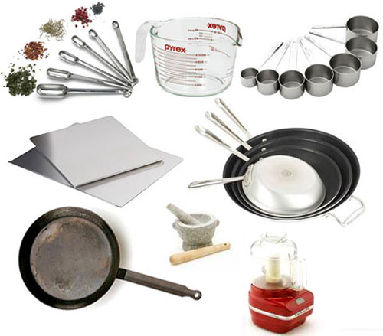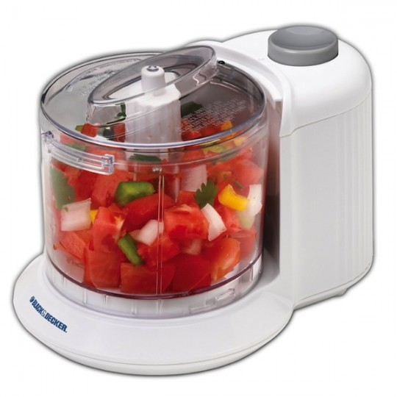

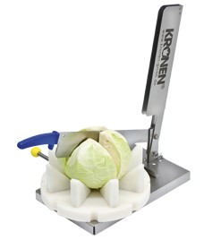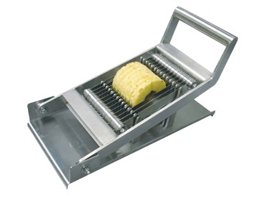

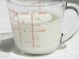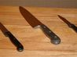
PLATE 1

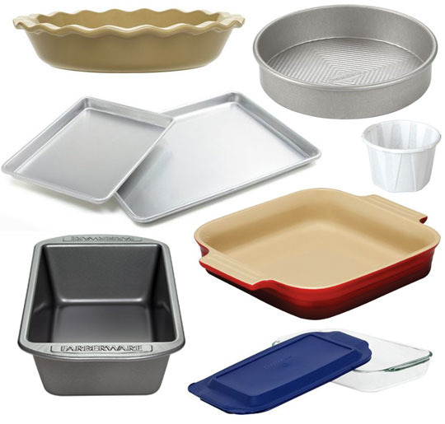

PLATE 2
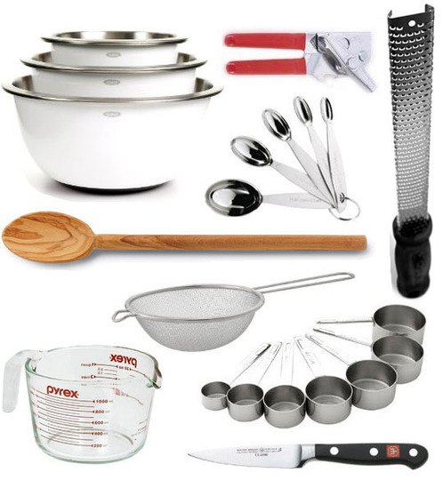

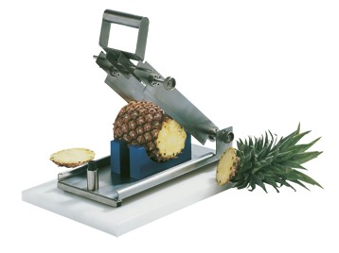
PLATE 3
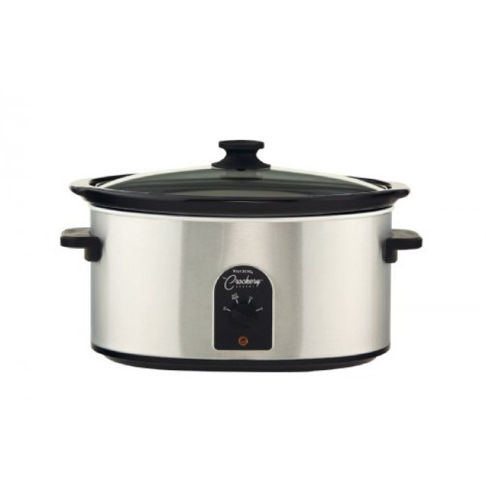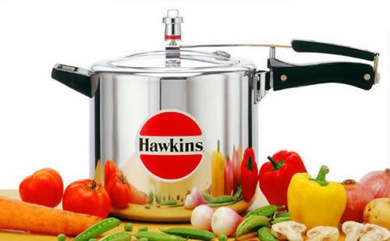

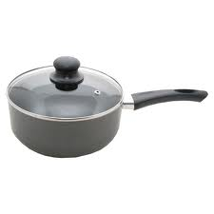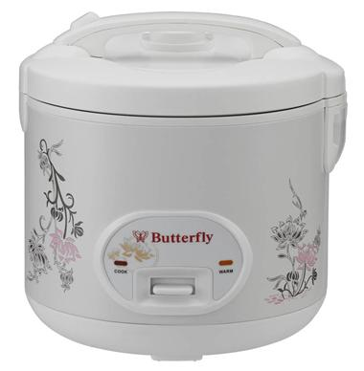

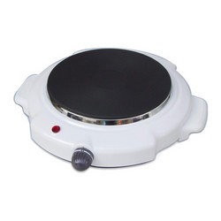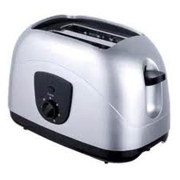

PLATE 4
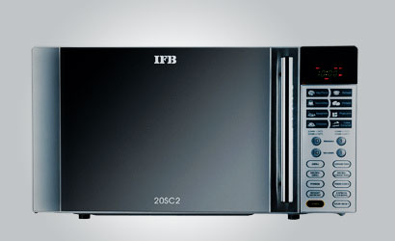

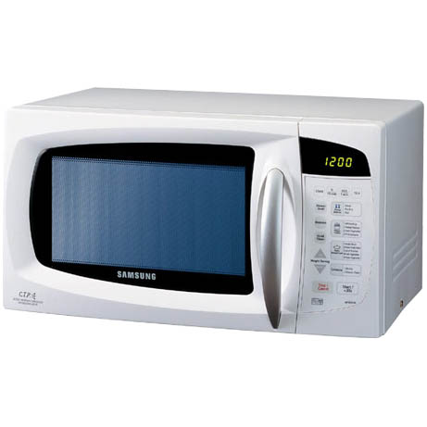
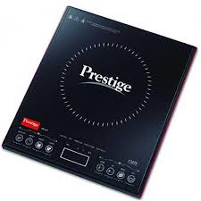
PLATE 5
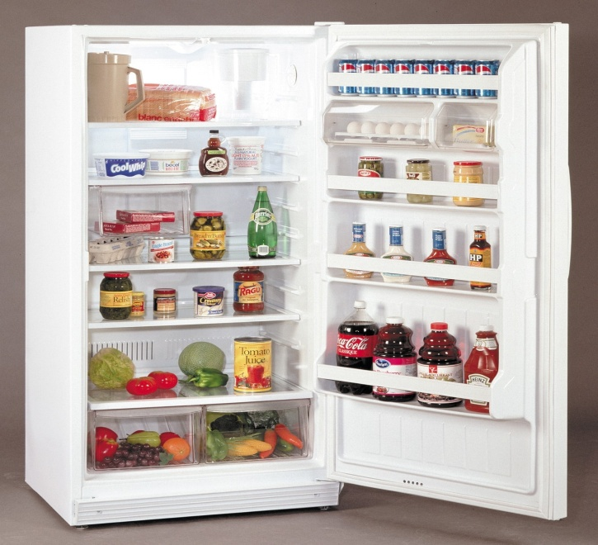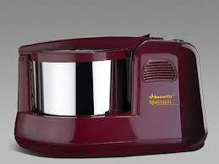

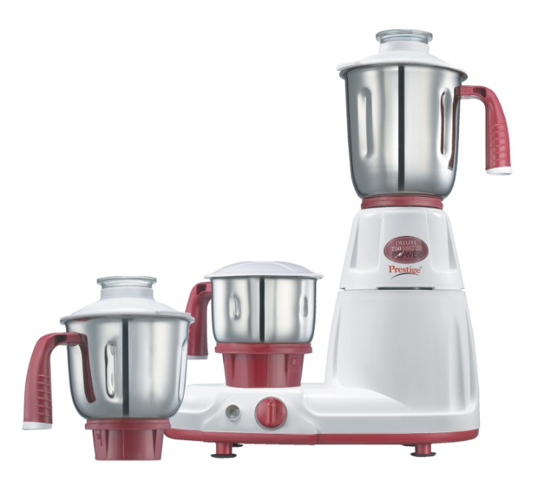

PLATE 6

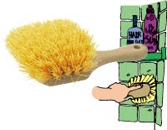
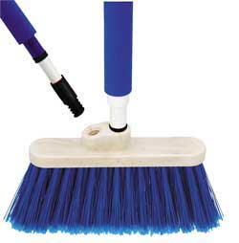

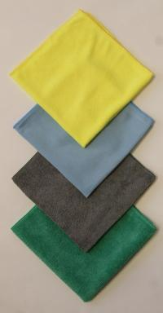
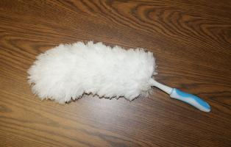

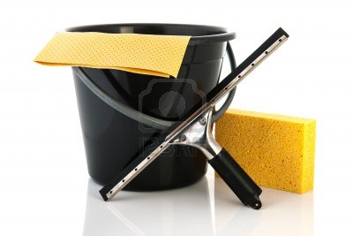
PLATE 7
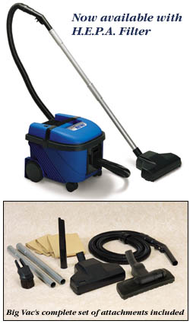

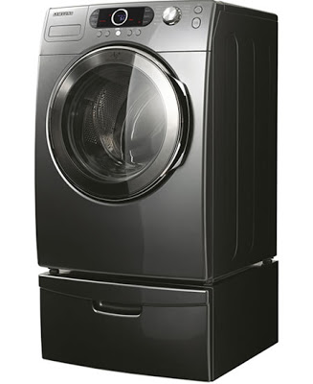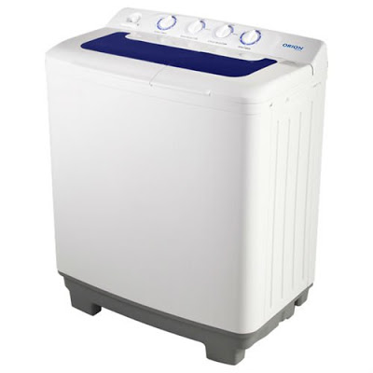

PLATE 8

LIST OF PLATES
TABLE TITLE PAGE
NO NO

- ELECTRICAL AND NON ELECTRICAL FOOD
PREPARATION EQUIPMENTS

- ELECTRICAL AND NON ELECTRICAL COOKING
EQUIPMENTS

- ELECTRICAL AND NON ELECTRICAL CLEANING
AND WASHING EQUIPMENTS

APPENDICES

TABLE TITLE
NO

- AN INTERVIEW SCHEDULE TO ELICIT INFORMATION
ON THE AVAILABILITY OF MODERN LABOUR SAVING DEVICES

- AN INTERVIEW SCHEDULE TO ELICIT INFORMATION
REGARDING THE EXTENT USE OF MODERN LABOUR SAVING DEVICES BY THE SELECTED HOMEMAKERS

Phase 2: Findings of the Household Survey:
A household survey was done to find out the extent of use of Modern Labour Saving Devices in order to conserve time and energy in the selected homemakers. It consists of the following steps.
- Socio – Economic Background of the Selected Homemakers.
- General Details on Labour Saving Devices.
- Use, Care and Maintenance of Labour Saving Devices.
- Benefits Accrued in Using Modern Labour Saving Devices.
- Problems Faced in Using the Devices.
1. Socio – Economic Background of the Selected Families:
The details on the socio economic background consists of the type and size of the family, educational status of the head of the family and homemakers, age level, occupational status and income level of the families.
- Type and size of the Family:
Table 7 explains the detailed information about the type and size of the selected families.
Table 7: Type and Size of the Family
Particulars | Percentage of households
A.Type of family
Nuclear | 79
Joint | 21
B.Family size
Small(1-3) members | 58
Medium(4-6) members | 27
Large(7 and above) | 5

Among the 100 selected households, the higher percentage of 79 families belonged to nuclear family system and the rest 21 per cent of them belonged to joint family ( fig 1A,1B). It denotes the disintegration of joint family system in the present era. Fifty eight per cent of the families adopted small family norm which had only 1-3 members. Twenty seven per cent of the families belonged to medium sized families which had 4-6 members. Only five per cent of the families had family members more than seven. It shows due to the employment of women there is a trend to the choice of adopting small family norms.

- Age of the Heads of the Families and Homemakers:
Table 8: gives the information regarding the age of the heads of the families and homemakers.
Table 8 :Age of the Heads of the Families and Homemakers
Age level  in years | Percentage of head of the family | Homemaker
Below 30 | 24 | 23
31-40 | 26 | 28
41-50 | 38 | 35
51 and above | 12 | 14

A maximum of 38 per cent and 35 per cent of the heads of the families and homemakers respectively were in the age level of 41-50 years and the minimum percentage 12 and 14 of them were above 51(fig 2).
Figure :2

C. Educational Status:
The educational status of the heads of the families and the homemakers are given in Table 9.
Table 9: Educational Status of the Heads of the Families and the Homemakers
Particulars | Percentage of
Particulars | Head of the family | Homemaker
Primary |  | -
Secondary | 10 | 8
Higher secondary | 12 | 15
Graduate | 28 | 26
Post Graduate | 29 | 32
Professional | 21 | 18

A majority of 29 per cent of the heads of the families and 32 per cent of the homemakers were post graduates. Even a minimum per cent of the heads (10 per cent) and homemakers ( 8 per cent) were having secondary level education. It is glad to note that all the selected heads and homemakers were literates even 21 per cent of the heads of the families and 18 per cent of the homemakers had completed professional courses(fig 3).
- Occupational Status of the Heads of the Families and Homemakers:
The detailed information about the occupational status of the heads of the families and homemakers are presented in Table 10.

Table 10: Occupational Status of the Heads of the Families and Homemakers
Occupational Status | Percentage of
Occupational Status | Head of the family | Homemakers
Business | 28 | -
Bank Officers | 20 | 10
Engineers | 23 | 2
Doctors | 4 | -
Teachers | 25 | 20
Full time Homemakers | - | 68

Regarding the occupational status of the heads of the families, a majority of 28 per cent were business persons, followed by 25 per cent of them were teachers, 23 per cent of them were engineers , bank officers ( 20 per cent) and doctors (4 per cent).
In the case of homemakers, 68 per cent of them were full time homemakers and the rest 32 per cent were employed homemakers (fig 4).
- Monthly Income of the Families:
Table 11 gives the information about the income level of the selected families
Table 11: Monthly Income of the Families
Income range  in Rs. | Percentage of households
40,000 – 50,000 | 22
50,000 – 60,000 | 27
60,000 – 70,000 | 35
More than 70,000 | 16

Though all the selected families belonged to high income group, there is a difference in their income level ( fig 5). A maximum 35 per cent of the families were in the income range of Rs.60,000 – 70,000/-. A minimum 16 per cent of the families were having an income above Rs.70,000/-. Amongst the surveyed households 27 per cent belonged to the income range between RS. 50,000/- and 60,000/- and 22 per cent o them earned an income between RS.40,000/- and 50,000/-.
Figure

2. General details on Labour Saving Devices:
This aspect includes the type of labour saving devices possessed by the selected homemakers.
- Type of Labour Saving Devices possessed:
The electrical and non-electrical devices used for various household activities are discussed below:

- Preparation Equipment:
Table 12 indicates the preparation equipment (non-electrical) possessed by the homemakers.
Table 12: Preparation Equipment (Non-Electrical) possessed by the Homemakers
Name of the Equipment | Percentage of the Homemakers*
Knife | 100
Mixing bowls | 100
Slicer | 98
Churner | 89
Cutting board | 79
Coconut scrapper | 79
Grater | 75
Peeler | 73
Steel strainer | 72
Vegetable chopper | 55
Juicer | 53
Hand mixers | 52
Juice Extractor | 52
Egg beater | 51
Chappathi pressure | 43
Knife and cutting board | 36
Potato slicer | 33
Curd beater | 31
Cheese grater | 29
Tomato slicer | 19
Dry measuring cups | 19
Liquid measuring cups | 14
Blender | 11
Cabbage cutter | 8
Pineapple cutting device | 7
Manual pineapple slicer | 6
Manual melon cutter | 3
*multiple responses
A majority of the homemakers using knife and mixing bowls (100 per cent), slicer (98 per cent), churner(89 per cent) , cutting board (79 per cent), coconut scrapper (79 per cent), grater (75 per cent), peeler (73 per cent) and steel strainer (72 per cent) when compared to other food preparation equipments.
The other new food preparation equipments used by the homemakers were vegetable chopper (55 per cent), juicer (53 per cent), hand mixers (52 per cent), juice extractor ( 52 per cent), egg beater ( 51 per cent), chappathi pressure (43 per cent), knife and cutting board ( 36 per cent), potato slicer (33 per cent), curd beater ( 31 per cent), cheese grater (29 per cent), tomato slicer (19 per cent), dry measuring cups (19 per cent), liquid measuring cups (14 per cent), blender (11 per cent), cabbage cutter ( 8 per cent), pine apple cutting device (7 per cent), manual pine apple slicer (6 per cent)and manual melon cutter(3 per cent).

Table 13: Preparation Equipment (Electrical) Possessed by the Households
Name of the equipment | Percentage of homemakers*
Refrigerator | 100
Mixie | 100
Grinder | 100
Egg beater | 36
Rotimaker | 30
Chappathi maker | 29
Food processor | 24
Water cooler | 18
Coffee maker | 11
Ice cream maker | 8
Electrical chopper | 8
*multiple responses
All the selected homemakers were possessing refrigerator, mixie and grinder because these three equipments have become necessary equipments in modern homes. The other preparation electrical equipments possessed by the selected homemakers were egg beater (36 per cent0, rotimaker (30 per cent), chappathi maker (29 per cent), food processor ( 24 per cent), water cooler ( 18 per cent), coffee maker (11 per cent), electrical chopper and ice cream maker (each 8 per cent).

ii) Cooking Equipments: Table 14 explains both the electrical and non-electrical cooking equipments possessed by the homemakers.
Table 14: Cooking equipments possessed by the homemakers
Name of the equipment | Percentage of homemakers
Electrical
Induction stove | 91
Electric rice cooker | 45
Microwave oven | 40
Coffee percolator | 33
Water kettle | 32
Toaster | 21
Rotisserie | 20
Baking oven | 19
Hot plate | 18
Stove with oven | 6
Tea kettle | 5
Non- electrical
Pressure cooker | 100
Sauce pan | 64
Frying pan | 64
idly cooker | 55
Idly steamer | 54
Milk boiler | 52
Non-stick tawa | 52
Pressure pan | 47
Non-stick pan | 45
Non-stick cooker | 28
Pie pan | 17

A majority of 91 per cent of the homemakers were having induction stove and minimum 6 percent of them were possessing stove with oven. The other electrical equipments possessed by the homemakers were electric rice cooker (45 per cent), microwave oven (40 per cent), coffee percolator ( 33 per cent), water kettle ( 32 per cent), toaster (21 per cent), rotisserie (20 per cent), baking oven (19 per cent) and hot plate (18 per cent).
All the selected homemakers were having pressure cooker. The other non- electrical equipments possessed by the homemakers were sauce pan and frying pan ( each 64 per cent), idly cooker (55 per cent), idly steamer (54 per cent), milk boiler and non- stick tawa ( each 52 per cent), pressure pan ( 47 per cent), non-stick pan (45 per cent), non- stick cooker ( 28 per cent), pie pan (17 per cent) and baking pan (10 per cent). These were the modern labour saving devices which were used by the homemakers to save their time and energy.
iii) Cleaning and Washing Equipments:
Table 15 shows the details about the electrical and non- electrical cleaning and washing equipments possessed by the households.
Table 15: Cleaning and Washing Equipments possessed by the Homemakers.
Name of the Equipment | Percentage of Homemakers
Non- Electrical
Brooms | 100
Dust bin | 100
Dust mop | 100
Dust pan | 100
Scrubbers | 95
Cleaning brushes | 89
Ceiling and wall brushes | 76
Feather duster | 65
Tile brush | 60
Window squeegee | 60
Household sponges | 50
Cleaning kit | 38
Microfiber cleaning clothes | 30
Plastic broom | 30
Flexible microfiber duster | 20
Double headed broom | 10
Electrical
Vacuum cleaner | 64
Washing machine  - Regular top loading  - Fully automatic  - Semi automatic | 65  24
- Front loading | 11

All the selected homemakers were using non- electrical cleaning equipments like brooms, dust bin, dust mop, and dust pan followed by scrubbers ( 95 per cent), cleaning brushes (89 per cent), ceiling and wall brushes (76 per cent), feather duster ( 65 per cent), microfiber duster (30 per cent), cleaning kit (38 per cent), plastic broom (30 per cent) and household sponges. Double headed brooms were used by few homemakers (10 per cent) .
Vacuum cleaners (64 per cent) were used by all the homemakers. Fully automatic washing machine (65 per cent) was preferred more than semi automatic washing machines (24 per cent). Front loading washing machines were used by 11 per cent of the selected homemakers.
3. Use, Care and Maintenance of Labour Saving Devices
a) Persons Incharge for the Operation, Care and Maintenance of the Equipments (Electrical).
Table 16 describes about the persons in charge for the operation, care and maintenance of the equipments (electrical).

Type of devices  Preparation | Percentage of Homemakers  Persons in charge for Operation*
Type of devices  Preparation | Homemaker | Mothers in law
Refrigerator | 80 | 20
Food processor | 83 | 17
Water cooler | 88 | 12
Mixie | 70 | 30
Grinder | 100 | -
Rotimaker | 100 | -
Chappathi maker | 93 | 72
Ice cream maker | 100 | -
Egg beater | 100 | -
Coffee maker | 100 | -
Electrical chopper | 100 | -
Cooking
Microwave oven | 100 | -
Stove with oven | 100 | -
Baking oven | 100 | -
Hot plate | 100 | -
Tea kettle | 100 | -
Rotisserie | 100 | -
Electric rice cooker | 93 | 7
Water kettle | 93 | 7
Induction stove | 89 | 11
Toaster | 85 | 15
Coffee percolator | 84 | 16
cleaning and washing
Washing machine | 93 | 7
Vacuum cleaner | 92 | 8
*multiple responses
Amongst the selected families homemakers were mainly responsible for handling all the equipments with much care. In few families mothers -in –laws were also engaged in operating the devices. Though the homemakers were mainly incharge for operating all the equipments 7 to 30 per cent of the mothers in law were operating the equipments along with their daughters in law exceptchappathi maker(72 per cent).
.ii) Frequency of Use of Labour Saving Devices:
Table 17 gives the information about the frequency of use of labour saving devices (Electrical).

Table 17: Frequency of Use of Labour Saving Devices (Electrical).
Type of devices  Preparation | Percentage of households  Frequency of use
Type of devices  Preparation | Daily | Weekly | Monthly
Refrigerator | 100 | -
Water cooler | 100 | -
Mixie | 100 | -
Food processor | 62 | 38
Electrical chopper | 62 | 38 | -
Coffee maker | 36 | 18 | 56
Rotimaker | 33 | 50 | 17
Chappathi maker | 27 | 62 | 11
Grinder | 20 | 80
Egg beater | 16 | 70 | 14
Ice cream maker | - | 25 | 75
cooking
Induction stove | 89 | 11 | -
Electric rice cooker | 44 | 33 | 23
Tea kettle | 40 | 60 | -
Water kettle | 31 | 46 | 23
Coffee percolator | 24 | 60 | 16
Microwave oven | 17 | 45 | 38
Toaster | 9 | 71 | 20
Stove with oven | - | - | 100
Baking oven | - | 47 | 53
Hot plate | - | 11 | 89
Rotisserie | - | 60 | 40
cleaning and washing
Washing machine | 20 | 80 | -
Vacuum cleaner | 7 | 60 | 33

All the selected homemakers were using equipments such as refrigerator, water cooler, mixie on daily basis. Above 60 per cent of the families were using food processor, electric chopper and induction stove on daily basis. Less than 50 per cent of the families were using rotimaker, chappathi maker, egg beater, coffee maker, microwave oven, electric rice cooker, toaster, coffee percolator, tea kettle, vacuum cleaner, washing machine and grinder daily.
A Majority 80 per cent of the families were using grinder and washing machine once in a week where as minority of 11 per cent of the families were using induction stove and hot plate on weekly basis.
All the selected families were using stove with oven on monthly basis followed by hot plate ( 89 per cent), ice cream maker ( 75 per cent). Less than 60 per cent of the families were using coffee maker, baking oven, rotisserie, vacuum cleaner, electric rice cooker, toaster, roti maker, coffee percolator, egg beater and chappathi maker.
Table 18: Frequency of Use of Labour Saving Devices Non-electrical Preparation Equipments.

Type of devices  Preparation | Percentage of households  Frequency of use
Type of devices  Preparation | Daily | Weekly | Monthly
Knife | 100 | - | -
Cutting board | 100 | - | -
Coconut scrapper | 100 | - | -
Liquid measuring cups | 100 | - | -
Dry measuring cups | 100 | - | -
Knife and cutting board | 100 | - | -
Mixing bowls | 100 | - | -
Grater | 85 | 15 | -
Slicer | 71 | 26 | 3
Steel strainer | 69 | 25 | 6
Curd beater | 67 | 33 | -
Churner | 61 | 39 | -
Hand mixers | 48 | 52 | -
Vegetable chopper | 43 | 57 | -
Peeler | 41 | 52 | 7
Juicer | 30 | 56 | 14
Chappathi pressure | 27 | 73 | -
Tomato slicer | 26 | 74 | -
Juice Extractor | 19 | 81 | -
Potato slicer | 15 | 85 | -
Egg beater | 15 | 78 | 7
Cheese grater | 13 | 87 | -
Cabbage cutter | - | 100 | -
Manual melon cutter | - | - | 100
Pineapple cutting device | - | - | 100
Manual pineapple slicer | - | - | 100
Blender | - | 18 | 82

All the homemakers were using equipments such as knife, boards mixing bowls, coconut scrapers, liquid and dry measuring cups, mixing bowls and cutting board on daily basis. Above 60 per cent of the homemakers were using slicer,grater, churner, steel strainer on daily basis. More than 50 per cent were using peeler, juicer, chappathi pressure,tomato slicer, juice extractor, potato slicer, cabbage cutter, egg beater and cheese grater on weekly basis. Manual melon cutter, pineapple cutting device, manual pineapple slicer and blender on monthly basis.
Table 19: Frequency of Use of Non- Electrical Cooking and Cleaning Equipments.
Type of devices  Cooking | Percentage of households  Frequency of use
Type of devices  Cooking | Daily | Weekly | Monthly
Milk boiler | 100 | - | -
Pressure cooker | 100 | - | -
Pressure pan | 100 | - | -
Idly steamer | 92 | 8 | -
Frying pan | 81 | 19 | -
idly cooker | 72 | 29 | -
Sauce pan | 70 | 30 | -
Pie pan | 58 | 42 | -
Non-stick pan | 44 | 56 | -
Non-stick tawa | 34 | 38 | 28
Non-stick cooker | - | 71 | 29
Baking pan | - | 60 | 40
Cleaning and washing
4Brooms | 100 | - | -
Dustbin | 100 | - | -
Dust pan | 100 | - | -
Scrubbers | 45 | 55 | -
Cleaning brushes | 44 | 56 | -
Dust mop | 40 | 60 | -
Window squeegee | 25 | 38 | 37
Household sponges | 20 | 80 | -
Microfiber cleaning cloths | 16 | 84 | -
Feather duster | 14 | 50 | 36
Flexible microfiber duster | - | 100 | -
Ceiling and wall brushes | - | 19 | 81
Double header broom | - | - | 100
Tile brush | - | 33 | 67
Cleaning kit | - | 100 | -
Plastic broom | - | 100 | -

Above 50 per cent of the homemakers were using cooking devices such as milk boiler, pressure cooker, pressure pan, idly steamer, frying pan, idly cooker, sauce pan and pie pan. Cleaning devices such as broom, dust bin and dust pan on daily basis.
Above 50 per cent of the homemakers were using cooking devices such as non stick pan, non stick cooker and baking pan on weekly basis. Like that cleaning devices such as plastic broom, cleaning kit, flexible microfiber duster, microfiber clothes, dust mop, cleaning brushes, scrubbers on weekly basis.
Above 60 per cent of the homemakers are using cleaning devices such as double headed broom, ceiling and wall brushes and tile brush on monthly basis.
4. Benefits Accrued In Using Modern Labour Saving Devices.
Table 20 shows the benefits accrued by homemakers in using modern labour saving devices in selected homemakers.
Table 20: Benefits Accrued In Using Modern Labour Saving Devices
Benefits accrued | Percentage of homemakers stated *
Time saving | 100
Energy conservation | 100
Alleviating fatigue | 84
Easy to operate | 82
Durability | 80
Aesthetic look | 74
Portable | 71
Easy maintenance | 69
Perfect, precise and compact | 48
Others | 1
*multiple responses
All the selected homemakers considered these modern labour saving devices were really conserved their time and energy. Above 80 per cent of the homemakers stated that these devices alleviated their fatigue easy to operate, easy to maintain and durable. Less than 50 per cent considered them as perfect, precise and compact.

5. Problems Faced in Using Modern Labour Saving Devices:
Problems which are faced by the home makers in using modern labour saving devices in the selected households are indicated in Table 21.
Table 21: Problems Faced in Using Modern Labour Saving Devices
Problems faced | Percentage of home makers stated *
Due to power failure electrical equipments cannot be used | 100
Small repairs incur high cost | 67
Repairing cannot be done | 57
Maintenance of the equipment difficult | 47
Special care and maintenance is required | 38
Not knowing the proper using of the devices | 36
Become obese due to the use of devices | 18
*multiple responses
Today current problem in our state is “scarcity of electricity”, excess usage of electricity and poor management of electric power were the main reasons for this situation. All the selected homemakers were not able to use the electrical equipments due to power failure. The other problems faced by them were high cost incurred for small repair, sometimes repairing cannot be done at all to some equipments, and maintenance of the equipments were very difficult. Even 18 per cent of the home makers felt they become obese when they use these devices. Not knowing the proper usage of the devices(36 per cent) and special care( 38 per cent and maintenance is required were the other problems stated by the homemakers.

