GLOBAL POSITIONING SYSTEM BASED LOCATION SEARCH SYSTEM FOR IOS DEVICES

PAVITHRA.S
09PCA15

A Project Report submitted to Avinashilingam University for Women, Coimbatore in partial fulfilment of the requirements for the Master’s Degree in Computer Applications

April, 2012

GLOBAL POSITIONING SYSTEM BASED LOCATION SEARCH SYSTEM FOR IOS DEVICES

PAVITHRA.S
09PCA15

A Project Report submitted to Avinashilingam University for Women, Coimbatore in partial fulfilment of the requirements for the Master’s Degree in Computer Applications

April, 2012

Signature of the Signature of the
Head of the Department Supervisor

Signature of the
External Examiner
ACKNOWLEDGEMENT

I would like to express my sincere thanks to God Almighty, for his constant love and grace that he has showered upon me.

I am very grateful to Thiru.T.K.Meenakshi Sundaram, M.A., M.Phil,Chancellor, Avinashilingam Institute for Home Science And Higher Education for Women, Coimbatore, for his support and encouragement during the course of my study.

I heartily thank Dr.(Mrs).Sheela Ramachandran M.Sc, P.G DIP., PH.D Vice Chancellor, Avinashilingam Institute for Home Science And Higher Education for Women, Coimbatore, for extending all resources that facilitated the conduct of the present study.

I express my humble gratitude to Dr.(Mrs). Gowri Ramakrishnan M.Sc., M.Phil., Ph.D., Registrar, Avinashilingam Institute for Home Science And Higher Education For Women, Coimbatore, for providing all facilities necessary for the study.

I am also thankful to Dr.(Mrs). R. Parvatham M.Sc., Dip.Ed. M.Phil., Ph.D., Dean Faculty of Science, for granting the facility required.

I wish to place on record my deep sense of gratitude to my project supervisor Dr.(Mrs).G.Padmavathi M.Sc., M.Phil., Ph.D., Professor and Head, Department of Computer Science for providing all the guidance to complete the project.

I owe great deal of gratitude to the project Coordinator Dr.(Mrs).P.Subashini
M.Sc., M.Phil., Ph.D., Department of Computer Science, for her kind advice and knowledgeable suggestion.

I would also like to extend my gratitude to Frontline Consulting and Services
(FCS inc.), Hyderabad for their guidance and support in this enriching endeavor.

It is a great pleasure in expressing my deep sense of gratitude to all other staffs and non-teaching staffs who have stood behind the screen in making of project.

I would like to extend my hearty thanks to one and all those who helped me directly or indirectly for the successful completion of the project.

Last yet importantly, I would like to thank my parents, my brother and all my
well-wishers for their motivation.

CONTENTS
SL NO. | CONTENTS | PAGE NOS.
 | Abstract
1 | Introduction to Apple Devices and Application Development
 | 1.1 Introduction | 1
 | 1.2 I-Phone Operating System | 2
 | 1.3 Prerequisites for I-Phone Development | 3
 | 1.4 Application Development | 3
 | 1.5 The Application Development Process | 4
 | 1.6 IPhone Application Vs. Android Application | 5
 | 1.7 Organization of the Report | 5
 | 1.8 Summary | 6
2 | GPS based Location Search for IOS Devices- An Introduction
 | 2.1 Introduction | 7
 | 2.2 Aim | 7
 | 2.3 Objectives | 7
 | 2.4 Assumptions | 8
 | 2.5 Significance | 8
 | 2.6 Steps involved | 9
 | 2.7 Existing applications | 10
 | 2.8 Comparison of Different LBS and Proposed System | 10
 | 2.9 Technical Specification | 11
 | 2.10 Basic Architecture and Information Flow | 11
 | 2.11 Challenges | 12
 | 2.12 Summary | 13
3 | State of the Art
 | 3.1 Techniques Available for Development of GPS Based  Location Search for IOS Devices | 14
SL NO. | CONTENTS | PAGE NOS.
 | 3.2 Waterfall Model | 14
 | 3.3 Incremental Model | 16
 | 3.4 Unified Model | 17
 | 3.5 Spiral Model | 18
 | 3.6 Extreme Programming | 19
 | 3.7 Compartitive Study Of A Few Models | 20
 | 3.8 Summary | 20
4 | Methodology | 21
 | 4.1 Introduction | 22
 | 4.2 Requirement Analysis | 23
 | 4.2.1 Stakeholder Identification | 23
 | 4.2.2 Stakeholder Interviews | 23
 | 4.2.3 Joint Requirements Development Sessions | 23
 | 4.2.4 Requirement List | 24
 | 4.2.5 Goals | 24
 | 4.2.6 Prototype | 24
 | 4.2.7 Use Cases | 25
 | 4.2.8 Data Flow Diagram | 26
 | 4.2.9 Types of Requirements | 27
 | 4.3 Software Requirements Specifications | 27
 | 4.4 Architecture | 28
 | 4.5 Technical Aspects | 29
 | 4.5.1 MVC Model | 29
 | 4.5.2 Roles and Relationships of MVC Objects | 30
 | 4.5.3 MVC as a Compound Design Pattern | 31
 | 4.5.4 Design Guidelines for MVC Applications | 32
 | 4.5.5 View-Controller in Cocoa (Mac OS X) | 32
 | 4.5.6 Framework and Kits | 33
SL NO. | CONTENTS | PAGE NOS.
 | 4.5.7 Finding the Location | 34
 | 4.5.8 Mapping the Location | 36
 | 4.5.9 Setting and Customization of Annotations | 36
 | 4.5.10 Google Weather API | 36
 | 4.5.11 XML Parsing | 37
 | 4.5.12 Steps for Friends in a Specific Location using  Facebook API | 37
 | 4.5.13 Coffee Shop Finder | 41
 | 4.5.14 Accessing Gmail through the application | 41
 | 4.6 Tests conducted | 41
 | 4.7 Summary | 43
5 | Output and Screenshots | 44
6 | Conclusion | 48
7 | Future Scope of the Project | 49
 | Bibliography | 50
 | Annexure I | 52
 | Annexure II | 55

ABSTRACT

It has been quite some time since Apple launched iPhone mobile and made a big wave across the world. Initially it got introduced in the US market and within a year's time it was available all over the world.The project titled “Global Positioning System Based Location Search System for I-Phone Operation System Devices” is an application proposed to suit the needs of Apple product users. With the GPS advantage Apple applications can be created for location based searches. The co-ordinates that are extracted can be applied to give exact and precise location on a map. Once the location is determined various details can be presented. The proposed application is a tabbed one where the user selects from “Current Location” and “Specific Location”. The Specific Location takes user inputs and displays it using Custom Annotation. Other informations such as weather details, friends, coffee shop etc. are displayed. This is an application that aims at travelers with Internet facility so that they can be guided throughout the world. The technology used in development of the proposed system is Xcode IDE with Objective C as the language. The system has been developed in a Mac OS-Lion which is backward compatible in nature. The various modules that have been successfully implemented are:

- Creation of a basic application and Interfaces
- Find current location
- Find the specific location of the place entered by the user
- Display temperature, humidity, friends’ from the locality, coffee shop etc of the specified place.

This system utilizes the information available from various API’s such as Google Maps, Google Weather API, Facebook API etc. Each data received is either in JSON or XML format which can be parsed using a parser to make the data available to the user. Various kits and frameworks have also been used such as MapKit framework, CoreLocation framework etc. Memory management has been user defined. The major requirement is that the user has an Apple device with Internet facility. This Internet facility should be GPS sensitive.

CHAPTER 1

INTRODUCTION TO APPLE DEVICES AND APPLICATION DEVELOPMENT

1.1 INTRODUCTION
It has been quite some time since Apple launched iPhone mobile and made a big wave across the world. Initially it got introduced in US market and within a year's time it was available all over the world.
The "touch technology” of the device, especially the multi-touch takes care of two fingers touching the screen at the same time. However there is more to iPhone than touch. Other important features are:
- Location finding: using GPS it finds where it is at that point of time in the world
- Accelerometer and Orientation: gives the ability to detect motion in three dimensions
- Programmable Vibrator, Camera, address book
Such features make iPhone more than a just a phone. Technically, iPhone exists in two largely similar versions:
- the 2007 original release and
- the 2008 3G release.
It is a 4.7- or 4.8-ounce computing device. Each device contains a 620 MHz RAM CPU that has been under clocked to improve battery performance and reduce heat. Both devices include 128 MB of dynamic RAM (DRAM), and from 4 to 16 GB of Flash memory. The primary difference between the two devices centers on the global positioning system (GPS) and networking.

Some technical specifications:
- iPhone is built on Apple’s OS X, which itself is built on Unix.
- iPhone has 480 x 320 touch screen
- Supports a mobile version of Safari browser
- Supports LAN and WAN networking using Wi-Fi
- Uses GPS over Wi-Fi
1.2 IPHONE OPERATING SYSTEM
iPhone Operating System (iOS) framework provide many standard classes that come with the framework, but sometimes need may arise to write one’s own subclasses. The iPhone operating system is divided in to four layers namely:
- Cocoa touch
- Media
- Core Services
- Core OS
as represented in the Figure 1.1. Each layer contains variety of frameworks that can be used in the application.
COCOA TOUCH
MEDIA
CORE SERVICES
CORE OS
Figure 1.1 four layers of cocoa

- Cocoa touch - the base framework, that contains the UI-Kit framework(User-Interface Kit) which includes window support, event support and user-interface management.
- Media – the framework that provide the protocols to deal with audio and video built in iPhone.
- Core Services – the frameworks used in all applications, data types.
- Core Operating System – the kernel level software dealing with threading, networking, I/O, memory etc.

1.3 PREREQUISITIES FOR IPHONE APPLICATION
DEVELOPMENT
IPhone programming requires the following:
- An Intel Mac running Mac OS X Leopard v10.5.4 or higher
- The iPhone SDK for iPhone OS. The iPhone SDK contains all the tools and utilities one needs to develop iPhone applications. In particular, it comes with Xcode 3.1(the development IDE) and the iPhone Simulator that allows application testing without needing a real device.
Though, applications can be tested on the simulator, it can be officially tested by registering them on the Apple site. This registration provides a secured certificate issued by Apple and can be used to test developed applications on the device itself.
1.4 APPLICATION DEVELOPMENT
In 2008, Apple released the iPhone software development kit (SDK), a developer toolkit that allowed programmers to develop iPhone application. iPhone SDK allowed users to develop two type of applications—Web development and Native iPhone Application development.
(Figure 1.2 shows the Types of Application Development. For more theoretical details refer Annexure I and [2])
APPLICATION DEVELOPMENT
WEB APPLICATION
NATIVE APPLICATION
Figure 1.2 types of application development
iPhone SDK uses the Objective-C language, which is an extension to the C language. Like any other mobile, iPhone too has a different programming platform; Windows Mobile (VB.NET/C#) and Android (Java) use object-oriented languages and are identical in syntax. However, Objective-C takes a totally different approach.
Objective-C as implemented by Apple is built entirely around Objects. It is used throughout the iPhone OS framework. Windows, views, buttons, sliders and controllers exchange information with each other in the form of events and actions in order to make the program run.
A header file (.h) and a source code (.m) file together represent each object in Objective-C.

1.5 THE APPLICATION DEVELOPMENT PROCESS
The application development process begins with the customer and team in full understanding of the core objective of the application and the benefits it needs to provide to the end user. Then the rigorous process that gets an idea from the concept to quality assurance. Every step in the application development process are carefully orchestrated to ensure the highest level of customer satisfaction.

1.6 IPHONE APPLICATION Vs ANDRIOD APPLICATION
The major competitor of apple devices and the programming ways are the android development. This is vaguely a new concept in the market but is one of the major competitors. The proposed system aims to create a more comprehensive location based search using GPS as it de facto. A comparison has been made on the basis of few criteria’s such as Games, Social Networking, Photos and movies, Music, Travel etc. The comparison has been shown in Table 1.1
Table 1.2 Comparison table of IPhone and Andriod
CRITERIA | IPHONE | ANDRIOD
Games | X
Social networking |  | X
Kid | X
Photos and movies | X
Music | X
Dining in | X
Dining out | X
Travel | X
E-books | X
Google apps vs. Apple app |  | X
Music streaming |  | X

From this table it is derived that IPhone applications have low Social networking plug in’s. To mitigate this an attempt is made to integrate a social networking site into the system.

1.7 ORGANIZATION OF THE REPORT

The first chapter gives a brief introduction about the IPhone and its application development. The second throws light on the proposed system i.e. “GPS based Location Search System for IOS Devices” and the third states the techniques with which it can be implemented. The fourth chapter gives in-depth detail of the development stages in a methodological manner stating the technique used and the technical aspects present in the system. Chapter five presents the output generated. Chapter six and seven deal with the summarization of the system and future scope for improvement.
1.8 SUMMARY
Thus, Apple created a marvellous device which has GPS that lets the device detect motion, and wide screen for better viewing of data and applications. It uses the Wi-Fi and lets the user access the Internet like any other laptop or computer. On the basis of these advantages, the proposed system has been deviced to help the device holder find various locations and further find details of it.

CHAPTER 2

GPS BASED LOCATION SEARCH FOR IOS DEVICES -
AN INTRODUCTION
2.1 INTRODUCTION
The Global Positioning System (GPS) is a space-based satellite navigation system that provides location and time information in all weather, anywhere on or near the Earth, where there is an unobstructed line of sight to four or more GPS satellites. With this GPS advantage various Apple applications can be created for location based searches. The co-ordinates that are extracted can be applied to give exact and precise location. Once the location is determined various details can be presented. The proposed system is an attempt to build such a native application that can be installed on any IOS device.
2.2 AIM

The project “GPS BASED LOCATION SEARCH SYSTEM” is an attempt to build such an application device that is commercial as well as user centric. It aims to create iPhone App that will do the following:

- Upon App opening - automatically identifies iPhone user location (based on Google GPS)
- Searches and identifies user specified place (based on Google GPS)
Displays the results on a map
- As per the location display information like temperature ,humidity, friend list, mail access etc using Weather API and Facebook API

2.3 OBJECTIVE

The major objectives of the proposed system are as follows:
  - To create a location based search to find a certain location or to locate the current location of an Apple product user.
  - The main element of the project is the GPS or Global positioning system
  - Once the location is fixed information about it is displayed
  - Integration of Social Networking, and various other API’s

Similar applications are APPLE certified app available in the APPLE APP STORE. But the major disadvantage being either

  - They require latest model of the Apple Device i.e. preferably backward compatible
  - They are highly loaded with features

The proposed system aims to mitigate the following disadvantages and build a simple location based application that will help a user not only to view his current location but also a specific location and all the details about it.

2.4 ASSUMPTIONS

The major assumption is that the user has an Apple device with Internet facility.

2.5 SIGNIFICANCE
Location data are used for a wide variety of purposes, ranging from social networking to turn-by-turn navigation services. They get location data using the classes of the Core Location framework. This framework provides several services that one can use to get and monitor the device’s current location:
- The significant-change location service provides a low-power way to get the current location and be notified of changes to that location. (ios 4.0 and later).
- The standard location service offers a more configurable way to get the current location.
- Region monitoring lets the user monitor boundary crossings for a defined area.

2.6 STEPS INVOLVED

The basic steps involved in creation of the proposed application are as follows (refer The Figure 2.1)
STEP 1: Creation of a basic application
STEP 2: Find current location on touch with CLLocation
    - The users current location is retrieved from the GPS
    - This data is then directly mapped to show the location
    - Location changes as per movement of the device
OR
STEP 3: Find specific location from the place entered by the user in the textbox
(full or partial address)
    - This user input passed to find the latitude and longitude of the location
    - The data is the form of web XML
    - This is passed through a XML Parser to retrieve the latitude and longitude
    - It is then mapped using Custom Annotation and MapKit Framework
STEP 4: Display temperature, humidity, friends’ from the locality, coffee shop etc of
the specific place
CREATE BASIC APPLICATION
FIND CURRENT LOCATION ON TOUCH
USING CLLLOCATION
FIND SPECIFIC LOCATION ENTERD BY USER IN TEXTBOX
DISPLAY TEMPERATURE, HUMIDITY, FRIENDS, COFFEE SHOP ETC
Figure 2.1 flow of the proposed application
2.7 EXISTING APPLICATIONS

Apple applications are widely available in the market. It can be either purchased or installed from the Apple Store. Mentioned below are few of the existing Location Based Application:

- Ditto : prompts user to update plans for what one is about to do, and then get recommendations from friends
- Yobongo: Yobongo is all about location-based messaging. For now, it only works in New York, Austin and San Francisco though.
- Shadow Cities: Shadow Cities the latest attempt to turn real-world cities into massively multiplayer games. Hugely popular in its native Finland, it's launching globally this year.
- Lonely Planet Audio Walking Tours: Travel firm Lonely Planet recently launched five walking-tour apps based on central London. Covering the West End, Covent Garden, the City, Spitalfields and the Southbank, they tie audio to location, plotting walks on Google Maps.
- Ask Around: Ask.com started life as the Ask Jeeves search engine, but its latest spinoff is a location-based conversation app. The emphasis is on questions and answers, with users able to tap into local knowledge when finding them somewhere unfamiliar.
- Love Clean London: London Mayor Boris Johnson has introduced the application. It aims to encourage citizen activism, as people report graffiti and other "environmental crimes" by uploading photos.

2.8 COMPARISON OF DIFFERENT LOCATION BASED SYSTEM
AND PROPOSED SYSTEM

Various applications are available in the market. But they have their set of disadvantages and advantages. A comparative study has been made in Table 2.1 showing the various existing applications on the basis of a few criterions.

Table 2.1 Comparison of various Location Based Application
and the Proposed System


2.9 TECHNICAL SPECIFICATION

Some of the technological requirements of the proposed application are given below:

OPERATING SYSTEM : MAC-OS LION
USER INTERFACE : XCODE
LANGUAGE : OBJECTIVE-C

2.10 BASIC ARCHITECTURE AND INFORMATION FLOW OF
THE PROPOSED APPLICATION
The proposed application being a GPS based application uses various frameworks such as CoreLocation, MapKit etc. The information flows from the user to the application and vice versa. The information flow of the system is shown in Figure 2.2
USER SELECTS APPLICATION LAUNCH
CURRENT LOCATION
SPECIFIC LOCATION
CORELOCATION FRAMEWORK
MAPVIEW
SET ANNOTATION
TEMPERATURE
HUMIDITY
FRIENDS
COFFEE SHOP
MAIL
OTHERS
Figure 2.2 information flow of the system

2.11 CHALLENGES

The major challenges in a GPS based location search system are as follows:
- Creating a view to display the map
- Accurate points from the GPS
- Plotting the points onto the map
- Custom Annotation
- Saving the location for further display of information
- Sensitive to location change
- Integration of social networking sites
- Integration and application of API’s
- Parsing the data received

2.12 SUMMARY

This chapter has given an insight to the basic view of the proposed system. Here the aim and objectives are presented showing the developers view of the system. The assumptions and technical aspects have also been put forward to give a basic guideline to the application. A comparative study has also been made with existing system throwing light on the proposed applications advantages. Lastly the architecture and basic challenges have been given showing how the problem is to be dealt with. With these aspects the leading chapters shall bring to light the various methodology with which the system can be developed giving importance to the most suitable technique.

CHAPTER 3
STATE OF THE ART

3.1 TECHNIQUES AVAILABLE FOR DEVELOPMENT OF GPS
BASED LOCATION SEARCH FOR IOS DEVICES

The Systems Development Life Cycle (SDLC) can be considered to be the oldest and formalized methodology or framework for building information systems. The main idea of the SDLC has been "to pursue the development of information systems in a very deliberate, structured and methodical way, requiring each stage of the life cycle from inception of the idea to delivery of the final system, to be carried out rigidly and sequentially" within the context of the framework being applied.

An Apple based application is different from other software’s available in the market. It is more iterarative and fast moving compared to other software’s development. Hence the technique of development has to separately dealt with
The software development methodology framework that can be followed for the proposed system is as follows:
- Waterfall model
- Incremental Model
- Unified Model
- Spiral Model
- Extreme Model

3.2 WATERFALL MODEL

The waterfall approach emphasizes a structured progression between defined phases. Each phase consists of a definite set of activities and deliverables that must be accomplished before the following phase can begin. The phases are always named differently but the basic idea is that the first phase tries to capture “What” the system will do, its system and software requirements, the second phase determines “How” it will be designed. The third stage is where the developers start writing the code, the fourth phase is the “Testing” of the system and the final phase is focused on “Implementation” tasks such as training and heavy documentation. However, in engineering practice, the term waterfall is used as a generic name to all sequential software engineering methodology.
Figure 3.1 below shows a traditional waterfall lifecycle

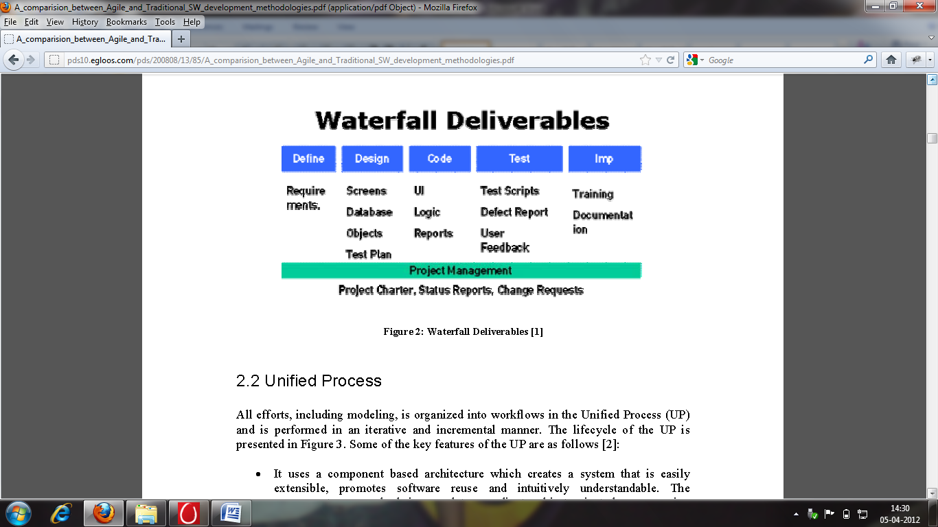
Figure 3.1: waterfall deliverables

The waterfall model can be applied in the application in phases that are completed sequentially before proceeding to the next phase. The salient attributes of the waterfall model if applied in the proposed system are:
- A formal method.
- A type of top-down development.
- Composed of independent phases to be done sequentially.
- Used in varied ways.
  - Steps are combined.
  - There are different starting and ending points.

3.3 INCREMENTAL MODEL

The incremental model performs the waterfall in overlapping sections attempting to compensate for the length of waterfall model projects by producing usable functionality earlier. This may involve a complete upfront set of requirements that are implemented in a series of small projects. As an alternative, a project using the incremental model may start with general objectives. Then some portion of these objectives is defined as requirements and is implemented, followed by the next portion of the objectives until all objectives are implemented. However the use of general objectives rather than complete requirements can be uncomfortable for management. Because some modules will be completed long before others, well-defined interfaces are required. Moreover, formal reviews and audits are more difficult to implement on increments than on a complete system. Finally, there can be a tendency to push difficult problems to the future to demonstrate early success to management.
Figure 3.2 shows the incremental model flow
REQUIREMENT
DESIGN
IMPLEMENTATION
REQUIREMENT
DESIGN
IMPLEMENTATION
REQUIREMENT
DESIGN
IMPLEMENTATION
Figure 3.2 incremental model

3.4 UNIFIED PROCESS

All efforts, including modelling, is organized into workflows in the Unified Process (UP) and is performed in an iterative and incremental manner. Some of the key features of the UP are as follows:
- It uses a component based architecture which creates a system that is easily extensible, promotes software reuse and intuitively understandable.
- Uses visually modelling software such as UML – which represent its code as a diagrammatic notation to allow less technically competent individuals who may have a better understanding of the problem to have a greater input.
- Manage requirements using use-cases and scenarios have been found to be very effective at both capturing functional requirements and help in keeping sight of the anticipated behaviors of the system.
- Design is iterative and incremental – this helps reduce project risk profile, allows greater customer feedback and help developers stay focused.
- Verifying software quality is very important in a software project. UP assists in planning quality control and assessment built into the entire process involving all member of the team.

Figure 3.3 unified model
These key features above are guidelines to be adhered throughout a projects’ lifecycle. On the basis of length of the project, UP divides the project into four phases .The four phases of unified modelling are (as shown in Figure 3.3):

- Inception – By the end of this process a business case should have been made; feasibility of the project assessed; and the scope of the design should be set.
- Elaboration – In this phase a basic architecture should have been produced and a plan of construction agreed. Furthermore, a risk analysis takes place and those risks considered to be major should have been addressed.
- Construction – This process produces a beta-release system. A working system should be available and sufficient enough for preliminary testing under realistic conditions.
- Transition – The system is introduced to the stakeholders and intended users. It is crossed when the project team and the stakeholders agree that the objectives agreed in the inception phase have been met and the user is satisfied.

3.5 SPIRAL MODEL

The spiral model, which combines elements of both design and prototyping-in-stages, in an effort to combine advantages of top-down and bottom-up concepts.There are four main phases of the spiral model:

    - Objective setting – Specific objectives for the project phase are identified
    - Risk assessment and reduction – Key risks are identified, analyzed and information is obtained to reduce these risks
    - Development and Validation – An appropriate model is chosen for the next phase of development.
    - Planning – The project is reviewed and plans are drawn up for the next round of spiral

This can be successfully implemented in the proposed application as it is itterative in nature. But the major diadvantage being time consuption.
3.6 EXTREME PROGRAMMING (XP)

The XP process can be characterized by short development cycles, incremental planning, continuous feedback, reliance on communication, and evolutionary design. A summary of XP terms and practices is shown :

- Planning – The programmer estimates the effort needed for implementation of customer stories and the customer decides the scope and timing of releases based on estimates.
- Small/short releases – An application is developed in a series of small, frequently updated versions. New versions are released anywhere from daily to monthly.
- Metaphor – The system is defined by a set of metaphors between the customer and the programmers which describes how the system works.
- Simple Design – The emphasis is on designing the simplest possible solution that is implemented and unnecessary complexity and extra code are removed immediately.
- Refactoring – It involves restructuring the system by removing duplication, improving communication, simplifying and adding flexibility but without changing the functionality of the program
- Pair programming – All production code are written by two programmers on one computer.
- Collective ownership – No single person owns or is responsible for individual code segments rather anyone can change any part of the code at any time.
- Continuous Integration – A new piece of code is integrated with the current system as soon as it is ready. When integrating, the system is built again and all tests must pass for the changes to be accepted.

3.7 COMPARTITIVE STUDY OF A FEW MODELS
Table 3.1 shows a comparative study of a few models namely waterfall, incremental and Boehm model. (Refer [1] and [4])
Table 3.1 Comparison of models
Criteria | Waterfall | Incremental | Spiral
STRENGTHS
Allows for work force specialization | X | X | X
Orderliness appeals to management | X | X | X
Can be reported about | X | X | X
Facilitates allocation of resources | X | X | X
Early functionality |  | X | X
Does not require a complete set of requirements at the onset |  | X | X
Resources can be held constant |  | X
Control costs and risk through prototyping |  |  | X
WEAKNESSES
Requires a complete set of requirements at the onset | X
Enforcement of non-implementation attitude hampers analyst/designer communications | X
Beginning with less defined general objectives may be uncomfortable for management |  | X | X
Requires clean interfaces between modules |  | X
Incompatibility with a formal review and audit procedure |  | X | X
Tendency for difficult problems to be pushed to the future so that the initial promise of the first increment is not met by subsequent products |  | X | X

3.8 SUMMARY
Though there are ample numbers of methodologies available only some are conducive to the specific software. These acts as a guide to an efficient modelling of any software. The developer then chooses the most conducive techniques and applies it in the development. Among these the most suitable methodology shall applied in the development of the proposed application
CHAPTER 4
METHODOLOGY

4.1 INTRODUCTION
Methodology is the process or steps taken in development of software. The steps taken for developing the GPS Based Location Search System for iOS devices is Agile Modeling Technique of Software Development.
This technology promotes development, teamwork, collaboration, and process adaptability throughout the life-cycle of the project. Agile methods break tasks into small increments with minimal planning and do not directly involve long-term planning. Iterations are short time frames (timeboxes). Each iteration involves a team working through a full software development cycle, including planning, requirements analysis, design, coding, unit testing, and acceptance testing when a working product is demonstrated to stakeholders. This minimizes overall risk and allows the project to adapt to changes quickly. Stakeholders produce documentation as required.
Agile methodologies [6] have been criticized for lacking any scientifically-based evidence to support their proponents' claims. Another common criticism of agile software development methods is that it is developer-centric rather than user-centric. Agile software development focuses on processes for getting requirements and developing code and does not focus on product design.
Yet with these criticisms this technique is useful in developing Apple Projects for its efficiency and reduced risk. The steps followed in this technique with relevance to the proposed application are as follows (as shown in Figure 4.1):
- Requirements analysis
- Specification
- Architecture
- Design
- Implementation
- Testing
- Deployment with user manual
REQUIREMENT ANALYSIS
SPECIFICATION
ARCHITECTURE
DESIGN
IMPLEMENTATION
TESTING
DEPLOYMENT WITH USER MANUAL
Figure 4.1 steps followed using agile technology for the proposed system

4.2 REQUIREMENT ANALYSIS

Requirements analysis in systems engineering and software engineering, encompasses those tasks that go into determining the needs or conditions to meet for a new or altered product, taking account of the possibly conflicting requirements of the various stakeholders, such as beneficiaries or users. The requirements should be documented, actionable, measurable, testable, traceable, related to identified business needs or opportunities, and defined to a level of detail sufficient for system design.The major steps of the process are shown in Figure 4.2:

REQUIREMENT ANALYSIS
STAKEHOLDER
ANALYSIS
STAKEHOLDER
INTERVIEWS
JRD
REQUIREMENT
LIST
GOALS
PROTOTYPE
USE CASES
SRS

Figure 4.2 steps of requirement analysis

4.2.1 STAKEHOLDER IDENTIFICATION

Stakeholders are those people who have genuine interest in the process. The main stakeholders of the software are identified as the
- company itself,
- its users and
- other iOS device users once the application is ready for the market.

4.2.2STAKEHOLDER INTERVIEWS

In this process the stakeholders present their needs in front of the developers and a discussion is held to ascertain the requirements. The team then decides whether the target is achievable, resources are adequate etc. Once both sides are satisfied the negotiation process begins. In certain occasions the stakeholder may have needs which are not achievable. These are immediately put forward and negotiated upon. Every step is systematically recorded for further use.

4.2.3 JOINT REQUIREMENTS DEVELOPMENT (JRD) SESSIONS

These are intermediatory sessions between the development stages where the team and the stakeholders sit together and discuss the progress. Here the requirements are further analyzed by the core developers and the process to be followed is put forth.
4.2.4 REQUIREMENT LIST

Once the requirements are decided upon they are carefully documented in chronological order. These are useful not only in the immediate stages but also in future projects. (refer Annexure I for basic requirement list)

4.2.5 GOALS

The requirement analysis is the pathway to set the goals to be achieved. On the basis of the requirements analyzed the team sets its goal Goals are set by team managers and leaders with firsthand experience in previous projects. They set feasible goals and set schedules that are achievable.

4.2.6 PROTOTYPE
Once the requirements are established a rough prototypes of the system is drawn. A prototype of the proposed application is shown in Figure 4.3:

Figure 4.3 prototype of proposed system
4.2.7 USE CASES
A use case is a list of steps, typically defining interactions between a role and a system, to achieve a goal. The actor can be a human or an external system. Use cases are often representing missions or stakeholder goals. In this case the proposed system was designed as per the requirement analysis and then the detailed requirements were captured as shown in Figure 4.4:

LAUNCH APPLICATION
FIND CURRENT LOCATION
FIND SPECIFIC LOCATION
FIND TEMPERATURE IN CELSIUS
FIND HUMIDITY IN %
FIND FRIENDS IN THE LOCATION FROM FACEBOOK ACCOUNT
BROWSE SEVERAL COFFEE SHOPS SITES
MAIL ACCESS
OTHERS INFORMATION
ACTOR

Figure 4.4 use case diagram of the proposed system

4.2.8 DATA FLOW DIAGRAM
After the requirements are deciphered and the data is ascertained the flow of the data is ascertained using the data flow diagram. The data flow diagram for the proposed system is shown in Figure 4.5
USER
SELECT
APPLICATION

LAUNCH APPLICATION

CURRENT LOCATION

SPECIFIC LOCATION

OTHER INFORMATION
INTERNET
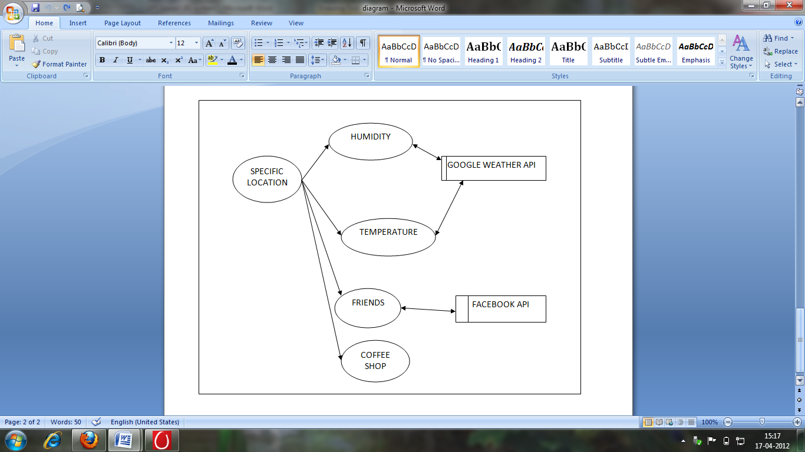
Figure 4.5 data flow diagram
4.2.9 TYPES OF REQUIREMENTS
The requirements of a development technique are both user and developer inclusive. Some of the requirements met during the process of development of the proposed system are:

- Customer Requirements
- Structural Requirements
- Behavioral Requirements
- Functional Requirements
- Non-functional Requirements
- Performance Requirements
- Design Requirements

4.3 SOFTWARE REQUIREMENTS SPECIFICATIONS
This is prepared after detailed communications with project team and the customer. It is a detailed document used by every member for successful development. A general organization of a SRS is as follows:
- Introduction
  - Purpose
  - Definitions
  - System overview
  - References
- Overall description
  - Product perspective
  - Product functions
  - User characteristics
  - Constraints, assumptions and dependencies
- Specific requirements
  - External interface requirements
  - Functional requirements
  - Performance requirements
  - Design constraints
  - Logical database requirement
  - Software System attributes
  - Other requirements
4.4 ARCHITECTURE

Every software has a defined architecture or pattern for development. The pattern is decided on the basis of users need, time constraint, financial status, intellectual property etc. The flow of activity decides the architectural pattern. In the application post requirement stage the activity diagram has been prepared to show the step wise workflow in the process. The activity diagram for the system is given in Figure 4.6:

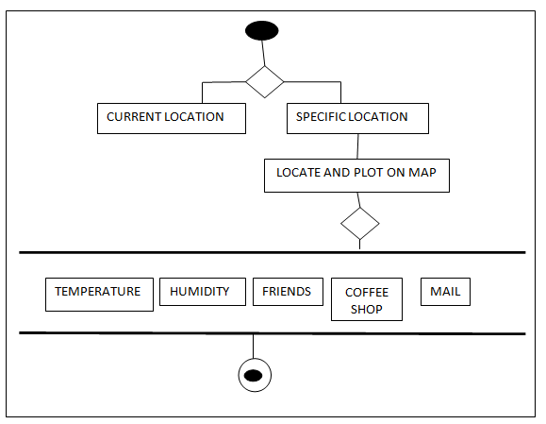

Figure 4.6 activity diagram for the proposed system

4.5 TECHNICAL ASPECTS

The application aims to create a location based search in which a certain location is searched for or the current location is identified of an Apple product user. The main element of the project is the Global positioning system (GPS). Once the location is mapped, various information about it is displayed. The main technical elements of the problem are:

- MVC Model
- Frameworks & Kits
- Finding the current and specific location
- Mapping the location
- Setting Annotations
- Customization of Annotations
- Graph API
- Generation of Access Token
- Steps for friends in a Specific location
- XML Parsing
- Google Weather API
- Zoom in, Zoom out and tabbed in nature

4.5.1 MVC MODEL

In software engineering, Model–View–Controller (MVC) is an architectural pattern that splits interactions between users and applications into three roles: the Model (business logic), the View (user interface), and the Controller (user input).This separation of concerns facilitates the independent development, testing, and maintenance of each role.
Although MVC comes in different flavours, the control flow is generally as follows:
- The user interacts with the user interface in some way (for example, by pressing a mouse button).
- The controller handles the input event from the user interface, often via a registered handler or callback, and converts the event into an appropriate user action, understandable for the model.
- The controller notifies the model of the user action, possibly resulting in a change in the model's state. (For example, the controller updates the user's shopping cart).
- A view queries the model to generate an appropriate user interface (for example the view lists the shopping cart's contents). The view gets its own data from the model. In some implementations, the controller may issue a general instruction to the view to render itself. In others, the view is automatically notified by the model of changes in state (observer) that require a screen update.
- The user interface waits for further user interactions, which restarts the control flow cycle.
The goal of MVC in the application is to simplify the architecture by decoupling models and views, and to make source code more flexible and maintainable. MVC has also been used to simplify the design of autonomic and self-managed systems.

4.5.2 ROLES AND RELATIONSHIPS OF MVC OBJECTS

The MVC design pattern in the proposed system considers there to be three types of objects:
- Model objects,
- View objects,
- Controller objects.

The MVC pattern defines the roles that these types of objects play in the application and their lines of communication. When designing an application, a major step is choosing—or creating custom classes for—objects that fall into one of these three groups. Each of the three types of objects is separated from the others by abstract boundaries and communicates with objects of the other types across those boundaries.

4.5.3 MVC AS A COMPOUND DESIGN PATTERN

Model-View-Controller is a design pattern that is composed of several more basic design patterns. These basic patterns work together to define the functional separation and paths of communication that are characteristic of an MVC application. However, the traditional notion of MVC assigns a set of basic patterns different from those that Cocoa assigns. The difference primarily lies in the roles given to the controller and view objects of an application. MVC is made up of three main components(refer Figure 4.6). They are:

- Composite—The view objects in an application are actually a composite of nested views that work together in a coordinated fashion (that is, the view hierarchy). These display components range from a window to compound views, such as a table view, to individual views, such as buttons. User input and display can take place at any level of the composite structure.
- Strategy—A controller object implements the strategy for one or more view objects. The view object confines itself to maintaining its visual aspects, and it delegates to the controller all decisions about the application-specific meaning of the interface behaviour.
- Observer—A model object keeps interested objects in an application—usually view objects—advised of changes in its state.

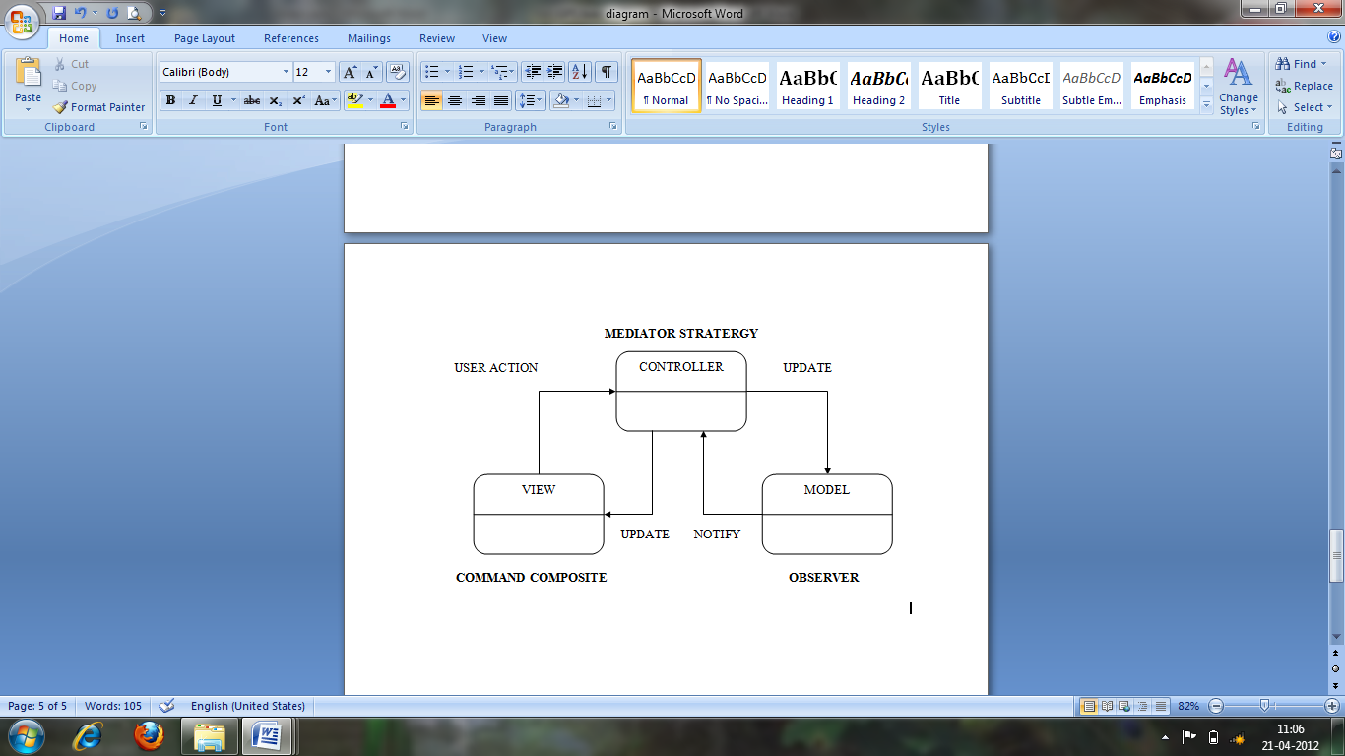
Figure 4.7 MVC as a compound design pattern
4.5.4 DESIGN GUIDELINES FOR MVC APPLICATIONS

The following guidelines apply to Model-View-Controller considerations in the design of applications:
- Instance of a custom subclass of NSObject as a mediating controller, use of instead one of the ready-made NSController objects designed for the Cocoa bindings technology; that is, use an instance of NSObjectController, NSArrayController, NSUserDefaultsController, or NSTreeController—or a custom subclass of one of these concrete NSController subclasses.NSObject subclass as a mediating controller.Although MVC roles can be combined in an object, the best overall strategy is to keep the separation between roles. This separation enhances the reusability of objects and the extensibility of the program they're used in.
- A goal of a well-designed MVC application is to use as many objects as possible that are reusable. In particular, view objects and model objects should be highly reusable.
- A view object should always go through a mediating controller object to learn about changes in an model object.
- Code dependency is limited in the classes of the application. The greater the dependency a class has on another class, the less reusable it is.

4.5.5 VIEW-CONTROLLER IN COCOA (MAC OS X)

The Model-View-Controller design pattern is fundamental to many Cocoa mechanisms and technologies. As a consequence, the importance of using MVC in object-oriented design goes beyond attaining greater reusability and extensibility for an application. Cocoa in Mac OS X includes the following architectures, mechanisms, and technologies that are based on Model-View-Controller (For further information refer [3]):

- Document architecture. In this architecture, a document-based
application consists of a controller object for the entire application (NSDocumentController), a controller object for each document window (NSWindowController), and an object that combines controller and model roles for each document (NSDocument).
- Bindings. MVC is central to the bindings technology of Cocoa. The concrete subclasses of the abstract NSController provide ready-made controller objects that the user can configure to establish bindings between view objects and properly designed model objects.
- Application scriptability. While designing an application to make it scriptable, it is essential not only that it follow the MVC design pattern but that the application’s model objects are properly designed.
- Core Data. The Core Data framework manages graphs of model objects and ensures the persistence of those objects by saving them. Core Data is tightly integrated with the Cocoa bindings technology. The MVC and object modeling design patterns are essential determinants of the Core Data architecture.
- Undo. In the undo architecture, model objects once again play a central role. The primitive methods of model objects (which are usually its accessor methods) are often where the undo and redo operations are implemented. The view and controller objects of an action may also be involved in these operations.

4.5.6 FRAMEWORK AND KITS
Cocoa Touch is a UI framework for building software programs to run on the iPhone, iPod Touch, and iPad from Apple Inc. Cocoa Touch provides an abstraction layer of iOS, the operating system for the iPhone, iPod Touch, and iPad. Cocoa Touch is based on the Mac OS X Cocoa API toolset and, like it, is primarily written in the Objective-C language. Cocoa Touch allows the use of hardware and features that are not found in Mac OS X computers and are thus unique to the ios range of devices. Just like Cocoa, Cocoa Touch follows a Model-View-Controller (MVC) software architecture. (Refer Annexure I for further details)
- Mapkit Framework: Mapkit is a high-level Objective-C framework that manages the graphical aspect of displaying a Google map within an application. The Map Kit framework provides an interface for embedding maps directly into the applications windows and views. This framework also provide support for annotating the map, adding overlays, and performing reverse-geocoding lookups to determine placemark information for a given map coordinate.
- CoreLocation Framework: This object incorporates the geographical coordinates and altitude of the device’s location along with values indicating the accuracy of the measurements and when those measurements are made. In iOS, this class also reports information about the speed and heading in which the device is moving.
- UIKit: The UIKit framework provides the classes needed to construct and manage an application’s user interface for ios. It provides an application object, event handling, drawing model, windows, views, and controls specifically designed for a touch screen interface
- CoreGraphics Framework: The Core Graphics framework is a C-based API that is based on the Quartz advanced drawing engine. It provides low-level, lightweight 2D rendering with unmatched output fidelity. User uses this framework to handle path-based drawing, transformations, color management, offscreen rendering, patterns, gradients and shadings, image data management, image creation, masking, and PDF document creation, display, and parsing.

4.5.7 FINDING THE LOCATION

One of the greatest features in the iPhone is the ability to get the location, which is available on all of the versions with the first edition relying on cell tower triangulation, the rest using built in GPS. Figure 4.8 shows the steps in a flow chart.

STEP 1: The Core Location framework is added by right clicking on the
"Frameworks" group and going to
Add > Existing Frameworks > CoreLocation.framework
This is the framework used to get a hold of location data.

STEP 2: The Core Location framework has few classes in it, the most important being
CLLocationManager. The CLLocationManager class handles updates to a
delegate when the location is changed.

STEP 3: Setup the location manager. This includes allocating a new one and
initializing properties on it. This is done to start updating the delegate and done inside the viewDidLoad method.

STEP 4: “distanceFilter” defines how far the location has to move before it will send
out an update, kCLDistanceFilterNone means it will always send an update

STEP 5: The delegate method above will be called when there is a new location
available. A CLLocation object has the coordinates, accuracy, altitude, and a timestamp.

STEP 6: The location and turn the degrees into degrees, minutes, and seconds then
display the value on the map using MapKit FrameWork.
ADD FRAMEWORK CORELOCATION
SETUP CLLLOCATION MANAGER

DISTANCE FILTER
ALLOCATE AND INITIALIZE
GET CO-ORDINATES
CONVERT TO DEGREES, MINUTES AND SECONDS
DISPLAY ON MAP
END
START
YES
NO
Figure 4.8 flow chart for finding location

4.5.8 MAPPING THE LOCATION

Once the location is found and the latitude and longitude are determined the next procedure is to map the location onto a “MapView”. The procedure is as follows:

STEP 1: The Core Location framework is added by right clicking on the
"Frameworks" group and going to
Add > Existing Frameworks > MapKit.framework
STEP 2: Map view is added to the middle of the screen, and click on the fourth tab in
the inspector toolbar to switch to the Attributes inspector. Click the checkbox for Shows User Location.

4.5.9 SETTING AND CUSTOMIZATION OF ANNOTATIONS
To set an annotations there are three steps:
- A class is created that implements the MKAnnotation protocol. It returns a title, subtitle, and coordinate.
- For every location to be marked on the map classes are created and added to the mapView with the addAnnotation method.
- The view controller is marked as the map view’s delegate, and for each annotation added it will call a method on the view controller called mapView:viewForAnnotation. This method returns a subclass of MKAnnotationView to present as a visual indicator of the annotation..

4.5.10 GOOGLE WEATHER API

It a Google initiated application programming interface that generates all types of weather information. These informations include temperature of place in both Celsius and Fahrenheit, humidity, forcast for the week etc. It is in the XML structure which is then decoded and used.

4.5.11 XML PARSING

All the data derived from the API’s are in the XML format (Refer to Annexure I for sample XML format).Data is retrieved in the form of web XML which is parsed for the information to be used. The basic steps are:

- The location data is initially determined and then plugged in to the GET request.
- The data retrieved is in the XML format
- The information has a prototyped structure
- The data is pulled from XML and strored

The various XML Parsers available are NSXMLParser, TouchXML etc. The most efficient being the NSXMLParser. This works in an event driven manner. NSXMLParser has been used in the application for efficiency purpose.

4.5.12 STEPS TO FIND FRIENDS IN A SPECIFIC LOCATION
USING FACEBOOK API

The steps to find a friend in a specified location using Facebook API are as follows:
- Authenticate user
- Ask user for Access of Information
- If granted pass the access token and retrieve user id and name
- With the user information find the number of friends
- List the friends
- Retrieve their hometown and current location
- Compare with user input and display name if there is a match

Facebook API is specifically developed for the IOS where the following steps are to be followed:

Step 1: Registering the application:
To begin integrating with the Facebook Platform the application is registered with the developers and the App Id is noted. This App Id helps to generate the Access Token for the Application. Figure 4.9 shows the Application registration page.
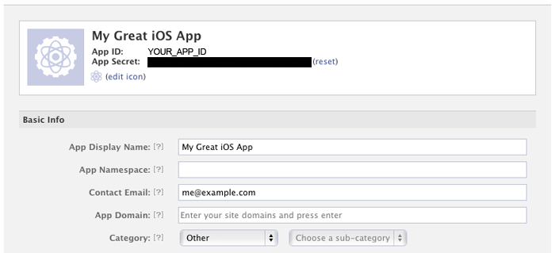
Figure 4.9 sample screen for registering in Facebook API

Step 2: Implementing SSO (Single Sign-On)
One of the most compelling features of the iOS SDK is Single-Sign-On (SSO). SSO lets users sign into the application using their Facebook identity. If the user is already signed into the Facebook ios application on their device one need not have to even type a username and password. Further, because they are signing to the application with their Facebook identity, one can get permission from the user to access their profile information and social graph.
Single Sign-On primarily works by redirecting the user to the Facebook application on the device. Since the user is already logged into Facebook, they will not need to enter their username and password to identify themselves. They will see the “auth dialog” with the permissions that the app has asked for and if they allow then they will be redirected to the app with the appropriate “access_token”.
The configurations required are:
- If the application is running in a version of iOS that supports multitasking, and if the device has the Facebook app of version 3.2.3 or greater installed
- If the device is running in a version of ios that supports multitasking, but it doesn't have the Facebook application of version 3.2.3 or greater installed, the SDK will open the authorization dialog in Safari.
- If the application is running a version of ios that does not support multitasking, the SDK uses the old mechanism of popping up an inline UIWebView, prompting the user to log in and grant access. The FBSessionDelegate is a callback interface that the application should implement: The delegate's methods will be invoked when the app successful logs in or logs out.
The steps after Single Sign-On are:
- Create
- Modify Application Delegate Header
- Modify Application Delegate implementation file
- Modify Application Properties list
- Test

Step 3: Adding the log out
When the user wants to stop using Facebook integration with the application the logout method is called to clear the app state and make a server request to invalidate the current “access_token”.
[facebook logout];
The logging out will not revoke the application's permissions, but will simply clear ones application's access_token. If a user that has previously logged out of the application returns, they will simply see a notification that they are logging into the application, not a notification to grant permissions. The simple steps are:
- Adding the logout button and handler
- Adding the logout callback handler

Step 4: Requesting additional information

By default, the user is asked to authorize the application to access basic information that is available publicly or by default on Facebook. If the application needs more than this basic information to function, specific permissions must be requested from the user. This is accomplished by passing a NSArray of permissions to the authorize method. This is where the Graph API has major role to play. Two techniques in Facebook API that need special mention are Graph API and Access Token.

GRAPH API: Graph API is an integral part of the Facebook social graph. It represents the objects in the graph (e.g., people, photos, events, and pages) and the connections between them (e.g., friend relationships, shared content, and photo tags). It requires “Authorization” from the user end. The major protocol used for authentication is OAuth 2.0 protocol OAuth 2.0 flows for user login and granting various types of information:
- Server-side (known as the authentication code flow in the specification) is shown in figure 4.10.

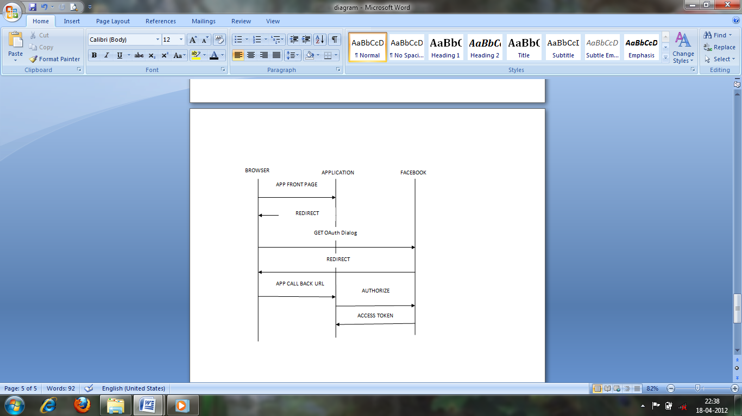

Figure 4.10 server side authentications

- Client-side is also known as implicit flow and is the vice versa of the server side authentication

GENERATION OF ACCESS TOKEN: Access token is the authentication key that helps an application connect to the network and retrieve the information. It is generated only when the Application is registered under Facebook Developers and the Client Id is verified. Then the FBCallBack method is used to retrieve the access token for the registered Application. The major advantage of the technique is security .Cross Site Request Forgery (CSRF) is an attack in which a trusted user unknowingly performs an action on website. To prevent this attack, pass and validate an identifier in the state parameter. If the response matches access is granted to the user.

4.5.13 COFFEE SHOP FINDER

It is a simple application where the Coffee shop details are integrated into the application. User can access the coffee shop website and check for location and other details relating to their needs.

4.5.14 ACCESSING GMAIL THROUGH THE APPLICATION

Through this the user can take advantage of mailing their information to anyone under the condition that they have a valid Gmail account.

4.6 TESTS CONDUCTED

Software testing is an investigation conducted to provide stakeholders with information about the quality of the product or service under test. Testing techniques include, but are not limited to, the process of executing a program or application with the intent of finding software bugs. The tests conducted for the application are:

- System testing
- End to End testing
- Sanity Testing
- Stress Testing
- Usability Testing
- Install/Uninstall Testing
- Security Testing

System testing – Entire system is tested as per the requirements.
STEP NO. | TEST | EXPECTED RESULT | ACTUAL RESULT
1 | Full system test | Complete execution without error | Complete run but dependent on Internet speed
End-to-end testing – Similar to system testing, involves testing of a complete application environment in a situation that mimics real-world use, such as interacting with a database, using network communications, or interacting with other hardware, applications, or systems if appropriate.
STEP NO. | TEST | EXPECTED RESULT | ACTUAL RESULT
1 | Full system test on IOS device (Iphone) | Complete execution on device | Complete run but dependent on Internet speed on device

Sanity testing - Testing to determine if a new software version is performing well enough to acceptable by users.
STEP NO. | TEST | EXPECTED RESULT | ACTUAL RESULT
1 | Sanity test | Working on new softwares | Works on latest version of ios devices with Internet facility

Stress testing – System is stressed beyond its specifications to check how and when it fails.
STEP NO. | TEST STEP | EXPECTED RESULT | ACTUAL RESULT
1 | Current place module | Pinpointing to current location | Complete run but dependent on Internet speed
2 | Specific place module | Pinpointing to specific location | Complete run but dependent on Internet speed
3 | Temperature & Humidity module | To find the Temperature and Humidity consistently for 10 places | Temperature and Humidity displayed
4 | Friends module | To find friend from the specific location | Friend found but speed slow with iterative searches.
Usability testing – User-friendliness check i.e whether a new user is able to understand the application easily.
STEP NO. | TEST | EXPECTED RESULT | ACTUAL RESULT
1 | Usability test | User friendliness test | Highly interactive

Install/uninstall testing - Tested for full, partial, or upgrade install/uninstall processes on different operating systems under different hardware, software environment.
STEP NO. | TEST | EXPECTED RESULT | ACTUAL RESULT
1 | Install/Uninstall test | Easily installable and de-installable | Easily configurable on IOS device if Apple Id and registration available

Security testing – Can system be penetrated by any hacking. Testing how well the system protects against unauthorized internal or external access.
STEP NO. | TEST | EXPECTED RESULT | ACTUAL RESULT
1 | Security test | Security against unauthorized entry and use of data | Safe because of use of GPS and Single Sign On

4.7 SUMMARY

This chapter covers the entire process of development from requirement to testing. Each technical aspect has been individually dealt with providing in depth information of each. The API’s used have been discussed with the authentication process. The testing process has also been visited in brief. The deployment stage has been discussed and shown in the next chapter.

CHAPTER 5
OUTPUT AND SCREENSHOTS

After the testing stage comes the deployment stage. Here the application is tested live on a simulator. Some of the simulator outputs of the application are as follows:
Figure 5.1 | application launch
Figure 5.2 | current location
Figure 5.3 | location search
Figure 5.4 | custom annotation
Figure 5.5 | information of specific location
Figure 5.6 | temperature of specific location
Figure 5.7 | humidity of specific location
Figure 5.8 | friends of a location
Figure 5.9 | coffee shop finder
Figure 5.10 | mail access
Figure 5.11 | others
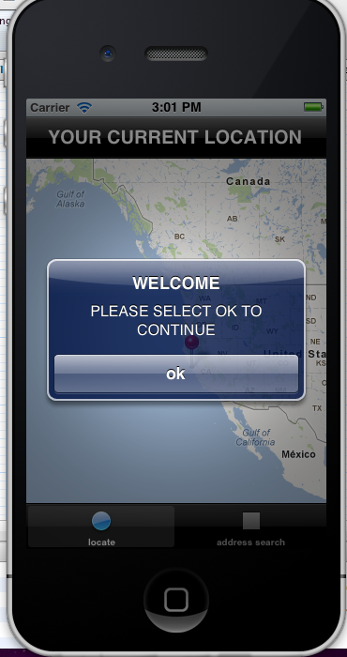
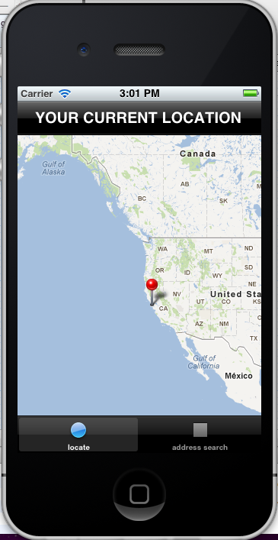

Figure 5.1 application launch Figure 5.2 current location

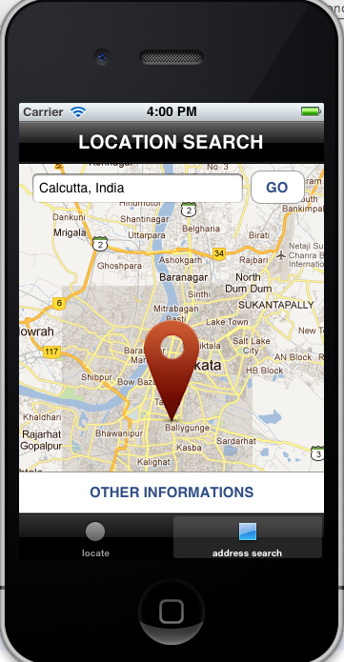
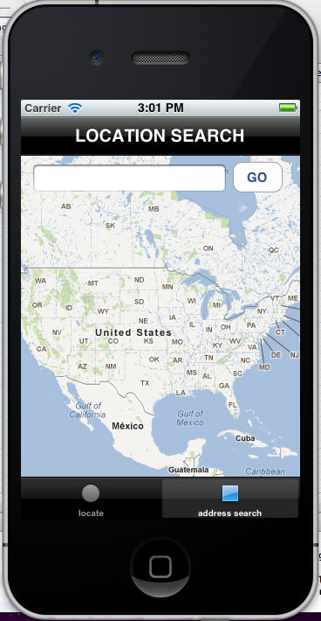

Figure 5.3 location search Figure 5.4 custom annotation
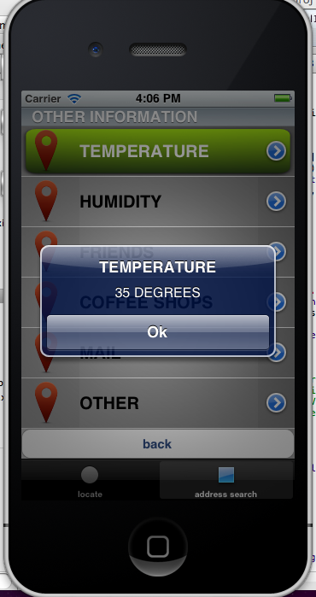
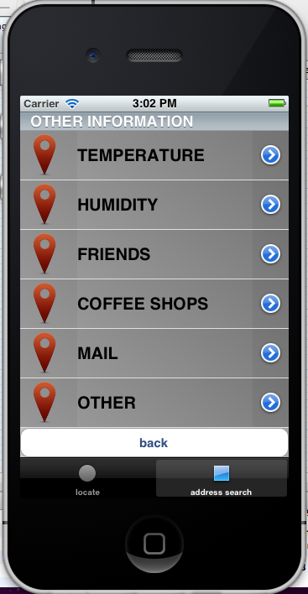
Figure 5.5 information of specific location Figure 5.6 temperature of a
specific location
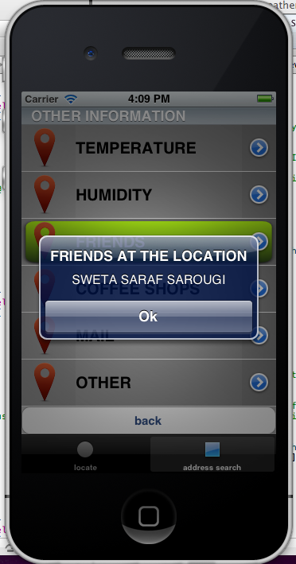
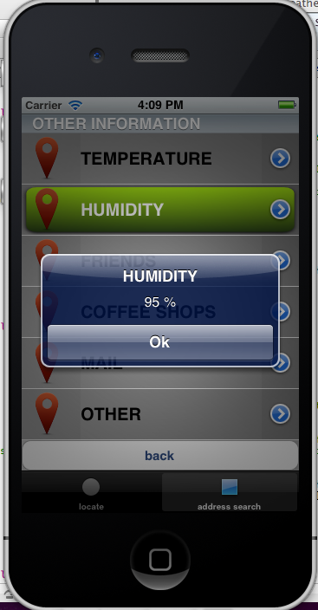

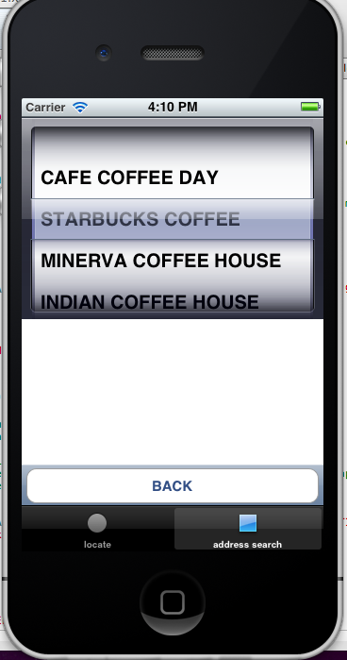
Figure 5.7 humidity of specific location Figure 5.8 friends of a location
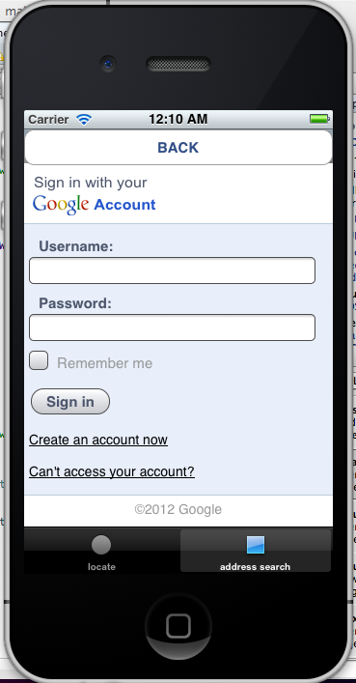

Figure 5.9 coffee shop finder Figure 5.10 mail access

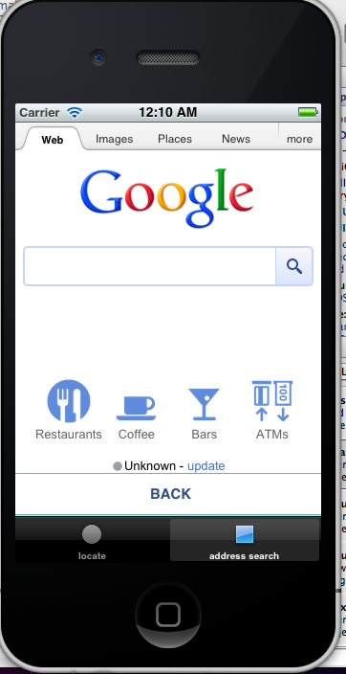

Figure 5.10 other facility searches

CHAPTER 6
CONCLUSION

The proposed system aims at the iOS users. It is a commercial tabbed application where the user retrieves all location based information. The information may be in the form of XML or JSON. The XML values retrieved are then parsed and plotted onto the map. These places can be either the current location or user specified. In the user specified tab various informations are available like the humidity, temperature, friend list etc. Different API’s such as the GOOGLE API and the FACABOOK API have been integrated successfully. Features included in the application are:

- To build an Apple based product
- Location based search
    - Present location
    - Some place in the world specifying only a specific name
- Weather information of the place
- Integration of social networking sites and the information available
- Movement detector i.e. Current location point changes with the movement of the device
- User friendly interface
- Accurate search
- Zoom in and Zoom out facility
- Perfect pinpoint of location
- Tabbed Application
- Custom Annotation

CHAPTER 7
FUTURE SCOPE OF THE PROJECT

The proposed system is an initiative to build an application for IOS devices. But every work has space for further development. The future scope for development of the system is as follows:

- Find information of the current place
- Places of visit
- Store Locator etc.
- To find a specific location in the world
- Display information about the location
- Areas of interest around it
- Nearest facilities available
- Airport, Railway, Bank, ATM etc
- Add tweets and reviews of the selected location

BIBLIOGRAPHY

TEXTUAL REFERENCES

[1] | M.A.Awad, 2005, A comparision between Agile and Traditional SW development methodology , Report submitted to The University of Western Australia, 2005
[2] | 2008,An Introduction to iPhone Application Development
[3] | IOS Developers, 2012, CocoaEncyclopedia
[4] | Reed Sorensen, Software Technology Support Center, Comparison of Software Development Methodologies
[5] | Ian Sommerville Lancaster University, UK; Documentation-a brief introduction
[6] | Teodora Bozheva, Hanna Hulkko, Tuomas Ihme, Jouni Jartti, Outi Salo  Stefan Van Baelen , ITEA-AGILE-D1_v1.0 Version .01, 2005
[7] | Xcode 4 tutorial - Xcode Tutorials

WEB REFRENCES

[1] | http://stackoverflow.com/questions/6516967/iphone-sdk-xcode-how-to-find-your-current-location-with-corelocation-xcode-4Apple official Documents
[2] | stackoverflow.com/.../how-to-find-location-using-mapkit-in-xcode
[3] | developer.apple.com/.../ios
[4] | www.quora.com
[5] | http://en.wikipedia.org/wiki/American_Foursquare
[6] | http://techcrunch.com/2011/10/31/qiuqiu-the-location-based-discovery-engine-for-android-applications/
[7] | http://vinnysoft.blogspot.in/2010/10/location-based-services-lbs-on-android.html
[8] | http://stackoverflow.com/questions/2046635/making-good-use-of-xcode-performace-tools
[9] | http://arxiv.org/ftp/cs/papers/0507/0507073.pdf
[10] | http://techcrunch.com/2011/12/24/top-30-android-apps-2011/
[11] | http://freewimaxinfo.com/apple-vs-android.html
[12] | http://www.softwaretestinghelp.com/types-of-software-testing/
[13] | http://www.raywenderlich.com/2847/introduction-to-mapkit-on-ios-tutorial
[14] | http://developer.apple.com/library/ios/#samplecode/MapCallouts/Introduction/Intro.html
[15] | http://www.cs.colorado.edu/~kena/classes/5828/s10/presentations/softwaredesign.pdf

ANNEXURE I

- Web applications primarily run on a browser using HTML, CSS and some programming language that can generate dynamic content (Java, ASP, .NET, JSP, RubY).
- Native applications run on iPhone like any other application on the device. They use iPhone SDK released by Apple with the inbuilt frameworks and other frameworks that it support.

XML format as retrieved from API

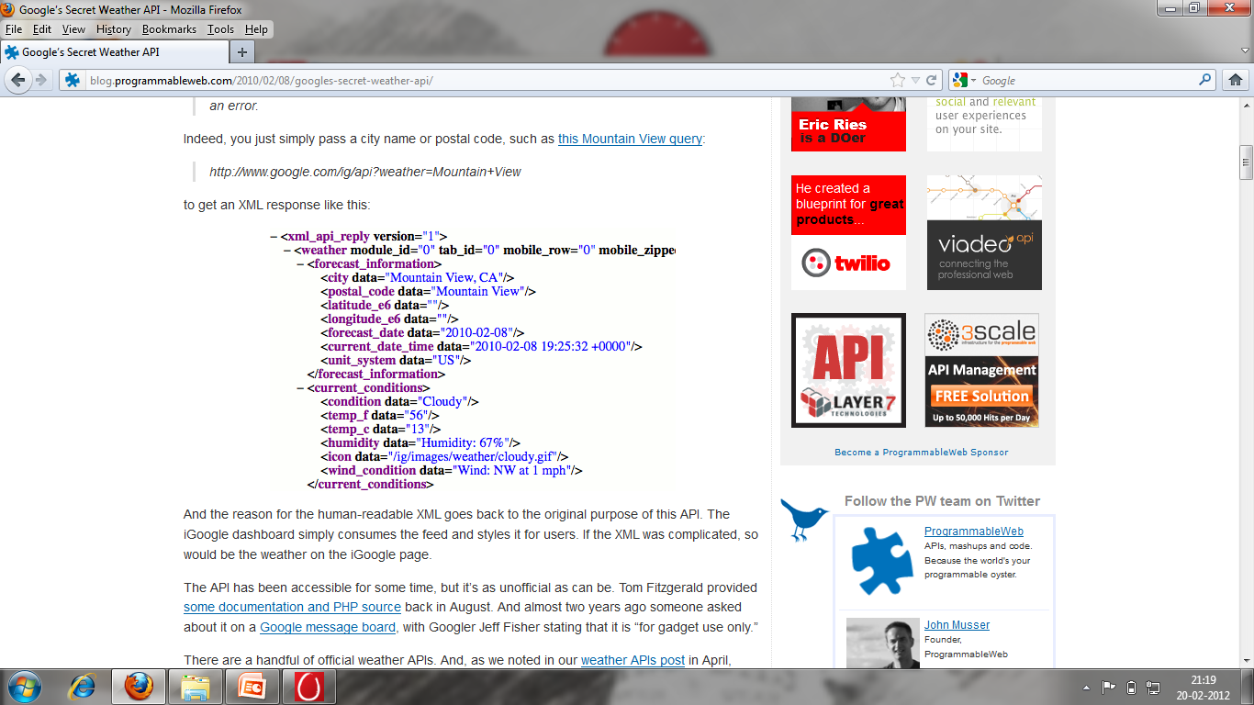

REQUIREMENT LIST

REQ 1: Location based Search engine
REQ 2: Utilize GPS advantage
REQ 3: Tabbed Application for different tabs for current and specific
location
REQ 4: Display of friend list, temperature, humidity and as many
information possible
REQ 5: User friendly interface

ABBREVIATIONS AND THEIR EXPANSIONS
Ample number of abbreviations has been used in the document. The expansions of few are given below (shown in Table 1):
Table 1 abbreviation and their expansions
SR NO | ABBREVIATION | EXPANSION
1 | IOS | I-Phone Operating System
2 | GPS | Global Positioning system
3 | APP | Application
4 | SSO | Single Sign On
5 | SDLC | System Development Life Cycle
6 | JRD | Joint Requirement Development
7 | MVC | Map View Controller
8 | API | Application Programming Interface

CLASSES INCORPORATED IN FRAMEWORK

SR NO | FRAMEWORKS | CLASSES
1 | Mapkit Framework | MKAnnotationView  MKMapView  MKPointAnnotation  MKUserLocation
2 | CoreLocation Framework | CLLocation  CLLocationManager  CLPlacemark  CLRegion
3 | UI Kit | UIAlertView  UIImagePickerController  UINavigationBar  UINavigationController

ANNEXURE II

SAMPLE CODE TO FIND CURRENT LOCATION
- (void)locationManager:(CLLocationManager *)manager didUpdateToLocation:(CLLocation *)nwLocation fromLocation:(CLLocation *)oldLocation
{
[locationManager stopUpdatingLocation];

CLLocationDegrees latitude=nwLocation.coordinate.latitude;
CLLocationDegrees logitude=nwLocation.coordinate.longitude;
mapView.mapType = MKMapTypeStandard;
CLLocationCoordinate2D coord = {.latitude = latitude, .longitude = logitude};
[mapView setCenterCoordinate:coord];
// [mapView setRegion:region];
[self.view addSubview:mapView];

AnnotationDelegate * annotationDelegate = [[[AnnotationDelegate alloc] initWithCoordinate:coord] autorelease];
[self.mapView addAnnotation:annotationDelegate];
}
@end

SAMPLE CODE TO FIND SPECIFIC LOCATION
- (CLLocationCoordinate2D) geoCodeUsingAddress{
CLLocationCoordinate2D myLocation;

NSString *place=[textField.text stringByReplacingOccurrencesOfString:@" " withString:@"%20"];
NSString *req = [NSString stringWithFormat:@"http://maps.google.com/maps/api/geocode/json?sensor=false&address=%@", place];
NSDictionary *googleResponse = [[NSString stringWithContentsOfURL: [NSURL URLWithString: req] encoding: NSUTF8StringEncoding error: NULL] JSONValue];
NSLog(@"%@",googleResponse);
NSDictionary *resultsDict = [googleResponse valueForKey: @"results"];

NSDictionary *geometryDict = [ resultsDict valueForKey: @"geometry"];

NSDictionary *locationDict = [ geometryDict valueForKey: @"location"];

NSArray *latArray = [locationDict valueForKey: @"lat"];

NSString *latString = [latArray lastObject];
NSArray *lngArray = [locationDict valueForKey: @"lng"];
NSString *lngString = [lngArray lastObject];
myLocation.latitude = [latString doubleValue];
myLocation.longitude = [lngString doubleValue];
return myLocation;
}
- (MKAnnotationView *) mapView:(MKMapView *)mapView viewForAnnotation:(id <MKAnnotation>) annotation
{
MKAnnotationView *customAnnotationView=[[[MKAnnotationView alloc] initWithAnnotation:annotation reuseIdentifier:nil] autorelease];
UIImage *pinImage = [UIImage imageNamed:@"pin.png"];
[customAnnotationView setImage:pinImage];
customAnnotationView.canShowCallout = YES;
UIImageView *leftIconView = [[UIImageView alloc] initWithImage:[UIImage imageNamed:@"pin.png"]];
customAnnotationView.leftCalloutAccessoryView = leftIconView;
UIButton *rightButton = [UIButton buttonWithType:UIButtonTypeDetailDisclosure];
[rightButton addTarget:self action:@selector(annotationViewClick:) forControlEvents:UIControlEventTouchUpInside];
customAnnotationView.rightCalloutAccessoryView = rightButton;
return customAnnotationView;
}
- (IBAction)addressButton:(id)sender
{
[textField resignFirstResponder];
MKCoordinateRegion region;
MKCoordinateSpan span;
span.latitudeDelta=0.2;
span.longitudeDelta=0.2;
CLLocationCoordinate2D location = [self geoCodeUsingAddress ];
if(addAnno != nil)
{
[mapView removeAnnotation:addAnno];
[addAnno release];
addAnno = nil;}
region.span=span;
region.center=location;
addAnno = [[AddressAnnotation alloc] initWithCoordinate:location];
[mapView addAnnotation:addAnno];
[mapView setRegion:region animated:TRUE];
[mapView regionThatFits:region];
mapView.delegate=self;
navigate.hidden=NO;
buttonOne.hidden=NO;
}

SAMPLE CODE TO FIND OTHER INFORMATION OF A SPECIFIC LOCATION

TEMPERATURE:

temp = [[[[XML componentsSeparatedByString:@"temp_c data=\""] objectAtIndex:1] componentsSeparatedByString:@"\""] objectAtIndex:0];
NSLog(@"TEMP>>>>>%@",temp);
NSString *forcast1=[NSString stringWithFormat:@"Temperature: %@ celsius" , temp];

HUMIDITY:

humid=[[[[XML componentsSeparatedByString:@"humidity data=\""] objectAtIndex:1] componentsSeparatedByString:@"\""] objectAtIndex:0];
NSString *forcast1=[NSString stringWithFormat:@"HUMIDITY: %@ " , humid];

FRIENDS:

NSString *client_id = @"282647585137204";
self.fbGraph = [[FbGraph alloc] initWithFbClientID:client_id];
[fbGraphauthenticateUserWithCallbackObject:selfandSelector:@selector(fbGraphCallback:) andExtendedPermissions:@"user_photos,user_videos,user_location,friends_location" andSuperView:self.view];
- (void)fbGraphCallback:(id)sender {
if ( (fbGraph.accessToken == nil) || ([fbGraph.accessToken length] == 0) ) {
[fbGraphauthenticateUserWithCallbackObject:selfandSelector:@selector(fbGraphCallback:) andExtendedPermissions:@"user_photos,user_videos,user_location,friends_location"];
}
Else
{
//GETTING THE FRIEND LIST
FbGraphResponse *fb_graph_response = [fbGraph doGraphGet:@"me/friends" withGetVars:nil];
SBJsonParser *parser1 = [[SBJsonParser alloc] init];
NSDictionary *parsed_json = [parser1 objectWithString:fb_graph_response.htmlResponse error:nil];
[parser1 release];
NSDictionary *data = (NSDictionary *)[parsed_json objectForKey:@"data"];
NSMutableArray *fid = [data valueForKey: @"id"];
NSMutableArray *fname = [data valueForKey: @"name"];
NSUInteger count=fid.count;
for(int i=0;i<count;i++){
NSString *fidpassed=[fid objectAtIndex:i];
//ACCESSING FRIEND LOCATION
NSString *memberid=fidpassed;
NSString*urlString=[NSString stringWithFormat:@"https://graph.facebook.com/%@?access_token=AAAEBEQToojQBALkYBuhMtTzxYUZBzJxPxO4lyFIlM5B7Cf2sZAGGbecenY2HH3kfol1UrFoDorNxrAttWtWxUtj8sBsiPqXpZBV6gqhZCAZDZD",memberid];
NSDictionary *googleResponse = [[NSString stringWithContentsOfURL: [NSURL URLWithString: urlString] encoding: NSUTF8StringEncoding error: NULL] JSONValue];
NSDictionary *location1 = [ googleResponse valueForKey: @"location"];
NSString *locationid = [location1 valueForKey: @"id"];
NSString *locationname = [location1 valueForKey: @"name"];
if([favoriteColorString isEqualToString:locationname]){
NSString* fname1=[fname objectAtIndex:i];
NSString* fid1=[fid objectAtIndex:i];
UIAlertView *alert = [[UIAlertView alloc] initWithTitle:@"FRIENDS IN THE SPECIFIED LOCATION" message:fname1 delegate:nil cancelButtonTitle:@"Ok" otherButtonTitles:nil];
[alert show];
[alert release];
break;
}
}
}
}

COFFEE SHOP:

NSString * address = @"http://www.cafecoffeeday.com";
NSURL *url = [NSURL URLWithString:address];
NSURLRequest *requestObj = [NSURLRequest requestWithURL:url];
[coffeeWebView loadRequest:requestObj];

MAIL:
NSString * address = @"http://www.gmail.com";
NSURL *url = [NSURL URLWithString:address];
NSURLRequest *requestObj = [NSURLRequest requestWithURL:url];
[coffeeWebView loadRequest:requestObj];

OTHER:
NSString * address = @"http://www.google.com";
NSURL *url = [NSURL URLWithString:address];
NSURLRequest *requestObj = [NSURLRequest requestWithURL:url];
[coffeeWebView loadRequest:requestObj];

