MORPHOLOGICAL GRANULOMETRIC FEATURES OF NUCLEUS IN AUTOMATIC BONE MARROW WHITE BLOOD CELL CLASSIFICATION
BY
P. PRINCESS
07PCA15

PROJECT WORK SUBMITTED IN PARTIAL FULLFILLMENT OF THE REQUIREMENTS FOR THE DEGREE OF

MASTER OF COMPUTER APPLICATIONS

DEPARTMENT OF COMPUTER SCIENCE
AVINASHILINGAM DEEMED UNIVERSITY FOR WOMEN,
COIMBATORE-43

APRIL-2010

CERTIFICATE

This is to certify that this project entitled “Morphological Granulometric Features of nucleus in Automatic Bone Marrow White Blood Cell Classification”, done by P.PRINCESS (07PCA15) has been submitted to Avinashilingam Deemed University for Women, Coimbatore-43 in partial fulfillment of the requirement for the award of the degree of Master of Computer Applications. This project has not found the basis for the award of any Degree/Diplamo/Associateship/Fellowship or similar title to any candidate of this university.

Certified as a bonafide record of the work submitted for the viva voce held on ___________2010.

Head of the Department Guide

Internal Examiner External Examiner

AGENDA

S.NO PARTICULARS PAGES

1. INTRODUCTION 1 1.1 Overview of the Project 2
1.2.Company profile 5

2. SYSTEM CONFIGURATION
2.1 Software Requirements 6
2.2 Hardware Requirements 6
2.3 Language Specification 7

3. SYSTEM STUDY AND ANALYSIS 12
3.1 Existing System 13
3.2 Proposed System 14

4. SYSTEM DESIGN 15
4.1 Input Design 15
4.2 Output design 16
4.3 Dataflow Diagram 16
4.4 Database design 17

5. SYSTEM DEVELOPMENT 19
5.1 Modules 19
5.2 Module Description 20

6. SYSTEM TESTING AND IMPLEMENTATION 22 6.1 Testing methodologies 22
6.2 System implementation 24
6.3 System Maintenance 28

7. CONCULSION 30

8. SCOPE FOR FUTURE ENHANCEMENT 31

9. BIBLIOGRAPHY 32

10. APPENDIX
10.1 System Flow Diagram 34
10.2 Data Flow Diagram 35
10.3 Screen Layout 38

DECLARATION

I here by declare that this project entitled “Morphological Granulometric Features of nucleus in Automatic Bone Marrow White Blood Cell Classification” submitted to Avinashilingam Deemed University for Women, Coimbatore, is a record of original work done by me under the guidance of Dr.(Mrs). S.N. Geethalakshmi MCA., Mphil., Ph.D., Associate Professor, Department of Computer Science, Avinashilingam Deemed University for Women, in partial fulfillment of the award of the degree of Master of Computer Applications, Avinashilingam Deemed University for Women. It is also declared that this does not form the basis for the award of any Degree/Diploma/Associateship/Fellowship in any other University and it is not similar to the one submitted by any other candidate.

Signature of the Guide Signature of the Candidate

ACKNOWLEDGEMENT

I would like to express my sincere thanks to God Almighty, for his constant love and grace that he has showed upon me, which kept me in good health, and sound mind without which my project would not have reached a successful end.

I would like to express my deep sense of reverential gratitude and sincere thanks to Thiru Mr. T.K.SHANMUGANANTHAM B.A., B.L. Chancellor, Avinashilingam Deemed University for Women, Coimbatore-43, for the opportunity given to me for undertaking this study and for providing the needed facility during the course of my study.

My sincere thanks to Dr. (Mrs) SAROJA PRABHAKARAN, M.A., Dip.Ed., (Madras), Ph.D (Mother Teresa), Vice Chancellor, Avinashilingam Deemed University for Women, Coimbatore-43, for providing all resources necessary for the study.

I would express my humble gratitude to Dr. (Mrs) GOWRI RAMAKRISHAN, M.Sc. (Madras)., M.Phil., Ph.D., Registrar, Avinashilingam Deemed University for Women, Coimbatore-43, for providing all facility necessary for this study.

I would express my boundless thanks to Dr.R.PARVATHAM, M.Sc., M.Phil., Ph.D., the Dean of Science of our University for her encouragement.

I wish to place on record my deep sense of gratitude to Dr.G.PADMAVATHI M.Sc., M.Phil. (Bharathiar), Ph.D., Professor and Head, Department of Computer Science for providing all the facilities to complete the project.

I express my heartfull gratitude to my internal Guide Mrs.G. GeethaB.E., M.Tech., Mphil., Senior Technical Assistant, Department of Computer Science, for guidance and timely suggestions shown in aiding me to consummate this project work successfully.

I am grateful to the project coordinator Dr. (Mrs) B.KALPANA, M.Sc. (Bharathidasan), M.Phil., Ph.D. (Avinashilingam) who was instrumental in granting me the facilities required for doing project.

I like to thank ASCENTZ TECHNOLOGIES, for providing all the necessary support for the successful completion of this project.

Finally, yet importantly, I would like to thank my parents and my brother for their support, encouragement and prayers, which were instrumental in the successful completion of this project.

SYNOPSIS

The proportion of counts of different types of white blood cells in the bone marrow, called differential counts, provides invaluable information to doctors for diagnosis. Due to the tedious nature of the differential white blood cell counting process, an automatic system is preferable.
In this project, we investigate whether information about the nucleus alone is adequate to classify white blood cells. This is important because segmentation of nucleus is much easier than the segmentation of the entire cell, especially in the bone marrow where the white blood cell density is very high.
In the experiments, a set of manually segmented images of the nucleus are used to decouple segmentation errors. We analyze a set of white-blood-cell-nucleus-based features using mathematical morphology.
Fivefold cross validation is used in the experiments in which Bayes’ classifiers and artificial neural networks are applied as classifiers. The classification performances are evaluated by two evaluation measures: traditional and classwise classification rates. Furthermore, we compare our results with other classifiers and previously proposed nucleus-based features.
The results show that the features using nucleus alone can be utilized to achieve a classification rate of 77% on the test sets. Moreover, the classification performance is better in the classwise sense when the a priori information is suppressed in both the classifiers.
1. INTRODUCTION

This project entitle” Morphological Granulometric Features of nucleus in Automatic Bone Marrow White Blood Cell Classification” deals with diagnosis of the disease. Differential counts of white blood cells in bone marrow provide invaluable information to doctors, and aid in patients’ diagnosis. Diseases such as leukemia, acquired immunodeficiency syndrome (AIDS), or cancers can be diagnosed by analyzing the white blood cell differential counts, i.e., the counts of different cell classes.
The traditional method for an expert is to use a microscope to select an area of interest in a bone marrow slide, detect a white blood cell, classify the cell based on his knowledge and experience, increase the count of the corresponding cell class, and repeat the cycle until all cells in the area of interest are counted. To perform all these processes manually is a very tedious process for a trained expert and, thus, an automated differential counting system that helps in saving time and money is highly desirable.

1.1 Overview of the Project
Bone marrow cells are normally diagnosed by light microscopy. Flow cytometry, which is normally used for differential blood cell counting of peripheral blood, is not suitable for bone marrow cells. This is because, in addition to its high price and complicated structure, markedly hypercellular or packed bone marrow and sclerotic bone marrow may yield too few cells for adequate analysis by flow cytometry. Data from flow cytometry should always be correlated with that from light microscopy.
White blood cells in bone marrow are classified according to their maturation stages. When a white blood cell becomes older, its size, the size and shape of the nucleus, and many other characteristics change. White blood cells in the myelocytic or granulocytic series can be classified into six classes, i.e., myeloblast, promyelocyte, myelocyte, metamyelocyte, band, and polymorphonuclear (PMN) in that order from the youngest to the oldest cells.
Three samples of each class are shown to illustrate the possible variation within each class. Due to the tediousness of manual systems, several methods have been proposed for automatic or partially automatic counting systems. Most of them, however, are for the applications in peripheral blood rather than for bone marrow. It should be noted that white blood cells in bone marrow are much denser than those in peripheral blood; therefore, segmentation of white blood cells in bone marrow is a more difficult problem than segmentation in peripheral blood.
Moreover, the immature cells are normally seen only in the bone marrow, which, thus, makes cell classification in bone marrow a more difficult and also a complex problem. Sanei and Lee achieved classification rates of more than 95% for mature cells in normal blood, more than 85% for immature cells in the blood, but only just over 70% (11 of 15) for immature cells in bone marrow.
Most of the proposed automatic techniques follow the traditional manual process of detecting a cell, extracting its features, classifying the cell, and then updating the counts. Beksac et al. achieved a 61% classification rate using neural networks and color- and area-based features in a 16-class problem of cell classification in both peripheral blood and bone marrow.
Color cell images were used by Ongun et al. Their data set contained 12 classes of white blood cells in bone marrow and peripheral blood. They extracted 57 features based on image intensity, color, texture, and shape from each cell using the information about the nucleus and cytoplasm.
A 70% to 30% ratio of training to test samples was used, where the samples were randomly selected from each class, and a neural network was trained and tested. This process was repeated 100 times, and the best performance from those 100 was selected. The rate of 90% correct classification was achieved using a multilayer perceptron.
By selecting the maximum rate, they have overestimated the overall capabilities of their method and placed some doubt on its generalization. Moreover, by selecting the same proportion of cells in each training and test sets, the classifiers are biased by a priori information of the number of cells in each class. six cell classes of bone marrow white blood cells in the myelocytic series were considered.
The correct classification achieved was given as about 77% using a total of 20 features. However, those 20 features were extracted using information of the entire cell, cytoplasm, and nucleus. The authors worked on color cell images using intensity, color, principle component analysis, and Bayes’ classifier. The cell data set comprised 15 classes, each of which contained 15 cells. As mentioned earlier, even though the overall classification rate is good, the rates for classification of cells in bone marrow were much lower than those in the blood.
Our previous research concentrated on the counting of white blood cells specifically in bone marrow. We developed the mixing theories of mathematical morphology, and applied them to the counting problem without classification. We also developed a new training algorithm for neural networks in order to count the number of different cell classes without classification. There are many approaches to cell segmentation in the literature.
Some examples of common techniques used in cell segmentation are thresholding, cell modeling, filtering and mathematical morphology, watershed clustering, fuzzy sets, etc. It should be noted that only the technique performed in was applied directly in the case of bone marrow, whereas, the other mentioned segmentation techniques were applied only to peripheral blood.
We propose a method for the classification of white blood cells using only their nucleus information. This idea is very useful in practice because one of the difficulties in the differential counting in bone marrow is how to deal with the cells that touch each other. This problem occurs frequently in cells of the bone marrow because there the white blood cells are very dense. If the cell classification is based only on the information about the nucleus, then we do not need to segment the entire cell, and only nucleus segmentation is adequate.
Although many techniques have been applied to cell segmentation, this problem is not solved, especially in touching cells. To decouple the effects of segmentation errors, we extract features from manually segmented nucleus of a white blood cell based on morphological granulometries. Bayes classifiers and artificial neural networks are applied to the problem of white blood cell classification of single-cell images and compare their results to those obtained by an expert. The results are compared to other classifiers and other previously proposed features.

  - Organization Profile

ASCENTZ Technologies, premier software solution providers in India. In brief stint we grown and developed many customized solutions across various domains/verticals. Our team works cooperatively to produce success for our clients. Gaining their trust and building a long-lasting affiliation. This tie up helps us to give in our best and generate good results and accomplishing the goals in a well premeditated structure. Our solutions not only productive but also have valued affordably for all our clients ranging from start ups, small business to leading corporations. Our team of experts provides a variety of best services on Sustainability, Focus, Dedication, and Cost Effectiveness. We explore it into all the major facets of corporate information technology.

Ascentz is a custom software development and Solutions Company based in Kovai, India. Ascentz possesses an experience in providing complex and diverse enterprise software development solutions to a large range of clients.
Ascentz has the exclusive experience in the software development stature, which takes pleasure of the customer retention rate.
Ascentz excels principled technology for the services promising outstanding business exposure for its clients. Ascentz on providing services that influence evolving efficient business model for the exclusive liberation.
Associated with a highly skilled team we are tweaking exclusive development and execution procedure to its benefited clients. Moreover, this is enabling us for the time bound delivery of the challenging solutions with confidence.

2.SYSTEM CONFIGURATION

2.1 Software Requirements:

- Front end : VS.net 2005
- Code Behind : C#.net
- Backend : SQL SERVER 2000

2.2 Hardware Requirements:

- Processor : Pentium IV
- RAM : 512 MB
- Monitor : 15” Color
- Keyboard : Logitech 106 keys
- Mouse : Logitech

2.3 Language Specification

2.3.1 Features of VISUAL BASIC .NET

2.3.1.1 The .NET frame work
The .NET Framework is a new computing platform that simplifies application development in the highly distributed environment of the Internet.

2.3.1.2 Objectives of .NET frame work:
- To provide a consistent object-oriented programming environment whether object codes is stored and executed locally on Internet-distributed, or executed remotely.
- To provide a code-execution environment to minimizes software deployment and guarantees safe execution of code.
- Eliminates the performance problems.
There are different types of application, such as Windows-based applications and Web-based applications. To make communication on distributed environment to ensure that code be accessed by the .NET Framework can integrate with any other code.

2.3.1.3 The common language run time (CLR):
The common language runtime is the foundation of the .NET Framework. It manages code at execution time, providing important services such as memory management, thread management, and remoting and also ensures more security and robustness. The concept of code management is a fundamental principle of the runtime. Code that targets the runtime is known as managed code, while code that does not target the runtime is known as unmanaged code.

2.3.1.4Features of the common language
The common language runtime manages memory; thread execution, code execution, code safety verification, compilation, and other system services these are all run on CLR.
- Security.
- Robustness.
- Productivity.
- Performance.

Security:
The runtime enforces code access security. The security features of the runtime thus enable legitimate Internet-deployed software to be exceptionally feature rich. With regards to security, managed components are awarded varying degrees of trust, depending on a number of factors that include their origin to perform file-access operations, registry-access operations, or other sensitive functions.

Robustness :
The runtime also enforces code robustness by implementing a strict type- and code-verification infrastructure called the common type system(CTS). The CTS ensures that all managed code is self-describing. The managed environment of the runtime eliminates many common software issues.

Productivity:
The runtime also accelerates developer productivity. For example, programmers can write applications in their development language of choice, yet take full advantage of the runtime, the class library, and components written in other languages by other developers.

Performance:
The runtime is designed to enhance performance. Although the common language runtime provides many standard runtime services, managed code is never interpreted. A feature called just-in-time (JIT) compiling enables all managed code to run in the native machine language of the system on which it is executing. Finally, the runtime can be hosted by high-performance, server-side applications, such as Microsoft® SQL Server™ and Internet Information Services (IIS).

2.3.2Data Access with ADO.NET
As you develop applications using ADO.NET, you will have different requirements for working with data. You might never need to directly edit an XML file containing data - but it is very useful to understand the data architecture in ADO.NET.
ADO.NET offers several advantages over previous versions of ADO:
- Interoperability
- Maintainability
- Programmability
- Performance Scalability

Interoperability:
ADO.NET applications can take advantage of the flexibility and broad acceptance of XML. Because XML is the format for transmitting datasets across the network, any component that can read the XML format can process data. The receiving component need not be an ADO.NET component.
The transmitting component can simply transmit the dataset to its destination without regard to how the receiving component is implemented. The destination component might be a Visual Studio application or any other application implemented with any tool whatsoever.
The only requirement is that the receiving component be able to read XML. SO, XML was designed with exactly this kind of interoperability in mind.

Maintainability:
In the life of a deployed system, modest changes are possible, but substantial, Architectural changes are rarely attempted because they are so difficult. As the performance load on a deployed application server grows, system resources can become scarce and response time or throughput can suffer. Faced with this problem, software architects can choose to divide the server's business-logic processing and user-interface processing onto separate tiers on separate machines.
In effect, the application server tier is replaced with two tiers, alleviating the shortage of system resources. If the original application is implemented in ADO.NET using datasets, this transformation is made easier.
ADO.NET data components in Visual Studio encapsulate data access functionality in various ways that help you program more quickly and with fewer mistakes.

Performance:
ADO.NET datasets offer performance advantages over ADO disconnected record sets. In ADO.NET data-type conversion is not necessary.

Scalability:
ADO.NET accommodates scalability by encouraging programmers to conserve limited resources. Any ADO.NET application employs disconnected access to data; it does not retain database locks or active database connections for long durations.

2.3.3Visual studio .NET
Visual Studio .NET is a complete set of development tools for building ASP Web applications, XML Web services, desktop applications, and mobile applications In addition to building high-performing desktop applications, you can use Visual Studio's powerful component-based development tools and other technologies to simplify team-based design, development, and deployment of Enterprise solutions.
Visual Basic .NET, Visual C++ .NET, and Visual C# .NET all use the same integrated development environment (IDE), which allows them to share tools and facilitates in the creation of mixed-language solutions. In addition, these languages leverage the functionality of the .NET Framework and simplify the development of ASP Web applications and XML Web services.
Visual Studio supports the .NET Framework, which provides a common language runtime and unified programming classes; ASP.NET uses these components to create ASP Web applications and XML Web services. Also it includes MSDN Library, which contains all the documentation for these development tools.

2.3.4Visual Basic .NET
Visual Basic. NET, the latest version of visual basic, includes many new features. The Visual Basic supports interfaces but not implementation inheritance.
Visual basic.net supports implementation inheritance, interfaces and overloading. In addition, Visual Basic .NET supports multithreading concept.

2.3.5 Microsoft SQL Server 2005
SQL is an interactive query language that gives and ad hoc access to store data. Using SQL interactively easy to manage the use of graphical computing environment for almost every task of system and database administration. SQL interactively, a user can get answers even to complex questions in minutes or seconds. Another important property of SQL is its nonprocedural.

2.3.6 C#
C# is an elegant and type-safe object-oriented language that enables developers to build a wide range of secure and robust application that run on the .NET Frame work. It can use C# to create traditional windows client applications, XML Web services, distributed components, client server applications, database applications, and much, much more. Microsoft visual C# 2005 provides an advance code editor, convenient user interface designers, intended debugger, and many other tools to facilitate rapid application development based on version 2.0 of the C# language and the .NET Frame work.

Features of C#

- C# is a simple, modern, object oriented language derived from C++ and java.
- It aims to combine the high productivity of visual basic and the raw power of C++.
- C# has been based according to the current trend and is very powerful and simple for building interoperable, scalable, robust applications.
- C# includes built in support to turn any component into a web service that can be invoked over the internet from any applications running on any plat form.
- Updating software components is an error prone task. Revisions made to the code can affect the existing program C# support version in the language. Native support for interfaces and method overriding enable complex frame works to be developed and evolved over time.
3.SYSTEM STUDY AND ANALYSIS

Systems analysis is the interdisciplinary part of science, dealing with analysis of sets of interacting entities, the systems, often prior to their automation as computer systems, and the interactions within those systems. This field is closely related to operations research. It is also "an explicit formal inquiry carried out to help someone, referred to as the decision maker, identify a better course of action and make a better decision than he might have otherwise made.
The systems-analysis phase is the specification of what the system needs to do to meet the requirements of end users. In the systems-design phase such specifications are converted to a hierarchy of charts that define the data required and the processes to be carried out on the data so that they can be expressed as instructions of a computer program. Many information systems are implemented with generic software, rather than with such custom-built programs.
Use of experimental approach (simulation) in understanding the behavior of an economy, market, or other complex phenomenon where mathematical analysis techniques are inadequate or unfeasible.

3.1 Existing System:

- The traditional method for an expert is to use a microscope to select an area of interest in a bone marrow slide, detect a white blood cell, classify the cell based on his knowledge and experience, increase the count of the corresponding cell class, and repeat the cycle until all cells in the area of interest are counted.
- To perform all these processes manually is a very tedious process for a trained expert and, thus, an automated differential counting system that helps in saving time and money is highly desirable.
- Bone marrow cells are normally diagnosed by light microscopy. Flow cytometry, which is normally used for differential blood cell counting of peripheral blood, is not suitable for bone marrow cells. This is because, in addition to its high price and complicated structure, markedly hyper cellular or packed bone marrow and sclerotic bone marrow may yield too few cells for adequate analysis by flow cytometry. Data from flow cytometry should always be correlated with that from light microscopy.

3.2 Proposed System:

- We propose a method for the classification of white blood cells using only their nucleus information. This idea is very useful in practice because one of the difficulties in the differential counting in bone marrow is how to deal with the cells that touch each other.
- This problem occurs frequently in cells of the bone marrow because there the white blood cells are very dense. If the cell classification is based only on the information about the nucleus, then we do not need to segment the entire cell, and only nucleus segmentation is adequate.
- Although many techniques have been applied to cell segmentation, this problem is not solved, especially in touching cells.
- To decouple the effects of segmentation errors, we extract features from manually segmented nucleus of a white blood cell based on morphological granulometries. We apply Bayes classifiers and artificial neural networks to the problem of white blood cell classification of single-cell images and compare their results to those obtained by an expert.

4. SYSTEM DESIGN

Design is concerned with identifying software components specifying relationships among components. Specifying software structure and providing blue print for the document phase.
Modularity is one of the desirable properties of large systems. It implies that the system is divided into several parts. In such a manner, the interaction between parts is minimal clearly specified.
Design will explain software components in detail. This will help the implementation of the system. Moreover, this will guide the further changes in the system to satisfy the future requirements.

4.1 Input design

In accurate input data is the most common case of errors in data processing. Errors entered by data entry operators can control by input design. Input design is the process of converting user-originated inputs to a computer-based format. Input data are collected and organized into group of similar data.
In the project, the input design is made in window forms and tables methods.

- Scan the blood sample
- Give the disease information
- Patient details

.

4.2 Output design:
Output design generally refers to the results and information that are generated by the system for many end-users; output is the main reason for developing the system and the basis on which they evaluate the usefulness of the application. In any system, the output design determines the input to be given to the application.
In the project, the output design is made in various window forms with various methods.
- View cells
- View blood details
- Diagnosis the disease
4.3 Data flow Diagram
A data-flow diagram (DFD) is a graphical representation of the "flow" of data through an information system. DFDs can also be used for the visualization of data processing (structured design).On a DFD, data items flow from an external data source or an internal data store to an internal data store or an external data sink, via an internal process.

A DFD provides no information about the timing or ordering of processes, or about whether processes will operate in sequence or in parallel. It is therefore quite different from a flowchart, which shows the flow of control through an algorithm, allowing a reader to determine what operations will be performed, in what order, and under what circumstances, but not what kinds of data will be input to and output from the system, nor where the data will come from and go to, nor where the data will be stored (all of which are shown on a DFD).

4.4 Database design:
A database is a collection of inter-related data stored with minimum redundancy to serve many users quickly any efficiently. Database design is used to define and then specify the structure of business objects and in the system.

4.4.1. Login
In the login table it contain the username and password, both data type is character the length of the data is 50. This table didn’t allow the null values.

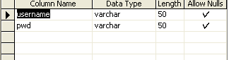

4.4.2. Diseasinfo
The disease information table contain the type of white blood cell then the minimum and maximum ratio of the cell , disease name and the reason of the disease. Data type is character and integer . This table didn’t allow the null value.

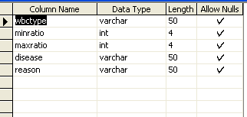

4.4.3. Image Details
In the image detail table it contain image id , image name , type, binay image , ratio, white blood cell count , thickness and reason of the disease. The datatypes are character , image and integer. This table also didn’t allow the null value.
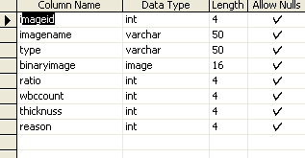

5.SYSTEM DEVELOPMENT
The systems development is a conceptual model used in project management that describes the stages involved in an information system development project, from an initial feasibility study through maintenance of the completed application.
Various SD methodologies have been developed to guide the processes involved, including the waterfall model (which was the original SDLC method); rapid application development (RAD); joint application development (JAD); the fountain model; the spiral model; build and fix; and synchronize-and-stabilize. Frequently, several models are combined into some sort of hybrid methodology. Documentation is crucial regardless of the type of model chosen or devised for any application, and is usually done in parallel with the development process.

5.1 Modules:
- Input Module
  - Blood sample.
- Pre Processing module
  - From the input blood sample we are going to do grace scale conversion.
- Segmentation module
  - Segment the white blood cells from the input sample.
- Training Cells
  - Train the project with the six stages of nucleuses.
- Classification module
  - Classify the input with the trained data.
- Disease Detection Module
  - Disease is there or not.
  - Name of the Disease.
5.2 Module Description

- Input Module:
Some Input module is give to our project.
  - The patient details ie. Patient name, patient number, complaints, doctor name, appointment date and time, fees etc.
  - Disease information that covered by the disease type and the symptoms of disease
  - Scanned blood sample of the patient

- Pre Processing Module:
This module is to convert the blood sample into grayscale image. Grayscale images are distinct from one-bit black-and-white images, which in the context of computer imaging are images with only the two colors, black, and white (also called bilevel or binary images). Grayscale images have many shades of gray in between. Grayscale images are also called monochromatic, denoting the absence of any chromatic variation. The importance of grayscale conversion is, because the project needs a common color to detect the edges of cells.
- Segmentation module:
Segmentation refers to the process of partitioning a blood cell image into multiple segments. The goal of segmentation is to simplify and/or change the representation of an cell image into something that is more meaningful and easier to analyze. Blood cell image segmentation is typically used to locate objects and boundaries in cell. More precisely, cell image segmentation is the process of assigning a label to every pixel in a cell image such that pixels with the same label that share certain visual characteristics.
The result of cell image segmentation is a set of segments that collectively cover the entire image, or a set of contours extracted from the image. Each of the pixels in a region are similar with respect to some characteristic or computed property, such as color, intensity, or texture. And find detect the six stages of nucleus from the white blood cell.

- Training Module:

  - Learning blood cells are matched to organizational blood cell.
  - A training file record is created for each login taking a blood cell. It holds an array of each cell taken.
  - Train the samples of every stage of nucleus to the project.
  - To train the blood cell select the nucleus set from the image list and click the 'Start Learning' button.
  - This will open the dialog for setting learning parameters. Use the default learning setting and just click the 'Start Learning’ button.
- Classification module:
After the training module the next step is classification module. This module is to compare the input blood sample with the trained blood sample Click 'Start classification' button to set input cell image, and the output will be displayed as the list of labels and corresponding nucleus output. The recognized cell image corresponds to the nucleus with highest output. You can test the each blood cell by clicking the button 'Start classification’. This module also helps us to classify the white blood cells.
- Disease Detection module:
This module is to detect the disease from segmentation process. This will make sure the blood sample has any disease or not, and then it shows the disease if it has occurred. This is report module.

6. SYSTEM TESTING AND IMPLEMENTATION
The process of performing a variety of tests on a system to explore functionality or to identify problems. System testing is usually required before and after a system is put in place. A series of systematic procedures are referred , while testing is being performed. These procedures tell the tester how the system should perform and where common mistakes may be found. Testers usually try to "break the system" by entering data that may cause malfunctioning of the system or return incorrect information. For example, a tester may put a city in a search engine designed to only accept states, to see how the system will respond to the incorrect input.
6.1 Testing methodologies:
The term System Testing can be used in a number of ways. In a general sense, the term ‘system testing’ refers to the testing of the system in artificial condition to ensure that it should perform as expected and as required.
From a system development perspective, system testing refers to the testing performed by the development team (the programmers and other technicians) to ensure that the system works module by module (‘unit testing’) and also as a whole.
System Testing should ensure that each function of the system works as expected and that any errors (bugs) are noted and analyzed. It should additionally ensure that interface for export and import routines, function as required. System Testing does not concern itself with the functionality of the system and whether this is appropriate to meet the needs of the users. Having met the criteria of the Test Plan the software may then be passed for User Acceptance Testing.
The various testing methodologies performed for this system is:
- Unit Testing
- Integration Testing
- Validation Testing
- Black Box Testing
6.1.1Unit testing
In computer programming, a unit test is a procedure used to validate that a particular module of source code is working properly. The idea about unit test is to write test cases for all functions and methods so that whenever a change causes a regression, it can be quickly identified and fixed.
As a result, it affords several benefits and allowed to correct the following errors.
- Mixed mode operations
- Incorrect initialization
- Incorrect symbolic representation of the expression
- Simplified integration
- Facilitated for the various changes made to the system

In this project login table is tested by this method, the zero length username and password are given and checked. Also the duplicate username is given and checked. Wrong username and password is given and checked.

6.1.2 Integration Testing
Integration testing is a logical extension of unit testing. Integration testing can proceed in a number of different ways, which can be broadly characterized as top down or bottom up. Testing is done for each module. After testing all the modules, the modules are integrated and testing of the final system is done with the test data, specially designed to show that the system will operate successfully in all its aspects conditions. Thus the system testing is a confirmation that all is correct and an opportunity to show the user that the system works.

6.1.3 Validation Testing:
The final step involves Validation testing, which determines whether the software function as the user expected. The end-user rather than the system developer conduct this test most software developers as a process called “Alpha and Beta Testing” to uncover that only the end user seems able to find.
The compilation of the entire project is based on the full satisfaction of the end users. In the project, validation testing is made in various forms. In disease detection form, the trained blood cells only accepted. The other keys are not accepted.

6.1.4 Black Box Testing
Black box testing, concrete box or functional testing is used in computer programming, software engineering and software testing to check that the outputs of a program, given certain inputs, conform to the functional specification of the program.
the term black box indicates that the internal implementation of the program being executed is not examined by the tester. For this reason black box testing is not normally carried out by the programmer. In most real-world engineering firms, one group does design work while a separate group does the testing.
Advantages of Black Box Testing

- More effective on larger units of code than glass box testing
- Testing needs no knowledge of implementation, including specific programming language
- Tester and programmer are independent of each other
- Test are done from a user’s point of view
- Will help to expose any ambiguities or inconsistencies in the specifications
- Test cases can be designed as soon as the specifications are complete

In this project all the function are tested to check whether all of them are working properly. The performance rate is verified by considering response time and speed. Hence the error are identified and corrected.

6.2 System implementation:

Implementation is the most crucial stage in achieving a successful system and giving the user’s confidence that the new system is workable and effective. Implementation of a modified application to replace an existing one. This type of conversation is relatively easy to handle, provide there are no major changes in the system.
Each program is tested individually at the time of development using the data and has verified that this program linked together in the way specified in the programs specification, the computer system and its environment is tested to the satisfaction of the user. The system that has been developed is accepted and proved to be satisfactory for the user. A simple operating procedure is included so that the user can understand the different functions clearly and quickly.
Initially as a first step the executable form of the application is to be created and loaded in the common server machine which is accessible to all the user and the server is to be connected to a network. The final stage is to document the entire system which provides components and the operating procedures of the system.

Plan
Implementation is the state in the project where the theoretical design is turned into a working system. The most crucial stage in achieving a new successful system and giving confidence on the new system for the users that will work efficiently and effectively. The system is implemented only after thorough testing is done and if it is found to work according to the specification.
It involves careful planning, investigation of the current system and is constraints on implementation, design of methods to achieve changeover, and evaluation of the changeover methods apart from planning. Two major tasks for preparing the implementation are educating, training the users and testing the system.

Implementation plan preparation
The implementation process begins with the preparation of plan for implementation. According to this plan other activities are carried out. In this plan discussion has been made regarding the equipment, resources and how to test the activities. Thus a clear planner prepared for the activities.

Equipment Acquisition
According to the above plan the necessary equipment have to be acquired to implement the new system, which would include all the requirements for installing and maintaining .Net framework, VB.net, SQL server,

Program code preparation
One of the most important development activities is coding or programming. The system flowcharts and other charts are converted into modular programs. They have to be compiled, tested and debugged.

User training and documentation
Once the planning has been completed the major effort in the computer department is that the user department must consist of educated and trained staff as the system becomes more complex. The success of the system depends upon how they are operated and used the system.
Thus the quality of training the personnel is connected to the success of the system. Implementation depends upon the right people being trained at the right time. Education involves creating the right atmosphere and motivating the user. Staff education should encourage the participation of all the staff.

Changeover
Changeover is the change of moving over from the old system to the new computerized system. In order that this is done all the files have to be converted to the new format. The accuracy of the conversion is of utmost importance both to user confidence in the system and to effective operation. When the files have been set up on the computer, the changeover can take place. There are several possible methods of doing this.
E.g. direct changeover, parallel running, pilot running, and staged changeover.

Direct changeover
This method is the complete replacement of the old system by new, in one move. When direct changeover is planned, system tests and training should be comprehensive and changeover itself is planned in detail.

In this project, direct changeover is applied where the entire system is implemented directly after it has been developed.

6.3 System Maintenance

Maintenance
The term “Software Maintenance” is used to describe software engineering activities. Maintenance activities involve making enhancements to software products, adapting to new environments and correcting problems. Software product enhancements may involve providing new functional capabilities, improving user displays and nodes of interaction, upgrading external documents and internal documentation or upgrading the performance characteristics of a system. Adaptation of software to a new environment may involve moving the software to a different machine, or for instance, modifying the software to accommodate a new telecommunication protocol or an additional disk drives. Problem correction involves modification and revalidation of software to correct errors.
Many activities performed during software development enhance the maintainability of a software product. They are:-

Analysis activities
The analysis phase of software development is concerned with determining customer requirements and constraints and establishing feasibility of the product.

- Develop standards and guidelines
- Set milestones for supporting documents
- Specify quality assurance procedures
- Identify likely product enhancements
- Determine resources required for maintenance
- Estimate maintenance costs

Architectural Design Activities
- Emphasize clarity and modularity as design criteria
- Design to ease likely enhancement
- Use standardized notations to document, data flows, functions, structure and interconnections
- Observe the principles of information hiding, data abstraction and top-down hierarchical decomposition

Detailed Design Activities
- Use standardized notations to specify algorithms, data structures and procedure interface specifications
- Specify side effects and exception handling for each routine

Implementation activities
- Use single entry, single exit constructs
- Use standard indentation of constructs
- Use simple, clear coding style
- Use symbolic constants to parameterize routines
- Provide margins on resources
- Provide standard documentation
- Follow standard internal commenting guidelines

Other activities
- Develop a maintenance guide
- Develop a test suite
- Provide test suite documentation

In this project, Detailed Design Activities, Implementation activities are applied where the entire system is maintained directly after it has been developed.

7. CONCULSION

Analysis of the white blood cell classification using only features extracted from the image of the nucleus is performed. Specifically, the six-class classification problem of white blood cells in myelocytic series is considered. The experiments performed on the white blood cell images taken from different areas in one slide. Features based on the morphological granulometries were extracted from each manually segmented blood cell’s nucleus. It should be noted that manual segmentation is performed only in the investigation step. In a real automatic system, the nucleus segmentation will be performed automatically.
This project shows that using only the nucleus-based features produced promising results. In addition to the traditional classification rate, considered the classwise classification rate, where the classification rate of each class is calculated separately and averaged over all classes at the end. The feature subsets to shows all the four proposed features are important. The classification performances are compared based on the proposed features to those of other previously proposed nucleus-based features using the same cell data set. The results showed that classifiers using the proposed features yielded better classification performances.
The misclassified cells may be those which give feature vectors close to the decision boundary between the adjacent classes. This classification disagreement for cells at the boundary also occurs in expert classification. It shows that the application of only nucleus-based features to the problem of automatic bone marrow white blood cell classification is very promising. Segmentation in an automatic cell classification system can be down-scaled to just segmenting nuclei, which is much easier than the segmentation of both the nucleus and cytoplasm. The output of this project was compared with the system that is training, for the effective and efficient implementation of the computerized system that has been developed.

8. SCOPE FOR FUTURE ENHANCEMENT

Every application has its own merits and demerits. The project has covered almost all the requirements.

- Further requirements and improvements can easily be done since the coding is mainly structured or modular in nature.

- Changing the existing modules or adding new modules can append improvements.

- The future enhancement is developing the application through website and useful manner than the present one.

9.BIBLIOGRAPHY
9.1. Book References

1. M. Beksac, M. S. Beksac, V. B. Tipi, H. A. Duru, M. U. Karakas, and A. N. Cakar, “An artificial intelligent diagnostic system on differential recognition of hematopoietic cells frommicroscopic images,” Cytometry, vol. 30, pp. 145–150, 1997.

2. L. W. Diggs, D. Sturm, and A. Bell, “The Morphology of Human Blood Cells”. Abbott Park, IL: Abbott Lab., 1985

3. H. Harms, H. Aus, M. Haucke, and U. Gunzer, “Segmentation of stained blood cell images measured at high scanning density with high magnification and high numerical aperture optics,” Cytometry, vol. 7, pp. 522–531, 1986.

4. V. Minnich, “Immature Cells in the Granulocytic, Monocytic, and Lymphocytic Series”. Chicago, IL: Amer. Soc. Clinical Pathologists Press, 1982.

5. G. Ongun, U. Halici, K. Leblebicioglu, V. Atalay, M. Beksac, and S. Beksac, “An automated differential blood count system,” in Proc. 23rd Annu. EMBS Int. Conf., Istanbul, Turkey, 2001, pp. 2583–2586.

6. G. Ongun, U. Halici, K. Leblebicioglu, V. Atalay, M. Beksac, and S. Beksac, “Feature extraction and classification of blood cells for an automated differential blood count system,” in Proc. Int. Joint Conf. Neural Netw., Washington, DC, 2001, pp. 2461–2466.

7.S. Sanei and T. K. M. Lee, “Cell recognition based on PCA and Bayesian classification,” in Proc. 4th Int. Symp. Ind. Compon. Anal. Blind Signal Separation, Nara, Japan, 2003, pp. 239–243.

9.2 Online references:

- http://www.new.ox.ac.uk/˜nmcgroga/work/transfer
- www.codeproject.com
- www.aridolan.com/ad/adb/NN.html

10.APPENDIX

10.1 System Flow Diagram

Input (Blood sample)
Edge Detection of blood cells
WBC count
Nucleus Classification
Segmentation
Disease Detection
Report
Database
Database

10.2 Data Flow Diagram

Level 0:
Input
Preprocessing
Analyze the report
Sample Classification
Edge Detection
Gray scaled sample

Level 1
Preprocessing
Classification
Traditional classifier
Class wise classifier
WBC count
Class wise count
Database

Level 2
Segmentation
Segment the stages of nucleus
Finding the count of nucleus
Disease detection
Report

Database

10.3 Screen Layout

MainForm

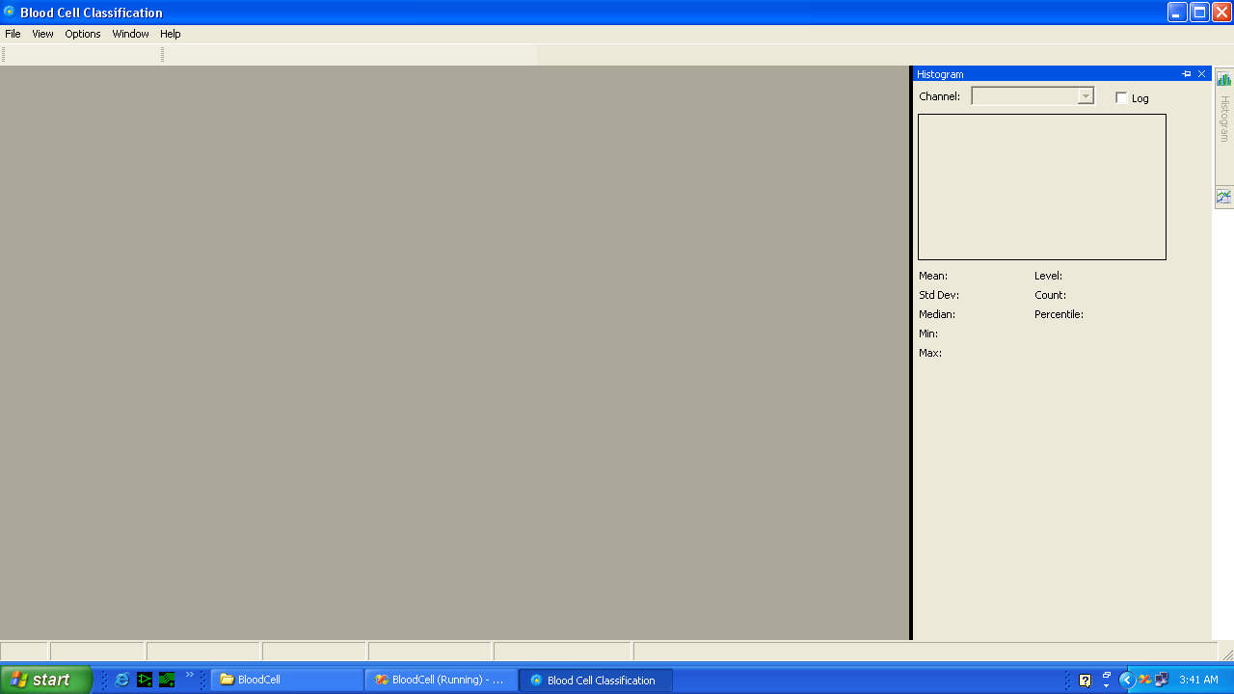
Form 1

Open the image file

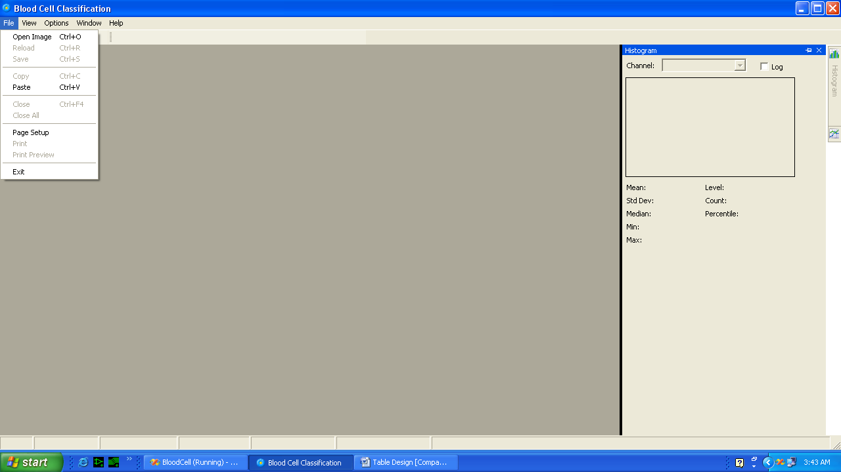
Form 2

Open Image

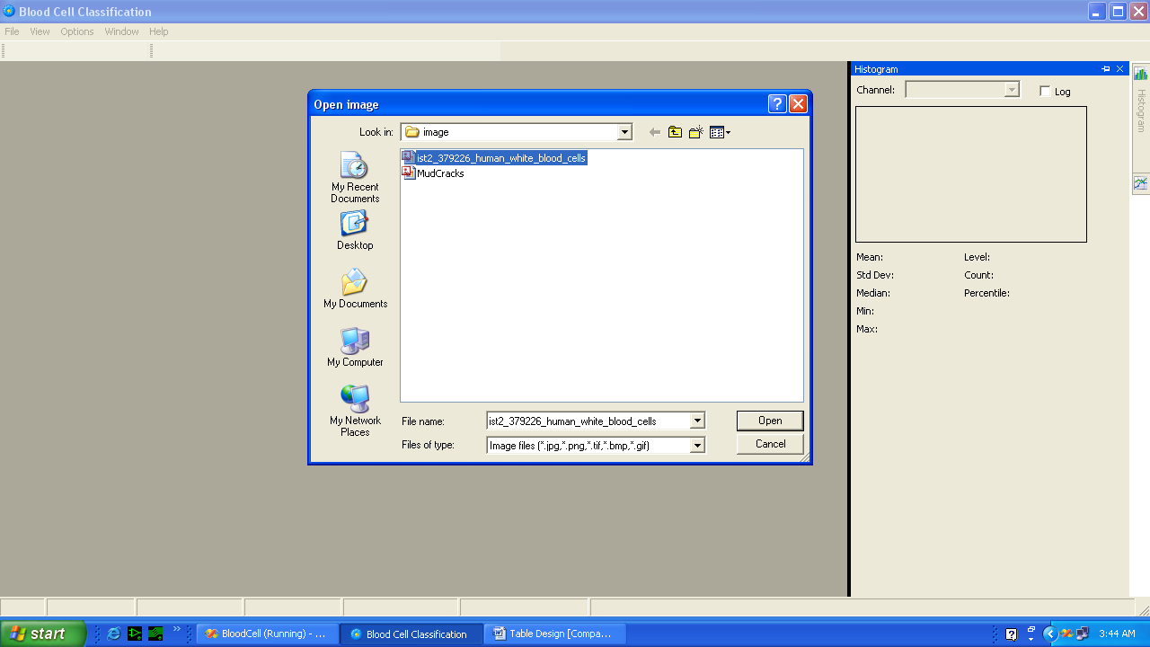
Form 3

Blood Cell

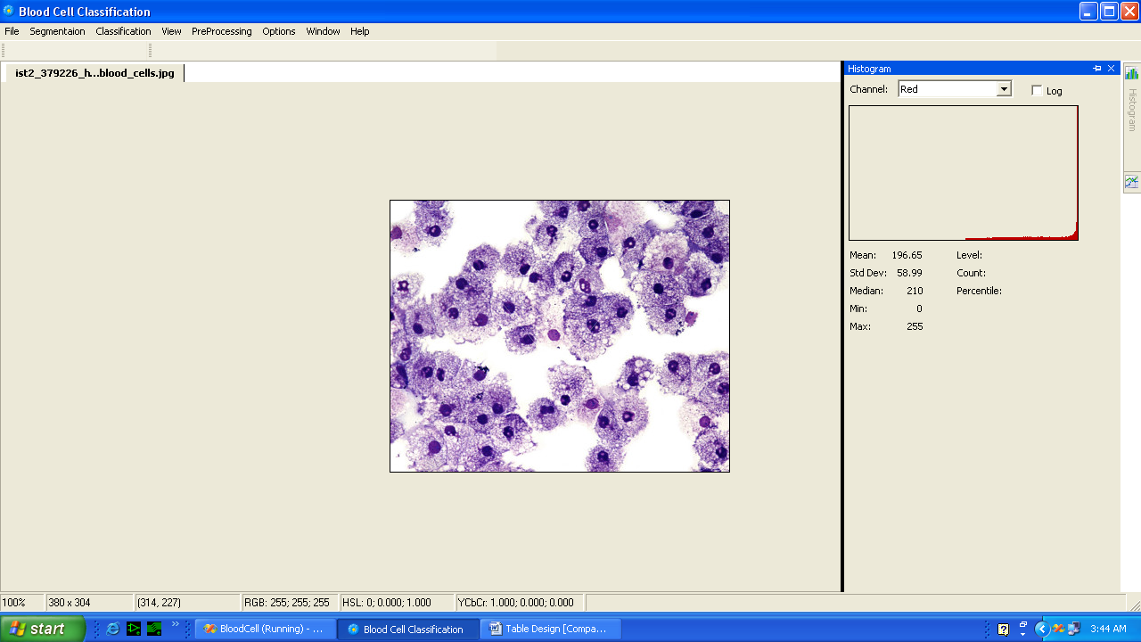
Form 4

Select the grayscale

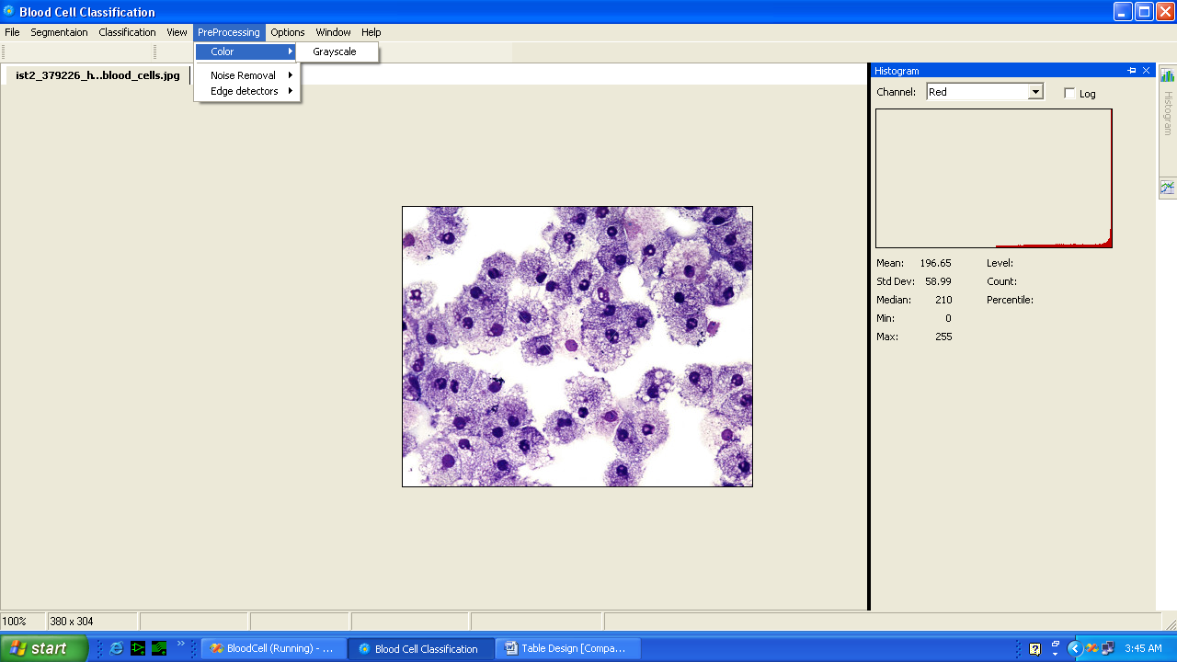
Form 5

Grayscale Conversion

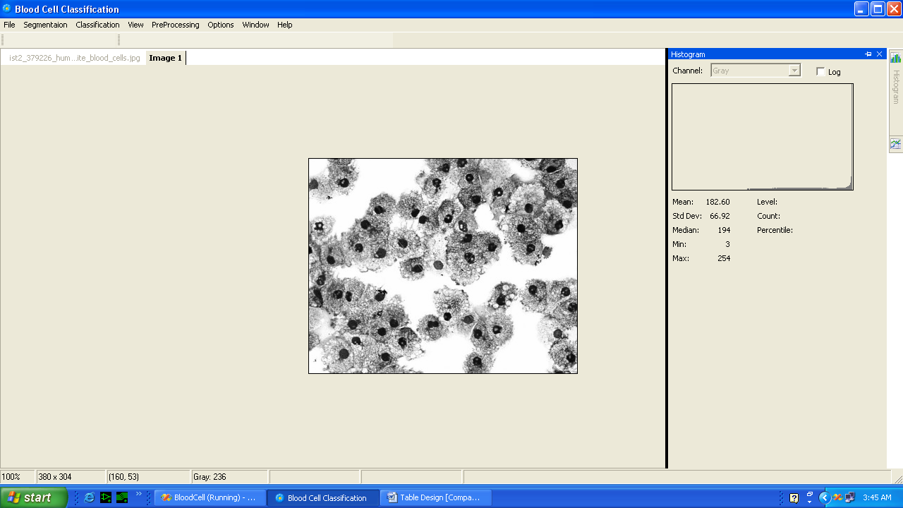
Form 6

Edge Detection

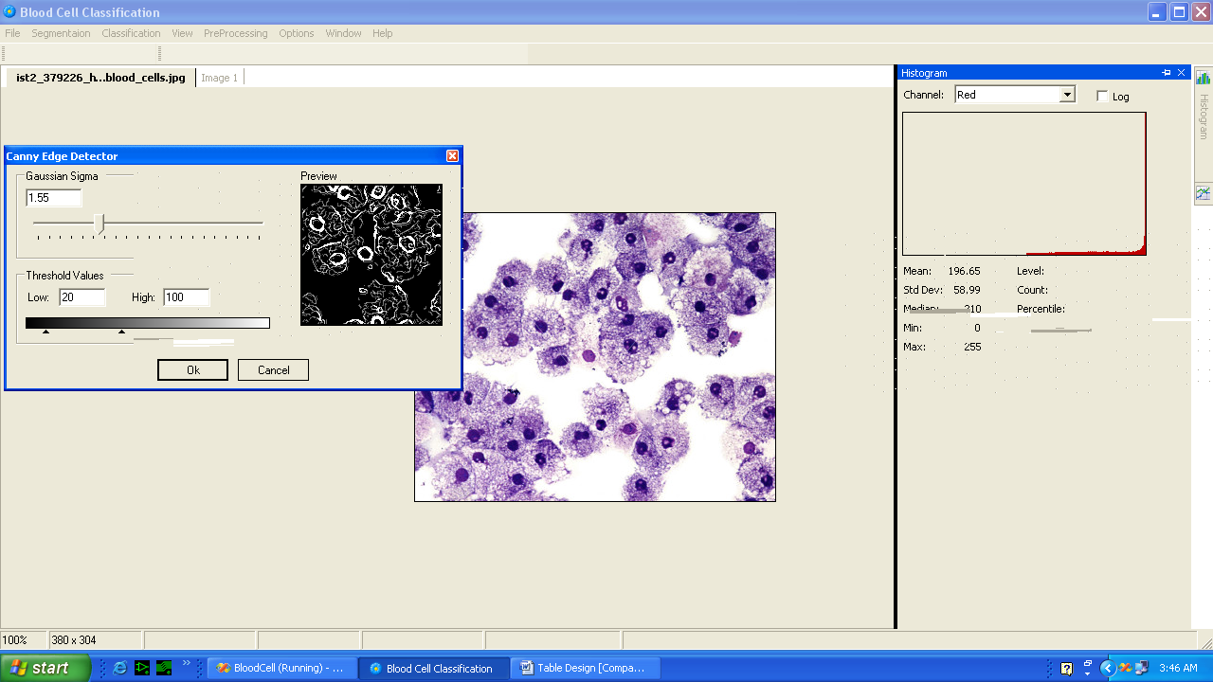
Form 7

Edge detected Image

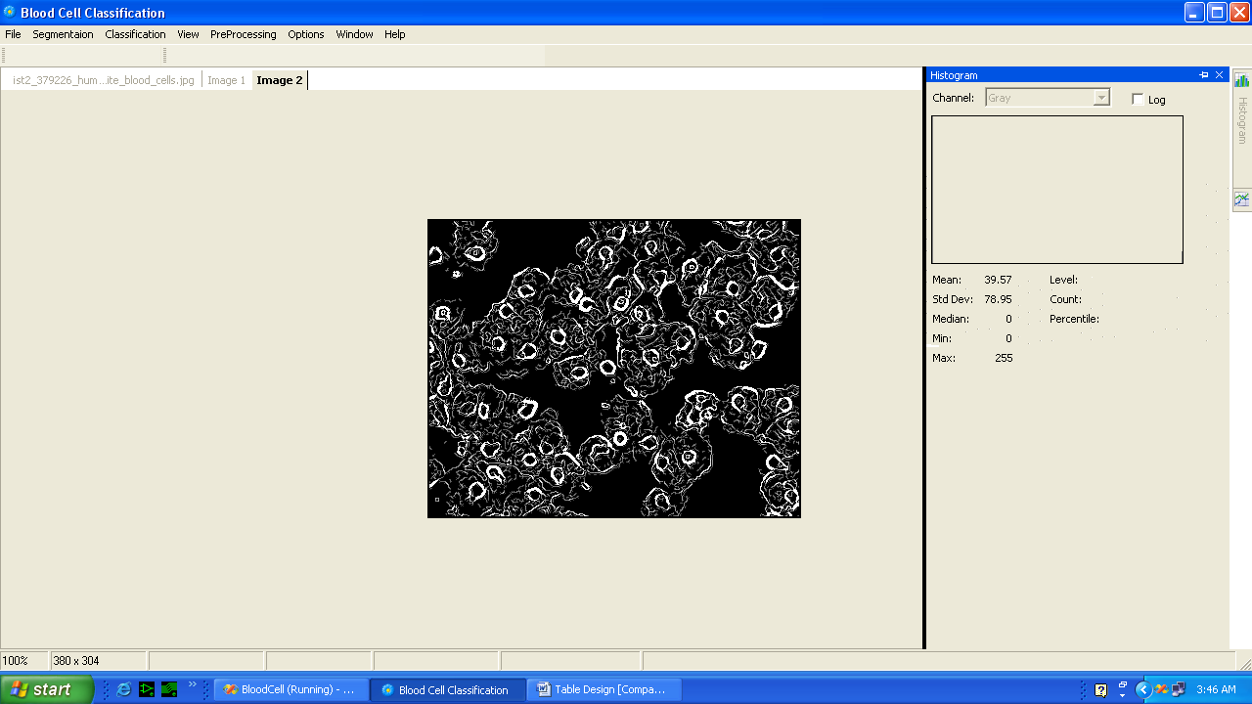
Form 8

Training Images

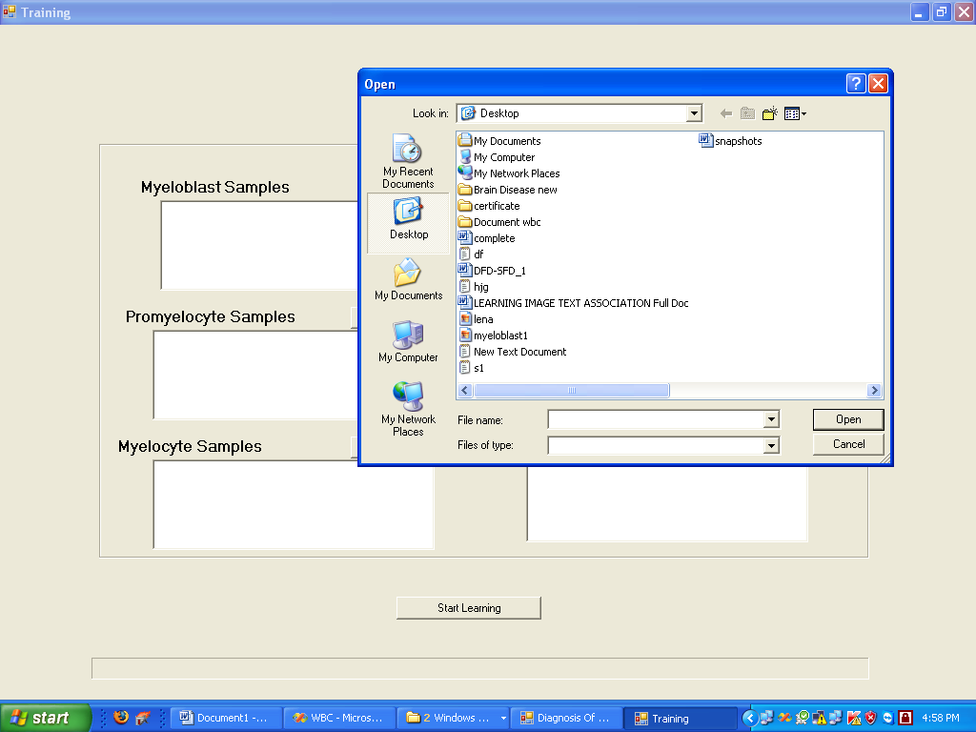
Form 9

Training

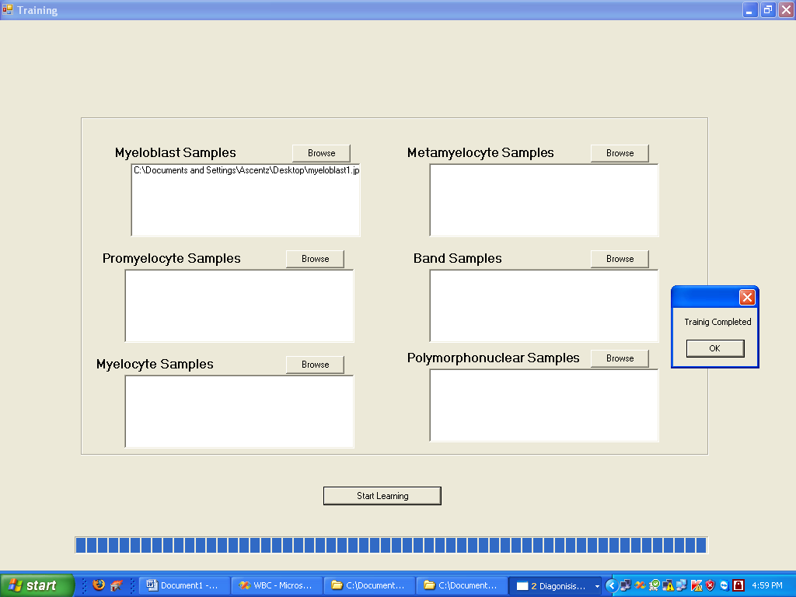
Form 10

Classification

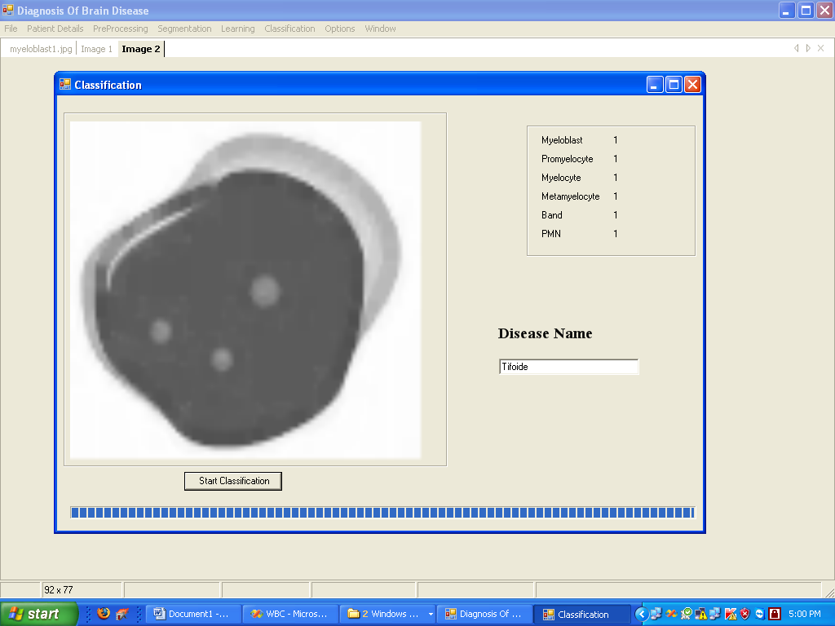
Form 11

Diagnosis of disease

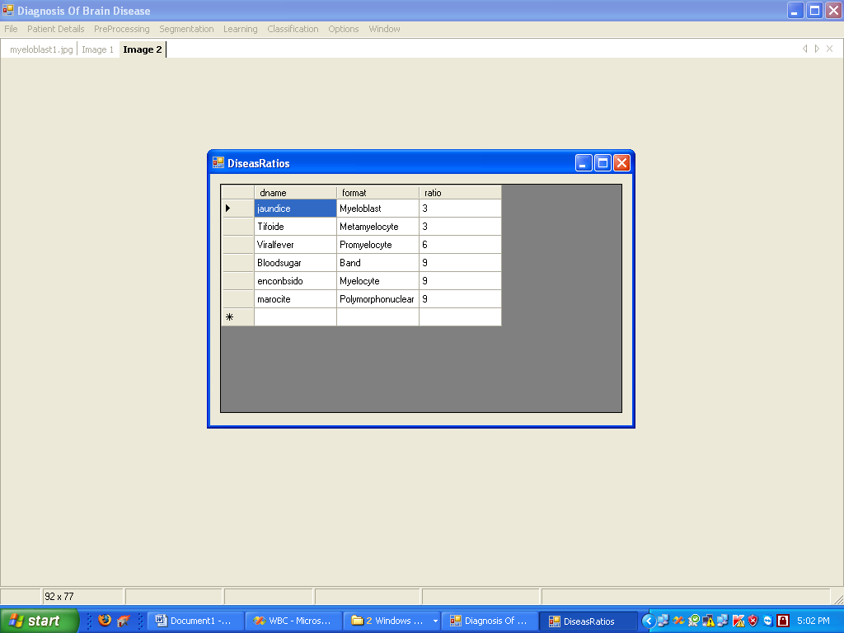
Form 12



